Notification template for Article 124 of the Capital Requirements Regulation (CRR) – Risk Weights
Template for notifying the European Banking Authority (EBA), European Central Bank (ECB) and European Systemic Risk Board (ESRB) of higher risk weights being set for immovable property pursuant to Articles 125(1) and 126(1) CRR or on applying stricter criteria than those set out in Articles 125(2) and 126(2) CRR

Please send/upload this template to:
- macropru.notifications@ecb.europa.eu when notifying the ECB (under Article 5 of the Single Supervisory Mechanism (SSM) Regulation);
- DARWIN/ASTRA when notifying the ESRB;
- eportal.eba.europa.eu when notifying the EBA.

The ESRB will publish the risk weights and criteria for exposures referred to in Articles 125, 126 and 199(1)(a) of the CRR as implemented by the relevant authority. This notification will be made public by the ESRB after the relevant authorities have adopted and published the notified macroprudential measure.

E-mailing/uploading this template to the above addresses constitutes official notification; no further official letter is required. To facilitate the work of the notified authorities, please submit the notification template in a format that allows the information to be read electronically.

- Notifying national authority
1.1 Name of the notifying authority | Finansdepartementet
1.2 Country of the notifying authority | Norway
- Scope of the notification and description of the measure
2.1 Exposures secured by mortgages on residential property | - Do you intend to set a higher risk weight than that set out in Article 125(1) CRR for exposures fully and completely secured by mortgages on residential property?  No.
- Do you intend to apply stricter criteria than those set out in Article 125(2) CRR for exposures fully and completely secured by mortgages on residential property?
No.
2.2 Exposures secured by mortgages on commercial immovable property | - Do you intend to set a higher risk weight than that set out in Article 126(1) CRR for exposures fully and completely secured by mortgages on commercial immovable property?  Yes.  - If yes, please specify:  Commercial immovable property, except agricultural immovable property, shall not be considered when assigning risk weights. This will result in a risk weight of 100 per cent for exposures secured by commercial immovable property and 75 per cent for exposures secured by commercial immovable property meeting the requirements for inclusion in the retail category. Exposures secured by agricultural immovable property, which is not considered residential immovable property, will be subject to the risk weight set out in article 126(1) CRR.
- Do you intend to apply stricter criteria than those set out in Article 126(2) CRR for exposures fully and completely secured by mortgages on commercial immovable property?

No.

2.3 Other relevant information | Any other relevant information.
- Timing for the measure
3.1 Timing for the decision | [Fylles ut av Finansdepartementet]  What is the date of the official decision? For SSM countries when notifying the ECB: provide the date on which the decision referred to in Article 5 of the Single Supervisory Mechanism Regulation (SSMR) will be taken.  Click here to enter a date.
3.2 Timing for publication | [Fylles ut av Finansdepartementet]  What is the date of publication for the notified measure?  Click here to enter a date.
3.3 Disclosure | [Fylles ut av Finansdepartementet]  Information about the strategy for communicating the notified measure to the market.  Please provide a link to the public announcement, if any.
3.4 Timing for application | [Fylles ut av Finansdepartementet]  What is the intended date for application of the measure?  Click here to enter a date.
3.5 Frequency/review | [Fylles ut av Finansdepartementet]  Does your decision to set higher risk weights have an expiry date? When will the decision be reviewed?
- Reason for setting higher risk weights or stricter criteria than those set out in Articles 125(2) or 126(2) CRR
4.1 Regulatory context | A 100 % risk weight on exposures secured by commercial property was implemented in Norway in 1989 as a part of the implementation of Basel I compliant regulation, was continued when implementing 98/32/EC and 98/33/EC in 2001, and later when implementing 2006/48/EC and 2006/49/EC in 2006.  When CRR was implemented in Norway in 2019, Norwegian authorities made use of the possibility in article 124 to set a higher risk weight for exposures secured by commercial real estate. This is done in Regulations on capital requirements and national adaptation of CRR/CRD IV (CRR/CRD IV regulations) section 6, which states that "Mortgages on commercial property shall not be taken into account when assigning risk weights in accordance with CRR Article 124(2)."
- Risk weights versus actual risks | The risk weight of 50% under the standardised method, for exposures fully and completely secured by mortgages on commercial immovable property, is not considered sufficient to reflect the actual risk.  The loss experience on commercial property lending in Norway indicates that risk is extremely volatile. Whilst in normal years, losses on commercial property can be very low, in crisis periods they have shown to dominate total loan losses.  Agricultural real estate has, over time, been one of the sectors within commercial real estate with the lowest loss rates.
4.3 Motivation | a) Loss experience  The full loss potential in commercial real estate lending is revealed in times of severe crises, hence the losses experienced during the Norwegian banking crisis (1988-1992) is considered to be most relevant. During the banking crisis the increase in commercial real estate losses was significantly larger than the portfolio as a whole. The Norwegian FSA has estimated the accumulated losses on exposures secured by commercial real estate over the period 1988-1992 to approximately 22 per cent.  The period 2008-2022 is characterized by strong economic development and losses have been low for all sectors. Nevertheless, the sector "agriculture, forestries and fisheries (excl. fish farming)" is among the sectors with the lowest losses, as visualized by the red line in figure 1. According to a survey made by Finanstilsynet (FSA Norway), losses stemming from lending collateralised by agricultural immovable property up to 50 per cent of the market value or 60 per cent of the lending value, have varied between 0,00 and 0,02 per cent of outstanding loans over the last ten years, while overall losses stemming from lending collateralised by agricultural immovable property have varied between 0,04 and 0,16 per cent of the outstanding loans in the same period.  Figure 1: Losses for different sectors in Norway (numbers include all loans)  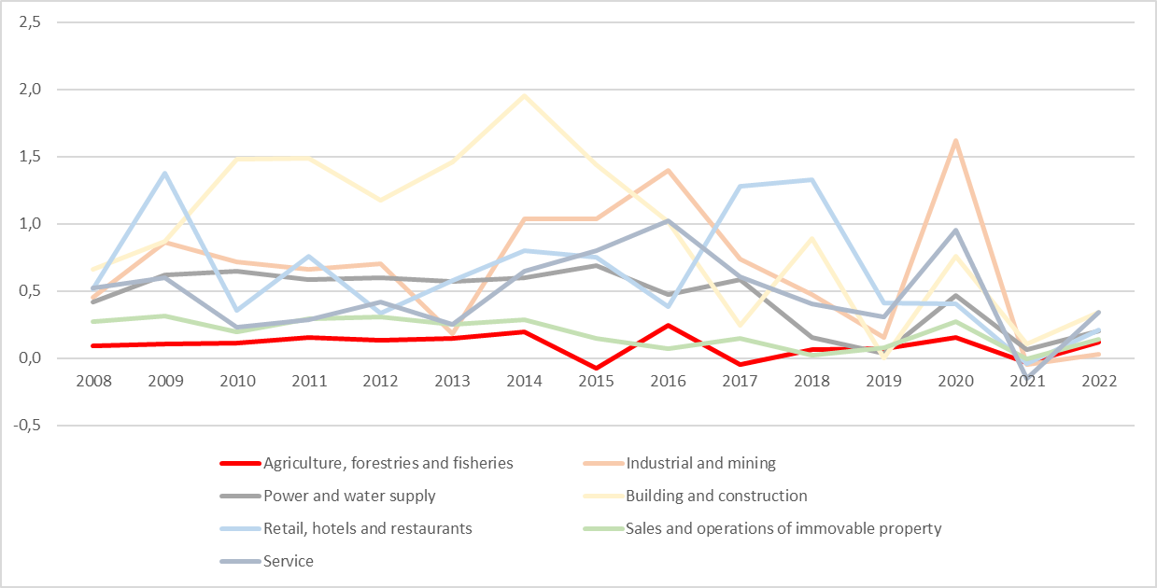  Source: Finanstilsynet (FSA Norway)
b) Forward-looking real-estate market developments
- There is high activity in the Norwegian economy and limited available resources. Central banks in several countries, including Norway, have raised policy interest rates to curb inflation. Since September 2021, the Central Bank of Norway has increased the policy rate 14 times to 4.5 percent, indicating that the interest rate will probably remain high for some time.

- There is significant uncertainty in the developments of the real economy, inflation, and financial markets in Norway. A gradual moderation in economic activity in Norway over the next couple of years is possible. The full effect of high inflation and higher interest rates has not yet been experienced, which could lead to declining housing and commercial property prices. A decline in housing prices can result in reduced consumption, thereby weakening earnings for businesses leasing premises, leading to lower profits in commercial property companies and increased credit risk for banks.

- Norwegian agriculture and forestry are eligible to state subsidy and support schemes. The earnings of many agricultural properties are positively affected of current subsidy and support schemes, hereby decreasing the likelihood of loan losses for banks.
c) Financial stability considerations
- Commercial real estate constitutes a large share of the banks total lending books, and real estate is also the prime collateral in lending to other business. Commercial real estate was a major driver of losses during the banking crisis in Norway in 1988-1992.

- Introducing a lower risk for commercial real estate under the standardized method may increase lending to the segment significantly. In the current situation this could be problematic considering banks' high exposure and the uncertainty in the economic outlook in general, and specifically in relation to the adaptation to higher interest rates.

- The total exposure to the agricultural sector is relatively low. Reducing the risk weight for only this sector is not considered to have major impact on financial stability.
- Sufficiency, consistency and non-overlap of the policy response
5.1 Sufficiency of the policy response | In the current economic environment, with high uncertainty both in general and specifically in relation to the commercial real estate market, it is considered important to keep the risk weight for exposures secured by commercial real estate at the current level. A decrease would reduce resilience in the banking sector and could increase lending to the segment.
5.2 Consistency of application of the policy response | The measure is mainly a continuation of current framework, apart from the exception of exposures secured by agricultural real estate. As this is considered to have a minor impact on the financial system in general, the measure is overall assessed to be consistent with previous and current policy.
5.3 Non-overlap of the policy response | The vulnerabilities in the Norwegian financial system are addressed by a number of regulations. The measure in question has a narrow target: Only exposures secured by commercial real estate in banks using the standardized method for credit risk are affected.  While a few other regulations are targeting, or partially targeting, commercial real estate, they have different functions. The systemic risk buffer is a broad measure targeting the inherent systemic risk in the entire banking system and was calibrated on the basis of current risk weights. The countercyclical capital buffer should primarily reflect the assessment of cyclical vulnerabilities in the financial system. The risk weight floor for commercial real estate is a backstop that only affect IRB banks.
- Cross-border and cross-sector impact of the measure
6.1 Assessment of cross-border effects and the likely impact on the Internal Market  (Recommendation ESRB/2015/2) | As the measure is mainly a continuation of current framework, it is not expected to have any cross-border effects or impact the Internal Market.

6.2 Assessment of leakages and regulatory arbitrage within the notifying Member State | The measure is not expected to contribute to leakages or regulatory arbitrage  within the Norwegian financial system.
- Miscellaneous
7.1 Contact person(s)/mailbox at notifying authority | [Fylles ut av Finansdepartementet]  Contact person(s) (name, phone number and e-mail address) and mailbox for further inquiries.
7.2 Any other relevant information | [Fylles ut av Finansdepartementet]
7.3 Date of the notification | [Fylles ut av Finansdepartementet]  Please provide the date on which this notification was uploaded/sent.  Click or tap to enter a date.

Council Regulation (EU) No 1024/2013 of 15 October 2013 conferring specific tasks on the European Central Bank concerning policies relating to the prudential supervision of credit institutions (OJ L 287, 29.10.2013, p. 63).
On request by the notifying authority, it may be agreed with the Head of the ESRB Secretariat that this notification, or a part thereof, should not be published for reasons of confidentiality or financial stability.
Recommendation of the European Systemic Risk Board of 15 December 2015 on the assessment of cross-border effects of and voluntary reciprocity for macroprudential policy measures (ESRB/2015/2) (OJ C 97, 12.3.2016, p. 9).

