Meld. St. 11(2019–2020) Report to the Storting (white paper), Summary
Digital transformation
and development policy

Introduction
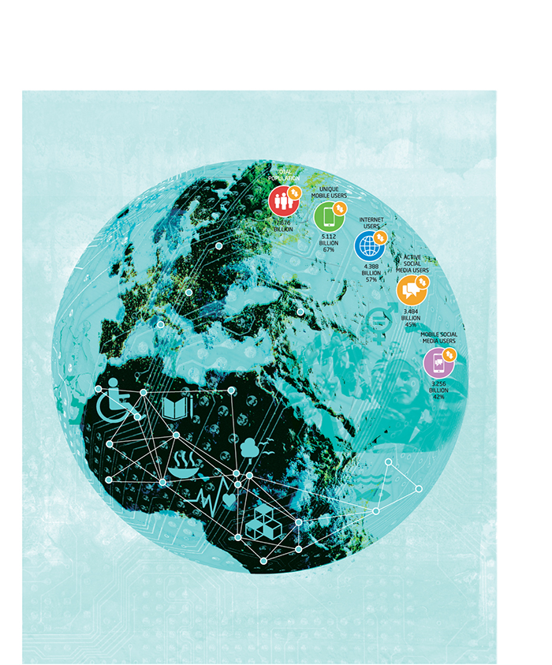

Purpose
The purpose of the Report is to define and provide strategic direction for digitalisation in Norwegian development policy, and to show how existing and new initiatives can be applied in priority areas. Digitalisation is an umbrella term that encompasses the introduction of digital tools and methods that streamline processes and change societies. Both nationally and internationally much is being done to harness digitalisation and new technology, but the efforts are often fragmented and uncoordinated. A more systematic and integrated approach is therefore needed to determine how digital transformation can be used to enhance the impact of Norwegian development policy. Digitalisation can increase the reach of existing development efforts and assist developing countries in capitalising on the potential of digital technologies. To build on lessons learned and encourage results beyond the scope of individual projects, Norway will take a systematic and integrated approach to use of technology in its development policy. Furthermore, Norway must lay the foundation for innovation and digitalisation in all its multilateral and bilateral efforts. Digitalisation is not an end in itself, but a means to:
- meet the challenges within the Government’s priority focus areas more effectively and with higher quality within the framework of the UN Sustainable Development Goals;
- renew and enhance development cooperation and reach those most in need, so no one is left behind;
- utilise digital solutions in low-income countries and in Norwegian humanitarian efforts to promote sustainable development, by boosting job creation and increasing competitiveness, among other things;
- increase investment in the basic infrastructure that countries need to utilise digital technology.
New technology, innovation and public-private collaboration makes it possible to strengthen Norway’s contributions to the Sustainable Development Goals. Norway will prioritise development cooperation with its partner countries and will direct resources where the needs are greatest. New opportunities will be a focus in Norway’s political dialogue with partner countries and with countries where Norwegian ICT firms and industry organisations are already actively engaged with local partners. Local strategies, ambitions and existing digital expertise of those countries will serve as the basis for Norwegian development cooperation.
The Government will incorporate digitalisation into its thematic areas of focus. Along with humanitarian efforts, the Government’s key development-policy focus areas are health, education, climate and the environment, oceans, private sector and agricultural development, renewable energy, the fight against modern slavery, human rights and financing for development. As work proceeds, the cross-cutting considerations relating to human rights, climate and the environment, gender equality and combating corruption will be safeguarded.
Norway expects our implementing partners within the prioritised areas to do more to identify, utilise and implement digital opportunities to reach more people and have more effect. More viritual meetings and online working methods may also contribute to reduced carbon emissions. Norway will work to improve coordination and flexibility to prevent fragmentation and duplication. In many cases, especially for projects that are fully publicly funded, open licences and open standards must be the main rule.
The use of digital technology is especially important in efforts to reach the most marginalised groups in society. Depending on the country, such groups may include persons with disabilities, religious and sexual minorities, and children who are prevented from attending school. The efforts will be carried out in broad partnership in the private and public sectors as well as academic and civil society organisations.
Norwegian efforts will focus on four barriers to digitalisation:
- Access
- Regulation
- Digital competence
- Exclusion

Digital transformation and development policy
The digital divide between developing and industrialised countries, and between urban and rural areas, is large. We will not achieve the Sustainable Development Goals by 2030 without the use of digital technologies.
The world is undergoing a digital revolution that is fundamentally changing how we live, work and relate to one another. Through digital means, the economy and society can continue to function, also in a crisis. However, poor countries that fail to utilise digital opportunities are increasingly lagging behind. Many areas around the world are faced with a lack of infrastructure, limited access to stable electrical power, poor reading- and writing skills and low levels of digital competence. Norway will work to ensure that developing countries are able to take part in the opportunities that innovation and new technologies provide. Marginalised groups and vulnerable individuals in poor countries are the furthest behind. Reaching them will require the use of digital tools and targeted policies.
Development funding can play an important role by serving as a catalyst for, and contributing strategically to, digital transformation processes already taking place in developing countries. Digital transformation processes are not limited to one sector, one part of the world, or one group. Trade and industry and research and innovation are strong drivers of digitalisation. The natural urge of individuals to find better solutions is another. The ramifications of technological developments are wide-ranging and cross-sectoral, and a combination of the above-mentioned drivers provide complementary effects.
Norway supports the development of sustainable democratic states. By providing assistance that takes advantage of technological potential, Norway can support development that promotes civic participation and democracy. Meanwhile we must remain aware of ways in which new technology may be misused to suppress and limit individual freedoms. The innovation and digitalisation potential of all Norwegian multilateral and bilateral assistance measures will be evaluated.
Norway commits to the Principles for Digital Development, which call for digital tools and methods that are user-centric, aligned with existing ecosystems or contexts, scalable, built for sustainability, and data-driven. This also entails a commitment to sharing, collaborating and improving one another’s solutions as much as possible while adequately addressing privacy and security concerns.
Part 1
The digital divide
– technology and
opportunity

Barriers –
the digital divide
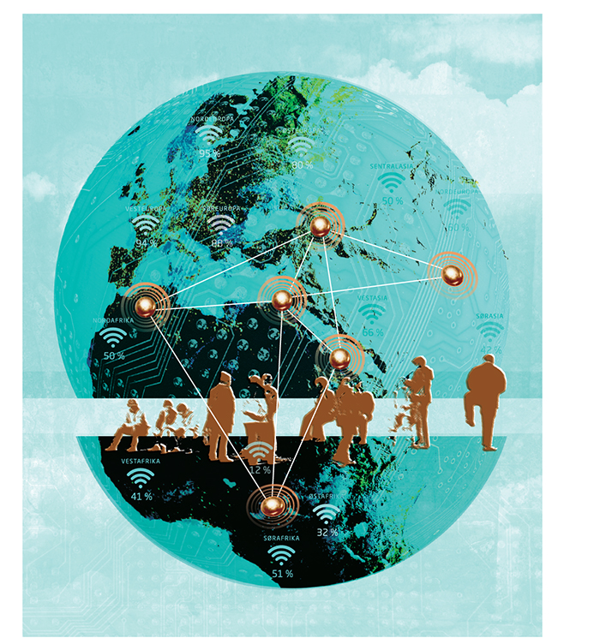

The global picture
For developing countries to make use of digital technology, and for the resulting benefits to be widely shared, the digital gap must be narrowed and barriers must be removed. This means developing the necessary infrastructure, instituting regulations, tailoring relevant digital solutions to local conditions and boosting local knowledge and expertise.
Norway will focus its efforts on four barriers in particular: access, ­regulation, digital competence and exclusion.

Access
Access to internet is covered by the Sustainable Development Goal 9, “Build resilient infrastructure, promote inclusive and sustainable industrialization and foster innovation”, with target 9c aiming to “significantly increase access to ICT and strive to provide universal and affordable access to internet in LDCs by 2020”. In addition, access to internet is considered as key to achieve a number of the other goals.
The internet is used by 4.4 billion people, or 57 per cent of the world’s population, and the number is rising quickly. Since January 2018 it has increased by a million users per day. Nevertheless, there are still 3.3 billion people who are not internet users. Most of them live in Southeast Asia and sub-Saharan Africa. The share of the population with internet access in developing countries is low, and is only about 20 per cent in the least developed countries. Large variations are seen from country to country.
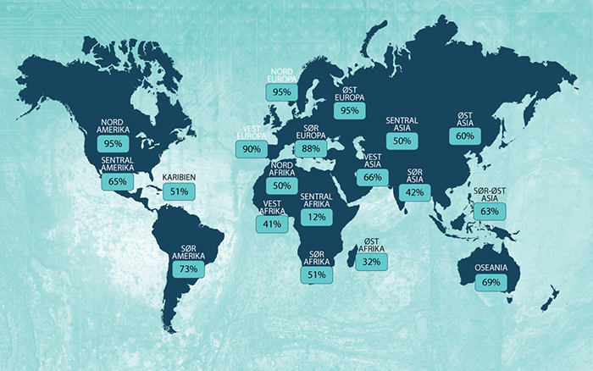
          - Internet access in 2019
wearesocial.com
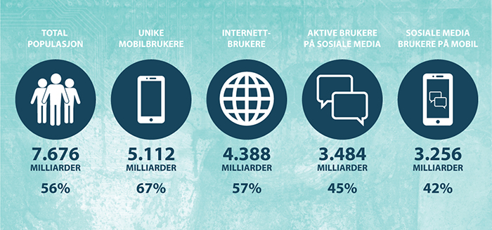
          - Global access and use, 2019
wearesocial.com

While much of the world’s population lacks affordable internet access, many of those who do have access use only a fraction of the potential it presents. The digital divide corresponds to – and reinforces – existing inequalities in wealth, opportunity, education and health. Many people who lack secure and affordable digital access belong to groups that are already marginalised or living in poor or rural areas.
At the end of 2018, more than 5.1 billion people subscribed to mobile communications services, an increase of 1 billion in four years. Eighty-eight per cent of the world’s population lived in areas with mobile broadband coverage. Access is unevenly distributed around the world. Ninety-two per cent of the Southeast Asian population lived in areas with such coverage, while in sub-Saharan Africa the corresponding figure was only 54 per cent.
In addition to mobile internet, fibre-based fixed internet connections are available in many coastal areas of developing countries, but it is often expensive and thus only accessible to a small portion of the population. Intensive efforts by SpaceX, OneWeb and others are under way to expand internet access in developing countries using satellites in low earth orbit.
Until full internet coverage becomes achievable in practice, there are technological solutions offering basic information and services to rural areas in sub-Saharan Africa. The “Internet Lite” project is a good Norwegian example of this (Box 2.1).
              - Digital inclusion and access to information for all
Norway supports the Basic Internet Foundation through the Vision 2030 initiative. The foundation, a collaboration between Kjeller Innovation and the University of Oslo, uses digitalisation to provide access to information as a basis for inclusion and strengthening of the rights of individuals and communities.
The Basic Internet Foundation works to provide free access to the information internet, or “Internet Lite”, and its overall objective is to promote digital inclusion. The foundation has developed a solution in which digital content requiring a large amount of bandwidth (such as video content) is filtered out, while “lighter” content (text and images) is made openly available. The foundation estimates that one person’s paid use of content requiring greater bandwidth can fund free access to “lighter” information content for dozens of users.
The foundation has developed inexpensive Wi-Fi hotspot systems for installation in villages that lack internet coverage, providing a very affordable “Internet Lite” to village populations in collaboration with local mobile communications operators. The systems are now being tested in Tanzania and the Democratic Republic of the Congo.

Regulation
Internet access is an essential factor for digital transformation to occur, but is not enough on its own. A strong analogue foundation is also required in the form of laws, regulations and institutions that make it possible to establish digital services and regulate the flow of data in a way that safeguards societal security, personal privacy and the private sector. Norwegian cooperation with developing countries to strengthen the competence and capacity of their public institutions therefore provides important support to realise the potential inherent in digitalisation.
A sound business and regulatory environment is crucial for a well-functioning private sector, which in turn is a prerequisite for job creation, economic growth, poverty reduction and government revenue generation. Assisting countries to establish stable and conducive framework conditions for business operations, investments and economic growth is a priority for the Government.
              - Regulation of the telecommunications market in Myanmar
The effects of Myanmar’s new Telecommunications Law of 20141 and the granting of licences to operators show the transformative power of updated regulations. The law introduced competition and created a stable framework that extends to foreign mobile operator development. It also lowered SIM card prices from USD 150 in 2013 to just USD 1.50 in 2015.2 The proportion of the population with mobile internet access in Myanmar jumped from 4.2 per cent at the end of 2013 to 23.3 per cent at the end of 2015. Government authorities also required operators to ensure that 10 million of the new subscribers were women. From the start, the authorities imposed coverage requirements on mobile operators, demanding high-quality coverage for mobile services and infrastructure even in new and previously inaccessible areas outside cities. As a result, the country’s citizens and businesses have been able to skip the analogue telephony stage. Five years after the introduction of a regulated telecommunications market, 75 per cent of the population are mobile internet users.3 In April 2018, the country established a dedicated fund for mobile telecommunications development in rural areas.4
1 https://www.jonesday.com/en/insights/2013/12/myanmars-new-­telecommunications-law
2 GSMA Intelligence, market data for Myanmar, January 2019.
3 GSMA Intelligence, market data for Myanmar, October 2019.
4 http://www.iicom.org/regions/asia-pacific/item/myanmar-starts-universal-service-fund

Digital competence
Digital competence may be defined as the ability to use digital devices to access, manage, understand, integrate, communicate, evaluate and generate information safely and effectively. Such skills are also commonly referred to as ICT literacy, information literacy and media literacy.
Both traditional reading skills and digital skills are needed to utilise and take advantage of the benefits of digital tools. Inadequate reading skills lead not only to basic language weakness but also to an inability to put modern technology to practical use. Even with a smartphone in hand, reading skills are needed to understand the device’s user interface, read what is on the screen and use the keyboard. For many people, the lack of a secondary language is a further obstacle to using the internet or a mobile device. More than 55 per cent of all websites have English, Chinese or Spanish as their main language. In regions with a high degree of illiteracy, mobile internet use is generally low. Women and marginalised groups are overrepresented among those lacking digital skills. In the poorest countries, the most important barrier to mobile internet use for men and women alike is a lack of reading skills and digital literacy.
In sub-Saharan Africa, 54 per cent of the population have mobile internet access, but for various reasons only 24 per cent use it. In Myanmar, which has a mobile network coverage rate of 75 per cent, Facebook accounts for almost all data traffic. According to a 2018 report by the Pathways to Prosperity Commission, almost all of the people in a group of developing countries (Kenya, Tanzania, Uganda, Nigeria, Bangladesh, Pakistan and India) have used a telephone to call someone at one time or another, but only about half have sent an SMS and only 30 per cent have used the internet. Digital exclusion is less and less a matter of users versus non-users and more about how and how often the technology is used. Access alone is therefore not sufficient – digital skills must also be developed locally.
There is a growing mismatch between the knowledge, skills and abilities of young people entering the workplace and the knowledge, skills and abilities being sought by employers. At the same time, the number of young people seeking to join the labour market is steadily rising. This illustrates the importance of access to education that builds digital competence.

Inclusion of marginalised groups
The most vulnerable groups are also the most difficult to reach. Digital technology may have a wider range than local, geographically defined projects. The opportunities offered by new technology can be used to reach marginalised groups and achieve the objective of leaving no one behind. The challenge is that the most marginalised groups are often those with the least access to digital tools and the internet, or even to electricity. Additionally traditionally excluded groups such as women and the rural poor, are the least effective internet users. Globally, 23 per cent fewer women than men are mobile internet users, and in South Asia the figure is 57 per cent.
The barriers preventing marginalised groups from using digital technology are numerous and complex. Telephony and mobile data costs, lack of relevant content, and security concerns are major barriers to mobile device ownership and mobile internet use. For many girls and women, negative social norms and strong social controls pose additional barriers to digital participation. If these barriers are removed, the potential is great.
Digital solutions can for example help to increase the participation in society, employment, social contact and political engagement among disabled people. According to the World Bank, 15 per cent of the world’s population have some form of disability. Digital tools allow those who fall outside the ordinary labour market to create their own workplace and invest in their own futures. Girls and women can gain access to education and work digitally even if, for various reasons, they must spend most of their time at home. Digital tools to report sexual abuse, harassment at school and slave-like conditions for children are other examples of the benefits of digitalisation for marginalised groups. In humanitarian crises, drones can distribute emergency aid and money can be transferred digitally to areas inaccessible to emergency personnel. Mobile technology can give marginalised groups access to savings accounts, credit and insurance. New digital business models providing market presence can be of great importance to ethnic minorities or others living in outlying areas.
Digitalisation in banking and finance has especially great potential to help a wide range of people. Digitalisation has made it possible to include people who otherwise might be invisible in public registries such as those documenting birth, death, marriage, business ownership, property ownership and school enrolment. If we manage to guide digitalisation towards including people who would otherwise be left out, we can promote a digital transformation of society with unbridled potential for development, democratisation and the protection of human rights.
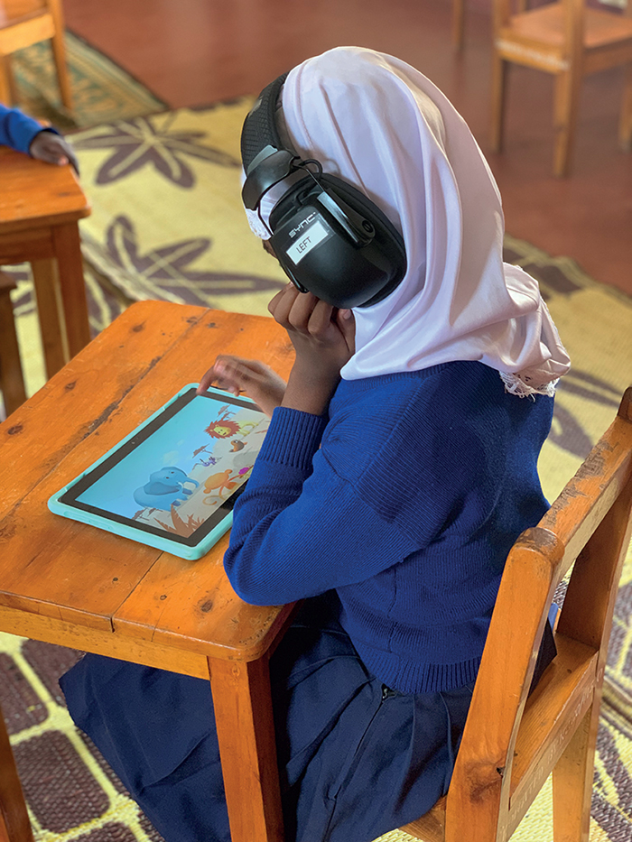
          - SINTEF’s test of screening technology for hearing impairment in Tanzania is a good example.
Photo: Tone Øderud, SINTEF
Digitalisation of public services can provide a major boost to people living in extreme poverty and others who have been discriminated against or marginalised. Equal treatment can only be achieved if state and local authorities demonstrate equal commitment in all areas, including those where religious, ethnic and political minorities live. Otherwise, digitalisation could actually reinforce discriminatory and corrupt social mechanisms.
The risk of digital exclusion must be considered in all digitalisation efforts. While the effects of having a digital identity are generally inclusive, it may be difficult to obtain biometric or other digital information from certain groups in the population. In some countries, ethnic minorities have been excluded from digital population registries. More than 75 per cent of the world’s stateless people are members of a minority group.

Digital security
– a prerequisite for development
The role of the internet in national economies, security, growth and development opportunities is large and expanding. At the same time, our increasing dependence on digital solutions gives rise to new vulnerabilities. The digital space opens societies to new and serious cross-border threats from both state and non-state actors. Such challenges are discussed in more detail in the International Cyber ​Strategy for Norway (2017) and the white paper Global security challenges in Norway’s foreign policy (Meld. St. 37 (2014–2015)).
Defence against digital threats is growing in importance. But defence alone does not create security. It is also necessary to address the underlying causes of the threats and to weigh potential countermeasures against the many benefits and opportunities that the digital space provides. We must strike the right balance between security and openness. A well-functioning digital space requires both. In addition to maintaining digital security, it is crucial to protect democratic values and the rights of individuals.
The authorities in countries where democracy is weak can use data and internet surveillance to strengthen control rather than to increase inclusion and transparency. Digital surveillance tools can be used against political opponents, journalists and critical voices in civil society. Digital platforms can be misused to spread hate and disinformation or to incite violent extremism. There have also been disturbing examples of personal data being harvested, covertly and on a vast scale, for use in political and social manipulation.
Digital security challenges are something all countries have in common, but they are harder to address in countries with weak societal structures as well as countries in conflict or in vulnerable regions. If the populations of developing countries are to seize the opportunities of digitalisation, it is important to strengthen the countries’ ability to address digital challenges and threats. Areas to focus on include institutional development, legislation, education and training, and knowledge and technology transfer.
Part II
Focus areas

Focus areas
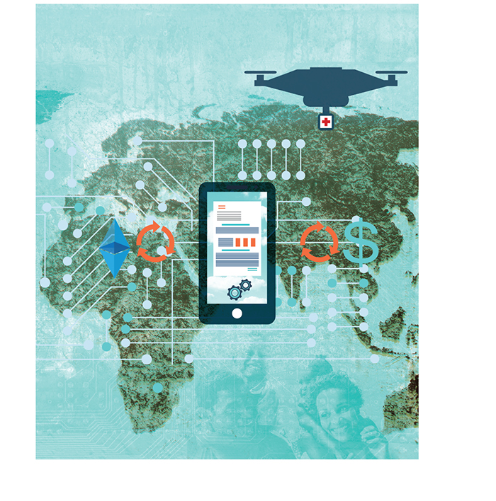

Systematic approach to digitalisation
A structured and methodical approach will be necessary for digital solutions to provide large-scale added value to those who need it most, and help to solve challenges in developing countries and during humanitarian crises. Six aspects in particular are often overlooked, each of which prompts a set of critical questions to be considered for all projects and measures:
Innovation – Does the measure in question rely on old structures and methods to solve tasks, or has innovative thinking been applied to working methods and technical solutions?
Local support and digital ecosystem – Does the measure generate local involvement? Is it set up to introduce and integrate the digital elements to a local digital ecosystem?
Marginalised groups and keeping the focus on people – How insightful is the measure about users and their needs? How will the project ensure user involvement, and how will universal design and inclusion be accounted for?
Digital competence – Does the measure ensure development of local competence? Will it accommodate for continued growth of local competence?
Digital technology – Has an assessment been conducted to determine which technology is best suited to meet the challenge?
Digital public goods and open data – Has a framework for open data and open source code been addressed? Will solutions be shared in a way that ensures their reuse?
The Government will:
- devise a method, guide and checklist for assessing, evaluating and reporting on digitalisation for all measures and efforts, both bilateral and multilateral.

Multilateral cooperation
on digitalisation
Rules-based international cooperation makes the world safer and more stable. The United Nations (UN) is an important arena for developing norms. UN organisations are, along with the development banks, Norway’s most important development policy partners. Norway expects its multilateral partners to make increasingly wider use of digital tools and to have a strategy for actively utilising digitalisation both to reach more people with greater precision and efficiency as well as to measure the effect of initiatives.
Norway supports the Principles for Digital Development established jointly by bilateral donors and the multilateral system. Norway expects all UN organisations to follow best practices and develop common digital solutions in a spirit of cooperation. Some actors, including donor countries and international organisations, are already incorporating technology and innovation in development initiatives. However, few systematic reviews of such efforts have been conducted. There is a risk that new solutions that cannot be reconciled with existing systems, or are superfluous, are developed. Norway will oppose development of competing initiatives by different UN organisations, argue for effective coordination and not support new initiatives where there are good existing solutions to build upon.
Norway supports digitally focused UN organisations, including the coordinating office for digitalisation under the UN Secretary-General (UN Global Pulse), the UN High-Level Panel on Digital Cooperation, the European Institute of Innovation & Technology (EIT), the European Space Agency (ESA), the European Union’s Earth Observation Programme, the International Mobile Satellite Organization (IMSO), Intelsat, the International Telecommunication Union (ITU), the UN Technology Bank, the European Organization for Nuclear Research (CERN) and the G20’s working group on digital and financial inclusion.
The United Nations Environment Programme (UNEP) has long had a focus on open environmental data. A body called the Working Group on Big Data and Digital Ecosystem for the Planet, which includes Norwegian experts, has been established. The Ministerial Declaration from the Fourth Session of the United Nations Environment Assembly (UNEA-4) in 2019 calls on the UNEP to develop a global environmental data strategy by 2025.
Norway also cooperates on Earth observation internationally through the Group on Earth Observations (GEO). Improved use of satellite data for environmental monitoring and global sharing of data to measure progress towards the Sustainable Development Goals are both of key importance.
The UN Committee on the Peaceful Uses of Outer Space (COPUOS) is the most important global space forum. Key tasks of COPUOS include developing an international framework to ensure the sustainable and peaceful use of space, coordinating global initiatives, facilitating international cooperation and disseminating knowledge about the use and benefits of space-based services among member countries and other UN organisations. The Norwegian Space Agency represents Norway in this collaboration. COPUOS has appointed a working group on the Space2030 Agenda in which Norway participates.
Norway entered into a new digitalisation partnership at the World Bank in 2019 and contributes to the World Bank’s multi-donor fund, the Digital Development Partnership (DDP). The World Bank’s Digital Moonshot for Africa aims to provide reasonable ICT access to the entire population of the African continent – a goal that will require sustained and committed efforts by government authorities, the private sector and development partners.
The African Development Bank (AfDB) is one of the most important channels for long-term Norwegian assistance to low-income African countries. The bank focuses on digitalisation to stimulate entrepreneurship and facilitate private sector development, especially in vulnerable states. In the ongoing policy dialogue, Norway emphasises that the bank must exploit technological opportunities. Among the bank’s initiatives is an Africa Digital Financial Inclusion Facility (ADFI) to promote financial inclusion.
The Government will
- promote digitalisation in all the governing bodies of multilateral organisations in which Norway participates, for the benefit of its partners in developing countries;
- support the development banks’ efforts to establish the basic infrastructure poor countries need to take advantage of digital solutions;
- continue supporting the World Bank’s Digital Moonshot for Africa and maintain dialogue with the African Development Bank on the need to extend basic infrastructure to reach marginalised groups and local communities;
- coordinate and strengthen technical collaboration, knowledge sharing and participation involving Norwegian expertise in areas where Norway has special competence or experience that is in demand;
- support initiatives that contribute to the integration of African economies and promote African cooperation, including Smart Africa’s work on electronic ID platform interoperability;
- promote the UN initiative Generation Unlimited.

Health
Digital solutions can give more people access to primary health care, medicines and health education, and provide the authorities with better access to health information as a basis for prioritising health efforts. The implementation of eHealth solutions holds great potential for developing countries, for instance in assisting in early detection, monitoring and tracing of diseases and health issues, but also health information tools to direct assistance to the areas in greatest need, in digital remote diagnostics, storage of health data, Big Data analysis and personalised medicine.
Norway is highly advanced in many areas in the field of health, including in health information. Access to information can have major impacts for public health. The internet is often one of the only places that provides widespread access to medical information and support without social stigma. Online technology can increase the efficiency, accuracy and reliability of health systems and make health information accessible in remote areas.
              - Health Information Systems Program (HISP) and Covid-19
In order to enable authorities to direct resources rapidly to areas of greatest health-needs, the University of Oslo has developed The Health Information Systems Program (HISP) that has become a standard in the Global South. All types of health data are collected, from barefoot health workers in the village to doctors in the clinic to policy makers in the region. All collected data goes - in real time - into the central government’s computer system, and is visualized through maps, graphs and other data. In this way, the authorities can see where they should put the resources and where the need is greatest. DHIS2 is the national software solution for health systems in more than 65 countries, and is estimated to reach more than 2.3 billion people. This is made possible by the University of Oslo, which has made the source code behind the computer program open on the web, so that the whole world can cooperate in the development. But more importantly, this has become a global movement, by building competence in the countries and regions through the Masteer and doctoral programs. The work is funded by several international donors, such as PEPFAR, the Global Fund, Unicef and the Gates Foundation. Shortly after the outbreak, the HISP environment developed a new app for Covid-19 registration and monitoring based on WHO standards. The app that registered corona-infected people was developed in Sri Lanka in early February and since then developed into a global community. Several countries are now using this app. The program is part of the Ministry of Foreign Affairs’ digital investment in development cooperation, and is administered by Norad in collaboration with Innovation Norway and the Research Council of Norway, under the Vision 2030 program.

For people with disabilities, digital technology can make daily life simpler, more productive and more meaningful through access to tools that enhance their functionality, connect them to a network to help them to feel less marginalised, and in some cases open the door to the labour market.
Cooperation with different actors, including the private sector, is often pivotal for success. One of many examples of this is a project to expand immunisation coverage through small mobile money-based Conditional Cash Transfers (mCCTs) in Pakistan. The project was carried out by the organisation Interactive Research and Development (IRD) in a district of Sindh province, and uses Telenor’s Easypaisa app for cash transfers via mobile phone. The IRD application combines vaccine registration, cash transfers and reminders. Results indicate that immunisation coverage increased from 16 per cent to 44 per cent.
Digital efforts in public health must be scalable to have an impact beyond the typical pilot phase. An example of a Norwegian-supported innovation project that can be used in other places is the Moyo foetal heart rate monitor, developed and tested by Laerdal Medical. The Moyo device monitors the heart rate of the mother as well as the foetus to increase reliability, and an alarm sounds if the device detects anything abnormal. The monitor is designed to function in low-resource settings and is lightweight and easy to use.
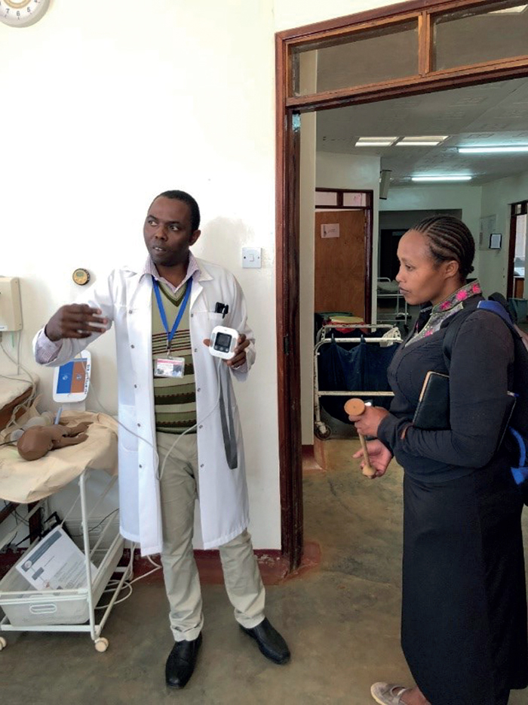
          - Testing and training in the use of the Moyo heart rate ­monitor at Haydom Lutheran Hospital in Tanzania.
Photo: Kari Moe Jacobsen, Norad
Norway has taken on a special responsibility to promote the use of IT and mobile telephony in maternal and children’s health. The goal is to raise the quality of health care services in developing countries, and to expand access at reduced cost. Norway supports promising new projects in a number of countries as a step in increasing the use of cost-effective, lifesaving digital innovations; building partnerships through, for instance, public-private cooperation; and developing sustainable, innovative business and funding models. For example, the logistics operation Freight in Time, in which Norfund is an investor, collaborates with GAVI, the Vaccine Alliance, to distribute vaccines in Uganda.
The link between health and indoor air quality is another area where digital technology can be of help. Through the non-profit Clean Cooking Alliance, Norway provides support for the use of new cookstove technology in Nepal. Sensors have been mounted to measure and transmit data about household air pollution. Individuals who have purchased new cookstoves are given portable monitors that collect data on exposure to poor air quality. Sensors are also mounted on household roofs to find out whether new technology may in addition help to reduce outdoor air pollution. All data are collected and analysed to obtain a robust understanding of the programme’s impact and to provide input for the dialogue with the authorities who are promoting smokeless kitchens.
In the period 2011–2017 and in connection with the Every Woman Every Child (EWEC) movement, digital health efforts were followed up in cooperation with a number of Norwegian and international organisations such as the Health Information Systems Programme (HISP), the Norwegian Institute of Public Health (FHI), the United Nations Foundation, the Global System for Mobile Communications Association (GSMA) and the World Health Organization (WHO).
Strengthening the health systems through improved data collection and analysis together with upscaling of digital health services will be essential to realising universal health coverage. Priority will therefore be given to activities in connection with District Health Information Software 2 (DHIS2)/HISP, implementation of the new resolution bolstering WHO’s normative role in digital health, and measures to introduce more digital tools and solutions in the recipient countries’ health systems. Special importance will be focused on the leadership of the countries in developing digital health strategies, as these are to form the basis for joint efforts, including domestic funding.
The Government will:
- continue to develop and expand the use of DHIS2/HISP and implement new resolutions to strengthen WHO’s normative role in digital health;
- give priority to increased use of digital solutions in the health systems of partner countries;
- facilitate simplified solutions for internet access in remote areas without internet coverage, based on Norwegian-developed solutions.

Financing for Development and financial inclusion
Financial inclusion is relevant to most of the Sustainable Development Goals and is high on the agenda of the UN, the development banks and the finance and telecommunications sector. About 30 per cent of the world’s population still lack access to basic financial services that most of us take for granted, such as payment services, savings, insurance and credit.
This is an area where digitalisation can play a significant role, and where a number of new initiatives are under way. Norway supports several international initiatives that promote financial inclusion, including the Consultative Group to Assist the Poor (CGAP), the Better than Cash Alliance and the Nordic Microfinance Initiative (whose largest investor is Norfund – the Norwegian Investment Fund for Developing Countries). Norway also participates in the G20’s working group on financial inclusion.
A major obstacle to development finance efforts lies in a cluster of economic problems faced by many countries: low productivity, limited technology transfer, lack of innovation, poor tax systems, extensive corruption and illicit capital flows. Improvement in all these areas will require enhanced digitalisation competence in both the public and the private sectors. Digitalisation within frameworks characterised by integrity, transparency and accountability can help in preventing, detecting and investigating tax evasion, corruption and illegal capital flows. Regulation through legislation, institutional frameworks, systems, expertise and capacity can channel digitalisation into constructive activities and strengthen national resource mobilisation for sustainable development. All of this is undermined by inadequate frameworks.
A key challenge in development finance relates to national and international economic secrecy. When economic actors do not make key financial information accessible to the authorities, it diminishes public resource mobilisation through lost tax and fee revenues and misuse of funds due to inefficiency and corruption. Hidden cash flows undermine markets and fuel unfair competition. Digitalisation can lead to greater secrecy, but with the right policy choices it can be a powerful tool in exposing hidden cash flows. Major efforts are underway nationally and internationally to develop an all-new, wide-ranging information flow. To limit the movement of profits and uncover tax evasion, many countries have agreed to exchange key tax information about economic actors in their jurisdiction. By 2020 some countries will also set up registries identifying the beneficial owners of private economic actors. A number of countries also require private business actors to report financial results, tax payments, investments and other items on a country-by-country basis. Such increased transparency and access to data will make it easier to combat harmful economic activities and the concealment of financial assets. It will also significantly increase the amount of data available. Cross-referencing and advanced data processing will be needed to make the data useful.
Digital finance solutions that provide individuals, businesses and public authorities with access to credit and other financial services can have an enormous financial potential. A McKinsey Global Institute report from 2016 shows that delivering financial services by mobile phone could benefit billions of people by spurring inclusive growth that adds $3.7 trillion to the GDP of emerging economies within a decade.
The UN Secretary-General has established a Task Force on Digital Financing of the Sustainable Development Goals (DFTF) with the involvement of United Nations Development Programme (UNDP) experts. The task force’s mandate is to explore how ongoing digitalisation in the financial sector can contribute to achieve the Sustainable Development Goals. The initiative was launched in late 2018 and is to conclude in early 2020. The goal is to identify opportunities, dismantle barriers, reduce risk and recommend action options for private and public actors, partly in order to support the principle of leaving no one behind. The initiative is intended to increase the UN’s capacity to play an active role in this field in collaboration with partners. The task force complements the Secretary-General’s High-Level Panel on Digital Cooperation, which submitted its report in the spring of 2019.
Private companies contribute to financial inclusion by offering alternatives to traditional bank branch offices. Telenor, for example, offers mobile phone customers a variety of banking services such as credit, insurance and savings. Some of its customers have not previously had access to such services, and the ability to transfer funds without the use of third parties saves them time and money. Such banking services are easier to establish when there is a customer base with access to mobile phones. Customer data can also be used in credit checks to provide more people with access to loans. Norfund’s investment in Equity Bank, in Kenya, is another example. Equity Bank’s Equitel platform provides full banking services. In total Norfund has invested about NOK 7 billion in financial institutions and microfinance, resulting in 1.8 million new clients in 2018.
The Government will:
- prioritise digitalisation of key areas, including tax and public procurement systems, where there is great potential for saving and mobilising national resources;
- prioritise cooperation to exploit digital technology’s potential for increased financing of development initiatives, and will place the issue high on the agenda during the Norwegian presidency of the United Nations Economic and Social Council (ECOSOC).

Education
An ever-growing youth population will need the skills required to take part in modern working life, where digital competence is becoming more and more essential. The International Finance Corporation (IFC) estimates that in sub-Saharan Africa alone, some 230 million jobs will require digital skills by 2030.
Internet access and digital tools are valuable for helping more people to develop basic skills in reading, writing and numeracy. They can be used to improve education in places that are located far from educational institutions, have low teacher capacity and a dearth of resources. One example is the VSO project Unlocking Talent in Malawi, which uses tablet technology to boost reading and numeracy skills (see Box 3.2).
              - Unlocking talent
The content of the educational app “onecourse” (developed in partnership with onebillion) has been designed in collaboration with Malawian authorities and is in keeping with national curricula and goals for reading and numeracy. The app is an interactive learning platform available in English and Chichewa, the main language of Malawi. The solution makes it possible to provide more content to a greater number of children, and the interactive learning platform gives pupils direct feedback. While solutions such as this can never replace a teacher, they can help to compensate for a lack of competent teachers in the classroom.

Using technology in education is not just important for conveying basic reading and mathematics skills, but also to enable more people to acquire digital skills. The demand for employees who can use digital tools will only increase. To fulfil these competency needs, young people must have access to practical experience and modern training to qualify them for the future labour market. Digital skills are therefore being incorporated into vocational training programmes in developing countries. It is important that course curricula are defined in collaboration with the ICT industry to ensure that the resulting skills are of relevance.
In 2016, Norwegian-supported cooperation was launched between the industry branch organisation ICT Norway and its Sri Lankan sister organisation Slasscom to develop entrepreneurship and test measures under the project Lær Kidsa Koding (Teach Kids Coding). The project established cooperation with local ICT companies and is now self-sustaining. Discussions are under way on whether to expand this initiative and use it as a regional hub for further digitalisation efforts in surrounding countries such as Bangladesh and Myanmar.
Higher education institutions are also important for the development of digital solutions. Under the Norwegian Programme for Capacity Development in Higher Education and Research for Development (NORHED), digital technology is being used to enhance the quality of and expand access to higher education. A number of online master’s-level programmes and courses have been developed, including in pedagogy in Nepal and health sciences in Malawi. A number of projects, including at the University of Oslo, have developed massive online open courses (MOOCs). One project, Occupational Health and Safety in Developing Countries, has 12 000 users worldwide from over 150 countries.
It is essential to ensure the inclusion of marginalised groups. Norway has therefore, among other things, helped to incorporate children with disabilities into household surveys, which means that their needs become visible and are reflected in the statistics. Additionally, Norway supports two innovation projects that are working with screening for visual and hearing impairments and designing aids for schoolchildren with disabilities in Tanzania. SINTEF is developing digital, game-based screening technology for the hearing impaired and a simple, inexpensive hearing-aid solution for schoolchildren. The Western Norway University of Applied Sciences is developing digital screening technology for visual impairments due to weak eye musculature, as well as a game-based digital training programme designed to improve this type of impairment in 3–4 weeks. As many as 25 per cent of all children are thought to be affected by this type of visual impairment. Visual and hearing impairments often go undiagnosed, and schoolchildren are often misdiagnosed as having ADHD or dyslexia or are excluded from schooling. These two projects open up new learning opportunities for children with disabilities, particularly marginalised groups such as those with albinism.
              - Technology to provide learning opportunities to children and young people with disabilities
Norway works to provide learning opportunities to children and young people with disabilities by means of technology, and makes use of a number of relevant tools in these activities. The Global Digital Library, which makes reading resources available in different languages and in both printed and digital versions, conforms to established standards for universal design (Web Content Accessibility Guidelines). Universal design makes it possible to implement more specialised functions, for example Braille and tools that support text-to-voice conversion. Books with sign language videos will also be added in selected languages in the course of 2019.

              - Using smartphones to combat negative social norms and provide learning opportunities for girls
Through the EduApp4Syria innovation competition, Norway has spearheaded the development of two open-source, free-access smartphone apps for self-teaching literacy games. One of these has now been localised into over 40 languages.
In northern Nigeria, the World Bank is testing whether access to digital learning opportunities for girls at home will enable more girls to attend school regularly. The girls and their parents are given smartphones with learning content installed in Nigerian Hausa. Pilot testing of the research design has shown promising results. The World Bank is planning similar studies in other countries in Africa and the Middle East. Norway will provide NOK 20 million over three years to the World Bank’s research.1
1 Subject to approval by the Storting.

Norwegian funding for education has increased significantly since 2013. Norway also supports educational efforts incorporating digital components that are carried out by civil society organisations, the business sector and the multilateral system. Norwegian educational assistance is largely implemented through multilateral institutions, funds and programmes, including the World Bank (i2i Fund, among others), UN organisations, Global Partnership for Education (GPE), UNESCO (e.g. Mobile Learning Week), the UN Refugee Agency (UNHCR), UNICEF and the Health Information Systems Programme (HISP) at the University of Oslo.
Norway supports the establishment and use of Educational Management Information Systems (EMIS) at the country level in developing countries through the GPE, UNESCO, UNICEF and the HISP at the University of Oslo. Such systems provide a basis for data collection, analysis and planning and are thus critical for improving resource use and learning outcomes in the educational sector. The systems help to provide documentation that more clearly reflects the needs of everyone, including minorities, people with disabilities and other vulnerable groups.
The Government will:
- strengthen Educational Management Information Systems (EMIS) at the country level in developing countries;
- continue support for educational technology to improve the quality of teaching, for vulnerable groups in particular;
- continue support for development and funding of open digital learning resources for basic skills;
- continue support for digitalisation of statistical systems to help to improve planning and resource distribution in the educational sector;
- continue capacity-building programmes in higher education that facilitate the development and use of digital technology to achieve the objective of better quality of and access to higher education;
- promote digital skills as part of efforts towards vocational training, in keeping with the Norwegian Government’s plan to escalate funding for vocational training and education in developing countries;
- promote better coordination of digitalisation efforts within global education;
- help to develop and scale up digital innovation through the Vision 2030 funding initiative with periodic funding announcements for grants to the business sector and expert communities;
- continue its cooperation with the International Telecommunication Union (ITU) and Cisco on establishing Digital Transformation Centres in one or two of Norway’s partner countries to expand digital competence and capacity at higher education institutions.

Climate, the environment and oceans
Digital technology contributes to sustainable development in three important ways in particular:
- Digital technology provides more knowledge about and better monitoring of the environment and climate.
- Digital technology can lead to more efficient, safe and sustainable industrial activity and energy production, thereby reducing emissions.
- Digital technology can simplify and enhance the authorities’ capability to consolidate the knowledge base and carry out ecosystem-based management and planning.
Increased digitalisation opens up opportunities to improve, simplify and streamline public administrative activities related to climate, the environment and oceans. Open, machine-readable data are more easily shared between different public agencies, with scientists and with society at large. This in itself may help to create a common knowledge base and effective administrative institutions across sectors.
Digitalisation can improve ocean management and ocean-based commercial activities in several ways. Digitalisation of application procedures in connection with licensing may reduce the risk of corruption, for examples by directing applications through a single public agency. Digital registries can make it easier to trace cash flows and ensure proper taxation. Norwegian marine and maritime management is based on fundamental knowledge about the ocean. The MAREANO seabed mapping programme has mapped roughly ten per cent of the seabed in Norway’s economic zone and supplies biological, geological, chemical and topographical data to the fisheries and environmental management authorities, among others. This knowledge constitutes an important foundation for the management plans in Norway’s three marine areas. The mapping programme is inter-ministerial. The methods and technology are undergoing constant development and will have transfer value for other coastal states.
Norway has been a driving force behind the United Nations decision to proclaim a Decade of Ocean Science for Sustainable Development (2021–2030), which will enhance understanding and increase demand for science-informed knowledge as a framework for sustainable growth based on marine resources. Norway’s Nansen Programme, with its research vessel Dr Fridtjof Nansen, assists developing countries in establishing ecosystem-based fisheries management. This includes collecting physical and biological information about fish stocks and the ocean, as well as training local scientists in practical marine research (see Box 3.5).
              - The Norwegian research vessel Dr Fridtjof Nansen
Since the early 1970s, successive research vessels named Dr Fridtjof Nansen have represented the state of the art in marine and fisheries research. From early on, the data collected have been digitalised and organised into databases. Digitalisation leads to a unique, historical databank that parties in partner countries can easily access for many purposes related to marine research and management. Examples include:
- Status of fisheries resources for fisheries management.
- Trends in biodiversity due to anthropogenic impacts such as climate change.
- Characterisation of marine ecosystems for maritime spatial planning.
- Academic research. Many partners abroad use data collected under the Nansen Programme in their higher education (master’s and doctoral degrees).

It is essential that data are stored responsibly in accessible databanks, and that efforts are made to strengthen the capacity of partner countries to do this.
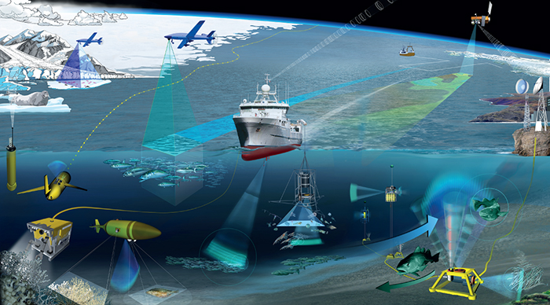
          - The RV Dr Fridtjof Nansen collects data that is made accessible to partner countries.
Satellite data are used in a number of areas of relevance to development policy, e.g. monitoring of deforestation and climate change and mapping of extreme weather events and natural disasters. Satellite imagery is used to monitor forest and land areas and oceans as part of efforts to combat deforestation, marine pollution and illegal, unregulated and unreported fishing. Better mapping of marine and terrestrial areas can enable developing countries to develop new resources sustainably. Governments and authorities can, for example, track vessels on-board automatic identification systems (AIS) to identify boats that aren’t authorised to fish in their waters, or are fishing illegally in protected areas. However, not all flag states require AIS fishing vessel tracking by satellite. Vessels involved in illegal fishing typically do not comply, as has been documented by the United Nations Office on Drugs and Crime and Interpol.
Systems for measurement, reporting and verification (MRV) play a key role in the activities relating to climate and forests. Satellite imagery has been an important tool for studying the status of the world’s rainforests for many years. Detailed imagery makes it possible to analyse forests and calculate the amount of forest that has been cleared. Some countries also use satellite imagery to detect illegal logging. Greater and more affordable access to cloud-based processing services is eliminating previously critical limitations related to hardware. Norway’s International Climate and Forest Initiative (NICFI) supports efforts to monitor and measure changes in tropical forests and to make this information publicly available via multiple channels: multilateral support via UN programmes and the World Bank; bilateral support to individual countries such as Indonesia, Colombia and Liberia; and specific projects such as Global Forest Watch. According to the UN, bringing a halt to deforestation could represent as much as 30 per cent of the solution in achieving global climate targets. In 2019 and 2020, the NICFI is procuring high-resolution satellite data of tropical land areas. The utilisation of such data for development purposes is typically limited by high transaction costs and licensing constraints. With a total budgetary framework of NOK 450 million over a maximum of four years, Norway intends to purchase high-resolution images of tropical land areas and make them freely available globally as a digital public good.
All of these areas require access to the latest data that is affordable and free from restrictions on usage. The Norwegian Space Centre supports open access to data, including for developing countries, from the EU Earth Observation Programme, Copernicus, as well as from the centre’s own current and future national programmes that keep an eye on shipping traffic, illegal fishing, rainforest distribution and more. The Norwegian Meteorological Institute (MET) practices open, user-oriented data access. Most data produced by MET are available through various application programming interfaces (API). The MET offers open access so that anyone can use the data in their solutions.
Digitalisation processes have the potential to reduce CO2 emissions and to enhance climate-friendliness in many industries and sectors by raising efficiency in logistics, value chains and transport. Decentralised production systems and value chains, using enabling technologies such as artificial intelligence and 3D printing, can reduce resource use and CO2 emissions. Greater opportunity to employ sharing economy models and more efficient use of existing resources can change consumption patterns and yield climate benefits.
The development of central databases and systems for storing environmental data, the use of technology and new data sources such as Earth observation/satellite data, as well as systems for making these data openly accessible, will be essential for environmental protection. Global and national databases for environmental information contain vital knowledge about protected areas, wetlands, coral reefs, threatened species and habitats, mangroves and other important marine bioresources, among others. These data must be made digitally accessible and used by the authorities in processes that require environmental impact and vulnerability assessments.
Facilitating and expanding the use of environmental data has been a key part of the Oil for Development programme over the past ten years. Development of systems for managing environmental data and information promotes more effective, knowledge-based decisions in the programme countries. Access to data and information on the state of the environment and environmental trends is essential for future knowledge-based management of marine areas.
The Internet of Things (IoT), together with better and more accessible telecommunications infrastructure, is expanding opportunities to observe and influence phenomena such as traffic flow and air quality. Robots, such as drones operating airborne and underwater, can make it easier to collect data on climate, access to water, vegetation cover, marine pollution and infrastructure.
Research groups at the Norwegian Institute of Bioeconomy Research (NIBIO) and Norwegian University of Life Sciences (NMBU) have developed digital solutions for local forest management and climate monitoring and are involved in a number of projects that may be of benefit to our partner countries. These include accurate measurements of biomass changes, efficient production of forest plant material, and local forest-based industry. The use of existing technology for data collection, e.g. sensor technology and satellite monitoring, as well as development of new technology such as Big Data analytics, autonomous control systems and artificial intelligence, will play an important role in realising the benefits of such solutions.
Climate change will have a greater impact on the countries in the South than on Norway. Knowledge and systems for adapting to climate change will be critical for ensuring responsible management and preparedness in vulnerable areas. Increased use of environmental data in the management of marine areas is essential for minimising the loss of bioresources. Knowledge about vulnerable areas and important natural resources improves the basis for determining which areas are in need of protection and which areas can be utilised.
The Government will:
- promote the development of good digital systems for managing and distributing open environmental data and information;
- promote the use of new technology and new sources of data, e.g. Earth observation/satellite data and other digital tools, in mapping and monitoring marine, land and forest areas;
- support UN Environment Programme (UNEP) efforts to build digital ecosystems with open climate and environmental data to promote effective management nationally and globally;
- help to boost partner countries’ capacity to utilise digital technology and other tools for monitoring the environment and climate;
- promote development of centralised datasets for important marine biodiversity data and basic data for monitoring the state of the environment and development trends;
- help to develop infrastructures for collection, maintenance, management, distribution and open use and exchange of marine environmental data;
- strengthen capabilities to analyse and prevent deforestation. NOK 450 million over four years has been allocated for purchasing high-resolution satellite images;
- contribute to the World Bank’s PROBLUE fund, which works to promote sustainable fisheries and aquaculture management, enhance capacity for management of marine resources in developing countries, and combat marine pollution;
- support cooperation with the Norwegian Meteorological Institute on the use of application programming interfaces to enhance local weather forecasts in selected Norwegian partner countries in Africa and Asia, and boost the institute’s capacity to follow up requests from international users;
- assess the possibility of working towards an International Maritime Organization (IMO) resolution to make Automatic Identification Signals (AIS) mandatory on all fishing vessels in international traffic;
- consider supporting satellite monitoring of fisheries to assist in efforts to reduce illegal, unreported and unregulated (IUU) fishing and other fisheries crime, via Norwegian and international specialist communities;
- strengthen Norwegian development cooperation in ocean management through the Ocean for Development programme;
- consider supporting satellite-based solutions in efforts to prevent and combat various forms of environmental crime, including illegal logging and other species crime, illegal mining, illegal trade in and dumping of waste, and pollution crimes, via Norwegian and international specialist communities.

Sustainable agricultural development and food security
Digital transformation is vital for achieving sustainable production across the entire agricultural sector. This is highlighted in a 2019 Food and Land Use Coalition report as one of ten critical transitions that would enable food and land use systems to provide food security and healthy diets for a global population of over nine billion by 2050, while also tackling our core climate, biodiversity, health and poverty challenges. This does not necessarily call for very advanced technology but rather for applying simple technology proven to have a major development effect.
With the spread of smartphones, a number of tools have been developed to assist smallholders to improve the quality and yield of their harvests significantly. Such tools offer access to expertise, video instruction for best practice (fertilising, seeding, watering, etc.), artificial intelligence for detecting diseases promptly, and better information regarding prices and market access.
Norway supports projects and strategic partnerships targeted towards implementing new technology that promotes efficiency, sustainability and modernisation in agriculture, and at the same time enhances opportunities for smallholders. The overarching objective of implementing digital tools in the agricultural sector is to reduce poverty and increase food security in both the short and the long term. Guided digitalisation processes and the introduction of digital tools will enable larger-scale stakeholders and exporters to integrate their activities with small-scale food producers and provide them with better access to input factors (seeds, fertiliser, seedlings, information), competency and markets.
In 2018 a major agreement on technology for the agricultural sector (agritech) was signed by the World Bank/International Finance Corporation (IFC) for the countries of East Africa. A number of pilot projects are introducing modern digital tools to approximately 50 000 smallholders in Ethiopia and other East African countries. One such tool to be utilised is Farmforce (see Box 3.6). Norway has supported a number of strategic partnerships that integrate a large number of smallholders with larger, professional actors, e.g. a vegetable project in Ethiopia directed by Joytech and the Development Fund that involves some 3 000 smallholders. Joytech provides high-quality seedlings that are distributed to the farmers, some of whom have tripled their yields.
The digital forecasting and information service known as VIPS (for Varsling innen planteskadegjørere in Norwegian), developed by the Norwegian Institute of Bioeconomy Research (NIBIO) and Norwegian Agricultural Counseling (NLR), facilitates integrated pest and disease control for agricultural crops and horticulture. The service combines data on pests and pest distribution with weather data. VIPS has an open source licence and is accessible to all, and may be valuable in combating pests in developing countries. Norway therefore supports cooperation between NIBIO and the Food and Agriculture Organization of the United Nations (FAO) in which data from VIPS is included in the FAO electronic forecasting system. The VIPS technology is also being tested in West Africa in cooperation with the International Institute for Tropical Agriculture (IITA). The Norwegian Embassy in Beijing supports a cooperative effort between the Chinese Academy of Sciences, regional agricultural universities and NIBIO on a Chinese version of VIPS.
              - Yara and IBM – digital farming
Yara and IBM have developed a digital farming platform that will enable farmers to increase yields, quality and revenues on existing agricultural land, thus preventing deforestation. IBM contributes capacity and expertise in AI, Big Data and blockchain technology, while Yara provides a century of experience and the agricultural science knowledge of more than 800 agronomists.
The open digital agricultural platform will be made globally available, and the ambition is to reach 100 million hectares of farmland, equal to seven per cent of the world’s agricultural land and including millions of smallholder farmers.

Digital tools also have an important role to play in food safety and animal health management, and may be used among other things to keep track of medicine consumption, diagnose disease, aid in treatments or supervise handling of infectious disease outbreaks in animals.
              - Farmforce
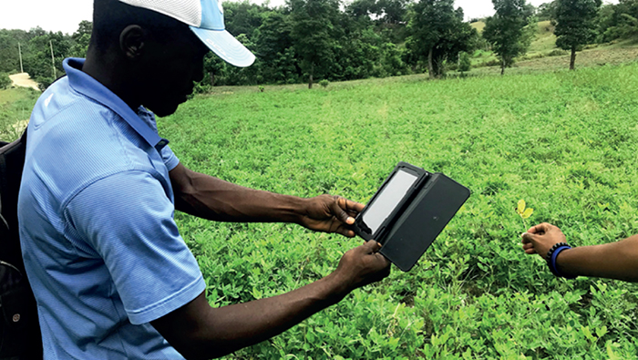
          - Smallholders can use the Norwegian app Farmforce via their smartphones.
Farmforce AS is a Norwegian IT company with a complete digital solution for smallholder farmers in developing countries. The company’s mobile app can be used offline, and links together data about the farmer, farm and production. When 3G or wi-fi is available, the data are uploaded to the cloud. This provides a more transparent, effective relationship between smallholders and buyers. At harvest the farmer can choose whether the payment takes place via payment towards outstanding loans registered in the system or mobile cash transfer. Standards-compliance certifications can be issued using data in the system and can help smallholders to gain eligibility in global markets. In many cases, this traceability allows the smallholder to enter new, previously inaccessible markets, which in turn yields greater income.
In Ivory Coast, the company is working with Cargill. The Farmforce platform enables Cargill to trace each individual cocoa sack that is shipped from the port in Abidjan back to the specific farmer and field. In this way, Farmforce helps Cargill to ensure sustainable cocoa production practices – with no use of child labour or deforestation – while ensuring that farmers are paid fairly.
In Haiti the company is working with Acceso Peanut Enterprise Corporation, with funding from the Clinton Foundation. Acceso advises farmers on how to increase production volume and offers input factors on a credit basis. Acceso also purchases the product directly from farmers at fixed, fair prices.
The Farmforce platform currently encompasses around 350 000 smallholders from 30 countries and is available in 14 languages. Approximately 20 000 loans worth a total of over USD 4 million have been organised via the platform. With 500 million smallholders globally, and the growing demand for sustainable production, Farmforce’s potential market is virtually unlimited.

The Government will:
- take a leading role in advocating for greater use of customised and new digital technology among small-scale producers of food and in other links of food systems;
- strengthen the capability of partner countries to take advantage of digital technology through e.g. knowledge centres and producer cooperatives;
- work to achieve better weather and climate forecasting that reaches more smallholders and fishermen, through among other things use of Norwegian technology (Yr) and Norwegian knowledge communities;
- strengthen development and use of digital platforms that promote guidance on sustainable food production, such as information about and forecasting of crop pests by using the Norwegian-developed VIPS service;
- assist in the development of food markets through digital tools that link sellers and buyers, including producer cooperatives that help to increase profits for farmers in the partner countries.

Energy
A stable energy supply for operating the internet and equipment is a prerequisite for digitalisation. Companies, schools, hospitals, public institutions and individuals are all dependent on electricity to use their PCs, tablets and mobile phones. At the same time, electricity suppliers are increasingly employing digital systems for managing and streamlining the grid, collecting payments via automated meters and the like. In recent years, costs in the market segment for small-scale energy solutions based on renewable sources have fallen. This is due both to technological advances and to new payment solutions, such as via mobile phone.
Norway has supported a number of companies in this segment, including the Norwegian Differ Group. Additionally, over the past two years, the Norwegian Investment Fund for Developing Countries (Norfund) has invested in a number of companies that supply off-grid electricity solutions to households and companies. In 2016 Norfund invested in d.light, a company that sells solar-powered lighting and household products in East Africa. In 2017 Norfund committed to a loan of NOK 104.9 million to M-Kopa, which delivers “pay as you go” solar energy systems for homes in Uganda and Kenya. Norfund has also provided project development funding to develop the Yoma Micro Power project, which supplies electricity to telecommunication towers and rural areas in Myanmar. This project thus encompasses both supplying energy and phasing in digitalisation.
Norway has supported installation and operation of smart meter systems in a number of countries. In Haiti, Norway supported the phasing in of smart metering. In this context, Norwegian funding helped SparkMeter, a US actor, to further develop its technology, and the company now has a sustainable business model for selling smart metering to multiple other countries. These meters have had a positive impact for the small, independent grid operated in Les Anglais, Haiti, and data transmitted is used to chart consumption. Smart meters are a component of the Energize Nepal research project, and a new project for electricity transmission and distribution in Nepal will also incorporate smart meters.
In a number of countries, the Norwegian Water Resources and Energy Directorate (NVE) has contributed to digitalisation and rationalisation of hydrologic measurements. Local authorities in Bhutan have received training in improved flood forecasting. In Liberia, the NVE and the Liberia Hydrology Service (LHS) have implemented the use of mobile phones by observers at fixed monitoring stations along watercourses. The phones are used for reporting daily readings as well as paying the observers. This provides for rapid updating of the database and prompt, secure payment to observers. Previously payments were distributed by visits from LHS, which sometimes cost more than the payments themselves, and there was also a risk that the observers would not receive their full payment.
The increasing digitalisation of the energy sector will reach developing countries gradually. To take advantage of the inherent opportunities of digitalisation, electric companies must have the financing and expertise to procure and operate digital infrastructure. This is not always the case in developing countries.
More extensive use of ICT and automated solutions in the power system entails greater requirements for security and preparedness relating to in the protection of personal privacy, data security and control systems.
The Government will:
- continue to give priority to development assistance to expand energy supply;
- incorporate digitalisation as an integral component of investment support and competence-building, in collaboration with Norwegian specialist communities and educational institutions where this is appropriate;
- through Norfund, continue to invest in development of renewable energy, both on-grid and off-grid, in poor countries.

Humanitarian assistance
Digitalisation, web-based technology and social media are enabling humanitarian organisations to work more effectively, and with a more targeted focus, to protect and assist people in areas affected by crisis and conflict. Digital technology makes it easier to involve the affected population in the humanitarian response and facilitates faster, more flexible humanitarian efforts, for instance through the ability to:
- provide earlier warnings of natural disasters;
- provide far more accurate information in real time about the nature and scale of a disaster;
- disseminate information more effectively and improve coordination of the response;
- ensure more effective documentation of the needs on the ground and faster registration of vulnerable people;
- make cash transfers faster and more secure;
- offer technology-based solutions for providing legal assistance to individuals;
- secure information and documents digitally before and during a disaster, in order to safeguard the rights of people affected by crises with regard to identity, property ownership etc.;
- reunite local communities and restore contact between family members who have been separated from one another as a result of a conflict or crisis.
The Norwegian Government’s humanitarian strategy for the 2019–2023 period lists humanitarian innovation as a priority area. The term “humanitarian innovation” refers to new products, forms of cooperation or other solutions that are measurably better than those that are in use today.
In cooperation with Innovation Norway, the Ministry of Foreign Affairs launched a new humanitarian innovation programme in 2018. The Humanitarian Innovation Programme Norway (HIP Norway), facilitates and provides funding for innovation pathways and partnerships between Norwegian humanitarian organisations or UN organisations and private actors. Funding under HIP Norway is contingent on partnership with private actors. The programme supports development and scaling of innovative, technology-driven solutions that promote smarter, better, more sustainable and cost-effective emergency relief for people affected by crisis. The solutions may be targeted towards both prevention of and humanitarian response to crises and disasters.
Through HIP Norway, NGO partners, global funds and multilateral organisations, Norway is involved in a number of measures for testing and expanding the use of digital technology in the humanitarian field.
The Norwegian Red Cross, the Norwegian Refugee Council, Norwegian Church Aid and Save the Children Norway are jointly developing a digital solution for ID documentation using blockchain technology. The solution is being used in cash transfer programmes and will ensure better ID solutions and improved protection of personal privacy for refugees and displaced people.
Over a million people affected by crises have received legal assistance through the Norwegian Refugee Council’s information, counselling and legal assistance (ICLA) programmes for displaced people. The need for such assistance is growing, and the Norwegian Refugee Council is now conducting comprehensive testing of new digital technology and is redesigning its programmes towards greater digitalisation in order to reach a greater number of people.
Norway supports the efforts of UNOSAT to strengthen the use of map- and satellite data in catastrophe prevention work in Asia and Africa. Using digital technology, UNOSAT produces rapid information and analyses regarding actual conditions on the ground during humanitarian crises. This material is available to humanitarian organisations free of charge. This means that even before they arrive, the organisations can assess needs, security matters, how the affected population is shifting, and other factors of importance for planning and implementing an effective humanitarian response.
The use of digital tools in humanitarian efforts must always be based on the principles of humanity, impartiality, neutrality and independence, and actions must be centred around the needs of the people affected. Digitalisation and wide-ranging compilation of information about individuals and vulnerable groups entail major challenges relating to protection of personal privacy and individuals. In crisis situations it may be even more difficult than usual to clarify the distribution of responsibility regarding access to digital material and its use. Misuse of information and information that has gone astray may have serious ramifications for already vulnerable people and make it even more challenging to protect them.
Increased awareness of risk factors relating to the use of digital solutions is essential. The term “digital dignity” has been introduced by the International Red Cross and Red Crescent Movement and serves as a good guideline for the use of technology and digitalisation in humanitarian efforts. Most major humanitarian actors have drawn up their own guidelines or handbooks for protection of personal privacy and data. Updated standards have been incorporated into a number of humanitarian networks, such as in the SPHERE Handbook. In the UN system, schemes and units to minimise risks have been established, such as the United Nations Office for the Coordination of Humanitarian Affairs (OCHA) Humanitarian Data Exchange. Nevertheless, there is a need for more stringent common standards for the collection, sharing, storage, usage, consent and ownership of data, using a rights-based approach and based on applicable international law. The actors need to cooperate more closely on mapping risk factors and addressing challenges. We must devise clearer lines of responsibility for dealing with sensitive information and ensure that such information is not circulated indiscriminately, and we must develop sound, common tools and stronger networks.
Digital forms of warfare such as cyber attacks, the use of armed drones and autonomous weapons systems are creating new challenges relating to international humanitarian law. In addition, digital attacks on critical infrastructure such as health services, drinking water supplies and power plants can have catastrophic humanitarian consequences. Systematic digital attacks on communications systems can alter the dynamics and increase the level of a conflict. For instance, the deliberate spread of online hate speech, disinformation campaigns and propaganda on social media may incite greater violence.
When dealing with digital forms of warfare, as with any use of weapons, it is vital to ensure compliance with international humanitarian law.
The Government will:
- promote increased use of digital technology when this provides faster and better humanitarian response and protection;
- work actively to enable our partners to utilise the opportunities inherent in digitalisation, and continue our advocacy for partnerships between authorities, the private sector and humanitarian organisations. We will primarily work with Innovation Norway, Norwegian humanitarian organisations, the International Red Cross and Red Crescent Movement and the UN system to achieve this.
- help to develop standards and raise awareness of risk factors for the use of digital solutions in humanitarian action, with a main focus on protecting the affected population;
- continue to promote innovation activities in humanitarian efforts as a step in following up the Norwegian Government’s humanitarian strategy, including through the Humanitarian Innovation Programme Norway (HIP Norway) and support for UNOSAT.
              - Community-based surveillance (CBS)
Cooperation between the Red Cross and Microsoft has resulted in a system for early detection and warning of disease outbreaks. Many outbreaks begin with a cluster of sick people or sudden deaths in a community which are not detected early enough by traditional surveillance systems. Community-based surveillance (CBS) uses feedback from community volunteers and enables the Red Cross to collect, analyse and interpret information on local health risks in order to prevent and respond quickly to outbreaks. Early warning can stop disease outbreaks from developing into large-scale epidemics and pandemics.

Private sector development
A higher degree of digitalisation in our partner countries may promote a more efficient private sector, access to new markets, innovation and scaling. Local value chains are often extremely inefficient and costly. Many actors take excessive profit margins. This poses obstacles to entrepreneurship. Digital platforms have a democratising effect. They give local businesses and entrepreneurs the opportunity to participate and market themselves in global value chains and to grow within digital trade and services, which creates jobs and contributes to sustainable growth. The internet and smart phones also provide a far larger ecosystem for entrepreneurs and can unlock access to partners, investors and customers.
Digitalisation will enhance competitiveness for the countries that best manages to take advantage of it. Digital solutions can increase productivity and competitiveness in many sectors, including agriculture, industry and the service sector. Developing countries – and in particular the private sector in these countries – that fail to take advantage of the opportunities that digitalisation offers will lose competitiveness and market shares and experience lower economic growth, which in turn will slow poverty reduction.
If developing countries are to take part in the digital global economy, they must have a labour force with relevant knowledge and competence. The African Development Bank’s job creation initiative for young people is based on the Jobs for Youth in Africa Strategy, which aims to ensure that 50 million young people receive job-related training and to create 25 million jobs for young people by 2025. Norway supports this initiative and considers it important in a security perspective as well, with a view to preventing radicalisation and migration.
Active entrepreneurial environments in a country also contribute to job creation and innovation. These environments often act as catalysts for spreading knowledge to other parts of society and can be a spearhead in lifting traditional sectors into the digital age. Kenya is a good example, with its many business incubators and accelerators that have helped to encourage thousands of young entrepreneurs to innovate. Norway has taken part in this through e.g. support for iHub (via the World Bank), Africa 118, ICT Norway’s collaboration with Strathmore University, GrowthAfrica and Antler (see Box 3.9). In addition, Norway supports the Youth Entrepreneurship and Innovation Multi-Donor Trust Fund (YEI Trust Fund), under the auspices of the African Development Bank. The fund promotes youth entrepreneurship with an emphasis on agriculture and new technology and focuses in particular on young people in fragile countries and migration hotspots in Africa. A criticism often directed at technology companies is that they do not create many jobs, and that efforts should be targeted towards other sectors instead. However, this overlooks the fact that technology companies often contribute significantly to innovation in other industries that are more labour-intensive, such as agriculture and health care. Additionally, these technology environments develop tools that benefit the entire population. Kenya’s M-Pesa mobile payment system, for instance, now in use by virtually the entire population, has led to the inclusion of large groups of society that were previously excluded from banking services.
              - Start-up generator in East Africa
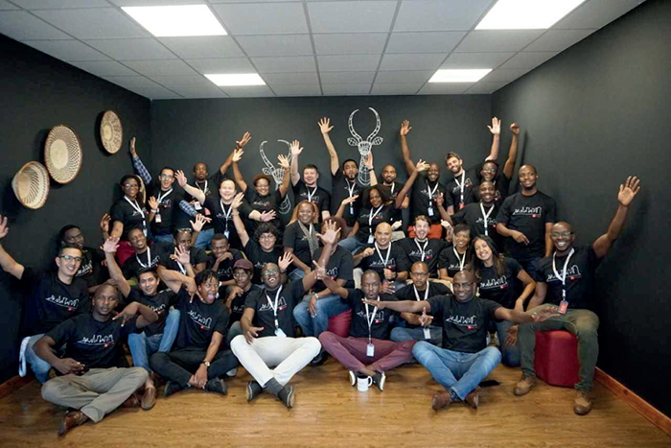
          - The first group of tech entrepreneurs from the start-up generator Antler in Nairobi.

Antler is a start-up generator that collaborates with talented people from around the world to build innovative growth businesses. Antler conducts a thorough screening process to select the top candidates (four per cent of applicants are selected for the programme) and works with them to find the right co-founders and connect them to a worldwide mentoring network within business and academia. Antler provides the entrepreneurs with support in the form of a grant from Day 1 and invests in their ideas via a seed capital fund. Antler was founded in 2017, and its activities in East Africa began in 2019 with support from Norway. Antler in East Africa is headed by Norwegian Marie Nielsen, and the management team members are all women.
Antler’s start in Nairobi has been met with great interest from potential entrepreneurs across Africa. Globally, Antler’s selected candidates average nine years of work experience, and 60 per cent have helped to start up a company before. Comparable targets have been set for entrepreneurs recruited to the programme in East Africa. Candidates have either in-depth knowledge in technology, a strong commercial background or experience with digital product development. In addition to delivering good financial results, the 20 start-ups founded by Antler’s East Africa inaugural recipients are expected to focus on finding innovative technological solutions to address major societal challenges facing the region and create a significant number of jobs.

In many cases, encouraging investment from and knowledge cooperation with the private sector is critical for scaling and impact. One example is IPCO AS of Halden, Norway, an IT company that expands wireless internet access via mobile phone. With Norwegian funding, IPCO has conducted feasibility studies in four regions of Uganda (Teso, Lwengo, Bunyoro-Kitara Kingdom and Busia) and has commenced pilot production in those regions.
IPCO cooperates with local partners for implementation. The wireless internet access and telephony project Rural Area Broad Band Internet (RABBIN) sets up access at relevant local meeting places such as schools, administrative offices, business clusters and health clinics. Revenues are secured partly through advertising sales and user payments according to usage. Internet-based activities such as gaming and video services that require greater bandwidth will not be available. Network towers will be constructed and connected to the physical infrastructure to provide internet access to surrounding areas of up to 60 km in diameter.
Norway’s Enterprise Development for Jobs scheme, supports new business enterprises in most sectors in developing countries, including the digital economy. The scheme provides funding for feasibility studies, partner search, training of local staff, infrastructure investments and pilot production.
A well-functioning financial sector is essential to enable the private sector to make necessary investments in digital technology. A key element of Norfund’s strategy is to inject capital and provide loans to banks and microfinance institutions in developing countries. Norfund is also considering investment opportunities in financial technology (fintech).
The Government will:
- investigate establishing a new window of opportunity under the grant scheme for support to companies for private sector development in developing countries targeted towards tech companies and start-ups. The scheme’s objective will be to provide grants to tech companies with business ideas that can encourage private sector development, technology transfer and job creation in developing countries. The scheme will be open to both Norwegian and international applicants.
- consider continued funding for the African Development Bank’s Youth Entrepreneurship and Innovation Multi-Donor Trust Fund (YEI Trust Fund).

Human rights
Norwegian politics are based on respect for basic individual rights and democratic rules as prerequisites for lasting peace and stability. Freedom of expression is a fundamental individual right which is also crucial to sustainable development, the rule of law and democracy. It contributes to a more informed society where decisions are made in open and legitimate institutions based on knowledge and participation. It is generally accepted that human rights are also valid in the digital space. However, respect for human rights is under threat both online and offline from many quarters. On the internet, freedom of expression, freedom of the press, privacy and civil society’s room to manoeuvre have come under pressure from state and non-state actors alike. The challenges vary, but some trends are clear.
National security concerns, anti-terrorism legislation, anti-corruption legislation and blasphemy and defamation laws are misused in many countries to prevent criticism and silence dissent online. The internet and social media are exploited as “new” channels for spreading disinformation, propaganda, hate speech and digital attacks.
Some journalists, bloggers and others who express their views online face harassment, threats, imprisonment or even death. Women are especially vulnerable to online harassment. Insufficient investigation and impunity for abuse are widespread. Upsetting experiences as well as the fear of offending others or of being subjected to surveillance all lead to increased self-censorship.
Forces seeking to restrict freedom of expression or political opposition have acquired a bigger, more versatile set of tools as digitalisation in society eases the way for surveillance, internet censorship, filtering and blocking. Government authorities can in other words exploit digitalisation to curtail transparency, freedom and security.
However, digital technology can also help in protecting human rights. Digitalisation strengthens access to information and gives individuals and civil society organisations new tools for disseminating their views. Algorithms can track language usage in digital spaces to prevent harassment, discrimination and hate speech. Such monitoring, however, may pose a threat to the rights of privacy and freedom of expression, among others. Understanding the impacts of digitalisation and regulation in the digital space is therefore a matter of increasing importance.
In 2019 the United Nations launched an action plan against hate speech which the Government regularly consults in its global efforts to counter hate speech. Norway launched an international cyber strategy in 2017. Norway is working to foster a digital space that promotes innovation and international trade, contributes to international stability and security, facilitates cybersecurity and safeguards democratic values and universal human rights.
The United Nations Educational Scientific and Cultural Organization’s (UNESCO’s) International Programme for the Development of Communication (IPDC) promotes media development in developing countries as well as free speech protection, and maintains a clear gender-equality perspective in its work. UNESCO also examines ethical, human rights and governance challenges associated with new technologies as well as how new technologies can help in achieving the Sustainable Development Goals. Norway is among the largest donors to this programme.
The Government will:
- strengthen Norway’s cooperation with multilateral and non-governmental organisations that address the points of connection between digitalisation and human rights, democracy and gender equality;
- renew its strategy to promote freedom of expression and independent media in foreign and development policy, with a special focus on challenges and opportunities associated with digitalisation;
- strengthen Norway’s efforts to protect human rights defenders in the digital space.

Gender equality and discrimination
With the adaption of the 2030 Agenda, UN Member States pledged to “leave no one behind”. In today’s global world, participation in society and development requires access to the internet, digital platforms and networks. Those currently lagging behind will keep losing ground if they do not take part in today’s digital development. Well-designed regulatory frameworks are an important foundation for successful, broad-based digitalisation. Key factors include participation, transparency and non-discrimination. Achieving the Sustainable Development Goals will require a major effort to ensure that women and men, and people with and without disabilities, have equal opportunities to utilise and benefit from technological advancements.
Underlying structural barriers to gender equality assert themselves in the digital world as well, and hinder access to digital development. Access restrictions, high cost, lack of education and ingrained prejudices and social norms limit the opportunities of women and girls to benefit from digitalisation. The Organisation for Economic Cooperation and Development (OECD) points out that girls are less likely than boys to receive an education that equips them to succeed in the digital world (for example in science, technology, engineering and maths). Since women and girls also use digital tools less than boys and men do, gender disparities seem likely to increase further in future, especially in less developed regions. According to the OECD, 327 million fewer women than men have a smartphone and mobile internet access.
Gender is not the only possible basis for exclusion from the digital sphere. Other reasons for discrimination, such as having a disability, must also be taken into account when addressing digitalisation in development cooperation. Estimates show that 25 per cent of people with a disability use the internet, in contrast to 56 per cent of non-impaired people. Beyond restrictions such as cost and other barriers, the technology design in itself is a major reason why people with disabilities cannot take full advantage of digital technology, as exemplified by unadaptable hardware and software.
Technology alone will not solve the challenges of discrimination or gender inequality. The underlying causes of limited access to and use of digital technology must be analysed and considered when addressing challenges related to discrimination, inequality and lack of rights. It is not enough to provide text-based information via SMS if the target group cannot read. But if illustrations and simple words are combined, or verbal information is made available via a toll-free number, such a service becomes far more accessible. It must also be presented in a language the users understand. For people with vision or hearing impairments, the risk that technology will have an exclusionary effect is especially large. At the same time, technology can be life-changing for this group if equipment and solutions are designed to meet its needs.
Norway supports the World Bank’s programme for the poorest countries (IDA19), which aims to increase women’s access to ICT both in working life and in banking services. Norway provides core support to UN Women, which has its own innovation strategy for the use of innovative solutions and technologies to promote women’s and girls’ rights. Norway also supports the United Nations Population Fund (UNFPA), which uses digitalisation in its work. An example is Geo-Referenced Infrastructure and Demographic Data for Development (GRID3), a tool UNFPA has developed specifically to ensure that no one is left behind. It is geared to the collection, storage and use of digital geographic census data of importance to decision-making processes, including service delivery where development needs are greatest. In areas that cannot be reached physically, GRID3 relies on satellites and simulation models. UNFPA has collected GRID3 data in South Sudan and Afghanistan for development purposes and is now collecting data in Nigeria as a contribution to that country’s national health plan efforts. UNFPA’s Population Data Platform (PDP) is a global “one stop” data platform for both quantitative and geographic data, including GRID3 data. PDP is a simple tool designed for national decision makers that includes data and analysis making it possible to identify those who are furthest behind – whether old or young – and what their service needs are. The tool is also useful for monitoring the implementation of Sustainable Development Goal measures. The first version was tested in 2018 and full launch was planned for November 2019, during the Nairobi Summit on ICPD25 marking the 25th anniversary of the International Conference on Population and Development. Norway also supports the International Telecommunication Union (ITU) and the Women Entrepreneurs Finance Initiative (We-Fi fund) for women digital entrepreneurs in developing countries, which was launched during Germany’s G20 presidency, as well as a number of other multilateral initiatives.
The Government will:
- encourage civil society organisations, multilateral organisations, multilateral banks and the private sector to incorporate targeted “leave no one behind” components that address the digital gap, especially with regard to people with disabilities and women/girls;
- consider support for organisations that work specifically towards innovation and digital solutions for people with disabilities, such as the Global Disability Innovation Hub in Kenya;
- provide guidance for a gender perspective on infrastructure investments in mobile networks through the development banks;
- promote digitalisation and gender equality in the governing bodies of relevant multilateral organisations;
- continue support for the World Bank’s programme for the poorest countries (IDA19), which aims to increase women’s access to ICT both in working life and in banking services;
- continue support for UNFPA and its GRID3 efforts.

Modern slavery
Modern slavery is an umbrella term that refers to various situations in which people are grossly exploited and are unfree to leave their situation due to threats, violence, coercion, deception or abuse of power. The term encompasses human trafficking, forced labour, debt bondage, online sale of sexual abuses to children, harsh child labour and forced marriage. Human trafficking is deprivation of liberty without the migrant’s consent and often occurs in connection with other forms of exploitation and degrading treatment. It is often linked to organised crime. About 40 million people are currently trapped in modern slavery. Of these, 25 million are victims of forced labour and 15 million of forced marriages. Seventy-one per cent of modern slavery victims are girls and women.
Globalisation and increased migration make modern slavery a growing challenge, with migrants and foreign workers at high risk of violence and abuse.
Today, information and communication technologies play a prominent role in the complex of problems associated with modern slavery. Technology can be used as a tool to exploit vulnerable people. As new technologies are developed, abusers are quick to exploit them. Job offerings posted on the internet sometimes prove to be traps to recruit migrant workers into forced labour. Abusers also “groom” young people for sexual exploitation on the internet and use mobile phone cameras to monitor and threaten victims.
At the same time, organisations, public authorities, research groups and the private sector are developing new tools and methods that can prevent and expose modern slavery.
Blockchain technology can trace all links in a manufacturing process, from extraction of raw materials to the finished product, and thus increase transparency and ensure supply chains free of slavery. In the Southeast Asian brick industry, for example, where slavery is widespread but companies are difficult to monitor due to their remote locations, creative measures including satellite technology are used to expose slavery.
Digital reporting tools for migrant workers can help to improve working conditions and prevent employers from switching contracts to trick migrants into exploitative relationships. With this in mind, Coca-Cola, the US State Department and Blockchain Trust Accelerator are collaborating on development of a pilot project to prevent contract switching for migrant workers. Using blockchain technology, information entered into a secure registry becomes permanent and verifiable.
Digital identity solutions can help to make it impossible to take away people’s ID. Identity papers, if they exist in the first place, are often confiscated to make victims unidentifiable. Information about rights and about safe, user-friendly alert mechanisms may be of significant value to this group. While extensive data sharing will enable such efforts to be even more effective, it also presents both ethical and practical challenges. Large-scale information sharing also takes place in connection with law enforcement investigations, arrests and evidence submission in human trafficking cases. In India, for example, the Aadhaar identity system has been used to track missing children.
Technology alone cannot stop modern slavery, but it can provide society with useful tools to make a difference in combating this evil.
Children account for some 25 per cent of all slavery victims. Studies have shown that a great deal is being done to combat child labour and child marriage. UNICEF has mounted a major effort in this area, while the United Kingdom and the Netherlands have assumed international leadership among bilateral donors.
According to UNICEF, more than 230 million children (as of 2014) are without a birth certificate and therefore invisible to the authorities. A large proportion of children who end up in modern slavery were not registered at birth. Birth registration can serve as a preventive measure against several types of modern slavery.
Some work is already being done in this area, whether initiated and carried out by developing countries themselves or by the UN and donor countries. UNICEF has projects that focus on children who risk falling into slavery in Pakistan, Ethiopia, Somalia and Sudan.
The Government will:
- strengthen Norwegian efforts to combat modern slavery in a dedicated development assistance programme, with sub-Saharan Africa as the main geographic focus;
- emphasise prevention, including support for birth registration and digital ID efforts, with a focus on groups most at risk;
- support research, responsible business practices and measures targeting the fisheries, agriculture and mining sectors.

Cross-cutting Norwegian initiatives
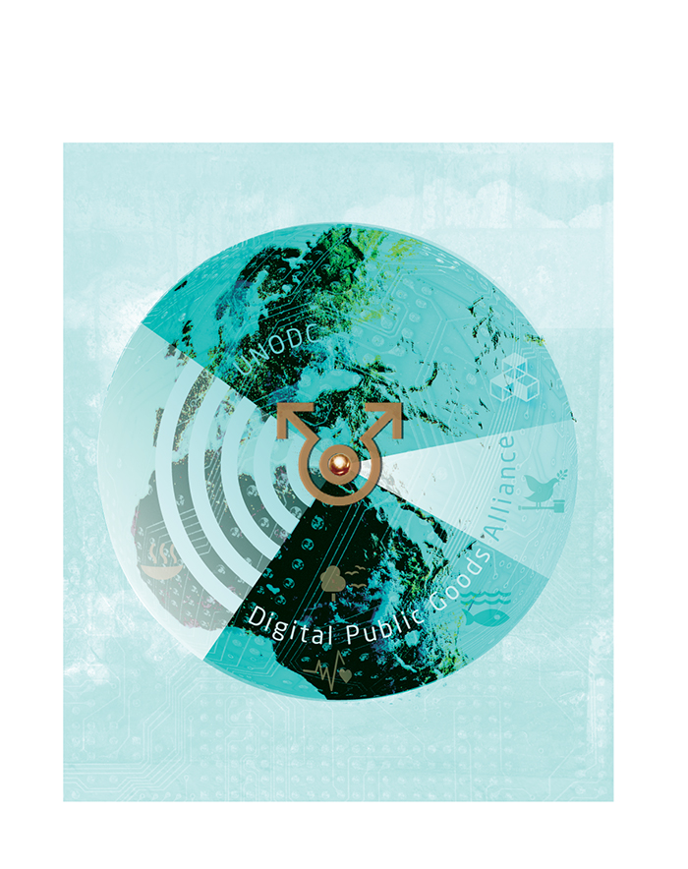

Digital security
Developing countries must be given a greater opportunity to benefit from the many possibilities that digitalisation entails as well as a more widespread ability to tackle digital challenges and digital threats. Norway can play an important global role in helping other countries and regions to expand their cyber capacity in line with a number of Sustainable Development Goals (Agenda 2030).
Outside of its bilateral cooperation agreements, Norway supports capacity-building measures through the World Bank and the UN system and is the largest contributor to the Global Programme on Cybercrime in the United Nations Office on Drugs and Crime (UNODC). The programme aims to strengthen the capacity of developing countries to investigate and prosecute offenses in the digital space.
Norway is an active partner in the Global Forum on Cyber ​Expertise (GFCE), a global platform enabling states, international organisations and private companies to work together to promote international capacity building and knowledge sharing in the digital security field.
The Government will:
- promote and support cybersecurity capacity building in developing countries. Capacity building in this sense includes institution building involving such bodies as national telecommunications authorities and national computer emergency response teams (CERTs); investigative capacity related to ICT crimes; development of national legislation on electronic communications; development of secure digital infrastructure; and establishment of warning systems;
- emphasise security as a fundamental factor in digitalisation efforts – for example, when implementing electronic systems for the exercise of governmental authority;
- place greater emphasis on robust infrastructure, security and transparency in the digital space as a part of the sustainable development agenda and the Government’s global efforts;
- assist developing countries by strengthening their competence and capacity to prevent, detect and manage digital threats as well as to combat ICT crimes and illegal capital flows that exploit the digital space.

Digitalisation for development
The newly created Digitalisation for Development programme is a central element of Norway’s international digital inclusion efforts. The programme is part of the Knowledge Bank within the Norwegian Agency for Development Cooperation (Norad). The Knowledge Bank is a political initiative intended to strengthen the competence and capacity of public institutions in selected partner countries, thereby helping to achieve the Sustainable Development Goals.
The Knowledge Bank’s cooperation assistance is demand-driven. Norwegian public institutions share knowledge in areas where Norway has special expertise and in ways relevant to the partner countries.
The Knowledge Bank currently cooperates with Norwegian institutions that have a strong digitalisation focus, including Statistics Norway, the Norwegian Tax Administration, the Norwegian Mapping Authority, the Brønnøysund Register Centre, the Norwegian Petroleum Directorate, the Ministry of Trade, Industry and Fisheries, the Norwegian Water Resources and Energy Directorate and Norwegian universities and university colleges, which often contribute digital components and share Norwegian digitalisation expertise in institutional cooperation with partners in developing countries.
The Digitalisation for Development programme is a key initiative to digital inclusion efforts and incorporates two main components: digital public goods and digital partnerships.

Digital public goods
Digital public goods are not a specific technology but a collective term for digital goods that have the potential to benefit or help countries and individuals. To qualify as digital public goods, a project or product must be i) non-rivalrous (meaning its use does not prevent others from using it), ii) non-exclusive (meaning no one can prevent others from using it) and iii) available across national borders. Applications, data, algorithms, platforms and standards are common examples of digital public goods.
Norway has a longstanding tradition of investing in public goods that have both national and international users – that is, public goods meant to serve the entire world, such as the seed vault in Svalbard and climate and forestry projects that combat global warming.
Digital technologies, content and data have the potential to become public goods, but it is not enough that they are available for free. They must also have an open source licence so that users know the right to use them will remain valid in perpetuity. There is a growing consensus in international development that digital solutions, content and data funded from development assistance budgets should be under an open licence. This is incorporated e.g. in the Principles for Digital Development.
Norway is building a portfolio based on long-term partnerships focused on selected digital public goods of potential use to multiple actors in a variety of developing countries. Norway’s portfolio represents an alternative approach in light of the widespread fragmentation and lack of coordination typical of international assistance today. The goal is to facilitate the reuse and further development of existing high-quality digital public goods so individual actors will have less need to seek to develop or purchase their own solutions.
Examples of digital public goods with their basis in Norway:
- The Health Information Systems Programme (HISP) is a global movement to establish better health information systems in developing countries. The University of Oslo plays a key role that includes maintaining and developing District Health Information Software 2 (DHIS2), an open source licence software. It is the preferred software for health systems in nearly 70 countries and is thought to have a global footprint encompassing nearly 2.3 billion people.
- The Global Digital Library collects and makes digitally available (for printing or digital reading) open licence educational reading resources in languages that children understand. The library platform and contents will be as universally designed as possible, including for users with visual impairments and other special learning needs. As currently planned the platform will have resources in 100 languages by the end of 2020. The platform also facilitates translation of the readers into more than 300 languages.
- Two open licence smartphone games in Arabic have been developed through the pre-commercial procurement of EduApp4Syria. To date the gaming apps have been installed on an estimated 300,000 mobile devices. An independent evaluation conducted in the Azrak refugee camp in Jordan and published in March 2018 concluded that the games improved reading skills (as measured by the number of correctly read words per minute) by an average of 50 per cent for children who played one of the games, while no change was registered for children in a control group.
- Yr is a weather service developed collaboratively by the Norwegian Meteorological Institute and the state broadcasting corporation NRK. Yr provides free, high-quality, advertisement-free weather forecasts for more than 10 million locations around the world and is already a widely used digital resource in numerous African countries and in various development assistance-funded initiatives. The Meteorological Institute has an open data policy. The data underlying Yr’s weather forecasts are accessible free of charge through an application programming interface (API).
- A digital forecasting and information service known as VIPS (for Varsling innen planteskadegjørere in Norwegian) facilitates integrated pest and disease control for agricultural crops and horticulture. The service combines data on pests and pest distribution with weather data. It has an open source licence that is accessible to all, but is aimed especially at farmers and advisers in Norwegian agriculture.
- In autumn 2018 and spring 2019 Norway participated on the UN Secretary-General’s High-Level Panel on Digital Cooperation. The panel discussed the potential for increased international cooperation on digital public goods, emphasising in particular how such cooperation could promote digital inclusion and improve information and service delivery for the world’s poorest population groups.
Alongside its participation on the high-level panel, Norway has been cooperating since autumn 2018 with the UNICEF Office of Innovation on development of a platform prototype for digital public goods and the identification of relevant international partners. The prototype is being developed to make it easier for organisations and individuals in low- and middle-income countries to find, use and adapt open licence technologies and content applicable to achieving the Sustainable Development Goals.
A key recommendation in the high-level panel’s report, which was submitted in summer 2019, is to establish an alliance and a platform, including forming criteria, for digital public goods. UN Secretary-General António Guterres has expressed support for this recommendation and seeks to encourage its implementation. Norway has taken a leading role in the area and has entered into an agreement with UNICEF to continue the effort to develop criteria and establish a platform for digital public goods as well as to build an alliance structure over the next two years. Along with Norway and UNICEF, active participants in the preliminary task of alliance development include Sierra Leone, UN Global Pulse and the Indian think tank iSPIRT.
Norway’s direct involvement in technology development is accompanied by a heightened focus by various partners on open licence technology and content. One important effort is a collaboration between the World Bank, the Bill & Melinda Gates Foundation, India and other parties to develop the digital identity platform MOSIP (modular open source identity platform). Another is UNICEF’s use of artificial intelligence and Big Data to map school internet access through Project Connect. In addition, many digital public goods of potential importance to developing countries are being developed by actors that do not think of themselves as development assistance actors. The Wikipedia encyclopaedia is a good example.
Digital public goods can help to achieve results in a given sector as well as to bridge sectors and affect achievement of targets in multiple areas simultaneously.
The McKinsey Global Institute has found that digital ID systems can “unlock” economic value corresponding to 3–13 per cent of GDP. The World Bank estimates that 110 billion hours could be saved by moving social and other public services to digital, ID-based systems, and that the roughly 1.7 billion people currently excluded could gain better access to the financial services sector.
The Government will:
- continue Norwegian efforts to play a leading role in the establishment of an alliance and a platform for digital public goods in close cooperation with the UN Secretary-General and partners;
- continue Norwegian efforts to help to develop a broad alliance structure and long-term operational solution for the platform that addresses cost-efficiency considerations and ensures predictability and security for platform users in low- and middle-income countries.

Digital partnerships
Succeeding with digital transformation efforts in development policy will be contingent on partnerships. Partnerships with private business and industry are especially relevant, but civil society organisations, the public sector and research institutions are of relevance as well.
In many cases, high-quality digital systems that already exist can be adapted or further developed, and it is not always necessary to develop completely new solutions. Pilot projects and testing are an important part of the innovation process, and an iterative improvement process is essential to develop solutions that are both universal enough to achieve large scale and adaptable enough to suit local needs. Digital partnerships are an important basis for coordination, collaboration and knowledge exchange between development assistance actors, private investors and implementers.
Such partnerships can help to put the focus on end users in developing countries by developing better digital solutions, accessing new markets and expanding the network of resources. Through digital partnerships, Norway can help to mitigate risk and serve as a catalyst for thinking ambitiously and scaling up innovations developed by innovation circles in developing countries.
The Government will:
- enter into a collaboration with the Global System for Mobile Communi­cations Association (GSMA) aimed at promoting digital inclusion and access to digital public goods through mobile distribution channels for vulnerable groups, such as women and the rural poor in low-income countries;
- support the Digital Impact Alliance’s work promoting the Principles for Digital Development and strengthening implementation of the principles in development cooperation.

Digitalisation through the Vision 2030 initiative
The Vision 2030 initiative promotes innovative Norwegian solutions that can contribute to the achievement of education- and health-related Sustainable Development Goals. The initiative had a budget framework of up to NOK 150 million for the 2016–2019 period. Norad has overall responsibility for the initiative’s implementation and cooperates with Innovation Norway and the Research Council of Norway on calls for proposals for innovation projects. The projects are based on partnerships between business actors, civil society organisations and research institutions.
Vision 2030 projects include the following:
- Leap Learning, in collaboration with Save the Children, develops digital learning materials for schools and informal education programmes in Somalia. The Leap Learning Labs employ digital content comprising more than 300 learning apps developed by leading educators for use on all platforms (including mobile phones and tablets). The labs also encompass hands-on games and problems for children to solve. All digital content is downloaded locally and can be used without an internet connection.
- Picterus is developing an app to make diagnosing jaundice easier, faster and cheaper in local settings in Tanzania and Uganda. Jaundice is a common condition among new-borns and is easy to treat if diagnosed quickly. Unfortunately, new-borns with jaundice in developing countries are less likely to be diagnosed than those in more developed countries, and some 114 000 children die of the condition each year in developing countries. Picterus is developing a simple jaundice screening technology that allows new-borns to be screened using inexpensive smartphones and a colour calibration card that can be printed out simply and cheaply at or near the screening site.
- Diwala is developing a solution to verify education and training using blockchain technology. Using secure, traceable, digital verification of education and training certificates that cannot be changed, individuals can create a digital identity and CV, leading potentially to new job opportunities and facilitating entrepreneurial development. Through the use of blockchain technology, users retain ownership of their own information and can decide for themselves whom to share it with. This technology is particularly relevant for a variety of marginalised groups, such as refugees.
- In collaboration with UN Women, EON Reality is developing a virtual reality-based training programme to combat violence against women. The virtual reality technology used in the project provides a transformative virtual experience that leads to better results, faster learning and improved knowledge retention so that users ultimately will make ­better choices.
The Government will:
- strengthen efforts under the Vision 2030 initiative by continuing and expanding the funding mechanism to Word til Kjerneformat for regjeringen.no (PMP W2K) areas where innovative Norwegian solutions may be particularly applicable to the pursuit of Sustainable Development Goals, and where the mechanism may serve as a catalyst.

https://digitalprinciples.org
https://www.itu.int/dms_pub/itu-d/opb/ldc/D-LDC-ICTLDC-2018-PDF-E.pdf
https://www.gsma.com/r/mobileeconomy/, The Mobile Economy 2019, report
https://www.gsma.com/r/mobileeconomy/, The Mobile Economy 2019, report
https://www.oneweb.world/
http://uis.unesco.org/sites/default/files/documents/ip51-global-framework-reference-­digital-literacy-skills-2018-en.pdf
http://uis.unesco.org/sites/default/files/documents/ip51-global-framework-reference-­digital-literacy-skills-2018-en.pdf
https://www.statista.com/statistics/262946/share-of-the-most-common-languages-on-the-­internet/
https://www.gsma.com/mobilefordevelopment/resources/mobile-gender-gap-report-2019/
https://www.gsma.com/mobilefordevelopment/resources/mobile-gender-gap-report-2019/
https://pathwayscommission.bsg.ox.ac.uk/sites/default/files/2018-11/digital_lives_report.pdf
https://www.gsma.com/mobilefordevelopment/resources/mobile-gender-gap-report-2019/
https://www.worldbank.org/en/topic/disability
https://www.nrc.no/globalassets/pdf/reports/myanmar/cedaw-report-web-7-march-2018.pdf
https://www.unhcr.org/ibelong/stateless-minorities/
https://www.regjeringen.no/en/dokumenter/meld.-st.-27-20182019/id2654250/
https://eit.europa.eu/
https://www.esa.int/ESA
http://www.imso.org/Public/
http://www.intelsat.com/
https://www.itu.int/en/Pages/default.aspx
https://www.un.org/ldcportal/ldc-technology-bank-launches-in-turkey/
https://home.cern/
The discussion paper “The Case for a Digital Ecosystem for the Environment” was submitted in March 2019.
GEO has prepared an overview of the SDG targets and indicators which Earth observation (using satellites and other methods) is helping to assess: “Earth observations and geospatial information: supporting official statistics in monitoring and achieving the 2030 agenda”.
https://www.worldbank.org/en/programs/digital-development-partnership
https://www.generationunlimited.org/
https://www.mckinsey.com/featured-insights/employment-and-growth/how-digital-finance-could-boost-growth-in-emerging-economies
https://digitalfinancingtaskforce.org/
https://www.ifc.org/wps/wcm/connect/38390d15-e30e-4d6e-b0d2-bb09f6146efa/Digital+Skills_Fact+Sheet_5-7-19.pdf?MOD=AJPERES
This is in line with the Norwegian Government’s strategy for green competitiveness.
This is in line with the Norwegian Government’s National geospatial strategy towards 2025 - ­Everything happens somewhere.
https://en.unesco.org/ocean-decade
https://www.regjeringen.no/no/aktuelt/hoyopploselige-satellittbilder/id2661754/. Subject to ­approval by the Storting. The measure is under the auspices of the Ministry of Climate and ­Environment (KMD).
https://www.foodandlandusecoalition.org/wp-content/uploads/2019/09/FOLU-Growing­Better-GlobalReport.pdf
https://www.sparkmeter.io/
https://www.sciencemag.org/news/2019/02/researchers-spy-signs-slavery-space
https://www.mckinsey.com/~/media/McKinsey/Business%20Functions/McKinsey%20Digital/Our%20Insights/Digital%20identification%20A%20key%20to%20inclusive%20growth/MGI-Digital-identification-Executive-summary.ashx
https://leaplearning.no/
https://www.picterus.com/
https://diwala.io/
https://www.eonreality.com/locations/norway/

