Klima- og miljødepartementet
Meld. St. 20
(2019–2020)
Norway’s integrated ocean management plans
Barents Sea–Lofoten area; the Norwegian Sea; and the North Sea and Skagerrak
Recommendation of 24 April 2020, approved in the Council of State the same day. (Solberg Government)

Summary
Value creation from Norway’s ocean-based activities now and in the future depends on maintaining good environmental status and high biodiversity in the marine and coastal environment, safeguarding the oceans as a source of food and using ocean resources sustainably. The management plans previously published for specific areas have established an overall framework and measures for the conservation and sustainable use of marine ecosystems. In this white paper, the Government describes how it intends to continue and consolidate Norway’s integrated, ecosystem-based ocean management plan system.
Purpose of the management plans
The purpose of the management plans is to provide a framework for value creation through the sustainable use of marine natural resources and ecosystem services and at the same time maintain the structure, functioning, productivity and diversity of the ecosystems. The management plans are thus a tool both for facilitating value creation and food security, and for maintaining the high environmental value of Norway’s marine areas.
Norway’s ocean management plan system
Norway laid the foundation for integrated, ecosystem-based ocean management in the white paper Protecting the Riches of the Sea (Report No. 12 (2001–2002) to the Storting). The white paper described the vision of maintaining clean, rich seas so that future generations can continue to harvest the wealth of resources that the sea has to offer. Since then, the Storting (Norwegian parliament) has considered and approved integrated, ecosystem-based management plans for all Norwegian sea areas.
The management plans clarify an overall framework and encourage closer coordination and clear priorities for management of Norway’s marine areas. They increase predictability and facilitate coexistence between industries that are based on the use of these areas and their natural resources. Activities in each management plan area are regulated on the basis of existing legislation governing different sectors. The various sectoral authorities are responsible for implementing the measures set out in the management plans, under relevant legislation that they administer.
This white paper brings together all the management plans for the first time. It includes a revised management plan for the Barents Sea–Lofoten area and updated management plans for the Norwegian Sea and the North Sea and Skagerrak. The Forum for Integrated Ocean Management and the Advisory Group on Monitoring are responsible for organising work on the scientific basis for the management plans, and there is a well-organised monitoring system for all three marine areas. There is now capacity in the management plan system to compile a sound, up-to-date scientific basis for a new white paper on the management plans every four years.
The Norwegian Government’s ocean policy
The Government is giving high priority to an active ocean policy and ocean-based commercial activities, both nationally and internationally. In spring 2017, the Government published its ocean strategy New growth, proud history and presented two white papers, The place of the oceans in Norway’s foreign and development policy (Meld. St. 22 (2016–2017)) and Update of the integrated management plan for the Norwegian Sea (Meld. St. 35 (2016–2017)).
In June 2019, the Government presented its updated ocean strategy, Blue Opportunities. The strategy highlights five key elements on which the Government’s ocean policy is based:
i) promoting, developing and defending the Law of the Sea;
ii) promoting conservation and sustainable use of marine ecosystems;
iii) contributing to knowledge-based management;
iv) supporting the implementation of international ocean-related instruments;
v) advocating an integrated approach to marine management that will underpin a sustainable ocean economy.
The Government has also taken important international ocean-related initiatives. In 2018, the High-level Panel for a Sustainable Ocean Economy was established. Its purpose is to create international awareness of the economic importance of the oceans, and an understanding that sustainable use of marine resources and safeguarding a healthy marine environment must be the foundation for increasing value creation. The need for integrated ocean management occupies a central place in the Panel’s work and was also a vital part of the backdrop to the Our Ocean conference that Norway hosted in Oslo in October 2019.
Environmental status and trends in Norwegian waters
Environmental status in Norway’s rich, productive seas is in many respects good, but climate change is having growing impacts, and is clearly affecting the status of ecosystems in both the North Sea and the Barents Sea. Current knowledge indicates that pressures and impacts related to climate change and ocean acidification will intensify markedly. Considerable challenges are expected to arise as a result of interactions between the expected impacts of climate change and ocean acidification, and the more direct local and regional impacts of human activity at sea and along the coast.
The Barents Sea–Lofoten area
In the Barents Sea, climate change has resulted in long-term trends of rising sea temperatures, shrinking ice cover and large-scale ecological changes, especially in the northernmost areas. The rising temperatures and shrinking sea ice cover have resulted in changes in ecosystem production and biomass. Total primary production (phytoplankton) has risen, and biomass has almost doubled, mainly as a result of rising quantities of Arctic krill species (zooplankton). There have also been observations of growing numbers of southerly krill species and a decline in the quantity of lipid-rich Arctic zooplankton species. The decline in sea ice has also had direct negative effects on ice-associated species, for example ringed seal, polar bear and a number of other species groups that live in and on the ice, such as ice algae, crustaceans and polar cod (Boreogadus saida). With a reduction in the area of suitable habitat available to many of these species, they may disappear from larger and larger areas of the Arctic. The Barents Sea is one of the areas where this is expected to happen most quickly, because of the rapid loss of sea ice in both summer and winter.
As a result of climate change and lower fishing pressure, some species, and particularly the cod stock, have expanded their range in the Barents Sea. At the same time, suitable habitat for Arctic species has become more restricted. So far, ocean acidification has not been registered in the Barents Sea.
The Norwegian Sea
In the Norwegian Sea, the water temperature has risen as a result of climate change and changes in ocean circulation, and acidification has been registered. Since 2006, observations of southerly species of zooplankton in the Norwegian Sea have been increasing. These are species that are common in the North Sea or further south and were previously not normally found in the Norwegian Sea. The changes observed in the species composition of zooplankton and fish communities are not as extensive as those recorded in waters further north and south, but the data for the Norwegian Sea are not as complete.
There has been some variability in zooplankton and fish production, but this is now relatively high for many species, while fishing pressure has decreased since the turn of the century. Inputs of pollutants are generally stable or declining. Many seabirds have suffered a dramatic population decline since the early 1980s.
The North Sea and Skagerrak
In the North Sea and Skagerrak, climate change has been causing significant warming since as long ago as the late 1980s. The water temperature is still high, and there has been a continuing spread of southerly zooplankton species, with substantial impacts on the rest of the ecosystem. There has been a considerable decline in kelp forests in the Skagerrak in recent decades. Marine heatwaves when water temperatures are abnormally high in summer have been an important contributory factor in this decline. Many fish stocks have grown considerably in recent years, while levels of pollutants have generally remained unchanged or declined.
Particularly valuable and vulnerable areas
Particularly valuable and vulnerable areas are identified on the basis of scientific assessments as being of great importance for biodiversity and biological production in an entire management plan area. The designation of areas as particularly valuable and vulnerable does not have any direct effect in the form of restrictions on commercial activities, but indicates that these are areas where it is important to show special caution, and where activities must be conducted in such a way that the ecological functioning and biodiversity of an area is not threatened. In the scientific basis for this white paper, the delimitation of three of these areas – the marginal ice zone, the polar front and the Eggakanten area (along the edge of the continental shelf) has been updated. The delimitation of some particularly valuable and vulnerable areas in the Norwegian Sea has been clarified and adjusted. The boundary of the sea areas surrounding Svalbard has previously only been delimited around Bjørnøya, but a preliminary demarcation line for the rest of this particularly valuable and vulnerable area has now been identified. In the North Sea–Skagerrak area, no changes have been made to the delimitation of particularly valuable and vulnerable areas.
The Forum for Integrated Ocean Management has evaluated the delimitation of the marginal ice zone as a particularly valuable and vulnerable area. This is a transitional zone whose value and vulnerability are linked to characteristic features and biological processes, and not just a dividing line between ice and open sea. After an overall assessment, the Government has decided to use the line where ice is found on 15 % of the days in April (15 % ice persistence), based on satellite observations of sea ice extent for the 30-year period 1988–2017, to delimit the marginal ice zone as a particularly valuable and vulnerable area.
Changing oceans
Norwegian seas are part of one continuous ocean system, and changes in other parts of the world’s oceans also influence areas under Norwegian jurisdiction. The entire system is affected by climate change and other large-scale pressures. Further development of Norway’s ocean management system must be based on an understanding of how climate change and other large-scale processes are affecting and will change Norway’s marine areas and how they are used.
Climate change is intensifying more rapidly than other pressures, both globally and in Norwegian seas. According to the Intergovernmental Science-Policy Platform on Biodiversity and Ecosystem Services (IPBES), it is likely that the impacts of climate change, in combination with the use of marine and coastal waters, overexploitation of living resources, pollution and the spread of alien species will further exacerbate the negative impacts on ecosystems that are already becoming apparent. The Arctic is highlighted as one of the regions where this can already be observed.
According to the Intergovernmental Panel on Climate Change (IPCC), the oceans are entering a new state, with rising temperatures, more acidic seawater, less oxygen, lower biological production and changes in ocean circulation. At the same time, the rise in global sea level is expected to accelerate. Marine and coastal areas at lower latitudes will be hardest hit. However, important marine ecosystems in Norwegian waters are also vulnerable. These include kelp forests, eelgrass meadows, cold-water coral reefs and ecosystems associated with the Arctic sea ice.
On the global scale, it is expected that both biological production and the catch potential of fish stocks will decline as the oceans warm. The decline will be greatest in tropical seas, and its extent will depend on the level of greenhouse gas emissions. In certain parts of the Arctic, productivity may rise. At the same time, the distribution of areas of suitable habitat for various species will shift towards the poles. The seawater will become increasingly acidic as it absorbs more CO2. These trends will result in major changes in marine ecosystems. The changes we have witnessed so far in the North Sea and the Barents Sea, where biological production has declined in southerly areas and increased further north in response to higher seawater temperatures, are in line with the expected large-scale changes described by the IPCC.
It is difficult to predict all the impacts of climate and environmental change on the oceans. There is therefore growing uncertainty about environmental conditions in the future and whether there is a viable basis for industries that depend on marine ecosystems. This will create new challenges for ocean management at national level and for international ocean cooperation.
Climate change and ocean acidification are altering the ecological basis for exploiting ocean resources; at the same time, action to achieve the necessary emission reductions will intensify the need to make use of the oceans, for example to increase production of food and renewable energy. It will be vital for the public administration both to make use of all ocean-based options for reducing greenhouse gas emissions and to tackle any environmental impacts this may have.
The cross-sectoral system of integrated ocean management plans combined with sound management within each sector puts Norway in a good position to deal with the challenges arising from rising activity levels and rapid climate and environmental change. At the same time, it will be important to take into account the changes to marine ecosystems and species distribution resulting from climate change and ocean acidification, which may make many species and ecosystems more vulnerable to other pressures. This will require research to understand climate change and its impacts on the oceans, and monitoring to make it possible to detect changes at an early stage; the public administration will also need systems in place to enable a rapid response to new information, including necessary measures. Mapping of the seabed is one approach to building up the knowledge base.
Ocean-based industries and value creation
Norway is rich in natural resources and has always taken a long-term approach to resource management for the benefit of society as a whole. Ocean-based industries play a vital part in value creation in Norway, and the oceans provide livelihoods for many coastal communities. For the foreseeable future, the oceans will continue to be a vital basis for jobs, value creation and welfare throughout Norway, and they can also be part of the solution to the environmental and climate-related challenges the world is facing. The Government recognises that marine resources are important for national value creation, and considers it important for exploitation of natural resources to have positive spin-off effects for communities.
Fisheries and aquaculture: Norway has a large and profitable fisheries and aquaculture sector, which harvests and produces a total of more than 3 million tonnes of seafood a year, mainly for export. In 2019, Norway exported seafood to a value of NOK 107.3 billion. Climate change and other pressures are expected to result in major changes in the size and distribution of fish stocks in the years ahead, creating challenges for fisheries and fisheries management. Current knowledge indicates that there is no potential to increase harvesting of wild fisheries resources that are already exploited, with the exception of snow crab.
Shipping: Shipping in all three management plan areas has risen moderately year by year in the period 2011–2017. This is part of a long-term trend linked to rising transport needs, which in turn are connected to economic developments and globalisation of the economy.
Petroleum activities: Norway’s seas and oceans contain rich oil and gas resources, which have played a key role in the development of the welfare state, and the sector plays a vital role in the Norwegian economy. In the more than 50 years since petroleum activities first began in Norway, this has grown into the country’s largest industry measured in terms of value added, state revenues, export value and investments. There are considerable remaining oil and gas resources on the Norwegian shelf. The resource accounts indicate that after 50 years, about half of the total petroleum resources had been extracted, and the proportion was higher for oil resources than for gas resources. The North Sea accounts for the largest proportion of production from the Norwegian continental shelf, and the province still holds considerable resource potential. New gas infrastructure has been established in the northern part of the Norwegian Sea: the Aasta Hansteen field, which started production in 2018, and the gas pipeline Polarled. There are currently two fields in production in the Barents Sea, Snøhvit and Goliat, and a third, Johan Castberg, is under development. Exploration activity on the Norwegian shelf has varied over the years, but has remained stable at a high level in recent years.
Emerging ocean industries: Offshore wind power, marine bioprospecting, extraction of minerals from the seabed, carbon storage below the seabed and hydrogen production are emerging ocean industries.
Offshore wind power is growing globally, and several processes are underway in Norway to encourage its development. Offshore wind is one of six priority areas in the national strategy for research and development of new, climate-friendly energy technology, Energi21. At present, development costs are considerably higher for offshore wind power than for land-based wind power, and there are other challenges associated with offshore industrial activity than with similar land-based activities. Floating wind power may become a substantial energy source if the costs can be reduced sufficiently for it to be competitive. The Hywind Tampen project is under development in the North Sea and will be the world’s largest floating wind farm to date.
Marine bioprospecting is of particular interest in northern seas because they are home to many species that are specialised to survive extreme and often changeable conditions.
Extraction of minerals from the seabed may have considerable market potential in future as electrification of society progresses. This is expected to increase demand for metallic minerals such as lithium, cobalt, nickel and manganese, and for certain rare earths that are used in electronics and battery technology. Polymetallic crusts and sulphides have been found on the Norwegian continental shelf.
According to both the IPCC and the International Energy Agency (IEA), it will be difficult and substantially more costly to achieve climate targets without carbon capture and storage (CCS) technology. Norway already has many years’ experience of carbon capture and storage under the seabed on the Norwegian continental shelf.
Green competitiveness: the Norwegian Government presented its strategy for green competitiveness in 2018. This links together industrial development and climate action. Renewable energy sources such as offshore wind, carbon capture and storage under the seabed, and green shipping are three areas where Norway has much to offer, and where sound ocean management can play a part in a green shift in the economy.
Coordinated spatial management and coexistence between ocean-based industries: in view of the expected growth in new and emerging ocean industries, the Government will consider whether there are certain geographical areas where many different interests intersect. It will be important to review the impacts, including the economic impacts, of various options for the use of Norway’s marine areas, and to weigh up potentially conflicting interests in individual cases.
Overall framework and measures for conservation and sustainable use of ecosystems
A comprehensive set of targets and indicators has been developed for the management plans. This white paper includes a status report on progress towards the targets set out in the earlier management plans. It presents measures relating to climate change, good environmental status and sustainable use, the knowledge base, the exchange of information and experience, and further development of the management plan system.
The earlier management plans presented a framework for petroleum activities in each geographical area. With some changes and refinements, this white paper gives a complete overview of the current framework for petroleum activities for all three management plan areas, which will apply until the management plans are next updated.
On the basis of new information from the IPCC, this white paper focuses particularly on climate change and its implications for ocean management in the future. The Government will ensure climate-resilient management of living marine resources and marine biodiversity, so that it is possible to maintain viable populations and ecosystem services as far as possible in a changing climate. The Government will actively pursue a policy to promote green transformation of the Norwegian economy.
As regards food production from the oceans, the Government will review options for sustainable harvesting of new species, particularly species at low trophic levels.
The Government will present an update of its integrated strategy to combat plastic waste, which will include measures to deal with both ocean- and land-based sources and will consider plastic litter and microplastics in the oceans, in freshwater and on land. The Government is working towards a new comprehensive global agreement to combat marine litter and microplastics, which will have the aim of eliminating inputs from all ocean- and land-based sources.
The Government will build up knowledge about marine ecosystems and how they are changing as a result of greater human activity, climate change and pollution. The Government will also strengthen knowledge about the role of marine ecosystems in global climate evolution.
The Government will continue to promote integrated, ecosystem-based management in international ocean cooperation, and will advocate the use of knowledge about climate change and other factors with an impact on the oceans as a basis for work in relevant international forums and agreements.

Introduction – integrated, ecosystem-based management
As an ocean and coastal nation, Norway is responsible for managing a rich and varied natural environment. Norwegian waters support abundant natural resources that have been an important basis for the development of the welfare state. Norway’s long-term approach to ocean resource management for the benefit of society as a whole has a long tradition. Value creation from ocean-based activities now and in the future depends on maintaining good environmental status and high biodiversity in the marine and coastal environment, safeguarding the oceans as a source of food and using ocean resources sustainably. In this white paper, the Government describes how it intends to continue and consolidate Norway’s integrated, ecosystem-based ocean management plan system.
Many environmental problems in the oceans are transboundary in nature, and the distribution of many living marine resources extends across national borders. Moreover, the oceans are under growing pressure from human activities. Changes in the ocean environment resulting from climate change, ocean acidification and inputs of pollutants such as hazardous substances and plastic waste not only have environmental impacts, but also have consequences for food security (supplies of safe and nutritional food), productivity, ocean-based industries and coastal communities. There is growing international recognition that the oceans offer part of the solution to major global problems such as hunger and malnutrition and climate change. These factors combined will make it vital to have a sound framework for ocean management and ocean policy in the future.
The UN Sustainable Development Goals provide a global framework for the international community’s efforts to promote development that meets the needs of the present without compromising the ability of future generations to meet their own needs. The 17 SDGs are a blueprint for a concerted global effort to be undertaken in the years up to 2030 to achieve environmentally, socially and economically sustainable development for everyone.
When the SDGs were adopted by the UN General Assembly in September 2015, the oceans were assigned a key role and a specific goal, SDG 14 on life below water, which is to ‘conserve and sustainably use the oceans, seas and marine resources’. Success in achieving SDG 14 will play a part in achieving several of the other goals, such as SDG 2 on zero hunger, SDG 7 on affordable and clean energy, SDG 8 on decent work and economic growth, SDG 9 on industry, innovation and infrastructure, SDG 12 on responsible consumption and production, SDG 13 on climate action and SDG 15 on life on land, see Figure 2.1. Conversely, the extent to which some of the other SDGs are achieved will have major implications for the state of the marine environment in the future. This applies particularly to SDG 13 on climate action and SDG 12 on responsible consumption and production.
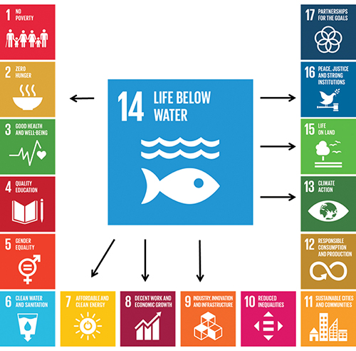
          - Implementation of SDG 14 will also play a part in achieving other SDGs.
United Nations Association of Norway/Ministry of Climate and Environment
The basis for the system of integrated ocean management plans was laid in the white paper Protecting the Riches of the Sea (Report No. 12 (2001–2002) to the Storting). Since then, the Storting (Norwegian parliament) has considered and approved management plans for all Norwegian sea areas. Norway has received a great deal of international recognition for its management plans, and a number of countries have developed or are developing their own systems for integrated, ecosystem-based ocean management. These processes have gathered new momentum as the concept of an integrated approach to ocean management that facilitates both value creation and protection of the marine environment has risen higher on the international agenda.
The UN Convention on the Law of the Sea is often referred to as the ‘constitution of the oceans’. The Convention regulates the rights and obligations of states as regards use of the seas and oceans, utilisation of marine resources and conservation of the marine environment. This ensures a predictable framework and stability for investments and economic activity. The Convention is vital for Norway with its strong energy, environmental, seafood and shipping interests. The Convention confers extensive rights on coastal states to utilise living marine resources and other resources on the continental shelf under its jurisdiction, and combines these with a duty to protect and conserve the marine environment. The combination of conservation and sustainable use of the marine environment is specified as the purpose of Norway’s system of ocean management plans.
There is growing international recognition that a sustainable ocean economy must be based on a good knowledge base and a sound marine management regime, together with action to address climate and environmental problems and steps to ensure that economic activity is sustainable.
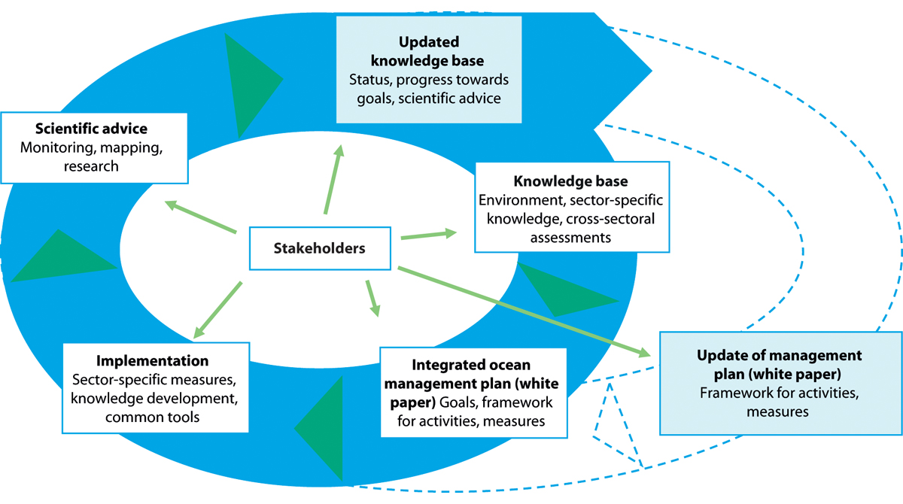
          - Ecosystem-based ocean management.
Norwegian Environment Agency

Norway’s system of integrated ocean management plans
The purpose of the management plans is to provide a framework for value creation through the sustainable use of marine natural resources and ecosystem services and at the same time maintain the structure, functioning, productivity and diversity of the ecosystems. The management plans are thus a tool both for facilitating value creation and food security, and for maintaining the high environmental value of Norway’s seas and oceans. They clarify an overall framework and encourage closer coordination and clear priorities for the management plan areas. Activities in each management plan area are regulated on the basis of existing legislation governing different sectors. The various sectoral authorities have the main responsibility for implementing the measures set out in the management plans, under relevant legislation that they administer.
Integrated, ecosystem-based ocean management is an approach to managing ecosystems and resources that involves finding a balance between use and protection of rich, productive ecosystems and the ecosystem services they provide, and thus promoting an equitable system of conservation and sustainable use. Ecosystem-based management uses available knowledge as a basis, and considers ecosystems as a whole, including people, when decisions are needed on ocean management and marine ecosystem management. The management plans implement an integrated, ecosystem-based management regime by evaluating the cumulative effects of all human activities on the marine environment and by managing the use of the oceans in a way that maintains the natural functions of ecosystems and ecosystem services. Ecosystem services are a vital basis for long-term value creation.
Norway’s ocean management plans are also integrated in the sense that they bring together all relevant parts of the public administration. Work on the management plans is coordinated by the interministerial Steering Committee for integrated ocean management, which is headed by the Ministry of Climate and Environment. Other ministries represented in the committee are the Ministry of Labour and Social Affairs, the Ministry of Finance, the Ministry of Defence, the Ministry of Justice and Public Security, the Ministry of Local Government and Modernisation, the Ministry of Trade, Industry and Fisheries, the Ministry of Petroleum and Energy, the Ministry of Transport and the Ministry of Foreign Affairs.
The management plans are knowledge-based. The scientific basis for the plans is drawn up by two advisory groups: the Forum for Integrated Ocean Management and the Advisory Group on Monitoring. The Forum for Integrated Ocean Management is headed by the Norwegian Environment Agency and is responsible for drawing up an overall scientific basis for updating and revising the management plans in cooperation with the Advisory Group on Monitoring. The Advisory Group on Monitoring (headed by the Institute of Marine Research) coordinates monitoring programmes for marine ecosystems and reports on environmental status in the management plan areas, see Figure 2.3.
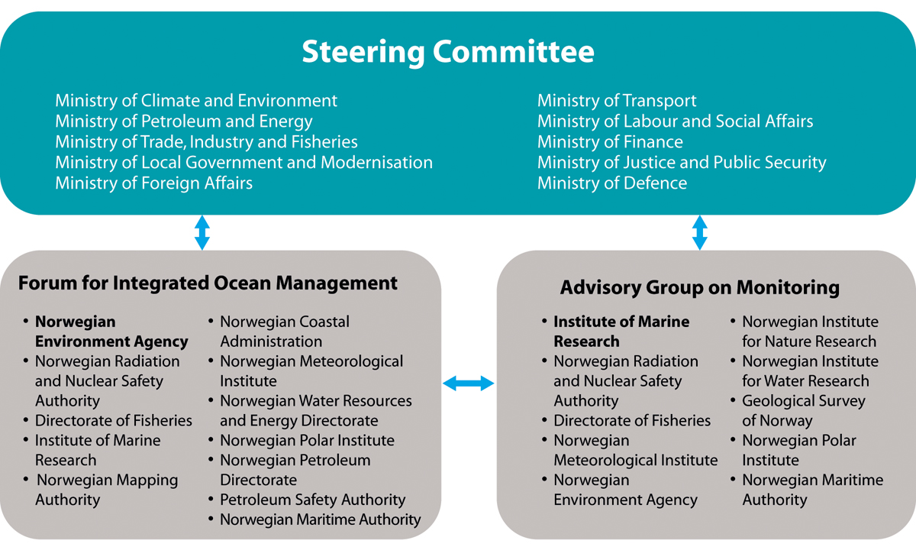
          - Organisation of the management plan work and government agencies represented in the Forum for Integrated Ocean Management and the Advisory Group on Monitoring.
Ministry of Climate and Environment
The management plan work does not specifically address important issues relating to safeguarding public and national security and maintaining emergency preparedness. However, sound ocean management, a clear framework for civilian and military activities and the availability of information for all stakeholders also contribute to clarity and predictability, and play a part in preventing accidents and maintaining crisis management capacity at sea.

The Government’s ocean policy
The Government is giving high priority to an active ocean policy and ocean-based commercial activities, both nationally and internationally. In spring 2017, the Government published its ocean strategy New growth, proud history and presented two white papers, The place of the oceans in Norway’s foreign and development policy (Meld. St. 22 (2016–2017)) and Update of the integrated management plan for the Norwegian Sea (Meld. St. 35 (2016–2017)).
In June 2019, the Government presented its updated ocean strategy, Blue Opportunities. The strategy highlights five key elements on which the Government’s ocean policy is based:
i) promoting, developing and defending the Law of the Sea;
ii) promoting conservation and sustainable use of marine ecosystems;
iii) contributing to knowledge-based management;
iv) supporting the implementation of international ocean-related instruments;
v) advocating an integrated approach to marine management that will underpin a sustainable ocean economy.
The Government has also taken important international ocean-related initiatives. In 2018, the High-level Panel for a Sustainable Ocean Economy was established. The Panel consists of heads of state and government from 14 countries, and is supported by the UN Secretary-General’s Special Envoy for the Ocean. The Panel is co-chaired by Norway’s Prime Minister and the President of Palau. Its members represent 30 % of the world’s total coastline, 30 % of its exclusive economic zones, 20 % of the world harvest from the oceans and 20 % of the shipping in the world fleet. The purpose of the Panel is to create international awareness of the economic importance of the oceans, and an understanding that sustainable use of marine resources and safeguarding a healthy marine environment must be the foundation for increasing value creation. The need for integrated ocean management occupies a central place in the Panel’s work, and was also a vital part of the backdrop to the Our Ocean conference that Norway’s Minister of Foreign Affairs hosted in Oslo in October 2019.

White paper on all Norway’s integrated ocean management plans
In this white paper, the Government describes how it intends to continue and consolidate Norway’s integrated, ecosystem-based ocean management plan system. The white paper brings together all three management plans for the first time. It includes a revised management plan for the Barents Sea–Lofoten area and updated management plans for the Norwegian Sea and the North Sea and Skagerrak. The white paper does not cover the waters off Bouvet Island or the Norwegian dependencies in Antarctica.
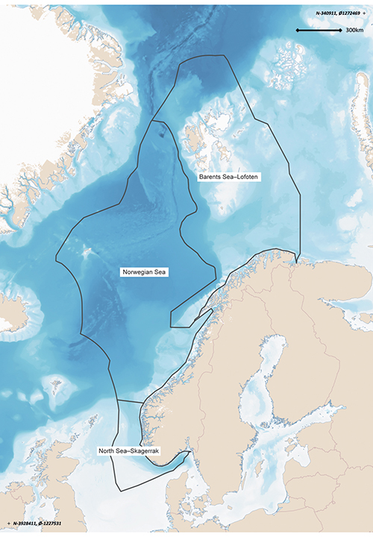
          - Map of the three management plan areas: the Barents Sea–Lofoten area, the Norwegian Sea and the North Sea and Skagerrak.
Norwegian Environment Agency
This white paper also follows up three requests from the Storting to the Government: a request dated 18 June 2015 to present an overall revision of the management plan for the entire Barents Sea–Lofoten area in the ordinary way, a request dated 14 June 2017 to present a scientifically based update of the delimitation of the whole marginal ice zone, including the West Ice, in connection with the revision of the management plan for the Barents Sea–Lofoten area, and a request dated 14 June 2017 for a new definition of the marginal ice zone if appropriate as part of the revision of the same management plan.
The overall scientific basis for this white paper consists of eleven reports on various topics from the Forum for Integrated Ocean Management and reports on environmental status in the three management plan areas from the Advisory Group on Monitoring (see Figure 2.5 and Appendix 1). In addition, the Management Forum commissioned reports giving an account of updated knowledge about the marginal ice zone and the polar front. Together, these documents constitute a status report on ecosystem-based management of Norway’s seas and oceans. A report summarising the overall scientific basis for the management plans has also been compiled. The reports are available to the public, and in most cases consultations, conferences and seminars have been organised during their preparation. A conference was also organised during preparation of the white paper to give stakeholders an opportunity to provide input, and written input was invited after the conference. All written input to the white paper is available on the Ministry of Climate and Environment’s website on regjeringen.no.
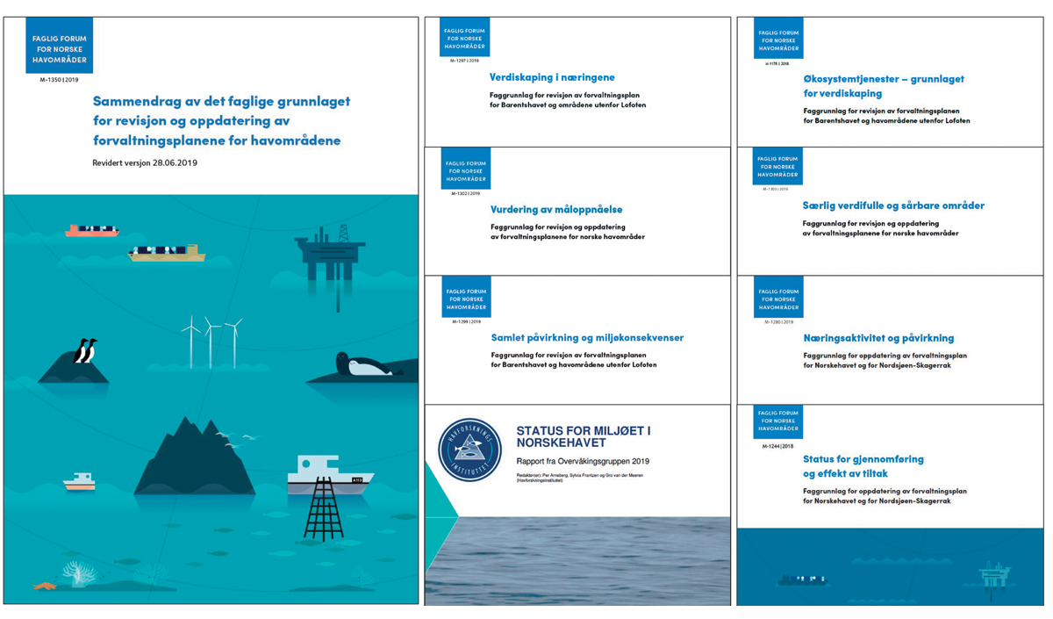
          - Some of the reports that are included in the scientific basis for the management plans (available in Norwegian only).
Forum for Integrated Ocean Management
The main emphasis for many of the topics discussed in this white paper is on changes and trends in the years after publication of the previous white papers on each management plan area. More thorough discussions of state, trends and measures for certain topics, such as marine litter and plastic pollution, can therefore be found in earlier white papers. Some topics and measures that were described in earlier white papers for individual management plan areas are relevant more generally, and are also discussed in the present white paper.
Structure of the white paper
Chapter 3 of the white paper gives an account of environmental status in the management plan areas, focusing on changes and trends. It also includes a review of progress towards the targets set out in the earlier management plans, based on measures that have been implemented. Chapter 4 describes changes that are taking place in the oceans at global level as a result of climate change and biodiversity loss, and what the implications may be for Norway’s seas and oceans. In addition to the scientific basis for the management plans, the chapter draws extensively on the IPCC Special Report on the Ocean and Cryosphere in a Changing Climate, published in September 2019, and the global assessment report published by the Intergovernmental Science-Policy Platform on Biodiversity and Ecosystem Services (IPBES) in May 2019. Chapter 5 gives an account of ocean-based industries and forecasts of their development. There has been some reorganisation of this chapter, and it is now structured more around ocean ecosystem services that form the basis for commercial activities and value creation than was the case in earlier white papers. The chapter also includes a brief description of the green transformation that is taking place in several ocean industries and of the establishment of new industries as a way of achieving the Government’s climate targets.
Chapter 6 assesses the risk of acute pollution from shipping and petroleum activities, describes the preparedness and response system, and discusses the risk of acute radioactive pollution. Chapter 7 describes Norway’s spatial management policy for the oceans, and Chapter 8 gives an account of relevant international cooperation on ocean management as a follow-up to the white paper The place of the oceans in Norway’s foreign and development policy. Chapter 9 describes the overall framework and measures for conservation and sustainable use of ecosystems in the management plan areas adopted by the Government.

Norway’s goals for integrated ocean management
As part of the integrated ocean management plans, goals have been set for the Government’s ocean policy and for management of the three management plan areas. These goals concern environmental status, value creation, coexistence between ocean industries, conservation and sustainable use.
Previously, the wording of the goals has varied to some extent between the different management plan areas, and some goals have only applied to one of the areas. In this white paper, the goals have been harmonised so that they all apply to all three management plan areas. In some cases, they have been clarified and simplified to facilitate reporting on progress towards the goals.
The following are the Government’s goals for management of the management plan areas:
Value creation, commercial activities and society
General goals
- Norway’s ocean management will promote sustainable use of ecosystems, areas and resources that ensures long-term value creation, employment and people’s welfare, to the benefit of Norway’s regions and the country as a whole.
- The ocean industries will continue to promote value creation and secure welfare and business development to the benefit of the country as a whole.
- Management of commercial activities in the management plan areas will be coordinated to ensure that the various industries are able to coexist and that the overall level of activity is adjusted to take account of environmental considerations.
Fisheries and seafood
- Living marine resources will be managed sustainably through the ecosystem approach.
- Norway’s seas and oceans will be a source of safe seafood.
- Harvesting activities and natural resource use that provide a high long-term yield within sustainable limits will be facilitated.
Petroleum activities
- Steps will be taken to facilitate the long-term profitable production of oil and gas. Petroleum activities will be carried out within a predictable framework and on the basis of health, environment and safety requirements and standards that are adapted to environmental considerations and the needs of other industries.
Offshore renewable energy
- The development of offshore renewable energy production will be facilitated, taking into account environmental considerations and other activities.
Maritime transport
- Favourable conditions will be provided for safe, secure, effective and environmentally friendly maritime transport.
Biodiversity and ecosystems
General goals
- Norway’s seas and oceans will be managed in a way that maintains diversity at ecosystem, habitat, species and genetic levels, and the productivity of ecosystems. Human activity in the management plan areas will not damage the structure, functioning or productivity of ecosystems.
Management of particularly valuable and vulnerable areas
- In particularly valuable and vulnerable areas, activities will be conducted with special care and in such a way that the ecological functioning and biodiversity of these areas are not threatened.
- The management regime will take special account of the need to protect vulnerable habitat types and species in particularly valuable and vulnerable areas.
Species and habitat management
- Naturally occurring species will exist in viable populations that provide for sufficient reproductive capacity and long-term survival.
- Species that are essential to the structure, functioning, productivity and dynamics of ecosystems will be managed in such a way that they are able to maintain their role as key species in these ecosystems.
- Harvested species will be managed within safe biological limits so that their spawning stocks have good reproductive capacity.
- Populations of endangered and vulnerable species and species for which Norway has a special responsibility will be maintained or restored to viable levels.
- The introduction and spread of alien organisms through human activity will be avoided.
- In marine habitats that are particularly important for the structure, functioning, productivity and dynamics of ecosystems, activities will be conducted in such a way that all ecological functions are maintained.
- Damage to marine habitats that are considered to be endangered or vulnerable will be avoided.
Sustainable harvesting
- Management of living marine resources will be based on the principles of sustainable harvesting.
- Harvesting will not have significant adverse effects on other parts of the marine ecosystem or its structure.
- Bycatches of marine mammals and seabirds will be minimised.
- Living marine resources will be harvested making use of the best available techniques for different types of gear to minimise negative impacts on other ecosystem components such as marine mammals, seabirds and benthic communities.
- Management of fish stocks and other biological resources will be adapted to a changing climate so that stocks are maintained at sustainable levels.
Marine protected areas
- A representative, ecologically coherent network of well-managed marine protected areas will be established in Norwegian waters.
Climate change and ocean acidification
- When marine ecosystems are used as carbon sinks, the need to maintain biodiversity and natural ecosystem functions will be taken into account.
- The cumulative effects of human activities on habitats and species that are adversely affected by climate change or ocean acidification (e.g. coral reefs) will be minimised, in order to maintain ecosystem functioning as fully as possible.
Pollution, marine litter and the risk of acute pollution
General goals
- Releases and inputs of pollutants to the management plan areas will not result in injury to health or damage the productivity of the natural environment and its capacity for self-renewal. Activities in these areas will not result in higher levels of pollutants in seafood.
Hazardous and radioactive substances
- Environmental concentrations of hazardous and radioactive substances will be reduced to background levels for naturally occurring substances and will be close to zero for synthetic substances. Releases and inputs of hazardous or radioactive substances will not cause these levels to be exceeded.
- Releases and use of substances that pose a serious threat to health or the environment in the management plan areas will be continuously reduced with a view to eliminating them.
- Operational discharges from activities in the management plan areas will not result in damage to the environment, higher levels of pollutants in seafood, or elevated background levels of oil, naturally occurring radioactive substances or other environmentally hazardous substances over time.
Inputs of nutrients, sediment deposition and organic material
- Anthropogenic inputs of nutrients, sediment deposition and inputs of organic matter will be limited in order to avoid significant adverse impacts on biodiversity and ecosystems in the management plan areas.
Marine litter
- Inputs of waste and microplastics to the management plan areas will be avoided.
- Waste quantities in marine and coastal areas will be reduced by means of clean-up operations where appropriate.
Underwater noise
- Activities entailing a noise level that may affect species’ behaviour will be limited to avoid the displacement of populations or other effects that may have negative impacts on the marine ecosystem.
Risk of acute pollution
- The risk of damage to the environment and living marine resources from acute pollution will be kept at a low level, and continuous efforts will be made to reduce it further.
- The high safety level in maritime transport will be maintained and strengthened.
- The governmental preparedness and response system for acute pollution will be adapted to and dimensioned on the basis of the level of environmental risk at any given time.
              - Classification system for assessment of ecological status
The classification system for assessment of ecological status will be used as a basis for an overall, knowledge-based assessment of the status of Norway’s major ecosystems. The system will be based on a set of scientific indicators and on available scientific knowledge about status and trends in Norwegian ecosystems.
In ecosystems where ecological status is good, ecosystem structure, functioning and productivity do not deviate significantly from those of intact ecosystems. Both ‘intact ecosystems’ and ‘good ecological status’ are defined on the basis of scientific knowledge and criteria.
Seven properties have been identified that can be used to characterise ecosystems where ecological status is good. These are primary production, biomass at different trophic levels, functional groups of organisms, functionally important species and structures, ecological patterns at landscape level and abiotic conditions. A general assessment of ecological status is made with respect to each of these properties, and these are used as a basis for assessing the overall ecological status of the ecosystem as a whole.
The system for assessing the ecological status of marine ecosystems will be used together with the goals and indicators established as part of the ocean management plans, and will complement them. The need for any adjustments to ensure the best possible coherence between goals and indicators will be considered later.
Pilot tests of the system have already been carried out, for example for the ecosystem in the Arctic part of the Barents Sea. Development of the system is continuing.
[Boks slutt]
The Norwegian Environment Agency is coordinating the development of a classification system for ecological status in all ecosystems (except for ecosystems in inland and coastal waters; these are already covered by the classification system used under the Water Management Regulations, which implement the EU Water Framework Directive in Norwegian law). The classification system for marine ecosystems will be established as part of the work on the ocean management plans. The Norwegian Institute of Marine Research is heading the subgroup for this part of the work. The knowledge generated will supplement the scientific basis for the management plans and will be integrated into the work of the Forum for Integrated Ocean Management. The first assessment of ecological status for all Norway’s sea and ocean areas is expected to be completed in the course of 2021. This will make it possible to further refine and supplement the goals for the management plans.

Environmental status and trends in Norwegian waters
Environmental status in Norway’s rich, productive seas is in many respects good, but climate change is having growing impacts, and is clearly affecting the status of ecosystems in both the North Sea and the Barents Sea. In the North Sea, rising temperatures have resulted in changes in the zooplankton community and a less productive ecosystem but with higher species diversity. Species in the existing fish community may be displaced by others spreading from further south. In the Barents Sea, rising temperatures and the loss of sea ice have resulted in a rise in overall primary production, and in large parts of the management plan area, Arctic species are being displaced by more southerly species. Major changes are taking place in the ecosystem in the northern part of the Barents Sea. No such marked shifts have been registered in the Norwegian Sea, but some changes have been observed, which in the case of zooplankton can be linked to climate variability.
The ocean climate is influenced both by anthropogenic climate change and by natural variability, which can both upward and downward temperature fluctuations. Anthropogenic climate change is causing a long-term trend of rising temperatures. However, there can be considerable natural variability between years and between decades, and it is generally much larger than anthropogenic change on these time scales. In the longer term, global warming will nevertheless result in rising sea temperatures and further loss of ice cover, with major ecological impacts.
In the Barents Sea, climate change has already resulted in long-term trends of rising sea temperatures, shrinking ice cover and large-scale ecological changes, especially in the northernmost areas. So far, ocean acidification has not been registered in the Barents Sea. Apart from climate change, human activity has resulted in only minor environmental changes since 2011. The fish stocks in the Barents Sea are generally sustainably managed, and pressures on the ecosystem from activities within the management plan area are within acceptable long-term limits.
In the Norwegian Sea, the water temperature has risen as a result of climate change, and acidification has been registered. The changes observed in the species composition of zooplankton and fish communities are not as extensive as those recorded in waters further north and south, but the data for the Norwegian Sea are not as complete. There has been some variability in zooplankton and fish production, but this is now relatively high for many species, while fishing pressure has decreased since the turn of the century. Inputs of pollutants are generally stable or declining. Many seabirds have suffered a dramatic population decline since the early 1980s. Since 2006, observations of southerly species of zooplankton in the Norwegian Sea have been increasing. These are species that are common in the North Sea or further south and were previously not normally found in the Norwegian Sea.
In the North Sea and Skagerrak, climate change has been causing significant warming since as long ago as the late 1980s. The water temperature is still high, and there has been a continuing spread of southerly zooplankton species, with substantial impacts on the rest of the ecosystem. There has been a considerable decline in kelp forests in the Skagerrak in recent decades. Marine heatwaves when water temperatures are abnormally high in summer have been an important contributory factor in this decline. Many fish stocks have grown considerably in recent years, while levels of pollutants have generally remained unchanged or declined.
Impacts on an ecosystem may be linked to direct pressures and physical disturbance of the ecosystem or to large-scale processes such as climate change. The cumulative impacts on an ecosystem are the result of a range of pressures acting on it. A combination of several pressures acting together may result in more severe impacts on marine ecosystems. For example, warming of the oceans and inputs of nutrients together worsen problems related to oxygen depletion, and warmer seas and ocean acidification in combination damage coral reefs more severely than either of these factors alone.
The effects of different human activities on biodiversity are assessed using an ecosystem approach and following the principle that cumulative impacts must be assessed. To assess the cumulative impacts of a range of direct anthropogenic drivers, it is important to understand the interactions between them. Our knowledge of these interactions is limited at present, but the situation is improving. In addition to information about existing drivers, it is important to have a sound knowledge of likely environmental impacts of rising activity levels and emerging industries. We can be reasonably certain that the pressures and impacts related to climate change and ocean acidification will become considerably greater. Chapter 4 describes what is already known about the probable main features of these pressures and impacts. However, there is more uncertainty about how species and ecosystems will be affected at regional and local level. Considerable challenges are expected to arise as a result of interactions between the expected impacts of climate change and ocean acidification, and the more direct local and regional impacts of human activity at sea and along the coast. Some drivers, such as hazardous substances, ocean acidification and climate change, can influence larger areas and all trophic levels in an ecosystem. Climate change also influences how hazardous substances spread and the environmental behaviour of these substances. Organisms that are already under pressure are often more vulnerable to other pressures or an increase in cumulative impacts.
Particularly valuable and vulnerable areas
Particularly valuable and vulnerable areas are identified on the basis of scientific assessments as being of great importance for biodiversity and biological production in an entire management plan area. They are selected using predefined criteria, the main ones being that the area concerned is important for biodiversity or for biological production. The designation of areas as particularly valuable and vulnerable does not have any direct effect in the form of restrictions on commercial activities, but indicates that these are areas where it is important to show special caution.
New knowledge has been obtained about species, habitats and vulnerability in the particularly valuable and vulnerable areas. Research, mapping and monitoring has confirmed the high environmental value of a number of these areas. However, the ongoing review of all the particularly valuable and vulnerable areas has shown that the environmental value and vulnerability of several areas should be further assessed. As part of its work on the scientific basis for the management plans, the Forum for Integrated Ocean Management will review the particularly valuable and vulnerable areas using the same methodology for describing valuable species and habitats and assessing vulnerability.
In the Barents Sea–Lofoten management plan area, areas of particular value have been identified adjoining several of the existing particularly valuable and vulnerable areas. They have been identified on the basis of new knowledge about seabird distribution and habitat use, and are considered to be candidates for inclusion in the system of particularly valuable and vulnerable areas. Mapping of seabird habitat use has revealed that the areas they use when foraging in the open sea extend further out from the coast than previously thought, up to 100 km from the breeding colonies.
As it continues its review of particularly valuable and vulnerable areas, the Forum for Integrated Ocean Management will also consider the candidate areas that have been identified and review the boundaries of the current particularly valuable and vulnerable areas. The criteria for assessing which areas qualify as particularly valuable and vulnerable will be harmonised for all three management plan areas, and the approach used will be similar to that used in corresponding work under the Convention on Biological Diversity to describe their ecological and biological value, and will use the same criteria as those for identifying Ecologically or Biologically Significant Marine Areas (EBSAs). This work will include vulnerability assessments for the candidate areas and descriptions of current human activities and their specific implications for vulnerability.

Environmental status in the Barents Sea–Lofoten management plan area
The state of the environment in the Barents Sea–Lofoten area is generally good. The dominant trends are rising temperatures and shrinking ice cover. These have further intensified since the management plan was updated in 2011. In response to the changing climate, the ecosystem in northern parts of the management plan area, primarily north of the polar front, is undergoing major change. Except for climate change, pressures on the Barents Sea ecosystem are within sustainable limits, and the cumulative impacts of human activities within the management plan are small. As a result of climate change and lower fishing pressure, some species, and particularly the cod stock, have expanded their range in the Barents Sea. At the same time, suitable habitat for Arctic species such as polar cod (Boreogadus saida) has become more restricted.

Oceanic climate change in the management plan area
A prominent characteristic of the Barents Sea ecosystem is the long-term rising trend in sea temperature over the past 40 years, although with marked variations.
Temperature, sea ice and ecosystem change
In the Barents Sea, it is apparent that global warming is resulting in a long-term rising trend in sea temperature. However, there can be substantial natural fluctuations between years and between decades. The combination of global warming and natural fluctuations is resulting in a long-term temperature rise, and both the maxima and minima of the natural fluctuations are gradually rising. Water temperatures in the Barents Sea were high in the 1940s and low in the late 1970s, but have risen considerably since then. In the past five to six years, there has again been some decrease in temperature (Figure 3.1). In parallel with the long-term temperature rise, sea ice cover has been declining. The ice has also become thinner, and there has been a sharp reduction in areas of multi-year ice. In addition, sea ice is forming later in autumn and thawing earlier in spring, giving a longer and longer ice-free period. Major ecosystem changes have been taking place in recent years in response to the changes in temperature and ice cover. The distribution of Atlantic and more southerly species is shifting northwards and eastwards from the southwestern part of the Barents Sea. The scale of ecosystem change is greatest north of the polar front, the zone where Atlantic water flowing polewards meets Arctic water flowing south.
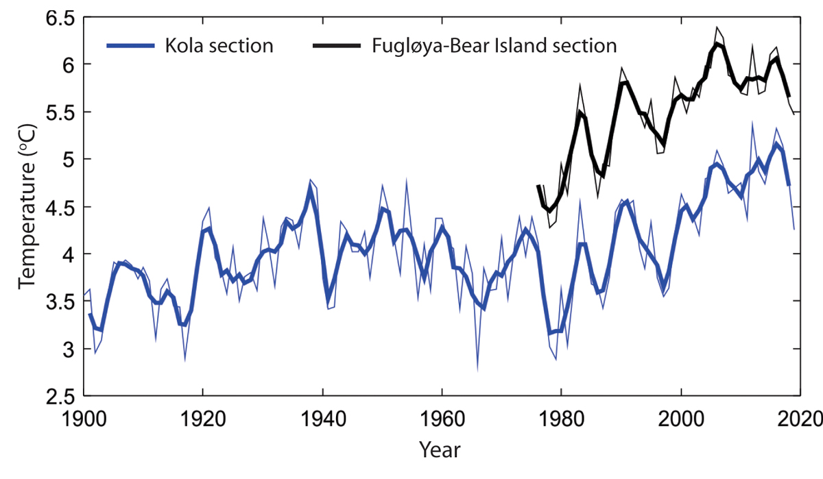
          - Temperature changes in the Barents Sea from 1900 to 2019. Temperature in the centre of the Atlantic inflow, depth 50–200 m for the Fugløya–Bear Island section (black), and depth 0–200 m for the Kola section (blue). Annual values are shown as thin lines and the three-year rolling mean as thick lines.
Institute of Marine Research and Russian Federal Research Institute of Fisheries and Oceanography (PINRO)
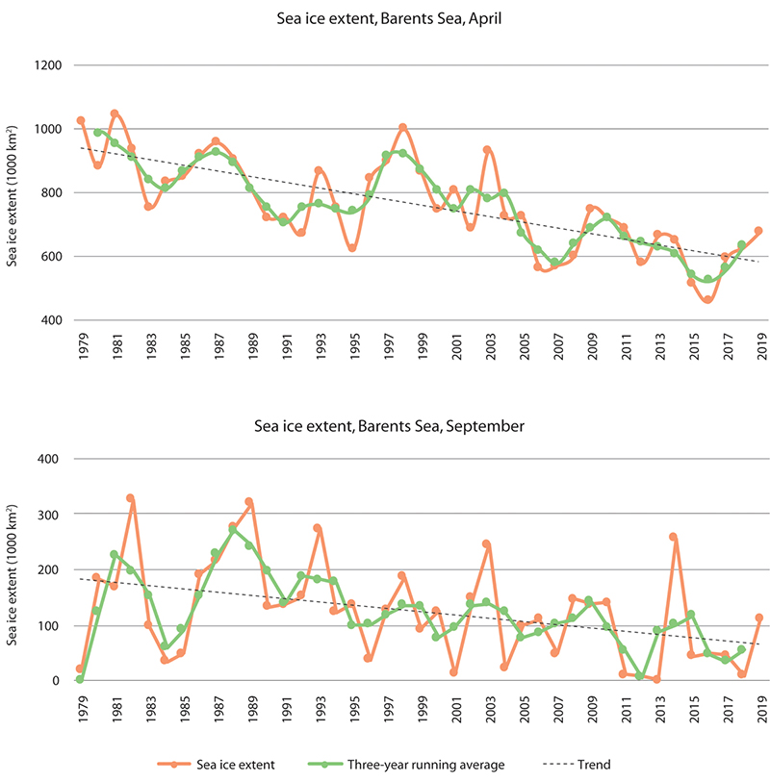
          - Trends in sea ice extent in the Barents Sea in April (upper panel) and September (lower panel) in the period 1979–2019. The data are shown as monthly means for each year (green line), three-year running averages (orange line) and the linear trend for the whole period (black dotted line). There are large interannual variations, but also a clear negative trend through the period.
Norwegian Polar Institute/Environmental monitoring of Svalbard and Jan Mayen (MOSJ)
Changes in the distribution of various species have resulted in structural changes in food webs (which represent feeding relationships between species in an ecosystem). The cod stock has been at a high level for the last 10 years, and its changing distribution has been particularly important for both the ecosystem and the fisheries. With rising temperatures and the declining extent of sea ice, cod have spread all the way to the northern and eastern boundaries of the Barents Sea in certain years recently. This has increased predation pressure on polar cod and other Arctic species in these areas. As a result, the Arctic fish species are now largely confined to a small area in the far north of the Barents Sea (Figure 3.4). A number of southerly species of benthic invertebrates and jellyfish have also been registered further north and east in the Barents Sea.
The Barents Sea ecosystem is naturally dynamic, and one consequence of this has been that the capelin stock, which is a key ecosystem component, has collapsed several times (Figure 3.3). Other important trends are the decline of a number of seabird populations, the growth of certain populations of marine mammals that have been protected for many years, and the spread of snow crabs into the Barents Sea.
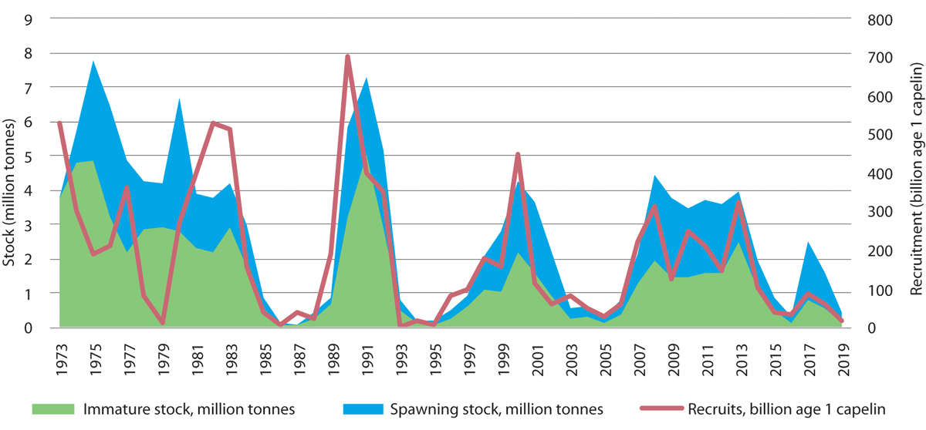
          - Estimated size of and recruitment to the Barents Sea capelin stock.
Institute of Marine Research
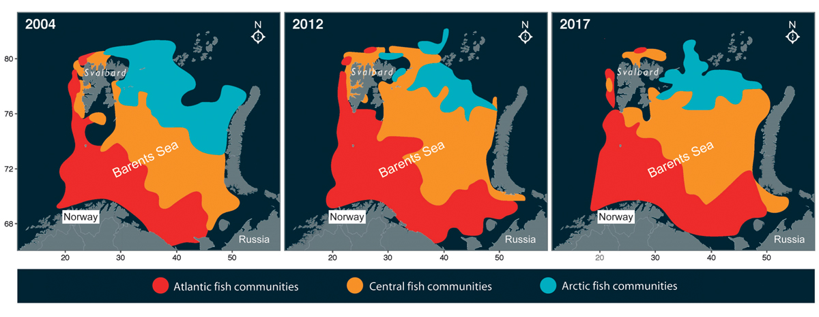
          - Changes in the distribution of Atlantic, central and Arctic fish communities in the Barents Sea from 2004 to 2017. The axes show longitude and latitude.
Institute of Marine Research
Rising temperatures and shrinking sea ice cover have also resulted in changes in production and biomass in the ecosystem. Total primary production (phytoplankton) has risen, and biomass in the pelagic part of the ecosystem has almost doubled, mainly as a result of the increasing biomass of Arctic krill species (zooplankton) (Figure 3.5). Growing numbers of southerly krill species have also been observed, and a decline in the quantity of lipid-rich Arctic zooplankton species. This is expected to have impacts on Arctic predators such as the polar cod.
The decline in sea ice has also had direct negative impacts on ice-associated species, for example ringed seal, polar bear and a number of other species groups that live in and on the ice, including ice algae, crustaceans and polar cod. As the area of suitable habitat available to many of these species declines, they may disappear from larger and larger areas of the Arctic. The Barents Sea is one of the areas where this is expected to happen most quickly, because of the rapid loss of sea ice in both summer and winter.
There may also be adverse impacts on benthic animals. When sea ice is present, ice algae attached to the underside of the ice contribute a share of primary production. When the ice melts in spring, much of this biomass sinks to the seabed, where it provides food for the benthic fauna. In an area that no longer has seasonal ice cover, the main primary producers are the phytoplankton, which are to a greater extent food for organisms in the water column, such as zooplankton, and thus form the basis of a pelagic food chain. A decline in the quantity of nutrients sinking to the seabed is therefore expected as the sea ice cover shrinks. As the ice becomes thinner, algal blooms are occurring even under the ice cover, which may compensate to some extent for the reduction in the biomass of ice algae.
Climate models indicate that there will be a continued rise in temperature and loss of sea ice in the years ahead. The changes are expected to be smallest up to the 1930s and accelerate up to 2060. Several models predict very limited amounts of sea ice in the Barents Sea by 2100. For this time horizon, the climate models also indicate that trends in greenhouse gas emissions will be of crucial importance for sea ice cover and thus for the impacts on species associated with sea ice.
Ocean acidification
Ocean acidification has been included in the Barents Sea monitoring programme since 2010. At present, only physico-chemical parameters are monitored, as is the case for the other management plan areas, but work is in progress to establish monitoring of biological effects in addition. So far, monitoring of acidity (pH) and dissolved CO2 in the Barents Sea has not confirmed that the CO2 content is rising, as has been observed in the Norwegian Sea. Because ocean chemistry is naturally very variable in the Barents Sea, longer time series will be needed to reveal acidification than in many other marine areas.
Since no changes in the level of dissolved CO2 have been observed, there are no documented ecological effects of acidification in the Barents Sea. The response to acidification is expected to differ greatly between species. In the long term, species that are tolerant to or benefit from increasing acidification will dominate, which may result in changes in species composition in the ecosystem. This in turn may have implications for ecosystem functioning.
Recent modelling suggests that ocean acidification will increase and there will be a steady decline in pH during this century. The estimated changes in acidity in the Nordic seas and the Arctic up to 2065 involve abrupt changes in pH level, in contrast to a stable pH level for many millions of years before that. The largest changes are expected in the Barents Sea, in the waters around Svalbard and in the Arctic Ocean.
Adult fish are expected to be resilient to ocean acidification, whereas reproduction and early life stages, for example cod and herring larvae, are potentially more sensitive.
Because of responses vary between species, ocean acidification may have impacts both on interspecific competition and on the relationships between different trophic levels in food chains. Such changes may cause ecological cascades throughout the system.
Other anthropogenic pressures acting together with acidification may also have implications for impacts on species and changes in ecosystems. This makes it important to consider the combined effects of ocean acidification and other pressures, for example rising temperatures.

Trends in various components of the Barents Sea-Lofoten ecosystem
Ecosystem trends in the Barents Sea–Lofoten area are described, mainly on the basis of state and pressure indicators for the area.
Plankton and sea ice biota
The rising temperatures and shrinking sea ice cover have resulted in changes in ecosystem production and biomass. Overall primary production has risen, and biomass in the pelagic part of the ecosystem has almost doubled, mainly as a result of rising quantities of krill. There have also been observations of growing numbers of southerly krill species. Considerable reductions in quantities of Arctic mesoplankton have been recorded since about 2004 in an area in the southwesterly Barents Sea where this parameter is monitored. Quantities of the Arctic amphipod Themisto libellula, which is a key species in the Arctic part of the Barents Sea, have also declined as the inflow of cold Arctic water has decreased.
Changes in the distribution and quantities of Atlantic and Arctic species in the Barents Sea may have wider effects in the ecosystem. Declining quantities of lipid-rich zooplankton species, for instance, are expected to have impacts on Arctic predators, which are highly dependent on lipid-rich prey. For example, Themisto libellula is an important prey species for polar cod.
The loss of sea ice has had direct negative effects on ice-associated fauna such as ice algae, amphipods and other crustaceans. When sea ice is present, ice algae attached to the underside of the ice contribute a share of primary production. When the ice melts in spring, much of this biomass sinks to the seabed, where it provides food for the benthic fauna. In an area that no longer has seasonal ice cover, the main primary producers are the phytoplankton, which are to a greater extent food for pelagic organisms such as the zooplankton. A decline in the quantity of nutrients sinking to the seabed is therefore expected as the sea ice cover shrinks. This may have negative impacts on the benthic fauna.
Fish stocks
In response to climate change, the ecosystem in northern parts of the management plan area, primarily north of the polar front, is undergoing major change. The distribution of northerly species such as cod and haddock has expanded considerably northwards and eastwards. The cod stock is at a high level, and the haddock stock is above the long-term average. Fishing pressure on the cod stock has been reduced.
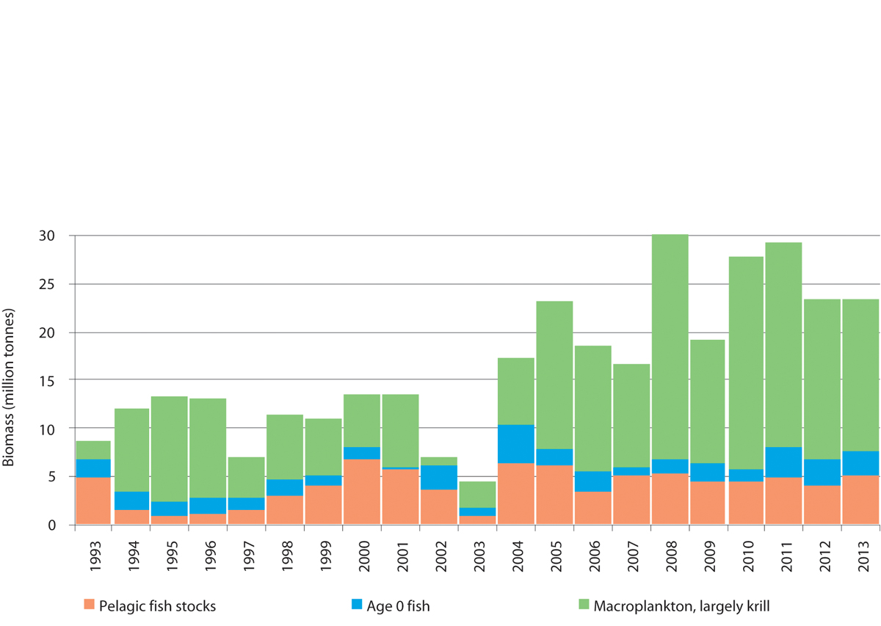
          - Estimated biomass of the pelagic component of the Barents Sea ecosystem from 1993 to 2013.
Institute of Marine Research
The golden redfish stock is at a low level because of earlier overfishing, while the beaked redfish stock has shown a positive trend in recent years. The golden redfish stock is still declining, and is now smaller than has ever before been registered. The species is classified as endangered on the 2015 Norwegian Red List, which includes species that are assessed as being at risk of extinction within Norway.
Seabirds
Populations of several of the most abundant seabird species in the Barents Sea have been declining for many years. They include common guillemot and kittiwake along the Norwegian mainland coast and Brünnich’s guillemot and puffin in all or most of the Norwegian part of the Barents Sea. After a population collapse due to a lack of food in winter 1986/87, populations of the three more southerly pelagic auk species – razorbill, puffin and common guillemot – have grown strongly and shown signs of recovery, especially on Bjørnøya. In Finnmark, numbers at the breeding colonies are still much smaller than they used to be. However, the Brünnich’s guillemot population is declining rapidly, and there has been a population decline of between 25 and 50 % since 1990 for Svalbard including Bjørnøya. If this trend continues, it is very probable that the Svalbard population of Brünnich’s guillemot will decline to such a low level that there is no prospect of its recovery in the next 50 years. New results also show that Brünnich’s guillemots in Svalbard stand out as being particularly vulnerable to an abrupt population decline.
              - Seabird migration patterns – importance of the Barents Sea in autumn
Seabirds from breeding colonies around the Barents Sea and Norwegian Sea are being tracked by the SEATRACK project (http://seatrack.seapop.no/map/), which has shown that the Barents Sea is more important for a number of seabird populations than was previously thought. Puffins are one example – birds from colonies are far south as Runde near Ålesund move to the Barents Sea after the breeding season, as shown on the map below. They remain in the area in the autumn months, August–October, and mix with birds from other colonies in mainland Norway, Svalbard and probably Russia. The Barents Sea is also important for common guillemots, as a foraging and moulting area for birds from populations as far south as the east coast of Scotland and as far west as Jan Mayen. The SEATRACK project tracks seabird movements using light-loggers, or GLS loggers, which are attached to a leg ring with cable-ties. Using this technology over large geographical areas and collecting long time series of data is the most cost-effective method for obtaining information on the importance of Norwegian waters for different seabird species and populations, and how dynamic the patterns of use are over time. Studies using logger technology make an important contribution to more ecosystem-based management of marine ecosystems.
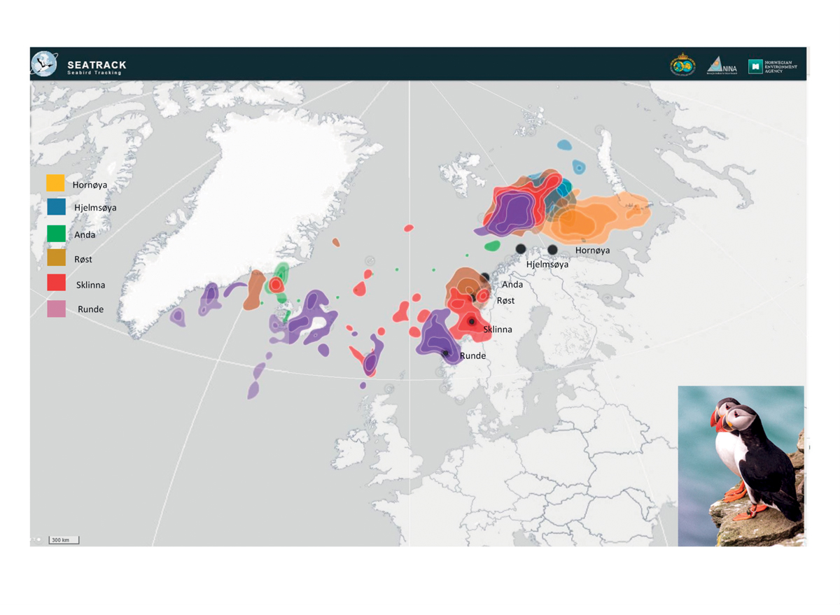
          - Distribution of puffins from six colonies along the mainland coast of Norway in the period August–October 2017, based on tracking data from light-loggers. The Barents Sea is an important moulting and nursery area for several seabird species in autumn.
SEATRACK
[Boks slutt]
With the rising sea temperatures, the Arctic food web is being replaced by a more southerly food web. This may be one of the reasons why Arctic seabird species (Brünnich’s guillemot and little auk) are declining, while numbers of more southerly species such as puffin, common guillemot and razorbill are increasing. Food supplies in the breeding season are an important factor, and it has been established that the decline in seabird populations is linked to food shortages. It is difficult to conclude definitely what is causing changes in food supplies, but secondary impacts of climate change and lower production of prey species have been suggested as possible factors. In addition, conditions in wintering areas for seabirds may be important. Harvesting of fish stocks has previously been considered as a possible reason for seabird decline, but is now believed to be of minor importance. Large populations of herring and mackerel may compete for food with seabirds. It is essential to ensure that seabirds, and many other predators in marine ecosystems, have adequate food supplies in the form of small plankton-feeding fish (fish larvae and small schooling fish species) and larger zooplankton such as Arctic krill species. In coastal waters, healthy kelp forests are vital for seabirds and other biodiversity and biological production. A number of seabird species are red listed. The situation of seabird populations was further discussed in the white paper Nature for life (Meld. St. 14 (2015–2016)).
New knowledge obtained through the SEAPOP mapping and monitoring programme for seabirds, including the SEATRACK module for their non-breeding distribution, shows that pelagic species such as the common guillemot, Brünnich’s guillemot, puffin and kittiwake use larger areas when foraging than previously thought, at times up to 100 km out to sea from the breeding colonies.
The seabird mapping and monitoring programme is expected to generate a considerable amount of new information about habitat use by these species outside the breeding season, and provide better data for the breeding season as well.
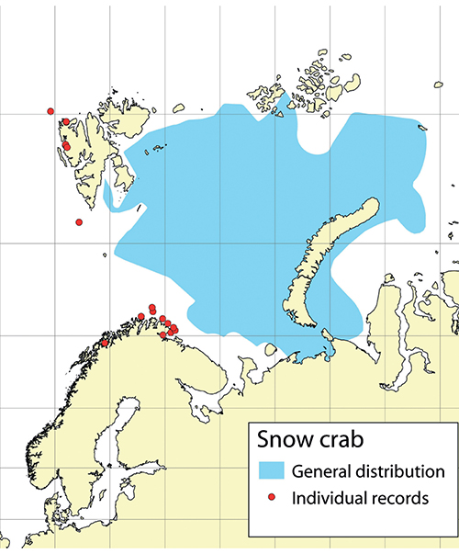
          - Distribution of snow crab in the Barents Sea and individual records outside this area, based on data up to the end of 2019.
Institute of Marine Research
Benthic fauna
There has been considerable variability in benthic biomass in different parts of the Barents Sea in recent years. Snow crabs were first registered in the Barents Sea in 1996, near Novaya Zemlya, and the species has been spreading westwards since then. It is likely to become established in much of the northern Barents Sea. The first snow crabs were recorded off the coast of Finnmark in 2005 and off Svalbard in 2011, and they are now widespread in most of the Barents Sea, with the highest densities in its central part. The population has now expanded to all suitable habitat on the Norwegian continental shelf. Numbers could potentially become high, and the snow crab could become an important predator and prey species in the Barents Sea ecosystem. A Russian study has shown that other benthic biomass decreases in areas where snow crab numbers have been high for several years. There has been uncertainty as to whether snow crabs were introduced in the Barents Sea or expanded their range naturally. On the basis of genetic analyses and records of snow crab from several localities between the Barents Sea and the Bering Strait, scientists now believe that snow crabs may have spread naturally westwards from the Bering Strait to the Barents Sea. The distribution of snow crabs is expected to correspond to areas where the temperature of the bottom water is suitable. The snow crab prefers lower water temperatures than for example the red king crab, and its is therefore likely to have a more northerly and easterly distribution. Although snow crabs are most numerous in the open sea, there have been individual records of snow crabs in coastal waters off eastern Finnmark.
The red king crab population is stable, and harvesting is unrestricted west of 26° E, which appears to be effectively limiting the westward spread of the species at present. However, red king crab is being taken as a bycatch in several areas in Troms. It already appears to be breeding in Balsfjorden south of Tromsø. It is uncertain how far south the species will become established. The Norwegian Biodiversity Information Centre has placed the red king crab in the category ‘very high risk’ in its Black List of invasive alien species, because it is considered to have high invasion potential and may have major ecological effects.
The population of cold-water shrimps in the Barents Sea has grown considerably, and is above the long-term average.
As explained earlier in this chapter, a decline in sea ice in an area may have negative impacts on the benthic fauna because inputs of nutrients from ice algae sinking to the seabed are reduced.
Marine mammals
Populations of marine mammals in the Barents Sea are now being influenced both by protection, which has allowed numbers of some species to increase, and by climate change. The walrus population has for example risen after protection, whereas ringed seals are under pressure because they depend on sea ice, and are suffering from habitat loss. The bowhead whale is critically endangered, and for many years was considered to be virtually extinct around Svalbard after overharvesting in the centuries from 1600 to the 1800s. However, recent studies have shown that there are substantial numbers of bowhead whales in the drift ice areas north of Svalbard and in the Fram Strait. Surveys have also shown considerable numbers of narwhals. Both these species are protected, but are highly dependent on the sea ice, and are therefore threatened by climate change. The decline in sea ice cover has also resulted in a steep reduction in the number of polar bear dens in the most important breeding areas.
Populations of the marine mammal species that are harvested are stable or growing. Seal populations along the mainland coast of the Barents Sea are healthy, in contrast to those of coastal seals further south along the Norwegian coast, including the Lofoten Islands. In some top predators, for example polar bears, levels of persistent, bioaccumulative and toxic substances are high enough to have negative effects on health. Animals that are weakened by such contamination may also be more vulnerable to the negative impacts of climate change.
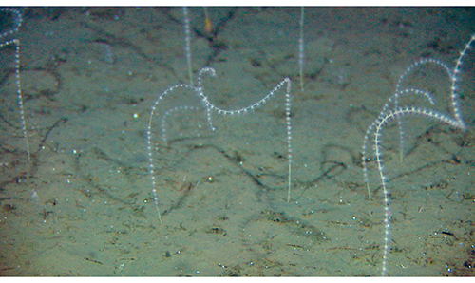
          - Radicipes coral garden, a habitat type classified as endangered in the Norwegian Red List for ecosystems and habitat types 2018.
Mareano
Threatened species and habitat types
In all, 26 species found in the Barents Sea–Lofoten area, including the waters around Svalbard, are listed as threatened in the 2015 Norwegian Red List. The conservation status of five species improved from 2010 to 2015 (spiny dogfish, beaked redfish, common eel, Sabine’s gull and mainland populations of common seal), while it worsened for six other species, most of them seabirds (razorbill, common tern, Brünnich’s guillemot, blue whale, ringed seal and the mainland population of fulmar). Two habitat types (Radicipes coral gardens and northern sugar kelp (Saccharina latissima) forests) are classified as endangered in the Norwegian Red List for ecosystems and habitat types 2018, while oarweed (Laminaria digitata) forests are classified as vulnerable. The habitat type Arctic sea ice is classified as critically endangered because of the reduction in the area of multi-year ice.

Pollution
Long-range transport of pollutants with air and ocean currents is the main source of pollution in the management plan area. However, we still know little about the overall transport of pollutants into the area.
Inputs and levels of several of the persistent, bioaccumulative and toxic substances that are monitored in air in Svalbard are still declining. These include heavy metals and certain organic pollutants. Other substances, for example the pesticide hexachlorobenzene (HCB), have shown a weak rise in recent years. There are still high levels of persistent, bioaccumulative and toxic substances in some species at higher trophic levels. Rising temperatures as a result of climate change are expected to increase the spread of such substances worldwide. As the sea ice melts and the permafrost thaws, hazardous substances may be remobilised and evaporate to the atmosphere in the Arctic. Major forest fires and fires on cultivated land have been shown to result in higher inputs of organic pollutants to the Arctic.
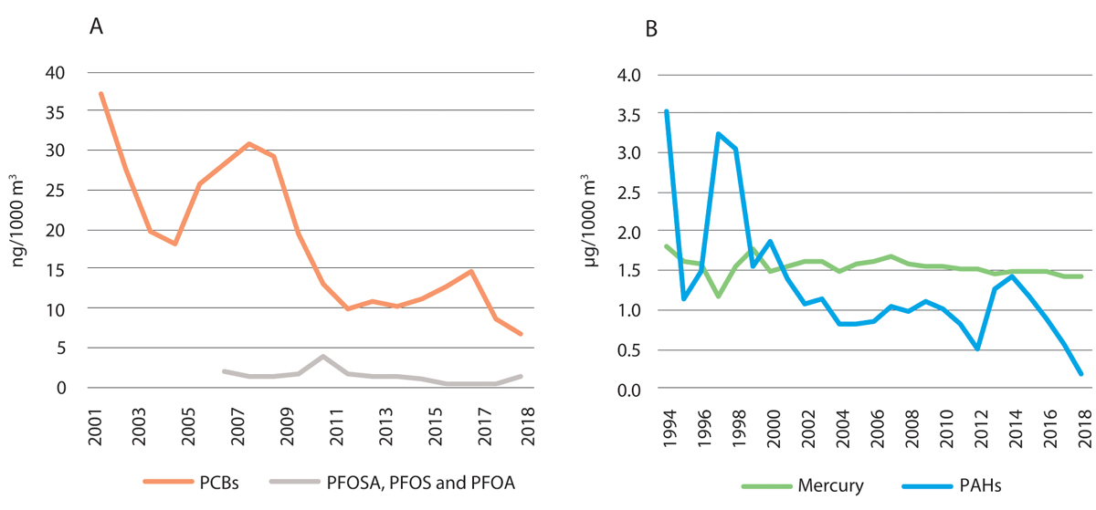
          - Annual mean concentrations of persistent, bioaccumulative and toxic substances in air measured at the Zeppelin observatory, Ny-Ålesund in Svalbard.
Norwegian Institute for Air Research, Norwegian Licence for Open Government Data
Inputs of radioactive pollution have declined in recent years, and levels of radioactivity in living organisms are well below the maximum levels set for human consumption. Inputs of nutrients and copper, primarily from aquaculture, are rising along the Norwegian coast, but it is unclear how much of this pollution is transported from coastal waters into the management plan area.
Levels of pollutants in living organisms are stable or declining. The levels are generally low, and well within the limits set for safe seafood. Concentrations of most persistent, bioaccumulative and toxic substances are also below levels that are considered high enough to affect the most vulnerable ecosystem components. The exception is top predators, where high contamination levels are still being registered. However, assessments of effects on the most vulnerable ecosystem components are uncertain because too little is known about the biological effects of such substances, and because new hazardous substances are constantly being detected in Norwegian waters.
Underwater noise
Underwater noise from seismic surveys, sonar and shipping may influence the behaviour of marine mammals. There is further discussion of this in Chapter 3.2 on the Norwegian Sea, which is also relevant to bowhead whale and narwhal north of Svalbard.

Particularly valuable and vulnerable areas in the Barents Sea–Lofoten area
The 2015 white paper on the management plan for the Barents Sea–Lofoten area (Meld. St. 20 (2014–2015)) stated that the need to update the delimitation of three particularly valuable and vulnerable areas – the marginal ice zone, the polar front and the sea areas surrounding Svalbard – would be assessed during revision of the management plan in 2020.
Work on the scientific basis for the management plan included an assessment of whether other areas than those already identified meet the criteria for designation as particularly valuable and vulnerable areas. No new areas were identified, but on the basis of already available knowledge, the delimitation of some areas was altered.
Eggakanten
The Eggakanten area, where there is a steep drop from the continental shelf to the deep waters of the Norwegian Sea, stretches all the way from Stad at about 62° N to the northwestern tip of Svalbard, and oceanographic processes are comparable along its whole length. The particularly valuable and vulnerable area Eggakanten has been extended to include the area around Svalbard, and is now delimited in the same way in the management plans for both the Barents Sea–Lofoten area and the Norwegian Sea. From Stad to Svalbard, it includes the entire continental slope and extends about 10 km on to the continental shelf. Its width varies depending on the steepness of the continental slope. Where the slope is steep, environmental conditions change rapidly, resulting in high diversity over short distances. Delimiting Eggakanten in this way means that about half of the Yermak Plateau northwest of Spitsbergen is included, which is the part of this area where biological activity is highest, down to a depth of about 800 metres (Figure 3.10).
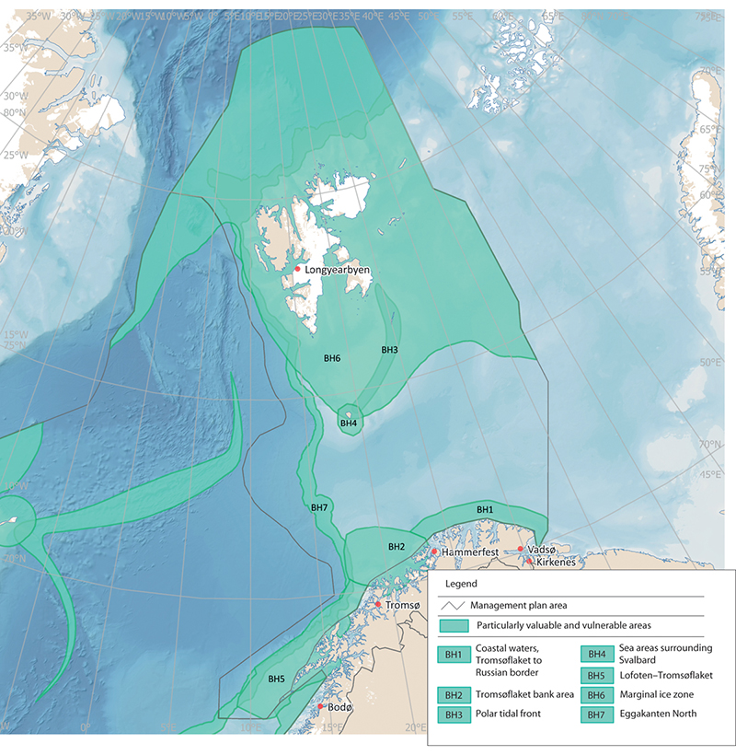
          - Particularly valuable and vulnerable areas in the Barents Sea-Lofoten management plan area.
Norwegian Environment Agency
The polar tidal front
There are three frontal zones around the shallow waters of the Spitsbergen Bank and the deeper trench of Hopendypet: a tidal front, a meltwater front and what has traditionally been called the polar front, i.e. the zone where Atlantic water flowing north meets Arctic water flowing south. These frontal zones are different in origin and structure, and therefore also differ in their influence on biological production and activity. The scientific basis for the management plans shows that the tidal front is the zone that is especially valuable and vulnerable. Biological production is high, and the tidal front is an important feeding area for seabirds. The rest of the Spitsbergen Bank area has also been shown to be particularly valuable because production and biodiversity are high and it is an important feeding, nursery and wintering area. The rest of the polar front zone is probably not as important for biological production as previously assumed, and is therefore not identified as a particularly valuable and vulnerable area. The delimitation of the particularly valuable and vulnerable area has therefore been adjusted so that it is restricted to the tidal front, and its name has been changed to the polar tidal front.
The marginal ice zone
Earlier management plans defined the marginal ice zone as a particularly valuable and vulnerable area and showed its extent on maps. It is intended to cover the variable extent of the marginal ice zone, i.e. the area across which it moves during an annual cycle between a maximum in April and a minimum in September. The particularly valuable and vulnerable area thus includes the parts of the marginal ice zone that are most important for the associated biological production and biodiversity.
The boundary of the designated marginal ice zone in the Barents Sea–Lofoten management plan is defined in statistical terms. It follows the line where sea ice has been present on 30 % of the days in April (this is known as 30 % ice persistence), on the basis of a multi-year time series of satellite observations of ice extent. Ice persistence is used as a measure of how likely it is that the marginal ice zone will be in a particular area in a specific month. April is the month chosen because this is when ice cover is normally at a maximum, and it therefore represents the maximum southerly extent of the marginal ice zone over the year. The criterion for determining whether ice is present is an ice concentration exceeding 15 %, meaning that ice covers more than 15 % of the sea surface.
In the 2006 and 2011 white papers on the management plan for the Barents Sea–Lofoten area, the marginal ice zone was delimited on the basis of ice observations from the period 1967–1989. The white paper Update of the integrated management plan for the Barents Sea-Lofoten area including an update of the delimitation of the marginal ice zone (Meld. St. 20 (2014–2015)) presented an update of the delimitation of the marginal ice zone based on ice data for the 30-year period 1985–2014. It also stated that a new update would be presented in the 2020 revision of the management plan for the Barents Sea–Lofoten area. In addition, the white paper announced that the definition used as a basis for determining the delimitation of the marginal ice zone was to be reviewed.
The Forum for Integrated Ocean Management has evaluated the delimitation of the designated marginal ice zone. This is a transitional zone whose value and vulnerability are linked to characteristic features and biological processes, and not just a dividing line between ice and open sea.
In scientific terms, the marginal ice zone is described as the transitional zone between open sea and ice-covered sea, where between 15 and 80 % of the sea surface is covered by ice. This zone is normally only a few tens of kilometres wide. The marginal ice zone is extremely dynamic, and moves from the area around Bjørnøya in the south in spring to north of Spitsbergen early in the autumn. In addition to seasonal variations, it shows more short-term variability, for example as a result of shifts in wind direction and strength.
As the ice melts and retreats northwards during the spring and summer, this creates light conditions and nutrient availability in the marginal ice zone that result in a concentrated bloom of ice algae and phytoplankton. The further north the marginal ice zone is, the larger the share of total primary production from ice algae within the ice or attached to the underside of the. Modelling indicates that most production of phytoplankton takes place within the marginal ice zone and for some distance south of it, and that production drops considerably where the ice concentration exceeds 80 %. From April to September, the productive zone moves northwards through the Barents Sea, and is followed by grazing and feeding plankton, fish, seabirds and marine mammals.
Because the high level of biological production at any time is generally restricted to a zone a few tens of kilometres wide, there may be very high concentrations of grazing species in the marginal ice zone. Together with the importance of the sea ice as a habitat for many species, this makes the marginal ice zone a biologically important and valuable area.
For the commercially important fish species in the Barents Sea, the marginal ice zone is primarily a feeding area, and to some extent a nursery area. Most fish species found in the marginal ice zone in the Barents Sea are strongly associated with the seabed, except for two pelagic species, polar cod and Arctic cod (Arctogadus glacialis).
Seabirds, particularly Brünnich’s guillemots and little auks, can congregate in large numbers in the marginal ice zone and in leads in the ice in spring. Black guillemots and ivory gulls are also common. In addition, fulmars, glaucous gulls and kittiwakes are observed in the marginal ice zone all year round. In late summer, 80–90 % of the world population of ivory gulls is found in the marginal ice zone in the northern Barents Sea. Polar bears occur at higher densities along the outer edge of the marginal ice zone than further north in areas of drift ice.
Several seal species use the ice for whelping, moulting and hauling out, but the importance of the marginal ice zone varies between species and between seasons. The bowhead whale, beluga and narwhal are the only whale species that are adapted to living in areas with ice all year round. In addition, baleen whales (blue, fin, humpback and minke whales) and toothed whales (orcas) feed in the marginal ice zone in the summer months.
A large proportion of biological production in the marginal ice zone sinks through the water column to the seabed, where it provides food for benthic organisms. The marginal ice zone and the northern part of the Barents Sea generally support a large number of benthic species and a high benthic biomass.
One of the most obvious impacts of climate change in the Arctic is the temporal and spatial reduction in sea ice extent. The ice is gradually withdrawing northwards, both in summer and in winter, but there are large interannual variations. The ice cover is also becoming thinner. Because of climate change and the rapid loss of sea ice, the multi-year Arctic sea ice found in the northernmost parts of the marginal ice zone is classified as critically endangered in the Norwegian Red List for ecosystems and habitat types 2018.
According to the Forum for Integrated Ocean Management, more is now known about the ecology of the marginal ice zone, including ecological interactions, species occurrence and vulnerability to different pressures. There are also up-to-date population figures for a number of species and more information about their occurrence in winter; knowledge has been developed about links between seabed, water column and ice (sympagic) communities; and better models are available that include more physical and biological components of the ecosystem.
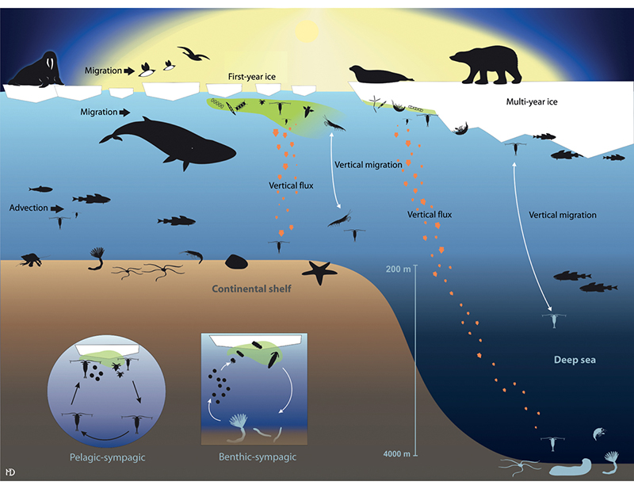
          - Simplified food web in shallow and deeper areas of the marginal ice zone.
Norwegian Polar Institute, von Quillfeldt et al. (2018). Miljøverdier og sårbarhet i iskantsonen [Report on environment and vulnerability in the marginal ice zone]
The scientific basis shows that biological production, species occurrence, vulnerability to different pressures and how these vary through the year and between years all influence the value and vulnerability of the marginal ice zone. However, at any time of year, the entire zone is important for a number of species and biological processes.
The Forum for Integrated Ocean Management has evaluated the delimitation of the marginal ice zone. In delimiting this particularly valuable and vulnerable area, it is necessary to take into account the whole extent of the area across which the marginal ice zone moves, including the large interannual variability. The Forum recommended continuing to use the presence of sea ice in April as a basis for delimiting the particularly valuable and vulnerable area, and basing calculations on the most recent time series of satellite observations of ice extent available, which is for the 30-year period 1988–2017. However, the members of the Forum had differing views on what level of ice persistence in April to use: 30 %, as before, or 0.5 %, which would result in the limit being drawn considerably further south.
On the basis of the Forum’s recommendations, the Government has decided to use the line where ice is found on 15 % of the days in April (15 % ice persistence) to delimit the marginal ice zone, based on satellite observations of sea ice extent for the 30-year period 1988–2017. The boundary can be updated using new ice data when the management plans are updated in future.
The marginal ice zone in the Barents Sea, identified and delimited as described above, extends into the northern and western parts of the Norwegian Sea. Two areas here are also designated as two particularly valuable and vulnerable areas – sea ice in the Fram Strait and the West Ice. There is a further account of these areas in the section on particularly valuable and vulnerable areas in the Norwegian Sea, Chapter 3.2.5.
Sea areas surrounding Svalbard
The sea areas surrounding Svalbard have been identified and described as a particularly valuable and vulnerable area in the Barents Sea–Lofoten management plan, but only the area around Bjørnøya has been delimited on maps in the management plan. The 2015 update of the management plan (Meld. St. 20 (2014–2015)) announced the scientific work in the period up to the revision of the management plan in 2020 would include an assessment of how the particularly valuable and vulnerable area around Svalbard can be delimited.
An outcome of this work is a proposal for delimitation of the sea areas surrounding Svalbard as a particularly valuable and vulnerable area. The preliminary delimitation is based on an assessment of the value of the area for biodiversity, but its vulnerability has not yet been assessed. This will be done as part of the review of all the particularly valuable and vulnerable areas being carried out by the Forum for Integrated Ocean Management. This process will also include final delimitation of the area.
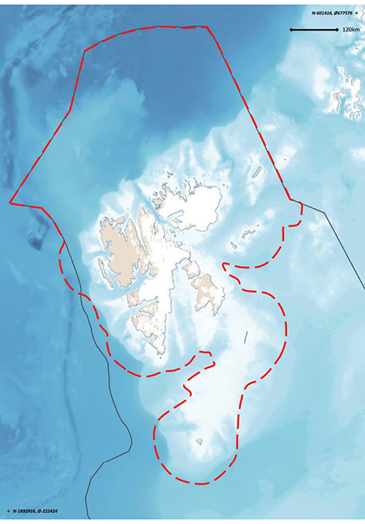
          - Preliminary demarcation of the particularly valuable and vulnerable area sea areas surrounding Svalbard, as proposed by the Forum for Integrated Ocean Management.
Norwegian Polar Institute
Three elements are particularly important as a basis for the proposed delimitation of the sea areas surrounding Svalbard: important feeding areas for pelagic seabird species that breed in Svalbard; feeding and breeding areas for marine mammals that are resident year-round near Svalbard; and a range of species and habitats in the Spitsbergen Bank area. In addition, various other valuable species and habitats are to be found within the preliminary demarcation line, boosting the value of the area as a whole. Habitat use and the importance of different parts of the area vary over the year and to some extent from year to year, depending on the location of grazing organisms and the sea ice at any given time.
The Spitsbergen Bank is of crucial importance for the ecosystems in this area. Annual primary production in this area is perhaps higher than anywhere else in the Barents Sea as a result of favourable physical conditions. Much of the primary production from the ice and the water column sinks to the seabed, and the high biomass on the seabed reflects this. A new biotope dominated by the sea cucumber Cucumaria frondosa was registered on the Spitsbergen Bank in 2017.
The waters around Bjørnøya form the southernmost part of this particularly valuable and vulnerable area. The island is a key locality for seabirds, and has some of the largest seabird colonies in the northern hemisphere. The most numerous species are common and Brünnich’s guillemot, little auk, fulmar and glaucous gull. Bjørnøya has the world’s northernmost large breeding colony of common guillemot, which accounts for almost 90 % of the total Norwegian population, and one of the world’s northernmost razorbill colonies. Brünnich’s guillemot and little auk are Arctic species, and the southernmost breeding colonies in the Barents Sea region are on Bjørnøya. It is estimated that more than one million seabirds use Bjørnøya during the breeding season. One reason for this is the rich food supplies in the surrounding waters.
The Vestfjorden
The Vestfjorden, between the Lofoten Islands and mainland Norway, has historically been one of the main spawning areas for Northeast Arctic cod. For most of the period 1970–2000, the Vestfjorden, including the fjord arms Ofotfjorden and Tysfjorden, was also the main overwintering area for Norwegian spring-spawning herring. Although its importance for herring has declined in recent years, the Vestfjorden is potentially a very important area for two of Norway’s major fish stocks. Geographically, most of this area lies in the Barents Sea–Lofoten management plan area, not in the Norwegian Sea management plan area. The description of Lofoten–Tromsøflaket below also applies to the Vestfjorden.
Tromsøflaket bank area
The Tromsøflaket is a shallow area at the entrance to the Barents Sea proper, and supports high biodiversity. The current systems are strongly influenced by the topography of the seabed, which creates eddies, so that the water masses have a relatively long residence time over the Tromsøflaket. The bank area is on the edge of the continental shelf. The eddies also result in longer retention times for fish larvae, for example herring, cod and haddock, and other organisms that drift more or less passively with the water masses, and also for non-living material. This also means that they may be exposed to negative pressures for longer periods. The northern part of the Tromsøflaket is also an important spawning ground for spotted wolffish. There are large and important sponge communities. This area also includes Lopphavet, where there are deep trenches and large coral communities that provide nursery areas for several fish species.
This is an important breeding and wintering area for seabirds, and includes two of Norway’s largest puffin colonies. Total estimates indicate that the puffin colonies in this area have not declined to the same extent as those further south. The relative importance of these colonies is increasing since they comprise a growing share of the Norwegian puffin population. There are two kittiwake colonies where numbers are stable, in contrast to the situation for most other Norwegian kittiwake colonies.
Coastal waters, Tromsøflaket to the Russian border
The coastal waters in this area are a productive environment with high biodiversity. There are rich fish resources, and this is a spawning ground for capelin, a key species in the ecosystem. There are large numbers of seabirds, particularly in the breeding season. Seabirds can forage up to 100 kilometres beyond the baseline. The inner part of the Varangerfjord is an important wintering area for Steller’s eider, common eider, king eider and long-tailed duck. Steller’s eider is the rarest diving duck in the world, and 5–10 % of the entire world population winters in the fjord. These coastal wates are also a moulting area for Norwegian and Russian populations of common eider, king eider and other sea diving ducks. Marine mammals use the whole area, and there are coral reefs in the western and southern parts. Various seabirds that are declining further south have positive population trends in this area, with the exception of kittiwakes, which are showing a very negative population trend. Both common guillemots and puffins breeding along the mainland coast are vulnerable to disturbance from the growing population of white-tailed eagles. Harvesting of red king crab has been unrestricted in this area in recent years, and observations show that the species only occurs in minimal numbers more than ten nautical miles from land. Large areas of kelp forest (Laminaria hyperborea and sugar kelp) along the coast of North Norway have been overgrazed by sea urchins. These habitat types have now been red listed in response to the declining area of kelp forests.
Lofoten–Tromsøflaket
This area has a wide variety of marine habitat types and marine landscapes, and provides a combination of important breeding, spawning, nursery and wintering areas for commercially important fish species, marine mammals and seabirds. It is the most important spawning area for Northeast Arctic cod and haddock. The area also includes the Røstrevet reef complex, the world’s largest known reef of the stony coral Lophelia pertusa. The reef complex is 35 km long and 3 km wide. The continental shelf off the Lofoten and Vesterålen Islands is very rich in nutrients, and plankton production is high. There is a rich fauna in the shallow areas. There are 330 small, intact coral reefs, some of them up to 40 m in height, in an area called Hola.
There are large breeding colonies of seabirds including common guillemot and puffin on the islands of Røst, Værøy and Bleiksøy. Islands and skerries in the Røst area are also an important breeding area for coastal seabirds including black guillemot, common eider and shag, and an important migration and wintering area for a large share of the world population of yellow-billed diver. Geese are making increasing use of the area for staging during the spring migration. Marine mammals such as grey seals, common seals, orcas and sperm whales are also found in the area.

Environmental status in the Norwegian Sea management plan area
The state of the environment in the Norwegian Sea is generally good, although with a few exceptions. The main trends observed since the mid-1990s are rising water temperature and an increase in the total quantity of pelagic fish species, together with a decline in the quantity of zooplankton. We know little about how or whether these changes are connected. Salinity in the upper water layers of the Norwegian Sea dropped sharply in 2017 and 2018, and the water is now fresher than at any time since 1980. This may be because inflowing water from both the Atlantic Ocean and the Iceland Sea has become fresher. Sea ice extent is declining in the Fram Strait in the northern part of the Norwegian Sea. The Norwegian Sea water has become more acidic throughout the water column, and pH appears to have declined more rapidly in parts of the Norwegian Sea than globally. This may have consequences for marine organisms that have calcium-based shells or skeletons. Ocean acidification will continue for many years, and it is vital to monitor how rapidly it proceeds. The long-term effects on ecosystems are uncertain.
The state of the environment in the Norwegian Sea was discussed in depth in the 2017 white paper containing an update of the management plan (Meld. St. 35 (2016–2017)). In this chapter, the main emphasis is on new information included in the status report published by the Advisory Group on Monitoring in 2019.

Oceanic climate change in the management plan area
The Norwegian Sea climate, described in terms of the distribution of water masses, is largely determined by the properties of the two main currents linking the Atlantic Ocean and the Arctic Ocean – the Norwegian Atlantic current, which transports relatively warm and saline water northwards in the eastern part of the Norwegian Sea, and the East Greenland current, which carries relatively cold, fresh water southwards in the western part of the Norwegian Sea.
Temperature and sea ice
The temperature time series for the Norwegian Sea show that temperatures were variable in the period 1951–2000, but have been consistently higher since 2000. As in the other management plan areas, this warming can be linked to natural changes in the large-scale circulation in the Atlantic Ocean, combined with global warming.
In the northernmost part of the Norwegian Sea, the Fram Strait between Svalbard and Greenland, there are large interannual variations in the extent of the sea ice. However, it has shown a downward trend in both April and September in the period 1979–2017. Higher sea and air temperatures reduce sea ice extent. Since satellite measurements of sea ice extent began in 1979, a downward trend has been observed in much of the Arctic. In the Fram Strait, the ice cover is also strongly influenced by processes in the Arctic Ocean. The ice is becoming thinner, and there are indications that ice export from the Arctic Ocean through the Fram Strait is increasing because the ice is flowing more rapidly through the area than before.
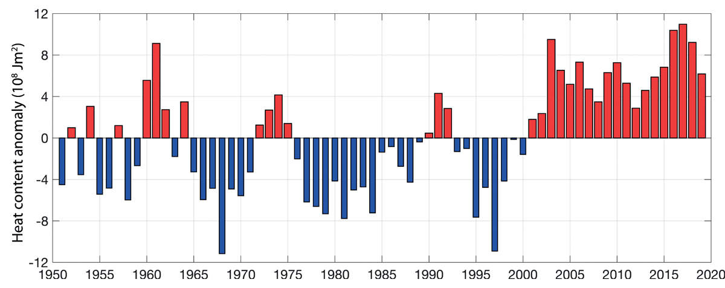
          - Time series for temperature, measured as the heat content of the Atlantic water south of the Arctic front in the Norwegian Sea, for the period 1951–2017, presented as anomalies relative to the long-term average.
Institute of Marine Research
Ocean acidification
Studies of inorganic carbon data over a period of more than 30 years show that the seawater in central parts of the Norwegian Sea is becoming more acidic and that calcium saturation levels are declining throughout the water column. Observations show that pH is declining more rapidly in parts of the Norwegian Sea than globally.
Ocean acidification has consequences for marine organisms that have calcium-based shells or skeletons. They will have difficulty in growing and surviving in areas where the seawater becomes too acidic, since it then dissolves calcium carbonate. Marine organisms that will be at risk in Norwegian waters include cold-water corals, which grow along much of the Norwegian coast, and the sea snail Limacina helicina, whose range includes the Norwegian Sea. Limacina helicina is an important prey species for organisms including fish and seabirds. Ocean acidification can also have direct effects on fish larvae and small copepods.
Ocean acidification will continue for many years even if CO2 emissions are reduced. It is vital to monitor how rapidly acidification proceeds and where the changes are greatest. Ocean acidification is influenced directly and/or indirectly by changes in temperature, salinity and biological activity, and there are large natural seasonal variations. Long time series are of crucial importance for an understanding of ocean acidification and its impacts in different areas.

Trends for various components of the Norwegian Sea ecosystem
Ecosystem trends in the Norwegian Sea are described, mainly on the basis of state and pressure indicators for the management plan area.
Kelp forests
Laminaria hyperborea kelp forests are important habitats and nursery areas for fish and other species. In North Norway (along the coast of the Norwegian and Barents Seas), large areas of kelp forest have been overgrazed by sea urchins over the past 40–50 years. In the last 20 or so years, gradual re-establishment of kelp forests has been taking place in the southern part of this region (Trøndelag county and parts of Nordland). This is probably explained by poorer recruitment of sea urchins in warmer water. Re-establishment of both Laminaria hyperborea and sugar kelp is expected to continue further northwards in the years ahead.
Northerly sugar kelp forests (in the Norwegian and Barents Seas) are classified as endangered on the 2018 Norwegian Red List for ecosystems and habitat types. Even though large areas of kelp forest have regrown, it is estimated that more than 50 % of the area of sugar kelp forest in North Norway has been lost. Northern Laminaria hyperborea forest is classified as near-threatened on the Red List. This species has been less affected by overgrazing, and kelp stands in the most exposed areas have never been overgrazed. Nevertheless, it is estimated that more than 20 % of Laminaria hyperborea tangle forest has been lost.
              - Ecological interactions in kelp forests – juvenile saithe and shags
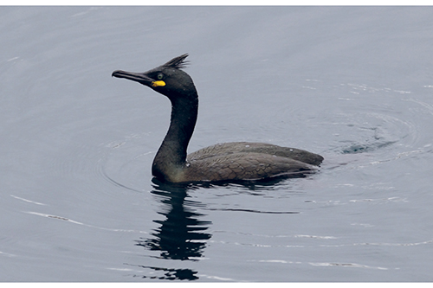
          - Shag.
Photo: Svein-Håkon Lorentsen
Kelp forests along the Norwegian coast are important nursery areas for the youngest year classes of saithe up to about three years of age, when they recruit to the mature pelagic stock. Studies of shags fitted with GPS loggers have shown that they feed largely in the kelp forests, and that a large proportion of their diet is saithe of the youngest year classes (0- and 1-year-olds). Coastal surveys of saithe spawning grounds do not provide adequate data for estimating numbers of one- and two-year old saithe. As a result, there is a lack of good data at an early stage on recruitment to the spawning stock of saithe stock. Recent studies show that the proportion of one-year-old saithe in the diet of shags around Sklinna in Trøndelag is strongly related to the indices for recruitment of three-year-old saithe to the pelagic stock (estimated two years later), for which reliable data is available. This approach could make it possible to estimate recruitment to the pelagic saithe stock two years earlier than at present, providing a better basis for setting a total allowable catch for saithe.
[Boks slutt]
Phyto- and zooplankton
Quantities of phytoplankton in the oceans are determined by currents, light conditions, water temperature, inputs of nutrients and grazing by organisms higher up the food chain. At present, it is difficult to draw any firm conclusions about changes in quantities, species composition or the timing of spring blooms of phytoplankton in the Norwegian Sea, because data are only available for a fairly small number of years and measurements have been made at varying times of year. Satellite data could potentially provide better information on phytoplankton quantities in the surface waters of the Norwegian Sea.
Zooplankton graze on phytoplankton and are important for all higher trophic levels in the food web, including carnivorous zooplankton, fish, marine mammals and seabirds. In the Norwegian Sea, the zooplankton provide food for the main pelagic fish species (herring, mackerel and blue whiting), for fish fry and larvae, and for a number of other fish species, including cod.
Zooplankton biomass in spring (measured in May) has been declining since just after 2000, but there are indications that it is now increasing again. In 2018, zooplankton biomass reached the average level for the time series as a whole. A steep reduction in the biomass of two important subarctic zooplankton species has been observed, but the wider ecological implications of this are unknown.
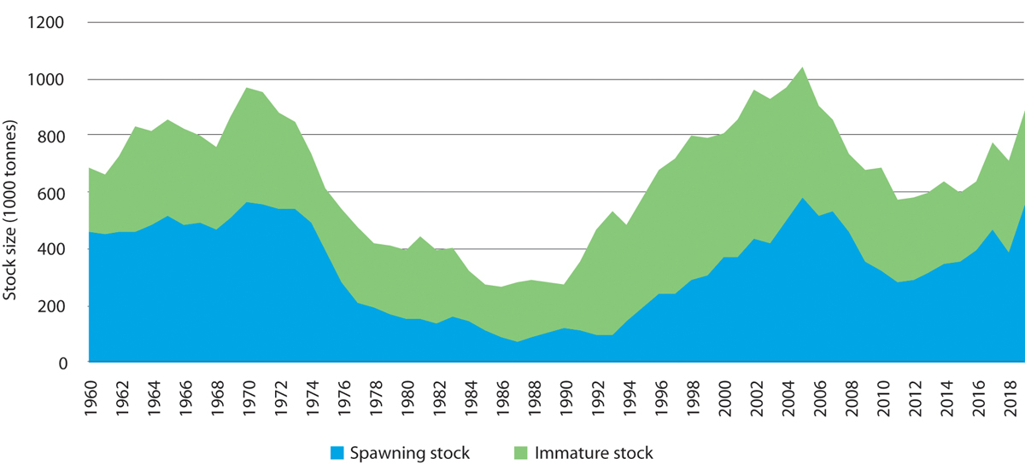
          - Time series showing estimated biomass of the immature stock and spawning stock of Northeast Arctic saithe in the Barents Sea and Norwegian Sea.
Institute of Marine Research
Southerly, or warm-water, species in the Norwegian Sea are species that are common in the North Sea or further south, but were previously not normally found in the Norwegian Sea. There has been a sharp increase in their biomass since 2006, and species that have been observed include several copepod species and a species of pelagic sea snail. The largest biomass of southerly species registered so far was in 2011. These are indicator species; their occurrence reflects changes in the physical, chemical or biological environment and indicates biogeographical changes or shifts, for example in response to climate change.
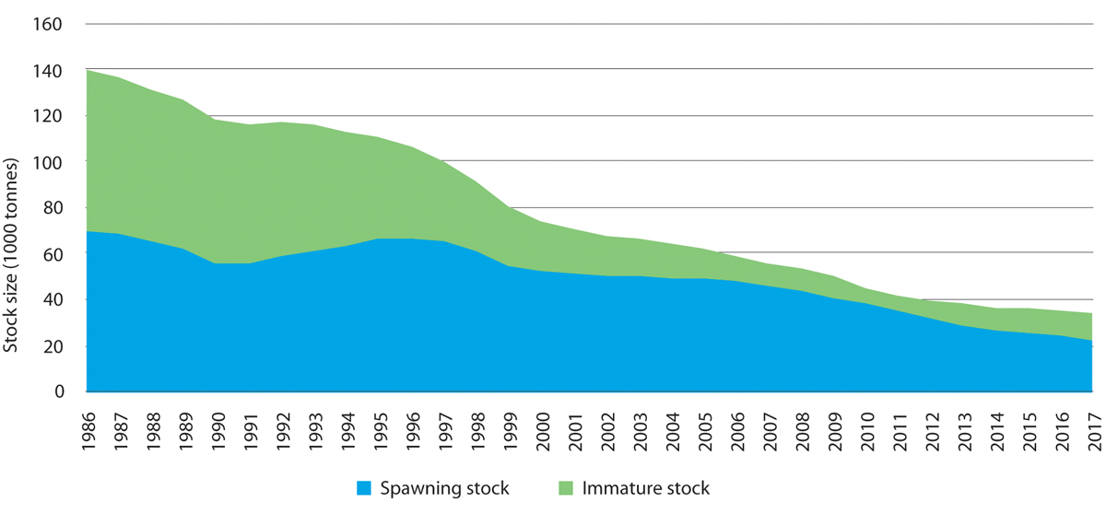
          - Time series showing estimated biomass of the immature stock and spawning stock of golden redfish in the Barents Sea and Norwegian Sea. The sum of the two gives the total stock size.
Institute of Marine Research
Fish stocks
The three major pelagic fish stocks in the Norwegian Sea are Norwegian spring-spawning herring, mackerel and blue whiting. The total biomass of these stocks rose considerably from 1995 to 2005, and has since remained at a relatively high level. Even though analyses show clearly that pelagic fish species compete for food, we still do not know whether the rise in pelagic fish biomass since 1995 is the cause of the decline in zooplankton biomass since 2000.
              - Sandeels along the Norwegian coast
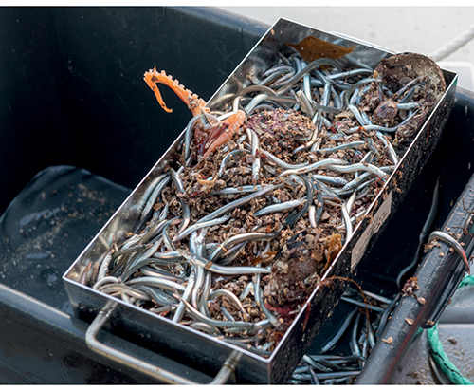
          - Sampling sandeels near Runde island.
Photo: Arild Hareide, Runde Environmental Centre
Small schooling fish species play a key role in marine ecosystems, linking zooplankton with top predators such as seabirds. In Norwegian waters, species such as sprat, herring, capelin and sandeels are particularly important components of the food web. Sandeel is a generic term for a group of small eel-like fish in the family Ammodytidae. Lesser sandeel and small sandeel are found all along the Norwegian coast, while great sandeel is commonest in the south. These species are found in large schools and are highly dependent on specific sandy substrates, where they spend much of the year burrowing in the sand.
Regular monitoring of the diet of breeding seabirds shows that sandeels are among the two or three most important prey types for the typical colony-breeding seabirds, and form a considerable proportion of the diet of kittiwake, common guillemot, razorbill and puffin chicks in many areas.
Little is known about sandeel stocks and their dynamics near the large seabird colonies. The availability of sandeels for breeding seabirds is probably determined mainly by natural variability in recruitment and the distance from colonies to local sandeel populations. We do not know how important local recruitment is for local stocks of sandeels, but studies have not shown genetic differences between lesser sandeels near the coast and further out in the North Sea. Local recruitment probably dominates, but in certain years there is larval drift from the North Sea stocks to coastal waters.
Since 2016, scientists have been mapping sandeel habitat and collecting biological data on sandeels around Runde island. In summer 2019, unusually large stocks of sandeels were registered along the coast from Rogaland and northwards to Hitra west of Trondheim. Sandeels formed a major part of the diet of breeding seabirds on Runde, and fishermen reported catching cod, saithe, haddock and mackerel with their stomachs full of sandeels. There had not been observations of such large quantities of sandeels since the 1960s. There were also sporadic reports of high quantities of sandeels from North Norway, but they did not account for a larger proportion of the diet of seabirds than normal.
[Boks slutt]
The spawning stock of Norwegian spring-spawning herring reached a peak in 2009, but has declined since then. In 2018, the spawning stock was estimated at 3.8 million tonnes, which is above the precautionary level. Recruitment of young year classes to the spawning stock has been weak for many years.
In recent years, mackerel distribution in the Norwegian Sea has expanded. Studies have been carried out to investigate whether this can be explained by rising temperatures. The results show that the expansion in distribution is primarily due to growth of the mackerel stock and not to higher temperatures.
The blue whiting stock in the Norwegian Sea increased and its distribution expanded up to 2003, but this was followed by a sharp decline. The trend reversed in 2011, and the stock grew until 2016, when it began to decline again. In addition, recruitment was low in 2017 and 2018.
The Northeast Arctic saithe stock was at a historically high level from 2001 to 2007, but then declined steeply up to 2011. Since then, it has risen again.
The beaked redfish stock has shown a positive trend. Recruitment to the spawning stock was weak from 1996 to 2004, but has been markedly stronger since then.
The golden redfish stock is now at the lowest level ever recorded, and recruitment has been low ever since the late 1990s. The stock is still declining. According to the International Council for the Exploration of the Sea (ICES), the stock has reduced reproductive capacity and is at a historically low level. Given the low reproduction rate, it is expected that the golden redfish stock will continue to be weak for many years. The species is classified as endangered on the 2015 Norwegian Red List. Other red-listed fish species are blue skate, basking shark, blue ling and spiny dogfish.
Seabirds
There have been dramatic declines in the populations of many seabirds in the Norwegian Sea since the early 1980s, when most monitoring programmes began; numbers of common guillemot (critically endangered) have dropped by 99 %, kittiwake (endangered) numbers at some colonies have declined by more than 90 %, and puffin (vulnerable) numbers have declined by 71 % in this period.
On the other hand, gannet numbers have risen sharply in the same period. The gannet population in Norway now numbers about 6000 pairs (5000 pairs around the Norwegian Sea), and is rising. One important reason for this success is thought to be that gannets feed on larger fish such as herring and mackerel.
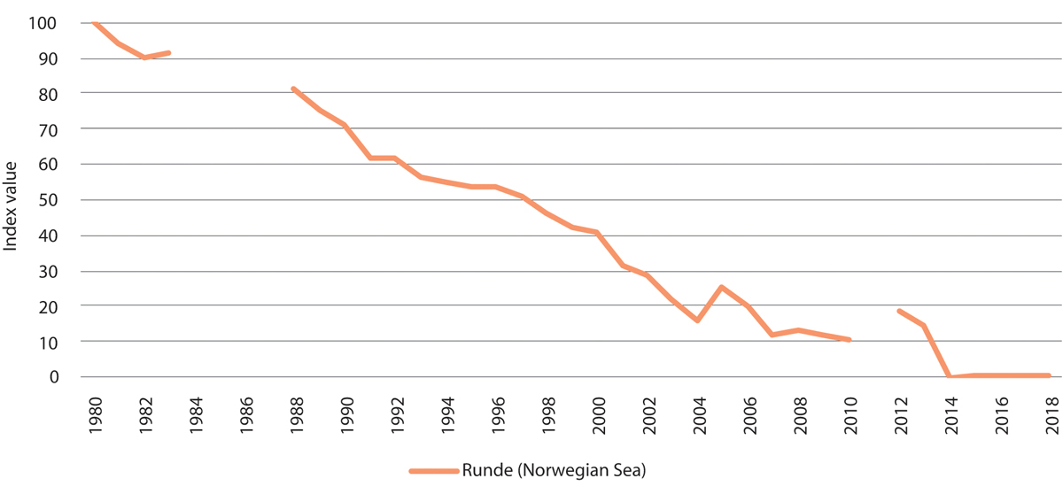
          - Population trend for kittiwakes on Runde island in the Norwegian Sea. Population expressed as index values. Breaks in the graph represent years where no data is available.
Norwegian Institute for Nature Research/environment.no
In this same period, the common eider population has declined by about 5 % per year in the areas between Møre og Romsdal county and Røst at the southern end of the Lofoten Islands that are included in the monitoring programme. This decline is worrying, especially because little is known about the causes.
Understanding of the changes that have been observed is limited, but climate change and changes in food supplies (zooplankton and small fish of pelagic and demersal species such as herring, sandeels and gadids) may be important. The Norwegian spring-spawning herring stock has not produced a strong larval year-class since 2004, and this has had a serious effect on the breeding success of Norwegian populations of pelagic seabirds. It is not known whether the growth of the mackerel stock in the Norwegian Sea has affected recruitment to fish stocks that are important in the diet of seabirds. Both common guillemots and kittiwakes, which nest on open ledges, are also vulnerable to predation and disturbance by raptors, particularly white-tailed eagles.
Pelagic seabird species such as common guillemot, puffin and kittiwake forage in areas up to 100 km out to sea from the breeding colonies on Jan Mayen and in mainland Norway.
Marine mammals
The hooded seal population is at the lowest level ever recorded. Modelling of the Northeast Atlantic population since 1945 shows a dramatic decline from about 1.3 million animals to about 200 000 in 1980, and a further decline to an estimated 81 000 animals in 2012. The harp seal population was estimated at about 430 000 in 2018. This is a reduction of 35 % since 2012.
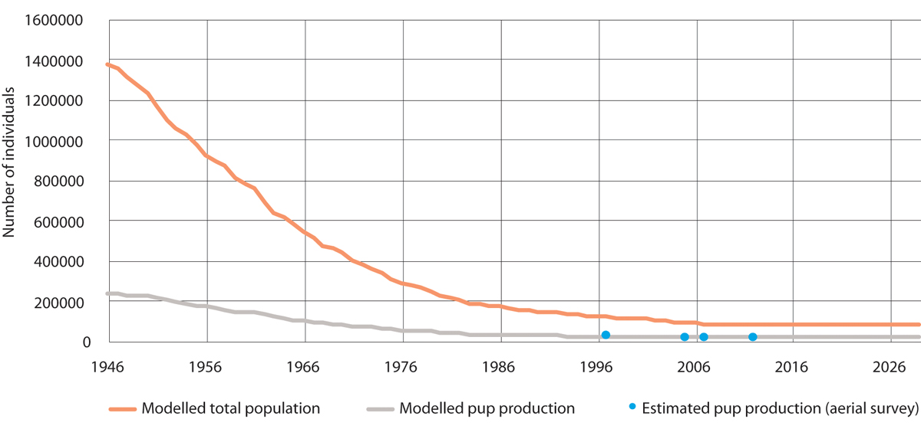
          - Modelled population of hooded seal in the West Ice. The orange line shows the modelled total population, the grey line shows modelled pup production and the blue dots show estimated pup production based on aerial surveys.
Institute of Marine Research/Environmental monitoring of Svalbard and Jan Mayen (MOSJ)
The most recent population estimates for the coastal seal species, grey seal and common seal, are those presented in the 2016 status report from the Advisory Group on Monitoring. The ban on hunting these species in parts of Trøndelag, introduced after a sudden population decline in 2015, has therefore been maintained.
New information on how Arctic whale species use the northern part of the Norwegian Sea management plan area has become available, and shows that the narwhal population is stationary.
The porpoise population was surveyed in 2105, and numbers in Norwegian waters north of 62 °N were estimated at 83 700. Porpoises in fjord areas other than Vestfjorden were not included, and it is thought that including these areas could increase the estimate by about 15 %. Recent analyses show that Norwegian gill net fisheries took an average annual bycatch of 3000 porpoises in the period 2006 to 2015. Modelling indicates that there may have been a certain real decline in the porpoise population in this period as a result of the bycatches.
The bowhead whale, hooded seal and otter are all on the 2015 Norwegian Red List of species.
Threatened habitat types
Norway has registered more reefs of the cold-water coral Lophelia pertusa than any other country, most of them in the Norwegian Sea. Because of a reduction in their total area and habitat degradation, coral reefs are categorised as near-threatened in the 2018 Red List for habitat types and ecosystems. Between 30 and 50 % of the registered reefs off the Norwegian coast that have been investigated have some degree of physical damage caused by bottom trawling. In areas where there is major damage, there are also clear effects both on the extent of reef complexes and on the species composition of coral reef communities. However, even less extensive damage has been shown to affect species composition and biological processes.
Hard-bottom coral gardens are dominated by vulnerable, very fragile soft corals (the sea fans Primnoa resedaeformis, Paragorgia arborea and Paramuricea placomus). This habitat type has been classified as near-threatened because the total area has declined and it is under pressure from the fisheries.
In shallower coastal waters, northern kelp forests (Laminaria hyperborea and sugar kelp) are now considered to be endangered and near-threatened respectively, and two habitat types are considered to be vulnerable (oarweed forests and mussel beds that are exposed to wave action). In the Fram Strait there is Arctic sea ice, which is classified as critically endangered in the 2018 Red List because of the reduction in the area of multi-year ice.
Alien species
Climate change and human activities such as shipping may result in the establishment of increasing numbers of alien species in the Norwegian Sea. Climate change may be a reason why species that would not otherwise have survived in the Norwegian Sea are now able to establish populations.
The comb jelly Mnemiopsis leidyi was introduced to Europe from the northeastern coastal waters of the US with ballast water, and has established populations in the North Sea. There is probably not an established reproducing population in the Norwegian Sea at present. However, considerable numbers of M. leydi are from time to time carried into the Norwegian Sea with the Norwegian coastal current. There is considered to be a very high risk that the species will be able to reproduce in the Norwegian Sea.
The Pacific oyster (Crassostrea gigas) has been registered as far north as Eide near Kristiansund. The species became established in Norway by spreading northwards from Sweden and Denmark, although there may be a proportion of individuals originating from earlier oyster cultivation. Two alien bryozoan species, Tricellaria inopinata and Schizoporella japonica, were found at several coastal localities in Møre og Romsdal county in 2017 and 2018. The habitat preferences of these species indicate that they could probably also become established on fixed or anchored installations further out to sea, in the management plan area itself. These examples show that there may be a considerable potential for alien species to spread to the Norwegian Sea management plan area as well.
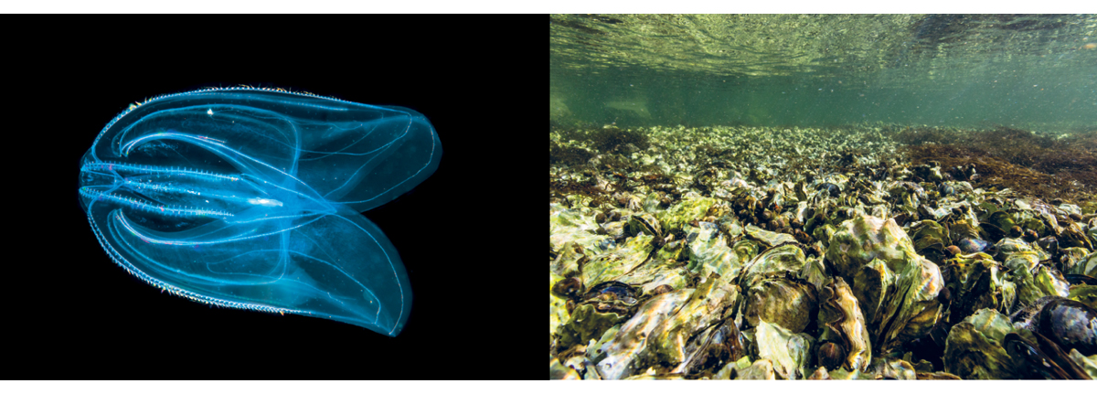
          - Alien species observed in the Norwegian Sea. The comb jelly Mnemiopsis leidyi to the left, and Pacific oysters to the right.
Photos: Erling Svensen (left), Kim Abel, Naturarkivet (right)

Pollution
Inputs of pollutants to the Norwegian Sea are generally stable or declining. Levels of pollutants are generally lower than in certain fjords along the coast and lower than in the North Sea and Skagerrak. However, there is some cause for concern.
Environmental quality standards have been set for a number of pollutants to protect the most vulnerable ecosystem components, and these levels are being exceeded for example for mercury, PCBs and brominated flame retardants (PBDEs) in a number of species. This means that the levels of persistent, bioaccumulative and toxic substances that accumulate in top predators, such as seabirds and marine mammals, may be high enough to have environmental impacts. However, levels of hazardous and radioactive substances are generally below the maximum permitted levels of contamination in seafood in the species that are monitored. The exceptions are fish liver (often contains high levels of organic pollutants), halibut from the Sklinnadjupet trough (high levels of mercury, dioxins and dioxin-like PCBs detected), edible crabs from Saltfjorden near Bodø and northwards (contain high levels of cadmium), and tusk from Vestfjorden (contains high levels of mercury). Marine litter, including micro- and nanoplastics, is present everywhere – on the seabed, in the water column and on the beaches. Little is known about levels of micro- and nanoplastics in seafood.
The pelagic fish species are important seafood resources, and large quantities are harvested in the Norwegian Sea. Hazardous substances are monitored regularly in both herring and mackerel in the Norwegian Sea. The results show that hazardous substances are present in these species, but the levels are not rising and are well below the maximum permitted levels in seafood.
Since 2010, concentrations of hazardous substances in air have been monitored on Andøya (Nordland). Concentrations of lead and cadmium have been more or less unchanged since measurements started and are similar to those measured in Svalbard, but lower than at the Birkenes measuring station in Southern Norway. The Andøya measurements show declining levels of mercury in air, and the same trend is being observed at Birkenes and in Svalbard.
Levels of many organic pollutants are lower at Andøya than in Svalbard. These include the pesticide HCB, PCBs, and brominated flame retardants (PPDEs). Levels of the pesticides HCH and DDT and of perfluorinated substances (PFAS, including PFOA) measured at Andøya are as high as or somewhat higher than levels in Svalbard.
Calculations of annual inputs of pollutants to coastal waters show a general downward trend for lead. Copper inputs showed signs of stabilisation or a weak decline from 2009, but increased again in the period 2013–2017. This rise is mainly explained by the use of copper in impregnation agents for salmon nets by the aquaculture industry. Inputs of nutrients rose steeply in coastal waters for a period starting in the 1990s, largely because of discharges from the aquaculture industry, but concentrations of these substances transported to the coast by rivers have been relatively stable. There has been no substantial increase in nutrient inputs since 2012. However, it is unclear what proportion of all these pollutants is transported from coastal waters into the management plan area.
Discharges of produced water to the Norwegian Sea currently make up 10–20 % of total discharges on the Norwegian continental shelf, and discharges of oil to water are considerably smaller than in the North Sea.
Underwater noise
Underwater noise from seismic surveys, sonar and shipping may influence the behaviour of marine mammals.
Noise from shipping is audible to both fish and marine mammals. It is unlikely that noise from shipping causes direct harm to fish and marine mammals, which has been demonstrated in individual organisms close to intense noise sources such seismic shooting and low-frequency sonar. However, temporary scare effects are to be expected. The scare effects of shipping on certain whale species have been investigated. It has been shown that when minke whales and porpoises come within a radius of about 600 and 1000 m respectively from a ship, they will take avoiding action. Other species, for example white-beaked dolphins, are attracted to boats. Responses to noise thus appear to vary from one species to another. One explanation may be that fish and marine mammals can become habituated to noise sources, even to noise that is intended to deter them. Studies suggest that seals and porpoises can become habituated to pingers attached to fishing gear to keep marine mammals away.
Passive acoustic monitoring (using data buoys) in the northwestern the Norwegian Sea has demonstrated underwater noise more or less all year round in areas that are key habitats for threatened populations of various whale species. These areas are relatively little used, and the results are not representative of the noise picture in the rest of the management plan area. Both bowhead whales and narwhals use the drift ice areas in the Fram Strait all year round, and exhibit intense vocal activity in the winter months (the mating season).

Valuable species and habitats in the deep sea
There are large deep-water areas under Norwegian jurisdiction in the Norwegian Sea, including the northernmost part of the Mid-Atlantic Ridge. This is the geologically most active area in Norway, where there are large underwater mountains and rift valleys, and areas with distinctive environmental conditions and ecosystems and habitat types about which little is known.
Habitats where there are hydrothermal vents and associated deposits of metal sulphides and methane hydrate (natural gas trapped in ice crystals) support very specialised organisms that form distinctive marine ecosystems along the Mid-Atlantic Ridge. There are also hydrothermal vents and associated deposits of methane hydrate along the continental slope, which support similar ecosystems. These ecosystems are based on chemosynthesis, meaning that organisms use chemical compounds in the water as a source of energy, rather than sunlight. Microorganisms are the primary producers in such ecosystems, and are a vital basis for all life in these areas. Hydrothermal vents can be active for thousands of years. When they are no longer active, the ecosystem in the area changes from the distinctive chemosynthetic system to one with a normal benthic fauna. Deposits of manganese crust, which are rich sources of various metals, have also been found in large areas of the Norwegian Sea. The crust is deposited from seawater on bare rock, and contains important chemical elements. There is now a growing research effort and more focus on the management of deep-water areas. Valuable species and habitats in deep sea areas were also discussed in the 2017 update of the Norwegian Sea management plan (Meld. St. 35 (2016–2017)).
Organisms living in extreme deep-sea environments have unique adaptations to enable them to survive in the extreme conditions. Microorganisms and biomolecules can be harvested for industrial and medical uses (marine bioprospecting) from hydrothermal vent fields. Research using cutting-edge DNA sequencing techniques has revealed a wide diversity of microorganisms and a vast, unique genetic reservoir in these ecosystems. Less is known about interactions between seabed ecosystems and those in the water column above, and research will be needed on this in future.
Hydrothermal vents and the formation of mineral deposits
So far, seven active and two inactive hydrothermal vent fields containing metal deposits have been discovered at depths of between 140 and 3100 metres in the Norwegian Sea.
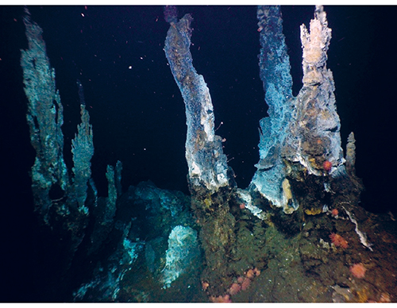
          - These ‘black smokers’ on the Mid-Atlantic Ridge between Jan Mayen and Bjørnøya are hydrothermal vents formed by the deposition of metal-rich sulphide minerals. Such areas support a highly diverse community of organisms closely adapted to the conditions, ranging from single-celled microorganisms to fish.
Photo: University of Bergen
The habitat types in areas around hydrothermal vents are often dominated by sponges and other filter feeders. The extent of our knowledge about the biology of the vent fields varies. On the Seven Sisters field and the Jan Mayen vent fields, surveys have shown dense assemblages of sea anemones and snails feeding on the bacterial mats, carnivorous sponges that live in symbiosis with methane-oxidising bacteria, calcareous sponges, hydroids and large numbers of sea lilies. The three Jan Mayen vent fields are the best surveyed thus far. They are situated about 70 km north-east of Jan Mayen itself. Little is known about the biology of the Ægir vent field, but it has a number of species in common with the Loki’s Castle vent field. The latter was discovered in 2008 and is much better known. It was also the first locality in Norwegian deep-sea areas where scientists found species that are specifically adapted to the high temperatures around hydrothermal vents. There is a wide variety of specialised species, including species that are endemic to the area.
In 2018, the Fåvne vent field was discovered at a depth of 3000 m midway between Jan Mayen and Bjørnøya. Here, highly metal-rich water gushes from a number of vents. The discovery of the Fåvne vent field has given us a greater understanding of the fauna associated with hydrothermal vents. The deep-water fauna on the active vent fields Loki’s Castle, Fåvne and Ægir is of exceptional interest. Species are specially adapted to the environmental conditions, and energy transfer through the ecosystem is driven by close interactions between microorganisms and higher organisms (symbiosis). The fauna is dominated by specialised polychaetes, snails, amphipods and sponges, and shows similarities with the fauna associated with hydrothermal vents near the edge of the Arctic Basin.
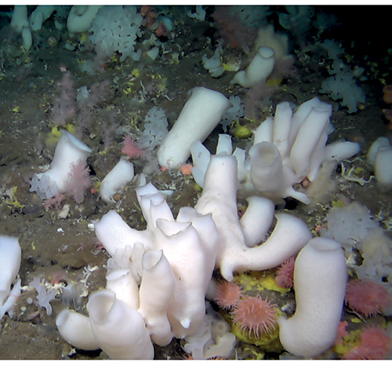
          - The hard-bottom areas around hydrothermal vents are often dominated by sponges and other filter feeders. These areas support high biodiversity and are particular importance for ocean nutrient cycles.
Photo: University of Bergen/SponGES
Methane hydrates
Methane hydrates consist of methane trapped in ice crystals in the seabed, and are only stable at high pressure and low temperature. They are found on the continental shelf and the continental slope in association with natural gas seeps. Methane hydrates can provide a source of energy. There are distinctive geochemical substrates around methane hydrate deposits and cold seeps, which provide a habitat for chemosynthetic bacteria. These bacteria support a distinctive fauna not dissimilar to that found around hydrothermal vents. However, the fauna associated with methane hydrates occurs over larger areas and is quite similar in different localities.

Particularly valuable and vulnerable areas in the Norwegian Sea
The summary report from the Forum for Integrated Ocean Management discusses the previously identified particularly valuable and vulnerable areas, and where the updated scientific basis indicates that modifications are needed. The updated scientific basis confirms the value and vulnerability of the areas for which no modifications were indicated. The delimitation of some particularly valuable and vulnerable areas in the Norwegian Sea has also been clarified and adjusted. The particularly valuable and vulnerable areas and the species and habitat types found in them are further discussed in the Forum’s reports and in earlier white papers on the management plans. This section discusses some updates to our knowledge about the particularly valuable and vulnerable areas in the Norwegian Sea.
The Vestfjorden has been removed from the list of particularly valuable and vulnerable areas in the Norwegian Sea and has been transferred to the list for the Barents Sea–Lofoten management plan area, where most of it lies. The rest largely overlaps with the particularly valuable and vulnerable area coastal waters Norwegian Sea.
In coastal waters Norwegian Sea, sea urchin populations are declining and kelp forests are recovering in the outer zone of coastal waters as far north as the southern part of Nordland county. The coral reefs in the Iverryggen area are considered to be in good condition. The waters between Vikna and the Vega archipelago (a World Heritage Site) and out to the Sklinna bank particularly valuable and vulnerable area are valuable for seabirds. In this area, there are large numbers of wintering and breeding coastal seabirds including common eider, shag, cormorant and black guillemot, and pelagic feeders including common guillemot, puffin and kittiwake. The lesser black-backed gull (subspecies Larus fuscus fuscus) also breeds in the area. This is considered to be more of a pelagic feeder than more southerly subspecies of lesser black-backed gulls.
The Jan Mayen area is nationally important for breeding seabirds. There are 15 breeding species and 22 different seabird colonies, with a total of more than 300 000 pairs of seabirds. The time series for seabird monitoring in this area are relatively short, and some species can show large annual variations. A decline has been registered for the common and Brünnich’s guillemot populations, while the fulmar and glaucous gull populations are stable and great skua numbers have risen. The West Ice north and west of Jan Mayen is a core breeding area for hooded and harp seals. The West Ice population of hooded seals has declined to less than 10 % of the level immediately after the Second World War, and has been protected since 2007. The population decline may be related to the reduction in ice cover.
The marginal ice zone in the Barents Sea, as identified and delimited as a particularly valuable and vulnerable area, extends into the northern and western parts of the Norwegian Sea, which are also ice-covered for part of the year. The areas in question are sea ice in the Fram Strait and the West Ice, which is in the northwestern part of the fisheries zone around Jan Mayen. The delimitation of these areas has been updated in line with the changes in the Barents Sea–Lofoten management plan area, so that their boundaries now follow the line where there is 15 % ice persistence in April, based on ice data for the period 1988–2017. The scientific basis shows that there are no grounds for distinguishing between very important areas closest to Jan Mayen and important areas further out, as was done in the original particularly valuable and vulnerable area ‘Areas near Jan Mayen and the West Ice’. The Forum for Integrated Ocean Management has therefore removed this division.
The area sea ice in the Fram Strait is dominated by sea ice transported southwards from the Arctic Ocean by ocean currents. The ice in the Fram Strait is often a mixture of ice of different origins, and therefore consists of ice types of varying age and with different properties. Ice in the part of the marginal ice zone within the Fram Strait is on average thicker, has more snow cover and lies above deeper water than much of the marginal ice zone in the Barents Sea. Because of the variety of ice types, many different types of ice-associated communities are also found. The marginal ice zone in the Fram Strait is important for ivory gulls and for the critically endangered Spitsbergen population of bowhead whale. The sea ice in the Fram Strait is gradually withdrawing northwards, both in summer and in winter, but there are large interannual variations.
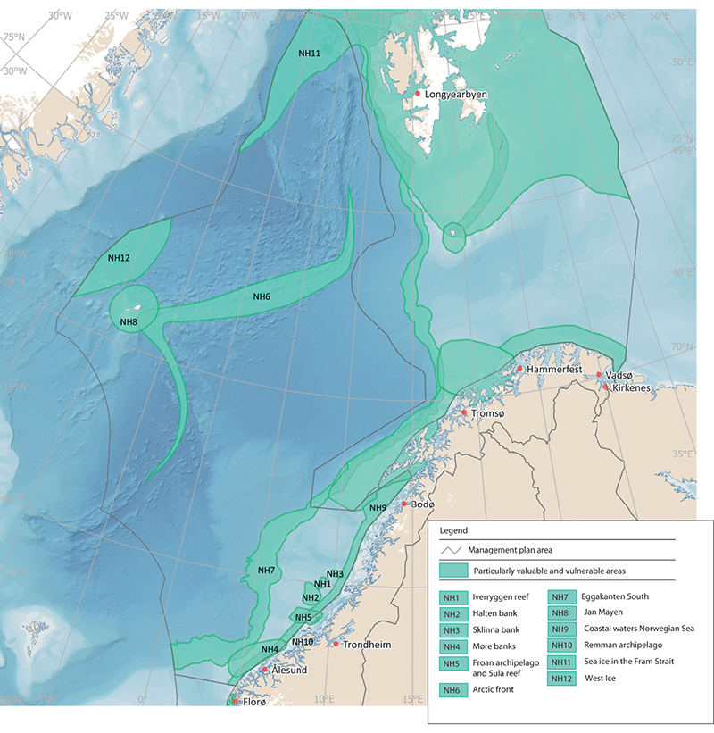
          - Particularly valuable and vulnerable areas in the Norwegian Sea management plan area.
Norwegian Environment Agency
The designated Arctic front area covers the zone where Atlantic and Arctic water meet. The area was originally described as a narrow zone stretching all the way through the Norwegian Sea where biological production is high and there is a rich diversity of animal species. As is the case for the polar front, there is so far no documentation that biological production is higher in the frontal zone than in the surrounding waters. However, the frontal zone may nevertheless be important as a habitat boundary for various species, and may be an area where species from different trophic levels aggregate. The Arctic front is an important feeding area for several whale species, including blue whale, fin whale, minke whale and bottlenose whale. The position of the Arctic front also has implications for the migration and distribution of Norwegian spring-spawning herring, which to a large extent avoids Arctic water masses.
The Remman archipelago is designated as a reference area for Laminaria hyperborea, and there is therefore no kelp harvesting in the area. There has been some increase in the vulnerability of seabirds in the area as a result of bycatches in the gill net and longline fisheries.
Coastal waters Norwegian Sea as designated stretches from Stad at 62° N northwards to the Vestfjorden. Many species use waters near the coast as a habitat and feeding area, and the area off the Norwegian Sea coast includes many localities that are important for seabirds. The section of the coastal zone from Stad to Runde, the coast of Sør- and Nord-Trøndelag (including the Froan, Vikna and Sklinna archipelagos) and the southern part of Nordland (including islands and skerries in Sømna and Vega municipalities), the Remman archipelago and the Vestfjorden are considered to be particularly valuable. Marine mammals such as the grey seal, common seal, common porpoise and orca occur all along the coast. Kelp forests are an important habitat for many marine organisms in the coastal zone.
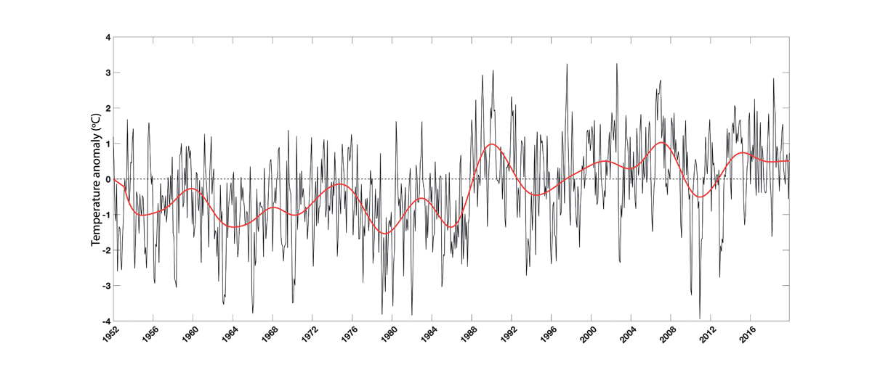
          - Temperature time series from 1952 to 2018 for Norwegian coastal waters in the Skagerrak and the North Sea, presented as anomalies relative to the period 1981–2010. Based on measurements by the Institute of Marine Research along the sections Torungen–Hirtshals and Utsira–Orkney (only measuring stations near the coast) and at the coastal stations Flødevigen, Lista, Utsira and Sognesjøen at depths of 0–10 m. The thin black line shows monthly values with the seasonal signal removed, while the red line shows the five-year rolling mean.
Institute of Marine Research

Environmental status in the North Sea and Skagerrak
The most important trends in the North Sea–Skagerrak ecosystem since 2011 include persistently high sea temperatures and a continuing spread of southerly zooplankton species, which has had substantial impacts on the rest of the ecosystem. Many fish stocks have grown considerably in recent years, while levels of pollutants have generally remained unchanged or declined.

Climate change in the management plan area
The northern North Sea constitutes most of the management plan area. It varies in depth from 0 to 500 m, and is heavily influenced by the inflow of oceanic water from the Norwegian Sea and Atlantic Ocean.
Temperature
Since the late 1980s, a generally rising trend in sea temperatures has been registered in the North Sea and Skagerrak, and temperatures have generally been above the long-term average for the period 1981–2010. Warming has slowed somewhat in the past ten years, but temperatures both in the surface layers and in deep water have remained high for the last 30 years. Although some of the warming can be linked to natural changes in the large-scale circulation in the Atlantic Ocean, most of it is related to the global warming trend.

Trends for various components of the North Sea–Skagerrak ecosystem
Ecosystem trends in the North Sea and Skagerrak are described, mainly on the basis of state and pressure indicators for the area.
Kelp forests
Sugar kelp forests are an important habitat type in Norway’s coastal waters, and are nursery areas and habitats for many marine species. In the Skagerrak and southwestern Norway, sugar kelp forests and eelgrass meadows are under considerable pressure from a number of factors. The decline in the distribution of sugar kelp in the Skagerrak is probably explained by periods in the late 1990s when summer temperatures were very high, which may have been lethal to the species, combined with high inputs of nutrients, which have favoured competing filamentous algae. Increasing runoff from land and inputs of humus and particulate matter can reduce light penetration in coastal water, increase sediment deposition on the seabed and reduce the depths to which kelp can grow. Reduced light penetration has been observed in the Norwegian coastal current over a long period. This may be a result of direct runoff to coastal areas. Monitoring of rivers that run into the Skagerrak shows that they have been transporting increased quantities of dissolved organic matter to the coast. In hard-bottom areas of the Skagerrak, sugar kelp is now found in shallower water than previously.
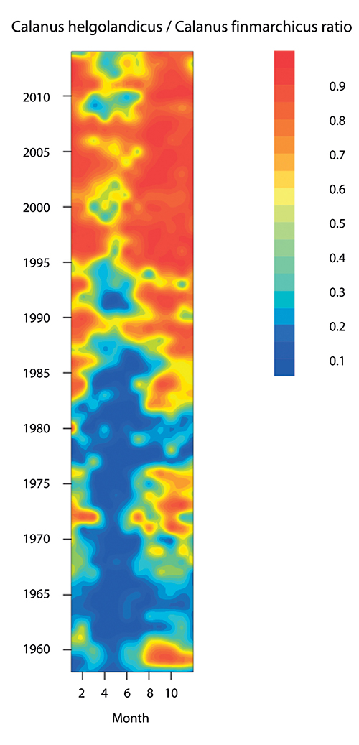
          - Ratio between the warm-water species Calanus helgolandicus and the cold-water species Calanus finmarchicus in the North Sea in the period 1958–2012. The figure shows that in the 1960s, substantial numbers of the warm-water species were only recorded at certain times of year, whereas after 1995 it has been dominant for most of the year.
Edwards et al. MCCIP Science Review 2013/ICES
Since 2000, there has been a weak improvement in the state of sugar kelp forests, but over the past 50 years its distribution has declined in the southern half of Norway, particularly in the Skagerrak. Losses were greatest in the Skagerrak around 2000 (50–80 %), but have also been substantial in the North Sea (50 %). Sugar kelp forests in the North Sea and Skagerrak (southern sugar kelp forests) are classified as endangered on the Norwegian Red List for habitat types and ecosystems 2018.
Phyto- and zooplankton
Primary production, or production of phytoplankton, has declined in recent years. This is probably because inputs of nutrients to the entire North Sea from the major European rivers and other land-based sources have been reduced. As a result, the previously serious problem of eutrophication has been largely eliminated.
In the North Sea, quantities of southerly zooplankton species have increased at the expense of zooplankton species that are adapted to colder water. The copepod Calanus finmarchicus is an important zooplankton species in the North Sea. In recent years, it has increasingly been replaced by the warmer-water species Calanus helgolandicus. Other changes have also been registered, and the proportion of other warm-water zooplankton species has been rising. One result of these changes is that the timing of reproduction for zooplankton species has shifted to later in the year.
These changes in the zooplankton community have had a variety of effects on other parts of the North Sea and Skagerrak ecosystems. The shift in the timing of zooplankton reproduction means that it no longer coincides as well with fish spawning seasons, which may have reduced fish food supplies and be one explanation for poor recruitment to several fish stocks. The shift towards warm-water species is also resulting in generally lower zooplankton production, which is expected to have implications for fish stocks generally and particularly for plankton-feeding species.
The increase in the proportion of warm-water zooplankton species may also explain why there has been an increase in observations of southerly fish species that are adapted to feeding on this type of plankton, such as European seabass, anchovy and pilchard. Such species have previously occurred sporadically in the North Sea, but breeding populations are now becoming established. The changes in the North Sea have resulted in an ecosystem that is less productive but has higher species diversity. The pelagic ecosystem in the North Sea is very complex, and knowledge about ecological links between the water column and the seabed is very limited. This makes it extremely difficult to predict what impacts climate change will have on benthic communities in the future.
Benthic fauna
A decline in mussel populations has been registered in recent years. Very little is known about the extent of this decline and what has caused it, but possible explanations are changes in the marine environment, greater predation pressure and disease. Declining mussel populations have also been observed in other countries, including France and the Netherlands. Mussel beds in all three management plan areas are categorised as vulnerable in the Norwegian Red List for ecosystems and habitat types 2018.
Fish stocks
The spawning stock of cod rose from 2011, but since 2017 has decreased considerably, to below the sustainable level. The sandeel stock in the southern part of the management plan area has risen. Stocks of Norway pout, saithe, herring and haddock are well above precautionary levels. However, several studies indicate that recruitment is weak and net production low, and these stocks may show a negative trend over time if recruitment does not improve. Stocks of most of the commercially important fish stocks in the North Sea are in better condition than in 2011 as a result of improvements in fisheries management. There is an even more marked improvement since the period before this, when a number of stocks were in poor condition because discarding of catches was permitted in EU and UK waters in the North Sea and Skagerrak and there were other weaknesses in the regulation of the fisheries.
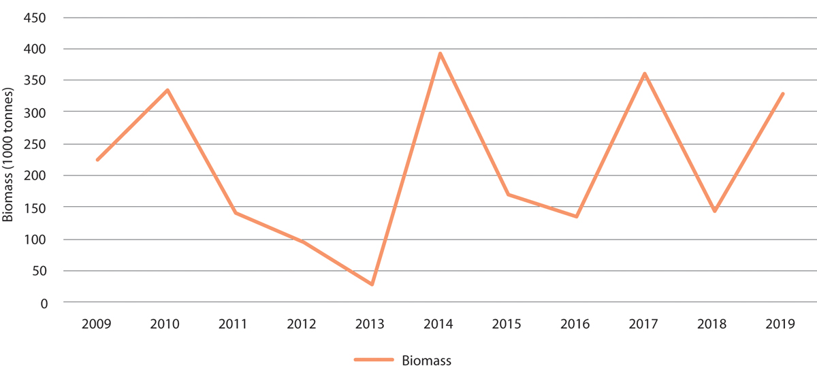
          - Measured biomass of sandeels (one year and older) in the Norwegian part of the North Sea, excluding the Viking Bank.
Institute of Marine Research/environment.no
The spawning stock of plaice rose from an estimated 200 000 tonnes in 2006 to a forecast 980 000 tonnes in 2018, and is now larger than when monitoring of the stock began in the 1950s. The ecological consequences of this change are unknown.
Seabirds and marine mammals
Overall seabird numbers in the North Sea and Skagerrak declined in the ten-year period 2007–2017. This was primarily due to a decline in the population of common eider and in breeding populations of large gull species such as the lesser black-backed gull. The reasons for the decline are largely unknown. The EU has recently finished phasing in a landing obligation banning discards of bycatches and unwanted catches. This will probably have a negative impact on seabird populations, since seabirds have until now fed on bycatches discarded by the fishing fleet. A landing obligation has been in force in Norwegian waters for much longer, and there will probably be no further impact on seabirds that forage in the Norwegian sector of the North Sea.
There has been little change in marine mammal populations in the last few decades. The porpoise population appears to be stable. The size of the only breeding colony of grey seals in the Norwegian part of the North Sea has not changed in recent years. An international survey of small cetaceans indicates that there are about 350 000 porpoises in the North Sea and Skagerrak. Porpoises are taken as a bycatch in fisheries, but the scale is unknown. The size of the minke whale stock has remained unchanged.
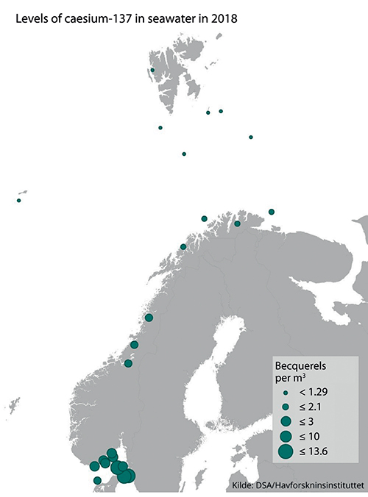
          - Levels of caesium-137 measured in seawater in 2018.
Norwegian Radiation and Nuclear Safety Authority/Institute of Marine Research
Alien species
Large numbers of the warm-water blue jellyfish Cyanea lamarckii have been observed in summer in the Skagerrak and eastern parts of the North Sea. In autumn, the comb jelly Mnemiopsis leidyi, an alien species, is being observed more and more frequently near the coast, especially from mid-August onwards. This species is largely associated with coastal waters, and densities in the open sea are low. Jellyfish are predators and may have major impacts on the planktonic food web.

Pollution
Inputs of pollutants to the management plan area via the atmosphere and rivers have generally been stable or declining since 2011. Inputs of persistent, bioaccumulative and toxic substances via the atmosphere and rivers have been stable or declining since 2011. Inputs of phosphorus, nitrogen and copper from fish farming along the coast of Western Norway rose steeply from 1990 onwards; the rise has continued after 2011, but has been less steep. It is uncertain to what extent these pollutants are transported out into the management plan area. On the whole, the extent of seabed affected by hydrocarbons from the petroleum industry has remained the same in recent years, but there has been a certain increase in some geographical areas. Since 2011, there has been no substantial change in the quantities of pollutants in produced water discharged from oil installations.
Levels of persistent, bioaccumulative and toxic substances in living organisms in the North Sea–Skagerrak management plan area are generally somewhat higher than in the Barents Sea–Lofoten area and the Norwegian Sea. Except for dioxins and dioxin-like PCBs in fish liver, and mercury in fillets of tusk from some areas, levels of most of these substances are below the maximum permitted levels in seafood. However, in most species the levels of mercury, PCBs and PBDEs exceed the low levels set in environmental quality standards, which are intended to protect species higher in the food chain such as seabirds and marine mammals. There are no grounds for concluding that there has been any change in pollution levels in living organisms in the North Sea since 2011.
Levels of radioactive pollution in seawater in the North Sea and Skagerrak are low, but somewhat higher than in the Norwegian Sea and the Barents Sea–Lofoten area. This is explained by proximity to the most important sources of radioactive pollution in Norwegian waters: the processing plants Sellafield in the UK and La Hague in France, and water flowing out from the Baltic Sea, which still contains pollutants originating from the Chernobyl accident. Levels of radioactive pollution in the marine environment have been gradually declining in recent decades. Levels of radioactive contamination (caesium-137) in fish and seafood are well below the maximum permitted level for seafood.

Particularly valuable and vulnerable areas
According to the scientific basis for the management plans, new knowledge obtained about the particularly valuable and vulnerable areas in the North Sea and Skagerrak does not indicate that there is any need to change the status of the existing areas. The updated knowledge base confirms the value and vulnerability of the previously identified areas. The particularly valuable and vulnerable areas and the species and habitat types found in them are further discussed in the Forum’s reports and in earlier white papers on the management plans.
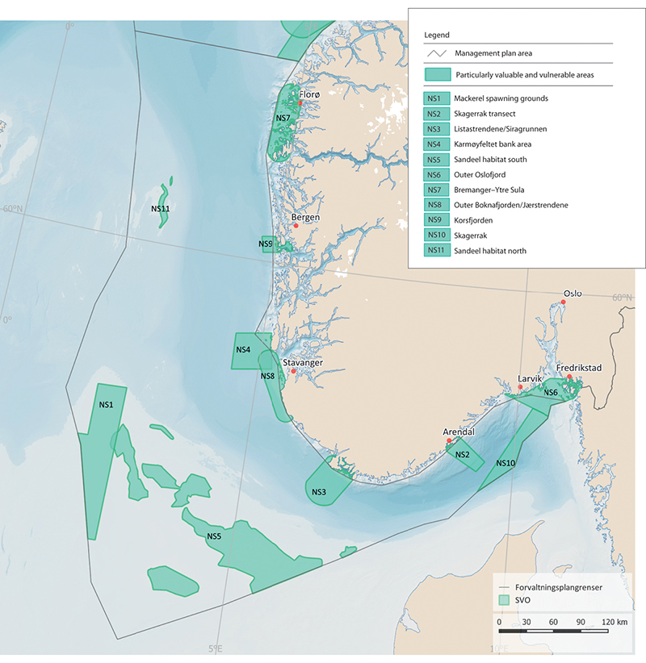
          - Particularly valuable and vulnerable areas in the North Sea–Skagerrak management plan area.
Norwegian Environment Agency
Parts of two of the particularly valuable and vulnerable areas, the Skagerrak and mackerel spawning grounds, are no longer included in the list because they are outside Norway’s jurisdiction and therefore do not come within the scope of the North Sea–Skagerrak management plan. The zone of coastal waters out to 25 km from the baseline was identified as a generally valuable area in the management plan for the North Sea and Skagerrak, but not as a particularly valuable and vulnerable area. However, the Forum for Integrated Ocean Management will consider the coastal waters of the North Sea-Skagerrak management plan area further in its review of the particularly valuable and vulnerable areas.
The original reason for identifying ‘mackerel spawning grounds’ as a particularly valuable and vulnerable area was that it includes the most important areas where the North Sea stock spawns in surface water in May–June. Mackerel is an ecologically and commercially important species in the North Sea. Atlantic water carrying mackerel eggs and larvae also flows into this part of the northern North Sea from mackerel spawning grounds west of Scotland and Ireland. The area is therefore valuable, but the part of it delimited as a particularly valuable and vulnerable area is not of greater importance for spawning than the waters around it. This is one of the areas the Forum for Integrated Ocean Management will consider further in its review.

Marine litter and microplastics
Marine litter and microplastics are causing growing environmental problems that are a threat to our continued sustainable use of the oceans, and may have impacts on ecosystems and threaten food safety and food security.
In 2017, the Government presented a white paper on waste policy and the circular economy (Meld. St. 45 (2016–2017)) including an integrated strategy to combat plastic waste. The 2017 update of the Norwegian Sea management plan included a separate chapter on plastic waste and measures and instruments to deal with the problem that are relevant to all three management plan areas. The status report for the Norwegian Sea published by the Advisory Group on Monitoring in 2019 includes more detailed and updated information on marine litter in all the management plan areas.

Marine litter – status and sources
In the North Sea, the amount of plastic in fulmar stomachs is used as an indicator of marine plastic pollution. This is a joint OSPAR indicator. Monitoring has shown a high but stable level of plastics in fulmar stomachs in the period 2005–2014. More than 60 % of the individuals sampled were found to contain more than 0.1 grams of plastic. Norway has adopted the OSPAR target that this level should be exceeded in less than 10 % of fulmars. In the Barents Sea and other parts of the Arctic, plastics have been found in the stomachs and pellets of several seabird species, including fulmar, little auk and Brünnich’s guillemot.
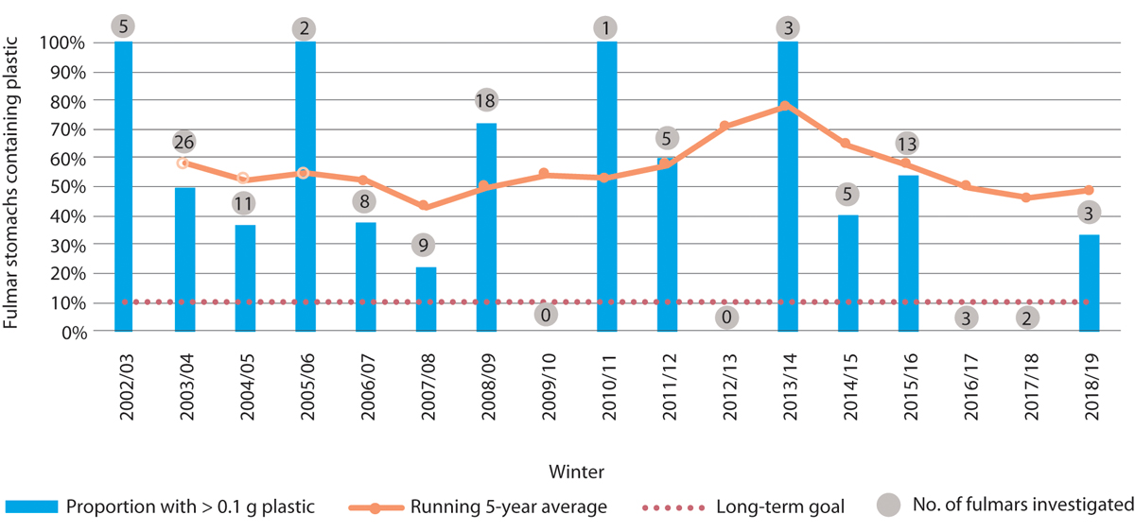
          - Percentage of fulmars in the North Sea found to have more than 0.1 g plastic in the stomach.
Norwegian Institute of Nature Research NINA
Our knowledge about plastics and microplastics in living organisms, whether in Norwegian waters or elsewhere, is limited. In Norway, microplastics have been found in organisms including mussels and other molluscs, cod, snow crab, Chinese mitten crab and marine worms. The levels detected have been low. In general, the smaller the size of the particles that can be detected by the analysis, the larger the number of particles found. Studies of animals have shown that the smallest particles can be absorbed into the tissues via the stomach. In addition to the effects of the plastics themselves, chemical additives and chemical contaminants on the plastics can be a problem. Furthermore, both pathogens such as bacteria and viruses and alien species found in or on plastics can be spread to new areas by ocean currents.
Many animals suffer injuries and die through becoming entangled in or ingesting plastics, and this has been well documented. However, little is known about the effects of plastic waste and microplastics at population or ecosystem level. A risk assessment by the Norwegian Scientific Committee for Food and Environment concluded that the risk of negative impacts is low at present, but that this situation could change over time.
Seven Norwegian beaches are included in the OSPAR beach litter monitoring programme. The monitoring results show little change in litter quantities over time, indicating that inputs of litter are not being reduced. At least 90 % of the litter is plastic. Litter has also been observed on the seabed in all areas that have been investigated, but there is not yet sufficient data to assess whether quantities are rising.
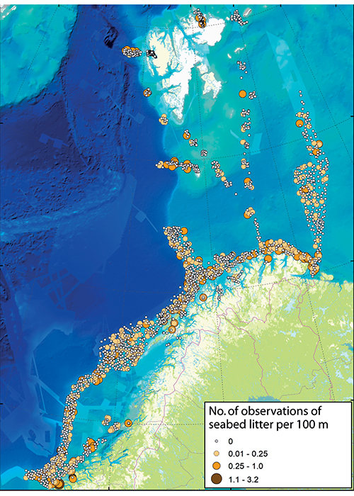
          - Observations of seabed litter in the Barents Sea and Norwegian Sea.
MAREANO
There are many different sources of marine litter, and it originates from a wide variety of activities both at sea and on land. Plastics make up the largest fraction of marine litter, and are the most serious problem. Microplastics originate from the degradation of plastic waste, sea-based sources such as ships’ paint and aquaculture, and inputs from a wide variety of land-based sources. The quantities of waste and microplastics that enter the marine environment from the different sources are very uncertain.
Registration of litter on beaches along the Norwegian mainland coast and the coast of Svalbard shows that consumer waste dominates in the southern part of the country, while sea-based sources including the fishing industry dominate further north and in Svalbard. This reflects differences in population levels and coastal activities. In areas that are heavily used for outdoor recreation, high levels of litter originating from these activities are registered. Plastic waste and microplastics are transported over long distances by ocean currents, between countries and continents, and some of the marine litter found in Norwegian waters thus originates from other countries. Microplastics also spread in the atmosphere, and are even found in the Arctic. There are indications that an accumulation zone for plastic waste and microplastics is forming in the Barents Sea. Microplastics may also accumulate in sea ice in the Arctic. Researchers believe that microplastics in seawater are trapped and may become concentrated in sea ice, and are released when the ice melts.
Observations from the MAREANO programme indicate that the fishing industry is one of the main sources of seabed litter in the Barents Sea and Norwegian Sea. About 40–60 % of all plastics registered in bottom trawl hauls in the Barents Sea are related to the fishing industry. A substantial proportion of beach litter consists of small plastic fragments and pieces of rope that cannot be traced back to an exact source. For Norwegian waters generally, fisheries, aquaculture and shipping have been identified as the main sources of marine litter. Estimates of the proportion of waste from different sources will depend partly on whether the calculations are based on the abundance, volume or weight of waste types.
A recent report from the consultancy SALT and the Nordland Research Institute estimates that the accumulated amount of litter along the coast of Norway originating from the seafood industries (fisheries and aquaculture) in Norway and internationally is in the order of magnitude of 100 million objects with a total weight of 10 000 tonnes. According to the report, explanations for releases of plastic waste from fisheries and aquaculture range from weaknesses in waste management systems, failure to follow routines, habit, wear and tear and a lack of maintenance, to deliberate dumping. Rope ends and net fragments are also commonly discarded during repairs at sea. The report describes the results of several studies that will provide a basis for action plans to be developed by the industries to reduce inputs of plastic waste to the marine environment.

Efforts to combat marine litter – status and further work
In the course of 2020, the Norwegian Environment Agency will present a new synthesis of knowledge about the sources of marine litter and microplastics in Norway, including sea-based sources such as the fisheries, aquaculture and shipping. Furthermore, GESAMP (the Joint Group of Experts on the Scientific Aspects of Marine Environmental Protection), an advisory body for the UN system, is working on a report on sea-based sources of marine litter across the world. In 2020, the Norwegian Environment Agency is to present proposals for supplementary action to reduce inputs of plastic waste and microplastics from sea-based sources, and knowledge about sources will be a vital basis for the proposals.
An updated, broader-based Norwegian strategy for combating plastic waste is also to be prepared in the light of new knowledge about the distribution, sources and effects of plastic waste, appropriate action, and experience of using various policy instruments. The strategy will deal with plastic litter and microplastics in the oceans, in freshwater and on land.
The Directorate of Fisheries organises an annual retrieval programme for lost fishing gear in Norwegian waters. Since this programme started in the early 1980s, more than 21 000 gill nets and 10 000 traps have been retrieved. The total weight of the gear retrieved is estimated at almost 1000 tonnes. Most of the gear retrieved has probably been lost by accident, but as late as 2019, fishing gear has been found that has clearly been deliberately abandoned. Norwegian fishermen are required to report the loss of fishing gear, and their reports provide part of the basis for determining the areas to be covered by the gear retrieval programme. In recent years, as much as 70 % of the gear retrieved has been returned to its owners.
The Fishing for Litter project has established a temporary scheme that allows fishing vessels to deliver marine litter taken as a bycatch in fishing gear in nine selected ports along the Norwegian coast, free of charge. The consultancy firm SALT Lofoten has been responsible for planning and implementing the scheme since 2015, with funding from the Norwegian Environment Agency. Two more ports are to be added to the scheme in 2020. The Government is now considering how to introduce legislation on the delivery of waste retrieved at sea free of charge, in line with the revised Port Reception Facilities Directive. Experience gained from the Fishing for Litter project will be an important basis for this work. In 2018, the Norwegian Environment Agency presented a review of producer responsibility for plastic waste from the fisheries and aquaculture. This is now being evaluated by the Ministry of Climate and Environment.
Since the refund scheme for end-of-life leisure craft was introduced in 2017, more than 20 000 boats have been delivered. The scheme is being expanded from 2020 to include aluminium boats and other boats with metal keels and ballast.
The Norwegian Environment Agency administers a grant scheme promoting action to reduce marine litter in Norway, including both removal of litter and preventive measures. The scheme focuses mainly on beach clean-up. In 2020, NOK 70 million has been allocated to the scheme.
The business sector also provides substantial funding for clean-up and removal of litter.
The voluntary organisation Hold Norge Rent (Keep Norway Clean) plays an important part in coordinating and providing advice on voluntary clean-up initiatives in Norway. The organisation also organises a network for cooperation between businesses, public authorities and voluntary organisations that are working to reduce marine litter and microplastics. Its operating grant is therefore to be increased from 2020.
The Norwegian Centre for Oil Spill Preparedness and Marine Environment is being established as a centre of expertise on the recovery and prevention of marine litter from sea-based sources. A key task is to establish a database and map service for information on beach litter clean-up as a basis for coordinated, effective efforts at national level. The centre will also be responsible for disseminating knowledge about the prevention of marine litter from sea-based sources.
The 2019 EU directive on reducing the impact of certain plastic products on the environment includes requirements for member states to introduce producer responsibility schemes for fishing gear, including aquaculture equipment. The EU has also revised the Port Reception Facilities Directive, which requires countries to provide adequate facilities for delivery of passively fished waste in their ports. The Norwegian authorities are taking steps to implement the requirements of these two directives.

Status report: progress towards the goals of the ocean management plans
The Forum for Integrated Ocean Management has reviewed progress towards the goals of the ocean management plans, and the results are summarised below. The report is based on the goals as they were formulated in earlier management plans. These goals have largely been retained in the present white paper, but their wording has been harmonised for all three management plan areas. The new goals are set out in full in Chapter 2.4.
Safe seafood
Fish and other seafood will be safe and will be perceived as safe by consumers in the various markets. Current knowledge indicates that this goal has been achieved for the Barents Sea–Lofoten management plan area, and partly achieved for the Norwegian Sea and the North Sea and Skagerrak. Levels of hazardous substances and radioactive substances are generally low and largely under the maximum permitted levels in seafood. However, concentrations above the permitted levels may be found in individual species in certain areas and in some specimens of species at high trophic levels, such as halibut. Levels of hazardous substances may also exceed the maximum permitted levels in fish liver and edible crabs. In some cases, measures such as prohibiting catches or advising against consumption have been introduced to ensure that seafood is safe. For example, in October 2017, catches of halibut from the outer Sklinnadjupet trench were banned and a requirement to discard all halibut exceeding two metres in length was introduced.
Activities in the Norwegian Sea and in the North Sea and Skagerrak will not result in higher levels of pollutants in seafood. The main source of pollutants found in seafood is probably activity outside the management plan areas. It is very uncertain how much activity within the North Sea–Skagerrak management plan area contributes to contamination of seafood, and knowledge is limited. The goal is considered to have been achieved for hazardous substances in the North Sea and Skagerrak. It is uncertain whether the goal has been achieved for the Norwegian Sea because of a lack of knowledge about the sources of the hazardous substances found as contaminants in seafood.
Environmentally hazardous substances
Environmental concentrations of hazardous and radioactive substances will not exceed the background levels for naturally occurring substances and will be close to zero for man-made synthetic substances. Releases and inputs of hazardous or radioactive substances from activity in the management plan areas will not cause these levels to be exceeded. There are still inputs of hazardous and radioactive substances to all three management plan areas, and the goals for hazardous substances have not generally been achieved. This conclusion is based on an overall evaluation of the available knowledge about inputs and levels of hazardous and radioactive substances.
Operational discharges from offshore petroleum activities and shipping
Operational discharges from activities in the management plan areas will not result in damage to the environment or elevated background levels of oil or other environmentally hazardous substances over the long term. There are substantial operational discharges from petroleum activities in the North Sea, which are resulting in rising background levels of oil, other environmentally hazardous substances and naturally occurring radioactive substances over time. There are also discharges of naturally occurring environmentally hazardous substances, naturally occurring radioactive substances and environmentally hazardous substances with produced water from petroleum activities in the Norwegian Sea. Levels of pollution in the Norwegian Sea are generally low, and it is unlikely that operational discharges from petroleum activities or shipping are causing environmental damage. However, there is still uncertainty about the damage that operational discharges may cause, including the possible long-term effects of drill cuttings on corals and sponges. The goal is therefore not considered to have been achieved for operational discharges from petroleum activities in these two management plan areas.
Operational discharges in the Barents Sea–Lofoten management plan area are limited, and are not thought to be resulting in rising background levels of oil or other environmentally hazardous substances or naturally occurring radioactive substances over time.
Operational discharges of oil in bilge water to the management plan areas are small and have not so far resulted in detectable changes in ecosystems. A lack of knowledge means that it is uncertain whether the goal has been achieved for operational discharges of environmentally hazardous substances (stern tube lubricants) from shipping.
Marine litter
Inputs of litter that have negative impacts on coastal waters, the sea surface, the water column or the seabed will be reduced. An overall evaluation of current knowledge indicates that the goal has not been achieved for any of the management plan areas. Large quantities of litter are being registered at many localities along the coast, in trawls, during mapping of the seabed and in the stomachs of seabirds and other animals. The results of beach litter monitoring indicates that there has been no decline in the number of objects found on the reference beaches since the previous report, even though there are regular beach clean-up operations on these beaches.
Monitoring of marine litter is inadequate, and there are gaps in our knowledge about environmental damage and inputs of litter from sources within and outside the management plan areas.
Risk of acute pollution
The risk of damage to the environment and living marine resources from acute pollution will be kept at a low level and continuous efforts will be made to reduce it further. Maritime safety measures and the oil spill preparedness and response system will be designed and dimensioned to effectively keep the risk of damage to the environment and living marine resources at a low level.
The risk of accidents in connection with petroleum activities is assessed as low in all three management plan areas. The goal is considered to have been achieved, which reflects the effectiveness of preventive measures during the reporting period and indicates which measures will be useful in preventing accidents in future.
The potential environmental consequences of spills vary from area to area and through the year, particularly depending on where and when seabirds are most vulnerable, and this affects the level of environmental risk. The discharge potential in the Barents Sea South, particularly the northern parts of this area, is considerably lower than elsewhere on the Norwegian continental shelf. Even so, the level of environmental risk for seabirds in the open sea is generally higher in the Barents Sea–Lofoten area than in the Norwegian Sea and the North Sea–Skagerrak, because larger numbers of vulnerable seabirds are present for much of the year. The goal of keeping the risk of damage to the environment and living marine resources at a low level is therefore not considered to have been achieved for the Barents Sea–Lofoten management plan area, even though the risk of accidents is low.
The environmental risk associated with fields that are on stream in the Norwegian Sea and the North Sea–Skagerrak is considered to be unchanged. There has been a high level of environmental risk associated with certain activities, and a need for risk-reduction measures, particularly to deal with high discharge rates and activity near the coast. The goal is therefore only considered to have been partially achieved.
Risk-reduction measures that have been implemented have reduced the risk of accidents resulting in spills from shipping in the management plan areas. Only a few accidents result in acute pollution, and the goal of reducing the risk of damage to the environment is considered to have been partially achieved. However, no specific assessments have been made of levels of environmental risk or any changes in these levels.
The volume of nuclear-powered shipping in all three management plan areas is rising, as is the volume of radioactive cargo in the Russian part of the Barents Sea. The goal of reducing the risk of environmental damage from these activities is therefore not considered to have been achieved.
The oil spill preparedness and response system at private, municipal and governmental level is risk-based. The preparedness and response system has been strengthened and various measures have been introduced at governmental level and by the oil and gas companies. However, it is difficult to verify how much these measures would reduce the consequences of spills, and the extent to which the goal has been achieved is uncertain.
Norway’s nuclear emergency preparedness system for Norwegian waters has been strengthened to some extent, but further improvements are needed in the resources available for monitoring and measuring radioactivity and in action that can be taken to prevent releases of radioactivity from disabled ships.
Underwater noise (North Sea–Skagerrak management plan area)
Activities entailing a noise level that may affect species’ behaviour will be limited to avoid the displacement of populations or other effects that may have negative impacts on the marine ecosystem. No indicators have been established to show trends in underwater noise levels from activities in the management plan areas and their environmental consequences. Too little is known about whether there are clear links between noise levels from various activities and the impacts on ecosystems. It is therefore not possible to determine the extent to which the goal has been achieved.
Nutrients, sediment deposition and organic material (North Sea–Skagerrak management plan area)
Anthropogenic inputs of nutrients, sediment deposition and inputs of organic matter will be limited in order to avoid significant adverse impacts on biodiversity and ecosystems in the management plan area. Inputs of nutrients from the Norwegian mainland are rising, but no significant adverse impacts have been demonstrated in the form of eutrophication or sediment deposition in the management plan area. However, given the rising inputs, the goal is not considered to have been achieved.
Climate change and ocean acidification (North Sea–Skagerrak management plan area)
When marine ecosystems are used as carbon sinks, the need to maintain biodiversity and natural ecosystem functions will be taken into account. At present, there is no activity in the management plan area that makes use of marine ecosystems as carbon sinks. It is very difficult to draw any conclusions about trends in the cumulative impacts of human activity on species and habitat types that are affected by climate change and ocean acidification, and whether these impacts have been minimised.
Particularly valuable and vulnerable areas and habitats
Activities in particularly valuable and vulnerable areas will be conducted with special care and in such a way that the ecological functioning and biodiversity of such areas are not threatened. This goal is considered to have been achieved for some particularly valuable and vulnerable areas and partially achieved for others, meaning that some of the ecosystem components that are evaluated are showing a positive trend, while others are stable or showing a negative trend. In some particularly valuable and vulnerable areas, it is uncertain whether the goal has been achieved. It is often uncertain whether and to what extent human activity within a specific area affects its ecological functioning or biodiversity. Fishing operations, particularly trawling, have been carried out in several of these areas for many years. Fisheries inevitably leave a footprint, and this has been taken into account in assessing how far the goal has been achieved. In addition, biodiversity and pressure from human activities have not been adequately mapped for all the particularly valuable and vulnerable areas. Because of overexploitation of the lobster stock and possible indirect effects of human activity on seabird populations, the goal is not considered to have been achieved for three particularly valuable and vulnerable areas: the Skagerrak transect, the Outer Oslofjord and the Skagerrak.
Damage to marine habitats that are considered to be endangered or vulnerable will be avoided. In assessing progress towards the goal, human activity in the management plan areas has been taken into account. Damage is taken to mean damage that can have effects at population level and on biodiversity, not damage to individual specimens of animals or plants. Progress towards this goal is also variable: it has been achieved or partially achieved for some habitat types, while a lack of knowledge makes progress difficult to assess for other habitat types. The goal has not been achieved for two habitat types: Isidella lofotensis coral gardens and fine-sediment seabed in deep water in the Skagerrak.
Species management
Naturally occurring species will exist in viable populations that provide for sufficient reproductive capacity and long-term survival, and genetic diversity will be maintained. This goal has been achieved for all the large commercial fish stocks and for marine mammals that are harvested, but it is more uncertain whether it has been achieved for fish stocks that are not commercially harvested and for benthic organisms. The goal has not been achieved for seabirds, some of the smaller commercial fish stocks and hooded seals in the Norwegian Sea.
Species that are essential to the structure, functioning and productivity of ecosystems will be managed in such a way that they are able to maintain their role as key species in the ecosystem concerned. The goal is considered to have been achieved for the management of key species in all three management plan areas.
Populations of endangered and vulnerable species and species for which Norway has a special responsibility will be maintained or restored to viable levels. The goal has not been achieved; populations of many endangered and vulnerable species and species for which Norway has a special responsibility are not at ‘viable levels’ according to the 2015 Norwegian Red List.
The introduction and spread of alien organisms through human activity will be avoided. The goal has not been achieved for the North Sea–Skagerrak management plan area. It is uncertain whether it has been achieved in the other management plan areas. There is inadequate monitoring of alien organisms that are spread with ballast water or on ships’ hulls, so that it is not possible to assess progress towards the goal for such species. It is too early to observe any effects of the implementation of the Ballast Water Management Convention, which entered into force in 2017.
Conservation of marine habitat types
The establishment of marine protected areas in Norway’s coastal and marine waters will contribute to an internationally representative network of marine protected areas. The goal is not considered to have been achieved in any of the management plan areas because much more work remains to be done on implementation of the marine conservation plan, and because the marine protected areas that have been established are not yet considered to provide a representative network that will maintain the full range of variation of habitat types.
Sustainable harvesting/use
Management of living marine resources will be based on the principles of sustainable harvesting. This goal has been achieved for all stocks that are harvested in the Norwegian Sea, including both large and small commercial stocks.
Living marine resources will be managed sustainably through the ecosystem approach based on the best available knowledge. Harvesting will not have significant adverse effects on other parts of the marine ecosystem or its structure. These goals are considered to have been achieved for the North Sea–Skagerrak management plan area.
Bycatches of marine mammals and seabirds will be minimised. It is uncertain whether this goal has been achieved for the North Sea–Skagerrak management plan area.
Living marine resources will be harvested making use of the best available techniques for different types of gear to minimise negative impacts on other ecosystem components such as marine mammals, seabirds and benthic communities. This goal is considered to have been achieved for the North Sea–Skagerrak management plan area.
Harvested species will be managed within safe biological limits so that their spawning stocks have good reproductive capacity. This has been achieved for species in the Barents Sea–Lofoten area, with the exception of coastal cod and golden redfish. The goal has now been achieved for red king crab, which is an improvement since 2010.

Knowledge building and knowledge needs
Norway gives priority to knowledge-based, integrated and responsible ocean management. Sound management of Norwegian waters must be based on a sound knowledge base built up through mapping, research and environmental monitoring. This chapter outlines the main knowledge needs in various areas. Earlier management plans and the Government’s long-term plan for research and higher education have also included an account of significant knowledge needs. Norway’s ocean management regime is based on a considerable body of knowledge, but there are still major gaps in our knowledge and understanding of the marine environment, and further mapping, research and monitoring are needed. Further developing our understanding is a vital basis for sustainable management of marine ecosystems.
Climate change, ocean acidification and inputs of pollutants such as hazardous substances and plastic waste are changing the oceans. The scale of these changes is already greater than we have experienced historically as a result of natural variability, and will increase further (see Chapter 4). This is affecting not only the marine environment, but also the basis for future ocean industries. Knowledge about these changes and the ability to predict and counteract them is of critical importance, both for the management of species and ecosystems and for further development of ocean industries. Such knowledge will also facilitate environmental improvements and strengthen green competitiveness in maritime industries.

The ocean environment and climate change
Marked changes have been observed in all three management plan areas as a result of climate change. These changes are expected to continue and become more pronounced over time. Together with ocean acidification, climate change is expected to affect not only ocean temperatures, but also ocean currents, ice conditions, extreme weather events, wave height and chemical conditions such as the pH of seawater and its oxygen content. Physical and chemical data from different seasons are therefore needed to learn more about year-to-year changes and put us in a position to understand changes in ocean climate and ocean acidification.
Furthermore, research will be needed to develop methods and models that will improve predictions of how climate change and ocean acidification will affect basic ecological variables and processes such as primary production, species and stock size and distribution, and future catch potential.
              - The Nansen Legacy project
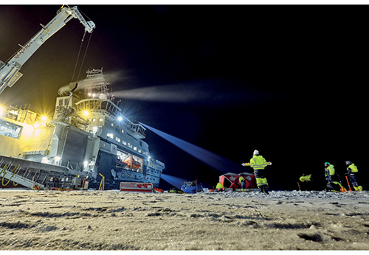
          - The Nansen Legacy: sampling from the RV Kronprins Haakon in the northern Barents Sea in December 2019.
Photo: Robin Hjertenes, Institute of Marine Research
The Nansen Legacy research project started in 2018, and is intended to improve scientific understanding of climate change and marine ecosystems in the central and northern parts of the Barents Sea. It involves cooperation between ten Norwegian research institutions.
In 2019, five research cruises were carried out, mainly using the ice-class research vessel Kronprins Haakon. Interdisciplinary data have been collected that show interannual variability in ice cover and water temperature in the northern Barents Sea. A cruise during the polar night in December 2019 found unexpectedly large numbers of organisms in icy waters in areas of drift ice, and considerable reproductive activity under the ice. Data collected from measuring instruments deployed for more than a year in the Barents Sea shows a considerable inflow of warm Atlantic water into the Barents Sea from the north, which had not previously been observed.
Preliminary analysis of geological cores from bottom sediments has provided a better understanding of sea ice dynamics in the Barents Sea since the last ice age. Analyses of historical ecosystem data from the Barents Sea show how the ocean climate influences the dynamic relationship between zooplankton and fish, which has important implications for sustainable management.
The project includes 40 early career scientists, who are working together with established researchers to collect and analyse data. In future, these young researchers will form the backbone of marine polar research in Norway, across disciplines and institutions.
The project is also focusing on outreach, communicating research questions and results to a wide audience through a variety of channels. Target groups include young people, the general public, researchers, decision makers and various interest groups.
[Boks slutt]

Marine ecosystems
Knowledge about the marine environment, marine ecosystems and processes in the oceans makes it possible to follow environmental status and trends in the management plan areas, manage the way they are used, and understand relationships between pressures and impacts on ecosystems, habitat types and species. A better understanding of functions and the natural interplay between different components of marine ecosystems is of key importance for sustainable ocean management.
There is also a pressing need for more knowledge about the ecosystem impacts of climate change and ocean acidification. This includes both knowledge about how climate change and ocean acidification are affecting ecosystems today, and knowledge that will improve our ability to predict future changes and provide a better basis for management. We need more knowledge and a deeper understanding of the pressures on ecosystems caused by factors such as harvesting, pollution, alien species and plastic waste and microplastics (see Chapter 3.6.4). Underwater noise is another example of an area where little is known about effects on marine species.
Human activity both at sea and on land is putting pressure on marine ecosystems. It is vital to develop an overall understanding of the cumulative impacts of the whole range of activities. We do not know enough about cumulative impacts, for example to what extent multiple impacts at individual level translate into population-level impacts. Further development of a harmonised scale for pressures and impacts from different sectors is needed, and methods for assessing cumulative impact and environmental impacts also need to be further developed. In the case of climate change, more needs to be learned about how reducing other pressures can help to maintain ecosystem functioning and make ecosystems more resilient, and how different policy instruments and combinations of them can be used most effectively to achieve this.
Major changes are taking place in seabird populations along the coast. Further studies are needed to identify the causes and find links between ecosystem processes and population changes. Some studies suggest that there are close links between the ocean climate, larval drift and declining seabird populations. More knowledge is also needed about seabird habitat use throughout the year.
Moreover, we need to strengthen the knowledge base on the ecosystem impacts of harvesting new species or new ecosystem components. These include the copepod Calanus finmarchicus and mesopelagic fish species, and research must include changing climatic conditions that may result in shifts in species distribution.

Mapping the seabed
Mapping of the seabed in Norwegian waters should be continued. The MAREANO programme, which started in 2005, maps depth and topography, sediment composition, biodiversity, habitats and biotopes, and pollution on the seabed in Norwegian waters. By the end of 2019, depth data were available for 28 % of Norway’s marine and coastal waters. Maps of sediments and biotopes were available for 10 % and 7 % respectively of marine and coastal waters.
The MAREANO programme is important as a basis for integrated, ecosystem-based management of Norwegian seas and oceans. It is important to continue this work to build up knowledge about seabed habitat types and biotopes with important functions, and about the resilience and vulnerability of marine benthic ecosystems to different pressures and to cumulative impacts, based partly on data from the MAREANO programme.
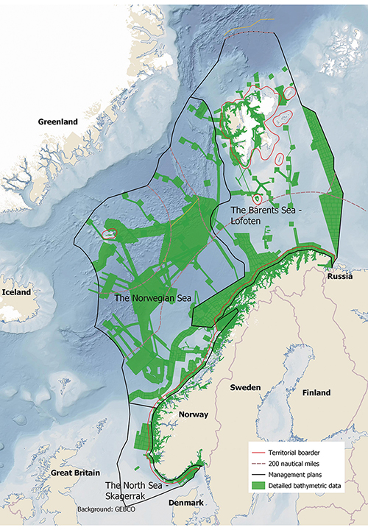
          - Areas where the MAREANO programme has mapped depth and topography or obtained data from other sources.
MAREANO

Marine litter and microplastics
More knowledge is needed about plastic waste, microplastics and nanoplastics, including sources, pathways of dispersal, and impacts on the fauna, ecosystems, ecosystem services, food safety and health. Research and innovation is also needed to find effective and environmentally sound ways of preventing and reducing inputs of marine litter and microplastics.
Standardised methods and indicators for measuring and monitoring plastics in the marine environment are essential for following trends in quantities and types of plastic over time.
Better data are also needed as a basis for evaluating measures and assessing their effects. Methods and indicators should be developed through international cooperation, including work within the OSPAR framework.
Mapping and monitoring of plastic waste and microplastics in the marine environment in Norway should be expanded and used in the international knowledge base and international cooperation.

Environmental monitoring
There is a need to further develop several of the indicators used for environmental monitoring or to improve reporting by making the information more accessible or improving the monitoring system. A closer focus on species composition is needed, including species at lower trophic levels, and more time series are needed on population size and habitat use. These developments are needed to make it possible to assess value and vulnerability on a smaller scale (both temporal and spatial). There are also gaps in the monitoring of benthic communities, alien species, threatened species and pollution.
Monitoring of pressures and impacts associated with human activity needs to be further developed. We also need to improve our understanding of which changes are caused by pressures from human activity in the management plan areas or adjoining coastal waters and land, and which are related to climate change and other large-scale processes or to natural processes and variability in the oceans. This applies particularly to pressures on areas identified as valuable and vulnerable. Better and more cost-effective methods also need to be developed for use in mapping and monitoring Norwegian waters.

Changing oceans
Norway has jurisdiction over large marine areas that are especially productive and rich in resources, but also vulnerable and undergoing rapid change. It is a challenging task for the Norwegian ocean management authorities to maintain the ecological structure and functioning of these areas, so that they continue to provide a long-term basis for value creation and welfare at a time when the climate, environmental conditions and ocean activities are changing rapidly.
Norwegian seas are part of one continuous ocean system, and changes in other parts of the world’s oceans also influence areas under Norwegian jurisdiction. The entire system is affected by climate change and other large-scale pressures. Further development of Norway’s ocean management system must be based on an understanding of how climate change and other large-scale processes are affecting and will change the world’s oceans and how they are used.
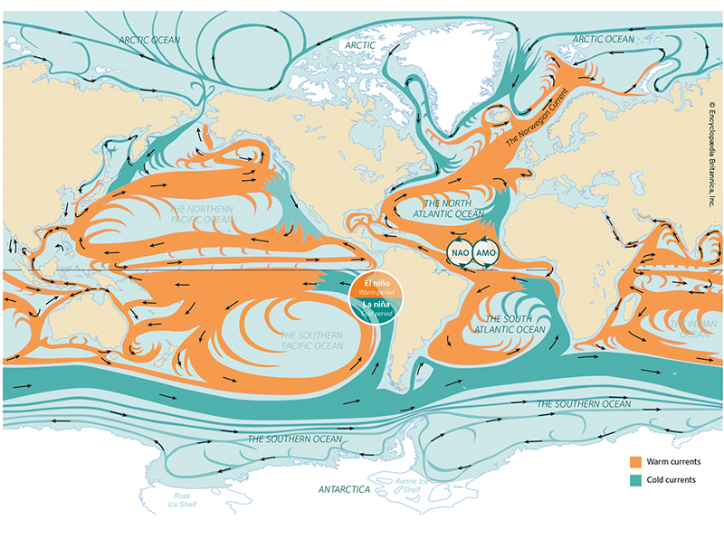
          - Global ocean currents. Norwegian waters form part of a continuous ocean and circulatory system.
Norwegian Environment Agency
This chapter describes some of the most important finds in three key scientific reports on these issues, all published in 2019: the IPCC Special Report on the Ocean and Cryosphere in a Changing Climate, from the Intergovernmental Panel on Climate Change, the IPBES Global Assessment of Biodiversity and Ecosystem Services from the Intergovernmental Science-Policy Platform on Biodiversity and Ecosystem Services, and The Ocean as a Solution to Climate Change from the High-level Panel for a Sustainable Ocean Economy. The chapter focuses particularly on conclusions that are relevant to Norwegian waters and possible implications for their management.
The world’s oceans contribute to human well-being by providing resources such as food, minerals and energy, transport routes and a basis for recreation and tourism. The oceans also moderate global warming by absorbing heat and CO2, and act as a sink for pollutants and waste produced by a rapidly growing population and expanding economy. This also means that the global ocean system, from the coastline to the deep sea, is under severe and growing pressure from human activity.
Population growth and increasing prosperity are also creating a demand for more food, energy and other resources from the oceans. The goal of rapid reductions in greenhouse gas emissions is intensifying this, for example increasing demand for production of offshore renewable energy.
It is difficult to predict all the impacts of climate and environmental change and expanding human activity on the oceans. There is therefore growing uncertainty about environmental conditions in the future and whether there is a viable basis for industries that depend on marine ecosystems. This will create new challenges for ocean management at national level and for international ocean cooperation.
Deterioration of the marine environment is also undermining the viability of the ocean economy. The OECD has described degradation of the marine environment as a result of climate change, ocean acidification, overfishing, land- and sea-use change and inputs of pollutants and plastic waste as a serious threat that is limiting opportunities for further development and growth.

Changing world oceans – drivers of change and impacts
IPBES has estimated that more than 40 % of the world’s ocean area is already strongly affected by human activity, and that cumulative impacts are increasing across two thirds of this area. There are wide variations between different areas. Coastal marine ecosystems in densely populated areas and in tropical waters are under the greatest pressure. However, climate change is also putting considerable pressure on the polar seas.
According to IPBES, there are four main direct drivers of change in marine ecosystems. The most important of these globally is fishing and other harvesting of marine organisms, followed by land- and sea-use change, including the development of infrastructure and aquaculture in the coastal zone. The third driver is climate change, and the fourth is inputs of pollutants and waste. The relative importance of these drivers varies between different parts of the world’s oceans. In Norwegian waters, climate change is the most important driver.
Climate change is also the driver that is intensifying most rapidly worldwide. According to IPBES, it is likely that the cumulative impacts of climate change, in combination with the changes in the use of marine and coastal waters, overexploitation of living resources, pollution and the spread of alien species will further exacerbate negative impacts on ecosystems. The Arctic is highlighted as one of the regions where this can already be observed.
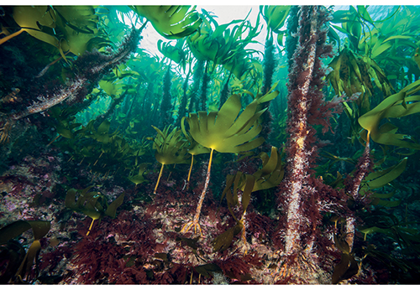
          - Kelp forest in Norway.
Photo: Erling Svensen
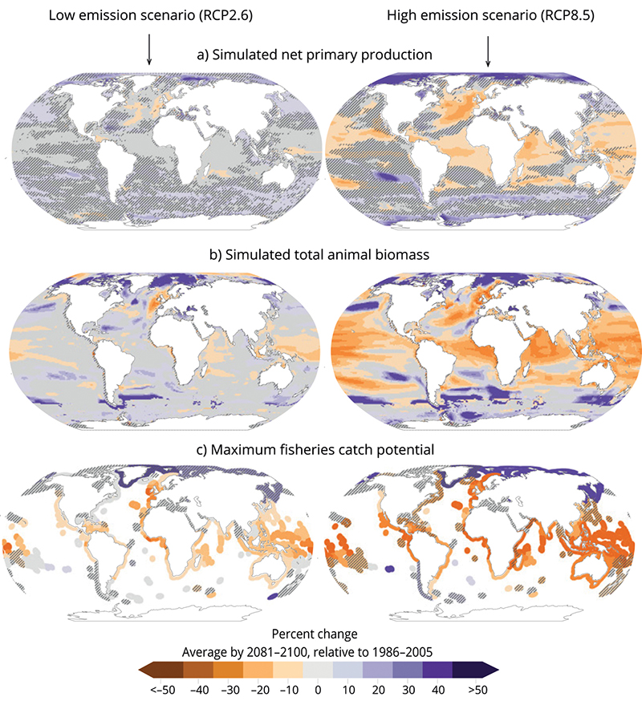
          - Projected changes in the world’s oceans by the end of this century: a) net primary production, b) total animal biomass, and c) maximum fisheries catch potential. Purple indicates a rise and orange a decline. The two sets of diagrams show, left, a low-emission scenario (RCP2.6), and right, a high-emission scenario (RCP8.5). Shaded areas indicate where there is disagreement between models, and white areas where there is a lack of data. Although the Arctic and Antarctic regions are not shaded in b) and c), there is considerable uncertainty associated with how different drivers interact and ecosystem responses in these regions.
IPCC
IPCC reports show that climate change will have major impacts both on the oceans and on our use of them. The oceans have taken up more than 90 % of the excess heat from anthropogenic global warming since 1970, and 20–30 % of total anthropogenic CO2 emissions since 1980. The rate of ocean warming has doubled in the past 25 years. The IPCC concludes that the oceans are entering a new state, with rising temperatures, more acidic seawater, less oxygen, lower biological production and changes in ocean circulation. Global sea level is expected to rise rapidly.
According to the IPCC report, marine and coastal areas at lower latitudes will be hardest hit. However, important marine ecosystems in Norwegian waters are also vulnerable to rising temperatures and ocean acidification. These include kelp forests, eelgrass meadows, cold-water coral reefs and ecosystems associated with the Arctic sea ice. Figure 4.4 shows the vulnerability of different marine ecosystems to climate change.
Globally, biological production in the oceans is expected to decline as the oceans warm. The decline will be greatest in tropical seas (Figure 4.3). At the same time, the distribution of areas of suitable habitat for many species will shift towards the poles. Seawater will become increasingly acidic as it absorbs more CO2. These trends will result in major changes in marine ecosystems. The IPCC has estimated that the global catch potential of fisheries may be reduced by up to 25 % by 2100 if greenhouse gas emissions are not reduced. In this case too, the reduction is expected to be greatest in the tropics. Changes in catch potential in polar waters are expected to vary, and may be positive in certain areas (Figure 4.3).
The changes we have witnessed so far in the North Sea and the Barents Sea, where biological production has declined in southerly areas and increased further north in response to higher seawater temperatures, are in line with the expected large-scale changes described by the IPCC.
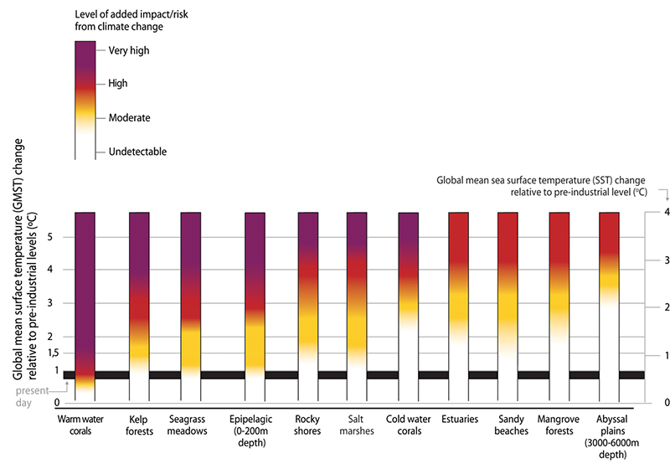
          - Assessment of impacts and risks for coastal and open ocean ecosystems under global warming. The left-hand y axis shows the rise in global mean surface temperature. The right-hand y axis shows the corresponding rise in global mean sea surface temperature. Temperature rise is relative to pre-industrial levels. The black band shows the present-day temperature.
IPCC
As the oceans warm, there is a rise in the frequency of marine heatwaves, or periods when seawater temperatures are extremely high. Their frequency has already risen considerably, and by the end of this century, they are expected to occur 20–50 times as often as at present. Tropical and Arctic waters are particularly vulnerable to such episodes. The rising frequency of marine heatwaves has already resulted in serious damage to tropical coral reefs.
At higher latitudes, kelp forests are among the ecosystems that are affected, particularly in the southern parts of their distribution. This is already clearly apparent in the Skagerrak, where marine heatwaves have in recent decades been a contributory factor in the serious decline in the distribution of sugar kelp (Saccharina latissima). While kelp forests may be lost in more southerly areas, their range may expand in the Arctic. This is consistent with the recovery of kelp forests that has been observed off the coast of Trøndelag and Nordland. Kelp forests are important nursery areas for fish and a vital habitat for a large number of marine species. Changes in the distribution of kelp forests may therefore result in major changes in ecosystems both further south and in Arctic waters.
In the Arctic seas, major changes can already be observed as a result of warmer seawater and the loss of sea ice. Since 1979, there has been a decline in sea ice in all seasons. In the period 1979–2018, sea ice extent in September declined by 12.8 % per decade. This is the most rapid decrease for at least 1000 years.
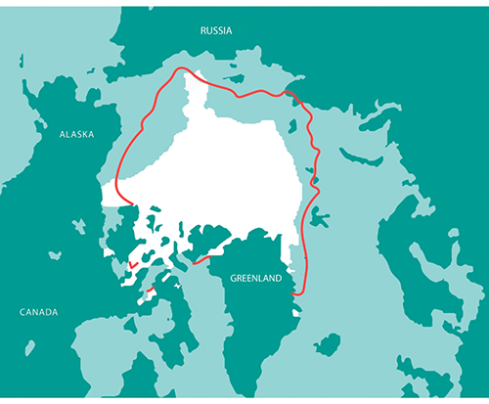
          - The map shows sea ice extent in the Arctic (white area) in September 2018. The red line shows the 1981 to 2010 average extent for the same month. Based on satellite images and the Sea Ice Index from the US National Snow & Ice Data Center.
Norwegian Environment Agency
The Barents Sea is one of the areas where sea ice is being lost most rapidly, and a steep downward trend has been observed in winter as well. As the seawater has become warmer, the distribution of temperate species has expanded, while that of Arctic fish species and ice-dependent species has shrunk, see Chapter 3. Species such as cod, haddock and mackerel have expanded their range hundreds of kilometres northwards. The rapid loss of sea ice in the Barents Sea since satellite measurements started in 1979 is believed to be the result of a combination of global warming and natural climate variability, since there was a cold period in the late 1970s.
According to the IPCC, the suitable habitat available to polar species will continue to shrink as a result of climate change, while the distribution of temperate species will continue to expand northwards. The loss of multi-year ice will also have an effect on primary production and biodiversity. This will have impacts on ecosystems in the marginal ice zone, on the seabed and in the open sea.
Changes in marine ecosystems are being amplified by ocean acidification, which is a result of the uptake of a proportion of anthropogenic CO2 emissions by seawater. Both the risk to ecosystems and uncertainty about future trends are greater when ocean acidification is taken into account. Cold water can absorb more CO2 than warmer water. This makes Arctic waters particularly vulnerable, and ocean acidification is widespread and rapid in the region. According to the IPCC, the area of the Arctic Ocean where calcium saturation is so low that calcium dissolves has expanded. This may have impacts on calcifying organisms. In Norwegian waters, acidification has been registered in the Norwegian Sea, but not so far in the Barents Sea.
It is considered highly likely that there will be substantial changes in marine Arctic ecosystems as a result of ocean acidification, and that there will be both direct and indirect impacts on marine organisms. Recent modelling suggests that ocean acidification will increase and there will be a steady decline in pH during this century, and abrupt changes in acidity level are projected in the Nordic seas and the Arctic in the period up to 2065. This may have impacts both on interspecific competition and on the relationships between different trophic levels in food chains.
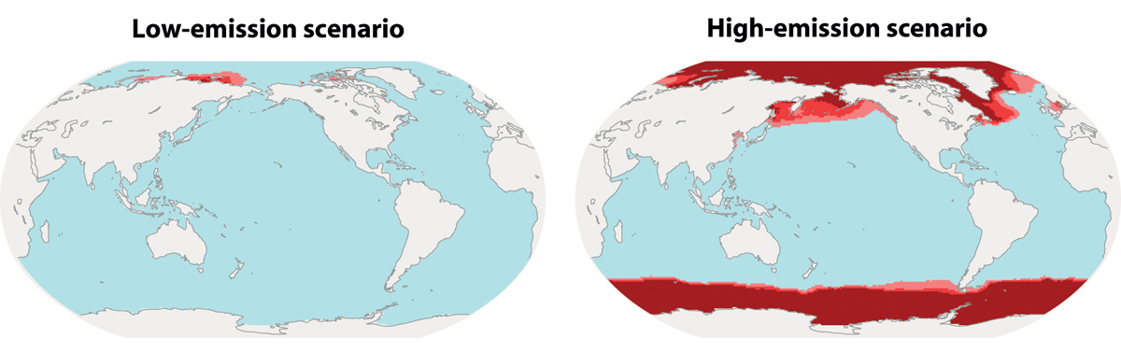
          - Projected distribution of aragonite undersaturation caused by ocean acidification towards the end of this century. Red shading indicates the areas where greatest acidification is expected. The two maps show a low-emission scenario (left, RCP2.6) and a high-emission scenario (right, RCP8.5). They show areas where year-round aragonite undersaturation is projected in the upper water layers in the period 2081–2100. More acidic seawater and aragonite undersaturation may have negative impacts on important marine species that are dependent on calcium to build their skeletons or shells, and thus alter marine ecosystems.
IPCC
Rising CO2 emissions are the most important cause of both global warming and ocean acidification. Both of these processes will therefore intensify as the atmospheric concentration of CO2 rises. Interactions between ocean acidification and global warming thus have important implications for the marine environment in the future. This is particularly true in the Arctic, where both warming and acidification are occurring most rapidly. Although we can be reasonably certain that northern seas will become both warmer and more acidic as a result of greenhouse gas emissions, there is still considerably uncertainty about the future impacts on marine organisms and the socio-economic consequences of this.
According to the report AMAP Assessment 2018: Arctic Ocean Acidification from the Arctic Council, current knowledge indicates that ocean acidification will drive changes in Arctic species and ecosystems at a magnitude that will affect people and communities. The report presents five case studies exploring the socio-economic impacts of ocean acidification and warmer seawater on fisheries in Greenland, Canada, Alaska and Norway, and concludes that the changes will pose considerable risks, although new opportunities may also arise. For Norwegian waters, the Barents Sea cod stock has been modelled to examine how the combination of climate change and ocean acidification may affect the cod fishery. The results indicate that the catch potential may be reduced by 80 % by 2100 if CO2 emissions continue to rise. These results are based on data from laboratory experiments, and have not yet been confirmed by documented real-world effects. There is considerable uncertainty concerning the results of all five case studies. Nevertheless, they give an idea of possible consequences, and of the risks and possible new opportunities associated with climate change and ocean acidification in Arctic seas.
Cold-water corals (Figure 4.7) are particularly vulnerable to ocean acidification, and could in the worst case die out or be outcompeted by other species that are more resistant to acidification. Cold-water coral reefs are important ecosystems in Norwegian waters, and provide food and habitats for many species, including tusk, saithe and redfish.
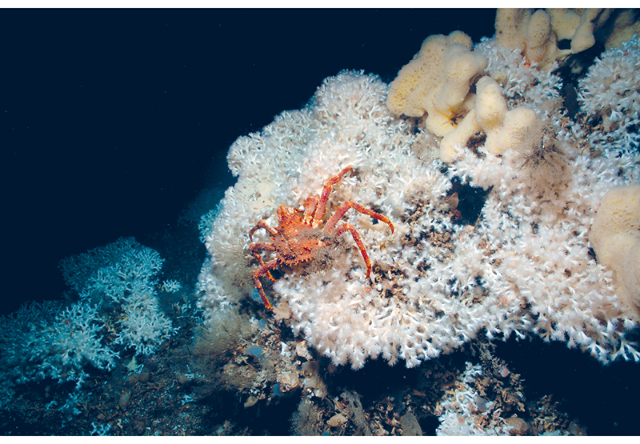
          - Cold-water coral reefs are a habitat for a wide variety of species.
Photo: Erling Svensen
The IPCC report shows that climate change, particularly in combination with inputs of nutrients, may be the reason for the observed increase in the frequency of toxic algal blooms in many areas, including the North Atlantic. This trend may have implications for the Norwegian aquaculture industry in future. Climate change may also increase the accumulation of hazardous substances in marine plants and animals, for example in the Arctic.
As the sea temperature rises, there is a northward shift in the areas that are most suitable for salmon farming, and the most southerly areas become less suitable. The Nofima research institute has analysed projected temperature trends in Norway’s aquaculture regions up to 2070, and has concluded that warmer water may become a problem for farmed salmon in the southern part of the country even in a low-emission scenario.
Climate change will also have impacts on the major ocean currents and their influence on the climate system. The main current system in the Atlantic Ocean, the Atlantic Meridional Overturning Circulation (AMOC) which includes the Gulf Stream and the Norwegian Atlantic current, has already been weakened. This trend is expected to continue. Any substantial weakening of this system will, according to the modelling results used by the IPCC, result in lower biological production in the North Atlantic and an increase in the number of storms in Europe.
The IPCC’s projections of climate and environmental change correspond well with trends in climate and environmental variables that can already be observed and measured today, both in Norwegian waters and elsewhere in the world. Both projections and observations show that climate change poses a considerable risk to ecosystems in Norwegian waters and to Norwegian seafood production. This risk will be far greater in the long term if emissions continue to rise than if we achieve rapid cuts in global emissions.

Climate change mitigation measures will also have impacts on the oceans
Climate change and ocean acidification are altering the ecological basis for exploiting ocean resources; at the same time, action to achieve the necessary emission reductions will intensify the need to make use of the oceans, for example to increase production of food and renewable energy. This will have implications for marine spatial management and may intensify pressure on the marine environment.
It is possible to produce food from the oceans with a relatively low environmental and carbon footprint. Food production from the oceans can be considerably increased if the marine ecosystems that provide the basis for this production are safeguarded. The greatest potential for increasing sustainable food production from the sea lies in expanding aquaculture. There is also a large unused potential for energy and mineral production from the oceans. Renewable energy from the oceans and carbon storage under the seabed will need to be a vital part of the solution if the world is to achieve the Paris Agreement goal of holding the global temperature increase to well below 2 °C.
At the Climate Action Summit held in conjunction with the UN General Assembly in 2019, the High-level Panel for a Sustainable Ocean Economy called on the world to step up ocean-based mitigation action to support the implementation of the Paris Agreement and the Sustainable Development Goals. The High-level Panel emphasised that ocean-based climate action could deliver up to one fifth of the emission reductions needed to limit global warming to 1.5 °C. The call was based on the conclusions of a special report commissioned by the High-level Panel. This estimate is very uncertain, and much more research is needed to confirm it, but the report shows that the ocean economy and ocean management can play an important role in reducing greenhouse gas emissions and implementing the Paris Agreement.
The mitigation potential is split between five main areas: ocean-based renewable energy; ocean-based transport; coastal and marine ecosystems; fisheries, aquaculture and dietary shifts; and carbon storage in the seabed.
There are strong Norwegian strong research groups and administrative bodies in these areas, and the business sector is at the forefront of developments, putting the country in a good position to lead the way. However, increasing production of food and renewable energy from the oceans could have a substantial environmental footprint and occupy large areas of ocean.
A Norwegian review of mitigation measures has been published analysing their potential for reducing emissions of greenhouses gases that are not included in the EU Emissions Trading System by 2030. The analysis was carried out by the Norwegian Environment Agency, the Norwegian Public Roads Administration, the Norwegian Coastal Administration, the Norwegian Agricultural Agency, the Norwegian Water Resources and Energy Directorate and Enova. The report identified measures that could reduce emissions from shipping, fisheries and aquaculture by 6.6 million tonnes CO2 equivalent in the period up to 2030. According to the report, intensifying efforts to speed up the transition to low- and zero-emission solutions in these industries will be important in achieving Norway’s climate target for 2030. Increasing food production from the oceans may also play a part in reducing greenhouse gas emissions. Dietary measures, which include increasing consumption of seafood, and measures to reduce food waste, are estimated to have emission-reduction potentials of 2.9 and 1.5 million tonnes CO2 respectively.
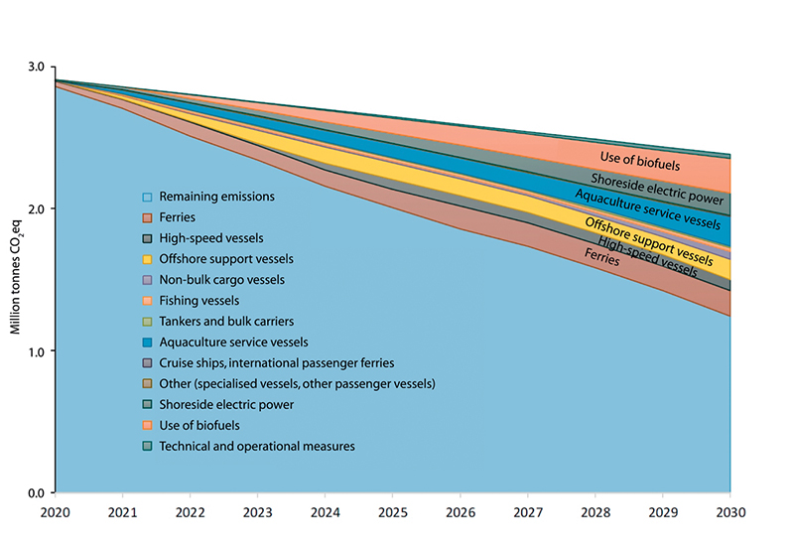
          - Emission reduction potential of mitigation measures for shipping for the period 2021–2030.
Norwegian Environment Agency
Economic growth and new technologies intended to reduce greenhouse gas emissions will require access to greater quantities of minerals. Examples include battery production and long-distance electricity transmission. Even if recycling is increased and a more circular economy is developed, mineral extraction will need to be expanded. There is therefore growing interest in the exploitation of seabed mineral resources, and Norway has recently adopted national legislation in this area. This is yet another activity that may affect the marine environment.
These developments highlight both the potential and the challenges related to spatial management and possible environmental impacts as the world makes more use of the oceans to reduce global greenhouse gas emissions.

Implications for ocean governance
Both the IPCC and IPBES have concluded that ocean governance must be adapted to the accelerating pace of climate and environmental change. Ocean governance must take into account the possible impacts of climate change in combination with other drivers of change, and it must be possible to adapt quickly as the situation changes. As climate change and ocean acidification intensify, it will be more difficult for administrative authorities to ensure that overall patterns of use and resource exploitation are sustainable, and to deal with new and intersecting user interests and possible conflicts related to changes in the distribution of living marine resources. And not least, it will be an increasingly challenging task to understand and limit the cumulative impacts of different activities in ways that maintain good environmental status. It will therefore be a vital task to ensure that ocean management authorities in Norway have the capacity and sufficient flexibility to deal with the accelerating pace of change.
One important message from the IPCC is that the higher the pace of climate change and the more adaptation action is delayed, the more difficult it will be to adapt successfully, and the less likely it is that adaptation will be successful. In the longer term, successful ocean governance and climate change adaptation will be dependent on success in bringing about rapid cuts in global greenhouse gas emissions and on taking early adaptation action. Thus, there are crucial links between climate policy, mitigation measures and efforts to ensure integrated ocean management in Norwegian waters.
This highlights the need to exploit the potential of the oceans and the ocean economy to play a part in climate change mitigation. According to the IPCC, the scale and speed of the impacts of climate change on the oceans will be such that it will be difficult for many communities to adapt to them, and for public authorities to respond adequately. In particular, the IPCC points out that governance systems are often too fragmented and poorly integrated across sectors and administrative divisions, making it difficult to respond in a way that is commensurate with the challenges facing us. Norway’s ocean management plans stand out in this context because of their cross-sectoral approach. Norway’s fisheries management regime also stands out because it is constantly adapted to the latest available knowledge about stocks and ecosystems, which is obtained from marine research groups and institutions and the International Council for the Exploration of the Sea (ICES).
IPBES has assessed what will be needed to manage the cumulative impacts of various drivers on the oceans. It concluded that what is needed is a mix of policy instruments and measures to conserve fish stocks and marine species and ecosystems, implemented on land, in freshwater and in the oceans. Coordination across sectors and stakeholders on the use of open oceans will also be needed. One type of action that IPBES highlights as effective is the expansion and strengthening of representative networks of protected areas, provided that they are well managed. Others are ecosystem-based management, effective fisheries quota systems, marine spatial management, protecting key marine biodiversity areas, reducing pollution from land and working closely with producers and consumers.
The IPCC emphasises that adaptation of ocean governance frameworks to make them climate-resilient to a large extent involves reducing or limiting other direct drivers of change in marine and coastal environments, such as land- and sea-use change, pollution and harvesting. Conservation of ecosystems through area-based measures, including developing networks of protected areas on land and at sea, is highlighted as particularly important. This can help to reduce cumulative impacts on areas and ecosystems that are given special protection, and to protect areas that will become important as the distribution of species and ecosystems changes in response to climate change.
The climate is changing most rapidly in the polar regions, and according to the IPCC, this poses risks to commercial and subsistence fisheries in the Arctic. This may have implications for regional economies and communities and for global supplies of fish and seafood. If emissions remain high, current management strategies may not make it possible to sustain current catch levels for some commercially valuable stocks. The IPCC noted that the capacity of governance systems in the Arctic and many other ocean regions has been strengthened, but nevertheless concluded that this is not happening rapidly enough to address the projected changes.
Both the IPCC and IPBES identify ecosystem-based management of the oceans and marine resources as an important approach for addressing climate change. This is also the fundamental approach of Norway’s ocean management plans and of management of marine resources as set out in the Marine Resources Act.
The cross-sectoral system of integrated ocean management plans combined with sound management within each sector puts Norway in a good position to deal with the challenges arising from rising activity levels and rapid climate and environmental change. The length of Norway’s coastline from north to south is also a good starting point for adapting management systems to the shifts in the distribution of species and ecosystems that are being driven by climate change.
However, it will be vital to continue the development of Norway’s management regime in order to address these challenges. We must for example take into account changes to marine ecosystems and species distribution resulting from climate change and ocean acidification, which may make many species and ecosystems more vulnerable to other pressures. This will require research to understand climate change and its impacts on the oceans, and monitoring to make it possible to detect changes at an early stage; the public administration will also need systems in place to enable a rapid response to new information, including necessary measures.

The ocean-based industries
Norway is rich in natural resources and has always taken a long-term approach to resource management for the benefit of society as a whole. Ocean industries play a vital part in value creation in Norway, and the oceans provide livelihoods for many coastal communities. Some of the country’s most innovative businesses, jobs and knowledge institutions have their origins in human settlement along the coast and use of the oceans. Close cooperation between knowledge institutions, the business sector, employees and authorities has played an important role in the historical development of Norway as an ocean economy.
There will be substantial opportunities in the future for growth and new jobs in industries that operate in a global market. For the foreseeable future, the oceans will continue to be a vital basis for jobs, value creation and welfare throughout Norway, and they can also be part of the solution to the environmental and climate-related challenges the world must deal with. The Government recognises that marine resources are important for national value creation, and considers it important for exploitation of natural resources to have positive spin-off effects for communities.
As part of the work on the scientific basis for the management plan, the Forum for Integrated Ocean Management obtained figures for value added and employment in the seafood, petroleum, shipping and tourism sectors from Statistics Norway, which are presented in Tables 5.1 and 5.2. After the knowledge base had been compiled, Statistics Norway revised the underlying data and provided updated figures for 2010 and 2016 for the four sectors. It also provided national figures for 2010, 2016 and 2019, with the exception of 2019 figures for the tourism sector.
            - Comparison of value added in four ocean industries in each of the management plan areas and the totals for Norway. Value added is shown in NOK billion (in current prices).
10J1xt2
 | Barents Sea–Lofoten |  | Norwegian Sea |  | North Sea–Skagerrak |  | Norway, total
Industry | 2010 | 2016 | 2010 | 2016 | 2010 | 2016 | 2010 | 2016 | 2019
Seafood | 11.9 | 21.4 | 12.3 | 20.3 | 8.9 | 16.8 | 33.1 | 57.9 | 64.7
Petroleum | 21.2 | 25.3 | 143.9 | 112.0 | 431.4 | 341.1 | 596.6 | 478.5 | 566.8
Shipping | 1.3 | 1.0 | 4.1 | 4.6 | 26.7 | 35.0 | 32.2 | 40.7 | 39.8
Tourism1 | 2.4 | 3.7 | 2.5 | 4.0 | 9.6 | 14.2 | 32.2 | 45.4 | -
Sum | 36.8 | 51.4 | 162.8 | 140.9 | 476.6 | 407.1 | 694.1 | 622.5 | 671.3
1 No figures for tourism are available for 2019.
Statistics Norway
            - Comparison of employment in the four ocean industries in each of the management plan areas and the totals for Norway. Employment figures in 1 000s.
10J1xt2
 | Barents Sea–Lofoten |  | Norwegian Sea |  | North Sea–Skagerrak |  | Norway, total
Industry | 2010 | 2016 | 2010 | 2016 | 2010 | 2016 | 2010 | 2016 | 2019
Seafood | 9.4 | 11.3 | 8.4 | 8.5 | 7.1 | 8.0 | 24.9 | 28.0 | 30.7
Petroleum | 13.7 | 14.5 | 25.8 | 25.8 | 73.8 | 74.3 | 113.4 | 114.6 | 110.0
Shipping | 1.7 | 2.9 | 5.7 | 4.4 | 20.4 | 25.2 | 27.8 | 32.5 | 32.0
Tourism1 | 4.8 | 6.1 | 4.8 | 7.1 | 17.1 | 21.0 | 74.2 | 88.4 | -
Sum | 29.6 | 34.8 | 44.7 | 45.8 | 118.4 | 128.5 | 166.1 | 263.5 | 172.7
1 No figures for tourism are available for 2019.
Statistics Norway
The figures indicate value added and employment in core activities and for the largest direct supplier companies for each sector. The figures include exports related to core activities but not to supply industries, and do not include wider spin-off effects.
There are major opportunities for blue growth. The OECD estimates that the global ocean economy will double by 2030 from the 2010 level, while providing a total of 40 million jobs. The world population will be close to 10 billion by 2050, and an increasing number of people will enjoy improvements in purchasing power. This will result in growing needs for food, energy, goods and services. There is also potential for further growth in both established and emerging ocean industries in Norway.
Green transformation of the ocean industries in Norway and internationally will also offer rich opportunities, involving both established and emerging industries. Offshore wind, carbon capture and storage under the seabed, and green shipping are among the areas where Norway has much to offer and where sound ocean management can promote the green transition. In 2019, the Government presented an action plan for green shipping as part of the follow-up of its strategy for green competitiveness.

Food production from the oceans
Norway has a large and profitable fisheries and aquaculture sector, which harvests and produces a total of more than 3 million tonnes of seafood a year, mainly for export. Thus, the importance of Norwegian seafood production reaches far beyond Norway’s borders. In 2019, the value of Norwegian seafood exports amounted to NOK 107.3 billion.

Current status and expected developments in economic activity
Fishing, sealing, whaling and other harvesting are based on wild living marine resources. Wild living marine resources belong to Norwegian society as a whole and are to be managed in a sustainable, economically profitable way that safeguards genetic material derived from them and promotes employment and settlement in coastal communities. Knowledge- and ecosystem-based management of marine resources will make it possible to continue to work towards these goals.
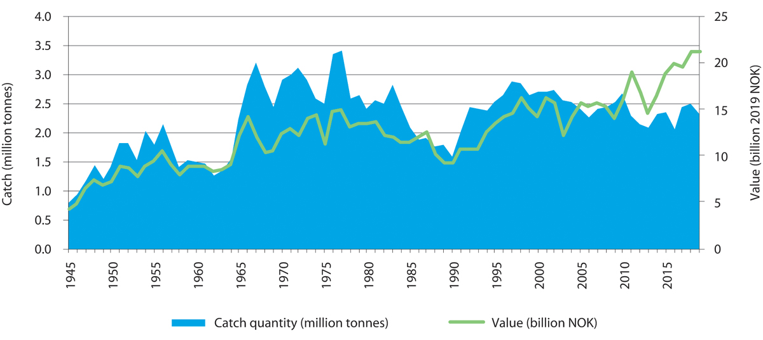
          - Norwegian marine capture fisheries, 1945–2019. The figure shows catch quantity (blue area) and landed value (green line).
Directorate of Fisheries
Catches by Norwegian vessels for the country as a whole totalled 2.7 million tonnes in 2010 and 2.2 million tonnes in 2016. The downturn is primarily due to reduced catches of Norwegian spring-spawning herring and capelin in the Barents Sea–Lofoten management plan area. At the same time, the cod harvest has increased from about 280 000 tonnes to 400 000 tonnes, which partly explains the increase in value added from 2010 to 2016.
Over time the number of fishing vessels has declined steeply, from 41 000 in 1960 to just over 17 000 in 1990. Since 2010 there has been little further reduction, and the number of vessels has been more or less constant, with a slight rise in recent years due in part to the expansion of wrasse fishing. The fisheries have also become much more efficient, and catch per person has risen by a factor of twenty since 1945.
Changes in the oceans affect fish stocks, and fisheries are affected by processes of change in the oceans, making it necessary to adjust catch sizes, management regimes and the way stocks are shared with other countries. Climate change and other pressures are expected to result in major changes in the size and distribution of fish stocks in the years ahead, creating challenges for fisheries and fisheries management.
The Northeast Arctic cod fishery is still the most important in Norway, and the stock is being sustainably managed. However, it may be affected by factors such as climate change and ocean acidification in future. The fjord and coastal cod stocks in North Norway are in poorer condition.
In the North Sea–Skagerrak area, total catches of the most important species were stable in the period 2010–2017. The main species are mackerel, herring, sandeels, Norway pout and shrimps. Mackerel catches declined from 129 068 tonnes in 2010 to 51 910 tonnes in 2017. Norway pout catches also declined (from 65 634 tonnes to 21 357 tonnes) while there was an increase in the landed volume of herring and sandeels.
For some years now, a northward shift in the distribution of key fish stocks has been observed. For example, the distribution of mackerel has been changing, and the important North Sea fishery has largely moved northwards to the Norwegian Sea in recent years.
There is considerable commercial interest in lobster trapping along the coast, particularly in Southern Norway. Because of the decline in the stock, stricter harvesting rules were introduced, but this alone has not been enough to improve stock status. In 2014, the Directorate of Fisheries invited municipalities to put forward proposals for areas to be permanently closed to lobster trapping. So far 41 such areas have been established but more are needed to build up the lobster stock. The Directorate’s invitation for municipalities to initiate local processes is therefore still open, and the aim is to establish an area in each relevant municipality that is closed to lobster trapping. A number of processes are already under way and the number of areas will increase.
In the Skagerrak, shrimp trawling is one of the most important fisheries.
In the Norwegian Sea, catches of the main species (herring, mackerel, saithe and cod) totalled 531 802 tonnes in 2013 and 678 803 tonnes in 2017. In both 2013 and 2017, herring accounted for the largest landed catch, 219 758 tonnes and 231 653 tonnes respectively. The increase in landed volume was mainly due to a sharp rise in mackerel catches (from 31 928 tonnes in 2013 to 167 747 tonnes in 2017).
Northeast Arctic cod is currently fished in large parts of the Norwegian Sea and the Barents Sea. If its distribution changes further in a northerly and easterly direction, the Norwegian Sea may become less important for cod fishing.
In the Barents Sea–Lofoten area, there was a sharp reduction in landed catches of the main fish stocks from 2010 to 2016. The most important species in the Barents Sea are cod, haddock, herring and capelin. The overall reduction was primarily due to reductions in landed catches of herring and capelin. The capelin stock fluctuated, and in 2016 the catch was set at zero. At the same time, landed catches of cod have increased somewhat, from 239 247 tonnes in 2010 to 346 361 tonnes in 2016.
Rising sea temperatures and greater inflow of Atlantic water are the main reasons for the northerly shift in the distribution of fish stocks. It appears likely that the focal point for important Norwegian fisheries will shift northwards and eastwards in coming years. As the sea ice melts, previously inaccessible areas are likely to become accessible for fishing. It will be important to carry out specific assessments of which areas can be opened for fisheries, and where the presence of valuable and vulnerable areas indicates that this should not be done.
Red king crabs are harvested only in the Barents Sea. The current management regime for the red king crab is two-pronged, with different management objectives east and west of 26° E. Harvesting is regulated by quotas east of this line, but is unrestricted west of the line to attempt to limit the westward spread of the species. The Norwegian management regime for red king crab is intended to maintain an area for commercial harvesting to support the parts of the fishing industry most seriously affected by the red king crab, while at the same time taking steps to limit its further spread. Management of this species is based on knowledge about its impacts on the ecosystem and about how realistic it is to limit its spread.
There are wrasse fisheries in all three management plan areas. Wrasses are used in controlling sea lice in salmon farms. In recent years, wrasse catches have increased considerably, and this has had major impacts on local stocks. Regulatory measures have been introduced for these species, including quotas and limitations on access.
There has been little change in kelp harvesting technology and the management of kelp harvesting in recent years. Kelp is harvested in the North Sea and the Norwegian Sea. There may be conflicts of interest between the role of kelp as a harvestable resource and its role in providing ecosystem services and as a habitat.
The Norwegian whale catch has remained stable at just over 400 minke whales annually. Minke whales are caught in all three management plan areas.
Aquaculture operations in Norway’s internal waters are outside the scope of the management plans, but form part of the whole picture because they depend on good environmental conditions and can have an impact on the marine environment.

Potential growth in food production from the oceans – new opportunities
Harvesting snow crab
Current knowledge indicates that there is no potential to increase harvesting of wild fisheries resources that are already exploited, with the exception of snow crab. Most stocks are already fully exploited, but it may be possible to target operations to catch fish of optimal size.
Since snow crabs were first recorded near Novaya Zemlya OK in the Barents Sea in 1996, the species has been spreading northwards and westwards, and has now expanded to all suitable habitat on the Norwegian continental shelf. The snow crab population has the potential to grow much larger, and the species could have a major impact on populations of other benthic organisms. So far no negative effects of snow crabs or harvesting of snow crabs on fisheries resources have been registered.
Norwegian vessels began harvesting snow crab in 2012. For 2020, a quota of 4 500 tonnes has been set in the Norwegian zone, equating to a landed value of roughly NOK 400 million. Currently, only part of the Norwegian continental shelf west of the Loophole is of interest for commercial fishing of snow crab. The population has risen significantly since 2010, but there is considerable uncertainty relating to productivity and carrying capacity. In the long term, snow crab may become a resource in the same way as other important stocks, but which areas develop a commercial density of crabs will depend on factors such as depth, temperature and food availability. Trapping of snow crabs may also lead to spatial conflicts with other activities such as shrimp trawling.
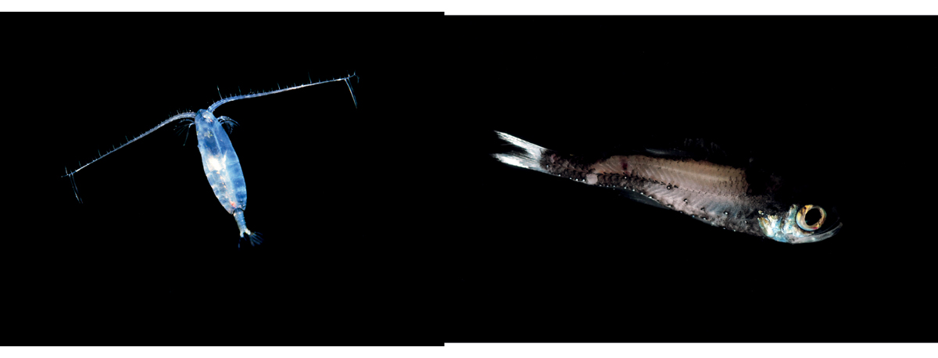
          - The copepod Calanus finmarchicus (left) and a mesopelagic lanternfish (right).
Photo: Erling Svensen (left); Institute of Marine Research (right)
The snow crab is in some ways similar to the red king crab, but differs regarding uncertainty as to whether it is an alien species (originally introduced by human activity) or has expanded its range naturally. Red king crabs are found near the coast, but it is unlikely that snow crabs will become established along the coast of mainland Norway.
Harvesting of the copepod Calanus finmarchicus and mesopelagic species
Harvesting of the copepod Calanus finmarchicus and mesopelagic species, i.e. harvesting at lower trophic levels than has been the case until now, may expand considerably in the coming years. Each year since 2003, C. finmarchicus has been harvested under an experimental licence. In 2018, the catch quantity was just over 1 300 tonnes, which is nearly double the quantity in 2017. In future, harvesting will be in accordance with the management plan that has been adopted. Licences for copepod trawling have now been granted, and a total allowable catch (TAC) has been set. C. finmarchicus occurs in all three management plan areas, but mainly in the Norwegian Sea.
A great deal of development work is being done on mesopelagic species, and the potential for harvesting could be large. Mesopelagic is used to describe species that live at depths of 200 to 1 000 metres in the water column. There have only been very limited catches of mesopelagic species by Norwegian vessels up to now, but there is interest in commercial harvesting of these resources. Developments are in progress, and 2019 was the first year when there were significant catches by Norwegian vessels.
Much work remains to be done on both C. finmarchicus and mesopelagic species in order to realise the major potential for harvesting in the form of new profitable fisheries. It is unclear to what extent large-scale harvesting of copepods and mesopelagic species will be developed, for a number of reasons. There is a huge biomass of resources at lower trophic levels, so that there is theoretically a large potential for commercial activity and value creation. There may be many areas of use for these resources, and feed for the aquaculture industry will be particularly important. Knowledge development in a number of areas will be required to realise the potential for harvesting both C. finmarchicus and mesopelagic species, including learning more about their biology and developing catch technology and processing techniques.
There is also a potential for developing harvesting of benthic resources at low trophic levels, such as sea cucumbers and bivalves, but the knowledge base on the harvesting potential, ecosystem effects of harvesting and food safety will have to be strengthened. A precautionary approach must be taken to all new types of harvesting, and more knowledge is needed about the environmental effects and impacts on food chains of such activities.
Offshore aquaculture
Marine aquaculture is the cultivation of marine organisms in both fed and unfed production systems. Production may take place in open or closed systems, and near the coast or offshore. Currently Norwegian aquaculture is heavily dominated by salmonids, which are fed.
Considerable technological innovation is in progress on production of salmon and rainbow trout in the future. The industry could change a great deal in the coming years, particularly with the development of offshore aquaculture. The Government has been using a system of development licences to promote the development of new aquaculture technology, including technology that is better suited to more exposed locations. Offshore aquaculture is not likely to replace existing forms of aquaculture but rather supplement coastal aquaculture production.
The Government is taking steps to facilitate the development of offshore aquaculture. These include the development of legislation, the siting of facilities within areas that are opened for offshore aquaculture, clarification of legislation on the working environment, safety and emergency preparedness, and rules on registration and if appropriate mortgaging of aquaculture installations. Spatial management issues relating to offshore aquaculture are further discussed in Chapter 7.
              - Kelp cultivation
Since 2012 there has been consistently strong commercial interest in kelp farming. The Ministry of Trade, Industry and Fisheries has issued aquaculture licences for cultivation of macroalgae to almost 50 different companies at over 80 sites from Rogaland to Finnmark counties. More applications are being processed. From 1 June 2019, the authority to grant aquaculture licences for the cultivation of aquatic plants was transferred to the county authorities, so it is now the same administrative agency that is responsible for issuing all ordinary aquaculture licences.
Sugar kelp (Saccharina latissima) and dabberlocks (Alaria esculenta) are the main species currently being cultivated in Norway, but aquaculture licences have been issued for more than 30 different species of macroalgae.
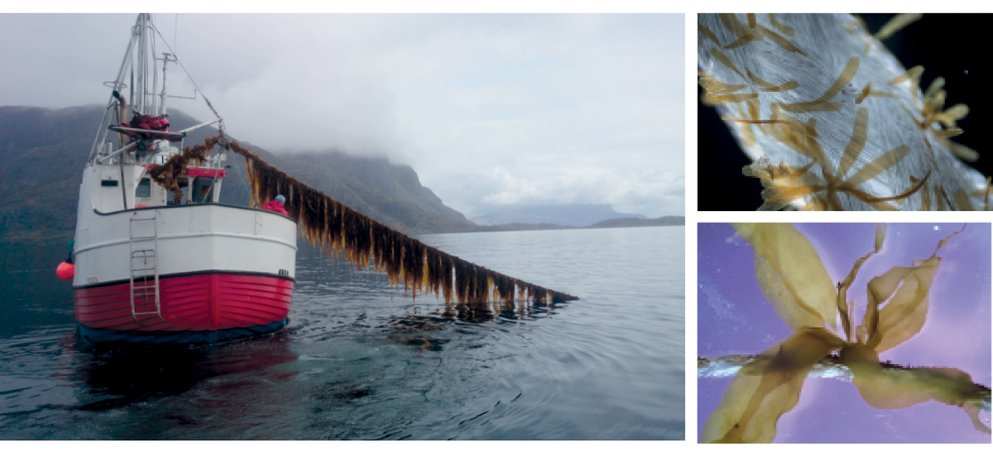
          - Production of sugar kelp (Saccharina latissima) (left). Juvenile sporophytes of dabberlocks (Alaria esculenta) on a seed rope (right).
Photo: Seaweed AS/Audun Oddekalv (left); Silje Forbord/SINTEF Ocean (right)
Kelp is used in a wide range of products, including food, feed, pharmaceuticals, biochemicals, plastics, biofuels, fertiliser and pesticides. Kelp cultivated in Norway is used primarily for human consumption in restaurants and health food products. Kelp farming can have positive environmental effects by 1) replacing products made from fossil raw materials, 2) replacing feed protein derived from areas that were originally rainforest, and 3) helping to recycle nutrients from fish farming (through integrated multi-trophic aquaculture (IMTA)).
Industrial-scale kelp farming will occupy considerable areas, which may create new spatial conflicts and possibly introduce new environmental problems. Good spatial planning is the best way of avoiding conflict. There are also food safety issues, such as the high iodine concentration in certain kelp species. The Norwegian Food Safety Authority and the Institute of Marine Research are obtaining more knowledge about the safe use of algae and algal products.
Kelp farming is still in the research and development phase. Feedback from companies that have started sugar kelp production indicates that they are being successful. However, for the industry to become commercially profitable, it will have to resolve various issues relating to kelp biology, documentation of food safety, development of equipment, product development and markets. Kelp farmers have organised various networks to share knowledge and experience. In 2018, according to statistics from the Directorate of Fisheries, 170 tonnes of kelp was cultivated, primarily sugar kelp.
[Boks slutt]
Cultivation of other species
By November 2017, licences had been issued for cultivation of macroalgae at 47 sites in Norway, covering a total planned area of 465 hectares. A number of companies are interested in combining kelp production with salmon farming, since for example sugar kelp can make use of dissolved nutrients from salmon production. Several research licences have been granted for studying this further. Cultivation of macroalgae needs relatively large sea areas. It is difficult to estimate value added and employment associated with this industry in future.
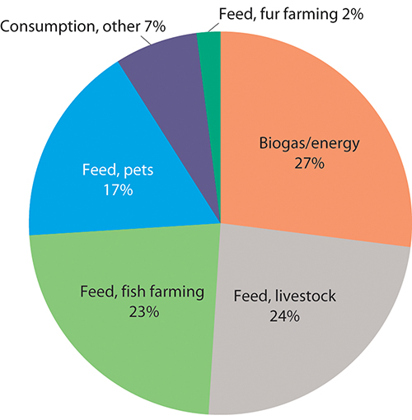
          - Areas of application for residual raw materials from fish and shellfish production.
BarentsWatch (Kontali and SINTEF)
Cultivation of organisms that do not require feeding, such as bivalves and kelp, offers considerable potential. Scaling up production will require more knowledge about issues including food safety, environmental impacts, technology and profitability.
Other potential aquaculture activities include production of sea cucumbers, which can consume waste from other aquaculture activities, sea ranching of native species and rearing wild-caught organisms such as sea urchins.
Utilisation of residual raw materials
According to a 2016 analysis by SINTEF, the fisheries and aquaculture sector produces about 914 000 tonnes of residual raw materials from a raw materials base of 3.3 million tonnes of fish and shellfish. About 75 % (689 000 tonnes) of this is used as ingredients (oil, proteins, supplements/premixes) in feed for fish, livestock, fur-bearing animals and pets, or in products for human consumption (seafood products, fish oil and extracts). A large proportion of the residual raw materials from aquaculture and the pelagic sector is utilised, but in the whitefish sector, large volumes are not utilised, and there is room for improvement in the shellfish sector as well.
The pelagic sector could supply even greater quantities of residual raw materials if the fish were to be sold filleted rather than exported whole, as they often are at present. Given the existing catch quantities, it is estimated that the unexploited potential for residual raw materials is 210 000–230 000 tonnes a year, mainly from the Barents Sea–Lofoten management plan area. Assuming that this would give a yield of 5 % fish meal costing NOK 10 per kilogram, the value would be NOK 100 million. This is residual raw material that would primarily be suitable for use in fish feed production. Other residual raw materials could be used domestically if Norway were to export more pelagic fish as fillets.

Value added and employment
Fishing has been an essential basis for settlement all along Norway’s long coastline. Norwegian waters have always provided a rich harvest of fish, which are still a vital natural resource today. More recently, fish farming has emerged as an industry of great economic importance. There are large numbers of aquaculture facilities from the southwestern tip of Norway northwards along the coast, but very few along the Skagerrak coast. Fish processing is also an important industry, with processing plants located along the coast where they can conveniently receive supplies from fisheries and aquaculture.
For the three management plan areas together, the seafood sector generated value added totalling NOK 57.9 billion and provided 28 000 jobs in 2016 (Tables 5.3 and 5.4). Of these, 24 800 were in core activities and 3 200 in supply industries. All three of the largest industries in the seafood sector, namely fishing, aquaculture and fish processing, grew from 2010 to 2016. This was mainly due to higher TACs for cod and higher prices for both wild and farmed fish. National figures for both value added and employment indicate that growth continued from 2016 to 2019.
            - Value added in the seafood sector in the management plan areas and the totals for Norway.
10J2xt2
Value added, shown in NOK billion (in current prices).
 | Barents Sea–Lofoten |  | Norwegian Sea |  | North Sea–Skagerrak |  | Norway, total
Industry | 2010 | 2016 | 2010 | 2016 | 2010 | 2016 | 2010 | 2016 | 2019
Fishing | 5.1 | 8.6 | 2.1 | 3.0 | 2.1 | 2.9 | 9.2 | 14.0 | 15.7
Aquaculture | 3.0 | 7.5 | 6.3 | 12.2 | 4.0 | 9.7 | 13.2 | 29.4 | 31.1
Fish processing | 2.3 | 3.3 | 2.4 | 3.2 | 1.7 | 2.7 | 6.4 | 9.2 | 12.1
Manufacture of crude fish oils and fats | 0.2 | 0.0 | 0.1 | 0.0 | 0.1 | 0.0 | 0.3 | 0.0 | 0.0
Wholesale of fish. crustaceans and molluscs | 0.6 | 0.8 | 0.6 | 0.8 | 0.4 | 0.6 | 1.6 | 2.2 | 2.5
Sum of core activities | 11.1 | 20.2 | 11.4 | 19.2 | 8.3 | 15.9 | 30.8 | 54.8 | 61.5
Supply industries | 0.8 | 1.2 | 0.9 | 1.1 | 0.6 | 0.9 | 2.3 | 3.1 | 3.2
Sum of core activities and supply industries | 11.9 | 21.4 | 12.3 | 20.3 | 8.9 | 16.8 | 33.1 | 57.9 | 64.7
Statistics Norway
            - Employment in the seafood sector in the management plan areas and the totals for Norway.
10J2xt2
Employment figures in 1 000s.
 | Barents Sea–Lofoten |  | Norwegian Sea |  | North Sea–Skagerrak |  | Norway, total
Industry | 2010 | 2016 | 2010 | 2016 | 2010 | 2016 | 2010 | 2016 | 2019
Fishing | 2.6 | 3.1 | 1.0 | 1.1 | 1.1 | 1.1 | 4.7 | 5.0 | 5.5
Aquaculture | 1.2 | 1.5 | 2.4 | 2.9 | 1.8 | 2.6 | 5.5 | 7.0 | 9.0
Fish processing | 3.7 | 4.6 | 3.4 | 3.2 | 2.9 | 3.0 | 10.0 | 11.1 | 11.5
Manufacture of crude fish oils and fats | 0.3 | 0.2 | 0.1 | 0.1 | 0.1 | 0.1 | 0.5 | 0.3 | 0.3
Wholesale of fish. crustaceans and molluscs | 0.7 | 0.6 | 0.6 | 0.4 | 0.5 | 0.4 | 1.9 | 1.5 | 1.6
Sum of core activities | 8.5 | 10.0 | 7.6 | 7.6 | 6.4 | 7.1 | 22.5 | 24.8 | 27.8
Supply industries | 0.9 | 1.3 | 0.8 | 0.9 | 0.7 | 0.9 | 2.4 | 3.2 | 2.9
Sum of core activities and supply industries | 9.4 | 11.3 | 8.4 | 8.5 | 7.1 | 8.0 | 24.9 | 28.0 | 30.7
Statistics Norway
In the North Sea–Skagerrak area, value added in the seafood sector amounted to NOK 16.8 billion in 2016, of which NOK 15.9 billion was from core activities, predominantly aquaculture, and NOK 0.9 billion from supply industries. Value added in the North Sea–Skagerrak area accounted for 29 % of total Norwegian value added in the seafood sector (see Table 5.3).
There were 8 000 employees in the seafood sector in the North Sea–Skagerrak area in 2016, of whom 7 100 were in core activities and 900 in supply industries. Employment in the North Sea–Skagerrak management plan area accounted for 27 % of total employment in the seafood sector in Norway (see Table 5.4).
In the Norwegian Sea, value added totalled NOK 20.3 billion in 2016: NOK 19.2 billion from core activities and NOK 1.1 billion from supply industries. Value added in the Norwegian Sea accounted for 35 % of all Norwegian value added in the seafood sector (see Table 5.3).
In the Barents Sea–Lofoten area, value added in the seafood sector totalled NOK 11.9 billion in 2010 and NOK 21.4 billion in 2016. The share of overall value added from the supply industries attributable to the Barents Sea–Lofoten area was estimated on the basis of the calculated share for core activities. This amounted to NOK 800 million in 2010 and increased to NOK 1.0 billion in 2016.
There were 9 400 employees in the seafood sector in the Barents Sea–Lofoten area in 2010 and 11 300 in 2016, an increase of about 20 %. This was mainly due to higher activity in the cod fishery as a result of higher TACs.

Current status and expected developments for environmental pressures and impacts
Fishing activities have major impacts on ocean ecosystems through harvesting of target species, disturbance of the seabed, unintentional bycatches and marine litter. The greatest impact is caused primarily by the annual removal of a significant proportion of the harvested year classes of commercial fish stocks.
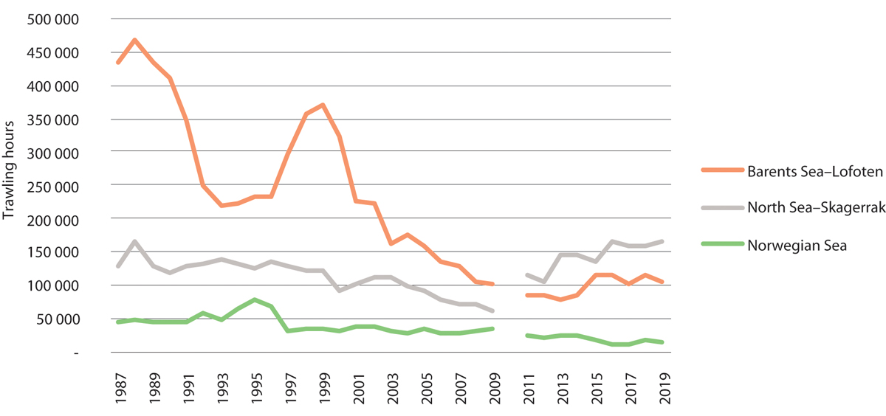
          - Number of trawling hours in bottom trawl fisheries in the management plan areas. There are no data for 2010 because of the changeover to electronic catch logbooks.
Directorate of Fisheries
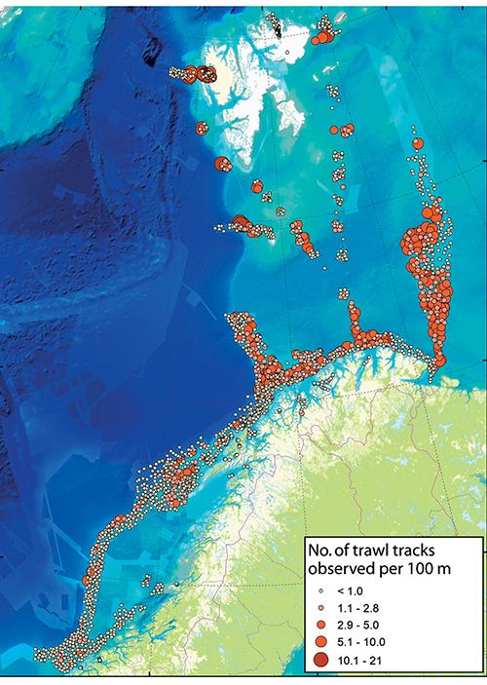
          - Number of trawl tracks observed per 100 metres.
MAREANO
The most important commercial stocks in Norwegian waters are generally in good condition. The fisheries management authorities have established a framework for the fisheries that has made it possible to maintain sustainable harvesting of the main commercial stocks in the Norwegian Sea and Barents Sea. However, there are certain exceptions. Of the smaller stocks, Norwegian coastal cod and golden redfish are still in poor condition. Golden redfish have been classified as endangered on the Norwegian Red List since 2015 and have been declining since the 1990s. The spawning stock is still below the precautionary level. It is therefore no longer permitted to fish specifically for this species.
The harvesting of target species also has indirect impacts on the ecosystem through effects on the food chain. This may influence predation pressure on some species, food availability for other species, or competitive relationships between species. Norway has therefore undertaken to pursue an ecosystem-based approach to fisheries management.
It is a general problem that there are relatively few controls on recreational fishing and fishing tourism in Norwegian waters.
Unintentional bycatches
Unintentional bycatches may have impacts on seabirds, marine mammals and benthic organisms such as corals and sponges, depending on the fishing gear used. In the Barents Sea, bycatches are assessed as having no to moderate impacts on seabirds, depending on the fishing gear and seabird group under consideration. Bycatches of certain northern seal species have clear but minor impacts at population level. Apart from this, the impacts of other bycatches, for example common porpoises in gill nets, are uncertain. In the Norwegian Sea, the limited harvest of golden redfish taken as a bycatch is considered to be too high.
Measures to reduce bycatches in Norwegian fisheries are specifically designed to avoid bycatches of undersized fish and fry. The objective is to allow fish to grow to maturity and become part of the spawning stock. The main measures used are the closure of fishing grounds if the intermixture of undersized fish is too high, mesh size requirements for gill nets and trawls, and requirements to use sorting grids in trawls.
Bycatches of fish eggs, larvae and fry could cause complications for harvesting of C. finmarchicus and mesopelagic species in the future.
Bottom trawling
In recent years, particular attention has been focused on the impacts of bottom trawling on benthic ecosystems. In the Barents Sea, the physical impacts of bottom trawling on benthic communities were assessed as minor, but moderate in areas that were trawled frequently. Direct and indirect measures have been implemented that have considerably reduced the impacts of bottom trawling on benthic communities in the last 15–20 years. There is a general prohibition against damaging corals. Regulations have been adopted protecting about twenty clearly delimited coral reef areas against bottom trawling and the use of other towed gear. There are strict restrictions on starting bottom trawling operations in new deep-water areas, and in 2019 new rules were adopted to regulate bottom fishing activities in the northern Barents Sea and the waters around Svalbard. Ten areas are completely closed for fishing operations, and no fishing operations may be started in areas that have not previously been fished without prior mapping (see Figure 5.7).
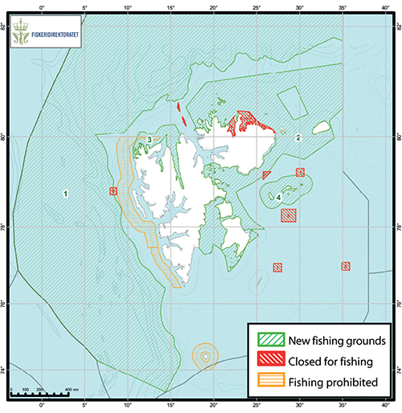
          - Areas around Svalbard that are closed for fishing operations.
Directorate of Fisheries
Marine litter
Much of the waste found in Norwegian waters originates from the fisheries and aquaculture sector, as described in Chapter 3. This waste is a source of plastic pollution, injures marine animals, and increases mortality in various animals, for example through ghost fishing. Lost gear can also cause problems for fishing operations. It is important to deal with this problem to ensure the sector’s overall sustainability, and the Directorate of Fisheries organises an annual retrieval programme for lost fishing gear. The dumping of any kind of waste from Norwegian fishing vessels is prohibited, and various measures have been introduced to reduce marine litter. In recent years there has been more focus on recreational fishing and trapping activities, which are popular along parts of the coast, particularly in the south, where lost lobster traps have become a problem. The requirement to use twine that is readily biodegradable in water can effectively limit ghost fishing if full compliance is achieved, but will not eliminate the litter problem. Both professional and recreational fishermen will need to exercise care to limit the scale of losses of gear in future.
Underwater noise and other pressures
Fishing vessels generate underwater noise from engines, propulsion systems (cavitation noise) and the use of fishing gear (e.g. bottom trawls). The use of echo sounding and sonar also adds to noise levels in the oceans and may have direct impacts on marine mammals and other animals. Noise and emissions to air are further discussed below in the section on shipping.
The fishing fleet also discharges organic (biodegradable) waste to the sea, primarily trimmings and byproducts. Organic waste dumped into the sea from fishing vessels is not an environmental problem in the management plan areas. The long-term trend, however, is for more and more of the residual raw materials to be used.
Impacts of aquaculture
At present, aquaculture activities are restricted to coastal waters, which are outside the management plan areas. However, it is a major industry in Norwegian waters and may in future expand to areas considerably further offshore than the sheltered waters currently used. The main pressures on the surrounding environment from aquaculture facilities are the spread of sea lice, escapes of farmed fish and genetic impacts on wild fish populations, waste such as nutrients and organic material, and discharges of hazardous substances including copper and delousing agents. Moreover, the aquaculture industry needs large quantities of feed, and feed production also has environmental impacts and impacts on global food supplies.
The environmental problems encountered in offshore aquaculture are expected to be the same as those associated with coastal aquaculture activities, but new spatial conflicts may also arise with traditional fisheries, shipping and offshore wind power as well as new issues relating to species and habitats. The scale of environmental problems will depend on factors including technology choices and the types of systems used.
In order to safeguard the natural environment, more knowledge is needed about the migration routes, habitats and feeding grounds of important wild fish species. Methodology adapted to the open sea should also be developed for monitoring environmental impacts on biodiversity and levels of pollutants including organic material and hazardous substances.
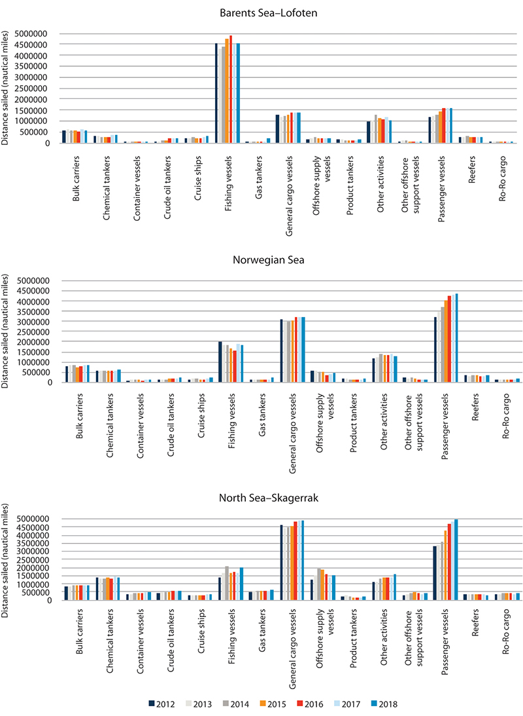
          - Distance sailed for various vessel categories in the period 2011–2017 in each of the management plan areas.
Norwegian Coastal Administration

Maritime transport

Current status and expected developments for economic activity
Shipping in all three management plan areas has risen moderately year by year in the period 2011–2017. This is part of a long-term trend linked to rising transport needs, which in turn are connected to economic developments and globalisation of the economy. Over shorter time periods, market fluctuations can result in changes within certain vessel categories.
The volume of shipping and shipping density differ greatly between the three management plan areas. In 2016, 45 % of total distance sailed was in the North Sea–Skagerrak area, 30 % in the Norwegian Sea and 25 % in the Barents Sea–Lofoten area. The Barents Sea–Lofoten area is nearly six times larger than the North Sea–Skagerrak area, but only accounts for about half as much distance sailed. The distribution of shipping between the management plan areas has remained relatively stable over time.
The volume of shipping is anticipated to increase by a total of 41 % for all three management plan areas combined by 2040. The anticipated increase is largest for the Norwegian Sea (49 %), followed by the North Sea–Skagerrak area (43 %) and the Barents Sea–Lofoten area (around 30 %).
The introduction of traffic separation schemes and recommended routes along the coast have helped to move shipping further out from the coast, separate traffic streams in opposite directions and establish a fixed sailing pattern.
There is a large volume of shipping in the North Sea–Skagerrak area, and there are important traffic streams in coastal areas. General cargo vessels and passenger vessels account for the greatest distance sailed (over half of total distance sailed in 2017). The largest increase since 2011 has been for passenger vessels.
Ships on the landward side of the baseline account for a significant share of distance sailed in the Norwegian Sea. However, the routeing system introduced in 2011 is clearly yielding results.
The Barents Sea–Lofoten area stands out because fishing vessels account for a substantially larger share of shipping than in the other management plan areas. The distance sailed by fishing vessels in the Barents Sea–Lofoten area is greater than in the North Sea–Skagerrak and Norwegian Sea areas combined. International shipping traversing the northernmost Norwegian waters is also on the rise. Nearly half of all maritime traffic (except for fishing vessels) in the Barents Sea–Lofoten area follows the recommended routes. Over 80 % of the largest ships and nearly all tankers follow these routes. This enhances safety and reduces accident risk.
              - Autonomous electric cargo vessels
The grocery wholesaler ASKO is planning to build two autonomous, electric, emission-free vessels (the AutoBarge design) to transport cargo across the Oslofjord between the towns of Moss and Holmestrand from 2024 onwards. The vessels will cross the fjord, manoeuvre and moor without a crew. A control centre on shore will monitor operations and be able to steer the vessels. The new vessels will have a daily cargo capacity of 128 semi-trailers in each direction across the Oslofjord, replacing 150 lorry trips per day between the east and west sides of the fjord. This will reduce annual energy consumption by 11.0 GWh at full operation as a result of shorter driving distances and the greater energy efficiency of the cargo vessels. In addition, 8.3 GWh of diesel will be replaced by electricity. The net result will be a reduction of 5 095 tonnes in CO2 emissions and a reduction in road transport of up to 2.2 million kilometres annually. The project has received NOK 119 million in investment support from Enova.
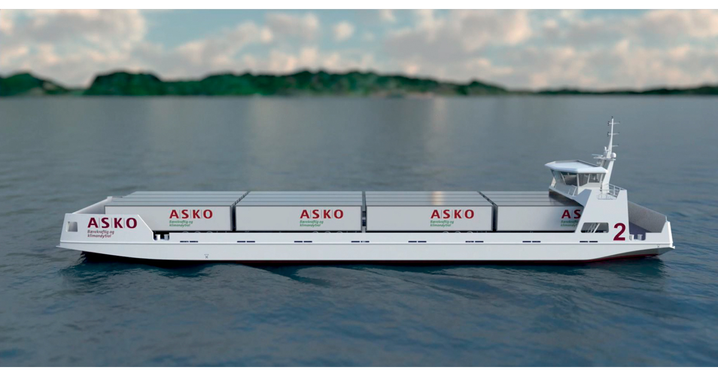
          - Autonomous cargo vessel.
ASKO
[Boks slutt]
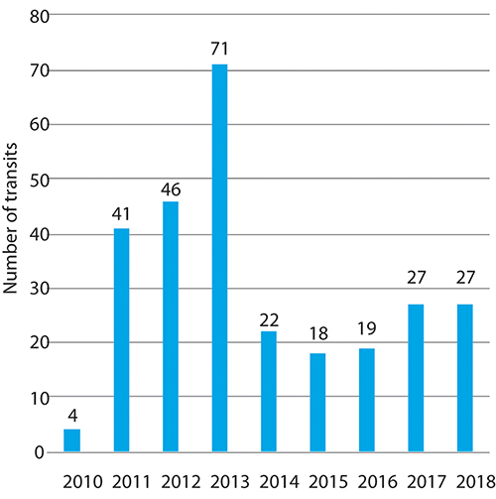
          - Vessels transiting the Northern Sea Route in the period 2010–2018.
Norwegian Coastal Administration
Automation and autonomous coastal navigation
Automated, and eventually autonomous, vessels will become increasingly important in the shipping industry. More autonomous ships will generally have various positive climate and environmental effects. Improvements in energy efficiency and optimisation of operations are some of the main benefits. The design of autonomous, unmanned vessels can also be made more aero- and hydrodynamic to reduce wind and water resistance. In combination, these factors will allow autonomous vessels to be highly energy-efficient and have low fuel consumption. This will make it possible for example to electrify more ships, and they will be able to operate for longer distances using electric propulsion.
The Government has been encouraging the development of autonomous technology and its use in ships for a number of years. Enova has provided grants of NOK 133 million for the construction of the Yara Birkeland, an autonomous electric container ship, and has granted NOK 119 million for development of the AutoBarge design for the grocery wholesaler ASKO (see Box 5.2).
Norway’s Act relating to ports and navigable waters was amended in 2019 to provide for autonomous navigation in coastal waters without the need to use a pilot. The Norwegian Maritime Authority takes part in all relevant projects at national level that involve autonomous ships and require certification of these vessels. The Maritime Authority and the Coastal Administration are both important partners for the industry.
Northeast Passage and Northern Sea Route
The reduced ice cover in the Arctic has to some extent opened up opportunities for maritime traffic between the Atlantic Ocean and the Pacific Ocean, both north of Canada via the Northwest Passage and north of Russia via the Northeast Passage and the Northern Sea Route (the part of the Northeast Passage in Russian waters). The prospect of cost savings motivates shipowners to consider using the Northeast Passage. Ships can potentially save 15–20 days at sea and reduce the distance sailed by two-thirds. So far, it is largely cargo vessels and some cruise ships that sail the Arctic route.
Statistics for the number of ships transiting the Northern Sea Route, see Figure 5.10, show that it is still uncertain what role the Northeast Passage will play in shipping between the Atlantic Ocean and the Pacific Ocean in both the short and long term.

Value added and employment
In the scientific basis for the management plans, value added and employment for shipping were calculated for each of the management plan areas, see Tables 5.5 and 5.6. The figures indicate that the bulk of value added and employment in the shipping sector is concentrated in the North Sea–Skagerrak area, while the Barents Sea–Lofoten area accounts for the smallest share. It remains to be seen what impact the anticipated increase in shipping in northern waters will have on value added and employment in North Norway.
            - Value added for shipping in each of the management plan areas and the totals for Norway.
10J2xt2
Value added, shown in NOK billion (in current prices).
 | Barents Sea–Lofoten |  | Norwegian Sea |  | North Sea–Skagerrak |  | Norway, total
Industry sector | 2010 | 2016 | 2010 | 2016 | 2010 | 2016 | 2010 | 2016 | 2019
Foreign shipping, cargo | 0.1 | 0.10 | 1.2 | 1.4 | 18.8 | 24.3 | 20.1 | 25.8 | 24.7
Domestic shipping, cargo; tugboats | 0.4 | 0.5 | 0.5 | 1.2 | 0.9 | 1.8 | 1.8 | 3.6 | 3.1
Domestic coastal shipping, scheduled | 0.5 | 0.1 | 0.8 | 0.2 | 1.3 | 0.4 | 2.6 | 0.6 | 0.4
Sum of core activities | 1.0 | 0.7 | 2.5 | 2.8 | 21.0 | 26.5 | 24.5 | 30.1 | 28.2
Sum of supply industries | 0.3 | 0.3 | 1.6 | 1.8 | 5.7 | 8.5 | 7.7 | 10.6 | 11.6
Sum of core activities and supply industries | 1.3 | 1.0 | 4.1 | 4.6 | 26.7 | 35.0 | 32.2 | 40.7 | 39.8
Statistics Norway
            - Employment in each of the management plan areas and the totals for Norway.
10J2xt2
Employment figures in 1 000s
 | Barents Sea–Lofoten |  | Norwegian Sea |  | North Sea–Skagerrak |  | Norway, total
Industry sector | 2010 | 2016 | 2010 | 2016 | 2010 | 2016 | 2010 | 2016 | 2019
Foreign shipping, cargo | 0.1 | 0.2 | 0.8 | 1.3 | 12.6 | 17.3 | 13.5 | 18.8 | 18.2
Domestic shipping, cargo; tugboats | 0.2 | 0.6 | 0.8 | 0.5 | 1.1 | 1.1 | 2.1 | 2.2 | 2.4
Domestic coastal shipping, scheduled | 1.0 | 1.6 | 2.5 | 1.4 | 2.7 | 3.3 | 6.2 | 6.4 | 6.4
Sum of core activities | 1.3 | 2.5 | 4.2 | 3.2 | 16.3 | 21.8 | 21.8 | 27.5 | 27.0
Sum of supply industries | 0.4 | 0.4 | 1.5 | 1.2 | 4.1 | 3.4 | 6.0 | 5.0 | 5.0
Sum of core activities and supply industries | 1.7 | 2.9 | 5.7 | 4.4 | 20.4 | 25.2 | 27.8 | 32.5 | 32.0
Statistics Norway
Norway has an internationally leading maritime industry, including shipping companies, maritime services, shipyards and equipment suppliers. The maritime industry is crucially important for settlement, value creation and employment, particularly in rural parts of Norway. There are maritime companies and strong clusters all along the coast from north to south. The sector is strongly specialised in high-tech market segments.
In 2018, the Norwegian maritime industry employed around 85 000 people, and the sector generated value added of NOK 142 billion. This means that the maritime industry accounted for 8 % of value added in Norway and 17 % of total Norwegian exports.
Norway is in a leading position globally as regards the deployment of zero- and low-emission technology in the maritime sector. Green shipping is opening up new opportunities for the Norwegian maritime industry. In autumn 2019, Menon Economics published a report on green value creation in the Norwegian maritime industry. According to Menon, green revenues in the maritime industry in 2018 totalled roughly NOK 28 billion. In addition, the industry made green investments of more than NOK 5 billion. Both revenues and investments have roughly tripled in the past few years. To follow up the strategy adopted by the International Maritime Organization (IMO) in 2018, including the ambition of cutting emissions from international shipping by at least 50 % by 2050, both green revenues and green investments will need to increase substantially in the years ahead. Norwegian companies are already supplying zero- and low-emission technology to the world market.

Current status and expected developments for environmental pressures and impacts
Emissions to air from shipping have increased in the three management plan areas in the period 2011–2017. The trend towards larger ships may partly explain why growth in emissions has been greater than growth in distance sailed in the same period. Another explanation may be the increase in the average speed of ships, particularly large ones, in recent years.
Greenhouse gas emissions from domestic shipping in 2017 have been estimated at 4.8 million tonnes CO2 equivalent using AIS data as a basis (the AIS system provides real-time information on vessel movements). This indicates a certain rise in emissions in recent years. On the other hand, Statistics Norway estimated 2017 emissions from domestic shipping and fishing at 2.95 million tonnes CO2 equivalent, based on registered sales of fuel in Norway for use in domestic shipping. The figures from Statistics Norway are included in Norway’s emission inventory, which is used as a basis for its emission reduction commitments.
A reduction in the carbon footprint of Norwegian shipping per tonne-kilometre is expected in the years ahead, partly due to stricter emission requirements and policy objectives designed to fulfil Norway’s emission reduction commitments. The Government’s ambition is to reduce emissions from domestic shipping and fishing vessels by half by 2030.
Cruise traffic results in substantial emissions to air of pollutants such as nitrogen oxides (NOx) and sulphur oxides (SOx), which have a negative impact on local air quality. From 1 March 2019, Norway introduced stricter requirements for releases to air and water from ships in the West Norwegian Fjords World Heritage Site.
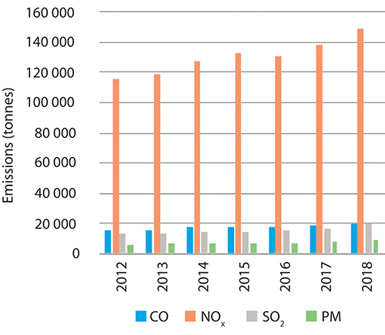
          - Releases to air from shipping in the management plan areas: particulate matter (PM), sulphur dioxide (SO2), carbon monoxide (CO) and nitrogen oxides (NOx).
Norwegian Coastal Administration
The introduction and spread of invasive alien species through ballast water or biofouling of ship’s hulls constitute one of the most serious ecological threats in fjords and oceans.
The Ballast Water Management Convention entered into force in September 2017, and is an essential tool for preventing the spread of alien species with international shipping. Under the convention, ships must now manage their ballast water so that potentially harmful aquatic organisms are removed or rendered harmless before ballast water is released.
Currently there are no binding national or international requirements intended to prevent or limit the transfer of harmful organisms through hull fouling. However, IMO has issued voluntary guidelines on the control and management of hull fouling to minimise the transfer of harmful aquatic organisms. The guidelines apply globally.
Noise from shipping is the most widespread source of low-frequency noise in the marine environment. Noise levels and frequencies will vary depending on ship size, speed and the type of propulsion system. The largest ships produce the highest noise levels at source and the lowest frequencies.
Long time series of measurements indicate that in certain areas, ambient noise has more than doubled each decade over the last 30–40 years. The increase in the volume of commercial shipping is probably the primary cause of this. Increased ambient noise can raise physiological stress levels in marine animals and interfere with their abilities to communicate with one another, find food and navigate. International studies show that noise from shipping can also influence the behaviour of marine animals and other organisms. It is unlikely that noise from shipping directly harms fish and marine mammals.

Petroleum activities
The petroleum industry is Norway’s largest, measured in terms of value added, state revenues, investment and export value. The industry contributes substantially to financing the welfare state. All across the country, the petroleum industry provides employment, accounts for much activity, and stimulates business, technological and societal development. The resource accounts indicate that after 50 years, about half of the total petroleum resources on the Norwegian continental shelf had been extracted, and the proportion was higher for oil resources than for gas resources.

Current status and forecasts of economic activity
At the beginning of 2020, 87 fields on the Norwegian continental shelf were producing oil and gas: 66 in the North Sea, 19 in the Norwegian Sea and two in the Barents Sea. Production in 2019 totalled 214 million standard cubic metres of oil equivalents (Sm3 o.e.). The start-up of the Johan Sverdrup field means that production will increase over the next few years.
At the beginning of 2020, some 85 discoveries were being considered for development. Most of these are small and will be developed as satellites with subsea installations tied back to existing infrastructure. However, it should be noted that even small development projects on the continental shelf would be considered to be major industrial projects if carried out onshore. Independent development is planned for the largest discoveries, but a number of smaller fields may also collaborate on building new infrastructure.
Exploration, development and production activity levels on the Norwegian shelf are high, and are expected to remain high in the years ahead. In the longer term, the number and size of new discoveries and developments, as well as how quickly production drops from existing fields as they are depleted, will be crucial in determining production and activity levels. Future prices will also have an impact. Most existing fields are resilient even when demand is declining and the price range is sinking. Norwegian production is a relatively low-cost way to bring new production to market, and new discoveries can be expected to be profitable even in these circumstances.
There is considerable potential for improved oil recovery from many on-stream fields beyond what is currently planned. Since 2000, various steps have been taken to improve recovery from fields in production. This has significantly increased the reserves.
The North Sea accounts for the largest proportion of production from the Norwegian continental shelf, and the province still holds considerable resource potential. The North Sea will continue to generate substantial value added for many years to come. New gas infrastructure has been established in the northern part of the Norwegian Sea: the Aasta Hansteen field, which started production in 2018, and the gas pipeline Polarled. These developments will also facilitate further new developments and exploration activities in this part of the Norwegian Sea.
Petroleum activities began in the Barents Sea South in 1979, and the area is an important petroleum province. There are currently two fields in production in the Barents Sea: Snøhvit and Goliat. The Snøhvit gas field began production in 2007. The natural gas is transported by pipeline to the onshore facility at Melkøya for processing, liquefaction and transport by ship to the market. In autumn 2019, cargo number 1 000 of LNG was shipped from Melkøya. The Goliat field began production in 2016 and is the first oil field in the Barents Sea, including the first installation in the Barents Sea that projects above the sea surface.
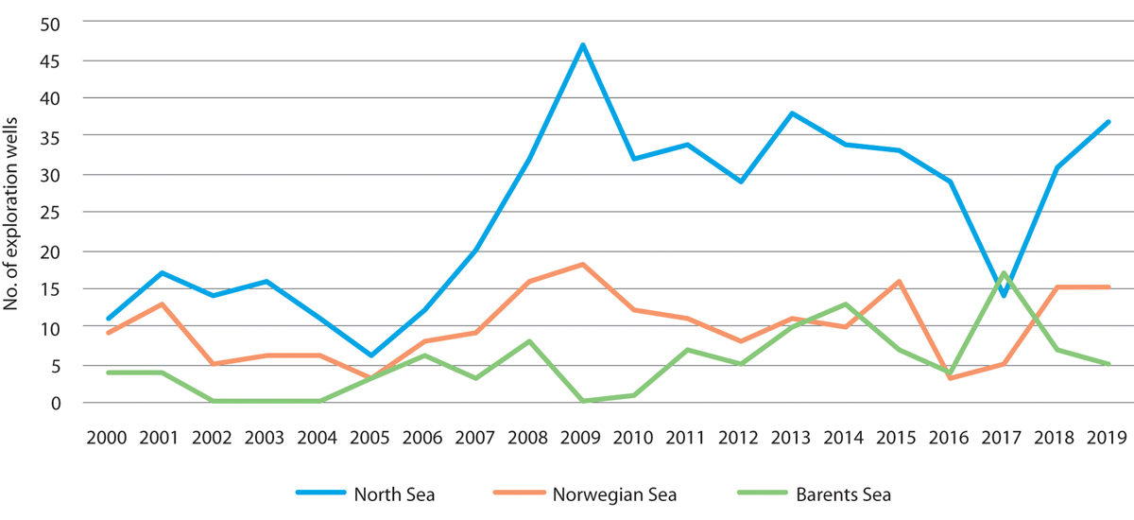
          - Overview of exploration wells drilled in the management plan areas, 2010–2019.
Norwegian Petroleum Directorate
The third field in the Barents Sea will be the Johan Castberg field, which is under development with production scheduled to start in 2022. This is the largest oil field found in the Barents Sea so far and consists of the three discoveries Skrugard, Havis and Drivis. The plan for development and operation (PDO) was approved in June 2018. Developments in the Barents Sea must deal with the area’s natural conditions such as extreme cold and icing of facilities. Several countries have been carrying out petroleum activities in the Arctic for several decades. The Norwegian Petroleum Directorate published a report on petroleum activities in the Arctic which provides an overview of these activities. Petroleum activities in the Arctic were also discussed in a proposition to the Storting on the Johan Sverdrup field and the status of Norway’s oil and gas activities published in 2015 (Prop. 114 S (2014–2015)).
Further discoveries have also been made in the Barents Sea, and the petroleum companies are working on possible development concepts with a view to making investment decisions. The Wisting discovery, currently the largest undeveloped discovery on the Norwegian continental shelf, is in the clarification phase.
The petroleum companies are showing great interest in the licensing rounds for the Norwegian continental shelf. In the latest licensing round for awards in predefined areas (APA 2019), 69 production licences were offered on the Norwegian shelf, with 33 in the North Sea, 23 in the Norwegian Sea and 13 in the Barents Sea. Nineteen different companies were offered status as designated operators.
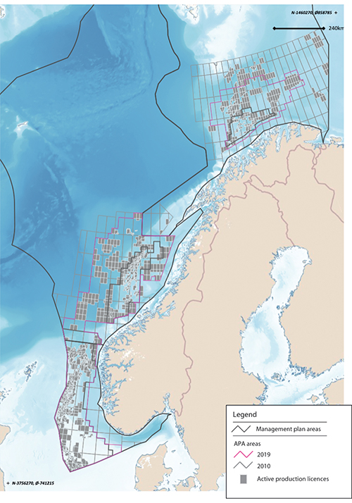
          - Map showing active production licences and expansion of the acreage covered by the system of awards in predefined areas (APA), from APA 2010 to APA 2019.
Norwegian Petroleum Directorate/Marine spatial management tool
Exploration activity on the Norwegian continental shelf has varied over the years, but has remained stable at a high level in recent years. On average, just under 50 exploration wells have been drilled on the Norwegian shelf every year since 2000. The North Sea has the highest overall number of exploration wells but in 2017, for the first time, more exploration wells were drilled in the Barents Sea than in the North Sea. In 2017, 17 exploration wells were spudded in the Barents Sea, as compared with five in 2016 and seven in 2018. In 2019, 57 exploration wells were spudded and 17 discoveries made on the Norwegian shelf, with a total estimated volume of 70 million Sm3 o.e.
There are large remaining oil and gas resources on the Norwegian continental shelf. Currently, the fields on the Norwegian shelf supply 2–3 % of global demand for oil and gas. The Norwegian Petroleum Directorate estimates that total discovered and undiscovered resources on the Norwegian shelf were approximately 15.7 billion Sm3 o.e. on 31 December 2018. ‘Resources’ is a collective term for all technically recoverable quantities of petroleum. Undiscovered resources are estimated at close to 4 billion Sm3 o.e., equivalent to roughly 40 Johan Castberg fields. The Petroleum Directorate expects approximately one-third of these undiscovered resources to be in the North Sea and the Norwegian Sea, and two-thirds in the Barents Sea. Knowledge about the Barents Sea is particularly limited, so that uncertainty regarding resource volumes is highest here. The actual resources could be either less than or substantially more than the current estimate from the Petroleum Directorate. The resource accounts include all resources on the Norwegian continental shelf, including those in areas that are not currently open for petroleum activities.
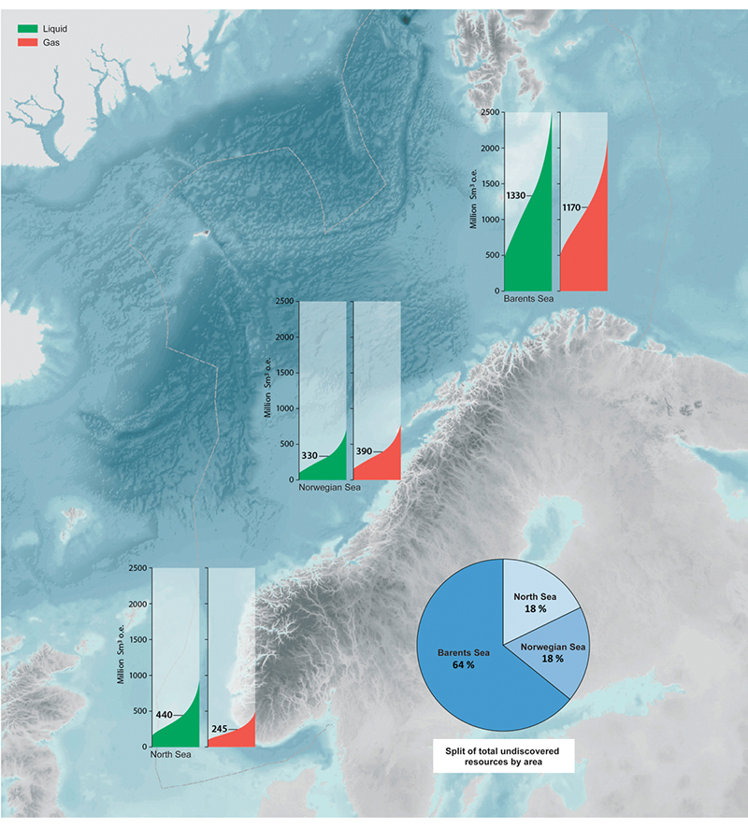
          - Resource estimate for undiscovered resources on the Norwegian continental shelf.
Norwegian Petroleum Directorate
Knowledge is an essential basis for sound resource management. In areas that are not currently open for petroleum activities, only the authorities are permitted to collect data and conduct surveys. As part of its long-term data acquisition in northern waters, the Norwegian Petroleum Directorate conducted a seismic survey in the northern Barents Sea that will provide important information on the geology of the area and a better resource estimate. Undiscovered resources on the Norwegian continental shelf could represent major assets for Norway.
For 2019, the allocation for geological surveys was increased by NOK 50 million so that knowledge acquisition could continue through mapping of petroleum resources in the Barents Sea North. This will be a continuation of the geological surveys carried out by the Norwegian Petroleum Directorate in recent years to advance the knowledge base on Barents Sea geology. Further geological data is needed to learn more about petroleum resources. Newer and better data gives the authorities greater understanding of petroleum systems as a whole, which is important both for sound resource management and for national economic interests relating to transboundary petroleum deposits.
Further information on regulation of petroleum activities
Petroleum activities may take place in areas opened by the Storting (Norwegian parliament) in accordance with the framework for specific geographical areas set out in the ocean management plans. The framework for petroleum activities is set out in Chapter 9.2.4.
Acreage for petroleum activities is allocated through two equally important types of licensing rounds. New acreage in frontier areas is allocated in numbered licensing rounds, which are normally held every other year. In more mature areas, where more is known about the geology and that are closer to planned or existing production and transport infrastructure, licences are issued every year through the system of awards in predefined areas (APA). The licensing process involves a number of steps. Numbered licensing rounds are opened by inviting companies to nominate blocks. The authorities assess the nominations, and a proposed announcement is submitted for public consultation. After this, the Ministry of Petroleum and Energy announces the round. After the applications have been processed and after negotiations with the companies on licensing conditions, the government makes the final decision on which areas are to be covered by production licences and the mandatory work programme for each licence.
It has been decided to continue the APA system as an annual licensing round on the Norwegian continental shelf. The APA system includes areas opened for oil and gas activities at least since 1994, and a significant proportion has been open since 1965. Fundamental features of the APA system are that APA areas are is expanded as the continental shelf is explored, and that it is predictable because no acreage is withdrawn once it has been included in the APA system. This is important for the system’s effectiveness. All areas that are open and therefore available for petroleum activities may be announced in numbered licensing rounds or through the APA system. The parts of the shelf to be included in each of the two types of rounds are determined on the basis of expert assessments of the maturity of different areas, particularly in relation to the need for stepwise exploration and utilisation of time-critical resources.
A predictable framework is important for the petroleum industry. The Government will continue to facilitate profitable production of oil and gas by maintaining a such a framework. This will include continuing the regular licensing rounds on the Norwegian continental shelf, in order to give the industry access to new exploration areas. To maintain employment, value added and state revenues over time, both large and small discoveries are needed at regular intervals.
Most of the Norwegian continental shelf was opened for exploration activity decades ago. Large discoveries are most often made early in the exploration phase, although there are exceptions. Thorough exploration of areas while the necessary expertise is available is vital to increase the likelihood of finding large, commercially viable discoveries.
Petroleum activities are subject to strict requirements and standards for health, environment and safety, which include safeguarding the natural environment. Approval from the authorities is required for all phases of activity, including exploration, development, operations and decommissioning. This also includes permits under the Pollution Control Act and consent under the health, safety and working environment legislation. The legislation is designed in such a way that the requirements are stricter when activities are taking place in areas where the safety and environmental situation is particularly challenging. It is also considered important to facilitate coexistence with other industries.
              - Development of the Johan Castberg field
The Johan Castberg field, about 240 km northwest of Hammerfest, is the third field development project in the Barents Sea. When scheduled production starts, this will be the world’s northernmost offshore development, but the operational challenges here do not differ substantially from those in fields further south on the Norwegian continental shelf. New factors that will need to be dealt with include polar lows, challenges relating to preparedness and response because of the remoteness of the field, and the possible occurrence of drift ice in extreme years. The development concept takes these into consideration. The load-bearing structures and anchoring systems of the floating production, storage and offloading vessel (FPSO) are designed to withstand drift ice. Statistically, it is estimated that drift ice will reach the Johan Castberg field once every 10 000 years. A system will be developed for continuous monitoring of ice conditions. If drift ice approaches to approximately 60 km north of the FPSO (73° N) and is forecast to drift further southwards, production will be halted and not resumed until there is a safe distance between the ice and the FPSO again.
[Boks slutt]
The Government and the Storting can decide that there may be conditions for, or restrictions on, activities in specific geographical areas. These are indicated when a licensing round is announced and are specified in the production licences. Restrictions on the times of year when seismic surveys or drilling in oil-bearing formations are permitted are spatial management tools that are used to regulate the petroleum industry (see also Chapter 9). The purpose of such restrictions is to avoid the risk of environmental damage at times when natural resources are particularly vulnerable, for example during spawning or spawning migration and during the breeding season for seabirds, while still allowing petroleum activities to be carried out. Spatial management tools such as seasonal restrictions on exploration drilling provide a framework for value creation while at the same time ensuring that important environmental considerations are taken into account. Moreover, licensees are required to carry out necessary seabed surveys to ensure that any coral reefs or other valuable benthic communities, including sandeel habitats, are not damaged by petroleum activities.

Value added and employment
The main goal of the Government’s petroleum policy is to facilitate long-term profitable production of oil and gas. A predictable framework is important for the petroleum industry. The Government will therefore continue the regular licensing rounds on the Norwegian continental shelf in order to give the industry access to new exploration areas. To maintain employment, value added and state revenues, both large and small discoveries are needed at regular intervals.
A large share of the value added from the petroleum sector accrues to the state, so that it can benefit society as a whole. The oil and gas industry plays a key role in the Norwegian economy, and it will continue to make a major contribution to financing the Norwegian welfare society.
The petroleum resources on the Norwegian continental shelf have laid the foundation for the development of a substantial oil and gas industry in Norway. The petroleum industry includes oil companies, supplier industries and petroleum-related research and education institutions. It accounts for a substantial proportion of Norwegian value added and provides employment in all parts of the country.
            - Value added in the petroleum sector in the management plan areas and the totals for Norway. Figures do not include value added from supply industry exports.
10J2xt2
Value added, shown in NOK billion (in current prices).
 | Barents Sea–Lofoten |  | Norwegian Sea |  | North Sea–Skagerrak |  | Norway, total
Industry | 2010 | 2016 | 2010 | 2016 | 2010 | 2016 | 2010 | 2016 | 2019
Sum of core activities | 19.0 | 21.9 | 128.5 | 96.8 | 385.2 | 294.8 | 532.8 | 413.6 | 497.2
Supply industries | 2.2 | 3.4 | 15.4 | 15.2 | 46.2 | 46.3 | 63.8 | 64.9 | 69.6
Sum of core activities and supply industries | 21.2 | 25.3 | 143.9 | 112.0 | 431.4 | 341.1 | 596.6 | 478.5 | 566.8
Statistics Norway
In 2019 the petroleum industry generated NOK 566.8 billion in value added (see Table 5.7). Most of the oil and gas produced on the Norwegian shelf is sold abroad and provides substantial export revenues. In 2018, the petroleum sector accounted for 17 % of Norway’s overall value added and approximately 43 % of export revenues. The sector also accounts for roughly 20 % of state revenues and Norway’s total investments. Value added per person directly employed in the petroleum industry in 2018 was approximately NOK 25 million, compared to roughly NOK 1 million in the Norwegian mainland economy as a whole. In 2019, total employment associated with the management plan areas in the petroleum sector, including core activities and the largest companies in the direct supplier industry for each of these, but not including wider spin-off effects, was about 110 000 persons (see Table 5.8). Total Norwegian employment related to the petroleum sector was approximately 139 900 persons in 2018, or about 5.1 % of total employment. Another roughly 70 000 persons were in employment directly or indirectly related to export activities of the petroleum supplier industry. In total, therefore, more than 210 000 Norwegian jobs were directly or indirectly related to petroleum activities on the Norwegian continental shelf and the export markets.
            - Employment in the petroleum sector in the management plan areas and the totals for Norway. Figures do not include employment relating to supply industry exports.
10J2xt2
Employment figures in 1 000s.
 | Barents Sea–Lofoten |  | Norwegian Sea |  | North Sea–Skagerrak |  | Norway, total
Industry | 2010 | 2016 | 2010 | 2016 | 2010 | 2016 | 2010 | 2016 | 2019
Sum of core activities | 6.6 | 6.9 | 12.3 | 12.2 | 35.2 | 35.2 | 54.1 | 54.3 | 55.6
Supply industries | 7.1 | 7.6 | 13.5 | 13.6 | 38.6 | 39.1 | 59.3 | 60.3 | 54.4
Sum of core activities and supply industries | 13.7 | 14.5 | 25.8 | 25.8 | 73.8 | 74.3 | 113.4 | 114.6 | 110.0
Statistics Norway
The Norwegian continental shelf is one of the world’s largest offshore markets and is important for the development of the Norwegian supply industry. The petroleum companies, oil and gas suppliers and wider value chain effects provide employment throughout the country.
Activity on the Norwegian continental shelf offers great potential for further development of the Norwegian supply industry, which would have positive productivity effects on other onshore industries. Recent research indicates that activity related to oil and gas exploration and extraction generates positive learning effects, not only between supply companies within the industry but also between companies in the petroleum industry and in other segments of the economy. The supply industry is thus an engine of growth and a source of revenue generation for the entire economy. In this way, interactions between the supply industry and traditional onshore industries that are exposed to competition promote a broader-based, resilient and knowledge-rich business structure. This in turn will support viable, knowledge-based jobs in all parts of Norway.
              - Spin-off effects of petroleum activities in North Norway
In keeping with Norway’s policy objective, offshore petroleum activities also have clear spin-off effects onshore both regionally and nationally. The Aasta Hansteen gas field in the northern Norwegian Sea, 300 km west of Bodø, came on stream in 2018. Its operator, Equinor, is running the field from Harstad in North Norway, with the supply base in Sandnessjøen and the helicopter base in Brønnøysund. Although the substructure and topside structure for the floating platform were built abroad, there were substantial deliveries from firms in North Norway during the development phase. These totalled more than NOK 1 billion by the end of 2018, according to a study by Bodø Science Park. For example, businesses in Mo i Rana, Sandnessjøen and Bodø supplied the suction anchors that keep the Aasta Hansteen platform in place, the subsea templates, and the platform’s fire doors. Geographical proximity is a particularly important competitive advantage for suppliers during the operation phase. The main employment effects of Aasta Hansteen will be related to activities at the supply and helicopter bases, but there will also be positive spin-off effects for other manufacturing, retail trade, hotels and restaurants, and business services.
[Boks slutt]
Farther north, in the Barents Sea, the Johan Castberg field is scheduled to start production in 2022. So far in the development phase, a number of the subsea templates and the flare boom for the floating production, storage and offloading unit (FPSO) have been produced in Sandnessjøen. The overall regional effect of the development phase on employment is estimated at close to 1 750 person-years in the region (including over 700 person-years in northern Troms and Finnmark county. In the operational phase, the effect is expected to be around 470 person-years in the region in a normal year, including 265 person-years in northern Troms and Finnmark. Johan Castberg will have an operations organisation in Harstad, which will further enhance operational expertise there. There is already greater activity at NorSea Polarbase in Hammerfest municipality as a result of the development of Johan Castberg, which is providing a basis for continued establishment of supply companies at the supply base and in Hammerfest town. This is a good example of how offshore activity can boost onshore employment, population growth and revenues. Businesses in Hammerfest also supply the Snøhvit and Goliat fields and the exploration rigs operating in the Barents Sea.

Current status and expected developments for environmental pressures and impacts
The petroleum industry can have negative impacts on the environment through operational discharges to the sea and air, underwater noise from seismic surveys and physical disturbance of the seabed. There have been few major crude oil spills on the Norwegian continental shelf, and no oil spills on the Norwegian continental shelf have reached the coast in the more than 50 years since petroleum activities began. No damage to the marine environment has been demonstrated as a result of the spills that have occurred during this period. Acute pollution is further discussed in Chapter 6. Safeguarding the natural environment has always been an integral part of Norway’s approach to managing its oil and gas resources in all phases of petroleum activities, from exploration to development, operations and field closure. There is a strict regulatory framework for discharges to air and sea from the petroleum industry.
A permit under the Pollution Control Act is required for operational discharges during petroleum activities. Permits are issued and administered by the Norwegian Environment Agency. The Petroleum Safety Authority is the supervisory authority for efforts by the petroleum companies to prevent oil and chemical spills to the sea. Permits do not apply to acute pollution, which is the result of unforeseen incidents. The impacts of operational discharges during petroleum activities in the Barents Sea are currently insignificant, as they were in 2011. The quantities of chemicals and drill cuttings discharged to the sea and of pollutants emitted to air generally tend to vary with the level of drilling activity. Major oil spills may cause environmental impacts, but historical data indicate the probability of a spill is very low. In the years ahead, some increase in activity levels in the management plan areas is expected in the petroleum industry, shipping and more generally.
Operational discharges of oil and chemicals to the sea
Discharges of chemicals to the sea tend to vary with drilling activity and the quantity of produced water, and are highest during drilling. The largest discharges of oil during normal operations are with produced water. The zero-discharge targets for discharges of oil and environmentally hazardous substances to the sea apply to discharges from petroleum activities. These targets were adopted in a white paper on an environmental policy for sustainable development (Report No. 58 (1996–1997) to the Storting). They apply to oil, added chemicals and naturally occurring substances discharged with produced water, including radioactive substances. Norway’s goal is for discharges of the most hazardous added chemicals (black and red categories) to be eliminated and that discharges of naturally occurring environmentally hazardous substances should be eliminated or minimised. For oil and other substances, the target is zero or minimal discharges of substances that may cause environmental damage. The targets were reproduced in full in the 2017 update of the Norwegian Sea management plan (Meld. St. 35 (2016–2017)).
Discharges of oil and chemicals to the Norwegian Sea and the North Sea vary from year to year with drilling activity. There has been a rise in discharges of substances in the red and black categories in these management plan areas, partly because certain substances have been moved to different categories. Drilling and well chemicals account for a large proportion of total discharges.
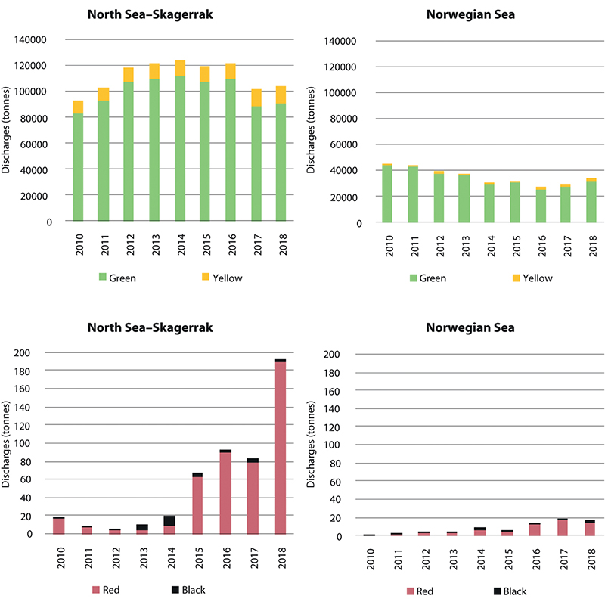
          - Trends in discharges of added chemicals in the North Sea–Skagerrak and Norwegian Sea management plan areas, by colour category (green, yellow, red, black).
Norwegian Environment Agency
Discharges of produced water to the North Sea and the Norwegian Sea have been variable since the previous scientific basis was published in 2010, but were somewhat lower in 2017 than in 2012. The North Sea fields accounted for 88 % of total discharges of produced water and oil on the Norwegian continental shelf in 2017. Discharges to the Barents Sea are much lower than on the rest of the continental shelf because there is limited activity and only two fields are in production. Discharges to the Barents Sea are largely related to drilling activity and consist mostly of water-based drilling mud (green category chemicals) and drill cuttings. Discharges of chemicals to the Barents Sea have nevertheless increased since the previous scientific basis was published, as a result of increased drilling activity in the area.
Produced water is discharged only from the Melkøya onshore facility, as was the case when the previous scientific basis was published. Discharges of produced water to the Barents Sea are expected to remain low in future, so that there is little reason to expect them to have negative environmental impacts.
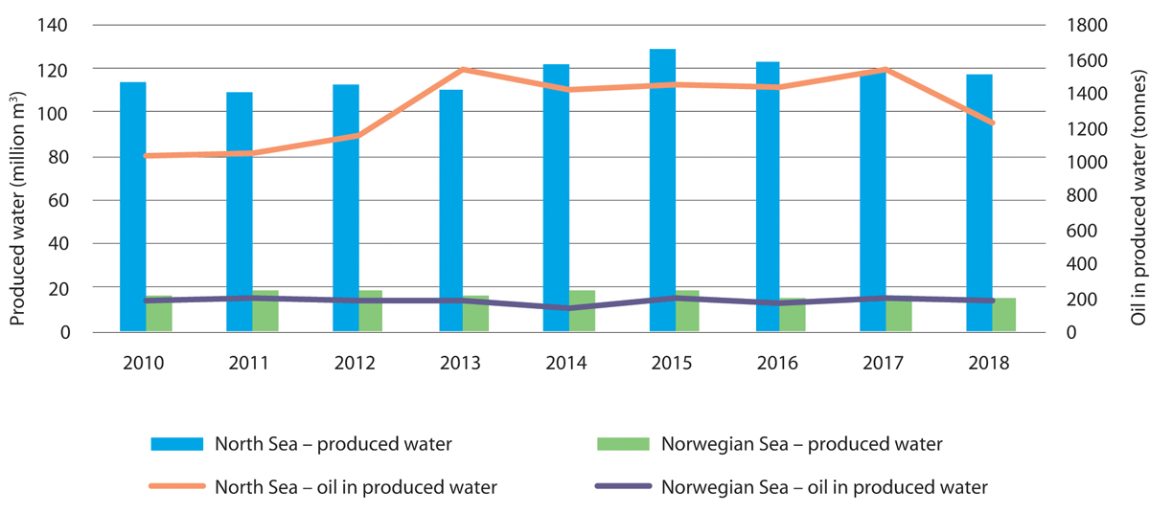
          - Trends in discharges of produced water and oil in produced water in the North Sea–Skagerrak and Norwegian Sea management plan areas, 2010–2018.
Norwegian Environment Agency
The assessment in 2010 indicated that the zero-discharge target for added environmentally hazardous substances had been achieved. However, reported discharges of added environmentally hazardous substances, including dispersed oil, naturally occurring substances, and naturally occurring radioactive substances have risen overall since 2010. This means that the zero-discharge targets for petroleum activities are now further from being achieved than was thought in 2010. The Norwegian Environment Agency therefore recommends continued efforts to reduce discharges of environmentally hazardous substances, but also notes that it will be difficult to achieve zero discharges, particularly because there are areas of use where the properties of chemicals that make them environmentally hazardous are necessary for their function.
              - Reducing greenhouse gas emissions from the petroleum industry
Greenhouse gas emissions from oil and gas recovery in 2018 totalled 14 million tonnes CO2 equivalent, or 27 % of Norway’s total emissions. The main instruments Norway uses to limit greenhouse gas emissions from petroleum activities are economic: emissions trading and the carbon tax. CO2 emissions from the petroleum sector have been included in the EU Emissions Trading System (ETS) since 2008, and have been subject to the carbon tax since 1991. This ensures that it is always in the petroleum companies’ own interests to implement emission-reduction measures. In its reporting to the UN Framework Convention on Climate Change (UNFCCC), Norway has estimated that as a result of action introduced in response to the carbon tax and the EU ETS, CO2 emissions from the Norwegian continental shelf may be nearly seven million tonnes lower in 2020 than they would otherwise have been. The oil and gas companies have implemented many measures on installations and onshore facilities, including installing more efficient gas turbines, improving energy efficiency, introducing solutions using power from shore, and carbon capture and storage.
[Boks slutt]
The latest scientific knowledge indicates that there is still uncertainty about whether produced water is likely to have ecological impacts. The efforts to reduce discharges of produced water in all three management plan areas are therefore still important. The research programme PROOFNY found that components in produced water can have a range of negative impacts on individual fish and invertebrates. It was concluded, however, that the potential for environmental damage as a result of discharges of produced water is only moderate, and that concentrations of components that have been shown to have adverse impacts are not generally found more than one kilometre from discharge points. Discharges of oil and chemicals to the Barents Sea are only expected to have minor impacts, since reinjection of produced water means that discharges are low. The overall implications of discharges of produced water for the ecology of the management plan areas are still unclear.
Emissions to air
Emissions to air from petroleum installations on the Norwegian continental shelf consist mainly of CO2, NOX, CH4 and NMVOCs. The main sources of CO2 and NOx emissions are power generation using gas turbines and engines, while the main source of methane and NMVOCs emissions is on- and offloading of oil.
Emissions of CO2 and NOx to air from the petroleum industry in the Norwegian Sea and North Sea are relatively stable, and are mainly from gas turbines used to generate power on fixed installations. Emissions to air in the management plan areas also come from exploration drilling, including well tests. The direct impacts of emissions to air from activities in the management plan areas are considered to be minor. However, they may contribute to acidification locally.
Petroleum activities in the Barents Sea are expanding, but emissions to air are still much lower than in the North Sea and the Norwegian Sea.
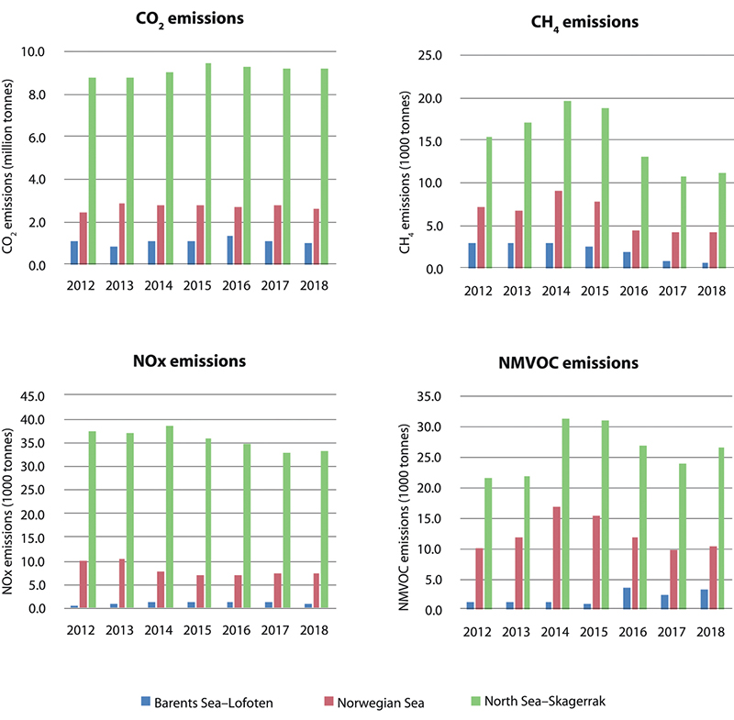
          - Emissions to air of CO2, NOX, CH4 (methane) and NMVOCs (non-methane volatile organic compounds) from petroleum activities in the three management plan areas, 2012–2018.
Norwegian Environment Agency
The main instruments Norway uses to limit greenhouse gas emissions from petroleum activities are economic: emissions trading and the carbon tax. These ensure that it is always in the petroleum companies’ own interests to implement emission-reduction measures. In its reporting to the UNFCCC, Norway has estimated that as a result of action introduced in response to the carbon tax and the EU ETS, CO2 emissions from the Norwegian continental shelf may be nearly seven million tonnes lower in 2020 than they would otherwise have been. As a result, emissions per unit produced on the Norwegian shelf are on average substantially lower than the average for oil-producing countries.
Physical impacts
Petroleum activity can put pressure on vulnerable benthic fauna such as corals and sponges, for example through deposition of drill cuttings. Corals and other benthic fauna can also be damaged when pipes and cables are laid and anchor chains and other installations are placed on the seabed. Operators are therefore required to survey any coral reefs and other valuable benthic communities that may be affected by petroleum activities and ensure that they are not damaged. Investigations after drilling operations have so far concluded that the physical and biological disturbance caused by deposition of drill cuttings is limited and local. Species and habitats can only recover rapidly from the deposition of drill cuttings if they can re-establish themselves quickly and the drill cuttings do not alter the habitat. A number of coral and sponge species are slow-growing and need a lengthy period to become re-established. They are therefore particularly vulnerable to this kind of disturbance.
In the Barents Sea, there are few fixed installations that have impacts on the benthic fauna, other than the pipelines and subsea templates for the Snøhvit and Goliat fields. Several of these are located near or in the Tromsøflaket in areas where there are sponge communities. Exploration is the dominant form of petroleum activity in this area. Where there are dense assemblages of sponges, it can be difficult to avoid disturbing individuals, but where possible, vessels with dynamic positioning systems can be used to avoid damage caused by anchors.
Good systems have been developed for safeguarding coral reefs and other valuable benthic communities through the general conditions stipulated in the licensing rounds, requirements in the health, safety and working environment legislation, and conditions in permits under the Pollution Control Act. The petroleum companies are required to carry out necessary mapping of coral reefs and other valuable benthic communities, and to ensure that they are not damaged by petroleum activities. The future impacts will depend on the scale of exploration activity and field development in areas where there are vulnerable species and habitat types, and the extent to which it is possible to take steps to avoid damage. In areas where there are dense assemblages of sponges, for instance, it may be more difficult to find areas where drill cuttings can be discharged without causing damage. There is considerable uncertainty about the ecological implications of such damage and the value of individual coral habitats, sponge communities and other valuable benthic habitats. There has been no petroleum activity in the main coral reef complexes in the Norwegian Sea, but there are coral habitats in large parts of the Norwegian Sea, including areas where there are petroleum activities. When petroleum activities are permitted in coral habitats, steps are taken to avoid significant damage. In some cases, the possibility of damage to some smaller areas has been accepted where it considered that this will not have a significant impact on the species and/or habitat type.
Seismic surveys
Seismic surveys are conducted to assess the potential for petroleum deposits and are an essential basis for petroleum activities. Geological surveys of the seabed involve the use of sound pulses generated by airgun arrays. It is these noise pulses in the form of sound waves or oscillations of particles in the water that are audible to fish and marine mammals.
Noise from seismic surveying has not been shown to cause changes in marine organisms. Some local mortality of fish larvae has been shown close to airgun arrays, but the effect at population level is still expected to be insignificant. The possible effects of seismic surveying on marine mammals are uncertain, and a lack of knowledge makes it difficult to assess what the impacts may be. Requirements to use soft-start procedures (activating airguns at low power and gradually increasing to full power) have been introduced to protect marine organisms better against seismic noise.

Tourism and leisure activities
The tourism sector has seen steady growth over the past 10 years, and tourists from around the world visit Norway to experience its clean, rich and undisturbed environment. Few countries have as long and varied a coastline as Norway, and the coastal environment, fjords and marine areas have great potential in terms of tourism. However, growing numbers of tourists are putting greater pressure on the environment, resources and coastal communities.
Coastal tourism is important in Norway, generating NOK 21.9 billion in value added and employing 34 300 persons in 2016. This means that coastal tourism accounted for roughly half of value added for Norway as a whole from the tourism industries included in the analysis.
Tourism-related value added is largest in municipalities adjoining the North Sea–Skagerrak area, but in relation to other activities accounts for a larger share of the total in municipalities adjoining the Barents Sea–Lofoten area. Along the coast of the Norwegian Sea, tourism accounts for only a small proportion of total added value, but provides more employment than the shipping sector (Tables 5.9 and 5.10).
            - Value added from the tourism sector in coastal municipalities adjoining the management plan areas. Value added is shown in NOK billion (in current prices).1
05J2xt2
 | 2010 |  | 2016
 | NOK billion | % of national total | NOK billion | % of national total
Norway, total (all municipalities) | 32.2 |  | 45.4
Barents Sea–Lofoten | 2.4 | 8 % | 3.7 | 8 %
Norwegian Sea | 2.5 | 8 % | 4 | 9 %
North Sea–Skagerrak | 9.6 | 30 % | 14.2 | 31 %
Sum, coastal municipalities | 14.5 | 45 % | 21.9 | 48 %
1 The share of tourism consumption in the coastal municipalities that is actually related to the features of nearby marine areas or the presence of the sea in itself is not known. This probably inflates the estimates shown for the municipalities adjoining the management plan areas.
Statistics Norway
            - Employment in the tourism sector in coastal municipalities adjoining the management plan areas. Employment figures in 1 000s.
05J2xt2
 | 2010 |  | 2016
 | 1 000s | % of national total | 1 000s | % of national total
Norway, total (all municipalities) | 74.2 |  | 88.4
Barents Sea–Lofoten | 4.8 | 7 % | 6.1 | 7 %
Norwegian Sea | 4.8 | 7 % | 7.1 | 8 %
North Sea–Skagerrak | 17.1 | 23 % | 21 | 24 %
Sum, coastal municipalities | 26.7 | 36 % | 34.3 | 39 %
Statistics Norway
Tourism and leisure activities in Norway’s marine and coastal areas depend on well-functioning ecosystems and opportunities to experience a clean natural environment. Foreign tourists are still drawn to Norway primarily by the scenery and natural surroundings, and these are also important for the destinations chosen by Norwegian tourists. The Government considers sustainable development of Norwegian tourism to be very important. The tourism and leisure activities that put most pressure on the environment are cruises, recreational fishing and fishing tourism, and leisure boating in coastal waters.
The islands, skerries and fjords along the coast offer a wide variety of opportunities for outdoor recreation, including bathing, recreational fishing and boating.
Cruise traffic
The number of cruise passengers increased by 64 % from 2011 to 2017, while the number of day-trippers who went ashore from cruise ships in Norwegian ports rose by nearly 50 %. In total, around three million day-trippers from cruise ships went ashore in Norwegian ports in 2017. According to the Institute of Transport Economics, almost 83 % of the growth in cruise ship calls in the 10-year period 2008–2018 was in Western Norway. In North Norway, the annual number of port calls has varied, but overall there has been a weakly rising trend over time. Moreover, average ship size (measured in terms of maximum number of passengers) in North Norway increased from 607 to 1 120 passengers from 2006 to 2018, which indicates that the number of cruise passengers visiting North Norway has been increasing.
The growing number of cruise ships, the increase in ship size and their emissions of greenhouse gases and of NOx, SOx and particulate matter, which add to local air pollution, are causing controversy. Figures from the Government’s action plan for green shipping show that cruise ships accounted for approximately 7 % of greenhouse gas emissions from domestic shipping in 2017. Although cruise ships have been made more environmentally friendly, the growing number of ships means that emissions are still rising.
A considerable number of cruise ships sail into waters that form part of the protected areas in Svalbard every year. The changing climate is making Svalbard’s environment especially vulnerable, and growing activity is adding to environmental pressures. A maritime accident involving a spill of heavy fuel oil could have irreversible environmental impacts, and oil spill response and recovery operations would be particularly challenging. Ships carrying heavy fuel oil are prohibited from sailing within the large protected areas in Svalbard, which include most of its territorial waters. The Government is considering extending this ban to other parts of Svalbard’s territorial waters.
On 1 March 2019, stricter requirements for releases to air and water were introduced for ships in the West Norwegian Fjords World Heritage Site (including stricter requirements for NOx and SOx emissions and discharges of wastewater). Norway has a special responsibility to manage these areas with a long-term, sustainable perspective. This was the first stage of the Government’s efforts to reduce greenhouse gas emissions and emissions that contribute to local air pollution from cruise ships. The Norwegian Maritime Authority is considering whether the environmental requirements for shipping in the West Norwegian Fjords World Heritage Site should be extended to other Norwegian waters.
Investing in onshore power facilities for ships is a way of reducing emissions from ships at berth. In addition to the onshore facilities, this requires ships to be equipped to use onshore power.
Whale watching
Whale watching along the Norwegian coast has become an important commercial activity. A number of companies operate year-round and have made large investments in vessels and equipment. Whale watching activities are run by both Norwegian and foreign companies.
Whale watching firms have previously been expected to follow national guidelines when giving tourists the opportunity to experience whales at close range. However, new regulations on whale watching entered into force in 2019. Their purpose is to ensure that whale watching activities are conducted safely, sustainably and non-intrusively and do not disturb whales in their natural habitat. A key aim of the regulations is to facilitate coexistence between the fishing industry and whale watching, and they take into account both safety and animal welfare considerations. Among other things, it is prohibited to conduct whale watching activities in a way that disturbs whales in their natural habitat, and whale watching vessels must keep a prescribed distance from fishing vessels that are actively fishing and from fixed gear.
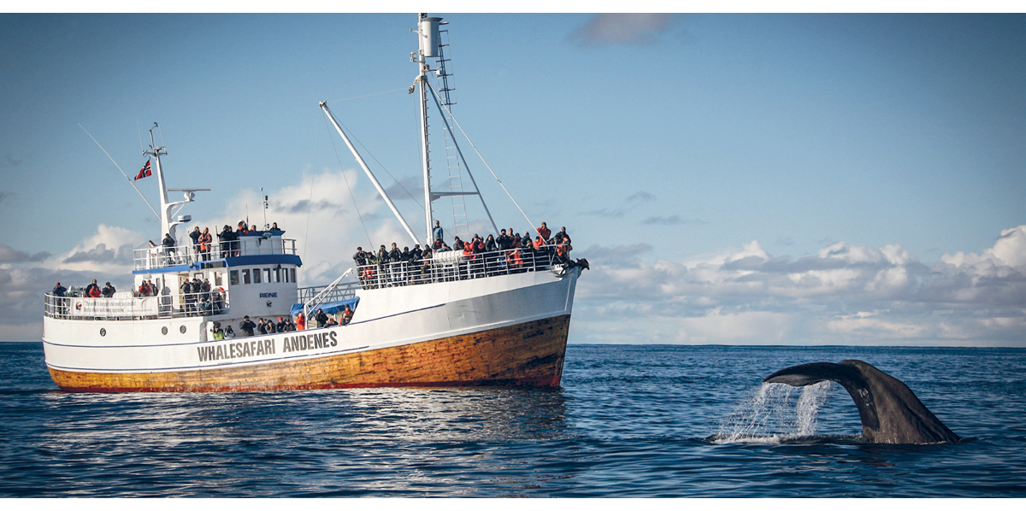
          - A whale watching boat.
Photo: Hvalsafari AS
Fishing tourism
In recent decades, a large number of tourist companies have grown up along the coast that cater for fishing tourism. This has provided a boost in activity and jobs in many coastal communities, but also puts greater pressure on fish resources. More knowledge is needed about the resources harvested by the fishing tourism industry. On 1 January 2018, new rules took effect for fishing tourism businesses, including mandatory registration of businesses and catch reporting. The objective is to obtain a better overview of the resources harvested by the fishing tourism industry, and also to make the industry more professional and give it greater legitimacy.
Recreational activities
Recreational activities in coastal waters are extensive and increasing. Summertime is particularly busy. According to a 2018 survey, there are 900 000 leisure craft in Norway. Most recreational activity takes place in the waters closest to the coast, so that there has only been limited spatial conflict with commercial shipping. Increased activity and boat traffic may nonetheless disturb vulnerable species and habitats in the coastal zone, for example breeding and moulting seabirds, fish and marine mammals. More marine litter is also registered in areas where the activity level is high. Prohibitions on boat traffic and access are introduced as needed to reduce pressure on the most vulnerable areas, particularly to protect seabirds.
Traditionally, recreational fishing and trapping activities have not been subject to regulation to the same extent as commercial fisheries and, more recently, fishing tourism. Recreational fishing and trapping is a form of outdoor recreation as well as providing food, and forms an important part of Norway’s coastal culture.

Emerging ocean industries
Emerging ocean industries are industries at an early stage of development in terms of technological development, employment and commercialisation. A lack of information on technology choices makes it difficult to assess what their environmental impacts will be.

Offshore renewable energy
Offshore wind power is growing globally. The pace of development is rapid and accelerating, particularly in the North Sea. Norwegian industry clusters and energy companies are playing an active role in this process. Norway’s neighbouring countries around the North Sea have built up an extensive portfolio of ongoing projects. According to the association WindEurope, installed offshore wind power capacity in the North Sea totalled 22 GW by the end of 2019. Most of this capacity has been installed over the last 10 years and the pace of new development is increasing. The International Energy Agency (IEA) report Offshore Wind Outlook 2019 estimates that by 2040, the offshore wind power industry may attract around USD 1 trillion in investment, with Europe and China as the largest growth regions.
              - Hywind Tampen floating wind farm
The Hywind Tampen project is for a floating offshore wind farm in the Tampen area of the North Sea, comprising 11 floating wind turbines, each with a capacity of 8 MW. Its annual production is expected to be roughly 384 GWh. The project will bring about a shift in the electricity supply to the Snorre and Gullfaks fields, replacing about one-third of the power needed by the platforms with renewable wind power. This will reduce CO2 emissions from the fields by some 200 000 tonnes annually. Each wind turbine will be mounted on a floating concrete spar foundation moored to the seabed by chains and suction anchors. The water depth at the wind farm is between 240 and 290 metres. The wind turbines and foundations will be assembled in port at Gulen in Western Norway before being towed out to sea for installation in spring 2022. The wind farm is under construction, and will according to plan start supplying electricity to the platforms in the fourth quarter of 2022. The estimated production life is 20 years.
One of the main objectives of the project is to further develop floating wind power technology. The costs of fixed wind power have been greatly reduced in recent years, while there is some way to go before floating wind power becomes profitable. This demonstration project has needed funding from Enova and the NOx Fund, which have allocated NOK 2.3 billion and NOK 0.6 billion, respectively. Energy from floating wind power could become an important resource if the costs of technology can be reduced enough to make it competitive with other energy sources. Enova reasoned that its support would bring floating wind power closer to commercialisation and could generate positive spin-off effects for emission reductions and the Norwegian business sector. This is the largest allocation Enova has ever made.
The companies participating in the project are the licensees at the Snorre and Gullfaks fields.

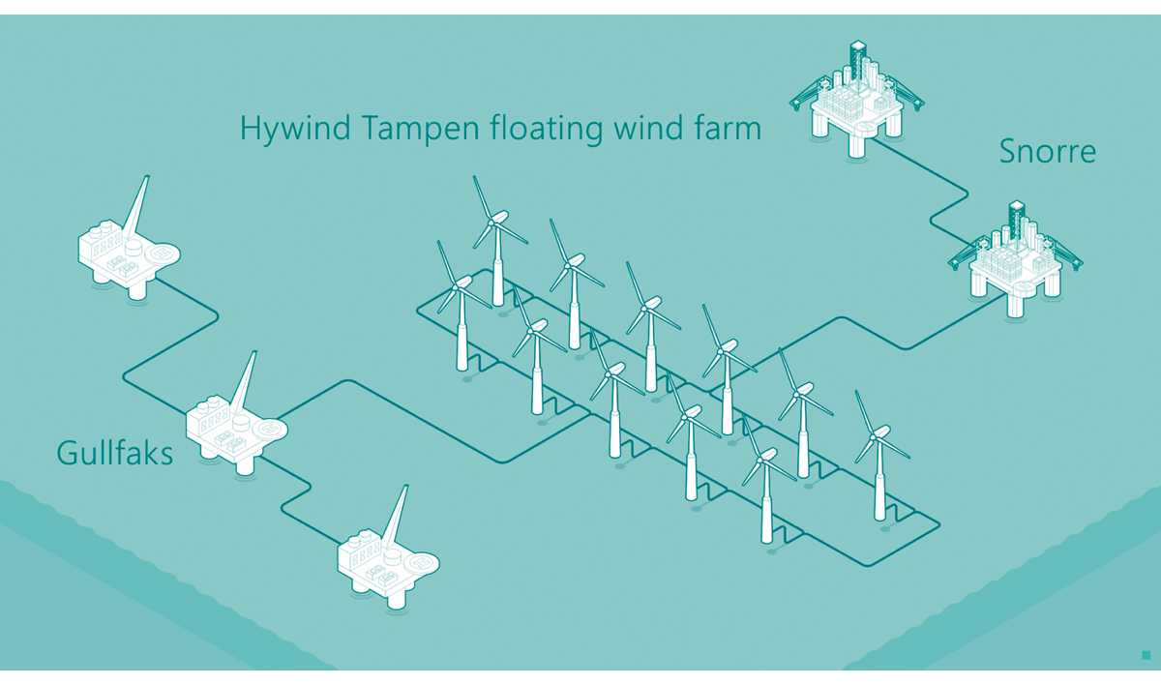
          - Diagram of the planned Hywind Tampen floating wind farm in the North Sea.
Equinor
[Boks slutt]
The Government is encouraging offshore wind power development. Offshore wind is one of six priority areas in the national strategy for research and development of new, climate-friendly energy technology, Energi21.
              - Electricity units
Electricity production and consumption is normally measured in watt-hours. But a watt-hour (Wh) is only a small unit – an output or consumption of one watt sustained for one hour – so it is often more practical to use kilowatt-hours (1 kWh is 1 000 Wh). Production at a power plant is typically measured in gigawatt hours (1 GWh is one million kWh). A country’s total production or consumption of electricity is usually expressed in terawatt hours (1 TWh is one billion kWh). In 2019, electricity production in Norway totalled 133 TWh.
Generation of renewable electricity is weather-dependent. Since the weather is variable from year to year, the production capacity of a power plant in Norway is often given for a year when the weather is normal. The Tonstad hydropower plant, Norway’s largest, has a normal annual production of 3.8 TWh.
A typical household consumes 16 000 kWh of electricity per year, which means that one TWh provides enough power for about 62 500 households.
[Boks slutt]
Demonstration projects in Norwegian waters can enable Norwegian companies to gain experience and contribute to innovation and development in the offshore wind power sector. In August 2019, Enova granted funding of up to NOK 2.3 billion for Equinor’s Hywind Tampen project, a demonstration project for floating wind power. The authorities are now processing the plan for development and operation (PDO) for the wind farm. Hywind Tampen could become the world’s largest floating wind farm, which is intended to supply renewable power to the Gullfaks and Snorre oil fields. Equinor plans to make the wind farm operational in 2022.
The opening of areas for offshore renewable energy production is governed by the Offshore Energy Act, which entered into force on 1 July 2010. Under the Act, offshore renewable energy production outside the baselines may as a general rule only be established after the public authorities have opened specific geographical areas for licence applications. The Act also provides for the award of licences for smaller demonstration projects for offshore wind power or wind power integrated with offshore petroleum installations without the area having been opened beforehand.
In 2010, a working group led by the Norwegian Water Resources and Energy Directorate identified 15 areas it considered suitable for offshore wind power, which have a potential annual energy production of 18–44 TWh.
In 2012, the Directorate conducted a strategic impact assessment of the 15 areas identified by the working group. This ranked the areas according to suitability, and recommended giving priority to five of them. In 2019, the Ministry of Petroleum and Energy held a public consultation on a proposal to open two areas in the North Sea, Sandskallen-Sørøya North and Utsira North. Additionally, input was requested on whether the Southern North Sea II area should also be opened. The consultation documents also included proposed regulations under the Offshore Energy Act which among other things set out licensing procedures more fully. The Ministry of Petroleum and Energy is currently reviewing the responses.
Existing and planned offshore wind farms generally use fixed installations in shallow water, typically at depths of up to 40 metres. It will be possible to exploit wind power to a much greater extent if wind farms are built in deeper water, for example using floating technology. Floating wind power is developing rapidly, and Equinor’s Hywind technology is a cutting-edge solution.
At present, development costs are considerably higher for offshore wind power than for land-based wind power, and there are other challenges associated with offshore industrial activity than with similar land-based activities. The technical and cost-related problems can to some extent be compensated for by better wind conditions offshore, and the fact that larger wind turbines can be built than is possible onshore. Norwegian ocean industries have considerable maritime and petroleum-related expertise that could play a role in the development of floating wind farms.
Knowledge about the environmental impacts of offshore wind power is variable, depending on the species, geographical area and other matters under consideration. Wind turbines do not themselves produce emissions to air, and it is considered unlikely that there will be any operational discharges to the sea. Thus, any releases of pollutants to air or the sea will occur during construction work and maintenance operations. Wind turbines do generate noise, however, both during installation and operation. There is general uncertainty about the actual effects and impacts of offshore wind power on seabirds, fish and marine mammals. Based on the knowledge available in 2012, the Norwegian Water Resources and Energy Directorate concluded that the impacts would vary between undetectable and small for fish, marine mammals and benthic communities, and from small to moderate for seabirds, but it also pointed out that mapping of benthic communities in the areas of interest was incomplete. Knowledge about potential impacts from wind power projects will be updated through environmental impact assessments of specific projects as part of the licensing process. The Norwegian authorities are in contact with relevant countries regarding offshore wind power development, through the North Seas Energy Cooperation and other channels.

Marine bioprospecting
Marine bioprospecting is a subspeciality of marine biotechnology that involves acquiring knowledge about genetic material, biomolecules and the properties of marine organisms that can be used for commercial purposes, for example in medicines and foods. Since 2007, systematic searches have been conducted for organisms, genetic material and biomolecules that may prove valuable as components in various products or processes. Material has been collected from around 1 200 locations, and close to 1 000 species of benthic organisms and algae, as well as samples of fungi and bacteria, are now stored in Marbank, Norway’s national marine biobank. Some patents based on Marbank samples have already been secured.
Organisms have been collected everywhere from the littoral zone to the deep sea and along the Norwegian coastline from Møre og Romsdal county to the Russian border, as well as around Svalbard and in other parts of the Barents Sea. The northern seas are of interest because they are home to many species that are specialised to survive extreme and often changeable conditions. Moreover, these are very large areas and most of the biodiversity has not yet been studied. Research at The Arctic University of Norway (UiT) has for instance led to the discovery of a number of cold-adapted enzymes that are now being produced and sold commercially.
The path from finding organisms to manufacturing useful products can often be a long one. Ten years is a short time in this context, and optimisation, verification and commercialisation are resource-intensive. Value chain development using discoveries with medical potential made in Norway is still in the early stages before the development of commercial products, and much of the research activity is being carried out as part of large-scale international projects. In 2019, for example, researchers at The Arctic University of Norway UiT published results describing the discovery of a new molecule, derived from a small Arctic marine organism, that kills breast cancer cells. This could one day be used in medication to treat the most aggressive type of breast cancer. The researchers believe that this finding is indicative of the tremendous potential of the oceans as a source of new medicines. See Box 5.8 for more about this discovery.
              - Marine biomolecules for medical use
In recent decades, researchers have become keenly aware that molecules from marine organisms may be useful in developing new medicines and vaccines. Molecules have been discovered that can kill cancer cells or show antibacterial or virus-inhibiting properties.
In December 2019, researchers at UiT published results showing that a small Arctic marine organism called a hydroid contains a molecule that kills cancer cells. The molecule selectively attacks the cells of triple-negative breast cancer tumours, the most aggressive type of breast cancer. The researchers believe that this finding is indicative of the tremendous potential of the oceans as a source of new medicines and that scientists are only beginning to discover substances that are to be found in the oceans and on the seabed. The hydroids were discovered in biological samples collected during a research cruise off Bjørnøya in 2011.
Earlier discoveries of particular relevance now are marine molecules with inhibiting effects on viruses closely related to the coronavirus SARS-CoV-2, the cause of the 2020 COVID-19 pandemic. The inhibitor molecules identified are from two Atlantic species, the red alga Griffithsia capitata from Spanish waters and the sponge Axinella cf. corrugata from Brazilian waters.
[Boks slutt]
New technology and the development of next-generation sampling methods using autonomous underwater vehicles (AUVs) is making it possible to collect organisms from new marine habitats. The biotechnological methods and data technology used to characterise organisms are being developed rapidly and becoming less costly. The combination of powerful digital tools and biotechnological techniques is making it possible to use and exploit biological materials to a far greater extent than before. This indicates that there is a great potential in Norway for value creation based on marine bioresources. In the EU, revenues from marine biotechnology are expected to reach EUR 1 billion in 2020.
It is important to provide a framework that allows research groups and the private sector to collect biological material from Norwegian environments and at the same time ensure that this is done within an environmentally sustainable framework. The potential for further discoveries is especially large since the oceans, and particularly the deep-sea areas, are still largely unexplored. Only small amounts of materials are needed for sampling, so bioprospecting is considered to have a low environmental impact and to be sustainable.

Mineral extraction
Extraction of minerals from the seabed may have considerable market potential in future. Population growth, greater prosperity, restructuring of the energy systems and technological advances will increase demand for a number of metallic minerals.
Mineral resources such as polymetallic crusts and sulphides have been found on the Norwegian continental shelf. Deposits of metallic sulphides have been found and sampled along the volcanic Mohn’s Ridge between Jan Mayen and Bjørnøya, and there are also clear indications of further deposits northwards on the Knipovich Ridge, west of Svalbard. The deposits are from hydrothermal vents, which build up chimney-like structures along volcanic spreading ridges. These ‘black smokers’ are dynamic structures that may be active for thousands of years before they are extinguished and, leaving behind sulphide mounds, which are thought to contain most of the seabed polymetallic sulphides. The polymetallic crusts, often called manganese crusts, build up as a coating on bare rock on the seabed. The crusts are mainly composed of manganese and iron, with smaller amounts of metals such as cobalt, nickel, titanium and some rarer metals. Deposits of manganese crust have been found and sampled during mapping of the Norwegian Sea. If polymetallic crusts are extracted, this will take place on bare rock where ferromanganese compounds have been deposited over long periods of time.
The Norwegian Petroleum Directorate has been commissioned to map the potential for mineral deposits on the Norwegian continental shelf, and surveyed deep-water areas of the Norwegian Sea in 2018 and 2019 and discovered new vent fields with a number of active and inactive vent systems. Sample analysis shows high concentrations of copper, zinc and cobalt in particular. Despite the mapping that has been carried out, there has been little exploration of Norwegian waters for mineral deposits.
Technologies for extracting minerals from the seabed are still under development, so there is uncertainty about the potential environmental impacts of these activities. Further information on possible extraction technologies will be presented in the strategic environmental assessment being prepared under the Seabed Mineral Act. Species and habitats that could be affected are discussed in Chapter 3.2.4 of this white paper.
Exploration for and extraction of seabed minerals could become an important ocean industry for Norway in the future. Norway has substantial expertise on sound, sustainable management of resources in and under the oceans. The Seabed Mineral Act entered into force in 2019. Its purpose is to provide a framework for exploration and extraction of mineral deposits on the Norwegian continental shelf in keeping with socioeconomic goals. The Act is based on experience from petroleum activities, and as a general rule, an area must have been officially opened before licences can be issued for exploration and extraction.
Before the official opening of an area, a strategic environmental assessment is required under the auspices of the Ministry of Petroleum and Energy. If opening of a new area for seabed mineral extraction is proposed, there must be a public consultation process on the draft decision and the strategic environmental assessment. Work on a strategic environmental assessment under the Seabed Mineral Act has been started, and the Norwegian Petroleum Directorate is working on a resource assessment and study programme. A strategic environmental assessment under the Act is intended to elucidate the possible environmental, industry-related, economic and social impacts of opening an area.

Offshore carbon capture and geological storage
According to both the IPCC and the International Energy Agency (IEA), it will be difficult and substantially more costly to achieve the climate targets without carbon capture and storage (CCS) technology. CCS technology will also be critical for achieving carbon-negative solutions in the second half of this century. The IPCC special report Global Warming of 1.5 °C cites CCS as one of many mitigation options needed to tackle climate change.
Norway already has many years of experience of CCS under the seabed on the Norwegian continental shelf. About 1.7 million tonnes of CO2 per year has been separated from gas produced on the Sleipner and Snøhvit fields and stored under the seabed. This is equivalent to 3–4 % of Norway’s total annual emissions. CCS can reduce emissions from industrial processes for which there are currently no alternative technologies, and make it possible to reform natural gas to produce emission-free hydrogen. Experience of CCS puts Norwegian business and research communities in a good position to participate in further developments. The Norwegian Petroleum Directorate estimates that it is possible to store more than 80 billion tonnes of CO2 in reservoirs on the continental shelf.
The Government’s ambition is to achieve a cost-effective solution for full-scale CCS in Norway, provided that this also results in technology development internationally. As part of the Norwegian full-scale CCS demonstration project, two industrial partners completed pre-project studies of CO2 capture at their facilities in autumn 2019. The consortium studying transport and storage of CO2 on the Norwegian continental shelf consists of Equinor in collaboration with Shell and Total. The objective is to develop a CO2 storage site of substantial capacity that can accommodate larger volumes of CO2 than will be captured from the sources in the Norwegian demonstration project. According to current plans, an investment decision could be made in late 2020 or early 2021. Successful implementation of this demonstration project could make it possible to connect more emission sources to the storage site, even beyond Norway’s borders. This would reduce costs by using shared infrastructure and through technology transfer.
The prohibition of the London Protocol on the export of wastes for dumping at sea has long been a legal barrier to transboundary cooperation on CCS infrastructure. In 2009, an amendment to the London Protocol was adopted to permit the export of CO2 for the purpose of sub-seabed storage in geological formations. The amendment will not enter into force until two-thirds of the contracting parties to the protocol have ratified it. By early 2020, only six of the 53 parties had ratified the 2009 amendment. In autumn 2019, the parties adopted a resolution, jointly submitted by Norway and the Netherlands, on the provisional application of the 2009 amendment. The resolution adopted in autumn 2019 provides a temporary solution to the prohibition on exports of CO2 for the purpose of sub-seabed storage in geological formations. Norway will continue to urge more parties to ratify the 2009 amendment so that it can formally enter into force.

Hydrogen production
Norway is in a good position to produce and make use of hydrogen, and already has considerable industrial experience in this field. The country has access to renewable energy and natural gas, expertise and experience of CCS, an innovative, world-class maritime industry, expertise and experience in petroleum activities, and needs to reduce greenhouse gas emissions. As a result, parts of the Norwegian business sector are well positioned to play a role in the growing market for hydrogen solutions and in driving developments in a number of sectors, both nationally and internationally.
Hydrogen and ammonia have been identified as two important energy carriers with a potential in green shipping. The Norwegian maritime industry has just begun to use both hydrogen, with two new builds of hydrogen-powered ferries, and ammonia, for fuel cells in one offshore supply ship. The latter project, ShipFC, received nearly NOK 100 million in funding under the EU framework programme Horizon 2020.
The possibility of using clean hydrogen and ammonia is consistent with Norwegian industrial and climate policy.

Acute pollution: risk and the preparedness and response system
Acute pollution is defined in the Pollution Control Act as significant pollution that occurs suddenly and that is not permitted under the Act. This chapter deals with acute pollution from shipping and petroleum activities, and with civilian and military activities that pose a risk of acute radioactive pollution.
Like any other human activity, shipping and petroleum activities involve an element of risk. To systematically prevent undesirable events, all stakeholders put a great deal of effort into risk management, including risk treatment.
No common, integrated approach has been established for dealing with accident risk and environmental risk across activities in various sectors. This means that assessments and results for different sectors cannot be compared directly.
The shipping industry involves a large number of stakeholders, and in principle, ships can sail anywhere in the oceans. Risk management in this sector is for the most part based on international conventions and other rules adopted by the International Maritime Organization (IMO). In addition, Norway has as a coastal state introduced a number of preventive measures that reduce the likelihood of accidents. For shipping, the likelihood of accidents is calculated on the basis of previous events involving different types and sizes of vessels and on the distance sailed in a given geographical area. The potential environmental consequences and risks of acute spills can be calculated using oil spill modelling and knowledge about the distribution and vulnerability of various species and habitats.
On the other hand, the petroleum industry is dominated by a small number of stakeholders and by stationary installations within limited geographical areas. Risk management in the petroleum activities are mainly focused on managing risks adequately at individual installations and is related to different types of activities. The stakeholders work extensively on risk.
The petroleum sector in Norway expresses risk in terms of the potential consequences of petroleum activities and the uncertainty associated with them. ‘Consequences’ include all possible outcomes of incidents that could potentially arise during activities. ‘Associated uncertainty’ is uncertainty relating to the potential consequences of incidents during activities and their effects. There may be uncertainty about the types of incidents that may occur, how often they are likely to occur, and the damage or loss that different incidents may cause as regards human life, health, the environment and material assets. Uncertainty also involves a lack of information, understanding or knowledge.
The likelihood of a nuclear accident or another nuclear or radiological event that has significant consequences and results in acute radioactive pollution outside an extremely limited area is generally low. The consequences of an event will depend on the content of radioactive material in the source, the measures taken at the source to reduce consequences, how the release occurs and which substances are released, and the way in which people and environment are exposed to the radioactive material.
Major accidents seldom occur but can have serious environmental consequences. The level of major accident risk is uncertain and depends on what individual stakeholders do to prevent accidents. Ensuring that the risk of accidents remains low is a vital part of reducing the level of environmental risk.

Environmental vulnerability
Acute pollution can harm organisms in the water column and on the seabed, seabirds and marine mammals, and organisms that live in coastal waters and the shore zone. Every spill is different, and the environmental consequences depend on location, timing, the type of spill and its volume, the species and habitats affected and how vulnerable they are to the pollutant in question, and the emergency response and other measures taken to reduce the consequences. The actual effects of a spill also depend on the state of the species and habitats affected and their importance in the ecosystem, in addition to their vulnerability to the pollutant involved. Major oil spills pose the greatest risk, and the main focus is therefore on improving scientific knowledge about vulnerability to oil pollution, regardless of whether spills are from vessels or petroleum installations.
Vulnerability to oil pollution
In recent years, much new knowledge and data have been obtained that further enhance our understanding of the vulnerability of the marine environment to oil pollution. A substantial body of experience and knowledge has been collected about the ecological impacts of the 2010 blowout in the Gulf of Mexico, for example on the effects of oil sedimentation and marine oil snow. There is a high level of research activity in Norway as well, including research on the tolerance of various organisms in Arctic areas to oil. Although a great deal of knowledge that is relevant to Norwegian conditions has been obtained on possible effects on individual organisms, the level of uncertainty is still high when assessing impacts at population and ecosystem levels.
Knowledge about habitat use by different seabird populations through the year has been considerably improved for the Barents Sea. The SEATRACK mapping project has provided new understanding of seabird distribution in the open sea, particularly in the autumn and winter. As a result, seabirds have been assessed as particularly vulnerable to acute pollution in several areas of open sea in addition to at the major breeding colonies. This assessment applies for example to common guillemots migrating by swimming after breeding, and the areas in the southeastern Barents Sea where they congregate after the swimming migration for the autumn and winter. Species such as puffins, common guillemots, Brünnich‘s guillemots and little auks also use large areas when foraging at sea during the breeding season. These areas extend further out from the breeding colonies than previously thought. Populations in decline are vulnerable to begin with, and new knowledge shows that abrupt reductions in population size will increase pressure on such populations and make them more vulnerable. Brünnich‘s guillemots from colonies on Bjørnøya and puffins from those on Røst stand out as being particularly vulnerable. Kittiwakes from the Vedøy, Hjelmsøya and Hornøya colonies are also particularly vulnerable.
Fish eggs and larvae are more exposed to oil pollution than adult fish because they drift more or less passively with ocean currents and cannot actively avoid oil pollution. In addition, fish eggs and larvae have a larger potential for absorbing oil components due to their high surface-to-volume ratio. These organisms are also particularly vulnerable to pollution in their early developmental stages. A number of Norwegian and international laboratory studies have been carried out to investigate exposure of fish larvae to oil for varying lengths of time in order to establish tolerance to oil and threshold values for developmental abnormalities and mortality. Results from the Institute of Marine Research project EGGTOX indicate that exposure to realistic concentrations of oil causes serious harm to eggs and larvae of haddock, cod, saithe, halibut, herring and polar cod. The thresholds for harmful effects of oil on different fish species are uncertain. As new information and new studies become available, it is important to adapt and adjust the threshold values used by the industry in environmental risk analyses.
To develop better tools for assessing the impacts of oil spills on fish stocks, the modelling system SYMBIOSES was developed as a collaborative project between the petroleum industry and a number of research institutions, including the Institute of Marine Research. So far, simulations have been run for spills in the spawning grounds for Northeast Arctic cod off the Lofoten Islands. The simulation showed that in the worst-case scenario that was simulated, up to 43 % of a year class of eggs and larvae could be exposed to lethal levels of oil. Further modelling indicates that such losses of eggs and larvae would have a limited effect on the Northeast Arctic cod stock (12 % loss of adult biomass). No simulations have been run for other species as yet, so these results cannot be directly transferred to other fish stocks. Uncertainty about the effects on species other than cod, particularly in the most important spawning areas, is therefore still high. In autumn 2019, the Institute of Marine Research published a study supporting these conclusions.
There are several areas of the Barents Sea that support a high diversity of important species and habitats that could be harmed by exposure to oil. However, there is a lack of knowledge about the vulnerability of these ecosystems and potential effects at ecosystem level. Several of the particularly valuable and vulnerable areas stand out as being nutrient-rich and with high biodiversity, and may be especially vulnerable to ecosystem effects in the event of acute pollution all year round or at certain times of year. In the Barents Sea–Lofoten area, this applies particularly to Lofoten–Tromsøflaket, the Tromsøflaket bank area, the marginal ice zone and the polar tidal front, and the sea areas surrounding Svalbard (including Bjørnøya). It is important to take a particularly cautious approach in these areas to avoid oil pollution and associated damage. In the Norwegian Sea and the North Sea–Skagerrak, the particularly valuable and vulnerable areas and also coastal waters and seabird breeding colonies are especially vulnerable to oil pollution.
The marginal ice zone is a highly productive area where a number of vulnerable resources could be affected simultaneously, and oil pollution in the area could have major impacts. An oil spill in the marginal ice zone could affect large congregations of seabirds and marine mammals (including polar bears), and also the plankton, ice algae and fish larvae in the water column and under the ice. The scale of the impacts on an oil spill will depend on its magnitude, where the spill occurs, the type of spill and the time of year.
Oil that is frozen into the ice can be transported with the ice as it drifts, and will be a source of pollution in areas where the ice melts. Because of the high biological production and diversity in the marginal ice zone, oil pollution in this area could affect the habitats of a large number of species and species groups.
There are still major gaps in our knowledge of the damage oil pollution could do to the ecosystem in the marginal ice zone, but its vulnerability is considered to be high. The impacts could be particularly severe in the event of a major oil spill across a large area of the marginal ice zone in spring or summer, when production in the water column is very high and large numbers of seabirds and marine mammals may be concentrated in limited areas.
Vulnerability to radioactive pollution
Ionising radiation from radioactive substances can affect organisms through both external exposure and internal exposure. Exposure types must be included in assessments of harmful effects. Different radioactive substances emit different types of radiation with varying ranges and potential to cause harm. The harmful effects of radiation and radiation-induced free radicals often involve DNA damage and cellular reactions which may cause biological damage.
Vulnerability to other acute pollution
Acute effects of chemical spills will primarily involve toxic substances. Assuming that the scale of such spills is limited in both volume and time, rapid dilution in coastal waters and particularly in the open sea will limit the exposure of living organisms to concentrations exceeding threshold levels for toxicity. These thresholds are known for organisms that have been tested against various substances, but not for all relevant organisms that may be exposed to pollutants.

Shipping
Vessel casualties, including groundings, collisions, structural failure and fire or explosion, occur at irregular intervals and can result in acute pollution.
In 2017, the Norwegian Maritime Authority registered 204 personal injuries and 244 vessel casualties. Figures for 2018 were 199 personal injuries and 240 vessel casualties. In the last five-year period, the combined total averaged 462 per year.
The overall number of injuries and accidents is trending downwards. The number of incidents involving fire, contact damage and occupational accidents is declining. Although fatalities do unfortunately occur on Norwegian vessels, the trend over time indicates a clear reduction of the most serious accidents.
A vessel casualty may involve personal injuries or fatalities as well as damage to or loss of the vessel itself. The Norwegian Maritime Authority recorded 1 241 vessel casualties in the most recent five-year period (2014–2018). The annual number of groundings was quite stable during the five-year period, while the number of accidents involving contact damage (collisions with piers, bridges, etc.), dropped from 58 in 2014 to 34 in 2018.
The probability of accidents is influenced by a number of factors, including the volume of transport, the traffic situation, the technical standard and equipment of vessels, crew qualifications and the preventive measures that have been introduced. The forecast frequency of accidents is highest in the North Sea–Skagerrak area and lowest in the Barents Sea–Lofoten area. This corresponds to the share of total distance sailed in each of the management plan areas and also the shares of total distance sailed that are close to the coast.
In the period 2014–2017, the number of vessel casualties in the Barents Sea–Lofoten area was relatively low compared to the numbers for the Norwegian Sea and the North Sea–Skagerrak. The number of accidents was highest in near-coastal areas. In all, 428 incidents were recorded in the Barents Sea–Lofoten area, of which 126 involved spills totalling 15 062 litres of various substances. There was an increase in the number of incidents during this period, but the time frame is too short, and there are too few incidents, to draw any conclusions about trends. Most registered spills were small, but the total spill volume was noticeably higher in 2015 than in 2014, 2016 and 2017. The largest single spill (1 500 litres) was a release of marine diesel from a fishing vessel in 2015. In 2018, 106 vessel casualties involving spills were reported, with a total spill volume of 52 m3 to Norwegian waters. Over the last three years, there has been little variation in spill volume.
In the period 2011–2017, there was an increase in the volume of both transit traffic and high-risk traffic in the Barents Sea. With the higher volumes of high-risk cargo and bunker oil, there is also a higher discharge potential and a possibility of more severe environmental impacts. Data from the Vardø Vessel Traffic Service (VTS) Centre show that the vessels transporting petroleum products from northwestern Russia are relatively new. In addition, serious accidents involving large tankers are very rare. Thus, the growth in the volume of traffic and in the volume of petroleum products transported do not result in much increase in the likelihood of accidents.
Maritime safety measures
The Polar Code lays down globally binding rules for ships operating in polar waters, i.e. Arctic and Antarctic waters. Its rules apply in addition to those of already existing conventions and codes on maritime safety and pollution from shipping (SOLAS, MARPOL, the STCW Convention, etc). The Polar Code consists of two parts, one on safety and one on environment-related matters. It sets specific requirements for ships operating in polar waters, for example on ship design, equipment, operations, environmental protection, navigation and crew qualifications. The most important environment-related provisions deal with pollution by oil, chemicals, sewage and garbage released from ships. The Polar Code is considered to be one of the most important developments for improving maritime safety in polar waters. The Polar Code entered into force on 1 January 2017.
The prohibition against carrying heavy bunker oil in the protected areas around Svalbard was introduced in 2007, and its scope was expanded from 1 January 2015. Ships are not permitted to use or carry heavy bunker oil when sailing into Nordaust- and Søraust-Svalbard nature reserves on the east coast of Svalbard or the three large national parks Sør-Spitsbergen, Forlandet and Nordvest-Spitsbergen in the western part of the archipelago. Instead, they must use light marine diesel, which causes less serious pollution in the event of a spill. The Government is considering extending this ban to other parts of Svalbard‘s territorial waters. Negotiations under IMO are underway to establish an international ban on heavy fuel oil in the Arctic.
Traffic separation schemes and recommended routes have been introduced between Vardø and Røst (in 2007), between Runde and Utsira and between Egersund and Risør (in 2011). These measures have helped to move shipping further out from the coast, separate traffic streams in opposite directions and establish a fixed sailing pattern. The traffic separation schemes reduce the risk of collisions, simplify traffic monitoring and give the maritime traffic control centres more time to come to the assistance of vessels when necessary.
The government emergency tugboat capability is designed to prevent or reduce the risk of acute pollution during towing operations or when assisting vessels in other ways. From 1 January 2020, operational responsibility for providing this capability has been transferred to the Coast Guard, under the administration of the Norwegian Coastal Administration. The Coast Guard will shortly have two new vessels in service, and will then have six vessels that provide tugboat capability. The Coastal Administration coordinates the use of government tugboat capability from the Vardø VTS Centre. The VTS Centre deploys tugboat capability in cooperation with the Coast Guard command centre at Sortland.
Vessel monitoring systems in Norwegian waters provide a detailed picture of maritime traffic and make it possible to provide assistance or take steps to limit damage at the right time. These systems also make it easier for the authorities to deal with accidents and run search and rescue operations. Further development of the infrastructure for receiving Automatic Identification System (AIS) signals from vessels has significantly enhanced vessel monitoring in recent years. A network of AIS base stations along the entire mainland coast and for the most heavily trafficked waters off Svalbard has been established. Satellites equipped with AIS receivers have also greatly enhanced monitoring in the open sea. The Vardø VTS Centre monitors shipping throughout Norway‘s exclusive economic zone and the waters around Svalbard, focusing particularly on tankers and other large vessels. The Vardø VTS also monitors compliance with the rules for the traffic separation schemes and recommended routes off the coast, and issues navigational warnings.
Fairway measures, such as dredging and blasting to remove shallows, improve safety and navigation in narrow coastal channels. Some fairway measures also reduce distance and time sailed. In many cases, fairway measures involve the removal of contaminated sediments, which improves environmental status in the ports and fairways where this is done.
The white paper on cooperation to improve maritime safety (Meld. St. 30 (2018–2019)) gives an account of maritime safety measures implemented in recent years. Together, these measures have enhanced maritime safety in Norway‘s marine and coastal waters.
Environmental risk
Integrated environmental risk and preparedness analyses were carried out for the mainland coast in 2011 and for Svalbard and Jan Mayen in 2014. The analysis of the likelihood of vessel casualties leading to acute pollution was updated in 2018, and shows only small changes in accident likelihood. The Norwegian Coastal Administration has developed new tools to calculate the likelihood of accidents and environmental risks associated with shipping, and will regularly assess trends in risk level once these tools are taken into use. If there are substantial changes in the level of environmental risk, it may be appropriate to adjust the capabilities of the governmental preparedness and response system for acute pollution.
There is uncertainty concerning potential environmental consequences associated with spills of new fuel types. The Coastal Administration has therefore analysed many of the new fuels that are now being taken into use in Norwegian waters and the Arctic. This builds a stronger basis for decisions about operations to deal with acute pollution, including assessing different response techniques and strategies.

Petroleum activities
In addition to operational discharges (discussed in Chapter 5), petroleum activities involve a risk of acute pollution. Acute pollution may be caused by events ranging from blowouts, where there is an uncontrolled flow from one or more reservoirs and large volumes of oil may be released to the sea, to small-scale spills of oil or chemicals, for example due to a ruptured hose or overfilled tank. The risk of spills during petroleum activities is also referred to as accident risk in this white paper. The risk of spills causing environmental damage is referred to as environmental risk.
For over 40 years, the Norwegian petroleum industry has been dealing with challenges in new areas, developing necessary knowledge and technology, and building up wide operational experience. Before starting activities in new areas, the industry dedicates substantial resources to knowledge acquisition, assessment and any measures considered to be necessary. The infrequency of accidents must be considered in conjunction with these preparations and with companies’ risk management systems and the improvements they make in subsequent phases of activity. After assessments, the Forum for Integrated Ocean Management concluded that no individual factors had been identified that were previously unknown and that cannot be managed within the framework of the current legislation, and/or are not already being dealt with through technology development.
Management responsibility for the petroleum sector is split between a number of ministries and directorates. From the outset, a key part of the system has been maintaining high health, safety and working environment standards. The Government‘s ambition is for the Norwegian petroleum industry to be world-leading in this field. The industry supports this ambition and is responsible for achieving it.
Incidents
There have been both large and small spills from oil and gas activities on the Norwegian continental shelf, but they have occurred relatively far from land and under favourable weather conditions, and response measures were implemented, so that the pollution has not reached land or caused environmental damage.
There was a decline in the number incidents involving crude oil spills on the Norwegian continental shelf in the period 2001–2018 (see Figure 6.1). This indicates that barrier failures have been occurring less frequently in recent years. The decline is due to a reduction in the number of incidents and in spill volumes. Incidents involving large spills occur infrequently, and there is insufficient data to identify a trend. Few incidents were registered in the Barents Sea–Lofoten area that resulted or could have resulted in acute pollution in the period 2001–2018.
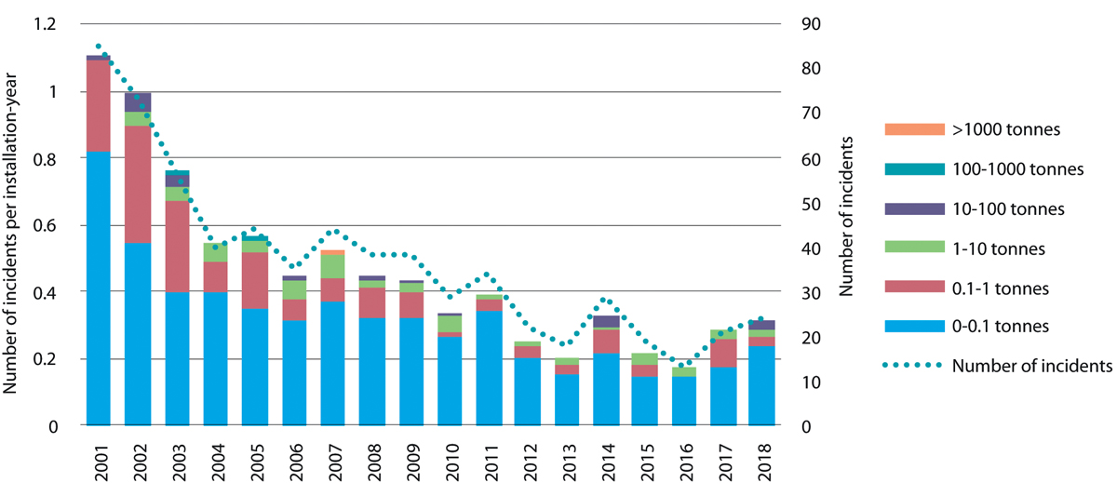
          - Number of crude oil spills in the management plan areas and total spill volume in the period 2001–2018.
Petroleum Safety Authority Norway
Chemical spills are the dominant type of incident involving acute pollution from petroleum activities on the Norwegian continental shelf (see Figure 6.2). Roughly 80 % of the incidents involving acute pollution in the period 2001–2018 were chemical spills. Around one-fourth of these involved a spill volume exceeding one cubic metre.
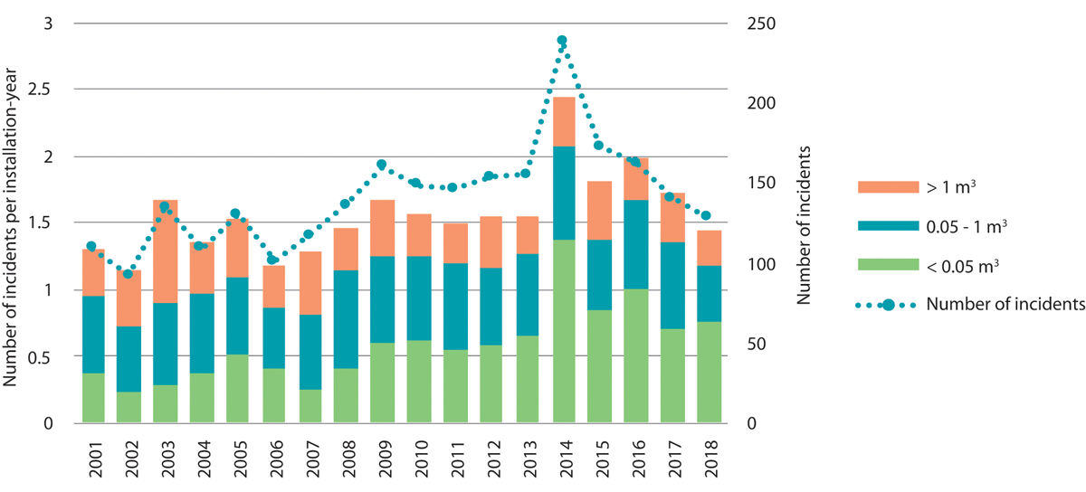
          - Number of chemical spills in the management plan areas and total spill volume in the period 2001–2018.
Petroleum Safety Authority Norway
There has been a decline in the number of incidents involving acute pollution in the Norwegian Sea in recent years. The same applies to incidents involving chemical spills. However, total spill volumes from incidents involving chemical spills have been high in recent years both in the Norwegian Sea and in the North Sea–Skagerrak.
The figures for 2001–2018, include too few registered incidents in the Barents Sea–Lofoten area to allow analysis of trends over time or comparison with the other management plan areas. However, both the figures and practical experience indicate that the safety level in the Barents Sea is on a par with that on the rest of the continental shelf. The level of activity in the Barents Sea since 2013 has enabled both the authorities and the operators to learn more about factors specific to particular areas.
Near misses
A near miss is an event that does not lead to a spill but that could have done so under different circumstances. Such events are analysed and followed up by the operators and the authorities, in particular the Petroleum Safety Authority, so that the experience gained can be used in preventive efforts and risk treatment.
In recent years there has been a tendency for the number of near misses on the Norwegian continental shelf to rise, because the number of well control incidents in the North Sea has risen. Most of these incidents have occurred during production drilling. Relatively large numbers of production wells have been drilled in the North Sea during the same period.
Measures to reduce accident risk
Much safety work involves preventing or mitigating the consequences of incidents. Often, the same mechanisms underlie near misses and more serious incidents, despite differences in the consequences. Small differences in circumstances may be enough to determine whether near misses and accidents result only in financial consequences or whether they also cause personal injuries and/or lead to acute pollution. Reducing accident risk is therefore a vital part of safety work. Whether it is possible in practice to avoid accidents that lead to acute pollution will depend greatly on risk management work by the companies during planning and operations.
Operators are responsible for preventing all incidents, including those that may lead to acute pollution. Accident prevention requires continuous efforts by competent, responsible stakeholders. Before starting activities, the operator must determine whether established procedures can be used, or whether further measures need to be implemented to operate responsibly. The authorities monitor this through supervisory activities and consent procedures. The Petroleum Safety Authority has a particular responsibility for ensuring that operators work systematically to reduce accident risk through targeted risk management, knowledge development, transfer of experience, and development of technology and standards.
The Petroleum Safety Authority has also taken various steps to ensure learning from experience, and has strengthened safety rules, provided information on requirements for risk management, and sought to improve barrier management. Stricter requirements for drilling of relief wells have been introduced, as well as a closer focus on dealing with uncertainty in risk management.
The Petroleum Safety Authority, in cooperation with the operators, has been focusing more on preventing well control incidents during exploration drilling, for instance through special attention to well design and changes to statutory requirements. Well control incidents can lead to major spills, and are therefore given high priority even though the likelihood of such accidents is low.
Subsea installations may also be a source of acute pollution. The industry and the authorities are cooperating on developing methods to prevent and detect such incidents. The development of technology for early detection of spills is a key part of these efforts.
The same health, safety and working environment legislation for petroleum activities applies to the entire Norwegian continental shelf. It includes requirements for risk management and to take local factors into account. The companies must therefore assess local conditions and take appropriate measures to deal with them. This makes it important to build up knowledge and information about local conditions. Experience has shown that there are certain local factors in the Barents Sea that require special measures to be taken. In recent years, the operators and the authorities have worked to develop knowledge and standards to deal with this. The companies dedicate substantial resources to knowledge acquisition, assessments and the necessary measures. They also cooperate on solutions to improve accident prevention and response, such as the oil spill preparedness and response system. Another priority area is development of technical and operational solutions adapted to conditions when icing is likely.
The Petroleum Safety Authority has been following and contributing to the development of knowledge and standards specifically related to these matters. The Authority has also taken a number of initiatives to consider how to foster closer cooperation between companies involved in petroleum activities in the Barents Sea.
Environmental risk
The environmental risk associated with petroleum activities is primarily related to oil spills. Releases of natural gas emissions and chemicals are not associated with a high level of environmental risk. Environmental risk is defined as the potential for environmental consequences from acute pollution.
The health, safety and working environment regulations require operators to conduct risk analyses of their own activities to support decisions when assessing risk-reducing measures, in keeping with requirements to minimise risk. The regulations also require operators to set their own acceptance criteria for environmental risk and apply these in managing their activities.
The operators’ analyses and assessments of environmental consequences and environmental risk, together with other available knowledge about potential environmental consequences, are used as a basis for determining requirements for acute pollution preparedness and response, as well as for assessing whether the risk level for activities described in an application is acceptable. The legislation requires analyses and assessments to be based on the best available underlying data and reasonable assumptions.
The environmental authorities need information on the potential for environmental consequences, the severity of the potential consequences and the associated uncertainty when assessing levels of environmental risk. Environmental risk is an important part of overall risk assessment, and risk management must include both preventive measures and measures to reduce consequences. The Petroleum Safety Authority and the Norwegian Environment Agency are seeking to enhance integrated risk management across different fields.
There is a substantial body of experience relating to spill scenarios, oil spill modelling and potential environmental consequences, environmental risk and challenges relating to preparedness and response in the Barents Sea. This experience, together with new knowledge about species and habitats, is important for understanding environmental risk in the management plan area.
The potential consequences will be greatest if a spill could affect areas where there are high concentrations of vulnerable species and habitats, such as the marginal ice zone and areas close to seabird colonies.
Seabirds stand out as being at high environmental risk in the Barents Sea. Although the discharge potential here, particularly in northern parts of the Barents Sea South, is considerably lower than elsewhere on the Norwegian continental shelf, the environmental risk for seabirds in the open sea is generally higher in the Barents Sea–Lofoten area than in the North Sea–Skagerrak and the Norwegian Sea, because larger numbers of seabirds are present for much of the year.
There is no reason to believe that environmental risk to fish is high, as long as there is no significant overlap between the presence of fish eggs and larvae and harmful concentrations of oil. The level of risk also depends on how vulnerable a particular stock is to the loss of a year class of recruits to the mature stock.
The level of environmental risk associated with most drilling and other field activity in the Norwegian Sea and the North Sea is within the range expected for these activities in these management plan areas. This is mainly because the likelihood of serious accidents is considered low and because, for many activities, there is a limited potential for environmental consequences in the most vulnerable areas. However, certain activities in the Norwegian Sea and the North Sea are associated with a high level of environmental risk because they have a potential for serious environmental consequences. Some wells are considered to pose a high environmental risk because of their potential for very high blowout rates and/or their location near the coast. New knowledge about the potential for oil sedimentation from spills is also of relevance for environmental risk assessments for the Norwegian Sea, where there are large, important cold-water coral reef complexes. Oil drift simulation for wells near the Viking Bank indicates that in the event of a spill, oil concentrations in much of the water column in the area could exceed the estimated threshold for harmful effects on fish larvae, including sandeels. Data on the specific oil concentrations that are harmful to sandeel eggs and larvae is not available, and will be needed to improve assessments of the environmental risk to sandeels.
Important measures for reducing environmental risk
The most important ways of reducing environmental risk are to take preventive action to reduce the likelihood of accidents involving spills and to avoid accidents in areas that are particularly vulnerable to acute pollution. Such measures may include robust well design, good standards of maintenance, measures to reduce potential spill volumes, and scheduling activities during periods when the environmental consequences of acute pollution would be smaller. In certain areas and at certain times of year, it will be difficult to reduce environmental risk sufficiently through preparedness measures. Scheduling activities outside the areas and times associated with highest environmental risk is one of the measures that can give the greatest reductions in the consequences of spills.

Activities involving nuclear and radioactive material
Large-scale nuclear accidents can have very serious consequences in nearby areas. In addition, radioactive pollution can be spread widely by winds and ocean currents and affect large geographical areas. Shortly after a nuclear accident, organisms may suffer external exposure to radiation or may ingest radioactive material. In the longer term, exposure will primarily be internal, through the uptake of radioactive substances in organisms and food chains. In recent years, environmental risk assessments have been conducted for accident scenarios involving nuclear-powered vessels, maritime transport of radioactive material, leaks from sunken nuclear submarines, and long-range transport of radioactivity released from reprocessing plants. These assessments indicate that for a number of accident scenarios, there is a potential for levels of radioactive substances to exceed thresholds set by the authorities.
Of Norway‘s three management plan areas, the Barents Sea–Lofoten area has the highest volume of traffic involving nuclear-powered vessels and vessels carrying nuclear weapons. This is also the area nearest sources and activities in northwestern Russia, including military facilities and activities, civilian nuclear reactors, civilian nuclear-powered vessels and transport of radioactive material, and floating nuclear power plants. There are also a number of sunken nuclear submarines and sites where radioactive waste has been dumped in the Barents Sea and the adjoining Kara Sea. There is also risk associated with a possible future increase in military activity and greater use of the Northern Sea Route, which may include the use of floating nuclear power plants and small modular reactors in connection with the anticipated rise in commercial activity.
Proximity to the Sellafield (UK) and La Hague (France) reprocessing plants entail shorter transport time and less dilution of radioactive material before reaching Norway‘s management plan areas of the North Sea–Skagerrak and the Norwegian Sea.

Preparedness and response to acute pollution: reducing the consequences of accidents
The Pollution Control Act distinguishes between private, municipal and governmental levels of the preparedness and response system for acute pollution. A basic principle of the Act is that anyone who is engaged in any activity that may result in acute pollution must ensure that the necessary preparedness and response system is in place to prevent, detect, stop, remove and limit the impacts of pollution. A municipality where there is a pollution incident has an obligation to take action if those responsible for the pollution are unable to deal with it. The central government is the supervisory authority for private and municipal acute pollution response operations, and can assume on-scene command if the situation is not being adequately handled by the polluter or municipality. At operational level, the overall preparedness and response system involves cooperation between the three levels described here.
The Norwegian Coastal Administration, under the Ministry of Transport, is responsible for the governmental preparedness and response system for acute pollution, and for supervision of the response of those responsible in the event of acute pollution. The Coastal Administration is also responsible for coordinating governmental, municipal and private resources to provide a national preparedness and response system for acute pollution.
The Norwegian Environment Agency, under the Ministry of Climate and Environment, is responsible for setting requirements for private and municipal preparedness and response systems, further developing preparedness and response legislation, and supervising private and municipal preparedness and response systems. The Petroleum Safety Authority, under the Ministry of Labour and Social Affairs, is responsible for technical and operational safety and for preventing acute pollution from petroleum activities.
The Government has decided to establish test facilities for oil spill response equipment at Fiskebøl, Nordland county, as part of the Norwegian Centre for Oil Spill Preparedness and Marine Environment. This will provide opportunities for testing equipment over long periods in cold conditions will and strengthen research and development of technology for operations in icy waters. In the longer term, this will improve Norway‘s oil spill preparedness. In addition, the Coastal Administration has launched a number of research projects on new methods for dispersion and in-situ burning of different types of fuel in cold waters.
The Pollution Control Act and Norway‘s national plan for the emergency preparedness and response system for acute pollution clarify roles and responsibilities, which also apply in the Barents Sea–Lofoten area. Exercises are held several times a year. The Coastal Administration takes part in large-scale exercises with the oil companies every year, and at least one exercise a year involves the governmental preparedness and response system assuming on-scene command. The Coastal Administration also participates in search and rescue (SAR) exercises and, together with the Joint Rescue Coordination Centre, conducts annual SAR and oil response exercises with Russian authorities in the Barents Sea. The Coastal Administration also carries out annual exercises with the governmental action control group and the Governor of Svalbard. In recent years, the Coastal Administration has carried out shoreline clean-up exercises in eastern Finnmark together with Russian partners and the intermunicipal acute pollution control committees. To define roles and responsibilities for preparedness and response even more clearly, the Coastal Administration will revise the national plan for the emergency preparedness and response system for acute pollution in 2020.
The Office of the Auditor General has investigated the authorities’ efforts to safeguard the environment and fisheries in connection with petroleum activities in the Arctic. The Storting has considered the Auditor General‘s report and responded to a number of its recommendations. The Auditor General concluded that the oil spill preparedness and response system is not properly adapted to the specific conditions in the Arctic. The report therefore recommends that the competent authorities should consider ways of strengthening research on new methods for oil spill response in icy conditions, obtain better information about the operators’ preparedness and response plans, and conduct emergency preparedness analyses and exercises in cooperation with other authorities and the industry in order to assess overall preparedness and response in the Arctic. Closer follow-up of municipal preparedness and response systems is also recommended. Steps have been taken to follow up the Auditor General‘s recommendations.
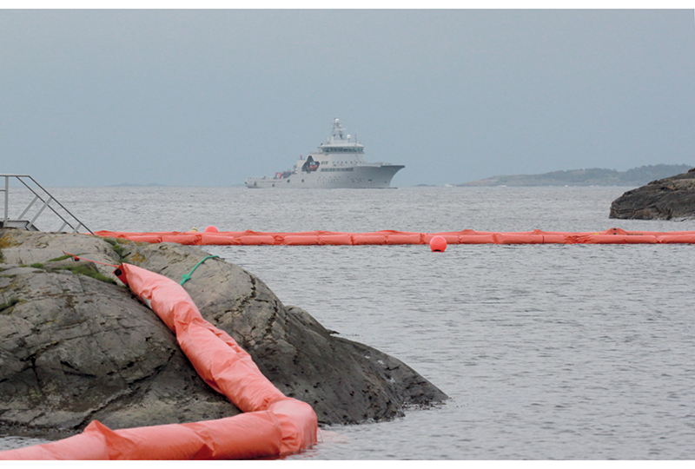
          - A coastal oil spill response exercise.
Norwegian Coastal Administration
The Coastal Administration and the Norwegian Environment Agency are seeking closer collaboration to ensure the right preparedness and response requirements for the petroleum industry, and effective coordination of national preparedness and response. To ensure better access to information, it may be appropriate to establish a joint database for operators’ preparedness and response plans.
Under section 43 of the Pollution Control Act, municipalities are required to provide for the necessary emergency preparedness and response system to deal with minor acute pollution incidents. The Norwegian Environment Agency is the supervisory authority for municipal preparedness and response and is authorised to set further requirements for the municipalities, while the Coastal Administration is responsible for coordinating the national preparedness and response system. To ensure closer coordination of municipal and governmental preparedness and response, the possibility of transferring responsibility for supervision and follow up of municipal preparedness and response from the Norwegian Environment Agency to the Coastal Administration will be considered. This could ensure seamless integration between municipal and governmental preparedness and response systems.
The Barents Sea–Lofoten area
Over the past decade, both the governmental and private preparedness and response systems for acute pollution have been built up. The white paper on cooperation to improve maritime safety (Meld. St. 30 (2018–2019)) reviewed ways of strengthening governmental preparedness and response. Based on the difficulties identified in the 2014 environmental risk and emergency preparedness analysis for Svalbard and Jan Mayen, the Government has implemented a number of measures to strengthen the preparedness and response system for acute pollution in the area. Service vessels under the Governor of Svalbard have been outfitted with additional oil spill response equipment and crews are trained to use it. Several new vessels have been included in the coastal preparedness and response system for Svalbard. The Coast Guard vessel KV Svalbard has been equipped with a heavy-duty oil containment boom reinforced for icy conditions. In cooperation with the Governor of Svalbard and the company Telenor, the Coastal Administration has developed a maritime broadband radio network for key areas of Svalbard‘s west coast.
The Coastal Administration has analysed many of the new fuels that are now being taken into use in Norwegian waters and the Arctic. These have been tested under Arctic conditions for persistence, evaporation rates, dissolution rates in water, dispersibility and toxicity. The Coastal Administration has also investigated releases of gases and particulate matter from the combustion of different fuels. This is important background information for environmental assessments of measures to deal with acute pollution.
The northernmost sea areas have little infrastructure and limited telecommunications coverage and capacity. The availability of oil spill response equipment and personnel is also limited, there is a lack of sites where recovered oil and waste can be deposited, and distances are long, meaning that response times are also long if there is an incident.
Natural conditions will also affect oil spill recovery operations – for instance the very limited daylight for part of the year, low temperatures and the risk of icing on equipment, and the often rapid shifts in weather conditions. The presence of ice makes it considerably more difficult to deal effectively with acute pollution. Finding efficient logistics solutions will be a major challenge for all types of operations in Arctic waters. Personnel and material will need to be transported to and from the area affected during an oil spill operation, and recovered oil will have to be transported out of the area unless it is burned off in situ. Operational platforms including ships, aircraft and drones must be robust and meet adequate safety standards. It is essential to comply with health, safety and working environment requirements for response personnel during all types of activities.
An oil spill response operation near Bjørnøya would be particularly challenging. Access to the island from both land and sea is difficult for response teams and equipment due to its exposed coastline and steep coastal cliffs. Even much of the more low-lying northern part of the island ends in a steep drop of 10–30 metres, making boat landings difficult. There are a few sandy bays and beaches, but even these are not protected from winds and rough seas. The exposed coastline and wave conditions akin to the open sea mean that standard oil recovery systems designed for fjord and coastal operations are not robust enough. Larger systems have the drawback of being difficult to manoeuvre near the coast. Access from land is extremely difficult because of a lack of infrastructure in addition to the terrain.
It would also be very demanding to carry out a large-scale shoreline-cleaning operation in Svalbard because of the long distances involved and the lack of resources and infrastructure on land. Dealing with waste would be particularly difficult, and it will be necessary to focus on techniques for reducing waste quantities.
Technology development has resulted in improvements of conventional methods for spill containment and recovery in open seas and coastal waters, but the cold, presence of ice and long distances still make response operations in both coastal waters and the shore zone a challenging task.
There are challenges relating to wave height, currents and operations in coastal waters and the shore zone in all three management plan areas. It is particularly demanding to carry out large-scale response operations in vulnerable coastal waters.
Both public- and private-sector studies have been carried out to assess the suitability of available oil spill response methods and equipment in the Barents Sea–Lofoten area, and how their suitability may vary from season to season. Based on knowledge about limitations relating to wave height, ice, wind and light conditions, the studies indicate that conditions for mechanical recovery of oil will seldom be favourable in winter but will often be favourable in the summer. Unfavourable conditions can significantly reduce operational effectiveness. Actual recovery effectiveness, which has not been assessed, will depend on the type of oil and degree of weathering.
The use of dispersants is not restricted to the same extent by the prevailing weather conditions, and weather statistics indicate that they will be suitable for use for more of the year. Since seabirds are considered to be the group at the highest environmental risk from oil spills in the Barents Sea, using dispersants may be an important part of a preparedness and response strategy for the area. However, dispersant delivery capacity for the Barents Sea is currently limited.
Subsea injection of dispersants was an important part of the response during the Gulf of Mexico blowout in 2010. Studies by the oil and gas industry indicate that water depths in the Barents Sea, the Norwegian Sea and northern North Sea are sufficient for subsea injection of dispersants to be effective, provided that the gas content of the oil is not excessive. However, more knowledge is needed about sedimentation of dispersed oil and possible formation of marine oil snow before dispersants are used in areas with a vulnerable benthic fauna.
Both mechanical recovery and dispersion can function satisfactorily in areas with some ice. Recent field trials have shown that mechanical equipment can be operated in areas with up to 10 % ice cover. However, the reduction in recovery effectiveness caused by the recovery of large quantities of ice with the oil has not been assessed. Both governmental and private response equipment has been tested, and steps have been taken to strengthen equipment to withstand the additional load of ice.
The use of in-situ burning has been considered as a way of dealing with oil trapped in ice and oil-polluted sediments in areas lacking the infrastructure needed to handle large quantities of waste. Burning trials have shown that significant amounts of viscous oil residue remain and must later be recovered. Further development work is needed to find a suitable recovery method for use during response operations.
Design and capabilities of the preparedness and response systems
Governmental preparedness and response
Governmental preparedness and response capability and the locations where equipment and other resources are available are determined on the basis of knowledge of environmental risk associated with oil spills from shipping in Norwegian waters. The Coastal Administration carried out environmental risk and emergency preparedness analyses for the mainland coast in 2011 and for Svalbard and Jan Mayen in 2014. These analyses are used in the work of optimising the design of the governmental preparedness and response system.
The petroleum industry‘s preparedness and response system
There is no clear-cut solution for how the preparedness and response system for petroleum activities on the Norwegian continental shelf should be designed. The system must be in reasonable proportion to risk, rather than based on worst-case scenarios. Nonetheless, the system is designed to deal with blowouts of relatively long duration, even though their likelihood is low.
The Office of the Auditor General has raised questions about whether certain weaknesses in the operators’ analyses, their presentation of results, and insufficient cooperation between the relevant authorities have resulted in an inadequate basis for making decisions about requirements for risk-reducing measures. There is a need to review the assumptions on which preparedness and response capability is based and how the response equipment and techniques available and their limitations are taken into account. The operators are now reviewing their guidelines for environmental preparedness analyses, and the Norwegian Environment Agency is considering amending the requirements set out in regulations and individual decisions.
Restrictions on when drilling is permitted can considerably reduce the environmental risk associated with exploration drilling. By the time production drilling starts, there is much more information about reservoir conditions and types of oil, and the likelihood of a blowout is lower than during exploration drilling. A gas blowout is primarily associated with a risk of fire or explosion. Oil spill response measures can reduce the consequences of a spill. There is always a possibility of oil spills and discharges of chemicals during oil production or drilling in oil-bearing formations. It is therefore vital that the industry maintains high safety standards and continues its efforts to reduce the risk of spills.
The oil spill preparedness and response system at private, municipal and governmental level is risk-based. Uncertainties regarding risk levels and which types of incidents may occur make it difficult to assess whether the design and capabilities of the preparedness and response system are appropriate. Measures have been introduced to strengthen the preparedness and response system both at governmental level and by the petroleum industry. However, it is difficult to verify how much these measures will reduce the consequences of spills, and the extent to which the goal for acute pollution has been achieved is uncertain.
Emergency preparedness system for nuclear accidents and acute radioactive pollution
Norway‘s nuclear emergency preparedness system involves authorities at the national, regional and local levels. The system is designed to rapidly establish an effective, science-based, coordinated response to nuclear accidents and ensure the rapid implementation of measures to protect lives, health, the environment and other important public interests. Norway‘s nuclear emergency preparedness system is led by the Crisis Committee for Nuclear and Radiological Preparedness.
In the event of a nuclear accident, the Crisis Committee will coordinate the responses of various authorities in different sectors, and can also implement measures itself. The spread of the radioactive pollution and its anticipated scale and severity will be modelled. Measurements and other information will also need to be obtained to feed into the models in order to characterise the type and amount of radioactive pollution. Life-saving efforts at the accident site/vessel will be given top priority. This work will be coordinated by one of the Joint Rescue Coordination Centres with expert assistance from the Crisis Committee and the Norwegian Radiation and Nuclear Safety Authority. Important action may include issuing advisories to and redirecting people in the vicinity, measures to deal with the vessel, and halting other nearby activities that are affected by the accident. Even minor incidents that do not involve a risk that radioactive material will be released could have serious impacts on Norwegian commercial interests such as seafood exports. The Crisis Committee and others involved in the system are engaged in continuous efforts to improve preparedness, for instance by following up the Crisis Committee‘s updated threat assessments.
The Ministry of Climate and Environment is in the process of extending the applicability of certain provisions of the Pollution Control Act to acute radioactive pollution. These concern the municipal and governmental preparedness and response system, preparedness and response plans, governmental on-scene command of operations, and the duty to provide assistance. This will make the Norwegian Radiation and Nuclear Safety Authority responsible for setting requirements for private and municipal preparedness and response systems, further developing preparedness and response legislation and supervising private and municipal preparedness and response for acute radioactive pollution. In addition, the Authority will assume governmental on-scene command if required during acute radioactive pollution incidents. This corresponds to the role the Coastal Administration has in dealing with other forms of acute pollution, which will facilitate the development of cooperation between the two bodies in administering the same legislation for different types of acute pollution, and will enable them to deal with complex pollution situations together.
Since the 1990s, Norway‘s nuclear emergency preparedness system has been built up through work under the Government‘s Nuclear Action Plan. Nuclear safety cooperation with Russia has been a particularly high priority, and formal and informal cooperation has been established between relevant Norwegian and Russian authorities. Norway‘s focus areas in the years ahead include dealing with sunken and dumped submarines and other radioactive objects, and cooperation on notification and preparedness and response, for example within the framework of the Norwegian-Russian Commission for Nuclear Safety.

Coordinated spatial management and coexistence between ocean-based industries
Sound management of Norwegian seas and oceans provides predictability and a long-term perspective, and helps to avoid conflict between sectors in the future. The central government authorities are responsible for spatial planning and management in all areas beyond one nautical mile outside the baseline, on the basis of legislation for different sectors and the integrated ocean management plans.
The ocean management plans are intended to provide an overall balance between use and conservation, based on knowledge about ecological functions and the value and vulnerability of different areas together with information about economic activity now and forecasts for the future. Each management plan sets out a framework for petroleum activities in specific geographical areas, including areas where no petroleum activities will be permitted to safeguard environmental or fisheries interests, areas where there are restrictions on the times of year when exploration drilling is permitted, and other areas where there are environmental and fisheries-related conditions. The framework for petroleum activities is thus a form of spatial planning that takes special account of environmental value and fisheries interests. The framework for petroleum activities is implemented under existing petroleum-sector legislation, and more generally, activities in each management plan area are regulated on the basis of existing legislation governing different sectors.
Earlier management plans include a thorough description of spatial overlap between three established ocean-based industries: fisheries, maritime transport and petroleum. In view of the expected growth in new and emerging ocean industries, the Government will consider whether there are certain geographical areas where many different interests intersect. It will be important to review the impacts, including the economic impacts, of various options for the use of Norway’s marine areas, and to consider where there may be spatial incompatibilities in individual cases.
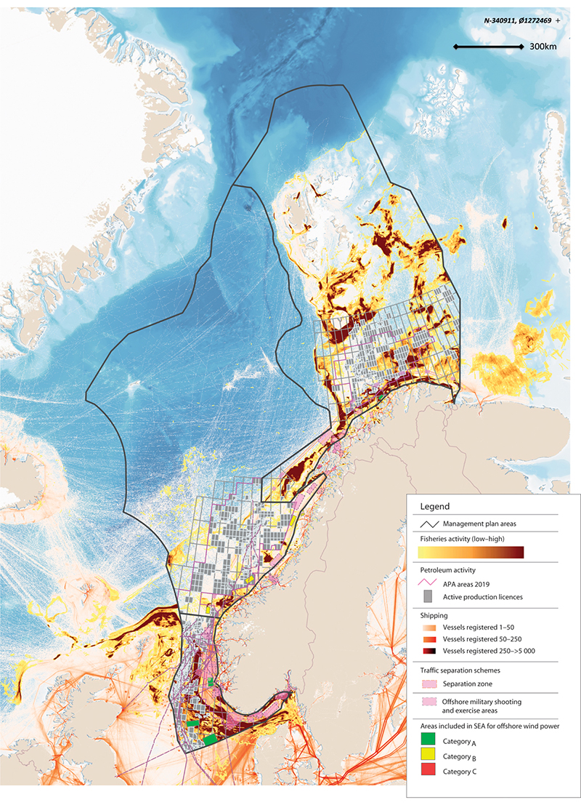
          - Overview of commercial activity in the management plan areas.
Directorate of Fisheries, Norwegian Coastal Administration, Norwegian Environment Agency, Norwegian Water Resources and Energy Directorate, Petroleum Directorate/Marine spatial management tool. Base map for the marine spatial management tool: GEBCO and Norwegian Mapping Authority
Marine spatial management tool
The North Sea–Skagerrak management plan (Meld. St. 37 (2012–2013)) identified the need to strengthen the spatial management element of the management plans and rationalise the process of updating and revising them. The Forum for Integrated Ocean Management was tasked with developing a tool for presenting and compiling spatial data for use in the management plan system, in close cooperation with BarentsWatch. The digital marine spatial management tool that has now been developed is designed to provide integrated geospatial information on industrial activities, species and habitats, and regulatory measures.
This will provide valuable support for sound spatial management in the management plan areas, and will be useful for the authorities, the business sector, interest organisations, other users of Norway’s waters and the general public.
The spatial management tool contains geospatial data sets for natural resources, commercial activities, environmental status, plans and regulatory measures, relevant reference data and basic marine data. The spatial management tool is still being developed as a support tool for work on the integrated ocean management plans. It is also a way of making the knowledge base for the management plans publicly available.
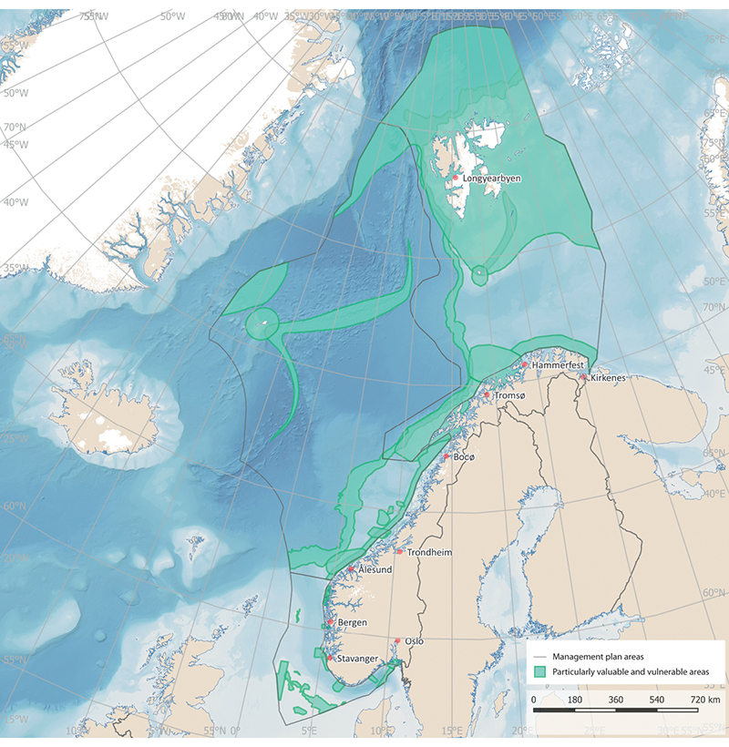
          - The particularly valuable and vulnerable areas identified in the three ocean management plans.
Norwegian Environment Agency/Marine spatial management tool
Particularly valuable and vulnerable areas
Particularly valuable and vulnerable areas have been identified as being of great importance for biodiversity and biological production in an entire management plan area. In these areas, activities will be conducted with special care and in such a way that the ecological functioning and biodiversity of the areas are not threatened. The designation of areas as particularly valuable and vulnerable does not have any direct effect in the form of restrictions on commercial activities, but indicates that these are areas where it is important to show special caution. It is possible to use current legislation to make activities in such areas subject to special requirements, and thus protect valuable species and habitats. The particularly valuable and vulnerable areas have been delimited on maps, and are further presented in Chapter 3.

Norway’s ocean management and its implications for regional growth and development
Spatial management of the waters closest to the coast (out to one nautical mile outside the baseline) is subject to the rules of the Planning and Building Act on planning and public consultation processes and environmental impact assessment. This means that there is a more fully developed system for coordination, cooperation and participation of all interested parties as regards spatial management in coastal waters. Legislation other than the Planning and Building Act also contains provisions that have implications for spatial management along the coast, including the Act relating to ports and navigable waters, the Marine Resources Act and the Aquaculture Act. Further out from the coast, spatial management is the responsibility of central government authorities.
Marine spatial planning and developments on land are closely linked. Decisions on where to site activities at sea may have major implications for developments at municipal and county level on land. At the same time, ocean-based commercial activities are dependent on infrastructure on land, including ports, transport networks and emergency preparedness and response resources.
The Government’s 2019 ocean strategy, Blue Opportunities, had a clear regional focus. Norway’s national ocean policy is developed through cooperation between central government, county and municipal authorities. A forum for systematic dialogue on ocean issues has therefore been established involving the Government, the counties, the Sámediggi (Sami parliament) and representatives of coastal municipalities. Other stakeholders are invited to take part when appropriate. The purpose of the forum is to facilitate dialogue, and it is not a decision-making body. The members of the forum decide on topics for discussion together, based on the priority areas of the ocean strategy that have implications for knowledge-based management, value creation, employment and skills in coastal communities.

Designating marine space for different uses – main features of decision-making processes
Authorities in different sectors are responsible for allocating decisions on which parts of marine space are to be allocated to different types of activities under the legislation they administer.
Offshore wind power
Apart from a floating wind turbine off Karmøy, there are no offshore wind farms in Norwegian waters. The Hywind Tampen wind farm, which will provide two oil fields with electricity, is being developed in the North Sea. So far, no areas have been opened for wind power development under the Offshore Energy Act. However, offshore wind power is showing strong growth internationally, especially in the North Sea.
In 2010, a working group led by the Norwegian Water Resources and Energy Directorate identified 15 areas it considered suitable for offshore wind power. In 2012, the Directorate conducted a strategic environmental assessment of the 15 areas to consider whether they should be opened for licence applications. This ranked the areas according to suitability, and recommended giving priority to five of them. The purpose of the strategic environmental assessment was to avoid conflict between wind power and other important interests, while also taking into consideration power grid access, development costs and the available wind resources. Nevertheless, it seems clear that offshore wind power could potentially come into conflict with other interests.
In 2019, the Ministry of Petroleum and Energy carried out a consultation process on whether two areas, Sandskallen-Sørøya North and Utsira North in the North Sea, should be opened for offshore energy production, and on draft regulations including rules governing the licensing process.
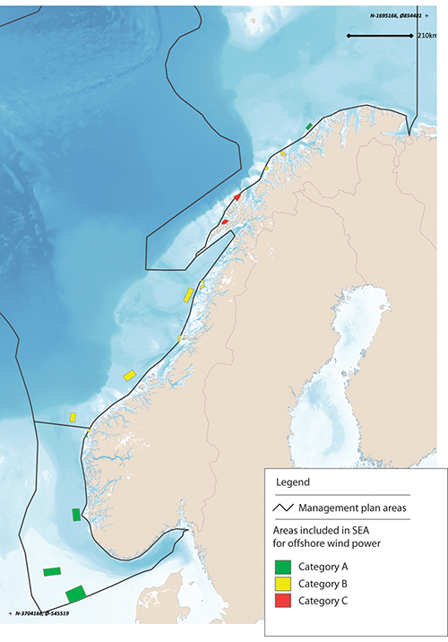
          - Areas included in the strategic environmental assessment for offshore wind power.
Norwegian Water Resources and Energy Directorate/Marine spatial management tool
Licence applications for offshore renewable energy production are dealt with under the Offshore Energy Act, which is the responsibility of the Ministry of Petroleum and Energy. The process for the Hywind Tampen wind farm is being dealt with under the Petroleum Act, which is the responsibility of the Ministry of Petroleum and Energy.
Offshore aquaculture
There has been growing interest in the development of offshore aquaculture in recent years. This is explained by a need for more space and by environmental and disease problems in a number of areas used for aquaculture at present. If aquaculture facilities are sited further out from the coast, new conflicts of interest are likely to arise with the traditional fisheries, shipping and offshore wind farms.
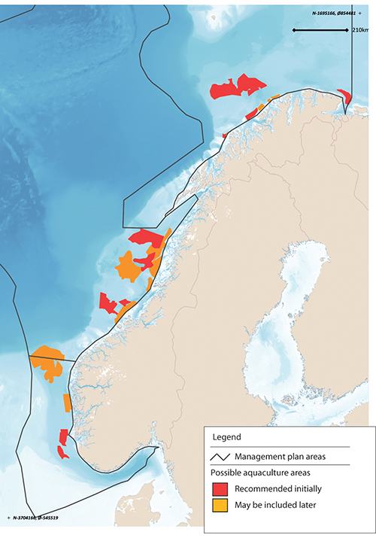
          - Areas recommended for inclusion in a strategic environmental assessment of offshore aquaculture.
Directorate of Fisheries
An interministerial working group has prepared a report on offshore aquaculture. This recommends that in areas outside the geographical scope of the Planning and Building Act, the central government should open sizeable areas (blocks) for offshore aquaculture under the Aquaculture Act. After this, it will be necessary to determine where the actual facilities are to be sited within each block. Further review of this process will be needed.
The report also recommends requiring the establishment of safety zones round offshore aquaculture facilities, and that these should be larger than the zones around coastal facilities. In addition, marking of aquaculture facilities should be adapted to operations in more open and exposed waters. Mobile self-propelled systems should be subject to the same navigational requirements as other shipping, to avoid collisions. More knowledge is needed about the migration routes, habitats and feeding grounds of important wild fish species so that environmental considerations can be properly incorporated.
The Directorate of Fisheries has recently submitted a proposal recommending strategic environmental assessment of 11 areas outside the geographical scope of the Planning and Building Act that have been identified as suitable for offshore aquaculture, and identifying 12 areas that may be included at a later date (Figure 7.4). Any allocation of areas will be decided under the Aquaculture Act, which is the responsibility of the Ministry of Trade, Industry and Fisheries.
Extraction of seabed minerals
Exploration for and exploitation of seabed minerals may in future become an important ocean industry for Norway.
The areas where minerals are likely to be extracted are expected to be far from the coast, in contrast to those that are attractive for many other activities.
The Seabed Mineral Act is administered by the Ministry of Petroleum and Energy, and is based partly on experience gained from petroleum activities. Under the Act, an area must as a general rule have been officially opened before licences can be issued for exploration and extraction.
Bioprospecting
Bioprospecting is a systematic search for organisms, genes and molecules that could provide key components for various products and processes in medicine, the process industries, food production and other sectors. As new sampling technology is developed, larger parts of the oceans will be of interest for bioprospecting.
Norway has no current plans to designate specific areas for bioprospecting, and areas where there are organisms that might be possible to exploit through bioprospecting in the future have not yet been systematically identified. Any regulation of the use of specific areas for bioprospecting would be introduced under the Marine Resources Act (Ministry of Trade, Industry and Fisheries) or the Nature Diversity Act (Ministry of Climate and Environment).
Routes for submarine cables
Submarine communications cables carry large volumes of data traffic. For example, almost all internet data traffic between islands and continents is transferred by cable. In Norwegian waters, the network of communications cables will grow and they will occupy larger areas of the seabed as the volume of data traffic rises.
There is currently no coordinated system determining where and when such cables are laid in Norway. Laying submarine communications cables is not regulated by law in the same way as other maritime infrastructure. The Ministry of Local Government and Modernisation has started legislative work on the regulation of submarine fibre-optic cables.
As a general rule, anyone planning to lay submarine power cables must apply for a permit under the Act relating to ports and navigable waters. Applications are processed by the Norwegian Coastal Administration. Information on such projects must be forwarded to the Norwegian Mapping Authority for inclusion on charts.
Norway has submarine power cables from the mainland to island communities, from the mainland to other countries (interconnectors), and from the mainland to certain petroleum installations. There are four subsea interconnectors between Kristiansand and Denmark, and one between Feda and the Netherlands. In addition, Statnett is building two new interconnectors, one between Feda and Germany and one between Kvilldal and the UK.
The oil and gas fields Valhall, Gjøa, Troll, Ormen lange, Snøhvit, Goliat and Johan Sverdrup are all now supplied with power from shore. Power from shore will also be used to supply the Martin Linge field when it comes on stream, and the joint solution for supplying power from shore to the Utsira High region will be in place by 2022. The petroleum industry is currently assessing whether to supply Oseberg, Troll B and C, Draugen and the fields on the Halten Bank with power from shore. Licensees are required to assess whether to use power from shore in connection with all new independent developments and major changes to fields that are on stream. In February 2020, the Norwegian oil and gas industry presented its climate roadmap, which includes an ambition to reduce greenhouse gas emissions from the sector by 40 % by 2030 and to close to zero by 2050. Using power from shore will be an important way of achieving these targets.
Development of offshore wind power will also require the construction of associated infrastructure. Offshore wind farms will generally be connected to the electricity grid via production radials owned by the producers. Alternatively, they can be connected to petroleum installations. Offshore wind developments that are largely intended for power export could be connected via radials directly to another country’s grid.
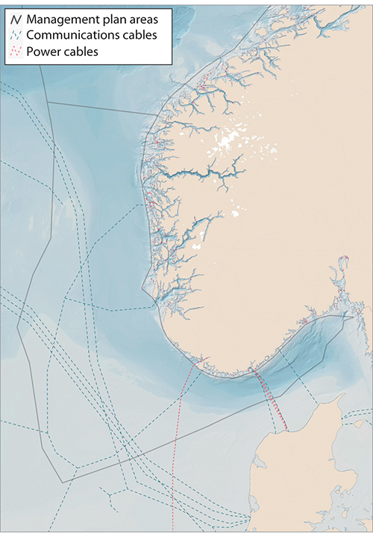
          - Submarine communications and power cables.
Norwegian Water Resources and Energy Directorate/Telegeography/EMODnet-Human Activities/Marine spatial management tool
Under the Energy Act, installations for production, transformation, transmission and distribution of electric energy inside the baseline may not be built, owned or operated without a licence. The Offshore Energy Act has similar licensing provisions for installations outside the baseline. However, the licensing provisions of the Offshore Energy Act may be set aside for electrical installations that are an integral part of petroleum activities and that are processed under the Petroleum Act.
The requirement to obtain a licence under the Energy Act also applies to new cables to link production facilities, interconnectors or petroleum installations to the grid in mainland Norway and to interconnectors between the Norwegian grid and other countries. For interconnectors, an additional licence for the export and import of electrical energy is required under the Energy Act, or under the Offshore Energy Act for interconnectors directly from installations on the Norwegian continental shelf to other countries.
The Norwegian Water Resources and Energy Directorate is the licensing authority for electrical installations, except for new major power lines longer than 20 kilometres carrying a voltage of 300 kV or more, which are licensed by the King in Council. The Ministry of Petroleum and Energy is the licensing authority under the Offshore Energy Act.
Offshore military shooting and exercise areas
The Norwegian Armed Forces currently have 87 offshore military shooting and exercise areas, from parts of the Oslofjord in the south to Kvænangen in the far north. These are described in an Official Norwegian Report (NOU 2004:27). Offshore shooting and exercise areas are essential to the Norwegian Armed Forces’ operational activities and ultimately for national emergency preparedness and crisis management capabilities. They are also intended to meet training and exercise needs for personnel, for testing equipment and for operational training for the Norwegian Armed Forces alone and together with allies. Areas have been designated to permit training for airborne, naval and underwater operations. When using these areas for exercises or other purposes, the Armed Forces must ensure that the environment is properly safeguarded.
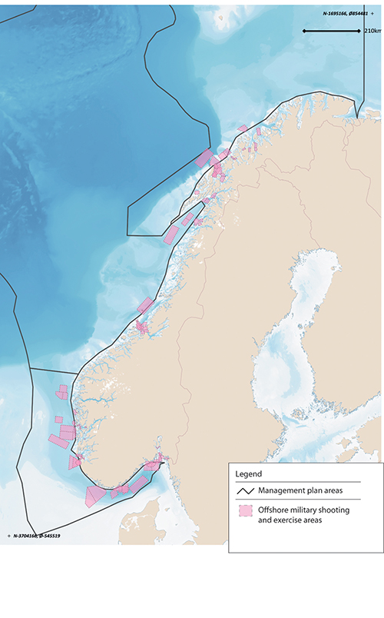
          - Offshore military shooting and exercise areas for the Norwegian Armed Forces, 2000.
Norwegian Armed Forces/Marine spatial management tool
The Ministry of Defence has tasked the Norwegian Defence Estates Agency, in cooperation with the Norwegian Armed Forces, with reviewing offshore military shooting and exercise areas. All relevant planning authorities in different sectors are involved in the work. The purpose is to look at how to formalise and manage these areas. The project also includes a review of the structure of the shooting and exercise areas and possible adjustments in the light of future needs, and it will make recommendations for decommissioning or changing existing shooting and exercise areas and for establishing new areas. The project will also consider the possibility of sharing the use of such areas with civilian interests, and is to be completed by mid-2020.
Marine protected areas and other effective area-based conservation measures
Marine protected areas and other effective area-based conservation measures are important tools for safeguarding areas where there are important ecosystems, habitats and species. The purpose of these tools is to ensure that areas are managed in a way that maintains their conservation value for the future. To achieve this, it must be possible to regulate pressures on conservation areas, and to implement active conservation measures where necessary. Any restrictions imposed on activity in such areas must be proportional to the purpose of protection.
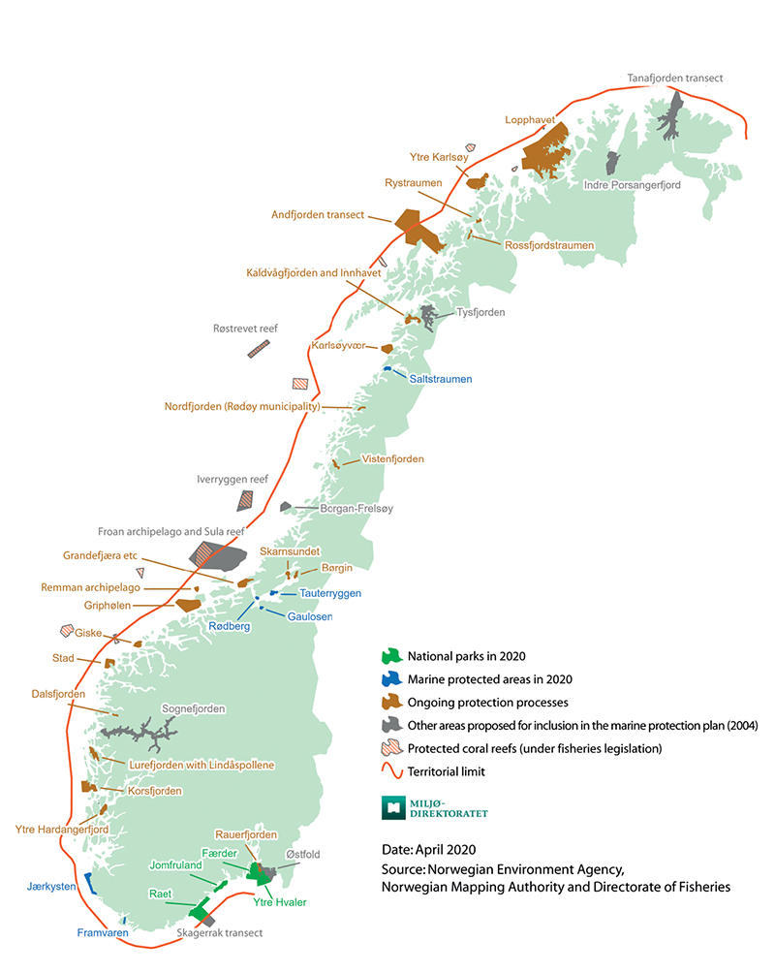
          - Existing and planned marine protected areas around mainland Norway.
Norwegian Environment Agency, Norwegian Mapping Authority and Directorate of Fisheries
Marine protected areas under the Nature Diversity Act may be established in Norway’s territorial waters, which extend to 12 nautical miles beyond the baseline. Around Svalbard, important marine species and habitats are protected where they are included in the marine parts of the national parks and nature reserves established under the Svalbard Environmental Protection Act.
In addition to the areas that are protected under these two Acts, marine protected areas can be established under the Marine Resources Act in all Norwegian waters and on the Norwegian continental shelf.
Efforts to safeguard marine areas and their species and habitat diversity for the future have been in progress for many years. In 2004, a broad-based advisory committee identified 36 marine areas along the coast that for further evaluation as part of these efforts. As of April 2020, six marine protected areas and four national parks including substantial marine areas had been established under the environmental legislation, and a further 18 marine protected areas including coral reefs had been established under the Marine Resources Act. Work on marine protected areas was discussed in more detail in the white paper Nature for life: Norway’s national biodiversity action plan (Meld. St. 14 (2015–2016)) and the 2017 update of the Norwegian Sea management plan (Meld. St. 35 (2016–2017)). Work on an overall national plan for marine protected areas has been started. A review of relevant area-based conservation measures has also been started so that appropriate fisheries management measures can be included when Norway reports to the Convention on Biological Diversity and other international forums on the proportion of marine and coastal areas covered by conservation measures.
Tourism
The tourism sector in Norway has been growing steadily for the past 10 years. Few countries have as long and varied a coastline as Norway, and the coastal environment, fjords and marine areas have great potential in terms of tourism.
No areas of sea are set aside specifically for tourism activities, as is done for several of the other ocean-based industries. However, certain restrictions have recently been introduced to avoid conflicts with fishing operations. It is now prohibited for whale-watching vessels to sail closer than 370 m to fishing vessels or fixed fishing gear, or for people swimming, diving or canoeing/kayaking to approach closer than 750 m. These restrictions have been introduced under the Marine Resources Act (Ministry of Trade, Industry and Fisheries).
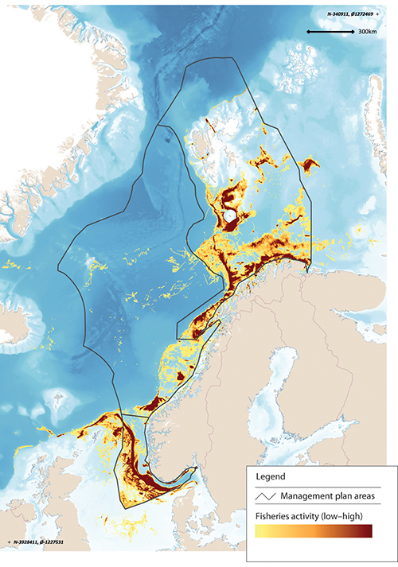
          - Level of fisheries activity in Norwegian waters.
Directorate of Fisheries/Marine spatial management tool
Fisheries
The level of fisheries activity varies over the year, from year to year, depending on stock development and changes in distribution and migration patterns (see Figure 7.8). Fishing grounds are not clearly delimited areas. Regulatory measures and spatial needs vary from one type of fishing gear to another. The distribution of some species, for example herring, is highly dynamic. In addition, changes are being observed in the distribution and migration patterns of many fish species as a result of climate change.
Currents along the Norwegian coast often form eddies rich in plankton and nutrients in the shallow bank areas. The availability of food and good light conditions result in high densities of fish locally in these waters. In addition, bottom conditions are favourable for the use of fishing gear, and the bank areas are therefore important fishing grounds.
The use of marine space by the fisheries is regulated under the Marine Resources Act (Ministry of Trade, Industry and Fisheries).
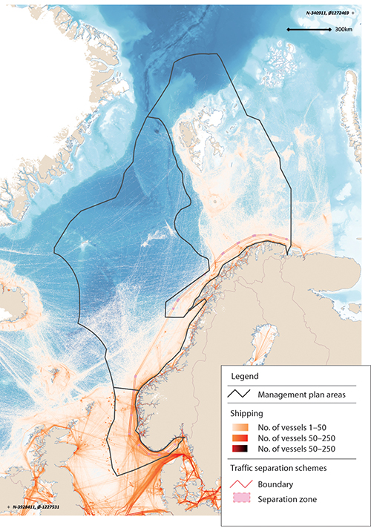
          - Map of shipping density.
Norwegian Coastal Administration/Marine spatial management tool
Maritime transport
Maritime transport accounts for more than 70 % of transport work in areas under Norwegian jurisdiction and 90 % of the volume of international transport. Maritime transport is thus very important both for the Norwegian business sector and for foreign trade. The volume of shipping (expressed as distance sailed) is expected to rise by about 40 % by 2040.
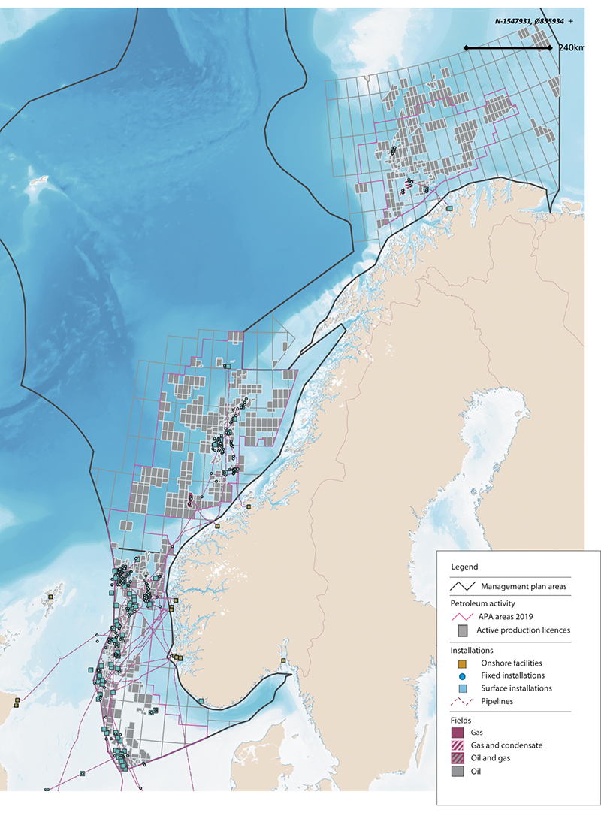
          - Petroleum activity on the Norwegian continental shelf.
Norwegian Petroleum Directorate/Marine spatial management tool
Areas are designated for traffic separation schemes, recommended routes and other regulatory measures for fairways under the Act relating to ports and navigable waters. Traffic separation schemes and recommended routes in Norway’s exclusive economic zone must also be approved by the International Maritime Organization (IMO). The introduction of traffic separation schemes and recommended routes along the coast has helped to move shipping further out from the coast, separate traffic streams in opposite directions and establish a fixed sailing pattern (Figure 7.9). This reduces the likelihood of collisions and groundings and makes it easier to intervene in the event of an accident.
In some cases, it might be possible to move recommended routes in the interests of other activities, but this is a process that requires extensive risk assessments and IMO’s approval. In other cases, this would not be possible, because moving a route would have negative impacts on maritime safety or would seriously impede passage in the area. Moving recommended routes further away from the coast could increase the distance sailed, increase greenhouse gas emissions and make it more complicated to provide assistance to ships when necessary.
Petroleum activities
Petroleum activities may take place in areas opened by the Storting (Norwegian parliament) under the conditions set out in the ocean management plans.
Acreage for petroleum activities is allocated through two equally important types of licensing rounds. New acreage in frontier areas is allocated in numbered licensing rounds, which are normally held every other year. In more mature areas, where more is known about the geology and that are closer to planned or existing production and transport infrastructure, licences are issued every year through the system of awards in predefined areas (APA). The licensing process involves a number of steps. Numbered licensing rounds are opened by inviting companies to nominate blocks. The authorities assess the nominations, and a proposed announcement is submitted for public consultation. After this, the Ministry of Petroleum and Energy announces the round. After the applications have been processed and after negotiations with the companies on licensing conditions, the government makes the final decision on which areas are to be covered by production licences and the mandatory work programme for each licence. More details can be found in Chapter 5.
Petroleum infrastructure, including platforms, subsea installations, pipelines and safety zones around installations, occupies large areas. At the beginning of 2020, 87 fields on the Norwegian continental shelf were producing oil and gas: 66 in the North Sea, 19 in the Norwegian Sea and two in the Barents Sea. The total length of gas pipelines installed on the Norwegian continental shelf is 8 800 km.
In addition to the permanent installations, seismic surveys occupy considerable areas while they are in progress. Seismic surveys are carried out at all stages from exploration to final production. Even though seismic surveys only last for a relatively short time in each phase, this is the activity that leads to the greatest conflict with the fisheries. Delaying seismic surveys can be extremely costly for the petroleum industry.
Petroleum activities are licensed under the Petroleum Act (Ministry of Petroleum and Energy).

Coordinated marine spatial planning in other countries
About 70 of the member states of the Intergovernmental Oceanographic Commission (UNESCO-IOC) now have some form of marine spatial planning. Norway’s ocean management plans are considered to constitute an established marine spatial planning system. Different countries’ systems vary widely. In 2014, the EU adopted a directive establishing a framework for maritime spatial planning (2014/89/EU, MSP Directive). The expected benefits of maritime spatial planning are:
- It will reduce conflicts between sectors and creates synergies between different activities.
- It will encourage investment by creating predictability, transparency and clearer rules.
- It will increase cooperation between countries to develop energy infrastructure, shipping lanes, pipelines, submarine cables and other activities, and also to develop coherent networks of protected areas.
- It will protect the environment through early identification of impacts and opportunities for multiple use of space.
Under the MSP Directive, the 23 coastal states of the EU are required to establish national maritime spatial plans by 31 March 2021. Member states themselves are responsible for determining the content of their plans and finding a balance between the use of the maritime space by different sectors. However, their plans must include all activities at sea, and these must be considered in conjunction with land-based activities. The plans must also facilitate cooperation between authorities in different sectors and different sectoral interests, and with third countries that have jurisdiction over adjoining coastal and marine areas. The MSP Directive has not been incorporated into the EEA Agreement.
Together with the EU Commission, the IOC has initiated a global project to promote marine spatial planning as a tool for implementing Sustainable Development Goal 14 on life below water and the UN Decade of Ocean Science for Sustainable Development.

International cooperation on ocean governance
The white paper The place of the oceans in Norway’s foreign and development policy (Meld. St. 22 (2016–2017)) stated that the Norwegian Government will continue to advocate broad support for the Convention on the Law of the Sea and will intensify efforts to promote Norwegian ocean interests. In the white paper, the Government charted how Norway can play a leading role in international ocean issues, particularly in efforts to achieve the Sustainable Development Goals (SDGs).
Many of the drivers of change that are adversely affecting marine ecosystems can only be addressed through a concerted international effort. Long-range transboundary pollution, global warming and ocean acidification, and the spread of plastic waste are all issues that require closer international cooperation.
Norway is therefore giving high priority to support for multilateral environmental agreements, ambitious implementation of the Paris Agreement, and further development of international cooperation to ensure ocean health and productivity in the future. This is followed through within the framework of international and regional environmental agreements and governance mechanisms, by cooperating on ocean management with neighbouring countries, and by assisting developing countries to develop sound ocean management regimes.

Institutions and arenas for international cooperation on ocean governance
Under the Convention on the Law of the Sea, states have a general duty to cooperate at global and regional level on protection and preservation of the marine environment. Norway shares ecosystems and important marine resources with other countries, and bilateral and regional cooperation is therefore an essential basis for sound ocean management. Norway has played a key role in the development of regional fisheries and ocean management organisations, which are important channels for promoting Norwegian policies and ocean interests. We have also played a part in the development of similar organisations in other parts of the world.
Norway is an active participant in work under the Convention for the Protection of the Marine Environment in the North-East Atlantic (the OSPAR Convention). The next OSPAR ministerial meeting has been postponed from July 2020 to 2021, and according to plan will be held in Lisbon. It will focus mainly on adopting OSPAR’s strategy for the period 2020–2030.
The North East Atlantic Fisheries Commission (NEAFC) is an important forum for fisheries cooperation between Norway and other countries in the region. Norway plays an active role in the NEAFC and has been an advocate of close cooperation between OSPAR and the NEAFC. The purpose of this cooperation is to ensure coordination of the work of the two organisations, for example to prevent illegal fishing and protect vulnerable areas.
For almost 50 years, Norway and Russia have been cooperating on joint management of the rich fish stocks in the Barents Sea through the Joint Norwegian-Russian Fisheries Commission. This cooperation has developed into a system covering a broad range of areas, including resource control, cooperation on coast guard and SAR operations, technical measures and Norwegian-Russian resource cooperation. The result is that the Northeast Arctic cod stock is one of the best managed fish stocks in the world, and is of vital importance for Norwegian coastal communities.
The Joint Norwegian–Russian Commission on Environmental Protection gives high priority to cooperation on the marine environment. One of the main purposes of its work is to obtain the best possible scientific basis for ecosystem-based management of the whole Barents Sea, and to share Norwegian experience that can be used in developing an integrated management plan for the Russian part of the Barents Sea as well. A coordinated environmental monitoring system for the entire Barents Sea and cooperation to deal with marine litter are being developed. Knowledge developed through the Norwegian-Russian fisheries cooperation provides important input to the work of the Environmental Protection Commission.
Iceland has included oceans and the blue economy among its priorities during its chairmanship of the Arctic Council in 2019–2021. The Council’s work on the marine environment will be strengthened when its new marine mechanism is launched in autumn 2020. In addition, the Council has a Working Group for the Protection of the Arctic Marine Environment (PAME).
However, it is not possible to resolve every issue at regional level; in certain areas, global cooperation is needed. Progress in implementing the 1982 UN Convention on the Law of the Sea and the 1995 Fish Stocks Agreement is monitored through conferences of the states parties, informal consultations and two annual resolutions that are debated and adopted by the UN General Assembly. Norway plays an active part in negotiations in areas including the environment, maritime safety and security, fisheries and continental shelf issues. Since 2006, the General Assembly has for example developed rules on the conduct of fisheries to avoid damage to corals and other vulnerable benthic habitats. The Food and Agriculture Organization of the UN (FAO) has prepared guidelines for the conduct of fisheries in vulnerable areas. These provisions have subsequently been implemented by regional fisheries management organisations such as the NEAFC and in Norwegian legislation. FAO has also prepared guidelines and action plans that are important in strengthening sustainable management of fisheries resources globally. FAO developed the Agreement on Port State Measures to combat illegal, unreported and unregulated (IUU) fishing on the basis of a Norwegian initiative.
The Convention on Biological Diversity is the global instrument for conservation of biodiversity and ecosystems. A post-2020 global biodiversity framework is to be negotiated under the Convention in 2021. Key Norwegian priorities for this work are effective follow-up of the conclusions of the Intergovernmental Science-Policy Platform on Biodiversity and Ecosystem Services (IPBES), strengthening the convention’s implementation mechanism, and promoting nature-based solutions. Norway’s national follow-up of the Convention includes developing specific goals and policy instruments to support efforts to maintain the biodiversity and productivity of marine ecosystems.
The United Nations Environment Programme (UNEP) promotes global cooperation on environmental protection. Norway has been seeking to put the oceans, and particularly marine litter, higher on UNEP’s agenda. In 2019–2021, Norway’s Minister of Climate and Environment is President of the UN Environment Assembly (UNEA), which is UNEP’s governing body. Norway is working actively towards a new comprehensive global agreement to combat marine litter and microplastics, and has been working for several years to bring this issue to the forefront at sessions of UNEA.
Norway is playing a leading role in the development of safe, environmentally friendly maritime transport. The International Maritime Organization (IMO) is the most important forum for achieving progress in this field. IMO has adopted various conventions to protect the marine environment against releases of oil, chemicals and waste from ships and against the spread of alien species. IMO’s ambition is to reduce greenhouse gas emissions from international shipping by half by 2050, and work is now in progress to find ways of achieving this in practice. Norway’s ambitions for a transition to green shipping, and its advanced maritime industry, are also driving the development of a green shipping industry at international level.
              - The Green Voyage2050 project
Norway is supporting the Green Voyage2050 project, a major international project that is part of IMO’s strategy to reduce greenhouse gas emissions from shipping. The project will promote global measures to reduce these emissions and test new technological solutions that can reduce emissions. The project will also support capacity-building activities in developing countries in order to put them in a position to meet their obligations to reduce greenhouse gas emissions and improve energy efficiency. In the initial phase of the project, eight countries in Africa, Asia, the Caribbean, Latin America and the Pacific region are taking pilot roles, and they will later support other countries in the development of green shipping in their regions.
[Boks slutt]
Reducing global CO2 emissions is the most important way of limiting the negative impacts of climate change on the oceans. The overall aim of the Paris Agreement, which is to hold global warming to well below 2°C above pre-industrial levels and pursue efforts to limit the temperature increase to 1.5°C, is of crucial importance for marine ecosystems. The Agreement contains provisions on emission reductions, adaptation to climate change, and support to developing countries in their transition to a low-emission development pathway. It is vital to ensure broad support for and effective implementation of the Paris Agreement. The oceans are receiving growing attention in the climate negotiations, both because of the rapid changes they are undergoing and because they offer part of the solution to the problem. Norway advocates an integrated approach to the oceans and climate change, using sound measures that both promote adaptation and enhance natural carbon sinks. In December 2019, Norway joined the International Alliance to Combat Ocean Acidification, or OA Alliance, a network to raise awareness of ocean acidification and of solutions that can limit acidification.

International initiatives to promote integrated ocean management
In the white paper The place of the oceans in Norway’s foreign and development policy, the Government expressed its ambition for Norway to play a leading international role in work on ocean-related issues. Since then, it has taken various initiatives at international level with a view to achieving this. Some of the most important of them are discussed below.
The High-level Panel for a Sustainable Ocean Economy
The High-level Panel for a Sustainable Ocean Economy was established on the initiative of Prime Minister Erna Solberg in 2018, against a backdrop of growing recognition of the great pressure that climate change, pollution and over-exploitation are putting on the ocean environment and marine ecosystems. The Panel consists of heads of state and government from Australia, Canada, Chile, Fiji, Ghana, Indonesia, Jamaica, Japan, Kenya, Mexico, Namibia, Palau and Portugal in addition to Norway. The Panel is also supported by the UN Secretary-General’s Special Envoy for the Ocean, Peter Thomson.
The purpose of the Panel is to create international awareness of the economic importance of the oceans, and an understanding that sustainable use of marine resources and safeguarding a healthy marine environment will result in increased value creation. Clean, healthy oceans are an essential basis not only for achieving SDG 14, but also for success in achieving various other SDGs, including those relating to poverty, hunger, health, energy and climate change.
The Ocean Panel was originally to present a comprehensive report at the second UN ocean conference in June 2020, but this was postponed in view of the pandemic. The conference will probably be postponed for a year, and the Ocean Panel will launch its report and recommendations in late 2020/early 2021. The report will draw on 16 Blue Papers commissioned by the Panel and prepared by an international group of experts. Each of these synthesises existing research and innovative solutions in ocean-related areas such as climate change, IUU fishing and pollution, and sets out recommendations for international action to achieve a sustainable ocean economy. The Ocean Panel’s recommendations will draw on this knowledge base, and multi-stakeholder coalitions and partnerships will be encouraged as a means of ensuring that the recommendations are implemented. Sustainable ocean management will be an important tool for achieving the SDGs.
The Our Ocean conferences – 2019 conference hosted by Norway
The Our Ocean conferences bring together governments, civil society, science and industry for discussion and awareness raising, and to build partnerships to protect the oceans and ensure they are sustainably managed.
The first conference took place in June 2014 following an initiative by former US Secretary of State John Kerry. The conference in Oslo on 23–24 October 2019 was the sixth in the series, and brought together 600 leaders from governments, civil society, science and industry, from a total of 100 countries. The importance of knowledge-based stewardship and integrated ocean management was a central theme of the conference. The programme had six main topics: climate change, ocean pollution, fisheries governance, food and livelihoods from the ocean, a sustainable ocean economy and promoting and protecting healthy oceans. Governments, businesses and organisations announced 374 voluntary commitments to action for clean, healthy and productive seas, with a total value of at least USD 63 billion. The conference gave Norway an opportunity to strengthen cooperation with other countries and organisations to improve ocean stewardship, and for special initiatives in certain fields, such as combating marine litter, intensifying efforts to stop fisheries crime, and raising awareness of forms of fisheries subsidies that contribute to overfishing. Norway announced commitments worth over NOK 3 billion to contribute to sustainable ocean management in the period 2020–2024.
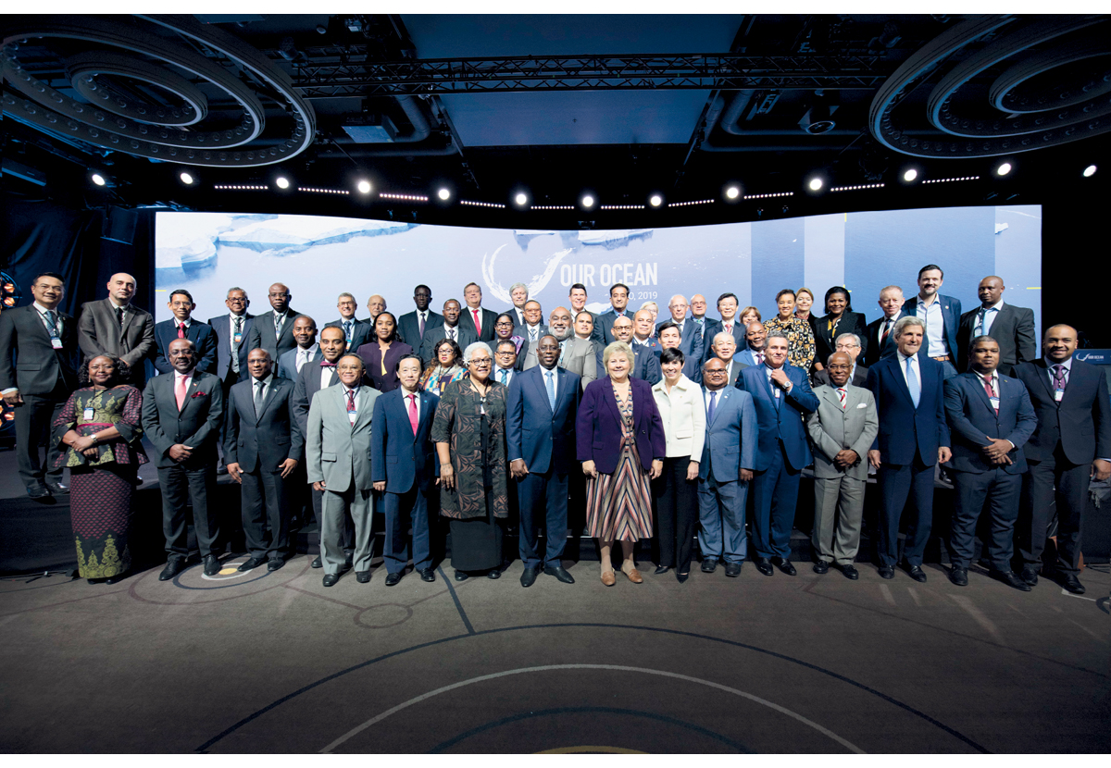
          - High-level participants at the 2019 Our Ocean conference.
Photo: Stine Østby/Medvind
Norway’s ocean policy and international relations
Ocean-related issues are a key part of Norway’s cooperation with most countries and regional and international organisations. The substance of the cooperation will vary, but may include promotion of Norwegian ocean industries, ocean-related development cooperation, research cooperation and cooperation to promote the international ocean agenda. A more strategic ocean dialogue has been started with some countries, as a forum for sharing experience and expertise and cooperating on possible action for clean and healthy oceans, sustainable use of ocean resources and growth in the blue economy. The formal dialogue framework and broad-based approach allow for a strategic exchange of views on approaches to ocean management and cooperation to promote international action. In addition to representatives from relevant public authorities, these dialogues may include participants from academia, business and civil society. An ocean dialogue was established with Australia in 2018 and with India in 2019. There are plans to establish similar arrangements with Indonesia and China in 2020. Norway is also seeking to strengthen its dialogue on ocean affairs with key European countries and with organisations such as the African Union and the Association of Southeast Asia Nations (ASEAN).
Marine litter and the spread of microplastics
Norway has been working for some years to enhance international cooperation to address the problem of marine litter and plastic waste. In 2017, following an initiative by Norway, the UN Environment Assembly reached agreement on a long-term zero vision to eliminate discharges of plastics and microplastics to the oceans. Norway is advocating a more concerted international effort to achieve this. In Norway’s view, the most important development will be to put in place a new global instrument obliging all countries to take action to halt inputs of plastic waste and microplastics to the oceans and the environment generally. An agreement must cover all sea- and land-based sources, and must lead to stronger and more targeted action and more effective use of resources.
Norway established a development programme to combat marine litter and microplastics in 2018. This is intended to play a part in achieving one of the targets of SDG 14, which is to prevent and significantly reduce marine pollution of all kinds by 2025, particularly from land-based activities. NOK 1.6 billion has been allocated to the programme for the period 2019–2022. The transfer of knowledge and expertise on marine litter and microplastics will also be part of the Oceans for Development programme.
Norway is playing a key role in implementation of the IMO action plan to address marine plastic litter from shipping and fisheries. In 2019, Norway entered into an agreement with IMO, which in cooperation with FAO is launching the Glo-Litter Partnerships Project. The purpose of the project is to assist developing countries to implement the IMO plastics action plan. Norway also gives high priority to Nordic cooperation, and during its most recent chairmanship of the Nordic Council, used its long experience of retrieving lost fishing gear to establish the Clean Nordic Oceans project. Norway is also following up the IMO action plan on marine plastic litter as part of regional cooperation on the marine environment under OSPAR, and in the development of a regional action plan on marine litter under the Arctic Council. In 2019, Norway became a member of the Global Ghost Gear Initiative, and intends to support specific projects to tackle the problem of lost and abandoned fishing gear under the initiative. Norway has also taken the initiative for bilateral cooperation on marine litter as part of Norwegian-Russian environmental cooperation and cooperation with a number of other countries.
Development programmes intended to enhance ocean governance
Norway’s model of integrated ocean management is often highlighted internationally as an example for others to follow. Sound ocean management and good governance generally are closely related, and development assistance in this area therefore requires a long-term approach. The development programmes described below are all demand driven, make use of Norwegian experience and public-sector expertise, and are based on scientific cooperation and knowledge sharing. They are intended to support developing countries in building public-sector expertise and capacity through institutional cooperation and by supporting civil society actors, education and research, and industrial development. The following development programmes administered by Norad are particularly relevant in the context of sustainable ocean management:
- Oil for Development was established in 2005, and its objective is economically, socially and environmentally responsible management of petroleum resources in partner countries. This is to be achieved through 1) establishing a legal and regulatory framework for the petroleum sector, 2) building up the capacity of the relevant administrative authorities, and 3) increasing transparency in management of the petroleum sector and holding the authorities accountable. The programme collaborates with public authorities and civil society organisations.
- Fish for Development was established in 2016 with the objective of increasing the ability of fisheries and aquaculture to contribute to socio-economic development in partner countries, for example through higher employment and better food and nutrition security. Programme activities are intended to help public authorities to build up their capacity for sustainable management, encourage research and educational institutions to assist the authorities and businesses with knowledge, data and advice about sustainable fisheries and aquaculture, and ensure that businesses exploit fisheries resources and engage in aquaculture production in a sustainable manner. The largest area of investment under Fish for Development is the EAF-Nansen programme, which involves cooperation between Norad, FAO, the Institute of Marine Research and the Directorate of Fisheries.
- Oceans for Development was launched in Oslo during the Our Ocean conference in October 2019, and is now being established. It is intended to supplement existing ocean-related programmes and initiatives and will focus on integrated ocean management, cross-sectoral coordination and a framework for sustainable ocean industries. Regional cooperation will also be a key element of the programme.
Norway has also played an active role in the establishment of the PROBLUE multi-donor trust fund in the World Bank system. Its overall goal is to achieve integrated, sustainable economic development and clean, healthy oceans. Activities will include analytical work, generating and sharing knowledge, supporting policy reform and encouraging private and public investment to support the ocean economy. PROBLUE focuses on four key themes: sustainable fisheries and aquaculture; marine litter and pollution management; sustainable development of key oceanic sectors; and building government capacity for integrated management of marine and coastal resources. The fund was established in 2019. Apart from Norway, donors include Canada, Denmark, the EU, Iceland, France, Germany and Sweden. Norway and the World Bank are co-chairing the Partnership Council of PROBLUE in 2020.
Cooperation to fight maritime crime
Agencies such as the police, coast guard and supervisory authorities often lack sufficient capacity and systems for exchanging information, which makes it very challenging to fight against fisheries and environmental crime and other maritime crime.
In 2018, Norway took the initiative for an international declaration on organised fisheries crime. The declaration has so far been supported by 27 countries, and its aim is to provide a political framework for international cooperation to combat transnational organised fisheries crime. Norway is seeking to strengthen political support for combating transnational organised fisheries crime through a resolution of the UN Commission on Crime Prevention and Criminal Justice.
Modern technology and satellite tracking make it possible to collect data from large areas, and are valuable in the fight against fisheries and environmental crime. Such techniques are particularly important in areas where it can otherwise be difficult to gain a good overview, such as Norway’s northernmost waters. This was further discussed in a white paper on space-related activities (Meld. St. 10 (2019–2020).

UN Decade of Ocean Science for Sustainable Development
The UN General Assembly has proclaimed the period 2021–2030 as the UN Decade of Ocean Science for Sustainable Development, with the aim of enhancing knowledge about the oceans globally. Research activities will be promoted and coordinated at national and global level with a view to achieving the SDGs, particularly SDG 14 on life below water. The objective is not only knowledge development, but also to ensure that knowledge is used in policy development and sustainable use of the oceans.
The two objectives of the Ocean Decade are to generate the scientific knowledge and underpinning infrastructures and partnerships needed for sustainable development of the ocean, and to provide ocean science, data and information to inform policy development in support of the SDGs.
The Intergovernmental Oceanographic Commission (UNESCO-IOC) is responsible for promoting and coordinating ocean science at global level, and has been tasked with planning the Ocean Decade. The IOC is being assisted in this work by an international group of experts. The IOC has drafted a roadmap for the Ocean Decade, and an implementation plan is to be completed in 2020. During the planning phase, research communities, businesses and other stakeholders are being encouraged to participate and provide input. Global planning meetings are being held, and a series of regional workshops is being organised in 2019 and 2020, for example for the North Atlantic and for Arctic seas. Norway is playing an active part in the planning process.
Norwegian marine research is already of a high calibre both nationally and in an international context. The Government’s ocean-related strategies give prominence to research and scientific knowledge, and management of ocean resources and the marine environment and ocean-based commercial activities are expected to be knowledge-based. The High-level Panel for a Sustainable Ocean Economy will be presenting its recommendations as the Ocean Decade begins. It will therefore be vital to ensure coherence between the High-level Panel’s recommendations and the research tasks that must be completed during the decade.
The Ocean Secretariat of the Research Council of Norway has been tasked with national coordination and follow-up of the Ocean Decade. This includes proposing goals for Norway’s efforts, priority research areas and what resources will be needed.
It is important to involve key Norwegian marine research groups and institutions in this planning process, and an expert group has been established to plan Norwegian contributions, initiatives and priorities related to the Ocean Decade. The group includes representatives of relevant research groups, the business sector and interest groups. In addition, dialogue meetings will be organised in various parts of Norway. These arrangements will be important for national coordination and follow-up, and as a means of obtaining input about the best ways of using Norway’s contributions during the Ocean Decade in efforts to achieve the SDGs.

UN Decade of Action on Nutrition (2016–2025)
The UN Decade of Action on Nutrition runs from 2016 to 2025. Under SDG 2, the world has adopted the goal of ending hunger and malnutrition. To provide sufficient safe, nutritious food for a growing population, we will need to produce more food from the oceans. It is therefore logical to coordinate work under the two UN decades. There is a certain potential for harvesting more from the oceans and a considerable potential for increasing aquaculture production, as set out in the report The Future of Food from the Sea commissioned from a group of experts by the Ocean Panel. As part of the Decade of Action on Nutrition, Norway has established an Action Network for Sustainable Food from the Oceans and Inland Waters for Food Security and Nutrition. Food from the oceans provides important nutrients that are often in short supply in other types of food, and seafood production can and should be increased. Norway can make use of its waters to contribute to this, especially by increasing aquaculture production.

Further development of international ocean governance
The Law of the Sea provides a stable and predictable framework for all use of the oceans, but at the same time is constantly being developed and adapted as new challenges arise. Negotiations are currently in progress on an international legal instrument under the Law of the Sea on the conservation and sustainable use of marine biodiversity in areas beyond national jurisdiction. This provides one example of global willingness to enhance the framework for international ocean governance. Another example is the work in progress under the International Seabed Authority to develop a regulatory framework for deep-seabed mining activities in what is known as ‘the Area’ beyond national jurisdiction. The starting point for this work is the provision of the Law of the Sea stating that the resources of the Area are the common heritage of mankind. The purpose of this work is to avoid a situation where only the technologically most advanced states are able to benefit from seabed mineral resources, and at the same time ensure that strict environmental standards are maintained. Norway also considers it important to work towards a regulatory framework that will support the implementation of the SDGs.

Overall framework and measures for conservation and sustainable use of ecosystems in the management plan areas
Norway has a long tradition of taking a long-term approach to ocean resource management for the benefit of society as a whole. The basis for value creation from Norway’s ocean-based activities now and in the future depends on maintaining the value of Norway’s marine and coastal environment, safeguarding the oceans as a source of food and using ocean resources sustainably. In this white paper, the Government describes how it intends to continue and consolidate Norway’s integrated, ecosystem-based ocean management plan system.
This white paper brings together all three management plans for the first time. It includes a revised management plan for the Barents Sea–Lofoten area and updated management plans for the Norwegian Sea and the North Sea and Skagerrak. The management plans previously published for the separate areas have established an overall framework and measures for the conservation and sustainable use of marine ecosystems. The present white paper is based on current policy, and proposes certain new measures.

Oceans and climate change
Ocean management must take into account the increasing impacts of climate change and ocean acidification, while at the same time promoting a green transformation and reducing greenhouse gas emissions.

Adapting to climate change and a warmer ocean
According to the Intergovernmental Panel on Climate Change (IPCC), the oceans are entering a new state as a result of rising CO2 levels and global warming. This may lead to far-reaching impacts on marine ecosystems and living resources, including those in Norwegian waters, which in turn will affect ocean industries and coastal communities. Pressure on ecosystems may be further intensified by ocean acidification and oxygen loss, shrinking sea ice cover and human activity. Achieving sustainable management of Norway’s sea areas will require knowledge about how these factors interact and how the impacts can be limited through ocean management.
The Government will:
- work to ensure climate-resilient management of living marine resources and marine biodiversity so that it is possible to maintain viable populations and ecosystem services as far as possible in a changing climate, and so as to safeguard natural carbon sinks;
- monitor changes in the implications of climate change for marine ecosystems and ocean industries and use the management plans to report on status, trends and implemented and planned measures;
- as part of work on the management plans, conduct a risk analysis for the management plan areas of direct and indirect effects of climate change on marine ecosystems and other relevant factors under different emission scenarios;
- further develop the knowledge base for climate change adaptation in ocean industries and ocean-dependent sectors of society;
- continue to monitor acidification and climate trends and the impacts on vulnerable calcifying organisms such as plankton and corals;
- enhance knowledge of the effects of climate change and ocean acidification on marine ecosystems and how they interact with other pressures.

Green transformation in the ocean industries
Ocean management can play a significant part in the global transition to a low-emission future, a goal that Norway is also pursuing. Norway’s nationally determined contribution under the Paris Agreement has recently been updated and enhanced. The target is to reduce greenhouse gas emissions by at least 50 % by 2030 compared with the 1990 level. It is also a Government target for Norway to be a low-emission society by 2050, where emissions have been reduced by 90–95 %. The Government’s strategy for green competitiveness, which was presented in 2018, links together industrial development and climate action. The Government will facilitate value creation by promoting the establishment of new green jobs and encouraging existing businesses to adapt in order to compete as climate policy becomes stricter and technology development proceeds rapidly.
Offshore wind, carbon capture and storage under the seabed, and green shipping are among the areas where Norway has much to offer and where sound ocean management can promote the green transition.
The Government will:
- pursue its ambition of reducing emissions from domestic shipping and fishing vessels by half by 2030, and promote the deployment of zero- and low-emission solutions in all vessel categories;
- promote further green growth and boost the competitiveness of the Norwegian maritime industry and facilitate an increase in exports of low- and zero-emission technology in the maritime sector;
- continue work on carbon storage under the seabed in Norwegian waters as a climate change mitigation measure;
- facilitate restructuring towards low-emission production of seafood;
- facilitate economically viable offshore renewable energy production.

Strengthening the oceans’ capacity for carbon uptake
Marine ecosystems such as kelp forests, seaweed communities and eelgrass meadows absorb CO2 through photosynthesis, thus helping the ocean to absorb much of the CO2 emissions. These ecosystems comprise natural carbon sinks in the ocean and are sometimes called ‘blue forests’. They are also important for marine biodiversity and can protect the coastline against extreme weather events by moderating wave action.
The Government will:
- work to maintain natural carbon sinks and safeguard marine biodiversity;
- enhance knowledge about carbon fixation by marine plankton and marine vegetation types such as kelp forests, seaweed communities and eelgrass meadows, and apply this knowledge to assess potential restoration measures;
- facilitate the development of new ocean industries such as environmentally friendly cultivation of seaweed and kelp as a measure for boosting carbon uptake.

Sustainable use, overall framework for activities and spatial management
The ocean industries are vital to employment and value creation in Norway, and the oceans provide livelihoods for many coastal communities. Norwegian waters contain rich oil and gas resources, which have played a key role in the country’s development. The oceans are also the basis for Norway’s large, sustainable seafood industry and its large maritime industry. Some of the country’s most innovative businesses, jobs and knowledge institutions have their origins in human settlement along the coast and use of the oceans. For the foreseeable future, the oceans will continue to be a vital basis for jobs, value creation and welfare throughout Norway.
The management plans are a tool for spatial management of Norway’s sea areas. Sound knowledge of these areas and marine ecosystems is an essential basis for finding a balance between conservation and sustainable use across sectors. Activities in each management plan area are regulated on the basis of existing legislation governing different sectors.

Sustainable, safe food production from the oceans
Norwegian fisheries and aquaculture management has evolved over many decades as new knowledge has developed, and Norway is one of the world’s leading coastal states in sustainable harvesting and use of the oceans. This development will continue. Monitoring results indicate that concentrations of contaminants are generally below the maximum permitted levels for food safety, but frequent monitoring is needed.
The Government will:
- review the possibility of sustainable harvesting of new species, particularly species lower in the food chain;
- build up knowledge about the impacts on ecosystems of harvesting new species and harvesting at lower trophic levels for all Norwegian sea areas;
- strengthen the knowledge base for the management and sustainable harvesting of snow crab in the Barents Sea.
- continue to collect data on bycatches and assess whether further measures are needed to reduce bycatches of marine mammals in fisheries;
- intensify efforts to prevent and expose fisheries crime;
- support measures and initiatives to improve utilisation of resources and reduce food waste;
- maintain good monitoring systems for documenting healthy and safe seafood.

Offshore aquaculture
Offshore aquaculture will use facilities that can be sited farther from shore than is normal at present. These facilities may be self-propelled or be designed to be towed between locations or to be static, and will produce substantially more than the capacity of current facilities. The environmental problems encountered are expected to be the same as those associated with coastal aquaculture activities, but new issues may also arise. The scale of environmental problems will also depend on whether facilities are fixed or mobile, and whether they use open cages or closed systems.
The Government will:
- develop a legal framework for offshore aquaculture that will facilitate further growth in the aquaculture sector and promote value creation within an environmentally sustainable framework;
- facilitate the availability of adequate knowledge about the vulnerability of biodiversity to the impacts of offshore aquaculture.

Safe, environmentally friendly maritime transport
Maritime activities in Norwegian waters are extensive and varied. The volume of both freight and passenger transport has increased over time, reflected by an increase in shipping. Maritime transport projections indicate that by 2040, distance sailed will increase by about 40 % from the 2013 level.
Maritime transport comprises many shipping segments, a number of which have lower emissions than alternative modes of transport.
Other segments result in substantial emissions to air of pollutants such as nitrogen oxides (NOx) and sulphur oxides (SOx), which have a negative impact on local air quality. From 1 March 2019, Norway introduced stricter requirements for releases to air and water from ships, largely specifically relating to cruise traffic in the West Norwegian Fjords World Heritage Site.
Maritime safety in Norwegian waters is generally high, and the annual number of accidents has been reduced in recent years.
The Government will:
- work to maintain and strengthen the high level of safety in maritime transport;
- consider whether to extend the environmental requirements for shipping in the West Norwegian Fjords World Heritage Site to other fjords in Norway;
- consider whether to extend the current prohibition against carrying heavy bunker oil in the protected areas around Svalbard and introduce a general prohibition in the territorial waters around Svalbard;
- consider whether to introduce size restrictions for ships in the protected areas around Svalbard;
- consider whether to impose stricter requirements relating to discharges of sewage from ships in Norwegian waters;
- consider new measures to prevent the spread of alien organisms through hull fouling and review the introduction of requirements based on IMO’s regulatory framework.

Framework for petroleum activities in the management plan areas
Each of the ocean management plans sets out a framework for petroleum activities in specific geographical areas. The management plans provide a good basis for sound resource management and a predictable regulatory framework for the oil and gas industry. In the light of new knowledge about vulnerable species and habitats and the environmental impacts of oil and gas activities, parts of the framework from the previous management plans have been revised. Some geographical areas, such as the polar front, are no longer specified in the framework for petroleum activities now that more is known about environmental conditions. Certain adjustments have been made to ensure coherence across the management plan areas. The framework for each of the management plan areas is shown in Figures 9.1, 9.2 and 9.3, and the information is also available through the marine spatial management tool on the BarentsWatch portal, https://kart.barentswatch.no/arealverktoy.
The framework for specific geographical areas will be used as a basis in the licensing rounds. Unless otherwise specified, the framework set out below will apply until any changes are made when the management plans are updated.
Framework for petroleum activities that applies to all the management plan areas
The Government will use the following framework as a basis for petroleum activities in all the management plan areas:
- In connection with numbered licensing rounds, and when licences are issued through the system of awards in predefined areas (APA), the authorities will continue to hold public consultations and take into account all available new knowledge about the effects of produced water and drill cuttings and other impacts on the environment and living marine resources;
- New production licences must include requirements for any necessary measures to ensure that the coral reefs and other vulnerable benthic fauna are not damaged by petroleum activities. Operators must be prepared to meet special requirements in order to avoid direct physical damage to the reefs from bottom gear and anchor chains, sediment deposition from drill cuttings and pollution from produced water;
- Continue efforts and follow-up to achieve the zero-discharge target for releases of hazardous substances to the sea from petroleum activities;
- Seek to reduce uncertainty as regards acoustic disturbance and other possible negative impacts of seismic surveys on marine life;
- Establish stricter requirements for activities in vulnerable areas to avoid damage (in line with the risk-based approach of the health, safety and working environment legislation).
Framework for petroleum activities in the Barents Sea–Lofoten area
The Government will use the following framework as a basis for petroleum activities in the Barents Sea–Lofoten area:
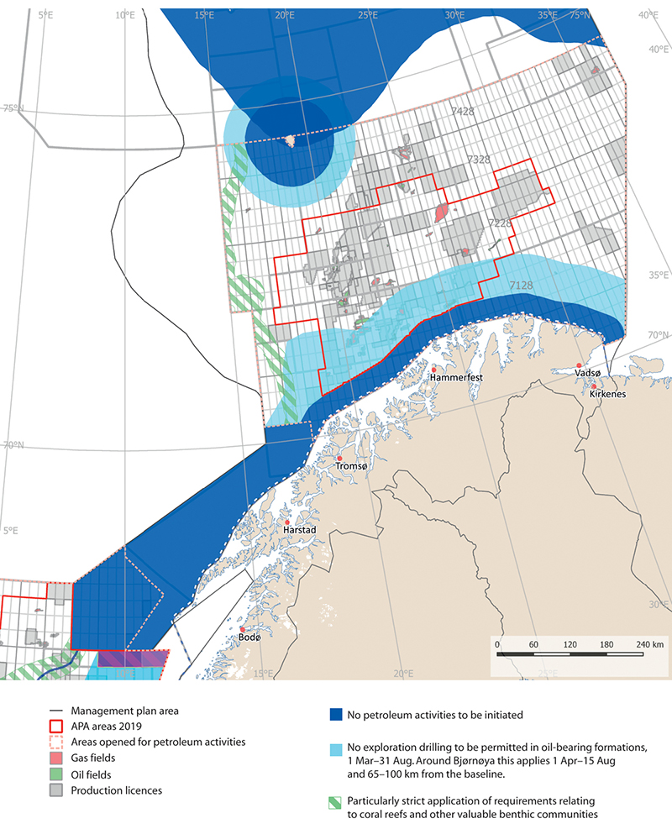
          - Framework for petroleum activities in the Barents Sea–Lofoten area.
Norwegian Environment Agency/Marine spatial management tool
- Coastal waters off Troms and Finnmark county to the Russian border
  - No petroleum activities will be initiated within a zone stretching 35 km outwards from the baseline from the Troms II petroleum province along the coast to the Russian border.
  - In a zone stretching between 35 km and 100 km outwards from the baseline, no exploration drilling in oil-bearing formations will be permitted in the period 1 March–31 August. This will be reviewed when the delimitation of the particularly valuable and vulnerable area ‘coastal waters, Tromsøflaket to the Russian border’ has been completed.
- Tromsøflaket bank area
  - In coastal waters of the Tromsøflaket, restrictions apply corresponding to those set out in the framework for the area ‘coastal waters, Troms and Finnmark county to the Russian border’.
  - No exploration drilling will be permitted in oil-bearing formations on the Tromsøflaket outside 65 km from the baseline in the period 1 March–31 August.
- Eggakanten North
  - There is a general principle that new production licences must include requirements for surveys to identify any coral reefs or other valuable benthic communities that may be affected by petroleum activities and ensure that they are not damaged. This will be particularly strictly applied in the Eggakanten North area. Special conditions may be included in licences in vulnerable areas to avoid damage.
- The marginal ice zone
  - No new petroleum activities will be initiated in areas where sea ice is found on 15 % of the days in April, based on sea ice extent data for the 30-year period 1988–2017. This will apply until any changes are made when the management plans are updated, in 2024 at the earliest.
- Bjørnøya
  - No new petroleum activities will be initiated within a 65-km zone around Bjørnøya.
  - In a zone stretching from 65 km to 100 km outwards from the baseline around Bjørnøya, no exploration drilling will be permitted in oil-bearing formations in the period 1 April–31 August.
- Nordland IV (unopened part), Nordland V (unopened part), Nordland VI (open part), Nordland VI (unopened part), Nordland VII and Troms II
  - The waters off the Lofoten and Vesterålen Islands and Senja will not be opened for petroleum activities and no impact assessments under the Petroleum Act will be carried out in the period 2017–2021.
- Other conditions
  - In areas less than 50 km from observed sea ice, exploration drilling in oil-bearing formations will not be permitted in the period 15 December–15 June.
Framework for petroleum activities in the Norwegian Sea
The Government will use the following framework as a basis for petroleum activities in the Norwegian Sea:
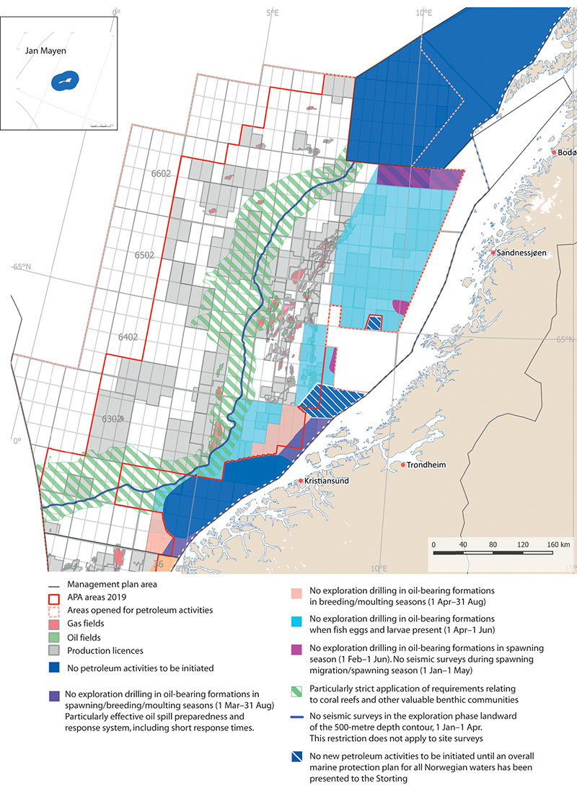
          - Framework for petroleum activities in the Norwegian Sea.
Norwegian Environment Agency/Marine spatial management tool
a) The Møre banks
  - No production licences will be awarded for the Møre banks. This does not apply to the parts of the Møre banks that are included in the system of awards in predefined areas (APA).
b) Halten bank, open part
  - No exploration drilling in oil-bearing formations in the spawning season (1 February–1 June);
  - No seismic surveys during spawning migration/in the spawning season (1 January–1 May);
  - Use of technology to deal with drill cuttings and drilling mud on herring spawning grounds.
c) Sklinna bank, open part
  - No exploration drilling in oil-bearing formations in the spawning season (1 February–1 June);
  - No seismic surveys during spawning migration/in the spawning season (1 January–1 May);
  - Use of technology to deal with drill cuttings and drilling mud on herring spawning grounds;
  - Particularly effective oil spill preparedness and response system, including short response times.
d) Coastal waters, northern part
  - No further opening of areas of coastal waters that are not currently open for petroleum activities.
e) Remman archipelago and coastal waters, southern part
  - No exploration drilling in oil-bearing formations in the spawning season and breeding and moulting seasons (1 March–31 August);
  - Particularly effective oil preparedness and response system, including short response times.
f) Entrance to the Vestfjorden, open part
  - No exploration drilling in oil-bearing formations in the spawning season (1 February–1 June);
  - No exploration drilling in oil-bearing formations in the breeding and moulting seasons (1 March–31 August);
  - No seismic surveys during spawning migration/in the spawning season (1 January–1 May);
  - Particularly effective oil spill preparedness and response system, including short response times.
Delimitation of the area – blocks: 6609/1, 2, 3 and 6610/1, 2, 3, 6611/1, 2.
g) Iverryggen reef
  - No new petroleum activities will be initiated in the Iverryggen reef area until an overall marine protection plan for all Norwegian sea areas has been presented to the Storting.
h) Froan archipelago/Sula reef
  - No new petroleum activities will be initiated in the Froan archipelago/Sula reef area until an overall marine protection plan for all Norwegian sea areas has been presented to the Storting.
i) Eggakanten South
  - There is a general principle that new production licences must include requirements for surveys to identify any coral reefs or other valuable benthic communities that may be affected by petroleum activities and ensure that they are not damaged. This will be particularly strictly applied in the Eggakanten South area. Special conditions may be included in licences to avoid damage.
j) Jan Mayen/West Ice
  - No petroleum activities will be initiated around Jan Mayen.
k) Other areas that have been opened for petroleum activities in the Norwegian Sea
  - No seismic surveys in the exploration phase are to be carried out landward of the 500-metre depth contour in the period 1 January–1 April. This restriction does not apply to site surveys.
  - No exploration drilling in oil-bearing formations in the period 1 April–15 June in the blocks 6204/1,2,3,4,5,7,8 and 6304/12 within the 500-metre depth contour; quadrant 6305 within the 500-metre depth contour, quadrants 6306, 6307, 6407/2,3,5,6,8,9,11,12; 6408/4,7; 6508, 6509, 6510, 6608/3,5,6,7,8,9,10,11,12; 6609, 6610 and 6611.
  - No exploration drilling in oil-bearing formations in the breeding and moulting seasons (1 April–31 August) in the blocks 6204/7,8,10,11; 6306/6,8,9; 6307/1,2,3,4,5,7.
Framework for petroleum activities in the North Sea and Skagerrak
The Government will use the following framework as a basis for petroleum activities in the North Sea and Skagerrak:
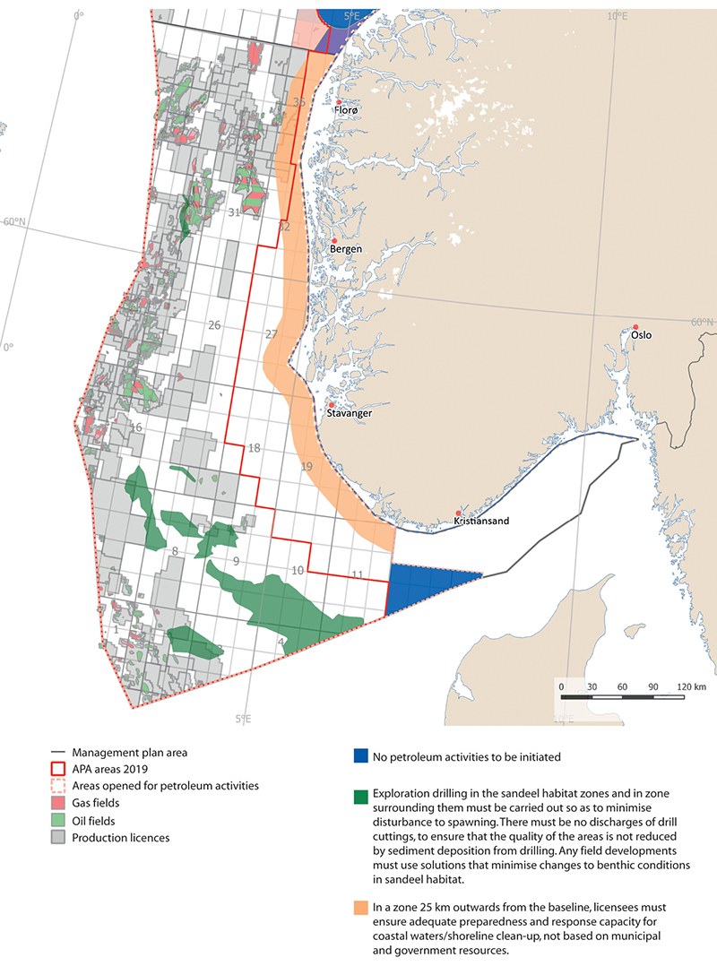
          - Framework for petroleum activities in the North Sea and Skagerrak.
Norwegian Environment Agency/Marine spatial management tool
a) Skagerrak
  - No petroleum activities will be initiated in the Skagerrak.
b) North Sea coastal waters
  - In a zone stretching 25 km outwards from the baseline, licensees must ensure adequate preparedness and response capacity for coastal waters and shoreline clean-up that is not based on municipal and government resources.
c) Sandeel habitat south and sandeel habitat north (Viking Bank)
  - Exploration drilling in the areas of sandeel habitat and in a zone surrounding them must be carried out in a way that minimises disturbance to spawning, and there must be no discharges of drill cuttings, to ensure that the quality of these areas is not reduced by sediment deposition from drilling activities.
  - Any field developments in these areas must use solutions that keep changes to benthic conditions in the areas of sandeel habitat to a minimum.

Offshore wind power
Offshore wind power is growing globally. The pace of development is rapid and accelerating, particularly in the North Sea. At present, development costs are considerably higher for offshore wind power than for land-based wind power, and there are other challenges associated with offshore industrial activity than with similar land-based activities. The technical and cost-related problems can to some extent be compensated for by better wind conditions offshore, and the fact that larger wind turbines can be built than is possible onshore. Floating wind power may become a substantial energy source if the costs can be reduced sufficiently for it to be competitive. Norwegian ocean industries have considerable maritime and petroleum-related expertise that could play a role in the development of floating wind farms.
Knowledge about the environmental impacts of offshore wind power is variable, depending on the species, geographical area and other matters under consideration. Based on the knowledge available in 2012, the Norwegian Water Resources and Energy Directorate concluded in its strategic impact assessment of offshore wind power in a number of areas of interest that the impacts would vary between undetectable and small for fish, marine mammals and benthic communities and from small to moderate for seabirds, but it also pointed out that mapping of benthic communities in the areas of interest was incomplete.
The Government will:
- open certain areas for licence applications for offshore renewable energy production and adopt regulations under the Offshore Energy Act;
- give weight to new knowledge when assessing whether to open areas and setting environmental requirements for licences, including knowledge about habitat use by seabirds and the impacts of offshore wind power on seabirds;
- build up expertise and knowledge on environmental impacts of offshore wind power.

Extraction of minerals from the seabed
In accordance with the Seabed Mineral Act, an area must as a general rule have been officially opened before licences can be issued for exploration and extraction. Before an area is opened, a strategic environmental assessment must be carried out under the auspices of the Ministry of Petroleum and Energy. A strategic environmental assessment under the Seabed Mineral Act has been started. The Norwegian Petroleum Directorate is working on a resource assessment and study programme. A strategic environmental assessment under the Act is intended to elucidate the possible environmental, industry-related, economic and social impacts of opening an area.
The Government will:
- in accordance with the Seabed Mineral Act, conduct a strategic environmental assessment for mineral extraction on the Norwegian continental shelf.

Sustainable tourism and leisure activities
More and more tourists from around the world are visiting Norway to experience its clean, rich and undisturbed environment. Few countries have as long and varied a coastline as Norway, and the coastal environment, fjords and marine areas have great potential in terms of tourism. However, growing numbers of tourists are putting greater pressure on the environment, resources and coastal communities. Cruise traffic around Svalbard has also increased significantly, and larger ships and more frequent calls are causing problems in a number of areas.
The Government will:
- safeguard the species and habitats that provide the basis for ocean-based tourism and leisure activities;
- build up knowledge about the use of marine and coastal areas for outdoor recreation, leisure activities and nature-based tourism and how people’s experience of these areas is affected by changes in activity levels and environmental status in the management plan areas;
- review whether cruise traffic around Svalbard can be restricted on the basis of preparedness, safety and security and environmental considerations.

Offshore military shooting and exercise areas
Offshore military shooting and exercise areas are essential to the Norwegian Armed Forces’ operational activities and ultimately for national emergency preparedness and crisis management capabilities. When using these areas for exercises or other purposes, it is important to safeguard the environment properly. A review of the future spatial needs of the Armed Forces and the potential for coordinating use of areas set aside for defence-related activities for several purposes is under way. This work will result in changes to the formal status and structure of these areas. Closing down or altering boundaries of some areas, may open up opportunities for civilian uses such as aquaculture or renewable energy production. If any new military shooting and exercise areas are to be established, military and other spatial interests will be weighed up against each other.
The Government will:
- consider changes in offshore military shooting and exercise areas to make their structure more efficient and strengthen the Armed Forces’ operational capabilities.

Coordinated spatial management and coexistence between ocean-based industries
In view of the expected growth in new and emerging ocean industries, the Government will consider whether there are certain geographical areas where many different interests intersect.
The Government will:
- facilitate sound decision-making on coexistence between ocean-based industries and coordinated spatial management by reviewing the impacts, including the economic impacts, of various options for the use of Norway’s marine areas, and will consider potentially conflicting interests in individual cases at political level as necessary.

Measures to ensure good environmental status and conservation of marine ecosystems
Environmental status in Norway’s rich, productive seas is in many respects good, but climate change is having growing impacts. In the North Sea, rising temperatures have resulted in changes in the zooplankton community and a less productive ecosystem. In the Norwegian Sea, climate change is resulting in higher seawater temperatures, and acidification has been registered. The loss of sea ice is causing changes in the ecosystem in the northern part of the Barents Sea. It is vital to maintain efforts to alleviate long-standing environmental problems and to promote continued value creation.

Particularly valuable and vulnerable areas
Particularly valuable and vulnerable areas have been identified as being of great importance for biodiversity and biological production in an entire management plan area. New information about seabird populations has been obtained through the mapping and monitoring programme SEAPOP. Knowledge about the seabed in the particularly valuable and vulnerable areas has been improved and the value of these areas has been confirmed through the MAREANO programme which is mapping the seabed in Norwegian waters.
The Forum for Integrated Ocean Management has begun a review of all the particularly valuable and vulnerable areas identified in the management plan areas on the basis of the new knowledge that has been built up.
The Government will:
- On the basis of the recommendations from the Forum for Integrated Ocean Management, delimit the boundary of the marginal ice zone as a particularly valuable and vulnerable area using the line where ice is found on 15 % of the days in April, as calculated using ice data for the 30-year period 1988–2017;
- by the end of 2021, complete the review of valuable species and habitats and their vulnerability for all the particularly valuable and vulnerable areas identified in the management plan areas;
- review whether areas containing underwater mountains meet the criteria for designation as particularly valuable and vulnerable areas.

Marine protected areas and other effective area-based conservation measures
Conservation measures are needed for a selection of Norway’s marine areas, habitats and ecosystems, both to safeguard valuable biodiversity and ecological functions, and to reduce pressures on and the vulnerability of marine ecosystems that are exposed to climate change and ocean acidification. Marine protected areas and other effective area-based conservation measures can also play a part in maintaining natural carbon sinks, both because physical disturbance of the seabed is avoided and because a healthy flora and fauna in marine and coastal waters contributes to carbon uptake and storage in seabed sediments.
The Government will:
- continue work on the establishment of marine protected areas;
- draw up an overall national plan for marine protected areas in the course of 2020;
- assess the need to protect distinctive and rare species and habitats in deep-sea areas.

Safeguarding species and habitat types
There is still a lack of knowledge about the ecological relationships between different parts of marine ecosystems and about marine habitats that are particularly important for the structure, functioning and productivity of ecosystems. Species that are essential to the structure, functioning and productivity of ecosystems will be managed in such a way that they are able to maintain their role as key species in the ecosystem concerned. The Norwegian Red List for ecosystems and habitat types 2018 indicates which habitat types are at risk of being lost in Norway.
The Government will:
- continue efforts to maintain viable populations of and improve the conservation status of endangered and vulnerable species in Norwegian waters;
- continue efforts to protect coastal cod stocks;
- continue efforts to protect coral reefs and other vulnerable benthic fauna against the use of bottom fishing gear;
- build up knowledge about the occurrence, vulnerability and conservation status of vulnerable and endangered species and habitat types in Norwegian waters.

Improving the situation for seabird populations
Populations of a number of seabirds have shown a considerable decline over time. We know a certain amount about the reasons behind these major changes, but more knowledge is needed about ecological interactions in ecosystems that are important for seabird populations, together with an overview of pressures on seabirds and measures that can be introduced to avoid seabird mortality. Earlier work involving cooperation between seabird experts and marine scientists should be further developed.
A national action plan for seabirds is being drawn up, in which various policy instruments and measures will be considered, including whether certain seabirds should be designated as priority species. Work on seabirds was also discussed further in the white paper on Norway’s national biodiversity action plan (Meld. St. 14 (2015–2016)). Knowledge about seabirds is being built up through the SEAPOP mapping and monitoring programme, including the SEATRACK module, which is mapping the non-breeding distribution of seabirds. A considerable amount of new information on seabird populations in Norwegian waters has been acquired through the programme. It is important to update and further develop this information, since it forms part of the knowledge base on seabirds and on the major marine ecosystems.
The Government will:
- present a national action plan in order to improve the situation for seabird populations;
- establish a permanent monitoring system for seabird bycatches in fisheries and consider targeted measures for reducing the scale of these unintentional bycatches;
- further develop the systematic efforts to build up knowledge about seabirds through the mapping and monitoring programme for seabirds, SEAPOP, including the SEATRACK module for their non-breeding distribution;
- carry out a new total census of breeding, staging and wintering seabirds along the Norwegian coast
- establish cooperation between seabird experts, marine scientists and climate researchers to further develop research on seabirds and marine ecosystems and how climate change will affect food supplies and the viability of Norwegian seabird populations;
- make map services on seabird habitat use available by publishing data through the marine spatial management tool for the ocean management plans.

Preventing the spread of alien species
The spread of invasive alien species is regarded as one of the most serious threats to biodiversity. Alien species can cause severe damage by displacing naturally occurring species. A number of alien species have become established in Norwegian waters. Most of them are benthic plant and animal species found near the coast, such as Pacific oysters (Crassostrea gigas) and japweed (Sargassum muticum). There are various vectors for the spread of marine species across the world’s oceans, for example shipping, aquaculture activities and unintended release.
The Government will:
- continue efforts to reduce numbers of Pacific oysters along the shoreline and around coastal islands and skerries;
- improve knowledge about and monitor the occurrence, spread and impacts of alien species in Norwegian waters.

Reducing pollution by hazardous substances
Monitoring of pollution levels in the management plan areas shows that inputs of most persistent, bioaccumulative and toxic substances and radioactive substances that are monitored are stable or in some cases declining. A slight rise in inputs via air to the Barents Sea has been measured in recent years.
Concentrations of the persistent, bioaccumulative and toxic substances that are monitored in sediments and marine organisms are stable or declining. There are environmental quality standards for a number of pollutants, which have been set at very low levels to protect the most vulnerable ecosystem components. These levels are still exceeded for certain pollutants, including mercury, PCBs and polybrominated diphenyl ethers (PBDEs), in most of the species that are monitored. The management plan goals related to hazardous substances are therefore not considered to have been achieved. The focus on reducing inputs of pollutants must therefore be maintained.
Much more information is still needed to give a complete picture of the levels of hazardous substances in the management plan areas. The monitoring programmes only include a limited selection of substances, and new chemicals are constantly being taken into use.
Transport from other countries with ocean currents and in the atmosphere accounts for a large proportion of inputs of hazardous substances to the management plan areas. Extensive international cooperation is therefore needed to deal with the problem. There are known to be considerable inputs with ocean currents, but only very rough estimates of inputs are available for individual substances, so that there is little information on changes in inputs. Climate change may influence inputs of persistent, bioaccumulative and toxic substances and other pollutants to the management plan areas.
The Government will:
- work for a stricter international regime governing persistent, bioaccumulative and toxic substances through instruments including the Stockholm Convention, the Minamata Convention and the regional Convention on Long-Range Transboundary Air Pollution;
- continue monitoring and mapping of hazardous substances in marine ecosystems;
- continue screening studies to detect new persistent, bioaccumulative and toxic substances in the management plan areas and develop new methods to make it easier to detect the potentially most dangerous pollutants;
- build up knowledge about the cumulative impacts on marine ecosystems of long-range transport of hazardous substances and about inputs from different sectors;
- build up knowledge about the combined effects of climate change and hazardous substances on marine ecosystems.

Combating marine litter and microplastics
It is still uncertain how much waste ends up in the marine environment in Norway. No data are available for estimating the total quantity of waste in Norway’s marine and coastal areas. To ensure effective reduction of inputs of plastic litter and microplastics to the marine environment, national and international measures must be designed so that they are targeted as precisely as possible to give the best possible effect. To do this, better documentation is needed of established and new sources and the quantities that come from different sources. Effective waste recovery as close to the sources as possible will also be required to reduce the quantity of plastic waste in the marine environment. There must be a systematic effort to ensure the use of the best available and up-to-date scientific knowledge, which may involve training, regulatory measures, agreements or other instruments in relevant industries and sectors. International cooperation will also be of crucial importance for reducing marine litter in the management plan areas.
The Government will:
- intensify monitoring of marine litter and microplastics in the marine and coastal environment;
- revise Norway’s strategy to combat marine plastic waste and the spread of microplastics;
- introduce legislation on the delivery free of charge for waste retrieved at sea, in line with the revised Port Reception Facilities Directive;
- assess how producer responsibility for fishing gear and aquaculture equipment best can be implemented in Norway, in line with the directive on reducing the impact of certain plastic products on the environment;
- take steps to improve the coordination and efficiency of clean-up and retrieval operations in Norway, including developing and deploying digital tools and maintaining central government involvement, for example through the Norwegian Centre for Oil Spill Preparedness and Marine Environment.

Underwater noise
Ambient noise levels are rising, primarily a result of the growing volume of shipping. Noise can disturb acoustic communication between marine mammals and make it more difficult for them to find and catch food and to navigate. Intense sound pulses produced by seismic activity, military sonar, detonations and pile-driving can result in behavioural changes in fish and marine mammals. Although much more has been learned over the past 10–15 years, little specific information is available about how noise pollution over time, often combined with other pressures, may affect populations of vulnerable species.
The Government will:
- build up knowledge about the impacts of underwater noise on fish and marine mammals;
- establish pressure indicators for underwater noise and harmonise them with the OSPAR system.

Strengthening preparedness and response to acute pollution
Norway’s goal is to keep the risk of environmental damage from acute pollution at a low level, and to make continuous efforts to reduce it further. The environmental authorities need information on the potential environmental consequences, the severity of the potential consequences and the associated uncertainty when assessing levels of environmental risk.
The Government will:
- continue the establishment of test and exercise facilities for oil spill response equipment at Fiskebøl in Nordland county;
- continue to play a part in developing a preparedness and response system for Arctic waters, partly in response to recommendations by the Office of the Auditor General in a report on the authorities’ efforts to safeguard the environment and fisheries in connection with petroleum activities in the Arctic;
- continue the development of Norway’s nuclear emergency preparedness system under the leadership of the Crisis Committee for Nuclear Preparedness.

Strengthening the knowledge base – mapping, research and monitoring
More knowledge and a better understanding are needed of ecosystem function and the impacts on ecosystems of factors such as human activity, climate change, ocean acidification, pollution and plastic and microplastics. This understanding is a vital basis for sustainable use of natural resources, innovation and economic development. Marine research and monitoring are international in nature, and are of crucial importance for effective international cooperation on ocean management.
There is a pressing global need for more knowledge about the oceans, mapping and monitoring of different areas, and sharing of experience and expertise. Norway supports international processes to develop the necessary knowledge, for example through the Intergovernmental Panel on Climate Change (IPCC) and the Intergovernmental Science-Policy Platform on Biodiversity and Ecosystem Services (IPBES). Administrative bodies in individual countries need more detailed knowledge, but many countries do not have sufficient capacity to acquire the knowledge they need. Norway is a world leader in several areas of marine research, and shares and develops its knowledge through extensive international cooperation.

Marine ecosystems
Basic knowledge about marine ecosystems, natural fluctuations and the impacts of human activity is needed to develop an integrated ecosystem-based ocean management regime.
More knowledge and a better understanding are needed of ecosystem function, the impacts on ecosystems of climate change, ocean acidification, pollution, plastic and microplastics, and physical pressures arising from human activity. Better methods of estimating the cumulative impacts on marine ecosystems should be developed.
To make it possible to evaluate progress towards the goals set in the ocean management plans, a system for coordinated monitoring of environmental status has been established, based on a representative set of indicators. The indicator set needs to be further developed to include more pressure and impact indicators, and should be coordinated with relevant work under OSPAR. Monitoring and measuring environmental status in the marine environment will be coordinated with the system of scientifically based criteria and management objectives for good ecological status, which is being developed.
The Government will:
- build up knowledge about marine ecosystems and how they are changing as a result of greater human activity, climate change and pollution;
- build up knowledge about the role of marine ecosystems in global climate evolution;
- improve knowledge about the links between marine and coastal ecosystems;
- further develop the monitoring system for ecosystems and environmental status in the management plan areas, and coordinate it with relevant elements of the OSPAR monitoring system;
- consider the use of satellite data in monitoring Norwegian waters;
- continue to support the development of research infrastructure and good test facilities for the ocean industries; this includes work on Ocean Space Laboratories.

Mapping marine habitat types and the seabed – the MAREANO programme
The interdisciplinary MAREANO programme maps the seabed in Norway’s marine and coastal waters, and provides information on the seabed based on its own surveys and syntheses of existing data. Information provided by the programme is used to promote sustainable management and the development of ocean-based industries.
The MAREANO programme has registered many new coral reefs, and as a result, a further ten areas of cold-water coral reefs in Norwegian waters were given special protection by designation as marine protected areas under the Marine Resources Act. Information from the programme has also resulted in the closure of fisheries in areas around Svalbard, for example to protect sea pen communities. Knowledge acquired through the MAREANO programme, for example about vulnerable habitat types such as coral reefs, gorgonian forests and sponge communities, is important for sustainable management of the seabed. More knowledge is needed about habitat-forming species such as sea pens and soft corals that have a dispersed distribution pattern, and about species and habitats in deep-sea areas. Data obtained through the MAREANO programme is being used for marine ecosystems in the preparation of maps of ecological information for Norway. The Norwegian system for classifying habitats, ecosystems and landscapes developed by the Norwegian Biodiversity Information Centre will be used to describe variation in the marine environment.
The Government will:
- continue the MAREANO programme for mapping the seabed in Norway’s marine and coastal waters;
- continue to map important marine habitat types, including endangered and vulnerable habitat types such as coral reefs and deep-sea species and habitat types.

International ocean cooperation
Norway advocates integrated, ecosystem-based management and the inclusion of key topics such as sustainable fisheries management, the oceans as a source of food, climate change, ocean acidification and marine litter in international ocean cooperation.
The IPCC’s special report on the ocean and cryosphere points out that pollution, runoff and other factors that have negative impacts on marine ecosystems also make them more vulnerable to climate change. Reducing other forms of pollution and environmental pressures is therefore an important approach for ensuring that the oceans can be used as a basis for nature-based solutions to the problem of climate change. International cooperation will be vital for the development of a basis for forward-looking, climate-resilient ocean management. This cooperation includes ocean-related processes during the UN General Assembly and within specialised agencies such as FAO and UNESCO and programmes such as UNEP, work in the regional fisheries management organisations, cooperation under the OSPAR Convention, and cooperation on implementation of the Convention on Biological Diversity and agreements on reducing pollution.
The UN Decade of Ocean Science for Sustainable Development (2021–2030) is intended to generate knowledge that can be used in achieving the Sustainable Development Goals. The new knowledge it generates will also benefit Norwegian ocean management and the Norwegian ocean industries. Norway’s promotion of knowledge generation through mapping, research and environmental monitoring during the ocean science decade will also be useful in the global effort to develop knowledge of the oceans. The ocean science decade overlaps with the UN Decade of Action on Nutrition (2016–2025), and will be able to supply knowledge that can be used in promoting food from the oceans in efforts to achieve food security and improved nutrition.
The Government will:
- continue to promote integrated, ecosystem-based management in international ocean cooperation;
- advocate using knowledge about the impacts on the oceans of climate change in combination with other factors as a basis for work in relevant international forums and agreements;
- work internationally towards sustainable management and restoration of existing carbon sinks in marine ecosystems, such as mangrove forests, eelgrass meadows and kelp forests;
- work towards a new comprehensive global agreement to combat marine litter and microplastics, which will have the aim of eliminating inputs from all ocean- and land-based sources;
- continue to support the efforts of developing countries to combat marine litter and plastic waste;
- through participation in international research cooperation, play a part in building up knowledge about global sources and environmental impacts of marine litter and microplastics;
- continue cooperation on the marine environment within OSPAR to ensure good ecological status in Norwegian waters and the North East Atlantic as a whole;
- strengthen cooperation on fisheries management measures in the North East Atlantic Fisheries Commission (NEAFC), including cooperation on the protection of vulnerable areas against fisheries activities;
- promote the role of seafood in achieving global food security and improved nutrition, for example through the Global Action Network Sustainable Food from the Oceans and Inland Waters for Food Security and Nutrition as part of the UN Decade of Action on Nutrition;
- strengthen ocean cooperation under the Nordic Council of Ministers and the Arctic Council, and continue cooperation with Russia on the marine environment;
- take the initiative for an assessment by the Arctic Council of future ecological impacts of climate change on the marine environment in the Arctic;
- encourage Norwegian participation in the UN Decade of Ocean Science for Sustainable Development and in the mission area on healthy oceans in the new EU research and innovation framework programme;
- by establishing the Oceans for Development programme, assist developing companies to establish and comply with a framework for integrated, sustainable ocean management, and through this contribute to food security, sustainable value creation and employment in an inclusive ocean economy;
- assist with capacity development in recipient countries to promote understanding and implementation of the Convention on the Law of the Sea as a basis for conservation and sustainable use of marine resources.

Further development of the management plan system
It will soon be 20 years since Norway began the development of its system of integrated ocean management plans. Including the present white paper, eight white papers on the management plans have been presented to the Storting (Norwegian parliament). However, this is the first time all of Norway’s integrated ocean management plans have been presented together in one white paper. This approach will make the management plan system more dynamic and flexible, and will for example make it possible to focus on specific topics across all three management plan areas. The Forum for Integrated Ocean Management and the Advisory Group on Monitoring provide an efficient framework for work on the scientific basis for the management plans, and there is a smoothly functioning monitoring system for all three management plan areas. The management plan system now has the capacity to compile a sound, up-to-date scientific basis for a new white paper on the management plans every four years, as requested by the Storting.
The mandates of the Forum for Integrated Ocean Management and the Advisory Group on Monitoring will be reviewed on the basis of experience from the preparation of the scientific basis for the present white paper, with a view to maintaining scientific integrity and ensuring effective use of resources. Participation by a range of stakeholders is an important part of the management plan work. There are plans to make the scientific results of work on the management plans more readily available in order to strengthen stakeholder participation.
The Government will:
- present a new white paper to the Storting on the integrated ocean management plans every four years;
- review the mandates of the Forum for Integrated Ocean Management and the Advisory Group on Monitoring with a view to ensuring high scientific quality and effective use of resources;
- continue the development of digital systems for communication information on Norway’s ocean management plans;
- ensure that public authorities that own data make their datasets and information available for use in the marine spatial management tool for the management plans;
- promote closer dialogue between local, regional and national authorities by making use of the forum for dialogue on ocean issues in the management plan work. The forum involves representatives of the Government, the counties, the Sámediggi (Sami parliament) and the coastal municipalities. Others are invited to take part when appropriate.

Economic and administrative consequences
This white paper focuses mainly on the further development of existing policy instruments and measures. Management of Norway’s seas and oceans is to be based on the best possible knowledge, and the intention is to strengthen the knowledge base for ecosystem-based management of Norwegian waters through mapping, monitoring and research.
Measures announced in this white paper will be funded within the existing budgetary framework. If any additional funding is needed, proposals for priority areas will be put forward in the ordinary budgetary processes. Follow-up of measures in the years to come will depend on economic developments and the budget situation.
The economic and administrative consequences of the measures proposed in the white paper can be predicted with varying degrees of accuracy, but as the proposals are implemented, the consequences for public and private actors will be assessed in the usual way as set out in Norway’s official instructions for planning and management of central government programmes and projects.
The Ministry of Climate and Environment
recommends:
that the Recommendation from the Ministry of the Environment concerning Norway’s integrated ocean management plans dated 24 April 2020 should be submitted to the Storting.

Scientific basis and reports commissioned for this white paper
Reports from the Forum for Integrated Ocean Management:
Næringsaktivitet og påvirkning – Faggrunnlag for revisjon av forvaltningsplanen for Barentshavet og havområdene utenfor Lofoten. [Ocean industries and associated pressures and impacts – Scientific basis for revision of the management plan for the Barents Sea–Lofoten area] M-1245/2018.
Status for gjennomføring og effekt av tiltak – Faggrunnlag for revisjon av forvaltningsplanen for Barentshavet og havområdene utenfor Lofoten. [Status report on implementation and effects of measures – Scientific basis for revision of the management plan for the Barents Sea–Lofoten area] M-1179/2018.
Økosystemtjenester – grunnlaget for verdiskaping – Faggrunnlag for revisjon av forvaltningsplanen for Barentshavet og havområdene utenfor Lofoten. [Ecosystem services as the basis for value creation – Scientific basis for revision of the management plan for the Barents Sea–Lofoten area] M-1178/2018.
Status for gjennomføring og effekt av tiltak – Faggrunnlag for oppdatering av forvaltningsplan for Norskehavet og for Nordsjøen–Skagerrak. [Status report on implementation and effects of measures – Scientific basis for revision of the management plan for the North Sea–Skagerrak] M-1244/2018.
Vurdering av måloppnåelse – Faggrunnlag for revisjon og oppdatering av forvaltningsplanene for havområdene. [Assessment of progress towards goals – Scientific basis for revision of the ocean management plans] M-1302/2019.
Næringsaktivitet og påvirkning – Faggrunnlag for oppdatering av forvaltningsplan for Norskehavet og for Nordsjøen–Skagerrak. [Ocean industries and associated pressures and impacts – Scientific basis for revision of the management plan for the North Sea–Skagerrak] M-1280/2019.
Samlet påvirkning og miljøkonsekvenser – Faggrunnlag for revisjon av forvaltningsplanen for Barentshavet og havområdene utenfor Lofoten. [Cumulative impacts and environmental impacts – Scientific basis for revision of the management plan for the Barents Sea–Lofoten area] M-1299/2019.
Risiko for og beredskap mot akutt forurensning – endringer og utviklingstrekk – Faggrunnlag for revisjon av forvaltningsplanen for Barentshavet og havområdene utenfor Lofoten. [Acute pollution: risk and the preparedness and response system – changes and trends – Scientific basis for revision of the management plan for the Barents Sea–Lofoten area] M-1304/2019.
Særlig verdifulle og sårbare områder – Faggrunnlag for revisjon og oppdatering av forvaltningsplanene for havområdene. [Particularly valuable and vulnerable areas – Scientific basis for revision of the ocean management plans] M-1303/2019.
Verdiskaping i næringene – Faggrunnlag for revisjon av forvaltningsplan for Barentshavet og områdene utenfor Lofoten. [Value creation in the ocean industries – Scientific basis for revision of the management plan for the Barents Sea–Lofoten area] M-1297/2019.
Publications commissioned by the Forum for Integrated Ocean Management:
Polarfrontens fysiske beskaffenhet og biologiske implikasjoner – en verdi- og sårbarhetsvurdering av polarfronten i Barentshavet [Physical features of the polar front and their biological implications – an assessment of the value and vulnerability of the polar front in the Barents Sea]. Fisken og Havet no. 8–2018, Institute of Marine Research. Lien, V. S., Assmy, P., Bogstad, B., Chierici, M., Drinkwater, K. F., Duarte, P., Gjøsæter, H., Hop, H., Ivshin, V., Jørgensen, L. L., Loeng, H., Lydersen, C., McBride, M. M., Buhl-Mortensen, L., Buhl-Mortensen, P., Kessel Nordgård, I., Skjoldal, H. R., Strøm, H., Sundfjord, A., Von Quillfeldt, C. H., Vongraven, D. (2018).
Miljøverdier og sårbarhet i iskantsonen [Valuable species and habitats in the marginal ice zone and vulnerability of the zone] (Brief Report no. 047): Norwegian Polar Institute 2018, 263pp. Von Quillfeldt, C. H., Assmy, P., Bogstad, B., Daase, M., Duarte, P., Fransson, A., Gerland, S., Jørgensen, L. L., Lydersen, C., Kessel Nordgård, I., Renner, A., Sandø, A. B., Strøm, H., Sundfjord, A., Vongraven, D. (2018).
Reports from the Advisory Group on Monitoring:
Statusrapport for Barentshavet: Status for miljøet i Barentshavet og ytre påvirkning – rapport fra Overvåkingsgruppen 2017. [Status report on the Barents Sea environment and external pressures – report from the Advisory Group on Monitoring 2017] Fisken og Havet, special issue 1b-2017, Institute of Marine Research, Arneberg, P and Jelmert, A. (Ed.).
Statusrapport for Nordsjøen og Skagerrak: Status for miljøet og ytre påvirkning i Nordsjøen og Skagerrak – rapport fra Overvåkingsgruppen 2018. [Status report on the North Sea–Skagerrak environment and external pressures – report from the Advisory Group on Monitoring 2018] Fisken og Havet, special issue 3–2018, Institute of Marine Research, Arneberg, P., van der Meeren, G.I. and Frantzen, S. Ed.) (2018).
Statusrapport for Norskehavet: Status for miljøet i Norskehavet – Rapport fra Overvåkingsgruppen 2019. [Status report on the Norwegian Sea environment – report from the Advisory Group on Monitoring 2018] Fisken og havet, no. 2019–2, Institute of Marine Research, Arneberg, P., Frantzen, S. and van der Meeren, G.I. (Ed.) (2019).

Indicators used in the monitoring system
A set of state and pressure indicators are used to monitor conditions in the management plan areas. The results are reported to the management plan system. The results and further information about the indicators are also available at https://miljostatus.miljodirektoratet.no/tema/hav-og-kyst/havindikatorer/ (in Norwegian only).
Barents Sea
02N1xx2
Topic | Indicator
Ocean climate | Temperature, salinity and nutrients in the Barents Sea
 | Transport of Atlantic water into the Barents Sea
 | Sea ice extent in the Barents Sea
Plankton | Phytoplankton biomass and production in the Barents Sea
 | Species composition of phytoplankton in the Barents Sea
 | Spring bloom of phytoplankton in the Barents Sea
 | Species composition of zooplankton in the Barents Sea
 | Zooplankton biomass in the Barents Sea
Fish stocks | Juvenile herring in the Barents Sea
 | Capelin in the Barents Sea
 | Blue whiting in the Barents Sea
 | Northeast Arctic cod in the Barents Sea
 | Greenland halibut
 | Golden redfish
 | Beaked redfish
Benthos | Red king crab
 | Coral reefs, soft corals and sponge communities in the Barents Sea
 | Benthic fauna in the Barents Sea
Seabirds and marine mammals | Kittiwakes in the Barents Sea
 | Common guillemots in the Barents Sea
 | Puffins in the Barents Sea
 | Brünnich’s guillemots in the Barents Sea
 | Spatial distribution of seabirds in the Barents Sea
 | Spatial distribution of whales in the Barents Sea
Alien species | Alien species in the Barents Sea
Threatened species and habitat types | Threatened species and habitat types in the Barents Sea
Pollutants | Pollutants in mussels along the coast of North Norway
 | Pollutants in polar bears in the Barents Sea
 | Pollutants in capelin in the Barents Sea
 | Pollutants in Brünnich’s guillemots in the Barents Sea
 | Pollutants in polar cod in the Barents Sea
 | Pollutants in shrimps in the Barents Sea
 | Pollutants in ringed seals in the Barents Sea
 | Pollutants in sediments in the Barents Sea
 | Pollutants in cod in the Barents Sea
 | Inputs of hazardous substances from the atmosphere to the Barents Sea
 | Radioactivity in seaweed along the Barents Sea coast
 | Beach litter in Svalbard
 | Inputs of pollutants via rivers to the Barents Sea
Human activity | Fish mortality
Advisory Group on Monitoring, status report on the Barents Sea, 2017
Norwegian Sea
02N1xx2
Topic | Indicator
Ocean climate | Ocean acidification
 | Temperature, salinity and nutrients in the Norwegian Sea
 | Transport of Atlantic water into the Norwegian Sea
Plankton | Phytoplankton biomass in the Norwegian Sea
 | Species composition of phytoplankton in the Norwegian Sea
 | Spring bloom of phytoplankton in the Norwegian Sea
 | Warm-water zooplankton in the Norwegian Sea
 | Zooplankton biomass in the Norwegian Sea
Fish stocks | Norwegian spring-spawning herring in the Norwegian Sea
 | Mackerel in the Norwegian Sea
 | Blue whiting in the Norwegian Sea
 | Northeast Arctic saithe in the Norwegian Sea
 | Tusk in the Norwegian Sea Brosme
 | Ling in the Norwegian Sea
 | Greenland halibut
 | Golden redfish
 | Beaked redfish
Seabirds and marine mammals | Hooded seals in the Norwegian Sea
 | Kittiwakes in the Norwegian Sea
 | Common guillemots in the Norwegian Sea
 | Puffins in the Norwegian Sea
 | Shags in the Norwegian Sea
 | Common eider in the Norwegian Sea
Alien species | Alien species in the Norwegian Sea
Threatened species and habitat types | Threatened species and habitat types in the Norwegian Sea
Pollutants | Pollutants in coastal cod in the Norwegian Sea
 | Pollutants in Norwegian spring-spawning herring in the Norwegian Sea
 | Pollutants in shrimps in the Norwegian Sea
 | Pollutants in sediments in the Norwegian Sea
 | Inputs of hazardous substances from the atmosphere to the Norwegian Sea
 | Pollutants in Greenland halibut in the Norwegian Sea
 | Pollutants in mussels along the Norwegian Sea coast
 | Hazardous substances in tusk in the Norwegian Sea
 | Hazardous substances in hooded seals
 | Hazardous substances in blue whiting in the Norwegian Sea
 | Hazardous substances in seabirds in the Norwegian Sea
 | Radioactive pollution in seawater in the Norwegian Sea
 | Inputs of pollutants via rivers to the Norwegian Sea
Human activity | Fish mortality in the Norwegian Sea
 | Inputs of oil from petroleum installations in the Norwegian Sea
Advisory Group on Monitoring, status report on the Norwegian Sea, 2019
North Sea and Skagerrak
02N1xx2
Topic | Indicator
Ocean climate | Ocean acidification in the North Sea and Skagerrak
 | Oxygen levels in bottom water in the Skagerrak
 | Sea temperatures in the North Sea and Skagerrak
 | Transport of water masses in the North Sea and Skagerrak
 | Nutrients in the Skagerrak
Plankton | Phytoplankton biomass and production in the Skagerrak
 | Spring bloom of phytoplankton in the North Sea
 | Species composition of zooplankton in the North Sea
Fish stocks | North Sea herring
 | Cod in the North Sea
 | Saithe in the North Sea
 | Haddock in the North Sea
 | Norway pout in the North Sea
 | Sandeels in the North Sea
Seabirds and marine mammals | Lesser black-backed gulls in the North Sea and Skagerrak
 | Shags in the North Sea and Skagerrak
 | Cormorants in the North Sea and Skagerrak
 | Common eider in the North Sea and Skagerrak
Alien species | Alien species in the North Sea and Skagerrak
Threatened species and habitat types | Threatened species and habitat types in the North Sea and Skagerrak
Pollutants | Inputs of hazardous substances from the atmosphere to the North Sea and Skagerrak
 | Inputs of pollutants via rivers and from coastal areas to the North Sea and Skagerrak
 | Pollutants in mussels in the North Sea
 | Pollutants in shrimps in the North Sea
 | Pollutants in plaice in the North Sea
 | Pollutants in sandeels in the North Sea
 | Pollutants in cod in the North Sea
 | Pollutants in North Sea herring
 | Imposex in dog whelks along the coast of the North Sea and Skagerrak
 | Radioactivity in seawater in the North Sea
 | Radioactivity in seaweed in the North Sea
 | Oiled common guillemots in southwestern Norway
 | Plastics in fulmar stomachs in the North Sea
 | Chronic exposure of fish to oil in the North Sea
 | Area of seabed contaminated with hydrocarbons (THC) and barium
Human activity | Inputs of oil from petroleum installations in the North Sea
 | Releases of radioactive substances from oil and gas to the North Sea
 | Releases from the nuclear power industry to the North Sea
 | Fish mortality in the North Sea
 | Bottom trawl activity in the North Sea (under development)
Advisory Group on Monitoring, status report on the North Sea, 2018

As shown on the Norwegian Meteorological Institute’s daily ice charts.

