Blue Ocean, Green Future
The Government’s commitment to the ocean and ocean industries

Introduction
The story of Norway is a tale of the ocean. The ocean contributes to value creation and employment along our entire coast, and lays the foundation for some of our most innovative companies and knowledge communities. Norway is rich in natural resources, and we have a long tradition of managing these resources with a long-term perspective to the benefit of society. This has provided the basis for value creation in the ocean industries.
The ocean provides opportunities for growth and employment in areas such as energy production, seafood, medicines and transport. However, the world’s oceans are also facing significant challenges, such as the loss of biodiversity, pollution, rising temperatures and acidification. Building a strong and sustainable ocean economy based on preserving clean and healthy oceans with well-functioning ecosystems, and enabling value creation through sustainable use, is therefore one of the Government’s most important tasks, both nationally and internationally. This will be essential for achieving the United Nations Sustainable Development Goals, and important for overcoming current crises and preventing future crises.
Through this document, the Government wishes to highlight the importance of the oceans for the Norwegian economy and society, and to provide an overview of the status of our commitment to the oceans and ocean industries in recent years. The document is not an exhaustive representation of the Government’s ocean policy, however it identifies the Government’s most important initiatives and results on the national and international stage.
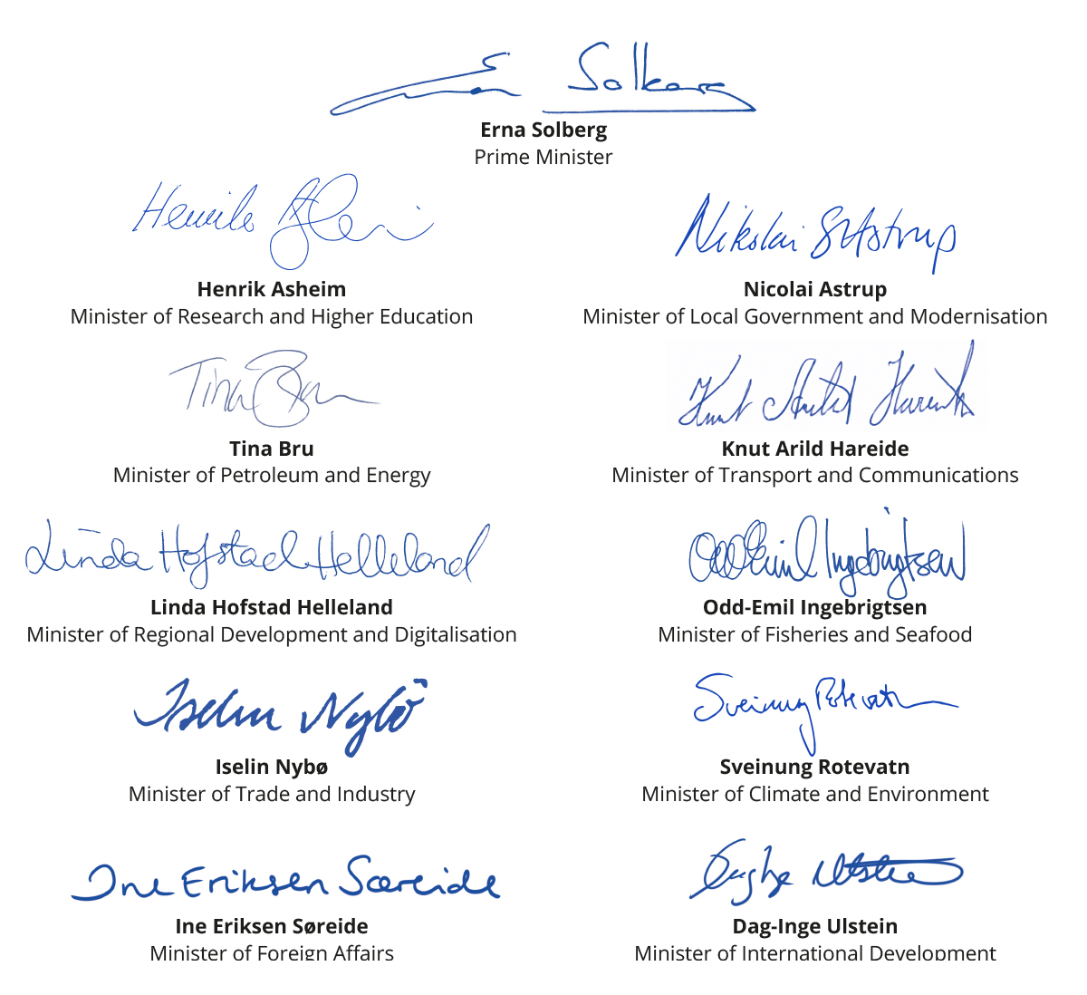

The Government is committed to the ocean and ocean industries
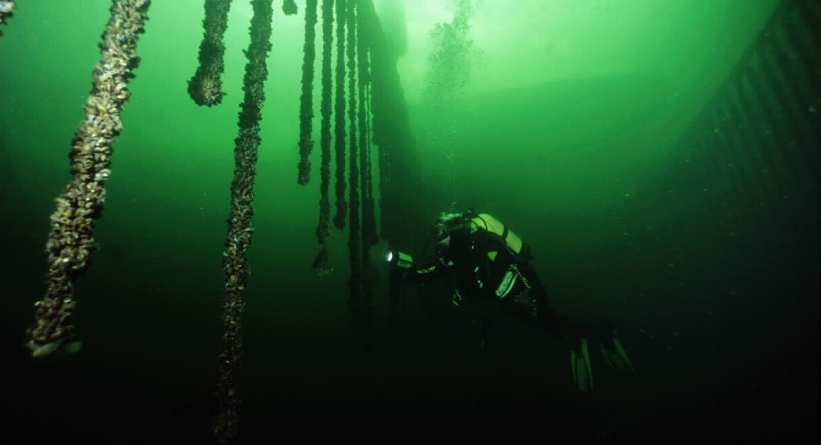
Diving for mussels. Photo: Per Eide Studio, Norwegian Seafood Council.
Since taking office in 2013, the Government has focused on the ocean and ocean industries. Five years ago the Government held a major ocean conference in Bergen and announced that it would present a dedicated ocean strategy. The strategy from 2017, “New Growth, Proud History”, became Norway’s first industrial policy document to include all of Norway’s ocean industries. The Government’s primary objective for the strategy is to contribute to the greatest possible overall value creation and employment in the ocean industries. The white paper on the oceans in Norway’s foreign and development policy and on the white paper on a management plan for the Norwegian Sea were presented that same year.
The Government stated in the Granavolden Government Declaration that it will facilitate further development of oil and gas activities and other ocean industries. There are many opportunities, the commitment is producing results, and developments in the ocean industries are taking place at a rapid rate. This was highlighted in the Government’s updated ocean strategy from 2019, “Blue Opportunities”, which presented the work related to new ocean industries. For example, offshore aquaculture offers both new opportunities for salmon production and the development and export of new technology and knowledge. Furthermore, offshore renewable energy has developed into what could become an important focus area for the Norwegian offshore and maritime equipment suppliers. The “Longship” initiative establishes infrastructure for carbon capture and storage (CCS) that facilitates commercial and technological development. In recent years, we have also seen impressive developments in green shipping. An increasing number of low and zero-emission vessels are in operation along the coast, and new types of fuel such as hydrogen and ammonia are being developed. Sustainable mineral activities on the seabed may also emerge as a new Norwegian industry in the coming years.

The primary challenge facing ocean policy
Combining the preservation of clean and healthy oceans with sustainable use is one of the Government’s most important tasks.
Our use of the ocean is changing, both existing and new ocean industries are being developed, and activity is increasing. The ocean and well-functioning ecosystems will provide us with more jobs, more food and clean energy. We will lay the foundation for a climate-neutral Norway of the future. At the same time, new data has revealed that the state of the world’s oceans is worse than previously thought. Emissions, marine litter and plastic pollution both from onshore and offshore activities create significant challenges, both locally and globally. Marine ecosystems and biodiversity are under pressure. This makes ocean policy and related initiatives both more important and more challenging.
Norway has world-leading players in research, technological development, ocean management and business. We therefore have good prerequisites for being able to achieve a sustainable ocean economy. The Government wants Norway to continue to play a leading role when concerted efforts are now made together with other countries to achieve these goals.
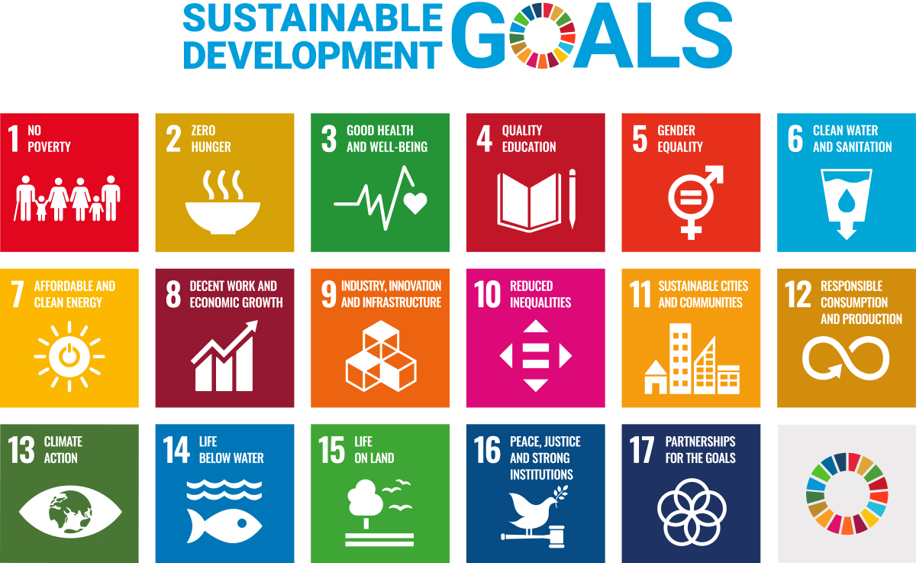

The United Nations 2030 Agenda for Sustainable Development
The 2030 Agenda with the 17 sustainable development goals is the world’s roadmap for eradicating poverty, combating inequality and stopping climate change by 2030. The ambition is to achieve universal prosperity in a manner that is compatible with environmental and climate concerns. Sustainable Development Goal no. 14 is to conserve and sustainably use the oceans, seas and marine resources in a manner that promotes sustainable development. As an ocean economy, Norway is reliant on being able to harvest resources from clean and healthy oceans. The ocean as a source of food, source of energy and transport route must be recognized and further developed, and the environmental value of Norwegian coastal and ocean areas needs to be preserved. Steps must also be taken for sustainable use of the ocean’s resources that will be necessary for achieving the sustainable development goals. The Government’s Action Plan for following-up the sustainable development goals will be presented to the Storting (Norwegian Parliament) by the summer 2021.
The United Nations General Assembly has proclaimed that the decade from 2021 to 2030 will be the United Nations Decade of Ocean Science for Sustainable Development. Achieving the 17 sustainable development goals is the most important driving force behind the initiative. The UN’s Intergovernmental Oceanographic Commission (IOC) is responsible for planning the decade and will coordinate its implementation.

The High Level Panel for a Sustainable Ocean Economy
It is the objective of the Government to create greater international understanding of the connection between the economic importance of the ocean and the environmental status of the ocean. In 2018, Prime Minister Erna Solberg established the High-level Panel for a Sustainable Ocean Economy and invited 13 sitting Heads of State and Government to join. Based on 16 commissioned Blue Papers, three special reports and a main report, the 14 members on the Panel presented a new ocean action agenda in December 2020. The work of the Ocean Panel shows that it is a matter of urgency to develop a holistic approach to ocean management across the globe in order to achieve the environmental, economic and social goals set in the United Nations 2030 Agenda for Sustainable Development.
The 14 world leaders of the Ocean Panel also committed to sustainably manage 100 per cent of the ocean area under national jurisdiction guided by Sustainable Ocean Plans by 2025. This means that in five years’ time, at least 40 per cent of the world’s coastline and 30 per cent of all exclusive economic zones will be covered by integrated management plans. The Ocean Panel also identifies 74 priority actions covering areas such as food, energy, tourism, transport, new ocean industries, minerals, climate change, coastal ecosystems, pollution, equity, knowledge, natural capital accounts, data/technology and finance. The action agenda has been developed with input from over 250 international experts, and an advisory network consisting of the private sector, civil society and international organisations. The Ocean Panel also urged leaders of coastal and ocean states across the globe to join in committing to the 100 per cent goal so that all Exclusive Economic Zones (EEZ) are sustainably managed by 2030. Moving forward, the Ocean Panel will continue its work in spearheading international efforts to implement the new ocean action agenda.

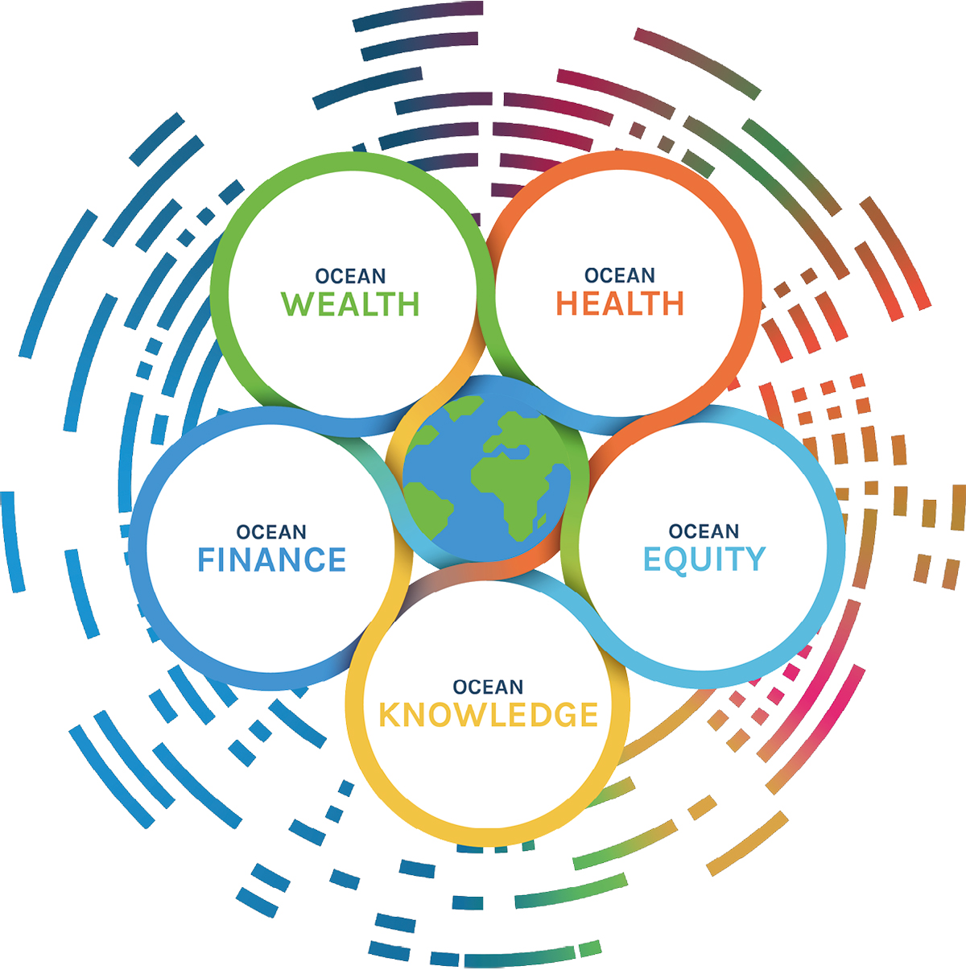
The Ocean Panel’s vision for effective protection, sustainable production and equitable prosperity will require mutually supportive transformations in five areas. Source: High-level Panel for a Sustainable Ocean Economy.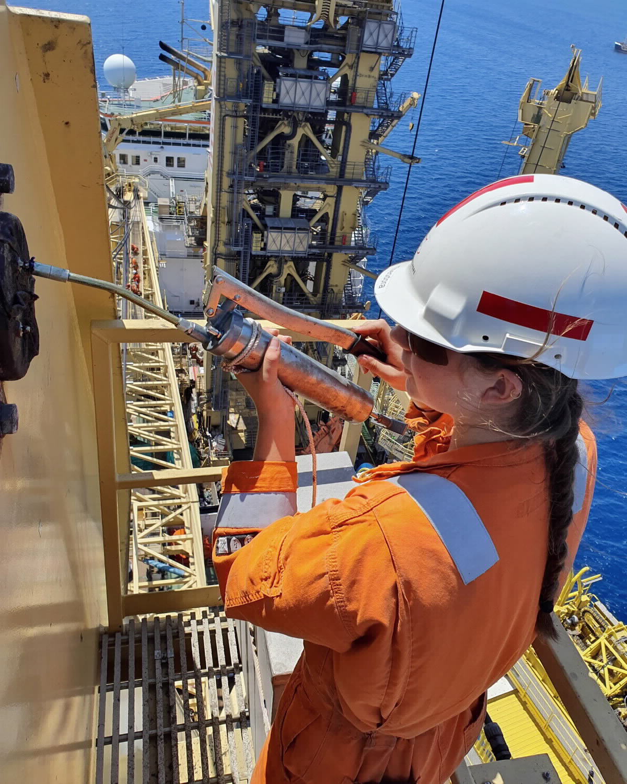
Maritime Career Ambassador Theodora at work. Photo: Theodora Elise Høie.
“We commit to bold transformations towards a sustainable ocean economy where environmental protection and conservation, and economic production and prosperity, go hand in hand. These transformations must unleash the full force of innovation across sectors in technology, finance and governance[…]”
The High-level Panel for a Sustainable Ocean Economy

The Government’s policy for a leading ocean economy
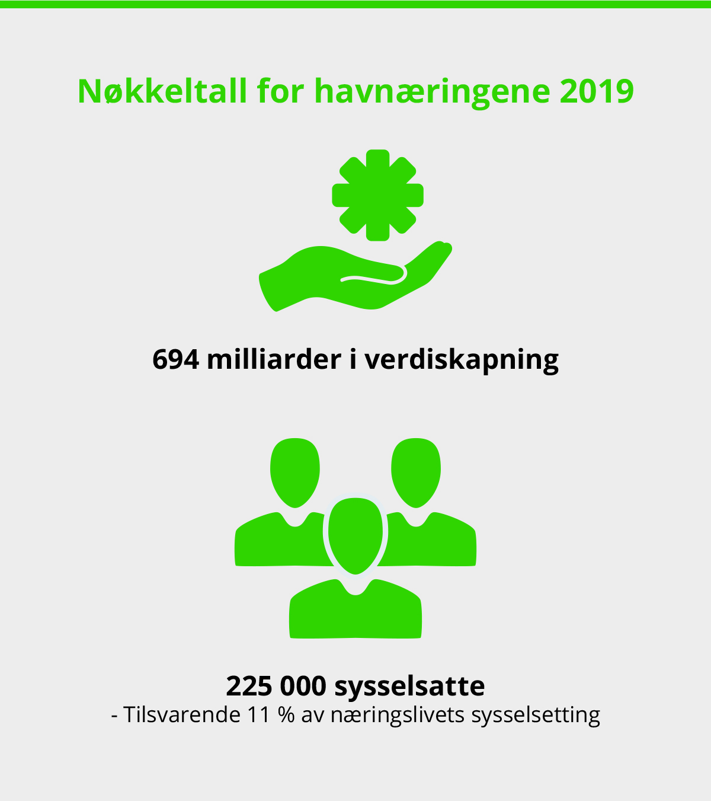
Employment and value creation in the ocean industries. Source: Menon Economics, 2019.
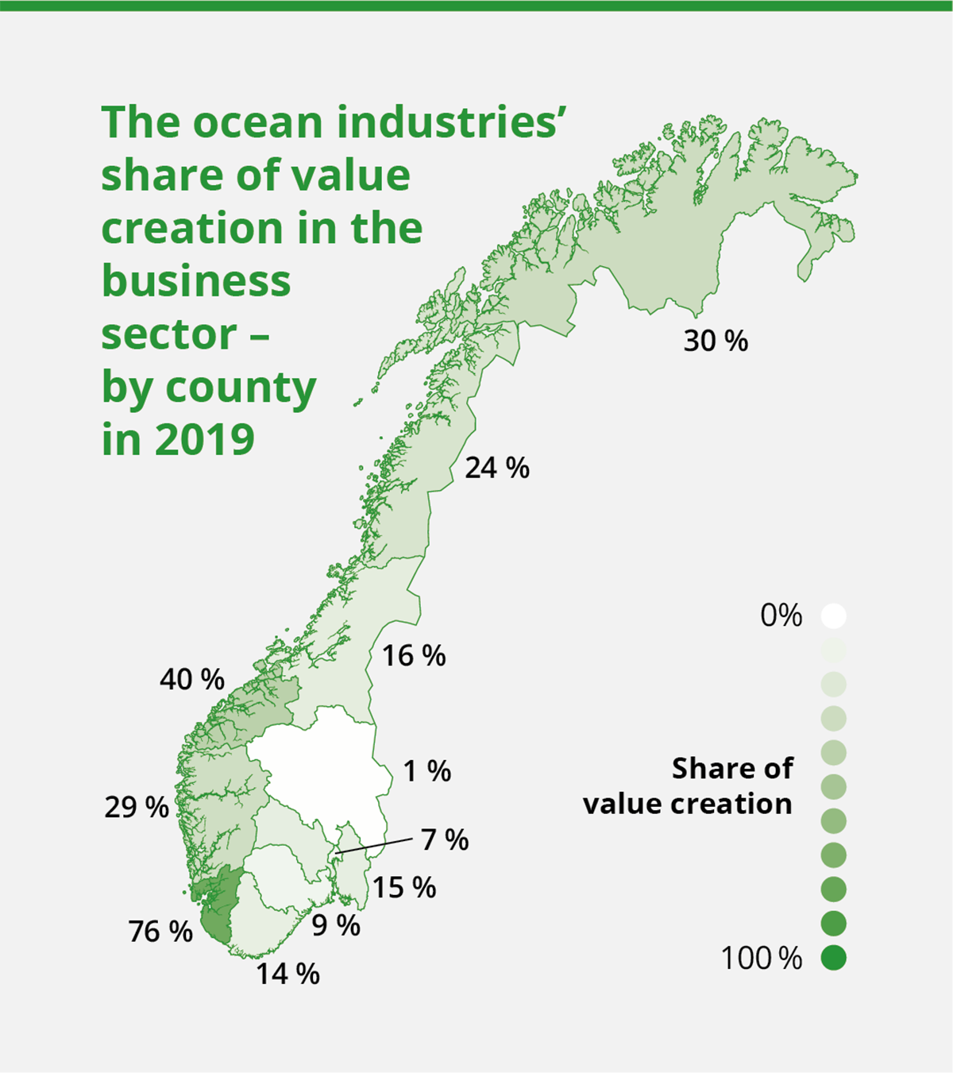
Value creation in the ocean industries. Source: Menon Economics, 2021.
The Government’s goal is for Norway to continue to be a leading ocean economy and to achieve the greatest possible value creation and employment from the oceans within sustainable limits.
The ocean policy laid out in the Government’s updated ocean strategy “Blue Opportunities” focuses on six areas that are mutually connected and support each other:
- Future-oriented ocean industries
- Education, skills and the labour market
- Research, technology and innovation
- Sound management and a predictable framework
- Clean and healthy oceans
- International cooperation and ocean diplomacy
In the updated ocean strategy, skills and digitalisation, regional and local value creation, climate change and green shipping were identified as the most important focus areas for ocean policy into the future.

Value creation and profitable jobs
In 2016, the Organisation for Economic Co-operation and Development (OECD) estimated that the global ocean economy will double by 2030 from the 2010 level, while providing a total of 40 million jobs. This could present major opportunities for further blue growth in industries where Norway has particular advantages and several world-leading players.
According to calculations by Menon Economics, 225,000 people in Norway work in the three major ocean industries of oil and gas, maritime and seafood. These industries are productive and their total value creation was NOK 694 billion in 2019. This means that almost 30 per cent of value creation in the Norwegian business sector is created by the ocean industries. New and emerging ocean industries come on top of this.
The oil and gas industry, including large parts of the specialised section of the supply industry, is Norway’s largest ocean industry with value creation of NOK 543 billion in 2019. According to Menon Economics, the industry employed just over 146,000 people nationwide in 2019. The maritime industry is the second largest with value creation of almost NOK 156 billion and 88,000 people employed in that same year, while the seafood industry had value creation of NOK 85 billion and employed almost 51,000 people. The figure above also demonstrates that there is an overlap between the ocean industries and that players in the supply industry in particular may belong to multiple ocean industries. The ocean economy can also include other businesses such as parts of the tourism industry that are focused on experienced-based activities linked to the ocean. There are also new and emerging ocean industries, such as offshore wind, carbon capture and storage (CCS) and sustainable mineral activities on the seabed.
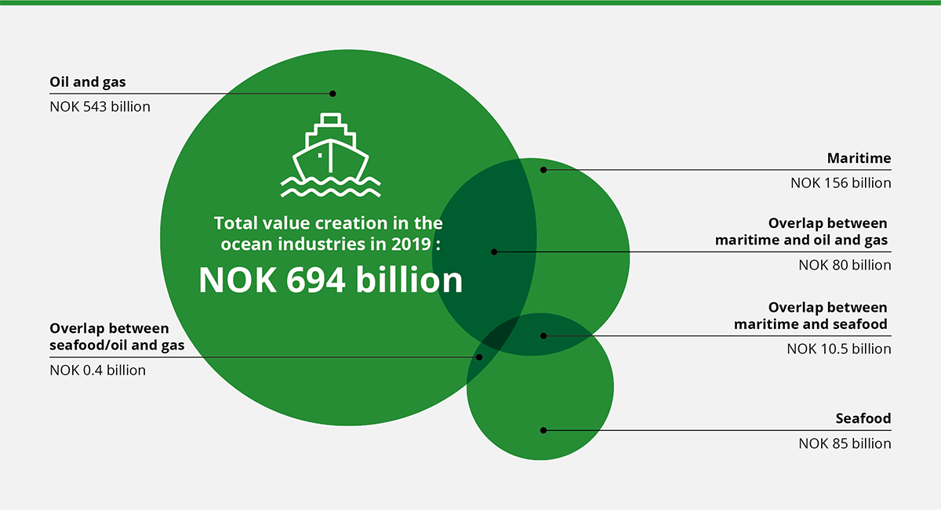
Value creation in the ocean industries of oil and gas, maritime and seafood in 2019. Source: Menon Economics.

Ensuring adequate and relevant skills
Increasingly more advanced technology in the established ocean industries and the emergence of new ocean industries will require further development of education and skills. Digitalisation and automation require a workforce with skills and knowledge that can further the competitiveness of the Norwegian ocean industries. Knowledge and experience-based skills in the Norwegian ocean industries are being maintained and further developed throughout the entire country. The petroleum industry in particular has generated substantial revenues for the Norwegian State and created positive ripple effects for the rest of the economy through knowledge, technology and demand for goods and services.
The close cooperation between companies, knowledge institutions, workers and government authorities has played an important role in the historical development of Norway as an ocean economy. The Government’s goal is for Norway to have a labour market in which employees enjoy security and flexibility, responsible employment practices, and a well-functioning and effective tripartite cooperation. If Norway is to be a leading ocean economy, the safety and welfare of workers must have priority.
The white paper on labour market relevance is part of the Government’s long-term commitment to interaction between the labour market and business sector and higher education, including greater emphasis on innovation and entrepreneurship in higher education. The Government has also initiated several measures to close the gap between the skills required by the labour market and the skills employees actually have. This is addressed in both the white paper on skills reform and white paper on the completion reform.
The ocean industries have a low proportion of female employees compared to other sectors of the Norwegian economy. Girls and Technology is a nationwide scheme aimed at increasing the proportion of girls in technology subjects at all levels of the education system. Increased female entrepreneurship is important for achieving greater gender equality in the business sector. In 2019, the Government presented an action plan for female entrepreneurs, with various measures to provide a good framework adapted to their needs.
In connection with the Storting’s consideration of the white paper on a forward-looking fisheries industry, the Storting asked the Government to develop a strategy for better gender equality in the fisheries industry. The Ministry of Trade, Industry and Fisheries has asked the Norwegian Institute of Food, Fisheries and Aquaculture Research (Nofima) to prepare a report describing the status of gender equality in the fisheries industry and that puts forward proposals for possible policy instruments and initiatives for promoting greater gender equality. The report will contribute to the Ministry’s preparation of a strategy for improving gender equality in the fisheries industry.
While considering the White Paper on maritime industry in the spring of 2021, the Storting asked the Government to develop a strategy for gender equality in the maritime industry. The Ministry of Trade, Industry and Fisheries will coordinate the work on the strategy.
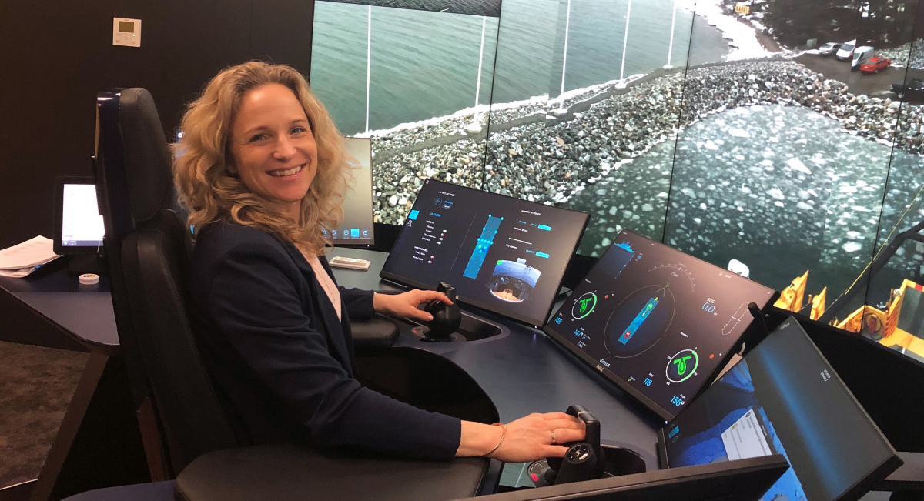
The Government wishes to contribute to gender equality in the ocean industries. Photo: Massterly.

A world leader in ocean management
The oceans are largely what provide the basis for the Norwegian welfare society, and it is essential that they are managed in a sustainable manner. Norway has a long tradition of knowledge-based ocean management. Good research-based management of ecosystems, ocean resources and the ocean industries ensures future economic activity and value creation.
Norway’s integrated ocean management plans are a tool both for ensuring value creation and food security and for maintaining the environmental value of Norway’s sea and ocean areas. These plans clarify the overarching frameworks and priorities for the management of Norway’s sea and ocean areas. They provide greater predictability and facilitate coexistence between industries that are based on the use of the sea and ocean areas and sustainable use of their resources. The management plans ensure a balance between different interests, and that all uses of the sea and ocean areas are considered in an overall context. This is in line with the Ocean Panel’s emphasis on integrated management plans for a sustainable ocean economy.
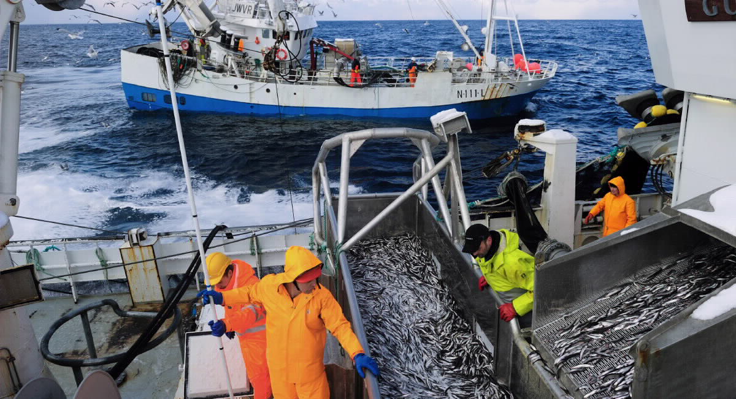
Capelin fishing. Photo: Johan Wildhagen, Norwegian Seafood Council.
The white paper on Norway’s integrated ocean management plans, presented by the Government in spring 2020, assembled for the first time all of the management plans for Norwegian waters in the Barents Sea and the areas off the coast of Lofoten, the Norwegian Sea, and the North Sea and Skagerrak in one white paper. The Government will present a new white paper on Norway’s integrated ocean management plans to the Storting every four years, with the next time being in 2024. In doing so, the Government is continuing and renewing the system of integrated and ecosystem-based management plans for the Norwegian Sea and ocean areas.
Norway has extensive experience in managing biological resources in the oceans. The annual fisheries agreements ensure sustainable harvesting of fish stocks that are shared with other countries. The agreements are based on independent scientific advice and contain binding conditions for quota allocation, management initiatives and control cooperation. Through the agreements, Norway is ensured a fair share when assigning quotas for joint regulated stocks.
The Government is also facilitating predictable and sustainable growth in the aquaculture industry. The new management system for continued growth in Norwegian salmon and trout farming was established in 2017. In the “traffic light” system, the coast is divided into production areas and the production capacity in these areas is adjusted based on environmental indicators and a fiscal rule. The colour of the traffic light is based on the impact of salmon lice on the wild salmon in the area. This determines whether the fish farmers in the area are permitted to increase or need to decrease their production.
During its period in office, the Government has facilitated profitable production of oil and gas through predictable framework conditions. The current practice of conducting regular licensing rounds to provide the industry with access to new exploration areas has been continued. Petroleum activities are strictly regulated. The authorities set requirements for permits, consent and approval during all phases of petroleum activities. The industry players themselves are responsible for complying with the regulations, while the authorities monitor their activities.
Norway’s tradition of knowledge-based ocean management will be at the heart of the management of completely new ocean industries such as offshore wind and seabed minerals. The Utsira North and Southern North Sea II areas were opened for offshore wind on 1 January 2021. These areas provide opportunities for demonstration projects and larger projects involving both fixed and floating offshore wind power. The Ocean Energy Act Regulations were enacted at the same time. The work on developing the framework for a new industry is complicated, however it will establish the basis for a long-term perspective and predictability.
Seabed minerals may become an important new ocean industry for Norway in the long-term and contribute to both employment and value creation. We have a long tradition of prudent and knowledge-based management of our natural resources, and this will also apply for the management of seabed minerals. These activities will only be permitted in Norway if they can be carried out in a responsible manner.
The Government has commenced a process of opening up areas on the Norwegian continental shelf for mineral activities in accordance with the Seabed Minerals Act. This process will enable us to obtain more, up-to-date and overall knowledge about the potential impact of seabed mineral activities. This will form the basis for any decision on whether to open up areas on the Norwegian continental shelf. The Norwegian Petroleum Directorate has been tasked with assessing the potential for seabed minerals on the Norwegian continental shelf. During the past three years, they have carried out data collection expeditions to the deep-sea areas near Mohns Ridge in the Norwegian Sea.
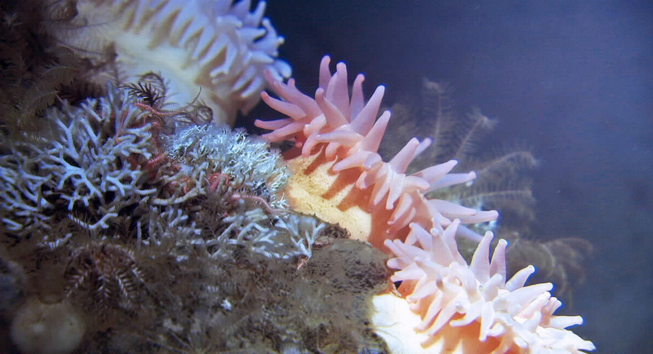
Sea anemones, moss animals and bristle worms. Photo: Mareano/Institute of Marine Research.

Clean and healthy oceans
Clean oceans with high levels of biodiversity and production provide the basis for sustainable utilisation of marine biological resources and healthy and safe seafood. Oceans play an important role in the face of global challenges relating to climate change, population growth, and the need for more food, medicines, energy, transport and minerals. At the same time, the many complex ecosystems of the oceans face significant threats, such as climate change, acidification, temperature rises, pollution and littering, overfishing and loss of biodiversity.
Climate change can also result in changes to the levels of pollutants in the food chain. The pollutants remain in the environment and in organisms long after the emissions cease, while new pollutants are added. Efforts to combat pollutants are therefore important, not only for the environment, but also for the ocean as a food source and for public health.

Plastic and microplastics
Marine plastic litter and the spread of microplastics is a growing global environmental problem that impacts on ecosystems and can be a challenge to both food safety and food security. In recent years, research efforts relating to plastic litter in water and seafood and the consequences of this have been intensified. A number of measures have been initiated to prevent marine litter in Norway. Much of the plastic litter in our northern sea areas comes from the fisheries and aquaculture industry. The Directorate of Fisheries has strengthened its work on preventing and cleaning up marine litter, and in March 2021 launched a new action plan to combat marine litter. The plan includes specific measures, including labelling of fishing equipment and registering lost fishing equipment. Efforts to prevent plastic littering are also being actively followed up through regional and global cooperation. In 2021, the Government will present a revised plastics strategy, which will comprehensively examine how to reduce plastic pollution.
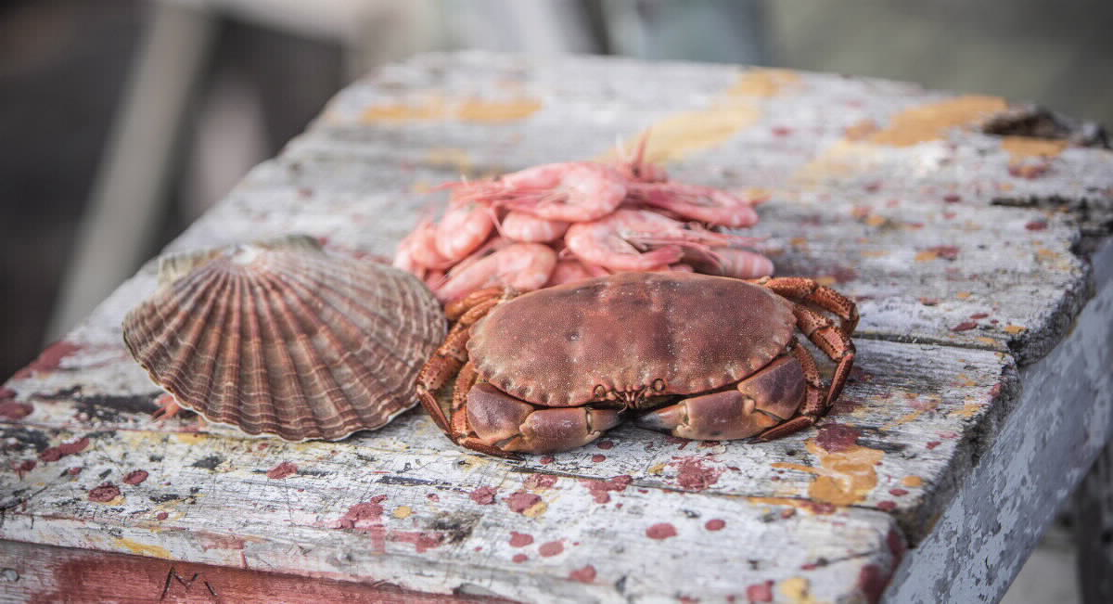
Norwegian seafood. Photo: Andreas Lindlahr, Norwegian Seafood Council.

Climate change and ocean acidification
According to the Intergovernmental Panel on Climate Change (IPCC), the oceans are entering a
new state as a result of rising CO2 levels and global warming. This may have significant consequences for marine ecosystems and living resources, including in Norwegian waters, which in turn will affect ocean industries and coastal communities. The Government will emphasise climate-resilient management of living marine resources and marine biodiversity, work to maintain natural carbon sinks (blue forests), and facilitate the development of new ocean industries such as environmentally friendly cultivation of seaweed and kelp as a measure for boosting carbon uptake.
The ocean economy can make an important contribution to necessary reductions in emissions. A report commissioned by the Ocean Panel has calculated that the ocean economy can contribute to one-fifth of the reduction in emissions that will be needed over the next 30 years to limit global warming to 1.5 degrees.

Conservation of marine nature
Norway manages sea areas with world famous fjords, a distinctive archipelago, unique cold water corals, open sea areas and deep seas with valuable nature on the seabed. Marine protected areas and other effective area-based conservation measures will contribute to preserving important underwater nature and ecological functions. There is a connection between rich biodiversity and biological production, ecosystem services that provide potential for harvesting, and the value creation we obtain from harvesting renewable resources. In the spring of 2020, the Government approved the establishment of nine new marine protected areas along the coast. In the spring of 2021, the Government presented a white paper on the conservation of marine nature to the Storting.
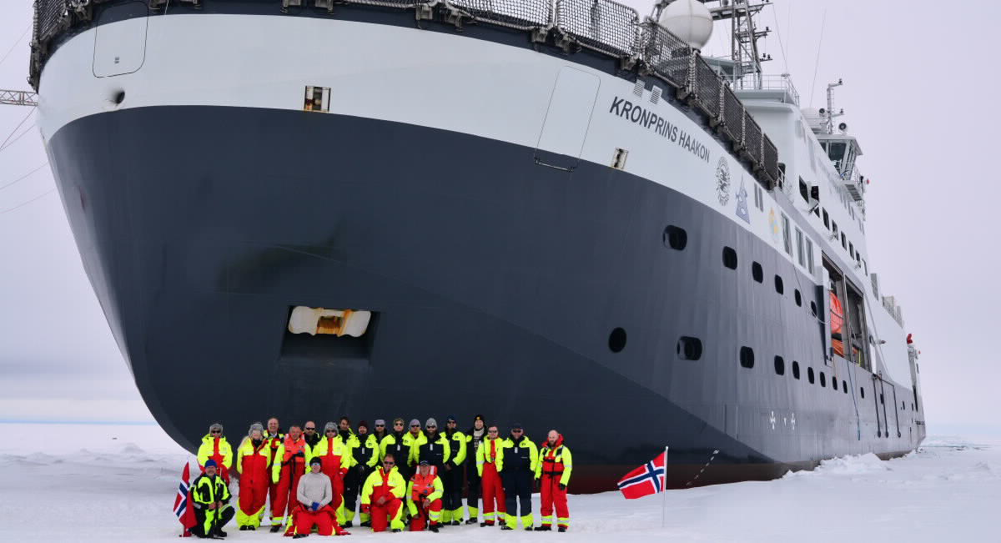
“Kronprins Haakon” during ice testing in 2018. Photo: Øystein Mikelborg/Norwegian Polar Institute.

Combating pollution
In recent years, much has been done through national and regional regulations, and global conventions to reduce and eliminate emissions of the most environmentally hazardous substances from land-based industry. Results from Norwegian environmental monitoring which show the spread of pollutants and impact on the environment and health are important for winning support for international regulations. In some areas, such as the Northeast Atlantic, measures have resulted in a sharp decline in emissions from land-based industry and a reduction in the concentrations of certain pollutants. There is little pollution in Norway’s open sea areas, however there are problems in some coastal areas, especially in sediments in ports and outside industrial sites, that are the result of previous emissions. The environmental status in the Artic is also generally good, but there are higher levels of certain pollutants in some areas. This is due to pollution from long-range transport. Norway is making significant efforts to continuously develop regulations both within the European Economic Area and globally, to reduce the use and discharge of chemicals that are hazardous to health and the environment.
Pollution from past activities is deposited in the seabed in many ports and fjord areas along the coast of Norway. This type of pollution is primarily a threat to plants and animals in the oceans, both through its acute impact and also through more long-term effects such as disturbances in reproduction and genetic material. The national action plan for cleaning up polluted seabeds prioritised 17 coastal and port areas because the pollution situation in these areas was considered particularly serious. Six of these areas: Oslo, Sandefjord, Trondheim, Harstad, Tromsø and Arendal, have now been remediated. Some other fjord areas, such as Puddefjorden, Listerfjorden and Kristiansandsfjorden, have been partially remediated. In cooperation with Hammerfest Municipality and Hammerfest Havn KF, the Norwegian Coastal Administration will commence the process of remediating the contaminated seabed in Hammerfest harbour during 2021. This work is expected to be completed in 2023.

Commitment to research and innovation
Research, knowledge and technological development are crucial to unlocking the potential for further value creation in the ocean industries, and for ensuring sustainable growth. The development of sustainable and emission-free solutions is vital for addressing the world’s environmental challenges and strengthening the competitiveness of the Norwegian ocean industries in a global market. Digital solutions and new technology represent an important part of the restructuring and development of the ocean industries.
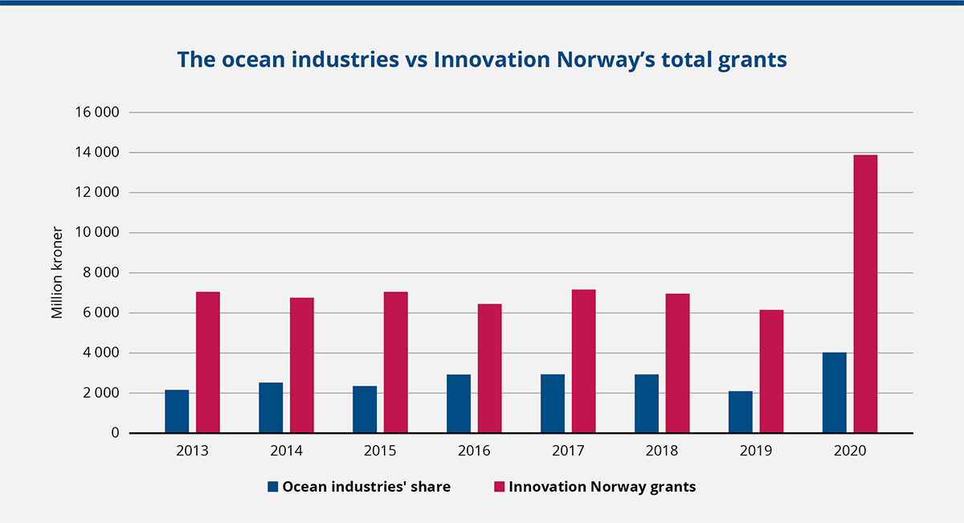
The ocean industries as a proportion of Innovation Norway’s total grants. Source: Innovation Norway
The Government has committed to maintaining and strengthening Norwegian ocean research and innovation. Therefore, a significant proportion of the grants from the Research Council of Norway and Innovation Norway go towards various ocean industries. This tells something about the unique position of the ocean industries in the development of the Norwegian economy. In addition to major initiatives in aquaculture, marine research, energy (including offshore wind), bioeconomy and petroleum, since 2014 the Research Council of Norway has had a coordinated focus on ocean technology to strengthen the ocean industries. The ocean industries take cooperation seriously, and they are represented in the majority of and the most important Norwegian industry clusters, including in the three GCE-clusters.
The Government has strengthened marine research efforts and contributes to increased knowledge for the commercial development and management of ocean and coastal ecology. This includes preliminary planning of the process of co-locating the Institute of Marine Research and the Norwegian Directorate of Fisheries.
Scientific advice, sound management principles and good control over the harvesting of resources are crucial for realising a high long-term return from marine stocks. The Directorate of Fisheries is an advisory and executive body within fisheries management, and cooperates with the Institute of Marine Research to provide the Government with the best available knowledge-based advice.
Green shipping, digitalisation and autonomy are particularly important areas for maritime research. Within oil and gas, more and more companies are investing in digital and environmentally friendly solutions, and are developing technology and expertise that can be used in other industries. The focus within energy and the environment is on offshore wind and hydrogen infrastructure, as well as fuel cells for maritime solutions. The supply industry from the oil and gas industries plays an important role in this transition.
It is important to have extensive and continuous monitoring of seafood in order to document the state of the ocean. Research and monitoring are continually adapting to new issues such as microplastics, new types of pollutants and new marine species that are being used as food. It is a priority to increase knowledge about healthy and safe seafood by considering the entire food chain - from clean and healthy oceans, safe and sustainable feed, and healthy and safe seafood, to the importance of seafood for health.
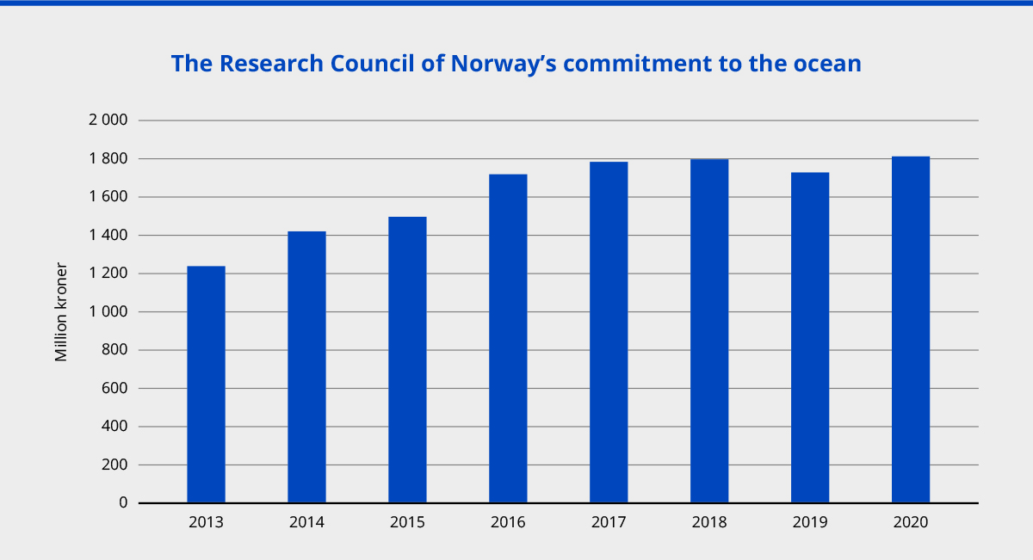
Grants from the Research Council of Norway for ocean-related projects. Source: Research Council of Norway.
The ocean industries receive a large proportion of the total grants allocated by Innovation Norway. From 2013 to 2020, the combined share amounted to 36.3 per cent (NOK 22.3 billion) of the total (NOK 61.4 billion) and has varied from 29.3 per cent to 45.8 per cent as a share of total grants during this period. This is based on a total of 7,436 grants for customer projects in the ocean industries.
The seabed in Norwegian waters is mapped by the Mareano Programme, which provides knowledge about depth and seabed topography, geology, sediment, habitats and pollution. By the end of 2020, depth data was available for approximately 28 per cent of Norway’s coastal and ocean areas. The knowledge generated by the Mareano Programme is important as a basis for integrated, ecosystem-based ocean management.

The Centre for the Ocean and the Arctic
The Centre for the Ocean and the Arctic was established in 2018. The Centre’s objective is to compile, analyse and disseminate knowledge regarding the effects of global and regional change processes on the blue economy and the basis for being able to harvest and create value from the resources in the High North and the Arctic, and communicate the results to both a national and an international audience. The Centre also facilitates dialogue on ocean and High North policy between industry, research, management and civil society.

Better data and marine basemaps are of major importance for coastal waters and port infrastructure. The Marine Basemaps Pilot Programme from 2020 to 2022 demonstrates new methods of collaborating on the collection and dissemination of data relating to seabed conditions along the coast. The Norwegian Mapping Authority, the Geological Survey of Norway and the Institute of Marine Research have an ambition to map the entire Norwegian coastal zone, an area totalling 100,000 square kilometres.
Norway is a full participant in the EU’s research partnership Horizon Europe, which has several blue initiatives in the works from 2021 to 2027. The Government is working to influence the EU’s blue programmes in order to ensure that these respond to key knowledge requirements in Norwegian ocean industries.
The governmental institutions’ research vessels, research stations and laboratories constitute a significant part of the marine research infrastructure that is under state ownership. The new ice-going research vessel “Kronprins Haakon” completed a voyage to Antarctica from December 2018 to May 2019, and has since completed several expeditions in the Arctic. The Government has started the process of procuring a new coastal research vessel, underwater robotics and sail drones.

United Nations Decade of Ocean Science
The United Nations Decade of Ocean Science for Sustainable Development from 2021 to 2030 will be a global initiative for raising awareness about the oceans. The decade will stimulate and coordinate national and global research efforts to achieve the sustainable development goals. Norway is one of the largest contributors to the Decade of Ocean Science through support for the UN Intergovernmental Oceanographic Commission (IOC). Norway is a member of the Ocean Decade Alliance, and Prime Minister Erna Solberg is a strong advocate of the alliance.
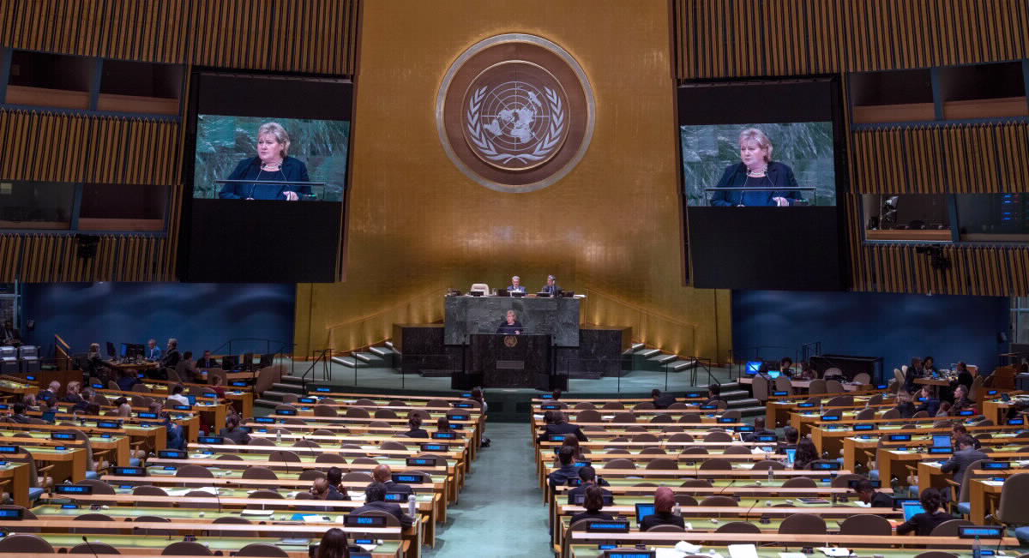
Prime Minister Erna Solberg addressing the UN General Assembly at the UN Headquarters in New York, September 2018. Photo: UN Photo/Cia Pak.

A leading international role in ocean-related matters
Norway is an attractive partner for international ocean cooperation. The international opportunities for Norwegian ocean industries are of major importance to economic development in Norway, and Norway will continue to take a leadership role internationally to ensure sustainable use. This includes both extensive efforts to promote a sustainable blue economy in developing countries and contributing towards achieving the UN sustainable development goals.
Support for the UN Convention on the Law of the Sea, international environmental agreements, further development of international cooperation and contributions towards knowledge-based management are necessary for ensuring, clean, healthy oceans for future generations.

Follow-up of the Ocean Panel
Follow-up of the Ocean Panel’s action agenda will be given high priority going forward. This work shows that it is a matter of urgency to develop a holistic approach to ocean management across the globe in order to achieve the United Nations 2030 Agenda for Sustainable Development. A sustainable ocean economy will also play an important role in rebuilding the global economy after the COVID-19 pandemic. The Panel’s work shows that investments in the ocean economy pay off, and can make significantly greater contributions to energy, food supply, health and climate than they do at present.
Looking forward, Norway and the Ocean Panel will work to obtain the broadest possible support for the action agenda and ensure that countries are able to deliver on these actions by 2030 or sooner.

International ocean conferences
The first UN ocean conference was held in 2017. The second was scheduled to take place in Portugal in 2020. However, it has been postponed until 2022 due to the COVID-19 pandemic. Norway is working to ensure that the conference will emphasise the importance of sustainable ocean management and a sustainable ocean economy to achieve the United Nations 2030 Agenda for Sustainable Development.
The Our Ocean Conference, which was held for the first time in the United States in 2014, brings together top leaders from governments, business, civil society and research institutions, who together seek to find solutions for healthy, clean and productive oceans, and to ensure sound ocean management. In 2019, the conference was held in Oslo, with over 500 leaders from 100 countries in attendance.
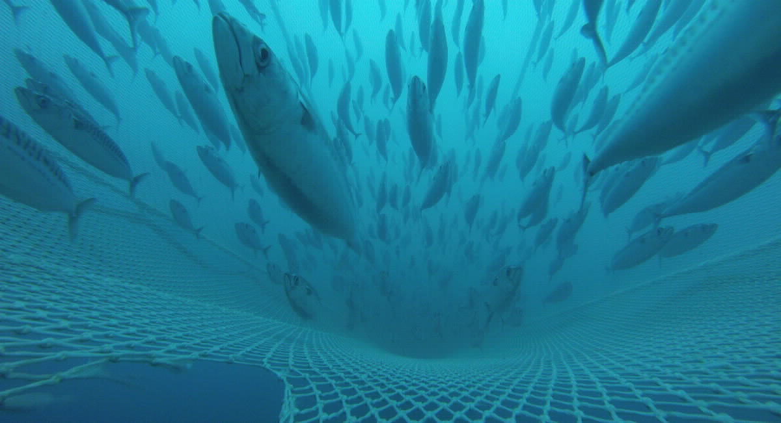
Shoal of mackerel. Photo: Leif Nøttestad, Norwegian Institute of Marine Research.

The ocean in development cooperation
Norwegian experience and expertise in the management of marine resources, the environment, ocean industries and in sustainable ocean management are in demand from a number of countries, especially developing countries. Norway has shared this knowledge and experience with other countries through various development cooperation projects and programmes over several decades. Norwegian development cooperation relating to the ocean amounted to NOK 743 million in 2019.
In addition to being an independent programme, the new knowledge programme “Oceans for development” managed by Norad will contribute to seeing ocean-related development cooperation in context. The primary objective is to contribute to a strengthened, sustainable and inclusive ocean economy in the cooperating countries. This will be achieved both through sharing of experiences and expertise between public institutions in the cooperating countries and Norway, and through cooperation agreements with multilateral organisations such as the Division for Ocean Affairs and the Law of the Sea (DOALOS) and the UN Intergovernmental Oceanographic Commission. Among other things, Oceans for Development is important to the follow-up of the Ocean Panel’s commitment to 100 per cent sustainable ocean management.
The “Fish for Development” programme was established in 2016 to achieve a more strategic and holistic approach to Norwegian fisheries development cooperation. The objective is that the fisheries and aquaculture sector will contribute to positive socio-economic development in the cooperating countries. This involves increased employment for women and men, as well as better food and nutritional security for the population. The programme makes Norwegian expertise and experience in fisheries and aquaculture available to developing countries.

Food from the ocean
For many years, Norway has actively worked both at a national and international level to promote the importance of a clean and healthy ocean, sustainable fisheries and aquaculture and safe and healthy food for food security and nutrition. At Norway’s initiative, the UN Committee on World Food Security (CFS) first discussed food from the oceans as an agenda item in 2014. Based on an expert report, the CFS recognised the importance of seafood for food security, both as a source of income and as a source of food with important nutrients.
At the UN Ocean Conference in 2017, Norway committed to establishing a global action network for sustainable food from the oceans and inland waters as part of the UN Decade of Action on Nutrition (2016–2025). The network promotes food from the oceans and inland waters as an important key for food security and nutrition, with a focus on solutions along the value chain, from healthy oceans and waters to healthy populations. The network views the UN Decade of Action on Nutrition, Decade of Ocean Science and Decade of Action to Deliver the Sustainable Development Goals as a whole.
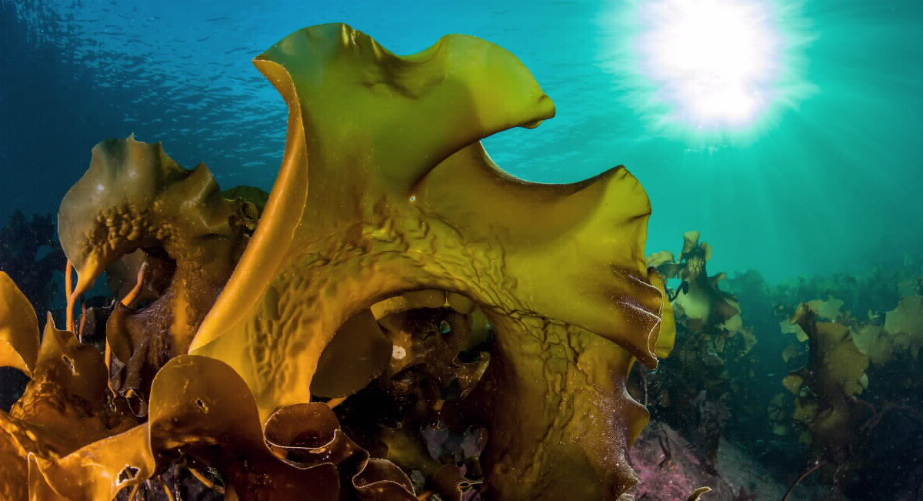
Sugar kelp. Photo: Erling Svendsen, Norwegian Institute of Marine Research.
Food from the ocean is also an important element in the work of the Ocean Panel, both through the Blue Paper “The Future of Food from the Sea” and in specific actions outlined in the Panel’s main report. Norway has emphasised this in the run-up to the upcoming UN Food Systems Summit in September 2021 and in development cooperation. In the preparations for the meeting, Norway will be co-hosting a global dialogue on food from the oceans. The global action network will promote food from the oceans in the lead up to the UN summit.
Food from the ocean is also an important element in the Norwegian action plan on sustainable food systems in the context of Norwegian foreign and development policy from 2019. The UN Food and Agriculture Organization (FAO) has developed a guide for reducing food waste in the value chain for fish.

Fisheries crime
For a number of years, Norway has been the driving force behind international efforts to combat fisheries crime. International interest in the issue has increased, particularly from 2018, when Norway’s Minster for Fisheries took the initiative to adopt an international ministerial declaration during a conference on fisheries crime in Copenhagen (Copenhagen Declaration). In connection with the adoption of this declaration, it was decided that Norway would be the secretariat for the declaration. As of April 2021, 34 states had pledged their formal support to the declaration.
International efforts to combat fisheries crime were further strengthened following the Our Ocean conference in 2019, where the Blue Justice Initiative was launched. The goal of the initiative is to reduce the extent of organised crime and illegal trade in the fisheries sector by strengthening interdisciplinary cooperation with the police, courts, prosecutors, and control agencies in the cooperating countries. The initiative now consists of a number of Norwegian-funded projects that work to assist developing countries in addressing the issues raised in the Copenhagen Declaration.
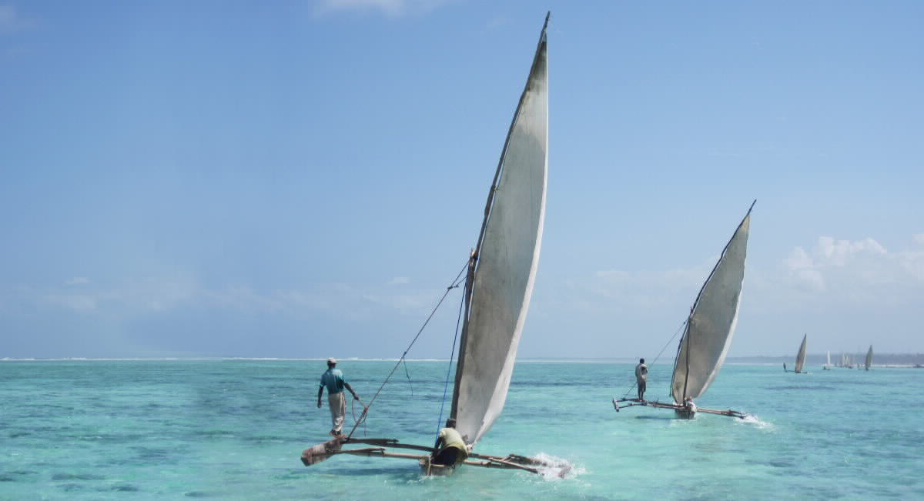
Ngalawa fishing boats in Tanzania. Photo: Ian Bryceson.

Marine litter
Marine litter and the spread of microplastics represent a global challenge for which Norway has taken an international leadership role. At Norway’s initiative, the third session of the UN Environment Assembly in 2017 agreed to a “zero vision” to stop all emissions of plastic waste into the oceans in the long-term. An expert group was also established, which was tasked with investigating the global measures that would be most effective in reducing plastic pollution in the oceans. The expert group completed their work in the autumn of 2020. Many countries are in favour of a new global agreement, and Norway wants the UN Environment Assembly to adopt a mandate for a negotiating committee at its fifth session in February 2022.
The Norwegian government has established a development cooperation programme to assist developing countries in preventing and reducing marine litter. This is an important contribution to the UN Environment Assembly’s “zero vision” to eliminate emissions of plastics and microplastics into the oceans. The programme was established in 2018, and NOK 1.6 billion will be spent on the programme from 2019 to 2024.
In 2018, Norway was a key player in the establishment of the Problue multi-donor fund, which is the World Bank’s blue economy programme. Combatting marine litter was important for Norway when the fund was established, but Norway now contributes to the entire scope of the fund, which includes efforts relating to sustainable fisheries, ocean industries and ocean and coastal zone management. The fund contributes to the implementation of the Ocean Panel’s commitment to 100 per cent sustainable ocean management in developing countries.

Strengthened ocean dialogue with key countries and organisations
An important initiative in the White Paper on the place of the oceans in Norway’s foreign and development policy was to strengthen dialogue and cooperation on ocean-related issues with relevant countries and organisations. Strategic ocean dialogues have since been initiated with Australia, India and Chile, and efforts are being made to do the same with Indonesia and China. The ocean cooperation with the USA, France, Kenya, Brazil, ASEAN, AU and the EU, among others, is being strengthened.
Within government cooperation among Nordic countries, Norway is a driving force for several initiatives concerning the oceans, including green shipping, the blue economy and ocean research. The Nordic countries are also a driving force for an international agreement on marine litter.
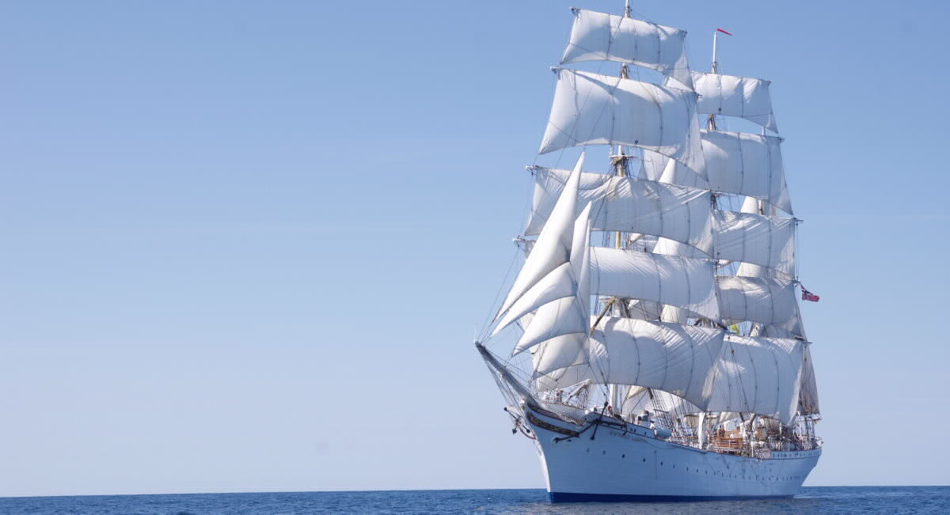
Statsraad Lehmkuhl will embark on the One Ocean expedition. Photo: Jesper Rosenmai.

The One Ocean expedition- Statsraad Lehmkuhl a sailing ambassador.
Over the course of 19 months, from August 2021 until April 2023, the ship Statsraad Lehmkuhl will visit 37 ports around the world and sail over 55,000 nautical miles.The purpose of the expedition is to raise awareness and share knowledge about the role of the oceans in sustainable development from a global perspective. This will be achieved by promoting learning about the oceans and developing sustainable leaders in collaboration with several universities and university colleges. Data collection and research will be carried out in collaboration with, among others, the Institute of Marine Research, the Norwegian Research Centre (NORCE) and the Norwegian Meteorological Institute. Last but not least, scientific information will be exchanged at the ports and on social media during the expedition.
The expedition will be an official part of the UN Decade of Ocean Science. One of the objectives is to disseminate, discuss and bring the Ocean Panel’s report out into the world. “One Ocean” is a national project in which the Ministry of Foreign Affairs, Ministry of Trade, Industry and Fisheries, the Ministry of Education and Research and institutions within academia, research, education and the business sector are partners.
Norway is continuing its long-standing efforts in various international cooperation mechanisms that contribute to global ocean management. This applies to the UN General Assembly and other global, standard-setting forums for the environment, shipping, mineral activities and fisheries. We actively contribute in the negotiations of the UN’s annual resolutions on the oceans. Continuous efforts are being made to strengthen and further develop the Law of the Sea as a tool for protecting the oceans through conservation and sustainable use of marine resources. Norway contributes actively to the negotiations in the International Seabed Authority (ISA) of an international regulatory framework that will ensure fair and safe utilisation of mineral resources beyond national jurisdictions in line with strict and knowledge-based environmental standards.
Norway is also actively contributing to the negotiations of a new agreement under the Law of the Sea Convention on Conservation and Sustainable Use of Marine Biodiversity of Areas Beyond National Jurisdiction (BBNJ), which includes rules for area-based conservation measures and impact assessments. Crucial efforts are also being done in regional cooperation forums for the environment and resource management, for example, in the Arctic, North Atlantic and Antarctic.
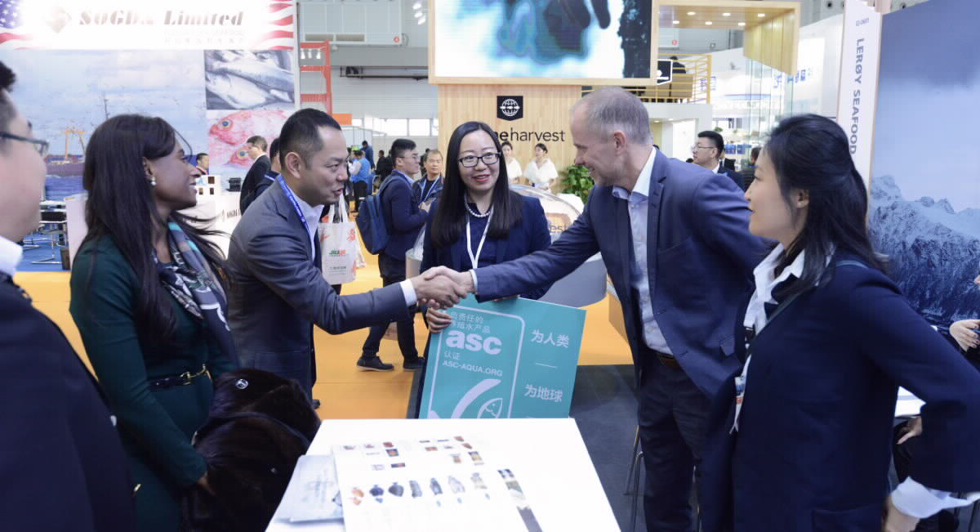
China Fisheries 2018. Photo: Innovation Norway.

Involvement of international business and industry
International business and industry play an important role in developing a sustainable global ocean economy. In 2018, the UN Global Compact established the Action Platform for Sustainable Ocean Business, in which the business sector, academia, governments and the UN system examine how the ocean industries can contribute to achieving the UN sustainable development goals. The Government has supported this work since the project’s establishment, which involves leading players in the most important ocean industries working together to assess regulations, and reaching agreements on principles for sustainable industrial development in the oceans.
The COVID-19 pandemic continues to take its toll on Norway and the rest of the world. Life and health have been heavily impacted by the pandemic and infection control measures have curtailed social and economic activity. This has had major consequences for people and businesses and the Norwegian and international economy.
In many places, ocean industries such as shipping, fishing and tourism have come to an almost complete halt. The business sector’s commitment to the ocean industries is an important contribution to not only access to healthy and safe food, but also to meet the longer-term needs for well-paid jobs and sustainable industries.

Sustainable ocean industries provide export opportunities
In order to deliver sustainable energy, food and transportation solutions, the Norwegian ocean industries are dependent on access to international markets. A well-functioning international trading system and good trade agreements are therefore a high priority for the Government. In October 2020, the Government presented an action plan to promote exports, with the ocean industries being one of the areas highlighted. As a follow-up to the action plan, the Government announced the establishment a new export promotion unit in June 2021 (Export Strategy Council). The unit will be responsible for identifying and implementing integrated strategic export initiatives in close cooperation with the business sector and the other public funding agencies. In order for efforts to promote Norwegian business and industry abroad to be as coordinated as possible, the export-oriented public funding agencies and the business sector cooperate in the Team Norway network.
An important part of Innovation Norway’s work is to contribute to promoting the ocean industries, and the digital service “The Explorer” demonstrates examples of Norwegian sustainable solutions. “Team Norway Havet” (Team Norway Oceans), which brings together the authorities, public funding systems and the ocean industry organisations, has established joint priorities for topics, materials, events and campaigns to contribute to the companies’ export initiatives.
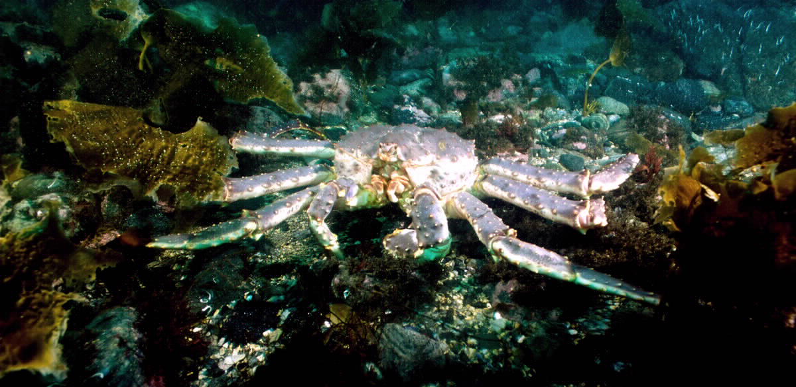
Red king crab. Photo: Per Eide Studio, Norwegian Seafood Council.

Developments in the ocean industries during the Government’s term of office
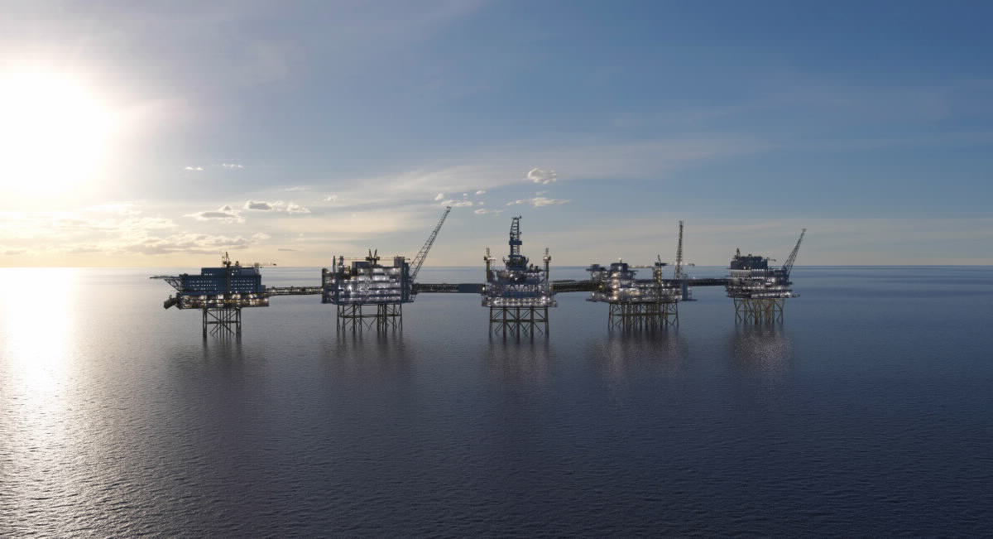
Johan Sverdrup Phase 2. Photo: Equinor.
The Government’s ocean policy aims to unlock the potential for continued sustainable job and value creation in the existing ocean industries, and facilitate the development and growth of new ocean industries.

A high-tech oil and gas industry creates jobs across the entire country
The petroleum industry is Norway’s largest and most important industry when measured in terms of value creation, government revenues, investments and export value. It contributes to economic activity across the country, while also stimulating positive commercial, technological and social development. Over the past few decades, the industry has had a profound and positive impact on the mainland economy and the Norwegian State’s financial situation. It is estimated that the industry (excluding the supply industry) will account for 14 per cent of total value creation, approximately 40 per cent of total exports in 2021, and contribute approximately NOK 154 billion in net revenues to the Norwegian State in 2021, equivalent to 14 per cent of government revenues.
We now have a world-class, high-tech, oil and gas industry. Learning effects and knowledge transfers also stimulate increased productivity and innovation in other parts of the business sector.
In June 2020, the Storting adopted temporary amendments to the Petroleum Tax Act. The purpose of the amendments was to stimulate investments in the petroleum industry, and contribute to maintaining the level of activity that supports the supply industry with jobs and technological development along the entire coast. Knowledge and technology developed in the oil and gas industry will not only be able to be broadly applied in other ocean industries, but also in other sectors such as medicine and onshore infrastructure projects.
Total oil and gas production in 2025 is expected to be at the same level as at the start of the 2000s, before production is expected to gradually decline. Investments until 2030 are expected to be slightly below the level seen in recent years. The Norwegian petroleum industry will continue to play an important role in the Norwegian economy over the next few years, however the industry is no longer expected to be an equally strong engine for growth up to and beyond 2030. Consequently, the favourable developments in productivity and wages that the rest of the economy experiences due to petroleum activities may decline. We cannot expect that one single new industry will take over from the petroleum sector as the growth engine.
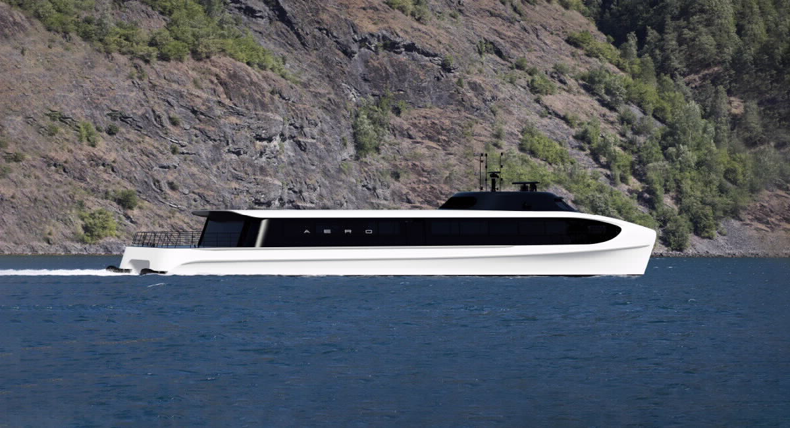
Electric high-speed vessel in Oslofjord. Illustration: Aero design by Brødrene Aa.

Greener and smarter shipping for lower emissions
Since taking office, the Government has strengthened its commitment to green shipping. Norway led the negotiations, which resulted in the IMO’s 2018 climate strategy of reducing total emissions from international shipping by at least 50 per cent by 2050 compared to 2008. The Government is also committed to the ambition of halving emissions from domestic shipping and fisheries by 2030 compared to 2005.
Norwegian maritime players are now world leaders in green shipping, and international companies are establishing themselves in Norway to be part of these developments. There are presently more than 70 ferries in operation with fully or partially electric propulsion systems. By the end of 2022, it is expected that there will be over 80, which is close to one third of all ferries in Norway. MF Hydra, the first hydrogen-electric ferry, will be put into service in 2022, and the first ammonia vessel will be ready for operations in the offshore sector in 2024. Despite a great deal having been done, we are still in the starting phase of the transition to green shipping. The Government announced a new policy in the white papers on maritime policy and climate plan 2021-2030. Among other things, low and zero-emission criteria will be introduced for new tenders for ferries and high-speed vessels when this is feasible. Efforts are being made to develop policies that contribute to the green transformation for service vessels in the aquaculture and offshore industries, and climate requirements will be assessed for public procurements of maritime transport services. In order to contribute to the development and use of low and zero-emission solutions in multiple segments, in 2020 the Government established new schemes focussing on short-sea shipping. All of these measures are in line with the Ocean Panel’s conclusions relating to sustainable shipping.
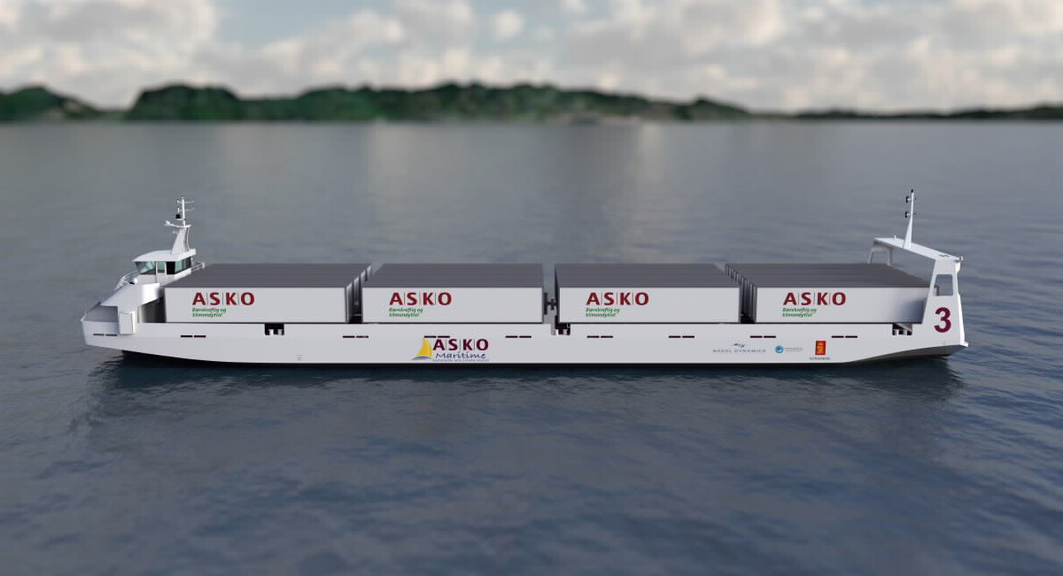
ASKO and Norgesgruppen's autonomous and electric sea drone that will operate between Moss-Horten. Illustration: ASKO and Naval Dynamics.

Zero-emission high-speed vessels with batteries in the Oslofjord
In collaboration with Brødrene Aa, Slemmestad Brygge, and several regional partners, the shipping company Norled has been awarded NOK 30 million through Pilot-E to develop, build and operate battery-electric high-speed vessels that offer routes to urban areas along the Oslofjord.
Autonomous vessels is another area in which Norwegian companies are at the forefront of developments. Digitalisation has enabled the development of automation solutions for vessels and can primarily be used for remotely operated or more or less autonomous ships. Several geographical test beds and test arenas have been established in Norway.
When it was established in 2016, Trondheimsfjorden was the first test bed in the world for testing autonomous and remotely operated vessels. In recent times, the industry has promoted several projects based on new technology and digitised solutions for approval by the Norwegian Maritime Authority.
For example, ASKO and Norgesgruppen have established a shipping company and signed a contract for the construction of two autonomous and electrically powered vessels, which will operate along the Moss-Horten route, and be part of a fully electric transport chain.

Scandinavian Reach Technologies AS (ScanReach)
ScanReach from Øygarden in Vestland develops wireless technology, sensors and software for digitalisation of the maritime sector. ScanReach has developed unique technology for sending data wirelessly through complex offshore steel structures. Combined with sensors and proprietary software, this enables full wireless connection and digitalisation onboard ships, offshore rigs and offshore wind farms.
In May 2020, Innovation Norway contributed NOK 18.5 million to five innovation projects through extraordinary innovation grants. ScanReach has teamed up with six different pilot customers from shipping, rigs and offshore wind to further develop and test new solutions for personnel safety, fuel monitoring, and detection of emissions of hazardous gases.
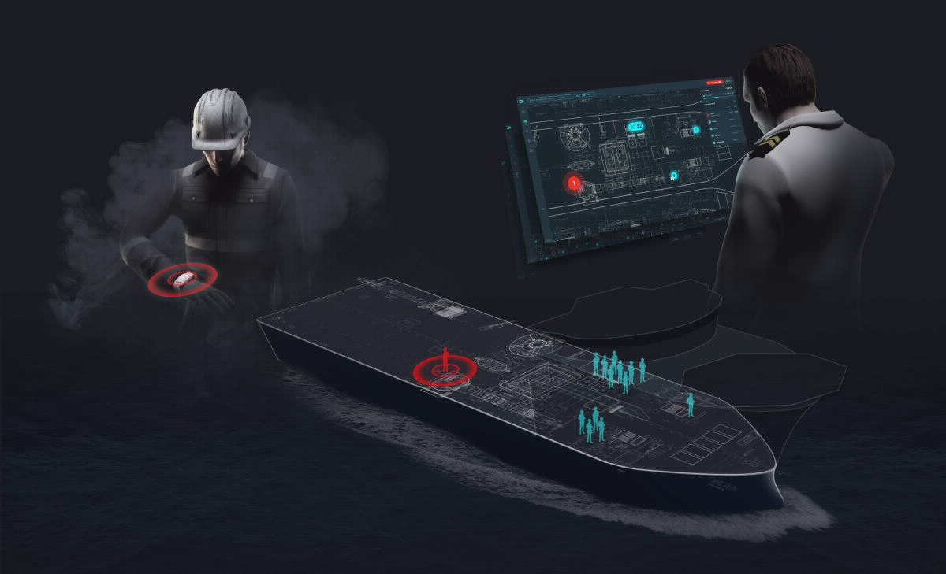
Illustration: Scandinavian Reach Technologies.
Enova is supporting the project by contributing NOK 119 million. Customised rules are required in order to ensure that the regulations will not hinder technological development.
Norway was one of prime movers behind the International Maritime Organization (IMO) commencing work on a system of rules for autonomous vessels in 2018. In Norway, the Harbours and Waterways Act now allows for permits for autonomous coastal voyages for compulsory pilotage vessels, and the Norwegian Maritime Directorate is working on developing a function-based and technology-neutral regulatory framework.
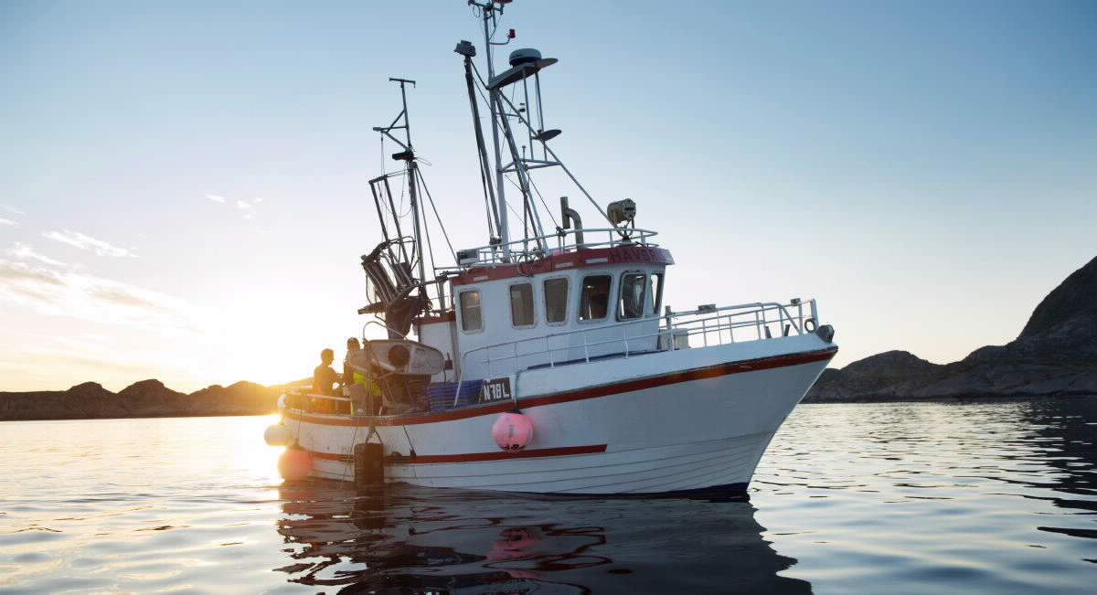
Fishing boat near Nordnesøy. Photo: Johan Wildhagen, Norwegian Seafood Counci.

A sustainable seafood industry along the entire coast
Norway is an ocean economy rich in fish stocks, and is also the world’s foremost producer of Atlantic salmon and rainbow trout. The seafood industry consists of many large and small enterprises spread out along the entire coast, and some of the larger companies have also established operations in other countries. The large quantities of fish in Norwegian waters have always provided the country with food, employment and income. In 2020, the aquaculture industry exported approximately 1.2 million tonnes of seafood. The export volume for the fisheries sector was 1.5 million tonnes. In 2020, the value of these exports from Norway was NOK 105.7 billion.
In order to support municipalities that make areas available to the industry, the Government has established an aquaculture fund. In the first few years, much of the remuneration for allocating new licences went to the host municipalities and county municipalities.
2021 saw the introduction of a production tax of NOK 0.40 per kilogram of salmon, trout and rainbow trout produced. This will result in increased revenues to the municipal sector of approximately NOK 500 million per year from and including 2022. In addition to the production tax, the host municipalities and county municipalities will receive 40 per cent of the revenues from future auctions from and including 2022.
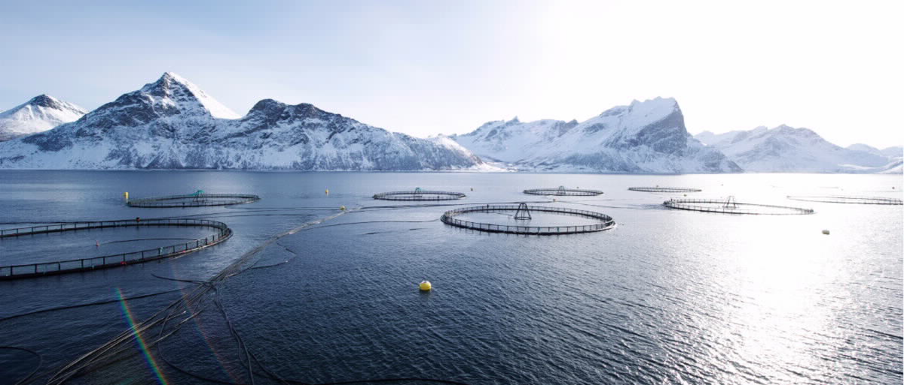
Salmon cages. Photo: Johan Wildhagen, Norwegian Seafood Council.

NCE Aquaculture
NCE Aquaculture is an aquaculture cluster in Nordland that focuses on increased value creation and innovation associated with commercial production of salmon and seafood for the global market. The cluster is a “locomotive” for further developing Norwegian aquaculture and related enterprises, and is a good example of the aquaculture industry gaining an increasingly stronger position in the region. The cluster is collaborating with Nord University, the regional processing industry and the authorities to develop biomarine ingredients for new, third-generation feed ingredients. The initiatives will use CO2 as an input factor and contribute to circular economic use of residual and waste products from the aquaculture industry for new bioproduction.

Open ocean aquaculture provides new opportunities
The aquaculture industry is undergoing rapid technological developments. These developments are being driven by both research communities and the industry’s need to solve environmental challenges such as escaping and sea lice. The authorities have used the allocation system to stimulate technological development through the 2013 allocation round involving “green salmon licenses”, and through the scheme for development licenses that was introduced in 2015. The latter contributes to significant innovation in the development of installations in more exposed waters and in the open ocean. These developments mean that more areas will become available for the production of seafood. The scheme has received a great deal of attention, and many applications have been received. The result of this will be many exciting and innovative projects, which can help promote the environment and area access. However, aquaculture production being able to take place in more exposed areas also entails new challenges relating to operations (including health, safety and environment), fish welfare and logistics.
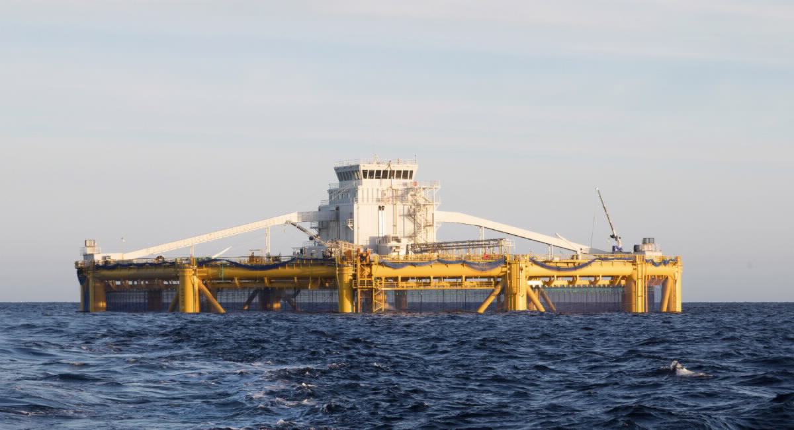
Salmar ocean farm. Photo: Thor Nielsen, Innovation Norway.

Offshore wind provides national and international opportunities
New offshore industries are emerging in the wake of the petroleum industry. On 1 January 2021, the Government opened up the Southern North Sea II and Utsira North areas for offshore renewable energy. One of the objectives of Norwegian offshore wind policy is to support the ability of Norwegian exporters to compete in a growing global market, as well as facilitate sustainable resource management in the long-term. Due to both our strong maritime sector and experience from the petroleum sector, Norway has a competitive advantage when it comes to floating offshore wind. Hywind Tampen, which will be the world’s largest floating offshore wind farm, is under development. Hywind Tampen has recieved a grant of NOK 2.3 billion from Enova. The next step in the commitment to offshore wind will be to realise offshore wind on an industrial scale in order to achieve economies of scale. Norwegian companies are already involved in international projects. In 2019, Norwegian companies had sales of just over NOK 11 billion in the offshore wind market. Exports and activity abroad have increased by 50 per cent since 2018 and account for more than 80 per cent of sales. Norwep estimates that Norwegian companies can achieve international sales of NOK 50 billion in offshore wind by 2030.
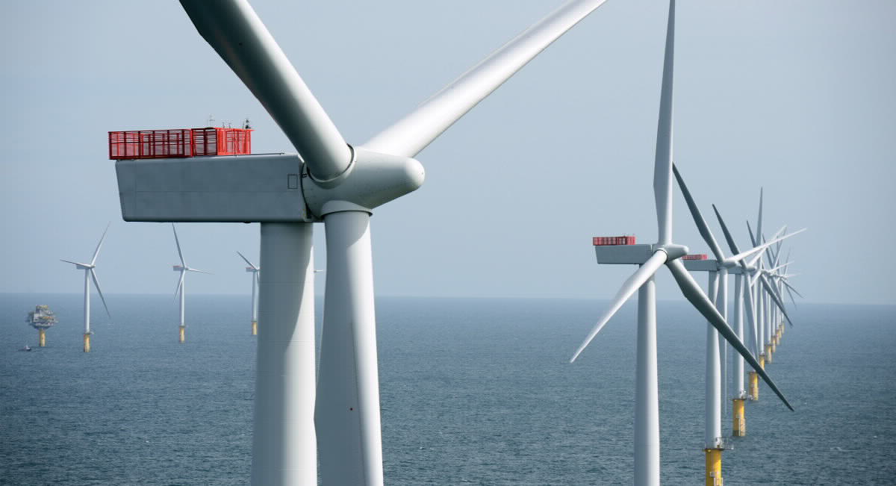
Offshore wind farm. Photo: Allan O'Neil/Equinor

Supplying anchoring solutions for floating offshore wind turbines
MacGregor supplies anchoring solutions for floating oil and gas installations. The company is now eyeing opportunities in the rapidly growing offshore wind market.
MacGregor Norway AS, (formerly Aker Pusnes AS), is one of the world’s leading companies in the development, design and delivery of deck machinery and anchoring systems for ships and offshore installations. The company was contacted by Equinor in connection with the latter upscaling a pilot project based on one floating offshore wind turbine to a farm with five floating offshore wind turbines – Hywind Scotland.
The solution was to create as simple a system as possible for solving a relatively complicated task. The challenges are somewhat different from traditional floating oil and gas installations. The dimensions are slightly smaller, but the number is higher. There is a major focus on costs and strong efforts are being made to keep the levelized cost of energy as low as possible.

Carbon Capture and Storage cuts emissions and creates new jobs
Carbon Capture and Storage (CCS) may contribute to cutting emissions in industrial processes where currently no alternative technologies exist. CCS could also enable conversion of natural gas into zero-emission hydrogen gas. Extensive experience from oil and gas activities, 25 years of experience with offshore CO2 storage, a world-class supply industry and research community, all give Norway a leading position within CCS.
The Government’s “Longship” initiative, where CO2 will be captured from Norcem’s cement factory in Brevik and possibly from Fortum Oslo Varme’s waste incineration plant and permanently stored under the seabed on the Norwegian continental shelf, is a Norwegian large-scale demonstration project encompassing capture, transport and storage of CO2. Longship will demonstrate that CCS is safe and feasible, and will facilitate learning and reduce costs in subsequent projects. The initiative will establish infrastructure for transport and storage of CO2 with surplus capacity, and facilitate commercial development by preserving, transforming and creating new industries and businesses. In the future, the Norwegian continental shelf may play an important role in reducing CO2 emissions from both Norwegian and European industry. The Norwegian Petroleum Directorate estimates that it is possible to store more than 80 billion tonnes of CO2 in reservoirs on the continental shelf.
Technology Centre Mongstad (TCM) has been in operation since 2012. A wide range of technology suppliers have tested, or plan to test, their carbon capture technology at the centre. The CLIMIT Programme supports the development of several different technologies and solutions, which may contribute to making CCS more efficient and safer. Through extensive international work, Norway has also contributed to global developments in capture, transport and storage of CO2. Through CLIMIT’s participation in ACT (Accelerating CCS Technologies), Norwegian researchers can apply for funding for projects with international partners. In addition to this, a research centre for environmentally friendly energy (FME) has been established, which is dedicated to CCS.
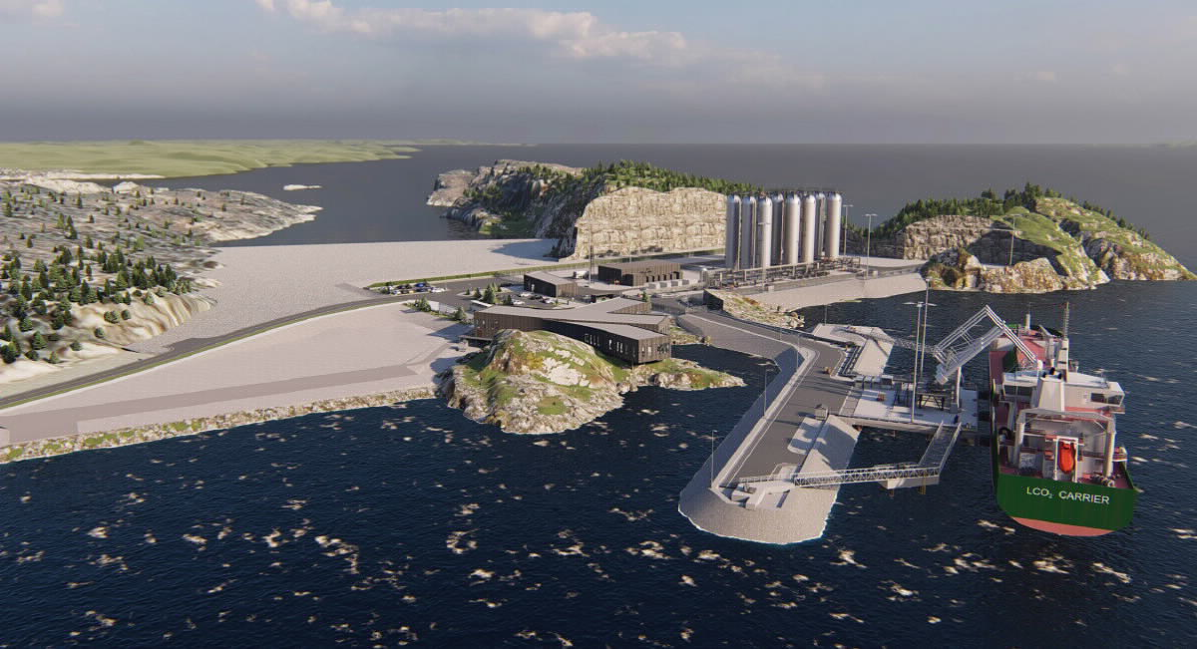
Northern Lights' CO2 receiving terminal in Øygarden municipality is a vital part of Longship. Illustration: Northern Lights.

Hydrogen may contribute to reduced emissions and increased value creation
The Government’s hydrogen strategy was launched in June 2020. The strategy paves the way for the continued commitment to hydrogen. A new roadmap for hydrogen specifies this commitment, and will be launched in a white paper on long-term value creation from Norwegian energy resources before summer 2021.
A key goal for the Government is to increase the number of pilot and demonstration projects in Norway, and thereby promote technological development and commercialisation. Shipping in particular is a relevant sector, where hydrogen enables zero emissions for voyages in which batteries are insufficient.
In 2020, the Research Council of Norway allocated more than NOK 150 million to 13 projects to develop hydrogen-based technology. PILOT-E has allocated NOK 70 million for zero-emission ocean-going transport solutions. Enova has allocated NOK 219 million to the development of two hydrogen-powered cargo ships under the project name Topeka. The cargo ships will sail between Stavanger and Kristiansund. These increasing allocations testify to the fact that hydrogen is becoming an increasingly more “market-ready” zero-emission solution. The next round of announcements for PILOT-E, with an application deadline in September 2021 and project start-up from January 2022, has zero-emission maritime short-sea shipping, and stakeholder coordination and strengthening of hubs for hydrogen, as two of the three thematic areas.
In the national budget for 2021, the Government has followed up the hydrogen strategy by allocating NOK 100 million to infrastructure and market development for hydrogen. These funds will support the development and establishment of necessary infrastructure, solutions for competitive and energy-efficient supply chains and hubs that facilitate commercial use of hydrogen.
Norwegian participation in IPCEI (Important Projects of Common European Interest) for hydrogen will be an important part of the Government’s roadmap for hydrogen. The link to the EU’s hydrogen initiative may also be important for Longship, which enables large-scale hydrogen production from Norwegian natural gas using CCS.
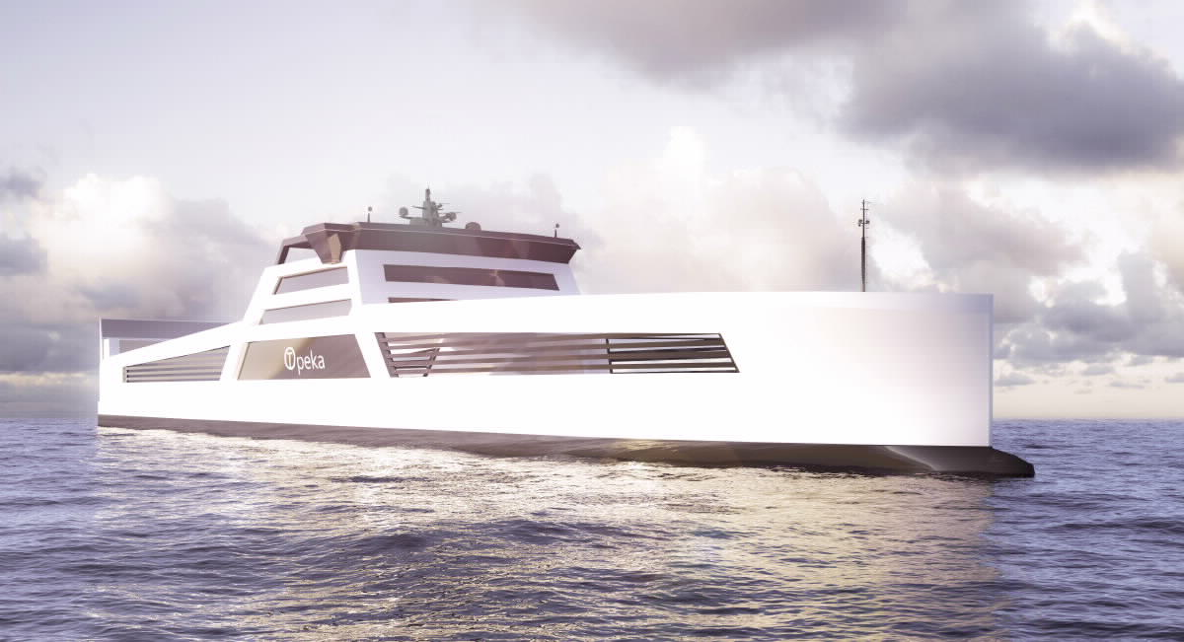
Topeka will be the world's first zero-emission hydrogen-powered cargo ship and will sail between Stavanger and Kristiansund. Illustration: Wilhelmsen and LMG Marin.

Mineral activities on the seabed open up new business opportunities
Mineral activities on the seabed may become a new and important ocean industry for Norway. These activities will only be permitted in Norway if they can be carried out in a prudent manner. Norwegian industry players are well positioned to become suppliers of knowledge and technology to a future seabed mineral industry, including subsea technology, such as designing equipment and carrying out advanced subsea operations. There will also be demand for maritime services.
Commercial activity related to seabed minerals is at a relatively early stage, however several players are showing interest in such activities on the Norwegian continental shelf. Greater development of renewable energy sources and increased digitalisation of society are particularly strong drivers of a growing demand for metals found on the Norwegian continental shelf.

Digitalisation, technology and the transfer of skills create synergies between ocean industries
Norway’s established and emerging ocean industries operate partly in harsh weather environments, with strong winds, high waves and freezing temperatures, and have developed technology and solutions that are able to withstand these types of challenges. New technological solutions enable learning across industries and allow for more flexible use of labour. The emerging industries build on the expertise and technology developed in established ocean industries, particularly the supply industry to the oil and gas industry. The green transition provides new opportunities for restructuring, innovation and growth across industries.
Digitalisation and automation provide opportunities for the development of new technology in all parts of the ocean economy, and may impact on trading patterns, production methods, localisation, operations and work methods. Increased digitalisation also means that more data is produced from the ocean industries than before. The use and sharing of data between stakeholders enables value chains to be streamlined, increases operational reliability, and facilitates more effective supervision. Digitalisation and automation may also contribute to more climate and environmentally-friendly operations. This provides opportunities for renewing and further developing business models, skills and regulations, and represents market opportunities for Norwegian technology suppliers.
Digitalisation and green shipping shall be assigned particular emphasis, and cooperation and sharing of experiences with associated and ocean-related education programmes, shall be facilitated when the work on strengthening maritime expertise is transferred to the Norwegian Agency for International Cooperation and Quality Enhancement in Higher Education (Diku) in 2022. In 2020, Diku allocated NOK 13.5 million for increased digital expertise in the ocean industries.

OPS Sjømat
(PPP (Public Private Partnership) Seafood) - value chain aquaculture was established in August 2020. This is a partnership between the Norwegian Seafood Federation, the Norwegian Seafood Associations and the public sector (through the Ministry of Trade, Industry and Fisheries), which has the goal of being a driving force for digitalisation and data sharing in the aquaculture industry. The goal is to develop and use digital solutions as tools to increase value creation in the industry, while at the same time providing the authorities with data that is necessary for good and efficient management.
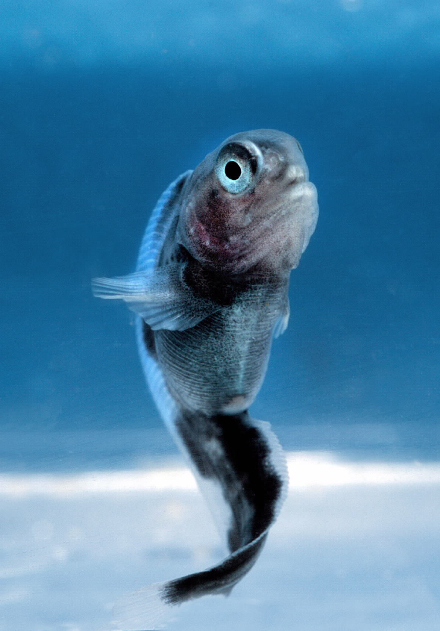
Fish farming - spotted wolffish fry. Photo: Per Eide Studio, Norwegian Seafood Council.

Ambitions going forward
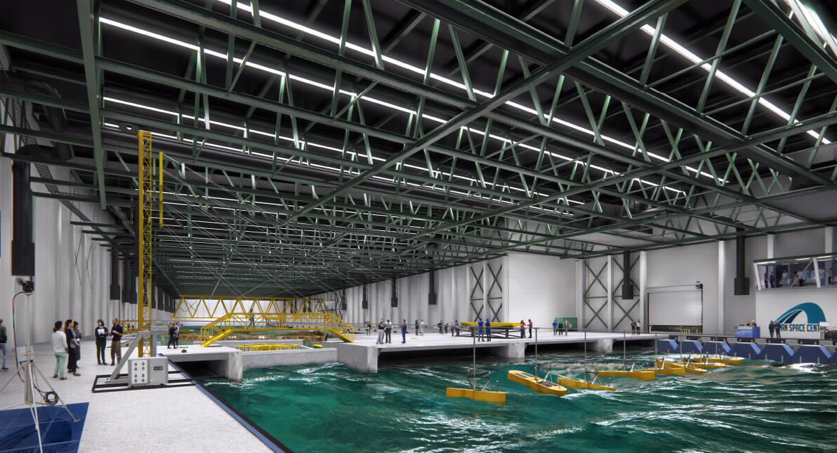
Ocean Space Centre. Illustration: Snøhetta/Plomp.
There has been increased awareness about the importance of the oceans and impressive developments in the ocean industries since Government’s first ocean strategy was presented. This applies, not least, to the new ocean industries. In the updated ocean strategy Blue Opportunities, the Government identified three focus areas for ocean policy in the future. These were skills and digitalisation, regional and local value creation, climate change and green shipping. The reasons for this were the ever-faster developments in technology and use of digital tools, ambitious climate targets, and the increasingly more important role played by the county municipalities in economic development. The three focus areas remain a high priority. Certain special initiatives will also be given serious attention going forward.
Prior to the summer of 2021, the Government will present a Coastal Strategy to promote profitable jobs, digitalisation and green competitiveness in existing and new industries along the entire coast.
Aquaculture has grown to become a significant industry in Norway, and may become even more important in the future. In order to realise the aquaculture industry’s potential for increased value creation within sustainable limits, the Government plans to present an aquaculture strategy before the summer of 2021. The strategy will address important challenges such as fish health and fish welfare, climate change and the environment, new feed resources and access to good and suitable areas. The issue of how we can utilise resources in a green circular economy will also be included in the strategy.
Work is continuing on renewing the marine technology laboratories at the Norwegian University of Science and Technology (NTNU). The Government has selected the Ocean Space Laboratories concept, which involves the construction of new laboratories in Trondheim. This also includes a fjord laboratory with measuring equipment for studying the environment, as well as devices in the waters off the coast of Ålesund and off the coasts of Hitra and Frøya. The laboratories will be adapted to the training and research needs of both established and new ocean industries.
In the spring of 2021, the Government will present a white paper to the Storting focussing on how Norwegian energy resources will contribute to well-paid jobs, value creation and welfare in the long term. The objective is that oil, gas and renewable energy will all continue to provide a basis for well-paid jobs and profitable industry across the entire country in years ahead. The white paper is forward-looking and describes the opportunities and policies for realising value creation and new jobs in the energy sector.
In the 2022 national budget, the Government will describe how the Ocean Panel’s various conclusions are to be followed up. The work of the panel will also be important in light of the COVID-19 pandemic, and will be a priority going forward. In its report from 2020, the Panel emphasised that the ocean is even more important than we thought, that the state of the ocean is worse than we thought, but that the ocean also has many of the solutions required by both mankind and the planet. An important part of the follow-up of the Ocean Panel is to gain global support for the 100 per cent commitment and ensure that sustainable ocean plans are implemented for all areas under national jurisdiction.
Hawaii. Photo: Unsplash.
The Decade of Ocean Science for Sustainable Development will be an important issue from 2021 until 2030 and will be a global initiative to increase knowledge about the ocean. For Norwegian research communities, the decade will be an important framework for both contributing internationally and aligning their own activities with key goals for sustainable development. The Research Council of Norway has prepared proposals for Norwegian research priorities and is organised in a manner which ensures that Norway is well prepared to participate in international research collaboration in the future. Norwegian participation is based on relevant national research programmes and established international cooperation, primarily through the EU. Relevant development cooperation programmes are also included as part of Norwegian participation in the Decade of Ocean Science. The most important activities have been reported to the Intergovernmental Oceanographic Commission of UNESCO (UNESCO/IOC). Norwegian ocean research, international cooperation and fisheries aid are already extensive, but further strengthening of these efforts will be assessed in connection with the annual budget process.
The ocean dimension will be important for Norwegian cooperation with the EU, including at national and regional level, when implementing the EU’s “European Green Deal”, and the EU is a close ally in the work on combating marine litter. Ocean will continue to be an important issue for Norwegian cooperation with other Arctic countries and regions and in following up the white paper on the High North.
Various ocean industries such as shipping, fishing and tourism have been heavily impacted during the COVID-19 pandemic. Examples of this include major problems relating to crew changes in international shipping and the practical disappearance of the international tourism market due to travel restrictions.
We need to protect the ocean better in order to be able to produce more healthy food and clean energy, and to safeguard jobs and transport at sea. This is essential for global, sustainable development towards 2030.
Strong international blue-green ocean cooperation is more important than ever.
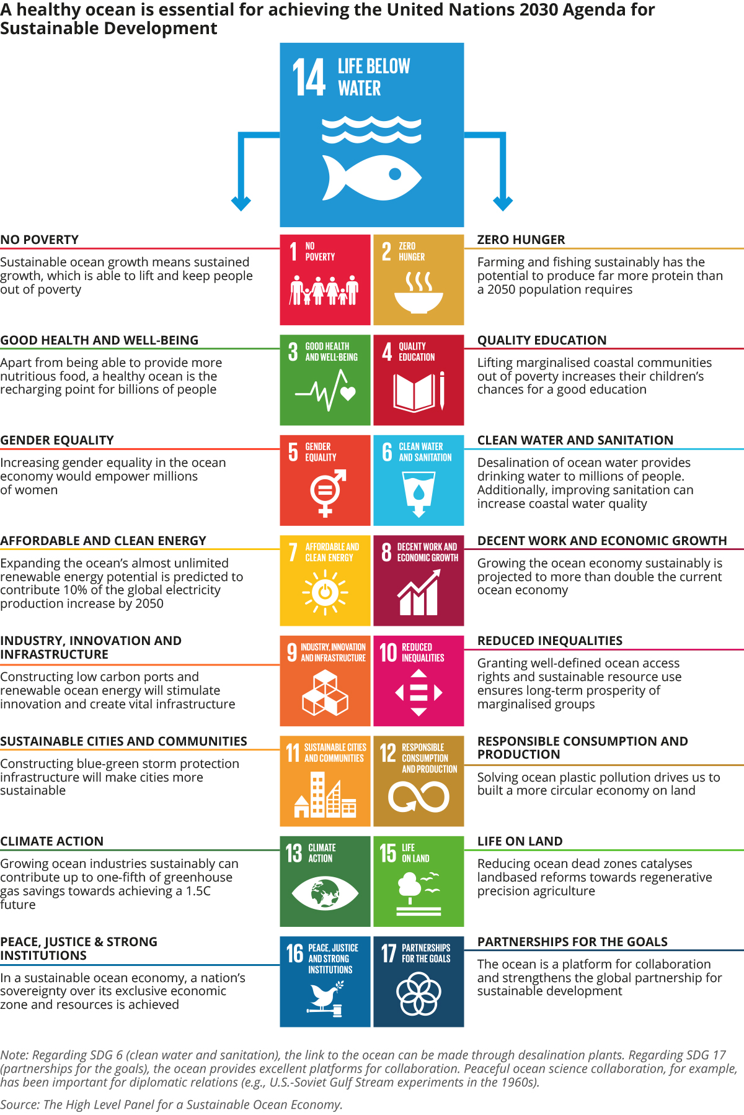

The Intergovernmental Oceanographic Commission of UNESCO (IOC).
Menon Economics (2019 figures)
These figures do not include the slightly less specialised suppy companies and other suppliers.
Report to the Storting (white paper) No. 16 (2020–2021) Education for restructuring — Greater labour market relevance in higher education, which the Government presented on 12 March 2021.
Report to the Storting (white paper) No. 14 (2019–2020) Skills Reform – Lifelong learning.
Report to the Storting (white paper) No. 21 (2020–2021) Completion Reform - with open doors to the world and the future.
Report to the Storting (White Paper) No. 32 (2018-2019) A Quota System for Increased Value Creation – A Forward Looking Fisheries Industry.
Report to the Storting (white paper) No. 20 (2019–2020), Norway’s integrated ocean management plans — Barents Sea–Lofoten area; the Norwegian Sea; and the North Sea and Skagerrak.
Sea lice is one such indicator.
www.oceanpanel.org/climate
Report to the Storting (white paper) No. 29 (2020–2021) Integrated national plan for the conservation of important areas for marine nature.
Report to the Storting (White Paper) No. 14 (2006-2007)) Working together towards a non-toxic environment and a safer future.
Global Centers of Expertise (GCE Node in Kristiansand, GCE Ocean Technology in Bergen and GCE Blue Maritime in Ålesund)
www.havarktis.no
Norad -The Norwegian Agency for Development Cooperation
UN Division of Ocean Affairs and Law of the Sea.
The Intergovernmental Oceanographic Commission of UNESCO.
UN Committee on World Food Security.
Government’s action plan on sustainable food systems in the context of Norwegian foreign and development policy. 2019–2023
United Nations Food and Agriculture Organization.
The guide is an online solution which allows different stakeholders in the value chain to quickly access knowledge about the causes of waste and possible solutions http://www.fao.org/flw-in-fish-value-chains/en/
White Paper no. 22 (2016-2017) on the place of the ocean in Norway’s foreign and development policy.
Other relevant mechanisms are the United Nations Environment Assembly (UNEA), the Convention on Biological Diversity (CBD), the International Maritime Organization (IMO), the Food and Agriculture Organization (FAO), as well as regional mechanisms such as the Convention for the Protection of the Marine Environment of the North-East Atlantic (OSPAR), the North East Atlantic Fisheries Commission (NEAFC), the Arctic Council and the Commission for the Conservation of Antarctic Marine Living Resources (CCAMLR).
BBNJ: Intergovernmental Conference on Marine Biodiversity of Areas Beyond National Jurisdiction.
https://www.theexplorer.no/
Revised National Budget 2021.
Report to the Storting (white paper) No. 10 (2020-2021) Greener and smarter – the maritime industry of the future
Report to the Storting (white paper) No. 13 (2020–2021) Climate Plan for 2021–2030
The PILOT-E scheme is a funding scheme established by the Research Council of Norway, Innovation Norway and Enova SF. The objective of the scheme is to promote more rapid development and deployment of new, environment-friendly energy technology products and services to help to reduce emissions.
International Maritime Organization, IMO.
Norwegian Energy Partners.
CLIMIT is the national programme for research, development and technology for CCS.
More information at https://www.forskningsradet.no/en/
Report to the Storting No. 9 (2020–2021) People, opportunities and Norwegian interests in the High North.

