Investing in a common future
A new framework for Norwegian development policy
Abbreviations
African Development Bank – AfDB
African Union – AU
Development Innovation Ventures – DIV
Foreign Direct Investment – FDI
Fund for Innovation in Development – FID
Global Innovation Fund – GIF
Gross Domestic Product – GDP
Gross National Income – GNI
International Aid Transparency Initiative – IATI
International Bank for Reconstruction and Development – IBRD
International Development Association – IDA
International Financing Corporation – IFC
International Monetary Fund – IMF
International Organization for Migration – IOM
Least developed countries – LDC
Multilateral Organisation Performance Assessment Network – MOPAN
Norway’s International Climate and Forest Initiative – NICFI
Norwegian Government Pension Fund Global – GPFG
Norwegian Ministry of Foreign Affairs – MFA
OECD Development Assistance Committee – DAC
OECD Development Co-operation Directorate – DCD
Official Development Assistance – ODA
Organisation for Economic Co-operation and Development – OECD
Special Drawing Rights – SDR
Total Official Support for Sustainable Development – TOSSD
United Nations Children’s Fund – UNICEF
United Nations Conference of States Parties (under UNFCCC) – COSP
United Nations Conference on Trade and Development – UNCTAD
United Nations Convention against Corruption – UNCAC
United Nations Development Programme – UNDP
United Nations Framework Convention on Climate Change – UNFCCC
United States Agency for International Development – USAID
World Bank’s Development Impact Evaluation – DIME
Figures
2.1 Three scenarios for reducing extreme poverty
2.2 Development slowed in low-income countries in the years before the pandemic
2.3 Highest relative inequality in South America and Africa
2.4 Half of the world’s population growth through 2050 will occur in 12 countries
2.5 High-income and higher-middle-income countries still account for most greenhouse gas emissions
3.1 ODA from members of the OECD Development Assistance Committee in 2022
3.2 Mobilised private finance mainly targeted middle-income countries
3.3 External financial flows to developing countries
3.4 ODA represents a large proportion of GNI in low-income countries
3.5 An increasing proportion of international aid is spent on climate
3.6 Composition of Norwegian aid
3.7 Most climate-related aid went to emission reductions
3.8 The ten largest recipient countries, 2017-2021
Boxes
2.1 Key takeaways from the sixth IPCC Assessment Report
3.1 OECD Development Assistance Committee
3.2 Aid to middle-income countries and emerging economies
3.3 Norway makes full use of the ambiguities in ODA
3.4 Reduction in maternal and neonatal mortality
3.5 Promising methods: ‘Benchmarking’, ‘best in class’ and scoring
3.6 Nexus – a comprehensive approach to fragility
4.1 Example of investment instructions
5.1 An investment under category 2 ‘Cooperation on global conditions for development’
5.2 Global public goods with no relevance to development
7.1 Norfund
8.1 Benchmarking’, ‘best in class’ and scoring
8.2 Disability-adjusted life years and economic rate of return
Tables
5.1 A new framework for Norwegian development policy
5.2 Schematic presentation of proposed developments in the two categories over time

Summary
The world is facing multiple global crises. Geopolitical tensions are rising, extreme inequality is persisting, poverty reduction has stalled, and the number of violent conflicts is increasing. At the same time, we are facing a climate and nature crisis that requires immediate action. The resources being mobilised to tackle these problems are far from sufficient, and many of the responses to them are not effective.
Norway is in a unique position, with far greater financial leeway than most other countries. However, much of its wealth is closely linked to the drivers of global climate change, and Norway must recognise that this also entails responsibilities. Since Norway is a major investor with an open economy, and is highly dependent on foreign trade, it is also in the country’s own interests to play a part in risk reduction and in managing global crises. Norway has a special responsibility and the capacity to mobilise more resources than others, and to use these resources effectively to reduce poverty. Norway also has an obligation to play a greater role in efforts to address global challenges.
In this report, the expert group provides advice and recommendations that can be used in this important work. The report outlines a new framework for development policy organised under the overarching principle of ‘investment in sustainable development’. According to this framework, aid is not understood exclusively as donated resources, but as an investment in our common future. This calls for clearer goals and targets and a stronger focus on results. To ensure that we are doing the right things in the right way, the expert group proposes criteria for measuring effectiveness and a reporting system.
Key recommendations:
- From 1 % to 2 % of GNI: given the global challenges and its own wealth, Norway should raise its level of ambition
Norway should adopt a more ambitious development policy, with a target of increasing total development finance – from both the public and the private sector – to about 2 % of its gross national income (GNI). This target reflects growing needs, other countries’ growing expectations about Norway’s contributions, and Norway’s financial capacity.
- Investment rather than donation: the yield from development finance can be considerably increased by setting clearer targets and reducing costs
A new overall framework for development policy is proposed, based on the principle of investment in sustainable development.
This calls for clearer and better delimited targets and a stronger focus on effective action to achieve results.
- We must both reduce poverty and deal with the global challenges – but the two objectives require different approaches
Norwegian development policy should have a clear poverty reduction profile but should also focus more strongly on dealing with global challenges, particularly the climate crisis. However, there should be a clearer distinction between these two objectives. The geographical distribution of poverty is different from that of greenhouse gas emissions.
Norway should intensify its global poverty reduction efforts and at the same time delimit them more clearly. The expert group proposes that 0.7 % of GNI – and more than this in the event of humanitarian crises – should be earmarked for poverty reduction and emergency aid. Parts of the current development budget are used for activities outside these areas.
A separate category is proposed for action to resolve the climate crisis and deal with other global challenges. Over time, funding for this category should be increased to 0.7 % of GNI.
- The private sector should play a larger role – and the public sector can influence this more strongly
Norway should establish an ambition to mobilise private investment corresponding to 0.7 % of GNI in developing countries. To achieve this, it will be necessary to scale up existing instruments and tools in the development sector, establish some new ones, and improve coordination in the aid sector by building up a ‘Team Norway’ for development.
- A new white paper on development policy should be published to establish a sound political basis for the new framework.
The expert group has reviewed Norwegian and international aid and concludes that the main weaknesses of current development policy are as follows: there are too many divergent goals, these goals are too elastic, instruments and tools are not updated as new problems arise, and systematic assessments of costs are not robust enough. As a result, aid is not effective enough and resource mobilisation is not sufficient to meet people’s needs. This report proposes two main steps to address the problems.
Firstly, the expert group proposes a new framework for assessing aid effectiveness, which is intended for general use in following up development policy goals. More specifically, this involves establishing an investment framework together with investment instructions to ensure that resources are used as effectively as possible towards sustainable development. Secondly, new categories are proposed for Norway’s international development finance, with more clearly defined targets and better differentiation of activities across the whole range of activities that will be required in the years ahead. This proposal is based on the idea that the different ambitions of development policy must be more clearly separated to enhance the effects of all activities. In practical terms, this involves a clearer split of Norway’s international development activities into two categories:
- Category 1: main focus on poverty reduction and development in the poorest countries, together with humanitarian assistance.
- Category 2: risk reduction and response to global challenges that affect developing countries particularly severely.
For category 1 activities, this will involve stricter application of the rules on official development assistance (ODA), whereas in category 2 there will be a more flexible approach to development-relevant global public goods, based on important principles for aid effectiveness. Most support in category 2 will qualify as ODA, but not necessarily all of it.
In addition to these two steps, the report discusses how Norway can most effectively mobilise private investment, and which specific mechanisms appear to be promising. These include using guarantees and insurance arrangements, increasing support to Norfund and Norway’s Climate Investment Fund, in addition to supporting the development banks and the proposals that have been made for boosting their loan capacity.
Overall, the expert group’s proposals provide a fresh starting point for Norway’s participation in international discussions about how new global challenges have altered the framework for development cooperation. They provide more clarity as regards objectives and the distinctions between financing for activities to achieve development policy targets and financing for global public goods, and as regards possible exceptions from the current ODA rules. The expert group believes that its recommendations will both provide some discipline in so far as public-sector investments require the use of new assessment methodology and must be more clearly based on existing knowledge and research. On the other hand, the recommendations provide more flexibility since the proposals shift the focus towards results and long-term social benefits.
As a way of enhancing Norway’s engagement at the interface between international development and the universal ambition of the SDGs, the expert group proposes that Norway should play an active part in the further development and use of the Total Official Support for Sustainable Development (TOSSD) framework as a supplement to the ODA system. This can also ensure universal participation in discussions on reporting of development finance.
A key question for the expert group has been how Norway’s financial resources and expertise can best be used in poverty reduction while at the same time helping to ensure a sustainable future for generations to come. The group points to a range of global threats to our common future, in particular the climate and nature crisis, which have a wide array of impacts. Other threats include war and conflict, faltering international cooperation and pandemics. The impacts of these threats are greatest in poor countries, but they also affect Norway – in political, social, and economic terms. The expert group proposes using a somewhat larger proportion of the Norwegian state’s financial leeway to invest in activities that will reduce global risk of this kind and ensure the production of global public goods. This proposal is based on long-term, enlightened self-interest. These activities should not be financed at the expense of but be additional to resources Norway has undertaken to provide to poorer countries.

Introduction
Reducing poverty has been a key aim of Norwegian development policy from the outset. In recent years, new global challenges have become increasingly urgent. These comprise both violent conflict and, in particular, climate change, which has the most severe implications for developing countries and undermines the conditions for long-term poverty reduction. This has changed and expanded the development agenda over time, where poverty reduction is increasingly linked to the ability to address not only local and national, but also global challenges. After a prolonged period of decline in global poverty, climate change is already undermining the livelihoods in many poor and middle-income countries. Furthermore, the pandemic has caused the number of people living in extreme poverty to increase for the first time in decades.
At the same time, the international aid system is under increasing pressure. The system is underfunded and not set up to deal with the challenges we are currently facing. Only a handful of rich countries are providing aid at a level that meets the international community’s targets, set by the United Nations at 0,7 % of Gross National Income, and defined as Official Development Assistance (ODA) by the OECD Development Assistance Committee. At the same time, a larger proportion of such ODA, including Norwegian, are being used to deal with global challenges such as climate change, pandemics, conflict and flows of refugees instead of the original goal of contributing to development in poor countries.
The aim set out in the Government’s political platform is to “spend 1 % of Norway’s GNI on international efforts to achieve the SDGs for socially, economically and environmentally sustainable development”. The wording can be interpreted to mean that international efforts do not necessarily have to be linked to ODA.
The expert group was established by the Ministry of Foreign Affairs (MFA) with a mandate to provide advice on the funding of efforts to support the global goals to achieve socially, economically, and environmentally sustainable development, and on how Norway can contribute to international discussions on global public goods.
The expert group’s mandate is threefold. It is tasked with providing advice on
- How the target set out in the Government’s political platform to spend 1 % of Norway’s GNI on international efforts to achieve the SDGs for socially, economically, and environmentally sustainable development should be followed up.
- How Norway can best contribute to the international debate on how to secure the funding needed to promote economic development and welfare in developing countries, as well as to deliver global public goods, and advice regarding internationally acceptable reporting system, as well as partners and arenas on which it should focus.
- Possible exceptions from ODA rules in the Norwegian aid budget. The expert group is tasked with proposing in which cases and to what extent, in rare cases and to a limited extent, funds can be used from the aid budget within the one per cent threshold of Norway’s GNI on international efforts to achieve the SDGs for socially, economically and environmentally sustainable development. The exceptions are not limited to ODA-approved countries but must be deemed to have a poverty-reducing effect.
To deliver on the mandate given and respond to the three specific tasks, the Expert Group has deemed it necessary to conduct a broad analysis of key development trends. Our analysis and recommendations are based on a twofold analysis: Firstly, an analysis of what the specific challenges or problems are, and whether they are of a national, regional, or global nature. Climate change and efforts to prevent and manage it are key factors in this respect. Secondly, an analysis of the more technical and formal aspects of Norwegian and international aid, and whether the system that encompasses what is defined as aid is suitable for tackling new challenges. The Development Assistance Committee (DAC) of the Organisation for Economic Co-operation and Development (OECD), which defines rules for what is approved as official aid (ODA), is particularly important in this respect. The same applies to other multilateral organisations such as the UN and the development banks.
We do not analyse the specific contents of Norwegian aid in detail, but concentrate, as specified in the mandate, on overall objectives and management systems as well as the international context in which Norwegian aid operates. Specifically, this means that we do not seek to measure or assess how Norwegian aid contributes to reaching different Sustainable Development Goals (SDGs). Nor do we assess whether, for example, support to education is more or less effective than support to health. We base our approach on the broad understanding of development that has characterised Norwegian aid and development policy for a long time, where human rights and gender equality are integral objectives and considerations.
In Chapter 2, we analyse global development trends and show that it is highly unlikely that the world will achieve the SDGs. We show how poverty is increasingly concentrated in what are often referred to as fragile states, how humanitarian crises and long-term development is increasingly interwoven, and how climate change threatens to undermine the development gains achieved over the past decades. However, we also show that there are positive developments and significant potential for generating economic growth and simultaneously tackling climate change. The conclusion is nonetheless clear: action is needed now if we are to avoid the catastrophic consequences of climate change, and this action must be taken in a way that does not lose sight of the aim of reducing poverty.
In Chapter 3, we analyse key developments in the international aid system, with particular focus on the role of key multilateral organisations, how different forms of aid are distributed, the proliferation of development objectives, and how climate change has over time become a key component of development financing. The conclusion is clear: The international aid system is underfunded, fragmented and not fit to the task of addressing the complex problems we are facing. Of particular importance to our mandate is the analysis of the very definition of official development assistance (ODA) within the framework of the OECD DAC. We show how the goal of a high volume of ODA has led to an expansion of what can count as ODA. The result is that there are too many different and poorly defined development objectives, which potentially undermines the quality and effectiveness of development work.
To address this problem, we outline a new framework for development policy in Chapter 4 based on the overarching principle of ‘investments in sustainable development’. The framework introduces a set of principles that redefine aid as investments with the aim of providing the greatest possible social returns. The intention is to clarify common interests and equal partnerships between donors and recipients of aid, and to establish clear criteria that can ensure effectiveness and results. The framework also identifies the importance of drawing on knowledge and research-based assessments of what kind of measures are most effective in achieving development policy goals.
Chapter 5 builds on this investment framework to suggest a new categorization of development aid, with distinct yet interrelated objectives. The argument is straightforward: In order to strengthen measurement and improve the effectiveness of different development interventions, it is necessary to formulate clear objectives. This involves categorizing Norwegian development aid into two broad areas: Poverty reduction and development in the poorest countries, together with humanitarian assistance (Category 1), and risk reduction and responses to global challenges – notably climate change – that disproportionally affect low- and middle income countries and undermine development (Category 2). These categories serve to highlight the increasing thematic and operational scope of development cooperation, as described in Chapter 3. There is still a clear expectation in our framework that most of Norway’s investments within the aid budget will be concentrated in and benefit poor and fragile countries. At the same time, it signals a greater transparency with respect to all countries’ self-interest in – and responsibility for – resolving global challenges.
In Chapter 6, we show how a reorientation of Norwegian development policy must be based on standards and rules on which international consensus can be established. Although ODA is under pressure, it remains the most important international measurement for donor contributions to development. Norway should therefore work towards a “refocused” ODA, while also actively contributing to further developing the new international reporting framework Total Official Support for Sustainable Development (TOSSD). This will provide an appropriate method of reporting and monitoring development financing also beyond ODA.
However, a clearer categorisation and increased focus on effectiveness are not sufficient to respond to current challenges. In Chapter 7, we describe the need urgent need to mobilize more resources, both from public and private sources. We describe how Norway can contribute to mobilizing more private investments, including which mechanisms are most effective to this end. This includes using guarantees and insurance schemes, increasing support to Norfund and Norway’s Climate Investment Fund, as well as supporting the development banks and the proposals that have been made for boosting their loan capacity.
The proposed framework for investments in sustainable development aims to move away from traditional aid and towards investments in a common, sustainable future, with a focus on genuine partnerships and results. All countries have a vested interest in investing in a sustainable future, but countries such as Norway have a particular responsibility to contribute according to the principles of a global division of responsibility.

The Expert Group and its Work
The recipient of the report is Minister of International Development Anne Beate Tvinnereim.
The expert group responsible for producing the report has consisted of: Ole Jacob Sending (Director of Research, Norwegian Institute of International Affairs – NUPI) (chair), Arild Angelsen (Professor at the Norwegian University of Life Sciences), Dan Banik (Professor at the University of Oslo), Anne-Marie Helland (Director in PwC Norway), Karoline Myklebust Linde (Managing Director in Laerdal Global Health), Jon Lomøy (retired), Trond Mellingsæter (Managing Director in Reitan Eiendom), Hilde Beate Selbervik (Associate Professor at the University of Bergen) and Liv Tørres (International Secretary of the Norwegian Confederation of Trade Unions – LO Norway).
The secretariat for the Expert Group has comprised Assistant Director General Kari Hauge Riisøen (chair), Special Representative Vegard Holmelid and Adviser Magnhild Bøgseth, all from the Ministry of Foreign Affairs (MFA), as well as Director Håvard Mokleiv Nygård, Assistant Director Katrine Andrea Heggedal and Senior Adviser Nikolai Henrik Wold Hegertun, all from Norad.

Method
The expert group’s analysis and recommendations are based on aid statistics from Norad, data and analyses from the OECD, the World Bank and the UN system, as well as a number of research reports from universities, research institutions and think tanks. It is also based on interviews and conversations with relevant public and private sector actors in Norway and internationally. The group has visited Washington DC, New York, Paris, Brussels and Addis Ababa and held several meetings at the civil servant level in Norway with the Ministry of Foreign Affairs and Norad, as well as with the Ministry of Health and Care Services and the Ministry of Climate and Environment. The expert group has also had meetings with Norwegian and international civil society organisations and research institutions. The private sector perspective has been obtained through conversations with Norfund, private investors, the International Financing Corporation (IFC) and the Confederation of Norwegian Enterprise’s (NHO) Forum for the promotion of business engagement, among others. The group has talked to leading large donors such as the USA, UK, France, Germany, and the European Commission, as well as with smaller donors such as the Czech Republic, Portugal, Switzerland and Poland. It has also had meetings with representatives of the Nordic countries, the chair of the OECD Development Assistance Committee (DAC), as well as with the OECD Development Co-operation Directorate (DCD), the OECD Centre for Tax Policy and Administration and the OECD Development Centre. The expert group has met with UN Deputy Secretary-General Amina Mohammed, the UN Secretary-General’s Secretariat, and various UN development organisations, including the UN Children’s Fund (UNICEF) and the UN Development Programme (UNDP) at central and country level, as well as the World Bank (WB) and the African Development Bank (AfDB). The group has also had meetings with think tanks in New York, Washington, Paris, Brussels and Addis Ababa. Several meetings have been held with representatives of developing countries in Addis Ababa and New York, with the Ethiopian authorities and with the African Union (AU).

Global challenges
The last three decades were marked by historical progress for many developing countries: extreme poverty and child mortality declined, and life expectancy and levels of education increased. Even in the years before the covid pandemic, however, there were signs that this trend was about to turn: In many developing countries, there was a slight decline in economic growth several years before the pandemic, and in the wake of it, we have seen an increase in the number of poor people in the world for the first time in decades. Infant mortality, which has seen a steady decline for decades, has now increased in several countries as a result of the pandemic. Forecasts are more uncertain but no less pessimistic, which stand in sharp contrast to the optimistic outlook that culminated in the formulation of the Sustainable Development Goals (SDGs) in 2015.
The war in Ukraine has led to food and energy crises across the entire world. Inflation and financial instability are spreading rapidly across continents. The covid pandemic also showed how events or crises have global consequences. The climate crisis is the clearest expression of these mutual vulnerabilities, but also how unevenly distributed these consequences are: While climate change does affect all societies, the most severe ramifications are and will be felt mostly by poorer countries and groups that have contributed the least to the problem.
Heightened geopolitical tensions also undermine multilateral cooperation, which is necessary to make progress on responding to global challenges. The effects of this rivalry on the functioning of the multilateral system to deliver aid effectively are significant.
The UNDP has for the first time since the inception of the Human Development Index registered a decline in human development. Loss of nature and possible collapse of ecosystems will have catastrophic consequences for communities and livelihoods in the Global South going forward. For example, the UN’s Intergovernmental Panel on Climate Change (IPCC) estimates that Africa has already lost 13 % of its gross domestic product (GDP) per capita due to the climate and natural crisis. Moreover, we have seen a global decline of democracy in recent years, and there are now twice as many countries moving in an authoritarian direction as there are countries moving in a democratic direction. Add to this that in absolute terms, the number of people in need of emergency relief has reached an all-time high at 274 million, up from 136 million in 2012.
Over half of the world’s low-income countries (58 %) currently have or are at great risk of facing debt problems. The combination of weak growth in the tax base, a strong US dollar and major budget deficits has increased the debt burden. Although the debt crisis of the 1990s was more severe, the International Monetary Fund (IMF) warns that a similar critical situation may arise in the medium term, especially when debt needs to be refinanced at ever-increasing interest rates, and by a much more differentiated group of creditors.
In his speech to the World Economic Forum Annual Meeting in Davos in January 2023, the UN Secretary-General pointed out that the world is facing a crisis of trust in the relationship between the Global North and the Global South. This is expressed in many ways, including in the field of climate. Climate-vulnerable developing countries – which are already feeling the consequences of climate change in the form of more frequent extreme weather and loss of livelihoods – do not feel that rich countries, which were largely responsible for the accumulated emissions that caused the problem, are contributing as they should to solving the problem.
Against this backdrop, the chapter describes key global challenges that form the basis for contemporary development cooperation.
In this chapter, we will
- show that the world has seen considerable progress in human development over the past 30 years, but that this positive development is now at risk without forceful action.
- show that there is a great and urgent need to invest in global problem-solving.
- show that there is significant potential for solving global challenges through ambitious and well-designed interventions, but that this requires both more public and private financing of development and the provision of global public goods.
- demonstrate that through such well-directed efforts over the next two to three decades we can avoid a manifold increase in future costs while at the same time helping poor countries to achieve sufficient capacity for economic growth.

Poverty, economic development and inequality
The last thirty years have been characterised by increased globalisation and economic growth. This economic growth has contributed to a significant reduction in extreme poverty in low- and middle-income countries. Yet, as Figure 2.1 shows, projections show that by 2030, many hundreds of millions of people will be living in extreme poverty around the world. If we add those living just above the extreme poverty line to this figure, the projection is even more dismal. With a poverty line of USD 3.65 a day, which is closer to the average of national poverty lines in several lower-middle-income countries, 23 % of the world’s population will live in poverty.
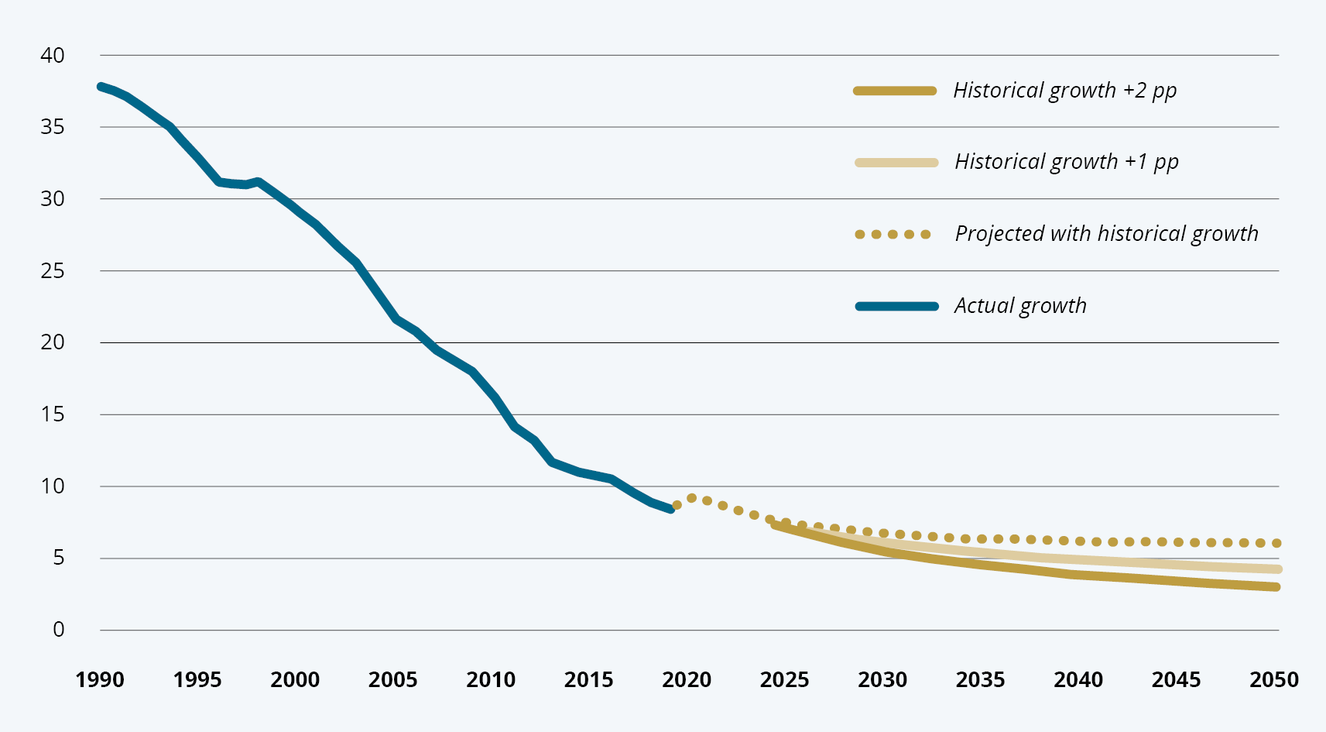
          - Three scenarios for reducing extreme poverty
Note: Global poverty rate of USD 2.15 a day in 2017 purchasing power parity. Percentage of the world’s population.
Source: World Bank, 2023. Poverty and Inequality Platform. Available at https://pip.worldbank.org/home.
Although future projections are bleak, the historical pattern is that the world has seen significant positive developments in poverty reduction over the past 30 years. Asia, in particular countries such as Vietnam, China, and India, has seen a formidable economic growth and associated poverty reduction. About one billion people have worked their way out of poverty in Asia in one generation. In sub-Saharan Africa extreme poverty was reduced from 55 to 41 % between 1990 and 2018. At the same time, however, the population doubled (to over one billion), bringing the number of people in extreme poverty up to around 150 million.
Both economic growth and the reduction in the number of poor people in developing countries were significantly lower in the period 2011–2019 than in 2000–2010 (see Figure 2.2). The World Bank estimates that global economic growth in the period 2020–2025 will be at its weakest in 60 years. A new report concludes that the long-term factors for growth have been weakened. This indicates that the economies of many low- and middle-income countries experienced structural problems even before the pandemic and the war in Ukraine.
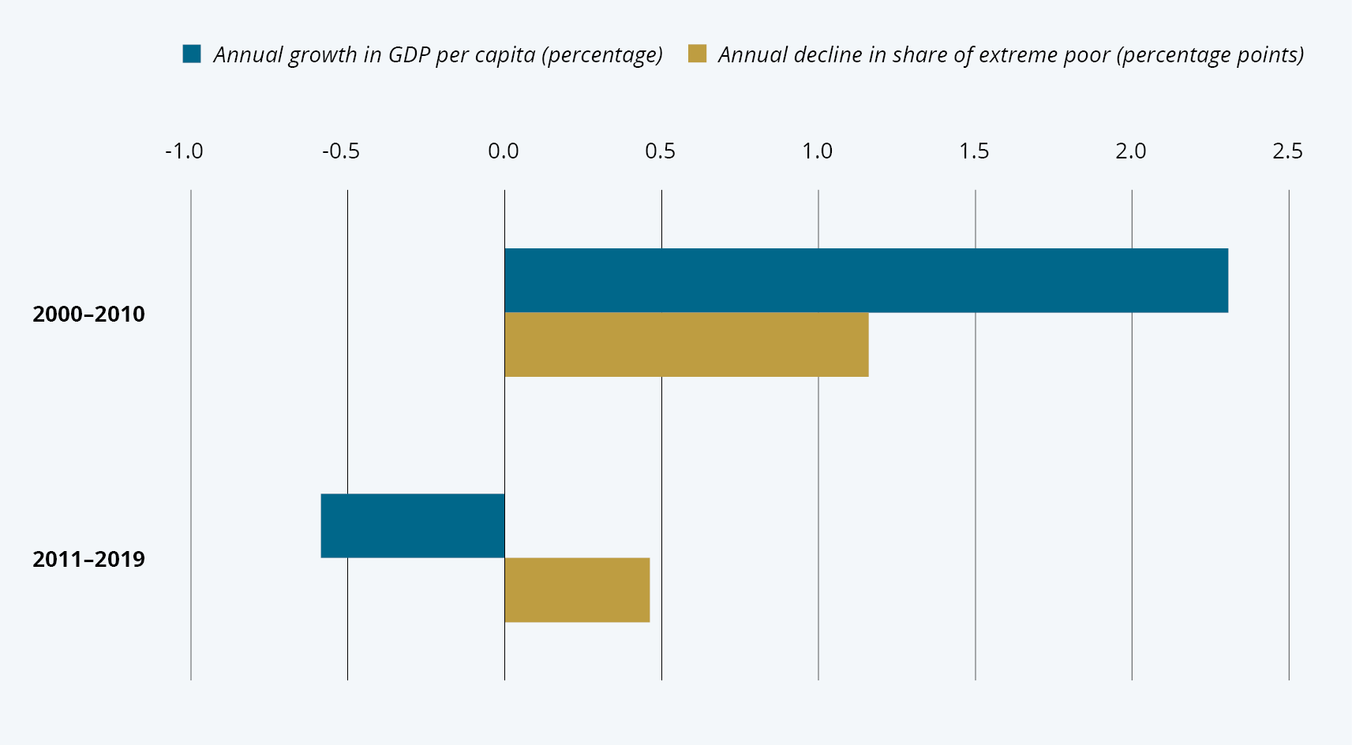
          - Development slowed in low-income countries in the years before the pandemic
Note: Average for the given periods. Note that we only have figures for the proportion of extreme poor in low-income countries up to 2018.
Source: World Bank, 2022. World Development Indicators (last updated April 2022). Available at https://databank.worldbank.org/source/world-development-indicators.
Corruption, and in particular cross-border corruption and other illicit capital flows, remain a major obstacle to development. The United Nations Convention against Corruption (UNCAC) notes that corruption undermines institutions and puts sustainable development, democracy and the rule of law at risk. The UNCAC also expresses concern about the links between corruption and other forms of crime, in particular organised and financial crime, including money laundering. Illegal export of capital stemming from, for instance, corruption and tax evasion leads to net capital flow from countries in the Global South to countries in the Global North, particularly to countries with low taxes and a high level of secrecy. This contributes to inequality, nationally and globally, and may give rise to social unrest and distrust.
The pandemic led to an increase in the proportion of extremely poor people in the world, from 8.4 % in 2019 to 9.3 % in 2020. As incomes in the poorest countries fell more than in rich countries, we have once again seen an increase in inequality between countries. This adds to a longer-running trend where extreme poverty is increasingly concentrated in sub-Saharan Africa.
Over the past 25 years, inequality between countries has declined significantly. Within countries, inequality is still high and, in many countries, increasing. Figure 2.3 compares inequality across the world’s countries. Globally, it is estimated that a reduction in the Gini coefficient of one percentage point per year would contribute more to poverty reduction than an increase of one percentage point in economic growth. Addressing inequality can therefore, in some cases, be an effective way of reducing poverty. However, redistribution alone is not a realistic way out of poverty for many low-income countries. This is especially true for certain countries in sub-Saharan Africa, where the overall income is still so low that significant economic growth is the only way to lift larger sections of the population out of poverty. Nevertheless, the map also shows that this region, in addition to harbouring many of the world’s poorest countries, also has some of the highest inequality rates in the world.
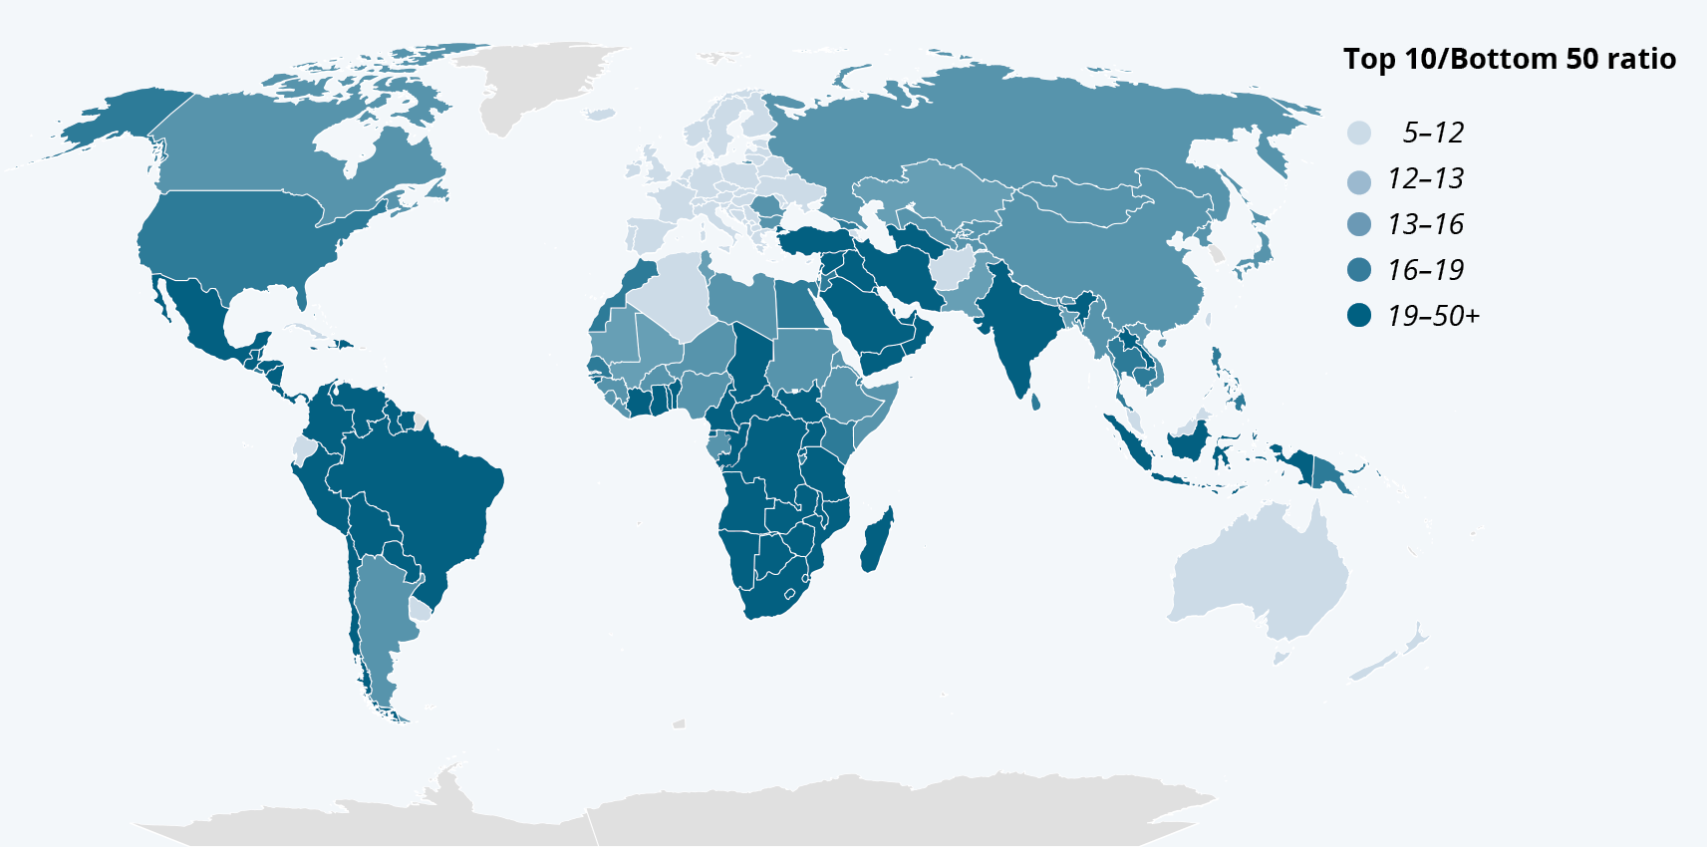
          - Highest relative inequality in South America and Africa
Note: The figure shows how many times less the lower 50 % of the population earned than the upper 10 % in 2021. For example, the lower 50 % of the population in Brazil earned 29 times less than the upper 10 %. Income includes pensions, social security and other individual benefits, but excludes other transfers and taxes.
Source: World Inequality Lab. 2022. Methodology. World Inequality Report 2022. Available at https://wir2022.wid.world/methodology.
Inequality is also manifest in how crises impact societies: In addition to the purely economic downturn during the pandemic, it was also in the poorest countries that we saw the biggest setbacks in health and education. By mid-2022, 72 % of people in high-income countries had been vaccinated with at least one dose of a Covid-19 vaccine, while only 21 % of people in low-income countries had been vaccinated in the same period. Moreover, the extent of missed school days was greatest in low-income and lower-middle-income countries, where the capacity for home learning is lowest. In these groups of countries, more than half of 10-year-olds were illiterate even before the pandemic. The economic consequences of the loss of learning will be substantial and lasting. Expressed in terms of increased years in poverty or reduced GDP, they may, according to some estimates, be even greater than the direct economic impact of the pandemic.
There is currently a high degree of climate inequality. The richest 10 % in the world, around 770 million people, account for about 48 % of the world’s greenhouse gas emissions. The poorest half of the world’s population, 3.8 billion people, only account for 12 % of global emission and yet these countries are at the same time most vulnerable to the consequences of climate change.

Fragile states are a particular challenge
Increasingly, extreme poverty will be concentrated in what are often classified as fragile states. Fragile states are often characterised by armed conflict and political violence and/or where government institutions are generally weak and unable to implement policies. The OECD highlights 60 contexts, mostly states, which are currently considered fragile. This means that 1.9 billion people live in fragile contexts. These areas are home to 73 % of the world’s extreme poor, a proportion that is estimated to rise to 86 % by 2030. Demographic developments will further intensify this trend, as half of the world’s total population growth until 2050 is expected to take place in just twelve countries, of which three of the five with the highest growth rates are fragile states; see Figure 2.4.
Aid is a crucial source of funding in fragile contexts. In 15 of the most fragile contexts, ODA volumes are seven times the amount of foreign direct investment and three times that of remittances from migrants. In 2020, total international aid allocated to fragile contexts reached a record high of USD 91.4 billion. Fragile states are a priority in Norwegian development cooperation. Eleven of Norway’s 16 current partner countries for development cooperation are defined as fragile states, including several of the largest individual recipients of Norwegian aid, such as Ethiopia and Syria.
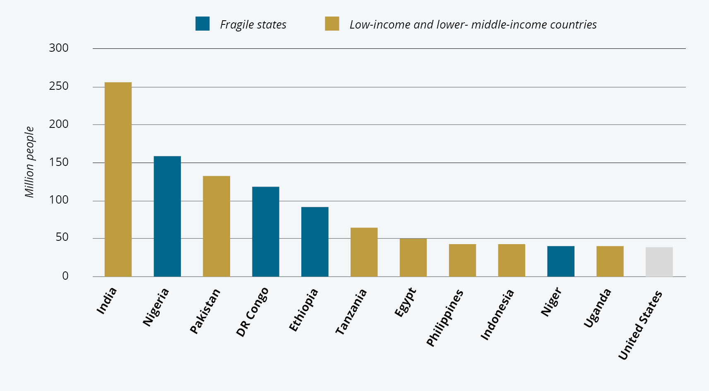
          - Half of the world’s population growth through 2050 will occur in 12 countries
Note: Population growth by 2050 in 12 countries. The UN projection of global population growth shows an increase of around two billion people through 2050. The twelve countries in the figure account for one billion of this increase.
Source: UN. 2022. World Population Prospects 2022. Available at https://population.un.org/wpp/.
The challenges associated with fragile states highlight a fundamental problem. Peace and stability are preconditions for development and economic growth. For low- and middle-income countries, a violent conflict costs on average around 30 years of GDP growth. At the same time, economic development is an important driver of reduced conflict and violence within and between countries. This forms the basis of what is referred to as the conflict trap: A low level of socio-economic development is a driver of conflict, while conflict has a further detrimental effect on economic development. This dynamic can lock countries in a spiral of conflict and poverty that is difficult to stop. Had the world only consisted of stable poor countries, we would most likely have achieved SDG 1 (End poverty in all its forms everywhere) within this decade.
The increase in the number of conflicts we have seen in recent years is therefore an ominous sign for the 2030 Agenda. Projections based on current levels of conflict and historical trends estimate a global economic loss (reduced economic activity) between 2022 and 2030 of USD 28 trillion. This economic loss is expected to grow to USD 292 trillion by 2050. About 150 million people are expected to live in extreme poverty caused by civil war in 2030, compared to a scenario without conflict.
Around 130 million of these live in only ten particularly vulnerable countries where conflict mitigation can make a highly effective contribution to reducing extreme poverty.

Climate change as a growing challenge
Climate changes may soon reach a ‘tipping point’ with potentially irreversible consequences. We can already observe how climate change is increasing the frequency of extreme weather events and droughts, destroying food production and displacing people. In this way, climate change can reverse the progress in human development. Reducing climate emissions and ensuring adaptation is therefore an urgent task.
The consequences of climate change are greatest in countries in the Global South, which have contributed the least to creating the problem. While there is no doubt that economic growth and climate action must go hand in hand in the long term, there is a tension in the short and medium term between prioritising economic growth and poverty reduction on the one hand and climate action on the other.
The IPCC highlights in its synthesis report (see box) that to achieve climate- and sustainability goals, it is necessary with climate resilient development. The core of climate resilient development is emission reduction, climate adaptation and sustainable development, with the aim of ensuring a safe climate, fulfilling basic human needs, eradicating poverty and enabling equitable and sustainable development.
              - Key takeaways from the sixth IPCC Assessment Report
Climate change is here now: Climate change is a threat to human well-being and planetary health (C.1). The IPCC now concludes that the effects of warming occur at lower temperatures than previously estimated (B.2, B.2.2). All regions of the world are already affected (A.1).
This decade is critical – every hundredth of a degree matters: The choices and actions implemented in this decade will have impacts now and for thousands of years (C.1). There is a rapidly closing window of opportunity to secure a liveable and sustainable future for all (C.1). With every additional increment of global warming, the number and intensity of extremes will become larger (B.1.3), making climate-resilient development more difficult to achieve (C.1.1).
Injustice: Who contributes to and who is affected by climate change is not fairly distributed (A.1.5, A.2.2). Vulnerable communities who have historically contributed the least to current climate change are disproportionately affected (A.2).
The need: Stopping global warming at 1.5 or 2 degrees requires immediate, comprehensive and sustained emissions cuts in all sectors this decade. (B.6). To limit warming to 1.5°C, global CO 2emissions must be halved by 2030 (B.6.1), reaching net zero CO 2 in the early 2050s (B.6.1).
Adaptation: A number of systemic constraints are preventing successful climate adaptation, such as a lack of financing and poor understanding of the urgency (A.3.5). Adaptation options often have long implementation times (C.2.1), and accelerated implementation of adaptation in this decade is essential (C.2.1). Adaptation options that are feasible and effective today will become less effective with increasing global warming (B.4), and human and natural systems will reach their adaptation limits (B.4).
People: Increasing weather and climate extreme events have exposed millions of people to acute food insecurity and reduced water security (A.2.2). The productivity of agriculture, fisheries and aquaculture has been weakened (A.2.4). Roughly half of the world’s population currently experience severe water scarcity for at least part of the year (A.2.4). In all regions, increases in extreme heat events have resulted in human mortality and morbidity (A.2.5). The incidence of infectious diseases and mental health challenges has increased (A.2.5). More and more people are being displaced (A.2.5). Economic loss from climate change has been detected in climate-exposed sectors, such as agriculture, forestry, fishery, energy, and tourism (A.2.6). Around 3.5 billion people live in contexts that make them highly vulnerable to climate change (A.2.2).
Box 2.1 (cont.)
Financing Both adaptation and mitigation financing will need to increase many-fold (C.7). To limit warming to 1.5°C or 2°C will require annual investments of three to six times the current levels (C.7.2) (C.7). Financing gaps and opportunities are largest in developing countries (C.7.4) and accelerated financial support from developed countries is crucial (C.7.4).
What we need to do going forward: Climate resilient development, i.e., both adaptation and emission reductions, is made possible by international cooperation and mobilisation of funding, especially for the most fragile regions, sectors and groups. To succeed in climate resilient development, we must include all levels of society – civil society, local authorities, the private sector – and work across sectors, but in a way that is adapted to local circumstances and conditions.
A new report series from the World Bank shows that for low-income and some middle-income countries, the greatest challenges will be of an economic and financial nature, both in terms of the direct costs incurred as a result of climate change and the requirements for investment in the transition.
Middle-income countries comprise 5.5 billion people and account for a rapid growth in emissions. Per capita emissions correlate strongly with income levels and are therefore highest in high-income countries (Figure 2.5). At the same time, we see that the previously strong correlation between growth and emissions changes has started to change in some countries. Many EU countries, for example, have already managed to decouple economic growth from increased greenhouse gas emissions. However, it is not enough that emissions grow more slowly than the economy – they must be dramatically reduced in the years ahead if we are to reach the 1.5°C target.
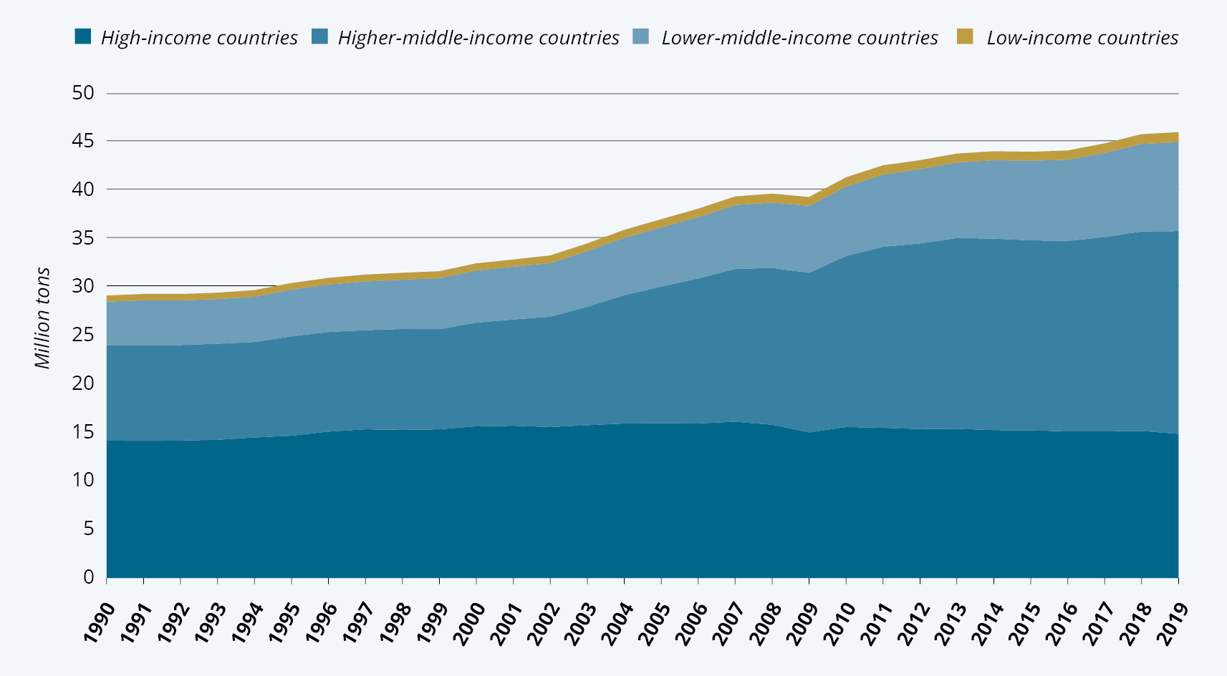
          - High-income and higher-middle-income countries still account for most greenhouse gas emissions
Note: Total greenhouse gas emissions per year, broken down by income category.
Source: World Bank, 2022. World Development Indicators (last updated 23 April 2022). Available at https://databank.worldbank.org/source/world-development-indicators.
The green transition will be crucial in the decades ahead. In countries with a high consumption of fossil fuels, this will lead to loss of income and investments in the short term, but an increase in gains in the longer term. The conflict between climate action and economic development is therefore most precarious in the short and medium term and is clearly greatest in low-income countries with limited financial leeway. During the transition, the degree of conflicting interests and the legitimacy of climate action will depend on the availability of funding and social safety nets for those affected.

Investment opportunities
Africa has over 60 % of the world’s unused arable land, and 90 % of its food is produced by small-scale producers. Investments in technology to increase productivity can significantly increase food production on the continent. This will ensure food for 200 million people across Africa who currently do not have access to enough food, and thus make a significant contribution to global food security.
Despite pessimistic developments, the potential for making good investments in developing countries is significant. Sixty per cent of the world’s highest-quality solar energy resources are found in Africa. These resources can make a crucial contribution to solving the world’s energy crisis, if they are developed. They also provide a unique starting basis for electrification of the continent and thus a growth trajectory based on renewable energy.
The African continent also has significant potential for digital infrastructure development. Africa has seen greater growth in mobile and internet access than any other region in the past decade. Over 40 % of Africa’s population now has access to the internet, and this is expected to grow by 11 % over the next 10 years, contributing to a 2.5 % GDP growth. Increased internet access will also mean increased access to a global digital labour market for the growing young population, and, in turn, unique access to labour for global technology companies.
More than 60 % of Africa’s population is currently under the age of 25. While the rest of the world’s population is ageing, 42 % of young people globally by 2030 will be Africans. Moreover, we are already seeing how the majority of African start-ups are run by Africans under the age of 35. There are also other positive demographic trends that give reason for optimism. The consequences of child and maternal mortality are disastrous, not only for the family, but for society at large in the form of loss of economic opportunities. Infant mortality has decreased by 59 % since 1990, while maternal mortality has decreased by 38 % between 2000 and 2021.
Investment in education for girls has long been known as one of the best investments developing countries can make. Education for girls contributes to reducing maternal and child mortality, lowering population growth and the number of child marriages, in addition to protecting children’s rights and strengthening women’s position at home and at work. Today, 87 % of girls complete primary and lower secondary school, an increase of 20 % (from 67 %) in 1995. This, too, provides a good basis for economic growth.

Pandemic, climate, war, protectionism and
lack of trust
Globalization entails both economic and political interdependence: Just as global trade helps produce growth and reduce poverty, the breakdown or reduction in such global trade have consequences for both rich and poor countries, albeit in uneven ways. Such interdependence extends to a range of issues, and there is broad recognition of the need for global cooperation on issues that are truly global in character. Action on climate changes is the clearest example, but it also applies to research and development of vaccines, tackling biodiversity, and producing digital public goods. The upshot of this is that – more than ever – developmental challenges in low- and middle-income countries are closely linked to global conditions and to the political and economic situation in high income countries.
The prevention and management of pandemics, for example, require global efforts, in rich and poor countries alike. However, Covid-19 showed the extent to which the resources for dealing with a pandemic are characterised by severe imbalances between rich and poor countries. International climate negotiations are also characterised by conflicting interests: Rich countries that have been responsible for the largest share of greenhouse gas emissions are now asking poor countries to decarbonise their economies while climate financing for such efforts often comes at the expense of traditional ODA targeting poverty reduction and is therefore not “additional” as agreed at the UN’s sixteenth climate change conference (COP 16) in 2010.
International trade, which was one of the main catalysts of the Asian development miracles seen in recent decades, is now facing an increasing number of protectionist measures, for instance in the form of customs fees, tariffs and technical barriers to trade. International goals to increase the least developed countries’ (LDC) share of global exports have not been met – they still only account for 1 % (the same as in 2011). Barring investments in China, foreign direct investment in low- and middle-income countries has declined significantly since 2008, from nearly 4 % of GDP to just over 2 %.
Decades of growth in international trade have contributed to increased economic growth and a reduction in the number of poor people in the world, despite population growth. The pandemic and the war in Ukraine have disrupted key global value chains, as access to raw materials, transport and production capacity have become more expensive or, at worst, been lost. Several countries have decided, also for security policy reasons, to become less dependent on these value chains by strengthening their own production capacity. Reduced international trade and disruption of global value chains will lead to reduced economic growth. This will also affect the poorest countries and slow the reduction of, or at worst increase, global poverty.
The past decades have seen a significant increase in the number of refugees and migrants. This trend affects both how aid is used and relations between countries. According to the UN International Organization for Migration (IOM), there were around 281 million international migrants in 2020, representing an increase of 81 million from 2000. At the same time, the number of refugees has increased dramatically in the past decade, to around 32.5 million in 2022. This can be partly explained by an increase in conflicts and political instability in several countries, such as Syria, Afghanistan and Venezuela, forcing millions of people to flee their home countries. Increasingly, climate change is contributing to this upward trend in migration and refugee flows.
Russia’s invasion of Ukraine has global consequences. For developing countries, it means both increased food prices and thus reduced food security, but also a relative decline in ODA funding as more of it is being channelled to help Ukraine. This development has arguably contributed to a further erosion of trust between countries in the Global North and Global South.

Conclusion
Global economic growth forecasts are weaker than only a few years ago. At the same time, the climate crisis produces new dilemmas for countries that need both rapid economic growth and a green transition at the same time. In general, global crises and events are impacting the prospects for development, thereby increasing the need for responses that are both national and global in orientation.
The 2020s have brought about fundamental changes in global development. The strong positive trends that dominated the decades leading up to the adoption of the SDGs have weakened, at the same time as new and overlapping crises have put further strain on development cooperation. Some crises have been brewing for a long time, while others have emerged quickly. Some of these have been predictable others not, but none of the crises have emerged in a vacuum. UN Secretary-General António Guterres summed up the challenge in a speech to the World Economic Forum in January 2023 by pointing out that while the need for urgent and effective international cooperation to prevent and act on global crises is higher than ever, mistrust and geopolitical tensions make such international cooperation less likely. In many ways, the character of global problems has outgrown the international political and institutional architecture that was established to solve them. This is the topic of the next chapter.

Development policy at a crossroads
Chapter 2 presented current challenges and crises, and this chapter turns to an analysis of key features of the system for international development cooperation. The cost of meeting the SDGs in developing countries ranged from USD 2,500 to USD 3,000 billion annually. After the pandemic, the OECD estimated that this gap may have increased to USD 4300 billion annually. The SDGs, and the timeframe set to reach them, are extremely ambitious, and yet the funding gap is increasing. Moreover, an increasing amount of aid is directed toward acute needs and humanitarian efforts, including aid to fragile states with ongoing violent conflicts. At the same time, global challenges have grown to become a key priority, and an increasing proportion of ODA is being used to fund action on climate change, pandemic preparedness and response to conflict and migration. This is happening at the same time as ODA is expected to deliver on its existing mandate of economic growth and welfare in developing countries. As we discuss below, development assistance can serve its purpose and do so effectively. Nevertheless, the amount of ODA allocated to the countries most in need is too low at the same time as new goals and challenges have been added to the international and Norwegian aid agenda, thereby stretching already limited funding ever more thinly at the same time as more funding is needed.
              - OECD Development Assistance Committee
The OECD Development Assistance Committee (DAC) is an international forum for many of the largest providers of aid.
The overarching objective of the DAC is to promote development cooperation and other relevant policies to contribute to the implementation of the 2030 Agenda for Sustainable Development, including sustained, inclusive and sustainable economic growth, poverty eradication, improvement of living standards in developing countries, and to a future in which no country will depend on aid.
In order to achieve this overarching objective, the Committee shall amongst others: a) monitor, assess, report and promote the provision of resources that support sustainable development by collecting and analysing data and information on ODA and other official and private flows, in a transparent way; b) review development cooperation policies and practices, particularly in relation to national and internationally agreed objectives and targets, uphold international norms and standards, protect the integrity of ODA, and promote transparency and mutual learning; c) provide analysis, guidance and good practice to assist the members of the DAC and the expanded donor community to enhance innovation, impact, development effectiveness and results in development cooperation.
In this chapter, we will
- describe how the international development cooperation system originally established to reduce poverty and contribute to economic growth in poor countries, are increasingly being used to address a series of global challenges, particularly related to climate change, conflict, and refugees
- show how this funding gap is exacerbated by the fragmentation of the architecture of international aid, which no longer appears fit for purpose
- show how Norwegian development cooperation reflects this international trend, despite high volumes of aid
- show that international development cooperation has been characterised by a (top-down) donor-recipient relationship and is ripe for modernisation

International aid is important but not sufficient
ODA is the key international measure of official and concessional flows of resources to developing countries. Rich countries agreed to commit to a GNI target for development aid as early as the 1950s, and in 1970 the target of 0.7 % of GNI to ODA was adopted. The 0.7 % target was reaffirmed at the 2015 Conference on Financing for Development in Addis Ababa. However, only a few provider countries meet the target (see Figure 3.1). ODA as a share of GNI has stagnated at the level reached in 2005, at around 0.3 % for all DAC donors combined. However, due to increased refugee costs in donor countries and aid to Ukraine in 2022, it rose to 0.36 %. This is the highest ODA GNI share since 1982.
Total ODA from DAC members in 2022 was USD 204 billion. If all provider countries had complied with the UN commitment and provided 0.7 % of their GNI as ODA, total ODA would have reached USD 390 billion, i.e., almost double.
The international donor community has for years envisioned that more private capital would flow to developing countries, narrowing the funding gap. This has particularly been the case when it comes to climate finance. Mobilising private investments by official development finance interventions is a key component of the funding strategy to achieve the SDGs and climate targets. There has been an increase in mobilised private capital, but this increase has stagnated, and the level is lower than expected. According to the OECD, almost USD 50 billion was mobilised annually between 2018 and 2020. Multilateral development banks are the largest actors, mobilising 69 % of the total in 2020. Bilateral actors accounted for 25 %, through their development finance institutions.
Of total mobilised private finance in 2020 only 17 % was provided to the least developed countries. 44 % was mobilised to lower-middle-income countries and 39 % to higher-middle-income countries. More than 30 % of mobilised private capital targeted emission reductions and/or climate adaptation, most of it going to emission reduction investments. The largest share (42 %) in 2020 was mobilised by direct investments in companies, while guarantees accounted for 18 %.
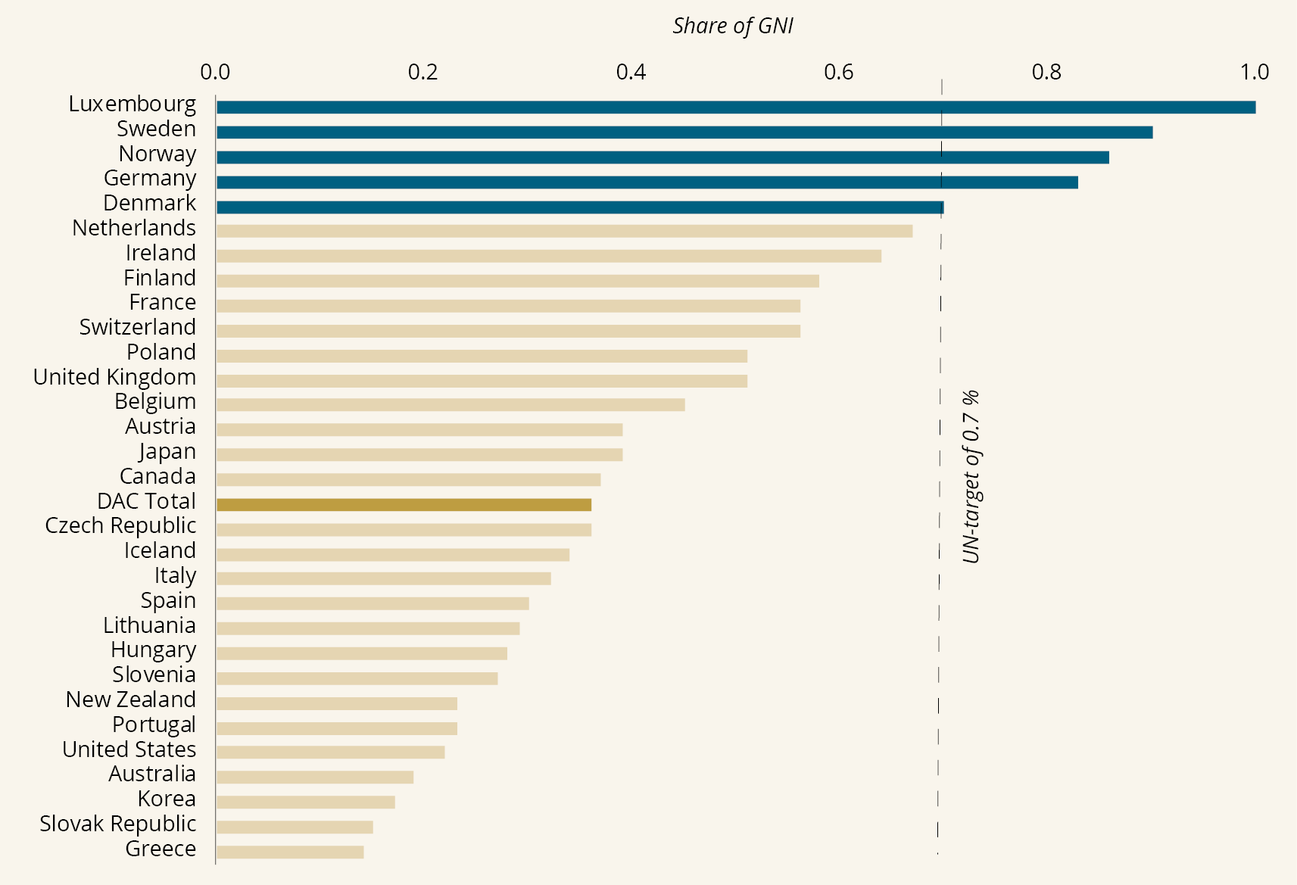
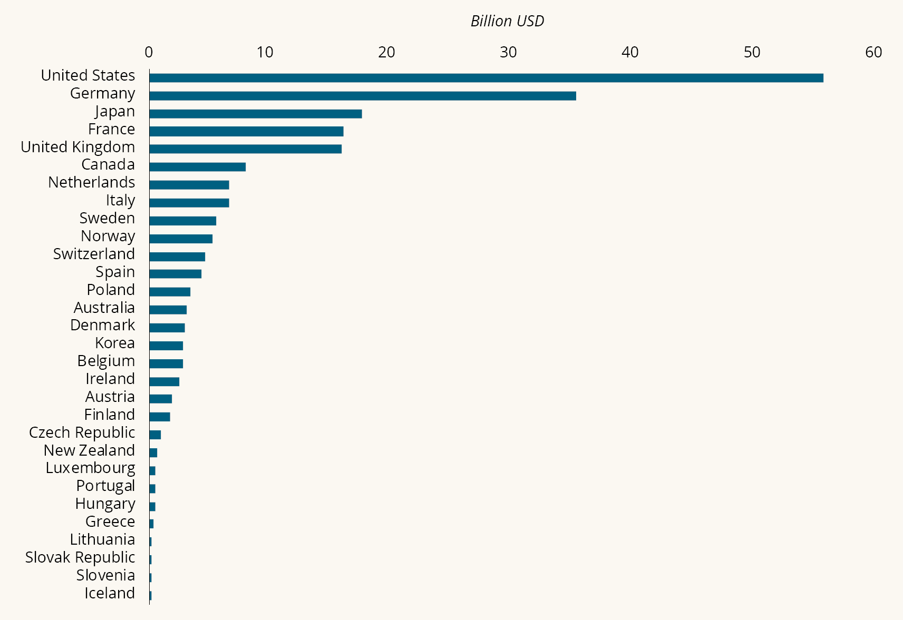
          - ODA from members of the OECD Development Assistance Committee in 2022
Note: Preliminary figures for 2022, reported through the Advance Questionnaire (ADV).
Source: OECD n.d. Total Flows by Donor (ODA + OOF + Private) [DAC1]. OECD.Stat. Available at https://stats.oecd.org/Index.aspx?DataSetCode=TABLE1.
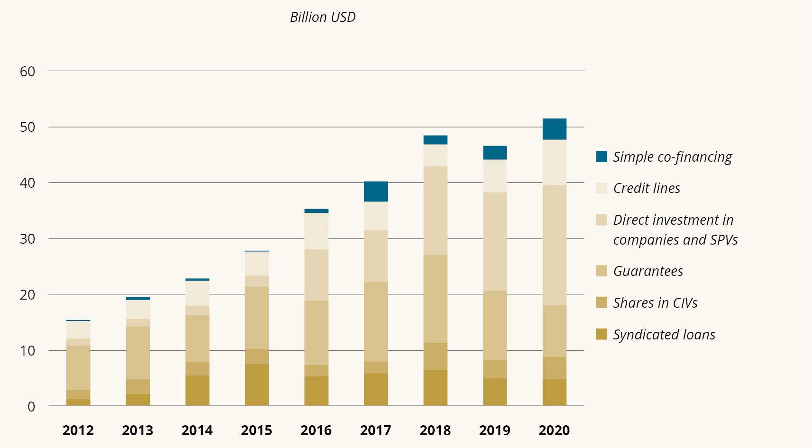
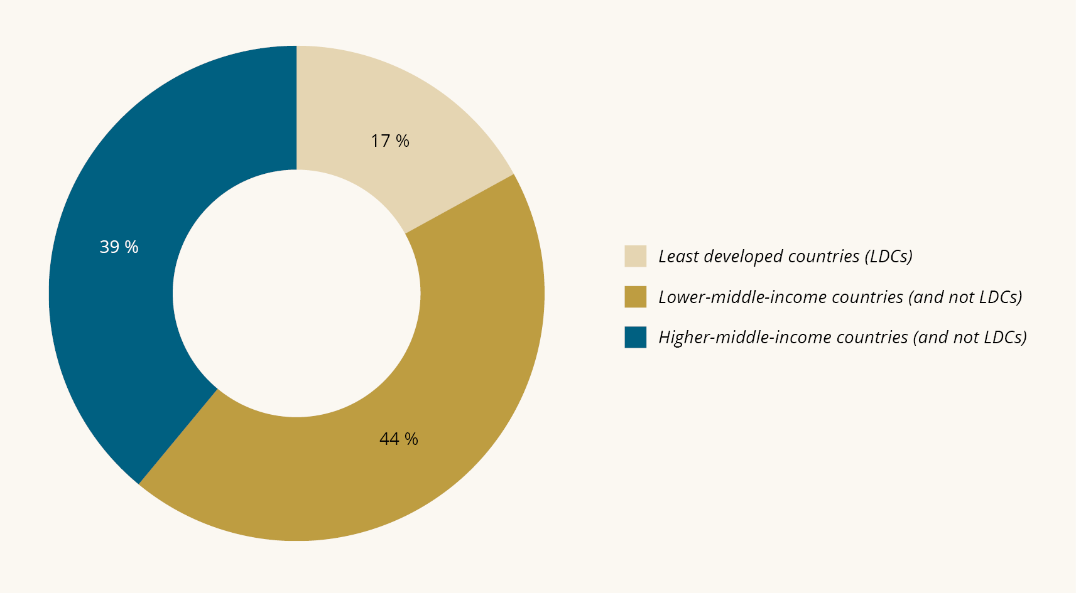
          - Mobilised private finance mainly targeted middle-income countries
Note: The pie chart shows an average for 2018–2020, and only shows mobilised private financing going to individual countries. Least developed countries (LDCs) now comprise 46 countries that are mainly low-income countries (26 out of 28 low-income countries) and lower-middle-income countries. In the figure, the two low-income countries that are not LDCs are included as LDCs.
Source: OECD 2022. Mobilisation. OECD.Stat (retrieved November 2022). Available at https://stats.oecd.org/Index.aspx?DataSetCode=DV_DCD_MOBILISATION.
DAC members are not alone in providing financial support for the economic development and welfare of developing countries. Many other donor countries have long traditions of doing so. One example is Turkey, which was among the top 10 donors globally in 2022 and provided aid equivalent to 0.79 % of GNI. In total, countries outside the DAC reported USD 17.8 billion to the OECD in 2022. In addition, it is estimated that over USD 7 billion in aid is distributed by a group of middle-income countries that do not report ODA, of which China, which has become one of the most important providers of development funding internationally, is the largest donor.
Another key trend is the proliferation of donors and development mechanisms. Between 2000 and 2019, the number of public donors increased from 47 to 70, while the number of development entities increased from 191 to 502. The increase in development mechanisms, particularly in the number of multilateral mechanisms, amplifies the risk of overlapping efforts and often increases the number of intermediaries. This reduces the resources that reach the end user. At the same time, the average size of donations has dropped from USD 1.5 million to USD 0.8 million.
The OECD has expressed concern about the impact these trends have on the effectiveness and quality of aid. Principles for aid effectiveness (see Chapter 5) emphasise precisely the importance of coordination, concentration, long-term perspectives, and national ownership in partner countries. All of this has become less attainable due to the proliferation of actors and mechanisms, and also because of an increase in emergency relief, which typically has to be channelled through non-state actors.
ODA makes up only part of the total international financial flows for sustainable development in developing countries. Remittances from diaspora communities in particular have become a major source of external funding. For developing countries, the level of both money transfers and foreign direct investment (FDI) in 2021 was well above ODA in total volume (see Figure 3.3).
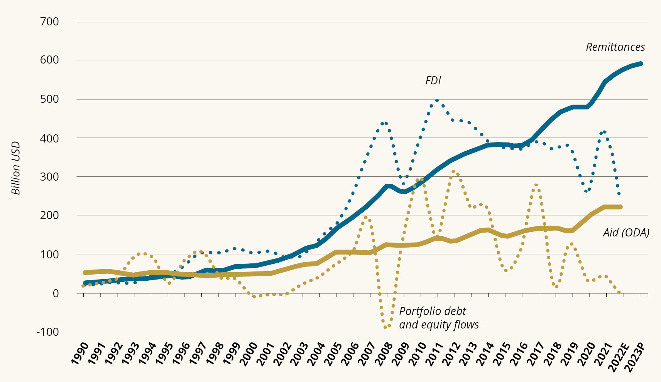
          - External financial flows to developing countries
Note: Financial flows to low- and middle-income countries, excluding China. FDI = Foreign Direct Investment. Remittances = remittances from diaspora. E = estimates, P = projections.
Source: Dilip Ratha, Eung Ju Kim, Sonia Plaza, Elliott J Riordan, Vandana Chandra and William Shaw. 2022). Remittances Brave Global Headwinds. Migration and Development Brief 37. Washington, D.C. KNOMAD-World Bank; World Bank. 2022). World Development Indicators (last updated April 2022). Available at https://databank.worldbank.org/source/world-development-indicators.
The picture is quite different if we distinguish between low-income, lower-middle-income and higher-middle-income countries. For the poorest developing countries, access to capital is limited and volatile, and ODA is a crucial source of external financing (Figure 3.4). Between 2017 and 2021, low-income countries on average received ODA equivalent to 9.9 % of their GNI, compared to a 0.7 % share for lower-middle-income countries.
This is why the UN urges donor countries to allocate at least 0.15 %– 0.20 % of their GNI to the world’s least developed countries, and why the 2015 International Conference on Financing for Development in Addis Ababa encouraged donors to set a target of at least 0.2 % of GNI for LDCs. However, like the 0.7 target, the LDC target is not met by the international donor community. In recent years, the average for DAC member countries has been around 0.09 % of GNI. Norway is one of the few exceptions. In 2021, Norway’s contribution to LDCs was 0.25 % of GNI, representing 27 % of its total aid contribution.
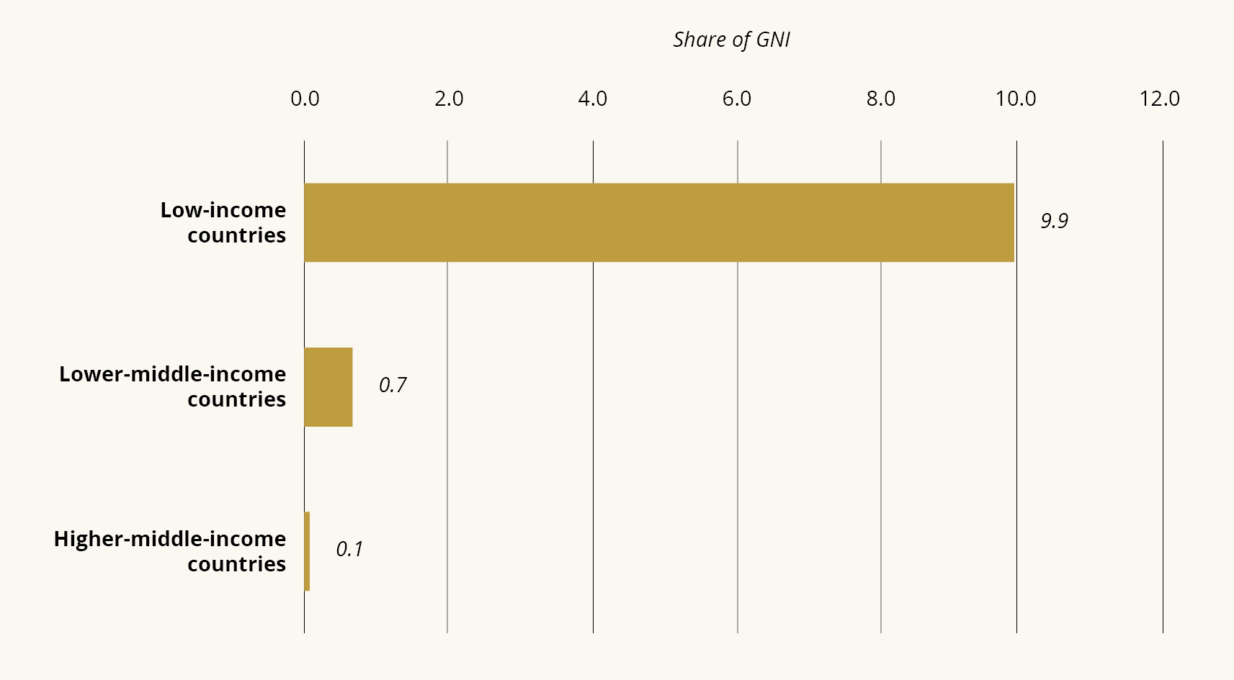
          - ODA represents a large proportion of GNI in low-income countries
Note: Official development assistance (ODA) as a proportion of the beneficiary countries’ gross national income (GNI), by income group. Average for 2017–2021.
Source: World Bank 2023. World Development Indicators (last updated 3 January 2023). Available at https://databank.worldbank.org/source/world-development-indicators.

More international aid to address crises and global challenges
Throughout ODA’s sixty-year history, it has been the most stable source of external funding for developing countries and measured in USD, there has been a significant increase in international aid over time. During the Covid-19 crisis in 2021, ODA reached its highest levels, with USD 186 billion, a real term increase of 8.5 % from the previous year. However, the scale of additional needs generated by the Covid-19 crisis is far greater than the increase in international ODA. In real terms, ODA only increased by 0.6 % when excluding the cost of Covid-19 vaccines in 2021, including surplus vaccines donated from donor countries.
If all Covid-19-related aid is excluded, gross bilateral ODA actually fell in 2020 except for ODA to upper-middle-income countries. International aid statistics for 2022 show that the war in Ukraine exacerbates the diversion of international aid away from Africa and the poorest countries. Aid earmarked for Ukraine amounted to USD 16.1 billion in 2022, equivalent to 7.8 % of total ODA from the DAC countries. An additional USD 10.6 billion was given to Ukraine from EU institutions, representing 38 % of their total aid. Eventually, the reconstruction of the Ukrainian state will also have to be partly financed by aid funds. The war in Ukraine will therefore affect the international aid system for a long time to come.
Refugee costs in donor countries constitute a significant and varying proportion of international aid. Refugee expenditure in international aid was historically high in 2016, accounting for 11 % of total ODA. Expenditure was halved by 2021, but increased significantly again in 2022 to 14.4 %, as a result of the flow of refugees from Ukraine. Preliminary figures for 2022 show that a large proportion of the increase in aid budgets can be attributed to support to Ukraine and related refugee costs in donor countries. At the same time, we see a decrease in the proportion of aid to other countries, and a real term decline in aid earmarked for Africa of 7.4 % from 2021 to 2022.
The climate crisis has increasingly affected the allocation of international aid and is likely to become an even more important consideration in the future. From 2018 to 2020, a total of USD 113.1 billion in climate funding was reported as ODA. This includes both climate adaptation and emission reductions. Most of the funding has gone to emission reductions, but the proportion allocated to climate adaptation is on the rise. The increase in funding for climate action contributes to a shift in aid from the poorest countries to middle-income countries. Between 2018 and 2020, just under a quarter of climate aid went to countries in Africa, while Asia received just under half (43 %). While there is broad international recognition that development and climate must be considered together, the figures show that prioritising climate has an impact on the allocation of international aid for other purposes, such as economic growth and poverty reduction, and that climate funding is largely covered by ODA budgets.
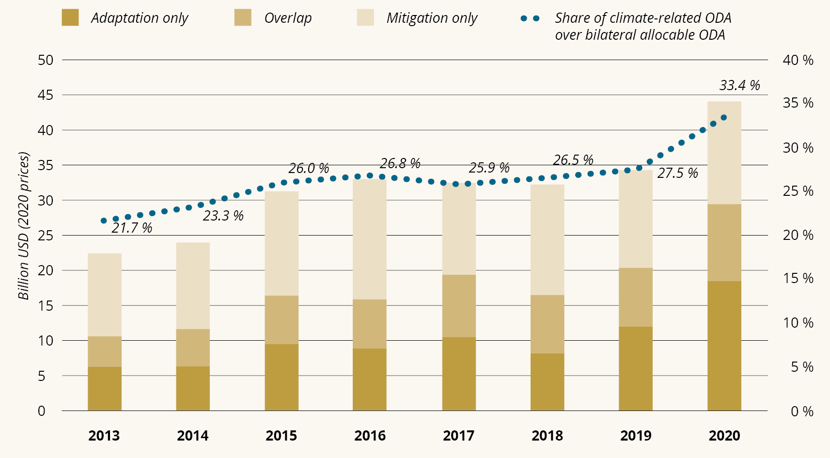
          - An increasing proportion of international aid is spent on climate
Note: Figures are on aid from members of the OECD DAC with climate change mitigation, climate adaptation or both as an objective. The columns show the agreed amount of funding in contracts containing climate goals in the applicable year. The trend line shows climate-related aid as a proportion of total bilateral allocable ODA in the applicable year. Bilateral allocable ODA includes all aid except core support to multilateral organisations, general budget support, debt relief, and expenditure in the donor country, such as calculated student support, information support, refugee costs and administration, as these by definition, cannot by tracked using markers for climate change.
Source: OECD. 2022). Climate-Related Official Development Assistance: A Snapshot. Paris: OECD Publishing.

Norwegian aid: substantial but fragmented
Norway is one of five members of the OECD DAC that achieves the UN target of 0.7 % of GNI as ODA. Norway has remained above 0.7 % of GNI since the mid-1970s and has been at around 1 % since 2009. In 2022, however, this percentage fell to 0.86 %. From 2000, the amount of Norwegian aid increased in line with the increase in GNI, from NOK 11 billion to almost 50 billion in 2022. Priorities and thematic areas have changed over time, due to changes in political priorities of new issues (climate in particular) and responses to international crises, as we discuss below.
International crises have had a significant impact on Norwegian aid. For example, the war in Syria brought an influx of refugees to Norway: In 2015 11 % of Norwegian aid went to ODA-approved refugee costs in Norway, rising to 18 % in 2016. Moreover, between 2016 and 2021, Syria was the largest recipient of Norwegian aid, even though it is not one of the Government’s seventeen priority ‘partner countries in development cooperation’. This shows the influence that conflict and humanitarian crises have on the disposition of aid.
In 2022, as a result of the war in Ukraine, refugee expenditure accounted for 9 % of total Norwegian aid. Since 2022, the war in Ukraine has changed the geographical disposition of Norwegian aid and this will continue for some years to come. Ukraine is the largest recipient of Norwegian aid, while the proportion of Norwegian aid that goes to countries in Africa and the LDCs is declining. The same trend can be seen in the preliminary figures for international aid.
Norwegian health aid remained stable for a long time, but from 2019 to 2021, aid earmarked for health more than doubled, from NOK 2.1 billion to NOK 4.6 billion. This can solely be explained by increased expenditure on Covid-19 tests, vaccines and protective equipment for health workers, as well as measures to combat the disease and Covid-19 mortality, and to control the extent and consequences of the pandemic.
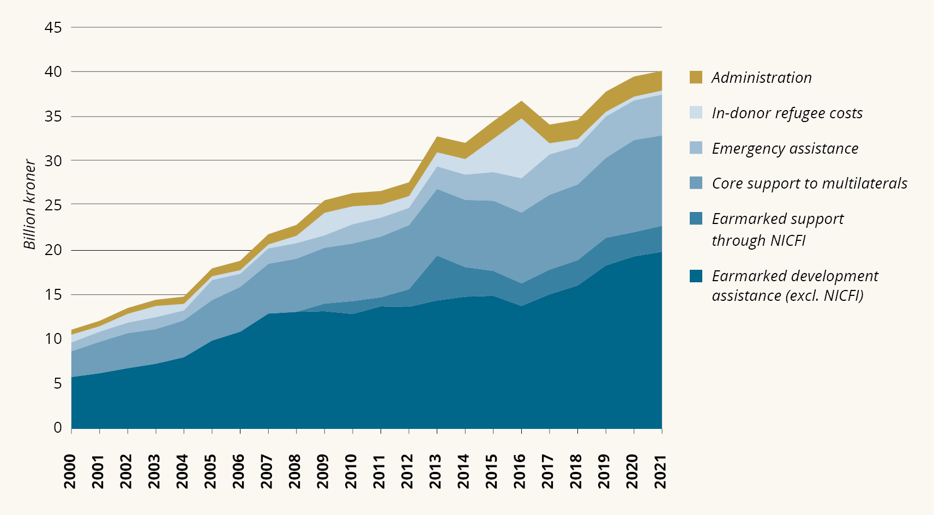
          - Composition of Norwegian aid
Note: Total Norwegian aid, 2000–2021.
Source: Norad n.d. Norwegian aid results. Statistics and results of Norwegian development aid. Available at https://resultater.norad.no/no.
From 2000, climate aid – mainly emission reductions – increased significantly (Figure 3.6). A large proportion of this – a total of NOK 34 billion in the period 2009–2021 – is from Norway’s International Climate and Forest Initiative. In 2021, total ODA-approved climate aid from Norway amounted to NOK 6.4 billion. This corresponds to 16 % of the total aid.
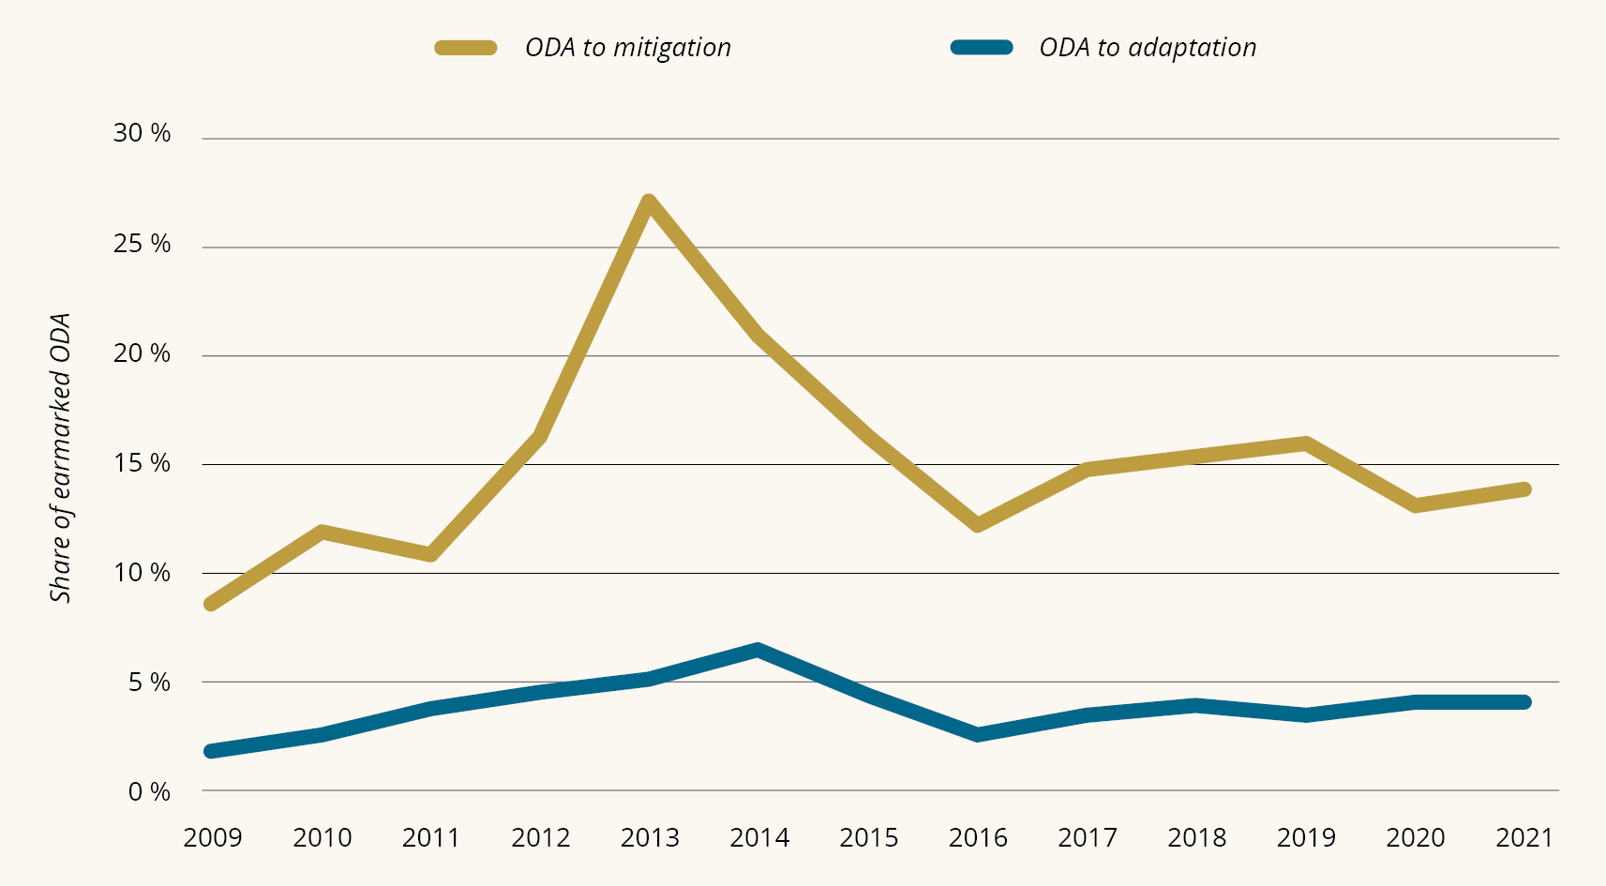
          - Most climate-related aid went to emission reductions
Note: The proportion of climate-related aid of Norwegian earmarked aid, excluding aid through Norfund. This includes 100 % of the disbursed amount under agreements that had climate change mitigation or adaptation as their principal objective, as well as 40 % of the disbursed amount under agreements that had these as secondary objective – in line with the Norwegian method. Earmarked aid: all aid except for administration and core support for multilateral organisations.
Source: Norad n.d. Norwegian development aid. Statistics and results of Norwegian development
aid. Available at https://resultater.norad.no/no.
At COP 26 in Glasgow, Norway committed to doubling its total annual climate funding from NOK 7 billion in 2020 to NOK 14 billion by 2026. Currently, the vast majority of Norway’s climate funding is provided for under the aid budget. How the increase to NOK 14 billion by 2026 will affect future Norwegian aid depends on how much of the increase is financed by ODA on the one hand, and how much is financed by Norfund’s (including the Climate Investment Fund’s) recycled investments and mobilised private capital estimates on the other. Absent a corresponding increase in overall ODA, however, this increase in climate financing will represent a significantly larger proportion of Norwegian aid, thus raising concerns of whether climate financing really will be additional.

Channels and partners in Norwegian aid
Another notable change in Norwegian aid over time is the choice of channels. In 2000, 14 % of aid went to governments and the public sector in developing countries, while this figure was just under 2 % in 2021. At the same time, the use of multilateral organisations has increased, and over several years, there has been a significant increase in support for global funds. Overall, the number of multilateral partners has grown, coupled with an increase in earmarked and fragmented funding to, in particular, the UN. New multilateral mechanisms are being added to an already complex structure, without the old ones being discontinued. In 2021, 56 % of Norwegian aid through multilateral organisations was earmarked funding.
Support distributed to some UN organisations is highly fragmented, with up to 100 agreements with the same organisation. In the OECD’s review of Norwegian aid, Norway’s choice of channels is highlighted as an area for improvement, noting that the main consideration should be the needs of partner countries, not the priorities of donor countries. In addition, this practice may undermine Norway’s efforts to strengthen the multilateral system, as earmarking and fragmentation reduces the efficacy of the multilateral system. This was also reiterated by various actors in the UN system with whom the expert group met during the review period.
Civil society has always been an important channel for Norwegian aid and has for a number of years remained stable at more than 20 % of ODA. In contrast, only 1 % of Norwegian aid is channelled directly through the private sector. However, Norfund invested NOK 5.3 billion in 2021 and with that, mobilised NOK 1.4 billion in private financing.
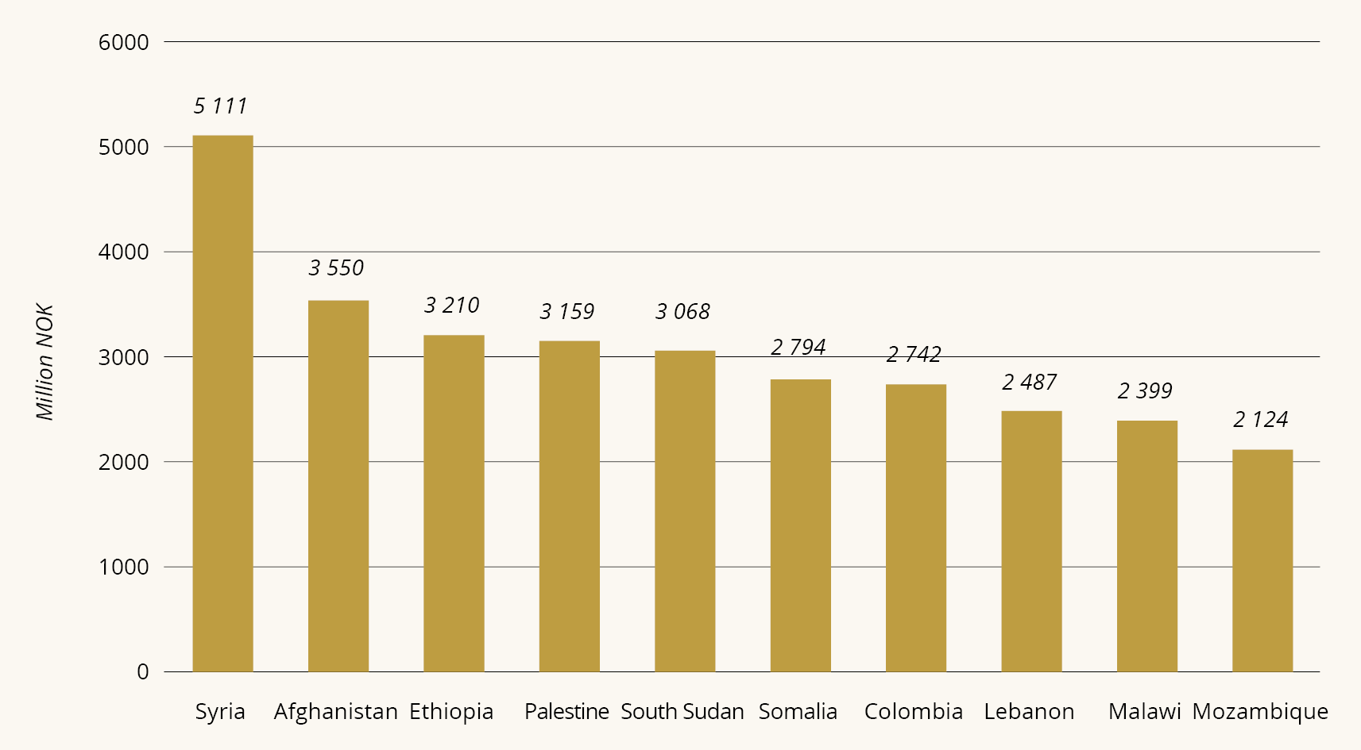
          - The ten largest recipient countries, 2017–2021
Note: The ten largest recipient countries of earmarked Norwegian aid to individual countries in the period 2017–2021.
Source: Norad n.d. Norwegian aid results. Statistics and results of Norwegian development aid. Available at https://resultater.norad.no/no.

Goal displacement and the pressure on aid
For several years, we have seen new goals and thematic priorities being added without established ones being discontinued or deprioritised. This reflects an international trend, where limited ODA resources are being used to address a series of new problems. The OECD DAC summarises it as follows:
Official development assistance (ODA) cannot solve all development challenges. […] Competing demands – from financing for global public goods and adaptation to the climate crisis to unprecedented urgent humanitarian needs – are stretching ODA budgets to breaking point. It’s hard to deliver effective development when resources are spread too thin. (OECD 2023a p. 7).
This is reflected, among other things, in the fact that aid has become more thematically fragmented, even though there has been a reduction in the number of projects and partners. In 2021, Norwegian aid was distributed among 1,640 projects, 101 beneficiary countries and 869 different agreement partners.
              - Aid to middle-income countries and emerging economies
In much of Norwegian aid, the development purpose is clearly defined and easy to identify. However, upon closer examination of aid to middle-income countries, it is more difficult to identify clearly defined developmental goals. One such example is the cooperation on forest conservation with Brazil. Another example is Colombia, the biggest recipient of long-term development aid from Norway in 2021, where almost half of the support went to energy and the environment sectors. The most striking example is perhaps the NOK 76 million of earmarked aid that went to China in 2021. Most of this aid, NOK 56 million, went to climate and environmental initiatives, which has been the most important sector for aid to China in recent years by far. China is perhaps one of the recipients of Norwegian aid where the paradox of using the label ‘aid’ for the cooperation – and financing it under the aid budget – is most evident: Extreme poverty in China has virtually been eradicated and the country is an economic major power on the verge of becoming a high-income country.
Norwegian development cooperation with middle-income countries can also have a poverty-reducing effect, of course, but there is nonetheless evidence to suggest that it is of a different nature than that in the poorest countries: Climate and environmental initiatives constitute a large proportion of aid to countries such as Colombia, Indonesia, Brazil, Gabon, Peru, Pakistan, China, and India. In these countries, Norwegian aid is invested in sustainable development, and poverty reduction is to a lesser degree a primary purpose of the cooperation. We saw earlier in the chapter that several of these countries are significant donors, and (collectively) this indicates that the time is ripe to re-think key elements of development aid.
Part of the definition of aid is that it should be directed towards the economic welfare and development of developing countries. A large proportion of Norwegian climate aid – such as cooperation with vulnerable developing countries on climate adaptation or concessional investments in clean energy in countries with poor access to energy – are directed towards this goal. At the same time, climate funding reveals how dilemmas linked to poverty orientation and other considerations related to sustainability are being brought to the forefront. The commitment made by wealthy countries at COP 15 in 2009, to mobilise USD 100 billion annually for emission reductions and adaptation, has not been honoured. In the negotiations on the goal of USD 100 billion, it was decided that the climate funding should be ‘new and additional’, but there is no agreed definition of how that should be interpreted. Countries have different perceptions of what new funds means, and many developing countries have criticised wealthy countries for allocating climate funding at the expense of existing ODA, and not thus as an addition. In its reports on climate funding to the UN Climate Convention, Norway (and other countries) justify how these funds can be described as additional. In Norway’s case, it is argued that the monetary amount of climate funding comes on top of the UN target of 0.7 % of GNI.
Norwegian and international climate funding is generally still in the form of ODA and is only to a limited degree ‘new money’. At the same time, the proportion of aid allocated to climate measures is increasing. One of the challenges this entails can be illustrated by investments in clean energy in developing countries. These are initiatives that can be reported as climate funding and ODA since energy production and consumption are strongly linked to economic development, while they also support a ‘green’ development trajectory. However, it is not certain that all energy projects have exclusively positive effects on social and economic welfare, and there will always be an opportunity cost when spending limited aid funds on clean energy. For example, support for access to clean energy in a low income countries has a greater impact on welfare than support for clean energy as a replacement for already existing fossil energy in a middle-income country. The former is more of a contribution to development and poverty reduction, whereas the latter is primarily targeted at emissions reduction. Donors’ climate commitments will likely continue to lead to a distortion of funding towards middle-income countries, where the effect on emission reductions is assumed to be higher but where the need for external concessional funding is lower.
In 2022, the international community adopted the Kunming-Montreal Global Biodiversity Framework (GBF), which highlights the importance of having an ambitious resource mobilisation strategy to support the implementation of the Convention on Biological Diversity (CBD). A target of USD 200 billion per year by 2030, mobilised from all sources, was set for biodiversity measures. This includes increasing international financial flows from developed to developing countries, and in particular the LDCs, to at least USD 20 billion per year by 2025, and to at least USD 30 billion per year by 2030. Many of the biodiversity measures will be essential to the welfare of developing countries, now and in the future. According to the World Bank, a collapse of ecosystem services (such as pollination and food from the sea) would result in a significant decline in global GDP, with the greatest impact in the most vulnerable low- and middle-income countries. Here, too, however, we see a tension between addressing short- and medium-term developmental goals, and long term global sustainability goals.
Health represents another area where the distinction between funding for development purposes and funding for global public goods are blurred. Funding for global health organisations and research into vaccines to tackle pandemics that affect both rich and poor countries may be hugely beneficial to the latter, but it is not necessarily ODA in terms of its primary objective. That is: Improved public health control and vaccination to prevent pandemics are of benefit to citizens in developing countries, but if the primary objective was health in developing countries, it is far from clear that it is the most effective measure.
Whether it concerns pandemic preparedness, environmental initiatives, oceans, migration, nature or climate, we are increasingly faced with the discussion of whether efforts are motivated primarily by poverty reduction or by something that is also – or perhaps primarily – motivated by self-interests of rich countries. When it comes to peace and security, the ODA directives are clearer than in other areas with global relevance. When the OECD DAC reached a consensus on allowing more military-related assistance to be reported as aid, Norway also wanted to make support for nuclear disarmament possible to report as ODA. However, this was rejected as it constitutes financing for a global public good. On the other hand, the DAC has accepted refugee costs in donor countries as ODA, even though this cannot be described as social and economic development in developing countries. On the contrary, it results in reduced access to funding for development purposes in poor countries and harms the integrity of ODA.
This applies not only to specific topics but also to countries and organisations. Through the development in of a ‘multidimensional vulnerability index’ (MVI), the UN surveys new types of vulnerabilities for various categories of countries. Some countries are more exposed to the consequences of the climate crisis than others, and interestingly, these include low, middle and high-income countries, as it is largely a country’s natural conditions that make them vulnerable. Discussions about where the boundaries should be set are ongoing, and there is continuous pressure to include ever new challenges in the international ODA framework.
As seen above, an increasing proportion of Norwegian aid goes to funding initiatives that have multiple goals, including support for global public goods. This does not necessarily mean that the initiatives are outside the scope of the ODA rules, as the DAC rules allows for support of development initiatives that partly or indirectly contribute to global public goods. However, it gives a clear indication that support for global public goods is an important part of current Norwegian development policy.
What is clear is that new objectives and priorities have been included in the Norwegian aid budget without new resources being added. The flexibility of ODA rules, combined with the fact that many OECD countries operate with broadly agreed upon targets of aid as a percentage of GNI, means that there is a political incentive to use ODA-approved funding to finance political priorities that are not necessarily primarily linked to ODA´s primary goal of increased welfare in low- and middle-income countries. Had Norway – and other donors – followed OECD-DAC´s recommendations to, for example, anchor development aid in local ownership and development plans, the approach to, and distribution of, aid would likely be quite different.
We have shown that an increasing proportion of international aid has been allocated to initiatives that support global public goods, that new goals have been added to the development agenda without new funding, and that the flexibility of ODA rules are used to finance priorities that are not first and foremost linked to development and poverty reduction. Members of the OECD DAC have chosen not to address this by altering the definition of ODA to include support for global public goods. Instead, a reinterpretation of the ODA directives has evolved and been partly endorsed, in which the funding of global public goods that is also considered to include the goal of development in ODA-approved countries, can be reported as ODA. Partly because of this, there is currently no clear distinction between ODA and financing of global public goods. This blurred distinction means that there is constant discussion in the OECD DAC about the limits of ODA, and that ODA is being challenged as a measure for rich countries’ contribution to developing countries.
The DAC has been criticised for how the ODA concept is maintained. Key donor countries criticise ODA for being old-fashioned and conservative and neither reflecting global challenges nor ‘new’ financing mechanisms that contribute to development. Some therefore argue that the ODA concept should be expanded. On the other hand, stakeholders from civil society, academia and developing countries criticise the DAC for undermining the integrity of ODA as a measure for wealthy countries’ contributions to developing countries, since too much is included in ODA such as funding for global public goods and in-donor costs.
              - Norway makes full use of the ambiguities in ODA
The Norwegian aid budget is influenced by discussions and consensus in the DAC on distinctions in ODA practices and mandates. Norway has not actively worked in the DAC to expand the definition of ODA but is taking full advantage of the flexibility in the existing rules. Where some donor countries have refrained from reporting on initiatives that are at the outer limits of the rules, Norway reports on all development initiatives that can possibly be interpreted as ODA.
There are examples of initiatives in the Norwegian aid budget that have stretched – and even crossed – the boundary of what may be reported as ODA. Examples of this include environmental and climate initiatives whose main objective is to clean-up oceans or reduce emissions, and where the goals of ‘economic development and welfare’ are not explicit or primary. Other examples are regional initiatives that are reported as ODA in which the geographical focus mainly includes countries that are on the DAC’s list but may also include a country that is no longer on the list of recipient countries. Other sectors in which the limits of ODA are thought to have curtailed the scope of initiatives supported by the Norwegian aid budget are work on global standards, for example against the death penalty, nuclear disarmament, and defence cooperation. In other areas, such as emergency relief and global health, the Government has chosen to use exemptions from the ODA rules in its aid budget. In its proposed budget for 2022 (Proposition No 1 to the Storting 2022), the Government emphasised that humanitarian crises could affect vulnerable people living in high-income countries, and that the Government will consider contributing humanitarian aid, even though these are not countries approved to receive ODA.
In its annual Development Cooperation Report, the OECD has repeatedly pointed out that the financing of global public goods is, and will remain, a major challenge for aid. The 2023 report emphasises that the point has been reached where it is necessary to find alternatives to ODA for funding health security and other global public goods, in order to avoid deprioritising development and growth in poor countries.

Total Official Support for Sustainable Development (TOSSD)
TOSSD is an international framework for a broad spectrum of officially supported financial flows to promote sustainable development. This is a relatively new framework for international financing, which originated from the Conference on Financing for Development in Addis Ababa in 2015. TOSSD monitors official support and mobilised private financial flows to sustainable development in developing countries and to international public goods, at the global and regional level. The main criterion for an activity or initiative to be reported as part of TOSSD is that it directly contributes to one of the SDG targets and if no substantial detrimental effect is anticipated on one or more of the other targets. TOSSD makes a distinction between ‘direct’ support for low- and middle-income countries and support for what it calls international public goods. This distinction arises from the fact that funding related to the first category (transfers to poor countries) is referred to as ‘Pillar I’, while efforts for cross-border public goods are referred to as ‘Pillar II’. In both cases, funding must be in line with the main criterion for supporting the SDGs. Furthermore, Pillar II activities must provide ‘substantial benefit’ to TOSSD countries and/or be carried out in direct cooperation with those countries or private and public institutions from those countries (see definitions and concepts in Appendix Z).
TOSSD has been developed and maintained by the TOSSD Task Force, but the long-term ambition is to bring TOSSD under the auspices of the UN to ensure representativeness. In March 2022, the United Nations Statistical Commission approved a new SDG indicator 17.3.1 for ‘Additional financial resources mobilised for developing countries from multiple sources’. The OECD and the United Nations Conference on Trade and Development (UNCTAD) are co-administrators of the SDG indicator, and TOSSD is an official data source for the global indicator framework for the SDGs.
The ambition for TOSSD is that it becomes and delivers some of the things ODA cannot:
- An inclusive framework, with membership representing all regions of the world, and a formalised governance structure representing a balance between income categories.
- Overview of South-South cooperation and other efforts for development from ‘new donors’.
- Overview of funding for global public goods for the benefit of developing countries over and above ODA.
- The opportunity to gain an overview of international investments in sustainability, which can be useful in efforts to coordinate and collate global sustainability efforts.

Development cooperation: Ripe for modernisation
Available policy instruments and sources of funding are not keeping pace with the scale and complexity of challenges. The money does not stretch far enough and – just as worrisome – the tendency to stretch aid funding to meet new needs or goals undermines the effectiveness and credibility of development cooperation. This trend is also reflected at an institutional level. The mandates of various multilateral development institutions are broadened without a corresponding increase of funding. In addition, there is little cooperation and coordination required to address complex problems related to violent conflict, humanitarian crises, and climate change. UN Deputy Secretary-General Amina Mohammed has pointed out, for example, that ‘Our current system of development co-operation is simply not meeting the scale of this challenge’. The expert group’s meetings with representatives of UN organisations and the World Bank revealed serious concerns, indicating that the system for development cooperation is dysfunctional in a number of areas, not least because of the propensity of donor countries to earmark contributions and use multi-donor trust funds. While earmarking may give donors visibility and control, it undermines the strength and capacity of multilateral cooperation when it comes to development purposes.
This crisis of governance is partly due to the fact that most development policy instruments, financing flows and institutions were established to deal with a more limited set of problems, and not the type of global and overlapping crises we are witnessing today. Although a focus on prevention has been on the agenda for a long time, the Covid-19 pandemic and the consequences of climate change have made us more aware of the significance of preparedness and prevention. The inadequate provision of global public goods – pandemic preparedness, conflict prevention, climate measures and nature conservation – can have catastrophic consequences, yet these challenges are still not prioritised highly enough. The result of this is a global ‘tragedy of the commons’, despite clear knowledge of the consequences of a lack of investment in prevention and preparedness. What is needed is binding international cooperation in which nations contribute according to their ability.
There is currently increased attention to the imbalance of power between the Global North and South. Emerging economies have become important development stakeholders and have a greater influence in decisions taken within the architecture of global governance, but more developing countries demand a more prominent role in discussions about the funding of development and global public goods. This is a follow-up point in the OECD’s flagship report Development Cooperation Report 2023 which addresses the ongoing discussion about the decolonisation of aid and points to the need to build meaningful partnerships and to draw on more research from low- and middle-income countries. It also states that DAC members should define clearer goals for locally led development, use and support local stakeholders to a greater extent, and adjust development cooperation in accordance with the partner country’s own priorities. This localisation debate is an effort to include and ensure sufficient resources for local authorities. Increased inclusion is also one of several measures mentioned in the High-Level Advisory Board on Effective Multilateralism’s report published in April 2023. A shift that would allow countries to determine their own development trajectory is crucial for sustainable development at the overarching level.
The DAC has been increasingly challenged as a donor forum. The committee, which represents the world’s largest group of traditional aid providers, has lost some of its prominence as a donor forum due to the emergence of new major economies (Brazil, Russia, India, China and South Africa – BRICS) and other aid donors. Although the DAC has implemented a number of reforms and become more inclusive, it is still criticised for being an exclusive ‘donor club’ that makes decisions that affects the entire development cooperation, yet without including the developing countries affected by these decisions.
Developing countries, and particularly civil society organisations, have called attention to this asymmetry, and the DAC – to its credit – have acknowledged it. The UN Secretary-General and the OECD are both now talking about a new type of ‘social contract’ adapted to current challenges. Such an approach involves more binding and mutual cooperation across countries to achieve a sustainable future. The OECD DAC stresses that this ‘is about much more than ODA’. What is needed is a comprehensive approach that draws on all policy instruments, sources of funding, and policy areas. There are many ongoing international initiatives aiming to improve the system and secure more funding, including under the auspices of the UN, the World Bank, and the IMF, in addition to key donors such as Germany and France. These initiatives indicate that there is a window of opportunity to influence international processes with the aim of making international development cooperation ‘fit for purpose.’

Is aid a good investment?
Aid is, under certain conditions, a good investment. It will, however, in many cases be difficult to document the effect of aid and conclude with certainty that an initiative or programme has had a causal effect on a particular outcome. Given the limitations of this report and the extensive international research on how, under what conditions, and in which contexts aid makes a difference, we are only able to point to some overall characteristics. Three major research traditions can be identified that substantiate in different ways that aid can be, and often is, a good investment.
Throughout the 1990s, what subsequently became known as the ‘evidence revolution’ became a widespread concept in economics and, to varying degrees, in the other social sciences. In research on aid, there was a particular increase in the use of randomised control trials (RCTs). We have learned from this literature that it is entirely possible to design aid measures that cost-effectively deliver results across different themes, and that it is possible to achieve such results even in contexts in which it is otherwise difficult to work. A commonly used example is cash transfers and social safety nets. Cash transfers are shown to be an effective way of reducing poverty, increasing food security and improving health and education in a wide range of contexts. Controlled studies show that cash transfers are an exceptionally effective aid measure and an excellent investment in sustainable development. Cash transfer of sufficient size will also have an effect in the longer term.
              - Reduction in maternal and neonatal mortality
Maternal and neonatal mortality are a huge cost to society. In 2019, there was an estimated welfare loss of USD 462 billion in the 55 countries with the highest rates of maternal and neonatal mortality, representing almost 6 % of the countries’ GDP. A report recently published by the Copenhagen Consensus Center shows that increased coverage of Basic Emergency Obstetric and Newborn Care (BEmONC) from 68 % to 90 %, and better access to family planning, are the most cost-effective ways to reduce maternal and neonatal mortality in these countries. For every USD invested, the social and economic benefits are estimated to be USD 87, and the cost-benefit ratio is thus 87.
On a more aggregated level, large overview studies show correlations between human development and aid, making it likely that aid has contributed to this development. Charles Kenny and Zach Gehan document that in a historical context, developing countries have seen impressive development along many of the most important measures of human development. Among other things, poor countries are experiencing higher living standards, longer life expectancy, higher levels of education and lower infant mortality rates than Western countries experienced when they were at a similar level of socio-economic development. These are precisely the areas in which aid had a particular focus and where it can likely be shown that aid at times had a significant impact.
There is also a broader international discussion related to the effect of aid on economic growth. Contributing to economic growth at a national level has never been a specific goal for Norwegian aid but unsurprisingly, it is considered the most overarching goal that aid can achieve. It is of course difficult to study the impact aid has on economic growth. It is by no means random which countries receive aid, and it is extremely complicated to separate the effect of aid from other factors. An early influential study showed that aid can have a positive effect on economic growth, but only when the recipient country implements what was classified as good policy. Following this, several conflicting studies were published showing that aid had a negative, positive or no effect on growth. A 2012 study endeavoured to clarify this discussion and found, given a set of assumptions about when the impact of aid will be visible in economic growth, that aid has in general contributed to economic growth over time. Recent meta studies and studies that more directly try to account for the fact that aid allocation is not random also indicate the likelihood of aid, over time, making an aggregate contribution.
There are promising models for more meticulous assessments of what works and what is effective based on ‘benchmarking’ and ‘best in class’ approaches, which appear to be favourable methodologies for evaluating various forms of aid (see box 3.5).
              - Promising methods: ‘Benchmarking’, ‘best in class’ and scoring
A decidedly comprehensive approach to development has often prevented more widespread use of benchmarks, which are a standard against which to judge if assistance is well spent. The use of benchmarks is an issue that is increasingly being raised (including by major donors such as USAID), particularly in light of research on cash transfers showing that the methodology has an effect on far more goals than just poverty reduction. However, it is difficult to specify one standard against which all efforts towards achieving the SDGs can be measured, even though there are individual initiatives and interventions, such as cash transfers, which appear to have positive effects across goals in the short and medium term. The complexity of the sustainability agenda suggests that we should instead adopt a ‘best in class’ approach to effectiveness.
When it comes to information about past results, we currently have little in the way of systematic approaches, quality assurance or comparisons. This does not only apply to Norway. There is no international database of readily available information about the evaluation of effects, costs and results of a myriad of initiatives in international development. One feasible way of improving the overview and the ability to learn is the use of scoring. An immediate summary of the assessment can be obtained by setting a score for each assessment of each aid initiative.
It is often a matter of finding one or more common denominators in the form of properties or characteristics of the results that make them easier to compare. It is crucial that the assessment is available in order to understand why the score has been given. The score is necessary for aggregation purposes and provides a quick overview and an indication of progress for an entire portfolio. It corresponds to the requirement in the Regulations on Financial Management in the Central Government on the possibility of assessing the degree of goal attainment. A number of objections may be raised, but the methodology provides clearer guidelines, frameworks and a systematic approach to assessments that are in any case based on the discretionary judgement of the executive officer. An appropriate methodology is already available but has not been sufficiently taken into use (between 2019 and 2021, an assessment of results and scoring only exist for 151 projects out of 4,104 aid agreements). A plethora of different countries and contexts also adds to the difficulty of ascertaining a benchmark or ‘universal score’. One option would be to take a selection of SDGs and their indicators and consider these in light of each country’s progress. This would, at the very least, measure a country’s progress against its own benchmarks.

What works in the most difficult contexts?
We have already identified fragile states and contexts as a particular challenge. According to a large compilation of evaluations and research from three fragile states that receive Norwegian aid (Afghanistan, South Sudan and Mali), very little of the most ambitious and transformative aid, such as institutional development, capacity-building, governance, justice and the rule of law, etc. has worked effectively.
Smaller scale, local and ‘technical’ (non-political and non-sensitive) interventions seem to work better. Examples of such projects include increasing access to basic healthcare and education, individual agricultural and water projects that are of great local relevance, and savings and loan groups for women. However, many of these initiatives are not sustainable and must largely be financed by external donors. Certain capacity-building projects can work, but success is often limited to the skills and expertise of individuals (ibid.).
The main conclusion of the literature review is in line with an important finding from an evaluation of Norway’s involvement in South Sudan, namely that transformative goals related to governance and democracy were based on inaccurate assumptions and did not lead to results, but that parallel systems that could serve the population were a realistic alternative. However, a large-scale evaluation of Norwegian aid to Somalia found that Norway had engaged in small but risky state-building projects that are unlikely to have been properly established without Norwegian support.
The emphasis on the legitimacy and capacity of institutions is pervasive in much of the literature, including in the OECD Principles for Good International Engagement in Fragile States and Situations. The task has not been made easier by the fact that more and more fragile contexts have illegitimate political governance. Approximately half of the population of fragile states live in such contexts, in which ‘normal’ aid for institutional development, ‘good governance’, anti-corruption, security reform and inclusive political processes are extremely difficult.
These are contexts in which it will not be possible to adhere to some of the OECD’s important principles for aid effectiveness and it will be important to work in other ways. Particular emphasis is placed on a continuous adaptation based on updated analyses of the context – what can be described in short as a constant interaction with the context. Where it is not possible to work at the government level, there are examples of contexts in which national systems have been ‘shadowed’ (endeavours to align aid with what existed of welfare services, but implemented by external parties). In some situations, however, it is necessary to resort to non-governmental organisations and international systems to serve the population.
Various evaluations and literature also highlight willingness to accept risks associated with adaptation and ‘trial and error’, and to focus on relevance, thinking short-term (not seeking perfection and sustainability, but relevance and momentum), small-scale and local initiatives, as well as pragmatic agreements with local and regional coalitions. The question is whether the current general administrative checks and procedures in the aid system allow such risk-taking, innovation and pragmatism that effective efforts in such contexts demand. Norway has agreed to accept a higher degree of risk in such contexts despite the tension between the administration’s need to control funding in fragile states and the need for subsidiarity, autonomy and experimentation. A more ‘realistic’ approach to reform in fragile contexts may also mean cooperating more with different types of actors and partners, including those with whom aid has not traditionally been associated.
              - Nexus – a comprehensive approach to fragility
It is important to recall the work on the principles and lessons learned from what are called a ‘comprehensive approach’ – or nexus approaches – in long-lasting and complex crisis situations and conflicts. Important milestones in this work have been the Grand Bargain Humanitarian Summit in 2016 and the OECD DAC Recommendation on the Humanitarian-Development-Peace Nexus from 2019. These initiatives criticise the outdated structure of the current development system in the face of many of today’s most difficult development contexts, making the current responses less effective. ‘Chronic’ crises and ever new layers of overlapping crises (conflict, failing food production, migration, climate change) mean that our model for different phases of development – humanitarian crises, reconstruction and long-term development, peace and reconciliation – does not make as much sense. In practice, the divisions around which we have built the development structure are fluid and dynamic. While the purpose of humanitarian efforts is to save lives and alleviate suffering in line with the humanitarian principles, long-term development policy and stabilisation efforts aim to address the root causes of conflict and vulnerability. The nexus approach is an endeavour to improve the interaction between these efforts and work towards longer-term solutions, improved prevention and institutional resilience to the next crisis, whenever possible. Having more unified goals across the different areas of engagement, as well as better coordination and long-term commitments, will force actors to focus more on the root causes of conflicts and crises and on a sustained reduction of needs.

Effective production of global public goods?
There is reason to believe that the provision of global public goods will continue to distort and reshape aid. ODA is far from being an adequate framework for this, and a wider range of policy interventions are needed. In fact, there is reason to believe that measures and resources from outside the traditional boundaries of aid are more effective at providing the world with global public goods. Moreover, an adequate solution to global challenges must need not always involve more development funding. It may, for example, be brought about by the reorganisation of existing funding, policies and incentive schemes. For example, carbon taxes and quotas are part of the solution to the climate problem. As UN Secretary-General Antonio Guterres has repeatedly pointed out, the adverse effects of the financial system on climate, nature and human welfare are a fundamental reason for the under-provision of global public goods. That is why a ‘do no harm’ principle for investment and financial activity will be an appropriate first minimum requirement for the efficient provision of global public goods.
According to Clement et al. expenditure on petroleum subsidies in low- and middle-income countries totalled USD 895 billion. This substantial sum is not targeted towards the poorest sections of the population (SDG 1) nor measures to reduce climate change (SDG 13). It also undermines other SDGs, such as good health and quality of life (SDG 3), reducing inequality (SDG 10), sustainable cities and communities (SDG 11) and protecting life on land (SDG 15). Another example is subsidies that cause harm to nature that are allocated to the agriculture, fisheries and forestry sectors totalling about USD 500 billion each year – equivalent to four times the funding for protection of biodiversity.
Another important perspective is how international crises can be anticipated. Conceicao calculates that adequately producing an important range of global public goods will amount to between 1 and 10 % of the cost of continued under-provision. In the case of global public goods and in line with the idea of prevention, it would also be natural to redirect funding towards a ‘better safe than sorry’ principle.
The Sustainable Development Agenda entails an expansion of aid and development policy to also address global ‘spillover effects’ (GDI 2020), which is often discussed in the context of global public goods. A key element here is the agenda for policy coherence for development. This means reducing conflicts between economic, social and environmental goals and cultivating synergies between different policy areas with the object of contributing to sustainable development. In relation to this, the OECD’s latest peer review of Norway in 2019 stated that ‘Norway demonstrates a commitment to policy coherence for sustainable development but struggles to achieve it in practice.’ This criticism was repeated in the OECD’s mid-term review in 2022. The OECD has developed eight guiding principles for coherent sustainable development. The principles range from political vision and leadership through long-term plans and commitments to concrete forms of cooperation and reporting. Together, they represent a new standard for interdepartmental cooperation and long-term visions. A real and effective contribution to global public goods should therefore include an analysis based on these principles.

Conclusion
The discussion above illustrates that the need to mobilise more resources and establish better international mechanisms to deal with a broader set of problems than the aid system – and ODA – can handle. Another dimension to this is time. An absence of sufficient resources to tackle today’s problems will make it substantially more expensive to deal with them in the future. Significantly more resources and a system that can use these resources effectively are needed to avoid any further reversal of economic development in the poorest countries, to prevent the consequences of climate change and to establish a better response to future pandemics. There is room for more efficient use of resources, and the demand for increased resources must therefore be accompanied by an increased demand for effectiveness. Chapter 4 introduces a framework for this, which establishes a number of principles for assessing the effective use of resources, and thus also provides a guiding principle for future development policy, including the role of ODA.

Investments in sustainable development: A new framework for development policy
With the current level of economic development, the World Bank estimates that around 600 million people will be living in extreme poverty by 2030. Climate change has happened faster than expected and has led to changes in precipitation patterns and more extreme weather, which, in combination with loss of nature, can destabilise countries and regions and undermine progress on a number of the SDGs. Seen together, this represents a complex set of challenges that need to be addressed simultaneously.
In the future, climate change will generate a constant stream of overlapping crises that will impact poor countries the hardest, but also wealthy countries, either directly or indirectly. Norway has a significant stake in contributing to the prevention of global instability and crises. The Coalition for Epidemic Preparedness Innovation (CEPI) points out that climate change will increase the likelihood of pandemics in the future. Norway’s vested interest in the prevention of international crises is not just about foreign policy and security policy considerations: Through the Government Pension Fund Global (GPFG), Norway has become a universal investor which cannot (fully) diversify away from systemic risk arising from climate change, political unrest, global economic crises and pandemics.
To help meet these challenges in the most effective way, we present in this and the next chapter a new development policy framework for investments in sustainable development. The framework is organised around a number of key principles and the specific operationalisation of these principles, which can more effectively tackle current and future challenges in a more effective way.
In this chapter, we will
- introduce a set of principles for a more comprehensive development policy, ‘investments in sustainable development’, and show how these principles broaden and challenge traditional thinking in development policy
- discuss which steps must be taken in order to use this framework effectively, both in Norway and in international development cooperation
- highlight the importance of having a consistent focus on effectiveness, adaptation and long-term results

Sustainable investments
The terms ‘sustainability’ and ‘sustainable development’ can be interpreted in different ways. A broad interpretation is that sustainable development encompasses all 17 SDGs. The Brundtland Commission’s interpretation from 1987 includes two central principles: the fair distribution of resources between and within generations, and development that ‘that meets the needs of the present without compromising the ability of future generations to meet their own needs’.
Another approach has been to divide sustainable development into three pillars, as the SDGs can also be grouped: an economic pillar, a social pillar and an environmental pillar. In addition to political sustainability, these three pillars have formed the basis of the expert group’s discussions on how to ensure sustainability over time:
- Environmental: development must take place within nature’s tolerance limits (for example, greenhouse gas emissions and local pollution must be limited) and be based on the preservation of natural capital (for example, soils and natural habitats).
- Economic: development must entail societal value creation that lays the foundation for income increases and poverty reduction, while also ensuring the profitability of individual actors (smallholders and businesses, for example).
- Social: the value creation must occur – and be distributed – in a way that is regarded as fair and legitimate and ensures popular support and ownership.
- Political: development strategies and policies must be grounded in political consensus, a ‘development bargain’ between influential groups and institutions. This applies within countries, between countries, and within donor countries, to ensure that priorities remain stable over time.

Three key investment principles
The discussion in Chapter 3 showed how the international system for assuring the quality of aid does not function well enough: The ODA rules have been diluted and neither ODA nor TOSSD function as adequate assurances of what constitutes good and effective aid. This is part of the reasoning behind formulating an investment framework for aid that sets up principles and guidelines to ensure that aid is used as effectively as possible. Our framework is based on a distinction between goals and criteria for effective interventions on the one hand, and the reporting system, such as ODA and TOSSD, on the other. The former should form the basis for assessments on how to best pursue and follow up political goals.
The problem can be illustrated by the way in which different development policy goals are put into practice. For example, Norway has a political ambition of contributing to both gender equality and climate adaptation. In addition to direct interventions to achieve such goals, these ambitions can also be included in other projects and interventions as ‘cross-cutting considerations.’ Thus, they are included in addition to goals such as poverty reduction or good governance. One of several examples of this in Norwegian aid administration is the Government’s goal that at least 50 % of all bilateral aid should have a gender equality focus. Women’s rights and gender equality has been and remains important to Norwegian development policy, and there are a number of examples of highly effective aid programmes to this end. However, the 50 % gender equality target does not provide any guidance on how to design the content and approach of these measures. This is operationalized by relying on what is known as ‘policy markers’ in ODA statistics. The policy marker for gender equality is used to highlight aid initiatives in which gender equality is an important goal across sectors and alongside other goals. This implies that one and the same intervention may aim to achieve many different goals. It may of course be the case that an intervention can achieve different goals, but within the current system, concerns related to the reporting system or budget lines often take precedence over thorough assessments of whether an initiative is effective.
Another example is the operationalisation of the political goal of tripling funding for climate adaptation in developing countries. The allocation letter to Norad for 2023 states that:
Norad will contribute to the Government’s goal of doubling climate finance and, within this, at least tripling climate adaptation by 2026 at the latest. All budgetary items will be assessed for this purpose. To ensure good statistics on climate finance, it should be remembered that all relevant climate measures are to be registered using the Rio markers for climate change adaptation and climate change mitigation in the MFA’s case-processing system.
The tripling of funding to climate change adaptation is thus here achieved by adding a goal of adaptation to already existing budgetary items for private sector development, agriculture, renewable energy, civil society, oceans and other items. Political ambitions for funding targets in different areas are thus not necessarily accompanied by actual increased funding. One of the consequences of this may be that the assessment of climate initiatives is done on the basis of the synergies to various budgetary goals rather than being a comparison of which measures are most effective. If there are too many such cross-cutting considerations or if they become too complex, there is a risk of introducing ill-designed earmarking that is difficult to implement, in turn hindering the achievement of an initiative’s primary goal. There is also a risk that individual interventions with multiple goals can be cited as having supported multiple political ambitions or goals at the same time. Thus, in some cases the same funding is counted more than once depending on which goal is considered opportune to highlight for reporting purposes.
Norway’s development policy objectives could have been managed more effectively if the assessment of different initiatives and goals was based on effective goal attainment, rather than how well they fit predetermined budget lines with already defined objectives. As seen in Chapter 3, existing research offers guidance on what kind of interventions are most effective. The challenge is to set up a framework in which such insights and assessments can take precedence over reporting routines. Our investment framework is an attempt to do just that.
What do we mean by investments in sustainability? What does it change? Firstly, an investment approach signals a change in the relationship between ‘donors’ and ‘recipients’. Establishing a more equitable partnership is a goal in itself. It also entails a greater openness about expectations and mutual needs (win-win). This can strengthen both long-term thinking and the realism of development policy. Secondly, an investment approach signals a stronger and more natural ownership of the processes one looks to support, as investments are not seen as charitable, nor one-sided solidarity. Thirdly, investment thinking signals a clear expectation of the greatest possible return for people and planet (positive societal impact). An investment approach therefore entails close monitoring of performance and results and a focus on cost-effectiveness, as it is in one’s own interest to monitor investments, costs and returns. An investment approach requires more systematic investigations and assessments prior to the decision to invest. Three principles are of particular importance in our context: (i) effectiveness and clear objectives, (ii) long-term and patient investments, (iii) active management.
Effectiveness and unambiguous project objectives
In order to be effective, investments in sustainability must yield the highest possible return on investment. This understanding of effectiveness combines ‘effectiveness in achieving objectives’ – that what is done is effective and relevant according to predefined goals – and ‘cost-effectiveness’, meaning that the use of time and resources are as low they can be to achieve the goals. In other words, emphasis is on doing the right things and doing those things right. Three basic criteria for achieving effectiveness are (1) a defined set of unambiguous objectives or goals; (2) choosing the most effective channel(s), initiatives and partner(s); and (3) the fewest possible costly intermediaries between the disbursement of funds and their intended target. Clear goals make it possible to optimise investments and evaluate which initiatives are most effective. For example, a better distinction should be made between investments with the primary goal of reducing greenhouse gas emissions and investments with the primary goal of poverty reduction.
Choosing the best partner(s) increases the effectiveness in achieving objectives. By reducing the number of agreements and unnecessary intermediaries the greatest possible proportion of the funds can be used to achieve the goal of the initiative. The ambition to reduce intermediaries must be weighed against the risks and capacity challenges this entails for Norwegian systems, and where this may come at the expense of the development cooperation’s ability to scale up projects by pooling resources.
Note that this approach builds on established principles of aid effectiveness. For decades, both in Norway and internationally, there has been a discussion about the need for more effective and less fragmented aid, but although ambitions related to ‘concentration’ and ‘harmonisation’ have been a recurring theme – also in Norwegian aid – Norway has not been able to concentrate aid. Moreover, work on the principles of aid effectiveness has been weakened in recent years. The view of the expert group is that an investment approach must be built on the principles of aid effectiveness and prioritised goals with high likelihood of societal impact. This is important because Norway’s overall international contribution to a sustainable future is limited and should be used as effectively as possible.
The commitment to place more emphasis on results has led to a far more nuanced and fine-grained approach to measuring performance, including impact evaluations and increased use of controlled studies at the intervention/implementation level. The International Initiative for Impact Evaluation (3ie) was founded in the wake of the OECD’s High-Level Forum in Accra in 2008 and compiles research and learning based on the fundamental question: ‘what works, for whom, how, why and at what cost?’ Insights from such methods must be used more systematically in evaluating which alternatives should be prioritised.
Long term approach – patient investment
In line with an investment approach, the most significant factor is the long-term societal impact. We do not want an increased focus on results to lead to simpler interventions with shorter cause-and-effect chains favouring the short and medium-term. The question we have to ask ourselves is what significant social, environmental or economic changes can realistically be envisaged at an aggregated level. As far as possible, development investments should break out of short-term funding patterns and focus on long-term solutions and prevention. Not all long-term effects can be accurately documented and measured, but they must be shown to be plausible.
A focus on long-term investments also serves as a counterweight to the political shifts and associated volatility that characterise parts of Norwegian and international aid. The goal should be to have a certain number of large-scale initiatives and prioritise following up these investments, rather than spreading limited resources too thinly. This could help reduce the complexity and fragmentation of international development cooperation, which has only increased in recent years.
Active management
The investment approach places emphasis on results and upgrades the importance of assessing how to manage projects and resources to achieve them. This means, inter alia, focusing on synergies between different initiatives (such as national resource mobilisation and private investment), scaling interventions that function well, and emphasizing flexibility, adaptation and active risk management in line with changing conditions and new knowledge.
In practice, this will entail more frequent adjustments to investments and interventions. This will require continuous, evidence-based monitoring and subsequent feedback. Active steps must be taken to put knowledge that is adapted to local contexts into practice, for example by creating links between authorities in the country where the aid funds are to be used, donors, and research institutions. Follow-up research should be used more actively than it is today to ensure more independent evaluations as well as proposals for adjustments.
The investment approach outlined here builds on and clarifies established principles on the importance of local ownership in the development process. As an investment, aid is viewed as a contribution that will yield a benefit, and in order to be successful all partners must be committed to the same goal. This means, for example, that donors must adapt their priorities to the respective countries’ own priorities and development plans. This includes using the recipient country’s own national systems and budgetary processes, as well as avoiding the use of aid to procure from the donor countries’ business and industry (such as ‘tied aid’ in the form of food aid from the donor country’s agricultural industry).
Such an approach will also entail a greater openness to experimentation, increased risk tolerance and a pragmatic consideration of predetermined plans. Increased transparency is another side to it. It should be made easier for citizens and elected representatives in donor countries and ODA countries to keep an overview and hold those responsible for different projects accountable. Transparency also ensures exchange of experience and learning across national borders. The International Aid Transparency Initiative (IATI), which has developed standards for transparency, publishes its findings on a regular basis. This will be a useful resource in this work.

Investments in sustainability in practice
The overarching principles for ‘investments in sustainable development’ are naturally generic and, if they are to serve as a tool for identifying priorities and initiatives that deliver results, they need to be clarified and put into practice. An important step will therefore be to develop a tool for due diligence, in the form of an ‘investment instruction’ or check list consisting of a set of questions that should be answered before major investment decisions are made. The Instructions for Official Studies and Reports, which applies to the Norwegian public administration, have elements of such a methodology, where a series of questions must be answered before deciding which measure or intervention is most suitable.
As a follow-up to the expert group’s report, more detailed investment instructions should be prepared based on the overarching principles proposed here. A good starting point for making a comprehensive assessment of the aid portfolio is to carry out such a due diligence prior to decisions being made at different levels of the system. Such assessments are already being made, but our proposal is to systematise these processes and align them with a set of overarching criteria in order to ensure effectiveness, long-term focus and active management.
It is worth noting that such instructions are not about assessing whether, for example, support for health is more effective than support for education, as thematic choices will largely be the subject of a political decision. Our proposal is to assess what kind of support or interventions are best within politically defined themes and priorities – known as a ‘best in class’ approach to effectiveness. It is also important to point out that the assessments of which priorities and initiatives are effective are carried out at different levels. Specifically, this means that once the budgetary aid framework for the following year has been set, recommendations to political leaders on the allocation of available funds should be prepared following the investment principles proposed above. The first step is to set unambiguous goals. This is a political responsibility and must therefore be followed up and implemented at civil service and administrative level. The recommendations for allocation within the budget framework should be prepared through cooperation between relevant ministries and then across the Ministry of Foreign Affairs on the basis of professional input and knowledge of effectiveness and results. The principles and investment instructions should form the basis for the management of allocated aid funds in the Ministry of Foreign Affairs, the Ministry of Climate and Environment, and at the foreign service missions and underlying agencies.
              - Example of investment instructions
Assessment of scale and importance of the problem: The starting point should be to focus on the biggest and most urgent problems and bottlenecks that require a solution, and where the outcome will maximise societal benefits.
Evaluation of potential and feasibility: The next thing to consider is the probability of success/return vs. the risk of failure. Evidence and systematic evaluations of effects and results (estimates of the societal benefits) should be available. If not, the initiative should be re-evaluated and piloted with a follow-up evaluation.
Assessment of alternative solutions: What are the most cost-effective interventions, and what gives the most sustainable development outcomes relative to the money invested? From research and impact evaluations, we know that there is a great deal of variation in the different initiatives’ effectiveness in achieving objectives and cost-effectiveness. It is therefore important to conduct a broad evaluation of alternatives and their impacts. Alternative solutions and their effects should be thoroughly assessed.
Ownership and demand: If an investment is made directly in a country, is there a ‘development bargain’ (World Bank 2017; Dercon 2021) that provides a supportive political environment, in the form of a consensus to development? To ensure demand-driven rather than supply-driven priorities, it is similarly important to ask: Which local and national groups are the best partners? Does the proposed investment align with what national authorities themselves want to prioritise? Can we support and contribute to governments adopting and implementing good policies?
Capacity, partnership and complementarities: Do we have administrative capacity and access to relevant expertise? What is our comparative advantage and what do other countries and multilateral organisations do better? Answering these questions can help identify areas that others neglect, and where even smaller investments can be catalytic.
Assessment of our time horizon: The analysis should also assess the long-term impact of the investment. Relevant questions are: What should the time horizon be? What will happen if this is postponed? How important is it that this is resolved now?
Intermediaries and transaction costs: How many intermediate levels are there between the disbursement of funds and implementation? How much of the funding ends up ‘on the ground’ and how much is lost in transaction costs on the way? Is it possible to distinguish between necessary (i.e., intermediaries that increase effectiveness, add value and reduce risk) and unnecessary intermediaries, thereby allowing us to streamline the process of achieving the goal?
Monitoring, follow-up and learning: Which systems are in place with partners or in our own organization to map, measure, ensure quality and evaluate the investment? How do we ensure that data and information are collated? How do we ensure transparency and learning?
A more detailed study should be carried out of which specific elements should be included in an investment instruction and, not least, what kind of knowledge should be applied in these assessments. Given that Norwegian aid is largely channelled through multilateral organisations, it will be important to use a wide array of data and knowledge about these organisations. The Multilateral Organisation Performance Assessment Network (MOPAN) and the aid effectiveness principles that have been developed over a number of years within international development cooperation are important in this respect. MOPAN’s assessments are in line with the expert group’s principles of effective and sustainable investment. The aid effectiveness principles are equally important criteria that, if followed, could increase the effectiveness of development cooperation and the long-term support of partner countries.

Conclusion
The purpose of an investment framework is primarily to emphasise the importance of effective goal attainment, while budgetary items and reporting systems are secondary objectives. In our view, the investment approach will also reflect a more equal relationship between ‘donors’ and ‘recipients’ of aid, as these will be grounded in common/shared interests and commitment to follow-up. The elements of the investment instruction discussed here are intended to outline the types of questions and issues that should be addressed and resolved as part of the assessment of different alternatives to achieve different policy goals. However, there is a significant difference between bilateral and multilateral aid. The former involves a significantly greater degree of control and flexibility, while the latter will require cooperation with and work through multilateral channels to ensure similar follow-up.

Restructuring of Norway’s international development activities
Effective investments and coordinated international efforts require clear and unambiguous goals. Given the increasing complexity of the problems and challenges, as described in Chapter 2, the fragmentation of policy instruments and the actors involved, described in Chapter 3, and the effectiveness principles presented in Chapter 4, it is necessary to organise and adjust the objectives and associated investments of Norwegian development policy.
Against this backdrop, we propose a new financing framework that is based on a clearer differentiation between different objectives and a more detailed system for assessing effectiveness. This will result in fewer conflicting objectives, more clear-cut terms of reference and funding mechanisms, and a more strategic approach to addressing global challenges. The rationale for our restructuring follows from our overall argument of ensuring effective use of resources and clearer goals for distinct categories of development.
In this chapter, we will
- Operationalize the investment principles presented in the previous chapter and make specific recommendations for the categorisation of Norway’s international efforts. The guiding principle for this re-categorization is that increased effectiveness requires an adaptation of policy instruments to address complex problems.
We propose a framework consisting of two main categories with distinct primary objectives and areas of impact:
- Investments in development
- Investments in poverty reduction and development
- Immediate crisis relief/response and stabilisation
- Investments in global public goods for development
The core dimension of our classification is what is increasingly seen as a continuum in development funding, with national and geographically specific efforts aimed at poverty reduction and development at one end, and efforts to tackle global challenges that has a clear developmental consequence, at the other end. A clearer distinction will ensure that investments target different types of initiatives and different groups of countries. The axis between short-term crisis relief and long-term development investment is another important dimension, as is income levels and fragility/vulnerability in different groups of countries. Both humanitarian efforts and long-term investments in sustainable development fall into category 1, as we increasingly need to consider them together – what is often known as a comprehensive approach or ‘nexus’ (see box 3.5). There are often underlying vulnerabilities, such as conflict or climate issues, which drive humanitarian crises and needs. The traditional structure of development cooperation, based on the idea that development is primarily a linear and sequential process from crisis to reconstruction and development, is misleading in many of these contexts.
            - A new framework for Norwegian development policy
Category | Goal | Thematic focus | Geographical focus | Reporting | Financing target
1 a)  Investments in poverty reduction and development: Re-focused ODA  «Nexus»  Comprehensive approach | Lasting poverty reduction and sustainable development | Basic needs, human and economic development, institutions and governance, prevention/resilience | Low-income countries, LDCs, fragile contexts (some lower middle-income countries) | It should be possible to report everything as ODA, and it should also be reported as TOSSD (which also includes ODA) | 0.7 % of GNI. More in connection with humanitarian crises
1 b)  Immediate  crisis response and stabilisation | Save lives, prevent conflict and reduce vulnerability | Humanitarian assistance and stabilisation of countries in crisis and conflict | ODA-eligible countries
2.  Investments in global public goods for development | Prevent and manage global development challenges that cannot primarily be resolved by or exclusively in developing countries, but disproportionally affects them. Fundamental preconditions for development. | Climate and environment; nature, infectious diseases, peace and stability, research and innovation, normative work. | Primarily ODA-eligible countries or in close cooperation with ODA-eligible countries | Mostly ODA. In addition, everything is TOSSD-eligible. | 0.3 % of GNI, stepped up over time up to 0.7 % (see Table 5.2)

Category 1a: Investments in poverty reduction and development (re-focused ODA)
Aid funds in this category should be used where they can make the biggest difference to poverty reduction. A number of the world’s least developed countries are experiencing reduced direct foreign investment, increased inflation, an increased debt burden and increased capital costs for investment. ODA therefore has the greatest significance in these countries, as well as in some lower-middle-income countries. In practice, however, this rationale has been difficult to follow because new goals – usually related to global challenges – have been added to the international development agenda.
As can be seen from Table 5.1, category 1a and its associated funding target represents a significantly stricter application of ODA rules than is currently the case: It represents an attempt to re-focus aid. Investments and efforts in this category will be geographically concentrated in the LDCs, fragile contexts and certain lower-middle-income countries. Our point of departure for this refocusing is that ODA rules, as described in Chapter 3, allow for a number of interventions and measures that are not necessarily the most effective in reducing poverty in developing countries. Category 1a should therefore only include measures that are assumed to be among the most effective contributions to poverty reduction.
Climate adaptation measures in low-income countries and in the LDCs are included in this category since costs associated with climate-related disasters and reversal of development caused by climate change have a direct, negative impact on poverty reduction. For many of the most climate vulnerable low-income countries, climate adaptation and economic growth largely go hand in hand, as key sectors such as agriculture need to be restructured to adapt to climate change. Investments in renewable energy in this category should be primarily aimed at increasing access to energy that contributes to development and reduces poverty, while emissions reduction is a secondary consideration (see category 2). This follows from the principle of emphasising effectiveness and clear and unambiguous objectives. Indirectly, it is also an important contribution to sustainability, as a development pathway based on significant carbon emissions can have negative consequences for long-term development. Nonetheless, the objective is to give priority to poverty reduction, thus ensuring clear goals, while also indicating which group of countries this category of aid will focus on (low-income countries, least developed countries, fragile states and certain middle-income countries).
A stricter application of ODA rules will mean that a number of aid-funded measures and initiatives that are today approved as ODA will fall outside the scope of category 1a. This applies to efforts to deal with global challenges where poverty reduction is not the primary objective, such as the financing of emission cuts (category 2). Specifically, climate and environmental initiatives have become a substantial part of Norwegian aid to middle-income countries such as Brazil, Colombia, Gabon, Indonesia, China and Peru, but also large low-income countries such as DR Congo, Ethiopia, India and Pakistan. In these contexts, poverty reduction clearly seem to be a secondary objective. Nor is poverty reduction the primary objective of using ODA funds to cover refugee expenditure in Norway. As a result, this is not placed in this category.
A more clear-cut development category for poverty reduction will prioritise countries with less access to resources and a pressing need for grant aid and concessional loans with grant elements. More urgent humanitarian efforts that are considered short-term and temporary will fall under category 1b, while more long-term work on strengthening national systems for crisis management and long-term, complex humanitarian situations, focused on resilience, will be included as a natural part of category 1a, cf. the OECD’s recommendations on the HDP nexus approach in humanitarian situations.

Category 1b: Crisis relief and stabilisation
We have chosen not to separate categories 1a and 1b as proportions of GNI, as the poorest countries are also to a much greater extent characterised by more frequent crises, either in the form of conflict or natural disasters, and because a larger proportion of global poverty challenges will be found in these countries. This is an important reason why more and more development actors are attempting to bridge the gap between humanitarian aid, long-term development cooperation and peacebuilding efforts (known as the “triple nexus”). At the same time, it is important to recognize that these are two distinct categories. Category 1b is more directly driven by crises than 1a, and the response is also based on humanitarian principles. More crises and increasing levels of conflict have contributed to the growing funding gap between humanitarian needs and actual mobilised financing. We also see that several types of crises interact and reinforce one another. As a result, an increasing proportion of international and Norwegian aid is therefore directed to short-term humanitarian efforts. If this trend continues, emergency relief budgets will make up a considerable proportion of the overall aid budgets. While new policy initiatives for prevention and resilience strengthening have been placed on the agenda, a substantial change remains to be seen. Only between 1 and 2 % of ODA in fragile contexts goes to crisis prevention, peacebuilding, and disaster risk reduction. As long as the goal of a more comprehensive approach based on the synergies between long-term and short-term efforts is not achieved, most of this aid will not constitute ‘investments’ (category 1a). A continued increase in category 1b therefore requires an innovative approach to prevention and the development of international crisis response rather than the current, more reactive funding system.
This is why we emphasise prevention, reconstruction and a long-term perspective in the transition to category 1a, and why the total amount allocated to category 1 must be increased in the event of major crises. This means that in the event of major crises, resources over and above 0.7 % should be mobilised, as we have recently seen with the Nansen Support Programme for Ukraine. This ensures that extraordinary needs do not lead to cuts and unpredictability in category 1a.

Category 2: Cooperation on global public goods for development
An increasing number of poor countries’ obstacles to development require investments and measures that largely take place outside the borders of the poorest countries. Category 2 therefore aims to prevent and address global and transnational challenges that affect developing countries particularly severely, but which require collective action on a global scale and greater efforts in higher-middle-income countries. This is also based on the 2030 Agenda, with its emphasis on (global) preconditions for development and poverty reduction. This category includes climate and environmental efforts, preservation of ecosystems, global health security, research cooperation, stabilisation efforts, as well as development and monitoring of international rules and standards. The spill-over effect of these challenges, and the extent to which they undermine preconditions for development, vary. Far from all of them have a global impact, yet their common cross-border nature entails a potential negative spillover effect on other countries and regions.
Climate change is the clearest example of a global challenge that hits developing countries the most. Around 3.5 billion people live in areas that are highly vulnerable to climate change. Without investment in emissions reductions and adaptation, the risk of climate catastrophes will soon increase in all regions of the world, and especially in poor countries, thereby contributing to a further increase in global inequality. For example, climate change is expected to cost Vietnam between 12 and 14 % of its GDP by 2050. The floods in Pakistan caused damage worth at least USD 14.9 billion and led to a direct economic loss of USD 15.2 billion. Without significant efforts to halt this development, achieving the poverty reduction target under category 1a may become particularly demanding and funding needs under category 1b will increase.
Category 2 investments will not necessarily be as effective as category 1 investments in fulfilling immediate development needs in low-income and fragile states. The gains from investing in global public goods are usually long term. In addition, the gains are indivisible and cut across national borders and income categories. As a rule, low-income countries are not in a position to prioritise efforts that require a long time-horizon and where access to expensive technology is needed. It will therefore be important that high-income and higher-middle-income countries help to ensure innovation, technology and knowledge sharing.

Criteria for category 2
In order to meet the demand for addressing the global challenges identified in category 2, Norway should increase its overall investments. Category 2 will also be the category where public funds can be expected to mobilize more private investment.
It is of fundamental importance that all category 2 investments must be based on the principles of sustainability and effectiveness. Even when the measures in themselves do not have poverty reduction as their primary objective, they must be designed in such a way that they pave the way for poverty reduction as effectively as possible, as well as prevent the reversal of development gains in future. Thus, even without a direct and immediate poverty-reducing effect, effective contributions to these basic preconditions for development will fall under category 2. An important condition for investments made under category 2 is that they deal with issues that will become far more difficult and expensive to deal with later. In line with our discussion of global public goods, effective preventive measures against climate change, pandemics and conflict will be far more cost-effective today than a reactive effort once the crises have occurred.
              - An investment under category 2 ‘Cooperation on
global conditions for development’ must:
- rest on the principles of sustainability and effectiveness and be designed with regard to what most effectively lays the foundation for poverty reduction, and prevents the reversal of development gains
- contribute to the preservation/provision of global public goods with greatest benefit to poor countries
- deal with issues that will become far more difficult and expensive to deal with if efforts are postponed
- be in line with the internationally established aid effectiveness criteria (see Chapter 4). This means that the investment must take place in an ODA country or in close cooperation with the country’s authorities or other national stakeholders.
- have great potential for future benefit for developing countries (for example by reducing emissions, preserving nature and the environment or pandemic preparedness)
- be financed through grants or have significant grant elements (for example, loans on favourable terms or realised risk provisions) financed by Norwegian public resources
- be a professionally established ‘best in class’ investment within its specific topic/sector, or include a mandatory plan for piloting, experimentation and impact evaluation before extensive scaling is carried out
A stable climate is a global public good that all countries will benefit from, but the consequences of not achieving it will hit poor countries the hardest. In line with the emphasis on unambiguous goals, category 2 includes measures that most effectively provide development-relevant global public goods. However, given the principle of aid effectiveness stating that developing countries must have ownership of investments, it is important to ensure that clear links to partner countries are established. It is particularly noteworthy that several of the aid effectiveness principles agreed upon by the international community are not well established in the field of climate funding, parts of which are somewhat chaotic involving many small grants and a large number of investors (fragmentation). In order for a measure with emission reduction as its primary objective to be financed under category 2, therefore, a link to low- and middle-income countries is required. The link can be ensured by implementing the initiative in an ODA eligible country and/or in cooperation with one or more ODA country’s governments and/or research institutions, businesses or organisations – either directly or through South-South cooperation or multilateral institutions.
Effective climate adaptation measures that are not considered to have a direct link to poverty reduction – such as the construction of dikes or other mitigation measures against the consequences of climate change in low- and middle-income countries – will also fall under this category. If the same action takes place in a high-income country, without any form of cooperation with or special relevance to a developing country, it may not be included as part of Norway’s international efforts under category 2. The same applies to the development of technology and research where the relevance for poor countries is uncertain.

Category 2 in light of current aid and the ODA rules
Current ODA rules and their implementation do not ensure that ODA-approved measures are adequately limited to interventions and activities that provide effective poverty reduction in developing countries. The donor countries that come together in the DAC have not been able to safeguard a strict application of the ODA rules. Instead, we see that the DAC members have diluted ODA over time, a development Norway has also contributed to over the past decades.
Our point of departure is to maximize effectiveness and impact for development. The flexibility we open up for in category 2 is based on effectiveness, and the geographical filter and requirements for cooperation with developing countries are aimed at avoiding a slippery slope where the one per cent of GNI set aside for aid is used to fund measures that are most relevant to high-income countries (see section 5.5.3 on global public goods with low relevance to development). Recall that this category is premised on considerations of fundamental preconditions for development. This means that activities and interventions must be designed with a primary focus on the social and environmental returns on the investment for developing countries. This may result in the activity or intervention falling wholly or partly outside the scope of the ODA rules. The considerations of effectiveness and poverty orientation apply to all investments in category 2, regardless of whether they fall within or outside the scope of the current ODA regulations. However, it is crucial to ensure that the somewhat broader framework for development financing and reporting (see chapter 6 on reporting) does not result in the dilution of aid, thereby contributing to undermining its effectiveness and impact. In our view, the prestige connected to a high level of ODA has contributed to diluting ODA. Our model entails a more stringent practice, and a clearer formulation of the goals to which this type of funding can be used. We believe this will help reduce the inherent tendency that the more that can be reported as ODA (increased quantity), the less effective overall aid will be (reduced quality). Norway should therefore work internationally to achieve a stricter application of ODA rules.
Although the ODA regulations will not be binding for category 2, the expert group believes that investments within the category that falls within 1 % of GNI should and will, as a rule, be reportable as ODA. The existing flexibility within the ODA rules to pursue ambitions for development-related global public goods is already sufficient to this end. In sum, it will be essential to ensure that Norway’s overall contribution to sustainable development is not reduced. That would break with the main message of our report.
We should also stress that more effective international efforts are not an argument for less funding. It is important that Norway continues to be seen as a generous ODA donor and that we strive to safeguard ODA’s effectiveness and integrity in order to generate credibility in relation to our commitments. It is also important to Norway’s ability to influence international processes. We believe that the investment framework and the new categorisation proposed above will ensure that future Norwegian international efforts become more effective, and will only in exceptional cases include measures that fall outside the ODA rules within the one per cent target. If the Government follows up the recommendations in this report, Norway will still report one per cent, or very close to one per cent, of GNI as ODA annually.
Below are three reasons why category 2 (within 1 % of GNI) may, in exceptional circumstances and to a limited extent, contain measures and activities that cannot be reported as ODA:
- Individual measures that will be effective given the criteria discussed above, but which fall outside the scope of the ODA rules, may be considered if they prove to be more effective than measures that fall within the ODA framework.
- The point above will provide the political leadership and government administration with more flexibility to ensure the most effective investments possible in global public goods for development.
- This flexibility makes it possible for Norway to be strict in its interpretation of the definition of ODA and at the same time work to tighten ODA rules within the DAC, thus helping to ensure the integrity of ODA as a measure of donor countries’ contributions to developing countries.
Given the pressing challenges described above, the expert group finds it imperative that funding under category 2 is increased over time (this will be discussed in more detail in section 5.4), above and beyond 0.3 % of GNI, which will lead to a total aid budget that exceeds one per cent. Increased contributions, beyond 1 % of GNI, will make it easier to consider new measures on the periphery or outside of ODA rules. In line with the proposal to think of aid as investments in sustainable development, it would be natural to consider new initiatives capable of creating partnerships between public and private stakeholders. In Chapter 7, for example, we describe how guarantee schemes and private investments can contribute.
New forms of cooperation can also be envisaged with the aim of creating and scaling up modern technologies of particular relevance to developing countries. This could, for example, be initiatives that draw on Norwegian and foreign/international research environments and are linked to the business sector and other actors in developing countries, for example in the form of programmes along the line of the Research Council’s ‘Centres for Research-based Innovation’ that specifically target challenges in developing countries. Another potential area of investments is in so-called Blue Forest initiatives, where knowledge environments in Norway and other high-income countries form partnerships with stakeholders in developing countries to reduce climate emissions while contributing to climate adaptation in low-lying rural areas. Within the area of global health, global health security initiatives can be envisaged that require investments in health technology and research, and that are particularly beneficial to developing countries while also contributing to global public goods.
If category 2 funding is not increased, there will in practice be very limited scope for new and increased efforts for global public goods for development. In Chapter 3, we described why contributions targeting the climate crisis will make up a significantly larger proportion of Norwegian aid in the future. Unless part of the climate funding is additional and allocated above the one per cent target, Norway’s existing climate financing commitments and promises – such as the increase from NOK 7 billion in 2020 to NOK 14 billion by 2026 – will make the scope for investment in other global public goods for development – such as efforts in peacebuilding, disarmament or international rules and guidelines for trade – very limited.
We stress that the overall purpose is to ensure maximum impact and effectiveness of those investments. The Government’s International Climate and Forest Initiative (NICFI) is an example of a category 2 initiative. One of its key principles is performance-based financing, i.e., that funding is disbursed based on verified reductions in greenhouse gas emissions (development-relevant global public goods). To be approved as ODA, the initiative contains and gives high priority to development-motivated components. NICFI is not primarily poverty-reducing (category 1a), however, it shows how category 2 financing can incorporate effective ODA-approved measures for development-relevant global public goods. In principle, however, our proposal opens up for the possibility that NICFI could be designed and implemented with a looser link to ODA rules, if ODA rules limit the effectiveness of reducing emissions, which is the primary objective.
Other concrete examples of interventions that may be able to achieve greater effectiveness through greater flexibility in relation to the ODA rules include Norfund and the Climate Investment Fund’s energy investments outside low-income countries. The same applies to investments in global health security and preparedness and global efforts to conserve biodiversity of particular relevance and value to developing countries. In the expert group’s assessment, there are some measures and activities that are currently financed outside the aid budget that could belong in category 2 if a more detailed assessment concludes that they are effective measures. This includes funding for disarmament efforts and UN peacekeeping operations.

Investments in global public goods with low relevance to development
Many important contributions to the SDGs will fall outside both categories 1 and 2. This includes measures to support global public goods that are not designed to reduce poverty reduction, which do not have the greatest possible benefit for poor countries, or that do not involve close cooperation with developing countries.
The production of global public goods often involves complex value chains that require input factors such as technology, diplomacy, finance, research and international regulatory development. They can also have different consequences for various industries, populations and countries. Investments in research and innovation in Norway can potentially make an important contribution to reducing greenhouse gas emissions. The same applies to energy efficiency in France or the USA. Every country’s contribution to the SDGs requires a comprehensive, cross-sectoral approach. In a broader perspective, it will therefore be important to ensure policy coherence for sustainable development.
Support for the provision of global public goods that benefit high-income countries as much as others should not, however, be financed from aid budgets. It is important to set a limit for what type of contributions can be included in category 2, and to avoid a slippery slope where references to “global” benefits is used as an argument for it to be funded by aid budgets. A case in point is funding for carbon capture and storage in high-income countries, basic research, international cooperation on sustainable ocean management, global cybersecurity and regional biodiversity initiatives in Europe. These are investments that constitutes important contributions to global public goods, but they have much less clear development consequences, and should therefore not be covered over aid budgets.
Refugee costs in donor countries should in our view be covered outside the aid budget. The OECD Development Committee’s rationale for including refugee costs in ODA is ‘to reflect the financial effort of hosting refugees and the sharing of responsibility with developing countries who host the vast majority of the world’s refugees.’ However, such expenditure has little direct relevance for developing countries, does not make an effective contribution to poverty reduction and growth, and entails only a very limited degree of cooperation with developing countries. Furthermore, this funding is intended to meet Norway’s obligation to persons who fulfil the conditions of the Refugee Convention.
              - Global public goods with no relevance to development
- Crisis relief for fragile high-income countries
- Global public goods with no particular relevance to poor countries
- Contributions to security and stability outside poor countries
- Normative work with no clear development motivation
- Handling of asylum seekers and refugees in rich countries
- Geographical focus: high-income countries
Funding: Outside the aid budget
Reporting: TOSSD – some initiatives may also meet the ODA criteria and be reported as ODA.

Increase in funding over time
How much money, measured as a percentage of GNI, to allocate to the different categories of aid is a political choice. Our task is to specify overarching objectives for the different categories. We nonetheless note that there is a growing consensus in the UN, OECD and among independent expert groups that (i) the need for investment in the green transition is substantial and will only increase, and (ii) that the longer one waits to scale up investment in climate and environmental measures, the more expensive it will be to achieve the same effect, both in terms of climate stabilisation and poverty reduction. According to the latest synthesis report from the IPCC, both financing gaps and opportunities are largest in developing countries, and accelerated financial support from high-income countries is crucial. Furthermore, it has been emphasised in several climate agreements that climate funding should come in addition to already established ODA funding. For example, Norway has pledged to double climate funding to developing countries, but it is unclear whether it will be genuinely “additional” as that depends on the total aid volume.
During the Conference of States Parties to the UN Climate Change Conference (COP27) in Egypt, the parties endorsed ‘new funding arrangements’, including a dedicated fund for “loss and damage”. A number of countries are experiencing a liquidity crisis, and more than half of the debt of climate vulnerable countries is the result of extreme weather events and natural disasters. If a large proportion of a country’s crisis and disaster management funds is financed by loans, it will have less national resources available for necessary long-term economic growth and adaptation. It is against this background that the expert group proposes an increase in funding of category 2, particularly in relation to climate finance.
            - Schematic presentation of proposed developments in the two categories over time
 | 2024 | 2025 | 2026 | 2027 | 2028 | 2029 | 2030 | 3021 | 2032
Category  1a and 1b | 0.7 % | 0.7 % | 0.7 % | 0.7 % | 0.7 % | 0.7 % | 0.7 % | 0.7 % | 0.7 %
Category 2 | 0.3 % | 0.35 % | 0.4 % | 0.45 % | 0.5 % | 0.55 % | 0.6 % | 0.65 % | 0.7 %
Total | 1.0 % | 1.05 % | 1.1 % | 1.15 % | 1.2 % | 1.25 % | 1.3 % | 1.35 % | 1.4 %

We propose increasing concessional financing/funding for categories 1 and 2 to a total of 1.4 % of GNI in 2032 (see Table 5.2), and more under category 1b in the event of crises. At the same time, private capital will be important contribution to sustainable development, both because of the need for more investments in low- and middle-income countries, and because of the development benefits it can bring about in the form of sustainable value chains and jobs. As we discuss in Chapter 7, we also propose setting a target to increase the mobilisation of private capital to the equivalent of 0.7 % of GNI over time.

Conclusion
In the expert group’s assessment, Norwegian aid and international development cooperation have become increasingly complex, with a growing number of objectives to be financed from the same pool of finite resources. We have therefore outlined a new framework in which the objectives of development policy are made clearer. This is primarily about creating a clearer distinction between distinct development policy goals that are too often assumed to go together. The framework will facilitate a more clear-cut focus on specific objectives and related assessments of what measures are most effective to reach stated objectives. We have also suggested an increase in funding to match the growing challenge of simultaneously reducing poverty and spurring development and addressing climate change and environmental degradation. In sum, such a framework will be robust in the face of the challenges that will have to be addressed now and in the future, and will contribute to increasing the effect of aid.

International reporting
Part of the expert group’s mandate is to provide recommendations on how Norway can contribute to the international debate on how the international community can edge closer to the dual ambition of both eradicating poverty and provide global public goods. This includes advice on international reporting systems, and what partners and arenas to engage with to discuss international funding and reporting. As shown in Chapter 5, the ODA system and the emerging TOSSD framework provides a platform for further engagement in this regard. In this chapter, we explain in more detail why this is important and how it should be followed up.
In this chapter, we will
- demonstrate that the OECD DAC remains important to ensure quality in Norwegian and international aid
- show that an additional framework beyond ODA is needed to report Norway’s investments in sustainable development
- discuss whether TOSSD is a suitable framework for Norway’s efforts for cooperation on global public goods for development
The OECD Development Assistance Committee has for many decades recorded and mapped member states’ aid and development funding. DAC statistics provide comprehensive data on the volume and trends in international ODA and other resource flows to developing countries. The reporting on behalf of the DAC provides unique insight into important trends and remain an important source of knowledge and information in assessing the quality and effect of aid. ODA is the key international measure for donor countries’ contributions to developing countries. However, the integrity of ODA and its relevance as a measure for donor countries’ efforts are under pressure. As discussed in Chapter 3, an increasing proportion of international aid has been allocated to initiatives that support global public goods, and the stretching of ODA rules to include new activities and measures is undermining the effectiveness and credibility of development cooperation. This is why we in Chapter 5 proposed a new framework, where ODA is practised more strictly. At the same time, new systems need to be developed to better reflect a changing international situation.
Norway, we suggest, should work internationally to restore the integrity of ODA by refocusing to the goal of making the biggest difference to poverty reduction. For a long time, new objectives and needs have been added to the international development agenda, and ODA rules, as they are practised today, include a number of measures that do not necessarily have the social and economic development of developing countries as their primary objective. The clearest example is donor refugee costs, but we also propose other initiatives and objectives that Norway should seek to exclude from ODA.
Norwegian public development and climate cooperation must be reported within internationally recognised frameworks for development finance. This is important to ensure a clearly defined scope for Norwegian investments, and the ability to monitor efforts. It is important that Norwegian development funding is subject to external assessment and monitoring, anchored in data and evidence, and based on agreed international principles and recommendations on effectiveness and good practice. This is precisely why it is necessary to work towards stricter ODA-rules, so that the DAC can serve its function in the best conceivable way. The DAC is still the international arena best positioned to ensure this. Moreover, the OECD Development Cooperation Directorate is a unique expert environment that monitors internationally recognised rules and guidelines for development cooperation. However, the DAC has also been criticised for being too donor-dominated and not sufficiently open to influence from the developing countries. The expert group believes that the DAC to a greater extent, should provide opportunities for developing countries to influence the development of ODA.
The DAC’s peer reviews of individual member countries’ development cooperation, which are carried out by other member countries, are important, as they provide in-depth examinations of the design and quality of development cooperation. DAC’s peer reviews take into account the changing development funding landscape and recent international commitments and agreements. The reviews also assess policy coherence for sustainable development, which is an important contribution to considering Norway’s international efforts as a whole – beyond ODA. It will be important to strengthen this work in line with other recommendations that suggest taking a broader perspective on development cooperation.

ODA Reporting
Norwegian development finance under categories 1a and 1b can be reported as ODA, since category 1 implies a tightening of ODA practices. The vast majority of category 2 funding would be in line with the DAC’s interpretation of the ODA definition and can also be reported as ODA. However, as already indicated, in some cases, investments in sustainable development under category 2 may go beyond the limits of ODA. The expert group’s assessment is that category 2, with the criteria we have established in Chapter 5, corresponds to the mandate given for this report, which is to give advice on ‘exceptions to the ODA rules’ that ‘in exceptional cases’ and ‘to a limited extent’ can be funded under the aid budget. These exceptions, according to the mandate, should also have a poverty-reducing effect. It is important in this respect to emphasise that the expert group does not consider ODA approval within the current DAC regulations to be sufficient to fulfil the ‘poverty reduction’ requirement. Had that been the case, ODA would not permit activities such as refugee expenditure and awareness-raising campaigns in high-income countries.
Our perspective on poverty and development in category 2 includes issues that – if not resolved – will undermine national efforts for poverty reduction. It should be possible to finance investments that fall outside the ODA framework but that have the same objective if doing so provides increased flexibility to achieve the objectives of category 2 more effectively. In our assessment, it should only be possible to consider financing measures that cannot be reported as ODA under category 2 (not in category 1). In practice, however, we believe that the requirements of effectiveness and sustainability, in addition to the geographical focus in terms of a requirement of close collaboration with developing countries will mean that the exceptions within the one per cent target will indeed be ‘exceptional’ and ‘limited’. We have already discussed examples of non-ODA measures within climate funding that can be assessed against the criteria for category 2 and the effectiveness principles. There are also examples of global health measures that could be considered, such as the vaccine coalition CEPI and the Pandemic Fund. As regards peace and security, the non-ODA share of UN peacekeeping operations as well as disarmament efforts can be considered. A further example is the financing of digital public goods aimed specifically at developing countries. This is not a list of recommended measures but examples that cannot always be fully reported as ODA, and that may be considered for funding in category 2 and possibly also within the one per cent target. All individual investments in sustainable development must be thoroughly assessed against alternative and potentially more effective measures and investments.

Reporting under the TOSSD framework
Total Official Support for Sustainable Development (TOSSD) is a framework for mapping international resource flows for sustainable development, which includes and goes beyond ODA. The TOSSD initiative is intended to be more inclusive and transparent than ODA (see complete review in Chapter 4). TOSSD provides an overview of South-South cooperation and other development efforts from donors beyond the DAC and is therefore a framework for development finance that better reflects the new development landscape. However, TOSSD is not an entirely suitable framework for Norway’s efforts for cooperation on global public goods for development. Pillar II of TOSSD includes not only international efforts, but also measures in donor countries that are of ‘transnational’ benefit, including climate measures. All protection or enhancement of greenhouse gas reservoirs (such as carbon capture and storage) can be reported within the TOSSD framework, on the grounds that it will benefit ‘all countries of the world’. There have been discussions within and outside the TOSSD Task Force on the definition and scope of Pillar II. Several members of the TOSSD Task Force have said that they see a need to establish a new Pillar III in order to distinguish more clearly between global and regional expenditure ‘for developing countries’ (Pillar II) and corresponding expenditure that is not of particular relevance to developing countries (Pillar III). Similarly, the UN Working Group on the Measurement of Development Support under SDG indicator 17.3.1 have emphasised the challenges of reconciling global public goods that all countries benefit from with the specific target (17.3) of mobilising resources for developing countries. This is one of the reasons why the TOSSD framework is not used in full for reporting related to this SDG target.
TOSSD also includes resource flows provided through numerous financial instruments regardless of concessionality, including – for example – loans on market terms and export credits, leaving TOSSD not well suited as a measure of overall donor effort. For Norway to be able to present its overall efforts for global public goods for development, it will require clarification and distinction between reporting criteria for global public goods with particular relevance to developing countries, one the one hand, and other global public goods, on the other. It will also require the development of a ‘donor perspective’ in TOSSD in addition to the ‘recipient perspective’, that reasonably presents donor countries’ efforts. Appropriate mechanisms to ensure quality and effectiveness of the support provided should also be put in place. The expert group considers TOSSD to be important, not least to ensure a more inclusive and genuinely universal arena for reporting and discussing aid and development. Thus, depending on the future direction and decisions of the new forum, TOSSD represents an opportunity to define a useful framework for Norwegian investments in sustainable development.

Conclusion
In an era where development finance and investments in sustainable development are evolving beyond the ODA framework, it is important to support the further development of international mechanisms for mapping, transparency, and quality assessment of development finance. OECD DAC and continued improvement of ODA rules are key in this regard. To preserve ODA, Norway should work internationally to promote a more stringent interpretation of the ODA definition, and for giving developing countries more influence in the discussions on ODA rules. At the same time, new goals and new partners in development cooperation require a new framework for reporting outside ODA. If designed appropriately, the TOSSD framework could be a suitable reporting system for investments in sustainable development. Norway should actively influence international discussions on the development of TOSSD and encourage broad participation in an inclusive governance structure for TOSSD.

Effective resource mobilisation
Even after a reorganisation aimed at improving effectiveness and an increase in public funding, this will be far from sufficient for developing countries to achieve the SDGs. New financial flows and investments must therefore be mobilised. Sustainable development can be accelerated through smart and efficient mobilisation of private capital and national resource mobilisation, if invested effectively. We think that Norway should aim to mobilise the equivalent to 0.7 % of GNI in private investments in sustainable development through new policy instruments and funding mechanisms.
In this chapter, we will
- describe tools and measures for mobilising national resources, including the development of tax systems and handling illicit financial flows, which must be done in close collaboration with governments
- show what Norway can do to increase mobilisation of private capital
- consider which type of funding is best suited to the different goals in categories 1 and 2

Financing of Norway’s international efforts
There is broad recognition of the need to mobilize also private investments in developing countries to achieve the SDGs. Part of the challenge is that the cost of capital is very high in low- and middle-income countries. Through direct investments and investments in capacity-building, governance, framework conditions and different forms of guarantees, public development funding can trigger private investment and help the state to increase its revenues from taxation. There is currently a wide range of policy instruments and mechanisms designed to increase national resource mobilization in developing countries and to mobilise more private investments for sustainable development. In the following, we will discuss different policy instruments that could be effective ways of increasing mobilisation of private and public capital.
The different channels and forms of funding are not independent of the objectives they are mobilized to reach, as some forms of funding are better suited to reach some objectives than others. It is therefore important to distinguish between different objectives when discussing the mobilization of resources so as to avoid goal displacement. For example, a singular focus on using public aid to ‘crowd-in’ private investments can cause goal displacement in that more aid will be spent on reducing the risks of private investments, which favour some countries, groups, companies and topics over others.

Mobilisation of funding for 1a: Investments in poverty reduction and development
As noted above, our recommendation is for Norway to continue to fund Category 1 with at least 0.7 % of GNI, and more during major crises with associated humanitarian needs, and to fund Category 2 activities with 0,3 %, with a gradual increase over time with a goal of 1,4 % of GNI. There are also several other steps Norway can take to mobilise additional funding for development, both in the form of increased resource mobilization in developing countries, and in the form of incentivizing private investments. Below, we discuss different funding schemes and their potential and relevance for each of the two categories of aid.
The role of multilateral development banks
In the foreseeable future, the majority of the world’s LDCs and fragile states will be in great need of ODA for crisis response and investments that contribute to long-term development, climate adaptation and crisis prevention. This is particularly important for heavily indebted countries where repayment of debts takes place at the expense of the provision of services to the population.
The increased need for financing has spurred a debate about how the development banks’ lending capacity can be strengthened. A report submitted by a G20 expert group in the summer of 2022 shows that the World Bank and the regional development banks can expand their lending by borrowing more in international capital markets with the capital they have already received. The G20 group notes that so-called balance sheet optimisation will enable the development banks to lend more without jeopardising their current AAA credit rating. The credit rating means that development banks can borrow at the most advantageous terms possible, have access to international capital markets in times of market turmoil and have priority creditor status. Maintaining this rating while significantly increasing lending will require greater contributions from owners, either in the form of new or extraordinary capital replenishment, or through fund mechanisms and hybrid capital that do not change the voting balance of the World Banks’ Boards of Governors. An often-used way of increasing lending capacity without changing ownership shares and voting weights is the establishment of fund mechanisms based on voluntary funding from Bank member states. However, separate funds contribute to fragmentation of aid and does not have the same multiplier effect as replenishment of the basic capital.
The World Bank’s International Development Association (IDA) is a particularly important tool for countries in category 1a. IDA provides concessional loans and grant aid to low-income countries. This is also cost-effective for donors, as the World Bank – because of its ability to loan on favourable terms in capital markets – has a multiplier of up to four, where 1 USD of basic capital generates 4 USD in increased lending. Norway should ensure good funding for IDA through the replenishment mechanism, while also working to ensure appropriate follow-up of the G20 recommendation. Increasing the lending capacity of IDA (and the International Bank for Reconstruction and Development (IBRD) discussed under category 2), is a very cost-effective funding instrument.
National resource mobilisation
Contributing to increasing the revenue base of developing countries by facilitating tax revenues, stopping outgoing illicit financial flows, and lowering political and structural obstacles to private investments, both local and international, will be crucial to a country’s efforts to combat poverty. Development partners can contribute with advice and capacity-building in cases where there is a political consensus to implement necessary reform for effective taxation, better distributive policies, and facilitation for business, industry, and job-creation. The development banks have a key role in these efforts.
Norway has a strong international position in this field and has been an independent and clear voice in negotiations on tax collaboration. Compared with many other Western countries, Norway has taken positions that are more closely aligned with those of developing countries. This gives Norway an advantage that can be used to help developing countries to take advantage of international agreements and to facilitate private investment and growth in the local private sector, as discussed in the next section.
In parallel with global efforts through the OECD and UN, where Norway must contribute to the inclusion of developing countries, Norway should also continue to step up its professional collaboration on competence-building and capacity-building in public institutions of partner countries that want to establish good framework conditions for private investments and economic growth. This often takes form of knowledge programmes in which experts exchange experiences on how to build and reform public institutions and regulatory frameworks. This will require dedicated resources in the public administrations where Norway chooses to actively engage.
Mobilisation of private investment
At present, only a negligible proportion, about 0.2 %, of Norwegian foreign investments go to low-income countries. This is primarily due to local framework conditions and associated risk profiles, as well as insufficient knowledge about the investment opportunities in these countries. There are, however, many examples of effective mobilisation of private capital for the least developed countries in the world. Norfund is already investing in countries such as DR Congo, Somalia, and Sudan, and has a solid track record of profitable investments in poor and also fragile states. These efforts should be strengthened and developed further, and sharing information about these investments will also contribute to a better understanding of the investment opportunities in these countries.
Ensuring greater impact must be a key aspect of increased mobilisation. One example of this is the United States Agency for International Development’s (USAID) Development Innovation Ventures (DIV). Since the programme was established, DIV has funded more than 200 projects in more than 50 countries. Across projects, DIV has attracted additional funding from private investors and foundations, thereby helping to scale up successful projects. DIV has achieved noteworthy results in a number of fields. Similar mechanisms have been established internationally, including the independent Global Innovation Fund (GIF) and the French government’s Fund for Innovation in Development (FID). There are groups in Norway that possess technology and expertise that could be scaled up and contribute to development. Norway should consider establishing a platform to support this process or take steps to establish a joint Nordic initiative. Within the multilateral system, the World Bank’s Development Impact Evaluation (DIME) group has piloted a model called ‘trial and adopt’. DIME has tested the model across World Bank projects in 64 countries and can demonstrate a significant increase in development impact in cases where its model for piloting, experiment and scaling was used.

Mobilisation of funding for 1b: Immediate crisis relief and stabilisation
Similar to category 1a, the primary source of external funding for countries in need of crisis relief and stabilisation will be public concessional funds. We have already identified fragile states as a particular challenge. It may be necessary to take calculated risks in such settings, while it is also effective to combine humanitarian aid and long-term development funding to prevent new crises, thus helping limit human suffering as well as reducing humanitarian costs.
An innovative solution for quick and efficient mobilisation of crisis response funds is introducing insurance schemes for humanitarian organisations and states. Such schemes can help minimise risk and ensure that funds are made available faster, thereby reaching the target group sooner. This could in turn save lives and reduce long-term costs. Insurance schemes can have a preventative effect if coordinated with other measures, such as the preparation of response plans. Their usefulness is dependent on a sufficiently long-time horizon and broad donor commitment. Insurance schemes could be introduced or scaled up where deemed useful for achieving results. Coordination with other and existing measures will be crucial to the value of such schemes. One example is what is known as forecast-based financing, under which insurance is based on threshold values. This arrangement is gaining popularity among states and humanitarian organisations as a means of protecting vulnerable communities against climate risk. Six new such initiatives were launched during COP 27. The principle is that the insurance claims are reimbursed based on pre-defined thresholds, for example water level for a flood or wind speed for a hurricane. This means that no assessments need to be made after the crisis has occurred, and the insurance money can therefore be disbursed more quickly in response to a crisis.
The overall long-term costs of insurance can be assumed to be equal to or higher than any disbursements due to the insurer’s need to cover administrative and capital costs. These costs must be balanced against the added value described below. Another added value is that the actor buying insurance knows how much funds will become available in the event of a crisis. This predictability could contribute to humanitarian organisations not having to shut down programmes prematurely in order to transfer funds to a new crisis. It could also enable farmers to take greater risks, for example by investing more in food production, despite knowing the risk of flooding or drought.
Insurance as a financial tool is at an early stage and needs further development to become an effective mechanism. The growing number of crises caused by climate change will render these insurances unprofitable, and there are some climate-related consequences that are already impossible to get insurance against. Such schemes will therefore be dependent on concessional funding, for example through fund mechanisms.
A number of evaluations of how the multilateral system handled the covid- 19 pandemic pointed out that the system handled the crisis well, but several important organisations, including WHO and the UNDP, had to spend a great deal of time and energy mobilising extra funds in the early stages of the pandemic. It is important to put in place funding mechanisms that allow for rapid response in order to ensure efficient resource mobilisation in a crisis situation. There are several ways to do this. One important contribution will be to increase core funding so that multilateral organisations can set aside funds to have sufficient flexibility in a crisis.

Mobilisation of funding for category 2: Investments in global public goods for development
Calculations show that there are investment opportunities worth at least USD 1,300 billion per year towards 2030 in areas where private sector investment is suitable. The estimated amount only equals around 0.5 % of all available capital in the international capital markets, but is high compared with the level of private capital that has reached low- and middle-income countries in recent years. In other words, if the world is to achieve the SDGs, it is crucial to find new ways of mobilising private capital for low- and middle-income countries on a large scale.
Resource mobilisation in category 2 can probably be more innovative and expansive than what is possible in category 1, and it makes sense to look at instruments such as guarantee schemes to incentivize larger private investments. Climate funding is particularly important in category 2, and the World Bank, as well as regional development banks, have a key role to play in this regard.
There are several types of risks associated with private investments. These risks may explain why developing countries have not succeeded in attracting as much capital as one hoped when the World Bank in 2015 launched ‘From Billions to Trillions: Transforming Development Finance Post-2015 Financing for Development’. Investors encounter different types of risk: market risk, operational risk, liquidity risk, foreign exchange risk, credit risk and political risk. Private investors are used to dealing with the first few risks on this list, especially in familiar markets. Credit risk (the risk that the other party will not fulfil its financial obligations) or political risk, such as sudden changes to market regulation or inadequate due process protection, in additional to foreign exchange risks, contributes to making the cost of capital high in developing countries. In the following, we assess some of the policy instruments that can be used to lower these risks and thus increase private investment, for example in capital-intensive infrastructure such as renewable energy.
Development banks
How the World Bank can or should contribute to more climate funding is the subject of much discussion. The IBRD is the World Bank’s window for middle-income countries and higher-middle-income countries. The bank borrows at low interest rates in international capital markets, which is mobilisation of private capital in practice. The capital is then lent to middle-income countries with a small mark-up to cover administrative costs. The potential of following up the G20 recommendations on how to increase lending capacity is even greater for the IBRD than for the IDA. The loan volume can be increased significantly by taking more risks and using innovative financial solutions (which is a way of mobilising private capital), but there is also a need for the owners to contribute more, either through a new or extraordinary replenishment or through fund mechanisms and hybrid capital. Whether to also introduce interest rate subsidies for middle-income countries as an incentive for investment in climate measures such as the transition from coal to renewable energy, is an on-going discussion.
Hybrid capital is another example of an innovative financial solution that several development banks are working on. These loans are structured in such a way that they are considered equity by credit rating agencies and under international accounting regulations. The hybrid capital can thus be geared, which means that the issuer can borrow additional capital in ordinary capital markets. One way of guaranteeing the development banks access to cheaper hybrid capital, proposed by the African Development Bank, would be for shareholders to invest in the African Development Bank’s approved hybrid capital instrument using IMF’s Special Drawing Rights (SDR), which the bank can then use to increase its capital available for lending.
Guarantee schemes
According to the OECD, guarantees are the most effective instrument for mobilising private capital for developing countries – in particular state guarantees, which require minimal capital provisions. By alleviating some of the risks for investors, more projects achieve an expected profitability and risk profile that makes it possible for them to be realised by means of private commercial capital. At the same time, it is important to find a balance that ensures that guarantee schemes do not alleviate the risk private actors must expect to bear and what reflects the actual risk of the project. This calibration is challenging. But using guarantees is still highly cost-effective because it brings down the risk for private investors, and only incurs a cost under predefined rules and thresholds.
A number of policy instruments exist for reducing different types of risks. Normally, the investors’ banks will provide relief against credit risk by issuing letters of credit or international guarantees. The banks thereby undertake to pay the investors should the original counterparties fail to do so. Commercial banks will normally also provide relief for foreign exchange risk by using different forms of futures contracts to ensure a guaranteed cash flow in one’s own or another currency. It is a challenge that commercial banks are unwilling to take the risks of engaging in transactions with and relating to poor countries or countries with authoritarian or unstable regimes. Different types of government guarantees with corresponding characteristics could solve this problem and facilitate private investments.
Guarantees provide risk relief in several ways. If the challenge is to secure funding for a project that already has acceptable expected profitability and risk profile, several types of advance payment guarantees can have a triggering effect and make the project viable for investment. If the challenge is lack of trust in the party responsible for paying (the counterpart), other types of payment guarantees can be considered. If it is uncertain whether the project can be completed, for example due to political risk, then some form of performance guarantees can be considered. If there is uncertainty concerning the legal framework, contract guarantees can be considered. It is important to have a good understanding of the relevant risks, while the choice of investment projects to support by issuing guarantees must be based on reliable professional assessments. It may be useful to diversify the guarantee portfolio, ideally by investing in countries and industries that are negatively correlated. If things go wrong in one place, the situation can often improve somewhere else. It is also a possibility to issue different forms of guarantees for investments to ensure that investors get the expected cash flow, either in full or in part, should it disappear or be reduced as a result of political interference with the activities.
Multilateral actors, such as the Multilateral Investment Guarantee Agency (MIGA) and IFC, have the capacity required to take on major projects and cover, for example, different types of political risk. This could be guarantees that energy will be purchased once a facility is completed or guarantees to mitigate liquidity or credit risks. However, it emerged in conversations with private actors that the ICF and MIGA are perceived as bureaucratic and inflexible and that their case processing times are too long. This means that using their guarantees for smaller projects does not justify the cost. Consequently, many business and industry actors are unable to take advantage of promising investment projects, as companies cannot afford to have capital and resources tied up for too long. Sweden and USA have had development guarantee schemes in place for more than a decade. Denmark has modelled its scheme on the experience in Sweden, and the two countries are now collaborating. State guarantees of the type used in the Swedish model can be a useful tool for looking at climate and development funding in combination. The government’s risk is kept under control and minimised by means of guarantee premiums calculated on the basis of expected risk. So far, Swedish, and American payouts covering guarantee losses have never exceeded the sum of guarantee premiums, which are set aside for potential losses. The model is cost-effective, as no state funds must be allocated to cover any losses, except for a limited amount during the scheme’s start-up until the portfolio reaches a certain level.
The Swedish guarantee scheme has mobilised an impressive 58 times the ODA contribution and nearly three times its guaranteed volume. Considering the potential inherent in such an instrument and its system for tackling risk, Norway and other countries should consider setting up similar schemes to meet the anticipated need to finance the green transition in developing countries. By collaborating with Sweden, and possibly also with Denmark, it will be possible to scale up initiatives and draw on each other’s expertise.
Direct investments
Direct investments through state-owned investment funds and investment platforms are another relevant policy instrument. The strength of state-owned investment funds is that they invest where capital is in short supply and contribute catalytically by mobilising other co-investors. Norfund is owned and funded by the Norwegian government and is the Government’s most valuable tool for strengthening the private sector in developing countries, thus helping to reduce poverty. Norfund is an effective instrument with good results that can be scaled up and expanded to more sectors. One reason for its success is that it uses a relatively high equity component compared with other forms of FDI. The Climate Investment Fund, which is managed by Norfund, has renewable energy as its main focus. This fund is an important financing instrument for climate and development and could grow into an even more important instrument for green energy access in developing countries.
              - Norfund
Norfund is a state-owned fund that invests in private enterprises in developing countries. The fund invests in renewable energy and financial inclusion, scalable enterprises, and green infrastructure. Norfund has a dual mandate: development and climate. The fund’s objective is to help build sustainable companies and industries in developing countries by contributing equity and other risk capital. The fund invests in activities that would not have been initiated by the private market due to the high risk. The climate mandate states that Norfund will invest in the transition to net-zero in emerging markets. Norfund has had an internal rate of return (IRR) of 5 % since inception, which is reinvested. Twenty-five per cent of the Government’s capital contribution is financed via the aid budget, while the other 75 % are an investment that will be returned to the state treasury should Norfund cease to exist. The entire capital contribution is recognised as ODA.
Investment platforms can help mobilise capital from actors that would not otherwise have the capacity or willingness to invest in a project. Markets in developing countries expose investors to higher and other forms of risks than they are familiar with from more developed markets. Moreover, it will often take a great deal of capacity to find and develop new projects suitable for investments. An investment platform may help to reduce the risk by taking on the preparatory work through its local network and develop worthwhile investment projects. The risk can be reduced by spreading the investments over several sectors, countries, and instruments. Depending on the model, investment platforms can also help support local businesses and industry, for example by investing in and developing a country’s financial sector. During meetings with Norwegian investors, reference was made to the importance of such platforms in providing information leading them to invest in developing countries. The public-private partnership (PPP) Abler Nordic, which Norfund owns together with the Danish state-owned investment fund IFU and several private investors, was highlighted as a good example.

Financing of Norfund over the aid budget
Seventy-five per cent of the funds allocated to Norfund (including the Climate Investment Fund) under the national budget is not charged as expenses in the central government accounts. This means that it is not necessary to have corresponding revenues (tax revenues or transfers from the Government Pension Fund – Global) for this part of Norfund’s capitalisation. These 75 % are considered as investments and recognised in Norway’s capital account. The basis for this arrangement is that the Government expects the assets to be preserved, including a return to Norfund appropriate to the risk of the investment.
On average, Norfund has recorded a profit on its investments, and the 75/25 breakdown has been in place since its formation. The expected return can change, however. If Norfund’s mandate/operational arrangement changed, and as a consequence the Ministry of Finance perceives the risk for losses to have increased and not covered by expected or observed profits, they may decide to alter the current 75/25 split and potentially finance a larger share of the capital contributions as expenses rather than as investments.
The difference between capital contributions as investments and grant aid as transfer payments will become clear in the event of a realisation, i.e., divestment with funds returned to the state treasury. The sales price will then be recognised as negative ODA. In this case, ODA will consist of the difference between the capital contribution and the sales price. Without divestment (realisation), the capital contribution still differs from ODA, which consists of transfer payments (grant aid), because the government retains ownership of the assets.
The expert group is of the view that because of the low risk of the placement in Norfund, and because it is not an actual expense but an investment in the national budget, only the 25 % of the transfers to Norfund that are counted as expenses should count as part of the one per cent target for aid in the national budget. This will free up an amount corresponding to the placement of assets, for other effective sustainable development investments.

Ambitions to mobilise private capital corresponding to 0.7 % of GNI
The expert group recommends an ambitious approach when it comes to facilitating and mobilising private investment and proposes setting a target to mobilise additional private resources corresponding to 0.7 % of GNI in private capital over time. Strategic investments within the present one per cent target, for example establishing a guarantee scheme, will be an important policy instrument. Achieving a volume of private investment in developing countries that will really make a difference, however, will also require a more comprehensive approach where business and industry cooperate with public agencies across a wide range of issues, including on national resources mobilization in developing countries. This is the only way to maximise the benefit of the sum of Norway’s expertise and resources.
In follow-up of the ambitious target of private investments corresponding to 0.7 % of GNI, it would be useful to find an agreed method to calculate how much private investment in sustainable development in developing countries that Norwegian public funds triggers. One possible method would be based on estimates of total mobilisation efforts in a broad sense and can include the whole range from direct to more indirect mobilisation and the use of catalytic policy instruments to facilitate investment. The calculated private capital triggered will extend far beyond what we can with certainty attribute directly to Norwegian public funds. The point of this ambition is thus not to set stringent requirements to be strictly monitored, but rather to draw attention to the opportunities and needs found in developing countries and to use the whole array of Norwegian policy instrument system to help mobilize private investments.
Norway is already following the OECD’s international standard for measuring mobilised private capital triggered by public funds. This is a method for measuring mobilisation that primarily looks to avoid double counting between donor countries and establish a direct causal connection between public funds and mobilised private capital. The OECD standard for measuring private mobilisation does not therefore identify all mobilisation triggered by public funds (for example what is being funded through development banks and multilateral funds), nor other public investments and efforts where mobilisation cannot be adequately documented. According to the OECD method, Norwegian aid mobilised NOK 1.4 billion from the private sector in 2021, triggered by Norfund’s investments. This corresponds to only 0.03 % of GNI. As mentioned above, this figure is an indication only, but it nevertheless demonstrates the need to trigger more private investments. The expert group’s recommendation of an ambition to mobilise capital corresponding to 0.7 % of GNI is better matched to the needs of developing countries. Above, we pointed to the use of guarantees, increased funding for Norfund and the Climate Investment Fund, and support via the development banks as the policy instruments and channels that are most effective in triggering private capital. As we discuss below, however, it is necessary to think beyond these measures to help mobilize both public and private resources for development.

Other resource mobilisation instruments
Achieving the goal of increasing mobilisation of private capital will require more than simply more catalytic aid. It also depends on developing platforms for exchange of knowledge, linking value chains and innovation chains, and not least initiatives focusing on taxation, working conditions and other regulatory factors. This has been a recurrent topic in the expert group’s conversations with different representatives of business and industry, civil society organisations and research groups. These factors lie beyond the scope of innovative financing mechanisms but are nevertheless of crucial importance.
The challenge is to create framework conditions that increase the probability of more private investments, in turn leading to poverty reduction. This can include anything from legal framework conditions to the qualifications of local staff and measures that can help to cultivate a local ecosystem for investment. Norway is already doing a lot and has a broad range of policy instruments in place, including those described here – such as Norfund – and the measures we suggest introducing, such as guarantee schemes. Other measures include business-development and -promotion schemes, and Norad’s Knowledge Bank has several relevant programmes, including – notably – Tax for Development. We propose establishing a Team Norway to bring together these policy instruments and coordinate them better. Such a team can operate as a platform or a network and will be able to bring together new and already available tools to achieve targeted and more harmonised efforts throughout the value chain for investments in selected countries. Team Norway activities will have to operate in close collaboration with the authorities of the host country and, if relevant, with local business and industry. It should include various parts of the Norwegian public administration with relevant expertise and tools, research institutions, the social partners and business and industry representatives.

Conclusion
In this chapter, we have shown that effective policy instruments for mobilising private capital exist. Conventional support in the form of aid will continue to be important to sustainable development. It is nonetheless necessary to mobilise private capital in parallel with aid to meet the extensive needs outlined earlier in the report. Considering the potential inherent in innovative financing schemes – in particular guarantees, direct investments via Norfund, as well as other measures – our assessment is that Norway should have ambitions to significantly increase the mobilisation of private capital.

Conclusions and recommendations
The world is at a crossroads. Poverty is increasing globally, and climate change is already having impacts on poor countries. Democracy, human rights and civil society are being undermined in more and more countries. In other words, there is a great deal at stake, and the choices we make now will influence the prospects of sustainable development for many years to come. This is true of the fight against poverty, climate action and efforts to determine what type of governance becomes dominant in different regions of the world.
As one of the world’s richest countries, Norway has a moral responsibility to influence these developments, and also greater opportunities to do so than most other countries. Norway also has a long tradition of providing more aid per capita than most other countries. As a result, Norway has considerable influence and a positive image, which have also been helpful for Norwegian interests. However, changing circumstances mean that Norway’s financial wealth is becoming increasingly dependent not only on new and growing markets, but also on political stability and on risk reduction and response to global threats and crises. The COVID-19 pandemic showed unequivocally that Norway is affected by what happens in other parts of the world.
In addition, the war in Ukraine has resulted in a sharp rise in oil and gas revenues, reinforcing other countries’ expectations that Norway will be a major contributor to poverty reduction and to efforts to address global challenges. Any signals that aid levels may be reduced or proposals to further water down ODA rules could jeopardise Norway’s reputation and reduce its international influence in several areas.
Contributions to development initiatives in poor countries and to climate change adaptation and mitigation are an investment in a common future for developing countries and for ourselves. The expert group therefore proposes a change of course in development policy, so that contributions to poverty reduction and to risk reduction and response to climate change and other global challenges should be considered as investments rather than donations.
The expert group concludes, firstly, that this change of course will require considerable upscaling of Norway’s contributions. This is also economically beneficial, because it is far less costly to invest in limiting climate change and reducing its impacts than to seek to manage impacts that have already occurred. The proposed increase in development finance is based on long-term, enlightened self-interest. It should therefore not be at the expense of but in addition to the resources Norway has undertaken to provide for poverty reduction, reducing inequality and humanitarian aid in poor countries. It is just as important as before, if not more important, to maintain a high level of ODA financing for these purposes. In addition to scaling up official finance flows, it will be important to use this to mobilise private capital, for example through guarantee arrangements. However, private capital should not be included when reporting on aid.
Secondly, the expert group’s position constitutes a new line of thinking as regards international development, where resources must be viewed as investments that are used to maximise social benefits. The expert group therefore proposes the establishment of an investment framework with clearly formulated goals and criteria. The aim is to ensure that all activities contribute as effectively as possible towards political goals adopted at various levels of the public administration. This must not result in a greater administrative burden for partners but must ensure effective allocation of aid funding and opportunities to make adjustments in order to achieve goals.
Thirdly, the expert group concludes that a ‘Team Norway’ should be established to coordinate the activities of all development cooperation stakeholders and ensure an integrated approach and policy coherence. This could combine regulatory work at national and international level with an integrated approach to overall goals, and ensure that research institutions, the public sector, civil society, together with the social partners, all work together. The focus on policy coherence is vital to maximise the returns on the resources – in terms of both funding and expertise – available from Norway for developing and scaling up investments and good solutions in developing countries.
Recommendations
The expert group was asked to (i) recommend ways of following up the aim set out in the Government’s political platform to spend 1 % of Norway’s GNI on international efforts to achieve the SDGs and socially, economically and environmentally sustainable development, (ii) recommend how Norway can most effectively contribute to the international debate on how to secure the funding needed to promote economic development and welfare in developing countries, as well as to deliver global public goods, and advice regarding internationally acceptable reporting systems, and (iii) recommendations on possible exceptions to ODA rules in the aid budget. In response, the expert group has made the following recommendations:
Aid to poor countries is more than just an expression of solidarity. It is also an investment in a common future. However, there is only a limited window of opportunity for mitigating and adapting to climate change – activities that will be of crucial importance in the fight against poverty and growing inequality. To ensure political debate and a sound political basis for the new approach, and to analyse and make decisions on the administrative and budgetary consequences of the specific recommendations of this report, the expert group recommends that a white paper should be prepared on the development policy choices Norway is facing.
A new framework for development policy: investing in sustainable development
- Investment principles: performance and effectiveness
To ensure genuine partnerships and achieve goals more effectively, the expert group proposes a new framework for thinking about, assessing, and following up the use of limited development finance, organised around investment principles designed to maximise social benefits.
This will include the following points:
- Following the principles of setting clear goals and requirements for effectiveness, taking a long-term approach, and showing patience, and active management and follow-up.
- Establishing an investment framework that makes it possible to assess which activities and channels are most effective for achieving specific political goals.
- Drawing up investment instructions for sound assessments as part of the management of Norwegian aid funding.
- Focusing more strongly on equitable partnerships with and political backing in developing countries (localisation).
- Clarifying development policy goals, and establishing two different categories of development activities, one focusing on development and poverty reduction (category 1) and the other on global public goods that are particularly relevant to developing countries (category 2).
- Making a complete review of Norway’s aid portfolio based on the investment principles set out in this report and the evaluation criteria included in the investment instructions.
- From 1 % to 2 % of GNI: poverty reduction and global challenges
The expert group proposes that Norway’s total contribution towards our common future should over time be doubled from 1 % to about 2 % of GNI. To ensure effective use of resources and good results, clear goals are needed. This is why the expert group proposes a two-pronged development policy, with two categories of activities.
- For category 1 (a and b), the overall objective is poverty reduction (1a), together with emergency aid during humanitarian crises (1b).
- For category 1 activities, this will involve markedly stricter application of ODA rules than is the case today. Only activities that are considered to contribute effectively towards achieving the overall objectives will be included. In line with this, funding for hosting refugees in Norway should be allocated from outside the aid budget.
- The expert group proposes that finance for category 1a and 1b activities together should correspond to 0.7 % of GNI, in line with the UN target, and should be higher than this in periods where there are major humanitarian crises and needs.
- For category 2, the objective is to play a part in addressing global crises that affect developing countries particularly severely, such as climate change. The expert group proposes funding initially corresponding to 0.3 % of GNI for this category, but in line with recommendations by the Intergovernmental Panel on Climate Change (IPCC) and the Paris Agreement, proposes that this should be gradually increased to reach 0.7 % of GNI by 2032.
- The increase in development finance in category 2 should not be at the expense of but in addition to resources provided under category 1.
- Target of mobilising private capital corresponding to 0.7 % of GNI for sustainable development
Official aid makes up only a small proportion of the investments needed to achieve the SDGs. The expert group therefore proposes a target of mobilising further private resources corresponding to 0.7 % of GNI over time. Action to achieve this target includes the following:
- Establishing or further developing arrangements involving guarantees to trigger private investments in cooperation with other Nordic countries.
- Increasing replenishment levels for Norfund and Norway’s Climate Investment Fund, and considering the inclusion of new sectors, for example health and education. Only the proportion of such replenishments that constitutes development expenses and is not purely an investment should be included as part of the aid budget.
- Increasing the use of investment platforms that reduce costs and risk levels, and that promote greater investment in local business and industry in developing countries.
- In addition to mobilising private capital, considering the use of innovative mechanisms to deal with risk factors such as natural disasters, including insurance arrangements that can be used to reduce risk and shorten response times during crises.
- Effective channels for official development assistance
The channels for official development assistance that are most effective will depend on which goals are to be achieved. A well-functioning multilateral system is vital for achieving the objectives of poverty reduction and delivering global public goods. The development banks – the World Bank and the regional development banks – are more effective than other channels for mobilising further funding because they leverage four times as much financial support to low-income countries as they receive in donor contributions. The development banks also have a role to play in achieving the target for greater private investment (see point 3 above). Funding via UN organisations will be another useful channel of delivery where aid operations can be combined with normative work.
- Norway should give priority to increasing replenishment levels through for instance the World Bank Crisis Facility and corresponding mechanisms in the African Development Bank. Increasing the loan capacity of these institutions will increase the likelihood of developing countries investing in green development and will result in a lower risk of debt problems than loans from other institutions.
- Norway should actively follow up and support the applicable G20’s recommendations on increasing the lending capacity of the development banks within the framework of their existing capital and without jeopardizing the banks’ long-term financial sustainability and high credit ratings.
- Norway should actively support the UN Secretary-General’s vision for inclusive multilateralism. In line with the proposal for an investment framework, Norway should work towards clearer goals for different parts of the UN system and towards more effective multilateral solutions, for example by strengthening core support, using earmarking less, and reducing the use of unnecessary intermediaries that drive up costs.
- Norway should particularly support those parts of the UN system that deliver results most effectively, but without undermining the UN’s important role as a norm-setter and a legitimate and representative actor.
- In cases where civil society organisations are the most effective channels for delivering humanitarian aid and development programmes and for strengthening democracy and governance, Norway will continue to support these organisations.
- Mobilising all development cooperation stakeholders
Norway can offer both financial and other resources. For these resources to be used successfully, it is vital to link together expertise and other tools and instruments so that different activities and investments are coordinated. The establishment of a ‘Team Norway’ for development to link together all stakeholders should be considered. This will include:
- An integrated, cross-sectoral approach to ensure policy coherence. This will require coordination at a high political level, with clearly defined responsibilities for following up strategies and action plans.
- Norwegian bilateral activities in category 2 should be concentrated in countries where Norway has a direct presence.
- A stronger focus on resource mobilisation at national level through taxation and by making action to combat corruption and illicit financial flows an integral part of other efforts in a country or sector. This is important not only as a way of establishing a good framework for economic growth via private investments (both national and international) but also for developing a social contract between a state and its citizens.
- Ensuring local ownership and cooperation with relevant national authorities.
- Support for research, civil society, democracy and good governance as an integral part of efforts to promote sustainable development.
- A focus on creating decent workplaces where the social partners are represented.
- Establishing innovation and value chains in developing countries on the same pattern as in Norway and the rest of Europe to forge links between research and innovation of particular relevance to developing countries.
- Support for regulatory work to reduce investment-related risk, support for developing expertise and industrial development at local level, and the establishment of investor platforms that can play a part in building up investment ecosystems.
- International reporting systems: ODA and TOSSD
Reporting systems are an important basis for ensuring international support and mobilising efforts to achieve shared goals. They are also essential for obtaining comparable data series, which are needed for quality assurance and learning over time. The OECD’s Development Assistance Committee (DAC) plays an important role by determining ODA rules but does not ensure adequate participation and influence by countries that receive aid funding.
- OECD-DAC is still the key channel for assessments and as a basis for allocation of Norway’s aid budget. Developing countries should have a seat at the table and be able to exert influence when ODA rules are being discussed.
- Norway should work internationally towards stricter application of the ODA rules.
- Provided that it is designed appropriately, the TOSSD framework should in the longer term be a suitable reporting system for investments in sustainable development. Norway should actively seek to influence international discussions on the development of TOSSD as an instrument for tracking these resources and a source of data on aid and should support broad participation by developing countries in governance arrangements for TOSSD.
- Norway should seek to ensure that the TOSSD framework includes a distinction between investments in global public goods that are of substantial benefit to developing countries and investments in global public goods in high-income countries that are not of substantial benefit to developing countries.
- To ensure that Norway’s total investments in sustainable development, including the proportion that does not come within the scope of ODA funding, are transparent and can be monitored nationally and internationally, Norway together with other countries should seek to ensure that the TOSSD framework is developed to include an appropriate donor perspective.
- Exceptions from ODA rules in the aid budget
In some cases, our interpretation of ‘investments in sustainable development’ may go beyond what is included in the current ODA rules. Within category 2 – cooperation on global public goods that are particularly relevant to developing countries – new activities may be organised in such a way that they are no longer in line with the ODA rules. This means that:
- There will not generally be exceptions from the current ODA rules for category 1 activities.
- In practice, the criteria included in the proposal: requirements relating to effectiveness and sustainability, and the geographical criterion that there must be a link to developing countries, together with the considerable scope already allowed by ODA rules for including investment in development, mean that any exceptions for category 2 activities will only apply to exceptional cases and will be very limited. The flexibility proposed here will primarily be relevant when finance for category 2 activities has increased so much that total development finance provided by Norway exceeds 1 % of GNI.
- In exceptional cases, it should be possible to use resources from the aid budget for category 2 activities for international financing of sustainable development (here divided into four pillars – social, economic, environmental, and political) if their ODA eligibility is doubtful or they are outside the scope of ODA rules. It should be an absolute requirement that activities have a poverty-reducing effect and improve effectiveness through greater financial flexibility compared with similar projects that fall within ODA rules.
- It should be possible to adjust the design or financing of activities that are already under way under the aid budget. Not having to adjust to the ODA rules might improve performance of some projects. This could be relevant for the Climate and Forest Initiative, Norfund, the Climate Investment Fund and organisations with a wide or global reach.
- Norway should seek to ensure that activities that are excepted from ODA rules but financed through the aid budget are covered by the tools used by the OECD’s Development Co-operation Directorate (DCD) to assess aid effectiveness. Activities should be evaluated as part of peer reviews to ensure that ex-post adjustments are made as necessary.
- Financing must be official and concessional in character.

List of references
Addison, Tony and Finn Tarp. 2015. Four key areas to improve aid effectiveness. UNU-WIDER Policy Brief. United Nations University. Available at https://www.wider.unu.edu/sites/default/files/PB2015-2-Four-key-areas-to-improve-aid-effectiveness.pdf.
Ahmad, Yasmin and Eleanor Carey. 2022. How COVID-19 and Russia’s war of aggression against Ukraine are reshaping official development assistance (ODA). Development Co-operation Profiles. Paris: OECD Publishing. Available at https://www.oecd-ilibrary.org/content/component/223ac1dd-en.
Balboni, Clare, Oriana Bandiera, Robin Burgess, Maitreesh Ghatak and Anton Heil. 2022. Why Do People Stay Poor? The Quarterly Journal of Economics 137 (2): 785–844.
Banerjee, Abhijit, Esther Duflo, Rachel Glennerster and Cynthia Kinnan. 2015. The Miracle of Microfinance? Evidence from a Randomized Evaluation. American Economic Journal: Applied Economics 7 (1): 22–53.
Caruso, Raul. 2010. Butter, Guns and Ice–Cream Theory and Evidence from Sub–Saharan Africa. Defence and Peace Economics 21 (3). Routledge: 269–283.
CBD. 2022. COP15: Nations Adopt Four Goals, 23 Targets for 2030 In Landmark UN Biodiversity Agreement. Tilgjengelig fra https://www.cbd.int/article/cop15-cbd-press-release-final-19dec2022. Retrieved 17 April 2023.
Chancel, Lucas. 2022. Global carbon inequality over 1990–2019. Nature Sustainability 5: 931–938.
Chancel, Lucas, Philipp Bothe and Tancrède Voituriez. 2023. Climate Inequality Report 2023. World Inequality Lab. Available at https://wid.world/wp-content/uploads/2023/01/CBV2023-ClimateInequalityReport-3.pdf.
Clemens, Michael A., Steven Radelet, Rikhil R. Bhavnani and Samuel Bazzi. 2012. Counting Chickens when they Hatch: Timing and the Effects of Aid on Growth. The Economic Journal 122 (561): 590–617.
Clements, Benedict J., David Coady, Stefania Fabrizio, Sanjeev Gupta, Trevor Serge Coleridge Alleyne, and Carlo A. Sdralevich. 2013. Energy Subsidy Reform: Lessons and Implications. Washington D.C.: International Monetary Fund. Available at https://www.imf.org/en/Publications/Books/Issues/2016/12/31/Energy-Subsidy-Reform-Lessons-and-Implications-40410. Retrieved 18 April 2023.
Collier, Paul and David Dollar. 2002. Aid allocation and poverty reduction. European Economic Review 46 (8): 1475–1500.
Collier, Paul, Lani Elliott, Håvard Hegre, Anke Hoeffler, Marta Reynal-Querol and Nicholas Sambanis. 2003. Breaking the Conflict Trap: Civil War and Development Policy. World Bank Policy Research Report, 56793. Washington D.C.: World Bank Group og Oxford University Press. Available at https://documents1.worldbank.org/curated/en/908361468779415791/310436360_200500070100031/additional/multi0page.pdf.
Corral, Paul, Alexander Irwin, Nandini Krishnan, Daniel Gerszon Mahler and Tara Vishwanath. 2020. Fragility and Conflict: On the Frontlines of the Fight Against Poverty. Washington D.C.: World Bank Group.
Davis, Shawn, Therése Pettersson and Magnus Öberg. 2022. Organized violence 1989–2021 and drone warfare. Journal of Peace Research 59 (4). Available at https://journals.sagepub.com/doi/10.1177/00223433221108428. Retrieved 19 April 2023.
Dercon, Stefan. 2022. Gambling on Development: Why Some Countries Win and Others Lose. Hurst.
Deutz, Andrew, Geoffrey M. Heal, Rose Niu, Eric Swanson, Terry Townshend, Zhu Li, Alejandro Delmar, Alqayam Meghji, Suresh A. Sethi and John Tobin-de la Puente. 2020. Financing Nature: Closing the Global Biodiversity Financing Gap. The Paulson Insitute, The Nature Conservancy, and the Cornell Atkinson Center for Sustainability. Available at https://www.paulsoninstitute.org/wp-content/uploads/2020/10/FINANCING-NATURE_Full-Report_Final-with-endorsements_101420.pdf.
Development Finance. 2022. Understanding Trends in Proliferation and Fragmentation for Aid Effectiveness During Crises. Washington D.C.: World Bank Group. Available at https://thedocs.worldbank.org/en/doc/ef73fb3d1d33e3bf0e2c23bdf49b4907-0060012022/understanding-trends-in-proliferation-and-fragmentation-for-aid-effectiveness-during-crises. Retrieved 17 April 2023.
Doyle, Michael W. and Nicholas Sambanis. 2000. International Peacebuilding: A Theoretical and Quantitative Analysis. The American Political Science Review 94 (4): 779–801.
Fortna, Virginia Page. 2008. Does Peacekeeping Work? Shaping Belligerents’ Choices after Civil War. Princeton, N.J.: Princeton University Press. Available at https://press.princeton.edu/books/paperback/9780691136714/does-peacekeeping-work. Retrieved 24 April 2023.
Garvacz, Weronika, David Vilalta, and Lasse Moller. 2021. The role of guarantees in blended finance. OECD Development Co-operation Working Paper 97. Paris: OECD Publishing. Available at https://www.oecd-ilibrary.org/docserver/730e1498-en.pdf?expires=1682361692&id=id&accname=guest&checksum=2E3A1078B54CE1BA09E4403E2649B736. Retrieved 24 April 2023.
Gates, Scott, Håvard Hegre, Håvard Mokleiv Nygård and Håvard Strand. 2012. Development Consequences of Armed Conflict. World Development 40 (9): 1713–1722.
Global Solar Atlas. i.d. Global Photovoltaic Power Potential by Country. Available at https://globalsolaratlas.info/global-pv-potential-study. Retrieved 19 April 2023.
de Groot, Olaf, Carlos Bozzoli and Tilman Brück. 2022. The global economic burden of violent conflict. Journal of Peace Research 59 (2). Available at https://journals.sagepub.com/doi/10.1177/00223433211046823. Retrieved 19 April 2023.
Guterres, António. 2023. Secretary-General’s Remarks at the World Economic Forum. Address to the World Economic Forum, 18 January 2023, Davos, Switzerland. Available at https://www.un.org/sg/en/content/sg/statement/2023-01-18/secretary-generals-remarks-the-world-economic-forum.
Hegre, Håvard, Lisa Hultman and Håvard Mokleiv Nygård. 2019. Evaluating the Conflict-Reducing Effect of UN Peacekeeping Operations. The Journal of Politics 81 (1): 215–232.
Hegre, Håvard, Håvard Mokleiv Nygård and Ranveig Flaten Ræder. 2017. Evaluating the scope and intensity of the conflict trap: A dynamic simulation approach. Journal of Peace Research 54 (2). Sage Publications, Ltd.: 243–261.
High-Level Advisory Board on Effective Multilateralism (HLAB). 2023. A Breakthrough for People and Planet: Effective and Inclusive Global Governance for Today and the Future. New York: United Nations University. Available at https://www.highleveladvisoryboard.org/breakthrough/pdf/56892_UNU_HLAB_report_Final_LOWRES.pdf.
Hout, Wil. 2015. Putting Political Economy to Use in Aid Policies. In A Governance Practitioner’s Notebook. Paris: OECD Publishing. Available at https://www.oecd.org/dac/accountable-effective-institutions/Governance%20Notebook%201.4%20Hout.pdf.
Hoy, Chris and Andy Sumner. 2016. Gasoline, Guns, and Giveaways: Is there New Capacity for Redis-tribution to End Three Quarters of Global Poverty? CGD Working Paper 433. Washington D.C.: Center for Global Development.
IDEA. 2022. Global State of Democracy Report 2022: Forging Social Contracts in a Time of Discontent. Stockholm, Sweden: IDEA. Available at https://www.idea.int/democracytracker/sites/default/files/2022-11/the-global-state-of-democracy-2022.pdf.
IMF. 2022. Macroeconomic Developments and Prospects in Low-Income Countries – 2022. Policy Paper No. 2022/054. Washington D.C. Available at https://www.imf.org/en/Publications/Policy-Papers/Issues/2022/12/07/Macroeconomic-Developments-and-Prospects-in-Low-Income-Countries-2022-526738. Retrieved 17 April 2023.
International Finance Corporation (IFC). 2020. e-Conomy Africa 2020: Africa’s $180 billion Internet economy future. Available at https://www.ifc.org/wps/wcm/connect/6a940ebd-86c6-4a38-8cac-5eab2cad271a/e-Conomy-Africa-2020-Exe-Summary.pdf?MOD=AJPERES&CVID=nmPYAEV.
Johnson, Justin Andrew, Giovanni Ruta, Uris Baldos, Raffaello Cervigni, Shun Chonabayashi, Erwin Corong, Olga Gavryliuk, et al. 2021. The Economic Case for Nature: A Global Earth-Economy Model to Assess Development Policy Pathways. Washington D.C.: World Bank Group. Available at http://hdl.handle.net/10986/35882. Retrieved 17 April 2023.
Juden, Matt and Ian Mitchell. 2021. Cost-Effectiveness and Synergies for Emissions Mitigation Projects in Developing Countries. CGD Policy Paper 204. Washington D.C.: Center for Global Development. Available at https://www.cgdev.org/sites/default/files/cost-effectiveness-and-synergies-for-emissions-mitigation-projects.pdf. Retrieved 18 April 2023.
Kelland, Kate. 2023. How climate change increases pandemic risk. CEPI. Available at https://cepi.net/news_cepi/how-climate-change-increases-pandemic-risk/. Retrieved 20 April 2023.
Kenny, Charles and Zack Gehan. 2023. Scenarios for Future Global Growth to 2050. CGD Working Paper 634. Washington D.C.: Center for Global Development. Available at https://www.cgdev.org/publication/scenarios-future-global-growth-2050. Retrieved 19 April 2023.
Kharas, Homi and Meagan Dooley. 2022. The evolution of global poverty, 1999-2030. Brookings Global Working Paper #166. Center for Sustainable DEvelopment at Brookings Institution. Available at https://www.brookings.edu/wp-content/uploads/2022/02/Evolution-of-global-poverty.pdf.
Korsgren, Pontus and Ulrika Lång. 2021. What Works? To Reduce Poverty Through Social Protection. Stockholm: SIDA.
Kremer, Michail, Sasha Gallant, Olga Rostapshova and Milan Thomas. 2021. Is Development Economics a Good Investment? Evidence on Scaling Rate and Social Returns from USAID’s Innovation Fund. Working Paper. Available at https://cpb-us-w2.wpmucdn.com/voices.uchicago.edu/dist/0/2830/files/2021/09/SROR-21.03.12_clean-3.pdf.
Lakner, Christoph, Daniel Gerszon Mahler, Mario Negre and Espen Beer Prydz. 2022. How much does reducing inequality matter for global poverty? The Journal of Economic Inequality 20 (3): 559–585.
Levy, Brian. 2014. Working with the Grain: Integrating Governance and Growth in Development Strategies. Oxford University Press.
Lie, Jon Harald Sande. 2020. The humanitarian-development nexus: humanitarian principles, practice, and pragmatics. Journal of International Humanitarian Action 5 (1): 18.
Madise, Nyovani, Arindam Nandi, Brad Wong, and Saleema Razvi. 2023. Achieving maternal and neonatal mortality development goals effectively: A cost-benefit analysis. Copenhagen Consensus Center. Available at https://www.copenhagenconsensus.com/sites/default/files/2023-03/Maternal%20and%20Newborn%20health%20Manuscript%20230211_1.pdf.
Mahler, Daniel Gerszon, Nishant Yonzan and Christoph Lakner. 2022. The Impact of COVID-19 on Global Inequality and Poverty. Policy Research working paper no. WPS 10198. Washington D.C.: World Bank Group. Available at https://documents.worldbank.org/en/publication/documents-reports/documentdetail/099250510052241154/IDU01d94e70603dc804f990b6130751d75dccb52. Retrieved 19 April 2023.
Melonio, Thomas, Rémy Rioux and Jean-David Naudet. 2022. Official Development Assistance at the Age of Consequences. Working Paper. Agence française de développement. Available at https://econpapers.repec.org/paper/avgwpaper/en14593.htm. Retrieved 18 April 2023.
Mitchell, Ian and Euan Ritchie. 2020. CDI 2020: China’s Commitment to Development. Center For Global Development | Ideas to Action. Available at https://www.cgdev.org/blog/chinas-commitment-development. Retrieved 19 April 2023.
Mitchell, Ian, Euan Ritchie and Atousa Tahmasebi. 2021. Is Climate Finance Towards $100 Billion «New and Additional»? CGD Policy Paper 205. Washington D.C.: Center for Global Development. Available at https://www.cgdev.org/sites/default/files/PP205-Mitchell-Ritchie-Tahmasebi-Climate-Finance.pdf.
Moyer, Jonathan D. 2023. Blessed are the peacemakers: The future burden of intrastate conflict on poverty. World Development 165: 106188.
Multilateral Organisation Performance Assessement Network (MOPAN). 2022. Lessons in Multilateral Effectiveness: More than the Sum of Its Parts?: The Multilateral Response to Covid-19. Paris: MOPAN. Available at https://www.mopanonline.org/analysis/items/MOPAN_COVID19_Overview_Final.pdf.
Multilateral Organisation Performance Assessement Network (MOPAN). i.d. MOPAN 3.0 Methodology Digest & Manual. Multilateral Organisation Performance Assessment Network (MOPAN). Available at https://www.mopanonline.org/genericpages/. Retrieved 18 April 2023.
Munevar, Daniel. 2018. Climate Change and Debt Sustainability in the Caribbean: Trouble in Paradise? Background paper, Intergovernmental Group of Experts on Financing for Development 2nd Session, 7. – 9. november. Genéve: UNCTAD. Available at https://unctad.org/system/files/non-official-document/tdb_efd2c01_Munevar_en.pdf.
Newell, Peter. 2022. Finance for the Common Good: Re-Thinking the Relationship between Finance, Poverty and Sustainability. In Financial Crises, Poverty and Environmental Sustainability: Challenges in the Context of the SDGs and Covid-19 Recovery, edited by Andreas Antoniades, Alexander S. Antonarakis, and Isabell Kempf, 17–24. Sustainable Development Goals Series. Cham: Springer International Publishing. Available at https://doi.org/10.1007/978-3-030-87417-9_2. Retrieved 18 April 2023.
Norad. 2020a. Blind Sides and Soft Spots – An Evaluation of Norway’s Aid Engagement in South Sudan. Norad-rapport 3/2020. Oslo: Norad. Available at https://norad.no/om-bistand/publikasjon/2020/blind-sides-and-soft-spots--an-evaluation-of-norways-aid-engagement-in-south-sudan/. Retrieved 18 April 2023.
Norad. 2020b. Evaluation of Norway’s Engagement in Somalia 2012-2018. Norad-rapport 7/2020. Oslo: Norad. Available at https://norad.no/om-bistand/publikasjon/2020/evaluation-of-norways-engagement-in-somalia-20122018/. Retrieved 18 April 2023.
Norad. 2023. Prisen på en tryggere framtid. Norad-rapport 1/2023. Oslo: Norad. Available at https://www.norad.no/contentassets/fb61c830cf15447986a8b980a319fd2a/norad_finansieringsrapport_januar_2023.pdf.
Norad. i.d. Bistandsresultater: Statistikk og resultater av norsk bistand. Available at https://resultater.norad.no/no. Retrieved 17 April 2023.
NOU 2022: 12. 2022. Fondet i en brytningstid: Statens pensjonsfond utland og endrede økonomiske og politiske utviklingstrekk. Oslo: Finansdepartementet. Available at https://www.regjeringen.no/contentassets/64bb4d38fdfb4d3c99e7a35b234f2fa2/no/pdfs/nou202220220012000dddpdfs.pdf.
NYU Center on International Cooperation. 2019. The Triple Nexus in Practice: Toward a New Way of Working in Protracted and Repeated Crises. New York: NYU Center on International Cooperation. Available at https://www.fsnnetwork.org/resource/triple-nexus-practice-toward-new-way-working-protracted-and-repeated-crises. Retrieved 18 April 2023.
OECD. 2007. Principles for good international engagement in fragile states & situations. Available at https://www.oecd.org/dac/conflict-fragility-resilience/docs/38368714.pdf.
OECD. 2019. OECD Development Co-operation Peer Reviews: Norway 2019. Paris: OECD Publishing. Available at https://www.oecd-ilibrary.org/development/oecd-development-co-operation-peer-reviews-norway-2019_75084277-en. Retrieved 17 April 2023.
OECD. 2020. States of Fragility 2020. Paris: OECD Publishing. Available at https://www.oecd-ilibrary.org/development/states-of-fragility-2020_ba7c22e7-en. Retrieved 19 April 2023.
OECD. 2021. Forward-looking Scenarios of Climate Finance Provided and Mobilised by Developed Countries in 2021-2025: Technical Note. Paris: OECD Publishing. Available at https://www.oecd-ilibrary.org/finance-and-investment/forward-looking-scenarios-of-climate-finance-provided-and-mobilised-by-developed-countries-in-2021-2025_a53aac3b-en. Retrieved 17 April 2023.
OECD. 2022a. Climate-Related Official Development Assistance: A Snapshot. Paris: OECD Publishing. Available at https://www.oecd.org/dac/climate-related-official-development-assistance-update.pdf.
OECD. 2022b. Development Co-operation Profiles. Paris: OECD Publishing. Available at https://www.oecd-ilibrary.org/development/development-co-operation-profiles_2dcf1367-en. Retrieved 17 April 2023.
OECD. 2022c. Global Outlook on Financing for Sustainable Development 2023: No Sustainability Without Equity. Paris: Organisation for Economic Co-operation and Development. Available at https://www.oecd-ilibrary.org/finance-and-investment/global-outlook-on-financing-for-sustainable-development-2023_fcbe6ce9-en. Retrieved 17 April 2023.
OECD. 2022d. States of Fragility 2022. Paris: OECD Publishing. Available at https://www.oecd.org/dac/states-of-fragility-fa5a6770-en.htm. Retrieved 18 April 2023.
OECD. 2022e. Other official providers not reporting to the OECD. In Development Co-operation Profiles. Paris: OECD Publishing. Available at https://www.oecd-ilibrary.org/development/development-co-operation-profiles_18b00a44-en. Retrieved 17 April 2023.
OECD. 2022f. Official Development Assistance by regime context (2010-19). OECD Development Policy Papers No. 44. Paris: OECD. Available at https://www.oecd-ilibrary.org/development/official-development-assistance-by-regime-context-2010-19_57ab4100-en. Retrieved 19 April 2023.
OECD. 2022g. OECD Statistics. Available at https://stats.oecd.org/. Retrieved 17 April 2023.
OECD. 2022h. Statistics on resource flows to developing countries. OECD. Available at https://www.oecd.org/dac/financing-sustainable-development/development-finance-data/statisticsonresourceflowstodevelopingcountries.htm. Retrieved 17 April 2023.
OECD. 2023a. Development Co-operation Report 2023: Debating the Aid System. Paris: Organisation for Economic Co-operation and Development. Available at https://www.oecd-ilibrary.org/development/development-co-operation-report-2023_f6edc3c2-en. Retrieved 17 April 2023.
OECD. 2023b. Private finance mobilised by official development finance interventions. Development Co-operation Directorate. Paris: OECD Publishing. Available at https://www.oecd.org/dac/2023-private-finance-odfi.pdf.
OECD. n.d. The Development Assistance Committee’s Mandate. Available at https://www.oecd.org/dac/thedevelopmentassistancecommitteesmandate.htm. Retrieved 17 April 2023.
Oteh, Arunma, René Karsenti, Elizabeth Nelson and Chris Humphrey. 2022. Reforming capital adequacy at MDBs: How to prudently unlock more financial resources to face the world’s development challenges. ODI. Available at https://odi.org/en/insights/proposals-to-reform-capital-adequacy-at-mdbs-how-to-prudently-unlock-more-financial-resources-to-face-the-worlds-development-challenges/. Retrieved 24 April 2023.
Oxford Business Group. 2019. The Report: Agriculture in Africa 2019. London, UK: Oxford Business Group. Available at https://oxfordbusinessgroup.com/wp-content/uploads/files/blog/specialreports/949525/africa_2019_special_report.pdf.
Prop 1 S, (2022–2023). 2022. Proposisjon til Stortinget (forslag til stortingsvedtak) for budsjettåret 2023. Arbeids- og inkluderingsdepartementet. Available at https://www.regjeringen.no/contentassets/89287bc3f9314a11a7a5d94613af2699/no/pdfs/prp202220230001aiddddpdfs.pdf.
Norwegian Ministry of Climate and Environment. 2023. Norway’s Eight National Communication: Under the Framework Convention on Climate Change. Status Report as of December 2022, Resubmitted in March 2023. Oslo: Norwegian Ministry of Climate and Environment. Available at https://www.regjeringen.no/contentassets/a69c7662e3ed4b1fa2f946f8e966343a/en-gb/pdfs/t-1582-e-norways-eighth-national-communication.pdf.
Sambanis, Nicholas and Håvard Hegre. 2004. Sensitivity Analysis of the Empirical Literature on Civil War Onset, paper presented at a Polarization and Conflict network meeting at Voksenåsen, Oslo, 2–4 July.
SIDA. 2023. The expert group’s meeting with SIDA concerning the Swedish guarantee scheme, 9 Ja-nuary 2023. Teams.
Slob, Anneke, Arne Disch, Stephanie Crasto, Adrien Lorenceau and Alexander O’Riordan. 2020. Evaluation of Norway’s Aid Concentration. Norad-rapport 4/2020. Oslo: Norad. Available at https://www.norad.no/contentassets/8d02ef5bdfea46b1bddb84882cdda37b/4.2020-evaluation_of_norways_aid_concentration.pdf.
Soucat, Agnès and Ilona Kickbusch. 2020. Global Common Goods for Health: Towards a New Framework for Global Financing. Global Policy 11 (5): 628–635.
The Economist. 2022. Economic growth no longer requires rising emissions. The Economist. Available at https://www.economist.com/leaders/2022/11/10/economic-growth-no-longer-requires-rising-emissions. Retrieved 19 April 2023.
Total Official Support for Sustainable Development (TOSSD). 2022. TOSSD Reporting Instructions. TOSSD. Available at https://www.tossd.org/docs/reporting-instructions.pdf.
UN. 2021. Our Common Agenda: Report of the Secretary-General. New York: UN. Available at https://www.un.org/en/content/common-agenda-report/assets/pdf/Common_Agenda_Report_English.pdf.
UN Secretary-General and Inter-Agency and Expert Group on Sustainable Development Goal Indicators. 2016. Report of the Inter-Agency and Expert Group on Sustainable Development Goal Indicators. E/CN.3/2016/2/Rev.1. New York: UN,. Available at https://digitallibrary.un.org/record/821651.
UN Stats. 2022. SDG Indicator Metadata (Harmonized Metadata Template – Format Version 1.1). UN Stats. Available at https://unstats.un.org/sdgs/metadata/files/Metadata-17-03-01.pdf.
UNCTAD. 2014. Developing countries face $2.5 trillion annual investment gap in key sustainable development sectors, UNCTAD report estimates. UNCTAD. Available at https://unctad.org/press-material/developing-countries-face-25-trillion-annual-investment-gap-key-sustainable. Retrieved 19 April 2023.
UNDP. 2022. Human Development Report 2021-22: Uncertain Times, Unsettled Lives: Shaping Our Future in a Transforming World. Human Development Reports. New York: UNDP. Available at https://hdr.undp.org/content/human-development-report-2021-22. Retrieved 19 April 2023.
UNESCO. 2021. An unfulfilled promise: 12 years of education for every girl. ED/GEM/MRT/2021/FS/2 Rev. Available at https://unesdoc.unesco.org/ark:/48223/pf0000377997. Retrieved 20 April 2023.
UNGA. 2015. Addis Ababa Action Agenda of the Third International Conference of Financing for Development. A/RES/69/313. Available at https://documents-dds-ny.un.org/doc/UNDOC/GEN/N15/232/22/PDF/N1523222.pdf?OpenElement.
UNGA (10th special Session). 1978. Final document of the Tenth Special Session of the General Assembly. A/RES/S-10/2. Available at https://digitallibrary.un.org/record/218448. Retrieved 24 April 2023.
UNGA (25th session). 1970. International Development Strategy for the 2nd United Nations Development Decade.
UNGA (75th session). 2022. Follow-up to and implementation of the outcomes of the International Conferences on Financing for Development: Report of the Secretary-General. A/77/223. UNGA. Available at https://www.un.org/development/desa/financing/sites/www.un.org.development.desa.financing/files/2020-10/SG%20report%20FFD%202020.pdf. Retrieved 18 April 2023.
UNHCR. 2022. Mid-Year Trends. UNHCR. Available at https://www.unhcr.org/mid-year-trends. Retrieved 19 April 2023.
UNICEF. 2023. Child Mortality: Under-Five Mortality. UNICEF DATA. Available at https://data.unicef.org/topic/child-survival/under-five-mortality/. Retrieved 20 April 2023.
United Nations Office of the High Representative for the Least Developed Countries, Landlocked Developing Countries and Small Island Developing States. i.d. Multidimensional Vulnerability Index. Available at https://www.un.org/ohrlls/mvi. Retrieved 17 April 2023.
Utenriksdepartementet. 2017. Strategisk rammeverk for norsk innsats i sårbare stater og regioner. Oslo: Utenriksdepartementet. Available at https://www.regjeringen.no/globalassets/departementene/ud/dokumenter/planer/saarbar-strategisk-rammeverk-oppdatert120717.pdf.
Utenriksdepartementet. 2023. Tildelingsbrev til Direktoratet for utviklingssamarbeid – Norad for 2023. Utenriksdepartementet. Available at https://www.regjeringen.no/contentassets/82928efb0ef545cd904e03ab51b51470/tildelingsbrev-til-norad-for-20234083741.pdf.
Wade, Paul. 2022. Hvordan kan bistanden mobilisere private investeringer til utviklingsland for å nå bærekraftsmålene? Norad-rapport 1/2022. Oslo: Norad. Available at https://www.norad.no/globalassets/publikasjoner/publikasjoner-2022/norads-rapportserie/hvordan-kan-bistanden-mobilisere-private-investeringer-til-utviklingsland-for-a-na-barekraftsmalene-.pdf.
Waglé, Swarnim and Kanni Wignaraja. 2022. The Great Upheaval: Resetting Development Policy and Institutions for ther Decade of Action in Asia and the Pacific. New York og Cambridge: UNDP og Cambridgre University Press. Available at https://www.undp.org/publications/great-upheaval. Retrieved 19 April 2023.
World Bank. 2020. The COVID-19 Pandemic: Shocks to Education and Policy Responses. Washington D.C.: World Bank Group. Available at http://hdl.handle.net/10986/33696. Retrieved 19 April 2023.
World Bank. 2022a. Poverty and Shared Prosperity 2020: Correcting Course. Washington D.C.: World Bank Group. Available at https://openknowledge.worldbank.org/server/api/core/bitstreams/b96b361a-a806-5567-8e8a-b14392e11fa0/content.
World Bank. 2022b. Vietnam Country Climate and Development Report. CCDR Series. Washington D.C.: World Bank Group. Available at http://hdl.handle.net/10986/37618. Retrieved 18 April 2023.
World Bank. 2022c. Pakistan: Flood Damages and Economic Losses Over USD 30 billion and Reconstruction Needs Over USD 16 billion – New Assessment. Available at https://www.worldbank.org/en/news/press-release/2022/10/28/pakistan-flood-damages-and-economic-losses-over-usd-30-billion-and-reconstruction-needs-over-usd-16-billion-new-assessme. Retrieved 18 April 2023.
World Bank. 2023. Falling Long-Term Growth Prospects: Trends, Expectations, and Policies. Washington D.C.: World Bank Group. Available at https://www.worldbank.org/en/research/publication/long-term-growth-prospects. Retrieved 19 April 2023.
World Bank. i.d. World Development Indicators. Available at https://databank.worldbank.org/source/world-development-indicators. Retrieved 17 April 2023.
Zürcher, Christoph, Patrick Labelle, Luan Borges, Kolby Hoare, Mir Ahmed Javid, Kathryn Kavanagh, Sabrina Sarna and Emily Woolner. 2011. Impact of Aid in Highly Fragile States. A synthesis of three systematic reviews of aid to Afghanistan, Mali and South Sudan, 2008 – 2021. Policy and Operations Evaluation Department (IOB) at the Ministry of Foreign Affairs of the Netherlands. Available at https://english.iob-evaluatie.nl/publications/sub-studies/2022/11/10/synthesis-of-systematic-reviews-in-afghanistan-mali-and-south-sudan. Retrieved 18 April 2023.

Appendix 1: Promising practices and models from other countries
Our proposal for investment instructions is based in part on models developed in other countries. USAID’s Development Innovation Venture (DIV) has a model based on systematic testing of pilot projects through three steps: (1) pilot, (2) testing and impact evaluation, and (3) scaling to new populations and contexts.
It is particularly relevant to the framework we are introducing here that the DIV model is based on a method for assessing the return on an investment. Here, DIV uses the concept of ‘social rate of return’ (SROR), which is designed to assess the return on a development investment. DIV translates social benefit into monetary value to provide a common unit (for an alternative, see the box on Disability-Adjusted Life Years (DALY) below) across topics and sectors. The method is intended to provide a more complete and comprehensive assessment of the return on social investments than traditional economic methods, such as economic return (present value), as it also includes, in addition to the economic effects of investments, social and environmental effects (direct and indirect effects).
Not all projects provide good data or a basis for estimating results. Instead, DIV uses a portfolio approach where they assume a large bias in goal attainment and therefore use the best available knowledge to arrive at a lower estimate of return for the entire portfolio. For projects that have not been or cannot/will not be evaluated for returns, existing knowledge is used. We believe methods such as this should be used as part of the investment instructions for Norwegian development policy.
What is important here, more generally, is the use of benchmarks to be able to explicitly measure programmes and initiatives against each other and prioritise between them (see box below). Explicit use of benchmarks is uncommon in Norwegian development policy. The investment instructions we are proposing will require extensive use of this methodology.
Greater use of methods to calculate the return of portfolios is an important means of ensuring that we are doing the right things, but it does not provide sufficient information about whether we are doing things in the right way. A crucial next step is therefore to ensure that the implementation of programmes and measures, portfolios, is carried out in a way that allows appropriate experimentation, adjustment and learning along the way in order to optimise and maximise the effect.
A particularly promising model called ‘trial and adopt ‘has been developed by the World Bank’s DIME. This simple model entails DIME working closely with partners to implement measures in a way that allows step-by-step experimentation along the way. Here, the World Bank uses parallel arm-controlled experiments, which are largely reminiscent of a ‘stepped wedge’ design. This approach is increasingly used in global health as a standard method to ensure effectiveness.
The World Bank has tested the approach on a wide range of projects and can demonstrate significant effects. In a project aimed at improving the sewage and drainage system in Indonesia, they used experimentation and scaling to achieve a 30 % decrease in diarrhoea and prevented the loss of nearly 20,000 DALY, without increasing the budget. Furthermore, a project in India that was intended to contribute to climate adaptation by funding rain insurance proved to hardly have any effect at all and was discontinued while still in the testing phase. Findings from across the projects where DIME has tested the method indicate that by making a moderate investment in knowledge in the programme, at around 1 % of the project costs, the effect can be increased by an average of as much as 50 %, within the same budget. These models should thus be considered in order to increase the impact of both Norway’s and the development banks’ investments.
              - ‘Benchmarking’, ‘best in class’ and scoring
A decidedly comprehensive approach to development has often prevented more widespread use of benchmarks, which are a standard against which to judge if assistance is well spent. The use of benchmarks is an issue that is frequently raised (including by major donors such as the USA), particularly in light of research on cash transfers showing that this method has an impact on far more goals than just poverty reduction. However, it is difficult to set a single standard against which all efforts towards the SDGs can be measured, despite individual initiatives and measures, such as cash transfers, appearing to have positive effects across goals and in the short and medium term. The complexity of the sustainability agenda means that we should rather adopt a ‘best in class’ approach to effectiveness.
When it comes to information about past results, we currently have little in the way of systematic approaches, quality assurance or comparisons. This does not only apply to Norway. There is no international database of readily available information about the evaluation of impacts, costs and results of a myriad initiatives in international development cooperation. One feasible way of improving the overview and learning opportunities is the use of scoring. An immediate summary of the assessment can be obtained by setting a score for each assessment of each aid initiative.
It is often a matter of finding one or more common denominators – properties or characteristics of the results that make it easier to compare them. It is crucial that the assessments are available in order to understand why the respective scores have been given. The score is necessary for aggregation purposes and provides a quick overview and an indication of progress for an entire portfolio. It corresponds to the requirement in the Regulations on Financial Management in Central Government to assess the degree of achievement of objectives. A number of objections may be raised, but the methodology provides clearer guidelines, frameworks and a systematic approach to assessments that are in any case based on the discretionary judgement of the executive officer. There is already a methodology for this, but it is has not been put into use (assessments and scoring of results are only available for 151 projects out of the 4,104 aid agreements between 2019 and 2021). The different countries and contexts involved also complicate using a benchmark or ‘universal score’. One option would be to take a selection of SDGs and their indicators and consider these in light of each country’s progress. This would, at the very least, measure a country’s progress against its own adopted benchmarks.
              - Disability-adjusted life years and economic rate of return
Disability-Adjusted Life Years (DALY) is a unit of measurement used to evaluate the burden of disease in a population. DALY was developed by the World Health Organization (WHO) as a way of quantifying both mortality and disability resulting from disease.
It is calculated by combining two main components: premature mortality and years of healthy life lost due to disability. DALY is thus a measure of the loss of health status and life expectancy in a population and can be used to compare the burden of various diseases and health problems.
It is a useful measuring device to help decision-makers prioritise health resources and set health improvement targets. By estimating the total burden of disease in a population, DALY can be used to identify the biggest health challenges and to prioritise effective measures to reduce the burden of disease. DALY can also be used to evaluate the effects of health interventions and treatments by comparing the figures before and after a particular intervention.
DALY has a number of limitations, however. One example is the difficulty in comparing DALYs between different countries and regions due to differences in health systems and data quality. DALY is nonetheless a valuable unit of measurement that can help inform decision-making and prioritise resources to reduce the burden of disease and improve the health of the population.
Economic Rate of Return
The American Millennium Challenge Corporation (MCC) provides assistance to developing countries to promote economic growth and reduce poverty. MCC differs from other bilateral donors in its very explicit use of Economic Rate of Return (ERR) in project assessment and decision-making.
ERR is a tool for measuring the return on an investment relative to the total cost. It takes into account both income and expenses over a certain period of time and calculates a percentage that indicates the return an investment will generate for each USD invested. MCC expects an ERR of at least 10 %to be willing to invest.
MCC also considers other factors such as environmental impact and social impact but ERR is an important factor in decision-making.
ERR makes it possible to quantify the expected return on an investment and provides decision-makers with a clear and objective way of comparing different investment options. This helps to ensure that MCC invests in projects with the greatest potential to contribute to economic growth and poverty reduction in the recipient countries.
MCC also uses ERR to evaluate the success of investments after completion. This provides a way of measuring the effectiveness of investments and adjusting future investment decisions in accordance with the results.

Appendix 2: Excerpts from the TOSSD directives
“Paragraphs from ‘TOSSD Reporting Instructions, May 2022”
Definition of TOSSD
8. The Total Official Support for Sustainable Development (TOSSD) statistical measure includes all officially supported resources to promote sustainable development in developing countries. This includes i) cross-border flows to developing countries and ii) resources to support development enablers and/or address global challenges at regional or global levels.
Definition of sustainable development
10. The concept of ‘Sustainable Development’ is defined as development that meets the needs of the present without compromising the ability of future generations to meet their own needs.
11. Sustainable Development in the TOSSD context is inherently linked to the Sustainable Development Goals as agreed in the 2030 Agenda. 6 Activities recorded as TOSSD support the implementation of the SDGs by generating sustainable economic growth, ensuring social inclusion, without compromising the environment. As and when the 2030 Agenda is concluded and replaced by another framework, the TOSSD measure will be updated to link to that framework.
Definition of International Public Goods and global challenges
15. International Public Goods (IPGs) are goods which provide benefits that are non-exclusive and available for all to consume at least in two countries. The term ‘good’ refers to resources, products, services, institutions, policies and conditions.
16. Global challenges are issues or concerns that bring disutility on a global scale and that need to be addressed globally.

Davis, Pettersson and Öberg 2022. Uppsala Conflict Data Program does not have updated figures for 2022, but other sources clearly indicate a further increase in violent conflict and political violence, e.g. The Armed Conflict Location & Event Data Project (ACLED). 2023. Year in Review: Global Disorder 2022. Grafton: ACLED. Available at https://acleddata.com/acleddatanew/wp-content/uploads/2023/02/ACLED_2022-Year-in-Review_Report_Jan2023.pdf.
Global public goods are goods that benefit all countries and populations. They are so-called non-exclusive and non-rival. Although it is probably only climate that genuinely has a global impact, a number of other challenges have an international ‘spillover effect’, affecting rich and poor countries alike.
The expert group follows the IPCC’s sixth main and synthesis report and employs a concept of sustainable development that includes climate resilient development.
World Bank 2022a.
Chancel 2022.
UNDP 2022, 4.
IDEA 2022.
OECD 2022d.
World Bank 2022a.
IMF 2022.
António Guterres 2023.
Waglé and Wignaraja 2022.
In countries such as the Democratic Republic of the Congo, Malawi, Madagascar and Nigeria, the number of people in extreme poverty doubled during the period, cf. Dercon 2022.
World Bank 2023.
Kharas and Dooley 2022.
Mahler, Yonzan and Lakner 2022.
The Gini coefficient shows income differences on a scale from 0 (equality) to 1 (inequality), cf. Lakner et al. 2022.
The measure of inequality in the figure as well as the Gini coefficient shows relative inequality. This means, for example, that if two countries have the same relative inequality, but one country has twice the level of income, the income disparities measured in money will also be twice as large.
World Bank 2020.
World Bank 2022a.
Chancel, Bothe and Voituriez 2023.
OECD 2022d.
Gates et al. 2012; de Groot, Bozzoli and Brück 2022.
Sambanis and Hegre 2004.
Collier et al. 2003; Hegre, Nygård and Ræder 2017.
Corral et al. 2020.
Davis, Pettersson and Öberg 2022.
Moyer 2023.
Ibid.
These are estimates and are subject to uncertainty, but they do indicate the magnitude of the challenge.
Norad 2023.
See World Bank. n.d. Country climate and development reports (CCDR). Available at https://www.worldbank.org/en/publication/country-climate-development-reports.
The Economist 2022.
Oxford Business Group 2019.
International Finance Corporation 2020.
UNICEF 2023.
UNESCO 2021.
UNGA 2022.
UNHCR 2022.
The calculation is from 2014. UNCTAD 2014.
OECD 2022c.
OECD 2023a.
Addison and Tarp 2015.
OECD n.d. The Development Assistance Committee’s Mandate.
UNGA 1970.
UNGA 2015.
OECD 2022c.
OECD 2023b.
OECD 2022b.
Ibid.
According to China’s Ministry of Finance, the country donated USD 3.2 billion in foreign assistance in 2019, while others have estimated China’s support for development cooperation (equivalent to ODA) in 2019 at USD 5.9 billion, cf. OECD 2022e. Loans make up the majority of China’s international development cooperation. China’s total stock of lending is estimated to be more than USD 400 billion and annual lending may be as much as USD 40 billion, cf. Mitchell and Ritchie 2020.
Development Finance 2022.
Ibid.
OECD 2023a.
China’s investments are disregarded in this figure.
Norad 2023; World Bank n.d. World Development Indicators.
It is also stated that the assembly is ‘encouraged by those donors who allocate over 50 % of their ODA to LDCs’, cf. UNGA 2015.
OECD 2022e. For 2016 to 2021 figures, see OECD 2022h.
This includes calculated land distribution of multilateral core support, cf. OECD 2022h.
Ahmad and Carey 2022.
Ibid.
According to the ODA directives, certain costs related to refugees residing in donor countries can be reported as ODA. More information can be found here: https://www.oecd.org/dac/financing-sustainable-development/development-finance-standards/refugee-costs-oda.htm.
Mitigation funding mainly goes to activities in the energy and transport sectors, while adaptation funding was distributed across a larger number of sectors, including water supply and sanitation, and agriculture, forestry and fisheries, cf. OECD 2021.
DAC statistics also show that climate funding allocated to Africa is concentrated in just a few individual countries, cf. OECD 2022a.
ODA accounts for around 84 % of bilateral climate funding (as reported to UNFCCC).
In addition to Norway, this includes Denmark, Sweden, Germany and Luxembourg, cf. OECD 2022g.
Certain costs relating to refugees (asylum seekers and individuals with refugee status) residing in donor countries can, in accordance with the ODA directives, be considered ODA. This only applies to the first 12 months of residency, see the Development Co-operation Directorate/Development Assistance Committee 2017.
Prop. 1 to the Storting (2022–2023).
The high proportion in 2013 is mainly due to an extraordinary disbursement of funding to Brazil of NOK 3.9 billion owing to a delay in the transfers.
Included in the doubling is a threefold increase in climate adaptation.
OECD 2019.
Norway follows the OECD’s international standard for measuring mobilised private capital triggered by public interventions. This is a limited method for measuring mobilisation, the purpose of which is to avoid double counting between donors and to determine the direct causal link between public funds and mobilised private capital. The OECD’s standard for measuring private mobilisation does not therefore capture all direct and indirect mobilisation triggered by Norwegian development funding.
Norad n.d. Norwegian aid results: Statistics and results of Norwegian development aid.
In particular, industrialised and developing countries have different perceptions of what new funding means. In its reports on climate funding to the UN Climate Convention, Norway (and other countries) justifies how these funds can be described as additional. Norway states that the climate funding is additional (new funds) since the amount comes ‘on top’ of the 0.7 % of GNI (UN target).
Norwegian Ministry of Climate and Environment 2023
In addition to this, energy projects often involve the use of large areas of land, which can contribute to an even greater loss and destruction of nature/biodiversity. Economic development is dependent on ecosystem services. Poorly planned projects that utilise land worthy of protected status may require more funding for nature restoration and conservation.
CBD 2022.
Johnson et al. 2021.
United Nations Office of the High Representative for the Least Developed Countries, Landlocked Developing Countries and Small Island Developing States 2023.
Countries on the list of TOSSD recipient countries. For any reporting year, this list includes all countries and territories listed on the ‘DAC List of ODA Recipients’, as well as any other countries and territories that have activated the TOSSD opt-in procedure. Any country or territory can activate the opt-in/opt-out procedure at any time. This procedure is voluntary, but ‘needs to be motivated by the specific economic, social or environmental context that the country faces’, cf. TOSSD 2022.
UN Stats 2022.
In 2022, the members of the TOSSD Task Force agreed to work on a proposal for a gradual transition towards a clarified and more formalised governance structure, including a permanent secretariat. The new forum has been named the International Forum on TOSSD, and the proposed Terms of Reference state that the forum will work in an open, inclusive, and transparent manner, in order to promote and support the effective global implementation of TOSSD.
OECD 2023a.
OECD 2023a.
High-Level Advisory Board on Effective Multilateralism (HLAB) 2023.
Firstly, the DAC has accepted a number of new members since 2009. Secondly, partnerships have been established with other donors such as Arabic donors and private philanthropists. One thing these partnerships have in common is that they develop into permanent dialogue structures (for example, ‘Arab-DAC Dialogue’) and enable aid to be reported from several non-DAC members. Thirdly, the DAC is increasingly cooperating with emerging economies and establishing opportunities for processes and discussions with civil society and multilateral organisations. The same applies to the DAC Working Group on Statistics, cf. Verschaeve, Joren and Jan Orbie 2016. The DAC is Dead, Long Live the DCF? A Comparative Analysis of the OECD Development Assistance Committee and the UN Development Cooperation Forum. The European Journal of Development Research 28: 571-587.
Our Common Agenda 2021; OECD 2023a.
OECD 2023a, 8.
Banerjee et al. 2015.
Korsgren and Lång 2021.
Balboni et al. 2022.
Kenny and Gehan 2023.
Collier and Dollar 2002.
Clemens et al. 2012.
Addison and Tarp 2015.
The main challenge is that this requires reforms that are not desired by the political elite, who often build their power on informal networks and patron-client relationships. There is also a fundamental dilemma related to the introduction of substantial resources into an area with a high level of conflict and few other available resources: as a rule, the actors in this context will try to control these resources in order to consolidate their power, and often use violence or threats of violence as their means (see Zürcher et al. 2022).
Norad 2020a.
Norway took high risks in Somalia by supporting the establishment of The Special Financing Facility, an innovative state-building program that, through its support, gave the federal government system the opportunity to pay civil servants and operate the fundamental functions of the state. This is referred to as a ‘game changer’ and paved the way for other donors and the World Bank to subsequently support the federal authorities; see Norad 2020b.
OECD 2007.
These are countries such as Afghanistan, Syria, South Sudan, Mali, Eritrea, Myanmar, Venezuela and Sudan, which are often subject to international sanctions.
The evaluation of South Sudan highlights that in the areas where Norway was effective, it was because of adaptability and flexibility – in adherence with a long-term commitment to the country’s development, cf. OECD 2020; OECD 2022d.
Center on International Cooperation 2019
Levy 2014; NYU Center on International Cooperation 2019; Lie 2020; Zürcher et al. 2022).
Norwegian Ministry of Foreign Affairs 2017.
Hout 2015.
Newell 2022; UNGA (75th Session) 2022.
Clements et al. 2013; see also Hoy and Sumner 2016.
Deutz et al. 2020.
Conceicao 2003.
The OECD defines policy coherence for development as an approach that take into account the objectives of development co-operation in external and domestic policies in areas which are likely to affect developing countries. In other words, we need to ensure that the development policy goals are not undermined by government policy in other areas.
The OECD started this work in the 1990s and, over time, it has gained more and more significance. In 2016, in the wake of Agenda 2030, the OECD renamed it ‘policy coherence for sustainable development.’ Over the past 20 years, Norway has promoted the policy coherence agenda on many occasions, but this has not had a major impact in practice.
Of Norwegian efforts, NOU 2008: 14 ‘Coherent for development? – How coherent Norwegian policies can assist development in poor countries’, was perhaps the most important milestone. The Ministry of Foreign Affairs later included coherence reports in its propositions, before the Solberg Government established a Policy Coherence Forum in 2018, in the wake of Norad’s evaluation of the topic published the same year. That being said, Norad and the OECD state in their evaluations that Norway has a number of problem areas where policy in practice clashes with principles of coherence, for example in relation to oil and gas, arms exports, trade and agriculture.
NOU 2022: 12 2022.
The wording in Prop. No 1 to the Storting (2022–2023) p. 57 is: ‘The Government has a goal that at least 50 % of all bilateral aid should have equality as a primary or secondary goal. This means investing in specific equality initiatives, including support for work on sexual and reproductive health and rights (SRHR). It also involves employing a gender perspective in large-scale initiatives such as those addressing climate change, clean energy, food security, health, education and a fair working life.’
Norwegian Ministry of Foreign Affairs 2023.
For example, thematic fragmentation has only increased in recent years, cf. Slob et al. 2020.
This is partly due to a lack of agreement on the practical follow-up of the principles – particularly between traditional and new donor countries. For that reason, the UN has called for stronger compliance, especially in the wake of Covid-19, which demonstrated the importance of national systems, coordination and collective efforts, cf. UNGA (75th Session) 2022.
Societal impact is usually the result of several factors and not just one particular donor’s investments. This is of particular relevance to Norway, as the primary goal of much of its aid has for some time been institutional development or system change.
Ministry of Finance 2016.
Multilateral Organisation Performance Assessment Network n.d. Methodology Digest & Manual.
The aid effectiveness principles are now being followed up by the Global Partnership for Effective Development Co-operation (GPEDC), which adopted a new monitoring framework in 2022. Although this is an important international process, it is uncertain whether Norway will commit to the monitoring efforts.
The most important measure, which applies to both category 1 and category 2, is the consideration of sustainability (long-term development return) and effectiveness, which the investment instructions aim to ensure.
Melonio et al. 2022 introduce a refocused ODA. They argue that the expansion of ODA to tackle global challenges leads to confusion and a lack of common goals, principles and norms.
China is perhaps one of the recipients of Norwegian aid where the label ‘aid’ appears most paradoxical. According to the Chinese government, extreme poverty in China has been virtually eradicated and the country is an economic and political major power on the verge of becoming a high-income country.
NYU Center on International Cooperation 2019.
World Bank 2022b.
World Bank 2022c.
For example, in that measures could have been designed more effectively had they not needed to be adapted to the ODA rules or regional measures among ODA countries that it is believed should be financed, but whose financing is prevented by the fact that they include a non-ODA country.
Doyle and Sambanis 2000; Fortna 2008; Hegre, Hultman and Nygård 2019; Caruso 2010; UNGA (10th special Session) 1978.
See OECD. n.d. In-donor Refugee Costs in Official Development Assistance (ODA); Development Co-operation Directorate/Development Assistance Committee 2017, 4.
OECD stresses that ‘[r]efugee protection is a legal obligation for OECD member states, all of whom are States party to the 1951 Geneva Convention Relating to the Status of Refugees and its 1967 Protocol’.
If no action is taken, emissions from low- and middle-income countries are expected to account for 66 % of global CO2 emissions by 2030, up from 44 % in 1990, cf. Persaud, Avinash, n.d. Breaking the Deadlock on Climate Change: The Bridgetown Initiative. Groupe d ‘études géopolitiques. Available at https://geopolitique.eu/en/articles/breaking-the-deadlock-on-climate-the-bridgetown-initiative/.
Mitchell et al. 2021.
Munevar 2018.
Private capital mobilised by public mechanisms and loans to developing countries under market conditions fall outside category 2 and will not be relevant to consider as exceptions.
TOSSD 2022, 37.
UN Secretary-General and Inter-Agency and Expert Group on Sustainable Development Goal Indicators 2016, paragraph 39.
Oteh et al. 2022.
Multilateral Organisation Performance Assessment Network (MOPAN) 2022.
Wade 2022.
Ibid.
The Government Pension Fund – Global, for example, held bonds issued by development banks worth a total of NOK 15 billion at the turn of the year 2022.
Garvacz, Vilalta and Moller 2021. OECD (2021)
SIDA 2023.
This emerged, for example, at a meeting with the Confederation of Norwegian Enterprise’s (NHO) Forum for the promotion of business engagement on 13 February 2023.
See Kremer et al. 2021.
Resources such as the 3ie Development Evidence Portal (DEP) are particularly important and relevant to this end.
The methodology is reminiscent of Problem-Driven Iterative Adaptation (PDIA), which is also a way for development cooperation stakeholders to test assumptions and existing solutions against a specific problem. PDIA goes even further in deconstructing the problem in context first, thereby excluding predetermined and externally defined solutions (often called ‘best practices’) before they have been tested out.
Definition first used in the Brundtland Report. (See ‘Report of the World Commission on Environment and Development: Our Common Future’, Chapter 2 ‘Towards Sustainable Development’, p. 41, New York: UN, 1987.) It contains within it two key concepts: i) the concept of ‘needs’, in particular the essential needs of the world’s poor, to which overriding priority should be given; and ii) the idea of limitations imposed by the state of technology and social organisation on the environment’s ability to meet present and future needs.
See «Transforming our world: the 2030 Agenda for Sustainable Development»: https://sustainabledevelopment.un.org/post2015/transformingourworld. Taking into account linkages with sustainable development frameworks established at regional or sub-regional level e.g. by the African Union Commission. See https://au.int/en/agenda2063.

