Norwegian Airspace Strategy

Preface
The airspace is an important and valuable part of the Norwegian territory, in the same manner as the mainland territory and territorial waters. It is an alternative transport route for maritime and land transport, and an arena for a number of activities and users with very different characteristics. However, a continuous growth in the nature and number of users and areas of use can result in capacity challenges and ambiguities regarding responsibilities. There is a need for clear rules governing the use of the airspace, taking into consideration increasingly advanced technologies, international agreements and obligations, a deteriorating security policy situation and well-established requirements for aviation safety, security, cyber security, preparedness and the environment.
On this basis, the Norwegian Government established a working group in March 2020 composed of members from the Ministry of Transport, Ministry of Defence, Ministry of Foreign Affairs, Norwegian Armed Forces, Avinor and the Civil Aviation Authority of Norway. Among other things, the group’s objective was to identify the current regulation of airspace use and how international framework conditions – in particular under the EU and Single European Sky – impact Norwegian authorities’ scope of action in the regulatory developments. It was also tasked with identifying traditional and new users of the airspace, assessing how access to airspace should be prioritised among users and assessing the interaction between civil and military aviation and the use of airspace within the framework of NATO’s plans and requirements. The group was also to assess what characterises a secure and necessary infrastructure for airspace use, including satellite-based infrastructure.
The Norwegian Government has prepared the Norwegian Airspace Strategy based on the work of the group. The Strategy outlines the main challenges relating to airspace use and highlights important choices for the future.
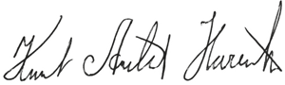
Knut Arild Hareide
Minister of Transport
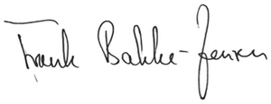
Frank Bakke-Jensen
Minister of Defence

Summary
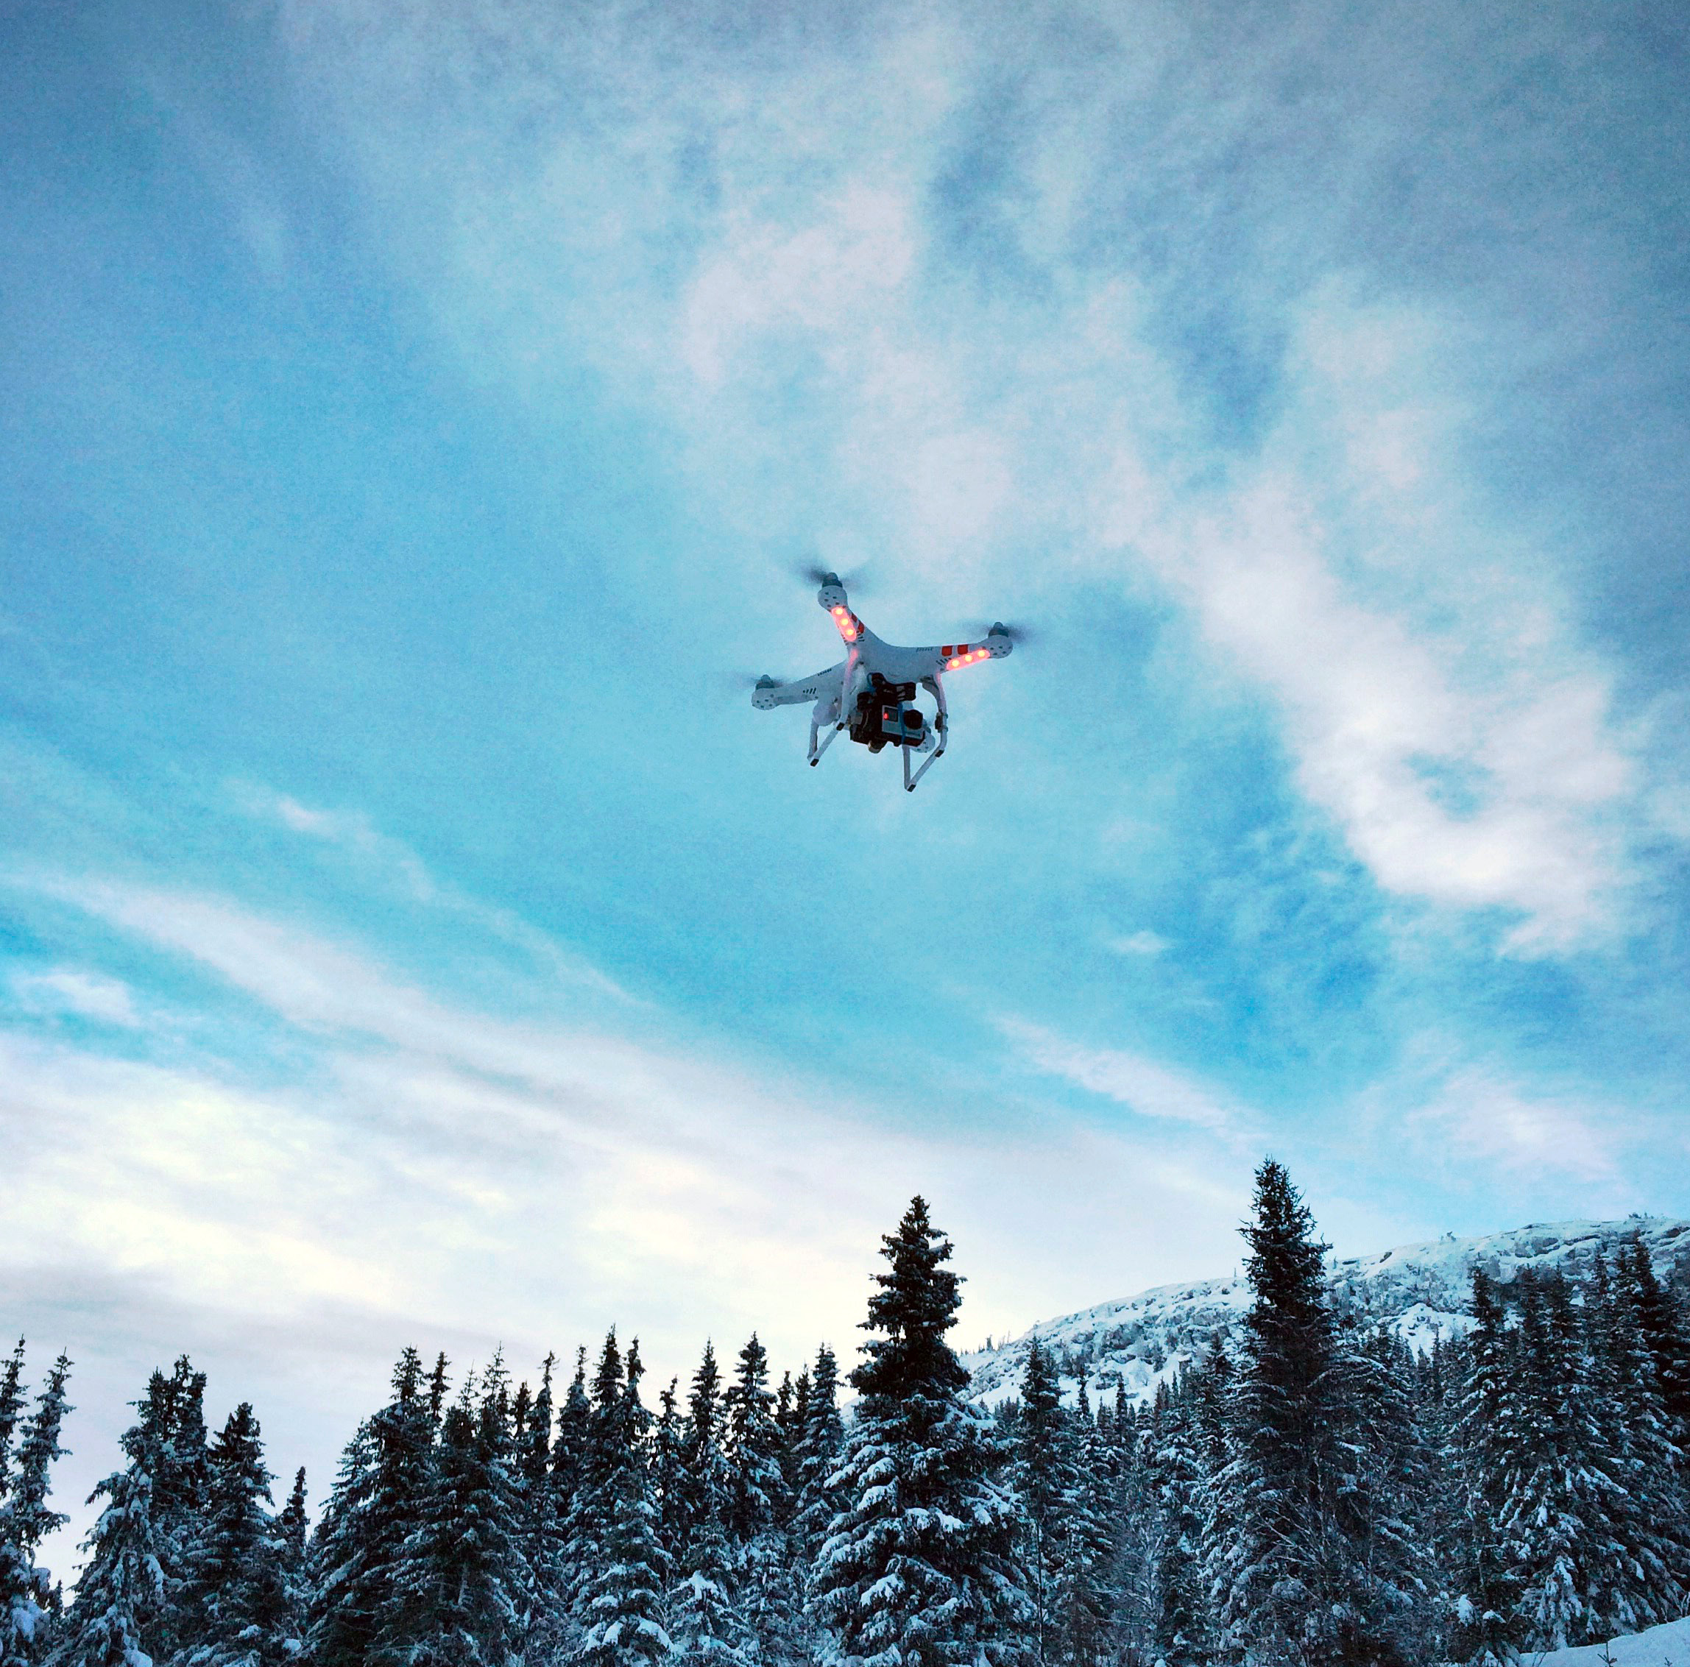
Photo: Civil Aviation Authority of Norway
The airspace is an important national resource and part of our territory in the same manner as our mainland and territorial waters. Access to the domestic airspace is not just a prerequisite for safeguarding state and public security, it is also a prerequisite for the normal functioning of society. The airspace has numerous areas of use, including civil and military aviation, space activities in transit, as well as communication and commercial activities. Its users have traditionally consisted of the Norwegian Armed Forces, airlines and air sports actors. However, new technologies, such as unmanned aerial vehicles, have resulted in new users and additional areas of use in recent years. Development trends in the areas of technology, regional security, supranational regulation and exercise of public authority, as well as an increase in the number of users, indicate a greater awareness of – and clear guidelines for – the administration of the airspace. This is also the background for the Norwegian Government’s development of a Norwegian Airspace Strategy.
Technologies, the number and types of airspace users and international regulations are rapidly and continuously developing. Therefore, the Strategy must be understood as a living document and the need for revisions will be assessed continuously.
The overarching objectives and initiatives in the Strategy are summarised below.
Clarifying the extent of the airspace and safeguarding Norwegian interests
An important starting point for being able to maintain sovereignty and optimal administration of the airspace is knowledge of, and a conscious attitude regarding the geographical boundaries of the airspace. The airspace is three dimensional, with clarified boundaries horizontally in relation to other states and down to the mainland, whereas the boundaries upward/outward toward outer space are not uniformly defined. The geographical boundaries of the airspace is an important framework condition for the administration thereof and there are strong interests underpinning such a clarification.
The state also has interests beyond our sovereign airspace. For instance, flights and other use of the airspace in the High North and Arctic areas are a natural part of the strategic assessments of the frameworks for airspace use.
The Norwegian Government will:
- Actively participate to promote Norwegian interests in international fora regarding the delimitation of conventional airspace and outer space, and flights in the border areas between conventional airspace and outer space.
- Actively participate in promoting Norwegian interests relating to the High North in international fora.
Clarifying roles and responsibilities
Several government ministries and state enterprises have roles and responsibilities relating to the airspace and contribute to establishing the frameworks for current and future use of the airspace. The Ministry of Transport, Civil Aviation Authority of Norway and Avinor play a particularly important role in the civil context, as do the Ministry of Defence and Norwegian Armed Forces in the military context. The Ministry of Trade, Industry and Fisheries and Norwegian Space Agency are responsible for the administration of Norwegian interests in outer space. It is important that the various authorities have unambiguous and clarified areas of responsibility, and that they are funded and structured to safeguard these areas. It is also important to ensure good interaction between the actors. The general developments in aviation, including the opening for international commercial actors and increased preparedness requirements on the part of the Norwegian Armed Forces, challenge the model in terms of funding and provision of services.
Safe and efficient use of the airspace requires a close cooperation between civil and military airspace users and authorities. Development and strengthening of the cooperation in respect of civil-military use is an important element in the Strategy. The Minister of Transport is responsible for the use of the airspace, on behalf of the Norwegian State. The Minister of Defence is responsible for safeguarding security and defence policy duties and functions in the Norwegian airspace, based on a solid civil-military cooperation in times of peace, crisis and war.
The Norwegian Government will:
- Facilitate the integration of the Norwegian Armed Forces’ needs and requirements in the public administration and provision of services, including military requirements for airspace administration and requirements for competence and certification to manage national and allied military operations.
- Assess new arenas for cooperation across sectors to contribute to the safeguarding of the state’s overall needs in the airspace.
- Review and update the current system for funding of airspace services.
Safeguarding Norwegian interests in international regulatory developments
Aviation is a global industry and states are dependent on close cooperation regarding development and follow-up of rules and framework conditions. The UN’s International Civil Aviation Organization (ICAO), the defence cooperation under the auspices of NATO and, not least, the cooperation in the EU, are especially important for the development of Norwegian airspace policy.
The EU has comprehensive plans and works underway of significance for administration and control of the airspace, cf. Chapter 5. This will also have consequences beyond the strictly geographical area for which EU member states have jurisdiction. The EU’s most recent initiatives and proposals for regulations build upon existing legislation under Single European Sky (SES). Desires for stronger harmonisation and improvement of efficiency may conflict with states’ interest in the administration of their own airspace. The EU’s decision-making competence in certain areas is proposed further expanded, but at the same time coordinated and within the Performance Scheme.
Currently, the specific legislative proposals (SES 2+) are being discussed in the Council and Parliament. It must be taken into account that in a somewhat more long-term perspective, there may be significant changes that Norway will have to relate to in a considered and qualified manner. The proposals will be of significance for both civil and military aviation and airspace use.
Through NATO, Norway is obliged to enable NATO operations in Norwegian airspace and prepare the transition for a NATO takeover of Norwegian airspace. The establishment of a situational overview in the air and “Air Policing” with combat aircraft of the alliance’s airspace is an ongoing and continuous NATO-led operation and thereby a prerequisite for our national assertion of sovereignty in the airspace. NATO has its own expert committees that regulate airspace and military aviation in times of peace, crisis and war. These are formalised in operational plans, standing directives and STANAGs that are presumed applied in the airspace of all member states. Experiences from the EU and NATO’s various committees indicate that the coordination efforts between them are not sufficient from a Norwegian perspective, and this is especially clear for the defence sector. Norway must – similar to the rest of the EU/EEA – be able to address conflicting instructions and comply if obligations imposed on the defence sector are followed up and made legally binding within the transport sector’s area of responsibility.
In addition to the international frameworks, the Norwegian Armed Forces has, through among other things, NORDEFCO, developed binding cooperation concerning airspace use across national boundaries. This is relevant in the High North, primarily in the North Sea Basin and in Skagerrak. A further development of this cooperation may yield operational and preparedness benefits for several sectors in the state.
The Norwegian Government will:
- Safeguard Norwegian civil and military legitimate interests in the implementation of the EU’s new initiatives under Single European Sky, including by ensuring the safeguarding of the Norwegian Constitution’s provisions regarding relinquishment of authority.
- Review how our obligations in relation to NATO are made legally binding in Norway.
- Further develop the cooperation regarding shared use of airspace across national boundaries based on the NORDEFCO model, in order to meet the needs of the Norwegian Armed Forces and other government agencies.
Review of national provisions pertaining to the airspace
Increased activity in the airspace, increased needs on the part of existing actors, and increased interest from parties other than the familiar actors, increases the pressure for clearer guidelines and rules governing the use the conventional airspace, but also in order parts of the airspace. This especially applies to drones and other unmanned aerial vehicles for use of the upper parts of the airspace towards outer space. Efforts are underway in the aviation sector under the auspices of ICAO and the EU regarding Higher Airspace, at the same time as commercial interests and commercial uses of a newer and less familiar nature are emerging.
The legal basis for the administration of the airspace must be clear and updated. The Norwegian Aviation Act is from 1993, a time when the challenges were somewhat different. New users have emerged and the traditional users are undergoing a transition, and there is a need for innovative thinking. The regulations have to be sufficiently flexible and robust.
A more challenging security policy situation and the developments in respect of military air operations require a clearer legal basis in order to meet our security needs, especially in crisis situations where both public and state security are challenged simultaneously, but also to be able to quickly receive allied assistance within the framework of NATO.
The Norwegian Government will:
- Assess the need for a revision of the aviation legislation’s provisions regarding use and administration of the airspace.
- Review preparedness measures and preparedness agreements so that the Norwegian Armed Forces receives the necessary provision of services for military preparedness purposes in times of peace, crisis and war.
Prioritising airspace users according to the purpose of the flight
As a main rule, the regulations allow for multiple airspace users to utilise the airspace, simultaneously. However, ever-increasing traffic may entail a necessity to prioritise between various airspace users, between civil and military users and between commercial and other types of flights.
The Civil Aviation Authority of Norway and the Norwegian Armed Forces have jointly developed a priority list for access to the airspace, where the purpose of the activity is the most important priority criterion:
- Air ambulance services take priority above all other traffic.
- Military operations (manned and remotely operated) in connection with the assertion of Norwegian sovereignty, exercising of public authority and in connection with crisis management and other armed missions always take priority above civil aviation.
- Flights in connection with police and customs assignments, search and rescue, other crisis management and other acute government missions, e.g., in connection with nature inspections, take priority above other civil aviation and military training flights.
- Open Skies flights take priority above all other flights except air medical services and government missions.
- Commercial aviation and military training flights are given approximately the same priority, but with the following adaptations:
- The need for airspace shall not result in the closure of airports.
- Commercial civil scheduled traffic takes priority on the routes between the biggest Norwegian cities, between Southern and Northern Norway, helicopter traffic offshore and traffic to and from Svalbard.
- Larger military exercises where Norwegian forces are participating shall be given particular weight.
- Preparedness exercises are given considerable weight, although less than military exercises where Norwegian forces are participating.
- Military training flights are given priority in predetermined areas, as long as these are booked in accordance with the Flexible Use of Airspace (FUA) Concept.
- Scheduled traffic is given priority above non-scheduled traffic.
- Passenger traffic takes priority above cargo transport.
- Other commercial flights (line inspections, sling-load etc., commercial general aviation).
- Aviation Flight school.
- Drone flights for commercial use.
- General aviation for recreation use, including air sports.
- Drone flights for recreation use.
The Norwegian Government will:
- Under normal circumstances prioritise airspace users according to the purpose of the flight and review the prioritisations in the transition from normal circumstances to crises.
Ensuring secure and efficient infrastructure for airspace use
Secure and efficient infrastructure is fundamental for aviation and use of the airspace. In recent years, there has been a shift from traditional and ground-based systems for digital and often satellite-based systems (GNSS). This is a result of technological developments and ICAO’s and the EU’s requirements for the introduction of performance-based navigation, which Norway has also implemented. The use of GNSS and performance-based navigation offer improved utilisation of the airspace and contribute to more efficient and environmentally friendly aviation. At the same time, there are potential security and vulnerability aspects involved in the considerable GNSS dependency.
With the continued development and upgrading of systems, such vulnerabilities must be addressed and it is necessary to make balanced considerations when new infrastructure is established and existing infrastructure is upgraded. It is important that Norwegian authorities in international, regional and bilateral aviation contexts share Norwegian experiences with GNSS/GPS disruptions with a view of developing good solutions for critical infrastructure in the field of aviation and airspace use.
The Norwegian Government will:
- Facilitate in order for systems that underpin preparedness functions in the airspace to have sufficient protection and redundancy in order to ensure continued operations following possible outages or compromising of civil computer networks, GPS signals etc.
- Ensure that Norway, together with other European countries, follows up the problems relating to GNSS disruptions in aviation in relation to ICAO in a joint European initiative on GNSS disruptions and vulnerabilities.
- Actively follow-up the development of technologies and services relating to the special conditions for aviation in the High North, in order to support the state’s strategic efforts and needs.
- Ensure that the national capability for airspace monitoring is viewed from a Total Defence perspective.
Lower emissions and less noise pollution
In most cases, traditional uses of the airspace involve emissions of greenhouse gases and noise. Through the Paris Agreement, Norway has committed to reducing greenhouse gas emissions and it is a national target to reduce noise pollution. Adaptations of airspace use can contribute to reduced emissions and noise pollution.
The Norwegian Government will:
- Continue the work on developing and utilising flight operational improvements at as many airports as possible in order to reduce greenhouse gas emissions and noise pollution for the airports’ neighbours and support the EU’s regulatory initiatives in this area.
- Follow-up the research relating to the climate impacts of emissions from aviation at higher altitudes.
Facilitating research, development and innovation relating to the Norwegian airspace
Norwegian actors in the area of airspace use must have access to a well-developed and future-oriented knowledge base and development scenarios. Some of this can be obtained from organisations and R&D environments abroad, but Norway has to establish its own knowledge environment relating to administration and use of the airspace and ensure a continuous updating of Norwegian innovation environments and in administrative and policy assessments and decisions.
The Norwegian Government will:
- Facilitate the systematic enhancement of knowledge regarding airspace use and the airspace, including considering the establishment of an RDI programme that can deliver research-based knowledge regarding the use of the airspace and development trends in a 10-20-year perspective.

Introduction
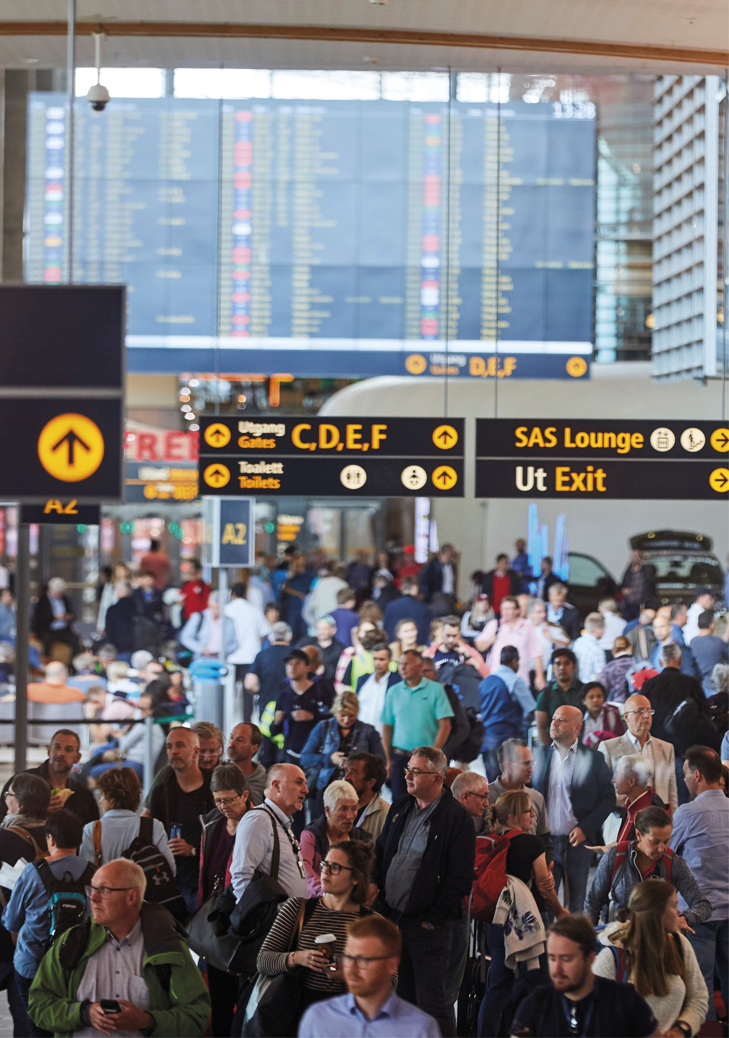
Photo: Avinor

Background
The airspace is an important and valuable part of the Norwegian territory and an important national resource in the same manner as our mainland and territorial waters. Administration of the airspace is part of Norwegian sovereignty policy. The airspace is of major significance for important areas of society in all parts of the country, and includes civil and military aviation, space activity in transit, communication, business development and recreational activities. Its users are a diverse mix of actors; civil and military, commercial and non-commercial. The objects in the airspace are an equally diverse mix of large and small – and increasingly unmanned – aircraft. The interest in the airspace and the manifold opportunities involved in a more intensive use are growing. In the future, new and more or less familiar areas of use, actors and technologies have to be expected, at the same time as there needs to be space for existing users. At the same time, well-established framework conditions such as aviation safety, security, cyber security, as well as the civil and military preparedness dimension, have to be safeguarded. This generates a need for clear framework conditions and clear rules governing the use of the airspace – corresponding to the rules that have been developed for mainland and sea areas.
Aviation is a global activity, and the Norwegian authorities’ scope of action is to a great extent affected by global and regional guidelines and binding obligations. Aviation is also easily impacted by the occurrence of special incidents. In recent decades, we have witnessed incidents including the terrorist attack on September 11, 2001, clouds of ash and now, the Covid-19 pandemic. The latter has abruptly and comprehensively impacted aviation and may have a relatively long-term impact and significant knock-on effects globally, at all levels. We must be prepared to develop the capability to handle unforeseen incidents and changes to the use of the airspace, also in the future.
The developments in the use of airspace indicate a need for a national strategy, with a complete overview of the administration of the airspace. This includes prioritisations, framework conditions, means, measures and efforts nationally, regionally and globally. At the same time, there are uncertainties relating to the future developments of airspace use. A strategy will therefore have to be flexible, and serve as an aid in planning, leading and regulating the airspace, depending on how the surroundings change in times of peace, crisis and armed conflict.

Working Group for a National Airspace Strategy
The Ministry of Transport has the overall responsibility for the airspace and for the identification and addressing of problems and trends in a comprehensive manner. The Civil Aviation Authority of Norway has the main responsibility for oversight of Norwegian civil aviation and associated regulatory developments. The Norwegian Armed Forces has a role as both a military aviation authority and as an important airspace user, and Avinor has a prominent role with imposed duties, as airport owner and as the provider of air traffic services and other air navigation services. The use of the airspace affects several government ministries and government authorities including the police, customs, fire and health services, and it is necessary to facilitate, among other things, air medical services, search and rescue operations and the development of Norway as a space nation.
In order to ensure a good professional basis and to safeguard as many considerations and interests as possible, the Norwegian Government in March 2020 established a working group led by the Ministry of Transport, with members from the Ministry of Defence, Ministry of Foreign Affairs, Norwegian Armed Forces, Civil Aviation Authority of Norway and Avinor. The Norwegian Government has prepared the Norwegian Airspace Strategy based on the work of the Working Group.

Extent and delimitation of the airspace
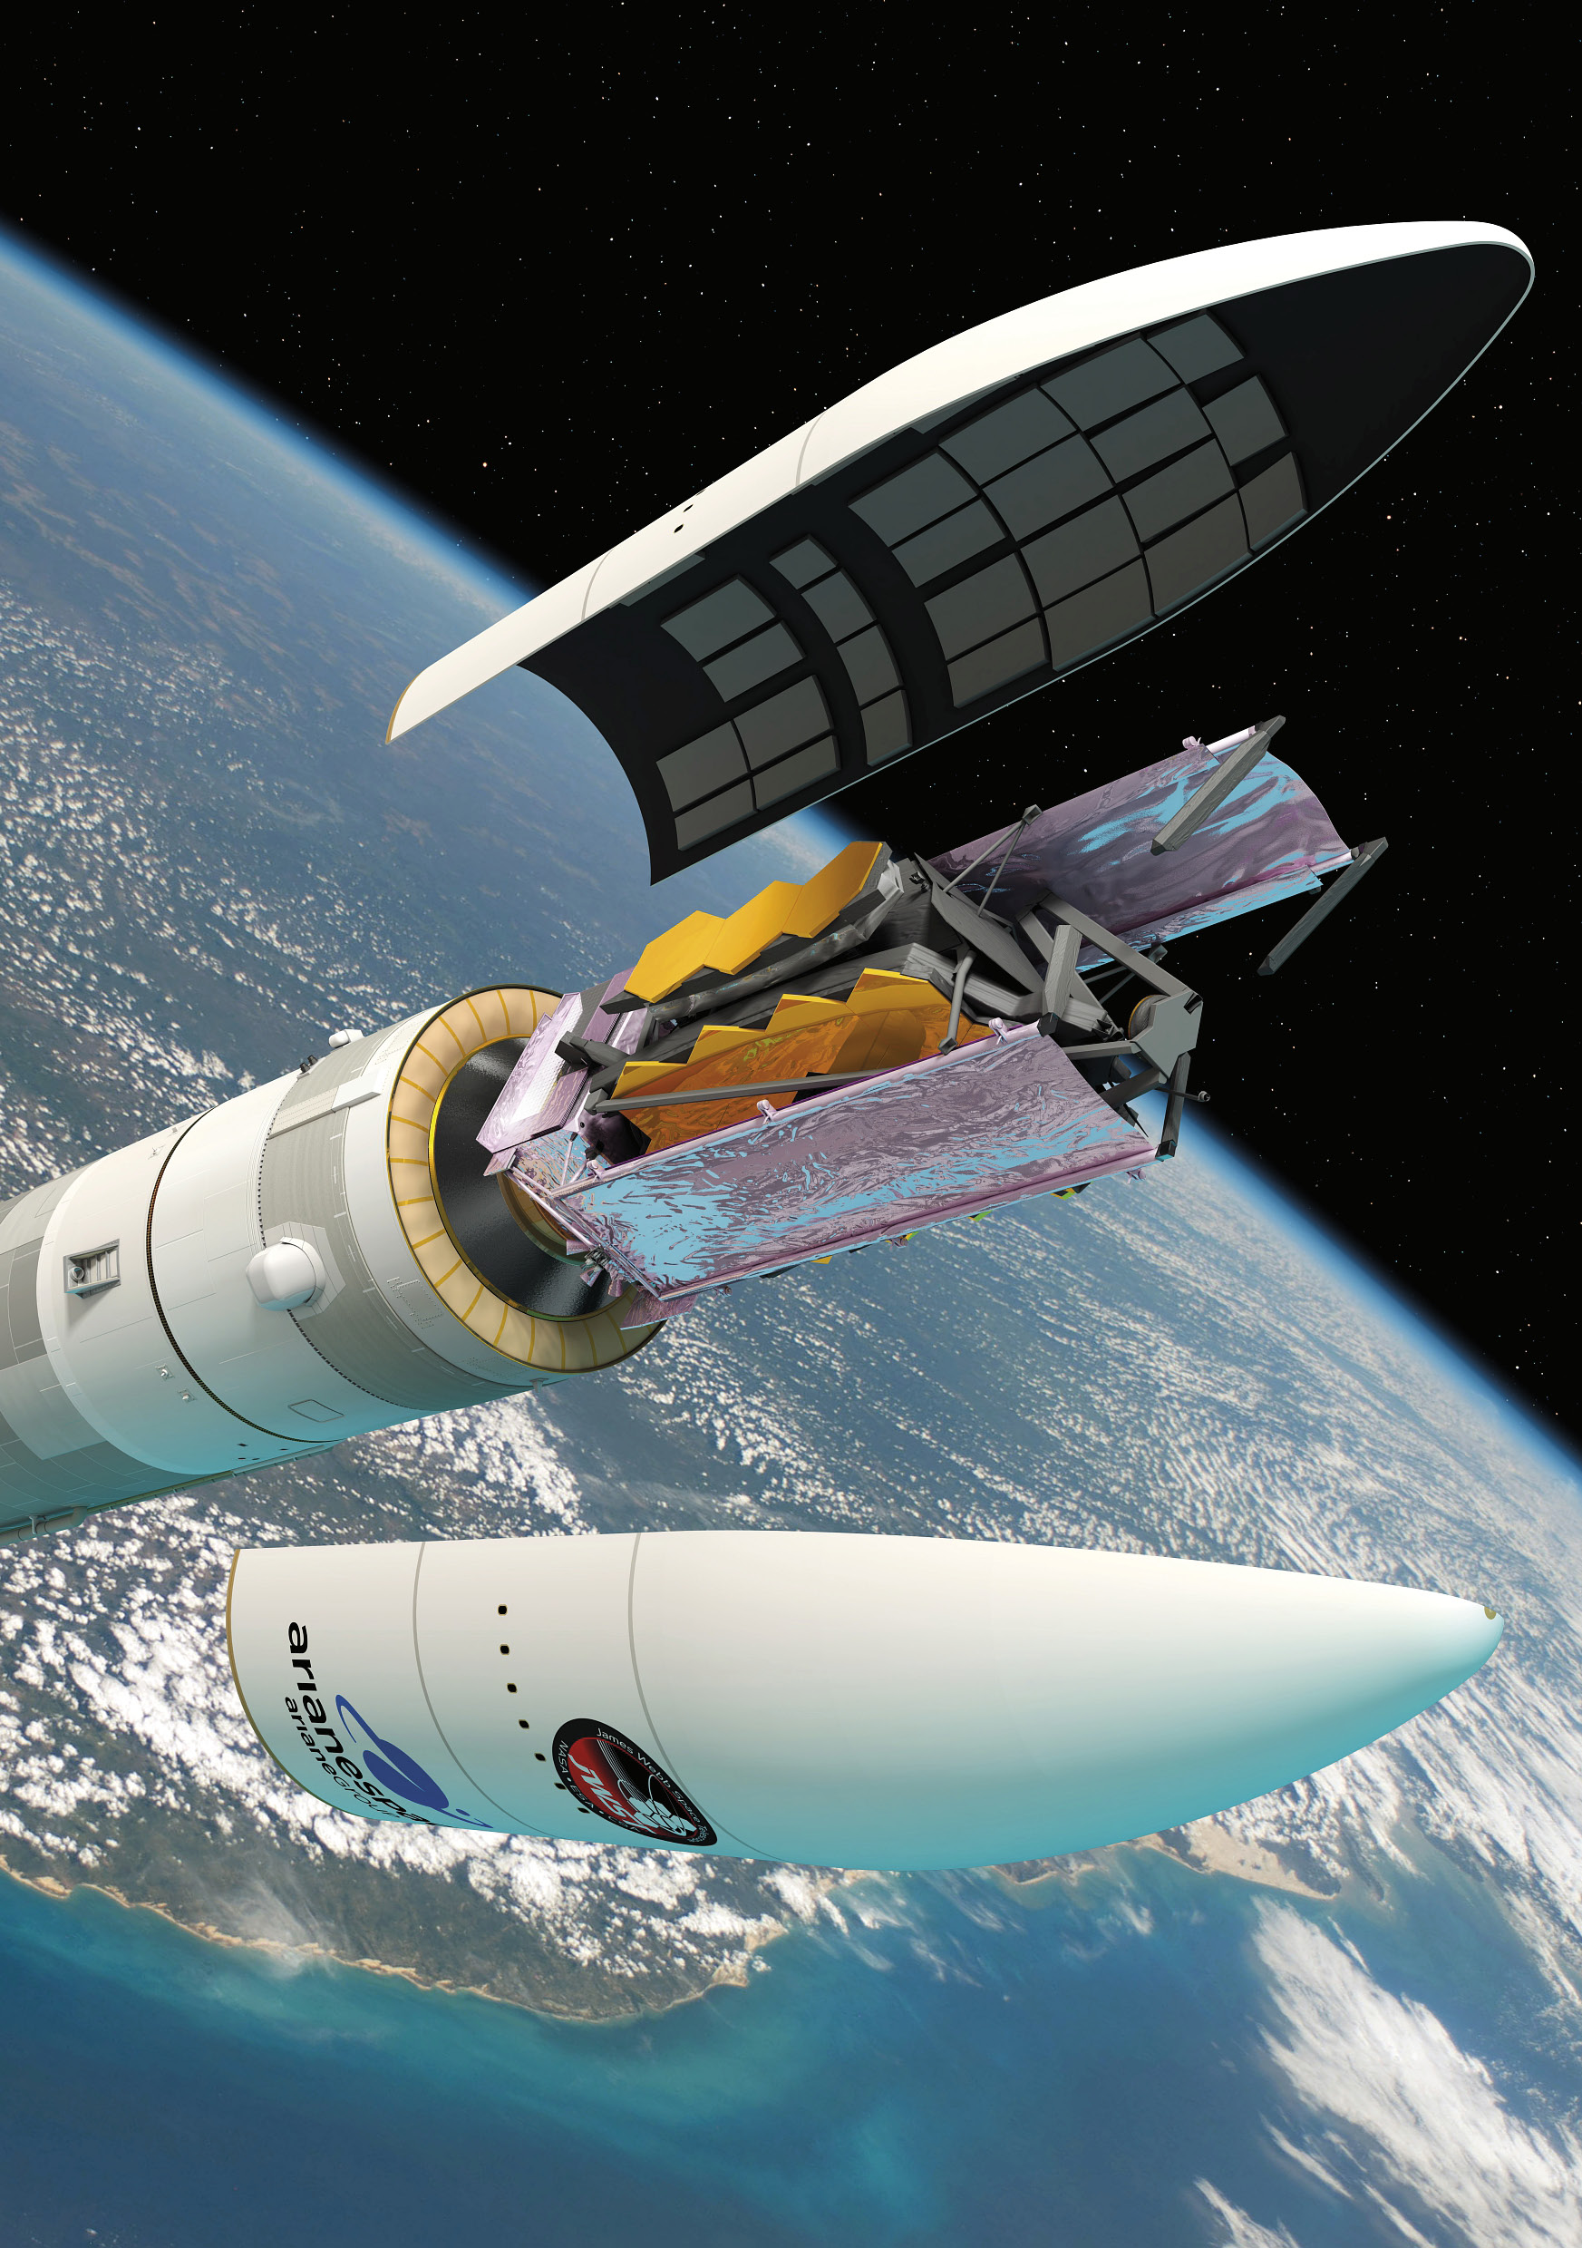
Illustration: ESA / D. Ducros
The airspace is a part of Norway’s territory in the same manner as the mainland territory and territorial waters. It is an alternative transport route to maritime and mainland transport but also the basis for other important functions in society. Sovereignty and the Norwegian right to exercise control are therefore just as important in the airspace as on the mainland and in territorial waters. In order to be able to administer this territory in a sound manner, an important starting point is to be aware of the geographical boundaries of the airspace.

Delimitation of the airspace in relation to outer space and the mainland
The conventional airspace, i.e., the airspace in the direction of outer space, is subject to regulation by states, by the Chicago Convention on International Civil Aviation and the International Civil Aviation Organization (ICAO), as well as regulations issued by the EU, cf. Chapter 5. States have sovereignty over their airspace and can, in principle, administer this space as a national resource. Efforts are currently underway in international bodies to regulate the use of outer space, including the delimitation of conventional airspace and outer space. The question was recently discussed in relation to Norwegian law in the Norwegian Government’s National Space Strategy, Meld. St. 10 (Report to the Storting (white paper)) (2019–2020) Høytflyvende satellitter – jordnære formål – en strategi for norsk romvirksomhet [High-flying satellites - down-to-earth purposes – a strategy for Norwegian space activities], as well as in the report Rett i bane [Into Orbit] by a law committee appointed by the Ministry of Trade, Industry and Fisheries to propose a new Act relating to activity in outer space (the Norwegian Space Law Committee).
The Space Law Committee highlighted the disagreements regarding a definition of outer space under international law and believes that Norway should await the international efforts on a possible multilaterally embedded definition. The Committee also believes there may be grounds for claiming that the boundary for outer space is not lower than 80km and not higher than 110km. This ambiguity in international law thereby relates to an area of approximately 30km. In the absence of an established boundary, it must be determined on a discretionary basis.
Even though there is currently limited activity in this area, the developments in aviation and space activities indicate that the level of activity will increase. For the activities in the border areas between conventional space and outer space, it will be necessary to distinguish between activities that, by their nature, are aviation, and activities that should be regulated by a new act relating to activities in outer space. More detailed guidelines regarding these delimitations will have to consider the authorities’ ongoing and future regulatory efforts. Furthermore, by defining “activity”, e.g., aviation activity, one can also define the scope of the act and establish the boundaries for a given type of activity.
The problems relating to the use of the upper parts of the airspace, e.g., the border areas between conventional airspace and outer space (Higher airspace operations and High altitude operations) are addressed in ICAO’s Resolution A40-7 and domestically. It is important that Norway continues to pay close attention to these efforts and remains engaged in all relevant fora.
Airspace use requires interaction with and permission from the Civil Aviation Authority of Norway. Andøya Space launches rockets and balloons on a regular basis and needs to consider the conventional airspace and outer space in the same operation.
Regarding the use of the airspace near ground level, it is undisputed that states can regulate the airspace above their territories down to the mainland or the ocean surface.

Horizontal delimitation of the airspace
The geographical scope of the airspace, understood as the extent and delimitation horizontally, is, in principle, fixed as it follows the delimitation of Norwegian mainland territory and the territorial waters.
Norwegian airspace above Norwegian territorial waters is delimited and extends to the territorial boundary of 12 nautical miles from the baseline. Beyond this boundary, international regulations apply, including ICAO’s standards and recommendations.
In Meld. St. 9 (Report to the Storting (white paper)) (2020–2021) Mennesker, muligheter og norske interesser i nord [People, opportunities and Norwegian interests in the north] , the Norwegian Government’s policies for the High North for the forthcoming years are presented. Therein, the Norwegian Government defines the High North as Norway’s most important strategic area of responsibility, while High North policy covers the international situation in the Arctic, the relationships with our neighbouring countries in the Barents Region and the Cap of the North, as well as the developments in Northern Norway. On this basis, flights and other uses of the airspace in the High North and Arctic areas will be a natural part of the strategic assessments regarding the framework for use of the airspace. However, there may be a need for more detailed clarification of what legal possibilities we have in the airspace above the parts of the High North that are outside of Norwegian territory.

Norway’s obligations in relation to ICAO
Under the auspices of ICAO, a global division of the international airspace has been undertaken (over the high seas) where air navigation services are provided. Norway has accepted the duty to provide air navigation services in certain parts of this airspace, cf. the figures below. Mainland Norway and southern parts of the Norway’s exclusive economic zone are located in the European region (EUR), whereas e.g., Svalbard and larger parts of Norway’s exclusive economic zone are located in the North Atlantic Region (NAT). NAT is divided in to seven flight information regions (FIR), where Bodø Oceanic FIR is the easternmost region. In the Bodø Oceanic FIR, Norway provides air navigation services from the control centre in Bodø.
Svalbard is located in the Bodø Oceanic FIR, where Norway provides air navigation services.
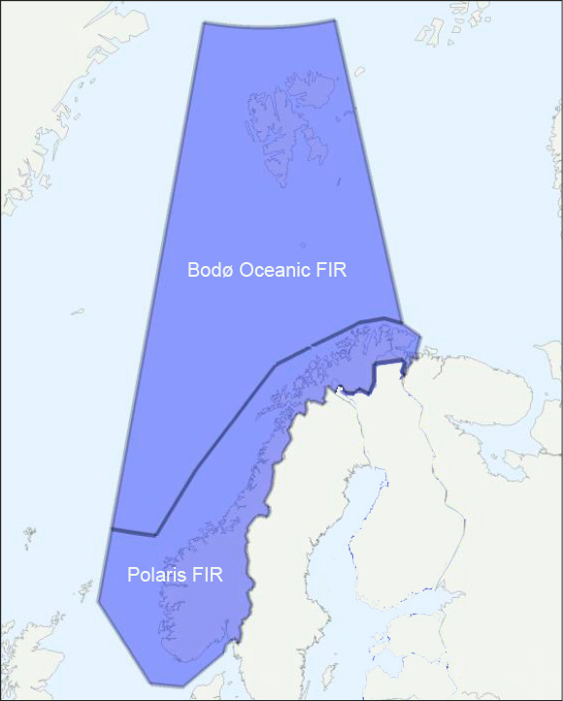
          - Flight information regions (FIR) where Norway provides air navigation services
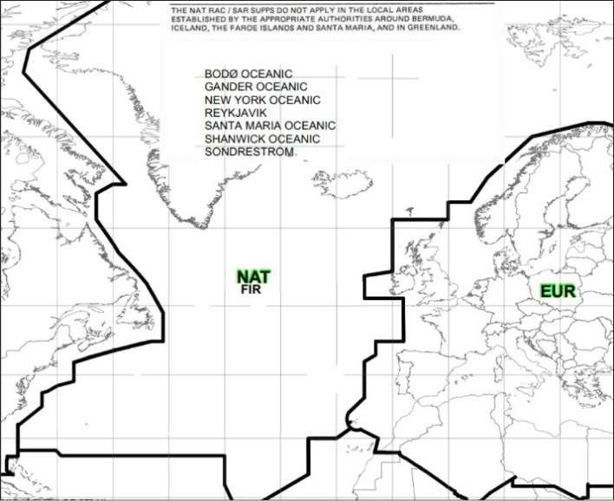
          - ICAO’s regional divisions – NAT and EUR

Strategy
The Norwegian Government will:
- Actively participate to promote Norwegian interests in international fora regarding the delimitation of conventional airspace and outer space, and flights in the border areas between conventional airspace and outer space.
- Actively participate in promoting Norwegian interests relating to the High North in international fora.

Authorities, roles and responsibilities
Photo: Avinor
Various authorities and other actors have roles and responsibilities relating to the airspace and contribute to establishing the frameworks for current and future use of the airspace. This especially relates to the Ministry of Transport, Civil Aviation Authority of Norway and Avinor in the civil context, and the Ministry of Defence and Norwegian Armed Forces in the military context. The Norwegian Space Agency has a particular responsibility for the administration of Norwegian interests relating to outer space.
A selection of government ministries and subordinate agencies that are and can become actors in the use and administration of the airspace is illustrated in Figure 3.1, below. The figure illustrates the importance of clear descriptions of responsibilities, but also that network building and defined processes must be emphasised throughout the spectrum of airspace administration and associated value chains.
The roles and responsibilities of the Norwegian authorities must also be viewed in context with the efforts of the EU to realise a common European airspace, cf. Chapter 5.

Government ministries’ roles and responsibilities
The Ministry of Transport has the overall responsibility for aviation and the Norwegian airspace and thereby for the identification and addressing of problems and trends in a comprehensive manner. The Ministry of Transport has a responsibility for the existence of a well-functioning framework for the use of the airspace, and that all users’ interests are safeguarded in an appropriate manner. The Ministry of Transport also has the overall responsibility for international cooperation and the overall responsibility for coordinating other authorities’ interests as airspace users.
The Ministry of Defence has the overall responsibility for regulatory functions associated with Norwegian state security and the international obligations Norway has entered into in respect of defence and security policy. At the same time, the Ministry of Defence supports public security and operates aircraft that safeguard regulatory functions and preparedness across several government ministries. In the event of a declared state of emergency and war, the Ministry of Defence can assume control of necessary exercising of authority that is delegated to other government ministries in peacetime. Necessary coordination of authority is planned and implemented under the Total Defence Concept.
The Ministry of Foreign Affairs’ responsibilities are the same as for the mainland and territorial waters and not unique to the airspace and relate to the upholding of Norwegian sovereignty in and on Norwegian territory.
The Ministry of Justice and Public Security’s duties and responsibilities relate to the police’s role in the establishment of local rescue coordination centres and the closure of airspace in connection with larger accidents and occurrences. Furthermore, the Joint Rescue Coordination Centres coordinate all emergency services and Norwegian Customs conducts border surveillance.
The Ministry of Trade, Industry and Fisheries’ duties and responsibilities relate to the Norwegian Space Agency’s administration of space activities, as well as support for fisheries surveillance and the Norwegian Coast Guard with the aid of air resources.
The Ministry of Local Government and Modernisation’s duties and responsibilities relate to the Norwegian Mapping Authority and the Norwegian Communications Authority.
The Ministry of Health and Care Services’ duties and responsibilities relate to the administration and operation of the Air Ambulance Services of Norway and the Emergency Medical Communication Centres.
The Ministry of Petroleum and Energy’s duties and responsibilities relate to the Norwegian Water Resources and Energy Directorate and associated expansion of wind turbines, power lines etc. Such installations have to be registered upon establishment and updating of overviews of aviation obstacles.
The Ministry of Climate and Environment’s duties and responsibilities relate to the Norwegian Meteorological Institute and the establishment of protected areas. For protected areas, the airspace above such areas will often be closed for general traffic up to 300 metres.
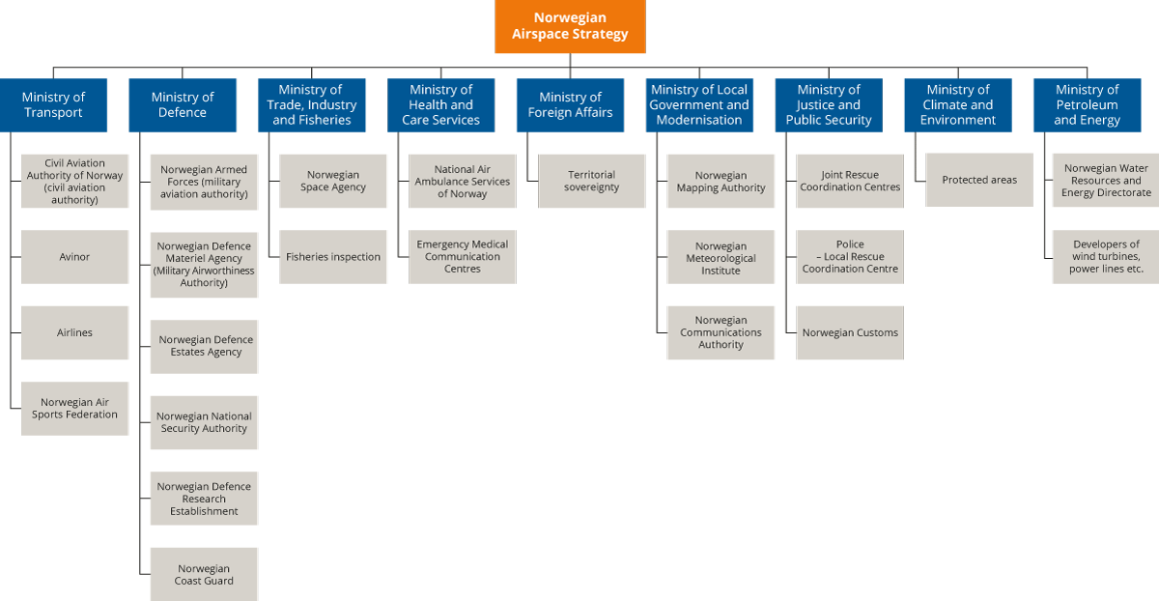
          - Actors in national airspace administration.

The Civil Aviation Authority of Norway’s role and authority as civil aviation authority
The Civil Aviation Authority of Norway has the main responsibility for oversight of Norwegian civil aviation. A key duty is to contribute to the actors in civil aviation fulfilling the requirements in the prevailing regulations. The Civil Aviation Authority of Norway approves organisations and individuals and supervises, among other things, aircraft, airlines, educational organisations, workshops, personnel, airports, air navigation services and general aviation. If necessary, the Civil Aviation Authority of Norway shall clarify and agree cooperation with other states’ aviation authorities regarding approval and oversight of organisations operating in Norway.
In step with the developments in the sector, the roles and functions of agencies are developing with the objective of optimal administration and in accordance with expectations, needs and challenges for modern aviation and airspace administration.
The Civil Aviation Authority of Norway also has directorate duties and shall, among other things, assist the Ministry of Transport in the regulatory work and establish regulations in areas where it has been delegated authority. Furthermore, the supervisory authority shall, among other things, assist the Ministry of Transport in the EEA work in accordance with the Ministry’s EEA Strategy and other guidelines for this work.
The Civil Aviation Authority of Norway is the national airspace authority. This entails authority to determine how the airspace shall be organised. There are continuous developments in the sector with additional users, technology development, digitalisation, intensified international processes and more complex conditions in the airspace. It is crucial that the Civil Aviation Authority of Norway has sufficient resources and competence to be able to handle the continuous developments. The Civil Aviation Authority of Norway shall also have dialogue with the Ministry of Transport regarding policy priorities for the use of the airspace for various societal purposes. It must be considered in greater detail what kind of authority the Civil Aviation Authority of Norway shall have in a situation where preparedness legislation takes effect.
It is being considered whether the Civil Aviation Authority of Norway should not only be designated authority for the administration of the conventional airspace, but also for activities relating to outer space. From an airspace perspective and based on an overall assessment of the state’s resources, there are a lot of arguments in favour of the Civil Aviation Authority of Norway being designated the role of administrative and supervisory authority pursuant to a new space act. The Civil Aviation Authority of Norway already has broad competence regarding airspace and questions relating to boundary-setting between the ordinary airspace and outer space.

Avinor AS
Avinor AS is a limited liability company where the state, represented by the Ministry of Transport, owns 100 per cent of the shares and the Ministry is the company’s general meeting. Avinor Air Navigation Services AS is a wholly owned subsidiary of Avinor AS. The Group is hereinafter referred to as Avinor. Avinor is categorised as a company with sector-specific objectives. Approximately half of Avinor’s revenue has in recent years derived from fees the airlines have paid for the services provided by Avinor. The remainder of the revenue has derived from its business operations in connection with the airports. The company has been self-financed, and revenue from commercially profitable airports has contributed to funding commercially unprofitable airports and social obligations. The air navigation services have been funded through air navigation service fees, payments for services from airport activities, intra-group coverage of expenses for services that are not paid for by external recipients, and commercial and contractual payments from external service recipients.
Avinor’s social mission is to own, operate and develop a nationwide network of airports for civil and military aviation. Furthermore, Avinor shall perform what is referred to as social obligations, as determined by its owner. Social obligations are obligations which Avinor is ordered to perform, and that are not necessary to carry out its social mission and that do not follow from acts and regulations.
Regarding air navigation services, Avinor has been designated general obligations and authority through a designation decision. It follows from the designation decision that: “Avinor shall ensure that both civil and military needs for air navigation services are covered. Avinor may be ordered to safeguard defence and preparedness duties beyond the duties with a direct legal basis in Section 13-9 of the Aviation Act. Possible financial compensation shall be determined in each individual case.” Furthermore: “Avinor undertakes to at all times have sufficient competence and capacity to meet the demand for the services that are covered by the designations. The requirements in the first sentence shall cover the demand from both civil and military users.”
The areas of control tower, approach control and air navigation services have been competitively tendered, and at Ålesund Airport and Kristiansund Airport, the services are provided by the Spanish company Saerco. The en-route services are not competitively tendered and Avinor Air Navigation Services AS has been designated by the Ministry of Transport as the supplier of such services until 2024.
Avinor Air Navigation Services AS has been assigned responsibility for a part of the national core duties for the aviation system in Norway to function in accordance with its social mission, including:
- Duties that follow from the monopoly situation (e.g., air traffic controller education)
- Duties of an administrative nature (e.g., technical advice to the Civil Aviation Authority of Norway and Ministry of Transport)
- Various core duties for airports or other areas of activity (e.g., key network services, surveillance data etc.)
In order to ensure efficiency, the order, funding and responsibility to perform the social obligations must be organised in a manner that provides incentives for the duties to be performed in a cost-effective manner. The state also cannot impose on Avinor a scope of social missions and social obligations that within efficient operations cannot be solved with the traffic and revenue envisioned after the pandemic. The parts of Avinor that are competitively tendered should not be charged for possible social obligations in a different manner than its competitors.

The Norwegian Space Agency (NOSA)
The Norwegian Space Agency (NOSA) is “the state’s strategic, coordinated and executing agency to ensure efficient use of outer space in the best interests of Norwegian society”.
NOSA, which is subordinate to the Ministry of Trade, Industry and Fisheries, is a directorate for the Ministry of Transport in cases concerning coordination responsibility for the civil navigation policy. NOSA is a key agency and an important Norwegian expert environment pertaining to satellite-based solutions utilised by aviation and on which it increasingly depends.
NOSA has important duties relating to the safeguarding of Norwegian membership in the European Space Agency (ESA) and the EU’s space programmes. Many of these duties interface with both the Ministry of Transport’s and Ministry of Defence’s areas of responsibility. There is dialogue between the Ministry of Ministry of Trade, Industry and Fisheries and the Ministry of Transport regarding the Civil Aviation Authority of Norway as the supervisory authority for space activities.
NOSA also has the secretariat function for the inter-ministerial space/space safety committees and therefore has the possibility to cooperate and coordinate with the ministries in matters that affect activities in these programmes.

The Norwegian Meteorological Institute (MET)
The Norwegian Meteorological Institute (MET) is an institution that is responsible for Norway’s public meteorological service for civil and military purposes. The institute is a public administrative body with special authorities, subordinate to the Ministry of Climate and Environment.
The duties of the Norwegian Meteorological Institute are to prepare weather forecasts, study Norway’s climate and issue climatological reports, and collect meteorological data in Norway, adjacent seas and on Svalbard. MET has been designated by the Ministry of Transport to provide aviation weather services. The aviation weather service is a special service that provides weather forecasts and weather reports adapted to aviation. Within Norway’s area of responsibility, the service is delivered on assignment from Avinor and the Norwegian Armed Forces pursuant to established agreements. The aviation weather service is part of the air navigation services and is subject to strict requirements regarding content and quality. The most important duties of an aviation weather service is monitoring of the airspace regarding dangerous weather conditions. Warnings are to be issued when necessary. Furthermore, routine warnings adapted to users and needs are provided.

The Norwegian Armed Forces’ role and authority as military aviation authority
The Norwegian Armed Forces has an independent responsibility with multiple roles and duties relating to the military component of aviation and airspace use, especially in times of crisis and war.
The Norwegian Armed Forces has in recent years undergone increasing formalisation, as expressed, among other places, in the document Norwegian Military Airspace Requirements (NoMAR) and through the meeting fora North European Functional Airspace Block Military Committee (NEFAB CMC), Nordic Defence Cooperation (NORDEFCO) “Easy Access Declaration” and the national strategy for determining Positioning, Navigation and Timing (PNT Strategy, cf. Chapter 7.2). The Norwegian Armed Forces also safeguards the host responsibility for allied state aircraft that operate in the Norwegian airspace.
The Chief of Defence (CoD) is the country’s highest ranking military official and the Norwegian Government’s and Minister of Defence’s closest military advisor in times of peace, crisis and war. The CoD is responsible for the military defence of the country being planned and prepared in cooperation with allied military authorities. The CoD is responsible for preparedness and mobilisation preparations in the Norwegian Armed Forces and is to monitor corresponding activities in civil bodies. The CoD is to contribute to the coordination of military and civil plans and that they in the best possible manner contribute to the country’s total defence. The CoD is to implement the preparedness measures indicated by the situation within the CoD’s authority (cf. Instructions for the Chief of Defence).
With a legal basis in the Aviation Act and regulated in more detail in regulations, the Chief of Defence is the military aviation authority. The aviation authority does not cover regulation of airspace. This is the responsibility of the Civil Aviation Authority of Norway.
The Chief of the Norwegian Air Force is an aviation authority, airport operator and airspace user and administrator in times of peace, crisis and war.
The Air Operational Inspectorate (AOI) is an independent part of the Norwegian Air Force and is the Military Aviation Authority (MAA) corresponding to the Civil Aviation Authority of Norway (CAA).
Furthermore, the Norwegian Armed Forces shall keep a military aircraft register (delegated to the Norwegian Defence Materiel Agency (NDMA)) and shall determine rules regarding, among other things, requirements for airworthiness and crew. The military aviation authority can determine rules regarding certification of personnel relating to military aviation.
The Chief of the Norwegian Air Force is also an aircraft operator through its structure of military air wings and squadrons. These are led by air wing chiefs who have the command of subordinate squadrons. Air wing chiefs can also be airport managers where this has been decided.
The Chief of the National Air Operation Centre (NAOC) reports to the Chief of the Norwegian Air Force and exercises tactical command of air operative forces on behalf of the Norwegian Air Force and also safeguards planning, coordination, management and execution of the Norwegian Air Force’s operative defence capability development activities coordinated with the Chief of the Norwegian Joint Headquarters (NJHQ). The Chief of the NAOC has the host responsibility for all military state aircraft operating in Norwegian airspace and the command of assigned allied forces.

Strategy
The Norwegian Government will:
- Facilitate the integration of the Norwegian Armed Forces’ needs and requirements in the public administration and provision of services, including military requirements for airspace administration, and requirements for competence and certification to manage national and allied military operations.
- Assess new arenas for cooperation across sectors to contribute to the safeguarding of the state’s overall needs in the airspace.
- Review and update the current system for funding of airspace services.

Airspace users
Photo: Avinor
The current airspace use and users are typically airlines carrying out commercial flights and other types of assignments, the Norwegian Armed Forces, air ambulance services, police, search and rescue, general aviation, air sports and new users such as drone operators and space actors. The development of drones has especially resulted in an increase in the number of users in recent years.

Different needs, different framework conditions
Actors who wish to operate in the airspace have different needs and different prerequisites for airspace use. Some activities are compatible with simultaneous use by multiple actors, while other activities require a segregated airspace. The equipment level on aircraft, the nature and purpose of the assignment and the commercial or societal value of the activities, are factors that must be taken into consideration when assessing whether a user shall be granted airspace access. It is not decisive whether a user is already established in aviation or it concerns a new actor.
Certain users will mainly operate at lower altitudes. This first and foremost involves drone operators but also certain parts of the general aviation segment and air sports activities such as hang gliding, paragliding, parachuting and model aircraft. This, in part, relates to needs, but also performance requirements may be decisive, since not all aircraft can operate at the same altitudes and over the same distances.
Some parts of aviation have an extensive need for air traffic services, e.g., air traffic control, due to traffic density and a need to maintain an acceptable safety level. This especially relates to commercial aviation, typically passenger and cargo traffic. The requirements for and orders concerning the establishment of air traffic services are largely set out in regulations and are also strongly harmonised internationally. Air traffic services are also to varying degrees provided in the airspace, and air traffic control is only provided at higher altitudes relating to approaches to and departures from larger airports. Increased traffic density can trigger a need for increased regulation.
State flights is aviation performed by a state in connection with the solving of duties and exercising of authority relating to, among other things, police duties, customs, search and rescue, fisheries surveillance and military duties. In Norway, the Norwegian Armed Forces performs several of the duties defined as state flights on behalf of other ministries and agencies. With increased complexity and increased dependencies, this creates challenges in that support functions may be distributed across several agencies. State flights are in principle exempt from the ICAO rules, and these exemptions are continued in the EU. On 26 May 2020, national Regulations relating to state flights for public purposes etc. were adopted. These Regulations entered into force on 1 January 2021. Missions are also carried out on behalf of the state that are not classified as state flights, e.g., in the areas of surveillance and health services.
Military air operations and certain other state missions may have a need for an entirely separate (segregated) airspace, e.g., in operations of a confidential nature or for safety reasons. Examples of this are flights in connection with larger military exercises, or larger accidents or disasters that cannot be executed in a safe manner in the same airspace as other aviation.

Civil airspace users
The airlines offering scheduled transport of persons and cargo on commercial terms are clearly the largest group of airspace users. Norway has a vast airport network that covers the entire country. 43 out of 48 airports with ordinary scheduled traffic are operated by Avinor AS. A good flight service is crucial in order for people to be able to reside throughout the country and at the same time have an acceptable access to hospitals, public authorities, larger cities and regional centres, as well as other important institutions and other infrastructure. Norway’s location in the northernmost part of Europe and access to other countries also requires good accessibility with flights and suitable air transport services to the rest of the world.
In 2019, Norway was the country in Europe with the most airline passengers to/from the country, in relation to the size of the population. A share of these were tourists and other visitors, but Norwegians are nevertheless among those who travel the most by plane. Long distances, challenging topography, dispersed population, high income and an open economy are important reasons for this.
Aviation is the part of the transport sectors that has been hardest hit by the Covid-19 pandemic and infection control measures. From January 2020 until January 2021, the number of domestic aircraft movements at Avinor’s airports fell by 33 per cent, while the number of aircraft movements to and from foreign countries fell by 81 per cent. Air traffic remains far lower than it was before the pandemic.
In addition to scheduled, commercial transport of persons and cargo, civil aviation also includes what is referred to as General Aviation (GA). GA includes both commercial and non-commercial aviation activities, including private and commercial small aircraft activities, as well as air sports activities that use hang gliders, paragliders, parachutes, model aircraft, etc. The GA community believes restrictions to access to airspace is one of the greatest challenges for the activity, today. In the Norwegian Government’s Small Aircraft Strategy which was presented in 2017, it is stated that hobby and leisure flights using small aircraft shall be ensured access to airspace but shall be given lower priority than other useful traffic. The Small Aircraft Strategy also states that the establishment of a controlled airspace shall not occur to a greater extent than necessary, and that considerations shall be made for small aircraft activities when introducing restricted areas.
Prioritisations between airspace users is discussed in more detail in Chapter 6.

The Norwegian Armed Forces as airspace user
The Norwegian Armed Forces has nine duties that are imposed by the Norwegian Parliament and stated in the long-term plan for the Norwegian Armed Forces. All of these duties may involve an airspace dimension, whether in times of peace, crisis or war. It is the duties to ensure a credible deterrence and defence within the framework of NATO’s collective defence, to avoid and address security policy crises with national resources, and facilitate allied engagement, which are the most challenging duties relating to airspace authority and administration.
In practice, these duties entail that the Norwegian Armed Forces shall have the capability to fly aircraft for national missions in the airspace of the at all times applicable civil airspace organisation in times of peace, crisis and war, as well as lead air operative reinforcements through the national airspace under corresponding conditions.
The development of aerial warfare is characterised by an increasing use of sensors, electromagnetic spectra and more precise weapon effects with longer range. Overall, this results in a greater need for airspace. It is a security policy trend that, with increased use of the airspace and a greater focus on achieving objectives without escalating to conflict, there are greater requirements for surveillance of the state’s airspace and for the identification of activity in the airspace.
The Nordic Defence Cooperation (NORDEFCO) has recently had great success with shared use of the airspace across national boundaries and there is an increasing demand from other nations to participate in exercises taking place in the NORDEFCO airspace. The EU views this airspace cooperation as a good example of how operations across national boundaries can be established. Future needs, e.g., in the North Sea/Skagerrak may generate a potential for new areas in which to establish air operative cooperation. New states for this type of cooperation will, in addition to Iceland, Norway, Sweden, Finland and Denmark, be Germany, the Netherlands and the United Kingdom.
In order to safeguard the Norwegian Armed Forces’ interests in the future, and to ensure necessary scope of action to execute air operations, the Norwegian Armed Forces must be capable of:
- Establishing the capability to assume national control of the airspace in a sector within a limited time frame.
- Ensuring a national capability for military airspace control, including a satisfactory capability for air surveillance.
- Having competence regarding military air operations overall.
- Having guaranteed short response times for adapted services.
- Having robust Communication, Navigation and Surveillance (CNS) and secure communication infrastructure.
- Providing surveillance and air navigation services for civil aviation.
The Norwegian Armed Forces is one of several state airspace users but is distinct in having its own aviation authority which is particularly intrusive in relation to other users in times of crisis and war.
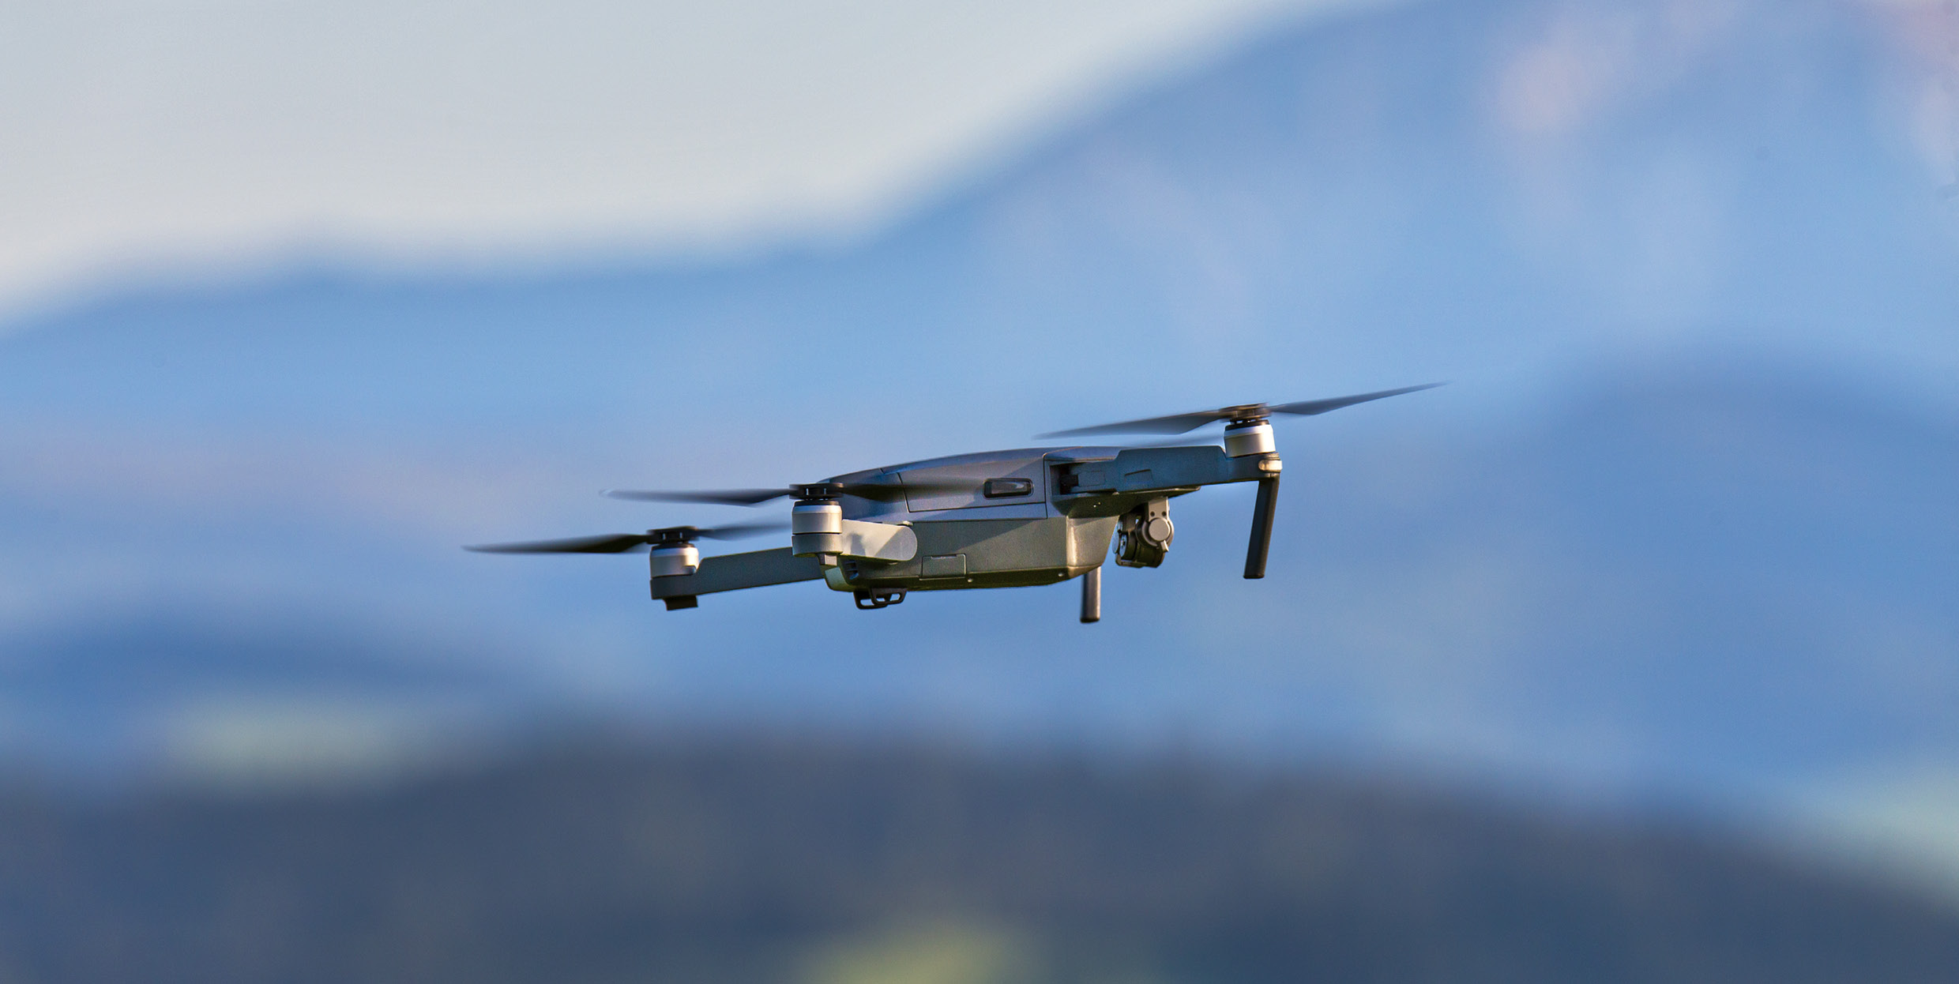
Photo: WeiseMaxHelloween

Drones and the integration of drones in the airspace
When we use the term drones in this document, this covers UAS (Unmanned Aerial System), UAV (Unmanned Aerial Vehicle) and RPAS (Remotely Piloted Aircraft System) etc.
The common denominator is that drones can be defined as unmanned aircraft that consist of various components, both on the ground in the air. Drones represent a risk for other airspace users and can, with varying degrees of autonomy, be controlled from the ground in order to reduce this risk.
Drones represent a new, important and complex group of aircraft in the Norwegian airspace. They open for the possibility of new forms of airspace operations and far more actors in aviation, and may, for a number of operations that are being carried out today, offer benefits in terms of safety, environment and cost-effectiveness compared to manned aviation. As of autumn 2020, there are more than 5000 registered drone operators in Norway, and more than 100,000 Norwegians own one or more drones. In recent years, we have witnessed a strong growth in the number of drone operators, and this trend is expected to continue.
In 2018, the Norwegian Government presented its first Drone Strategy. The Strategy outlines the main challenges relating to the use of drones and is to contribute to the development of Norwegian drone activities occurring in a market-driven and socially beneficial manner. The Strategy only focuses on drones that are utilised for ordinary civil use and for public, civil purposes.
The Norwegian Armed Forces uses drones in several contexts and sizes, ranging from combat drones barely weighing 20 grams (10cm in length) and to strategic drones weighing 6-7 tonnes, the size of large passenger aircraft. For the period 2022-2026, the Norwegian Armed Forces has planned to procure a larger number of drones distributed across several different classes/types. The largest drones (Global Hawk) will only be deployed in Norway in an allied context to operate from dedicated bases.
The development of drones has until now not had a significant focus on interaction with existing actors in traditional aviation, especially with regard to equipping for necessary navigation, communication and surveillance.
Furthermore, most drones that are currently used in the airspace are significantly smaller in size than traditional aircraft.
In order to achieve the target of integration of drones in the airspaces used by manned aircraft, there needs to be a focus on acts and provisions regulating the entire chain of unmanned aviation. Operators of unmanned systems cannot expect to be able to operate freely alongside manned flight systems without meeting corresponding requirements throughout this chain.
In sum, this means that existing safety functions that aviation uses in the various parts of the airspace are not equally effective in relation to drone operations as they are for operations of manned aircraft. On this basis, Norwegian provisions determine that aircraft that do not have a pilot on board shall yield to other aircraft, cf. Section 49 of the Regulations of 30 November 2015, no. 1404 Relating to aircraft that do not have a pilot on board etc.
Thereby, as a main rule, unmanned aviation is not given the same priority to airspace access as manned aviation in the current system, cf. Chapter 6. This challenge must be solved before the potential relating to the use of drones in the Norwegian airspace can be realised. Among other things, there is currently a new type of service being developed that specifically targets drones; Unmanned Traffic Management (UTM). UTM is to contribute to drones being granted easier access to airspace and become better integrated in the existing systems of aviation. In Norway, Avinor Air Navigation Services plans to roll out a UTM system at the largest Norwegian airports during 2021. The UTM system will simplify – and in the long term be able to automate – the processes relating to requesting access to airspace around these airports.
At the European level, the European Commission has prepared a regulation on a regulatory framework for U-space. U-space does not have a legal definition but is described as a set of air traffic services particularly directed at drones that are used in an automated manner through a digital system in a given airspace (“U-space airspace”) determined by the individual state in its own territory. The U-space regulation is expected to be incorporated into Norwegian law and will establish the frameworks for how UTM services shall function and be offered to users. The rules will take effect from the beginning of 2023.
The development of UTM and U-Space will be able to reduce the challenges relating to the use of drones in the Norwegian airspace and it is important to monitor the technological and regulatory developments in this area. At the same time, we have to expect that well-functioning management services for drones will result in a significantly higher number of drone operators in the Norwegian airspace. This will create additional pressure on the capacity in the airspace, which in turn requires clear guidelines for prioritisation of airspace access.
A major and unresolved question in connection with the establishment of UTM is how the provision of services in uncontrolled airspaces shall be addressed. Currently, there does not exist any form of control services in this airspace. Activities that involve risks or require separation occur within activated danger and restricted areas. Manned aircraft in this type of airspace operate in accordance with standards and recommended guidelines determined by ICAO/EU, including established rules regarding the duty to yield. For this type of aviation, there exist safety nets such as the concept “sense and avoid”, the principle of announcing one’s own position and intentions using VHF radio and the use of anti-collision systems and radar transponders. Currently, uncontrolled airspace is freely used by all actors in respect of manned aircraft. If UTM were to cover this part of the airspace, it would entail a significant additional equipment requirement to be imposed on manned aviation to ensure the necessary interaction between the various airspace users. The most extreme consequence of this would be an amendment of the regulatory framework so that users have to be granted positive access to uncontrolled airspace in breach of the right to free movement.

New types of aircraft with low or zero emissions
In the Climate Action Plan 2021–2030 it is stated that the Norwegian Government wishes to contribute to the rapid phasing in of aircraft with low or zero emissions in Norwegian aviation.
With the phasing in of new types of aircraft, e.g., electric or hydrogen-powered aircraft, the consequences for all parts of the aviation system will have to be assessed and resolved. This includes consequences for the infrastructure on the ground, the operations of the aircraft, personnel and the use of the airspace. The assessments to date are that these aircraft do not create particular challenges for the use of the airspace. It is expected that air traffic flow management and separation in relation to other traffic are safeguarded by existing procedures. During a phasing-in period, it is relevant to allocate airspace for testing of low and zero-emission aircraft.
By conducting ongoing impact analyses, it will be possible to identify security, operational and commercial challenges and opportunities the development represents.

Strategy
The Norwegian Government will:
- Review preparedness measures and preparedness agreements so that the Norwegian Armed Forces receives the necessary provision of services for military preparedness purposes in times of peace, crisis and war.

Regulatory developments and international frameworks
Photo: Vertigo3d
The prevalence of aviation is global, and the Norwegian authorities’ scope of action is to a great extent affected by global and regional guidelines and binding obligations. Norway has also largely adapted to regional and global guidelines and regulations. The UN’s International Civil Aviation Organization (ICAO), the defence cooperation under the auspices of NATO and, not least, the EU, are especially important for the development of Norwegian airspace policy.
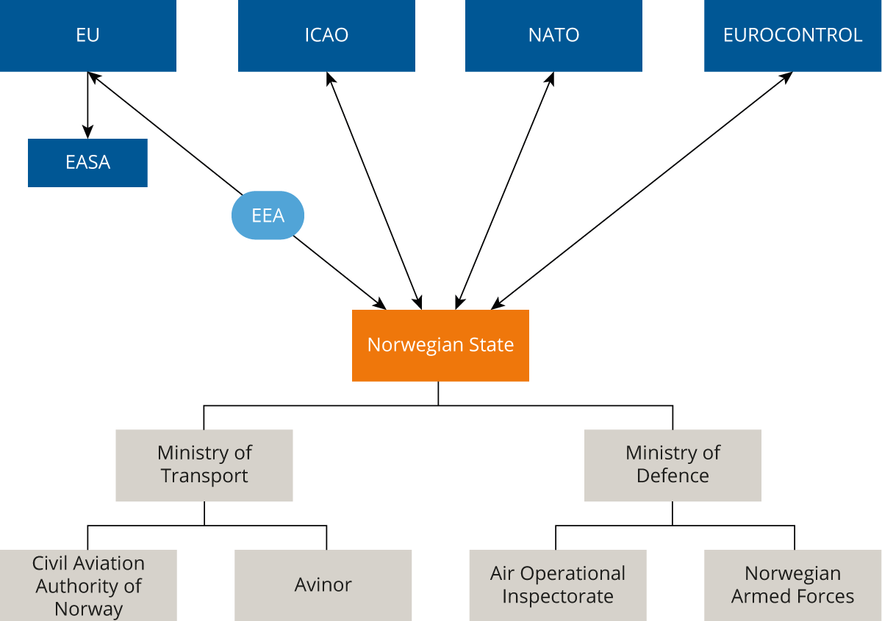
          - The figure illustrates the connection between global, regional and national government and administrative actors.

Global actor – The UN Specialized Agency ICAO
The Chicago Convention on International Civil Aviation is an international treaty that determines the overarching rules governing international civil aviation, and which establishes the International Civil Aviation Organization (ICAO). By having acceded to the Chicago Convention, Norway, as a state, has a number of rights and obligations under international law that also relate to the use of the airspace. Principally, the Convention establishes each state’s exclusive sovereignty over the airspace above the territory of the state, and the states are obliged to provide air navigation services of an adapted scope in their own territory.
Regarding the more detailed rules governing how the airspace in the individual state is to be organised, these are mainly set out at the global level in what are referred to as standards, recommendations and procedures, hereinafter referred to as the “ICAO rules”, which follow from annexes and other supporting documents to the Chicago Convention. Through the Convention, states parties undertake to observe the ICAO rules to the extent possible. Thus, states parties may refrain from fully observing the ICAO rules in their own territory but are then required to actively inform ICAO thereof.
It is first and foremost Annex 11 to the Convention regarding Air Traffic Services that is of direct relevance for how the airspace is organised. The Annex states the main rules for how the airspace is to be divided, based on the availability of air traffic services. The Annex and the Norwegian national Regulations relating to airspace organisation generally correspond. Norway has reported minor deviations to ICAO, relating to special Norwegian conditions that have made it necessary to establish a controlled airspace at a lower altitude than indicated by the ICAO rules.
Since the most important processes in the development of global aviation occur under the auspices of ICAO, Norway has to have an overview of ongoing processes, and seek to have direct influence in areas that are of particular importance for us. However, it is most appropriate to devote the majority of resources relating to international efforts to the European level. Through the EU system, we can especially influence common European positions in relation to ICAO. It is also important that Norway has a special focus on the processes in the EU, since these are largely converted into binding regulations for its member states. Such regulations will, in principle, also become binding for Norway as they fall under the scope of the EEA Agreement.

Trans-regional actor – NATO
Through NATO, Norway also undertakes to ratify STANAGs (Standardisation Agreements) and plans that first and foremost enable NATO operations in the Norwegian airspace and prepare transitions for a NATO takeover of the Norwegian airspace. The regulations affect the implementation of Norwegian assertion of sovereignty as the establishment of a recognised air picture and “Air Policing” of the Alliance’s airspace is an ongoing and continuous NATO-led operation.
Norway participates in relevant committees in NATO that develop frameworks and guidelines for military use of the airspace in the Alliance. Through this participation, Norway has the possibility to influence the development of plans and STANAGs.
Since several NATO counties are not part of the EU/EEA, the EU’s regulations will not necessarily be implemented in NATO. However, Norway is entirely dependent on being able to establish NATO-led operations in the Norwegian airspace as part of its security policy. Norwegian authorities will be challenged as to whether they are willing to transfer the exercising of public authority in the airspace to NATO if we are unable to fully support NATO operations.

Regional actor in Europe – the EU
Through the EEA Agreement, Norway is bound by all EU regulations in respect of airspace under international law, and there is also a strong presumption of continuous implementation of new legislation in the area (cf. the presumption of legislative and judicial homogeneity within the EEA). The trend in the EU is that the ICAO rules are directly implemented into EU law by way of separate legislative acts, with possible common European deviations. From 2022, certain ICAO-based principles for the organisation of the airspace will apply pursuant to EU legislation, including which factors are to be emphasised when determining the need for air traffic services in the individual parts of the airspace.
With the Single European Sky (SES) initiative, the EU shapes the administration of the European airspace. The objective of the SES regulations is, among other things, to contribute to safer, less expensive, more efficient and more environmentally friendly aviation in Europe, based on a more integrated and modern European aviation system that is capable of handling future growths in traffic.
The first SES regulatory package adopted by the EU in 2004 concerned, among other things, the establishment of National Supervisory Authorities (NSAs) to regulate the provision of monopoly services, the introduction of state certification of the national air traffic service providers and the introduction of Flexible Use of Airspace (FUA) to accommodate the needs of both civil and military aviation. In addition, the joint European ATM research programme, SESAR, was launched. In Norway, the NSA is the Civil Aviation Authority of Norway.
The first revision of the regulations (SES 2) was adopted in 2009. Rules were established for the Performance Scheme. The Performance Scheme is based on European contributions (performance plans) to common European targets for member states’ provision of air navigation services in the areas of safety, cost-efficiency, environment and capacity. In addition, a network manager function was established to complement and ensure optimal use of the common European network. Under SES 2, member states were also required to establish what is referred to as Functional Airspace Blocks (FAB), consisting of multiple states’ airspaces.
A further revision (SES 2 +) was proposed by the European Commission in 2013 but was never adopted by the Council and Parliament due to disagreements between member states.

The EU’s proposal for amendments to the SES regulations
In autumn 2020, the European Commission submitted a revised proposal; SES 2+. The Commission clearly states that it believes there is a need for further improvement of efficiency, especially relating to the use of the airspace. A strengthening of the network functions and the work of the network manager are considered important means of realising common targets. The European Commission emphasises opportunities for more extensive coordination and cooperation to achieve the most efficient traffic management possible throughout the network. The Commission also proposes to strengthen the possibilities for competitive tendering and privatisation of parts of air traffic services that have traditionally been provided as part of monopoly services.
A further growth in traffic in European aviation over the next 20 years challenges traditional solutions for safe and efficient traffic management. This is the background for the work and report prepared by SESAR Joint Undertaking: «”A proposal for the future architecture of the European Airspace/Airspace Architecture Study”. At the same time, the European Commission received the report from a specially appointed group, “the Wise Persons Group”: «The future of the Single European Sky». The European Commission has given weight to these reports in the revision of its most recent legislative proposal: SES 2+: “A fresh look at the Single European Sky”. Therein, it is stated, among other things, that larger and more structural changes need to be implemented in order for the European airspace to be able to accommodate future growths in traffic.
The tendency in European aviation until the spring of 2020, prior to the Covid-19 pandemic, has been major capacity challenges where the current European aviation system has reached its capacity limit with existing operating models. This especially applies to central parts of Europe. Other characteristics of European aviation include that it is fragmented and inefficient with national special interests, pressure on cost levels and the emergence of new actors, such as drones, which are challenging the convention use of the airspace. The capacity challenges have been high on the agenda in the EU, and there has been discontent with the fact that the European suppliers of air navigation services have not sufficiently succeeded with efficiency improvement measures following the introduction of the SES regulations in 2004. There has also been discontent with the fact that the proposal from 2013 could not be adopted.
It is too early to assess the long-term effects of the Covid-19 pandemic on aviation. Eurocontrol expects that traffic will at the earliest return to 2019 levels in 2024.
The Commission wishes to implement targeted measures, including through strengthening the common European network to avoid congestion of air traffic, prevent sub-optimal flight routes, facilitate a market for common European data services, as well as innovative solutions that contribute to efficient and environmentally friendly European aviation.
The proposals in SES 2+ are currently under consideration by the Council and Parliament. The plan was that the Council would be done with its work before Christmas 2020, but negotiations and clarifications are now at the earliest expected in the second half of 2021, with entry into force first in 2024/2025.
It is important to identify whether there are aspects of the new proposal that affect special Norwegian interests in both a short-term and long-term perspective, and whether this indicates a more active and enterprising attitude on Norway’s part. To date, Norway has had a positive wait-and-see attitude to the consideration of the legislative proposals and the discussions that are now ongoing in the Council and Parliament.
The member states are holding continuous, in-depth discussions regarding the individual aspects of the proposal in the Working Party on Aviation and are thereby also clarifying their national positions. There are several challenging problems for which it appears difficult to garner sufficient support. As a non-EU member state, Norway has little possibility to influence this work.
Norwegian consideration of the proposals will be handled in accordance with established procedures, but it cannot be rules out that there may be problems that are of such a nature that they need to be elevated to a more overarching context and subject to more strategic assessment.

Possible consequences of the amendment proposals in the Singe European Sky regulations
Through the EEA Agreement, Norway has the possibility to influence the regulatory developments in the EU in terms of the best possible safeguarding of Norwegian interests, and structures have been established to ensure this. This possibility to influence, however, is greatest regarding rules that are adopted by the Commission, i.e., detailed implementation rules based on overarching framework regulations that are adopted by the Council and Parliament. In the drafting of overarching regulations that are adopted by the Council and Parliament, Norway has fewer possibilities to influence on its own because we are not formally represented in these institutions.
The SES2+ package that the European Commission formally relaunched in September 2020 is expected to be implemented in the EEA Agreement. Norwegian possibilities to influence up until adoption in the EU are limited. However, it may be important to identify significant aspects of the regulatory proposal and new amendments that are proposed by the Council and Parliament, so that clear Norwegian positions can be prepared and communicated in relevant channels in the EU system.
Norway is positive to the SES initiative and has implemented the legislation from 2004 and 2009, respectively, in addition to an extensive and detailed set of implementation rules with a legal basis therein. The amendments at the overarching level that are now being discussed will have major significance for the development and framework conditions for European aviation. This will result in a continued development with stronger coordination and control of civil air traffic service provision.
The current SES 2+ proposal involves strengthening existing mechanisms in order for decisions in the network functions to be followed up by all actors involved. An efficient handling of capacity challenges, in particular, presupposes the strengthening of such centralised solutions. For Norway and other European limitrophe states, these challenges are not as pressing. Similar to many other countries, it is important for Norway to ensure that measures are not implemented that will affect airspace users and authorities unnecessarily or entail more expensive requirements, which are primarily a result of Central European challenges. Norwegian authorities are continuing to assess whether it is appropriate to argue in favour of scalable and differentiated requirements to safeguard these concerns.
The performance and charging scheme of the air navigation services is strengthened in that the existing Performance Review Body (PRB) is embedded as a permanent structure under EASA, but nevertheless shielded and ensured independence and financial and professional autonomy from EASA, otherwise. The process for approval of national performance plans for the en route services will be direct and finally regulated by EASA as PRB, but these decisions may be appealed to a separate, dedicated appeal body – the Appeal Board for Performance Review.
It is natural to examine what effects the implementation of the EU’s initiatives will have for Avinor. In a longer time frame, the EU’s clear ambition is to digitalise, and to a greater extent automate the air traffic services in the European air space. This presupposes a coordinated roll out and implementation of new technologies, which, among other things, may open for more virtual air traffic service units that can provide services regardless of state affiliation. It opens the possibilities for more extensive provision of services across national boundaries.
The proposal to facilitate the opening of the market for exchange of common European data services, will also be assessed carefully. There is a desire for these and other support services for the air traffic services to be offered to a greater extent on competitive terms. On the one hand, this will be beneficial in terms of economies of scale and, presumably, cost savings. It may also entail access to new markets for Norwegian service providers, either independently or in alliances with others. However, there are certain concerns relating to whether a smaller Norwegian service provider like Avinor would be sufficiently competitive in such a market, or if European actors would take over responsibilities and duties that have traditionally be provided by the national service provider. Several of the largest Central European service providers have already positioned and established themselves in the market.
There is also a security policy dimension that will possibly require an acceptable solution relating to common data exchange, where it is proposed to make network data available for the entire European network.

Consequences of international developments in aviation for the Norwegian Armed Forces
The international development in regulations and administration of the airspace is largely driven by and for commercial aviation. For instance, the intention of SES is to improve the performance of the air navigation services relating to the civil application of the airspace by improving safety, reducing the environmental impact, increasing capacity and improving cost-effectiveness in civil aviation. Even though it is explicitly stated in the SES regulations that states’ sovereignty over their own airspace is not affected, and that the rules are also not applicable to military operations and military training (this is proposed continued in SES 2+), the developments affect the operating environment for military air operations.
The developments in the areas of automation, data exchange and digitalisation are formalised in international regulations and challenge military aviation’s special needs and thereby its capabilities to solve the duties of the Norwegian Armed Forces. This becomes especially apparent when the Norwegian Armed Forces is to fly according to civil aviation rules and when the Norwegian Armed Forces assumes control of the airspace and has to safeguard the civil aviation rules. Generally, it is also a challenge that civil aviation and the Norwegian Armed Forces have traditionally used many of the same systems for surveillance and flight navigation, and changes to these functions on the civil side will affect the Norwegian Armed Forces.
Therefore, the Ministry of Defence has for several years focused on the development and drivers of the SES regulations and has through the development of a concept study outlined measures to face the challenge that the long-term ambition of SES represents.
Military aviation must have effective and secure access to all types of airspace to train, conduct exercises and to execute missions within national and allied frameworks in times of peace, crisis and war. The concept study addresses, among other things, challenges relating to digitalisation, automation and the development of the network functions that are established in SES. Viewed in context with the military aviation technological and performance developments, as well as the deteriorating security policy situation in our surrounding areas, the concept study recommends the creation of a limited military air navigation service. It is especially the need for rapid transition from daily operations to crises that make such an establishment relevant. In practice, this service can be included as a specified provision by Avinor Air Navigation Services AS with requirements established by the Norwegian Armed Forces and which is under military aviation command on a day-to-day basis. Such an arrangement will fall within Avinor’s obligations through the designation decision. The concept study has been subject to external quality assurance according to the instructions of the Ministry of Finance. The external quality assurance supports the recommendation of a service with established military requirements and an emphasis on integrated civil-military cooperation. In the evaluation, the investment costs for all measures that are not platform specific for the Norwegian Armed Forces are estimated at approximately NOK 2.5bn. The conclusions from this work have formed the basis for the work on a Norwegian Airspace Strategy in order to provide an overall civil-military presentation.
Norway is one of few countries in Europe that currently does not have a military air navigation service, and the Norwegian Armed Forces therefore does not have competence within its own organisation to safeguard own air navigation, considering that the services are to be provided by a civil air traffic service provider. Given the developments, it appears that Norway, in a Total Defence context, is best served by, in addition to the already established civil-regulated air navigation services, also establishing a certification system, regulated by the Military Aviation Authority (MAA), which, overall, safeguards ICAO’s, the EU’s and NATO’s requirements. This includes air traffic services (ATS), communication, navigation and surveillance services (CNS), aeronautical information services (AIS), meteorological services (MET) and search and rescue services (SAR). This will contribute to achieving robust and seamless transitions in the administration of the airspace throughout the conflict scale, which is currently not the case. NATO’s requirements for military air navigation services are specified and are in principle a number of additional requirements to ICAO and the EU, where the civil requirements for certification of controllers and organisation are prerequisites.
The concept study also assesses other challenges that the Norwegian Armed Forces has to solve when the operating environment in the airspace changes:
Recognised air picture: The operating environment has developed to utilise “cooperative” systems for air navigation, – which entails that all aircraft have to be capable of sending identification data to all airspace users. In order to assert sovereignty and control of the airspace, it is a prerequisite to also have the capability to detect “non-cooperative targets”, e.g., aircraft that fail to disclose their identity, purpose and position. Currently, we depend on a nationwide network of primary radars to achieve this – the Norwegian Armed Forces is alone in safeguarding this service based on requirements set by NATO, and the state will require increased sensor capabilities in order to compensate for the loss of primary radars.
Information security and cyber security: Air operations are entirely dependent on rapid and secure information exchange of digital data between all relevant actors and operators. SES entails major changes in terms of digitalisation and automation, and this affects the vulnerability of the system. The National Security Authority (NSA) currently does not allow the Norwegian Armed Forces’ command, control and information system (K2IS) to connect to civil ATM computer systems. Military aviation must have the capability to protect mission-critical information and compromising of information is not acceptable. Sharing of information with unclassified systems will therefore be a challenge. The centralised networks and services that are established in connection with SES are not as robust as the classified and secure networks that are used in connection with military air operations. Military systems must have sufficient protection and redundancy in order to ensure continued operations following possible outages or compromising of civil computer networks, GPS signals etc.
Interoperability: The Norwegian Armed Forces will address the interoperability dimension relating to materiel and procedures by being as “civil as possible and as military as necessary”, though there is a need for adaptations. Military aircraft must have multiple systems/equipment onboard to satisfy both the civil and military requirements in order to be able to operate seamlessly in larger military formations (national and allied forces) in airspaces with civil traffic. It appears from the concept study regarding the Norwegian Armed Forces’ adaptation to the SES regulations that materiel projects to adapt military aircraft and other military aviation components in relation to full implementation of the SES ambition will significantly increase the costs of military aviation.

The Norwegian Aviation Act
The EEA regulations in respect of aviation are implemented in Norwegian law in accordance with the Aviation Act of 11 June 1993. Section 1-1 of the Aviation Act determines that “Aviation in the realm may only be undertaken in accordance with this Act and
regulations laid down under the provisions of this Act.” The Aviation Act consists of two parts – the first part regarding civil aviation and the second part regarding military aviation and other state flights for public purposes. Civil aviation is administered overall by the Ministry of Transport and, in practice, largely by the Civil Aviation Authority of Norway by way of delegation of authority. Subordinate regulations to the Aviation Act are issued in the form of regulations. Part II of the Act contains a chapter regarding military aviation and these rules are administered by the Ministry of Defence, which has designated the Chief of Defence (CoD) as Military Aviation Authority (MAA). The CoD has further delegated MAA to the Chief of the Norwegian Air Force. The MAA currently does not have regulated military aviation pursuant to regulations.
Section 9-1 of the Aviation Act states that the Ministry shall issue regulations about what precautions must be observed in
order to avoid collisions between aircraft or other air accidents and otherwise in
order to ensure safety against hazards and inconveniences, including noise
pollution resulting from aviation activities. Otherwise, Chapter 9 contains provisions concerning, among other things, restricted areas and flight paths. Section 16-1 of the Aviation Act contains an authorisation concerning the implementation of the EEA Agreement in respect of civil aviation. This also applies to acts concerning the use of the airspace, such as acts relating to SES. Decisions implemented in accordance with Section 16-1 of the Aviation Act take precedence over the other provisions in the Aviation Act.
It is the Civil Aviation Authority of Norway as civil aviation authority that determines how the airspace shall be adapted. In principle, there are no parts of the airspace that are exclusively subject to military authority. However, the military can determine restrictions in the airspace in case of acute or unresolved military situations, including war and war-like and similar states of emergency (Section 9-1 a, second paragraph of the Aviation Act). Beyond this, we have an arrangement regarding flexible use of the airspace, especially directed at the Norwegian Armed Forces’ need for reserving parts of the airspace for military training. This arrangement is regulated under the Regulations of 13 March 2007 relating to flexible use of the airspace, which implements Regulation (EU) 2150/2005, Flexible Use of Airspace (FUA Regulation) in Norwegian law. The Regulations establish the various national Norwegian schemes for strategic, practical and tactical governance with regard to a flexible use of the airspace and constitute a civil-military committee comprised of representatives from the Civil Aviation Authority of Norway and the Norwegian Armed Forces, which is tasked with administering the scheme at the overarching level. Put simply, the scheme entails that the Norwegian Armed Forces can book predefined airspace blocks on short notice for training purposes. This airspace is then, in principle, reserved for the exclusive use of the Norwegian Armed Forces for the period this is needed. The strategic part of FUA involves a review of needs and possible adaptations of the predefined airspace areas, in scope and time.
In Part II of the Aviation Act, Chapter XVII concerns military aviation. Section 17-6 of the Chapter specifies provisions in the civil part of the Aviation Act that also apply to military aviation. In Section 17-7 it is stated that the same applies for regulations issued under certain provisions of Part I of the Aviation Act, unless the King (Norwegian Government) decides otherwise. Pursuant to Section 17-8, the King may also determine that other provisions of Part I of the Aviation Act apply to a corresponding extent to military aviation. Military aviation is administered by the Ministry of Defence and further regulated pursuant to the Regulations of 13 February 2015 no. 123 Relating to military aviation and the Provisions for Military Aviation (BML), which are internal instructions issued by the Military Aviation Authority.
The legal basis for the administration of the airspace must be clear and updated. New users have emerged and the traditional users are undergoing a transition, which will entail a need for innovative thinking. The regulations have to be sufficiently flexible and robust.

Strategy
The Norwegian Government will:
- Safeguard Norwegian civil and military legitimate interests in the implementation of the EU’s new initiatives under Single European Sky, including by ensuring the safeguarding of the Norwegian Constitution’s provisions regarding relinquishment of authority.
- Review how our obligations in relation to NATO are made legally binding in Norway.
- Further develop the cooperation regarding shared use of airspace across national boundaries based on the NORDEFCO model, in order to meet the needs of the Norwegian Armed Forces and other government agencies.
- Assess the need for a revision of the aviation legislation’s provisions regarding use and administration of the airspace.

Organisation of the airspace and prioritisation of access to airspace
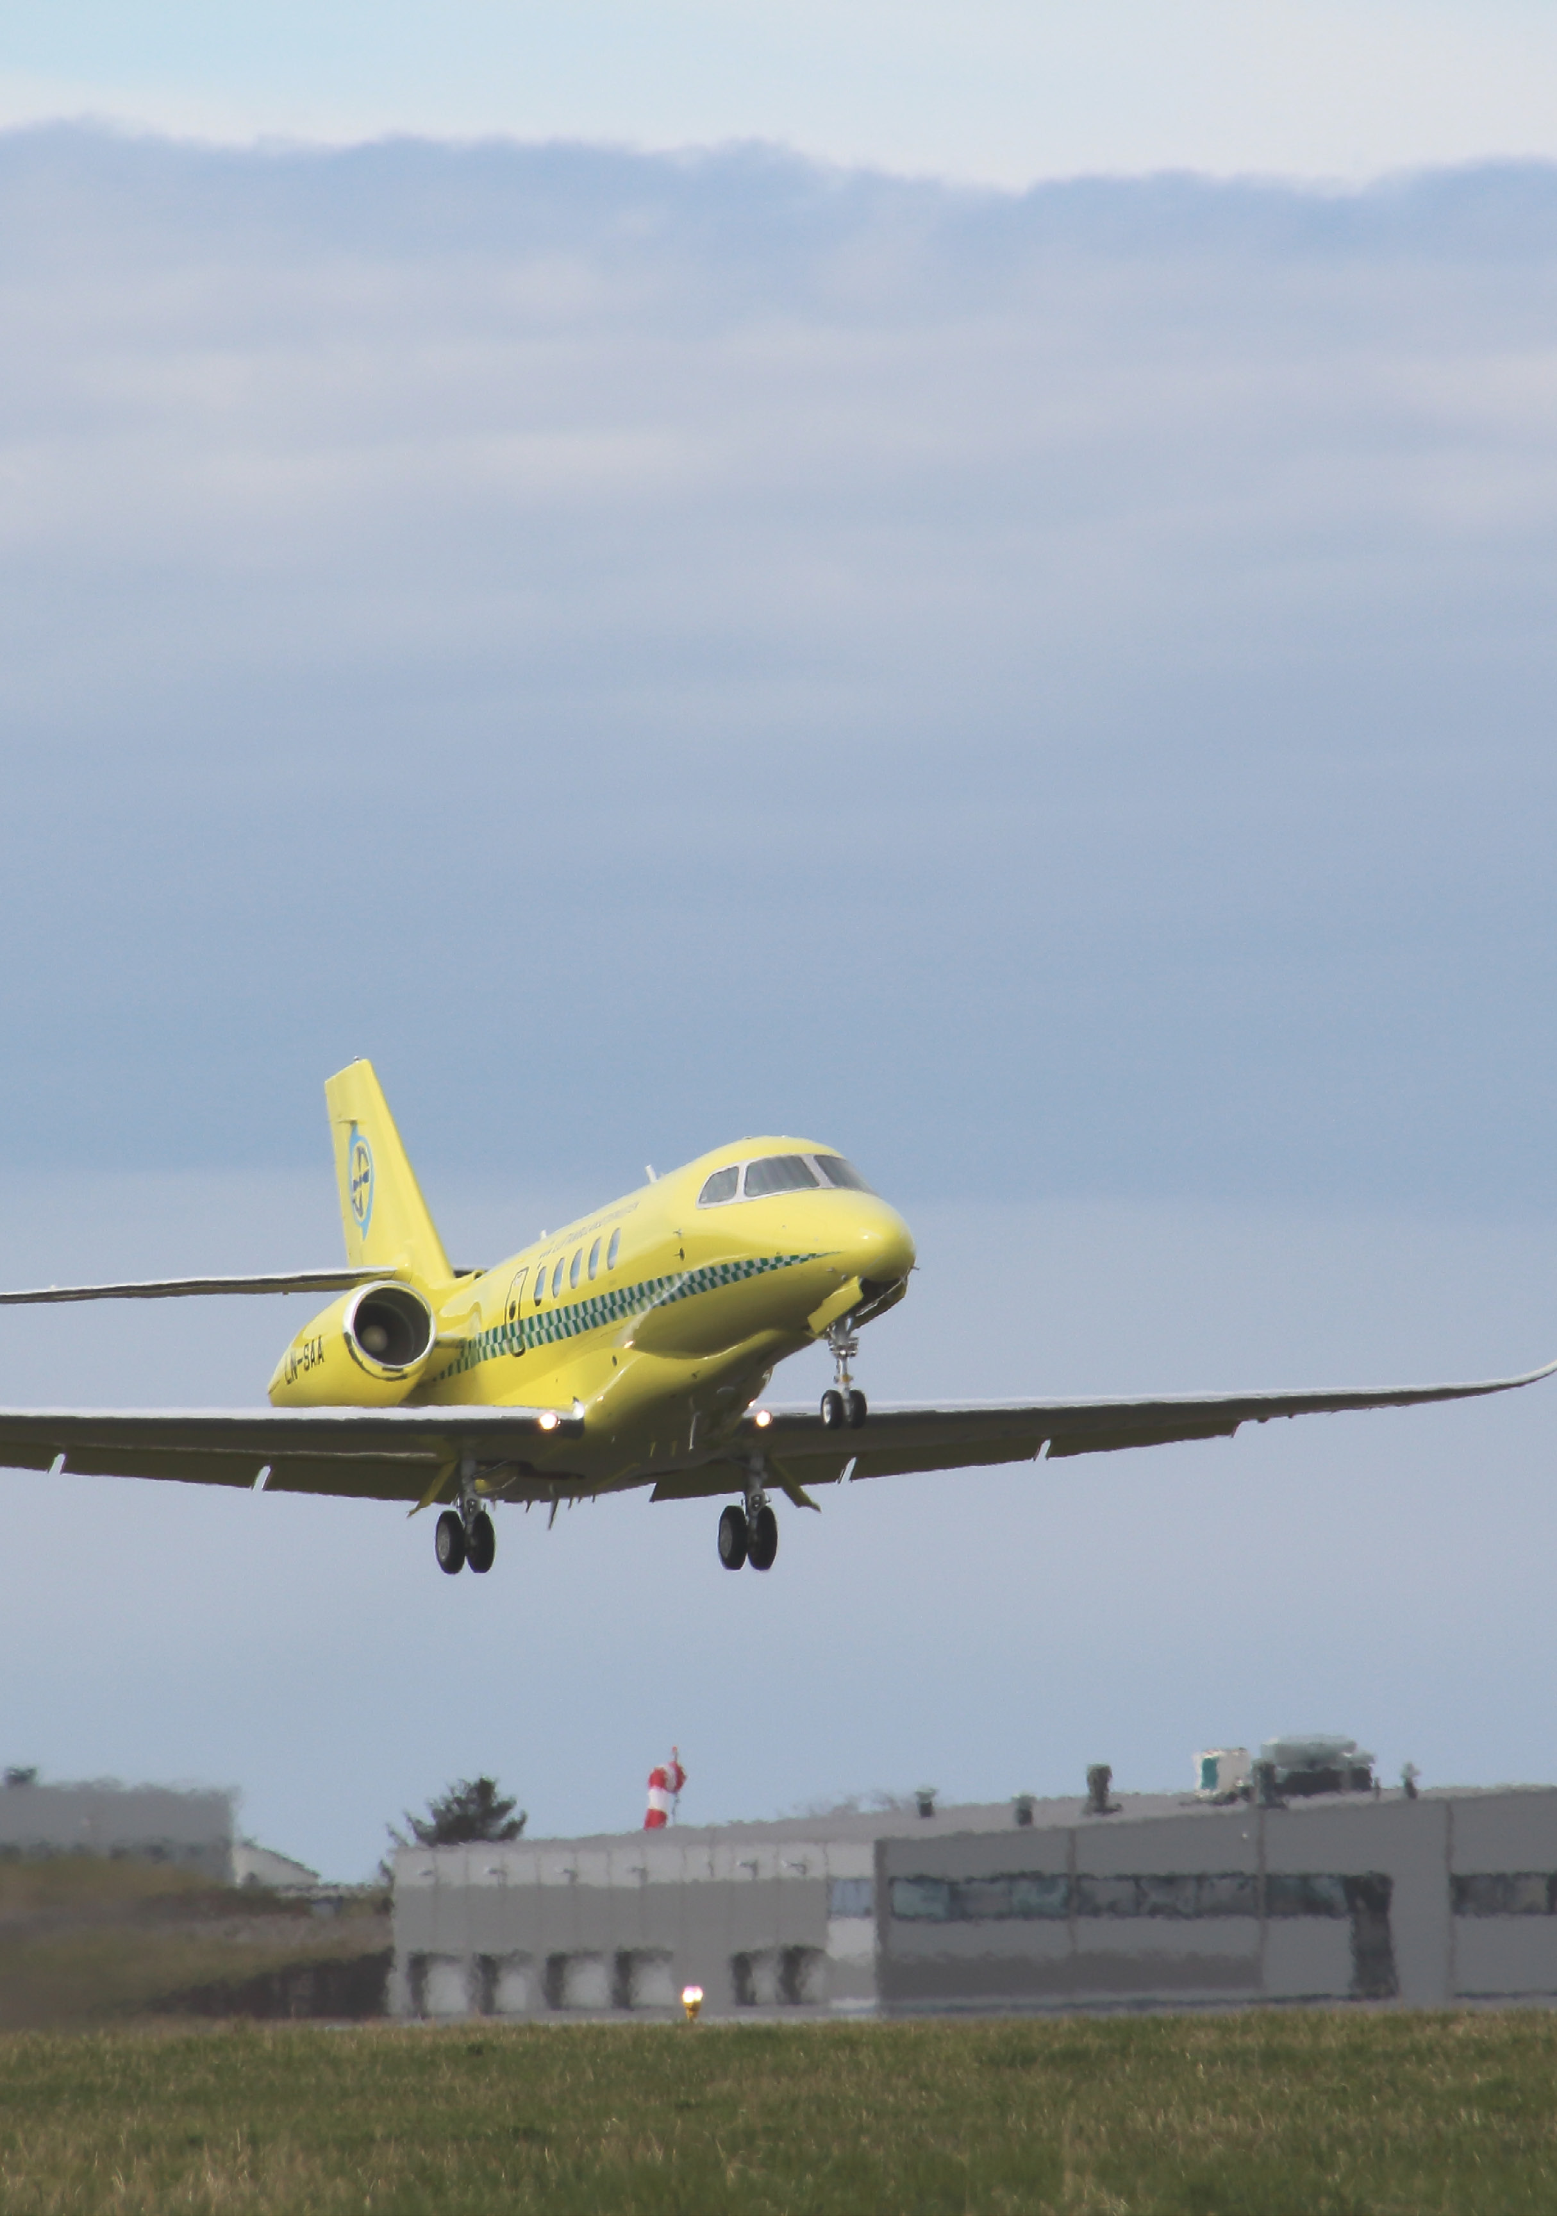
Photo: Norwegian Air Ambulance Service Health Trust

Organisation and classification of the airspace
The annexes to the Chicago Convention contain international standards and recommendations for aviation. Annex 11 describes how states’ airspace shall be organised and what services shall be provided in accordance with the airspace’s classification in order to achieve a safe, orderly and efficient flow of air traffic.
Annex 11 provides the opportunity to classify airspace in seven different airspace classes, which are defined alphabetically from A to G. Furthermore, the Annex describes what shall apply in each of these classes in terms of what types of operations can be permitted, who are to be separated from each other, what services shall or can be provided, what speed limitations apply, whether radio communication equipment is required and whether aircraft are subject to clearance from the air traffic services. As part of the SES legislation, the EU has further harmonised member states’ implementation of Annex 11. This also applies to Norway via the EEA Agreement.
Airspaces can be divided into two main categories – controlled or uncontrolled. In controlled airspaces, air traffic services are provided and aircraft in such airspaces are subject to clearances in order to gain access. Controlled airspace can belong to classes A to D. Uncontrolled airspace can belong to classes F and G, whereas airspace class E is a hybrid solution where certain operations are subject to clearance and separated from each other, while other operators can move freely without such instructions. The airspace classes in the beginning of the alphabet have stricter rules and requirements than the latter classes.
In the Norwegian airspace, we use airspace classes A, C and D for controlled airspace, whereas our uncontrolled airspace is classified as G airspace. Controlled airspace is only established where it is necessary in order to ensure the safety of aircraft near airports, along approach and departure routes, as well as during the en route phase between various airports. The rest of the airspace is uncontrolled in order to facilitate use without unnecessary restrictions. The exception from this principle is the many “STOLports”, where the airspace is uncontrolled, but in order to enhance the safety level, there are requirements for two-way radio communication with the air traffic services to be able to operate.
Generally, we can say that it is safer to travel in controlled airspace because most operations therein are ensured separation from each other. In uncontrolled airspace, individual aircraft commanders must personally ensure necessary separation, based on available information and there are no established minimum distances.
Regardless of which airspace class an airspace is defined as, Annex 11 also provides the opportunity to establish areas where flights can only take place on special conditions, restricted areas, and areas where activities are announced that pose a danger to aircraft during flights, known as danger areas. As a main rule, restricted areas are used to protect an activity within an area, while a danger area is used to protect aircraft outside of an area. Both types of areas can be established temporarily or permanently, depending on the duration of the measure. Examples of such areas in Norway are the restricted area over downtown Oslo intended to protect key state functions and danger areas that established around the Norwegian Armed Forces’ firing ranges.

Priority needs
The airspace and associated services have to be organised, and access has to be prioritised appropriately for all affected service providers and airspace users. This has to be done for all parts of the conflict scale from peace, through crisis and incident management to armed conflict.
The airspace is a limited resource. As a main rule, the regulations facilitate so that multiple airspace users can use the airspace at the same time, while in certain cases it is necessary to reserve airspace for a specific purpose at the expense of other users’ wishes.
To a considerable extent, such conflicting wishes can be adapted with the flexibility of users or with the aid of technological solutions – but not always. As a tool to be able to clarify situations where there are conflicting requests relating to use of the airspace, there is a need for a priority overview of which users are to be given priority in which situations. Such an overview is prepared on the basis of a cooperation between the Civil Aviation Authority of Norway and the Norwegian Armed Forces. The overview is not intended to be exhaustive but will be an important guiding factor for the aviation authorities regarding how the airspace is to be used and for the air traffic services’ daily administration and enforcement.
The overview will apply under normal societal conditions, i.e., not during war or similar states of emergency. In the transition between normalcy and crises, there is currently a lack of prioritisation rules and this should therefore be assessed in more detail.

Prioritisation criteria
Airspace access is decisive in order for an aircraft to be used for a desired purpose. When there is a need to prioritise between various actors, it is the purpose of the activity that should be given most weight. It is not a decisive factor for the prioritisation whether the aircraft is manned or unmanned during the operations.
Traditionally, the situation is that actors in principle have the same priority, meaning that the first to request airspace access, shall have the highest priority. (First come, first served.) In addition, there are a number of internationally determined rules regarding the duty to yield if multiple airspace users are operating in the same area/airspace.
Aviation shall support society’s goals regarding welfare, safety and economic development. An established overview of how airspace users are prioritised will contribute to providing all actors in Norwegian aviation with predictability in planning, operation and development relating to airspace use and air navigation services, and to an efficient, economical, safe, accessible and robust aviation sector in Norway.
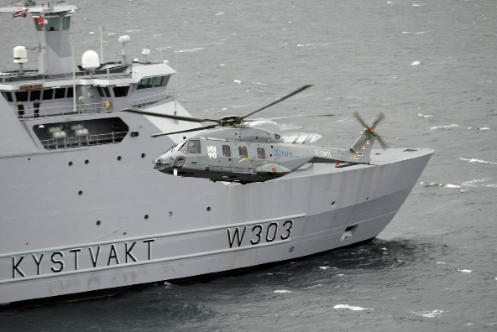
Photo: Norwegian Armed Forces

Prioritisation of airspace access
National security and facilitation for emergency services are considered to have the highest priority. The possibility of having an efficient and broad use of the airspace in crises and emergency situations must always take precedence over other considerations.
As part of a national security policy, it is a political ambition that Norway shall be attractive for the implementation of NATO exercises and exercises with allies. Therefore, it is important that the prerequisites for conducting large international exercises in Norway and in Norwegian airspace provide good benefits for the units involved in the exercises. International exercises should be given a high enough priority that civil aviation has to expect some inconveniences during the periods in which the exercises are taking place. In order to protect national security, it is important that state flights are well trained for the tasks. This means that it is important to facilitate good training opportunities in everyday life, especially for the emergency services and for the military.
A large part of this training requires either a segregated airspace or the establishment of danger areas.
Civil passenger and cargo transport are very important for Norwegian society. It is crucial that commercial actors can have predictable day-to-day operations, within known and accepted cost limits. Predictability is important, and one should seek to avoid significant inconveniences for scheduled traffic.
Other commercial flights may, depending on the circumstances, have the same priority as, or higher priority than, civil passenger and cargo transport. This will depend on the specific purpose of the flight, and must to a considerable extent be based on whether it involves significant financial values or important societal needs. This may, e.g., involve emergency calls or transport of vital goods, such as medicines or organs.
General aviation shall ensure access to airspace, but must, as a main rule, however, be prioritised lower than the traffic mentioned, below. To the extent one can practically separate general aviation for purposes other than leisure use, this should take priority ahead of leisure use. However, special considerations should be made for larger events and meets for leisure flights and air sports. In the Norwegian Government’s Small Aircraft Strategy, which was presented in August 2017, it is stated that “The Norwegian Government finds that the organisation of Norwegian airspace shall balance the needs of the various users of the airspace. Hobby and leisure flights using small aircraft shall be ensured access to airspace but must nevertheless be prioritised lower than other commercial traffic. ... When establishing controlled airspace, the airspace shall not be of a greater scope than necessary. With the introduction of restricted areas, the authorities shall to the extent possible take into consideration small aircraft activities.”
In principle, drone flights have a lower priority than other traffic. This especially relates to the fact that the cost of adapting drone flights is normally lower than with the use of conventional aircraft. However, here, too, the purpose of the flight is decisive.
The below list summarises the order of priority described above. The priority list shall not be understood as absolute in all circumstances but shall be a clear starting point for the prioritisations the aviation authority and air traffic services shall make when taking regulatory, strategic and tactical decisions regarding the use of the airspace.
- Air ambulance flights.
- Military operations (manned and remotely operated) in connection with the assertion of Norwegian sovereignty, exercising of public authority and in connection with crisis management and other armed missions.
- Flights in connection with police and customs assignments, search and rescue, other crisis management and other acute government missions, e.g., in connection with nature inspections.
- Open Skies flights.
- Commercial aviation and military training flights are given approximately the same priority.
- The following adaptations apply in relation to commercial aviation and military training flights:
- Needs for airspace must not hinder traffic in/out of airports located under this airspace.
- Commercial civil scheduled traffic takes priority on the routes between the biggest Norwegian cities, between Southern and Northern Norway, helicopter traffic offshore and traffic to and from Svalbard.
- Larger military exercises where Norwegian forces are participating shall be given particular weight.
- Preparedness exercises are given considerable weight, although less than military exercises where Norwegian forces are participating.
- Military training flights are given priority in predetermined areas, as long as these are booked in accordance with the Flexible Use of Airspace (FUA) Concept.
- Priority between commercial flights is determined as follows:
- Scheduled traffic is given priority above non-scheduled traffic.
- Passenger traffic takes priority above pure cargo transport.
- The financial value of the flight shall be emphasised.
- Aviation Flight school.
- Drone flights for commercial use.
- General aviation for recreation use, including air sports.
- Drone flights for recreation use.
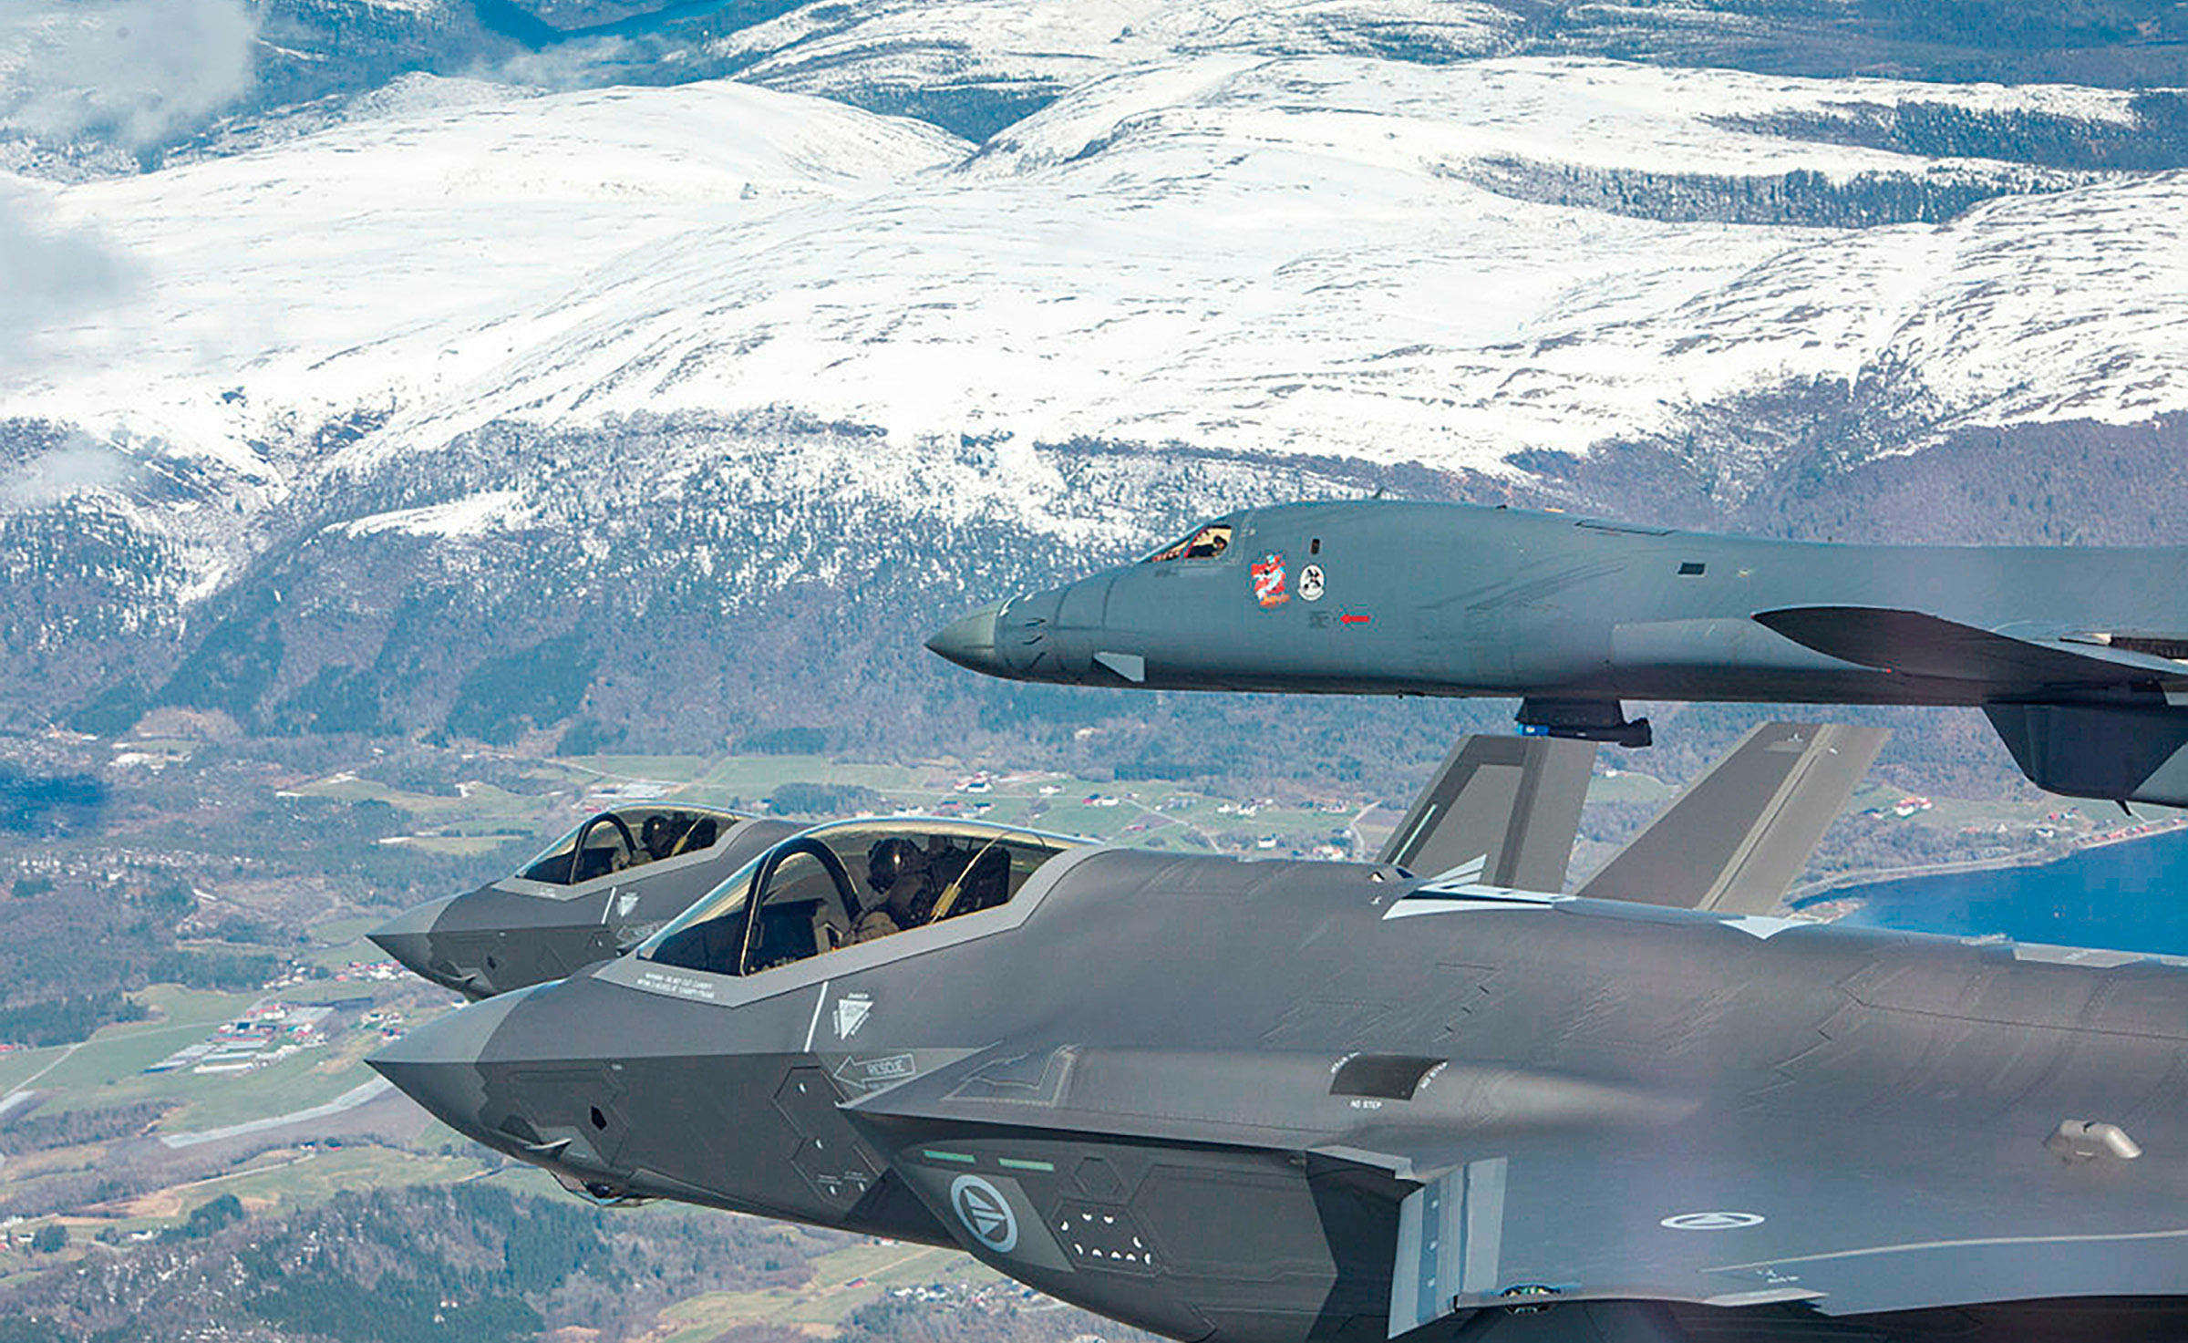
Photo: Norwegian Armed Forces

Needs for prioritisation and use of Norwegian and allied military forces in times of peace, crisis and war
Military operations will have a vital role in the organisation of the airspace in times of peace, crisis and incident management and in armed conflict. The military airspace control and authority can take over from the civil authority at a specific preparedness level. This follows from the Act of 15 December 1950 Relating to special measures in time of war, threat of war and similar circumstances (Preparedness Act) and is operationalised through the preparedness system in the Norwegian Armed Forces.
It is of crucial importance for the capability to maintain control of the airspace that the transition between the two phases is regulated in such a manner that the civil-military cooperation, in terms of roles, responsibilities and authority, is clarified and feasible in accordance with national and allied plans, including the Preparedness System for the Norwegian Armed Forces (BFF) and the Civil Emergency Preparedness System (SBS).
The previously mentioned need for military-regulated air navigation services, in addition to the civil services, will facilitate the safeguarding of civil and military aviation in the best and most efficient manner throughout the conflict scale, cf. Chapter 5. This can be solved with the establishment of a military air navigation capacity, integrated into Avinor’s existing services, where military requirements apply. This capacity will then be subject to the operational command of the Chief of NAOC and will be given training and certification regarding military plans and systems, in addition to civil certifications. This scheme can be solved through an expanded preparedness agreement. It is important to practice relevant scenarios in peacetime so that the overall civil-military organisation is capable of planning, leading and implementing operations in accordance with the intention and within specific time frames.
It is especially in two circumstances that the Norwegian Armed Forces has a need for close coordination with and support from civil aviation actors, in this context airport operators and air navigations services, including air traffic services;
- in the execution of armed missions in peacetime, crisis and in case of high alert, including securing of airspace priority and access to civil infrastructure;
- in case of mobilisation and war.
In order to safeguard these needs, the Norwegian Armed Forces is dependent on civil aviation actors having sufficient competence and capabilities with respect to military air operations.
The Norwegian Armed Forces also has to solve operational missions without preparedness legislation having taken effect. Previously, this was in part safeguarded through a cooperation agreement (hereinafter the Preparedness Agreement) between the Norwegian Civil Aviation Administration and the Norwegian Air Force. This agreement was terminated in 2009 and has not been replaced. Requirements for the safeguarding of the Norwegian Armed Forces’ needs for air navigations services were then addressed in the Ministry of Transport’s designation decision to Avinor.
In order to ensure that the Norwegian Armed Forces is able to safeguard its duties described in the Long-Term Plan for the Norwegian Armed Forces, including with a view of competitive tendering of air navigation services, it is desirable to have a basis in acts or regulations that regulates the support from civil aviation actors in peacetime. In 2018, a provision was included in the Regulations of 11 November 2003 Relating to the establishment, organisation and operation of air traffic services, which states that the relevant provider of air traffic services shall safeguard military aviation’s special needs, and that these needs shall be reflected in agreements with the Norwegian Armed Forces. However, this provision does not cover air navigation services as whole, nor does it cover airport operators. Therefore, there may be a need to prepare a regulatory provision that has a broader scope than just for the air traffic services, and which also applies in times of crisis and war. At the same time, it can be considered whether regulatory provisions should be created that set special certification requirements for military air navigation services, with a legal basis in Chapter 17 of the Aviation Act.
The military need for air navigation services will be the same for the entire conflict scale, including peace, crisis and war, but threats and the need for separation will escalate and correspond to the level of conflict. The need for a greater airspace volume will also escalate in step with conflict and military level of activity. Protection against terrorism is also part of the threat assessment that military planners must take into consideration. The Ministry of Justice and Public Security has the overall responsibility for Defence Against Terrorism (DAT) and the civil and military needs that have to be harmonised and coordinated. Anti-terrorism operations are in the same manner as search and rescue operations (SAR) supported by the Norwegian Armed Forces.

Strategy
The Norwegian Government will:
- Under normal circumstances prioritise airspace users according to the purpose of the flight and review the prioritisations in the transition from normal circumstances to crises.

Necessary and secure infrastructure
Illustration: Inok
Secure and efficient infrastructure is fundamental for aviation and use of the airspace. In the field of aviation, a transition is underway from traditional and ground-based systems to digital and often satellite-based systems (Global Navigation Satellite Systems, GNSS). This is a result of technological developments and ICAO’s and the EU’s requirements for the introduction of Performance-based navigation (PBN). The EU requirements are also set out in Regulation (EU) 2018/1048, which Norway has also implemented. The use of GNSS and PBN offer improved use of the airspace and contribute to more efficient and environmentally friendly aviation. At the same time, there are potential security and vulnerability aspects involved in the considerable GNSS dependency.

Communication, navigation and surveillance
Communication, Navigation and Surveillance (CNS) relates to the installation, operation and maintenance of facilities for communication with, navigation for and surveillance of air traffic.
Historically, such facilities have been physical installations such as radio transmitters/receivers and antennae on the ground that have exchanged data and been in contact with equipment on board the aircraft. These ground-based, conventional facilities are now increasingly being replaced by satellite-based services (GNSS).
In addition to GNSS for positioning and navigation on board planes/aircraft, airspace surveillance and communication is increasingly also based on GNSS as a source of position and time synchronisation.
Satellites and their signals have a universal problem. They are far from the earth’s surface and there is a limited transmission power. This means that the signal is relatively weak and possible to drown out. In case of jamming, the CNS services will to varying degrees cease unless other infrastructure independent of GNSS is available. We are now at a crossroads for all CNS services, where digitalisation and use of satellite-based services will be exclusively used in normal operations. The advantage of such satellite-based services is an unsurpassed precision, accessibility and low costs for users. This enables e.g., shorter and more precise approach procedures, as well as the possibility to arrange for approaches outside of densely populated areas. However, there is a vulnerability and failure probability involved in these systems that one must be aware of and willing to accept.
In accordance with the requirements in 2018/1048 concerning performance-based navigation, Avinor has prepared a PBN transition plan. This plan describes the phasing out of conventional approach instruments at Norwegian airports in the period leading up to 2030. The plan assesses the extent to which conventional systems should be maintained as a back-up solution to support aviation in case of GNSS outages. The ground-based, conventional facilities are owned and operated by airports and air navigation suppliers, and the costs of procurement, installation and operation have been charged to airspace users through a take-off fee and fees for air navigation services that are expected to be reduced in the future. If needs in local communities or preparedness considerations indicate a desire to retain conventional systems, it has to be considered who will then bear the additional costs for these. If these additional costs are borne by the air navigation service suppliers or airport operators, the EU legislation will limit the possibility to charge a fee for maintenance. The costs of retaining conventional systems for safeguarding national needs for infrastructure and services beyond civil needs, should be borne by the parties that have such needs.

The PNT Strategy: overarching and coordinating
PNT systems is the common name for ground-based and satellite-based systems (GNSS) for positioning, navigation and timing. Failure of PNT services may, among other things, be due to disruptions of GNSS signals caused by natural and manmade sources and may in the latter case be unintentional or targeted.
The PNT Strategy Right place, right time. The National Strategy for positioning, navigation and timing, which was presented in November 2018, is part of the Norwegian Government’s work on strengthening public security and facilitating technological development. The Strategy addresses sectoral authorities at various administrative levels, as well as developers, suppliers and users of PNT systems and services. The Strategy reviews PNT systems and how they are used in various parts of society and proceeds to assess vulnerabilities to failure. On this basis, measures are identified to reduce vulnerabilities.
The main objectives for the Strategy are to ensure that we are able to benefit from use of the PNT systems and utilise new opportunities provided by the systems, contribute to awareness raising regarding society’s dependence on PNT systems, and contribute to the reduction of society’s vulnerabilities relating failure of PNT systems through preventive measures and preparedness.

Navigation strategy for aviation in Norway
The growth in air traffic entails that higher requirements must be set in terms of how accessible airspace is used. At the same time as a high safety level must be maintained, measures have to be initiated that contribute to increased capacity and efficiency in the air traffic management system; not just nationally, but throughout the pan-European network. To ensure the optimal effect of the measures, it is important that as many actors as possible apply identical and harmonised requirements. This occurs in the EU area through the common European regulations mentioned above concerning performance-based navigation, Regulation (EU) 2018/1048.
In parallel with the adoption of this Regulation, ICAO and the EU have, at the global and regional levels, respectively, encouraged member states to create their own navigation strategies. The Norwegian Navigation Strategy was established by the Ministry of Transport on 11 December 2020.
The work on the Navigation Strategy also includes risk assessments of the vulnerabilities in aviation and risk assessments performed by Avinor, including vulnerabilities in the air navigation services. Avinor’s perception is that aviation as a whole is moving in the direction of an everyday situation where the consequences of GNSS outages will become increasingly problematic.
The PBN Regulation determines that conventional procedures shall not be used after 2030. Therefore, it is a target to reduce local, conventional air navigation facilities by reducing the scope thereof in the coming decade. This will render the navigation function especially vulnerable in terms of outages, and for some types of planes in the current fleet.
However, the PBN Regulation contains exemption possibilities to ensure necessary operation of air navigation services. In this connection, the Regulation mentions in particular the possibility to maintain a network of conventional navigation aids and associated surveillance and communication infrastructure. Therefore, the plan is to retain conventional systems and instrument procedures at airports and in airspaces of national and regional importance. The more detailed solutions are stated in the transition plan prepared by Avinor.

National capability for airspace surveillance
The developments in civil aviation challenge the military capability to carry out national airspace surveillance. The reasons for this are two-fold. Firstly, the Norwegian Armed Forces’ chain of surveillance radars with primary radar coverage has been gradually reduced over the past 10-20 years, since the majority of the sensors have passed their expected lifespan, and replacements have been delayed. This radar chain shall have the capability to detect all types of flying objects in the airspace (uncooporative targets) with the aid of traditional radar technology. A project for the implementation of new sensors is underway and will be completed by 2030.
Second, Avinor has established a new position monitoring system, based on installations on the ground that coordinate signals transmitted by the aircraft (Wide Area Multilateration, WAM) with a future implementation of ADS-B (Automatic Dependent Surveillance – Broadcast) as a supplement. This has resulted in the need for conventional primary and secondary radars to be gradually phased out in civil aviation, with the exception of Oslo Airport.
The consequence of this development is that the Norwegian Armed Forces has to a lesser extent been able to base its work on the civil air traffic services’ equipment to carry out national airspace surveillance.

GNSS/GPS disruptions in aviation
The most known GNSS systems are GPS (U.S.), which is also the most used, GLONASS (Russia), Beidou (China) and gradually also Galileo (EU), which is the system where Norway is participating. The systems are owned and controlled by the aforementioned states, which are thereby in a controlling/dominant position for critical infrastructure internationally.
Norwegian aviation experienced prolonged GPS interference from the Russian side of the border in 2018, where Northern Norway was especially exposed. The Norwegian Government took these disruptions seriously and decided in 2019 to establish a working group under the auspices of the Ministry of Transport. The Working Group was tasked with identifying and assessing threats and risks, impacts and handling relating to GNSS disruptions, especially the impact of the GPS system in aviation. The Working Group presented the report GNSS/GPS-disruptions in aviation in December 2019.
At the overarching/policy level, the message of the report is that Norwegian authorities do not have ownership or control of GNSS/GPS-systems, and that Norwegian authorities’ scope of action is therefore limited.
The report recommends openness and awareness raising regarding possibilities and limitations with the use of GNSS systems, the necessity of back-up systems and alternatives, as well as a conscious attitude regarding the vulnerabilities/risks one is willing to take. Prevention of unwanted occurrences is most important, but the report also emphasises the further development and continuous updating of notification procedures and plans and tools for restoration following disruptions. Measures must also be facilitated within each sector, but also across sectors, e.g., through an operations centre under the auspices of the Norwegian Communications Authority (Nkom). The report also devotes considerable attention to measures to limit/prevent the use of jammers.
Another point in the report includes a description of the complexity of the infrastructure in the area of air navigation, where one depends on a common time reference in order for the systems to function optimally. GNSS-based time synchronisation is a simple and inexpensive way to ensure the same time everywhere in a distributed system, but this also involves a vulnerability if GNSS is the only time source. In order to improve redundancy in the air navigation systems, Avinor will procure atomic clocks for time synchronisation that are not dependent on GNSS.
The report summarises that one should not prevent technological developments but be aware of the balance between the use of modern and digitalised technology and the understanding of vulnerabilities.
As a follow-up, it was decided that the Ministry of Transport would incorporate the report on GNSS/GPS disruptions into its work on a Norwegian Airspace Strategy, at the same time as each government ministry has an independent responsibility for follow-up within their areas of responsibility.
Regarding the High North, and especially in relation to GNSS/GPS disruptions on the part of Russia, it follows from the report that the use of GNSS-based navigation systems is particularly vulnerable. This has to do with the fact that disruptions and outages of necessary infrastructure for aviation may have especially serious consequences for the High North, because of the considerable distances and few or no alternative forms of transport. The report does not examine alternative solutions in-depth, but the establishment or maintenance of certain conventional surveillance/navigation instruments in parts of Finnmark may be a sensible measure to safeguard airspace users. This also applies to Svalbard.

Frequency disruptions
Nkom, which is the electronic communication authority jointly with the Ministry of Local Government and Modernisation, has over several decades followed up frequency use that causes disruptions of electronic communication services. Nkom wishes to formalise this work to a greater extent through the establishment of a radio interference centre. Since early 2020, Nkom has used disruptions of navigation signals (e.g., GPS) as a “pilot” for how a radio interference centre can function in practice, with special attention given to the establishment of rapid and reliable notification channels and procedures.
In the cases that have occurred involving disruptions of GPS in aviation, Nkom has had especially close contact with Avinor, the Civil Aviation Authority of Norway and the Ministry of Local Government and Modernisation.
In situations where the sources of the disruption are found in other countries, Nkom documents the facts and addresses the case at the ministerial level for assessment and follow-up.
Nkom has legal bases in the Electronic Communications Act to shut down jammers and other equipment that result in disruption or blocking of services for electronic communication that threaten lives, health and safety. Currently, Nkom does not have any legal basis for stopping the sale of jammers or confiscating jammers that are not actively in use.
Norwegian authorities consider it important to highlight Norwegian experiences with GNSS/GPS disruptions in international, regional and bilateral aviation contexts, with a view of developing good solutions for critical infrastructure in the field of aviation and airspace use.

Strategy
The Norwegian Government will:
- Facilitate in order for systems that underpin preparedness functions in the airspace to have sufficient protection and redundancy in order to ensure continued operations following possible outages or compromising of civil computer networks, GPS signals etc.
- Ensure that Norway, together with other European countries, follows up the problems relating to GNSS disruptions in aviation in relation to ICAO in a joint European initiative on GNSS disruptions and vulnerabilities.
- Actively follow-up the development of technologies and services relating to the special conditions for aviation in the High North, in order to support the state’s strategic efforts and needs.
- Ensure that the national capability for airspace monitoring is viewed from a Total Defence perspective.

Aircraft noise pollution and greenhouse gas emissions
Photo: alexandrumagurean
Use of the airspace contributes to, among other things, noise pollution near airports and emissions of greenhouse gasses and other climate impacts from aviation. By adjusting the airspace use, both climate impacts and noise pollution can be reduced, and contribute to Norway reaching its targets and obligations in these areas.

Aviation and climate
Emissions of greenhouse gasses from domestic aviation is covered by Norway’s international emissions obligations in the Kyoto Protocol and the Paris Agreement. Emissions from Norwegian domestic civil aviation represented slightly more than 2 per cent of total Norwegian emissions in 2019, corresponding to approximately 1m tonnes of CO2. As a result of the Covid-19 pandemic, air traffic and emissions were drastically reduced in the spring of 2020 and have remained at a low level ever since.
However, aviation impacts the climate through mechanisms other than CO2 emissions. Air traffic contributes to the formation of condensation trails and cirrus clouds at high altitudes. The effect of cirrus clouds and condensation trails is potentially very strong and even stronger than the CO2 effect. A common approach is to assume that the overall climate impact of aviation is 1.8–1.9 times higher than the effect of CO2emissions alone. However, there is considerable uncertainty in this regard and currently the additional effect is not taken into account in Norwegian or international climate policy.
The Norwegian Government’s climate policy for aviation is presented in the Climate Action Plan for 2021–2030 (Meld. St. 13 (Report to the Storting (white paper)) (2020–2021)). In this report, it is stated that the Norwegian Government wishes to facilitate a strengthened climate policy for aviation, where a carbon tax and emissions allowance are the most important means. However, more efficient use of the airspace and optimisation of landings and departures will also reduce fuel consumption and thereby CO2 emissions. To ensure efforts from all actors, the EU is using the performance system for air navigation services as a means to ensure the shortest and most fuel-efficient flights. New technologies make it possible to increase the volume of traffic that can be managed safely within a given airspace and time frame. Norway, Sweden, Denmark, Finland, Latvia and Estonia introduced Free Route Airspace in 2016. This is an organisation of airspace that allows the airlines to no longer have to follow predefined paths, but instead follow the best possible route (paths in three dimensions) in relation weather conditions and wind, as well as the desire to fly the shortest distance possible and thereby use less fuel. Eurocontrol has calculated that the introduction of Free Route Airspace will result in a reduction of emissions from European aircraft in the amount of 10,000 tonnes of CO2 per day (based on 2019 traffic figures). The lack of co-location of air traffic services, combined with different systems, may, however, contribute to Free Route Airspace becoming challenging to practice.
The EU’s research programme SESAR has established a project that will be able to reduce the non-CO2-related climate impact of aviation in the upper part of the airspace by up to 10 per cent in return for an increase in costs of just 1 per cent, by adjusting the speed and altitude of airplanes.
As a further development of the regulations for SES, the European Commission has proposed to modernise the management of the European airspace and establish more sustainable and efficient airline routes. This is considered to have the potential to reduce aviation emissions by up to 10 per cent.
From a purely climate and environmental perspective, Norway should support the EU’s regulatory initiative. However, such support must be weighed against other aspects of the proposal, which, among other things, impact how the air traffic services are organised and sovereignty over national airspace, cf. Chapter 5.

Aircraft noise pollution
Noise pollution from airplanes and helicopters is linked to the use of airspace and affects many people around the airports. Traffic management and adjustment of approach and departure procedures based on a monitoring of the noise situation is an important means of reducing noise. Satellite-based approach and departure procedures offer new possibilities for choice of paths, which may remedy the situation and are increasingly being used. At the same time, more precise approaches and departures mean that noise becomes more concentrated over the same areas, rather than more dispersed.
Currently, Oslo Airport is the only airport that has its approach and departure pattern regulated by regulations out of consideration for noise. The extent to which such regulations will also become relevant for other airports in the future has not been determined. The Civil Aviation Authority of Norway has in a draft for new legislation on airspace organisation proposed a provision that grants the individual airport the opportunity to determine zones around the airport where flights are not permitted.
Going forward, both supersonic aircraft and drones in densely populated areas may cause significant noise problems that require new means, including new rules for the use of the airspace.

Balancing aircraft noise pollution and greenhouse gas emissions
The introduction of satellite-based procedures for approaches and departures can create new possibilities for directing traffic outside of areas burdened by noise pollution. Such procedures can also be used to reduce greenhouse gas emissions. In some cases, procedures resulting in reduced noise might cause increased emissions and vice versa. The announcement of satellite-based procedures can thereby, depending on location and runway direction, identify contradictions between targets relating to finance, efficiency, noise and greenhouse gas emissions.
Therefore, it is important that satellite-based approaches to the greatest extent possible combine a reduction in emissions of greenhouse gasses with the reduction of aircraft noise pollution for the airports’ neighbours. This has been introduced at Oslo Airport in the form of curved approaches and, following the good experiences there, curved approaches are now being introduced at additional airports. This is an example of satellite-based solutions that combine the two environmental challenges, emissions and noise, and that also contribute to an efficient use of the airspace.

Strategy
The Norwegian Government will:
- Continue the work on developing and utilising flight operational improvements at as many airports as possible in order to reduce greenhouse gas emissions and noise pollution for the airports’ neighbours and support the EU’s regulatory initiatives in this area.
Follow-up the research relating to the climate impacts of emissions from aviation at higher altitudes.

Research, development and innovation
Photo: Avinor
Aviation and the use of the airspace are facing considerable structural changes. This applies to technological developments, new areas of application for the use of the airspace and the organisation of the use of the airspace. Norway is a knowledge-based society with an emphasis on strong decision-making bases for new strategies and regulations.

Need for Norwegian RDI regarding airspace
Important decisions and regulations regarding airspace use are being initiated and developed under international and regional auspices. Large organisations and enterprises have access to, in part, in-house RDI facilities or are able to purchase such facilities. In many cases, Norway can gain access to such RDI activities and the results thereof, but not always.
Norway also needs to be able to assess national needs on its own terms and Norwegian conditions that are not included in international and regional projects and supporting documents. To date, no comprehensive RDI projects have been established that address the opportunities of the airspace, or the opportunities and obstacles for Norway in connection with international and regional initiatives and regulations. There are several environments that address aviation, but it must be acknowledged that there is a dearth of necessary evaluation capacity regarding the airspace in Norway.
There is a need to systematically increase knowledge regarding airspace use and the airspace as a resource for Norway in the areas of transport, business development, fundamental societal functions, tourism and leisure. There is a need for a national RDI programme for airspace and air traffic management, e.g., directed at introducing new or significantly improved processes, systems and services.
There is a need to develop RDI environments that can contribute with factual bases, knowledge from research and practical experience as a basis for policy decisions regarding the airspace as a resource for Norway.

Ongoing RDI activities
The Norwegian Defence Research Establishment (FFI) is the defence sector’s key research institution, the purpose of which is to conduct applied research and development (R&D) for the needs of the defence sector. FFI also solves many big and small tasks for others, e.g., public and private enterprises with responsibility for public security and preparedness. On topics relating to the airspace, FFI has, among other things, supported the Norwegian Armed Forces in assessing what consequences and possibilities the introduction of SES has for military aviation in Norway. FFI is also researching the use of airplanes, helicopters, drones, as well as detection and possible handling thereof, relating to military purposes.
An important RDI institution outside of Norway is EU/SESAR. As the technological pillar in Europe’s ambitious SES initiative, SESAR is the mechanism that coordinates and concentrates all of the EU’s RDI activities in the air navigation sector and combines the expertise throughout Europe to develop a future-oriented air navigation sector in the European airspace. Currently, SESAR brings together approximately 3000 experts in aviation, where several Norwegian companies, including Avinor, SINTEF and Indra Navia are involved.
With a budget of EUR 1.6bn until 2024, the current research programme, SESAR 2020, will support projects to provide solutions in four key areas for aviation: airport operations, the European network, air traffic services and technological aids. From 2024, a continued SESAR programme is planned, with European research funding to continue the future-oriented development of European aviation.
Norwegian actors have the same possibilities as EU member states to receive funds from the EU’s research and development programmes in order to develop the airspace and airport solutions of the future, but Norwegian actors will not have access to packages of measures for the implementation of these solutions. Therefore, there is a need for Norwegian actors to focus their RDI efforts on the areas where the need for competence is greatest and where, through RDI, it is possible to secure a better basis for the implementation of common European solutions at a later date. An example of this is the project that examines the possibilities of curved approaches to achieve noise pollution reductions, lower fuel consumption and reduced emissions of greenhouse gases where Norwegian actors are actively participating.
Eurocontrol also has a knowledge base and evaluation capacity to which Norway has the possibility to gain access. The EUROCONTROL Experimental Centre in Brétigny outside of Paris conducts research and development and a large part of Eurocontrol’s efforts in SESAR take place in Brétigny.
The NATO Industrial Advisory Group (NIAG) leads and coordinates NATO member countries’ resources in the areas of research, development and capacity building. On assignment from the North Atlantic Council (NAC), NIAG has a close cooperation with NATO’s senior committees, joint headquarters and advises NAC and the senior committees in the form of research reports (NIAG studies). The reports that are of relevance in this context are those commissioned by the following senior committees: the Aviation Committee (AVC (ATM services, Airworthiness)), Command, Control, Communication Board (C3B(GNSS, ADS-B)) and the Military Committee (MC (UAV))NATO/EUROCONTROL). The ATM Security Coordinating Group (NEASCOG) was formally established in 2003 by NATO and Eurocontrol as a forum for addressing the threat that was identified following the attacks on September 11, 2001. NEASCOG also facilitates larger NATO exercises and mobility of larger air forces (Rapid Air Mobility – RAM). NEASCOG uses experts from member states in the areas of air navigation and aviation organisations including ICAO, IATA, EU etc.

Norwegian ATM actors
There are a number of examples of technological developments in Norway by Norwegian ATM actors having produced ground-breaking safety benefits in aviation, both domestically and in the rest of the world. This industry will continue to develop and deliver future technology of a high quality on the international arena. This may have an impact not only on the individual enterprise, but also for society by ensuring robust infrastructure in Norway.
Critical societal infrastructure developed in Norway is in use at all Norwegian airports and along the country’s flight paths to support the airplanes en route between airports. This includes e.g., radio equipment, navigation equipment, display equipment, decision support tools for air traffic controllers, control room equipment and more. Such knowledge-based activities under Norwegian auspices have to form part of the overall understanding of the robustness of available Norwegian infrastructure and, especially in challenging times, it may be valuable to safeguard such environments with critical societal competence. In crisis situations, it may become challenging to obtain such equipment from other countries, and we could face a safety problem in that there is a lack of competence to maintain and operate the equipment that is already deployed at Norwegian airports. The Norwegian Government’s policy described in Meld. St. 9 (Report to the Storting (white paper)) (2015–2016) National Defence Industry Policy covers this type of services and is linked with our ability to safeguard national security.

Strategy
The Norwegian Government will:
- Facilitate the systematic enhancement of knowledge regarding airspace use and the airspace, including considering the establishment of an RDI programme that can deliver research-based knowledge regarding the use of the airspace and development trends in a 10-20-year perspective.

Financial and administrative impacts
The Ministry of Defence and Ministry of Transport will in cooperation with other affected government ministries follow up the various points in the Strategy.
The Strategy calls for efforts, the purpose of which are, among other things, to better facilitate targets regarding suitable use and access to the airspace, considering both the various users and what types of prioritisations are applied. Furthermore, the purpose of the Strategy is to clarify the various authorities’ areas of responsibility, and there is a presumption of close cooperation between civil and military airspace users and authorities.
Some of the Strategy’s follow-up items may have financial and administrative impacts. It is especially the Ministry of Defence and Ministry of Transport, with subordinate agencies, which may be affected. All measures described in the Strategy can be covered by the Ministry of Transport’s and Ministry of Defence’s applicable budget frameworks.
Regarding the EU’s new initiatives under Single European Sky, these are handled in separate processes, where, among other things, financial and administrative consequences are accounted for. This will also apply to changes announced through SES II+, which is expected to be finalised by the EU in 2022. The role of the Strategy relating to SES is to facilitate that the overall national interests relating to airspace can be safeguarded in the best possible manner. The Airspace Strategy per se entails no obligations in the SES cooperation.

www.icao.int/Meetings/a40/Documents/Resolutions/a40_res_prov_en.pdf
Annex 11 to the Chicago Convention www.icao.int/safety/airnavigation/nationalitymarks/annexes_booklet_en.pdf
Meld. St. 8 (Report to the Storting (white paper)) (2019–2020), The state’s direct ownership of companies – Sustainable value creation/ Innst. 225 S (Recommendation to the Storting) (2019–2020).
Strategy for Small Aircraft Activities in Norway www.regjeringen.no/contentassets/131c330f68b744d588152ac6c4702ee5/strategi-smafly.pdf
Norwegian Drone Strategy www.regjeringen.no/no/dokumenter/norges-dronestrategi/id2594965/
Climate Action Plan for 2021–2030. Meld. St. 13 (Report to the Storting (white paper) (2020–2021). www.regjeringen.no/no/aktuelt/heilskapeleg-plan-for-a-na-klimamalet/id2827600/
www.sesarju.eu/sites/default/files/documents/reports/Future%20Airspace%20Architecture%20Proposal.pdf
ec.europa.eu/transport/sites/transport/files/2019-04-report-of-the-wise-persons-group-on-the-future-of-the-single-european-sky.pdf
eur-lex.europa.eu/legal-content/EN/ALL/?uri=SWD:2020:187:FIN
Regulation (EC) No. 549/2004 amended Regulation (EC) No. 1070/2009, Article 1 No. 2: “The application of this Regulation and of the measures referred to in Article 3 shall be without prejudice to Member States' sovereignty over their airspace and to the requirements of the Member States relating to public order, public security and defence matters, as set out in Article 13. This Regulation and the measures mentioned in Article 3 do not cover military operations and military training.”
Proposed Article 1 No. 2 in the new SES Basic Regulation: “The application of this Regulation shall be without prejudice to Member States’ sovereignty over their airspace and to the requirements of the Member States relating to public order, public security and defence matters, as set out in Article 44. This Regulation does not cover military operations and training.”
Standards And Recommended Practices – SARPs
www.regjeringen.no/contentassets/abd1dec7647a4c22aaef7d93046e3f2b/pa-rett-sted-til-rett-tid.pdf
luftfartstilsynet.no/globalassets/dokumenter/horinger/2018/desember/norsk-navigasjonsstrategi-utkast.pdf
www.regjeringen.no/no/dokumenter/forstyrrelser-innen-luftfart/id2789626/
Lund, M.T., B. Aamaas, T. K. Berntsen and J.S. Fuglestvedt (2016): Luftfart og klima – En oppdatert oversikt over status for forskning på klimaeffekter av utslipp fra fly [Aviation and Climate – an updated overview of the status of research on climate impacts of emissions from aircraft]. Centre for International Climate and Environmental Research (CICERO) report 2016:05

