Council on Ethics for the Norwegian Government Pension Fund Global
Annual Report 2022
The Council on Ethics gives recommendations to Norges Bank on observation and exclusion of companies from the Norwegian Government Pension Fund Global
etikkradet.no

Foreword by the Council’s chair
The world is constantly changing, yet there is little variation year on year in the potential norm violations and risks assessed by the Council on Ethics. However, looking back at my eight years as chair of the Council, the changes are more noticeable.
The operationalisation of the updated ethical guidelines and new criteria has had a major impact on our work in 2022. A new criterion relating to the sale of weapons has resulted in several recommendations linked to the sale of weapons to Myanmar. The criterion on corruption has been expanded to include other serious financial crime, such as money laundering. We will soon embark on the challenging task of assessing our first cases under the expanded criterion, and we know that outside expectations in this area are high. Work on this criterion will be extensive, even though it may not result in a large number of recommendation. The adjustment of our mandate, requiring even closer coordination with Norges Bank, has been useful in many ways, also with respect to implementing these changes.
If we search, we find. This is mostly the case for any deep dive into the majority of issues on our table. Over the past year, we have devoted considerable resources to labour rights, sometimes with a focus on forced labour, but we have also worked on companies’ contribution to the infringement of freedom of expression and the violation of human rights through mass surveillance, as well as the rights of indigenous peoples. In 2022, like the year before, we assessed many cases relating to the violation of the rights of individuals in situations of war or conflict.
Many ethical problems are well known and are covered by the media worldwide. Yet, the highly publicised cases are not always the Council’s main focus – at least not when the level of media attention is at its peak. When a country hosts a major sporting event, its human rights shortcomings are frequently the subject of much discussion. In such circumstances the spotlight is on companies in the Fund. The Council started investigating forced labour in the Gulf states in 2015, well before the spotlight was turned on, and we will continue to monitor developments well after the stadium lights have been turned off. However, there are many other countries across the world where migrant workers or minority groups are subjected to unacceptable conditions. The Council prioritises the most serious cases and the companies most closely associated with the norm violations.
With respect to the environment, we focus on activities that impact areas of particular importance for the world’s natural heritage or that constitute an increased risk endangered species becoming extinct. Many of our cases relate to deforestation, various types of pollution or the harvesting of natural resources through, for example, mining or the construction of hydroelectric power schemes. Renewable energy is space-intensive to produce and creates new markets for rare minerals. The green transition could therefore cause increased pressure on the natural environment in the years to come. At the same time, there is growing international awareness of our shared global responsibility to protect nature and its bounty. In December 2022, Norway joined 195 countries in agreeing to the Kunming-Montreal Global Biodiversity Framework, which contains ambitious global goals and targets for the protection and restoration of nature. An innovative aspect of this agreement is that it contains clear goals for what business and the financial sector must do to help stop the loss of biodiversity. This could lead to the development of new norms and new systems for environmental impact monitoring and reporting in the years ahead.
When I became the Council’s chair in 2015, the use of artificial intelligence in modern weapons systems posed a merely hypothetical risk of serious future norm violations. Yet even at that time, the Council voiced its concerns about lethal autonomous weapons systems. The first confirmed use of an autonomous drone in a theatre of war came in 2020. Wars of increasing intensity, like that in Ukraine, as well as geopolitical tension in Asia, may provide incentives for the accelerated development of such systems.
Lethal autonomous weapons systems are not currently included in the list of weapons that constitute grounds for exclusion from investment by the GPFG. Nor is the Council aware of any GPFG-related companies that produce such weapons.
Instead, rapid technological progress has also brought the mass surveillance sector to the Council’s attention. It represents a permanent and growing risk of contributing to serious norm violations. Such products and services infringe many fundamental rights and may contribute to detention on political grounds, torture and murder in the service of the state. Mass surveillance which enables states to perpetrate such human rights violations may be performed by means of equipment and services supplied by companies in which the GPFG is a shareholder. The intrusion of algorithms into our daily lives through the products and services supplied by GPFG-related companies will probably become a new topic for the Council. In this field, regulations are underway, but they are mostly regional in nature and their implementation is slow. The Council can therefore be a part of driving forward these emerging norms for responsible business conduct.
This is the last foreword that I will write for the Council’s annual report. It has been a great privilege for me to chair the Council on Ethics for more than eight years. Very few positions in Norway offer the opportunity to make a real difference in the world – and to do so together with a team of highly dedicated professionals at the Ministry of Finance, Norges Bank and the Council on Ethics. I would particularly like to commend the Council’s secretariat, who perform their mission in an exemplary fashion, and on whose tireless efforts we are all entirely dependent. In 2015, the set-up of our institutions had just been amended. This resulted in a challenging process of hammering out demarcation lines, increasing transparency and settling on the roles and responsibilities for initiating cases. But with the good will of all parties, and a growing understanding of the fact that we are all part of a joint effort, I believe that we have succeeded in creating a solid platform for our collaboration and its further development. We have all strengthened our respective teams. And, yes, people do make a difference.
Nevertheless, one question still lingers, and perhaps it always will; is the threshold for exclusion too high? When the level of responsible behaviour expected of GPFG-related companies and of those who invest in them increases, should the Council on Ethics – in the exercise of its mandate – adjust the threshold correspondingly? We constantly question whether our threshold is in line with these expectations. It is a tough job, but someone’s got to do it.
Johan H. Andresen,
Chair of the Council on Ethics

Members of the Council on Ethics and its secretariat
The Council on Ethics
Johan H. Andresen (Chair)
Andresen holds an MBA from Rotterdam School of Management, Erasmus University. He owns and chairs the board of Ferd, where he was CEO for 14 years. He has previously been employed as Product Manager at International Paper Co in the USA and served as a partner at the Tiedemann Group. Andresen has held a number of directorships and currently serves on the boards of Abler Nordic, Junior Achievement Europe and Oslo Science City.
Svein Richard Brandtzæg (Vice Chair)
Brandtzæg has a doctorate in engineering from the Norwegian University of Science and Technology (NTNU) and a diploma in business administration from BI Norwegian Business School. Over the course of 34 years, he occupied a variety of positions at Norsk Hydro ASA, both in Norway and abroad. For 10 years up until 2019, he was the company’s CEO. Brandtzæg has served on the boards of directors of numerous enterprises and industry associations. He is currently vice chair of DNB ASA, dormakaba SG and Swiss Steel AG, and a director of Mondi PLC.
Cecilie Hellestveit
Hellestveit is a lawyer, with a doctorate in humanitarian law. She also holds a MPhil in Middle Eastern Studies. Hellestveit has worked at various research institutions, including PRIO, SMR, NUPI, IKOS and ILPI. She has also worked as a non-resident fellow at the Atlantic Council in Washington DC. She is currently a researcher at the Norwegian Academy of International Law and is a special advisor at the Norwegian National Human Rights Institution. Hellestveit has authored a textbook on the international law of war and several books on armed conflict.
Siv Helen Rygh Torstensen
Torstensen is a lawyer, who is currently EVP Legal & Compliance at Equinor ASA. She has worked for Equinor in various roles since 1998, mostly in the Legal & Compliance Department. She has previously served as the company’s Chief Compliance Officer. Torstensen also headed the CEO’s Office for three years until August 2019. Before joining Equinor, she worked as a lawyer with the law firm Cappelen & Krefting DA and in Stavanger City Council’s Legal Services Department.
Vigdis Vandvik
Vandvik has a PhD in plant ecology and is a professor at the Department of Biological Sciences at the University of Bergen, where she also heads the CeSAM Centre for Sustainable Area Management. Since 2017, she has been affiliated with the Bjerknes Centre for Climate Research. Vandvik has gained international experience through participation in a number of international research projects and committees. She has also participated in various advisory councils and committees. Vandvik is a member of the Intergovernmental Science-Policy Platform on Biodiversity and Ecosystem Services (IPBES) and the Norwegian government’s Nature Risk Committee. She was previously vice chair of the main committee of the Norwegian Scientific Committee for Food and Environment (VKM).
Secretariat
The Council has a Secretariat that investigates and prepares cases for the Council. At the close of the year, the Secretariat had the following employees:
- Eli Lund, Executive Head of Secretariat (MEcon)
- Elisabeth Andvig (MScPol & Intl. Pol.)
- Lone Fedders Dybdal (MPhil)
- Kjell Kristian Dørum (Cand. Polit.)
- Erik Forberg (Cand. Scient.)
- Hilde Jervan (Cand. Agric.)
- Aslak Skancke (MSc Engineering)
- Victoria Skeie (Mphil)
- Erlend Stenberg (LLM)

The work of the Council on Ethics
The Council on Ethics for the Norwegian Government Pension Fund Global is an independent body that makes recommendations to Norges Bank to either exclude companies from the GPFG or place them under observation. The Council’s assessments are based on ethical guidelines for the GPFGs investments, determined by the Norwegian Ministry of Finance. The guidelines contain both product-based exclusion criteria, targeting the production of tobacco, cannabis, coal or certain types of weapons, and conduct-based exclusion criteria, such as serious financial crime, the sale of weapons to certain states, human rights abuses and environmental damage. The threshold for exclusion is intentionally high. The guidelines are forward-looking and apply to unacceptable conditions that are ongoing or may occur in the future. They are not meant to be a mechanism through which to punish companies for past actions. All the Council’s recommendations are published on its website as soon as Norges Bank has announced its decision.
Portfolio monitoring and information gathering
The Council constantly monitors whether companies in which the GPFG has invested engage in operations which fall within the scope of the Guidelines for Observation and Exclusion of companies from the Government Pension Fund Global. The Council works on many cases and issues in parallel. Several consultants have been commissioned to identify companies whose operations may be covered by the exclusion criteria. In addition, the Council monitors a number of databases and websites containing information on, for example, corruption, weapons sales or companies’ human rights abuses. The Council is also approached by organisations and individuals who call on it to consider specific cases. These contacts may be made directly to the Council or forwarded from Norges Bank.
While all relevant product-based cases are investigated, the Council must prioritise which cases to examine in more detail under the conduct-based criteria. In this context, the Council gives weight to the violation’s scope and seriousness, its consequences, the company’s responsibility for or contribution to the matter concerned, what the company is doing to prevent or mitigate the harm caused, and the risk of similar incidents occurring in the future.
Access to information varies significantly from country to country. To compensate for the fact that not all serious cases are picked up on through day-to-day portfolio monitoring, the Council undertakes its own inquiries into areas of high risk. When the Council has selected a particular issue for further investigation, it generally follows this up over several years. For example, the Council has focused on companies whose working conditions verge on forced labour since 2016 and has kept a keen eye on the extraction of natural resources from Western Sahara since 2005.
The Council obtains information from research environments as well as national and international organisations, and often commissions third-party consultants to specific cases. The Council frequently engages in dialogues with company officials during the assessment process.
As a result of a public inquiry into the ethical framework for the GPFG, the Guidelines for Observation and Exclusion of Companies from the Government Pension Fund Global were adjusted in 2021. These changes have had a major impact on the Council’s work in 2022. Two new exclusion criteria were introduced – one product-based and one conduct-based – while the scope of other criteria was expanded. As a result, the Council’s secretariat was permitted to add two new positions to its headcount. Under the new arrangements, Norges Bank and the Council are required to coordinate their efforts more closely. In 2022, this has been the case with respect to a number of companies and topics, particularly in connection with the implementation of the new guidelines.
            - The Council on Ethics’ activities in the period 2020–2022
Year | 2020 | 2021 | 2022
No. of limited companies in the GPFG at year-end | 9150 | 9340 | 9228
No. of companies excluded at the recommendation of the Council on Ethics at year-end | 71 | 80 | 91
No. of companies placed under observation at the recommendation of the Council on Ethics | 6 | 9 | 9
No. of companies on which the Council on Ethics issued a recommendation during the year | 12 | 21 | 21
No. of companies excluded during the year at the recommendation of the Council on Ethics | 10 | 12 | 13
No. of companies placed under observation during the year | 0 | 3 | 4
No. of observations concluded during the year | 1 | 0 | 4
No. of exclusions revoked during the year | 2 | 3 | 2
No. of new cases accepted for assessment during the year | 120 | 91 | 81
No. of cases concluded during the year | 104 | 86 | 79
Total no. of companies under assessment during the year | 206 | 195 | 193
No. of companies the Council has been in contact with | 77 | 66 | 71
No. of companies the Council has met with | 16 | 12 | 14
No. of Council meetings | 10 | 14 | 10
Secretariat (no. of staff) | 8 | 8 | 9
Budget (NOK million) | 18.7 | 18 | 20.2*
The table summarises the scope of the Council’s inquiries into companies in 2022, compared with in 2021 and 2020. Companies excluded by Norges Bank under the coal criterion, without the Council’s recommendation, are not included in the table. Companies that have been delisted from a stock exchange are removed from the list of excluded companies as and when delisting occurs.
* The budget increase is due to the allocation of two new secretariat positions with budgetary effect from, respectively, 1 January and 1 July 2022.
Summary of the Council’s activities in 2022
Table 2.1 provides a summary of the Council’s activities in the past three years. The companies in which the GPFG has invested form the starting point for the Council’s work. In 2021, it was decided to substantially reduce the number of companies in the GPFG’s benchmark index. Despite this, the share portfolio has for the most part comprised more than 9,000 companies, headquartered in over 60 countries.
At the close of 2022, 91 companies were excluded from investment by the GPFG at the recommendation of the Council, while nine were under observation. In addition, Norges Bank had, at its own initiative, excluded 72 companies under the coal criterion and placed 13 under observation. This was the first year in which Norges Bank was able to assess companies under the climate criterion without first receiving a recommendation from the Council. However, the Bank has not so far published any such decisions.
The Council issues its recommendations to Norges Bank, which then makes a decision on the case. In 2022, the Council issued recommendations on a total of 21 companies. Of these, 17 related to exclusion, one to the revocation of exclusion, two to observation and one to the termination of observation. Nine of the recommendations to exclude were prompted by the changes in the GPFG’s ethical guidelines introduced in 2021.
Since Norges Bank undertakes a thorough assessment of all the Council’s recommendations and also needs time to divest its shareholdings in companies, some of the decisions published in 2022 were based on recommendations issued by the Council in 2021. For the same reason, not all the Council’s recommendations from 2022 have yet been published. All recommendations are published when Norges Bank announces its decision after the shareholding concerned has been sold. Summaries of the recommendations published in 2022 may be found in Chapter 12.
The Council always has many cases in progress, and it is common to have cases under assessment in relation to the majority of exclusion criteria. It is not unusual for a company to be the subject of several different cases. We also have cases involving more than one company. In 2022, the Council worked on a total of 206 cases, relating to 193 different companies. Of these, 81 were opened during the year, while 57 were opened in 2021. The assessment of 79 cases was concluded during the year. This includes cases on which a recommendation was issued to the Bank, cases where no grounds for exclusion or observation were found, and cases relating to companies in which the GPFG was no longer invested. The Council investigated eight companies which left the GPFG without a recommendation being issued.
          - New cases in 2022
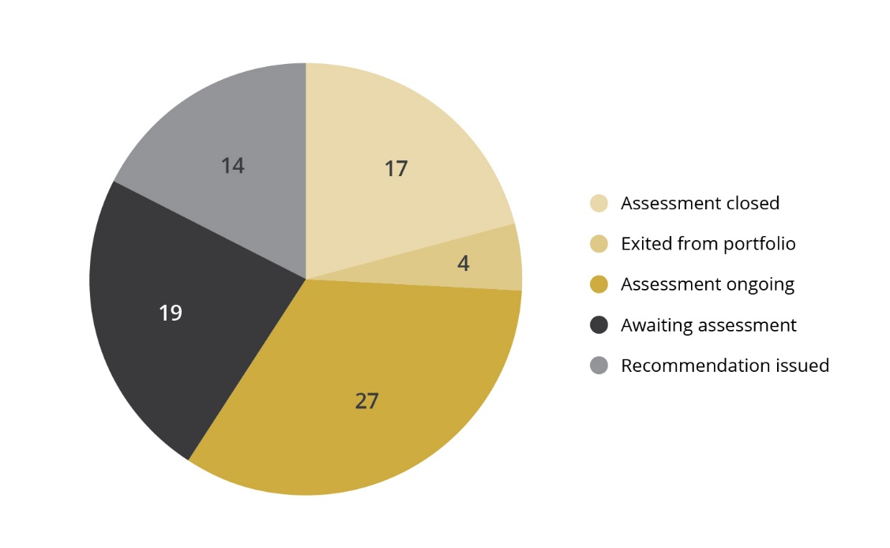
Figure 2.1 shows what happened to the 81 cases that the Council opened in 2022. The majority did not end in a recommendation to exclude a company or place it under observation, but were clsoed at an early stage in the assessment process. A recommendation to exclude a company or place it under observation, or to revoke a previous exclusion or observation decision, was issued in 14 of the 81 new cases opened in 2022, while 17 were shelved. The assessment of four of the new cases was terminated because the companies were no longer part of the GPFG portfolio. Assessment of 22 of the cases remains ongoing, while 19 cases are still waiting for assessment to commence.
The risk of gross corruption was the assessment topic for 15 of the new cases opened in 2022, while financial partnership with the armed forces in Myanmar was the topic in 10 cases. Other common topics include loss of biodiversity and contribution to human rights violations through the sale of mass surveillance technology.
          - Regional breakdown of the GPFG’s shareholdings
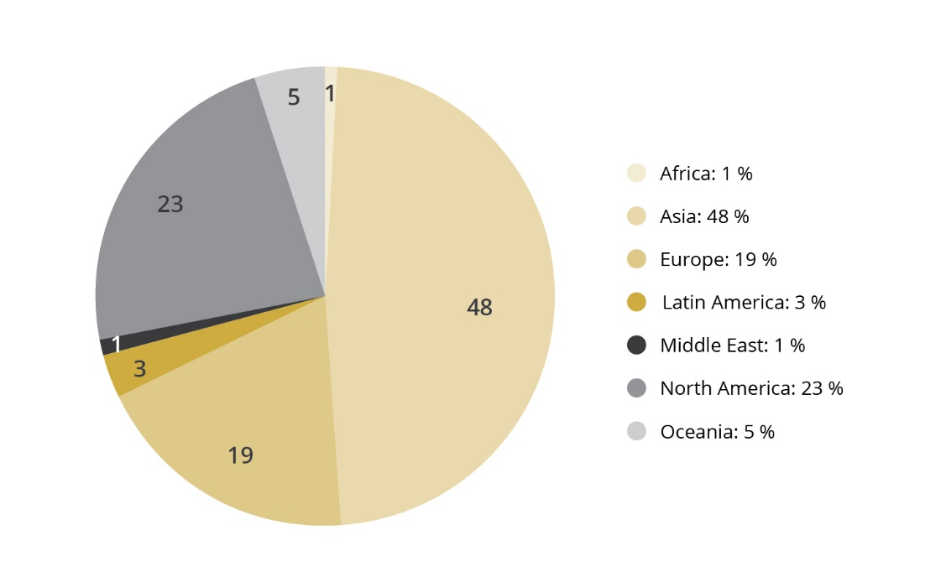
          - Regional breakdown of the companies assessed by the Council
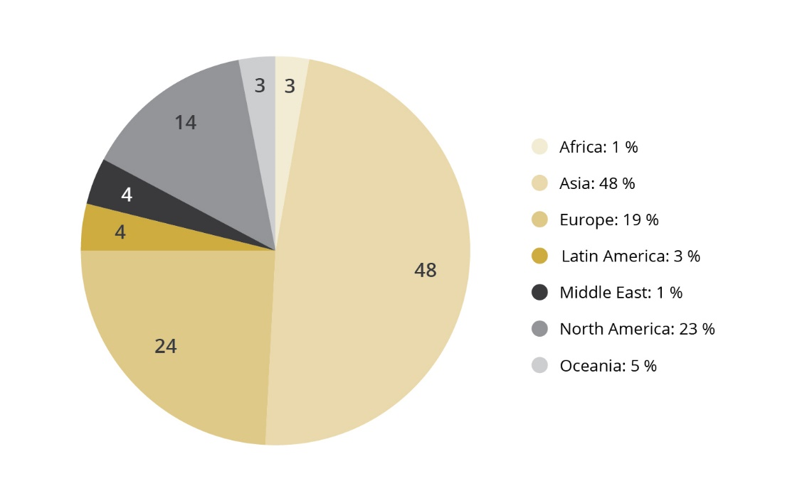
Figure 2.2 shows a regional breakdown of the GPFG’s shareholdings at the close of 2022, while Figure 2.3 shows a regional breakdown of the companies assessed by the Council during the year. The geographic distribution of companies assessed by the Council varies from year to year. In 2022, there was a greater correlation than in previous years between the regional distribution of companies in the GPFG and those assessed by the Council. An important reason for this is that the bulk of the companies which came up for assessment as a result of the changes in the ethical guidelines in 2021 were from Europe and the USA.
Most of the almost 100 Asian companies that the Council assessed in 2022 were scrutinised on the basis of their financial partnerships with the armed forces in Myanmar, the break-up of ships for scrap by means of beaching, and forced labour. Asian companies are often investigated as part of a review of topics which the Council monitors especially closely because the ethical risk is high. Nevertheless, some companies are picked up on through the general portfolio monitoring process. Ten of the companies on which the Council issued recommendations in 2022 are from Asia.
In 2022, the Council assessed approx. 50 companies from 14 different countries in Europe. As in 2021, the majority of these cases related to the risk of corruption and various human rights abuses. The human rights cases related to mass surveillance, forced relocation and violations of the rights of indigenous peoples, for example.
Around a third of the almost 40 companies domiciled in North America were assessed in relation to human rights abuses, while the remaining cases are evenly distributed with respect to the majority of criteria. All the companies excluded for production of cannabis are from North America.
          - Countries with most companies under investigation
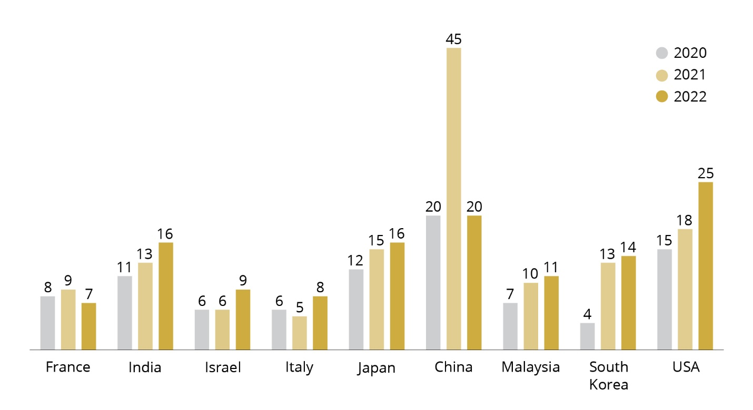
Figure 2.4 shows the number of companies under investigation in 2020, 2021 and 2022 from the nine countries from which most companies under assessment in 2022 were drawn. In 2021, Thailand and the UK were included in a similar presentation.
The increase in the number of companies from the USA, which had the most companies under assessment in 2022, is due in part to the changes in the ethical guidelines introduced in 2021. This is because the USA has more companies producing tobacco or cannabis, and many large weapons manufacturers. In 2021, there was a sharp increase in the number of Chinese companies under assessment. This was, in part, linked to investigations into human rights violations relating to the internment of Uyghurs in the Xinjiang Uyghur Autonomous Region, and to the assessment of companies using body parts from endangered animal species in the production of medicines. A good many of these cases were also concluded in 2021, though work relating to forced labour in Xinjiang remains ongoing.
          - Breakdown of the Council’s work by criterion
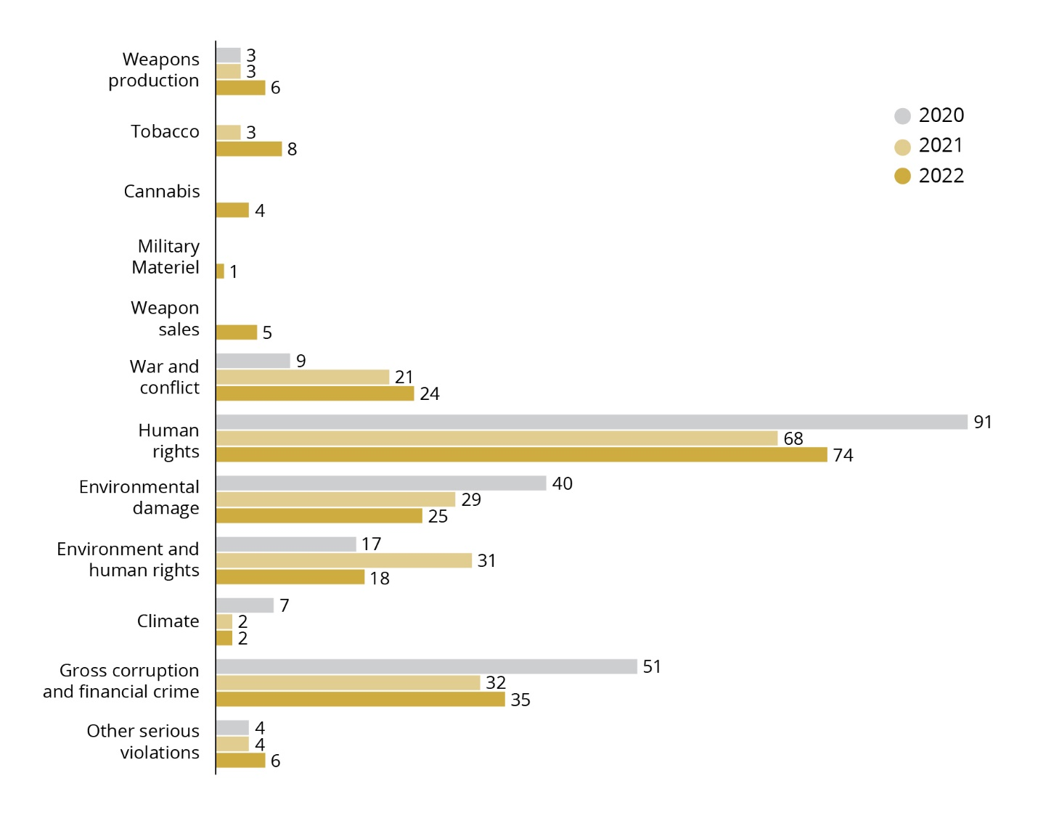
Work under the various criteria
Figure 2.5 shows a breakdown of the cases on which the Council has worked in 2022, by exclusion criteria. There was a sharp increase in the number of cases assessed under product-based criteria, due to the changes in the ethical guidelines. Production of cannabis and tobacco account for the bulk of these cases, though there are also some weapons-related cases.
Nevertheless, human rights-related cases continue to dominate. Many cases have their starting point in inquiries the Council itself has initiated. Such inquiries may, for example, be prompted by suspicions that labour-intensive sectors in some countries may be using forced labour. This then leads to a large number of companies undergoing a preliminary assessment. The Council first identifies all companies whose operations may be exposed to such a risk. It then contacts relevant companies to obtain information that can confirm or refute the Council’s suspicions. Based on the companies’ responses and information from other sources, the Council decides which companies to examine in more detail.
Some cases that are assessed under the human rights criterion may also fall within the scope of additional exclusion criteria, even though it is the human rights abuses on which the Council focuses. For example, an activity may impact an area in which indigenous people live and materially impair their livelihoods, without them having been adequately consulted, at the same time as the project being undertaken will cause serious environmental harm. Indigenous peoples’ sympathetic use of nature means that many of the areas in which they live are of high conservation value and contain resources that have not previously been exploited.
Under the war and conflict criterion, the Council has assessed numerous cases where companies in the GPFGs portfolio engage in financial cooperation with companies controlled by the armed forces in Myanmar. Some cases have also related to business activities in the West Bank.
Under the environment criterion, the Council has continued to work on pollution from mining and industrial activity, damage to conservation areas and loss of biodiversity. Much of this work is part of a systematic assessment of selected risk areas. However, two of the three recommendations issued in 2022 under this criterion applied to companies picked up on through news monitoring.
It has been important for the Council to establish a good foundation for the work prompted by the expansion of the corruption criterion to also cover other serious financial crime. Currently, the Council has several companies under investigation for money laundering. A number of the new cases from 2022 are linked to corruption in the telecoms sector.
Under the criterion relating to other serious violations of fundamental ethical norms, the Council has examined the risk of damage to cultural heritage sites, as well as the extraction of resources in Western Sahara.
Contact with companies
Figure 2.6 shows a regional breakdown of the companies the Council has been in contact with, while figure 2.7 shows a breakdown of the same companies by exclusion criterion. The Council has been in contact with 71 companies and met with 14 of them. The Council contacts companies which it wishes to examine in more detail after a preliminary investigation. The Council first asks the companies for information that can provide a better foundation for an assessment of their operations. Every company assessed under the conduct-based criteria is given an opportunity to comment on a draft of the Council’s recommendation before a final version is forwarded to Norges Bank.
          - Breakdown of contact with companies by criterion
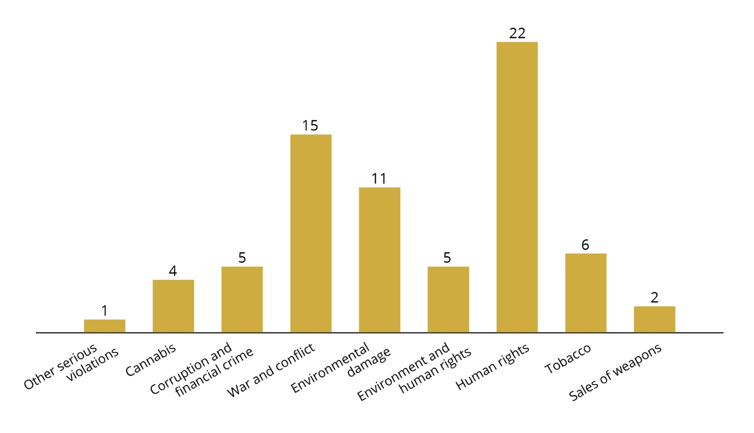
          - Breakdown of contact with companies by region of domicile
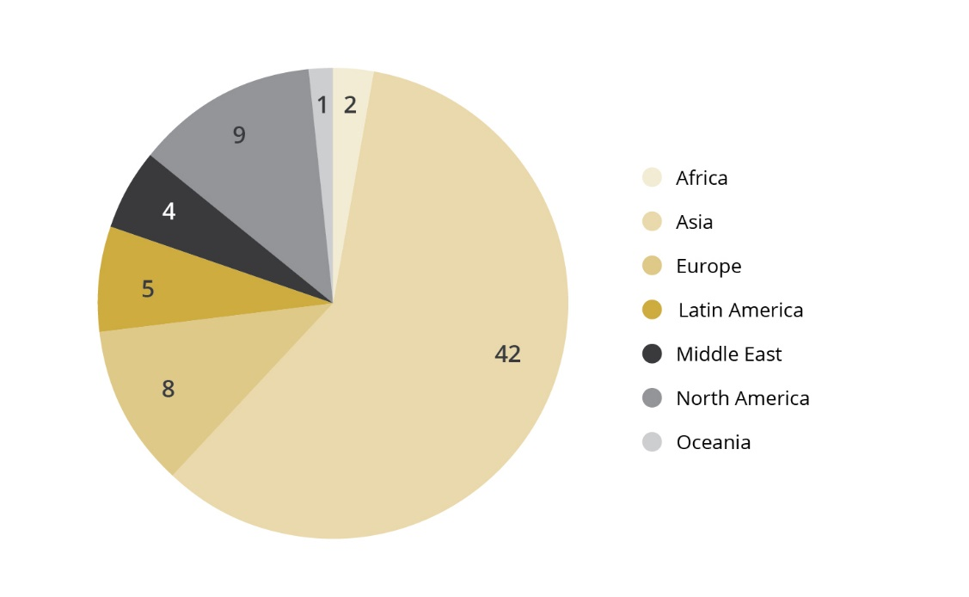
The Council attaches importance to the information provided by companies. In line with the Ethics Commission’s conclusions, a lack of response on the part of a company may help to increase the ethical risk associated with it. The majority of companies reply, though some do not. Of the 71 companies with which the Council was in contact in 2022, 23 companies did not reply. Some of these were contacted late in the year, so a response may yet be forthcoming. In 2022, recommendations were issued to exclude 10 companies that had declined to reply to the Council’s inquiries. Seven of these were excluded on the grounds of their tobacco or cannabis production.
When the Council meets with companies, it is often late in the assessment process, usually as a result of a draft recommendation to exclude the company, or in connection with observation. Figure 2.8 shows a breakdown of the companies the Council met with in 2022 and the criteria they were assessed under. Three of the companies the Council met with in 2022 are under observation.
          - No. of meetings with companies, by criterion
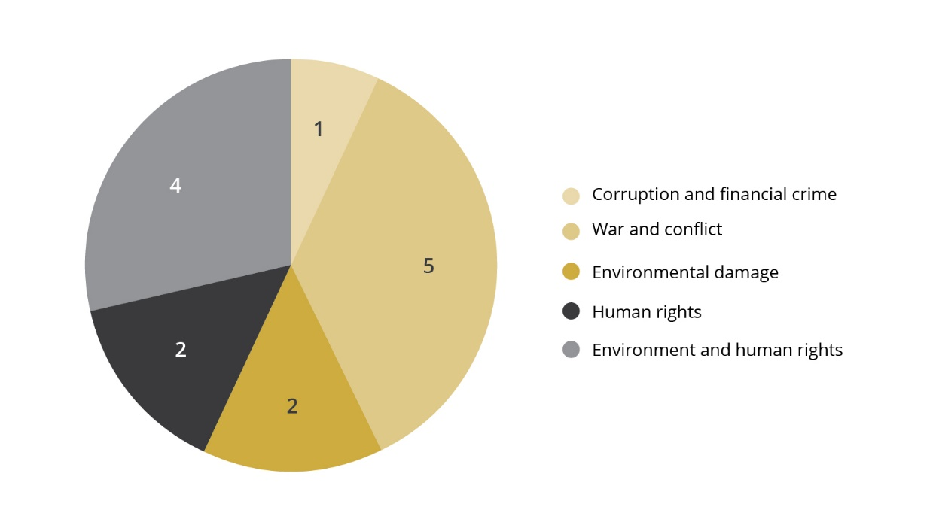
Reassessment of excluded companies
Companies are not excluded for a specific period of time, and their exclusion may be revoked as soon as the grounds therefor no longer exist. Each year, the Council checks whether or not companies still engage in the activity for which they were excluded. For some companies, a more in-depth investigation is carried out. This may be at a company’s request, for example, or if there are indications of a major change in its operations. If a company has implemented measures that have led to sufficient improvement in the conditions on which exclusion was based, the Council issues a recommendation to revoke its exclusion. Such improvements must be observable in practice and not simply be stated in the company’s plans and strategies. One common reason for a recommendation to revoke an exclusion is that the company has discontinued or disposed of that part of its business that constituted the grounds on which it was based.
In 2022, the Council recommended that the exclusion of one company be revoked. Norges Bank also revoked the exclusion of a company on the basis of a recommendation issued by the Council in 2021. Companies that have been delisted from a stock exchange are removed from the list of excluded companies without the Council’s recommendation being rescinded.

Product-based criteria
Section 3 of the guidelines sets out the criteria for the “product-based observation and exclusion of companies” as follows:
(1) The GPFG shall not be invested in companies which themselves or through entities they control:
a. develop or produce weapons or key components of weapons that violate fundamental humanitarian principles through their normal use. Such weapons include biological weapons, chemical weapons, nuclear weapons, non-detectable fragments, incendiary weapons, blinding laser weapons, antipersonnel mines and cluster munitions
b. produce tobacco or tobacco-products
c. produce cannabis for recreational use
(2) Observation or exclusion may be decided for mining companies and power producers which themselves, or consolidated through entities they control, either:
d. derive 30 per cent or more of their income from thermal coal,
e. base 30 per cent or more of their operations on thermal coal,
f. extract more than 20 million tonnes of thermal coal per year, or
g. d) have the capacity to generate more than 10,000 MW of electricity from thermal coal.”
In 2022, the Council worked mostly on the implementation of the changes in the guidelines’ product-based criteria adopted in 2021. The production of cannabis for recreational purposes was one of the new exclusion criteria. Furthermore, the Council may now assess companies in the benchmark index with respect to product-based criteria, even though the GPFG holds no shares in them. One objective of excluding such companies is to eliminate them from the benchmark index against which the Bank’s performance is measured. This occurs only if companies are excluded through a formal decision to exclude.
In practice, the Council will assess companies in which the GPFG does not hold shares only at Norges Bank’s request. During the year, the Bank drew the Council’s attention to several such companies. In 2022, four companies were excluded for the production of cannabis and three for the production of tobacco.
In connection with the changes in the ethical guidelines adopted in 2021, it was also made clear that production of nuclear weapons delivery platforms could lead to exclusion from investment by the GPFG, if the platforms’ sole purpose was to carry nuclear weapons. In practice, this means submarines. The assessment of relevant companies will continue in 2023.
The ongoing work under the product-based criteria involves the assessment of cases that emerge through the portfolio monitoring process. Each year, a number of cases are identified which relate to companies that have either stopped producing the types of weapons for which they were excluded or which have started producing new types of weapons that must be assessed against the ethical guidelines.
With regard to the coal criterion, the guidelines allow Norges Bank to make decisions concerning the observation or exclusion of companies without a recommendation from the Council. A division of labour has been agreed between Norges Bank and the Council, under which the Bank identifies and assesses companies which fall within the scope of the coal criterion. The Council’s consultant nevertheless reports to the Council on companies which may fall within the scope of the criterion. The Council shares all relevant information with the Bank.

Human rights, war and conflict
Section 4 of the guidelines states that “Companies may be excluded or placed under observation if there is an unacceptable risk that the company contributes to or is responsible for:
a. serious or systematic human rights violations
b. serious violations of the rights of individuals in situations of war or conflict […]”
In 2022, the Council worked on a wide range of human rights cases. Some related to issues which the Council has been working on for many years and which will always be an important aspect of its endeavours. This applies, for example, to serious or systematic labour rights abuses, including working conditions verging on forced labour. The Council has also embarked on more novel topics, such as infringement of the right to freedom of expression and human rights violations made possible by mass surveillance.
The Council continued to devote much time and resources to assessing enterprises that cooperate with companies owned or controlled by the armed forces in Myanmar. These assessments are performed under the criterion relating to war and conflict. Under this criterion, the Council has also continued to assess companies doing business in the West Bank.

Serious or systematic human rights abuses
Most of the human rights cases assessed by the Council in 2022 relate to labour rights abuses. Many became aware of the working conditions that migrant workers are frequently exposed to in connection with the 2022 FIFA World Cup in Qatar. Recruitment fees, the confiscation of identity papers and restrictions on their right to change jobs can place workers in a situation where they are compelled to accept pay and working conditions that are less favourable than they were led to expect, and that could put their life and health at risk. For several years, the Council has examined the working conditions of migrant workers, not only at companies operating in Qatar, but also in other countries with a large contingent of migrant workers.
In 2021 and 2022, the Council focused on the rubber glove industry in Malaysia, which produces 65 per cent of the world’s rubber gloves. The world’s largest producers are Malaysian or have factories there. In the past few years, working conditions verging on forced labour have been reported at several of these companies.
In 2022, the Council recommended the exclusion of the Malaysian company Supermax Corp Bhd, because migrant workers had paid high recruitment fees and were subjected to an extensive system of punishments and fines, extremely long working hours and restrictions on their freedom of movement. Nor did the company contribute meaningfully to the Council’s assessment process. In the Council’s view, this indicated that the risk of systematic labour rights abuses was likely to persist. Because the company had announced that it would implement improvements, Norges Bank decided to place it under observation. Another rubber glove company that the Council looked into had compensated workers for the recruitment fees they had paid, improved working conditions and established procedures to avoid workers having to pay recruitment fees in the future. The Council therefore considered the risk of forced labour at this company to be small. So far, the Council has assessed five rubber glove manufacturers.
The working conditions experienced by migrant workers in this business sector have attracted significant international attention. Civil society has taken action, certain countries have imposed import restrictions on some companies, and the media have reported on them. This seems to have led to improvements in working conditions. However, migrant workers are also subjected to working conditions verging on forced labour in other business sectors and countries. The Council will continue to investigate GPFG-invested companies where the risk of such labour rights abuses is high.
In 2019, the Council began a process to identify GPFG-invested companies which contribute to serious human rights abuses through the development and sale of mass surveillance technology. The assessment focuses on companies where information obtained by means of their systems has facilitated extremely serious norm violations, such as murder, torture and arbitrary detention.
In 2022, the Israeli company Cognyte Software Ltd was excluded from investment by the GPFG. Several of the countries alleged to be among the company’s customers stand accused of extremely serious human rights violations, such as kidnap, torture and other forms of abuse targeting vulnerable groups, including sexual minorities. The Council concluded that this must have been known to the company, and that the surveillance of political opponents and minorities was a foreseeable risk, given the products and services that the company supplies.
Since 2020, the Council has examined the risk that GPFG-invested companies are contributing to human rights abuses being perpetrated against the Uyghur minority in China. The Report to the Storting (White Paper) on the Government Pension Fund 2021, Meld. St. 24 (20–21), discusses companies deemed to represent a high risk of contributing to extremely serious norm violations while access to information thereon is limited. Where there is little company-specific information and a significant risk of serious norm violations, the Council is permitted to attach importance to risk assessments at the country and business sector level. A lack of information may contribute to an unacceptable risk, particularly if a company demonstrates a lack of willingness to respond to the Council’s inquiries. At the same time, every company shall be assessed individually and in detail.
Since it is difficult for the Council to make its own inquiries into companies’ contributions to human rights abuses in China, assessments here must be based on publicly available information combined with risk assessments.
In August 2022, the UN High Commissioner for Human Rights published a report establishing that Uyghurs have suffered serious human rights violations linked to what the Chinese authorities describe as an “anti-extremist strategy” and the “poverty alleviation”. The report confirmed what civil society and testimony from Uyghurs had already pointed to: forced labour, the suppression of minorities, arbitrary detention, torture and persecution. Publicly available information identified several companies which are highly likely to have been involved in such norm violations. In 2022, the Chinese company Li-Ning was excluded from investment by the GPFG due to the risk of contributing to forced labour.
A new type of case for the Council in 2022 related to companies’ contribution to the infringement of freedom of expression. In February 2023, the state-controlled Polish energy company Polski Koncern Naftowy Orlen SA (Orlen) was placed under observation following a recommendation issued by the Council in 2022. In 2020, the company acquired the newspaper publisher Polska Press. The acquisition gave Orlen control of the majority of Poland’s regional newspapers, in addition to a large number of local media houses and online portals. The recommendation rests on the risk that Orlen, through its acquisition of Polska Press, is helping to restrict freedom of the press, and thereby freedom of expression, in Poland. Democracy and press freedom are further discussed in Chapter 6.
In 2022, once again human rights cases constituted the majority of the cases identified through the portfolio monitoring process. Topics on which the Council worked in 2022, but which have so far not resulted in a recommendation to exclude a company or place it under observation, include violation of the rights of indigenous people in connection with the extraction of natural resources, sexual harassment in the workplace and security service’s use of violence in connection with conflicts over the control of land.

Serious violation of the rights of individuals in situations of war or conflict
There has been a sharp increase in the number of cases being assessed under this criterion in the past couple of years. This is due to the heightening of several conflicts. The number of cases the Council must assess fluctuates primarily when the situation in areas in which many companies in the GPFGs portfolio operate deteriorates, and when the abuses perpetrated against the civilian population are particularly egregious.
In 2022, the majority of these cases related to companies with links to the military junta in Myanmar. In addition to two companies which were excluded for selling weapons to the regime, three recommendations related to this issue. Further details of the Council’s efforts and assessments are presented below.
The Council has also continued to investigate companies with links to the West Bank. Here, the issue is whether companies contribute to the occupation of territory in violation of international law.
So far, the Council has not assessed any companies in relation to their potential contribution to the violation of international law in Ukraine. This is partly because Russian companies will be divested from the GPFG as soon as practically possible. There is therefore no point in the Council assessing Russian companies.

Companies’ business partnerships with the armed forces in Myanmar
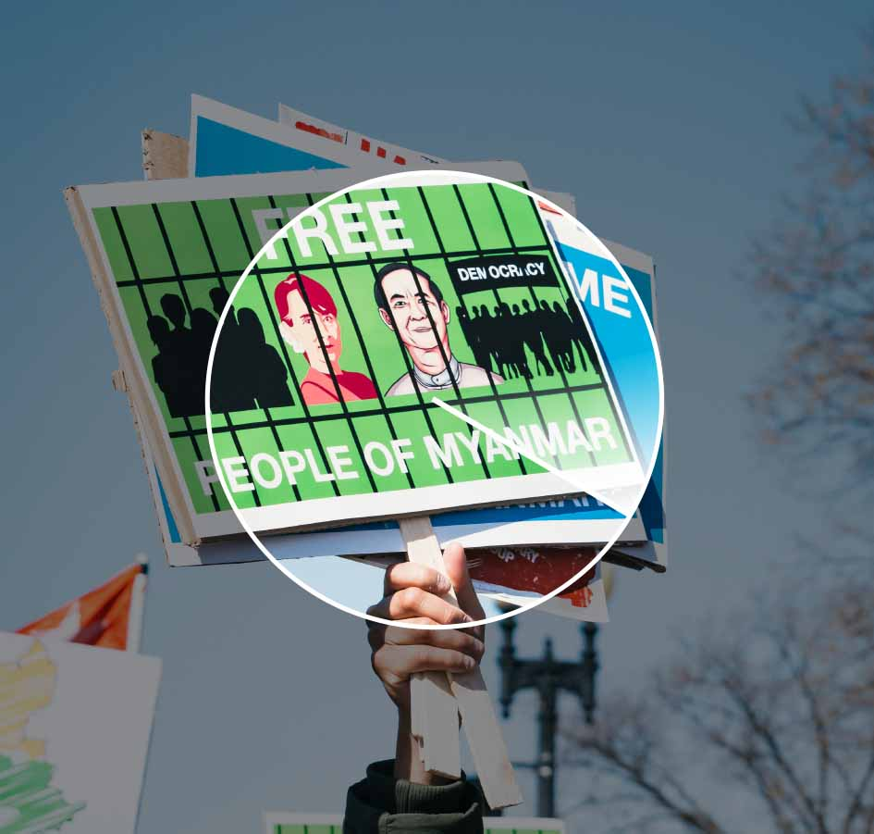
On 1 February 2021, the armed forces in Myanmar staged a coup d’état. Hundreds of thousands of civilians have protested against the coup by means of boycotts, strikes and demonstrations nationwide. This resistance has been met with violence by the armed forces, and thousands of people have been killed since the generals took power.
In certain areas, opposition to the regime has evolved into armed conflict. For many years even before the coup, Myanmar’s armed forces committed acts of atrocity against the civilian population. Year after year, the UN High Commissioner for Human rights has reported on the appalling situation facing the Muslim Rohingya community, which the armed forces continue to persecute. At present, the International Court of Justice (ICJ) is considering several cases relating to violations of the Genocide Convention, while the International Criminal Court (ICC) is considering cases relating to crimes against humanity.
The UN High Commissioner for Human Rights has repeatedly called on businesses with operations in Myanmar not to cooperate with companies controlled by the armed forces and to avoid business operations that help to boost the armed forces’ financial strength. Both the EU and Norway have imposed sanctions on several military-controlled companies because the revenues from them increase the armed forces’ capacity to perpetrate abuses.
The regime controls swathes of the country’s economy through a network of companies. In 2019, the Independent International Fact-Finding Mission on Myanmar published several reports on the armed forces’ financial interests. The reports identified interests associated with the two military-owned conglomerates: Myanmar Economic Corporation (MEC) and Myanma Economic Holdings Limited (MEHL). MEC is owned and controlled by the Ministry of Defence, while MEHL is owned and operated by former generals and military units, and is strongly influenced by Myanmar’s top military leadership.
In 2022, the Council continued to identify the business activities that companies in the GPFGs portfolio have in the country. This review showed that many companies have halted ongoing projects, pulled their businesses out of the country or announced their intention to do so. The Council is communicating with several companies to obtain more information about what they are doing to avoid their operations contributing to abuses for which the armed forces are responsible. Relatively few companies have carried out thorough due diligence assessments, and in the majority of cases, the companies would almost certainly not have sufficient influence to prevent new abuses while the Myanmar military remains in power. In the Council’s view, companies in this situation have no other option than to withdraw from the country to avoid contributing to norm violations. Due to the particular risk of contributing to serious norm violations in areas of war and conflict, the Council takes the position that companies with operations in such areas must demonstrate particular prudence and due diligence.
In 2022, the Council issued three recommendations to exclude companies with operations in Myanmar, with reference to the war and conflict criterion. Two companies have been placed under observation since 2021. In particular, the Council has assessed whether the companies concerned have a business partnership with military-controlled entities, whether this partnership could have a strategic impact, and the extent to which the companies’ business activities in Myanmar contribute to boost the armed forces’ financial capacity. The Council’s recommendation concerning the Thai oil company PTT PLC and its subsidiary PTTOR, which was published in 2022, is based both on PTTOR’s business partnership with MEC and the oil and gas revenues that PTT generates for the regime. Since revenues from oil and gas production in Myanmar constitute the regime’s largest source of income, it is this contribution that the Council considers to be the most important element in PTT’s contribution to the serious abuses for which the armed forces are responsible.

Democracy and freedom of the press
According to the Freedom in the World 2022 report, democracy as a form of government has been steadily losing ground over the past 16 years, while authoritarian regimes have made headway. In addition to such regimes attacking fundamental freedoms in their own countries, there has been a clear tendency for them to support each other through “anti-democratic alliances”. According to Freedom House, only around 20 percent of the world’s population now lives in completely free countries.
Free and fair elections, independent systems and institutions that safeguard the balance of power and transparency, as well as mechanisms to prevent political control of the media and judiciary are some of the preconditions for a functioning democracy. We have seen many examples of attacks on freedom of expression and freedom of the press, or of regimes attempting to take control of the media. This may happen through the courts, legislative amendments, acquisitions, various forms of harassment, as well as through propaganda and disinformation. According to the World Press Freedom Index, which is compiled by Reporters Without Borders (RSF), press freedom was considered “good” in just eight out of 180 countries in 2022. According to UNESCO’s World Trends in Freedom of Expression and Media Development report, 85 per cent of the world’s population has experienced a reduction in press freedom in their own countries over the past five years.
It must also be assumed that the downturn in press freedom has a negative impact on the areas covered by the GPFG’s ethical guidelines, since it leads to the exposure of fewer cases of serious wrongdoing, while fewer of those involved are held to account. It also makes it more difficult for the Council to obtain information about potential norm violations perpetrated by GPFG-invested companies.
The Council’s October 2022 recommendation to place the Polish energy company Polski Koncern Naftowy Orlen SA (Orlen) under observation must be seen partly in this light. The starting point for the recommendation was Orlen’s acquisition of the newspaper publisher Polska Press and the ramifications this could have for freedom of the press in Poland. The acquisition of Polska Press gives Orlen control of most regional newspapers in the country and a large number of local media houses and online portals. A number of key actors have pointed out that the Polish state’s ownership of Orlen means that Polska Press could be subjected to political interference and that the acquisition has therefore a negative impact on freedom of expression. This criticism is made in the broader context of diminishing press freedom in Poland.
This is the first case in which the Council has considered a reduction in, or lack of, freedom of expression as an issue under the human rights criterion. Freedom of expression, including freedom of the press, is covered both by the International Covenant on Civil and Political Rights (ICCPR) and the European Convention on Human Rights.
The loss of freedom of expression and subsequent risk of political interference is particularly serious in connection with elections, and the Council has noted that several actors have expressed serious concerns about the independence of Polska Press’s publications in connection with the 2023 general elections. The extent to which this risk will manifest itself remains uncertain. Due to the uncertainty about developments going forward, the Council therefore recommended that this company be placed under observation.

Companies’ sales of weapons to certain states
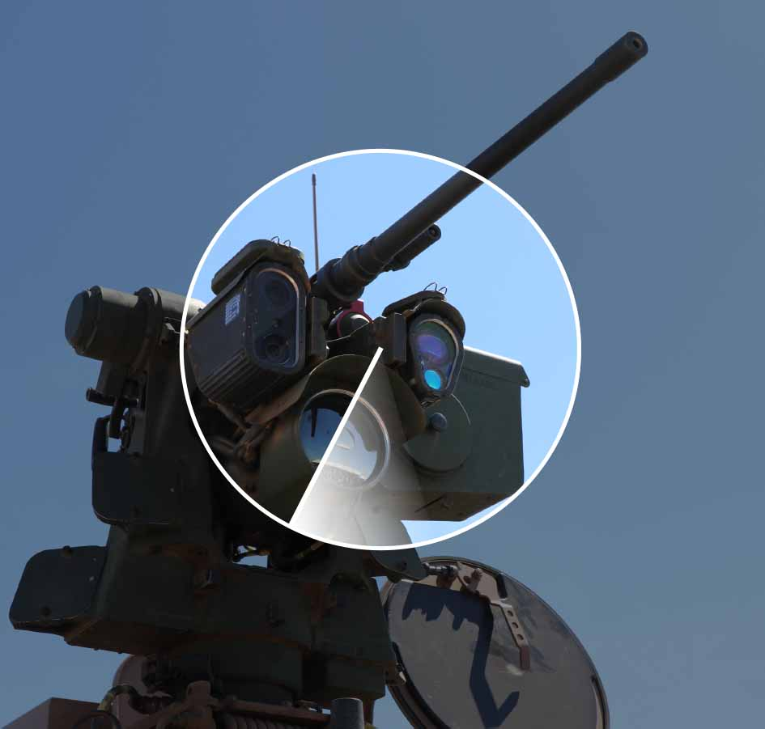
Section 4 of the guidelines states that: “Companies may be excluded or placed under observation if there is an unacceptable risk that the company contributes to or is responsible for: […]
c. the sale of weapons to states engaged in armed conflict that use the weapons in ways that constitute serious and systematic violations of the international rules on the conduct of hostilities
d. the sale of weapons or military materiel to states that are subject to investment restrictions on government bonds as described in section 2-1(2)(c) of the Management Mandate for the Government Pension Fund Global […]”
In the autumn of 2021, the GPFG’s guidelines were expanded with the introduction of a new criterion relating to companies’ sales of weapons to countries engaged in armed conflicts. This came as an addition to the existing criteria relating to the companies’ production and sale of weapons. The exclusion of companies that produce or sell weapons may now be assessed in relation to three criteria in the guidelines.
            - Three criteria for exclusion based on the production or sale of weapons
 | The criterion covers companies that… | Comment
Section 3(1)(a) | … develop or produce weapons or key components of weapons that violate fundamental humanitarian principles through their normal use. Such weapons include biological weapons, chemical weapons, nuclear weapons, non-detectable fragments, incendiary weapons, blinding laser weapons, antipersonnel mines and cluster munitions. | Product-based criterion. Exclusion must be recommended.  In practice, this criterion currently encompasses companies’ production of nuclear weapons and cluster munitions.  Applies to companies irrespective of their production volume.  Most challenging aspect: Drawing the line with respect to nuclear weapons production.
Section 4(c) | … sell weapons to states engaged in armed conflict that use the weapons in ways that constitute serious and systematic violations of the international rules on the conduct of hostilities. | Conduct-past criterion. Exclusion or observation may be recommended.  Applies to the sale of weapons to states engaged in conflicts in which serious violations of international law are foreseeable. The Council must consider which states these are.  Applies primarily to the types of weapons that may be used to target civilians.
Section 4(d) | … weapons or military materiel to states that are subject to investment restrictions on government bonds as described in section 2-1(2)(c) of the Management Mandate for the Government Pension Fund Global. | Conduct-past criterion. Exclusion or observation may be recommended.  Applies to the sale of weapons to such states as the Norwegian Ministry of Finance has determined. At present, these are: Russia, Belarus, Syria, Iran and North Korea.  Applies to all types of weapons and military equipment.
It would be natural to view the application of sections 4(c) and 4(d) in conjunction, since both apply to companies’ sales of weapons to certain states. However, there are some key differences between the criteria:
- With respect to section 4(c), it is up to the Council to consider which states the criterion shall be applied to. For section 4(d), it is the Norwegian Ministry of Finance that decides which states it covers.
- Section 4(c) applies to the sale of weapons to states engaged in armed conflict. This is not a requirement pursuant to 4(d).
- For section 4(c), a key aspect in the assessment is how the weapons are used by the recipient state. Section 4(d) requires no assessment of how or to what extent the weapons are used.
- According to section 4(c)’s preparatory works, this criterion is intended to apply primarily to types of weapons which could be used to target civilians. Section 4(d) applies to all types of weapons and military equipment.
In the autumn of 2021, the Council started work in relation to section 4(c) by performing a systematic review of ongoing conflicts in which serious and systematic violations of humanitarian law are taking place. Then we identified companies which sell weapons to the parties engaged in these conflicts. The Council commissioned the Geneva Academy of International Humanitarian Law and Human Rights to produce the report A Survey of Current Armed Conflict and International Humanitarian Law. The report provides a thorough survey of ongoing armed conflicts and an assessment of the extent of compliance with the rules of humanitarian law in each of the various conflicts.
On the basis of this report, the Council decided to first examine the potential sale of weapons to Saudi Arabia, the United Arab Emirates (UAE), Ethiopia, Libya and Myanmar on the part of GPFG-invested companies. So far, the Council has issued recommendations to exclude two companies which supply weapons to the regime in Myanmar.
The Stockholm International Peace Research Institute (SIPRI) surveys the state-to-state sale of weapons as part of its activities. SIPRI’s database contains country-level information about sellers and buyers, weapons types, volumes ordered and delivered, and the year of order placement and delivery.
On the other hand, SIPRI’s databases do not contain information on which companies have produced the weapons. Nor do they contain any assessment of whether the weapons are of a type that may be used specifically to target civilians. This is something the Council itself has assessed on the basis of the information in SIPRI’s database for the period 2019–2021.
The assessment of the kinds of weapons types that may be used specifically to target civilians is approximate. The table below contains both weapons types that clearly fall within this category (bombs, ground-target missiles) and types that may fall within such a category, such as combat aircraft, tanks and other armoured vehicles.
The majority of weapons delivered to the states concerned are of a type not deemed capable of specifically targeting civilians. This includes naval vessels and weapons intended for use against surface vessels, submarines and aircraft, and military materiel such as transport aircraft, radar systems, lorries, etc.
            - Deliveries of weapons to certain states
Delivered to | No. of weapons deliveries 2019–2021 | No. of deliveries of weapons types that can be used specifically to target civilians | No. of deliveries from GPFG-invested suppliers | No. of unique companies
Saudi Arabia | 60 | 23 | 6 | 3
UAE | 25 | 7 | 1 | 1
Ethiopia | 7 | 4 | 0 | 0
Libya | 4 | 2 | 0 | 0
Myanmar | 11 | 4 | 2 | 2
TOTAL | 107 | 43 | 9 | 6
A total of 107 agreements for the delivery of weapons to Saudi Arabia, the United Arab Emirates (UAE), Ethiopia, Libya and Myanmar were found for the period 2019–2021. These are the countries which the Council has decided to assess first under section 4(c) of the ethical guidelines.
Forty-three of the agreements relate to weapons types that could definitely or potentially be used to target civilians. Of this number, we found nine deliveries supplied by companies in which the GPFG holds shares. Since the same company could have multiple deliveries in the same country, as well as deliveries to several of the relevant countries, the number of unique companies stands at six.
Three companies accounted for six deliveries to Saudi Arabia. One of the companies also supplied the UAE. A further two companies supplied weapons to Myanmar, while one company supplied only the UAE.
Two companies that sold weapons to the regime in Myanmar were excluded in 2023 under the new criterion, at the recommendation of the Council on Ethics. The Council notes that the USA has recently changed its policy with respect to the sale of weapons to the parties involved in the conflict in Yemen. Licences for the export of relevant types of weapons to Saudi Arabia, for example, have therefore been rescinded. The objective is to prevent the supply of weapons types that may be used specifically to target civilians. This change will influence the Council’s assessment of future risk relating to companies’ sales of such materiel.
With respect to the ethical guidelines’ section 4(d), the Council has not identified any companies in the GPFG’s portfolio which sell weapons to states covered by the government bond exemption, i.e. Russia, Belarus, Syria and North Korea. It is known that Russia has sold weapons to both Belarus and Syria, but the GPFG has no investments in the Russian arms industry and, in any case, the Norwegian Ministry of Finance has decided that the Fund shall divest all its investments in Russian enterprises. Furthermore, it has been reported that Russia, in connection with the war in Ukraine, is buying military materiel from Iran and North Korea. However, the GPFG has no investments in these countries.
Companies are being assessed in relation to the ethical guidelines’ sections 4(c) and 4(d) on an ongoing basis. Information about sales contracts entered into in 2022 will be assessed as and when it comes to light, and could result in recommendations to exclude additional companies.

Climate and environment
Section 4 of the guidelines states that: “Companies may be excluded or placed under observation if there is an unacceptable risk that the company contributes to or is responsible for: […]
e. severe environmental damage
f. acts or omissions that on an aggregate company level lead to unacceptable greenhouse gas emissions
[…]”

Severe environmental damage
In 2022, under the environment criterion, the Council continued to work on cases relating to the impairment of areas of high conservation value or the potential extinction of endangered species. Serious environmental damage may occur for many reasons. The Council has looked at several cases relating to the conversion of land containing important biodiversity for agriculture, mining, hydroelectric production, infrastructure or other purposes, and cases relating to pollution from industry and shipbreaking. According to the Intergovernmental Science-Policy Platform on Biodiversity and Ecosystem Services (IPBES), land use change, exploitation of natural resources and pollution are the three most important of the five main reasons for the loss of biodiversity and ecosystem services worldwide; the other two being climate change and invasive alien species. The Council’s work therefore help to set standards for what may be considered as serious norm violations based on what the international expert community considers the most important threats to nature worldwide.
In many of the cases the Council assesses under the environment criterion, inadequate policies and systems for impact assessment, as well as poor decision-making processes, diminish opportunities to identify the risk of serious environmental damage. A lack of methods for the development and documentation of mitigating measures is thus also part of the risk picture. This is in line with IPBES, which finds that the underlying societal reasons for the damage to, and loss of, nature may be found in economic, demographic, regulatory, cultural and other conditions. The Council’s work is therefore also helping to uncover underlying causalities, clarify key factors behind norm violations and point to both opportunities and the need for development.
              - Kunming-Montreal Global Biodiversity Framework
In December 2022, 196 countries signed the Kunming-Montreal Global Biodiversity Framework. The primary aim of this agreement is to stop the loss of ecosystems and biodiversity, and ensure a fairer distribution of nature’s bounty by 2050. This agreement reflects growing international awareness of our shared global responsibility to protect nature and the benefits it provides. One innovative feature of the Kunming-Montreal Global Biodiversity Framework is that it sets clear and frequently quantifiable targets for reducing biodiversity loss. Another is that it places responsibility for helping to reduce biodiversity and environmental loss on the business and financial sectors. For example, it is expected that companies, especially major transnational enterprises, monitor, assess and openly share information about their exposure to biodiversity-related risks, and to their dependence and impact on nature. Companies are further expected to make this information freely accessible to consumers and public authorities, so that the risk to biodiversity and negative impacts can be reduced, and sustainable production and positive impacts increased (Kunming-Montreal Global Biodiversity Framework, Target 15). Public authorities must ensure the full integration of biodiversity and its multiple values into policies, regulations, planning and development processes (Target 14) and ensure that all areas are under participatory integrated biodiversity-inclusive special planning and/or management processes relating to land and sea use change, to bring the loss of areas of high biodiversity importance close to zero by 2030 (Target 1). Also important is the agreement’s ambitious goal of phasing out subsidies harmful for biodiversity by a targeted USD 500bn per year by 2030 (Target 18), as well as the goal of mobilising at least USD 200bn per year in public and private financing for the restoration and preservation of biodiversity (Target 19), and ensuring the sharing of capacities and resources (Targets 17, 20, 21). This package of targets establishes strong incentives for the development of norms and thresholds for what constitutes serious environmental damage, as well as new systems for monitoring and reporting the environmental impacts and dependencies of both the business and financial sectors in the years ahead.
In many of its recommendations to exclude companies under the environment criterion, the Council has rested its assessment on the loss of globally endangered species and important ecosystems. In 2022, for example, the Council took a closer look at the construction of certain hydroelectric power projects where the risk of biodiversity loss is considerable. The Indian company NHPC Ltd, which is the builder, owner and operator of the Lower Subansiri hydropower project in India, was excluded in 2022 due to the inundation of an over 30 km2 global biodiversity hotspot and the impact that operation of the power station will have downstream.
In 2022, the Council continued assessing GPFG-invested companies whose operations risk harming internationally important conservation areas or areas of particular importance with respect to biodiversity. The highest risks relate to mining operations, agricultural production, energy production and infrastructure projects. Many of the companies, which have been identified in several consultant reports, have projects which have not yet got underway, but which the Council will monitor going forward. The Council has also commenced an assessment of other companies with respect to environmental risk. This work will continue in 2023.
The observation of companies on matters relating to biodiversity has also been an important part of the Council’s work under the environment criteria in 2022. Here, the Council assesses whether the measures the companies have implemented are sufficient to reduce the risk of serious environmental damage. Such assessments can be difficult, not least due to a lack of environmental data. Companies can also engage in several different types of problematic activities. In relation to one of the companies under observation, it has emerged that a subsidiary other than the one which prompted the observation decision has operations involving a high risk of important biodiversity loss. Based on the Council’s experience, companies with weak policies and systems for identifying and mitigating the negative consequences of their operations seem to have a higher probability of being involved in multiple norm violations than others.
The Council has also worked with companies responsible for serious pollution related to both mining and other operations. The recommendation concerning the South Korean company Young Poong Corp relates to serious pollution from a smelting works in South Korea. The company failed to reply to the Council’s queries during the assessment process, but has subsequently said that it wishes to share information in order for its exclusion from the GPFG to be revoked. The Council has also been approached by other companies asking what is required for an exclusion to be revoked. We see this as an indication that exclusion can lead to changes in reporting and, hopefully, also in companies’ business practices.
The break-up of ships for scrap by means of beaching continues to be an important area for the Council’s work – as it has been since 2017. The Council constantly monitors whether companies dispose of ships or oil platforms for break-up on the beaches of certain countries in Asia. Based on general information about environmental and working conditions in connection with beaching in Bangladesh and Pakistan, the Council has taken the position that beaching represents an unacceptable risk of environmental damage or serious abuse of workers’ rights in these two countries. The risk associated with shipbreaking in India is assessed on a case-by-case basis.
The Council visited several shipbreaking yards in India in 2022 and observed substantial differences between them with regard to the steps taken to prevent environmental damage. The Council has been in contact with several companies which dispose of ships for breakup by means of beaching. As a result, some of them have introduced new policies regarding responsible shipbreaking. In 2022, it was announced that the Korean company Hyundai Glovis Co had been placed under observation because it had disposed of ships for break-up by means of beaching, but had indicated that it would change its practice in this area.

Change with respect to the climate criterion
The Council’s ethical guidelines have contained a criterion concerning unacceptable greenhouse gas emissions since 2016. The Council has issued five recommendations under this criterion, resulting in a total of four companies being excluded. This criterion has been hard to put into practice. In its 2021 annual report, the Council explained why it was proposing that primary responsibility for the climate criterion should be transferred to Norges Bank. The Council’s letter to the Norwegian Ministry of Finance on this subject was also included in the 2021 annual report.
It was decided to implement this change in 2022. In practice, therefore, Norges Bank now has primary responsibility for the climate criterion. The actual wording of the criterion has not changed. The Council will, for a time, follow up the companies already excluded under the climate criterion, but will not normally assess new companies on this basis.

Gross corruption and other serious financial crime
Section 4 of the ethical guidelines states that: “Companies may be excluded or placed under observation if there is an unacceptable risk that the company contributes to or is responsible for:
[…]
g. gross corruption or other serious financial crime
This criterion originally applied to gross corruption. In 2021, it was expanded to also cover other serious financial crime. A key area of focus for the Council’s work in 2022 has therefore been to start monitoring and assessing companies in relation to this new aspect. The new member of staff designated to work on these issues joined the organisation in June.

Other serious financial crime
To establish the best possible foundation for prioritisation and the best methodological approach to the field of financial crime, the Council organised a seminar in London in the autumn of 2022. During the year, substantial resources were devoted to the planning, preparation and staging of this seminar. Participants were primarily international experts with a background in banking and finance, investigative journalism, consultancy work and academia. The main focus of the seminar was the financial sector, money laundering and tax crimes.
One of the key topics at the seminar was the role that banks and financial institutions in western countries, not least in the major financial centres, play in the laundering of money stolen through corruption and other forms of financial crimes in countries that are resource-rich but often poor and undemocratic. The ongoing war in Ukraine resulted in a particular focus on the flow of money from Russia, including how such funds can also help to undermine western democracies and democratic processes through so-called “strategic corruption”.
Several of the seminar’s participants pointed out that it was impossible to quantify precisely the global scale of money streams from illegal sources (money laundering), but that it was probably enormous and that the high-profile money laundering scandals we have witnessed in recent years are likely just the tip of the iceberg. A lot has happened in the anti-money laundering field in the past 20–30 years, both with respect to the development of international standards and its criminalisation at the national level. At the same time, criminals have adapted their practices and working methods. Combatting the problem therefore remains extremely challenging. It was pointed out that governments and authorities give too little priority to financial crime and that collaboration between private (the banking and finance sector) and public (police, prosecution services, tax authorities) entities should be developed and improved.
Financial institutions’ own risk assessments were highlighted as one of the most important factors in the prevention of money laundering. The absence of effective and thorough risk assessments, combined with a fear of being sanctioned by public authorities if the money laundering regulations are not complied with, has created an excessive focus on quantity, i.e. the volume of Suspicious Activity Reports, rather than the quality of these reports. This means that resources which could have been used for the effective monitoring and combatting of money laundering and other forms of financial crime are wasted.
The Council’s follow-up of individual companies will focus on the efforts they are making with respect to risk assessments and how risks are identified, reduced and managed within their operations. This includes companies’ due diligence assessments of new customers and business partners.
Companies’ historic risk appetite was also highlighted as an important factor that is highly indicative of the individual company’s corporate culture. In this regard, several seminar participants felt that benchmarking against other companies within the same sector would be a useful tool. In the area of financial crime, the board of directors’ role, including board members’ backgrounds and competence, was also highlighted as a key factor. In addition, transparency relating to assets’ real owners (beneficial ownership) and the importance of publicly accessible registers was also discussed. In Norway, for example, work is currently underway to establish a register of beneficial owners.
In 2022, the Council commenced the assessment of a few companies with respect to serious financial crime. All of them operate in the financial sector. Two of these are European, while one is based in Asia.

Gross corruption
In 2022, the Canadian private jet aircraft manufacturer, Bombardier Inc, was placed under observation, while observation of the Italian defence contractor Leonardo SpA was concluded. Leonardo had been under observation since 2017. The Council recommends observation more often in corruption cases than in other types of cases. This is because the norm violations normally took place some years before they came to light, while companies involved in corruption will often implement changes that create uncertainty about developments going forward.
The Council monitors how the companies that have been placed under observation are working with and developing their anti-corruption programmes and systems. The Council also watches out for any new allegations of corruption that may arise. If no new corruption cases emerge and the company seems to have established an anti-corruption system in accordance with internationally recognised standards, the Council normally recommends that observation be terminated. This is, however, no guarantee that the company concerned will not become involved in corruption once again. In that case, the Council may decide to reassess the company.
An observation process can be fairly resource-intensive. In 2022, the Council started observing the South Korean building contractor Hyundai Engineering & Construction Co Ltd (HDEC). In June, the Council visited the company in Seoul. At the same time, it took the opportunity to meet with several relevant organisations in the anti-corruption field in South Korea.
The Council continuously monitors any allegations of corruption relating to companies in which the GPFG has invested. Companies linked to several serious corruption allegations are systematically registered, sorted by sector and ranked with respect to risk. This overview is constantly updated and expanded. Within certain sectors, allegations have emerged against so many companies that it is also possible to perform a more collective assessment of them. In 2022, the Council has performed such a review of companies within the telecoms sector.
The telecoms sector has long been highlighted as having one of the highest levels of corruption risk in the world. This must be seen in light of several factors. The past 30 to 40 years have seen massive technological advances, deregulation and privatisation within the sector, which has led to huge growth in sales and revenues, also in emerging markets. In the past decade, in particular, the sector has experienced a surge in growth, which is linked to the development of mobile telephony and rising demand for high-speed networks. The vast sums spent on licences, equipment contracts, acquisition of formerly state-owned operators, as well as other mergers and acquisitions, provides both incentives and opportunities for grand corruption. Furthermore, the telecoms industry is particularly at risk of corruption due to the large number of actors involved and the sector’s complex governance structures, which result in close day-to-day contact between the public and private sectors with regard to the award of licences, regulation, supervision, etc.
In addition to telecoms companies, the Council is currently assessing companies within the oil service sector. This work will continue in 2023.

Council on Ethics’ public hearing response regarding NOU 2022: 12
Consulation response issued to the Ministry of Finance on 19 December 2022
The Council on Ethics refers to the letter of 29 September, in which the Council is invited to submit a public hearing response regarding the Official Norwegian Report NOU 2022: 12 The Fund in a changing world – The Government Pension Fund Global and new economic and political developments [Fondet i en brytningstid – Statens pensjonsfond utland og endrede økonomiske og politiske utviklingstrekk].
The Commission was appointed to assess which international economic and political developments could be relevant for the Government Pension Fund Global (GPFG) in a few years’ time and what significance they may have for the control and management of the Fund. As far as the Council on Ethics can see, none of the Commission’s recommendations touch directly on the Council’s mandate or activities. However, the Commission does point to several key issues and developments which could impact the Council’s ability to exercise its mandate and to potential consequences of the Council’s activities. The Council would like to make some remarks concerning these matters.
The Council points to the importance of the GPFG’s framework for responsible investment for its legitimacy and public trust, and to the Council’s role as part of this.
In section 12.2 of the report, the Commission points out that the conditions for engaging in responsible investment may be impaired if the GPFG increases its investments in companies domiciled in countries with weaker democratic institutions and less favourable conditions for freedom of expression and a free press, or in countries where the apparatus of the state and the market are more closely bound together. The Commission also writes that the opportunity to alter companies’ behaviour through the exercise of shareholder influence will often also be more limited in countries where companies and the state are closely related. This corresponds with the Mestad Commission’s findings in the Official Norwegian Report NOU 2020:7.
The Commission underlines the importance of the GPFG being perceived as a purely financial investor – in other words, not as a political actor or a tool for Norwegian foreign policy. At the same time, the Commission recognises that such a perception of the Fund may, in some circumstances, be difficult to uphold. In section 12.3, the Commission points out that the Council’s recommendations to Norges Bank concerning the observation or exclusion of companies does, on occasion, attract considerable media attention. The Council writes:
“The starting point for the Council on Ethics’ assessments and application of the ethical guidelines is the activities of companies, not the actions of states. For some types of cases, however, it is inevitable that criticism of companies will also be perceived as criticism of the authorities in other states. This will apply particularly in cases where companies operate under licence from the authorities or even at their behest, or in cases relating to state-controlled companies.”
In Part 3 of the report, the Commission discusses risk management and risk tolerance in a new risk picture. Here, the Commission envisages a growing gap between expectations and what can realistically be achieved through responsible investment of the GPFG’s funds. In section 14.1, the Commission writes:
“Responsible investment management will be more important, but also more challenging. There are rising expectations with regard to what can and should be achieved through responsible investment management, and often also a desire to be among those who lead the world in this area. Demands and expectations for responsible investment management have become more comprehensive in their breadth, depth and execution. At the same time, the conditions for engaging in responsible investment management may become more challenging in that a steadily growing proportion of the Fund is invested in states with less democracy, transparency and press freedom, as well as less appetite for investments by funds that may be perceived as critical of the governing regime.”
The Council on Ethics concurs with these assessments.
As the Commission points out, the starting point for the ethical guidelines and the Council on Ethics’ assessments has been the actions of companies, not states. The idea has been that it is possible to establish and maintain a distinction, so that criticism of companies is not perceived as criticism of states, and thereby attempt to shield the GPFG from the consequences that criticism of states could have for the GPFG’s other investments and, ultimately, for other Norwegian interests and foreign policy objectives. As the Commission also points out, such a distinction may be difficult to sustain. In this connection, the Council would like to remark that the introduction of section 4(c) in the Guidelines for the Observation and Exclusion of Companies from the Government Pension Fund Global (GPFG) in 2021 requires the Council to assess the Fund’s investments in companies on the basis of states’ breaches of international law.
The Council assesses companies domiciled all over the world and endeavours to have a broadly sourced pool of information on which to base its assessments. The Council’s annual reports for 2018 and 2019 show that the geographic distribution of the companies with which the Council has worked largely reflects the geographic distribution of companies in which the GPFG is invested, although some geographic areas may be overrepresented in relation to some criteria.
All the recommendations regarding the observation or exclusion of companies which the Council issues must be deemed to constitute a criticism of the companies concerned. To varying degrees, they may also be perceived as criticism of states. This is particularly clear in cases relating to state-controlled companies, companies which act directly on behalf of a state, or companies which contribute to state’s norm violations in other ways. The extent to which this creates problems that result in unacceptable consequences for the GPFG or other Norwegian interests is not something the Council on Ethics can, by itself, mitigate within the framework of its mandate.
Yours sincerely,
Johan H. Andresen
Chair of the Council on Ethics for the Government Pension Fund Global

List of excluded companies by 31. desember 2022
Severe environmental damage
- Barrick Gold Corp
- Beijing Tong Ren Tang Chinese Medicine Co Ltd
- Bharat Heavy Electricals Ltd
- China Traditional Chinese Medicine Holdings Co Ltd
- Duke Energy Corp (including the below wholly-owned subsidiaries)
- Duke Energy Carolinas LLC
- Duke Energy Progress LLC
- Progress Energy Inc
- ElSewedy Electric Co
- Freeport-McMoRan Inc
- Genting Bhd
- Grand Pharmaceutical Group Ltd
- Halcyon Agri Corp Ltd
- MMC Norilsk Nickel PJSC
- NHPC Ltd
- POSCO
- Posco International Corp
- Ta Ann Holdings Bhd
- Tong Ren Tang Technologies Co Ltd
- Vale SA
- Volcan Cia Minera SAA
- WTK Holdings Bhd
- Young Poong Corp
- Yunnan Baiyao Group Co Ltd
- Zijin Mining Group Co Ltd
Severe environmental damage | Serious or systematic human rights violations
- Evergreen Marine Corp Taiwan Ltd
- Korea Line Corp
- Thoresen Thai Agencies PCL
- Vedanta Ltd
Serious violations of the rights of individuals in situations of war or conflict
- Ashtrom Group Ltd
- Danya Cebus Ltd
- Elco Ltd
- Electra Ltd
- Mivne Real Estate KD Ltd
- Oil & Natural Gas Corp Ltd
- PTT Oil and Retail Business PCL
- PTT PCL
- Shapir Engineering and Industry Ltd
- Shikun & Binui Ltd
Other particularly serious violations of fundamental ethical norms
- Elbit Systems Ltd
Gross corruption or other serious financial crime
- JBS SA
- ZTE Corp
Serious or systematic human rights violations
- Centrais Eletricas Brasileiras SA (Eletrobras)
- Cognyte Software Ltd
- Formosa Chemicals & Fibre Corp
- Formosa Taffeta Co Ltd
- Honeys Holdings Co Ltd
- Li Ning Co Ltd
- Luthai Textile Co Ltd
- Page Industries Ltd
- Zuari Agro Chemicals Ltd
Unacceptable greenhouse gas emissions
- Canadian Natural Resources Limited
- Cenovus Energy Inc
- Imperial Oil Limited
- Suncor Energy Inc
Production of nuclear weapons
- Aerojet Rocketdyne Holdings Inc
- Airbus Finance BV
- Airbus SE
- BAE Systems Plc
- Boeing Co
- BWX Technologies Inc
- Fluor Corp
- Honeywell International Inc
- Huntington Ingalls Industries Inc
- Jacobs Engineering Group Inc
- Lockheed Martin Corp
- Northrop Grumman Corp
- Safran SA
- Serco Group Plc
Production of cluster munitions
- Poongsan Corp
- Textron Inc
Production of tobacco
- Altria Group Inc
- British American Tobacco Malaysia Bhd
- British American Tobacco Plc
- Eastern Co SAE
- Gudang Garam tbk pt
- Hanjaya Mandala Sampoerna Tbk PT
- Huabao International Holdings Ltd
- Imperial Brands Plc
- ITC Ltd
- Japan Tobacco Inc
- KT&G Corp
- Mativ Inc
- Philip Morris Cr AS
- Philip Morris International Inc
- Scandinavian Tobacco Group A/S
- Shanghai Industrial Holdings Ltd
- Swedish Match AB
- Universal Corp/VA
- Vector Group Ltd
Production of cannabis for recreational use
- Aurora Cannabis Inc
- Canopy Growth Corp
- Cronos Group Inc
- Tilray Brands Inc
Production of coal or coal-based energy
- AGL Energy Ltd
- Capital Power Corp
- CESC Ltd
- CEZ AS
- China Coal Energy Co Ltd
- China Power International Development Ltd
- China Resources Power Holdings Co Ltd
- China Shenhua Energy Co Ltd
- Chugoku Electric Power Co Inc/The
- CLP Holdings Ltd
- Coal India Ltd
- CONSOL Energy Inc
- Datang International Power Generation Co Ltd
- DMCI Holdings Inc
- DTE Energy Co
- Evergy Inc
- Exxaro Resources Ltd
- FirstEnergy Corp
- Glencore PLC
- NRG Energy Inc
- NTPC Ltd
- RWE AG
- Sasol Ltd
- WEC Energy Group Inc
- Washington H Soul Pattinson & Co Ltd
- Whitehaven Coal Ltd
- Xcel Energy Inc
- Yankuang Energy Group Co Ltd.
- Aboitiz Power Corp
- AES Corp
- AES Gener SA
- ALLETE Inc
- Alliant Energy Corp
- Ameren Corp
- American Electric Power Co Inc
- Electric Power Development Co Ltd
- Electricity Generating PCL
- Emera Inc
- Eneva SA
- Engie Energia Chile SA
- Great River Energy
- Guangdong Electric Power Development Co Ltd
- Gujarat Mineral Development Corp Ltd
- HK Electric Investments & HK Electric Investments Ltd
- Hokkaido Electric Power Co Inc
- Hokuriku Electric Power Co
- Huadian Energy Co Ltd
- Huadian Power International Corp Ltd
- Huaneng Power International Inc
- IDACORP Inc
- Inner Mongolia Yitai Coal Co Ltd
- Jastrzebska Spolka Weglowa SA
- Korea Electric Power Corp
- Lubelski Wegiel Bogdanka SA
- Malakoff Corp Bhd
- MGE Energy Inc
- New Hope Corp Ltd
- Okinawa Electric Power Co Inc/The
- Otter Tail Corp
- PacifiCorp
- Peabody Energy Corp
- PGE Polska Grupa Energetyczna SA
- PNM Resources Inc
- Public Power Corp SA
- Reliance Infrastructure Ltd
- Reliance Power Ltd
- SDIC Power Holdings Co Ltd
- Shikoku Electric Power Co Inc
- Tata Power Co Ltd/The
- Tenaga Nasional Bhd
- TransAlta Corp
- Tri-State Generation and Transmission Association Inc

List of companies placed under observation
Serious violations of the rights of individuals in situations of war or conflict
- Adani Ports & Special Economic Zone Ltd
- Kirin Holdings Ltd Co
Severe environmental damage
- Astra International Tbk PT
- Marfrig Global Foods SA
Severe environmental damage | Serious or systematic human rights violations
- Hyundai Glovis Co Ltd
- Pan Ocean Co Ltd
Gross corruption or other serious financial crime
- Bombardier Inc
- Hyundai Engineering & Construction Co Ltd
Serious or systematic human rights violations
- Supermax Corp Bhd
Production of coal or coal-based energy
- Berkshire Hathaway Energy Co
- BHP Group Ltd/BHP Group Plc
- CMS Energy Corp
- Kyushu Electric Power Co Inc
- MidAmerican Energy Co
- NorthWestern Corp
- OGE Energy Corp
- Pinnacle West Capital Corp
- SCANA CORP
- Southern Co/The
- Tohoku Electric Power Co Inc
- Uniper SE
- Vistra Corp
An updated list can be found at https://www.nbim.no/en/the-fund/responsible-investment/exclusion-of-companies/

Published recommendations
            - List of companies about which recommendations were published in 2022
Company | Criterion | Recommendation | Decision | Issued | Public
Adani Ports & Special Economic Zone Ltd | War or conflict | Observation | Observation | 15.11.2021 | 07.03.2022
Aurora Cannabis Inc | Cannabis | Exclusion | Exclusion | 30.03.2022 | 07.09.2022
Bombardier Inc | Corruption | Observation | Observation | 22.10.2021 | 07.03.2022
Canopy Growth Corp | Cannabis | Exclusion | Exclusion | 30.03.2022 | 07.09.2022
Cognyte Software Ltd | Human Rights | Exclusion | Exclusion | 17.06.2022 | 15.12.2022
Cronos Group Inc | Cannabis | Exclusion | Exclusion | 03.05.2022 | 07.09.2022
Eastern Co SAE | Tobacco | Exclusion | Exclusion | 30.03.2022 | 07.09.2022
Hanjaya Mandala Sampoerna Tbk PT | Tobacco | Exclusion | Exclusion | 30.03.2022 | 07.09.2022
Hansae Co Ltd | Human Rights | Termination of observation | Termination of observation | 25.11.2021 | 07.03.2022
Hansae Yes24 Holdings Co Ltd | Human Rights | Termination of observation | Termination of observation | 25.11.2021 | 07.03.2022
Hyundai Glovis Co Ltd | Environment | Observation | Observation | 17.12.2021 | 07.03.2022
IJM Corp Bhd | Environment | Revoke exclusion | Revoke Exclusion | 22.02.2022 | 15.06.2022
Li Ning Co Ltd | Human Rights | Exclusion | Exclusion | 30.09.2021 | 07.03.2022
Leonardo SpA | Corruption | Termination of observation | Termination of observation | 23.08.2022 | 15.12.2022
NHPC Ltd | Environment | Exclusion | Exclusion | 24.02.2022 | 07.09.2022
Nien Hsing Textile Co Ltd | Human Rights | Termination of observation | Termination of observation | 17.12.2021 | 07.03.2022
PTT Oil & Retail Business PCL | War or conflict | Exclusion | Exclusion | 06.05.2022 | 15.12.2022
PTT PCL | War or conflict | Exclusion | Exclusion | 06.05.2022 | 15.12.2022
San Leon Energy PLC | Other violations | Revoke Exclusion | Revoke exclusion | 21.10.2021 | 07.03.2022
Scandinavian Tobacco Group A/S | Tobacco | Exclusion | Exclusion | 24.02.2022 | 07.09.2022
Supermax Corp Bhd | Human Rights | Exclusion | Observation | 24.02.2022 | 15.06.2022
Tilray Brands Inc | Cannabis | Exclusion | Exclusion | 03.05.2022 | 07.09.2022
Young Poong Corp | Environment | Exclusion | Exclusion | 01.03.2022 | 07.09.2022
The Council publishes recommendations on its website at the same time as Norges Bank announces its decision on the case. A summary of the recommendations published in 2022 is presented below.
Every year, the Council reviews the companies that have been excluded from investment by the GPFG to find out if the grounds for exclusion still exist. In 2022, the exclusion of two companies was revoked. One company had ceased petroleum exploration in Western Sahara and therefore no longer contributes to serious violation of fundamental ethical norms. The other company had divested its plantation business and was therefore no longer responsible for serious environmental damage in connection with the conversion of tropical forests to plantations.
During the year, a total of 13 companies were excluded under five different criteria. Two companies were excluded under the war and conflict criterion, on the basis of their business partnerships with the armed forces in Myanmar. Two companies were excluded because they contribute to serious environmental damage: one through pollution from a smelter works and the other due to the loss of biodiversity through the construction of a hydroelectric power scheme. Two companies were excluded for contributing to human rights abuses: one for the use of forced labour in Xinjiang, China, and the other for the sale of mass surveillance technology and associated services. Four companies that were not in the GPFG’s portfolio were excluded from the Fund’s investment universe on the basis of their production of cannabis for recreational purposes, while three companies outside the portfolio were excluded on the grounds of their production of tobacco.
It was announced that four companies had been placed under observation in 2022. One was placed under observation on the grounds of corruption, one for serious violation of the rights of individuals in situations or war or conflict, one in connection with human rights abuses and one for both serious environmental damage and human rights abuses. The observation case under the war and conflict criterion relates to a company that has business partnerships with the armed forces in Myanmar. The Council had recommended the exclusion of the company placed under observation in relation to the human rights criterion on the grounds of the poor living and working conditions suffered by employees at its own facilities. However, Norges Bank decided that the company’s progress should be observed instead. The company placed under observation under both the environment and human rights criteria has disposed of ships for break-up on beaches in Pakistan and Bangladesh.

Summaries of recommendations published in 2022

Adani Ports & Special Economic Zone Ltd
Issued 15 November 2021
The Council on Ethics recommends that Adani Ports & Special Economic Zone Ltd (APSEZ) be placed under observation due to an unacceptable risk that the company is contributing to serious infringement of the rights of individuals in situations of war and conflict. The recommendation concerns APSEZ’s business association with the armed forces in Myanmar.
In Myanmar, APSEZ does business through its subsidiary Adani Yangon International Terminal Company Limited. In 2019, this subsidiary signed a Build-Operate-Transfer/lease agreement with the military-owned conglomerate Myanmar Economic Corporation (MEC) to develop the Ahlon International Port Terminal in Yangon.
APSEZ is listed on the Bombay Stock Exchange and the National Stock Exchange in India. At the close of 2020, the Norwegian Government Pension Fund Global (GPFG) owned 0.73 per cent of the company’s shares, worth around NOK 840 million.
In February 2021, the armed forces in Myanmar staged a military coup. After the coup, armed conflicts in the country have intensified, and over 1,000 people have been killed. Assaults on the civilian population are ongoing, and there is a substantial risk that new, gross abuses will be perpetrated by the armed forces.
The Council takes the position that any company operating in an area of conflict has a duty to exercise particular care. The Council also relies on the UN’s Independent International FactFinding Mission on Myanmar, which found that any business relationship with MEC constitutes a high risk of contributing to human rights abuses and the violation of international humanitarian law. In the Council’s view, APSEZ’s collaboration with MEC may contribute to strengthening the armed forces’ economic and logistical capacity.
In October 2021, APSEZ announced that it was planning to exit its investment in Myanmar. In light of the situation in the country, there is significant uncertainty with respect to when such a withdrawal will be possible to implement. The Council therefore recommends that the company be placed under observation.

Aurora Cannabis Inc
Issued 30 March 2022
The Council on Ethics recommends to exclude Aurora Cannabis Inc from investment by the Norwegian Government Pension Fund Global (GPFG) due to production of cannabis for recreational use.

Bombardier Inc
Issued 22 October 2021
The Council on Ethics recommends that Bombardier Inc be placed under observation pursuant to the criterion relating to gross corruption or other serious financial crime in the Guidelines for Observation and Exclusion from the Norwegian Government Pension Fund Global (GPFG).
Bombardier is one of the world’s largest producers of private jet aircraft and has more than 16,000 employees in over a dozen countries. Bombardier also produced commercial aircraft up until February 2020, and used to be one of the world’s largest manufacturers of railway rolling stock and ancillary equipment. However, this part of the business was sold in January 2021. The company is listed on the Toronto Stock Exchange. At the close of 2020, the GPFG owned 1.03 per cent of the company’s shares, worth NOK 80.7 million.
The Council’s investigations have revealed that Bombardier or its subsidiaries can be linked to allegations or suspicions of corruption in six countries over a period spanning more than ten years. All the cases relate to bribes or suspicious transactions amounting to more than USD 100 million, via agents, intermediaries or partners, with the object of winning contracts for Bombardier’s subsidiaries.
The Guidelines for Observation and Exclusion from the Government Pension Fund Global (GPFG) look forward and the issue to be assessed is whether there is an unacceptable risk that the company is contributing to or is itself responsible for gross corruption. When assessing whether there is an unacceptable risk, the Council attaches importance to the systems the company has in place to prevent corruption, what the company has done to prevent the incidents in question, follow them up and communicate in relation to them, as well as the general corruption risk the company faces in connection with its operations.
The ‘tone from the top’ is crucial if a company is to be able to establish a culture in which ethical guidelines are complied with. The only example the Council has found of senior management communicating a zero tolerance for corruption is a statement by the then CEO in 2014. In light of the corruption investigations linked to the company and risk exposure in some very challenging markets, the Council considers that the company’s senior management could be expected to communicate more actively on this subject.
The Council notes that Bombardier has long had guidelines in place for the performance of third-party due diligence inquiries. Although the Council considers this to be positive in principle, it nevertheless questions the practical implementation of the guidelines. The company has disclosed that it has performed due diligence on partners and customers mentioned in this report, without uncovering any factors that constitute a risk of corruption.
At the same time, publicly available information indicates that these partners/customers have operated in part through shell companies and in part been politically exposed. The discrepancy between what the company has disclosed and the information the Council has obtained from other sources causes the Council to question how effectively the company is handling third-party risk.
The Council also notes that Bombardier has long had a whistleblower system in place and a dedicated team to follow up and investigate allegations of potential irregularities. Although this is important, the Council attaches greatest weight to the company’s ability to show how whistleblower reports are followed up in practice.
The Council notes that in 2015 and 2016, the company received three internal reports concerning the Azerbaijan project. As far as the Council is aware, Bombardier did not launch any inquiries into these matters until the Swedish police force started its investigation in the autumn of 2016. Nor has the company disclosed whether the case has had any consequences for those in the company who were involved. In the Council’s view, this too makes it questionable whether the company’s guidelines are being followed up in practice.
In the Council’s overall assessment, there is an unacceptable risk that Bombardier could also in future contribute to or itself be responsible for gross corruption. The Council’s decision to recommend that the company be put under observation and not be excluded from investment by the GPFG at this time rests on the fact that Bombardier, in 2021, divested its Transportation division, the business to which the majority of the corruption cases were linked. Compared with the remaining aviation business, the Transportation division was involved in far more public procurement projects, which brings with it a higher corruption risk. Even though Bombardier remains a global company, which could operate in many demanding markets with a high risk of corruption, the Council considers that it is uncertain what developments may occur forward in time, see section 6(5) of the GPFG’s ethical guidelines.
During the observation period, the Council will both obtain information about Bombardier’s anti-corruption efforts and monitor the emergence of new revelations linking the company to cases of alleged gross corruption or other serious financial crime.

Canopy Growth Corp
Issued 30 Mach 2022
The Council on Ethics recommends to exclude Canopy Growth Corp from investment by the Norwegian Government Pension Fund Global (GPFG) due to production of cannabis for recreational use.

Cognyte Software Ltd
Issued 17 June 2022
The Council on Ethics recommends that Cognyte Software Ltd (Cognyte) be excluded from investment by the Norwegian Government Pension Fund Global (GPFG) due to an unacceptable risk that the company is contributing to serious human rights abuses. The recommendation relates to human rights abuses that may be enabled by the company’s products and services.
Cognyte is an Israeli company that supplies surveillance software. Cognyte was previously part of Verint Systems (Verint), but was spun off as an independent company in 2021. Cognyte is listed on the Nasdaq exchange in the USA. At the close of 2021, the GPFG owned 0.87 per cent of the company’s shares, worth NOK 79 million.
Based on publicly available information, the Council considers that Cognyte’s products and services may have enabled serious norm violations. The company provides bespoke technological solutions, as well as training, service and maintenance. Several of the states that are said to be among its customers have been accused of extremely serious human rights violations, including abduction, torture and other forms of abuse targeting vulnerable groups, including sexual minorities. The accusations are wide-ranging and relate to many different countries.
An important factor for the Council is that the company must have known that some of its customers have been accused of extremely serious human rights violations. The Council also considers that surveillance of political opponents and minorities is a foreseeable risk for the company, given the products and services it offers.
With regard to the risk going forward, the Council attaches importance to the emergence, as recently as December 2021, of information that Cognyte’s solutions had been used for the surveillance of politicians and journalists. The Council considers that the information which Cognyte has shared with it does not adequately address the serious allegations made against the company. The Council has been particularly keen to understand what measures the company has implemented to avoid involvement in such norm violations in the future, but has received only superficial answers from the company. The Council therefore concludes that there is an unacceptable risk of Cognyte contributing to human rights violations.

Cronos Group Inc
Issued 3 May 2022
The Council on Ethics recommends to exclude Cronos Group Inc from investment by the Norwegian Government Pension Fund Global (GPFG) due to production of cannabis for recreational use.

Eastern Co SAE
Issued 30 March 2022
The Council on Ethics recommends to exclude Eastern CO SAE from investment by the Norwegian Government Pension Fund Global (GPFG) due to production of tobacco or tobacco-products.

Hanjaya Mandala Sampoerna Tbk PT
Issued 30 March 2022
The Council on Ethics recommends to exclude Hanjaya Mandala Sampoerna Tbk PT from investment by the Norwegian Government Pension Fund Global (GPFG) due to production of tobacco or tobacco-products.

Hansae Co Ltd and Hansae Yes 24 Holdings Co Ltd
Issued 25 November 2021
In June 2017, the two South Korean companies Hansae Co. Ltd (Hansae) and Hansae Yes24 Holdings Co Ltd were placed under observation due to the risk of systematic labour rights abuses at Hansae’s garment factories. Hansae produces textiles and garments in Vietnam, Myanmar and Haiti, among others.
During the observation period, Hansae has implemented numerous measures to improve working conditions at its factories. The company has also made changes to its management and compliance systems, and the sum of these measures may help to create lasting improvements.
The Council on Ethics considers that the risk of systematic labour rights abuses at the company’s operations is no longer unacceptable, and recommends that observation of Hansae Yes24 Holdings Co Ltd and Hansae Co Ltd be terminated.

Hyundai Glovis Co Ltd
Issued 17 December 2021
The Council on Ethics recommends that Hyundai Glovis Co Ltd be placed under observation. Hyundai Glovis is a South Korean company providing logistics and transport services, primarily in the area of motor vehicle transport. The company owns and operates a fleet of bulk carriers and car transport vessels. At the close of 2020, the GPFG owned 0.75 per cent of the company’s shares, worth approx. NOK 410 million.
The basis for the Council’s assessment is that Hyundai Glovis has disposed of decommissioned vessels by sending them to be broken up for scrap on beaches in Pakistan and Bangladesh, a practice known as ‘beaching’, where working conditions are extremely poor. The process also causes severe environmental damage. The Council considers that by disposing of ships for scrapping in this way, the company can be said to contribute to serious human rights violations and severe environmental damage.
When assessing the risk that the company will contribute to such norm violations in the future, the Council has attached importance to the company’s statement that it will consider better ways to break up decommissioned vessels from now on. The company has further stated that it has no plans to dispose of any more ships for breakup until 2024. In the Council’s view, this should give the company sufficient time to find better alternatives for the breakup of its decommissioned vessels. On this basis, the Council recommends that the company be placed under observation. The issue to be observed is whether the company introduces an acceptable practice for the disposal of decommissioned vessels. If, in future, the company disposes of decommissioned vessels for breakup in ways that result in serious environmental damage or gross human rights abuses, the Council may recommend that the company be excluded from investment by the GPFG.

IJM Corp Bhd
Issued 24 February 2022
The Council on Ethics recommends that the exclusion of the company IJM Corp Bhd from the Government Pension Fund Global (GPFG) be revoked.
In 2014, the Council on Ethics recommended to exclude IJM Corp Bhd from the GPFG due to the risk of the company being responsible for severe environmental damage through its conversion of tropical forest into oil palm plantations. At the time, the company was developing plantations in lowland rainforest in East Kalimantan, Indonesia. The Council emphasised that the company seemed not to have implemented measures to reduce the loss of biodiversity.
In 2021, IJM Corp divested its stake in its plantations business and is no longer involved in the development and operation of plantations. The Council on Ethics therefore considers that the grounds for exclusion no longer exist.

Leonardo SpA
Issued 23 August 2022
In May 2017, Leonardo SpA (Leonardo) was placed under observation due to the risk that the company was contributing to or was itself responsible for gross corruption. Norges Bank made this decision on the basis of a recommendation to exclude the company issued by the Council on Ethics in December 2016. The Council’s recommendation rested on allegations of corruption linking the company to the bribery of public officials, via intermediaries, in India, South Korea, Algeria and Panama in the period 2009 to 2014. The Council considered that the company had not adequately substantiated that it had implemented targeted internal anti-corruption procedures. For the Council, the decisive factor was Leonardo’s use of agents and how the company managed this risk.
Throughout the observation period, the Council has had the impression that Leonardo’s efforts to prevent, detect and deal with corruption have steadily improved. The Council’s assessment now is that the company seems to have put in place an anti-corruption system that, in most areas, aligns with internationally recognised recommendations.
Since the autumn of 2020, the Council has been aware that two former Leonardo employees have been implicated in a new corruption case in Italy. No information has so far emerged to indicate that the company is encompassed by the ongoing investigation. The Council does not consider it expedient to continue observing the company pending new information that casts a different light on the case in question in Italy.
The Council no longer considers the risk of gross corruption in the company’s business operations to be unacceptable and recommends that observation of Leonardo be discontinued.

Li Ning Co Ltd
Issued 30 September 2021
The Council on Ethics recommends that Li Ning Co Ltd (Li-Ning) be excluded from investment by the Norwegian Government Pension Fund Global (GPFG) due to an unacceptable risk that the company is contributing to serious human rights abuses in China’s Xinjiang Uyghur Autonomous Region.
Li-Ning is a Chinese company that manufactures and sells sports clothing and equipment. The company is listed on the Hong Kong Stock Exchange. At the close of 2020, the GPFG owned 1.2 per cent of the company’s shares, worth NOK 1.76 billion.
Several reports and news articles have described the ongoing human rights abuses in Xinjiang, both relating to internment camps and forced labour. It is therefore well documented that producing in or purchasing certain products from this region, including textiles and cotton, are associated with a particular risk of becoming involved in forced labour.
Information published on Chinese websites indicate that Li-Ning signed a cooperation agreement with Xinjiang Jinfujie Clothing Co Ltd (Jinfujie) in 2017. According to these sources, the agreement was intended to make Jinfujie Li-Ning’s “production base”. Publicly available information indicates that Jinfujie manufactures inside an internment camp in Xinjiang, and that the company has several production facilities in the region which are said to have taken on many workers via government-sponsored programmes targeting ethnic minorities. Li-Ning is also linked to human rights abuses in Xinjiang through other suppliers.
In light of the information available, as well as the general risk relating to textiles production in Xinjiang, the Council considers that there is a risk of forced labour linked to Li-Ning’s operations. The Council does not have information indicating that Li-Ning has investigated or addressed this risk with respect to Jinfujie or other suppliers, and the company has not answered the Council’s requests for information. The Council therefore concludes that the risk of the company contributing to serious human rights abuses is unacceptably high.

NHPC Ltd
Issued 24 February 2022
The Council on Ethics recommends that NHPC Ltd (NHPC) be excluded from investment by the Norwegian Government Pension Fund Global (GPFG) due to an unacceptable risk that NHPC is responsible for or contributes to severe environmental damage.
NHPC (previously the National Hydroelectric Power Corporation Limited) is an Indian company that is majority-owned by the Indian government. NHPC is listed on stock exchanges in Mumbai (BSE and NSE) in India. As of 31 December 2020, the GPFG owned 0.19 per cent of NHPC’s shares, worth a total of NOK 50 million. NHPC develops, owns and operates a range of hydropower projects, including the Lower Subansiri Hydropower Project (the Project) currently under construction. When completed, the Project will be the largest hydropower scheme in India, with an installed capacity of 2,000 MW.
The Project has been controversial for more than 20 years. The agreement with the construction contractor was signed in 2003 but due to conflicts and challenges related to licensing and land acquisition, construction works did not start until 2005. At that stage, the scheme was scheduled enter operation in 2010. Various issues have resulted in further delays with multiple stops in construction. At present, the Project is expected to become operational in 2022–2023.
The Project’s size, location and proposed operational regime have resulted in protests and allegations of harm to local people’s livelihoods and important biodiversity. The reservoir will inundate 33.5 km2 that mainly consist of forest areas in a region known as the Eastern Himalaya Biodiversity Hotspot, one of 36 global biodiversity hotspots. Areas that will be lost are partly located in international Key Biodiversity Areas, where species new to science have recently been found in the forests to the west of the project area. There are endemic and threatened species in the project area, which will be adversely affected by the Project.
The Project is planned for hydro-peaking operations. This means that the power plant will be run at full or near full capacity during parts of the day when demand for power is high (typically in the morning and/or in the evening), and with very low capacity at other times of the day. The hydro-peaking operations appear planned with variation from 240 m3/s (very low capacity) to 2,579 m3/s (full capacity). This will result in very high river flow variations downstream of the dam, which will have destructive environmental impacts, including for the endangered Ganges River Dolphin. The large fluctuations in river flow also represents a safety hazard to the many people living along a 126 km section of the river.
NHPC has neither replied to the Council on Ethics’ questions nor commented on a draft recommendation for the company’s exclusion.
The Council considers that NHPC is responsible for the project impacts because the company controls planning and construction and will, as the owner, be responsible for operating the completed power plant. The Council considers that the risk of severe environmental damage is unacceptable, due to inundation of a large forest area containing internationally important biodiversity. The hydro-peaking operations will result in long-term and wide-ranging environmental damage downstream of the power plant, including harm to threatened species. It also poses a substantial risk to local people living along the river. The Council also emphasises the fact that the environmental studies that informed project decision-making appear to be inadequate, and that NHPC has not provided information about meaningful measures to avoid, minimise and mitigate adverse impacts.

Nien Hsing Textile Co Ltd
Issued 17 December 2021
In July 2018, the Taiwanese company Nien Hsing Textile Co Ltd (Nien Hsing) was placed under observation due to the risk of systematic abuse of labour rights at the company’s textiles factories. Nien Hsing produces yarn, fabric and apparel in Taiwan, Vietnam, Lesotho and Mexico.
The Council’s 2018 recommendation was based largely on investigations into working conditions at the factories in Lesotho, where female employees were subjected to widespread sexual harassment. During the observation period, Nien Hsing has implemented substantial changes to address gender-based violence and harassment. The Anti-Gender Based Violence and Harassment Program, which was established through agreements with brand-named customers, trade unions, women’s rights organisations and Nien Hsing, has been crucial for driving these changes. The Council’s investigation from 2021 shows that the company’s corporate culture has changed, harassment has been reduced and employees find that complaints mechanisms work. Management’s attitudes have also changed, and the company is now working more systematically to prevent labour rights abuses at its factories.
The Council deems the risk of systematic labour rights abuses at the company’s operations to no longer be unacceptable and recommends that observation of Nien Hsing be terminated.

PTT Oil & Retail Business PCL and PTT PCL
Issued 6 May 2022
The Council on Ethics recommends that the Thai company PTT PCL (PTT) and its subsidiary PTT Oil and Retail Business PCL (PTTOR) be excluded from investment by the Norwegian Government Pension Fund Global (GPFG) due to an unacceptable risk that the companies are contributing to serious violation of the rights of individuals in situations of war and conflict. The recommendation relates to the companies’ activities in Myanmar.
At the close of 2021, the GPFG owned 0.35 per cent of the shares in PTT, worth NOK 998.8 million, and 0.11 per cent of the shares in PTTOR, worth NOK 96.4 million. The companies are listed on the Stock Exchange of Thailand.
PTT is a fully integrated oil and petrochemical company which, through its subsidiary PTT Exploration and Production PCL is partnering with the state-owned oil company Myanma Oil and Gas Enterprise (MOGE) in three offshore gas fields in Myanmar. PTTOR engages in the distribution of petroleum products and retail sales, and is a partner in a joint venture which, in 2019, entered into a Build Operate and Transfer (BOT) agreement with the military-owned conglomerate Myanmar Economic Corporation (MEC) for the construction and operation of an oil terminal and a liquid natural gas (LNG) filling facility. Both MOGE and MEC are controlled by the Myanmar armed forces and are subject to sanctions by the EU and several other countries, including Norway.
In February 2021, the armed forces in Myanmar staged a coup d’état, after which armed conflicts in the country have intensified. At least 1,600 people have been killed and more than 12,500 have been interned. The UN High Commissioner for Human Rights has stated that the armed forces’ actions could qualify as crimes against humanity and war crimes. Assaults on the civil population are ongoing and there is a substantial risk of new, extremely serious abuses by the military.
When assessing the companies’ contribution to such abuses, the Council takes the position that companies must demonstrate particular care and due diligence when operating in situations of war or conflict. As in previous recommendations, the Council attaches importance to whether the companies’ business operations in Myanmar help to strengthen the armed forces’ financial capacity and to the fact that business partnerships with military-owned entities represents a particularly high risk of contributing to the armed forces’ abuses. The Council finds it material that the UN High Commissioner for Human Rights advises against financial cooperation with military entities, that sanctions have been imposed on MOGE and MEC precisely because revenues from these companies increase the armed forces’ ability to commit serious norm violations, and that PTT and PTTOR cannot point to any initiatives that reduce this risk.
In accordance with the Council’s previous practice, PTTOR’s business partnership with MEC, which receives revenues through the BOT agreement, would not by itself lead to its exclusion from the GPFG. However, since the military coup in 2021, the oil and gas industry constitutes the largest source of revenue for the armed forces. In the Council’s view, therefore, PTT’s engagement in this area constitutes the most important element in the company’s contribution to the serious abuses for which the armed forces are responsible.

San Leon Energy PLC
Issued 21 October 2021
San Leon Energy Plc (San Leon) was excluded from the Government Pension Fund Global (GPFG) in 2016 as a result of the company’s petroleum prospecting in Western Sahara. As the prospecting that led to the exclusion has now ceased, the Council on Ethics recommends that the exclusion of the company be revoked.

Scandinavian Tobacco Group A/S
Issued 24 February 2022
The Council on Ethics recommends that Scandinavian Tobacco Group A/S be excluded from the investment universe of the Government Pension Fund Global (GPFG) due to this company’s production of tobacco products.

Supermax Corp Bhd
Issued 24 February 2022
The Council on Ethics recommends that Supermax Corp Bhd (Supermax) be excluded from the Norwegian Government Pension Fund Global (GPFG) due to an unacceptable risk that the company is contributing to human rights abuses. The recommendation concerns the living and working conditions experienced by migrant workers at the company’s production facilities in Malaysia.
Supermax is a Malaysian manufacturer of rubber gloves, with three subsidiaries that collectively operate 12 factories in Malaysia. Supermax and its subsidiaries employ approx. 3,800 people, around 60 per cent of whom are migrant workers. At the close of 2020, the GPFG owned 1.35 per cent of the company’s shares, worth approx. NOK 455 million. Supermax is listed on the Bursa Malaysia stock exchange.
Due to the Covid-19 pandemic, it has not been possible for the Council to carry out its own investigations in Malaysia, and the company has declined to participate in an online due diligence assessment. The recommendation is therefore based on the information that is publicly available. Since 2019, several news reports have been published about very poor living and working conditions experienced by the company’s employees. Allegations include the payment of high recruitment fees, very long working hours, an elaborate system of publishments and fines, and restrictions on workers’ freedom of movement.
These practices seem to have been ongoing for several years and to have affected many workers. Even though the Council has not taken a position on whether the allegations in this case constitute forced labour, the Council notes that the treatment of the workers correspond to several of the ILO’s indicators of forced labour. In any event, such treatment could contravene the right to decent, safe and healthy working conditions.
In light of the seriousness of the allegations against Supermax, the Council considers that the company’s response has largely been inadequate. The company has denied that any human rights infringements have taken place, claims that living and working conditions are good, and asserts that the workers’ testimonies are incorrect or exaggerated. Despite this, the company has given notice that it will implement a number of measures to improve living and working conditions and ensure that its workers do not pay recruitment fees.
The Council takes a positive view of the measures the company has announced. However, it has not been possible to assess the measures and their implementation because the company has not replied to the Council’s latest enquiries. It is also unclear whether the measures will reduce the risk of human rights abuse in the longer term. In the Council’s experience, this risk is best managed by the company working systematically to uncover and manage risk, and communicating clearly that any human rights abuse is unacceptable. The Council needs solid documentation that this is the case, and the company has not, so far, shared such information. On this basis, the Council has concluded that the risk of future human rights abuses is unacceptably high.

Tilray Brands Inc
Issued 3 May 2022
The Council on Ethics recommends to exclude Tilray Brands Inc from investment by the Norwegian Government Pension Fund Global (GPFG) due to production of cannabis for recreational use.

Young Poong Corp
Issued 1 March 2022
The Council on Ethics recommends that Young Poong Corp (Young Poong) be excluded from investment by the Norwegian Government Pension Fund Global (GPFG) due to an unacceptable risk that Young Poong is responsible for or contributes to severe environmental damage.
Young Poong is listed on the stock exchange in South Korea. As of 31 December 2020, the GPFG owned 0.24 per cent of the company’s shares, worth a total of NOK 18.8 million.
Young Poong owns and operates the Seokpo smelter in South Korea, which went into operation in 1970. Following multiple expansions, the smelter is currently one of the largest producers of zinc in the world. Annual production at the smelter is approximately 400,000 tonnes of zinc bars, 728,000 tonnes of sulphuric acid, 1,830 tonnes of copper sulphate, 3,000 tonnes of electrolytic copper cathode, 100 tonnes of indium, and 46,000 tonnes of silver by-product.
The Seokpo smelter has been accused of causing serious pollution as well as harm to both the environment and human health for many years. Such allegations have been made by local people, workers at the smelter, civil society organisations, researchers and the public authorities. Studies show that the smelter can be linked to serious persistent and ongoing pollution. This includes the emission of heavy metals (e.g. cadmium, zinc, lead and arsenic) and sulphur dioxide (SO2) to the air. Regular discharges of polluted wastewater during operations, combined with accidental releases, also result in heavy metals (e.g. cadmium, zinc, lead and copper), fluorine and selenium polluting the Nakdong River that runs next to the smelter. This river is also a source of drinking water. Recent studies show that the pollution continues.
Substantial pollution has resulted in high levels of metals, including arsenic, cadmium, zinc, lead, copper and mercury, in soils in surrounding areas. Workers at the smelter are exposed to health risks due to dust with metals and gasses that have resulted in health problems and illness.
For years, government authorities have ordered the company to implement remedial measures and temporary shutdowns until improvements have been made. Authorities have also issued fines, some of which the company has contested in the courts. The authorities continue to issue new remediation orders to Young Poong. A company executive and an employee at a firm providing environmental monitoring services have received prison sentences for comprehensive manipulation of emission monitoring data. In this instance, values for air pollution that were substantially above national limits and international standards had been changed to show values far below these limits.
Young Poong has neither replied to the Council on Ethics’ questions nor commented on a draft recommendation to exclude it from the GPFG.
The Council considers that Young Poong is responsible for or contributes to long-term and substantial pollution as well as harm to human health and the environment. Levels of air, water and soil pollution are far above national limits and international standards. Despite having had a long period to implement corrective measures, the company does not appear to have taken steps that substantially reduce ongoing or historically accumulated pollution in surrounding areas. Given the company’s repeated and continuing violations of requirements and standards, and failure to implement measures that substantially reduce pollution, the Council finds that there is an unacceptable risk of future pollution and severe environmental damage.

Observation
Section 6(4) of the ethical guidelines states that: “Observation may be decided when there is doubt as to whether the conditions for exclusion are met or as to future developments, or where observation is deemed appropriate for other reasons.”
            - Companies under observation at the close of 2022
Company | Criteria | Topic
Adani Ports & Special Economic Zone Ltd | War or conflict | Business association with the armed forces in Myanmar
Astra International Tbk PT | Severe environmental damage | Deforestation
Bombardier Inc | Gross corruption | Corruption
Hyundai Engineering & Construction Co Ltd | Gross corruption | Corruption and bid rigging
Hyundai Glovis Co Ltd | Environmental damage and Human Rights | Beaching
Kirin Holdings Ltd Co | War or conflict | Business association with the armed forces in Myanmar
Marfrig Global Foods SA | Severe environmental damage | Deforestation
Pan Ocean Co Ltd | Environmental damage and Human Rights | Beaching
Supermax Corp Bhd | Human Rights | Poor working conditions
In addition, Norges Bank is responsible for following up a further 13 companies which it has placed under observation at its own initiative with reference to the coal criterion.
The Council on Ethics is responsible for following up companies that have been placed under observation at its recommendation or where Norges Bank has decided that the Council shall observe a company. The Council may, at any time during the observation process, recommend that a company be excluded or that observation be terminated. In 2022, the observation of four companies was terminated. Four new companies were placed under observation during the year. The Council now has nine companies under observation.
During the observation period, the Council normally submits one or more observation reports to Norges Bank on each company which has been placed under observation at the Council’s recommendation. The Council obtains information from open sources but can also investigate matters with the help of consultants. The observation reports are published on the Council’s website in the same place as the original recommendation.
The observation process depends on good cooperation between the companies concerned and the Council. A draft version of the observation report is sent to the companies for their comments before it is submitted to Norges Bank. Meetings are often held with the companies. In 2022, the Council met with three companies that were under observation and was in written communication with a further four companies.
In 2022, no observation report was issued on Astra International, which has been on the observation list on the grounds of its plantation operations since 2015. This was because the Council has recently started examining a different matter relating to the company, which must be assessed in more detail before the Council can submit its report.
Pan Ocean has been under observation since 2018 because it has disposed of ships for break-up by means of beaching. If new ships are broken up in this way, the Council would normally recommend the company’s exclusion. The company did dispose of a ship for beaching in Bangladesh in 2021. Following dialogue with the Council, the company has announced the adoption of a new policy for the disposal and break-up of decommissioned vessels. This policy will ensure that, henceforth, the company’s decommissioned vessels will be disposed of in a responsible manner. In an observation report to Norges Bank, the Council has proposed that the observation period for this company be extended for a further four years.
Four of the companies under observation were placed on the list in 2022. A summary of the recommendations may be found in the previous chapter.

Guidelines for Observation and Exclusion of companies from the Government Pension Fund Global (GPFG)
As of 5 September 2022
This translation is for informational purposes only. Legal authenticity remains with the original Norwegian version, Retningslinjer for observasjon og utelukkelse av selskaper fra Statens pensjonsfond utland, as published in Norsk Lovtidend (lovdata.no).

I. Purpose and scope

§ 1 Purpose
The purpose of the Guidelines for Observation and Exclusion of companies from the Government Pension Fund Global (the ethical guidelines) is to avoid that the Government Pension Fund Global (GPFG) is invested in companies that cause or contribute to serious violations of fundamental ethical norms, as set out in these guidelines’ sections 3 and 4.

§ 2 Scope
These guidelines apply to the work of the Council on Ethics for the Government Pension Fund Global (the Council on Ethics) and Norges Bank (the Bank) on the observation and exclusion of companies from the GPFG’s equity and fixed-income portfolios. Advice and decisions pursuant to the criteria set out in section 3 may also apply to companies only included in the reference index or to be included in the reference index.

II. Criteria for observation and exclusion of companies

§ 3 Criteria for product-based observation and exclusion of companies
(1) The GPFG shall not be invested in companies which themselves or through entities they control:
develop or produce weapons or key components of weapons that violate fundamental humanitarian principles through their normal use. Such weapons include biological weapons, chemical weapons, nuclear weapons, non-detectable fragments, incendiary weapons, blinding laser weapons, antipersonnel mines and cluster munitions
produce tobacco or tobacco-products
produce cannabis for recreational use
(2) Observation or exclusion may be decided for mining companies and power producers which themselves, or consolidated through entities they control, either:
derive 30 per cent or more of their income from thermal coal,
base 30 per cent or more of their operations on thermal coal,
extract more than 20 million tonnes of thermal coal per year, or
have the capacity to generate more than 10,000 MW of electricity from thermal coal.

§ 4 Criteria for conduct-based observation and exclusion of companies
Companies may be excluded or placed under observation if there is an unacceptable risk that the company contributes to or is responsible for:
serious or systematic human rights violations
serious violations of the rights of individuals in situations of war or conflict
the sale of weapons to states engaged in armed conflict that use the weapons in ways that constitute serious and systematic violations of the international rules on the conduct of hostilities
the sale of weapons or military materiel to states that are subject to investment restrictions on government bonds as described in section 2-1(2)(c) of the Management mandate for the Government Pension Fund Global
severe environmental damage
acts or omissions that on an aggregate company level lead to unacceptable greenhouse gas emissions
gross corruption or other serious financial crime
other particularly serious violations of fundamental ethical norms.

III. Organisation of the work

§ 5 The Council on Ethics’ work
(1) The Council on Ethics makes recommendations to the Bank on the observation and exclusion of companies in the GPFG’s portfolio, in accordance with the criteria set out in sections 3 and 4, and on the revocation of observation and exclusion decisions; see subsection 7 and section 6(7).
(2) The Council on Ethics monitors the GPFG’s investments, see section 2, for the purpose of identifying companies that contribute to or are themselves responsible for the products or conducts set out in sections 3 and 4.
(3) The Council on Ethics takes up cases at its own initiative or at the request of the Bank. The Council on Ethics shall develop and publish principles for the selection of companies for closer investigation.
(4) The Council on Ethics shall be free to gather the information it deems necessary and shall ensure that each matter is thoroughly investigated before making a recommendation regarding observation, exclusion or revocation of such decisions.
(5) A company that is being considered for observation or exclusion shall be given an opportunity to present information and opinions to the Council on Ethics at an early stage of the process. In this context, the Council on Ethics shall clarify to the company what circumstances may form the basis for observation or exclusion. If the Council on Ethics decides to recommend observation or exclusion under section 4, its draft recommendation shall be presented to the company for comments.
(6) The Council on Ethics shall describe the grounds for its recommendations to the Bank. The Bank may adopt more detailed requirements relating to the form of such recommendations.
(7) The Council on Ethics shall have routines for assessing whether basis for observation or exclusion still exists. In light of new information, the Council on Ethics may recommend that the Bank revoke an observation or exclusion decision. These routines must be made public. Companies that have been excluded must be informed of these routines separately.

§ 6 Norges Bank’s work
(1) Based on the advice submitted by the Council on Ethics, the Bank makes decisions on observation and exclusion in accordance with the criteria set out in sections 3 and 4, and on the revocation of observation and exclusion decisions; see section 5(7) and section 6(7). The Bank may, at its own discretion, make decisions on observation and exclusion, and on the revocation of such decisions under section 3(2) and section 4(f).
(2) In assessments pursuant to section 3(2), importance shall also be attached to forward looking assessments, including any plans the company may have that will change the level of extraction of coal or coal power capacity relating to thermal coal, reduce the income ratio or business share based on thermal coal and/or increase the income ratio or business share relating to renewable energy sources.
(3) Advice and decisions on the exclusion of companies pursuant to section 3(2) shall not encompass a company’s green bonds, where these are recognised through inclusion in indexes for such bonds or verified by a recognised third party.
(4) In assessing whether a company is to be excluded under section 4, the Bank may, inter alia, consider factors such as the probability of future violations of norms, the severity and extent of the violations and the connection between the norm violation and the company in which the Fund is invested. The Bank may also consider the breadth of the company’s operations, including whether the company is doing what can be expected to reduce the risk of violations of norms within a reasonable time frame. Relevant factors in these assessments include the company’s corporate governance, guidelines and efforts on environmental and social conditions, and whether the company is contributing to remedying measures with respect to those who are or have previously been affected by the company’s conduct.
(5) Companies may be placed under observation if it is uncertain whether grounds for exclusion exist or what developments may occur forward in time, or when expedient for other reasons. Before any decision to exclude a company or place it under observation is made pursuant to section 6(1), the Bank must consider whether the exercise of ownership rights could be an appropriate way to reduce the risk of continued norm violations or could be more appropriate for other reasons. The Bank shall consider the full range of measures at its disposal and apply the measures in a coherent manner.
(6) The Bank shall ensure that sufficient information is available before it makes a decision regarding the exercise of ownership rights, observation or exclusion, or revokes any such decision.
(7) On the basis of new information, the Bank may ask the Council on Ethics to assess whether the grounds for observation or exclusion continue to exist.

§ 7 Exchange of information and coordination between the Bank and the Council on Ethics
(1) To facilitate good coordination between the Bank and the Council on Ethics, and the effective interaction of different measures, the Bank and the Council shall hold regular meetings.
(2) The Council on Ethics provides the Bank with information about companies it has selected for an initial assessment under these guidelines. The Bank provides the Council on Ethics with a list of the companies it is working on and company information that could be relevant for the Council’s assessments.
(3) The Council on Ethics may ask the Bank for information on matters concerning individual companies, including how specific companies are dealt with in the context of the exercise of ownership rights. The Council on Ethics may ask the Bank to contact companies with which the Council is unable to establish contact for the purpose of soliciting information. The Bank may ask the Council on Ethics to make its assessments of individual companies available to it and be given access to the Council’s communications with the companies concerned.
(4) The Bank and the Council on Ethics shall establish detailed procedures for the exchange of information and coordination to clarify responsibilities and promote productive communication and integration of the work of the Bank and the Council on Ethics.
(5) Communication with the companies shall be coordinated. The Bank may attend meetings that the Council on Ethics has with companies. The Bank exercises the GPFG’s shareholder rights; see Management mandate for the Government Pension Fund Global.

§ 8 The Council on Ethics’ composition and organisation
(1) The Council on Ethics consists of five members based on nomination by the Bank and appointed by the Ministry of Finance. The Ministry also appoints a chair and deputy chair based on nomination by the Bank. The Bank’s nominations shall be submitted to the Ministry no later than three months prior to the expiry of the appointment period.
(2) The Council on Ethics performs its work independently and autonomously. The Council on Ethics’ composition must ensure that it possesses the required expertise to perform its functions as defined in these guidelines.
(3) Members of the Council on Ethics shall be appointed for a period of four years. If a Council member steps down during their period of appointment, a new member may be appointed before the remaining portion of the period has expired.
(4) The Ministry sets the remuneration payable to the members of the Council on Ethics and the Council on Ethics’ budget.
(5) The Council on Ethics has its own secretariat, which falls administratively under the Ministry’s purview. The Council on Ethics shall ensure that the secretariat has appropriate procedures and routines in place.
(6) The Council on Ethics shall prepare an annual operating plan, which shall be submitted to the Ministry. The operating plan shall describe the priorities set by the Council on Ethics for its work; see section 5.
(7) The Council on Ethics shall provide the Ministry with an annual report on its activities. This report shall be submitted no later than three months after the end of each calendar year.
(8) The Council on Ethics shall evaluate its work regularly.

§ 9 Meetings with the Ministry of Finance
(1) The Ministry, the Bank and the Council on Ethics shall meet at least once a year. The report on responsible investment management included in the annual report to the Norwegian parliament (Stortinget) on the management of the GPFG shall be based in part on the information exchanged at such meetings.
(2) The Ministry and the Council on Ethics shall meet at least once a year. The following matters shall be discussed at these meetings:
activities in the preceding year
other matters reported by the Ministry and the Council on Ethics for further consideration.

IV. Public disclosure

§ 10 Publication
(1) The Bank shall publish its decisions pursuant to these guidelines. Such public disclosure shall be in accordance with section 6-1(5) of the Management mandate for the Government Pension Fund Global. When the Bank publishes its decisions, the Council on Ethics shall publish its recommendations. When the Bank makes decisions in accordance with section 6(1)(2) at its own discretion or decides to implement a measure other than that recommended by the Council on Ethics, the Bank shall explain its decision.
(2) The Bank shall keep a publicly available list of companies that have been excluded from the GPFG or have been placed under observation pursuant to these guidelines. Each year, the Bank shall publish details of the progress made in cases involving the exercise of ownership rights under these guidelines.

V. Other provisions

§ 11 Power of amendment
The Ministry may issue additions or make amendments to these guidelines.

§ 12 Entry into force
§ 4(1)-(3) enter into force immediately. Other sections enter into force 1 January 2015. From that same date, the Guidelines for Observation and Exclusion from the Government Pension Fund Global (GPFG) adopted on 1 January 2010 are rescinded.

Report to the Storting (White Paper) on the Government Pension Fund 2021, Meld. St. 24 (20–21), pp. 139–140, https://www.regjeringen.no/no/dokumenter/meld.-st.-24-20202021/id2843255/
United Nations Office of the High Commissioner, “OHCHR Assessment of Human Rights Concerns in the Xinjiang Uyghur Autonomous Region, People’s Republic of China” (31 August 2022).
Freedom House. 2022. Freedom in the World 2022, pp. 1–11, https://freedomhouse.org/sites/default/files/2022-02/FIW_2022_PDF_Booklet_Digital_Final_Web.pdf
RSF’s 2022 World Press Freedom Index: a new era of polarisation: https://rsf.org/en/rsf-s-2022-world-press-freedom-index-new-era-polarisation
UNESCO. 2022. Journalism Is a Public Good: World Trends in Freedom of Expression and Media Development, Global Report 2021/2022, https://unesdoc.unesco.org/ark:/48223/pf0000380618
IPBES (2019): Summary for policymakers of the global assessment report on biodiversity and ecosystem services of the Intergovernmental Science-Policy Platform on Biodiversity and Ecosystem Services, S. Díaz, J. Settele, E. S. Brondízio, H. T. Ngo, M. Guèze, J. Agard, A. Arneth, P. Balvanera, K. A. Brauman, S. H. M. Butchart, K. M. A. Chan, L. A. Garibaldi, K. Ichii, J. Liu, S. M. Subramanian, G. F. Midgley, P. Miloslavich, Z. Molnár, D. Obura, A. Pfaff, S. Polasky, A. Purvis, J. Razzaque, B. Reyers, R. Roy Chowdhury, Y. J. Shin, I. J. Visseren-Hamakers, K. J. Willis, and C. N. Zayas (eds.). IPBES secretariat, Bonn, Germany. 56 pages. https://doi.org/10.5281/zenodo.3553579
IPBES (2019)
Kunming-Montreal Global biodiversity framework: https://www.cbd.int/doc/c/e6d3/cd1d/daf663719a03902a9b116c34/cop-15-l-25-en.pdf

