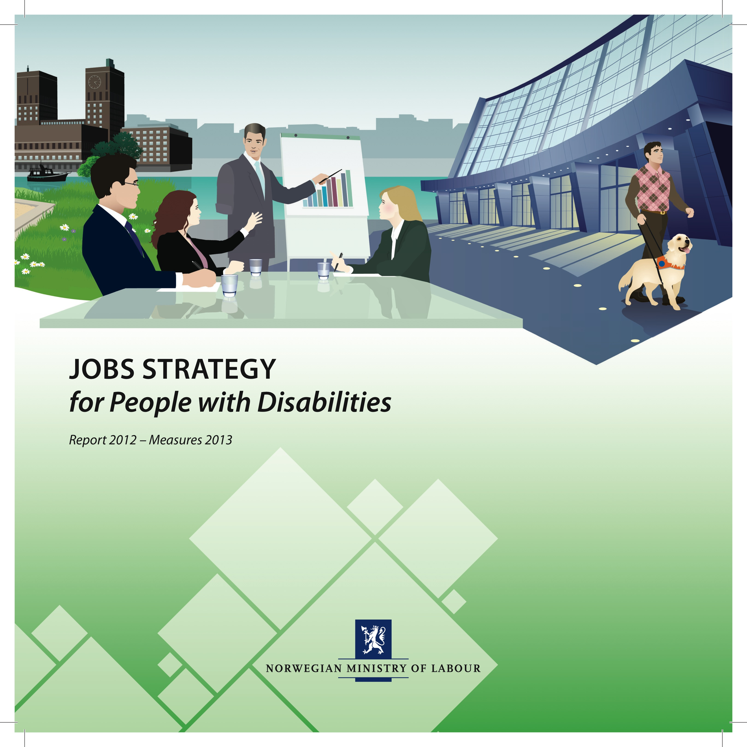

1. Foreword

Norway has a high employment rate and high productivity and value creation. Labour is our most important resource. Yet, a large proportion of the population is outside the labour market on public benefits. About 600,000 people of working age are outside the labour market in Norway.

Surveys show that the labour market participation rate is lower for people with disablities than for the general population, and that young people with disabilities struggle entering the labour market. During the second quarter of 2012, 84,000 unemployed persons with disablities, of which 18,000 were under the age of 25, stated that they wanted a job.

People with disabilities’ low rate of participation in the labour market affects not only the living conditions of the individuals concerned, but society as a whole. We know that intervention at an early stage can prevent people from ending up as long-term benefit recipients. The Agreement on a More Inclusive Working Life (IA agreement), is a response to this, and is high on the Government’s agenda. The Govern­ment’s vision is an inclusive labour market with equal rights, obligations and opportunities to participate for all. Everyone should have a chance to use their skills in the labour market for their own benefit, and for the benefit of society as a whole. In this way, we can achieve a richer and more diverse labour market, and increase welfare, productivity and value creation for the common good.

Based on this vision, the Government presented
the Jobs Strategy for People with Disabilities as an appendix to the National Budget for 2012. The National Budget for 2013 takes the Jobs Strategy forward, and strengthens it with further measures. The Government’s Jobs Strategy includes several measures to reduce barriers that impair people’s functional abilities in order to make the labour market accessible to more young people with disabilities. The Jobs Strategy aims to strengthen the Government’s cooperation with the social partners regarding sub-goal 2 of the IA agreement.

The Government cannot solve the challenges in the labour market alone, but will have to work closely with the social partners and organisations for disabled people. It is in individual workplaces and enterprises that people are employed and their skills and resources are utilised. We can only achieve a more inclusive labour market when each of us helps to break down the barriers.

Anniken Huitfeldt
Minister of Labour

Contents

1. Foreword page 3
2. Introduction page 6
3. Figures and statistics page 9
4. Report 2012 page 11

5. Initiatives in 2013 page 15
2. Introduction

The Jobs Strategy for People with Disabilities was introduced in 2012 and will continue in 2013. The main target group remains the under-30 age group.

By following up the new IA agreement for the 2010-2013 period, the Government and the social partners have increased their focus on raising labour market participation for people with disabilities. The importance of cooperating with the social partners has been a key element in the preparation of the Jobs Strategy. The social partners and the Government share responsibility for its implementation.

It is in individual enterprises and workplaces that inclusion takes place. We therefore need more enterprises willing to recruit young jobseekers with disabilities to permanent positions, summer jobs and trainee programmes or to provide places on labour market programmes. This applies equally to the state, municipal and private sectors. According to the IA Agreement, the social partners shall work actively to encourage enterprises to provide places on training and work experience programmes for people who are not in work, and for people with a reduced capacity for work or disabilities.

The Government will continue and strengthen the measures in the Jobs Strategy. Many measures have been launched aimed at increasing labour market participation and assisting employers who employ persons with disabilities or who provide places for work experience programmes, including facilitation and follow-up measures. These initiatives are supplementary to the Government’s overall policy of contributing to a more inclusive workplace for vulnerable groups.

In 2013, the Government will use government agencies as model services to serve as role models for other state entities. The agencies will undertake to provide work training and experience for young people with disabilities. The purpose of this is to gain experience from which other governmental agencies may learn in relation to recruitment, adaptation, facilitation, how to organise work, career development amongst others.

One important goal of this work is that the agencies should emphasise good practises for employing people with disabilities. The work will be done in close cooperation with the Norwegian Labour and Welfare Service. The Ministry of Government Administration, Reform and Church Affairs will also be involved, with the aim of ensuring good transfer of experience to other government agencies. The Norwegian Labour Inspection Authority and the Norwegian Public Service Pension Fund have been chosen to be model services.

The municipalities are important workplaces from an inclusion perspective. The Ministry of Labour has, in cooperation with the Norwegian Association of Local and Regional Authorities (KS), invited the municipalities of Sandnes, Bergen, Sarpsborg and Lindesnes to be model municipalities for the inclusion of more young people with disabilities in the labour market. The collaboration will be based on the policy instruments that the Government makes available through the Jobs Strategy, and will make use of available resources to ensure that systematic and targeted efforts will help more people into the labour market.
Through this work, the municipalities and the Norwegian Labour and Welfare Service will join forces in a systematic attempt to identify and register success factors and obstacles to increased goal attainment. The Norwegian Labour and Welfare Service will assist the municipalities by following them up closely and providing assistance with facilitation.

The organisations of disabled people are important
to assist the authorities and the social partners.
In order to facilitate the best possible implementation of the Jobs Strategy also in 2013, the Government plans to continue the close dialogue and cooperation with the social partners and the organisations of disabled people.
3. Figures and statistics¹

Every year, Statistics Norway conducts an ad hoc module survey on persons with disabilities in connection with its Labour Force Survey (LFS). This survey module covers people who state that they have physical or mental health problems of a permanent nature. In 2012, approximately 15 per cent of the population aged 15-66 years (521,000 persons) described themselves as disabled. This percentage has remained relatively stable over time.

The labour market participation rate is lower for persons with disabilities (41%) than for the general population (75%). The percentage of people employed dropped between 2008 and 2011, for people with disabilities and for the general population alike. The proportion of employed people with disabilities fell by one percentage point from 2011 to 2012. This modest decrease could be due to statistic uncertainty in the sample survey.

Half of all employed people who describe themselves as disabled work part-time. The unemployment rate is slightly higher for people with disabilities (about 6% of the labour force) than for the general population. One in four disabled people without employment state that they would like to work. This percentage has remained virtually unchanged over time.

Figures from the 2011 ad hoc module in the LFS indicate that people with disabilities who state that they receive health-related benefits and other people with disabilities should be considered two distinct groups. In 2011, the difference in employment rates between disabled people who stated that they received a health-related benefit and able-bodied people was 58 per cent. The difference in employment rates between other disabled people and able-bodied people was just eight percentage points.

4. Report 2012

In 2012, the Government presented a separate Jobs Strategy for People with Disabilities. The primary target group is people under the age of 30, and also includes people with disabilities who do not have a reduced capacity for work. It is still too soon to evaluate the results of this project. The results of the strategy will be examined, and an evaluation will be initiated during the spring of 2013.

During the first half of 2012, nearly half of the Jobs Strategy’s registered target group took part in labour market measures. This is a higher percentage than for the group of persons with a reduced capacity for work as a whole. This shows that young people under the age of 30 are given priority when places on labour market programmes are allocated. There is also an increase in the proportion of the target group to have undergone an assessment of their needs and capacity to work by the Norwegian Labour and Welfare Service, and who have thereby had their work capacity determined and had a plan for further employment-oriented assistance prepared.

All the counties have hired labour market coaches to work on the Jobs Strategy. These positions are based at the Inclusive Workplace Support Centres, and focus on following up the county’s enterprises and employers. Special county coordinators for the Jobs Strategy have also been appointed in all counties.

Special competence-raising programmes have been developed, one aimed at the labour market and one for employees of the Norwegian Labour and Welfare Service. An extensive information programme concerning the Jobs Strategy was implemented during the autumn of 2012.

The organisations of disabled people have been closely involved in work both on the competence-raising programme and on the communication strategy. This year, a special communications plan has been prepared, which highlights information and communication activities in different channels and media. The communication work is an integral part of the Jobs Strategy measures.

The use of the new mentor scheme and the functional assistance scheme has gradually been stepped up during the first six months of 2012.

The number of persons who have been given facilitation guarantees has increased significantly in 2012. As of August 2012, just over 3,000 persons had an active guarantee, compared with approximately 1,500 persons in August 2011. The facilitation guarantee is used both as a means of coordinating different forms of employment-oriented assistance and as a form of quality assurance for the work carried out.

The trial project offering workplace facilitation subsidies to jobseekers to cover various expenses incurred by the employer has so far been used less than expected. Usage is expected to be stepped up towards the end of the second half of 2012 and in 2013.

The Norwegian Labour and Welfare Service’s efforts in relation to persons with mental health problems have been considerable, among other things as part of the Escalation Plan for Mental Health and the National Strategic Plan for Work and Mental Health (2007-2012). An important part of this effort was related to cooperation and coordination of assistance in the labour and welfare sector and in the health and care sector. The strategy plan was completed at the end of 2012, and the resources linked to the plan will be continued within the ordinary scope of the Norwegian Labour and Welfare Service from 2013.
Several research studies relevant to the Jobs Strategy were published in 2012. One study calculated the profitability for society if more people with disabilities were employed. The socio-economic gains will be considerable if the Jobs Strategy succeeds.²

An interview survey of employers identified the problems faced by jobseekers with disabilities in the labour market. Many employers consider it a risk to employ persons with disabilities, and are therefore reluctant to take on the employer’s responsibility that it entails. There have also been reports about the difficult transition between education and the labour market for young people with disabilities. This information forms an important basis for the further development of the Jobs Strategy.³
elser. Denne informasjonen er et viktig grunnlag for den videre utviklingen av Jobbstrategien.

5. Initiatives in 2013

Occupational and educational travel
Occupational and educational travel is made a permanent, nationwide scheme from 2013.

Until now, occupational and educational travel for people with functional impairment has been a trial project in all the Norwegian counties except Norway’s capital Oslo. The trial project started in 2001.

The scheme is intended to help people with disabilities into employment and education. The trial was designed to fit with established transport and support schemes, and was intended to cover persons with diasabilities who fell outside the scope of the established schemes.

An assessment of the trial project under the auspices of the University of Nordland showed that occupatio­nal and educational travel has helped more persons with disabilities to find work and to work more than they would otherwise have been able to do.

The trial included users from all the counties except Oslo. The reason for this was that the City of Oslo had its own municipal system. The proposal for a permanent nationwide scheme in 2013 involves extending the state scheme to cover users in Oslo too. The state scheme is not intended to prevent the municipalities from operating municipally funded transport schemes as a supplement.

The budget has been increased by NOK 33 million, which brings the total amount allocated to occupational and educational travel in 2013 to NOK 63 million. Work will continue to determine how users in Oslo can be phased into the national scheme, including how to ensure that the scheme is expediently organised in Oslo during a transitional period.

Places on labour market programmes

900 places on labour market programmes are allocated to the Jobs Strategy in 2013. This is 400 more places than in 2012. The target group will also be given priority within all of the labour market measures.

Many of the Jobs Strategy’s policy instruments aim to reduce the employers’ perceived risk in employing a person from the target group. The plan for 2013 is to increase the focus on measures in the ordinary labour market.

It will be a priority to increase the use of work experience places in the ordinary labour market, wage subsidies and various follow-up schemes such as work with assistance, mentors and functional assistants. A new trial whereby employers receive subsidies for employing persons that meet the work assessment allowance requirements will also be available to the Jobs Strategy’s target group.

The National Strategic Plan for Work and Mental Health (2007-2012) was completed at the end of 2012. About 1,000 places on labour market programmes associated with this plan continue within the ordinary scope of the Norwegian Labour and Welfare Service from 2013 and onward. The work of developing the range of labour market measures available to this group will continue.

Permanently facilitated work
Permanently facilitated work, either in sheltered enterprises or in the ordinary labour market, is intended to provide meaningful work to people with minimal chances of entering the labour market on normal pay and with normal working conditions are slim. People with mental disabilities are an important target group for this measure, and accounts for one out of three participants.

The measure has been increased by 100 places, so that the funds allocated will permit an average of 9,200 places in labour market programmes in 2013. The funding for this measure has been separated, making it a separate budget item.

Public agencies as good examples
The Government has started an initiative in which selected municipalities and government agencies shall work in a goal-oriented and systematic way to include more young people with disabilities in the labour market.

The enterprises shall help to provide work training and experience for young people with disabilities, and to gain experience from which other agencies may learn.

The Norwegian Labour Inspection Authority and the Norwegian Public Service Pension Fund have been chosen as model government agencies. The Ministry of Government Administration, Reform and Church Affairs will participate with the aim of helping to ensure that experience is passed on to other government agencies.

The municipalities are also important arenas for inclusion. The Ministry of Labour has, in cooperation with the Norwegian Association of Local and Regional Authorities (KS), invited the municipalities of Sandnes, Bergen, Sarpsborg and Lindesnes to be model municipalities for the inclusion of more young people with disabilities in the labour market. The Norwegian Labour and Welfare Service will assist the municipalities by following them up and providing assistance with facilitation. The cooperation will be based on the policy instruments in the Jobs Strategy. One of the goals is to improve knowledge about the factors that promote and hinder labour market participation.

Initiatives targeting young people
It is important for the Government to prevent young people from being excluded from work and education. The Norwegian Labour and Welfare Service’s work has therefore been strengthened by allocating NOK 30 million to following up young people in 2013.

The Government has changed the way in which the guarantee schemes are organised for young people aged 20-24 years in 2013. The target group for the guarantees are changed from including only unemployed young people to also including young people with a reduced capacity for work, including those with disabilities.
Many young people have complex needs, and require coordinated assistance from several agencies. This is resource-intensive work, and experience has shown that the largest Labour and Welfare Offices face the greatest challenges in their follow-up work with young people.

The Government wants to establish special contact persons in 2013 for the largest Labour and Welfare Offices’ work of following up young people who are not employed or in education. This will particularly strengthen the offices’ possibilities of providing well coordinated follow-up of young people with complex challenges.

New trial projects
Wage subsidies
The Government has initiated a trial project in the counties of Hordaland, Oslo, Vest-Agder and Østfold in which employers will receive subsidies to employ people who meet the requirements for the work assessment allowance. Young recipients of the work assessment allowance will be given priority. Sixteen per cent of work assessment allowance recipients are under 30 years old, and most of this group has little or no work experience.

This trial project, together with the Jobs Strategy is expected to help more people becoming permanent members of the working population after a period on labour market measures. It will be possible for the participants in this labour market measure to work part-time or full-time for up to three years, and they will be temporarily employed during this period. Up to 40 per cent of the employer’s wage costs will be covered.

This trial project will start in 2013 and last for a period of five years. The plan is to have 300 participants at the end of the first year, and a maximum of 500 participants. In addition to wage subsidies to the employer, funds will be set aside to follow up both the employer and the participants.

Performance-based funding
The plan is to start a trial project with performance-based funding in connection with the follow-up of people with a reduced capacity for work during the last half of 2013. The purpose of the project will be to test whether financial incentives have an effect in stimulating the organisers of labour market measures to increase their efforts to help more people with a reduced capacity for work to gain entry to the labour market.

Individual follow-up
It will be considered whether to start a trial based on a special follow-up method that is internationally known as ‘supported employment’. The goal is early placement in the labour market and close follow-up with clear quality requirements of work performed. This follow-up is intended to help to ensure that people are taken on and retained in the ordinary labour market.

Ongoing trial projects
Facilitation subsidies and facilitation guarantees
The allocation of NOK 25 million to the facilitation subsidy trial continues in 2013.

A facilitation subsidy trial for jobseekers with a reduced capacity for work was initiated in 2012. The target group for this trial is people with a reduced capacity for work who are outside the labour market. Facilitation subsidies will make it possible for employers to cover costs that may be incurred in connection with various adaptations of the work situation.

Enterprises that help jobseekers with a reduced capacity for work to find a job or participate in labour market programmes in the ordinary labour market are eligible for such subsidies. Subsidies can also be granted for courses and short-term training measures. Expenses relating to the purchase of items and work aids can also be covered, in the same way as in the existing system for employees on sick leave.

The use of facilitation guarantees and contact persons in the Norwegian Labour and Welfare Service will also continue on the basis of the good experience gained from this project in 2012. This is intended to make it easier for the Norwegian Labour and Welfare Service to follow up the Jobs Strategy’s target group more closely.

Follow-up by functional assistants and mentors
The work relating to the functional assistance trial in the labour market were improved in 2012. The allocation of just over NOK 30 million continues in 2013.

The purpose of the trial scheme for functional assistance in the labour market is to make it easier for persons with severe physical impairments to work. The scheme entails an assistant to help individuals with practical tasks in their everyday work.

Follow-up by means of mentors will continue within the framework of the regulations introduced in 2012. The scheme is intended to ensure that the employees and participants in the labour market measure receive the required professional, social and practical support in the place of work or training.

Individual job support
The National Strategic Plan for Work and Mental Health (2007-2012) is a special initiative aimed at helping people with mental health problems to find work. The strategy plan was completed at the end of 2012, and the resources linked to the National Strategic Plan continues within the ordinary scope of the Norwegian Labour and Welfare Service from 2013. The continuation of the Jobs Strategy will also benefit young people with mental health problems.

In addition, the Norwegian Labour and Welfare Service and the Directorate of Health will continue to work together on testing a form of individual job support. This was developed to give people with mental health problems the necessary medical assistance in combination with individual follow-up aimed at them finding jobs in the ordinary labour market.
This form of follow-up is known internationally as ‘Individual Placement and Support’ (IPS). The follow-up is based on a close, binding cooperation between the municipality, the health service and the Norwegian Labour and Welfare Service, and helps underpin and further develop policy instruments relating to the Jobs Strategy.

Occupational rehabilitation
The method development trial in the occupational rehabilitation measure will continue. The purpose of this trial project is to test, develop and evaluate methods and models in occupational rehabilitation with a view to making users more able to find or retain employment. The trial will be evaluated.
NOK 13.1 million are allocated as funding for the occupational rehabilitation method development project in 2013.

Indefinite wage subsidies trial
The indefinite wage subsidies (TULT) trial project will continue in 2013. The purpose of TULT is to improve the possibility that people with a permanently and significantly reduced capacity for work will find ordinary employment, and to prevent people from ending up on disability pensions.

Earmarked positions in NAV
In order to facilitate the Norwegian Labour and Welfare Service’s work of implementing the Jobs Strategy, funding for special labour market coaches at the Inclusive Workplace Support Centres and county coordinator positions for the Jobs Strategy in all the counties continues.

Funds have also been allocated for the continuation of the information development and competence-raising work associated with the Jobs Strategy under the auspices of the Norwegian Labour and Welfare Service. This work includes both a competence-raising programme aimed at the labour market and a programme for Norwegian Labour and Welfare Service employees.

Job creation projects
The subsidy scheme for job creation projects is a policy instrument that can help people with disabilities who want to start their own business to achieve this goal. The Norwegian Labour and Welfare Service supports providers of courses that provide training and guidance to potential entrepreneurs.

An evaluation carried out by Rambøll on behalf of the Directorate of Labour and Welfare shows that this scheme has had generally positive effects. Owning one’s own business can be a good option for people with disabilities, since this can be a flexible arrangement in terms of working hours, physical presence in the workplace and the possibility of adapting work to variations in one’s ability to work. The respondents felt that the courses were educational, useful and enabled them to start their own businesses. The scheme targets the unemployed and persons with a reduced capacity for work.

Technical aids
Expenses relating to technical aids have increased in recent years, particularly when it comes to interpreters for hearing-impaired people in work and education. Many young people with hearing impairments take higher education. There has also been an increased focus on interpreting at work as a result of the ‘Interpreter in the workplace’ trial under the auspices of the assistive technology centres in four counties. Expenses relating to physical adaptation of workplaces has remained stable for the past three years.

The number of cases concerning technical aids in the workplace received by the Norwegian Labour and Welfare Service has decreased between 2008 and 2011. This reduction could indicate that employers tend to cover the expenses for workplace adaptation to a somewhat greater extent than before, rather than applying for a grant. Equipment that used to be considered special equipment is increasingly becoming standard goods. Expenses per case have increased somewhat, and the technical aids expenses have therefore stabilised.

The proposed allocation for 2013 is NOK 145 million.

Work and physical activity
People with disabilities are among the priority target groups of sports and labour market policies alike. Physical activity promotes health and forms a basis for inclusion in society and in the labour market. There are different forms of contact and cooperation between the Norwegian Labour and Welfare Administration, municipalities and local sports organisations. The cooperation includes various projects and measures relating to rehabilitation and inclusion. One of the goals of this cooperation is to motivate and recruit people with disabilities for participation in the labour market. The Government also wants to encourage cooperation between the labour authorities and sports organisations with the goal of providing activities for people who, for various reasons, are not active in the labour market, cf.
Report No 26 to the Storting (2011-2012). Den norske idrettsmodellen (‘The Norwegian sports model’
– in Norwegian only).

Jobs Strategy for People with Disabilities, Annex to Proposition to the Storting 1 S (2011–2012)
For a more detailed description of the Jobs Strategy for People with Disabilities see the Annex to Proposition to the Storting 1 S (2011–2012), submitted together with the National Budget for 2012, see the following link on the Government website regjeringen.no:

http://www.regjeringen.no/en/dep/ad/dok/rapporter_planer/planer/2011/jobstrategy.html?id=657116

Total overview of measures in 2013
Jobs Strategy for People with Disabilities

Occupational and educational travel
Places on labour market programmes
Permanently facilitated work
Public agencies as good examples
Initiatives targeting young people
New trial projects
Wage subsidies
Performance-based funding
Individual follow-up
Ongoing trial projects
Facilitation subsidies and facilitation guarantees
Follow-up by functional assistants and mentors
Individual job support
Occupational rehabilitation
Indefinite wage subsidies trial
Earmarked positions in NAV
Labour market coaches at the Inclusive Workplace Support Centres
County coordinators for the jobs strategy
Job creation projects
Technical aids
Work and physical activity

Utgitt av:
Arbeidsdepartementet

Offentlige institusjoner kan bestille flere
eksemplarer fra:
Departementenes servicesenter
Internett: www.publikasjoner.dep.no
E-post: publikasjonsbestilling@dss.dep.no
Telefon: 22 24 20 00

Publikasjonskode: A-0036 B
Design: Magnolia design as
Illustrasjon: Grafisk Form
Trykk: Grøset Trykk 01/2013 – opplag 3000

² Arild H. Steen et al.: Samfunnsøkonomisk analyse av økt sysselsetting av personer med nedsatt funksjonsevne. (‘A socio-economic analysis of increased labour market participation for people with disabilities’). Work Research Institute report 5/2012. ³ Eivind Falkum: Risiko og inkludering (‘Risk and inclusion’). Work Research Institute report 11/2012.

