Council on Ethics for the Norwegian Government Pension Fund Global
Annual Report 2023
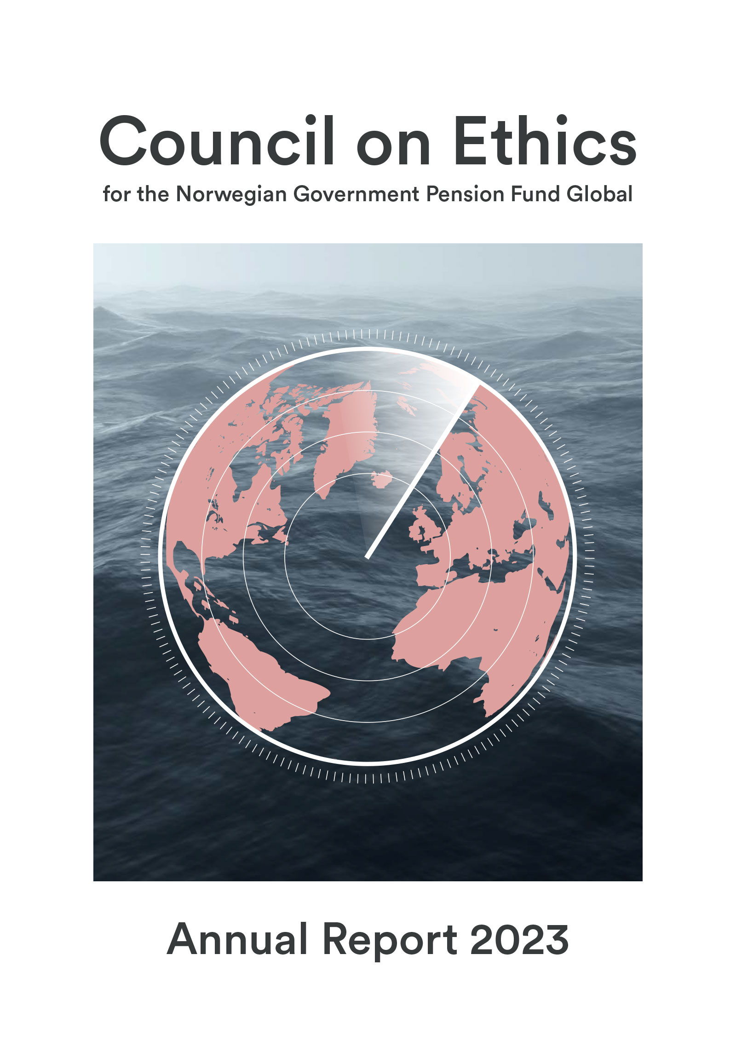

Foreword by the Council’s chair
Having previously served on the government-appointed Ethics Commission, from 2019 to 2020, and after some two years getting up to speed as a council member, this has been my first year as Chair of the Council on Ethics. I hope that the experience I have acquired through 34 years at Norsk Hydro, 10 of which as the CEO, as well as directorships in many Norwegian and international companies, will prove useful. Given the complex issues and perspectives that the Council works with, our most valuable and important success factor is the expertise and diversity which both the Council’s members and the staff of our eminent secretariat collectively bring to the table.
Over the years, the Council has built up a solid international reputation. It is clear to me that expectations with respect to the Council’s work will not lessen as the years go by. It is therefore with all due respect for the role that I now take up the baton previously held so sturdily by my predecessor as chair, Johan H. Andresen. I would like to express my heartfelt gratitude to Johan for his skilful leadership of the Council from 2015 until the summer of 2023.
Norway’s Government Pension Fund Global (GPFG) owns shares in approximately 9,000 companies worldwide. The Council’s purpose is to uncover any unacceptable risk that these companies are violating ethical norms, regardless of where in the world the abuses take place. You may think that sounds like an impossible task. However, through various portfolio-monitoring systems, the Council is presented with hundreds of news reports on GPFG-invested companies that may be linked to norm violations that could fall within the scope of the Fund’s ethical guidelines. Our main priority is to uncover the most serious violations and the companies most closely associated with them. If we consider the risk of future norm violations to be unacceptable, we recommend that Norges Bank either excludes the companies concerned from investment by the GPFG or places them under observation.
The Guidelines for Observation and Exclusion of Companies from the Government Pension Fund Global (GPFG), otherwise known as the ethical guidelines, form the basis for the Council’s assessments. In recent years, the Council has devoted considerable resources to assessing companies in situations of war or armed conflict. In such situations, companies must take particular care not to contribute to serious norm violations. Under the ethical guidelines, however, a company’s mere presence in an area of conflict is not sufficient grounds for its exclusion from the GPFG. In 2023, the Council has assessed companies operating in areas of conflict in relation to several of the ethical guidelines’ criteria. This includes those relating to war and armed conflict, the production and sale of weapons, and the umbrella criterion “other particularly serious violations of fundamental ethical norms”.
Other topics we have covered in 2023 include abuse of Indigenous peoples’ rights, poor working conditions, corruption, money laundering, deforestation in vulnerable areas, the further endangerment of already threatened species and animal cruelty. Societal changes, or changes in accepted norms, impact where the Council focuses its efforts. For example, the Kunming-Montreal Global Biodiversity Framework from 2022 has already played, and will continue to play, an important role in our assessments. Digitalisation and artificial intelligence (AI) are also topics that will become increasingly important in the years ahead.
The Council generally engages in extensive dialogue with the companies it is assessing. Some companies are highly responsive and openly share data and information, whereas others fail to reply when we contact them. In addition to information provided directly by the companies concerned, the Council relies on a range of different sources. We are wholly dependent on being able to engage external consultants and speak with subject experts in order to build an adequate factual basis for our assessments. However, access to information has worsened in some parts of the world in recent years. In some cases, we see that people working “on the ground” for NGO’s, the media or other organisations put themselves and their lives in danger. This is something that we must take into account, so that we do not make the situation worse for these individuals. If it is dangerous or impossible to conduct a thorough investigation, and the companies under assessment fail to provide adequate information, the Council may conclude that the risk to the GPFG is unacceptably high.
In many countries, businesses are facing rising expectations with respect to corporate social responsibility (CSR). From the Council’s point of view, new reporting standards and follow-up requirements are helpful. The EU has adopted new legislation, with effect from 2024, which includes a double materiality requirement. Double materiality means that a company must report on its global impact as well as its financial results. A growing demand for reporting transparency may contribute to increased compliance with ethical standards and make businesses operate more sustainably. However, such a development is unlikely to affect all companies worldwide. The Council’s endeavours to identify companies that represent an unacceptable risk of future violation of the GPFG’s ethical guidelines will therefore remain as necessary as ever.
Svein Richard Brandtzæg, Chair of the Council on Ethics

Members of the Council on Ethics
The Council on Ethics
Svein Richard Brandtzæg (Chair)
Brandtzæg has a doctorate in engineering from the Norwegian University of Science and Technology (NTNU) and a diploma in business administration from BI Norwegian Business School. Over the course of 34 years, he occupied a variety of positions at Norsk Hydro ASA, both in Norway and abroad. For 10 years up until 2019, he was the company’s CEO. Brandtzæg has served on the boards of directors of numerous enterprises and industry associations. He is currently chair of Dormakaba AG and a director of Mondi PLC and Eramet Norge AS.
Siv Helen Rygh Torstensen (Vice Chair)
Rygh Torstensen is a lawyer, who is currently EVP Legal & Compliance at Equinor ASA. She has worked for Equinor in a variety of roles since 1998, mostly in the Legal & Compliance Department. She has previously served as the company’s Chief Compliance Officer. Torstensen also headed the CEO’s Office for three years until August 2019. Before joining Equinor, she worked as a lawyer with the law firm Cappelen & Krefting DA and in Stavanger City Council’s Legal Services Department.
Cecilie Hellestveit
Hellestveit is a lawyer, with a doctorate in humanitarian law. She also holds an MPhil in Middle Eastern Studies. Hellestveit has worked at various research institutions, including PRIO, SMR, NUPI, IKOS and ILPI. She has also been affiliated with the Atlantic Council in Washington DC and the Max Planck Institute in Germany. She is currently a researcher at the Norwegian Academy of International Law and is a special advisor at the Norwegian National Human Rights Institution. Hellestveit has authored a textbook on the international law of war and several books on contemporary armed conflicts.
Vigdis Vandvik
Vandvik has a PhD in plant ecology and is a professor at the Department of Biological Sciences at the University of Bergen, where she also heads the CeSAM Centre for Sustainable Area Management. Since 2017, she has been affiliated with the Bjerknes Centre for Climate Research. Vandvik has extensive experience at the intersection between research, public administration and environmental policy, and has participated in a number of national and international research projects, knowledge processes and committees. She has also participated in various advisory councils and commissions. She is the lead author of several reports published by the Intergovernmental Science-Policy Platform on Biodiversity and Ecosystem Services (IPBES).
Egil Matsen
Matsen holds a PhD in Economics from the Norwegian School of Economics and Business Administration (NHH) and is currently Professor of Economics at the Norwegian University of Science and Technology (NTNU). Matsen has previously served as Deputy Governor of Norges Bank, with particular responsibility for the Government Pension Fund Global (GPFG) and was a member of the Bank’s Executive Board. He has also been employed as CEO of Forte Fondsforvaltning, professor and head of the Department of Economics at the NTNU, and as a scientific advisor in Norges Bank’s research department. He is currently a member of KLP’s Board of Directors.
Secretariat
The Council has a Secretariat that investigates and prepares cases for the Council. At the close of the year, the Secretariat had eight employees, and is headed by Eli Lund.

The work of the Council on Ethics
The Council on Ethics for the Norwegian Government Pension Fund Global is an independent body that makes recommendations to Norges Bank to either exclude companies from the GPFG or place them under observation. The Council’s assessments are based on ethical guidelines for the GPFGs investments, determined by the Norwegian Ministry of Finance. The guidelines contain both product-based exclusion criteria, targeting the production of tobacco, cannabis, coal or certain types of weapons, and conduct-based exclusion criteria, such as serious financial crime, the sale of weapons to certain states, human rights abuses and environmental damage. The threshold for exclusion is intentionally high. The guidelines are forward-looking and apply to unacceptable conditions that are ongoing or may occur in the future. They are not meant to be a mechanism through which to punish companies for past actions. All the Council’s recommendations are published on its website as soon as Norges Bank has announced its decision.
Portfolio monitoring and information gathering
The Council constantly monitors whether companies in which the GPFG has invested engage in operations that fall within the scope of the Guidelines for Observation and Exclusion from the Government Pension Fund Global. The Council works on many cases and issues in parallel. Several consultants have been commissioned to identify companies whose operations may be covered by the exclusion criteria. In addition, the Council monitors a number of databases and websites containing information on, for example, corruption, weapons sales or companies’ human rights abuses. The Council is also approached by organisations and individuals who call on it to consider specific cases. These contacts may be made directly to the Council or forwarded from Norges Bank.
The Council assesses every company that the portfolio-monitoring process flags up in relation to the product-based criteria. However, cases relating to the conduct-based criteria are highly heterogeneous. The Council therefore selects only certain cases for further investigation on the basis of the violation’s scope and seriousness, its consequences, the company’s responsibility for or contribution to the matter concerned, what the company is doing to prevent or mitigate the harm caused, and the risk of similar incidents occurring in the future.
Access to information varies significantly from country to country. To compensate for the fact that not all serious cases are picked up on through day-to-day portfolio monitoring, the Council undertakes its own inquiries into areas of high risk. When the Council has selected a particular issue for further investigation, it generally follows this up over several years. For example, the Council has focused on companies that dispose of decommissioned vessels for breakup at yards where working conditions and environmental safeguards are extremely poor since 2017, and has kept a keen eye on the extraction of natural resources from Western Sahara since as far back 2005.
The Council obtains information from research environments as well as national and international organisations, and often commissions third-party consultants to investigate specific cases. The Council also communicates with company officials during the assessment process.
            - The Council on Ethics’ activities in the period 2021–2023
Year | 2021 | 2022 | 2023
No. of limited companies in the GPFG at year-end | 9340 | 9228 | 8859
No. of companies excluded at the recommendation of the Council on Ethics at year-end | 80 | 91 | 92
No. of companies placed under observation at the recommendation of the Council on Ethics | 9 | 9 | 12
No. of companies on which the Council on Ethics issued a recommendation during the year | 21 | 21 | 16
No. of companies excluded during the year at the recommendation of the Council on Ethics | 12 | 13 | 6
No. of companies placed under observation during the year | 3 | 4 | 5
No. of observations concluded during the year | 0 | 4 | 2
No. of exclusions revoked during the year | 3 | 2 | 2
No. of new cases accepted for assessment during the year | 91 | 81 | 102
No. of cases concluded during the year | 86 | 79 | 100
Total no. of companies under assessment during the year | 195 | 193 | 209
No. of companies the Council has been in contact with | 66 | 71 | 69
No. of companies the Council has met with | 12 | 14 | 11
No. of Council meetings | 14 | 10 | 10
Secretariat (no. of staff) | 8 | 9 | 9
Budget (NOK million) | 18 | 20.2 | 18,1
The table summarises the scope of the Council’s assessment of companies in 2023, compared with in 2022 and 2021. Companies excluded by Norges Bank under the coal criterion, without the Council’s recommendation, are not included in the table. Companies that have been delisted from a stock exchange are removed from the list of excluded companies as and when delisting occurs. This applied to three companies in 2023.
Summary of the Council’s activities in 2023
Table 2.1 provides an overview of the Council’s activities over the past three years. The companies in which the GPFG has invested form the starting point for the Council’s endeavours. At the close of 2023, the GPFG had invested in just under 9,000 limited companies headquartered in more than 70 countries.
At the close of 2023, 92 companies were excluded from investment by the GPFG at the recommendation of the Council on Ethics. A further 12 companies were under observation. In addition, Norges Bank has, at its own initiative, excluded 72 companies under the coal criterion and placed a further 12 under observation. Since 2022, Norges Bank has also been permitted to assess companies under the climate criterion without needing a recommendation from the Council. So far, however, the Bank has not published any such decisions.
The Council issues recommendations to Norges Bank, which makes a decision on the case in question. In 2023, the Council issued recommendations on 15 companies. Ten recommendations related to exclusion, two to the revocation of exclusion, one to observation and two to the termination of observation.
Since Norges Bank performs a thorough assessment of all the Council’s recommendations, and it also takes time to divest shares in companies, some of the decisions published in 2023 relate to recommendations issued by the Council in 2022. For the same reason, not all the recommendations from 2023 have yet been published. All recommendations are published on the Council’s website at the same time as Norges Bank announces its decision after the securities have been sold.
The Council always has many cases in progress, and it is common to have cases under assessment in relation to the majority of exclusion criteria. It is not unusual for a company to be the subject of several different cases. We also have cases involving more than one company. In 2023, the Council worked on a total of 223 cases, relating to 209 different companies. Of these, 102 were opened during the year, while 52 were opened in 2022. The assessment of 100 cases was concluded during the year. This includes cases on which a recommendation was issued to the Bank, cases where no grounds for exclusion or observation were found, and cases relating to companies in which the GPFG was no longer invested. The Council investigated five companies which left the GPFG without a recommendation being issued.
          - Status of new cases opened during the year
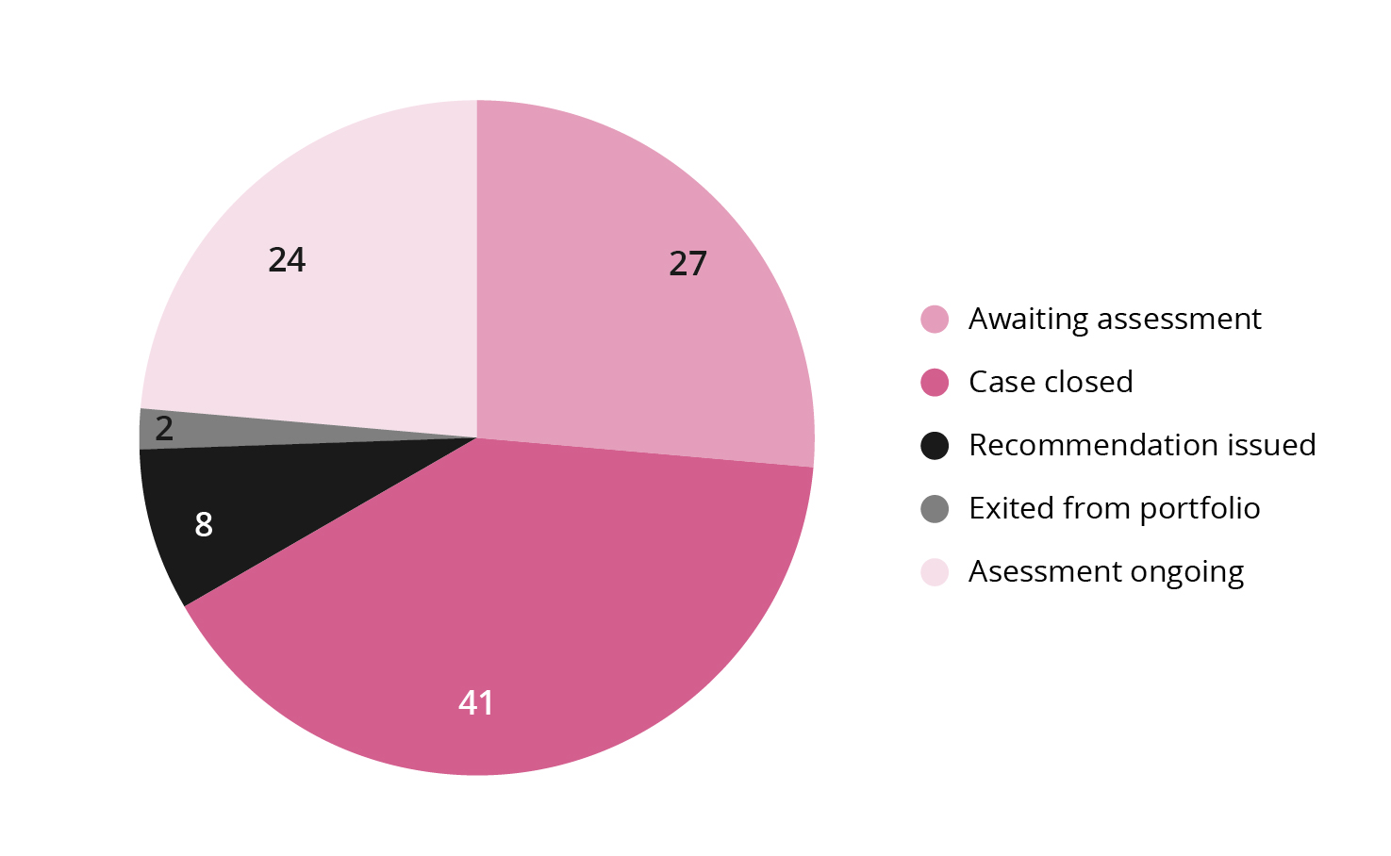
Fig. 2.1 shows how the 102 cases opened for assessment in 2023 were dealt which. The majority of cases do not end in a recommendation to exclude a company or place it under observation, but are shelved at an earlier stage in the assessment process. With respect to the 102 new cases in 2023, eight resulted in recommendations to exclude or place a company under observation, or to terminate a company’s exclusion or observation period, while 41 were shelved. The assessment of two new cases was terminated because the companies were no longer in the portfolio, 24 cases are still under assessment, while the assessment of 27 cases has not yet commenced.
The risk of gross corruption in the construction industry was the basis for assessment in 16 of the cases opened in 2023. The vast majority arose from a general review of corruption cases linked to companies in this business sector. Other frequent topics relate to the production and sale of weapons, operations in areas of war or conflict, labour rights violations or loss of biodiversity.
          - Regional breakdown of the GPFG’s 8,859 shareholdings at the close of 2023
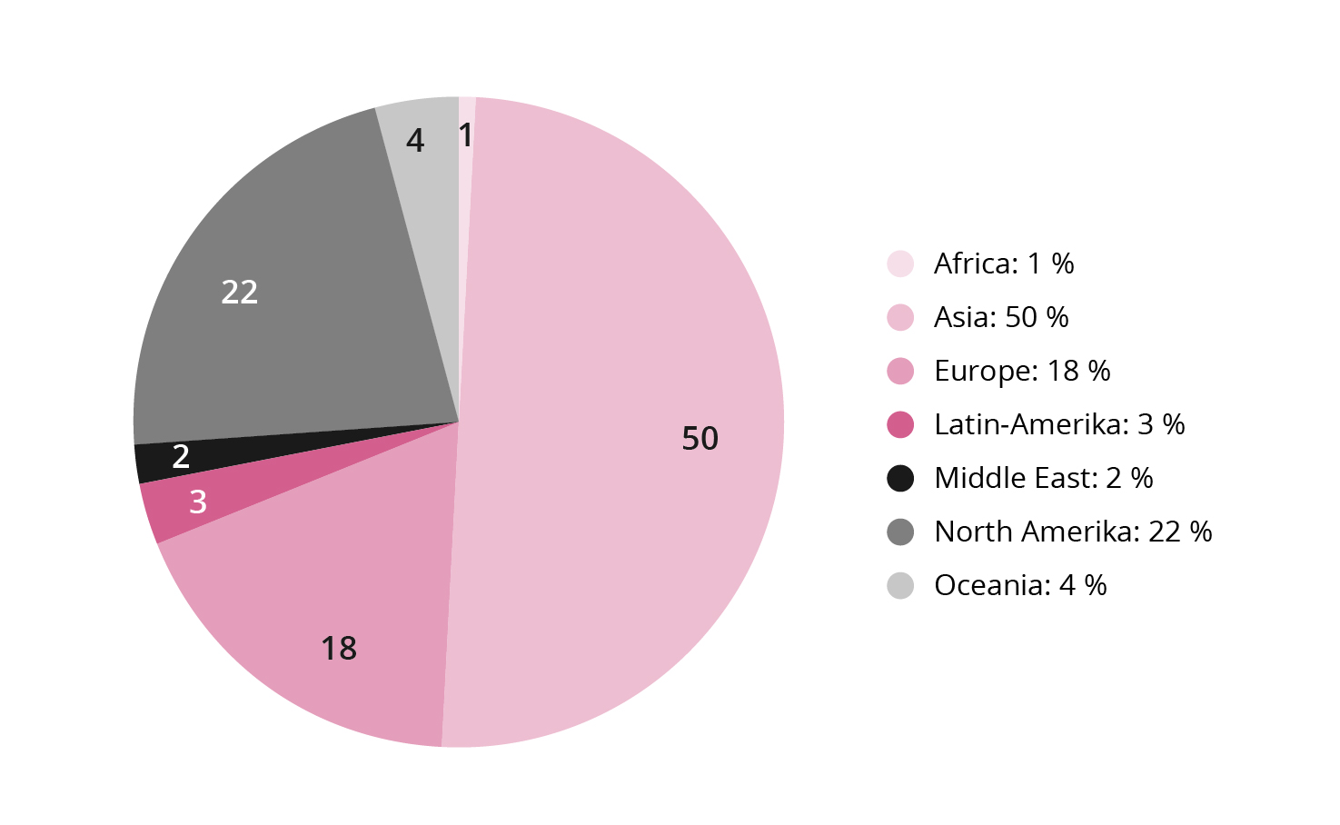
          - Regional breakdown of the companies assessed by the Council
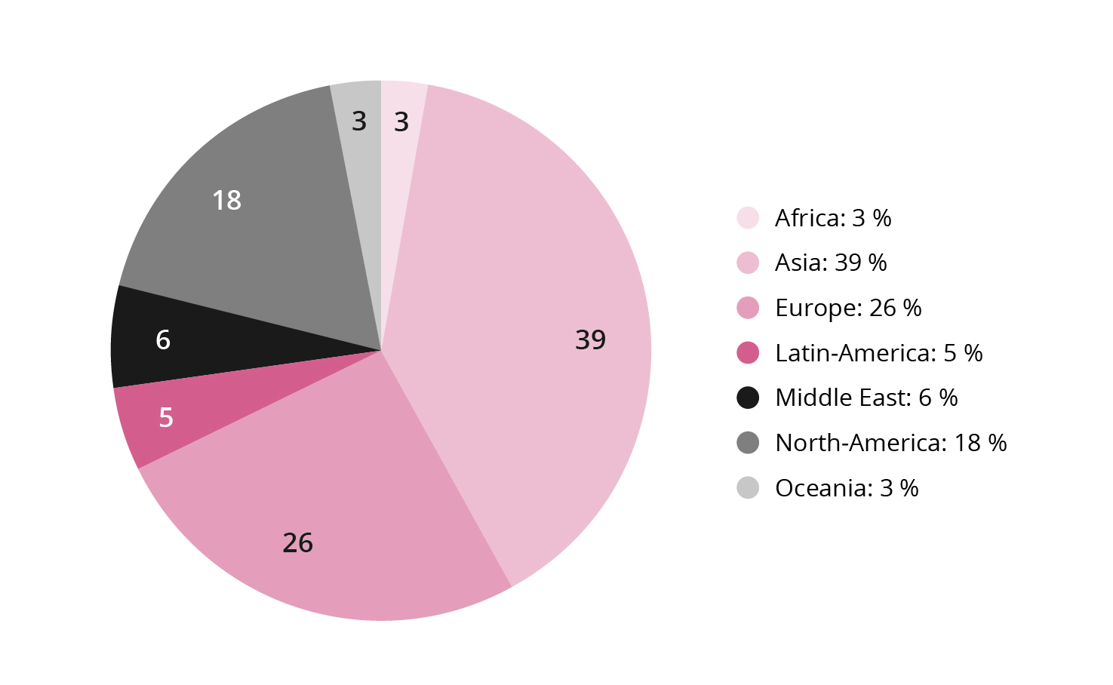
Fig. 2.2 shows the regional breakdown of the GPFG’s shareholdings at the close of 2023, while fig. 2.3 shows the regional breakdown of the companies assessed by the Council during the year. The geographic distribution of the companies assessed by the Council varies from year to year. While in previous years the Council on Ethics has had a slight overweight of Asian companies under review, compared with the proportion of Asian companies in the portfolio, in 2023 there was a corresponding overweight of European companies under review. This is partly due to a decline in European companies in the portfolio towards the end of the year, while the proportion of Asian companies has increased.
Around half of the 80 or so Asian companies that the Council assessed in 2023 relate to human rights abuses, primarily poor working conditions and forced labour. Gross corruption and serious environmental damage were otherwise the predominant grounds for assessment. The Asian companies are often examined as part of a review of issues that the Council monitors particularly closely because the ethical risk is high. This applies, for example, to the risk of migrant worker exploitation in multiple countries, human rights abuses in China’s Xinjiang province and the risk that companies operating in Myanmar are contributing to the military junta’s abuses. Some companies are identified through the general portfolio monitoring process. Eleven of the companies on which the Council issued recommendations in 2023 were from Asia.
In 2023, the Council has worked with almost 60 companies from 16 different European countries. In the past couple of years, the majority of cases have related to the risk of corruption and other financial crime, as well as various human rights abuses. The human rights cases involve violation of labour rights, forced migration and violation of the rights of Indigenous peoples. Two of the companies on which the Council issued recommendations in 2023 are European.
Around 50 companies are domiciled in the Americas. The predominant grounds for assessment in these cases are human rights abuses and gross corruption. The other cases are evenly spread across the other criteria for which the Council is responsible. One of the companies on which the Council issued a recommendation in 2023 is from North America.
          - Countries with most companies under assessment
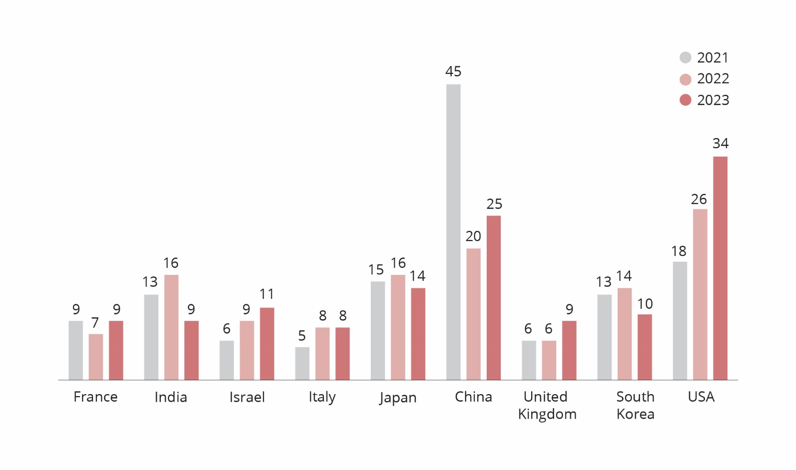
Fig. 2.4 shows the number of companies under assessment in 2021, 2022 and 2023 from the nine countries from which most companies under assessment in 2023 were drawn. In 2022, Malaysia was included in a similar presentation.
The number of companies from the USA which are under assessment continued to rise in 2023. These cases relate to a variety of norm violations across the majority of criteria. Most of the companies assessed under the weapons-related criteria are domiciled in the USA. There is now a better correlation than before between the proportion of US companies under assessment and the number of US companies in the GPFG.
          - Breakdown of the Council’s work by criterion
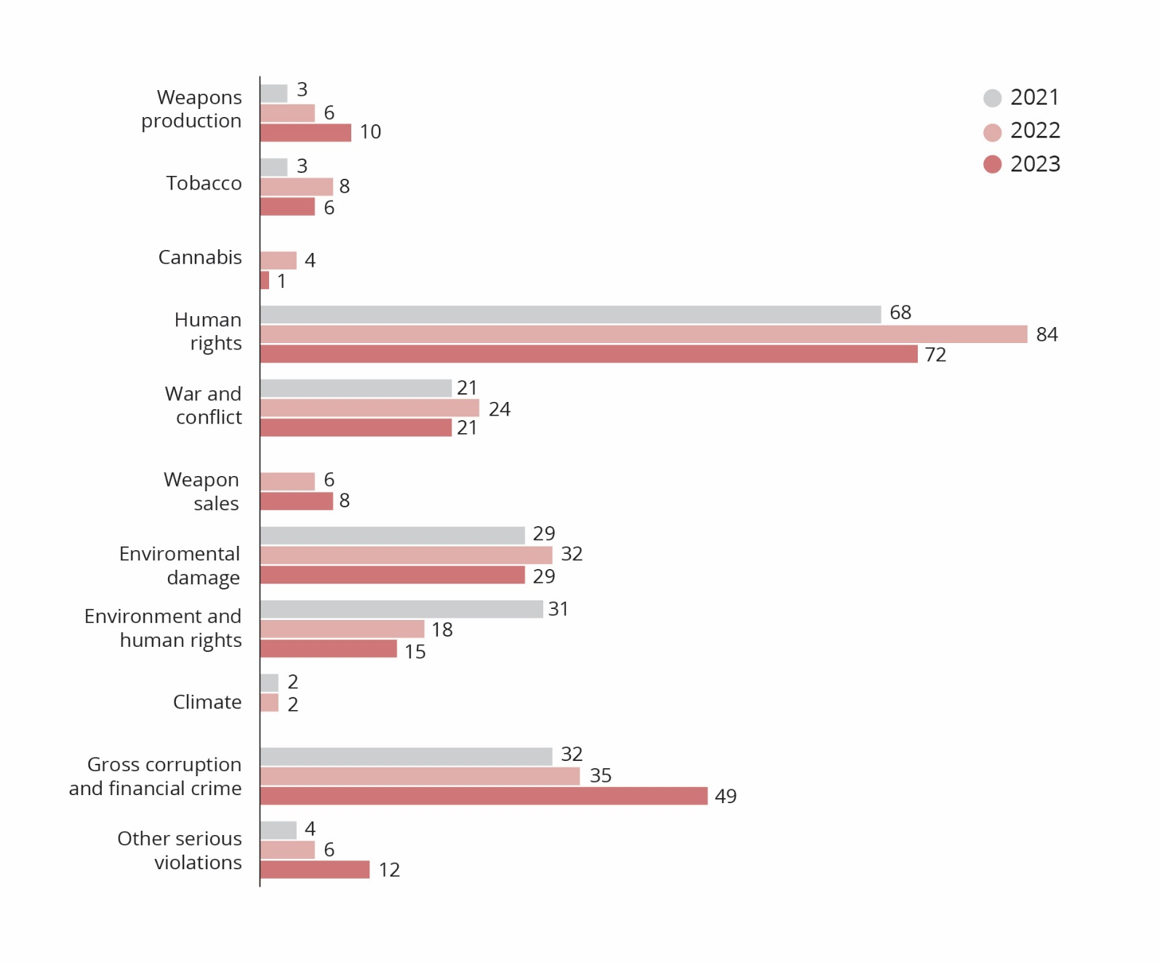
Work under the various criteria
Fig. 2.6 shows a breakdown of the cases the Council has worked on in 2023, by exclusion criteria. There has been a sharp increase in the number of companies being assessed in relation to financial crimes, while the number of cases under assessment in relation to the criteria “Other serious violations” and “Production of certain types of weapons” has continued to rise. This is partly due to the changes in the guidelines resulting from the Ethics Commission’s report. These included an expansion of the corruption criterion to also encompass other forms of financial crime; serious abuse of animal welfare was clearly designated within the criterion for other serious violations; while the product-based weapons criterion was expanded to also encompass nuclear weapon delivery platforms.
Human rights cases continue to predominate, followed by financial crime. Many of these cases spring from investigations the Council has itself initiated. These may be based on suppositions about the risk of forced labour in some countries or corruption in certain business sectors. The Council initially assesses all companies with operations that may be exposed to this risk. It then selects the companies where the risk appears to be greatest and contacts them to request information that can confirm or disprove the Council’s suppositions. In such assessments, a large number of companies may undergo a preliminary assessment, while the focus is relatively quickly narrowed to just a few.
Around half of the human rights cases relate to labour rights. In addition, the Council continues to focus on the abuse of Indigenous peoples’ rights. Indigenous people are often vulnerable to abuse in connection with the extraction of natural resources and infrastructure building, and there are also cases where companies have established plantations on land claimed by Indigenous people. Furthermore, the Council is still closely monitoring companies that dispose of decommissioned vessels to be broken up for scrap at yards where working conditions and environmental safeguards are poor. Companies investigated in relation to shipbreaking are assessed under both the human rights criterion (extremely poor working conditions) and the environment criterion (pollution).
In 2023, the Council has assessed a number of cases under the war and conflict criterion, where GPFG-invested companies have financial partnerships with companies controlled by the armed forces in Myanmar. Other cases have related to the West Bank and Gaza, as well as companies with operations in Russia.
The loss of biodiversity is the predominant basis for assessment under the environment criterion, followed by industrial pollution. The four companies whose exclusion the Council recommended under the environment criterion in 2023 all related to the loss of biodiversity.
The main focus for the cases assessed under the financial crime criterion was corruption in the construction industry and banks that fail to comply with the legislation intended to prevent and deal with suspicions of money laundering. A survey of corruption cases relating to a large number of companies was carried out in 2023. Many of these were shelved at an early stage in the assessment process.
With regard to the criterion concerning other serious abuses of fundamental ethical norms, the Council has focused particularly on the risk of serious animal welfare abuses. This criterion is applied to all serious norm violations that do not naturally fall within the scope of the other criteria. The types of cases therefore differ widely. In 2023, they ranged from the risk of damage to cultural heritage sites to involvement in Russia’s war of aggression against Ukraine.
Contacts with companies
Figures 2.7 and 2.6 show breakdowns of the Council’s contacts with companies in 2023, by criterion and by region. The Council has been in contact with 69 companies and held meeting with 11 of these. The Council contacts companies which, following a preliminary assessment, it wishes to study in more detail. The Council initially asks the company for information that could provide a better foundation for an assessment of its operations. Every company that is assessed in relation to the conduct-based criteria is given the opportunity to comment on a draft recommendation, before the Council issues its recommendation to Norges Bank.
          - Breakdown of contacts with companies by criterion
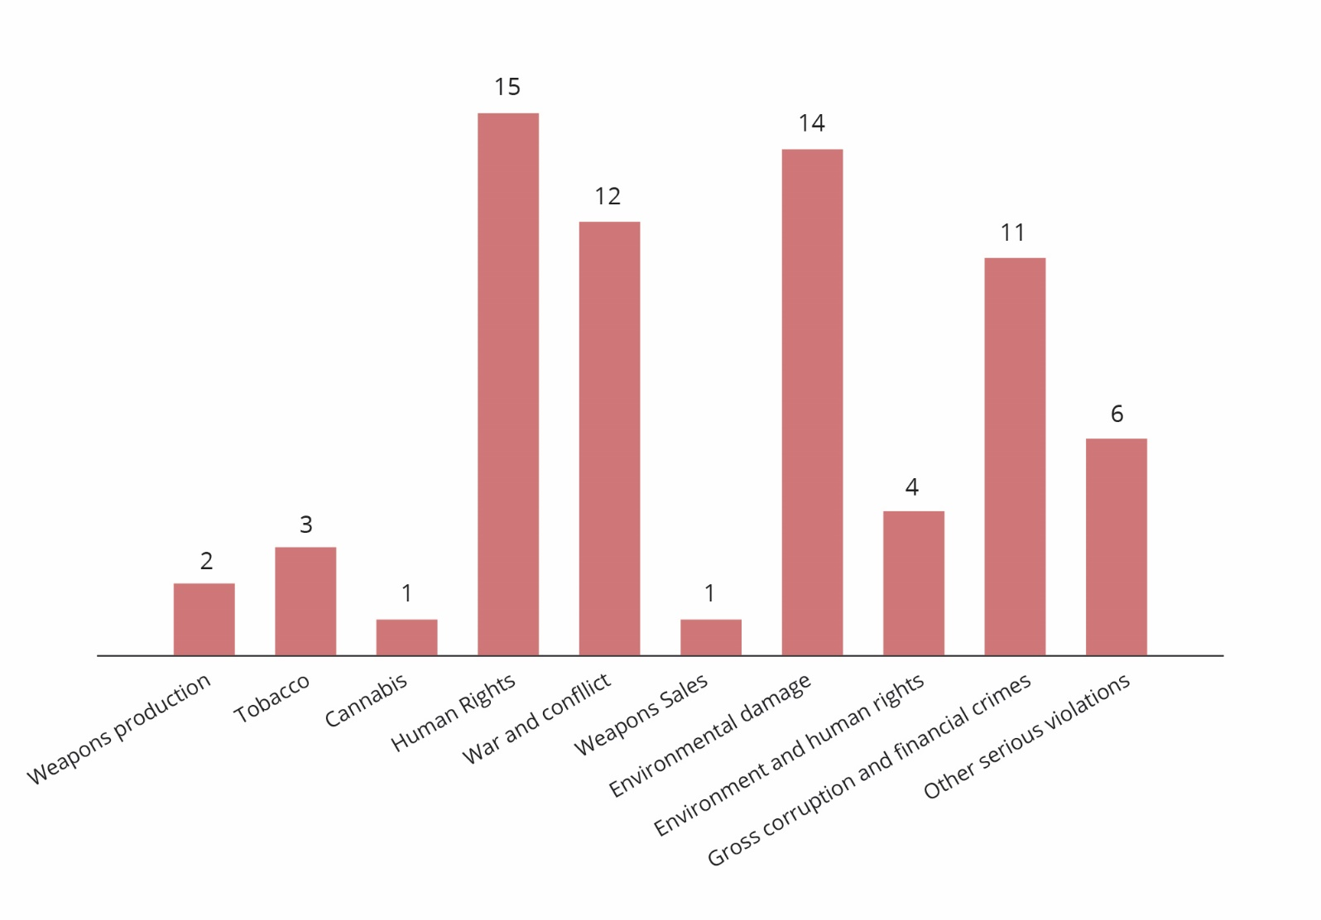
          - Breakdown of contacts with companies by region of domicile
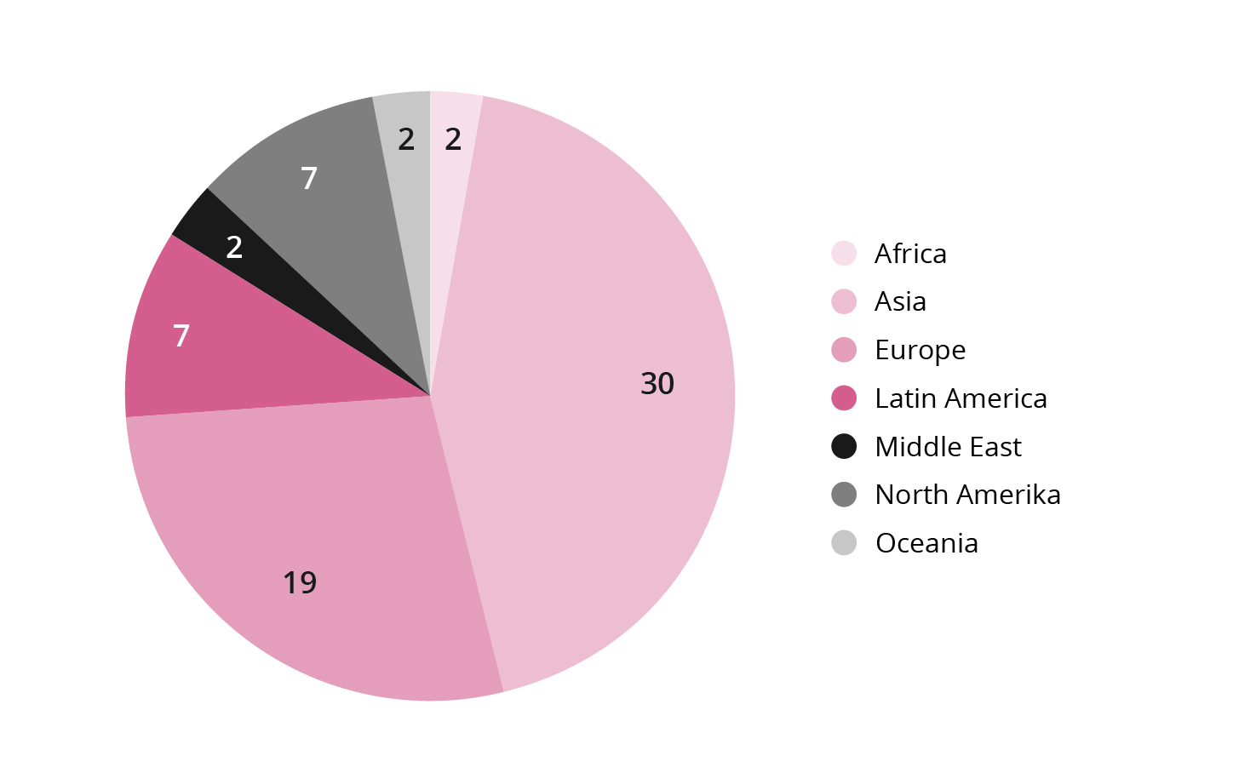
The Council attaches importance to information provided by companies and considers that a lack of response from companies may contribute to a heightened ethical risk. Most companies respond, although there are some exceptions. Of the 55 companies the Council contacted in 2023, 19 failed to respond. Some of these were contacted late in the year, so a response may still be forthcoming. In 2023, the Council issued recommendations to exclude two companies that had not replied to the Council’s queries.
In 2023, the Council’s contacts with European companies rose sharply. Two of these companies are under observation, while the exclusion of another has been revoked. The number of Asian companies contacted by the Council has fallen slightly since 2022, but this reflects the regional distribution of companies under assessment.
When the Council meets with companies, it is often late in the assessment process – often in response to a draft recommendation to exclude a company – or in connection with the observation process. Fig. 2.8 shows a breakdown of the companies the Council met with in 2023 and the criteria against which they were being assessed. Two of the companies the Council met with in 2023 are under observation, while one has been excluded for several years.
          - Number of meetings with companies, by criterion
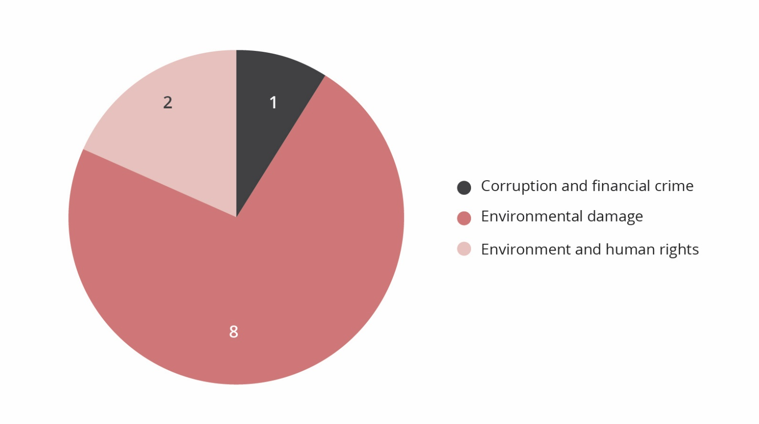
Assessment of companies that are excluded or under observation
Companies are not excluded for a specific period of time and their exclusion may be revoked if the grounds therefor no longer exist. Norges Bank decides whether to revoke a company’s exclusion on the basis of a recommendation from the Council on Ethics.
During the observation period, the Council normally submits one or more observation reports to Norges Bank on each company placed under observation at the Council’s recommendation.
In 2023, the exclusion of two companies was revoked and the observation of two companies terminated.

Product-based criteria
Section 3 of the guidelines sets out the criteria for the “product-based observation and exclusion of companies” as follows:
(1) The GPFG shall not be invested in companies which themselves or through entities they control:
- develop or produce weapons or key components of weapons that violate fundamental humanitarian principles through their normal use. Such weapons include biological weapons, chemical weapons, nuclear weapons, non-detectable fragments, incendiary weapons, blinding laser weapons, antipersonnel mines and cluster munitions
- produce tobacco or tobacco-products
- produce cannabis for recreational use
(2) Observation or exclusion may be decided for mining companies and power producers which themselves, or consolidated through entities they control, either:
- derive 30 per cent or more of their income from thermal coal,
- base 30 per cent or more of their operations on thermal coal,
- extract more than 20 million tonnes of thermal coal per year, or
- have the capacity to generate more than 10,000 MW of electricity from thermal coal.”
The Council’s work with respect to the product-based criteria involves assessing companies identified through the portfolio monitoring process. Each year, a number of cases are flagged up that relate to companies which have either ceased producing the types of weapons for which they were excluded or started producing new types of weapons which must be assessed in relation to the ethical guidelines. In 2023, one recommendation to exclude a company was issued on the basis of its involvement in the production of nuclear weapons. A recommendation was also issued to revoke the exclusion of one company that is no longer involved in the production of nuclear weapons.
With regard to the thermal coal criterion, the guidelines allow Norges Bank to make decisions concerning the observation or exclusion of companies without a recommendation from the Council. A division of labour has been agreed between Norges Bank and the Council, under which the Bank identifies and assesses companies which fall within the scope of the coal criterion. The Council’s consultant nevertheless reports to the Council on companies which may fall within the scope of the criterion. The Council shares all relevant information with the Bank.

Human rights, war and conflict
Section 4 of the guidelines states that “Companies may be excluded or placed under observation if there is an unacceptable risk that the company contributes to or is responsible for:
a. serious or systematic human rights violations
b. serious violations of the rights of individuals in situations of war or conflict […]”

Serious or systematic human rights abuses
More than 70 of the over 200 cases on which the Council worked in 2023 related to the risk of human rights abuses, and almost half of these related to labour rights. The first recommendation that the Council issued in 2005 related to the infringement of labour rights both in the company’s own operations and in its supply chain. The case related to the use of under-age workers, work that was dangerous or hazardous to health, discrimination and violation of trade union rights. Some time later, the Council assessed several companies working with suppliers that systematically and extensively used child labour in connection with seed production. In 2015, the Council embarked on a systematic examination of working conditions at textiles factories. This involved over 40 factory visits in nine countries, primarily in Asia. Working conditions in many of these factories were extremely poor and there were widespread labour rights violations, despite regular inspections by the factories’ customers.
Labour rights violations are identified through both systematic reviews of businesses where the risk is particularly high and ongoing news monitoring. In 2023, the Council conducted investigations into several companies in certain African countries. These investigations were carried out with the help of consultants and were based on interviews with workers, as well as inspections if the companies allowed. Indications of extremely poor working conditions were found in the companies examined. In particular, the sexual harassment of female workers seemed to be rife.
Working conditions verging on forced labour have also been an issue on which the Council has worked extensively. Migrant workers’ employment terms, particularly those relating to recruitment, may place the individual worker in a situation in which they are forced to accept pay and working conditions that could limit their ability to terminate the employment relationship and, in the worst case, put their life and health in danger. In 2015, the Council started investigating migrant workers’ employment terms and conditions in connection with the construction of facilities for the 2022 FIFA World Cup in Qatar. The Council’s investigations were subsequently extended to other Gulf states. More recently, the Council has focused on the rubber glove industry in Malaysia, with the recruitment of migrant workers for industrial production in Taiwan being investigated in the past year. The Council has also taken a closer look at certain European companies’ use of migrant workers.
In many countries, there is a growing demand for labour which is largely met through the importation of workers from countries in Asia and Africa. Despite greater international attention being paid to migrant workers’ employment terms and conditions, and companies’ increasing tendency to compensate workers for costs relating to recruitment (so-called zero-fees policies), our investigations show that the risk of serious norm violations remains considerable and that one cannot rely on this being picked up on by NGOs or the media. It is therefore necessary for investors to also perform their own due diligence in order to identify companies that are responsible for such norm violations. The Council will therefore continue to work on this issue but will take the risks associated with doing so into account. In some Gulf states, for example, on-site investigations may pose a considerable risk to both the consultants and their informants. In such cases, the Council will rely on risk assessments for companies and business sectors, in accordance with the report to the Storting on the management of the government pension funds (Meld. St. 24 (20–21). Such risk analyses also impact the Council’s assessment of GPFG-invested companies that are accused of contributing to human rights abuses against the Uighur population in China, a topic that the Council has worked on for the past three years. Since it is difficult for the Council to perform its own inquiries into companies in China, its assessments must be based on publicly accessible information. Such information is now less readily available, which makes documenting and assessing Chinese companies’ contribution to human rights abuses more challenging.
The Council focuses especially on the violation of indigenous people’s rights, primarily the abuse of land rights and loss of livelihood, often in connection with the extraction of natural resources and the construction of infrastructure. The portfolio monitoring process shows a growing number of cases relating to the energy transition. The extraction of metals for battery production and the construction of hydropower and wind power generating schemes are examples of projects that are increasingly taking place in areas belonging to indigenous peoples and that may threaten their cultures, livelihoods and, in the worst case, their very existence. The Council is working on several such cases. A combination of inadequate consultation, ignorance and poor process management on the part of the company often leads to serious norm violations.
Thus, in 2023, the Council had about 70 cases under assessment, of which around a third were concluded during the year. Much time is spent obtaining information, commissioning consultant-based assignments, assessing the facts and engaging in dialogues with companies. This is both a material and important aspect of the Council’s work, even though only a few cases culminate in a recommendation.

Serious violations of the rights of individuals in situations of war or conflict
In recent years, serious armed conflicts have arisen in areas where many GPFG-invested companies operate. The Council has therefore assessed a larger number of companies than previously in relation to the war and conflict criterion. In 2023, this work has addressed companies with operations linked to the military regime in Myanmar, the occupation of the West Bank and the war in Ukraine. The Council has issued recommendations to exclude three companies and terminated the observation of one company. All these companies had operations in Myanmar.
Several of the criteria for exclusion from investment by the GPFG are designed to target companies linked to conflict situations. Further details concerning the Council’s endeavours relating to the assessment of companies’ contribution to norm violations in areas of conflict may be found in Chapter 5.

Assessing the risk that companies are contributing to norm violations in areas of conflict
The Council on Ethics has devoted considerable resources in recent years to investigating whether companies in which the Government Pension Fund Global (GPFG) is invested are contributing to the violation of ethical norms in the growing number of countries embroiled in serious conflict situations. However, the mere presence of a company in an area of conflict will not, in and of itself, constitute grounds for recommending its exclusion. There must be a link between the company’s operations and the norm violations.
Companies operating in areas of war or conflict must be expected act with particular prudence and care. They must, for example, perform thorough investigations into the potential consequences of their operations and act with due diligence also in their choice of business partners.
Several of the provisions in the Guidelines for Observation and Exclusion of Companies from the Government Pension Fund Global have been designed to address such situations. Section 4(b) of the guidelines applies to companies that risk contributing to serious violation of the rights of individuals in situations of war or conflict. The wording of the criterion is open and provides no clear guidance on how it is to be applied. The Council has issued recommendations under this criterion in consequence of breaches of the international law of occupation in the West Bank, the risk of serious human rights abuses in connection with forced relocation in the Democratic Republic of Congo (DRC), the risk of enhancing the military junta’s capacity in Myanmar, and the risk of violence relating to oil installations in South Sudan.
Section 4(c) of the guidelines applies to companies which sell weapons to states engaged in armed conflicts that use those weapons in ways that constitute serious and systematic violations of the international rules on the conduct of hostilities. This criterion was added to the guidelines in connection with the parliamentary proceedings on the Ethics Commission’s report in 2020 (NOU 2020:7). Here, the Council was instructed to base its judgements on a broad pool of information and reports from authoritative institutions which show that the weapons are consistently being used in ways that do not accord with the rules of international law. The violations of humanitarian law must be serious and reflect a systematic failure over time, such as in the choice of targets, precautions or proportionality assessments. When a war breaks out or hostilities escalate, the Council will monitor developments with regard to norm violations and links to companies in the fund. Under this criterion, the Council has so far recommended the exclusion of companies that sell weapons to Myanmar.
Section 4(d) of the guidelines concerns the sale of weapons or military materiel to states that are subject to investment restrictions on government bonds as described in Section 2-1(2)(c) of the Management Mandate for the Government Pension Fund Global. This provision precludes the fund from investing in bonds issued by states that are subject to extensive sanctions that Norway endorses, and in companies that supply weapons or military materiel to these states. The Norwegian Ministry of Finance decides to which states these restrictions apply at any given time. When Myanmar was previously covered by this provision, the Council recommended that one company be excluded on the grounds of its sales of military materiel to the country. The government bond exemption currently applies to Russia, Belarus, North Korea and Syria.

The Council’s work with companies associated with the conflict in Myanmar
The civilian population in Myanmar has been subjected to extremely serious abuses by the country’s armed forces for many years. These abuses were intensified after the military coup on 1 February 2021, when civil resistance was met with extreme violence.
The use of violence in Myanmar has subsequently escalated. Investigations carried out by the UN Independent Investigative Mechanism for Myanmar reveal, for example, that even children have been tortured, conscripted for military service and arbitrarily detained. Members of the country’s military leadership are currently facing charges in the International Court of Justice for violation of the Genocide Convention and in the International Criminal Court for crimes against humanity, on the basis of the atrocities perpetrated against the Rohingya ethnic minority in 2017 and 2018.
The UN High Commissioner for Human Rights has repeatedly appealed for businesses operating in Myanmar not to collaborate with companies controlled by the armed forces and to avoid their business activities contributing to any further reinforcement of the armed forces’ financial strength. Both the EU and Norway have imposed sanctions on several companies controlled by the armed forces, on the grounds that the revenues from these companies increase the armed forces’ capacity to commit abuses.
The close ties that some companies had to the military in Myanmar was revealed by the UN’s Independent International Fact Finding Mission on Myanmar which, in 2019, published several reports on the economic activities of two military-owned conglomerates, Myanmar Economic Corporation (MEC) and Myanma Economic Holdings Limited (MEHL). MEC is owned and controlled by Myanmar’s Ministry of Defence, while MEHL is owned and operated by former generals and military units, with the country’s Commander-in-Chief playing a highly influential role.
Prior to the military coup, the Council focused on those GPFG-invested companies that had long-term partnerships with these military conglomerates. The Council issued recommendations to place under observation two companies which were engaged in such partnerships but had announced their intention to terminate the business relationship. One of these companies was subsequently removed from the list of companies under observation because the company divested the business concerned.
After the military coup, it was no longer appropriate to distinguish between companies that were owned by the military and those under state control. In 2022, the Council issued recommendations to exclude three oil companies which had entered into joint ventures with the state-owned oil company MOGE. Of material importance for the Council’s decision was the fact that the UN High Commissioner for Human Rights had advised against economic cooperation with military units and that sanctions had been imposed on MOGE precisely because revenues from these companies boost the armed forces’ capacity to commit gross violations of ethical norms. The oil and gas industry is the biggest source of revenue for the armed forces. The Council had never previously recommended that companies be excluded primarily on the grounds that they generate revenue for an oppressive regime. This must be seen in light of the fact that the abuses, as it is assumed by authoritative sources and institutions, that the armed forces subject the country’s own population to are extremely serious, that extensive international sanctions have been imposed on the country and that revenues from resource extraction provide a significant inflow of foreign currency that is important for the purchase of arms and armaments. In 2023, two companies were placed under observation due to their partnerships with a state-owned telecommunications company in Myanmar, since there is a risk that these companies are contributing to serious human rights violations made possible by surveillance of the telecom network.
Section 4(b) of the ethical guidelines, the war and conflict criterion, is not the only provision that may be used with respect to companies that contribute to the junta’s unlawful attacks on the civilian population. In 2023, two companies were excluded under section 4(c), which concerns the sale of weapons to states that use them in violation of the rules on the conduct of hostilities. Several UN bodies have concluded that the regime in Myanmar conducts targeted attacks on its own civilian population.

The Council’s work with companies operating in the West Bank/Gaza
Because international law is violated on a permanent basis in the Occupied Palestinian Territories (OPT), the Council has always focused attention on companies’ operations there. Any increase in the level of conflict in the OPT gives grounds to intensify that focus. In many areas, the Israeli settlements in the OPT are fully integrated with Israel. There will therefore be a large number of GPFG-invested companies with operations in Israel that also have some form of presence in the settlements or operations relating to them.
The Council’s assessments do not depend on where a company is domiciled. The key factor is always the connection with and seriousness of the norm violation in question. The Council therefore considers the role that both Israeli and non-Israeli companies play in this complex situation. With respect to operations in the OPT, it is nevertheless natural to pay additional attention to Israeli companies, since the likelihood of them having operations that fall within the scope of the ethical guidelines must generally be presumed to be higher than for non-Israeli companies.
At the Council’s recommendation, nine companies have been excluded from investment by the GPFG on the grounds of their links to Israeli settlements in the OPT, pursuant to section 4(b) of the guidelines. In these cases, the Council has referred to Article 49 of the Fourth Geneva Convention: “The Occupying Power shall not deport or transfer parts of its own civilian population into the territory it occupies.” The objective of the Fourth Geneva Convention is to protect enemy civilians in wartime, and to prevent military occupying powers from appropriating land in a manner contrary to international law through the use of their own civilians. Israel’s construction of settlements in the OPT constitutes a clear violation of the Convention’s provisions. Companies that are complicit in this can therefore be said to contribute to serious violations of the rights of individuals in situations of war or conflict, and are thus encompassed by section 4(b) of the GPFG’s ethical guidelines.
The first recommendations to exclude companies with links to the OPT related to construction companies engaged in the physical building of settlements. Since the building of settlements accounts for the very core of the norm violation, the Council rested its conclusion on the existence of a direct link between the companies’ construction activities and the state’s violation of international law.
Subsequently, companies that construct road systems linked to the settlements have also been excluded at the Council’s recommendation. These road systems are largely reserved for Israelis and create considerable obstacles to Palestinians’ movement in the OPT. In addition, companies that own and rent out commercial premises in Israeli industrial estates linked to settlements in the West Bank have also been excluded. In these cases, too, the Council has rested its conclusion on the Fourth Geneva Convention and assessed companies’ contribution to the state’s violation thereof.
In the OPT-related cases, the Council has taken the view that exclusion requires a close connection between the companies’ operations and the underlying norm violation. Thus, a company’s mere presence in the OPT does not constitute sufficient grounds for recommending its exclusion. Unlike some other conflict areas where the Council has assessed companies’ business operations, such as South Sudan and Congo, a large number of GPFG-invested companies may be directly or indirectly linked to operations in the OPT. Where to draw the line with respect to companies’ contribution to norm violations in the OPT therefore raises far more questions than in many other conflict areas.
If GPFG-invested companies have operations in the OPT that are of a type previously deemed to be grounds for exclusion, the Council will recommend their exclusion. However, it must be asked whether the limits that the Council has set for companies’ unacceptable contribution to violation of international law are too narrow drawn. Establishing precisely where this threshold should lie is largely a matter of discretionary judgement, and may also be altered if the seriousness of the norm violations increases. When the Council assessed the first companies and lay the foundation for its practice when assessing OPT-related cases, around 2005–2006, the normative framework was less developed than it is today, and the companies’ own responsibility less clearly delineated. The Council follows developments in the OPT closely and will constantly consider whether there are grounds to recommend that further companies be excluded from investment by the GPFG.
The war in Gaza, which broke out after Hamas attacked Israeli territory on 7 October 2023, has raised new issues relating to the Occupied Palestinian Territory (OPT). This applies in particular to the actual prosecution of the war in Gaza, in connection with which several of the guidelines’ provisions are relevant. Examples include section 4(b) concerning companies that risk contributing to the serious violation of the rights of individuals in situations of war or conflict, and section 4(c) concerning companies that sell weapons to states engaged in armed conflict that use the weapons in ways that constitute serious and systematic violations of the international rules on the conduct of hostilities. In addition, section 4(h) concerning other serious abuses of fundamental ethical norms will also be relevant. The rules governing the conduct of hostilities set out in international law are being broken by both sides in the war, and the scale, intensity and humanitarian consequences of the way the war is being waged have led the International Court of Justice (ICJ) in the Hague to consider allegations that elements of Israel’s campaign could constitute genocide under the Genocide Convention. The Council has followed these developments closely in 2023.

The Council’s work with companies associated with the war in Ukraine
Shortly after Russia invaded Ukraine in February 2022, the Norwegian Ministry of Finance decided that the GPFG should divest its shareholdings in Russian companies. However, this decision did not encompass companies listed on stock exchanges in other countries but with a presence in or activities targeting Russia. This covers, for example, subsidiaries located in Russia or trading partnerships with Russian interests. Such a presence and activities may nevertheless be encompassed by the ethical guidelines.
Companies which sell weapons or military materiel to Russia or Belarus may be excluded from investment by the GPFG. This follows from the Ministry of Finance’s decision of 25 March 2022, stating that the GPFG may no longer own government bonds issued by Russia or Belarus. As a result, the sale of weapons and military materiel to these countries may lead to exclusion under section 4(d) of the guidelines.
Furthermore, the exclusion of companies which help to buttress Russia’s illegal occupation of Ukrainian territory may be considered pursuant to the guidelines’ section 4(b), the war and conflict criterion. This may, for example, cover involvement in the construction of homes for the exclusive use of Russian immigrants to occupied areas.
The Council may also recommend that companies be excluded if they, materially and directly, help enable the Russian authorities to maintain the ongoing war of aggression against Ukraine in violation of international law. This may be covered by the guidelines’ section 4(h), which opens for exclusion/observation of companies that contribute to, or are themselves responsible for, “other particularly serious violations of fundamental ethical norms”.
The Council assessed six companies in 2023 for various forms of contribution based on this approach, and has recommended the exclusion of one company.

Companies’ sales of weapons to certain states
Section 4 of the guidelines states that: “Companies may be excluded or placed under observation if there is an unacceptable risk that the company contributes to or is responsible for: […]
c. the sale of weapons to states engaged in armed conflict that use the weapons in ways that constitute serious and systematic violations of the international rules on the conduct of hostilities
d. the sale of weapons or military materiel to states that are subject to investment restrictions on government bonds as described in section 2-1(2)(c) of the Management Mandate for the Government Pension Fund Global […]”
Section 4(c) and section 4(d) both pertain to companies’ sales of weapons to certain states.
Pursuant to section 4(c), companies may be excluded if there is an unacceptable risk that they are selling weapons to states that use them in violation of humanitarian law. This criterion was introduced in 2021 at the recommendation of the Ethics Commission. The provision’s wording makes it clear that it applies to violations of humanitarian law that are both serious and systematic. The preparatory work states that the criterion shall apply to weapons that may impact civilians in particular. In other words, the criterion does not open the way for a general exclusion of companies that sell weapons to states that violate humanitarian law in an armed conflict. The Council is also required to base its assessment on a broad pool of information and reports from authoritative institutions, which show that the weapons are consistently being used in ways that contravene international rules on the conduct of hostilities.
In its first assessment, the Council relied on a report from the Geneva Academy of International Humanitarian Law and Human Rights, which reviewed documentation of humanitarian law violations in a large number of conflicts. Nevertheless, it is the Council that must assess which conflicts and states the criterion should be applied to, and then identify the companies that sell weapons encompassed by the criterion.
The so-called government bond exception has been included in the GPFG’s mandate. The objective is to preclude the GPFG from investing in government bonds issued by states that are subject to extensive international sanctions that are also endorsed by Norway. The Ministry of Finance decides which countries the provision should be applied to – currently North Korea, Syria, Russia and Belarus. Section 4(d) of the guidelines prescribes the exclusion of companies that sell weapons to states encompassed by the government-bond exception. Section 4(d) of the guidelines applies to the sale of all weapons and all military materiel, and therefore has a far wider scope than section 4(c). Pursuant to section 4(d), moreover, it is not presumed that any assessment be made of how the weapons are used – it is not even presumed that the weapons are used at all, since the purchasing states are not necessarily in armed conflict.
In August 2022, pursuant to section 4(c) of the ethical guidelines, the Council recommended the exclusion of two companies that sell weapons to the authorities in Myanmar, which may have been used in violation of humanitarian law. These cases were published in 2023. The Council attached importance to the fact that the country’s armed forces have committed serious abuses of the civilian population. The abuses have been numerous and constitute, in the Council’s view, serious and systematic violations of international rules on the conduct of hostilities.
The Council considers whether section 4(c) of the guidelines should also be applied to companies’ sales of weapons to other states, for example in connection with the warfare in Gaza. Furthermore, the Council monitors the GPFG’s portfolio with respect to companies that sell weapons or military materiel to states encompassed by the government-bond exception. The Council issued a recommendation to exclude one company under this provision in 2023.

Climate and environment
Section 4 of the guidelines states that: “Companies may be excluded or placed under observation if there is an unacceptable risk that the company contributes to or is responsible for: […]
e. severe environmental damage
f. acts or omissions that on an aggregate company level lead to unacceptable greenhouse gas emissions […]”

Severe environmental damage
Under the environment criterion, the Council has focused particularly on cases relating to the loss of important biodiversity, deforestation and pollution from mining activity. This is a continuation of issues that the Council has previously worked on.
The Intergovernmental Science-Policy Platform on Biodiversity and Ecosystem Services (IPBES) estimates that a million species are threatened with extinction, in part as a result of habitat destruction and loss, as well as direct exploitation through international trade in wildlife and fisheries. Endangered species constitute an important topic for the Council’s environment-related recommendations. In 2023, the Council assessed several companies whose operations pose a direct threat to endangered species’ continued survival. The recommendation to exclude the Power Construction Group of China Ltd was based on the company’s contribution to the severe environmental damage caused by the construction of the Batang-Toru hydropower plant in Northern Sumatra, Indonesia. The project is located in the last part of the critically endangered Tapanuli orangutan’s habitat to remain intact. The Council has concluded that the project will constitute a serious threat to the species’ continued survival.
In 2023, the Council endeavoured to define what counts as unacceptable behaviour in an environmental context and may therefore constitute grounds for excluding companies from investment by the GPFG, on the basis of the Kunming-Montreal Global Biodiversity Framework from 2022. One of the Biodiversity Framework’s main goals is to halt the loss of areas that are important for biodiversity, including complex ecosystems such as old, intact rainforest, by 2030. The Biodiversity Framework has placed greater emphasis on the role of companies in the conservation of biodiversity, and has established an expectation that companies which have or are planning to establish operations in such areas exercise greater care and due diligence. For example, it is expected that major international enterprises will monitor, assess and share information about exposure to nature risk and make this information freely available, so that nature risk and adverse impacts may be reduced. In 2023, the Council focused on companies operating in those areas deemed among the most important for the conservation of biodiversity from a global perspective, irrespective of their protection status. In cases relating to areas of high conservation value and biodiversity, the Council’s mandate permits it to contribute to the definition of limits on what is considered unacceptable with respect to companies’ exploitation of natural assets in the coming years.
The Council has also worked with companies that are responsible for severe pollution, primarily relating to mining operations. In 2021, consultants were commissioned to identify GPFG-invested companies that engage in polluting gold mining activities. The consultants’ final report contained a list of 11 businesses whose operations were reported to be linked to serious environmental and/or social impacts. Water pollution stands out as particularly problematic in relation to these operations. The Council assessed several of these companies in 2023. The review of the gold mining operations has been relatively time consuming, since many of the incidents referred to in the consultants’ report occurred some years ago and are documented only in a few media reports. There is often little tangible documentation that water pollution is actually taking place, while the actual effects of such pollution on biodiversity and local populations is seldom rigorously substantiated. Even in cases where data from water samples exist, establishing a direct causal relationship between mining operations and elevated levels of metals in water has proved challenging, since gold mines are often situated in areas with relatively high natural occurrence of metals.
In 2023, the Council recommended the exclusion of four companies under the environment criterion.

Shipbreaking
For several years, the Council has focused on environmental and working conditions within the shipbreaking sector. Several shipping companies have been excluded from investment by the GPFG at the Council’s recommendation because they have allowed their decommissioned vessels to be broken up for scrap at shipbreaking yards where environmental and working conditions are extremely poor. The Council has also influenced some shipping companies to change their practice in this area and, in future, ensure their decommissioned vessels are broken up in a safe and appropriate manner. With respect to this topic, the Council recommended in 2023 that the exclusion of one company and the observation of another be revoked. At the close of 2023, two shipping companies are excluded from investment by the GPFG due to the way they dispose of their decommissioned vessels, while one company is under observation.
The value of decommissioned vessels lies in the steel and other materials that can be recovered from them and recycled. From a resource and environmental point of view, it is desirable that as much as possible of these materials are recycled, provided that their recovery is carried out safely. Unsafe practices at shipbreaking yards can lead to serious environmental harm and involve extremely hazardous working conditions.
A milestone in the international effort to improve conditions in this sector was achieved in 2023, when Bangladesh, Pakistan and Liberia ratified the Hong Kong International Convention for the Safe and Environmentally Sound Recycling of Ships (HKC), such that it will enter into force in 2025.
The HKC addresses several important aspects of the recycling of decommissioned vessels. For example, the Convention sets minimum requirements for infrastructure and operations at shipbreaking yards. In 2025, all shipbreaking in India, Pakistan and Bangladesh must take place in compliance with the Convention’s provisions. Together, these countries account for a significant proportion of the world’s shipbreaking capacity.
With the entry into force of the HKC, the foundation is laid for improvements in the shipbreaking industry. This presumes that real changes are made in the way the work is performed at a large number of shipbreaking yards. Some yards in India and Bangladesh have already upgraded to a standard that complies with the Convention’s provisions. Shipping companies can help to promote positive developments in this sector by letting their decommissioned vessels be broken up for scrap at yards that have been upgraded to meet the Convention’s requirements.
The Council is aware that, while waiting for the HKC to formally enter into force, classification companies have issued certificates stating that shipbreaking yards operate in compliance with the Convention’s provisions, so-called Statements of Compliance with the HKC. The Council’s investigations into shipbreaking yards in Alang, India, have shown that a large number of the yards there can produce such certificates despite not being technically equipped in compliance with the Convention’s provisions or the underlying IMO Technical Guidelines to which the Convention refers. For example, the majority of the yards did not have adequate facilities for drainage and the collection of liquid effluent. These facilities were either incomplete, defective or lacking altogether. The Council has therefore been concerned that such certificates have been issued to shipbreaking yards that, in reality, are not operated in compliance with the HKC. Another concern has been that even though the yards may be technically equipped to operate in compliance with the Convention, work at the yard does not take place in a way that is compliant with it.
Shipping companies should, at the very least, have a policy for the breaking up of decommissioned vessels that complies with the HKC, and should select shipbreaking yards that operate in compliance with the Convention. Furthermore, after disposing of a vessel for break-up, shipping companies should follow up the process either through their own on-site representatives or a third party, to ensure that the work is performed safely and securely.
Although the HKC establishes an important framework for improvement, demand by the shipping companies will remain a key driver for improvement within the global shipbreaking industry. The Council will pay special attention to this when the work within ship dismantling is continued.

Unacceptable greenhouse gas emissions
The Council on Ethics’ guidelines have contained a criterion concerning unacceptable greenhouse gas emissions since 2016. The Council has issued five recommendations to exclude, and a total of four companies have been excluded under this criterion. In practice, Norges Bank has assumed primary responsibility for the climate criterion since 2022. The criterion’s wording remains unchanged. For a period going forward, the Council will follow up the companies that have already been excluded, but will not normally assess new companies under the climate criterion.

Gross corruption and other serious financial crime
Section 4 of the ethical guidelines states that: “Companies may be excluded or placed under observation if there is an unacceptable risk that the company contributes to or is responsible for: […]
g. gross corruption or other serious financial crime

Gross corruption
In 2023, the British oil service company Petrofac Ltd was placed under observation, while the Council’s observation of the South Korean construction company Hyundai Engineering & Construction Co Ltd (HDEC) and the Canadian private aircraft manufacturer Bombardier Inc continued. The Council recommends observation more frequently in corruption-related cases than in other cases. This is both because the norm violations generally occurred some time before they came to light, and because companies involved in corruption will often implement changes that prompt uncertainty about developments forward in time.
With respect to companies under observation, the Council examines how they are working with and developing their anti-corruption systems, and monitors whether allegations concerning new cases of corruption are revealed. If no new corruption cases emerge and the company seems to have put in place an anti-corruption system in line with internationally recognised recommendations, the Council normally recommends that observation be terminated. However, there is no guarantee that a company will not become involved in corruption once again. In that case, the Council can conduct a new assessment of the company.
The Council monitors allegations of corruption linked to GPFG-invested companies on an ongoing basis. Companies linked to multiple serious allegations of corruption are systematically logged, sorted by business sector and ranked with respect to level of risk. This overview is constantly updated and expanded. Within certain sectors, allegations concerning such a large number of companies have been identified that it is also possible to perform a more holistic review of them. In 2022, the Council performed such a review of nine companies in the telecoms sector, with one of these subject to a closer examination in 2023.
In 2023, an equivalent review commenced of 25 companies in what the FTSE defines as the “Construction and Materials” sector. This has long been highlighted as one of the sectors with the highest corruption risk in the world. A number of factors contribute to this. The projects, especially infrastructure projects, are often substantial. The construction of dams, power stations, industrial facilities and motorways can cost tens of billions of Norwegian kroner. It is easier to hide substantial bribes and inflate costs in large projects than in smaller ones. Furthermore, large construction projects are often more or less “customised”. This can make it harder to compare expenditures with other projects, which also makes it easier to inflate costs and hide bribes. Public authorities are also usually involved. Most large-scale infrastructure projects are owned by the authorities, and even when they are carried out under private ownership, they will nevertheless depend on public approval initially or on agreements concerning payment for use of the final ‘product’. The industry may be heavily regulated at both the national and local level, and it is usually necessary to obtain many different kinds of permits. The greater the discretion the relevant authorities enjoy, combined with the projects’ structural and financial complexity, the greater the opportunities they have to solicit bribes from the contractors.
The review of the Construction and Materials sector had not yet concluded at year-end. So far, one company within this sector has been selected for closer examination. In addition, the Council also embarked on the assessment of a state-controlled oil and gas company in 2023.

Other serious financial crime
So far, the Council has issued no recommendations to exclude companies or place them under observation pursuant to the criterion’s expansion to cover “other serious financial crime” as well. The criterion was added to the ethical guidelines in 2022 and an associated staff resource recruited in June that same year. In 2023, the Council continued working on several of the assessments of individual companies, all of which operate in the financial sector, that had already been commenced. At the close of the year, the assessment of three companies had come to an end, while five assessments remain active at the start of 2024. The Council engages in a dialogue with the companies under assessment at an early stage. In this connection, it was in contact with four companies in 2023.
The Council has otherwise obtained an overview of companies domiciled or with substantial business activities in countries which, based on authoritative sources, have a heightened risk of money laundering. The Financial Action Task Force’s (FATF), which maintains a so-called ‘grey list’ of countries that do not have adequate provisions to combat money laundering, is a key source in this respect – particularly when the grey-listing is due to national failings in the area of supervision and enforcement. This work had not finished at the close of the year, but has so far led to two companies being selected for further assessment.
Apart from this, the Council continuously monitors specific allegations concerning matters that fall naturally within the scope of this criterion. In line with the guidelines issued by the Ethics Commission, the Council is particularly interested in companies that are repeatedly involved in incidents of financial wrongdoing. Such incidents are logged on an ongoing basis and are used as the basis for assessing whether the company concerned should be contacted and assessed in further detail.

Other particularly serious violations of fundamental ethical norms
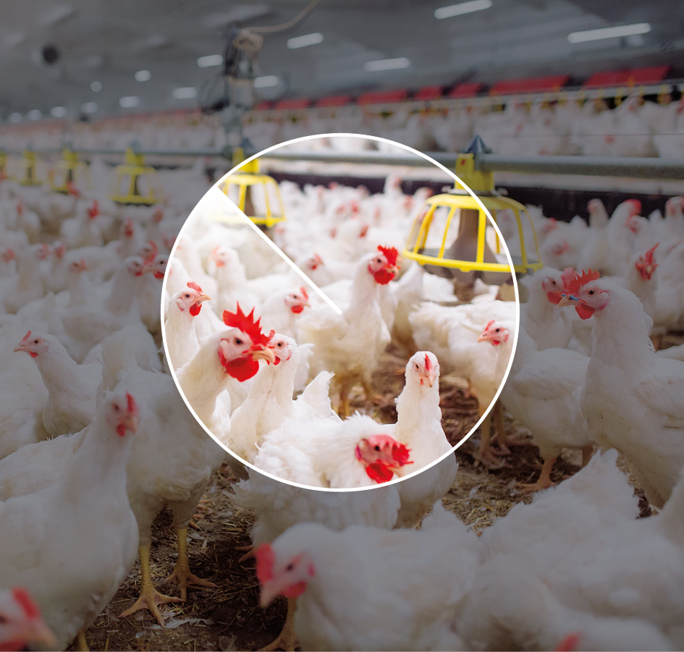
Section 4 of the guidelines states that: “Companies may be excluded or placed under observation if there is an unacceptable risk that the company contributes to or is responsible for: […]
h. other particularly serious violations of fundamental ethical norms”
In the past year, the number of companies being assessed in relation to the criterion for other serious norm violations increased. The criterion may be applied to cases that do not fit in any of the other criteria. In 2023, the Council focused particularly on animal welfare violations and companies’ contributions to Russia’s war in Ukraine. The only exclusion under this criterion in 2023 related to resource extraction in Western Sahara at the behest of the Moroccan authorities. This is an issue that the Council has been following for many years, and several companies have been excluded on this basis. These cases rest on Morocco having no legal sovereignty over Western Sahara’s natural resources. The Council has attached importance to the fact that the activity has not been substantiated as being in accordance with the wishes and interests of Western Sahara’s people, and that the activity helps to maintain an unclear situation in the area. In 2023, Delek Group Ltd was excluded because the company had signed an agreement with Moroccan authorities to engage in petroleum prospecting off the Western Saharan coast.
PT Semen Indonesia (Persero) Tbk was placed under observation in 2023, following a recommendation issued by the Council in 2022. The company is Indonesia’s largest producer of cement and extracts limestone in the Maros-Pangkep area of South Sulawesi. The company was placed under observation due to the risk of damage to irreplaceable prehistoric cultural heritage sites, including 40,000-year-old cave paintings. The Council will assess whether the measures the company implements help to reduce the risk of harm to these cultural heritage sites. Even though the company has taken positive steps to protect the sites, the Council considers that there is still a way to go with respect to identifying risks and developing and implementing a management plan to reduce the risk of damage to the cultural heritage sites. The Council will therefore continue its observation of the company.

Animal welfare
Through the Ethics Commission’s report and the Norwegian parliament’s debate on the subsequent Pension Fund Report, it was emphasised in 2021 that serious animal welfare violations fall within the scope of the Ethical Guidelines for the GPFG. While animal welfare was not introduced as a separate criterion, this type of norm violation was included in the umbrella criterion “other serious violations of fundamental ethical norms”.
The Ethics Commission on animal welfare:
That animals are entitled to be treated without unnecessary stresses and strains enjoys broad support in Norway and internationally. Section 3 of the Animal Welfare Act, which was introduced in 2010, states: “Animals have an intrinsic value which is irrespective of the usable value they may have for man. Animals shall be treated well and be protected from danger of unnecessary stress and strains.” Correspondingly, the EU’s Lisbon Treaty (2009) establishes that EU member states have a duty to take account of individual animals’ welfare needs. Along with 177 other states, Norway is a member of the World Organization for Animal Health (OIE), which is a standard-setting organisation within the framework of the WTO, among others. The OIE has adopted animal welfare standards that must be considered global standards.
In its proceedings concerning the report, the Norwegian parliament (Storting) endorsed the Commission’s assessments and expressed the expectation that the Council on Ethics would address norm violations relating to animal rights. The Storting explicitly endorsed the statement that “animals are entitled to be treated without unnecessary stresses or strains”.
The Council has begun working systematically to create a framework for how companies that are responsible for serious animal welfare violations can be identified and assessed. The Council takes the Norwegian Animal Welfare Act and similar international legislation as its starting point. Although the legislation varies from country to country, the Council’s position is that activities permitted in Norway shall not be encompassed. The purpose of the Animal Welfare Act is to promote good animal welfare and respect for animals. This applies to their treatment and all factors influencing animal welfare. The key factor is that animals must be treated well and protected from the danger of unnecessary stresses and strains. Animals must also be given the opportunity to display their natural behaviour. In practice, the greatest emphasis is placed on negative liberty. This means that protection against external stresses, such as infection from outside and control over the physical surroundings, is weighted more heavily than animals’ ability to engage in normal behaviour among other members of their species.
With respect to animal welfare cases as well, the Council considers companies on the basis of the seriousness of the violation and the closeness of their involvement in it, as well as the likelihood of the company’s practice continuing in the future. This means, for example, that a significant number of individual animals must be subjected to cruel treatment before the Council engages in the case. In the first instance, the Council will look at cases where GPFG-invested companies systematically subject a large number of individual animals to serious welfare violations in their own operations, and where it does not appear as though the company has tangible and credible plans to improve the conditions concerned.

The Council on Ethics’ response to the Norwegian government’s consultation on the European Commission’s proposed regulation prohibiting products made with forced labour
Response submitted to the Norwegian Ministry of Trade, Industry and Fisheries on 19 September 2023
We refer to the consultation paper, published by the Norwegian Ministry of Trade, Industry and Fisheries on 25 August this year, concerning the European Commission’s proposed regulation prohibiting products made with forced labour.
The Council on Ethics supports an explicit ban throughout the EU and EEA area on the marketing, sale or export of products which have been wholly or partly produced by means of forced labour. Enforcing this legislation may be challenging, but that is not in itself an argument against such a prohibition.
The proposal supports other legislation that requires companies to take responsibility for grossly unethical practices in their supply chains. The proposal provides a further incentive for companies to uncover where there may be a risk of forced labour and take steps to reduce it. This could therefore lead to greater attention being paid to the risk of forced labour.
This proposal is closely linked to the EU’s Corporate Sustainability Due Diligence Directive (CSDDD), which has not yet come into effect. The government body tasked with investigating suspected forced labour must take account of the steps companies have taken to uncover and address the risk of norm violations, see point 25 in the Ministry’s consultation paper. Although guides do exist for how this should be done, there is no single right answer that describes what the correct reaction is in each individual case. In other words, there is considerable discretionary leeway when assessing whether a company has implemented a due diligence assessment in accordance with the CSDDD and therefore should not be prioritised for further investigation pursuant to the forced labour regulation.
While companies must be selected for further investigation on the basis of the risk of forced labour linked to the manufacture of the company’s products, the burden of proof lies with the authorities. In other words, the authorities must prove that forced labour has actually been involved in the manufacture of any products for which a confiscation order is sought, see point 26 of the consultation paper. It will be easier for the enforcement bodies to submit evidence of forced labour in countries where the authorities attempt to uncover and penalise such conditions than in countries whose authorities do not pursue suspicions of forced labour.
The legislation rests on international standards. The extent to which working conditions are deemed to constitute forced labour under ILO Convention No. 29 is nevertheless not unambiguously defined. The ILO has drawn up a set of indicators for forced labour, but it is not clearly defined if all of these indicators, or only one of them, must be present before working conditions may be characterised as forced labour. Here, too, there will be considerable room for the exercise of discretionary judgement.
When the existence of forced labour has been finally determined, the penalty is the confiscation of the product concerned, see point 30 of the consultation paper. The Council on Ethics wishes to point out that working conditions which may fall within the definition of forced labour have been uncovered in several business sectors in Europe, and not merely in connection with the type of products that pass through customs on their way from one country to another. In the construction and shipbuilding industries, for example, it has been revealed that parts of a building or ship may be produced with forced labour, while the bulk is manufactured under lawful working conditions. How the regulation should be applied to such products needs to be clarified.
Based on the Council’s experience, investigating the existence of forced labour will be challenging, both for the companies and the government agencies tasked with enforcing the regulation. With respect to forced labour pursuant to ILO Convention No. 105, the situation is already such that the states in which forced labour occurs most frequently also restrict the right to conduct investigations. In such states, it is possible to determine that there is a high risk of forced labour, but only rarely possible to identify exactly which products have forced labour as an “input factor”.
This challenge may be further exacerbated when the alleged forced labour could result in specific sanctions against individual companies that may perform assignments on behalf of the government or operate with the government’s blessing. In the Council’s view, it would be good if the regulation leads to a more systematic effort by European and national authorities to map the extent of global forced labour. The Council would nevertheless like to point out that the regulation itself could make such efforts more difficult. Journalists, civil society organisations and consultants already incur a considerable risk when they attempt to obtain reliable information about forced labour in certain authoritarian countries. Because the regulation links such information gathering directly to enforcement agencies and the imposition of punitive measures in Europe, this could become even more hazardous.
Much of the forced labour taking place in companies’ supply chains occurs in the agricultural sector. Tracing forced labour to specific products is particularly challenging here. A company may, for example, purchase cotton or textiles from a country in which forced labour is widespread, but where cotton is also produced without recourse to forced labour. Even if the company specifies in its contracts that the cotton used in its products must not have been produced with forced labour, it is difficult to verify this is actually the case in practice. In reality, the enforcement body cannot rely on the tools outlined in the CSDDD being effective, nor can it prove decisively whether a supply chain contains forced labour.
In other words, there is considerable room for discretionary judgement in the practising of the CSDDD and the regulation on which comments are currently being sought. Furthermore, investigating forced labour, as well as norm violations associated with companies’ operations more generally, is exceptionally resource intensive. The Council would also like to point out that disagreement may arise between different states’ enforcement bodies, given the subjective nature of the assessments. The proposal does not seem to contain any mechanisms through which such disagreements may be resolved.
In the Council’s opinion, it is important that the individual enforcement bodies have sufficient resources, see point 19 of the consultation paper. Furthermore, extensive collaboration between the states’ enforcement bodies is needed to ensure that the regulation is practised in a uniform manner and to increase the legislation’s impact, see points 39, 42 and 44 of the consultation paper. In light of the uncertainty surrounding how the regulation is to be practised, the Council considers that it would be advantageous to gain experience from the work relating to the CSDDD before the final regulation is adopted.

List of excluded companies by 31. desember 2023
Severe environmental damage
- Barrick Gold Corp
- Beijing Tong Ren Tang Chinese Medicine Co Ltd
- Bharat Heavy Electricals Ltd
- China Traditional Chinese Medicine Holdings Co Ltd
- Duke Energy Corp (including the below wholly-owned subsidiaries)
- Duke Energy Carolinas LLC
- Duke Energy Progress LLC
- Progress Energy Inc
- ElSewedy Electric Co
- Freeport-McMoRan Inc
- Genting Bhd
- Grand Pharmaceutical Group Ltd
- Halcyon Agri Corp Ltd
- MMC Norilsk Nickel PJSC
- NHPC Ltd
- POSCO Holdings Inc
- Posco International Corp
- Power Construction Group of China Ltd
- Ta Ann Holdings Bhd
- Tong Ren Tang Technologies Co Ltd
- Vale SA
- Volcan Cia Minera SAA
- WTK Holdings Bhd
- Young Poong Corp
- Yunnan Baiyao Group Co Ltd
- Zijin Mining Group Co Ltd
Severe environmental damage | Serious or systematic human rights violations
- Evergreen Marine Corp Taiwan Ltd
- Korea Line Corp
- Vedanta Ltd
Serious violations of the rights of individuals in situations of war or conflict
- Ashtrom Group Ltd
- Danya Cebus Ltd
- Elco Ltd
- Electra Ltd
- GAIL India Ltd
- Korea Gas Corp
- Mivne Real Estate KD Ltd
- Oil & Natural Gas Corp Ltd
- PTT Oil and Retail Business PCL
- PTT PCL
- Shapir Engineering and Industry Ltd
- Shikun & Binui Ltd
Other particularly serious violations of fundamental ethical norms
- Delek Group Ltd
- Elbit Systems Ltd
Gross corruption or other serious financial crime
- JBS SA
- ZTE Corp
Serious or systematic human rights violations
- Centrais Eletricas Brasileiras SA (Eletrobras)
- Cognyte Software Ltd
- Formosa Chemicals & Fibre Corp
- Formosa Taffeta Co Ltd
- Honeys Holdings Co Ltd
- Li Ning Co Ltd
- Luthai Textile Co Ltd
- Page Industries Ltd
- Zuari Agro Chemicals Ltd
Sales of weapons to states in armed conflicts
- AviChina Industry & Technology Co Ltd
- Bharat Electronics Ltd
Unacceptable greenhouse gas emissions
- Canadian Natural Resources Ltd
- Cenovus Energy Inc
- Imperial Oil Ltd
- Suncor Energy Inc
Production of nuclear weapons
- Airbus SE
- BAE Systems Plc
- Boeing Co
- BWX Technologies Inc
- Fluor Corp
- Honeywell International Inc
- Huntington Ingalls Industries Inc
- Jacobs Solutions Inc
- Lockheed Martin Corp
- Northrop Grumman Corp
- Safran SA
Production of cluster munitions
- Poongsan Corp
- Textron Inc
Production of tobacco
- Altria Group Inc
- British American Tobacco Malaysia Bhd
- British American Tobacco Plc
- Eastern Co SAE
- Gudang Garam tbk pt
- Hanjaya Mandala Sampoerna Tbk PT
- Huabao International Holdings Ltd
- Imperial Brands Plc
- ITC Ltd
- Japan Tobacco Inc
- KT&G Corp
- Mativ Holdings Inc
- Philip Morris Cr AS
- Philip Morris International Inc
- Scandinavian Tobacco Group A/S
- Shanghai Industrial Holdings Ltd
- Universal Corp/VA
- Vector Group Ltd
Production of cannabis for recreational use
- Aurora Cannabis Inc
- Canopy Growth Corp
- Cronos Group Inc
- Tilray Brands Inc
Production of coal or coal-based energy
- Aboitiz Power Corp
- AES Andes SA
- AES Corp
- AGL Energy Ltd
- ALLETE Inc
- Alliant Energy Corp
- Ameren Corp
- American Electric Power Co Inc
- Capital Power Corp
- CESC Ltd
- CEZ AS
- China Coal Energy Co Ltd
- China Power International Development Ltd
- China Resources Power Holdings Co Ltd
- China Shenhua Energy Co Ltd
- Chugoku Electric Power Co Inc/The
- CLP Holdings Ltd
- Coal India Ltd
- CONSOL Energy Inc
- Datang International Power Generation Co Ltd
- DMCI Holdings Inc
- DTE Energy Co
- Electric Power Development Co Ltd
- Electricity Generating PCL
- Emera Inc
- Eneva SA
- Engie Energia Chile SA
- Evergy Inc
- Exxaro Resources Ltd
- FirstEnergy Corp
- Glencore PLC
- Great River Energy
- Guangdong Electric Power Development Co Ltd
- Gujarat Mineral Development Corp Ltd
- HK Electric Investments & HK Electric Investments Ltd
- Hokkaido Electric Power Co Inc
- Hokuriku Electric Power Co
- Huadian Energy Co Ltd
- Huadian Power International Corp Ltd
- Huaneng Power International Inc
- IDACORP Inc
- Inner Mongolia Yitai Coal Co Ltd
- Jastrzebska Spolka Weglowa SA
- Korea Electric Power Corp
- Lubelski Wegiel Bogdanka SA
- Malakoff Corp Bhd
- MGE Energy Inc
- New Hope Corp Ltd
- NRG Energy Inc
- NTPC Ltd
- Okinawa Electric Power Co Inc/The
- Otter Tail Corp
- PacifiCorp
- Peabody Energy Corp
- PGE Polska Grupa Energetyczna SA
- PNM Resources Inc
- Public Power Corp SA
- Reliance Infrastructure Ltd
- Reliance Power Ltd
- RWE AG
- Sasol Ltd
- SDIC Power Holdings Co Ltd
- Shikoku Electric Power Co Inc
- Tata Power Co Ltd/The
- Tenaga Nasional Bhd
- TransAlta Corp
- Tri-State Generation and Transmission Association Inc
- Washington H Soul Pattinson & Co Ltd
- WEC Energy Group Inc
- Whitehaven Coal Ltd
- Xcel Energy Inc
- Yankuang Energy Group Co Ltd.

List of companies placed under observation
Serious violations of the rights of individuals in situations of war or conflict
- Adani Ports & Special Economic Zone Ltd
- KDDI Corp
- Sumitomo Corp
Severe environmental damage
- Astra International Tbk PT
- Marfrig Global Foods SA
Severe environmental damage | Serious or systematic human rights violations
- Pan Ocean Co Ltd
Gross corruption or other serious financial crime
- Bombardier Inc
- Hyundai Engineering & Construction Co Ltd
- Petrofac Ltd
Serious or systematic human rights violations
- Supermax Corp Bhd
- ORLEN SA
Other particularly serious violations of fundamental ethical norms
- Semen Indonesia Persero Tbk PT
Production of coal or coal-based energy
- Berkshire Hathaway Energy Co
- BHP Group Ltd/BHP Group Plc
- CMS Energy Corp
- Kyushu Electric Power Co Inc
- MidAmerican Energy Co
- NorthWestern Corp
- OGE Energy Corp
- Pinnacle West Capital Corp
- Southern Co/The
- Tohoku Electric Power Co Inc
- Uniper SE
- Vistra Corp
An updated list can be found at Observation and exclusion of companies | Norges Bank Investment Management (nbim.no)

Published recommendations
            - List of companies about which recommendations were published in 2023
Company | Criterion | Recommendation | Decision | Issued | Public
AviChina Industry & Technology Co Ltd | Sales of weapons to certain states | Exclusion | Exclusion | 23.08.2022 | 24.01.2023
Bharat Electronics Ltd | Sales of weapons to certain states | Exclusion | Exclusion | 23.08.2022 | 24.01.2023
Delek Group Ltd | Other serious violations | Exclusion | Exclusion | 30.05.2023 | 18.12.2023
GAIL India Ltd | War or conflict | Exclusion | Exclusion | 29.11.2022 | 27.04.2023
Hyundai Glovis Co Ltd | Human Rights and Environmental damage | Terminate observation | Terminate observation | 16.05.2023 | 03.10.2023
KDDI Corp | War or conflict | Exclusion | Observation | 29.06.2023 | 18.12.2023
Kirin Holdings Co Ltd | War or conflict | Terminate observation | Terminate observation | 03.02.2023 | 22.03.2023
Korea Gas Corp | War or conflict | Exclusion | Exclusion | 29.11.2022 | 27.04.2023
ORLEN SA | Human rights | Observation | Observation | 24.10.2022 | 22.02.2023
Petrofac Ltd | Corruption | Observation | Observation | 03.04.2023 | 06.07.2023
Power Construction Corp of China Ltd | Environmental damage | Exclusion | Exclusion | 14.02.2023 | 06.07.2023
Semen Indonesia Persero Tbk PT | Other serious violations | Observation | Observation | 19.12.2022 | 25.05.2023
Serco Group PLC | Nuclear weapons | Revoke exclusion | Revoke exclusion | 22.09.2023 | 21.11.2023
Sumitomo Corp | War or conflict | Exclusion | Observation | 29.06.2023 | 18.12.2023
Thoresen Thai Agencies PCL | Human Rights and Environmental damage | Revoke exclusion | Revoke exclusion | 12.05.2023 | 03.10.2023
The Council publishes recommendations on its website at the same time as Norges Bank announces its decision on the case. A summary of the recommendations published in 2023 is presented below.
Each year, the Council reviews the companies that have been excluded to identify whether the grounds for exclusion still exist. In 2023, the exclusion of two companies was revoked. One company had ceased engaging in the production of nuclear weapons, while the other had not disposed of ships for breakup since it was excluded in 2018.
During the year, a total of six companies were excluded under four different criteria. Two companies were excluded under the war and conflict criterion, due to their financial ties with the armed forces in Myanmar. Two companies were excluded due to the sale of weapons to Myanmar. One company was excluded because it contributes to environmental damage through the loss of biodiversity resulting from the construction of hydropower generating facilities. One company was excluded because it contributes to the serious violation of other fundamental ethical norms through prospecting for oil off the coast of Western Sahara at the behest of the Moroccan authorities.
Of the five decisions to place companies under observation that were published in 2023, one related to gross corruption, two to serious violation of the rights of individuals in situations of war or conflict, one to human rights abuses and one to serious violation of other fundamental ethical norms. The Council had originally recommended the exclusion of the two companies placed under observation in relation to the war and conflict criterion, due to the risk that they were contributing to serious norm violations in Myanmar through their partnership with a telecoms company which was conducting surveillance activities at the orders of the regime.
In 2023, the observation of two companies was terminated. One was under observation due to its financial relations with the armed forces in Myanmar. Observation was terminated because the company had ended this partnership and divested its operations in Myanmar. The second company was under observation because it had previously disposed of ships for breakup at yards operating to an unacceptable standard. The company has now introduced a new policy for responsible shipbreaking, and the grounds for further observation therefore no longer exist.

Summaries of recommendations published in 2023

AviChina Industry & Technology Co Ltd
Issued 23 August 2022
The Council on Ethics recommends that AviChina Industry & Technology Co Ltd (AviChina) be excluded from investment by the Norwegian Government Pension Fund Global (GPFG) due to an unacceptable risk that the company sells weapons to a state that uses weapons in ways that constitute serious and systematic violations of international humanitarian law (IHL). The background for this recommendation is the sale of light combat aircraft to the armed forces in Myanmar.
AviChina is a Chinese company that engages in the development and sale of aircraft and aviation products. At the close of 2021, the GPFG owned 0.37 per cent of the company’s shares, worth NOK 137 million. The company is listed on the Hong Kong Stock Exchange (HKEX).
In December 2021, several light combat aircraft of the type K-8 were delivered to the armed forces in Myanmar. The aircraft are thought to have been produced by companies which AviChina controls. It has been reported that such aircraft have previously been used in combat in Myanmar.
In February 2021, the armed forces in Myanmar staged a coup d’état. Both before and after the coup, the armed forces have perpetrated extremely serious abuses against the civilian population, relating in part to ongoing armed conflicts in the country. Several UN bodies have reported that the armed forces have deliberately attacked civilian targets. In some cases, this has involved the use of combat aircraft. The attacks have been numerous and constitute, in the Council on Ethics’ assessment, serious and systematic violations of IHL. This information has long been in the public domain, and the Council takes the position that anyone selling weapons to Myanmar since 2018 should have understood that they could be used in violation of IHL.
In its assessment of the risk of contributing to new abuses forward in time, the Council has attached importance to the fact that the company supplied aircraft to Myanmar despite the military coup and the information concerning the armed forces’ abuses. The delivery in December 2021 is said to be part of a larger contract, which indicates that further deliveries may take place. Although the Council has contacted the company on several occasions, it has not replied to the Council’s queries.

Bharat Electronics Ltd
Issued 23 August 2022
The Council on Ethics recommends that Bharat Electronics Ltd (BEL) be excluded from investment by the Norwegian Government Pension Fund Global (GPFG) due to an unacceptable risk that the company sells weapons to a state that uses the weapons in ways that constitute serious and systematic violations of international law. The background for this recommendation is the sale of military equipment to the armed forces in Myanmar.
BEL is an Indian producer of aviation and defence electronics. At the close of 2021, the GPFG owned 0.32 per cent of the company’s shares, worth NOK 195 million. The company is listed on the National Stock Exchange of India (NSE).
In July 2021, BEL delivered a remote-controlled weapons station (RCWS) to Myanmar. This weapons station has been developed to remotely control a machine gun from inside an armoured vehicle. It is reported that such vehicles are used in attacks on civilians in Myanmar.
In February 2021, the armed forces in Myanmar staged a coup d’état. Both before and after the coup, the armed forces have committed extremely serious abuses against Myanmar’s civilian population, relating in part to ongoing armed conflicts in the country. Several UN bodies have reported that the Myanmar armed forces, also known as the Tatmadaw, have deliberately attacked civilian targets. The attacks have been numerous and, in the Council’s view, constitute serious and systematic violations of international law. This information has long been in the public domain, and the Council takes the position that anyone selling weapons to Myanmar since 2018 should have understood that they could be used in violation of international law.
When assessing the risk of the company’s potential contribution to new abuses forward in time, the Council has attached importance to the fact that it delivered military equipment to Myanmar despite the military coup and the information concerning the Tatmadaw’s abuses. The company has also previously sold military equipment to the armed forces in Myanmar, and has a sales office in the country. Even though the specific delivery is limited in scope, the Council has given weight to the fact that there seems to be a more extensive relationship between BEL and the armed forces in Myanmar. Although the Council has contacted the company on several occasions, BEL has not responded to its queries.

Delek Group Ltd
Issued 30 May 2023
The Council on Ethics recommends that Delek Group Ltd be excluded from the Government Pension Fund Global because the company is responsible for a serious violation of fundamental ethical norms. The background is the company’s petroleum prospecting offshore Western Sahara.
At the end of 2022, the GPFG held shares in the company to the value of NOK 600 million, corresponding to three per cent ownership. Delek Group is an Israeli company, listed on the Tel Aviv stock exchange. Delek Group’s wholly owned subsidiary NewMed Energy is involved in exploration, extraction and production of natural gas and condensate.
The company has entered into an agreement with Moroccan authorities for petroleum exploration offshore Western Sahara. Morocco does not have legal, sovereign rights over this area’s natural resources.
The Council has considered that Delek Group’s exploration activities offshore Western Sahara must be considered a serious violation of fundamental ethical norms as per the Fund’s ethical guidelines, as the activity is not conducted in accordance with the wishes and interests of the people of Western Sahara, and because it contributes to maintain an unresolved situation for the area. With regard to the risk of future violations, the Council points out that the exploration agreement has a term of up to eight years.

GAIL India Ltd
Issued 29 November 2022
The Council on Ethics recommends that GAIL (India) Ltd (GAIL) be excluded from investment by the Norwegian Government Pension Fund Global (GPFG) due to an unacceptable risk that the company is contributing to serious violations of the rights of individuals in situations of war or conflict. The recommendation relates to the company’s business activities in Myanmar.
At the close of 2021, the GPFG owned 1.15 per cent of the company’s shares, worth USD 89.1 million. GAIL is listed on the Bombay Stock Exchange (BSE) and the National Stock Exchange of India.
GAIL is an integrated natural gas company engaged in the exploration, production, distribution and sales of natural gas. GAIL is a partner in a joint venture with the state-owned oil company Myanma Oil and Gas Enterprise (MOGE) in the Shwe project, a gas field off the coast of Myanmar. GAIL has a minority share in the project. MOGE is controlled by Myanmar’s armed forces (Tatmadaw) and is subject to sanctions by the EU and several other countries, including Norway.
In February 2021, the armed forces in Myanmar staged a coup d’état. Since then, armed conflicts within the country have intensified. The United Nations High Commissioner for Human Rights has asserted that the Tatmadaw’s actions could qualify as crimes against humanity and war crimes. The abuse of the civilian population is ongoing and there is a considerable risk of further extremely serious abuses being perpetrated by the military in Myanmar.
As in previous recommendations, the Council has attached importance to whether the company’s business operations in Myanmar help to strengthen the Tatmadaw’s financial capacity. The Council also takes the position that any business partnership with entities controlled by the armed forces constitutes a particularly high risk of contributing to abuses perpetrated by the Tatmadaw. A material factor for the Council is that the UN High Commissioner for Human Rights advises against any economic cooperation with military-owned entities, that sanctions were imposed on MOGE precisely because revenues from such companies boost the Tatmadaw’s ability to commit serious norm violations, and that GAIL cannot point to any measures that reduce this risk. Since the military coup in 2021, revenues from the oil and gas industry have been the Tatmadaw’s largest source of income.
The Council on Ethics presumes that the company is unlikely to have sufficient influence to enable it to prevent new abuses, as long as the Tatmadaw holds power in the country. In the Council’s opinion, the company will therefore have no other options but to withdraw from its partnership with MOGE, if it is to avoid contributing to norm violations. GAIL has given no indication of its intention to do so. On the contrary, the company indicates that it will seek additional business opportunities in Myanmar. This leads the Council to presume that the company will remain in the country and that it will continue to generate substantial revenues for the junta. The Council therefore concludes that the risk of contributing to the violations of the rights of individuals in situations of war or conflict is unacceptable and recommends that the company be excluded from investment by the GPFG.

Hyundai Glovis Co Ltd
Issued 12 May 2023
The Council on Ethics recommends that observation of Hyundai Glovis Co Ltd be terminated. Hyundai Glovis was placed under observation in 2022 at the recommendation of the Council on Ethics. The company has now introduced a new policy for the responsible ship recycling. The Council therefore considers that there are no longer grounds for continued observation.

KDDI Corp
Issued 29 June 2023
The Council on Ethics recommends that KDDI Corp (KDDI) be excluded from investment by the Government Pension Fund Global (GPFG) due to an unacceptable risk that the company is contributing to serious violation of the rights of individuals in situations of war or conflict. KDDI is an integrated provider of telecommunication. This recommendation relates to the company’s telecommunications business in Myanmar.
At the close of 2022, the GPFG owned 1.13 per cent of KDDI’s shares, worth USD 788.7 million. KDDI is listed on the Tokyo Stock Exchange.
On 1 February 2021, the armed forces in Myanmar staged a military coup. Since the coup, the armed conflicts taking place within the country have intensified. The UN High Commissioner for Human Rights has stated that the armed forces’ actions could qualify as crimes against humanity and war crimes. Assaults on the civilian population are ongoing and well-documented, and there is a substantial risk that the military will commit new, extremely serious abuses.
In Myanmar, KDDI is a partner in a joint venture that has signed a joint operation agreement with Myanmar Posts and Telecommunications (MPT). MPT is one of four telecommunications operators in Myanmar. Through the joint venture, KDDI has provided technology and engineering capacity to MPT. Since the coup, MPT has been under military control.
It has been reported that MPT and other telecoms operators in Myanmar have been ordered to install and activate spyware and surveillance software that enable the regime to monitor customers’ phone and internet use in real time. In this way, the regime can listen into conversations, read text messages, monitor internet and email traffic, and track the location of users. The level of surveillance has intensified since the coup.
It is not known how data from MPT is used by the police and armed forces. However, it is known that such monitoring has enabled serious norm violations. This includes the arrest of those opposed to the regime on the basis of information obtained through surveillance. MPT’s surrender of personal data constitutes a considerable risk to the civilian population and infringes the individual’s right to liberty, safety and freedom from torture, as well as the right to a private life and freedom of expression. When assessing KDDI’s contribution to norm violations, the Council attaches importance to the fact that the company is engaged in a business association with a partner that enables serious and systematic violations of human rights and humanitarian law. Although KDDI plays no direct role in the surveillance, the Council presumes that the company is aware that MPT has installed and activated tools for the political monitoring of human rights activists, political opponents and other individuals.
In its dialogue with the Council, KDDI has asserted that it has performed due diligence assessments, that it continuously assesses the human rights situation in the country and that it has attempted to use its influence to address the risk of human rights violations relating to the surveillance. Although this is positive, the company’s efforts have borne little apparent fruit. KDDI has elected to remain in Myanmar out of concern for its own employees and to help maintain the telecoms infrastructure and communications capacity. The Council acknowledges that the choice between remaining in the country and pulling out represents a potential dilemma for the company and that it has limited freedom of action in its partnership with MPT. Nevertheless, the Council considers that this cannot be accorded decisive weight when there is a considerable risk that MPT will continue to surrender customer data that will enable serious abuses to be perpetrated on the civilian population. While the military holds power in the land, it is unlikely that KDDI will wield sufficient influence to prevent this. The Council concludes, therefore, that as long as KDDI’s partnership with MPT persists, the risk of the company contributing to the violation of the rights of individuals in situations of war or conflict will remain at an unacceptable level.

Kirin Holdings Co Ltd
Issued 2 February 2023
In March 2021, Kirin Holdings Co Ltd (Kirin) was placed under observation pursuant to the criterion concerning serious violations of the rights of individuals in situations of war and conflict, due to the company’s business partnership with the military conglomerate Myanmar Economic Holdings Public Company (MEHPCL) in Myanmar.
At the close of 2022, the GPFG owned 1.22 per cent of Kirin’s shares, worth NOK 1.68 billion.
Kirin is a Japanese holding company with several subsidiaries operating primarily in the beverage and pharmaceutical production sectors. The company was a partner in two joint ventures with MEHPCL. The armed forces in Myanmar have committed acts of extreme brutality against the country’s civilian population, including the Rohingya community, a religious minority in Myanmar. The Council on Ethics considered that a business partnership with MEHPCL represented a high risk of contributing to serious abuses by the country’s armed forces. Before the Council issued its recommendation, Kirin disclosed that it was considering making changes to its business operations in Myanmar. The Council recommended that the company be placed under observation due to developments forward in time.
Kirin has now terminated its partnership with MEHPCL and no longer operates in Myanmar. The Council therefore considers that the grounds for observing the company have ceased to exist and recommends that observation be terminated.

Korea Gas Corp
Issued 29 November 2022
The Council on Ethics recommends that Korea Gas Corporation (KOGAS) be excluded from investment by the Norwegian Government Pension Fund Global (GPFG) due to an unacceptable risk that the company is contributing to serious violation of the rights of individuals in situations of war or conflict. The recommendation relates to the company’s business activities in Myanmar.
At the close of 2021, the GPFG owned 0.19 per cent of the company’s shares, worth USD 5.9 million. KOGAS is listed on the Korea Stock Exchange (KRX).
KOGAS engages principally in the importation of natural gas for the domestic market and the construction and maintenance of gas terminals and gas pipelines in South Korea and elsewhere. It also owns shares in offshore gas fields. In Myanmar, KOGAS is a partner in a joint venture with the state-owned oil company Myanma Oil and Gas Enterprise (MOGE) in the Shwe project, a gas field off the coast of Myanmar. KOGAS has a minority share in the project. MOGE is controlled by Myanmar’s armed forces (Tatmadaw) and is subject to sanctions by the EU and several other countries, including Norway.
In February 2021, the armed forces in Myanmar staged a coup d’état. Since then, armed conflicts within the country have intensified. The United Nations High Commissioner for Human Rights has asserted that the Tatmadaw’s actions could qualify as crimes against humanity and war crimes. The abuse of the civilian population is ongoing and there is a considerable risk of further extremely serious abuses being perpetrated by the military in Myanmar.
As in previous recommendations, the Council has attached importance to whether the company’s business operations in Myanmar help to strengthen the Tatmadaw’s financial capacity. The Council also takes the position that any business partnership with entities controlled by the armed forces constitutes a particularly high risk of contributing to abuses perpetrated by the Tatmadaw. A material factor for the Council is that the UN High Commissioner for Human Rights advises against any economic cooperation with military-owned entities, that sanctions were imposed on MOGE precisely because revenues from such companies boost the Tatmadaw’s ability to commit serious norm violation, and that KOGAS cannot point to any measures that reduce this risk. Since the military coup in 2021, revenues from the oil and gas industry have been the Tatmadaw’s largest source of income.
The Council presumes that the company is unlikely to have sufficient influence to enable it to prevent new abuses, as long as the Tatmadaw holds power in the country. In the Council’s opinion, the company will therefore have no other options but to withdraw from its partnership with MOGE, if it is to avoid contributing to norm violations. KOGAS has given no indication of its intention to do so. This leads the Council to presume that the company will remain in the country and that it will continue to generate substantial revenues for the armed forces. The Council therefore concludes that the risk of contributing to the violation of the rights of individuals in situations of war or conflict is unacceptably high and recommends that the company be excluded from investment by the GPFG.

ORLEN SA
Issued 24 October 2022
The Council on Ethics recommends that Polski Koncert Naftowy Orlen SA (Orlen) be placed under observation pursuant to the ethical guidelines’ human rights criterion. The background for this is Orlen’s acquisition of the newspaper publisher Polska Press and its implications for freedom of the press in Poland.
Orlen is an integrated energy company listed on the Warsaw Stock Exchange. The company’s largest shareholder is the Polish state. At the close of 2021, the GPFG owned 1.18 per cent of the company’s shares, worth NOK 822 million.
The acquisition of Polska Press gives Orlen control over the majority of the country’s regional newspapers, in addition to a large number of local media companies and online portals. Numerous key actors have pointed out that the state’s ownership of Orlen potentially exposes Polska Press to the exercise of political influence and that the acquisition therefore has an adverse impact on freedom of expression. This criticism has been levelled in the context of diminishing press freedom in the country.
With regard to the company’s contribution to norm violations, Orlen has carried out the acquisition and, as owner, contributed to the replacement of editors and removal of criticism from the public discourse. Confronted with the negative consequences of the acquisition, the company has stated that it was a purely commercial decision that fits well with its strategic goals. The company has emphasised that it respects national legislation covering the media market and that it will not interfere in the editorial content of Polska Press’s publications.
In the Council’s view, there is no contradiction between the acquisition being undertaken for commercial reasons and it having an adverse impact on freedom of the press at the same time.
The risk of political interference is particularly serious in connection with elections, and the Council notes that several actors have expressed serious concern about the independence of Polska Press’s publications in connection with the elections in 2023. To what extent this risk will materialise is nevertheless uncertain. Due to this uncertainty about future developments, the Council recommends that the company be placed under observation.

Petrofac Ltd
Issued 3 April 2023
The Council on Ethics recommends that Petrofac Ltd be placed under observation pursuant to the criterion relating to gross corruption or other serious financial crime in the Guidelines for Observation and Exclusion of Companies from the Government Pension Fund Global (GPFG).
Petrofac Ltd is a British oil service company, with 8,200 employees distributed across 32 departments worldwide. It is listed on the London Stock Exchange. The company engages primarily in the design and construction of infrastructure for oil and gas production, as well as the operation and maintenance of such facilities. At the close of 2022, the GPFG owned 1.19 per cent of the company’s shares, worth approx. NOK 52 million.
The Council’s investigations have shown that Petrofac, or its subsidiaries, may be linked to allegations or suspicions of corruption in six countries over a period of 15 years. All the cases relate to allegations of bribery or suspicious transactions via agents or through subcontractors in order to win contracts for Petrofac’s subsidiaries. A former Petrofac executive has pleaded guilty to a total of 14 counts of bribery, involving a combined total of over USD 80 million, which was paid in order to win contracts worth in excess of USD 8 billion for the company. Of the total amount paid in bribes, the company has pleaded guilty in relation to USD 44 million.
The Guidelines for Observation and Exclusion of Companies from the GPFG are forward-looking, and the issue to be assessed is whether there is an unacceptable risk that the company is contributing to or is itself responsible for gross corruption.
When assessing whether there exists an unacceptable risk, the Council attaches importance firstly to the extent to which the company has implemented effective measures to prevent, detect and respond to corruption. The corruption risk in the business sector and countries in which the company operates are also factors in the assessment. Otherwise, the Council attaches importance to whether the company has helped to shed light on the case, and takes the position that it is up to the company to substantiate that it is working effectively to prevent corruption if the risk to the GPFG is to be deemed acceptable.
The Council notes that in her sentencing remarks following the company’s conviction in Southwark Crown Court in the UK, the judge acknowledged that since the corrupt acts took place, Petrofac has significantly strengthened its compliance organisation and due diligence processes, and that it has terminated all contracts with agents where this is not required under national law. Petrofac has shared little information about how it handles markets where the use of agents was previously crucial to winning contracts. Petrofac still operates in a business sector and in several countries in which the risk of corruption is high. Several of the countries to which allegations or suspicions of corruption are linked remain Petrofac’s most important markets. The Council has received information about the company’s general procedures for the identification and management of corruption risk, but not about what Petrofac considers to be the most important corruption risks, how these are prioritised and what specific measures the company has implemented to deal with the identified corruption risks.
With respect to sanctions for violation of the company’s guidelines, the Council notes Petrofac’s assurance that it has “cleaned the house” after the corrupt acts came to light. Nevertheless, it is impossible for the Council to make any qualified assessment of whether the company has implemented any proportionate, dissuasive and visible responses on this basis.
The court found that Petrofac has made serious attempts to change the culture within the company, and points out that large parts of the board and management have been replaced since the corrupt acts took place. Nevertheless, the Council notes that anti-corruption does not seem to be a core competence of any of the board members appointed to the Ethics and Compliance Committee after the serious allegations of corruption became known. The Council also attaches importance to the fact that two of today’s board members served on the board when the corrupt acts took place and have held key positions at the company for many years. As board chair and CEO, respectively, these two have – until now – had ultimate responsibility for establishing a good “tone from the top” and a strong compliance culture within the company. The Council therefore finds reason to question whether these have been the appropriate individuals to communicate the message of culture change to the organisation in the change process it has undergone. Another expression of companies’ “tone from the top” and compliance culture is whether they themselves report wrongdoing and cooperate with the relevant investigations. The Council perceives there to be a contradiction between Petrofac’s claims of dialogue with the UK’s Serious Fraud Office (SFO) and the findings of the court when it handed down its verdict against the company.
The Council therefore considers that uncertainty still attaches to some elements of Petrofac’s compliance programme, its corporate governance and the change in culture the company now claims to have implemented. Petrofac’s new compliance organisation was put in place not long ago, making it difficult to fully assess the impact of the company’s anti-corruption measures. Because the Council considers that developments forward in time remain doubtful, it takes the view that the company should be placed under observation pursuant to section 6(5) of the Guidelines.
During the observation period, the Council will monitor developments in the ongoing corruption cases and observe Petrofac’s anti-corruption efforts, in part through dialogue with the company. If additional cases of gross corruption or other forms of serious financial crime are uncovered, or if the company cannot demonstrate that it is doing enough to prevent, detect and deal with corruption and other financial crime within its business operations, the condition for recommending the company’s exclusion from the GPFG could be met.

Power Construction Corp of China Ltd
Issued 14 February 2023
The Council on Ethics recommends that Power Construction Corp of China Ltd (PowerChina) be excluded from investment by the Norwegian Government Pension Fund Global (GPFG) due to an unacceptable risk that the company is contributing to, or is itself responsible for, serious environmental damage.
PowerChina is a Chinese multinational company that engages in the construction of hydropower schemes and operation of power stations, among other things. At the close of 2022, the GPFG owned 0.03 per cent of the company’s shares, worth NOK 40.3 million. The company’s shares are listed on the Shanghai Stock Exchange.
This case relates to the potential loss of important biodiversity. The Council’s assessment rests on the UN Convention on Biological Diversity (CBD) and the Kunming-Montreal Global Biodiversity Framework, from 2022, which sets targets for reducing the loss of ecosystems and species, and establishes an expectation that companies shall contribute towards this end.
PowerChina’s wholly owned subsidiary Sinohydro Corp Ltd (Sinohydro), is responsible for the construction and operation of the Batang Toru hydropower project in Indonesia, which lies on the Batang Toru river in South Tapanuli, NorthSumatra. The project includes the construction of an almost 80-metre high dam, which will create a reservoir covering nearly 1 km2, as well as tunnels, coffer dams access roads, soil deposit sites, workers’ housing areas, etc. The work should have been completed in 2022, but is several years behind schedule – partly due to the pandemic and partly to a funding shortfall.
The project is located in a Key Biodiversity Area, which is also home to the critically endangered Tapanuli orangutan. The Tapanuli orangutan is the most endangered of all the great apes, and habitat loss is the most important threat to the survival of this species. The Council attaches considerable importance to the fact that there are fewer than 800 of these animals left in the Batang Toru forest, that this forest is the species’ only remaining habitat worldwide, and that this habitat is estimated to cover less than 5 per cent of the Tapanuli orangutan’s original range.
The hydropower project lies in the area with the highest concentration of orangutans, in a landscape partly covered by dense lowland rainforest in which a number of other critically endangered species, as well as species new to science (in 2015), also live. This area will be permanently destroyed as a result of the project.
In addition, it is likely that the project’s infrastructure will further fragment the Tapanuli orangutan’s habitat and block connectivity between different parts of its range, thereby reducing the genetic exchange between population groups. The project’s impact on all the endangered species that depend on this area will probably be significant, and the project increases the likelihood of several critically endangered species, including the Tapanuli orangutan, becoming extinct.
The Council also notes that 17 employees and local community members have died in connection with the project over a period of two years, and that the company does not seem to have addressed this. In the Council’s opinion, the deaths are a clear indication that the company’s safety measures are insufficient and that its safety culture is inadequate.
PowerChina has not replied to the Council’s queries.
The company has also been awarded contracts in other areas where the environmental risk is extremely high. Although the Council has not assessed in detail any other projects that the company has taken on, they indicate that the company’s operations are not curtailed by environmental considerations.
The Council concludes that the construction of the hydropower project in Batang Toru will have a destructive impact on the environment, thereby further reducing the Tapanuli orangutan’s habitat, and will pose a serious threat to the survival of this orangutan species as well as other critically endangered species.

Semen Indonesia Persero Tbk PT
Issued 19 December 2022
The Council on Ethics recommends that PT Semen Indonesia (Persero) Tbk (SIG) be placed under observation for a period of three years pursuant to the ethical guidelines’ criterion concerning “other particularly serious violations of fundamental ethical norms”. The Council’s recommendation rests on the risk of damage to prehistoric and especially important cultural heritage sites in the Maros-Pangkep karst landscape in South Sulawesi, Indonesia. The importance of protecting humanity’s cultural heritage is expressed in several international conventions and guidelines.
SIG is Indonesia’s largest producer of cement. Through its subsidiary, PT Semen Tonasa, the company operates a limestone quarry, a clay pit and four cement factories in the Maros-Pangkep area.
Some of the oldest rock art in the world is to be found in the Maros-Pangkep region’s karst landscape. One of the caves, which was discovered by scientists in 2017, contains the world’s oldest figurative cave art, a hunting scene found to be at least 43,900 years old. The significance of the rock art in Maros-Pangkep lies not merely in its antiquity, but also in its importance for our understanding of the symbolic thinking of early modern humans.
With the assistance of experts, the Council has investigated the risk of Semen Tonasa’s activities damaging the rock art. The investigation identified a total of 40 locations containing rock art and archaeological sites inside or adjacent to the areas in which Semen Tonasa holds mining concessions.
The rock art is in the process of deterioration. Climate change, driven by human activity, seems to be an important factor. There is no clear evidence that the company’s activity is harming the rock art, but the company’s activity increases the risk. Semen Tonasa has no systematic monitoring of rock art sites which provides a basis for assessing the activities’ impact on the rock art. The lack of a clear risk picture is due to weak underlying data and inadequate monitoring of the sites. The Council considers that a lack of oversight over the impact of the company’s operations constitutes a significant risk, given the outstanding cultural heritage which the rock art represents. Without adequate steps to identify risks and implement necessary measures, the Council considers the risk that the company’s operations may damage examples of irreplaceable cultural heritage to be unacceptable.
SIG and Semen Tonasa have disclosed that they have implemented numerous measures to protect the cultural heritage. This includes reducing the sites’ exposure to dust and vibration, and intensifying their monitoring. The company further states that it is committed to protect all cultural heritage sites and that it will draw up a plan for the management of cultural heritage in its concessions in partnership with experts in the field. It therefore appears as though the company now wants to take a more systematic approach to the management of the cultural heritage.
The Council on Ethics considers that the company must take particular responsibility for ensuring that Semen Tonasa’s activities do not contribute to the destruction of the rock art, given the outstanding global significance of the cultural heritage it represents. This responsibility also extends to the protection of cultural heritage as yet undiscovered. As the company does not appear to have implemented previously recommended measures concerning the protection of cultural heritage sites in its concession areas and the measures are still in the planning stage, the Council recommends that SIG be placed under observation in order to monitor the implementation of these measures.

Serco Group PLC
Issued 21 September 2023
The British company Serco Group Plc (Serco) has been excluded from the Norwegian Government Pension Fund Global (GPFG) since 2007 due to its involvement in the production of nuclear weapons. Since the grounds for the company’s exclusion no longer exist, the Council on Ethics recommends that it be revoked.

Sumitomo Corp
Issued 29 June 2023
The Council on Ethics recommends that Sumitomo Corp (Sumitomo) be excluded from investment by the Government Pension Fund Global (GPFG) due to an unacceptable risk that the company is contributing to serious violation of the rights of individuals in situations of war or conflict. Sumitomo is a Japanese conglomerate with manufacturing and trading activities within six business areas, one of which is media and digital services. This recommendation relates to the company’s telecommunications business in Myanmar.
At the close of 2022, the GPFG owned 1.38 per cent of Sumitomo’s shares, worth USD 288.4 million. Sumitomo is listed on the Tokyo Stock Exchange.
On 1 February 2021, the armed forces in Myanmar staged a military coup. Since the coup, the armed conflicts taking place within the country have intensified. The UN High Commissioner for Human Rights has stated that the armed forces’ actions could qualify as crimes against humanity and war crimes. Assaults on the civilian population are ongoing and well-documented, and there is a substantial risk that the military will commit new, extremely serious abuses.
In Myanmar, Sumitomo is a partner in a joint venture that has signed a joint operation agreement with Myanmar Posts and Telecommunications (MPT). MPT is one of four telecommunications operators in Myanmar. Through the joint venture, Sumitomo has provided expertise and advice in the field of sales and marketing, as well as the expansion of the telecommunications network. Since the coup, MPT has been under military control.
It has been reported that MPT and other telecoms operators in Myanmar have been ordered to install and activate spyware and surveillance software that enable the regime to monitor customers’ phone and internet use in real time. In this way, the regime can listen into conversations, read text messages, monitor internet and email traffic, and track the location of users. The level of surveillance has intensified since the coup.
It is not known how data from MPT is used by the police and armed forces. However, it is known that such monitoring has enabled serious norm violations. This includes the arrest of those opposed to the regime on the basis of information obtained through surveillance. MPT’s surrender of personal data constitutes a considerable risk to the civilian population and infringes the individual’s right to liberty, safety and freedom from torture, as well as the right to a private life and freedom of expression. When assessing Sumitomo’s contribution to norm violations, the Council attaches importance to the fact that the company is engaged in a business association with a partner that enables serious and systematic violations of human rights and humanitarian law. Although Sumitomo plays no direct role in the surveillance, the Council presumes that the company is aware that MPT has installed and activated tools for the political monitoring of human rights activists, political opponents and other individuals.
In its dialogue with the Council, Sumitomo has asserted that it has performed due diligence assessments, that it continuously assesses the human rights situation in the country and that it has attempted to use its influence to address the risk of human rights violations relating to the surveillance. Although this is positive, the company’s efforts have borne little apparent fruit. Sumitomo has elected to remain in Myanmar out of concern for its own employees and to help maintain the telecoms infrastructure and communications capacity. The Council acknowledges that the choice between remaining in the country and pulling out represents a potential dilemma for the company and that it has limited freedom of action in its partnership with MPT. Nevertheless, the Council considers that this cannot be accorded decisive weight when there is a considerable risk that MPT will continue to surrender customer data that will enable serious abuses to be perpetrated on the civilian population. While the military holds power in the land, it is unlikely that Sumitomo will wield sufficient influence to prevent this. The Council concludes, therefore, that as long as Sumitomo’s partnership with MPT persists, the risk of the company contributing to the violation of the rights of individuals in situations of war or conflict will remain at an unacceptable level.

Thoresen Thai Agencies PCL
Issued 12 May 2023
The Council on Ethics recommends that the exclusion of Thoresen Thai Agencies PCL (Thoresen Thai) from investment by the Norwegian Government Pension Fund Global (GPFG) be revoked.
As per the Council’s recommendation, Thoresen Thai has been excluded from investment by the GPFG since 2018. The Council recommended exclusion because the company had disposed of decommissioned vessels for break up on beaches in Pakistan and Bangladesh, where environmental and working conditions were considered to be extremely poor.
The company has not disposed of further ships to be broken up for scrap since 2018. The Council therefore considers that grounds for exclusion no longer exist.

Observation
Section 6(4) of the ethical guidelines states that: “Observation may be decided when there is doubt as to whether the conditions for exclusion are met or as to future developments, or where observation is deemed appropriate for other reasons.”
            - Companies under observation at the close of 2023
Company | Criteria | Topic
Adani Ports & Special Economic Zone Ltd | War or conflict | Business association with the armed forces in Myanmar
Astra International Tbk PT | Severe environmental damage | Deforestation
Bombardier Inc | Gross corruption | Corruption
Hyundai Engineering & Construction Co Ltd | Gross corruption | Corruption and bid rigging
KDDI Corp | War or conflict | Business association with the armed forces in Myanmar
Marfrig Global Foods SA | Severe environmental damage | Deforestation
ORLEN SA | Human rights | Freedom of the press
Pan Ocean Co Ltd | Environmental damage and Human Rights | Ship Recycling
Petrofac Ltd | Gross corruption | Corruption
Semen Indonesia Persero Tbk PT | Other particularly serious violations of fundamental ethical norm | Damage to prehistoric and especially important cultural heritage sites.
Sumitomo Corp | War or conflict | Business association with the armed forces in Myanmar
Supermax Corp Bhd | Human Rights | Poor working conditions
In addition, Norges Bank is responsible for following up a further 12 companies which it has placed under observation at its own initiative with reference to the coal criterion.
The Council is responsible for following up the companies that Norges Bank has decided to place under observation in connection with a recommendation on observation or exclusion. At any time during the observation period, the Council may recommend that the company concerned be excluded or deleted from the observation list. In 2023, the observation of two companies was terminated. Five new companies were placed under observation during the year. At the close of 2023, the Council’s observation list numbered 12 companies.
During the observation period, the Council normally submits one or more observation reports to Norges Bank on each company which has been placed under observation at the Council’s recommendation. The Council obtains information from open sources, but can also investigate matters with the help of consultants. The observation reports are published on the Council’s website in the same place as the original recommendation.
The observation process depends on good cooperation between the companies concerned and the Council. A draft version of the observation report is sent to the companies for their comments before it is submitted to Norges Bank. Meetings are often held with the companies. In 2023, the Council met with two companies that were under observation and was in written communication with a further four companies.
Five of the companies under observation were added in 2023. A summary of the recommendations may be found in the previous chapter.

Guidelines for Observation and Exclusion of companies from the Government Pension Fund Global (GPFG)
As of 5 September 2022
This translation is for informational purposes only. Legal authenticity remains with the original Norwegian version, Retningslinjer for observasjon og utelukkelse av selskaper fra Statens pensjonsfond utland, as published in Norsk Lovtidend (lovdata.no).

I. Purpose and scope

§ 1 Purpose
The purpose of the Guidelines for Observation and Exclusion of companies from the Government Pension Fund Global (the ethical guidelines) is to avoid that the Government Pension Fund Global (GPFG) is invested in companies that cause or contribute to serious violations of fundamental ethical norms, as set out in these guidelines’ sections 3 and 4.

§ 2 Scope
These guidelines apply to the work of the Council on Ethics for the Government Pension Fund Global (the Council on Ethics) and Norges Bank (the Bank) on the observation and exclusion of companies from the GPFG’s equity and fixed-income portfolios. Advice and decisions pursuant to the criteria set out in section 3 may also apply to companies only included in the reference index or to be included in the reference index.

II. Criteria for observation and exclusion of companies

§ 3 Criteria for product-based observation and exclusion of companies
(1) The GPFG shall not be invested in companies which themselves or through entities they control:
- develop or produce weapons or key components of weapons that violate fundamental humanitarian principles through their normal use. Such weapons include biological weapons, chemical weapons, nuclear weapons, non-detectable fragments, incendiary weapons, blinding laser weapons, antipersonnel mines and cluster munitions
- produce tobacco or tobacco-products
- produce cannabis for recreational use
(2) Observation or exclusion may be decided for mining companies and power producers which themselves, or consolidated through entities they control, either:
- derive 30 per cent or more of their income from thermal coal,
- base 30 per cent or more of their operations on thermal coal,
- extract more than 20 million tonnes of thermal coal per year, or
- have the capacity to generate more than 10,000 MW of electricity from thermal coal.

§ 4 Criteria for conduct-based observation and exclusion of companies
Companies may be excluded or placed under observation if there is an unacceptable risk that the company contributes to or is responsible for:
- serious or systematic human rights violations
- serious violations of the rights of individuals in situations of war or conflict
- the sale of weapons to states engaged in armed conflict that use the weapons in ways that constitute serious and systematic violations of the international rules on the conduct of hostilities
- the sale of weapons or military materiel to states that are subject to investment restrictions on government bonds as described in section 2-1(2)(c) of the Management mandate for the Government Pension Fund Global
- severe environmental damage
- acts or omissions that on an aggregate company level lead to unacceptable greenhouse gas emissions
- gross corruption or other serious financial crime
- other particularly serious violations of fundamental ethical norms.

III. Organisation of the work

§ 5 The Council on Ethics’ work
(1) The Council on Ethics makes recommendations to the Bank on the observation and exclusion of companies in the GPFG’s portfolio, in accordance with the criteria set out in sections 3 and 4, and on the revocation of observation and exclusion decisions; see subsection 7 and section 6(7).
(2) The Council on Ethics monitors the GPFG’s investments, see section 2, for the purpose of identifying companies that contribute to or are themselves responsible for the products or conducts set out in sections 3 and 4.
(3) The Council on Ethics takes up cases at its own initiative or at the request of the Bank. The Council on Ethics shall develop and publish principles for the selection of companies for closer investigation.
(4) The Council on Ethics shall be free to gather the information it deems necessary and shall ensure that each matter is thoroughly investigated before making a recommendation regarding observation, exclusion or revocation of such decisions.
(5) A company that is being considered for observation or exclusion shall be given an opportunity to present information and opinions to the Council on Ethics at an early stage of the process. In this context, the Council on Ethics shall clarify to the company what circumstances may form the basis for observation or exclusion. If the Council on Ethics decides to recommend observation or exclusion under section 4, its draft recommendation shall be presented to the company for comments.
(6) The Council on Ethics shall describe the grounds for its recommendations to the Bank. The Bank may adopt more detailed requirements relating to the form of such recommendations.
(7) The Council on Ethics shall have routines for assessing whether basis for observation or exclusion still exists. In light of new information, the Council on Ethics may recommend that the Bank revoke an observation or exclusion decision. These routines must be made public. Companies that have been excluded must be informed of these routines separately.

§ 6 Norges Bank’s work
(1) Based on the advice submitted by the Council on Ethics, the Bank makes decisions on observation and exclusion in accordance with the criteria set out in sections 3 and 4, and on the revocation of observation and exclusion decisions; see section 5(7) and section 6(7). The Bank may, at its own discretion, make decisions on observation and exclusion, and on the revocation of such decisions under section 3(2) and section 4(f).
(2) In assessments pursuant to section 3(2), importance shall also be attached to forward looking assessments, including any plans the company may have that will change the level of extraction of coal or coal power capacity relating to thermal coal, reduce the income ratio or business share based on thermal coal and/or increase the income ratio or business share relating to renewable energy sources.
(3) Advice and decisions on the exclusion of companies pursuant to section 3(2) shall not encompass a company’s green bonds, where these are recognised through inclusion in indexes for such bonds or verified by a recognised third party.
(4) In assessing whether a company is to be excluded under section 4, the Bank may, inter alia, consider factors such as the probability of future violations of norms, the severity and extent of the violations and the connection between the norm violation and the company in which the Fund is invested. The Bank may also consider the breadth of the company’s operations, including whether the company is doing what can be expected to reduce the risk of violations of norms within a reasonable time frame. Relevant factors in these assessments include the company’s corporate governance, guidelines and efforts on environmental and social conditions, and whether the company is contributing to remedying measures with respect to those who are or have previously been affected by the company’s conduct.
(5) Companies may be placed under observation if it is uncertain whether grounds for exclusion exist or what developments may occur forward in time, or when expedient for other reasons. Before any decision to exclude a company or place it under observation is made pursuant to section 6(1), the Bank must consider whether the exercise of ownership rights could be an appropriate way to reduce the risk of continued norm violations or could be more appropriate for other reasons. The Bank shall consider the full range of measures at its disposal and apply the measures in a coherent manner.
(6) The Bank shall ensure that sufficient information is available before it makes a decision regarding the exercise of ownership rights, observation or exclusion, or revokes any such decision.
(7) On the basis of new information, the Bank may ask the Council on Ethics to assess whether the grounds for observation or exclusion continue to exist.

§ 7 Exchange of information and coordination between the Bank and the Council on Ethics
(1) To facilitate good coordination between the Bank and the Council on Ethics, and the effective interaction of different measures, the Bank and the Council shall hold regular meetings.
(2) The Council on Ethics provides the Bank with information about companies it has selected for an initial assessment under these guidelines. The Bank provides the Council on Ethics with a list of the companies it is working on and company information that could be relevant for the Council’s assessments.
(3) The Council on Ethics may ask the Bank for information on matters concerning individual companies, including how specific companies are dealt with in the context of the exercise of ownership rights. The Council on Ethics may ask the Bank to contact companies with which the Council is unable to establish contact for the purpose of soliciting information. The Bank may ask the Council on Ethics to make its assessments of individual companies available to it and be given access to the Council’s communications with the companies concerned.
(4) The Bank and the Council on Ethics shall establish detailed procedures for the exchange of information and coordination to clarify responsibilities and promote productive communication and integration of the work of the Bank and the Council on Ethics.
(5) Communication with the companies shall be coordinated. The Bank may attend meetings that the Council on Ethics has with companies. The Bank exercises the GPFG’s shareholder rights; see Management mandate for the Government Pension Fund Global.

§ 8 The Council on Ethics’ composition and organisation
(1) The Council on Ethics consists of five members based on nomination by the Bank and appointed by the Ministry of Finance. The Ministry also appoints a chair and deputy chair based on nomination by the Bank. The Bank’s nominations shall be submitted to the Ministry no later than three months prior to the expiry of the appointment period.
(2) The Council on Ethics performs its work independently and autonomously. The Council on Ethics’ composition must ensure that it possesses the required expertise to perform its functions as defined in these guidelines.
(3) Members of the Council on Ethics shall be appointed for a period of four years. If a Council member steps down during their period of appointment, a new member may be appointed before the remaining portion of the period has expired.
(4) The Ministry sets the remuneration payable to the members of the Council on Ethics and the Council on Ethics’ budget.
(5) The Council on Ethics has its own secretariat, which falls administratively under the Ministry’s purview. The Council on Ethics shall ensure that the secretariat has appropriate procedures and routines in place.
(6) The Council on Ethics shall prepare an annual operating plan, which shall be submitted to the Ministry. The operating plan shall describe the priorities set by the Council on Ethics for its work; see section 5.
(7) The Council on Ethics shall provide the Ministry with an annual report on its activities. This report shall be submitted no later than three months after the end of each calendar year.
(8) The Council on Ethics shall evaluate its work regularly.

§ 9 Meetings with the Ministry of Finance
(1) The Ministry, the Bank and the Council on Ethics shall meet at least once a year. The report on responsible investment management included in the annual report to the Norwegian parliament (Stortinget) on the management of the GPFG shall be based in part on the information exchanged at such meetings.
(2) The Ministry and the Council on Ethics shall meet at least once a year. The following matters shall be discussed at these meetings:
- activities in the preceding year
- other matters reported by the Ministry and the Council on Ethics for further consideration.

IV. Public disclosure

§ 10 Publication
(1) The Bank shall publish its decisions pursuant to these guidelines. Such public disclosure shall be in accordance with section 6-1(5) of the Management mandate for the Government Pension Fund Global. When the Bank publishes its decisions, the Council on Ethics shall publish its recommendations. When the Bank makes decisions in accordance with section 6(1)(2) at its own discretion or decides to implement a measure other than that recommended by the Council on Ethics, the Bank shall explain its decision.
(2) The Bank shall keep a publicly available list of companies that have been excluded from the GPFG or have been placed under observation pursuant to these guidelines. Each year, the Bank shall publish details of the progress made in cases involving the exercise of ownership rights under these guidelines.

V. Other provisions

§ 11 Power of amendment
The Ministry may issue additions or make amendments to these guidelines.

§ 12 Entry into force
§ 4(1)-(3) enter into force immediately. Other sections enter into force 1 January 2015. From that same date, the Guidelines for Observation and Exclusion from the Government Pension Fund Global (GPFG) adopted on 1 January 2010 are rescinded.

