The Norwegian Defence Pledge
Long-term Defence Plan 2025–2036
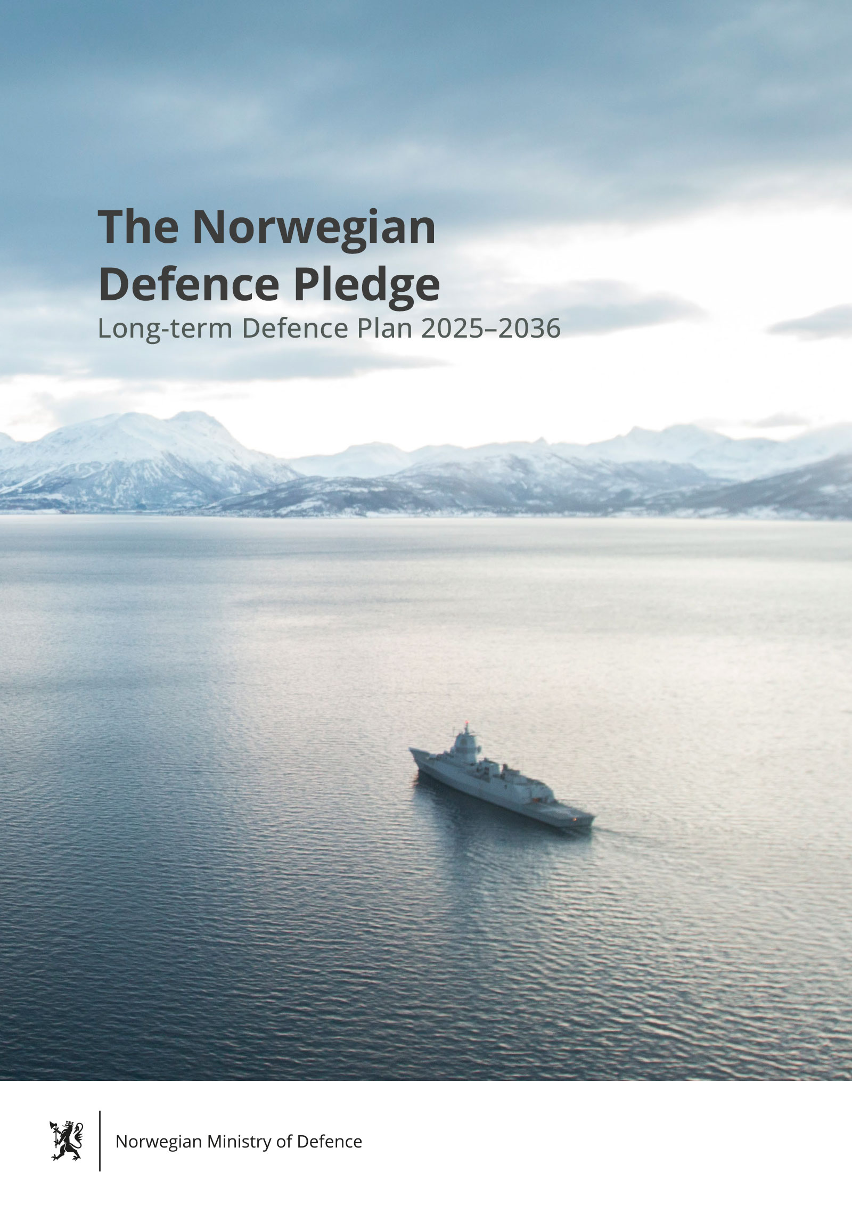

2 % and beyond. Norway’s reinforced commitment to NATO.
Norway will reach the NATO commitment of spending 2% of GDP on defence in 2024. Through our new long-term defence plan, Norway will continue to increase defence spending significantly from 2025-2036.
Through major investments, we will significantly improve and expand our defence capabilities in order to strengthen Norwegian and allied security, NATO’s deterrence and defence, our defence capabilities, and our ability to receive and support allied forces. An important goal is to increase the volume and flexibility of the Norwegian military to enhance our military posture and the defence of the Alliance.
Norway is a nation with considerable maritime interests. Combined with our immediate proximity to Russia’s nuclear submarine force, maintaining situational awareness in the High North and in the North Atlantic is paramount.
This long-term defence plan emphasises capabilities in the maritime domain through the planned procurement of a minimum of five new frigates with anti-submarine warfare capability as well as minimum of five new submarines. Norway will invest in new long-range surveillance drones and satellites. Norway will strengthen air defence capabilities with additional ground-based air defence systems, as well as long-range air defence capability.
Finland and Sweden’s entry into NATO will significantly strengthen allied security. It also facilitates further security integration among Nordic countries. The Norwegian Army will strengthen its capacity with two new land combat brigades and long-range precision fires. The Home Guard will receive more equipment, personnel and training. New helicopters will be acquired for the army and special forces. Stocks of munitions, spare parts, fuel and equipment will be rapidly increased. Norway will introduce more simulators and acquire one additional C-130J transport aircraft.
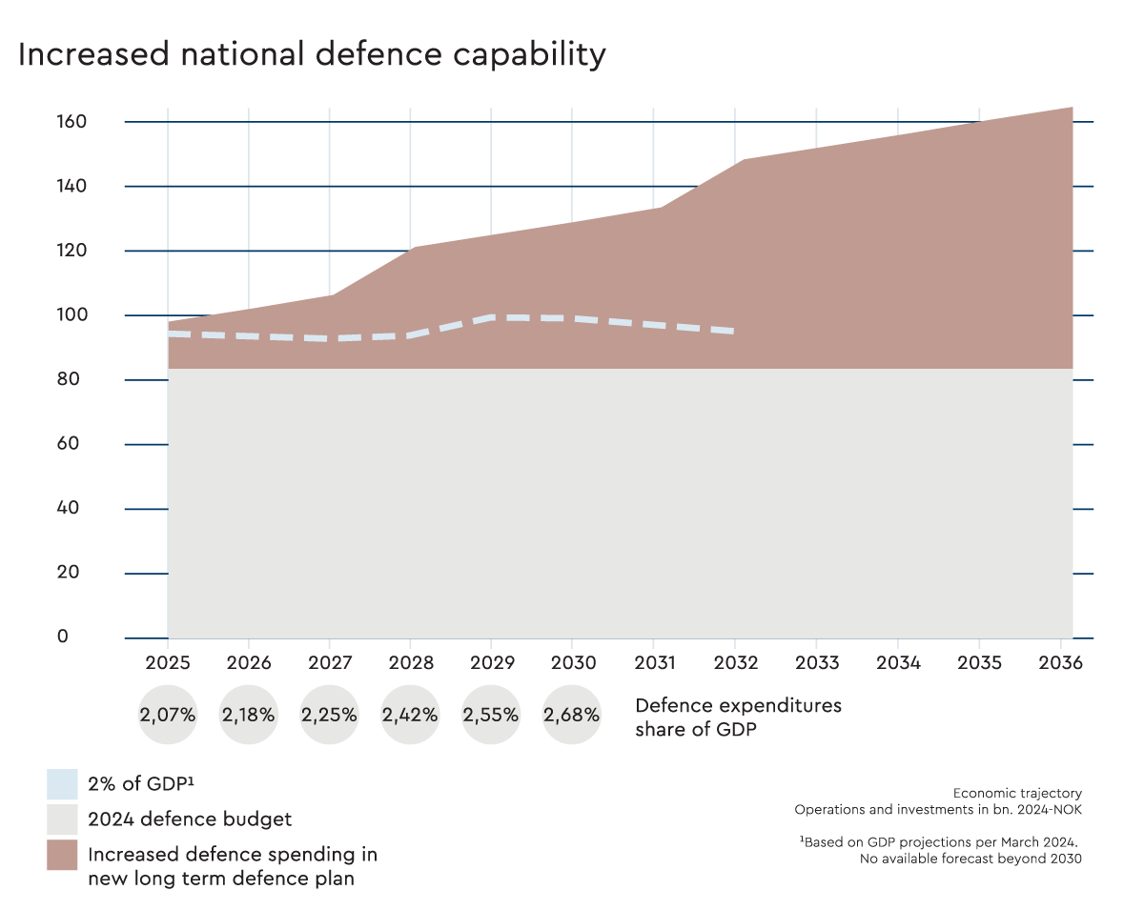

A more demanding security situation
The Norwegian Defence Pledge is presented at a time when the international security situation is more unstable, dangerous and competitive than it has been for a long time. Norway is insufficiently prepared to handle both current security challenges and the emerging security landscape.
We find ourselves in a rivalry over values and worldviews, between democracies and authoritarian regimes. The rise of China is asserting pressure on the prevailing world order and an assertive Russia is challenging the Euro-Atlantic security architecture. This recognition is a an important premise for the choices made in this plan.
The deteriorating security situation requires the ability and willingness to adapt to a time of increased unpredictability and an increasing risk of military conflict.
Norway’s response comes in the form of stronger national defence, closer cooperation within NATO and with allies, and continued support for Ukraine. Norway will take on a greater responsibility for allied and national security in the Euro-Atlantic area, and increase the ability to defend the Alliance and Norway with our allies.
We will do this through major investments to increase our military capacity, volume, and sustainability. The government will strengthen capabilities to improve situational awareness and military posture in our immediate surroundings.
Finland and Sweden’s NATO membership strengthens allied security, increasing the importance of host- and transit-nation support for allied forces. The security situation entails a greater need for more forces with improved readiness and ability to cooperate with Allies.
This long-term plan proposes a number of measures in order to reduce vulnerabilities and increase the combat power, availability, endurance and sustainability of the Armed Forces. The government is committed to increase staffing and strengthen the capacity for operations. The Armed Forces are to recruit and retain more people.
The risk of military conflict involving Norway and our allies has increased. This realisation is the basis for this long-term plan, and the further development of our Armed Forces.
Our security must be defended every day at home and abroad to prevent and deter other actors from imposing their will by force, and in order to respond with force if needed.
Our ability to prevent, avert, and manage crisis and war will be strengthened. Norway will take greater responsibility for our own and allied security. Norway will use significantly more of our country’s resources on defence, security, and preparedness.
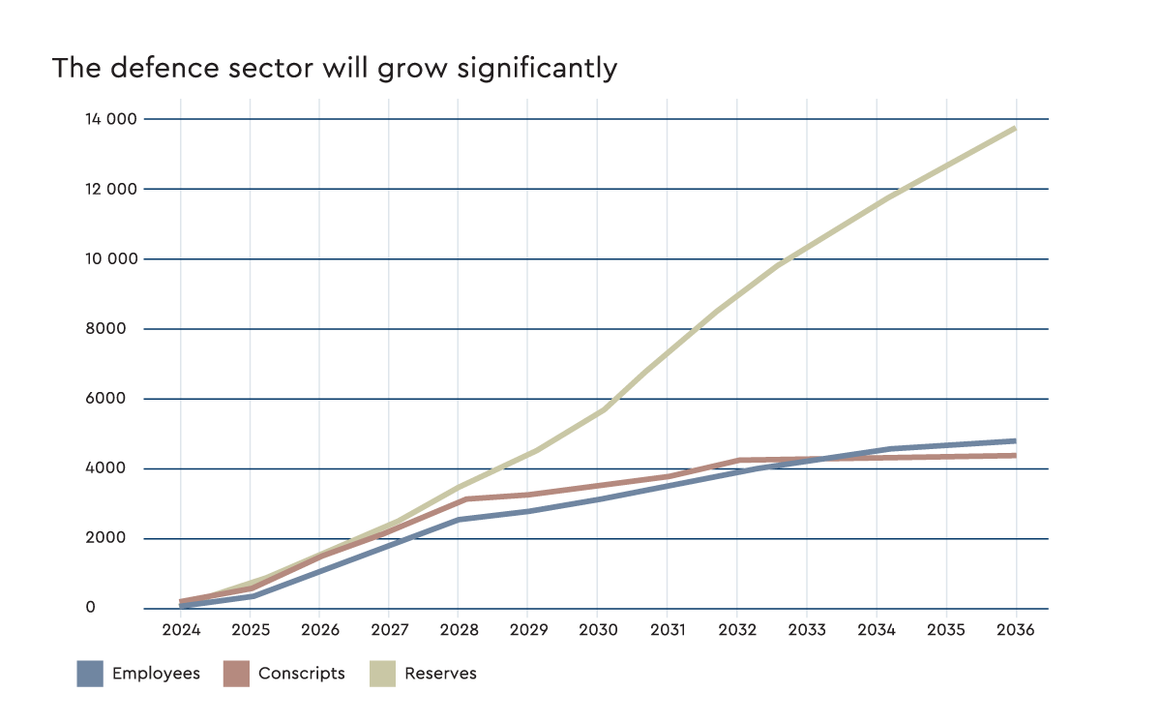

Deterrence and Defence
Safeguarding our security is increasingly challenging. This requires a clear strategic direction for the development of the Armed Forces.
The primary objective of Norway’s defence effort is to prevent and deter aggression, in continuous and close collaboration with allies. This requires the strengthening of our capabilities and posture in order to maintain stability in our immediate surroundings. It also requires increased availability of our Armed Forces for continuous operational use , at home or abroad in support of the alliance. The capacity and availability of the Armed Forces will be strengthened to facilitate high and sustained activity.
Norway and the Armed Forces must be better equipped and prepared if deterrence fails. The armed forces need to improve its readiness and sustainability, and be able to respond with all relevant means together with allies.
Our NATO membership and allied cohesion provide the foundation for Norwegian and allied security. Strengthening our national defence capabilities must underpin an integrated approach to strengthening NATO’s deterrence and defence posture.
A whole-of government approach is required to improve society’s resilience against military and non-military threats. International cooperation and collaboration between governmental agencies, businesses and the population, within the framework of the Norwegian total defence concept is a priority. Civil-military cooperation is an integral part of the Norwegian defence effort.
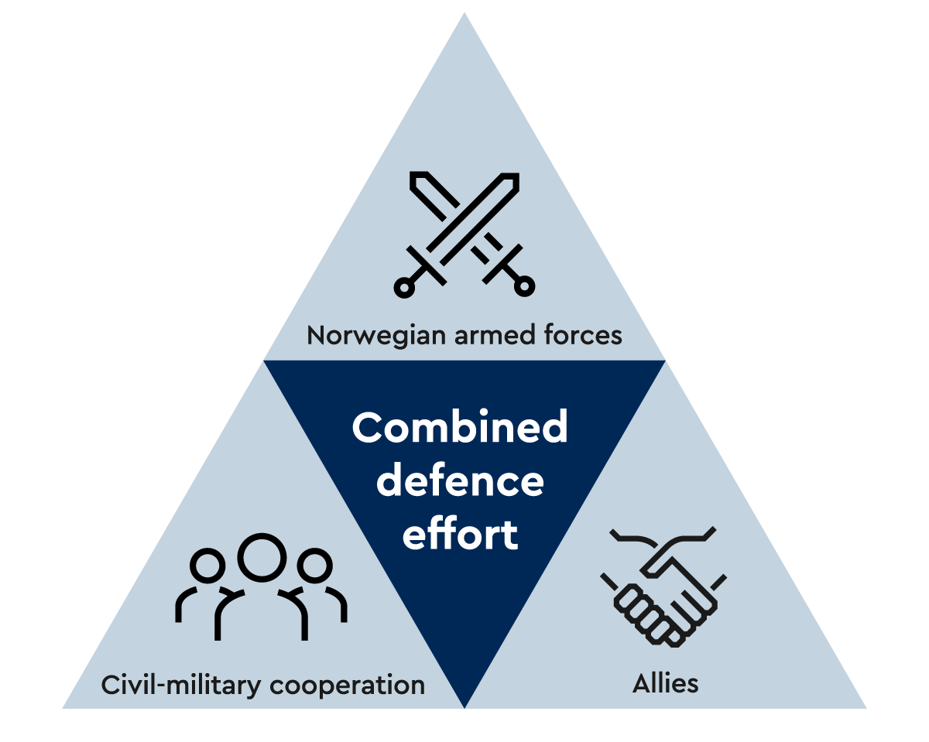
The Norwegian Defence Concept

The Norwegian Defence Pledge
The government proposes a comprehensive defence commitment. The government proposes an increase of 600 billion NOK in defence spending between 2025 and 2036, to a total of 1624 billion NOK in defence spending over twelve years. It proposes to address weaknesses in the current structure, while at the same time significantly increasing our defence effort. Four major efforts are prioritised; increased capabilities for situational awareness, a new maritime surface fleet, strengthening air defence capabilities, and increased capacity and volume in the Army and Home Guard.

Addressing weaknesses through increased stocks of munitions, spare parts and more personnel
The Armed Forces must be able to integrate with allied efforts and contribute to defending Norway or allies. This includes the ability to operate in high intensity conflicts:
- Stocks of munitions, spare parts, fuel and equipment will be rapidly increased. Operational frameworks are strengthened, and more personnel will be recruited.
- The Armed Forces’ ICT infrastructure and digital foundations are modernised and streamlined.
- The capacity for receiving allied forces is strengthened to better enable Norway to receive allied reinforcements throughout the Nordic region.

Enhancing situational awareness in the High North
The ability to detect, and understand the intentions of a potential adversary is paramount. Norway’s strengthening of the Armed Forces will prioritise national capacity for surveillance and situational awareness, monitoring and understanding the developments in our surroundings - especially in the High North.
- The Armed Forces will aquire satellites for monitoring and communication for increased operational capability.
- To enhance the effectiveness of maritime patrol aircrafts, a P-8 simulator will be procured for the maritime patrol aircrafts at Evenes.
- To strengthen situational awareness, the Armed Forces will procure, as part of international cooperation with allies, long-range drones with sensors and systems for monitoring maritime areas of interest in the north.
- The Armed Forces’ operational headquarters and tactical headquarters will be further strengthened, as well as the Armed Forces’ information infrastructure.

Fleet plan 2024: Strengthening the Navy
Norway has considerable maritime interests across vast ocean areas, with significant value creation in the maritime sector. In order to promote Norwegian security interests, the maritime domain is prioritised through major investments in new and increased capabilities.
- To maintain continuous situational awareness and posture in Norwegian areas of interest, a minimum of five blue water frigates capable of contributing in the full spectrum of maritime operations will be procured. The frigates will be acquired, operated, and maintained in partnership with a close ally.
- Maritime helicopters with anti-submarine warfare capability will be procured to operate as part of the frigate system.
- A standardised class of vessels in two sizes will be developed and procured to fulfill the missions of the Navy and the Coast Guard.
- Four new submarines have already been approved for procurement in cooperation with Germany. The government recommends acquiring at least one additional submarine.

Strengthening Norway’s Air Defence
A major priority is to strengthen the Armed Forces’ ability to protect vital infra structure against attacks from cruise missiles, tactical ballistic missiles, and unmanned aerial systems.
- Four new NASAMS medium range air defence systems will be procured for the Air Force and the Army. New radars will be acquired.
- The government reccommends procuring a long-range air defence system in order to protect one geographical area against tactical ballistic missiles.

Enhancing the capacity of the Army and the Home Guard
The Army will consist of three land combat brigades. The Home Guard will increase in size and receive equipment appropriate for an expanded national responsibility.
- The development of Brigade North as a heavy infantry brigade with four mechanised manoeuvre battalions and associated support units will be completed.
- Finnmark land defence will be strengthened with combat air defence, an artillery battalion, one light infantry battalion, engineer company, ISTAR squadron, strengthened leadership, and developed into the Finnmark Brigade
- Brigade South will be established as a reservist-based light infantry brigade to secure allied reception areas and act as a mobile reaction force.
- Long-range precision fires will be added to the land force.
- The Home Guard will be strengthened with more equipment, training, and more personnel. Combined, the regular Home Guard forces and the response forces will amount to 45,000 by 2036.
- The Armed Forces will be supplied with new helicopters to support the Army and special forces.
The Royal Norwegian Navy will be strengthened with a comprehensive new fleet plan that will renew and enhance Norway’s maritime capacity. Norway’s future navy will be developed along three lines; new frigates, new standardised vessels and new submarines.
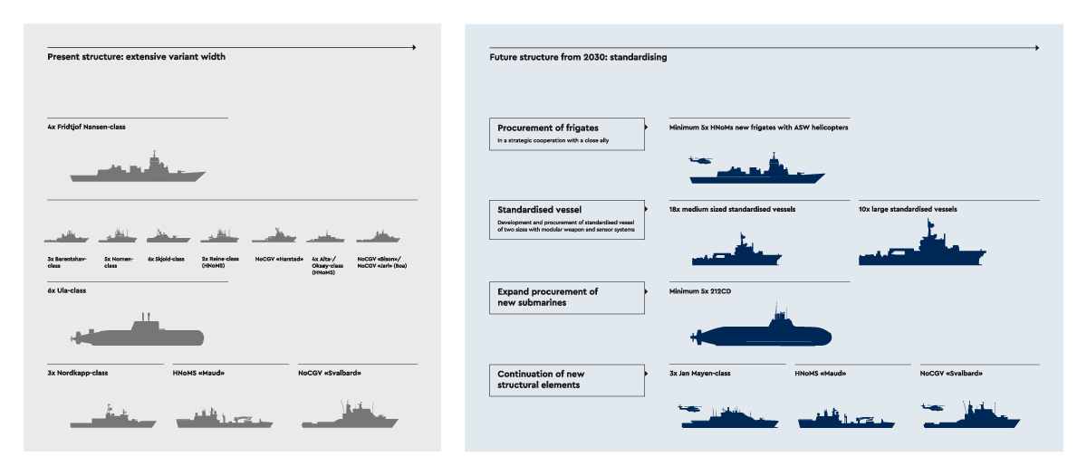

A new era in Nordic defence cooperation
A united Nordic region strengthens NATO’s deterrence and defence capabilities in Northern Europe. It significantly increases NATO’s collective military capacity, and facilitates further military cooperation and integration efforts among Nordic countries and supports effective efforts for shared defence planning, command structures, and force compositions. Exploiting the full potential of such cooperation will take time.
Nordic NATO-membership allows for expanded defence cooperation. Norway will play a prominent role in the defence of Finland and Sweden, and Finnish and Swedish territory can be used by allied forces in the defence of Norway.
Finnish, Norwegian and Swedish territory and infrastructure will have greater significance for the defence of Northern Europe and forms the basis for increased training among allies.
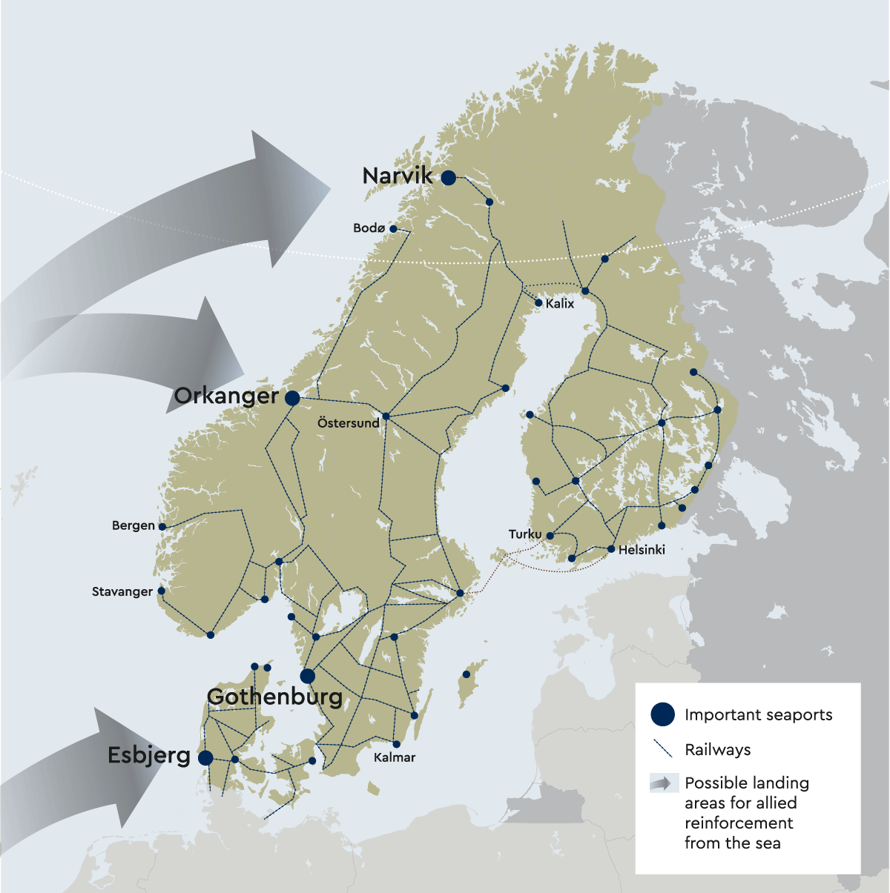

Strengthening the prerequisites for defence
To succeed in building stronger defence capabilities, significant measures must also be taken in areas that support this effort:

Boosting personnel and competence
The volume of our Armed Forces will be increased by several thousand personnel. The Armed Forces’ educational institutions will be strengthened. Innovative measures to recruit and retain personnel, better utilisation of the conscription system, and expanded use of reservists will also be implemented.

Faster acquisitions
Equipment, Information and communication technology, as well as infrastructure will have to be procured faster. The government will work to ensure that acquisitions are conducted faster and in greater volume, while still emphasising good governance.

Buildings and property
The government will establish sufficient housing, quarters, and barracks of good quality. Where necessary pace of construction will be weighted equally with cost. Infrastructure to support allied reception and support will be prioritised.

Climate, innovation, and research
The defence sector must adapt rapidly to a changing world. Climate change, technological development, and a more complex threat environment is challenging the way we conduct military operations. The government will strengthen research and development, emphasising innovation, and intensifying efforts to reduce emissions.
