Meld. St. 20 (2020–2021) Report to the Storting (white paper)
National Transport Plan 2022–2033
English summary

Foreword
Transport is first and foremost about people – about travelling safely and efficiently together. In a country like Norway, with its extensive coastline, high mountains and long fjords, we need to connect urban and rural areas and the people who live there.
We have always needed to travel and to transport goods and commodities. An efficient, environmental-friendly and safe transport system is one of the most important cornerstones of a modern society, and an important prerequisite for value creation and welfare.
Planning and building infrastructure in Norway is often both difficult and expensive. However, people must be free to live and work where they wish, and our prosperity depends on the value creation that takes place in all parts of the country. That is why we must maintain and develop a transport system that is capable of connecting all parts of the country together. To succeed we must keep up with and encourage technological advances and dare to think differently. At the same time, we have to choose the solutions that give us the highest possible value for the public investments in transport projects.
The Government has given transport high priority. Our investments have led to shorter travel times on both rail and road, more frequent train departures, better traffic safety and positive urban development. At the same time, the transport sector has been modernised through several reforms that have led to more competition, innovation and efficiency. This work is now being followed up by an ambitious and realistic National Transport Plan that is intended to ensure that the most important challenges are addressed in the right order. This will create new opportunities and lead to further modernisation of the sector.
What appears to be the best solution today is not necessarily the best solution in ten years. A new method of managing the transport sector – through portfolio management and continuous optimisation – will therefore be introduced. To avoid making decisions today that prove to be erronous in future, we must not commit to detailed projects at a too early stage. In the National Transport Plan 2022–2033, the Government wants to underline that a project can be adjusted, if necessary, to meet the challenges the project is intended to address. The transport agencies will therefore have more room for maneuver to continuously optimise and further develop projects, to choose the best solutions, and to propose changing the order in which projects are implemented, if new conditions indicate that the priorities need to be changed.
The Government wants to develop all modes of transport further. The plan will contribute to make travelling easier and increase the competitiveness of business and industry. The plan will underpin the global Sustainable Development Goals and Norway’s climate and environmental goals. The overriding objective for the National Transport Plan 2022–2033 is: An efficient, environmental-friendly and safe transport system in 2050.
Knut Arild Hareide (sign.)
Minister of Transport
Figure 0.1 Knut Arild Hareide
Minister of Transport

About Norway – population, topography and transport infrastructure
Population: 5,391,369 inhabitants as of 1 January 2021
Inhabitants per sq. km. land area: 17.3
Population growth rate (2019): 0.7 per cent
Norway has the lowest population density in Europe after Iceland. However, more than 80 per cent of the population live in urban areas, where the population density is 1,991 per sq. km (2020).
Area (mainland): 323,808 sq. km
Length of coastline (mainland, including fjords and bays): 28,953 km
A large part of the country is unsuitable for settlement or agriculture due to harsh climatic conditions, poor soil quality and difficult terrain.
Mainland topography (2020)
Built-up area: 1,7 per cent
Agriculture: 3, per cent
Marsh/wetland: 5,3 per cent
Freshwater and glaciers: 7 per cent
Forest: 37,4 per cent
Mountain and mountain plateau: 45 per cent
Transport infrastructure
Public roads, total: 94,700 km
National roads: 10,500 km
County roads: 44,700 km
Local roads: 39,500 km
Total number of road tunnels: more than 1,200
Railway network, total: 4,208 km
Electrified: 2,459 km
Double track: 290 km
Airports with scheduled flights: 48
Ports and docks: 3,000
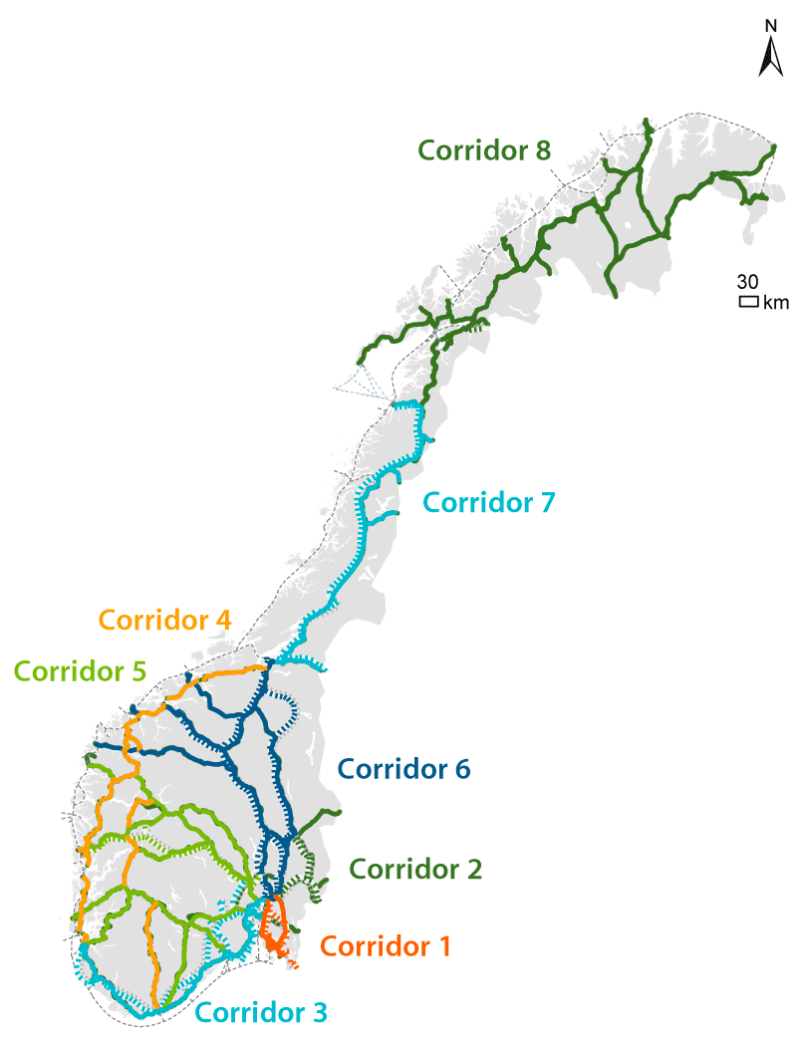
          - National transport corridors

About the National Transport Plan
The National Transport Plan, which is submitted to the Storting (the Parliament) as a white paper, is produced every four years and sets forth the Government’s transport goals, strategies and priorities in a long-term perspective.
The National Transport Plan 2022–2033 (Report No 20 to the Storting (2020–2021)) was presented to the public and submitted to the Storting in March 2021. This is the sixth plan under the current planning system, covering all modes of transport. The plan presents policies and priorities within an economic frame for a twelve year period and provides perspectives towards 2050.
The preparation of the White Paper is backed by an extensive and inclusive process, involving input from ministries, agencies, regional authorities, urban municipalities, business, industry and other users and interest groups. An important objective has been to ensure an inclusive process while aiming at a more strategic and dynamic plan that identifies and addresses the main challenges for future transport. The transport agencies (Avinor ltd, the Norwegian Railway Directorate, Bane NOR, the Norwegian Public Roads Administration, Nye Veier, the Norwegian Coastal Administration) were given several missions and tasks on a wide range of topics during the process. The responses and deliverables were subject to public hearings, which took place in spring 2020. In sum, these contributions have provided a broad insight into the future needs and opportunities for the transport sector.
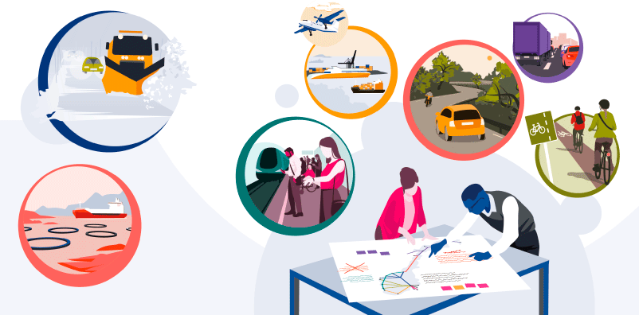
          - Transport planning

Recent advances in the Norwegian transport sector
The Government has introduced reforms in all parts of the transport sector. Steps have been taken to facilitate competitive tendering, thereby increasing efficiency and innovation, but cooperation has also been encouraged in cases where this contributes to more efficient use of resources. Another result of these reforms and the organisational changes the agencies have undergone is that the authorities’ role has become clearer and, in many cases, more distinct from other activities. The way the sector is organised is intended to preserve the strong expert knowledge environment in the transport sector, thereby ensuring that they can fulfil their societal missions.
- Nye Veier has been established and builds main roads more efficiently.
- Opening the rail sector to competition has resulted in more railways for the funds invested and better services.
- The Norwegian Public Roads Administration now has a new and more efficient organisation.
- The county authorities have been assigned administrative responsibility for the county roads.
- The road toll reform reduced the number of road toll companies from 60 to five.
- Entur has been established as a national travel planner for public transport.
- New taxi regulations ensure forward-looking services in both urban and rural areas.
- Commercial express bus services have been liberalised, and unnecessary needs assessments have been discontinued.
- The Urban Growth Agreements lead to improved accessibility and more environmental-friendly transport solutions.
- In the major urban areas, the Government covers a substantial part of the costs of large public transport projects.
- The coastal route has been subject to tender.
- The reorganisation of the Norwegian Coastal Administration aims to trigger rationalisation gains by common organisation of related fields.
- As a result of public procurement requirements and support schemes, there are now around 70 low and zero-emission ferries in service in Norway.
- The Government’s electric car policy has been a major force to achieving more than 50 per cent of new passenger cars sold in Norway now being zero-emission cars.
- Avinor and the Civil Aviation Authority are working to make Norway a leading country in the phasing-in of aircraft with low or zero emissions.

National Transport Plan 2022–2033 – Overview
In the National Transport Plan 2022–2033, the Government has emphasised developing a good transport system that provides everyone freedom and opportunities, increases quality of life, contributes to value creation, protects and saves lives, and helps to improve health, the environment and the climate.
Children and young people are the users of today’s and tomorrow’s transport options. With the Children’s Transport Plan, the Government wants to ensure that children and young people can enjoy good mobility while also being safe in traffic. Long-term endeavours to reduce road accidents have yielded particularly good results for children and young people.
The Government plans for total financial framework of around NOK 1,200 billion (118 billion euro) during the plan period, of which NOK 1076 billion is provided from state funds and NOK 123 billion from road tolls. The funds will be used to develop and maintain good, forward-looking transport solutions throughout Norway.
The use of resources in individual fiscal years will be adapted to the overall profile of the national budget within the bounds that follow from the fiscal rule and the state of the Norwegian economy. Changes to budgetary freedom of action could affect both the phasing-in and implementation of the plan. This budgetary room for manoeuvre is expected to be more limited in the years to come, and measures will increasingly have to be funded within the existing economic constraints.
The level of public investments is high in Norway compared to most other countries. Investments in transport have been given particularly high priority in the past decade. Since 2003, the investment level has more than doubled measured as a proportion of the economy. This gives ample room for opportunity if the resources are spent well. The Government has implemented a number of new transport policy measures in recent years, and it is now facilitating the realisation of further gains to achieve more efficient use of public resources, in particular through optimisation and portfolio management.
It is not desirable to have a transport plan that ties the authorities to a specific use of resources and project design regardless of cost increases, new technological opportunities and changes in transport demand. During the preparation of this plan, the transport agencies have shown that there are great possibilities to get more value for money by optimising projects. The agencies will continue to optimise while the plan is implemented. At the same time, we introduce portfolio management of the investments, which means that the projects that prove most success with optimisation efforts can be implemented first. Portfolio management means that, during the plan period, the agencies can propose the order and scope of projects and measures to be implemented within the framework of the National Transport Plan 2022–2033.
This plan was developed while the coronavirus pandemic led to extensive changes in the transport sector. It is difficult to estimate how long the consequences of the pandemic will last and the shape they will take. In light of this uncertainty, a new approach to priorities and implementation through portfolio management, as described in this plan, is vital if we are to ensure making the right choices in and for the future.
The Government is now presenting an ambitious and realistic transport plan that will ensure that we are able to implement mature and good projects at the right time. In a time with major societal and technological changes, this plan facilitates predictability while also allowing for necessary flexibility by continuously assessing transport demand and financial freedom of action before decisions are made.
In addition to major investments, we will maintain the infrastructure that is already in place. Good maintenance is vital for a reliable transport service and satisfactory management of public resources.
The Government aims to:
- plan for total financial framework of around NOK 1,200 billion (118 billlion euro) during the plan period, of which NOK 1,076 billion is provided from state funds and NOK 123 billion from road tolls. The state funding breaks down as follows: NOK 510 billion for national roads, NOK 52 billion for county road grants, NOK 393 billion for the rail sector, NOK 33 billion for coastal administration, NOK 80 billion for measures in urban areas, NOK 5 billion for airports, and NOK 3 billion for initiatives across transport sectors
- invest in renewal, operation and maintenance to reduce the maintenance backlog, improve operational reliability and take account of expected climate change
- further develop infrastructure through a high investment level in large projects, railway investment packages (measures that deliver improved railway services), improvement of sections of road, landslide/rockslide protection, fairway improvements, measures in fishing ports, and grants for airport developments
- increase the State’s funding of county roads to enable the county authorities to expand housing and labour market regions and improve the conditions for commercial and industry transport.

Initiatives relating to the five policy objectives for an efficient, environmental-friendly and safe transport system in 2050
An efficient, environmental-friendly and safe transport system in 2050 is the overarching, long-term policy objective for the transport sector. Five equally important policy objectives have been developed for the use of resources during the plan period. The objectives are presented in Figure 5.1.
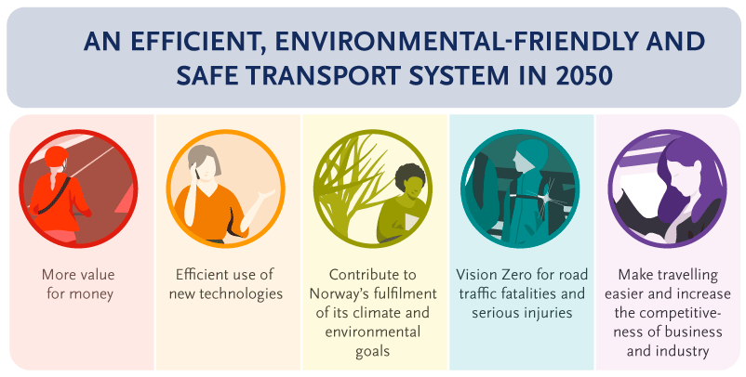
          - The policy objectives for the transport sector
The global Sustainable Development Goals have inspired the overarching objective for the transport plan. The transport plan and its follow-up will have a positive effect on Norway’s possibility of achieving several of the Sustainable Development Goals by 2030.

We will achieve better results from public spending (“value for money”)
          - Value for money
The ambitions for the transport plan have never been higher, and it is important that the large amounts invested are used efficiently. The work on the plan has therefore been permeated by the goal of getting value for money. Furthermore, investments in transport can benefit from associated value chains when projects are implemented.
The Government has implemented several reforms to enable the transport agencies to utilise the resources allocated to the sector more efficiently. One example is the establishment of Nye Veier. It has been given extensive autonomy to manage the development of its projects, including through portfolio management. This model has led to reduced costs and society getting more value for money. All the agencies will continue their endeavours to optimise projects, and, with this plan, we are implementing portfolio management of investments, so that the agencies themselves can recommend the scope and order of projects. We will also start using elements from the Nye Veier model to achieve more efficient development of railway infrastructure.
By introducing portfolio management, the Government is changing the dynamic of the Norwegian transport sector – from competition for a project to be included in the National Transport Plan to competition to develop the best projects. At the same time, this means that the scope and order of the projects presented in the white paper are not necessarily final. The project overview as presented in the white paper shows the priorities as defined at present. The agencies will continue to optimise, and changes may occur that affect priorities. The agencies will also cooperate with business and industry where this may improve projects. We will therefore facilitate earlier involvement from the building and construction industry, and further development of procurement and contract strategies, also for operation and maintenance.
Cost-/benefit analyses have been an important part of the basis for assessing the priorities in this plan. Addressing the most important challenges first also entails assessing what we believe to be the important considerations when further developing the transport system in the entire country. A solid base for decision-making in the transport sector will therefore be important, including managing uncertainty. As a result of further optimisation and portfolio management, the implementation of the transport plan could result in greater socio-economic profitability than has been the case so far.
The Government aims to:
- continue to realise the gains from the transport sector reforms
- prioritise on the basis of the challenges we want to address, and not commit to detailed projects
- introduce portfolio management in the transport sector, whereby continuous optimisation, competition, learning and more coherent development will help us to choose the best solutions and achieve value for money
- further develop the cost-benefit analyses and other basis for decision-making to ensure coherent, sustainable and long-term strategic planning
- utilise the potential of business and industry to create forward-looking solutions, such as facilitating earlier involvement and smart use of procurement and contract strategies.

We will use new technologies and research to obtain more efficient and safe transport with lower emissions
          - Use new technologies
New technologies offer better solutions to some of the challenges we have previously addressed through traditional approaches for improving accessibility, capacity and transport safety. Automation, electrification and zero-emission mobility, new business models and the development of intelligent transport systems are some of the drivers in the smart and green transition of the transport sector.
The National Transport Plan 2022–2033 provides for substantially stronger efforts in developing and implementing new technologies in the transport sector. Research, development, piloting and innovation are important elements in this strategy. Through the development of innovation-friendly rules and regulations, we will facilitate the development of new technologies and contribute to mobility solutions and services that will help us achieve the objectives for the transport sector.
The Government aims to:
- use the portfolio management system to enable and provide incentives for continuous optimisation of investments, in line with the pace of the technological development
- cater for the appropriate development, implementation and operation of the digital solutions that sustain the functionning of the transport systems
- ensure robust and updated regulations, including the use of regulatory sandboxing in areas that are considered technologically promising, and actively seek to influence European and international regulatory development
- actively use public procurement and other broad measures to promote technological development
- follow closely technological trends internationally through continuous knowledge-collection, carrying out of technological pilot projects and participate in international co-operation
- facilitate more and better utilisation of the growing amounts of data generated in the transport sector, as a basis for better planning, traffic management and a number of other applications
- make Norway an attractive test-bed for testing new technological solutions, including autonomous and low-emission means of transport in all modes
- facilitate research, development and piloting, both in the transport agencies and through instruments administered by the national R&D agencies, in accordance with technology-related EU research in Horizon Europe
- promote constructive triangular co-operation between transport authorities, research institutions and private industry and business, with a view to enable Norwegian business and industry to develop smarter mobility solutions
- develop a knowledge strategy that can offer an overview of the main challenges in the transport sector and set out a strategic direction for national R&D in the transport sector.

We will develop a transport sector that contributes to the achievement of Norway’s climate and environmental goals
          - A transport sector that helps to achieve Norway’s climate and environmental goals
The transport sector accounts for almost a third of Norway’s greenhouse gas emissions. The Government’s Report No 13 to the Storting (2020–2021) Klimaplan for 2021–2030 (‘Climate Action Plan for 2021–2030’) was presented in January 2021 as a White Paper. The Climate Action Plan describes how Norway will achieve its ambitious climate goals. The Government’s climate policy for the transport sector is described in detail in the Climate Action Plan. The plan shows that, unless we intensify our use of policy instruments, there will be an emissions gap by 2030. Among the key policy instruments implemented to cut emissions from the transport sector are carbon tax, biofuel quota obligations, different requirements for the use of zero and low-emission technology and investment support schemes. The EU Emissions Trading System is the main policy instrument for the aviation industry. The policy targets for new zero-emission vehicles from the National Transport Plan 2018–2029 remain unchanged, and form the basis for the policy instruments in the Climate Action Plan. The overall emission cuts outlined in the Climate Action Plan mean that we are on course to reduce transport sector emissions by 50% in 2030 compared with 2005.
The National Transport Plan 2022–2033 will contribute to the ambition to reduce transport sector emissions by 50% by 2030 and contribute to Norway achieving its climate and environmental goals.
The policy targets from the National Transport Plan 2018–2029 remain unchanged:
- all new passenger cars and light vans shall be zero-emission vehicles by 2025
- all new city buses shall be zero-emission vehicles or use biogas by 2025
- by 2030, all new heavier vans, 75 per cent of new long-distance buses and 50 per cent of new lorries shall be zero-emission vehicles
- by 2030, goods distribution in the biggest city centres shall take place with virtually zero emissions.
The targets are based on a prerequisite of improvements in technological maturity.
The Transport Plan also follows up the Government’s Action Plan for Fossil-free Construction sites in the transport sector, which was presented at the same time as the Climate Action Plan. The Government will prioritise the implementation of pilot projects for fossil-free construction sites. Increased carbon tax, biofuel quota obligations, and requirements relating to public procurements are key policy instruments for cutting emissions at construction sites as well.
Coordinated land use and transport planning will ensure efficient land use and facilitate environmental-friendly modes of transport. Combined with the “zero growth” objective in the cities, this will help to reduce emissions. The use of cultivated land shall be assessed separately and reduced in transport systems.
The transport agencies’ measures and activities can have a negative impact on ecosystems, for example in the form of fragmentation, destruction of habitat types, barrier effects, disturbances to bird and animal life, the spreading of harmful alien organisms, reduced water quality and the spread of environmentally harmful chemicals and plastic. To increase knowledge and ensure that encroachments on nature areas are as small as possible, the transport agencies and relevant authorities, including the Norwegian Environment Agency, will plan a pilot project for a no net loss stretch of road. The Sustainable Development Goals and a new global framework for the preservation of biodiversity shall form the basis for the work in the sector.
Within their areas of responsibility and with the resources at their disposal, the agencies shall strengthen their efforts to remove plastic waste and implement preventive measures to reduce plastic waste and microplastics into the environment.
During the plan period, the transport agencies shall follow up their work on reducing noise at its sources.
Climate
The Government aims to:
- use general policy instruments, such as the carbon tax and support schemes, as well as biofuel quota obligations, to reduce emissions from the transport sector
- facilitate the development of zero and low-emission solutions in the transport sector
- continue the efforts to achieve the policy targets that, by 2025, all new passenger cars and light vans shall be zero-emission vehicles and all new city buses shall be zero-emission vehicles or use biogas, and that, by 2030, all new heavier vans, 50 per cent of new lorries and 75 per cent of new long-distance buses shall be zero-emission vehicles
- contribute to ensuring that more people choose climate-friendly modes of transport, such as cycling and public transport
- use public procurements to help ensure that zero and low-emission solutions are developed and introduced in the transport sector
- use regulations such as requirements for zero-emission technology in public procurements and emission standards
- use other policy instruments that are important to reducing emissions in the transport sector, including coordinated planning of land use and transport infrastructure
- follow up the Government’s Action Plan for Fossil-free Construction sites in the transport sector, including prioritising NOK 75 million per year in the first six-year period for pilot projects for fossil-free construction sites in the transport sector
- consider policy instruments aimed at ensuring efficient handling of uncompacted material from construction sites
- consider both land use and transport planning when developing transport projects
- assess the establishment of alternative fuel infrastructure and transport infrastructure in a common context, for example by facilitating charging infrastructure at rest stops
- reduce the total area used for transport projects through reuse and optimisation, and by protecting the most carbon-rich areas
- further develop a method for including direct emissions from construction and land-use in the cost-benefit analyses included in impact assessments, conceptual appraisal and in the basis for other decision-making in transport projects, and, in that regard, consider how this can be implemented in connection with the governance of the different transport project portfolios
- consider more closely the possibility of using the Road Traffic Act Section 7 to establish zero-emissions zones for climate reasons, initially in the form of pilot projects in a few cities. The national road networks shall not be included in zero-emission zones
- endeavour to reduce emissions from the operation and maintenance of transport infrastructure.
The environment
The Government aims to:
- contribute to achieving or maintaining good conditions in the ecosystems, especially the coherent blue-green infrastructure, and take account of natural diversity and water environments when planning, developing, operating and maintaining infrastructure and managing property
- avoid planning transport projects through protection areas and, as far as possible, avoid crossing of and encroachments in protected watercourses. Valuable and vulnerable areas of national interest should not be destroyed use the mitigation hierarchy as the basis for ensuring that damage is avoided to the greatest possible extent before considering the implementation of mitigation measures, rehabilitation measures or ecological offset solutions
- plan a pilot project for a no net loss road with the assistance of the environmental authorities, among others
- reduce salt pollution along the national road network
- test an indicator for natural diversity
- that the transport agencies, within their areas of responsibility and with the resources at their disposal, shall strengthen their efforts to remove plastic waste and implement preventive measures to reduce plastic waste and microplastics into the environment.
- contribute to compliance with the Pollution Regulations’ limit values for local air quality and noise
- contribute to meeting the national targets for local air quality
- help to ensure that the municipalities have sufficient policy instruments in place to comply with limit values and national targets for local air quality.

We will invigorate efforts for transport safety and the vision of zero road fatalities and serious injuries
          - A vision of zero traffic fatalities and serious injuries
The “vision zero” for a transport system where no one is killed or seriously injured applies to the entire transport sector. Measures to achieve the vision zero will have a positive impact on Sustainable Development Goal 3.6 of halving the number of global deaths and injuries from road traffic accidents.
For several years, we have seen a positive development in road safety, thanks to wide-ranging efforts and close cooperation between authorities, the voluntary sector and others. In 2020, fewer than 100 people died in road traffic accidents for the first time since 1947 (this equals a fatality rate of 18/million). Head-on collisions are still the main challenge on the national road network, whereas run-off-the-road traffic accidents are the most common on the county roads network. The number of bicycle or electric scooter accidents is increasing in the major cities. The Government’s ambition is that the number of fatalities and serious injuries in road traffic shall be reduced to a maximum of 350 by 2030, of which maximum 50 shall be fatalities. This means a reduction of 50 per cent compared with the current numbers. The long-term ambition is that there shall be zero fatalities in road traffic in 2050. The level of ambition is high and requires continued efforts in road safety work.
The safety level in Norwegian aviation is very high, and the Government will endeavour to maintain and develop the efforts in this area. The risk associated with Norwegian rail transport is very low and has been further reduced through systematic work on safety and technical barriers. The current risks are mainly related to the surroundings, such as natural incidents and people’s behaviour on and near rail tracks. There is a generally high marine safety level in Norwegian waters. An increase in ship traffic and other activity in coastal and offshore areas is expected in the period up to 2033, as is increased use of low and zero-emission solutions and automation. Safety measures at sea must be further developed and adapted to this development.
The Government aims to:
- use the vision zero as the basis for transport safety priorities
- continue the efforts to maintain the high safety level in transport by rail, air and sea
- pursue the ambition that the number of fatalities and serious injuries in road traffic shall be reduced to a maximum of 350 by 2030, of which maximum 50 shall be fatalities, and that there shall be zero fatalities in road traffic in 2050
- focus on measures targeting infrastructure, measures for pedestrians and cyclists in urban areas, targeted efforts in relation to high-risk factors and vulnerable road users, measures to reduce accidents involving heavy goods vehicles, and support technological developments that promote safety
- endeavour to ensure that, by 2028, 60 per cent of traffic performance on national roads with a speed limit of 70 km/h or higher takes place on roads with median barriers, and that all national roads with a speed limit of 70 km/h or higher will eventually meet a minimum standard for run-off-the-road accidents
- place particular emphasis on the needs of pedestrians, cyclists, and motorcyclists in the design, construction, operation and maintenance of roads
- ensure that children can be safe in traffic, for instance by securing roads near schools, in local communities and other infrastructure, traffic and mobility training and information campaigns
- earmark NOK 500 million in the initial six-year period for measures that improve road safety for children and young people, including establishing a grant scheme to encourage local efforts for safe roads near schools and in local communities.

We will make travelling easier and increase the competitiveness of Norwegian business and industry
          - Make travelling easier and increase the competitiveness of Norwegian business and industry
Values are created all over Norway and form the basis for our prosperity. The freedom to travel to work and school or to recreational activities and friends is important for individuals and for the overall welfare in Norway. The transport system contributes to value creation by enabling high labour force participation, good residential and labour market regions, sustainable use of the country’s resources and extensive trade with the rest of the world. The transport system shall be so designed that it helps to ensure that Norway remains a good place to live, regardless of age and functional ability. Universal design is key principle to achieve this.
To provide business and industry with good growth conditions and enable increased competitiveness, and to contribute to well-functioning housing and labour market regions, the Government will prioritise maintenance of existing infrastructure throughout the country. Minor investments in road and rail projects will also result in better utilisation of the infrastructure. The Government has prioritised several major investments that improve transport services in corridors and urban areas, while at the same time achieving a geographical balance between robust regional policy and the need for urban development.
The Government plans to strengthen the county roads network through an earmarked grant scheme. Under the scheme, counties are required to select roads on the basis of two criteria: Expansion of housing and labour market regions, and roads of particular importance for certain industries. Projects for maintenance, renewal and improvement must be prioritised within this framework. The focus on county roads is important for the further development of rural areas.
The main challenges in the major urban areas are poor accessibility and delays in the road network and public transport system. This affects both individuals and the business community. Road traffic is also one of the biggest sources of air pollution and noise in urban areas. The Government continues its efforts to achieve zero growth in passenger traffic by car in the major urban areas – with the goal that greenhouse gas emissions, congestion, air pollution and noise shall be reduced through efficient land use and through ensuring that growth in passenger traffic is carried out by public transport, cycling and walking. This initiative will promote Sustainable Development Goal 11 regarding sustainable cities. The Government will follow up the Urban Growth Agreements for the Oslo area, Bergen area, Trondheim area and Nord-Jæren area. Funds are earmarked to enable renegotiation of these agreements in the long term. Steps will also be taken to facilitate Urban Growth Agreements in five other urban areas: Kristiansand, Buskerudbyen, Grenland, Nedre Glomma and Tromsø.
With this Transport Plan, the Government introduces a focus on good solutions for smaller urban areas as well. To facilitate climate and environmental-friendly urban development and good accessibility, the Government will establish a new grant to strengthen efforts relating to public transport, cycling and walking in smaller urban areas.
As part of the Government’s regional policy objectives, a climate-friendly and efficient transport system is important for small towns and their surrounding areas. These towns are vital hubs for the population and business community in their region, and thereby for the Government’s policy objectives for regional balance.
Norwegian business and industry are spread throughout the country, and a large proportion of the production of raw materials and industrial production takes place in rural areas and along the coast. For many enterprises, the distance from the production site to the market, whether it is domestic or international, is a long one. Sea, road, rail and air transport offer different qualities and advantages that meet different customers’ needs. The Government will focus on socio-economically profitable measures that increase efficiency and reliability, reduce transport times, improve safety, and are climate and environmental-friendly, and will thereby help to strengthen the competitiveness of business and industry.
The Government regards the transport system in North Norway as a means to facilitate regional development and provide new possibilities for the most important industries in the region. Its transport system will be developed in an environmentally sustainable manner, emphasising safety and accessibility for everyone. The economic and social development of this region is a national concern. The rich resource base contributes to economic growth for the whole of Norway.
The Government wants to ensure accessibility and functionality in the transport system, under both normal and extraordinary circumstances. The society in general and the transport sector are rapidly changing, and the sector will face a complex risk, threat and vulnerability situation in the years ahead. The Government will follow up the overarching objectives as they are summarised in the strategy for civil protection in the transport sector, by implementing measures that reduce the risk of undesirable incidents and acts, and their consequences. Climate projections in Norway show that the whole country will experience climate change. The transport sector must be prepared to both prevent and handle larger, more frequent and more severe natural incidents, and climate adaptation is a priority area in the civil protection strategy.
Aviation is changing as a result of the coronavirus pandemic. The drop in demand, overcapacity, a strained financial situation on the part of the actors involved, the airlines’ hunt for new business opportunities and the relative attractiveness of the Norwegian domestic market all contribute to this situation. The Government wants to maintain well-functioning air services.
The Government aims to:
- contribute to the development of housing and labour market regions throughout Norway through development of corridors with shorter travel times and a high degree of reliability
- increase the grants to the county authorities for upgrading the county roads network
- present a separate strategy for strengthening small towns’ and urban areas’ position as regional powerhouses, so that they can contribute to growth, equal living conditions and sustainable development throughout Norway
- contribute to continuous, universally designed travel chains
- give children opportunities to become active and independent transport users
- take the needs of children and young people into account in land use and transport planning
- continue the Urban Growth Agreements scheme to reduce greenhouse gas emissions, congestion, air pollution and noise in urban areas through efficient land use and by ensuring that passenger traffic growth is carried out by public transport, cycling and walking
- follow up the agreements for the Oslo area, Bergen area, Trondheim area and Nord-Jæren, and facilitate renegotiation of the agreements in the longer term
- contribute to the extension of the Bergen Light Rail network to Åsane in Bergen and a new Majorstuen station in Oslo through the Urban Growth Agreements
- take steps to facilitate Urban Growth Agreements also for the Kristiansand region, Buskerudbyen, Grenland, Nedre Glomma and Tromsø
- assess how to follow up the recommendations from the expert committee for revenues urban toll road collection
- establish a new grant scheme for climate and environmental-friendly urban development and accessibility in Bodø, Ålesund, Haugesund, Arendal/Grimstad and Vestfold conurbation (Tønsberg, Sandefjord and Larvik)
- make it a long-term goal that cycling’s share in urban areas shall be around 20 per cent and 8 per cent nationwide
- continue the work on achieving the goal of virtually zero emissions from goods distribution in the largest city centres by 2030
- strengthen freight transport by sea through a separate short sea shipping strategy and national port plan
- strengthen freight transport by road by improving accessibility, regularity, availability and travel times, for instance by continuing planning the national road network for up to 25,25-metre-long modular trucks during the plan period
- increase the capacity, reduce the costs, and improve the regularity and profitability of freight transport by rail, i.e. through capacity-increasing measures on the most important freight lines and rationalisation of timber transport
- cooperate with neighbouring countries on joint development of transport services
- upgrade and further develop the road network in Northern Norway, to facilitate economic development and expand the housing and labour market regions
- improve fairways and access to the ports of Røst, Værøy, Andenes, Årviksand, Kjøllefjord and Vardø
- reduce transport times and increase capacity for rail freight transport
- continue to improve emergency preparedness against acute pollution in the Northern Norway
- ensure accessibility and functionality in the transport system, under both normal and extraordinary circumstances
- strive to achieve a high transport security level and avoid large-scale undesirable incidents that lead to injuries to people, or damage to the environment or material assets, and reduce the consequences of such incidents should they nevertheless occur
- seek to highlight and include civil protection in cost-benefit analyses in connection with transport infrastructure projects
- prioritise implementing the new Security Act in the transport sector
- maintain a systematic overview of the risk and vulnerability situation in the transport sector
- strengthen the regulation and monitoring of digital security in the transport sector, as well as the ability to carry out efficient digital handling of incidents
- further develop the transport sector’s role in Norway’s total defence system and facilitate robust emergency preparedness in the transport sector to be able to maintain necessary transport capacity across the crisis spectrum
- ensure local support for road tolls, a uniform toll rate system and limit cost-increasing special schemes
- ensure that toll rates reflect the socio-economic costs of transport to a greater extent
- take account of technological developments, changed needs and international driving forces for the development of a collection and toll rate system in the future
- consider whether road pricing should be used to a greater extent
- give more emphasis to the impact of road tolls on the profitability of projects, and introduce a socio-economic financing test
- allocate funds to relocate Bodø Airport and build a new airport in Mo i Rana during the initial six-year period
- prioritise the protection of roads susceptible to landslides/rockslides
- implement and follow up a conceptual appraisal report for transport solutions in Northern Norway, including assessments of the need for the Northern Norway Railway line
- ensure good air transport services over time and follow up developments in aviation
- facilitate the aviation industry’s transition to the low-emission society
- continue the work on a strategy for Norwegian aviation.

How we allocate our resources – main figures
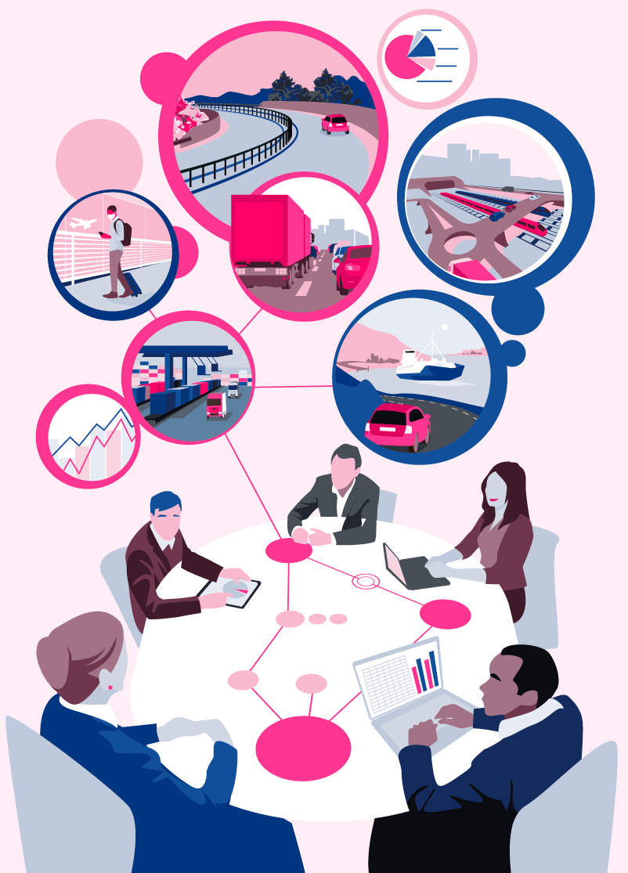
          - Resource allocation
The Government plans for a financial framework of around NOK 1,200 billion during the plan period, of which NOK 1,076 billion from state funds and NOK 123 billion from road tolls. This means an average annual level of NOK 89.7 billion in government funding during the twelve-year period. Road tolls paid by motorists will be reduced by NOK 7.5 billion as a result of grants to reduce toll charges outside urban areas. The Government plans for continued growth in budgetary spending on the transport sector, but not as high growth as set out in the National Transport Plan 2018–2029.
The financial framework of NOK 1,076 billion over twelve years includes:
- NOK 510 billion for national roads
- NOK 52 billion in county road grants
- NOK 393 billion for the rail sector
- NOK 33 billion for maritime infrastructure and coastal management
- NOK 80 billion for measures in urban areas
- NOK 5 billion for airports
- and NOK 3 billion for initiatives across transport sectors, such as efficient and environmental-friendly use of new technologies.
The use of resources in individual fiscal years will be adapted to the overall profile of the national budget within the constraints that follow from the fiscal rule and the state of the Norwegian economy.
            - Overview of total spending distributed by purpose. State funds and other funding. Annual average. Million 2021-NOK
04J1xt2
Area | Budget 2021 | Annual average NTP 2018–2029 | Annual average NTP 2022–2033
National roads1 | 36,431 | 43,204 | 42,496
County road grants | 2,913 | 2,789 | 4,370
Urban areas | 6,458 | 6,070 | 6,672
Rail sector | 27,154 | 29,578 | 28,850
Coastal administration2 | 1,592 | 2,674 | 2,740
Airports | - | 364 | 388
Initiatives across transport sectors | 79 | 100 | 252
Total state funds, excl. purchases of passenger transport by rail | 74,627 | 84,778 | 85,768
-Procurement of passenger transport by rail3 | 3,910 | - | 3,900
Total state funds | 78,537 | - | 89,667
Estimate, other financing | 8,800 | 12,000 | 10,300
1 Minor investments in urban areas carried out by the Norwegian Public Roads Administration are included in the total for Urban areas, and grant schemes for county roads under the Norwegian Public Roads Administration’s budget are included in the total for County road grants.
2 Funds for emergency preparedness against acute pollution, with the exception of funds for the Norwegian Emergency Towing Service, are now included in the financial framework and in the basis for comparison in 2021/2018–2029. Funds for the Norwegian Coastal Administration’s user-funded pilotage and vessel traffic services, funds for managing the wreck of U-864 and other special operating expenses are not included in the budgetary framework.
3 The procurement of passenger transport by rail was not included in the National Transport plan 2018–2029. In the balanced budget for 2021, NOK 650 million for supplementary agreements in connection with the coronavirus pandemic have been excluded.

Selected important projects and measures
Maintenance and renewal efforts will be strengthened. Around a quarter of the state’s budgetary spending will be spent on operation, maintenance and renewal. The Government gives high priority to preserving the existing infrastructure, and to facilitating operation of the infrastructure to achieve efficient transport.
The Government will develop the national road network in all of Norway. Around 40 landslide/rockslide-, improvement- and development-projects are planned for all over Norway. Some of these are described in Chapter 7.1. below. At the same time, the projects that have already been initiated, such as E18 Lysaker–Ramstadsletta, E39 Rogfast, Rv. 555 Sotrasambandet (Sotra Connection), E39 Lønset–Hjelset, E39 Betna–Vinjeøra–Stormyra, E16 Bjørum–Skaret, Rv. 4 Roa–Gran and E6 Helgeland South, will tie up a large portion of the budget in the years ahead.
Nye Veier’s budgetary framework by annual grants has been extended from 2035 to 2041. This will enable the company to expand its portfolio from 700 to 1,226 km of national roads, and to cover a larger geographical area.
The Government has prioritised increasing grants to the county authorities to expand housing and labour market regions, to improve conditions for commercial traffic and to upgrade tunnels. A continued strong focus on Urban Growth Agreements and co-funding of large scale public transport projects in the major urban areas are also prioritised.
In the rail sector, the Government will prioritise increased maintenance and renewal, and ensuring that already initiated railway investment packages are completed. This means giving priority to InterCity rail infrastructure to Hamar, Tønsberg and Moss. Plans have been made to initiate eleven new investment packages, which will improve both passenger and freight transport services. The investment packages will enable increased the frequency to and from Trondheim, Oslo, Bergen and Stavanger, and improve WiFi coverage. The Ringerike Line, the Arna–Stanghelle section of the Voss Line and the Stokke–Sandefjord section of the outer InterCity Vestfold Line are prioritised large scale projects in the initial six-year period.
The Stad Ship Tunnel is prioritised in the initial six-year period. The Government also plans to make more funds available for fairway improvements and reducing the maintenance backlog on aids to navigation along the coast. The grant scheme for short sea shipping (incentive scheme) is continued, while there are plans to strengthen the grant scheme for efficient and environmental-friendly ports.
The Government has prioritised the implementation of pilot projects for fossil-free construction sites, and dedicated grant funding for the Children’s Transport Plan. The Government will strengthen its focus on research and piloting in the transport field and will also facilitate better use of data in the transport sector.
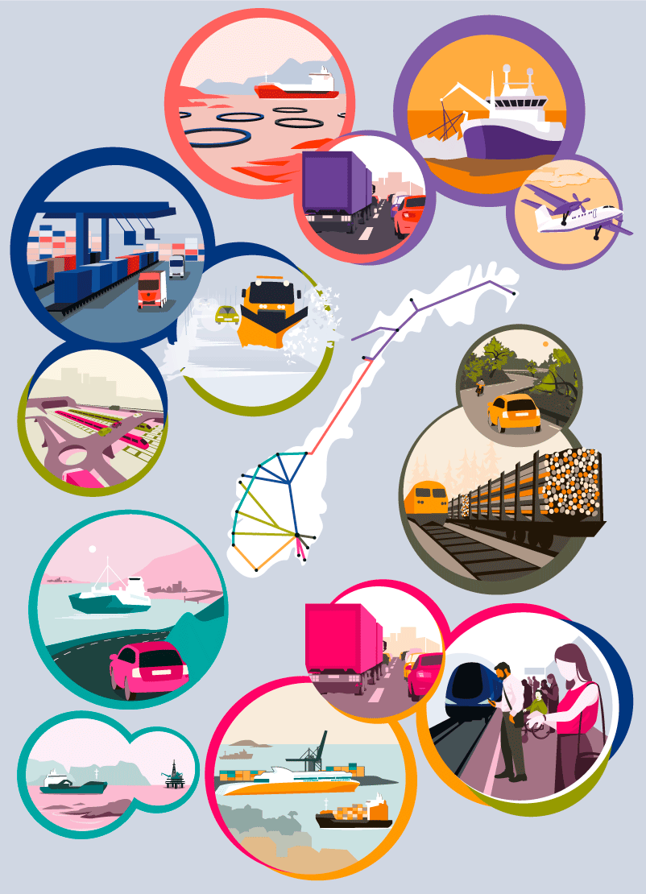
          - Transport corridors – different challenges and priorities

Ambitions for developing the transport corridors during the plan period
The eight national transport corridors comprise the most important long-distance transport routes in Norway and play a key role in the competitiveness of Norwegian business and industry. By developing the national transport corridors, the Government will also contribute to developing the housing and labour market regions all over Norway.
Oslo–Svinesund/Kornsjø (Corridor 1)
In the initial six-year period, the plan will facilitate completion of the ongoing extensive rail investments in the Østfold Line. At the same time, accessibility will be improved on the road network, including the development of Rv. 22 Glommakryssing (crossing of the Glomma river), and measures will be implemented to improve safety and accessibility for sea transport. Further possible development of the rail sector is planned for the second six-year period. This will improve the train service to the towns in the south of Viken county, and strengthen international connections for freight and passenger transport. Furthermore, road projects will be explored to increase accessibility and traffic safety in and around cities and towns, while new surveys and assessments will form the basis for the development of fairway projects.
Oslo–Ørje/Magnor (Corridor 2)
In the initial six-year period, the focus will be on improving accessibility on the road network from the Swedish border and towards Oslo through the development of E18 Retvet–Vinterbro. Nye Veier will consider the project E16 Kongsvinger–E6. Measures will also be prioritised in the initial six-year period that increase capacity for freight transport by rail. In the second six-year period, strategies will be developed for further improvement and development of the road network, and for facilitating further development of the Kongsvinger Line.
Oslo–Grenland–Kristiansand–Stavanger (Corridor 3)
In the initial six-year period, the plan will facilitate completion of investments in the Vestfold Line, to enable four train departures per hour between Tønsberg and Oslo. By prioritising the start-up of the outer InterCity investment package on the Vestfold Line, the Government also wants to improve the train service between Oslo and Skien. This will enable two trains per hour on this section. Smaller projects on the Jæren Line will also be prioritised. The Government plans considerable investments in the road sector, and will prioritise the start-up of several major projects, including on Rv. 19 Moss, E39 Ålgård–Hove, E134 Oslofjord connection (stage 2), E134 Dagslett–E18 and E18/E39 Gartnerløkka–Kolsdalen. Nye Veier is responsible for important road stretches in this corridor, and will consider implementing measures here. Accessibility and safety measures along the coast will also be given priority.
During the second six-year period, solutions may be considered for the rail sector that will strengthen the growing housing and labour markets in Nord-Jæren and Buskerudbyen in the long-term. Strategies will also be developed for further improvement and development of the road network, and new fairway initiatives will be considered.
E18 Lysaker–Ramstadsletta in Bærum was started in November 2020. This is the first phase of the planned development of E18 between Lysaker and Drengsrud in Viken (West Corridor). This phase also includes the cross connection between Gjønnes and Fornebu. Further planning of E18 West Corridor is under way.
Stavanger–Bergen–Ålesund–Trondheim (Corridor 4)
In the initial six-year period, the Government plans significant spending on completing several large scale road projects in the corridor, including Rogfast and the Sotra Connection (a Public-Private Partnership). The fjord crossing projects E39 Ådland–Svegatjørn and E39 Ålesund-Molde, which will contribute to a significant reduction in travel times in this corridor, will also be prioritised. It is proposed to transfer several landslide/rockslide protection projects on Rv. 13 to the portifolio of Nye Veier. Building the Stad Ship Tunnel will improve accessibility and contribute to increased safety. In the second six-year period, landslide/rockslide protection and improvements to the road network are planned in order to increase accessibility and traffic safety. Fjord crossings and improvements to the various roads between the fjords in and around the urban areas will be weighed against each other. New surveys and assessments will form the basis for the development of fairway projects.
Oslo–Bergen/Haugesund (Corridor 5)
Resources spent in this corridor will improve the quality of the road network and secure stretches of road that are susceptible to landslides/rockslides. Investments here will also improve the railway services and increase capacity. In the initial six-year period, the Government will prioritise the joint project Ringerike Line (railway) and E16 Høgkastet–Hønefoss (highway). Nye Veier’s portfolio will be expanded to include the E16 Skaret–Høgkastet section. These projects will result in one continuous housing and labour market region from Oslo to Ringerike. In the western part of the corridor, the Government will prioritise the development of the road and railway between Arna and Stanghelle, which will increase traffic safety and capacity. The Government also plans to complete the building of a double track between Arna and Bergen, in addition to several road projects, including Rv. 36 Skjelsvik–Skyggestein and E134 Røldal–Seljestad. In the second six-year period, work will continue on developing better accessibility on roads and railways in the corridor.
Oslo–Trondheim, with branches to Måløy, Ålesund and Kristiansund (Corridor 6)
In the initial six-year period, investments in the Dovre Line will facilitate more and quicker train departures between Hamar and Oslo. Measures are also planned for combined freight transport by rail, in addition to road projects on Rv. 3 in Østerdalen and on E136 in Ålesund. Nye Veier is responsible for a relatively large share of the proposed road projects in this corridor, and will consider the stretches for which they are responsible. In the last six-year period, strategies will be developed for further improvement and development of the road network, and new railway projects will be developed.
Trondheim–Bodø, with branches to the Swedish border (Corridor 7)
In the initial six-year period, investments in the Trønder and Meråker Lines will facilitate the possibility for two trains per hour between Melhus and Steinkjer and also electrified rail travel between Trondheim-Stjørdal, Stavne-Leangen and the Meråker line. The Government is also planning measures for combined freight transport by rail between Trondheim and Bodø. Plans will be made for major improvements of sections of the E6 road north from Grong in Trøndelag county to Nordland county. Nye Veier is responsible for a relatively large share of the proposed road projects in this corridor, and will consider measures for the stretches for which they are responsible. Nye Veier’s portfolio will be expanded to more stretches of road in this corridor. To improve conditions for sea transport, there are plans to improve the fairway to Mo i Rana. The Government also plans to allocate funding for the relocation of Bodø Airport, which will release land for urban development. Grants for a new airport in Mo i Rana are also prioritised, which will enable a more expedient approach and allow larger aircraft to land and take off. New road and rail projects will be developed in the second six-year period. Regional development and efficient rail freight transport will be emphasised. New surveys and assessments will form the basis for the development of fairway projects.
Bodø–Narvik–Tromsø–Kirkenes (Corridor 8)
The investments in the initial six-year period gives room for starting up more road projects, such as Hålogalandsveien (a Public- Private Partnership) and E6 Megården–Mørsvikbotn. Nye Veier will consider the stretches of road for which it is responsible, and its portfolio will be expanded in this corridor. The Government plans to implement several measures in the coastal area that will improve safety and accessibility for sea transport and access to several ports in the corridor. New port facilities are still needed in Longyearbyen, but circumstances have changed since Report No 33 to the Storting (2016–2017) National Transport Plan 2018–2029 was submitted. Upgrades for the Ofoten Line are included in the package for combined freight transport between Oslo and Narvik.
In the last six-year period, the plan is to further improve the road network and better protect against landslides/rockslides in the corridor. Studies of further capacity needs on the Ofoten Line will form the basis for assessing new measures. Further development of the railway in Northern Norway will be seen in light of the recommendation from the conceptual appraisal of transport solutions in Northern Norway. New surveys and assessments will form the basis for the development of fairway projects.
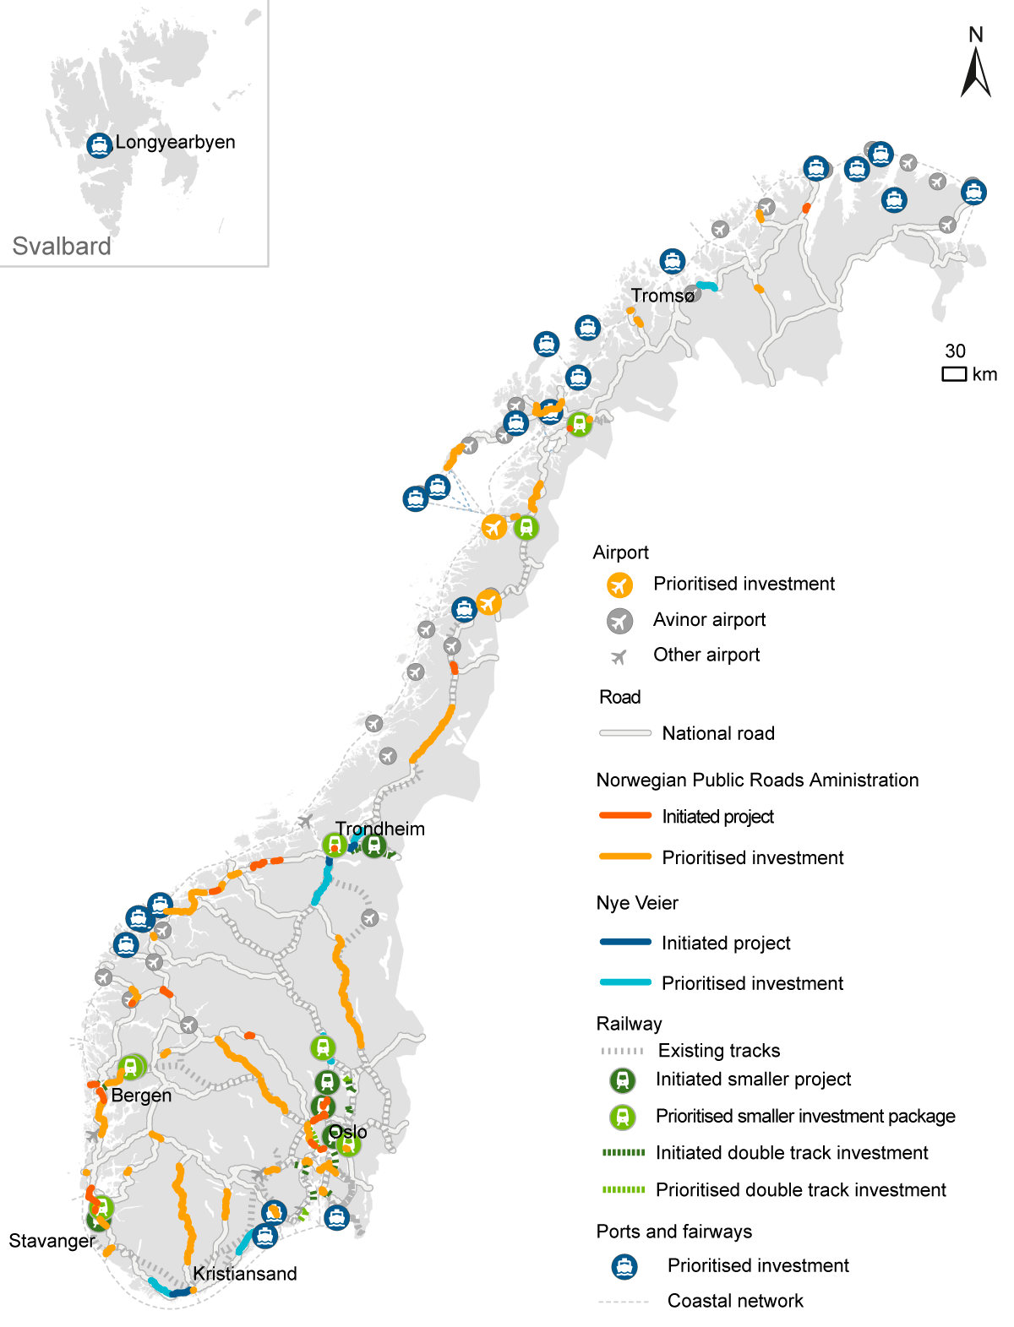
          - Project priorities for the first six-year period

