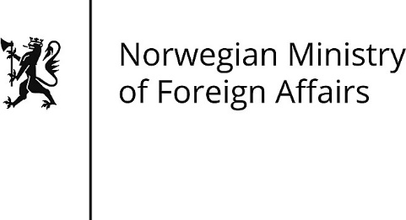 | Application for grants from the  Ministry of Foreign Affairs  S02 - Application for small scale grants
Ministry of Foreign Affairs  Postbox 8114 Dep  N-0032 Oslo |  | The application and attachments should be sent to post@mfa.no with a copy to the unit responsible for the grant scheme. For more information see regjeringen.no
Read this first
- The budget and results framework should be attached to the application.
- In principle, all the information asked for in the application form should be filled in. If any questions are not relevant, this should be explained.
- Instructions and questions that may be relevant are provided in the comments.

Key information
Name of applicant (and abbreviation)
Name of applicant (and abbreviation)
Grant scheme
Unit responsible for the grant scheme (in the Ministry or at a mission abroad)
Total amount applied for (in NOK)
Year 1
Year 2
Year 3

PART I: GENERAL INFORMATION ABOUT THE APPLICANT
1. Contact information, applicant
1.1 Postal address
1.2 Telephone no. | 1.3 Email address
1.4 Website
1.5 Contact person, name and title
1.6 Contact person, email address |  |  | 1.7 Contact person, telephone no.
2. About the applicant
2.1 Type of organisation (enter a cross in one box per line)
☐ Governmental/public | ☐ Non-governmental, specify: |  |  |  | ☐ Multilateral
☐ Norwegian, org. no.: |  | ☐ Non-Norwegian, org. no. if relevant:
2.2 Brief description of applicant
2.3 Brief description of applicant’s routines for procurement, anti-corruption work and internal control
2.4 Information about the auditor
2.5 Has the applicant previously received support from the Ministry, a mission abroad, Norad or FK Norway? ☐ No ☐Yes If yes, give details:
3. Bank details
3.1 Name and address of the bank
3.2 Name of the account holder
3.3 Account number/IBAN number |  | 3.4 Swift-code |  | 3.5 Currency of the account

PART II: THE PROJECT/PROGRAMME
4. General information about the project/programme
4.1 Where will the project/programme be implemented (area/country)?
4.2 Project/programme duration (mm.yyyy–mm.yyyy)
4.3 Sector/field
4.4 Is the application for additional support for a project/programme that is already receiving or has already received support?
☐ No | ☐ Yes, agreement no.:
4.5 If yes, give a brief description of the results achieved so far and status for the project that has previously received support
5. Applicant’s competence and capacity to carry out the project/programme
5.1 The applicant’s experience with the thematic and geographical area of the project/programme and other relevant experience
6. Description of the project/programme and anticipated results
6.1 Describe the project’s main activities, main objectives and target group
6.2 Description of the project/programme
7. Risk, cross-cutting issues and sustainability
7.1. Assess what risks could affect goal achievement. Also describe the risks that could have a negative impact on cross-cutting issues (human rights, women’s rights and gender equality, climate and the environment, and anti-corruption)
7.2. Describe the sustainability, local ownership and exit strategy of the project/programme
8. Budget and financing plan
8.1. Comments to the attached budget
9. Additional information
9.1 Any additional information of relevance for the application

DEL III: VEDLEGG
☐ Number ___ Budget (mandatory)
☐ Number ___ Results framework
☐ Number ___ Implementation/activity plan
☐ Number ___ Theory of change
☐ Number ___ Documentation of bank details
☐ Number ___ ____________________________
☐ Number ___ ____________________________

Date and signature
I confirm that I am authorised to enter into legally binding agreements on behalf of the applicant, and I confirm that to the best of my judgement the information in this application is correct.

_________________ ______________________
Place and date Name, title and signature

