Meld. St. 1 (2026–2027)
Chapter 2.2, 2.3 and 3.1

2.2 The Norwegian economy
Activity growth in the Norwegian economy increased last year, but the pace of growth has slowed somewhat over the past year. Growth is expected to increase again ahead, particularly because purchasing power developments provide a basis for higher private consumption. At the same time, the Norwegian economy is affected by turbulence globally. Inflation and interest rate expectations in Norway have also picked up since early in the year. Consumer price inflation is above the inflation target, and since winter Norges Bank has adjusted its course from planning for further interest rate cuts to raising the interest rate and signalling that more interest rate increases may be forthcoming. Heightened uncertainty and higher interest rates are dampening activity growth.
Inflation is influenced by a number of factors. On the one hand, petroleum prices have risen (see Box 2.2). In addition, wage growth was higher than expected last year, and many enterprises have to cover higher costs by raising selling prices. The war in the Middle East is adding to uncertainty about how inflation will develop in the period ahead as it affects prices for petroleum and other commodities such as fertiliser and metals. On the other hand, the krone has appreciated since the beginning of the year. This is curbing inflation.
Higher prices for oil, gas and other commodities increase government revenues, but overall are considered to have a relatively modest effect on growth in the mainland economy. Since Norway is an exporter of petroleum and other commodities, high prices in isolation have a stimulating effect on the economy. At the same time, higher energy prices will draw in purchasing power from Norwegian households. In addition, combined with heightened uncertainty, this will dampen growth among Norway’s main trading partners.
As recently as January, Norges Bank projected that the key policy rate would be lowered this year. This message was abandoned at the monetary policy meeting in March, and at the monetary policy meeting in May, the policy rate was raised from 4 to 4¼ per cent (Chart 2.8). The policy rate was raised further to 4½ per cent at the monetary policy meeting in September. In connection with the September meeting, the Bank stated that there will probably be a need to maintain a high policy rate for a period ahead and that it is prepared to raise the interest rate further if the inflation outlook so warrants. In justifying a tighter monetary policy, the Bank has emphasised that a situation must be avoided where firms and households begin to plan for inflation to remain high, as this may result in more persistent inflation.
Box 2.2 Development in petroleum prices
In late February, the United States and Israel launched military strikes against Iran, and shipping through the Strait of Hormuz came to a near complete halt. Normally, about 20 per cent of global oil production and a corresponding share of global liquefied natural gas (LNG) production are transported through the strait, mainly to Asian countries such as China, India, Japan and South Korea. The loss has led to a sharp reduction in the supply of oil and gas. There is still considerable uncertainty associated with the further development of the conflict and about when export volumes willnormalise.
Oil prices
Oil prices have been markedly higher this year than last year (Chart 2.5). So far this year, oil prices have averaged USD 88 per barrel, the highest since 2022. Ever since the war broke out, the oil market has been characterised by periodically large daily fluctuations in response to news about the conflict. However, futures prices have always priced in an expectation that a political solution is not far away, which has contributed to keeping oil prices lower than implied by physical market disturbances in isolation.
The price increase is mainly related to sharply reduced oil production in the Middle East since February, where fields have been shut down for safety reasons or are producing less than normal due to limited export capacity and limited local storage capacity. Alternative overland transport routes are used but have limited capacity. In addition to the near closure of the Strait of Hormuz, since mid-September the Houthi militia has carried out a major offensive along Yemen’s Red Sea coast, taking control of the Bab al-Mandeb Strait. This has amplified the threat to Saudi Arabia’s oil exports through the Red Sea, which it has increasingly used as an alternative to Hormuz. In addition, Saudi Arabia’s east-west pipeline, which has been the country’s main export route past Hormuz, was shut down after drone strikes. The pipeline is expected to be largely out of service for several weeks.
Since last year, OPEC and a number of other producer countries (OPEC+) have gradually increased production quotas after a few years of reduced quotas to stabilise the oil market. Since the outbreak of war, OPEC+ has further increased production quotas. The actual production increases have been considerably lower than implied by the quota increases, partly because the group’s spare production capacity is limited.
The United States has significantly increased its oil exports after the Strait of Hormuz closed. The US has released large volumes from its strategic stockpiles. Shale oil production can adapt relatively quickly, but is at the same time price-sensitive, and after a long period of expansion the sector is now in a maturing phase characterised by consolidation. Russia has managed to maintain high export volumes over time, but production is increasingly hit by Ukrainian drone strikes on oil infrastructure, adding to uncertainty about the country’s future export capacity.
Before the conflict, the oil market was characterised by a supply surplus and extensive inventory build-up, including large volumes stored on tankers, mainly sanctioned oil from Russia, Iran and Venezuela. The loss of oil and oil products from the Middle East has since led to large global inventory drawdowns. In mid-March, the International Energy Agency (IEA) announced a coordinated release of 400 million barrels of crude oil and oil products from the stockpiles, the largest stockpile release it has carried out. China is estimated to have the world’s largest oil stockpile, and when the war in the Middle East broke out, it is believed to have replaced part of the loss from the Middle East with inventory drawdowns. Since summer, Chinese imports have edged up again, in pace with some increase in oil deliveries from the Middle East.
There is considerable uncertainty about future developments in the oil market. If the conflict continues and oil exports from the Middle East are curtailed, prices could remain high. In this report, it is technically assumed that oil prices will move in line with futures prices from mid-June. This implies an oil price of USD 85 per barrel in 2026 and USD 75 per barrel in 2027, measured at fixed 2027 prices. This corresponds to NOK 803 and NOK 703 per barrel respectively. By comparison, the average oil price in the period 2022–2025 was NOK 940 per barrel (measured at fixed 2027 prices). As a result of the assumption of a stronger krone this year than last year, the projected oil price increase in 2026 is smaller measured in NOK than in dollars.
Gas prices
The gas price shows a slightly different path from the oil price. Before the outbreak of the war in the Middle East, prospects for high growth in the supply of liquefied natural gas (LNG) had contributed to a decline in the European gas price through 2025 (Chart 2.5). The war in the Middle East contributed to a marked rebound in the gas price. The loss of LNG deliveries through Hormuz has kept prices high and contributed to weaker inventory build-up in Europe. The prospect of lower-than-normal inventory levels in Europe heading into winter is again contributing to a risk premium in prices. Futures prices indicate that prices are expected to continue to rise in the near term.
Trade in LNG has become increasingly important, partly as a result of the development of receiving terminals. This has made the regional gas markets more closely linked. Gas prices are now determined to a greater extent than before in a global market where importing regions compete for gas. The disruption to the LNG market as a result of the war in the Middle East is therefore affecting the price of gas in Europe. Last year, the EU covered more than 40 per cent of its gas needs with LNG, a share that has more than doubled since 2021.
Norwegian gas is mainly exported by pipeline to Europe, and has in recent years accounted forabout 30 per cent of the total gas imports of both the EU and the UK. Norwegian gas is more important for Europe than before as EU has sharply reduced imports of Russian gas and has decided to complete the phase-out by November 2027.
Demand for LNG in Asian countries, including China, has been weaker than previously expected, partly because higher prices have made gas less competitive compared to other energy sources. In Europe, gas demand is less price sensitive, as much of the consumption goes to heating buildings, where it is challenging to quickly switch to alternative energy sources.
The key LNG plant in Qatar was damaged in March, and part of its export capacity is expected to be out of service for several years. At the same time, increased LNG exports from other countries, particularly the US, are helping to cushion some of the decline from the Middle East.
The filling of gas stocks in the EU has been slow through the summer, and in mid-August the stocks were filled to about 60 per cent, the lowest level for the season in several years. Low inventories increase the need for LNG imports going forward, while uncertainty about deliveries from the Middle East remains high.
There is considerable uncertainty surrounding developments in the gas price in Europe. How long the war in the Middle East lasts, and how quickly the supply side normalises, will be of great importance. This applies to transport through the Strait of Hormuz and the Bab al-Mandeb Strait, as well as the reconstruction of damaged production capacity. Gas price developments will also depend on weather conditions in Europe and demand developments in Asia.
In this report, the average price for Norwegian gas exports is technically assumed to be USD 15.0 per MMBtu this year and USD 11.5 per MMBtu next year measured in fixed 2027 prices, which corresponds to NOK 5.4 and 4.1 per Sm3 respectively. There is considerable uncertainty about developments in gas prices, and the futures market in mid-September indicates that prices may be higher than this.
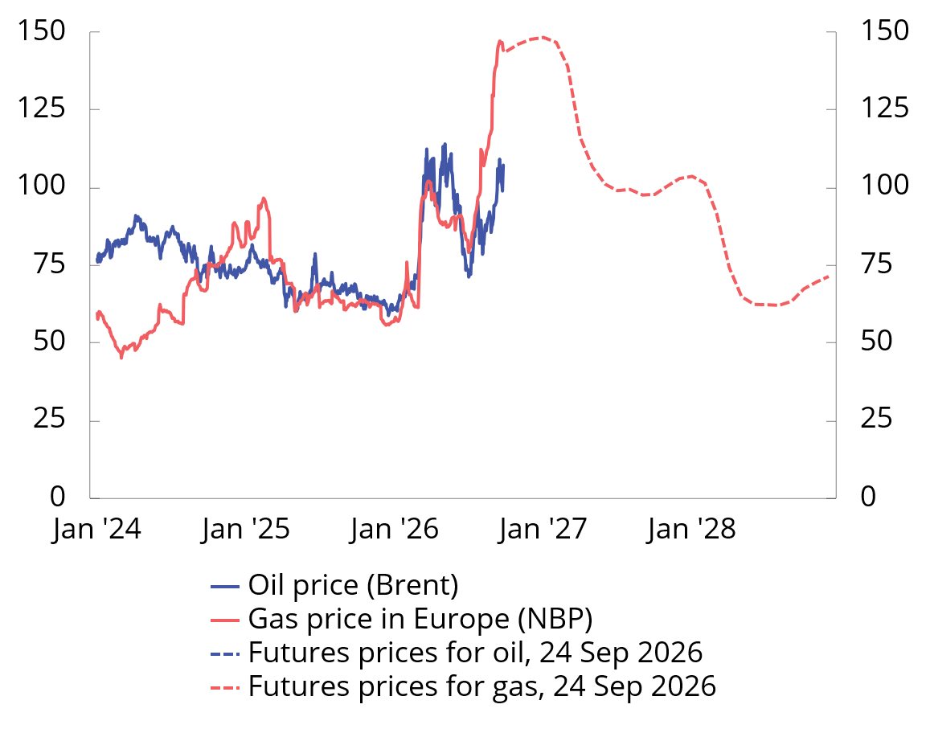
Chart 2.5 Oil and gas spot- and futures prices. USD per barrel. 2024–20281
1 Daily observations through September 24, 2026. Monthly observations for forward prices from October 2026.
Sources: Macrobond and Ministry of Finance.
Table 2.1 Main figures for petroleum activities
 | 2025 | 2026 | 2027 | 2028
Prerequisites:
Crude oil price, NOK per barrel | 707 | 785 | 703 | 681
Crude oil price, 2027-NOK per barrel | 749 | 803 | 703 | 666
Crude oil price, 2027-USD per barrel | 72 | 85 | 75 | 71
Gas price, 2027-NOK per Sm3 | 4,7 | 5,4 | 4,1 | 3,3
Gas price, 2027-USD per MMBtu | 12,0 | 15,0 | 11,5 | 9,2
Sources: Statistics Norway, Macrobond, Ministry of Energy and Ministry of Finance.
Capacity utilisation is close to normal
Capacity utilisation can be assessed on the basis of various economic indicators, including labour market indicators, GDP growth and inflation, as shown in Chart 2.6. The chart illustrates that the nominal side and the real economic side of the economy are now sending slightly different signals. Some of the indicators are close to or below their historical averages, while both wage and price inflation are still higher.
The share of enterprises in Norges Bank’s regional network reporting capacity problems has gradually declined over the past year. It is now at its lowest level since the beginning of 2020. A number of contacts also report that it has become somewhat easier to recruit labour, and the share of companies reporting that labour shortages are curtailing output is somewhat lower than the historical average. The decline in the number of job vacancies over the past year also indicates that labour shortages have eased. Despite the decline, the number of vacancies remains high historically. Registered unemployment is still low and well below the average for the past 20 years. Unemployment measured by the Labour Force Survey (LFS) has risen in recent years. A large part of this increase can be attributed to people seeking work alongside school or studies, and this year LFS unemployment has fallen slightly. Overall, the indicators in Chart 2.6 show that capacity utilisation is close to a normal level.
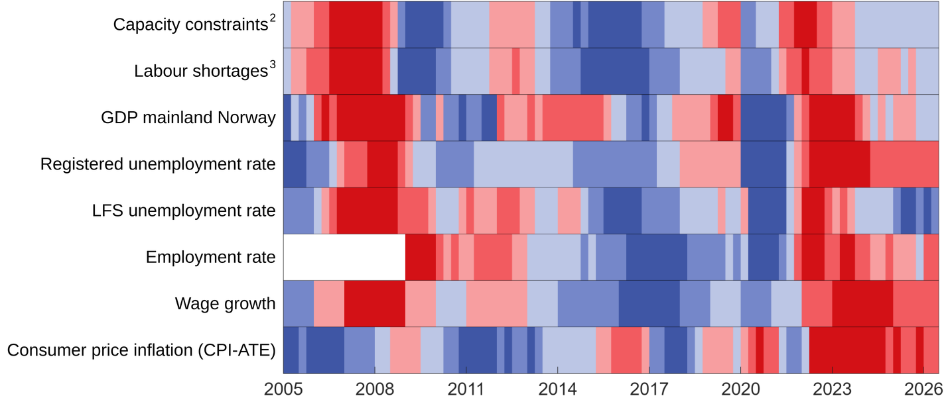
Chart 2.6 Selected indicators of capacity utilisation in the Norwegian economy.1 1st quarter 2005–2nd quarter 2026
1 Red colours are a sign of a boom with pressures in the economy, while blue colours are a sign of recession and spare capacity. The colour scale reflects how large the gap, or deviation from the average, is. The darkest colours represent the third of the observations with the largest positive and negative deviation. The indicators are measured as the deviation from the average in the period shown in the chart, with observations from the pandemic years 2020 and 2021 removed from the time series. The exceptions are inflation, which is measured as a deviation from the inflation target, and GDP, which is measured as a deviation from a simple trend. This means that they have not been adjusted for the abnormally low activity development during the pandemic. The trend is estimated using the HodrickPrescott filter, where the smoothing parameter is set at 40,000.
2 Capacity constraints refer to the share of the contact businesses in Norges Bank’s regional network that will have some or more significant problems in increasing production/sales without investing additional resources.
3 Labour shortages refer to the share of the contact businesses in Norges Bank’s regional network reporting that labour shortages are curtailing production/sales.
Sources: Norges Bank, Statistics Norway, Norwegian Labour and Welfare Administration and the Ministry of Finance.
After growth picked up in mid-2024, growth in the Norwegian economy has slowed somewhat over the past year. Continued high inflation, somewhat higher interest rates and greater uncertainty are expected to dampen growth this year, even though households are set to experience solid purchasing power development. Household consumption is expected to push up growth somewhat again next year (Chart 2.7). In the years ahead, the contribution to growth from public demand is expected in isolation to be approximately the same as in previous years. Petroleum investment, which in recent years has contributed to sustaining growth in the Norwegian economy, is projected to fall from high levels.
After growing by 1.7 per cent last year, the mainland economy is projected to grow by 1.1 per cent this year. This is lower than projected trend growth in the economy, but growth is expected to return to near trend growth in the course of the year. For 2027, growth is estimated at 1.7 per cent.
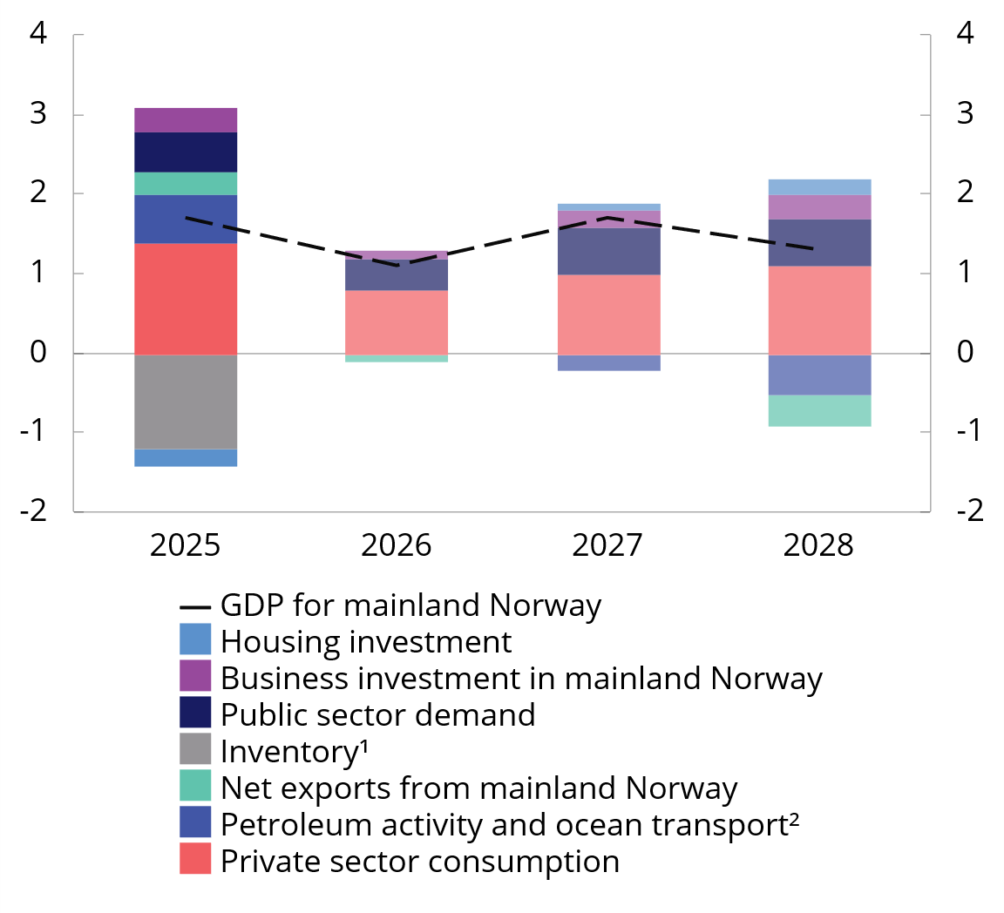
Chart 2.7 Development in mainland GDP by demand component. Growth in per cent. 2025–2028
1 Inventory changes and other statistical discrepancies.
2 Petroleum activities and ocean transport describe the demand from these industries towards the mainland.
Sources: Statistics Norway and Ministry of Finance.
Inflation is expected to remain above the inflation target
It is expected to take time for consumer price inflation to return to target (Chart 2.9). So far this year, inflation, measured by both the change in the consumer price index (CPI) and the consumer price index adjusted for tax changes and excluding energy products (CPI-ATE), has been around 3 percent, approximately the same as in 2025. In August, the 12-month rise in the CPI was 3.3 per cent, while for the CPI-ATE it was 3.0 per cent. The rise in prices picked up from July to August as a result of last year’s reduction in child daycare prices falling out of the twelve-month change.
Energy prices have increased, reflecting higher prices for both fuel and electricity. Without the electricity support schemes, the impact on the CPI would have been greater (see Box 2.3). The temporary reductions in fuel taxes also pulled CPI growth down slightly this year, but the development in energy prices nevertheless contributes to the CPI being projected to grow somewhat more than the CPI-ATE this year. Next year, energy prices are expected to pull down consumer price inflation considerably. However, there are only minor differences between the projections for CPI growth and CPI-ATE growth for 2027. This is due to a further reduction in the threshold for the VAT exemption for electric cars next year. This will not affect the CPI-ATE, but is expected to lift the 12-month change in the CPI from January.
Imported inflation has increased somewhat since last autumn, but the appreciation of the krone is expected to dampen it in coming years.
Inflation is projected to remain high, particularly as wage growth is expected to remain relatively high without high productivity growth. The effect of high wage growth is particularly visible in the contribution to overall inflation from services without rent (Chart 2.10). The combination of the rise in prices for new rental contracts and a continued backlog of CPI adjustment in existing leases has led to a recent rise in measured growth in rents. The rise in rents is assumed to contribute to holding up inflation also next year. Even though the rise in house rents has been higher than normal in recent years, an estimated consumer price index excluding rents has moved broadly in line with the CPI.
Table 2.2 Principal figures for the Norwegian economy. Percentage change from previous year, unless otherwise stated.

 | NOK billion1
 | 2025 | 2025 | 2026 | 2027 | 2028
Real economy
Mainland GDP2 | 4398 | 1,7 | 1,1 | 1,7 | 1,3
Employment |  | 0,7 | 0,6 | 0,4 | 0,4
Unemployment rate, registered (level) |  | 2,1 | 2,1 | 2,1 | 2,1
Unemployment rate, LFS (level) |  | 4,5 | 4,5 | 4,5 | 4,5
Demand components and GDP2  Demand from mainland Norway3 | 4596 | 1,9 | 1,2 | 1,8 | 2,1
Private consumption | 2341 | 2,6 | 1,4 | 1,8 | 2,0
Business investment | 505 | 2,7 | 1,2 | 1,3 | 3,0
Housing investment | 209 | -3,6 | -0,4 | 3,2 | 3,8
Public sector demand | 1539 | 1,4 | 1,1 | 1,7 | 1,7
Petroleum investment | 281 | 7,2 | -2,0 | -4,0 | -7,7
Export | 2504 | 2,7 | 2,9 | -0,3 | -0,3
Crude oil and natural gas | 1100 | 0,8 | 4,5 | -2,9 | -3,0
Mainland Norway | 1216 | 5,9 | 1,2 | 2,1 | 1,9
Import | 1858 | 2,6 | 1,4 | 1,2 | 2,2
Gross domestic product (GDP) | 5511 | 1,1 | 1,3 | 0,7 | 0,4
Prices
Annual salary |  | 4,9 | 4,6 | 4,0 | 3,5
CPI |  | 3,1 | 3,3 | 2,7 | 2,4
CPI-ATE |  | 3,1 | 3,1 | 2,8 | 2,4
Crude oil price, USD per barrel (level) |  | 68 | 83 | 75 | 72
Three-month money market rate (level)4 |  | 4,4 | 4,5 | 4,6 | 4,0
Import-weighted exchange rate (I-44 level) |  | 119,6 | 113,4 | 112,9 | 112,9
Krone exchange rate5 |  | 0,6 | 5,4 | 0,5 | 0,0
International economy6
GDP trading partners |  | 2,0 | 1,7 | 1,8 | 1,8
CPI trading partners |  | 2,1 | 2,5 | 2,3 | 2,2

1 Preliminary national accounts figures in current prices.
2 Growth rates from 2025 onwards stated in volume termes.
3 Excluding inventory changes.
4 Corresponds to the money market rate forecast in Norges Bank’s Monetary Policy Report 2/26.
5 Percentage change inverse of the I-44 exchange rate index. A positive number indicates a stronger krone.
6 Norway’s 10 most important trading partners weighted together with their respective shares of Norwegian exports of goods excluding oil and gas and Norwegian imports of goods excluding ships, oil platforms and crude oil.
Sources: Statistics Norway, IMF, Eurostat, Norges Bank, Norwegian Labour and Welfare Administration, Reuters, Macrobond and the Ministry of Finance.
Registered unemployment still low
In several of the years following the pandemic, there has been a shortage of labour. As a result, employment growth has been more dependent on the supply side than on the labour market’s demand-side.
Labour shortages have eased somewhat recently, but employment has continued to increase over the past six months at about the same pace as in the two preceding years. There has been an increase in both private industries and public administration. In the second quarter of this year, about 20 000 more people were employed than at the same time last year. More than 70 per cent of the increase occurred in private industries. Employment is expected to increase further ahead, with growth of 0.6 per cent this year and somewhat more subdued growth next year.
Registered unemployment has remained low for several years. At end-August, 2.1 per cent were registered as fully unemployed (Chart 2.11). This is the same level as the average for last year. Unemployment measured by the Labour Force Survey has declined somewhat this year and corresponded to 4.5 per cent trend-adjusted in August this year. Overall, unemployment is projected to show little change ahead. The labour market is discussed in more detail in Section 2.4.
Real wage growth this year and next
Solid profitability in manufacturing, high price growth and low registered unemployment have contributed to high wage growth in recent years. Annual wage growth last year was 4.9 per cent, five tenths higher than the norm negotiated in last year’s wage settlements. This resulted in substantial real wage growth.
Wage formation in Norway is based on the frontfag model, where key tariff areas in the internationally exposed sector (the frontfag) negotiate first and set the norm for the other areas. In agreement with the Norwegian Confederation of Trade Unions (LO), the Confederation of Norwegian Enterprises (NHO) estimates annual wage growth in manufacturing as a whole in the NHO area at 4.4 per cent this year.
The labour cost share for manufacturing is a key indicator for monitoring the competitiveness of the frontfag. The labour cost share overall in 2025 was below the average for the past 20 years. Nevertheless, there are considerable differences between branches of manufacturing. In engineering and shipbuilding, the share of labour costs has declined for several years. In commodity-based manufacturing, the labour cost share fell by more than 30 per cent from 2020 to 2022, partly as a result of a significant increase in commodity prices. In isolation, the reduced share of labour costs for manufacturing as a whole in recent years provides room for wage growth to remain higher than the rise in prices ahead. There is uncertainty associated with developments in both commodity prices and energy prices. If these were to be reduced, profitability in manufacturing would be dampened. This could then affect wage growth. Changes in the exchange rate will also affect profitability in manufacturing.
Unemployment is low in several parts of the labour market, and many employers still face challenges recruiting labour. This report assumes overall annual wage growth of 4.6 per cent this year. Next year, annual wages are projected to increase by 4 per cent. This implies solid real wage growth both this year and next year.
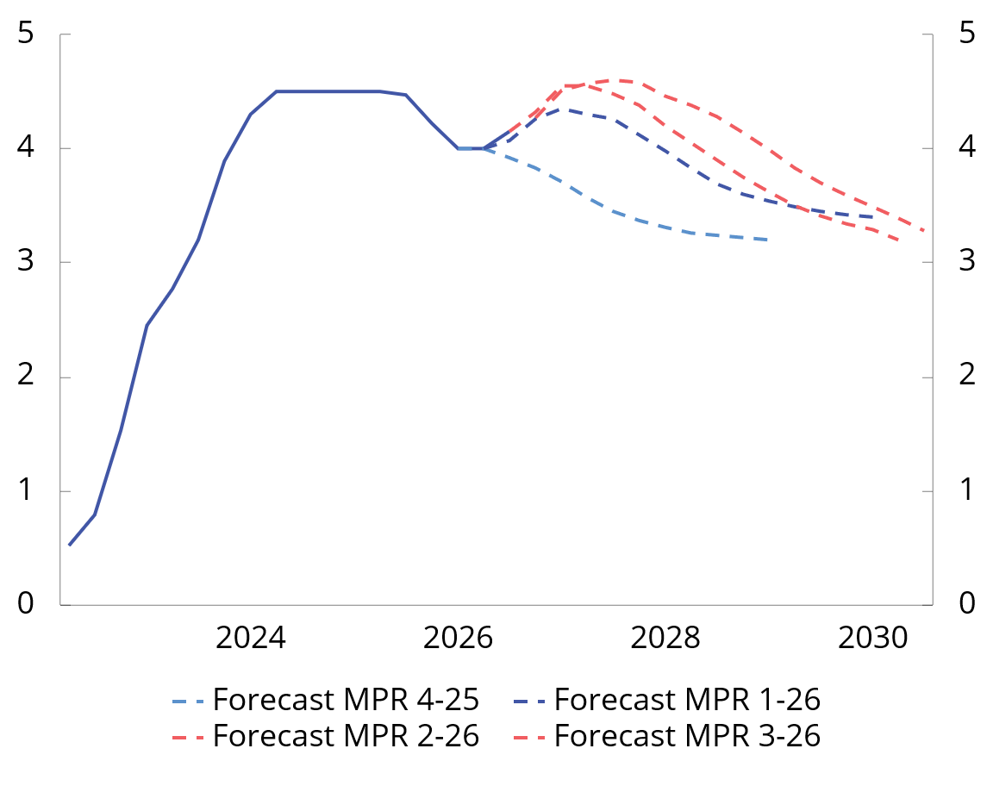
Chart 2.8 Norges Bank’s key policy rate. Percent. 1st quarter 2022–2nd quarter 20301
1 Norges Bank’s projections for the key policy rate at different times. Monetary Policy Report (MPR) 4/25 was published on 18 December 2025, MPR 1/26 on 26 March 2026, MPR 2/2026 on 18 June 2026 and MPR 3/2026 on 24 September 2026.
Source: Norges Bank.
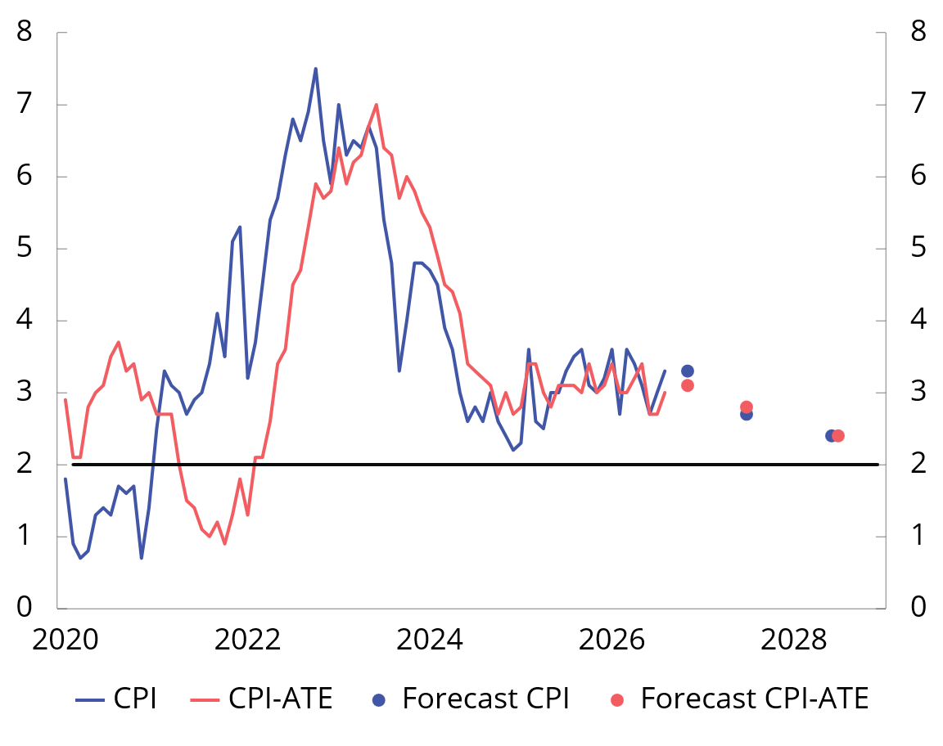
Chart 2.9 Twelve-month growth in the CPI and CPI-ATE. Percent. 2020–2028
Sources: Statistics Norway and Ministry of Finance.
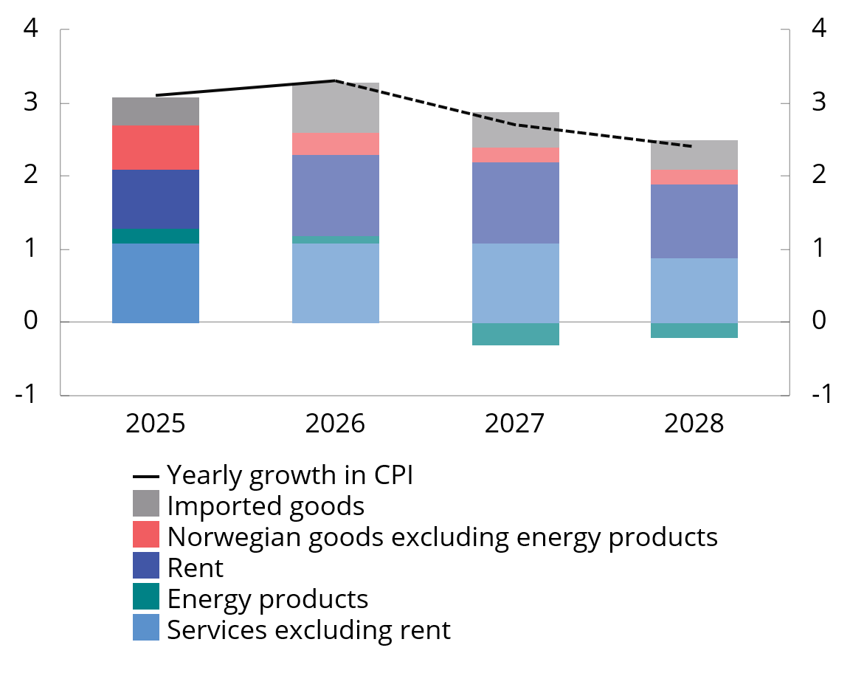
Chart 2.10 CPI growth and contribution to growth. Percent. 2025–2028
Sources: Statistics Norway and Ministry of Finance.
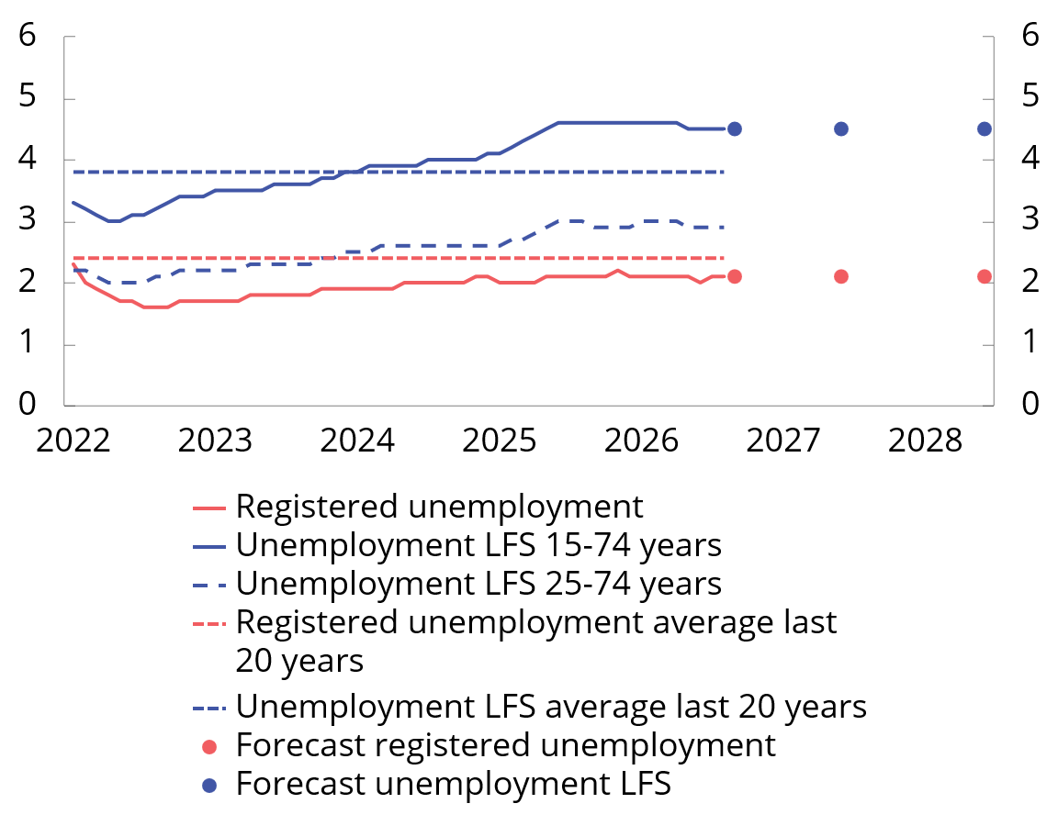
Chart 2.11 Registered unemployed and LFS unemployed as a percentage of the labour force. Seasonally adjusted. 2022–20281
1 Historical unemployment averages are the averages for the period 2006–2019 and 2022–2025.
Sources: Statistics Norway, Norwegian Labour and Welfare Administration and the Ministry of Finance.
Households are pulling the brakes slightly this year
After solid growth in consumption last year, growth slowed in the first half of this year. Some of the development is due to strong growth in car purchases in the fourth quarter last year, which was followed by a marked fall in the first quarter of this year. Consumption was approximately unchanged from the first to the second quarter, and current statistics indicate that growth this year will be fairly sober. Weaker developments may indicate that heightened uncertainty and somewhat higher interest rates have made households more hesitant and that they are saving a higher share of their income than previously.
Solid income growth is underpinning household consumption. Real wage growth has been solid in recent years and is projected to remain high. Nor do the interest rates assumed ahead prevent further growth in household real disposable income. Consumption growth is expected to pick up somewhat from next year.
Postponed housing investment upturn
Housing investment has remained broadly unchanged over the past year and a half, after falling sharply in 2023 and 2024. This year there was a marked fall in housing investment in the first quarter and growth in the second quarter. An upturn in housing investment has long been expected, but in the updated projections the upturn has been further deferred (see Chart 2.12). A number of factors dampen the upturn. Higher interest rates and higher construction costs have pushed down activity in the construction industry. New home sales have developed weakly this year and are lower than at the same time last year. At the same time, the rise in second-hand house prices has been relatively weak so far this year (Chart 2.13), and lower than the rise in prices for new homes. It helps maintain the large price difference between new and resale homes, which makes new homes less attractive. The level of housing investment is projected to remain broadly unchanged this year. Higher real income is expected to push up household demand for new homes further out. Housing investment growth is expected to pick up gradually from next year.
Low housing investment in recent years also means that the number of completed homes has declined. It may be interesting to compare the annual increase in the number of households, as it can be a simple guideline for how much housing construction is needed over time. In recent years, the number of completed dwellings less departed dwellings has been below the increase in the number of households (Chart 2.14). This may indicate pent-up demand for new homes, which may support the projection of an increase in residential construction in the coming years. At the same time, it is difficult to capture the amount of spare capacity in the unused portion of existing housing stock. Moreover, in the longer term it is reasonable to assume that the increase in the number of households will decline because of lower population growth. This may reduce the need for residential construction further ahead.
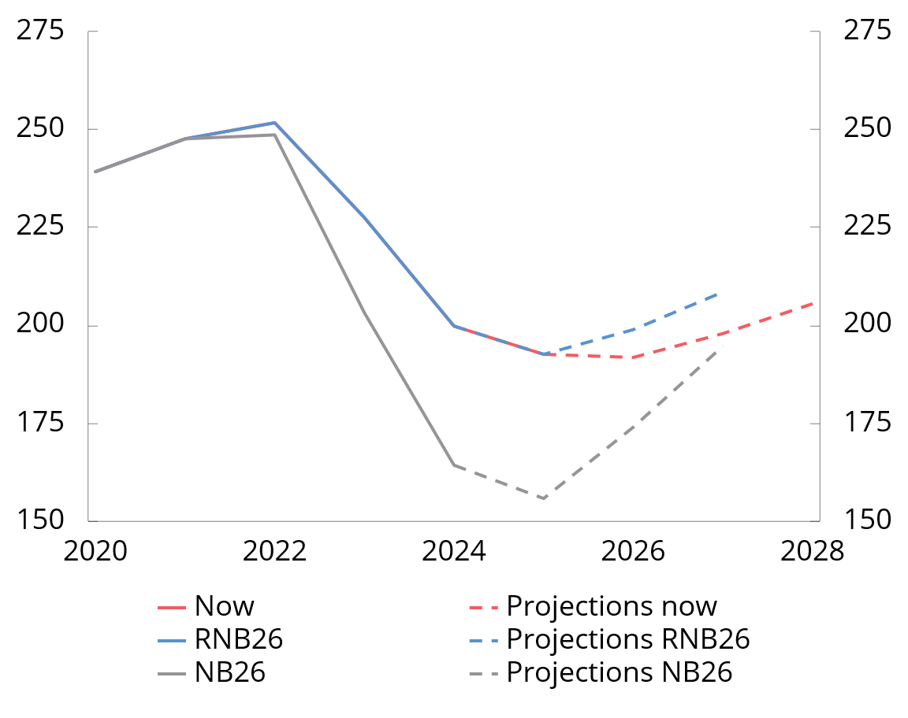
Chart 2.12 Projections for housing investment at different points in time. NOK billion at 2023 prices. 2020–2028
Sources: Statistics Norway and Ministry of Finance.
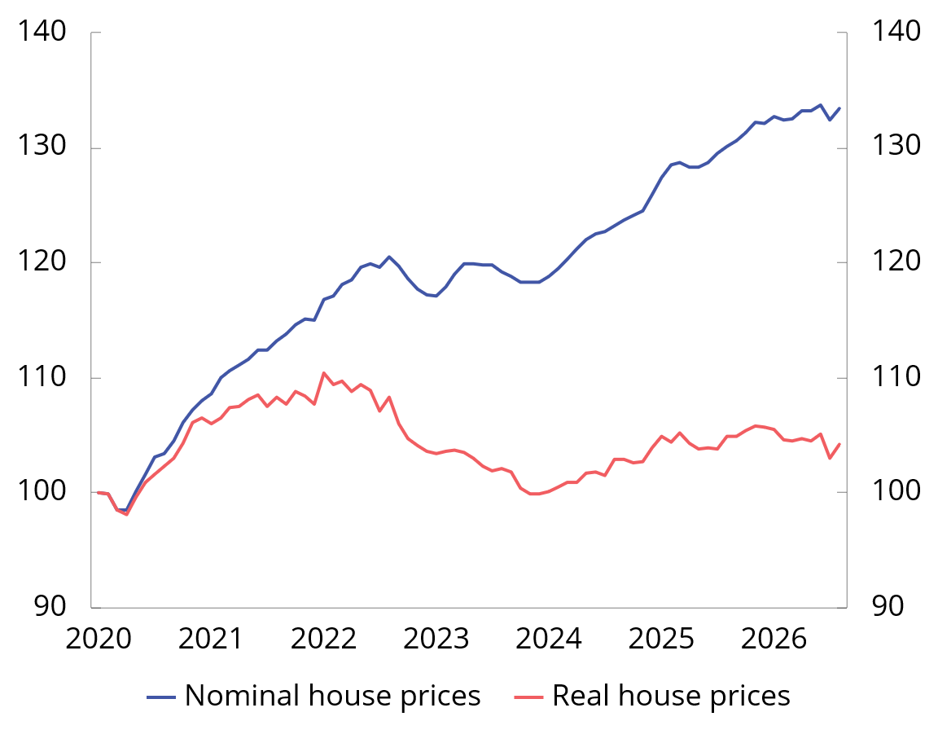
Chart 2.13 Second-hand housing prices.1 Index. Jan. 2020=100. Seasonally adjusted. Jan. 2020-Aug. 2026
1 Real house prices are calculated by deflating Real Estate Norway’s seasonally adjusted second-hand housing price series by the seasonally adjusted consumer price index (CPI).
Sources: Real Estate Norway, Property Value, Finn.no, Statistics Norway and Ministry of Finance.
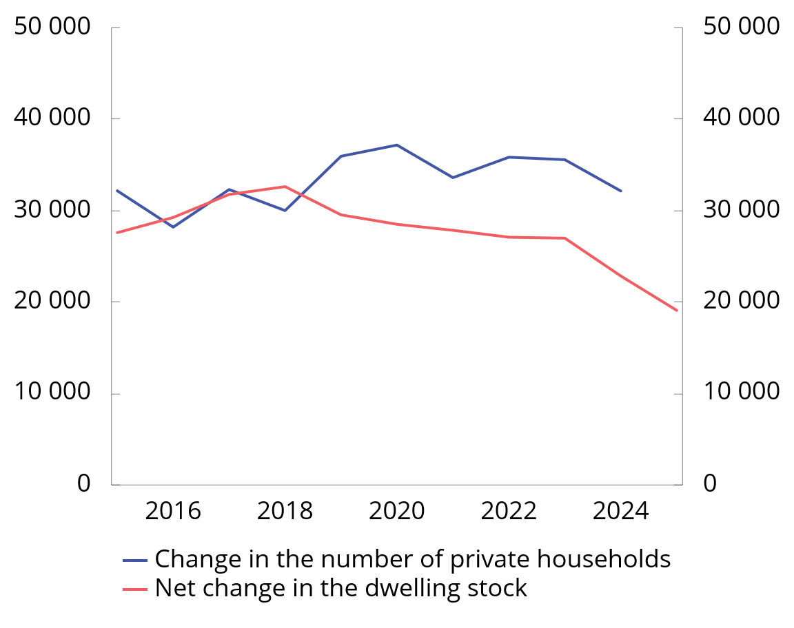
Chart 2.14 Change in the number of private households and the number of completed dwellings (including conversions) less the number of departed dwellings. 2015–2025
Source: Statistics Norway.
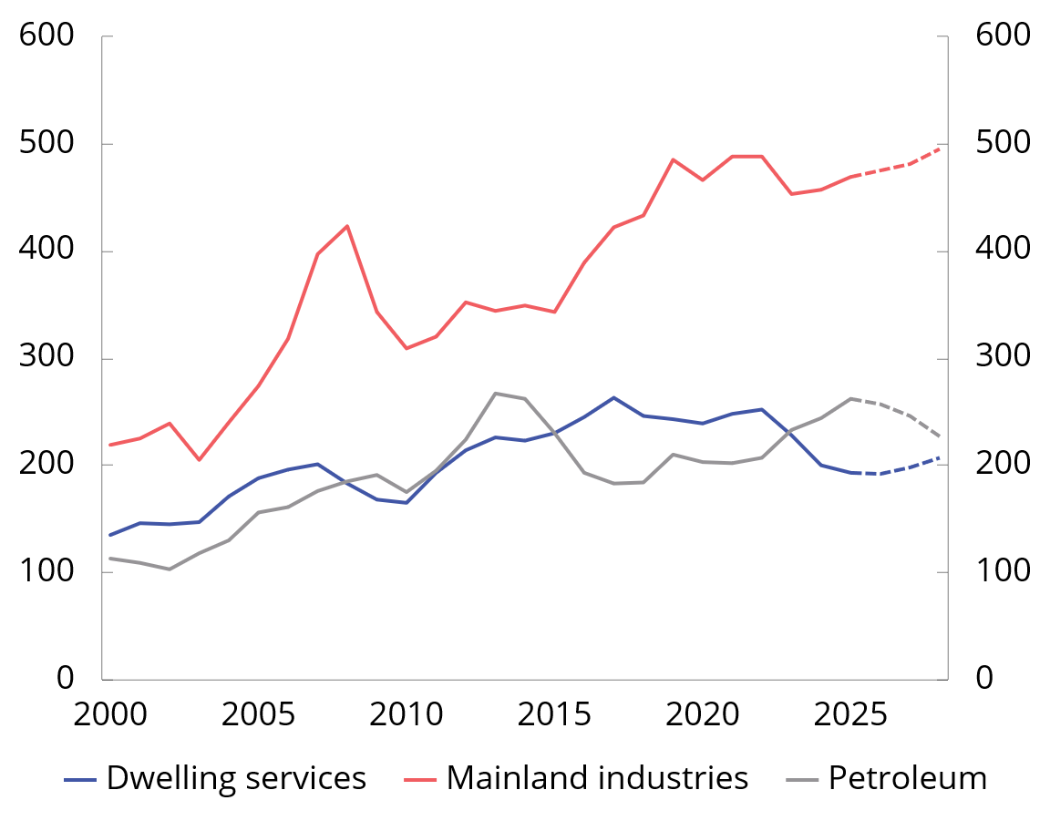
Chart 2.15 Gross fixed capital formation. Housing, mainland industries and petroleum. NOK billion at 2023 prices. 2000–2028
Sources: Statistics Norway and Ministry of Finance.
Higher interest rates dampen growth in business investment
Mainland business investment has shown modest developments in recent years (Chart 2.15). The enterprises in Norges Bank’s regional network expect moderate growth in output ahead. The outlook is weakest for oil services, while it is strongest for household services. Excluding investment in electricity supply, which is expected to increase markedly, the projections in this report imply a decline in business investment this year. Investments in power supply are expected to boost growth also in 2027 and 2028. Lower interest rates are then expected to contribute to some growth in non-power investment.
Lower growth impulses from petroleum investment
Petroleum investment has increased sharply over the past three years, primarily because of field development (Chart 2.15). The increase must be seen in the context of the temporary tax rules adopted by the Storting in spring 2020, which provided more favourable tax terms for developments where the plan for development and operation (PDO) was submitted by the end of 2022. The scheme contributed to an unusually high number of PDOs being submitted in 2022. The level of petroleum investment has long been expected to decline as these developments are completed. This picture is supported by reporting from the oil companies to the Norwegian Offshore Directorate and by Statistics Norway’s investment intentions survey. In this report, it is assumed that petroleum investment will decline gradually from this year.
The krone has appreciated
The krone, as measured by the import-weighted exchange rate index I-44, has appreciated markedly this year (Chart 2.16). Compared with the beginning of the year, the krone is now about 8 per cent stronger. The appreciation must be seen in the context of the rise in petroleum prices and a wider interest rate differential against other countries. The upward exchange rate has reversed most of the krone depreciation that occurred through 2023. A stronger krone in isolation contributes to curbing inflationary pressures in the Norwegian economy.
The projections for the Norwegian economy are based on the technical assumption that the krone exchange rate will remain unchanged, based on the level prevailing in mid-July.
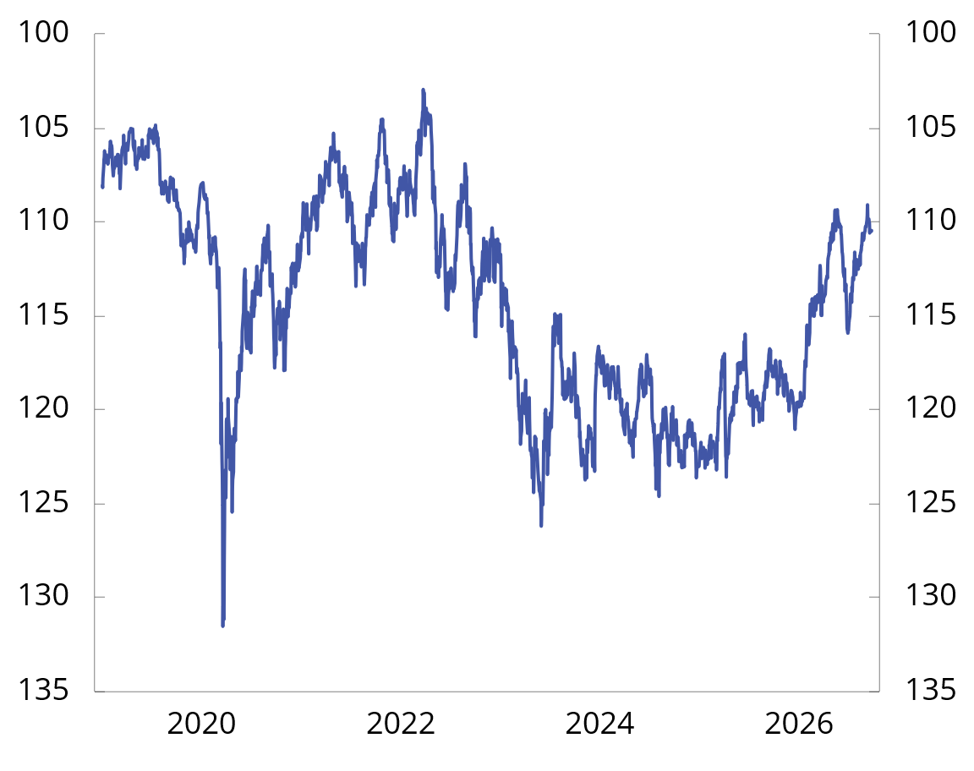
Chart 2.16 Import-weighted exchange rate index (I-44).1 1 Jan. 2019–24 Sep. 2026
1 I-44 is a calculated exchange rate index based on exchange rates between NOK and the currencies of Norway’s 44 most important trading partners measured by import value. A higher index value indicates a weaker krone, and the axes have therefore been inverted to show developments in the value of the krone measured in foreign currency.
Sources: Statistics Norway and Ministry of Finance.
Defence focus characterises public demand
After several years of fairly high growth in public demand for goods and services, growth last year was somewhat lower than the historical average and lower than growth in the mainland economy. Growth in public demand is also expected to be lower than the historical average this year, and the projection has been revised down compared with the revised national budget. This is due to lower-than-expected growth in defence spending. Next year, public demand is projected to grow in pace with the mainland economy. Growth is being driven by high demand in defence, while low investment growth in the state-owned civil sector is expected to dampen growth somewhat.

2.3 The balance of risks
The backdrop for the projections is a troubled world. So far, the war in the Middle East has not had the same consequences for the world economy as feared this spring. The risk of persistently high inflation, on the other hand, appears to be as great as earlier this year. The main risk factors are related to:
- The economic effects of the war in the Middle East. The war has contributed to higher inflation expectations and lower growth prospects for the world economy. Although the IMF points out that the world economy has so far fared better than feared, it points out that continued turbulence may lead to large movements in energy prices, bottlenecks in the production and delivery of goods and services, higher inflation prospects and higher interest rates. However, the risk goes both ways. If the level of conflict is reduced and the oil and gas market normalises rapidly, this could boost the global economy.
- Trade policy. There is persistent uncertainty related to US trade policy. The US has increased tariffs on a substantial share of its imports from Norway. There is a risk that customs duties may increase further and be higher than those imposed by the US on other countries. The overall effect on the Norwegian economy of higher tariffs on exports to the US is considered moderate in the short term, but for some businesses the consequences may be considerable.
- Persistently high inflation in Norway. Consumer price inflation has been above target for several years, and wage growth last year was higher than expected. International inflation is expected to be higher as a result of the turbulence in the Middle East. High inflation over time may prompt businesses and households to start planning for inflation to remain high. In that case, Norges Bank may have to raise the policy rate more than assumed. This may result in weaker and more unbalanced economic developments. Conversely, a faster-than-expected fall in inflation may provide a basis for earlier interest rate reductions and stronger and more balanced growth in activity.
- Rise in long-term interest rates. The increase in long-term interest rates, combined with high public debt, has increased the vulnerability of government finances in a number of countries (see discussion in Section 2.1). Higher interest rates make it more expensive to refinance debt and finance new budget deficits. Over time, this may limit fiscal space, particularly in countries with high debt and weak budget balances. If investor confidence in the sustainability of government finances weakens, higher risk premiums may amplify the rise in interest rates and further increase debt burdens. This may result in abrupt tightening of government budgets and weaker economic activity. At the same time, optimism related to artificial intelligence (AI) has stimulated investment and activity, and fuelled a rise in equity prices, particularly in the US. Expectations of higher productivity and earnings have probably helped counteract some of the negative effect that a rise in long-term interest rates normally has on equity prices. If expectations concerning the gains from AI are revised down substantially, both investment and equity prices may fall abruptly. In combination with high long-term interest rates, this may amplify the turbulence in financial markets and weaken growth prospects internationally and in Norway.
Box 2.3 Effect of electricity support and Norgespris on the CPI
The government introduced the electricity support scheme in December 2021 to help households deal with extraordinarily high electricity prices. In October 2025, the Government introduced Norgespris as an alternative to the ordinary electricity support scheme.
To illustrate the effect of the electricity support and Norgespris on the CPI from 2021 to 2025, Statistics Norway has, on request, calculated an index where the support schemes have been removed. In this index, power is measured at market prices, while the network tariff is at the same level as before the schemes were introduced. The series is called electricitysupport. The CPI, on the other hand, captures the actual electricity prices faced by households, including the electricity support scheme, Norgespris and reduced electricity tax. When the spot price increases, the gap between the CPI without electricity support and the CPI will increase (Chart 2.17). In August, the 12-month rise in the CPI without electricity support was 4.9 per cent, while the rise in the CPI was 3.3 per cent. The calculations based on observed market prices may overestimate the significance of the support schemes in curbing inflation somewhat if the schemes themselves have affected electricity prices through higher demand.
The consumer price index adjusted for tax changes (CPI-AT) shows a similar development to the CPI without electricity support. The CPI-AT is an index that measures the price development of goods and services adjusted for changes in indirect taxes, such as value added tax and excise duties. Statistics Norway considers the electricity support scheme and Norgespris to be subsidies, and the CPI-AT therefore measures electricity prices by the market price of electricity. Historically, the gap between the CPI and CPI-AT has been very close to zero, but since 2022 there has been a persistent deviation that correlates with the level of electricity prices (Chart 2.17).
In preparing the projections for the CPI, futures prices from financial markets for electricity are used. Futures prices are then adjusted to take into account how the electricity support scheme and Norgespris affect the prices faced by households. In the projections, it is assumed that the share using Norgespris will increase somewhat. In the projections for the CPI without electricity support, futures prices are used as a basis without such adjustments. For 2026, higher power prices are assumed than the previous year. This means that the CPI without electricity support is projected to grow by 4.3 per cent in 2026, while the projection for CPI growth for the same year is 1.0 percentage points lower (Table 2.3). For 2027 and 2028, futures prices indicate a decline in electricity prices from the previous year. This pulls the CPI projection without electricity support markedly down. The projection for CPI is less affected as the support schemes also dampen the effect of falling electricity prices.
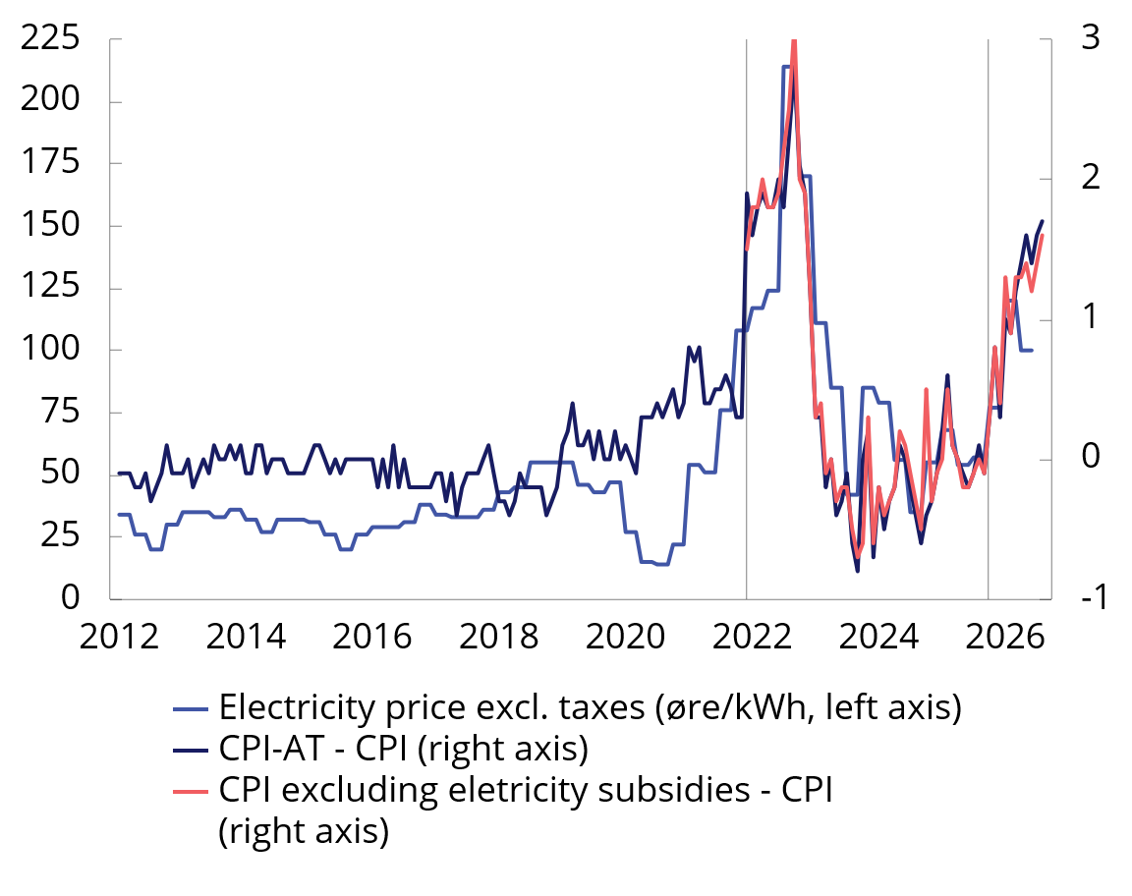
Chart 2.17 Electricity price and the gap between the CPI andrespectively, the CPI withoutelectricity support and CPI-AT. 2012–20261
1 The left and right axes are øre/kWh and twelve-month change in per cent, respectively. Vertical lines indicate December 2021 (when the government introduced the electricity subsidy scheme) and October 2025 (when the government introduced Norway’s price).
Sources: Statistics Norway and Ministry of Finance.
Table 2.3 CPI and CPI excluding electricity support. Percent.1 2021–2028
 | 2021 | 2022 | 2023 | 2024 | 2025 | 2026 | 2027 | 2028
CPI2 | 3,5 | 5,8 | 5,5 | 3,1 | 3,1 | 3,3 | 2,7 | 2,4
CPI without electricity support3 | 3,6 | 7,7 | 5,4 | 3,0 | 3,2 | 4,3 | 2,4 | 2,1
1 Annual change.
2 2021–2025 is historical CPI from Statistics Norway table 03014. 2026–2028 are estimates prepared by the Ministry of Finance.
3 Electricity support includes the electricity subsidy scheme for electricity and grid tariffs, as well as Norgespris. 2021–2025 are historical figures compiled by Statistics Norway. Figures for 2026–2028 have been prepared by the Ministry of Finance.

3.1 Fiscal policy in 2027
Fiscal policy stance
In the fiscal budget for 2027, the Government proposes a use of fund resources, measured by the structural non-oil budget deficit, of NOK 608.4 billion, equivalent to 12.6 per cent of mainland Norway trend GDP (Table 3.1). Measured as a share of the economy, this is approximately unchanged from this year. Fund spending is expected to correspond to withdrawals from the GPFG of 2.7 per cent of the fund value and 26.6 per cent of fiscal budget expenditure.
The fiscal policy stance aims to balance cyclical considerations with the long-term goals of sustainable public finances and to safeguard the growth potential of the economy.
The Norwegian economy continues to grow, although the pace of growth has slowed somewhat over the past year. Inflation is above the inflation target, and since winter, Norges Bank has adjusted its course from planning for further interest rate cuts to raising the interest rate and signalling that more interest rate increases may be forthcoming. Cyclical considerations and the need not to overburden the monetary policy imply a cyclically neutral fiscal policy stance.
In the interest of sustainable development in government finances, government finances used in the event of major changes in the value of the fund should be adjusted gradually over several years. This contributes to stable welfare services and framework conditions and reduces the risk that fiscal policy in itself contributes to instability in the economy.
The fund now finances just over one in four krones of expenditure in the fiscal budget (Chart 3.4). The fund capital has contributed to a strengthened public service offering. At the same time, they have made the welfare state more vulnerable to a fall in financial markets and fluctuations in the krone exchange rate. The value of the fund has increased sharply in recent years, but has fluctuated considerably since the New Year (Charts 3.5 and 3.6). There is considerable uncertainty surrounding developments ahead. In the fiscal policy stance in each year, it must be taken into account that the value of the fund is uncertain and that the fund may fall abruptly.
Fiscal policy must also take into account that unforeseen events may occur that require a strong fiscal response, such as during the pandemic and as a result of Russia’s war of aggression in Ukraine. Increased spending in the event of economic downturns and gradual adjustment of spending in the event of a fall in fund value suggest that fund spending should be below 3 per cent in normal times, so that fund spending over time corresponds to the expected real return of 3 per cent. In previous analyses by the Ministry of Finance, it has been estimated that fund spending of 2.7 percent of the fund in normal times results in fund withdrawals that over time correspond to the expected real return of 3 percent.
The budget proposal assumes a fund value of NOK 22 400 billion at the beginning of 2027. This is NOK 1 100 billion more than at the beginning of 2026.
The sustainability of government finances is influenced not only by the level of fund spending, but also by how that capital is spent. International experience shows that substantial revenues from oil and gas extraction or other non-renewable natural resources are no guarantee of sustained high prosperity. Revenues from natural resources can become a cushion that contributes to delaying necessary measures or reforms to utilise society’s resources more efficiently. In the longer run, this may result in weaker productivity growth and lower labour force participation. Measures on the expenditure side or the tax side that strengthen incentives to work, increase productivity or otherwise improve the growth potential of the economy are beneficial for both welfare and the fiscal balance over time. See Meld. St. 31 (2023–2024) the white paper on Long-term Perspectives on the Norwegian Economy 2024 and chapter 5 of this white paper for a more detailed discussion of the importance of increased productivity and efficient use of resources.
Table 3.1 Key figures in the national budget. NOK billion and per cent
 | 2025 | 2026 | 2027
Structural non-oil fiscal deficit | 507,4 | 583,4 | 608,4
Measured in per cent of mainland Norway trend GDP | 11,6 | 12,7 | 12,6
Change from previous year in percentage points (budget indicator)1 | 1,8 | 1,1 | 0,02
Measured as a percentage of the Government Pension Fund Global | 2,6 | 2,7 | 2,7
Measured as a percentage of central government budget expenditure | 24,5 | 26,5 | 26,6
1 Change in structural non-oil fiscal deficit measured as a share of mainland Norway trend GDP.
2 The budget indicator for 2027 is -0.04.
Source: Ministry of Finance.
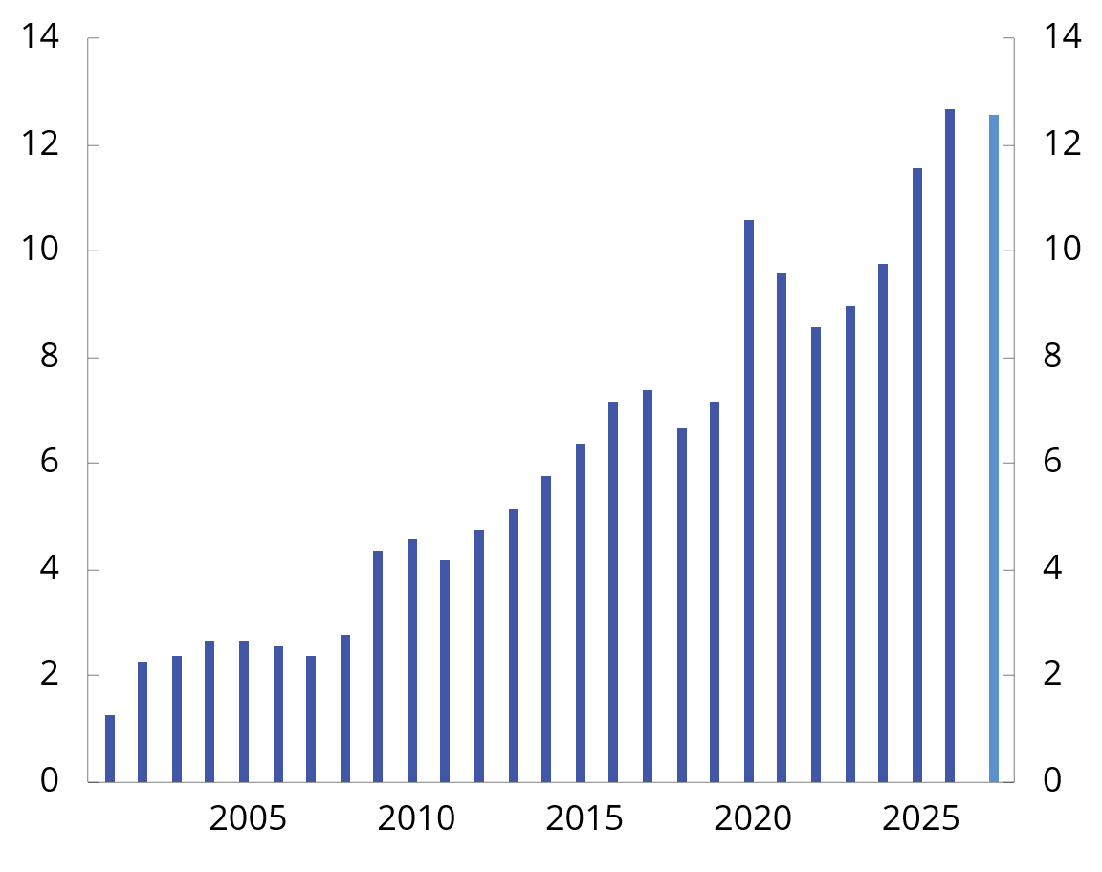
Chart 3.1 Structural non-oil fiscal deficit. Per cent of mainland Norway trend GDP. 2001–2027
Source: Ministry of Finance.
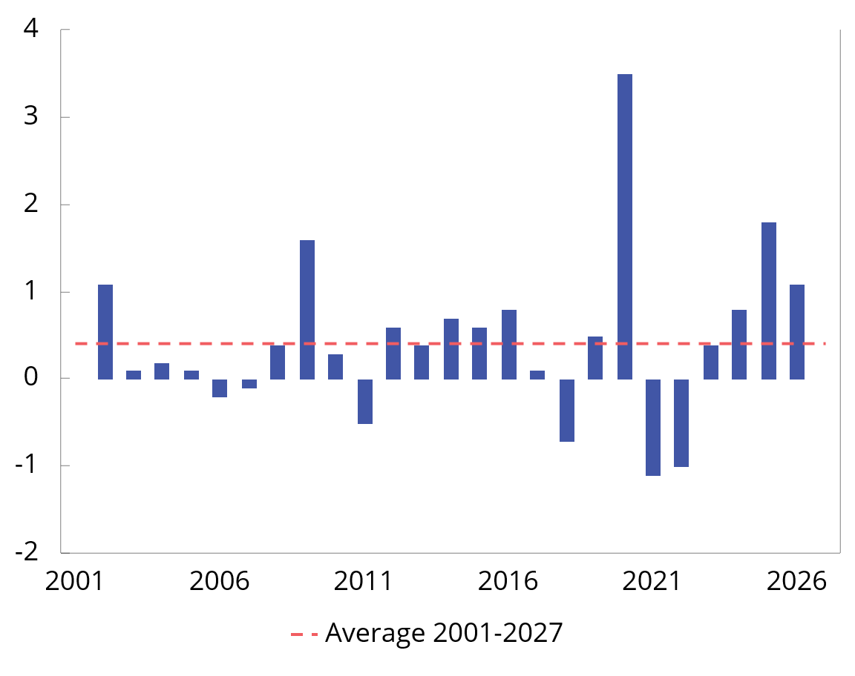
Chart 3.2 Structural non-oil fiscal deficit as a percentage of mainland Norway trend GDP. Change from previous year (budget indicator). 2001–2027
Source: Ministry of Finance.
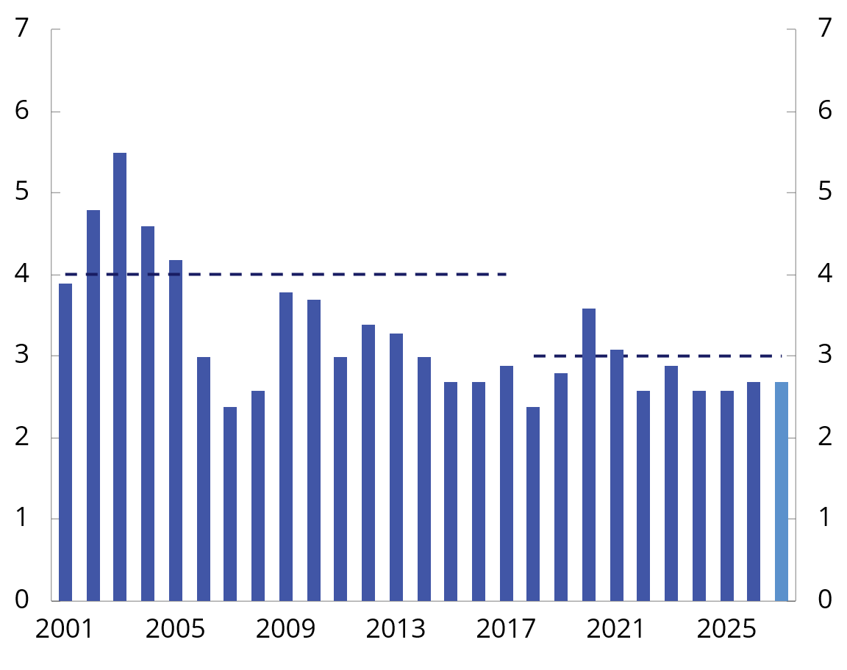
Chart 3.3 Structural non-oil fiscal deficit. Per cent of the Government Pension Fund Global. 2001–2027
Source: Ministry of Finance.
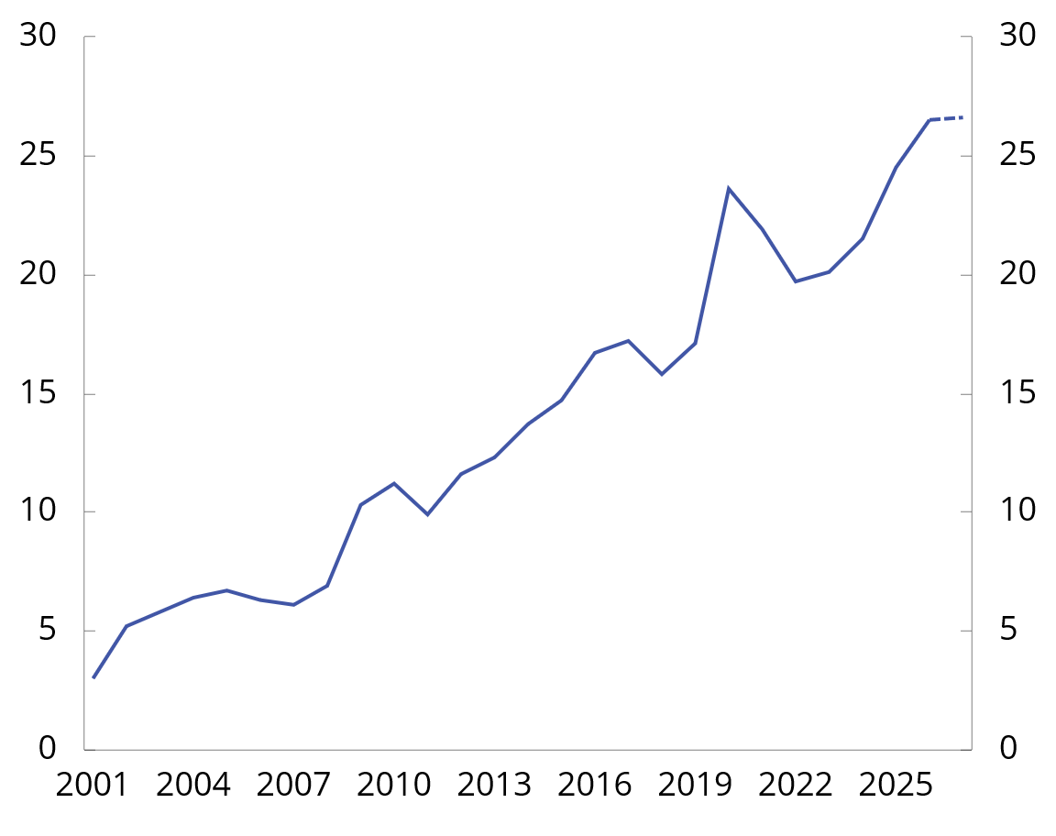
Chart 3.4 Fund spending as a share of fiscal budget expenditure. Per cent. 2001–2027
Source: Ministry of Finance.
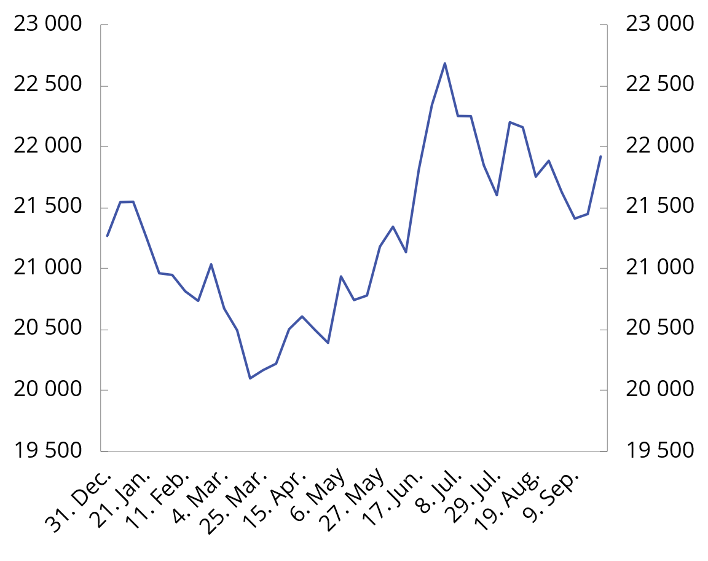
Chart 3.5 Market value of the Government Pension Fund Global. NOK billion. 31 December 2025–23 September 20261
1 Preliminary figures for September as the month has not ended.
Sources: Norges Bank Investment Management and the Ministry of Finance.
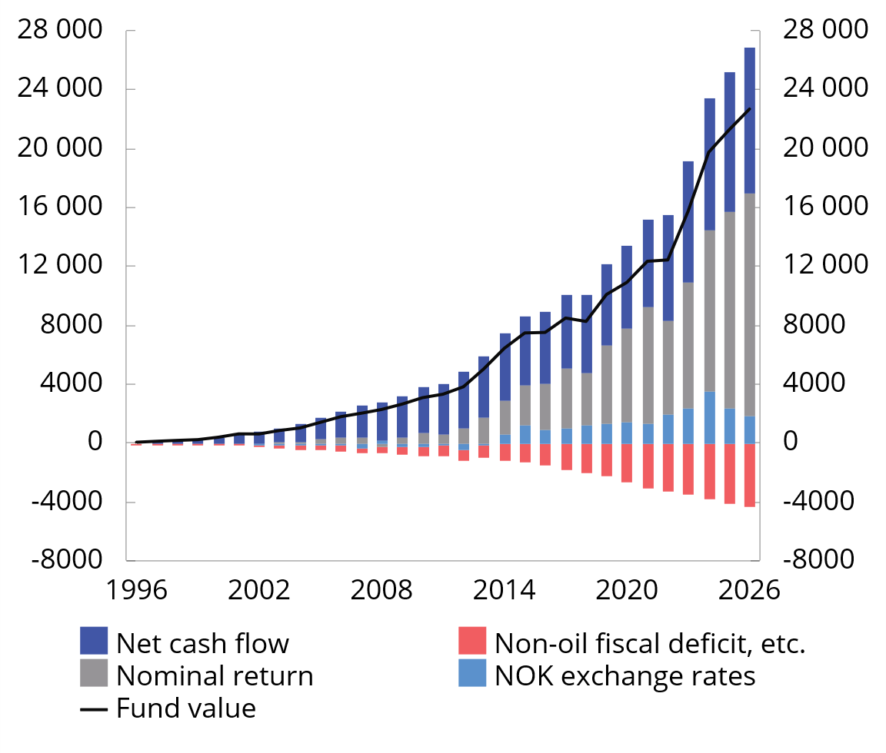
Chart 3.6 Contribution to change in the market value of the Government Pension Fund Global. NOK billion. 1996–20261
1 Fund value as of 31.12. For 2026, the market value is shown as of the first half of the year. The nominal rate of return is net of management costs.
Sources: Norges Bank Investment Management and the Ministry of Finance.
Budget effect calculations
In order to measure the effect of fiscal policy on economic activity, it must be taken into account that different public revenues and expenditure have different effects on the economy, and that temporary cyclical changes in taxes and unemployment benefits also affect activity. For example, tax revenues will increase and unemployment benefit payments will decrease during a boom, and the opposite in a recession.
Using the macroeconomic models KVARTS and NORA, the Ministry of Finance estimates how fiscal policy affects economic activity. The calculations show the impact on mainland GDP compared with a path where growth in public revenues and expenditure follows trend growth in the economy. In isolation, the budget proposal for 2027 is projected to increase mainland Norway GDP by 0.1–0.2 per cent next year, which can be interpreted as a broadly neutral fiscal policy stance. The effect on the economy is pulled up somewhat in 2027, as public demand is projected to grow somewhat faster than trend growth.
Fiscal policy influences economic activity over several years. Overall, fiscal policy in recent years is projected to have a neutral effect on the economy this year and next. The methods behind the calculations and differences in estimated budgetary effects in KVARTS and NORA are described in more detail in Appendix 2.
Table 3.2 Budget effects on mainland Norway GDP according to KVARTS and NORA.1 per cent
 | Effects on mainland Norway GDP
 | 2025 | 2026 | 2027 | 2028
KVARTS
Budget proposal for 2025 | -0,3 | -0,4 | -0,4 | -0,3
Budget proposal for 2026 |  | 0,0 | 0,1 | 0,2
Budget proposal for 2027 |  |  | 0,2 | 0,3
2025–2027 overall2 | -0,3 | -0,4 | -0,1 | 0,1
NORA
Budget proposal for 2025 | -0,2 | -0,1 | -0,1 | -0,1
Budget proposal for 2026 |  | 0,0 | 0,0 | 0,0
Budget proposal for 2027 |  |  | 0,1 | 0,1
2025–2027 overall2 | -0,2 | -0,1 | 0,0 | 0,0
1 The effect on economic activity is based on how various revenue and expenditure items (accrued) for the public administration as a whole develop compared with trend growth in the economy. The deviation from the baseline scenario is combined with fiscal multipliers. The multipliers are based on the models and describe the extent to which changes in various expenditure and revenue items influence economic activity. The effects of the so-called automatic stabilisers in the budget are taken into account, i.e. that unemployment benefit expenditure increases and tax revenues fall during a recession, while the reverse happens during a boom.
2 Due to rounding, summation of the individual items above may differ from the sum presented in this row.
Source: Ministry of Finance.
Other key figures
The non-oil deficit is the actual transfer from the Government Pension Fund Global to the fiscal budget. This is estimated at NOK 561.7 billion next year, see Table 3.3. The structural non-oil budget deficit measures the underlying use of fund resources, adjusted for the fact that tax revenues, certain expenditure that fluctuates with business cycles, and some other variables vary considerably from year to year. In 2027, deviations from trend for taxes and unemployment benefits account for most of the corrections.
Real underlying fiscal budget spending growth is estimated at 0.2 per cent from this year to next year (Table 3.4). This is lower than the average for subsequent years, which must be seen in the context of increased expenditure through 2026, for example in connection with the revised national budget. In addition, some of the increased use of fund resources next year will go to tax and fee reductions, while it has to a greater extent gone to expenditure increases in the preceding years.
The central government’s net cash flow from petroleum activities is estimated to fall from NOK 670.6 billion to NOK 568.4 billion from 2026 to 2027, see Table 3.5 and Box 3.4. In addition, the temporarily high tax revenues resulting from the discontinuation of the tax deduction account scheme in 2026 will be eliminated. Estimates of net allocations to the Government Pension Fund Global will therefore fall from about NOK 216 billion in 2026 to NOK 6.7 billion in 2027.
Table 3.3 The structural non-oil fiscal deficit1
 | 2025 | 2026 | 2027
Non-oil fiscal deficit | 475,7 | 454,8 | 561,7
+ Net interest and transfers from Norges Bank. Deviations from trend | 33,0 | 14,1 | 8,7
+ Special accounting matters | 3,5 | 79,7 | 11,1
+ Taxes and unemployment benefits. Deviations from trend | -4,8 | 34,8 | 26,9
= Structural non-oil fiscal deficit | 507,4 | 583,4 | 608,4
1 See Appendix 1 for a more detailed description of how the structural non-oil budget deficit is calculated.
Source: Ministry of Finance.
Table 3.4 Underlying fiscal budget expenditure1. Projections in NOK million and percentage change
 | 2026 | 2027
State budget expenditure | 2 239 372 | 2 321 798
- Government petroleum activities | 35 500 | 35 000
- Unemployment benefits for the unemployed | 16 930 | 17 695
+ Interest expenses | 21 524 | 25 300
= Expenditure other than petroleum activities, unemployment benefits and interest expenses | 2 165 418 | 2 243 803
- Refugees in Norway financed through the aid framework | 3 358 | 2 581
+ Adjustment for pension premiums, etc., health enterprises | 2 842 | 3 413
= Underlying expenses | 2 164 903 | 2 244 634
Change in value in per cent. |  | 3,7
Price change in per cent. |  | 3,4
Volume change in per cent. |  | 0,2
1 The calculation of underlying expenditure growth excludes fiscal budget expenditure on government petroleum activities, interest expenses and unemployment benefits. In order to make expenditure comparable over time, adjustments have been made for extraordinary changes and certain accounting considerations in accordance with standard procedures.
Source: Ministry of Finance.
Table 3.5 Key figures in the fiscal budget and the Government Pension Fund. NOK billion
 | 2025 | 2026 | 2027
Total revenue | 2 290,1 | 2 455,2 | 2 328,5
1 Revenues from petroleum activities | 692,7 | 706,1 | 603,4
1.1 Taxes | 382,9 | 389,1 | 358,9
1.2 Other petroleum revenues | 309,8 | 317,0 | 244,5
2 Revenues excluding petroleum revenues | 1 597,4 | 1 749,1 | 1 725,1
2.1 Taxes from mainland Norway | 1 416,4 | 1 591,6 | 1 560,4
2.2 Other income | 181,0 | 157,5 | 164,6
Total expenses | 2 101,8 | 2 239,4 | 2 321,8
1 Expenditure on petroleum activities | 28,7 | 35,5 | 35,0
2 Expenditure excluding petroleum activities | 2 073,1 | 2 203,9 | 2 286,8
Central government budget surplus before transfer to Government Pension Fund Global | 188,3 | 215,8 | 6,7
- Net cash flow from petroleum activities | 664,0 | 670,6 | 568,4
= Non-oil surplus | -475,7 | -454,8 | -561,7
+ Transfer from the Government Pension Fund Global | 480,2 | 454,8 | 561,7
= Central government budget surplus | 4,5 | 0,0 | 0,0
+ Net provision for the Government Pension Fund Global | 183,8 | 215,8 | 6,7
+ Interest and dividend income, etc., in the Government Pension Fund1 | 462,5 | 460,2 | 515,0
- Transfer from the Government Pension Fund Norway | 11,7 | 12,3 | 13,4
= Combined surplus in the fiscal budget and the Government Pension Fund1 | 639,1 | 663,7 | 508,3
Memo:
Interest and dividend income, etc., in the Government Pension Fund Global | 444,4 | 440,1 | 493,7
Market value of the Government Pension Fund Global2 | 19 735 | 21 258 | 22 400
Market value of the Government Pension Fund2 | 20 116 | 21 675 | 22 847
Retirement pension commitments under the National Insurance Scheme2.3 | 11 375 | 12 043 | 12 744
1 Does not include capital gains or losses.
2 At the beginning of the year.
3 The net present value of existing accrued rights to future retirement pension payments under the National Insurance Scheme.
Sources: Ministry of Finance and Statistics Norway.

See Working Paper 2025/2 Government Pension Fund Global and medium-term fiscal policy for a description of the calculations.

