National Wellbeing Strategy
From measurements to policymaking 2025–2030


Summary
The National Wellbeing Strategy is anchored in the white paper on public health, Meld. St. 15 (2022–2023). The aim of the strategy is to provide direction for developing policies that to a greater extent take into consideration what is important, based on our current measurements of wellbeing in the population. With this National Wellbeing Strategy, the Government also wishes to facilitate an equalisation of social differences in wellbeing.
Although Norway’s population generally enjoys high wellbeing, this is unevenly distributed and for some groups the trend appears to be heading in the wrong direction. People with low education levels, with financial difficulties, who are unemployed, have mental health problems or disabilities, as well as parts of the immigrant population, Sámi people and LGBTQ+ people appear to have a lower wellbeing than the general population. There is a need for a more even distribution of wellbeing across population groups. There is also a need for stronger and clearer efforts to combat climate change, prevent biodiversity loss and follow up the Sustainable Development Goals. This is essential for the wellbeing of both current and future generations.
This strategy describes the most important focus areas for achieving these goals. It addresses the development of a system for regular and comprehensive national, regional and local measurements of the population’s wellbeing. It emphasises the importance of developing indicators that can be used to monitor developments and form the foundation for social and political decision-making. At the same time, it discusses the challenges and uncertainties that arise from using wellbeing indicators as a basis for policymaking in contrast to more objective measurements.
The strategy discusses its relation to the UN Sustainable Development Goals, public health work and the relationship between GDP and wellbeing. Possible instruments discussed in the strategy include implementing wellbeing in legislation, a new thematic guide for the instructions for official studies and reports on health and wellbeing, the importance of cross-sectoral ownership, embedding wellbeing in various reports, and experiences from other countries that use wellbeing as a supplementary measure of societal development. International experiences show that high-level political commitment is essential for the work on using wellbeing as part of the basis for political decisions and initiatives. The Government wishes to emphasise that this strategy is a first step along this path. It will be followed up by an action plan that ensures cross-sectoral ownership and follow-up of the focus areas and recommendations described in Chapter 7.

Introduction
Wellbeing is about having a good life. It involves shared values, societal benefits and social justice. A high level of wellbeing is a shared value across groups, municipalities, regions and countries. High wellbeing promotes health and mastery, and it can strengthen resilience in the face of various burdens and stress. High level of wellbeing in the population has positive consequences for society as a whole: This includes less sick leave absence, a lower mortality rate and better life outcomes for each individual. Emphasising wellbeing in policy development can help equalise social differences and create a fairer and more just society. Wellbeing can be considered a resource for society as it can better equip the population to meet various challenges.
The central government has a key role in ensuring that its citizens have the necessary conditions to live a dignified and fulfilling life, but it should be reluctant to define what constitutes a good life. Therefore, the National Wellbeing Strategy does not define any specific form of lifestyle as being the correct one. The measurement system includes both objective and subjective indicators of wellbeing (1). Objective indicators are what we today generally view as welfare factors – such as the work and study environment, housing and communities, and financial and material situations. Subjective factors include, for example, meaning and mastery, a sense of security and belonging and satisfaction. Resources and material assets are fundamental parts of wellbeing, and economic concerns weigh heavily when measuring wellbeing. There are correlations between financial situations and mental health, including suicide. Social differences in economics are a fundamental factor behind social differences in wellbeing.
Figure 2 presents examples of subjective and objective components included in wellbeing measurements.
The strategy is based on the perspective of how we can better facilitate the provision of the individual opportunities for a good life.
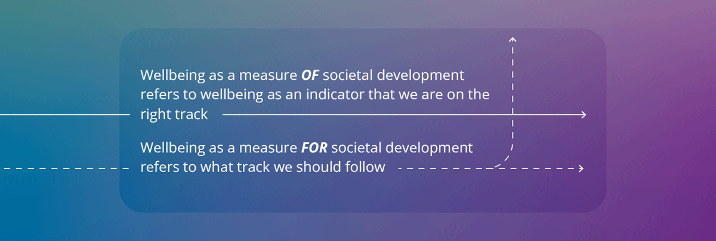
A great deal of work is being done in today’s administration with relevance for the wellbeing strategy, and wellbeing is mentioned in a number of white papers, action plans and strategies. The decision to prepare a National Wellbeing Strategy for Wellbeing as a measure of societal development and to equalise social differences in wellbeing is anchored in the white paper on public health, Meld. St. 15 (2022–2023). (2). “Wellbeing as a measure of societal development” refers to wellbeing as an indicator that we are on the right track. “Wellbeing as a measure for societal development” refers what track we should follow.
The Ministry of Health and Care Services has led the work on the strategy, which has been developed with input from a working group comprised of representatives from the Ministry of Health and Care Services, the Norwegian Institute of Public Health, the Norwegian Directorate of Health and Statistics Norway, as well as Menon Economics. In addition, several government sectors, both at the ministry and directorate level, the Norwegian Association of Local and Regional Authorities and representatives from county governor’s offices, county authorities, municipalities, as well as voluntary and non-profit organisations have contributed their input. The strategy was sent out for input in March 2024. Input has been important for the development of the strategy itself but it also forms the foundation for further work on an action plan during the 2025–2030 strategy period.

Goals for the National Wellbeing Strategy
With this National Wellbeing Strategy, the Government seeks to lay the foundation for developing goals and instruments to ensure a societal development that facilitates equal opportunities for a good and meaningful life and that ensures a good and even distribution of wellbeing in the population. The aim is for knowledge from wellbeing measurements in the population, wellbeing indicators and knowledge of how wellbeing is distributed in the population to be used to a greater extent in political decision-making processes. In this way, measures can be developed that are more in line with the citizens’ own needs. This in turn can contribute to a fairer society and a stronger democracy.
At the same time, it is important to recognise that there will also be challenges with using wellbeing as a measure of and for societal development. Among other things, this must be organised in a manner that allows for different life choices. Wellbeing as a measure must always be weighed against different political priorities and values. Wellbeing consists of both objective and subjective components (see Figure 2), and it is the objective components in particular that can be influenced through policymaking. The subjective components are fundamentally difficult to measure and are also more difficult to emphasise in policy development as they will depend, among other things, on the expectations and starting points of individuals and groups. These are factors that will be important to take into account in future work on wellbeing as a measure of and for policy development.
The strategy will highlight how the concept of wellbeing can be used across sectors and form the basis for prioritisations in national and local budget processes. To achieve this, there is a need for national, regional and local measurements of the population’s wellbeing and an indicator framework that allows us to monitor developments. These are necessary but not sufficient conditions for achieving the goal of wellbeing as a measure of and for societal development. Other instruments include acts, regulations, guidelines and supervision that ensures sufficient compliance with this goal in all sectors. At national, regional and local levels, it is necessary to ensure an economic structure and governing tools to achieve a stronger correlation between economic development and the population’s wellbeing. The pathway from measurements to policymaking is discussed in more detail in Chapter 5.2.
With the National Wellbeing Strategy, Norway also wishes to contribute to the work of developing a Nordic model both for measuring wellbeing and for how wellbeing can be used as a measure of and for societal development. The Nordic co-operation is described in Chapter 6.1.

Background of the National Wellbeing Strategy
Wellbeing does not necessarily coincide with economic prosperity. Over the past decade, there has been a growing interest and commitment to wellbeing both internationally and in Norwegian professional environments. A growing number of countries are now using their populations’ wellbeing as a supplementary measure of societal development. The UN (3) points out that the reason for the growing global interest stems from the need to address the complex and interwoven challenges and crises facing the world in the 21st century. Examples include climate challenges and environmental degradation, pandemics, social differences and rapid technological changes. When encountering these issues, politicians and decision-makers need a tool that encompasses phenomena that have value for people’s lives and thus also for society, and which are to a lesser extent linked to economic growth. This can promote decision-making that is in the best interests of the people, the planet, peace and partnership.
In Norway, wellbeing as a measure of societal development was mentioned in the National Budget for 2010 (4) and later in the white paper Public Health Report: Good health – a common responsibility (Meld. St. 34 (2012–2013)) (5), where the need to develop better measures of societal development and the term “gross national wellbeing” was used. The white paper on public health focussing on mastery and opportunities (Meld. St. 19 (2014–2015)) (6) also mentions the need for data and indicators that cover various aspects of wellbeing. The need to develop good measures and indicators of wellbeing is also mentioned in Long-term Perspectives on the Norwegian Economy 2017 (Meld. St. 29 (2016–2017)) (7). Follow-up of these reports resulted in the report Gode liv i Norge [Good lives in Norway] (available in Norwegian only) in 2016 (8) about measuring wellbeing. The report was prepared by the Norwegian Directorate of Health in collaboration with Statistics Norway, the Norwegian Institute of Public Health and the NOVA/OsloMet Norwegian Social Research institute. The primary recommendation in the report is that comprehensive information on wellbeing should be included as a basis for both health policies and other policy areas. Based on this report, a measurement system was developed and tested (9), and Statistics Norway conducted the first national measurement of the population’s wellbeing in 2020. National surveys conducted in 2021, 2022, 2023 and 2024, in addition to a number of surveys conducted in counties and municipalities all provided information on wellbeing at a local level. Both national and regional surveys indicate clear social inequities in wellbeing that is important to address. The national surveys are the mainstay of work on wellbeing in Norway.
Health-related wellbeing has also been a key issue in the development of health economic analyses over the past 20 years, with health economic research groups at universities playing a key role. Important questions in health economics research have included whether “years of life lost” or “years of life gained” is too narrow a measure of losses and gains from introducing new treatment methods, and how wellbeing years can be measured and valued. A description of how health and wellbeing can be included in assessments can be found in Chapter 5.2.5.
Developments in Norway have paralleled those in a number of other countries. Through its Better Life Initiative from 2011, the OECD has been an important driving force in efforts to put wellbeing on the political agenda. In 2019, New Zealand became the first country in the world to launch a Wellbeing Budget and now publishes this annually as an important part of its national budget (10). Countries such as Scotland, Iceland, Finland and Wales are now following New Zealand in its transition to a wellbeing economy. This is described in more detail in Chapter 5.2.6.
The Government seeks to develop a model that emphasises wellbeing as a measure of and for societal development and that can shift wellbeing from a subjective and individual condition or experience to a collective value that the authorities can promote, facilitate and manage at the societal level to a greater extent than today.

What is wellbeing?
Wellbeing is about what really matters in people’s lives. The term is used to describe both subjective experiences and objective conditions. The subjective wellbeing (inner experiences) is about how life is experienced by the individual. It includes both assessments of life (e.g. life satisfaction) and functioning in daily life (e.g. sense of mastery and meaning), as well as positive and negative emotions (such as happiness and sadness). The objective wellbeing (external factors) deal with especially important aspects of the life situation, such as freedom, security, health, community and opportunities for self-development (11).
The term quality of life can be used in other countries, which can also be defined as wellbeing, wellness and contentment. In our work on the national strategy, we have decided to consistently use the term wellbeing. The concept of wellness emphasises that a good life involves both inner experiences and actual conditions. This is consistent with how the term wellbeing is used internationally, for example by the OECD and Eurostat, the European statistics agency. The term wellbeing also emphasises, the quality of the whole life. The fact that the term wellbeing is a concept that can help us to see the totality of people’s lives is also emphasised in the report Livskvalitet – Anbefalinger for et bedre målesystem [Wellbeing – Recommendations for a better measurement system] (available in Norwegian only) (9) and Statistics Norway’s report on the indicator framework (1).
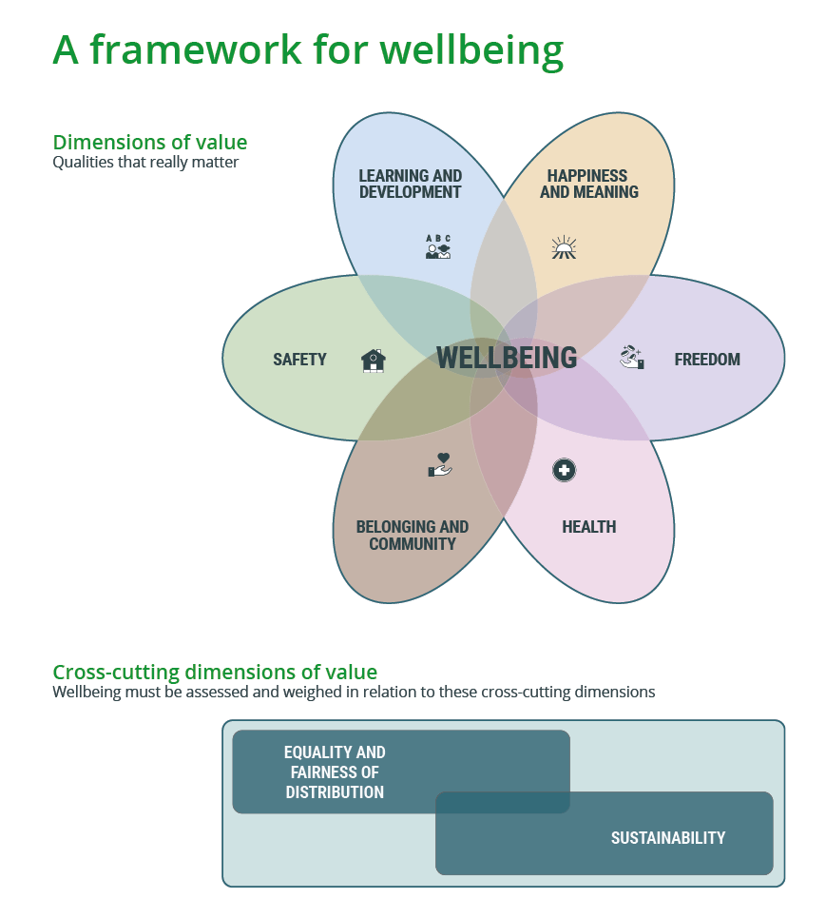
Figure 1. Value dimensions of wellbeing (1)
Design: Thomas Bjørnskau, Statistics Norway
The key components of the concept of wellbeing are illustrated in Figure 1. The leaves of the “wellbeing flower” represent the most important factors, or values, for wellbeing. These values can be regarded as end goals in themselves rather than the means of realising other benefits, and there has been strong support among the population (cf. the Norstat survey, Chap. 4.4).
In the figure, happiness and meaning represents the purely subjective wellbeing such as emotions, meaning and engagement, while freedom represents the ability to realise one’s own objectives and have control over one’s own life. Health includes both one’s own physical and mental health and that of loved ones. The value belonging and community represents the quality of different types of communities and social relationships, such as relationships with family, friends and colleagues, where social support and a sense of belonging are important. The value security represents the absence of various forms of risk and events that can threaten, among other things, physical integrity and the fulfilment of basic needs. Access to social networks and health services are also important aspects of security. Learning and development involves the opportunity to learn and develop, which will enable the person to use their abilities, social skills and knowledge. These values overlap with our common human needs, our physiological needs, the need for security, belonging, self-realisation, mastery and development. When these needs are met, the wellbeing is positively affected. When they are not met, the wellbeing is negatively affected.
The two cross-cutting dimensions in Figure 1 are fundamental values that are of significance for the wellbeing: Equality and fair distribution and the value of sustainable development.

How do we measure wellbeing?
The values shown in Figure 1 are the starting point for wellbeing measurement tools and indicators as presented in the report Livskvalitet – Anbefalinger for et bedre målesystem [Wellbeing – Recommendations for a better measurement system] (available in Norwegian only) (9) and in the report on an indicator framework for measuring wellbeing in Norway (1). A more detailed description of the indicator framework can be found in Chapter 5.1.
Because wellbeing is about what makes life good and what really matters in people’s lives, there is widespread agreement that measurements of wellbeing must include both subjective and objective components. The national measurements of wellbeing that have been prepared on the basis of the report Livskvalitet – Anbefalinger for et bedre målesystem [Wellbeing – Recommendations for a better measurement system] (available in Norwegian only) (9) include both a set of subjective measures and a set of objective measures. Measurement tools for the objective wellbeing are based on the most important frameworks and arenas for people’s lives (see Figure 2). These include physical and mental health, social community and relationships, work and education, economic and material situations, housing, local environment and safety, society and rights, leisure and culture, knowledge and skills. This list helps to further concretise the six wellbeing values (the wellbeing flower). For example, freedom is about financial situations (economic freedom and action), labour (autonomy in the workplace) and governance (democratic participation and absence of discrimination).
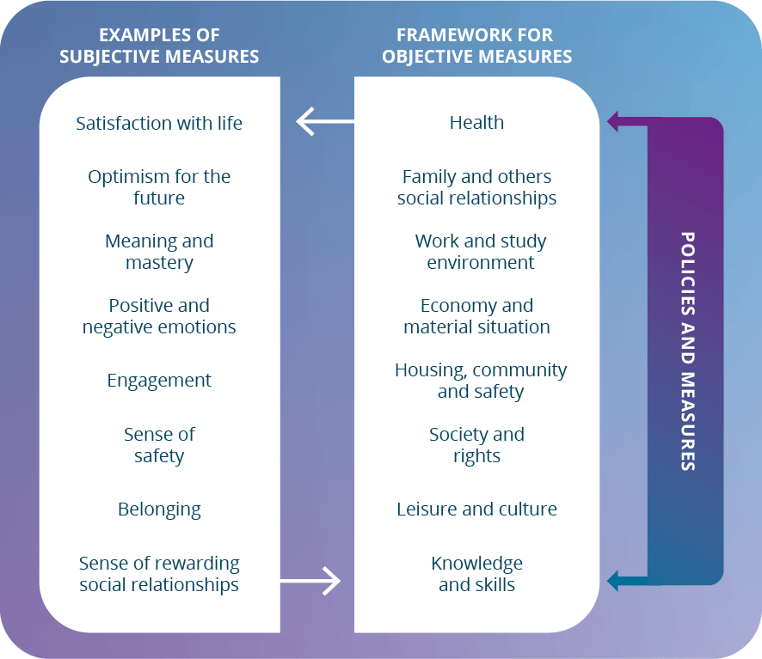
Figure 2. Subjective and objective components of wellbeing measurement
The objective goals affect opportunities for achieving a high subjective wellbeing. For example, good health and sufficient financial resources will lay the foundations for optimism for the future and belief in one’s own coping skills and mastery, which in turn can affect the objective components in a positive way. In this way, the subjective and objective aspects of wellbeing can form part of a mutually reinforcing feedback loop, in either “good” or “bad” circles. Public policies can facilitate good circles by influencing the objective components, for example through welfare, labour market and education policies, legislation, etc.
The components of both the subjective and objective wellbeing have been important in the work of developing an indicator framework that can be used both to monitor developments in the population’s wellbeing and for policymaking.

Relationship between wellbeing, sustainability and the UN Sustainable Development Goals
Promoting wellbeing at the community level involves creating communities that are active, resilient and sustainable locally, nationally and globally. Wellbeing combines the health, economic, social and environmental dimensions of sustainable development (12). Statistics Norway’s report Forslag til et rammeverk for måling av livskvalitet i Norge [Proposal for a framework for measuring wellbeing in Norway] (available in Norwegian only) (1) mentions three sustainability imperatives: Satisfy human needs, ensure social justice and respect environmental limits. The key themes within each imperative are eradicating extreme poverty, promoting human opportunities, ensuring political participation and equitable distribution, combating climate change and halting biodiversity loss (13). Satisfying human needs and ensuring social justice is fully in line with the wellbeing perspective. Freedom, security, health and self-development can be viewed as fundamental human needs. Combatting climate change and halting biodiversity loss is important both in its own right and for the wellbeing of both current and future generations (1). The UN emphasises that crises such as environmental degradation, pandemics, climate change, natural disasters and social inequities make it more important than ever to develop decision-making tools that place human needs as the basis for societal development, rather than the goal of economic growth.
The 2030 Agenda is the world’s action plan for sustainable development, concretised through 17 Sustainable Development Goals (SDGs) and 169 targets, and involves achieving sustainable development along three dimensions: economic, social and environmental. The Sustainable Development Goals were adopted at the UN General Assembly in 2015, with the support of all 193 Member States. Norway was a driving force behind the adoption of the goals, and is committed to working to ensure that the world achieves these goals by 2030. The SDGs represent a new and holistic approach to development. They encompass all countries and affect all parts of society. These commitments have been followed up through Mål med mening – Norges handlingsplan for å nå bærekraftsmålene innen 2030 (Meld. St. 40 (2020–2021)) [Meaningful goals – Norway’s action plan to achieve the Sustainable Development Goals by 2030] (available in Norwegian only). Follow-up is led by the Ministry of Digitalisation and Public Governance in collaboration with the other ministries.
Although wellbeing is included as part of the heading in the main goal, nr. 3, there are no indicators linked to this. Based on national indicators and suggested measuring points as set out in Norway’s action plan for achieving the Sustainable Development Goals by 2023, Statistics Norway established a sustainability indicator project in 2022, on behalf of the Ministry of Local Government and Regional Development. Statistics Norway collaborates with all ministries and respective subordinate agencies on the review and assessment of relevant national indicators for the sustainable development goals and targets under these, as a supplement to the UN’s global indicator set. The Ministry of Health and Care Services, which is responsible for working to achieve Sustainable Development Goal 3, “Ensure healthy lives and promote wellbeing for all at all ages”, has involved the Norwegian Institute of Public Health and the Norwegian Directorate of Health in the work on the “sustainability indicator project”. This review has resulted in the most relevant indicators in a Norwegian context for achieving the sub-goals under Goal 3, but there is still a lack of relevant indicators for the main goal itself, Goal 3.
The national work on wellbeing and the development of the indicator framework could be a way for Norway to follow up the Sustainable Development Goals and operationalise the wellbeing section of SGD 3. This can therefore be an important supplement to the global and national indicators.
The Government has decided to present a new white paper on the Sustainable Development Goals in 2025. Wellbeing is discussed in particular in Chapter 4 involving a safe and socially sustainable welfare society.

The relationship between wellbeing, health and public health
Health and wellbeing are interconnected, and health encompasses somatic, oral, mental and sexual health. Factors that affect health and wellbeing are fairly similar across groups and individuals. The most important determinants of wellbeing largely overlap with the determinants of health, and also largely coincide across groups. In Norstat’s survey (Chapter 4.4), health appears to be one of the most important aspects of a good wellbeing, along with family, security and freedom. Wellbeing surveys in the population also include a number of questions related to both physical and mental health, and health is one of the ten dimensions used by Statistics Norway in its report on a proposal for a framework for measuring wellbeing in Norway (1).
Wellbeing as part of public health work in Norway has over the past decade evolved from being synonymous with subjective and individual experiences to also being a collective societal value that can be used to indicate a desired direction for societal development. Wellbeing is therefore a broader policy area than public health.
At the same time, we know that good and evenly distributed public health is important for achieving the goal of a good and evenly distributed wellbeing. Therefore, wellbeing as a societal goal also emphasises the importance of good public health work at national, regional and local levels.
The principles of public health work are relevant to work on promoting a good wellbeing. This applies, for example, to cross-sectoral co-operation and initiatives across administrative levels, the equalising of differences, efforts aimed at social determinants and ensuring that measures work best for those who need them most (proportionate universalism). These are principles that affect the population at large and that will help reduce social differences in both health and wellbeing. There is also cross-party agreement on the three goals of the national public health policy.
Although many of the principles are the same, the goals for public health work and wellbeing work differ: The goal of public health work is to achieve better health throughout the population, while the goal of wellbeing work is to provide a better overall measure of and for societal development across sectors and policy areas. Public health work will nevertheless be of great importance in promoting wellbeing as a societal goal.

Wellbeing as a goal
There is currently no comprehensive measure of wellbeing that encompasses both subjective and objective components of importance for wellbeing.
The limitations of using a country’s GDP as a measure of societal development is the main message of the report “Beyond GDP”, often referred to as the Stiglitz Report (14). In this report prepared for the OECD, Stiglitz and colleagues describe how excessive reliance on GDP as a measure of economic performance misled policymakers who did not recognise the approaching 2008 financial crisis. The report emphasises the following:
“…change the focus of our statistics from measuring the size of economic production, which is what GDP is about, to measuring what shapes the wellbeing of people today and that of future generations… What you measure affects what you do” (p. 7).
In accordance with the recommendations of the Stiglitz Report, the Ministry of Health and Care Services commissioned Statistics Norway in March 2023 to develop an indicator framework for wellbeing that could form the basis for policymaking. The indicator framework is intended to provide an overview of the status and development of key factors that affect wellbeing. It will also play a key role in planning efforts, assessing measures and being able to make projections and modelling of the consequences of various measures. The framework will be used to assess the achievement of policy goals, and by monitoring the indicators over time, they can show whether policy goals are being achieved, such as economic security or a reduction in the number of people outside the labour market. The set of indicators should be able to help answer the question of whether the population is doing better or worse, in which areas and for which groups. The set of indicators could also form part of the knowledge base for developing political strategies and action plans, and it can be used in budget processes at various levels.
The current system for assessing government measures is based on the instructions for official studies and reports. This means, among other things, that socioeconomic analyses of measures that have significant benefit or cost effects must be carried out. This system will continue to underlie studies as a basis for decision-making. And better wellbeing for different groups could also be a goal for policy development within the current framework. However, the indicator framework could eventually contribute by supplementing the current basis for decision making.
There are a number of challenges associated with measuring wellbeing. Wellbeing consists of both objective and subjective components, and it is particularly the subjective components that are fundamentally difficult to measure adequately. These will, among other things, often depend on the expectations, conditions and genetics of individuals and groups. Caution must be exercised to avoid unintended distortions in the use of resources if this is to be given weight in policy development.
Generally, however, there are clear correlations between subjective wellbeing and many aspects of objective living conditions. Two OECD reports (15; 16) have examined the problems associated with measuring subjective wellbeing and have concluded that the most commonly used measures were relevant and provided valid information. The 2023 report (16) emphasises the benefits of using subjective wellbeing in policymaking. The use of indicators of a subjective wellbeing was recommended by both the first and second Stiglitz Commission (14). None of these reviews have concluded that the challenges associated with measurements mean that subjective wellbeing cannot be used as one of several indicators of societal development. Statistics Norway’s measurement system for subjective wellbeing is based on a thorough review of the research literature on measurement issues, including the OECD guidelines. However, it is important to be aware of pitfalls and interpretation issues when using this, as with all other welfare statistics.
Statistics Norway’s national measurements of the population’s wellbeing are based on three sources: respondents’ assessments of their own subjective wellbeing, descriptive indicators and register information. This information provides a good basis for knowledge about the population’s wellbeing and is an important supplement to the indicators in Statistics Norway’s proposed indicator framework. In this framework, subjective wellbeing is one of ten dimensions. The others consist either exclusively of objective indicators or in other cases, a combination of objective and subjective indicators. Objective measures include life expectancy, perpetually low income, NEET (Not in Education, Employment or Training) and deaths attributed to narcotics, intoxication or suicide. A nuanced measurement system must show the breadth and diversity of a population’s interests and concerns, and what is important in their lives. The subjective wellbeing is important, but it is not all that matters. The National Wellbeing Strategy has therefore used both subjective and objective components for wellbeing as a measure of and for societal development.
Chapter 4.1 provides a description of the national wellbeing surveys, while Chapter 5.1 provides a more detailed description of the indicator framework.
Based on regular measurements, follow-up of the indicator framework and legal and regulatory framework, wellbeing can be incorporated into goals and priorities both nationally and locally and become a component of the authorities’ decision-making processes. Countries that are at the forefront of efforts to implement wellbeing as a measure of societal development largely use economic instruments, e.g. through various forms of wellbeing budgeting.
In Norway, the Norwegian Public Health Act requires systematic overview work at regional and local level. County authorities and municipalities are therefore well placed to work in accordance with principles that are compatible with wellbeing as part of the decision-making basis for political prioritisation. At the government level, consideration will be given to developing a system for how wellbeing and distribution can be emphasised in plans and budgets across sectors. A figure providing an overview of the measures and actions that can be taken can be found in Chapter 5.2.6.

Equalising social differences in wellbeing
Inequality in material security or finances is often a key determinant of wellbeing and can be manifested through more qualitative experiences, such as the extent to which one experiences meaning, social support or life mastery. Socioeconomic differences are associated with social differences in wellbeing.
The national wellbeing surveys conducted by Statistics Norway since 2020 show that several groups score significantly lower on all 12 indicators of subjective wellbeing compared to the rest of the population. This applies to people who are unemployed, people in the lowest income bracket, people with a low level of education, people with disabilities or with symptoms of mental illness, and LGBTQ+ individuals. Other groups that score lower than the rest of the population on indicators 9 through 11 are people with low incomes, disabled persons, people under the age of 45 living alone, people aged 18–24 and students/pupils. Fylkeshelseundersøkelsene (2019–2022) [the County Health Surveys (2019–2022)] (available in Norwegian only) indicate that Sámi people in Nordland, Troms and Finnmark score the same as or somewhat lower than the rest of the population on questions about wellbeing (17).
The 2024 National Wellbeing Survey indicates that subjective wellbeing is unevenly distributed in the population, similar to previous surveys. People with a university or college education, people with a high income and employed people are among those who are most satisfied with life and that report a good wellbeing more often than others. People living with a partner or spouse are also among those who report higher than average satisfaction on many of the indicators included in the statistics. Unemployed people, people with health problems and single people are among the groups that are less satisfied with life and more often experience a low wellbeing. Non-heterosexuals are also among the most vulnerable groups.
Participation in working life may be important for wellbeing and there is a significant difference in wellbeing for unemployed and disabled persons and that of employed persons. Disabled people are a group with health issues who are entirely or partially outside the labour market. Those with long-term health issues and or symptoms of mental health problems, regardless of labour market status, are also among those groups with the highest proportion of reported dissatisfaction with life – 40 and 60 per cent respectively in 2024.
Sexual health is positively associated with both general health and perceived wellbeing (18). Individuals with a sexual orientation other than heterosexuality are also among those groups with the poorest subjective wellbeing. The 2023 Ungdata survey shows that young people with sexual orientations other than heterosexuality are less satisfied with life than those who are heterosexual. They are also less optimistic about the future, are more lonely, have poorer relationships in school and with parents, and are more often subjected to bullying and sexual abuse than others (19).
Parts of the immigrant population are also a vulnerable group. According to the Living Conditions Survey (Statistics Norway 2017) (20), immigrants have on average poorer living conditions than the general population in terms of finances, employment, working conditions, housing standards, social relationships and health. From 2020 to 2022, 28 per cent of all individuals with an immigrant background living in Norway had a persistently low income, compared with 11 per cent of the entire population (based on the EU60). Furthermore, 6 out of 10 children in the low-income group have an immigrant background, according to a report by Statistics Norway in January 2024 (21). Large families and low parental employment are among the factors that could explain this.
The immigrant group as a whole does not differ much from the rest of the population on many of the indicators, despite having poorer living conditions on average. At the same time, there are significant and most likely selective non-responses from immigrants in the surveys that could have impacted these results. Immigrants comprise a significantly varied group and the proportions stated in the tables may to some extent conceal the fact that there may be major differences in wellbeing between immigrants with different national backgrounds, basis for residence and length of stay in Norway. The aim should be to capture this part of the population to a greater extent, both as a whole and in the form of different groups.
The National Wellbeing Survey was carried out five years in a row, from 2020 to 2024. Coincidentally, the implementation of the first three surveys coincided with major changes in the world situation. The first survey in March 2020 was conducted during a period where society gradually shut down due to the pandemic. The following year, in March 2021, the population was living under a number of restrictions, and some places in the country, such as Oslo, shut down again. At the time of the survey in March 2022, the war in Ukraine had just broken out. The surveys in March 2023 and 2024 were conducted while the war in Ukraine was still going on and there was a period of steep price increases and rising interest rates. It is difficult to know for certain how the various circumstances have affected the results of the surveys, However, it is likely that people have felt more stress and anxiety than they otherwise would have.
The economic situation in 2023 and 2024, with steep price increases and rising interest rates, has also likely had an impact on the population’s general satisfaction. For instance, satisfaction with one’s own financial situation declined from 6.6 in 2021 to 6.2 in 2023 and 2024 on a scale of 0–10. Changes in how people experience their own personal finances varies among different groups, and the decline in satisfaction is greatest among those aged 25–44 and the working population. Older individuals and pensioners, on the other hand, did not generally report a decline in satisfaction with their financial situation.
On behalf of the Norwegian Directorate of Health, Statistics Norway has conducted analyses of social inequities in wellbeing (22). In these analyses, Statistics Norway has tried to determine which categories have had the greatest impact on wellbeing and have studied interaction effects that show whether the impact of certain categories (e.g. unemployment) vary due to another category (e.g. disability). The analyses show that most people in the population have one or more of the characteristics associated with a lower wellbeing and that a majority have two or more. The analyses also show that the impact on wellbeing largely depends on individual characteristics. For example, the report mentions that people under the age of 45 with a low income have a higher wellbeing (average 7.9) than the national average, while people who have little financial freedom and long-term health problems have a somewhat lower wellbeing (average 6.4) than the national average.
Wellbeing in Norway appears to be evenly distributed geographically. Statistics Norway’s 2024 national survey on wellbeing shows no significant differences in “satisfaction with life” between counties. Nor are there any significant differences with respect to centrality. The least central municipalities score just above the national average, 7.0 compared to 6.9. The County Health Surveys show significant differences between municipalities, but they do not appear to vary according to centrality. Other factors, most often the demographic composition, can explain these differences. It can be assumed that this even geographical distribution in wellbeing is related to Norway’s universal welfare schemes and services regardless of geography, and that the economy is generally doing well throughout the country.
There are somewhat greater geographical differences in subjective wellbeing when people are asked about satisfaction with specific aspects of life, such as where they live. Satisfaction with where one lives is lowest in the least centralised areas (7.6) and in Finnmark (7.3), while satisfaction is highest in the second most and moderately central areas (8.0) and in Vestfold (8.3).
The national, regional and local measurements of wellbeing, in addition to the choice of indicators in the indicator framework, as well as Statistics Norway’s report on social inequities in wellbeing, will provide more knowledge about differences in wellbeing and reasons for these differences. This can provide a better basis for policy development and have significance for achieving the goal of equalising social differences in wellbeing in Norway.
The majority of the population in Norway has, and has had a good wellbeing. This is likely due to specific historical and cultural conditions, which in total have given us the society we have today. At an overarching level, we have a welfare state that provides its citizens with a number of universal welfare programmes. Other important factors include the redistribution of wealth, trust between citizens and in the governance system, a well-functioning legal system, a transparent public administration and a well-regulated labour market.
Over the past few decades, Norway has therefore used various other measures and instruments to create the welfare state we have today, which is broader than what GDP is able to measure. Norway is also ranked second highest on the Human Development Index, which includes all countries in the world. The index was developed by the United Nations Development Programme (UNDP) to emphasise that economic growth alone is not sufficient to assess a country’s development. The index measures a country’s average achievements in three basic areas: Life expectancy, education and income (GDP per capita).
The Nordic countries all have high GDP and are stable welfare societies. They are among the ten countries with the highest scores for subjective wellbeing in the World Happiness Report published by the UN Sustainable Development Solutions Network (SDSN). However, Norway dropped from number 1 in this ranking in 2017 to number 7 for the third consecutive year in 2025, and inequalities in health and wellbeing are increasing. A report on inequality in health and wellbeing in Norway (the Marmot Review report) (23) describes Norway as a country characterised by a high and rising standard of living for large parts of the population, but also with significant and persistent social and economic inequality. The report points out that although Norway has a long tradition of welfare policies and structural goals, inequalities in health and social determinants still exist and are increasing.
Figure 3 illustrates how prosperity in Norway has significantly increased by around 70 per cent, while the percentage of those who consider themselves happy compared to not happy has been relatively stable or declining.
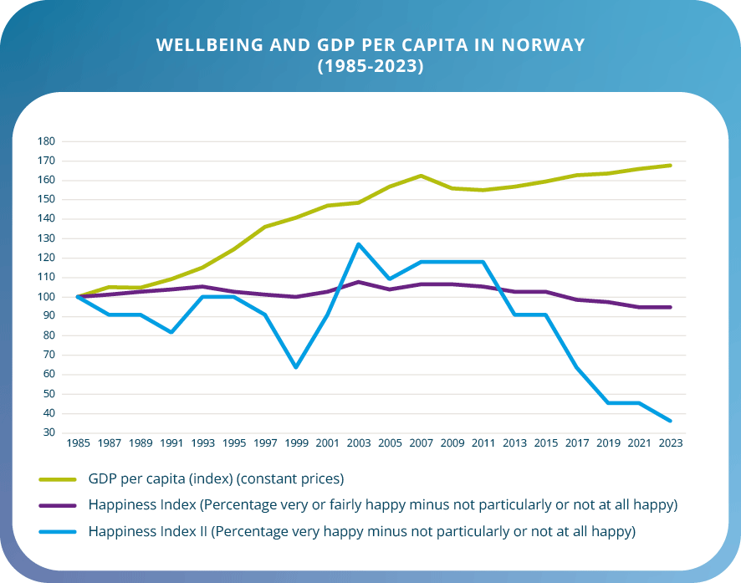
Figure 3. Subjective wellbeing and GDP per capita in Norway 1985–2023
The values are normalised to 100 for the 1985 base year to show relative development over time. Source: GDP figures and median income from Statistics Norway; figures on wellbeing/happiness from Norsk Monitor
Prepared by Henrik Lindhjem, Menon Economics
The decline in the happiness index from 2011 to 2023 has been particularly sharp in younger age groups. In these age groups, growing concerns about what the future will look like in terms of career and educational opportunities and finances may be explanatory factors. Other factors that appear to contribute to reduced happiness and satisfaction are dissatisfaction with social relationships, health, physical fitness and body image.

Wellbeing as a component of welfare policies
The aim of labour and welfare policies is to create financial security, to equalise differences in income and living conditions, and to contribute to help and self-help (24). Labour and welfare policies are therefore closely linked to wellbeing.
For the individual, employment provides income, a sense of belonging and better living conditions. Employment can be a key aspect of good living conditions that fulfils many material, social and psychological needs, provided there is also a good working environment. A high level of employment also means we can have good income security schemes that ensure income and freedom for those who are unable to work. This coincides with what is referred to as a subjective and objective wellbeing (cf. Chap. 2.3). Income and access to financial resources provide opportunities for consumption and investments and are important prerequisites for a high wellbeing. Welfare also depends on how the country’s income is distributed, on the population’s state of health and mortality, access to cultural, natural and recreational resources, access to leisure time and the extent of loneliness and crime. International studies emphasise a relatively close relationship between a country’s value creation, economic inequality and other indicators of living standards and welfare. However, it is worth noting that a high level of material wealth is not necessarily synonymous with a high wellbeing and good public health (25).
The Norwegian working life model is characterised by a high level of unionisation, a high prevalence of collective bargaining agreements and good co-operation between the parties, which has resulted in high productivity, strong competitiveness and considerable adaptability in Norwegian working life. The model has also contributed to a compressed wage structure and smaller economic differences.
Employment and a secure working life form the basis for good value creation. A high employment rate also finances welfare schemes. Income security schemes are designed to contribute to financial security for the individual, equalise differences and contribute to good economic growth. The contribution of income security schemes and public welfare services for reducing economic inequality is essential for improving the living conditions of vulnerable groups and has previously shown a correlation with the general wellbeing in the population. Labour market policies are intended to promote a good supply of labour, reduce and prevent unemployment and prevent people from being excluded from the labour force for long periods. Labour market measures are an example of an instrument designed to strengthen the individual’s ability to find work, which could contribute to an improved wellbeing for the individual.

Monitoring and knowledge development
“We therefore need to ask people not only about general satisfaction, but also about joy and mastery in everyday life, about a sense of meaning, freedom of action, respect and belonging, about hopelessness, stress or pressure. We need to combine such data with information about actual living conditions, social conditions and living and working conditions – putting people in a wider context. And finally, we need to monitor the development over time so we can understand who gets worse and who gets better – how, in what way and under what circumstances” (9).
The Government’s goal is to ensure adequate knowledge about wellbeing in the population, how wellbeing is distributed across different groups, and how wellbeing develops over time.
To achieve this goal, regular national, regional and local wellbeing surveys will be conducted that encompass different geographical levels with good representation from different population groups. This is particularly important, as there is an increasing proportion of people who, for various reasons, have immigrated to Norway, in addition to an increasing number of descendants of individuals with immigrant backgrounds, including those with one Norwegian-born and one foreign-born parent. The data will be used to monitor developments over time and conduct sector-relevant analyses. Furthermore, the National Indicator Framework (1), which is currently under development, will be regularly updated and further developed as needed.
Comprehensive and regular wellbeing surveys could provide answers to how different aspects of wellbeing develop and are distributed across society. Wellbeing surveys could therefore be an important management tool for prioritising efforts and evaluating change over time, for example as a result of pandemics, changes in population composition or specific implemented measures. The National Wellbeing Survey conducted by Statistics Norway in March 2021 during the pandemic shows that satisfaction in the population was significantly lower in March 2021 than in March 2020. The same applies to optimism about the future and a meaningful everyday life. The survey shows a decline in 10 out of 12 indicators of subjective wellbeing between 2020 and 2021. This decline coincides with changes in living conditions, including an increase in the proportion of people who report having health or mental health problems, sleep issues, pain, lack of social contact and loneliness. Overall, the number of restrictive measures implemented during a pandemic appears to have had a direct effect on the wellbeing of the population. This effect seems to vary according to the intensity or duration of the measures, and it is assumed that wellbeing will return to a more “normal” level when the pressure decreases (11).
Average satisfaction in the population has improved since the “low point” in 2021, but it is still somewhat lower in 2024 than it was in March 2020. It is also lower than in surveys conducted prior to the pandemic (for example, Folkehelseundersøkelsene [County Health Surveys] (available in Norwegian only) (26) and the Gallup World Poll. The sense of meaning, engagement and emotions have scarcely changed since 2021, while satisfaction with physical health has continued to decline. Satisfaction with mental health has not improved either. Recent data from the County Health Surveys show that the level of most wellbeing indicators is lower than both before and during the pandemic (26). This applies across age, gender and education.
The factors included in both the national and local measurements of wellbeing in the population, along with the indicator framework, will form a knowledge base for the work to develop wellbeing as a measure of and for societal development in Norway. Access to qualitative knowledge through participation processes could also provide greater insight into the wellbeing of different groups.
In addition, the international measurements published in the “World Happiness Report” and the “Human Development Index” can be an indicator of developments in Norway compared with other countries.

National measurements: Wellbeing in Norway
There are two main sources of knowledge about the population’s wellbeing. One is register data, i.e. information about wellbeing that can be retrieved from public registers, which encompasses the entire population. These registers only cover objective aspects of wellbeing, such as income and wealth, crime, employment, education, mortality/life expectancy and certain aspects of living conditions. However, register data does not cover all relevant aspects of the objective wellbeing.
In order to also include the subjective aspects of wellbeing, it is necessary to conduct sample surveys and ask people how they are doing.
For years, Statistics Norway has been conducting surveys on the living conditions of the population, starting in 1973. In recent years, the Living Conditions Survey has been coordinated with the surveys that Norway is obliged to conduct as part of the EEA agreement, EU-SILC (European Union Survey of Income and Living Conditions). These surveys are conducted annually and consist of three parts: One part is a core set of questions determined by Eurostat (the statistical office of the EU), another part is also determined by Eurostat but consists of topics that vary from year to year, while a third is nationally determined. Other sample surveys that provide information on aspects of the population’s wellbeing include the European Health Interview Survey (EHIS), the European Working Conditions Survey (EWCS), the EU Labour Force Survey (EU-LFS) and the European Time Use Surveys (HETUS).
Together with register data, these sample surveys provide a large amount of important information about the population’s wellbeing, although they do also have certain weaknesses: Subjective wellbeing is relatively poorly covered and the surveys are conducted in the form of telephone interviews, which may lead to an underreporting of negative feelings and evaluations. Another weakness is that the ability to see cross-connections is limited by the rotation of themes.
These weaknesses were why a new measurement system that included recommended questions and methods for conducting wellbeing surveys in Norway was presented in 2018 in the report Livskvalitet – Anbefalinger for et bedre målesystem [Wellbeing – Recommendations for a better measurement system] (available in Norwegian only) (9). This report provides both recommendations on measurement tools for comprehensive wellbeing measurements (a dedicated wellbeing survey) and a minimum battery of questions to be used in surveys that do not focus solely on wellbeing, or that are smaller in scope but also seek to cover key components of wellbeing. These surveys are conducted online, which means that participants do not have to engage with an interviewer. Surveys like these also allow for a larger sample size than what is common for living condition surveys.
The recommended measurement system for a comprehensive measurement of wellbeing forms the basis for the national population surveys on wellbeing conducted by Statistics Norway. From 2022, wellbeing was established as a separate official statistic at SSB.no, and key parts of the survey are published as tables in Statistics Norway’s statistics bank, StatBank, as part of its statistics programme for the 2024–2027 period. Statistics Norway has decided to limit the statistics to subjective wellbeing dimensions, and the following indicators are included in the statistics: Satisfaction with different areas of life; (life in general, physical and mental health, the place one lives, available leisure time, financial situation); Overall satisfaction with life; Meaning and mastery (optimism for the future, sense of meaning, sense of engagement, sense of mastery and fulfilment, rewarding social relationships), and Positive and negative emotions. The indicators are broken down into various personal characteristics such as gender, age, level of education, income, economic status, civil status, national background, etc. Consideration should be given to whether the question “What does a good life mean for you?” from the survey conducted by Norstat in spring 2023 (see Chapter 4.3) should be included in the national measurements.
The system still has some weaknesses. The wellbeing surveys have a higher non-response rate than the surveys conducted in the form of telephone interviews. The non-response rate is particularly high among those with a lower level of education and among those over the age of 80. It is also significantly higher among people with immigrant backgrounds. These are groups that also have relatively high non-response rates in other surveys, although the web-based survey method seems to reinforce these issues.
The wellbeing survey does not include children and young people under the age of 18, nor does it provide information on minorities such as the Sámi people and national minorities. Nor does the current system provide figures at a lower geographical level than the county.
Overall, these weaknesses indicate a need to establish a system that ensures representativeness of the above-mentioned the groups and that enables annual data collection in addition to existing data sources.

Local measurements: Fylkeshelseundersøkelsene [County Health Surveys]
The Norwegian Institute of Public Health has since 2019 measured wellbeing at the local level through Fylkeshelseundersøkelsene [County Health Surveys] (available in Norwegian only). The aim of these surveys is to provide an overview of public health issues at regional and local levels and to contribute to knowledge for use in cross-sectoral municipal and county authority public health work. Among other things, the surveys have contributed to mapping mental health challenges and problems of loneliness across the country. These have shown municipal variations that are not reflected in national statistics.
The data collected helps county authorities, municipalities, health authorities and other organisations to develop and implement targeted public health measures and policies. The surveys are primarily conducted online. Large samples have provided data at the municipal level, and in some cases, also from smaller geographical units, such as city districts. They also provide data on minorities such as the Sámi people.
The purpose of the County Health Surveys is to fulfil the counties’ obligations under Section 21 of the Norwegian Public Health Act, “Overview of public health and health determinants in the county. County authorities shall have a sufficient overview of the population’s health in the county and the positive and negative factors that may influence this.” Wellbeing questions were included in the survey in 2019. The County Health Surveys is one of several sources for the work on preparing four-year documents and maintaining an ongoing overview in accordance with specific requirements in the regulations relating to public health.
As the County Health Surveys have several purposes, it is the so-called “minimum battery” from the above-mentioned measurement tool that was included with certain additional questions regarding such as happiness, gratitude and wellbeing in the local community. The minimum battery is a fixed element in the County Health Surveys to ensure comparable data across different surveys and regions over time and against similar questions in Statistics Norway’s national surveys. This battery encompasses the key domains of wellbeing, including both subjective and objective components.
The County Health Surveys have some of the same weaknesses as Statistics Norway’s Wellbeing Surveys. Young people under the age of 18 are not included, and there is a relatively low response rate among the youngest and oldest age groups and various immigrant groups.
Strengths of County Health Surveys include the opportunity to obtain statistics at the municipal and district level, as well as the fact that the surveys are adapted for register links and the opportunity to build panel data (follow up people over time). Statistics at the municipal level are important because municipalities are responsible for areas such as schools, health, the local community, etc. that are of significance for the wellbeing of the population in each municipality.
The Norwegian Institute of Public Health offers to carry out County Health Surveys on behalf of the county authorities, cf. Section 21 of the Public Health Act and Section 7 of the Regulations relating to the overview of public health. Fylkeshelseundersøkelser [County Health Surveys]. By the end of 2024, the County Health Surveys will encompass all counties apart from Trøndelag County Authority, which has other data sources. Data has been collected from around 450,000 people in the past four years. For some county authorities, there are now several completed surveys that offer comparisons over time at the regional and local level, and there is follow-up data from the same individuals for a significant sample in certain counties (FHUS koronaundersøkelsen [County Health Surveys, COVID-19 survey] (available in Norwegian only)). In order for a measurement system to collect data at the local level and monitor developments over time, it is essential to have a system for collecting data at both the county and municipal levels.

Measurements of wellbeing among children and young people
National and local surveys do not include children and young people under the age of 18. The most important source of knowledge about wellbeing among children and young people is Ungdata (27). Ungdata poses several questions about wellbeing and provides figures for all municipalities and counties throughout Norway, and it has been used for monitoring for the last decade. Wellbeing was included as a separate theme in Ungdata in 2020. Since 2010, 915,000 young people from nearly all Norwegian municipalities have participated in the youth section of the Ungdata surveys. Since 2017, more than 150,000 children in year levels 5–7) have responded to the Ungdata Junior survey. Ungdata can therefore provide good insight into what it is like to be young in Norway today. The Norwegian Institute for Welfare Research (NOVA) at OsloMet – Metropolitan University is responsible for conducting the Ungdata surveys in collaboration with the country’s seven regional centres of expertise in the field of substance abuse (KORUS). This collaboration is linked to the implementation of the local Ungdata surveys and the development of Ungdata as a tool for municipalities and county authorities. Ungdata is a useful source of knowledge for the overview efforts of county authorities and municipalities under the Public Health Act.
Ungdata Plus is a new survey, where 12,000 children aged 10–13 in Vestfold and Telemark were invited to take part in the survey in the spring of 2023. Participants will be followed up through repeated surveys into adulthood. The aim of Ungdata Plus is to learn more about the links between leisure habits, wellbeing and health. Unlike the ordinary Ungdata survey, which provides an overview of situations in the various municipalities and among different groups of children and young people at one point in time, Ungdata Plus will follow the same respondents over time.
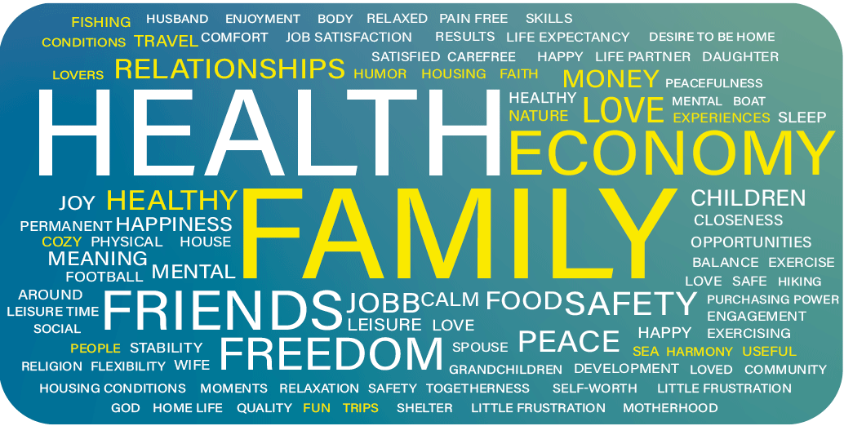
Figure 4. Word cloud with words most often mentioned by people when asked what a good life is for them
Prepared by Henrik Lindhjem, Menon Economics
Ungdata Plus is a collaboration between KORUS South, Vestfold and Telemark county authorities, the University of South-Eastern Norway and NOVA – OsloMet.
Children and young people are a focus area of Statistics Norway’s statistical programme for the 2024–2027 period. In 2024, Statistics Norway will ask questions about wellbeing in its survey on children’s leisure time, in which children as young as six years old will participate. This survey will be conducted every three years.
Several of the indicators on children and young people in Statistics Norway’s proposal for an indicator framework (1) are obtained from Ungdata. In future work, it must be assessed whether these are sufficiently comprehensive for children and young people’s wellbeing. Statistics Norway is considering whether there may be a need to prepare a separate set of indicators for children and young people, where Ungdata would be an important source. In addition, the annual pupil survey would
be a good source of data. Statistics Norway notes that the OECD has selected a solution with a separate set of indicators for children and young people. Children’s right to participation must be safeguarded in future work.
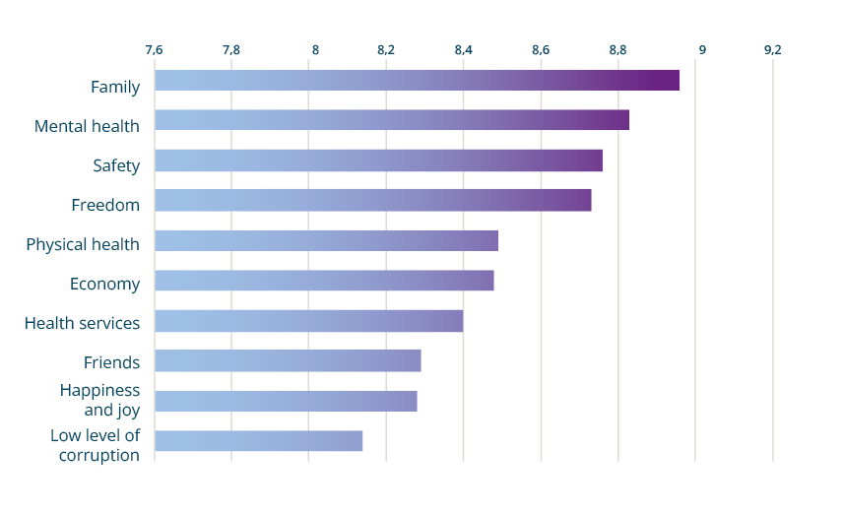
Figure 5. Highest ranked areas for people’s lives (score above 8)

The population’s perception of what is important for a good life
As part of the work on the National Wellbeing Strategy, a survey was conducted among the Norwegian population to investigate what the people themselves perceive as important for a good life. This survey was conducted with Norstat’s respondent panel in March 2023. It was representative of the Norwegian population based on known socio-demographic characteristics such as age and education and had a response rate of 22.5 per cent. Although the response rate is low, the responses are in line with what was identified by other research, both in Norway and internationally (28, 29).
The survey began with an open question formulated as follows: “What is a good life for you?” People were asked to provide up to five key words or brief sentences. The results are displayed as a word cloud in figure 4, where the size of the words describes their frequency. As the figure shows, family and health are the dominant themes. These are followed by finances, friends, freedom, security, love, work, (good) food and (good) relationships. While the adjective “good” was typically used in conjunction with health, adjectives mentioned in connection with “finances” or “money” were typically related to security, stability, independence (and rarely linked to wealth). Relationships and friends were often described in connection with the adjectives “good” and “close”. The word cloud illustrates the rather broad diversity in what people describe as good lives.
The survey also had a set of 42 aspects/areas of life, where respondents were asked to indicate how important each of the areas were for a good life on a scale from 0 (not important at all) to 10 (very important). The ten most important areas are shown in figure 7.
The rating largely coincides with the open-ended question in the first part of the survey, with family emerging as the highest ranked area of people’s lives. In Statistics Norway’s proposed framework, there is currently no specific indicator for family relationships. In the future, the inclusion of family relationships in the indicator framework should be assessed.
There is a strong consensus when the results are broken down by age, gender and party affiliation (“Which party would you vote for if there was a general election tomorrow?”). This means that these aspects of life are important, regardless of political views, age or gender. However, there are some differences between the groups. For example, those with low incomes (<NOK 200,000 personal income) will rank certain areas somewhat differently than those with high incomes (>NOK 800,000). However, these are minor differences, and 9 out of 10 areas are ranked among the top 10 by both low and high income earners. The data material is too small with too limited information to enable analyses at the group level. In order to investigate, with greater certainty, perceptions of what is important for a good life among the different groups, larger and more detailed surveys must be conducted. This particularly applies to the various minority groups. Although data from international surveys show a high degree of consistency between different countries and cultures, some of the areas emphasised for a good life will be influenced by local conditions, history and culture.

Research and knowledge development
Norway has consistently scored high on the international measurement of wellbeing as indicated in the World Happiness Report (30). This report ranks the subjective wellbeing for most countries in the world and has been published by the UN Sustainable Development Network annually since 2012. It is worth noting that the ranking of a nation’s wellbeing depends to a large extent on how wellbeing is defined. However, the results for 2023 showed that Norway was the only Nordic country to drop in this international ranking, from first place in 2017 to eighth place in 2022 and to seventh place in 2023, 2024 and 2025 (31). More knowledge is needed about the reasons for the decline in wellbeing in Norway. This development may reflect a number of interconnecting factors. The Norwegian Monitor survey (32) indicates that less satisfaction may be linked to less optimism about the future in the form of greater concerns about the economy, working life and sustainability, particularly among those under the age of 40.
We know a great deal about what can affect an individual’s wellbeing. Crucial factors include genetics and personality traits, individual social and financial conditions, and health-related issues such as illness and chronic pain. Other factors include social changes and societal structures, developments on international stock exchanges, climate change and war. New research from Norway emphasises the importance of environmental factors, such as perceived discrimination and social support (33), in addition to factors such as crime and security. Other environmental factors such as access to nature and cultural environments, food safety, physical activity, a sense of belonging and social cohesion also show a positive correlation with wellbeing, while pollution and insecurity in neighbourhoods are negatively associated. Social and economic inequality in society generally has a negative impact on the wellbeing and may have negative ripple effects, such as greater mistrust. There are also indications that improving the wellbeing can have a protective effect against various physical and mental health issues.
Yet there are significant knowledge gaps. We know too little about what would be the best instruments to promote and equalise wellbeing in the population, and about how the importance of the aforementioned influencing factors, and the interactions between them, varies across individuals and population groups, as well as over time. Changes, initiatives and reforms can influence one another so that their effects become complementary or counteractive. Knowledge of such complex processes requires regular surveys and up-to-date research. We also have insufficient knowledge about effect size, causal relationships and effective measures. In general, it appears that each individual impact factor has relatively little significance on its own (34) but that they are amplified in interactions with other risk or health-promoting factors, which together constitute chronic burdens or enduring resources. In other words, there is extensive knowledge about associations and individual contexts, but limited knowledge about complex causal mechanisms.
There is also limited knowledge about wellbeing and key current areas such as technology and digitalisation (e.g. artificial intelligence), climate, environmental factors such as urbanisation, the importance of proximity to nature and the cultural environment. Other key areas we need learn more about are structural factors such as reforms (e.g. the introduction of the interdisciplinary topic “Public health and life skills” in the National Curriculum), and kindergartens/schools, the working environment, social media, living conditions and various health-promoting structural measures such as changes to tax policies, access to recreational areas and regulatory changes.
The national wellbeing surveys conducted by Statistics Norway are purely cross-sectional surveys. The lack of panel data, where the same people are followed up over time weakens the opportunities to say something about causality, which and therefore makes them less useful for policymaking. There is therefore a strong need for robust research that can contribute to more knowledge to be utilised in policy decision-making processes.
Statistics Norway, the Norwegian Institute of Public Health and the Norwegian Directorate of Health have all played key roles in the development of the wellbeing measurement system. There are also a number of professional communities that can contribute with research and knowledge development in various areas of the wellbeing field, such as the HEMIL Centre at the University of Bergen, OsloMet, NTNU and PROMENTA at the University of Oslo. It is also important that knowledge about wellbeing in the population is also disseminated to the population in the form of information about what can improve wellbeing.

Prioritisation and policy development
The National Wellbeing Strategy is anchored in the white paper on public health, Meld. St. 15 (2022–2023). The aim of the strategy is to provide direction for developing policies that to a greater extent take into consideration what is important for a good wellbeing, based on current measurements for wellbeing in the population. National and regional wellbeing measurements, together with a selection of indicators (indicator framework), could form part of the knowledge base for societal and policy design at national, regional and local level. The measurements and the indicator framework are necessary, but not sufficient instruments. The primary goal of the strategy is to ensure that society develops in a manner that equalises social differences in wellbeing and reflects what the population believes to be important for a good life.
At the regional and local level, the Public Health Act and the regulations relating to public health overview with their requirements for overview efforts and links to plan strategy work, are key instruments for prioritisation and policy development. Wellbeing is now included in the Public Health Act, which was revised in spring 2025. There is no equivalent system at the central government level that can function as an instrument for prioritisation and policy development. A system will therefore be developed to ensure that wellbeing can be used across sectors and form the basis for prioritisations in national and local processes. One potential model for the government’s systematic wellbeing work is shown in Figure 6.
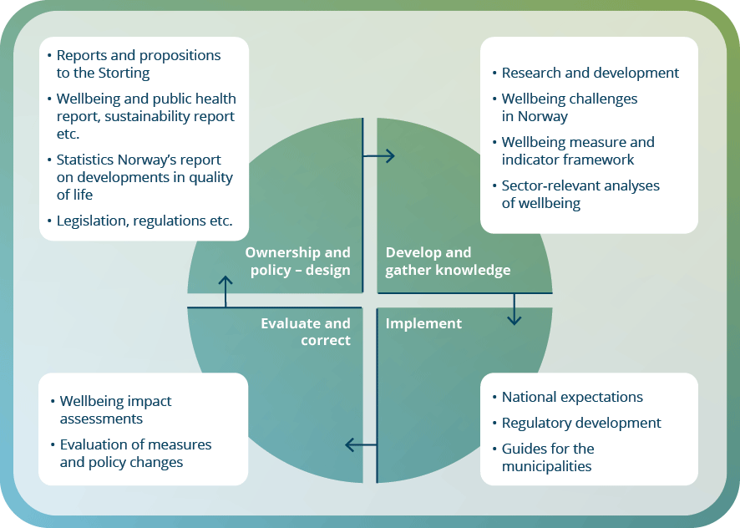
Figure 6. Systematic wellbeing work at the central government level
The model is based on developing and gathering knowledge to identify wellbeing challenges in Norway through the use of wellbeing measurements, indicator frameworks and sector-relevant analyses. Initiatives to meet these challenges can be addressed when the Government, every four years, presents its national expectations for regional and municipal planning to promote sustainable development throughout the country. The county authorities and municipalities must follow up the national expectations in its plans and planning strategies. Any consequences of measures and changes must be assessed and evaluated and may lead to ownership and policy design in the form of, e.g., reports and propositions to the Storting (Norwegian Parliament), as well as revisions to legislation and regulations.

Development of an indicator framework for wellbeing
In March 2023, Statistics Norway was commissioned by the Ministry of Health and Care Services to make recommendations for an indicator framework that can be used to assess the achievement of policy goals aimed at improving the population’s wellbeing and equalising social differences in wellbeing. The indicator framework is important for gaining an overview and knowledge of social conditions that can be influenced through policymaking. The framework must also be viewed in the context of the UN Sustainable Development Goals and Norway’s follow-up of these. It will also be considered whether the framework can be linked to the instructions for official studies and reports, as well as the existing guide. This is discussed in Chapter 5.2.5 regarding instructions for official studies and reports.
In the assignment for Statistics Norway, it was specified that the framework should cover both the subjective and objective wellbeing, as well as factors that in various ways affect both an subjective and objective wellbeing in different ways (perspective on the power of influence). The framework will also include the topics of social and geographical inequality. As several studies have indicated that loneliness is one of the factors that leads to the greatest loss of wellbeing, the framework should also include loneliness. The national surveys do not include children and young people under the age of 18, and Statistics Norway was therefore asked to consider how children and young people can be addressed. In its work on the framework, Statistics Norway will also assess the extent to which data can be broken down to municipality level, or whether there is a need for a separate set of indicators at the municipal level.
The report by Statistics Norway Forslag til et rammeverk for måling av livskvalitet i Norge [Proposal for a framework for measuring wellbeing in Norway] (available in Norwegian only) was finalised in December 2023 (1). The indicator framework contains ten dimensions and has proposed 54 indicators across these ten dimensions, including children and young people. Approximately half of the indicators can be estimated at the municipal level, but this requires some adjustments. Statistics Norway has assumed that the set of indicators must measure development over time and that it must be monitored through annual statistics. It is also emphasised that these indicators must form the basis for comparisons across geographical areas and that they can be compared with other countries, and the Nordic countries in particular. The set of indicators will highlight and present the degree of social, economic and geographical inequalities in the distribution of wellbeing.
Statistics Norway has based its choice of indicators on several important premises. The most important criterion is relevance. There should be a strong relationship between the definition of wellbeing and the choice of indicator. Other premises are outcome measures – that the indicators cover both the subjective and objective wellbeing. They must also be easy to understand and disseminate, and it must be possible to interpret changes over time as either improvements or deterioration in people’s wellbeing. The indicators must have political relevance so that they can be influenced through policy and be sensitive to changes in political decisions and the use of resources. The indicators must also enable analyses of inequality so that this can be broken down into different sub-groups, demographically, socially, economically and geographically.
Statistics Norway has chosen ten dimensions as the basis for the indicator framework: Subjective wellbeing: Health, Knowledge and skills, Finances and material goods, Physical security, Governance, participation and rights, Social community and relationships, Work and education, Leisure and culture, and Nature and local environment.
The report should be viewed as the first step in a larger body of work to develop a framework. The framework must be revised at regular intervals. There may also be a need to involve other sources of data to encompass the municipal/district levels. Work to include children, young people, the elderly and immigrants must be continued. Statistics Norway emphasises that there will be a need for a separate assessment of the relationship with the Public Health Profiles (reports that provide information on health status and its determinants in counties, municipalities, and boroughs) to ensure less ambiguity about how the wellbeing indicators and framework differ from the Public Health Profiles. Statistics Norway also believes that the framework should over time be expanded to include indicators of sustainable development and the characteristics of social institutions, as is done in New Zealand.
The current framework is extensive and complex. Through the input received, a number of suggestions have also been made for expansions to include both new dimensions and new indicators. It has also been emphasised that there is a need to ensure good data on groups that are currently inadequately covered, such as the oldest age groups, immigrants and LGBTQ+ persons. Furthermore, there has been an expressed need to go into more detail at the geographical level by providing figures for city district and living condition zones in the largest municipalities. If Statistics Norway is given the assignment to further develop the framework and indicator system, it will take these needs into account as far as possible. The interest for an expansion must be considered in relation to the available resources and the need for an indicator system that is not too extensive and complicated.
Further work should be done on methods to simplify the content so that it can, for example, be used to specific policy proposals. Consideration should be given to whether an additional dimension should be added or included in one of the other dimensions, which could take into account how international crises and conflicts may affect the population’s wellbeing.
Many countries issue publications that provide an overview of trends in the national wellbeing. Statistics Norway presents quarterly indicators for economic development in its own publication and also has a role in compiling and presenting sustainability indicators. It may be appropriate for Statistics Norway to play a similar role with respect to developments in wellbeing in Norway. In Statistics Norway’s report on the indicator framework, there is a proposal to consider a separate publication on wellbeing in Norway that could be published, for instance, every two years, and which could form the basis for an informed public debate on this development in Norway.

Methods, tools and measures: Wellbeing goals in decision-making processes across sectors
There is a need for a wide range of instruments in the process from measurements to policymaking. There is a need for a system that enables regular measurements of wellbeing to be conducted across the entire population, nationally, regionally and locally. Legislation, cross-sectoral ownership and a new guide for the instructions for official studies and reports on health and wellbeing, along with educational tools, can contribute to a policymaking where wellbeing is a supplementary measure of and for societal development. An action plan as proposed in Chapter 7 will be essential for designing concrete measures based on the strategy.
There may be a need to clarify wellbeing goals in the legislation. Data from the wellbeing surveys must be used for analyses that are relevant for policymaking at both national and local levels, and for all sectors that have ownership of and responsibility for the wellbeing goals. Educational instruments must be developed, such as in the form of guides that can be used by the municipalities. The guide for health and wellbeing in the instructions for official studies and reports (35) should be followed up to assess whether and how “Wellbeing Adjusted Life Years” (WALY – see Chapter 5.2.5) can be used for policymaking. Guidelines for the work on wellbeing should be followed up in National expectations for regional and municipal planning. Wellbeing as a measure of and for societal development can be incorporated into various reports. For example, the current white paper on public health can to a greater extent also include wellbeing, which would indicate both responsibility for and the development of public health and wellbeing in the different sectors. Wellbeing can also be more systematically integrated into other relevant reports such as the white paper on an action plan to achieve the SDGs by 2030. Statistics Norway could also produce a publication that presents developments in wellbeing and that corresponds to the publication Statistics Norway publishes for economic developments in Norway. This will, overall, give the Storting and the Government the means to make political decisions that can form the basis for prioritisations in national and local processes. A complete presentation is shown in Figure 7.

Systems for national and regional measurements of wellbeing
Since 2022, wellbeing has been a subject for official statistics in Statistics Norway, which aims to conduct annual surveys of the population’s wellbeing and publish selected results in Statbank Norway. The wellbeing surveys should be developed further, both in terms of coverage and non-response issues. Statistics Norway is aware that the non-response rate is significant for certain groups and has implemented certain measures, such as translating the questionnaire of the wellbeing survey into Polish and Lithuanian to reduce the non-response rate in these groups. Individuals aged 80 and above also have a relatively high non-response rate, and it is recommended to conduct non-response studies and test various measures related to data collection for the oldest age group (36). Statistics Norway notes that it may be desirable to expand its coverage for age groups by reducing the age of its respondents, perhaps all the way down to age nine. However, Ungdata has good measures of wellbeing, which can provide a source of knowledge about wellbeing among children and young people (see Chapter 4.3).
Yet certain groups will still not be included, or only partially included in wellbeing surveys, and there will still be a need for separate surveys adapted for different groups. For example, studies of wellbeing among people with cognitive impairments will require an inclusive research design with in-person surveys.
It is also essential to have a system for conducting surveys that provides data at the county and municipal levels. Fylkeshelseundersøkelsene [County Health Surveys] (available in Norwegian only) are currently conducted by the Norwegian Institute of Public Health on behalf of the county authorities, cf. Section 21 of the Public Health Act. Implementation is voluntary for the county authorities. The system must also take into account changes in societal development that may affect the population’s wellbeing.

Wellbeing in legislation
In several pieces of legislation, it may be applicable to include requirements with relevance to wellbeing. This could help achieve the goal of including wellbeing a measure of societal development and equalising social differences in wellbeing. The Public Health Act regulates the tasks of the central government, county authorities and municipalities to prevent disease, promote health and wellbeing and to equalise social differences. This Act entered into force on 1 January 2012. The Public Health Act was revised in the spring of 2025 and wellbeing is now included and has replaced “wellbeing” as a term. Future work must take into consideration whether other legislation should also include wellbeing. One of the prerequisites for such assessments is a progression in the professional work on the indicators.
Certain countries, such as Wales, have developed their own legislation to improve the country’s wellbeing in a number of areas: Well-being of Future Generations (Wales) Act (37). The Act focuses on improving the social, economic, environmental and cultural wellbeing in Wales. The aim is to “make the public bodies listed in the Act to think more about the long-term, work better with people and communities and each other, look to prevent problems and take a more joined-up approach”. The Act also operationalises the SDGs to ensure they are adapted to the national context of Wales.
Well-being of Future Generations (Wales) Act
The Act specifies seven clear goals for what Wales seeks to achieve through its wellbeing work: “A prosperous Wales; A resilient Wales; A healthier Wales; A more equal Wales; A Wales of more cohesive communities; A Wales of vibrant culture and thriving Welsh language”. The Act includes the government, central and local government authorities, voluntary organisations, national park authorities, fire and rescue services, cultural and sports councils, etc.

Cross-sectoral ownership
Wellbeing as a concept is sector-neutral and is not owned by a single sector but rather developed and maintained in all areas of society. This means that several sectors of society have responsibilities and instruments that can be combined to promote good lives for the population. An approach involving several ministries and subordinate agencies is therefore planned in the further work so that wellbeing as a goal cuts across both sectors of society and administrative levels.
The concept and work on wellbeing as part of the public health work has evolved over the past decade. Section 22 of the Public Health Act places a responsibility on central government authorities to assess consequences for the population’s health where relevant. In addition, the Public Health Act makes the Norwegian Directorate of Health responsible for providing information, advice and guidance on strategies and measures in public health work (cf. Chapter 2.6). By virtue of this role, national health authorities have previously been driving the national work on wellbeing in close collaboration with Statistics Norway and a number of research environments. The healthcare sector will continue to play an important role, but on equal footing with other sectors that are important for helping to ensure good lives for the population.
One of the most important areas to follow up towards 2030 is the further embedding of the wellbeing perspective in the social sectors. Based on sectoral analyses of the wellbeing surveys, the sectors can explore what their social mission involves from a wellbeing and distribution perspective, what initiatives and measures they have already implemented that are positive for wellbeing, and what they can do more of to promote this further. One of the most important tasks during the strategy period will be to involve the various sectors to ensure that each sector’s contribution and measures can be viewed as a whole. Measures from several sectors can be used and combined to promote a good and evenly distributed wellbeing throughout the population. For example, the voluntary sector can contribute to improving wellbeing in many areas of society and ensuring sufficient anchoring of various forms of cross-sectoral collaboration and participation processes. Voluntary organisations are key actors and meeting places for shared interests and participation in society.

Wellbeing in relevant white papers
A number of reports have been published that address areas that can strengthen the work on the population’s wellbeing and the goal of wellbeing as a measure of and for societal development. Among other things, it will be assessed whether to include wellbeing in:
White paper on an action plan to achieve the SDGs by 2030 The Ministry of Local Government and Regional Development presented the white paper Mål med mening – Norges handlingsplan for å nå bærekraftsmålene innen 2030 (Meld. St. 40 (2020–2021)) [Meaningful goals – Norway’s action plan to achieve the SDGs by 2030] (available in Norwegian only). Work on a new white paper regarding the work on the SDGs has been initiated under the leadership of the Ministry of Digitalisation and Public Governance. Wellbeing is included as a theme together with public health in a report that is planned to be presented in spring 2025.
Public Health Report: The Public Health Report is currently published every four years and addresses a number of cross-sectoral areas that also have relevance for the wellbeing. It should therefore be considered whether the current public health report should include wellbeing to a greater extent. A joint report could be presented to the Storting every four years, and the most relevant ministers will be responsible for their own parts of the report. This would include areas such as public health, upbringing and living conditions, work and education, working environment, cultural environment, housing and local environment, social civil protection and immigration, climate and environmental challenges, culture and gender equality, agricultural policy and the aviation, road and rail sectors. It must be ensured that public health is integrated in such a way that it does not jeopardise systematic public health work. The purpose of such a report would be to promote public health and wellbeing and to equalise social differences in health and wellbeing both nationally and across sectors. In this way, we can achieve a broad anchoring and follow-up of both public health and wellbeing as measures of and for societal development. The disadvantage of such a joint message must also be considered. The public health perspective might appear to be weakened, while wellbeing as a supplementary measure of and for societal development could be viewed as part of public health work and thus not a goal in itself. A separate wellbeing report could therefore also be considered. Including wellbeing in various reports may also function as reports to the Storting.

Thematic guide for the instructions for official studies and reports: Health and wellbeing
“Wellbeing Adjusted Life Years is going to be the golden standard in the future”.
The Norwegian Directorate of Health has recently prepared a thematic guide for the instructions for official studies and reports (35). The thematic guide provides specific recommendations on how life and health can be included in official reports and socioeconomic analyses in a way that ensures consistency between the various relevant units of measurement that can be used. This applies to their health and wellbeing content, as well as the economic values with which such units of measurement may be included. In this way, the thematic guide supplements the overarching guide by the Norwegian Agency for Public and Financial Management, which provides recommendations on all aspects of socioeconomic analyses (38). It is essential that the content and economic values of health and wellbeing units are consistent in order to make good and legitimate judgments on the different effects when consequences for life and health are to be weighed against other consequences of social measures.
Judgments on comparisons of the different effects involves weighing the consequences for one group of the population against the consequences for other groups of the population. These consequences may differ in both material and non-material ways and to a different extent. This makes proportionality assessments both political and challenging, and it becomes even more difficult when lives and health are affected. One challenge is that these are consequences that could have a major impact on people’s subjectively perceived wellbeing. The consequences may also be irreversible, and they have no market prices. It would also be difficult to determine any compensation and compensatory measures if someone is negatively affected.
The instructions for official studies and reports are intended to promote good decision-making and an efficient use of resources. When analysing government measures, the minimum requirement would be to always answer six specific questions. For measures that are expected to have significant effects, socioeconomic analyses must be carried out in accordance with the current circular from the Ministry of Finance (39). According to the circular, the economic value of a statistical life (VSL) is 30 million in 2012-NOK, and must be used in socioeconomic analyses within all sectors. The value of a statistical life (40) is defined as the value of a unit’s reduction in expected deaths in a given period. An estimated VSL represents a population’s (in this case Norway’s population) total willingness to pay for a risk reduction that is just large enough to be expected to save one life. When determining willingness to pay, it is assumed that the measure affects a large number of individuals and that the risk for each individual is small. Updated figures for VSL can be found with the Norwegian Agency for Public and Financial Management.
Another description of what VSL involves could be material consumption and all other consumption/activities that provide wellbeing, including the value of the health-related wellbeing. The phrase “overall wellbeing” is used in the thematic guide to describe what is included in VSL.
The unit of measurement to be included in socioeconomic analyses of measures affecting public health and wellbeing may vary depending on the level of precision required to capture what is important in different contexts. In many cases, the benefit of introducing measures to reduce the population’s risk of being affected by injuries or illness will be that we avoid loss of overall wellbeing.
However, there is insufficient knowledge about how the overall wellbeing can be measured in a consistent and uniform way, and how overall wellbeing is comprised of health-related and other types of wellbeing. The recommendations in the thematic guide on the choice of health unit take into account the necessity of capturing what is essential and that there is a lack of knowledge about wellbeing. A change measured in health-related wellbeing and health loss, as they included in quality-adjusted life years (QALY) and disability-adjusted life years (DALY) respectively, can be used as indicators of changes in overall wellbeing. Health-related wellbeing and health loss can be measured and are measured using recognised and widely used measuring instruments. Until a similar measurement instrument is established for total wellbeing (and components other than health that are included in total wellbeing), it is likely that QALYs and DALYs will function as useful indicators. They can then be used as a starting point for estimating changes in overall wellbeing, in cases where the risk of injuries and illness can also be assumed to result in changes in overall wellbeing. An economic valuation of these indicator health units, based on the established value of a statistical life, could provide an economic value that is relevant for use in socioeconomic cost-benefit analyses.
There are still many unresolved methodological issues, which is a concern of many other countries as well. The thematic guide is therefore based on pragmatic and preliminary recommendations on health and wellbeing units, as well as the economic values of such units. At the same time, however, the thematic guide indicates how to proceed in order to obtain more knowledge and thus be able to conduct future studies that better capture what is important for the population’s life and wellbeing.
The thematic guide refers to the overall wellbeing. This concept is also discussed in a report on wellbeing by the HM Treasury (HMT) in the United Kingdom (41). This report shows how total wellbeing can be measured and valued in a unit called WELLBY (wellbeing adjusted life years, also referred to as WALY). This value can be set to be consistent with the value of a statistical life or a value of a QALY as determined by the UK and The Green Book. The British report also refers to a number of unresolved methodological issues and it is emphasised that the economic values of WELLBY are only included as an illustration of possible use, and that these are not to be regarded as recommended values by HMT.
If in the future we wish to implement WELLBY/WALY for policymaking in Norway, it will be important to determine what is included in the concepts of overall wellbeing and health-related wellbeing respectively, as well as what is included in the established value of a statistical life. How a value of a statistical quality-adjusted life year can be calculated and used in a consistent manner in different contexts is thus also a relevant question. As the various health and wellbeing units can be given different contents, another unresolved question is what units would be most suitable for Norway (given the assumptions on which VSL is based in Norway).
The Danish Happiness Research Institute has performed WALY estimations for different life circumstances for people over the age of 50 in Denmark. These estimations showed that it is severe loneliness which leads to the greatest loss of wellbeing and number of WALYs per person per year. This is more than for depression, Alzheimer’s, other forms of dementia or unemployment. These estimations are first and foremost an example of how it is possible to use WALY in a policymaking context.
Statistics Norway’s framework for wellbeing can be assessed in relation to the instructions for official studies and reports and the current guide, and in relation to the value of a statistical life where the link to GDP is formalised.

Wellbeing as part of the decision-making basis for political prioritisations
“Now is the time to correct a glaring blind spot in how we measure economic prosperity and progress. When profits come at the expense of people and our planet, we are left with an incomplete picture of the true cost of economic growth” (42).
Using wellbeing in this context as part of the decision-making basis for political prioritisations means using the tools and instruments described in this strategy. These can help develop the foundation for a system that will eventually result in wellbeing becoming a measure of and for societal development.
The concept of a wellbeing economy, or “wellbeing economy” has gained increasing prominence in the work on wellbeing, and it is utilised in various contexts within the WHO, EU and OECD. There is no uniform definition of what constitutes a wellbeing economy and, according to the WHO, this must be tailored to each individual country. The WHO European Office for Investment for Health and Development has proposed a working description of the core elements of a wellbeing (wellbeing) economy:
A wellbeing economy is an economy in which public and private investments, expenditures and resources are used to improve a human, societal, environmental and economic wellbeing that can be enjoyed by all (23).
For decades, Norway has been developing a welfare model and an economy that does not differ significantly from the definition of a wellbeing economy as described by the WHO. Nevertheless, systematically using wellbeing as a measure of and for societal development could contribute to further developing the societal model and economy we have today. A societal development intended to promote wellbeing and the social equalisation of wellbeing requires key societal structures to be better adapted to ensure that they contribute to reaching this goal. The economy is one of the fundamental structures that has the greatest impact on the manner in which society is governed and organised, and Norway has solid structures to build on.
Countries that have come the furthest in developing a wellbeing economy utilise some of the same tools in this work: In a wellbeing economy, conventional economic indicators are complemented by a broad set of indicators that capture other areas of society that are important for determining whether people experience life as being good (43). Such sets of indicators can guide policy development and correspond with the indicator framework that Statistics Norway has developed for a Norwegian context.
Several countries are in the process of developing “wellbeing budgets” (wellbeing budgets). These are national budgets or parts of national budgets that also aim to promote the wellbeing of the population. Budget priorities are anchored in national wellbeing frameworks and objectives. While New Zealand launched its first wellbeing budget in 2019, Canberra is the first jurisdiction in Australia to incorporate a wellbeing framework into its budget process, launching its first wellbeing budget in 2023 (44).
Methods for including wellbeing in socioeconomic analyses have also been developed in countries such as the UK and New Zealand. There is also a Nordic initiative – Trivselsbanken/The Wellbeing Bank – in Denmark, where The Happiness Research Institute plays a key role.
Central to the wellbeing economy approach in many countries is the attempt to break down barriers between sectors of society through the development of alliances for the purpose of achieving common goals and implementing a concerted effort that benefits society as a whole, while delivering high social returns on public spending and investments (23).
Certain countries, such as New Zealand, Italy and France, have statutory requirements for knowledge about wellbeing to be reported on a regular basis. In some countries, this requirement is determined in connection with budget processes and legislation. Countries such as Scotland, Wales, Iceland, Ireland and Finland have also expressed interest in incorporating their wellbeing frameworks into their budget processes. In Norway, references to wellbeing in various reports could include regular reports to the Storting (cf. Chapter 5.2.4).
Example: New Zealand
“Wellbeing refers to what it means for our lives to go well. It encompasses aspects of material prosperity such as income and GDP. And it also encompasses many other important things such as our health, our relationships with people and the environment, and the satisfaction we take in the experience of life”.
Since 2011, the Treasury of New Zealand has developed a framework for measuring and analysing wellbeing, a Living Standards Framework (LSF). To support the LSF, the Ministry of Finance has also developed an indicator system, the LSF Dashboard. The system has a total of 103 indicators, of which 62 relate to individual and collective wellbeing and 18 to institutions, and 23 indicators measure the four aspects of national wealth.
Since 2019, New Zealand has been publishing annual wellbeing budgets, and its Treasury is required by law to publish a wellbeing report every 4 years. The Wellbeing Budget 2023 is an important source of the country’s budget information (10).
There are some common characteristics for successfully introducing a wellbeing economy. The following is based on knowledge gained from the work in Finland, Iceland, Scotland and Wales (45).
- A high-level political engagement is critical for advancing wellbeing economies both nationally and internationally. These four countries have anchored the work in the prime minister’s/first minister’s offices.
- Legislation and politically binding commitments play a crucial role in implementing policies that are in line with a wellbeing economy (e.g. the Well-being of Future Generations Act in Wales, the Fiscal policy statement in Iceland and the Community Empowerment Act in Scotland).
- Indicators and calculation systems are key to defining what is measured in a welfare economy, monitoring and informing and evaluating policies on a regular basis.
- Fiscal tools and budgeting strategies are essential for supporting cross-sectoral work and promoting co-operation and discussion between different actors such as public health bodies, and to design policies aimed at achieving the best possible wellbeing.
- Implementing innovative policy tools is key to changing and shifting to a wellbeing economy.
The Nordic Council of Ministers points out that a wellbeing economy may be better suited to meeting many of the current and future challenges and crises than current social structures (43).
The actual concept of the wellbeing economy and what it should contain is currently imprecise and there is likely long way to go before it can be used for active policies a Norwegian context. Nevertheless, the five characteristics described above could be of significance for efforts to prioritise wellbeing in important decision-making processes.
An illustration of what this might look like in a Norwegian context, and which will developed further in the action plan, is shown in Figure 7:
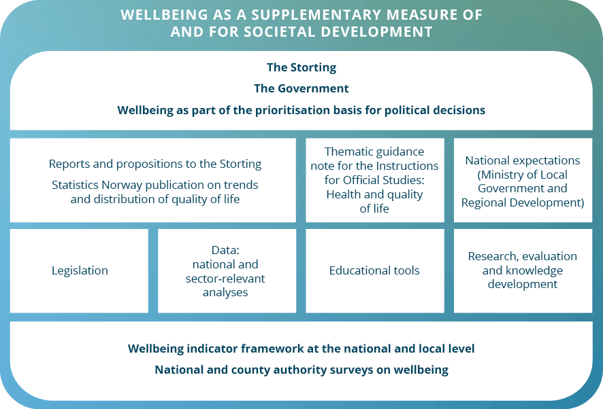
Figure 7. Wellbeing as a supplementary measure of and for societal development: Actions and instruments that can lead to policy and budget prioritisations

Nordic and international collaboration
In 2021, the Nordic Council of Ministers published the report “Towards a Nordic Wellbeing Economy” (43), which addresses various aspects of a wellbeing economy and the importance of not solely emphasising the countries’ GDP. Internationally, the OECD, the Wellbeing Alliance (WEAll) and Wellbeing Economy Governments (WEGo) are promoting the development of emphasising wellbeing as a measure of and for societal development in addition to GDP.

Nordic experiences – opportunities and co-operation
As part of their public health policies, the Nordic countries have initiated a collaboration to implement wellbeing as a measure of societal development. Iceland and Finland are among those countries in the Nordic region – and in the world – that are at the forefront of implementing wellbeing in their policymaking Both are members of the international partnership Wellbeing Economy Governments (WEGo) and they participate in the Wellbeing Economy Alliance, which is also well established in Denmark and Sweden. The background for the work in these Nordic countries is the financial crisis of 2008, which highlighted the need to take a closer look at how the welfare state could create a secure society that facilitates good lives for everyone, without compromising the climate and the environment.
The Danish Happiness Research Institute, together with the Østifterne association, has started a project to establish a value bank called Trivselsbanken/The Wellbeing Bank. The intent of the value bank is to assist decision-makers and welfare providers to value interventions and public policies based on WALYs (Wellbeing Adjusted Life Years). The value bank will mainly be based on Danish and Nordic data, and it will be openly accessible and free of charge. They will collect data on wellbeing in a “wellbeing data library” and use this to assist welfare providers (e.g. voluntary organisations) in using WALY value assessments in their evaluations. They will further assist public decision makers with capacity building for conducting WALY assessments and build knowledge of best practices on how to apply WALY in decision-making processes using their networks. Consideration should be given to whether Norway should contribute data and gain knowledge of how the Trivselsbanken/The Wellbeing Bank works.
With the support of the Nordic Council of Ministers, Iceland organised the first Wellbeing Economy Forum in the summer of 2023. A Nordic network for a wellbeing economy has been established, and Norway should consider contributing to this network.
As shown in the examples below, the Nordic countries have had different progressions and different approaches to working with wellbeing as a measure of and for societal development.
Finland
Wellbeing is synonymous with wellbeing in Finland and is linked to social sustainability, while recognising the interdependence with economic and environmental sustainability. The health sector has ownership in close collaboration with the Prime Minister’s Office, while the Finnish Federation for Social Affairs and Health, an umbrella organisation for 200 different NGOs, has an informal leadership role. Finland has also drawn up an action plan for the wellbeing economy.
Iceland
The wellbeing approach encompasses both subjective and objective dimensions. Wellbeing is directly linked to factors in society, the economy and the environment as expressed through extensive wellbeing surveys in Iceland. The Prime Minister’s Office has a leading role in this work. Iceland has developed an indicator framework consisting of 39 indicators encompassing the areas of “society”, “environment” and “economy”, i.e. the objective components of wellbeing. However, efforts are now underway to include indicators that encompass the subjective wellbeing. The indicators are linked to the UN Sustainable Development Goals. Statistics Iceland will monitor these indicators.
Sweden
As of 2017, the Swedish Government’s spring budget included an overview of 15 different indicators, called “new measurements of prosperity”. These indicators are intended to provide an idea of prosperity development, both in terms of the population’s wellbeing and sustainability of the economy in the long term. The set of indicators consists of five economic, five environmental and five social indicators. Social indicators include self-assessed health, interpersonal trust and satisfaction with life. The 15 indicators have been presented in every spring budget since 2017, distributed by economic, environmental and social indicators. This provides a simple overview of trends and conditions, and to some extent, inequality in distribution.
Denmark
Denmark conducts regular measurements of wellbeing, but not in the form of panel data (time series), and no indicator framework or targets have been developed for the population’s wellbeing. However, the think tank The Happiness Research Institute is a leader in wellbeing and wellbeing economics and has authored the report “Towards a Nordic Wellbeing Economy” for the Nordic Council of Ministers. In addition, a non-profit think tank has been established that is dedicated to wellbeing economics in a broad sense: The Wellbeing Economy Lab (WELA).

International experiences – opportunities and co-operation
Bhutan is the country that many believe has been working the longest to develop a policy-integrated framework for measuring and analysing welfare. As early as 1972, the King of Bhutan declared that Gross National Happiness was more important than the Gross National Product. Extensive data collection has been carried out since 2008 and a special Gross National Happiness Commission was established. The commission is the government’s body for incorporating this perspective and its associated measurement system, into policy. All policy plans are to be evaluated in terms of how they fit into the Gross National Happiness framework (46).
Over the past decade, a growing number of countries and organisations have worked to ensure that wellbeing becomes an overarching goal for societal development, and that it consequently supplements or replaces traditional societal goals. More than half of OECD member countries have developed some form of wellbeing/wellbeing framework. These frameworks reflect areas of importance for a good life for the nation’s population. The frameworks also illustrate the extent to which opportunities to live a good life are equally distributed across the population.
Wellbeing and prosperity have been key priorities for the OECD for several years, particularly through its Better Life Initiative launched in 2011. The How’s Life? report is published regularly and provides a comprehensive picture of welfare in the OECD countries and other major economies. The OECD has established the Centre on Wellbeing, Inclusion, Sustainability and Equal Opportunity (WISE). Its purpose is to generate new data and policy approaches to improve people’s wellbeing and reduce inequalities, and to gain a better understanding of how policies will impact people’s lives both today and in the future. WISE has proposed to develop a Knowledge Exchange Platform on Wellbeing Metrics and Policy Practice. Norway supports this proposal.
Scotland, Iceland, Finland, Canada, Wales and New Zealand have established the Wellbeing Economy Governments partnership (WEGo). WEGo is a collaboration between national and regional governments to promote the sharing of expertise and transferable policy practices.
Wellbeing Economy Alliance – WEAll
The Wellbeing Economy Alliance (WEAll) is the leading collaboration of organisations, alliances, movements and individuals working towards a wellbeing economy and to contribute to human and ecological wellbeing. WEAll was established in 2018 as a project of limited duration to catalyse the transition to a quality-of-life economy by fostering connection and collaboration between different actors in the new economy ecosystem.
Wellbeing Economy Governments partnership – WEGo
The Wellbeing Economy Governments partnership (WEGo) is a collaboration between national and regional governments interested in sharing expertise and transferable policy practices to advance their shared ambition of building wellbeing/wellbeing economies. WEGo is currently comprised of six national governments: Scotland, New Zealand, Iceland, Wales, Finland and Canada.
WHO – Universal Well-being Economy Initiative (U-WE)
U-WE aims to influence economic and financial institutions and to inspire governments, business and the third sector to invest in recovery and growth practices that will improve personal, economic, social and environmental wellbeing for everyone in the WHO European Region. It was launched by WHO/Europe through the recently established New Economics Expert Group (NEEG) and the WHO European Office for Investment for Health and Development based in Venice, Italy.
EU Wellbeing Economy Coalition
The Institute for European Environmental Policy and the ZOE Institute for Future-fit Economies founded the EU Wellbeing Economy Coalition to promote civil society co-operation and help move policies beyond economic growth towards a wellbeing economy. This includes non-governmental organisations, think tanks and trade union organisations, and it constitutes a diverse group with a shared vision to build a wellbeing economy at the EU level.
In addition to Nordic co-operation, it may be of particular interest to Norway to collaborate with the OECD’s newly established Centre on Well-being, Inclusion, Sustainability and Equal Opportunity (WISE) to exchange experiences and participate in the upcoming knowledge platform. It should also be assessed whether Norway can both contribute to and gain knowledge through participation in WEGo (Wellbeing Economy Governments partnership) together with the six countries represented there.

A cross-sectoral action plan to follow up the work on wellbeing during the 2025–2030 strategy period
The National Wellbeing Strategy identifies some of the systems, methods and tools that will be important for Norway’s ability to move from today’s wellbeing measurements to future policymaking that emphasises, to a greater extent that today, a good and evenly distributed wellbeing for the entire population. It is national and local policymaking that can lead to better lives for the population and equalise social differences in wellbeing. During the strategy period, this will be followed up with an action plan in a number of areas related to monitoring and knowledge development, prioritisation and policy formulation, as well as Nordic and international co-operation. All recommendations concerning studies and further work as part of an action plan must be in accordance with the requirements for a basis for decision-making in the instructions for official studies and reports.

Wellbeing as a supplementary measure of and for societal development
The wellbeing measurements and the indicator framework form the very foundation of the work on wellbeing in the Government’s strategy. Systems for implementation, development and updates should therefore be established. Data from national and local measurements must be analysed to ensure they become sector-relevant and accessible to users, and that they can be used for policymaking. It should be assessed whether it is possible to develop “wellbeing profiles” similar to the “public health profiles” and “weight profiles” that have been assigned to the Norwegian Directorate of Health from 1 January 2024. Wellbeing profiles could be a useful tool for both county authorities and municipalities/districts. Research and knowledge development in the field of wellbeing is still relatively new in Norway, and it may therefore be appropriate to establish an overall professional environment or network for wellbeing in Norway. Funds channelled to the Research Council from the ministries would be most relevant for research in this area.
The following should be investigated further:
- Establish a system for regular wellbeing measurements at the national and county levels that can provide governance information for national, regional and municipal/local government authorities. Monitoring must not only be done regularly, it must also be adapted to political and societal developments. Furthermore, consideration must be given to how underrepresented groups can be included or made visible, in addition to measures that can reduce selective non-responses. Wellbeing among children and young people, people with immigrant backgrounds, health challenges, living conditions and the elderly should be prioritised. Consideration must also be given to whether a coordination of questions regarding living conditions by Statistics Norway/Eurostat and the implementation of these in county public health surveys could provide better data.
- Consider establishing an open and accessible statistics bank with wellbeing data at the national, county and municipal level, cf. Statistics Norway’s statistics bank for the national measurements.
- Consider further developing and evaluating the indicator framework prepared by Statistics Norway, and how the recommendations in its report can be followed up. Consideration should also be given to how the input received in the input round for the indicator framework can be followed up in further work.
- Assess the development of wellbeing profiles for counties and municipalities.
- Further develop knowledge, research and evaluation, e.g. evaluation of policy measures and demographic changes in with respect to wellbeing. There is a need for more knowledge about social integration, isolation and loneliness and how to promote integration and reduce loneliness through structural measures, including research into causal factors. Data based on the wellbeing measurements should be used for analyses with relevance for different sectors and policymaking.
- Assess how children’s right to participation and the requirement for considering the best interests of the child (cf. Section 104 of the Constitution of Norway and Articles 3 and 31 of the UN Convention on the Rights of the Child) can be safeguarded in further efforts.
- Establish a broad-based reference group as a participation arena for following up systems for measurements, indicator development and evaluations.
- Investigate the possibility of establishing a general professional environment or network for wellbeing in Norway with responsibility for wellbeing analyses at both the national and local level, research, knowledge development and evaluation. Funding for research is channelled through the Research Council of Norway.

Prioritisation and policy development
There is a need to further investigate both the tools and measures described in this strategy, and to assess whether there are other actions that could help achieve the goal of wellbeing as a measure of and for societal development, and an equalisation of social differences in wellbeing. Further work is needed in order to ensure cross-sectoral anchoring that can provide ownership and be useful for different sectors. It is recommended to proceed with the following points:
- Follow up on wellbeing in the Public Health Act and assess wellbeing in other legislation.
- Further develop the thematic guide for the instructions for official studies and reports on health and wellbeing so that wellbeing considerations can be better integrated into assessments and analyses.
- Consider whether Statistics Norway should issue a separate publication every two years on trends in the national wellbeing, similar to Statistics Norway’s quarterly reports on the economic indicators.
- Consider including wellbeing in reports to the Storting, and whether a public health and wellbeing report should be presented to the Storting on a regular basis. Furthermore, consideration must be given to how wellbeing should be referred to in reports, such as the white paper on an action plan to achieve the SDGs by 2030.
- Assess whether and how wellbeing can be addressed in national expectations regarding regional and municipal planning.
- Assess how different sectors’ instruments can be viewed in context and implemented to promote a good and evenly distributed wellbeing in the population. This must be viewed in the context of conducting sector-relevant analyses of wellbeing.
- Utilise wellbeing knowledge to measure and evaluate the impact of policy decisions on wellbeing.
- Design proposals for how the indicator framework can contribute to reducing social inequity in wellbeing.
- Present proposals for how the voluntary sector can work with different sectors to put wellbeing on the agenda. Voluntary organisations offer children and adults opportunities to develop social skills, friendships and networks.

Nordic and international collaboration
There is a great deal of activity in the field of wellbeing in both Nordic and international forums, and co-operation and involvement with Nordic and international forums can not only help achieve Norwegian goals for wellbeing but also contribute to the development of a Nordic model for how wellbeing can be measured and used as a measure of and for societal development. It is recommended to investigate and continue work on the following points:
- Participate in the Wellbeing Economy Forum and the Nordic Wellbeing Economy Network, established in Iceland in 2023.
- Collaborate with the OECD Centre on Wellbeing, Inclusion, Sustainability and Equal Opportunity (WISE) and its knowledge exchange platform.
- Consider participation in the Wellbeing Economy Governments partnership (WEGo), in which Iceland, Finland, Scotland, New Zealand, Wales and Canada are participants.
- Further investigate co-operation to develop a Nordic model for both measurements of wellbeing and for wellbeing as a measure of societal development within the framework of the Nordic Council of Ministers. Co-operation with the Danish Happiness Research Institute and Trivselsbanken/The Wellbeing Bank, which is currently being established, should also be considered.

Economic and administrative consequences
The National Wellbeing Strategy itself has no financial or administrative consequences. Any measures resulting from the strategy will be examined further. Any implementation of such measures will require budgetary considerations and prioritisations.

References
1. Barstad A, Rønning E, Bjørnskau T. Forslag til et rammeverk for måling av livskvalitet i Norge [Proposal for a framework for measuring quality of life in Norway] (available in Norwegian only). Oslo: Statistics Norway (2023. 2023/51). ISBN 978-82-587-1885-4.
2. Meld. St. 15 (2022–2023) Folkehelsemeldinga – Nasjonal strategi for utjamning av sosiale helseforskjellar [Public Health Report – National Strategy for the Equalisation of Health Disparities] (available in Norwegian only). Ministry of Health and Care Services, 2023.
3. UN System Chief Executives Board for Coordination. Valuing what counts – United Nations System-wide Contribution on Progress Beyond Gross Domestic Product (GDP). United Nations System, 2022.
4. Meld. St. 1 (2009–2010) Nasjonalbudsjettet 2010 [National Budget 2010] (available in Norwegian only).
5. Meld. St. 34 (2012–2013)
Public Health Report – Good health – a common responsibility.
6. Meld. St. 19 (2014–2015) Folkehelsemeldingen – Mestring og muligheter [Public Health Report – Mastery and Opportunities] (available in Norwegian only).
7. Meld. St. 29 (2016–2017)
Long-term Perspectives on the Norwegian Economy 2017. Oslo: Ministry of Finance, 2017.
8. Barstad, A. Gode liv i Norge. Utredning om måling av befolkningens livskvalitet [Good lives in Norway. Report on the measurement of the population’s quality of life] (available in Norwegian only). Oslo: Norwegian Directorate of Health. (2016). IS-2479.
9. Nes, RB, Hansen T, Barstad A. Livskvalitet – Anbefalinger for et bedre målesystem [Quality of life – Recommendations for a better measurement system] (available in Norwegian only). Oslo: Norwegian Directorate of Health. (2018). IS – 2727.
10. Government of New Zealand. Wellbeing Budget 2023: Support for today. Building for tomorrow. New Zealand Government, 2023.
11. Nes, RB, et al. Folkehelserapporten: Livskvalitet i Norge [Public Health Report: Quality of Life in Norway] (available in Norwegian only). Oslo: Folkehelseinstituttet, 2021.
12. World Health Organization. Towards developing WHO’s Agenda on Wellbeing. Geneva: WHO, 2021.
13. Holden E, Linnerud K. Bærekraftig utvikling – en ide om rettferdighet [Sustainable Development – An idea of justice] (available in Norwegian only) Oslo : Scandinavian University Press, 2021.
14. Stiglitz J, Fitoussi J, Durand M. Beyond GDP: Measuring What Counts for Economic and Social Performance. Paris: OECD Publishing, 2018.
15. OECD. OECD Guidelines on Measuring Subjective Wellbeing. Paris: OECD Publishing, 2013.
16. Subjective Wellbeing Measurement: Current Practice and New Frontiers. OECD, 2023.
17. Torheim, LE et al. Folkehelserapporten: Helse i den samiske befolkningen [Public Health Report: Health in the Sámi Population] (available in Norwegian only). Oslo: Norwegian Institute of Public Health, 2024.
18. Hensel DJ, Nance J, Fortenberry JD. The association between sexual health and physical, mental and social health in adolescent women. Journal of Adolescent Health, 59, 2016, Vol. 4.
19. Bakken, A. Ung i Oslo 2023 [Young in Oslo 2023] (available in Norwegian only). Oslo: OsloMet NOVA – Norwegian Social Research, 2023. 6/23.
20. Slik har vi det – livskvalitet og levekår [How we are doing – Quality of Life and Living Conditions] (available in Norwegian only). Oslo: Statistics Norway (2017).
21. Normann, TM. Barn i lavinntektsfamilier [Children in Low-Income Families] (available in Norwegian only). Oslo: Statistics Norway, 2024.
22. Støren, Norwegian Association of Local and Regional Authorities (KS) et al. Sosial ulikhet i livskvalitet [Social Inequality in Quality of Life] (available in Norwegian only). Oslo: Statistics Norway (2024. 2024/22).
23. Marmot, M et al. Rapid Review of Inequalities in Health and Wellbeing in Norway since 2014. London: UCL Institute of Health Equity, NTNU WellFare, 2023.
24. Folketrygdens lovparagraf: Lov om folketrygd. Folketrygdloven. [National Insurance Act Provision: The National Insurance Act. National Insurance Act]. Ministry of Labour and Social Inclusion, 1997.
25. Meld. St. 14 Perspektivmeldingen [Long-term Perspectives on the Norwegian Economy] (available in Norwegian only). Oslo: Ministry of Finance, 2021.
26. Knapstad, M, et al. Folkehelseundersøkelsen i Agder 2023: Fremgangsmåte og utvalgte resultater [Public health survey in Agder 2023: Procedure and selected results] (available in Norwegian only). Oslo: Norwegian Institute of Public Health, 2024.
27. Ungdata. OsloMet – Metropolitan University.
28. Sollis, K, et al. Conceptualisations of wellbeing and quality of life: A systematic review of participatory studies. World Development, 2022, 160: 106073.
29. Næss, S. Theories. Hva mener folk flest om hva som er viktig for livskvaliteten? [What do most people believe is important for quality of life?] In Moum T, Eriksen J Næss S. Livskvalitet. Forskning om det gode liv [Quality of Life. Research on the Good Life] (available in Norwegian only). Bergen: Fagbokforlaget, 2011.
30. Helliwell, JF, et al. World Happiness Report. New York: Sustainable Development Solutions Network, 2023. ISBN 978-1-7348080-5-6.
31. Helliwell, JF, et al. World Happiness Report. New York: Sustainable Development Solutions Network, 2025. ISBN 978-1-7348080-8-7.
32. Hellevik O, Hellevik T. Hvorfor ser færre unge lyst på livet? Utviklingen for opplevd livskvalitet blant ungdom og yngre voksne i Norge?[Why do fewer young people have a positive outlook on life? Development of perceived quality of life among young people and young adults in Norway] (available in Norwegian only). Nordic Journal for Youth Research, 2, 2021, Vol. 2.
33. Bjørndal, L, et al. Mental Health and Environmental Factors in Adults: A Population-based Network Analysis. American psychologist, 2024, 79.3: 368.
34. Goetz F, Gosling SD, Rentfrow PJ. Small Effects: The Indispensable Foundation for a Cumulative Psychological Science. Perspectives on Psychological Science, 17, 2022, Vol. 1, pp. 205-215.
35. Nasjonal veileder om virkninger på helse og livskvalitet i utredninger og samfunnsøkonomiske analyser – temaveileder til utredningsinstruksen[National guide on effects on health and quality of life in assessments and socioeconomic analyses – thematic guidance notes on the Instructions for Official Studies] (available in Norwegian only). Oslo: Norwegian Directorate of Health, 2024.
36. Statistics Norway. Quality of Life in Norway. Oslo: Statistics Norway (2023).
37. Future Generations Commissioner for Wales. Wellbeing of Future Generations (Wales) ACT. 2015.
38. Norwegian Agency for Public and Financial Management. Veileder i samfunnsøkonomiske analyser [Guide on socioeconomic analyses] (available in Norwegian only). Norwegian Agency for Public and Financial Management 2023.
39. Ministry of Finance. Prinsipper og krav ved utarbeidelse av samfunnsøkonomiske analyser [Principles and requirements for the preparation of socioeconomic analyses] (available in Norwegian only). Oslo: Ministry of Finance, 2021. R-109/2021.
40. Samfunnsøkonomiske analyser – verdien av et statistisk liv [Socioeconomic analyses – the value of a statistical life] (available in Norwegian only). Oslo: Norwegian Agency for Public and Financial Management, 2024.
41. Wellbeing Guidance for Appraisal: Supplementary Green Book Guidance. HM Treasury, GOV.UK. 2021.
42. United Nations Executive Office of the Secretary-General (EOSG). Valuing What Counts – United Nations System-wide Contribution on Progress Beyond Gross Domestic Product (GDP). HLCP Core Group on Beyond GDP. 2022.
43. Birkjær M, Gamerdinger A, El-Abd S. Towards a Nordic Wellbeing Economy. Copenhagen: Nordic Council of Ministers, 2021. ISBN 978-92-893-7092-9.
44. ACT Government. Treasury. 2023-24 ACT Budget. Canberra, Australia, 2023.
45. WHO, Euopean Region. Deep dives on the well-being economy showcasing the experiences of Finland, Iceland, Scotland and Wales. WHO, 2023. WHO/EURO:2023-7033-46799-68216.
46. Brooks, J. Avoiding the Limits to Growth: Gross National Happiness in Bhutan as a Model for Sustainable Development. Sustainability. 2013.
47. Diener ED, Lucas RE, Oishi S. Advances and Open Questions in the Science of Subjective Wellbeing. Collobra: Psychology, 1, 2018, Vol. 4, 15.
48. Oishi S, Kesebir S. Income inequality explains why economic growth does not always translate to an increase in happiness. Psychological Science, 26, 2015.
49. What is a Wellbeing Economy? Wellbeing Economy Alliance, 2023.
50. Bjørnskau, T. Forslag til et rammeverk for måling av livskvalitet i Norge [Proposal for a framework for measuring quality of life in Norway] (available in Norwegian only). Oslo: Statistics Norway (2023. 2023/51).
51. Easterlin, R. Does Economic Growth Improve the Human Lot? Some Empirical Evidence. Reder MW (eds) David PA. Nations and Households in Economic Growth. New York: Academic Press, Inc, 1974.
52. Ministry of Finance. Prinsipper og krav ved utarbeidelse av samfunnsøkonomiske analyser [Principles and requirements for the preparation of socioeconomic analyses] (available in Norwegian only). Oslo: Ministry of Finance, 2021. Circular R – 109.
53. Birkjær M, Gamerdinger A, El-Abd S. Towards a Nordic Wellbeing Economy. Copenhagen: Nordic Council of Ministers, 2021. ISBN 978-92-893-7092-9 (ONLINE).

Norwegian Directorate of Health 08092023: Innspill til Nasjonal livskvalitetsstrategi [Input for the National Wellbeing Strategy] (available in Norwegian only)
Three main goals for public health policy: (1) Norway will be among the three countries in the world with the highest life expectancy; (2) The population will have several more life years characterised by good health and wellbeing and fewer social disparities in health, and (3) We will create a society that promotes health throughout the population. In: Meld. St. 15 (2022–2023) Folkehelsemeldinga [Public Health Report] (available in Norwegian only).
List of codes for low income: Households have a low income if their equivalised disposable income is below 60 per cent of the median income
https://www.gallup.com/analytics/318875/global-research.aspx
A national minority refers to religious and/or linguistic minorities with a long-standing connection to the country. In Norway, the Kvens/Norwegian Finns, Forest Finns, Romani/Tater, Roma and Jewish people all have the status of national minorities.
http://www.ungdata.no
Norway in 7th place in the World Happiness Report 2025 – Norwegian Institute of Public Health
Director J. D. Sachs, Centre for Sustainable Development, Columbia University, at the launch of the World Happiness Report 2021: Launch of the 2021 World Happiness Report (youtube.com)
For more information on the theoretical basis for determining the value of VSL, see Norwegian Official Report (NOU) 2012: 16 Cost-Benefit Analysis, Chapter 10.
https://dfo.no/fagomrader/utredning-og-analyse-av-statlige-tiltak/samfunnsokonomiske-analyser/verdien-av-et-statistisk-liv-vsl
Michael Birkjær, The Happiness Research Institute Presentation to the working group, March 2023
Example: Measuring What Matters: Toward a Quality of Life Strategy for Canada – Canada.ca

