Norwegian Ministry of Foreign Affairs
Norway’s efforts for peace and conflict resolution
in a troubled world
Meld. St. 30 (2024–2025) Report to the Storting (white paper)
List of abbreviations
AHLC
The International Donor Group for Support to the Palestinians (Ad Hoc Liaison Committee)
AL
Arab League
ASEAN
Association of Southeast Asian countries
AU
African Union
CSSR
Syria Civil Society Support Room
DAG
Dialogue Advisory Group
DPPA
United Nations Department of Political and Peacebuilding Affairs
ECFR
European Council on Foreign Relations
EIP
European Institute of Peace
ETA
The Basque rebel movement (Euskadi Ta Askatasuna) in Spain
ELN
National Liberation Army (Ejército de Liberación Nacional) of Colombia
EU
European Union
FARC
Revolutionary Armed Forces of Colombia (Fuerzas Armadas Revolucionarias de Colombia)
FEMWISE
The Network of African Women in Conflict Prevention and Mediation
UN
United Nations
HD
Centre for Humanitarian Dialogue
HTS
Organization for the Liberation of the Levant (Hay’at Tahrir al-Sham)
ICC
International Criminal Court
ICG
International Crisis Group
ICJ
International Court of Justice
IFIT
Institute for Integrated Transitions
IGAD
Intergovernmental Authority on Development
IRA
Irish Republican Army
ISIL
Islamic State in Iraq and the Levant
ISKP
Islamic State in Khorasan Province
JEP
Special Jurisdiction for Peace in Colombia
LRA
Lord’s Resistance Army
LTTE
The Tamil Tigers
MSU
Mediation Support Unit at the UN
NATO
North Atlantic Treaty Organization
NDFP
National Democratic Front of the Philippines
NORDEM
Norwegian Resource Bank for Democracy and Human Rights
NORCAP
Norwegian Capacity to International Operations
NOREF
Norwegian Centre for Conflict Resolution
NSS
National Security Strategy
OAS
Organization of American States
OECD
Organization for Economic Co-operation and Development
OIC
Organization of Islamic Cooperation
OLA
Oromo Liberation Army
PA
Palestinian Authority
PLO
The Palestine Liberation Organization
PRIO
Peace Research Institute Oslo
PST
Police Security Service
SPLM/A
Sudan People’s Liberation Movement/Army
SPU
Government Pension Fund Global
TNC
Transitional National Council
UNMISS
United Nations Mission in South Sudan (UN peacekeeping force)
UNTSO
United Nations Truce Supervision Organization (UN observer mission in the Middle East)
UNVMC
UN Verification Mission in Colombia monitoring the implementation of the 2016 peace agreement with the FARC
URNG
Alliance/umbrella organization of several revolutionary groups in Guatemala (Unidad Revolucionaria Nacional Guatemalteca)
WPS
Women, peace and security
Norwegian Ministry of Foreign Affairs
Norway’s efforts for peace and conflict resolution
in a troubled world
Meld. St. 30 (2024–2025) Report to the Storting (white paper)
Recommendation of the Ministry of Foreign Affairs on 10 June 2025,
approved by the Council of State on the same day
(Støre Government).

Introduction
Diplomacy for peace and conflict resolution is one of Norway’s most important lines of action for a safer and more stable world, which is in Norway’s clear interest. Efforts to resolve wars and conflicts are an integral part of Norwegian foreign policy and are intertwined with Norway’s foreign policy efforts to ensure our own security and welfare and to find common solutions to global challenges. Norway’s National Security Strategy (2025) emphasises the significance of our principled defence of international law and the importance of efforts to reduce war and conflict. Efforts to promote peace and conflict resolution are an essential part of this. The work is often done in close contact with close allies, key countries in other regions, the UN and civil society.
The work is wide-ranging and has included over forty wars and conflicts over the past thirty-five years. Norway has facilitated comprehensive peace agreements in distant conflicts, such as in Colombia, Nepal and Guatemala, and for a number of ceasefires and humanitarian agreements. We have also worked purposefully on conflicts that affect Europe more directly, from the Palestine issue and Afghanistan, to Iran, Yemen, Syria and the Horn of Africa. Following Russia’s full-scale invasion, we have drawn on our broad experience to support Ukraine in its preparation for and conduct of negotiations.
Norway’s participation in conflict resolution is in demand. The reasons for this are described in the white paper. It is a premise that Norwegian diplomats are in principle willing to talk to all parties in a conflict, even those with whom we fundamentally disagree, as long as they are interested in discussing political solutions. Another prerequisite is Norway’s willingness to work long-term with conflicts, across changing governments, which requires broad political support. Norway is also a flexible peace actor, with the ability and willingness to assume the risks involved in addressing new challenges.
For Norway, it is always important to work to include women and minorities and to promote solutions in line with international law and human rights. Experience indicates that this provides better conditions for lasting peace.
The white paper shows that Norway’s efforts to promote peace and conflict resolution are more important than ever in a world that is changing at a rapid pace, with more war and conflict and with the UN Charter under pressure. Norway’s security rests on a global order based on international law, and the same applies to our welfare. Russia’s war against Ukraine represents a direct threat to Ukraine’s sovereignty and European security. In Europe, we must do our utmost to meet this threat. The United States’ orientation towards Asia as a result of its rivalry with China means that Europe must take a greater responsibility. Conflicts are also getting closer to us. In today’s globalised world, Norway’s security is affected both directly and indirectly by distant conflicts.
Diplomacy for peace and conflict resolution builds valuable political capital and expertise. The work provides links to key countries and actors, and this is important in the shaping of Norwegian foreign policy and the promotion of national interests. Norway is internationally regarded as a leading player in conflict resolution, due to its long experience and credibility in the field. It is important to maintain this capital.
The white paper provides an account of these efforts, both historically and today. It discusses various examples of Norwegian involvement in conflict resolution, dilemmas we face, and lessons on which we must draw. It describes why Norway is working for peace and conflict resolution, what the objectives of these efforts are, and which conditions are important for working to achieve results. The white paper shows that we achieve a great deal with relatively few resources, through a broad diplomatic effort that cannot solely be measured in the number of peace agreements signed. The white paper shows that the work is significant, both where solutions are achieved, and where it is not possible to find lasting solutions. It emphasises the importance of further developing and prioritising this work as a key part of Norwegian foreign policy, with the expertise and resources required.

Delimitation
In the autumn of 2024, the Storting asked the Government to “present a white paper on Norway’s long-term international efforts for peace and reconciliation”. Norway’s international work for peace has a long tradition in Norwegian foreign policy. It includes a broad set of measures and instruments, including humanitarian efforts, conflict prevention, peacebuilding, long-term development efforts and the strengthening of multilateral commitments, with the objectives of disarmament and non-proliferation of nuclear weapons, among other things. A large number of state and non-state actors are involved in this work.
The topic of this white paper is limited to Norwegian diplomatic efforts to reduce or resolve conflicts. Efforts are made through diplomatic contact with actors in conflicts, facilitation of talks and negotiations between conflict parties, as well as follow-up of ceasefires and peace agreements. This part of Norwegian foreign policy is discussed here using the terms peace and conflict diplomacy and efforts for peace and conflict resolution.
The term reconciliation often has a broader meaning and is considered less appropriate here for the focused diplomacy that aims to reduce conflicts or guide them into a political negotiation track.
The white paper deals with Norway’s own efforts and cooperation with state and non-state partners. Some processes have not previously been discussed publicly by Norway. The white paper limits itself to those processes that can be transparent. Many processes in which Norway is involved are highly sensitive. At worst, publicising and disclosing our own work can put individuals at risk, exacerbate ongoing conflicts and contribute to mistrust both between parties and towards Norway as a discreet and low-profile supporter.
In terms of timeframe, the white paper is limited to the period from the early 1990s until today, while at the same time pointing the way forward. This does not mean that Norway was not engaged in peace work prior to the 1990s. But it was only then that peace and conflict diplomacy emerged as a separate, delimited discipline in Norwegian foreign policy and was established as a separate operational instrument. This was possible due to political attention and broad political support. Governments led by various parties agreed on the importance of contributing to international conflict resolution. Norway’s role in peace processes opened doors and promoted international relevance. Later, steps were taken to professionalise and institutionalise the efforts. The white paper first describes this journey – and important choices that were made along the way – before pointing the way forward for further Norwegian efforts, in an increasingly conflicted world.
Presented in May 2025, Norway’s National Security Strategy (NSS) provides a comprehensive and overarching presentation of foreign, security, defence and emergency preparedness policy, based on Norway’s national security. The priorities in this white paper are in line with the NSS, which emphasises international law and binding international cooperation as the foundation for peace and international security.

Summary
International politics is entering challenging times. We are facing a changing world order, with greater geopolitical tension, weakened cooperation in international institutions and increased pressure on international law. The number of conflicts has not been higher since the end of World War II, and the conflicts are becoming increasingly complex. They have also come closer to home, and distant conflicts can affect us directly. The heightened security policy situation and a more unpredictable Russia require that we must invest more in the security and defence of Norway. This is the reason why all parties in the Storting support the Long-term Plan for the Defence Sector, which was adopted in 2024, and why the Government presented the first National Security Strategy in May 2025, with which the priorities in this white paper align.
With increased conflict in the world, the need for peaceful international conflict resolution will also increase. Diplomacy for peace and conflict resolution has long been a priority and an integral part of Norwegian foreign policy. For a small state with an open economy, it has been in our own interest to contribute to the settlement of armed conflict and to promote a global order in which international law is respected. Today, this work is more important but also even more demanding, than ever.
At a time when war and conflict threaten our security and interests directly and indirectly to a greater extent than they have for a long time, the Government will give priority to further developing diplomatic efforts to promote peace and conflict resolution. There is much to build on. Over several decades, Norway has built up sought-after expertise in this field.
The white paper identifies three goals for further work. Overall, the goal is to mitigate and resolve conflicts. Peace and conflict diplomacy is an important instrument in the work to promote peace and security, together with broader efforts such as humanitarian aid, development assistance, support for multilateral institutions and security policy cooperation. Another goal is to promote measures and solutions based on international law and the ownership of the parties. This is important at a time when international law is under pressure. The parties’ ownership means that it is the parties to the conflict themselves who are responsible for a peace process and the negotiated results, which, together with the inclusion of war victims, women and local communities, increases the chance of sustainable solutions. A third goal is to create political capital and insight. The work on peace and conflict resolution positions Norway in international arenas and provides insight into the interests and positions of various actors, including global and regional powers and other third countries.
Important cross-cutting priorities throughout are women, peace and security, victims’ rights and transitional justice, humanitarian diplomacy, and climate and the environment.
Since around 1990, Norway has been involved in peace and conflict diplomacy in more than 40 countries and processes. Norway’s involvement can be divided into four types of roles: 1) contact diplomacy, 2) informal facilitation, 3) formal facilitation, and 4) contribution to processes that are formally led by others. The white paper shows examples of and describes how Norway has worked in a number of different processes.
Norway’s efforts to promote peace and conflict resolution are characterised by a number of approaches that we believe provide advantages and results, including discretion and a willingness to talk to all parties to a conflict who are open to discussing political solutions, violence reduction or confidence-building measures. Norway’s efforts are also characterised by a long-term perspective, flexibility and willingness to take risks, based on political consensus and political commitment on the Norwegian side.
In the various roles and many conflict situations described in the white paper, we face a variety of dilemmas that require a good understanding of conflict and actors and solid risk analyses. Firstly, there is a risk that Norwegian involvement may contribute to legitimising controversial actors or behaviour. This must be weighed against the risk that breaking off contact will undermine the ability to exert influence and may lead to diplomatic isolation of the parties to the conflict. This can further worsen the security situation and social conditions. The assessment of successive Norwegian governments has been that the upsides can outweigh the downsides if the contact is handled in a good way and at the right level, with clear messages and expectations.
Secondly, there may be tension between the need for firmness of principle in the event of violations of international law and the need for pragmatism in conflict resolution. For Norway, it is crucial that there is broad support for international law, including humanitarian law and human rights. At the same time, it may reduce Norway’s ability to facilitate a peace process if we come out with strong public criticism of the parties to a conflict.
A third dilemma can arise when we engage in conflict resolution where we cannot take an impartial role. In Afghanistan and Libya, Norway participated in NATO operations, while we also worked diplomatically for peaceful solutions. In Russia’s war against Ukraine, where Norway has chosen a clear side, it is out of the question to take a role as an impartial facilitator. Nevertheless, Norway is contributing by exchanging experiences and providing support to strengthen Ukraine’s participation in negotiations. We are also actively contributing in European diplomacy to support the peace process, in close contact with the United States.
Norway’s role in several key conflicts from the early 1990s highlighted the value of the efforts and how it promoted Norwegian interests. The need to systematise and professionalise the efforts led to the establishment of the Ministry of Foreign Affairs’ Section for Peace and Reconciliation, which heads many of Norway’s operational roles in conflict resolution and administers aid funds for the work. This amounts to approximately 0.68 per cent of the Ministry of Foreign Affairs’ total budget for humanitarian efforts and development cooperation. Budget item 151.70 includes support to NOREF and other international conflict resolution organisations.
Norway’s work for peace and conflict resolution draws on cooperation with a number of actors. The efforts are usually part of an international division of labour and are rooted in communication with close allies, including the EU and the US. Norway also cooperates closely with the UN and many international non-state actors, in addition to a number of other countries. On the Norwegian side, other ministries and agencies are providing important support. NOREF Centre for International Conflict Resolution is an independent foundation funded by the Ministry of Foreign Affairs, which contributes to peace work in many processes. The Ministry of Foreign Affairs cooperates well with several Norwegian civil society organisations. Historically, several of Norway’s peace engagements have started with Norwegian civil society organisations.
What do we achieve? Sometimes fully-fledged peace agreements are reached, but this does not happen often. Nevertheless, Norway’s efforts can help lay the foundation for de-escalation or conflict resolution and alleviate suffering for the civilian population in conflict areas, for example through confidence-building, violence reduction, ceasefires and humanitarian corridors.
Furthermore, peace and conflict diplomacy contributes to strengthening Norway’s bilateral relations with individual countries and organisations both within and outside our closest circle of allies. The white paper refers to a number of examples of this. In a troubled world, it is in Norway’s interest to strengthen these contacts. A number of countries are also investing considerable resources in conflict resolution and wish to learn from Norwegian experiences. This reflects the perception of Norway as a pioneering country in the field and the recognition that peace and conflict diplomacy is an area of foreign policy that provides political capital and is important for safeguarding national interests.
We expect that the demand for Norway’s involvement in conflict resolution will continue. To be effective in a changing world, Norway must build on the lessons learned about what works, and at the same time further develop its policies and tools. By exploiting existing Norwegian advantages in peace and conflict diplomacy, this can continue to be a cost-effective investment. Norway should continue to prioritise the field politically and with sufficient resources, and the white paper outlines several concrete measures.

The world in a time of transition
Our world order is changing, and international politics is in a period of transition. The decades following the Cold War were characterised by optimism and a relatively high degree of peace and predictability. The international community was brought more closely together through economic globalisation, freer trade, digitalisation and strengthened intergovernmental cooperation. It was possible to reach agreement in global negotiations on fundamental issues, including human rights, nature, climate and health. The International Criminal Court (ICC) was established. A significant degree of intergovernmental order was the result of a stronger multilateral system in which there was relatively broad agreement to respect international law. The United States was actively engaged in developing this so-called ‘liberal world order’, and Europe and the EU also strengthened themselves as a driving force for this.
However, this did not mean that the world was free of serious wars and conflicts. Europe in the 1990s was strongly affected by the wars in the Balkans. There were genocides in Rwanda and several civil wars in Africa, including in DR Congo. In the 2000s, order and security were threatened by terrorist attacks, such as Al Qaeda’s attack on the United States in 2001, and the subsequent ‘War on Terror’. The wars in Afghanistan and Iraq, global armed jihadism, ethnic and sectarian conflicts, as well as major popular uprisings during the ‘Arab Spring’, led to upheavals in states and societies in the Middle East and North Africa. There was an increase in terrorism against European countries as well. The ongoing conflict between Israel and Palestine and other countries in the region contributed to undermining stability in the Middle East. At the same time, the direct threat to states, and the number of interstate armed conflicts, was at a historically low level. The 1990s and early 2000s were also characterised by the emergence of popular rule and democracy, and many countries experienced positive developments and economic growth.
The end of the Cold War also opened up new room to manoeuvre for Norway. Aided by the reduced tensions between the Great Powers and the relationship of trust between Norway and the United States, we were invited to engage as an impartial facilitator in several conflicts: first in Guatemala, then as facilitator of the back channel between Israel and the Palestine Liberation Organization (PLO) that led to the Oslo Accords, followed by involvement in a number of countries such as Sri Lanka, East Timor, the Philippines, Nepal, Sudan and Colombia.
In just a few years, the world situation has changed. We have uncertain international waters ahead of us. Russia’s war in Ukraine constitutes a serious violation of the UN Charter and threatens the European security order. We are facing serious threats from Russia, and after decades of peace, a new era has begun for Norway and Europe. This is the most serious security situation for Norway since World War II. Many people fear war and conflict in our own region. We are witnessing growing rivalry between global powers, especially China and the United States. Technological development is accelerating in areas such as artificial intelligence and biotechnology, with direct effects on the information space and intergovernmental cooperation. In addition, this has consequences for modern warfare. International trade and the economy are increasingly overridden by national interests. At the same time, the power of multilateral institutions is being weakened, and their legitimacy is being challenged. International law is under pressure, liberal and democratic values are being threatened, and normative policies based on these values are being contested. Great powers and regional powers are increasingly assertive, with the risk that the prohibition on the use of force enshrined in the UN Charter and the principle of state sovereignty may be weakened.
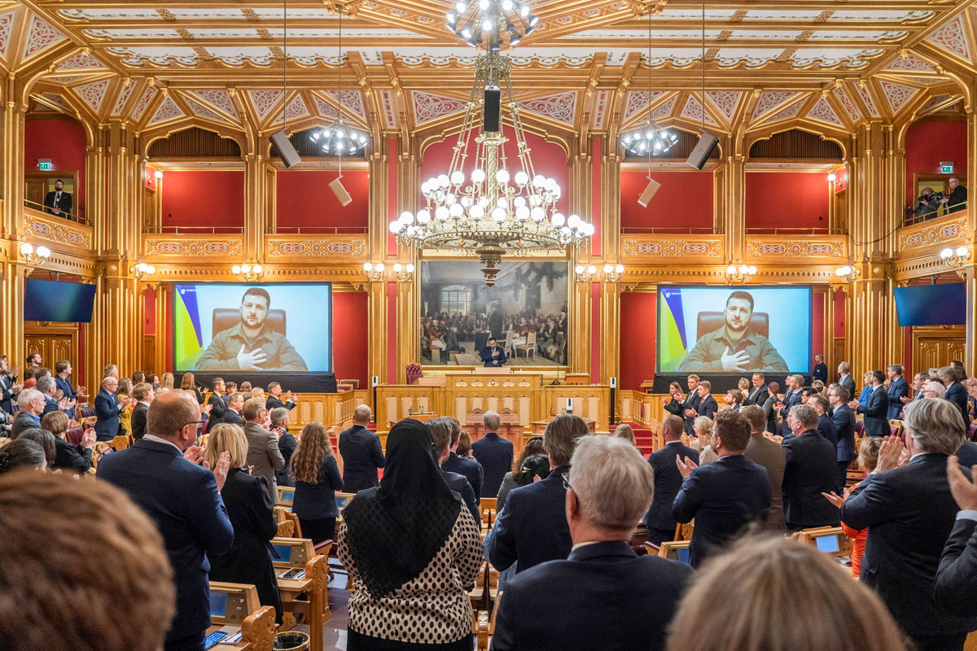
          - Ukrainian President Volodymyr Zelenskyy addresses the Storting on March 30, 2022.
Photo: Heiko Junge/POOL/NTB
The statistics confirm that the level of conflict in the world has increased since the beginning of the 2020s. Today, we have the highest number of conflicts since the end of World War II. In 2025, there are approximately 60 active conflicts in 35 of the world’s more than 200 states. In 2024, one in seven people worldwide was exposed to conflict, and about 130,000 people were killed directly in combat. The vast majority of conflicts are civil wars, but in recent years there have also been several interstate conflicts. In comparison, in 1993 there were 44 conflicts in the world. All of these were civil wars, and the number of killed was around 45,000.
Today’s conflicts are becoming increasingly complex, with a larger number of actors, a higher degree of involvement of regional actors and third parties, as well as increased interlinkages between conflicts. This can make it more challenging to find peaceful solutions. The world can be described as one complex theatre of conflict. The Western and Eastern Hemispheres are intertwined, not only through communication, trade, and investment, but also through associations and coalitions across regions. We are witnessing major shifts in US global policy, which may mean that the US is moving away from its role as a stabilising anchor for a global order based on international law. There are also new dynamics in the strategic relationship between Russia and China. The military support from Iran and North Korea has strengthened Russia’s ability to wage war against Ukraine. The conflicts between Israel and Palestine and between Israel and Iran have ramifications for a number of conflicts both inside and outside the Middle East. A conflict situation in one place can affect the balance in other places. One example is how Assad’s fall in Syria was closely linked to Russia’s war against Ukraine and Iran’s weakened influence as a result of the war in Gaza and Lebanon. This also led to changes in the respective positions of Israel, Iran, Turkey, and Russia in the Middle East. We see a similar complexity in the conflict in Sudan, where local conflict lines are amplified and extended through interference from external actors.
There is little to indicate that the trend of increased conflict and tension will abate, at least not in the short term:
- Russia has violated the basic prerequisites for security in Europe. Although Russia will probably avoid seeking direct conflict with NATO, there is reason to believe that its security and foreign policy goals – and methods for achieving them – may remain incompatible with Norwegian and European interests in the foreseeable future.
- The international role of the United States is unpredictable and changing, and it is uncertain whether it will once again step up as a champion of a global order based on international law.
- International institutional cooperation is weakening. We see less willingness among key states to negotiate and stand by binding solutions to war and conflict in the UN Security Council. Multilateral institutions lack funding and the ability to find solutions and deal with humanitarian crises. Flight and migration may increase as a consequence of this.
- There is a shift in power out and away from Europe and the Atlantic area, with a greater role for China and emerging economies, which are seeking greater international influence.
- In global disarmament and non-proliferation efforts, there is conflict and a crisis of confidence. In a tense geopolitical situation, deterrence is given greater emphasis.
- Increasing geopolitical tensions are playing out in new arenas. Competition is increasing for access to critical raw materials and resources, and for global leadership in the development of new technology such as artificial intelligence, satellites and drones. The global economy is characterised by more protectionism, trade wars and uncertainty.
- Climate challenges are the biggest and most fundamental challenges we face. Nevertheless, the problem is denied in some key circles, and international attention is turned to other issues. Climate change can contribute to higher levels of conflict and struggle for resources, and in many cases migration when population groups have reduced access to water and agricultural areas.
It is symptomatic that the economic costs of war and conflict are increasing. In 2023, global costs were about USD 19.1 trillion. At the same time, investments in measures that contribute to peace globally have fallen almost 40 per cent over the past 15 years. Western countries are cutting their own aid budgets at the same time as spending on defence and military rearmament is increasing.
War and conflict create or exacerbate key global challenges. Radicalisation, climate change, pandemics, the proliferation of nuclear, chemical and biological weapons, risks related to artificial intelligence and new technology, the blocking of trade routes, increasing prices and changing framework conditions for international trade and investment are examples of cross-border threats that no country can tackle alone. Situations that lead to refugee and migration flows entail major challenges, first and foremost for the people who are fleeing, but also for transit and receiving countries. Such challenges require cooperation across national borders, but it has become more challenging to agree on common solutions.
This helps to bring conflicts closer to us, while events far away can affect us directly more than ever. Norway’s security rests on a global order in which the UN Charter is respected. The same applies to our welfare and economy. Norway is an open economy, and Norwegian export companies and our maritime industry will be affected if markets are negatively affected by instability and conflict. The Government Pension Fund Global is a long-term and universal investor, and the fund’s return is affected by systemic changes and systemic risk as a result of international conflicts.
International conflict resolution is also changing. Diplomatic and political initiatives to prevent, mitigate or resolve conflicts have not kept pace with the increase in the number of crises. The great powers’ lack of cooperation and declining support for the UN system undermine the ability to prevent and resolve conflicts. Attempts at conflict resolution are increasingly influenced by national interests and dealmaking. Regional powers with different interests are more involved than before in conflicts both within and outside their regions. Sometimes this provides opportunities to achieve solutions to devastating conflicts, but it can also contribute to complicating negotiations. It is increasingly challenging to adequately include women in peace processes. If international law and the ownership of the parties to the conflict and local communities are not taken into account, there is a risk of less inclusive and sustainable political solutions.

The core of Norwegian peace and conflict diplomacy
Over several decades, Norway has built up cutting-edge expertise and international political capital through diplomatic craftsmanship to mitigate and resolve conflicts. This approach is rooted both in our national self-interests and in our humanitarian tradition, and it is no less important in a more complex and conflict-ridden world. Norway is actively responding to global changes and is constantly adjusting its efforts to meet them. This chapter describes Norway’s engagement for peace in more detail. First, we identify three goals that are central to the work.

Objectives for Norway’s efforts to promote peace and conflict resolution
- Mitigating and resolving conflicts (main goal)
War and conflict threaten Norway’s security and interests both directly and indirectly. It is particularly important to contribute to counteracting war and conflict at a time when these are increasing, geopolitics are changing, and the global order based on international law is threatened. Peace and conflict diplomacy is an important instrument in efforts to reduce international conflicts and humanitarian crises, together with broader instruments such as humanitarian efforts, aid and support for multilateral institutions.
- Promoting measures and solutions based on international law and the ownership of the parties
In conflicts, Norway promotes political solutions that are in line with international law, including humanitarian law and human rights. This work is important at a time when not all actors involved have such a focus. In addition, the principle of ownership by the conflict parties is the guiding principle for Norwegian involvement. If the party is a state, it clearly must own and take responsibility for a peace process and its results. If the party is a rebel group, it must also be involved and take responsibility for creating peace. Together with the inclusion of victims, women, and communities, this increases the chance of sustainable solutions.
- Creating political capital and insight
Our work on peace and conflict resolution positions Norway in international arenas, opens doors and builds cooperative relations with countries and organisations that are important to us. Our work provides us with insight into the interests and positions of conflict parties and various actors, including global and regional powers and other third countries. This is important for understanding a changing world and further developing tools to deal with new situations. There is an international demand for Norwegian assessments and expertise in conflicts.

Historical context
Peace and conflict diplomacy have deep roots in Norwegian foreign policy. This is also due to geopolitical and geoeconomic characteristics of Norway, with a long and exposed coast, large sea areas and strategic natural resources that are geographically located between historical Great Powers. Peace and conflict resolution have thus always been closely linked to Norway’s national interests and basic security needs. As early as when Norwegian foreign policy was first established, in the years after 1905, Norway was engaged in reducing or preventing interstate conflicts. The Norwegian Parliament had also been given the task of awarding the Nobel Peace Prize in accordance with Alfred Nobel’s will, written in 1895, with the first award being given in 1901. After the establishment of the UN, the previous line of neutrality in Norwegian foreign policy was replaced by collective commitments to conflict prevention and conflict resolution. After World War II, Norway was involved in the establishment of the defence alliance NATO in 1949 and turned more towards the United States. Political controversies surrounding Norway’s transatlantic turn in security policy were sought to be balanced with international cooperation and a commitment to contributing development aid. Norway became a strong supporter of UN peace efforts and invested considerable resources in efforts to promote disarmament and the establishment of peacekeeping forces under the UN’s auspices. Norwegian diplomats were also involved in several attempts to resolve interstate conflicts.
Peace and conflict diplomacy also has a historical basis in the policy values of religious and church communities, popular peace movements and the international labour movement. Norway has a long tradition of broad popular engagement and international solidarity with the oppressed, the poor, refugees and internally displaced people. This commitment has been a prerequisite for the development of the ‘Norwegian model’ in Norwegian humanitarian policy, i.e. close cooperation – but also a clear division of roles – between Norwegian authorities and humanitarian organisations. A large number of actors from Norwegian civil society have for a long time worked actively on the root causes of violence and conflict. Much of this work has been directly linked to aid, development work and people-to-people cooperation in vulnerable and conflict-prone areas. Several of Norway’s peace engagements, including in Guatemala, Haiti, the Philippines, East Timor and Sudan/South Sudan, started with Norwegian church actors and humanitarian organizations on the ground.
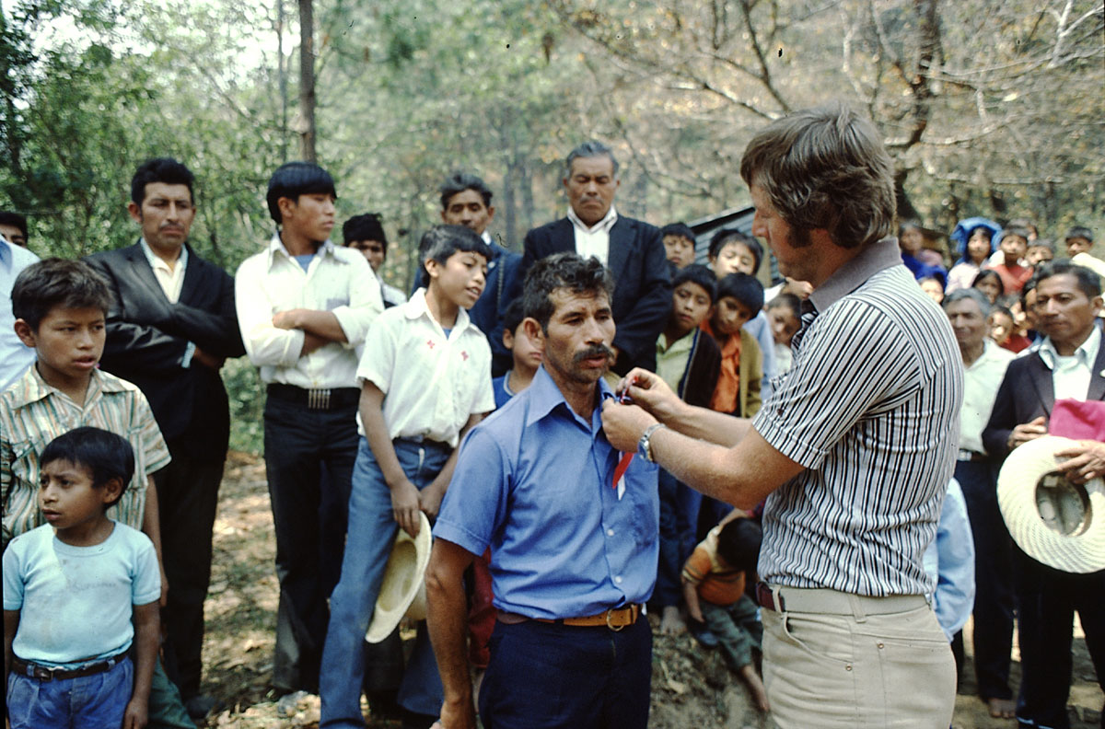
          - Norwegian Church Aid’s representative Petter Skauen (right) presents an honorary award in 1978, as part of his work in Guatemala. Several such awards were presented to members of the local population who distinguished themselves for their contribution to promoting peace and safeguarding respect for human rights in their communities.
Photo: Norwegian Church Aid
The decisive prerequisite for Norway’s increased involvement from the early 1990s was the change in the global level of tension. This allowed for a geographical expansion of the focus of Norwegian foreign policy. Reduced tensions internationally contributed to diplomatic involvement in conflicts in Africa, Asia and Latin America becoming less politically sensitive for our alliance partners. Norway’s foreign policy interests related to conflict reduction and conflict prevention were thus changed. Previously, the focus was mostly on a general reduction of the level of interstate conflict, with an emphasis on broad multilateral efforts, intergovernmental disarmament agreements, development policy and poverty reduction. Now, there was also a targeted diplomatic effort aimed at specific individual conflicts. In this way, Norwegian peace and conflict diplomacy increasingly became a foreign policy resource and interest in the first years after the Cold War. Broad Norwegian consensus on the general outlines of foreign policy has been crucial for Norway becoming one of the key players in the field internationally in recent decades. In the so-called Refleksprosjektet (‘Reflect Project’), which gathered input for renewing Norwegian foreign policy in Meld. St. 15 (2008–2009), report to the Storting (white paper), Norwegian engagement in peace was referred to as a high priority that is also linked to Norwegian interests.

Adjusting perceptions – and some myths
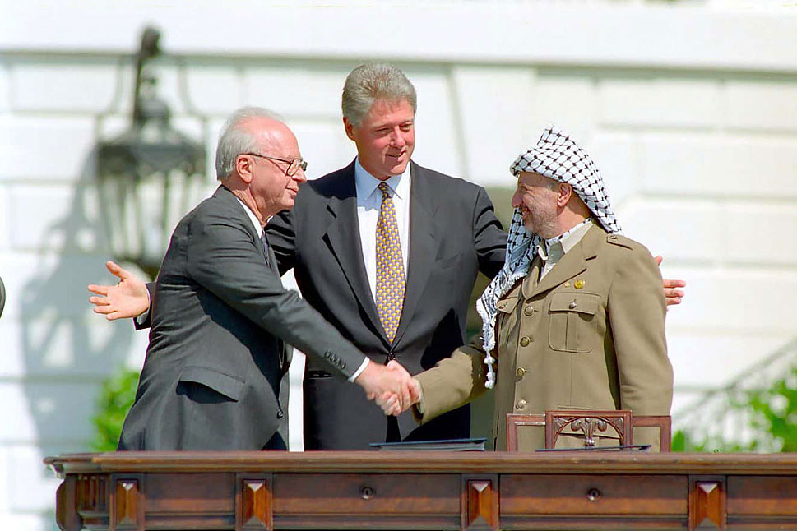
          - Israeli Prime Minister Yitzhak Rabin, US President Bill Clinton, and Yasser Arafat at the signing ceremony for the Oslo Accords on September 13, 1993.
Photo: Wikimedia Commons, Vince Musi/The White House
              - The Oslo Process
On September 5, 1993, an early Sunday morning, The New York Times printed a long article on Norwegian foreign policy. At the top of the first page, as an eye-catcher for the newspaper’s almost two million Sunday subscribers, was the headline “How Oslo helped shape the Middle East Pact”. Just under a week earlier, Norway’s then foreign minister, Johan Jørgen Holst, had invited unsuspecting Norwegian and foreign journalists to a press conference at the Ministry of Foreign Affairs in Oslo. He talked about secret meetings, and about how Norway and Norwegian diplomats had facilitated and helped bring about a historic agreement between Israel and the PLO. The article in The New York Times provided further details. The newspaper’s journalists described what they referred to as the sensational “Oslo connection”. It said that the work had been going on in all secrecy for just over a year. There had been a large number of meetings and gatherings around Norway: in Østfold, in Lillehammer, and in hotel rooms and addresses in various places in the centre of Oslo. “It was all a soft and subtle combination of relaxed surroundings, home-cooked meals, mutual respect and the ability to tell the right joke to ease a tense situation,” the newspaper’s reporters wrote.
This is how the modern story of the so-called “Peace Nation of Norway” began.
Source: Haberman, C. (1993, September 5). Mideast Accord: The Secret Peace/A special report; How Oslo Helped Mold the Mideast Pact. New York Times, Article, p. 1.
[Box ends]
This white paper seeks to nuance some notions and dispel some myths about Norwegian peace and conflict diplomacy, which have become established over time in the Norwegian public sphere. These include:
- Results are measured in the number of peace agreements: It is not often that full-fledged peace agreements are reached, and one should have a broader perspective on what is measured as results. Keeping dialogues going can in and of itself reduce conflict and provide protection for the civilian population, for example in the form of humanitarian relief or violence reduction (see Chapter 8 for a more detailed description of results).
- Peace and conflict diplomacy is an expensive investment: The actual financial resource needs for Norwegian peace and conflict diplomacy are relatively limited compared with other efforts. In 2025, the budget for peace and reconciliation (budget item 151.70) is NOK 395 million. This amounts to approximately 0.68 per cent of the Ministry of Foreign Affairs’ total budget for humanitarian efforts and development cooperation. Budget item 151.70 includes support to NOREF and other international conflict resolution organisations.
- Norway’s contact with some groups and states is controversial: In the public discourse on Norwegian foreign policy, it is sometimes signalled that Norway’s contact with groups and states with which other countries do not have contact is highly controversial. Norway’s efforts are usually part of an international division of labour and are strongly anchored in collaboration with our closest allies and are therefore not particularly controversial in a global context.

Characteristics of the Norwegian effort
There are some characteristics that apply to Norway’s efforts to promote peace and conflict resolution. In our experience, these approaches create better and more sustainable results.
Willingness to talk to all parties. In order to understand underlying interests and uncover possible solutions, it is necessary to have contact with the actors who have influence and hold power in a conflict situation. In principle, Norway talks to all parties to a conflict who are open to discussing political solutions, the curbing of violence or confidence-building measures. In Norway’s contact with controversial conflict actors, we are clear that the contact does not entail an acknowledgement of them or their behaviour. The risk of legitimation and risk-mitigating measures are assessed on an ongoing basis, and this is discussed further in Chapter 4.
Discretion. It is often risky for parties to a conflict to talk to each other, especially before a formal negotiation process has been launched. Norway maintains a low profile and can consult and bring the actors together quietly. In such a secret, exploratory phase or process, trust can be built. A number of actors have stated that one of the main reasons why they want Norway as a facilitator is because we have the will and ability to contribute discreetly without the need to highlight our own efforts.
Ownership by the parties. Lasting peace depends on the political will to find solutions of which both parties to a conflict have ownership. Without ownership, there is as a rule less chance that agreements will be complied with. Norway’s approach emphasises the ownership of the parties, also in cases where other actors contribute to creating external conditions for peace.
Unbiased facilitation. Norway has extensive experience of impartial support for parties’ peace efforts. This means that Norway does not take sides in a conflict and ensures that our support does not favour one side or the other. Impartiality does not mean neutrality. Norway’s values remain firm. We work to promote inclusion, democracy, the rule of law and human rights in peace processes, including where this is met with resistance from the parties.
At the same time, Norway also contributes to conflicts where we are not impartial, for example with advice and support for one party’s capacity to negotiate with the other. We also contribute with facilitation where the parties are aware that Norway is not impartial, but where they still have confidence in our craft.
Inclusion. Norway always strives for the most inclusive processes possible. This is a demand that is often put forward by civil society in the countries in which the conflict is ongoing. Inclusion means that all actors and sectors affected by the conflict and the peace that is being negotiated are listened to and can provide input. Inclusion of women is a particular priority. Inclusion ensures broader ownership in the population, which in turn contributes to a more sustainable peace. However, inclusion is often limited in earlier phases by the need for discretion.
Long-term. When Norway engages in a peace process, we have a tradition of doing so thoroughly and with a long-term perspective. The parties must be able to rely on us to accompany them through thick and thin, regardless of political winds and external storms. The prerequisite for this has been broad political support in Norway.
Flexibility. A characteristic of Norway’s efforts, both in our short-term assistance and long-term engagements, is that we have the ability and willingness to intervene quickly with support for processes in different phases. This is often a prerequisite when a window opens to mitigate or resolve a conflict peacefully. Rapid decision-making processes and flexible resources as well as close cooperation across ministries are important.
Political engagement. In Norwegian peace and conflict diplomacy, the distance between political leadership and the civil service is short. Norway’s peace efforts are always rooted in political mandates. Decisions can be made quickly when needed, which is a prerequisite for agility and efficiency.
Risk appetite. Norway accepts that there is a high risk of failure in this field. The complexity is considerable, and the dilemmas are many. The political temperature in a conflict is often high, and the situation is unpredictable when hostilities are ongoing. Norway is therefore continuously working on conflict analyses, assessment of current issues, and extensive networking in order to have the best possible understanding of the situation and to be able to reduce the political risk of getting involved. Norway is also keen to learn from experience and continuously improve its craft.
Knowledge, experience and harm prevention. ‘Do no harm’ is a key principle of caution to prevent harmful effects of diplomatic and humanitarian efforts. Solid knowledge and understanding of the conflict is a prerequisite to being able to play a role and assume the responsibility that lies in the role of facilitator.
Resources. Peace and conflict diplomacy requires competent and predictable human and financial resources. This makes it possible to explore new opportunities, be present in the field, facilitate exploratory contacts and negotiation meetings, as well as support agreements that have been made. Our resources give us flexibility and the ability to act at short notice.
Networks and partners. Norway cooperates closely with NGOs and expert communities, as well as other countries, the UN, and international organisations. This has resulted in a wide network of contacts that are actively used in our engagements.

Different roles in Norwegian peace efforts
Since about 1990, Norway has been involved in peace and conflict diplomacy in more than 40 countries and processes with different types of engagements, large and small (not all of which can be mentioned here for reasons of discretion). Norwegian peace and conflict diplomacy can be divided into four types of roles: contact diplomacy, informal facilitation, formal facilitation, and Norwegian efforts in processes that are formally led by others. In many processes, we have had different roles at different times. There are also some efforts that fall outside of these categories. For example, since 1993, Norway has chaired the International Donor Group for Support to the Palestinians (AHLC), in which Palestine and (until recently) Israel have met regularly together with the donors. This role has entailed Norwegian diplomats being involved in conflict resolution between Israel and Palestine for over 30 years.
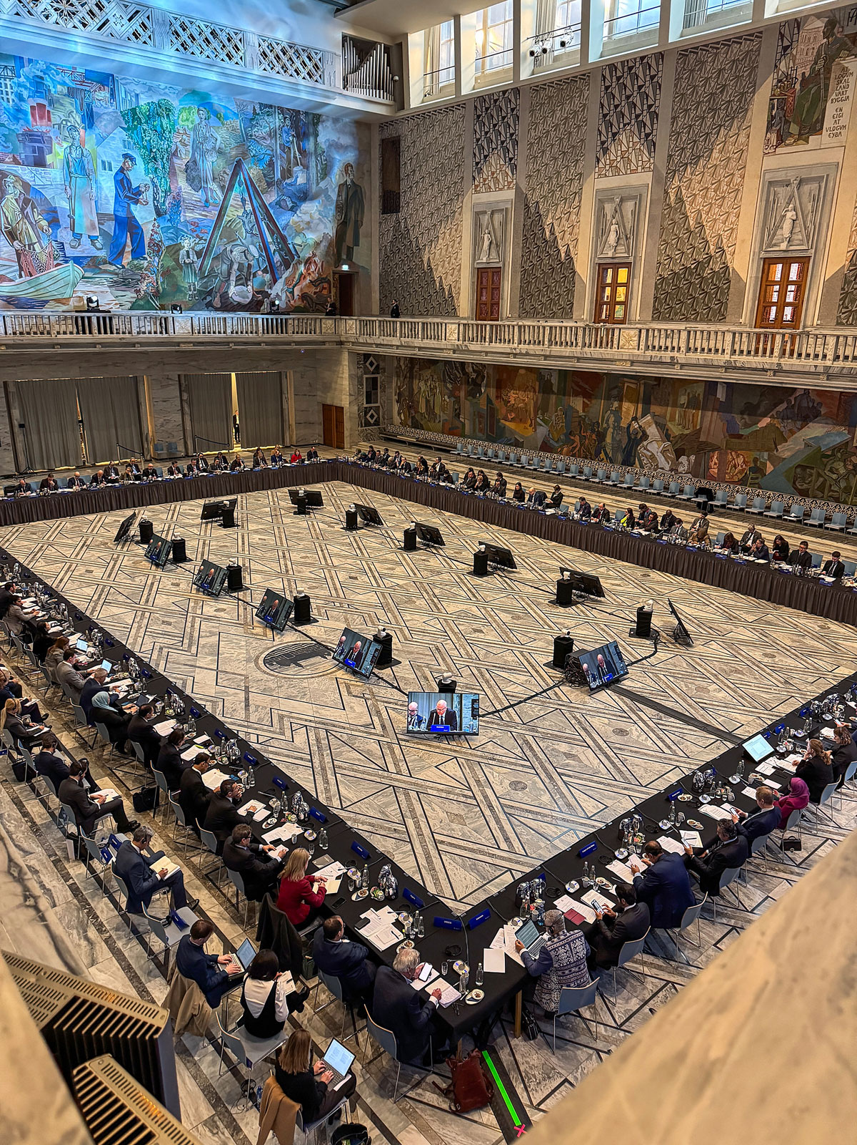
          - Meeting of the Global Alliance for the Implementation of the Two-State Solution in Oslo on 15 January 2025.
Photo: Guri Solberg/Ministry of Foreign Affairs
              - Four types of roles for Norwegian peace and conflict diplomacy
02J0xx2
1 | Contact diplomacy  - exploring opportunities for negotiations and political solutions, conveying messages and engaging in advocacy work  - building contact and trust with all relevant parties to a given conflict, including de facto authorities and non-state armed actors  - capacity building of parties in thematic areas such as negotiations/negotiation techniques, humanitarian law, transitional justice, ceasefires, monitoring and verification of agreements, and women, peace and security  - contact with neighbouring countries, regional powers and major powers about a conflict  - humanitarian diplomacy to promote humanitarian access and protection of civilians  - contact diplomacy is part of all engagements and can lead to or run in parallel with the other roles  Examples are Afghanistan–Taliban, Yemen–Houthis, Islamist groups in the Middle East and North Africa including Hamas and the Muslim Brotherhood, militia groups in Iraq, Somalia including Somaliland, and Syria including HTS.
2 | Informal facilitation  - facilitating parties meeting each other, or communicating indirectly, often in secret, and talking about possible peace solutions, de-escalation, ceasefires, prisoner exchanges, increased access to humanitarian aid or other confidence-building measures  - recurring meetings of this type are often referred to as a back-channel  - may lead to roadmaps or agreements to start a formal process  - may involve dialogue between countries in a region about a conflict  - also includes informal facilitator roles in peace processes where the parties want an informal, rather than a formal, third party  Examples are Nepal–Communist Party of Nepal CPN (Maoist), Myanmar, Afghanistan, Iran, Israel–Palestine, Libya, Serbia–Kosovo, Haiti and East Timor.
3 | Formal facilitation  - formal role as facilitator, guarantor and the like in a negotiation process; may border on mediation  - bringing parties in conflict together for formal negotiations  - includes ‘shuttle diplomacy’ during periods when the parties are not sitting together around the table  - often includes active involvement in the implementation phase, after a peace agreement or ceasefire agreement has been signed  Examples are Colombia–FARC and –ELN, Philippines–NDFP, Israel–PLO (Oslo Process), Sri Lanka–Tamil Tigers (LTTE), Venezuela (authorities–opposition).
4 | Processes formally led by others  - Involvement can be extensive even if Norway does not have a formal role, or has just a supporting role on paper  - includes processes where Norway has hosted conversations, contributed to the facilitation of parts of the process, or contributed with professional support and advice to one or more parties  Examples are Ukraine, Ethiopia-Tigray, Ethiopia-Oromo Liberation Army, Guatemala, Aceh (Indonesia), Nigeria, Sahel, Spain-ETA, North and South Sudan, Thailand, Uganda-Lord’s Resistance Army, Cyprus.
[Box ends]

Contact diplomacy
In some situations, the parties do not wish to meet each other, but nevertheless have an interest in contact with Norway (see Box 3.2 for a description of such contact). Contact diplomacy can form the basis for a Norwegian contribution to a potential negotiation process. Norway sometimes wishes to prevent a country or actor from being diplomatically isolated through contact, as a lack of contact from Western countries or the wider world may lead to less opportunity to influence attitudes and fewer openings for resolving conflicts. North Korea, Myanmar after the coup in 2021, and Afghanistan under the Taliban from 1996–2001, are examples of regimes that have had very limited diplomatic contact with the outside world.
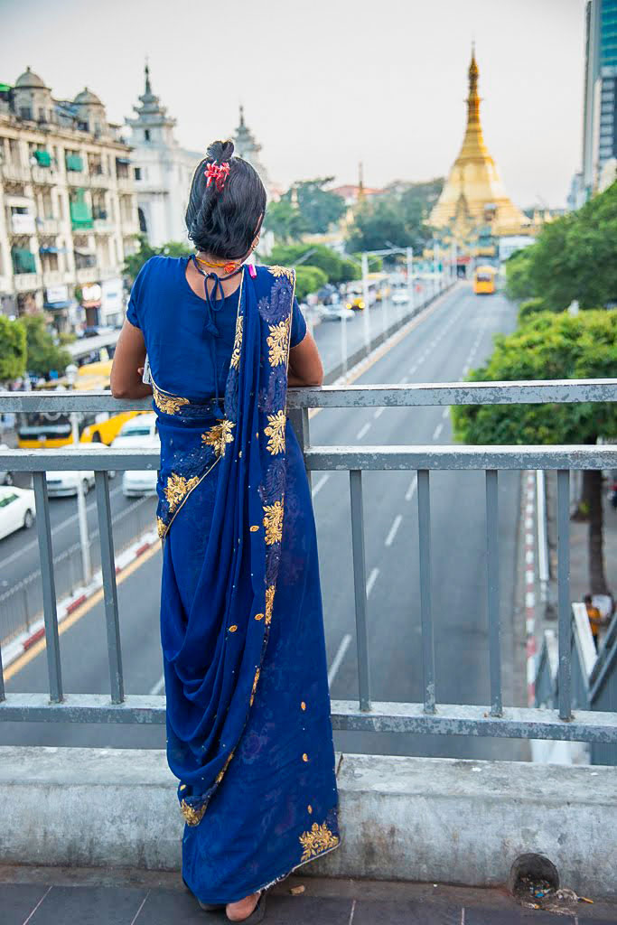
          - Norway has a long-term commitment to peace in Myanmar.
Photo: Espen Rikter Svendsen/Ministry of Foreign Affairs
In both Afghanistan in the 2000s and in Libya in 2011, early contact diplomacy was about gaining an overview of the parties’ decision-making processes and positions, and assessing how dialogue on conflict resolution could be promoted in a secret phase. At an early stage of the international engagement in Afghanistan after 2001, Norway’s assessment was that military measures alone would not lead to a lasting peace. Norway talked to the Taliban about possible peaceful solutions for many years before the organisation entered into formal negotiations with the US in 2018. Norway’s main objective was to try to lay the foundation for peace negotiations between the Taliban and the authorities in Kabul, and to promote women’s rights in a future peace deal. In retrospect, there is a broad recognition that all actors, including the Taliban, should have been included in a political solution during the peace conference in Bonn after the Taliban was removed from power in 2001. Instead, negotiations with the Taliban were not opened until they had a much stronger position. Through quiet diplomacy, Norway helped prepare the ground for intra-Afghan negotiations, which took place in Doha in 2020. The negotiations were demanding, partly as a result of an increasingly uneven balance of power. By the time international forces withdrew, the Taliban had become strong enough to take power in Afghanistan militarily.
The Taliban is an example of a contact that has been and remains challenging. Despite a number of setbacks, contact with Afghanistan’s de facto authorities has continued after the Taliban seized power militarily in 2021. The aim is to continue Norway’s long-term efforts to assist the Afghan people and to contribute to stabilisation that can counteract uncontrolled migration and the spread of terrorism. PST’s open threat assessment for 2025 states that the ISIS branch in Afghanistan and the surrounding area, the Islamic State in Khorasan Province (ISKP), poses the greatest terrorist threat to Europe. The oppression of girls and women and the exclusion of other Afghan groups from political governance is not a sustainable situation for the country, and this is a key message from Norway. Norway alone will have limited opportunities for success, and the efforts are linked to broader international diplomacy, with long-term goals. The experience from the 1990s is that isolation of Afghanistan can be unfortunate (more on this in Chapter 4).
Another example is the contact with the Houthis in Yemen. The starting point for Norwegian contact was to support the UN’s efforts for a peace process in Yemen and to help deal with one of the largest humanitarian crises caused by conflict in recent decades. The contact has continued even after the outbreak of the Gaza war in the autumn of 2023, when the Houthis launched a number of attacks on civilian ships in the Red Sea, including attacks on a Norwegian-owned ship that the government strongly condemned. In coordination with other countries’ diplomatic efforts, Norway also has raised grave concerns related to hostages, the arrest of UN personnel, and restrictions on humanitarian activities. The possibility of returning to efforts for a political solution to the conflict in Yemen has always been central to contact with the Houthis and other involved Yemeni, regional and international actors.
In order for Norway to prioritise contact with an actor or group, it is a prerequisite that there is some room for discussing topics such as political solutions, the reduction of violence, confidence-building measures, or humanitarian access and protection. Different countries play different roles in conflict resolution. The decision to engage with a party or group is usually coordinated with other relevant countries involved in the conflict. Norway’s independent role provides certain advantages, and our contact policy is usually appreciated by close allies, like-minded parties, and major powers involved.
              - Terrorist lists
An important aspect of Norway’s engagement is that we have been more willing than many others to talk to all parties in a conflict, including those with whom we disagree the most. This is often crucial in order to be able to find diplomatic solutions. Norway’s commitment to be able to act as an impartial actor, to have contact with parties in conflict and to facilitate talks, as well as to support the implementation of agreements that have been made, was the main reason why Norway decided in 2006 not to join the EU’s terrorist list. Norway does not have its own national list of terrorist organisations, but has supported the EU’s lists of persons responsible for serious human rights violations, which partly overlaps the former list.
At the same time, Norway gives high priority to international efforts to combat terrorism through both national measures and international cooperation. Among other measures, Norway implements sanctions against the groups and individuals to which we are obliged under international law following a decision by the UN Security Council, including Resolution 1267 (1999)1 which targets Al-Qaeda, ISIL and associated groups, and Resolution 1373 (2001).2 The UN resolutions require all states to criminalise support for terrorism, including denying financial support and refuge to terrorists. Norway’s criminal law definition of terrorist offences is based on similar descriptions as those that apply in the EU member states.
The war on terror contributed to the establishment of important UN resolutions on combating terrorism. At the same time, a number of countries introduced terrorist lists, which were also used to indicate that diplomatic engagement with the groups on the list should be avoided. Several countries went further than the UN and listed rebel groups (and even legal political parties) as terrorists and introduced punitive provisions aimed at contact with such groups. This became an obstacle to peace and conflict diplomacy, including the implementation of some already-established ceasefire agreements. In Sri Lanka, for example, the EU’s listing of the Tamil Tigers led to the withdrawal of the Nordic EU countries in the ceasefire monitoring mechanism (Sweden and Denmark) from the mission. Norway and Iceland were left on their own. The US and EU listing of the Tamil Tigers during the process slowed down the exposure of the group’s leadership to the outside world. The listing may have reduced the effect of international support for the peace process and made it easier for the Sri Lankan authorities to resume the war without fear of strong international reactions.
1 United Nations Security Council. (1999, October 15). Resolution 1267. https://www.undocs.org/S/RES/1267%20(1999)
2 United Nations Security Council. (2001, September 28). Resolution 1373. https://www.unodc.org/pdf/crime/terrorism/res_1373_english.pdf
[Box ends]
Contact diplomacy does not require major resources. Resources are mainly limited to meeting and travel expenses. Experts are sometimes contracted, such as analysts with good local knowledge. Only when a process develops and there is an opening for formal negotiations or democratisation processes with elections and reforms, Norway and the international community provide support through the aid budget, and efforts become more resource-intensive in line with the increased opportunities to achieve lasting results.

Informal facilitation
There are many examples of how informal processes can result in a reduction in violence or prevent escalation. This is important, not least at a time when the room for manoeuvre for all-encompassing peace agreements has diminished. Norway has provided a significant number of such meeting places and channels, with the aim of creating trust, clarifying interests, and seeking agreement on conflict-reducing measures and agreements.
Preparations for the Colombian process with the FARC went on in secret for two years, including a six-month secret negotiation phase facilitated by Norway and Cuba. In the secret phase, the parties agreed on a roadmap and an agenda for the official negotiations that began in 2012. This gave them the confidence to take the process into the public eye. Here, Norwegian diplomats assisted, among other things, in retrieving FARC negotiators from the jungle using helicopters from the International Committee of the Red Cross. In Venezuela, Norway led almost three years of soundings between the authorities and the opposition before they were ready to sign a letter of intent on a new formal negotiation process in 2021.
In 2023, Norway hosted a confidential meeting between Iran’s deputy foreign minister and top diplomats from France, the United Kingdom, and Germany (the so-called E3 countries) and the EU. There was interest from the parties to continue the dialogue and explore opportunities for reducing tensions after the US withdrew from the nuclear deal in 2018 and relations between Iran and the Europeans had deteriorated. The European countries continued to negotiate with the Iranians on the nuclear deal. At the same time, they were highly critical of Iran’s handling of demonstrations, support for Russia’s war against Ukraine, the arrest of European citizens and the use of proxies in conflicts in the Middle East and in operations on European soil. The purpose of the meeting was to maintain dialogue between the parties despite these challenging political issues. The meeting in Norway was the first time the parties met again after the last nuclear negotiations in Vienna broke down in the autumn of 2022. The meeting in Norway was made known by the participants afterwards and helped to slow down a negative development.
Another example is the secret talks in Oslo in 2011 between a delegation from Gaddafi’s regime and the Libyan opposition, which met in an attempt to stop the war. This happened at the same time as Norwegian fighter jets participated in NATO’s bombing campaign in Libya. The Norwegian diplomats nevertheless had sufficient confidence among Gaddafi’s closest people. The attempt was coordinated with the United States, but foundered, among other reasons, due to a lack of support among other NATO allies to negotiate with Gaddafi’s people without him accepting his resignation as a pre-condition.
In 2010, Norway was asked to contribute to direct contact between Kosovo and Serbia with the aim of normalising relations between these neighbouring countries in southern Europe. At that time, it was not politically acceptable for them to meet. Frozen conflict, local uncertainty, and the risk of renewed war characterised the situation. In cooperation with the EU, NATO, European countries and the United States, Norway had invested heavily in the reconstruction and development of the Western Balkans after the wars in the former Yugoslavia in the 1990s. Norway had also accepted many refugees from the conflicts. We therefore responded positively to the request and contributed to the establishment of such contact. This developed into a parallel support process for the negotiations on normalisation facilitated by the EU, which led to the Brussels Agreement in 2013. According to the parties themselves, the support process contributed to agreement on important progress in the formal negotiations.
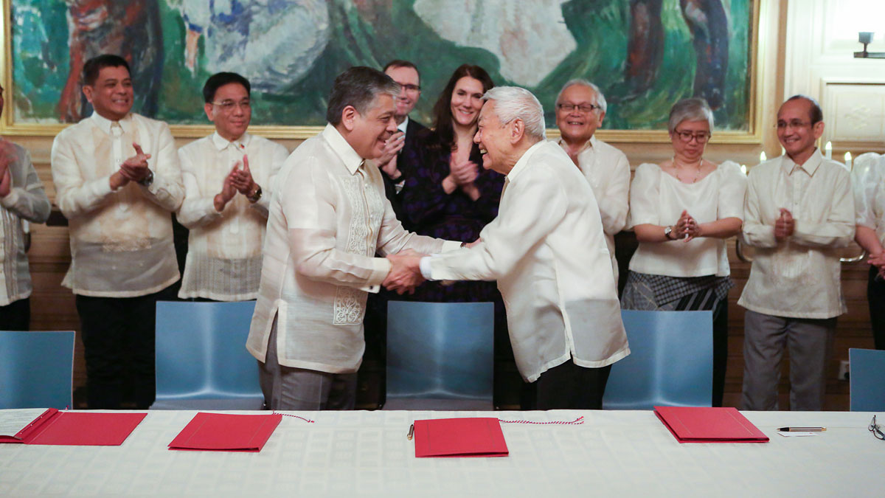
          - Norway has participated in various peace negotiations in the Philippines since 2001. This photo is from the signing of a joint vision for peace on November 23, 2023 in Oslo between the Philippine government and the communist movement National Democratic Front of the Philippines.
Photo: Matias Rongved/Ministry of Foreign Affairs
In Nepal, Norway worked closely with the parties to the conflict as an informal facilitator from an early phase through the signing of a comprehensive peace agreement in 2006 between Maoist rebels and an interim government consisting of seven parties. The peace agreement has been gradually implemented over the past 19 years. Together with the agreement between the Colombian authorities and the FARC, the peace agreement in Nepal is one of the few comprehensive agreements since the year 2000 that has ended wars. The agreement stabilised this strategically located country situated between the regional powers of China and India, and led to the establishment of a federal democracy that distributes power to the country’s provinces. The agreement also laid an important foundation for the inclusion of women, minorities, formerly untouchables, and people with disabilities.
Norway’s contribution to Nepal included using the embassy and the ambassador’s residence as informal meeting places, also during the implementation phase of the agreement. Norway contributed expertise during the process and at short notice established the monitoring mission that received weapons and combatants when the agreement to stop the war had been signed, as the UN could not set up a monitoring mission quickly enough. The mission was later transformed into a UN mission with Norwegian leadership. The parties to the conflict and the population have the credit for having facilitated their own negotiations on the peace agreement. At the same time, the leaders on both sides have thanked Norway for its important informal facilitator role.
Support from the countries surrounding a conflict is often important for a successful peace process. In some cases, Norway has facilitated regional cooperation to reduce tensions and resolve conflicts. For example, Norway, together with the Afghan authorities, facilitated a series of informal meetings between key people from countries around Afghanistan and the United States. The meetings contributed to the establishment of a formal regional cooperation process with the aim of supporting lasting peace in Afghanistan.

Formal facilitation
The most well-known role is where Norway contributes as an official third-party facilitator or guarantor of formal peace negotiations. Here, Norway brings parties in a conflict together, organises and participates in negotiation meetings, and sets the framework for a process according to their wishes. Norway may shuttle between the parties or bring them together for official or secret joint meetings. When Norway has taken on such roles, this has often led to close cooperation with the United States, various European countries, the EU, the UN, regional powers and neighbouring countries, as well as with the authorities in the conflict countries.
One of the most extensive Norwegian engagements has been in Colombia. In addition to supporting the implementation of the comprehensive peace agreement between the Government and the FARC from 2016, Norway currently plays facilitator roles in several ongoing negotiation processes between the government and various groups, including the guerrilla group ELN and two groups of FARC dissidents. In addition, we assist with advice and technical support for negotiations between the government and various urban crime networks in several of Colombia’s cities.
The formal peace negotiations between the government and the FARC were facilitated by Norway and Cuba in Havana from 2012 to 2016. Long-term contact diplomacy and a number of cooperation measures with the armed forces, the judiciary and civil society with the aim of facilitating a peace process when the time was ripe, contributed to Norway being asked to take on this role. As a facilitator, Norway supported the parties on an ongoing basis both practically, politically and financially. Norway contributed with meeting places, transport, expertise, and crisis management, and was present in the negotiation meetings between the parties. The peace agreement that was signed ended a conflict that had been going on for over 50 years, with several hundred thousand killed. About 13,500 FARC soldiers laid down their arms. Colombian President Juan Manuel Santos received the Nobel Peace Prize for his efforts in 2016. The agreement deals with everything from a ceasefire to land reform, the fight against drugs and transitional justice. The FARC is today a legal political party with representation in the National Assembly.
However, the role of facilitator does not cease when an agreement is signed, and Norway has since 2016 actively supported the implementation of the agreement in Colombia. The experience and trust gained during the negotiations have been valuable in ensuring the agreement’s survival over time, under successive Colombian governments. Challenges in the implementation phase also provide important learning that is useful in other processes.
Norway has facilitated the negotiations between the authorities in the Philippines and the communist movement NDFP (National Democratic Front of the Philippines) since 2001, which makes this one of our longest-standing engagements. There have been rounds of formal negotiations, back-channel talks, and periods of lower intensity. Since 2022, there has been progress on efforts to resolve the conflict, and the parties are now working on a framework agreement for a final peace agreement. The conflict has lasted for over 50 years, with more than 40,000 killed, driven by social and economic inequalities in society, among other things. The Philippines is an example of how Norway’s long-term contact with the parties to the conflict during both good and challenging periods builds trust over time and enables progress towards a peaceful solution.
              - Venezuela – in search of a political solution
In 2019, the government and opposition in Venezuela asked Norway to be the official facilitator of negotiations on a political solution to the conflict. Norway was asked to take on the role, partly because of our work on peace and conflict resolution in Colombia. The process was requested by the international community. The UN, the US, the EU, Russia, China, Turkey, and countries in the region showed strong support for Norway’s work.
The involvement in Venezuela led to the presidential election in 2024. The talks followed in the wake of a number of previous attempts at negotiations. There was broad agreement globally on the need for a political solution to the 20-year-long conflict that had caused one of the world’s largest migration crises and significant instability in the region. At times, there was considerable scepticism from some people in the Venezuelan opposition about starting negotiations with the government, and the criticism levelled at Norway on social media was considerable. When Norway nevertheless chose to get involved, it was because the leading parts of the opposition desired negotiations and there was demand in international community for Norway’s involvement.
During the negotiation process, the parties built up trust and lines of communication. In 2021, they agreed on a common vision for the negotiations and signed five sub-agreements in the following year. In 2022, it was agreed to use frozen Venezuelan funds for national welfare services. In 2023, the parties laid down the conditions for the 2024 presidential election. During the COVID pandemic, an agreement was reached on access to vaccines and medical equipment.
The negotiation process resulted in a united opposition, but did not lead to the broad political solution that the parties had set as their goal. The reasons for this are complex. Dilemmas and political risks associated with Norway’s role in Venezuela were continuously considered. Several Norwegian governments have decided to be involved.
In protracted, deep-seated conflicts, few things are more valuable and needed than quiet, persistent, patient [and] neutral facilitation by parties who can listen, keep confidences, bring the parties together and generally serve as a trusted sounding board. Norway’s engagement in Venezuela is an outstanding example.
William Ury, founder of the Harvard Program on Negotiation and co-author of the book “Getting to Yes: Negotiating Agreement Without Giving In” from 1981. Quote from February 20, 2025
[Box ends]
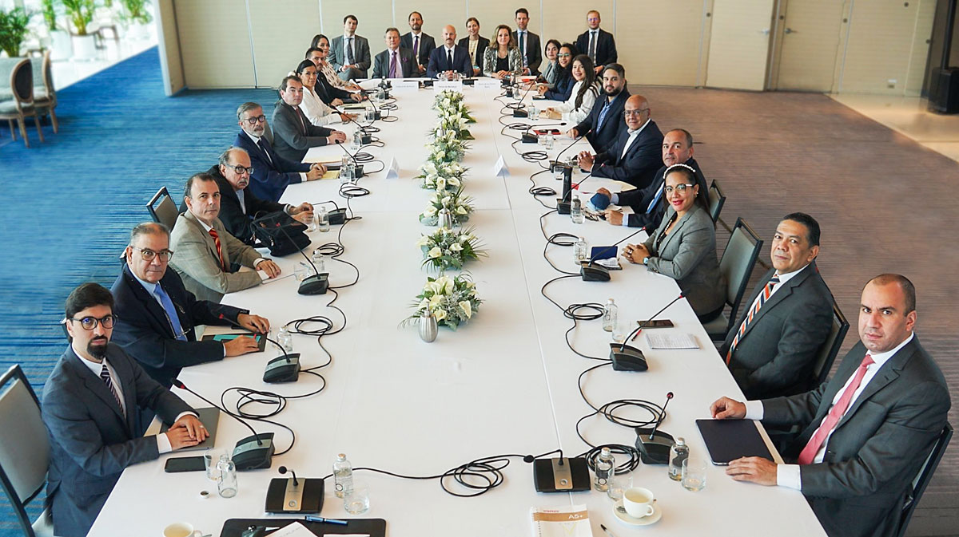
          - For several years, Norway facilitated negotiations between the government and the opposition in Venezuela on a political and inclusive solution to the conflict, based on a desire from both parties. Photo from the signing of the memorandum of understanding that the parties signed in Mexico City in August 2021.
Photo: Ministry of Foreign Affairs
The war between the Sri Lankan authorities and the Tamil Tigers (LTTE) cost an estimated 80,000–140,000 civilian lives over a quarter of a century. The negotiations began as indirect and secret. Norway facilitated a comprehensive ceasefire agreement that halted much of the violence and laid the foundation for several rounds of negotiations on a political solution. Despite considerable will for a period, both sides remained beholden to short-term political considerations. The parties also did not make sufficient compromises, and failed to anchor visions of profound changes well enough within the population. After the 2005 election, the authorities increasingly focused on military means. Despite repeated attempts by Norway and the international community to bring the parties back to the table, the war ended in military victory for the government forces. In early 2009, government forces killed at least 40,000 civilians, mainly Tamils with whom the Tamil Tigers had entrenched themselves on a narrow strip of land by the sea.
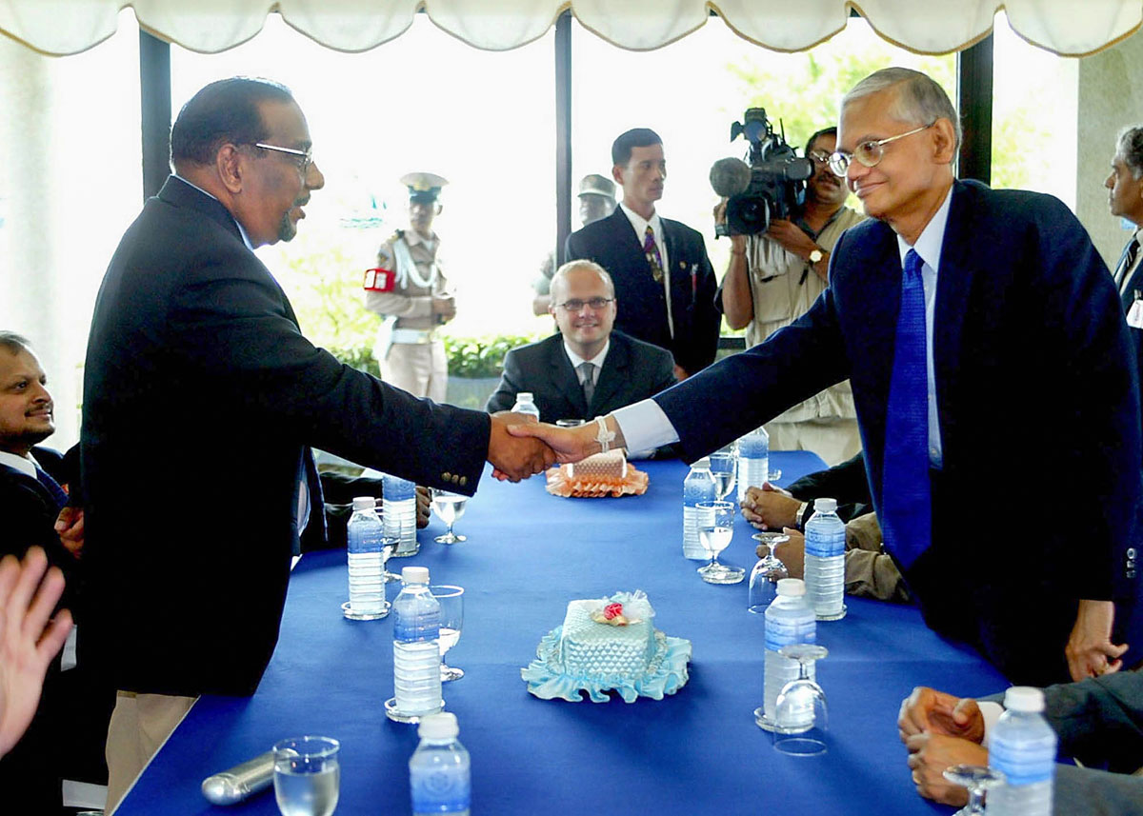
          - Minister of Constitution and chief negotiator G.L. Peiris from the Sri Lankan authorities and chief negotiator Anton Balasingham from the Tamil Tigers greet each other, with Norway’s State Secretary Vidar Helgesen in the role of facilitator, during the first round of peace negotiations for Sri Lanka in Thailand in September 2002.
Photo: Stephen Shaver, POOL/AP Photo
In Sri Lanka, Norway experienced how sensitive it is to facilitate impartial mediation between a government and a non-state armed group. The third-party role required patience and the ability to withstand significant criticism from parts of Sri Lankan society. Norway cooperated closely with India, Japan, the EU, and the United States during the peace process in Sri Lanka. The humanitarian suffering and the country’s strategic location in the Indian Ocean between Europe, India, and China contributed to the international community’s strong support for the peace process and to it regarding Norway’s role as important. At the same time, international support and pressure were not sufficient to keep the process going when the parties’ own faith in a negotiated solution waned.
Norway has facilitated negotiations on its own, such as in the Philippines, Venezuela, and Sri Lanka, and jointly with other states, such as Guatemala and Colombia. Regardless of whether we are working alone or with others, it is important to have strong international support, in the form of groups of friends, observers or other international constellations. It is often necessary to have a strong player behind you, who can put pressure on the parties or offer incentives if needed, in order to increase the chances of a solution. The United States has taken on this role in many processes.

Processes formally led by others
The last category deals with work where the Norwegian involvement has often been extensive, but in processes formally led by others. Norway’s role has primarily been to provide a professional framework and safe haven for sensitive conversations, or to assist with advice to parties and expertise as requested. A recent example is in the ceasefire negotiations on Gaza after 7 October 2023, where Norway has been closely involved in the negotiations on the release of hostages and has supported the parties and the formal mediators through the sharing of assessments and information.
Another example is the negotiations that ended the second civil war between North and South Sudan. The war lasted from 1983 to 2005 and was the longest in Africa’s history. An estimated two million people were killed in acts of war or died of hunger and disease as a result of the war. Twice as many were forced to flee. IGAD, a regional organization consisting of the countries of the Horn of Africa, led the negotiations that led to the signing of the Comprehensive Peace Agreement in 2005. Norway was actively engaged through the troika cooperation between Norway, the United States, and the United Kingdom, where we contributed expertise and advice. The relationship with the Sudan People’s Liberation Movement/Army (SPLM/A), which largely represented the population of South Sudan, was close. This was partly due to the Norwegian organizations Norwegian People’s Aid and Norwegian Church Aid, which had assisted the population in need during the civil war. After the signing, Norway supported the implementation of the agreement.
The peace agreement succeeded in ending Africa’s longest and bloodiest war, and provided an opportunity to address the causes of the conflict and create a just Sudan. That did not happen, for which the parties themselves primarily must take responsibility. The resistance to implementing the necessary profound changes in Khartoum contributed to South Sudan’s insistence on holding a referendum on secession or continued unity. Over 98 per cent voted for secession and South Sudan became an independent country on July 9, 2011. Since then, Sudan and South Sudan have been marked by war and conflict, with tragic consequences for the civilian population in both countries. This shows how important it is that an agreement is firmly anchored among local powerholders.
              - The Troika cooperation between Norway, the United States, and the United Kingdom
The Troika cooperation is unique in Norwegian peace diplomacy and has enabled Norway, the United States, and the United Kingdom to work closely together on conflict resolution in the Horn of Africa for decades. The cooperation was developed through efforts to support the regionally-led peace process between North and South Sudan. This experience has been important for Norway during its two terms on the UN Security Council. The cooperation between the three countries is based on a common set of core values, but the countries are also different and have complemented each other. The influence of the United States on the parties has been important. Britain was a member of the EU and had in-depth knowledge of the Sudanese state apparatus, a legacy of the Anglo-Egyptian Condominium of which Sudan was a part. Norway’s network among Sudanese civil society actors and public engagement in Norway have both been a strength in our contribution.
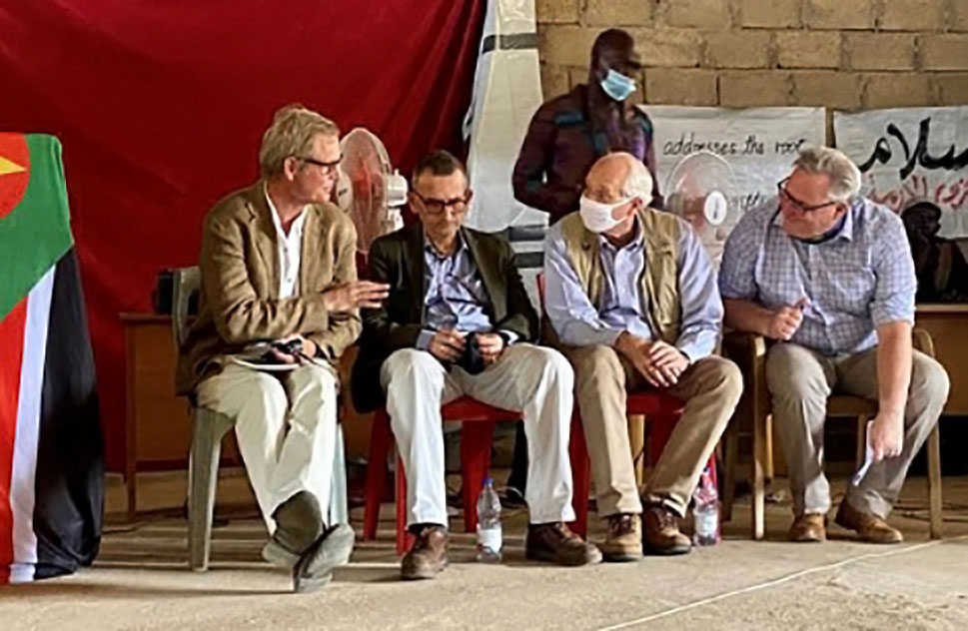
          - A visit to Kauda in Sudan in 2021 by Troika representatives from Norway, the United States, and the United Kingdom, in addition to the Special Representative of the UN Secretary-General in Sudan.
Photo: Ministry of Foreign Affairs
[Box ends]
Another example is from Spain. The Basque rebel movement ETA was established in 1959 and was responsible for a number of major terrorist attacks and murders that continued after the transition to democracy in 1976. Governments of varying parties had sought dialogue with the movement without success. In 2005, the Spanish government informally asked the Centre for Humanitarian Dialogue (HD, see Chapter 6) for assistance in establishing contact with the movement with a view to laying the foundations for a solution. The process was politically controversial in Spain, and the authorities wanted a discreet non-governmental international facilitator such as HD to make it possible to keep a certain distance from the talks and avoid internationalization. At the same time, there was a need for support from states for the process. The Norwegian support was provided at the request of the Spanish government and developed over time. Together with Switzerland, Norway contributed safe meeting places, transport, facilitation of conversations, and as a witness. Norway has not previously discussed its role publicly. However, leaders from both major government parties have publicly confirmed Norway’s role in their memoirs. Along the way, the experiences of the British government and the Irish Republican Army (IRA) from the peace process in Northern Ireland were also drawn upon.
The ETA process is an example of how a non-governmental international facilitator such as HD may need assistance from a state for complementary roles. This ‘hybrid diplomacy’ was critical for the decision by the parties to sit down at the negotiating table. There were several breaks in the negotiations along the way. Police efforts to counter the movement continued in parallel with the talks, and ETA did not cease its armed activity. A final agreement was never reached. However, the combination of pressure from the Spanish authorities and facilitation of talks with support from Norway created a dynamic that contributed to ETA unilaterally declaring in 2011 that it was ending its armed activity. In 2018, ETA went a step further and unilaterally dissolved the organization. ETA was removed from the EU’s terrorist list in 2022. Parts of the Basque political movement now exist as legal political parties.
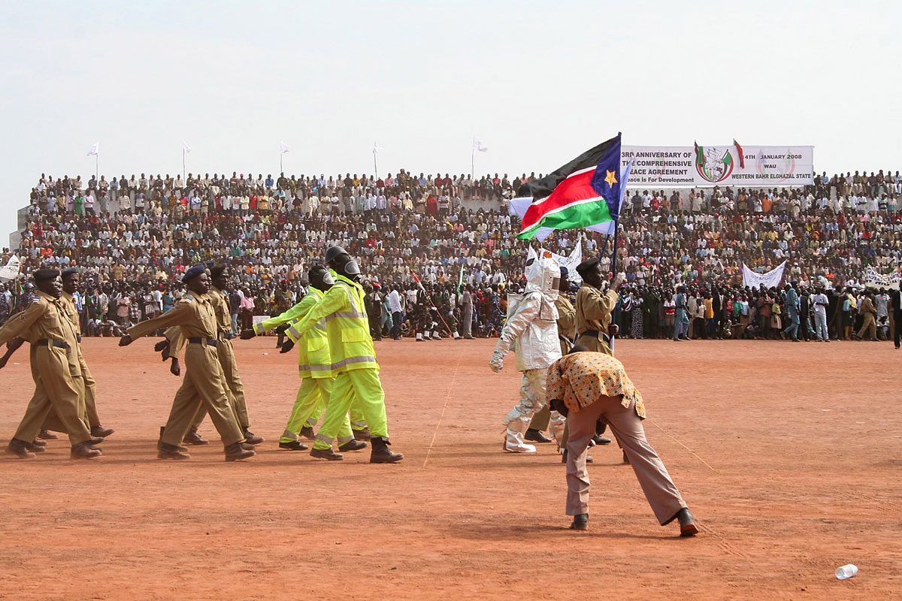
          - Norway was strongly involved in the peace process between North and South Sudan. The photo is taken during the three-year anniversary celebration of the peace agreement in South Sudan in 2008.
Photo: Heidi Elburgi Johansen/Ministry of Foreign Affairs.

Dilemmas
In different roles and conflict situations, Norway faces different dilemmas. This requires a good understanding of conflict and actors and solid risk analyses. This chapter takes a closer look at some of the dilemmas faced in peace and conflict diplomacy and discusses how risks can be reduced and managed.

Do we legitimise controversial actors or behaviour?
Norwegian engagement in a process is based on the parties to the conflict desiring Norway’s involvement. However, this is not a guarantee that the will for peace is present. An important question is whether our involvement can contribute to prolonging a conflict or be used to legitimise warfare? It cannot be ruled out that some actors want a ceasefire in order to be able to strengthen themselves and regroup. Others may enter into negotiations to create an impression of a willingness to reach peace, in order to improve the country’s or organization’s reputation. Offering controversial actors or regimes contact or an international meeting place can give them a sense of international legitimacy.
However, the assessment of successive Norwegian governments in recent decades has been that the upsides can outweigh the disadvantages, if contact and meetings are handled in a good way and at the right level, with clear messages and expectations. In some cases, isolation may be necessary, but this also has a number of problematic aspects. One loses both situational awareness and opportunities to influence when there is no contact, and there is a risk that isolation contributes to miscalculations and strengthens repressive elements internally. In Afghanistan under the Taliban in the period 1996–2001, for example, Al Qaeda was given more leeway, which they used to plan and prepare for the terrorist attacks on September 11, 2001.
              - The Taliban in Oslo
At the Soria Moria Hotel at Nordmarka in Oslo, Norway organised a meeting on behalf of the international community in January 2022 between representatives from Afghanistan’s de facto authorities and international diplomats from the US, the EU, and the UK, among others. The Taliban members also met with representatives of Afghan civil society. The purpose was to discuss human rights, including women’s rights, and humanitarian conditions in Afghanistan. The meetings took place a few months after the Taliban took power militarily in August 2021. Although the meeting provided an opportunity for the Taliban to try to appear legitimate (something that was also highlighted in the Norwegian public sphere), it has been important for Norway, like-minded countries, and several leading Afghan activists to continue to discuss relevant priorities directly with the de facto authorities, and to avoid a repeat of the mistake of isolating the Taliban in the 1990s.
[Box ends]
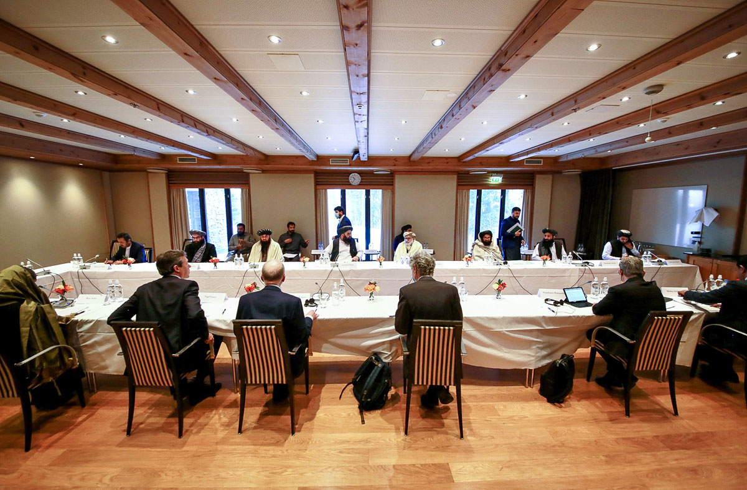
          - Meeting between the Taliban and various countries’ special representatives for Afghanistan in Oslo on 24 January 2022.
Photo: Ministry of Foreign Affairs
It can be easier to uncover conflict parties’ interests or hidden agendas when you have good knowledge of and follow the parties over time. As part of a long-term approach, insight and a certain degree of trust are built. The position of moderate forces internally can also be strengthened through dialogue with Norway and other countries. It can undermine the relationship with a party if one cuts off contact during difficult periods or goes public with criticism. The willingness of parties to negotiate often varies during a process and is often related to the situation on the ground, which a facilitator must take into account. Such assessments are demanding, and are relevant to several processes in which Norway is and has been involved. We assess current issues continuously and conduct extensive networking efforts to have the best possible situational awareness and be able to reduce political risk. Norway is also keen to learn from experience and continuously improve its process work.

Principles and pragmatism
When Norway deals with conflicts and associated violations of international law, there are various considerations that must be taken into account. There may be some tension between the need for firmness of principle and the need for pragmatism when working with conflicts.
For Norway, it is crucial that there is broad support for international law. It is also important for those affected by a conflict that negotiated solutions safeguard international law, including women’s rights and victims’ rights. That is why we are clear to the parties when we enter into a process, and principled when parties to a conflict do not respect international law, including humanitarian law and human rights. We have placed particular emphasis on not acting with what many call ‘double standards’. It is a banner issue for Norway to defend international law, regardless of who violates it. The most relevant examples are the violations of international law that Russia is responsible for in Ukraine, and those that Israel is responsible for in Palestine. Norway has, on the basis of principle, publicly condemned violations of international rights committed by both countries.
Norway’s approach to conflict resolution is value-based. At the same time, effective diplomacy requires that trust is built, even with actors in whom there is initially little confidence. In fact, being consistent in terms of values can strengthen contact with parties who do not share our views. They know what Norway stands for, and respect that we are open about it in discussions. At the same time, public condemnation of conflict parties can create distance. A negotiated solution could improve the human rights situation in a conflict area and prevent future violations of international law more effectively than public condemnation. It is therefore important to consider how criticism is presented:
Public criticism. Civil society and local actors can demand a clear Norwegian voice on censurable conditions in individual countries. On occasion, however, Norway’s condemnation of terrorist acts and violations of international law has led to interruptions of facilitation work for shorter or longer periods. Criticism must be weighed against the added value of maintaining contact with and trust in the parties. In some contexts, Norway supports joint acts and statements under the auspices of, for example, the UN and the EU, or we are part of an international division of labour where other countries front the criticism externally. Sometimes it is also necessary to change our approach. In Venezuela, after the presidential election in 2024, Norway chose to clearly distance itself from the conduct of the election, as did international observers and other countries. This represented a change of direction from our commitment as an impartial facilitator.
Confidential dialogue. Norway often raises violations of international law in confidential dialogue with the parties. This can be important to ensure a sustainable process and a viable end result. Many processes are undermined by the parties committing serious abuses at the same time as negotiations are ongoing. The parties can use the negotiating table to raise such issues. Dealing with violations of international law will almost always be crucial for a lasting peace solution.
Legal responsibility. Norway works for transitional justice and victims’ rights, which should be a key part of peace processes. Transitional justice is intended to ensure that those who have committed serious abuses in a conflict are held accountable, that the victims receive redress, and that the crimes do not recur. Norway is a state party to the International Criminal Court (ICC), which imposes a special responsibility where Norway assists as a facilitator of negotiations. Norway also supports the International Court of Justice in The Hague’s (ICJ) follow-up of potential violations of international law through advisory opinions. The two courts are crucial to ensuring respect for international law, including humanitarian law.
At the same time, the prospect of international prosecution may make actors in a conflict reluctant to find a peaceful solution. Finding a balanced solution between justice and a peaceful solution can be a demanding issue in a negotiation situation. How the issue is handled is often crucial to ensuring the legitimacy of a peace agreement, both nationally and internationally.
There is room for balanced trade-offs between a peace solution and the desire for a fair legal settlement. The ICC’s competence is based on the so-called complementarity principle. This means that the states themselves will have the main responsibility for prosecuting crimes. It is only in the event of an unwillingness or inability to carry out such a national prosecution that the court will be able to hear the case. If there is a genuine investigation at the national level of the same persons for similar crimes, the ICC will normally have to respect this. For example, Colombia chose to establish a special national court for peace, which the ICC respected with reference to the principle of complementarity. The fact that the parties established a truth commission and a commission for disappearances is also important to ensure the rights of victims in Colombia.

How impartial is Norway?
Norway has a tradition of impartial peace diplomacy in conflicts. Norway has rarely had strong national interests related to specific solutions or specific parties in the conflicts in which we have been involved. However, there are exceptions. In Afghanistan and Libya, Norway participated in NATO operations, while we also worked diplomatically for peaceful solutions.
Most of the conflicts Norway has been involved in in recent decades have been civil wars. The landscape is now also characterised by devastating interstate conflicts. In Russia’s war against Ukraine, Norway has clearly chosen sides, and it is out of the question to take on any role as an impartial facilitator. Russia’s attack on Ukraine in violation of international law affects important Norwegian, European, and allied security interests. Military and civilian support for Ukraine is fundamental for the country to be able to defend itself against Russia’s warfare and to ensure a solution that safeguards international law and Ukraine’s and Europe’s security needs. Norway and Ukraine are exchanging experiences in conflict resolution, and Norway is helping to strengthen Ukraine in negotiations. Norway is also taking diplomatic initiatives together with European partners and in close contact with the United States to support a peace process.
A prerequisite for Norwegian involvement in conflict resolution is that the parties to a conflict wish for and request such involvement. Norway’s role is to support the parties in finding agreed solutions. However, being impartial does not mean being value-neutral, and it is challenging if the parties enter into agreements that are contrary to international law. The peace talks in Doha in 2020 between the Afghan government on the one hand and the Taliban on the other never resulted in a peace agreement. If they had succeeded, it is likely that the agreement would have laid the foundation for a political system with stronger restrictions for women, as a result of demands from the Taliban. Could Norway have supported an outcome that ensured the absence of war at the expense of women’s inclusion and rights? The answer is not a given, as the alternative must also be considered. Continued war or an armed takeover (as was the case) also have devastating consequences, including for women and children.
In the current international situation, it is important to show the significance of impartial diplomacy with an emphasis on the ownership of the parties. Norway is often in a good position to assist conflict parties in finding good political solutions because we can step into impartial roles, while we at the same time have credibility when it comes to promoting international law.

Professionalisation
Norway’s peace efforts in conflicts in the 1990s and early 2000s had a visible value and promoted Norwegian interests in several ways. This created a need to strengthen, professionalise and systematise the work. The Ministry of Foreign Affairs established a separate section for peace and reconciliation in 2003. The goal was to gather a significant part of the operational work, the expertise created in the processes, the responsibility for grant schemes, and competence building. This has been important for Norway’s ability to learn from experience, ensure a high quality of work, and further develop efforts in the face of an ever increasing array of new situations.
The work of systematising and professionalising the efforts is continuous. According to the report A Good Ally: Norway in Afghanistan 2001–2014 (the so-called ‘Godal Report’) from 2016, Norwegian peace and conflict diplomacy in Afghanistan was important for professionalising the effort.
An important aspect of the work is the political commitment. In Norway, the effort is rooted at the political leadership level, while much of the day-to-day work takes place at the official level. Smooth interaction and a clear division of roles between the political leadership and the civil service make Norway’s diplomatic engagement effective and flexible, and have been key factors in achieving results. Decisions can be made quickly when needed. Political leadership contributes to processes, uses networks and contacts in relevant capitals, meets conflict parties, and undertakes visits on the ground.
Earmarked aid funds are a key part of the work for peace and conflict resolution. Grant funds for conflict resolution are channelled through Norwegian and international partners and local organisations at the country level. Grants also cover operational expenses for meetings and negotiations in which Norway is engaged, including security measures, meeting rooms and transport. Funding for the implementation of peace agreements is also important. This may include support for reforms, measures to strengthen human rights, the inclusion of women and vulnerable groups, demobilisation and reintegration of armed forces, judicial settlements, ombudsman functions and truth commissions.
A number of countries have recently wished to strengthen their involvement in peace processes and wish to learn from Norwegian experiences. Some seek to strengthen or build up an internal apparatus for peace diplomacy. Countries we are in contact with about this include Brazil, Canada, Cuba, Finland, Indonesia, Ireland, Kenya, China, Malaysia, Malta, Mexico, Oman, Qatar, Saudi Arabia, United Kingdom, Switzerland, Sweden, South Africa, Turkey, and Uruguay.
Several countries are investing considerable resources in conflict resolution, and strategic decisions are often made at the highest level. The increased interest among these countries shows a broad recognition that peace and conflict diplomacy is an area of foreign policy that is important for safeguarding national interests and that provides political capital.
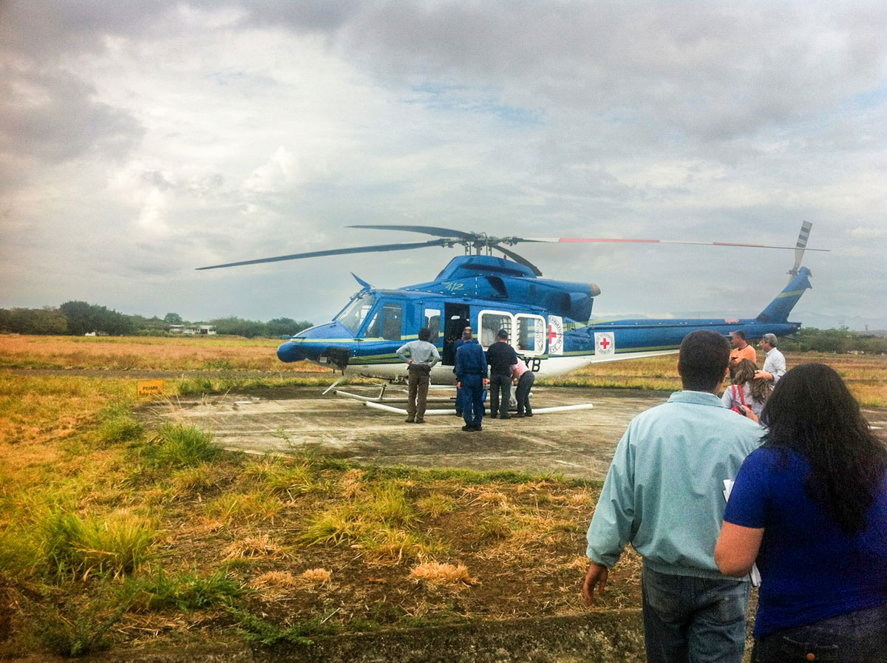
          - Several of the FARC’s delegates were flown by helicopter to take part in negotiations during the Colombian peace process. Here, a delegation is seen boarding an International Committee of the Red Cross helicopter in 2012.
Photo: Dag Nylander
              - The importance of good logistics
The importance of a well-prepared meeting cannot be underestimated. Logistics is often a large and important part of the work on conflict resolution. Peace processes can break down almost before they have begun, if the practical aspects go wrong. The following description is from a secret meeting in Norway between the parties to the war in Libya in 2011. It shows several of the dilemmas when arranging secret meetings, such as complying with the parties’ need for secrecy, avoiding a bad start, and treating the parties equally and with the respect they expect:
The delegations had to arrive separately. If they were left idle together in the hallway outside, there was a risk that the opening would go wrong. Besides, we had to decide who should go first. And where they should be placed. Those who came in and sat down first were, in a way, the room’s owners. If you are placed closest to the door, the feeling of being a visitor grows. Both can seem biased and be seen an expression that we as hosts have taken a stand. When two sovereign, independent states meet, this can be solved by placing a table crosswise with the short side facing the door. For us, it was more complicated. Gaddafi was still the ruler of a state, while the TNC was a rebel group in enemy territory. At the same time, Jalil and TNC were already recognised by France and Qatar, among others. In the end [… it was decided that we should] base ourselves on the formal status of the parties. Zidan knew that Norway did not regard his group as Libya’s new ruler. Gaddafi’s people should therefore sit down first, and the table could stand with the long side facing the door. We spent hours on similar details. The size and shape of the table, for example. And the meeting room. Intimate and small or grand and official? The decision was made to find a small room, preferably hidden deep inside a hotel, to create security. Then we had to track down a table that was short but wide enough to create sufficient distance. On the outside of the room, we needed two more meeting rooms. One for “B” and one for “T”, for clothes and phones, and for breaks in the meeting if the atmosphere became heated.1
1 Thune, H. (2023). Thune, H. (2023). Strengt fortrolig: Norges hemmelige forsøk på å stanse krigen i Libya. Kagge Forlag AS, side 162. (‘Strictly confidential: Norway’s secret attempt to stop the war in Libya’. Kagge Forlag AS, page 162. in Norwegian only.)
[Box ends]
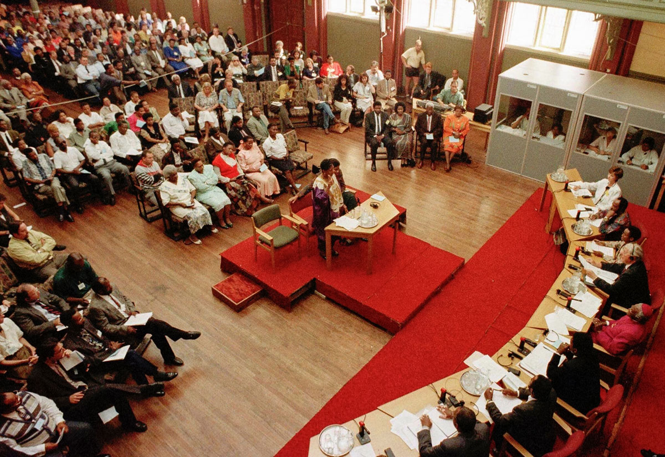
          - The first meeting of South Africa’s Truth and Reconciliation Commission was held in 1996. The commission was important for the country’s peaceful transition from apartheid to democracy.
Photo: Mike Hutchings/AP
              - Cooperation with South Africa
Norway has a long-standing cooperation with South Africa in the field of peace and reconciliation. South Africa has valuable experience from its own history of a peaceful transition from apartheid to democracy and is a major diplomatic power on the African continent. Norway’s commitment to counter racial segregation in South Africa became strong throughout the 1960s. Together with the Nordic countries, Norway provided political and financial support to the liberation movement, including the largest party, the African National Congress, and to refugees in neighbouring countries. Norwegian solidarity and aid organisations participated actively. Among other things, Norwegian Church Aid and the Inter-Church Council were part of a Christian network that worked strategically to combat the policy of racial segregation. The apartheid regime came to an end through several major and minor negotiations between political parties in the period 1990–1993. Norway actively supported these processes. After the first free elections in 1994, and before the country got a new constitution in 1996, the Truth and Reconciliation Commission was established. This was a pioneer in international reconciliation work and was led by Archbishop Desmond Tutu, who was awarded the Nobel Peace Prize in 1984.
Bilateral cooperation in this field currently has a particular focus on skills development and the inclusion of women in peace mediation and conflict resolution on the African continent.
[Box ends]

Partners
Norway’s international work for peace and conflict resolution is mainly led by the Ministry of Foreign Affairs, and this effort is an important part of the Foreign Service’s work. At the same time, Norway’s efforts are part of a larger whole, where we collaborate with a number of actors. Other ministries and agencies have important roles and contribute support to the work. Norwegian, local and international non-state actors are also valuable partners. In addition to the partners mentioned in this chapter, Norway works closely with a number of other countries. This is discussed in several other places in the white paper and is not repeated here.

Other Norwegian state institutions
The Ministry of Foreign Affairs is in close dialogue with other ministries and agencies and directorates that are relevant to peace initiatives and negotiations, including the Ministry of Justice, the Directorate of Immigration, the Ministry of Defence and the Ministry of Climate and Environment. There is also contact between the Ministry of Foreign Affairs and the Norwegian Intelligence Service in connection with several conflict situations, while the clear distinction between the roles of diplomacy and intelligence remains unchanged. Over the past twenty years, the Norwegian Police Security Service (PST) has built up operational expertise in security and logistics, and contributed to Norway being able to quickly and professionally offer confidential meeting places.

NOREF
The NOREF Centre for International Conflict Resolution was established in 2008 by the Ministry of Foreign Affairs as an independent foundation. NOREF works discreetly through self-initiated, informal, and operational diplomacy and support for Norwegian and international initiatives for conflict resolution. The funding comes from the Ministry of Foreign Affairs. NOREF works in several regions and countries, including in the Middle East, the Sahel, Myanmar, Colombia, and the Philippines.

Norwegian civil society organisations
Many Norwegian civil society organisations and church actors have worked in conflict areas over time. The humanitarian and development-oriented efforts, often based on local partnerships, have given these organizations a deep understanding of the area in which they work, a broad network in society, and access to key decision-makers. This has spurred several of them to explore opportunities for political dialogue and peace talks. Examples are Norwegian Church Aid’s engagements in a number of countries, including Eritrea and Ethiopia, Guatemala, Haiti, Mali, and East Timor, and Norwegian People’s Aid’s efforts in South Sudan and Myanmar, among others. The Norwegian Refugee Council, Caritas Norway, the Norwegian Red Cross and Save the Children are other Norwegian organisations that have been involved in various conflict countries. The Ministry of Foreign Affairs has good cooperation with the Norwegian organisations in conflict areas where Norway is involved.
Norwegian organisations have also consolidated their efforts through people-to-people cooperation with local communities in Norway. Various diaspora groups have also emphasised the importance of involving local communities and ensuring popular ownership of the political processes.
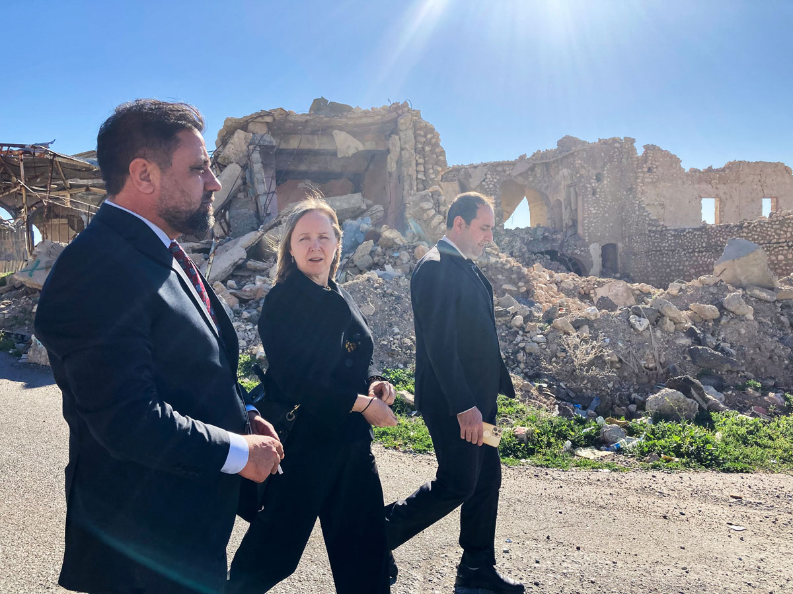
          - Photo from a NOREF visit to Sinjar in Iraq in 2023, nine years after IS attacked the Yazidi minority that has its main home there. NOREF supports dialogue work in the area to promote local cooperation and limit conflict.
Photo: Katja Strøm Cappelen/NOREF
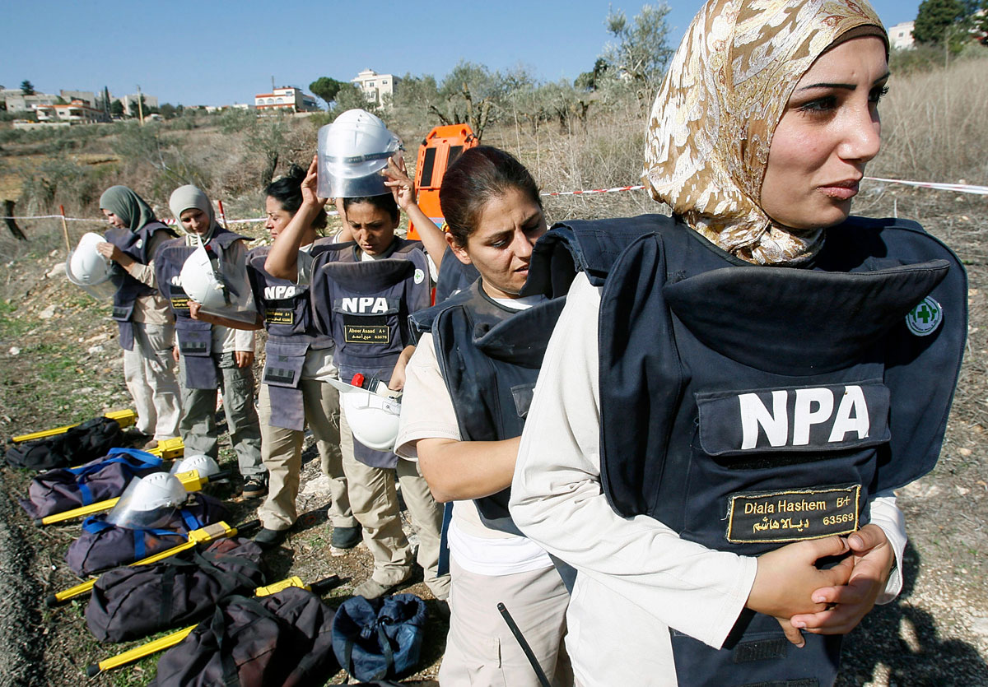
          - A team of deminers trained by Norwegian People’s Aid prepares to search for cluster bombs in a field near the city of Tibnin in southern Lebanon in 2008.
Photo: Ali Hashisho/REUTERS

International dispute resolution organisations
International and regional conflict resolution organizations have contributed to peace and conflict resolution around the world, often in cooperation with Norway. Norwegian funding is provided in the form of core support or project support. The areas of work range from local conflict resolution to facilitation of peace processes, humanitarian negotiations, and analysis activities. The organisations have expertise in many fields and provide advice to parties. They often play complementary roles to official actors such as Norway. In their own way, these organisations contribute to Norway achieving the goal of reducing and resolving conflicts.
For example, the Centre for Humanitarian Dialogue (HD) has supported the UN and Turkey’s facilitation of negotiations between Ukraine and Russia that resulted in the grain agreement in 2022, and it promotes dialogue on cooperation and risk management between countries in the South China Sea. In addition, HD has supported the UN in negotiating the ceasefire in Libya in 2020 and facilitated agreement on local ceasefires in the Sahel region. Promediation is also an important partner in the Sahel, facilitating local negotiations with local communities and armed Islamist groups to curb violence and increase humanitarian access. The Berghof Foundation contributes with capacity building and expertise for parties in conflict, with a particular focus on resistance groups and women. It works directly with women to strengthen their voice in negotiations, including in Sudan. It has helped negotiate local agreements for the distribution of water and other resources in Iraq and built a network of local resource persons who assist in clan conflicts in Somalia. The Berghof Foundation has also supported regional dialogue initiatives in Ethiopia (including dialogue between Oromo groups).
The international partners receiving Norwegian support include:
- Centre for Humanitarian Dialogue (HD)
- International Crisis Group (ICG)
- European Council on Foreign Relations (ECFR)
- Berghof Foundation
- Inter Mediate
- Promediation
- European Institute of Peace (EIP)
- Institute for Integrated Transitions (IFIT)
- Stimson Center
- Atlantic Council
- Dialogue Advisory Group (DAG)
In addition to the major international organisations, Norway supports local organisations involved in dialogue and conflict resolution work at the country level. These are often well placed to mitigate conflict in their areas. Norway gives particular priority to support for local women-led organisations.
              - The Oslo Forum and the collaboration with the Centre for Humanitarian Dialogue
In 2003, Norway and HD launched a joint peace mediation conference in Oslo. Since then, the Ministry of Foreign Affairs and HD have arranged the Oslo Forum 21 times. Each June, the Norwegian Minister of Foreign Affairs hosts around 100 peace mediators, decision-makers, experts and parties to conflict who gather to exchange experiences from peace diplomacy and conflict resolution.
The forum has become an important meeting place. The fact that parties to conflict also participate distinguishes Oslo Forum from many other international mediation conferences. Actors who cannot otherwise have contact often meet to explore the possibilities for dialogue in an ongoing conflict. The forum addresses current issues, with an emphasis on how contact diplomacy and facilitation can contribute to mitigating and resolving conflicts. In recent years, the Oslo Forum has been expanded to include regional conferences, with Oslo Forum events held in Beijing, Doha, Mexico City, and Muscat. In addition, HD and the Ministry of Foreign Affairs have a joint Oslo Forum podcast, The Mediator’s Studio.
[Box ends]
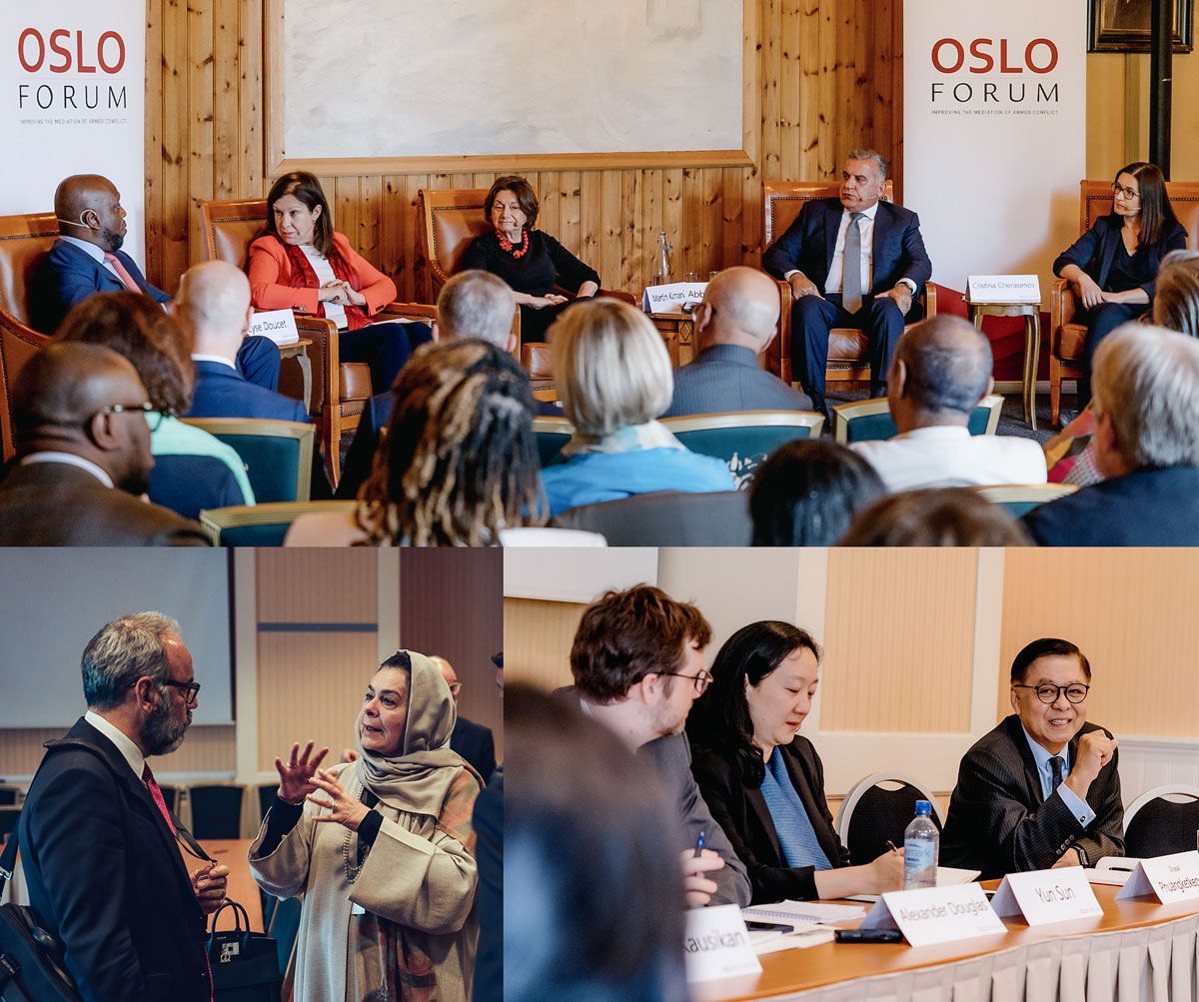
          - Participants in conversation during Oslo Forum in 2022 and 2024.
Photo: Centre for Humanitarian Dialogue and Flick/Ilja C. Hendel/Oslo Forum

United Nations
Norway is committed to supporting the UN’s role in peace diplomacy, which is enshrined in international law and values in the UN Charter and based on political neutrality. Norway has cooperated closely with the UN at various levels in a wide range of peace processes. Increased geopolitical tension between the permanent member states of the UN Security Council in recent years has stood in the way of the major wars we are facing, such as Russia’s war against Ukraine, the war in Gaza and the civil war in Sudan, being resolved through the UN. Nevertheless, the UN has a unique toolbox for peace, from preventive diplomacy to peace operations, special representatives, and peacebuilding at the grassroots level, which is supplemented and supported by the organisation’s work under the other pillars of comprehensive efforts. The Secretary General can provide so-called ‘good offices’ – a platform for talks between parties in conflict. The United Nations Department of Political Affairs and Peacebuilding (DPPA) plays a key role and is an important partner. With Norwegian support, it maintains a travelling team of experts in peace mediation who assist with advice and facilitation of peace processes (Mediation Support Unit, MSU).
UN peace operations, both peacekeeping operations and special political missions, play an important role in preventing conflict and maintaining peace. Norway is contributing personnel and funding to UN peace operations as part of our comprehensive peace efforts. Often, an operation will support and contribute to the implementation of peace agreements achieved through peace diplomacy and mediation. One example is the United Nations Verification Mission in Colombia (UNVMC), which monitors the implementation of the 2016 peace agreement. The Norwegian Armed Forces are currently contributing personnel to the UN peace operation in South Sudan (UNMISS) and the UN Observer Corps in the Middle East (UNTSO). The police also secondment personnel to UNMISS and UNVMC, and Norway sends civilian experts to UN operations through the Norwegian Resource Bank for Democracy and Human Rights (NORDEM).
UN peace operations have been under pressure over time, and it is now more than ten years since a new major operation was last established. This is due, among other things, to geopolitical tensions, a lack of resources, and the need for modernization. Strengthened cooperation with regional and sub-regional organisations, not least the African Union (AU), is an important part of the innovation in this area. Norway actively supports the reform efforts, based on a clear view that UN peace operations are an important tool for safeguarding international peace and security.

Regional organizations
In order for a peace process to make progress and produce results, regional anchoring is often crucial. Occasionally, peace processes are also initiated in – and by – the regions. Parties to conflict often need neighbouring countries to support peace and refrain from exacerbating conflicts. Regional cooperation can help neighbouring countries come together in supporting peace rather than emphasising competing interests that can exacerbate conflict. The region can also put pressure on parties if necessary. Key regional players include the African Union (AU), the Arab League (AL), the European Union (EU), the Organization of Islamic Cooperation (OIC), the Association of Southeast Asian Nations (ASEAN), the Organization of American States (OAS), and various sub-regional organizations.
Norway is well positioned to achieve results together with regional organisations. Norway has a strategic partnership agreement with the AU Commission and supports the AU’s work on peace and conflict management, as well as the AU’s work on women, peace and security, including the women peace mediator network FEMWISE. In Southeast Asia, Myanmar is the most high-profile conflict in which Norway has been involved. Our long history of support for peace and democracy in Myanmar has given Norway good insight into a complex conflict that is destabilising the region. This is valued in ASEAN. Since 2015, Norway has had a partnership with this association of ten countries that are home to 660 million people in Southeast Asia. This is Norway’s fifth largest trading partner after the EU, the UK, China, and the US. There is great potential for cooperation and trade in a wide range of fields of importance to Norway.

Cross-cutting priorities
Norwegian peace and conflict diplomacy encompasses several intersecting priorities where professional expertise has been built up over time. These are inclusion and women, peace and security, victims’ rights and transitional justice, and humanitarian diplomacy. There is increasing attention to climate change as a driver of conflict. Climate, the environment, food, and health are also included as an intersectional priority in the work on peace and conflict resolution. During Norway’s membership of the UN Security Council in 2021–22, Norway was a driving force for the Council to recognise the link between conflict, security, and climate change.
              - Peace and conflict resolution in a comprehensive approach
The Government has a comprehensive approach as the guiding principle for all Norwegian development assistance. This entails strengthened interaction between the three aid pillars: humanitarian protection, conflict resolution/peacebuilding, and long-term development. Experience indicates that when the efforts under the three pillars are coordinated, they have a mutually reinforcing effect. Assisting a crisis-stricken population and limiting the humanitarian consequences of armed conflict, improves the conditions for prevention and conflict resolution through political processes. Efforts to resolve conflicts and build peace also reduce humanitarian needs and lay the foundation for long-term development.
Reports from the Organisation for Economic Co-operation and Development (OECD) and a number of international evaluations point out that the peace dimension is the least emphasised part of an overall international effort and a so-called “missing link”. There is a lack of willingness globally to invest, politically as well as economically, in peace efforts. Norway’s extensive efforts to resolve conflicts and build peace stand out in this context. This is in line with aid recommendations and is also a strength for Norway as a humanitarian and development actor.
The term ‘peacebuilding’ is used for measures that alleviate the drivers behind – or the root causes of – conflict breaking out in a society. Doing something about the drivers of conflict is necessary for peace to be sustainable in the long term. As a member of the UN Peacebuilding Commission, Norway contributes to promoting peacebuilding in all global peace and development efforts.
An important part of Norway’s international peace efforts is also aimed at binding multilateral commitments with the goal of disarmament and non-proliferation of nuclear weapons, as well as democracy-building and safeguarding human rights, including women’s rights.
[Box ends]

Inclusion and women, peace and security
In order for peace processes to be legitimate and sustainable, it is important that the voices of the population are represented and heard. It is then not possible for 50 percent of the population to be excluded from discussions about the country’s future. In 2025, it will be 25 years since UN Security Council Resolution 1325 on Women, Peace and Security (KFS) was adopted. The resolution states that women play a crucial role in international peace and security, and that the international community must work to increase the representation of women at all levels in order to succeed in preventing, managing, and resolving conflict. Norway is one of the strongest supporters of the agenda and promotes it on many levels. In addition to its own efforts to increase the number of women in negotiating delegations, Norway supports civil society and research institutions in order to position women and their voices in conflict resolution.
              - Global Alliance of Women Mediators
Norway has long worked to strengthen the proportion of women peace mediators. In the major peace processes between 1992 and 2018, the proportion of women facilitators and mediators was only three per cent.1 In 2015, the Nordic countries took the initiative to establish a Nordic network of women mediators, which was launched in Oslo the same year, inspired by a similar South African initiative. The purpose was to promote women as experts and mediators in peace and reconciliation processes, not only women from the Nordic region, but also from other regions. The Norwegian network currently consists of over 50 members. PRIO, NOREF and the Ministry of Foreign Affairs have supported the work from the start. PRIO is the operational partner of the network.
Soon after the creation of the Nordic Women Mediators network, the AU’s FEMWISE, the Mediterranean Network, and the Commonwealth Network were established. In 2018, Norway took the initiative to bring them together in a global alliance for regional women’s mediator networks, which was launched in 2019. Shortly after, the Arab League Network and the Southeast Asian Women’s Mediator Network also joined the global alliance.
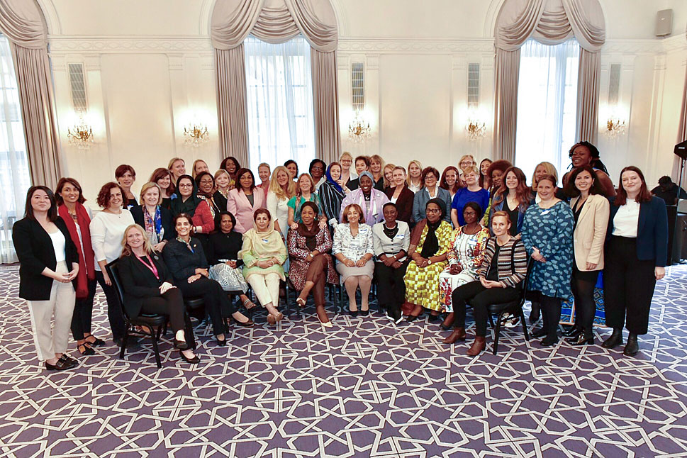
          - Norway was involved in the establishment of a global alliance of regional networks of women mediators, launched in New York in 2019. Norway participates actively in the global alliance, in close cooperation with the other members of the Nordic network.
Photo: Ministry of Foreign Affairs
1 UN Women. (2023). Facts and figures: Women, peace, and security. https://www.unwomen.org/en/articles/facts-and-figures/facts-and-figures-women-peace-and-security
[Box ends]
Conflict-related sexual violence is a widespread problem. Norway is strongly committed to mapping the problem, implementing measures to reduce such violence, supporting victims and survivors, and, not least, getting conflict parties to commit themselves to refraining from these types of methods of warfare.
In 2023, the Government launched Norway’s fifth national action plan on women, peace and security (WPS). The plan contains goals for Norwegian efforts, nationally and internationally. In addition, there are separate guidelines for WPS work with peace and conflict resolution.
Norway’s efforts are taking place in a context characterised by a decline in women’s and girls’ rights and participation globally. Russia’s war of aggression against Ukraine, the warfare in Gaza, and the civil war in Sudan have clearly shown how conflict has different consequences for the population depending on gender. In all these situations, women’s active involvement will be crucial to achieving lasting peace.
              - Inclusion of women in Colombia’s peace process
In the peace process between the authorities and the FARC guerrillas in Colombia, Norway encouraged the parties from the outset to include women. Norway shared experiences from other peace processes and made expertise available. Both parties included women in their delegations. The parties established a separate commission to safeguard women’s participation in the process and the gender perspective in the texts of the agreement. It was an innovation that representatives of the parties themselves were part of such a commission.
In order to include women’s and others’ voices in the process, delegations of women and representatives of the LGBTQ+ community were invited to Havana, where the negotiations were taking place. They shared their experiences of how the armed conflict had affected them and provided concrete input. They also met with the leadership of both parties. The Commission for Gender Equality actively contributed to the discussions on the decommissioning of arms, reintegration, and victims’ rights. The Truth Commission was to arrange for its own hearings of women and how the conflict had affected them. In the agreement on transitional justice, it was made clear that there would be no amnesty for sexual violence. The sub-agreements on land reform and rural development, political participation, and the fight against drugs had already been negotiated when the commission was established. These texts were reviewed again with a gender perspective. For example, it was explicitly stated that women shall have the right to own land and be given priority in the distribution of land, subsidies, and loans. A special committee was to ensure that women’s rights and the gender perspective were followed up in the implementation of the peace agreement. Norway was a driving force in this work.
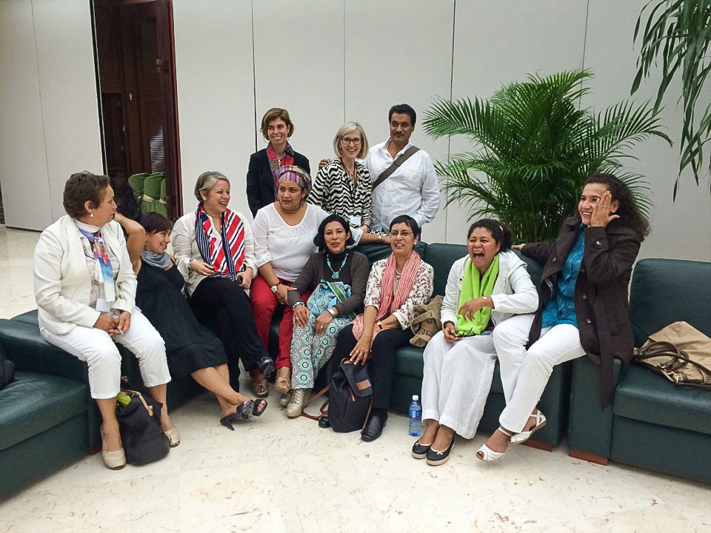
          - Members of the gender commission consisting of female negotiators in the Colombia process together with a representative of Norway.
Photo: Ministry of Foreign Affairs
[Box ends]
In many conflict countries, children, i.e. people under the age of 18, make up 50 per cent or more of the population. Norway supports young people’s engagement in line with Security Council Resolution 2250, the UN Convention on the Rights of the Child and the Security Council resolutions on children and armed conflict. Efforts are also made to include children in peace processes, not only as victims of war, but as active peacebuilders in their own communities. Save the Children, among others, is an important contributor to this.

Victims’ rights and transitional justice
In order for peace agreements to last over time and contribute to genuine reconciliation among the population, it is important that the parties agree on mechanisms for dealing with violations of international humanitarian law and crimes against humanity. This is to ensure accountability for abuses in a transitional phase between armed conflict and peace, or between dictatorship and democracy. Transitional justice aims to provide recognition and redress to victims and ensure that they are heard and included, strengthen individuals’ trust in state institutions, promote respect for human rights, and strengthen the rule of law. These are important steps towards reconciliation and the prevention of new human rights violations, and can lay the foundation for lasting peace. The likelihood of a mechanism succeeding is greater if the victims participate in its design.
It can be very challenging to negotiate agreement on a system of transitional justice that is both perceived as fair for the victims and acceptable to the responsible parties. There are different models for this, and Norway has key partners with good expertise in the field. Transitional justice can include both judicial and non-judicial mechanisms such as truth commissions, special courts, prosecution initiatives, restorative sentences, compensation to victims, law reforms, and establishing the rule of law. Measures to ensure victims’ rights to commemorate their dead and document events are also important. Norway supports initiatives by the UN Human Rights Council on mechanisms for obtaining documentation and testimony on human rights violations, which can subsequently be used in transitional justice processes. Such mechanisms exist in both Sri Lanka and Syria.
              - Colombia: Truth and Justice
The Special Jurisdiction for Peace (JEP) was established through the peace agreement with the FARC in Colombia in 2016, and deals with the most serious and systematic violations of humanitarian law that took place during the conflict. The Special Jurisdiction is one of three pillars of the transitional justice system established by the peace agreement. Together with the Truth Commission and the Special Unit for the Search for Persons reported missing in the context of and due to the armed conflict, the JEP will ensure justice for the many victims of the armed conflict. According to the Truth Commission’s final report presented in June 2022, more than 450,000 people lost their lives as a result of the conflict between the government and the FARC in the period 1958–2016, and more than eight million people were forcibly displaced.
JEP is independent and established for a period of 15 years. It investigates those who had senior responsibility, both in the guerrilla groups and in the government forces. Those who publicly take responsibility for serious crimes could receive a sentence of up to eight years of community service. The Special Jurisdiction has garnered great trust internationally, but is controversial in Colombia. The system is very complex, and it takes a long time to issue indictments and hand down sentences.
The JEP is not intended to investigate all atrocities committed during the conflict, but to establish a minimum of truth and justice, so that the country can move forward in the reconciliation process.
Norway is an important supporter of the JEP in Colombia and provides substantial support to the entire transitional justice system, including the follow-up of the Truth Commission’s final report and the work to find the remains of people who disappeared during the conflict.
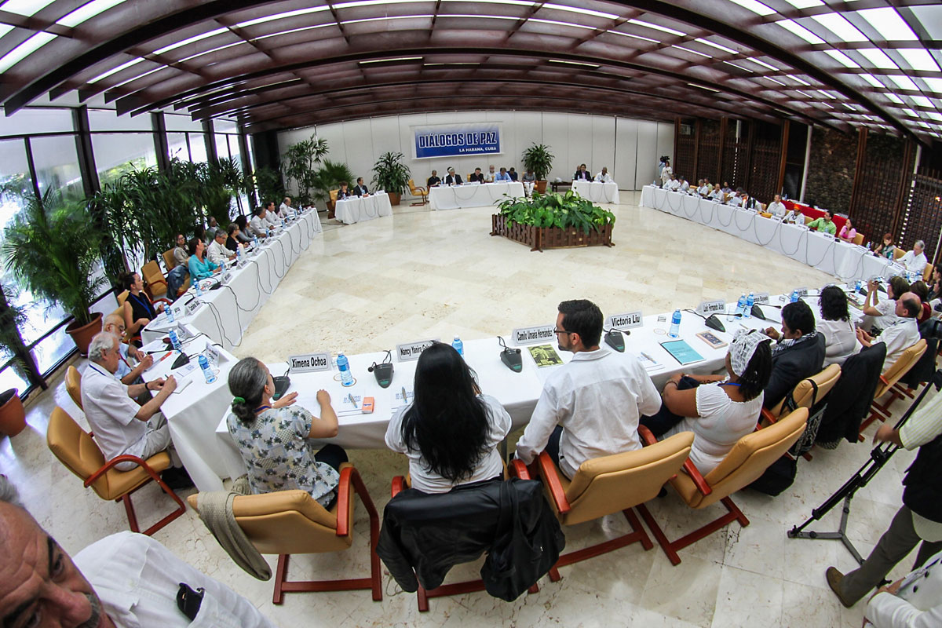
          - Together with Cuba, Norway has facilitated the peace talks between the Colombian authorities and the FARC guerrillas. Here from a meeting in Havana, Cuba, where victims of the conflict met the parties in 2014.
Photo: Ministry of Foreign Affairs
[Box ends]

Humanitarian diplomacy
Norway is a driving force in ensuring that parties to armed conflicts comply with their obligations under humanitarian law. Humanitarian diplomacy is intended to promote the protection of civilians and safeguard people’s rights, dignity and needs in armed conflicts and humanitarian crises. These are important topics in our contact with parties to conflict. We also work with humanitarian actors who negotiate access with governments and armed groups and work to ensure humanitarian protection.
Efforts to promote protection and humanitarian access are important elements of a peace process. To achieve results, we should initially talk to all relevant actors, including authoritarian regimes and non-state armed groups that have territorial control. We must have a long-term and systematic commitment. Humanitarian dialogue can be a common platform for parties to a conflict and help to create trust between them. Protection helps reduce the worst cases of violence and abuse resulting from warfare, which undermines trust and creates escalating cycles of violence, hatred and revenge. It is also important to depoliticise humanitarian efforts and ensure that humanitarian principles are respected. Humanitarian needs and obligations must not become bargaining chips in political processes.

Climate, environment, food and health
The links between conflict and climate change, food and health have become increasingly clear. Although climate and the environment in themselves are rarely direct triggers of war and conflict, climate change and environmental degradation are often one of several underlying causes, and can be a driver of conflict. The Intergovernmental Panel on Climate Change (IPCC) estimates that between 3.3 and 3.6 billion people live in conditions particularly vulnerable to climate change. Lack of water, food and nutrition security, arable land, education and jobs are increasing social and economic insecurity. This may lead to political and military conflict and migratory pressure, including in Europe’s neighbouring areas in Africa and the Middle East.
In a wider perspective, it is also the case that war and conflict contribute to major greenhouse gas emissions. In ongoing war and conflict situations, it is rarely possible to implement necessary climate and environmental measures. It is therefore important that parties to a conflict include climate, nature and basic services in their agenda for dialogue and negotiations. Cooperating on specific environmental and climate measures can also build trust for parties to a conflict, and may in some cases be less sensitive than other topics.
To date, there have been few processes and few peace agreements that have largely considered or included climate aspects, but this is a topic with increasing focus. Norway is in dialogue with conflict actors in this field, including in Colombia, where deforestation is a topic in its contacts with groups that control rainforest areas in the Amazon.

What do we achieve?
Good results ultimately depend on the parties’ willingness to find solutions and create lasting peace. Changes in a conflict situation are also influenced by other factors, and there are many factors over which parties to a conflict do not have control. Progress and setbacks are measured over a long period of time. Results come step by step and must be constantly fought for. There are many stages and different paths to a peace solution. The yardstick for results must therefore be more nuanced than the opposing poles of war and ‘lasting peace’. Norway can point to a number of processes in which our efforts have contributed to reducing or resolving conflicts, including in cases where a complete peace agreement has not been reached. For example, Norway has contributed to ceasefire agreements and humanitarian corridors that have had an impact on civilians, who are often the hardest hit by armed conflict.
Peace and conflict resolution work can involve small and often not immediately visible steps. In some cases, maintaining dialogue or building trust between conflicting parties can act as a brake on the conflict. The existence of a negotiating table can change the political expectations of the countries and actors involved, and can encourage the parties to show restraint so that the levels of violence decrease.
In this chapter, we discuss what Norway has achieved through active peace and conflict diplomacy in recent decades, in light of the three goals outlined in Chapter 3.1. We also describe useful experiences that will be taken into account in future work. This chapter is also limited to a selection of processes about which it is possible to have sufficient transparency.
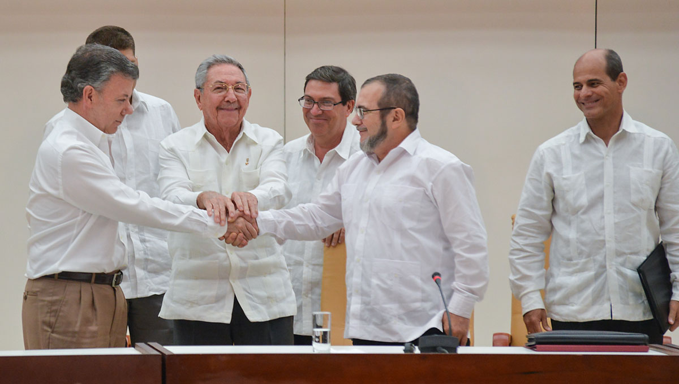
          - Together with Cuba, Norway has facilitated the peace talks between the Colombian authorities and the FARC guerrillas. Here from the signing of one of the sub-agreements in Havana, Cuba on September 23, 2015.
Photo: Omar Nieto

Mitigating and resolving international conflicts
Norway has supported a number of parties to conflict in resolving some of the bloodiest civil wars of recent decades, concluding ceasefires, opening up humanitarian access, implementing confidence-building measures, and avoiding escalation. Among the seven negotiation processes in which Norway has either been a formal facilitator or had a central role as an informal facilitator, six have resulted in various forms of negotiated agreements (Colombia, the Oslo Process, Sri Lanka, Venezuela, Guatemala, and Nepal) and one remains ongoing (the Philippines). Comprehensive peace agreements have been signed in Colombia as well as in Guatemala and Nepal.
In Colombia, the parties reached a final peace agreement in 2016 with Norwegian facilitation, which resulted in the demobilisation of about 13,500 former guerrilla soldiers from the FARC, a quarter of whom were women. The FARC ceased to exist as an armed organization. The agreement is being implemented, despite a number of challenges.
In Nepal, Norway contributed throughout the negotiation process that led to a comprehensive peace agreement in 2006. The agreement has largely been implemented, and Nepal is about to embark on the final part on transitional justice.
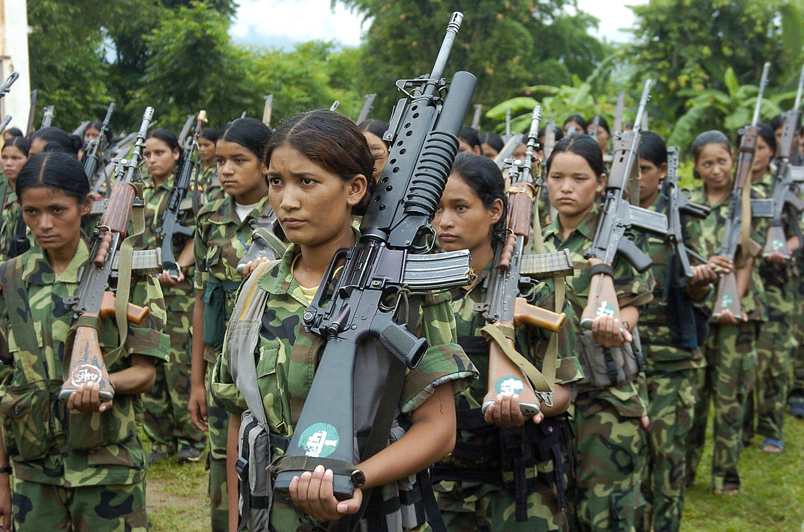
          - Norway provided a unique and informal meeting place for the parties during the peace process in Nepal, and supported the UN and monitoring of the peace agreement signed in 2006. The work included disarmament and integration of the Maoist forces, pictured here during the commemoration of a ceasefire in 2006.
Photo: NTB/REX (621908b)
In Sri Lanka, the parties, with Norwegian leadership, signed a ceasefire agreement with an associated monitoring mechanism, which produced humanitarian results during the years it was active from 2002 to 2008 (particularly in the period 2002–2006). The war was eventually ended militarily, while some of the political issues remained unresolved.
In Guatemala, Norway was an informal facilitator of talks between the authorities and the guerrilla group URNG, which resulted in a letter of intent in Oslo in 1990. Together with other countries, Norway supported the subsequent UN-led negotiation process that resulted in a peace agreement in 1996, three sub-agreements of which were signed in Oslo. An external evaluation from 1998 concluded that Norway played a significant role in ending the civil war in the country.
In Venezuela, the parties negotiated a letter of intent in 2021, as well as a number of partial agreements, without finding a lasting solution to the political conflict between the government and the opposition.
In the Philippines, Norway, together with NOREF, has facilitated the government’s negotiations with the communist movement and played a key role in the demobilization in Mindanao. The Philippine government and the rebel movement Moro Islamic Liberation Front entered into a peace agreement that resulted in the creation of a self-governing area in Muslim Mindanao. The decommissioning of arms and the reintegration of former soldiers back into civilian life have been crucial to ensuring a lasting peace. Norway has a leading role in the disarmament mechanism. By 2025, 26,000 of 40,000 former combatants will have been demobilised.
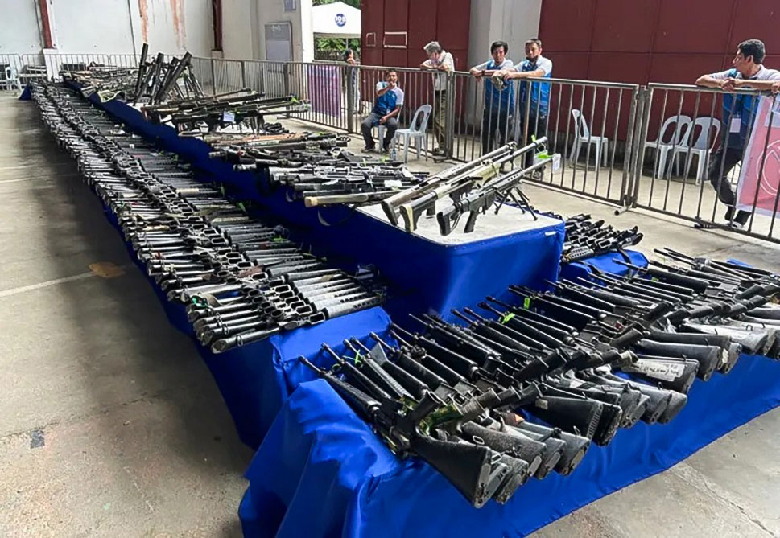
          - Norway has participated in various peace negotiations in the Philippines since 2001. This picture is from the disarmament process of former fighters from the Moro Islamic Liberation Front.
Photo: William Hovland/NOREF
In Ethiopia, Norway contributed to the AU’s mediation efforts in the Tigray conflict, which resulted in a ceasefire agreement in 2022. The conflict had led to extensive humanitarian suffering, gross human rights violations, and millions of people fleeing. It is estimated that there have been hundreds of thousands of war-related deaths. Through NORCAP, Norway contributed directly to the AU’s mediation efforts to support African ownership. It took two years to get the warring parties to the negotiating table, but when it first happened, a ceasefire agreement was negotiated in Pretoria within two weeks. Norway also supported the establishment of a monitoring mechanism at an early stage, which contributed to stabilisation and an incipient normalisation of everyday life for the inhabitants of Tigray. At the same time, this is a story about intensive negotiations and unresolved issues that were set aside along the way. The peace and the situation in Tigray remain fragile, and key questions remain.
In the Sahel region, local peace agreements negotiated with Norwegian support have reduced conflict, increased the mobility of the civilian population, and contributed to the reopening of schools. This is a result of Norway’s cooperation with NOREF and non-governmental organisations such as Inter Mediate, Promediation and HD, as well as local organisations and institutions that can exert influence on decision-makers. The inclusion of women has been challenging given traditional gender roles, but partners have managed to involve women through targeted dialogues. In Mali, Norway actively contributed to ensuring women’s participation in the monitoring committee for the peace agreement between the authorities and opposition groups (the Algiers Agreement).
The Oslo Accords between Israel and the PLO were an interim agreement that was planned to open up for new rounds of negotiations on the most difficult political issues. These have not yet been resolved, but the agreement was an important attempt to indicate a diplomatic path that for decades had broad support among our close allies and the majority of UN member states. The agreement also laid the foundation for an international effort to facilitate a sustainable Palestinian state by establishing basic institutions. The work for a two-state solution has now become far more difficult, but is still a high priority for Norway. We also contribute to solving problems that arise in the absence of a peace process and two-state solution.
A recent example was Israel’s decision to pay tax and customs revenues that it collects on behalf of the Palestinian Authority (PA), and which it long withheld after the terrorist attack on October 7, 2023. The situation had arisen due to a disagreement between the countries over transfers to Gaza, and the retention contributed to a critical economic situation for the PA. In dialogue with the parties, Norway, with the support of the United States, negotiated a temporary arrangement under which Norway was the intermediate station for part of the tax and customs revenues. This laid the foundation for the PA to receive almost 3 billion Norwegian krone from Israel, which meant that teachers, nurses, police officers and cleaners could once again receive salaries, and that basic services were maintained. Norway was able to play such a role because of good contacts and a high level of trust among key high-level figures in the countries involved. Since 7 October 2023, Norway has also used contacts with Israel and Hamas to work for access to Gaza for aid organisations.
In Syria, Norway’s long-term engagement and contact with all parties has been important in promoting humanitarian access and protection of civilians. This included the Assad authorities in Damascus and confidential contact with HTS when it controlled Idlib province. HTS was listed as a terrorist organization by the UN and subject to UN sanctions. Due to the sensitivities in Western countries regarding contact with a terrorist organization, Norway and HD stepped in and contributed to communicating messages. Among other things, the dialogue helped to ease international humanitarian access to Idlib somewhat. It also helped hinder the introduction of conservative legislation that HTS was considering introducing in the province. Overall, there is reason to claim that the dialogue helped cement HTS’s strategic choice away from jihadist ideology and towards seeking to become a responsible political actor.
When HTS took over power in Damascus in December 2024, Norway’s multi-year contact with the movement enabled us to quickly be in a position to talk to key people in the power apparatus and be able to discuss ideas for the way forward towards the reconstruction of a new and free Syria. Since then, the Norwegian dialogue with HTS has focused on including all Syrian society groups in the political process and finding agreed political solutions. The national dialogue conference in 2025 had this as its purpose, and both the conference and the follow-up have been supported by Norway via partner organisations. Norway has also supported local dialogues and preparatory work for transitional justice. It is too early to estimate the extent to which Syria will succeed in establishing an inclusive government that has broad acceptance among the population, and preventing the escalation of violence. But the opportunities are greater if the international community engages the new authorities in the crucial transition process.
Back channels and discreet contact with parties have resulted in a number of confidence-building measures in various conflicts. In Afghanistan, Norwegian contact diplomacy supported international efforts to implement measures such as the release of hostages and improved security in areas where the UN was working to combat polio. Between Serbia and Kosovo, Norway’s back channel contributed to the EU-led dialogue on normalisation and the Brussels Agreement in 2013. During the COVID-19 pandemic, Norway engaged in dialogue with various parties to conflicts on temporary ceasefires to prevent the spread of the virus and ensure humanitarian access, including in southern Thailand. In the Philippines, a long-term commitment has meant that Norway is listened to when we raise violations of humanitarian law with one or the other of the parties. Norway has helped secure ceasefires during holidays and the COVID-19 pandemic in the Philippines, and gained access to political prisoners. In Colombia, Norway has contributed to the release of a number of kidnapped civilians, prisoners of war, and hostages. Temporary ceasefires have been signed as part of the Colombian negotiation processes and have brought humanitarian relief to the local population. Negotiations with criminal networks in urban conflicts have led to a decline in the number of killings, kidnappings and recruitment of children in Colombian cities such as Medellin and Buenaventura.
In East Timor, Norway contributed to a national dialogue on reconciliation in the period 2006–2010. It was established at the request of the authorities and on the basis of Norwegian civil society support for the liberation of East Timor in 1999. Norway’s involvement helped to cool the situation and reduce tension between social actors, at a time characterised by political turbulence and social unrest. Dialogue initiatives and measures for inclusion and a fair legal settlement were carried out.
Negotiations can also result in a solution without reaching an agreement. An example is the previously mentioned confidential process between the Spanish government and the Basque resistance movement from 2005, which was facilitated by Norway and HD. The dialogue was regularly interrupted by crises as a result of terrorist attacks and domestic political disagreement, but the very existence of a process supported an expectation of a cessation of violence and strengthened the possibility of a political solution. ETA has emphasised the importance of the dialogue for its 2011 decision to lay down its arms. Spain emphasises, however, that to the extent that the talks worked (if at all), it was because they were followed by effective police operations and the imprisonment of a large number of people associated with ETA. At the same time, the process created an internal dynamic in the Basque Country that reduced support for ETA’s terrorist activities in the Basque resistance movement.

Promoting measures and solutions based on international law and the ownership of the parties
Norway’s principle is to promote political solutions that are in line with international law, including humanitarian law and human rights. This is communicated to parties in a conflict, often early in the process, and frequently both in public and behind closed doors.
The holistic perspective and the concrete experience from conflict work in the field contribute to Norway speaking with weight in the UN and other multilateral forums. An important concern for Norway has been to build consensus in the UN and among state and private actors that the approach to conflict resolution must be inclusive and safeguard key humanitarian and human rights rules.
Norway’s efforts in the field of peace and conflict resolution were an important contributing factor to Norway winning a seat on the UN Security Council in 2020. Our strongest cards in the election campaign were significant and consistent support for the UN, in combination with extensive experience as a facilitator in international peace processes. Women, peace and security, and the rights of children and young people were particularly emphasised during Norway’s membership of the Security Council in 2021–2022, along with peace diplomacy. For example, in 2021, Norway and Niger negotiated a unanimous adoption of Security Council Resolution 2601, which was the first resolution dedicated to the protection of education in conflict situations.
Among the processes that Norway has facilitated, it is in the Colombian process with the FARC that the clearest results have been achieved in terms of universal rights, in the form of separate agreement chapters on transitional justice, women, peace and security, indigenous peoples’ rights, the protection of human rights defenders and the strengthening of economic, social and political rights. The peace agreement in Nepal also paved the way for better fulfilment of universal rights. However, the inclusion of such provisions in agreements does not guarantee that the rights are respected.
In January 2016, the Syria Civil Society Room (CSSR) was established by the Office of the UN Special Envoy for Syria to promote an inclusive political process in Syria. NOREF and Swisspeace have been implementing partners for the UN in the work. The CSSR provides Syrian civil society actors with the opportunity to meet, exchange ideas, and contribute perspectives to the UN and other relevant actors. The CSSR has helped strengthen the role of civil society in the peace process and make the Syrian political dialogue more inclusive and representative. Norway has also supported the Women’s Advisory Board that includes women from various backgrounds in Syria. The Board has advised the UN Special Envoy’s Office since 2016, with extensive concrete input on the political process.
Following the Taliban’s takeover of power in Afghanistan, Norway has prioritised bringing the de facto authorities together with representatives of Afghan civil society and the international community. The Taliban’s top leadership has introduced an increasingly repressive policy towards women and girls. It is worth noting that several of the Taliban leaders who have participated in the talks with Norway, other countries, and Afghan women leaders over time have publicly challenged the current policy in Afghanistan. This cannot be attributed to Norway’s efforts alone, but is interesting in the assessment of the value of contact diplomacy in the longer term in this conflict. On a number of occasions in recent decades, Norway has ensured the inclusion of Afghan women in discussions about a peaceful solution in Afghanistan. Norway’s work has also helped to keep efforts to promote the position of women high on the international agenda.
In a number of countries, Norway has supported the countries’ national action plans for women, peace and security, including in the Philippines, which has built up a leading role in this field in Asia. Both the government and the communists are now providing solid representation of women in their respective negotiating delegations.
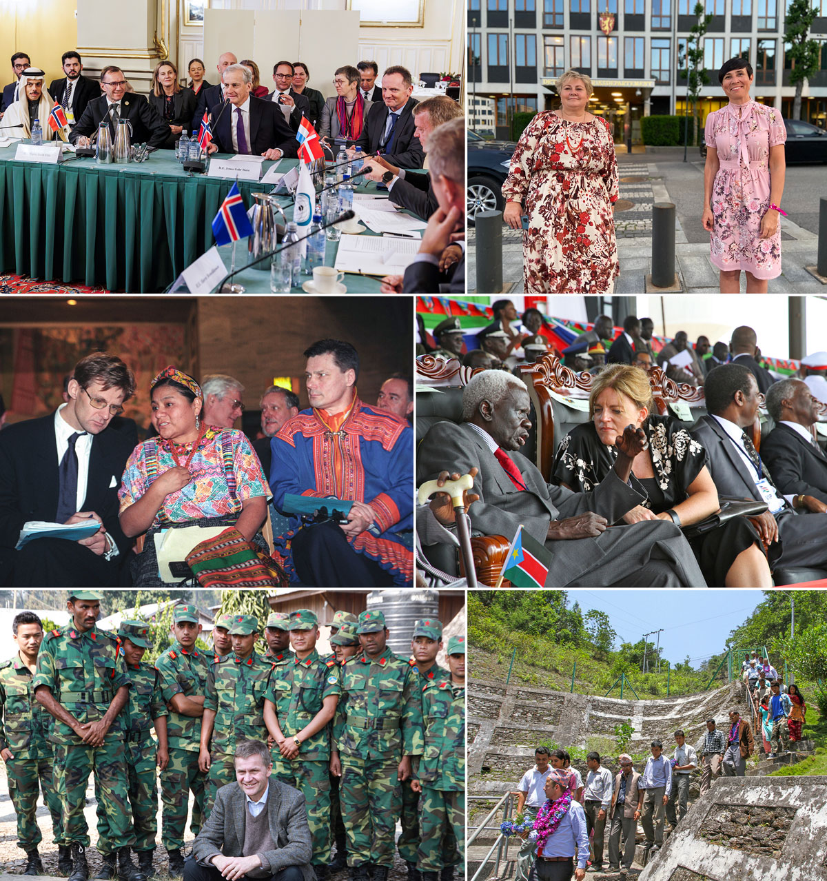
          - Broad political commitment to peace and conflict resolution.
Top left: Prime Minister Jonas Gahr Støre (Labour Party) and Minister of Foreign Affairs Espen Barth Eide (Labour Party) host foreign ministers from the Middle East, the Nordic countries and the Benelux countries in Oslo on Friday 15 December 2023 in a meeting on Gaza. Photo: Killian Munch/Ministry of Foreign Affairs
Top right: Prime Minister Erna Solberg and Minister of Foreign Affairs Ine Eriksen Søreide mark the election of Norway to the UN Security Council for the period 2021–2022. “We will use the experience gained from decades of work for peace and reconciliation to build bridges and seek solutions to the challenging conflicts that come before the Security Council,” said Prime Minister Erna Solberg when the election was decided. Photo: Marte Lerberg Kopstad/Ministry of Foreign Affairs
Centre left: Nobel Peace Prize laureate from 1992 Rigoberta Menchu with the President of the Sami Parliament, Ole Henrik Magga, and State Secretary in the Ministry of Foreign Affairs Jan Egeland (left, Labour Party). The parties to the civil war in Guatemala signed a peace agreement in Oslo City Hall in 1996. Photo: Berit Roald Scanfoto/NTB
Centre right: Norway’s former Minister of International Development Hilde Frafjord Johnson, here in conversation with Abel Alier, who was central to the liberation struggle, during a celebration to mark South Sudan’s 1st anniversary as the world’s newest state in 2012. Photo: Ministry of Foreign Affairs.
Bottom left: Minister of the Environment and International Development Erik Solheim visits Nepal in 2012. Here in Shaktikor camp in Chitwan, which is demobilizing former Maoist soldiers. Norway has supported the peace process in Nepal for a long time. Photo: Trond Viken/Ministry of Foreign Affairs.
Bottom right: Minister of International Development Heikki Holmås (Socialist Left Party) visited Nepal in 2012, where he followed up on the work on the new constitution. Photo: Lasse Bjørn Johannesen/Ministry of Foreign Affairs
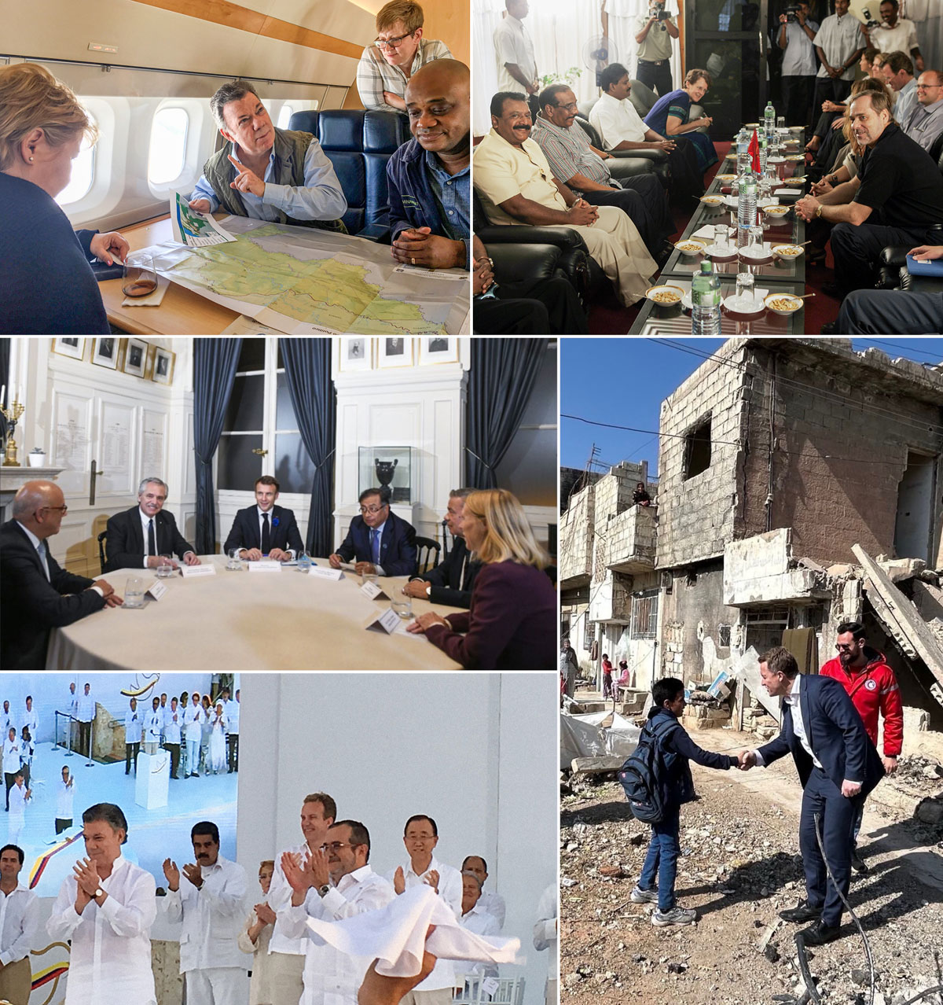
          - Broad political commitment to peace and conflict resolution.
Top left: Prime Minister Erna Solberg in dialogue with Colombian President Juan Manuel Santos in 2018 about deforestation in areas controlled by the FARC. Photo: Johan Vibe/Ministry of Foreign Affairs.
Top right: Minister of Foreign Affairs Jan Petersen (Conservative Party) in a meeting with the Tamil Tigers (LTTE) in Sri Lanka in January 2005. Photo: Heiko Junge/NTB
Centre left: Venezuela meeting in Paris in November 2022, hosted by President Macron with presidential colleagues from Argentina and Colombia, Foreign Minister Huitfeldt and the parties’ heads of delegation. Photo: Idun Tvedt/Ministry of Foreign Affairs.
Bottom left: Minister of Foreign Affairs Børge Brende (Conservative Party) attends the signing of the peace agreement between the Colombian authorities and the FARC in Cartagena on 27 November. September 2016. Photo: Ministry of Foreign Affairs
Bottom right: State Secretary Andreas Kravik (Labor) on a visit to Eastern Ghouta in Syria in February 2025 for talks with the new rulers. Photo: Yngvild Berggrav/Ministry of Foreign Affairs

Creating political capital and insight
Through its efforts to promote peace and conflict resolution, Norway builds contact with parties to conflict and gains an understanding of how they think and act. When we engage in processes that are important to allies and other countries, this contributes to close relations and political capital for Norway. The contact with various actors involved in conflicts around the world also gives us a deeper understanding of regional and global developments and the causes of conflict. This is valuable knowledge when we are to contribute to peace solutions, but is also of direct relevance to our national security analyses.
The dialogue with the United States has been particularly close in relation to most of Norway’s key peace engagements. Norway’s efforts in Latin America have led to close dialogue with the United States on issues such as security, the fight against drugs, and migration. Moreover, the United States has often valued our contact with groups with whom they themselves could not easily speak. Norway’s long-term contact with the Taliban, Hamas, the Houthi militia, and the Iranian authorities has mainly been part of an informal division of labour. In its contact with these groups, Norway has also consulted closely with other related European countries. For decades, the Troika cooperation between Norway, the United States, and the United Kingdom on Sudan and South Sudan has contributed to close relations, as have efforts to promote peace and contact diplomacy in Afghanistan.
Our ties to the EU will be even more important in the future in a turbulent time with major security challenges. The Partnership Agreement with the EU on Security and Defence Cooperation from May 2024 sets the framework for enhanced cooperation in the field of defence and security. The EU wished to institutionalise cooperation on conflict diplomacy with Norway, and this is now enshrined in the agreement. Joint support for Ukraine’s defence is also discussed. Norway plays a role in the expanded European diplomacy to achieve a solution to the war that safeguards Ukraine’s territorial integrity and independence, European security, and international law.
In terms of foreign policy, the room to manoeuvre in the field of peace and conflict resolution has often been greater for Norway than for other European actors, as we have not been bound by the EU’s common foreign and security policy. Norway has cooperated closely with the EU in conflicts from Afghanistan to Venezuela.
Peace and conflict diplomacy contributes to strengthening Norway’s bilateral relations with individual countries and organisations, including outside our closest circle of allies. Strengthening these contacts is in Norway’s interests, in a more unstable world where political and economic power relations are changing. There are many examples of how Norwegian engagements have given us valuable access around the world:
- Norway’s role as a peace actor, including in Latin America, was one of the reasons why Brazil invited Norway to join the G20 Guest of Honour in 2024. Guest of Honour membership has provided us with an arena for contact and interaction with the world’s largest economies.
- At the same time as China has increased its own ambitions with regard to contributing to peace processes, it has shown increased interest in Norwegian experiences from conflict areas both close to China (such as Myanmar and Afghanistan) and in the rest of the world (such as in the Middle East).
- Our work in Southeast Asia also provides close links to ASEAN as Asia emerges as an even more important region for Europe. In particular, the long-term efforts in the Philippines, Myanmar, Nepal and Sri Lanka have contributed to Norway’s credibility as a partner in Asia. This has laid the foundation for significant cooperation in several fields. Through this work, Norway has also gained good insight into China and India as actors in the region.
- In Afghanistan, contact with India, Iran, China, Pakistan, Qatar, Russia, and Turkey, as well as the United States, and European countries, was crucial to both understanding the framework within which Norway was working, and to creating confidence in the possibilities for a political solution. A number of countries have shown interest in Norwegian perspectives on Afghanistan.
- In the Middle East, Norway is in contact with countries such as Saudi Arabia, Oman, Turkey, Qatar, Egypt, and the United Arab Emirates on conflict resolution. One example is the collaboration with Saudi Arabia on the leadership of the global alliance for the implementation of the two-state solution. Norway’s support for regional de-escalation, conflict resolution, and cooperation is appreciated. Norway’s extensive engagement in the Middle East has contributed to close contact with – and good insight into – virtually all countries in the region and the dynamics between them.
- Norway, Oman, and Switzerland have trilateral cooperation on conflict resolution.
- In Latin America, the engagements have contributed to close contact with countries in the region, including Cuba, Brazil, Mexico, Chile, and Ecuador, as well as actors outside the region such as the EU, Turkey, and Russia.
- Norway has cooperated closely with Turkey on support for a political process between Somalia and Somaliland and on regional cooperation on Afghanistan.
- Norway’s efforts to resolve conflicts in the Horn of Africa have provided important links to the AU and the regional organisation IGAD.
These ties to a broad group of actors also provide a basis for working with coalitions of countries that wish to support international law, norm-based world trade, and multilateral solutions to conflicts and crises.

The way forward
As described in this white paper, Norway finds itself in a world of increased conflict and a great deal of uncertainty. The conflicts are also drawing closer to Norway. The international normative and institutional frameworks that we have largely taken for granted, and on which Norwegian security and welfare depend, are under pressure. No one can predict how deep and lasting these changes will be. It is likely that the number of wars and conflicts, as well as the level of geopolitical tension, will remain high. This will be a serious challenge and may lead to increased threats to Norway’s security, way of life, and values.
The need for peaceful international conflict resolution will increase. Despite many more brokers and facilitators on the scene, there is currently a decline in financial investment in peace and conflict resolution globally. There is a demand for Norway’s involvement in conflicts, which we expect to continue. Norway’s engagement in peace in recent decades has contributed to good international positioning. This must be maintained. Access to decision-makers in capitals around the world will be important for Norway in uncertain times. The insight we gain from being close to the parties and countries involved in conflicts is important for our understanding of global and regional developments. In order to be effective supporters of conflict resolution in a changing world, Norway must build on the lessons learned about what works and at the same time further develop its policies and tools in the field.
This will include:
- cooperating with several countries and actors that have different strengths and approaches to conflict resolution, for example working in combination with larger regional and global actors
- safeguarding our impartial profile where possible, but at the same time using Norwegian expertise in conflicts where we are partial, which is important, among other things, in order to contribute to peace and stability in Europe
- not losing focus on conflicts further away, which in various ways have an impact on Norwegian security and other national interests
- continuing to act discreetly, talking to all parties, and seeking to contribute to inclusive peace processes in which the parties have ownership, which provides more sustainable solutions, and which is important at a time when the international focus is often shifting towards short-term stabilisation
- continuing to emphasise the safeguarding of international law and the strengthening of human rights. Norway has a clear interest in a stable global order based on international law. This is something we also gain recognition for in broad groups of countries that have reacted to double standards in various conflicts.
The heightened security policy situation and a more unpredictable Russia require that we must invest more in the security and defence of Norway. This is the reason why all parties in the Storting support the Long-Term Plan for the Defence Sector and why the Government has presented the first national security strategy. Continued clear efforts in peace and conflict diplomacy are necessary in parallel with the strengthening of the security and defence sector. Prioritising this work further will contribute to policy formulations and solutions in a new and unpredictable time in international politics, and also ensure that what has been built up through Norwegian capital in the field is not lost. This is a cost-effective investment. The work for peace and conflict resolution must be seen in the context of security policy and other efforts to safeguard national interests. This requires strengthened cooperation with other ministries and state institutions.
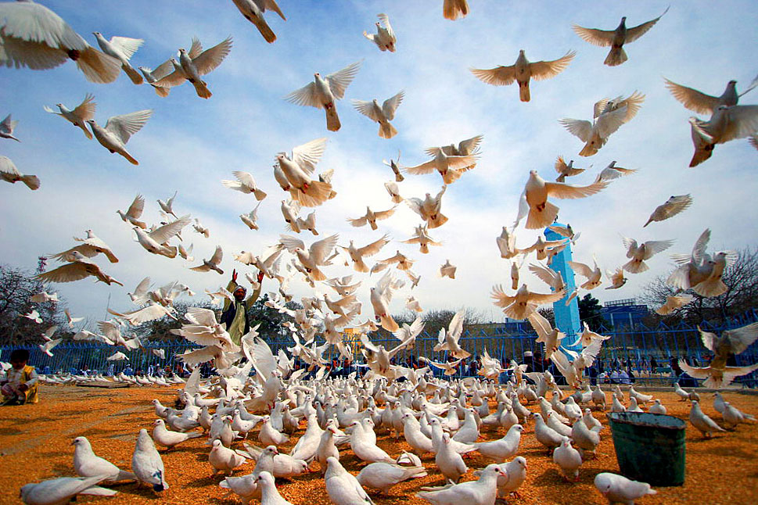
          - The commemoration of the International Day of Peace in Afghanistan in 2007.
Photo: Helena Mulkerns/Flickr/UN Photo

Measures
The Government will prioritise:
- maintaining Norway’s key role in international peace and conflict resolution, including systematising learning and skills development, preserving Norwegian strengths and using new tools and working methods in the face of new developments
- ensuring sufficient resources and expertise to promote Norwegian efforts for peace and conflict resolution in line with the high political priority given to the field
- strengthening the interaction between Norway’s security policy efforts and efforts to promote peace and conflict resolution
- emphasising the Norwegian profile, which entails being able to act discreetly, efficiently, flexibly and long-term, in contact with all relevant parties, and with a willingness to take political risks when deemed necessary
- strengthening national coordination and cooperation across ministries and subordinate government agencies and units
- considering an increased local presence in prioritised processes within the current budget
- utilising the opportunities offered by the Oslo Forum as an important arena for networking and dialogue between relevant international mediators and parties in conflict
- targeting the implementation of Security Council Resolution 1325 and National Action Plans on Women, Peace and Security
- helping parties to conflict to incorporate climate and nature into their agenda for dialogue and negotiations
- strengthening cooperation across countries and with new prominent actors in the field of peace and conflict resolution
- collaborating with Norwegian and international organisations working in the field, including the UN, civil society, the private sector, academia, the media, and interest groups

Financial and administrative consequences
It is assumed that the measures and policies outlined in this white paper will be covered within the current budget.
The Ministry of Foreign Affairs
recommends:
that the recommendation from the Ministry of Foreign Affairs concerning Norway’s efforts to promote peace and conflict resolution in a troubled world dated 10 June 2025 be submitted to the Storting.

The Storting (2025). Resolution 101 for the National Budget 2025. Prop. 1 S (2024–2025), recommendation. 2 S (2024–2025). https://www.stortinget.no/no/Saker-og-publikasjoner/Vedtak/Vedtak/Sak/?p=100203
Office of the Prime Minister (2025). National Security Strategy. Regjeringen.no https://www.regjeringen.no/no/dokumenter/nasjonal-sikkerhetsstrategi/id3099304/
Prop. 87 S (2023–2024) The Defence Pledge – for Norway’s Security – Long-term Plan for the Defence Sector 2025–2036. Ministry of Defence. https://www.regjeringen.no/no/dokumenter/prop.-87-s-20232024/id3032217/
Calculation of percentage from figures from the National Budget 2025 (blue book, balanced budget adopted by the Storting in the autumn of 2024). The total amount for the aid budget (balanced budget 2025) is NOK 58,044,000,000 and the total for Chapter 151, item 70 peace and reconciliation is NOK 395,260,000.
Established through the Helsinki Final Act of 1975 and further developed after the fall of the Berlin Wall in 1989 with a more united Europe and EU and NATO expansion.
Office of the Prime Minister (2025). National Security Strategy. Regjeringen.no https://www.regjeringen.no/no/dokumenter/nasjonal-sikkerhetsstrategi/id3099304/
Rustad, S.A. (2025). Conflict Trends: A Global Overview, 1946–2024. PRIO Paper. Oslo: PRIO. Forthcoming 11 June 2025.
Rustad, S.A. (2024). Conflict Trends: A Global Overview, 1946–2023. PRIO Paper. PRIO. https://www.prio.org/publications/14006 and Uppsala University. (n.d.). Uppsala Conflict Data Project (UCDP). accessed 18 May 2025 at https://ucdp.uu.se/
Four interstate conflicts in 2025 from UCDP 2025. These are: Ukraine–Russia, Afghanistan–Pakistan, USA/UK–Yemen and Iran–Israel. PRIO. (2025). Conflict Trends – published June 10, 2025.
Uppsala University. (n.d.). Uppsala Conflict Data Project (UCDP). Accessed 18 May 2025 at https://ucdp.uu.se/
Institute for Economics & Peace. (2024). Global Peace Index 2024. https://www.economicsandpeace.org/wp-content/uploads/2024/06/GPI-2024-web.pdf
OECD. (2023). Peace and Official Development Assistance. OECD Development Perspectives, 37. OECD Publishing. https://www.oecd.org/en/publications/peace-and-official-development-assistance_fccfbffc-en.html
Report No. 22 (2023–2024) to the Storting, Government Pension Fund 2024. Ministry of Finance. https://www.regjeringen.no/no/dokumenter/meld.-st.-22-20232024/id3033198/
Harpviken, K. B. & Tryggestad, T. L. (2025). Norsk fredsengasjement: Spenning mellom idealisme og interesser? I Svendsen, Ø. & Haugevik, K. (Red.) Dilemmaer i norsk utenrikspolitikk (1. utg). Cappelen Damm Akademisk. (Norwegian Peace Engagements: Tension between Idealism and Interests?’ I Svendsen, Ø. & Haugevik, K. (Eds.). Dilemmas in Norwegian Foreign Policy (1. edition). Cappelen Damm Akademisk. (in Norwegian only)
Pharo, H. Ø. (2023). Folkeforbundet og De forente nasjoner: Stormakter og småstater i en ny verdensorden – og Norges plass i den. I H. Ø. Pharo, Ø. Østerud, J. Simensen og S. Engh (Red.), Kampen for en ordnet verden: Folkeforbundet, FN og Norge. (‘The League of Nations and the United Nations: Great Powers and Small States in a new World Order – and Norway’s place therein’. I H. Ø. Pharo, Ø. Østerud, J. Simensen and S. Engh (Eds.), Kampen for en ordnet verden: Folkeforbundet, FN og Norge. (‘The Struggle for an Orderly World: The League of Nations, the UN, and Norway’) Dreyers forlag. (in Norwegian only)
Tamnes, R. (1997). Norsk utenrikspolitikks historie: Bd. 6. Oljealder. 1965–1995. (The History of Norwegian Foreign Policy: vol. 6. The Age of Oil. 1965–1995’. Universitetsforlaget. (in Norwegian only)
Egeland, J. (1989). Impotent superpower – potent small states: Potentials and limitations of human rights objectives in the foreign policies of the United States and Norway. Oxford University Press.
Report No. 40 (2008–2009) to the Storting on Norway’s Humanitarian Policy. Ministry of Foreign Affairs. https://www.regjeringen.no/no/dokumenter/stmeld-nr-40-2008-2009-/id563842/ and the Ministry of Foreign Affairs. (2008). Norway’s Humanitarian Policy. https://www.regjeringen.no/globalassets/upload/ud/vedlegg/hum/hum_strategi_web08.pdf (in Norwegian only)
Nissen, A. (2015). The Peace Architects: Norwegian Peace Diplomacy Since 1989 [PhD thesis]. Department of Archaeology, Conservation and History, University of Oslo.
Report No. 15 (2008–2009) to the Storting on Interests, Responsibilities and Opportunities – Main Lines of Norwegian Foreign Policy. Ministry of Foreign Affairs. https://www.regjeringen.no/no/dokumenter/stmeld-nr-15-2008-2009-/id548673/
Report No. 1 (2024–2025) to the Storting on the National Budget 2025. Ministry of Finance. https://www.regjeringen.no/no/dokumenter/meld.-st.-1-20242025/id3056833/ and Prop. 1 S Appendix 2 (2024–2025) For the financial year 2025 – Amendment of Prop. 1 S (2024–2025) National Budget 2025 and Prop. 1 LS (2024–2025) Taxes and duties 2025 (balancing). Ministry of Finance. https://www.regjeringen.no/no/dokumenter/prop.-1-s-tillegg-2-20242025/id3072373/
Calculation from figures from the National Budget 2025 (blue book, balanced budget adopted by the Storting in the autumn of 2024). The total amount for the aid budget (balanced budget 2025) is NOK 58,044,000,000 and the total for Chapter 151, item 70 peace and reconciliation is NOK 395,260,000.
The Norwegian Police Security Service (PST). (2025). National Threat Assessment 2025. https://www.pst.no/globalassets/2025/nasjonal-trusselvurdering-2025/nasjonal-trusselvurdering-2025_no_web.pdf (in Norwegian only)
Ministry of Foreign Affairs. (December 12, 2023). Condemning attack on Norwegian ship in the Red Sea. Regjeringen.no. https://www.regjeringen.no/no/aktuelt/fordommer-angrep-pa-norsk-skip-i-rodehavet/id3018236/
NOU 2016: 8 A Good Ally: Norway in Afghanistan 2001–2014. https://www.regjeringen.no/no/dokumenter/nou-2016-8/id2503028/ pg.155
According to the UN, at least 100,000 killed. The number of casualties is uncertain, as no aid organisations or other international actors were allowed into so-called safe zones during the final phase of the war in 2009, and in 2011 the UN estimated the total number of civilians who died during the last months of the war at 40,000. Around 330,000 were trapped in the so-called safe zones. Petrie, C. (2012). Report of the Secretary-General’s Internal Review Panel on the United Nations Action in Sri Lanka. https://digitallibrary.un.org/record/737299?ln=en&v=pdf
Sørbø, G.M., Goodhand, J., Klem, B., Nissen, A.E. and Selbervik, H. (2011). Pawns of peace. Evaluation of Norwegian Peace Efforts in Sri Lanka, 1997–2009 (Evaluation Report no. 5/2011). NORAD. https://www.cmi.no/publications/4233-pawns-of-peace-evaluation-of-norwegian-peace
Center for Preventive Action (2025, April 15). Civil War in Sudan [Global Conflict Tracker]. https://www.cfr.org/global-conflict-tracker/conflict/power-struggle-sudan
Ministry of Foreign Affairs. (2025, March 19). We condemn Israel’s resumption of hostilities in Gaza. Regjeringen.no. https://www.regjeringen.no/no/aktuelt/fordommer-israels-gjenopptakelse-av-krigshandlinger-i-gaza/id3092845/
NOU 2016: 8 A Good Ally: Norway in Afghanistan 2001–2014. https://www.regjeringen.no/no/dokumenter/nou-2016-8/id2503028/
Ministry of Trade, Industry and Fisheries. (2025, January 24). ASEAN – Declaration of Cooperation. Regjeringen.no. https://www.regjeringen.no/no/tema/naringsliv/handel/nfd---innsiktsartikler/frihandelsavtaler/partner-land/asean-samarbeidserklaring/id3084735/
Ministry of Foreign Affairs. (2022, January 14). Norway’s key leadership tasks in UN Security Council. Regjeringen.no. https://www.regjeringen.no/no/aktuelt/sentrale-lederoppgaver/id2895563/
Office of the Special Adviser on Gender Issues and Advancement of Women (OSAGI). (n.d.) Landmark resolution on Women, Peace and Security. https://www.un.org/womenwatch/osagi/wps/
Ministry of Foreign Affairs (2023). The Government’s Action Plan: Women, Peace and Security (2023–2030). Regjeringen.no. https://www.regjeringen.no/no/dokumenter/regjeringens-handlingsplan-kvinner-fred-og-sikkerhet-2023-2030/id2993862/
United Nations. (2015, December 9). Security Council, Unanimously Adopting Resolution 2250 (2015), Urges Member States to Increase Representation of Youth in Decision-Making at All Levels. https://press.un.org/en/2015/sc12149.doc.htm
Security Council Report. (approx.). UN Documents for Children and Armed Conflict. Accessed 18 May 2025, at https://www.securitycouncilreport.org/un-documents/children-and-armed-conflict/
O’Kane, C., Feinstein, C. and Giertsen, A. (2009). Children and Young People in Post-Conflict Peacebuilding. DCAF. https://resourcecentre.savethechildren.net/document/children-and-young-people-post-conflict-peacebuilding; Freedson, J. and Kemper, Y. (2023). Building Peace with Children – Expanding Children’s Participation in Peace Processes. Save the Children International. https://resourcecentre.savethechildren.net/document/building-peace-with-children-expanding-childrens-participation-in-peace-processes
Ministry of Foreign Affairs. (2024). Norway’s Humanitarian Strategy. https://www.regjeringen.no/no/dokumenter/strategi-for-norsk-humanitar-politikk/id3039373/
Sørbø, G. M. et. al. (1998). Norwegian Assistance to Countries in Conflict. The lessons of experience from Guatemala, Mali, Mozambique, Sudan, Rwanda and Burundi (Evaluation Report 11.98). CMI/PRIO on behalf of the Ministry of Foreign Affairs.
Lorentzen, J. (2025). Explaining changes in women’s representation in peace processes: The adoption of a gender quota in the Agreement Monitoring Committee in Mali. International Political Science Review, 0(0). https://doi.org/10.1177/01925121251323483
The Prime Minister’s Office and the Ministry of Foreign Affairs. (2024, February 18). Norway assists in scheme for crucial transfers from Israel to Palestine. Regjeringen.no. https://www.regjeringen.no/no/aktuelt/norge-bidrar-til-avgjorende-ordning-for-pengeoverforinger-fra-israel-til-palestina/id3025994/ and the Ministry of Foreign Affairs. (2025, January 12). Norway is transferring Palestinian clearance revenues. Regjeringen.no. https://www.regjeringen.no/no/aktuelt/palestinske-skattepenger-overfores/id3083079/
Pedersen, N. (2009). Pedersen, N. (2009). Den gode viljen. Ein dokumentar om norsk fredspolitikk. Spartacus forlag. (‘The Good Will. A Book on Norwegian Peace Policy’. In Norwegian only)
Nissen, A. (2023). Sikkerhetspolitikkens primat – norsk freds- og forsoningspolitikk under Ine Eriksen Søreide. (‘The Primacy of Security Policy: Norwegian Peace and Reconciliation Policy During Ine Eriksen Søreide’s Term’. In Norwegian only) International Politics, 81(1), 3–13. https://doi.org/10.23865/intpol.v81.4102
United Nations Security Council. (2021, October 29). Resolution 2601. https://www.securitycouncilreport.org/atf/cf/%7B65BFCF9B-6D27-4E9C-8CD3-CF6E4FF96FF9%7D/s_res_2601.pdf
The Ministry of Foreign Affairs and the Ministry of Defence. (2024, May 28). Norway and the EU sign Security and Defence Partnership. Regjeringen.no. https://www.regjeringen.no/no/aktuelt/norge-og-eu-inngar-avtale-om-forsvars-og-sikkerhetspolitisk-samarbeid/id3040958/

