Official Norwegian Reports NOU 2022: 12
The Fund in a changing world
The Government Pension Fund Global and new economic and political developments
To the Ministry of Finance
The Commission was appointed by Royal Decree on 3 September 2021 to examine which international economic and political developments may be of relevance to the Government Pension Fund Global some years into the future, as well as their potential implications for the management of the Fund. The Commission is hereby submitting its report. Its recommendations are unanimous.
03N0xx2
Oslo, 26 September 2022
Ulf Sverdrup (Chair)
Harald Magnus Andreassen |  | Olav Chen | Alexandra Bech Gjørv
Jon Gunnar Pedersen |  | Helge Seland | Inger Stensaker
Olaug Svarva |  |  | Jonas Tallberg
Karin Thorburn |  |  | Astrid Undheim
 |  |  | Thomas Ekeli (Head of Secretariat)
 |  |  | Tom Arild Fearnley
 |  |  | Leiv Lunde
 |  |  | Julie Michelet
 |  |  | Anita Nergaard
 | Ingeborg Cecilia Seeberg
 |  |  | Aslak Skancke
 |  |  | Yngvar Tveit
 |  |  | Fredrik Willumsen
 |  |  | Vibeke Øi
 |  |  | Petter Ølberg
 |  |  | Eivind Øy

Executive summary
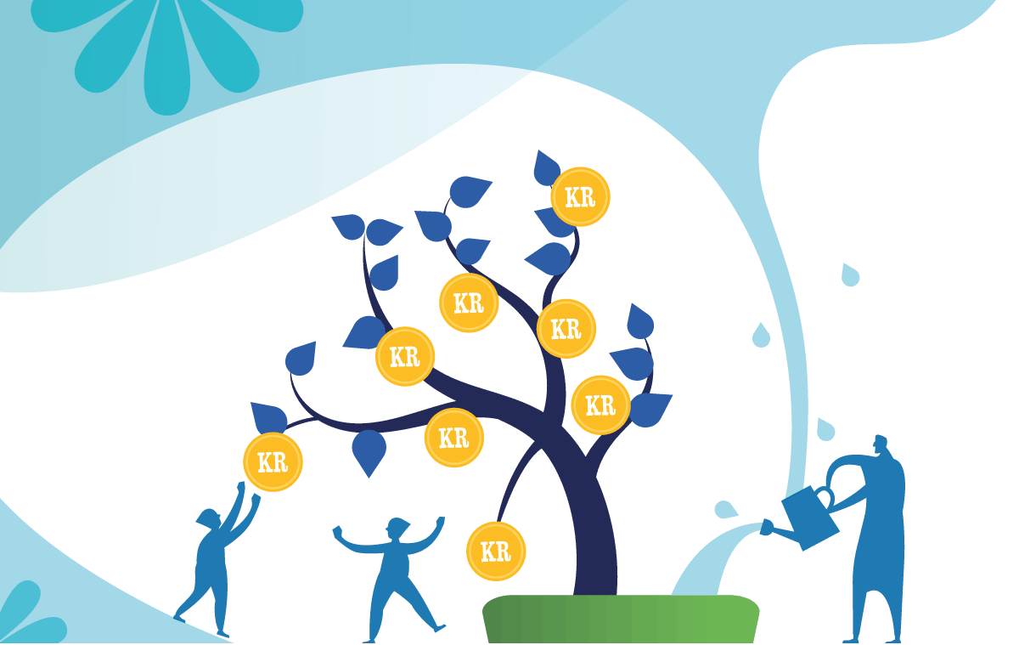

Unique latitude
The Government Pension Fund Global (GPFG) has given Norway considerable room for manoeuvre. Norway has reaped large gains from oil and gas activities. These revenues have been channelled into a fund; currently valued at close to NOK 12,000 billion, which is managed with a financial objective for the benefit of both current and future generations.
Norway’s wealth depends on international developments
The establishment and development of the Fund has transformed Norway from a petrostate to also being an investor state. Oil price risk has gradually been replaced by the risk arising from fluctuations in the international financial markets. The Fund has over the same period become an increasingly important source of public expenditure funding. Future welfare in Norway is therefore increasingly dependent on international economic and political developments. In this report, we analyse some key developments and discuss how the Fund and Norway can best respond to a changing world.
Policy facilitated high economic growth
The petroleum resources were a natural endowment, but the technology, the policy, the investment management model and the Fund are all manmade. Democratic political decisions ensured that most of the petroleum wealth accrues to the Norwegian population and is managed in a prudent manner. It was at the same time recognised that the key component of a strong economy is a highly-skilled, productive and adaptable labour force.
We are currently experiencing a global energy crisis. The oil and gas industry, including the offshore supply industry, has a prominent role in European energy security and the revenues are large. In the longer term, the role of these industries will decline and change. Much of the industrial and commercial expertise that has been developed is likely to be of benefit in new emerging industries.
The Fund has grown dramatically
The value of the Fund has grown rapidly since its inception in 1996. The Fund value reached NOK 2,000 billion in 2007 and is now close to NOK 12,000 billion. Its growth has been especially steep in the last few years. The downturns have been few and short. No one envisaged such growth 25 years ago. In 2021, the GPFG was valued at almost four times Mainland Norway GDP and more than six times fiscal budget expenditure.
Petroleum revenue inflows have been large, but in recent years returns on the investments have become increasingly more important for the Fund development. Return on the Fund has been strong, reflecting among other things favourable developments in the world economy, with high company earnings, and an extended period of declining interest rates, which boosted the valuation of the Fund’s equity and real estate investments.
The GPFG is now of major importance to the fiscal budget
The portion of the fiscal budget funded from the GPFG has increased, to a level currently about 20 percent. The steep increase in the Fund value has, through the fiscal policy guideline, offered scope for strong growth in public expenditure. The petroleum revenues have contributed to GDP per capita growth in Norway having outpaced the OECD average since 1970, while public expenditure has been expanded to almost 60 percent of GDP, which is higher than in any other OECD country. Consequently, prudent management of the GPFG is now of major importance to Norwegian fiscal space and the funding of the welfare state.
Norway is converting its oil and gas wealth
In simplified terms, one might say that the resources have been moved from oil and gas in the ground to financial assets. Norway now holds a diversified financial portfolio abroad. This wealth conversion is an economic, political and democratic accomplishment. It has also resulted in better diversification of Norway’s national wealth and turned the GPFG into one of the largest single-owned funds in the global financial market.
The Fund affects Norway’s international relations
A large GPFG, with significant ownership stakes in many companies worldwide, relies on professional investment management and well-functioning financial markets. There has since the very beginning also been broad consensus that the GPFG shall not be a Norwegian foreign policy tool, but the Fund has nonetheless become an ever more important factor in Norway’s international relations. The Fund affects Norway’s status, reputation and interests as well as expectations, threats and opportunities facing Norway. A considerable financial wealth provides Norway with a financial freedom most other countries can only hope for. A large sovereign wealth fund may however draw political attention, become the subject of political pressure from allies or vulnerable to attacks from various threats.
Multiple factors explain the large increase in value
Prudent investment management has been important. However, luck has also played a role. The Fund has reaped the benefit of several highly favourable circumstances in the world economy and in international politics. Large petroleum revenue inflows to the Fund have for example been used to purchase equities during periods of moderate prices. Besides, financial market returns have been relatively favourable in a historical perspective. Norway's accumulation of financial wealth far exceeds scenarios predicted by the models used by the Ministry of Finance or other experts.
These positive developments cannot be expected to continue
The Fund is facing a changing world in several ways. Petroleum revenues are currently very high, but will eventually decline. The upheavals taking place in international politics and the international economy will also bring change, uncertainty and risk. Norway will face difficult dilemmas, and will also in the future need to face difficult trade-offs.
This report analyses key developments and uncertainties. We discuss the Fund’s ability to bear different types of risk, of both a financial and non-financial nature, which should be considered by those directly involved in managing the Fund, but also by politicians and the population in general. The outlook is uncertain, but several factors point to a higher likelihood that company earnings and the return on the Fund’s investments will be lower than before, while the pressure to make withdrawals for the funding of public expenditure may increase.
We outline some scenarios that may stimulate debate
Many people may find some of the scenarios we present in chapter 13 (in Norwegian only) surprising. We hope they will stimulate productive and broad debate, not only on the themes falling within the Commission’s mandate and considerations relating to the Fund, but also on the key policy areas that may to some extent affect whether the most frightening scenarios unfold, such as foreign policy, climate policy, nature policy and social justice policy. We believe that information, transparency and contemplation serve to strengthen the Fund’s ability to bear risk.
A combination of policies and natural resources have given Norway unique room for manoeuvre for the future. The Commission’s role is to inform on the basis of current knowledge, and to outline some potential strategies, as a contribution to paving the way for prudent policy and investment management also in coming years. As the management of the GPFG is likely to become more demanding, it is important for the investment management model to continue to evolve in response to new needs. The Commission recommends certain modifications for the present, and identifies some issues and considerations that may be of relevance at a future juncture.

Prudent management
The establishment and growth of the GPFG reflect prudent management of the petroleum revenues. Norwegian authorities drew lessons from their own and others’ hard-earned experience from the economic policy of the 1970s and ‘80s, and Norway has in the last 30 years avoided the extensive problems experienced by many other countries with large natural resource endowments. Norway has thereby demonstrated that democracies are able to act responsibly and with a long-term perspective. The Commission believes that the key success factor has been broad political support for a prudent strategy for managing the petroleum revenues. This strategy has been characterised by the following:
- All petroleum revenues have been channelled into the Fund, and spending takes place via the fiscal budget only.
- The Fund invests in a broad portfolio of international equities, fixed-income securities and real estate.
- A fiscal policy guideline encouraging responsible spending, with a long time horizon.
- Comprehensive transparency and professionalism, with a focus on continually evolving the investment management model, to make it cost effective, sustainable and confidence-inspiring.
The management of the Fund assets has a clear objective
The management of the Fund assets has since the very beginning had a financial objective – to achieve the highest possible return, given an acceptable level of risk. Hence, the Fund is not a political instrument for attaining, for example, regional, industrial, climate or foreign policy objectives. Such objectives shall be addressed in the ordinary manner via fiscal budget prioritisations, partly funded by the return on the GPFG.
There has also been a clear division of responsibilities between political authorities and the operational management. Political authorities, represented by the Storting (Parliament) and the Government, have decided the key elements of the investment strategy in the form of a benchmark index and an ethical framework. The investment management strategy is characterised by a large proportion of equities, diversified across listed markets worldwide, with Fund performance over time largely reflecting global stock market developments and the average return achieved by other investors.
Norges Bank (the Norwegian Central Bank) has been responsible for providing investment strategy advice and making individual investment decisions, within the scope of responsible investment management practice. A separate business area of Norges Bank – NBIM – conducts the operational management. The investment activities should, according to the mandate, be close to the benchmark, but Norges Bank may deviate from the benchmark index within specific limits.
This governance structure and the investment strategy are the main components of what we refer to as the GPFG investment management model.
The investment management has evolved gradually
The management has evolved over time through thorough processes endorsed by the Storting. Although most of the key principles adopted at the establishment of the fund have been retained, the investment management has evolved considerably in response to accumulated experience, new insights and relevant challenges.
The equity share has for example been increased from 0 to 70 percent, which has paved the way for significantly higher returns, but also for more volatility in the Fund value. The investment universe has also been expanded to include real estate and unlisted renewable energy infrastructure. Active ownership have assumed a prominent role over time, and the ethical framework has been adopted and expanded.
The considerable number of changes and modifications, large and small, have generally been preceded by thorough assessments, typically based on various expert reports, as well as subsequent processes involving the Storting and the general public. This Commission’s input is thus part of a long sequence of proposals for gradual modifications and adaptations, large or small, within the same general framework.

A favourable global situation
The timing of the GPFG’s emergence has been fortunate
The Fund has in much of its first quarter of a century been riding a wave of international political optimism and belief in the future, inspired by the collapse of communism, the triumph of globalisation, the digital revolution, ever freer world trade, increased economic integration, robust multilateral institutions, peaceful coexistence, the strengthening of individual liberty, and a confidence in the continued spread of liberal democracy. These developments have also played a key role in generating the robust growth in the world economy and the high financial market returns in the first 25 years of the Fund’s existence.
Technological development and economic integration
Technological development and economic integration are key drivers of productivity. These two drivers have worked in tandem. Technological progress and innovation have paved the way for ever more productive production processes, while a more integrated global economy and the expanded exchange of goods have enabled more efficient resource utilisation.
A favourable policy framework has boosted economic growth. The new economic world order after World War II established multilateral institutions and an international legal framework, which fostered political and economic cooperation, as well as the removal of economic growth impediments. This is of particular value to small countries with open economies. Faster communications provided access to ever larger markets, global value chains emerged, and technological progress paved the way for new business models. Freer movement of capital ensured that profitable investments were funded and that investors reaped higher returns.
In particular, globalisation was boosted by China joining the WTO in 2001. This opened the global economy to a large pool of inexpensive manpower looking for economic opportunities, which paved the way for a strong economic upturn, combined with low inflation. The Norwegian economy benefitted from this in the form of both low import prices and attractive export opportunities, as well as positive development in the value of the GPFG.
Listed companies have faced favourable conditions
Company earnings and return on equity have increased significantly in the last 25 years. Profitability developments are related to robust growth in the global economy, globalisation and more efficient operations. Profitability has also been boosted by some companies using their market power to steeply increase shareholder value, by global business taxes having been reduced on average, and by declining interest expenses. In addition, reduced macroeconomic volatility and lower interest rates served to increase the market valuations of a number of assets, including listed equities and real estate. This period has coincided with the phase-in of a higher equity share for the GPFG.
This has of course not been a linear development. The GPFG has also been through several demanding periods. The financial crisis in 2008, in particular, was a momentous event, for both the real economy and the financial markets. The crisis caused a brief, but significant reduction in the Fund value, tested confidence in the management of the GPFG and has featured prominently in subsequent discussions of political endorsement, investment choices and risk management.
The challenges are now piling up
Greenhouse gas emissions have continued to expand and biological diversity has been heavily depleted. Climate change already has a major direct impact on the global economy and societies worldwide. The indirect effects will also increase.
The power dynamics in international relations and the international economy are changing. China is in the process of becoming the world’s largest economy, a technological superpower and a major player in international politics, also militarily. The conflict level in international politics is increasing. Power is shifting and systems of government are changing, while the international order and international organisations are being weakened. There is war in Europe. Political rivalry, especially between the US and China, is on the increase, and the economy, technology and financial markets are in the process of becoming key elements of such rivalry.
Globalisation could to some extent be in the process of levelling off or being reversed. Globalisation has served to bring several hundred million people out of extreme poverty over the last few decades. The benefits of globalisation have however been unevenly distributed and inequality has increased in many countries, and the recent Covid pandemic, along with food and energy market price developments, have added to this trend of increased inequality in many areas. Increased inequality provides fertile ground for tension, nationalism and protectionism. War and energy crisis in Europe are boosting the Fund's revenues and giving rise to discussions about Norwegian energy policy. The situation may also have consequences for Norway's international reputation.
The international situation is now changing
We know from history that development is rarely linear. Many of the developments that were particularly favourable for the GPFG may be about to head in another direction than that of the last few decades.
Tendencies towards democratic decay, protectionism, domestic polarization and economic decoupling will have implications for economic growth and Fund returns, and for the relationship between politics and the economy, but also for the overall risk situation.
It is against this backdrop that the Commission has been appointed.

The Commission’s mandate
The Commission’s mandate was issued by the Ministry of Finance on 3 September 2021, and modified on 9 November 2021. The mandate is set out in full in Appendix 2 (in Norwegian only), but its core scope is as follows:
Part 1. Which developments may be of relevance to the GPFG some years into the future?
The Commission shall […] describe and assess how and to what extent developments internationally and in financial markets, including key drivers, may affect return and risk. Relevant risk is in this context includes, inter alia, financial risk, reputational risk to the GPFG and to Norway, as well as security policy and foreign policy risk. Such developments may be:
Major macroeconomic developments and key drivers, including economic integration, productivity and technological development, climate change, transitioning of the global economy in line with the Paris Agreement, equity returns, interest rates and risk premia, as well as changes to institutional aspects of financial markets and the significance of increased concentration of companies’ market power.
Key political developments, including changing systems of government, power shifts and geopolitical rivalry, as well as vulnerabilities resulting from technological development.
The discussion may include, inter alia, illustration of potential scenarios.
Part 2. What are the potential implications of the said developments for the management of the GPFG?
The Commission shall assess whether the developments addressed in Part 1 may have implications for:
The underpinnings of the investment strategy for the Fund, such as the emphasis on broad diversification of the investments to reduce risk and harvest risk premia, and its role as a financial and responsible international investor with a high degree of investment management transparency. The Commission shall also assess whether the prevailing situation calls for a reassessment of some of the investment strategy modifications made in recent years.
Governance of the Fund, including the management, measurement and control of risk, the required risk assessment expertise communication and understanding of the risk assumed, as well as the division of responsibilities between the owner and the investment manager.
The Commission is not charged with proposing specific changes to the investment strategy for the GPFG. The fiscal policy guideline also falls outside the scope of its mandate.
The Commission has been asked to examine which developments may be of relevance to the GPFG some years into the future, as well as their potential implications for the management of the Fund. These are major, important and difficult questions, which no one knows the answers to at present:
- Which international economic and political developments may be especially dominant in future?
- How may these potentially affect returns on, and the development of, the GPFG, including diversification and responsible investment strategies?
- How can the Norwegian political authorities best meet these challenges, to ensure a continued consensus on a prudent investment management and spending model that remains resilient in the face of changing circumstances?
We are in this report seeking to describe certain aspects of the current situation and potential future developments. We also discuss some potential strategies for meeting new challenges that may arise.
Our analysis is based on a simple model in which the GPFG is affected by international and domestic factors
Figure 1.2 illustrates some of the factors and relations addressed in this report: International economic and political developments affect the value of the GPFG’s securities through financial market valuations, through various forms of market regulations and restrictions, as well as by changing the room for manoeuvre in Norwegian politics (blue arrows). Norwegian politics both affect and are affected by factors relating to the GPFG. Political authorities make decisions on governance of, and withdrawals from, the Fund (red arrow), on investment strategy and responsible investment (green and purple arrows), as well as via foreign policy (yellow arrow).
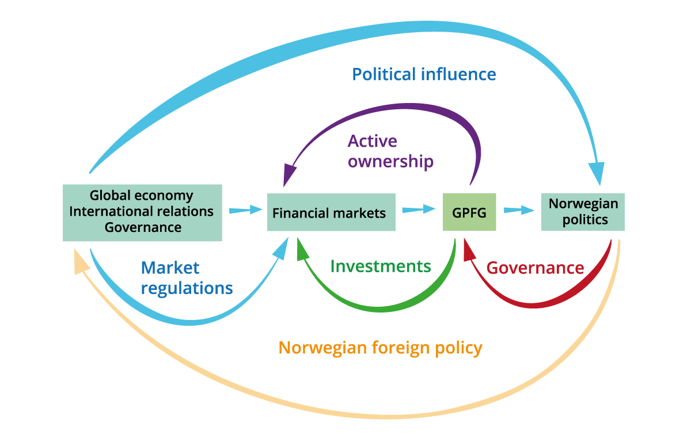
          - Our simple model with key causal links
The figure illustrates how the GPFG is affected by the international economy and international politics through the Fund’s financial market investments, and how the GPFG is affected by decisions made by Norwegian political authorities regarding the management of the Fund.
The Commission.

New economic and political developments
Climate change and the green transition
Fossil fuels, industrialisation and population growth have caused anthropogenic change to the relative balance and stability that have characterised nature since the Last Glacial Period. Greenhouse gas emissions, deforestation, land use and natural resource overconsumption have resulted in global warming and reduced biological diversity. Without a change of course, changes in climate and in the natural environment may lead to the collapse of important ecosystems and threaten the very basis of existence for millions of people.
However, increased climate change awareness has resulted in climate policy measures aimed at reducing greenhouse gas emissions and preparing society for a changing climate. These involve a complete transformation of the global energy systems, which will have major economic, social and political implications, including for international power relations. One should also be prepared for the possibility of even more comprehensive and complex measures being put on the agenda to protect the reproductive capacity of nature.
Norway and the GPFG are facing considerable climate risk
Since we do not have complete knowledge of the various implications of climate change, climate policy and climate-related technological development, Norway and the GPFG are facing risk arising from changes in climate and in the natural environment. A high degree of uncertainty at many levels means that this risk is considerable. Climate risk has certain peculiarities that distinguishes it from other issues that investors need to address, since it plays out over a very long time horizon, may result in sudden policy changes of major importance, raises fundamental ethical issues, and is characterised by potentially dramatic implications and major uncertainties that are hard to quantify. The litigation risk is also likely to increase.
Implications of climate change and the climate transition for the management of the GPFG have been examined in detail in the recently submitted expert group report on Climate risk and the Government Pension Fund Global (2021), and the Commission endorses its assessments. The expert group proposed, inter alia, a set of principles for managing climate risk in the GPFG, that Norges Bank’s responsible investment be based on an overarching long-term goal of net zero emissions from investee companies (in line with the Paris Agreement), a further development of Norges Bank’s active ownership efforts to influence company conduct and improve market functioning through better climate risk reporting, as well as specific provisions on the measurement, management and reporting of climate risk.
Technology creates solutions and challenges
Technological development has solved many problems facing humankind and has paved the way for phenomenal growth in the global economy over time. Technological innovation remains a key component of the transition to a zero-emission economy and lays the foundations for further improvements in both health and the material standard of living.
However, in addition to technological change giving rise to productivity growth and structural transitions in the economy, it also brings important challenges in relation to for example market power, competition, taxation, data protection, security, as well as cyber and political military dominance.
Technology affects the GPFG in several ways. Technology companies have in recent years enjoyed exceptional growth and profitability, related to technological innovation, network effects and dominant market power. Such companies now constitute a major part of the Fund portfolio. Looking forward, technological change is not only creating uncertainty about the financial return on the GPFG through company earnings, but is also having implications for the Fund’s operational risk (including cyberattacks), reputational risk (including potential demands for divestment of company holdings out of concern for data protection, employee relations, etc.), as well as political risk, especially in relation to geopolitical rivalry for technological dominance in terms of industrial and military power.
Demographic developments affect economic development and political power
The world’s explosive population growth has shifted the demographic focus towards Asia and Africa. China has become one of the world’s largest economies and a political powerhouse, and India and countries in Africa have great potential.
Populations are at the same time declining in parts of the world. Population growth has turned to decline in Japan, China and Europe, which will inhibit economic growth. Like a number of high-income countries with developed welfare schemes, the Norwegian economy is facing a demographic transition that will require tough public spending decisions.
A lack of consensus about continued economic integration inhibits growth
International economic integration is, in combination with technological progress and demographic developments, the key driver behind the growth in the global economy since World War II. Open, integrated markets serve to spread ideas, knowledge and new solutions. However, economic and political power shifts create tension. There has in the last few years been a tendency for growth in the international exchange of goods, services, technology, ideas and capital to decrease, and for global integration to face political headwinds in a number of countries. This may have implications for global economic growth, as well as for financial market pricing and investment allocation.
Political risk is becoming more important
Political risk is likely to take on a more prominent role in financial markets and to be accorded more importance in the management of the GPFG. Political developments have always affected the global economy and financial markets, and political crises and situations have at certain times posed challenges in the management of the GPFG in its first 25 years.
However, we are now seeing indications that the general development towards deregulation, transparency and depoliticisation of the markets is in the process of being replaced by more regulation and national political control and a desire for stronger national control. National control may also entail increased protection against foreign ownership and thereby fewer or different investment opportunities for the GPFG.
Globalisation has been of great benefit to the world, but also brings challenges
The unequal distribution of the gains from globalisation has posed political challenges in many countries. A number of countries have experienced increasing internal inequality, and this may be a source of social and political instability. Globalisation has had a negative impact on climate and nature, although production as such has been cost and resource effective.
It is, moreover, increasingly acknowledged that close economic ties may also entail unwanted dependencies and give rise to demanding security challenges. Both businesses and authorities are therefore increasingly focused on strengthening their resilience and reducing their vulnerabilities. Political and security considerations are accorded more weight, often to the detriment of purely economic interests.
This serves to undermine the idea that the market can be kept separate from politics, or that economic integration and interaction will in itself bring countries closer to each other politically. It is especially the emergence of China that has led to these realisations, but Russia’s invasion of Ukraine in defiance of international law has added a new impetus.
The political landscape has changed
Russia’s invasion of Ukraine is a dramatic and brutal break with the post-war international order and has plunged both Europe and the international system into an acute and deep crisis. It is nonetheless China that is considered the main long-term challenge for the US, and this assessment is likely to guide US, and increasingly also European, thinking and policy making in various sectors for a long time to come, including in ways that will affect the regulatory framework facing international investors. Rivalry is likely to have fundamental implications for global developments.
Towards a more distinct decoupling of the world
This will to some extent be a distinction between fundamental values and between democratic and authoritarian states. It is to be expected that states and companies will find it difficult to walk the tightrope between conflicting considerations, and some will increasingly be forced to choose sides and positions. Investors may also face difficult and costly choices, but the concept of being invested in a large number of countries based purely on market considerations, which to some extent underpins the current investment management model for the GPFG, may become more demanding, and maybe less accepted, than before.
Economic and financial measures are mobilised as foreign policy tools
The regulation of trade, finance and technology is increasingly being used as a means of attaining foreign policy or geopolitical objectives. New barriers and obstacles are introduced in order to regulate economic interactions, and more sophisticated information systems are being developed to manage and control flows. This tendency also triggers a number of countermeasures from states that are in turn seeking to reduce their vulnerability and to strengthen their resilience.
We are experiencing a mounting political desire for greater cohesion between politics and the economy
When a state is considered a political and military rival, it is considered less politically acceptable to maintain economic ties with that state. Russia’s war against Ukraine has triggered such a discussion and shift towards decoupling and divestment in earnest. Similar developments are also to some extent already underway between Western countries and China. This approach may also spread to other countries and jurisdictions.
Rivalry may have fundamental implications
This observation applies both to global developments and to the Fund. Mounting tension between the superpowers, as well as deep-rooted long-term rivalry and decoupling of the world, means that political risk is more unpredictable and may increase in many countries. The ability to further develop the international political and legal framework may be weakened, and economic growth may be lower for the next few decades.
This development means that international crisis management capacity, also in relation to economic and financial crises, may be reduced. We cannot take US leadership and Western concord for granted. The Western world accounts for a declining share of the world economy, while that of Asia, and especially China, is increasing rapidly. Moreover, the Fund may be subjected to mounting pressure from both Norwegian and international communities that are advocating curtailment of its investments in certain countries.
All in all, the Fund and the Norwegian authorities need to be prepared for more difficult political balancing acts, more situations in which the Fund or Norway may come under pressure, and more crises in financial and capital markets that are managed in a less coordinated manner than has been the norm in the last two decades.
In a tenser international climate, one also needs to be prepared for the Fund to suffer investment restrictions or other actions that diminish the Fund value or expected returns. These may come in the form of restrictions that target all investors, or all sovereign investors, or that only target Norway, like-minded countries or the Fund in particular.
Systems of government are changing
Regime type, systems of government, legal systems and the international order will influence the future of the GPFG. An open, liberal and stable legal system has presented international investors with favourable conditions. This report discusses how developments in systems of government, legal systems and the system of international cooperation might change the risk facing the GPFG. We have attached special weight to analysing trends in regime type and systems of government, which may affect returns, the scope for responsible investment as well as the owner’s ability to bear risk. We have also examined international cooperation trends, which may affect the development of norms, international rules, as well as the capacity to manage joint global challenges and future crises.
Democratisation has stagnated, and to some extent been reversed, in the last few decades. There are indications of mounting support for non-democratic forms of government in a number of countries, and of countries with non-democratic forms of government playing a more important role in the global economy. Authoritarian states have increased in number and become more authoritarian, and relatively democratic countries have decreased in number, while some of them have moved towards more authoritarian systems of government.
An important feature of this more recent autocratisation trend is that it is driven by political leaders who have ascended to positions of power through democratic elections, and who have thereafter quite subtly and slowly changed the system of government step by step: Autocratisation typically involves taking steps such as restricting freedom of expression, curtailing the scope for operating free and independent media, and undermining the activities of independent organisations in civil society. The judicial system of these countries is weakened, with the independence of their courts being challenged. Direct manipulation of elections tends to come somewhat later in this process.
The system of government is of significance to the GPFG
There is no clear, unequivocal and obvious relationship between systems of government and economic growth, but the Commission has commissioned a comprehensive review of global academic literature, which suggests that democracy does, on average, have a positive effect on economic growth.
Democracies have a lower probability of becoming embroiled in armed conflict with other democracies, typically have less adversarial and more well-functioning bilateral relations, and tend to be more open to international cooperation and international regulations. Democracies generally have more developed financial markets. At a general level, it may be assumed that democracies offer somewhat better protection of property rights, while suffering less corruption and less arbitrary economic policymaking.
An investment manager’s scope for responsible investment is also affected by the system of government. Authoritarian regimes generally score lower on issues such as protection of human rights, including employee rights, or access to local public goods, for example in relation to health or the environment. In principle, one might envisage that the scope for change through active ownership would be greater in authoritarian regimes than in democracies, quite simply because such states offer more potential for improvement. However, the scope for change through active ownership is reduced if there is more corruption, more impenetrable regulations, restricted access to information, limited freedom of expression, a state that is not firmly based on the rule of law, and no free press.
A well-functioning international order is important to the GPFG
The current diversified investment strategy would not have been possible without prior liberalisation and organisation of open and well-functioning financial markets with harmonised rules and standards. In addition to benefitting from an international network of authorities and international organisations that regulate the market, it is in a closely integrated world advantageous – especially for small countries – to manage imbalances and international crises in a coordinated manner.
However, the foundations of the international financial system are under pressure. The establishment of international financial institutions, such as the World Bank, the IMF, the GATT and the OECD, in the wake of World War II introduced rules, institutions and procedures governing international trade and financial interaction. Although one has largely been able to reform, entrench and professionalise the system in line with global market developments, this development came to an almost complete halt after 2010. This coincided with the aftermath of the financial crisis and China’s increasing prominence in the global economy.
The existing system is no longer considered legitimate by everyone, and is no longer able to sufficiently renew itself in line with developments and needs. It is getting gradually more difficult to achieve unanimous support for necessary reforms or regulatory developments in consensus-based institutions. This is likely to result in bilateral solutions, increased regionalisation and the emergence of alternative arenas for cooperation and conflict resolution.
A shift towards more problem solving outside the established institutions and tendencies of more «law of the jungle» rather than a rules-based system, is unfavourable for Norway and the GPFG. Increased protectionism, also within finance, and more of an emphasis on security considerations rather than free markets, may be negative from a market and efficiency perspective. It increases unpredictability and the risk of investing internationally.
These developments may indicate lower returns
Against a backdrop of relatively low – but now increasing – interest rates, and high levels of debt globally, we discuss how economic and political developments may in various ways influence economic growth, company earnings, government finances and the financial market pricing of equities and fixed-income securities in the GPFG portfolio.
The significance of key drivers behind company earnings may be reduced. The return on equity investment is closely linked to the profitability of companies, which has been increasing for the last 30 years. A number of structural changes have paved the way for higher profits, including more market power, a higher portion of the profits accruing to shareholders, globalisation, a lower interest burden, higher valuation of future cash flows, tax competition and a greater role for intangible capital. Some of these tendencies may persist, while others will probably not.
The return on fixed-income securities is subject to uncertainty. The global debt level is high, on the part of both governments and companies. Debt servicing has been stable due to record-low interest rates, but this may be about to change. Debts have become riskier, with longer maturities and lower credit quality, which would generally not be a problem for investors if this higher risk is duly reflected in financial market pricing. History offers numerous examples of authorities in various countries reducing their debt level in various ways, most of which entail losses for fixed-income investors.
Norway should be prepared for lower and more uncertain returns on the GPFG. Fund returns depend on cash flows from company earnings and debt servicing on the part of companies and authorities. There is a broad range of potential outcomes, but we note that a continuation of the high real returns from the GPFG’s first 25 years would not seem the most likely outcome for the next 25 years. The loss in value in the first half of 2022, which was 14.4 percent (NOK 1,680 billion) is not uncommon for a fund like the GPFG.
The GPFG may be faced with market access problems
As a large, sovereign global investor, the Fund may be faced with various types of restrictions on what assets it is permitted to acquire. Mounting geopolitical risk and a tendency to use financial markets as an arena for rivalry mean that additional investment restrictions must be expected in the time to come.
It may become more demanding to maintain a low level of operational risk. In addition to required compliance with what may become an ever more comprehensive sanctions regime and a range of investment restrictions, various digital threats may challenge Norges Bank’s operational management.
The GPFG may also be affected by developments in Norway
Although a major part of the report’s discussion is concerned with how international economic and political developments may affect the value of the GPFG’s securities, it is also important to examine how developments in Norway may affect governance of the GPFG. The Norwegian political system is stable, and Norway is a relatively high-trust society. The fiscal policy guideline and the fund structure appear to enjoy broad support from the Storting.
Some developments may nonetheless pose challenges. Demographic developments will increase public expenditure, and one also cannot exclude changes to confidence in, and political support for, the fiscal policy principles and the model underpinning the success of the Fund.
A large fund and less fiscal space may be politically demanding
The perceived room for manoeuvre in fiscal policy may well be less in the years to come – as the result of lower growth in the GPFG due to declining petroleum revenues, more modest returns on investment and larger commitments on the expenditure side of the fiscal budget.
Mounting pressure to make withdrawals of such magnitude that the real value of the Fund is depleted would probably be manifested in public and subjected to broad media scrutiny and public debate. There may, however, be other ways of drawing on the Fund, or of preventing all revenues from being channelled into the Fund, that are more likely to go under the radar. The Commission identifies some proposals that have been highlighted in the political debate, which would in practice change the fiscal policy framework and reduce the scope for successful implementation of the current investment strategy for the GPFG.
Financial returns and responsible investment are of importance to the legitimacy of the GPFG
The Fund having experienced 25 years of favourable returns, with only short periods of setback, has served to build confidence in the investment management model. However, much of the attention paid to the Fund is focused on non-financial matters.
The legitimacy and reputation of the GPFG are decisive to its ability to meets its mandate. Reputational damage may have major repercussions, both nationally and internationally. A weaker reputation in Norway may undermine society’s confidence in the Fund, thereby potentially reducing support for the hitherto successful spending model and investment strategy. And reputational damage abroad may inhibit the Fund’s investment opportunities and invite litigation and seizures. Legitimacy is closely linked to confidence, both of which are related to reputation.
The Fund’s reputation in Norway and abroad are linked
However, the Fund’s reputation with various stakeholders in Norway and internationally is not necessarily concurrent. It may be a dilemma that some of the measures that can serve to strengthen the Fund’s reputation in Norway may at the same time serve to impair the Fund’s reputation abroad. The exclusion of companies from the Fund’s portfolio, based on the ethical guidelines, may for example strengthen the legitimacy and reputation of the Fund in Norway. Such exclusions may at the same time be perceived by some as politically motivated, and impair the Fund’s reputation and access to opportunities as a financial investor abroad.
The Fund’s role as a financial investor is of decisive importance to its international reputation
Although there has been a broad consensus that the GPFG is a financial investor, the non-financial aspects of its management are drawing ever more attention. Attention to ethics and responsibility is important for the legitimacy of the Fund, but it can be demanding to strike the right balance between responsible investment and not leaving international stakeholders with the impression that the Fund is a political player. The gap in expectations, between what an investor should do, on the one hand, and what it can in fact achieve with a relatively small ownership stake, on the other hand, may also be large.
The Commission believes that the GPFG’s scope for being a successful financial investor is primarily dependent on the Fund also being perceived as a financial investor by authorities and market participants in other countries. The Fund’s attractiveness as an investor is likely to be reduced if it is perceived as a tool for promoting Norwegian foreign policy interests or a policy measure to further development aid or other idealistic or political objectives. A perception of the GPFG as a political tool may also conceivably affect how host countries treat other Norwegian companies in their country.
The governance model must be based on realistic expectations
Excessive return expectations may undermine confidence in the Ministry of Finance, Norges Bank’s investment management and the Fund structure as such. Discontent may brew in the wake of an extended period of weaker returns than one has been used to, for example as the result of major slumps in the Fund value during market turbulence which we are very likely to experience at some point, and which will to a lesser extent than before be offset by high petroleum revenues.
Large withdrawals from the Fund during a crisis, at a time when share prices are low and risk premiums are high, may also result in weaker returns over time. The same applies to a potential expectational gap in terms of what global challenges can be solved by responsible investment, or what others may expect from a sovereign wealth fund such as the GPFG. The visibility and size of the Fund may also influence what others expect from various aspects of Norwegian foreign or security policy.
Different future scenarios may be used to evolve the investment management
Our inability to predict the future makes us wary of basing our discussion on a future scenario that we believe to be the most likely. In addition to shedding light on a range of international and domestic economic and political developments, we have therefore outlined multiple scenarios to examine how robust the current investment management model is to various situations.
We are envisaging several qualitative scenarios:
- Tainted money: From pride to shame
- The Fund in a squeeze: A shrinking investment universe
- Norwegian disease: The Fund is depleted
We have also modelled several quantitative scenarios:
- Historical crises
- Deglobalisation
- Stagflation
Some of the scenarios assume radical change and may seem dramatic. Although there is not necessarily a high probability that these will materialise exactly as outlined, they are plausible and contain elements that we can already see looming on the horizon, while pointing to potential sequences of events that should be taken into consideration when thinking about how the Fund should be managed in the future.
The Commission hopes the scenarios will capture the attention of the reader and put the focus on key mechanisms and risk factors that may affect the performance and management of the Fund. Such stress testing can in any event provide insights that may serve as a basis for contemplation and evolvement of the investment strategy for, and governance of, the GPFG.

From risk analysis to risk management
The GPFG investment management model serves Norway well
The Fund is characterised by strong political ownership of most aspects of its management. The investment management strategy is characterised by a large proportion of equities, diversified over listed markets worldwide, with Fund performance over time largely reflecting global stock market developments and corresponding to the average return achieved by other investors. Transparency, responsibility and an ethical framework are key elements for building confidence in investment management. The Commission finds that this investment management model is also the best one for a future involving the developments and challenges we have outlined.
The Commission is not proposing any fundamental changes to the investment strategy or governance system for the Fund. We nonetheless discuss some potential strategies for meeting new challenges that may arise. We identify trade-offs that will have to be made by political authorities and Norges Bank at future junctures.
Norway should be prepared for investment management to become more demanding
We are living in a time of major structural change in international politics and the international economy. Norway should be prepared for weaker investment performance for the GPFG, for both financial and non-financial risk to increase, and for political authorities to meet demanding situations and be faced with difficult choices. The Fund has grown larger and the effects if different types of risk materialise may have a greater impact on government finances and the ability to remain committed to a financially sound long-term investment strategy.
Being a large investor in a global economy means that one will in any event face numerous dilemmas. Fluctuations may be large and there is also “nowhere to hide” for a large fund like the GPFG. Weaker investment performance and higher financial and non-financial risk may also challenge several principles underpinning the GPFG investment management model to a greater extent and in different ways than we have been used to.
Geopolitical risk may become more prominent
Investors need to consider geopolitical risk when setting out their investment framework and operational management approach. Such risk may be of particular importance to a sovereign fund like the GPFG, and the risk it faces may also be different than for other investors. Geopolitical risk should therefore be included, along with other types of risk, in the basis for the assessments and decisions made by the Ministry of Finance and Norges Bank in the management of the Fund. The Commission has developed a set of principles for managing geopolitical risk. An important point is that managing geopolitical risk has commonalities with other risk management and should be part of a holistic risk management system.
Clear rules and some flexibility
A large fund will benefit from having clear rules and procedures. A more volatile risk situation also necessitates a certain flexibility in investment management. A changing risk outlook may for example lead the Ministry of Finance to decide that the benchmark index should not automatically follow the decisions of the index provider, or to have some leeway for Norges Bank to make investment decisions that diverge from the benchmark index (for example divestment based on financial risk analyses).
Increased resilience
The foundations for meeting new challenges should be further developed. The Commission is, as mentioned, of the view that Norway and the GPFG are in principle well placed for meeting an uncertain future, but notes that the ability to deal with various changes and crises can be enhanced by:
- Strengthening insight into the prevailing situation. This requires the systematic gathering of even more information, advice and knowledge on changeable topics such as politics, economics and technology.
- Evolving the ability to steer clear of certain crises. Improved envisioning of what difficult situations may arise, combined with systematic assessment of the various investment strategy components, will improve the ability to modify the Fund’s investments in reflection of changes in the risk outlook and the owner’s risk tolerance.
- Having robust systems for managing those crises that do occur. Good crisis management, which reduces the negative impact of crises occurring, require high preparedness, regular training, as well as a clear division of roles and responsibilities. It is of decisive importance to avoid hurried changes to the investment strategy amid a crisis.
- Strengthening the ability to learn from crises and experience. The ability of organisations to learn from crises requires them to recognise that crises may differ in their origin and impact, and it is crucial to draw lessons from relevant experience; systematically and not anecdotally.
New political and economic developments give rise to risk on the part of the GPFG
In this report, the term “risk” refers to uncertainty about events that entail deviations from an expected, planned or envisioned development, which deviations may be positive or negative. Most forms of activity involve some element of risk. Hence, the challenge is to strike the right balance between the concern to generate returns and assume risk, on the one part, and to preserve value, on the other part.
The risk facing the GPFG may be managed in different ways. Risk management principles are typically focused on the need for risk to be analysed and assessed in view of the owner’s risk tolerance, after which it should be decided how one would prefer to manage the identified risks.
The key mechanism for managing risk in the management of the GPFG is the diversification of investments based on a benchmark index with a large share of listed equities across a considerable number of countries and companies worldwide. Within this investment framework, the Fund shall be managed responsibly.
Usually ample compensation for taking financial risk
The financial market’s pricing is forward-looking and swiftly reflects new information. Despite periods of major structural shifts and dramatic geopolitical events, investors have in the long run been well rewarded for assuming financial risk – provided that they have diversified their investments and pursued a suitable investment strategy that matches their own risk tolerance, and remained committed to the strategy during periods of turbulence.
The owner’s risk tolerance is a key element
Since there is no single definition of risk, and no single risk measure that captures all relevant risk factors, the GPFG’s overall ability to bear risk is a matter requiring nuanced assessment. The GPFG’s distinctive characteristics – size, time horizon and ownership – are important in determining the owner’s risk tolerance and the Fund’s ability to bear risk.
The GPFG has similarities with other funds, but also some distinctive characteristics that distinguish the Fund from others. The GPFG may be considered to have a relatively high ability to bear financial risk compared to other investors, since Norway is a well-functioning country with a productive and adaptable population, with a high net financial wealth managed in an intergenerational perspective. However, the ownership and affiliation of the GPFG may possibly make it less able to absorb exposure to certain types of non-financial risk than other investors.
Different types of risk need to be balanced against each other
The report highlights how the various types of risk need to be considered and balanced against each other (cf. also figure 1.3). An assessment of political risk or reputational risk internationally, or legitimacy and confidence considerations in Norway, may for example affect what type of, and how much, financial risk is taken in the composition of the Fund portfolio. The report (in chapter 13, in Norwegian only) draws up scenarios that illustrate how different types of risk may influence each other and need to be balanced against each other.
Ethical and political considerations affect the GPFG’s tolerance for non-financial risk. Two political considerations are of particular importance to Norway. The first of these is what public opinion in Norway is calling for, which is largely accommodated by the objective of highest possible financial return, given an acceptable level of risk assumed, and by the responsible investment and ethical framework for the GPFG.
The other consideration, which is becoming more prominent, is the expectations of other market participants, states, organisations and groups internationally. This refers, inter alia, to expectations and obligations associated with the role of a good investor, but also to those associated with being an ally or a member of the numerous foreign policy groupings that Norway belongs to. The expectations placed on the Fund are changing, and one must therefore be prepared for expectation management in relation to various stakeholders to become both more important and more challenging.
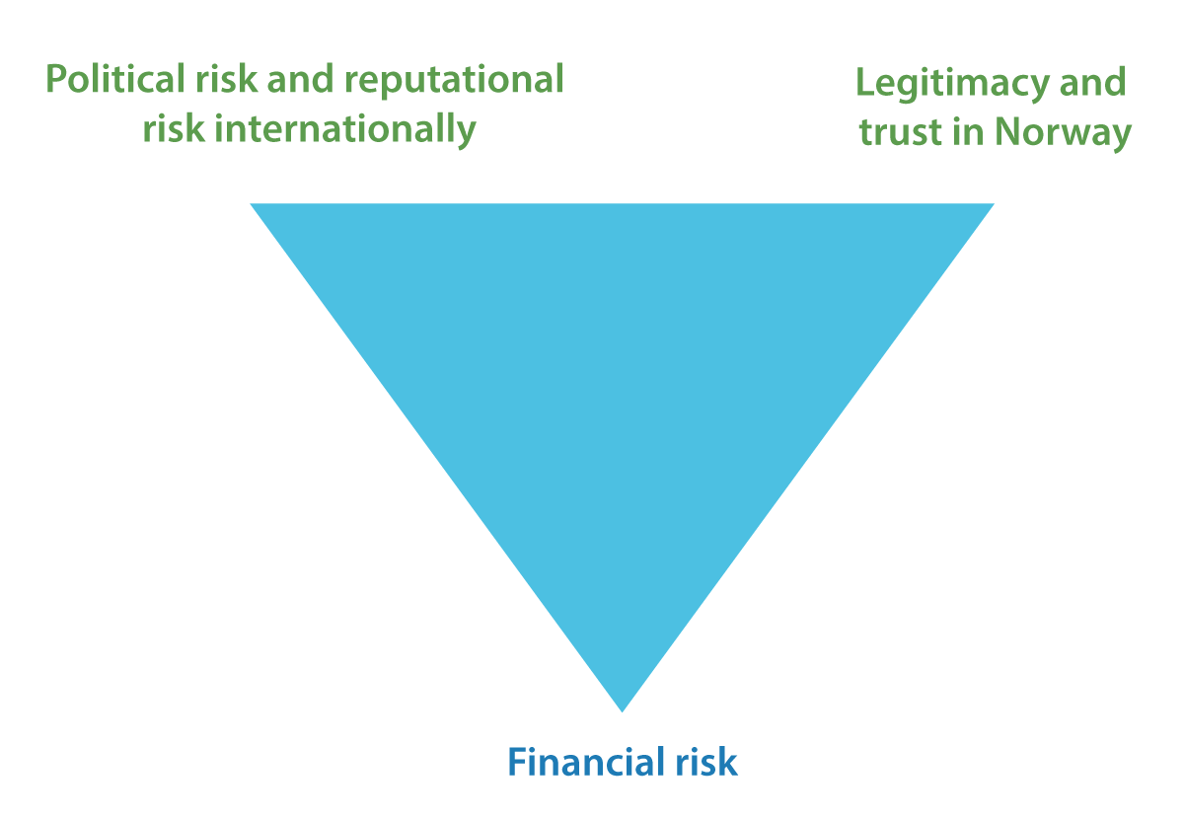
          - Different types of risk that need to be balanced against each other
The figure illustrates that different types of financial and non-financial risk need to be balanced against each other.
The Commission.
Risk tolerance may change over time
Risk tolerance tends to be procyclical – risk tolerance may seem high in good times, only for then to fall steeply in times of crisis. Risk tolerance may be developed and become better understood through knowledge and learning, and thereby become more stable and resilient over time.
The GPFG’s risk exposure needs to be broadly supported
Any changes to the Fund’s risk profile should be carefully considered, and not impulsive. If the risk is not well understood and accepted by the owner – i.e. by political authorities and ultimately by the Norwegian population – and the materialisation of various forms of risk gives rise to criticism, a lack of confidence and potentially a sudden investment strategy shift, there is a high risk that financial performance will be weaker than originally assumed (because one is in reality buying assets expensively and selling them cheaply).
Understanding and developing the owner’s risk tolerance is therefore a key priority in future-proofing the Fund, through extensive dialogue and knowledge transfer between Norges Bank, the Ministry of Finance, the Storting and the wider public. The investment strategy should reflect the risk tolerance. Various aspects of the risk associated with the investment strategy should be communicated clearly to the Storting and the Norwegian population.
There is a need for regular reviews
There is, in a changing world, a need for regular reviews of the risk situation and its implications for the owner’s risk tolerance and the management of the Fund. The developments outlined by the report may indicate a need for involving the Fund’s stakeholders to make them aware of the GPFG’s new risk situation, with a view to identifying, developing and balancing the Fund’s tolerance for different types of risk.
The report notes that the changing risk outlook facing the GPFG may increasingly be related to various types of financial and non-financial risk that the Fund may perhaps, in view of its distinctive characteristics, not be as well suited for exposure to as are other investors. The Ministry of Finance and Norges Bank will need to continue balancing different types of risk against each other, as well as monitoring any changes in the risk outlook and adapting the Fund’s risk exposure to match risk tolerance.

Evolvement of the GPFG investment management model
The management of the GPFG should be evolved in response to a changing risk outlook. We therefore discuss the importance of a suitable investment strategy and a governance system that inspires confidence and legitimacy in Norwegian society.
This includes a clear financial investment management objective (which underpins a professional asset management), an ethical framework (which also confers legitimacy), a diversified portfolio (which provides resilience against unknown risks, as well as the best possible ratio between return and risk), a high equity share (which contributes to favourable long-term returns at an acceptable level of risk), effective active ownership (which strengthens company earnings over time), as well as good communications and training outreach initiatives aimed at broad swaths of Norwegian society (to build an understanding of the importance of responsible long-term investment). We also discuss, in view of the GPFG’s high dependency on international affairs, how Norwegian authorities may support the interests of the GPFG in its international relations.
Good processes and relevant expertise at all levels
It is in this context important for all levels of the governance system – the Storting, the Government, the Ministry of Finance, the Executive Board of Norges Bank and the investment management organisation NBIM – to have good processes, relevant expertise and an intellectual readiness to accommodate both gradual and sudden changes in the risk outlook. We note that the Ministry of Finance and Norges Bank should pay considerable attention to how the GPFG may be affected by changes in the global political, economic and financial system. It is important to think through potential implications, run regular exercises and build the ability to manage cross-pressure.
The investment strategy should evolve
The Commission would recommend the Ministry of Finance to systematically and regularly review the investment strategy and to assess, in view of new developments and new knowledge, whether there are measures that might serve to improve the ratio between return and risk, including potential modifications to the composition of the benchmark index and the mandate for Norges Bank’s investment management, to ensure that the Fund can continue to make the most valuable contributions possible to fiscal budget funding.
In analysing and assessing potential models for withdrawals from the Fund, it is important to prevent the GPFG from adopting a procyclical investment behaviour that undermines Fund returns in pressured situations. One should aim to avoid risk exposures that result in a sudden strategy shift if that risk manifests itself (for example in the form of a financial or political crisis).
When Norges Bank evaluates various forms of risk, it should also integrate geopolitical risk in its assessments to create a GPFG portfolio that delivers the highest possible risk-adjusted return in conformity with the owner’s risk tolerance.
The principle that the Fund shall be as broadly diversified as possible should be retained
To invest as broadly as possible offers scope for reaping company earnings worldwide. Diversification is a good way of spreading risk.
It is, however, to be expected that the diversification goal may increasingly come into conflict with other political considerations. Excluding certain countries and companies from investment, in full or in part, may be desirable under certain ethical, security or political criteria, but may also involve a cost in the form of lower expected return and/or higher risk in the portfolio.
The Commission examines the various courses of action that are available, and notes that it may in the time to come become more relevant than before to make use of the procedures and the flexibility embedded in the current framework for managing demanding situations that may arise. It is desirable for the Fund to have clear rules and a high degree of predictability, but there may at the same time be a need for a system and a mindset that is sufficiently flexible to respond to international volatility.
Responsible investment could become more demanding
Political authorities should be aware that responsible investment may become more demanding. They should also take care to avoid any excessive gap between expectations for what can be achieved through the ethical framework, on the one part, and what can realistically be achieved, on the other part. The ethical consideration of ensuring favourable returns for future generations needs to be carefully balanced against other ethical considerations.
An independent council should be established
The Commission recommends that the Ministry of Finance establish an independent council. The council may be tasked with monitoring, examining and evaluating various aspects of the Fund, including geopolitical issues, and making recommendations to the Ministry of Finance for measures in relation to management of the GPFG’s risk situation.
The Ministry of Finance and Norges Bank need sufficient capacity and expertise
It is important to ensure that one attracts high-calibre professionals with relevant expertise, also on the issues highlighted in this report, when recruiting for the Ministry of Finance, the Executive Board of Norges Bank and NBIM.
The mandate should be reviewed
We also recommend that the Ministry of Finance review the mandate to ensure that Norges Bank’s strategy and risk taking are in conformity with the overarching interests of the GPFG. While one should ensure a governance structure with clear lines of responsibility and sound corporate governance, it should be considered whether it might be appropriate to have a somewhat more general mandate that stipulates applicable investment management principles.
General understanding of the Fund’s role needs further strengthening
In attending to Norway’s interests abroad, including in relation to international organisations and international regulations, the Ministry of Finance and the Ministry of Foreign Affairs should consider whether there is a need for enhancing the knowledge of, and the attention paid to, the needs and interests of the GPFG.
It is of key importance to build an understanding both domestically and abroad of the Fund’s role as a financial investor. The Ministry of Finance and Norges Bank should seek to develop optimal communications and effective training resources for the Storting, media and other interested parties on key aspects of the management of the GPFG. We note, incidentally, that the term “Oil Fund” fails to reflect that a major portion of the Fund value is currently generated by investment returns, and not by petroleum revenues. Colloquialisms take on an existence of their own, but this term is no longer apposite.
Prudent management of the GPFG is very important
Our assessments are based on an acknowledgment that the management of the GPFG is now of very major importance to the Norwegian economy and public finances, and that prudent investment management is of decisive importance for a continuation of the Fund’s successful track record. We know from history that large fortunes and funds may wilt and wither. A challenge for Norway as a country is to ensure that the GPFG does not suffer that fate.

The report structure
This report is comprised of three parts. The first part outlines the history of the Fund from its inception until now (chapters 2-4, in Norwegian only). This is followed by the main part of the report (chapters 5-13, in Norwegian only), which analyses various developments and risk factors that are of importance to the GPFG in the years to come, based on the simple model in figure 1.2.
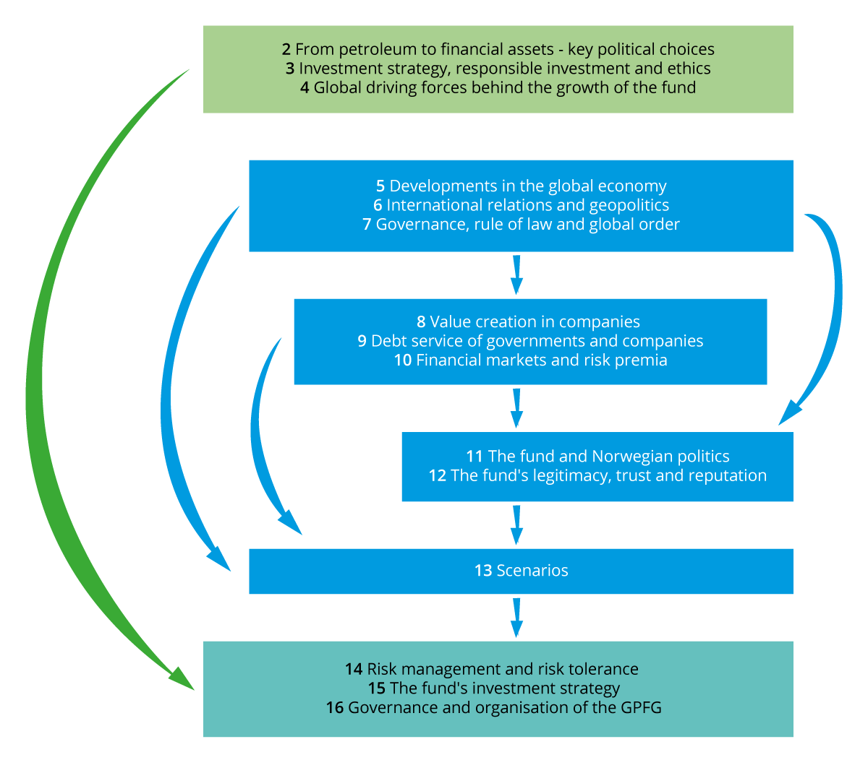
          - The relationship between the chapters
The figure illustrates the structure of the report and how the various chapters relate to each other. Part I outlines the history of the Fund until now (chapters 2-4), part II analyses various developments and risk factors that are of importance to the GPFG (chapters 5-13), while part III presents how the authorities should manage this risk situation (chapters 14-16).
The Commission.
We first discuss how the global economy, international politics, geopolitics, systems of government and the international order may affect the Fund in different ways (chapters 5-7). We thereafter examine how the Fund’s holdings of equities and fixed-income securities are affected by company earnings and economic growth, as well as by the debt-servicing capacity of companies and states (chapters 8-9), and also by how securities are traded and priced in financial markets (chapter 10). In addition to these international effects, Norwegian choices in the governance and management of the Fund, as well as the Fund’s legitimacy, confidence and reputation, are also important influences on the GPFG (chapters 11-12). This provides a basis for summarising potential scenarios that the GPFG should be prepared for (chapter 13).
Finally, the third part of the report outlines how the Commission believes that the authorities should manage this risk situation (chapters 14-16, in Norwegian only). The structure of the report and the relationship between the chapters is illustrated in figure 1.4. Some additional details can be found in appendices, including a survey of the current research status on various issues to do with countries’ system of government, economic development and the conditions facing international investors (Appendix 4, in Norwegian only).

The Commission’s contribution
We would like to stimulate an informed public debate
It is our ambition that the Commission’s analysis and message may lay the foundations for an improved understanding of the risk facing the GPFG and how that risk should be managed. A shared and agreed understanding of what the Fund is, and what it is not, and how it should be managed will in itself reduce risk.
Successive political authorities have in the last 30 years accumulated strong ownership of the current investment management model, and this should continue. New generations of voters and politicians enter the scene, and it is important to maintain the public debate and evolve the investment management model.
We have therefore sought to draft this report in a language and format that is accessible to all citizens with an interest in current affairs. The Fund is the joint property of the Norwegian population; both current and future generations, and the management of Norway’s joint financial wealth is dependent on support and legitimacy. Any changes in the management of the Fund should therefore be well understood by stakeholders.
The report may also be of relevance to others. Our report is of course primarily about the GPFG, but we believe that the issues we address may also be of relevance and interest to other investors; both public and private, as well as to large Norwegian businesses, in which the State will often hold ownership stakes.
We are taking a bird’s-eye view
Our focus is on shedding light on relevant developments some years into the future, and thereafter on examining whether these may be of significance to Fund risk and return, and to governance and the investment strategy. This may then give rise to a subsequent contemplation of more specific changes. We do not have answers to every question, but we are seeking to highlight what we believe to be the key factors and to point to how these should be dealt with in the management of the GPFG.
We are seeking to take a fairly long-term view. The mandate calls for the Commission to take a long-term view, but the route that brings us to a long-term outcome is also of importance. Different risk factors and scenarios play out over different time horizons. We have not wanted to restrict our analysis to one specific time horizon, and are instead seeking to discuss the issues in a timeless manner, which is not overly dominated by what is making the headlines right now. It is in any event important to look some way into the future, since it will normally take some time from the Commission‘s report is published until any specific recommendations on the management of the GPFG may be implemented.
In the really long run, uncertainty is very high
Some developments and risk factors are easier to estimate and calculate than others, and therefore easier to understand, respond to and manage. Such future development paths may be related to changes in inflows to, and outflows from, the Fund, to the Fund being invested in an ever-increasing number of countries, to markets and politics changing, to the expectations placed on the Fund changing over time, etc. The Commission has sought to carry out some analyses of such issues.
However, in a really long historical perspective it is not improbable that major dramatic events may result in radical swings and that large parts, or all, of the wealth evaporates. When civilisations and states can vanish, wealth can also vanish, as we know from history. Few things last forever.
It is a historical fact that invasion, occupation and deprivation of sovereignty, war involving weapons of mass destruction, as well as large-scale revolutionary social or economic change, tend to bring major upheavals. Correspondingly, various types of natural phenomena may have a major impact on the economy and on social organisations. Cosmic phenomena such as solar storms and comets have brought major upheavals in the past. And natural disasters such as earthquakes or tsunamis may trigger enormous shocks. We have just experienced the large-scale impact of a global pandemic, despite the disease having fairly low mortality and science rapidly developing an effective vaccine. Finally, it may be difficult to now envision the potentially radical and transformative consequences of both climate change and technological change, including the development of disruptive technologies such as artificial intelligence, quantum computers, etc.
Our recommendations are based on the current investment management model
The current investment strategy and governance system for the GPFG have been developed over many years. The Commission builds on this tradition of gradual evolvement in response to new challenges and new insights, as stipulated by our mandate.
We have thus started out from the perspective of the Fund as it is – one integrated fund held by the State that reduces complexity and keeps investment management costs down. We have not considered fundamental questions relating to the size of the Fund. (When is the Fund large enough? Who should benefit from the Fund; the Norwegian population or others as well? Should there be multiple funds? May an excessively large fund become a burden to future generations, by way of high spending and “differentness” that impair productivity and competitiveness? Should the Fund instead be used for solving joint global challenges?)
Nor have we examined more philosophical issues in relation to the value of money, but we take the opportunity to revisit Arne Garborg’s poem On money, which may serve to illustrate the significance of a broader perspective on the GPFG and on Norway’s financial wealth:
“Money is far from being the greatest good; nor the second greatest. But it is of great benefit to those who use it sensibly.”
We have not examined the organisation of investment management
The Commission was at the outset asked to “examine whether the current organisation of the GPFG under Norges Bank will be the most appropriate structure for the future, or whether new challenges suggest that it should be organised separately”. This part of the mandate was omitted after the change of Government, and the Commission has therefore refrained from examining that issue.
The term “risk” is at the heart of this report
As mentioned, risk refers to uncertainty about events that entail deviations from a planned or envisioned development, which deviations may be positive or negative. A key goal for risk management will be to withstand negative deviations, and to benefit from the opportunities opened up by positive deviations. The attention will in most cases be focused on negative deviations, because it will generally be less demanding to adapt to positive than to negative developments and surprises.
The magnitude of the risk depends on the scope and scale of the potential consequences, how likely it is considered that these will occur, and the robustness of the knowledge these assessments are based on.
Relevant risks in this report are, in particular, financial risk, political risk and reputational risk. There is no single definition of risk, and no single risk measure that captures all relevant risk factors.
The risk facing the GPFG relates to the revenues and expenses of the Fund
In order to shed light on relevant political and economic developments that may affect the GPFG, and in order to outline plausible scenarios, we start out from factors that will influence the revenues and expenses of the Fund. The GPFG will be affected by a large number of factors relating to political developments in Norway and internationally, as well as by developments in the global economy and financial markets:
- Petroleum revenues: Affected by availability of exploration areas, prospectivity, environmental policy, petroleum production, productivity, price, climate policy and the tax system.
- Fund revenues: Affected by interest payments, dividends and the market pricing of the securities, which factors are themselves influenced by company profitability (with technological development, market power, costs, tax and general economic growth as key drivers), the GPFG’s active ownership (with well-run companies and well-functioning markets as a focus), and the investment strategy for the GPFG (with risk preferences, ethical framework and political endorsement as key components).
- Transfers to the fiscal budget: Affected by the growth capacity of the mainland economy and the ongoing budget resolutions.

Financial and administrative implications
The Commission’s report and recommendations aim to contribute to better decisions in the management of the Government Pension Fund Global. There is a clear upside to improving decisions, but this may also require some resources and entail certain administrative costs. The Commission’s recommendations are of a general nature; any costs are hard to quantify, but are not assumed to be substantial compared to the benefits of improved investment management. The potential costs associated with poor management of the various scenarios identified in the report may be very large.

The Commission
The Commission has comprised 11 members: Ulf Sverdrup (Chair), Harald Magnus Andreassen, Olav Chen, Alexandra Bech Gjørv, Jon Gunnar Pedersen, Helge Seland, Inger Stensaker, Olaug Svarva, Jonas Tallberg, Karin Thorburn and Astrid Undheim. Details on the background and qualifications of the members are provided in Appendix 3 (in Norwegian only). The Commission has held 11 meetings.
The Commission has been supported by a secretariat, with the following members: Thomas Ekeli (Head of secretariat), Tom Arild Fearnley, Leiv Lunde, Julie Michelet, Anita Nergaard, Ingeborg Cecilia Seeberg, Aslak Skancke, Yngvar Tveit, Fredrik Willumsen, Vibeke Øi, Petter Ølberg and Eivind Øy.
The Commission has had the pleasure of meeting with a number of people with relevant insights and experience. From the Ministry of Finance: Jan Tore Sanner, Kari Olrud Moen, Hans Henrik Scheel and Espen Erlandsen. From Norges Bank: Øystein Olsen, Øystein Børsum, Nicolai Tangen, Yngve Slyngstad, Dag Huse, Patrick Du Plessis. From the Supervisory council of Norges Bank: Julie Brodtkorp and Marianne Aasen. Persons with experience from the management of the GPFG: Kristin Halvorsen, Siv Jensen, Svein Gjedrem, Tore Eriksen, Martin Skancke, Knut Kjær and Ola Mestad. Other persons with relevant expertise: Even Aas, Wanming Du, Elliot Gamble, Brent Gilkes, Thor Giæver, Håkon Bruaset Kjøl, Carl Henrik Knutsen, Christyan Malek, Eme Onuoha, Joti Rana, Ricardo Rezende, Martin Sandbu, Ellis Skinner, Per Strömberg, Wegger Strømmen, Gustav Saastad, Kenneth Sebuganda, Cheng Chih Sung and Eirik Wærness.
Appreciation is also extended to Birgitte Wiken i the Ministry of Finance for valuable assistence with charts, and to Birgitte Reff Kolbeinsen in Melkeveien Designkontor for expressive illustrations that help tie the report together.
Written feedback was invited from stakeholders when the appointment of the Commission was made public. The Commission received feedback from the Norwegian Animal Protection Alliance, which feedback is available on the Ministry of Finance website.

Mainland GDP is total GDP minus the contribution from the petroleum sector.
See for example the book Over evne on the history of the Ministry of Finance, 1965–1992 (Lie & Vennesland, 2010).
China is the world’s largest economy measured by purchasing power parity-adjusted exchange rates (PPP), but still somewhat smaller than the US if measured by market-based exchange rates.
At yearend 2021, the value of the three largest technology companies accounted for no less than 6.4 percent of the Fund’s equity portfolio, or 4.6 percent of the entire Fund.

