Norway’s Humanitarian Strategy
2024–2029
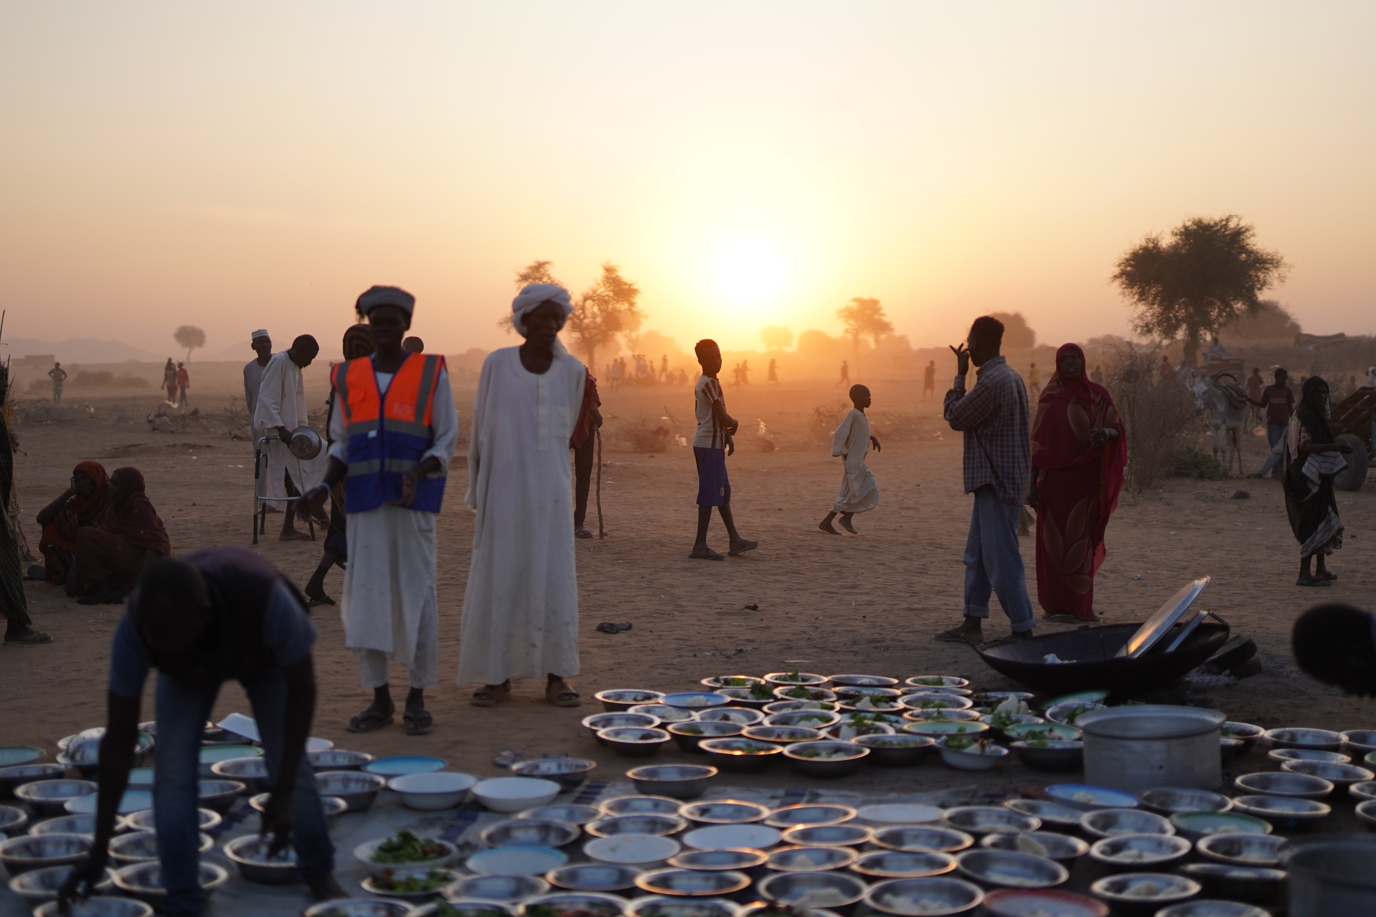
Photo: © ICRC/Mohammed Jamal

Foreword
October 2026
Since Norway’s humanitarian strategy was launched in May 2024, global humanitarian needs have continued to grow. At the same time, the amount of funding allocated for humanitarian action and long-term development efforts has been severely reduced. From 2024 to 2025, humanitarian funding declined by 36 %, and there was a shortfall of USD 30 billion in funding for the UN’s hyper-prioritised global appeal. Russia’s brutal war against Ukraine, now in its fifth year, has led to persistent and complex humanitarian needs and has changed the development assistance priorities of Norway and other major humanitarian donors. In 2025, two cases of famine were documented simultaneously for the first time – in Sudan and in Palestine (Gaza).
Parallel to this, respect for international humanitarian law and the humanitarian ­principles has diminished significantly among the parties to conflict. Fewer countries are willing to speak out against violations of international law. As a result civilians, including humanitarian ­personnel, are not receiving the protection to which they are entitled.
We therefore find ourselves facing a dual crisis: 1) a funding crisis that has created an urgent need for reform of the UN, the development assistance system and the wider humanitarian sector, and 2) a civilian protection crisis in which warring parties must demonstrate that they are once again willing to respect the international legal framework that limits the harmful effects of war.
This was the backdrop when the Ministry of Foreign Affairs, together with many of its most important national and international partners, marked the two-year anniversary of the humanitarian strategy. The aim was to highlight the strategy’s continued relevance in the geopolitical context of today.
We have chosen to refine our approach to humanitarian policy and action and target it along two tracks: how we will fund humanitarian efforts via a more effective, reformed humanitarian system, and how we will work in the political arena to strengthen the protection of civilians in crises and conflict. At the same time, we will maintain our efforts to reduce humanitarian needs through long-term development cooperation and peace efforts.
More effective, results-based funding. Norwegian humanitarian funding will be used more strategically to promote reform and efficiency, with clear expectations relating to visibility and results. Our humanitarian assistance will increasingly be provided in the form of core funding, pooled funds, unearmarked contributions and strategic partnerships. We also expect our partners to commit to implementing efficiency measures within their own organisations and complying with coordination reforms across the humanitarian system. Incentive structures to promote efficiency will be developed in cooperation with other key donor countries. In cases where partners are unable to fulfil their commitments, or results fail to materialise, support levels will be re-evaluated.
Effective, principled humanitarian action requires cooperation between international and local actors. Locally led humanitarian efforts must be granted a larger proportion of humanitarian funding than it has today. We will look at new mechanisms for providing direct financial support to local actors, and will also work to strengthen their participation in decision-making processes.
Strengthening protection of civilians in armed conflicts and crises. Norway will remain a firm defender of international humanitarian law and the humanitarian principles in conflict areas across the world. To maintain the legitimacy of this framework, we must avoid double standards. It is a key aim of humanitarian response to protect people from violence and abuse, and this may also involve dialogue with the parties on both sides of a conflict. Norway will focus in particular on ensuring protection of children, refugees and internally displaced persons; preventing sexual and gender-based violence; and addressing the use of weapons with unacceptable humanitarian consequences.
Continuing the fight against hunger. As many as 343 million people are living with acute food insecurity today. Efforts to combat hunger by providing food assistance, implementing preventive measures to sustain food production and safeguarding long-term self-sufficiency in crisis situations will therefore remain a high priority for Norway.
Espen Barth Eide
Åsmund Aukrust

PART I MAIN GOALS
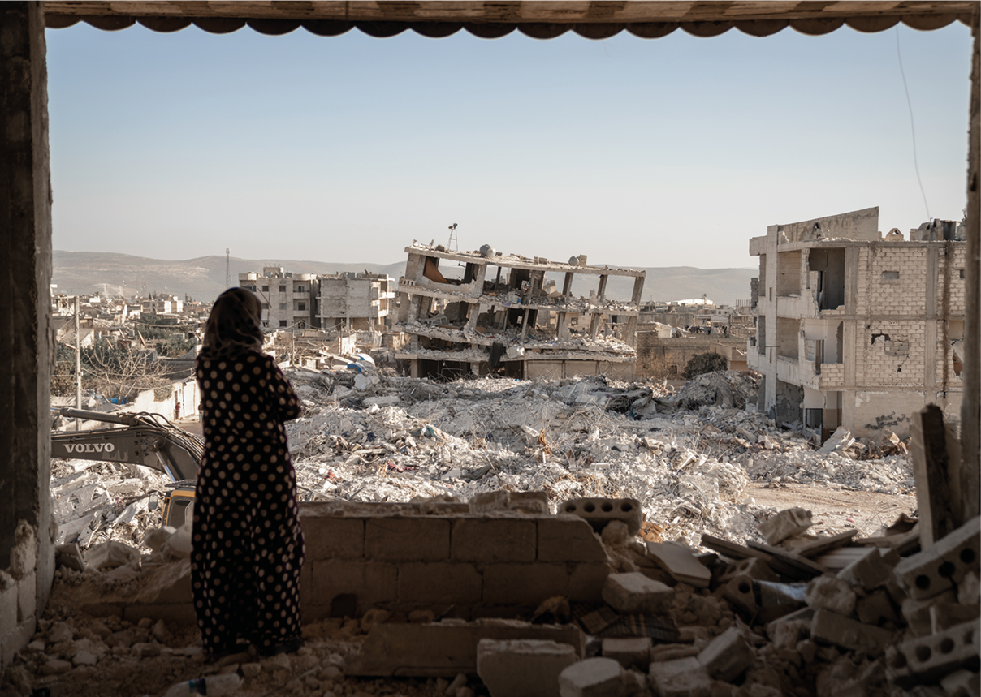
Photo: © UNFPA/Karam Al-Masri

Norway’s humanitarian vision and role
The aim of Norway’s humanitarian policy is to save lives, alleviate suffering and uphold human dignity and rights in humanitarian crises, in line with the humanitarian imperative. Norway shall be a leading donor country and humanitarian policy actor.
We will be clear about the values and principles underlying our humanitarian engagement. We will promote a multilateral system in which international law, including international human rights law and international humanitarian law, are respected.
Norway’s humanitarian efforts will be based on the humanitarian principles and respond to acute needs. The objectives shall be distinctly humanitarian but must also be understood in the context of other aspects of Norway’s foreign and development policy.
This strategy sets out a continued and distinct focus on the protection of civilians against violence and abuse, and violations of international law in humanitarian crises and armed conflict. Norway will continue to be an advocate of the protection of internally displaced people and contribute to improving the long-term response to the major refugee situations the world is facing. International efforts to assist as many people as possible in close proximity to where they live must be strengthened, wherever possible.
We have a long tradition of actively promoting compliance with, and the further development of, international law and the international framework that provide the basis for humanitarian action. Legally binding conventions such as the Anti-Personnel Mine Ban Convention, the Convention on Cluster Munitions as well as the political Safe Schools Declaration are a few examples. We will continue our engagement in this area.
Food security and response to acute hunger crises represent new focus areas during the strategy period. We will strengthen disaster risk reduction and anticipatory action to prevent new and recurring hunger crises. Norway will contribute to remedying the growing humanitarian consequences of climate change. Our efforts on health and education in crisis and conflict will continue.
Norway will prioritise humanitarian diplomacy during the strategy period. We will remain open to dialogue with all states, parties and actors in conflicts and humanitarian disasters, to promote the safeguarding of the civilian population and its right to protection and emergency assistance. We will also support humanitarian partner organisations in their efforts to ensure humanitarian access in areas of conflict.
We will contribute to a stronger and more efficient humanitarian sector. We will follow up the Grand Bargain Declaration and continue our commitment to improving the global humanitarian system. Our aim is to bolster humanitarian efforts and reduce the funding gap through increased efficiency, innovation and strengthened local humanitarian response. We will ensure good interaction between humanitarian efforts, conflict prevention and resolution, stabilisation efforts, development cooperation and peacebuilding, to reduce the scale of sudden and slow-onset crises.
We will promote enhanced disaster risk preparedness and anticipatory action ahead of expected crises. Furthermore, Norway will contribute to early recovery and sustainable solutions in protracted humanitarian crises and will select partners who work in line with these priorities.
It is the obligation and responsibility of national authorities to protect and provide assistance to their own population in the event of a humanitarian crisis. The task of the international community and the various humanitarian organisations is to respond in areas where the authorities are unable or unwilling to protect or provide assistance to people in need of humanitarian aid. These efforts should complement and strengthen local response. Different humanitarian crises require different responses. Humanitarian efforts must be adapted to meet the different needs of people affected by different types of crises. Norway will promote a rights-based approach, seeking to increase the involvement of people affected by crises in humanitarian efforts so that, instead of simply being recipients of humanitarian aid, they are participants in the response. Among other things, this entails that people with disabilities must be included, and their representative organisations must participate in the planning and implementation of programmes. The gender perspective is to be integrated into all our humanitarian efforts, and special priority shall be given to women’s rights and participation.
Decisions concerning Norwegian humanitarian support will be based on the needs of the affected population, assessments of local capacity, the response capacity of humanitarian organisations, local presence, access, and involvement from other donors. The thematic areas and country situations that have been identified as priorities by Norway – areas and countries where our efforts can make a real difference – will also be considered when making decisions concerning humanitarian financing.
There must be a clear connection between Norway’s humanitarian policy priorities and Norway’s role as a donor country. It is more important than ever to forge alliances that include not only like-minded countries and traditional partners, but also countries and actors we do not usually cooperate with.
Norway’s humanitarian funds will primarily be channelled through the United Nations, the International Red Cross and Red Crescent Movement, and humanitarian non-governmental organisations. These actors should, to the greatest extent possible, work with local staff and local partners. Partnerships are to be equitable and ensure capacity exchange of competence with local organisations. We will provide both predictability and flexibility for our partners, and at the same time set requirements regarding quality and results. Norway will also work to increase the number of donors contributing to global humanitarian efforts and will invest in good humanitarian financing mechanisms at both the global and country level with a view to ensuring that humanitarian action is well-coordinated and effective.
Norway will demonstrate transparency and a willingness to make use of new and effective solutions and technology to strengthen our humanitarian efforts. We will promote a green humanitarian response so that environmental and climate considerations are better integrated into our humanitarian efforts. Our humanitarian efforts must be further developed on the basis of knowledge, lessons learned, innovation, and broad interaction with a wide range of actors and affected groups. Research-based knowledge and dialogue with specialist groups, humanitarian partners and other countries will help to ensure that Norwegian humanitarian policy is tailored, to the extent possible, to the challenges of our time.
Main goals
The goal of humanitarian action is to save lives, alleviate suffering and safeguard human dignity and rights in armed conflicts and humanitarian crises.
People in need shall receive the necessary protection and assistance in line with the humanitarian principles. Development, climate, peace and humanitarian efforts must form part of a comprehensive approach to reduce humanitarian needs.
We will promote locally led humanitarian response, innovation, and reform. The gender perspective is to be integrated into all efforts.
Norway will work with other countries and partners to:
- strengthen the protection against the harmful effects caused by the use of military force, violence and abuse in armed conflicts and humanitarian crises;
- promote respect for international humanitarian law, international refugee law and international human rights law;
- combat hunger and work to avert future hunger crises and humanitarian consequences of climate change;
- promote rapid, flexible, and predictable funding for humanitarian efforts.

PART II THE HUMANITARIAN LANDSCAPE
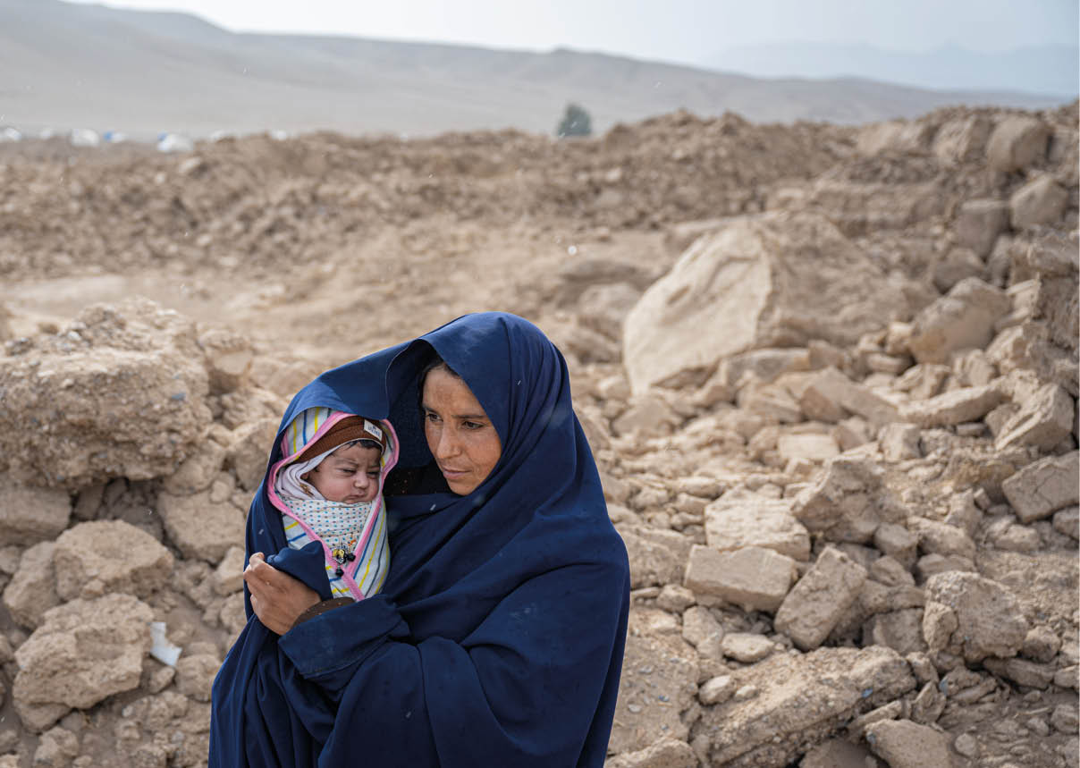
Photo: © Norwegian Church Aid/Håvard Bjelland

The global humanitarian situation

Complex crises result in increased humanitarian needs
Humanitarian needs have increased drastically in the five years since the previous strategy was launched. The number of people in need of humanitarian aid has more than doubled, from 135 million in 2018 to more than 300 million people in 2024.,
Both sudden-onset and protracted crises have become more complex. Crises are also affecting entirely new countries. They are caused by new and recurring armed conflicts, climate change, increasing polarisation, the aftermath of the COVID-19 pandemic, geopolitical upheavals, democratic decline, and poverty. Increasing urbanisation entails that crises impact a greater number of people when they occur.
Most crises are protracted in nature, and the vast majority of people in need live in countries that have had a UN-coordinated appeal for five or more consecutive years. Many people are experiencing multiple crises simultaneously. Conflict affected areas are also often the most vulnerable to climate change and natural disasters and the least able to handle them.
At the same time, it has become more challenging for humanitarian organisations to reach those in need of assistance due to security challenges and bureaucratic hurdles. Armed actors make it particularly difficult to gain safe access to those in need.
Protection needs in humanitarian crises are substantial and growing. Populations are also severely affected because their fundamental rights are not respected, and they are subjected to violence and abuse. Marginalised groups and children are particularly vulnerable.
Sexual and gender-based violence is a widespread problem in crisis and conflict situations. Human trafficking is also a major problem in many crises.
Armed conflicts are increasing in number and duration, causing massive humanitarian needs. The number of both armed conflicts between states and armed conflicts involving non-state actors has increased. Wars are often being fought in cities and other densely populated areas. Sieges and blockades are often used as strategies by parties to armed conflict. This results in many civilians being killed or injured and causes large-scale displacement. When explosive weapons are used in populated areas, it is estimated that nine out of ten victims are civilians. Approximately one in five children in the world lives in a conflict area or is displaced by war. The number of children killed or injured due to armed conflict is very high.
A growing number of people are forced to flee their homes. According to the UNHCR, the number of displaced people was more than 110 million at the end of 2023. Furthermore, the UNHCR expects that there will be more than 130 million forcibly displaced people by the end of 2024. This is 60 million more than at the end of 2018. More than two-thirds are internally displaced. Most people who flee their home country seek refuge in neighbouring countries, which often have limited capacity to meet the needs of both displaced people and their own population.
Vital infrastructure is destroyed and often not rebuilt, as crises and conflicts persist. This devastation causes human suffering and can have major and long-lasting economic and social consequences.
The number of climate-related and natural disasters has increased significantly since 2018. The world’s population is experiencing more frequent droughts, floods, wildfires, and landslides, triggering new humanitarian needs. Climate phenomena, such as El Niño, are increasingly leading to droughts, floods, and extreme weather events. Climate change is an increasingly important cause of displacement according to the UN Intergovernmental Panel on Climate Change. Many communities are affected by several of these crises simultaneously.
A growing number of people are unable to secure enough food to feed themselves and their families. According to the World Food Programme (WFP), more than 300 million people in 72 countries are affected by hunger crises (IPC 3+), in 2024. These numbers are extremely high and are attributable not only to the aforementioned factors but also to structural poverty and inequality.

The structure of the humanitarian sector
The humanitarian sector includes international and local organisations with different mandates, competencies, and responsibilities. Norway engages with the UN-led humanitarian system, the International Red Cross and Red Crescent Movement, the work of which is based on international humanitarian law, as well as the Norwegian humanitarian organisations and their local partners. These actors complement one another and cooperate through different structures, both globally and at country level.
- Mandated by the UN General Assembly, the UN Office for the Coordination of Humanitarian Affairs (OCHA) coordinates humanitarian efforts in crisis-affected countries through what is known as the cluster system, where each sector of humanitarian action has a UN organisation with a relevant mandate and competence as cluster coordinator. These clusters coordinate the efforts of local and international organisations. See Box 1.
- Mandated by the 1951 Refugee Convention and the UN General Assembly, the UN High Commissioner for Refugees (UNHCR) leads and coordinates the response in refugee host countries. The response in refugee host countries is organised into sectors, with the various UN organisations and other humanitarian organisations contributing their competencies and resources.
- The International Committee of the Red Cross (ICRC) has a separate mandate pursuant to the Geneva Conventions to protect and assist people who are victims of armed conflict, and operates independently of the UN system. It is part of the Red Cross and Red Crescent Movement, together with the International Federation of Red Cross and Red Crescent Societies (IFRC) and more than 190 Red Cross and Red Crescent Societies. At the country level, the host National Society leads and coordinates the humanitarian response with support from ICRC in conflict situations, and with support from IFRC in other humanitarian crises, including natural disasters.
In addition, national and regional preparedness and response mechanisms have been established, which are activated particularly in connection with natural disasters and public health crises. Important contributions that Norway can draw upon in international humanitarian response are the Norwegian Directorate for Civil Protection (DSB) and the EU Civil Protection Mechanism (UCPM).
There have been several reforms to the UN humanitarian structure that have made it increasingly efficient and more capable of reaching large numbers of people. However, there is a common recognition that the structure needs to be further simplified and that the UN needs to work more closely with local actors. This is an ongoing effort led by OCHA.
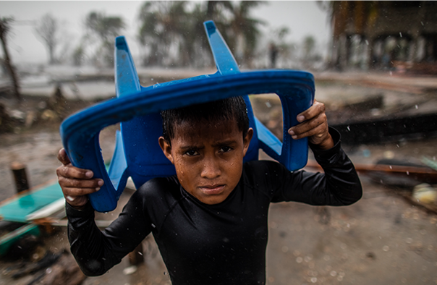
Photo: © UNICEF/UN0372375/Ocon/AFP-Services

Humanitarian efforts are challenged
In recent years, the humanitarian sector has grown and become more professional and more effective. Humanitarian financing has increased, humanitarian actors are helping more people than ever before, and humanitarian efforts are better coordinated and achieve better results. However, the gap between needs and available resources is large and growing, and is expected to continue to widen in the years to come.
Humanitarian financing is often unpredictable and short-term, while humanitarian crises often have clear warning signs and tend to last for a long time. This makes long-term planning difficult for humanitarian actors.
The sector is also challenged by attempts to politicise humanitarian aid. Some organisations are perceived as Western-based and oriented, with limited connections to local communities. Local populations may have experiences from previous crises that generate a distrust of the international community which humanitarian actors are perceived as being part of. The legitimacy and relevance of the humanitarian sector are challenged when the response does not meet the needs of crisis-affected people, and neither the authorities, parties to conflicts nor the international community are able to resolve the crises.
Most often solutions to crises affecting populations are found outside the humanitarian sector. A comprehensive policy approach and the interaction of instruments within long-term development policy, conflict resolution and peace building, humanitarian efforts as well as climate action and human rights efforts are necessary.
The Sustainable Development Goals will not be achieved unless more is done to include people affected by crisis and conflict. Intensified and better coordinated efforts to reach the most vulnerable people are needed if we are to live up to the Leave No One Behind principle.
              - The humanitarian cluster system
The aim of the humanitarian cluster system is to ensure good coordination and avoid gaps and duplication in humanitarian response. The cluster system is activated in humanitarian crises at the request of the UN Emergency Relief Coordinator. The clusters are groups of humanitarian organisations, both UN organisations and non-governmental organisations, working in sectors such as water, health and protection. One or two organisations have dedicated leadership responsibility in each sector.
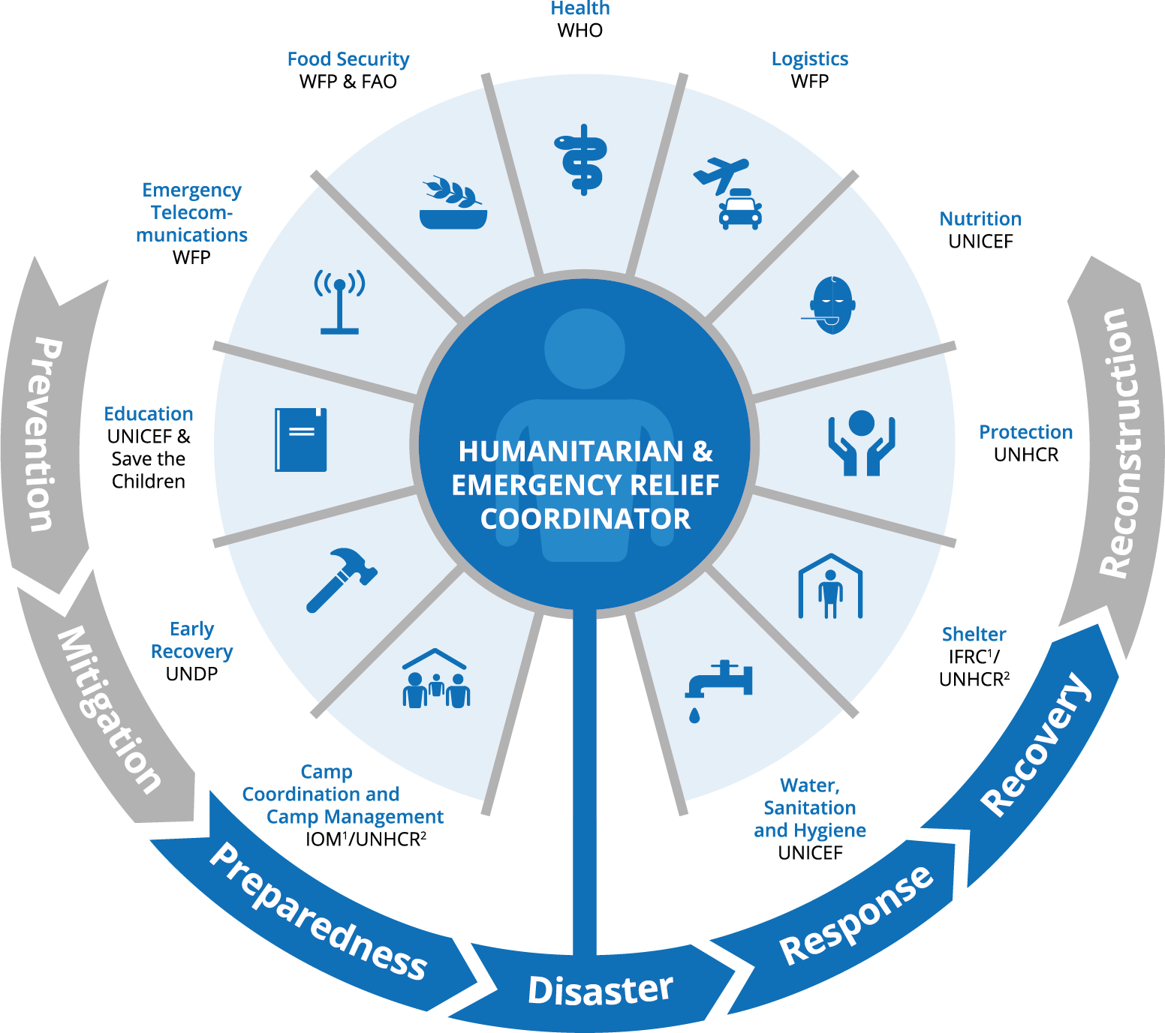
          - The humanitarian cluster system
1 Disaster situations
2 IDPs (from conflict)
Source: OCHA

International humanitarian law and the humanitarian principles
International human rights law, the 1951 Refugee Convention and international humanitarian law form the legal framework for humanitarian action. Common to these rules is that they concern the protection of human lives and dignity. International humanitarian law only applies in situations of armed conflict, while international human rights law applies at all times, in peace and in war. It is crucial that humanitarian efforts are based on the rights enshrined in this legal framework. This rights-based approach also entails focus on participation, non-discrimination and accountability, in addition to the right to life, food, health services and education.
Under international humanitarian law, parties to armed conflict have a number of obligations based on the requirement to ensure balance between the military need to use armed force in certain situations (the principle of military necessity) and the need to prevent/limit to the greatest extent possible the harm and suffering inflicted as a result of use of armed force (the principle of humanity). This balance is reflected in the rules and principles of IHL, inter alia in the prohibition against directing attacks against the civilian population, the requirement that parties to an armed conflict must distinguish between civilians and combatants and between civilian objects and military objectives (the principle of distinction), as well as the prohibition against launching attacks expected to cause incidental loss of civilian life, injury to civilians, damage to civilian objects, or a combination thereof, which would be excessive in relation to the concrete and direct military advantage anticipated (principle of proportionality). International humanitarian law also contains several obligations to protect civilians and the wounded regardless of which side they are on, and to protect health workers and medical facilities, vital civilian infrastructure, as well as nature and the environment. Furthermore, parties to armed conflict must allow and facilitate the rapid and unimpeded passage of humanitarian relief.
Failure to respect and comply with these rules is a widespread problem in many armed conflicts, and the consequences for civilians are severe. This problem is exacerbated by the fact that many of today’s armed conflicts are taking place in densely populated areas.
Today, the constellation of actors involved in armed conflicts tends to be more fragmented than it was in the past, and it can be difficult to identify exactly who the parties to the conflict are at any given time. Armed groups, other non-state actors, terrorist organisations and criminal groups motivated by financial gain often do not relate to the rules of international law. In some cases, this may be due to a lack of knowledge of the rules. The educational efforts of the ICRC and other actors are therefore of great importance in promoting increased compliance with international law, including on the part of these groups. State actors also violate international law in many armed conflicts. Political will, in addition to knowledge, training and leadership in the armed forces, is key to ensure the protection of civilians. The development of new weapons technology, such as autonomous weapons, and the use of unconventional warfare, including cyberattacks, also add to the challenges regcompliance with the established rules of international humanitarian law.
              - International humanitarian law
International humanitarian law consists of several international conventions as well as customary international law rules that have evolved over many years, and which are considered binding upon all. The four Geneva Conventions of 1949 have been universally ratified, and form, together with Additional Protocols I and II of 1977 the core of international humanitarian law. All parties to a conflict, including non-state armed groups, are bound by international humanitarian law. All states have a responsibility to respect, and to ensure respect for international humanitarian law.

              - Sexual violence as a war crime
Sexual violence includes violations such as rape, sexual slavery and forced pregnancy. Conflict-related sexual violence is prohibited under international humanitarian law. Depending on the circumstances, sexual violence may be considered both as individual war crimes as well as crimes against humanity, and in certain situations it may also be considered a constituent act in the crime of genocide. Nevertheless, conflict-related sexual violence (CRSV) is often used as a method of warfare. CRSV is addressed in several UN Security Council resolutions on Women, Peace and Security (WPS).
Civilians and civilian infrastructure, such as hospitals and schools, are often attacked and it is becoming increasingly difficult to gain humanitarian access and provide protection.,,
To ensure safe and unimpeded humanitarian access to civilians and promote respect for international humanitarian law, it is necessary to engage in dialogue with the various parties to conflict.
Compliance with international humanitarian law reduces civilian suffering, prevents war crimes, and can contribute to strengthening the possibility of various peace initiatives. Efforts to promote respect for international humanitarian law can thereby contribute to conflict resolution.
Norway’s humanitarian efforts are based on the humanitarian principles (see Box 3.3). These principles constitute an ethical framework and operational tool for humanitarian actors to reach those most affected. Particularly in conflict-related crises, these principles are important to ensure that those affected have access to emergency assistance and protection, without discrimination, and regardless of where they are in relation to the line of conflict. For the safety of humanitarian workers, it is also important that they remain impartial and are not used in support of the political or military objectives of one of the parties. In striving for a comprehensive response, it is important to factor in the need for humanitarian actors to work in accordance with the principles. This is particularly important where the authorities are party to a conflict.
Actors in the humanitarian sector may be put under pressure to follow political instructions from the parties in an armed conflict, from their own authorities and from donors. This can make it challenging for them to uphold the humanitarian principles. It can also undermine the general respect for the principles and reduce access to various groups in vulnerable situations. It is crucial to engage in close dialogue with partners on such dilemmas.
In recent years, several new actors, both donors and operational organisations, have emerged. These actors do not necessarily adhere to the UN-based framework for humanitarian assistance. It is important that the established organisations and donors stress knowledge of and respect for the humanitarian principles to these new actors.
              - The humanitarian principles
The humanitarian principles are derived from the Fundamental Principles of the International Red Cross and Red Crescent Movement and are enshrined in international humanitarian law. They are to form the basis for all humanitarian action in both conflict situations and natural disasters, as set out in UN General Assembly resolutions 46/182 and 58/114.
The four principles are as follows:
Humanity Human suffering must be addressed wherever it is found. The purpose of humanitarian action is to protect life and health and ensure respect for human beings.
Impartiality Humanitarian action must make no distinctions based on nationality, gender, ethnicity, religious belief, or political opinions.
Neutrality Humanitarian actors must not take sides in hostilities or engage in controversies of a political, ethnic, religious, or ideological nature.
Independence Humanitarian action must be autonomous of authorities’ and other parties’ political and military actions and objectives.
The principles of humanity and impartiality are to form the basis for all Norwegian humanitarian efforts. The principles of neutrality and independence are a means of gaining trust and access to provide protection and humanitarian assistance in an impartial manner. How the principles of neutrality and independence can best be complied with will depend on the context. It is precisely because there are not always simple answers to the challenges humanitarian organisations must face, that Norway is seeking to promote an experience-based approach aimed at ensuring that the humanitarian response can reach those who are most vulnerable.
The Norwegian Ministry of Foreign Affairs has drawn up a guidance note in consultation with several Norwegian humanitarian organisations. The purpose of the guidance note is to enhance respect for and promote compliance with the humanitarian principles. The guidance note, which was updated in 2024, is intended as a dynamic tool to promote mutual learning opportunities and a better understanding of the principles.
Humanitarian action often takes place in areas affected by armed conflict. In many crisis situations, military presence can ensure the safety of the civilian population. Peacekeeping forces mandated to protect civilians can play an important role in this regard. Good dialogue between armed forces and humanitarian actors is crucial to promote and avoid unintended military attacks. Furthermore, there is a need for effective information sharing on humanitarian activities, civilians, and civilian infrastructure (known as deconfliction). The interplay between humanitarian actors, other civilian institutions and military actors can at times render principled humanitarian efforts difficult, if it creates uncertainty regarding roles, responsibilities, and objectives. This is especially the case where military forces/uniformed peacekeeping personnel participate in humanitarian tasks. Role confusion in relation to humanitarian, political and military actors can weaken the population’s trust in humanitarian organisations. This can also increase the risk of attacks on humanitarian aid workers. Some states also use emergency aid as part of a political or military strategy.
Nevertheless, to save lives, it is sometimes necessary for humanitarian operations to receive military support for logistical purposes or to gain safe access to those in need. The use of military assets in conflict situations presents dilemmas. Norway has supported the development of international guidelines with a view to ensuring that both international military support and support from individual countries in humanitarian crises is based on a clear division of roles. Although military contributions can fill humanitarian gaps, such engagement must be limited to exceptional situations and must be closely coordinated with humanitarian actors and the host country.
Norway’s policies on sanctions remain unchanged. Norway’s view is that multilateral and legally binding sanctions adopted by the UN Security Council, or other measures with broad international support, have the greatest legitimacy and coercive power to influence a state or other actors that threaten international peace and security. Norway has supported the EU’s restrictive measures with a few exceptions. It is important that sanctions regimes do not have unintended adverse consequences and hinder the work of humanitarian actors. Norway supports the inclusion of humanitarian exceptions in all sanctions regimes where this is relevant. A prerequisite for this is good dialogue with, and accountability on the part of, humanitarian partners to reduce the risk of misuse and diversion of funds. Norway will also seek to ensure that all international action against terrorism complies with international humanitarian law, the principles of the rule of law and international human rights law.
              - Sanctions and humanitarian exceptions
The sanctions regimes currently implemented in Norwegian legislation are based on sanctions adopted by the UN Security Council and restrictive measures taken by the EU. The UN Security Council may impose sanctions to maintain or restore international peace and security in accordance with Article 41 of Chapter VII of the UN Charter. Sanctions adopted by the UN are legally binding for all UN Member States.
The EU adopts restrictive measures as part of its Common Foreign and Security Policy. The EU currently has over 40 different sanctions regimes in place targeting, for instance, conflict situations, regimes, and individual actors. Norway has supported the EU’s restrictive measures with a few exceptions.
Under international humanitarian law, all states are obliged to facilitate humanitarian access. The Norwegian Government places considerable emphasis on providing guidance to Norwegian actors to minimise the unintended adverse consequences of sanctions for humanitarian actors. This applies particularly to humanitarian actors whose mandate is to operate in areas affected by armed conflict, political instability, and humanitarian crises. Most Norwegian sanctions regulations will contain explicit exceptions for humanitarian actors from asset freezing provisions.
All Norwegian humanitarian organisations are expected to have good sanctions risk management procedures in place. Humanitarian actors should, to the extent possible, structure their operations in a way that reduces the risk of funds and assets becoming available to listed individuals and entities.

A comprehensive approach
Humanitarian crises and armed conflicts have complex causes. We cannot prevent, remedy, or solve them by humanitarian means alone. In many societies, conflict resolution, development, disaster risk reduction, humanitarian response and recovery are needed simultaneously.
A comprehensive approach is required to address such multifaceted needs. Norway and most of our partners adhere to the OECD/DAC recommendation to prioritise prevention, mediation, and peacebuilding, invest in development where possible, while ensuring that immediate humanitarian needs are met – often referred to as triple nexus or a comprehensive approach. The purpose is to contribute to reducing vulnerability and humanitarian needs over time, enable crisis-affected populations to become more self-reliant, limit the humanitarian consequences of armed conflict and lay the foundation for prevention and resolution of conflicts through political processes.
New crises impact most severely already vulnerable societies characterised by poverty, weak institutions, climate change, deteriorating ecosystems and/or armed conflict. To contribute to resilient and stable societies and respond to humanitarian needs, we must make use of all of our policy instruments and consider them part of a coherent whole.
Humanitarian actors are increasingly operating with longer-term perspective as crises are becoming more protracted. They provide emergency response and seek more sustainable solutions to ensure services and protection. In addition to humanitarian action, there is a need to invest in preventive measures and work to address the underlying causes of crises and armed conflicts. The same applies to vulnerability to natural disasters. Instruments within development, conflict resolution and peacebuilding, as well as other relevant policy measures, must also be utilised in crisis-affected societies. A comprehensive approach is crucial to address issues such as food security, education and health. It is also essential in the efforts to support people affected by climate change and degraded ecosystems, as well as to find durable solutions for displaced people and to support their host communities.
Norway endeavours to ensure more coordinated policies between humanitarian assistance, development cooperation and peacebuilding to prevent and reduce the risk of protracted humanitarian crises.
The intentions of a comprehensive approach must be translated into practical policies. Each chapter in Part III of the Strategy identifies specific follow-up measures for humanitarian action and humanitarian policy that will contribute to a more comprehensive approach. This must be considered in conjunction with other relevant strategies, particularly regarding climate adaptation, food security and sustainable use and conservation of nature.

Coordination of humanitarian efforts, peacebuilding and long-term development assistance
We must emphasise the interaction between humanitarian action, conflict resolution and peace efforts. Humanitarian crises largely occur in states and communities affected by armed conflicts. This underscores the need for political solutions and conflict resolution at the national and local levels. Failure to protect civilians subjects the population to suffering and abuse which may undermine trust and the foundation for durable and peaceful solutions.
Norway invests considerable resources in conflict resolution, peace and reconciliation processes. These efforts are important to reduce humanitarian needs. We must also recognise and fund local actors engaging in conflict prevention and resolution through dialogue and mediation. Many of these actors implement measures which reduce conflict, facilitate integration of internally displaced people and reintegration of refugees, and enhance the resilience of local communities. Conflict reduction is an important prerequisite for development.
In contrast to humanitarian efforts, long-term development cooperation and stabilisation efforts can address the underlying causes of conflict and vulnerability. To this end, poverty eradication, institution building, good governance, human rights and gender equality are key. Development and stabilisation actors can bolster the capacity of governments and local communities to manage and prevent crises, develop early warning and preparedness systems, and ensure the provision of basic services for the population.
Development actors should engage at an early stage in humanitarian crises, as they bring both long-term development expertise and more sustainable financing. This also applies to support for displaced people and their host communities. The UN and the multilateral development banks play an important role in this respect. There is a need for greater flexibility and tolerance of not achieving planned results in long-term development efforts in fragile states and regions. Prevention and reduction of the scale of humanitarian crises should therefore be an explicit goal of development cooperation, alongside development goals such as poverty eradication.
Many of the organisations Norway supports have broad mandates covering humanitarian, long-term development cooperation and peace efforts.
A well-functioning UN and cooperation with non-governmental organisations and national and local authorities where possible, are important to ensuring efficient and comprehensive efforts. In this context, the UN Resident Coordinator, who also serves as Humanitarian Coordinator in countries affected by humanitarian crises, plays a key role.
The World Bank and the regional development banks particularly stress the importance of partnerships with the UN, the private sector and civil society in fragile and conflict-affected situations. In recent years, the World Bank has increased its presence and strengthened measures in crisis-affected countries and adopted new tools for crisis preparedness and response. Norway is also a driving force behind the increasingly closer collaboration between the UN and the World Bank on conflict prevention and peacebuilding.
              - Cash-based assistance programme for comprehensive action in Somalia
Somalia has experienced protracted crises since the collapse of the Somali state during the civil war in the 1990s. Armed conflict, the struggle for scarce natural resources and climate change render Somalia increasingly vulnerable to new humanitarian crises. Norway has supported the reconstruction of Somali institutions and economic reforms in tandem with humanitarian assistance. Through the World Bank, Norway has supported the Shock Responsive Safety Net for Human Capital Project (BAXNAANO). The programme is implemented by the Somali Ministry of Labour and Social Affairs with support from UN agencies including the WFP and UNICEF. Since 2019, BAXNAANO has provided cash assistance to 220,000 low-income households. Through a dedicated crisis response window, cash assistance has been provided to an additional 615,000 households, thereby strengthening their resilience to humanitarian crises caused by locust infestations and drought.

Comprehensive efforts against hunger
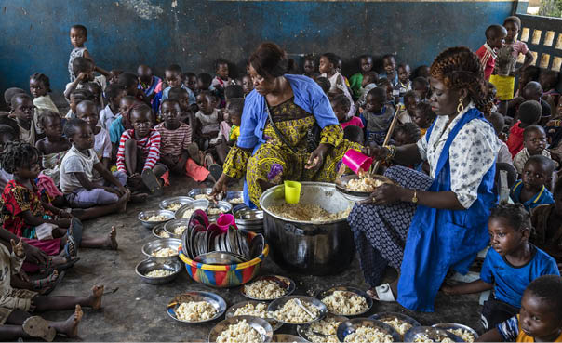
Photo: © WFP/Gabriela Vivacqua
Disaster prevention is crucial to addressing the global hunger crisis. In principle, this should be a component of long-term assistance. However, it often requires a comprehensive approach whereby long-term development, humanitarian and peacebuilding actors must cooperate with local authorities and the international community. Preventing violent conflict and contributing to peacebuilding in areas affected by war and instability will reduce the risk of hunger crises. The most vulnerable populations must be far better protected against food crises, and the use of starvation as a method of warfare must end. Improved food security can prevent humanitarian disasters and reduce humanitarian needs. Climate adaptation measures must be prioritised. Our aid will contribute to building resilient local communities that are able to avoid food shortages and hunger catastrophes. This necessitates increased emergency preparedness capacity, the strengthening of social safety nets and insurance mechanisms against extreme weather events.

Preparedness and disaster risk reduction for natural disasters
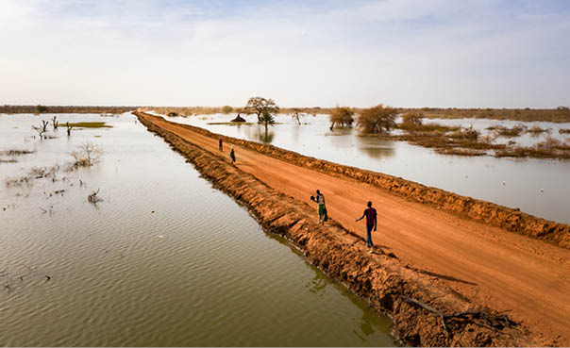
Photo: © UNHCR/Andrew McConnell
Disaster prevention, preparedness and recovery following natural disasters, including climate-related events, are key to Norway’s development policy. The humanitarian crisis response must be intricately linked to all phases of such efforts, with the aim of reducing the humanitarian consequences.
The Sendai Framework contains a set of agreed global targets and indicators for disaster risk reduction and has also elevated disaster risk reduction and preparedness on the international agenda. The UN Office for Disaster Risk Reduction (UNDRR) coordinates disaster risk reduction efforts in the UN system and is responsible for implementing the Sendai Framework.
There is a clear correlation between climate adaptation, preservation of nature, prevention of climate and natural disaster, and the need for humanitarian efforts. Prevention of and preparedness for extreme weather events, earthquakes and other natural phenomena are costly, however, disaster response and recovery have a much higher cost. Low-income countries and vulnerable groups are disproportionately affected.
Norway supports the financing of climate-resilient recovery and reconstruction through multiple channels. Recovery and reconstruction are components of the work on loss and damage associated with the adverse effects of climate change, and form part of the funding arrangements implemented following COP28, including the newly established Fund for responding to Loss and Damage.
Humanitarian actors can play a role in disaster prevention, preparedness, and recovery efforts. However, it is primarily the development actors that must further these efforts, in cooperation with local authorities.
During the strategy period, we will support preparedness, risk reduction, nature conservation and climate adaptation efforts as part of a comprehensive approach to reduce vulnerability and humanitarian needs.
              - Anticipatory action – a forecast-based approach
The purpose of anticipatory action is to reduce the humanitarian consequences of extreme weather events by acting before the event occurs. About half of all disasters can be predicted, and about a quarter can be predicted with a high degree of certainty. In order to act ahead of a crisis, there is a need for high-quality analyses of weather and climate data and of how droughts and floods have previously impacted food production and food security for various segments of the population. Therefore, it is important to strengthen local and national weather and climate forecasting capacity.
Norway supports anticipatory action across the climate, development, and humanitarian sectors, including through the World Food Programme (WFP) and the Food and Agriculture Organization of the United Nations (FAO). Anticipatory action is now an integral part of the UN Central Emergency Response Fund (CERF) and the Disaster Response Emergency Fund (DREF) of the International Federation of Red Cross and Red Crescent Societies (IFRC).
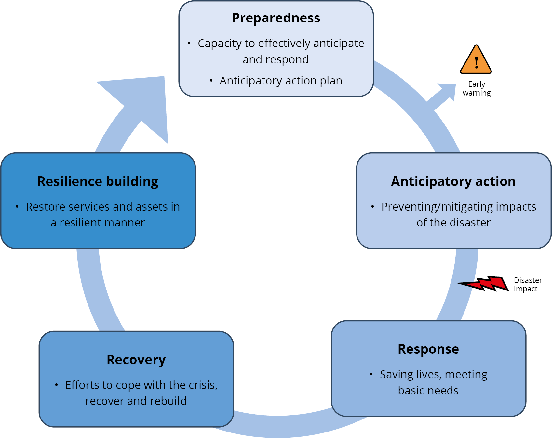
          - The figure is a schematic representation of the different stages of anticipatory action.

4.4 Dilemmas arising in interaction
To ensure that crisis-affected populations have access to basic services, humanitarian organisations may assume responsibility for maintaining infrastructure and services that are normally within the purview of the government. There are often good reasons for humanitarian organisations to assume responsibility for such tasks, including early recovery. This is especially the case where the political situation precludes cooperation with the authorities and development actors are not present. The efforts of humanitarian actors can contribute to preventing system collapse and are necessary to save lives and alleviate suffering, contributing to more efficient use of resources. Preventing system collapse helps avoid the need for more costly mitigating measures to meet the basic needs of the population.
However, this should not be a long-term responsibility of humanitarian actors. It risks diverting capacity from other, more acute, crises, and humanitarian actors also risk being perceived as biased due to close ties to the authorities. In protracted conflict situations, humanitarian actors face difficult dilemmas if their operations are perceived as contributing to the continuation of conflict and maintaining of authoritarian regimes. This may occur if parties to a conflict or authorities use resources on warfare or oppression, leaving the responsibility for basic services to humanitarian organisations. It must always be a prerequisite that humanitarian action is carried out in accordance with the humanitarian principles. There must be a clear division of roles and responsibilities among the different actors.
It is important that humanitarian organisations, where possible and expedient, interact with, and subsequently transfer tasks to, authorities or actors with competence and resources to carry out long-term development work. This is necessary for the humanitarian response to be phased out.
More effective and coordinated efforts at the intersection of humanitarian action, development and peacebuilding also require changes on the part of donors, including Norway. For instance, this may involve a greater degree of coordination of and cooperation on the management of funds for these efforts, particularly at the country level. Norwegian embassies play a key role by providing comprehensive assessments and analyses.

PART III EFFECTIVE HUMANITARIAN RESPONSE: IMPLEMENTING NORWAY’S HUMANITARIAN POLICY
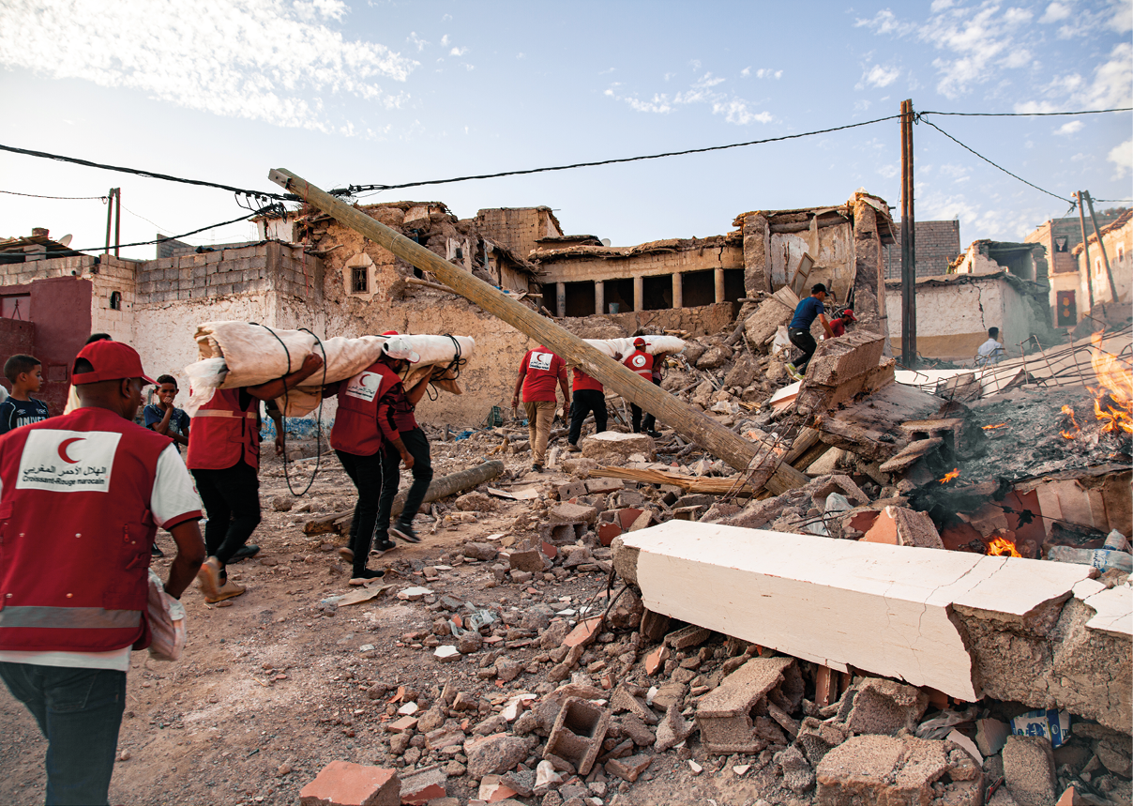
Photo: © IFRC/Benoit Carpentier

People affected by crisis at the centre of the response
Norway’s humanitarian efforts are to be based on the affected populations and their needs, knowledge, and capacity. This entails that humanitarian actors must facilitate the active participation of the affected populations in the planning and implementation of the humanitarian response, without discrimination. Crisis-affected people should also be able to hold humanitarian organisations accountable for the quality and effectiveness of their humanitarian efforts. Accountability to Affected Populations is a fundamental principle in this regard.
High-quality context and conflict analyses and sound knowledge of the demographic composition of affected populations and underlying structures are crucial to ensure that the measures are adequately adapted to the situation. Analyses must be based on reliable data that are e.g. gender- and age-responsive and take into account how different forms of discrimination and inequalities may interact and exacerbate vulnerabilities. People in vulnerable situations, especially among religious and ethnic minorities, indigenous peoples, LGBTIA+persons, women, children, elderly people and people with disabilities, are particularly at risk. It is crucial that they themselves and their representative organisations participate in the planning and implementation of humanitarian efforts. Women’s rights and participation shall be prioritised, and we will contribute to strengthening women’s leadership in humanitarian response. Children and young people must be included in a meaningful way.
The Norwegian Government will
- promote a rights-based approach where crisis-affected people and their representative organisations are included in the decision-making processes, planning and implementation of humanitarian efforts;
- promote UN reforms to ensure that the needs of, and the participation by, crisis-affected people, are at the centre of the response, including in the UN’s coordination of emergency aid.

Protection and humanitarian assistance
Norway’s humanitarian policy is implemented through the provision of humanitarian assistance and measures to protect people who are affected by humanitarian crises. Assistance and protection are two closely intertwined areas of humanitarian action.
In a humanitarian context, protection is understood to cover strengthening of and compliance with the international legal framework that applies in armed conflict (international humanitarian law), including the obligation of parties to armed conflicts to protect civilians and other protected groups from being affected by military attacks and other adverse impacts, directly or indirectly, caused by warfare. Furthermore, protection includes operational humanitarian action, in all humanitarian crises, which contributes to protection from violence and abuse, including violations of international human rights law or other rules of international law occurring as a result of a particular humanitarian crisis.
In this strategy, humanitarian assistance is used in a broad sense to include material relief and logistics support. Assistance may be, e.g., in the form of health services, medicines, food, water, sanitation, shelter and education.
Although there are significant unmet needs for humanitarian assistance, the main challenge in today’s crises is the inadequate protection of crisis-affected people. The lack of compliance with international humanitarian law in armed conflict results in civilians and civilian infrastructure being severely affected by the actions of the parties to the armed conflict. Even where international humanitarian law is respected, warfare causes major humanitarian protection needs. Norway will continue to prioritise protection by promoting respect for international humanitarian law and strengthening operational humanitarian efforts to prevent violence and abuse.
Providing humanitarian assistance is an important part of Norway’s humanitarian efforts. Humanitarian organisations are now delivering assistance to far more people than they did in the past. This is primarily due to an increase in financing, new technology and better coordinated ways of working, but also prepositioning, flexible financing mechanisms and staffing solutions, as well as increased use of early recovery.
Norway’s protection and assistance measures shall be rights-based, safeguard gender equality and target the needs of the most vulnerable people.
Norway will continue to promote reform of the humanitarian sector, and the focus on innovation, including the scaling up of successful innovations.

Protection – a continued commitment
Norway will continue its commitment to protection in humanitarian crises and armed conflict. International humanitarian law, international refugee law and international human rights law constitute the international legal framework for protection. In humanitarian efforts, a distinction is made between the protection of civilians and civilian infrastructure in armed conflict in accordance with international humanitarian law, and humanitarian protection measures in all types of humanitarian crises.
Humanitarian action must, to a greater extent, contribute to reducing the risk of violence and abuse, and targeted protection measures must be prioritised and funded – including in the early stages of a crisis response. Norway plays a leading role in these efforts and will take new initiatives to promote respect for international humanitarian law and strengthening of the operational humanitarian protection efforts. We will reinforce alliances with humanitarian organisations, multilateral organisations and committed states to achieve progress, particularly in relation to people at high risk of being subjected to violence and abuse in vulnerable situations.
By working locally, including through mediation, some humanitarian actors are developing programmes to not only respond to, but also more actively prevent and protect against, violence. Norway will support such efforts.
Norway will continue to promote the protection of refugees and internally displaced people and contribute to a human rights-based, coordinated, and long-term response to the major refugee situations. Durable solutions for internally displaced people will be an important aspect of these efforts. This will remain a priority for Norway. We will help ensure effective follow-up of the High-Level Panel on Internal Displacement through the UN Secretary-General’s Action Agenda and support for the follow-up of the work done by the Secretary General’s Special Adviser on Solutions to Internal Displacement.
We will continue to prioritise the protection of educational institutions against attacks and military use in armed conflict. Attacks on health and humanitarian workers is a widespread and growing problem. Norway will continue its efforts to ensure their protection in crises and armed conflicts.
Protection of civilians against various types of weapons, mines and other explosives is given special priority. Warfare in densely populated areas is particularly devastating for civilians and vital infrastructure and requires a more adapted humanitarian response. Food systems must be maintained, and civilians must be protected from the use of starvation as a method of warfare.
People without valid documentation to confirm their identity, marital status, family relationships and property ownership are particularly vulnerable in crises. Missing documents, or documents not being recognised, is a problem that affects single women and children in particular. Norway will continue to draw attention to this issue at the international level and will support new and innovative solutions to ensure that crisis-affected people are issued the necessary documents.
Many people disappear during crises and armed conflicts and remain missing. The authorities in the country concerned have the primary responsibility for preventing disappearances and for respecting the next of kin’s right to information about the missing person. Norway will, in cooperation with relevant actors, particularly through The Global Alliance for the Missing, which Norway was part of establishing in 2021, work to draw attention to these challenges and will support relevant measures.
Digital threats represent an increasing risk for civilians living in conflict-affected areas. Challenges arise because of the blurred distinction between military and civilian digital infrastructure, as well as the dependency and vulnerability associated with the digitalisation of information and services. Disinformation exacerbates conflicts and increases the risk of groups and individuals being subjected to violence and abuse. The risk of misuse of personal data is also high in the humanitarian sector. Inadequate protection of personal data can be life-threatening for crisis-affected people.
The Norwegian Government will
- promote a strengthened humanitarian protection response;
- strengthen the interaction between humanitarian protection, conflict prevention and resolution, as well as peacebuilding;
- support initiatives and innovative measures to strengthen protection against digital threats in humanitarian contexts, including the protection of personal data.
              - Protecting civilians from digital threats in armed conflict
The International Committee of the Red Cross has initiated systematic and important work on digital threats that affect the civilian population in armed conflicts. The Global Advisory Board on Digital Threats in Armed Conflict identified challenges and issued recommendations. In October 2023, the ICRC released a report containing a series of recommendations to parties to armed conflicts, authorities, humanitarian organisations, and the private sector. This is an initiative Norway will follow closely.
Global Advisory Board on Digital Threats in Armed Conflict | ICRC
Key initiatives will focus on the following themes:

Protection of civilians in armed conflict
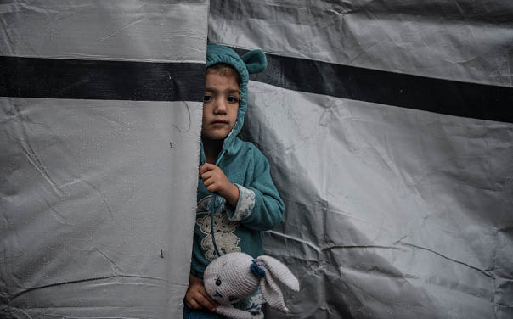
Photo: © ICRC/Abed Zaqout
Norway will actively promote the protection of civilians and compliance with international humanitarian law. We will counter attempts to undermine or weaken obligations under international humanitarian law, show political engagement in situations where international humanitarian law is violated, and help to ensure that such violations are documented and prosecuted.
It is important to ensure that the humanitarian consequences of crises and armed conflicts and the need to protect civilians is high on the national and international agendas. In recent decades, most of the world’s states have managed to unite around several important agreements that further develop international humanitarian law, including the Anti-Personnel Mine Ban Convention and the Convention on Cluster Munitions. Norway will take political initiative and show perseverance in seeking to further develop and strengthen the international framework. We will strengthen cooperation concerning the practical implementation of these obligations with relevant actors, including the Norwegian Armed Forces and the International Red Cross and Red Crescent Movement. One example is the Norwegian-led Safe Schools Declaration from 2015. Norway will continue to focus on the consequences of the use of explosive weapons in populated areas.
Compliance with international humanitarian law is not in itself sufficient to prevent civilian suffering. War and conflict carried out in line with the laws also result in harm and human suffering. We must always seek to reduce harm and suffering to human beings using the means at our disposal, not least through effective and principled humanitarian action.
The Norwegian Government will
- promote respect for – and compliance with – international humanitarian law;
- take a leading role in international forums and support measures that reduce human harm and suffering and strengthen the protection of civilians.

Protection of children and young people
Children and young people are a large and complex group who are particularly at risk and in special need of protection. Children also enjoy special rights.
Children are disproportionately affected in crises and armed conflicts. At the beginning of 2024, approximately 470 million children are living in a conflict affected area or are displaced. In humanitarian crises, children and young people are often left to fend for themselves, without the care and support of their loved ones. This renders them particularly vulnerable. Gender-based differences influence and can exacerbate vulnerabilities. In many cases, children do not have identity papers, in part because their births have not been recorded. This can undermine their chances of being granted citizenship and access to health services and education.
Young people often have little influence and visibility in humanitarian response. They are overlooked, and are perceived and treated as neither adults nor children. This results in particular vulnerabilities and needs. Young people are severely affected, however, they also have considerable capacity and often take on major responsibilities for themselves and their loved ones. They are an important resource that should, to a far greater extent, be allowed to participate in the design and implementation of humanitarian programmes. Therefore, it is necessary to increase the focus and engagement around young people in humanitarian efforts.
In armed conflict, children are especially vulnerable during military attacks in populated areas. The recruitment of children to armed forces and groups is on the rise. The risk of abuse is high, and many children and young people are traumatised. There is a need for both preventive measures to avoid recruitment, and for reintegration and psychosocial follow-up adapted to the target group.
It is important that children and young people with disabilities are included and able to participate on an equal footing with others to the greatest extent possible. Children and young persons with disabilities are particularly vulnerable to being subjected to violence and abuse. They are among the first to lose access to education and other basic services, and often the last to be included again.
Protection of children and young people will be given high priority in our humanitarian efforts. Norway will play an active role with a view to ensuring that the international community steps up its efforts to protect children and their rights and ensures their participation. Norway’s efforts to promote the protection of children in armed conflict in the UN Security Council will be followed up. The same applies to the commitments from the Oslo International Conference on Protecting Children in Armed Conflict of 2023. We will prioritise measures to prevent violence and abuse against children and young people, as well as the follow-up of survivors. In conjunction with our work in other policy areas, Norway will seek to prevent the recruitment and use of children by armed forces and groups, and strengthen efforts to release and reintegrate recruited children back into society.
The Norwegian Government will
- promote measures and initiatives that strengthen the protection of children and young people in situations of crisis and conflict and, through humanitarian diplomacy, direct attention to warfare that particularly affects children, including urban warfare;
- strengthen efforts to prevent children from being separated from their parents or caregivers in humanitarian crises, and support efforts to restore family relations where they have been separated.

Protection of education
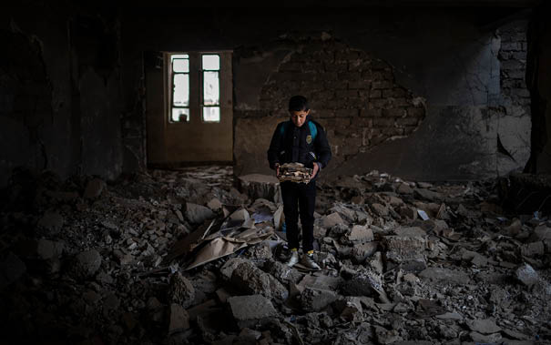
Photo: © UNICEF/UN0611862/Ibarra Sánchez
Safe access to education in crisis and armed conflict is essential to ensure the right to education and to protect children and young people. In many armed conflicts, educational institutions are subjected to military attacks or used for military purposes. This means that children and young people are denied access to education and the protection it provides. This is a major, growing problem.
During the period 2020–2021, more than 5,000 attacks on schools, universities, students, and teaching staff were reported to have been carried out by state and non-state actors in 85 countries. The protection of educational institutions and affiliated individuals is a continued priority.
The main aim of the 2015 Safe Schools Declaration is to prevent attacks on schools and universities and prevent military use of such institutions. States that endorse the Declaration commit themselves to implementing measures to prevent the military use of educational institutions and thereby avoid such institutions becoming military targets. At the launch of this strategy, 119 states have endorsed the Declaration. In 2021, Norway initiated a network to support the implementation of the Declaration. The network contributes to the exchange of experience, information, and support at the country level.
The Declaration laid the foundation for Norway and Niger to jointly negotiate the unanimous adoption of Security Council Resolution 2601, which is the first of its kind dedicated to the protection of education in conflict situations.
The Norwegian Government will
- continue efforts to encourage more states to endorse and implement the Safe Schools Declaration, and mobilise in favour of implementation of Security Council Resolution 2601.

Protection of health
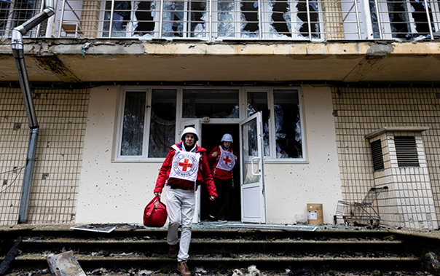
Photo: © ICRC/Alyona Synenko
To ensure that persons affected by crises and armed conflict have safe access to vital health services, it is crucial to protect the health sector from attacks. Hospitals and other health facilities must remain safe havens for civilians. Despite being afforded special protection under international humanitarian law, attacks on health workers, health facilities and ambulances are a widespread and growing problem in several armed conflicts. This results in fatalities and considerable harm to patients, personnel, and relatives, and has major consequences for the health sector, both during and after crises.
The recovery of health services in post-conflict and post-disaster situations is challenging. In many cases, personnel are gone and the facilities have been destroyed. In protracted crises, it can take decades for the population to regain access to basic health services. The World Health Organization (WHO) plays an important role in documenting attacks on the health sector and the consequences of such attacks.
The Norwegian Government will
- promote respect for and protection of health facilities and medical personnel, through continued engagement and partnerships with relevant organisations;
- work to ensure that parties to a conflict respect and protect the health sector, and promote Security Council Resolution 2286, which condemns attacks against the wounded and sick, medical personnel, health facilitates and humanitarian personnel.

Refugees and internally displaced people
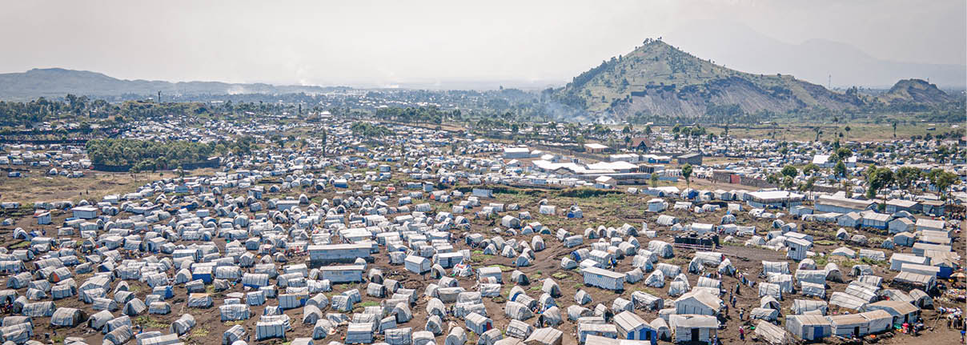
Photo: © UNFPA DRC/Junior Mayindu
The number of people who have been displaced as a consequence of conflict has increased dramatically in recent years. Close to two-thirds are displaced in their own countries, while the rest have crossed borders to other countries. A growing number of people are also being displaced as a result of climate change and natural disasters. In addition, there are large numbers of vulnerable migrants who are not recognised as refugees under the 1951 Refugee Convention. Nevertheless, they may all need humanitarian assistance and protection in line with the humanitarian imperative. Girls and women who are forcibly displaced and along migration routes are particularly vulnerable to exploitation, violence, and sexual abuse.
Norway’s efforts to ensure the protection of refugees are based primarily on its obligations under the 1951 Refugee Convention and its 1967 Protocol. The Global Compact on Refugees is a key framework for greater predictability and burden sharing with host communities. The Global Refugee Forum is the main follow-up mechanism to the Global Refugee Platform.
Unlike refugees, internally displaced people are not entitled to special international protection beyond what is set out in international human rights law and international humanitarian law. One exception is the African Union convention for the protection of internally displaced people (the Kampala Convention). The humanitarian needs of internally displaced people are comparable to those of refugees. Norway has played a leading role in international efforts to improve the protection of internally displaced for several years, particulary in the UN. In 2019, Norway contributed to the establishment of the High-Level Panel on Internal Displacement, which focuses on durable solutions.
Most displaced people seek protection in neighbouring areas. Many host communities for displaced people are characterised by high levels of poverty. This may constrain the political will, as well as the ability, to give residence and contribute to local integration. Norway will continue to prioritise support both to displaced people and the poor and vulnerable people in their host communities. This is also important to counteracting polarisation between the displaced population and the host communities. A more comprehensive approach can contribute to increasing the chances of finding durable solutions. Norway will continue to support host countries to ensure that borders remain open for displaced people. We will work to ensure that displaced people are included in national systems and development plans, and contribute to durable solutions through international development cooperation. Norway contributes to the resettlement of refugees in close cooperation with the UNHCR, as part of our humanitarian efforts.
The Norwegian Government will
- maintain Norway’s engagement relating to the protection of and assistance to refugees, internally displaced people and their host communities;
- contribute to durable solutions for displaced people, including through the resettlement of refugees;
- work to ensure that vulnerable migrants have access to humanitarian aid based on their needs.

Persons with disabilities
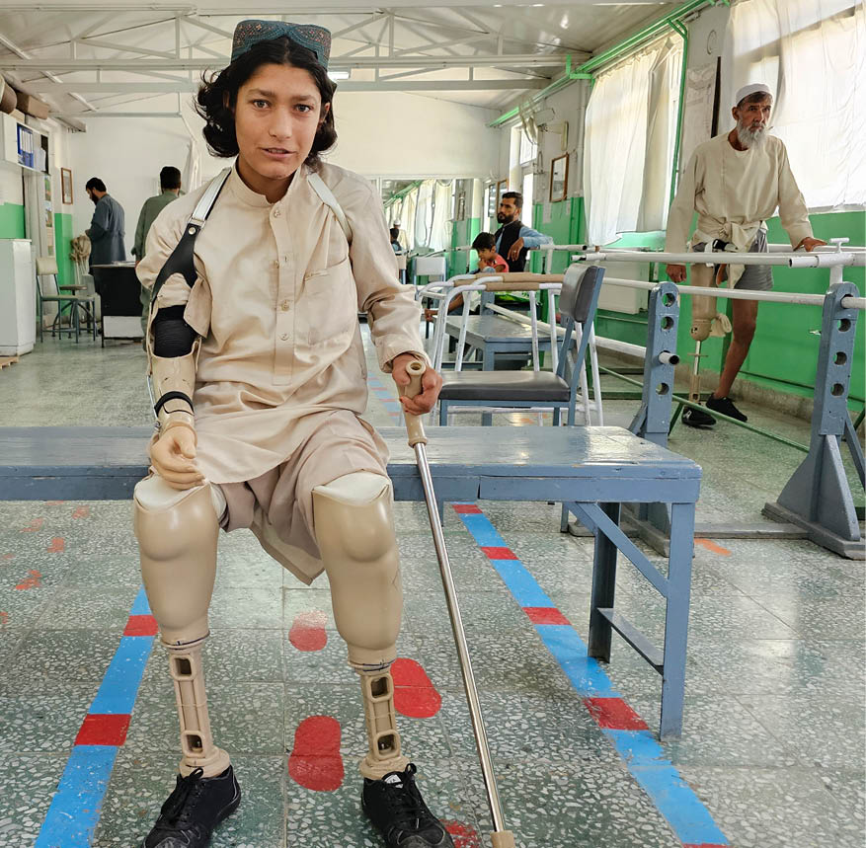
Photo: © ICRC/Mohammad Masoud Samimi
Persons with disabilities are entitled to special protection under international humanitarian law. Parties to armed conflicts have a special responsibility to ensure respect of and protection to persons with disabilities. Security Council Resolution 2475 (2019) is an important instrument in this regard. Nevertheless, today’s crises and conflicts are severely impacting persons with disabilities. The number of persons with disabilities is sharply increasing due to injuries caused by mines and explosives, among other things.
Humanitarian actors shall facilitate the same access to humanitarian assistance for persons with disabilities as for the general population, as well as ensure their active participation in the planning and implementation of the humanitarian response.
The special protection needs, including increased risk of sexual and gender-based violence, must be understood and addressed. There is a need for improved knowledge and figures in this regard. The dialogue with organisations representing persons with disabilities must be strengthened in humanitarian crises and in global political processes related to the protection of civilians. At the same time, there is already a recognition that the right to protection, assistance and participation of persons with disabilities must be given higher priority.
The Norwegian Government will
- ensure that the international framework to protect civilians from violence and abuse includes the protection and rights of persons with disabilities;
- promote adaptation for and inclusion of persons with disabilities and their representative organisations in all humanitarian efforts, in line with the recommendations from the 2022 Global Disability Summit in Oslo.

Protection against sexual and gender-based violence
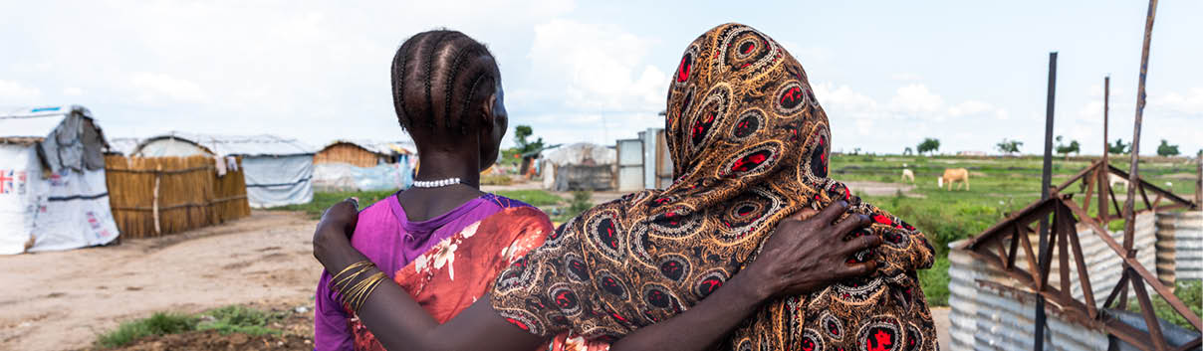
Photo: © UNOCHA/Alioune Ndiaye.
Sexual and gender-based violence (SGBV) is a widespread problem in humanitarian crises and armed conflict. Gender-based violence is often closely linked to the unequal distribution of power and the desire to exert control over individuals and groups. Girls and women are particularly vulnerable. However, boys, men and LGBTIA+persons are also affected.
When humanitarian crises or armed conflict occur and/or people are displaced, underlying inequalities and discrimination may be further exacerbated. There is often a breakdown of existing protection mechanisms. Gender-based violence, such as sexual violence, physical and psychological violence, including domestic abuse and sexual harassment, often intensifies in such circumstances.,, Harmful practices, such as child and forced marriage and female genital mutilation, can also be exacerbated in humanitarian crises.
Sexual violence, such as rape, sexual slavery and forced pregnancy, perpetrated by, or on behalf of the authorities in a country constitutes a human rights violation. When it is perpetrated as a part of warfare, it is also a violation of international humanitarian law. In many conflicts, sexual violence and abuse is used as a method of warfare to spread fear and insecurity, as well as to ‘ethnically cleanse’ or humiliate an ethnic group.
The vulnerability of individuals can be compounded by the intersectionality of their gender, ethnicity, age, religion, sexual orientation, gender identity and disabilities. Young girls and young women are often subject to further marginalisation, are often overlooked, and are at increased risk of sexual and gender-based violence, resulting in serious mental and physical health problems.
Sexual and gender-based violence often leads to stigmatisation and social exclusion, undermines stability, and breaks down social structures. Children conceived as a result of rape in armed conflict, and other children who have biological parents from opposing sides of a conflict, are particularly vulnerable.
Combatting sexual and gender-based violence will remain a high priority for Norway, and we will maintain a high level of support for prevention and follow-up of survivors. Psychosocial support and access to sexual and reproductive health services will be an important component of this endeavour. Survivors of sexualised and gender-based violence have the right to participate in defining their needs and priorities. These shall guide the response.
Violence and abuse against boys and men, which often occurs in connection with detention, requires increased attention and efforts.
In addition, we will work to ensure that our partners have capacity and competence on this matter. Local, women-led organisations are important and are often the first responders. Organisations representing LGBTIA+persons and persons with disabilities shall be involved.
Norway will promote a comprehensive approach that seeks to change social norms and structures that contribute to sexual and gender-based violence.
Norway will contribute to the prevention of sexual violence in conflict by supporting the training of parties to conflict. We will work to ensure that state and non-state actors involved in the use of sexual violence as a tactic of warfare are held accountable. Sexual violence as designation criteria in the UN sanctions regimes may also be a relevant instrument.
The Norwegian Government will
- continue efforts to combat sexual and gender-based violence in humanitarian crises and armed conflict;
- increase support for local, women-led organisations to strengthen their work relating to sexual and gender-based violence in humanitarian crises.

Humanitarian disarmament – protection against weapons and explosives
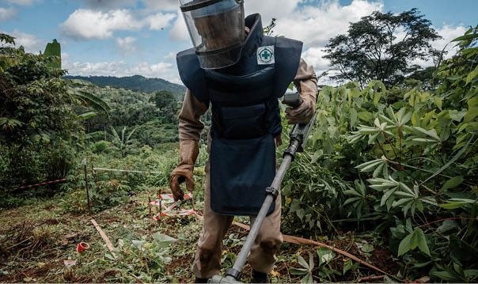
Photo: © NPA/Sean Sutton
Norway is working to combat the use of weapons and methods of warfare that have particularly harmful effects on civilians and civilian infrastructure. Conventional weapons such as mines and cluster munitions, as well as weapons of mass destruction, such as nuclear weapons, are examples of such weapons.
High priority will be given to efforts to combat the use of weapons that continue to cause death and injury long after a conflict is over, such as mines and cluster munitions.
Norway has played an active part in the development and implementation of legally binding instruments such as the Anti-Personnel Mine Ban Convention and the Convention on Cluster Munitions. These efforts have helped to reduce the number of persons killed or injured by mines, cluster munitions or other explosive weapons during or after conflict.
We will continue our efforts to secure greater support for these conventions and for the Arms Trade Treaty. We will support the work to safeguard stockpiles of weapons and thus prevent weapons and ammunition from falling into the wrong hands during or after a conflict.
Survivors of mines and cluster munitions have played a key role in the development of this set of rules, and it is important that their organisations are included. Gender is highly significant, both in terms of understanding humanitarian consequences and in strategies and operational work on clearance and reconstruction. Norway will continue to prioritise these aspects of humanitarian disarmament.
Norway will continue to defend and promote international humanitarian law and work to ensure increased accession to the disarmament conventions. We will contribute to strengthening legal framework and good practices. We will lead the way in processes and discussions on the regulation of the use of new and existing weapons, such as autonomous weapon systems, and the humanitarian consequences of their use, as well as the humanitarian consequences of nuclear weapons.
The Norwegian Government will
- take a leading role in international efforts to combat the use of weapons that have unacceptable humanitarian consequences and support efforts to clear mines and other explosives during and after conflicts.

Urban warfare
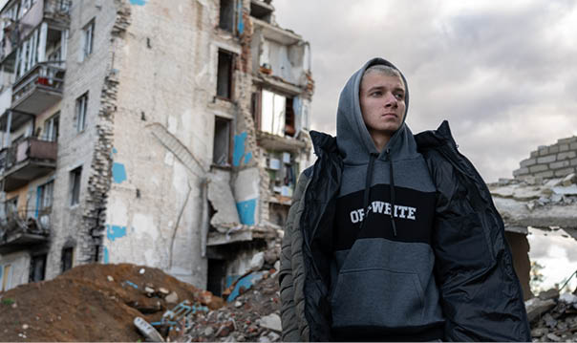
Photo: © UNICEF/UNI484041/Filippov Ukraine, 2022
Increasingly more people live in densely populated areas. During crisis and conflict, even more people turn to cities, to access vital services. Warfare and the large-scale use of explosive weapons in densely populated areas result in increased and changed needs for protection. When explosive weapons are used in cities, an average of nine out of ten casualties are civilians.The destruction of civilian infrastructure causes immense suffering, disease, and death, and it deprives the population of their livelihoods. These consequences increase over time as conflicts persist and infrastructure is not rebuilt.
Norway works to ensure compliance with the obligation to protect civilians under international humanitarian law. We will also draw attention to the provisions of international law that apply specifically to parties to armed conflict when conducting military operations in urban areas. The Political Declaration on Strengthening the Protection of Civilians from the Humanitarian Consequences Arising from the Use of Explosive Weapons in Populated Areas (the EWIPA Declaration) is an important instrument in this regard.
The Norwegian Government will
- work to ensure better protection of civilians and civilian infrastructure against the consequences of urban warfare, and promote the increased endorsement and implementation of the Political Declaration on Strengthening the Protection of Civilians from the Humanitarian Consequences Arising from the Use of Explosive Weapons in Populated Areas (the EWIPA Declaration).

6.2 Securing vital services and infrastructure
Humanitarian crises often involve large-scale destruction of essential infrastructure and services that are of vital importance to the lives and health of the population. People lose their homes, their livelihoods and access to vital services. This contributes to the spread and worsening of disease. It also leads to increased violence, risk of abuse, gender discrimination and other violations of fundamental rights. Affected populations often put themselves at great risk when attempting to meet basic needs such as shelter, food, water, fuel, and health services.
While working to provide access to essential services, humanitarian actors must also ensure the safety and dignity of crisis-affected people and minimise unintended adverse consequences of their actions.
Norway will, where appropriate and feasible, contribute to early recovery and sustainable solutions in protracted humanitarian crises. At the same time, early recovery can be challenging politically and in terms of security. It can face resistance if the recovery favours or contributes to supporting disputed authorities or other parties to a conflict. There is also a risk that the infrastructure will be destroyed yet again.
Infrastructure and basic services are the responsibility of the authorities. However, there may be good reasons why humanitarian organisations support or assume such tasks for shorter periods of time. Their efforts can help to prevent systems from collapsing. Nevertheless, it is not desirable that humanitarian organisations provide such services for extended periods of time. A comprehensive approach is key in this regard. Development actors should be involved at an early stage and can play an important role in building robust systems and solutions that can withstand ongoing and future crises.
The Norwegian Government will
- contribute to protecting and restoring critical infrastructure, shelter, and basic services, both during and after natural disasters and armed conflicts.

Water and sanitation services
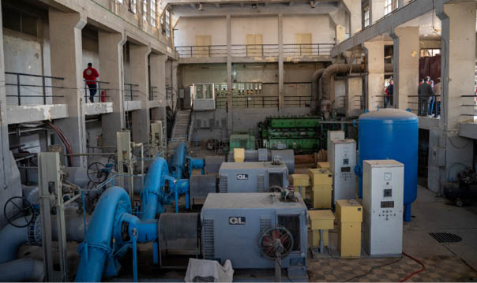
Photo: © Norwegian Red Cross/Olav A. Saltbones
Good solutions for access to water and sanitation saves lives and alleviates suffering. The disruption of such infrastructure has enormous humanitarian consequences.
Humanitarian organisations must often resort to expensive and unsustainable solutions to ensure supplies during the acute phase of a crisis. Examples include water trucking, and temporary sanitation solutions, such as latrines. Over time, these solutions are far more expensive, more harmful to the environment and less efficient than repairing existing systems. A number of organisations and donors are contributing to a shift in the response towards more sustainable solutions. Norway will support these efforts. An example is the International Red Cross and Red Crescent Movement’s work on stabilising and repairing large water systems in Syria.
The Norwegian Government will
- support humanitarian organisations in their efforts to ensure water, sanitation, and hygiene (WASH) solutions in humanitarian disasters and crises.

Access to energy in crises
There is a growing realisation of the importance of access to clean energy for crisis-affected people. Lack of access to energy in humanitarian crises can pose an acute threat to life and health. Energy is required to run healthcare services and to meet basic needs such as cooking, lighting, heating, and communications with the outside world. Therefore, it is necessary to strengthen efforts to increase energy access in both sudden-onset and protracted humanitarian crises.
In recent years, Norway has invested considerably in green energy solutions in the humanitarian sector, and we will continue this effort. Renewable energy solutions have numerous environmental benefits and ensure greater operational safety and better protection in conflict zones. We will fund risk reduction measures and projects that utilise innovative business models which can increase access to clean energy for people affected by crises.
The Norwegian Government will
- continue efforts to increase access to clean, affordable and reliable energy for displaced and crisis-affected people, both in sudden-onset and protracted humanitarian crises.

Health services in humanitarian crises
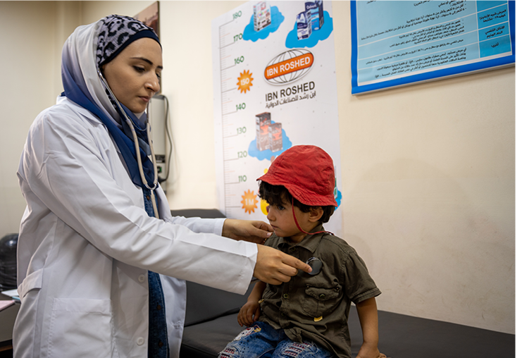
Photo: © Norwegian Red Cross/Olav A. Saltbones
Support for lifesaving and basic health services is a key component of all humanitarian efforts. This includes medicines, first aid, surgery, vaccines, child and maternal health interventions, responses to waterborne and airborne diseases, sexual and reproductive health services, health services for persons with disabilities and for people with chronic and noncommunicable diseases, as well as mental health services and psychosocial support. In addition, there is a growing need for services for people with chronic diseases.
The sharp increase in noncommunicable diseases also requires adjustment on the part of humanitarian actors to be able to respond to the prevailing clinical symptoms. The treatment of noncommunicable diseases involves special challenges in humanitarian crises, as instability and weakened health systems impede access to health services.
Women and young girls face greater risks during childbirth, and there are many more unwanted pregnancies in crises. It may be difficult for menstruating women to obtain sanitary products. Women who are pregnant, giving birth and breastfeeding require special care. Norway will give high priority to measures that promote sexual and reproductive health services in humanitarian crises, and health services for survivors of sexual and gender-based violence, regardless of their gender.
People in crises are at increased risk of trauma. It is important that survivors can receive appropriate mental health services and psychosocial support. This is a neglected service in humanitarian crises which should receive greater attention and resources.
In sudden-onset crises, lack of access and capacity in the local health services may trigger a need for temporary and mobile solutions. Norway will continue to support national and international preparedness mechanisms for rapid response, both in terms of equipment and personnel. However, it is important to consider the possibility of utilising and strengthening local infrastructure and personnel, rather than flying in field hospitals and personnel. No one can respond more rapidly to a public health crisis than those who are already on the ground.
Good national health systems are the best preparedness against public health crises. Investments in vaccines, hygiene, drinking water and proper nutrition also reduce the incidence of infectious diseases and strengthen resistance. This must, primarily, be addressed through long-term development assistance. Norway will promote comprehensive health efforts to develop robust health systems in crises. The COVID-19 pandemic demonstrated the importance of development actors utilising existing humanitarian coordination mechanisms to ensure the best possible response in humanitarian situations.
The protection of the health sector against attacks in armed conflicts is a precondition for safe access to health services, cf. section 6.1.
The Norwegian Government will
- provide support for lifesaving and basic health services in connection with humanitarian efforts;
- support work relating to sexual and reproductive health in crisis situations;
- work to strengthen mental health services and psychosocial support.
              - A comprehensive approach to education in crisis and conflict in Syria
The right to education is at the crux of Norway’s comprehensive efforts in Syria and is key to unlocking hope for the future. Protracted conflict and persistent humanitarian crisis have interrupted the education of millions of children and young people and many school buildings have been destroyed because of the war. In 2023, around 2.4 million school-age children were out of school. Although the situation is daunting, our partner, Education Cannot Wait, has, since 2017, succeeded in providing high-quality education for more than 400,000 children, 75,000 of whom are internally displaced. Norway prioritises mental health services and psychosocial support, as well as measures to make schools safe and prevent sexual abuse. After the 2023 earthquake, the Global Partnership for Education also contributed by rehabilitating school buildings and temporary education solutions, teaching materials and training teachers to provide psychosocial support.

Education in crisis and armed conflict
Norway will continue to champion the right to education in crisis and conflict situations. Girls, children with disabilities and displaced people are particularly prioritised in this effort. This involves both protecting educational institutions against military use and attacks (see section 6.1) and safeguarding the provision of high-quality education as part of humanitarian response and comprehensive efforts.
Education is lifesaving in humanitarian situations and has both an immediate and long-term positive effect for individuals and their communities. Education is highly sought-after by children and young people affected by crisis and their families. Being in school offers protection and contributes to a sense of normality in everyday life. Schools can also be used to provide children with nutrition programmes, health services and sexual education. Gaps in education can make it difficult for adults to obtain vocational qualifications, and thereby be able to support themselves and their families.
224 million school-age children are growing up in crisis and conflict-affected areas. More than half lack basic reading and math skills. 72 million children are entirely without access to education. The climate crisis is also contributing to keeping children out of school. Since 2020, 62 million children have had their education disrupted by climate shocks.
Education has become a more integral and prioritised component of humanitarian response. This is especially the case in protracted crises and refugee situations. Increased coordination and support from development actors is necessary to safeguard the provision of education and develop local capacity. The development of remote learning solutions has also improved access in difficult security situations. Norway supports UNESCO’s work on a Convention on the Recognition of Qualifications concerning Higher Education, which would be of great importance to displaced youth.
Humanitarian funding for education measures should not be continued when it is possible to transfer responsibility to national authorities or development actors.
The Norwegian Government will
- continue to focus on education for children and youth in crisis and conflict.

6.3 Increased efforts to end hunger and promote food security
The world is on the brink of a global hunger crisis. Record numbers of people are experiencing hunger, malnutrition, and food shortage, even though UN Member States have agreed to achieve zero hunger by 2030. The World Food Programme (WFP) estimates that over 300 million people in 72 countries are affected by hunger crises in 2024 (IPC 3+).
A major cause of the hunger crisis is the persistent and growing number of armed conflicts. In situations of armed conflict, cultivated land and necessary infrastructure for storage, transport and processing are destroyed and supply chains are disrupted. In Africa, more than 80 per cent of people affected by hunger and food shortage live in countries or areas affected by conflict. Other causes include climate change and extreme weather events, supply chain volatility, and higher input costs in food production. Food shortages can have major and lasting negative impacts on health, may lead to social and political unrest, flight and displacement.
Emergency assistance will remain a key instrument in addressing acute hunger crises. Food and water distribution, school meal programmes or cash transfers are vital when crises have erupted.
At the same time, Norway will promote increased food security. Preparedness mechanisms and early warning, to ensure anticipatory action, where possible, will also be important. Disaster risk reduction and enhanced resilience avert hunger crises and free up resources that can be used to reach more people in an acute response.
A lack of infrastructure and resources often weakens markets and prevents distribution between different geographical areas. Humanitarian efforts must support local food production and local suppliers where possible. Cash is often the most effective form of aid, helping to prevent local food markets from collapsing. In other circumstances, the distribution of basic goods, such as food, may be necessary.
Items distributed must be adapted to local needs, be culturally acceptable and contribute to improving the nutritional situation. To ensure that emergency aid reaches the hunger-affected with the greatest needs, it is of particular importance to ensure a gender-sensitive and inclusive programming. Climate and environmental considerations must also be taken into account in humanitarian efforts to combat hunger.
Famine (IPC 5) occurs almost exclusively in areas of armed conflict. This occurs where humanitarian actors are prevented from gaining safe and adequate access, and because some parties to conflicts use starvation as a method of warfare, in violation of international humanitarian law. To avert such disasters, Norway will escalate its efforts for safe access, and respect for international humanitarian law.
Both the UN and other humanitarian organisations rely on the WFPs logistics, and communication services, as well as the WFP-managed UN Humanitarian Air Service (UNHAS) which enables transport of food and vital aid to remote areas. Norway will prioritise support for UNHAS.
The Norwegian Government will
- strengthen our efforts in hunger crises;
- actively work to prevent hunger in areas of armed conflict;
- contribute to preventing hunger crises and reducing future vulnerabilities, including through support for systems for preparedness, early warning, and anticipatory action.
              - The five stages of food insecurity
The UN’s Integrated Food Security Phase Classification (IPC) system has become the global standard for classifying acute food insecurity and malnutrition. The system employs a scale with five levels or phases of acute food insecurity, each phase defined by clear criteria, such as the number of hunger-related deaths in a population, or the proportion of a population that is acutely malnourished due to lack of food:
Phase 1: Minimal food insecurity.
More than 80 per cent of households are able to meet essential food and non-food needs without engaging in atypical and unsustainable strategies to access food and income.
Phase 2: Stressed food situation/Persistent food insecurity.
Households have minimally adequate food consumption but are unable to afford some essential non-food expenditures without engaging in stress-coping strategies.
Phase 3: Crisis/Acute food insecurity.
Households either have food consumption gaps that are reflected by high or above-usual acute malnutrition, or are marginally able to meet minimum food needs but only by depleting essential livelihood assets or through crisis-coping strategies.
Phase 4: Emergency/On the brink of famine.
Households have large food consumption gaps, which are reflected in very high acute malnutrition and excess mortality; or can mitigate large food consumption gaps but only by employing emergency livelihood strategies and asset liquidation. At this stage, the population often no longer has the resources or energy to relocate to places where there is access to food.
Phase 5: Hunger catastrophe/Famine.
The word famine is only used when a hunger crisis has reached a catastrophic stage involving extreme levels of acute malnutrition and mortality. Households have an extreme lack of food and/or other basic needs even after full employment of coping strategies.

6.4 Humanitarian consequences of climate change
The Intergovernmental Panel on Climate Change estimates that between 3.3 and 3.6 billion people live in contexts that are highly vulnerable to climate change. The poorest areas of the world will be most vulnerable to the adverse effects of climate and environmental change. More frequent natural disasters and more extreme weather events have several immediate humanitarian consequences and often pose an acute threat to life and health. Climate and environmental degradation create new and aggravate existing humanitarian crises. Such degradation can contribute to heightened tension, increased violence, exacerbate ongoing conflicts and force more people to flee their homes.
The humanitarian consequences of climate change will grow as global warming increases. Water and food shortages will become an increasing problem. Heightened efforts are, therefore, required to address both the immediate and future humanitarian consequences of climate change. Prevention, preparedness and adaptation are key to limiting the scale of humanitarian crises.
Natural disasters exacerbated by climate change, such as droughts, floods and wildfires are often recurring and predictable. Humanitarian efforts through the WFP, the Disaster Response Emergency Fund (DREF) of the IFRC and the UN Central Emergency Response Fund (CERF) are increasingly directed to preparedness programmes and early warning based anticipatory action.
At the same time, climate-related humanitarian crises are increasingly unpredictable. Therefore, flexible funding that can be made available quickly is of increasing importance.
Climate change adaptation is a prioritised area in the Norwegian Government’s development policy. The Strategy for climate change adaptation, disaster risk reduction and the fight against hunger forms the basis of Norway’s tripling of its climate finance by 2026. The climate change adaptation strategy prioritises prevention of climate-related humanitarian crises. It comprises the thematic areas of early warning systems and climate services, nature-based solutions, climate-resilient food production, infrastructure, and innovative financing mechanisms.
Climate financing only reaches to a limited degree the most vulnerable communities and displaced people. This is particularly the case in areas affected by armed conflict. Funding mechanisms for loss and damage, including the new Loss and Damage Fund established at COP28, must target particularly vulnerable developing countries.
Good quality data related to weather, climate and risk must be available at the local level. Local preparedness and local ownership of climate change adaptation efforts are becoming increasingly important considering growing humanitarian needs.
The Norwegian Government will
- support early warning systems and anticipatory action to reduce the scale of humanitarian crises;
- advocate in favour of climate financing benefitting, more effectively, the most vulnerable people and the areas most exposed to the adverse impacts of climate change;
- ensure that Norwegian-funded climate adaptation measures contribute to preventing humanitarian crises and reducing humanitarian needs.
              - Early warning
Early warning of natural disasters is pivotal to saving lives and crops and reducing material damage resulting from climate change. That is why UN Secretary-General António Guterres initiated the Early Warnings for All initiative. The aim of the initiative is to ensure everyone on Earth is protected by early warning systems by the end of 2027. The World Meteorological Organisation is spearheading this effort in collaboration with the UNDRR, the IFRC on preparedness and response, and the International Telecommunication Union for the distribution of information. The Early Warnings For All initiative is a good example of coordination between different actors with common interests.

Humanitarian diplomacy, partnerships and instruments

7.1 Humanitarian diplomacy
Humanitarian diplomacy is how we advocate to uphold people’s rights, dignity and needs in humanitarian crises, and promote the protection of civilians in armed conflict. To achieve results, we need to support actors that contribute to these objectives, and we, ourselves, need to be willing to talk to everyone, including authoritarian regimes and de facto authorities. We must maintain long-term and systematic engagement with parties to armed conflict.
Norway shall have a clear and recognisable voice for the protection of civilians in armed conflict. We will remind the parties of their obligations and political responsibilities under international law, as well as identify and support practical measures to ensure the protection of civilians. We will also call out violations of international law and, where possible, contribute to strengthening means of holding non-compliant parties accountable. Norway will strengthen its role in upholding and further developing international law. Norway will support the specific mandate and role of the International Committee of the Red Cross (ICRC) to uphold and further develop international humanitarian law. In some areas, we will assume leadership responsibility for normative work, both within and outside the UN system. This involves active diplomacy internationally and at the country level.
In some conflict situations, Norway may have particular advantages that can be actively harnessed to enhance humanitarian access. Norway will work to depoliticise humanitarian action and to ensure respect for humanitarian principles.
Norway will promote rapid, safe, and unimpeded access to humanitarian aid for people in need. In particular, Norway will take a leading role in ensuring that parties to armed conflicts fulfil their obligations under international humanitarian law to allow and facilitate humanitarian action based on humanitarian principles. We will support humanitarian actors that negotiate access with authorities and armed groups. Issues around access are often highly politicised and involve various forms of risk.
Norway will take a leading role in promoting safety for humanitarian actors, with minimal bureaucratic impediments and without corruption. We will also work to improve the efficiency and coordination of the system for global humanitarian efforts. To maximise the effectiveness of humanitarian response, we need to view the various thematic areas and instruments in connection and work closely with relevant partners. This includes working to strengthen the support for and legitimacy of humanitarian efforts and organisations operating in crisis-affected areas.
Humanitarian diplomacy will also be employed to prevent and curb the escalation of humanitarian crises. Conflict resolution involves both peace and security policy and requires coordinated diplomatic efforts. It is important that humanitarian considerations, and the interests and needs of the affected population are heard and taken into account in relevant political processes, particularly in peace and reconciliation efforts.
The Norwegian Government will
- put forth initiatives that contribute to reducing violence and risk for people affected by armed conflict and other humanitarian crises, and contribute to ensuring that parties to armed conflict comply with international humanitarian law;
- promote rapid, safe, and unimpeded humanitarian access in crises and armed conflicts, in cooperation with humanitarian partners;
- help to ensure that selected partners develop the necessary competence and capacity to negotiate humanitarian access;
- promote respect for humanitarian principles and freedom of action for humanitarian actors working in accordance with these principles;
- ensure that humanitarian issues are considered in relevant political processes, particularly in peace and reconciliation efforts, and strengthen the links between humanitarian diplomacy and conflict resolution.

7.2 Partnerships
The main channels for translating Norway’s humanitarian priorities into action are the UN, the International Red Cross and Red Crescent Movement, and Norwegian humanitarian organisations. The way in which we support and cooperate with our partners is decisive for our ability to achieve results – both at the operational, the policy and the normative levels.
Norway chooses partners that work in line with the humanitarian principles and internationally established standards for humanitarian action. Humanitarian action must be rights-based. Women’s rights and needs must be integrated into all stages of humanitarian response, from needs assessment and planning to implementation and reporting. All partners are required to have guidelines and whistleblowing mechanisms in place to prevent violence and abuse by humanitarian aid workers and to prevent sexual harassment. The Norwegian Ministry of Foreign Affairs and the Norwegian Agency for Development Cooperation (Norad) have introduced a policy of zero tolerance for inaction against sexual exploitation, abuse, and harassment (SEAH), and require grant recipients to prevent, detect and respond to SEAH in line with international recommendations. Similarly, they are required to have guidelines and warning mechanisms to prevent, uncover and respond to abuse and corruption. It is also a requirement that grant recipients have systems and procedures in place to ensure good use of resources and funds.
The four cross-cutting issues of human rights, women’s rights and gender equality, climate and environment and anti-corruption must also be considered in relation to all humanitarian action.
Geographical presence and insight into the context, as well as relevant expertise for each specific crisis will be important in the selection of partners. This helps ensure access in challenging areas and to direct efforts towards the most vulnerable groups. Where Norway’s diplomatic presence is limited by budget constraints and safety considerations, dialogue with local partners becomes more difficult but even more necessary.
Local actors have knowledge of the context and local power dynamics, knowledge of needs, and often unique access to and legitimacy within the population, and they are the first to respond when a crisis occurs. Strengthening local and national actors in crisis situations is, therefore, an investment in sustainable national preparedness and may build institutions in a more long-term, societal perspective.
Norway is committed to promoting a more locally led response. In the Grand Bargain Declaration, the goal is for 25 per cent of all humanitarian funding to go as directly as possible to local actors. This is challenging because, as donors, we do not have the capacity to follow up large numbers of smaller grants. The fact that local organisations are socially and politically rooted in the society may also raise questions about their ability to operate in line with the humanitarian principles.
Donors often choose to support international humanitarian organisations they know well, that have international responsibilities and mandates, and have the ability to deliver at scale. The UN humanitarian Country-based Pooled Funds, the International Red Cross and Red Crescent Movement, and Norwegian and international humanitarian organisations are important channels for supporting local organisations. Local decision-making and involvement in the implementation of humanitarian efforts are important. Partnerships should be equitable and aim to shift power and resources away from international organisations and towards local actors.
Cooperation with Norwegian organisations is an important element of Norway’s humanitarian efforts. Close cooperation, combined with a clear division of roles between Norwegian authorities and the organisations concerned, has impacted positively the development of both Norwegian and international humanitarian policy. It has also helped Norwegian organisations play a leading role internationally in several areas.
This cooperation was further developed upon entering into strategic partnerships with Norwegian organisations for the period 2020–2024. This type of partnership received a positive assessment in the 2022 Mid-Term Review. Therefore, there will be a new call for strategic partnerships and a continuation of the mechanism. We will also consider entering into agreements with other partners offering a particular geographical or thematic expertise.
Our strategic partners will be chosen through an open process based on clear criteria. These will include compliance with the humanitarian principles, response capacity, humanitarian access, commitment to strengthening locally led response and integration of the gender perspective into all stages of humanitarian response. The Strategic partnerships provide the organisations with increased predictability and better opportunities to respond rapidly and flexibly to crises.
An important element of this cooperation will be the dialogue on risk and results. It is crucial that donors are willing to take political and financial risks to respond to the greatest needs in the hardest-hit areas, and that they are realistic about what can be achieved. At the same time, the safety of the actors implementing the response must be ensured. In the context of the Grand Bargain, the ICRC, the Netherlands, and InterAction have prepared a Risk Sharing Framework. The purpose of this framework is to have a more comprehensive and predictable approach to risk between the various actors in humanitarian response.
The Norwegian Government will
- choose partners that work in line with the humanitarian principles and internationally established standards for humanitarian work;
- emphasise equitable partnerships where local organisations have a genuine say in the planning and implementation of humanitarian efforts;
- identify measures for increased risk sharing with partners.
              - Grand Bargain
The Grand Bargain was adopted at the World Humanitarian Summit in 2016. The aim is to reduce the humanitarian funding gap through increasing effectiveness, innovation and improving coordination with long-term development efforts. Key areas for action are more flexible and predictable funding, harmonised reporting requirements, better coordination, increased funding for local humanitarian actors, the inclusion of people affected by crises, and the greater use and coordination of cash-based assistance in humanitarian action. Norway endorsed the Grand Bargain at the Summit together with the UN, a range of non-governmental organisations and other top donors. Efforts are now underway leading up to the 10th anniversary of the Grand Bargain in 2026, with a continued emphasis on promoting flexible and multi-year funding, local humanitarian response and participation as the first goal. The second goal is to change the humanitarian sector by emphasising anticipatory action, improved cooperation across sectors (nexus), and innovative financing mechanisms.

7.3 Good Humanitarian Donorship
Norway will promote more effective and strategic international financing of humanitarian action, including improved financing to anticipatory action.
The objectives and commitments emanating from Good Humanitarian Donorship and the Grand Bargain underpin Norway’s humanitarian work, including the aim to provide flexible and multi-year funding to our humanitarian partners and encourage other donors to do the same. This is crucial to make humanitarian action more effective and to improve coordination with long-term development efforts. It is also necessary to ensure increased capacity and effectiveness of humanitarian organisations in response to acute humanitarian situations and changing needs.
Strengthening the UN’s humanitarian efforts is an important component of Norway’s UN policy. The way Norway and other donors support and finance the UN has a major effect on the results that can be achieved. UN Member States have committed to allocating a greater share of the funding as core contributions or to pooled funding intended to support cooperation. The ongoing reform of the UN is the most comprehensive and binding change in ways of working for more comprehensive efforts that we have seen in the UN system. Norway will follow up on the UN reform, to encourage Member States to contribute sufficient funding, and, through participation in the boards and through our diplomatic missions, ensure that the UN itself adheres to its own reform commitments.
Support to funds that promote cooperation, including the UN Central Emergency Response Fund (CERF) and the International Red Cross and Red Crescent Movement’s Disaster Response Emergency Fund (DREF), contributes to ensuring rapid, effective, and coordinated response in sudden-onset and underfunded humanitarian crises. They also contribute to forecast-based efforts and anticipatory action. The UN Country-based Pooled Funds will continue to be important channels for Norway’s funding, to strengthen locally led humanitarian response.
As mentioned above, Norway has increased the number of multi-year agreements with humanitarian partners in recent years. A balance must be achieved between the use of multi-year agreements and the need to have sufficient funding available throughout the year to be able to respond in the event of sudden onset or escalations of humanitarian crises. All multi-year agreements are subject to the approval of the Storting (Norwegian Parliament).
An overarching policy goal for Norway is to improve, simplify and streamline grant management. This also applies to our cooperation with the UN.
The Norwegian Government will
- contribute and promote rapid, flexible, and predictable international financing in humanitarian crises, with an emphasis on contributions to humanitarian funds and organisations;
- play a part in strengthening local and national capacity to respond to humanitarian crises, among others through relevant fund mechanisms;
- view the various budget lines as a coherent whole, to ensure that they complement each other and contribute to reducing vulnerability and humanitarian needs over time.
              - Use of cash in emergency aid
Norway has promoted the increased use and coordination of cash in humanitarian action. The use of cash has now become a preferred instrument for many organisations. An important principle in this respect is to promote the participation of national and local actors, and that decisions be made as closely as possible to the crisis-affected population. The use of cash enables crisis-affected people to prioritise their own needs. Cash helps strengthen local markets and supply chains. Supporting local markets using cash rather than commodity-based assistance, can help retain jobs and generate economic growth. This is important to avoid inundating the market with free or subsidised goods, which can undercut local businesses and producers, rendering them uncompetitive. Using cash can also be more cost-effective than other types of assistance, as logistics and administration expenditures are reduced. Norway will continue to promote good, locally led and inclusive coordination of cash-based assistance.

7.4 Humanitarian innovation
The term humanitarian innovation refers to new products, forms of cooperation, business models, technology, services, solutions, or sources of financing that are measurably better than existing ones. The innovation may lead to improved effectiveness or quality. The solutions may be more sustainable and environmentally friendly or have other positive ripple effects. Humanitarian innovations save lives, alleviate suffering and uphold human dignity. Innovation and innovative solutions may also reduce costs, and thus help to reduce the humanitarian funding gap.
The development and use of new technologies, including artificial intelligence, satellite imagery, data analytics and warning systems, are key aspects of humanitarian innovation. These technologies can offer new methods for understanding and responding to crises, optimising resource distribution and improving decision-making in humanitarian operations. Artificial intelligence is already offering solutions that improve the efficiency of humanitarian response and will increasingly be utilised in the future. Solutions can be developed for early warning and emergency preparedness, analyses and rapid information to and interaction with the affected population.
However, technological innovations and the use of artificial intelligence also present new challenges related to ethics, disinformation, data protection, accountability, and digital security. We will support initiatives and innovative measures that enhance protection against cyber threats in humanitarian contexts, including the protection of personal data, and help to ensure that the humanitarian sector’s specific concerns are considered in the development of relevant legislation and standard. Capacity building and research will be key, both to adopt and develop solutions, and to address these challenges.
One weakness of the innovation work in the humanitarian sector is the fact that affected populations are rarely involved. Therefore, cross-sector innovation partnerships must be developed that actively involve end-users and develop solutions that better meet the affected population’s needs. The gender perspective must be included in these efforts as well.
Humanitarian innovation is also slowed by short-term financing, limited risk tolerance, and weak links between the humanitarian and business sector. Norway will be a strategic partner for strengthened innovation efforts in the humanitarian sector, by sharing risks with our partners, and by facilitating innovation arenas and networks.
There is a need to develop skills and a culture of innovation in the humanitarian sector, and promote cooperation on innovation, both between humanitarian organisations and between the humanitarian sector and the business sector. We will continue our commitment to and leadership in humanitarian innovation, and contribute to increased openness, sharing and collaborative learning. Through the continuation of the Humanitarian Innovation Programme (HIP Norway) and other innovation investments, the Government will contribute to the establishment of innovation partnerships between humanitarian organisations, academia, and private actors.
The Norwegian Government will
- support innovative measures, especially in the areas of protection, combatting hunger and humanitarian consequences of climate change;
- continue the Humanitarian Innovation Programme (HIP Norway).
              - HIP Norway – the Norwegian Government’s initiative for humanitarian innovation
The Humanitarian Innovation Programme was established by the Norwegian Ministry of Foreign Affairs in 2018 in cooperation with Innovation Norway. Projects must be based on humanitarian needs and develop solutions through partnerships between humanitarian organisations and private enterprises. People affected by humanitarian crises must be included throughout the project cycle. The programme is intended to de-risk innovation in the humanitarian sector, through awarding grants to projects that would not otherwise have been implemented, and through capacity building. Protection, green response, food security, innovative financing and health and sanitation solutions are the prioritised thematic areas for the innovation programme
Innovations developed through HIP Norway:
New technology to detect improvised explosive devices: Norwegian People’s Aid, Bertel O. Steen and CEIA/Sensec have developed a specially adapted flashlight and metal detector that help mine clearance specialists detect tripwires associated with improvised explosive devices.
Virtual reality in the treatment of survivors of gender-based violence: Norwegian Church Aid, Fornix and Healium are developing new virtual therapy and treatment solutions.
Innovative insurance mechanisms for women smallholder farmers: UN Women, the United Nations Fund for Capital Development and Oko have developed an insurance mechanism that is triggered in the event of crop failure, benefiting women smallholder farmers.

7.5 Green and sustainable humanitarian response
Awareness of environmental consequences and sustainability considerations in humanitarian efforts must be increased. Humanitarian disasters and humanitarian response put pressure on the environment and natural resources; e.g. displaced people are often dependent on wood or charcoal for cooking. This can result in conflicts over resources with the local population and forest degradation in areas around camps for displaced people. Planning humanitarian operations from a short-term perspective may also result in costly and more polluting solutions, such as the use of diesel generators. Energy access in humanitarian crises is also discussed in section 6.2.
Norway will work to ensure that environmental and climate-related considerations are better safeguarded and integrated into all stages of the humanitarian response. Through cooperation with local actors, we will promote greater use of new technologies and innovation, particularly in the field of environmentally sound energy solutions.
Green humanitarian response imposes requirements for energy efficiency, maintenance needs, waste management and emissions. Local procurement and production of emergency aid products reduce emissions related to logistics. Local waste management must be kept in mind when purchasing technological solutions that may contain chemicals, such as phones and solar cells. Models of circular economy should be developed for the handling of plastic products and packaging materials. Repairability, maintenance and waste management should be emphasised when purchasing goods.
The Norwegian Government will
- require our partners to choose sustainable, renewable, repairable, and more environmentally friendly solutions for their humanitarian operations.
              - The world’s first circular model for managing electronic waste in humanitarian contexts
In recent years, humanitarian organisations have distributed millions of solar lamps and other solar-powered energy solutions to displaced persons. When these products stop working, they pose potential harm to the local community and the environment if the waste is not securely managed. With the support of the Humanitarian Innovation Programme (HIP Norway), the International Organization for Migration (IOM) and several private partners have developed the following solutions to address this challenge:
- systems for retrieving damaged products and actively worked with refugees and host communities to make them aware of the hazards related to improper handling of e-waste;
- a repair centre where the collected products are repaired by local technicians;
- a «BatLab» where old batteries are tested by technicians, who assemble viable batteries into large battery packs that can be used to supply power to, e.g., households;
- guidelines on how humanitarian organisations can make greener procurements and make greater use of warranties and spare parts from damaged products.

7.6 Innovative financing and the role of the private sector

Innovative financing
Innovative financing means financing mechanisms and models designed to address development challenges and humanitarian tasks that are not adequately met by traditional funding sources or that can be solved more efficiently.
Many innovative financing mechanisms are intended to attract fresh funding, e.g. from the private sector, and include a variety of models and approaches, such as insurance-based mechanisms for natural disaster management, anticipatory financing, various forms of public-private financing and risk-sharing with the private sector through bonds. Such mechanisms should be need-driven, and to an even greater extent developed in cooperation with local communities, which in most cases are the first responders when a crisis occurs. New financing mechanisms may also encourage the use of traditional aid as a catalyst to mobilise other and larger capital flows. The Norwegian Government will support this work and continuously assess investments in new and innovative financing mechanisms.
The Norwegian Government will
- support innovative financing models which have a documented effect;
- strengthen dialogue at the political level with potential new donors, the private sector, and supporters of the humanitarian system.
              - Innovative financing for increased food security
In Kenya, only two per cent of the food consumed in urban areas is locally produced. This leaves low-income households vulnerable to price increase and disruption to food supply chains. Urban food production can constitute an important safety net for low-income households which on average spend up to half of their income on food. Hydroponic cultivation (cultivation without the use of soil) is a solution that requires minimal land and is thereby well-suited for food production in urban areas. There are several such initiatives in the humanitarian sector, however, they struggle to scale up despite good results.
With the support of the Humanitarian Innovation Programme, the World Food Programme (WFP) addresses these challenges through an innovative financing model, whereby people can access favourable loans to purchase their own hydroponic cultivation equipment which is repaid through the income generated by the crops. A community of practice has also been developed by farmers engaging in hydroponic cultivation, to exchange knowledge and experiences.

The role of the private sector
The private sector plays an important role in humanitarian efforts, but often as a supplier rather than a partner. Closer partnerships and joint development of solutions will better meet humanitarian needs than traditional procurement alone. The business sector can contribute knowledge and technologies which others do not have.
The humanitarian sector is perceived as difficult to enter by the business community. The former is characterised by time-consuming and complex procurement processes and cumbersome bureaucracy. The private sector may also find that sanctions and counter-terrorism legislation make it difficult to supply goods and services for use in certain country situations. To foster partnerships and better harness private sector competence, structural efforts must be made to enable private actors to deliver suitable humanitarian solutions. It is also important to bear in mind the private sector and its role as supplier of goods and services, in the design of humanitarian exceptions in sanctions regimes and counter-terrorism efforts.
We will help further develop platforms and collaborations which facilitate increased investments and interactions with the private sector.
The efforts of the local business sector are important both during and after crises. Humanitarian actors should seek to purchase goods and services locally, whenever appropriate. However, in countries and regions affected by crisis, there may be a limited number of businesses that offer the required goods or services, and corruption may also be a widespread problem. Humanitarian organisations must, therefore, have a sound understanding of local economic conditions and markets.
Where Norwegian companies have special expertise, they may offer technology and innovation that will make the humanitarian response more effective and sustainable.
The Norwegian Government will
- continue efforts to increase cooperation between the private sector and humanitarian actors and encourage involvement of the local business sector in humanitarian crises.

PART IV THE PATH AHEAD
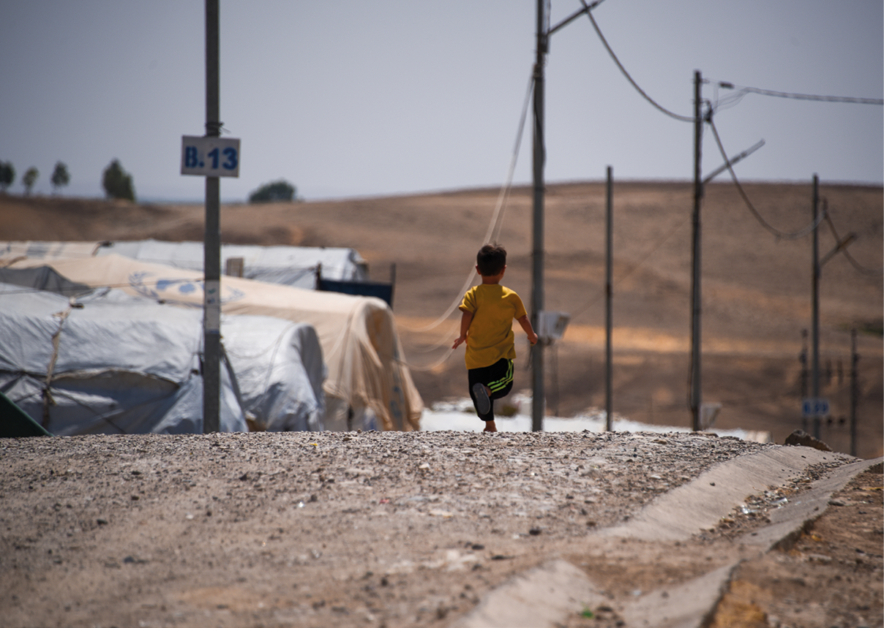
Photo: © NRC/Ahmed Kaka

Continuous competence building and learning
Humanitarian crises generally arise in complex political situations and when circumstances are already difficult. It is therefore vital that the Foreign Service and Norad have the necessary expertise and make the best use of their overall resources.
Norway will interact with a wide range of stakeholders in its humanitarian efforts. In countries where Norway has a diplomatic presence, the embassies will play a key role in assessing the humanitarian situation, following up the organisations receiving humanitarian funding from Norway, coordinating with other donors, and engaging actively in humanitarian diplomacy. Our embassies and other diplomatic missions also play a key role in ensuring a comprehensive approach and seeing the tools and approaches at our disposal in a broader context. Competence building efforts on humanitarian issues will be strengthened, particularly within humanitarian diplomacy.
Faced with increased humanitarian needs and a growing funding gap, humanitarian efforts must be as efficient as possible. Efforts must be based on the best available knowledge regarding needs and means, must apply knowledge, evaluations, reviews, and feedback mechanisms from affected populations to strengthen learning and knowledge development in the Foreign Service and Norad, and ensure sound prioritisation of funds. New initiatives and engaging in new priority areas require specialised competence in the areas we are most keen to focus on.
We will seek to cooperate with other donors, affected countries and neighbouring countries to share knowledge and identify new forms of collaboration that may yield better results and ease both Norway’s and our partners’ administrative burdens. We will seek to engage new supporters for the global humanitarian system. This is important both to strengthen funding for global humanitarian efforts, but also to strengthen universal support for the humanitarian principles and international humanitarian law.
The increased collection, sharing and analysis of data will strengthen the ability of humanitarian actors to anticipate, prevent and respond to humanitarian crises. Support to the further development of data regarding funding streams for humanitarian operations, early warning mechanisms and anticipatory action will be emphasised. The use of artificial intelligence and machine learning also have the potential to improve the basis for decision-making for preventive action and preparedness in the humanitarian sector, while risks must be managed. Improved access to statistics across different demographic characteristics, including gender and age, is also important to ensure that humanitarian programmes are adapted to the diverse needs of crisis-affected populations.
Cooperation with innovation actors and with Norwegian and international research and knowledge centres will be continued with a view to developing new solutions, increasing analysis capacity, and enhancing knowledge-based decision-making in humanitarian response. Here, our humanitarian partners are also valuable dialogue partners.
The Norwegian Government will
- strengthen humanitarian expertise in the Foreign Service and Norad;
- continue cooperation efforts with humanitarian research and knowledge centres to achieve increased knowledge and competence sharing.

Follow-up of the strategy
This strategy covers the period 2024–2029. A mid-term review will be carried out, and the follow-up of the Strategy will be evaluated at the end of the period.
Updated versions of guidelines will be available on the website Government.no, including guidelines for the humanitarian principles and guidelines for a comprehensive approach, as well as other future relevant guidelines for the implementation of the humanitarian strategy.

Appendix

List of abbreviations
AU African Union
ATT UN Arms Trade Agreement
CERF Central Emergency Response Fund
DREF The Disaster Response Emergency Fund of the International Federation of the Red Cross and Red Crescent Societies
UN United Nations
FAO UN Food and Agriculture Organization
ICRC International Committee of the Red Cross
IDA International Development Association
IFAD International Fund for Agricultural Development
IOM International Organization for Migration
IPC System for Integrated Food Security Phase Classification
Norad Norwegian Agency for Development Cooperation
OCHA UN Office for the Coordination of Humanitarian Efforts
OECD Organisation for Economic Co-operation and Development
UCPM European Union Civil Protection Mechanism
UNFPA UN Population Fund
UNHCR United Nations High Commissioner for Refugees
UNHAS United Nations Humanitarian Air Service
WFP World Food Programme
WHO World Health Organization

Overview of humanitarian terminology
Accountability to the affected population: Humanitarian organisations should be held accountable by crisis-affected people in relation to the quality and effectiveness of their humanitarian efforts. This principle, known as Accountability to Affected Populations (AAP), also entails that crisis-affected people should be able to participate and influence decisions without discrimination, and that their dignity, capacity, and abilities are recognised.
Protection: In a humanitarian context, protection is understood to encompass strengthening of and compliance with the international legal framework for armed conflict (international humanitarian law), including the obligation of parties in armed conflict to protect civilians and other protected groups against military attacks and other adverse impacts, directly or indirectly, caused by warfare. Furthermore, protection includes humanitarian action in all humanitarian crises that contributes to protection against violence and abuse, including violations of international human rights law or other international legal rules, occurring because of a humanitarian crisis.
The humanitarian principles. Humanity, neutrality, impartiality, and independence must be the underlying principles for all humanitarian action. They are derived from the Fundamental Principles of the International Red Cross and Red Crescent Movement and are enshrined in international humanitarian law. See Box 3.3.
Do no harm: This is a precautionary approach to prevent humanitarian and development efforts from having adverse impacts.
Education Cannot Wait: This global fund for education in crises was established in 2016. Its aim is to mobilise political will to strengthen education in crises through increased financial support and better coordination of efforts, including better coordination between humanitarian and long-term development efforts.
Refugee: Under the 1951 Refugee Convention, refugees are people who have a «well-founded fear of being persecuted for reasons of race, religion, nationality, membership of a particular social group or political opinion». Furthermore, they must be «outside the country of their nationality», i.e. they must have crossed an international border, and must be unable to, or due to a well-founded fear of being persecuted, unwilling to avail themselves of the protection of that country. Stateless persons who are outside their country of habitual residence are also considered to be refugees if they meet the same criteria.
International Refugee Law: The 1951 Refugee Convention defines the term refugee, sets out the principle of non-refoulement, which means that refugees may not be returned to a country where their life or freedom would be threatened, and outlines the rights of refugees. The scope of the Convention was extended under the Protocol Relating to the Status of Refugees, which was adopted in 1967 and removed the temporal and geographical restrictions of the 1951 Convention.
Displaced persons: The term displaced persons is often used as a general term for persons who are fleeing, or are forced to flee, their homes. If they are still in their own home country, they are often referred to as internally displaced persons. If they have crossed an international border, they are considered refugees if they also meet the requirement of a well-founded fear of persecution under the 1951 Refugee Convention.
Good Humanitarian Donorship: The initiative and forum established by donor states in 2003 to share experience and define common principles and standards for humanitarian action. Its objective is to achieve more effective and principled humanitarian action.
The Grand Bargain Declaration: Declaration adopted at the World Humanitarian Summit in 2016. The aim is to reduce the humanitarian funding gap through increasing effectiveness, innovation, and coordination with long-term development efforts. See Box 7.1 in Chapter 7.
Humanitarian assistance: Humanitarian assistance is used in a broad sense to include material relief and logistics support. Assistance may e.g. be in the form of health services, medicines, food, water, sanitation, shelter, and education.
Humanitarian innovation: The development of new products, forms of cooperation or other solutions that increase the effectiveness and/or quality of humanitarian action.
Innovative financing: Financing mechanisms and models that seek to address development challenges and humanitarian needs that are not adequately met by traditional funding sources, and that seek to provide quicker, more efficient funding and achieve better results than traditional models.
International Humanitarian Law: A set of international legal rules governing how parties to armed conflicts are to conduct their military operations. The purpose of these rules is to limit the harmful effects of war and to protect non-combatants. International humanitarian law (also referred to as the law of war) has been developed over more than 100 years by numerous conventions and international customary law and is binding for everyone. The four Geneva Conventions of 1949, together with Additional Protocols I and II of 1977, form the core of international humanitarian law with their rules governing, inter alia, the protection of civilians, the protection of medical personnel and the treatment of prisoners of war and wounded and sick soldiers.
Internally displaced persons: Persons who are forced to leave their homes due to armed conflicts, widespread violence, human rights violations, or natural disasters, but who have not crossed an internationally recognised border.
Climate change adaptation: Climate change adaptation involves understanding the consequences of climate change and taking action to prevent or reduce harm on the one hand, and, on the other hand, to harness the opportunities that the changes may entail.
Leave no one behind: The principle of the 2030 Agenda for Sustainable Development that no individual, group, region, or country is to be left behind.
Food security: Food security is when all people, at all times, have physical and economic access to sufficient, safe, and nutritious food to meet their dietary needs and food preferences for an active and healthy life.
Migrant: A migrant, like a refugee, has crossed an international border, but is not entitled to special protection under the 1951 Refugee Convention. Nevertheless, migrants may have considerable humanitarian protection needs and are entitled to protection from human rights violations wherever they are.
Safe Schools Declaration: The Safe Schools Declaration was adopted in Oslo in 2015 with the aim of strengthening protection of schools in situations of armed conflict, inter alia by endorsing states using the guidelines for protecting schools and universities from military use in such situations, to prevent them from becoming military targets.
Sendai Framework: International framework containing agreed global targets and indicators for disaster risk reduction. The Sendai Framework for Disaster Risk Reduction was adopted at the World Conference on Disaster Risk Reduction in 2015.
Anticipatory action: The purpose of anticipatory action is to mitigate the humanitarian consequences of extreme weather events through actions in advance of the event.

Among the member countries represented on the OECD Development Assistance Committee (DAC).
Adopted at the World Humanitarian Summit in 2016.
See the definition of the term rights-based approach in Chapter 3.
OCHA. Humanitarian Action | Overview 2018. https://humanitarianaction.info/overview/2018
OCHA. (2024, February 15). Inter-Agency Coordinated Appeals: January update. Humanitarian Action. https://humanitarianaction.info/article/inter-agency-coordinated-appeals-january-update
ALNAP. (2022). The State of the Humanitarian System. ALNAP Study. London: ALNAP/ODI. https://sohs.alnap.org/sites/alnap/files/content/attachments/2022-10-02/alnap-2022-sohs-report.pdf
Development Initiatives. (2023). Global Humanitarian Assistance Report. Global Humanitarian Assistance Report 2023 – Development Initiatives (devinit.org)
ALNAP (2022).
Action on Armed Violence [AOAV]. (2023, April 24). Explosive Violence Monitor: 2022. Action on Armed Violence. https://aoav.org.uk/2023/explosive-violence-monitor-2022/
Save the Children International. (2024). 7 ways we’re protecting children in crisis in 2024. https://www.savethechildren.net/7-ways-we-are-protecting-children-in-crisis-in-2024
UNHCR. (2023, October 25). Mid-Year Trends 2023 | UNHCR. https://www.unhcr.org/mid-year-trends-report-2023
UNHCR (2023, November 23) UNHCR. https://reporting.unhcr.org/global-appeal-2024-6383
IPCC. (2023). Climate Change 2023 Synthesis Report. https://www.ipcc.ch/report/ar6/syr
WFP Global Operational Response Plan: Update #10 – February 2024 | World Food Programme. (2024, February 19). https://www.wfp.org/publications/wfp-global-operational-response-plan-update-10-february-2024
See Box 6.3 in section 6.3.
UNSDG | Leave No One Behind
Report of the Secretary-General on the protection of civilians in armed conflict (S/2018/462). (2018). UN Security Council. https://reliefweb.int/report/world/report-secretary-general-protection-civilians-armed-conflict-s2018462-enarru
WHO. (n.d.). Surveillance System for Attacks on Health Care (SSA). https://extranet.who.int/ssa/LeftMenu/Index.aspx
Insecurity Insight Aid in Danger. https://insecurityinsight.org/projects/aid-in-danger
Guidelines on the Use of Foreign Military and Civil Defence Assets in Disaster Relief (Oslo Guidelines, 1994 – revised 2007), Guidelines on the Use of Military and Civil Defence Assets to Support United Nations Humanitarian Activities in Complex Emergencies (MCDA Guidelines, 2004 – revised 2006)
OECD DAC Recommendation on the Humanitarian-Development-Peace Nexus, OECD/LEGAL/5019
Report of the Secretary-General on the protection of civilians in armed conflict (S/2023/345). (2023). UN Security Council. https://reliefweb.int/report/world/protection-civilians-armed-conflict-report-secretary-general-s2023345-enarruzh
This is a separate goal in the Norwegian food strategy Combining forces against hunger – a policy to improve food self-sufficiency
Montier, Weingärtner and Klasser (2022) The potential for disaster risk finance and anticipatory action – Guiding the setting of humanitarian targets. ODI and Start Network. https://www.preventionweb.net/publication/anticipatory-action-and-disaster-risk-finance-guiding-setting-humanitarian-targets
Relevant action plans in this area are the National Action Plan: Women, Peace and Security (2023–2030), the Action Plan for Women’s Rights and Gender Equality in Norway’s Foreign and Development Policy (2023–2030), the Action Plan on Gender and Sexual Diversity and Equality for all: Norway’s strategy for disability-inclusive development (2022–2025)
See The Global Alliance for the Missing | Missing Persons Platform (icrc.org)
Save the Children International. (2024). Save the Children Humanitarian Plan 2024: Acting Now to protect Children’s Future | Save the Children’s Resource Centre. Save the Children’s Resource Centre. https://resourcecentre.savethechildren.net/pdf/HumanitarianPlan_2024_Update.pdf/
UN General Assembly, UN Security Council (2023). Children and armed conflict – Report of the Secretary-General (A/77/895-S/2023/363). https://reliefweb.int/report/afghanistan/children-and-armed-conflict-report-secretary-general-a77895-s2023363-enarruzh
Global Coalition to Protect GCPEA Education from Attack. (2022). Education under Attack 2022. https://eua2022.protectingeducation.org/
See African Union Convention for the Protection and Assistance of Internally Displaced Persons in Africa (Kampala Convention) | African Union (au.int)
Conflict-related sexual violence – Report of the Secretary-General (S/2023/413). (2023). UN Security Council. https://www.un.org/sexualviolenceinconflict/wp-content/uploads/2023/07/N2312781.pdf
International Committee of the Red Cross. (2022, February 3). “That never happens here”: Sexual and gender-based violence against men, boys, LGBTIQ+ people. International Committee of the Red Cross. https://www.icrc.org/en/document/sexual-gender-violence-against-men-boys-lgbtiq
International Rescue Committee. (2023, October 20). What is gender-based violence – and how do we prevent it? The IRC. https://www.rescue.org/article/what-gender-based-violence-and-how-do-we-prevent-it
See Box 3.2 in Chapter 3.
See paragraph 6 of Security Council Resolution 2511 (2020) https://www.un.org/securitycouncil/content/sres2511-2020-0
Action on Armed Violence [AOAV]. (2023, April 24). Explosive Violence Monitor: 2022. Action on Armed Violence. https://aoav.org.uk/2023/explosive-violence-monitor-2022/
See e.g. ICRC. (2023). After earthquake damage in northwest Syria, urgent action needed to prevent collapse of water systems and avoid devastating humanitarian consequences. International Committee of the Red Cross. https://www.icrc.org/en/document/after-earthquake-damage-northwest-syria-urgent-action-needed and ICRC (2023). Syria: facts and figures in Jan–Jun 2023. International Committee of the Red Cross. https://www.icrc.org/en/document/syria-facts-and-figures-jan-jun-2023
Education Cannot Wait. (2023, June 5). Crisis affected children and adolescents in need of education support: New global estimates and thematic deep dives | Education Cannot Wait. https://www.educationcannotwait.org/resource-library/crisis-affected-children-and-adolescents-in-need-education-support-new-global
Education Cannot Wait. (2023, October 26). Futures at risk: Climate-Induced Shocks and their toll on education for Crisis-Affected children | Education Cannot Wait. https://www.educationcannotwait.org/resource-library/futures-risk-climate-induced-shocks-and-their-toll-education-crisis-affected
WFP (2024). Global Operational Response Plan: Update #10 – February 2024 World Food Programme. (2024, February 19). https://www.wfp.org/publications/wfp-global-operational-response-plan-update-10-february-2024
The Africa Centre for Strategic Studies. (2023, October 17). Conflict remains the dominant driver of Africa’s food crisis. Africa Centre for Strategic Studies. https://africacenter.org/spotlight/unresolved-conflicts-continue-to-drive-africas-food-crisis/
The UN defines food security as follows: Food security is when all people, at all times, have physical and economic access to sufficient, safe and nutritious food to meet their dietary needs and food preferences for an active and healthy life.
IPCC. (2023). Summary for policymakers. I Climate Change 2022: Impacts, Adaptation and Vulnerability. Contribution of Working Group II to the Sixth Assessment Report of the Intergovernmental Panel on Climate Change (pp. 3–34). https://doi.org/10.1017/9781009325844.001
See e.g. the Intergovernmental Science-Policy Platform on Biodiversity and Ecosystem Services (IPBES)
See the Principles for Locally Led Adaptation and the Donor Statement on Supporting Locally Led Development which Norway has endorsed.
Examples of this are the Professional Standards for Protection Work (ICRC), The Sphere Handbook 2018 (Sphere), 2019 Edition of the Minimum Standards for Child Protection in Humanitarian Action (CPMS) (Alliance CHPA)
See the Guidelines for dealing with reports of sexual exploitation, abuse and harassment involving grant recipients in the Foreign Service – regjeringen.no
See Risk Sharing Framework – Enhancing the Impact of Humanitarian Action Through Improved Risk Sharing – World | ReliefWeb
Good Humanitarian Donorship (GHD) is an informal network of 42 donors, including Norway, that are working together to enhance the coherence and effectiveness of donor action. Read more about GHD here: https://www.ghdinitiative.org/ghd/gns/home-page.html

