A just world is an equal world
Action Plan for Women’s Rights and Gender Equality in Norway’s Foreign and Development Policy (2023–2030)

Introduction
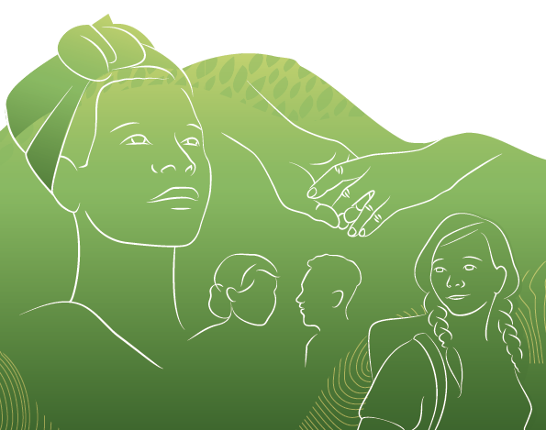
This Action Plan provides guidelines for Norway’s efforts to promote women’s rights and gender equality in foreign and development policy. In reference to girls and women in this Action Plan, it encompasses girls and women in all their diversity, irrespective of ethnicity, age, disability, sexual orientation, gender identity and expression. The Action Plan aims to contribute to achieving the Sustainable Development Goals by 2030, particularly Goal 5, on women’s rights and gender equality.
The rights of girls’ and women and gender equality are about the just and equitable distribution of power, influence, and resources irrespective of gender. A gender perspective helps in understanding how norms, attitudes, traditions, institutions, structures, reforms, and measures may affect genders differently, and how individual opportunities are affected.
Women possess expertise, resources and perspectives that benefit society, as leaders, entrepreneurs, politicians, primary earners and partners. Strengthening the role of girls and women in society optimises the utilisation of resources they possess. Working for girls’ and women’s rights and gender equality means working towards equality, freedom, power, opportunities and living conditions for all.
Girls and women all over the world face obstacles imposed by gender norms and other structural barriers. Women and men are not homogenous groups - having different experiences, needs, views and interests, depending on factors such as class, social background, ethnicity, disability and age. These experiences and needs are not only different, but also opposing. In many cases, different grounds of discrimination may interact and reinforce each other, increasing the risk of exclusion and discrimination. Examples include age, disability, religion, ethnicity (including physical appearance), sexual orientation and gender identity.
Discrimination and gender inequality also impacts boys and men. In certain societies, individuals are constrained by inflexible gender roles that impede their ability to make independent choices. Boys and men, particularly those defying gender role norms, are also affected by sexual and gender-based violence. A lack of gender equality and restrictive norms on masculinity may provoke behaviours that harm women. Emphasising positive masculine norms may reduce negative behaviours and violence, while improving the lives of men, their partners, children and local communities.
Imbalance in the just and equitable distribution of power between women and men restricts women’s autonomy and impedes their access to and control over resources and income. This disparity affects women’s participation in decision-making processes and exercising their right to sexual and reproductive health. Gender inequality manifests itself in discriminatory laws, norms, attitudes and practices evident within the family, labour market and in educational choices.
Girls and women face living conditions marked by poverty, limited land rights and less access to health services, food security and education compared to their male counterparts. Girls and women face a substantially higher risk of being subjected to violence and child marriage. They are also vulnerable to female genital mutilation and unwanted pregnancies. The Covid-19 pandemic has exacerbated existing inequalities between women and men with domestic violence surging globally, and particularly affecting women. Climate change and conflicts have the potential to further exacerbate gender inequality given that women frequently experience a disparity in access to resources and opportunities in influencing the political agenda in comparison to men.
Various well organised and influential actors, including right-wing forces and certain religiously motivated organisations and alliances, promote a conservative agenda on gender equality and sexual and reproductive health and rights (SRHR). These well-funded actors, who work internationally, believe that family values, culture and tradition are threatened by countries and groups promoting gender equality. Their mobilisation efforts are particularly focused on sexual and reproductive health and rights, including abortion rights and comprehensive sexuality education, the freedom to promote gender and sexual diversity and fundamental rights for LGBT+ people. This is taking place across the board in countries where rights are to be realised and in multilateral forums where normative frameworks are negotiated. Norway must work on both fronts, ensuring that there is a connection between our national and international commitments. We must respond more rigorously to attempts that impede women’s rights and gender equality.
Norway maintains a comprehensive approach to women’s rights and gender equality. Efforts in women, peace and security are detailed in Norway’s National Action Plan “Women, Peace and Security (2023-2030).” Efforts for women in humanitarian settings are covered more fully in Norway’s Humanitarian Strategy.

How do we stand today?
Women’s rights and gender equality have progressed globally in recent decades. There are more women in parliament and more female heads of state than there were 30 years ago. A growing number of girls and women are pursuing education, gaining increased access to contraception, while early marriage is declining.
Despite notable achievements, full gender equality remains a distant goal, with the Sustainable Development Goal on gender equality still far from realisation. The Covid-19 pandemic has underscored the fragility of progress, emphasising that advancements are not always enduring. In a world characterised by constant change, the dynamic landscape poses both challenges and opportunities for gender equality. Evolving political and economic developments can empower girls and women by redefining their roles and enhancing decision-making authority. The advancement of digital tools and innovative technologies presents potential in bridging disparities and providing new opportunities for girls and women. Contemporary technology serves as a gateway to expanded knowledge, increased participation and influence in society, as well as providing paths for improved income and a more inclusive digital world. It is critical that a gender equality perspective underpins development efforts. Our collective responsibility is to seize these opportunities, ensuring that strides in gender equality not only endure, but strengthen over time.
Sexual and reproductive health and rights
Being able to decide over your own body is about power, freedom of choice and, not least, dignity. Bodily autonomy is crucial for gender equality.
Over the past decade, significant progress has been made nationally and internationally in strengthening sexual and reproductive health and rights (SRHR) through policies, laws and initiatives. For example, abortion legislation has been liberalised in countries such as Argentina, Colombia, Nepal, Mozambique, and Cambodia.
Despite progress, securing SRHR for all, remains a distant goal. A global consensus on norms and values concerning the rights of women, girls and LGBT+ people over their own bodies and sexuality is yet to be realised. The right to bodily autonomy often emerges as one of the primary targets for assaults by anti-democratic forces. Comprehensive sexuality education continues to be controversial, and in many countries both abortion and same-sex relationships remain criminalised. In addition, many countries impose restrictions on freedom of expression and association, preventing the promotion of human rights for lesbian, gay, bisexual, transgender and intersex (LGBT+) people.
Inadequate representation of women, young people and marginalised groups in relevant decision-making processes often results in the underfunding and political deprioritisation of SRHR. Challenges persist throughout the life cycle of girls and women, including unwanted teenage pregnancies and barriers such as limited access and negative attitudes to contraceptives.
The United Nations Population Fund (UNFPA) estimates that 257 million women wanting to avoid pregnancy are not using modern contraception. In low-income countries, pregnancy-related complications, including unsafe abortions, stand as the leading cause of mortality among girls and women aged 15-19 years. The previous positive trend of decreasing pregnancy-related mortality has stagnated over the past decade. Fortifying health systems to incorporate a comprehensive approach to SRHR in primary health care is crucial to redirecting this trend in a positive trajectory.
The deprivation of rights and limited access to services and information about sexual health, bodily autonomy, harmful practices, HIV, AIDS, sexually transmitted diseases and menstruation pose significant challenges for individuals striving to make informed and safe choices about their own bodies and health.
Level of education also emerges as a pivotal factor for girl’s health and lives. Educated girls are less likely to marry early and face reduced risks of early pregnancy. Extended schooling additionally reduces the risk of contracting HIV. Early school dropout, on the other hand, exacerbates the probability of early pregnancies, with girls being five times more likely of falling pregnant early. Unwanted teenage pregnancies are intricately linked to child, early and forced marriage, often resulting in girls struggling to remain in school.
Discriminatory and stigmatising norms and practices compound challenges faced by girls and women with disabilities, indigenous groups and queer persons. These groups encounter even greater obstacles in accessing comprehensive sexuality education and sexual and reproductive health (SRH) services. For example, persons with disabilities may experience stigmatisation of their sexuality. Furthermore, women and young girls using drugs, are in prison or selling sex are both more vulnerable and harder to reach with relevant HIV and SRH services.
Sexual and gender-based violence and harmful practices
Sexual and gender-based violence and harmful practices are structural issues that involve the regulation of girls’ and women’s sexuality. This is connected to discriminatory legislation, culturally and religiously based gender roles, family traditions, coercive control, and unequal power distribution among genders. Gender-based violence refers to all types of violence: physical, digital, sexual, psychological, economic, and domestic forms, alongside gender-based and sexual harassment. This violence frequently extends into the digital world and is often intertwined with instances of physical violence and abuse.
Harmful practices like child and forced marriages, as well as female genital mutilation, are also gender-based violence. These practices limit girls’ and women’s bodily autonomy and decrease their control over their sexual and reproductive health. Such practices also limit their educational opportunities, access to healthcare, control over resources and income, as well as participation in societal and labour market activities.
Globally, 27% of women aged 15 years and above have experienced physical and sexual violence from a husband or partner at some point in their lives. While gender-based violence primarily affects girls, women and LGBT+ persons, boys and men are also affected. Violence against mothers and children can be passed down through generations. Digital platforms also become arenas for gender-based violence, with women and LGBT+ individuals facing heightened levels of violence, harassment, and threats online in comparison to men.
Multiple and intersecting forms of discrimination renders certain groups, such as LGBT+ persons, girls and women with disabilities, indigenous peoples, and ethnic and religious minorities, particularly vulnerable. Girls and young women with disabilities, especially those with cognitive challenges, are at greater risk of being victimised than others. Women with disabilities are four times more likely than other women to be subjected to sexual and gender-based violence Indigenous women, in particular, have been exposed to severe gender-based violence, including forced sterilisation, human trafficking, sexual violence during migration, and in conflict situations. This poses a significant challenge for indigenous women and queer people actively involved in advocating for rights. The LGBT+ community is vulnerable to harmful attempts at altering their sexual orientation and/or gender identity. Conversion therapy may be conducted by both health professionals and religious leaders.
Cultural or religious practices and norms are used as justifications for the subjugation of girls and women to harmful practices in some countries. Poverty and social inequality further amplifies these practices. Globally, approximately 12 million girls are married off each year, with the highest prevalence of child marriages in West and Central Africa. Boys can also fall victim to child marriage, though not to the same extent as girls. Moreover, repercussions are frequently more severe for girls. Crises caused by poverty, natural disasters, epidemics, war and conflict heighten the risk and prevalence of child marriage.
For girls, child marriage can result in early pregnancy, social isolation, mental health issues, disrupted schooling, limited engagement in the labour market and increased risk of domestic violence. Child marriage deprives girls of their autonomy in making decisions about their lives and threatens their educational journey, alongside economic, political, and social participation. When young girls give birth, the risk of complications and mortality increases. Globally, there has been a reduction in the proportion of child marriages in recent years, though regional variations persist. The most substantial decline is observed in South Asia, where the percentage of child brides has fallen from almost 50 percent to below 30 percent. Nevertheless, progress needs to accelerate 17 times faster than the rate of the past decade in order to achieve the Sustainable Development Goal of ending child marriage by 2030.
Female genital mutilation is an extreme form of discrimination and violence against girls and women, inducing profound negative psychological reactions and enduring physical painful complications, sometimes leading to death. The UN estimates that a minimum of 200 million girls and women currently alive have been subjected to female genital mutilation. Despite advancements in some countries, the practice remains prevalent in parts of Africa, and in certain countries of the Middle East and Asia. Successful strategies in combatting female genital mutilation often involve collaboration with local community.
Equal economic rights and participation in the labour market
Strengthening women’s economic rights holds significant socio-economic benefits. The impact of limited female participation in the economy is striking. Calculations from the International Monetary Fund (IMF) show that countries with low levels of female participation in the labour force could potentially boost their gross domestic product (GDP) by as much as 35% by closing the gender gap in the workforce.
Women control a smaller share of the world’s resources than men and encounter disparities in opportunities and rights. They face obstacles in pursuing education, accumulating personal financial resources or property, inheriting assets, participating in the formal labour market, and influencing the division of labour and responsibilities within their households. A persistent gender pay gap further exacerbates these inequities. Furthermore, a lack of responsibility and inequitable division of labour within households often affects women’s ability to effectively manage their own time and income-generating work. Achieving a more equitable distribution of care responsibilities between men and women at home not only enhances women’s participation in the labour market, but also fosters improved developmental conditions for children. When men take greater responsibility as parents/care givers, they contribute to better formative conditions for children and better health for fathers and mothers.
Stigmatisation and discrimination against queer people create disproportionate poverty for this community. The absence of access to and completion of education beyond primary school level undermines the long-term social and economic mobility of young women and the LGBT+ community. Norms dictating a woman’s place within the home often impedes female participation in the labour market. Additionally, challenges such as insufficient time for breastfeeding, parental leave and limited access to childcare facilities act as barriers to achieving women’s equal participation in the workforce. Inadequate protection by employers against sexual harassment of women and queer people in the workplace further compounds these obstacles.
Entrepreneurship emerges as a potential avenue for employment and the economic empowerment for women, but opportunities for female entrepreneurs are frequently constrained. Studies indicate that the proportion of women-led businesses diminishes as the size of the company increases. This trend is influenced by various factors such as social norms, access to childcare facilities, limited access to finance, networks, markets, and technology. The scarcity of access to and proficiency in using digital tools, coupled with the underrepresentation in information technology (IT) positions, prevents women from benefiting from and participating in the ongoing digital transformation.
Women are important actors in agriculture and fisheries industries in low- and middle-income countries. However, they often face challenges related to land ownership rights and access to capital and other resources. This impact is particularly difficult for women with disabilities and indigenous women, as they grapple with other additional structural barriers that, when combined with gender-based obstacles, reinforce inequities. These challenges are exacerbated by climate change, with women bearing a disproportionate burden. In many societies, women tend to shoulder more informal work tasks and responsibilities than men, coupled with lower formal ownership of land. This situation leads to overlooking women’s contributions and needs, limiting their involvement in processes and decisions that will significantly affect their work.
Equal participation in political and public life
Promoting women’s right to equal participation in political and public life is essential for a well-functioning democracy. Women assume political roles as politicians in political parties, parliaments, and governments. They are voters and influential decision-makers through activism, leadership, local communities, government, organisations, business, academia, and the media. Despite their critical contributions, studies reveal women’s underrepresentation in decision-making at all levels, especially those facing multidimensional discrimination.
While women have made significant strides in political arenas at different levels, achieving equal participation remains a distant goal, with sluggish progress. Notably, ministries’ political leadership are often gender segregated. Ministries addressing perceived women-related issues such as gender equality, family relations, social inclusion, welfare, indigenous peoples and minorities, are headed by women, while they are less likely to lead ministries of finance, defence and home affairs.
Studies consistently show that women’s leadership in political processes results in decisions that advance gender equality. Inclusive peace negotiations with women serving as peace mediators and activists results in agreements that address women’s rights and gender equality, with potential for greater sustainability. Women’s participation and the integration of a gender perspective in post-conflict reconstruction are crucial for upholding the rights and equality of girls and women in society.
Freedom of association is vital for advocating human rights across sectors. Women’s organisations, trade unions, media, journalists, and human rights defenders play pivotal roles in upholding and promoting freedom of association. They are instrumental in influencing changes in labour and family laws, and for ensuring women’s right to decent work and equal rights in the labour market.
Exclusion, violence and hate speech are factors that restrict opportunities and engagement in political participation and human rights work for women and LGBT+ people. Governments may also limit the scope of action for civil society actors. Progress made is precarious and women and queer people are particularly vulnerable in the face of threats, attacks, sexual harassment, assault, and abuse, particularly evident on digital platforms.
Despite numerous initiatives aimed at strengthening women’s political participation, altering discriminatory norms, attitudes and practices remains challenging. In many places, political participation is still perceived as a domain reserved for men, with little impetus to change structural conditions that limit women’s participation in political and public life. This is evident in nomination processes within political parties and organisations. Lack of access to networks and funding means that female candidates fail. Ensuring quality education for all can play a transformative role in changing discriminatory norms, attitudes and practices, providing women with the knowledge needed to actively participate in public and political life. School stands as a crucial arena for strengthening girls’ democratic participation through student councils and various forums for children and young people’s participation and leadership.
Climate change affects people differently
The combination of climate change, natural disasters and the loss of biodiversity is one of the greatest challenges of our time. Climate and natural crises have adverse ramifications for food production, food security, and can exacerbate issues related to migration, humanitarian crises, war, and conflict. The potential for violence and multidimensional discrimination, particularly against indigenous peoples, LGBT+ people and persons with disabilities, may escalate. Women consistently face limited access to resources and services in comparison to men, rendering the consequences of climate change and environmental degradation disproportionately impactful on women.
Climate change affects women’s health in different ways and presents them with increased health challenges. Pregnant women are particularly vulnerable to heat stroke. They are also affected by increases in diseases such as malaria and dengue. Climate change may also lead to reduced access to nutritious food, while various natural disasters devastate health infrastructure and impede access to sexual and reproductive rights and health services.
Critically, reducing emissions is pivotal in addressing the climate crisis. Climate change adaptation and prevention are imperative to mitigating the negative impacts of climate change on society, the environment and economy. Women often face challenges in acquiring the necessary resources to adapt to climate change, further reinforcing structural gender differences. Indigenous people are disproportionately affected, facing threats to their livelihoods due to environmental pollution and land loss. In addition, individuals with disabilities contend with stigma and physical and fiscal barriers, limiting their opportunities in agriculture. Building climate resilient communities necessitates robust support from national and local governments in order to prevent the reproduction of discrimination and exclusion. Solutions must be developed considering and incorporating the experiences and needs of the entire population. Concurrently, restructuring provides an opportunity to enhance the focus on gender equality.
Agriculture, forestry, fishing, and aquaculture – vital for food security – are susceptible to climate change. Many small-scale producers, notably women, are among the most vulnerable to climate change and other natural events. Women in these industries face challenges in accessing economic resources, knowledge networks, resources such as credit and access to markets, making it more difficult for them to adopt adaptation strategies. Small-scale food producers are often excluded from technological innovation and policy decisions, with technological advancements predominantly targeting male farmers.
Eliminating gender disparities in food systems as advocated by the UN Food and Agriculture Organisation (FAO) could contribute an additional USD 1 billion to the global GDP and ensure food security for 45 million people. The lack of organisation and bargaining power in markets for small-scale food producers underlines the positive impact of membership in farmers’ organisations and cooperatives on the incomes of farmers. Safeguarding the rights of women and indigenous peoples is achievable through women-led cooperatives, farmers’ and fishery organisations alongside social dialogue with authorities and small-scale food producers.
The transition to a low-carbon society and the adoption of renewable energy present substantial opportunities for gender equality and women’s empowerment. However, women’s, participation in the formulation of energy policy, and in the planning and implementation of measures for energy access and the transition to renewable energy, is limited. The position women hold globally, nationally and in households means that women are less likely than men to be identified as relevant actors and change agents in the green transition. To ensure a successful transition, the involvement of girls and women is crucial at global, national, and local levels.
Women’s participation in climate and environmental negotiations and political decision-making processes related to climate, the environment and food security lags behind that of men. Climate activists advocating for gender equality, call for climate action to be gender-responsive, though there is limited consensus and understanding of what this entails. Despite the integration of gender and gender equality goals in overarching climate agreements, knowledge is rarely integrated into negotiations and discussions on specific solutions and financing mechanisms.
There is an urgent need for further research on how climate impacts people differently, based on gender and other factors. Knowledge gaps persist on the connections among climate, gender and health, as well as the gender dimension between climate and migration.

What leads to change?
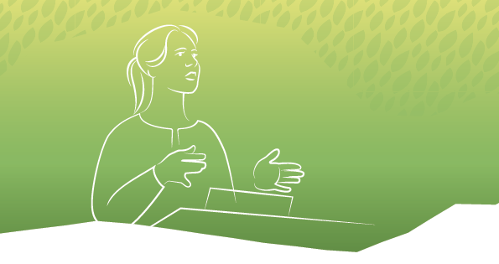
Discriminatory norms, attitudes and practices have proven resistant to change in many areas. Progress has been precarious, with frequent setbacks. There is a need for renewed efforts to address the fundamental causes that perpetuate gender inequality. On the global stage, this is denoted as transformative change.
Enduring societal transformation that advances women’s rights and gender equality at local, national and global levels occurs across multiple dimensions concurrently. The Action Plan identifies three transformative categories of change drivers:
- Normative frameworks, laws, structures and institutions Globally adopted norms, frameworks, the implementation of national legislation and strengthening of institutions promoting women’s rights and gender equality serve as significant drivers of change. At the global level, this includes contributing to negotiations within multilateral forums on conventions and resolutions. It also entails supporting regional, national and local actors dedicated to enacting national laws and policies that foster gender equality and ensure equal opportunities for all. Frequently, this entails amending discriminatory legislation, introducing laws safeguarding women and regulations that facilitate access to resources. The same principles apply to reforming public institutions and other formal structures that wield and perpetuate power, as well as laws and practices that discriminate against or hinder equality based on sexual orientation or gender identity. In certain instances, it means ensuring that adopted legislation is implemented in practice. This extends to public policies providing access to services and benefits that advance gender equality, or facilitate the realisation of women’s human rights, providing equal opportunities in areas such as education, health, and employment.
- Power dynamics The attitudes and practices of individuals in positions of authority play a pivotal role in advancing gender equality and the realisation of women’s rights. They also serve as important drivers of change. This applies to attitudes and practices evident in interpersonal dynamics among partners and family members within the household, local communities, and social networks. It is equally relevant in more structured environments, such as interactions between managers and employees in a workplace, or between leaders of traditional and religious organisations and their constituents, as well as broader societal contexts. The focus lies in addressing relationships between girls and women and those vested with the power to define and make decisions.
- Women’s agency and decision-making power The capacity of women, both individually and collectively, to make decisions, take action and exert influence is a fundamental driver of change. Women’s individual agency involves the right to make independent choices, have bodily autonomy and, be able to own assets and hold offices and positions at local, national and global levels. It also includes the freedom to express themselves and engage in human rights work. This necessitates that women possess the knowledge, ability and resources to act, lead and influence decisions.

How will we contribute to change?
The Action Plan extends Norway’s enduring commitment to promoting women’s rights and gender equality in its foreign and development policy. Our efforts are rooted in human rights and the Sustainable Development Goals.
Norway, maintaining its role as a steadfast advocate, will continue to assert itself on the global stage to achieve gender equality and safeguard the rights of all girls and women. We are resolute in our commitment to combat all forms of discrimination based on gender, sexual orientation, gender identity and gender expression. We will and must work broadly to promote women’s rights and gender equality across the breadth of Norway’s foreign and development policy.
Our most significant opportunities for influencing global developments in gender equality are through strategic cooperation with diverse partners, diplomatic efforts in multilateral forums and at national level, and financial contributions, particularly through development funds. Political dialogue and diplomatic endeavours often concentrate on global norms, whether in global forums or through engagement in dialogue with and influencing the national authorities in implementing global conventions, resolutions and international agreements to which they have acceded. We aim to forge alliances across regions and seek collaboration with countries that may not align with us on every issue.
Human rights-based approach
Realising human rights is not only an inherent objective, but also a driver for sustainable development, poverty eradication, democracy and attainment of lasting peace. The primary responsibility for this lies with countries’ respective governments. To contribute to enduring transformation, efforts must be inclusive and grounded in human rights. This involves working to ensure that those entitled to rights can assert them, while duty-bearers uphold these rights. Aside from being intrinsically important, gender equality may serve as strategic entry point for initiating discussions on human rights issues with decision-makers and authorities at large.
The international normative framework serves as the cornerstone for both Norway’s engagement in multilateral forums and its bilateral efforts to combat discrimination and exclusion, while fostering gender equality. Norway commits to working throughout all levels of its foreign service to champion, instigate, change and implement global norms.
The international normative framework
The international normative framework for women’s rights and gender equality includes the:
- UN Universal Declaration of Human Rights
- UN International Covenant on Civil and Political Rights
- UN International Covenant on Economic, Social and Cultural Rights
- Outcome document of the World Conference on Human Rights in Vienna in 1993
- UN Convention on the Elimination of All Forms of Discrimination against Women
- UN Convention on the Rights of the Child
- UN Convention on the Rights of Persons with Disabilities
- UN International Labour Organization (ILO) conventions nos. 100, 111, 156, 183 and 190
- Platform for Action from the UN Women’s Conference in Beijing in 1995
- Programme of Action from the 1994 Cairo Conference on Population and Development
- 2030 Agenda and its 17 Sustainable Development Goals
- UN Protocol to Prevent, Suppress and Punish Trafficking in Persons, Especially Women and Children
- Yogyakarta Principles for the Application of International Human Rights in Relation to Sexual Orientation and Gender Identity
- UN Human Rights Council resolutions on women’s rights, SRHR, gender and sexuality diversity
- UN Security Council resolutions on women, peace and security
- Council of Europe Convention on preventing and combating violence against women and domestic violence (Istanbul Convention)
- Maputo Plan of Action 2016–2030 for access to sexual and reproductive health services
- Montevideo Consensus on Population and Development
- European Convention on Human Rights
- EU Equal Treatment Directive
- EU Equal Pay Directive
Active participation and shared responsibility are imperative
Girls and women cannot solely bear responsibility for transforming our societies. Achieving gender equality is a collective endeavour that involves everyone. Attitudes and practices are acquired and transmitted from adults to children, across generations. It is important to involve individuals of all ages – children, young people and the elderly – in efforts to raise awareness and change norms. Individuals and organisations with power and influence, such as political leaders, academia, faith communities, private business, and interest groups such as trade unions and civil society, bear the responsibility of working for gender equality. Religious and traditional institutions play a central role in mobilising efforts to change discriminatory gender roles and norms. National authorities are fundamental to ensuring that equality and non-discrimination are anchored in legislation.
More boys and men must be involved in the achievement of gender equality. Boys and men have and should strengthen their roles in fostering improved gender relations and promoting a more equitable distribution of power. Both boys and girls, as well as men and women, may encounter limitations in their opportunities as a result of traditional gender roles. Quality education stands as a pivotal component in the initiatives aimed at transforming gender relations.
Involving young people is essential. They represent the entrepreneurs, leaders and researchers of the future. Simultaneously, they are contemporary users of systems and services, serving as activists, drivers and agents of change. Ensuring their meaningful participation is therefore indispensable.
A comprehensive approach to combatting multiple and intersecting forms of discrimination
Women can face discrimination on multiple grounds, with these factors reinforcing each other. For instance, women with disabilities often experience multidimensional discrimination. Women may encounter a range of complex, structural and institutional barriers. LGBT+ rights are an integral component of the gender equality agenda and an integral part of the Action Plan. Efforts for gender equality, especially to those subjected to multiple and intersecting forms of discrimination, require comprehensive strategies across multiple sectors and involve diverse actors to effectively combat multiple and complex forms of discrimination.
Alliances and partnerships
Norway will forge extensive alliances to achieve our goals. The effectiveness of international norms and conventions for gender equality is amplified when robust and independent women’s movements actively engage for political change. We will strengthen our cooperation with and support for women’s and youth organisations, social movements and groups advocating for gender equality, including those representing marginalised communities, such as queer people, indigenous peoples, and persons with disabilities.
Women’s organisations and other civil society organisations working to improve women’s rights and gender equality within their own countries will be key partners. Norwegian civil society organisations are important partners for facilitating cooperation with local organisations. Change agents within national government structures may also serve as valuable partners.
We will seek cooperation with other Norwegian ministries and strengthen professional cooperation between Norwegian institutions and countries that seek knowledge and draw on Norway’s experiences. In these partnerships, Norway aims to contribute to the exchange of expertise between Norwegian and partner country authorities in the field of gender equality. This includes initiatives such as the Gender Equality for Development knowledge program and integrating gender equality in other knowledge programmes.
We will also operate as a driving force for women’s rights and gender equality through multilateral and regional forums. The normative arenas of the UN system are pivotal to Norway’s efforts to reinforce and safeguard global norms on girls’ and women’s rights. Through building alliances with other countries and participating in UN organisations, development banks and global funds, we will be a key instigator for women’s rights and gender equality, including the advancement of LHBT+ rights. Key arenas include the UN Human Rights Council, the Commission on the Status of Women, the Commission on Population and Development, and the Third Committee of the UN General Assembly, all of which address social, cultural and human rights issues. These bodies set a global standard and specify obligations for policies formulated at national level. Norwegian and international civil society organisations are key partners in this work.
Our endeavours to promote gender equality globally involves engaging in dialogue with our partners, including UN Women, the World Health Organisation (WHO), the International Labour Organisation (ILO), the UN High Commissioner for Human Rights and the UN Population Fund (UNFPA). We will base our efforts on knowledge and support change agents who demonstrate tangible results. In addition to employing both local and multilateral approaches, establishing partnerships and fostering institutional cooperation with national authorities is necessary to realising the goals of the Action Plan. The Action Plan will demonstrate our priorities to our partners and the global community.
Local, national, and multinational businesses are also important partners. The business community plays a vital role in job creation and technology development, and in adherence to the UN Guiding Principles for Responsible Business Conduct and the Norwegian Transparency Act. It is important to integrate a gender perspective in due diligence assessments, work plans and reporting from entities receiving Norwegian business support. The integration is essential to ensuring a meaningful contribution to global gender equality.
Locally led development
We must contribute to shifting and balancing decision-making and agency more equitably for genders. This requires an understanding of the context and adaptability through locally led development, aimed at understanding the reasons behind discrimination faced by girls and women. It is essential to identify those not represented, the upholders of existing structures and the catalysts for change. Fostering diversity among girls and women who organise themselves and build social movements is imperative. This diversity helps in gaining influence in local and national decision-making processes, as well as global negotiations and decision-making forums. Norwegian foreign service missions play a significant role in enhancing our contextual understanding for the implementation of the Action Plan.
The integration of women’s rights and gender equality in all key initiatives
Norway funds both targeted and integrated initiatives for gender equality in foreign and development policy. We remain committed to our objective of a minimum of 50 percent of all bilateral aid explicitly prioritising gender equality as a principal or significant target. Efforts will be made to integrate a gender perspective in all major initiatives, spanning areas such as climate, renewable energy, food security, health, education, peace and humanitarian efforts, and decent work.
Through EEA and Norway grants, Norway contributes to reducing economic and social disparities in 15 European countries, and to strengthening bilateral relations. Cooperation is guided by principles rooted in respect for fundamental rights, the rule of law and democracy. In the current period, two programme areas directly advance gender equality, “Domestic and Gender-based Violence”, and “Work-life Balance”. Several other programme areas also include gender equality components, these span justice, business and innovation, research and health, local development, civil society, including rights for LHBT+ people, the inclusion of Roma people and migration. The emphasis on addressing gender-based violence and domestic violence will be reinforced in the upcoming funding period, alongside a strong commitment to integrating efforts to promote gender equality across all programmatic areas.
Norway must persist in implementing targeted measures advancing the rights, participation, and position of girls, women, and queer people in society. Efforts will be intensified to facilitate their meaningful participation and influence in decisions related to policy formulation and social development, particularly in key development cooperation initiatives.
Gender equality and human rights as cross-cutting issues
Gender equality and human rights are among four cross-cutting issues in Norwegian development co-operation. These considerations aim at preventing Norwegian development aid from causing harm or having unintended negative effects on human rights and gender equality. They serve as mandatory minimum requirements that apply irrespective of sector, partner, and type of programme. The two other cross-cutting issues are anti-corruption and climate change and the environment.
Instruments strengthening gender equality and women’s rights
We employ various instruments, channels and partners in our foreign and development policy to contribute to global and national changes. Advocacy, advising, awareness-raising and empowerment may be undertaken by a diverse range of actors, including ourselves, Norwegian foreign and development policy actors, as well as multilateral, regional, national and/or local actors. Norway collaborates with and provides funding to a wide array of national and local entities, including civil society organisations. In addition, together with our partners, we use several types of instruments to advance the gender equality agenda and strengthen women’s rights. Some of the most crucial are:
- Advocacy and expert advisory work preferably directed towards national authorities to facilitate legislative changes and implement new policies.
- Awareness-raising and empowerment of girls and women, and other actors and groups enabling them to advocate for their own rights.
- Training and capacity building of girls, women, boys and men, as well as their organisations to strengthen their influence and decision-making power.
- Knowledge production strengthening knowledge and supporting data for the change agenda.
- Delivery of services, in for example health and education, helps girls and women realise their rights.
- Principles for business co-operation ensuring women’s access to decent work through local business development and the adoption of non-discriminatory practices.
- Innovation and digitalisation as both a means to accelerating development, and an end in itself, by ensuring girls and women have equal access to technology and digital solutions.
We will continuously assess which types of instruments are most suitable and effective in achieving our goals. Different partners possess different advantages and may be more suitable for forming alliances or collaborations to collectively bring about change.
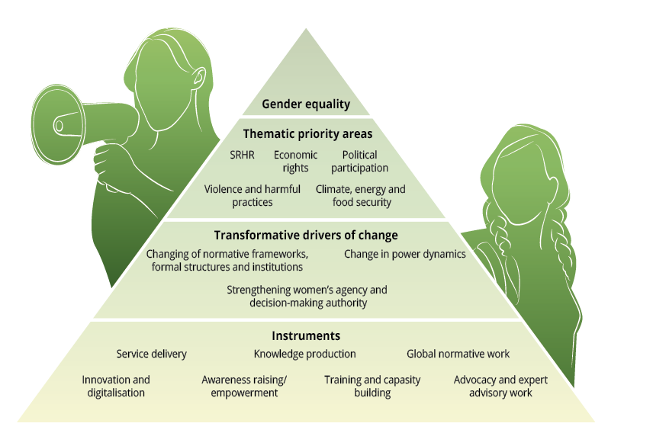
Figure: Priority areas, change drivers and key instruments in the Action Plan.

In addition to specific priorities defined under each goal area, we will give precedence under all goal areas:
- Normative frameworks, structures and institutions promoting gender equality and combatting multiple and intersecting forms of discrimination
- Contributing to strengthening global normative work, including conventions and resolutions.
- Ensuring women’s, LGBT+ and youth organisations, feminist and social movements and human rights defenders have influence and impact on the development and implementation of normative frameworks.
- Encouraging faith-based actors in promoting gender equality within their institutions.
- Influencing decision-making in governing bodies such as UN organisations, development banks, global funds and financing mechanisms on their work on normative frameworks and their implementation.
- Engaging in dialogue with national governments and regional actors on national legislation and knowledge-based non-discriminatory and gender-equitable national policies, budget priorities and plans.
- Supporting research and knowledge on technology and innovation that contribute to changing gender roles and fostering more gender equal societies.
- Strengthening the collection, access to and use of gender- and age-disaggregated data and statistics, including strengthening Global South-based research.
- Supporting the development and use of technology and innovation that contributes to normative frameworks for gender equality and combats multidimensional discrimination.
- Power dynamicss promotinge gender equality and combatting multidimensional discrimination
- Engaging in dialogue with authorities and community, religious and traditional leaders on norms, attitudes and practices that endorse gender equality and exploring ways in which they can leverage their influence to combat discrimination.
- Collaborating with civil society to champion gender equality and counteract discriminatory norms, attitudes, and practices.
- Contributing to research and knowledge, including from the Global South, on power relations that promote or limit gender equality and multidimensional discrimination.
- Women exercising effective agency and decision-making power
- Supporting initiatives that contribute to women leaders, politicians, negotiators and activists gaining access to and agency in decision-making arenas.
- Supporting initiatives that empower girls and women, ensuring they possess the capacity and knowledge to make and influence decisions that affect them.
- Supporting organisations led by and for women, young people, persons with disabilities, queer and indigenous peoples to build capacity, access tools and have the opportunities to influence normative and legislative changes at local, national, regional and global levels.
- Supporting the capacity of women human rights defenders to wield influence in decisions-making processes.
- Ensuring that girls and women have equal access to information, knowledge, services and digital tools.
- Contributing to the active participation of women in research production and the integration of gender perspectives in all research.
- Contributing to the development and utilisation of research and knowledge by women, especially from the Global South.

Goal 1: All individuals have the right to bodily autonomy

Targets:
- All individuals have access to sexual and reproductive health and rights, including contraceptives and safe abortion.
- Children and adolescents receive age-appropriate and comprehensive sexuality education in and out-of-school.
- International acceptance of sexual rights.
Norway’s distinctive contribution lies in our national policy on sexual and reproductive health and rights (SRHR), coupled with our clear and unwavering international position in support of SRHR. This commitment is firmly rooted in the right to health, and work for SRHR as an integral component of universal health coverage. Norway has been a longstanding advocate on politically sensitive topics, including access to contraception and counselling, comprehensive sexuality education in and out- of- school and the right to safe abortion. Our commitment extends to substantial financial support for international initiatives in this field, with both civil society and multilateral organisations as key partners. We remain dedicated to this approach, aligned to the Foreign Service’s guidelines for SRHR work. The guidelines for freedom of religion and belief, along with Norway’s development policy strategy for inclusion of persons with disabilities are also relevant in this endeavour.

We will prioritise:
- Promoting the right to decide over one’s own body (SRHR), bilaterally and internationally.
- Supporting and advancing broad cross-regional alliances to co-ordinate efforts to promote SRHR. This includes bilateral and multilateral dialogue, as well as co-operation with relevant civil society organisations.
- Collaborating with various actors to develop and share research-based knowledge about the value of SRHR and the costs of not ensuring access to SRHR for all.
- Collaborating with global, national and local governments and stakeholders in spreading information and facilitating access to age- and gender-appropriate sexual and reproductive health services for individuals of all genders and ages, including contraception and safe abortion services.
- Supporting organisations that promote safe sex, good health and sexual pleasure in their programmes, including young people.
- Collaborating with faith-based organisations and networks to mobilise and support progressive voices, fostering proactive actions at local and national levels including contributing to dialogues aimed at ensuring safe abortion for women.
- Supporting comprehensive sexuality education in and out-of-school.
- Advocating for the incorporation of comprehensive sexuality education into primary and secondary school curricula, both within and outside the classroom.
- Supporting advocacy for access to age and gender-appropriate sexual and reproductive health services and comprehensive sexuality education for adolescents, LGBT+ people, persons with disabilities and other marginalised or vulnerable groups.
- Strengthening national health systems to include SRHR in primary health care and universal health coverage plans.
- Strengthening access to sexual and reproductive health services and information in humanitarian efforts.

Sustainable Development Goals we are contributing to:
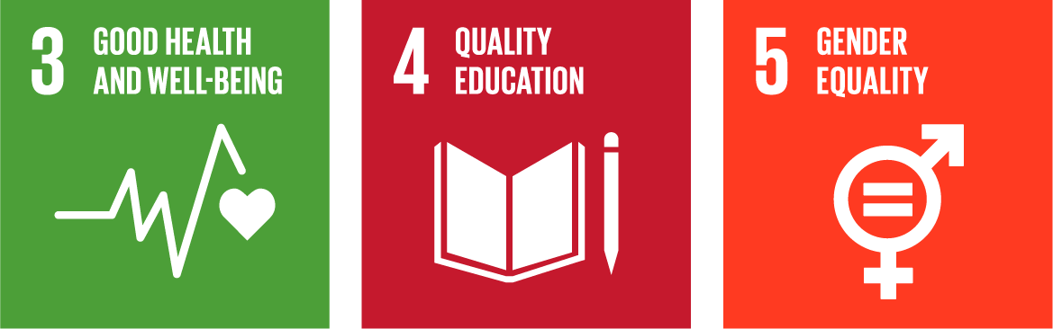

Goal 2: All individuals have the right and opportunity to lead their lives free from violence and harmful practices

Targets:
- No individual is subjected to any form of sexual and gender-based violence.
- No individual is subjected to child and forced marriage.
- No individual is subjected to female genital mutilation.
Norway’s distinctive contribution lies in our national policy to combat domestic violence and the application of our experiences in international engagement. An example is the forthcoming national plan to escalate efforts against violence and abuse directed at children and domestic violence. In this initiative Norway is dedicated to advancing and upholding to the Council of Europe Convention on preventing and combating violence against women and domestic violence (the Istanbul Convention) across relevant international contexts.
Through continued financial and political support, including global funds targeting the eradication of female genital mutilation and child marriage, Norway has cultivated strong relationships with key partners such as multilateral and civil society organisations. Combating gender-based violence is also a priority for the EEA and Norway grants. Norway has been a leader in the fight against sexual and gender-based violence in its humanitarian efforts, as well as in the women, peace and security agenda. The Action Plan must be viewed in the context of Norway’s humanitarian strategy. The Ministry of Foreign Affairs’ guidelines for freedom of religion and belief is also relevant in this work.

We will prioritise:
- Contributing to comprehensive and co-ordinated initiatives to combat harmful practices, with the aim of preventing violence and protecting and aiding survivors.
- Preventing sexual and gender-based violence by supporting women’s movements and other stakeholders working to change legislation and combat impunity.
- Strengthening targeted and integrated work with boys and men to challenge negative masculine gender norms that contribute to the acceptance of violence and harmful practices. This includes engaging in dialogue and collaboration with women’s movements.
- Promoting work involving women, men, girls, boys and LGBT+ persons as well as other influencers to challenge harmful gender norms.
- Mapping and combatting the digital dimension of all forms of violence, which disproportionately affect women, LGBT+ persons, children and young people. Particular emphasis is placed on women and queer people who express themselves in the public sphere through digital and social media.
- Engaging in dialogue and collaboration with traditional and religious leaders and faith-based organisations to influence changes in norms on sexual and gender-based violence, conversion therapy, child marriage and female genital mutilation.
- Strengthening the interaction between groups working for freedom of religion and belief and those working locally, nationally and internationally for gender equality and diversity in gender and sexuality.
- Sustaining efforts to prevent and combat sexual and gender-based violence in armed conflict and during humanitarian crises in peacetime. The needs and priorities of survivors shall be at the centre of the response.
- Integrating information and knowledge about harmful practices in comprehensive sexuality education both in and out-of-school.
- Addressing the vulnerabilities of certain groups, such as LGBT+ persons, persons with disabilities and other marginalised groups.

Sustainable Development Goals we are contributing to:
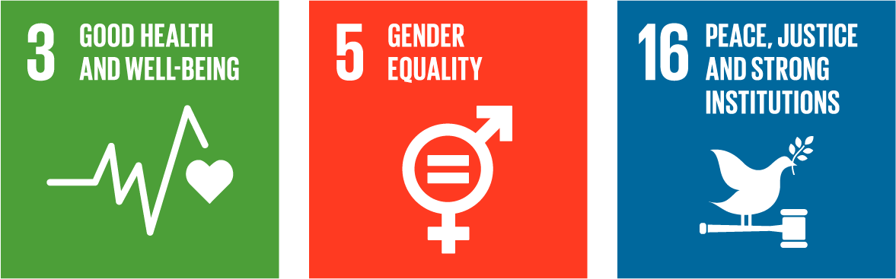

Goal 3: All individuals have equal economic rights and opportunities to participate in the labour market

Targets:
- All individuals have the right and opportunity to secure decent work and have the right to form and join a trade union.
- All individuals have the right to inherit and own property, alongside access to economic resources and financial services.
- All individuals have the right and opportunity to receive education that equips them for gainful employment.
Norway’s distinctive contribution lies in both our national experience of women’s participation in the labour market and a steadfast international commitment to gender equality. The Norwegian labour market operates on a model that encourages everyone with the opportunity to participate in the workforce. Increasing the proportion of women in the labour force has been instrumental to Norway’s economic growth. Norway has largely succeeded in facilitating high female labour force participation, entrepreneurship, and innovation, and ensuring the full integration of trade unions in working life.
A robust framework of laws, regulations and institutions safeguards the rights and obligations of workers, while ensuring gender equality in access to education and career choices. This provides greater opportunities for employment and income. Norway values enduring partnerships with multilateral development banks, financial institutions, relevant UN organisations and civil society organisations, which not only serve as recipients of financial support but also as valuable long-term collaborators.

We will prioritise:
- Supporting the efforts of the ILO and the implementation of the global agenda for the right to decent work and social justice for all. This includes supporting initiatives that prevent workers from facing harassment, including sexual harassment and other inappropriate behaviours.
- Supporting trade unions and employers’ organisations that advocate decent work for all through social dialogue.
- Strengthening women’s participation in the labour market, including through assistance for social safety nets and welfare services.
- Supporting international and national work focused on innovative solutions and changes in the care sector, including the equitable distribution of care work within households.
- Supporting business initiatives that prioritise job creation for women and vulnerable groups.
- Supporting initiatives that facilitate women’s participation at all levels of management and decision-making in the public and private sector.
- Following up on Norfund’s work to ensure equal opportunities and promotion of gender balance at all levels in the fund and its invested enterprises. This includes ensuring that women and men have equal access to financing.
- Contributing to safe and inclusive digital public infrastructure, including digital identification, civil registries, payment platforms and systems for secure data exchange. This aims to enhance women’s and LGBT+ people’s access to welfare services, economic participation, and job creation opportunities.
- Supporting national governments’ initiatives to develop and implement non-discriminatory legislation, legal reform, and policies ensuring women’s access to resources, financial services, and parental leave.
- Supporting international and national initiatives and financing mechanisms that promote female entrepreneurship and innovation, as well as promoting knowledge of and access to financial services.
- Working towards ensuring equal participation of women with disabilities in the labour market.
- Supporting measures to ensure that all girls start and complete lower secondary school.
- Working towards universal enrolment and completion of quality primary education and increasing the proportion of girls and women enrolling and completing secondary and tertiary education, particularly in the fields of science, technology, engineering, and maths (STEM).
- Supporting vocational training and other measures contributing to safe and decent work for women and queer persons, as well as facilitating career choices across gender-segregated sectors.
- Sharing knowledge and Norwegian experiences on how women’s economic participation, combined withactive gender equality and employment policies, have strengthened the position of women and girls in society and, ultimately, economic development and growth in Norway.

Sustainable Development Goals we are contributing to:
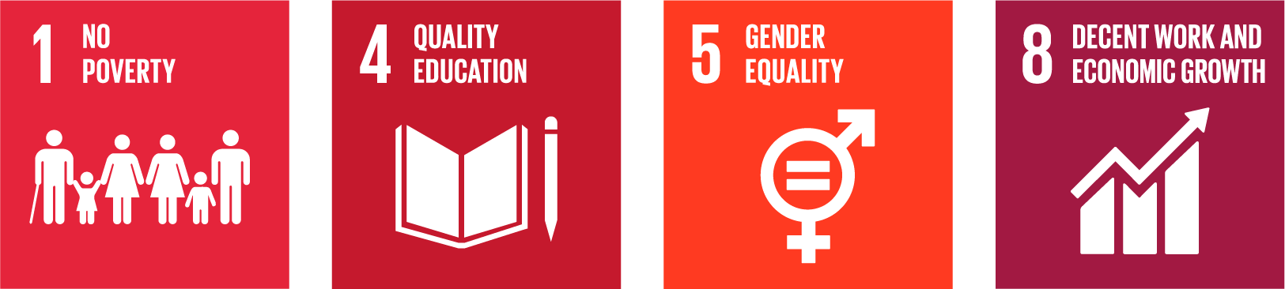

Goal 4: All individuals have equal political rights and opportunities to participate in public life

Targets:
- Uphold and implement a robust global normative framework for women’s rights and gender equality that is maintained and implemented at national level.
- Women have full, equal and meaningful representation, with genuine influence in political processes and political bodies.
- All individuals are safe and have the opportunity to work for human rights.
- All girls and women, have the necessary skills to actively participate in society.
Norway’s distinctive contribution lies in our national expertise in women’s participation in politics and public life, coupled with a sustained and unwavering global commitment to gender equality. We have extensive experience in developing, implementing, organising and advocating for women’s representation and participation in political decision-making processes and public life at all levels. The foundation of Norway’s efforts to promote gender equality globally is rooted in a stable and enduring prioritisation. In addition, we have collaborative partnerships with multilateral organisations, authorities and civil society organisations with the legitimacy and knowledge to influence gender equality in society.
The strategy for freedom of expression in foreign and development policy has a clear gender equality profile. The Norwegian Foreign Service’s guidelines for supporting human rights defenders draws on extensive experience from our human rights work. Recognising the interdependence of women’s participation in political processes and their participation in peace and security efforts, Norway has consistently prioritised both nationally and globally. The National Action Plan for Women, Peace, and Security provides a detailed exploration of Norway’s commitment to fostering women’s participation in peace and security work.

We will prioritise:
- Supporting actors working to increase the representation of women, LGBT+ people and young people in political forums and decision-making processes at local, national and global levels.
- Supporting government efforts to develop and implement non-discriminatory legislation, legal reforms and policies that ensure women’s and LGBT+ persons’ equal and meaningful participation in political public life.
- Providing long-term and flexible support to local and South-based women’s, LGBT+ and youth organisations, including girl-led organisations and feminist and social movements.
- Strengthening research communities working on gender equality for better knowledge-based policy making, including for and with young people.
- Contributing to capacity development and protection schemes for women human rights defenders.
- Strengthening access to safe communication and training in digital safety and security for girls, women and LGBT+ persons who speak out in public.
- Ensuring that all girls and women have the knowledge and skills, including through public education, to enable them to actively participate in society.

Sustainable Development Goals we are contributing to:
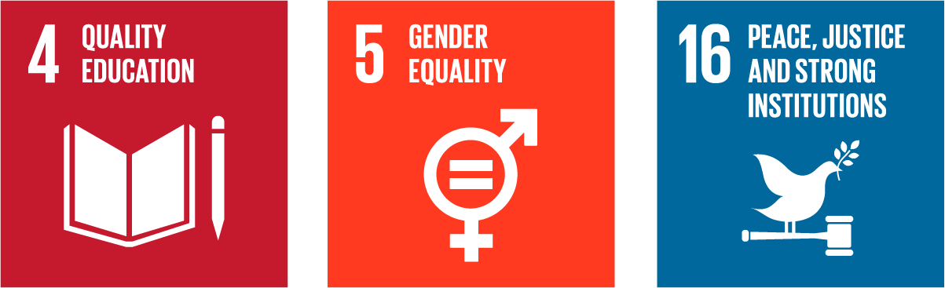

Goal 5: All individuals have the right and opportunity to contribute and participate in work for climate, energy and food security

Targets:
- Women are acknowledged as agents of change, with genuine influence in decision-making processes in the green transition.
- Women’s rights, gender equality and participation are integrated into the preservation of biodiversity, sustainable management of natural resources, climate change adaptation and the prevention of climate- and environment-related disasters.
- Women’s rights and participation in renewable energy and food security is strengthened.
- Women’s role as food producers and contributors to food chains and food systems is strengthened.
Norway’s distinctive contribution lies in our dedicated support for inclusive climate action and the commitments we uphold at both national and global levels. The International Climate and Forest Initiative is central in this context. Our focus on transitioning to and facilitating access to renewable energy constitutes a significant aspect to curbing gas emissions. In addition, our commitment to gender equality is a key emphasis in Norway’s strategy for food security in development policy and in our strategy for climate adaptation, prevention of climate-related disasters and combating hunger.

We will prioritise:
- Incorporating gender equality considerations as a distinct criterion in assessments of partners involved in all climate, energy and food security initiatives. Partners will be required to report on the gendered impacts of their efforts on women and men.
- Integrating gender equality into knowledge programmes focusing on fish, oceans, agriculture, and energy.
- Supporting the integration of gender equality considerations in the development of government policy for climate change adaptation and emission reduction.
- Supporting measures that strengthen women’s participation in decision-making processes related to climate issues at the local, national, and global levels.
- Ensuring that girls and women have access to knowledge, enabling them to contribute effectively to work on climate, energy and food security.
- Contributing to girls’ and women’s participation in transitional processes aimed at increasing access to renewable energy in households.
- Amplifying the focus on energy sources that specifically advance gender equality, such as ensuring sufficient and affordable electricity for cooking, clean cookstoves and decentralised energy solutions.
- Encouraging women’s involvement and participation in the planning, development and operation of renewable energy production, including through support for vocational training and higher education.
- Supporting women’s participation in and access to disaster prevention programmes and weather forecasting services.
- Supporting favourable framework conditions that facilitate female small-scale fishers’ access to fisheries and aquaculture.
- Supporting the organisation of women small-scale producers in cooperatives, farmer and fishery organisations.
- Supporting women food producers’ access to production methods, approaches, services, and innovation that provide climate-resilient food production.
- Supporting women’s participation and leadership in sustainable forest management with a particular focus on indigenous peoples and indigenous women.
- Supporting women’s participation and leadership in the sustainable management of natural resources.
- Supporting initiatives that contribute to raising awareness of how climate change impacts access to sexual and reproductive health and rights and ensuring the inclusion of SRHR in national climate plans.
- Following up Norfund’s efforts in advancing equal opportunities for women and men at all levels within the investments of the Climate Investment Fund.
- Strengthening the knowledge base and supporting research on the interconnections between climate and gender equality.

Sustainable Development Goals we are contributing to:
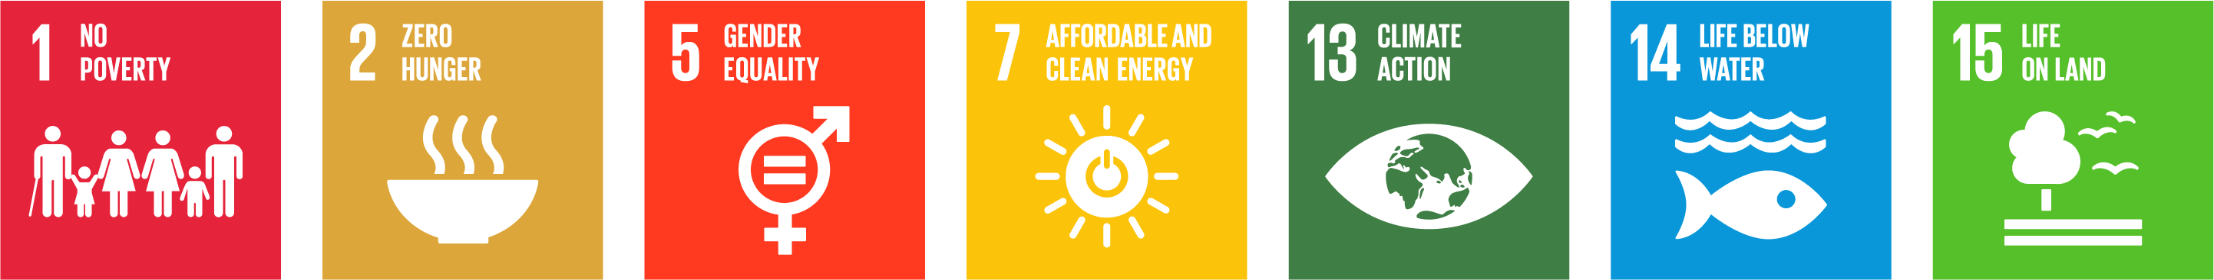

Implementation of the Action Plan
We commit the entire Foreign Service to these efforts
The implementation of the Action Plan will be carried out by relevant sections in the Ministry of Foreign Affairs, at the missions of the Foreign Service, in Norad and at other public administrative entities responsible for Norwegian foreign and development policy funds, including through the Knowledge Bank. The Action Plan’s priorities will be realised through political leadership, diplomacy and engagement in normative processes. In addition, we will fund tangible measures that lead to gender equality.
We coordinate our work internally
Working for gender equality globally also requires the Ministry to work for this internally. Public authorities have a duty to work actively, purposefully and systematically to promote gender equality and prevent discrimination. This also involves preventing harassment, sexual harassment, gender-based violence and counteracting stereotyping.
Departments, sections, project units and foreign service missions within the Ministry and Norad must organise their work so that they have the necessary expertise and capacity to integrate and follow up on gender equality and non-discrimination considerations. All staff in the Ministry should possess a solid understanding of efforts to combat sexual harassment, aligning with our international obligations to combat sexual abuse, exploitation, and harassment. As part of strengthening our work, we will also continue to build competence and offer training on women’s rights, gender equality and SRHR, as well as queer rights across the board.
While the Section for Human Rights, Democracy and Gender Equality, within the Ministry of Foreign Affairs, is the technical specialist in this area, all sections have an independent responsibility to advance the integration of gender equality in their areas of responsibilities. To ensure that women’s rights and gender equality are integrated throughout the Foreign Service, gender equality contacts will be designated in each relevant section in the Ministry of Foreign Affairs. Norad will maintain its use of gender equality contacts. The gender equality contacts will hold biannual meetings to coordinate the implementation of the plan throughout the Foreign Service, with meetings chaired by the Ministry of Foreign Affairs’ policy director for women’s rights and gender equality.
All strategies and action plans developed by the Ministry of Foreign Affairs must align with this Action Plan. Women’s rights and gender equality should be consistently considered in meetings, speeches and other written materials.
The Ministry of Foreign Affairs, foreign service missions and Norad are required to outline in their annual work plans how they intend to ensure women’s rights and gender equality in their respective areas. The internal resource page containing tips and guidelines for promoting women’s rights and gender equality in foreign and development policy will be further developed.
In the annual budget proposal, the Ministry is obligated to report on efforts to integrate gender equality and non-discrimination considerations into its work. This includes detailing how the Ministry translates principles, procedures, and standards for gender equality and non-discrimination into action, evaluating the achieved results, and communicating the Ministry’s expectations for future work in this regard
We adjust our efforts
The Action Plan will be in effect from 2023 to 2030. During this period, local, national and global circumstances will shape how priorities are defined and realised. We maintain a flexible approach to our initiatives, continuously assessing our own efforts to ensure tangible results. Two-year work plans will be formulated to allow for adjustments and optimisation of our strategies.
We join forces
An annual celebration of women’s rights in foreign and development policy coinciding with International Women’s Day on 8 March. This event will assess the status of women’s rights and gender equality globally, emphasising Norwegian priority areas and results.
Every two years, youth consultations will be conducted at selected embassies to ensure the voices of children and young people are heard, enabling their participation in gender equality matters that impact them directly. The initial round of youth consultations in 2023 contributed insights for the development of this Action Plan.
We report
The outcomes of Norwegian efforts will be reported annually, through a combination of planned knowledge gathering and knowledge production. These diverse methods collectively contribute to the annual reporting as follow:
What | Who | Type of information
General reporting | Ministry of Foreign Affairs  Norad | Reporting on defined indicators per goal and target.  Thematically relevant global trends, statistics and research results.
Aid statistics and analyses | Norad | Production and analysis of Norwegian aid statistics.  Quantitative and qualitative analyses of goal achievement, monitoring the gender equality marker for relevant sectors.
Partner results including multilaterals | Ministry of Foreign Affairs  Foreign Service missions  Norad | Collection of annual reporting and analyses from selected partners, including reporting provided to multilateral boards under particular thematic areas.
Thematic/geographical knowledge products | Norad | Production of in-depth thematic and/or geographic knowledge products in collaboration with external and independent research institutions.
Annual reporting will be collaboratively prepared through consultation between the Section for Human Rights, Democracy and Gender Equality at the Ministry of Foreign Affairs and Norad.
In addition to the annual reporting, a mid-term review is scheduled for 2026, serving as a management tool for potential adjustments to the Action Plan. Furthermore, a final evaluation is planned for 2029, allowing results to inform the formulation of a new action plan in 2030.

Flor, L. . S., Friedman, J., Spencer, C. N., Cagney, J., Arrieta, A., Herbert, M. E., Stein, C., Mullany, E. C., Hon, J., Patwardhan, V., Barber, R. M., Collins, J. K., Hay, S. I., Lim, S. S., Lozano, R., Mokdad, A. H., Murray, C. J. L., Reiner, R. C., Jr, Sorensen, R. J. D., Haakenstad, A., … Gakidou, E. (2022). Quantifying the effects of the COVID-19 pandemic on gender equality on health, social, and economic indicators: a comprehensive review of data from March, 2020, to September, 2021. Lancet, 399(10344), 2381–2397. Available at: https://doi.org/10.1016/S0140-6736(22)00008-3.
Norway’s National Action Plan: Women, Peace and Security (2023-2030). Available at: Norway’s National Action Plan: Women, Peace and Security (2023-2030) - regjeringen.no
Norway’s Humanitarian Strategy: An effective and integrated approach. Available at: https://www.regjeringen.no/en/dokumenter/strategi-for-norsk-humanitar-politikk/id2608151/.
World’s Best News (2023) Arbeidet for en likestilt verden fortsetter [Efforts for an equal world continue - in Norwegian only]. Here are six examples of progress (web page). https://verdensbestenyheter.no/nyheter/arbeidet-for-en-likestilt-verden-fortsetter-her-er-seks-fremskritt/.
The definition of SRHR that is used is the Lancet-Guttmacher Commission’s comprehensive definition of SRHR, see Starrs, A. M., Ezeh, A. C., Barker, G., Basu, A., Bertrand, J. T., Blum, R., … Ashford, L. S. (2018). Accelerate progress–sexual and reproductive health and rights for all : report of the Guttmacher-Lancet Commission. LANCET, 391(10140), 2642–2692. Available at: https://doi.org/10.1016/S0140-6736(18)30293-9.
UNFPA (2022). Challenges to choice (web page).Available at: SWP Report 2022: Challenges to choice | United Nations Population Fund (unfpa.org)
WHO (2023) Trends in maternal mortality 2000 to 2020: Estimates by WHO, UNICEF, UNFPA, World Bank Group and UNDESA/Population Division. Geneva: World Health Organization. Available at: Trends in maternal mortality 2000 to 2020: estimates by WHO, UNICEF, UNFPA, World Bank Group and UNDESA/Population Division
Plan International (2023). Teenage pregnancy (web page). https://plan-international.org/srhr/teenage-pregnancy/.
WHO (2021). Violence against women. Key facts (web page). https://www.who.int/news-room/fact-sheets/detail/violence-against-women
ACPF (2011). Violence against Children with Disabilities in Africa: Field studies from Cameroon, Ethiopia, Senegal, Uganda and Zambia. Addis Ababa: The African Child Policy Forum. Available at: African Child Policy Forum (ACPF) Official website - ACPF | Resource Centre - Publications - Violence Against Children with Disabilities in Africa: Field Studies from Cameroon, Ethiopia, Senegal, Uganda and Zambia (africanchildforum.org)
UN Women (2020). Accepting the challenge. Women with disabilities: for a life free of violence. Montevideo: UN Women. Available at: Accepting the challenge. Women with disabilities: or a life free of violence. An inclusive and cross-cutting perspective (unwomen.org)
UN Human Rights Council. Violence against indigenous women and girls: Report of the Special Rapporteur on violence against women, its causes and consequences, Reem Alsalem. 21 April 2022, UN Doc A/HRC/50/26. Available at: https://www.ohchr.org/en/documents/thematic-reports/ahrc5026-violence-against-indigenous-women-and-girls-report-special.
UNICEF (2022). Child marriage (web page). https://data.unicef.org/topic/child-protection/child-marriage/.
UNICEF (2021). Towards Ending Child Marriage: Global trends and profiles of progress. New York: United Nations Children’s Fund. Available at: https://data.unicef.org/resources/towards-ending-child-marriage
UN Women (2022). Progress on the Sustainable Development Goals: The gender snapshot 2022. UN Women. Available at: https://www.unwomen.org/en/digital-library/publications/2022/09/progress-on-the-sustainable-development-goals-the-gender-snapshot-2022
UNFPA (2023). Female genital mutilation (web page). https://www.unfpa.org/female-genital-mutilation.
UNFPA (2023). UNFPA-UNICEF Joint Programme on the Elimination of Female Genital Mutilation (web page). https://www.unfpa.org/unfpa-unicef-joint-programme-female-genital-mutilation.
IMF Blog (2018). Economic Gains from Gender Inclusion: Even Greater than You Thought (web page). https://www.imf.org/en/Blogs/Articles/2018/11/28/blog-economic-gains-from-gender-inclusion-even-greater-than-you-thought.
The World Bank (2022). Female labor force participation (web page). https://genderdata.worldbank.org/data-stories/flfp-data-story/.
Women spend three times more time on unpaid care work than men according to the International Labour Organization (ILO) (2022). The gender gap in employment: What’s holding women back? (web page). https://www.ilo.org/infostories/en-GB/Stories/Employment/barriers-women#global-gap.
Ubfal, Diego (2023). What Works in Supporting Women-Led Businesses? World Bank Group Gender Thematic Notes Series. Washington, DC: World Bank Group.
UN Women (2023). Facts and figures: Women’s leadership and political participation (web page). https://www.unwomen.org/en/what-we-do/leadership-and-political-participation/facts-and-figures.
Inter-Parliamentary Union (2023). Women in parliament (web page). https://www.ipu.org/impact/gender-equality/women-in-parliament.
UN Women (2023). Women in politics: 2023 (web page). https://www.unwomen.org/sites/default/files/2023-03/Women-in-politics-2023-en.pdf.
UN Women (2015). Women’s Participation and a Better Understanding of the Political (web page). https://wps.unwomen.org/participation/.
The Economist Intelligence Unit (2021). Measuring the prevalence of online violence against women (web page). https://onlineviolencewomen.eiu.com
UN Commission on the Status of Women. Achieving gender equality and the empowerment of all women and girls in the context of climate change, environmental and disaster risk reduction policies and programmes: report of the Secretary-General. 4 January 2022, UN Doc E/CN.6/2022/3. Available at: https://digitallibrary.un.org/record/3956348?ln=en#record-files-collapse-header.
FAO (2023). The status of women in agrifood systems. Rome: FAO.
This is an adapted version of the framework used by the OECD Development Assistance Committee. The framework consists of three key dimensions: 1) norms, structures and institutions, 2) relations, and 3) agency. The theory is that you have to work along all dimensions simultaneously to achieve profound and lasting change.
See note 5.
Norwegian guidelines for sexual and reproductive health and rights. Available at: https://www.regjeringen.no/contentassets/daaf87fe8aab47f18636e7dcb98c9511/srhr_veileder.pd.
Veileder for utenrikstjenestens arbeid med tros- og livssynsfrihet [Guidelines for the Norwegian Foreign Service’s work on freedom of religion and belief]. Available at: https://www.regjeringen.no/no/dokumenter/ny-veileder-for-utenrikstjenestens-arbeid-med-tros-og-livssynsfrihet/id2983169/.
Equality for all. Norway’s strategy for disability-inclusive development (2022–2025). Available at: https://www.regjeringen.no/en/dokumenter/equality_all/id2901152/.
See note 3.
International strategy for freedom of expression. Available at: https://www.regjeringen.no/en/dokumenter/international-strategy-for-freedom-of-expression2/id2866234/.
Norwegian guidelines for support to human rights defenders. Available at: https://www.regjeringen.no/no/dokumenter/norwegian-guidelines-for-support-to-human-rights-defenders/id2992011/.
See note 2.
Combining forces against hunger – a policy to improve food self-sufficiency. Norway’s strategy for promoting food security in development policy. Available at: https://www.regjeringen.no/en/dokumenter/Food-security-strategy/id2948780/.
Climate change, hunger and vulnerability: Strategy for climate change adaptation, disaster risk reduction and the fight against hunger. Available at: https://www.regjeringen.no/en/dokumenter/climate_vulnerability/id2963175/.
Section 24 of the Equality and Anti-Discrimination Act.
See Section 24, second paragraph, of the Equality and Anti-Discrimination Act.

