Ministry of Climate and Environment

Norway’s Climate Action Plan for 2021–2030
Meld. St. 13 (2020–2021) Report to the Storting (white paper)
Ministry of Climate and Environment

Norway’s Climate Action Plan for 2021–2030
Meld. St. 13 (2020–2021) Report to the Storting (white paper)
Recommendation of 8 January 2021 from the Ministry of Climate and Environment, approved in the Council of State the same day. (The Solberg Government)
Part I
Introduction

A plan to cut emissions, not economic growth

Introduction
Anthropogenic climate change will have serious and irreversible impacts on nature and society throughout the world. Changes are already occurring, and the impacts are becoming apparent in Norway. It is vital to prepare society for change and to adapt to a changing climate. Combating climate change requires a vigorous and concerted global effort to reduce greenhouse gas emissions.
Norway is stepping up and taking responsibility. We will do our share of the work at both national and international level. These efforts will come at a price, but the cost of climate inaction will be far higher than the cost of tackling the problem now.
The world is experiencing more frequent and more intense extreme weather events. Temperatures are rising, snow and ice are melting, sea levels are rising, seawater is becoming more acidic and wildfires are becoming more frequent. Vulnerable species and ecosystems are disappearing. Climate change will intensify in the years ahead.
Preventing catastrophic environmental degradation is crucial to safeguarding the well-being of future generations.
Climate change is a global problem, but emissions are caused by actions and processes at local level.
Under the Paris Agreement, Norway, like almost every other country in the world, has undertaken to reduce greenhouse gas emissions. Adoption of the Paris Agreement was a turning point in international climate cooperation. Together with the United Nations Framework Convention on Climate Change (UNFCCC), the agreement provides a solid framework for global climate action in the future.
The target of the Paris Agreement is to hold the increase in the global average temperature to well below 2°C above pre-industrial levels and pursue efforts to limit the temperature increase to 1.5°C. The Agreement also aims to increase countries’ ability to adapt to the adverse impacts of climate change and to make finance flows consistent with a pathway towards low greenhouse gas emissions and climate-resilient development.
Norway has communicated a nationally determined contribution (NDC) under the Paris Agreement to reduce greenhouse gas emissions by at least 50 % and towards 55 % by 2030 compared to 1990. This is a crucial step on the path towards Norway’s target of being a low-emission society by 2050.
The action taken by Norway and the rest of the world over the next ten years will determine whether or not it is possible to check anthropogenic climate change.
Several countries that are major emitters have not yet enhanced their formal targets (NDCs) under the Paris Agreement, but there have been encouraging signals that the level of ambition is rising. In December 2020, the EU enhanced its target under the Paris Agreement. The new target is to reduce emissions by at least 55 % by 2030, up from the previous target of a 40 % reduction. The UK has adopted an ambitious new climate target of reducing emissions by 68 % by 2030. The new US President has announced that the country will be pursuing a more ambitious climate policy, and in autumn 2020, China adopted a long-term target of achieving climate neutrality by 2060.
The UN Sustainable Development Goals (SDGs) provide an overall framework for addressing the major national and global challenges facing the world today. Implementing the Paris Agreement is an essential basis for achieving SDG 13 on climate action. Climate change and climate policy have a bearing on most areas of society and thus on many of the other SDGs. The Norwegian Government’s climate policy is intended to improve welfare standards at the same time as cutting emissions. Climate policy must not be considered in isolation, but as the sum of policy in many areas. Close coordination and an integrated policy for sustainable development in all sectors are an essential basis for achieving climate targets and for a coherent approach that makes it possible to achieve goals in other areas. Various elements must be put in place to ensure that Norway can make a successful transition. Progress and emission reductions will also depend on the ability to take other considerations into account, for instance relating to the economy, food security, biodiversity and adaptation to climate change.
Norway will have to go through a major transformation process, which will involve reducing emissions but not hampering development. The Government will therefore pursue an ambitious climate policy that will make it possible to achieve climate targets and at the same time provide a good framework for more jobs, greater welfare and sustainable growth of the Norwegian economy. Efforts to halt climate change involve great challenges, but also offer the opportunity to create a better Norway.
Value creation is an essential basis for halting climate change, not a barrier. The real problem is not greater welfare and value creation, but the biodiversity loss and greenhouse gas emissions. Green growth is possible, but requires a policy that enables the business sector to develop and deploy new technologies to replace yesterday’s fossil solutions. Products and services will need to have a much smaller climate footprint in the future. It must pay to invest in green solutions.
In 2021, for the first time, Norway and the EU’s shared commitments apply to all Norwegian emissions. 2021 also marks the beginning of a new policy approach for non-ETS greenhouse gas emissions. This is no longer based solely on a target for the emission reductions to be achieved in ten years’ time – there is also an emission ceiling for each year of the period. The annual emission budget is reduced for each year up to 2030, and in the agreement on climate action with the EU, Norway’s final target for 2030 is a 40 % reduction in non-ETS emissions compared with the 2005 level.
The Government is planning to exceed this commitment. This white paper presents a plan for achieving the Government’s goal of reducing Norwegian non-ETS emissions by 45 % by 2030.
The agreement with the EU does not set national targets for ETS emissions in the same way as for non-ETS emissions. The installations covered by the EU Emissions Trading System (EU ETS) have to collectively reduce their emissions to achieve the overall target. Norwegian installations in sectors covered by the system are playing their part in achieving this target in the same way as installations in other European countries. The carbon price in the system is determined by the market, and emissions are reduced where it costs least to do so. In order to present the Government’s climate policy as a whole, this white paper also includes an account of how ETS emissions can be reduced, and policy instruments for achieving this. Among other things, the central government will support and promote further technological developments in the ETS sector.
Forest and other land categories play an important role in the context of climate change. The plan set out in this white paper shows how the Government intends to enhance removals and reduce emissions from forest and other land categories, and make use of renewable forest raw materials in bringing about a green shift in the economy. Norway’s commitment for the land use, land use change and forestry (LULUCF) sector in the climate agreement with the EU is that emissions from the sector will not exceed removals by 2030.
In developing Norway’s climate plan, the Government has taken into account uncertainty relating to emission trends, the effects of climate policy, technological developments and the costs of implementing mitigation and adaptation measures.
The Government also wishes to continue cooperation with the EU on a more ambitious climate target. In December 2020, the EU enhanced its target for 2030 under the Paris Agreement. The new target is to reduce emissions by at least 55 % below 1990 levels by 2030. This is formulated as a net target, which includes all CO2 removals by forest and other sinks. To achieve the new target, the EU will need to update its climate legislation to implement deeper cuts in emissions. The action Norway takes to achieve its own target for 2030 will depend on how the EU implements its more ambitious 2030 target.
Tightening of the EU rules may mean that Norway’s obligations under the legislation will require deeper emission cuts than those presented in this white paper. It will take time before new legislation is in place, and it will not apply in Norway until the Storting (Norwegian parliament) has given its consent. In addition, new legislation may not apply until after 2025. It therefore makes sense to plan for implementation of Norway’s current obligations under EU legislation, while at the same time maintaining a higher level of ambition and being prepared to adjust the climate action plan at a later date if necessary. Norwegian emissions must be reduced in any case, and action will be needed to enhance removals by forests.
The Government will at intervals evaluate the policy instruments being used to implement the climate action plan and Norway’s progress towards the 2030 target. If necessary, the mix of policy instruments will be adjusted. The Government intends to present further white papers on climate policy at regular intervals, starting in 2024.
The challenges posed by climate change are global, and can only be dealt with through global cooperation. Norway is playing a leading role internationally in advocating that countries should pursue more ambitious climate policies to make it possible to achieve the long-term temperature target of the Paris Agreement. Active climate diplomacy and support for the efforts of developing countries to adapt to climate change and achieve a low-emission development pathway are both important elements of Norway’s efforts. Norway’s International Climate and Forest Initiative is Norway’s largest contribution to international climate action and its most important contribution to reducing emissions in developing countries.
Norway will set a good example at home and will be a leading advocate of international climate cooperation. Climate initiatives in Norway will be designed to bring about domestic emission reductions and to develop technology that can also be used internationally. Norway will play a part in creating climate solutions for the future.
The world is still in the midst of the COVID-19 pandemic, which is currently having an effect on greenhouse gas emissions. The pandemic resulted in a steep drop in economic activity worldwide in 2020. The eventual scale and duration of the pandemic is still uncertain, and we do not know what the long-term effects will be on economic growth, energy consumption and greenhouse gas emissions. To achieve lasting emission reductions, we must make use of low-emission technology and new climate-friendly solutions when economic activity increases again.
The Government is working towards a green transition in Norway after the pandemic. In 2020, about NOK 4.5 billion was allocated to a green restructuring package, including funding for research, innovation and green restructuring in the business sector and at local government level. In Norway’s budget for 2021, which is an extraordinary pandemic budget, funding for the most important climate and environmental priorities has been increased by about NOK 11 billion.
Efforts to curb climate change involve great challenges, but also offer the opportunity to create an even better Norway. One of the competitive advantages of Norwegian business and industry is its highly skilled workforce.
To achieve the deep cuts in emissions that are needed, Norway will need to develop and deploy new technologies and new solutions for the production and use of goods and services. Higher taxes on greenhouse gas emissions combined with regulatory measures and grants for research, innovation and technology development will contribute to sustainable development. Norway’s industrial policy must yield emission reductions while its climate policy encourages industrial development.
The Longship project for the capture, transport and storage of CO2 in Norway is a milestone in the Government’s industrial and climate policy efforts. The project will cut emissions and contribute to technology development and thus new jobs.
Although a transition that results in more sustainable industries may increase value creation in the long term, it will also involve costs. Pursuing a proactive climate policy may strengthen the competitive position of the Norwegian economy and protect it against even higher costs further into the future. In the short term, it will be important to take steps to avoid unreasonable negative impacts for individual people.
Norway’s climate policy is closely intertwined with EU climate policy, both through the EEA Agreement and through the agreement on cooperation with the EU to fulfil the 2030 climate target. Norwegian and EU companies compete in the same markets. The EU’s ambitious climate targets and the implementation of the European Green Deal – the EU strategy for green growth – will influence Norway’s green transition.
It will be of crucial importance to shift public and private finance towards more climate-friendly investments. According to Norway’s Climate Risk Commission, both public- and private-sector investors need sound assessments of how a low-emission development pathway will influence the risks associated with long-term investments, and sound risk management systems. To help investors to reduce climate risk and finance green solutions, the EU is now formulating criteria for sustainable economic activities.
Climate initiatives in Norway are intended to contribute to domestic emission cuts, enhance CO2 removals and promote technological advances that can be used both in Norway and internationally. However, as a small open economy, Norway is highly dependent on access to new technology that is being developed in other countries, such as electric vehicles.
Norway has a good starting point. Electricity production is already largely renewable: in 2019, renewable electricity accounted for 98 % of production. Many EU countries, on the other hand, are now shifting from power production based on fossil and nuclear energy to renewable energy. The proportion of renewable electricity production in the EU is rising steadily, and reached about 32 % in 2018. In other countries, heating of buildings is a major source of emissions, but this is not the case in Norway. Norway must therefore cut emissions from other sources to achieve its targets.
In many respects, Norway is leading the way in climate policy. Participation in the EU ETS is combined with a high standard carbon tax rate that applies to most non-ETS emissions. Norway is at the forefront in the use of electric vehicles. Various other regulatory measures have also been adopted, such as a prohibition on using mineral oil to heat buildings and biofuel quota obligations for both road transport and aviation.
Norway’s greenhouse gas emissions are declining, and in 2019 reached the lowest level for 27 years. Progress is being made, not by chance but as the result of a successful climate policy.
Having pursued an active climate policy for many years, Norway now has a broad mix of instruments in its climate policy toolbox. The Government will retain policy instruments that are known to give results and make them more effective to make it as certain as possible that Norway will achieve its environmental targets at the lowest possible cost to society. The Government will assess new instruments and introduce those that will be effective enough for Norway to achieve its emission reduction targets.
Cross-sectoral instruments such as taxation of greenhouse gas emissions and emissions trading are the main instruments of Norwegian climate policy. These instruments put a price on emissions and give every household and company incentives to reduce emissions and to develop and deploy climate-friendly solutions. They also ensure that emissions are reduced where it is cheapest to do so. A clear, predictable framework is vital for the business sector. This applies to climate policy just as it does to other areas. For example, businesses need a predictable framework if they are to invest in climate-friendly technologies and solutions. It must pay to make green choices. This is why the Government intends to make stepwise increases in the taxation level for non-ETS greenhouse gas emissions, reaching NOK 2000 per tonne CO2eq in 2030. It is why vehicle taxes are designed to make it advantageous to choose emission-free vehicles. It is why Norway is participating in the EU ETS, which sets a cap on greenhouse gas emissions from a large number of installations in Europe. The cap, or number of emission allowances in the system, is being systematically reduced year by year. As a result, total emissions are being progressively reduced.
It is only possible to dispense with high-emission solutions if low-emission options are available. Together with pricing of emissions, the Government will therefore continue to provide financial support for the development and deployment of new technology.
The Government will make use of the purchasing power of the public sector to speed up the pace of development, for example by including climate-related requirements in public procurement processes in the transport sector.
In areas where the Government proposes the introduction of specific requirements, these will generally be requirements to use low- or zero-emission technology. It will be up to the market to determine whether electrification, hydrogen, biogas or another technology is most appropriate. The goal is to reduce emissions, not to choose one technology in preference to another.
Although the Government’s main climate policy instruments are emissions pricing, requirements in public procurement processes and financial support, it will also make use of regulatory measures and prohibitions where necessary.
The transformation process will require people with knowledge and skills, and the Government is therefore focusing on education and research. It will also require businesses that are innovative, and the Government is therefore fostering a competitive and adaptive business sector. Action will be required at every level, and the Government is therefore giving municipalities and counties a freer hand to introduce their own climate-related measures. Access to capital will also be vital, and the Government is therefore giving priority to ensuring robust government finances and well-functioning financial markets, financial stability and a productive and sustainable business sector. The Government has laid the basis for a green transition and green growth by reducing taxation of income and assets. At the same time, tax levels on greenhouse gas emissions and releases of environmentally harmful substances have been raised. A stable, predictable carbon price in the years ahead will provide a strong incentive to invest in and deploy zero-emission technology, and also simplify planning for companies and other stakeholders.
Nature and climate are closely interconnected. The same drivers are to a large extent behind both climate change and environmental degradation. The combination of climate change and loss of biodiversity may make it more difficult to provide food for a growing global population in the years up to 2050. Measures to achieve climate policy targets and biodiversity targets will therefore often, but not always, go hand in hand. Norway will choose solutions that are both climate-friendly and environmentally sound, and is advocating the same approach internationally.
Norway is now setting a course for 2030. If we are to achieve our climate targets and succeed in the green transformation, Norwegian society as a whole society must pull in one and the same direction.

The Government’s ambitions for transforming Norway into a more climate-friendly society between 2021 and 2030
Norway’s climate policy is intended to give people freedom and opportunities. During the next ten years, Norway needs to go through a green transformation process that will affect every sector of society. The Government will pursue a climate policy that improves people’s lives and gives room for growth in the business sector. However, government climate policy can never be better than the sum of the choices made freely by millions of people. The Government will provide a framework that encourages people to make climate-friendly choices and increases everyone’s freedom of choice.

Making it easier for people to travel in climate-friendly ways
By 2030, the aim is that it will be easy for people in Norway to find emission-free ways of travelling.
Sustainable transport systems provide benefits for society. Electric cars and buses improve air quality in towns, and quieter high-speed passenger vessels give commuters a more comfortable ride. If fewer people drive cars, there is less congestion for those who still need to use the roads. Road safety improves if more goods transport is transferred to rail and sea.
Good options must be available for people who do not travel by car. It must be made even easier for people to choose to walk, cycle or take public transport to work, school and leisure activities. Walking and cycling are good for people’s health. Densification of areas that already built up will be continued, both in cities and in smaller communities.
People who do travel by car must be able to choose vehicles that do not emit greenhouse gases. By making sure that it pays for people to choose climate-friendly cars, we will build a better society together, one where emissions are lower and the air is cleaner.
Emissions from the petrol and diesel vehicles still on the roads must be as low as possible. Using sustainable biofuels instead of fossil fuels is one way of reducing their emissions.
Emissions from public transport must be reduced or eliminated. The requirement for all new local buses to be emission-free from 2025 onwards will improve air quality and reduce noise levels in towns. This is another way of cutting emissions and making the air people breath cleaner.
Better train services will improve many commuters’ lives, allowing people to make a climate-friendly choice and leave the car at home. If trains are faster, more frequent and more punctual, people can choose more freely where they want to live and work.
Norway is already making good progress. Since the peak year 2015, annual greenhouse gas emissions from road traffic have declined from 10.1 million tonnes CO2eq to 8.5 million tonnes CO2eq in 2019. The Government’s focus on public transport is giving results. Before the COVID-19 pandemic, record numbers of people were using public transport in Oslo, and statistics showed more than one million passenger trips a day. In 2019, the light rail system in Bergen recorded 18.6 million passenger trips, which is a marked increase since the system opened in 2010. The same positive trend was apparent in the Trondheim region and in Nord-Jæren (Stavanger region). In all, passenger trips on public transport in Norway rose from 561 million in 2013 to 718 million in 2019. Once the pandemic is over, the Government hopes that people who can do so will go back to public transport rather than using private cars.
This would have a positive impact on air quality. In 2018, no Norwegian cities recorded concentrations of nitrogen dioxide (NO2) in air exceeding the limit value. This was the first time since the limit value was introduced in 2002.
If people have greater freedom to choose climate-friendly ways of travelling, society as a whole is improved, and Government policy will therefore be designed to facilitate this.

Enabling commercial transport to become more efficient and sustainable
By 2030, the aim is that it will be easy for businesses to transport goods in climate-friendly ways. Reliable, efficient commercial transport is vital to the smooth functioning of society. Emissions from both goods transport in urban centres and long-distance transport the length and breadth of Norway must be reduced in the future. This will offer opportunities for a forward-looking transport industry, and will enable many businesses to reduce their climate footprint.
The share of electric vehicles in the passenger car fleet is already higher in Norway than anywhere else in the world, and the Government is promoting the same trend for the commercial transport segment. The proportion of small electric vans is rising faster than it did for passenger cars. The Government is using tax breaks and grants through Enova to ensure that businesses have the freedom and opportunity to choose electric vehicles.
The development of emission-free vehicles in the heavier commercial transport segment is proceeding more slowly, but will probably gain speed in the next ten years. The Government will take steps to make emission-free trucks a viable and attractive option for goods transport. The Norwegian business sector can lead the way in the green technology transition in the transport sector. This will both reduce emissions and give Norwegian businesses a competitive advantage in the future.
Maritime transport accounts for a large proportion of the volume of international transport, and ships call at many ports along the Norwegian coast. Facilities for shoreside electric power, charging infrastructure and at a later date, infrastructure for alternative transport fuels such as hydrogen, ammonia and biofuels, must be developed to facilitate zero-emission maritime transport. Enova is supporting the development of this type of infrastructure.
Road transport is the dominant mode of transport for bulk materials over short distances and for goods distribution in urban areas. Rail transport plays an important part in transport between Norway’s largest cities.
Emissions from internal combustion engine vehicles can be reduced by using biofuels and biogas. The Government intends to increase the biofuel quota obligation for road traffic so that the current volume of biofuels is maintained despite declining sales of liquid fuels as electric vehicles are phased in. To reduce the risk of a rise in global emissions, such increases will largely be in the form of requirements to use advanced biofuels. The Government intends to introduce biofuel quota obligations for offroad diesel and shipping from 2022. This will make it possible to reduce transport emissions without seriously inconveniencing the industries involved. The biofuel quota obligation for offroad diesel will be gradually increased to the same level as for road traffic by 2030. In the Government’s view, the same biofuel quota obligation should apply to road traffic and offroad diesel, and it will consider whether this can apply to shipping as well.
Stakeholders in the business sector have taken initiatives for private-public partnerships to speed up developments. The Green Shipping Programme and the new Green Land Transport Programme are developing pilot projects and sharing knowledge and experience to eliminate barriers and reduce the risk for individual businesses. The Government will continue this productive cooperation to accelerate the pace of development.

A world-class maritime industry
By 2030, the aim is for emissions from domestic shipping and fishing vessels to have been reduced by half compared with the 2005 level. This will offer rich opportunities for the Norwegian maritime industry. Norway has a long and proud tradition as a seafaring nation. The green transition will provide new openings for ship designers, technology companies and clusters and workers at Norwegian shipyards. Various segments of the maritime industry are already leading the way in green transformation of the sector, and the Government will build further on this.
The world’s first all-electric car ferry, MF Ampere, was put into service on the Sognefjorden in 2015. It was built under an innovation contract, with some public funding. The Norwegian Public Roads Administration and the counties have been taking the lead in including requirements for low- and zero-emission solutions in procurement processes for ferry services that are part of the national and county road systems. The development of electric ferries is one of the best examples of how good coordination of grant schemes with official requirements and public procurement can speed up technology development. In the course of 2020, 26 ferry services were electrified, and by 2022 there will probably be around 70 electric ferries in operation. Electric high-speed passenger vessels are being developed. The first hydrogen-powered high-speed vessel is being developed, and the Government plans a call for tenders for a hydrogen-powered ferry to operate across the Vestfjorden. The industry has shown how much it can achieve when necessary, and has both created jobs and reduced emissions.
However, the transition will need to be speeded up to achieve the Government’s ambitions. The Government will therefore continue its initiatives for green shipping. Strong support for the development and deployment of zero- and low-emission technology is needed to encourage green fleet renewal and make the sector more competitive.
The Government’s action plan for green shipping was published in 2019. The Government will promote the development of low- and zero-emission solutions for all vessel categories, stimulate further green growth and boost the competitiveness of the Norwegian maritime industry, and facilitate an increase in exports of low- and zero-emission technology in the maritime sector.
By combining pricing of emissions, support for innovation and the use of climate-related requirements in procurement processes, the Government will do its part to ensure that the green transition continues. The Government intends to introduce low- and zero-emission requirements in all new procurement processes for ferry and high-speed vessel services where feasible. The Government also intends to introduce requirements for zero- and low-emission solutions for aquaculture service vessels, and will consider the introduction of new requirements for offshore support vessels.
The Government also has a clearly stated political ambition to shift freight transport from road to rail and sea, and this shift can also reduce greenhouse gas emissions. Growing transport needs may also make growth and green fleet renewal possible for the short sea cargo fleet. Laying the groundwork now can put the Norwegian maritime industry in a good position to develop green solutions for shipping in the years ahead.

A fulfilling life for people in all parts of Norway
The aim is that in 2030, people will continue to have opportunities to live in dynamic towns, cities and communities and find jobs in viable businesses in all parts of Norway. There are long distances between regions and communities in Norway, and a dispersed pattern of settlement. There is nothing to be done about the geography of the country, which means that driving or flying is the only option for many people. To maintain the dispersed settlement pattern, the Government has to pursue a proactive policy to enable people to live rich lives both in towns and in smaller communities.
Attractive cities with a dynamic urban environment combine higher population density with effective transport solutions and a high quality of life. By making effective use of existing built-up areas, it is possible to reduce transport emissions, limit nature and biodiversity loss and reduce the need to build roads, water supply and sewerage systems and other infrastructure. Green spaces in urban areas must be safeguarded. These areas can be used to build resilience to heavier rainfall and other extreme weather events.
It is also vital that land in more rural areas is used in ways that result in low emissions. Spatial planning can be used to provide a framework for safeguarding forest and other land categories and ensuring that homes, workplaces, shops and other facilities are all close together. Even so, people in small communities will need to use cars more often than those living in larger cities. Electric cars should be the natural choice. This will only be the case if everyone in rural districts has easy access to charging infrastructure.
The kinds of jobs that will be needed as Norway makes the transition to a low-emission society will be found in all parts of the country. Businesses that take responsibility at an early stage can gain a competitive advantage in the green transition in the ten years to 2030. Examples include shipyards that build electric ferries, plants that manufacture new products using organic waste from agriculture and aquaculture, new factories that produce low-emission hydrogen, and sustainable forestry that produces materials for climate-friendly buildings.
The primary industries will play an important part in Norway’s green transition. They supply biological raw materials from forests and other sources, which can replace materials and energy that are associated with higher emissions. They are also playing an increasingly important role in climate-resilient, sustainable food production.
Buildings where people live and work must be climate-friendly both in the construction phase and when they are in use. By re-using materials and buildings for new purposes, it is possible to reduce raw material and energy use and cut waste generation and greenhouse gas emissions. The central government administration owns large numbers of buildings all across the country, and will provide a good example by seeking to achieve a common set of climate and environmental aims for public buildings. These will apply to the central government administration in its roles as developer, manager and tenant of property.

Healthy, sustainable, climate-friendly food on Norwegian tables
By 2030, the aim is that Norway will be producing healthy, sustainable, climate-friendly food from the land and the oceans.
Norwegian farmers have drawn up an ambitious plan for cutting their own greenhouse gas emissions. The Government is supporting their important contribution to climate action. Priority areas in the plan include farmers switching from fossil fuels to electricity, sustainable biofuels and biogas for their machinery, which will give climate benefits, and making better use of livestock manure and of local fodder resources. Livestock will continue to be important in Norwegian food production, and to play a part in maintaining the cultural landscape in the areas of the country that are best suited to livestock production. At the same time, Norway has the potential to produce more fruit, vegetables and grain, which are the foodstuffs with the lowest climate footprint.
Norway has abundant water supplies, low levels of animal disease and a relatively cold climate. Farmers have access to advanced technology, and can therefore use effective production systems and methods. The current Government is giving high priority to the conservation of agricultural land. The target for limiting the conversion of cultivated land for other purposes has been met three years in succession.
Nevertheless, some agricultural land areas are still being lost to construction and infrastructure development and to soil degradation. The Government considers it important to halt land degradation and if possible enhance carbon uptake. This is a key element of the climate agreement between the Government and the agricultural sector.
The aquaculture industry supplies sustainably produced seafood. In future, emissions from aquaculture production will be reduced even further. The Government intends to introduce requirements to ensure that zero- and low-emission solutions are used for aquaculture facilities where possible. Requirements to use low- or zero-emission technology will also be introduced for aquaculture service vessels. This means that there will be lower emissions from more and more of the vessels and trucks that transport fish from fish farms to the markets.
All stakeholders in the food industry have an important part to play in the transition to a more sustainable food system. Sustainability is of key importance to the industry, which is constantly seeking to improve transport systems and packaging and to reduce food waste and energy use.
It must become easier for people to choose healthy, sustainable, climate-friendly food. Action to reduce food waste and to encourage people to follow the dietary recommendations from the Directorate of Health helps to reduce emissions. Following these recommendations means that people need to eat more fish, whole-grain foods, fruit and vegetables, and limit the amount of red meat and processed meat in their diet.
Central government agencies will set a good example by buying healthier, more sustainable and more climate-friendly food in line with the Directorate’s recommendations, and by reducing food waste. If everyone eats a little more sustainably, wastes less food and follows dietary recommendations, public health will improve and the climate will benefit.

A manufacturing sector for the future
The aim is that in 2030, Norway will have a competitive manufacturing sector that produces low-emission goods and products. Much of this sector is covered by the EU ETS, so that there is a price on emissions. In the years ahead, businesses will need to have a good overview of significant climate-related risks and take them into account in their planning and investments. Given a successful green transition, Norway will also be in a good position to provide secure employment for people in all parts of the country. The greater the increase in world demand for renewable energy and climate-friendly products, the more Norwegian industry will benefit, provided that Norway has switched to manufacturing such products at an early stage.
The Norwegian manufacturing sector has ready access to electricity from renewable sources. There is also a culture of cooperation between leading centres of expertise, innovative start-ups and established industries, which drives the development of innovative solutions. These are important competitive advantages that put Norway and Norwegian manufacturing in a favourable position. The Government will facilitate innovation and continue to promote initiatives that will be needed to achieve Norway’s climate targets.
New industries and businesses may arise as part of the transformation process over the next few years. The pace of development may be speeded up if there is stronger national and international commitment to tackling climate change. Fields where innovation is taking place include offshore wind power, using biochar and hydrogen to replace coal as a reducing agent, cellulose fibre in the production of fodder for the aquaculture industry and pets, and the recovery and re-use of construction materials.
The Government is seeking to ensure that its climate policy results in growth and does not encourage businesses and activity to move out of Norway. The taxation system is designed to promote growth, enable businesses to become more competitive, and encourage the creation of more new, competitive jobs. Lower taxation of businesses helps to strengthen their competitiveness while at the same time reducing emissions.
Electricity prices are rising as a result of EU climate policy. Countries that wish to do so may provide state aid to certain sectors to compensate for the higher electricity prices resulting from the operation of the EU ETS. This is permitted to reduce the risk of carbon leakage, i.e. the risk that companies in Norway and the rest of Europe will move production elsewhere or be outcompeted by businesses in countries with less strict climate policies. The Government is in the process of evaluating how Norway’s compensation system can be continued after 2020. Grants for the development of low-emission technologies also reduce the risk of carbon leakage. These measures make it possible to combine effective climate policy with an effective manufacturing sector.
The Government is working vis-à-vis the European Commission to ensure a favourable framework for the Norwegian business sector. One aim is to ensure close coordination with EU programmes so that Norwegian companies can make use of EU research and have opportunities to obtain research funding.
The Government has submitted a proposal to the Storting on support for the Longship project, a full-scale CCS demonstration project that comprises CO2 capture, transport and storage. If successful, the project will contribute to the development of CCS as an effective mitigation tool and will facilitate industrial development. For CCS to function as an effective, competitive climate policy instrument, more facilities must subsequently be established elsewhere in Europe and in the rest of the world.
Support from public funding agencies lowers the level of risk, thus making it possible to carry out green projects that would not otherwise have been initiated. Public funding is being used to achieve Norway’s climate targets and at the same time support and promote industrial development.

Norway as an energy nation
The aim is that in 2030, Norway will be a major producer of renewable energy, and the petroleum industry will be producing oil and gas efficiently, with low emissions, and will be playing a part in developing and deploying new technology.
To ensure industrial development and jobs for the future, the connections between petroleum production and renewable energy developments must be taken into consideration. The electrification of installations on the continental shelf using power from shore ties the power supply system on land closely to offshore oil and gas production.
The Government is already giving priority to the development of offshore wind power, which will enable Norway to produce renewable energy offshore as well as on land. The world’s largest floating offshore wind project, the Hywind Tampen wind farm, under the leadership of Equinor, is receiving funding from Enova and the NOx Fund. The wind farm will supply oil and gas installations on the Snorre and Gullfaks fields with renewable electricity. In 2021, several areas on the Norwegian continental shelf are being opened for development of offshore wind energy production.
Activity on the Norwegian continental shelf will have changed by 2030. The large oil and gas fields are maturing and gradually becoming depleted, and fewer and fewer large discoveries are being made. Global demand for oil and gas is also being affected by technology development and by the mitigation action countries are taking to achieve their targets under the Paris Agreement. Restructuring and adaptation will be needed in the time ahead. It will be vital to ensure that the skills and technology developed in the petroleum industry are transferred to other areas.
Norway’s petroleum policy must be used to an even greater extent to promote industrial development in other sectors. During spring 2021, the Government will present a white paper on long-term value creation from Norwegian energy resources. Oil, gas and renewable energy will all contribute to value creation, public welfare and viable jobs in the future. The Government will use the white paper to show how industrial development can be continued in Norway in the future while at the same time achieving the Storting’s target of halving emissions from the Norwegian continental shelf by 2030.
Achieving Norway’s climate targets will require electrification of various sectors, including transport, manufacturing and oil and gas extraction. This in turn requires adequate electricity supplies and a well-developed, flexible power supply system. The white paper on long-term value creation from Norwegian energy resources will also discuss the Norwegian power supply system and Norway’s access to renewable energy as a basis for the green transition and value creation, both on land and on the continental shelf.
The development of battery technology and battery production are vital for further electrification of the transport sector both in Norway and internationally. Norway and Norwegian industrial enterprises have a considerable potential for green growth in connection with the production of raw materials for batteries and battery cells and the recovery of materials from spent batteries.
Hydrogen technology is another area where Norway has considerable potential. The white paper on long-term value creation from Norwegian energy resources will include a roadmap for hydrogen technology. The Government published a hydrogen strategy in June 2020, which showed that this is a field where Norway can make an important contribution towards a low-emission development pathway, especially in the transport and manufacturing sectors. In line with a decision by the Storting that public procurement processes for ferry services should include requirements to use low- or zero-emission technology, the Norwegian Public Roads Administration will include a requirement to use hydrogen technology for the ferry service Bodø–Røst–Værøy–Moskenes, which is part of the national road system. This is a way of strengthening the position of Norwegian stakeholders along the whole value chain, including shipyards and hydrogen producers, and of making Norwegian companies in the hydrogen industry more competitive.
Norway also has considerable potential for bioenergy production on land, from forestry and agricultural resources. Using sustainable biomass to produce energy and heat is a win-win solution, particularly when biomass replaces fossil energy sources. Together with communal solutions such as district heating and the use of waste heat, stationary heating solutions based on biomass can increase flexibility and relieve pressure on the power supply system when the load is high. There is also a potential for using forest waste and residual raw materials from the forestry industry to produce advanced biofuels. In addition, biomass resources are vital in various carbon-negative technologies, for example electricity production combined with capture and storage of biogenic carbon.
As an energy nation, Norway will enjoy major opportunities in the next ten years. A worldwide process of electrification will be taking place, and Norway is engaged in the development of hydrogen technology and sustainable battery technology. Emissions from all sources must be reduced across the world, and the Government is promoting the development of CCS technology. The world needs more energy and new energy technologies. Norway will consider interactions between various sectors to facilitate innovative industrial development and the creation of green jobs.

A green knowledge society
Norwegian research groups and institutions and the business sector are working together to find good solutions for the transition to a low-emission society. A workforce with the right skills and expertise is vital to the deployment of new technological solutions. Together with the focus on lifelong learning in schools, university colleges and universities, ensuring a high level of relevant skills in the workforce will be essential to the success of Norway’s green transition.
To create new jobs in Norway and strengthen the country’s competitive position, we will need to give priority to innovation and development. Cooperation between the business sector and research and innovation groups and institutions increases the likelihood that climate-related solutions will be developed in Norway. Industry-oriented funding instruments are an important tool in the transition to a low-emission society. The Research Council of Norway, Innovation Norway, Enova and SIVA (the Industrial Development Corporation of Norway) offer a range of grant schemes and are cooperating on joint initiatives to promote green growth.
The Green Platform initiative was recently launched by the Government as a tool for coordinated, enhanced and targeted efforts to promote a green transition in the business sector.
As a party to the EEA Agreement, Norway has access to funding from the EU’s Horizon 2020, which is the world’s largest research and innovation programme. About 93 % of the funding available through the programme has now been allocated, and Norwegian research and innovation groups have been awarded the equivalent of almost NOK 14 billion. Norway has received support for a particularly large number of projects dealing with climate, environment and energy. Norwegian researchers and businesses will continue to have access to key arenas for research and innovation cooperation in Europe and globally. The results of this cooperation are apparent both in the maritime industry and in other sectors.
Rapid societal transformation will require people to be adaptable. The technologies and solutions we are using today may become obsolete in the near future. This is why knowledge institutions must encourage lifelong learning. People must be able to gain new skills so that they are not excluded when new jobs replace the old ones.
The country’s highly skilled workforce is a key competitive advantage for the Norwegian business sector. The entire educational system, from schools to higher education institutions, is involved in providing new opportunities and enabling emissions to be cut in the future.

Sustainable management of forest and other land categories
Sustainable management of forest and other land categories is an important element of the solution to global warming. Norway’s commitment is that by 2030, emissions from land use, land use change and forestry (LULUCF) sector will not exceed removals. Norway will manage forest and other land categories and resources sustainably and take steps to ensure a high level of CO2 removals and low emissions. Forest and other land categories absorb CO2, act as carbon sinks and provide materials, food, energy and clean water. Forests, wetlands and other areas protect against flooding, landslides and avalanches. They are also habitats for a variety of plants and animals and important for outdoor recreation.
Sustainable forest management is intended to promote CO2 uptake and storage and boost supplies of renewable raw materials that can be used to replace fossil energy and materials. Forest management will focus even more on enhancing CO2 removals and expanding forested areas so that CO2 uptake increases. Use of forest resources will be combined with protection and conservation measures to ensure that forestry is sustainable, and that biodiversity and ecosystem services are maintained. Some current forest-related measures will have a climate impact in the next ten years, but most measures primarily have longer-term effects.
The Government will pursue a policy that reduces emissions from the conversion of forest, peatland and agricultural areas for other purposes. This will include promoting effective, sustainable spatial planning, which encourages the densification of towns and built-up areas rather than urban sprawl. Planning will take into account the need for green spaces, promote people’s well-being and result in dynamic cities and communities. The Government will provide a framework for effective spatial planning that finds a balance between interests relating to food production, infrastructure, climate change, biodiversity, the cultural environment, business and industry, and ecosystem services. Efforts to restore peatlands and other wetlands and carbon-rich areas will continue. A number of solutions that are both climate-friendly and environmentally sound have already been developed.

Summary of Norway’s climate action plan

Introduction
This climate action plan will put Norway on track to achieve its enhanced target of cutting greenhouse gas emissions by 50–55 % by 2030, and its long-term target of reducing them by 90–95 % by 2050. The plan includes measures and instruments for reducing both ETS and non-ETS emissions, and for increasing CO2 removals and reducing emissions from forest and other land categories. Importantly, it also explains how adjustments to climate policy will be considered as necessary during the planning period so that the 2030 climate target is achieved. Specific measures and instruments to cut non-ETS emissions by 45 % form a key element of the plan. Norway will therefore be well prepared when the EU strengthens its climate legislation. Norway’s current commitment is a 40 % cut in non-ETS emissions, either in Norway or in other European countries.
The Government’s target is for Norway to reduce its non-ETS emissions by 45 % between 2005 and 2030. Converted into an emission budget, this corresponds to total emissions over the next ten years of no more than 201.8 million tonnes CO2eq. If Norway’s current climate policy remains unchanged, it is estimated that its emissions during this period will total 218.4 million tonnes CO2eq. The Government is therefore proposing new policy instruments and measures that will reduce Norway’s non-ETS emissions by at least 16.6 million tonnes CO2eq over the ten years, so that the target can be achieved. In all, it is estimated that the climate action plan presented here will cut emissions by 20 million tonnes CO2eq. This is more than is needed to achieve the target of reducing non-ETS emissions by 45 % set out in the current Government’s political platform
Under its climate agreement with the EU, Norway has an additional commitment to ensure that emissions from the land use, land use change and forestry (LULUCF) sector over the period 2021–2030 do not exceed removals. Preliminary calculations indicate that Norway’s net emissions may be around 18 million tonnes CO2eq, if the managed forest land flexibility (often referred to as the compensation mechanism) that is part of the EU accounting rules is included. Without the compensation mechanism, Norway would probably have to record accounted net emissions of about 27 million tonnes CO2eq. In this climate action plan, the Government presents policy instruments to increase removals of CO2 and reduce emissions from the LULUCF sector.
The Government expects further adjustments to the rules for the EU ETS in addition to what is currently planned, so that the cap is tightened and emissions are reduced even more. The part of this climate action plan dealing with ETS emissions will equip the Norwegian manufacturing sector and the oil and gas industry to comply with stricter rules for the EU ETS and cope with the transition to a low-emission society.
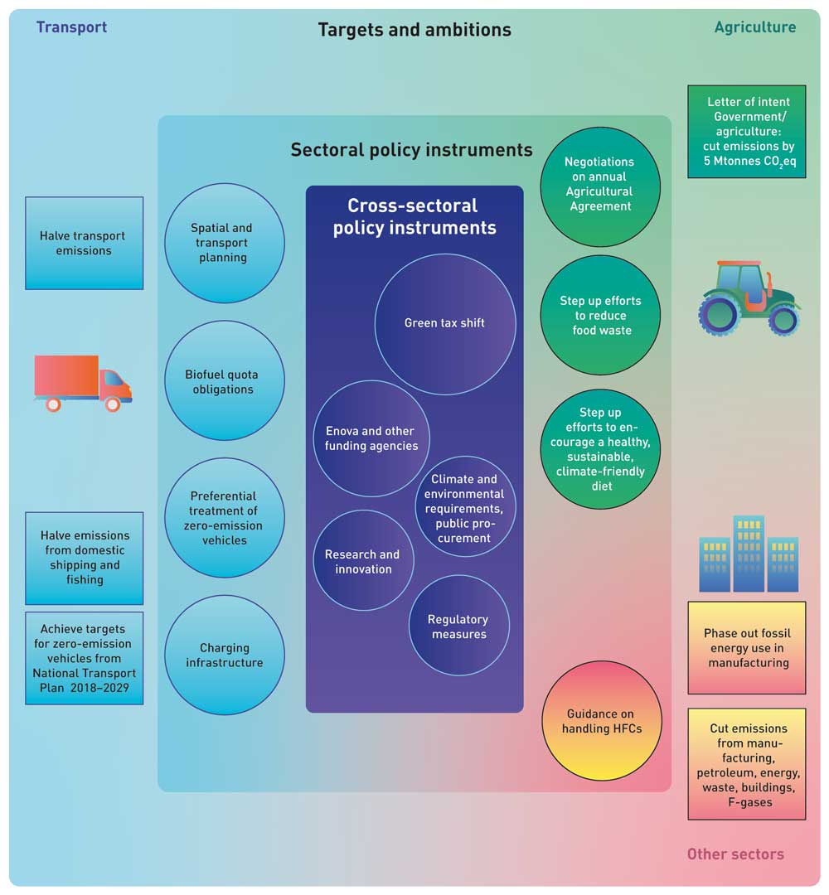
          - The main policy instruments for reducing non-ETS emissions in the climate action plan. Achieving the targets for zero-emission vehicles set out in the National Transport Plan 2018–2029 will require advances in technological maturity in various segments of the transport sector.

The most important elements of Norway’s current climate policy
There was much to build on in preparing this climate action plan. A number of important climate policy instruments are already in place. Norway was one of the first countries in the world to introduce a carbon tax, in 1991. Under the EEA Agreement, Norwegian companies have been included in the EU Emissions Trading System since 2008.
Today, climate-related taxes combined with emissions trading are proving effective in cutting greenhouse gas emissions across sectors. These two policy instruments apply to more than 80 % of greenhouse gas emissions in Norway. In addition, the design of vehicle taxes gives people incentives to buy zero-emission vehicles.
Funding provided through the Research Council of Norway is supporting research and the generation of new skills and innovation in both academia and business and industry. Funding through Enova supports the development of new technologies and their early market introduction. Innovation Norway contributes to sustainable growth and exports. The Klimasats grant scheme funds important climate initiatives at municipal and county level, and Nysnø Climate Investments provides capital that can be invested in new, climate-friendly technology.
Since its establishment in 2001, Enova has supported the implementation of more than 7 000 energy and climate projects. In 2021, Enova has been allocated NOK 3.3 billion to support solutions for the future. This is an increase of NOK 1.6 billion since 2013. The Klimasats grant scheme has so far funded 1300 different projects in all parts of the country.
In Norway’s largest urban areas, integrated urban land-use and transport agreements are being used to facilitate close cooperation between central and local government on coordinated spatial and transport planning, major investments in public transport and to provide better solutions that will encourage people to cycle and walk. As part of the implementation of the current National Transport Plan, Norway’s annual budgets have in recent years included larger allocations to the railways than ever before.
The Pollution Control Act is used to set various minimum requirements that enterprises must meet, and municipalities and counties are expected to give high priority to efforts to reduce greenhouse gas emissions in their planning activities.
The Government will build further on these policy instruments, and also plans to introduce new instruments.
There will be considerable uncertainty relating to emission trends, the effects of climate policy, technological developments and the costs of implementing mitigation measures well into the period 2021–2030. In addition, Norway may have to meet stricter requirements under EU climate legislation as rules are tightened to meet the enhanced 2030 target the EU has adopted. The climate action plan presented here is therefore both ambitious and flexible.

Reducing Norwegian emissions without causing a rise in global emissions
Although Norway, like other countries, has taken on obligations to cut its own emissions, it is important to ensure that the policy instruments introduced to do this are also rational in a global context. Norway’s agreement with the EU helps to avoid a situation where emissions elsewhere in Europe rise as a result of Norwegian climate policy.
The world will not benefit if Norway pursues a policy that results in carbon leakage, in other words if Norway reduces emissions in a way that directly or indirectly causes emissions to rise in other countries. This would not be sustainable, and would make it more difficult for other countries to succeed in their green transition.
The key sectors discussed in this white paper, such as transport and agriculture, are largely shielded from the risk of carbon leakage. However, many companies in aviation, shipping and long-distance road transport can choose the countries where it is cheapest for fuelling. Moving operations out of Norway is primarily an option for manufacturing companies if their competitive position is weakened by the climate policy instruments Norway uses. In addition, many goods and services that are produced and consumed in Norway could potentially meet competition from stakeholders abroad. The proposals for policy instruments presented in this white paper take this into account.
There is considered to be little risk that the proposed policy instruments targeting manufacturing industries will result in companies moving their operations out of Norway. The parts of the manufacturing sector that generate non-ETS emissions are largely shielded from international competition, although certain branches are exposed. The risk of carbon leakage is largely associated with imports of goods and intermediate inputs that have a large climate footprint in countries outside the EU. In such cases, consumption in Norway may increase emissions in other parts of the world.
In this white paper, the Government proposes only limited use of conventional biofuels, since their use may increase deforestation in production countries and in the worst case cause a rise in global emissions. The risk of carbon leakage is also the reason why the white paper proposes that dietary changes and reduction of food waste should be the first stages in restructuring production in the agricultural sector, so that the end result is not a rise in imports. At the same time, the agricultural sector must start to prepare now for consumption patterns to change in the near future in line with health and climate policy targets.

The most important changes for non-ETS emissions
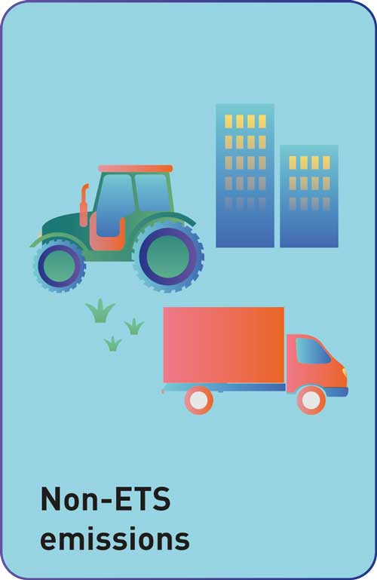

In this white paper, the Government is announcing new policy proposals in several important areas to accelerate cuts in non-ETS greenhouse gas emissions, in other words emissions that are not covered by the EU Emissions Trading System. These proposals apply to emissions from transport, agriculture and certain other sources. The most important changes are outlined below.
In the Government’s view, the policy instruments proposed in this white paper will be sufficient to reduce non-ETS emissions by 45 % by 2030 and thus achieve the Government’s target. This will also meet the emission reduction commitment for non-ETS emissions that Norway has agreed with the EU, which entails a cut of 40 %. However, the level of uncertainty is high, and the actual emission reductions may be either lower or higher than estimated.
Green tax shift
The Government intends to raise taxes on greenhouse gas emissions and offset this by reducing other taxes for groups that are affected by greenhouse gas taxation. This will give stronger financial incentives to choose climate-friendly solutions. The carbon tax, which at present is about NOK 590 per tonne CO2eq, will be increased to about NOK 2 000 per tonne CO2eq up to 2030. The Government considers that this will be sufficient to ensure that Norway meets the commitment in its agreement with the EU to reduce emissions by 40 % by 2030.
CO2 emissions from road traffic must be further reduced, and the Government is therefore maintaining the targets for the introduction of zero-emission vehicles, expressed as shares of new vehicles sold, as set out in the National Transport Plan 2018–2029. It is therefore important to ensure that vehicle taxes and other policy instruments continue to provide incentives to reduce CO2 emissions and to phase in zero-emission vehicles.
Phasing in low- and zero-emission technology
Where technological developments make it possible, the Government will introduce requirements to use low- and zero-emission technology. From 2020, the Government intends to introduce requirements to ensure the use of zero-emission solutions in public procurement processes for passenger cars and small vans. From 2025, similar requirements will be introduced for procurement processes for local buses. The design of requirements for local buses will be considered to find ways of including buses running on biogas. These requirements will be important for achieving the targets for zero-emission vehicles, expressed as shares of new vehicles sold, as set out in the National Transport Plan 2018–2029. This white paper also announces the Government’s intention to introduce criteria concerning zero- and low-emission solutions, where feasible, for new procurement processes for ferry services and later for all procurement processes for high-speed passenger vessel services. Requirements for zero- and low-emission solutions for aquaculture service vessels will according to plan be brought in gradually from 2024 onwards.
The Government will work towards gradual phase-out of the use of fossil fuels for energy purposes in industrial installations that are outside the scope of the EU ETS by 2030, and of the use of fossil gas for heating and drying buildings during construction by 2025. An important means of achieving this will be the gradual increase in the carbon tax rate. If necessary, the Government will consider introducing further policy instruments, including a prohibition on the use of fossil fuels for these purposes.
Greater use of climate-related requirements in public procurement
The Government will include climate-related requirements in more public procurement processes, for example for construction projects in the transport sector. The Government also intends to facilitate a transition to fossil-free construction sites in the transport sector by 2025. Furthermore, the Government will promote the inclusion of environmental and climate-related requirements in public procurement processes for food and meal services.
A clearer climate profile for Enova
The Government has given Enova a clearer climate profile for the next four-year period, so that its purpose is to contribute to Norway’s emission reduction commitment and contribute to Norway’s transition to a low-emission society. Enova will contribute to the development of technologies necessary towards 2030 and the low emission society in 2050.
More use of sustainable biofuels
The Government is seeking to replace fossil fuels with sustainable biofuels in road transport, offroad diesel, aviation and shipping. The biofuel quota obligation for road traffic is to be increased in the period up to 2030, so that the current volume of biofuel is maintained as further electrification and other changes result in declining sales of liquid biofuels. In addition, the Government plans to introduce biofuel quota obligations for offroad diesel and fuel for shipping from 2022. The proportion of biofuel required in offroad diesel will gradually be increased so that the biofuel quota obligation is the same as for road traffic. In the Government’s view, the same biofuel quota obligation should apply to road traffic and offroad diesel, and it will consider whether this can apply to shipping as well. The Government will consider the proportion of biofuels required by the biofuel quota obligations every two years, and make adjustments if appropriate. This will be done for the first time in 2022. The Government will gain experience of application of the new advanced biofuel quota obligation for aviation before considering whether to increase the proportion of advanced biofuel required.
Cutting emissions from agriculture
The Government will use the letter of intent it has signed with the agricultural organisations as a basis for climate-related work in this sector in the years ahead. In the letter of intent, the parties have undertaken to reduce emissions and enhance carbon uptake by a total of 5 million tonnes CO2eq in the ten-year period 2021–2030.
The specific measures and policy instruments that will be used to achieve this will be considered in the negotiations on the annual Agricultural Agreements. Climate-related measures in agriculture must not result in a rise in the level of subsidies. Moreover, the letter of intent signed by the Government and the agricultural organisations must not put constraints on the policy instruments the Government can use. The mitigation effect of the annual Agricultural Agreement will be set out in the budget proposals for each year’s agreement. The Government’s efforts to promote a healthy, sustainable and climate-friendly diet will be strengthened and further developed, as will efforts to reduce food waste.
Cutting other emissions
The Government will take steps to reduce emissions from the use of fluorinated gases in products.
The Government is launching the Longship project for the capture, transport and storage of CO2. This will facilitate future projects that can reduce non-ETS emissions, for example from waste incineration. One example is the planned carbon capture project at Fortum Oslo Varme’s waste incineration plant. The Government intends to co-fund this project provided that the company provides sufficient funding of its own and obtains funding from the EU or other sources.

The most important changes for the land-use, land-use change and forestry sector

The land-use, land-use change and forestry (LULUCF) sector accounts for a large volume of CO2 removals and provides raw materials and renewable energy that can replace products that result in higher emissions in other sectors. The Government is therefore proposing a number of measures to enhance CO2 removals in forest and to maintain the carbon stock in soils in forest, agricultural areas and other green spaces. These measures will play an important part in achieving Norway’s 2030 climate targets, and will be even more important for achieving the long-term climate target.
Enhancing CO2 removals in forests
The aim is to enhance CO2 removals in Norway’s forests. The Government will therefore consider ways of strengthening existing mitigation measures for forest, introduce statutory requirements relating to a minimum age for tree felling and facilitate afforestation of new areas on the basis of clear environmental criteria. This white paper also gives an account of new mitigation measures in managed forest land that offer a high potential for enhancing CO2 removals and are easy to implement. Measures to which this applies specifically include improving practices for tending young-growth stands, treatment of stumps to control conifer root rot, and choosing suitable tree species for restocking after felling.
Cutting emissions from the development of green (carbon-rich) areas
The Government will seek to reduce the development of forests, peatlands and agricultural areas for other purposes. Municipalities, counties and central government agencies will receive sound guidance and good tools so that they can take carbon-rich areas into consideration in spatial planning. The Government will emphasise that spatial planning processes should be used to promote the development of compact towns and urban areas, and that the potential for densification and transformation should be used before new areas are developed.
Cutting emissions from other forms of land use
The Government will promote a shift from peat-based to peat-free products, and consider the introduction of a tax on greenhouse gas emissions from peat extraction and a ban on opening new sites for peat extraction. The Government will continue the restoration of peatlands and other wetlands.

The most important changes for ETS emissions and Norway’s transition to a more climate-friendly society
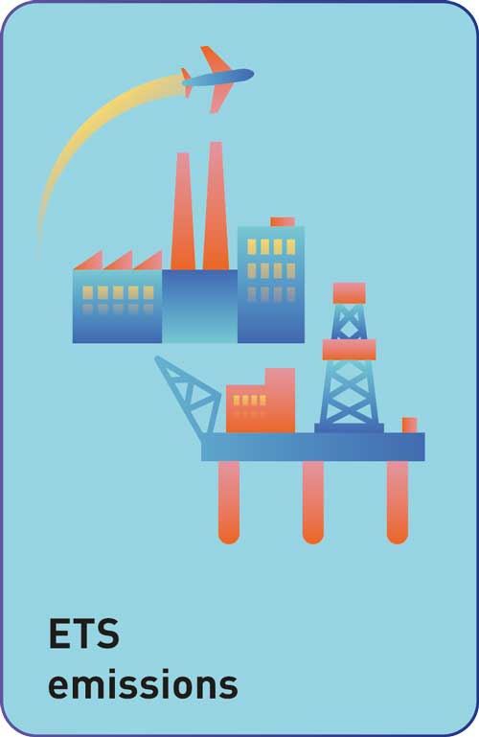

The price of emission allowances is the main instrument for reducing ETS emissions. To speed up emission reductions in petroleum, industrial production and aviation, the Government will intensify work on the green transition, developing new technology and ensuring that Norway’s industrial sector is competitive in the future.
Higher, more predictable carbon price for the petroleum industry
The Government intends to raise the carbon tax in line with the rise for non-ETS emissions and consider the tax rate in conjunction with the price of emission allowances in the EU ETS, so that the total carbon price reaches NOK 2 000 per tonne CO2eq in 2030, measured in fixed 2020 NOK. This will give stronger financial incentives to cut emissions, and make it easier for industries to plan emission reductions.
Strengthened Enova as a climate measure for innovation
The Government has given Enova a clearer climate profile for the next four-year period. The transition to a low emission society and innovation that contributes to this, are important goals. This is particularly relevant in the case of ETS emissions, since public funding for research and development is an important supplement to the emissions trading system.
Promoting carbon capture and storage (CCS)
The Government will implement the Longship project for the capture, transport and storage of CO2. The aim of the project is to develop CCS as an effective mitigation tool and to contribute to technology development internationally.
Developing the Green Platform initiative
The Government intends to build further on the Green Platform initiative, which involves cooperation between the Research Council of Norway, Innovation Norway, SIVA (the Industrial Development Corporation of Norway) and Enova. The initiative was established as part of a green restructuring package to promote innovation and development despite the economic impacts of the COVID-19 pandemic.
Stepping up green research and innovation
The Government will maintain its focus on research and innovation, both in Norway and through Norway’s participation in the EU funding programme for research and development, Horizon Europe.
Improving reporting of climate-related and environmental information
The Government will follow legislative developments in the EU closely as it seeks to improve reporting of climate-related and environmental information, and consider whether amendments to the Accounting Act are needed so that investors and other stakeholders can receive relevant, comparable climate-related and environmental information. The Government will engage in dialogue with the business sector on how to facilitate better and more relevant corporate reporting of climate-related and environmental information.
Expert committee
The Government will appoint an expert committee to review the overall framework for promoting climate-friendly investment in Norway. The Government will tailor the committee’s mandate to fit with other related processes and committees and avoid unnecessary overlap with other work in the same field.
Climate and environmental aims for public buildings
The Government has formulated aims for public buildings and property in the civilian sector. These will apply to the central government administration in its roles as developer, manager and tenant of property. The central government will seek to make full use of existing buildings, ensure re-use of buildings, re-use materials and choose environmentally friendly materials. The central government will also establish a common methodology for measuring the overall climate and environmental impact of public buildings, and will attach importance to the environmental benefits of re-using already developed areas and existing buildings, and of siting its premises in line with central government planning guidelines.

Other policy instruments the Government will consider
The Government will also consider the introduction of a number of other policy instruments to reduce greenhouse gas emissions.
Zero- and low-emission zones
- At present, municipalities can establish low-emission zones in order to improve local air quality under section 13 of the Road Traffic Act and the regulations relating to low-emission zones for motor vehicles, which were adopted on 20 December 2016. The regulations do not currently provide the legal authority to establish such zones purely on climate-related grounds. The Government will consider how the conditions for establishing low-emission zones can be amended to include climate considerations.
- A number of municipalities have called for the authority to establish zero-emission zones. To enable the municipalities to play a leading role in developments, and as a way of speeding up the transition to zero-emission technology for both commercial and passenger transport, the Government will consider the use of the legal authority provided by section 7 of the Road Traffic Act to establish zero-emission zones on climate-related grounds. This will initially be in the form of a pilot project in a few cities. Zero-emission zones must not include trunk roads/national roads.
Emissions from the construction industry
- The Government will consider the introduction of a general requirement for construction sites in the transport sector to be fossil-free. Central government agencies will start pilot projects and consider policy instruments that can improve the efficiency of transport of bulk materials.
National transport plan
- Use the National Transport Plan 2022–2033 to support the ambition of reducing transport emissions by 50 %.
Requirements relating to conversion of forest land to pasture
- The Government will consider requirements and procedures for the conversion of forest land to pasture to ensure that conversion does not involve evasion of regeneration obligations under the forestry legislation.
Tax on mineral fertiliser
- The Government will review the effects and impacts of introducing a tax on mineral fertiliser, and how it could be introduced. The purpose of this would be to reduce nitrous oxide emissions.
Other taxes and policy instruments
- The Government will consider a gradual increase in the tax on waste incineration to the standard carbon tax rate. Policy instruments will be reviewed to reduce the use and emissions of sulphur hexafluoride (SF6), a fluorinated gas that among other things is used in the power supply sector. Furthermore, the Government will review the introduction of a tax on methane emissions from onshore facilities in the petroleum sector, corresponding to the tax that already applies to offshore activities.

Climate action by Norway in a changing world

Introduction to the problem of climate change
The world population has risen from one billion in 1800 to almost eight billion today. Living standards have improved, and fewer and fewer people are living in extreme poverty. However, the development and alteration of natural ecosystems, greenhouse gas emissions and air and water pollution have been putting increasing pressure on the environment worldwide.
We are already witnessing the effects of climate change in Norway. Precipitation is rising and the duration of snow cover is decreasing. Glaciers are shrinking, patterns of flooding are changing and sea level is rising. In many places, the growing season is lengthening and winter is becoming shorter. Observations from monitoring stations in all parts of Norway show that the average temperature has risen by one degree Celsius since 1900, and by half a degree in the past 15 years alone. Dramatic changes are taking place in Svalbard and the rest of the Arctic – in fact, no other region of is warming more rapidly than the Arctic. Since 1971, the average winter temperature in Svalbard has risen by 7 degrees Celsius.

Photo: Geir Wing Gabrielsen/Norwegian Polar Institute
              - The Intergovernmental Panel on Climate Change
The Intergovernmental Panel on Climate Change (IPCC) was established in 1988 by the World Meteorological Organization (WMO) and the UN Environment Programme (UNEP). The IPCC is a scientific body, and its most important task is to provide regular assessments and summaries of current scientific knowledge of the climate system and climate change. The IPCC does not itself carry out research. Its reports are the most important scientific basis for the international climate negotiations under the United Nations Framework Convention on Climate Change (UNFCCC).
[Boks slutt]
Addressing climate and environmental challenges is one of the most important tasks facing us today. Higher temperatures, more frequent and more intense weather extremes, and ecosystem degradation are jeopardising human survival and pose a threat to health, welfare and economic growth in the future. Climate change may also create and intensify conflict in different parts of the world through factors such as drought, flooding and extreme weather, and through shortages of water, food, soil, space and other resources. Norway and other parts of the world may face new security challenges as a result. Moreover, climate change in the Arctic, and the loss of ice cover, may result in growing interest in the potential of natural resources and in changes in sailing patterns and military presence in the region.
              - Climate change
According to WMO, the atmospheric concentration of CO2 has risen from about 280 ppm (parts per million) in pre-industrial times to about 414 ppm today. It is around 3–4 million years since CO2 levels last exceeded 400 ppm. About 40 % of anthropogenic CO2 emissions in the period 1750–2011 are still present in the atmosphere. The oceans have absorbed around 30 %, causing ocean acidification. The remaining 30 % of these emissions has been removed from the atmosphere and is stored in terrestrial ecosystems (source: IPCC AR5, Climate Change 2014 Synthesis Report SPM 1.2). The years 2015 to 2018 have been confirmed as the four warmest years on record. 2017 is still the warmest year on record (global average temperature about 1.1 oC above pre-industrial levels). According to WMO, the global average surface temperature in 2018 was approximately 1.0 °C above the pre-industrial era. Most of the increase has taken place since the mid-1970s. The current rate of emissions means that the temperature is rising by 0.2 oC every ten years.
[Boks slutt]
According to the IPCC, see Box 2.1, anthropogenic greenhouse gas emissions are the dominant cause of the observed global warming. Sources of these emissions include the combustion of coal, oil and gas, industrial processes and cement production, and forest degradation and deforestation.
Major wildfires in California and Australia, rain in winter in Svalbard and the severe drought in Northern Europe in summer 2018 are dramatic examples of the impacts of climate change. Both in Norway and in the rest of the world, we will have to adapt to the climate change that has already taken place and that we know will continue. At the same time, emissions must be cut drastically to avoid further irreversible impacts of climate change.
Nature and climate are closely interconnected. The way people use nature influences the climate, and at the same time climate change influences nature. We humans have never influenced nature as strongly as we are doing now, and climate change is intensifying environmental pressures. The combination of climate change and loss of biodiversity is jeopardising our ability to provide food for a growing global population. The same drivers are to a large extent behind both climate change and environmental degradation. Coordination of climate and biodiversity policies is therefore vital.
              - Limiting global warming to 1.5°C
In 2018, the IPCC published the Special Report Global Warming of 1.5°C. The report shows that limiting global warming to 1.5°C would give considerable benefits compared to warming of 2°C. For example, there would be a lower frequency and intensity of weather extremes in areas where most people live, and up to 10 million fewer people would be exposed to the risks of sea level rise. There would be smaller net reductions in yields of wheat, maize and rice. The proportion of the world’s population exposed to water stress would be reduced by up to 50 %, and the number of people exposed to climate-related risks and susceptible to poverty would be reduced by up to several hundred million. In addition, there would be a lower risk of reaching critical tipping points, where crossing a threshold may result in irreversible change. For example, marine ice sheet instability in Antarctica and/or irreversible loss of the Greenland ice sheet could be triggered at around 1.5°C to 2°C of global warming.
[Boks slutt]
The Paris Agreement is a framework for climate action by the whole world. Climate change is a global problem, because emissions have the same impact on the climate irrespective of where they originate. Climate change will affect everyone. The problem can only be dealt with through global action to reduce and eventually eliminate greenhouse gas emissions. The UN Framework Convention on Climate Change entered into force in 1994, and its ultimate objective is ‘the stabilisation of greenhouse gas concentrations in the atmosphere at a level that would prevent dangerous anthropogenic interference with the climate system.’ In 2015, the parties to the Convention adopted the Paris Agreement, under which almost every country in the world has agreed to the long-term temperature target of holding the increase in the global average temperature to well below 2°C above pre-industrial levels and pursuing efforts to limit the temperature increase to 1.5°C above pre-industrial levels. The parties have also agreed on the common aim of reaching global peaking of greenhouse gas emissions as soon as possible and undertaking rapid reductions thereafter, so as to achieve a balance between anthropogenic emissions by sources and removals by sinks of greenhouse gases in the second half of this century.
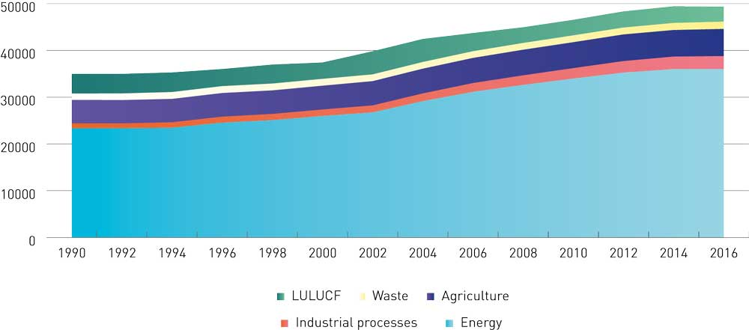
          - Global emissions in million tonnes CO2eq from the energy sector (including electricity/heat production, transport, construction), industrial processes (including cement production, F-gases), agriculture (including enteric fermentation, rice production), waste (including landfill, wastewater treatment) and the LULUCF sector. Figures for the period 1990–2016.
CAIT
Under the Paris Agreement, each country has an obligation to communicate a nationally determined contribution (NDC) to the overall response to climate change every five years. Each country determines what its own contribution is to be, and each successive NDC is to represent a progression from the previous five-year period and reflect the country’s highest possible ambition. In setting their NDCs, countries are required to consider the results of five-yearly global stocktakes assessing collective progress towards the long-term temperature target and the common aim for emissions set out in the Agreement. This system is intended to ensure that the world over time achieves the long-term temperature target of the Paris Agreement.
The Paris Agreement also aims to increase countries’ ability to adapt to the adverse impacts of climate change, and to make finance flows consistent with a pathway towards low greenhouse gas emissions and climate-resilient development.
There is no time to lose. To limit global warming to 1.5°C, global CO2 emissions must be reduced by 40–50 % by 2030. To achieve the targets of the Paris Agreement, several of the countries that are major emitters will have to enhance their national targets under the Agreement.
Emissions of short-lived climate forcers must also be reduced. These include gases and particulates, especially methane and HFCs in addition to black carbon (soot). They have a shorter atmospheric lifetime than CO2, but have a substantial warming effect in the short term. Early cuts in emissions of short-lived climate forcers will therefore help to limit the temperature rise. Permanent cuts in these emissions will reduce the need to achieve negative emissions at a later stage. However, such reductions must be achieved in addition to, not instead of, reductions in emissions of long-lived greenhouse gases such as CO2. Many mitigation measures that will reduce emissions of short-lived climate forcers also have other beneficial effects, for example on air pollution and public health. The Norwegian Environment Agency has published a mitigation analysis for Norway 2021–2030 and a separate report on the short-term climate impacts of the same measures, together with their health and environmental co-benefits.
By 2050, the world must be carbon neutral. This means that emissions have been minimised, and that action has been taken to compensate for the remaining emissions that cannot be eliminated by enhancing removals of CO2, for example in forest and in soils in agricultural ecosystems, or through technical solutions such as carbon capture and storage. Measures to remove CO2 from the atmosphere will be essential since it is not realistic to eliminate all emissions, for example emissions from food production.

Norway’s contribution to global climate action
The challenges posed by climate change can only be dealt with through global cooperation between countries. Norway is a driving force in international climate action. The legal framework for this work is provided by the Climate Change Convention and the Paris Agreement. The Paris Agreement sets out a long-term temperature target that has gained global support. So far, the nationally determined contributions (NDCs) that countries have communicated under the Paris Agreement are far from enough to give an emission trajectory in line with its long-term temperature target. Countries were requested to submit new or updated NDCs under the Paris Agreement in the course of 2020. Norway responded promptly, and submitted a substantially enhanced target on 7 February 2020.
Norway’s International Climate and Forest Initiative is Norway’s largest contribution to international climate action. It will not be possible to achieve either the targets of the Paris Agreement or the UN Sustainable Development Goals (SDGs) unless losses of the world’s rainforests are reduced and reversed. These forests help to maintain a stable climate, support high biodiversity, and provide livelihoods for millions of people who live in and near rainforests. The Climate and Forest Initiative will continue to pursue its strategy of supporting forest countries in their efforts to manage rainforests sustainably and reducing market pressures on rainforests by reducing demand for raw materials that drives deforestation.
Norwegian climate finance for developing countries will be designed to assist developing countries to achieve their targets under the Paris Agreement. In addition to the Climate and Forest Initiative, priority areas of Norwegian climate funding are renewable energy and climate change adaptation and climate-related disaster risk reduction. Norway also assists other countries to achieve their climate targets through active climate diplomacy and by supporting the efforts of developing countries to achieve a low-emission development pathway and adapt to climate change. The Green Climate Fund is the key channel for climate finance under the Paris Agreement. The Norwegian Government will contribute a total of NOK 3.2 billion to the fund over the period 2020–2023, and Norway also has a seat on the board.
Norway is working actively to ensure sound rules for market-based cooperation under the Paris Agreement. This type of cooperation on emission reductions can encourage countries to take a more ambitious approach to climate action. Through its involvement in initiatives including the Transformative Carbon Asset Facility (TCAF) and a bilateral programme organised through the Global Green Growth Institute, Norway is taking part in the development of pilot projects to test new forms of market cooperation within the framework of the Paris Agreement. The purpose of such forms of cooperation is to promote permanent change in developing countries through programmes that support the development of low-emission solutions for specific sectors in a country.
Norway is also promoting a shift to more sustainable public and private investments, in line with the aim of the Paris Agreement to make finance flows consistent with a pathway towards low greenhouse gas emissions and climate-resilient development. In addition, Norway seeks to ensure that trade and investment agreements promote green growth and take climate change and environmental considerations into account. Norway is involved in the development of international carbon markets, carbon pricing, in phasing out subsidies on fossil fuels, and in action to reduce international transport emissions and emissions of short-lived climate pollutants. Furthermore, Norway is engaged in bilateral environmental cooperation with China, India and South Africa, and is supporting international initiatives to promote a transition to a green economy in developing countries.

Norwegian greenhouse gas emissions and removals
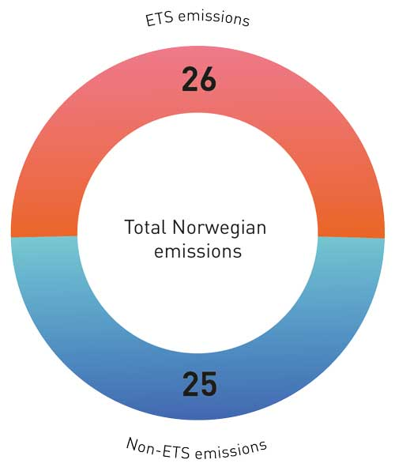
          - The split between ETS and non-ETS emissions in Norway (in million tonnes CO2eq)
Statistics Norway and Norwegian Environment Agency
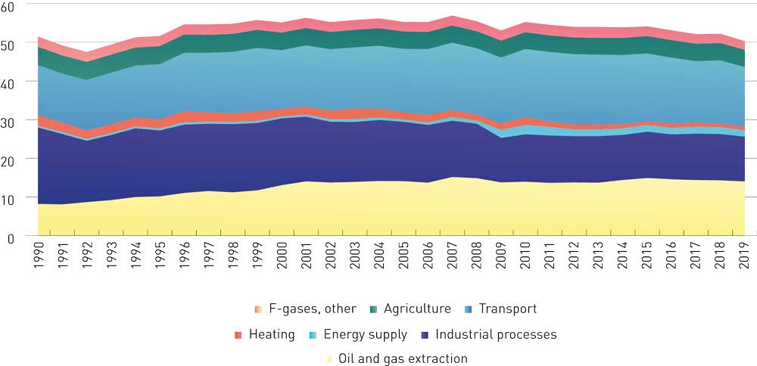
          - Norwegian emissions split by source, 1990–2019 (in million tonnes CO2eq)
Statistics Norway
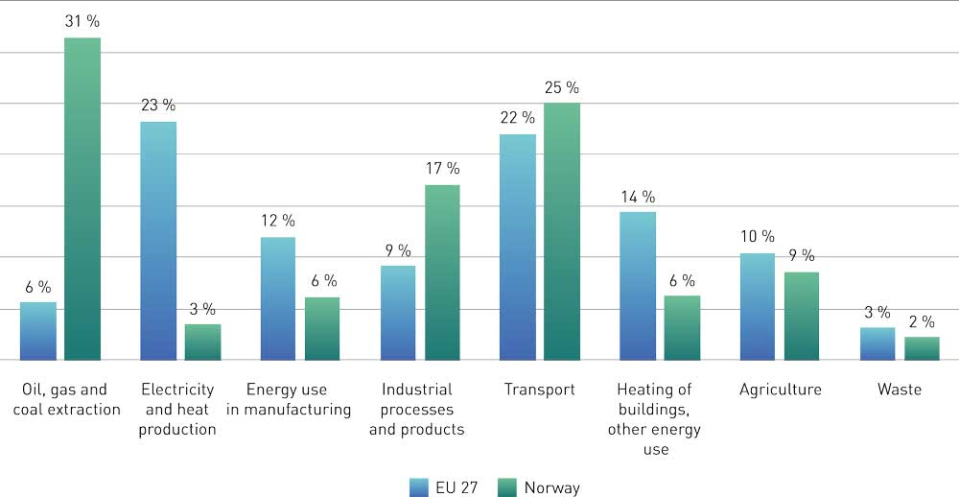
          - Emissions split by sector in the EU and Norway, as percentages of total emissions (2018).
European Environment Agency, EEA greenhouse gas data viewer
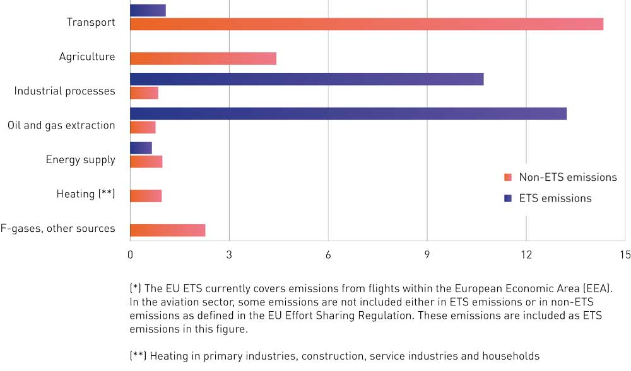
          - Norwegian emissions (million tonnes CO2eq) split between the ETS and non-ETS sectors (2019).
Statistics Norway and Norwegian Environment Agency
Norway’s greenhouse gas emissions are declining. In 2019, its aggregated greenhouse gas emissions were 50.3 million tonnes CO2eq, This is the lowest level since 1993, 12 % below the peak in 2007, and a reduction of 1.2 million tonnes since 1990. At the same time, GDP nearly doubled from 1990 to 2019. Emissions from oil and gas extraction totalled 14 million tonnes CO2eq in 2019. Emissions from this sector have risen by 71 % since 1990, but have been reduced somewhat from the peak in 2007. Emissions from industrial processes were 42 % lower than in 1990, and this is the main reason for the drop in overall emissions. Emissions from road traffic rose by almost 37 % from 1990 to 2015. Since 2015, these emissions have been reduced by about 16 %, while at the same time the population has grown sharply. In addition, there are emissions and removals in forest and other land categories. In 2018, there were net removals of 23.7 million tonnes CO2 in the land use, land use change and forestry (LULUCF) sector in Norway, calculated according to the accounting rules of the Climate Change Convention. There are some differences between these accounting rules and those for LULUCF emissions and removals under EU legislation. Among other things, the EU rules limit the share of net removals in managed forest land that can be included towards compliance with the ‘no debit’ rule. See Chapter 4 for more details.
The largest sources of greenhouse gas emissions in Norway are oil and gas extraction and road traffic and other transport, as shown in Figure 2.4. Other transport includes emissions from aviation, shipping and mobile motorised equipment.
Norway’s oil and gas production is high compared with the EU average, and emissions from the sector are therefore also high. On the other hand, Norway has abundant supplies of renewable energy, so that emissions from electricity generation are low. The share of emissions from industrial processes is relatively high, but emissions from energy use in manufacturing are lower than the EU average. A large proportion of the energy used to heat buildings in Norway is electricity. Emissions from heating buildings therefore make up a smaller share of overall emissions than they do in the EU, where fossil fuels are currently more widely used. In the period up to 2030, most EU countries will continue to make considerable reductions in emissions from buildings, whereas Norway will not be able to do as much in this sector. Figure 2.5 shows the shares of emissions from various sectors in Norway and the EU averages for the same sectors.
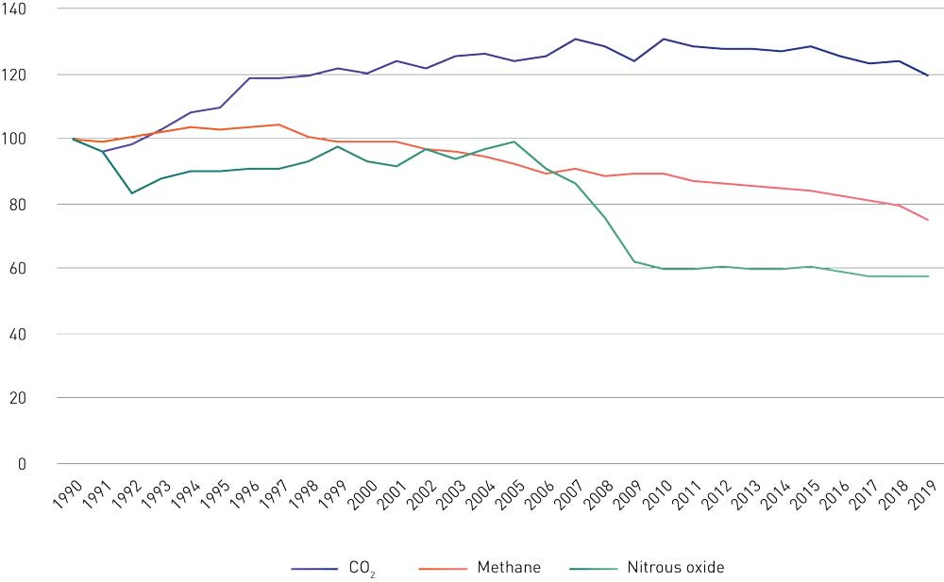
          - Emissions of methane, nitrous oxide and CO2 in Norway from 1990 to 2019, using 1990 as the base year (index 1990 = 100).
Statistics Norway
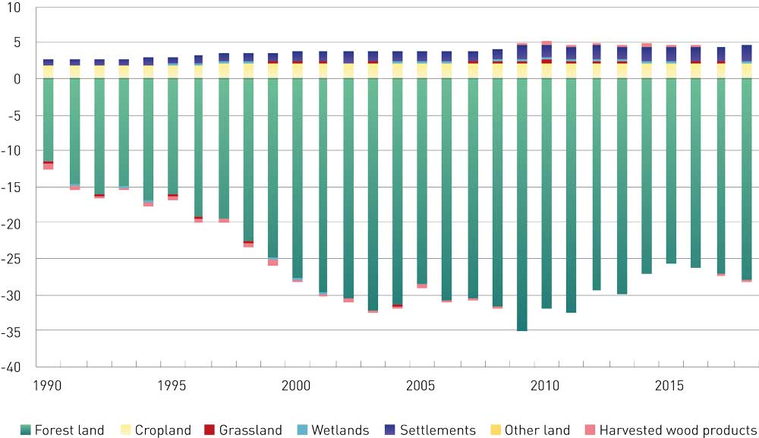
          - Net emissions and removals for the LULUCF sector in Norway, 1990–2018, as reported to the UNFCCC. (Greenhouse Gas Emissions 1990-2018, National Inventory Report). Negative figures (-) indicate net removals and positive figures (+) net emissions. Figures in million tonnes CO2e.
Norwegian Environment Agency
Figure 2.6 shows the split between ETS and non-ETS emissions for different sectors in Norway. Emissions in the ETS sector account for about half of Norway’s total emissions. In 2019, 24.6 million tonnes CO2eq of the total were non-ETS emissions. ETS emissions originate largely from industrial processes and oil and gas extraction. In addition, some emissions from the energy supply and aviation sectors are included in the ETS sector. The largest sources of non-ETS emissions are road traffic, other transport and agriculture. There are also non-ETS emissions of F-gases and from the petroleum industry, manufacturing and other sources such as buildings.
              - Norway’s emission inventory and other methods of calculating emissions
Norway reports figures for its emissions and removals of greenhouse gases to the UN every year. The emission inventory is based on IPCC methodology, and the annual reports are reviewed by expert review teams appointed by the UN. The emission figures presented in this white paper are from Norway’s official national emission inventory.
The UN methodology requires emissions to be reported by the country in which they occur. This avoids double counting. One exception from this rule is timber harvesting, which is accounted for as emissions in Norway regardless of whether or not the timber is exported. The national emission inventory is geographically restricted to Norway. This means that emissions associated with goods and services purchased for use in Norway are not included in the Norwegian figures. In Sweden, the authorities also publish statistics on emissions associated with imported products and goods to make it possible to monitor so the scale of these emissions can also be monitored. The Norwegian Environment Agency is to investigate methodologies for this type of emission inventory.
[Boks slutt]
Figure 2.7 shows Norway’s annual emissions of the three most important greenhouse gases, CO2, methane and nitrous oxide, from 1990 to 2019, using 1990 as the base year. CO2 emissions rose by 19 % from 1990 to 200S9, but have since declined somewhat. Nitrous oxide emissions have been reduced by about 42 % in the same period, and methane emissions by 25 %.
Figure 2.8 shows net emissions and removals for the LULUCF sector as calculated under UNFCCC rules. According to the accounting rules of the EU legislation, and given its obligation to comply with the ‘no debit’ rule for the LULUCF sector, Norway is likely to have to record accounted net emissions of about 18 million tonnes CO2eq over the ten-year period 2021–2030, if the compensation mechanism that is part of the EU accounting rules is included. Certain conditions have to be met to make use of the compensation mechanism. Without the compensation mechanism, Norway would probably have to record net emissions of about 27 million tonnes CO2eq. This is discussed further in Chapter 4.

Norway’s climate targets
Norway will become a low-emission society by 2050. Achieving this target will involve reductions in greenhouse gas emissions of the order of 90–95 % by 2050 from the level in the reference year 1990. The effect of Norway’s participation in the EU Emissions Trading System is to be taken into account in assessing progress towards this target.
This climate action plan for 2030 is intended not only to ensure that Norway achieves its 2030 targets, but also to ensure the necessary progress towards becoming a low-emission society by 2050. According to the Government’s long-term low-emission strategy, Norway and other countries will by 2050 have achieved low emissions in all sectors. This means that energy and resource efficiency are high and a circular economy underpins low-emission, sustainable production and consumption. The success of this transformation process will be vital to the competitive position of the Norwegian economy.
Norway will reduce emissions by at least 50 % and towards 55 % by 2030 compared to 1990. In February 2020, Norway was the third country in the world to submit an enhanced 2030 target to the UN as its commitment under the Paris Agreement. The Government wishes to achieve this target in cooperation with the EU. Through the agreement on climate action, Norway has already undertaken to cooperate with the EU to reduce emissions by at least 40 % by 2030 compared with the 1990 level.
Targets specifically for non-ETS emissions. Under the terms of the climate agreement with the EU, Norway is to cut emissions from transport, buildings, agriculture and waste (non-ETS emissions) by 40 % by 2030 compared with the 2005 level. This target can be achieved through national cuts in emissions and/or by using flexibility mechanisms. The Government plans to exceed this target, and aims to reduce emissions by 45 % through national cuts. If strictly necessary, it will be possible to make use of the flexibility mechanisms set out in the EU legislation.
Figure 2.9 illustrates Norway’s climate targets for 2030 and 2050.
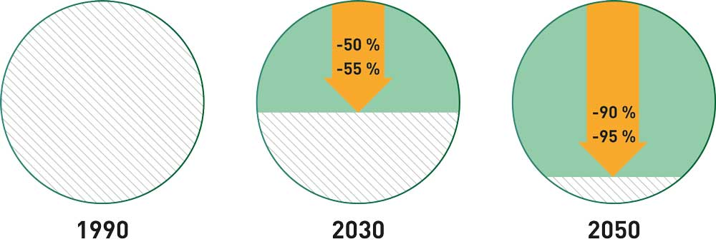
          - Norway’s climate targets for 2030 and 2050 (reductions relative to 1990)
Norway has set itself an additional target of being climate neutral by 2030, see Box 2.5 for more information.

Norway’s commitments under the climate agreement with the EU
The agreement with the EU on climate action provides a framework for Norwegian climate policy. Norway and Iceland entered into this agreement with the EU in October 2019. Under the agreement, Norway will take part in EU climate legislation from 2021 to 2030. The legislation is designed to achieve emission reductions of at least 40 % compared with the 1990 level. This is an overall target for all EU member states, Norway and Iceland and for all sectors. Since the EU, Norway and Iceland have separate NDCs under the Paris Agreement, each party reports separately on its emissions and progress towards its NDC. Figure 2.10 shows how Norway’s 2030 targets fit together. The EU’s climate policy has three main pillars.
              - Norway’s target of being climate neutral from 2030 onwards
In addition to becoming a low-emission society by 2050 and achieving its target under the Paris Agreement, Norway has set the target of being climate neutral by 2030. In connection with its consent to ratification of the Paris Agreement, the Storting (Norwegian parliament) asked the Government to work on the basis that Norway is to achieve climate neutrality from 2030. This means that from 1 January 2030, Norway must ensure that remaining Norwegian greenhouse gas emissions are offset by equivalent emission reductions in other countries. Climate neutrality can be achieved through the EU ETS, international cooperation on emission reductions, emissions trading and project-based cooperation. In its recommendation on this matter, the Standing Committee on Energy and the Environment stated that action to achieve the target of climate neutrality through emission reductions in other countries must meet standards that guarantee real and permanent emission reductions and environmental integrity.
The Government will report back with more information on a programme for purchasing emission reductions abroad once more knowledge has been obtained and targets for the post-2030 period have been clarified.
The Paris Agreement provides for cooperation between countries to implement their NDCs. The Government is working on the development of pilots for market cooperation under the Paris Agreement that can be used towards the target of climate neutrality. Cooperation of this kind will make it possible to cut emissions more rapidly and at lower cost, and will contribute to a green transition in other countries. This will in turn enable countries to set more ambitious targets. Rules for market cooperation under the Paris Agreement are expected to be adopted in November 2021 during the Glasgow climate summit.
[Boks slutt]
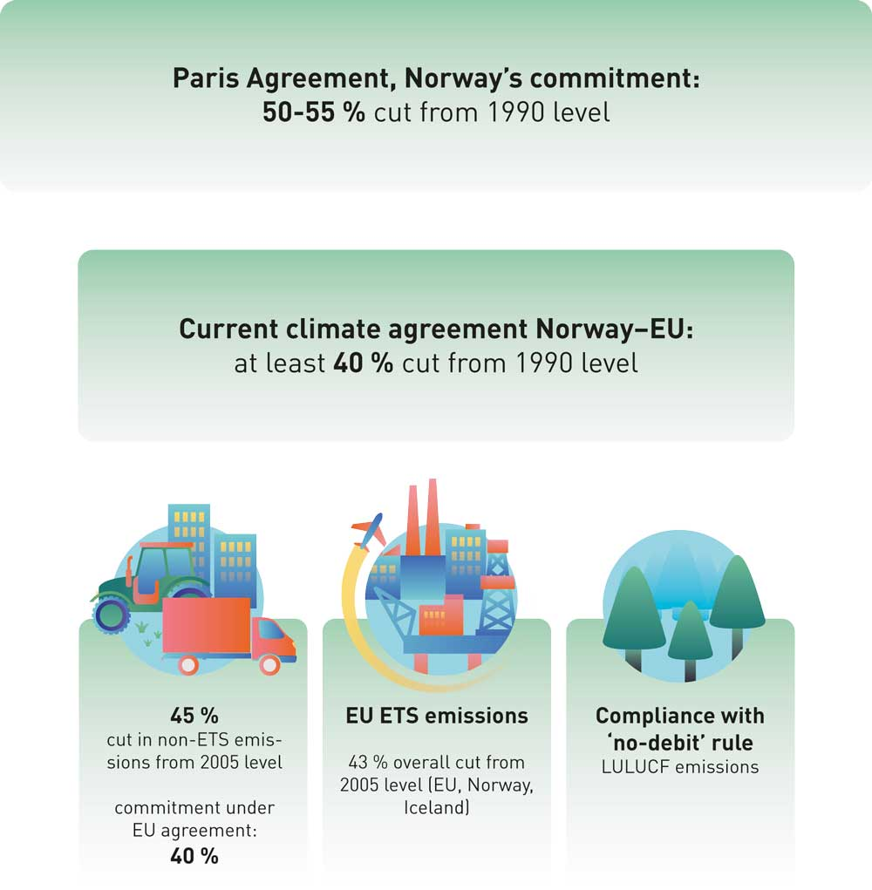
          - Norway’s system of climate targets for 2030
The first pillar of EU climate policy deals with non-ETS emissions. Norway’s target for non-ETS emissions under its agreement with the EU is a 40 % reduction by 2030 compared with the 2005 level. This will be translated into a binding emission budget with emission ceilings for each year in the period 2021–2030. The legislation allows for each country’s emission budget to be met through a combination of emission reductions within the country and transfers of emission units from other European countries.
The Government has set itself a more ambitious target than Norway’s obligation in the agreement with the EU: to cut non-ETS emissions by 45 % through domestic measures. Non-ETS emissions are dealt with in greater detail in Chapter 3.
The second pillar of EU climate policy deals with ETS emissions. The EU Emissions Trading System applies to the largest emission sources within Norwegian manufacturing industries and the petroleum industry. The cap, or number of emission allowances in the system, is being gradually reduced to achieve a reduction of 43 % in emissions in 2030 compared with 2005. This is an overall reduction for all installations covered by the EU ETS. Emissions from European aviation have been included in the EU ETS since 2012. ETS emissions are dealt with in greater detail in Chapter 5.
The third pillar of EU climate policy deals with the LULUCF sector. This includes anthropogenic emissions and removals of greenhouse gases from land use, land use change and forestry. The factors that particularly influence emissions and removals are the level of harvesting (relative to the reference level), land-use change such as deforestation and afforestation, and the natural spread of forest and scrub. The EU’s climate legislation includes accounting rules for emissions and removals in the LULUCF sector. Norway has an obligation to ensure that overall greenhouse gas emissions from the LULUCF sector do not exceed removals (this is known as the ‘no debit’ rule). If Norway has net accounted emissions for the period 2021–2030 as a whole, this obligation must be fulfilled by making use of flexibility mechanisms. The LULUCF sector is dealt with in greater detail in Chapter 4.
The legislation provides for various forms of flexible implementation both within each of these policy pillars and between them. If a country reduces its emissions or enhances removals by more than it is required to do, the surplus can be traded. For example, emission units for non-ETS emissions can be transferred between the EU member states, Norway and Iceland. If there is an emissions gap in the LULUCF sector, countries can meet their commitments through further domestic cuts in non-ETS emissions, or by buying emission units from other countries that have a surplus in the non-ETS or LULUCF sectors. Norway and eight other countries can also use a limited number of emission allowances from the EU ETS to achieve their targets under the Effort Sharing Regulation, and thus indirectly in the LULUCF sector.
The EU legislation and Norway’s climate agreement with the EU are discussed further in Prop. 94 S (2018–2019) requesting the Storting’s consent to the agreement between Norway and the EU (in Norwegian only).

Cooperation with the EU on a more ambitious climate target
When Norway and the EU concluded their agreement, the target both parties had communicated to the UN was still a 40 % reduction in emissions by 2030 compared with the 1990 level. Norway will therefore take part in the climate legislation the EU has adopted to ensure that emissions are cut by 40 %, as discussed earlier in this chapter.
The Government has since submitted an enhanced NDC under the Paris Agreement, with a target of cutting emissions by at least 50 % and towards/up to 55 % by 2030 compared to 1990. The Government wishes to cooperate with the EU on achieving this target. In December 2020, the EU enhanced its own 2030 climate target. The new target is a net domestic reduction of at least 55% in greenhouse gas emissions by 2030 compared to 1990. This is formulated as a net target, which includes all CO2 removals by forest and other sinks. It is based on the European Commission’s proposal for a 55 % cut in emissions by 2030, see Box 2.6. Emissions and removals of CO2 in the LULUCF sector can be accounted for in various ways. The EU has not yet communicated the methodology it wishes to use.
The EU will be making necessary amendments to its the legislation to ensure that the new and enhanced 2030 climate target is achieved. The European Commission has announced that legislative proposals will be presented in June 2021. Once the legislation has been adopted by the EU, Norway will need to consider whether the updated legislation should also be made applicable in Norway, and if so on what conditions. The legislation will not apply in Norway until the Storting has given its consent. The Government will therefore have to wait until the EU’s legislative proposals have been presented and the EU has made its decisions before presenting its views on how Norway should achieve its enhanced target and whether this should be done in cooperation with the EU.
Until new EU rules for achieving the enhanced target are adopted, Norway will follow the current legislation and will plan its climate policy on this basis. This applies to the rules on the Emissions Trading System, the non-ETS emissions covered by the Effort Sharing Regulation, and the LULUCF sector. Regardless of the outcome, Norwegian emissions must be reduced, and removals in the LULUCF sector must be increased. In the case of non-ETS emissions, the Government is planning to exceed its commitment under the agreement with the EU.
              - The European Commission’s proposal for a more ambitious EU climate target
In September 2020, the European Commission proposed that the EU should raise its emission reduction target for 2030 from at least 40 % to at least 55 % compared to 1990 levels. The Commission viewed this target as a stepping stone to the 2050 climate neutrality goal. Climate neutrality requires a balance between emissions and removals of greenhouse gases. The new 2030 target proposed by the Commission is therefore a net target that takes into account a larger proportion of CO2 removals in the LULUCF sector. There are several different accounting methods that can be used, and it is still unclear how the EU intends to account for CO2 removals in the LULUCF sector. Together with its proposal to enhance the climate target, the Commission presented a communication on stepping up the EU’s 2030 climate ambition. The publication outlines different ways in which the EU could amend its climate legislation to achieve a more ambitious target, and provides important signals on the Commission’s views about how the enhanced target should be achieved. Possible changes include not only making the current legislation more stringent, but also changing the structure of the legislation, including expanding the EU ETS to include more sectors. The Commission has previously announced that it is looking into the possibility of expanding the EU ETS to include emissions from road transport and buildings. The Commission has also aired the possibility of moving non-CO2 emissions from agriculture, mainly methane and nitrous oxide, to what is now the land use sector. In this case, it might be possible to repeal the Effort Sharing Regulation as a whole. Decisions on changes of this kind need thorough consideration. It would take several years before they could be implemented.
According to the European Commission, achieving the enhanced 2030 target will require ambitious action to reduce emissions in all sectors of the EU economy and to limit the need to balance any remaining emissions with removals in the LULUCF sector and other forms of CO2 removal. The Commission’s analysis deals with EU-wide emissions and does not consider emissions at member state level.
In June 2021, the Commission will put forward proposals for amendments to the climate legislation to ensure that an enhanced climate target can be achieved. Norway is following the EU’s work closely and will continue to work actively to safeguard Norwegian interests. This also applies to the legislative developments the Commission is about to embark on.
The European Parliament and the Council will be involved in the process, and it will probably take several years before the EU’s revised climate legislation is put in place.
[Boks slutt]

The SDGs and EU climate action are vital to the transformation process
Norway’s climate action plan must be in line with the SDGs
The 17 UN Sustainable Development Goals, the SDGs, are the world’s plan for ending poverty, reducing inequality and combating climate change by 2030, see Figure 2.11. SDG 13 concerns action to combat climate change; several of the other goals are also of key importance for achieving climate targets. Countries must take urgent steps to combat climate change and its impacts, recognising that the UNFCCC is the most important international and intergovernmental forum for negotiations on global climate action. Climate policy involves action to cut emissions and at the same time adapt to a changing climate. It is important to ensure that Norwegian society develops along a path that continues to allow people to lead good lives and offers attractive places to live. The transformation process must be equitable. We must avoid any inequitable consequences of Norwegian climate policy, and maintain high employment.
          - The UN Sustainable Development Goals.
United Nations Association of Norway
This climate action plan describes the part Norway intends to play in achieving SDG 13, and how these efforts can be organised to be in line with the other SDGs. Climate policy must be harmonised with action in other areas such as eliminating poverty and safeguarding the environment.
The Government is preparing a national action plan for Norway’s work on the SDGs. This will be in the form of a white paper, to be presented in spring 2021.
Climate policy must contribute to the transition to a low-emission society
The transition process will involve costs, but by taking a normative and proactive approach to climate policy, the Government is seeking to avoid far higher costs at a later stage. If Norway is to achieve its climate targets, both public and private investments must be made more sustainable. Decisions taken now will influence how difficult it is to achieve the 2030 and 2050 targets. A stricter global climate policy and technological developments mean that investments that were profitable yesterday will not necessarily be profitable tomorrow. This applies particularly to investments in infrastructure and other long-term investments. Investments in low-emission solutions not only help to curb climate change and speed up the transition to a low-emission society, but can also reduce the risk of making unsound investments.
Climate policy must promote competitiveness
The Norwegian business sector is facing a world undergoing transformation, and where climate and environmental policy is becoming more and more ambitious at both national and international level. The operating framework for businesses is changing because of stricter rules on greenhouse gas emissions, environmental matters and the use of resources and shortages in raw material supplies.
There is growing awareness among consumers and businesses, and demand for greener goods and services is rising. This is opening up opportunities for value creation in new, green commercial activities, and for making use of new business models. The competitive position of businesses will be more closely linked to the extent to which they can offer green goods and services. Combined with a policy that results in rising costs for greenhouse gas emissions, this will provide financial incentives to use resources more effectively. One result may be that products and materials are kept in use for longer.
Developments in the EU affect Norway
The EU is Norway’s most important trade partner. Much of the policy developed in the EU also applies to Norway or influences Norwegian businesses directly and indirectly.
The European Green Deal is the EU’s ambitious strategy for green growth and a climate-neutral Europe. The document establishes climate and environmental policy as integral to all policy areas. Regardless of whether the subject is consumer issues, the transport system, industry or the energy we all use, it is vital to ensure that policy in an area does not result in environmental damage or rising greenhouse gas emissions.
The policy being followed by the EU is also providing support for the green transformation of the Norwegian economy and the establishment of new jobs in green industries. Both consumers and the business sector in Norway will observe changes in the production of, demand for and financing of goods and services in the EU.
The EU is preparing action plans and strategies for all sectors, including the financial sector. These will be linked to the budgets and research effort needed to achieve EU climate targets. As time goes on, policy will also be laid down in the form of new and revised legislation. Through the EEA Agreement, Norway is part of the EU internal market and largely shares EU legislation on products, food, the environment, financial services, climate change and waste. Relevant legislation in these areas will also be applicable in Norway.
In the period 2014–2020, Norway has participated in Horizon 2020, the EU framework programme for research and development, which has been very important for Norwegian research institutes and businesses. Norway will also take part in the next funding programme for research and development, Horizon Europe (2021–2027), see Chapter 6.2 on research and innovation. Norway is involved in Copernicus, the EU Earth observation programme, whose services include climate and environmental monitoring. In addition, Norway will participate in the new EU space programme (2021–2027). From 2021 onwards, Norway will also be involved in the EU’s Innovation Fund, which will be funded through the auctioning of 450 million allowances in the EU ETS. The fund will provide grants for commercial demonstration of innovative low-carbon technologies in the period 2021–2030. For further information, see Chapter 5.2.
The EU’s long-term budget for 2021–2027 and the COVID-19 recovery package show that the EU is taking climate change seriously. At least 30 % of total expenditure from the long-term budget and the recovery package (Next Generation EU) will target climate-related projects. It has also been decided that 35 % of total research and investment funding in the Horizon Europe programme will be allocated to climate-related activities. All allocations and loans from the EU must meet sustainability criteria. The long-term budget and recovery package include major initiatives concerning digitalisation and support to European industry and employees.
Figure 2.2 shows the main elements of the European Green Deal. It is essential to the success of the green transition that it is both fair and inclusive. The EU is taking steps to mobilise public and private funding for the transition process.
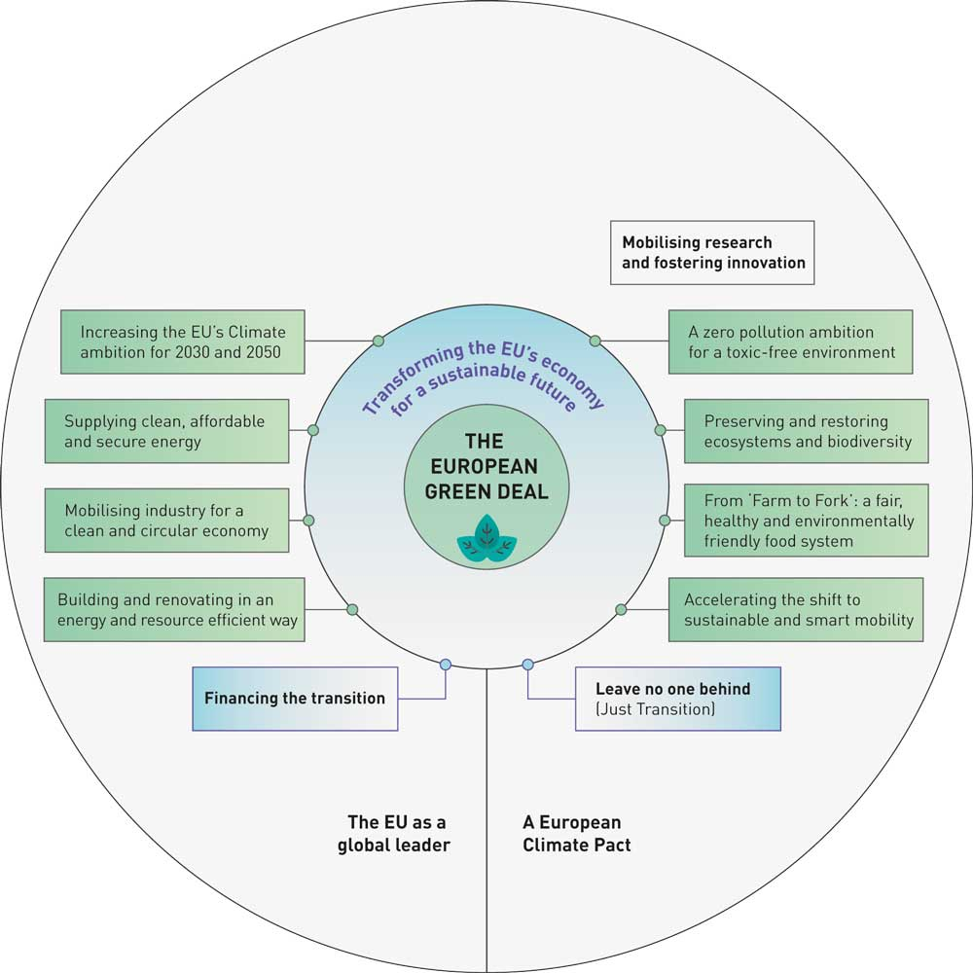
          - The main elements of the European Green Deal.
European Commission: The European Green Deal (COM 2019/640 final)
Part II
Norway’s Climate Action Plan for 2021–2030

The Government’s plan for cutting non-ETS emissions
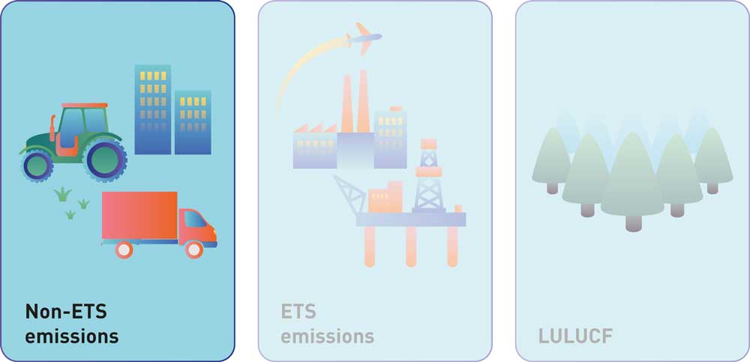
          - The EU’s 2030 climate and energy framework is divided into three main pillars, one of which deals with non-ETS emissions.

Emission reductions up to 2030

What needs to be done?
The Government’s political target is for Norway to reduce its non-ETS emissions by 45 % by 2030. This chapter describes the Government’s plans for achieving the 45 % target. Emissions and removals in the land use, land use change and forestry (LULUCF) sector are not discussed here, but are dealt with in Chapter 4. Norway’s climate agreement with the EU includes a commitment for the parties to cooperate on reducing emissions by at least 40 % by 2030. Under the agreement, Norway has been assigned binding annual emission allocations for non-ETS emissions, which translate into an emission budget for the years 2021–2030.
Chapter 1 of this white paper gives a general account of how the Government intends to reduce non-ETS emissions. The Government will use a combination of policy instruments that simultaneously promote value creation and green transition. The present chapter sets out in more detail how the Government plans to achieve the necessary reductions, and gives an account of different sectors and policy instruments.
Norway’s emission budget is illustrated in Figure 3.2, and Box 3.1 explains more fully how annual emission allocations are calculated. The Government intends to reduce Norway’s non-ETS emissions by 45 %, in other words by more than the 40 % to which Norway is committed under the agreement with the EU. The Government aims to achieve this reduction through domestic measures, and is making plans to this end. If strictly necessary, Norway can also make use of the EU flexibility mechanisms. The 45 % target is a political goal, and is not legally binding.
The Ministry of Finance presented updated emission projections for Norway in the 2021 National budget. These are described further in Chapter 3.2. There is considerable uncertainty relating to the estimated effects of current climate policy on emissions in the future. The projections indicate that Norway is likely to stay within its emission budget for the first few years of the period 2021–2030, but that further policy developments will be needed to close the emissions gap later on. The emissions gap is even larger for the 45 % reduction target. In other words, it will be necessary to make Norway’s current climate policy more ambitious, both to meet the commitment in the agreement with the EU and to achieve the Government’s target of reducing non-ETS emissions by 45 % through domestic measures.
If competitive low-emission solutions are developed more rapidly than assumed, it may be possible to reduce emissions more rapidly than the projections indicate. On the other hand, technological developments could be slower than assumed as a basis for the projections. Figure 3.2 shows the emissions gap to Norway’s commitment under the agreement with the EU and to the Government’s political target.
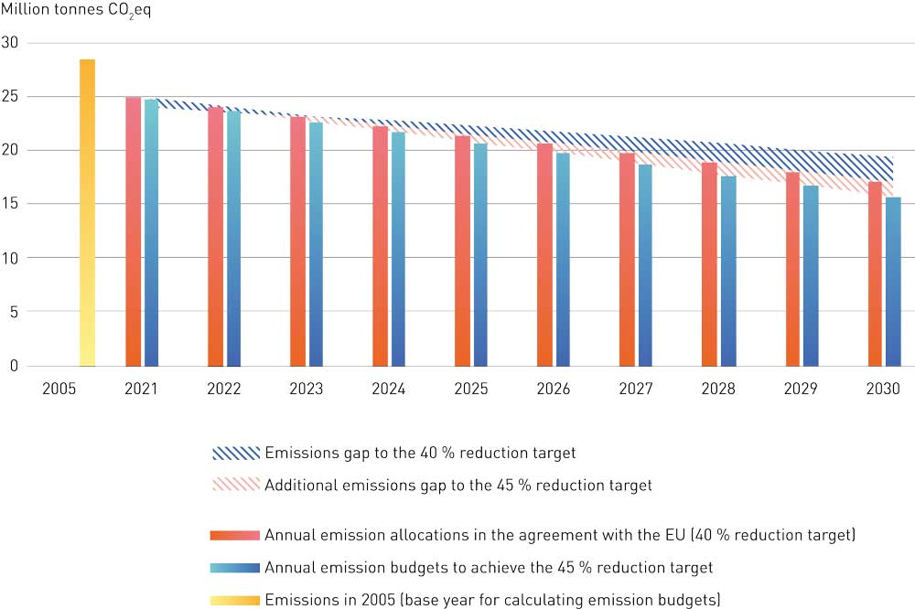
          - The emissions gap between projected emissions, based on current climate policy, and emission budgets for a 40 % and 45 % reduction in emissions by 2030 (million tonnes CO2eq).
Ministry of Finance, Ministry of Climate and Environment and Norwegian Environment Agency
Norway’s annual emission allocations for the target of a 40 % reduction in emissions have not yet been finalised. According to the currently available figures, the overall emission budget for the period 2021–2030 will be 210 million tonnes CO2eq. Norway’s projected emissions for the ten-year period are over 218 million tonnes CO2eq, so that the emissions gap for the whole period will be 8.4 million tonnes CO2eq.
If the Government’s target of reducing non-ETS emissions by 45 % by 2030 relative to the 2005 level is converted into an emission budget in the same way, the overall budget is reduced to 202 million tonnes CO2eq, and the emissions gap increases to 16.6 million tonnes CO2eq. In this climate action plan, the Government describes how it intends to step up its climate ambition and close the emissions gap. The plan will reduce emissions by over 16.6 million tonnes CO2eq more over the periode 2021-2030 than the reductions projected to result from current climate policy.
The EU has enhanced its 2030 climate target, see Chapter 2, and this may in the long term have consequences for Norway’s climate agreement with the EU. If Norway’s emission reduction target under the Effort Sharing Regulation is not increased to 45 %, the Government will officially make this a single-year target to be achieved in 2030 rather converting it into an emission budget. (Box 3.1 explains the different ways of expressing emission targets.) In other words, Norway will ensure that emissions are 45 % lower in 2030 than they were in 2005. Calculating the 45 % target in this way requires emissions to be reduced by just under 4 million tonnes CO2eq in 2030 relative to the updated projections. However, the Government’s ambition is to achieve the 45 % target in the form of an emission budget for 2021–2030. This would result in overall emission reductions of 16.5 million tonnes CO2eq more than the projected reductions for the ten-year period.
              - Annual emission allocations under the Effort Sharing Regulation
A target for greenhouse gas emission reductions can be expressed as the emission level to be achieved in a specific year. For example, one of Norway’s targets is to reduce non-ETS emissions by at least 50 % and towards 55 % by 2030 compared with the 1990 level. However, in the context of climate change, it is emission levels over time that are important. It therefore makes sense to set a target not only for the emission level to be achieved in ten years’ time, but also for the total volume of emissions over the ten-year period. Under the climate agreement with the EU, Norway’s 2030 target (as a percentage of non-ETS emissions) is converted to an emission budget for 2021–2030, expressed as binding annual emission allocations for each year of the period. The same system is followed for each country. The annual limits become smaller over the period, so that the emission allocation for 2022 is slightly smaller than that for 2021, and so on. In Figure 3.2, red bars show Norway’s annual emission allocations as set out in the climate agreement with the EU.
Norway’s climate agreement with the EU includes rules for calculating annual emission allocations under the Effort Sharing Regulation. The annual allocations are formally determined by the EFTA Surveillance Authority (ESA), based on a comprehensive review of emission inventory data on non-ETS emissions for 2005, 2016, 2017 and 2018. The base year for non-ETS emissions is 2005, and Norway’s emissions must be 40 % lower in 2030 than they were in 2005. The main reason for using 2005 rather than 1990 as the base year is the lack of reliable data for emissions from non-ETS sources in 1990. This is linked to the fact that the EU ETS only became operational in 2005. The starting point for Norway in 2021 is determined on the basis of its emission figures for 2016, 2017 and 2018. The emission allocation for 2021 is therefore larger than the allocation for 2030. ESA will make a formal decision on the figures at a later date.
Norway’s formally assigned annual emission allocations are legally binding, and ESA and the EFTA Court are responsible for monitoring and enforcing compliance. They do this through reviews of emission inventories and other reports Norway is required to prepare. If Norway does not meet its obligations, ESA can bring a case before the EFTA Court, which may find Norway to be in breach of the EEA Agreement. The legislation also provides for sanctions that may be applied to ensure that countries meet their emission commitments. If Norway’s emissions exceed its annual allowances, it must take corrective action, and the excess emissions, multiplied by a factor of 1.08, will be added to its emission figures for the following year. These procedures will be carried out through the normal system of surveillance and judicial control under the EEA Agreement.
Under the climate agreement with the EU, Norway also has an obligation to ensure that by 2030, emissions from the LULUCF sector do not exceed removals (the ‘no debit’ rule). If Norway does not meet this obligation, it must either reduce its domestic non-ETS emissions further or buy emission units from other European countries.
[Boks slutt]

What are Norway’s plans for reducing non-ETS emissions?
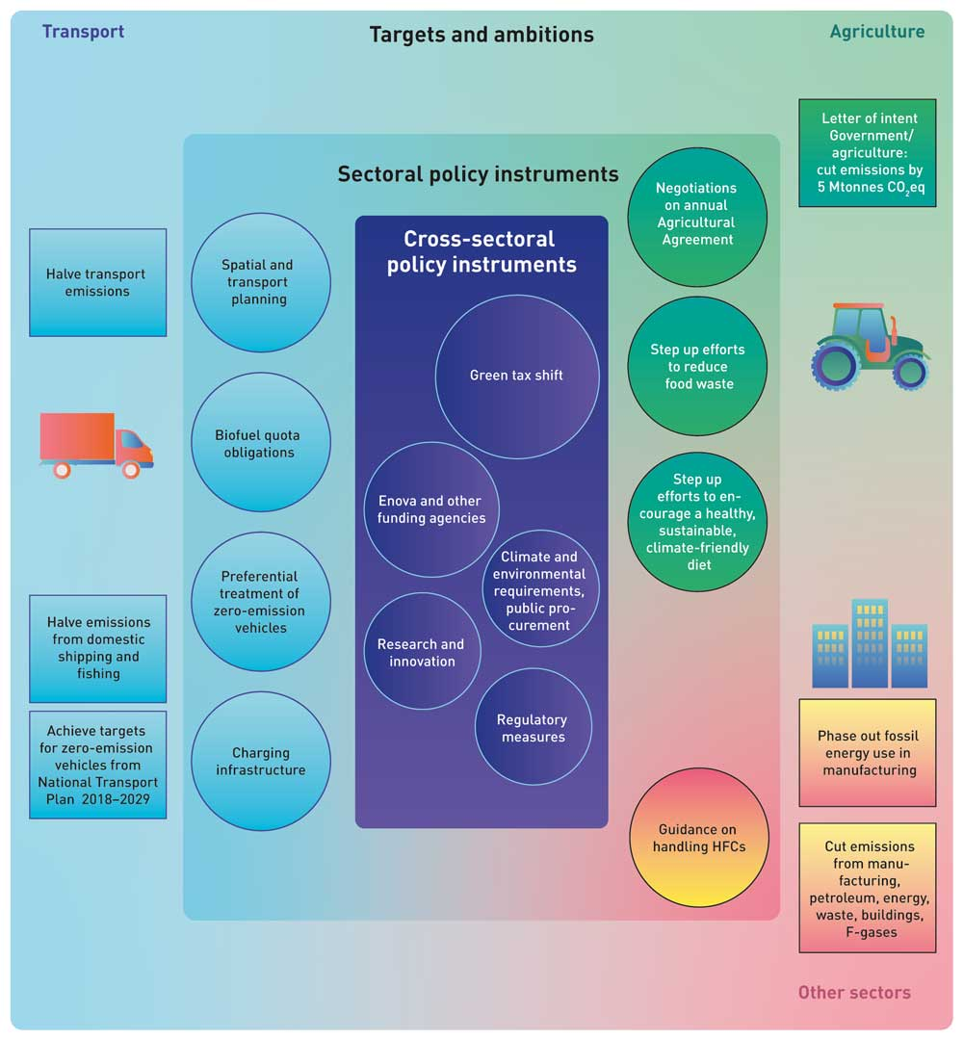
          - The main policy instruments for reducing non-ETS emissions in the climate action plan. Achieving the targets for zero-emission vehicles set out in the National Transport Plan 2018–2029 will require advances in technological maturity in various segments of the transport sector.

Introduction
According to the updated projections, Norway’s current climate policy will continue to provide incentives for substantial cuts in emissions up to 2030. The Government has been increasing taxes on greenhouse gas emissions for several years, and has in addition removed a number of the reduced tax rates and exemptions. The Government has also been taking an ambitious approach to electrification of the transport sector, and has made regular stepwise increases in the biofuel quota obligation for road traffic. Moreover, the Government is encouraging the phase-in of solutions for the future through Enova, which provides funding for projects to develop and deploy new technology that will reduce emissions. There are also government initiatives for the development of new technology in sectors including shipping. Emissions would be much higher than the level today without the use of these policy instruments.
Chapter 3.1.1 explains that according to current information, there is an emissions gap that must be closed in order to achieve the Government’s target of reducing non-ETS emissions by 45 % through domestic measures.
The gap between the projections and the overall emission budget for the 45 % target is 16.6 million tonnes CO2eq. The Government will therefore step up its climate action to close the gap. This will include building further on a number of existing policy instruments and introducing new ones. Recent rapid technological advances, especially in the transport sector, are enhancing the effect of policy instruments that are already in use and making it easier to choose zero-emission solutions. In the years ahead, technological advances will support emission cuts, while climate action can encourage further technology development.
This chapter introduces the policy instruments the Government intends to use and the part they will play in reducing emissions and in Norway’s green transformation. Policy instruments will interact and in some cases overlap or have synergistic effects.
The effects of taxes and other policy instruments depend on a variety of factors, including the policy followed in other areas and economic developments. The estimates used here and shown in Table 3.1 are based on an assessment of the situation at the time of writing. Actual trends in the ten-year period may be different. There is considerable uncertainty relating to emission trends, the effects of climate policy, and not least, to technological developments and the costs of implementing mitigation measures. Norway therefore needs a flexible climate action plan that takes into account possible adjustments to policy instruments during the planning period.
            - Emissions gap and estimated effects of climate policy instruments (million tonnes CO2eq)1
03J0xt2
Emissions gap for 40 % target |  |  | 8.4
Emissions gap for 45 % target |  |  | 16.6
 | Emission reductions from requirements in legislation or procurement processes | 3
 | Emission reductions from increases in the carbon tax rate | 7.5
 | Emission reductions credited to the agricultural sector in the emission inventory | 4
 | Emission reductions from changes in biofuel quota obligations | 5.5
Total estimated emission reductions |  |  | 20
Possible additional effects
 | Compensation for increases in carbon tax for road traffic (may reduce emission cuts) | 0 to -3
 | Effect of achieving targets for zero-emission vehicles (National Transport Plan 2018–2029) | 1
 | Effects of new national transport plan, new agreement with Enova, other relevant policy instruments (see Chap. 3.1.2.3) | Not quantitatively estimated
1 Figures (except those for the emissions gap) are rounded off to the nearest 0.5 million CO2eq.
Statistics Norway, Norwegian Environment Agency, Ministry of Finance, Ministry of Climate and Environment
It is not equally easy to make quantitative estimates of the effects of all aspects of climate policy. The quantitative effect of a tax or a requirement to use zero-emission solutions by a specified target date can be estimated, but it is more difficult to quantify the emission reductions that will be brought about for example through Enova’s activities, improvements in public transport or the long-term green shipping initiative. As a result, Table 3.1. does not completely reflect the estimated effects of the Government’s climate policy.
In some policy areas, the most appropriate approach is to plan well in advance. Examples are stepwise increases in taxes and the introduction of climate-related requirements in legislation or procurement processes. In other areas, the use of policy instruments will be evaluated as needed.
The next sections therefore discuss policy instruments whose effects have been quantitatively estimated separately from those for which there are no quantitative estimates. Table 3.1 shows that implementing policy instruments whose effects have been quantitatively estimated will make it possible to close the emissions gap and achieve the 2030 target of reducing non-ETS emissions by 45 %. If additional new policy instruments are implemented, emissions may be reduced further.

Policy instruments whose effects have been quantitatively estimated
Figure 3.4 shows the estimated contributions of different policy instruments to emission reductions. Emissions pricing through taxation will continue to be the main instrument of Norwegian climate policy. However, achieving Norway’s climate targets through the carbon tax alone would require a very high tax rate. The Government therefore intends to increase the carbon tax rate gradually from its current level of about NOK 590 to NOK 2000 per tonne CO2eq in 2030 (2020 NOK).
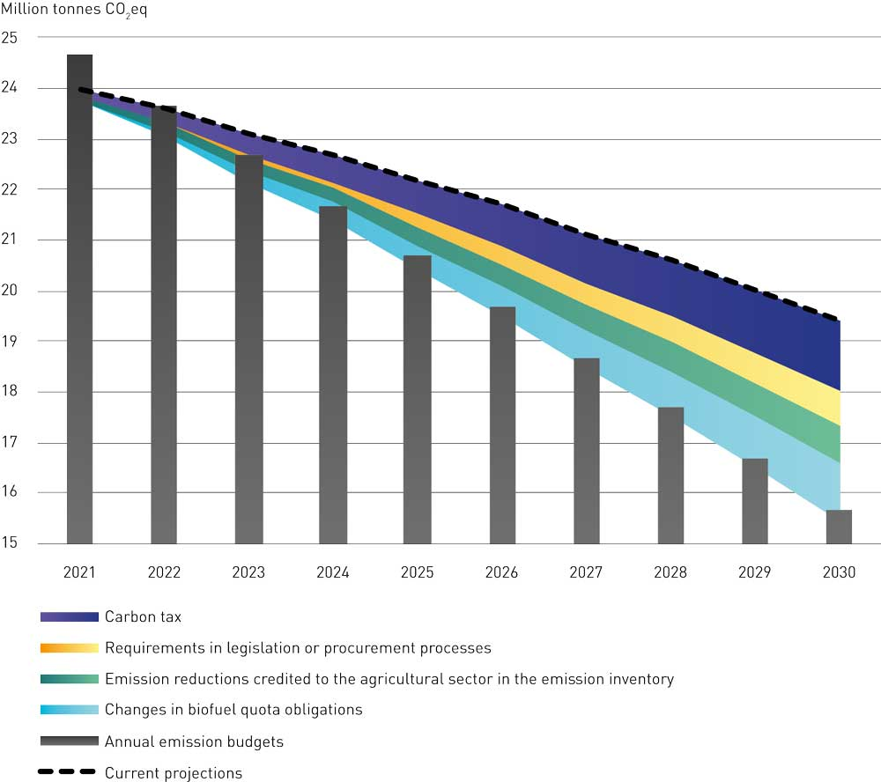
          - Closing the emissions gap: how the carbon tax, biofuel quota obligations and other policy instruments are expected to reduce emissions enough to reach Norway’s 45 % target for non-ETS emissions (figures in million tonnes CO2eq).
Statistics Norway, Norwegian Environment Agency, Ministry of Finance, Ministry of Climate and Environment
It is estimated that increasing the tax rate to this level can reduce non-ETS transport emissions by about 3.5 million tonnes CO2eq and other non-ETS emissions by 4 million tonnes CO2eq. These figures are based on data from Statistics Norway and results from the macroeconomic model SNOW (see Box 3.3), the Norwegian Environment Agency and the mitigation analysis for Norway 2021-2030. They are also based on the assumption that the effect on emissions will increase steadily throughout the period 2021–2030. The overall increase in the tax rate and the rate for each specific year will need to be determined through the normal budgetary processes and assessed in the light of technological developments, but must ensure that emissions are reduced sufficiently.
The Government’s policy is not to increase the overall level of taxation. This means that any increase in a tax rate must be offset by corresponding reductions in other taxes, primarily for the groups affected by the tax increase. In accordance with its political platform, the present Government has provided compensation for the rise in the carbon tax rate in the 2020 and 2021 budgets by reducing road use duty. This reduction counters the effect of a rise in the carbon tax for large parts of the transport sector. Estimates suggest that if the Government continues to compensate for increases in the carbon tax rate up to 2030 by reducing road use duty, this on its own would make the overall reduction in greenhouse gas emissions about 3 million tonnes CO2eq smaller than if no compensation was provided (see ‘Possible additional effects’ in Table 3.1). The Government has not yet come to a decision on whether to continue this compensation mechanism. Other tax-based compensation mechanisms will also be considered to avoid the counter-productive effect of reducing the effect of the carbon tax on emissions. The Government’s climate policy is intended to minimise the negative economic impacts for ordinary people. It must pay to reduce greenhouse gas emissions, but at the same time, climate policy must not entail unreasonable costs. Specific proposals for changes in the taxation system will be presented to the Storting (Norwegian parliament) in the annual budget proposals.
The Government is using the targets for zero-emission vehicles set out in the National Transport Plan 2018–2029 as a basis for designing policy instruments. These targets list the proportions of new vehicles in different categories that are to be zero-emission by specific years in the period up to 2030. The targets are based on the assumption that zero-emission technologies in the different transport segments will mature so that they become competitive with conventional solutions. Increases in the carbon tax rate combined with incentives to choose zero-emission solutions will play a part in achieving these targets. Various other policy instruments also influence developments and how rapidly new types of vehicles are taken into use. They include purchase taxes, fuel taxes, user benefits, requirements in public procurement processes, grant schemes, local regulatory measures and the development of charging infrastructure. During the ten-year period 2021–2030, the design of these policy instruments will be adjusted as appropriate to the situation.
To achieve the target that all new local buses are to be zero-emission vehicles or run on biogas by 2025, the Government intends to make this a general requirement in all public procurement processes from 2025. This alone could reduce emissions by about 1 million tonnes CO2eq in the period 2025–2030. Vehicle taxes will be important in achieving the target for all new passenger cars and small vans to be zero-emission vehicles from 2025 and for the introduction of a requirement to use zero-emission solutions in public procurement processes for passenger cars and small vans from 2022. Enova will play a key role in achieving the targets for heavy-duty vehicles – for all new large vans, 50 % of new trucks and 75 % of new long-distance coaches to be zero-emission vehicles by 2030. In addition, the Government will consider whether to introduce requirements to use zero-emission solutions in public procurement processes for these vehicle categories and services as well, but this will only be appropriate once the technology in the various segments has matured sufficiently. Achieving these targets may result in emission cuts of around 1 million tonnes CO2eq, see ‘Possible additional effects’ in Table 3.1.
The Government intends to introduce national zero- and low-emission criteria in new procurement processes for ferries and high-speed passenger vessels, where feasible, from 2023 and 2025 respectively. In addition, requirements for zero- and low-emission solutions for aquaculture service vessels are planned to be introduced gradually from 2024 onwards where feasible. Combined, these measures may cut emissions by up to 2 million tonnes CO2eq.
The carbon tax and requirements to use low- and zero-emission solutions in the transport sector are policy instruments with overlapping effects. The overlap is estimated to correspond to 0.5–1 million tonnes CO2eq. In the assessments presented here, the net effect of requirements to use low- and zero-emission transport solutions is categorised as ‘Emission reductions from requirements in legislation or procurement processes’ (Table 3.1).
The Government will, as a minimum, maintain the current sales volume of biofuels for road traffic, so that the emission cuts resulting from biofuel use are not reduced by the decline in sales of liquid fuels as electric vehicles are phased in. This must be achieved in a way that does not result in a rise in global emissions. The Government intends to introduce biofuel quota obligations for offroad diesel and shipping from 2022. The biofuel quota obligation for offroad diesel will be gradually increased to the same level as for road traffic. In the Government’s view, the same biofuel quota obligation should apply to road traffic and offroad diesel, and it will consider whether this can apply to shipping as well. The biofuel quota obligations for road traffic and offroad diesel combined may result in emission cuts of about 5.5 million tonnes CO2eq over the period 2021–2030. For aviation, the Government will gain experience of application of the new biofuel quota obligation before considering whether to increase the proportion of biofuel required. This is discussed further in Chapter 3.4.
              - Mitigation analysis for Norway 2021–2030: terms of reference, methodology and main findings
The mitigation analysis for Norway 2021–2030 (Klimakur 2030, in Norwegian only)1 formed an important part of the scientific basis the Government used in preparing this climate action plan. In their terms of reference, the group of experts commissioned to prepare the analysis were asked to assess possible mitigation measures and policy instruments that could reduce Norway’s non-ETS emissions by at least 50 % by 2030 compared with the 2005 level. They were also asked to assess measures and policy instruments to enhance removals and reduce emissions in the LULUCF sector. The analysis was coordinated by the Norwegian Environment Agency, and the expert group also included representatives of Statistics Norway, Enova, the Norwegian Public Roads Administration, the Norwegian Coastal Administration, the Norwegian Agricultural Agency, and the Norwegian Water Resources and Energy Directorate. The group analysed 60 different measures that could cut non-ETS emissions by a total of about 40 million tonnes CO2eq in the period 2021–2030 compared with the current baseline projections. This corresponds to a reduction of more than 50 % compared with the 2005 level. The group looked at both economic and private costs of the measures, and other barriers that may hinder their implementation unless incentives are provided. In many cases, the cost of a measure will vary widely between different stakeholders, and there will also frequently be a considerable difference between the economic cost of a measure and the costs for individuals or companies. The main findings of the expert group for non-ETS emissions from different sectors are discussed in boxes 3.7, 3.19 and 3.26.
The term ‘mitigation measures’ is used to mean concrete actions to reduce greenhouse gas emissions, for example switching from petrol to electric vehicles. ‘Policy instruments’ are the tools available to central and local authorities, such as regulatory measures, taxes, subsidies and information activities.
There are uncertainties relating to several aspects of the mitigation analysis, including the cost estimates, the emission reduction potential of the measures and the emission projections. It is also difficult to assess when new technology will become available, and how quickly different stakeholders can change their behaviour. These uncertainties could have both negative and positive effects on emission reductions.
The entire expert group agreed on the main findings of the analysis. The group emphasised that the analysis was intended as a scientific basis, not as a recommendation.
A public consultation2 was held on the group’s report, and a large number of responses were received. In all, there were 1730 responses, 51 of them from municipalities and counties, 190 from organisations and businesses, and 1489 from individual people. Most of the responses focused on policy instruments and how the mitigation analysis can be used in further development of Norway’s climate policy. There were also many proposals for policy instruments in specific sectors and assessments of general policy instruments such as the carbon tax. Many stakeholders commented on the need for packages of measures to promote the transformation process.
More information can be found in Chapters 3.4, 3.6 and 3.7.
1 https://www.miljodirektoratet.no/klimakur
2 https://www.miljodirektoratet.no/aktuelt/nyheter/2020/mai-2020/klimakur-2030-vekket-stort-engasjement/
[Boks slutt]
The Government and the agricultural organisations have signed a letter of intent with the aim of reducing emissions and enhancing removals by a total of 5 million tonnes CO2eq over the period 2021–2030. The letter of intent applies to all mitigation measures for agricultural activities whose effects can be accounted for in the sectors agriculture, transport, heating of buildings and LULUCF (with the exception of forestry) in Norway’s official greenhouse gas inventory. Since this means that some reductions in emissions in other sectors are credited to agriculture, the Government estimates that a reduction of 4 million tonnes CO2eq will be accounted for in the agricultural sector over the period 2021–2030.
Raising the carbon tax rate will reduce emissions from all vehicle and vessel categories. When fuel costs rise, it pays to reduce emissions, either by driving less or by choosing zero-emission solutions. The largest reductions in emissions are expected to be brought about by electrification of commercial transport.
For other non-ETS emissions, the main effects of increasing the carbon tax rate are expected to be reductions in emissions due to declining use of fossil fuels in manufacturing and an increase in the proportion of used HFCs recovered and destroyed. Emission reductions are also expected in the building sector, the oil and gas industry and waste incineration.
The gradual increase in the carbon tax rate is an important means of phasing out heating using fossil fuels in the manufacturing sector, and may result in substantial emission reductions in the period 2021–2030. If necessary, the Government will consider introducing further policy instruments, including a prohibition on the use of fossil fuels for this purpose. The Government will also work towards gradual phase-out of the use of natural gas for heating and drying buildings during construction. Emissions of HFCs and PFCs are expected to decrease considerably as a result of higher taxes and a corresponding increase in tax refunds, combined with an increase in advisory and supervisory activities.
There is considerable uncertainty surrounding the figures for estimated effects of tax increases on emissions in these sectors. The actual emission reductions will therefore depend on decisions made in the future. The calculations used here are based on the assumption that all emissions are subject to the same carbon price, including emissions that are not taxed today and those taxed at lower rates than the standard carbon tax rate for non-ETS emissions. The Government has proposed the introduction of a tax on waste incineration from 2021, and will consider a stepwise increase in the tax rate. The Government will also raise the tax rate for natural gas released to air on the continental shelf to the standard rate for non-ETS emissions.
The combination of a rising carbon tax, climate-related requirements in public procurement processes, regulatory measures, financial support and measures in the agricultural sector will make it possible for Norway to achieve its target of reducing non-ETS emissions by 45 % by 2030.
              - Macroeconomic analysis by Statistics Norway of a 50 % reduction in Norway’s non-ETS emissions by 2030
In June 2020, Statistics Norway published a report1 in response to a request by the Government to analyse the overall costs of a 50 % cut in non-ETS emissions. Statistics Norway was asked to conduct a macroeconomic analysis of emission reductions on this scale, and to assess how the mitigation analyses and cost estimates from the mitigation analysis for Norway 2021–2030 could be used in the macroeconomic analysis.
Statistics Norway analysed long-term macroeconomic impacts using the general equilibrium, multi-sector SNOW model of the Norwegian economy.
Statistics Norway analysed how high a uniform price for all greenhouse gas emissions outside the ETS sector would need to be to achieve a 50 % reduction in emissions. The analysis also examined where emission cuts would take place and what the macroeconomic impacts would be. The macroeconomic impacts of this were assessed relative to a projection without any policy changes. This reference scenario is based on the projections presented in the 2020 National Budget.
Statistics Norway analysed two possible ways of using the extra revenue generated by taxing emissions: recycling the revenue to households through a lump-sum transfer and reducing the income tax rate. The analysis indicates that the emission price would have to be increased to NOK 3 200 and NOK 3 500 per tonne respectively in the two scenarios (in real 2013 prices) in order to halve Norwegian non-ETS emissions by 2030. These prices correspond to about NOK 3 700 and 4 100 per tonne in real 2020 prices. This is the marginal abatement cost, i.e. the cost of the, most expensive measure implemented to reduce emissions.
According to the analysis, four economic areas, as defined in the SNOW model, account for 90 % of the emission cuts: road transport (47 %), waste and district heating (19 %), agriculture and forestry (17 %) and construction (7 %). The model classifies activities by economic sector, and does not use the same sectors as the national emission inventory. This means for example that it is difficult to use SNOW to identify emissions belonging to the transport sector in the emission inventory, since many economic sectors use different types of vehicles and vessels in their operations.
In the scenario where revenue from taxing emissions is recycled to households through lump-sum transfers, behavioural changes result in a marked macroeconomic contraction, with GDP, employment and private consumption falling by 0.4, 0.3 and 1.1 % respectively by 2030 compared with the reference scenario. The overall costs for households and the business sector in this scenario are estimated at NOK 7.6 billion (real 2013 prices). These figures reflect the direct costs to households and businesses of changing their behaviour and choosing technologies that result in lower emissions. The utility of the consumer is reduced by 0.8 %. The utility of the consumer depends on the populations consumption of goods, services and leisure time. The social costs of this scenario are found to be more than twice as high as the direct costs. This is partly because the higher emission price comes in addition to existing climate policy instruments that are not cost effective, and because the labour supply is reduced. The utility loss can be seen as a metric for social costs. The analysis did not put a value on greenhouse gas emission reductions.
In the second scenario, where the extra revenue from a stricter climate policy is used to reduce the income tax rate, the distortion in the labour market is reduced both directly and by counteracting existing labour-related tax wedges. As a result, social costs (utility) are halved relative to the first scenario, even though the direct costs of cutting emissions are higher. This is because reducing income tax stimulates economic activity, and GDP, employment and private consumption all rise compared to the reference scenario, by 0.3, 0.9 and 0.2 % respectively.
[Boks slutt]

Policy instruments whose effects have not been quantitatively estimated
The Government has stepped up its efforts to promote the development of new technology and a green transition in the Norwegian business sector. These efforts will be continued using the full range of public funding agencies. The Research Council of Norway, Innovation Norway, Siva and Enova are developing a new long-term joint initiative, the Green Platform Initiative. This is intended to promote a low-emission development pathway in the Norwegian business sector and green competitiveness both in Norway and abroad. Enova, a state-owned enterprise that funds the development and introduction of climate technologies, has been given a clearer climate profile for the next four-year period. One of Enova’s tasks is to realise the effects of the carbon tax, but at the same time, it has the opportunity to prioritize reducing emissions further in all sectors. By participating in the EU funding programme for research and development, Horizon Europe, the EU’s Innovation Fund and other EU arenas for cooperation, Norway’s funding agencies in the research and innovation system will be able to scale up their efforts and achieve better results.
The Government has made green shipping a priority area in order to promote the development of a forward-looking maritime industry in Norway. The Government’s ambition is to reduce emissions from domestic shipping and fishing vessels by half by 2030. In 2021, the Government will continue to use policy instruments specifically designed to promote green fleet renewal in short sea shipping and bring about emission reductions in the cargo vessel segment. The Storting has requested the Government to propose ways of ensuring the introduction of zero- and low-emission solutions for offshore support vessels, and in response the Government will present its plan to the Storting in 2021. This will also assess new requirements that can be phased in from 2022.
The Government intends to co-fund the carbon capture project at Fortum Oslo Varme’s waste incineration plant, provided that the company provides sufficient funding of its own and obtains funding from the EU or other sources. If this project is implemented, the carbon capture facility will remove and store 0.4 million tonnes CO2 per year, about half of which will be emissions from incineration of material of biological origin.
Norway’s four largest urban areas have concluded integrated urban land-use and transport agreements, which have made it possible to reduce growth in traffic volumes and greenhouse gas emissions. Five other smaller urban areas have received funding from an incentive scheme for improvements in public transport. In these areas too, car traffic has remained more or less unchanged or been reduced in recent years (see Chapter 3.4.2.7). Better coordination of spatial and transport planning and a more funding for integrated urban land-use and transport agreements, railways and other public transport, and cycling and walking, will yield further emission reductions in the years ahead. It is difficult to make a quantitative estimate of the overall effect of these measures. In spring 2021, the Government will present the National Transport Plan 2022–2033, which will be used to support the ambition of reducing transport emissions by 50 %.
To reduce emissions from construction activities, the Government will shortly present an action plan for fossil-free construction sites in the transport sector. Initiatives to be announced in the action plan include pilot projects for fossil-free construction sites, to be run by the subordinate agencies of the Ministry of Transport, and the assessment of measures for effective management of bulk materials. These initiatives may result in emission reductions beyond what is brought about by increases in the carbon tax, technology development and permanent market change.
The Government will consider amendments to the Technical Construction Regulations, taking a broad-based environmental approach. Central government agencies will be expected to attach importance to the environmental benefits of re-using already developed areas and existing buildings, and of siting premises near urban centres and public transport nodes. This approach can reduce emissions related to energy and material use and from transport.

Emission trajectories for specific sectors
The present Government’s political platform states that it will specify ambitions for reducing non-ETS emissions in different sectors, in response to a request made by the Storting in 2018. The Government’s ambition for the transport sector is to reduce greenhouse gas emissions by half by 2030 relative to 2005. This is discussed further in Chapter 3.4. The basis for ambitions for the agricultural sector is the letter of intent signed by the Government and the agricultural organisations. In this climate action plan, the Government estimates that emissions accounted for in the agricultural sector will be reduced by 4 million tonnes CO2eq during the period 2021–2030. This is discussed further in Chapter 3.6. The Government expects the total reduction in other non-ETS emissions to be in the region of 4 million tonnes CO2eq, but has not specified ambitions for the remaining non-ETS emissions by sector. The remaining emissions are from a number of very different sources, ranging from households and manufacturing to F-gases in products, and each source accounts for only a small proportion of total non-ETS emissions. Thus, the Government does not consider that it would serve any useful purpose to specify ambitions further by sector. Other non-ETS emissions are discussed further in Chapter 3.7.
Figure 3.5 shows how this climate action plan, using taxes, other policy instruments and emission reductions in the agricultural sector, can close the emissions gap and make it possible to achieve Norway’s target of reducing non-ETS emissions by 45 % compared with the 2005 level. Table 3.1 shows figures for emission reductions, while Figure 3.5 illustrates the effects expected in different sectors. The estimated figures are uncertain and depend on a number of factors, such as the pace of technology development and the effects of policy instruments. The estimates are based on an analysis by Statistics Norway of the costs of emission reductions, using the macroeconomic model SNOW, and an assessment of the measures presented in the mitigation analysis for Norway 2021-2030 and of how much of their emission reduction potential can be achieved through the policy instruments the Government proposes to use.
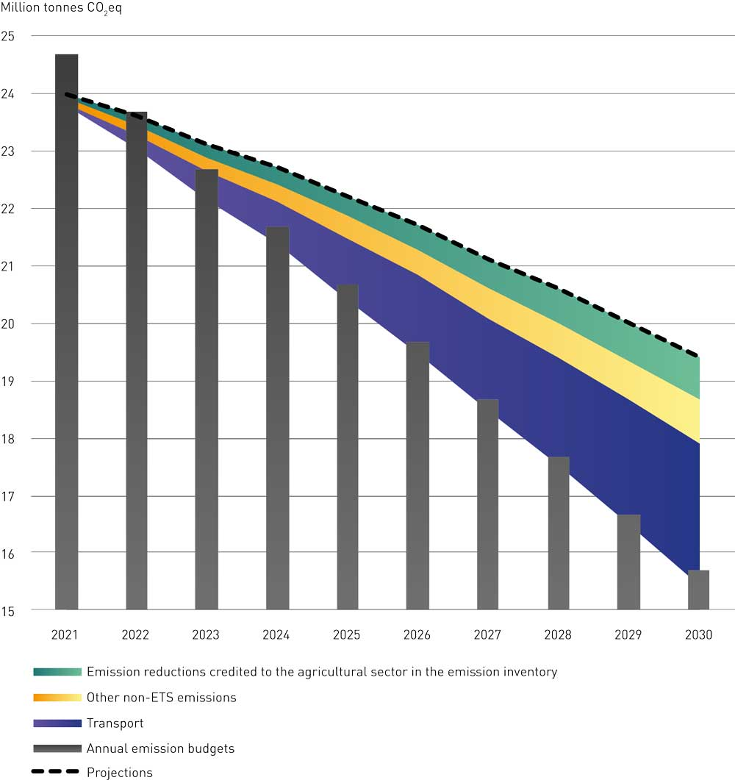
          - Reductions in non-ETS emissions in different sectors expected to be achieved through the Government’s climate action plan (million tonnes CO2eq)
Statistics Norway, Norwegian Environment Agency, Ministry of Finance, Ministry of Climate and Environment

An ambitious and flexible plan
This climate action plan describes how the Government intends to achieve its ambition of reducing non-ETS emissions by 45 % through domestic emission reductions. If necessary, the Government will consider other policy instruments such as greater use of biofuels or prohibiting certain emission sources. The Government will also if needed make use of flexibility mechanisms under the EU legislation to ensure that emissions are reduced sufficiently. Emission levels depend on many uncertain factors that may interact in unforeseen ways. Other unexpected events like the COVID-19 pandemic may occur in the future. The effects of the various policy instruments used depend on the actions of several million Norwegians, several thousand companies, and technology developments globally. This makes it necessary to assess whether the necessary emission reductions are being achieved, and the Government will therefore assess whether Norway is on track to meet its climate target during the planning period. It will use the system of annual reporting to the Storting under the Climate Change Act to assess both implementation of this climate action plan and Norway’s progress towards the 2030 target. If progress is not satisfactory, policy instruments will be adjusted as necessary.
If Norway’s non-ETS emissions are higher than its annual allocation, it can borrow from the allocation for the following year; if it has a surplus of emission units, it can bank the surplus for later use. If Norway for some reason is unable to meet its obligations under the EU legislation using national measures, it will have to use the EU flexibility mechanisms to do so. This means paying for further emission cuts or removals in other EU/EEA countries. The Effort Sharing Regulation makes countries accountable for their emissions and ensures a reduction of total emissions in Europe, while the flexibility mechanisms function as a safety valve. However, the Government’s plan is for Norway to meet its commitment through national emission cuts.

Historical emissions and projections of non-ETS emissions within the scope of the Effort Sharing Regulation
In 2019, Norway’s non-ETS emissions totalled 24.6 million tonnes CO2eq, or about half of its overall emissions excluding the LULUCF sector. These emissions were reduced by about 11 % from 2005 to 2019.
The projections referred to in this chapter include the impacts of policy measures and instruments that have already been implemented, but not of new measures and instruments announced in this white paper.
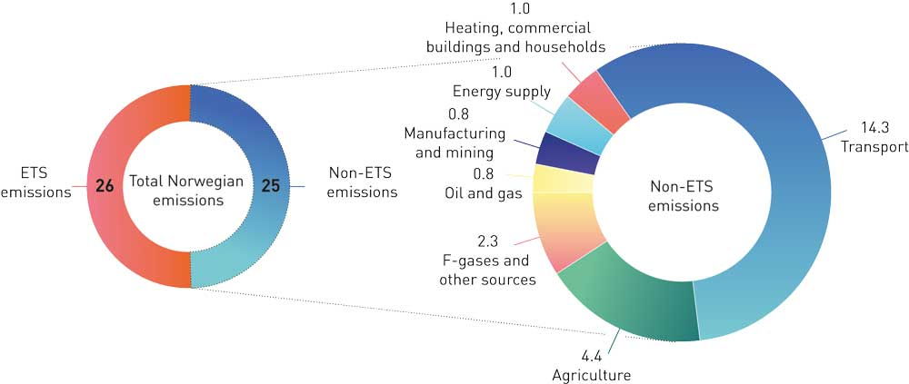
          - Norway’s non-ETS emissions by sector in 2019 (million tonnes CO2eq).
Statistics Norway and Norwegian Environment Agency
In the 2021 National Budget, the Government presented updated projections of Norway’s greenhouse gas emissions. These are based on assessments of underlying trends in the Norwegian and the global economy, including economic growth and technological and demographic conditions. In line with international guidelines, the projections are based on continuation of current climate policy, both in Norway and internationally.
Even if Norway fulfils its obligations, current policies around the world are not sufficient to achieve the targets of the Paris Agreement. The calculations are therefore based on the assumption that economic growth and general technological advances in the international economy will continue at about the same pace as until now. This means that it is assumed that the development of new climate-friendly technology internationally – which Norway will be reliant on to become a low-emission society, will be neither more rapid nor slower than has been observed historically.
If competitive low-emission solutions are developed more rapidly than assumed, it may be possible to reduce emissions more rapidly than the projections indicate. Taxes, emission allowances and other regulatory measures already give the Norwegian population and businesses incentives to make use of new technology as it becomes available. On the other hand, technological developments could be slower than assumed as a basis for the projections.
The projections are not a description of the Government’s targets, nor do they reflect the effects of new policy or policy instruments to be introduced at a later date. Targets that have been adopted but where no proposals for changes in policy instruments or measures have been put forward, and measures that have been considered but have not yet resulted in regulations, decisions on taxes, agreements or the like, are not incorporated into the projections.
The projections indicate that greenhouse gas emissions will decline by about 2 % per year from 2019 to 2030. With this trajectory, emissions would be about 9.5 million tonnes CO2eq lower in 2030 than in 2019. It is estimated that non-ETS emissions will account for almost half of this reduction, or a little over 5 million tonnes CO2eq. It is estimated that ETS emissions will decline by just over 4 million tonnes CO2eq in the same period.
Table 3.2 shows historical figures and projections for non-ETS emissions in different years and different sectors. Transport emissions rose from 1990 to a maximum in 2012. Since then, they have been declining, and this trend is expected to continue. According to the projections, transport emissions in 2030 are expected to be 15 % below the 1990 level. Emissions from agriculture have been reduced by 6 % since 1990, and are projected to be a little below the 1990 level in 2030. Non-ETS emissions from manufacturing have been greatly reduced since 1990, and emissions in 2030 are projected to be more than 80 % below the 1990 level. Emissions from heating buildings have also declined steeply, partly as a result of the prohibition on using mineral oil to heat buildings. Figure 3.7 shows trends in non-ETS emissions over time for various sectors.
As explained in the 2021 National Budget, the COVID-19 pandemic and the infection control measures that were introduced in Norway and in the rest of the world caused a contraction in both the Norwegian and the international economy in 2020, and economic activity is likely to be lower than normal well into 2021. Lower economic activity also influences greenhouse gas emissions, and the projections include a temporary decline in emissions as a result of the COVID-19 pandemic. This is mainly related to a decline in transport volumes and somewhat lower industrial production.
The possibility that the pandemic will result in long-term structural changes with longer-term implications for emission trends cannot be ruled out. It is possible that travel volumes, both for work and for leisure, will prove to have been permanently reduced, for example because of a shift to digital solutions and working from home. On the other hand, private car use may increase at the expense of public transport. It is very uncertain which of these effects will dominate and be most persistent.
The projections indicate a decline of almost 1 million tonnes in Norway’s total greenhouse gas emissions from 2019 to 2020. In line with developments in the Norwegian economy, the projections are based on the assumption that the downturn related to the pandemic and infection control measures will largely be reversed in 2021. Nevertheless, some decline in overall emissions is expected in the period up to 2025. The projections show a further decline in transport emissions as a result of rising numbers of zero-emission vehicles, which becomes increasingly apparent during the period up to 2030. ETS emissions are also projected to drop steeply in the period up to 2030, primarily as a result of lower emissions from the petroleum industry.
The projections of greenhouse gas emissions were updated on the basis of the macroeconomic estimates presented in the 2021 National Budget. The level of emissions depends on the actions of several hundred thousand companies and millions of people. The projections seek to incorporate general trends and tendencies underlying these actions.
The projections are based on continuation of current climate policy, both in Norway and internationally. This means that that the tax base and rates for the carbon tax and other taxes are kept unchanged, and that calculations are based on the observed prices of EU futures contracts. It is also assumed that support for technology development, for example through Enova, will be maintained. Key assumptions underlying the projections are discussed in more detail the 2021 National Budget.
According to the projections, CO2 emissions are expected to decline by a little over 20 % by 2030, while the estimated emission reductions for other greenhouse gases are smaller. Overall emissions of greenhouse gases other than CO2 are expected to decline from 8.1 million tonnes CO2eq in 2019 to 7.4 million tonnes CO2eq in 2030. The reduction in methane emissions is partly explained by declining emissions from landfills. Methane emissions from agriculture are projected to remain at about the same level as today, since agricultural production is expected to keep pace with population growth, while a certain decline in emissions per unit of production is expected. (Methane as a greenhouse gas is discussed further in Chapter 3.6.) Nitrous oxide emissions are projected to remain stable in the years ahead, while implementation of the EU’s 2014 revised F-gas Regulation is expected to result in a decrease in HFC emissions after 2020. However, SF6 emissions are expected to rise.
The estimate for Norway’s greenhouse gas emissions in 2030 presented in the 2021 National Budget has been revised downwards by 4.5 million tonnes CO2eq since the previous projections, which were presented in the 2019 National Budget. This is mainly because estimated emissions from oil and gas extraction are lower, to a large extent because of increasing electrification of petroleum installations.
If current policy is continued, emissions from road transport are projected to decrease from 8.5 million tonnes CO2eq in 2019 to 5.3 million tonnes CO2eq in 2030. This is mainly because it is assumed that phase-in of low- and zero-emission vehicles will increase further in the coming years. The share of electric cars in sales of new passenger cars has been rising by up to 10 percentage points per year over the past few years, and reached 48 % in the first eight months of 2020. The updated projections use the assumption that the share of electric cars will reach 90 % in 2025 and 95 % in 2030 without any policy changes. By way of comparison, the projections in the 2019 National Budget assumed that 75 % of new passenger cars would be electric in 2030. Sales of electric cars have grown more rapidly than expected since the earlier projections were published in autumn 2018. The share of electric vans in sales of new vans in 2025 is assumed to be half of that for passenger cars, which is the same assumption as in the 2019 National Budget. This means that projections for sales of electric vans are also higher than they were in 2019. The pace of technological development for heavy-duty vehicles is also expected to pick up gradually, but developments will be later and slower than for lighter vehicles. There are few zero-emission solutions for these vehicle categories at present, and further developments are uncertain.
The projections are also based on the assumption that the actual percentage of biofuels by volume in fuels for road use will be 15.5 % from 1 January 2021, in line with the biofuel quota obligation.
There has been a marked reduction in emissions from domestic shipping and fishing vessels in recent years. This is probably explained by a reduction in activity level for offshore supply vessels, a shift to less emission-intensive fuels and the use of new technology. It may also be partly explained by a rise in the proportion of vessels bunkering outside Norway. The projections are based on the assumption that this is a permanent reduction, and that further technological advances will mean that emissions continue to decline after 2020. About one third of Norway’s ferries will be using battery technology by the end of 2021. Enova is providing substantial funding in the form of grants for the introduction of zero- and low-emission technology in the maritime sector.
Emissions from the use of mineral oil to heat commercial buildings and homes have been reduced by about 90 % since 1990. Emissions from this source will be virtually reduced to zero in the years ahead, since using mineral oil to heat buildings was prohibited from 2020. However, the use of gas to heat buildings will still generate emissions, and there will be methane emissions from fuelwood use. It is also assumed that there will be some remaining emissions from the use of mineral oil, since exemptions from the prohibition may be granted, for example for holiday homes that are not connected to the grid. Emissions from heating of buildings are estimated to be 0.25 million tonnes CO2eq in 2030. This is the same level as in the 2019 National Budget.
Non-ETS emissions from the energy supply sector are generated mainly by the incineration of waste containing fossil carbon and the use of fossil energy carriers in small-scale combustion installations. In the projections, these emissions are expected to remain at about the current level. As in the earlier projections, emissions from landfills are expected to be further reduced as a result of the prohibition against landfilling of biodegradable waste. Emissions from agriculture are expected to remain relatively stable in the years ahead. In 2019, the Government and the agricultural organisations signed a letter of intent with the aim of reducing emissions and enhancing removals in the agricultural sector.
            - Non-ETS emissions by sector and year (historical figures and projections)
06J1xt2
Million tonnes CO2eq | 1990 | 2005 | 2019 | 2025 | 2030
Road transport | 7.4 | 9.5 | 8.5 | 7.0 | 5.3
Other transport | 4.8 | 5.9 | 5.8 | 5.7 | 5.1
Agriculture | 4.7 | 4.5 | 4.4 | 4.4 | 4.5
F-gases and other sources | 2.7 | 2.5 | 2.3 | 2.0 | 1.6
Oil and gas | 1.0 | 1.1 | 0.8 | 0.9 | 0.8
Manufacturing | 4.5 | 1.6 | 0.8 | 0.8 | 0.8
Energy supply | 0.4 | 0.5 | 1.0 | 1.0 | 1.0
Heating of buildings | 2.7 | 1.8 | 1.0 | 0.3 | 0.3
Total | 28.3 | 27.6 | 24.6 | 22.2 | 19.4

Statistics Norway, Norwegian Environment Agency and Ministry of Finance.
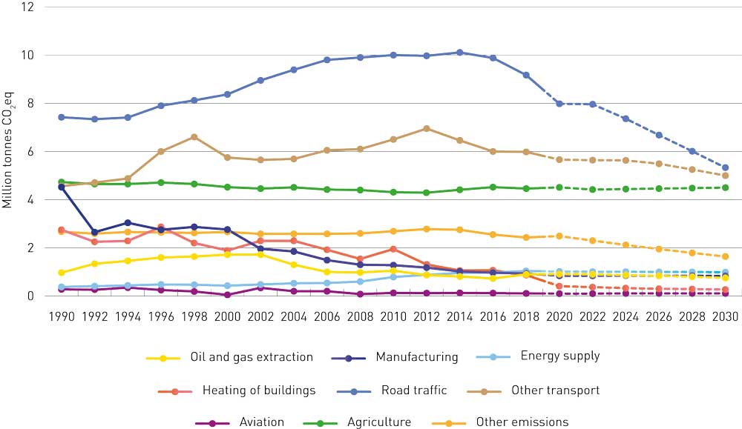
          - Historical emissions and projections, non-ETS emissions (million tonnes CO2eq)
Statistics Norway, Norwegian Environment Agency and Ministry of Finance
Assuming the continuation of current climate policy and policy instruments, and that demographic and economic trends and the pace of general technological advances are close to what is expected up to 2030, both in Norway and internationally, a continued reduction in emissions is projected up to 2050. However, the level of uncertainty is high, and the projections must therefore be considered as a rough approximation. Technological advances from year to year and other improvements in efficiency are expected to outweigh the effects of economic and population growth. In addition, lower emissions from oil and gas production and further steps to phase out the use of fossil energy for heating and transport purposes are expected to play a part in reducing emissions. The overall conclusion is that emissions will be roughly halved in 2050 compared with the current level. The projections are uncertain, and the level of uncertainty increases over time.

Policy instruments to reduce emissions

The rationale for Norway’s use of policy instruments
The policy instruments Norway uses are intended to contribute towards emission targets at the lowest possible cost to society. One implication of following the principle that policy instruments should be used effectively is that the Government will use specific policy instruments in the situations where they are most suitable.
The main instruments of Norwegian climate policy are cross-sectoral: taxes on greenhouse gas emissions and emissions trading. Both these instruments put a price on emissions and make it more expensive to release greenhouse gases. Taxes provide an incentive to reduce emissions both through immediate action and through investment in research and development that will make it possible to reduce emissions at a later date. Pricing of emissions is particularly effective when zero- and low-emission solutions have reached the market or are nearing market introduction. Emission pricing makes such solutions more attractive to consumers and businesses relative to solutions that result in higher emissions. Raising carbon taxes will promote efficiency and encourage a shift from car use to walking, cycling and use of public transport.
In addition to instruments that put a price on emissions, the Government will use other policy instruments to reduce barriers and correct market failures related to technology development, and in specific markets. Current examples include support for technology development and innovation in all sectors through Enova and Innovation Norway, the use of climate-related requirements in public procurement processes, and the prohibition on the use of mineral oil to heat buildings.
It can be appropriate to use direct regulation on its own when an alternative technology or a different solution is mature enough to be deployed. For example, legislation has been introduced prohibiting the use of mineral oil for heating and the landfilling of biodegradable waste. This is a particularly appropriate way of dealing with emissions that are not easily taxed.
Which policy instruments are suitable and where depends partly on which low- and zero-emission alternatives are available and how mature they are. Different forms of market failure and barriers require different combinations of policy instruments.
During the development of a technology, when solutions are not yet mature and costs are still high, it is important to improve the technology and drive down costs. The most important policy instrument at this stage is support for research, development and innovation on zero- and low-emission solutions. Norway is dependent on technological advances to achieve its targets. Without public support, there will be too little investment in these activities.
Once there are mature research results, the purpose of grants is to make it possible to speed up and scale up pilot and demonstration projects and full-scale testing, so that technology costs are reduced and solutions reach the market more quickly. In this phase, innovative procurement can also play a part in accelerating technology development.
As technologies and solutions mature, it is important to increase market volumes so that new solutions can be deployed and play a part in reducing emissions. As a small country, Norway is dependent on being able to deploy technologies developed in other countries.
Policy instruments for specific sectors are discussed in later chapters.

Raising taxes on greenhouse gas emissions between 2021 and 2030
The Government will:
- Gradually raise taxes on non-ETS greenhouse gas emissions to approximately NOK 2 000 per tonne CO2eq in 2030. The state revenue from these increases will be used to reduce other taxes.
- Assess the effects and impacts of introducing a tax on mineral fertiliser, and how it could be introduced. The purpose of the tax would be to reduce nitrous oxide emissions.
The Norwegian taxation system currently includes three climate-related taxes on non-ETS emissions. The first is the carbon tax on mineral products, which is levied on fossil energy products such as petrol, diesel, LPG and natural gas. The tax applies to all use of these products for road traffic, and also for other transport such as domestic shipping and aviation. This tax also applies to the use of the same products in agriculture, fisheries less than 250 nautical miles from the coast, the construction industry and manufacturing industries that are not covered by the EU ETS. The second climate-related tax is the tax on all production and import of the greenhouse gases HFCs and PFCs. Thirdly, the carbon tax on emissions from petroleum activities on the Norwegian continental shelf applies to non-ETS emissions of natural gas from petroleum extraction.
              - Climate-related taxes
A climate-related tax puts a price on greenhouse gas emissions, and its purpose is to reduce these emissions. Taxes are effective climate policy instruments provided that they can be designed to target emissions accurately. This will ensure that economic operators have to pay for their emissions and have an incentive to reduce them.
Taxes also provide incentives to avoid behaviour that will increase greenhouse gas emissions, since this will also increase costs. An accurately targeted tax is also a cost-effective policy instrument. A tax on greenhouse gas emissions gives stakeholders an incentive to take action to reduce emissions provided that the cost per emission unit of the measures they use is lower than the tax rate. The damage caused by greenhouse gas emissions is the same irrespective of where they originate, who is responsible for the emissions, and which activity causes them. For a climate-related tax to be cost-effective, everyone must pay the tax at the same rate per emission unit. This means that the tax base must be broad, and that reduced tax rates and exemptions for certain stakeholders or industries should be avoided. Norway’s current climate-related taxes apply to almost all uses of fossil fuels that result in non-ETS emissions, and are the most important policy instrument in the Government’s toolbox for reducing these emissions.
[Boks slutt]
Emissions that are not subject to the carbon tax nor included in the ETS originate largely from the agricultural sector, and consist of methane and nitrous oxide. They include roughly 480 000 tonnes CO2eq in the form of emissions of nitrous oxide from the use of mineral fertilisers. From 1988 to 1999, Norway levied a tax on phosphorus and nitrogen in mineral fertiliser, but this was discontinued in 1999. At the same time, it was decided as part of the Agricultural Agreement to introduce a system of environmental programmes in agriculture. A grant scheme for environmentally friendly manure application has been established. Grants are also available for impermeable covers for manure storage facilities and for increasing the capacity of such facilities. Norway has adopted regulations relating to fertiliser products of organic origin, which govern the storage and application of livestock manure. The regulations are being revised with the aim of introducing stricter rules to reduce releases to air and water. Emissions of nitrous oxide from mineral fertilisers have remained more or less stable since the tax was abolished.
Norway’s Green Tax Commission recommended the reintroduction of the tax on mineral fertiliser to reduce releases of nutrients and greenhouse gases. The Commission was of the opinion that a tax on the nitrogen content of mineral fertiliser on climate-related grounds would result in more cost-effective adaptation. If the tax were to be reintroduced, the costs incurred by the agricultural sector would be incorporated into calculations of farmers’ incomes. These are used as a basis for determining the budgetary framework for the negotiations on the annual Agricultural Agreement. The letter of intent signed by the Government and the agricultural sector is intended to give genuine, adequate reductions in emissions in the period up to 2030. If there is insufficient progress, the Government will consider the introduction of new policy instruments. The Government will therefore assess the introduction of a tax on mineral fertilisers to reduce nitrous oxide emissions from soils. The assessment will look at the possible effects of the tax both on greenhouse gas emissions and on agricultural production, other effects, and how the tax could be introduced.
In recent years, the Government has increased tax rates and also worked systematically to widen the tax base, so that a larger share of emissions is taxed. In the 2021 National budget, the Government proposed the introduction of a tax on waste incineration. With this, more than 70 % of Norway’s non-ETS emissions will be subject to taxation in 2021.
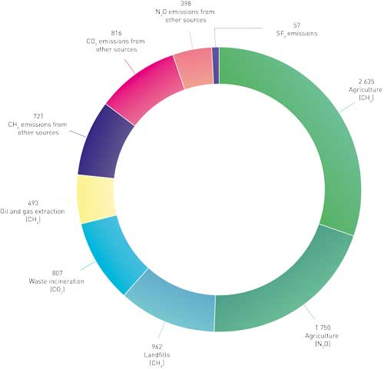
          - Sources of non-ETS greenhouse gas emissions that are not priced, 2019. Emission figures from 2018 (in 1000 tonnes CO2eq)
Ministry of Finance, Statistics Norway and Norwegian Environment Agency
The Government has also initiated an assessment of a tax and other policy instruments targeting SF6 emissions. This is further discussed in Chapter 3.7. The Government will also consider making direct emissions of methane and non-methane volatile organic compounds (NMVOCs) from onshore petroleum installations subject to the carbon tax, provided that satisfactory measurement and calculation methodology is available.
The remaining non-ETS emissions originate from a variety of smaller sources, and taxation is probably not an appropriate instrument for reducing these emissions.
From 2021 to 2030, the Government will gradually increase the standard tax rate for non-ETS emissions to about NOK 2 000 per tonne CO2eq, measured in fixed 2020 NOK. This is an overall rise of about NOK 1 400 from the 2021 tax rate, and will be one of the most important steps for achieving Norway’s international obligations and the Government’s ambitions relating to climate change.
The overall increase in the tax rate and the rate for each specific year will need to be determined through the normal budgetary processes and assessed in the light of technological developments, but must ensure that emissions are reduced sufficiently. In this white paper, the effects of increasing climate-related taxes have been assessed on the assumption that a gradual year-by-year increase in tax rates up to 2030 will result in a linear increase in the effects. If tax rates are increased more rapidly earlier in the period, this may result in a greater anticipated effect on emissions. If increases in tax rates are delayed, the anticipated effect on emissions may be smaller. If technological advances are made more quickly than has been assumed and the cost of zero-emission solutions falls more rapidly than expected, it may be possible to achieve the same reduction in emissions with a lower tax rate. On the other hand, slower technological progress may result in smaller emission reductions than the current estimates.
The Government’s policy is not to increase the overall level of taxation. This means that any increase in a tax rate must be offset by corresponding reductions in other taxes, primarily for the groups affected by tax rises. In accordance with its political platform, the present Government has provided compensation for the rise in the carbon tax rate in the 2020 and 2021 budgets by reducing road use duty. Since a rise in the carbon tax in isolation results in higher fuel prices, road use duty has been reduced so that the rise in the carbon tax has not had consequences for people who drive petrol or diesel cars.
Road use duty is not levied in order to put a price on greenhouse gas emissions; its purpose is to put a price on other social costs of road use, such as accidents, congestion, noise, wear and tear on roads and emissions of particulate matter. But like the carbon tax, road use duty affects the sales price of petrol and diesel. A reduction in road use duty therefore counters the effect of a rise in the carbon tax. Estimates suggest that if the Government continues to compensate for increases in the carbon tax rate up to 2030 by reducing road use duty, this on its own would make the overall reduction in greenhouse gas emissions about 3 million tonnes CO2eq smaller than if no compensation was provided (see ‘Possible additional effects’ in Table 3.1). The Government has not yet come to a decision on whether to continue this compensation mechanism. Other tax-based compensation mechanisms will also be considered to avoid the counter-productive effect of reducing the effect of the carbon tax on emissions. The Government’s climate policy is intended to minimise the negative economic impacts on ordinary people. It must pay to reduce greenhouse gas emissions, but at the same time, climate policy must not entail unreasonable costs. Specific proposals for changes in the taxation system will be presented to the Storting in the annual budget proposals.
The increasing numbers of electric vehicles, technological advances and improvements in public transport mean that any future increases in fuel taxes will be less important for many people.
The policy the Government describes in this white paper puts Norway on track to exceed both its commitment to reduce non-ETS emissions by 40 %, as set out in the climate agreement with the EU, and Norway’s ambition of reducing non-ETS emissions by 45 %. As policy instruments are implemented, it will be easier to see their actual effect on emissions. It may therefore be necessary to adjust the use of policy instruments during the period 2021–2030.
On its own, a carbon tax rate of NOK 2 000 per tonne CO2eq would result in higher fuel prices. However, prices are also dependent on a number of other factors. Ten years provides plenty of time to adapt to higher tax rates. For example, more fuel-efficient fossil-fuel vehicles and improved, lower-cost electric vehicles will become available in the next few years. In addition, the Government is aiming for all new passenger cars to be zero-emission vehicles from 2025, and it has introduced policy instruments to facilitate this.
In the short term, higher climate-related taxes will increase costs for companies that use fossil fuels in production processes. The costs of transporting goods and passengers will also rise if fossil fuels are used for this purpose. The extent to which costs rise will vary between stakeholders and will also depend on how they adapt to rising costs. This in turn will depend on the availability and cost of climate-friendly technologies and alternative solutions. There is a great deal of uncertainty surrounding these factors, and it is therefore not possible to make precise estimates of the increases in costs. If businesses are exposed to international competition, a tax level exceeding that levied by Norway’s competitors will be a competitive disadvantage and may reduce their profitability. If a company already has a small operating margin, a rise in tax rates could ultimately result in its closure or a move to another country. The risk of such effects will depend on what competing countries do: the more ambitious their climate targets are, and the more effective the policy instruments they introduce, the lower the risk will be. Businesses that adapt to the new situation will have a competitive advantage over those that face higher costs because they generate pollution.
In the Government’s view, a tax level of about NOK 2 000 per tonne CO2eq will strike a good balance between its ambition to achieve emission reductions through domestic action and the need to take into account the profitability of the Norwegian business sector. Over a ten-year period, it is possible for the business sector to adapt to a higher tax level by switching to low-emission alternatives. Raising climate-related taxes gives people and businesses incentives to make environmentally-friendly choices, and is an important way of reducing Norway’s greenhouse gas emissions.

Regulatory measures
Norwegian legislation includes various acts and regulations that influence greenhouse gas emissions, and some that also influence carbon removals. There are some provisions that were adopted primarily to reduce greenhouse gas emissions, such as the prohibition on landfilling of biodegradable waste under the Pollution Control Act, and other more general legislation that has several purposes, including emission reductions. The Planning and Building Act is a good example of the second category.
Regulatory measures are environmentally effective policy instruments, and a suitable way of promoting the use of technologies and solutions that are already available. It is possible for example to include requirements for the use of zero-emission solutions in procurement processes, as is now being done for both ferries and local buses, or to prohibit the use of outdated solutions. An example of the latter is the prohibition on using mineral oil to heat buildings. Biofuel quota obligations have been introduced under the product legislation to ensure more use of biofuels in conventional vehicles.
Regulatory measures are a good supplement to general taxes in situations where for administrative or technical reasons it is not possible or desirable to impose taxes on emissions. Regulatory measures can also be an effective way of overcoming behavioural barriers that hinder the implementation of measures even if taxation makes them economically viable. The Government will make use of regulatory measures to reduce greenhouse gas emissions and promote the transition to a low-emission society where they are appropriate. Among other things, the Government will consider how section 7 of the Road Traffic Act can be used to give municipalities the authority to establish zero-emission zones on climate-related grounds. The Government is also announcing further biofuel quota obligations under the product legislation. If necessary, the Government will consider policy instruments in addition to the gradual increase of the carbon tax rate, including prohibiting the use of fossil fuels, to phase out their use for energy purposes in the manufacturing sector.
              - The Pollution Control Act and the Planning and Building Act
The Pollution Control Act provides the authority to regulate emissions in permits by setting requirements to conduct environmental impact assessments or to use the best available techniques (BAT), or by setting specific emission limits. Regulation of greenhouse gas emissions has been introduced for certain greenhouse gases in the manufacturing sector and the petroleum industry and for methane emissions from waste treatment. In addition, a number of regulations have been adopted under the Act that indirectly regulate greenhouse gas emissions, for example regulations relating to fertiliser products of organic origin and regulations prohibiting the use of mineral oil to heat buildings.
The Planning and Building Act also provides for the reduction of greenhouse gas emissions to be given priority in planning processes. For example, plans under the Act are required to incorporate climate change considerations through action to reduce greenhouse gas emissions and adapt to anticipated climate change, including through energy supply, land use and transport solutions. The central government planning guidelines on climate and energy planning and climate change adaptation make it clear that municipalities and counties are expected to give priority to reducing greenhouse gas emissions, for example by setting ambitious targets for emission reductions.
[Boks slutt]

Public procurement – how the public sector is leading the way in the green transition
The public sector is a major consumer, investor and economic operator. The sector influences the climate and environment both in Norway and internationally through purchases of products and services, the transport solutions it chooses, energy use, waste management, and requirements imposed on subcontractors. National, county and municipal authorities purchase goods, services and construction work worth around NOK 560 billion a year.
Including environmental and climate-related requirements in public procurement processes is an essential tool for reducing Norway’s greenhouse gas emissions, promoting green industrial development and stimulating demand for low-emission products and services. Green procurement of public transport services has been particularly important for the transition to environmentally-friendly transport.
There is good provision in the legislation for including environmental and climate-related requirements in public procurement processes. The Public Procurement Act requires the public sector to organise its procurement activities in such a way that they reduce harmful environmental impacts and promote climate-friendly solutions where relevant. Contracting authorities are also required to take lifecycle costs into account in each contract and to focus on reducing harmful environmental impacts and promoting climate-friendly solutions.
Costs may rise as a result of the inclusion of environmental and climate-related requirements in procurement processes; for example, transaction costs and purchase prices may be higher. Contracting authorities should therefore focus particularly on sectors and areas where the potential environmental benefits are particularly large or where public procurement can play an important part in developing the market for new climate- and environmentally-friendly solutions.
Areas where public procurement is a particularly suitable instrument for achieving Norway’s climate and environmental targets include transport, construction, the circular economy, food and food waste, plastics and hazardous substances. The Government will give priority to these areas, and describes how in the chapters on the relevant sectors. To clarify overall priorities for the contracting authorities, the Government will prepare an action plan for increasing the proportion of green public procurement processes and green innovation. Its purpose will be to simplify public procurement processes, make them more effective and professional, and make them a more targeted instrument for achieving the Government’s climate and environmental targets and supporting the green transition.

Support for technology development and early market introduction

The research and innovation system from research to market introduction
Norway is dependent on rapid technological advances and widespread use of new technologies to achieve its climate targets.
Norway has a well-developed research and innovation system with funding agencies that can support initiatives from research to market introduction of new technologies and solutions. The Research Council of Norway provides support for early-phase initiatives in research, competence development and innovation for the education and business sectors. It also funds the Centres for Environment-friendly Energy Research (the FME scheme) and Centres for Research-based Innovation (SFIs). Innovation Norway contributes to sustainable growth and exports through the grant scheme for environmental technology, the bioeconomy programme and other schemes such as innovation grants and innovation contracts. Objectives relating to sustainability and green solutions have been included in the assessment criteria for all of Innovation Norway’s funding schemes. Enova supports late-phase technology development and early market introduction. The Klimasats grant scheme supports projects to reduce greenhouse gas emissions and promote the low-emission transition at municipal and county level. SIVA (the Industrial Development Corporation of Norway) plays a part in the transition through its five Catapult Centres, where companies can develop new green solutions. The centres were established under the Norwegian Catapult Programme, and provide access to equipment for testing new services and products. This can drive the implementation of new green technologies and speed up market introduction. For example, the Sustainable Energy Catapult Centre at Stord in Western Norway has recently established a test centre for greener fuels and has test facilities for offshore wind power. Nysnø Climate Investments provides capital that can be invested in new, climate-friendly technology.
Cross-cutting initiatives have been established to streamline the pathway from research to market introduction. For example, the Pilot-E scheme involves cooperation between the Research Council of Norway, Innovation Norway and Enova on environment-friendly energy technology. The recently established Green Platform Initiative is intended to promote a green transition in the business sector, and involves cooperation between the Research Council of Norway, Innovation Norway, SIVA (the Industrial Development Corporation of Norway) and Enova.

Enova
A new four-year agreement between Enova and the Ministry of Climate and Environment came into force from 2021. The Government has given Enova a clearer climate profile for this period and adjusted its overall objective, which is now to contribute towards Norway’s emission reduction commitments and contribute to the transition to a low-emission society, as set out in the Ministry’s budget proposal for 2021.
Enova’s activities focus on late-phase technology development and early market introduction. Grants for late-phase technology development help to speed up the pace and scale of pilot and demonstration projects and full-scale testing, so that new technologies and solutions reach the market more quickly. Enova’s funding instruments will play an important part in reducing Norway’s non-ETS emissions by accelerating the early market introduction of climate-friendly technologies and solutions with the aim of them becoming the preferred solutions without government support in the long term. The transport sector will account for a large proportion of Enova’s activities, including support from the Zero-emission Fund. This is because the sector is responsible for a large volume of emissions and technology development is needed in heavy-duty vehicle segments, and because as time goes by more and more vehicle and vessel types and models will be ready for market introduction.
Effective funding instruments are vital in this work. The rolling four-year agreements between Enova and the Ministry and flexible, long-term funding through the Climate and Energy Fund give Enova a wide degree of freedom and flexibility to respond quickly to new opportunities and to support those projects that offer the greatest opportunities to influence developments. Given uncertainties about how rapid technology development may be in various sectors, freedom and flexibility within the framework of the four-year agreement will be extremely important in the years ahead.
The new four-year agreement for 2021–2024 specifies the objective of Enova and the fund more fully through two specific goals, which are to contribute to: a) reductions in non-ETS greenhouse gas emissions in the period up to 2030 and b) technology development and innovation that will be instrumental in reducing emissions during Norway’s transformation to a low-emission society by 2050. The agreement also specifies that Enova is expected to find good solutions that take into account the need for an effective energy system, since there are close links between the energy system and the emission reductions needed in the transition to a low-emission society.
Technology development and innovation will be needed in all sectors to reduce Norway’s emissions and achieve the transition to a low-emission society without adverse effects on welfare. This applies equally to the transport sector and to manufacturing industries. For example, sustained initiatives for technology development will be needed in manufacturing industries in the ETS sector so that they can achieve the transition. This is an area where technology development pathways may be very long, and the process needs new impetus now. Advances in technology in the next 10 years will be vital in achieving sufficient momentum by 2030 so that emission reductions continue after this.
Sufficient technology development in the non-ETS sector will also be needed to make it possible to reduce emissions in the period up to 2030. For example, there is still much to be done in the way of development and pilot projects before there are market-ready zero-emission solutions in heavy-duty transport segments and in shipping. To ensure that Enova’s activities are effective, it is therefore necessary to strike a good balance between short-term emission reductions and technology development that will make it possible to reduce emissions in the long term in all sectors.
The new four-year agreement with Enova is based on experience gained from earlier agreements, and makes use of Enova’s expertise and experience in designing funding instruments. The agreement puts Enova in a position to expand its current initiatives and to play an important part in achieving emission reductions and in Norway’s transition to a low-emission society.
The Government has increased allocations to Enova in several successive budgets, to about NOK 3.3 billion per year. The four-year rolling agreements provide a good framework for adjusting Enova’s activities as needed. The next opportunity will be in connection with the agreement period starting in 2025.

Halving transport emissions
The Government’s target is to halve emissions from the transport sector by 2030. Transport accounts for roughly 60 % of non-ETS emissions in Norway. Without deep cuts in transport emissions, it will be impossible to achieve the target of reducing non-ETS emissions by 45 % by 2030.
If emissions from the transport sector are to be cut by half, it must pay to choose emission-free vehicles. There is a large share of electric cars in sales of new passenger cars in Norway. In future, the Government intends to make zero-emission vehicles the natural preferred choice for heavy vehicles as well. Biofuels will be used to reduce emissions from petrol and diesel vehicles. At the same time, it must become even easier to choose to walk, cycle or take public transport. Initiatives for green shipping will be continued. Norway’s maritime industry is a leader in the green transition for a number of vessel categories. The Government intends to build on this.
Restructuring the transport sector will be a complex, demanding process. At the same time as reducing emissions, we must also ensure a good transport system for the general public and businesses. A number of policy instruments are in use and are producing results. The Government’s policy is designed to cut emissions in ways that take into account the stakeholders and commercial activities that are currently responsible for the emissions. The mix of policy instruments therefore combines higher taxation with incentives and support for low-and zero-emission solutions. It will be necessary to assess the scope and design of the various instruments during the period up to 2030 in the light of actual emissions and technology advances.
The Government will:
- Reduce non-ETS emissions from the transport sector by half by 2030 using the policy instruments presented in this climate action plan;
- Raise the taxation level for non-ETS greenhouse gas emissions to approximately NOK 2 000 per tonne CO2eq in 2030, measured in fixed 2020 NOK;
- Continue to provide incentives for phasing in zero-emission solutions for new vehicle sales;
- Use Enova to support technology development and early market introduction in the transport sector;
- Make use of public procurement processes to promote the development and deployment of zero- and low-emission solutions in the transport sector;
- Use regulatory measures, particularly emission standards, to reduce emissions from the transport sector;
- Use other instruments that are important for cutting emissions in the transport sector, including coordinated spatial and transport planning;
- Use the National Transport Plan 2022–2033 to support the ambition of reducing transport emissions by 50 %.
Phasing in zero-emission solutions in all vehicle categories
The Government will:
- Design policy instruments on the basis of the targets for zero-emission vehicles set out in National Transport Plan 2018–2029, which entails:
- Targeting incentives to choose zero- and low-emission solutions as clearly as possible and facilitating the achievement of the target for new car sales by 2025 to consist almost exclusively of zero-emission cars;
- Continuing to use the funding agency Enova to support technology development and early market introduction in the transport sector. This is particularly relevant for achieving the targets for large vans, long-distance coaches and other heavy-duty vehicles.
- Continuing to use public procurement processes to promote the development and deployment of zero-emission solutions. This is particularly relevant for achieving targets for local buses and for goods distribution in urban centres;
- Seeking to introduce requirements to ensure the use of zero-emission solutions in public procurement processes for new local buses from 2025. Ways of ensuring that requirements include buses running on biogas will be considered.
- Seeking to introduce requirements to ensure the use of zero-emission solutions in public procurement processes for passenger cars and small vans from 2022;
- Assessing the possibility of including requirements for zero-emission solutions in public procurement processes for large vans, long-distance coaches and trucks;
- Facilitate the rapid development of charging infrastructure throughout the country using a combination of policy instruments and market-based solutions to keep pace with the expanding use of electric modes of transport;
- Set requirements for parking spaces in new buildings and buildings that undergo major renovation to be electric vehicle ready.
              - Targets for zero-emission vehicles in Norway’s National Transport Plan
Norway’s National Transport Plan 2018–2029 sets out a number of targets for new zero-emission vehicles:
- All new passenger cars and small vans are to be zero-emission vehicles from 2025;
- New local buses are to be zero-emission vehicles or run on biogas from 2025;
- By 2030, all new large vans, 75 % of new long-distance coaches and 50 % of new trucks are to be zero-emission vehicles;
- By 2030, goods distribution in the largest urban centres is to be virtually emission-free.
The targets are based on the assumption that zero-emission technologies in the different transport segments will mature so that they become competitive with conventional solutions.
[Boks slutt]
Biofuels
The Government will:
- As a minimum, maintain the current sales volume of biofuels;
- Seek to introduce a biofuel quota obligation for offroad diesel from 2022, which will gradually be increased up to 2030 to the same level as for road traffic;
- Seek to introduce a biofuel quota obligation for shipping from 2022;
- Seek to combine the biofuel quota obligations for road traffic and offroad diesel, and assess whether the same proportion of biofuels could be made applicable to shipping;
- Gain experience of application of the new advanced biofuel quota obligation for aviation before considering whether to increase the proportion of advanced biofuel required;
- Consider the proportion of biofuels required by the biofuel quota obligations every two years, and make adjustments if appropriate, starting in 2022. The need for emission cuts must be weighed against price, biofuel availability, risk of deforestation, Norway’s obligations under international law and trade policy interests.
- Consider the use of various instruments to ensure that a rise in sales of biofuels as a result of the gradual increase in the carbon tax rate does not lead to rising global emissions.
Action plan for fossil-free construction sites in the transport sector
The Government will:
- Present an action plan for fossil-free construction sites in the transport sector; this will include:
- initiating pilot projects for fossil-free construction sites to be run by the subordinate agencies of the Ministry of Transport;
- making use of requirements in public procurement processes as a means of reducing emissions from construction sites in the transport sector, with a view to facilitating a transition to fossil-free construction sites by 2025;
- initiating an assessment of requirements and goals for fossil-free construction sites in the transport sector;
- considering instruments to ensure effective management of bulk materials such as soil and gravel from construction sites in the transport sector;
- reviewing the external costs of construction activities other than CO2 emissions.
Climate action at local level
The Government will:
- Consider adjustments to the provisions on low-emission zones so that they can also be established on climate-related grounds;
- Consider the use of the legal authority provided by section 7 of the Road Traffic Act to establish zero-emission zones on climate-related grounds, initially in the form of a pilot project in a few cities. Zero-emission zones must not include trunk roads/national roads.
- Contribute to the development of methods for more accurate quantification of how land-use change and changes in transport systems affect traffic volumes and trends in land use in urban areas. This is intended to simplify sustainable land-use and transport planning by the municipalities;
- Require central government agencies to attach importance to the environmental benefits of re-using already developed areas and existing buildings, and of siting their premises near public transport nodes and the centre of towns and urban areas, in line with central government planning guidelines for coordinated housing, land use and transport planning;
- Make it clear that in urban areas, reductions in greenhouse gas emissions, traffic congestion, air pollution and noise should be brought about by effective spatial planning, and that public transport, cycling and walking should be used to meet the growth in the volume of passenger transport;
- Call on the municipalities to use existing instruments to take climate and environmental issues into account in urban areas.
Shipping and fishing vessels
The Government will:
- Maintain its ambition of reducing emissions from domestic shipping and fishing vessels by half by 2030 compared to the 2005 level, and continue to develop policy instruments and assess new instruments as needed to achieve this;
- Consider the use of climate-related requirements in public procurement processes for maritime transport services, with a view to introducing them in 2023;
- In the course of 2023, introduce criteria concerning zero- and low-emission solutions, where feasible, for new procurement processes for ferry services;
- In the course of 2025, introduce criteria concerning zero- and low-emission solutions, where feasible, for all procurement processes for high-speed passenger vessel services;
- Continue to provide support to the counties so that they can promote zero- and low-emission solutions for ferries and high-speed passenger vessels;
- Introduce requirements for zero- and low-emission solutions for aquaculture service vessels, to be phased in gradually from 2024 where feasible;
- In 2021, present a plan to the Storting (Norwegian parliament) in response to its decision requesting the Government to propose ways of ensuring the introduction of zero- and low-emission solutions for offshore support vessels; this will include assessing new requirements to be phased in from 2022;
- Continue to play a leading role in the work of the International Maritime Organization (IMO) on reducing greenhouse gas emissions.

Emission trends, targets and ambitions
In 2019, non-ETS greenhouse gas emissions from the transport sector totalled roughly 14.3 million tonnes CO2eq, see Figure 3.9. This was a reduction of 2.5 million tonnes CO2eq or 14 % in the period 2014–2019.
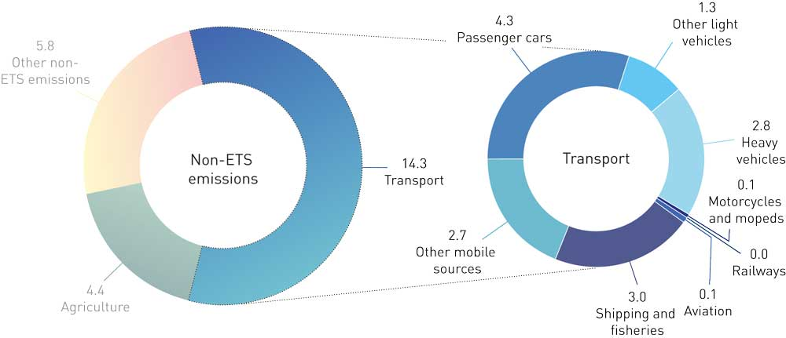
          - Non-ETS emissions from transport in 2019, in million tonnes CO2eq.
Statistics Norway and Norwegian Environment Agency.
Emissions from the transport sector are largely non-ETS emissions, with the exception of aviation emissions, which are mainly in the ETS sector. Aviation emissions are further discussed in Chapter 5.7. In 2019, non-ETS transport emissions were 2 million tonnes CO2eq higher than in 1990 but 1.2 million tonnes below the 2005 level.
Emission trends vary from one transport segment to another. The largest source of transport emissions is road traffic, and emissions from this segment were reduced by 7.3 % from 2018 to 2019. Passenger cars are still the largest source of transport emissions, but emissions are declining with the increasing use of biofuels and the significant increase in electric vehicle use. It will take some time before the full effects of electric vehicle use become apparent in Norway’s emission inventory.
              - Mitigation analysis for Norway 2021–2030: main findings for transport
A new mitigation analysis for Norway 2021–2030 has considered 32 different measures to reduce emissions in the transport sector. These measures give an additional emission reduction potential of about 22 million tonnes CO2eq over the period 2021–2030, compared with the projections presented in the 2021 National Budget. This includes 9.6 million tonnes CO2eq from road transport, about 5.9 million tonnes CO2eq from non-road mobile machinery and other transport and about 6.5 million tonnes CO2eq from shipping, fisheries and aquaculture.
The measures considered include action to reduce transport volumes and to increase the use of alternative propulsion technologies. For road transport, battery-electric propulsion is considered to be the technology in market introduction at present, but hydrogen technology may become an alternative for the heaviest trucks, tractor units and long-distance coaches in future. In the shipping sector, the variety of vessel categories and operating patterns means that a number of technological solutions may be of interest. For example, battery-electric solutions are suitable for ferries used on short routes with fixed times for port calls, while energy carriers such as hydrogen, ammonia and biofuels are more suitable for segments where vessels sail longer routes further out to sea, such as the cargo segment. All increases in the use of biofuels in the measures considered are based on advanced biofuels, i.e. biofuels produced mainly from waste and residual materials, not from food and fodder crops. The analysis assumes that global production of advanced biofuels will be sufficient to meet increased demand in Norway, but that prices will rise leading up to 2030.
[Boks slutt]
According to the projections presented in the 2021 National Budget, non-ETS emissions from the transport sector are expected to be reduced from 14.3 million tonnes CO2eq in 2019 to 10.4 million tonnes CO2eq in 2030 – a reduction of roughly 27 %. The projections are based on the assumption that current policy instruments are maintained, including effective policy instruments targeting electric vehicles. The reduction in emissions will also be dependent on the availability of charging infrastructure for heavy vehicles. See Chapter 3.2 for more about the projections.
The Government’s ambition is to reduce greenhouse gas emissions in the transport sector by half between 2005 and 2030. This is expressed as a single-year target for 2030, see Box 3.1. The Government has also set a number of targets for sales of new zero-emission vehicles, see Box 3.6. Achieving these will require advances in technological maturity in various segments of the transport sector. The Government also has a specific ambition to reduce greenhouse gas emissions from domestic shipping and fishing vessels by half by 2030 compared with the 2005 level.
A steady trend towards halving of transport emissions by 2030 will be crucial for achieving Norway’s target of reducing non-ETS emissions by 45 %. Reducing emissions throughout the period 2021–2030 will mean that cuts have an effect in every year up to 2030, not only in 2030.
In the Government’s view, the policy instruments set out in this climate action plan could reduce overall non-ETS emissions by 12 million tonnes over the period 2021–2030 compared with the current baseline projections. Figure 3.10 shows the calculated emission trajectory for non-ETS transport emissions if the Government’s climate action plan is implemented.
The Government intends to specify that all new local buses are to be zero-emission vehicles or run on biogas by 2025 by making this a general requirement in all public procurement processes from 2025. This could reduce emissions by about 1 million tonnes CO2eq over the period 2025–2030.
The Government also intends to introduce national zero- and low-emission criteria in new procurement processes for ferries and high-speed passenger vessels, where feasible, from 2023 and 2025 respectively. In addition, requirements for zero- and low-emission solutions for aquaculture service vessels are planned to be introduced gradually from 2024 onwards where feasible. In total, this could reduce emissions by up to 2 million tonnes CO2eq over the period 2021–2030.
The Government will maintain the current sales volume of biofuels by increasing the biofuel quota obligation for road traffic. This could reduce emissions by about 2.7 million tonnes CO2eq over the period 2021–2030 compared with the level expected without any change in the required percentage of biofuels and declining sales of liquid fuels. The Government also intends to introduce a biofuel quota obligation for offroad diesel from 2022, which will gradually be increased up to 2030 to the same level as for road traffic. This could cut emissions by an additional 2.8 million tonnes CO2eq over the period 2021–2030. In addition, the Government intends to introduce a biofuel quota obligation for shipping from 2022.
The Government will gradually increase the carbon tax rate to NOK 2 000 per tonne CO2eq, which could reduce emissions from the transport sector by about 3.5 million tonnes CO2eq over the period 2021–2030. This is based on the assumption that the carbon tax is raised steadily through the ten-year period.
Halving transport emissions means that in 2030, they must be reduced to a total of about 7.7 million tonnes CO2eq. As mentioned above, according to the projections presented in the 2021 National Budget, non-ETS emissions from the transport sector are expected to be reduced to 10.4 million tonnes CO2eq in 2030. This leaves an emissions gap in 2030 of about 2.7 million tonnes CO2eq. In all, the emission reductions outlined above will keep Norway on course to reduce transport emissions by roughly half by 2030 compared to the 2005 level.
The targets for zero-emission vehicles set out in the National Transport Plan 2018–2029 are to be maintained, and the Government will design the policy instruments described in this climate action plan so that they can be achieved. Achieving these targets will reduce emissions by more than the calculations show. Since it is not possible to quantify tax design or funding available through grant schemes precisely for each year up to 2030, it is impossible to make a direct assessment of the effects of the policy instruments on emissions. Furthermore, the integrated urban land-use and transport agreements for Norway’s largest urban areas, the Government’s action plan for fossil-free construction sites in the transport sector, and other instruments with a substantial effect on greenhouse gas emissions will produce greater emission reductions than the figures calculated in this plan.
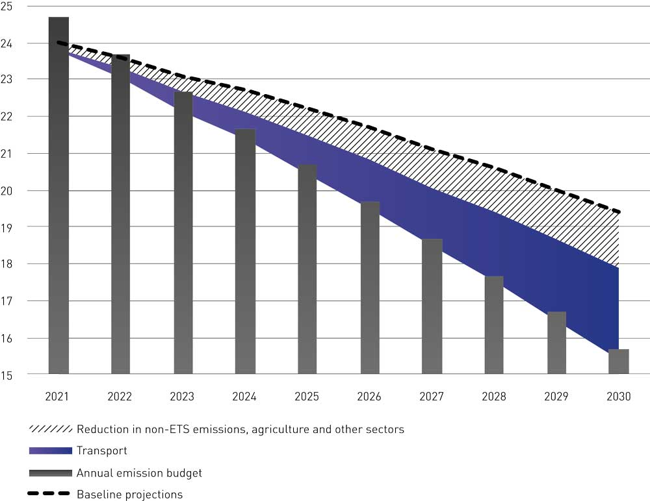
          - Emission trajectory for non-ETS transport emissions (in million tonnes CO2eq) under the Government’s climate action plan.

Policy instruments
In this white paper, the Government is presenting instruments to reduce non-ETS emissions from the transport sector by half by 2030. These instruments are also designed to achieve the targets for new zero-emission vehicles set out in the National Transport Plan 2018–2029.
Almost all action taken in the transport sector will influence greenhouse gas emissions. A number of policy instruments have been introduced with the specific aim of reducing emissions. There are also many instruments that are not primarily designed to cut greenhouse gas emissions but that may nevertheless have an effect on them.
The Government is working along several tracks to reduce transport emissions. Firstly, more low- and zero-emission vehicles and vessels are being phased in. Secondly, climate-friendly fuels are being phased in for fossil fuel vehicles and vessels. Thirdly, coordinated spatial and transport planning is being used to reduce overall transport needs and facilitate more public transport use, cycling and walking.
Various types of action are proposed to speed up emission reductions for different vehicle and vessel categories in line with the targets that have been adopted. These involve maintaining or modifying policy instruments, or in some cases introducing new ones. At the same time, it is important to consider the overall effects of policy instruments, both as regards particular vehicle and vessel categories and as regards the overall approach for the transport sector. Policy instruments work together: some supplement each other or can be used as alternatives, some reinforce each other, while certain instruments are mutually exclusive. All vehicle and vessel categories will be affected by real increases in fuel taxes as the carbon tax rate is raised. The extent to which other policy instruments, particularly grant schemes, are used will also depend on these tax rates. Using requirements in legislation may limit opportunities for using grant schemes.

The carbon tax
The carbon tax rate is the main policy instrument for reducing greenhouse gas emissions from the transport sector. All transport emissions are currently subject to the carbon tax on mineral products, meaning that emissions are priced equally across vehicle and vessel categories. The extent of emission reductions and how they are made will to a large extent depend on the market.
The Government intends to make stepwise increases in the carbon tax to approximately NOK 2 000 per tonne CO2eq in 2030, see Chapter 3.3.2. This will provide a stronger incentive to choose low-emission forms of transport.
What effect does this policy instrument have on emissions, and what is its cost?
A higher carbon tax rate affects emissions primarily through increases in fossil fuel prices and stronger incentives to choose zero-emission technologies or for example make more use of public transport. For households and companies that do not use zero-emission vehicles, a carbon tax rate of NOK 2 000 may mean higher costs.
To encourage technological development and market introduction in transport segments where emission-free alternatives are not yet mature, the Government sees a need to continue using other policy instruments to supplement the carbon tax, such as subsidies and grants.

Vehicle taxes
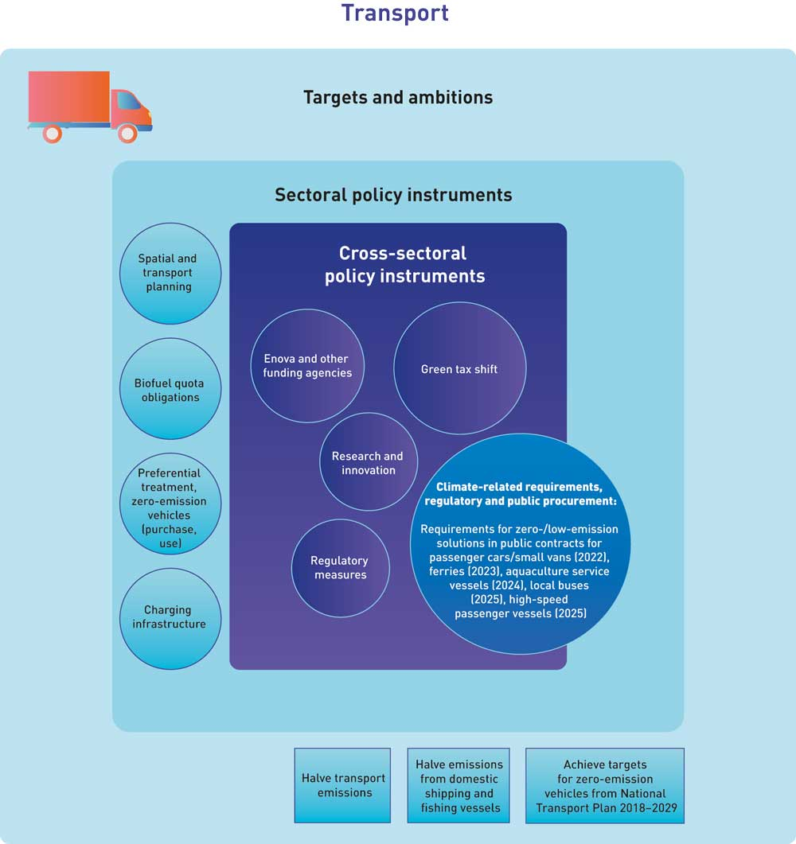
          - Policy instruments designed to reduce non-ETS transport emissions. Advances in technological maturity in various segments of the transport sector will be required to achieve the targets set out in the National Transport Plan 2018–2029. Requirements for shipping will be introduced only where conditions are feasible.
In recent decades, vehicle taxes have been used to encourage a shift towards zero- and low-emission vehicles in Norway. For example, CO2 and NOX components have been included in vehicle registration taxes, and various tax exemptions have been introduced for zero-emission vehicles. This policy has been effective, resulting both in more lower-emission conventional vehicles and in substantial progress in phasing in hybrid and zero-emission vehicles. Norway has therefore made good strides in reducing the average emission intensity of passenger cars. In the updated cross-party agreement on climate policy, the Storting adopted the target that emissions from new passenger cars should not exceed 85 g CO2/km in 2020. This target was reached well before 2020. In 2019, emissions from new passenger cars averaged 60 g CO2/km. Figure 3.12 shows 2018 emissions from new passenger cars in various European countries.
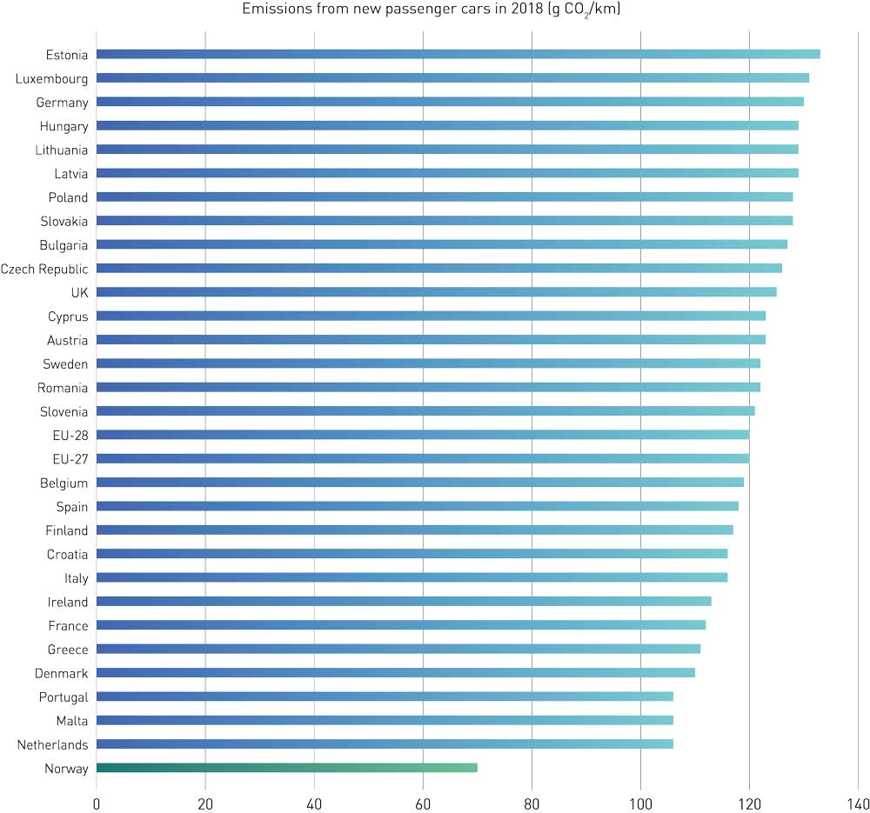
          - Emissions from new passenger cars in 2018 (g CO2/km)
Norwegian Environment Agency
In 2019, CO2 emissions from passenger cars in Norway were 21.4 % lower than at their peak in 2010. About 10 % of passenger cars in Norway are now zero-emission vehicles, and more than half of all new passenger cars are zero-emission cars. No country has a larger share of zero-emission cars than Norway. For the period up to 2025, vehicle taxes and other policy instruments will be designed to facilitate achievement of the target for new car sales by 2025 to consist almost exclusively of zero-emission cars.
Originally, the primary purpose of vehicle taxes was to generate state revenue. In addition, taxes on the use of vehicles are intended to put a price on the external costs of their use. The transition to zero-emission vehicles, brought about in part by tax exemptions, has led to a steep drop in state revenue from vehicle taxes. In addition, the external costs of vehicle use other than CO2 emissions are either not priced or not accurately priced. Norway’s current system of vehicle taxes is therefore not sustainable with respect to either revenue or environmental considerations. In the years ahead, the system will need to be reorganised to rectify this.
In the 2021 National Budget (Meld. St. 1 (2020–2021)), the Government presented principles for designing a future vehicle tax system. A sustainable vehicle taxation system must put a price on the external costs of using vehicles. It must include taxes on the purchase and ownership of vehicles, be built on a stable tax base, and be designed to be as technology-neutral as possible. A sustainable vehicle taxation system must also be designed to be equitable. The principles set out in the National Budget indicate how vehicle taxation should be designed from 2025. In the next few years, vehicle taxes should be gradually changed to follow these principles.
CO2 emissions from road traffic must be further reduced, and the Government is therefore maintaining the targets for the introduction of zero-emission vehicles, expressed as shares of new vehicles sold, as set out in the National Transport Plan 2018–2029. This means that vehicle taxes and other policy instruments must continue to provide incentives for reducing CO2 emissions and phasing in zero-emission vehicles. Until the transition to zero-emission vehicles is complete, a balance must therefore be struck between the sustainability of the vehicle taxation system and achieving the targets for zero-emission vehicles set out in the National Transport Plan 2018–2029.
Changes to Norway’s vehicle taxes are considered as part of the annual budgetary processes. The speed of the transition to a sustainable vehicle taxation system must be assessed taking into account how the changes will affect state revenue, the environment and other political objectives. The Government will therefore propose specific changes to vehicle taxes in future national budgets.
What effect does this policy instrument have on emissions, and what is its cost?
Vehicle taxes can be divided into taxes on vehicle purchase, ownership and use. Taxes on purchase and ownership can be used to influence the size and composition of the vehicle fleet in Norway. Zero-emission vehicles are exempt from both VAT and the registration tax, which provides a strong incentive to purchase such vehicles. In addition, the CO2 component of the registration tax means that vehicles with high CO2 emissions are taxed more heavily those with low CO2 emissions, creating an incentive to purchase conventional vehicles with low emissions. The road traffic insurance tax is also lower for zero-emission vehicles, adding to the incentives to own electric vehicles.
Putting a price on the external costs of using vehicles, such as CO2 emissions, requires taxes on use. The most important taxes on vehicle use in Norway are the carbon tax on mineral products and the road use duty on fuel. The carbon tax puts a price on CO2 emissions, while the road use duty puts a price on other external costs of vehicle use such as accidents, congestion and noise. Fuel taxes do not apply to zero-emission vehicles, but electricity for electric vehicles and plug-in hybrids is subject to the electricity tax. The fuel taxes create an incentive to reduce the use of conventional vehicles and choose fuel-efficient or zero-emission vehicles. However, since there is no road use duty for zero-emission vehicles, the external costs of their use have not been priced.
Overall, Norway’s vehicle taxes create strong incentives to choose zero-emission vehicles. The Institute of Transport Economics has estimated that if all CO2-differentiated taxes and grant schemes are included, the implicit carbon price for passenger cars in Norway was at least NOK 12 500 per tonne CO2 in 2019 and at least NOK 11 200 in 2020. According to the Institute, conservative estimates of the implicit carbon prices for the individual taxes were used throughout. Similarly, the Ministry of Finance has estimated that the overall tax incentives for electric vehicles amount to NOK 10 000–15 000 kroner per tonne CO2. This estimate is based on the carbon tax rate (present value) needed to provide just as strong an incentive to choose electric vehicles as the current preferential taxation. This estimate does not include the exemption from the registration transfer fee or financial advantages outside the taxation system such as exemption from or reduction of road tolls, car ferry prices and parking fees, and access to bus lanes. The figures are based on a simplified set of assumptions. In specific cases, level of support may be considerably higher or lower, depending on the specifications of the electric vehicles, the specifications of alternative vehicles with combustion engines, and driving patterns.

Funding instruments
Significant technology development will be needed in the transport sector in order to halve emissions by 2030. The Government’s proposals for increases in climate-related taxes will not be enough on their own to promote the technology development and deployment needed to achieve Norway’s ambition of halving emissions. Public funding for research, technology development and early market introduction will also be needed. The Government provides support through funding agencies including the Research Council of Norway, Enova, Innovation Norway and the Klimasats grant scheme.
Enova is the main funding agency the Government uses to support technology development and early market introduction of green solutions. The Government has given Enova a clearer climate profile in the agreement for the next four-year period, see Chapter 3.3.5. Enova is relevant for all sectors, but in the years ahead will mainly target the sectors with the largest emissions and the greatest need for technology development. This applies particularly to heavy vehicle and vessel categories. Enova will also be important in supporting the development of infrastructure for zero-emission fuels for vehicles and vessels, in the early phase when public funding is necessary.
Since 2016, Enova has provided roughly NOK 900 million per year in funding for transport sector projects. In the maritime sector, Enova supports the establishment of charging infrastructure for zero- and low-emission ferries and high-speed passenger vessels, the electrification of maritime transport, and the establishment of infrastructure for shoreside electric power in ports and on vessels. In the vehicle sector, Enova supports technology development for heavy vehicles, infrastructure for zero-emission fuels, public transport and the production of biogas and biofuels. Through the Zero-emission Fund for commercial transport, Enova promotes greater use of battery-electric, hydrogen and biogas solutions on land and at sea through early market introduction. As technology matures in more and more areas, this will be an important way of encouraging early market introduction, for example of zero-emission heavy vehicles.
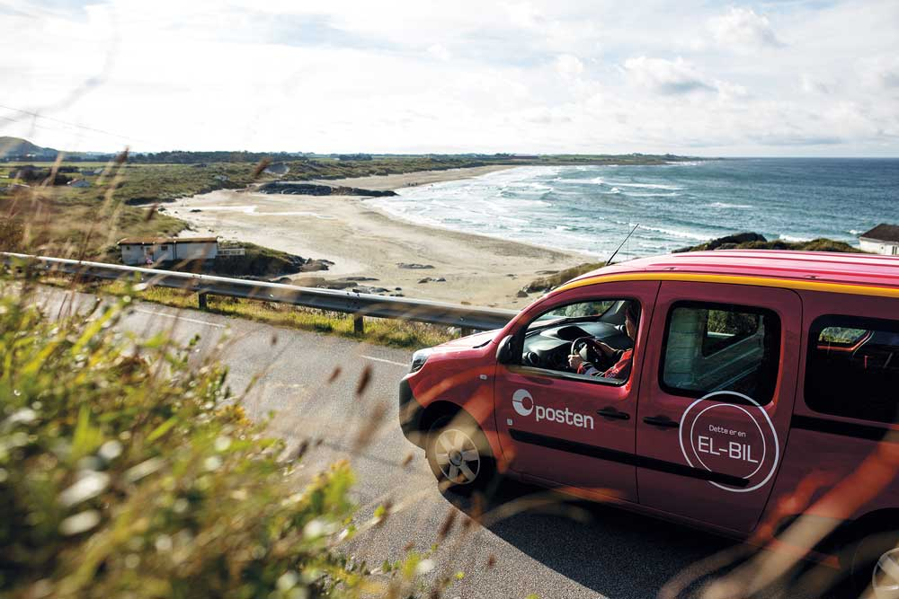

Photo: Norwegian postal service
The Klimasats grant scheme offers support to counties and municipalities for projects in areas including climate-friendly transport and climate-friendly spatial and transport planning. Klimasats funding has been awarded to projects to include requirements for low- and zero-emission solutions in county procurement processes for high-speed passenger vessels, the establishment of cycle parking at public transport nodes, electric vans, charging infrastructure for taxis, smart transport solutions, e-bikes for official use, and charging points for electric vehicles. Grants have also been awarded for planning and assessing climate-related measures and for networking to build expertise. The Klimasats grant scheme was established as a temporary scheme in 2016, and was to run for at least five years. The Government will continue the scheme in 2021 to ensure that support continues to be available for municipal and county efforts to cut greenhouse gas emissions.
              - The Klimasats grant scheme supports the transformation process at municipal and county level
Municipalities and counties play a key role in efforts to reduce greenhouse gas emissions. The state supports this important work at local government level, and has been providing funding for climate-related measures at municipal and county level since 2016. The Klimasats grant scheme contributes to emission cuts, raises awareness of possible measures, and increases demand for climate-friendly goods and services. The scheme has also moved climate higher up the agenda at local government level, and has provided funding for some 1 300 projects all across Norway since its inception in 2016. With support from Klimasats, important climate-related networks have also been established, which share expertise and make it easier to carry out climate-related measures across municipal borders.
In 2020, for example, the ports along the Oslo fjord (Oslo, Larvik, Drammen, Fredrikstad, Porsgrunn, Kristiansand and Moss) were awarded funding to assess ways of reducing greenhouse gas emissions from ports and maritime transport in the region. Cooperation makes it cheaper and easier for each municipality to find the most effective climate-related solutions. In addition, the project will generate valuable knowledge for other Norwegian ports.
Klimasats funding enables municipalities to purchase construction services that make use of zero-emission machinery still in the pilot phase, despite the extra costs. Now that the scheme has been running for several years, technologically advanced zero-emission solutions are being used at construction sites all across Norway. For example, Horten municipality has received funding for climate-friendly construction of a new upper secondary school, while Gjøvik municipality received support to make use of an electric tower crane and the world’s first all-electric 35-tonne excavator.
All the projects that have received Klimasats funding are listed on the website of the Norwegian Environment Agency.
[Boks slutt]
What effect does this policy instrument have on emissions, and what is its cost?
Financial support is used as a policy instrument in this context to promote technology development and early market introduction in segments where zero-emission alternatives are not yet mature. Funding schemes also trigger the implementation of measures that would be difficult to realise through taxation, such as spatial planning for a climate-friendly society. Support for investments in ambitious technology pathways lays a foundation for making emission reductions in the time ahead, after 2030 as well, and thus contributes to the long-term transformation process. For certain technologies, the time between concept and market standard is so long that it will be a major challenge for Norway to achieve its 2050 target unless this work is well underway by 2030.
The economic and administrative costs depend on how many projects receive grants and the level of funding. Optimally, grants should be designed to achieve emission reductions that are as cost-effective as possible, and to realise economically viable projects that would not otherwise have been feasible.

Biofuel quota obligations
Biofuels and biogas (see Chapter 3.5 on the action plan for biogas) reduce emissions by replacing fossil fuels in vehicles and vessels with combustion engines. The use of biofuels is important in reducing emissions from Norway’s transport sector, and in 2019 biofuel use resulted in a reduction of CO2 emissions by roughly 1.3 million tonnes in the national emission inventory.
              - Emissions from combustion of biofuels
Emissions from combustion of biofuels count as zero in the greenhouse gas inventory for the energy sector. If the raw materials are derived from the LULUCF sector, emissions from harvesting are accounted for in the LULUCF sector. If the raw materials are derived from agriculture, emissions count as zero since they are part of the short-term carbon cycle (lasting +/- one year). The use of biofuels is a sound mitigation measure if the raw materials are obtained from sustainable forestry or agricultural production. However, raw materials that contribute to deforestation are more problematic. The main concern is emissions from indirect land-use change in cases where production of raw material for biofuels displaces food production. This may in turn result for instance in clearing of rainforest to compensate for areas lost to food production.
[Boks slutt]
In Norway, biofuel quota obligations ensure that biofuels make up a certain proportion of overall fuel sales. There are currently no quota obligations for biogas. A biofuel quota obligation for road traffic was first introduced in 2009, and from 2017 there has been an additional requirement to include a certain proportion of advanced biofuels in the mix. The biofuel quota obligation has been gradually increased. On 1 January 2021 it was raised to 24.5 %, and the proportion of advanced biofuels to 9 %. For aviation, a biofuel quota obligation of 0.5 % advanced biofuels was introduced on 1 January 2020. Biofuels can be used in offroad diesel and for shipping as well as for road traffic and aviation.
The Government wants future increases in biofuel quota obligations for road traffic and aviation to be met primarily using advanced biofuels.
Sales of fossil petrol and diesel will decline in the years ahead, partly because there will be more zero-emission vehicles on the road. This means that over time, the volume of biofuels sold to meet a specific biofuel quota obligation as a percentage of sales will also decline, thus reducing their contribution to emission cuts. To counteract this, the Government plans to increase the biofuel quota obligation for road traffic in order to maintain a constant volume of biofuels up to 2030.
The Government also intends to introduce a biofuel quota obligation for offroad diesel from 2022, which will gradually be increased to reach the same level as for road traffic by 2030. In addition, the Government intends to introduce a biofuel quota obligation for shipping from 2022. The biofuel quota obligations for road traffic and offroad diesel should in future be combined into a single quota obligation. This will give market actors more flexibility to use biofuels where appropriate. The Government will assess whether the same biofuel quota obligation can be made applicable to shipping as well.
The Government will consider the proportion of biofuels required by the biofuel quota obligations every two years, and make adjustments if appropriate, starting in 2022. This will provide predictability for sellers and users of biofuels. The Government’s policy is that biofuel quota obligations will be further increased if this proves necessary for achieving the emission targets. At the same time, the need for increased use of biofuels must be assessed on the basis of price and availability, and biofuel use in Norway that would lead to rising emissions in other countries must be avoided. Norway’s biofuel use must be in line with its international legal obligations.
The Government will gain experience of application of the new advanced biofuel quota obligation of 0.5 % for aviation before considering whether to increase the percentage for this sector.
In this white paper, the Government presents a credible plan for achieving Norway’s 2030 climate targets through national emission cuts. There is considerable uncertainty relating to emission trends over the next ten years. Should it prove necessary during this period, adjustments to policy instruments will be considered. The level of emissions depends on many uncertain factors that may interact in unforeseen ways.
The biofuel quota obligations can be adjusted relatively quickly if emission trends make this necessary. In its annual reporting to the Storting under the Climate Change Act, the Government will assess implementation of this climate action plan and Norway’s progress towards the 2030 target. If progress is not satisfactory, the use of policy instruments must be adjusted as necessary. Such adjustments, together with purchases of emission allowances and any additional use of biofuels, will ensure that Norway achieves its climate targets.
The planned increases in the carbon tax will over time make biofuels more competitive relative to fossil fuels. How competitive they become and how quickly this happens will depend on price developments for both types of fuels. One effect of gradually increasing the carbon tax could be that in the longer term, the proportion of biofuel sold exceeds the quota obligations. When biofuels become more competitive than fossil diesel will depend on price developments for both biofuels and fossil diesel. Because there are technical blending limits for FAME biodiesel, it is likely that fossil diesel will first be replaced by conventional HVO biodiesel as the carbon tax is increased.
Conventional HVO biodiesel may be produced from raw materials that entail a higher deforestation risk, such as palm oil. Depending on future price developments, this type of HVO biodiesel may become competitive when the carbon tax reaches NOK 2 000 per tonne CO2eq. This applies to its use for road traffic, shipping and offroad diesel. The Government will consider the use of various instruments to ensure that a rise in sales of biofuels as a result of the gradual increase in the carbon tax rate does not lead to rising global emissions.
It is uncertain whether HVO biodiesel from other conventional raw materials that involve a lower deforestation risk will become cheaper than fossil diesel with the planned carbon tax increases. Should this type of biofuel become competitive for example by 2025, it could result in emission reductions of the order of 10–15 million tonnes CO2 over the period 2021–2030. However, new price assessments by the consultancy firm Argus indicate that this will not happen. When estimating the emission reductions brought about by implementing this climate action plan, the Government has not included the effect of any increase in biofuel use as a result of a rising carbon tax rate, see Chapter 3.1.2.
What effect does this policy instrument have on emissions, and what is its cost?
Biofuel quota obligations bring about rapid, reliable emission cuts in Norway. In 2019, sales of more than 600 million litres of biofuels were reported for road traffic, corresponding to 15 % of fuel sales by volume. Biofuels thus resulted in a reduction of 1.3 million tonnes in CO2 emissions as reported in the national emission inventory. The new requirement from 1 January 2021 will also yield a similar reduction in emissions. The increase in the biofuel quota obligation will shift sales from conventional to advanced biofuels. Because advanced biofuels count double towards the quota obligation, the change will not result in an increase in the total volume of biofuels. An increase in advanced biofuel use has a significant effect internationally, and also when the risk of indirect land use change (ILUC) is included in estimates of global emission reductions. The estimated global emission reductions from biofuel sales in 2019 were about 530 000 tonnes CO2eq when ILUC is included. For 2021, the equivalent figure is a reduction of 925 000 tonnes CO2eq.
Since advanced biofuels count double towards the biofuel quota obligation, the increase in the proportion of advanced biofuels to 9 % considerably restricts the share of biofuels involving a high deforestation risk that can be used in a blend. Also, from 1 July 2020, the scope of the road use duty was expanded to include all biofuels. This means that it does not pay in practice to sell a larger volume of biofuels than required by the biofuel quota obligation. These changes are important in ensuring that Norwegian imports of biofuels do not contribute to deforestation.
Raising the biofuel quota obligation for road traffic so that the sales volume of biofuels is maintained unchanged up to 2030 will increase the emission reductions from biofuels by about 2.7 million tonnes CO2eq over the period 2021–2030, compared to the estimated reduction if biofuel quota obligations remained unchanged while the volume of liquid fuels for road traffic declined. It is estimated that the introduction of a biofuel quota obligation for offroad diesel, to be gradually increased to the same level as for road traffic, will increase emission reductions from biofuels by an additional 2.8 million tonnes CO2eq in the period 2021–2030.
Thus, the overall effect of the increases in biofuel quota obligations presented by the Government in this white paper will be to reduce emissions by roughly 5.5 million tonnes CO2eq over the period. In addition, the Government intends to introduce a biofuel quota obligation for shipping.
For the authorities, the biofuel quota obligations will result in some administrative costs for inspection and enforcement. Users of biofuels will experience higher pump prices as a result of quota obligations, since biofuels are more expensive than fossil fuels. Biofuels vary in price, and advanced biofuels are costlier than conventional biofuels. In the mitigation analysis for Norway 2021–2030, the economic cost of using advanced biofuels is estimated at about NOK 2 000 per tonne CO2eq. Uncertainty is high, but according to the latest assessments, biofuel prices are expected to increase beyond this in the period up to 2030 as a result of rising global demand.
Raising the carbon tax rate will make biofuels more competitive against fossil fuels, but by how much and when is difficult to forecast. It is therefore difficult to assess whether biofuel sales towards the end of the period 2021–2030 will be a result of the need to meet biofuel quota obligations or of lower prices than for fossil fuels.
Economic impacts, including costs incurred by the public sector, companies and households, in addition to possible carbon leakage and the distributive effects of biofuel quota obligations, will be reviewed when changes are considered as mentioned above.
Figure 3.14 shows the shares of zero-emission vehicles in Norway’s vehicle fleet in 2017, 2018 and 2019. Conventional vehicles still make up a large majority of vehicles in all categories.
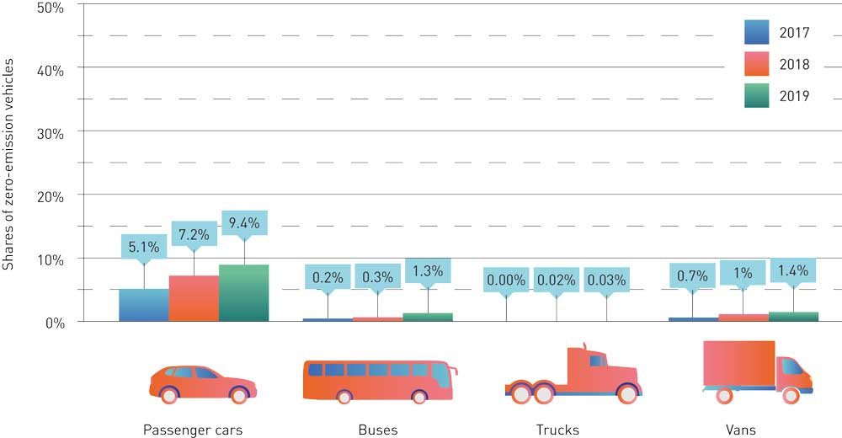
          - Zero-emission vehicles as shares of different categories of vehicles in Norway.
Sweco

Public procurement
The public sector purchases large volumes of transport services every year. By including climate-related requirements in procurement processes, the state can reduce emissions and encourage accelerated development of new technology. Procurement in this sector includes both transport services for the public and indirect transport through the purchase of goods and services. Public transport services include passenger transport such as bus, air, tram, train, ferry and high-speed passenger vessel services, and also waste collection, patient travel, school transport, and transport services for people who are unable to use public transport. Indirect transport includes the transport of goods and services and services including an element of transport.
The Government has set targets for public transport to be fossil-free by 2025, and for goods distribution in the largest urban centres to be emission-free by 2030. In addition, all new passenger cars and small vans are to be zero-emission vehicles from 2025. New local buses are to be zero-emission vehicles or run on biogas from 2025, and by 2030, all new large vans, 75 % of new long-distance coaches and 50 % of new trucks are to be zero-emission vehicles. See also Box 3.6.
In its political platform, the Government announced that requirements for zero-emission transport solutions would be included in public procurement processes whenever feasible. In a 2020 report, the Norwegian Government Agency for Financial Management and the Norwegian Environment Agency found that there is an unrealised potential for using the options available under the procurement legislation to apply minimum requirements and award criteria relating to zero-emission transport solutions, and to use contractual terms requiring gradual electrification.
In the procurement market for local buses, taxis, and tradesmen, services and goods transport that use vans, zero- and low-emission vehicles could be required to a much greater extent than is currently being done, since the technology is available.
The Government will therefore seek to introduce requirements to ensure the use of zero-emission solutions in public procurement processes for passenger cars and small vans from 2022. These requirements will be formulated so that extraordinary weather conditions and the like can give grounds for exemptions.
The Government will seek to introduce similar requirements for local buses from 2025, The design of these requirements will be considered to find ways of including buses running on biogas.
Norway’s regulations relating to environmental and energy requirements in procurement processes for vehicles for road transport apply both to the public sector and to companies that provide services for the public sector. The Government will initiate the process of amending the regulations and expanding their scope to include zero-emission requirements.
Zero-emission models of large vans, trucks and long-distance coaches are still considerably more expensive than conventional models. It will still be difficult for contracting authorities or suppliers to cover the extra costs without supplementary instruments such as grants. At present, the technology is not mature enough to be able to determine a timeline for introducing statutory zero-emission requirements for these vehicle categories, but this should be considered further. However, requirements will not be introduced until the technology in the various segments is sufficiently mature.
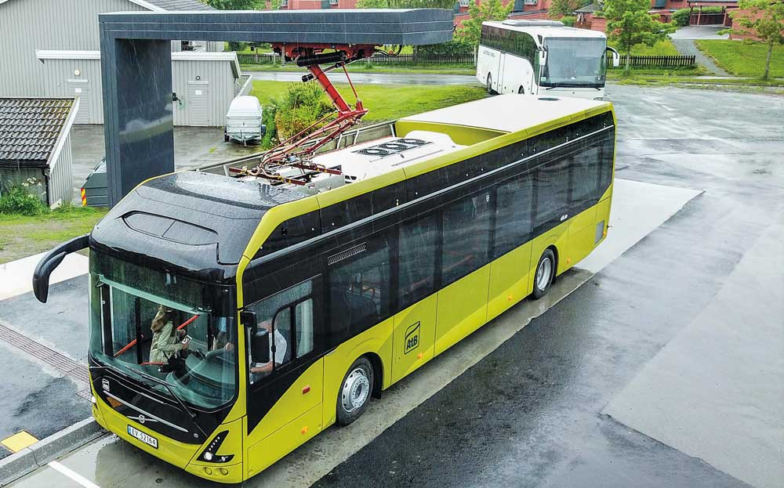

Photo: AtB
Zero-emission models of trucks, refuse collection vehicles and construction machinery are still significantly more costly than fossil-fuel models. Operating costs are lower for biogas vehicles, and the technology is more mature, so that they are a good low-emission option in the heavy vehicle segment. The Government will use public procurement as a tool for achieving large-scale increases in the shares of zero- and low-emission heavy vehicles, which in turn may reduce production costs and purchase prices in the long run.
In its action plan for fossil-free construction sites in the transport sector, the Government has announced that it will use requirements in public procurement processes as a means of reducing emissions from these construction sites. This will facilitate a transition to fossil-free construction sites by 2025. The Government will also consider the introduction of a more general requirement for construction sites to be fossil-free as part of its follow-up to the Storting’s request for an action plan. A pilot project for fossil-free construction sites will be initiated, to be run by the subordinate agencies of the Ministry of Transport, and the Government will consider instruments to ensure effective management of bulk materials from construction sites in the transport sector. Action to improve logistics and efficiency can reduce the need for transport at and around construction sites.
The Government is also working on the introduction of zero- and low-emission requirements and criteria in public procurement processes in the shipping sector for a number of vessel categories. See further information in Chapter 3.4.5.
As described in Chapter 3.4.2.4, the Government plans to introduce biofuel quota obligations for offroad diesel and shipping from 2022. Biofuel quota obligations contribute to emission reductions because fossil fuels are replaced by sustainable biofuels. Biofuel use intended to satisfy climate-related requirements in public procurement processes, and that is reported as part of biofuel quota obligations, is not considered to have any further effect on emissions beyond what is achieved by fulfilling the quota obligations.
What effect does this policy instrument have on emissions, and what is its cost?
Environmental and climate-related requirements in public procurement processes have a great deal of potential to accelerate the phase-in of zero- and low-emission technology in the transport sector. By creating high demand, the public sector can play a part in reducing production costs and market prices for new technology. Central government and county contracting authorities have already required the use of zero-emission technology in a number of public transport procurement processes. This has resulted in the deployment of new technology. Green procurement can thus be considered as investment in a technology, market or expertise that can yield cost-effective environmental benefits over time.
The emission reduction potential in the transport sector directly related to requirements in public procurement processes is estimated by the Norwegian Environment Agency and the Norwegian Agency for Public and Financial Management to be greatest for construction sites and bulk transport. The emission reduction potentials for the period 2021–2030 are estimated at around 1.1 million tonnes CO2eq for construction sites and about 0.5 million tonnes CO2eq for bulk transport (2020 report from the Norwegian Environment Agency and Norwegian Agency for Public and Financial Management).
Including such requirements may cause the economic and administrative costs to rise while the technology is still immature. In some cases, such purchases may entail more administration for the procurer. The additional costs of zero- and low-emission transport solutions vary widely, both between different vehicle segments and within each segment. In most cases, introducing new technology is costly and risky.
According to the mitigation analysis for Norway 2021–2030, electric passenger cars and small vans will become competitive with fossil-based transport solutions in the period 2022–2025. For buses, the cost will vary between different procurement processes. The county authorities are responsible for public transport in urban areas. According to the mitigation analysis, the purchase price of an electric bus is currently about twice that of a bus with a combustion engine. However, the operating costs of electric buses are about half those of conventional buses. This will entail higher costs for the counties for the first few years, but investment and operating costs for buses are likely to decline from about 2025 onwards. In the period 2016–2020, Enova provided approximately NOK 500 million in support for zero-emission buses and the necessary charging infrastructure. The Government will compensate the local government sector for any additional costs incurred as a result of the introduction of low- and zero-emission requirements for new passenger cars, small vans and local buses, provided that there is budgetary provision for this.

Other regulatory measures
User benefits for zero-emission vehicles
Economic incentives make it more attractive for people to choose climate-friendly solutions. User benefits for electric vehicles have been of key importance for the increase in the share of these vehicles in the vehicle fleet in Norway. These benefits include reduced road tolls, car ferry prices and parking fees, and access to bus lanes. The Government is currently working on provisions prescribing that electric cars are not to pay more than half the normal price for parking in municipal spaces. Current guidelines for road toll charges allow for lower rates or exemptions for zero-emission vehicles. Rates can be set locally for these vehicles at all toll stations, and may vary between 0 and 50 % of the standard rate minus any discount for a vehicle toll tag. Oslo and Viken counties are in the process of developing a similar system for exemptions and discounts for biogas vehicles.
Local authorities make the final decisions on user incentives for electric vehicles. The Norwegian Public Roads Administration monitors traffic in bus lanes and can if necessary engage in dialogue with local authorities on limiting access to these lanes for electric vehicles.
What effect does this policy instrument have on emissions, and what is its cost?
Numbers of electric vehicles are highest in areas where there are toll rings, road toll projects and ferry services. There is much to indicate a correlation between local user benefits and numbers of electric vehicles. According to the mitigation analysis for Norway 2021-2030, the average person who purchased a small electric car in 2020 will recoup the additional cost within a very few years. For large passenger cars, the mitigation analysis estimates this will be the case from 2022. This is primarily because switching from petrol to electricity reduces energy costs, but also because toll charges and maintenance costs are lower.
The economic and administrative costs incurred by local authorities depend on the share of electric vehicles in the fleet. The number of electric vehicles on Norwegian roads has been rising sharply in recent years, particularly in and around urban areas. As these numbers rise, revenue from tolls declines. Traffic in bus lanes also increases where electric vehicles are allowed to use them, and this has made it necessary for local authorities to limit electric vehicle access to certain stretches of bus lanes. One common requirement is that there must be at least one passenger in the vehicle at certain times of day.
Requirements relating to vehicles
Norway sets emission requirements for vehicles through national regulations. These regulations implement the EU rules on emission performance standards. This legislation is important both for reducing emissions from individual vehicles and for stimulating technology development.
Norway’s current regulations set a target for the average emissions of each manufacturer’s new car fleet of 95 g CO2/km. The average emissions of new cars sold in Norway are much lower, 60 g CO2/km in 2019.
Cars sold in Norway are included in the European target that average emissions should not exceed 95 g CO2/km. This makes it attractive for car manufacturers to sell environmentally friendly cars in Norway, and the range of zero-emission models has grown in recent years. The availability of zero-emission models in all vehicle categories is an essential basis for successfully reducing greenhouse gas emissions, and also for achieving the Government’s targets for sales of zero-emission vehicles.
In spring 2019, the EU adopted stricter emission performance standards for passenger cars, vans and heavy-duty vehicles. The new regulations set stricter emission performance standards for cars and vans in 2025 and 2030 and set CO2 emission standards for heavy-duty vehicles for the first time.
The Government supports these new requirements and will incorporate the legal acts into the EEA Agreement as quickly as possible.
The Government will also follow the work being done in the EU and other countries, which are considering whether they can ban certain vehicle types. The European Commission’s Communication on stepping up Europe’s 2030 climate ambition noted that vehicle emission performance standards have proved to be effective in reducing emissions. The Commission therefore signalled that it would strengthen emission standards for cars and vans for 2030. The Commission also noted that cars have a relatively long lifetime (10–15 years) and announced that the Commission will assess when it should no longer be permitted to place internal combustion engine vehicles on the market.
Zero- and low-emission zones
Municipalities can use a number of policy instruments to promote environmental and climate change considerations in urban areas. These include flexible road toll charges, temporary increases in toll charges in periods when air pollution is high, fee-based low-emission zones to reduce local air pollution, and temporary traffic bans. Municipalities can also curb traffic in urban areas and city centres through parking restrictions, for example by limiting the number of parking spaces available to the general public and through the price system for parking.
The Government urges the municipalities to use existing instruments to take climate and environmental issues into account in urban areas. The Norwegian Environment Agency and the county governors have improved their support and guidance for climate-related efforts by the municipalities, and will continue to provide help and guidance so that the municipalities can make effective use of existing policy instruments.
The Government considers it important for individual municipalities to have a wide range of tools for reducing their greenhouse gas emissions. At present, municipalities can establish low-emission zones in order to improve local air quality under section 13 of the Road Traffic Act and the regulations relating to low-emission zones for motor vehicles, which were adopted on 20 December 2016. The regulations do not currently provide the legal authority to establish such zones purely on climate-related grounds. The Government will consider adjustments to the provisions on low-emission zones so that they can also be established on climate-related grounds.
Several cities, particularly Oslo and Bergen, would also like to be able to establish zero-emission zones to reduce greenhouse gas emissions. In its 2021 climate budget, the Oslo City Government announced that it will assess how zero-emission zones can be designed and what effect they may have on emissions, with the aim of establishing a zone or zones during the current City Government’s term of office. The City of Bergen published a green strategy in 2016, which included the aims of introducing a zero-emission zone in parts of the city centre in 2020 and making the entire city centre a zero-emission zone by 2030.
A zero-emission zone is a delimited area where access is restricted to vehicles that use zero-emission solutions, such as electric, hydrogen and possibly biogas vehicles. This means that fossil-fuel vehicles are not allowed to use the roads.
Section 7, first paragraph, of the Road Traffic Act provides the legal authority to establish zero-emission zones. The authority to make decisions on these matters has been delegated to the Ministry of Transport. The Government will consider the use of this legal authority to establish zero-emission zones on climate-related grounds, initially in the form of a pilot project in a few cities. Zero-emission zones must not include trunk roads/national roads. The Government intends to determine more specifically how this will be done in the course of 2021.
Establishing zero- and low-emission zones on climate-related grounds will provide support for achieving the Government’s targets for new passenger cars and vans to be zero-emission vehicles by 2025 and for goods distribution in the largest urban centres to be virtually emission-free by 2030.
What effect does this policy instrument have on emissions, and what is its cost?
The economic and administrative costs of establishing zero-emission zones will depend on a number of factors, including the size and location of the zones. The use of fossil-fuel vehicles will be prohibited in zero-emission zones, which means that people who still need to drive in these areas will have to invest in new, emission-free vehicles. If zero-emission zones are established, individuals and companies that need to drive within these areas will therefore face additional costs, unless they have already purchased zero-emission vehicles. The municipalities will be responsible for assessments, establishing zero-emission zones, information activities, and enforcing the rules and penalties, and will therefore incur administrative costs. Zero-emission zones will yield climate and air quality benefits. The scale of the benefits will depend on how people, companies and so on adapt to their introduction, how permanent zero-emission zones are and how large they are. Introducing zero-emission zones may also increase sales of zero-emission vans and trucks, thus leading to wider market introduction of zero-emission vehicles in general. Reductions in local emissions will have health benefits for people who live in or spend time in and around zero-emission zones.
              - The municipalities play an important role in climate action
Municipalities of all sizes are leading by example and setting ambitious emission reduction targets. The City of Oslo has a target of cutting emissions by 95 % by 2030, Trondheim and Stavanger both have a target of 80 %, and Bergen aims to be 100 % fossil-free by 2030. Municipalities play a key role at local level both in mitigation action and in adapting society to a changing climate.
Smart cities and communities have received more attention in recent years as a local, cross-sectoral approach to mitigating climate change and reducing pressure on the environment. Creating smart cities and communities includes developing more climate-friendly solutions for transport/mobility (both on land and at sea), energy, buildings, waste management and social planning.
The municipalities hold the key to spatial planning for a climate-smart future. Spatial planning influences consumption, energy use and emissions, and also the carbon removal capacity of forest and other land categories(see Chapter 4.5 and 4.6. The municipalities also provide various services, exercise authority and procure goods and services, which means that the entire municipal budget can potentially be used as a climate policy instrument.
Through their role in social development, the municipalities can set a clear strategic course for development of a low-emission society using regional and local conditions as a basis. Climate considerations must be included in all municipal decision-making. Directors of municipal bodies, mayors, heads of finance and their staff must integrate climate considerations into important decisions. Decisions taken today will have an impact on energy use and emissions far into the future. Choices that are not consistent with a low-emission development pathway will make it more difficult and costly to achieve climate targets.
Municipalities, like other stakeholders, face climate risk because of a lack of complete knowledge about the different impacts of climate change and the consequences of climate policy and climate-related technology development. In planning, the municipalities must take into account possible direct and indirect impacts of a changing climate and also recognise the possible consequences of a stricter climate policy.
Hamar municipality has set the ambitious target of replacing its vehicle fleet with electric passenger cars and vans. It has also considered how to use its vehicles more efficiently than at present, and is in some cases using e-bikes rather than motor vehicles. The municipality has also involved residents through various events to encourage them to cut their own emissions. In addition, the municipality has drawn up a climate budget that it uses as a management tool to ensure that its climate and energy plan and climate-related measures are implemented.
The example of Stad municipality demonstrates that smaller municipalities can also take an ambitious approach to climate change. It has a thermal energy system that uses heat exchange with water from the fjord to heat and cool large buildings in the town of Nordfjordeid. The municipality is drawing up a new strategy for achieving its ambitious target of reducing transport emissions to zero. This includes new types of public transport suitable for an outlying municipality and a tourist industry based on zero- and low-emission solutions. In addition, Stad municipality is actively participating in a nationwide network that is working on practical steps for the transition to a low-emission society at municipal level.
The Norwegian Environment Agency has also developed a number of tools to assist municipalities in their climate-related work. These include municipal emission inventories, an air quality mapping tool, guidelines and advice, and climate-related podcasts and webinars.
[Boks slutt]

Coordinated spatial and transport planning
Promoting public transport, cycling and walking through good planning and organisation
The Government aims to achieve growth throughout Norway on the basis of a sustainable spatial and transport policy that reduces travel needs, land use and greenhouse gas emissions. The Government expectations for regional and municipal planning and the central government planning guidelines for coordinated housing, land-use and transport planning will be used as a basis for this.
The proportion of zero-emission cars is increasing significantly. However, internal combustion engine vehicles are still expected to make up a large share of the car fleet in Norway in 2030. The mitigation analysis for Norway 2021-2030 shows that measures to reduce the volume of transport are important both for emission reductions early in the period 2021–2030 and for reducing land use.
Densification of city centres and around public transport nodes is key to strengthening the basis for dynamic cities and promoting more use of public transport, cycling and walking. Compact cities and well-coordinated housing, land-use and transport planning enable more people to leave the car at home. If there are fewer cars on the road, there is more room for commercial transport and people who for various reasons need to use a car. More cycling and walking also have public health benefits. E-bikes have increased cyclists’ mobility and may encourage more people to cycle in the years ahead.
The Government considers it important for most commercial activity, residential developments, workplaces and establishments that have large numbers of visitors to be located within urban areas that are defined and delimited through municipal planning processes. This can encourage the development of dynamic cities and communities and focus developments around nodes along the main public transport axes.
The Government wishes central government agencies to lead by example and promote this approach. The Government will therefore require central government agencies to give weight to the environmental benefits of re-using already developed areas and existing buildings, and of siting their premises near public transport nodes and the centre of towns and urban areas, in line with central government planning guidelines. This applies to the central government administration in its roles as developer, manager and tenant of property. See Chapter 7.3 for more about these roles and common environmental aims.
A number of factors influence whether people use environment-friendly modes of transport, but the key factor is whether a car is available for a particular trip. Instruments that regulate traffic, such as road tolls and parking restrictions, are also important for decisions about whether to use a car for a trip. Municipalities can limit car use in city and urban centres by introducing parking restrictions, for example by limiting the number of parking spaces or through pricing. Restricting parking is an effective tool, and has the greatest effect in dense urban areas, where distances between important urban functions are short and it is easy to choose public transport or to cycle or walk.
The Government will contribute to the development of methods for more accurate quantification of how land-use change and changes in transport systems affect traffic volumes and trends in land use in urban areas. This is intended to simplify sustainable land-use and transport planning by the municipalities. Statistics Norway has recently developed new methodology for calculating greenhouse gas emissions from land-use change. In parallel with this, the Ministry of Local Government and Modernisation has initiated the development of a spatial management tool to provide better data on future land use, including parking, for use in the regional transport model. The tool will be ready for use in 2021, and will provide important information about changes in transport and land use and their effects on greenhouse gas emissions, based on data from the land-use element of municipal master plans.

Photo: Fredrik Varfjell/NTB
Integrated urban land-use and transport agreements for sustainable cities
Norway’s cities are growing, and 75 % of population growth in Norway in the years ahead is expected to be in the four largest urban areas. Projections also indicate that the overall transport volume is expected to increase throughout the country. The split between transport modes is expected to remain fairly stable. According to the mitigation analysis for Norway 2021–2030, the nine urban areas covered by the system of integrated urban land-use and transport agreements account for almost half of passenger-car kilometres in Norway. Projections in connection with work on the National Transport Plan indicate that unless new targeted measures are introduced, road traffic could increase by 12–16 % in the four largest urban areas.
Integrated urban land-use and transport agreements are one of the key instruments the central government uses to ensure that growth in the volume of passenger transport is met by using public transport, cycling and walking, not by increasing car use. The target of zero growth in passenger car traffic is the starting point for these agreements. This target has recently been updated and reformulated to clearly state its purpose. The actual target of zero growth in passenger transport by car has been retained.
The target now states that in urban areas, reductions in greenhouse gas emissions, traffic congestion, air pollution and noise are to be brought about by effective spatial planning, and that public transport, cycling and walking should be used to meet the growth in the volume of passenger transport.
To achieve the target of zero growth in passenger transport by car, land use management must support the development of efficient and attractive public transport services and make it easier to cycle or walk. It will also be necessary to maintain the focus on public transport, cycling and walking.
So far, integrated urban land-use and transport agreements have been concluded with Norway’s four largest urban areas (the Trondheim, Stavanger, Bergen and Oslo areas). Five other smaller urban areas (the Tromsø, Drammen, Porsgrunn/Skien, Sarpsborg/Fredrikstad and Kristiansand areas) are also included in this system, but do not yet have full agreements. They have received funding from an incentive scheme for improvements in public transport.
A key component of the integrated urban land-use and transport agreements is the government support available for large-scale public transport projects that are considered to be of national or significant regional importance. In the 2021 budget, an allocation of NOK 6 billion was proposed for the integrated urban land-use and transport agreements covering the four largest urban areas, including funding for light rail systems in the Oslo and Bergen areas and bus rapid transport systems in the Trondheim and Stavanger areas.
The agreements covering the four largest urban areas are resulting in large-scale investment in pedestrian and cycle paths and public transport. They include main cycle routes in the Stavanger and Bergen areas in addition to the public transport projects mentioned above. Once all these projects are completed, they are expected to have far-reaching effects on the use of environmentally friendly forms of transport.
Urban environment and urban development agreements for the period 2016/17–2023, which were forerunners of the integrated land-use and transport agreements, have already produced good results. From 2017 to 2019, passenger car traffic was reduced in the Oslo, Bergen and Stavanger areas. Car traffic in Trondheim rose slightly over the same period. In the Oslo region, numbers of people using public transport reached record levels, with over a million daily trips on buses, light rail and railways. The other three of the largest urban areas also saw marked increases in trips by public transport. In the Stavanger area the number of trips by bus was approximately 22.3 million in 2019, a 26 % increase from 2017. In the same period, Bergen saw a 16 % increase in trips by bus and light rail, reaching 64.8 million trips in 2019. Trondheim recorded roughly 33 million trips by bus and tram in 2019, an increase of 8 % from 2017. Public transport use has also increased in the five smaller urban areas that have agreements under the incentive scheme for public transport.
The Norwegian national travel survey indicates similar trends. In 2019, fewer people than before travelled by car, and more people used public transport and cycled in the four largest urban areas. The proportion of travel by public transport in the Oslo, Bergen, Trondheim and Stavanger areas rose by 2–5 percentage points from 2014 to 2019. Cycling as a share of all travel rose by one percentage point over the same period.
The integrated urban land-use and transport agreements provide a useful cooperative arena where central government, county and municipal authorities can plan and coordinate land use and transport systems for the largest urban areas. The Government wishes to continue this form of cooperation. The Government will discuss work on these agreements in more detail in the National Transport Plan 2022–2033.
Infrastructure that supports efforts to reduce emissions
The Government uses the rolling National Transport Plan to set out a framework for transport policy throughout Norway for a 12-year period.
There are various ways of responding to population growth and growing transport demand: for example, by using existing infrastructure more effectively or improving it, or through new investments and large-scale modernisation of infrastructure. Transport infrastructure includes roads, railways, seaports and airports.
The railway budget has been substantially increased over the past few years. In the 2021 budget, the Government proposed an allocation of approximately NOK 32 billion for the railways, which is more than twice the 2013 level. Construction of railways results in greenhouse gas emissions, but emissions in the operational phase are low or zero.
The public road budget has also been significantly increased. With an increase in road capacity and the current vehicle fleet, emissions will rise, but traffic flow may also be improved, for example for buses and cyclists. On the other hand, rising numbers of zero-emission and biofuel vehicles will reduce emissions. Nevertheless, increasing road capacity around Norway’s largest urban areas will make it more difficult to achieve the target of zero growth in passenger car traffic without using road tolls or other instruments for regulating traffic.
Greenhouse gas emissions as a result of land-use change in the area directly occupied by a transport project, for example the area occupied by construction of a new road or rail line, must also be taken into account when assessing greenhouse gas emissions from infrastructure. See Chapter 4.5.7 for more about this.
Shifting freight transport from road to rail and sea will have positive effects on congestion and traffic safety and will also have climate and environmental benefits.
In spring 2021, the Government will present the new National Transport Plan 2022–2033, which will support the ambition of reducing transport emissions by half.
What effect does this policy instrument have on emissions, and what is its cost?
Coordinated spatial and transport planning that ensures effective land use and promotes environmentally friendly forms of transport will generally also contribute to emission reductions.
It is difficult to estimate the costs of achieving zero growth in passenger transport by car, since these will depend on which measures are used. The most important policy instrument for the central government is the system of integrated urban land-use and transport agreements. At the same time, the mix of policy instruments targeting road users will largely be determined by local authorities, and will depend on which measures are implemented. It is also difficult to estimate the cost effectiveness of individual elements of the integrated urban land-use and transport agreements, since they are so closely interwoven. For example, the emission reduction potential of increasing cycling and walking depends on whether these forms of transport replace trips using fossil-fuel cars. Achieving zero growth in passenger transport by car will benefit the business sector, for example by making it easier to transport goods and services to customers.

Charging infrastructure
To achieve the Government’s targets for zero-emission vehicles (see Box 3.6), it is essential that charging infrastructure is widely available throughout Norway. As set out in its action plan on alternative transport fuels infrastructure, the Government intends the development of publicly available charging infrastructure to be market-based. However, the state, through Enova, will contribute where developments are not commercially viable. Queues for charging are a signal to economic operators that establishing more charging infrastructure in an area would be profitable.
There are still parts of Norway that lack the necessary charging infrastructure, partly because it is not profitable to establish commercial operations there. In such cases, Enova can provide funding for necessary charging infrastructure in order to create a basis for commercial operations. Since 2015, Enova has provided a total of about NOK 136 million for the establishment of charging infrastructure for electric vehicles. In 2020, NOK 64.5 million in funding was granted for 25 new charging stations in Troms og Finnmark county.
              - Battery technology
Battery technology is a key technology for a successful transition to a low-emission society. Demand for batteries is rising worldwide and across sectors in response to climate change and environmental concerns. In the years ahead there will be a need for large-scale production and storage of renewable energy, which in turn will require huge battery capacity.
Energy-efficient battery technology and a sustainable value chain for batteries are vital for electrification of the transport sector. Electrification has already led to considerable advances in battery technology, giving us electric vehicles with steadily increasing range. As a result of the economic incentives for buying zero- and low-emission vehicles in Norway, 50 % of new car sales thus far in 2020 are electric vehicles. The figure for heavy vehicles is much lower, but demand is expected to rise in the longer term.
Electric vehicles have lower lifetime emissions than internal combustion engine vehicles. Although emissions from manufacturing are higher for electric vehicles, their total emissions will still be substantially lower. This is even true of electric vehicles powered by electricity produced from fossil fuels, because they use less energy during operation. Total emissions from electric vehicles will decline as the global power supply is decarbonised and as technological advances are made in battery production.
In October 2020, the European Commission proposed a new regulatory framework for batteries.
The draft batteries regulation provides a framework for the development of a battery industry in Europe by 2030. The proposal includes provisions on increasing collection and recycling rates for end-of-life batteries and recovery of valuable materials, and requirements for consumer information and guidance and on the sustainability of batteries. It is essential to regulate production and introduce requirements relating to battery procurement to deal with the problems associated with this rapidly growing, immature industry. In particular, attention has been focused on mining operations to extract raw materials such as cobalt for battery production, because they involve hazardous working conditions and serious environmental degradation.
Norway requires batteries to be recovered, in line with producer responsibility requirements, and there are plans to increase capacity for battery recovery in Norway.
There is a high level of expertise in metal production in the Norwegian business sector, and ready access to renewable energy. Industry representatives have emphasised that Norway is in a strong position to produce sustainable raw materials and batteries for the steadily growing battery market in Norway and internationally.
[Boks slutt]
At present, charging infrastructure is readily available for passenger cars and vans, and new charging stations are being installed at a steady pace. The introduction of electric trucks and buses and the necessary charging infrastructure is still in an early phase. For local buses running on scheduled routes, charging infrastructure is typically installed in connection with procurement of the buses, and Enova has already played an important role in this area.
In future, the demand for charging infrastructure will be influenced by the number of electric vehicles and their charging needs. Batteries and the ranges of new electric vehicles are improving constantly, and more and more people are charging their cars at home. The Government will facilitate home charging by amending the legislation on housing cooperatives and similar forms of housing so that residents are entitled to install charging points for electric and plug-in hybrid vehicles.
To encourage more people to purchase zero-emission vehicles, the Government will amend the Technical Construction Regulations to include requirements for parking spaces in new buildings and buildings that undergo major renovation to be electric vehicle ready. This means that buildings will be constructed with cable routes for charging infrastructure, and that sufficient space will be set aside for installing charging points. The Government will report back to the Storting with more information on these matters in 2021.
The municipalities also play an important role in the development of charging infrastructure, and they are urged to implement strategies to ensure that charging infrastructure is adequately distributed throughout their municipality. Given the expected future increase in numbers of electric vehicles, the Government has indicated that the counties and municipalities should use planning procedures under the Planning and Building Act to ensure that sufficient charging stations are established. Municipalities should therefore routinely require the establishment of charging facilities when areas are designated for parking. Through the Klimasats grant scheme, the Government has provided support for municipal advice on charging for housing collectives and on land-use planning for filling stations.
Planning and development of the road system and charging infrastructure should be coordinated. One example of this approach is that the Ministry of Transport has asked the Directorate of Public Roads to draw up a strategy for rest stops that can facilitate the installation of charging infrastructure at rest stops on main roads and truck stops, such as considering whether sufficient power can be supplied and setting aside the necessary space, etc. The Ministry has also asked for the strategy to outline possible new models of public-private cooperation that could be introduced for larger rest stops as economic operators adapt their operations to include new activities such as electric vehicle charging. Operators must meet clear, non-discriminatory and predictable conditions in their dialogue with the Norwegian Public Roads Administration. Users of all kinds of electric vehicles must be able to use charging points that are established at rest stops. The Government will discuss further how planning and development of the road system and charging infrastructure can be coordinated in the National Transport Plan 2022–2033.
Similarly, it is important to ensure that the energy legislation is adapted to the new needs created by the development of charging infrastructure. This is discussed further in Chapter 8.
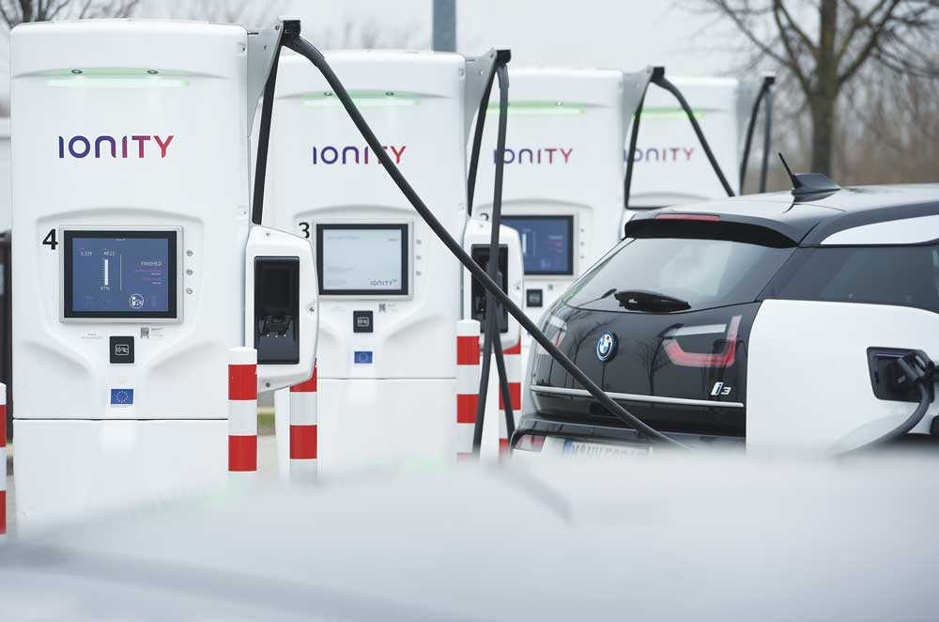

Photo: Stefan Sauer

Halving emissions from domestic shipping and fishing vessels
The green transition in the shipping sector is a special priority for the Government. The Government’s action plan for green shipping (2019) confirmed its ambition of reducing transport emissions from domestic shipping by half by 2030 compared with the 2005 level, and that the Government will promote the use of zero- and low-emission solutions in all vessel categories.
The action plan covers all vessel categories, including cargo vessels, ferries and high-speed passenger vessels, and various specialised vessels. Norway is playing a leading role globally in taking zero- and low-emission technology into use in the maritime sector. However, the shipping sector is cyclically sensitive. By spearheading the further development of green shipping, the Norwegian maritime industry can maintain an important competitive advantage internationally.
Green fleet renewal also opens up opportunities for Norwegian suppliers and creates jobs along the entire maritime value chain. Menon Economics estimated that 7 000 people were employed in the green maritime industry in 2018. The industry includes shipyards, suppliers of both maritime equipment and technological services, shipping companies and more.
The Government is now building on the groundwork provided by the action plan for green shipping. For several years, the Government has been continuing and strengthening schemes to promote zero- and low-emission solutions in the shipping industry. In 2020, the Government allocated a total of NOK 735 million for green shipping. The Government is maintaining its ambition of reducing emissions from domestic shipping and fishing vessels by half by 2030 compared with the 2005 level, and will continue to develop policy instruments and assess new instruments as needed to achieve this. Equipping the shipping sector for the future requires large-scale investment, and the choices that shipping companies make today will have long-lasting effects on emissions from this sector. For example, it typically takes three years from ordering a new ship to its completed construction, and its expected lifetime is 25–30 years. Action taken by the Government today will thus yield emission reductions well beyond 2030 and help Norway to achieve its target of becoming a low-emission society by 2050.
              - New energy carriers for shipping
In its hydrogen strategy, the Government announced that it would survey all ferry services, high-speed vessel services and other scheduled maritime traffic in order to identify the zero-emission technologies that may be suitable. The aim is to give the authorities and the private sector a better overview of zero- and low-emission technologies that could be of interest in the maritime sector, including the use of hydrogen. The Government is preparing a roadmap for hydrogen technology designed particularly to support the development and establishment of infrastructure, focusing on the establishment of hydrogen hubs and supply chains that will facilitate the commercial use of hydrogen. The Government will promote the deployment of new energy carriers.
[Boks slutt]

Policy instruments to promote green shipping
Norway’s maritime industry includes stakeholders along the whole value chain from technology development and ship design to shipping companies and users of various forms of shipping services and maritime operations. This is a strong starting point for developing zero- and low-emission solutions, which include energy efficiency measures, battery technology, shoreside electric power, hydrogen, ammonia and biofuels. There are several technologies that still need to mature further, and support will be needed for technological development and early market introduction. But there has been significant maturation in some market segments, and solutions are being developed and demonstrated for more and more segments.
Taxation
Domestic shipping is subject to the carbon tax on fossil fuels. However, carbon pricing in the shipping sector is often not sufficient to justify the costs of developing new environmental technology. There are wide variations between vessel categories, in industrial structure and in operating patterns. A ship is a major investment with a long lifetime, which means that the green transition will mainly involve fleet renewal through capital-intensive new builds. Technological development is well under way, but costs related to green technology are still high for most vessel categories. This means the green transition in the shipping sector requires a relatively long time horizon.
Grant schemes
Well-designed grant schemes that are used to support projects where there is a prospect that zero- and low-emission solutions will in time become competitive without support are necessary to compensate for high costs and risk levels. To ensure green fleet renewal in short-sea shipping, particularly for cargo vessels, special schemes have been established for the short-sea shipping fleet. These are discussed in Chapter 3.4.4.5.
Innovation contracts have been very important for the introduction of zero-emission technology, such as battery and hydrogen propulsion, in the ferry sector. The world’s first all-electric car ferry, MF Ampere, was built under an innovation contract. Since 2015, the number of electric ferries has been rising each year, and by 2022 more than 70 are expected to be in operation. Innovation contracts are currently being used to develop and introduce zero-emission technology for high-speed passenger vessels. Experience gained from using innovation contracts for ferries is being applied to other segments of the shipping sector.
In recent years, shipping has become an important priority area for Enova, with considerable potential for both technological development and market changes that will reduce emissions. Between 2015 and autumn 2020, Enova awarded grants totalling NOK 3.2 billion for maritime projects. This has helped to drive rapid developments, particularly in electrification.
Ferries are the vessel category where most progress has been made in electrification. Enova has supported the development of infrastructure that has made it possible for county authorities to require the use of zero- and low-emission solutions when procuring ferry services. As a result, ferries that use battery-electric propulsion for a large proportion of their operations are now being constructed and put into service. Hybrid electrification is increasingly viewed as a suitable technology and preferred solution, as evidenced by interest in new categories such as fisheries, aquaculture and cargo vessels. The increased demand opens up opportunities for more supply-side operators, which is instrumental in establishing the value chain needed for electrification to become a sustainable and financially viable solution. Norway has substantial supplier and shipbuilding industries that manufacture and assemble equipment needed for electrification, and a number of battery manufacturers have established operations in Norway as well.
DNV GL estimates that vessels at berth account for 7 % of greenhouse gas emissions from shipping. Support for the establishment of shoreside electric power is therefore an important priority for the Government. Enova has awarded NOK 629 million to over 80 shoreside electric power projects, and shoreside electric power facilities are being established or already operating in more than 60 ports. This makes it possible for ships to connect to shoreside electricity while at berth. In 2020, Enova launched three new support schemes relating to shoreside electric power: for infrastructure investments, for pre-projects for shoreside facilities, and for installation of shore power systems in existing vessels.
Requirements for zero- and low-emission solutions in legislation and procurement processes
Requirements for zero- and low-emission solutions for specific vessel categories in legislation and public procurement processes are another important policy instrument. Such requirements, in combination with targeted funding arrangements and taxes, are necessary for ensuring the green transition. The Government is proposing the introduction of requirements and criteria for the use of zero- and low-emission solutions for a number of vessel categories. For details, see Chapter 3.4.4.2–3.4.4.4.

Policy instruments to promote zero- and low-emission solutions for ferries and high-speed passenger vessels
In all, there are 130 ferry services in Norway. In the course of 2020, 26 of these were electrified, and by 2022 there will probably be around 70 electric ferries in operation. In addition, the Norwegian Public Roads Administration has an innovation contract for a hydrogen-powered ferry. The first hydrogen-powered high-speed passenger vessel and the first electric high-speed passenger vessel are being developed. In the mitigation analysis for Norway 2021–2030, it was estimated that the measures analysed for ferries and high-speed passenger vessels combined could reduce emissions by 1.9 million tonnes CO2 in the period 2021–2030.
Of the 130 ferry services in Norway, 16 are part of the national road system, which means that the central government is responsible for procurement of the services through the Norwegian Public Roads Administration. All the other ferry services are part of the county road system, and the counties are responsible for procurement. Zero- and low-emission solutions for ferries have thus far been introduced through a combination of requirements in public procurement processes and funding from Enova, the NOx Fund and others. There will be new tendering rounds for most ferry services in Norway during the period 2021–2030. In the course of 2023, the Government will therefore seek to introduce criteria concerning zero- and low-emission solutions, where feasible, for new procurement processes for ferry services.
              - Requirements for ferries in new procurement process
The Norwegian Public Roads Administration will include requirements for zero- and low-emission solutions, including hydrogen propulsion, when a new call for tenders is issued for a ferry service across the Vestfjorden that is part of the national road system. This will make an important contribution to the development of hydrogen solutions for ferries and is also a way of increasing demand for hydrogen as an energy carrier.
[Boks slutt]
Zero- and low-emission solutions for high-speed passenger vessels are at an earlier stage of development than those for ferries. Just as experience gained in the ferry sector is useful in the development of zero- and low-emission solutions for high-speed vessels, so can developments in the high-speed passenger vessel segment have considerable transfer value for other vessels requiring higher speeds and more power than ferries. Several counties are now drawing up calls for tenders requiring zero-emission solutions for high-speed passenger vessels. Through the Klimasats grant scheme, the Government has provided substantial support to the counties in their efforts to phase in zero- and low-emission solutions for high-speed passenger vessels. The Government is also continuing an allocation for the development of zero-emission high-speed vessels in 2021, with a budgetary framework of NOK 80 million. To support these efforts, the Government will develop zero- and low-emission criteria for use in procurement processes for new high-speed passenger vessels, where feasible, in 2025. This will require the technology to be sufficiently mature and a real alternative for the counties.
              - Barometer of progress towards the green transition in the shipping sector
DNV GL carried out a survey of the technology status of the domestic shipping fleet, published in early 2019, which provided a good starting point for developing a green barometer for shipping. This is a useful tool for monitoring the deployment of low- and zero-emission solutions over time, and for measuring progress towards climate and environmental targets.
In its green shipping action plan, the Government decided that development and improvement of the barometer should continue, with the aim of expanding its scope to include a broad range of measures and technologies such as biofuels, hydrogen, sail technology and energy efficiency measures. Another aim is to reduce uncertainty associated with the estimated figures for ships on the order book. Regular updates of the barometer will provide important information about the progress of the green transition in the shipping sector, and what further action is needed by the industry itself and the authorities.
The figure below shows the status of the barometer of progress towards the green transition in shipping, as updated by DNV GL in October 2020.
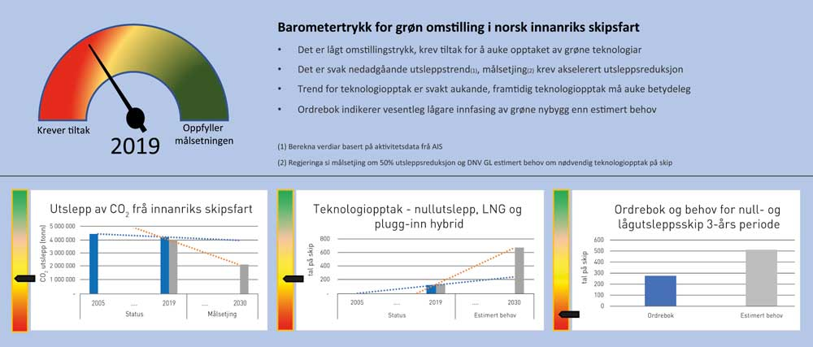

DNV GL
The barometer shows that progress in the transition to green domestic shipping in Norway is too slow to achieve the Government’s target of halving domestic shipping emissions by 2030. Further action both by the industry and by the authorities will therefore be needed in order to ensure adequate uptake of zero- and low-emission solutions and allow the emission reduction target to be achieved.
The assessment of overall progress towards the transition is based on three data sets. First, estimates indicate that greenhouse gas emissions from domestic shipping are too high and are not falling quickly enough. Second, the data show that there is too little implementation of zero- and low-emission solutions on ships currently in operation for every vessel category except ferries, and this must therefore be increased significantly in the near future. Third, the order book for new builds for the next three years includes too few ships that according to plan will use zero- and low-emission solutions. These three factors combined result in the slow rate of progress towards the green transition.
Research and development (R&D) activity on new zero- and low-emission technologies and alternative fuels is another topic that could be incorporated into the barometer. Current R&D activity may give an indication of whether the new technologies that are needed are maturing quickly enough. Work is in progress to incorporate this into the next update of the barometer.
[Boks slutt]
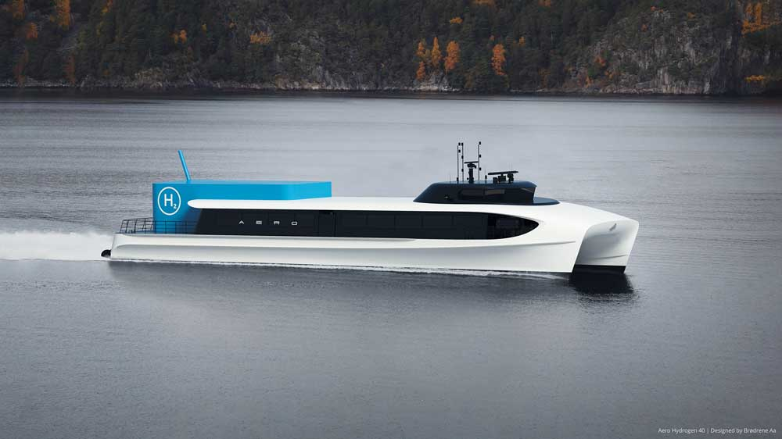
          - Zero-emission high-speed vessels of the future may look like this. The Aero Hydrogen 40 concept was developed by Brødrene Aa in collaboration with Westcon Power and Automation, Boreal and Ocean Hyway Cluster. The 277-passenger vessel will be battery- and hydrogen-powered and reach 34 knots, with an output of 2 600 kW.
Photo: Brødrene Aa
What effect does this policy instrument have on emissions, and what is its cost?
A number of assessments of costs in the county ferry sector show that the counties are incurring additional costs as a result of the transition to zero- and low-emission technology. The Government has therefore increased non-earmarked funding to the counties several times to make it easier for them to give priority to zero- and low-emission solutions for ferries and high-speed passenger vessels. In the 2018 National Budget, block grants to the counties were increased by NOK 100 million, allocated to counties responsible for ferry and high-speed passenger vessel services, and the 2021 budget increased the block grants for this purpose by an additional NOK 100 million. In addition, an extra allocation of NOK 150 million was made in the revised 2020 National Budget.
The introduction of zero- and low-emission criteria in new procurement processes for ferries and high-speed passenger vessels, where feasible, will play a part in reducing emissions from these two vessel categories. By announcing its intention of introducing such criteria in new procurement processes for ferries in 2023 and for high-speed passenger vessels in 2025, the Government is giving stakeholders an opportunity to plan ahead. The Government considers it important to introduce such requirements only where feasible, and will take special circumstances such as geographical conditions, a lack of infrastructure or disproportionately costly technology into account where necessary. It is therefore uncertain whether the entire emission reduction potential identified in the mitigation analysis for Norway 2021–2030 will be realised. Policy instruments that promote technological developments in maritime transport also offer good opportunities for value creation for Norway.

Policy instruments to promote zero- and low-emission solutions for aquaculture service vessels and fishing vessels
In aquaculture, feed barges, workboats and service vessels account for emissions totalling about 0.4 million tonnes CO2eq annually. The smaller aquaculture vessels are suitable for electrification given their size and that they typically travel short distances locally. Around 60 % of the feed barge fleet already uses shoreside electric power, and as long as there is sufficient grid capacity, further electrification of aquaculture service vessels will also be possible.
The Government will introduce requirements for zero- and low-emission solutions for aquaculture service vessels, to be introduced gradually from 2024 where feasible, to ensure that this segment of the aquaculture industry also keeps pace in the green transition. The requirement will apply to the feed barge fleet and to aquaculture service vessels that operate within a small geographical area, typically in connection with one site or a cluster of sites. Gradually phasing in the requirements where feasible will take into account the fact that some sites are far from land and the possibility of electrification is limited. Introducing zero- and low-emission solutions for vessels used at such sites would entail far higher costs and would require the development of technologies such as hydrogen and ammonia, which are not commercially competitive at present. Requirements for zero- and low-emission solutions can only be introduced provided that technological solutions are available that are mature enough for commercial use, and they are suitable for a specific site. Furthermore, greater use of and demand for charging infrastructure for electricity must be expected as a result of introducing requirements, other alternative fuels will be in greater demand, and more grid capacity will be needed.
The fishing fleet has previously benefited from a refund system for the carbon tax on fuel bought for use in fisheries less than 250 nautical miles from the coast. This system has been discontinued from 2020. To ease the transition for the industry, it has been replaced by a compensation system, which is to be gradually phased out by 2025. The new compensation system is not linked to emissions but to each vessel’s share of the total catch for the compensation group to which it belongs. This new approach is intended to provide more incentives to operate in more climate-friendly ways. It means that mineral products for use in fisheries less than 250 nautical miles from the coast are now subject to the standard carbon tax rate on greenhouse gas emissions, which increases the carbon price in line with other industries.
What effect does this policy instrument have on emissions, and what is its cost?
The introduction of requirements for zero- and low-emission solutions for aquaculture service vessels where feasible will promote further technological development and emission reductions. It is uncertain whether the full emission reduction potential identified in the mitigation analysis for Norway 2021–2030 can be realised. This will depend partly on how phase-in is planned from 2024, the substance of the requirements, and how many sites are considered to be unsuitable for zero- and low-emission solutions.
The consequences for the industry will depend on how quickly requirements are phased in and the substance of the requirements. Requirements are to apply where feasible. This takes into account the fact that some sites are far from land or in areas lacking infrastructure, and the possibility of electrification is limited.
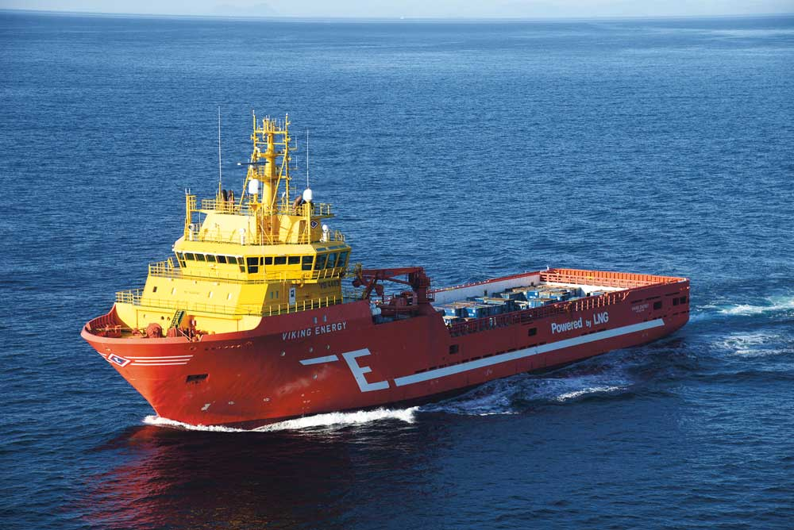
          - The offshore supply vessel Viking Energy is being retrofitted to use ammonia as fuel from 2024.
Photo: Eidsevik Offshore AS

Policy instruments to promote zero- and low-emission solutions for offshore support vessels
In the mitigation analysis for Norway 2021–2030, the emission reduction potential for offshore support vessels in the ten-year period was estimated at 1 million tonnes CO2eq. Offshore support vessels include supply vessels and other specialised vessels for offshore activities. At present, emissions from offshore support vessels in the petroleum industry are subject to the carbon tax, and it is possible to apply for grants from Enova for energy and climate-related measures for these vessels. The petroleum industry is a leader in the deployment of low-emission technology. Equinor, for example, sets requirements for battery-hybrid ships, shoreside electric power and energy-efficiency measures in new long-term contracts. Equinor has announced its ambition to reduce emissions from its maritime activities in Norway by 50 % by 2030, compared to the 2005 level.
As part of the follow-up of its action plan for green shipping, the Government has initiated a review of the legal basis for introducing requirements for zero- and low-emission solutions, and what the consequences would be for the industry. When it considered the bill Temporary amendments to the Petroleum Taxation Act (Prop. 113 L (2019–2020)), the Storting asked the Government to propose ways of ensuring the introduction of zero- and low-emission solutions for offshore support vessels. In 2021, the Government will present a plan to the Storting showing how its decision will be followed up, including assessing new requirements to be phased in from 2022.
What effect does this policy instrument have on emissions, and what is its cost?
Introducing requirements for zero- and low-emission solutions for offshore support vessels in petroleum production can play a part in reducing emissions. It is uncertain whether the full emission reduction potential identified in the mitigation analysis for Norway 2021–2030 can be realised by introducing such requirements. This will depend partly on the timing and the substance of the requirements. The consequences for the industry will depend on how quickly requirements are phased in and the substance of the requirements.

Policy instruments to promote green fleet renewal of the short-sea cargo segment
Short-sea cargo vessels that are used for domestic transport in Norway typically operate mainly in Norwegian waters and the Baltic Sea. Many of these cargo vessels are old and inefficient. According to a report commissioned from Menon Economics in 2020, around 400 Norwegian-owned cargo vessels operate primarily in Norwegian waters, and about 200 of these are over 20 years old. In the Government’s green shipping action plan, domestic emissions from cargo vessels in 2017 were estimated at about 1.1 million tonnes CO2, based on AIS data from Norwegian waters.
To reduce Norwegian emissions, the Government has launched an initiative for green fleet renewal of the short-sea cargo segment. The initiative includes strengthening green fleet renewal activities under the Green Shipping Programme, a scheme for scrapping old vessels in the short-sea shipping fleet to remove them from the market, and a loan scheme for short-sea shipping and fishing vessels to promote green fleet renewal. Through these measures, the Government increased budgetary allocations to green fleet renewal by a total of NOK 420 million in 2020. This is a vital contribution to the transition to zero- and low-emission solutions in short-sea shipping, which will require significant investment for a shipping segment that is exposed to international competition. The green transition in the short-sea cargo segment is still in an early phase, and in the years ahead major increases will be required in the use of new fuels and technologies such as electrification, hydrogen, ammonia, LNG and biofuels.
              - Green renewal of the cargo segment under the Green Shipping Programme
The Green Shipping Programme, a public-private partnership currently involving 55 partners in the private sector and 11 observers in the public sector, is designed to ensure maturation for rapid upscaling of technology for green fleet renewal through pilot projects. Since it was started in 2015, the Green Shipping Programme has established 28 pilot projects, eight of which have resulted in solutions being put into practice or in construction projects. These include projects on zero-emission fuels such as hydrogen and projects seeking to mature technology for tomorrow’s maritime transport using automation and smart solutions. One good example is the pilot project for autonomous, all-electric container transport across the Oslofjord run by the grocery wholesaler ASKO. In combination with the company’s fleet of electric trucks, this will provide a complete zero-emission logistics chain. In 2019, the project received an Enova grant of NOK 119 million, which illustrates diffusion from the Yara Birkeland project that Enova has previously supported. The concept can be further developed for hydrogen propulsion over longer distances. Another example is the project to build the world’s first hydrogen-powered bulk carrier, involving Felleskjøpet (a Norwegian agricultural cooperative) and HeidelbergCement.
[Boks slutt]
In its green shipping action plan, the Government stated that it is necessary to identify possible challenges relating to funding for green renewal of the short-sea cargo fleet, with a view to improving the framework for this process. The Government will continue the green fleet renewal initiatives that were started in 2020, i.e. the loan scheme for short-sea shipping and fishing vessels, the scheme for scrapping old vessels in the short-sea fleet, and green renewal activities under the Green Shipping Programme. The use of climate-related requirements in public procurement processes will be considered with a view to introducing them in 2023.
What effect does this policy instrument have on emissions, and what is its cost?
The Government will ensure that the recently established policy instruments for green renewal of the short-sea cargo segment are harmonised with existing policy instruments and introduce climate-related requirements in public procurement processes, thus ensuring that policy instruments promote technological development and emission reductions in this segment. Because the operating pattern of the short-sea shipping fleet involves transport both within and beyond Norwegian waters, policy instruments in this sector will play a part in reducing domestic emissions and may also have ripple effects beyond Norway’s borders.
Policy instruments must be assessed regularly to ensure they function as intended. This will also make it possible to take into account any need for adjustment. The costs and benefits of policy instruments will depend on the results of the assessments and decisions made in the annual budgets.
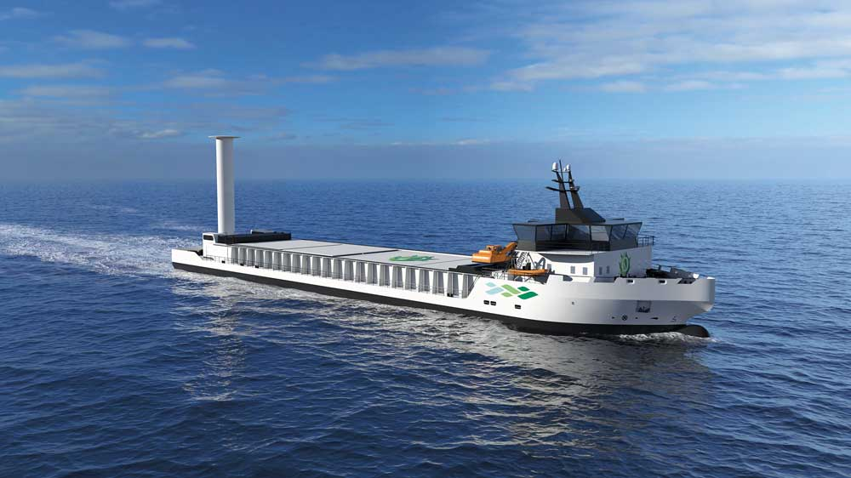
          - A concept for a green bulk carrier for the future, from Norwegian shipbuilder Vard and the Green Shipping Programme.
Photo: Vard

Norway’s involvement in international efforts to reduce emissions from shipping
Shipping is a global industry, and the Government’s point of departure is that environmental and climate-related requirements for international shipping should be established by the International Maritime Organization (IMO). The Government will maintain its leading role in this work. In addition, the Government considers it important to cooperate closely with the EU, which has announced proposals in various sectors including green shipping in the European Green Deal. The introduction of zero- and low-emission fuels will require broad-based international efforts, and the Government therefore considers it important that activities in more international arenas, such as Nordic cooperation, are organised to support this shift. It is also necessary to ensure the fastest possible global transition to zero- and low-emission shipping solutions by providing assistance to developing countries. The Government is doing this by cooperating with IMO on the GreenVoyage2050 project. The Government will strengthen cooperation with IMO on assistance to developing countries in their efforts to prevent marine pollution and reduce greenhouse gas emissions from ships.
In 2018, IMO adopted a climate strategy setting out levels of ambition for emissions, including reducing emissions from international shipping by at least 50 % by 2050. Its vision is to phase out greenhouse gas emissions as soon as possible in this century. The negotiations on the strategy were chaired by Norway, represented by the Ministry of Climate and Environment, which is also heading the follow-up of the strategy. IMO’s climate strategy is a political document that establishes levels of ambition and a plan for how to achieve them. The strategy will need to be followed up with legally binding emission requirements for shipping. In November 2020, the IMO Marine Environment Protection Committee (MEPC) approved new climate-related requirements to ensure that the level of ambition for 2030 is achieved. These are designed to cut the carbon intensity of shipping (i.e. emissions per unit of transport work) by at least 40 % by 2030 compared with the 2008 level. These requirements will probably enter into force before 2023.
Norway will play a leading role in IMO’s further efforts to phase in zero- and low-emission fuels in shipping and to develop new mechanisms for achieving emission targets. IMO’s climate strategy is to be updated every five years, and Norway will seek to ensure that the next version is ambitious and has a clear plan for practical follow-up.
By acting as a leader in the transition to green shipping domestically, Norway can promote the adoption of Norwegian standards internationally. This could play a part in reducing emissions from all shipping worldwide. It could also open up market opportunities for Norwegian maritime solutions. The Government will continue to promote Norwegian interests in IMO and to act as a driving force within IMO for stricter international climate-related and environmental rules for shipping.

Uncertainty, economic and administrative consequences, and effects on emissions
The effects of tax increases on both emissions and the various stakeholders will be influenced by the way tax increases are brought in and what other policy instruments are implemented. For example, clear advance notice and predictable, gradual increases will allow households and businesses more time and opportunity to adapt. The use of other policy instruments, such as the vehicle taxation system and grant schemes under Enova, will affect how much opportunity the various stakeholders have for adaptation. Different market segments face different barriers and types of market failure, and the combinations of policy instruments that will be most suitable and effective for achieving the Government’s targets will vary from one segment to another.
The report from Statistics Norway (see Box 3.3) on the costs of reducing Norwegian non-ETS emissions by 50 % estimated that a carbon price of NOK 2 000 could result in a reduction of more than 40 % in emissions in 2030 compared with the 2005 level. Achieving the targets set by the Government for the transport sector will require combinations of policy instruments, some of which may both strengthen the effects of raising carbon tax rates and not least ease the transition for people and businesses currently using fossil fuels.
Administrative and economic consequences
Higher carbon tax rates will create stronger incentives to reduce emissions from transport by switching to zero-emission technology and through lower fuel consumption by those vehicles that use petrol and diesel.
Costs will rise for households and businesses that continue to use internal combustion engine vehicles if their travel patterns do not change. However, before any substantial rise in tax rates, there will be plenty of opportunity for stakeholders to adapt so as to reduce or avoid cost increases, and as time goes on there will be more and better alternatives. Raising tax rates gradually gives stakeholders time to adapt.
Stricter requirements in public procurement processes may mean higher purchasing costs for municipalities and counties, particularly in the next few years. Over time, lower operating costs will make categories such as electric ferries and buses economically viable. The Government has already done much to ensure that short-term financial pressures do not prevent sound long-term decisions, for example by using the Klimasats grant scheme and increasing block grants to the municipalities and counties. The use of innovation contracts has been vital for technological development in the ferry sector, and in 2020 the Government allocated earmarked funding for an innovation contract for zero-emission high-speed vessels.
It is uncertain what effect increasing carbon tax rates will have in shipping, fisheries and aquaculture. It is assumed that low-cost measures such as electrification of the ferry sector will be implemented regardless of whether tax rates are raised. The Norwegian Environment Agency estimates, with a considerable level of uncertainty, that there is an emission reduction potential of about 0.63 million tonnes CO2 in the period 2021–2030, assuming the carbon tax rate is raised gradually to NOK 2 000 per tonne CO2eq and that other policy instruments are not changed. This corresponds to roughly 10 % of the emission reduction potential for all measures assessed for shipping, fisheries and aquaculture in the mitigation analysis for Norway 2021–2030. There is also uncertainty concerning the effect of raising the tax rate for vessel categories with an operating pattern that makes it possible to bunker abroad or register fuel purchased in Norway as fuel for international operations, and thus avoid the tax. At the same time, it is assumed that stakeholders in the maritime sector will respond to a price signal, and that announced increases in the tax rate in combination with more specific policy instruments for different vessel categories will promote a faster green transition.
For the authorities, the biofuel quota obligations will result in some administrative costs for inspection and enforcement. These costs will depend on when biofuel quota obligations are introduced for different vessel categories, the adjustments that are needed, and so on. Users of biofuels will experience higher pump prices as a result of quota obligations, since biofuels are more expensive than fossil fuels. Biofuels vary in price, and advanced biofuels are costlier than conventional biofuels. It is estimated that the increase in the biofuel quota obligation from 1 January 2021 to 24.5 % biofuels and 9 % advanced biofuels will result in an increase in pump prices of NOK 0.09 per litre excluding tax.

Action plan for biogas

Using biogas cuts emissions and reduces waste
Achieving climate targets will require a variety of solutions in all sectors – solutions that are both climate-friendly and environmentally sound, both in Norway and internationally.
Biogas is one part of the equation for reducing emissions and is also part of a circular approach to resource use. Utilising biodegradable waste in biogas plants is smart waste management that recovers important nutrients such as nitrogen, phosphorus and potassium. This helps to make food sustainable and climate friendly. Biogas production captures methane, which is a short-lived climate forcer, and uses it for more sustainable commercial transport on the roads and in a world-class maritime industry.
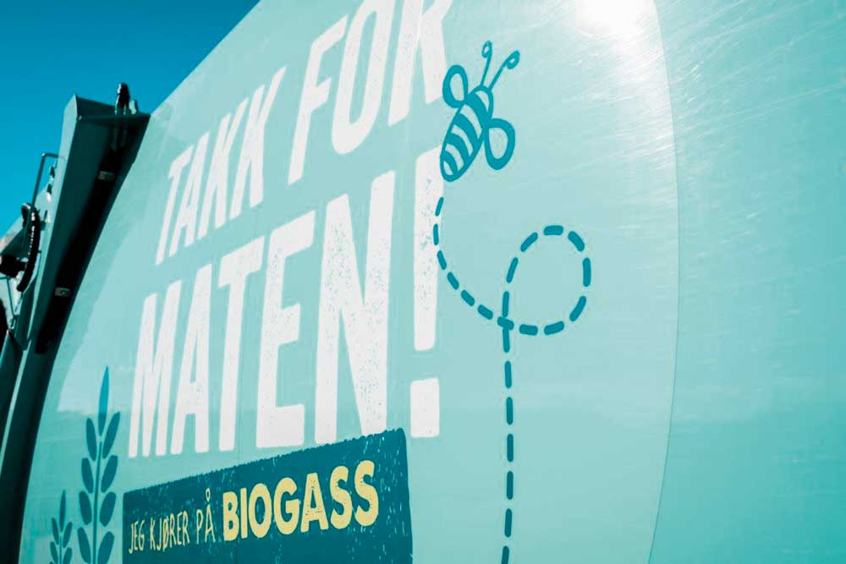

Photo: Biogass Oslofjord
Biogas is already in use as fuel for vehicles on Norwegian roads. Biogas can replace natural gas in shipping and manufacturing. The technology and expertise are in place in Norway; Norwegian biogas technology is prize-winning. Research, development and innovation are resulting in better use of biogas, and biogas production is creating jobs in rural districts. Emissions are reduced when livestock manure is used in biogas production and when the biogas replaces fossil energy sources.
Producing biogas from waste is smart utilisation of resources that would otherwise be lost. It is also essential to reduce waste quantities, and not to make ourselves dependent on generating waste. However, some waste will always be generated as long as humans, animals and plants inhabit the Earth. There is reason to believe that biogas will play a role not only in the green transition but also in the low-emission society from 2050 onwards.
              - Biogas basics
When biological material decomposes under anaerobic conditions, biogas is formed. Biogas consists mainly of CO2 and methane, with trace amounts of other gases. This process occurs naturally, for example in deposits on lakebeds and in landfills. Since methane, in addition to its high energy density, is a potent greenhouse gas, landfilling of biodegradable waste has been prohibited in Norway since 2009.
Biogas plants are a way of managing biodegradable waste such as sewage sludge, food waste, aquaculture waste and slaughterhouse waste. In a biogas plant, decomposition takes place under controlled conditions, and the gas that forms is captured. To use biogas as fuel, the CO2 must be separated from the methane, so that the gas is upgraded to fuel quality with a methane content of at least 97 %. The gas can also be cooled under pressure and liquefied for easier transport. In the rest of this text, the term ‘biogas’ refers to upgraded biogas in either gas or liquid form.
Biogas can replace natural gas directly. Both consist of highly concentrated methane, but biogas is renewable and therefore an energy carrier of interest for land transport, shipping and industry. CO2 separated from the gas stream at biogas plants can be captured and stored or used to replace fossil CO2, for example in carbonated drinks and greenhouses or as dry ice.
The material remaining in a biogas plant is called digestate. Depending on the nutrient content of the raw materials, digestate can be used as biofertiliser. Biofertiliser is rich in some of the most important nutrients for plant growth: potassium, phosphorus and nitrogen. These are often referred to as the ‘big three’ nutrients, and are typically applied to soils in mineral fertiliser. Digestate with a lower nutrient content can be used as soil conditioner to improve soil structure in agricultural areas. In this way, nutrients are returned to the nutrient cycle.
This is why biogas is often referred to as an example of the circular economy in practice. Resources that would otherwise be lost as waste become resources in new processes.
[Boks slutt]

The Government’s biogas initiative
In connection with the 2020 budget (Prop. 1 LS (2019–2020)), the Government announced that it would present an action plan for biogas. This climate action plan for achieving Norway’s 2030 targets will improve the framework for a variety of zero- and low-emission solutions. The action plan for biogas therefore promotes greater production and use of biogas using both general and sector-specific policy instruments of Norway’s climate and environmental policy.
The planned increases in the carbon tax to NOK 2 000 per tonne CO2eq may make biogas more competitive against fossil alternatives. This may increase biogas use for road transport, in manufacturing and for heating buildings. See Chapters 3.4 and 3.7.
The Government intends to introduce a biofuel quota obligation for shipping from 2022. The Norwegian Environment Agency and the Norwegian Maritime Directorate have outlined how this obligation could be designed. The model they propose is restricted to domestic shipping and to the use of advanced biofuels and biogas. They consider that it may be appropriate to design the biofuel quota obligation so that it increases the use of biogas.
If biogas is included in a biofuel quota obligation, it will be necessary to review the current support regime. State aid rules limit the types of requirements and support schemes that can be applied simultaneously. A biofuel quota obligation might in addition encourage higher imports of biogas that has benefited from production support schemes. When the introduction of a biofuel quota obligation is considered, policy instruments and trade in biogas in an international perspective will therefore also be considered.
The grant scheme for deliveries of manure to biogas plants was expanded through the 2020–2021 Agricultural Agreement, see Chapter 3.6. This encourages the use of more manure in biogas production and increased production of biogas.
Strengthening the use of policy instruments, as described above, comes in addition to the initiatives that Norway has been pursuing for some years to promote biogas use. A number of policy instruments are being used to promote higher biogas production and demand.
Biogas is not subject to road use duty. From 2020, road use duty on natural gas is one-sixth of the rate for petrol, as measured by energy content. In the 2020 National Budget, it was announced that road use duty on natural gas would be gradually increased up to 2025. From 1 July 2020, road use duty was expanded to include all biofuels for road use, which may give stronger incentives to use biogas.
The current and previous governments have promoted a number of grant schemes to support the production, infrastructure and use of biogas as a climate-related measure, particularly in the transport and agricultural sectors:
- Enova is an important funding agency which for several years has been offering funding instruments to support biogas production and vehicles and associated infrastructure for biogas use. Enova supports technology development and production of biogas, and since 2014 has awarded grants totalling roughly NOK 430 million for biogas production. Enova also supports greater use of biogas solutions, such as infrastructure and vehicles, through early market introduction.
- Innovation Norway’s bioenergy and technology programme for the agricultural and forestry sector is designed to encourage farmers and forest owners to produce, use and supply bioenergy as heat, fuel or other forms of energy. The programme provides funding for investment in facilities for biomass-based production of biogas, heat, electricity, biofuels and biochar. Innovation Norway’s grant scheme for environmental technology provides grants for the development, construction and testing of new environmental technology.
- The Norwegian Agriculture Agency has a grant scheme for deliveries of manure for biogas production, which has been operating since 2013. In the 2020–2021 Agricultural Agreement, the parties agreed to continue this scheme. NOK 9 million was allocated to the scheme, an increase of NOK 4 million from the previous year, and the size of the grants available was increased.
- The Klimasats grant scheme can provide municipalities and counties that wish to make use of biogas in public transport with support for infrastructure projects. The scheme also supports feasibility studies and assessments of local biogas potential.
In addition, some Klimasats funding is set aside for knowledge development, assessments and information dissemination in the field of climate and environment.
- The Research Council of Norway has funding available for research related to biogas, particularly under the BIONÆR and ENERGIX programmes, and other programmes may also be relevant for biogas research.
Municipalities and counties are important stakeholders in the transition to a low-emission society, as they are aware of local opportunities and needs. There are ambitious local politicians who deserve much of the credit for the role that biogas plays today. They have paved the way for production and infrastructure development, and created demand by including environmental and climate-related requirements in public procurement processes, adapted to local conditions. See more about public procurement in Chapter 3.4.2.5.
Local initiatives can have a substantial impact. A good example is the Biogass Oslofjord network involving the counties in the region, and there are many other examples of cooperation between municipalities/counties and the business sector throughout Norway. Another initiative is the decision by the steering group for Oslopakke 3 (a road and public transport package for the Oslo region) to recommend that vehicles running on biogas should be exempt from road tolls in Oslo. Further consideration of how to implement this in practice is still needed.

Biogas as part of the circular economy
Biogas is an example of circular economy in practice. In theory, this is a simple and obvious idea, making use of biological processes that occur naturally. In practice, developing a value chain for biogas on an industrial scale can teach us a great deal about what it takes to make processes circular and thus avoid unnecessary emissions.
One general challenge is that recycled resources are often costlier than fossil or virgin alternatives. The value chains for diesel, plastics and other petroleum products, new furniture, new clothing and new electronics have been in place for many years and are well developed. They operate on a large scale, run smoothly and are cost-effective.
Biogas is costlier than natural gas. The value chain for biofertiliser is immature and is still a cost driver for biogas plants, even though there is intrinsic value in returning nitrogen, potassium and phosphorus to the natural nutrient cycle instead of using mineral fertiliser or peat. Opportunities for using ‘green CO2’ in manufacturing and food production are only just beginning to emerge.

Use of biogas
Biogas is most widely used in transport segments where there are few or no alternatives to fossil fuels. For the moment, it is being used for heavy road vehicles, but there is also growing interest from the shipping industry. Price is the greatest challenge. Biogas costs more than diesel for road vehicles, and much more than diesel or natural gas for shipping. Prices vary between or are determined by agreements between suppliers and transporters, which is similar to the system for large-scale users of diesel. Prices are shown on the pumps at filling stations.
Gas-powered vehicles and vessels are also more costly than conventional types, but gas-powered engines are available for most road vehicles, and ships have been using LNG as fuel for many years. Norwegian shipping companies are already using this technology. In shipping, manufacturing and the heating sector, the need for new investment is limited, since biogas can replace natural gas directly where it is currently used. Nevertheless, there are additional costs relating to infrastructure. As of 2020, there are only three liquefied biogas (LBG) filling stations for road vehicles, all in Eastern Norway. The infrastructure in other parts of Europe is fairly well developed, with filling stations for both LBG and LNG.
Large vessels are particularly difficult to electrify. For such vessels, both weight and volume are important factors, so biogas is suitable. Stakeholders are familiar with natural gas and have the technical expertise to use it. Natural gas blended with 10 % biogas is already available, and a number of new vessels along the coastal route Bergen–Kirkenes are to use biogas.
The number of trucks using biogas is increasing, but the number of biogas buses is levelling off. Still, this indicates that there are stakeholders using or buying transport services who are willing to pay somewhat extra for more environmentally and climate-friendly forms of transport. This, together with state aid to cover some of the additional costs, is helping to develop the biogas market.
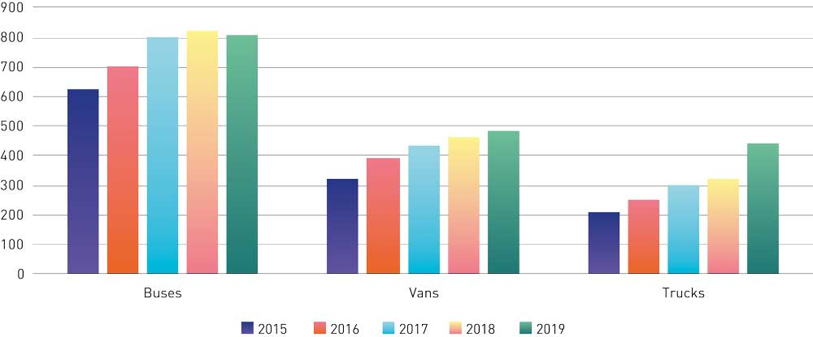
          - Numbers of gas-powered heavy vehicles, 2015–2019.
Statistics Norway table 11823 and Sund Energy (2016).
If tractor units running on biogas account for 10 % of new sales of tractor units by 2030, which is the figure used by the Norwegian Environment Agency in the mitigation analysis for Norway 2021–2030, emission reductions would total 0.47 million tonnes CO2eq over the period 2021–2030. This is based on sales of 150 new tractor units per year. From 2018 to 2019, the number of registered gas-powered trucks increased by 124 with the current mix of policy instruments. Reaching a 10 % market share would require LBG production of roughly 300 GWh per year. By comparison, the world’s largest LBG plant, Biokraft Skogn, produces 125 GWh per year.
Biogas use is also sensitive to variations in prices of other fuels and to technological developments for other non-fossil fuel vehicles. But even if good battery-electric long-distance coaches or tractor units are available by 2030, there may still be fairly large market niches for biogas use. This is both because many users will already have purchased and become familiar with biogas vehicles and because of other advantages associated with these vehicles, such as their long range, the short time required for refuelling, and the good biogas infrastructure in other parts of Europe.
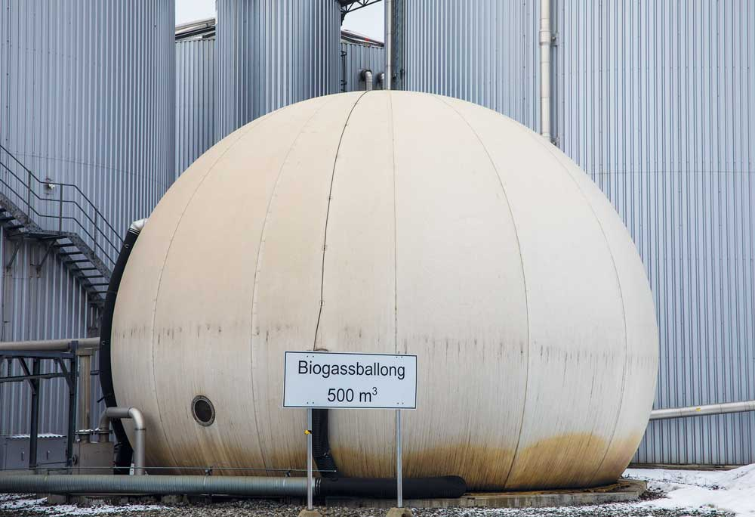

Photo: Ole Berg-Rusten/NTB

Current and future biogas production
The most common feedstocks (raw materials) currently used in biogas production in Norway are sewage sludge and food waste. This is because the first biogas plants here were set up by municipal and intermunicipal waste management companies as part of the waste management system. The world’s first biogas plant to process food waste only was established in Lillehammer ahead of the 1994 Winter Olympics.
In recent years, a number of commercial actors have entered the market, and more and more new feedstocks are being introduced. Examples include manure, fish silage, commercial food waste, slaughterhouse waste and forest residues. Since the main purpose of the private biogas plants is precisely to produce biogas, they have an incentive to streamline operations and test new feedstocks. At the same time, work is in progress at a number of private and publicly owned plants to develop value chains for the by-product streams, CO2 and biofertiliser.
New technology, more efficient processes, increased interest from both public and private stakeholders, and the use of new feedstocks point to an increase in Norwegian biogas production in the years ahead. In an analysis of policy instruments to promote biogas use and production, the Norwegian Environment Agency estimates the total potential for biogas production in Norway in 2030 at 2.5 TWh. The analysis is limited to anaerobic digestion of organic waste and residues using currently available technologies. Biogas can also be produced using other technologies such as ‘power-to-gas’ (electrofuels) and biomass gasification, or it can be imported. The Environment Agency’s analysis does not include the production potential from these sources or from completely new feedstocks.
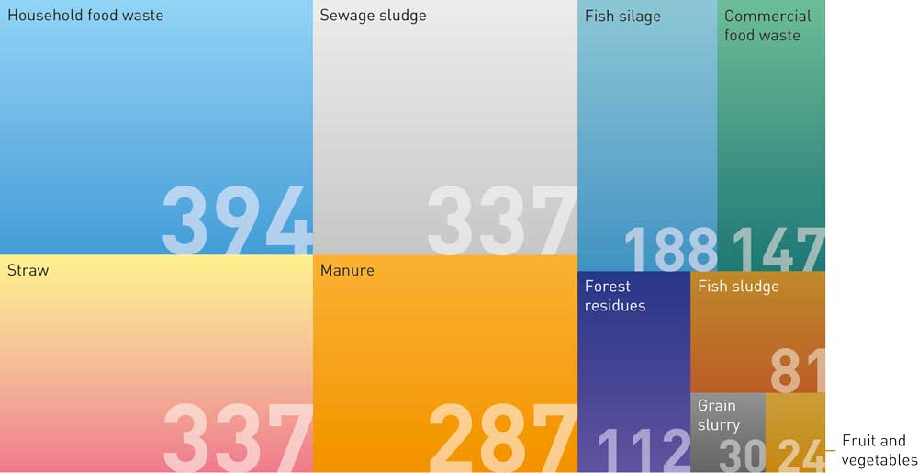
          - Potential for biogas production in 2030 (GWh)
Norwegian Environment Agency (2020)

Biogas production costs
Several factors influence the likelihood that different feedstocks will be used for biogas production in the future. Production costs are particularly important, and these vary widely between feedstocks. For production to approach the estimated potential level, it will be necessary to use some of the more expensive feedstocks, unless new alternatives can be found. Production costs for these feedstocks could be so high that production is not economically viable based on the current willingness to pay for biogas as fuel.
The most inexpensive feedstocks are sewage sludge and food waste, which are the feedstocks chiefly used today. Production costs for biogas produced from fish silage and fish sludge are also relatively low. Biogas producers are paid to accept these feedstocks, with the exception of sewage sludge, since this is considered to be a form of waste treatment.
Manure is one of the feedstocks with the highest production costs due to its low energy density. However, the fact that the biological digestion process starts in an animal’s stomach can play a part in stabilising the production process at a biogas plant, and in some cases make it possible to extract more energy from other feedstocks. Transport and production costs are nevertheless important barriers to the use of manure.
Manure is one of the few feedstocks that is already in use today, as fertiliser, and also one of the few feedstocks that yields a climate benefit when it is used to produce biogas. This is because biogas production greatly reduces the period during which manure is stored at farms, so that greenhouse gas emissions to the atmosphere are reduced and more methane is captured at biogas plants. Agriculture is also a key user of biofertiliser. Using manure for biogas production therefore reduces emissions at several stages of the value chain.

Climate benefits of biogas
Sustainable biogas is produced from waste, and waste quantities must be reduced. This applies particularly to food waste. Norway’s goal is to prevent and reduce food waste along the entire food value chain, from primary production to the consumer (see Chapter 3.6.6 about the agreement between the authorities and the food industry to reduce food waste). The biogas production process itself mainly releases methane, and these emissions must be minimised to ensure greater climate benefit. At the same time, emissions from biogas use in Norway count as zero in the national emission inventory, since this biogas is produced from biological material and the emissions are part of the short-term carbon cycle.
Biogas plays a role in reducing greenhouse gas emissions at several stages in the value chain and across sectors. Biogas reduces emissions when it is used to replace fossil fuels, while biofertiliser can reduce emissions from agriculture when used appropriately. In addition, CO2 from biogas production can replace fossil CO2 in the food industry.
It is possible for producers to document the climate benefits of the biogas they sell. Two Norwegian producers, Greve Biogass and VEAS, currently sell biogas that is Nordic Swan ecolabelled. In 2019, Avfall Norge (a Norwegian waste management and recycling association) introduced an industry norm for biogas to make it easier to document the climate benefits and sustainability of Norwegian biogas. This is based on criteria in the revised Renewable Energy Directive (REDII). In 2020, an extra module was added to the industry norm for calculating the effect of biofertiliser on emissions. A number of biogas plants have also begun to make use of the ‘green CO2’ formed when biogas is upgraded to fuel quality, for example as dry ice or in carbonated drinks. This further increases the climate benefits.
Reporting of climate benefits is still voluntary but can help to professionalise the biogas industry. It may also strengthen demand for Norwegian biogas and digestate and for exports of biogas technology.

The international framework for biogas
Norway has a large volume of trade with the rest of the world, and is therefore influenced by changes in framework conditions in neighbouring countries. In the past 10–15 years, constant adjustments have been made to the design of support schemes for biogas in the EU. A number of countries in the internal market currently provide some form of operating support or production premium per kWh of biogas produced. Some provide extra support for upgrading and liquefaction, and some also differentiate support by feedstock. Sweden, Denmark and the Netherlands will be making changes to their support schemes in the next few years. The trend is for support to be shifted away from electricity and heat production and towards upgrading of raw biogas to biomethane.
The changes in Sweden are in response to a lack of harmonisation of the support regimes, particularly vis-à-vis Denmark. In Sweden, the taxation system provides incentives to use biogas, whereas Denmark provides production premiums. This has resulted in the export of Danish biogas to Sweden, where tax exemptions are granted for biogas that has already received a production premium. Swedish biogas producers have found it difficult to compete with the doubly subsidised imported biogas, and Swedish biogas production stagnated. In 2019, a Swedish Government Official Report on biogas was presented, which included proposals for a new support regime.
Norway is a small open economy, and any lack of harmonisation of policy instruments with neighbouring countries may affect both production and use of biogas, as in the Swedish case. But unlike nearly all its neighbouring countries, Norway uses almost no natural gas for heating, so its gas grid is not well developed. Infrastructure for biogas filling stations is being developed, and it is therefore uncertain whether biogas imports will rise if Sweden phases in production support. The Norwegian Government will monitor the situation closely to see how changes in the framework influence Norwegian biogas value chains. Biogas use is growing. Biogas is already important today, and will play an even more crucial role in the transition to a low-emission society and a circular economy.

Enhancing removals and reducing emissions in agriculture
The Government and the agricultural organisations have signed a letter of intent to enhance removals and reduce emissions of greenhouse gases in the sector. Norwegian farmers are also taking the initiative to reduce their own emissions. These efforts will play a part in ensuring that Norway can achieve its climate targets. In the letter of intent, the parties undertake to reduce emissions and enhance removals by a total of 5 million tonnes CO2eq in the ten-year period 2021–2030. To support these efforts, the Government will provide a framework that facilitates sound climate-related choices by the agricultural sector. In parallel, the Government will promote changes in consumption patterns that will indirectly reduce greenhouse gas emissions from agriculture.
The Government will:
- Use the letter of intent between the agricultural organisations and the Government as a basis for climate-related work in this sector in the years ahead;
- Include assessments of climate-related measures and instruments in the agricultural sector as a natural part of the negotiations on the annual Agricultural Agreement;
- Require the mitigation effect of the annual Agricultural Agreement to be set out in the budget proposals for each year’s agreement;
- Together with the agricultural organisations, identify how policy instruments can best be designed to achieve Norway’s agricultural policy goals and at the same time strike a balance between these goals and climate and environmental targets;
- intensify efforts to improve the emission inventory for the agricultural sector;
- Assess the effects and impacts of introducing a tax on mineral fertiliser, and how it could be introduced. The purpose of the tax would be to reduce nitrous oxide emissions;
- Facilitate greater use of Norwegian feed resources, including rough grazing.

Emission trends
In 2019, emissions from the agricultural sector totalled 4.4 million tonnes CO2eq (see the green-shaded parts of Figure 3.26). This corresponds to about 8.8 % of Norway’s total greenhouse gas emissions and about 18 % of non-ETS emissions.
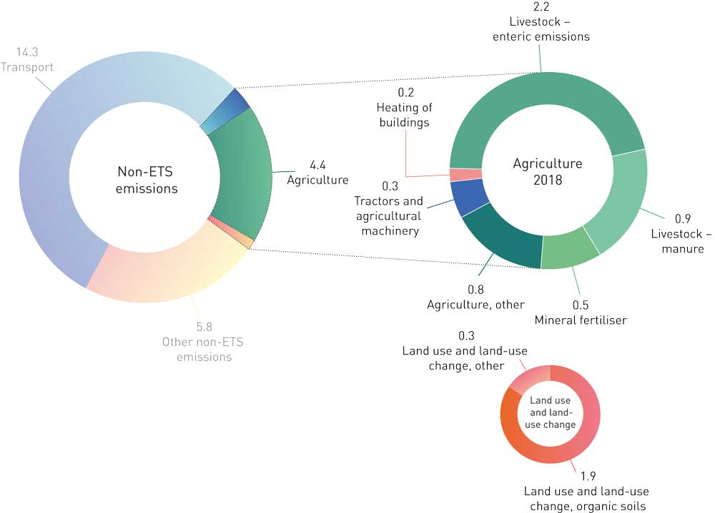
          - Emissions from the agricultural sector in million tonnes CO2eq by source and shown as a share of non-ETS emissions (2019)
Statistics Norway and Norwegian Environment Agency
Since 1990, emissions from agriculture have declined by just over 6 %, but they have remained fairly stable since 2000. Emissions per unit of production have been reduced through long-term, systematic breeding programmes, good animal health, feed development and more precisely targeted fertiliser application. In the greenhouse gas inventory reported to the UN, emissions accounted for in agriculture do not include transport, land use and land-use change, or energy use in the agricultural sector. These emissions are accounted for in other sectors.
Agriculture is the largest source of methane and nitrous oxide emissions in Norway. In 2019, agriculture was responsible for about 103 000 tonnes of methane emissions, a reduction of 5.3 % from 1990, and almost 6 000 tonnes of nitrous oxide, a reduction of 1.1 % from 1990. Emissions from agriculture originate mainly from fertiliser application and livestock, in other words in connection with food production. As a result of the complex processes involved and diffuse emissions from soils, the level of emissions from the use of mineral fertiliser and manure is very uncertain.
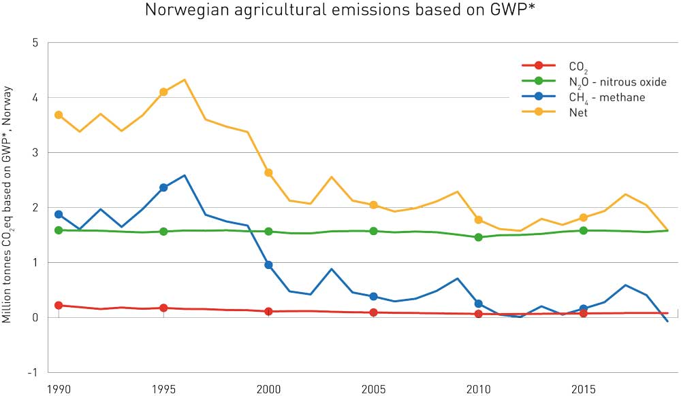
          - The cumulative contribution of Norwegian agriculture to global warming, by gas. (Million tonnes CO2eq using the emission metric GWP*, Norway)
CICERO (2020): Metodikk for framstilling av klimaeffekt på kort og lang sikt (omarbeidd versjon) (In Norwegian, English summary.)
The emission projections published by the Ministry of Finance are for a ‘business-as-usual’ scenario, which only includes the effects of policy measures and instruments that have already been adopted. The projections presented in the 2021 National Budget for emissions that are accounted for under agriculture in the emission inventory indicate that emissions will total around 4.5 million tonnes CO2eq per year up to 2030, in other words about the same as at present. If emissions that are accounted for in other sectors (transport, heating of buildings, and land use and land-use change) are included in addition to those that are accounted for under agriculture, the projections indicate total emissions of just over 7 million tonnes CO2eq from agricultural activities in 2030.
It is vital to ensure that Norwegian agriculture is properly equipped to deal with a changing climate, including rising temperatures, higher precipitation, more flooding and drought, and increasing threats from various pests. Agriculture has always sought to adapt its practices as closely as possible to weather and climatic variability. Climate change in Norway may offer new opportunities for production that farmers can exploit, but it will also result in greater uncertainty. Technological advances and research-based, practical agronomical knowledge will be vital for success. Adaptation to climate change is not within the remit of this white paper, which presents the Government’s plans for reducing emissions and enhancing removals in the period 2021–2030.
Methane, which is a short-lived climate forcer, accounts for a large proportion of emissions from agriculture. The quantity of methane in the atmosphere is rising globally. Because methane has short-lived effects, the amount of warming it causes is primarily linked to emissions over the last ten years (see Box 3.17). Stable or weakly declining methane emissions do not contribute to any further warming.
              - Short-lived climate forcers behave differently from long-lived greenhouse gases
Short-lived climate forcers such as methane, hydrofluorocarbons and ground-level ozone do not accumulate in the atmosphere in the same way as long-lived greenhouse gases. This is because their atmospheric lifetime, from a few days to a few years, is much shorter than that of long-lived greenhouse gases such as CO2 and nitrous oxide. This means that both the quantity of short-lived climate forcers in the atmosphere and their warming effect depends on the recent level of emissions. Such gases are a problem because they have strong warming effect while they remain in the atmosphere. Thus, any emissions (or reductions in emissions) of short-lived climate forcers have a more immediate, but also a more transient, effect on the temperature. This effect only continues for as long as emissions (or reductions in emissions) continue. Long-lived greenhouse gases such as CO2 behave differently. CO2 does not break down in the atmosphere, but accumulates until it is absorbed by the oceans or soils.
Achieving a specific temperature target may require emissions of short-lived climate forcers to be reduced, but not necessarily to zero. Modelling results from the Intergovernmental Panel on Climate Change (IPCC) indicate that global CO2 emissions must be reduced to net zero, whereas methane emissions must be reduced by at least 35 % to achieve the 1.5 oC target. Global methane emissions have been rising rapidly in recent decades.
The more transient effects of methane emissions also mean that the timing of emissions and emission reductions makes a difference. In the case of CO2, it matters less when emissions occur. The temperature at a future point in time will depend on the total quantity of anthropogenic CO2 emitted by then. Warming due to methane emissions, on the other hand, is mainly the result of emission levels in the immediately preceding decades. Reducing methane emissions will therefore have a more immediate effect, and may help to avoid warming in excess of the temperature targets.
However, emissions of methane and greenhouse gases generally also have more long-term effects, since the adverse effects of the warming they cause while in the atmosphere continue long after they have been broken down. For example, after seawater has been warmed up, it can continue to transfer heat to the atmosphere for many years after the atmospheric lifetime of short-lived climate forcers.
[Boks slutt]
In the last few years, climate researchers have developed a new emission metric, called GWP*, to express the warming effect of short-lived climate forcers over time. This methodology uses the established emission metric GWP100 as a basis for converting emissions to CO2-equivalent emissions. Figures 3.27 and 3.28 use GWP* to show the annual and cumulative contributions, respectively, of Norwegian agriculture to global warming from 1990 to 2019. Expressed as annual emissions in CO2eq, emissions from agriculture have made up about 8.8 % of total Norwegian emissions over this period. The cumulative contribution of these emissions to global warming since 1990 is about half this level, or about 4.4 % of Norway’s total contribution. This is because there has been some decline in methane emissions during the period. The situation could change quickly if methane emissions rise.
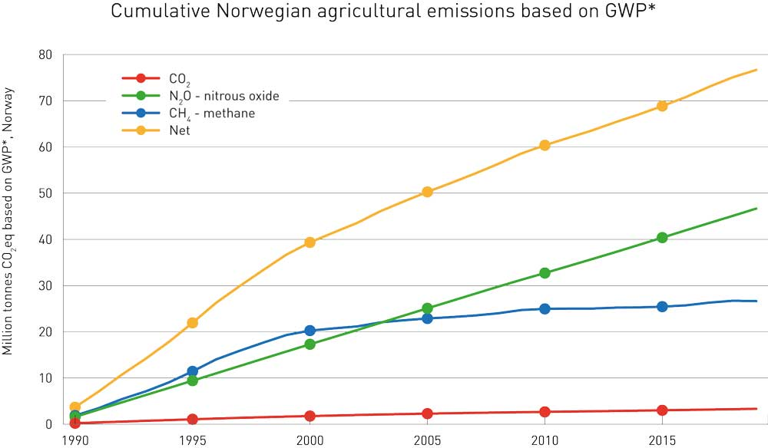
          - The annual contribution of Norwegian agriculture to global warming, by gas. (Million tonnes CO2eq using the emission metric GWP*, Norway)
CICERO (2020): Metodikk for framstilling av klimaeffekt på kort og lang sikt (omarbeidd versjon) (In Norwegian, English summary.)
              - Letter of intent between the agricultural organisations and the Government on reducing emissions and enhancing removals
In June 2019, Norway’s two main agricultural organisations and the Government signed a letter of intent setting out a climate target for the agricultural sector, which is to reduce emissions and enhance removals by a total of 5 million tonnes CO2eq over the period 2021–2030. The letter of intent applies to all mitigation measures for agricultural activities whose effects can be accounted for in the sectors agriculture, transport, heating of buildings and LULUCF (with the exception of forestry) in Norway’s official greenhouse gas inventory.
According to the letter of intent, responsibility for reducing emissions is shared between the agricultural sector and the Government. The agricultural sector is expected to achieve a substantial share of the emission reductions, for example through breeding programmes, better fertiliser management and a switch to fossil-free energy use.
The Government’s efforts to promote changes in consumption patterns may indirectly reduce greenhouse gas emissions that are accounted for in the agricultural sector. These efforts include initiatives to achieve the goal of reducing food waste by 50 % by 2030 and to persuade people to follow the dietary recommendations from the Directorate of Health.
The parties recognise that it will take time before the effects of measures that are implemented become apparent in the emission inventory, and that the letter of intent may not produce results until the latter part of the period 2021–2030.
[Boks slutt]

The social mission of agriculture
Maintaining an active, sustainable agricultural sector throughout Norway will provide a variety of public goods for society. As Norway makes the transition to a low-emission society, the Government view it as important that greenhouse gas emissions are reduced and removals of carbon enhanced in ways that sustain food production and public goods, and that food production is based on the resources that are available in Norway.
Norway’s agricultural policy is based on objectives set out in a white paper on agricultural policy published in 2016 (Meld. St. 11 (2016–2017)). The four objectives are 1) safeguarding food security and maintaining preparedness, 2) maintaining agricultural production in all parts of the country, 3) increasing value creation, and 4) ensuring sustainable agriculture and lower greenhouse gas emissions.
The fundamental task of agriculture is to produce food, and it is not possible to eliminate emissions from the sector entirely. In the Government’s view, it is therefore reasonable that agricultural emissions are reduced less than emissions in other sectors. After Norway makes the transition to a low-emission society by 2050, emissions from agriculture will be some of the last remaining emissions.
Food from Norway has a reputation as safe, nutritious and of high quality. In addition, Norwegian food producers use smaller quantities of antibiotics and pesticides than those in other countries. The Government will continue to provide a framework that facilitates sound climate-related choices by the agricultural sector, and continue its efforts to ensure that Norwegian agriculture is world-leading in sustainability.

Ambitions for the agricultural sector: letter of intent between the Government and the agricultural organisations
In 2019, the Government signed a letter of intent with the two main agricultural organisations (see Box 3.18), which is divided into three main parts:
- The contribution the agricultural sector itself is to make towards reductions in greenhouse gas emissions in the period 2021–2030.
- The Government’s efforts to promote changes in consumption patterns that may indirectly reduce greenhouse gas emissions from the agricultural sector in the period 2021–2030-
- Rules for implementing parts A and B and accounting rules for climate-related measures.
The agricultural sector is only responsible for the measures in part A, while the Government is responsible for those in part B. Together, the measures in parts A and B are intended to reduce greenhouse gas emissions by 5 million tonnes CO2eq, and measures in part A are intended to bring about a substantial share of the reduction. The letter of intent must not put constraints on the policy instruments the Government can use in the future and must not be conditional on a rise in the level of subsidies.
The policy instruments the Government is proposing here are intended to play a part in enhancing removals and reducing agricultural emissions in line with the letter of intent. They are divided into the same two groups as in the letter of intent, so that Chapter 3.6.5 describes what the Government will do to follow up part A of the letter of intent, and Chapter 3.6.6 what it will do to follow up part B. Implementation of the letter of intent (part C) is discussed at the end of Chapter 3.6.
Figure 3.29 illustrates how the Government believes it will be possible to achieve the target of the letter of intent with the agricultural organisations to reduce emissions by 5 million tonnes CO2eq in the ten-year period 2021–2030.
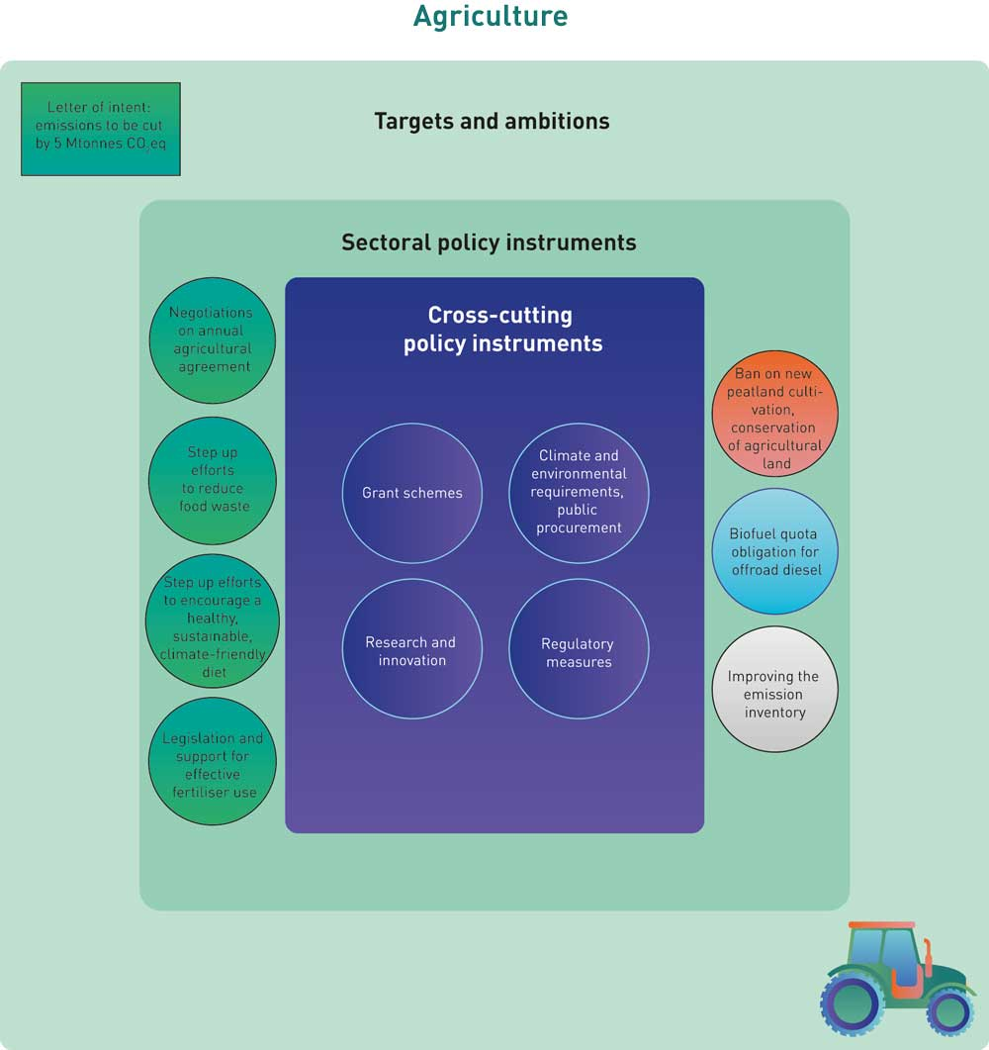
          - Policy instruments to reduce emissions and enhance removals in agriculture
              - Mitigation analysis for Norway 2021–2030: main findings for agriculture
The mitigation analysis for Norway 2021–2030 estimates the emission reduction potential in the agricultural sector at about 5 million tonnes CO2eq over the period. This corresponds to 13 % of the total emission reduction potential reviewed in the analysis. The analysis included 16 different measures in the agricultural sector. Some of these cannot be quantified or be accounted for in the emission inventory, and therefore cannot at present be used to achieve Norway’s climate targets. Others will result in emission reductions in the LULUCF and transport sectors. Eight of the measures included in the analysis can currently be accounted for in the agricultural sector. Four fertiliser-related measures that are possible to quantify were lumped together under ‘Various fertiliser-related measures’.
For more general information on the mitigation analysis for Norway 2021–2030, see Box 3.2.
[Boks slutt]

Agriculture’s contribution to achieving the 45 % target in the period 2021–2030
The measures described for the agricultural sector in this chapter must contribute towards Norway’s climate targets, including the Government’s target of reducing non-ETS emissions by 45 %. The figures presented here therefore only include effects that can currently be credited in the greenhouse gas inventory, in line with the letter of intent between the Government and the agricultural organisations.
The agricultural sector is in a special position because some emissions from agricultural activities are not accounted for under agriculture in the emission inventory. For example, emissions from tractors and agricultural machinery are accounted for in the transport sector, while CO2 emissions from agricultural areas are accounted for in the LULUCF sector. The letter of intent between the Government and the agricultural organisations applies to all mitigation measures for agricultural activities whose effects can be accounted for in the sectors agriculture, transport, heating of buildings and LULUCF (with the exception of forestry) in Norway’s official emission inventory. In the mitigation analysis for Norway 2021–2030 (see Box 3.19), the total emission reduction potential in the agricultural sector is estimated at 5.1 million tonnes CO2eq for the period 2021–2030. This includes 0.6 million tonnes CO2eq that can be achieved through action by the agricultural sector itself (part A of the letter of intent), and 4.5 million tonnes CO2eq that can be achieved indirectly through the Government’s efforts to promote changes in consumption patterns (part B of the letter of intent). The estimates in the mitigation analysis also show that there is a potential for the agricultural sector to reduce emissions that are accounted for in other sectors by about 1.1 million tonnes CO2eq. These figures include only measures whose effects are accounted for in Norway’s emission inventory.
In the letter of intent, the parties undertake to reduce emissions and enhance carbon uptake by a total of 5 million tonnes CO2eq over the ten-year period 2021–2030. The emission reductions may be in several different sectors, and the share that is in the two sectors transport and heating of buildings will also make a contribution towards the target of reducing non-ETS emissions by 45 %. Changes in emissions and removals in the LULUCF sector can make a contribution towards the obligation to ensure that emissions from this sector do not exceed removals (the ‘no debit’ rule).

Photo: Lars Sandved Dalen/ Norwegian Institute of Bioeconomy Research
The mitigation analysis for Norway 2021–2030 also included measures whose effects cannot currently be quantified or accounted for in the emission inventory. Such measures cannot at present play a part in achieving Norway’s climate targets, even though they could potentially be useful as mitigation measures. The Government is therefore seeking to build up more knowledge to make it possible for such measures over time to be accounted for in the emission inventory, but the level of uncertainty is high. The plan is therefore to achieve Norway’s climate targets on the basis of currently available methods and knowledge.
During the public consultation on the mitigation analysis, a large number of responses were received concerning the analysis of measures in agricultural sector. A number of them identified weaknesses in the analyses. This confirms that it is vital to maintain a focus on knowledge development, both to identify cost-effective measures for reducing greenhouse gas emissions from agriculture, and to identify their consequences for society.
As mentioned above, emission reductions that count towards the target in the letter of intent may be made in several different sectors. In other words, there are various different ways for the Government to meet its obligations. In this climate action plan, the Government uses the assumption that emissions accounted for in the agricultural sector will be reduced by 4 million tonnes CO2eq. This corresponds to reducing emissions in the agricultural sector by about 9 % in the period 2021–2030 compared with the level in the current projections. These figures are based on the target in the letter of intent and the conclusions reached in the mitigation analysis on the potential for agriculture to reduce emissions that are accounted for in other sectors. Figure 3.31 shows the emission trajectory for the agricultural sector if the Government’s climate action plan is implemented.
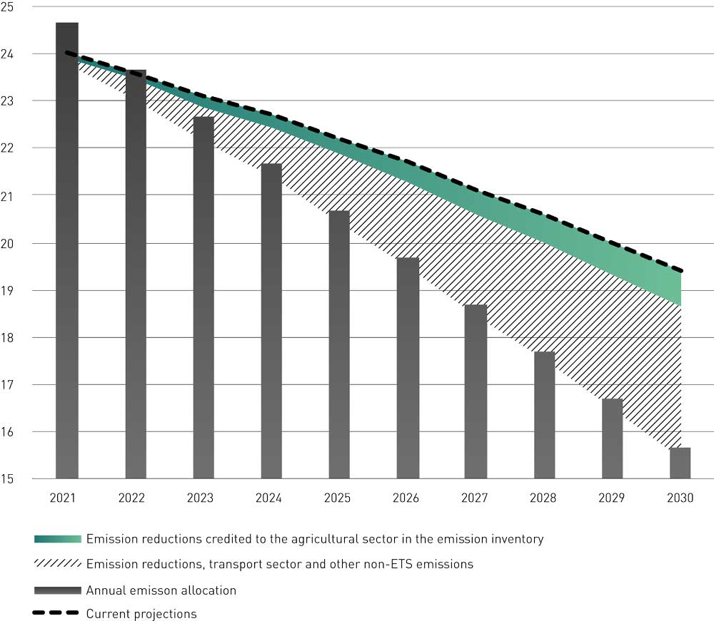
          - Emission trajectory for the agricultural sector under the Government’s climate action plan (million tonnes CO2eq).
The parties recognise that some measures under the letter of intent will take time to phase in, and that it will also take time before their effects become apparent in the emission inventory, so that the letter of intent may not produce results until the latter part of the period 2021–2030. To reduce cumulative emissions by about 9 %, emissions must be almost 20 % lower in 2030 than in 2021 if measures are phased in so that there is a linear increase in their effects. The effect on global warming will depend on how emission reductions are split between the three greenhouse gases.
To follow up the 2019 letter of intent, the agricultural organisations drew up a climate action plan for the sector, published in 2020. This sets out how the agricultural sector intends to achieve the target of the letter of intent through action in defined focus areas, with the individual farm and what farmers can do themselves as a starting point. The plan also points to the importance of achieving emission cuts without reducing food production in Norway. It describes how farmers will make structured, targeted efforts to achieve the transition to more sustainable agriculture. The plan identifies eight focus areas, and estimates that action in these areas combined will achieve the target of the letter of intent and reduce greenhouse gas emissions from agriculture by 4–6 million tonnes CO2eq over the next ten years. The estimated emission reduction potential for transport measures in the climate action plan from the agricultural sector is rather higher than the estimate in the mitigation analysis for Norway 2021–2030.
The discrepancy between these two estimates shows that it may be possible to achieve larger reductions in agricultural emissions than estimated in the mitigation analysis, and also that calculating the emission reduction potential of different measures and instruments is a very complex task. The agricultural sector considers it vital to achieve emission cuts without reducing production. If meat production declines in response to lower consumption, any resulting reduction in emissions will be additional to the estimates in the agricultural climate action plan.
A greenhouse gas calculator for Norwegian farms was launched on 15 October 2020 by an agricultural climate initiative. It is designed to document emissions at farm level and to help farmers to find good ways of reducing their own emissions. Advisory services will be important as a follow-up to this work, and in the 2020 Agricultural Agreement, NOK 3 million was set aside to develop a course plan for climate advisory services.
In the time ahead, the Government will take steps to follow up both part A and part B of the letter of intent it has signed with the agricultural organisations. Analyses show that it is possible to reduce emissions by more than the target set out in the letter of intent. The Government will provide a framework that facilitates sound climate-related choices by the agricultural sector. At the same time, it will facilitate sound choices by consumers as regards dietary choices and food waste. It is a challenging task to modify people’s behaviour, and it is also difficult to identify the exact effects of policy instruments on greenhouse gas emissions. In addition, the effects of various mitigation measures cannot at present be included in the emission inventory, either because no suitable methodology has been developed for calculating these effects, or because there is insufficient data to calculate the effects. It is therefore difficult to assess the shares of the emission reductions that will be achieved through parts A and B. The Government will follow up the letter of intent in line with part C to ensure that the target of reducing emissions by 5 million tonnes CO2eq is achieved. Box 3.20 describes how selected EU countries are seeking to reduce agricultural emissions.
              - Agriculture and climate change in the EU
The EU’s ambition is to reduce greenhouse gas emissions from agriculture steeply by 2030 compared with the 1990 level. The EU countries have already reduced their emissions considerably since 1990. An important factor in this has been the large drop in domestic ruminant numbers in Eastern European countries that have joined the EU, combined with a rise in production from the remaining animals in these countries.
The EU aims to reduce greenhouse gas emissions from agriculture while at the same time producing enough food for its own population and maintaining its position as the largest exporter of agri-food products in the world.
The largest emissions from agriculture in the EU are from livestock (enteric methane emissions) and fertilisers. At the same time, it is desirable to maintain agricultural grassland since it provides the best carbon sink in farmland and is important for conservation of the agricultural landscape, and because production from these areas contributes to food security. A certain rise in milk production in the EU is expected from 2019 to 2030. Red meat production is expected to decline in the same period, as a result of anticipated changes in the dietary choices of EU consumers. Poultry production is the only meat category expected to grow. In its food and agriculture strategy Farm to Fork, the EU emphasises the importance of improving people’s health by providing consumer information on healthy, sustainable food.
Germany has set a target of reducing greenhouse gas emissions from agriculture by 33 % by 2030 compared with the 1990 level. The most important climate action will be to reduce inputs of nitrogen to agricultural areas, use manure to produce biogas, increase the share of land used for organic farming, carry out research on more climate-friendly feed and breeding, and reduce food waste.
The Netherlands has reduced greenhouse gas emissions from agriculture by 17 % since 1990. Its target is to reduce them by a further 3.5 million tonnes CO2eq by 2030, including 2 million tonnes is to be achieved through reducing emissions of methane and other greenhouse gases from greenhouses. In addition, the Netherlands envisages that the following measures will reduce greenhouse gas emissions from agriculture: improved housing systems for livestock, breeding programmes, more precise and improved fertiliser application, better management of peat meadows, agricultural research and advisory services for farmers.
Greenhouse gas emissions from agriculture in Ireland total 20.2 million tonnes CO2eq, or 33 % of the country’s total emissions. This large share is explained by Ireland’s position as a major producer of milk and beef for Europe and the rest of the world. Ireland considers it important to use its resources to meet food demand internationally while at the same time contributing to climate commitments. Ireland’s target is to reduce greenhouse gas emissions from agriculture to 17.5–19 million tonnes CO2eq by 2030 through more effective use of fertiliser, breeding programmes and carbon sequestration in grassland.
Denmark’s target is to reduce greenhouse gas emissions from the food sector by 62 % by 2030 compared to the 1990 level. The most important agricultural measures will be protecting carbon-rich soils, promoting biogas production, reducing nitrification of manure and mineral fertiliser, breeding and genetics, and better feed management.
[Boks slutt]

Greenhouse gas emissions and removals the agricultural sector itself can influence
This section discusses part A of the letter of intent, which concerns measures that the agricultural industry itself can determine and implement, The industry is free to determine which specific measures are used. In line with the letter of intent, measures that are introduced must not be conditional on a rise in the level of subsidies.
Part B of the letter of intent concerns the Government’s efforts to promote changes in consumption patterns that may indirectly reduce greenhouse gas emissions from the agricultural sector. These efforts are discussed in Chapter 3.6.6 below.

A shift to a more climate-friendly agricultural policy
Norwegian agricultural policy is developed on the basis of cooperation between the central government and the agricultural industry to achieve politically determined objectives (see Chapter 3.6.2). Policy instruments for achieving these objectives are set out in the annual Agricultural Agreement. This makes the negotiating process and the annual agreements the most important mechanism for designing and implementing policy instruments in the agricultural sector.
The main agricultural policy instruments are support schemes and regulatory measures. Support schemes under the Agricultural Agreement interact with other policy instruments (import protection, market regulation, legislation, quotas, price support, research/advisory services, etc) in efforts to achieve agricultural policy objectives. As a result, the Agricultural Agreement is also the main mechanism for achieving the objective of ensuring sustainable agriculture with lower greenhouse gas emissions.
Through the Agricultural Agreement, the central government allocates substantial funding to climate and environmental measures, investment, and research, development, and testing of more sustainable farming techniques, see for example Box 3.21. Research and development is vital for the transition to more sustainable agriculture with lower greenhouse gas emissions. In addition to research funding provided through the Agricultural Agreement, the Government allocates funding through the Research Council of Norway, Innovation Norway and Enova. For example, the Research Council has recently issued a call for proposals for a research project on how the various segments of food systems work together, and which parts of the system can and should be transformed. The goal is to build long-term, sustainable food systems that enhance the competitiveness of Norwegian business and industry and play a part in the transformation of Norway and the world as a whole.
The climate footprint of producing agricultural goods varies between products. Since general support schemes influence agricultural operations, they also have implications for the associated emissions and removals of greenhouse gases. Assessments of the measures and instruments that should be used in climate-related work in the sector form part of the negotiations on the annual Agricultural Agreements. When the Storting (Norwegian parliament) considered the 2016 white paper on agricultural policy (Meld. St. 11 (2016–2017)), it was decided that the Agricultural Agreement should be made more climate friendly in order to achieve agricultural climate targets.
To obtain a better overview of the climate-related effects of changes made during the annual negotiations on the Agricultural Agreement, the Government wishes the mitigation effect of the Agricultural Agreement to be set out in the budget proposals for each year’s agreement. The annual assessment is intended to ensure that the shift in a more climate-friendly direction is sufficient to achieve the target for reductions in agricultural greenhouse gas emissions. It will also provide a basis for the Government and the agricultural organisations to identify how Norway’s agricultural policy instruments can be designed to achieve agricultural policy objectives and at the same time strike a balance between these objectives and climate and environmental targets.

Priority areas
The text below discusses several priority areas for cooperation between the Government and the agricultural organisations to reduce emissions and enhance removals of greenhouse gases. These are 1) phasing out fossil fuels in agriculture, 2) improving production systems and resource use, 3) important initiatives for sustainable agriculture and 4) increasing carbon sequestration.

Phasing out fossil fuels for transport and heating
Both fuel consumption in agriculture (by tractors and agricultural machinery) and fossil energy use for heating purposes are subject to the carbon tax. The only remaining exemption from the carbon tax for mineral products applies to LPG (liquefied petroleum gas) and natural gas for use in greenhouse nurseries.
The use of fossil fuel, both for machinery and for heating farm buildings and greenhouses, results in total emissions of about 0.5 million tonnes CO2eq per year from agriculture. The letter of intent between the agricultural organisations and the Government (part A) applies to these emissions.
Biofuels in agriculture: At present, almost all agricultural and forestry machinery uses fossil fuels. Practical tests as part of a project on biodiesel in Norwegian agriculture run by the research institute Ruralis have shown that biodiesel can be a suitable fuel for tractors. Unlike fossil offroad diesel, biodiesel is not subject to the carbon tax or the basic tax on mineral oil. Even so, the purchase price of biodiesel is substantially higher than that of fossil diesel. If the use of fossil fuel is phased out over ten years and it is replaced by renewable alternatives, the emission reduction potential is around 1.4 million tonnes CO2eq over the period 2021–2030. The Government will seek to introduce a biofuel quota obligation for offroad diesel from 2022, which will gradually be increased up to 2030 to the same level as for road traffic. The actual effect on emissions of using biofuel in Norwegian agriculture will depend on how the biofuel quota obligation is designed.

Photo: Erling Fløistad/ Norwegian Institute of Bioeconomy Research
Fossil-free heating in agriculture: greenhouse gas emissions from heating in agriculture originate from greenhouses and livestock housing. Diesel and oil are also used in generators at mountain summer farms and in grain dryers. Emissions from heating in agriculture have been reduced in recent years, largely because many farmers have switched from fuel oil to natural gas and bioenergy, and because of a reduction in total energy use. The greenhouse nursery sector has been making targeted efforts to reduce energy use for many years. It is now making use of more environmentally friendly energy sources than before, and emissions have been substantially reduced. Emissions from heating of buildings in agriculture have been reduced by 13 % from 1990 to 2019.
Innovation Norway and Enova have established grant schemes to promote the use of bioenergy in greenhouses and for other heating in the agricultural sector. In 2018, the Government decided that from 1 January 2025, the prohibition on using mineral oil to heat buildings will also include the use of mineral oil to heat farm buildings. If all use of fossil fuels in agriculture is phased out and they are replaced with renewable alternatives, the emission reduction potential is just over 0.4 million tonnes CO2eq in the period 2021–2030.

Improving production systems and resource use
A number of the mitigation measures for the agricultural sector provide important public goods such as improvements in the aquatic environment, greater biodiversity and lower emissions to air (ammonia). These are win-win solutions: the sector can play a part in achieving national and international environmental targets and the measures implemented also reduce greenhouse gas emissions. Such measures can also have economic benefits, and a number of them also involve improvements in agronomic practices.
              - A ‘Living Lab’ in Trøndelag county
There is a ‘Living Lab’ at Mære Agricultural School in Trøndelag county, owned by the county authority. The centre is an arena for testing and demonstrating innovative climate and energy solutions for agriculture in close cooperation with farmers. The centre’s objectives are to contribute to a shift to more climate-smart agronomic practices and a shift from farms as energy consumers to farms as energy suppliers, to play a part in climate- and energy-related innovation, and to improve education and training. The centre is part of a broad-based network including R&D institutions, agricultural organisations and the public administration and businesses at regional and national level.
[Boks slutt]
Improving fertiliser application and storage: Fertiliser is an important resource, but in several regions of Norway, typically those where livestock numbers are high, more fertiliser is produced and applied than is needed to ensure satisfactory crop growth. The use of both mineral fertiliser and manure results in nitrous oxide emissions. In 2019, 74 % of nitrous oxide emissions in Norway were from fertiliser application and other sources in the agricultural sector. Emissions of nitrous oxide from agriculture in 2019 were estimated at almost 6 000 tonnes N2O, or about 1.8 million tonnes CO2eq. Fertiliser use also results in nutrient run-off and eutrophication of water bodies, and in emissions of ammonia to air. Nutrient run-off from excess fertiliser use must be reduced in order to achieve the environmental objectives of the Water Framework Directive, which has been incorporated into Norwegian law under the EEA Agreement. The deadline for achieving the environmental objectives is in 2022. Norway is still exceeding its emission ceiling for ammonia under the Gothenburg Protocol, and will implement further measures to achieve its emission reduction commitment for the next period, which starts in 2020.
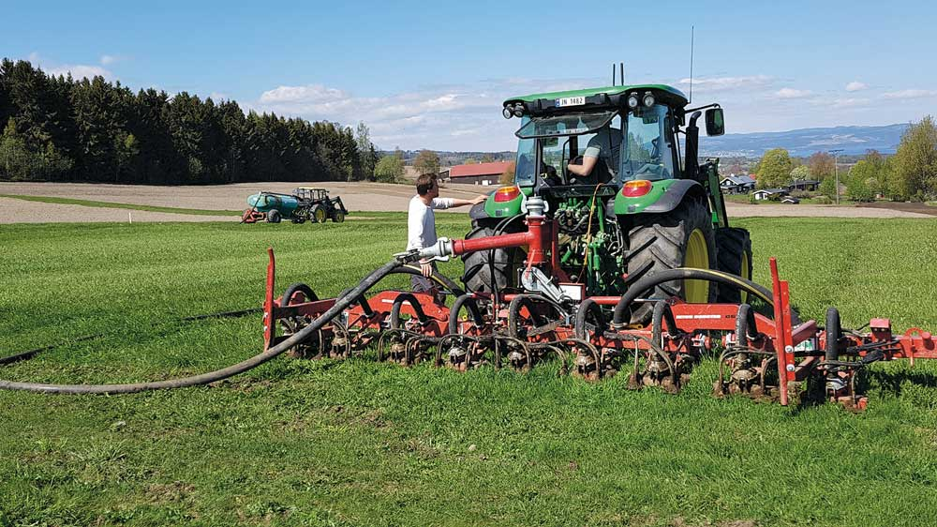

Photo: Audun Korsæth/Norwegian Institute of Bioeconomy Research
Emissions to air and water from manure are being reduced by already established legislation and grant schemes. The application and storage of manure in Norway is governed by the regulations relating to fertiliser products of organic origin, which are currently under revision. The Norwegian Agriculture Agency, the Norwegian Food Safety Authority and the Norwegian Environment Agency have proposed various amendments. These include stricter requirements for storage facilities and storage capacity, and revised requirements for the spreading area required and the times when manure application is permitted. Norway’s regulations on nutrient management plans set out requirements that must be met for holdings to be eligible for agricultural support schemes. The annual Agricultural Agreements include funding for investments in upgrading manure storage facilities and effluent tanks and for environmentally friendly manure application systems. The introduction of a tax on mineral fertiliser is to be assessed, as mentioned in Chapter 3.3.2.
In the mitigation analysis for Norway 2021–2030, four different manure-related measures were considered: covers for manure storage facilities (for pig manure); environmentally friendly manure application; better timing of manure spreading and better storage capacity; and regulation of the spreading area for manure. The total emission reduction potential for these four measures is about 330 000 tonnes CO2eq over the period 2021–2030.
Manure as a resource for biogas production: Emissions from manure can be reduced by using it as a feedstock for biogas plants. A grant scheme for deliveries of manure for biogas production has been operating since 2013. The 2019 Agricultural Agreement included a decision to appoint a working group that during the next year would consider further ways of designing existing and new policy instruments to increase the use of manure for biogas production and at the same time maximise climate and environmental benefits, which was discussed in connection with the National Budget (Prop. 120 S (2018–2019)). Following up this decision, the parties agreed during the negotiations on the 2020–2021 Agricultural Agreement to continue the grant scheme. NOK 9 million was allocated to the scheme, an increase of NOK 4 million from the previous year, and the size of the grants available was increased.
Biogas production is sensitive to market demand. Higher demand for biogas will make it possible to use more manure to produce biogas. Policy instruments that can be used to stimulate biogas production and use are generally cross-sectoral. The planned carbon tax increases will to some extent stimulate the demand side, but it is uncertain how much they will do this. (See Chapter 3.5 for more about biogas and the action plan for biogas.)
One of the measures considered in the mitigation analysis for Norway 2021–2030 was the use of livestock manure in biogas production, which has an emission reduction potential of 250 000 tonnes CO2eq for the period 2021–2030. This figure is based on the assumption that the quantity of manure used in biogas plants increases gradually from the current level of 1 % to 25 % in 2030.

Important initiatives for sustainable agriculture
Continuing and intensifying initiatives for improvements in forage quality, animal health, fertility and breeding, and for better drainage, can lower the climate footprint of agriculture in two ways. On the one hand, there may be direct improvements in nutrient cycling in animals, plants and soils. Emissions per animal, unit area and unit of input can be reduced, but these changes are difficult to incorporate into the emission inventory. Such measures are therefore not accounted for directly in the emission inventory at present, but will be partly expressed through lower livestock numbers if yields increase or animal health is improved. Research and development activities are in progress with the aim of making it possible to quantify emission reductions and if possible include these measures in the emission inventory at a later date. On the other hand, improvements in these areas may mean that less fertiliser or fewer animals are needed to achieve the same level of production. These are quantitative effects that are included in the emission inventory. The effects these measures may have on greenhouse gas emissions through land-use change and changes in energy and fertiliser use must also be taken into consideration.
Better feed: the fibre content of feed for ruminants influences enteric methane emissions. Methane emissions from ruminants can be reduced by developing knowledge and improving routines for feeding and for feed production and harvesting practices. Knowledge is also being developed about the use of feed additives to reduce methane emissions from ruminants.
Better animal health, fertility and breeding: Improving productivity, particularly in animal husbandry, results in lower greenhouse gas emissions. The productivity of animal husbandry can for example be increased through improvements in animal health and fertility, and through breeding programmes. Certain improvements in productivity have been incorporated into the baseline projections. Further improvements may result in larger emission cuts.
Norway is a world leader in animal health. Healthy, fertile animals are better for the climate than animals that are in poorer health. In milk production, breeding programmes have resulted in a 10 % decrease in emissions per unit produced since 1980. In the 2017 Agricultural Agreement, NOK 15.5 million was earmarked for a breeding project to be run by Geno (the breeding company for Norwegian Red cattle), which will also match this funding. The funding will be used in a programme to breed dairy cattle that generate lower methane emissions without any adverse effects on other breeding goals such as better animal health.
The Agricultural Agreements include various grant schemes that are designed to boost productivity. They include support for breeding organisations, veterinary services and other joint measures and also grants to individual holdings. Higher productivity must be considered in conjunction with other agricultural policy goals. Farming more extensively, for example using of rough grazing to a larger extent, can be an important way of achieving other goals, such as maintaining the cultural landscape and safeguarding biodiversity.
Drainage: Well-drained soils provide favourable conditions for plant growth and nutrient uptake, and there is less risk of soil compaction. Emissions of nitrous oxide are also lower from well-drained soils, since drainage reduces the water content of soils. This in turn reduces the amount of the nitrogenous fertiliser applied that is converted into nitrous oxide.
The effect of improving drainage can be reflected in the emission inventory if it results in lower consumption of nitrogen in mineral fertiliser. Increasing the yield per unit area also reduces emissions per kg harvested, and improves income on a holding. Since 2013, the Agricultural Agreement has included a grant scheme for drainage of agricultural soils. Other hydrotechnical measures can be combined with drainage, and these are also eligible for grants. Grants are not provided for drainage or cultivation of new areas. Grants may not be awarded if measures will cause significant damage to other properties or to biodiversity, or if they entail a significant risk of flooding and water pollution or a risk of damage to cultural monuments and sites that have automatic legal protection.
Technological developments: Norway is a leader in the development and deployment of new technology that can reduce the climate and environmental footprint of food production. Innovative, smart technology adapted to large and small holdings will be an important part of the solution, and can make food production more resource effective and sustainable (see Box 3.22).
              - Reducing greenhouse gas emissions by using agricultural technology
Increasing sustainable food production in Norway will require the use of climate-friendly practices that also have environmental benefits. Norwegian developers of agricultural technology are providing useful support for these efforts.
The agricultural robot Thorvald can be customised to carry out a variety of different tasks, and in the long term this technology can replace large fossil-fuel tractors.
Norwegian livestock breeding companies make use of modern imaging technology and biotechnology. Using such technologies can help to maintain the positive trend of the last few decades, when emissions from agriculture have been declining.
Geno, which has been engaged in systematic cattle breeding for more than 100 years, estimates the emission reduction potential of their entire breeding programme for the period 2021–2030 to be in excess of 1 million tonnes CO2eq.
A number of companies offer farmers tools based on data collected by various types of sensors and monitoring systems from emission sources in livestock accommodation and in the fields. The flow of real-time information enables farmers to optimise their use of inputs and at the same time limit climate and environmental impacts.
Agriculture is the largest source of emissions of both methane and nitrous oxide. A major Norwegian fertiliser producer is cooperating with a global IT concern to offer comprehensive digital services combined with site-specific agronomic advice on plant production. This may help to reduce nitrous oxide emissions from mineral fertiliser. Another Norwegian company has developed a solution that can increase yields and reduce emissions of methane and nitrous oxide, based on plasma technology that converts manure into higher-quality fertiliser. In a pilot project at a Danish dairy farm, this technology reduced greenhouse gas emissions by 28 %.
Such innovations are designed to reduce greenhouse gas emissions from agriculture and improve sustainability by reducing releases of other substances to air and water as well.
[Boks slutt]

Enhancing carbon removals and storage and other climate benefits
Agricultural areas can provide important climate benefits in the form of CO2 removals and methane oxidation in soils. Farming methods such as livestock husbandry that make use of grassland and pasture also maintain open landscapes and thus a higher ground albedo than in areas that become overgrown with shrubs and trees. The albedo of a surface is an expression of its ability to reflect light. Higher ground albedo counteracts global warming.
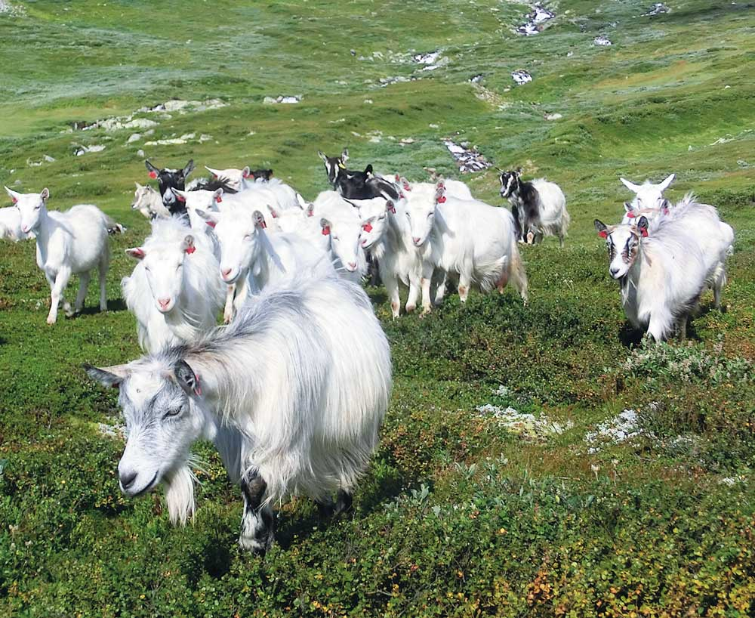

Photo: Yngve Rekdal/Norwegian Institute of Bioeconomy Research
Healthy soils give better yields, provide important ecosystem services, remove more CO2 from the atmosphere, play a part in climate change adaptation and water purification, and support a richer flora and fauna. If soil quality declines, runoff of nutrients and other substances and greenhouse gas emissions may become a problem. Over time, soils can become impoverished if their carbon content declines, causing problems for agriculture and in relation to climate change. It is vital to reverse these trends. In the time ahead, it will therefore be essential to build up knowledge and introduce better practices for increasing carbon sequestration in soils, improving soil health and sustainable use of agricultural areas.
Norway has therefore joined the ‘4 per 1000’ initiative, which was launched during the climate summit in Paris in 2015. The name ‘4 per 1000’ refers to the fact that if the soil carbon level increased globally by 0.4 % per year, this would significantly reduce annual CO2 emissions to the atmosphere. This is not possible to achieve everywhere, and is not a substitute for emission cuts, but it is a common goal to improve carbon retention in soils. Emissions and removals of CO2 from arable land and pasture are also included in the letter of intent between the Government and the agricultural organisations, but in Norway’s greenhouse gas inventory, these emissions are accounted for in the land-use change and forestry (LULUCF) sector.
The Agricultural Agreement includes various grant schemes for research on soil health and for practices that promote carbon sequestration in soils. Such measures are expected to result in more favourable trends for emissions and removals in agriculture than has been the case until now and used as a basis for the current projections.
Prohibition against new cultivation of peatland areas: Peatlands store large quantities of carbon. Intact peatlands are likely to remain in an equilibrium state over time as regards greenhouse gases, since carbon uptake through growth is balanced by methane emissions from anaerobic degradation. In addition, peatlands are important for water regulation and biodiversity, particularly birds and insects. Intact peatlands can play a part both in reducing the scale of climate change and in moderating its impacts in the form of droughts and flooding.
Drainage and other land-use change in peatlands trigger degradation processes in organic material, giving rise to emissions of carbon dioxide and nitrous oxide.
In 2019, the Storting considered amendments to the Land Act, including provisions on climate change considerations when cultivating new areas. On 2 June 2020, the Ministry of Food and Agriculture adopted amendments to the regulations on new cultivation of land. As a general rule, new cultivation of peatland is now prohibited. The municipalities are authorised to grant exemptions from this prohibition in special cases.
Emissions from peatland that is cultivated continue for some decades after drainage ditches are dug, until decomposition of the organic matter is complete. This means that action now also has important implications for future emissions. In reports to the UN and the EU, Norway has estimated that restrictions on cultivation of peatland will result in overall emission reductions of 450 000 tonnes CO2eq over the period 2021–2030, of which a little under 400 000 tonnes CO2 will be accounted for in the LULUCF sector and 70 000 tonnes CO2eq (nitrous oxide) in the agricultural sector. It is not possible to give a precise estimate of how much peatland would have been cultivated in the years ahead without this prohibition.
The Government is already promoting the restoration of peatland and other wetlands as a combined climate change mitigation and biodiversity measure. In 2020, the Government allocated NOK 21 million to these efforts.

Intensifying efforts to improve the greenhouse gas inventory
Norway’s greenhouse gas inventory follows the international guidelines drawn up by the IPCC. The knowledge base is constantly developing, and there have been considerable advances in the accounting methodology for the agricultural sector. Nevertheless, the effects of various measures described in the mitigation analysis for Norway 2021–2030 cannot currently be registered in the emission inventory. This applies for example to carbon sequestration in soils, the use of catch crops and drainage of agricultural soils. This is because methods for calculating the effects of these measures on emissions have not yet been developed or because there is insufficient data.
In line with the letter of intent between the Government and the agricultural organisations, measures implemented by agriculture, but that are not included in Norway’s national greenhouse gas inventory in the period 2021–2030, will not be counted towards the target of reducing emissions by 5 million tonnes CO2eq. However, a separate greenhouse gas inventory for such measures is to be established under the letter of intent. The ambition is to incorporate the effects of these measures into the national greenhouse gas inventory over time.
At present, about two thirds of the estimated emission reduction potential of the measures outlined in the climate action plan from the agricultural sector cannot be credited either towards the target of the letter intent or towards Norway’s climate targets, even though these measures will in practice result in reductions in greenhouse gas emissions. The Government considers it important to continue the development of methodology for measuring the effects of various measures on emissions from biological production. It is also important to develop mitigation measures further so that they can be used as widely as possible. The Government will therefore intensify efforts to improve the emission inventory for agriculture, so that the effects of new measures in the sector can be incorporated in the long term.

The Government’s efforts to promote changes in consumption patterns that may indirectly reduce greenhouse gas emissions from agriculture
The Government will:
- Continue and further develop work on the action points in the Norwegian National Action Plan for a Healthier Diet;
- Step up and further develop cross-sectoral work on diet and climate change, including cooperation with the food industry;
- Gradually step up efforts to raise awareness about and facilitate a shift to a healthy, sustainable and climate-friendly diet in day care centres, schools and out-of-school-hours care;
- Promote the inclusion of environmental and climate-related requirements and the use of established dietary criteria in public procurement processes for food and meal services. This will include providing advice for contracting authorities based on the current public procurement legislation;
- Carry out more frequent surveys of dietary habits in different population groups as part of efforts to promote a healthy, sustainable and climate-friendly diet, and to assess whether current policy is sufficient to achieve the aim of persuading the Norwegian population to follow dietary advice from the Directorate of Health;
- Consider the establishment of model for cooperation at county and municipal level to facilitate a shift to a healthy, sustainable and climate-friendly diet. This will include improving information on dietary habits and factors that can affect public health, in line with the Public Health Act;
- In dialogue with the food industry, look at the structure, funding and tasks involved in awareness-raising activities to ensure more consistent communication of dietary advice from the Directorate of Health;
- Ensure that central government agencies lead by example, and step up efforts to reduce food waste in the public administration in order to contribute towards the targets of the agreement between the authorities and the food industry on the reduction of food waste;
- Take steps to improve the overview and reporting on food waste in the public sector;
- Ensure that the main reports to be delivered in 2020 and 2025 under the agreement between the authorities and the food industry are included as part of the basis for assessing whether policy instruments need to be adjusted to achieve the targets of the agreement and contribute towards the 2030 climate target;
- Call on the ministries that have signed the agreement on the reduction of food waste to encourage more parties to endorse it;
- Engage in dialogue with agricultural information offices, the Norwegian Seafood Council and others on how they can intensify their efforts to reduce food waste;
- Consider the reduction of food waste in conjunction with gradually stepping up efforts to raise awareness about facilitating a healthy, sustainable and climate-friendly diet in day care centres, schools and out-of-school-hours care;
- Consider the reduction of food waste in conjunction with increasing the proportion of overall food resources harvested/cultivated that is utilised, including increasing the use of residual raw materials.
The agricultural sector is seeking to reduce emissions per unit of production, as described in Chapter 3.6.5. In addition, changes in food consumption may lead to changes in the composition of agricultural production, which in turn may influence greenhouse gas emissions from agriculture. The text below describes how the Government will follow up the part of the letter of intent (part B) that concerns the Government’s efforts to promote changes in consumption patterns.
The letter of intent lists the following examples of what the Government will seek to do:
- achieve the target of reducing food waste by 50 % by 2030;
- persuade the Norwegian population to change their food habits so that they are as far as possible in line with dietary advice from the Directorate of Health.
If the target of halving food waste is achieved, it will not be necessary to produce as much food. If efforts to encourage people to follow dietary advice from the Directorate of Health to a greater extent are successful, demand for red meat and processed meat will be lower. If consumption of food types such as red meat that result in high greenhouse gas emissions is reduced, farmers will adapt to the reduction in demand and produce less of these food types. Greenhouse gas emissions from agriculture will decline as a result. Dealing with the global problems of climate change will require collective action and behavioural change, according to the UN Environment Programme (UNEP). This is why changes in consumption patterns are included in the letter of intent between the Government and agriculture. The EU’s food and agriculture strategy Farm to Fork also deals with the entire food system and the links between healthy people, healthy societies and a healthy planet, see Box 3.23.
              - The EU’s Farm to Fork Strategy
In May 2020, the European Commission presented its food and agriculture strategy, Farm to Fork. This deals with the entire food production chain, all the way from land and sea to the consumer. It focuses on fair food systems and on the production of healthy and affordable food, and also on environmental performance along the whole value chain. Action to reduce food waste is also an important part of the strategy. For example, the EU rules on date marking are to be revised.
The strategy also emphasises the consumer perspective, and the European Commission points to the links between sustainability, diet and health. Consumers are to be empowered to make healthy food choices through improvements in labelling, for example better, simpler nutrition labelling. The aim is to restrict marketing of foods high in fat, sugars and/or salt. Information for consumers on production methods and environmental and ethical issues may also be included in the labelling. A proposal for a sustainable food labelling framework will be presented by 2024.
Together with Farm to Fork, the European Commission presented the EU Biodiversity Strategy for 2030. This describes how dependent people are on the rich variety of life on earth both in economic terms and for our health.
[Boks slutt]
The Norwegian health authorities recommend a varied diet including plenty of vegetables, fruit and berries, whole-grain foods and fish, and limited amounts of processed meat, red meat, salt, sugar and saturated fats. The climate footprint of producing agricultural goods varies between products, and recommendations for a healthy diet coincide to a large extent with those for a more sustainable diet. The Government’s aim is for the Norwegian population to follow dietary advice from the Directorate of Health.
In 2018, at least 390 000 tonnes of food that could have been eaten was thrown away in Norway – by the food industry, wholesalers, retailers and consumers. In addition to ensuring that once food is produced it reaches people’s plates and is eaten, it is important to make better use of food resources that are harvested or cultivated. This also means avoiding the loss of valuable resources by using more of the residual raw materials.
The UN defines a sustainable food system as one that ‘delivers food security and nutrition for all in such a way that the economic, social and environmental bases to generate food security and nutrition for future generations are not compromised.’ Food produced from the land currently meets 95 % of people’s calorie requirements, and food from the oceans only 5 %. According to the UN Committee on World Food Security, sustainably produced seafood has an important but often overlooked role to play as regards food security and nutrition.
The seafood contribution is dependent on a clean and healthy environment and sustainable resource management and production. In addition, enough safe, healthy seafood must reach the end of the food value chains so that it can be eaten. An integrated approach is needed, involving cooperation between all sectors and stakeholders that are responsible for and influence different elements of the food value chain. Institutions such as the Institute of Marine Research, the Nofima research institute and the SINTEF group provide information as a basis for assessments relating to healthy, sustainable seafood.
The Nordic Council of Ministers is revising the Nordic Nutrition Recommendations before publishing a new edition in 2022. These recommendations form the basis for the official national dietary recommendations in the Nordic countries, and will be largely based on a health perspective. However, the new edition of the recommendations will integrate sustainability to a greater extent than before where there is sufficient scientific documentation.

Policy instruments
It is a challenging task to change people’s dietary habits, but nevertheless essential to persuade the Norwegian population to follow dietary advice from the Directorate of Health. All research and experience shows that changing people’s dietary habits requires a number of measures that interact across sectors, and depends on close cooperation between public, private and voluntary stakeholders. It is difficult to measure the effect of individual measures and to assess each measure separately from all the other actions taking place at the same time. According to reports from the World Health Organization and the Directorate of Health, a concerted, broad-based effort is needed to achieve results.
The Government will continue and further develop work already in progress on the basis of the Norwegian National Action Plan for a Healthier Diet (2017–2021/2023) and the 2019 white paper on public health policy (Meld. St. 19 (2018–2019)). In the time ahead, there will be a special focus on strengthening a sense of ownership of the action plan in the ministries, identifying responsibilities at municipal and county level, and increasing the involvement of the voluntary sector. Sustainability will also be emphasised more in this work.
In 2017, the Norwegian authorities signed an agreement with the food industry with the target of reducing food waste by 50 % by 2030. All food production results in greenhouse gas emissions. If less food is thrown away, it will not be necessary to produce as much food from the land and the oceans, either in Norway or in other countries from which Norway imports food. This will result in lower greenhouse gas emissions. As of November 2020, 103 companies had endorsed the agreement on food waste and undertaken to measure and report both on the scale of food waste and on what action they are taking. There is still a potential for wider participation in the agreement, including by entities in the public sector.

Priority areas

Children and adolescents
We develop habits early in life, and it is therefore important to help children and adolescents to establish good habits in order to reduce food waste and develop a healthy, climate-friendly and sustainable diet.
Sustainability will be given a more prominent place in work on people’s diets through competence-building measures and by sharing information on good models for food and meals for children in day care centres, schools and out-of-school-hours care. An already existing activity programme on food, health and the environment for children in out-of-school-hours care will be further developed as part of this work. The programme is run by a social enterprise called Folkelig in cooperation with the national centre for food, health and physical activity at the Western Norway University of Applied Sciences. The new framework plan for out-of-school-hours care will include sections on diets and meals as part of the follow-up to a 2019 white paper on a more inclusive education system (Meld. St. 6 (2019–2020)). The dietary advice from the Directorate of Health will be used as a basis.
Knowing about a healthy, sustainable diet, practical cooking, raw materials and ways of avoiding food waste is important for everyone. Important target groups include parents, staff at day care centres and out-of-school-hours care, and teachers whose subjects include food and health are important target groups.
Seafood consumption in Norway is lower than recommended by the Directorate of Health. A national nutrition programme, ‘Fiskesprell’, is designed to encourage children and adolescents to eat more seafood, in line with the Directorate’s recommendations. It includes courses for employees at day-care centres and schools, and provides teaching materials and financial support for purchasing seafood. Climate change and sustainability are to be integrated into the programme, including information on how eating more seafood and reducing food waste can contribute to the fight against climate change.
              - Sustainable diets in Scandinavia
Sweden
In Sweden, the authorities provide dietary advice on eating habits that are both healthy and environmentally sustainable. These include explanations of the negative effects on health of eating too much red meat and processed meat, and also point out that meat production has substantial impacts on climate change, eutrophication and biodiversity. The Swedish dietary guidelines therefore recommend that people should reduce meat consumption or replace a few meat dishes a week with vegetarian options on environmental grounds. However, the authorities point out that meat production also has positive environmental impacts because livestock help to maintain the open cultural landscape.
Denmark
The Danish Veterinary and Food Administration tasked the National Food Institute with investigating the carbon footprint of the average Danish diet. It was found that 57 % of the carbon footprint is from animal products, 24 % from snacks and various beverages, and 15 % from vegetable products. The Danish authorities are considering how the dietary guidelines can be supplemented with information to provide inspiration by showing people how they can reduce the impact of their diet on the climate.2 One result is an information campaign launched by the food and climate ministers. This is designed to help Danish consumers to make climate-friendly choices when they are deciding what to eat for their next meal.
1 https://www.livsmedelsverket.se/matvanor-halsa--miljo/kostrad/rad-om-bra-mat-hitta-ditt-satt/kott-och-chark
2 https://altomkost.dk/nyheder/nyhed/nyhed/nye-kostraad-faar-klima-paa-menuen/
[Boks slutt]

Cross-sectoral cooperation
Letter of intent between the health authorities and the food industry. The health authorities and the food industry have signed a letter of intent for the period 2016–2021. About 100 businesses have undertaken to work towards a healthier diet containing less salt, added sugar and saturated fats and more fruit, berries, vegetables, whole-grain foods and fish. The Government will maintain and intensify its cooperation with the food industry on these tasks. Work is now in progress on a revised letter of intent which will apply up to 2025.
Municipalities and counties: The local government level has a key role to play in efforts to encourage and facilitate sound eating habits and a good diet. The Public Health Act and the Planning and Building Act set out the obligations of municipalities, counties and central government relating to work on public health, including nutrition, and also taking climate change considerations into account. The voluntary sector has an important role to play in this area. The Government will therefore consider the establishment of a model for cooperation at county and municipal level to facilitate a shift to a healthy, sustainable and climate-friendly diet.
Formalised cross-sectoral cooperation would need to be grounded in a shared knowledge base and strike a balance between different interests, and any measures implemented should help to clarify local responsibilities. Such cooperation must be considered in conjunction with local government climate and environmental initiatives such as the Klimasats grant scheme. Other initiatives that are relevant here are the programme for municipal public health work, and Matgledekorpset and Matvett, which are discussed in box 3.25. A pilot project may be organised to assess the possible effects of cross-sectoral cooperation. The Directorate of Health has produced guidance for local public health work, which would be an important tool in this work. The purpose of a cross-sectoral model of cooperation would be to help and encourage people to eat a healthy, sustainable and climate-friendly diet. It would be possible to draw on experience from relevant work at municipal level in Norway, and also from countries such as Sweden and Denmark. To help the Government assess whether to initiate such cooperation, the Directorate of Health will be asked to draw up a proposal or a timetable for the work. This should include a brief description of possible models. An assessment of the proposal will be coordinated with the Norwegian Environment Agency and will include cost estimates.

Photo: Jon Hauge/Aftenposten/NTB

Public procurement, nutrition and climate change
The Government will promote the inclusion of environmental and climate-related requirements and the use of established nutritional criteria in public procurement processes. The aims are to raise awareness among people responsible for purchasing goods and services, encourage the development of healthier products and make healthy food more easily available to consumers. This work should be coordinated with efforts to reduce food waste. It will include providing advice for contracting authorities based on the current procurement legislation. In 2020, the Directorate of Health is to publish guidance, incorporating input on procurement from the Norwegian Agency for Public and Financial Management. The advice will also draw on initiatives for healthy food in workplaces and in food service venues, and will refer readers to the Agency’s templates for green public procurement.

More frequent dietary surveys
Good forecasts of the demand for different types of products are needed to put primary producers and the food industry in a better position to make sustainable long-term investment decisions. The Norwegian Institute of Public Health and the Directorate of Health are responsible for monitoring changes in Norwegian diets at different levels and in different population segments. The Government has identified a need for a better overview, and intends to ensure more frequent dietary surveys to follow up efforts to promote a healthy, sustainable and climate-friendly diet. The surveys will also be used to assess whether current policy is resulting in sufficient progress towards the goal of persuading the Norwegian population to follow dietary advice from the Directorate of Health. In addition, dietary surveys will be important in following up the letter of intent between the Government and the agricultural organisations, and will provide valuable information that can be used to adjust agricultural policy to consumer demand.

Awareness, information and communication on healthy, sustainable and climate-friendly food
For many Norwegians, one barrier to eating a diet in line with advice from the Directorate of Health is uncertainty about what constitutes a healthy, sustainable and climate-friendly diet. It is therefore vital to communicate dietary information to the general public. The Government will seek to raise awareness both in the general public and among key personnel in supermarket chains, the education system and health and care services. The Directorate of Health will continue its communication activities. It is important to provide complete, consistent and scientifically based information on healthy, sustainable and climate-friendly diets.

Review of information activities
Norway currently has four information offices for different types of agricultural products, whose task is to encourage consumption of food produced in Norway. Their activities are funded through a statutory tax on sales paid by the producers, and the funds are managed by an independent body. The legislation makes it possible to use market regulation as an agricultural policy instrument. The Norwegian Seafood Council has a similar role for the fisheries and aquaculture industry. These bodies play an important role in communicating enjoyment of food and providing information on practical food preparation. It can be difficult for people to find the information they need to change their dietary habits to follow the Directorate of Health’s advice more closely. The Government will engage in dialogue with the agricultural information offices and the Seafood Council to review the structure, funding and tasks involved in awareness-raising activities. The aim is to achieve more consistent communication of the dietary advice provided by the Directorate of Health.
Providing complete information combined with awareness raising can improve people’s knowledge about issues such as the shelf life, storage and use of leftover food, which will help to reduce food waste. Various channels are used to communicate information on how everyone can reduce food waste, including matportalen.no, the Norwegian Food Safety Authority, Matvett (see Box 3.25), the agricultural information offices and the Seafood Council. The Government will engage in dialogue with Matvett, the agricultural information offices and the Seafood Council on how they can intensify their efforts to reduce food waste.

Encouraging more parties to join the agreement on the reduction of food waste
All the ministries that have signed the agreement with the food industry on the reduction of food waste will encourage more parties to join the agreement. The Government will also step up its efforts to reduce food waste in the public sector. Public procurement processes will be actively used as a tool in this work. In this connection, the Government will promote the inclusion of environmental and climate-related requirements in procurement processes for food and meal services. Contracting authorities will receive advice based on the current procurement legislation. Matgledekorpset and Matvett, which are discussed in box 3.25, can play a part in intensifying efforts to reduce food waste in the public sector.

Photo: Fredrik Sandberg/NTB
Good data are needed to follow up the agreement and to determine whether its targets are being achieved. The Government will therefore seek to improve surveys of and reporting on food waste along the entire food value chain.
              - Examples of action to reduce food waste
Matvett
The Government supports Matvett, a company owned jointly by food producers, food retailers and the food and beverage service sector, whose mission is to prevent and reduce food waste. It was established in continuation of a project that ran from 2009 to 2015 and was instrumental in reducing food waste per person by 12 % during this period. Since 2015, the food sector has reduced food waste per person by a further 12 % in the period 2015–2018, and is on track to achieve the target of a 15 % reduction by 2020. In 2017, Matsvinn started a project specifically for the food and beverage service sector, in which participating establishments aimed to reduce food waste by 20 % by 2020. The project is trying to reach 50 % of establishments in the sector. More than 2300 establishments are taking part, including hotels, canteens, public-sector bodies and filling stations/services. As part of the project, a number of municipalities have agreed to monitor and report food waste at care homes, day care centres and out-of-school-hours care. Guidelines on the safe use of leftover food have been drawn up, including an annex for care homes on providing safe meals for the elderly.
Food Banks Norway
The Government supports Food Banks Norway, which is an umbrella organisation for the seven Norwegian food banks. These distribute surplus, in-date food from retailers, wholesalers and producers to disadvantaged people. In 2019, the network of food banks distributed 2 627 tonnes of food, corresponding to more than 5.25 million meals.
Matgledekorpset
The target groups for the Matgledekorpset project are people responsible for buying, preparing and serving food to the elderly, and carers both in institutions and in home care services. It also seeks to raise awareness in the municipal administration of the links between food purchases, diet and enjoyment of food. The network consists of experts who are food enthusiasts and willing to share their experience. Information about the project is available on the website matgledekorpset.no (in Norwegian only). As part of the project, the Government has set up teams in several counties. One of their tasks is to provide insight into how food waste can be reduced.
[Boks slutt]

Reporting and identifying whether efforts to reduce food waste should be intensified
There are two subsidiary targets under the target of halving food waste by 2030 in the agreement: to reduce food waste by 15 % by 2020, and to reduce it by 30 % by 2025, both compared with the 2015 level. Under the agreement, the authorities undertake to coordinate reporting on food waste in different parts of the food value chain in order to identify where action is most urgently needed. The Ministry of Climate and Environment has overall responsibility for coordination and for ensuring joint reporting on the results achieved in 2020, 2025 and 2030. The agreement provides a good framework for achieving the target of reducing food waste by 50 % by 2030. The first main report will be published in 2021. It will describe progress towards the targets and identify areas where extra effort is needed. The main reports will form part of the basis for assessing whether policy instruments need to be adjusted in order to achieve the targets of the agreement and contribute towards the 2030 climate target.

Uncertainty, economic and administrative consequences, and effects on emissions
The letter of intent between the Government and the agricultural organisations sets out the target of reducing emissions and enhancing carbon uptake by a total of 5 million tonnes CO2eq over the ten-year period 2021–2030. This target has been arrived at based on the effects of three different categories of mitigation measures. Firstly, it includes the effects of measures targeting agricultural production itself, which reduce emissions per unit of production. Secondly, it includes the effects of measures that influence energy use and transport on farms and enhance carbon removals. Thirdly, it includes the indirect effect of changes in dietary patterns and a reduction in food waste, since these will result in changes in the composition of agricultural production. The letter of intent also states that measures to reduce emissions and enhance removals from agricultural production itself are intended to bring about a substantial share of the overall reduction in emissions.
Agriculture has several special features that are not shared with other parts of the non-ETS sector. Two of these are that it influences many different sources of emissions and removals, and that emissions from the sector consist largely of methane and nitrous oxide. Since different greenhouse gases have different properties, the letter of intent also requires recording and reporting of emission figures for each greenhouse gas separately as well as expressed in CO2eq.
If the targets for reducing food waste are achieved and efforts to encourage people to follow dietary advice from the Directorate of Health to a greater extent are successful, patterns of demand for agricultural products will change. The agricultural sector is responsible for adapting production to demand. The scale of the consequences for agriculture in Norway will depend partly on how quickly and to what extent food waste is reduced and diets change.

The mitigation effect of implementing the letter of intent between the Government and the agricultural organisations
The climate action plan from the agricultural sector presents assessments of a variety of possible measures. It concludes that greenhouse gas emissions from agriculture can be reduced by 4–6 million tonnes CO2eq over the next ten years without reducing food production in Norway. This also includes a number of measures whose effects are accounted for under transport, energy use and LULUCF (excluding forest) in the emission inventory, and some measures whose effects cannot currently be quantified or accounted for in the emission inventory. These cannot at present play a part in achieving Norway’s climate targets, even though they could potentially be useful as mitigation measures. The Government is seeking to build up more knowledge so that the effects of as many as possible of these measures can over time be included in the emission inventory. The mitigation effect of the use of policy instruments in the agricultural sector will be set out in the budget proposals for each year’s Agricultural Agreement.
A group has been appointed to compile data on the mitigation effects of the letter of intent between the Government and the agricultural organisations (see Chapter 3.6.7.4), and will play an important role in further developing knowledge about mitigation measures in the agricultural sector and in providing input for further development of the greenhouse gas inventory for agriculture. The greenhouse gas calculator, which is designed to document emissions at farm level, will also be important for work in this field in the future.
However, it is uncertain to what extent this work will give results that are apparent in Norway’s greenhouse gas inventory within the time frame for the letter of intent, in other words by 2030. The plan is therefore to achieve the targets on the basis of currently available methods and knowledge. According to the mitigation analysis for Norway 2021–2030 and the climate action plan from the agricultural sector, the agricultural sector itself could reduce emissions by about 600 000–900 000 tonnes CO2eq in the period 2021–2030 using measures whose effects can currently be accounted for in agriculture in the emission inventory.
These figures indicate that the Government’s contribution relating to dietary habits and food waste will also be needed to achieve the target of the letter of intent. The Government’s work on dietary changes is part of its public health work, but changes in people’s diets can also have implications for climate change mitigation. The estimated emission reduction potential in agriculture of changes in consumption patterns presented in the mitigation analysis for Norway 2021–2030 is based on scenarios for how people’s diets change and the effects of measures to reduce food waste.
In 2017, the Norwegian authorities signed an agreement with the food industry with the target of reducing food waste by 50 % by 2030. According to the mitigation analysis for Norway 2021–2030, achieving this target would make it possible to reduce emissions from agriculture by 1.5 million tonnes CO2eq in the period 2021–2030. This would require broad-based cooperation across sectors and administrative levels, with the agreement with the food industry as the most important tool.
According to the mitigation analysis for Norway 2021–2030, greenhouse gas emissions could be reduced by 2.9 million tonnes CO2eq over the period 2021–2030 if people change their dietary habits to follow the Directorate of Health’s advice more closely. Achieving this would require a broad range of policy instruments. Figures for the reduction in greenhouse gas emissions that can be brought about by dietary changes are very uncertain. The emission reduction potential depends on how people’s diets change. The average Norwegian eats about 500 g of red meat products and processed meat a week, but there are considerable differences between population groups. About 55 % of men and 33 % of women currently eat more red meat and processed meat than is recommended on health grounds. The calculations for the measure ‘transition from red meat to a plant-based diet and fish’ in the mitigation analysis are based on the assumption that the people who eat most red meat and processed meat will replace consumption exceeding the recommended amounts (500 g of meat products and processed meat such as meatballs, sausages, etc per week) with plant-based food and fish. It is assumed that the rest of the population will continue to eat the same amounts of red meat and processed meat as at present. In other words, only people who eat more red meat than the health authorities recommend are assumed to reduce their consumption in the mitigation analysis. The mitigation analysis also assumes that the share of people’s consumption of both meat and plant-based products produced in Norway will rise. The effects of other possible scenarios for dietary changes are also quantified in the mitigation analysis. The estimated emission reductions brought about in these scenarios range from 2 to 8 million tonnes CO2eq.
It is difficult to identify the exact effects of policy instruments on people’s diets and in the next instance on agricultural production and thus greenhouse gas emissions. Nevertheless, the mitigation analysis for Norway 2021–2030 examined factors that are currently barriers to changing dietary behaviour so that it is in line with the advice of the Directorate of Health, and identified possible policy instruments for reducing these barriers. The policy instruments outlined in this climate action plan are a good basis for a plan for dietary change in 2021–2030, and largely continue and intensify existing policy. The policy instruments are in line with those outlined in the mitigation analysis, but not all of them are included.
If the proposed policy instruments do not have the desired effect on people’s diets, they can be adjusted during the period 2021–2030 as more knowledge is acquired on the dietary habits of different segments of the Norwegian population.

Cost-benefit analysis of mitigation measures
A number of the mitigation measures for the agricultural sector also provide co-benefits in the form of important public goods such as improvements in the aquatic environment, greater biodiversity and lower emissions to air. This applies for example to the fertiliser-related measures. Their overall social benefits may therefore be greater than shown by analyses of their climate impact only. Some measures may have negative side-effects in other areas, for example by making it more difficult to achieve goals such as maintaining agricultural production throughout the country and maintaining diverse agricultural landscapes. One example is the measure ‘transition from red meat to a plant-based diet and fish’. It is important to weigh up the effects of different measures and how they contribute towards agricultural goals.
The effects of a range of measures on greenhouse gas emissions are estimated in the mitigation analysis for Norway 2021–2030. In addition, it includes cost-benefit analyses of these measures. For example, it was found that the transition from red meat to a plant-based diet and fish would be socially profitable. The social co-benefits of changes in dietary habits are a longer life and a better quality of life for individuals, lower costs for health services and lower productivity losses (i.e. higher tax revenues as a result of lower absence due to illness, disability and death). There is considerable uncertainty associated with such calculations. The mitigation analysis also points out that lower meat consumption may have adverse side-effects on employment, settlement patterns and the cultural landscape.
The mitigation analysis is based on the assumption that Norway’s current system of policy instruments will be maintained. Not all co-benefits and adverse side-effects were analysed. Many of the responses to the public consultation on the mitigation analysis mentioned this as a weakness. The Government and the agricultural organisations should therefore consider how Norway’s agricultural policy instruments can be designed to achieve agricultural policy objectives and at the same time strike a balance between these objectives and climate and environmental targets. If demand for red meat and processed meat is reduced, it will be particularly important to continue to facilitate greater use of Norwegian feed resources.
Several of the fertiliser-related measures will have co-benefits in addition to their climate impact, because reducing runoff to water bodies and emissions of ammonia to air can improve water quality and help to achieve Norway’s emission reduction commitment under the Gothenburg Protocol. It is difficult to determine the monetary value of these effects, and this was not attempted in the mitigation analysis. The social profitability of the fertiliser-related measures depends on how ammonia, phosphorus and nitrate releases are valued. They can be valued on the basis of the costs of implementing abatement measures and/or on the basis of the costs of the damage caused by releases of these pollutants. The costs of the damage result from a combination of releases of particulate matter that is harmful to health, environmentally harmful eutrophication and acidification, and releases of nitrous oxide, which is a greenhouse gas. Norway has not established national monetary values for releases of these substances.
Reducing food waste can reduce resource use and have wide-ranging social benefits. Stensgård et al (2020) estimated that reducing food waste in line with the agreement between the health authorities and the food industry will yield overall benefits valued at NOK 19 billion. In other words, the agreement will both reduce social costs and reduce greenhouse gas emissions from Norwegian agriculture. There are uncertainties in the calculations, and it is difficult to establish whether these uncertainties combined result in over- or underestimation of emission reductions and costs.

Carbon leakage
Carbon leakage is used to refer to a situation where policies or activities in one country result in greenhouse gas emissions in another country. Norway should not achieve its climate targets in a way that contributes to higher emissions in other countries. For example, reducing production support for the agricultural goods with the largest climate footprint could result in higher greenhouse gas emissions in other countries if consumption of these goods remained stable in Norway. This is because Norway would then need to import goods that would otherwise have been produced in the country. This is the starting point for the letter of intent between the Government and the agricultural organisations, where the plan is for changes in consumption to come before changes in production. This will prevent a reduction in production in Norway from resulting in higher imports and carbon leakage.
When Norway imports goods for use in agricultural production, for example machinery and some raw materials for feed concentrates, their production has resulted in emissions in their countries of origin. Without access to imported raw materials for feed, livestock production and quality would decline. Steps are therefore being taken to facilitate greater use of Norwegian feed resources, for example so that more soya for agricultural purposes can be replaced with protein produced in Norway.

Assessing and adjusting the use of policy instruments during the period 2021–2030
It is vital to consider the overall picture when developing policy instruments to reduce greenhouse gas emissions from the agricultural sector. Policy must be developed so as to strike the best possible balance between agricultural policy objectives and other considerations, including climate change and the environment, food supplies, sustainability, the natural resource base and public health. More knowledge and better practices are also needed to increase carbon sequestration in soils, improve soil health and ensure sustainable use of agricultural areas. Assessments of climate-related measures and instruments in the agricultural sector are included as a natural part of the negotiations on the annual Agricultural Agreement.
A number of agricultural measures were considered in the mitigation analysis, but some of them cannot be quantified or accounted for in the greenhouse gas inventory, and some will result in emission reductions that are accounted for in other sectors in the inventory. Some measures will improve production systems and resource use in the agricultural sector. These are various fertiliser-related measures, use of animal manure in biogas production, improving livestock health, fertility and breeding, increasing grazing periods for milk cows, and measures dealing with drainage and feed. The measures have to be implemented at the level of individual holdings. Statutory requirements can be introduced to ensure that measures are implemented, but a substantial barrier is the lack of private profitability. Uncertainty about how beneficial they are for operations on a holding and whether they will have a climate impact can also be a barrier to implementing measures. Grants, information and guidance that can encourage and make it possible for farmers to carry out these measures are therefore useful policy instruments in addition to statutory requirements. One barrier to the use of animal manure in biogas production is the current lack of a profitable value chain, and particularly the high costs of transporting manure.
Another group of mitigation measures for the agricultural sector will increase carbon sequestration. These include using catch crops, carbon sequestration in biochar and halting new cultivation of peatland. Only the last of these can be accounted for in the emission inventory at present. These measures can be implemented where holdings change their operating practices. The most important barriers are a lack of private profitability, a lack of knowledge, and the lack of a value chain for biochar. Grants that compensate for higher costs can provide an incentive to implement measures.
Part C of the letter of intent between the Government and the agricultural organisations sets out rules for implementing parts A and B and accounting rules for climate-related measures. A group including representatives of the parties and experts has therefore been appointed with responsibility for the greenhouse gas inventory for agriculture. The group will present status reports on progress towards the target in connection with the annual negotiations on the Agricultural Agreement. Every third year (in 2023, 2026 and 2029), a more in-depth report is to be produced as a basis for assessing whether progress is satisfactory. The Government will then consider whether it is necessary to adjust the use of policy instruments. The parties recognise that some measures will take time to phase in, and that it will also take time before their effects become apparent in the emission inventory, so that the letter of intent may not produce results until the latter part of the period 2021–2030.
The letter of intent between the Government and the agricultural organisations is an agreement on cooperation and provides a shared platform for further efforts to reduce emissions and enhance removals. Agriculture is important as part of the solution to how Norway can achieve its climate change obligations. The letter of intent demonstrates that the agricultural sector is taking this responsibility very seriously.

Reductions in other non-ETS emissions
In addition to emissions from transport and agriculture, non-ETS emissions include those from heating buildings, waste management and the use of fluorinated gases (F-gases) in products. A small proportion of emissions from manufacturing, petroleum activities and power and heat generation are also non-ETS emissions. The Government will act to reduce emissions in these sectors in line with its target of reducing non-ETS emissions by 45 % by 2030. Raising climate-related taxes is the most important step. The Government is promoting the replacement of fossil energy with emission-free energy carriers, better handling of F-gases, and measures targeting petroleum activities. The Government will ensure emission reductions while at the same time fostering a competitive business sector and maintaining a secure energy supply.
The Government will:
- Raise taxes on non-ETS greenhouse gas emissions to NOK 2 000 per tonne CO2eq in 2030 (see Chapter 3.3.2);
- Consider a gradual increase in the tax on waste incineration;
- Assess policy instruments to reduce the use and emissions of sulphur hexafluoride (SF6);
- Provide more information about the legislation on HFCs and intensify inspection and enforcement activities;
- Work towards gradual phase-out of the use of fossil fuels for energy purposes in industrial installations that are outside the scope of the EU ETS by 2030, and of the use of natural gas for heating and drying buildings during construction by 2025. An important means of achieving this will be the gradual increase in the carbon tax rate. If necessary, the Government will consider introducing further policy instruments, including a prohibition on the use of fossil fuels for these purposes.
- Consider making direct emissions of methane and non-methane volatile organic compounds (NMVOCs) from onshore petroleum installations subject to the carbon tax, provided that satisfactory measurement and calculation methodology is available;
- Raise the tax on natural gas emissions to air to the standard tax rate for non-ETS emissions.

Emission trends and ambitions
Roughly 24 % of non-ETS emissions stem from sectors other than transport and agriculture. They include emissions from manufacturing, petroleum activities, energy supply, heating buildings, waste management, the use of fluorinated gases in products, and certain other sources. Figure 3.37 shows how non-ETS emissions are split between different sources.
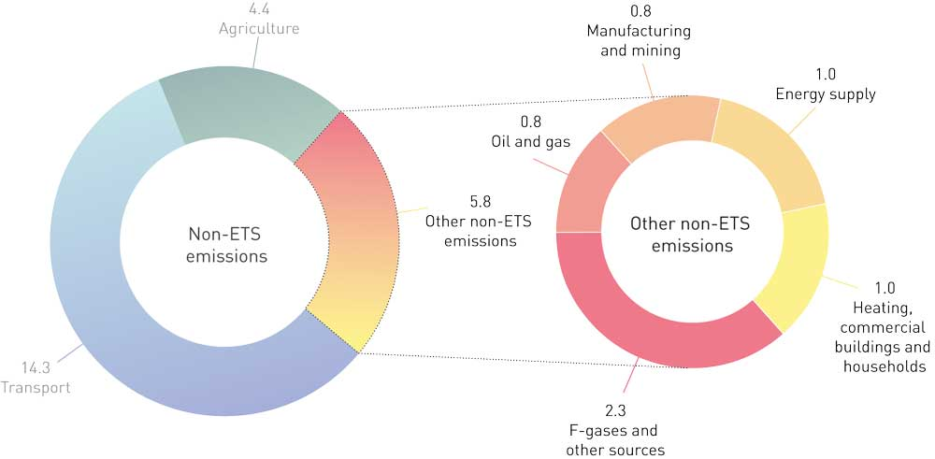
          - Non-ETS greenhouse gas emissions by sector (million tonnes CO2eq in 2019).
              - Mitigation analysis for Norway 2021–2030 – main findings for sectors other than transport and agriculture
The mitigation analysis for Norway 2021–2030 assessed measures that could reduce non-ETS emissions from the manufacturing sector by 3.2 million tonnes CO2eq over the period 2021–2030. Switching from use of fossil fuels to emission-free energy carriers offers the greatest potential. In addition, it is possible to reduce emissions from use of fossil fuels by improving energy efficiency and heat recovery. Some measures that can reduce process emissions from manufacturing were also analysed. Reducing these emissions often requires new technology and can therefore be more difficult.
The measures considered for the petroleum industry could reduce non-ETS emissions by 1.7 million tonnes CO2eq over the period 2021–2030. These involve reducing emissions and increasing recovery rates for methane and NMVOCs.
Measures in the sectors heating, energy supply, waste management and F-gases have an overall emission reduction potential of 3.8 million tonnes CO2eq over the period 2021–2030. Measures considered include replacing natural gas with emission-free energy carriers for heating buildings, increasing recovery and destruction of used HFCs, and switching from coal-fired power generation to renewable energy in Longyearbyen.
Carbon capture and storage (CCS) at the waste incineration plants in Oslo, Bergen and Trondheim was also assessed. This could reduce emissions by a total of 4.0 million tonnes CO2eq over the period 2021–2030. Just over half of this would be emissions from incineration of material of biological origin.
[Boks slutt]
Other non-ETS emissions have declined by 23 % since 2005. The projections indicate that with the current mix of policy instruments, emissions will continue to fall to a level about 41 % lower in 2030 than in 2005. There has been a particularly large reduction in emissions from heating buildings, and this is expected to continue in 2020. Non-ETS emissions from manufacturing and petroleum activities have been considerably reduced since 2005. The projections indicate that there will be a slight reduction in emissions from manufacturing up to 2030, while emissions from petroleum activities will be more or less stable. With the current mix of policy instruments, non-ETS emissions from manufacturing and petroleum activities, heating buildings, energy supply and other sources are projected to total about 50 million tonnes CO2eq over the period 2021–2030.
The Government has not specified ambitions for reducing non-ETS emissions by sector other than for transport and agriculture, but will provide a framework for reducing emissions in the other sectors in line with the Government’s target of reducing non-ETS emissions by 45 % by 2030. In the Government’s view, the policy instruments set out in this climate action plan could reduce non-ETS emissions from the other sectors by approximately 4 million tonnes over the period 2021–2030 compared with the current baseline projections. Figure 3.38 shows the calculated emission trajectory for non-ETS emissions if the Government’s climate action plan is implemented.
Box 3.26 discusses the main results for measures for other non-ETS emissions assessed in the mitigation analysis for Norway 2021–2030.
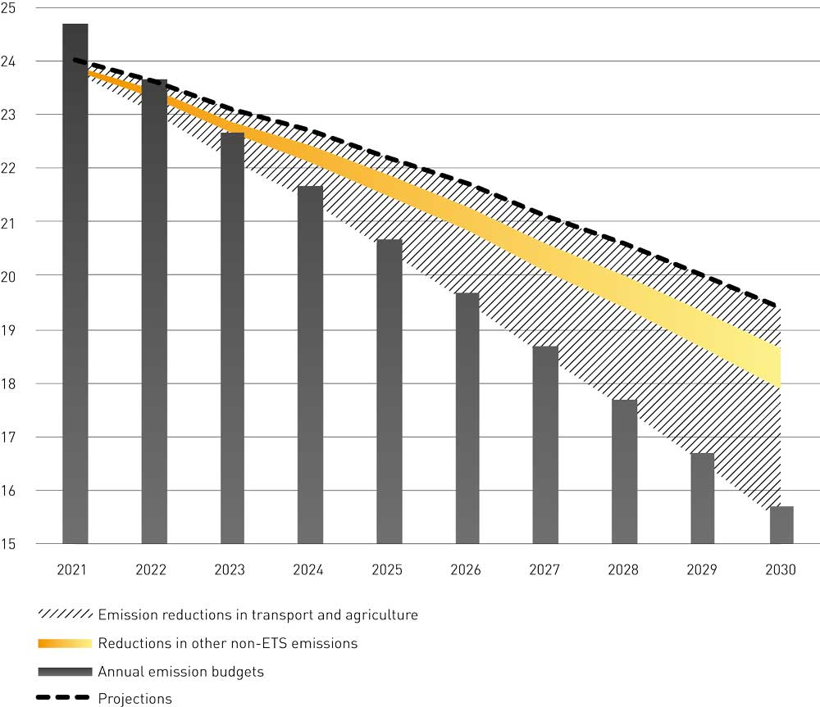
          - Emission trajectory for non-ETS emissions from sectors other than transport and agriculture (in million tonnes CO2eq) under the Government’s climate action plan.

Policy instruments
Policy instruments are already in place to reduce emissions from manufacturing, petroleum activities, energy supply, heating, F-gases and waste management.
Climate-related taxes already apply to a proportion of these emissions, see Chapter 3.3.2, and increases in the tax rates will also apply to these emissions. Mineral oil, natural gas and LPG are subject to the carbon tax. These energy carriers are used particularly for energy purposes in manufacturing and for heating buildings. A climate-related tax (carbon tax on methane) applies to about three-fourths of emissions from cold venting in the oil and gas industry. There are also taxes on the import and production of HFCs and PFCs, which are primarily used in cooling and air conditioning systems. These taxes are levied at the standard carbon tax rate, which will increase gradually to NOK 2 000 per tonne CO2eq in 2030, see Chapter 3.3.2. This will have an impact on emissions from manufacturing, petroleum activities, heating of buildings, and the use and management of F-gases, as discussed further in Chapter 3.7.3.
Manufacturing, petroleum activities, waste management, the use and management of F-gases, and heating of buildings are regulated under the Pollution Control Act, either through permits or by regulations. Chapter 3.3.3 deals further with regulatory measures.
Grants, for example through schemes run by Enova, help to cover additional costs for stakeholders seeking to invest in ways to reduce emissions. Enova grants are also intended to promote accelerated market introduction of new technologies and make them more widely available. Read more about Enova in Chapter 3.3.5.
Making the general policy instruments more effective, as discussed in Chapter 3.3, will play a part in reducing emissions. In addition, the Government will use some policy instruments in specific sectors. Figure 3.39 shows policy instruments for reducing non-ETS emissions from these sectors.
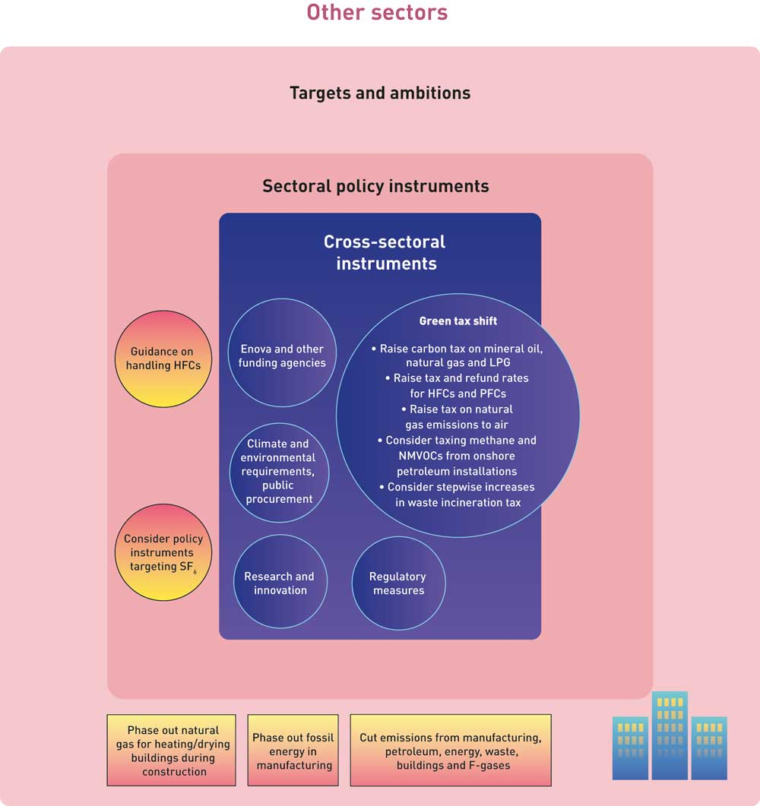
          - Policy instruments to reduce non-ETS emissions from manufacturing, petroleum activities, energy supply, waste management, heating of buildings and use of F-gases.
The policy instruments proposed by the Government in this white paper can cut these emissions by roughly 4 million tonnes CO2eq in the period 2021–2030. The main reductions in emissions are expected to be from declining use of fossil fuels in manufacturing and an increase in the proportion of used HFCs recovered and destroyed, but emissions from buildings, the oil and gas industry and waste incineration are also expected to decrease. Increasing climate-related tax rates is expected to have the greatest effect, see the discussion of estimates of quantitative effects and the uncertainties relating to them in Chapter 3.1.2.
The gradual increase in the carbon tax rate is an important means of phasing out heating using fossil fuels in the manufacturing sector. If necessary, the Government will consider introducing further policy instruments, including a prohibition on the use of fossil fuels for this purpose. The Government will work towards phase-out of the use of natural gas for heating buildings during construction by 2025.
Emissions of HFCs and PFCs are expected to decrease considerably as a result of higher taxes and a corresponding increase in tax refunds, combined with an increase in advisory activities and inspection and enforcement of the legislation on these gases.
There is considerable uncertainty surrounding the figures for estimated effects of tax increases on emissions in these sectors. The actual emission reductions will depend on decisions made in the future. The calculations used here are based on the assumption that all emissions are subject to the same carbon price, including emissions that are not taxed today and those taxed at lower rates than the standard carbon tax rate for non-ETS emissions. The Government has proposed the introduction of a tax on waste incineration from 2021, and will consider a stepwise increase in the tax rate. The Government will also raise the tax rate for natural gas released to air on the continental shelf to the standard rate for non-ETS emissions, and will consider introducing a methane tax on emissions from onshore petroleum installations.

What are the effects of the policy instruments on the different sectors?

Manufacturing: reducing emissions by increasing the carbon tax rate
Non-ETS emissions from manufacturing totalled 0.8 million tonnes CO2eq in 2019. Roughly two-thirds of this came from the use of fossil fuels, with the remaining emissions coming directly from processes.
The Government expects to see the use of fossil fuels for energy purposes in industrial installations that are outside the scope of the EU ETS gradually phased out by 2030. An important means of achieving this will be the gradual increase in the carbon tax rate. If necessary, the Government will consider introducing further policy instruments, including a prohibition on the use of fossil fuels for these purposes.
Most manufacturing enterprises are technically able to switch to energy carriers other than oil, gas and coal. The most suitable alternatives are electricity and biofuels. Where it is available, district heating can be a competitive solution. For certain activities, other solutions such as heat pumps can be of interest. Biofuels include solid biofuel (for example wood pellets), biogas and bio-oil. In many cases, existing oil- and gas-fired boilers can run on biogas or bio-oil after some modifications. More use of electricity may have consequences for the power supply system in certain areas, see Chapter 10.
A rising carbon tax rate will make it more costly to use oil and gas for heating, providing an incentive to switch to other energy carriers.
Manufacturing enterprises in a number of different industries use oil and gas. The food industry and asphalt manufacturing have the highest non-ETS emissions from oil and gas use. There are also some non-ETS emissions from use of oil and gas in the metallurgical industry, the chemicals industry, petroleum refining and the pulp and paper industry, but the bulk of emissions from these sectors come within the scope of the EU ETS.
There are about 22 000 manufacturing enterprises in Norway. It is not known how many of these use mineral oil and natural gas. Non-ETS emissions from oil- and gas-fired stationary heating originate from businesses with relatively small-scale combustion installations. Installations over 20 MW are in the ETS sector.
Some exemptions from the carbon tax on mineral oil and natural gas still apply in 2020. The Government will make natural gas and LPG used in certain power-intensive processes subject to the carbon tax from July 2021 at the earliest, as set out in the 2020 budget (Prop. 1 LS (2020–2021) and Innst. 3 S (2020–2021)). The tax rate will be set at 25 % of the standard carbon tax rate in 2021 and will apply to areas of use for which there is currently a tax refund scheme.
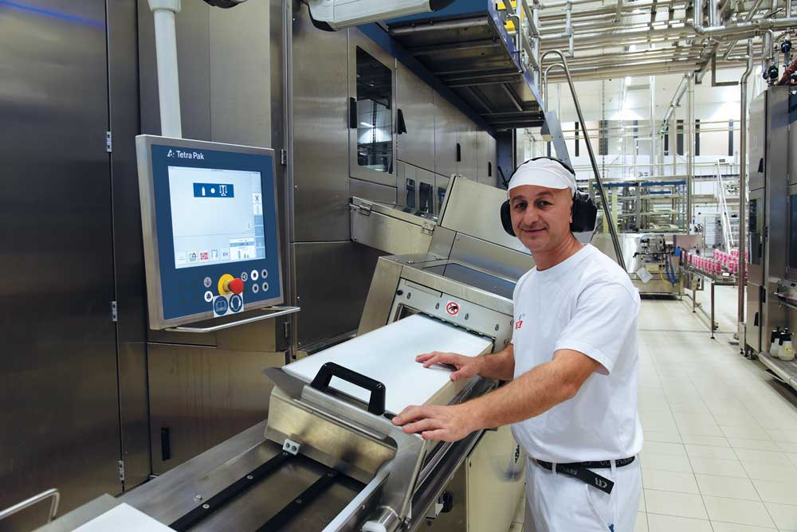
          - TINE’s processing plant in Bergen uses heat pumps and district heating.
Photo: Olav Håland/TINE.

Heating: reducing emissions by increasing the carbon tax rate
In 2019, emissions from heating buildings totalled 1.0 million tonnes CO2eq, primarily from the use of natural gas. Fuelwood use also generates some methane emissions. Raising the carbon tax rate will encourage building owners to switch from natural gas to other energy carriers such as electricity, biofuels, district heating and heat pumps.
The construction industry uses mineral oil and natural gas for heating and drying buildings during construction and renovation. The use of mineral oil for this purpose will be prohibited from 2022, and the Government will work towards phase-out of the use of natural gas by 2025. Natural gas in this context includes all gases of fossil origin, including propane, the most commonly used gas for heating buildings during construction. An important means of achieving this will be the gradual increase in the carbon tax rate. Raising carbon taxes may encourage stakeholders to switch from natural gas to other energy carriers such as electricity or bioenergy such as biogas. If necessary, the Government will consider introducing further policy instruments, including a prohibition on the use of fossil fuels for this purpose. The use of natural gas in greenhouses is exempt from the carbon tax, so raising the tax rate will not reduce emissions from this source.

Waste incineration: reducing emissions through CCS and taxation
The Government intends to introduce a tax on waste incineration from 2021, as set out in connection with the 2020 budget (Prop. 1 LS (2020–2021) and Innst. 3 S (2020–2021)). So as not to introduce large extra costs without giving the industry time to adapt, the Government has proposed a tax rate of NOK 149 per tonne CO2 in 2021, corresponding to 25 % of the standard carbon tax rate. The Government will return to the question of increasing the tax rate in the 2022 budget.
This tax is intended to provide an incentive to reduce emissions from incineration of material of fossil origin, for instance by increasing sorting of waste and recycling. Increasing recycling rates has other environmental benefits in addition to reducing greenhouse gas emissions. Moreover, stricter recycling requirements will be phased in under new EU directives.
CCS will be an important technology for reducing emissions from waste management. Some waste is of biological origin. Capturing and storing emissions from incineration of biological material results in net negative emissions, since these emissions are regarded as climate-neutral.
Emissions that are captured and stored and emissions from incineration of hazardous waste are exempt from the proposed tax. An increase in the carbon tax rate to NOK 2 000 per tonne CO2eq, which is to be the standard rate in 2030, will make CCS more economically attractive but may not be sufficient to make CCS at waste incineration plants profitable by 2030. However, DNV GL concludes that stakeholders may find CCS to be profitable at a carbon tax rate of NOK 2 000 per tonne CO2eq, provided that the capacity of the carbon storage facility is used effectively, lessons are learned and there are some cost reductions. Since about half of emissions from waste incineration are from biological material, and therefore not included in the tax base for the tax on waste incineration, the tax will provide less incentive to implement CCS in this sector than in other sectors.
The Government intends to co-fund the CCS project at Fortum Oslo Varme’s waste incineration plant, provided that the company provides sufficient funding of its own and obtains funding from the EU or other sources, see Chapter 6.5.2 in this white paper and the white paper Longship – Carbon capture and storage (Meld. St. 33 (2019–2020)). The plant will be able to reduce emissions by 0.4 million tonnes CO2eq per year, half of which will be of biological origin.
Successful implementation of the Government’s Longship project will lower the threshold for establishing new carbon capture projects. Future Norwegian carbon capture plants will have to compete for investment and operational funding from general grant schemes, for example under Enova and from the EU’s Innovation Fund. The state will not engage in direct negotiations on state aid with individual stakeholders. In the long term it may be possible to capture carbon from several waste incineration plants, which could lead to large cuts in emissions.
Owners of the waste incineration plants in Bergen, Trondheim, Stavanger, Kristiansand and elsewhere in Norway can apply for funding for studies of carbon capture projects under the CLIMIT programme, which is run by Gassnova SF, and from other public funding agencies. Under the CLIMIT programme, funding has been awarded to projects at the waste incineration plants in Trondheim and Kristiansand.

Reducing emissions of fluorinated gases through information and taxation
Fluorinated gases (F-gases) are used in cooling systems, air conditioners, heat pumps, high-voltage electronics and certain other products. Hydrofluorocarbons (HFCs), perfluorocarbons (PFCs) and sulphur hexafluoride (SF6) are all potent greenhouse gases. In Norway, the use and sale of these gases is governed by regulations under the Pollution Control Act, the Road Traffic Act and the Product Control Act.
Emissions of SF6 are currently low in Norway. SF6 use in the power supply sector is expected to rise up to 2030 due to expansion of the power grid. Only a very small proportion of the installed SF6 leaks out of equipment, less than 1 % under normal conditions. Nevertheless, its use should be reduced, including in new, large-scale installations in the power supply sector, since there is some risk of leakages wherever SF6 is installed. About half of SF6 emissions come from the power supply sector. It is important to minimise emissions of SF6. The Government is assessing policy instruments to reduce its use and emissions.
In the years ahead, a number of air conditioning systems and a good deal of cooling and freezing equipment will be taken out of use. Increasing the collection rate for used HFCs can prevent their release into the atmosphere from products that are discarded or repaired. To increase the quantity of HFCs collected, the Norwegian Environment Agency will distribute information about the obligation to collect HFCs and about the refund scheme and collection points. The Environment Agency will also step up inspection and enforcement activities targeting companies that deal with products containing refrigerants. Providing more information and intensifying inspection and enforcement of the legislation on HFCs will require more resource use by the Environment Agency.
There is a tax on production and import of HFCs and PFCs. The tax is refunded if end-of-life products are returned to approved collection points so that the HFCs and PFCs can be destroyed.
As the tax rate is raised, the amount refunded will also increase. This will provide a strong incentive to collect and destroy used HFCs and PFCs. Even though it will pay for operators to return used HFCs and PFCs, it may be necessary to make better arrangements for return and provide better information about the rules on handling these gases. With adequate information and good return arrangements, calculations indicate that higher tax and refund rates can cut emissions considerably in the period 2021–2030.
The European Commission plans to revise the F-gas Regulation, which regulates the production, import and use of F-gases, by the end of 2021. Once the EU adopts the amendments, Norway will assess whether they are EEA-relevant and whether the Norwegian legislation needs to be amended. Norway does not consider the EU import regime for HFCs to be EEA-relevant and does not participate in it.

Consider a new energy supply system in Longyearbyen
The energy supply system in Longyearbyen is based primarily on coal. Emissions from this source are neither subject to the carbon tax nor included in the ETS. In connection with its consideration of the white paper Svalbard (Meld. St. 32 (2015–2016)), the Storting asked the Government to initiate a broad-based review of the options for the future energy supply system in Svalbard based on sustainable, renewable solutions, as set out in the recommendations from the Standing Committee on Foreign Affairs and Defence (Innst. 88 S (2016–2017)). In 2018, an external review was conducted and an open meeting was held to obtain input. In the course of 2019 and 2020, the Ministry of Petroleum and Energy and the Norwegian Water Resources and Energy Directorate quality-assured the reviews and the input they received. Additional assessments, for example of energy solutions in a transitional phase between the current coal-powered plant and a new, long-term solution, have also been carried out. The Ministry of Petroleum and Energy is conducting more thorough cost-benefit analyses for a short list of energy solutions and combinations of solutions. The Government’s position is that the future energy supply system must be reliable, sustainable and cost-effective.

Petroleum activities
Non-ETS emissions from petroleum activities in 2019 totalled about 0.8 million tonnes CO2eq, and originated from cold venting, point sources and fugitive emissions such as leaks. The non-ETS emissions consist of methane and NMVOCs. Emissions can be reduced through recovery, operational optimisation and flaring. There are also emissions of methane and NMVOCs during offshore loading of crude oil, and these can be reduced through recovery and by using recovered VOC vapour as fuel.
Emissions of natural gas to air from petroleum activities on the Norwegian continental shelf are subject to the carbon tax. This is currently levied at a lower rate than the standard rate for non-ETS emissions. The Government will raise this to the standard rate for non-ETS emissions. Higher tax rates can promote emission reductions, for example through operational optimisation and higher recovery rates.
Emissions of methane and NMVOCs from onshore petroleum installations are not subject to the carbon tax, partly because of a lack of precise enough measurement methods. Work is under way to improve the measurement and calculation methodology. Provided that satisfactory methodology is available, the Government will consider making direct emissions of methane and NMVOCs from onshore petroleum installations subject to the carbon tax, in line with the policy that the standard tax rate should apply to all non-ETS emissions.

Uncertainty and economic and administrative consequences
Businesses that use fossil fuels will incur higher costs as a result of increases in climate-related tax rates. The cost of delivering waste for incineration may also rise slightly for businesses. Users of SF6 may face higher costs related to policy instruments to reduce emissions.
Other parts of the business sector, such as companies that supply energy solutions based on renewable energy sources, may become more profitable due to the effects of policy instruments. There will also be more financial incentive to deliver used HFCs and PFCs for destruction in accordance with the rules.
Costs will rise for households that use natural gas for heating as the carbon tax rate is increased. It will be possible for them to switch to other energy solutions. Households may also see a slight rise in costs related to the tax on waste incineration.
State revenue will rise when the carbon tax and the tax on waste incineration are increased. A tax on SF6 would also boost revenue. The Norwegian Environment Agency will need to dedicate more resources to information activities and guidance relating to the legislation on HFCs.
Both central and local government bodies will incur greater costs as a consequence of the increased carbon tax if they use fossil fuels, and from the tax on waste incineration, in the same way the business sector and households are affected. Some municipalities own incineration plants and operate them on a partly commercial basis. Such plants may become less profitable as a result of the tax on waste incineration.
The overall effect of the Government’s climate policy is to redistribute wealth away from greenhouse gas emitters, whether they are in the business sector, the public sector or households, and towards stakeholders that have lower emissions or are involved in developing and deploying emission-free solutions.
The risk of carbon leakage depends particularly on the extent to which companies are exposed to international competition and on the proportion of their total costs that is energy-related. Non-ETS manufacturing includes very different industries, and there is probably wide variation in the degree to which they are exposed to international competition. A few companies compete primarily with companies that are within the scope of the EU ETS. For these companies, a tax rate that is substantially higher than the price of EU emission allowances could be a particular disadvantage. However, there are probably few companies that have non-ETS emissions from energy use and are engaged in energy-intensive production. This means in most cases, a company’s energy costs, including the carbon tax, are likely to make up a relatively small proportion of its total costs. The tax on waste incineration will weaken the competitive position of waste incineration plants in Norway vis-à-vis plants in Sweden, which could lead to carbon leakage.

Use of flexibility mechanisms
The EU legislation for non-ETS emissions provides for countries to use flexibility mechanisms to achieve their emission targets; in other words, a target can be achieved in other ways than through mitigation measures for domestic emissions. Examples of flexibilities are that countries can buy emission units from other European countries (i.e. surplus units that they do not need to achieve their own targets), access emission allowances from the EU ETS, and access credits from the land use sector. A country that has a surplus of emission units after achieving its target for a specific year may also bank the surplus for use in later years.
The impacts of greenhouse gas emissions do not depend on where the emissions occur. The flexibility mechanisms that are part of the EU system are intended to allow more cost-effective implementation of emission cuts across the EU. Norwegian emissions can be offset by corresponding emission reductions in EU countries. It may cost less to contribute to emission reductions in EU countries than to achieve the entire reduction through domestic measures in Norway. We do not know what the price of emission allowances under the Effort Sharing Regulation will be until agreements have been concluded for 2021–2030. Using the current price of emission allowances under the EU ETS as a basis, the cost of cooperating with EU countries on the necessary reductions may be around NOK 250 per tonne. This is clearly lower than the cost of many domestic mitigation measures. As Figure 5.5 shows, it is anticipated that the price of emission allowances in the EU ETS will rise, and that the rise will be particularly steep if it is assumed that the EU increases its 2030 target to a 55 % cut in emissions relative to 1990. The figure is based on an analysis by Refinitiv (Thomson Reuters).
In the period 2013–2020, it has also been possible to use international credits from countries or mitigation projects outside the European Economic Area. This flexibility is not being maintained for the period 2021–2030.
The Government’s political target is for Norway to reduce its non-ETS emissions by 45 % by 2030. If strictly necessary, flexibility mechanisms will be used. This climate action plan provides a credible path making it likely that the 45 % target can be achieved without the need to use the flexibility mechanisms. However, the effects of the policy instruments it sets out are uncertain, and it is also uncertain when these effects will become apparent. Technological and economic developments and population growth are all factors that will strongly influence emissions in the years ahead. It may therefore be necessary to adjust the action plan described in this white paper.
In the time ahead, the Government will evaluate whether it is necessary to make policy instruments more effective or make use of flexibility mechanisms. For more about evaluation of the use of policy instruments during the planning period 2021–2030, see Chapter 9. If the climate action plan, with any necessary adjustments during the period, does not have sufficient effect, it may be necessary to make use of flexibility mechanisms to achieve the emission reduction commitment Norway has agreed with the EU. This will enable Norway to meet its commitment and prevent emissions to the atmosphere from exceeding its target.
Under the Effort Sharing Regulation, Norway is required to report annually on non-ETS emissions. If emissions are higher than the number of emission units Norway has been allocated or has banked for the year in question, it is possible to borrow a limited number of emission units from the following year. If this situation arises, it will be necessary to consider more extensive mitigation measures or make use of the flexibility to access allowances from the EU ETS or from bilateral agreements with individual EU countries.
Norway had the option to access a limited amount of allowances from the EU ETS that can be used to offset emissions in the effort sharing sectors, and notified the European Commission before the deadline that it wished to make use of the full amount of this flexibility for the period 2021–2030. In principle, this means that the same number of allowances will be subtracted from Norway’s auctioning volume in the ETS for each year of the period. This corresponds to up to 5.7 million ETS allowances for the whole period 2021–2030. Using ETS allowances in this way guarantees Norway access to flexibility in the event that it is strictly necessary to meet its emission commitments. However, notification that Norway intends to make use of this flexibility does not necessarily mean that the allowances will in fact be used under the Effort Sharing Regulation. The allowances are deducted from Norway’s auctioning amount under the EU ETS account and are placed in a closed account under the Effort Sharing Regulation. Allowances from this account may only be used if Norway has a shortfall, in other words has not met its annual emission budget through domestic emission reductions or by using other flexibility mechanisms. Allowances in the account that originate from the EU ETS and that are not used to achieve Norway’s target under the Effort Sharing Regulation or in the LULUCF sector will be cancelled at the end of the compliance period. In this way, they will be used towards overachievement of the EU-wide emission reduction target. In any case, Norway will pay for these allowances through lower auctioning revenue from EU ETS allowances. It is possible to decide not to use the flexibility or request a downward revision of the percentage of ETS allowances to be used to offset emissions in the effort sharing sectors for the second five-year period, in other words from 2026. It will also be possible to use the allowances accessed from the EU ETS indirectly towards compliance with the ‘no debit’ rule for the LULUCF sector. Chapter 4.7 describes the use of flexibility mechanisms in the LULUCF sector.

The Government’s plan for enhancing removals and reducing emissions in the LULUCF sector
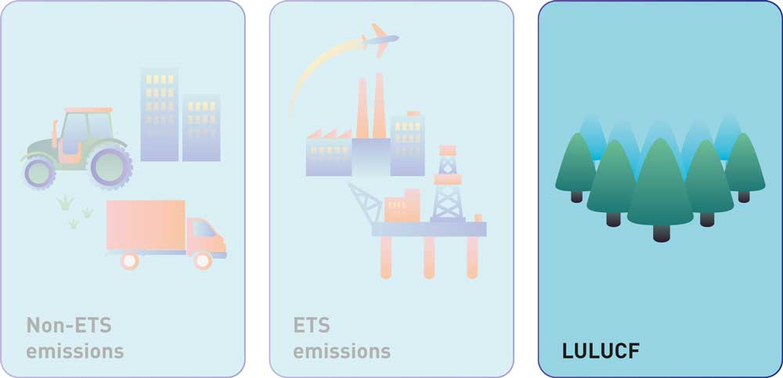
          - The EU’s 2030 climate and energy framework is divided into three main pillars, one of which deals with the LULUCF sector.

Introduction
Forest and other land categories must be protected and managed sustainably. Land use and land-use change influence both removals and emissions of greenhouse gases. Forests absorb CO2 and store carbon in living biomass and soils. In contrast, the conversion of forest, peatland and agricultural areas to other forms of land use results in substantial greenhouse gas emissions.
In the context of climate change, land use, land-use change and forestry (LULUCF) is treated as a separate sector, which includes forest land, cropland, grassland, wetlands, settlements and other land, and also harvested wood products. Land-use change, the conversion of land from one of these categories to another, is also reported. Under its climate agreement with the EU, Norway has an obligation to ensure that emissions from the LULUCF sector do not exceed removals over the period 2021–2030, calculated using the accounting rules of the EU legislation (this is often known as the ‘no debit’ rule).
In 2018, net removals in the LULUCF sector in Norway totalled 23.7 million tonnes CO2eq, as reported in the greenhouse gas inventory according to the rules of the Climate Change Convention. The high level of removals in the forest land category in Norway is partly a result of extensive post-war planting, and partly due to the fact that forest planted in this period has now reached its fastest-growing phase. A large quantity of carbon has been sequestered in living biomass and soils. The total carbon stock in Norway, including carbon in soils, is estimated at 7 billion tonnes, which is equivalent to about 26 billion tonnes CO2. This carbon stock is split as follows: 32 % in forest, 33 % in mountain areas, 21 % in wetlands, 13 % in aquatic ecosystems and 3 % in cultural landscapes.
All land categories are included in the greenhouse gas inventory, but only anthropogenic emissions and removals are estimated and reported. In Norway, managed land areas make up about half of the total land area.
              - Forest, other land categories and climate change in a global perspective
At global level, forests and other terrestrial ecosystems can play a central role in climate change mitigation, through action that increases removals and sequestration of carbon, measures to reduce emissions and the use of biomass to replace materials that are associated with higher greenhouse gas emissions. In its special report Climate Change and Land, the Intergovernmental Panel on Climate Change (IPCC) estimates that the natural response of land to human-induced climate change has resulted in a net sink that is more than twice as high as the volume of anthropogenic greenhouse gases emitted as a result of land use and land-use change. The way forest, farmland, grassland and wetlands are managed is both part of the problem and a vital part of the solution. The Intergovernmental Science-Policy Platform on Biodiversity and Ecosystem Services (IPBES) has estimated that given sound, sustainable management, forests and other terrestrial ecosystems can provide more than one third of the mitigation needed before 2030 to meet the goal of limiting global warming to 2 oC. According to the IPCC, agriculture, forestry and other land use (AFOLU) activities account for 23 % of global anthropogenic greenhouse gas emissions. A substantial proportion of this is from agriculture, both in the form of direct emissions of nitrous oxide and methane, and indirectly through CO2 emissions from deforestation to convert land for grazing and other types of agricultural production. Most of the modelled pathways that limit warming to 1.5 degrees require land-based mitigation options that use considerable areas of land. These include reducing deforestation, restoring and establishing new forest, production of bioenergy and the use of carbon-negative technologies (for example storage of biochar in soils and bioenergy with carbon capture and storage, or BECCS). However, options such as using land to grow bioenergy crops or for afforestation will increase pressure on land resources. Both the IPCC and the IPBES conclude that to mitigate climate change and maintain biodiversity, it is vital to reduce deforestation and forest degradation and to promote forest conservation, ecosystem restoration and sustainable forestry.
[Boks slutt]

Projections for the LULUCF sector
The Norwegian Institute of Bioeconomy Research published emission projections for the LULUCF sector in 2019. Figure 4.2 shows that net removals in the sector are expected to decline over the next 20 years, before stabilising and then increasing somewhat in the second half of this century. These developments are primarily related to changes in net removals in forest. The projections are based on historical levels of activity in the reference period 2010–2017, and the trends may change if activity levels change.
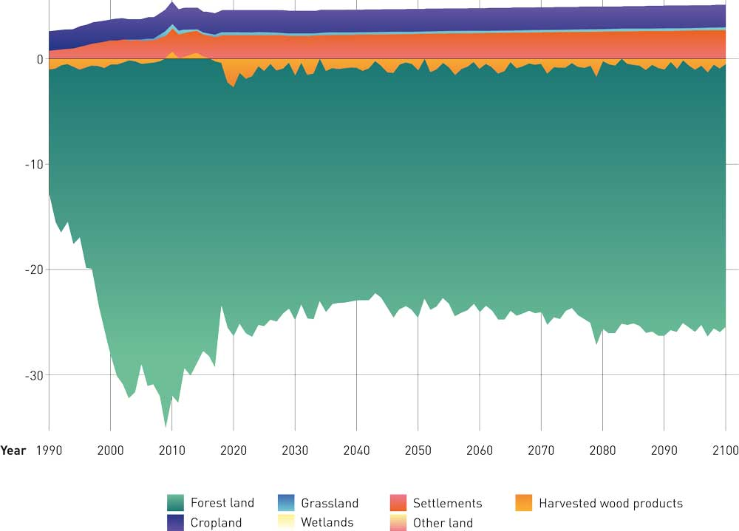
          - Projections from the Norwegian Institute of Bioeconomy Research of net emissions from the LULUCF sector in Norway as reported under the Climate Change Convention (million tonnes CO2eq). Negative signs (-) indicate removals. The figure includes emissions of CO2, nitrous oxide and methane, and removals of CO2.
Norwegian Institute of Bioeconomy Research (2019)
Figure 4.3 shows that if emissions and removals in the LULUCF sector follow the projections from the Norwegian Institute of Bioeconomy Research, Norway’s overall accounted net emissions from the sector under the rules of the EU legislation for the period 2021–2030 are likely to be about 18 million tonnes CO2eq (annual figure in Figure 4.3 multiplied by 10). This is based on the assumption that Norway makes use of the managed forest land flexibility, or compensation mechanism, set out in the EU legislation. Certain conditions have to be met to make use of the compensation mechanism, and Norway will be able to compensate accounted net emissions of up to 35.5 million tonnes CO2eq from managed forest land. According to the projections, Norway’s accounted net emissions from managed forest land will be 9 million tonnes CO2eq, less than the ceiling of 35.5 million tonnes CO2eq available through the compensation mechanism. If Norway does not make use of the compensation mechanism, the total emissions gap in the LULUCF sector as a whole may be 27 million tonnes CO2eq. Much of this is a result of large annual emissions from deforestation.
For a country to use the compensation mechanism, there must be EU-wide compliance with the ‘no debit’ rule, and the country in question must have planned or initiated measures to maintain or enhance carbon stocks in forest and other land categories. The compensation mechanism applies only to accounted emissions from managed forest land, and may not be used to offset emissions from deforested land, afforested land, managed grassland, managed cropland or managed wetland.
Figure 4.3 shows the land accounting categories used in the EU legislation. Areas where land use is reported as managed forest land are currently forest and remain as forest land during the reporting period. Afforestation and deforestation generally involve permanent changes in land use. Afforested land is converted to forest either through planting or through natural spread of forest. Deforested land is converted for other purposes, for example for use as cropland, for roads or for buildings. CO2 emissions from managed cropland and grassland are reported as LULUCF emissions, whereas methane and nitrous oxide emissions from the same areas are reported as emissions from agriculture, and are therefore accounted for in the non-ETS sector. Managed wetlands, including peatlands and water bodies, are to be included as a land accounting category for the period 2026–2030, but are not included in Figure 4.3, since this would have little effect on the overall picture.
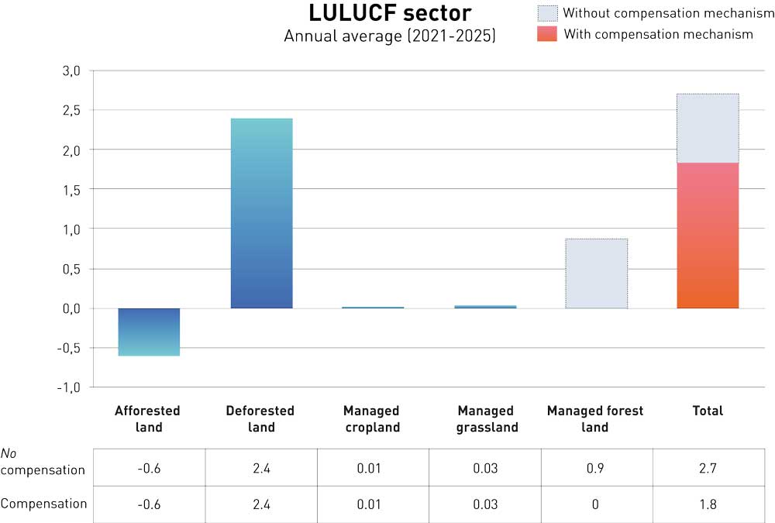
          - Norway’s projected annual emissions and removals for the various land accounting categories and for the LULUCF sector as a whole during the first period (2021–2025) under the LULUCF Regulation, in million tonnes CO2eq. The totals are shown relative to the ‘no debit’ rule. Positive figures (+) indicate net emissions, and negative figures (-) indicate net removals. Wetlands are to be included from 2026.
The figure is based on projections published by the Norwegian Institute of Bioeconomy Research (2019), using updated figures from Norway’s official greenhouse gas inventory (2020) and a revised reference level for managed forest (November 2020).
Figure 4.3 shows projected emissions and removals from the different land accounting categories and overall net emissions from the LULUCF sector, both without and with use of the compensation mechanism. Overall emissions for the ten-year period are expected to be highest from deforested land, at 24 million tonnes CO2eq. Net accounted emissions from managed forest land over the ten-year period are projected to be about 9 million tonnes CO2eq. CO2 removals in managed forest land are expressed relative to a reference level. If actual removals are lower than the reference level, Norway will report accounted net emissions. If actual removals are higher than the reference level, Norway will report net accounted removals. The actual level of harvesting relative to the reference level strongly influences accounted removals in managed forest land. The figure for Norway’s projected net emissions from managed forest land, 9 million tonnes CO2eq, is based on forest management practices in the reference period 2000–2009, and on the subsequent rise in the harvesting level. Net removals in forest are therefore projected to be lower than the reference level. It will be possible to use the managed forest land flexibility to compensate for some net emissions from managed forest land. Afforested land is projected to yield net removals of 6 million tonnes CO2eq over the period. These areas include both land where forest is planted and areas where forest spreads naturally. Emissions from managed cropland and grassland are projected to total 0.3 and 0.1 million tonnes CO2eq respectively over the ten-year period. Managed wetlands are to be included as a land accounting category for the period 2026–2030, but are not included here, since this would have little effect on the overall picture.
The estimates are very uncertain, partly because changes in actual harvesting levels have a strong influence on removals in managed forest, and partly because it is difficult to make reliable estimates of future land-use changes. Any net accounted emissions in the LULUCF sector must be compensated either by larger emission reductions in the national non-ETS sector or by using other flexibility mechanisms. This is discussed further in Chapter 4.7.
Forests provide raw materials in the form of timber, fibre, feed and energy for many sectors. For example, wood can replace building materials associated with higher emissions, and forest residues can be used to produce biofuels, thus reducing emissions from transport. Emissions from timber harvesting are accounted for in the LULUCF sector, whereas the benefits of lower emissions during use of the timber appear in the non-ETS or ETS sector.

The Government’s plans for the LULUCF sector
To enhance removals in forest, the Government will:
- Continue to use existing mitigation measures for forest to enhance removals and consider ways of strengthening them. The Government will focus on measures that have a positive climate impact and positive or acceptable environmental impacts.
- Consider new mitigation measures in managed forest land that offer a high potential for enhancing CO2 removals and are easy to implement. This applies specifically to improving practices for tending young-growth stands, treatment of stumps to control conifer root rot, and choosing suitable tree species for restocking after felling.
- Introduce requirements relating to minimum ages for tree felling in the Forestry Act and regulations relating to sustainable forestry, in line with the requirements in the current Norwegian PEFC Forest Standard.
- Facilitate afforestation of new areas as a mitigation measure on the basis of clear environmental criteria.
To reduce emissions from the development of green areas, the Government will:
- Take steps to ensure that municipalities, counties and central government agencies receive sound guidance and good tools so that they can take carbon-rich areas into consideration in spatial planning.
- Further develop the knowledge base on land-use change.
- Emphasise that spatial planning processes should be used to promote the development of compact towns and urban areas, and that the potential for densification and transformation should be used before new areas are developed.
- Ensure that carbon-rich areas are taken into consideration as part of the basis for decision making in central government transport projects.
- Ensure that carbon-rich areas are taken into consideration in licensing procedures for energy installations.
- Seek to reduce the conversion of peatland for other purposes through planning under the Planning and Building Act and other appropriate measures. The Government will develop a specific strategy to prevent the conversion of peatland.
To reduce emissions from other forms of land use, the Government will:
- Continue to promote a shift from peat-based to peat-free products.
- Consider amendments to the requirements for labelling peat-based products in connection with the revision of the regulations relating to fertiliser products.
- Consider the introduction of a tax on greenhouse gas emissions from peat extraction.
- Consider the introduction of a ban on opening new sites for peat extraction and measures under the Planning and Building Act to avoid the granting of new licences for peat extraction before a decision has been made on a ban.
- Consider requirements and procedures for the conversion of forest land to pasture to ensure that conversion does not involve evasion of regeneration obligations under the forestry legislation.
- Continue the restoration of peatlands and other wetlands.
It is not possible to determine exactly how far this climate action plan will contribute towards compliance with the ‘no debit’ rule for the LULUCF sector. It is particularly difficult to quantify the effects of action to reduce emissions from the conversion of forest and other land categories. In addition, the reference level for managed forest land and reference levels for the other land categories will be adjusted when calculation methodology and activity data in the emission inventory are updated in future. The rest of this chapter describes how the Government plans to enhance removals and reduce emissions in the LULUCF sector.

How the Government plans to enhance removals and the carbon stock in forests

Introduction
Forests at high northerly latitudes, like those in Norway, are slow-growing. This means that there are few policy instruments and measures that can give measurable effects by 2030. The measures that will have the greatest short-term effects are improving practices for tending young-growth stands, reducing harvesting of young-growth stands and fertilisation. However, the slow pace of growth also means that it is important to start other, more long-term measures. These will have effects in the period from 2030 and up to 2050, when Norway’s target is to be a low-emission society.
Net removals in forest have been declining since 2009, and this trend will continue up to 2050 unless new measures are introduced or the existing measures are strengthened. Strengthening existing mitigation measures will result in more rapid reversal of the declining trend in removals, and a much higher long-term level of removals in forest (see Figure 4.7). The Norwegian Institute of Bioeconomy Research and the Norwegian Environment Agency have estimated that the long-term effect of the measures discussed in this white paper may be to increase annual net removals in forest to about 6.5–8 million tonnes CO2 by 2100, depending on the scope of the measures and when they are implemented (see Table 4.1). There will be additional removals from afforestation of new areas. This estimate is based on a number of assumptions, and there are several sources of uncertainty, but scaling up these efforts will in any case have a substantial effect. Thus, forest-related measures will contribute towards the aim of the Paris Agreement of reaching a balance between emissions and removals at global level in the second half of this century. Resilient forests where the level of CO2 removals is high and the overall carbon stock in forest is increasing will be important for the climate, biodiversity and the forestry and wood industry both now and in the future. Forests can also function as an important supplier of biomass, which can be used to reduce emissions in other sectors in the years ahead. The demand for biomass in other sectors is discussed in the relevant chapters.
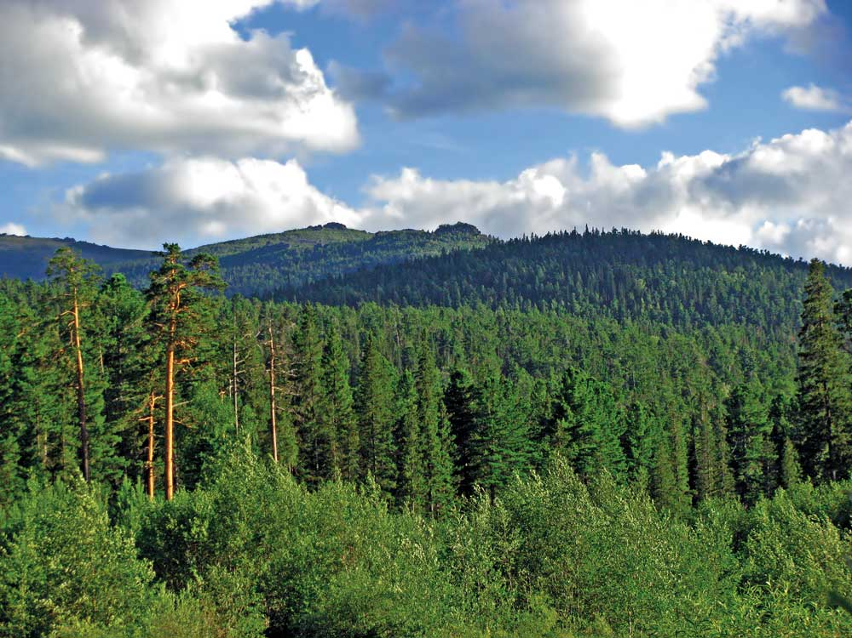
          - Forests absorb large quantities of CO2 from the atmosphere
Photo: Colourbox
To enhance carbon removals in forest, it is important to consider carbon uptake at all stages of production. A great deal is already being done, and the Government will further develop existing mitigation measures for forest. This can provide benefits for business and industry and a basis for increasing value creation and employment in Norway. Biodiversity, outdoor recreation and other environmental interests must be taken into account when measures and policy instruments are initiated in this sector.

Grants for higher planting densities, forest tree breeding and fertilisation of forest
In 2016, three grant schemes were introduced with the aim of increasing CO2 removals in forest. The first is designed to encourage planting seedlings at higher densities when regenerating forest after harvesting. This increases the standing stock and thus CO2 removals in forest. The second is a grant scheme to improve forest tree breeding. The aim is to use the genetic variation in forest trees to breed tree seed that yields higher production than unimproved seed from ordinary forest stands, and that is more resilient to climate change. The third grant scheme is for targeted fertilisation of forest as a climate mitigation measure, with accompanying environmental criteria. In forest areas where a lack of nitrogen is a limiting factor for growth, application of nitrogen fertiliser results in increased growth in tree height and diameter over a ten-year period. This also increases CO2 uptake by the trees. The grant scheme for fertilisation of forest is to be reviewed in 2021.
Modelling shows that there is still a potential for further enhancing CO2 removals through the three grant schemes. This is limited in the short term, but increases towards 2100. Together with stricter follow-up of obligations relating to regeneration after harvesting (Chapters 4.4.6 and 4.4.7), these three schemes have an overall long-term potential to increase annual removals by 3.5 million tonnes CO2. The figure is based on assumptions described in a report from the Norwegian Institute of Bioeconomy Research. The economic cost of all these measures is estimated to be below NOK 500 per tonne CO2. Their effect in 2100 will depend on when they are implemented in specific forest areas and the scope of the grant schemes, particularly in the case of regeneration after harvesting. The Government will continue and consider whether to expand the grant schemes. Actions that will have a positive climate impact and a positive or acceptable environmental impact will be given priority. The three grant schemes were discussed in the white paper Norway’s Climate Strategy for 2030 (Meld. St. 41 (2016–2017)).

Tending young-growth stands
Tending young-growth stands involves selecting good-quality trees and ensuring that they are optimally spaced, so that stand growth and quality are as good as possible. Tending young-growth stands at the right time ensures that the trees develop straight, high-quality trunks. This timber can be used for climate-friendly construction products that will continue to store carbon for long periods of time. In addition, wooden materials can replace materials associated with higher greenhouse gas emissions, thus yielding climate benefits. Forest owners can tend young-growth stands to promote variation in species composition, which may enhance biodiversity. Tending young-growth stands also makes forests more resilient to windthrow, snow damage and other climatic factors. Thus, tending young-growth stands is important in the adaptation of forestry to a changing climate. The Norwegian PEFC Forest Standard is the dominant forest certification scheme in Norway, and is used for almost all timber that is harvested for sale. According to the PEFC Standard, owners must ensure that there is a substantial proportion of broad-leaved trees where climatic conditions and soils are suitable. The standard also requires that when tree species replacement is to be carried out, an owner must take steps to ensure that broad-leaved trees make up at least 20 % of trees on the property. Tending of young-growth stands is needed in an area totalling about 40 000 hectares per year, but on average, only about 27 000 hectares per year was tended in the ten-year period 2009–2018. This means that a substantial backlog is being built up. Tending a larger proportion of young-growth stands at the right time could increase removals by 0–0.5 million tonnes CO2 per year up to 2030, rising to 0.9–1.3 million tonnes CO2 in 2050 and 1.5-3.3 million tonnes CO2 in 2100. The economic cost of the long-term benefits is less than NOK 500 per tonne CO2. Tending young-growth stands will to some extent be profitable for owners. However, activity in this area is low since forest owners are cautious about making investments that will only give a return for future generations. The Government will give further consideration to the need to expand tending of young-growth stands as a climate mitigation measure.

Requirements relating to minimum ages for tree felling
The timing of harvesting influences the capacity of forests to absorb CO2 and the quantity of carbon stored over time. If trees are felled when they have reached harvesting age, CO2 uptake will be higher than if they are harvested earlier. This will not have a negative impact on biodiversity and may provide more timber for industrial use. The Norwegian Institute of Bioeconomy Research has estimated that a prohibition on harvesting young-growth stands corresponding to the requirements of the Norwegian PEFC Forest Standard could increase CO2 removals by 0.3 million tonnes a year. This is based on the assumption that the stands are healthy and not exposed to damage or to pests such as insects or root rot. The Government will introduce requirements relating to minimum ages for clear cutting and seed tree felling in the Forestry Act and the regulations on sustainable forestry. These will correspond to the requirements of the PEFC Forest Standard. It will be possible to apply to the municipality for exemptions from the new provisions, according to the rules already included in the legislation. The Government will start the process of amending the legislation as soon as possible.
Delaying harvesting beyond the minimum ages set out in the Norwegian PEFC Forest Standard until stands reach economic maturity may increase long-term carbon removals by a further 0.7 million tonnes CO2 per year, according to the Norwegian Institute of Bioeconomy Research. The Institute emphasises that this figure may be an overestimate, since it is based on the assumption that tree density in the stands used in the calculations is optimal and they are not affected by climate-related damage or different types of pests. However, even after correction for this, there is a substantial remaining potential for enhancing removals. The Government will therefore commission a study of why forest owners choose to fell stands before they reach harvesting age. The results will be used as a basis for assessing the need for policy instruments to promote later harvesting, with a view to enhancing carbon removals in forest. The Government will also assess whether the statutory minimum ages for felling should be higher than the current requirements in the PEFC Forest Standard.
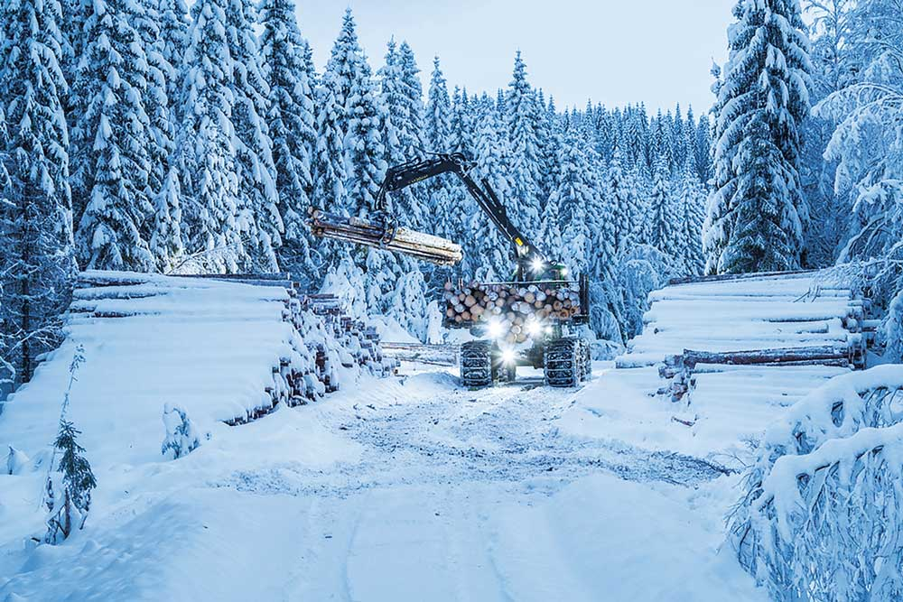
          - Forestry operations in winter.
Photo: Steinar Johansen

Reducing damage caused by conifer root rot
Norway spruce grows quickly where site quality is medium to good, but is also vulnerable to various types of rot fungi. Conifer root rot is most widespread and accounts for about 80 % of the problem. Inspection in connection with harvesting shows that every fifth spruce tree in Norway is infected with conifer root rot. About 500 000 m3 of the volume of sawlogs harvested in Norway in 2019 was damaged by conifer root rot. This affects the annual increment in Norwegian forests, and results in decomposition of biomass and the release of CO2 to the atmosphere. In addition, it reduces the quality of the timber and means that it cannot be used for long-life materials. The energy content of the timber is also lower.
The most important way of reducing conifer root rot in spruce forest is to prevent its spread to healthy forest. The fungus spreads less easily in lower temperatures or when the ground is snow-covered. If stands are thinned or timber is felled when there is no snow cover or during mild weather in winter, stumps should be treated with a fungicide. Most modern logging machinery is fitted with equipment for the application of fungicides, but this is not widely used in Norway. In areas where root rot is a particularly serious problem, it may be appropriate to harvest stands earlier than the normal age. Other measures include tree species replacement and encouraging the growth of mixed forest where root rot is a problem.
It is not realistic to eliminate root rot entirely from spruce forest, but it is possible to limit the problem using fairly simple measures. Reducing damage caused by root rot will have a positive effect both in the context of climate change and for the forestry industry, and the economic cost of the measure is under NOK 500 per tonne CO2. In addition, this is normally in the interests of forest owners. However, the benefits are not felt until the next generation, and stump treatment is therefore rarely used. Taking these factors into consideration, the Government will consider how best to promote the reduction of damage caused by root rot.

Following up obligations relating to regeneration after harvesting
The Forestry Act and the regulations relating to sustainable forestry require owners to take steps within three years of felling to ensure satisfactory regeneration. The regulations specify the minimum legal seedling density and the recommended density depending on growing conditions (site quality). The municipalities are responsible for ensuring compliance with the provisions of the regulations. Figures from the National Forest Inventory and from surveys of the results of environmental and forestry measures show that tree density in about 20 % of regeneration areas is lower than required by the regulations relating to sustainable forestry. This means that the full potential for carbon removals will not be achieved in the years ahead. The Norwegian Agriculture Agency has developed a system for checking compliance with obligations relating to regeneration. This is based on whether there is agreement between the figures for harvesting and for regeneration in the financial management system for the forestry industry. Failure to comply with the obligations relating to regeneration may result in a coercive fine, or the authorities may implement regeneration measures at an owner’s expense. If owners do not ensure suitable conditions for regeneration, they may be required to notify the authorities of subsequent harvesting operations, and notification may also be sent to the relevant certification body. Action to follow up regeneration obligations will continue to be important in the years ahead.
Forest owners are free to decide whether forested areas are to be converted to managed grassland. The obligations relating to regeneration under the Forestry Act apply to rough grazing, but not to managed grassland. If forest is converted to managed grassland, the area is deforested, and the resulting emissions must be accounted for in accordance with the EU legislation. The Ministry of Agriculture and Food, in consultation with the Norwegian Agriculture Agency, will consider a proposal to require documentation that conversion of an area to managed grassland is based on a real need. This is further discussed in Chapter 4.6.2.

Use of suitable tree species for regeneration
As mentioned above, figures from the National Forest Inventory and from surveys of the results of environmental and forestry measures show that tree density in about 20 % of regeneration areas is lower than required by the regulations relating to sustainable forestry. This percentage is somewhat higher if only the tree species that are best suited to growing conditions at a site are included. If the regulations are amended so that only the tree species that are best suited to a site count towards the minimum density requirements, carbon removals in forest could be enhanced. The Government intends to amend the regulations relating to sustainable forestry to include such a requirement.

Clearing drainage ditches in productive forest
About 2700 km2 of managed forest in Norway has a network of drainage ditches designed to increase timber production. Most of this area (93 %) is now productive forest. In 2006, a prohibition on draining peatland for forestry production was introduced. Over time, established drainage systems become blocked by twigs and branches, moss and other organic material, and water accumulates. Clearing ditches provides better conditions for forest to become established after felling, resulting in optimal forest growth and CO2 removals. This is particularly important where ditches may have been damaged by logging machinery and offroad transport.
Surveys of the results of environmental and forestry measures show that the area where ditches need to be cleared totals about 4 500 hectares a year, which corresponds to 10 % of the area that needs to be regenerated each year. These are areas that have already been drained, not new areas. The Norwegian Institute of Bioeconomy Research estimates that clearing ditches after final felling in relevant areas could result in an increase in net uptake of CO2 in living biomass (wood) of about 2 million tonnes per year towards the end of this century. Any changes in the soil carbon stock and effects on other emissions of other greenhouse gases such as nitrous oxide and methane would be additional to this. However, it is not possible to quantify the effects of ditch clearing on the soil carbon stock and other greenhouse gases on the basis of current knowledge. There has been little research in this field, but given a rise in above-ground biomass, empirical observations suggest that soil carbon will increase because litter input will rise to exceed the decomposition rate for existing soil carbon. The Institute of Bioeconomy Research considers soil carbon in previously drained forest soils to be more resistant to further decomposition than soil carbon in recently drained forest soils. There has been little research on the possible impacts of clearing existing ditches on biodiversity and the environment; work has focused on the effects of constructing new drainage ditches. However, clearing ditches will probably have less impact than constructing new ditches. The Government is willing to consider including ditch-clearing as a mitigation measure, but more knowledge needs to be obtained about other effects this may have. For example, possible impacts on biodiversity, water quality and other environmental factors should be investigated.
In parallel with this, the Government has initiated a revision of the regulations relating to sustainable forestry. This process will include the introduction of a prohibition on clearing old drainage ditches in areas where no productive forest has been established. A 2016 white paper on policy for the forestry and wood industry (Meld. St. 6 (2016–2017)) made it clear that peatland restoration efforts should give priority to areas of drained peatland where there is no productive forest.

Afforestation of new areas
Expanding the area of forest land is another way of enhancing CO2 removals. This can be done by afforestation of areas that are not currently managed forest land or where there is little forest. It can also happen through the natural spread of forest in areas of cultural landscape that are no longer in active use, which is a continuous process. In 2012, in the updated cross-party agreement on Norwegian climate policy, the Storting (Norwegian parliament) decided that the Government should develop a strategy for increasing afforestation. In the period 2015–2018, a pilot project was carried out to gain experience of various measures and ways of organising the work. The Norwegian Environment Agency and the Norwegian Agriculture Agency presented an evaluation in 2019 and recommended some changes after the pilot phase. These recommendations were intended to increase the climate impact of afforestation, reduce conflict with environmental interests and find less bureaucratic ways of organising the work. In its political platform, the present Government states that it will continue work on cost-effective mitigation measures such as afforestation using native tree species.
The Government will facilitate afforestation of new areas on the basis of clear environmental criteria. The evaluation by the Norwegian Environment Agency and the Norwegian Agriculture Agency will be used as a basis for continuing this scheme, and the Government will ask the two agencies to prepare a set of guidelines on the basis of experience gained during the pilot phase. The Government will follow the recommendation that areas of very high site quality should not be given priority for afforestation, since such areas offer suitable conditions for the development of broad-leaved forest, which is important for biodiversity.
Some areas are of national and/or significant regional environmental value. The Government’s position is that afforestation should not take place in these areas. The non-native tree species that are most widely used in Norway grow better and therefore absorb more CO2 than Norwegian tree species. However, they are also placed in the ‘severe impact’ category in Norway’s Alien Species List. A grant scheme for afforestation of new areas will therefore apply to the use of Norwegian tree species only.
If the area of forest land is increased or tree species are replaced in areas where natural spread of forest is in an early phase, CO2 removals will increase up to 2050 and 2100. The cost of this measure is estimated at under NOK 500 per tonne CO2. Forest products can also be used to replace materials associated with higher emissions. The Government will therefore facilitate afforestation of new areas as a mitigation measure on the basis of clear environmental criteria.

Measures to reduce the level of climate risk
Norway has large areas of mature forest that can be harvested in the period up to 2030. After harvesting, owners must according to the legislation take steps to ensure regeneration within three years. Norwegian forests are slow-growing, and decisions made now will have consequences for managed forest land up to the end of the century. It is therefore vital to take a long-term approach. Long-term climate change adaptation in forestry can enhance CO2 removals, reduce greenhouse gas emissions and reduce the risk of damage that may affect life and health, material assets, biodiversity and the economic base. Forests must therefore be managed in a way that makes them more resilient to a changing climate.
An emergency preparedness and response system is vital in both the long and the short term to deal with events such as insect outbreaks, wildfires and wind damage. Storms can cause huge damage to forests, and combined with shorter periods of frozen ground, higher precipitation and more frequent and more intense extreme precipitation events, will destabilise stands of trees. Windthrow has negative impacts on both the climate and the forestry industry, and can also be a threat to life and health and damage infrastructure. After large-scale windthrow, assistance from the forestry industry will be needed to clear blown trees that have damaged key infrastructure. Using forestry machinery for this purpose can delay efforts to clear and salvage blown timber in forests. In the next instance, this may affect forest hygiene and preparedness against secondary pests such as bark beetles. Preparedness analyses are needed to identify the best ways of dealing with these challenges. However, forest owners can also play a part in planning and action to reduce natural hazard damage. In the short term, the timing of thinning is important for resilience to high winds. In addition, the risk of damage can be reduced by designing clearcuts so as to avoid instability in transitional zones to the surrounding forest. In the longer term, forests can be made more resilient to high winds by tending young-growth stands at the appropriate time, so that the trees that are retained can develop symmetrical crowns and root systems that allow them to withstand wind and snow damage better. Another option is to consider tree species replacement where this may reduce the risk of damage.
The Norwegian Institute of Bioeconomy Research and the Norwegian Forest Seed Centre are engaged in cooperation to breed seeds and forest trees that are better adapted to a changing climate. As the climate warms, some foreign tree species and Norway spruce from more southerly latitudes may prove to be more suitable than native trees. However, foreign tree species may also have negative impacts, for example on biodiversity. Regulations issued under the Nature Diversity Act therefore require a permit for any new planting or sowing of foreign tree species to avoid negative impacts on biodiversity. Forest tree breeding in Norway has so far focused on Norway spruce, but the Forest Seed Centre has started a project to scale up breeding and production of Scots pine seeds.
Forest roads must be planned and designed for higher precipitation, so that access is maintained and the roads do not result in unexpected flood damage or trigger erosion and landslides. Forest roads are also important for emergency preparedness, since they can function as firebreaks or provide access if public roads are closed because of landslides, avalanches or flooding. Regulations under the Forestry Act apply to areas of protective forest, where the forest provides protection for other areas of forest or against natural hazards. These regulations should be reviewed as part of climate change adaptation in the forestry industry.
Since wildfires release CO2, methane and soot, a good wildfire preparedness and response system is also important in the context of climate change. However, certain forest species are dependent on forest fires. The number of days when there is a risk of fire is expected to rise in forested areas, and the wildfire season may become considerably longer. A well organised wildfire preparedness and response system is crucial for limiting damage. The right forest management practices can also lower fire risk. Wildfires can be prevented or made less intense and therefore easier to extinguish by creating a mosaic of forest of varying species composition and age.
In many parts of Norway there are large populations of cervids that cause grazing damage to forest. This can make it difficult to use tree species other than Norway spruce for forestry purposes. Measures to protect regeneration areas against grazing damage should therefore be considered, together with ways of adjusting cervid populations to the available grazing resources without undermining commercial interests or depleting the carbon stock in forests in the long term.
A research project called Climate-Smart Forestry Norway 2020–2024 has been established to identify robust forest management approaches and provide management guidelines and advice that will make forests more resilient to climate change. The research project also aims to help forest owners ensure higher, sustainable economic returns from their forests and to contribute to reductions in greenhouse gas emissions through the replacement of fossil raw materials with wooden products. The project is funded through research funding for agriculture and the food industry administered by the Norwegian Agriculture Agency and through the BIONÆR research programme, and is coordinated by the Norwegian University of Life Sciences. The project involves cooperation between Norwegian, Finnish and Dutch forest research institutes.
In addition to this long-term research project, the Ministry of Agriculture and Food and the Ministry of Climate and Environment believe that a study of climate change adaptation in the forestry industry is called for. This would provide a basis for management advice that would also take into account effects on the industry, biodiversity, outdoor recreation and other interests.
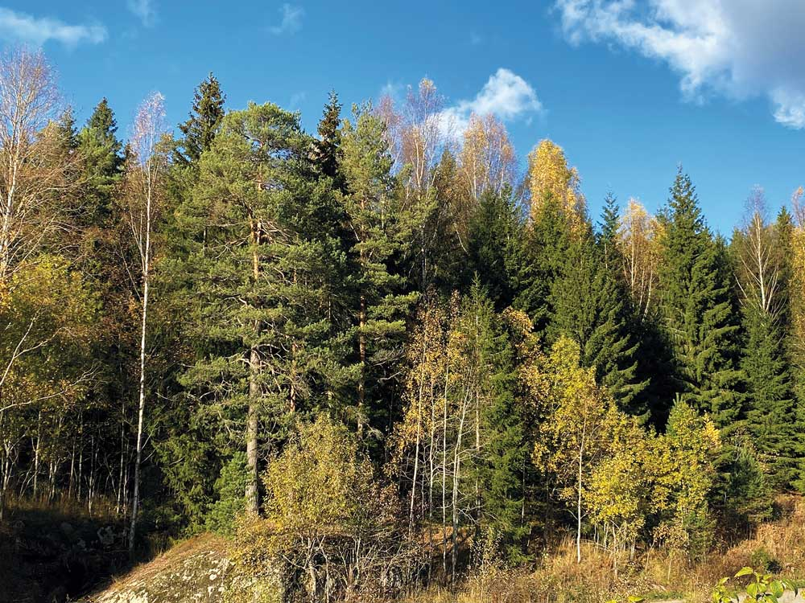
          - Mixed forest containing a variety of tree species
Photo: Irene Lindblad/ Ministry of Climate and Environment

Overall effect of mitigation measures in managed forest land
Annual net removals in forest in Norway have been declining since 2009. Net removals in 2009 totalled 35 million tonnes CO2eq, but were down to just under 28 million tonnes CO2eq in 2018 (National Inventory Report 2020). The decline in annual net removals is expected to continue in the years ahead unless new measures are introduced. The volume of net removals will gradually level off and then start to increase again.
In 2016, the Government initiated several measures to increase net removals in forest. The three grant schemes for forest tree breeding, higher planting densities after harvesting and fertilisation of forest were introduced, and at the same time, follow-up of compliance with regeneration obligations was intensified. If these measures are scaled up and the new measures for enhancing removals in managed forest land described in this climate action plan are introduced, the declining trend in CO2 removals may be reversed more quickly, and removals may rise to a higher level in the long term. This is illustrated in Figure 4.7.
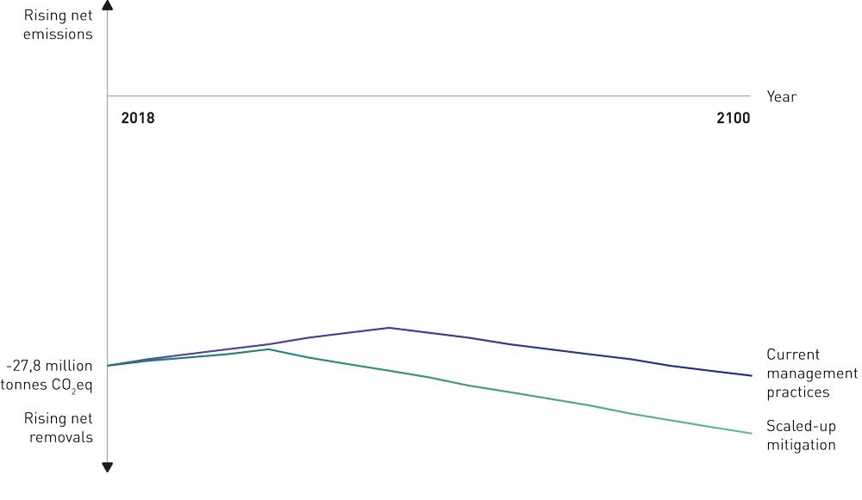
          - Illustration of the possible effects of scaling up some measures to enhance removals in managed forest land. The diagram shows that intensifying management will reverse the declining trend in net removals, after which annual removals will rise. If more mitigation measures are implemented, annual removals may rise further, and measures such as minimum age requirements for tree felling may give a clearer effect more rapidly.
Norwegian Institute of Bioeconomy Research (6(153), 2020)
Table 4.1 shows possible effects of various forest-related mitigation measures as analysed in several reports, including the mitigation analysis for Norway 2021–2030 and a report from the Norwegian Institute of Bioeconomy Research. The analyses use different calculation methodologies and are based on different assumptions, so that results for different measures are not directly comparable. Because of interaction between measures, it is not possible to add the figures together directly. However, the estimates do show that scaling up mitigation measures will have a considerable long-term effect, perhaps as much as 6.5–8 million tonnes CO2eq by 2100. There will be additional removals from afforestation of new areas. The actual effects of the measures will depend on their design and scope, which the Government will return to at a later date.
04J2xt2
            - The potential of various forest-related mitigation measures for enhancing removals. The estimates are from several analyses based on different calculation methodology and assumptions, and are therefore not directly comparable. Interactions between measures mean that the figures cannot be added together directly. The actual effects will depend on the design and scope of the measures.
 | Annual potential for enhancing removals (million tonnes CO2/CO2eq)
Measure | Estimated potential in 2030 | Estimated potential in 2100 | Cost
Existing measures
Nitrogen fertilisation of forest (assuming rate of application is unchanged) | 0.14–0.27 | 0.14–0.27 | < NOK 500/tonne CO2
Forest tree breeding | 0.1 | 1.1 | < NOK 500/tonne CO2
Higher planting densities | 0.0 | 1.0 | < NOK 500/tonne CO2
Possible additional measures
Minimum ages for felling in line with PEFC Forest Standard | 0.3 | 0.3 | < NOK 500/tonne CO2
Tending young-growth stands | 0–0.5 | 1.5–3.3 | < NOK 500/tonne CO2
Reducing damage caused by conifer root rot |  | 1.0 | < NOK 500/tonne CO2
Using suitable tree species for regeneration, tree density corresponds to legal minimum | 0.1 | 1.3 | < NOK 500/tonne CO2
Afforestation of new areas | Depends on scope | Depends on scope | < NOK 500/tonne CO2

Cutting emissions from the development of green areas

Introduction
The conversion of forest, peatland and agricultural areas (green areas) for other purposes results in emissions of about 2 million tonnes CO2 a year. Most of this is from the development of forest land. The conversion of green areas also has negative impacts on biodiversity and the environment. Through the climate agreement with the EU, Norway is accountable for emissions from the conversion of green areas to a greater extent than before.
Land is being used to build homes, holiday homes, roads, commercial buildings, sports facilities and a variety of other structures. These processes will need to continue, but it is also vital to take into consideration the value of green areas, so that the conversion of green areas for other purposes is kept to a minimum. In other words, smart and effective spatial management is needed. For example, former industrial sites can be re-used, and new developments can be sited away from the most carbon-rich areas such as peatlands and highly productive forest.
In 2020, the European Commission proposed a wide-ranging biodiversity strategy for 2030. This is influenced by the serious decline and loss of nature that has already occurred. Restoring nature, particularly carbon-rich ecosystems, is therefore a key element of the strategy, together with large-scale expansion of nature protection. Norway is in a better position than many European countries, but the negative trends are apparent here too. Spatial management need to be improved to avoid severe losses, including economic losses, in the future.
Statistics Norway has estimated (Notater 2020/10) that the total area in Norway developed for buildings and infrastructure in the period 2008–2019 was 540 km2. More than 80 % of this was previously natural habitat or agricultural land. Zoning provisions in current municipal master plans allow for the development of a further 2 777 km2, of which 56 % is currently forest land, 20 % other land, 8 % peatland and 6 % agricultural land.

Spatial planning at municipal level
The municipalities are the main spatial planning authorities under the Planning and Building Act, but the central government determines the overall framework through regulations, government expectations for regional and municipal planning (under section 6-1 of the Act) and central government planning guidelines (under section 6-2 of the Act). The Government will continue to emphasise that spatial planning processes should be used to promote the development of compact towns and urban areas, and that the potential for densification, transformation and re-use of areas and buildings should be used before new areas are developed. This approach will reduce transport needs and thus emissions from transport. It will also mean that less nature and agricultural land that is converted for buildings and infrastructure, and will reduce emissions from these types of land-use change. Last but not least, this approach to spatial planning can contribute to the development of dynamic communities that are attractive to live in.
The Government will take steps to ensure that municipalities and counties receive sound guidance and good tools so that they can take carbon-rich areas into consideration in spatial planning. At the request of the Norwegian Environment Agency, the Norwegian Institute of Bioeconomy Research developed a greenhouse gas inventory for the LULUCF sector for all municipalities in Norway for 2010 and 2015. Municipalities and counties can use this information as a basis for efforts to reduce emissions and enhance removals linked to different types of land use in the municipalities. The Environment Agency has also developed a calculation tool that enables municipalities to estimate the effects of planned changes in land-use on emissions and removals. This can be used to compare the effects of different options for land use. Any conversion of forest and other green areas will result in greenhouse gas emissions, but the volume of emissions will depend on the land category that is to be developed (peatland, forest, agricultural land, etc).

Forest and peatland
The main cause of emissions from land-use change in Norway is deforestation, which in turn is largely for construction and infrastructure development. It is therefore crucially important to reduce the conversion of forest for other purposes in order to approach compliance with the ‘no debit’ rule for the LULUCF sector.
It is also vital to prevent the conversion of peatland as far as possible. These areas store large quantities of carbon in the form of dead plant material that accumulates over thousands of years and becomes peat. Peat accumulates because the waterlogged conditions in the soil prevent complete decomposition of the plant material. The deeper the peat, the larger the carbon stock. Peatlands are also important for biodiversity, particularly birds and insects, and provide other ecosystem services in addition to carbon storage. Peat has a unique ability to retain water and release it slowly, thus moderating both drought and flooding.
When an area of peatland is used for construction or infrastructure development, part or all of the area is drained and excavated. The large carbon stock in the peat becomes a major source of emisssions, and emissions per unit area are often much higher than when other types of land are developed. However, it is not a straightforward matter to compare the climate impacts of developing peatland with those of developing highly productive forest, because the reduction in future carbon sequestration must also be taken into account. The carbon stock is normally much higher in peatland than in forest on mineral soils, but annual carbon uptake is higher in forest.
The Government will seek to reduce the conversion of peatland for other purposes through planning under the Planning and Building Act and other appropriate measures. The Government will develop a specific strategy to prevent the conversion of peatland. This process must include an evaluation of ways of preventing the conversion of peatland without increasing pressure to develop forest and agricultural land. Special consideration must also be given to areas of forest growing on peat soils. These areas are often former peat bogs that have been drained and planted. The conversion of such areas for other purposes may result in even higher emissions than similar developments on peatland that has not been drained.
The Ministry of Climate and Environment will also consider issues relating to the conversion of peatland for other purposes in connection with follow-up of the white paper Nature for life – Norway’s national biodiversity action plan (Meld. St. 14 (2015–2016)).

Tax on greenhouse gas emissions resulting from land-use change
The current projections indicate that Norway’s net accounted emissions in the LULUCF sector are likely to be about 18 million tonnes CO2eq for the period 2021–2030 (if Norway makes use of the compensation mechanism), mainly as a result of the conversion of forest to other land categories. To comply with the ‘no debit’ rule in the agreement with the EU, Norway must offset these emissions by purchasing LULUCF credits from other countries or emission allowances under the Effort Sharing Regulation. We do not know what the price of purchased LULUCF credits will be until an agreement has been negotiated with a country that has credits to sell. Assuming as an example that the price is NOK 200 per tonne, net emissions of 18 million tonnes in the period 2021–2030 will cost about NOK 3.6 billion. Currently, developers are not required to pay for greenhouse gas emissions that result from the conversion of forest or other green areas. The conversion of such areas results in the degradation of various ecosystem services, including carbon storage. The polluter-pays principle could justify the introduction of a tax on land conversion for construction and infrastructure development, and perhaps on other forms of land-use change that result in greenhouse gas emissions. It would be a complicated process to introduce a tax of this kind. The Government is not proposing the introduction of a tax now, but will consider the question further.
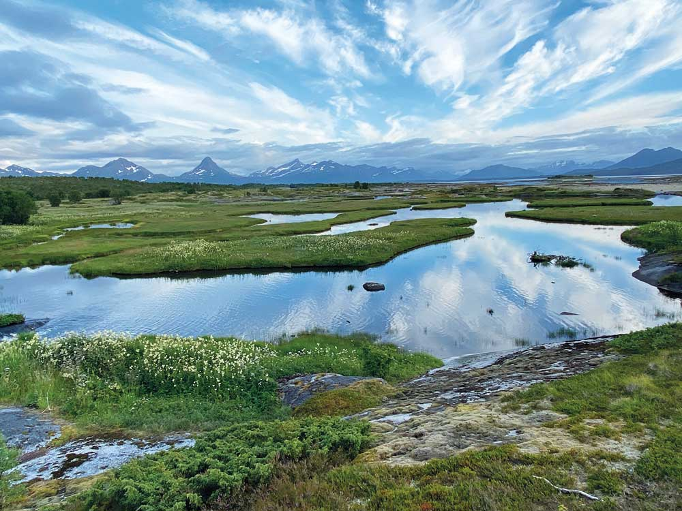
          - Most wetlands contain large quantities of carbon and are habitats for a wide variety of species. From Steinslandsosen nature reserve, Hamarøy, Nordland county.
Photo: Irene Lindblad/Ministry of Climate and Environment

Guidelines for planning holiday homes
The Ministry of Local Government and Modernisation is revising the guidelines for planning holiday homes. The new guidelines will include a thorough discussion of the siting of new holiday homes. Most new developments are now ‘cabin villages’ of varying sizes, and a decreasing are single scattered buildings. The guidelines will also deal with the climate-related effects of constructing holiday homes and of transport to and from them. There may be conflicts of interest as regards biodiversity, the cultural environment, landscapes, agriculture, climate change and transport. These will also be discussed in the guidelines. For example, it is undesirable to allow the construction of holiday homes above the treeline in the mountains in order to avoid developments on forest land. The guidelines will recommend that new holiday homes should be sited within or near areas already developed areas, that the green structure should be taken into consideration, and that construction on peatland should be avoided.

Assessing the need for central government planning guidelines for mountain areas
A call for tenders has been issued for a study intended to provide a basis for deciding whether there is a need for central government planning guidelines for mountain areas. This is in line with the Government expectations for regional and municipal planning, and follows up recommendations in several white papers. The guidelines for planning holiday homes will be a key consideration in this work. It has not yet been decided how the scope of central government planning guidelines for mountain areas would be delimited.
More than 40 % of all holiday homes in Norway are situated less than 100 m above sea level, and a large proportion are on the coast, in the 100-metre belt nearest the shoreline where the general rule is that new construction is not permitted. The central government planning guidelines for the shoreline, which provide for regional differentiation of the management regime, are being revised. Together, the new guidelines on planning holiday homes, the revised central government planning guidelines for the shoreline, and possible new central government planning guidelines for mountain areas will provided sound guidance for municipalities, counties and central government agencies, so that they can take carbon-rich areas into consideration in spatial planning.

Central government transport projects
The Norwegian Public Roads Administration has developed a method and a manual for environmental impact assessment (EIA) of road transport projects. The method is based on cost-benefit analysis of potential impacts, both those that are priced (quantified in economic terms) and those that are not. Greenhouse gas emissions as a result of land-use change in the area directly occupied by a transport project, for example the area occupied by construction of a new road, are included in the priced impacts. The manual describes a method for estimating greenhouse gas emissions from the area occupied by a project, based on average factors for five different land categories: forest land, divided into high, medium, and low site quality; agricultural land; and peatland.
Transport projects may also lead directly or indirectly to the conversion of land for other purposes: for example, a new road may make it attractive to develop residential areas or to site commercial buildings in new areas. The transport authorities have no control over such secondary effects, and their impacts are difficult to quantify. Some transport projects may facilitate more climate-friendly land use than others, for example by encouraging densification around transport nodes. The manual indicates that when this is a key consideration, the EIA process should include sensitivity analyses of different patterns of land use to investigate how different options may influence CO2 emissions. The manual describes when and how such supplementary analyses should be included.
The methods for assessing the impacts of land-use change described in the manual are relatively new (2018), and the way the manual is used in practice varies a good deal.
During the preparation of the National Transport Plan 2022–2033, the Ministry of Transport and the Ministry of Climate and Environment will consider the transport projects included in the plan with a view to estimating greenhouse gas emissions from the area occupied by each project. For large-scale projects in the transport plan, the area of land to be converted will be estimated for each project. Areas will be estimated for the following land categories:
- Forest – high site quality
- Forest – medium site quality
- Forest – low site quality
- Agricultural land
- Peatland.
This process will give a rough estimate of CO2 emissions from the land that will be required for the different large-scale projects. Further development of the methodology is needed. The Ministry of Transport will continue to develop good practice for these assessments in dialogue with other agencies and companies, and will consider whether any amendments to the manual are needed.

Cutting emissions from other forms of land use

Conversion of peatland to agricultural land
The Government has adopted a prohibition against new cultivation of peatland, as further discussed in Chapter 3.6. In recent years, the area of peatland converted to agricultural land has been roughly the same as that converted for construction and infrastructure development. The prohibition against new cultivation is therefore an important way of safeguarding peatland. Peatlands contain large carbon stocks, and are important for biodiversity and ecosystem services.

Conversion of forest land to agricultural land
In the period 1990–2017, conversion of forest to managed grassland accounted for 19 % of deforestation and 8 % of emissions from deforestation in Norway. The conversion of cropland for other purposes and the prohibition against new cultivation of peatland may add to pressure on forest land. To counteract the pressure to convert forest land to agricultural land, it is important to continue the active use of existing cropland and grassland. Important measures include reducing the conversion of agricultural land for other purposes and maintaining agricultural production in all parts of the country. Both of these measures continue current agricultural policy.
Under the Land Act, forest land may after harvesting be converted to managed grassland without the need to apply to or receive approval from the municipality. For areas converted in this way to be included in the basis for production grants for grazing, they must meet certain requirements set out in the classification system for land cover used by the Norwegian Institute of Bioeconomy Research. They must be clearly cultivated, and must be dominated by grazing-tolerant grasses and herbs. They must have been cleared of bushes, scrub and felling waste so that they are suitable for the livestock that use the area. The obligations relating to regeneration under the Forestry Act apply to rough grazing, but not to managed grassland. There is no requirement to fence areas of managed grassland, since virtual fencing systems are available. The rules are not entirely clear, and it is therefore necessary to consider how to ensure that any conversion of forest to managed grassland is based on a real need. The Ministry of Agriculture and Food, in consultation with the Norwegian Agriculture Agency, will assess amendments to the legislation to ensure that this is the case.

Cutting emissions from peat extraction
Peatlands store large quantities of carbon and are important for biodiversity. Peat is a limited resource, and its extraction and use results in greenhouse gas emissions. Most peat is extracted from raised bogs, which are a threatened habitat type in Norway and in Europe more generally. In the period 2012–2017, about 330 000 m3 of peat a year was extracted in Norway. It is therefore important to develop peat-free and low-peat alternatives quickly, to make use of renewable resources and to reduce the use of peat. The Norwegian Environment Agency has drawn up a proposal for a plan for the transition from peat-based to peat-free products. In the plan, the Agency assesses the availability of alternative growing media and gives a preliminary account of policy instruments that could be used to phase in the use of peat-free products. Commercial peat extraction is only permitted in areas that are designated for raw material extraction in municipal land-use plans under the Planning and Building Act. Peat is currently being extracted from 21 areas covering a total of about 11 km2. Six more areas are designated for raw material extraction in municipal land-use plans, but have not so far been used for peat extraction. At the current rate of extraction, the producers could operate for another 20 years in the 27 areas that have already been designated for this purpose. The best measure for countering the negative impacts of peat extraction and use on the climate and biodiversity is to prevent extraction from new areas. However, this requires that sufficient quantities of alternative products are available, so that peat from Norway is not replaced with imported peat.
The Government will therefore consider the introduction of a ban on opening new sites for peat extraction. The Government will also consider measures under the Planning and Building Act to prevent new licences for peat extraction from being granted before a decision has been made on a ban. In parallel with this, the Government will continue to promote a shift from peat-based to peat-free products.
The Government will also consider the introduction of a tax on greenhouse gas emissions from peat extraction.
The peat and growing media industry has special expertise on the growing media and soil conditioners that will be needed by a low-emission society. The Government will encourage the industry to shift towards more climate and environmentally friendly products, and will give the industry plenty of time to develop such products. The Government will continue to promote a shift from peat-based to peat-free products. If this is successful, it will reduce the risk of carbon leakage. The public administration will follow up the plan proposed by the Environment Agency within the existing budgetary framework. The Ministry of Climate and Environment and the Ministry of Agriculture and Food have allocated funding for research and analysis to the Research Council of Norway and other institutes.
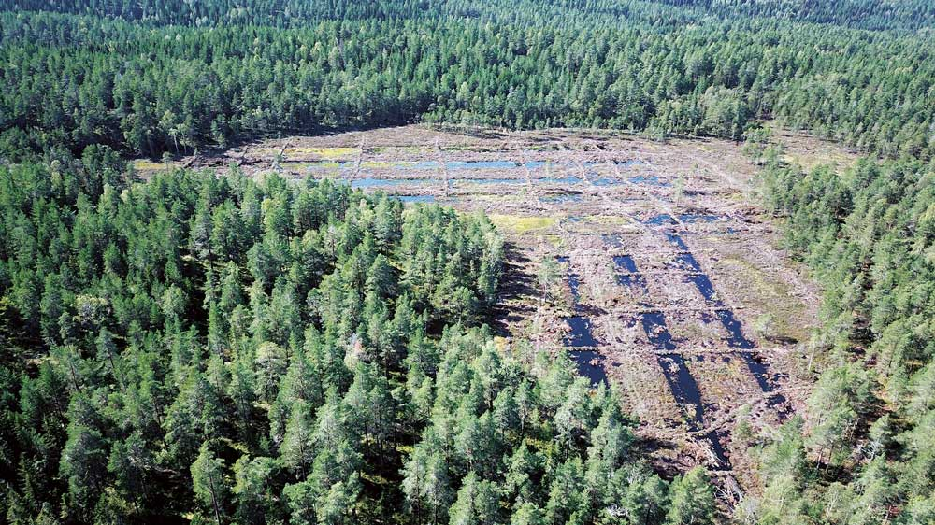
          - Ødegårdsmosan in Oslo, where peat has previously been extracted. Steps have been taken to restore the bog.
Photo: Pål Martin Eid/Norwegian Nature Inspectorate, Oslo

Restoration of peatlands and other wetlands
Drained peatlands release greenhouse gases because the low water table allows oxygen to enter the peat, which speeds up decomposition of the organic material in the peat soil. Blocking drainage ditches reduces the loss of carbon. Restoration projects for peatland and other wetlands in Norway have been in progress for the past five years, headed by the Norwegian Environment Agency. So far, 190 km of drainage ditches have been blocked in more than 80 different areas. Most of the restored peatland areas have deep peat and have been restored because of their importance both in the context of climate change and for biodiversity. The Government will continue restoration projects of this kind and similar solutions that are both climate-friendly and environmentally sound. Examples include restoration along river systems and the establishment of wetlands and grassed waterways to stop runoff from agriculture. The Norwegian Environment Agency has been tasked with revising the restoration plan, which will apply for a new five-year period.
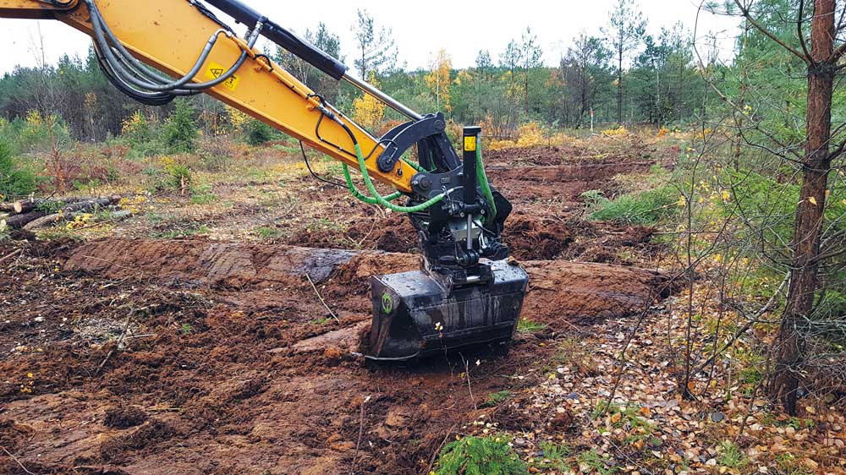
          - During peatland restoration, old drainage ditches are blocked with peat and other material from the site. The surface vegetation in the ditches is removed by the excavator before infilling and then replaced.
Photo: Pål Martin Eid//Norwegian Nature Inspectorate, Oslo

Flexibility mechanisms under the EU land use and forestry regulation
Under the EU land use and forestry regulation, countries must ensure that their accounted emissions from the LULCF sector do not exceed accounted CO2 removals over the period 2021–2030. This is known as the ‘no debit’ rule. The regulation provides for several types of flexibility, depending on whether a country has net emissions or removals in the LULUCF sector. Certain conditions have to be met to make use of these flexibilities. These were discussed in Prop. 94 S (2018–2019) requesting the Storting’s consent to the agreement between Norway and the EU (in Norwegian only).
If emissions exceed removals, compliance with the ‘no debit’ rule can be achieved through extra national reductions in non-ETS emissions, for example in the transport and agriculture sectors. These will be additional to the commitment for reductions in the non-ETS sector. The alternative is to buy emission units from other European countries, either emission units available in their non-ETS sector or credits from the LULUCF sector. Non-ETS emission units bought from other countries can be used to offset emissions either in the non-ETS sector or in the LULUCF sector. However, LULUCF credits bought from other countries may only be used towards compliance with the ‘no debit’ rule for the sector, not to satisfy the commitment in the non-ETS sector. The legislation also includes a compensation mechanism, managed forest land flexibility, which Norway can use to compensate for accounted net emissions of up to 35.5 million tonnes CO2eq over the period 2021–2030. This means that under certain conditions, Norway can harvest about 2 million m3 more than the reference level for managed forest without having to report net accounted emissions (this is further explained in Chapter 4.2). The compensation mechanism applies only to accounted emissions from managed forest land and not to other emissions, for example from deforestation or drainage of peatland.
If removals from managed forest land are higher than the reference level, the credits can be used to offset some emissions from other land categories, such as deforested land and wetlands converted to other land accounting categories. However, there is a cap on how much of a country’s net accounted removals from managed forest land can be used in this way. For Norway, the cap is about 1.75 million tonnes CO2 per year. The increase in the carbon stock in harvested wood products (HWP) is not subject to this limitation, and credits from this sector can be used in full. If a country has overall net accounted removals for the LULUCF sector, it may use some of the surplus removals to close an emission gap in its national non-ETS sector. For Norway, this is limited to a maximum of 1.6 million tonnes in total over the ten-year period. If there are net accounted removals in the LULUCF sector in the first five-year period (2021–2025), a country may also bank the surplus and use the credits in the next five-year period (2026–2030). Alternatively, it can sell LULUCF credits to other European countries.

Uncertainties
The Government has developed plans for enhancing CO2 removals in forest and reducing emissions from land use and land-use change. According to current estimates, it is nevertheless likely that under EU accounting rules, Norway will have substantial net accounted emissions from the LULUCF sector. There is considerable uncertainty in the estimates of removals and emissions. It is difficult to make reliable estimates of future land-use changes such as deforestation, and of how actual harvesting rates will develop. Actual harvesting levels relative to the reference level strongly influence accounted removals in managed forest land. Norway is expected to report net accounted emissions from managed forest land, but even with a figure of zero here, there would be net emissions from the LULUCF sector as a whole because there will be net emissions from the other land categories combined. The reference level for managed forest land will be adjusted in future to reflect updates of the background data and the methodology for the greenhouse gas inventory. In addition, natural processes such as forest fires and insect outbreaks may result in emissions, and these are difficult to estimate in the projections. Any net accounted emissions in the LULUCF sector can be offset using flexibility mechanisms or by scaling up measures to reduce emissions from the domestic non-ETS sector. This is discussed in Chapter 4.7.

Economic and administrative consequences
Value added in the value chains for forest and forest products
Climate mitigation measures for forest are intended to make it possible for CO2 removals and the carbon stock in forests and harvested wood products (HWP) to stabilise at a higher level than would otherwise be the case. This can be achieved through management practices that improve forest growth and by expanding the use of HWP. Mitigation measures for forest differ from those in other sectors because a general increase in the growing stock also has the co-benefit of increasing value added in the forestry and wood industry. This applies both to primary production and to forest-based manufacturing.
Biodiversity and outdoor recreation
Forestry operations have a visual impact, alter the surroundings for outdoor activities and the quality of people’s experience, and influence living conditions locally for plants and animals. Most of the climate mitigation measures for forest discussed here will involve more intensive production and could have negative impacts on biodiversity and other environmental factors. Whether climate change and biodiversity considerations come into conflict, and if so to what degree, will depend on the specific mitigation measure, where it is implemented and on what scale, and how it is implemented. The impacts of mitigation measures on biodiversity are likely to be more acceptable in areas that are already being actively used for forestry production than in areas that are currently under more extensive management. The Government believes that it is possible to design mitigation measures so that the environmental impacts are acceptable.
Various ways of incorporating environmental considerations into Norwegian forestry policy have been developed over the years to avoid unacceptable pressure on biodiversity and the environment. Environmental and outdoor recreation interests are taken into account through forest certification schemes, the Forestry Act and the regulations relating to sustainable forestry, the Nature Diversity Act, and environmental criteria that apply to economic instruments for the forestry industry. Similar requirements will be included if new climate mitigation measures for forest are established.
Afforestation of new areas and tree species replacement are the mitigation measures for forest that appear to be most likely to affect outdoor recreation and people’s enjoyment of forest landscapes. Other mitigation measures will have less impact on these interests provided that opportunities for shared use are provided for in the normal way.
Uncertainty
Climate mitigation measures for forest generally have effects in the long term. Carbon stocks in forest and soils change slowly, and measuring change is a complicated task. The estimates of the long-term effects of mitigation measures are therefore uncertain. Some sources of uncertainty are described in this chapter. Developing methodology for measuring emissions and removals of greenhouse gases, for example in peatland and other wetlands and in forest soils, is a challenging process. In addition, as long as climate change continues, it is very uncertain how Norway’s forests will develop in the next 50–100 years. This will depend both on the scale of climate change and on how trees and other vegetation respond. The growing risk of diseases, outbreaks of pests, wildfires and storm damage that may affect CO2 uptake and timber production and quality is also part of the picture.
Municipal responsibilities
Amendments to the regulations relating to sustainable forestry including requirements relating to minimum ages for tree felling (see Chapter 4.4.4) may give the municipalities some additional forestry-related administrative tasks. The statistics show that these requirements will apply to 3–4 % per year of the area of managed forest land, or about 1400 hectares. Using the average size of clearcuts as a basis, this would correspond to 400–500 clearcuts a year. Assuming that these are evenly distributed across the country, each municipality would have to deal with one to two applications per year.

The Government’s plan for cutting ETS emissions
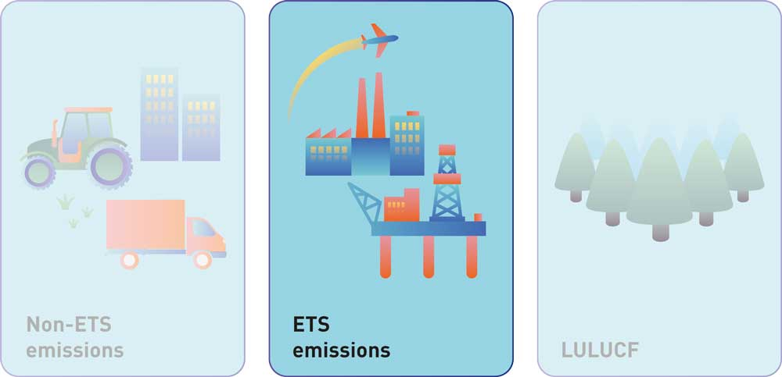
          - The EU’s 2030 climate and energy framework is divided into three main pillars, one of which deals with ETS emissions.

Figures and projections for emissions in the ETS sector
The EU Emissions Trading System (EU ETS) applies to a large proportion of emissions from industrial production, the petroleum industry and aviation. In 2019, Norway’s ETS emissions totalled 25.6 million tonnes CO2eq, or about half of its overall emissions. They originate largely from oil and gas production and industrial processes.
The overall volume of emissions included in the EU ETS is being reduced gradually. There are no national emission targets for ETS emissions as there are for non-ETS emissions.
Emissions from industrial production, the oil and gas industry and aviation are mainly in the ETS sector (see Chapter 2, Figure 2.6, showing the split between ETS and non-ETS emissions). Under half of emissions from the energy supply sector are ETS emissions. Figure 5.2 shows Norway’s ETS emissions split by sector in 2019.
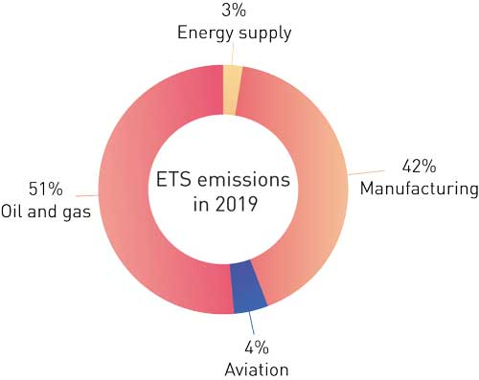
          - Norway’s ETS emissions by sector in 2019
Statistics Norway, Norwegian Environment Agency
Industrial production: I 2019, emissions from industrial production included in the ETS sector totalled 10.7 million tonnes CO2eq, or about one fifth of overall Norwegian greenhouse gas emissions. The manufacturing industries responsible for the largest volumes of ETS emissions are the ferro-alloy, aluminium, cement, mineral fertiliser, pulp and paper and chemicals industries. Major sources of greenhouse gas emissions are the use of coal as a reducing agent in the metal industry, the use of fossil inputs in the chemical industry, and the cement industry. Point sources of emissions in the cement industry include energy production and manufacturing processes, the largest being decarbonisation of limestone to produce clinker.
In recent decades, greenhouse gas emissions from industrial production in the ETS sector have declined, particularly emissions of fluorinated gases (F-gases) from aluminium production and emissions of nitrous oxide from production of mineral fertiliser. This is because new technology has been developed and deployed and better control systems have been introduced.
The petroleum industry: In 2019, greenhouse gas emissions from ETS installations in the petroleum industry totalled 13.2 million tonnes CO2eq. This is equivalent to about one fourth of Norway’s overall greenhouse gas emissions. These emissions are expected to decline from 13.4 to 9.7 million tonnes CO2eq in the period 2020–2030, to a large extent because of increasing electrification of petroleum installations. These emissions are largely from gas turbines that either generate electricity or are used to operate pumps and compressors on oil and gas platforms.
Power and heat generation: In 2019, greenhouse gas emissions from power and heat generation included in the EU ETS totalled 0.7 million tonnes CO2eq, or 49 % of total emissions from energy production. Large combustion installations that supply energy to businesses are included in the EU ETS, but not installations for the incineration of household waste.
Aviation: In 2019, greenhouse gas emissions from aviation totalled 1.2 million tonnes CO2eq. Over 90 % of domestic aviation is included in the EU ETS, which currently covers emissions from flights within the European Economic Area (EEA). Small commercial operators that operate few flights and have low emissions are not included in the EU ETS, and nor are police and SAR flights.
Table 5.1 and Figure 5.3 show Norway’s historical ETS emissions from 1990 to 2019 and projections from the 2021 National Budget (Prop. 1 (2020–2021)).
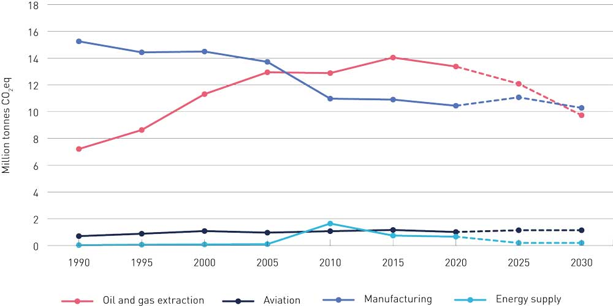
          - Norway’s ETS emissions 1990–2030 (million tonnes CO2eq)
Statistics Norway, Norwegian Environment Agency, Ministry of Finance, Ministry of Climate and Environment
The Government presented updated emission projections for Norway up to 2030 in the 2021 budget. The projections do not serve as a plan for reducing emissions, but are an assessment of the emission trajectories based on policy measures and instruments adopted at the time the projections were prepared.
            - Norway’s ETS emissions split by sector: historical figures and projections (million tonnes CO2eq)
07J1xt2
 |  | 1990 | 2005 | 2019 | 2025 | 2030
ETS emissions |  | 23.2 | 27.7 | 25.6 | 24.5 | 21.3
 | Oil and gas extraction | 7.2 | 12.9 | 13.2 | 12.1 | 9.7
 | Manufacturing and mining | 15.2 | 13.7 | 10.7 | 11.1 | 10.3
 | Other sources | 0.7 | 1.1 | 1.7 | 1.3 | 1.3

Statistics Norway, Norwegian Environment Agency, Ministry of Finance, Ministry of Climate and Environment
Given the assumptions on which the projections are based, ETS emissions are expected to decline by about 4.3 million tonnes CO2eq, or about 17 %, from 2019 to 2030. This corresponds to a reduction of 6.4 million tonnes CO2eq, or about 23 %, from the 2005 level. The largest reductions in the years ahead are expected to be achieved in the oil and gas industry.
Projections for emissions from oil and gas production are prepared by the Norwegian Petroleum Directorate and are based on reporting by the oil and gas companies. These are supplemented with data on emissions from onshore facilities associated with onward transport of petroleum products.
Projections for other ETS emissions are prepared by the Ministry of Finance in consultation with the Norwegian Environment Agency.

Policy instruments for reducing ETS emissions
The price mechanisms linked to the EU ETS are intended to be the main drivers of mitigation measures in the ETS sector. The EU ETS is designed to ensure that the most cost-effective measures are implemented to achieve specific goals. It pays for companies to implement measures that are based on already available technology and cost less than the current price of emission allowances.
The oil and gas industry, most domestic aviation and industrial use of natural gas are subject to the carbon tax in addition to being included in the EU ETS. In addition, there is an air passenger tax on all domestic flights, and an advanced biofuel quota obligation for domestic aviation.
A stable, predictable carbon price in the years ahead will provide a strong incentive to invest in and adopt zero-emission technology, and will also simplify planning for companies and other stakeholders. The Government therefore intends to raise the carbon tax for domestic aviation and emissions from oil and gas extraction that are within the scope of the EU ETS in line with the rise for non-ETS emissions (see Chapter 5.5 and 5.7 and Box 5.1). Rises in the carbon tax will be considered in conjunction with the price of emission allowances in the EU ETS, to that the total carbon price does not exceed NOK 2 000 per tonne CO2eq in 2030, measured in fixed 2020 NOK, unless the price of emission allowances alone is higher than this.
              - Carbon tax on ETS emissions
An emissions trading system provides an incentive to reduce emissions since the market determines a carbon price in line with the overall emissions cap for the system. Levying a tax on emissions that are within the scope of the emissions trading system provides another incentive, in addition to the price of emission allowances, to reduce the level of activity or invest in new solutions and technologies. This may in turn result in a lower demand for emission allowances. All other things being equal, the price of allowances may decline, making more allowances available for use by other installations in the system. This means that a tax on ETS emissions will not in principle contribute to a reduction in global greenhouse gas emissions over time. At present, there is a surplus of emission allowances in the EU ETS. A system has been established to reduce the surplus and prevent the price of emission allowances from falling too low (see the explanation of the Market Stability Reserve in Chapter 5.3). This will also help to ensure that a carbon tax in addition to the ETS has a global effect on emissions provided that the surplus of allowances is larger than the threshold for transfer to the reserve, but the effect will be smaller than the reduction in emissions from the sectors to which the tax applies.
[Boks slutt]
The Government will not introduce a carbon tax on ETS emissions that are not currently subject to the tax.
A sustained initiative for technology development will be of crucial importance for restructuring Norwegian business and industry as part of the transition to a low-emission society. The authorities are supporting research and innovation that can result in the development of new solutions and low-emission technologies in the ETS sector. Businesses that have plans to develop such solutions can receive support, and at the same time the authorities are providing a framework that encourages business and industry to reduce emissions and change to production and products that are consistent with a low-emission society. In the Government’s view, policy instruments for the industrial sector should be even more clearly targeted than at present to encourage the phase-in of new technologies. Energy-efficient industry with low emissions is essential in the transition to a low-emission society.
The Government has given Enova a clearer climate profile for the next four-year period, and the transition to a low-emission society and innovation that contributes to this are important goals for Enova in the new agreement period, see Chapter 3.3.5.2 for more about Enova. Enova’s role is particularly important in the case of ETS emissions, since public funding for research and development is an important supplement to the emissions trading system. Enova provides support for technology development and innovation in the ETS sector that can make it possible to reduce production-related emissions, see Box 5.2.
New industries will need to be developed to meet future needs. Expanding production of renewable energy from offshore wind and solar power and making greater use of hydrogen and battery technology will offer opportunities for new commercial activities related to production, maintenance, control systems and other services.
              - Enova’s support for technology development makes it possible to reduce ETS emissions – some examples
In 2014, Enova agreed to support Hydro’s pilot project for energy-efficient, lower-emission aluminium production on Karmøy in Western Norway. With this project, Hydro is at the forefront of developments internationally. The groundbreaking technology from the Karmøy pilot is now being used in the start-up of an upgraded production line at another plant in Western Norway, Hydro Husnes.
Energy from floating offshore wind farms may become an important resource globally if the technology costs can be reduced enough to make it competitive with other energy sources. In 2019, Enova provided NOK 2.3 billion in funding for Equinor’s project to develop the world’s largest floating offshore wind farm, Hywind Tampen. The project is intended as a step towards commercialisation of floating offshore wind power.
The Rockwool plant in Moss south of Oslo has received funding from Enova to replace fossil-fuel melting furnaces with a new generation of electric furnaces. Replacing the heating system will reduce emissions from the production of stone wool, which is used to insulate buildings, by about 80 %. Successful implementation of the project offers considerable potential for technology diffusion, since Rockwool has a number of plants globally, and their annual emissions total 1.7 million tonnes CO2eq.
[Boks slutt]
The EU Innovation Fund
The EU Innovation Fund is funded through the auctioning of 450 million allowances in the EU ETS. It will provide grants for commercial demonstration of innovative low-carbon technologies in the period 2021–2030. The projects will focus on renewable energy, energy-intensive industries, energy storage and carbon capture, use and storage.
              - Norwegian expert group to assess the use of carbon contracts for difference
In October 2020, the Government appointed an expert group to assess the funding instrument known as carbon contracts for difference (CCfDs). The expert group was asked to evaluate how such contracts function; whether this is a relevant funding instrument in Norway and if so, whether there are certain areas or technologies where such contracts would be particularly suitable; and how the use of CCfDs could be organised. The expert group did not assess the effectiveness of CCfDs, in other words their economic costs and emission reduction potential compared with alternative policy instruments for reducing greenhouse gas emissions.
A CCfD guarantees a fixed carbon price for the emission reductions actually achieved by a project, while the government takes on an uncertain financial obligation linked to developments in the carbon price. The contract thus eliminates the carbon price risk for the investor, and in addition, the fixed carbon price can be set at a higher level than the current carbon price in the market. For each year of the contract, the government pays a grant calculated as the difference between the agreed price and the actual carbon price, provided that the latter is lower. Thus, CCfDs can be a useful funding instruments for projects whose viability is strongly dependent on carbon prices, which are very uncertain both now and in the future. This suggests that CCfDs may primarily be relevant as a funding instrument in the ETS sector.
So far, no countries have taken CCfDs into use as a funding instrument. The Netherlands will probably be the first to do so, and plans to use an auctioning system. However, other countries do have experience of using contracts for difference that are not directly linked to emission reductions, but instead to the production of renewable energy.
The working group concluded that contracts for difference may be a suitable funding instrument for projects involving technology that is mature and ready for market introduction, but not yet commercially mature. This applies to technologies that are at levels 2–4 of the commercial readiness level (CRL) scale. The scale uses six levels to describe how a technology is commercialised, from early market introduction to full market penetration or commercial maturity. The expert group’s view was that CCfDs could be used to supplement current funding instruments, since none of these compensate for higher operating costs when using new technologies to reduce emissions. In some cases, operating costs may be permanently higher, while in others the costs may be higher in an introductory phase, but are expected to be reduced through learning effects from projects in an early market introduction phase. There are few areas that can be identified as particularly appropriate for CCfDs at present. This is because the number of projects at the right level of maturity is limited, and they do not form a particularly homogeneous group. According to the expert group, the most suitable areas are hydrogen production, carbon capture and storage (CCS) and emission reduction projects in the process industries.
Because the number of relevant projects in Norway is relatively small, the expert group concluded that it may be difficult to achieve sufficient competition through auctioning, which is the preferred way of allocating contracts for difference. To begin with, the group therefore considered it to be more realistic to consider the possibility of allocating CCfDs on the basis of negotiations and documented additional costs.
The expert group noted that Innovation Norway, Gassnova and Enova all have good funding instruments for pilot and demonstration projects. However, once the technology used by projects is sufficiently mature for commercial development to begin, funding instruments to support technology development and reductions in greenhouse gas emissions are only provided by Enova. Contracts for difference could supplement the funding instruments Enova already has for late-phase technology development and early-phase market introduction. The expert group therefore recommended that Enova should consider how contracts for difference could function together with its existing funding instruments. The group also pointed out that various matters would need to be clarified, for example relating to the design of contracts and funding.
Within the framework of its four-year agreement with the Ministry of Climate and Environment for 2021–2024, Enova has a wide degree of freedom to design funding instruments. Enova has started an evaluation of whether CCfDs could supplement existing funding instruments.
[Boks slutt]
The funding available will depend on the price of emission allowances in the EU ETS. According to estimates from the European Commission, the fund will provide around EUR 10 billion in the period 2021–2030 if the price of emission allowances is EUR 20 per tonne CO2, while EUR 15 billion will be available with an allowance price of EUR 30 per tonne of CO2.
Norway is eligible to make full use of the fund, and Norwegian companies can apply for funding in the same way as those in EU member states. The fund will provide up to 60 % of the additional costs of using innovative energy and climate technology instead of conventional technology. This applies to both capital and operational costs of projects. Both direct and indirect reductions in greenhouse gas emissions may be included in the calculations. Enova has a special responsibility for administering Norwegian applications to the fund.

The EU Emissions Trading System and how it functions
The EU ETS sets a cap on emissions from industrial processes, the petroleum industry, power and heat generation and aviation. For every tonne of greenhouse gases emitted, a company must hold an emission allowance (see Box 5.4). The EU ETS is a long-term policy instrument that gradually tightens restrictions on emissions.
In line with the EU’s target of reducing overall emissions by at least 40 % compared with the 1990 level, the number of emission allowances is being reduced every year to ensure that emissions are 43 % lower in 2030 than they were in 2005 for the sectors covered by the EU ETS, see Figure 5.4.
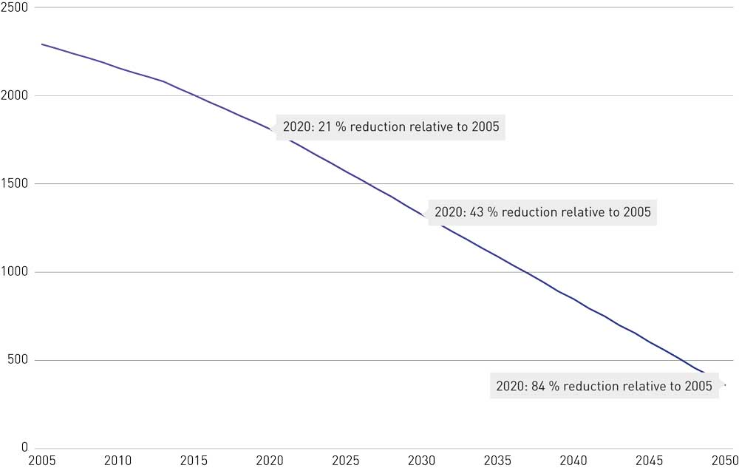
          - The EU ETS and the gradual reduction in the cap, or number of emission allowances available (million tonnes CO2eq).
European Commission, Ministry of Climate and Environment
              - Brief description of how the EU ETS functions
The EU ETS is a ‘cap-and-trade’ system. The overall volume of greenhouse gases that may be emitted by the installations covered by the system is limited by a cap on emission allowances. The cap is progressively tightened so that total emissions are reduced.
Within the cap, companies are allocated or buy emission allowances, which they can trade as needed. The cap on the total volume of emissions ensures that emission allowances have a market value.
At the end of each year, companies must surrender enough allowances to cover all their emissions, or face large fines as a penalty for the excess emissions. If a company reduces its emissions, it may retain emission allowances against its future needs or sell them to another company that has too few emission allowances.
Emission allowances are traded in a market. Emissions trading provides flexibility, ensuring that emissions are cut where the cost of doing so is lowest. A robust carbon price also encourages research, innovation and investment in low- and zero-emission technologies and solutions.
European Commission
[Boks slutt]
There is currently a surplus of allowances in the EU ETS. To achieve the level of ambition for the period 2021–2030, the number of emission allowances issued per year is being reduced at a higher rate than previously. In addition, a Market Stability Reserve has been operating since 2019. This reduces the overall surplus of emission allowances in the system by transferring allowances from the market to the reserve when the surplus exceeds a pre-determined threshold. From 2023 onwards, allowances held in the reserve in excess of the previous year’s auction volume will be permanently cancelled. In this way, the reserve will contribute to a tighter cap on emissions and higher carbon prices, thus strengthening the incentive to cut emissions within the scope of the EU ETS. This system does not currently apply to aviation, because the emission allowances for this sector are not included in the basis for calculating the volume of allowances to be transferred to the Market Stability Reserve.
Under the rules of the EU ETS, it is also possible to purchase and voluntarily cancel emission allowances. Cancelling allowances reduces the volume of emissions within the emissions trading system. In principle, cancelling one emission allowance reduces emissions by one tonne CO2eq. However, as long as the surplus in the EU ETS exceeds the threshold for transfer to the Market Stability Reserve, the effect of voluntarily cancelling allowances may be less than one tonne per allowance. This is because voluntary purchase and cancellation of emission allowances will reduce the surplus of allowances circulating in the market, and thus the number of allowances that are transferred to the reserve.
The EU ETS covers about 140 stationary installations in Norway, including various forms of industrial production, oil and gas facilities and combustion installations. In the aviation sector, there are six operators that report to Norway. Aviation within the EEA has been included in the EU ETS since 2012. The system encourages operators to adapt by making investments and adjusting their operations when the cost of action is lower than the price of emission allowances.
In most European countries, emissions in the ETS sector are dominated by electricity generation for industrial purposes and general energy supplies.
The EU ETS plays a part in driving higher electricity prices in Europe. When the carbon price rises, the price of electricity production from coal and natural gas also becomes more costly, and it becomes relatively more profitable to develop renewable energy. Thus, the EU ETS provides incentives to develop renewable energy production and decarbonise the energy sector in Europe.
Norway is integrated into the European power market through cross-border interconnectors, mainly to Sweden, Denmark and the Netherlands. Changes in electricity prices in other parts of Europe therefore influence prices in the Norwegian power market. In 2020 and 2021, new interconnectors with Germany and the UK are being completed. This will enable Norway to take advantage of differences between different power systems and ensure reliable electricity supplies.
The EU considers it important to avoid carbon leakage, the term used of a situation where businesses transfer their operations to other countries because of costs related to the EU ETS. Industries that are most at risk of carbon leakage therefore receive a larger share of emission allowances free of charge, and some sectors are also eligible for compensation for increases in electricity costs as a result of the EU ETS. Compensation arrangements were introduced in 2013, and participation was optional. Norway chose to take part, and in all, 46 Norwegian installations are currently entitled to compensation for these indirect emission costs. Most of them are in the aluminium, silicon and ferro-silicon, pulp and paper and chemical industries. In Norway’s 2021 budget proposal, NOK 2 567 million was allocated to compensation for indirect emission costs. Disbursements in 2021 provide compensation for costs incurred in 2020.
The European Commission has revised the guidelines for compensation for indirect emission costs for the period 2021–2030. The Government is now considering how to organise Norwegian arrangements for this period.

The price of emission allowances in the period up to 2030
The price of emission allowances in the EU ETS has varied between EUR 0 and a little over EUR 30 per tonne CO2eq since the market was established in 2005. In the most recent years it has generally been over EUR 20 per tonne, after remaining consistently well below EUR 10 per tonne for many years.
Future prices of emission allowances are influenced by many different factors, and the level of uncertainty is high. As in other markets, prices are largely determined by supply and demand. The planned reduction in the volume of emission allowances will reduce supply. All other things being equal, this will drive prices upwards. However, it is uncertain how high demand for emission allowances will be in the future. As businesses take part in the transformation process and reduce their emissions, they will need fewer emission allowances, thus reducing demand.
Expectations about the EU’s level of ambition for emission reductions and how this will be reflected in the supply of emission allowances within the EU ETS constitute one of the most important drivers of the price of emission allowances. The EU’s ambition of becoming climate-neutral by 2050 and its more ambitious target for 2030 are examples that will affect expectations.
The EU’s more ambitious climate target for 2030 may entail amendments to the EU ETS that result in a rise in the price of emission allowances.
Unexpected economic events also have impacts on the carbon market. This became clear during the financial crisis of 2007–2008, when the price of emission allowances dropped substantially.
The scope of the emissions trading system and the opportunities available for trading with other markets are other factors that influence the price of emission allowances. Possible future developments such as linking the EU ETS to other emissions trading systems and expanding it to include the transport sector may also influence prices.
Considered in isolation, the Market Stability Reserve is a factor that drives the price of emission allowance upwards because it reduces the number of allowances available.
Figure 5.5 shows historical data for the period 2008 to October 2020, futures prices for 2021–2025, and medians derived from various scenarios containing prognoses of emission allowance prices up to 2030, from a number of analytical firms and financial experts. The estimates are based on a range of assumptions about different market drivers. The estimates included in the scenarios were published before the EU announced its more ambitious 2030 target. The figure also includes Refinitiv’s analysis, published on 14 October 2020, which reflects the proposed more ambitious 2030 target (55 % reduction in emissions, 65 % EU ETS share). The futures prices are market prices adjusted for interest rates (source ICE-ECX).
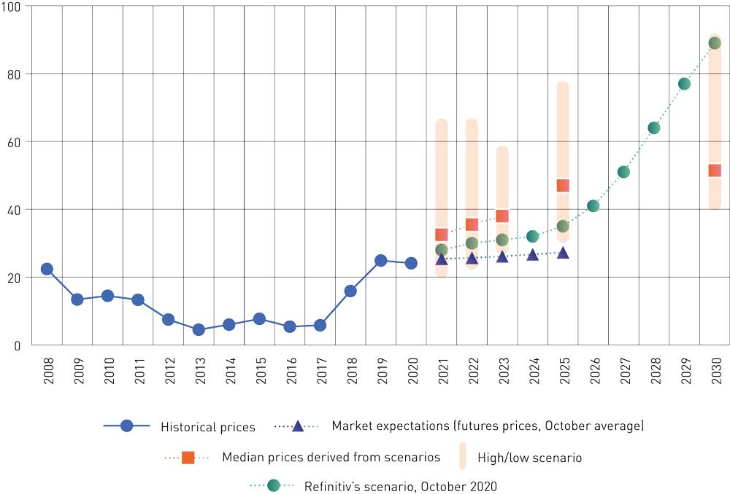
          - Historical prices and estimated futures prices (nominal) of emission allowances in EUR per tonne CO2eq. The historical prices are annual averages. The futures prices are from October 2020. The medians are derived from a set of scenarios.
Refinitiv (formerly Thomson Reuters), Carbon Pulse poll
14J1xt2
 | 2008 | 2009 | 2010 | 2011 | 2012 | 2013 | 2014 | 2015 | 2016 | 2017 | 2018 | 2019 | 2020
Historical price, EUR/tonne | 22.4 | 13.4 | 14.5 | 13.3 | 7.5 | 4.5 | 6.0 | 7.7 | 5.4 | 5.8 | 15.9 | 24.9 | 24.11

1 Average up to and including October 2020. The price of emission allowances had risen to about EUR 34/tonne on 4 January 2021.
Refinitiv (formerly Thomson Reuters)
The prognoses for the period 2021–2030 from various scenarios indicate that the market expects the price of emission allowances to rise steadily up to 2030. The level of uncertainty is high. For 2030, the median price given by the set of scenarios is just over EUR 51 per tonne, while the range is from EUR 42 to EUR 90 per tonne. According to Refinitiv’s scenario, the emission allowance price is expected to rise from 2026 and ends up at about EUR 90 per tonne in 2030, on the assumption that the EU adopts its more ambitious 2030 target. Futures prices rise to about EUR 27 per tonne in 2025, using the price of emission allowances in October 2020 as a basis.
The implementation of mitigation measures in response to the price of emission allowances depends on whether there are measures available that cost less than the emission allowance price. The ETS sector was not included in the terms of reference for the mitigation analysis for Norway 2021–2030. This means that there is no overview of mitigation measures and their economic costs for ETS-sector industrial production and oil and gas activities corresponding to that for the non-ETS sector. However, there are other sources of information. In 2020, the Norwegian Water Resources and Energy Directorate surveyed the technical potential for electrification of large land-based industrial plants. The report does not include information on the costs of the electrification measures. Towards the end of 2020, the strategic forum Prosess21 (see Box 5.6) published reports on mitigation measures and policy instruments for process industries in the ETS sector. In addition, the Norwegian Petroleum Directorate, in cooperation with the Norwegian Water Resources and Energy Directorate, the Petroleum Safety Authority and the Norwegian Environment Agency, published a report on power from shore to the Norwegian continental shelf in June 2020 (see Box 5.5). This includes assessments of the costs of electrification of various fields on the Norwegian continental shelf.

Cutting emissions from oil and gas activities
The Government will:
- Raise the carbon tax on ETS emissions from domestic aviation and from the oil and gas industry in line with the rise for non-ETS emissions, so that the overall carbon price in 2030 (tax + price of emission allowances) is about NOK 2 000 per tonne CO2, measured in fixed 2020 NOK. The overall carbon price must not exceed NOK 2000 in the period 2021–2030.

The Norwegian oil and gas industry
The overall objective of Norway’s petroleum policy is to provide a framework for profitable long-term production of oil and gas. The Government’s climate policy is designed to ensure that it pays to develop and deploy technologies and solutions that reduce greenhouse gas emissions. The oil and gas industry has been a cornerstone of the Norwegian economy for several decades, and will continue to play an important role in the economy in the years ahead. The petroleum industry is currently Norway’s largest, measured in terms of value added, state revenues, investment and export value. About 200 000 people are directly or indirectly employed in the oil and gas industry and associated industries.
The COVID-19 pandemic and low oil prices have created a difficult situation for the oil and gas industry because of national and global infection control measures and the subsequent drop in economic activity. The Storting (Norwegian parliament) therefore adopted temporary amendments to the petroleum taxation system (Innst. 351 L (2019–2020)) allowing accelerated depreciation, thus delaying tax payments and improving companies’ liquidity. These amendments have helped to maintain activity levels and retain expertise in the industry during the crisis. It has been made clear that the oil and gas companies are expected to make use of the opportunities they have been given to continue work on economically viable projects, including projects designed to reduce emissions.
The Storting has also requested the Government, together with the oil and gas industry, to present a plan for reducing emissions from oil and gas production by 50 % by 2030 compared with the 2005 level, on the basis of current policy instruments. The plan must also take into account the importance of finding cost-effective measures for reducing emissions, including further electrification of existing oil and gas fields and the use of low- and zero-emission technology on new fields, and the consequences for the onshore power supply system. This work is to be completed in the course of 2021.
In 2021, the Government is to present a white paper on long-term value creation from Norwegian energy resources. In addition to value creation and industrialisation based on the natural resources on the Norwegian continental shelf, the Government will use the white paper to discuss important drivers of change in the energy market and technological developments, the global framework, international agreements, and European climate and energy policy. The Government will also use the white paper to follow up the Government’s request for a plan for reducing emissions from oil and gas production by 50 %.
We are facing major changes in the global energy market, which are driven by factors including new technology, stricter climate policy and the steadily increasing demand for energy. This is creating new challenges and new opportunities for the oil and gas industry on the Norwegian continental shelf. In the long term, global demand for oil and gas will be influenced by the mitigation action countries take to achieve their targets under the Paris Agreement. This will require a transition from fossil to renewable energy production and use, which will also influence Norwegian oil and gas production. The Norwegian offshore industry has previously shown its ability to adapt to change and make use of new opportunities. However, it is too early to conclude what impacts a global energy shift may have on Norwegian oil and gas production and activity on the Norwegian continental shelf.
Uncertainties relating to future oil and gas prices and the future costs of emissions from production are economic risk factors that stakeholders in the industry take into account when making decisions.
As set out in Norway’s long-term low-emission strategy for 2050 (Prop. 1 S (2019–2020)), the Government will follow up the recommendations of Norway’s Climate Risk Commission, and require oil and gas companies to identify climate-related risks in their plans for development and operation. This will be further discussed in the 2021 white paper on long-term perspectives on the Norwegian economy. Climate risk is further discussed in Chapter 6.4.

Policy instruments for reducing emissions
Raising the overall price of CO2 emissions from oil and gas activities
The Norwegian authorities have been using effective policy instruments to reduce emissions from petroleum extraction for many years. The carbon tax and the emissions trading system are the main instruments of climate policy for the Norwegian continental shelf. Today, the EU ETS applies to about 95 % of greenhouse gas emissions from the oil and gas industry. In addition, emissions are subject to a carbon tax, and the industry is directly regulated, one example being that flaring is prohibited except when necessary for safety reasons. The overall price companies pay for their emissions has risen in recent years to about NOK 750 per tonne CO2 in 2020. The carbon tax rate will probably be increased by a further 7 % in the 2021 budget after adjustment for inflation, to NOK 543 pr tonne CO2. This will probably result in an overall price of more than NOK 800 per tonne CO2 in 2021, depending on price developments in the EU ETS. The price of emissions from the Norwegian continental shelf is higher than for most other industries in Norway, and already considerably higher than in other petroleum-producing countries.
The Government intends to raise the carbon tax on ETS emissions from the oil and gas industry in line with the rise for non-ETS emissions between now and 2030, so that the total carbon price reaches about NOK 2 000 per tonne CO2eq in 2030, measured in fixed 2020 NOK. The overall carbon price must not exceed NOK 2000 in the period 2021–2030.
Ensuring a stable, predictable and high price for emissions provides incentives to invest in and use low- and zero-emission technologies, and is an important driver of a long-term transition. The gradual increase in the overall price of emissions from the petroleum industry will provide support for climate action by the oil and gas companies, which is already well under way. It will encourage the adoption of technology that would not have been taken into use on the basis of the price of ETS emission allowances alone. This policy also means that the price will be the same for all emissions from oil and gas activities that are ETS emissions and/or subject to the carbon tax, which will encourage cost-effective emission reductions in the sector. It is difficult to estimate how much it may be possible to reduce emissions as a result of the rising price. This is discussed further in Box 5.1 and Chapter 5.8.
Other policy instruments
Gas flaring has been generally prohibited since petroleum activities began on the Norwegian continental shelf. It is only permitted when necessary for safety reasons. Permits for flaring are issued by the Ministry of Petroleum and Energy. In connection with new developments, there is a requirement to use the best available technologies (BAT). Technological developments influence what is regarded as BAT, which over time results in stricter requirements for the use of technology to reduce emissions on the Norwegian continental shelf.
In connection with new independent developments and major changes to fields that are on stream, licensees are required to assess whether to use power from shore. Operators include the following factors when considering whether to use power from shore: the cost of using other options such as gas turbines to generate power, the cost of full or partial electrification of offshore installations, the availability of power from the onshore grid, electricity prices, gas prices and the expected cost of emissions. The high cost of emissions gives the operators an incentive to implement projects to use power from shore provided that the cost is less than that of the price of emission allowances and the carbon tax combined. The authorities deal with energy solutions for petroleum installations as part of their administrative procedures for the plans for development and operation (PDO) and plans for installation and operation (PIO) submitted by the operators.
Experience shows that these policy instruments function as intended. On average, emissions per unit produced on the Norwegian continental shelf are about half of the average for other petroleum-producing countries.
The authorities are also supporting research on solutions to reduce emissions. Since 2010, the Ministry of Petroleum and Energy’s goal has been for at least NOK 25 million per year of the funding allocated to petroleum research to be used for projects on energy efficiency and the reduction of greenhouse gas emissions. From 2019, this goal was increased to NOK 35 million.
In the period 2010–2019, 39 of the projects funded through the petroleum research programmes PETROMAKS2 and DEMO 2000 were specifically dedicated to reducing emissions or improving the efficiency of energy use. In the same period, the programmes also funded 167 projects of considerable relevance to improving energy efficiency and reducing greenhouse gas emissions, even though this was not their primary purpose.
A new low-emission research centre for the petroleum industry, LowEmission, was established in 2019. The centre is an arena for cooperation between research groups and the petroleum industry, and its purpose is to develop technology and solutions that will help the industry to achieve its long-term target of zero emissions in 2050. The Research Council of Norway is providing NOK 120 million in support over an eight-year period through the PETROSENTER scheme.
              - Power from shore to the Norwegian continental shelf
The Norwegian Petroleum Directorate, in cooperation with the Norwegian Water Resources and Energy Directorate, the Petroleum Safety Authority and the Norwegian Environment Agency, has published a report on power from shore to installations on the Norwegian continental shelf.1 The report was published in June 2020 and is an update of a study published by the same four agencies in 2008.
The study shows that since 2008, a number of development projects on the Norwegian shelf have used power from shore. There are now 16 oil and gas fields where power from shore is being used or a decision has been made on its use. All of them are expected to have operational power-from-shore solutions from 2023 onwards. At that point, they will account for about 45 % of oil and gas production from the Norwegian shelf. It is estimated that avoided emissions as a result of these projects will total 3.2 million tonnes CO2 a year. This corresponds to about a quarter of total emissions from petroleum activities in 2019.
The report also gives an account of developments in the technology for power from shore since 2008. For example, the necessary equipment is lighter and requires less space, and power can be transmitted over longer distances at lower cost. In addition, the consequences of rising electricity consumption for the onshore power supply system are discussed. Most of the power-from-shore projects that are in the planning phase will require new investments in the grid. The report describes a high level of activity, with assessments of a number of new power-from-shore projects, and several projects approaching investment decisions. These include power from shore to the Oseberg Field Centre, Oseberg Sør, Troll B, Troll C, Sleipner Øst and the Melkøya onshore facility (Hammerfest LNG).
1 Kraft fra land til norsk sokkel (English summary: Power from shore to the Norwegian shelf. Summary of report 2020)
[Boks slutt]

Potential emission reductions in the petroleum industry
The main source of emissions from the Norwegian continental shelf is the gas turbines that are used to generate electricity or heat or run pumps and compressors on the platforms. These turbines account for more than 80 % of energy supplies to offshore installations.
Several types of measures can be used to achieve further reductions in emissions from the Norwegian shelf. Power from shore offers the greatest emission reduction potential. Individual power-from-shore projects often result in substantial emission reductions. The costs and emission reduction potential of using power from shore vary widely from one field to another. The economic cost of this measure therefore varies widely from one installation to another. Costs are generally higher for existing installations than for new ones because major alterations are needed.
Energy efficiency measures are the category with the next highest emission reduction potential. These are often small-scale projects, and the costs vary widely. Emissions can be reduced by replacing old, inefficient turbines with new, more efficient turbines. The cost of doing this varies considerably from one installation to another, depending among other things on their remaining lifetime. It is also possible to take steps to reduce emissions from flaring, but because there is little flaring on the Norwegian shelf, the overall emission reduction potential is much smaller than for power-from-shore and energy efficiency projects.
Offshore wind power is another solution for reducing emissions from power supplies to offshore installations. The operators of the Gullfaks and Snorre fields are building a floating offshore wind farm, the Hywind Tampen wind farm, which will supply electricity to the Gullfaks A and Snorre A platforms. It is planned to start operating in 2022. Hywind Tampen is also a project designed to develop technology for new renewable electricity production. The project has received NOK 2.3 billion in support from Enova and NOK 566 million from the NOx Fund. The project is playing a part in further technological development. The aim is that in the long term, this will be an economically viable solution without support, and competitive with other forms of electricity production.
Natural gas is the dominant energy commodity used by oil refineries and gas processing plants in their operations. Parts of several of these facilities have been electrified. The Norwegian Water Resources and Energy Directorate has published a study of the technical potential for further electrification of large land-based industrial plants, including the onshore facilities in the petroleum industry. This is further discussed in Chapter 5.6 below.
More use of power from shore on the Norwegian continental shelf and electrification of onshore facilities will result in a rise in electricity consumption and may require investments in the electricity grid in Norway. This is further discussed in Chapter 8.

Cutting emissions and industrial restructuring

Norwegian industrial production in the ETS sector
Industry can play several roles in the transition to a low-emission society. In addition to reducing its own emissions, industry contributes to the green transition by supplying materials, technologies and solutions that make emission reductions possible in other areas of activities and sectors, both in Norway and internationally. The Norwegian process industries supply materials and raw materials that are used in a wide range of green products, including aluminium for the production of electric and hybrid vehicles, and nickel, which is a vital component in battery manufacture.
The process industries account for a large proportion of Norwegian industrial production in the ETS sector. They include the manufacture of aluminium and ferro-alloys, the chemical industry, mineral industry, manufacture of mineral fertilisers, refineries and the pulp and paper industry. The availability of electricity supplies from renewable sources is a key reason for the establishment of Norwegian process industries, which often account for substantial local value creation.
Products and materials from Norwegian industry are of high-quality and much sought-after, and a large proportion of the production from the process industries is exported. The export value of physical goods from Norwegian process industries is about NOK 170 billion per year, which corresponds to around 17 % of the total value of Norwegian exports (Statistics Norway, 2018). If refinery products are excluded, the value of exports from the process industries is about NOK 100 million per year. Standard products make up a large proportion of products from the process industries, but it has been reported that there is a shift under way towards advanced speciality products, in cooperation with customers and end users. This is an important way of increasing value creation in the process industries.
Products from the process industries form part of major value chains, for example in construction, the transport sector and the energy sector. The most important export markets are Germany, Sweden, the UK, the Netherlands and the US.
Electricity consumption by the process industries totals about 42 TWh per year, making the sector the largest electricity consumer in Norway. Norway has good supplies of renewable electricity and a highly skilled business sector. Businesses tend to have a flat structure, and there is a culture of cooperation between leading centres of expertise, innovative start-ups and established industries, which drives the development of innovative solutions. A report published by Menon Economics in 2019 concludes that the process industries are one of the sectors that will be most important in increasing Norwegian exports, and that they can also play a part in reducing global greenhouse gas emissions.

Policy instruments for restructuring and emission reductions
A suitable overall framework is required so that business and industry can make use of the resources and skills available in Norway to develop competitive industries in international markets.
Both direct climate policy instruments, such as the emissions trading system, compensation for indirect emission costs and support for research and innovation, and the general framework, including the taxation system, access to energy and the availability of knowledge and skills, must be consistent with the targets that have been adopted. For example, access to renewable energy is a vital basis for the introduction of climate mitigation measures by industry.
The strategic forum Prosess21 provided input to this white paper, and has identified measures and instruments that may be important for restructuring and continued innovation in the Norwegian process industries. Prosess21 has put forward various proposals, including establishing markets for climate-neutral and circular products, and intensifying work on the circular economy and the bio-based process industry. Important factors are adequate power supplies at competitive prices and greater access to EU funding and EU cooperation. Prosess21 identified the potential for green growth related to an initiative for a national battery value chain and pointed out that further support for R&D and innovation will be necessary for the development of the low-emission solutions that will be needed in industry.
              - Prosess21
The strategic forum Prosess21 is building further on work done when preparing the roadmap for the process industries. Its main task is to provide strategic advice on how Norway best can follow a pathway towards minimal emissions from the process industry in 2050 and at the same time provide a framework for sustainable growth in these industries during this period. Prosess21 is to present its results in early 2021.
[Boks slutt]
The Government intends to support continued emission cuts and action to strengthen new green industries. As discussed in Chapter 6.2 on research and innovation, the Green Platform initiative was recently launched by the Government as a tool for coordinated, enhanced and targeted efforts to promote a green transition in the business sector. Innovation Norway, the Research Council of Norway and SIVA (the Industrial Development Corporation of Norway), together with Enova, are cooperating on this initiative.
The Government will ensure satisfactory participation in EU programmes, so that Norwegian companies can make use of EU research and have opportunities to obtain research funding. The Government’s aim is to build up expertise in Norwegian industry and promote the green transition through access to joint European research and cooperation. There are many programmes that are important for industry, in fields including carbon-neutral and circular industries, battery technology, hydrogen and circular bio-based solutions. Chapter 6.2 describes the Government’s plans for increasing Norwegian participation in international research and innovation cooperation.

Possible climate mitigation measures for industrial production in the ETS sector
The implementation of mitigation measures by industrial installations in the ETS sector will depend on whether there are solutions that can be realised on the basis of existing technology, and that are cheaper than buying emission allowances. Many solutions are not yet available, either because the technology has not been developed, or because the cost is too high.
The development and deployment of low-emission technology often involves very long development pathways. Deployment of new technology frequently requires a period of 10–30 years, including R&D, pilots and testing, depending on the complexity of the project. For example, it took 14 years of development and testing to complete Hydro’s pilot aluminium plant on Karmøy, which received a grant of NOK 1.55 billion from Enova (see Box 5.2). Over the coming 10 to 20 years, research and innovation must be used to reduce the cost of existing low- and zero-emission solutions. New solutions must also be developed and deployed to make it possible to achieve the 2050 target.
As we approach 2050, it will be crucial for the Norwegian process industry to have achieved its ambition of making production entirely or nearly emission-free. The ferrosilicon and aluminium industries, for example, are already largely electrified and their combustion emissions are therefore low. However, they generate CO2 emissions through the use of coal as a reducing agent. In other process industries, there are emissions of process gases from fossil inputs used in production. Emission reductions will largely have to be realised using new technologies and solutions.
It is very uncertain which solutions will be successful. A greater R&D effort will help to clarify which solutions will be possible to use in the future.
Carbon capture and storage (CCS)
The Government will implement the Longship project, a full-scale Norwegian CCS demonstration project that comprises CO2 capture, transport and storage. The Government’s proposal is to implement CO2 capture at the Norcem Brevik cement plant in Porsgrunn. This would be the first full-scale carbon capture plant in the world at a cement factory. It could reduce emissions from Norcem Brevik by about 400 000 tonnes CO2 per year, which corresponds to about half of total emissions from the plant (for further detail see Chapter 6.5).
Circular solutions
Many businesses are taking circular solutions into use. They are for example making more use of recycled materials, which reduces life-cycle emissions from products.
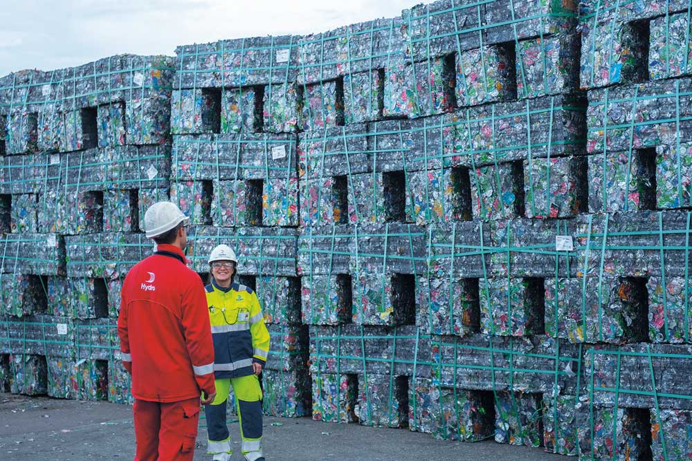
          - Hydro Holmestrand, where all beverage cans that are returned in Norway are melted down and recycled.
Photo: Marius Motrøen
The process industry sector has been identified as one of four sectors that will be particularly important for the development of a circular economy in Norway, together with construction and buildings; wholesale and retail trade; and the bio-based sectors (agriculture and forestry, and aquaculture and fisheries) (Deloitte, 2020). The Norwegian process industries are considered to have a comparative advantage in a global circular economy through the availability of large quantities of electricity from renewable sources. This allows them to produce and reprocess critical raw materials with only low greenhouse gas emissions, and to use by-products and residual raw materials from their own operations or other industries. Industry clusters that exchange and make use of by-products provide examples of solutions for making better use of energy and local residual raw materials. The role of the process industries in the transition to a more circular economy will be further discussed in the Government’s strategy for developing a green, circular economy.
Various companies are also looking into CCU (carbon capture and utilisation) solutions. These involve using CO2 from waste gases to produce fuels, chemicals, and other carbon-based products such as plastics. The climate benefits depend on a number of factors, such as whether emissions are captured and whether they are of fossil or biological origin. Another relevant factor is how the captured carbon is used, and whether it replaces other fossil emissions. If CCU only postpones carbon emissions, there is little climate benefit. Deploying CCU can play a part in the development of carbon capture technologies.
Bioresources are part of the solution
The wood processing and woodworking industries supply a wide range of products that are important for society and the green transition. The wood processing industry produces biobased chemicals and is developing advanced biofuels. The woodworking industry, in cooperation with the construction industry, has developed products to increase the use of wood in buildings. Both buildings constructed of cross-laminated timber and glued laminated timber structures provide climate benefits in the form of low emissions during the manufacturing process, and carbon storage throughout product lifetimes. In some parts of the process industries, biocarbon can be used to replace fossil carbon as a reducing agent.
The industrial sector is dependent on ready access to sustainable timber, since a large number of products produced from carbon of biological origin will be needed to reduce fossil emissions. Carbon of biological origin can also be recycled and re-used. At present, this can be done by re-using and recycling construction products, but in future it will also be possible to capture and use CO2 from chemicals and fuels based on biological materials. The use of materials of biological origin is an essential basis for achieving negative emissions from carbon capture and storage (bioenergy with carbon capture and storage, or BECCS).
In the longer term, it may be possible to use carbon derived from algae and other aquatic biomass for industrial purposes.
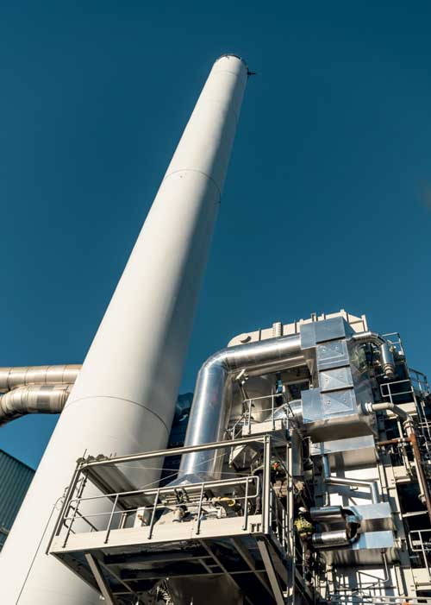
          - The Rockwool plant in Moss south of Oslo
Photo: Rockwool
Electrification reduces emissions and provides opportunities for new industries
Norway is playing a leading role in electrifying the transport sector, the petroleum industry and industry. Research, innovation and the development of battery production are essential for large-scale electrification of the transport sector both in Norway and internationally. The process industries claim to have considerable potential for growth linked to the production of raw materials for batteries, the manufacture of battery cells, and green recycling of materials from spent batteries. Several Norwegian firms are planning to establish battery production based on different technologies and at several stages of the value chain, from inputs to recycling. A few plants are already operational, and other firms are at the planning stage or have started pilot plants. The industry has identified a further need for support for research, innovation and industrialisation to make battery production cheaper, greener and more effective and to increase capacity so that production becomes more competitive. It has been pointed out that the overall framework for stakeholders in the Norwegian battery industry must be comparable with those for the rest of Europe, so that they are not in a weaker competitive position internationally.
Emissions from the use of fossil fuels in industry, both for heating and for industrial processes, can be reduced through electrification and by using electric boilers and furnaces. For example, electric furnaces have been replaced by fossil-fuel furnaces at the Rockwool plant in Moss (see Box 5.2).
The Norwegian Water Resources and Energy Directorate has published a study of the technical potential for electrification of large land-based industrial plants so that they can switch from using fossil fuels. Seven industrial plants reported that emission cuts are technically feasible through direct electrification. The costs of the specific measures have not been calculated. These measures combined could reduce CO2 emissions by 2.3 million tonnes. Five of the seven measures are based on technology that is already available. The measures identified would require investment in the power grid, some of which would need to be on a large scale and would take a long time to implement. Whether these electrification measures are implemented will depend on whether the companies themselves consider them to be economically viable. Two of the seven plants for which the report discusses electrification measures are the Yara fertiliser plant on Herøya and Borregaard’s biorefinery in Sarpsborg. Yara is now developing a pilot electrification project to demonstrate the potential, with support from by Enova.

Cutting emissions from aviation
The Government will:
- Seek collaboration with the other Nordic countries on assessing how emissions from international aviation can be reduced in the period up to 2030. This will include evaluating whether to remove the constraint on taxation of fuel supplied to international aviation in the standard Scandinavian air services agreement.
- Raise the carbon tax on ETS emissions from domestic aviation in line with the rise for non-ETS emissions, so that the overall carbon price in 2030 (tax + price of emission allowances) is about NOK 2 000 per tonne CO2, measured in fixed 2020 NOK. The overall carbon price must not exceed NOK 2000 in the period 2021–2030.
- Continue the cooperation between the European Union Aviation Safety Agency (EASA) and the Civil Aviation Authority Norway on the early introduction of low- and zero-emission aircraft.
- Continue to advocate a higher level of ambition for both the EU ETS and CORSIA.
- Provide a suitable framework for Norway to become an arena for testing and developing low- and zero-emission aircraft, and ask the Civil Aviation Authority Norway and Avinor to take steps to make ground-based infrastructure and air space available.
- make use of existing funding instruments, for example under Enova, to develop and phase in low-emission technology more rapidly.
- encourage the deployment of low- or zero-emission technologies, and require their use once technologies are mature.
In 2019, aviation accounted for about 2.5 % of global emissions. Emissions from domestic civil aviation corresponded to just over 2 % of total Norwegian emissions in the same year. Greenhouse gas emissions from flights within and from Norway have risen in recent years. From March 2020, emissions dropped sharply as a result of the COVID-19 pandemic. Future developments in air traffic are uncertain.
Norway is to become a low-emission society by 2050, meaning that emissions will have been reduced by 90–95 %. This will involve low emissions in all sectors, including aviation. The national greenhouse gas inventory includes only emissions to Norwegian territory. Emissions from international aviation are generally not included in the nationally determined contributions (NDCs) countries communicate to the Paris Agreement. Nor are emissions from international aviation included in the statutory targets of Norway’s Climate Change Act.
Using low-emission technology and phasing in sustainable aviation fuels will help to make aviation more climate-friendly and better adapted to the low-emission society. Internationally, the possibility of developing an ecolabelling system for aviation is also being considered. An Official Norwegian Report (NOU 2019: 22) on aviation made a number of recommendations on the further development of climate policy relating to aviation. Avinor and the Civil Aviation Authority Norway have presented the Ministry of Transport with a proposed programme for the introduction of electric aircraft in Norway. This includes recommendations for further measures to promote low- and zero-emission aviation.
Efforts to reduce emissions from aviation are being pursued both at national level and in international forums such as the UN’s International Civil Aviation Organization (ICAO), EASA, and the European Civil Aviation Conference (ECAC). The Nordic aviation authorities work together to reduce the environmental impacts of aviation in forums including a working group specifically for this purpose. In June 2019, the Civil Aviation Authority Norway concluded a binding multiannual agreement to collaborate with EASA on the early introduction of zero- and low-emission aircraft. The agreement includes cooperation on technology development, the regulatory framework and other measures and incentives that can accelerate developments. As a continuation of the cooperation established through this agreement, the Civil Aviation Authority Norway and EASA, together with other key stakeholders in the European aviation sector, are taking part in the High-level Task Force for Zero-emission Aviation.

Policy instruments currently in use in the domestic aviation sector
Emissions from domestic aviation are largely subject to the carbon tax and included in the EU ETS. The ETS sets an annual cap on emissions included in the system.
In 2016, an air passenger tax of NOK 80 was introduced for each passenger flying from a Norwegian airport. From 1 April 2019, the tax was altered and two different rates were brought in. In 2020, the rate for flights to destination countries where the capital city is less than 2 500 km from Oslo, and to all EU/EEA countries, was NOK 76.50 per passenger. For countries where the capital city is more than 2 500 km from Oslo, the 2020 rate was NOK 204. The air passenger tax is primarily a fiscal tax, but may also provide an environmental benefit by reducing demand for flights.
The COVID-19 pandemic has put the aviation sector in a very difficult position, and the air passenger tax was therefore temporarily repealed in 2020 and 2021.
In 2020, a biofuel quota obligation of 0.5 % advanced jet biofuels was introduced for aviation, calculated as a percentage of total aviation fuel sales each year. Norway was the first country in the world to adopt a biofuel quota obligation for jet biofuels used in aviation. So far, Norway is the only EU/EEA country that levies a carbon tax on domestic aviation. Through Enova, companies in the aviation sector are eligible for grants for developing and phasing in low-emission technology.

Policy instruments currently in use in the international aviation sector
Emissions from international aviation within the EU/EEA are largely included in the EU ETS. Obligations for international aviation to reduce emissions are partly addressed by ICAO`s market-based mechanism CORSIA (the Carbon Offsetting and Reduction Scheme for International Aviation).
ICAO has adopted an aspirational goal of carbon-neutral growth from 2020 onwards. This is to be achieved through technological and operational improvements, the use of sustainable aviation fuels, and offsetting of emissions. In June 2020, the ICAO Council decided to use emissions in 2019 as the reference level, rather than the average of 2019 and 2020, in view of the steep reduction in air traffic due to the pandemic. Emissions exceeding the 2019 level must be compensated for by purchasing emission units from other sectors. ICAO’s goal of carbon-neutral growth from 2020 onwards is not compatible with the targets of the Paris Agreement.

Policy instruments for the period up to 2030
The Government intends to take steps to make its climate policy for the aviation sector more effective. The carbon tax and the emissions trading system are the most important policy instruments for reducing greenhouse gas emissions from aviation. A stable, predictable carbon price provides an incentive to invest in and adopt low- and zero-emission technology as it becomes available, and also makes planning easier for stakeholders and companies. The Government will therefore increase the carbon tax on ETS emissions from domestic aviation so that the overall carbon price is about NOK 2 000 per tonne CO2 in 2030, measured in fixed 2020 NOK. Providing a signal that the tax will be increased also enhances the credibility of the transition to a low-emission society.
The Government intends to promote the rapid phase-in of low- and zero-emission technology in Norwegian aviation, for example by making it easy and attractive for innovators to use Norway as an arena for testing and developing low- and zero-emission aircraft. The Government will take a technology-neutral approach, and stakeholders in the aviation industry will be eligible for grants from Enova and other funding agencies for research and innovation and for phasing in low-emission technologies.
Future developments in the aviation industry are uncertain as a result of the COVID-19 pandemic. If the pandemic results in a permanent reduction in the demand for flights, this will reduce emissions from aviation. When air services are reduced, airlines are first expected to phase out the oldest aircraft, which have the highest emissions and fuel costs. This may reduce emissions per flight. Pre-COVID-19 signals from aircraft manufacturers indicate that small electric aircraft could probably be introduced on commercial routes during the period 2025–2030. However, it is possible that the industry’s focus on zero-emission technology will be disrupted by the pandemic. The Government will encourage the continuation of these efforts after the pandemic is over. The Civil Aviation Authority Norway and Avinor should take steps to make ground-based infrastructure and air space available for testing of low- and zero-emission technology. The Government has in addition proposed that flights using low- and zero-emission aircraft should be exempt from the air passenger tax, provided that this is approved by the EFTA Surveillance Authority, in order to speed up the introduction of such aircraft.
The Government will consider whether to make use of public procurement as an instrument for increasing demand for low- and zero-emission aircraft. The central government purchases air services on routes where the market alone does not result in satisfactory scheduled air services, under the rules for public service obligations. The scheduled services to which public service obligations apply are to be administered by the counties from 2022 in the three northernmost counties and from 2024 in the rest of the country, when the current central government contracts expire. The Government will monitor technological developments and assess whether environmental requirements should be imposed once the technology is mature. The counties will be free to include environmental requirements in the public procurement processes.
International cooperation is also vital in the green transition for the aviation sector, and the Government will continue to advocate a higher level of ambition for both the EU ETS and CORSIA. The Government will also seek collaboration with the other Nordic countries on assessing how emissions from international aviation can be reduced in the period up to 2030. This will include evaluating whether to remove the constraint on taxation of fuel supplied to international aviation in the standard Scandinavian air services agreement.

Uncertainties and economic consequences
Consequences of inclusion in the EU ETS and support for industrial restructuring
Industries on the Norwegian mainland will pay the same price for emission allowances as those elsewhere in Europe. In Norway, the proportion of ETS emissions in industry linked to industrial processes is higher than in other countries. In most other European countries, the largest volume of emissions is from energy production.
Eliminating a large proportion of process emissions will require new technologies and new solutions. The development of new technology takes time and is often costly. There are various uncertainties related to the actual development pathways. It is for example uncertain which technologies will be developed and whether they will be successful. Industries that succeed in cutting emissions can gain a competitive advantage in markets where there is a demand for low-emission products.
Support from Enova and the Green Platform initiative and research cooperation at national and international level (see Chapter 6) provide incentives for developments that will give emission reductions and promote the green transition in Norwegian business and industry. Regular assessments of whether the policy instruments in use are sufficient to reach the adopted targets will be needed.
Risk of carbon leakage
The risk of carbon leakage depends particularly on the extent to which companies are exposed to international competition and on the proportion of their total costs that is related to energy and greenhouse gas emissions.
An ambitious climate policy requires a special focus on the risk of carbon leakage. Industries and companies may transfer their operations away from Norway if the overall costs are higher and the framework less favourable than in competing countries. If the price of emissions is higher in Norway than in other countries, this may affect the competitiveness of Norwegian businesses. Carbon leakage may be a gradual process, where businesses invest less in existing factories and plants, or sudden, where plants are closed down while capacity increases in other countries. Such developments might limit the global effect of mitigation measures on emissions, while Norway could lose key businesses and expertise.
Businesses in the Norwegian process industries are to a large extent engaged in supplying raw materials or intermediate products for further processing and production in other countries. The sector operates in markets that are highly exposed to international competition, with many global actors. The operating framework is very important for their ability of businesses to compete globally.
The Government will take steps to counteract the risk of carbon leakage, among other things through the compensation arrangements for indirect emission costs for energy-intensive industry. The compensation arrangements will counteract the effect of rising costs related to power consumption by industry. The Norwegian Government is seeking to ensure that compensation arrangements continue after 2020. In addition, grants for the development of low-emission technologies will reduce the risk related to higher prices for emission allowances in the future.
Consequences of increasing the carbon tax for the petroleum industry and the aviation sector
The carbon tax on ETS emissions from domestic aviation and from the oil and gas industry is to be increased, as explained in Chapter 5.5 and 5.7.
The effect on emissions of a carbon tax in addition to inclusion in the EU ETS has not been calculated exactly, but this gives businesses a stronger incentive to reduce emissions and to develop and deploy new solutions and technologies. Levying a carbon tax on emissions that are included in the EU ETS may however reduce the demand for emission allowances. All other things being equal, this could reduce the price of emission allowances, and more allowances could become available in the market for use by other businesses in the EU ETS.
For the EU as a whole, the effect of the carbon tax may be to reduce emissions or to maintain them at the same level as would have been the case otherwise. There is currently a surplus of emission allowances in the market. The Market Stability Reserve (MSR), which is discussed in Chapter 5.3, will reduce the number of emission allowances available in the system, giving an overall reduction in emissions.
It has not been decided how Norway’s carbon taxes are to be increased. The consequences for different industries and individual businesses have therefore not been evaluated.
The oil and gas industry: The market determines oil and gas prices, and oil and gas produced in Norway competes with production from other countries. Higher costs, including emission costs, may influence investments and the level of activity in the industry. At the same time, if the cost of greenhouse gas emissions rises, this provides an incentive to use and invest in low-emission solutions to reduce emissions. The effect on emissions will depend on whether low-emission solutions are available, the costs of mitigation measures and whether it is feasible to implement them. Of the mitigation measures that have been analysed, using power from shore will give the largest emission reductions. The costs vary widely from one oil or gas field to another, and are generally higher for existing installations than for new ones.
Domestic aviation has not traditionally been exposed to stiff competition, and rising costs have therefore to a large extent been shifted to customers. It is reasonable to assume that increasing the carbon tax will result in higher ticket prices and higher costs for businesses and individual people who buy air transport services. The consequences of raising the carbon tax will therefore depend among other things on whether consumers have other transport options, and whether airlines take zero- and low-emission solutions into use when they reach the market.
Part III
Norway’s green transformation process

Norwegian businesses: restructuring and green competitiveness

Restructuring of Norwegian business and industry
The Government will:
- appoint an expert committee to follow up the Storting’s request to consider the overall framework for promoting climate-friendly investment in Norway.
The global benefits of implementing climate action in line with the climate targets will outweigh the costs that the world will incur as a result of climate change in the event of failure to act. However, in the short term the costs may be perceived as high by individual people. For most countries, pricing greenhouse gas emissions in line with the Paris Agreement will mean a considerable increase in price. The transition to a low-emission society will require a transformation process. The relative profitability of sectors and technologies may change. An important part of the restructuring process will be to transfer inputs from one sector to another so that they can be used where they will give the greatest yield. A high international price for greenhouse gas emissions will be a vital basis for the success of the low-emission transition. This will affect every industry, not just those that have traditionally been considered as ‘green’.
In Norway, the business sector is already accustomed to paying for greenhouse gas emissions. The carbon tax was first introduced in 1991. It is estimated that without Norway’s active climate policy, its greenhouse gas emissions in 2020 would have been 21.0–24.8 million tonnes higher than was in fact the case. Norwegian businesses that take responsibility at an early stage can gain a competitive advantage in the green transition.
Norway’s competitiveness is determined by its ability to maintain a reasonably stable balance of payments while at the same time making full and effective use of the country’s resources. For a small open economy like Norway, it is vital to make use of technology developed elsewhere in order to maintain its competitiveness.
An individual company or industry is competitive if it can compete successfully in product markets with companies in Norway and abroad, or with industries in Norway and abroad in markets for labour and capital. An industry or a company that receives subsidies to correct for market failures can improve its competitive position. However, this may result in poorer overall use of resources if the level of subsidisation exceeds the market failure it is intended to correct. Using cross-sectoral policy instruments in climate policy, such as taxation of greenhouse gas emissions and emissions trading, means that the market determines where emissions can be reduced most cost effectively.
Norway’s transition to a low-emission society will require everyone to play a part. A well-qualified labour force and incentives that make it attractive to participate in the labour market are two of the factors that will ensure the necessary capacity for change. Effective national markets and the fact that Norway is open to international markets form part of a sound framework for the business sector and for the development and adoption of new technology. Because economic policy is designed to stabilise economic developments over time, the business sector avoids unnecessary loss of production and major restructuring costs when there is an economic downturn. By restructuring the tax system to reduce taxation of income and assets and at the same time increase taxation of activities involving emissions that are harmful to the climate and environment, the Government has laid the basis for a green transition and green growth. Taking action to ensure that the Norwegian economy retains its adaptive capacity is the best possible preparation for the green transition. Through its economic, climate and business policy, the Government has developed a good framework for a business sector that already had considerable adaptive capacity.
The EU has shown through its long-term budget for 2021–2027 and the recovery package for the COVID-19 pandemic (Next Generation EU) that it is taking climate change seriously. At least 30 % of total expenditure from the long-term budget and a large proportion of the recovery package will target climate-related projects. All allocations and loans from the EU must meet sustainability criteria. Major initiatives include those for digitalisation and support to European industry and employees.
In its input to this white paper, the Norwegian business sector has highlighted the importance of a framework that does not hinder the green transition (see for example Chapter 5).
The Government will appoint an expert committee to review the overall framework for promoting climate-friendly investment in Norway. This is a response to a request by the Storting (Norwegian parliament) for the Government to consider issues including the overall framework for climate-friendly investment. This issue is also being considered in several other processes and as part of the work of other committees. The strategic forum Prosess21 is to publish its final report in early 2021, and Norway’s strategy for developing a green, circular economy will also be published in spring 2021. Part of the mandate of a committee appointed to assess the impact of the COVID-19 pandemic on Norway (‘Norway towards 2025’) is to consider the basis for Norway’s business sector in the future, including new digital business opportunities, the green transition and sustainability in business models. The Ministry of Petroleum and Energy is to present a white paper on long-term value creation from Norwegian energy resources in 2021. This will include topics such as future developments in the Norwegian petroleum industry, the interplay between onshore and offshore power generation, and offshore wind power, hydrogen technology, carbon capture and storage (CCS) and seabed minerals. For more about this, see Chapter 1.2.7. It will also be relevant for the expert committee to consider the EU regulation on a taxonomy for sustainable economic activities. The Government will therefore tailor the committee’s mandate to fit with other related processes and committees and avoid unnecessary overlap with other work in the same field. The aim is to facilitate the greatest possible value creation within a sustainable framework.

The role of research and innovation in achieving the climate targets
The Government will:
- Encourage the research and innovation sector to play a leading role in Norway’s transition to a low-emission society, in line with the white paper Long-term Plan for Research and Higher Education 2019–2028 (Meld. St. 4 (2018–2019)).
- Encourage public funding agencies to compile an overview of funding and report, in a way that is as comparable as possible, on how funding for research and innovation promotes the transition to a low-emission society. The overview should be based on the reporting work begun under the Green Platform initiative.
- Use the Green Platform initiative as one of the main tools for promoting the transition to a low-emission society.
- Increase Norwegian participation in international research and innovation cooperation, and use cooperation on climate action with the EU as one of the main tools for the green transition.

Building on existing initiatives
Norway’s climate policy is research-based. Researchers discovered that the climate was changing and documented the links between human activity and rising temperatures. And it is through education, research and innovation that solutions for the future will be developed.
To achieve Norway’s climate targets, it is essential to invest in research and innovation. The Government is doing this through allocations for Norwegian research, participation in international cooperation, and incentives for the business sector to give priority to research and innovation.
These efforts will provide part of the basis for creating jobs and new business and industry in Norway, while at the same time reducing greenhouse gas emissions.
Raising carbon tax rates provides a strong incentive for the business sector to give priority to research and innovation and will expand markets for low-emission solutions. Norwegian companies and research groups can take a leading international role in enhancing green competitiveness.
The Government has a high level of ambition for Norwegian research and higher education. The white paper Long-term plan for research and higher education 2019–2028 (Meld. St. 4 (2018–2019)) sets out policy guidelines for government initiatives in this area. ‘Climate, the environment and clean energy’ is one of the plan’s long-term priorities. The Government will therefore continue to invest in research and innovation to promote the transition to a low-emission society.
Research plays a part in ensuring a strong, broad-based knowledge base for a green transition. Knowledge makes it possible to develop solutions that both reduce greenhouse gas emissions and safeguard nature. More knowledge is needed about climate risk and about measures that can strengthen society’s resilience. Future public- and private-sector decisions on investments and the siting and development of businesses, infrastructure and buildings must not conflict with achieving the necessary long-term emission cuts.
Both the Intergovernmental Panel on Climate Change (IPCC) and the Intergovernmental Science-Policy Platform on Biodiversity and Ecosystem Services (IPBES) communicate knowledge about the green transition, and it is therefore important to consider their messages together. Low-emission and nature-based solutions should be given priority. Information in global reports must be supplemented with a national knowledge base so that it can be translated into national policy and action. An integrated approach to each issue is needed so that different interests can be weighed up against each other and it is possible to find the right priorities. There is a need for systematic reviews dealing with disputed topics across sectors. More research impact studies are also needed, since they provide knowledge about the benefits to society of the research that has been carried out. As regards the measures discussed in the mitigation analysis for Norway 2021–2030, further knowledge is particularly needed about measures in the agriculture and forestry sectors, the energy sector and fisheries and aquaculture.
Research and innovation is also needed on the development of legislation, international agreements and financial instruments. To ensure that people accept climate mitigation measures and changes, an understanding of why people act the way they do and values, interests and motives is essential. This will require research in the fields of law, social sciences and the humanities in addition to more interdisciplinary research.

Statistics and reporting on research and innovation
In 2017, spending by Norwegian research groups and companies on research and development (R&D) in the thematic areas climate, environmentally friendly energy, environmental technology, land use and land-use change, and the circular economy totalled about NOK 10 billion. This corresponded to 14 % of all R&D expenditure in 2017. The corresponding figure for 2015 was NOK 8 billion, which was 13 % of total R&D expenditure that year.
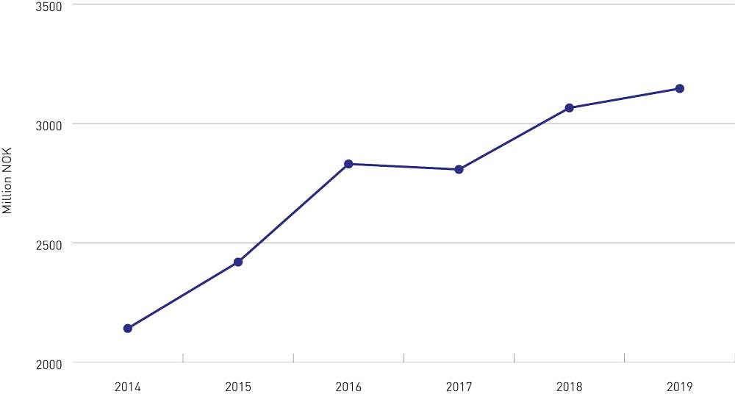
          - Grant allocations by the Research Council of Norway in the period 2014–2019 for projects under the priority area ‘climate, the environment and clean energy’ in the long-term plan (NOK million).
Research Council of Norway.
In 2019, grant allocations by the Research Council of Norway under the priority area ‘climate, the environment and clean energy’ totalled NOK 3.1 billion. This corresponded to 30.4 % of the NOK 10.2 billion in grant allocations by the Research Council, and was 47 % higher than in 2014. The funding allocated in 2019 was mainly for projects on clean energy and low-emission solutions, the bioeconomy and climate research. In recent years, the number of projects focusing on the circular economy and low-emission solutions has been rising.
The Government is further increasing research funding under ‘climate, the environment and clean energy’ in the 2021 National Budget.
It is vital to have a good overview of the overall use of resources on research and innovation designed to promote the transition to a low-emission society. At present, no overall statistics are available on allocations for this purpose by the Research Council of Norway, Innovation Norway, SIVA (the Industrial Development Corporation of Norway) and Enova. The statistics should be compiled, even though funding agencies may use different statistical categories and tagging systems. Norwegian terminology and statistics should as far as possible be comparable with international systems, and particularly with EU statistics.
Both the Government’s strategy for green competitiveness (2017) and its Long-term Plan for Research and Higher Education 2019–2028 state that there will be a special focus on climate and environment in publicly funded research, innovation and technology development wherever relevant.
Industry-oriented funding instruments must be consistent with the transition to a low-emission society. Funding must be well coordinated, and the funding agencies should, as far as possible, report in a way that is as directly comparable as possible on how funding promotes the transition to a low-emission society. The new EU taxonomy for sustainable economic activities is relevant here, see Chapter 6.4.2 for more details.

The Green Platform initiative – joint action with a clear direction
It is vital for the funding agencies to play their part in Norway’s transition to a low-emission society by 2050. Substantial funding is currently being granted for the development of climate-related and environmental solutions through industry-oriented funding instruments. This is being done both by making sustainability an important consideration in general grant schemes and through grant schemes specifically for climate- and environment-friendly solutions. The Research Council of Norway, Innovation Norway and SIVA also have a joint action plan for the bioeconomy as part of the follow-up of the Government’s bioeconomy strategy.
In the past few years, the PILOT-E scheme, administered by the Research Council, Innovation Norway and Enova, has been successfully fast-tracking new energy solutions from research to deployment.
Green Platform is the Government’s most recent initiative, intended to support coordinated, enhanced and targeted efforts to promote a green transition. In 2020, the Storting allocated NOK 333 million for the initiative. The Research Council, Innovation Norway and SIVA are jointly responsible for managing and allocating the funding. The Government intends to propose funding totalling NOK 1 billion over the three-year period 2020–2022. The Green Platform initiative will build further on the already established cooperation on green growth with Enova, and will develop this further as a model for cooperation on targeted initiatives.

The EU is the driving force for a green transition in research and innovation
The EU’s Horizon 2020 (2014–2020) has been the world’s largest research and innovation programme. At least 35 % of Horizon 2020’s total budget was expected to be allocated to research and innovation addressing climate action. By July 2019, a level of 29 % had been reached.
Horizon 2020 has enhanced the quality of Norwegian research and Norwegian innovation capacity and competitiveness. According to a study on Norwegian participation, there have been substantial learning and network effects. Norwegian companies that have participated actively in Horizon 2020 projects have been able to access research, partners, funding and international markets.
Norwegian participants have been awarded a total of NOK 2.6 billion of Horizon 2020 funding for programmes on climate, environment and energy. This amounts to just over one-fifth of all Horizon 2020 funding awarded to Norwegian participants. About 37 % of this funding has gone to research institutes, roughly 34 % to the business sector, 18 % to the university and university college sector, 4 % to the Research Council of Norway and 7 % to others.
The EU’s next research and innovation programme, Horizon Europe, runs from 2021 to 2027. Its objectives include helping to deliver on the targets of the European Green Deal, addressing major societal challenges and strengthening European competitiveness in line with the aims of the UN Sustainable Development Goals and the Paris Agreement. It has been proposed that at least 35 % of Horizon Europe’s total budget should support climate action, and that all parts of the programme will contribute to this.
Horizon Europe will involve cross-sectoral cooperation to find sustainable solutions. Climate, Energy and Mobility is one of the joint research and innovation clusters that will boost climate research and play a part in establishing a renewable energy sector and a zero-emission transport sector by 2050. Another cluster is Food, Bioeconomy, Natural Resources, Agriculture and Environment, which aims to ensure sustainable, circular use of natural resources and food and nutrition security.
Norwegian participation in Horizon Europe is a very important way of strengthening Norwegian research and restructuring the business sector for the transition to a low-emission society by 2050. Norway is participating in the planning of Horizon Europe, and the Government is focusing on making use of opportunities to give the Norwegian business sector, public sector and researchers access to European funding for climate-related research and innovation.
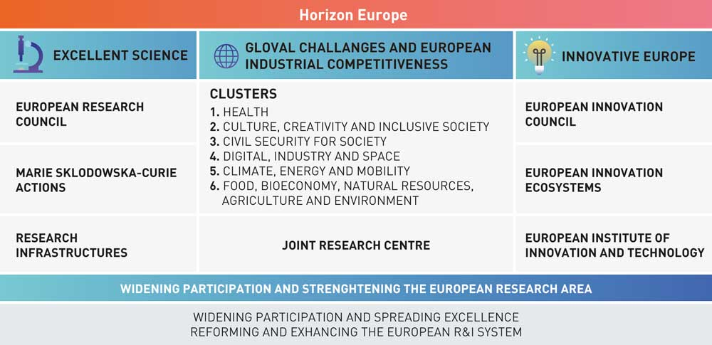
          - Overview of Horizon Europe, the EU’s ninth Research and Innovation Framework Programme.
Research Council of Norway.

Education and skills for the green transition
Norway will invest in knowledge as a means of preparing for the future. According to the Norwegian Committee on Skill Needs, technological developments, challenges related to climate change and demographic changes will result in new tasks and new ways of working that may result in changes in the industrial structure, working life and skill needs in the years ahead.
The Government has made it clear that it expects universities and university colleges to adapt their programmes so that they are in line with the skills that society needs now and will need in the future. In spring 2021, the Government will present a white paper on the workplace relevance of the skills and knowledge provided by higher education, in order to strengthen cooperation between the higher education sector and stakeholders in the labour market on higher education programmes.
In spring 2020, the Government presented a white paper entitled The Skills Reform – Lifelong Learning (Meld. St. 14 (2019–2020) and Innst. 370 S (2019–2020)). The objective of the skills reform is to ensure that no one’s skills become obsolete, and to close the gap between what the labour market needs and the skills people actually have.
There is growing interest in studying subjects that provide skills relating to sustainable nature management and climate change. For instance, a rising number of students have been indicating ‘green’ programmes as their first choice at the Norwegian University of Life Sciences (NMBU), the Inland Norway University of Applied Sciences and Nord University. The largest rise in numbers has been for forestry and plant science programmes. These programmes provide knowledge that will be essential for adaptation to climate change.
In 2020, the Government allocated funding for 90 new study places in the subjects sustainable economy and green technology. NOK 100 million was allocated to flexible education and training systems, with the green transition as a priority area.

Corporate greenhouse gas reporting
A large number of companies have for a long time been accounting for and reporting on their emissions, both total emissions and emissions associated with products. Many of them use the Greenhouse Gas Protocol (GHG Protocol), which is an international standard for corporate accounting and reporting. The protocol includes reporting of direct greenhouse gas emissions from a company’s own activities (scope 1), indirect emissions from electricity generation (scope 2), and indirect emissions from suppliers and the use of products (scope 3). This makes it possible to identify emission reduction opportunities both for a company’s own operations and for those of its suppliers, and can provide a basis for reporting, for example to customers and financial stakeholders.
In September 2020, PwC published a climate index for the 100 largest companies in Norway. In 2019, 49 of these had adopted quantitative targets for reducing their climate footprint. In addition, 68 of the companies report on their greenhouse gas emissions, and nearly all of them use the GHG Protocol as the framework for their reports. Of these, 44 include indirect (scope 3) emissions in their GHG inventories.
Another form of reporting is product-based. This is generally based on life cycle assessment (LCA), which makes it possible to pinpoint where emissions occur along the whole value chain for a product, and also make it possible to identify opportunities for reducing emissions at high-emission stages of the value chain. Product declarations are also possible to use as documentation in dialogue with customers. The EU is currently developing methods such as the Product Environmental Footprint to provide a common methodology for businesses and to make it easier for customers to compare products from different manufacturers.
To encourage investors to fund green solutions, companies must be more open about their climate footprint. In the EU, large companies are required to comply with the Non-Financial Reporting Directive. In 2019, the EU published guidelines on reporting climate-related information. The European Commission is now evaluating the directive, and one of its goals is to ensure better and more comparable reporting of climate-related information. This is further discussed in Chapter 6.4 below.

Financing solutions for the future
The Government will:
- Follow legislative developments in the EU closely as it seeks to improve reporting of climate-related and environmental information. The Government will consider whether amendments to the Accounting Act are needed so that investors and other stakeholders can receive relevant, comparable climate-related and environmental information.
- Engage in dialogue with the business sector on how to facilitate better and more relevant corporate disclosure of climate-related and environmental information.

The financial sector is leading the way
For the green transition to succeed, a larger proportion of both private and public finance flows must be used to fund green solutions and sustainable activities.
Investors and other stakeholders are focusing increasingly on green investment and on reducing their own financial risk in the face of stricter climate policies, technological developments and physical climate change (climate risk). A number of banks, pension funds, insurance companies and investors have been reducing their exposure to certain types of fossil energy in the past few years. They have focused primarily on coal, but the same trend is becoming increasingly apparent for oil and gas as well.

Photo: sarayut/iStock
The financial sector can also act as a driving force for the green transition in other parts of the private sector. The sector can for example develop financial instruments and products that make it easier for investors to identify sustainable investments, and can offer financial products that give customers incentives to cut their emissions. The Norwegian financial sector already offers a range of green financial products. A report from EY on the pace of the green transition in the Norwegian business sector describes a clear rise in the availability of green products from the financial sectors, such as green bonds, green loans and green funds. The market for green bonds is for example growing strongly internationally. However, the lack of universally recognised principles or standards for classifying green financial products can hinder growth in the market for sustainable investment and make it difficult for customers to gain an overview. ‘Greenwashing’ is also made possible by a lack of standards for green financial products. Establishing standards for green financial products can facilitate market growth. The EU’s work on a taxonomy for sustainable economic activities may be important in this connection. This is further discussed below.

EU action on sustainable finance
The European Commission has estimated that there is already a need for additional investments of EUR 260 billion per year by 2030 for the EU to achieve its climate and energy targets. The EU’s intention of making its climate targets more ambitious will result in an even greater increase in the need for sustainable investments.
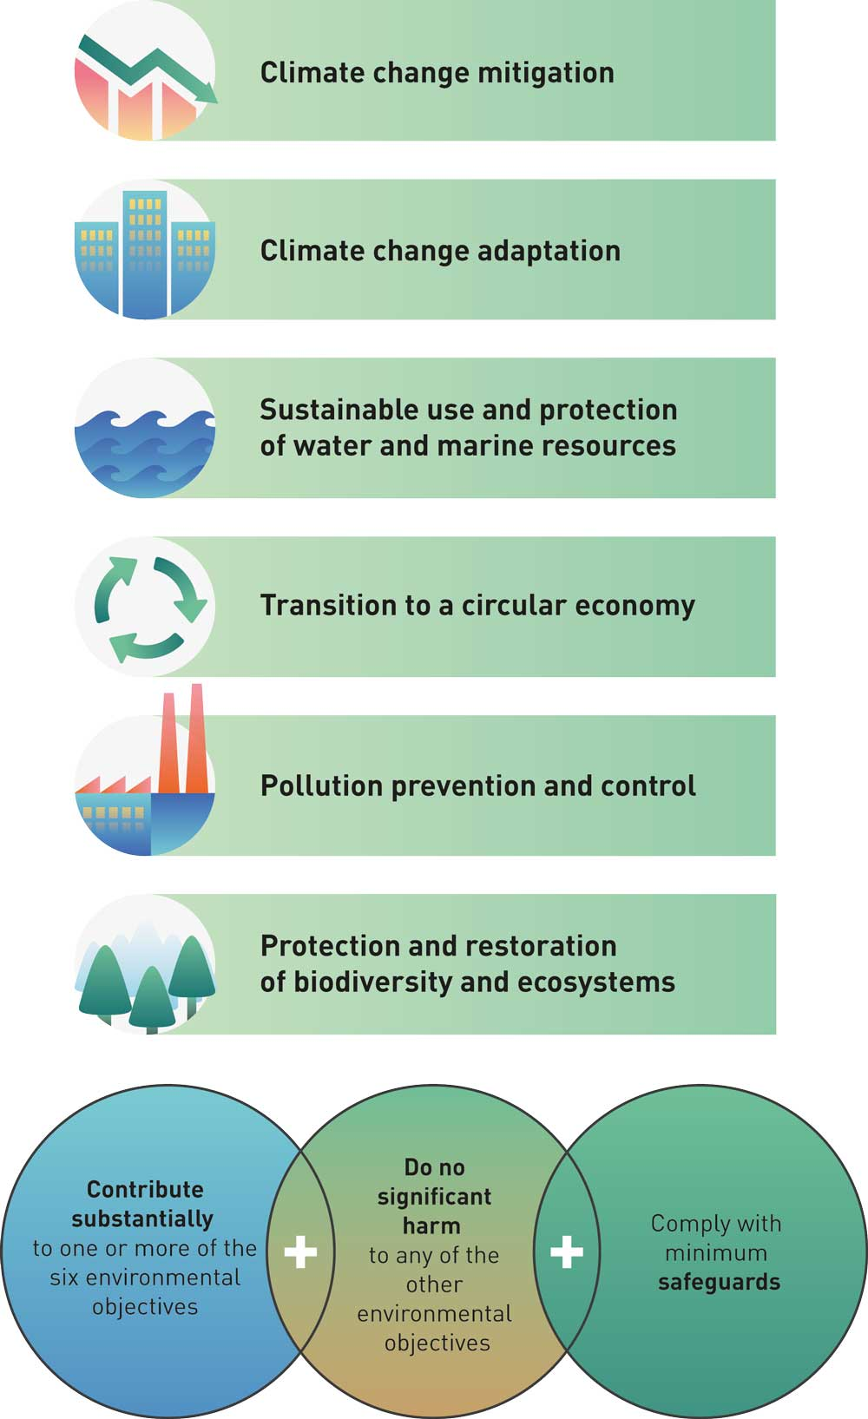
          - The EU taxonomy for sustainable economic activities
For an economic activity to be defined as sustainable in accordance with the EU taxonomy, it must contribute substantially to one or more of the six defined environmental objectives, which are shown in the green boxes. In addition, it must do no significant harm to any of the other environmental objectives, and must comply with minimum safeguards.
European Commission with adaptations by the Ministry of Climate and Environment
The EU is engaged in the important work of ensuring that investment and finance are in line with climate targets. The aims of the European Commission’s action plan on financing sustainable growth are to reorient capital towards more sustainable investments, manage financial risks stemming from climate change, environmental degradation and social issues, and foster transparency and long-termism in financial and economic activity. The Norwegian Government supports these aims, and is following closely as the EU implements the action plan.
To build a common understanding of which investments are sustainable, the EU is developing a taxonomy for sustainable economic activities (see Figure 6.4). This classification system is being developed in line with the EU’s long-term climate and environmental targets. Joint European criteria are intended to make it easier for investors to compare investment opportunities across countries and sectors, give companies incentives to make their business models more sustainable and make it simpler for investors to identify sustainable investments.
The Taxonomy Regulation detailing the classification system was adopted by the EU in spring 2020. It is considered to be EEA-relevant. The Financial Supervisory Authority of Norway has proposed that the regulation should be incorporated into Norwegian law in a new act relating to disclosure of sustainability information. The Ministry of Finance is holding a public consultation on the proposal, with a deadline for input of 8 January 2021. The requirements of the regulation apply to financial market participants and to companies that are required to report non-financial information under the Accounting Directive. This means that companies must among other things report on the proportion of their economic activities that is sustainable according to the criteria in the taxonomy. The requirements of the regulation will also be relevant for national authorities.
On the basis of recommendations from an expert group, the European Commission will adopt delegated acts establishing criteria for determining which activities qualify as contributing substantially to climate change mitigation or adaptation. Norway provided input to the Commission during a recent consultation on the technical screening criteria. These are expected to be finally adopted early in 2021, and will apply in the EU from 31 December 2021. The Commission will determine criteria for the other four environmental objectives (see Figure 6.4) by the end of 2021, and these will apply in the EU from 31 December 2022.
In connection with the Sustainable Europe Investment Plan, which is part of the European Green Deal, the European Commission announced that it would be presenting a renewed strategy for sustainable finance in early 2021. In continuing its work, the Commission will consider whether the taxonomy for sustainable economic activities should be expanded to define activities that do not contribute substantially to or that do harm to the environmental objectives. The Commission will also consider whether the scope of the taxonomy should be widened to include other SDGs, for example those on social issues. Moreover, the Commission will consider the use of the taxonomy in the public sector and will use the new InvestEU Programme to test the use of the taxonomy in practice.

Sustainable investment requires climate risk assessments and disclosure of climate-related information
As shown above, it is crucial that finance flows target investments that promote a low-emission pathway rather than hindering it. Decisions on investments with a long lifetime, for example for hydropower and water supply infrastructure, roads and buildings, are made every day at various levels and by a variety of stakeholders. It is therefore vital to ensure proper assessment of how a low-emission development pathway will affect the viability of long-term investments in both the private and the public sector and the risks associated with them, and to find suitable responses. Assessments of this kind reduce the risk of making unsound investments.
Norway’s Climate Risk Commission noted that there are several forms of climate risk. Transition risk is linked to the consequences of climate policy and technological developments in the transition to a low-emission society. Physical climate risk is linked to the consequences of physical changes in the environment, including the costs of more frequent and intense flooding and drought, sea level rise and other physical impacts.
              - Framework for climate-related financial disclosures
The Task Force on Climate-related Financial Disclosures (TCFD) was established by the Financial Stability Board, an international body whose members include financial institutions in all the G20 countries. The TCFD was established to develop a framework for voluntary climate-related financial risk disclosures that can help companies to identify climate-related risks and opportunities. Its recommendations have been widely endorsed internationally, and also has backing from much of the Norwegian financial sector. The TCFD has recommended among other things that companies should:
- Disclose how they take climate-related risks into account in their strategic planning.
- Disclose how these risks are identified, assessed and managed. This can make companies more aware of the risks climate change may pose for their business models.
- Use scenario analysis to assess the implications of reasonable climate policy scenarios for their business models, particularly a scenario in which the temperature rise is limited in line with objectives of the Paris Agreement.
Climate Risk Commission/Prop. 1 S (2019–2020)) vedlegg 1: Noregs lågutsleppsstrategi for 2050
[Boks slutt]
Reporting on climate risk can raise companies’ awareness of the types of climate-related risks and opportunities they may face. The TCFD recommendations (see Box 6.1) provide a framework for climate-related financial risk disclosures. The TCFD was established by the financial authorities of the G20 countries. Its recommendations are intended to help companies report relevant climate-related information and also raise their awareness of the risks climate change, technological developments and a stricter global climate policy may pose for their business models. They include a recommendation that companies should disclose how resilient their strategies are to a range of climate change scenarios. One of these scenarios should be in line with the long-term temperature target of the Paris Agreement. Scenario analyses can be very valuable for investors, since companies have to indicate how they can make money if climate policy ambitions are achieved.
To encourage investors to fund green solutions, companies must be more open about their climate footprint. In the EU, large companies are required to comply with the Non-Financial Reporting Directive. The European Commission is now evaluating the directive with a view to ensuring better, more comparable reporting of climate-related information. The Commission is using the TCFD framework as a basis for amendments to the directive. Reporting of greenhouse gas emissions is an important basis for analysing climate risk. In updating the directive, the European Commission will therefore concentrate on how companies report their greenhouse gas emissions. The Commission will present amendments to the directive in early 2021. The directive is EEA-relevant, and the amendments will probably require changes to the requirements on disclosure of sustainability- and climate-related information under Norwegian law.
Norway’s Climate Risk Commission also highlighted the financial risks associated with stricter climate policy, technological developments and climate change that businesses face when making investment decisions. The Commission therefore recommended improvements in the disclosure of climate risk by both businesses and public-sector bodies. One important recommendation by the Commission is that Norwegian companies should use the TCFD framework as a basis for climate-related financial disclosures (see Box 6.1).

The Government’s contribution to work on cIimate risk and sustainable finance
Investors are increasingly calling on businesses to provide information on sustainability and climate risk. It is vital that companies report relevant and comparable climate-related information so that the financial sector can identify sustainable projects and deal with climate risk.
Both the Climate Risk Commission and Finance Norway recommend that Norwegian businesses should make use of the TCFD framework in their corporate reporting. As discussed in the 2019 and 2020 white papers on financial markets, the Government supports the Commission’s recommendation and expects large Norwegian companies to disclose climate-related information. To ensure comparable reporting standards across companies, sectors and countries, companies should follow international standards such as the TCFD framework. Pending amendments to the EU legislation, the Government has not proposed amendments to Norwegian national requirements for corporate reporting on climate risk.
The finance sector’s own roadmap points out that the availability of financially relevant climate data is limited. In addition, a recent survey by the Financial Supervisory Authority of Norway showed that reporting on sustainability and climate risk by listed companies is incomplete and inconsistent.
In the years ahead, companies will be expected to improve their disclosure of information on sustainability and climate risk as a result of growing demand from the financial markets and future amendments to the legislation. Possible barriers to improvements in reporting may include a lack of access to climate-related data and limited knowledge, for example of how to use scenario analyses, particularly in smaller companies. The authorities can play a part by ensuring a framework for better and more relevant corporate reporting through action to improve access to climate-related data and build up expertise in companies.
The Government will therefore engage in dialogue with the business sector on how to facilitate better and more relevant corporate disclosure of climate-related and environmental information.
Cooperation between the authorities, the finance sector and other relevant stakeholders can for example contribute to the development of knowledge about climate-related data, reporting and scenario analyses across sectors. Such cooperation can also help to identify where more knowledge is needed, and how the authorities can promote the use of the new tools and frameworks.
The Climate Risk Commission developed a good basis for work on climate risk in Norway. In the forthcoming white paper on long-term perspectives on the Norwegian economy, the Government will include stress tests of Norway’s public finances and national wealth. In this connection, scenarios for oil, gas and carbon prices will be established, including one scenario in which the ambitions of the Paris Agreement are achieved. The Government will consider the Commission’s recommendation that a suitable framework should be established for disclosure of climate-related risks in the public sector and at national level. The Commission recommended the preparation of central government guidelines on climate risk to improve the decision-making system for the public sector. The Government will review existing guidance on economic analysis for the most relevant sectors and consider whether climate risk is adequately taken into account, given the Commission’s recommendation.
In the revised national budget for 2019 and the 2019 white paper on financial markets, the Government has given an account of its assessments of the Commission’s recommendations. In the white paper on long-term perspectives on the Norwegian economy to be published in spring 2021, the Government will provide an overview of efforts to identify and reduce climate-related risks.

Initiatives for the green transition, technological developments and technology leaps

Technological developments are vital for achieving the climate targets
The development of new technologies and solutions will be vital for achieving emission reductions in the period up to 2030 and in the longer term. The International Energy Agency (IEA) compiles information on technology development in its annual Tracking Clean Energy Progress reports. The IEA has found that on a global basis, only a few technologies are developing in line with its own Sustainable Development Scenario, which is intended to be consistent with a temperature rise of less than 1.8 oC. Only five of 38 technology areas are on track to achieve this scenario (see Figure 6.5). These are solar PV; lighting (LED); data centres and technologies; rail; and electric vehicles. All other technology areas require further resources and technology development.
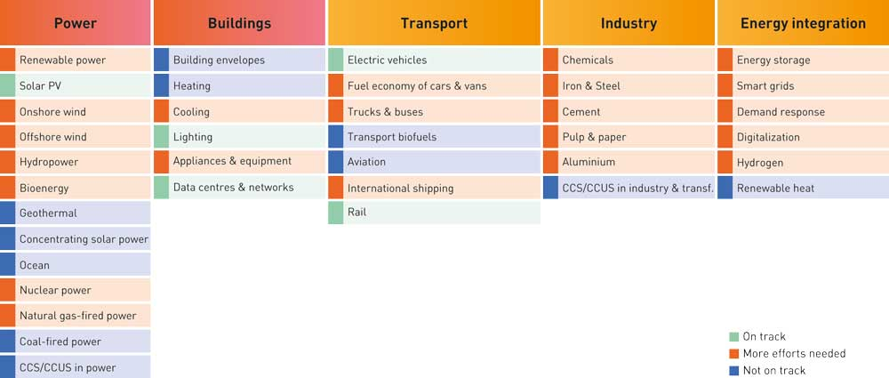
          - Technology areas that are important for the green transition.
Adapted from IEA Tracking Clean Energy Progress 2019 by the Research Council of Norway
The Government will encourage the development of Norwegian business and industry, among other things through a focus on climate technology and by using a variety of instruments to promote its development, including research and development and grants for pilot and demonstration projects and market introduction of new technology (see Chapter 6.2 on research and innovation).
Developing and deploying low-emission technologies often involves very long development pathways. To achieve the climate targets, the cost of existing low- and zero-emission solutions must be reduced through research and innovation over the next ten to twenty years. This can result both in emission cuts in Norway and in the development of new industries and export opportunities.
The petroleum industry, for example, can offer a great deal of knowledge and expertise, and has the innovation capacity to develop new technologies with a potential for reducing greenhouse gas emissions both within the oil and gas sector and in other sectors. This expertise will be important in the development and deployment of technologies in areas such as offshore wind, CCS, the exploitation of seabed minerals and hydrogen production from natural gas coupled with CCS. Over time, these can become important industries together with the petroleum industry.
The Government has therefore taken initiatives to support important technology development pathways that can play a part in developing new solutions for reducing greenhouse gas emissions both in Norway and globally. Some of these are described further below.
              - Energy-efficient, low-emission value creation
Energy-efficient, low-emission production processes will be crucial for the necessary transition to a low-emission society. Using the Norwegian metallurgical industry as a basis, grants from Enova have contributed to the development of a competitive Norwegian solar cell industry, which is at the forefront of energy efficiency developments internationally. One of the most recent projects where Enova has been involved is an innovative project to recover silicon from the waste stream from wafer production, run by REC (now Elkem). This has never been done before either in Norway or elsewhere. Enova provided NOK 110 million in support for construction of the first demonstration plant in Kristiansand. Another example is NorSun’s new production line for monocrystalline silicon ingots and wafers in Årdal. Enova has provided a loan of NOK 195 million for this demonstration project. This has enabled NorSun to upgrade its plant and deploy highly innovative technology that is at the cutting edge globally as regards the energy efficiency of solar cell silicon production.
Enova has provided support for technology development and full-scale implementation that will put Glencore in Kristiansand and Boliden in Odda at the forefront internationally as regards emission-free production of copper and zinc respectively. In 2014, Glencore received a grant of NOK 380 million for construction of an innovative, energy-efficient production plant, and in 2019, Boliden was granted NOK 340 million to deploy several new and innovative technologies at its plant in Odda.
Norske Skog constantly improves its paper mills and introduces new technology, and as a result they are some of the most energy-efficient in the world, with a high rate of energy recovery and use of renewable energy. Enova has for many years been providing support for Norske Skog in its efforts to develop key technology for energy-efficient pulp production and for energy recovery both from waste heat and from waste materials produced during biogas production.
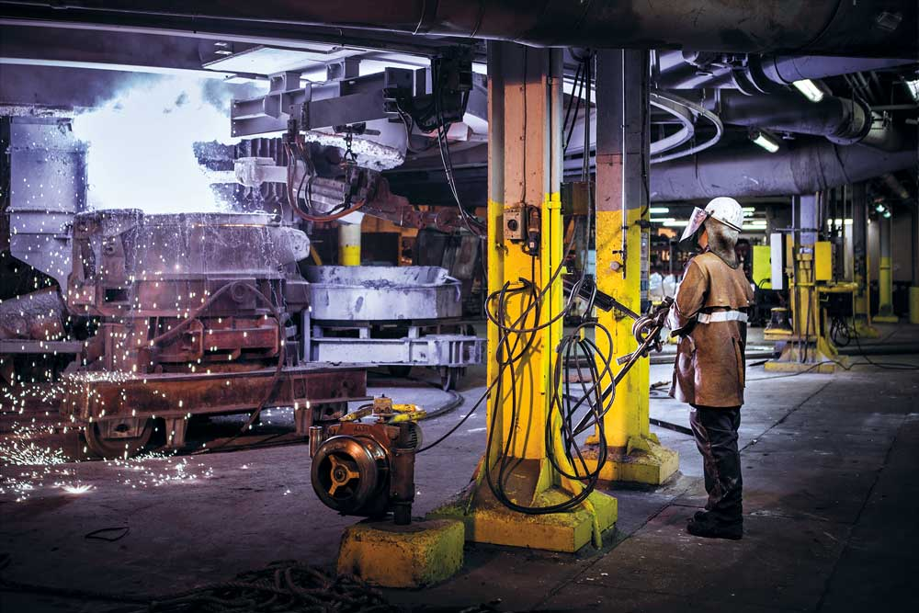
          - Elkem Solar
Photo: Enova
[Boks slutt]

Carbon capture and storage and the Longship project
Reports from the IPCC show that carbon capture and storage (CCS) will be necessary to reduce emissions from industry and power generation and move towards negative emissions, thus reducing global greenhouse gas emissions in line with the climate targets at the lowest possible cost.
The Government will promote the development of technology for carbon capture, transport and storage and facilitate the development of a cost-effective solution for full-scale CCS in Norway that also results in technology development internationally.
The Government will provide support for the implementation of a full-scale Norwegian CCS demonstration project called Longship, which comprises CO2 capture, transport and storage. The Government’s proposal is for the first CO2 capture project to be implemented at the Norcem Brevik cement plant in Porsgrunn, and for CO2 to be transported by ship to a terminal in Øygarden municipality in Western Norway, and then by pipeline to a well where CO2 will be injected into a subsea formation for permanent storage. The Northern Lights project, which involves collaboration between Equinor, Shell og Total, will be responsible for CO2 transport and storage. The Government intends to co-fund the carbon capture project at Fortum Oslo Varme’s waste incineration plant, provided that the company provides sufficient funding of its own and obtains funding from the EU or other sources.
In the first instance, the direct national emission reductions from this project will be about 400 000 tonnes CO2 per year once the Norcem capture project is operational, and will rise to about 800 000 tonnes per year if the Fortum Oslo Varme project is also realised. About half of the 400 000 tonnes in emission reductions from the Fortum project will be of biological origin.
The project will also have indirect climate-related impacts because the demonstration of a complete, flexible value chain for carbon capture and storage and the establishment of transport infrastructure will play a part in reducing costs for subsequent projects.
The Longship project may make a significant contribution to the development of CCS as an effective mitigation tool and result in technology development internationally. The project is intended to demonstrate that CCS is both safe and feasible. It will facilitate learning effects and cost reductions for subsequent CCS projects, and will establish infrastructure that can also be used by other projects. This will lower the threshold for establishing new carbon capture projects. The Longship project is also intended to serve as a platform for business development.
International cooperation on technology development and emission reductions will be vital for the world to achieve the global temperature targets. It will also be needed for the success of the Longship project. The project is part of a concerted international effort to develop a vital mitigation tool, and it will only be successful if subsequent projects make use of the infrastructure and knowledge it generates. The project should primarily be judged by whether it achieves its own goals and the Government’s goals for CCS. In the short term, there may be other measures requiring comparable resources use that would result in larger emission reductions, but short-term national emission reductions are not the main purpose of the project. A number of analyses have shown that in the longer term, CCS is a crucial, cost-effective mitigation measure. The Government’s assessment is that the Longship project will pave the way for cost reductions that will make CCS an effective mitigation measure if other countries follow suit and introduce specific policies in this area. The project highlights the importance and value of international cooperation on technology development and emission reductions.
Through Northern Lights’ efforts to create a market for CCS in Europe, it has become clear that several projects are considering using the infrastructure in Norway. The agreement on government support for the transport and storage component of the project is designed to attract new projects. Northern Lights’ will obtain its revenues from storage of CO2 from new projects, which gives the consortium a strong incentive to develop the CO2 storage market. In the Government’s view, it is important for storage capacity provided by Northern Lights to be used by stakeholders that are not directly financed by the Norwegian state. If this is successfully achieved, it will provide clear evidence that the project has had the desired effect. Norway also needs the EU and individual European countries to play a part in developing CCS as a mitigation tool. The Government is therefore now anticipating a European response so that the remaining capacity of the storage facility is used by third parties that are not directly financed by the Norwegian state.
The Government is involved in other work on CCS in addition to the Longship project. Research, development and technology demonstration provide a vital basis for speeding up wider deployment of CCS technologies. The Technology Centre Mongstad (TCM) has been operational since 2012. A large number of stakeholders have tested or plan to test their technologies at the centre. The CLIMIT research and development programme has supported the development of several different technologies and solutions to make CCS more effective and safer. The CLIMIT programme is participating in an international initiative called Accelerating CCS Technologies, thus enabling Norwegian researchers to apply for support for projects with international partners. This contributes to international knowledge sharing. The CLIMIT programme and work at the TCM will also play a part in realising the benefits of the Longship programme. In addition, one of the Centres for Environment-friendly Energy Research (under the FME scheme) is dedicated to CCS. The centre has a number of industry and research partners from Norway and abroad, who are seeking to speed up developments and the demonstration of industry-driven innovation. Through international cooperation, Norway has contributed to the global development of CCS technologies.

Offshore wind power
Offshore wind power is a renewable energy source that can play a part in cutting greenhouse gas emissions globally. In November 2020, the EU presented its offshore renewable energy strategy, which includes an ambition of realising 300 GW of installed capacity for wind power by 2050. Europe is in the lead in the development of offshore wind power, but the technology is developing rapidly, and offshore wind offers a large international potential for growth. Many Norwegian companies are aware of opportunities in this market.
Through its petroleum and maritime activities, Norway has developed a great deal of experience and expertise in offshore technology. It is therefore in a good position to play a role in maturing wind power technology so that it more rapidly becomes a competitive, renewable alternative and yields emission reductions globally. Both Equinor and the Norwegian supply industry are involved in the development of some of the largest offshore wind farms in Europe and the US, including both bottom-fixed and floating turbines. Floating wind power is a less mature technology, which is transitioning from the demonstration stage to full-scale testing. There is considerable interest in the development of floating wind power technology in Norway, and the world’s largest floating wind farm, Hywind Tampen, is under construction. The first floating wind turbine, Hywind, was installed off the island of Karmøy in 2009, and is now part of the test infrastructure there. Several different floating wind technologies are to be tested at this site in the years ahead. For example, the EU has awarded EUR 25 million to an international consortium that is planning to test a 10 MW floating turbine. The project is led by the Spanish company Iberdrola, and the consortium includes several Norwegian companies.
Offshore wind power has been an R&D priority, and the Research Council of Norway has awarded more than NOK 500 million to research projects on fixed and floating turbines. The Government’s green restructuring package includes steps to expand R&D on renewable energy, for example by establishing a Centre for Environment-friendly Energy Research (under the FME scheme) focusing on wind power.
The Government has decided to open two areas, Utsira North and Southern North Sea II, for licence applications for offshore renewable energy production, including wind power projects. The decision applies from 1 January 2021. Utsira North is suitable for floating wind power; Southern North Sea II is shallow enough for fixed wind power to be developed, but floating wind power would also be possible. The two areas offer considerable opportunities for development, with a combined potential for wind power of up to 4500 MW in installed capacity. See Box 6.3.
              - Areas opened for offshore wind power in Norway
Utsira North is west of Haugesund, and is suitable for the development of floating wind power, which is the most interesting technology from a Norwegian point of view. This is a large area, covering 1010 km2, and is close to land and therefore suitable for both demonstration projects and larger scale projects. Its size also means that it is possible to make adjustments to accommodate other interests during licensing procedures.
Southern North Sea II is in the southeastern North Sea, bordering on the Danish economic zone, which means that it is of interest for direct electricity exports. The area covers 2591 km2, and the water depths make it possible to develop bottom-fixed wind power, but floating wind power developments are also a possibility.
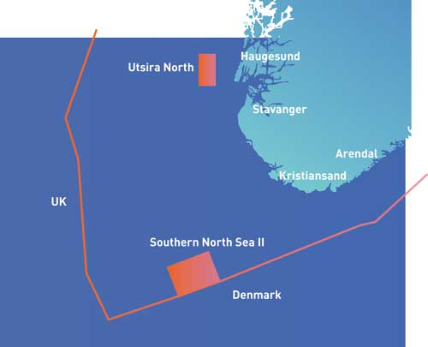
          - Utsira North and Southern North Sea II, the two areas that have been opened for licence applications for offshore renewable energy production
Norwegian Water Resources and Energy Directorate
[Boks slutt]

Hydrogen
Hydrogen is an energy carrier with a considerable emission reduction potential both nationally and globally, and a potential for value creation for Norwegian business. At present, annual global consumption of hydrogen is about 70 million tonnes, mainly in the chemical industry and oil refining. About 90 % of the hydrogen used in Europe is currently produced from natural gas, resulting in substantial emissions.
The Norwegian Government presented its hydrogen strategy on 3 June 2020. The strategy provides a basis for the Government’s continued work on hydrogen, and must be considered in conjunction with other relevant documents the Government has presented or is preparing.
If hydrogen is to be a low- or zero-emission energy carrier, its production must be a very low- or zero-emission process. As described in the mitigation analysis for Norway 2021–2030, hydrogen technology is immature for use in certain sectors. High costs are a key barrier to the use of hydrogen in maritime transport and heavy-duty vehicles, and as an input factor in industrial processes. One important goal for the Government is to increase the number of pilot and demonstration projects in Norway and thus contribute to technology development and commercialisation. This goal is being backed up by broad-based support for the development of zero-emission technologies and solutions across all the funding agencies. The Research Council of Norway, Innovation Norway and Enova are involved in developing and demonstrating energy-efficient and cost-effective methods and a value chain for the production, transport, storage and use of clean hydrogen, for example through joint calls for proposals under the PILOT-E scheme. Norway has also joined the EU cooperation on IPCEIs (Important Projects of Common European Interest) on hydrogen. This scheme is intended to support innovative projects in selected fields that require cross-border coordination. Grants are provided through national systems, but IPCEIs are exempt from the normal state aid rules, and Norway notifies the EFTA Surveillance Authority (ESA) separately of any plans to grant state aid for such projects. Enova will be responsible for administering Norway’s participation.
The public sector can use its procurement activities to be an important driver of innovation and a transformation in the Norwegian economy. As a way of promoting new technology, the Norwegian Public Roads Administration will include requirements for zero- and low-emission solutions when a new call for tenders is issued for a ferry service across the Vestfjorden that is part of the national road system, see Chapter 3.4.4. The two main ferries on the Bodø–Røst–Værøy–Moskenes route will have to be at least 85 % hydrogen-powered.
In the 2021 budget, the Government has increased funding for hydrogen activities by NOK 100 million, with a special focus on supporting the development and establishment of infrastructure. The Government is particularly interested in work on hydrogen hubs and supply chains, which will facilitate the commercial use of hydrogen. In spring 2021, the Government will therefore present a white paper on long-term value creation from Norwegian energy resources, which will include a new roadmap for hydrogen intended to encourage a more systematic approach in the years ahead. The white paper will also address topics such as Nordic cooperation, the use of public procurement, export opportunities and the interplay between energy carriers and different types of infrastructure.

Agriculture and forestry
Innovative, smart technology adapted to large and small holdings can make food production more resource effective and sustainable. Precision techniques involve using new technology to adapt and tailor management decisions in agriculture, forestry and livestock grazing, including reindeer husbandry. In precision farming, for example, the application of fertiliser, pesticides and lime is adjusted to meet site-specific needs. These needs are mapped using information from many sources, and techniques rely heavily on the use of various types of sensors, cameras and satellite positioning systems. The equipment needed can be installed on tractors, autonomous robots or unmanned aircraft.
In forestry, satellite positioning systems are used throughout the value chain. For example, they are used in connection with environmental inventories in forests, which improve the quality of forestry activities by providing information on valuable biodiversity and the cultural heritage. Livestock on unfenced rough grazing are being fitted with radio bells, so that the position of individual animals can be recorded via a satellite navigation system. This allows closer supervision of livestock, thus improving animal welfare. In addition, it is much easier to gather the animals at the end of the grazing season. Earth observation systems and interpretation of satellite images have been used to some extent to monitor the carrying capacity of reindeer grazing areas.
New technological solutions are also being used in mapping and monitoring programmes in the agriculture and forestry sector. These services improve precision and effectiveness in work in various areas: the National Forest Inventory, monitoring of forest damage, statistics on uncultivated land, monitoring of the agricultural landscape and cultural heritage, and field experiments run by farmers’ groups and research institutes. The technology is important for the development of the agricultural and forestry sector and in the implementation and monitoring and verification of agricultural and forestry policy. In addition, activities in this field provide data that can be used by the environmental authorities and to meet Norway’s international reporting obligations, for instance as regards climate change.

The circular economy and digitalisation

Transition to a circular economy vital for tackling climate change
Emissions from the extraction of raw materials, production processes and land use will be lower in a circular economy, as stated in documents including the EU Circular Economy Action Plan (see Box 6.4) and input from business and industry. The action plan points out that half of total greenhouse gas emissions come from resource extraction and processing. Scaling up re-use and recovery and making resource use more effective will reduce greenhouse gas emissions from businesses and their suppliers and customers. At present, products and materials that could be re-used are often discarded as waste after a single use. As a result, greenhouse gas emissions from raw material extraction, production processes and land use are much higher than from value chains where products are used for longer and there is more re-use and recycling. Businesses have identified the benefits to be gained from cluster collaboration, which enables a group of businesses to make better use of energy resources and materials than they could separately. They have also pointed out that to facilitate trade in secondary raw materials in a larger market, it is necessary to develop better systems and better documentation of these materials.
              - The European Commission’s Circular Economy Action Plan
The action plan describes how the EU’s work on products, production, consumption, waste, buildings, plastics and the food sector will be designed to support the European Green Deal. The plan includes a range of actions to develop more sustainable products, services and business models and to steer consumption patterns in a more sustainable direction in order to make better use of resources and prevent waste. Much of the plan will be relevant to Norway under the EEA Agreement.
[Boks slutt]
The new EU Circular Economy Action Plan was published in March 2020. It includes action points to promote a circular economy which will be important for achieving the EU’s goal of being a climate-neutral, resource-efficient and competitive economy in 2050.
Deloitte was commissioned by the Ministry of Climate and Environment to assess which sectors offer the greatest potential in connection with the development of a circular economy in Norway. Deloitte considered these to be construction and buildings; wholesale and retail trade; the bio-based sectors (agriculture and forestry, and aquaculture and fisheries); and the process industries. A report from EY found that few businesses are concerned about the climate footprint of their products during use or about circular solutions, even though these can provide opportunities for new services or products.
The Government will be presenting Norway’s strategy for developing a green, circular economy in 2021. The Government wishes Norway to play a pioneering role in the development of a green, circular economy that makes better use of resources. The strategy will demonstrate how value creation can be increased within sectors and through cooperation between sectors while at the same time ensuring that the economy puts less pressure on the climate and environment. This can be done for example by designing products to have a longer lifetime and making it easier to repair them and to re-use buildings, products and materials. Another approach is to facilitate the use of by-products and residual raw materials that are currently not used in other products. The Government has a wide range of tools at its disposal to provide a good framework for the development of a circular economy, from product design to recycling. The growing consumer demand for low-emission products will also be crucial in promoting circularity and reducing emissions. The central government must do its part both as a purchaser and as a consumer to create markets for such products in different sectors (see Chapter 3.3.4).

Digitalisation as part of the green transition and the circular economy
The Government wishes Norway to be at the forefront in making use of new digital opportunities in all sectors. Digitalisation involves using technology to renew, simplify and improve. It lays a foundation for more value creation and innovation and can help to boost productivity in the private and public sectors. The present Government’s political platform clearly expresses the importance of digitalisation in all sectors, and is a basis for a leap forward in the digitalisation of society. In its Circular Economy Action Plan, the European Commission points to digitalisation as a vital basis for circular solutions and for achieving the climate targets. The Commission views the digital transition and the green transition as twin drivers of the European Green Deal and for achieving the transition to a climate-neutral, resource-efficient and circular economy.
In a circular economy, it is important to maintain a good overview of the secondary raw materials that arise in a value chain and how they can be used in other production processes. To realise the potential for enhancing circularity, it will be crucial to develop digital solutions for information on material and waste streams, and to make data accessible across value chains and industries. The EU has announced that it is planning to develop product passports, a form of digital product labelling that will make it easy for consumers to find information on what products contain, how long their lifetime is intended to be, and whether they are possible to repair and recycle.
Digitalisation can be used to reduce greenhouse gas emissions in many areas. One of these is transport, where examples have been particularly prominent during the COVID-19 pandemic. Transport can be replaced by digital communication, or public transport can be improved through good communication with customers on timetables and up-to-date information. Digitalisation can provide support for car-sharing arrangements and other examples of a sharing economy. It also facilitates digital product labelling and digital markets for second-hand products, which encourage re-use, recycling and improved waste management to provide secondary raw materials of high quality. In the electricity market, digitalisation makes it easier to take advantage of demand response and operate the grid more efficiently.
In early 2021, the Government will present a white paper on the data-driven economy and data-driven innovation. Acquiring, using and sharing data will be vital for Norway’s competitiveness in the future.

Construction and buildings

Greenhouse gas emissions from construction and buildings
Construction and buildings account for about 40 % of global energy consumption and roughly 30 % of global greenhouse gas emissions. Over 80 % of the sector’s emissions are from construction products. The Intergovernmental Panel on Climate Change (IPCC) points out that since a large proportion of the current building stock will still exist in 2050, renovating and upgrading existing buildings will play an important role in reducing emissions from this sector.
Emissions from heating of buildings in Norway are low. The prohibition on using fossil oil to heat buildings was announced as early as 2012, with effect from 1 January 2020. From 1 January 2022, the prohibition will be extended to include the use of fossil oil for heating and drying buildings during construction and renovation. Under the Regulations on technical requirements for construction works (Technical Construction Regulations), it is not permitted to install heating systems that use fossil fuels (oil or gas) in new buildings.
Statistics Norway estimates direct greenhouse gas emissions from construction to be around 2 million tonnes CO2eq. This figure includes emissions from heating and drying buildings during construction and the use of construction machinery, as well as emissions from transport to and from construction sites in cases where the vehicles are accounted for as part of the sector.
The construction industry is also responsible for emissions related to construction products, transport and land-use change. These emissions are largely accounted for in other sectors. In Norway, emissions from the transport and manufacture of construction products are either subject to taxation or come within the scope of the EU ETS or other regulatory measures. The construction sector can contribute to carbon storage in construction products. Using more wooden materials from Norwegian timber would have a positive effect on Norway’s greenhouse gas inventory, since this would be accounted for as removals in the land use, land use change and forestry (LULUCF) sector.
In other words, the construction industry has an important part to play in addressing the problem of climate change. The industry has demonstrated a very solution-oriented and adaptable approach to earlier changes in the Technical Construction Regulations. The industry itself has called for clear requirements and a predictable framework that affects the entire sector equally. Previous changes have resulted in substantial innovation and technological development.
          - Mjøstårnet (the Mjøsa tower) is the world’s tallest wooden building, and stores carbon equivalent to 3 000 tonnes of CO2.
Photo: Moelven
As announced in its political platform, the present Government intends to facilitate a transition to fossil-free construction sites by 2025. The public sector has a special responsibility to ensure that publicly funded construction sites lead the way. The Government will therefore be presenting an action plan for fossil-free construction sites in the transport sector, see Chapter 3.4.
The municipalities can include climate-related requirements in public procurement processes for their own construction projects, and many already do so.
Rising prosperity and consumption are making current resource use across the world unsustainable. Resources must be used more efficiently than is currently the case. This is the starting point for the EU Circular Economy Action Plan, which identifies construction and buildings as one of seven key product value chains. One of Norway’s environmental targets is that growth in the quantity of waste generated will be considerably lower than the rate of economic growth, and that the resources in waste will be used as fully as possible through recycling and energy recovery.
The EU Waste Framework Directive, which is part of the EEA Agreement, requires 70 % of non-hazardous construction and demolition waste to be re-used or recycled by 2020. Norway is not currently achieving this level; in 2018, just under 43 % of all construction waste was re-used or recycled. To achieve the target, construction products must be designed for re-use or recycling. Future regulatory measures must therefore facilitate this type of design while also helping to reduce waste quantities below the current levels.
As part of the input for Norway’s strategy for developing a green, circular economy, the Ministry of Climate and Environment commissioned a study from Deloitte. This identifies construction and buildings as one of the sectors with the highest potential for greater circularity, partly because it generates large quantities of waste.
The transition from a linear to a circular economy is part of the solution to making the construction and buildings sector more sustainable. Continuing to use existing buildings, re-using existing buildings in innovative ways and recycling will all reduce the use of raw materials, waste quantities, emissions and energy consumption. These are measures that effectively reduce greenhouse gas emissions immediately – not just estimated benefits some decades into the future. Re-using buildings more widely may also reduce emissions from land-use change.
A study by SINTEF (2020) considered life-cycle analyses (LCAs) of more than 120 Norwegian construction projects. Calculations of greenhouse gas emissions in the study show that renovation is more climate-friendly than new construction. From a life-cycle perspective, it is most often more climate- and environment-friendly to maintain, use and further develop the existing building stock. Where possible, we should therefore seek to maintain existing buildings rather than demolish them and build new ones.
The SINTEF study found that the most important measures to consider when renovating existing buildings are a combination of selecting environment-friendly materials, implementing energy efficiency measures and using renewable energy. It is also important to choose the most appropriate measures to improve energy efficiency in existing buildings. Measures should not be so far-reaching that the embodied emissions resulting from new measures actually rise by more than the savings in operational emissions (such as heating-related emissions) (SINTEF 2020). It should also be possible to carry out such measures without compromising the historical value of buildings to any great extent.
In keeping with its ambition for Norway to play a part in the transition to a more circular economy, the Government will present its strategy in 2021 (see Chapter 6.6).
              - Greenhouse gas emissions associated with the construction sector
The construction sector can reduce emissions and increase the carbon stock in buildings in various ways, including using more sustainable materials, re-using and recycling, designing for re-use, and siting buildings to reduce greenhouse gas emissions from the area they occupy and from transport for the people who use the buildings.
Thus, the construction sector influences various other sectors. Some examples are listed below:
- Transport-related emissions from the siting of buildings and from the actual construction process;
- Demolition, transport of bulk materials and land-use change. Emissions from the construction of new buildings can be high, so it is important to re-use or convert existing buildings instead of building new ones;
- Production of materials and products that are used in buildings. Norway’s emissions from other sectors as a result of construction activities are estimated at about 4.2 million tonnes CO2eq (Asplan Viak 2019). In addition, emissions from imported construction products are estimated at 5.8 million tonnes CO2eq. This picture could be changed through more efficient land use and a more circular approach including re-use and recycling.
- Improving energy efficiency and freeing up energy capacity. Implementing energy efficiency measures in buildings and using waste heat can free up electricity for other purposes, promote the electrification of society and for example reduce the need for wind power and hydropower developments;
- The LULUCF sector. Using more wood products in construction means that the carbon in the wood is stored for long periods. Using more wood products manufactured in Norway may result in removals that can be accounted for in the LULUCF sector and count towards Norway’s compliance with the ‘no debit’ rule.
[Boks slutt]

Climate-related requirements for buildings
It will not be possible to achieve national and international climate targets without reducing greenhouse gas emissions from construction and buildings. In Norway, the sector accounts for roughly 40 % of energy consumption and a large proportion of resource use and waste generated. Elsewhere in Europe, the largest source of greenhouse gas emissions from buildings is the use of fossil fuels during the operation phase, for instance for heating. In Norway, however, the largest remaining emissions are related to the actual construction process such as emissions from the production of materials and transport.
This was highlighted in a report from the Bygg21 programme and a report by Asplan Viak, both on greenhouse gas emissions in the construction and buildings sector. The Asplan Viak report found that about 15 % of total emissions in Norway are related to activities in this sector. The largest proportion of these emissions is in fact in other sectors, for example the production of materials and transport of raw materials, waste and construction products. Norway’s construction-related emissions in other sectors were estimated at about 4.2 million tonnes CO2eq (Asplan Viak 2019). Norway imports a large share of the raw materials and construction products used in the country. According to the Asplan Viak report, emissions from imported construction products were estimated at 5.8 million tonnes CO2eq. These emissions are recorded in other countries’ greenhouse gas inventories.
The energy requirements in Norway’s Technical Construction Regulations have thus far dealt with energy efficiency and the use of renewable energy largely by requiring an energy-efficient building structure and the use of renewable energy supplies. It is important to reduce energy consumption as far as possible and reasonable in financial terms. If energy now used in buildings is freed up, it could be used in other sectors to replace fossil energy and reduce the need for new electricity production and developments in undisturbed areas.
As announced in its political platform, the present Government will develop energy requirements for buildings in line with the cross-party agreement on climate policy. As part of the follow-up of the 2012 update of the agreement (Innst. S 390 (2011–2012)), the energy requirements contained in the Technical Construction Regulations were tightened to passive-house level in 2015, and the Government is now developing energy requirements corresponding to nearly zero-energy level.
The point has been reached where it is necessary to consider the balance between further improving energy efficiency and using more materials, taking into account both environmental pressures and costs. Use of materials and energy consumption in buildings must be considered together, since total emissions associated with buildings depend on the combination of the two. More flexible requirements, and technology- and material-neutral requirements for CO2 emissions per m2, may drive major innovation. It is relatively straightforward to express such requirements in quantitative terms. This would also avoid the use of many different measurement parameters, which could open the way for additional measures that would increase costs but be of little real value, and would also eliminate incentives for greenwashing, or making changes without any real cuts in emissions. Such requirements should be announced well before they are implemented in order to allow for effective cooperation on methodology, to give the industry time to adapt and to promote innovation.
An analysis by the Norwegian Construction Products Association found that emissions from Norwegian-manufactured construction products are lower than those from imports. This applies to the manufacture of construction products, where Norwegian suppliers are world leading. The difference is even more marked when emissions from the transport of construction products are included. Introducing climate-related requirements in the Technical Construction Regulations would thus strengthen green value creation and competitiveness in Norway.
For requirements of this kind to achieve the intended effect, it is vital to know what is being measured and how. Developing a common system of standards and requirements for specifications will be an important part of this work. Digitalisation, open data and machine-readable documentation will play a key role.
This will require amendments to the Technical Construction Regulations and the regulations on documentation for construction products, and close cooperation between the authorities and the construction industry. The Government has already made a good start on this work.
The construction industry is a major and important purchaser. Requirements or incentives to make more use of climate- and environment-friendly materials will change purchasing patterns and can help to drive the development of innovative, climate-friendly solutions and products. More emphasis on the climate and environmental footprint of materials in the Technical Construction Regulations could play a part in creating a future market for zero- and low-emission solutions, and encourage companies to invest in and choose these solutions.

A common set of environmental aims for the central government administration in its roles as developer, manager and tenant of property
The Government has formulated a set of climate and environmental aims for public buildings and property in the civilian sector. These will apply to the central government administration in its roles as developer, manager and tenant of property:
- The central government will seek to make full use of existing buildings and ensure re-use of empty properties;
- The central government will re-use construction products and enable other parties to re-use construction products from public buildings;
- The central government will promote climate-friendly construction products in cooperation with the industry;
- The central government will establish a common methodology for measuring the overall climate and environmental impact of buildings and properties in the central government civilian sector, with a view to making improvements and establishing shared targets;
- Central government agencies will give weight to the environmental benefits of re-using already developed areas and existing buildings, and of siting their premises near public transport nodes and the centre of towns and urban areas, in line with central government planning guidelines for coordinated housing, land use and transport. This applies to the central government administration in its roles as developer, manager and tenant of property.
The climate and environmental impact of properties used by the central government and of its construction projects must be reduced. The central government will lead the way and facilitate the green transition. As a major developer, manager and tenant of property, the central government has a major responsibility for promoting responsible, efficient use of society’s resources. According to official figures (statenslokaler.no, in Norwegian), in 2019 the central government civilian sector owned or rented about 2 500 properties with a total area of 7.6 million m2. This means that there is considerable potential for central government activity in this field to play a part in reducing emissions. Central government influences the construction and buildings sector mainly through procurement processes, particularly in the case of construction projects, but the location of central government agencies, which have many employees and visitors, will also influence transport needs and opportunities to travel by public transport, cycle or walk. Thus, the central government is a major stakeholder that can influence and develop the buildings and property sector. Clearer climate-related and environmental requirements will play a part in expanding the market for green, innovative solutions. This will create a predictable framework and accelerate the green transition in the buildings and property sector.
The central government has not previously established a common set of aims for its buildings and property, so the level of ambition may vary from one central government agency to another. In the Government’s view, coordinating climate and environmental policy for central government buildings and property offers considerable potential. This is why a common set of climate and environmental aims for public buildings and properties in the civilian sector has now been presented. The Government is also developing an integrated strategy for this area, which according to plan will be put forward in 2021.
By making use of existing properties rather than commissioning new builds, the central government can play a role in relieving pressure on undeveloped areas and reducing greenhouse gas emissions from land-use change. Of all the measures that can reduce environmental impacts in the construction and buildings sector, using the existing building stock rather than new builds to meet needs has the greatest environmental effect. This is because of the large emission reduction potential offered by reducing new construction activity, which in turn decreases the need for new materials. Retaining and re-using existing properties also makes it possible to preserve existing public spaces, architecture and buildings.
When central government agencies improve space efficiency in the properties they are using, some of their premises will be underused. These should be a natural first choice if another central government body needs premises in the same area. When central government agencies need to rent premises, they should also look for existing buildings that would meet their needs.
The Government also wishes to promote the use, re-use and transformation of historical buildings and the built environment through coordinated use of policy instruments, see the white paper New goals for Norway’s cultural environment policy – involvement, sustainability and diversity (Meld. St. 16 (2019–2020)). The central government administration manages a large number of properties of historical interest, and it is therefore important for the administration to set a good example as regards the continued use and re-use of historical buildings.
Construction products represent large volumes of resources, and emissions associated with their manufacture are high. Re-using construction products rather than manufacturing new products thus offers a large emission reduction potential.
Systematically re-using construction products will lengthen their life span. Their positive economic effect will be prolonged until they reach the end of their functional life span and need to be recycled. This also means that central government agencies will have to make less use of new construction products and instead plan how products can be carefully removed from existing buildings and dismantled so that their life span is prolonged. Under the current legislation, this will mean that central government agencies are considered to be manufacturers of construction products. They will therefore be responsible for ensuring that products made available for re-use meet performance standards, and that this is documented. Re-using or recycling construction products, whether in other public buildings or private buildings in Norway or abroad, will create value where they are used. Buildings that incorporate used construction products will have a lower climate footprint than buildings consisting of new construction products, since the manufacture of similar new products entails higher emissions.
Establishing shared targets and a common methodology for measuring the climate and environmental impact of buildings in the central government civilian sector may increase the capacity of the central government to harmonise the way climate change and environmental considerations are taken into account across sectors. This will also make it possible to compare the results and effects of climate-related and environmental measures. One shared target could for example be to reduce greenhouse gas emissions by introducing a shared minimum level of ambition for emissions for central government construction projects, going beyond the current requirements of the Technical Construction Regulations. It is important to consider the entire life cycle of a building – not only the construction process but also the use phase and beyond. LCAs consider greenhouse gas emissions throughout a building’s life cycle – from the extraction of raw materials and manufacture of construction products to the end-of-life phase. Thus, they provide a more complete picture of the impacts of demolition and new construction on the environment and society, as compared with those of renovation and re-use. A complete LCA of greenhouse gas emissions will make it easier to decide which buildings can and should be upgraded, what should be done and how this will affect the building’s overall emissions. In this way, the central government will play a part in driving the development of climate-friendly, energy-efficient solutions and facilitating the climate-friendly use of buildings.
Even if it is possible to achieve large-scale re-use of construction products, new products will always be needed. Some materials are long-lasting, while others cannot be directly re-used but can be recycled into new products.
The central government has a key role to play in promoting climate-friendly materials. Since the central government spends billions a year on buildings and construction products, it is also in a position to drive innovation by rewarding low-emission solutions. This must be done so that emission requirements for construction products are based on the principle of technology neutrality. Environmental product declarations are a good tool for this, because they provide information about emission levels associated with individual products. If this information is used systematically in estimating buildings’ greenhouse gas emissions, high-emission products can be rejected in favour of low-emission products. In central government construction projects, construction products are purchased by contractors on behalf of the central government. To achieve the desired effect, it is therefore essential to include requirements in public procurement processes that will guide contractors when they select construction products.

Renewable energy is making the green transition possible

Access to energy
Norway has plentiful supplies of renewable energy resources, mainly in the form of flexible hydropower production. About 98 % of Norwegian electricity production is renewable. In addition, market design and the structure of the power grid ensure that the overall power system is used effectively. These features combined mean that Norway is in a good position to increase electricity use in areas that are currently based on the use of fossil energy.
Norway’s energy system already has a high degree of electrification. Further progress, particularly in the transport sector, will be needed to achieve the country’s climate targets and the transition to a low-emission society. A flexible energy system can speed up electrification and result in lower costs for households and the business sector.
The main elements needed to achieve this are effective regulation and correct pricing, but they are not always sufficient to drive the necessary technological and market developments. Enova has a role to play in finding good solutions that meet the need for an energy system that is effective during a period of major change. For instance, coordination between thermal energy and the power system needs to be improved, and new technologies and solutions for energy storage and demand response must be developed.
Energy efficiency is still important in all sectors, and it often pays for individual people to improve their energy efficiency. Smart meters provide better information on electricity consumption and are important as a tool for facilitating other technological solutions, for example smart charging of electric cars.
Norway currently has a surplus of renewable electricity in years when weather conditions are normal. There is also likely to be an electricity surplus both in Norway and in the Nordic region in the years ahead, even given the anticipated increase in consumption by households, transport, industry and the petroleum industry.
The Government’s policy is that renewable electricity production should be profitable, which means profitable at both the macroeconomic (see the Energy Act) and the microeconomic level. The development of new production capacity for renewable electricity must take place at a pace and on a scale that does not result in unacceptable consequences for communities or for environmental and other important public interests. There will be many areas that are not suitable for the development of renewable energy production because of their national and/or significant regional environmental value. Where developments are permitted, valuable landscapes and biodiversity must be safeguarded. The expansion of production capacity for renewable energy must be based on a thorough evaluation of the advantages and disadvantages for society. In a white paper on onshore wind power (Meld. St. 28 (2019–2020)), the Government proposed that impacts on landscapes and the environment, society and neighbours should in future be given greater weight in licensing procedures for onshore wind power developments.
Wind power currently offers the greatest potential for new renewable electricity production in Norway, both onshore and offshore, as is also the case elsewhere in the Nordic region. The Government has decided to open certain areas for licence applications for offshore renewable energy production, including wind power projects. The areas Utsira North and Southern North Sea II are being opened from 1 January 2021. Utsira North is suitable for floating wind power; Southern North Sea II is shallow enough for fixed wind power to be developed, but could also be used for floating wind power.
There is still a potential for some new hydropower development in river systems that are not permanently protected. It is also possible to increase production from existing hydropower installations by upgrading and expanding them. The Government’s policy is that as a general rule, protection of river systems will be maintained, as set out in the 2016 white paper on energy policy (Meld. St. 25 (2015–2016)).
Both when carrying out new hydropower or wind power projects and when upgrading and expanding existing installations, the companies themselves have to assess the commercial viability of projects and apply for the necessary licences. Commercial viability depends mainly on electricity prices, which in turn are governed by market conditions in Norway and neighbouring countries. Important drivers of electricity prices include developments in electricity consumption and new power production, and the price of emission allowances in the EU ETS.
New cross-border interconnectors will integrate Norway and the rest of the Nordic region even more closely into the wider European market in the period up to 2020. Norway’s cross-border transmission capacity is currently about 6200 MW. New interconnectors to Germany and the UK that are scheduled for completion in 2020 and 2021 will increase this capacity to about 9000 MW. This will enable Norway to take advantage of differences between different power systems and thus ensure reliable electricity supplies.
It is not possible to avoid negative impacts on the environment or other interests completely when developing renewable energy production and expanding the electricity grid. It is important to safeguard Norway’s valuable and varied landscapes, ecosystems, habitats and species. Environmental impacts are therefore always weighed against public interests in all development projects.
The environmental impacts vary from one project to another. Both hydropower and wind power projects affect the fauna, the natural environment, landscapes and the cultural environment, and also opportunities for outdoor recreation and people’s enjoyment of the outdoors. Hydropower developments influence fish and fishing opportunities, and habitats and areas associated with river systems. Wind farms often require larger areas and can reduce the connectivity of habitats and ecosystems, causing disturbance and habitat fragmentation for mammals, birds and other animals. Birds are particularly vulnerable to collisions with wind turbines. Like other infrastructure developments, pylons and power lines have impacts on the landscape, outdoor recreation and biodiversity. Birds as a group are also most vulnerable to collisions with power lines.
Norway also has substantial biomass resources in the forestry and agricultural sectors that offer a large technical potential for bioenergy production. Greater use of felling waste and of by-product streams from wood processing and the pulp and paper industry are the solutions that offer the largest potential. If felling waste is left to rot in the forest, it will over time generate greenhouse gas emissions. If the waste is utilised, there will be emissions in the LULUCF sector, but at the same time emissions in other sectors will be reduced if the resources are used to replace fossil energy. It is important to leave at least 30 % of felling waste in situ to maintain the nutrient content of the soil, and to retain tree stumps, damaged and dead trees and large broad-leaved trees in order to maintain biodiversity. The Government has adopted targets to increase advanced biofuel use. Establishing Norwegian production of these fuels will contribute to green value creation based on the country’s own resources.
Together with communal solutions such as district heating and the use of waste heat, stationary heating solutions based on biomass can increase flexibility and relieve pressure on the power supply system when heating needs are highest and the load is high.

The Norwegian electricity sector up to 2030
Following a period when little new power production capacity was developed in Norway, there has been a considerable increase in the past few years. At the beginning of the fourth quarter 2020, Norwegian power production capacity was 151 TWh in a year with normal weather conditions. Since 2015, electricity production has risen by about 12.6 TWh, of which 4 TWh is hydropower and 8.8 TWh wind power (there has also been a small reduction in thermal power production). In the same period, electricity consumption rose by 4.3 TWh to 134.7 TWh in 2019. Norway currently has an electricity surplus, given normal weather conditions.
In the next few years, electricity production is expected to rise, largely as a result of wind power projects that are already under way. Most of the wind farms currently being planned or built will be completed in 2022. There are also major projects in progress in Norway’s neighbouring countries. The Norwegian and Nordic electricity surplus is therefore expected to increase in the next few years, despite the growing demand for electricity.
Electricity consumption is expected to increase in several sectors and in new areas up to 2030. Industry and the petroleum sector in particular are expected to use more electricity. In addition, electrification in the transport sector will result in higher electricity consumption, but the quantity involved is relatively small compared with that in other sectors.
Developments in consumption in the latter part of the period 2021–2030 are uncertain. For example, the pace of electrification in the transport sector could be higher than assumed, resulting in higher electricity consumption. Hydrogen may also become an important energy commodity in the transition to a low-emission society. It is particularly suitable for long-distance transport, for example heavy-duty road vehicles and ships. Hydrogen may also be of interest in other sectors, for example in industrial processes. Hydrogen production by electrolysis requires large volumes of electricity.
With the prospects of an electricity surplus and an increase in cross-border transmission capacity, Norway is in a good position to increase electricity consumption in the period up to 2030.

The power grid
A well-developed power grid is an essential basis for electrification. Major grid investments are now being made in various parts of Norway and at all grid levels. In the period up to 2030, many of the transformers and power lines in the distribution grid will have to be replaced because of their age. When they invest in new installations, the grid companies can take into account the increase in peak energy demand anticipated as a result of rising consumption. This will ensure that the grid becomes even more robust in the next few years and has sufficient capacity for a higher degree of electrification. Statnett (Norway’s transmission system operator) and the local grid companies have made an overall assessment of how the grid should be designed and developed to meet peak energy demand. The aim is to expand the grid only as much as is necessary and at the lowest possible cost for consumers.
The electrification of industry, cars, buses and ferries has made it necessary to increase the capacity of the distribution grid. The capacity of the regional grid has generally been sufficient to deal with the rise in consumption. Statnett has considered the consequences of increasing electrification for the power grid. Its analyses show that higher electricity consumption by the transport sector will have little effect on the need to upgrade and expand the transmission grid, but may result in many investments being brought forward. Electrification of certain ferry services is proving difficult because of limited capacity in the transmission grid, but these are exceptional cases.
By law the grid companies at all grid levels are obligated to offer all customers a grid connection. When necessary this obligation includes planning, applying for licenses and investing in new capacity without any unfounded delay, in order to ensure that new grid connections as soon as possible can meet operational requirements. The lead time for grid connections may be longer than the time it takes before the new consumption is in place. Binding agreements between the relevant grid company and the consumer requiring a connection can help to ensure good coordination and reduce the risk of unnecessary analyses and unsound investments for both parties.
Major grid investments are now being made in various parts of Norway and at all grid levels. These will both facilitate the achievement of climate targets and enhance Norway’s competitiveness. According to the Norwegian Water Resources and Energy Directorate, grid investments totalling NOK 135 billion are expected in the ten-year period 2018–2027. Statnett is for example anticipating an annual investment level of more than NOK 4 billion up to 2030 as a result of plans to upgrade and renew the transmission grid throughout the country.
Given the high investment level, it is crucial to ensure that the costs are no higher than necessary, and that the right investments are made. In addition, a reasonable way must be found to split the costs between grid customers. If a grid customer asks for a connection to the grid or an increase in capacity or quality, and the customer’s request entails a need for grid investments, the grid company must require the customer to pay all or part of the investment cost through a connection charge. Connection charges are intended to give customers more effective price signals regarding siting, design and establishment.
Connection charges communicate the costs of customers’ requests for connections or higher capacity, for example to establish fast-charging stations for electric vehicles or shoreside electric power in ports. This allows customers who request a connection to assess this against other options, for example using charging infrastructure that requires less power and smarter control systems, using extra batteries or taking other action to reduce energy needs and peak energy demand. In some cases, connection charges can also be reduced by establishing charging infrastructure at a site where there is plenty of grid capacity. Such measures can ensure that total investments are no higher than necessary. Grid investments that are not paid for through connection charges must be paid for by other customers of the grid company through higher tariffs.
In autumn 2020, the Ministry of Petroleum and Energy held a consultation on proposed legislative amendments that would allow a grid company and a consumer to conclude an agreement on a grid connection with the proviso that the customer could be disconnected or have to reduce consumption in certain circumstances. These amendments would make it possible to provide new connections or allow an increase in consumption without the necessity for grid investments, to the benefit of both the grid company and the customer. In many cases, this would enable the grid company to provide a connection more quickly.

Peak load and grid costs
Optimal use of grid capacity is an essential basis for the success of electrification. If the grid is not used effectively, there is a risk that it will be expanded more than necessary. This can result in environmental disturbance that could have been avoided and in higher tariffs than necessary for households and businesses.
In recent years, the peak load in Norway has increased more than energy use. The result is higher peak loads at certain times, while the costs have to be spread across fewer kilowatt-hours. Peak load pricing can make customers more aware of their own peaks in electricity consumption and how these affect the costs of grid operation, and can provide incentives for customers to modify their behaviour. The overall long-term effect may be lower grid tariffs.
Peak load pricing can be an effective and rational way of spreading the costs of grid operation. The Norwegian Water Resources and Energy Directorate, in its role as Norway’s national regulatory authority for energy, has held a consultation on proposed changes to the structure of grid tariffs. The proposal involves a greater degree of peak load pricing. The latest proposal is being assessed by the Ministry of Petroleum and Energy at the time of publication.

Implementation of the climate action plan and further white papers on climate policy

Introduction
The Government will:
- Give an account of the implementation of the climate action plan and Norway’s progress towards the 2030 target in its annual reporting to the Storting under the Climate Change Act;
- present further white papers on climate policy at regular intervals, starting in 2024.
In this white paper, the Government presents a plan for Norway’s climate policy for the next ten years, and charts a course towards a low-emission society. The policy instruments that are necessary will be used to achieve Norway’s climate targets. However, this does not mean that the development of Norwegian climate policy has been finalised. The implementation of the plan and action to achieve the targets start now. To ensure that Norway achieves its climate targets, progress must be assessed regularly. This chapter describes how the Government will follow up the climate action plan, assess the policy instruments it uses and use reporting as a tool for assessing progress.
The effects of policy instruments depend on a range of factors, and there are many sources of uncertainty. Technology development could prove to be either slower or more rapid than the analyses indicate.
The Government will follow up the climate action plan over time, and will give an account of the implementation of the climate action plan and Norway’s progress towards the 2030 target in its annual reporting to the Storting (Norwegian parliament) under the Climate Change Act. These reports will give an indication of whether the course that has been charted needs to be adjusted.
The Government also intends to present white papers on climate policy at regular intervals, starting in 2024. In the 2024 white paper, the Government will report on emissions and assess progress in reducing them, and consider whether policy adjustments are needed.
The timing of white papers on climate policy after 2024 will depend on several factors, including whether any changes are made to Norway’s commitments under the climate agreement with the EU. The EU has enhanced its 2030 climate target, and will in this connection be making amendments to its climate legislation. Amendments to the EU legislation may have implications for Norway’s climate policy under the climate agreement with the EU. It may be appropriate to consider presenting a new white paper on climate policy when there are amendments to EU climate legislation that will be relevant for Norway.

Reporting and review mechanisms enhance transparency

Reporting to the Storting, the EFTA Surveillance Authority and the UN
Reporting is an important tool for assessing status and providing information to the public. Reports provide information on how climate policy is functioning and whether Norway is on track to achieve its climate targets and the transition to a low-emission society.
Norway has obligations to report on climate change at several levels. Norway reports to the UN under the Climate Change Convention and the Paris Agreement and to the EFTA Surveillance Authority under the climate agreement with the EU, and the Government reports to the Storting under the Climate Change Act.

Reporting to the Storting under the Climate Change Act
Under Norway’s Climate Change Act, the Government is required to report to the Storting every year, providing a status report and an account of progress towards Norway’s climate targets. The information submitted must include an account of changes in emissions and removals of greenhouse gases, projections of emissions and removals, progress towards the climate targets, an overview showing sectoral emission trajectories for non-ETS emissions, a status report on Norway’s emission budget and how Norway is adapting to climate change. In its annual reports, the Government will give an account of the implementation of this climate action plan and Norway’s progress towards the 2030 target.

Reporting to the UN under the Climate Change Convention and the Paris Agreement
Norway has been reporting in line with its commitments under the UN Climate Change Convention for a number of years. The national greenhouse gas inventory is reported every year (National Inventory Report), while biennial reports take stock of the effects of national climate policy every other year, and include calculations of the effects of climate policy instruments or groups of instruments to reduce greenhouse gas emissions. These reports also include information on public financial support provided by Norway. Every four years, Norway submits a comprehensive report (National Communication) that gives a wide-ranging account of the country’s climate policy. The national communications also include information on climate research, climate change in the education system and climate change adaptation. Expert review teams review all the reports submitted to the Climate Change Convention.
Under the Paris Agreement, Norway will continue to submit a National Inventory Report every year. In addition, Norway will report on progress towards its target under the Paris Agreement (its Nationally Determined Contribution), and provide information on climate change adaptation, and on financial, technology transfer and capacity-building support provided to developing countries. These reports will be submitted every two years from 2024 onwards.

Reporting to the EFTA Surveillance Authority under the climate agreement with the EU
From 2021 onwards, Norway is required to report regularly to the EFTA Surveillance Authority on progress towards its commitments under the climate agreement with the EU. These reports will provide a basis for the Authority to assess whether Norway is meeting its commitments under the agreement. Norway is required to submit its greenhouse gas inventory data every year (15 March) and a status report on its climate policy, climate policy instruments (or groups of instruments) and the most up-to-date emission projections every other year (15 March). The biennial reports must also where possible include an account of the effects of Norway’s climate policy and the policy instruments it is using.

Comprehensive reviews of national inventory data
Under the climate agreement with the EU, the EFTA Surveillance Authority will carry out comprehensive reviews of Norway’s inventory data in 2027 and 2032. The first review in 2027 will cover emissions and removals in the period 2021–2025, and the second will cover the period 2026–2030. If the reviews show that Norway is not meeting its commitments, the sanction mechanisms set out in the legislation will be used.

Economic and administrative consequences of Norway’s climate action plan for 2021–2030

General picture
Achieving the climate targets for 2030 will entail costs. However, the costs of global failure to reduce emissions would be extremely high. It will also be costly if the Norwegian economy is not adequately prepared for a situation where global climate targets are achieved. The policy instruments the Government sets out in this action plan will have implications for almost everyone in Norway in one way or another. Many of the emission reductions included in the plan will have co-benefits in addition to their climate impact, as described in the chapters on specific sectors. Raising climate-related tax rates will strengthen incentives for a green transition so that the need to use fossil energy can be eliminated.
Putting a price on emissions is consistent with the polluter-pays-principle. Moreover, using cross-sectoral policy instruments helps to ensure a uniform price for emissions. The authorities are promoting a transition by providing support both for specific measures and for technology development, for example through Enova. This will make the transition easier and less costly for both businesses and households. Substantial funding is being allocated to climate-related work, including an allocation of about NOK 3.3 billion to Enova in 2021. There is considerable uncertainty about technological developments and about the effects of different mitigation measures on both emissions and costs. The consequences and the design of Norway’s climate policy therefore need to be evaluated at intervals. The technical committee on methodology relating to climate change mitigation provides advice on improvements in the methodology for assessing the effects of policy instruments, and presents annual reports.
The Government intends to increase the carbon tax gradually to NOK 2000 per tonne CO2eq (2020 NOK), which is expected to result in large reductions in emissions. The Government’s policy is not to increase the overall level of taxation. This means that any increase in a tax rate must be offset by corresponding reductions in other taxes, primarily for the groups affected by tax rises.
Statistics Norway prepared a macroeconomic analysis of a 50 % reduction in non-ETS emissions in connection with the mitigation analysis for Norway 2021–2030. This indicates that the emission price would have to be increased to about NOK 4 000 per tonne in order to reduce Norway’s non-ETS emissions by 50 % by 2030 through increases in the tax rate. Both households and businesses will incur direct costs when tax rates are increased because they will change their behaviour and choose more expensive technologies associated with lower emissions. The analysis shows an overall utility loss, which can be seen as a metric for social costs. The analysis also demonstrates that the way in which higher revenue from taxation is used is important. If the revenue is used to reduce taxation of labour income, both GDP and consumption increase, and the utility loss is smaller. The carbon tax and the analyses are further discussed in Chapters 3.1 and 3.3.
The overall increase in the tax rate and the rate for each specific year will need to be determined through the normal budgetary processes and assessed in the light of technological developments, so that emissions are reduced sufficiently. In this white paper, the Government has assumed that increasing the tax rate gradually year by year will result in a linear increase in the effects on emissions. If tax rates are increased more rapidly earlier in the period, this may result in a greater anticipated effect on emissions. If increases in tax rates are delayed, the anticipated effect on emissions may be smaller. If technological advances are made more quickly than has been assumed and the cost of low- and zero-emission solutions falls more rapidly than expected, it may be possible to achieve the same reduction in emissions with a lower tax rate. On the other hand, it may be necessary to speed up the increases in the tax rate if progress in reducing non-ETS emissions is too slow.
A higher carbon tax rate affects emissions primarily by increasing the price of emissions and giving stronger incentives to choose zero-emission technologies and/or take other action such as making travel more effective. Adjustments of this kind may result in higher costs for both the business sector and individual people. If businesses continue to use fossil-based solutions, a carbon tax rate of NOK 2 000 may mean higher operating costs. Other tax rates for both companies and households may be reduced since the Government intends to compensate for the increase in the carbon tax.

Consequences for the transport sector
Opportunities for people and businesses to adapt to stricter climate policy, for example by choosing zero-emission solutions, are improving and becoming more and more numerous. Increasing the carbon tax rate gradually will ensure that changes are not too great from one year to the next. For cars, it is now assumed that given anticipated developments in sales of new cars, about half the passenger cars on Norwegian roads will be zero-emission vehicles by 2030 and therefore not affected by the rising tax rate. It is also expected that a large proportion of the cars that are still internal combustion engine vehicles will be hybrids with low fuel consumption. Improvements in the performance of electric cars and a higher carbon tax give strong incentives for high-mileage drivers, for example taxi drivers, to choose electric vehicles. Developments for heavy-duty vehicles are more uncertain, although it is expected that a transition to zero-emission vehicles can take place rapidly once the technology is available. The rising carbon tax rate will also provide a stronger incentive to improve transport logistics to make transport more effective and reduce emissions and operating costs.
The Government is using combinations of policy instruments to achieve the targets for the transport sector. Policy instruments in addition to taxation, such as grants, regulatory measures and coordinated spatial and transport planning, can ease the transition for people and businesses that are currently using fossil fuels.
Higher carbon tax rates will create stronger incentives to reduce emissions from transport by switching to zero-emission technology and lowering fuel consumption, or through an increase in the number of people choosing to use public transport. On its own, the rising carbon tax rate will mean higher costs for households and businesses that continue to use fossil vehicles if their travel patterns do not change.
It is assumed that stakeholders in shipping, fisheries and aquaculture will respond to a price signal, and that announced increases in the tax rate in combination with more specific policy instruments for different vessel categories will promote a faster green transition. For road traffic, the Government will consider adjustments to the provisions on low-emission zones so that they can also be established on climate-related grounds. The Government will also consider the use of the legal authority provided by section 7 of the Road Traffic Act to establish zero-emission zones on climate-related grounds, initially in the form of a pilot project in a few cities and not including trunk roads/national roads. This would expand the toolbox available to the municipalities. If zero-emission zones are established, individuals and companies that need to drive within these areas will face additional costs, unless they have already purchased zero-emission vehicles. The municipalities will be responsible for assessments, establishing zero-emission zones, information activities, and enforcing the rules and penalties, and will therefore incur administrative costs. At the same time, establishing low- and zero-emission zones may yield other benefits by improving local air quality and reducing noise from commercial transport in city centres. The scale of these benefits will depend on how people, companies and so on adapt to their introduction, how permanent zero-emission zones are and how large they are.
Stricter requirements in public procurement processes may mean higher purchasing costs for municipalities and counties in the next few years, but over time, lower operating costs will make categories such as electric ferries and buses economically viable. The Government intends to introduce requirements to ensure the use of zero-emission solutions or biogas in new procurement processes for buses from 2025. According to the mitigation analysis for Norway 2021–2030, switching to electric buses is likely to result in declining investment and operating costs for municipal bus services from about 2025 onwards. The costs of establishing charging infrastructure are included in the calculations in the mitigation analysis. The Government also intends to ensure the use of zero-emission solutions in public procurement processes for passenger cars and small vans from 2022 onwards.
The Government will introduce criteria concerning zero- and low-emission solutions, where feasible, for new procurement processes for ferry services and high-speed passenger vessel services in the course of 2023 and 2025 respectively. Estimates by DNV GL indicate that for most ferry and high-speed passenger vessel services, the introduction of low- and zero-emission solutions will result in higher costs for the counties, but there are considerable variations between routes. The counties will receive compensation for extra costs resulting from criteria concerning zero- and low-emission solutions in procurement processes for ferries and high-speed passenger vessels. The Government will present specific proposals relating to compensation in the annual budgets. The central government is supporting technology development through several channels, including the Klimasats grant scheme and Enova, both of which can provide support for modification and refitting of vessels and for the development of infrastructure such as shoreside electric power and charging facilities.
Changes to the biofuel quota obligation for road traffic and the introduction of a biofuel quota obligation for offroad diesel (see Chapter 3.4.2.3) will involve administrative costs for the authorities. Users of biofuels will experience higher pump prices as a result of quota obligations, since biofuels are more expensive than fossil fuels. Moreover, prices are expected to rise up to 2030 as a result of increasing global demand.
More use of biofuels will have consequences for the municipalities in the form of higher operating costs. How much the costs rise will depend among other things on price developments for fossil fuels and biofuels.
The Government intends to introduce requirements for zero- and low-emission solutions for aquaculture service vessels, to be phased in gradually from 2024 where feasible. The requirements will apply to vessels for commercial use. More use of low- and zero-emission solutions in response to requirements in procurement processes may necessitate the development of onshore infrastructure.
This climate action plan will help to drive restructuring of the transport sector, increasing the share of zero-emission vehicles and expanding the use of biofuels.
In urban areas, reductions in greenhouse gas emissions, traffic congestion, air pollution and noise should be brought about by effective spatial planning, and public transport, cycling and walking will be used to meet the growth in the volume of passenger transport. It should be easy to get around in Norway’s cities, and the negative impacts of road traffic should be reduced to a minimum. Many elements of a sound climate policy deal primarily with providing a good residential environment, improving conditions for the business sector and improving mobility for everyone.

Consequences for the agricultural sector
The letter of intent between the Government and the agricultural organisations sets out the target of reducing emissions and enhancing carbon uptake by a total of 5 million tonnes CO2eq over the ten-year period 2021–2030. In addition to emission reductions in agriculture, some cuts in emissions in other sectors are also credited to agriculture under the agreement. In this climate action plan, the Government therefore estimates that a reduction of 4 million tonnes CO2eq will be accounted for in the agricultural sector over the period 2021–2030 in Norway’s official greenhouse gas inventory. Assessments of climate-related measures and instruments in the agricultural sector are included as a natural part of the negotiations on the annual Agricultural Agreement.
A number of the mitigation measures for the agricultural sector can also contribute towards other social goals such as improvements in the aquatic environment, greater biodiversity and lower emissions to air. Their overall social benefits may therefore be greater than shown by analyses of their climate impact only. Several of these measures will also involve improvements in agronomic practices. Some measures may have negative side-effects in other areas, for example by making it more difficult to achieve goals such as maintaining agricultural production throughout the country and maintaining diverse agricultural landscapes.
According to calculations presented in the mitigation analysis for Norway 2021–2030, changes in consumption patterns that may indirectly reduce greenhouse gas emissions from the agricultural sector will be socially profitable. This applies both to dietary changes in line with the recommendations from the Directorate of Health, and to reducing food waste in line with the agreement between the authorities and the food industry. The mitigation analysis does not quantify the consequences of changes in policy instruments targeting the agricultural sector or changes in the public goods provided by the agricultural sector. However, it is difficult to identify the specific effects of policy instruments on people’s diets and in the next instance on agricultural production and thus greenhouse gas emissions.
The counties and municipalities will not be affected to any great extent by the measures set out in this climate action plan to reduce emissions from agriculture, other than the changes that are part of the annual Agricultural Agreements.

Consequences for other sectors that generate non-ETS emissions
Businesses that use fossil fuels will incur higher costs as a result of increases in climate-related tax rates. Many of these businesses will be able to avoid the higher taxes by switching to electricity, biofuels, heat pumps or other energy carriers derived from renewable resources. Making such changes also involves costs. More use of electricity may also have consequences for the power supply system in certain areas, see Chapter 8. Climate policy instruments may improve the profitability of other parts of the business sector, such as companies that supply energy solutions of these kinds. There will also be more financial incentive to deliver used HFCs and PFCs for destruction in accordance with the rules.
Costs will rise for households that use natural gas for heating as the carbon tax rate is increased. It will be possible for them to switch to other energy solutions, as described for the business sector in the previous paragraph.
Like businesses and households, local government bodies will incur greater costs as a consequence of the increased carbon tax if they use fossil fuels, for example for heating. Some municipalities own waste incineration plants and operate them on a partly commercial basis. Such plants may become less profitable as a result of the tax on waste incineration.

Consequences for land use, land-use change and forestry (the LULUCF sector)
Mitigation measures for forest differ from those in other sectors because a general increase in the growing stock also has the co-benefit of increasing value added in the forestry and wood industries. This applies both to primary production and to forest-based manufacturing. At the same time, most of the climate mitigation measures for forest discussed in this white paper will involve more intensive production and could have negative impacts on biodiversity and other environmental factors. The Government believes that it is possible to design mitigation measures so that the environmental impacts are acceptable.
Reducing the development of forests, peatlands, agricultural areas and other carbon-rich areas for other purposes has benefits for the climate, biodiversity, forestry, farming and food security, but puts constraints on how areas can be used. There are synergies between densification and the re-use of already developed areas on the one hand and reduced transport needs leading to lower transport emissions on the other.
Amendments to the regulations relating to sustainable forestry including requirements relating to minimum ages for tree felling (see Chapter 4.4.4) may give the municipalities some additional forestry-related administrative tasks. The statistics show that these requirements will apply to 3–4 % per year of the area of managed forest land. Assuming the areas in question are evenly distributed across the country, each municipality would have to deal with one to two applications per year.
If a ban on opening new sites for peat extraction is introduced, peat extraction would be restricted to areas already in use. At the current rate of extraction, the producers could operate for another 20 years in the areas where peat is already being extracted. The Government will continue to promote a shift from peat-based to peat-free products. If this is successful, it will reduce the risk of carbon leakage from imports.
The plan for reducing the development of green areas involves little in the way of new local government obligations. The Government will take steps to ensure that municipalities and counties receive sound guidance and good tools so that they can take carbon-rich areas into consideration in spatial planning. A ban on opening new sites for peat extraction would restrict local government powers as regards spatial planning under the Planning and Building Act. The Government will develop a specific strategy to prevent the conversion of peatland. It is too early to say what the consequences will be for municipalities and counties.

The use of flexibility mechanisms
The Government is planning for Norway to meet its commitment for non-ETS emissions through national emission cuts. If necessary, the Government will consider using other policy instruments. The Government will also if strictly necessary make use of flexibility mechanisms under EU legislation to ensure that emissions are reduced sufficiently.
If Norway’s non-ETS emissions are higher than its annual allocation, it can borrow from the following year’s allocation. If there is a surplus of emission units, these can be banked for later use. If Norway for some reason is unable to meet its obligations under the EU legislation using national measures, it will have to use the EU flexibility mechanisms to do so. This means paying for further emission cuts or removals in other EU/EEA countries. The Effort Sharing Regulation makes countries accountable for their emissions and ensures a reduction of total emissions in Europe. The flexibility mechanisms that are part of the EU system are intended to allow more cost-effective implementation of emission cuts across the EU. They also function as a safety valve, ensuring that targets are achieved.
The Government has developed plans for enhancing CO2 removals in forest and reducing emissions from land use and land-use change. Given the currently available information, it is likely that under EU accounting rules, Norway will have substantial net accounted emissions from the LULUCF sector. In this case, it will be possible for Norway to cut non-ETS emissions, for example from transport and agriculture, by more than its commitment, in order to comply with the ‘no debit’ rule for the LULUCF sector. It will also be possible to access allowances from the EU ETS or emission units from other European countries, either emission units available in their non-ETS sector or credits from the LULUCF sector. The level of uncertainty as regards emissions from the LULUCF sector is high. This is further discussed in Chapter 4.8.
If a country chooses to use the flexibility to access allowances from the EU ETS, the costs will depend on the market price of emission allowances in the second half of the period 2021–2030. If Norway concludes agreements with other countries on cooperation under the Effort Sharing Regulation, the price will depend on what is agreed in each case. The costs of making use of these flexibility mechanisms are uncertain, and will depend among other things on what it costs for other countries to reduce their emissions, and on whether EU countries are interested in buying emission allowances from Norway.

Consequences for sectors that generate ETS emissions
The Government intends to raise the carbon tax for domestic aviation and emissions from oil and gas extraction that are within the scope of the EU ETS in line with the rise for non-ETS emissions. The overall carbon price (tax + price of emission allowances) is to be increased to about NOK 2000 per tonne CO2 in 2030, measured in fixed 2020 NOK. The overall carbon price is not to exceed NOK 2000 in the period 2021–2030.
Industries on the Norwegian mainland in the ETS sector will not be subject to the carbon tax, but will pay the same price for emission allowances as those elsewhere in Europe. In Norway, the proportion of ETS emissions in industry linked to industrial processes is higher than in other countries. Eliminating a large proportion of process emissions will require new technologies and new solutions. The development of new technology takes time and is often costly. There are various uncertainties related to the actual development pathways.
Many Norwegian industries export much of their production, and compete successfully in international markets. If the price of emissions is higher in Norway than in other countries, this in itself can weaken the competitiveness of Norwegian businesses and result in carbon leakage if businesses that are exposed to international competition move their production to countries with a less strict climate policy.
The Government will counteract carbon leakage, in other words reduce the risk that companies move production to countries with less strict climate-related legislation because of the costs of emission allowances, through the compensation arrangements for indirect emission costs for energy-intensive industry. In addition, grants for the development of low-emission technologies will reduce the risk related to higher prices for emission allowances in the future. Restructuring of the industrial sector must take place without any unnecessary loss of industries that are otherwise competitive, so that Norway’s business and industry remains internationally competitive in the future and can provide export revenue.
The oil and gas industry will pay more for its emissions when the carbon tax is increased. Oil and gas prices are determined in the global market, and petroleum from Norway competes with oil and gas from other countries. Higher costs, including emission costs, may influence investments and the level of activity in the industry. At the same time, if the cost of greenhouse gas emissions rises, this provides an incentive to use and invest in low-emission solutions to reduce emissions.
The carbon tax rate for domestic aviation will also be increased up to 2030. Together with a range of other policy instruments targeting technology development, this will give the aviation industry incentives to make use of low- and zero-emission technology. In the short term, a higher tax may result in higher ticket prices, as long as emissions continue. If zero- and low-emission solutions are phased in, the airlines will pay less in carbon tax. Making ground-based infrastructure and air space available for testing may involve higher costs for Avinor and the Civil Aviation Authority Norway, and the cooperation between the Civil Aviation Authority Norway and EASA may involve higher costs for the Civil Aviation Authority.
Support from Enova and the Green Platform initiative, national research cooperation and participation in international research will provide incentives for emission reductions and for a green transition in Norwegian business and industry. Access to risk capital for green solutions, for instance through Nysnø Climate Investments, will also provide support for the transition process. Together with rising costs for greenhouse gas emissions (taxes and price of emission allowances), this is intended to provide incentives for emission cuts and restructuring by Norwegian businesses.
Industries that succeed in cutting their emissions will gain a competitive advantage in markets where there is a demand for low-emission products. The European Green Deal is expected to result in the development of markets where low-emission products are in demand.
The Ministry of Climate and Environment
recommends:
that the Recommendation of 8 January 2021 from the Ministry of Climate and Environment concerning Norway’s Climate Action Plan for 2021–2030 should be sent to the Storting.

Norwegian Centre for Climate Services, NCCS report no. 1/2019: Climate in Svalbard 2100.
The Green Climate Fund (GCF) was established by the parties to the UNFCCC as the key channel for large-scale multilateral finance for both mitigation and adaptation measures.
Prop. 94 S (2018–2019) Samtykke til deltakelse i en beslutning i EØS-komiteen om innlemmelse i EØS-avtalen av rettsakter som inngår i felles oppfyllelse av EU av utslippsmålet for 2030.
Norway’s annual emission allocations will be based a different set of GWP values from those used here. They will be calculated using GWP values from the IPCC’s Fifth Assessment Report (AR5), not those from the fourth report (AR4), which are used as a basis in this white paper.
NOU 2015: 15 Environmental pricing Report from the Green Tax Commission (Summary in English)
Published as National expectations regarding regional and municipal planning
The proposal was delayed until December 2020
In the 2020 budget, NOK 20 million was allocated to the Green Shipping Programme and NOK 80 million under the Klimasats grant scheme for zero- and low-emission ferries and high-speed passenger vessels. In the revised 2020 National Budget, NOK 75 million was allocated to a scheme for scrapping vessels in the short-sea shipping fleet, NOK 25 million to Green Shipping Programme for fleet renewal in the short-sea shipping fleet, NOK 20 million to an innovation contract for high-speed passenger vessels under Klimasats, NOK 65 million to the MAROFF programme and NOK 150 million to the counties to compensate for additional costs related to zero- and low-emission ferries. In addition, NOK 300 million was allocated to a loan scheme for short-sea shipping and fishing vessels.
https://www.miljodirektoratet.no/publikasjoner/2020/mars-2020/virkemidler-for-okt-bruk-og-produksjon-av-biogass/
https://www.miljodirektoratet.no/tjenester/klimatiltak/klimatiltak-for-ikke-kvotepliktige-utslipp-mot-2030/sjofart-fiske-og-havbruk/bruk-av-avansert-biodrivstoff-til-skipsfart/
https://www.miljodirektoratet.no/myndigheter/klimaarbeid/kutte-utslipp-av-klimagasser/klima-og-energitiltak/transport/klimavennlige-kjoretoy/
The Norwegian Environment Agency (2020) has published a more in-depth review of the availability, potential and costs of various feedstocks (in Norwegian only).
For more information see: https://www.miljodirektoratet.no/publikasjoner/2020/mars-2020/virkemidler-for-okt-bruk-og-produksjon-av-biogass/ (in Norwegian only) and https://www.regatrace.eu/wp-content/uploads/2020/02/REGATRACE-D6.1.pdf
https://www.riksdagen.se/sv/dokument-lagar/dokument/statens-offentliga-utredningar/mer-biogas-for-ett-hallbart-sverige_H7B363
Norwegian Environment Agency (2020): Metodikk for framstilling av klimaeffekt på kort og lang sikt (In Norwegian, English summary.)
Ruralis (2019): Ren biodiesel som drivstoff i norsk landbruk. (In Norwegian only.)
Based on the projections in the 2021 National Budget and assuming linear phase-in of renewable alternatives.
Based on the projections in the 2021 National Budget and assuming linear phase-in of renewable alternatives.
Meld. St. 11 (2016–2017) Endring og utvikling – En fremtidsrettet jordbruksproduksjon. (In Norwegian only.)
Nasjonalt råd for ernæring (2017): Bærekraftig kosthold – vurdering av de norske kostrådene i et bærekraftperspektiv. (In Norwegian only.)
Animalia (2020): Kjøttets tilstand (In Norwegian only)
Helsedirektoratet (2012): Norkost 3 (In Norwegian only)
Stensgård, A. et al. (2020): Samfunnsøkonomisk analyse av halvering av matsvinn i henhold til bransjeavtalen om redusert matsvinn – Klimakur 2030. NIBIO Rapport. M-1495|2019. (In Norwegian only)
Norwegian Institute of Bioeconomy Research (2019): Framskriving for arealbrukssektoren – under FNs klimakonvensjon, Kyotoprotokollen og EUs rammeverk. (In Norwegian only.)
Norwegian Institute of Bioeconomy Research (6(9), 2020) Klimakur 2030 – beskrivelse av utvalgte klimatiltak knyttet til skog. (In Norwegian only.)
Søgaard et al. (6(153), 2020): Klimakur 2030 – beskrivelse av utvalgte klimatiltak knyttet til skog. Supplement.
Håndbok V712 Konsekvensanalyser (English brochure Impact assessment of road transport projects)
Prop. 94 S (2018–2019) Samtykke til deltakelse i en beslutning i EØS-komiteen om innlemmelse i EØS-avtalen av rettsakter som inngår i felles oppfyllelse av EU av utslippsmålet for 2030
Norway’s overall emissions = 24.6 million tonnes CO2eq in the non-ETS sector (Effort Sharing Regulation) + 25.6 million tonnes CO2eq in the ETS sector + 0.1 million tonnes CO2eq from aviation not included in either category.
The EU has since adopted a more ambitious climate target for 2030. This is further discussed in Chapter 2.4.2.
Carbon Pulse, Poll, 6 October 2020 - Historical prices of emission allowances, annual averages, EUR per tonne CO2eq.
Refinitiv (formerly Thomson Reuters): EUA price forecast: Climate ambition matters
Kraft fra land til norsk sokkel (English summary: Power from shore to the Norwegian shelf. Summary of report 2020)
Prosess21 (2020): Produktutvikling i prosessindustrien, ekspertgrupperapport
Winje et al (2019): Klimaomstilling i norsk næringsliv (Menon)
Deloitte (2020) Kunnskapsgrunnlag for sirkulær økonomi (Summary in English Study for a National Strategy for Circular Economy)
Norwegian Ministry of Climate and Environment (2020). Norway’s Fourth Biennial Report under the Framework Convention on Climate Change.
Nordisk institutt for studiar av innovasjon, forsking og utdanning (NIFU), Rapport 2019:11: Ressursinnsatsen til FoU innenfor tematiske områder i 2017 (Norwegian only). This figure is based on expenditure reported in the main category ‘Climate’, the sub-categories renewable energy and energy efficiency under ‘Energy’, and the sub-categories environmental technology, land use and land-use change and circular economy under ‘Environment’. The figures for expenditure are rough estimates, and there may be some overlap in the reports on which the statistics are based. The 2015 statistics for land use and land-use change and circular economy under ‘Environment’ are based on reporting for 2014.
Better growth, lower emissions – the Norwegian Government’s strategy for green competitiveness (2017).
Samfunnsøkonomisk analyse AS Report 06-2020: Norway’s participation in the EU framework programmes for research and innovation. An impact assessment of participation in FP7 and H2020.
NOU 2020: 2. Framtidige kompetansebehov III – Læring og kompetanse i alle ledd. (Third report of the Norwegian Committee on Skill Needs)
https://ec.europa.eu/finance/docs/policy/190618-climate-related-information-reporting-guidelines_en.pdf
International Energy Agency, World Energy Investment 2020, p. 176.
EY: Tempo på grønn omstilling i norsk næringsliv, November 2019.
More information on the EU’s action plan on financing sustainable growth is available on the European Commission’s website: https://ec.europa.eu/info/business-economy-euro/banking-and-finance/sustainable-finance_en. It was also discussed in the white paper on financial markets 2020 (Meld. St. 22 (2019–2020) Finansmarkedsmeldingen 2020).
The Financial Supervisory Authority of Norway also proposed that the Regulation on sustainability-related disclosures in the financial services sector should be incorporated into Norwegian law in the same act. This regulation requires companies offering investment products and financial advisers to practice transparency and disclose information to their customers on how they integrate sustainability risk into their risk assessments, and how investment products that have objectives relating to environmental, social and governance matters contribute to progress in these areas. The consultation documents were published here (in Norwegian only): https://www.regjeringen.no/no/dokumenter/horing-forslag-til-ny-lov-om-opplysninger-om-barekraft/id2781264/
Technical Expert Group on Sustainable Finance, final report: https://ec.europa.eu/info/files/200309-sustainable-finance-teg-final-report-taxonomy_en
NOU 2018: 17 Klimarisiko og norsk økonomi, December 2018 (Short version in English Climate risk and the Norwegian economy).
Roadmap for Green Competitiveness in the Financial Sector: https://www.finansnorge.no/contentassets/6e938f41d8a44a4984f87444a18ce320/roadmap/roadmap-for-green-competitiveness-in-norwegian-financial-sector_digital.pdf
https://www.iea.org/topics/tracking-clean-energy-progress
Kunnskapsgrunnlag for sirkulær økonomi, Deloitte, 2020 (Summary in English Study for a National Strategy for Circular Economy)
Tempo på grønn omstilling i norsk næringsliv (EY, 2019)
European Commission (2020): Circular Economy Action Plan.
Deloitte (2020): Kunnskapsgrunnlag for nasjonal strategi for sirkulær økonomi (Summary available in English, Study for a National Strategy for Circular Economy).
SINTEF (2020): Grønt er ikke bare en farge: Bærekraftige bygninger eksisterer allerede, SINTEF Fag 68 (in Norwegian only).
Bygg21 (2018): Bygg- og eiendomssektorens betydning for klimagassutslipp (in Norwegian only).
Asplan Viak (2019): Bygg- og anleggssektorens klimagassutslipp (in Norwegian only).
https://www.regjeringen.no/contentassets/7e9e2220540a4ecd8bf335c0e6dbfc60/dnv-gl-sammendragsrapport.pdf
Norway is already committed to accessing allowances from the EU ETS for the first half of the period, see Chapter 3.8.

