Ministry of Foreign Affairs
When trouble strikes abroad
Consular assistance and assistance from the Norwegian authorities in crisis situations abroad
Meld. St. 18 (2024–2025) Report to the Storting (white paper)
Ministry of Foreign Affairs
When trouble strikes abroad
Consular assistance and assistance from the Norwegian authorities in crisis situations abroad
Meld. St. 18 (2024–2025) Report to the Storting (white paper)
Recommendation from the Ministry of Foreign Affairs 4 April 2025,
approved by the Council of State on the same day.
(Støre Government)

Summary and main message
Norwegians travel abroad more and more frequently. In addition, the number of Norwegians holding more than one citizenship has grown, and more Norwegian citizens are settling in other countries. At the same time, the world has become more unstable, and Norwegians are increasingly being affected by wars, pandemics and natural disasters. All this has resulted in a large number of, and in some cases complex, requests for consular assistance. The expectations of Norwegian citizens abroad as to the assistance the Norwegian authorities can provide are at times unrealistic.
In order to reduce the gap between the consular services the Norwegian authorities can offer and the expectations of Norwegian citizens abroad, it is important to ensure that there is general understanding and acceptance of the types of consular services that can be provided and who is eligible to receive assistance.
This white paper identifies key developments and trends and describes the scope and nature of Norway’s consular services today. It discusses whether it is realistic to continue to deliver, and reasonable to expect, the current level of consular services in a globalised and digitalised world, and sets out the guiding principles for how work in this area should be carried out in the future.
The assistance provided by the Norwegian authorities to Norwegians abroad is based, among other things, on the principles of individual responsibility and self-help. Priority will continue to be given to urgent and serious cases where people’s health and safety are at stake, and to cases that could entail violations of human rights and cases involving minors.
Most consular assistance is provided directly by Norway’s 82 embassies and consulates general around the world. Assistance is also provided by the Ministry of Foreign Affairs in Oslo, and the approximately 300 Norwegian honorary consulates, which are situated in many parts of the world.
Close cooperation on consular affairs has been established with the other Nordic countries, and the EU is an important partner when it comes to consular crisis management abroad. Norway participates actively in the EU Civil Protection Mechanism (UCPM), for example.
This white paper does not contain proposals for any major changes to the consular services provided today, but concludes that the current system for issuing passports at the missions is not sustainable, and therefore proposes adjustments in this area.
As a result of the fact that an increasing number of Norwegians have dual citizenship and more Norwegians live abroad, the Government has proposed carrying out a review to consider in more detail what consequences emigration from Norway should have for the consular assistance offered by the Norwegian authorities.
Providing advice and guidance to Norwegians abroad is a core component of consular assistance. Disseminating clear information is an important means of reducing the need for consular assistance. The Government will strengthen information activities, and in connection with the presentation of this white paper, the Ministry of Foreign Affairs has decided to replace the term ‘travel advice’ with ‘travel warning’.
Expenses incurred by the Foreign Service in connection with consular assistance are covered under the Ministry of Foreign Affairs’ operating budget, whereas the Norwegian citizens concerned will be required to cover their own expenses. Exceptions may be made in complex, acute crisis situations. The Norwegian authorities may demand reimbursement of their expenses in exceptional cases where gross negligence has been shown and where the potential preventive effect of this is a key consideration.
The Government will continue to give priority to providing professional consular services to Norwegians abroad while ensuring sound use of resources.

Introduction and background to the white paper
The white paper Assistance to Norwegians abroad (Meld. St. 12 (2010–2011)) was published in 2011. Although the framework and main principles of consular assistance had been established long before, this was the first time the full breadth of consular assistance to Norwegians abroad was presented in a white paper.
Since the publication of the previous white paper, various developments and trends have made it necessary to consider whether there is need to make adjustments to the consular assistance offered today. For example, Norway now allows dual citizenship. The nature of consular cases changes in step with demographic and social developments, and there is a need to update some of the legislation. The demand for consular services is high, and the Ministry of Foreign Affairs is seeing that people have increasingly high expectations of the types of services they should be able to receive abroad.
No one is entitled to receive consular assistance. Nor is anyone obligated to request consular assistance or to accept the assistance that is offered.
For the purposes of this white paper, the term ‘nordmann’ (a Norwegian) is defined as ‘a person who has Norwegian citizenship’. This is not a question of culture, identity or ethnicity.
The term ‘Foreign Service’ generally refers to the Ministry of Foreign Affairs in Oslo and all Norway’s missions abroad, i.e. embassies, consulates general and permanent missions to international organisations. In this white paper, it is the 82 embassies and consulates general abroad that are relevant, and they are referred to as ‘the missions’. Norway’s approximately 300 honorary missions are referred to in this document as ‘honorary consulates’. These are headed by honorary representatives, who are referred to as ‘honorary consuls’.
Norwegians travel a great deal. According to Statistics Norway’s travel survey, Norwegians made 8.4 million trips abroad in 2024. In addition, many Norwegians live abroad more or less permanently – working, studying or after retirement. Many Norwegians lead cross-border lives: they have close family ties in other countries or alternate between living in Norway and living abroad. Others choose to emigrate from Norway, and some Norwegians have never or have rarely been in Norway.
This white paper describes the current status of Norway’s consular services and relevant developments and trends, and sets out realistic recommendations for how work in this area can be further developed in the future.
Developments and trends
The number of Norwegians who originally come from a country other than Norway has risen steadily in recent decades. Over the past 45 years, some 500 000 people have applied for and been granted Norwegian citizenship. Until 2020, Norway adhered to the principle of single citizenship. When Norway decided to allow dual citizenship, it was estimated that more than 50 % of those who had applied for and been granted Norwegian citizenship before this time had nevertheless been able to retain their original citizenship because it had not been possible to relinquish it. These individuals therefore became dual citizens when they were granted Norwegian citizenship, just as those who apply for and are granted citizenship today normally do, depending on the legislation in the other country. In addition to those who apply for and are granted Norwegian citizenship, many people automatically acquire more than one citizenship at birth. Dual citizenship may have implications for the types of consular assistance the Norwegian authorities can offer.
The fact that many Norwegians have dual citizenship means that they can be in their ‘home country’ both in Norway and in another country. It is often the case that when they are in their other home country, whether they are visiting or permanently residing there, people with dual citizenship are treated in the same way as other citizens of that country. This has implications for the types of consular assistance they can expect to receive.
The Foreign Service is seeing a steady rise in cases involving Norwegian citizens who have never been in Norway or have very weak ties to the country. Some Norwegians choose to settle in countries where the security situation is extremely challenging, or establish families in a country from which they have previously fled.
Every year, thousands of Norwegian children are born abroad. The procedures and legal framework for dealing with cases involving children and their citizenship and identity have long been fragmented and complicated. These are difficult cases for the missions to deal with, and the missions use substantial resources clarifying issues relating to national identity numbers, passports and paternity.
In recent years, it has become clear that more and more Norwegians live abroad for part or all of the year. Not all of them register as having emigrated, and some of them continue to be voluntary members of the Norwegian National Insurance Scheme. The missions come in contact with many Norwegians who basically reside abroad but who have not notified the National Population Register that they have moved away from Norway. As a result, they may receive social security benefits from Norway unlawfully. All public authorities have a statutory duty to notify the National Population Register of any information they receive that is at variance with the information registered there.
Most Norwegians who live abroad manage well on their own and seek assistance from the local authorities as needed. However, there is a clear trend that as Norwegians living in other countries grow older, their need for assistance increases and they tend to contact the missions for help. Some of them have health problems, and some need help communicating with other Norwegian authorities. Many have difficulties navigating today’s digital society, and do not have BankID, for example. They need to have a valid ID document, but are not able to travel to an embassy to renew their passport. In all likelihood, the number of elderly Norwegians who live abroad will continue to grow, and this will lead to greater pressure on the missions in certain countries. In addition, the Foreign Service is seeing a rise in the number of Norwegians suffering from mental illness who need assistance during trips abroad.
Over the past decade, the Norwegian Foreign Service and the foreign services of other like-minded countries have had to deal with a number of especially complex consular cases. This includes cases involving individuals who have moved to a conflict zone to join a terrorist organisation and have then been interned by a non-state armed group. There have also been cases where individuals have been subject to enforced disappearance or arbitrary detention. Such cases are very rare but are challenging to deal with.
More and more Norwegians are being affected by major crises abroad. This is partly due to increased global instability and partly to the fact that more people holding a Norwegian passport travel abroad, both on short trips and to settle in other countries. This includes countries and areas where Norwegians have traditionally not tended to travel or settle, and to which the Norwegian authorities advise against travelling.
A number of major crises in recent years have illustrated this trend. Following the collapse of the Afghan state in August 2021, a large-scale operation involving many parts of the Norwegian government administration was initiated. Under somewhat chaotic circumstances, an airlift operation was carried out and more than 1 100 people were transported from Afghanistan to Norway. In spring 2023, internal tensions in Sudan escalated, and a complex operation to assist Norwegian citizens ensued. This time some 140 people were transported to Norway. Following the attack on Israel on 7 October 2023 and Israel’s response, a large-scale, prolonged operation was launched to get Norwegian citizens out of Israel and Gaza and bring them to Norway. This applied to approximately 200 and 300 people, respectively.
The Foreign Service’s work to assist Norwegian citizens affected by crisis situations abroad has required greater resources over the past few decades, and the Ministry of Foreign Affairs has significantly strengthened its crisis management capacity. Close cooperation with other relevant ministries, such as the Ministry of Defence, the Ministry of Justice and Public Security, and the Ministry of Health and Care Services, is essential in dealing with large-scale crises.
Consular cases and the media
Consular cases and crises attract considerable interest from the media. The Foreign Ministry’s Communication Unit receives some 2 000 enquiries from the media every year, and around 25 % of these concern consular matters.
In connection with some of the consular cases that are reported on in the media, there are sometimes unrealistic expectations as to the types of assistance the Norwegian authorities can offer. It is important to communicate clearly what the Foreign Service can and cannot do. This can sometimes be difficult as the Ministry can often only provide limited information for reasons of confidentiality or out of consideration for the individual or individuals concerned.
There have also been instances where parties to a case have sought to use media coverage to put pressure on the Norwegian authorities to provide more assistance. Contact with the media will not affect the level of consular assistance to be provided by the Foreign Service.
When a crisis situation arises abroad, there is always a great deal of media attention, and the Ministry of Foreign Affairs immediately receives enquiries about whether any Norwegians are affected. In such situations, there is a huge need for information, and the Ministry aims to provide relevant and adequate information to all those who are directly and indirectly affected.

What is consular assistance and how is it organised?
The consular field covers a wide range of activities, and it is difficult to find a single definition that provides an adequate description of what it entails. ‘Consular assistance’ is not a term with a clear legal definition, and its scope may change over time. Some tasks or services that were once commonly provided or were necessary for the Foreign Service to offer Norwegian citizens abroad are no longer relevant, while new tasks and services have been added to the list. A brief historical overview is provided in the next section, before further discussion of what is meant by consular assistance.

History
Norway’s aspiration to have its own foreign service and consular service triggered the dissolution of the union with Sweden in 1905. At that time, the consuls’ responsibilities revolved to a large extent around promoting and safeguarding Norwegian business interests abroad, particularly the interests of the shipping industry. The history of the Norwegian Foreign Service has therefore been inextricably linked to shipping, and much of the consular work described in historical sources concerns assistance to Norwegian shipping companies and seafarers. Although the Foreign Service is still responsible for providing assistance in cases involving shipping and the maritime industry, the context is now very different.
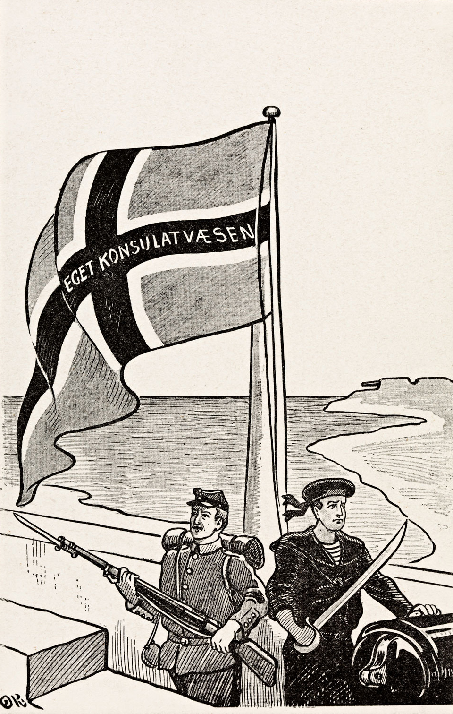
          - Norway’s own consular service
Norway’s aspiration to have its own consular service triggered the dissolution of the union with Sweden in 1905.
Illustration: Eget Konsulatvæsen (Our own consular service) by Olaf Krohn/National Library of Norway
Until relatively recently, travel to and communications with Norway were slow, and the diplomatic and consular missions therefore used to provide a number of consular services that are no longer relevant today. As recently as the early 1990s, the services set out in the Instructions for the Foreign Service as appropriate for missions to provide included forwarding post, acting as a depository for securities and transferring savings back to Norway. At the beginning of the 2000s, it was still quite common for missions to assist Norwegians with drawing up and registering wills and settling estates. The subsequent digitalisation of society and changes in political and other priorities mean that these tasks are no longer relevant for the missions, but new needs have emerged. For example, to follow up the long-term priorities of Norway’s integration policy, special representatives have been appointed to some missions to deal with individual consular cases involving negative social control and honour-motivated violence. The Foreign Service has also established positions for ID experts to strengthen efforts relating to establishing identity and checks of identity in immigration and consular cases.
The Indian Ocean tsunami in December 2004 was in many ways a turning point in the consular field both in Norway and in other countries. Most of the Norwegians directly affected by the disaster were tourists, and a white paper on the tsunami disaster and Norway’s central crisis management system was presented to the Storting in 2005 (St.meld. nr. 37 (2004–2005)). Experience drawn from the crisis formed an important part of the basis for the 2011 white paper on consular affairs Assistance to Norwegians abroad and thus also for the way consular work has been organised since then. The emergency preparedness system under the Foreign Service has been considerably strengthened in the last 20 years.

Consular assistance includes advice, services and help
The Norwegian authorities use the term ‘consular assistance’ to cover all forms of advice, services and help and support that Norwegian authorities provide to Norwegian citizens abroad. The term includes both statutory and non-statutory tasks, and also some tasks that the Norwegian state undertakes in its own interest.
Technological advances have made it possible for many tasks and services that previously required in-person attendance to be provided digitally. Within the Foreign Service’s field of responsibility, there has been a particularly marked change as regards maritime matters, where various tasks have been digitalised and transferred from the missions back to Norway. In the immigration field, the Foreign Service has also achieved good results by outsourcing services. This is a positive and planned course of development, which ensures better services and more effective use of resources. The development of improved public digital services is expected to continue, and all parts of the public sector should consider whether and how they can interact with Norwegians who are resident or staying outside Norway.
Consular advice
The Ministry of Foreign Affairs issues two types of general consular advice intended to prevent problems from arising. One of these is general travel information for all countries, which provides Norwegians with general guidance about issues it can be useful for travellers to be aware of or consider before visiting a country. The other is official travel warnings, which are issued in cases where there is reason to advise Norwegians to leave or avoid travelling to a specific country, area or region. These two forms of preventive consular assistance are described in more depth in chapter 4.
In some cases, it may be difficult to define and distinguish general advice on consular matters from advice and guidance provided directly by other public bodies. For example, it is quite clear that it is the responsibility of the Norwegian Institute of Public Health to give general advice on infection control and travel vaccines, and that people must contact the health services for advice about their own health. However, many Norwegians expect the Foreign Service to be able to answer questions about matters such as taxation, pension rights and access to health services, but questions in these areas must be addressed to the Norwegian Tax Administration, NAV (the Norwegian Labour and Welfare Administration) or Helfo (the Norwegian Health Economics Administration), respectively. In general, the Foreign Service should seek to avoid providing advice and guidance on matters that are the responsibility of other government agencies. The Government will seek to strengthen coordination between different Norwegian agencies on these matters.
Consular services
Most Norwegian citizens who meet up in person at a mission do so because they need a specific consular service. Each year, the Foreign Service issues around 20 000 passports, solemnises about 300 marriages and issues about 4 000 notarial certificates. In connection with the 2021 general election, some 7 500 overseas votes were received. Most of these consular services are governed by legislation administered by other ministries, and fees are charged for a number of them. These administrative services are described in more depth in chapter 5.
It is not possible for the Norwegian authorities to provide administrative services in every corner of the world that Norwegians travel to, but the Government will consider options for further digitalisation and for outsourcing to improve certain services.
Consular help for individuals
Help for individual people is the form of consular assistance that is most difficult to describe briefly and in general terms. This type of assistance will always be tailored to the individual, and the help provided will depend on the circumstances in a particular case. In many cases, the help the Norwegian authorities can provide is in practice limited to offering advice and guidance.
Other types of help given in individual cases may also include visiting Norwegians who are in prison abroad or forwarding information about a death to the Norwegian police so that they can notify the next of kin in Norway. Another example is that consular staff may need to report a concern about a person’s situation to the local authorities in a country so that they in turn can take steps to protect the person’s health and safety.
Every day, the Foreign Service follows up cases involving children and young people who are in difficult circumstances abroad. Missions in countries that are popular tourist destinations for Norwegians regularly experience situations where Norwegian children are abandoned for short periods of time as a result of their parents’ drug or alcohol abuse or mental health problems. Every year, the Foreign Service is also involved in cases where individuals are or may be subject to negative social control or honour-motivated violence while abroad. Consular help for individuals is described in more depth in chapter 6.
Consular crisis management
Occasionally, situations arise that affect large numbers of Norwegians at the same time and that require an extraordinary response and special measures. These are referred to as crises in this white paper.
There are no specific rules and regulations governing assistance to Norwegian citizens during crises abroad. In legal terms, any such assistance falls within the same category as all other consular assistance. This does not change even when decisions on special measures are taken during some crises.
The Norwegian authorities have dealt with a range of different crises abroad since the white paper Assistance to Norwegians abroad was published in 2011. In some cases, the Norwegian authorities offer assisted departure from dangerous situations or areas. Consular crisis management is described in more depth in chapter 7.
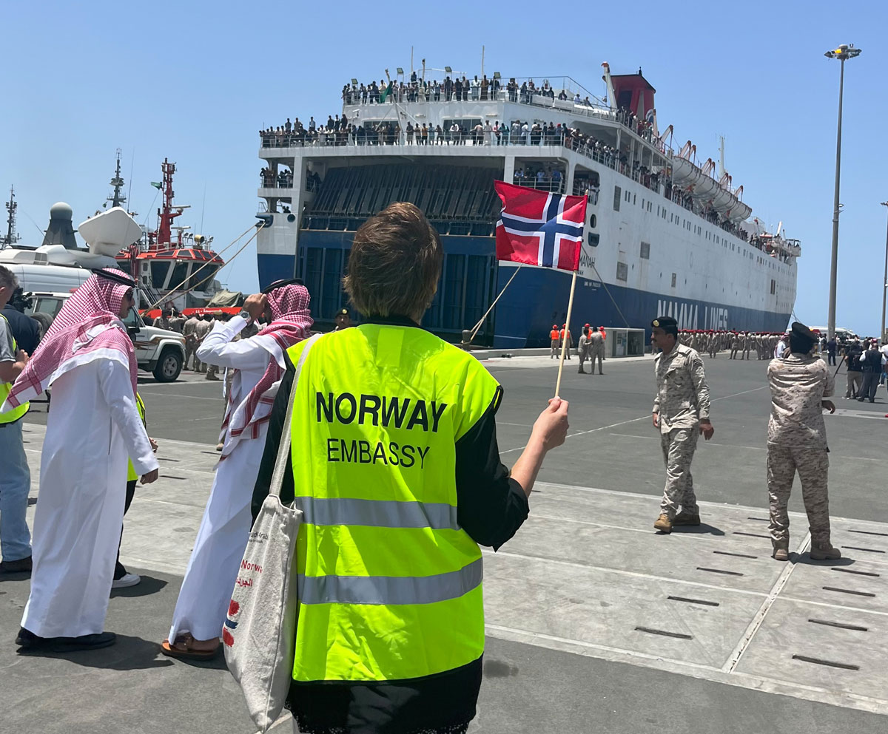
          - Assisted departure
The Embassy in Riyadh meeting Norwegian citizens arriving in Jeddah, Saudi Arabia, from Sudan in April 2023.
Photo: Embassy in Riyadh/Ministry of Foreign Affairs

Who is eligible for consular assistance?
No one has a statutory right to consular assistance, but a fairly broad category of people may be eligible for some form of consular assistance from the Norwegian authorities. Whether or not consular assistance can be provided must be assessed on a case-by-case basis, and will depend on a person’s circumstances and the type of consular assistance they are requesting. Certain consular services can only be offered to Norwegian citizens, while for others the main criterion is that a person is resident in Norway. There are also services for which neither citizenship nor place of residence is relevant.
              - Danish and Swedish rules on who can be offered consular assistance
Denmark: The consular services section of the Danish Ministry of Foreign Affairs works together with Danish embassies and consulates to assist Danish citizens and foreigners who are permanently resident in Denmark when they encounter problems abroad. Fees are charged for assistance provided by the Ministry or by a Danish embassy or consulate in another country.
Sweden: People in the categories listed in the Act relating to financial consular assistance are eligible for assistance from the Ministry for Foreign Affairs and the embassies when they are abroad. These are:
- Swedish citizens residing in Sweden.
- Refugees and stateless persons residing in Sweden.
- If there are special reasons, consular financial assistance can also be provided to a Swedish citizen not residing in Sweden, and a foreigner residing in Sweden. However, under the legislation, consular help for people who are not resident in Sweden is very restricted and will only be offered in exceptional cases.
Source: Websites of the Danish Ministry of Foreign Affairs (www.um.dk) and the Swedish Ministry for Foreign Affairs (www.regeringen.se).
[Boks slutt]
Norwegian citizens
The Foreign Service is responsible for providing consular assistance to Norwegian citizens, and this is clearly expressed in section 1 of the Foreign Service Act. Most of the people who ask for and are offered various forms of consular assistance are Norwegian citizens.
The 2011 white paper Assistance to Norwegians abroad stated that in the Government’s view, higher priority should be given to assisting Norwegians on short trips abroad than to assisting those who are permanently resident in another country. However, there has been a widespread practice of providing consular assistance to Norwegians who are permanently resident abroad as well. Chapter 7 on crisis management includes further discussion of the limits of such assistance and whether rules should be introduced requiring people to demonstrate ties to Norway in addition to Norwegian citizenship in order to be eligible to receive consular assistance. This may be particularly relevant in the case of people who are citizens of more than one country.
Norwegian citizens who are also citizens of other countries will need to contact the authorities in these countries for queries in certain areas. For example, the Norwegian authorities cannot answer questions about citizenship of other countries, about other countries’ rules for issuing passports, or about other rights and obligations that follow from citizenship of another country, such as military service obligations. If a dual citizen is staying in another country of which they are a citizen, or enters a third country using a non-Norwegian passport, Norway’s ability to provide consular assistance may be restricted by the authorities of the country concerned. In some countries, for example, the Foreign Service does not have access to imprisoned Norwegians who are dual citizens because the country’s authorities do not recognise or allow consideration to be given to their Norwegian citizenship.
Non-Norwegian citizens
According to long-established practice, and as clarified in the legislative history of the Foreign Service Act, there may also be cases where it is natural for the Foreign Service to assist non-Norwegians. In this context, both the legislative history of the Act and the 2011 white paper Assistance to Norwegians abroad specifically mention non-Norwegians who are refugees or stateless and resident in Norway, and who therefore have a Norwegian travel document and use it when travelling abroad. Opportunities to receive consular assistance from their home country are likely to be very limited for people in these groups.
If other non-Norwegians ask the Norwegian authorities for consular assistance, they will normally be referred to the foreign service of the country where they are citizens. According to Statistics Norway’s population statistics, more than 600 000 non-Norwegian citizens were resident in Norway in 2024. None of these can expect to receive any form of consular assistance from Norway if they for example are arrested in a third country or while they are on holiday in their own home country.
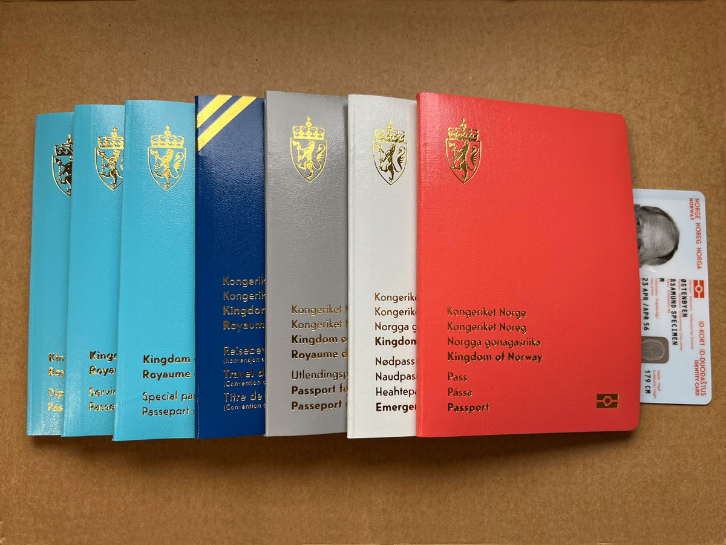
          - Different types of Norwegian travel documents
Anyone travelling on a Norwegian travel document can request consular assistance from the Norwegian authorities.
Photo: Ministry of Foreign Affairs
Legal entities
The Foreign Service Act (section 1, first paragraph, item 2) was amended in 2015 to make it clear that the Foreign Service is also responsible for providing assistance to Norwegian businesses and organisations. This amendment was in line with already existing practice, and was intended to reflect the responsibilities of the Foreign Service for promoting the Norwegian business sector abroad. Business promotion in itself is not considered to be consular assistance and is not further discussed in this white paper.
In the context of this white paper, this clarification is particularly useful in connection with crises abroad. Crisis management in the Foreign Service is to a large extent organised within the consular framework and context, and the 2015 amendment can be interpreted as meaning that legal entities can be the recipients of types of assistance that would normally be given to individuals. It is difficult to define in advance whether assistance from the Foreign Service in a particular situation is to be considered ‘consular assistance’ or something else (for example standard contact with the authorities on common administrative matters). The answer will depend on the actual situation and the specifics of the case. Some examples are described below.
Piracy was dealt with as a separate point in the 2011 white paper Assistance to Norwegians abroad. It is quite clear that the Foreign Service may have a responsibility to provide assistance to a Norwegian shipping company if a ship sailing under the Norwegian flag is attacked by pirates abroad or in international waters. During the COVID-19 pandemic, starting in 2020, the Foreign Service made every effort to assist Norwegian shipping companies and Norwegian-flagged ships with matters such as embarking and disembarking crew and entry permits. The aim was to maintain Norwegian shipping and global trade in very difficult and rapidly changing circumstances.
In 2013, 17 Statoil employees were caught up in a terrorist attack and hostage situation in Algeria. During the crisis, assistance from the Foreign Service was largely organised with Statoil as the main recipient. A number of other Norwegian actors organised their assistance in the same way. This approach may also be appropriate in other circumstances where an individual is in a difficult situation abroad as a result of where they are employed. The specific assistance that can be offered must be assessed on a case-by-case basis, but it will not normally be natural to offer substantial consular assistance to a Norwegian legal entity (a Norwegian company, foundation or the like) if most of the people affected by an incident are not Norwegian citizens.
Delimitation and clarification of the scope of consular assistance
Consular assistance is not an extension of or a substitute for employer responsibility or other types of responsibility that private or public legal entities have as regards their own employees, students or others who are affiliated with them.
This is something that also applies to government employees who are on official travel abroad or posted abroad outside the framework of the Foreign Service. In their case, consular assistance may supplement and support the efforts of a ministry or subordinate agency, but is not a substitute for their own employer responsibility.
The Ministry of Foreign Affairs has employer responsibility for its own employees. Each mission has employer responsibility for its own locally employed staff, and also a responsibility for other people who are affiliated with the mission, for example student interns. The consular assistance a mission can provide may be limited by the need to ensure the safety and security of employees. The Foreign Service has emergency preparedness plans, which for worst-case scenarios may include temporary closure of a mission and evacuation of personnel.
In some situations, it is expedient for various governmental bodies to coordinate their responses closely. The withdrawal from Kabul in 2021 is an example of a situation where it would have been very difficult for the Foreign Service to continue to operate the mission safely, and then evacuate its personnel on its own. In addition, it is highly unlikely that the assisted departure from Kabul offered to other Norwegian citizens would have been practicable without the presence and assistance of the Norwegian Armed Forces.
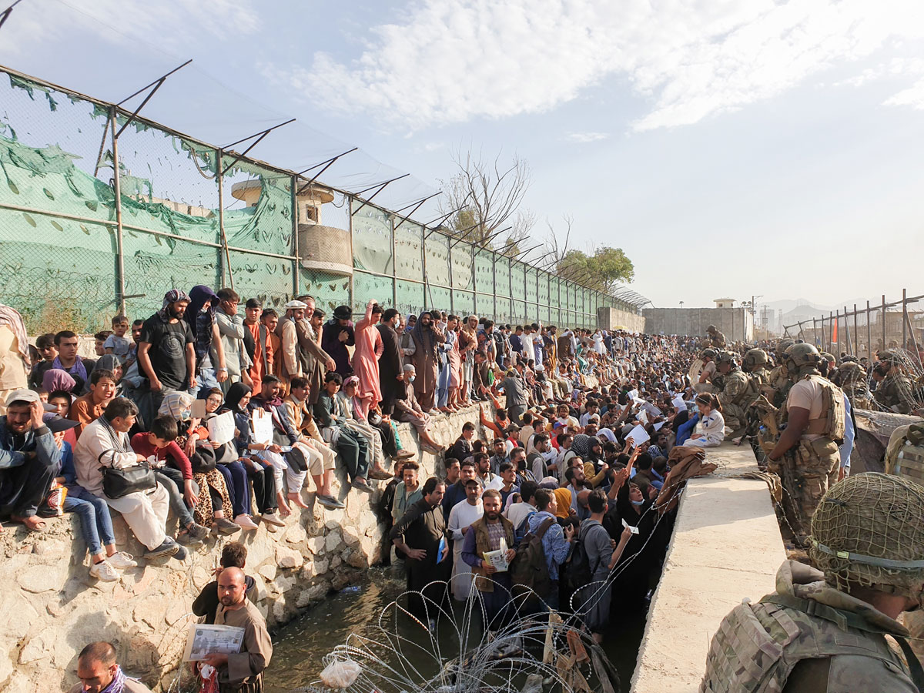
          - The withdrawal from Kabul in 2021
Military personnel from various countries and other people seeking to leave Kabul in August 2021.
Photo: Norwegian Special Operations Commando/Norwegian Armed Forces

Legal framework
A combination of international and national law provides the basis for the consular assistance the Norwegian authorities can provide to Norwegians abroad, and also places certain constraints on this assistance.

International legal framework
Everyone has a duty to comply with the legislation that applies at any given time in the country they are in. This basic requirement follows from the principle of state sovereignty in international law.
Under international law, it is in principle up to each state to decide how it exercises authority in its own territory. However, international rules, for example human rights obligations, define limits for an individual state’s exercise of authority. As a general rule, it is the state where a person is staying that is responsible for ensuring compliance with such rights and obligations.
This means that the kind of assistance that the Norwegian authorities are able to provide to Norwegian citizens abroad is contingent not only on Norwegian legislation and policies, but also on the legislation of the country where that person happens to be.
The legal basis enabling the Norwegian authorities to provide consular assistance in other countries is derived from international law. The most important agreements for Norway in the field of consular affairs are the Vienna Convention on Consular Relations and the Helsinki Treaty on Nordic Cooperation. Norway is also a party to the European Convention on Consular Functions, and has entered into certain individual bilateral consular agreements.
International law, and particularly the Vienna Convention, makes it possible for Norway to provide consular assistance and consular services abroad. However, international law offers very little guidance on the specific scope of the assistance that can be provided.

Norwegian legal framework and internal rules
In Norwegian law, the overall framework for consular assistance is set out in the objects clause of the Foreign Service Act, which states that the Foreign Service is responsible for providing advice and assistance to Norwegian nationals. The Foreign Service has the primary responsibility for providing assistance to Norwegians abroad. The Foreign Service carries out its tasks either on its own behalf or on behalf of other Norwegian authorities and institutions.
Two of the Foreign Service’s three main tasks are related to consular affairs. According to section 1, first paragraph, items 2 and 3, of the Foreign Service Act, these tasks are:
2. to provide advice and assistance to Norwegian nationals and legal entities vis-à-vis foreign authorities, persons and institutions; and
3. to provide assistance to Norwegian nationals abroad, including assistance in connection with criminal prosecution, accidents, illness and death.
The Foreign Service Act does not use the term ‘consular assistance’, and does not seek to define what consular assistance means in practice. However, the legislative history of the Act mentions marriages and notarial acts as examples of consular services. Moreover, section 1, first paragraph, item 3, of the Act was amended in 2002 to include examples of the kinds of situations people requesting consular assistance may find themselves in. The purpose of the amendment was to provide the legal authority to process sensitive personal data. The provision has not been amended since the implementation of the General Data Protection Regulation (GDPR) in Norwegian law. It has been deemed necessary to assess whether the Foreign Service Act provides an adequate legal basis for processing of sensitive personal data in the field of consular affairs, and work on this has been initiated.
The provisions of the Foreign Service Act are supplemented by provisions in the Instructions for the Foreign Service. This is an internal document for the Foreign Service, largely dealing with the administration of the diplomatic and consular missions, but about one third of the document consists of detailed provisions regulating consular matters. The Ministry of Foreign Affairs has also produced other internal guidelines on dealing with consular cases.
The Ministry has identified a need to further develop and modernise the consular framework and has initiated a process to further delimit and clarify the scope of consular assistance. The Government will give priority to this process. Guidance regarding the exercise of discretion in specific consular cases should as far as possible be publicly available, while at the same time taking into account the need to protect sensitive working methods from disclosure.

There is no legal right to consular assistance
Section 1 of the Foreign Service Act describes the tasks of the Foreign Service, but does not entitle individuals to require the intervention of the Foreign Service in specific cases, or to specify how it should intervene. Decisions on whether the Foreign Service should provide assistance in specific cases, and what consular assistance can be offered, are subject to the discretion of the public administration.
While the Foreign Service Act does not establish the scope of rights and duties in the consular field, these may be more clearly defined if a specific consular task or service is governed by other legislation. For example, many missions issue passports on a regular basis, and rights and duties in connection with this service are determined by the provisions of the Passport Act. Other relevant provisions, such as those of the Public Administration Act, also apply in full to this service. As regards the non-statutory element of consular assistance (advice and help), there are no formalised application procedures, and case processing does not normally involve individual decisions under the Public Administration Act or other formal decision-making. Nevertheless, there is an absolute requirement to exercise impartiality, which includes a prohibition on unfair discriminatory treatment. Consular assistance is offered with a degree of discretion and in line with the framework and principles for consular matters that follow from established administrative practice and this white paper. The principle of equal treatment is considered to be very important, and the Ministry coordinates activities globally to avoid the emergence of differing practices at different missions.

Organisation and use of resources
The Foreign Service consists of all Norway’s missions abroad and the Ministry of Foreign Affairs in Oslo. In this white paper, it is the embassies and consulates general abroad that are headed by a career officer (a foreign service officer posted abroad) that are relevant.
Norway has diplomatic relations with 196 countries, and as of spring 2025, had either an embassy or a consulate general headed by a career officer at 82 localities in 75 of these countries. In addition, Norway has about 300 honorary consulates in 125 different countries, and these are also an important part of the consular infrastructure.

The Ministry of Foreign Affairs and the diplomatic and consular missions
The missions are responsible for a very wide range of tasks, including consular matters. All foreign service officers are prepared to deal with both consular cases and crises during a posting abroad. Consular cases and incidents may arise without warning, and elements of the work at a mission are inevitably reactive in nature and event-driven.
It is estimated that the missions use a total of around 200 person-years annually on consular matters. The total resource use is split between many different employees. At each mission, there is at least one posted foreign service officer with overall responsibility for consular matters and emergency planning. At a few missions, one or more posted employees work full-time on consular matters, but in general, such matters only make up a small part of the work of posted employees. Day-to-day consular work is to a large extent dealt with by locally employed staff, but posted employees, including ambassadors and consuls general, often assist in dealing with particularly complex individual cases.
Every year, the missions register more than 30 000 consular enquiries and cases, and in addition issue close to 20 000 passports. Aggregated data from the past five years show that an estimated 45 % of all consular enquiries concern advice and guidance to individuals. Many enquiries are about general questions that are uncomplicated for the missions to answer, for example by referring the person to already existing information on the internet or elsewhere. About 50 % of all cases dealt with by the missions involve administrative consular tasks. These largely consist of issuing passports and related tasks concerning children born abroad, but also include services such as notarisation.
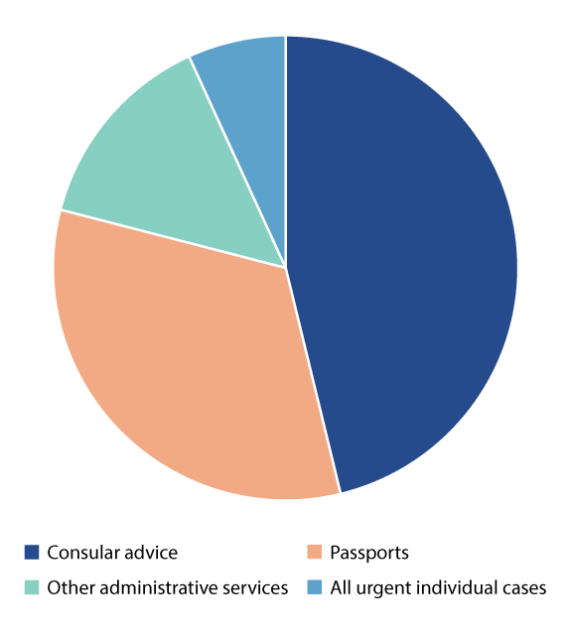
          - Distribution of different types of consular cases and enquiries
Administrative services account for about 50 % of all cases. Some 45 % of cases concern various types of advice and guidance. The remaining 5 % include all urgent individual cases.
Source: Ministry of Foreign Affairs
The remainder, approximately 5 % of consular cases and enquiries, includes everything except passports, other administrative tasks and general advice. Every data point in this category represents a case that the Foreign Service is dealing with or has dealt with, in contact with people who are in difficult situations. During the past five years, these have included several thousand cases involving deaths abroad or emergency assistance, and several hundred cases concerning people in prison abroad or child abductions. Although this category only makes up a small proportion of the total number of cases, it accounts for a large share of resource use.
Outside a mission’s opening hours, members of the public can contact UDops (the Foreign Service Response Centre) in Oslo. The centre receives about 16 000 calls a year. In general, it does not provide advice to the public or assist the missions with complex, lengthy individual cases. Such matters are dealt with by another section, which is also responsible for overall strategic work on consular affairs. In addition, the Ministry has crisis management teams on call to deal with major incidents and crises. In all, around 50 people in the Ministry work full-time on consular affairs and crisis management. In the event of a major crisis, all necessary resources are mobilised from other parts of the Ministry as well, as described in chapter 7.
Strategic work on consular affairs
The Ministry of Foreign Affairs has overall responsibility for resource management and policy development in the field of consular affairs. The Ministry also carries out tasks that in other areas could have been the responsibility of a directorate or that would naturally be dealt with by an external executive agency. The fact that the Foreign Ministry deals with this field at both strategic and operational level is both a strength and a challenge. It is a recurring issue that progress in the overall strategic development of the consular field is hampered because resources have to be allocated to dealing with individual cases and crises that may threaten the health and safety of Norwegian citizens. The preparation of this white paper has provided an opportunity to take stock of what still needs to be done to further develop the consular field. A large proportion of consular assistance is based on practices reaching back many decades, in some cases probably more than a hundred years. An overall review is needed to further clarify certain aspects of the consular framework in more detail, and as mentioned in chapter 3.4.2, the Government will give priority to this work.
The Foreign Service is also seeking to shift resource use away from advice and guidance to individuals and towards better and more appropriate general advice to the public. This can be achieved through strategic communication activities and by using modern digital solutions to provide clearer, quality-assured and more cohesive information, so that individuals can find answers themselves.

Honorary consulates
Norway currently has about 300 honorary consulates. They are staffed by honorary consuls, who perform their duties for Norway without receiving a salary or other remuneration. Most of them (about 90 %) are not Norwegian citizens.
The role of the honorary consuls has changed since the dissolution of the union with Sweden in 1905. At that time, the consulates had close links with the Norwegian shipping industry and dealt with its needs for assistance. As more Norwegians began to travel abroad, it became important for the consulates to provide emergency assistance to travellers, for example people whose passports or money had been stolen. Many consulates have also played an important role for Norwegians resident abroad, who have been able to receive consular services such as having a passport issued.
Most of the services traditionally provided by the consulates have ceased to be relevant; for example, they no longer carry out routine tasks related to passports and immigration. Many of the honorary consuls now work mainly on other tasks to support the efforts of Foreign Service missions to safeguard Norway’s interests abroad. They may for example be involved in promoting cultural cooperation, providing advice to Norwegian companies and providing assistance during official visits from Norway. The honorary consuls have extensive local knowledge and networks, and are therefore in a good position to provide such services. This element of their work is not further discussed in this white paper, since it does not come within the scope of consular assistance. However, these are services that the consuls are continuing to carry out on behalf of the Foreign Service, and that should receive considerable attention in a future review of the system of honorary consulates.
There is wide variation from one consulate to another in how much of the workload consists of traditional consular tasks. In areas where many Norwegians are permanently resident, the consulates receive daily enquiries from people needing advice and assistance. From time to time, there is an urgent need for assistance, for example in connection with deaths, imprisonment or child welfare cases. However, enquiries most frequently concern a need for assistance that requires contact with other Norwegian authorities. The question is whether it is appropriate for the Foreign Service to undertake such tasks, or whether other agencies should have responsibility for this themselves.
Even though most of the honorary consuls no longer have much involvement in traditional consular tasks, we should not underestimate their importance on occasions when they are needed. They play a critical role as part of the emergency preparedness system, both when it comes to providing assistance to individuals and in connection with major crises. Many of the consuls are in countries where Norway has no embassy, and will play a crucial role for Norway for example if assisted departure needs to be organised. Norway’s consular infrastructure and emergency preparedness is considerably strengthened through the system of honorary consulates.
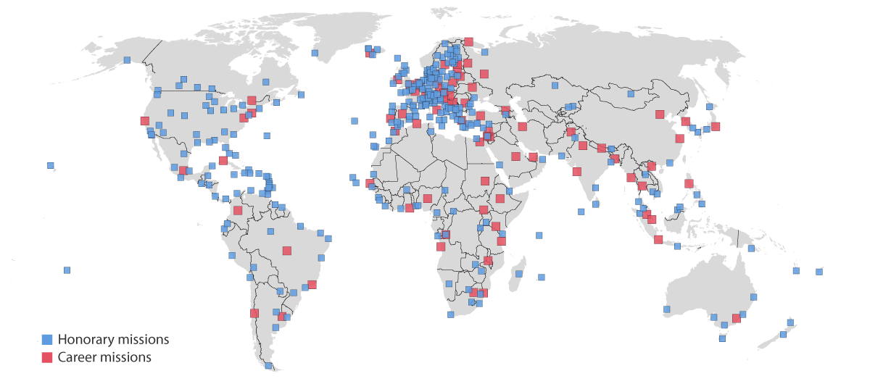
          - Norway’s consular presence abroad
The map shows a snapshot of where Norway had embassies and consulates general (career missions) and honorary consulates at the start of 2025. It includes two missions that were temporarily closed, and a few honorary consulates where the process of appointing a new consul was underway.
Source: Ministry of Foreign Affairs
Foreign Service expenditure on the operation of the honorary consulates is fairly low. The Norwegian authorities only cover specific expenses in certain circumstances. In 2024, the costs of office allowances and official expenses for all the honorary consulates totalled about NOK 21 million. A few consulates where the level of activity was high accounted for most of this, largely in the form of expenses for office premises and employees. For example, the consulates in Spain accounted for one third of total expenditure.
Nevertheless, the Government has identified a need to review the system of honorary consulates. At present, there are no satisfactory standards in place for administration of the consulates, and the regulatory framework and routines need to be updated to standardise operations. A clearer framework for administration of the consulates and clarification of what they are expected to provide as regards both traditional and new tasks will make it possible to use resources more effectively. The Ministry will therefore initiate a broad-based review of the tasks and administration of the honorary consulates.

International consular cooperation
There is regular dialogue between the foreign services of different countries on challenges and possible solutions in the field of consular affairs. Norway maintains a particularly close dialogue and structured cooperation with the other Nordic countries. The EU is an important partner in the area of crisis management. Norway also cooperates with the foreign services of other like-minded countries when this is natural, both in individual cases and when considering questions of principle.
Nordic cooperation on consular affairs
Norway cooperates closely with the other Nordic countries on consular matters, both with the services in the other Nordic capitals and with Nordic diplomatic and consular missions in third countries. The formal basis for Nordic cooperation on consular affairs is the 1962 Helsinki Treaty on Nordic Cooperation. Article 34 of the Treaty establishes that representatives of the foreign services of any of the Nordic countries are also to assist citizens of another Nordic country if that country is not represented in the territory concerned. Nordic cooperation also includes close cooperation in connection with crises.
Nordic working groups have been established in a number of consular areas, and officials from the five Nordic countries meet on a regular basis to coordinate activities and exchange information. There are also regular meetings of the Nordic and Baltic countries. Much of the cooperation deals with preventive measures, for example coordination of travel warnings and collaboration on crisis management. The extent of consular cooperation at missions varies from place to place, ranging from physical co-location and joint administrative support functions to mutual operational assistance in consular cases in connection with major incidents. The Nordic missions also generally cooperate closely on crisis management and emergency preparedness, as discussed in chapter 7.2.
Individual consular cases may also involve cooperation between the foreign services of Nordic countries. The level of assistance provided to citizens of other Nordic countries in such cases should not, in principle, exceed the level of assistance they could normally expect from their own foreign service. Assistance to citizens of other countries should be closely coordinated with the relevant Nordic mission or foreign ministry, which are responsible for making decisions in consular cases involving citizens of their own country. All the Nordic countries have set up 24/7 response centres that can be contacted outside office hours. Experience shows that providing consular assistance to citizens of other Nordic countries only accounts for a small proportion of the work at Norwegian missions.
Consular cooperation with the EU
The EU has for many years been seeking to improve coordination and cooperation in the consular field within the Union. However, the EU has encountered many of the same problems as the Nordic region, such as lack of harmonisation of legislation and differences in the practical organisation of consular assistance.
Under the Treaty of Lisbon, EU citizens have ‘the right to enjoy, in the territory of a third country in which the Member State of which they are nationals is not represented, the protection of the diplomatic and consular authorities of any Member State on the same conditions as the nationals of that State.’ To ensure implementation of this provision, steps are being taken to facilitate the exchange of information and improve coordination of the EU member states’ national efforts as regards both consular matters and crisis management.
The EU countries have made more progress in coordinating their visa arrangements. Norway has entered into agreements with several other Schengen countries on receiving and processing visa applications on each other’s behalf. This is possible because all the Schengen countries use the same legislation as a basis for processing applications, which is set out in the EU regulation known as the visa code. The Schengen countries and the European Commission cooperate on application of the legislation at many levels and in various forums in Brussels and locally at diplomatic and consular missions.
In practice, the most important element of consular cooperation between Norway and the EU concerns cooperation during major crises and when organising assisted departure from a crisis-affected area. This is described in more detail in chapter 7.2.
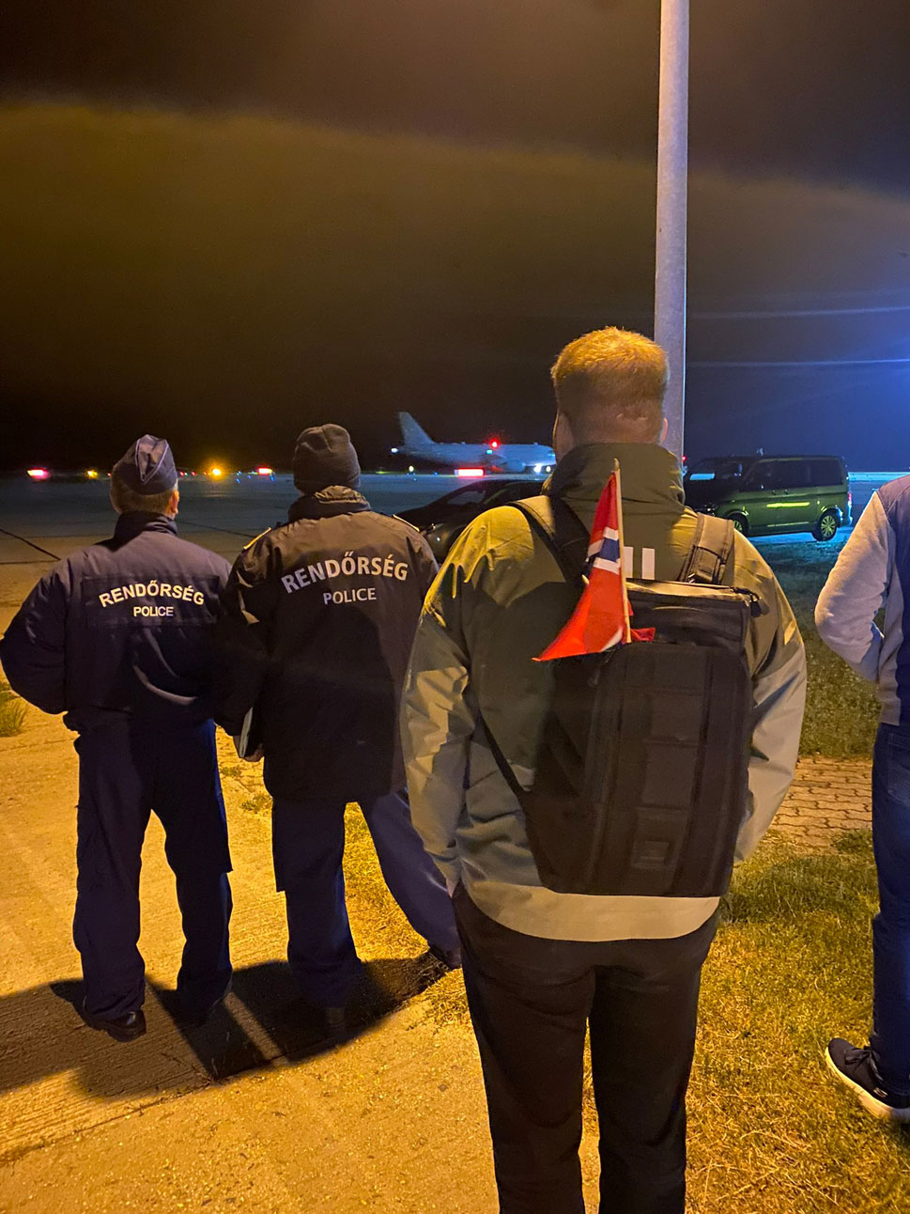
          - International consular cooperation
The Embassy in Budapest meeting Norwegian citizens who were provided with assisted departure from Sudan via Hungary. This was a result of international consular cooperation.
Photo: Norwegian Embassy in Budapest/Ministry of Foreign Affairs

Individual responsibility and self-help
The assistance provided by Norwegian authorities to Norwegians abroad is based on the principles of individual responsibility and self-help. The most important thing people can do to help themselves is to ensure that they have adequate travel insurance. This was one of the key points made in the previous white paper on consular assistance (Meld. St. 12 (2010–2011)) and it is still valid today. These principles apply both in cases involving assistance to individuals and in cases involving crisis management.

Travel insurance
Norwegians are not required to have travel insurance, but it is strongly recommended that anyone who travels abroad purchases it. According to figures from the insurance industry, far too many people, especially young adults, travel without travel insurance.
Individuals who choose to travel without adequate travel insurance are exposing themselves to significant financial risk, particularly if they experience health problems. If they fall ill, are injured or have an accident while abroad, the cost of the necessary medical treatment may quickly become very high, and they or their next of kin may have to cover these costs themselves. Those who choose to travel without travel insurance should have sufficient funds to cover unforeseen costs such as for a hospital stay or medical transport back to Norway. The experience of the Foreign Service is that the death of an uninsured person abroad puts the next of kin in a very difficult position, requiring them for example to decide whether to engage a local funeral director and pay to have the deceased transported to Norway for burial.
As a general rule, Norwegian citizens are not automatically entitled to medical treatment when abroad. This applies to all countries apart from the other Nordic countries, the EU/EEA countries and Switzerland. In these countries, medical expenses incurred during a temporary stay will be covered on an equal footing with the nationals of the country concerned, provided that the individual involved can present a European Health Insurance Card. It is important to be aware that the card does not necessarily cover all types of expenses, such as expenses for transport back to Norway. Transport on an air ambulance from a European country back to Norway may cost upwards of NOK 300 000. It is therefore important to have valid travel insurance in addition to the European Health Insurance Card, and to bear in mind that different rules may apply for those who have chosen to take up residence in another country.
For travellers in countries outside the Nordic countries and the EU/EEA, it is generally the case that neither the Norwegian authorities nor the local authorities will cover expenses in connection with medical treatment. In some countries, critical life-saving treatment may be provided free of charge, but not any other forms of medical treatment. Travel in these countries without valid travel insurance thus poses an even greater risk. A hospital stay in the US, for example, can cost up to NOK 100 000 per day, while the price of an air ambulance from Thailand to Norway can exceed NOK 1 million.
It is particularly important for Norwegian citizens who are staying for an extended period in, or have emigrated to, other countries to find out about the implications this has for their health insurance. Most travel insurance policies require permanent residence and membership of the Norwegian National Insurance Scheme. Compulsory membership of the Norwegian National Insurance Scheme confers certain health care-related and pension rights, and stays abroad can affect the individual’s membership. It is up to the individual to find out about the impacts that a planned stay abroad (or in progress) may have on their rights under the Norwegian National Insurance Scheme, and determine whether to apply for voluntary membership of the scheme when this is desirable and provided that they meet the requirements. Students studying abroad must have their own travel insurance, and there are a number of companies that offer student policies.
Most Norwegian insurance companies link their policy terms and conditions to any advice against travel to a particular country that has been issued by the Ministry of Foreign Affairs. This is a business decision taken by the industry itself. In cases where the Ministry of Foreign Affairs has advised against travel to the final destination, the travel insurance may be deemed invalid for the entire journey.

Costs and reimbursement of expenses
In accordance with current practice, expenses incurred by the Foreign Service in connection with consular assistance are covered under the Foreign Ministry’s operating budget, whereas the individuals concerned will be required to cover their own expenses. This means the embassy does not charge for its time or travel costs, but the individual involved must pay for such things as doctor’s consultations, legal assistance or airline tickets home. In exceptional cases, where life and health are at stake, certain unforeseen expenses in connection with assistance to Norwegians abroad may be covered. See chapter 5.7 for more information. In other special circumstances, where the recipient of consular assistance has shown gross negligence, the Norwegian authorities may demand reimbursement of their expenses. The potential to demand reimbursement is important, as it may have a preventive effect.
As a rule, Norwegians who receive assistance in connection with major crises have also been required to cover their own expenses. For example, individuals have been required to pay a specified amount when they use transport services made available by the Norwegian authorities. In practice, this means that individuals must either document that they have adequate travel insurance coverage or apply for an emergency loan. The Foreign Service can then have its expenses refunded at a later time.
In cases involving assisted departure, the Foreign Service has generally not received full reimbursement for the expenses that relate directly to the individual involved. This is partly because it is difficult to calculate costs during an ongoing crisis. In the Government’s view, consideration should be given to establishing a framework where the state would cover a somewhat larger portion of the costs associated with unexpected crises, such as natural disasters, while individuals who take too great a personal risk by travelling to or staying in areas the Norwegian authorities have advised against, would be required to cover more of the costs themselves. This could also have a preventive effect.

Preventive consular assistance
Providing advice and guidance to Norwegians abroad is a core component of consular work. The purpose is to equip individuals with the information they need to make sound, informed choices about foreign travel. These information activities are an important means of helping people to help themselves. The aim is to reduce to a minimum the number of people who end up in a situation where they need consular assistance abroad.
The Ministry issues two types of general consular guidance. These are now referred to as travel information and travel warnings, and they are intended to prevent problems from arising. Both are published on regjeringen.no and are among the most read content there. Travel information and travel warnings are also available on the Foreign Ministry’s travel app Reiseklar, which is also used to send notifications of incidents in relevant countries. In addition, the app provides easy access to the travel registration portal reiseregistrering.no, where Norwegians travelling or planning to travel abroad can register their trips and receive timely information by email or text message from the Foreign Service if a significant incident occurs in the country they are travelling to. The app was launched in 2021 and has been downloaded to some 400 000 phones. It is used by more than 20 000 people every month.
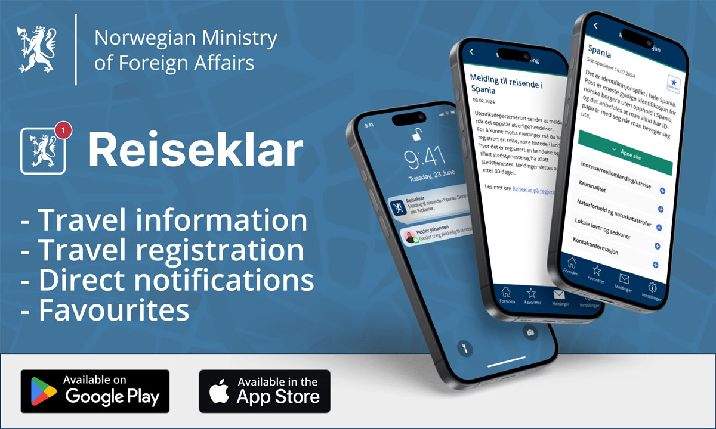
          - The Foreign Ministry’s travel app Reiseklar (‘Travel-ready’)
The information in the Reiseklar app is in Norwegian only.
Illustration: Ministry of Foreign Affairs
In addition to the information available on regjeringen.no, the missions also provide some general consular guidance on their websites (norway.no). This includes practical and administrative advice, as well as answers to frequently asked questions. Norwegians living permanently in other countries are a key target group for this information.

Travel information
Travel information issued by the Ministry of Foreign Affairs provides Norwegians with advice and guidance about risks it may be useful to be aware of and consider before deciding to travel to a country. It is the task of the mission that is in, or has responsibility for, the country concerned to make the assessments and update the information as necessary. The Ministry’s travel information is not a substitute for material that is publicly available on the internet or in commercial travel guides, or for information that other authorities are better suited to provide.
Travel information for each country is divided into fixed categories. General information is provided on the security situation, healthcare, crime and the risk of natural disaster in the country concerned. The travel information includes a brief overview of key local laws and customs that differ from those in Norway, as well as essential contact information, such as emergency numbers for the police and health services. General information about national entry and exit rules is also provided. Experience shows that publishing correct, up-to-date information reduces the number of enquiries the missions and the Ministry receive from members of the public.
Individuals can use the Ministry’s travel information to assess for themselves the risks of travelling to another country. In addition to the general risks faced by anyone who travels to or stays in a particular country or area, it is unfortunately the case that certain people or groups may encounter varying degrees of scepticism, discrimination, harassment or even criminal sanction. When assessing the risks involved, it is therefore essential that individuals give consideration to risks specifically associated with who they are or what they plan to do abroad. The Foreign Ministry’s travel information for many countries includes a brief description, for example, of risks specifically faced by LGBT+ people. A number of other groups may also be subject to greater risk when travelling abroad. As with sexual orientation and gender expression, factors such as gender, ethnicity and religion may increase the level of risk. The same applies to disabilities, chronic diseases and mental disorders. An individual’s area of work may be another risk factor, and dual citizenship can make some people more vulnerable. This is especially the case for those engaged in political or social activism in their country of origin.
Advice for vulnerable groups on the risks of travelling abroad should primarily be provided by actors with specialised knowledge, who can give better, more specific guidance than the missions about the risks involved.

Travel warnings
The Norwegian authorities can never guarantee that journeys or stays abroad will be safe. In cases where the Ministry of Foreign Affairs considers that the situation in a country or area is such that Norwegians should avoid travelling there, an official travel warning is issued. This was previously referred to in Norwegian as reiseråd (travel advice). However, in connection with the presentation of this white paper, the term has now been changed to reiseadvarsel (travel warning) to help Norwegians to better distinguish between specific travel warnings and general travel information. Although the term has been changed, the purpose and structure of this information remain unchanged and are described below.
A travel warning is issued in cases where there is reason to advise Norwegians to leave or avoid travelling to a specific country, area or region. This is generally because of war, war-like situations or other forms of unrest that, on the basis of an overall assessment, indicate that Norwegian citizens should not travel to the place in question or stay there.
              - The Foreign Ministry operates with three levels of travel warnings
- Advice against non-essential travel to a country or area.
- Advice against all travel to a country or area.
- Advice against all travel to or stays in a country or area, including urging Norwegians to leave the area.
[Boks slutt]
The Foreign Ministry’s travel warnings clearly advise against travelling or staying in a country or area, but they do not constitute travel bans or travel restrictions preventing individuals from travelling where they wish. It will always be up to individuals to assess how much risk they are willing to accept.
In countries or areas for which travel warnings have been issued, it will be difficult and sometimes impossible for the Foreign Service to provide consular assistance. Moreover, it is common practice in the insurance industry to deem travel insurance invalid for trips to countries where a travel warning is in effect, as mentioned in chapter 4.1. The Ministry of Foreign Affairs has published information clarifying the level of consular assistance the public can expect to receive in connection with trips to countries and areas for which a travel warning has been issued. This information has been translated into English, French, Arabic, Urdu, Tigrinya, Polish and Somali in order to make it accessible to dual citizens and transnational families in particular.
Official travel warnings are issued, revised or withdrawn following an overall assessment of the situation in question. Decisions to issue travel warnings are not politically motivated, and their sole purpose is to enhance the safety and well-being of the Norwegian public. However, it is clear that travel warnings issued by Norway can prompt reactions, and there have been cases where the Norwegian authorities have reacted to advice issued by the foreign services of other countries regarding specific risks associated with travelling to Norway. The Ministry is therefore considering the need to provide more information about the key factors included in the assessments that are carried out when official travel warnings are issued.

Travel registration
In 2024, Norwegians registered a total of 114 684 trips or stays abroad in the Foreign Ministry’s travel registration portal (reiseregistrering.no) or via the Reiseklar app. The trips were to 230 different countries and territories. About a third of all registered trips were to Spain, Greece, Türkiye, Thailand, Italy or France.
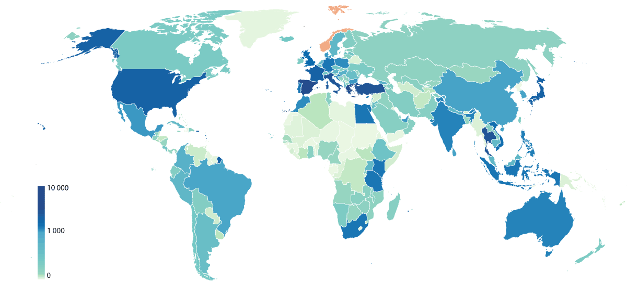
          - Trips registered in the travel registration portal reiseregistrering.no in 2024
Source: Ministry of Foreign Affairs
Registering a trip in the portal is voluntary, and does not give the Foreign Service information about where someone actually is. The Foreign Service does not, for example, have access to location data in the Reiseklar app.
When a serious incident or crisis occurs, the Ministry of Foreign Affairs can rapidly disseminate useful, practical information to those who have registered that they are in a country. The threshold for sending out information to registered users will vary. In countries with good warning systems and countries where most Norwegians can be expected to be able to follow local media on their own, there may be less reason for the Ministry to send out messages.
Most messages are sent out in connection with an ongoing crisis management operation. Experience shows that the number of Norwegians present in a country is generally far higher than the number of people registered. As a result, registrations often rise sharply in the first few days of a crisis. In a crisis situation it is crucial that the Foreign Service can target its efforts towards the people who are actually affected. Norwegians who are in the area but are not affected are therefore urged to make this known, including to family members or friends in Norway.
It is important to modernise and upgrade technical tools that can facilitate communication with the public in crisis situations. A number of commercial solutions are already available that enable people to communicate that they are safe and do not need assistance. In the longer term, consideration will be given to the possibility of developing solutions for two-way communication with members of the public using a suitable digital interface. In the future, if an assisted departure operation is to be carried out or some other need for consular assistance arises it should, for example, be possible for members of the public to confirm their identity or apply for an emergency loan digitally. Manual solutions must remain available, but relying on them as standard practice, as is the case today, is not cost-effective and is not always feasible.
              - Travel warnings
Norwegian citizens may have difficulty travelling out of a country while a major crisis is ongoing. Airports may be closed at short notice and the authorities may impose a state of emergency or curfew. In severe crises, the Ministry of Foreign Affairs urges Norwegian citizens in affected areas to leave before it is too late. Individuals registered in the travel registration portal reiseregistrering.no or using the Reiseklar app will receive messages with advice about possible departure options. When the Ministry of Foreign Affairs issues the highest level of travel warning, this is also an indication that it may be difficult or impossible for the Foreign Service to help people who remain in the area.

          - Communication with the public
Recording an information video urging more Norwegians to use the Foreign Ministry’s travel app Reiseklar.
Photo: Ministry of Foreign Affairs
[Boks slutt]

Administrative tasks – services to the public
Most consular matters involve administrative tasks that can be classified as consular assistance. This primarily concerns tasks relating to passports, marriages, notarial acts, legalisation of documents, letters rogatory, advance voting and matters relating to seafarers. There are also a variety of more peripheral tasks that the Foreign Service can carry out for other Norwegian authorities or for Norwegian citizens. In most cases, such tasks are governed by legislation that is the domain of other ministries.
The review of the consular services in this white paper will seek to identify and discuss challenges and dilemmas related to the scope and nature of the administrative consular services being provided and identify ways to further professionalise services and promote more effective use of resources.

Passports
The majority of passports issued to Norwegian citizens are issued in Norway, and the police issue some 700 000 passports annually. Norwegian missions abroad are also authorised to issue passports, and in 2024, a total of 80 missions processed roughly 19 000 passport applications.
Approximately 6 % of the passports issued by missions are emergency passports. Emergency passports are issued when an individual who is abroad urgently needs a new passport, for example because their ordinary passport has been lost or stolen, or has expired.
The remaining 94 % of passports issued at missions are ordinary passports that are being renewed or issued for the first time. The Foreign Service uses considerable resources on passport-related matters.
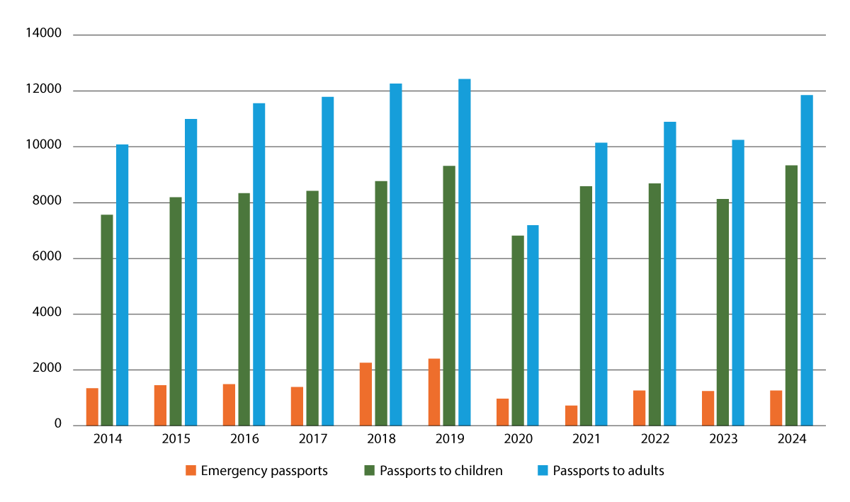
          - Passports issued at missions
The table shows the number of passports issued at Norwegian missions in the period 2014–2024, divided into emergency passports and ordinary passports to children (under 16 years of age) and adults (ordinary passports are valid for ten years from the age of 16).
Source: Police IT unit/Ministry of Foreign Affairs
In recent years, a reform to significantly enhance quality has been implemented in the passport field, and the number of passport offices in Norway has been reduced. To maintain the necessary processing quality and level of expertise, a passport office should, as a general rule, issue at least 4 000 passports annually. This reform has not been introduced for the Norwegian missions abroad. There are currently more passport offices abroad than in Norway, and none of the missions issue as many as 4 000 passports per year. Very few of the Foreign Service’s passport offices handle a high enough volume of cases for staff to gain sufficient practical experience.
Maintaining many small passport offices at various locations abroad poses a number of challenges relating to resource use and the ability to ensure the quality of the services. In light of this, together with the increased complexity of case processing and the pressure to streamline the distribution of the Foreign Service’s resources, the Government believes that the current system is no longer sustainable. The background and challenges to be dealt with are outlined in the Review of the Foreign Service.
It is the Government’s view that Norwegian missions abroad should continue to issue emergency passports. However, it is necessary to reduce the services relating to ordinary passports that have been available to the public. Missions with very few foreign service officers and missions where it is difficult for other reasons to ensure the quality and security of case processing will no longer be authorised to issue ordinary passports. The question of which missions this will involve will be determined after further consideration.
The Government will also consider reducing the number of Norwegian missions in Europe to which applications for passport renewals can be submitted and consolidating this as a service to be provided by specific key missions. It will still be possible for other missions to process first-time applications for a passport. As part of this, consideration will also be given to whether the Embassies in Copenhagen and Stockholm should continue to accept passport applications, given their proximity to Norway. For example, the Swedish Embassy in Oslo no longer offers a service issuing ordinary passports to Swedish citizens in Norway.
The Government will also consider limiting the public’s ability to choose which mission to use when submitting applications for a passport abroad. The current freedom to choose makes it difficult for the missions abroad to predict the amount of passport work or organise it effectively. The missions are only equipped to receive a limited number of visitors, and expanding this capacity will entail significant costs.
In the long term, the Government will look at the possibilities for establishing agreements with external service providers on receiving applications for passport renewal. Such agreements have already been introduced in the UK and the Netherlands, for example. Cooperation with external service providers on passport-related issues has not been investigated so far, but the Norwegian authorities do have a similar agreement in place for receiving visa and residence permit applications. As is the case for these immigration cases, it is the practical tasks associated with the passport renewal application process that will be open to potential outsourcing. This includes collection of biometric data, identity checks (ID control), receipt of supporting documents and delivery of the finished passports. The processing and assessment of the applications will still be carried out at the relevant mission abroad. Outsourcing the system for application submission could be a means of maintaining passport services in places with increasing case volumes and large case portfolios. Otherwise, in order to maintain the passport service in such places, the alternative is to increase the number of posted employees to strengthen capacity, and in some cases this will also require expanding the buildings or leasing larger premises.
In 2024, the Foreign Service issued approximately 9 100 passports to children under the age of 16. These passports have a shorter validity period than adult passports, and the service providing passports to children will therefore need to be assessed separately.

          - Passport work at the missions
In 2024, approximately 19 000 Norwegian nationals submitted applications for passports at one of 80 missions. At most missions, it is the locally employed staff who register the incoming passport applications.
Photo: Embassy in Ankara/Ministry of Foreign Affairs
ID control and first-time applications for a passport
Each year, the Foreign Service processes approximately 3 000 cases involving first-time applications for passports for children born abroad. Unlike children born in Norway, children born abroad are not automatically registered by the Norwegian authorities. Norwegians living abroad are not required to inform the Norwegian authorities of the birth of a child abroad, and they are free to decide whether to apply for a passport for themselves and their children.
Cases involving first-time applications for passports for children born abroad can be particularly challenging, as the starting point always involves a child who has not been entered into any Norwegian registries. The Norwegian authorities then have no confirmed information regarding who the child’s parents are, and whether the child is a Norwegian citizen. These are questions that must be clarified in detail in connection with an application for a passport, and each case contains aspects that are regulated in four different acts of legislation. It is problematic for individuals and the Norwegian authorities alike that the provisions of the Children Act, Norwegian Nationality Act, Passport Act and Population Register Act are not harmonised. In some cases, it is necessary to carry out DNA testing to establish the relationship between a (presumed) parent and a child. This is time-consuming, and it is not unusual for a case to take several months before processing is completed. Furthermore, in certain cases, there may be serious considerations that weigh into the matter, such as considerations related to human trafficking and human rights violations.
In November 2024, the Government decided to appoint an interministerial working group with representatives of the relevant ministries and their subordinate agencies. The working group will take a closer look at the need for any legislative and organisational changes in the framework for clarifying the identity of children born abroad. It will identify inconsistencies and lack of harmonisation in the current legislation with a view to recommending further assessment of the need for amendments. The working group will also recommend further consideration of potential organisational or structural measures to ensure an adequate degree of control and establish more effective processes for establishing the identity of children born abroad. The aim of the recommended measures must be to prevent misuse of legislation and must safeguard the rights of children.
In its assessment of potential structural and organisational measures, the working group may also consider whether it would be beneficial to consolidate responsibility for decision-making relating to first-time applications for passports for children born abroad under a single unit located in Norway. This would facilitate close cooperation between all parties involved, establish a specialist group with expertise on these issues, and ensure equal treatment of applications, which are currently being submitted to and processed by 80 different passport offices abroad. It will also be of interest to identify which services the missions must be able to offer Norwegian citizens abroad on behalf of the Norwegian government administration, and the staffing and expertise that this will require. For example, it would be a good idea to consider the types of cases in which it should still be possible to submit a paternity claim at a mission. The working group will present a report with concrete recommendations by May 2025.
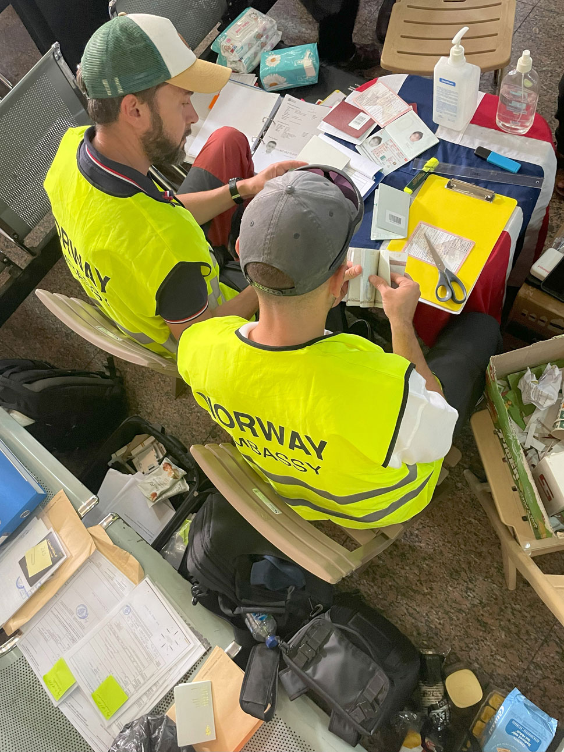
          - Emergency passports for assisted departures
The Embassy in Cairo and one of the Foreign Service’s ID experts at the border crossing from Gaza to Egypt in November 2023. While the surroundings in a crisis situation may look different from an office, emergency passports are still issued according to the rules that apply in other cases.
Photo: Ministry of Foreign Affairs

Surrogacy
Surrogacy is when a woman carries and gives birth to a child for another person or couple who are to be the child’s legal and social parent(s). The Norwegian authorities advise against the use of surrogacy abroad and do not provide assistance with surrogacy processes.
Nevertheless, some Norwegians choose to enter into surrogacy arrangements abroad. The general rules for establishing parentage and citizenship apply to children born through surrogacy as well. Under Norwegian law, it is the woman who gives birth to the child who is the child’s mother. In cases where the surrogate mother is a foreign national, the child’s father must be a Norwegian citizen in order for the child to acquire Norwegian citizenship from birth.
In surrogacy cases the missions only provide assistance with establishing the child’s identity, including paternity, and with processing passport applications in accordance with the general Norwegian rules. One of the challenges faced by the missions is that the authorities in some countries do not enter the surrogate mother’s name on the birth certificate, listing the name of the intended mother instead. Unless it is explicitly stated, it can be difficult for the missions to determine whether surrogacy has been used.
Some parents choose to return to Norway with the child without having been in contact with a mission. This is possible in cases where the child holds a passport from the surrogate mother’s home country and does not need a visa to enter Norway. In such cases the mission will only become involved if it receives a request for assistance from the Office for Children, Youth and Family Affairs (Bufetat) to obtain the surrogate mother’s consent to the child’s adoption. It may be difficult for the mission to make contact with the surrogate mother, both due to language and logistical issues and due to the length of time that has passed since the birth. By the time the adoption application is filed, the surrogate mother may consider the process to be over.
In order to ensure high-quality services and equal treatment in surrogacy cases as well, it would be beneficial for the processing of first-time passport applications for children born abroad to be carried out by a central unit or agency in Norway. This would help to build expertise in identifying surrogacy cases when this has not been disclosed in the case documents.

Adoption
People who are resident in Norway who wish to adopt a child abroad must first apply for prior consent from Bufetat. If prior consent has been obtained, a foreign adoption will as a rule be recognised in Norway and will have the same legal effect as a Norwegian adoption. If at least one of the adoptive parents is a Norwegian citizen, the child will automatically acquire Norwegian citizenship under the provisions of the Norwegian Nationality Act. Registration of the adoption or issuance of a Norwegian adoption order, registration in the National Population Register and allocation of a national identity number to the adopted child are all carried out after the child has moved to Norway. The parents must go to the tax office together with the child and register the child as having moved to Norway.
The missions only deal with a few adoption cases every year. The kind of assistance the families need from the Foreign Service depends on local factors, such as the emigration procedures applicable to the child and whether the child will also retain its original citizenship. In some cases it may be necessary for the mission to issue a Norwegian travel document for the child to be able to enter Norway. If the passport authorities have no clear objections, a temporary passport (emergency passport) without a national identity number may be issued to an adopted child. This is a practical solution generally considered to be acceptable and in line with the strict rules that apply to approved intercountry adoptions.
The missions may also be contacted by Norwegian citizens living abroad who have adopted a child through a domestic adoption process in the current country of residence and want the adoption to be recognised in Norway. Examples include adoption of the children of a non-Norwegian partner. Norwegians living in another country may apply to Bufetat for recognition of adoptions carried out abroad. Not all adoption decisions taken in another country are considered ‘adoptions’ under Norwegian rules.
There have been cases where people resident in Norway have adopted a child through a domestic adoption process in another country without obtaining prior consent from Bufetat. It is possible in such cases to apply to have the adoption recognised in Norway, but these applications are only approved in exceptional cases. There has been a sharp decline in intercountry adoptions to Norway in recent years, and the rules relating to intercountry adoption have been tightened. It is therefore conceivable that there will be a rise in the number of people adopting children through domestic adoption processes in other countries and subsequently trying to have these adoptions recognised in Norway.

Marriage
It is possible for Norwegian citizens to get married at certain missions. This is a consular service that is currently available at 23 of the missions, and some 300 wedding ceremonies are carried out at missions every year. This is a low volume of activity in administrative terms, and most of the marriages are solemnised at missions in Europe.
Norwegian citizens are not entitled to be married at a mission. The solemnisation of marriage has been offered at certain missions for largely historical reasons, and today this is very rarely defined as an essential consular task. A review of the Foreign Service was carried out in 2022. The subsequent report proposed discontinuing the practice of offering solemnisation of marriage at the missions. Some of the missions currently authorised to perform marriage ceremonies for Norwegian citizens would like to continue to do so and are making use of their spare capacity to deliver this service. It is up to each mission to determine how many marriage ceremonies it has the capacity to perform.
Detailed provisions on solemnisation of marriage at missions have over the years been set out in the Instructions for the Foreign Service, which was most recently updated in 2003, and in the separate Regulations of 21 May 2001 relating to the solemnisation of marriage by Norwegian Foreign Service officers (Norwegian only). These regulations have not yet been updated, for example to reflect the fact that the Norwegian Marriage Act was made gender-neutral in 2009. Efforts to amend the regulations are now under way and this work is expected to be completed by the time this white paper is presented to the Storting. In connection with this a recommendation will be put forward to make solemnisation of marriage at missions a service for which a fee is payable, in line with normal practice in Norway.
The rules on who is eligible to be married at a Norwegian mission vary from country to country. The Norwegian authorities require the approval of the authorities of the host country to be able to carry out official acts of this kind. If the authorities of the host country do not allow same-sex marriages, the mission may not solemnise such marriages. In all countries it is a requirement that one of the parties must be a Norwegian citizen and neither party may be a citizen of the host country. A list of the Norwegian missions authorised to solemnise marriages and who can get married where can be found on regjeringen.no (Norwegian only).
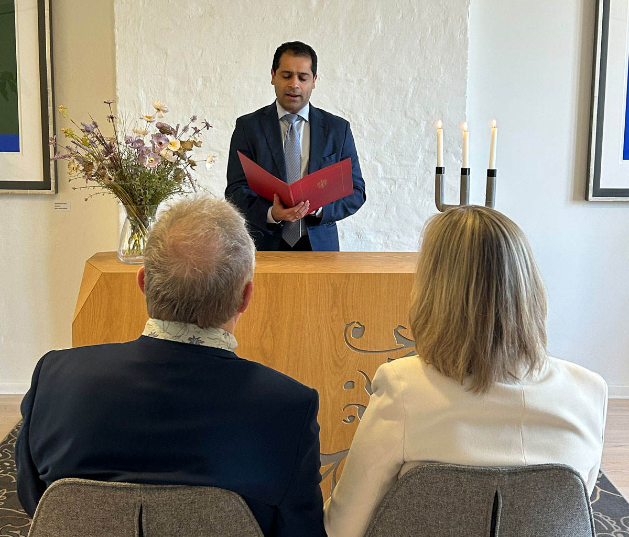
          - Performing a marriage ceremony at a mission
Norwegian Foreign Service employees at 23 missions carry out marriage ceremonies for around 300 couples every year. On 7 March 2025, two couples were married at the Embassy in Copenhagen.
Photo: Norwegian Embassy in Copenhagen / Ministry of Foreign Affairs

Matters related to seafarers and shipping
Norwegian shipping interests abroad are expanding. According to the Norwegian Shipowners’ Association, the Norwegian fleet has grown by approximately 30 % since the last white paper on consular affairs was published. Every day some 1 300 Norwegian-controlled vessels and rigs sail and operate in markets across the world. The Foreign Service cooperates closely with the industry.
Cooperation between the Foreign Service and the shipping industry does not revolve around consular assistance as it is understood today, but is often a combination of, or takes place in the interface between, consular assistance, crisis management, business promotion and general contact between national authorities. Norway’s shipping fleet is a unique emergency response resource that can be called upon when needed by the Foreign Service, especially in connection with evacuation by sea in a crisis situation.
Providing assistance to seafarers and the shipping industry has played a key role in the development of consular services, but today, the number of cases relating to seafarers is declining. In 2024 the Foreign Service registered 521 cases globally, of which 75 % were at the Embassy in Manila. The decrease in the number of cases is partly due to fact that the Norwegian Maritime Authority has modernised and digitalised many of its processes. This is a welcome development which helps reduce resource use at the missions while also enhancing the quality of case processing. One aspect that remains unchanged is that the missions can approve seafarers’ doctors on behalf of the Norwegian Maritime Authority. The Norwegian Shipowners’ Association has called for greater predictability in this area and has recommended further assessment of the approval process, including the role of the Foreign Service. There is a need to update some of the legislation in this area. Together with the Ministry of Trade, Industry and Fisheries, the Ministry of Foreign Affairs will carry out a comprehensive review of the legislation and instructions assigning specific tasks relating to seafarers and shipping to the Foreign Service. The aim is to clarify the legal framework.

Notarial acts and legalisation
Every year, some 4 000 notarial acts are performed at the missions. The missions may, as a rule, carry out the same tasks that a notary public in Norway is authorised to perform. The job of the notary public is to verify facts. The most common types of notarial acts are: certification of a true copy of a document; verification of an original document; verification of signature; and verification of signature and authorisation to sign on behalf of a Norwegian enterprise.
The missions may perform notarial acts on behalf of Norwegian citizens or in cases where the matter is otherwise linked to Norway or Norwegian interests, and an assessment is carried out in each case to determine whether a notarial act may be performed. Documents issued in other countries will not be notarised, for example certified as true copies or original documents. If a Norwegian needs to obtain a notarised copy of their Norwegian passport, the mission may certify that it is a true copy of the original, but if the matter concerns a foreign passport, the individual concerned will be asked to contact the authorities of the issuing country.
Legalisation is a formal procedure, established as common practice, for giving an official document issued by the authorities in one country legal effect in another. Examples of relevant Norwegian documents in this context are birth certificates, certificates of no impediment to marriage/marriage licences, certificates of educational qualifications, and certificates issued by the Brønnøysund Register Centre. Legalisation refers to a certification process, whereby a document is certified by the foreign ministry in the issuing country and then again by the embassy or consulate of the country where the document is to be used.
The Apostille Convention, which Norway is party to, simplifies the legalisation process. A document to which an apostille has been affixed in Norway will be accepted by the authorities of a country that is party to the Convention, without the need for further certification.
As a general rule, under the procedure for carrying out legalisation of documents, this responsibility lies with a country’s foreign ministry. Documents issued by other countries for use in Norway must be legalised by the issuing country’s foreign ministry.
The Ministry of Foreign Affairs legalises approximately 7 000 documents every year. All legalisation of documents is currently carried out by the Ministry in Oslo. Documents may be submitted either by post or delivered in person during the legalisation office’s opening hours (one morning a week). In connection with the Ministry’s move to the new government office complex, an assessment will be carried out of how best to provide these services as of 2026.

Letters rogatory
The Norwegian judicial authorities may request assistance from the authorities of another country in connection with a civil or criminal case. These formal requests for assistance are called ‘letters rogatory’ (or ‘letters of request’) and may be used, for example, in connection with the service of documents, examining witnesses, obtaining DNA samples, and the search and seizure or transmission of documents or other evidence. International judicial cooperation is regulated in a number of international agreements.
Where necessary, the Foreign Service can provide assistance to the judicial authorities in dealing with letters rogatory, and they do so with regard to approximately 550 letters rogatory every year, of which around 350 concern service of process.
The missions’ tasks in connection with letters rogatory largely involve providing assistance with transmitting documents between the Norwegian and foreign judicial authorities. Missions may, however, also be asked to carry out certain more concrete tasks, for example service of process and examination of witnesses.
Most countries permit other states’ consular officers to effect service of process on their fellow citizens in the host country. The way in which service of process is carried out varies from country to country and can involve delivering documents directly to an individual at their home or place of work or requiring the individual concerned to come to the mission. In some countries, service of process may be carried out by post, or with the help of a private delivery service. The Ministry of Foreign Affairs will assess, in consultation with the Ministry of Justice and Public Security, whether it may be possible to make greater use of digital solutions, particularly in cases where the party being served is in another country.
Sometimes the Norwegian judicial authorities ask a mission for assistance with taking witness statements from Norwegian citizens who are abroad. As a general rule, missions may comply with such requests if this is acceptable to the country in question and if the mission is given enough time to plan how to carry this out in practice. Usually this is a matter of providing a suitable venue and a video link and often of checking the identity of the witness. In most cases, a letter rogatory should be sent to the country concerned in advance, as many countries view remote examination of witnesses as an act that requires approval from the relevant national authorities.

Receipt of advance votes
The Foreign Service facilitates advance voting, enabling voters who are abroad to cast their ballots in advance in parliamentary elections to the Storting (Norwegian parliament) and Sámediggi (Sámi parliament) as well as in municipal and county council elections. Traditionally, advance voting has been available at all embassies and consulates general, and at some honorary consulates. Just as in Norway, organising advance voting is a relatively challenging task.
In connection with the 2021 general election, some 7 500 overseas votes were received. In the municipal elections in 2023, some 3 000 overseas votes were received. As part of its preparations for the elections that year, the Foreign Service distributed almost 19 000 physical ballot papers to 282 cities in other countries. A total of 1 180 kg of election materials were dispatched by courier from Oslo to 79 missions. The missions then forwarded some of the materials to honorary consulates where returning officers had been appointed.
No statistics or other data are kept on the number of advance votes received at specific locations abroad, but in 2023, at least 80 % of the official voting materials sent abroad were never used.
Considerable resources are used on sending election materials out to the missions and returning completed ballots to Norway. Under the Election Act, voters who are abroad may vote by post without visiting a mission in person, and they do not need to use official voting materials when doing so. A total of 287 postal votes were received in 2023.
The Government is proposing that in future the missions should no longer be sent election materials but should instead facilitate advance/postal voting by themselves printing out ballot papers and sending postal votes back to the polling stations in Norway. Missions that expect to deal with a large number of advance votes may still order election materials from Norway. Providing information about elections and how to cast ballots from abroad will remain a priority for the missions.

          - Election materials ready to be sent to the missions
A total of 1 180 kg of election materials were distributed to Norwegian missions and consulates in 2023.
Photo: Norwegian Directorate of Elections

Emergency loans
If something unforeseen happens abroad and the individual concerned does not have adequate travel insurance and cannot, for instance, afford to pay for a flight back to Norway, they must, as a rule, seek to obtain the necessary funds themselves or ask for help from family, friends or others. Employers may sometimes be willing to help by for example providing a salary advance payment. Once all other options have been exhausted, the individual may apply to the Foreign Service for an emergency loan. Repayments on these loans are collected by the Norwegian National Collection Agency. Failure to pay off a loan is grounds for the police to consider denying or revoking a passport.
The practice of offering emergency loans is based on a long-standing tradition and is formalised in the Instructions for the Foreign Service. The Ministry of Foreign Affairs has identified a need to further develop and modernise the consular framework, and this includes the emergency loan scheme. At present, the only way to apply for an emergency loan is by completing a paper form that has remained relatively unchanged for around 40 years. In exceptional circumstances, the Ministry may cover certain unexpected expenses in cases where the criteria for receiving an emergency loan have not been met but where it is necessary to provide assistance to protect life and health. Steps will therefore be taken to modernise and professionalise the administration of these schemes.
Emergency loans are also used in connection with assisted departures. While some people may genuinely need a loan, experience shows that the scheme is also used because the Foreign Service does not have systems or tools in place to receive user payments in real time while a crisis is ongoing. It is unfortunate that people who can afford to pay for themselves in practice have to take out a loan from the state. The Ministry of Foreign Affairs will be looking into other ways of receiving payments from the public.
Over the past 10 years, the Foreign Service has sent around 700 cases concerning repayment of emergency loans to the Norwegian National Collection Agency. There was a spike in the number of cases in 2021 and 2023 because of various crises those years. It is estimated that the Foreign Service issues around 30 emergency loans in a ‘normal’ year. There has been a slight upward trend in recent years, unrelated to major crises. The average amount of an emergency loan over the past decade was approximately NOK 9 300. The total amount of the loans issued in the period 2014–2024 was approximately NOK 6 million. According to the Norwegian National Collection Agency, just over NOK 1 million of that sum was still outstanding at the end of 2024.
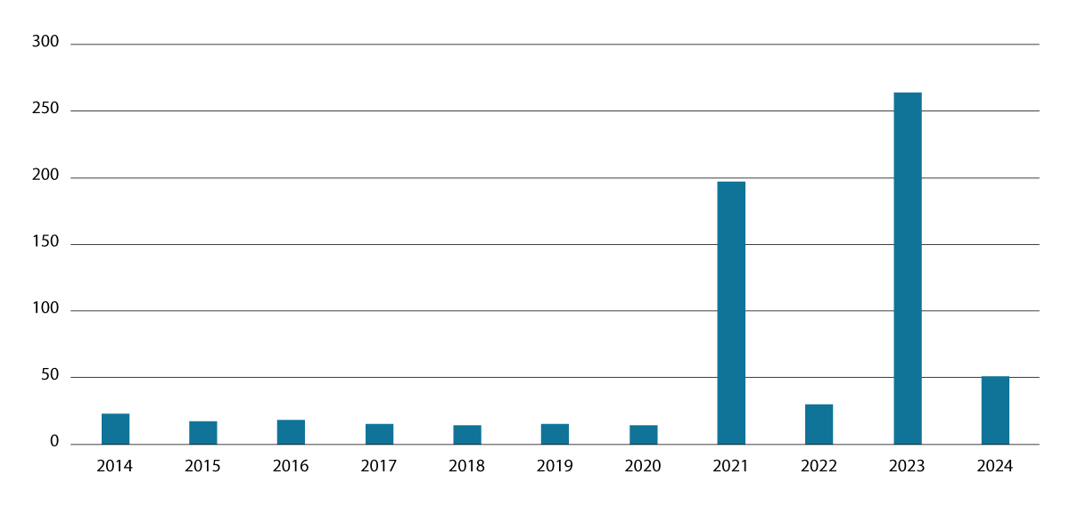
          - Number of emergency loans issued in the past decade
The figure shows the years in which cases concerning emergency loans were sent by the Foreign Service to the Norwegian National Collection Agency. Cases involving loans issued in connection with the COVID-19 pandemic were submitted in 2021. Loans issued in 2023 primarily relate to assisted departures from Israel and Gaza.
Source: Norwegian National Collection Agency/Ministry of Foreign Affairs
The Government considers the emergency loan scheme to be an important safety net that should be retained. It is important that the criteria are reviewed and clarified. This type of scheme should be regulated by law or regulations, and an assessment should be carried out to determine whether it can be managed more effectively. To be prepared for any contingency, it must still be possible to receive and process emergency loan applications manually, but the general rule should be that applications can be submitted digitally.

Help for individuals
The vast majority of trips abroad proceed without any problems. Sometimes people encounter difficulties in other countries that they are able to resolve themselves or with the help of their insurance company, fellow travellers, friends or family. It is one of the key tasks of the Foreign Service to provide assistance to individuals who find themselves in a difficult situation while travelling abroad, and the missions will seek to provide all the help they can within the established framework. However, it is important that individuals take responsibility themselves by preparing well for their trips abroad and ensuring that they have adequate travel insurance coverage.
It must be made clear that the Norwegian welfare state only covers Norwegian territory and that it is the legislation of the country concerned that applies to Norwegians when they are abroad.
              - Overstaying a visa
Many countries impose heavy penalties for violation of immigration regulations. Norwegian citizens who travel to another country are guests of that country and are expected to behave accordingly. Individuals who overstay their allotted time in a country are in essence abusing the host’s hospitality.
Norwegian embassies around the world are seeing an increase in the number of cases where Norwegian citizens are required to pay high fines or go through lengthy administrative processes to rectify a situation in which they have stayed in a foreign country beyond their visa expiration date. There have also been cases where Norwegians have been given long prison sentences because they have been unable to pay their overstay fines. Such actions by local authorities are often intended as a deterrent and may be designed to prevent other foreign nationals from abusing the trust they have been shown when they were granted permission to enter a country and stay as a guest.
[Boks slutt]
This chapter provides a brief description of some of the most common types of consular cases involving serious illness and accidents, loss of life, assistance to minors, arrests, imprisonment and other forms of deprivation of liberty. In these types of cases, the Foreign Service primarily provides assistance by offering advice and guidance on the best ways for an individual to deal with the situation. The Foreign Service may also be able to offer some concrete, practical assistance.
The assistance described in this chapter differs from the consular services described in chapter 3.2 and 5, which are largely regulated under specific legislation. The assistance described in this chapter has no statutory basis.

Reports of concern and missing person reports
Many consular cases begin when a friend or family member contacts the Foreign Service with concerns about the safety or welfare of a Norwegian citizen who is travelling abroad. In most cases, these incidents are resolved relatively quickly, either because the individual concerned turns up or the family and friends themselves manage to establish contact with them. However, sometimes enquiries that begin as a concrete or general concern can bring to light serious or tragic circumstances, for example that the person in question has been imprisoned, has had a serious accident or has died. For this reason, cases involving a report of concern must always be taken seriously and the Foreign Service will seek to provide the most effective assistance or guidance it can in each individual case.
The Foreign Service does not have the ability to trace Norwegian citizens abroad, or to carry out an investigation into what might have happened to someone. Therefore, in many cases the Foreign Service will recommend that the concerned friend or family member contact the Norwegian police in order to report the person as missing. Efforts to trace missing persons can generally only be carried out through international police cooperation.
In some cases, a ‘missing’ person may not wish to talk to friends or family. If the concerns reported appear to be serious, the mission may decide to consult the local authorities, for example, to find out whether they have any information about an incident involving the person in question. In cases where there is a report of immediate danger to life and health, the mission may decide to contact the local police directly to enable them to try to locate the person and carry out a welfare check.

Accidents and illness
While it is easy for people to believe ‘it won’t happen to me,’ both the Foreign Service and the insurance industry know from experience that something happens to someone every single day, and accidents or illness can strike anyone, anywhere in the world.
It is primarily the individuals who choose to travel abroad without travel insurance who end up needing consular assistance in connection with accidents or illness. Their inability to pay for the costs of necessary health services often poses the greatest problem. In some cases, this can be resolved relatively easily. If a person travelling in the EU/EEA countries or Switzerland has left their European Health Insurance Card at home, and a request is submitted during normal Norwegian working hours, Helfo (The Norwegian Health Economics Administration) can quickly issue a temporary card. Other cases can be more difficult to resolve, and on occasion the Foreign Service has been contacted and informed that payment must be received before life-saving treatment can begin. Such situations are very challenging and raise a number of fundamental dilemmas.
The Norwegian state is not an insurance fund for Norwegian citizens who have chosen to travel abroad without adequate and valid travel insurance. The same applies to Norwegians who have emigrated from Norway, and to Norwegian citizens who have never lived in Norway. The Foreign Service does not have the resources to cover hospital expenses incurred by Norwegians abroad. When necessary, it may be possible in some cases for the missions to provide a financial guarantee to cover such expenses provided the patient, a relative or other person has deposited sufficient funds with the Ministry of Foreign Affairs beforehand.
If there is no one who can, or is willing, to provide a guarantee for such expenses, a mission may in certain cases grant the person concerned an emergency loan. For more information, see chapter 5.7.
Some individuals contact the Foreign Service because they need advice on where to get necessary medical treatment. While the missions can sometimes provide information on potential doctors and hospitals, it is never possible for them to guarantee the quality of these health care services. Travel insurance companies generally have their own lists of doctors or hospitals they recommend and can advise their clients on where to go and how to deal with questions about payment for health services.
Responsibility for initiating search and rescue operations in connection with accidents or natural disasters lies with the authorities of the country concerned. The Foreign Service does not play any role in search and rescue operations abroad, nor can it decide to initiate such operations, but it can provide information. The priorities set by the authorities in another country may differ from those many Norwegians would consider to be reasonable and prudent. This may be due to different traditions, different ways of organising rescue operations or differences in terms of available resources. It is important that Norwegians are aware that any expenses incurred in connection with search and rescue operations abroad are not covered by ordinary travel insurance.
              - The impacts of the climate crisis and overtourism
Embassies along the Mediterranean coast are seeing that forest fire seasons are now lasting for several months, and there is an increasing risk of severe flooding and contamination of drinking water, among other things. These developments, combined with growing tourist flows and heightened pressure on basic national infrastructure such as rescue services and health care, are expected to lead to an upsurge in the types of difficult situations that Norwegians may encounter on their summer holidays.
The local authorities attach importance to allocating their resources to the most important issues, and to protecting life and health. Many travel agencies have good emergency response plans and have measures in place to ensure that their clients have a place to sleep if a hotel is threatened by fires. Individuals who have purchased travel insurance may also receive helpful assistance from their insurance company. Norwegian citizens should not expect the Norwegian authorities to provide water bottles, extra clothes or first aid wherever they travel.
[Boks slutt]

Mental illness
Many Norwegians live with psychological problems and mental health issues. Most people with such health challenges cope well when on holiday abroad. However, the Foreign Service increasingly needs to provide assistance to Norwegian citizens who suffer serious mental illness while abroad.
Norwegian missions abroad and the Foreign Service Response Centre at the Ministry of Foreign Affairs occasionally receive calls from Norwegians abroad who are having suicidal thoughts. Efforts have been underway for some time to provide employees in the Foreign Service’s first-line services with basic training in dealing with these difficult conversations. If there is deemed to be an immediate threat to life and health, the authorities in the country in question may be asked to carry out a welfare check. The Foreign Service also cooperates with relevant helplines in Norway.
People suffering from serious mental illness are often especially vulnerable and can be difficult to help. The Foreign Service cannot implement measures on behalf of someone who does not wish to receive consular assistance, and some individuals find it hard to ask for help. In situations involving acute mental health problems abroad, even those who want to seek appropriate mental health care may have difficulty in obtaining it. The standard of mental health care services in many countries is very poor and in some cases essentially non-existent. Unfortunately, there are situations in which people who are urgently in need of mental health care are arrested instead of receiving health care. There have been cases where the Foreign Service helped to convey information regarding an individual’s mental health history from a Norwegian health institution to the local authorities in order to ensure that this is given due consideration when determining further criminal proceedings.

Scheme for assisting and repatriating people with serious mental illness
Most insurance policies contain provisions stating that the coverage does not extend to pre-existing medical conditions that are registered or under treatment before departure from Norway. As patients with serious mental illness often do not have travel insurance, the Norwegian authorities provide special assistance to this patient group.
The Ministry of Health and Care Services has established a grant scheme for assisting and repatriating Norwegians suffering from serious mental illness while abroad. The scheme provides funding to cover expenses relating both to the transport of foreign nationals with serious mental illness from Norway to their home country, and to the transport of Norwegian citizens with serious mental illness back to Norway from abroad. The Norwegian Directorate of Health is responsible for administering the scheme, and the responsibility for taking decisions on funding in individual cases has been delegated to the offices of the county governors.
The Foreign Service cooperates with Norwegian health trusts on cases involving Norwegian citizens with serious mental illness abroad. An assessment of whether a person should be transported back to Norway is carried out by medical personnel, and repatriation is conditional on the consent of the person concerned. In recent years funding under the scheme has been used to repatriate between 15 and 30 individuals with severe mental illness to Norway each year. The grant scheme was established in the 1990s, and the Government will take steps to initiate a review of its framework.
People suffering from a serious mental illness who are unable to take care of themselves abroad may be denied a passport or have their passport revoked when they return to Norway. It is therefore standard practice for the Foreign Service to inform the police about individuals who have been transported back to Norway with the help of funding under this scheme, as this will better enable the police to determine whether the individual concerned fulfils the necessary requirements for having a passport.

Deaths
The Foreign Service deals with between 1 200 and 1 400 cases involving deaths abroad each year. This figure has doubled since the previous white paper on consular affairs was published. The increase may reflect the overall rise in the number of Norwegian citizens travelling abroad at any given time.
Notification of next of kin
All countries that are party to the Vienna Convention on Consular Relations of 1963 are obliged to ‘inform without delay’ the consular post of the sending state when a citizen of that state dies. However, notification procedures are not always automatic, and the length of time it takes before the Norwegian authorities are notified of deaths abroad can vary. This is particularly the case for persons with dual citizenship who die in their other home country. The Foreign Service is therefore frequently first informed of a death by the next of kin.
In situations where the next of kin are unaware that a family member has died abroad, the Foreign Service will obtain confirmed information from the local authorities and pass this on to the Norwegian police, who will then notify the next of kin in Norway in accordance with the standard procedures for notification of deaths in Norway.
It is crucial that the process of notifying the next of kin does not start until the identity of the deceased has been established and confirmed in writing by the local authorities, which are usually the local police or health service. In some cases, it may take some time before the mission receives the substantiated information needed to begin the notification process. While it is important that the next of kin are notified as soon as possible, there must not be the slightest doubt about the identity of the deceased when the mission requests that the next of kin are to be informed. In the interim, the next of kin may have been informed of the death through other channels. This may create a difficult situation for the persons involved, but the ramifications of an incorrect notification of a death can be very distressing.
Notification of death form
When a Norwegian citizen dies abroad, it is necessary to send a ‘Notification of death’ form to the National Population Register to ensure that the death is registered by the relevant Norwegian authorities.
The authorities in the country in which the death occurred are responsible for issuing an official death certificate. The procedure for issuing death certificates varies from country to country, but the certificate is normally a physical document that may also contain security features to prevent forgery or other forms of misuse. The time it takes to issue such death certificates and the method of delivery to the Foreign Service may also vary. In many cases, it is the next of kin who are the main recipient of the death certificate.
At present, once an official death certificate has been issued by the local authorities, a ‘Notification of death’ form is sent as a physical document from the mission to the National Population Register. The Ministry of Foreign Affairs seeks to modernise and simplify this procedure, and will work together with the Ministry of Finance to assess the potential for digitalisation of this process.
Advice and guidance for the next of kin
After they have received news of the death of a family member, many next of kin contact the Foreign Service. The missions can provide them with some advice and guidance on steps to take in the given situation.
If the deceased had travel insurance, the mission may help the next of kin to establish contact with the deceased’s insurance company, which will arrange for transport of the coffin or urn and deal with various other practical tasks. If the deceased did not have travel insurance, the mission may among other things help the next of kin to find a local funeral director or provide assistance with transferring money.
Sometimes, there is no next of kin who want to arrange or can afford to pay for repatriation of the deceased or a funeral in the country in question. In these cases, the deceased will be buried locally at the country’s expense in accordance with local legislation and practice.
The Foreign Service does not cover any expenses related to transport or funerals, and it does not provide assistance in dealing with the deceased’s belongings or issues concerning inheritance. Any assistance will usually be confined to advising the next of kin on who they should consult. The settlement of an estate after a death abroad can be a complex matter, and the individuals involved will normally need legal assistance. The missions abroad keep lists of local lawyers who can be consulted.

          - Foreign Service Response Centre (UDops)
The Foreign Service Response Centre in Oslo receives around 16 000 calls every year from Norwegians abroad.
Photo: Ministry of Foreign Affairs

The Foreign Service’s role in serious criminal cases
Norwegian citizens are occasionally subject to serious crimes abroad, including gross violence, rape and murder. It is always the authorities in the country where the incident took place who are responsible for investigating and, where appropriate, prosecuting the offence.
The Foreign Service can provide advice and guidance to Norwegians affected by serious crime abroad. Individual needs for assistance vary considerably depending on the type of crime, and where in the world and how long ago the offence was committed. The assistance that can be provided primarily involves establishing contact with, for example, family members, the local police, local courts and lawyers, and potentially also the local health service and other support services. If the Norwegian police are involved in the case, the mission may also provide assistance with establishing contact between the Norwegian police and the police authorities in the country concerned. This is particularly relevant in cases where the Norwegian police are in contact with the family in Norway or are offering assistance and information to the foreign police authorities investigating the case.
Individuals who are subject to gross violence or rape often need follow-up from the health services, and they often wish to return to Norway as quickly as possible. Victims who are young adults and have valid insurance coverage may find that their insurance company is able to help to cover the costs of a parent travelling abroad to support them, or help to arrange their return journey and/or psychological support. There are considerable differences between legal procedures in different countries and between the seriousness with which various crimes are viewed. This applies in particular to cases involving sexual abuse and rape, where contact with the police and the legal system may be very difficult for both female and male victims. Views also differ about the legal status of victims, and this is why some victims choose not to report or pursue the matter, even though they would have done so if they had been in Norway.
Cases involving Norwegian citizens killed abroad are always very difficult for the victim’s family. The consular assistance offered by the Foreign Service in such cases is generally the same as in other cases involving deaths abroad, but it usually also involves helping to establish contact between the next of kin and the local police and a lawyer. In some cases, the Norwegian and foreign police authorities may also cooperate on the case through international police channels. In cases where a person has been killed, it may take some time before the body of the deceased is released so that the next of kin or the deceased’s insurance company can arrange for the coffin to be transported to Norway.
There have been several cases where the presumed perpetrator has evaded prosecution by travelling to a third country or back to their home country after committing a crime. This makes the police’s work more difficult. It is up to the police in the country where the incident took place to decide whether to issue an arrest warrant for the perpetrator and request to have them extradited from the country in which they are staying. The Foreign Service plays no role in the work of the prosecuting authorities in other countries or in any dialogue between two other countries concerning extraditions.

Assistance to minors
Every day the Foreign Service deals with cases involving children and young people who find themselves in a difficult situation abroad. These cases are given high priority, and the Foreign Service makes every effort to provide assistance, as children and young people can be particularly vulnerable when they are abroad.
At the same time, it is important to state openly that it may be difficult for the Foreign Service to help minors abroad and that it is not always possible to resolve or help resolve a case in the way we should wish. It is also important to make it clear that the Foreign Service is not responsible for Norwegian children who are in another country. It is the country in which the child is staying that is responsible for safeguarding the child’s rights under the Convention on the Rights of the Child.
In Norway, children have strong legal protection, and support services such as child welfare services, family counselling, education and health care are well developed. Other countries may not have similar support structures in place. It is also the case that practices that are illegal in Norway may be legal in other countries.
It is the duty and responsibility of parents to make decisions on behalf of their children, and it is the individuals with parental responsibility for a child who decide where the child should live and how it should be raised. This also applies in cases where the living conditions in the foreign country where the child lives differ from those in Norway. In cases where there is joint parental responsibility, both parents must agree before their child can move from Norway to another country or be taken on a longer trip abroad. Children have the right to be heard, and the parents have a duty to give weight to the child’s opinions in accordance with the age and maturity of the child.

Child welfare services
Children sometimes suffer as a result of decisions taken by their parents or because of unforeseen events. Missions in countries that are popular tourist destinations for Norwegians regularly experience situations where Norwegian children are abandoned for short periods of time as a result of their parents’ alcohol or substance abuse or mental health problems. These children are particularly vulnerable because they often do not speak the local language and do not have any other family nearby. Children with ties to more than one country may be vulnerable as well. Today, more and more families have ties to more than one country, and this has led to a growing number of international parental disputes and child welfare cases that are difficult for the Norwegian authorities to deal with.
The Foreign Service cannot intervene directly to protect or care for Norwegian children abroad. This can only be done by the child welfare authorities in the country concerned. If there are no such official institutions locally, there may still be local voluntary organisations that can take on this role. Cases like this can often be resolved by grandparents or other family members in Norway agreeing to travel abroad to help bring the child back to Norway.
The Foreign Service can play a coordinating role, and will submit a report of concern to the Norwegian child welfare services in cases where there is a duty to so under the Child Welfare Act.
Norway has ratified the 1996 Hague Convention. This has strengthened cooperation with other countries that are party to the Convention on dealing with cross-border parental disputes and child welfare cases. The Norwegian Directorate for Children, Youth and Family Affairs (Bufdir) is Norway’s central authority for the Convention. The transmission of information under the Convention, including reports of concern, takes place directly between the designated central authorities of the various countries.
If there is a need to convey concerns relating to a child welfare case between Norway and a country that is not party to the Convention, this can be done via the Foreign Service.

Child abduction
Cases involving international child abductions are very challenging. The type of assistance the Norwegian authorities can offer in these cases depends both on the country the child has been abducted to and the country the child has been abducted from. The information provided in this white paper primarily relates to cases involving child abductions from Norway.
International child abduction is a criminal offence under Norwegian law. It includes cases where a child is unlawfully removed from the country in contravention of the parental responsibility of the other parent and cases where a child is unlawfully retained following a lawful stay abroad, for example for a holiday or access stay. It also includes cases where a child who is under a care order issued by the Child Welfare Tribunal is taken out of the country without the consent of the child welfare services.
Many of the cases the Foreign Service deals with concern transnational families where at least one parent is a foreign national or a Norwegian citizen originally from a country other than Norway. Most of the abducted children in these cases are also dual citizens. Family law varies from country to country, and the legislation in the country concerned may not confer equal status on women and men in child abduction cases. Cases in which a man abducts a child to his other home country where the legal status of women is weak may also share similarities with cases involving negative social control and honour-motivated violence, as described in chapter 6.7.
Abducting a child from Norway is a criminal offence, and the left-behind parent may report the matter to the police. The police can issue an international alert for the abductor and the missing child, which can help locate them and lead to the arrest of the abductor if, for example, they cross an international border. When the police receive a report of a child abduction, they must also notify NAV (the Norwegian Labour and welfare Administration) to discontinue the payment of benefits and child allowance. Imposing economic sanctions on the abductor can sometimes encourage the abductor to cooperate in arranging the return of the child, but this is not always the case. Some child abduction cases remain unresolved until the child comes of age and can decide for themselves where they want to live.
Norway has ratified the 1980 Hague Convention. If a child has been abducted from Norway to another contracting state, individual assistance will be given by the Norwegian Directorate for Children, Youth and Family Affairs (Bufdir), Norway’s central authority for the Convention.
If a child has been abducted from Norway to a country that is not party to the international conventions on child abduction, there are no intergovernmental instruments in place that can be used to secure the return of the child to Norway. In practice, the only assistance the Norwegian authorities can offer in such cases is confined to providing information, guidance and advice to the left-behind parent. This is the responsibility of the Ministry of Foreign Affairs. At the start of an international child abduction case, the Ministry will invite the left-behind parent to an initial meeting in order to offer guidance and advice on the various options available.
Webpages on international child abduction are available on the government website, and the Government will update these webpages as necessary and make them available in additional languages.

Negative social control and honour-motivated violence
The term ‘negative social control’ is used to describe situations where someone uses pressure, threats or coercion to restrict another person’s life choices or prevent them from making independent decisions about their own life. Forced marriage, situations where an individual is forced to stay abroad against their will and various forms of abuse are also types of negative social control. Combating negative social control and honour-motivated violence is one of four main objectives of the Government’s integration policy. Prevention is key in this context, as is following up the individuals affected and taking steps to prosecute those responsible when possible. Efforts in this area primarily take place in Norway, and the Ministry of Labour and Social Inclusion has overall responsibility for coordinating this work. More details will be presented in a new action plan against negative social control and honour-motivated violence to be presented in spring 2025.
The Ministry of Foreign Affairs takes part in these efforts together with various other ministries and directorates. For a more detailed presentation and discussion, see NOU 2024: 13 Lov og frihet (Law and freedom, Official Norwegian Reports, Norwegian only). This white paper provides a general description of the framework for the consular assistance that can be provided in cases involving these issues.

Consular assistance to at-risk individuals
Every year the Foreign Service assists around 250 individuals who have been subject to or are at risk of negative social control or honour-motivated violence abroad. The Foreign Service gives high priority to dealing with these cases when they arise. Combating negative social control and honour-motivated violence is a key objective of the Government’s integration policy, and special representatives on integration issues have been posted at the Embassies in Amman, Ankara, Islamabad and Nairobi as extra resources for dealing with cases involving negative social control and honour-motivated violence. These special representatives are appointed by the Norwegian Directorate of Integration and Diversity (IMDi) and also help to promote prevention by carrying out competence-building activities abroad.

          - Special representatives on integration issues
In addition to specific work with consular cases involving individuals who have been subject to or are at risk of negative social control or honour-motivated violence, the special representatives on integration issues carry out competence-building activities.
Photo: Embassy in Nairobi / Ministry of Foreign Affairs
Almost all of the cases relating to negative social control and honour-motivated violence that the Foreign Service deals with involve transnational families. Most of these families are affiliated with a country in the Middle East, East Africa or South Asia. A large number of those who are at risk also have dual citizenship. The security situation in many of the areas where cases involving negative social control occur is challenging, and Norway often only has a limited consular presence there.
Limited scope of action in cases involving negative social control and honour- motivated violence
In these cases as well, individuals may have unrealistic expectations about what the Foreign Service can do to help. It is therefore important to make it clear that cases of this type cannot always be resolved.
Norwegian legislation does not apply abroad, and all individuals must respect the applicable laws of the country they are in. The local authorities are responsible for ensuring the safety of people within their national borders and only they have the right to employ forcible means on their own territory. Once an individual has been taken abroad, it may be too late to prevent them from being subject to negative social control or honour-motivated violence, such as forced marriage and female genital mutilation, or to curb the ramifications of it.
If the Norwegian authorities are concerned about an individual who is abroad, they may decide to ask the local authorities to carry out a welfare check to find out how the person is doing and implement any necessary protective measures.
Only the authorities of the country in which the person is staying are permitted to intervene directly in these situations. If the Norwegian authorities believe that an individual’s life and health are at risk and that concrete action is called for to prevent harm, they must rely on the host country’s authorities to carry out the necessary measures. The Foreign Service can alert the local authorities to a situation but does not have the authority, expertise or practical ability to prevent individuals from becoming victims of crime, human rights violations or other forms of abuse while abroad.
Cases involving negative social control and honour-motivated violence often encompass actions that are illegal under Norwegian law but are not necessarily considered a criminal offence or otherwise unacceptable in the country in which the person is staying. These are especially challenging cases, as Norwegian rules and values are rooted in a very different reality that may not reflect the situation viewed from the other country’s perspective.
It is often difficult for individuals who are subject to negative social control and honour-based violence to help themselves. Both their immediate and extended family may be the inherent cause of their situation. Consular assistance in these cases, like many others, primarily consists of offering advice and guidance. When possible, the Foreign Service can also help to facilitate transport to Norway, for example by issuing passports. Often, the greatest challenge is that the individuals at risk have been deprived of their freedom of movement by the parent, spouse or other member of the extended family who wants them to remain in the country abroad.
Negative social control inflicted abroad can also extend to limiting the individual’s ties to Norway. For individuals who are not Norwegian citizens, this may for example entail preventing them from renewing their settlement permits. Cases of this type can involve adults, often the spouses of Norwegian citizens, as well as children. The consular assistance provided to this group often shares an interface with matters relating to immigration. Foreign Service officers working directly with consular matters at the missions (such as the special representatives on integration issues) frequently cooperate closely with employees of other agencies working on immigration matters. In Norway, the Expert Team against negative social control and honour-based violence at the Directorate for Children, Youth and Family Affairs (Bufdir) includes representatives of the Directorate of Immigration (UDI) to help to coordinate these efforts.
Cases where the Foreign Service is able to provide consular assistance to minors on their own generally involve young people who are old enough to ask for help themselves. In some of these cases, considerations relating to the child’s life and health may make it necessary to provide assistance without informing the parents that the child has sought help, and sometimes at odds with the parents’ decision on where the child is to live. These are highly complex cases that involve a number of serious implications and dilemmas.

Scheme to cover travel expenses
A special scheme has been established to cover travel expenses for individuals who have been subject to or are at risk of negative social control, forced marriage or female genital mutilation. This reimbursement scheme has been in place for many years. The scope and objectives of the scheme have been adjusted in various phases, and a more detailed presentation of the scheme is provided in NOU 2024: 13 Lov og frihet. The scheme is administered by the Expert Team at Bufdir. Travel expenses covered under the scheme are granted on the basis of assessment by the Expert Team.
Both the conclusions of Official Norwegian Reports 2024:13 and issues emerging in connection with individual cases have highlighted areas where the scheme’s objectives need to be clarified and regulated, and the Ministry of Labour and Social Inclusion has initiated an interministerial process to revise the rules and framework.

Criminal prosecutions abroad
Sometimes, Norwegians are detained or imprisoned abroad. The Foreign Service estimates that there are more than 100 Norwegian citizens in custody abroad or in some other way deprived of their freedom of movement by the local authorities at all times.
As stated in chapter 3.4, everyone has a duty to comply with the legislation that applies in the country they are in. Individuals who violate the law in the country they have chosen to travel to must expect to be arrested and prosecuted in that country.
The key advice the Foreign Service gives people who have been arrested, imprisoned or subject to some form of prosecution abroad is to engage a local lawyer.

Apprehension, arrest or detention
When a Norwegian citizen is arrested or otherwise detained in another country, the police in that country are to inform the person that they have the right to request consular assistance. If the person concerned would like assistance, the police are to notify a Norwegian mission of the arrest.
The way this works in practice varies from country to country. The length of time it takes before the Foreign Service is notified that a Norwegian citizen has been arrested and is requesting consular assistance may also vary. Under the provisions of Article 36 of the Vienna Convention on Consular Relations, the Foreign Service is to be informed ‘without delay’, but it is common for this to take a few days. The Foreign Service is therefore frequently first informed of an arrest by the family or friends of the person concerned.
The missions give high priority to visiting Norwegian citizens as quickly as possible after they have been arrested. The possibilities for visiting prisons and how quickly an initial visit can be made will vary from case to case. It has become more common to offer preliminary support digitally or over the phone.
The Foreign Service does not assess the substance of the case in question or take a position on the question of guilt. The Norwegian authorities are not a party in cases involving Norwegian citizens abroad and cannot represent them in a foreign court of law.

Prosecution and due process
Legal systems and legal safeguards differ widely from country to country. Norwegian citizens who are subject to criminal prosecution or other legal proceedings abroad cannot expect the legal processes to be the same as in Norway. It is the responsibility of the authorities of the country in which the legal proceedings take place to ensure that fundamental legal safeguards are upheld.
The Norwegian authorities set clear limits to the right of foreign states to intervene in legal proceedings before Norwegian courts. Likewise, they show great caution about going into the legal aspects of cases that are being prosecuted before foreign courts. However, the Norwegian authorities may become more actively engaged in cases where Norwegian citizens are involved and the criminal process is obviously unsatisfactory, there is gross differential treatment, or human rights are being violated. In special cases this may include initiating a dialogue at a political level, but the key, most common way of addressing problems is for the Norwegian citizen’s lawyer to raise the matter before a local court according to the rules that apply under local law.
All Norwegian citizens who are arrested or imprisoned or in some other way involved in court proceedings abroad will need legal assistance. The missions keep lists of relevant local lawyers who can be consulted in the host country and in any other countries for which the mission is responsible, and can make these available to Norwegian citizens who need help to find a lawyer. The lists do not represent any recommendation of specific lawyers by the Norwegian authorities.
Legal assistance can be very expensive. In some cases the authorities of the host country will appoint a lawyer and cover legal expenses. This will vary from country to country and may depend on the type of case in question. The Foreign Service does not cover any expenses relating to legal assistance for Norwegian citizens detained or imprisoned abroad.
It is possible to seek financial support to cover legal expenses abroad. Applications for free legal aid for cases abroad are processed by the Office of the County Governor, which may grant free legal aid under certain exemption provisions and when special grounds apply. The Foreign Service can provide assistance in forwarding applications to the Office of the Country Governor and, in certain cases in helping to disburse any allocated funds.
Norwegian citizens imprisoned abroad often wish to engage a lawyer in Norway to assist them as well. Norwegian lawyers are rarely authorised or licensed to represent their clients in other countries’ courts, and may have limited knowledge of the local legal system. In these cases the lawyers maintain a direct dialogue with one another.
In certain cases, the Foreign Service may decide to attend a Norwegian citizen’s trial abroad as an observer. This is only done in exceptional cases where there are grave concerns about the individual’s fundamental rights or their life and health. The purpose is to signal the Norwegian authorities’ interest in the case, but the Foreign Service may not intervene in the case or seek to influence the court proceedings. Generally, the Foreign Service makes an effort to observe court cases involving the death penalty as a potential outcome. The Foreign Service does not have an automatic right to participate as an observer at court proceedings abroad, and may need to obtain permission from the local authorities or the local court. Considerations relating to resource use and the need to ensure the safety and security of employees can limit the frequency and degree to which the Foreign Service is able to observe court cases abroad.

Prison visits and prison conditions
Visiting a Norwegian citizen who has been detained or imprisoned abroad is an important consular task.
The purpose of prison visits is to establish and maintain dialogue with the prisoner and with relevant contact persons at the prison. When appropriate, and in consultation with the prisoner or the prisoner’s lawyer, the mission may in some cases choose to meet with the prison authorities to relay claims on behalf of the prisoner about e.g. mistreatment, discrimination or inadequate health-related follow-up. In such cases it is important to make it clear to the authorities of the country in question that it is their responsibility to ensure the health and safety of prisoners.
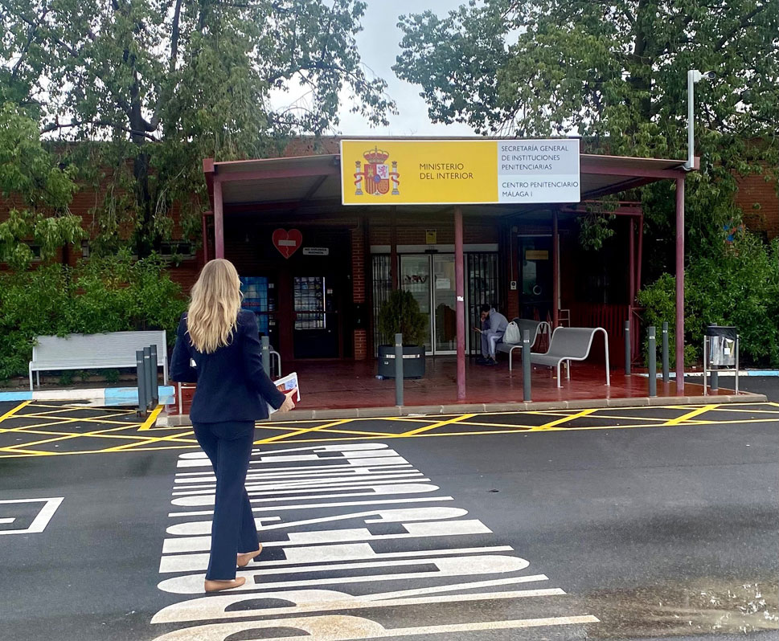
          - Prison visits
Foreign Service officers or honorary consuls may visit Norwegians imprisoned abroad.
Photo: Norwegian Embassy in Madrid/Ministry of Foreign Affairs
If a person is in custody for a long period or has been committed to prison, the mission will follow up the prisoner on a regular basis. When it is practicable and responsible in terms of safety and security, the mission will usually try to organise at least one prison visit per year. The frequency of visits may vary from case to case, and in very serious cases the mission may consider it necessary to visit the prisoner more frequently. This is to be clarified in a dialogue between the mission and the Ministry. The decision to pay more frequent visits often reflects grave concerns regarding a prisoner’s health and safety. Thus the allocation of Foreign Service resources in this area will generally be based on sensitive personal information that is subject to a duty of confidentiality.
People not associated with the Foreign Service may also wish to visit Norwegians imprisoned abroad. These are often friends, family members or representatives of NGOs. The Norwegian Church Abroad (Sjømannskirken), for example, offers prison visits as an important part of its outreach activities for Norwegians in foreign countries, and many prisoners greatly value these visits. The Foreign Service informs prisoners of the services available and can pass along requests for visits.
Conditions in foreign prisons are often very different from Norwegian standards. People held in pre-trial custody or serving a sentence in another country cannot expect standards that are higher than the general prison standards in the country in question. Many prisons have complaints mechanisms in place for prisoners who wish to raise their concerns about prison conditions. In especially serious cases, the Foreign Service will relay a prisoner’s concerns to the prison authorities, who will always have responsibility for ensuring the health and safety of prisoners.
In most countries, prisoners have access to a nutritious diet and hygienic sanitary facilities, and inmates can often purchase items and services that make their situation easier. In some cases, friends or family members in Norway can transfer money directly to an inmate’s ‘prison account’ or provide funds another way. If necessary, the Foreign Service may provide assistance in transferring funds.

Death penalty and other unacceptable penal sanctions
Sometimes Norwegian citizens are being prosecuted in countries that practise the death penalty or use other unacceptable penalties, such as flogging or other forms of corporal punishment.
The Norwegian authorities are actively engaged in international efforts to abolish the death penalty. Cases where a Norwegian citizen has been or is in danger of being sentenced to death are followed up closely and given high priority, and the Norwegian authorities will always request that the sentence is not carried out in such cases. When necessary, it is normal practice to raise the matter at a high political level.

Transfers of sentenced persons
After all local legal proceedings have been completed and a final judgment has been passed in a foreign court, the prisoner may apply to Norwegian or foreign judicial authorities for transfer to Norway to serve part or all of the sentence. Applications for transfers may be submitted via a mission abroad and will be processed by the Norwegian Correctional Service, or in certain cases by the Ministry of Justice and Public Security.

Especially complex consular cases
Every year the Foreign Service deals with a small number of cases that are particularly complex and require a different level of focus than typical types of consular cases. The following provides a brief overview of some of the complex consular problems that Norway and other countries’ foreign services may encounter. Since these types of cases are very rare, the cases described here do not necessarily involve Norwegian citizens specifically. They are presented here to demonstrate the complexity of these issues and the potential problems that may arise.

Disappearances and arbitrary detentions
As described in chapter 6.1 on reports of concern and missing person reports, family members or friends in Norway sometimes lose contact with a person travelling abroad. In a few of these cases, there may be reason to suspect that the individual has been ‘taken’ by a state actor. If the state in question denies any knowledge of the case, it may be because the local authorities genuinely not have any information about the individual, or it may be a case of an enforced disappearance.
Enforced disappearance is a blatant violation of human rights, and the missing person usually has no form of legal protection. Cases involving such disappearances are very difficult, and the Foreign Service has few or no means at its disposal to determine what has actually transpired. The only way to find answers is if the local authorities investigate the matter, and they are unlikely to do so if they are behind the disappearance. The Foreign Service often advises the next of kin to report the disappearance to the Norwegian police, and will follow the matter up at regular intervals with the local authorities.
Arbitrary detentions
In recent years the foreign services of other countries have dealt with a number of cases involving arbitrary arrests or detentions where a country’s authorities have ostensibly detained foreign citizens for the purpose of exerting political pressure. This phenomenon is sometimes referred to as hostage diplomacy.
Norway has endorsed the Declaration Against Arbitrary Detention in State-to-State Relations launched by Canada in 2021. International cooperation on preventing and responding to such incidents is important. At the same time, it is crucial to carefully consider when to define a case as anything beyond the ordinary exercise of authority. The politicisation of an individual case does not necessarily make it easier to deal with or serve the interests of the arrested person. It is therefore advisable to use caution in all discussion involving such cases.

Kidnappings abroad
Sometimes a Norwegian citizen is kidnapped abroad. Kidnapping is a criminal act committed by groups or individuals for political or criminal purposes and in pursuit of a specific aim. Hostage-takers usually demand a ransom, but may issue demands for political or other concessions from the authorities of Norway or other countries.
Internationally, there have been several high-profile examples of individuals who have been abducted while abroad. Some cases are resolved or closed relatively quickly, whereas others may be ongoing over several years. Unfortunately, the person who has been kidnapped is sometimes killed, either by the hostage-takers or in connection with the measures implemented by the local authorities to resolve the situation. For Norway’s part, the most serious case in recent years was the 2015 murder of a Norwegian citizen kidnapped by the terror organisation ISIL.
The Ministry of Foreign Affairs maintains close, constructive cooperation with other parts of the government administration in connection with cases where Norwegian citizens have been kidnapped abroad. Although these cases generally involve a single individual, the assistance efforts are often dealt with by establishing a separate crisis management team. Kidnapping cases need to be kept confidential, and good routines for communication are essential. There is often an immediate danger to an individual’s life and health, and there have been instances where the Norwegian media have been aware of a kidnapping abroad, but have chosen not to publish the story out of consideration for the individual involved.
Norway does not pay ransom money. This is an important principle and will be maintained in all dealings with terrorists and other criminals, both because payment of any ransoms would increase the risk of other Norwegians being taken hostage and because the Norwegian authorities do not wish to support the financing of criminal and terrorist activities.
              - Foreign terrorist fighters – an example of multiple consular issues
During the 2010s a number of Norwegians travelled to conflict areas in the Middle East. Several of them chose to join a terrorist organisation involved in the civil war in Syria. The situation in the region was serious and unpredictable. Individuals who travel or settle abroad implicitly accept the risks that entails, and individuals who stay in an area for which the Norwegian authorities have issued a travel warning are placing themselves at heightened risk. This includes the risk that the Foreign Service may have little or no ability to assist them if something happens. This was very much the case in the territory controlled by the terrorist organisation ISIL.
After ISIL was defeated in territorial terms in 2019, a small number of Norwegian women and their children were interned in camps in northeastern Syria. As the security situation stabilised, it became possible to offer consular assistance to those living in the camps. A total of 14 individuals, including 6 orphaned children, received consular assistance enabling them to travel to Norway.
Asking for and accepting any offers of consular assistance is voluntary. In these particular cases, none of the adult women chose to seek consular assistance from the Norwegian authorities for a long period. This is every individual’s prerogative. Parents with parental responsibility have the right and the duty to make decisions for their children, and if the parents do not wish to receive consular assistance, there is generally very little that the Norwegian authorities can do. The Foreign Service does not have the competence or authority to take children away from their parents or to decide that the children are to travel to Norway.
One complicating factor in some consular cases is that it can put the individual at risk if it becomes known that they have asked for consular assistance. Another factor that made these particular cases more difficult was the need to establish the children’s identities and ascertain that they were indeed Norwegian citizens. It was necessary to carry out DNA testing of all the children to determine whether they qualified for assistance to travel to Norway (see chapter 5.1).
The type of consular assistance offered in these cases is referred to internationally as ‘repatriation’. While all Norwegian citizens have the right to enter Norway, this does not mean that the Norwegian state is under obligation to organise the arrangements for their travel or to retrieve Norwegians abroad and repatriate them. This applies to all types of consular cases, such as those involving individuals subject to negative social control (see chapter 6.7) or assisted departures in crisis situations (see chapter 7.3).
While international arrest warrants had been issued for the Norwegian women in the camps in Syria for belonging to a terrorist organisation, the women were not under arrest, and the prosecuting authorities had not asked to have them extradited. The consular assistance that was provided in connection with their transport to Norway was based on their free choice. These were extraordinary circumstances outside the normal parameters of consular assistance, and safeguarding the health and well-being of children was a key consideration. Because international warrants had been issued for the adults, practical aspects relating to several of these cases were dealt with in close cooperation with the police.
The consular assistance offered in these cases was extensive and resource-intensive and involved a wide array of ministries, directorates and agencies. Certain elements of the Foreign Service’s crisis management organisation were employed to assist with repatriation using a rapid deployment team (URE). This included transporting five orphaned children to Norway on a medevac flight in 2019. This was due to concerns about the life and health of the children. Because they were orphans, the costs were covered under the budget of the Ministry of Foreign Affairs. In the cases where adults were given assistance to return together with their children, steps were taken to recover the costs from the individuals concerned. There is limited precedent for doing this in consular cases, but as was pointed out in white paper Assistance to Norwegians abroad (Meld. St. 12 (2010–2011)), it is appropriate to seek to recover costs in extraordinary cases where gross negligence has been shown and where the potential preventive effect of this is a key consideration.
[Boks slutt]

Human trafficking
Human trafficking is a serious crime and a violation of fundamental human rights. The Foreign Service does not have any concrete consular tasks in this area but may play a part in identifying potential victims of human trafficking abroad when dealing with consular cases, including in its efforts to combat negative social control and honour-motivated violence and issues relating to immigration cases.
If a Foreign Service employee receives information that gives ground to believe that a person is, or is at risk of becoming, a victim of aggravated human trafficking, the duty to avert a criminal offence applies. In such cases the Foreign Service will notify and establish contact with the relevant authorities about the case. Efforts may involve contact with the police, the Directorate of Immigration or other authorities as well as identifying and following up potential human trafficking cases in connection with the processing of applications for passports, visa and residence permits.
If a mission receives questions from individuals abroad about the rights they have in Norway in regard to violence, abuse and exploitation, the mission will refer them to the relevant Norwegian authorities.
The Ministry of Justice and Public Security will present a strategy for combating human trafficking in spring 2025.

Assistance in crisis situations
As stated earlier in this white paper, the Norwegian authorities provide various forms of consular assistance to Norwegian citizens abroad. This section of the white paper focuses on crisis situations that typically require an extraordinary response and special measures. For the purposes of this white paper, the term crisis refers specifically to these types of situations.
There are no specific rules and regulations governing assistance for Norwegian citizens during crises abroad. In legal terms, any such assistance falls within the same category as all other consular assistance. This does not change even in those crisis situations when special measures are implemented. Norwegian citizens abroad are not entitled to any extended right to assistance from the Norwegian authorities if they are affected by a crisis in the country they are in.
Experience shows that cross-sectoral cooperation between ministries and government agencies is essential to achieve effective management of crises and other large-scale incidents. Major steps have been taken to improve the crisis management system since the catastrophic tsunami that struck South Asia in 2004, in which 84 Norwegians were among those who died. The commission appointed to evaluate Norway’s response strongly criticised the Ministry of Foreign Affairs for inadequate crisis management capacity. Since then, broad-based, long-term efforts have been underway to strengthen the collective ability of the Ministry and the Norwegian authorities to deal with large-scale crises affecting Norwegian citizens abroad.
Crises that have taken place since the white paper Assistance to Norwegians abroad (Meld. St. 12 (2010–2011)) was published in 2011 have generally been the result of terrorist attacks, natural disasters, large-scale accidents, pandemics and the ramifications of war and conflict. Each year, 120 to 150 events with the potential to develop into a major crisis are entered in the Foreign Ministry’s crisis management system. It is impossible to predict with any certainty the types of crises that will arise in the coming decades. It is likely, however, that crisis situations related to climate change will entail even greater challenges, even though many countries are working hard to mitigate the impacts. Future crises that may emerge in this context include natural disasters such as landslides, forest fires and flooding.
              - The COVID-19 outbreak in 2020
‘When I gave my foreign policy address last year, few people envisaged that just a week later borders and airspace would be closed, countries would introduce curfews, and planes all over the world would be grounded. On 14 March last year, the Ministry of Foreign Affairs issued global travel advice. For the first time ever, the Ministry advised against non-essential travel to all countries. Norwegian citizens travelling abroad were told to find a safe way to return to Norway. From many places, this was easier said than done. An aviation guarantee scheme was established to help the airlines in a very difficult situation. This was a partnership between the Ministry of Foreign Affairs and the Ministry of Transport and involved a state guarantee to cover the costs to the airlines of carrying out scheduled flights and charter flights. Individual passengers paid for their own tickets, but we ensured that the flights could go ahead. In the course of a few hectic spring weeks, some 6 500 passengers on 51 flights returned safely to Norway from a wide range of countries including Morocco, Spain, Türkiye, Brazil, Nigeria, Ghana, Pakistan and Cyprus. Consular assistance is an important part of the Foreign Service’s area of responsibility.’
Foreign policy address to the Storting 19 April 2021, Minister of Foreign Affairs Ine Eriksen Søreide
[Boks slutt]
Several key trends may be pointing to an increasingly turbulent world ahead, with a risk of more war and more conflict. Russia’s ongoing war against Ukraine is a stark reminder that major wars can pose a threat in Europe and in our region as well. In coming years, the Norwegian authorities need to be prepared to tackle a world situation in which war and conflict are more prevalent.
In order to provide Norwegian citizens abroad with the necessary, appropriate consular assistance during future crises, Norway must adapt to accommodate the emerging trends. Otherwise, the use of resources in connection with crisis management will be at the expense of the ability to deal with other key priorities. There are not unlimited resources available for crisis management abroad; nor should there be.
On the whole, the ability of the Norwegian authorities to manage crisis situations abroad has been greatly improved. Nonetheless, the question is always whether the crisis management system can stand up to the next crisis. Being as prepared as possible requires a continuous effort. Managing a crisis over an extended period places a heavy burden on personnel in and outside of the Foreign Service. To improve both crisis management and crisis prevention, it is crucial to evaluate and learn from the responses to past crises. The adjustments to the consular crisis response proposed in this white paper are based on the experience gained and lessons learned in the years since publication of the previous white paper on consular assistance.
              - Crisis management is resource-intensive
The war between Israel and Hamas and the broader crisis in the Middle East is the longest-lasting, most resource-intensive crisis the Ministry of Foreign Affairs has dealt with since the Ministry established its general crisis management team in 2005. Following the attack on Israel on 7 October 2023 the crisis management team was fully mobilised to provide assistance to more than 200 Norwegian citizens seeking to leave Israel. After Israel’s retaliation against Hamas, the team helped more than 300 people to leave Gaza for Norway. Only after two months of around-the-clock operation was the crisis management team dismantled. More than 150 people from various government agencies contributed to the consular assistance provided by the crisis management team. This included some 40 individuals from the Armed Forces, the justice sector and the health sector. Numerous other employees from a variety of ministries were also involved in the efforts.
[Boks slutt]

Crisis management system for incidents abroad
As a general rule, when a crisis abroad affects Norwegians, it is the authorities of the country where the crisis occurs that are responsible for dealing with the situation. Any initiatives by Norway and other countries will be a supplement to the response of the host country. If a country has limited capacity to deal with crises, it will often welcome assistance from other countries. A Norwegian response to a crisis abroad must in all cases take place within the overall framework established by the host country for Norwegian or other international efforts.
The Norwegian authorities’ crisis management system has been improved in various ways since the catastrophic tsunami in 2004. The Government has overall responsibility, and the Crisis Council, where all the ministries are represented at the Secretary General level, is the highest administrative coordinating body. In accordance with section 1 of the Foreign Service Act, the Ministry of Foreign Affairs has a special responsibility in connection with crisis situations abroad that affect Norwegian citizens or interests. The Ministry of Justice and Public Security is to support the Ministry of Foreign Affairs and address any need for cross-sectoral coordination in Norway. When the Ministry of Foreign Affairs is responsible for crisis management, the other ministries and agencies are to support their response. When the Ministry of Foreign Affairs requires assistance from agencies organised under the auspices of other ministries, such assistance will be requested in accordance with applicable procedures. The Government’s Crisis Support Unit (KSE) in the Ministry of Justice and Public Security is responsible for carrying out designated tasks to support crisis management efforts by the lead ministry and the Crisis Council, and for supporting the coordinating role of the Ministry of Justice and Public Security in the area of civil protection.
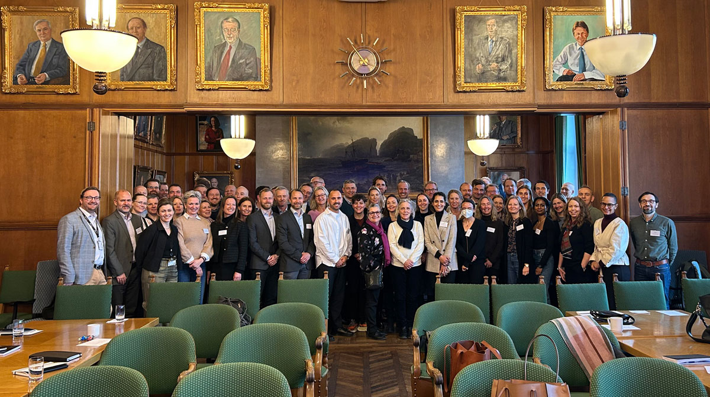
          - Cooperation among ministries and agencies
The Ministry of Foreign Affairs’ annual emergency response team seminar, with liaison officers from the health services, the police and the Armed Forces, was held in February 2025 at the headquarters of the Norwegian Shipowners’ Association.
Photo: Ministry of Foreign Affairs
Effective crisis management is dependent on close collaboration between various ministries and assistance from a variety of agencies. Close cooperation between the Armed Forces and the health and justice sectors is often of special importance when moving crisis-response resources from Norway to crisis-affected areas abroad. In many crisis situations the Ministry of Foreign Affairs has deployed emergency response units (UREs), whose capabilities have been tailored to the crisis at hand. The Armed Forces and the police can provide key resources and capabilities, for example in relation to the security and transport of Norwegian citizens. The same is true for the Norwegian Shipowners’ Association, with which the Ministry of Foreign Affairs has a special agreement. This agreement is unique to Norway and makes it possible to use the extensive resources of the Norwegian merchant fleet as part of a crisis response.
The Foreign Service’s crisis management system is being adapted more or less continuously as new experience is gained. The current system is flexible and scalable, and routines have been established to expand its scope using resources from other parts of the Foreign Ministry and from other ministries and agencies. In the case of a major crisis, all necessary resources are mobilised. Crisis management is led and handled centrally at a crisis centre established at the Foreign Ministry, with other relevant ministries and agencies brought in to participate. The numerous crisis responses of recent years have required the use of considerable resources not just by the Ministry of Foreign Affairs, but by other ministries and agencies as well.
The Ministry’s ability to manage crises has been improved in several ways in recent years. Today’s technical solutions, such as the mobile app Reiseklar, provide new opportunities to inform and guide Norwegian citizens and companies abroad. The Ministry also actively utilises warning messages to notify Norwegians who are in areas where the Ministry sees it as likely that a crisis will develop. A key task in the years ahead will be to look for new ways to further enhance preventive aspects of crisis management.
Every crisis is unique and raises a specific set of problems and challenges. It is therefore crucial to approach each crisis with strategic and operational flexibility. Success requires, among other things, a good network of contacts in the country where the crisis is taking place. Norway’s embassies and consulates general have a particular responsibility in this regard. Norway’s approximately 300 honorary consuls in 125 countries are another important resource. Personal networks and contacts have played a vital role in the management of various crisis situations. The Norwegian authorities will also continue their close, effective cooperation with the shipping industry, the Norwegian Church Abroad and the travel and insurance industries, among others.
              - Leaving Lebanon, autumn 2024
Many Norwegian citizens followed the Foreign Ministry’s advice to leave Lebanon when the security situation in the country deteriorated. The airport in Beirut stayed open, but it became difficult to find space on the few flights that remained. One airline increased capacity, and offered to reserve seats for Norwegian citizens who wished to leave. The Ministry of Foreign Affairs informed Norwegians about available seats on a number of flights, and a number of Norwegian citizens took advantage of the opportunity.
[Boks slutt]

International cooperation
In some crises abroad, Norway will be just one of many countries affected. Others share the same challenges that Norway faces during a crisis abroad. Over time, this shared experience has led to extensive international cooperation in which Norway takes active part.
In many crisis situations, international cooperation will play a significant role in the response, not least by ensuring access to capabilities that Norway in many cases would be unable to provide on its own. Cooperating with other countries and organisations facilitates more efficient use of resources and helps to lower crisis management costs.
EU cooperation on crisis management is extensive, and mechanisms for operational coordination and collaboration have been established. The EU Civil Protection Mechanism (UCPM) is an important tool for strengthening joint crisis preparedness and response efforts. Norway and 9 other countries outside the EU also participate in this mechanism. The UCPM makes it possible to mobilise resources when national capabilities are not available. It also includes reimbursement schemes that make it possible to reduce the cost of assisted departure for Norwegian citizens during a crisis. The Directorate for Civil Protection (DSB) administers Norway’s participation in the UCPM. In addition to UCPM cooperation, Norway entered into an agreement with the EU in 2024 that expands Norwegian participation in broader EU crisis management efforts.
During the COVID-19 pandemic, Norway was invited to take part in political crisis management meetings in the EU’s Integrated Political Crisis Response (IPCR) mechanism. Meetings in this crisis response mechanism are generally limited to EU member states, but Norway was given access based on its membership of the Schengen cooperation. During the pandemic, Norway took part in the development of, among other things, mobility rules inside the Schengen Area and in discussions on assisted returns for citizens.
In October 2023 the EU decided to activate the IPCR in connection with the war in the Middle East. Norway was again invited to take part as EU member states were discussing, among other things, actions to support citizens affected by the war.
Norway is also a member of the Non-combatant Evacuation Operation Coordination Group (NEOCG), a broad-based forum for the coordination of assisted departure operations from crisis areas. The group was established after the crisis in Lebanon in 2005, where there were major problems due to the lack of coordinated evacuation procedures. The NEOCG will be important to Norway in future crises where assisted departure is considered.
The Nordic countries also work together closely on crisis management. In addition to the close cooperation between Nordic diplomatic and consular missions around the world, there are weekly meetings in the Nordic capitals where assessments are discussed. When a crisis arises, Nordic cooperation is vital, especially during the response phase.

Assisted departure
More and more Norwegians are being affected by crises abroad. One explanation for this is that more people holding a Norwegian passport are travelling abroad, both on short trips and to settle in other countries. This includes countries and areas where Norwegians have traditionally not tended to travel or settle.
In some crisis situations a decision has been taken to organise assisted departure, meaning that the Norwegian authorities offer assistance to leave a country or area. Although assisted departure in principle only entails providing assistance to get people out of a crisis-affected area, it has very often involved transport to Norway. This is because neighbouring countries and/or transit countries do not wish to have responsibility for individuals that the Norwegian authorities have evacuated from a crisis-affected area. In practice, therefore, assisted departure has become a form of assisted entry into Norway. An assisted departure operation is a major undertaking that requires substantial resources (see for example Box 7.2).
There have been several examples of assisted departure operations since the publication of the previous white paper on consular affairs. In 2011, Norwegians were offered air travel from Japan to Norway after the Fukushima nuclear power accident. Following the collapse of the Afghan state in August 2021, a large-scale operation involving many parts of the Norwegian government administration was initiated. Under somewhat chaotic circumstances, an airlift operation was carried out and more than 1 100 people were transported from Afghanistan to Norway. In spring 2023 the outbreak of civil war in Sudan led to a complex operation to evacuate the Embassy and assist Norwegian citizens. A total of 140 people received assistance on this occasion, and in addition Norway helped other countries to transport their citizens out of Sudan. Some months later, following Hamas’s attack on Israel on 7 October 2023 and Israel’s response, a large-scale, prolonged operation was launched to get Norwegian citizens out of Israel and Gaza. Altogether assistance was provided to approximately 200 people from Israel and 300 from Gaza to travel to Norway.
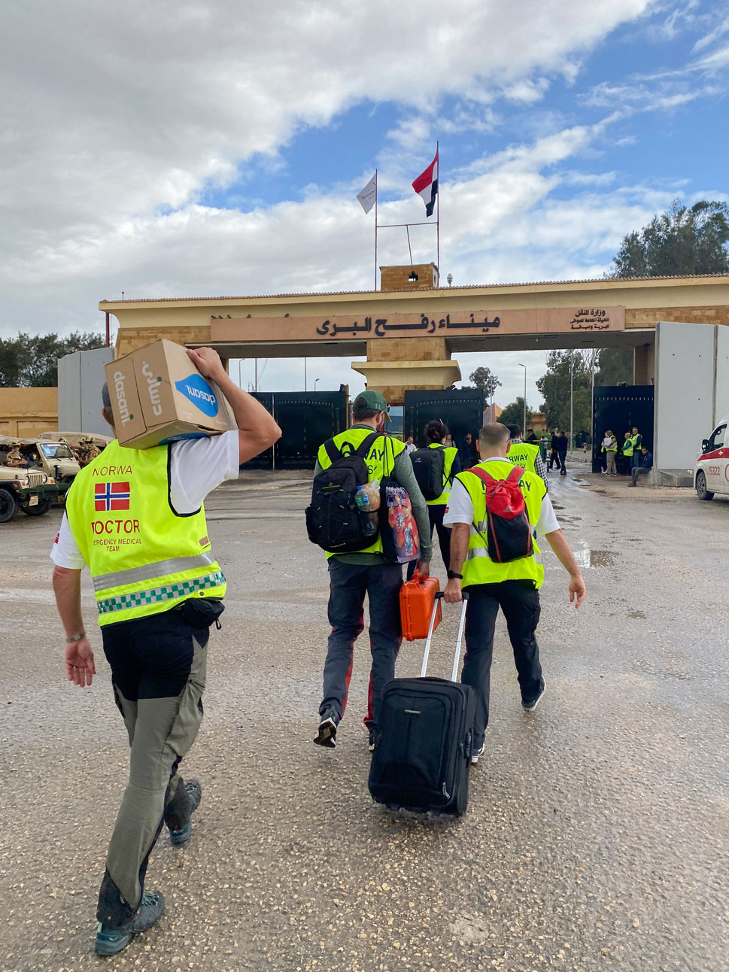
          - Deploying the emergency response unit (URE)
Posted and locally employed staff of the Embassy in Cairo with members of the Foreign Ministry’s emergency response unit (URE) at the Gaza border in November 2023.
Photo: Ministry of Foreign Affairs
Assisted departure operations from crisis-affected areas are resource-intensive and complex. They can also pose a significant security risk to Norwegian personnel. The Foreign Service’s work to assist Norwegian citizens affected by crisis situations abroad has required increasingly larger resources over the past few decades. To reduce the complexity and cost of responding to crises requiring assisted departure, steps will be taken in future crisis situations to assess whether to limit the assistance to transport out of a crisis area to a safe neighbouring country or transit country rather than to provide transport that includes entry into Norway. This is in line with the guidelines for assisted departure described in the white paper Assistance to Norwegians abroad (Meld. St. 12 (2010–2011)).
There is also a need to define in more detail when and to whom assisted departure is to be offered, including weighing the importance of any travel warnings that have been issued and the type of affiliation the individual has with Norway.

Implications of travel warnings
For the Norwegian authorities, the decision of whether to offer assisted departure will always require an assessment of specific factors such as the severity of the situation and the availability of commercial transport alternatives. Another crucial factor will be whether the situation arises suddenly or is in an area that Norwegian citizens have been urged to leave or for which an official travel warning has been issued. The Norwegian authorities will, as far as possible, help individuals to find ways to leave an area while it is still possible to do so, for example via ordinary commercial flights. Individuals who choose voluntarily to remain in an area it was possible to leave cannot expect to receive any type of consular assistance, and the authorities will have a high threshold for offering assisted departure. It may nevertheless be possible to make exceptions for especially vulnerable groups, such as children who are abroad alone, or individuals who have been subject to negative social control. There have been examples of people who chose to remain in an area despite a travel warning urging people to leave because they thought it would be easier to wait until the authorities could come and help them out. Individuals being given an assisted departure who are found to have acted with negligence may be required to cover a larger share of the travel costs than has been the practice to date.
              - Unequivocal Swedish advice on the situation in Lebanon in 2024
‘Should the conflict escalate at short notice, people risk becoming stuck in the country. At that point, every Swede in Lebanon bears a great deal of personal responsibility. It is time to speak plainly about the consequences for those who choose to travel despite the Ministry’s advice against travel. In brief, it involves four points:
- You cannot expect to receive assistance from the Swedish Government to leave the country. For more than eight months, the Ministry for Foreign Affairs has urged Swedes to leave Lebanon. The Swedish Government’s ability to provide help in a crisis situation will be very limited. The situation can become so serious that it is simply not possible to assist Swedes in Lebanon, for example if the security situation for central government employees greatly complicates a relief effort. The Swedish Government has no obligation to carry out an operation under the conditions expected to prevail.
- In an escalating situation or a war, accessing health care, food and other supplies can be very difficult.
- Your insurance usually no longer applies when you choose to travel to countries that the Ministry for Foreign Affairs advises against travelling to.
- In addition, the Swedish Embassy has very limited opportunities to assist people who may need consular support. Consular support is assistance that the Government can offer you when you are abroad – help you receive when you are unable to help yourself.’
From an opinion piece by Minister for Foreign Affairs Tobias Billström, Expressen, 15 July 2024
[Boks slutt]

Norwegian citizens – requirements to demonstrate ties to Norway in addition to citizenship?
The vast majority of the people offered assisted departure from crisis-affected areas abroad by the Norwegian authorities have been Norwegian citizens, with the exception of the departure operation from Afghanistan, which was an extraordinary situation. No distinction has been made between Norwegian citizens who are temporarily visiting the crisis-affected area and Norwegian citizens who have emigrated and permanently reside outside Norway.
In past crises where assistance has been provided in the form of organised assisted departure, the group of people eligible for assistance has been determined specifically for each crisis. In the case of the assisted departure from Japan after the 2011 tsunami and from Israel in 2023, most of the individuals who received assistance were permanent residents of Norway and only visiting Japan or Israel for a short stay (typically a holiday or study trip). In connection with the assisted departure from Sudan and Gaza, however, most of those who received assistance did not reside in Norway. They were largely Norwegian citizens with dual citizenship who were originally from, and had close family ties to, the country they were assisted in leaving.
While there may be very good reasons for helping Norwegian citizens to leave a crisis-affected area, in the case of families that cannot demonstrate any genuine ties to Norway, such assistance would fall more under the category of humanitarian aid than consular assistance. It will also require considerable reception capability in Norway.
As stated in chapter 2, many Norwegians hold dual citizenship or permanently reside abroad, and the Foreign Service is increasingly dealing with Norwegian citizens who have never been in Norway and have very weak ties to the country. In the Government’s view, there is a need to consider establishing criteria requiring some form of affiliation with Norway in addition to citizenship in order to qualify for assistance from the Norwegian authorities to leave a crisis-affected area and travel on to Norway. Relevant requirements could include permanent residence in Norway, registration in the Norwegian National Population Register, membership of the Norwegian National Insurance Scheme or other objective criteria. The degree to which citizenship of other countries is to be given any weight should also be considered. This will entail a change in current practice, and the Ministry of Foreign Affairs will review the issue in cooperation with other relevant ministries.

Foreign nationals
Certain categories of foreign nationals have also been eligible to take part in assisted departure organised by the Norwegian authorities. These are primarily foreign nationals permanently residing in Norway on a valid residence permit, including individuals residing in Norway who have a Norwegian refugee travel document or Norwegian immigrant’s passport. Close family members of Norwegian citizens who have been granted a residence permit in Norway may also be eligible when they travel together with their Norwegian family members.
There will also be instances when individuals are granted a Norwegian residence permit while a crisis is taking place. However, the Norwegian authorities cannot assume responsibility for ensuring that everyone who has been granted a permit can travel all the way to the Norwegian border. That would be beyond the scope of consular assistance, both during a crisis and in a normal situation.
The group defined as eligible for the Afghanistan operation in 2021 represented an exception. In the wake of 20 years of extensive civilian and military assistance to the country, there were various special issues that needed to be taken into account during this operation. Some 80 % of those who received assistance were Afghan citizens who did not belong to a category of foreign national that would normally have been offered consular assistance.

Families with different nationalities – challenges relating to immigration legislation
When it comes to eligibility for assisted departure, families where one or more members are Norwegian citizens and one or more are foreign nationals without right to reside in or enter Norway pose a particular challenge.
              - A transnational family
‘Adam’ arrived in Norway at the age of 16 as an unaccompanied minor from a country affected by war and conflict. He was granted refugee status in Norway, and after many years applied for and was granted Norwegian citizenship. He also retained his original citizenship. After Adam had been issued his first Norwegian passport, the situation in his home country changed sufficiently for him go back and visit. There he met ‘Nora’, whom he subsequently married. Because Adam had a permanent job in Norway and Nora’s application for a Norwegian residence permit was rejected, they decided to continue living in different countries. Adam visited Nora abroad as often as he could.
Nora and Adam had three children, all of them born and raised abroad where they live with their mother. Nora is not a Norwegian citizen, and she and the children have never been to Norway. The children are citizens of the country in which they live, but they also inherited Norwegian citizenship from their father when they were born. Because Nora and Adam never visited the embassy to apply for Norwegian passports for the children, the children are not known to the Norwegian authorities and are required to take a DNA test before they can be registered in the Norwegian National Population Register and obtain Norwegian passports.
[Boks slutt]
In situations involving assisted departure (which often entail entry into Norway), the wish to provide assistance to families such as this tends not to be compatible with immigration legislation, and the solutions are dependent on individual decisions taken by the immigration authorities on granting of entry visas and further grounds for residence in Norway.
To provide assisted departure for Norwegian minors, a parent or another person responsible for the child is often required to accompany the child on the journey. If a Norwegian child is in a crisis-affected area without their Norwegian parent, it has been standard practice to offer the non-Norwegian parent assisted departure to accompany the child even if that parent does not have a Norwegian residence permit. In some cases it has been deemed appropriate to allow a parent accompanying a Norwegian child to also be joined by their other children, even if these children are not Norwegian citizens or do not have Norwegian residence permits.
When a foreign national without a Norwegian residence permit is included in an assisted departure, it is necessary in many cases to grant an entry visa to individuals who would normally not have received one.
Many of the foreign nationals who have been included in assisted departure would not have fulfilled the criteria for a residence permit or visa if they had applied through ordinary channels, and some have already had previous applications for family immigration rejected. The reasons for this may be that they do not meet the criterion for assured subsistence, that there is evidence of polygamy, or that the marriage was entered into when one or both parties were under the age of 18 (child marriage). Although offers of assisted departure to individuals without a residence permit do not entail any guarantee of further residency in Norway, there is always a risk that their entry into Norway will circumvent immigration rules established to prevent forced marriage and negative social control, among other things.
In cases where foreign nationals without right to reside in or enter Norway have been offered assisted departure, the Ministry of Justice and Public Security has issued special instructions to the Directorate of Immigration on granting a national visa or entry visa for Norway in accordance with the special rules for cases involving foreign policy considerations in the Immigration Act. The individuals who came to Norway after the crises in Afghanistan and Gaza were included in the resettlement refugee quota and granted residence permits as refugees or on humanitarian grounds.
In cases where assisted departure is organised in connection with a situation of war and conflict, it may be very difficult for an individual to return to their country of origin if their application for asylum or for residency on other grounds is rejected. Thus there is reason to maintain a restrictive practice when it comes to offering assisted departure to individuals who do not have a residence permit in Norway. It will also be necessary to implement certain control measures in connection with assisted departure of foreign nationals. The issues described above show that close cooperation between the Ministry of Foreign Affairs, the Ministry of Justice and Public Security and relevant subordinate agencies is essential.
When a crisis is occurring it is difficult to decide which categories of individuals are to be eligible for assisted departure and which ones the Norwegian authorities cannot take responsibility for. This should be defined as clearly as possible beforehand. After this white paper has been debated in the Storting, the Government will therefore draw up clear and transparent guidelines on how to define eligible groups.

The way forward
In this white paper, the Government has provided an account of the scope and nature of Norway’s consular services today. As is made clear, the Foreign Service devotes substantial resources to this work, which includes crisis management, an area where the Foreign Ministry’s capacity has been significantly increased in recent years.
Since the publication of the previous white paper on consular assistance in 2011, various developments and trends have made it necessary to consider whether the level and nature of consular assistance currently provided is appropriate or whether adjustments are needed. Today, for example, there are more Norwegians staying or living in other countries, as a result of both dual citizenship and changing travel and settlement patterns; crisis preparedness has become more resource-intensive; and digital advances have made it possible to provide services from Norway that previously could only be offered at the local level.
The demand for consular services is expected to increase in the years ahead, and this includes assistance with leaving a crisis-affected area. In order to prevent an even greater gap between the expectations of Norwegian citizens abroad and the actual services the Norwegian authorities can offer, it is important to ensure that there is general understanding and acceptance of the types of consular services that can be provided and who is eligible to receive assistance.
In the Government’s view, consular assistance must continue to be based on the principles of individual responsibility and self-help. The Government considers it important to emphasise that these principles apply even before a trip abroad is undertaken, and will take steps to strengthen what can be defined as preventive consular assistance. For example, in connection with the presentation of this white paper, the Ministry of Foreign Affairs has decided to replace the term ‘travel advice’ with ‘travel warning’.
The Government will seek to establish closer alignment between travel warnings and the types of consular assistance people can expect to receive. If, for example, someone chooses to ignore a warning about staying in a certain area and does not take advantage of the opportunities to leave on their own while this is still possible, they cannot expect to receive consular assistance or be offered assisted departure at a later date.
The Government will continue to give priority to providing assistance to Norwegians staying abroad for a short period rather than those who are permanently resident in another country, and will carry out a review to consider in more detail whether to establish clearer criteria for required ties to Norway, in addition to Norwegian citizenship, in order to qualify to receive consular assistance, including assisted departure.
There is a need to put in place clearer guidelines setting out the cases in which assisted departure is to be offered to foreign citizens. Here, consideration must be given among other things to the risk that entry into Norway may circumvent important provisions in the immigration legislation. The Government will propose a set of guidelines for this after this white paper has been debated by the Storting.
Consular cooperation with the other Nordic countries and the EU will be further developed in areas where this is considered appropriate. Crisis management is one area where this is particularly relevant.
The Foreign Service provides a range of services to the public, often on behalf of other Norwegian ministries or government agencies. These will be streamlined and digitised as far as possible. For example, responsibility for approval of seafarers’ doctors may be transferred to the Norwegian Maritime Authority, and consideration will be given to how to simplify and digitise notifications of deaths and how to achieve better use of resources in connection with providing information about elections and advance voting at missions abroad.
To maintain the necessary quality and security in connection with the issuing of passports, and to ensure optimal use of resources, it will in future no longer be possible to apply for an ordinary passport at all embassies or consulates general, but these missions will still be able to issue emergency passports. In the long term, the Government will assess whether to outsource receipt of applications for passport renewals to an external service provider, or to digitise this service, as certain other European countries have done.
The honorary consulates are part of our consular and crisis preparedness system. They are an important resource, available at a relatively low cost. In the Government’s view, there is a need to carry out a review of the system of honorary consulates; a clearer framework for administration of the consulates and clarification of what they are expected to provide as regards both traditional and new tasks will make it possible to use resources more effectively.
The review of Norway’s current consular practices has revealed that some of the regulatory framework in this area is outdated or imprecise. The types of consular assistance individual Norwegians can expect to receive and the services the Foreign Service is to be able to provide must be clearly defined. The Ministry of Foreign Affairs has therefore initiated a review of the instructions and legislation with a view to further clarifying the consular framework.
Under the current rules, expenses incurred by the Foreign Service in connection with the provision of consular assistance are covered by the Norwegian authorities, whereas the individuals concerned are required to cover their own expenses. This will continue to be the case. Exceptions may be made in complex, acute crisis situations. The Norwegian authorities may demand reimbursement of their expenses in cases where gross negligence has been shown by the individuals receiving assistance.
The Government will continue to give priority to providing professional consular services to Norwegians abroad and to ensuring sound use of resources.

Economic and administrative consequences
Measures relating to the further development and updating of instructions and legislation in the consular field have no or limited economic and administrative consequences and will be funded within the current budgetary frameworks in the relevant ministries.
Measures relating to professionalisation and simplification of procedures that involve drawing on the expertise of specialist communities outside the Foreign Service or making better use of existing tools are expected to lead to more effective use of public resources.
Measures relating to reducing the number of passport offices will have economic and administrative consequences. This proposal follows up previous reports on improving the efficiency of the passport services and the Review of the Foreign Service carried out in 2021. A report will be drawn up that will outline the specific economic and administrative consequences of the proposed measures. The report itself will be drawn up within the current budgetary frameworks in the relevant ministries.
The proposal to prepare a report on the possible outsourcing of passport application processing abroad will require extra resources and will be dealt with in connection with ordinary budgetary processes in due course. The same applies to proposals concerning the further development of existing, or the development of new, technical and digital solutions.
The proposal to consider establishing criteria to determine eligibility to be offered assisted departure, including the requirement to demonstrate ties to Norway, could lead to savings in public resources, in terms of the costs associated both with the assisted departure operation itself and with reception and settlement in Norway. The report itself will be drawn up within current budgetary frameworks in the relevant ministries.
The Ministry of Foreign Affairs
recommends:
That the Recommendation of the Ministry of Foreign Affairs concerning the white paper on When trouble strikes abroad – Consular assistance and assistance from the Norwegian authorities in crisis situations abroad dated 4 April 2025 be submitted to the Storting.

The term ‘dual citizen’ refers to a person who holds more than one citizenship. People who lost their Norwegian citizenship previously when Norway did not allow dual citizenship may now regain their Norwegian citizenship by sending a notification to the Norwegian authorities.
Non-Norwegian citizens who hold a Norwegian refugee travel document are not permitted to return to their home country. However, once they have been granted Norwegian citizenship, no such restrictions apply.
A special representative is a foreign service officer from another government agency, posted to a mission for special purposes for a specified period of time, and temporarily employed by the Ministry.
This means either a refugee travel document or an immigrant’s passport. These documents are issued by the immigration authorities under the provisions of Chapter 12 of the Immigration Regulations.
The Ministry has used the term ‘evacuation’ in reference to its own employees, since as the employer it has the authority to issue instructions, for example to leave a mission. When other Norwegian citizens are given consular assistance to leave a country, the term ‘assisted departure’ is used. This is further described in chapter 7.3.
Vienna Convention on Consular Relations of 24 April 1963.
Treaty of Co-operation between Denmark, Finland, Iceland, Norway and Sweden of 23 March 1962.
The European Convention on Consular Functions (ETS No. 61) entered into force in 2011 after ratification by five states: Norway (1976), Greece (1983), Portugal (1985), Spain (1987) and Georgia (2011).
The 1958 Foreign Service Act stated that the Foreign Service was responsible for providing advice, assistance and protection. This was amended in 2002, according to the legislative history, to make it clear that the Foreign Service does not and is not intended to ‘protect’ Norwegians in relation to foreign authorities, persons or institutions. Its task is to assist Norwegians in situations where problems have arisen or may arise.
This figure includes two missions that are temporarily closed.
In autumn 2020, a survey carried out in connection with a review of the Foreign Service estimated that the resources used totalled 164 person-years for locally employed staff and 33 person-years for posted employees. For the Foreign Service as a whole, the estimate is close to 250 person-years annually.
For more information, see chapter 6.4 Deaths.
Detailed information on health rights abroad is available at www.helsenorge.no.
More information is available at www.nav.no.
The figure includes two missions with passport authority (Kabul and Khartoum) which were temporarily closed in 2024 and physically relocated to other missions (Islamabad and Nairobi).
In 2024, the three largest passport offices abroad were at the Embassies in London, Copenhagen and Stockholm. The Embassies issued approximately 3 400, 1 800 and 1 200 passports respectively.
Deloitte and the Fridtjof Nansen Institute carried out a Review of the Foreign Service in 2021, at the request of the Ministry of Finance and the Ministry of Foreign Affairs. The report is available on regjeringen.no (Norwegian only).
‘Notarial acts’ refers to the various tasks that notaries public are authorised by law to perform. The terms ‘notarial services’, ‘notarial certification’ and ‘notarisation’ are also used.
Hague Convention of 1961 (Convention Abolishing the Requirement of Legalisation for Foreign Public Documents)
Missions may in theory also provide assistance with taking out-of-court statements or taking evidence (consular court), but this is extremely rare.
See sections 5 and 7 of the Passport Act.
The scheme is described in detail in the guide ‘Hjemsendelse av alvorlig psykisk syke. Gjennomføring av pasienttransporter til og fra utlandet’ (Repatriation of individuals with severe mental illness. Organising patient transport to and from abroad, Norwegian only) issued by the Norwegian Directorate of Health.
Convention of 19 October 1996 on Jurisdiction, Applicable Law, Recognition, Enforcement and Co-operation in respect of Parental Responsibility and Measures for the Protection of Children.
Section 261 of the Penal Code on removal from care.
See the act relating to the discontinuation of benefits and child allowance following an international child abduction (Norwegian only).
Convention of 25 October 1980 on the Civil Aspects of International Child Abduction. In addition, the European Convention of 1980 on Recognition and Enforcement of Decisions concerning Custody of Children and on Restoration of Custody of Children.
www.barnebortforing.no
Figures from the Norwegian Directorate of Integration and Diversity (IMDi) count each individual as a separate case, although most cases involve families with several children. In the period 2019–2023 IMDi registered between 235 and 273 cases annually. As a basis for comparison, the Foreign Service deals with a total of roughly 30 000 consular cases globally each year.
Read more in chapter 6.1 on reports of concern and missing person reports.
According to the territorial principle in international law, the receiving State is entitled to exercise authority by enacting legislation, rendering judgements and employing coercive measures within its own territorial limits.
The term ‘enforced disappearance’ refers to an arrest, detainment, abduction or other deprivation of liberty carried out by a state actor or by persons or groups acting on behalf of or with the permission of the state.
Security and Defence Partnership Between the European Union and Norway – agreement signed 28 May 2024.

