Call for action

The Nordic Ministers for Sport call on the International Handball Federation to review uniform rules in accordance with gender equality to prevent that uniform policies tarnish the name of sport.

The Norwegian beach handball team was recently fined by the European Handball Federation (EHF) for wearing shorts instead of their required bikini uniforms for the bronze medal game at the European Beach Handball Championships in Bulgaria. The incident serves to highlight the double standards many athletes face when it comes to men’s versus women’s uniforms in various sports.

Noting that dress codes in some sports can be both outdated and gendered, we emphasize the need for action not only to accommodate current female athletes, but also to support and encourage all athletes regardless of their gender or background to remain in sport

We acknowledge and support the commitment of the EHF to raise the issue of uniforms at the international level and urge the International Handball Federation (IHF) and other international sports federations to review uniform rules and to allow athletes to be dressed in a way that suits performance and comfort.

September 2021:

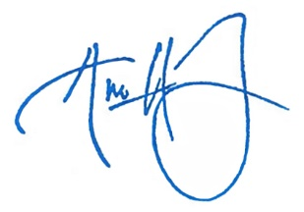
Ane Halsboe-Jørgensen
Minister for Culture
Denmark

Antti Kurvinen
Minister of Culture and Sport
Finland

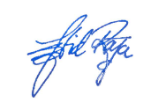
Abid Raja
Minister of Culture and Equality
Norway

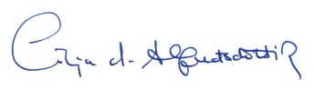
Lilja D. Alfreðsdóttir
Minister of Education, Science and Culture
Iceland

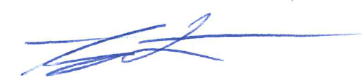
Amanda Lind
Minister for Culture and Democracy
Sweden

