Norwegian guidelines for freedom of religion or belief

Preface

In many countries across the globe, people are subject to discrimination due to their religion or belief. This is a situation we view with great concern.
In 2013, the Ministry of Foreign Affairs issued guidelines for the efforts of the Foreign Service to promote the rights of religious and belief minorities. The guidelines attracted widespread interest and laid the foundation for close cooperation with relevant stakeholders in Norway and abroad. The past decade has seen increasing challenges in this area, and this has in turn led to broader international interest and engagement.
In its political platform, the Government states that it will work for upholding international law and human rights, with particular emphasis on promoting freedom of expression, freedom of assembly, and freedom of religion or belief. These revised guidelines highlight two areas where there is a special need to strengthen efforts to protect and promote freedom of religion or belief. This includes a clearer focus on the role of gender and gender equality in this work, as well as on the intersection between freedom of expression and freedom of religion or belief.
While the first version of the guidelines primarily addressed the rights of religious minorities, the revised guidelines highlight the right to freedom of religion or belief of all people, not just minorities. However, the fact remains that there are still many examples of discrimination against and persecution of religious minorities all over the world.
The use of religion for political purposes is not a new phenomenon. For centuries, religious beliefs, doctrines, traditions, and practices have been used to justify discrimination and exclusion of women, girls, and people of diverse sexual orientations and gender identities. It is important to stress that human rights apply to all people, regardless of their religion or belief, sexual orientation, or gender identity. We have dedicated a chapter to this issue in these guidelines.
Policies that promote inclusion, tolerance and diversity are essential to fully realise the right to freedom of expression. While freedom of religion or belief protects individuals, it cannot be used as an argument to prohibit or censor criticism of religious faith or practices. Criticism of religions must be tolerated. At the same time, there is disagreement on how to balance considerations relating to the right to freedom of expression with the right to freedom of religion or belief. There is a need to have a thorough understanding of these thematic rights to be able to conduct a nuanced dialogue, and we have dedicated a separate chapter to this as well.
Freedom of religion or belief is an important component of our efforts to achieve the UN Sustainable Development Goals and ensure that no one is left behind. Religious minorities are often marginalised and unable to practice their rights. We stress that discrimination based on religion or belief is a violation of human rights. Freedom of religion or belief is a fundamental human right that must be seen in the context of other thematic human rights.
When discussing these issues internationally with other states and stakeholders, it is important to draw on our own past in the context of the challenges we have faced and continue to face. These guidelines therefore include a chapter on Norway’s own history and experience relating to freedom of religion or belief.
The purpose of the revised guidelines is to better equip the Foreign Service to support efforts promoting the right to freedom of religion or belief, according to the international human rights framework. We hope that these guidelines will be a useful resource in the work of the Foreign Service in this area.

Anniken Huitfeldt
Minister of Foreign Affairs
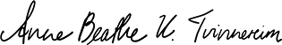
Anne Beathe Tvinnereim
Minister of International Development

Introduction
Freedom of religion or belief means that all people have the right to practise their religion or belief, either alone or in community with others, in public or in private. Freedom of religion or belief is closely linked to freedom of assembly and association. In other words, there is a close connection between individual and collective freedoms.
Freedom of thought, conscience, religion or belief is fundamental for a human being. To hold or not hold a religion or belief, and to change a religion or belief, is therefore also a right that should not be interfered with. However, the freedom to manifest one’s religion or beliefs, alone or in community with others, may be restricted under certain conditions, such as when necessary to protect the rights and freedoms of others. The right to freedom of religion or belief is not absolute and may not be used as grounds for discrimination against others. Appendix 1 provides a more detailed description of the normative basis for safeguarding the right to freedom of religion or belief.
In many countries, religion and religious arguments are often employed as a tool in political discourse or for recruitment to religious groups that use interpretations of holy scriptures to justify discrimination and the use of violence. This conflicts with values of importance to us, such as gender equality, freedom of expression and respect for the rights of ethnic, linguistic, religious, sexual and gender minorities. It threatens fundamental principles such as non-discrimination and equality before the law and can affect majority and minority groups alike.
Discussions on freedom of religion or belief are often rooted in opposing interests and power relations, regardless of whether they involve countries, NGOs, religious or non-religious actors. Arguments about whether one religion or belief is superior to another should not be employed; rather, the focus should be on fundamental values and the individual’s right to freely choose a religion or belief, alone or in community with others.
The Government will work to prevent infringements on democracy and human rights and fight against violations of international law and human rights wherever they take place, with particular emphasis on freedom of expression, freedom of belief and freedom of assembly.
The goals for our efforts to promote freedom of religion or belief involve ensuring that: (i) individuals and groups have legal protection and equal access to welfare services, so that there is no discrimination on the basis of religion or beliefs; (ii) civil society organisations are able to exercise freedom of religion or belief; (iii) national authorities and private actors support freedom of religion or belief in legislation and practice; and (iv) international actors challenge national actors and hold them accountable in the area of freedom of religion or belief and the rights of religious minorities.
For civil society actors, this means ensuring that groups and individuals are aware of the right to religious freedom, ensuring that they are able to document and communicate violations of religion or belief, and ensuring that they can advocate for the inclusion of freedom of religion or belief in legislation and promote the implementation of this legislation. For international actors, such as the UN and other multilateral and regional organisations, this means requiring national authorities to comply with their international human rights obligations, including the right to freedom of religion or belief.
The Section for Human Rights, Partnerships and New Technologies in the Global department (formerly the Section for Democracy, Human rights and Gender equality in the Multilateral department) has a thematic responsibility for the Norwegian Foreign Service’s work with freedom of religion and belief. It collaborates closely with the geography sections on issues affecting individual countries. The work is led by a special representative who also manages financial support for Norwegian and international partners. The Directorate for Development Cooperation (Norad) also supports work with freedom of religion and belief within the framework of cooperation with civil society.
Updated positions in Norwegian and English are available on the MFA platform “UD-intra”. The Section for Human Rights, Partnerships and New Technologies is available for questions about Norwegian positions in the field and can be contacted at the following e-mail address: seksjon.for.menneskerettigheter.partnerskap.nyteknologi@mfa.no

What is the role of the Foreign Service?
- Have insight into the status of freedom of religion or belief in the host country, with a focus on both legal and de facto constraints, as these may be defined in some countries by the authorities, families, local communities or extremist groups.
- Be in direct contact with religious groups and representatives of different minority groups, including interreligious forums that promote freedom of religion or belief based on respect for human rights.
- Be familiar with the goal hierarchy for Norway’s efforts to promote freedom of religion or belief and ensure that relevant measures are in line with these (Appendix 3 in the online version available on intranet).
- Assess whether issues related to freedom of religion or belief should be incorporated as an integral component of development cooperation and assess whether to provide financial or technical support to particularly relevant government institutions or civil society actors that work with freedom of religion or belief.
- Work to prevent individual minority groups from being systematically excluded from support schemes in development cooperation because of prevailing religious and cultural attitudes in the host country.
- Have an overview of the relevant country’s ratification status on the International Covenant on Civil and Political Rights and find out whether the country has entered a reservation to any relevant articles.
- Play an active role in developing Norway’s recommendations to individual countries in the UN Human Rights Council’s Universal Periodic Review (UPR) in the area of freedom of religion or belief.
- Assess whether to engage parliamentarians and the government in a dialogue with civil society organisations to help promote greater openness on the issue of freedom of religion or belief.
- Include freedom of religion or belief as a part of the dialogue with the authorities and civil society organisations at country level when relevant challenges have been identified. This makes it possible to raise awareness about the importance of this issue and follow up Norwegian policy in this area.
- Identify Norwegian and international partners that work in the interface between freedom of religion or belief and gender equality and maintain a dialogue with them.
- Cooperate with likeminded countries, including within the framework of the Article 18-Alliance (formerly IRFBA). Norway is a member of the alliance, which consists of roughly 40 countries that in many cases have developed joint positions on central issues. Cooperation at country level with alliance members may be useful, even though policies in the area may differ (Appendix 4 in the online version available on intranet).

Norway’s history and experience
Representatives of other countries will often be aware that Norway previously had an official religion and state church. They may use their knowledge of the former state church system to counter our arguments on the need to promote freedom of religion or belief and a diverse, liberal society. It will therefore be useful in such cases to have some background knowledge about the history of Norwegian religious policy and the transition from religious hegemony to a society that is open to a diversity of religions and beliefs.

History of religious policy in Norway
The Lutheran Reformation in Norway was introduced by Royal Decree in 1537. The king became the head of the church, and the religion of the king was to be the religion of the people. Those who continued to follow Catholic practices were subject to reprisals. In 1569, the king issued a set of articles that foreigners had to accept to enter the realm (Fremmedartiklene), and immigrants to Norway were required under this to profess the Evangelical-Lutheran religion. Foreigners belonging to other faiths could be granted temporary residence in Norway if they had skills the country needed, but they were banned from proselytising.
The Norwegian Constitution of 1814 continued the religious monopoly of the absolute monarchy, establishing it as a constitutional duty to baptise and raise children in the Church of Norway, and making it mandatory for the monarch to belong to the Church and protect it. The Norwegian Constitution excluded Jews and Catholic monastic orders from entry to the realm. The Quaker movement was introduced to Norway in 1814 by returning Norwegian prisoners of war who had converted during their captivity in England. The Quakers challenged the religious monopoly by refusing to pay the church tax or serve in the military, by not baptising their children and by getting married without a priest present. They were not permitted to bury their dead in consecrated ground, were fined and their property was confiscated. Some members of the Quaker community emigrated to North America as religious refugees in 1825. The lay preacher Hans Nielsen Hauge (1771–1824) founded a widespread religious movement and revival that questioned the role of priests as officials and the Church of Norway in general. Despite this, however, Hauge remained a member of the state church throughout his life. The Quaker and layman movements triggered a political debate that paved the way for repealing the Conventicle Act (Konventikkelplakaten), a decree issued in 1741 that had given Lutheran priests a monopoly on conducting all religious meetings.
The enactment of the first Dissenter Act in 1845 was a pivotal event during this period. Various subsequent legislative reforms gradually moved Norway away from a policy of religious discrimination and towards greater acceptance of diversity. The Dissenter Act (1845) made it possible for other Christian denominations to establish their religious communities in Norway and gave Norwegian citizens the right to resign membership of the Church of Norway. Nevertheless, Christian Dissenters and others who were not members of the state church were still excluded from participating in several areas in society. These restrictions were gradually lifted in the late 1800s and onwards into the 1900s. Religious freedom was ultimately enshrined in the Norwegian Constitution in 1964.
Articles relating to the state church in the Norwegian Constitution were repealed on 22 May 2012, and a new Article 16 was introduced on freedom of religion and the state’s relationship with the Church of Norway and other religious and belief communities. Article 16 reads, ‘All inhabitants of the realm shall have the right to free exercise of their religion. The Church of Norway, an Evangelical-Lutheran church, will remain the Established Church of Norway and will as such be supported by the State. Detailed provisions as to its system will be laid down by law. All religious and belief communities should be supported on equal terms.’
In 2013, a special commission appointed by the Government submitted an official report with a number of policy recommendations on freedom of religion or belief for an open and diverse society. On 1 January 2017, the Church of Norway became an independent legal entity, and a new act consolidating the existing legislation for religious and belief communities (trossamfunnsloven) entered into force on 1 January 2021. The new act, which applies to all religious and belief communities, contains a separate chapter for the Church of Norway. This chapter sets out the general obligations and principles that apply to the church. For religious and belief communities outside the Church of Norway, the new act provides clarification regarding the grounds for refusal of grants and sets out reporting requirements related to gender equality, prohibited grounds for discrimination, and activities targeting children and youth. Public funding may also be denied if communities receive financial support from countries that do not respect the right to freedom of religion or belief. These issues are assessed by the Office of the County Governor based on a detailed set of criteria. The Church of Norway may still apply for and receive allocations under government and municipal budgets, while religious and belief communities outside the Church of Norway are only eligible for government grants. The act extends the provisions stipulating that the religious age of majority for children is 15 years of age. This has remained unchanged since the Dissenter Act was amended in 1891.

Challenges and opportunities in a society open to a diversity of religions and beliefs
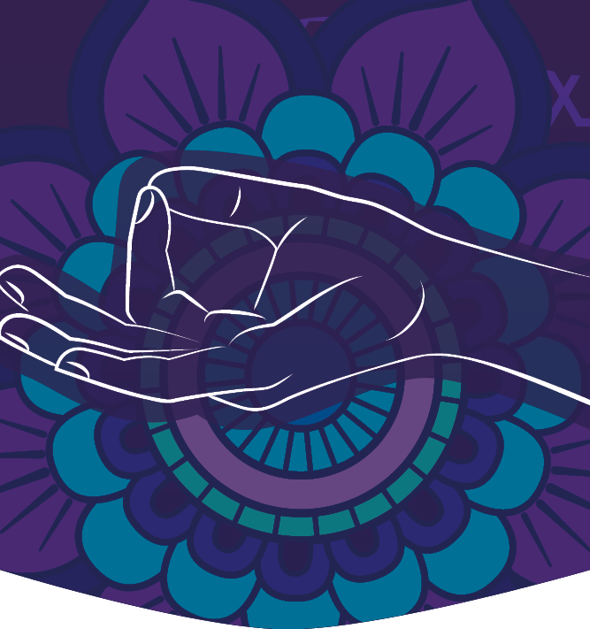
The growing diversity of religions and beliefs in Norway has generated tensions, but also more dialogue, and given rise to new forms of cooperation that entail both legal and practical challenges and opportunities.
Working for change from within. Individuals and groups within the church have worked to promote the equality and rights of women and LGBT+ people in the Church of Norway. The Norwegian YWCA and the Norwegian Association of Women Theologians (NKTF) played a key role in achieving women’s equality and their right to vote within the church, but also in the political arena and in society at large. In 1961, Ingrid Bjerkås was ordained as Norway’s first female priest, and in 1993, Rosemarie Köhn became the first female bishop in the Nordic region. In 1976, lesbian and gay Christians formed the Open People’s Church group (Åpen Kirkegruppe), which became a driving force for the changes that took place in the Church of Norway relating to LGBT+ people until 2014, when the Open People’s Church group was established as a political organisation within the Church’s democratic structure. The possibility of church weddings for same-sex couples was the main issue on their agenda.
Christianity, Religion and Ethics Education (CREE). The former public school subjects Christianity, and the corresponding alternative Philosophy of life, were replaced in 1997 by a new mandatory subject on the school curriculum called Christianity, Religion and Philosophies of life (KRL). The new subject was intended to bring together pupils from all religious and belief communities to convey knowledge and create a foundation for dialogue and tolerance. However, inconsistencies regarding how to practice the limited right of exemption led to a legal case that made its way through the Norwegian court system, ending in the European Court of Human Rights (ECHR). In its judgment on the case in 2007, the ECHR held that there had been a violation of human rights. The UN Human Rights Committee had come to the same conclusion in 2004. The public-school system’s Christian object clause in effect at that time, the limited right to exemptions and considerations regarding the rights of parents, were all crucial factors in the court’s decision. The case led to changes in the public curriculum, and the subject is now known as Knowledge of Christianity, Religion, Philosophies of life and Ethics (KRLE).
Calls to prayer from mosques. In 2000, the Legislation Department of the Ministry of Justice found that a political proposal to ban calls to prayer from mosques was in violation of the right to practise religion. Most Norwegian mosques do not broadcast calls to prayer, and if they do, the calls must comply with the regulations related to noise pollution.
Passport photos and religious garments: Norway and France were the only European countries to stipulate that people’s ears must be visible in photos in passports and on national identity cards. This posed a special challenge to Sikhs, who were not permitted to renew their passports unless they took off their turbans to be photographed. Some Muslim women were also affected by the requirement. The regulations relating to passports were amended in 2020.
Clothing that covers the face and the hijab: In 2018, the Storting (Norwegian parliament) passed a law banning the use of clothing that covers the face in day-care centres, schools, institutions of higher education, and in obligatory classes for newly arrived immigrants. The ban is not general and only applies in the educational setting. Discussions on the use of hijabs have been a part of the public debate. There has also been a debate on changing the police uniform regulations for allowing women to wear a specially designed hijab, based on an English model. The debate concluded with a set of rules confirming that it is still a primary aim for the police to be presented as neutral, without the wearing of clothing or symbols associated with a religion or belief.
Residence permits for religious leaders: Religious leaders from abroad seeking to work in Norway were required to have completed education at master’s degree level and/or have a salary level corresponding to the salary for people with equivalent qualifications in Norway. Meanwhile Buddhists, Hindus and some African church communities operate with a tradition-based education that is often of a more practical nature, targeted towards ceremonial purposes or involving a less comprehensive theoretical form of training similar to that of layman movements in Norway. Some leaders are supported entirely by their congregations without receiving a regular salary, while for others, it is customary to have a salary level far lower than what the regulations stipulated. The regulations have now been amended so that it is possible to apply for a dispensation.
Spiritual service in public institutions etc.: Public hospitals and institutions involved in elderly care, alongside the Norwegian Correctional Services and the Norwegian Armed Forces have traditionally employed chaplains from the Church of Norway. But there is also a long-standing cooperation between the health authorities and other religious and belief communities to develop services that target the needs of people belonging to different religions or belief groups. Several trials have been carried out at the larger hospitals. The Norwegian Correctional Services have organised a system for cooperating with religious leaders outside the Church of Norway. The Norwegian Armed Forces have established a corps of advisers from different religious and belief communities. In addition, the former practice of Christian prayers in the field has been replaced with a more general ethics appeal. Individual care plans for people who are dependent on municipal health and care services must accommodate the right of service users to the framework and assistance needed to exercise their religion or beliefs. This includes an obligation on the part of support persons to accompany service users to religious gatherings.
The rights of national minorities: Respecting the rights of national minorities often entails a significant focus on their religion and religious practices. Norway is under obligation to comply with the Council of Europe Framework Convention for the Protection of National Minorities from 1999. A national Action Plan in this area has been drawn up and is the purview of the Ministry of Local Government and Regional Development. Starting in the mid-1800s, the Norwegian authorities pursued a Norwegianization and assimilation policy vis-á-vis the Sámi people and other minority populations. In recent years, there has been agreement on measures to remedy the injustices this policy represented. An amendment was made to the Norwegian Constitution in 1988 and at the opening of the Sámediggi (Sami parliament) in 1997, His Majesty King Harald issued an apology. A truth and reconciliation commission, the Commission to Investigate the Norwegianization Policy and Injustice against the Sámi and Kvens/Norwegian Finns, is to present its report in 2023. At the commemoration of the International Holocaust Remembrance Day in 2012, then Prime Minister Jens Stoltenberg apologised on behalf of the Norwegian Government for the injustices carried out against Norwegian Jews during the Holocaust. In 2015, based on the results of the Tater/Romani Committee’s Report Assimilation and Resistance: Norwegian policies towards Tater/Romani people from 1850 to the present, the Norwegian Government apologised for the suffering inflicted on these groups and individuals.
LGBTIQ+ people’s rights: The Norwegian Government’s Action Plan on Gender and Sexual Diversity (2023–2026) specifically aims to increase tolerance towards gender and sexual diversity in minority groups and religious communities. Many LGBT+ people in Norway are also members of religious or belief groups, and some experience challenges related to their group’s view on gender and sexuality. Research shows that belonging to several minority groups can pose particular challenges and cause individuals to suffer from intersectional or multiple discrimination.

What is the role of the Foreign Service?
- Be familiar with the evolution of a democratic Norwegian society that is open to a diversity of religions and beliefs and use this knowledge in dialogue with other countries and organisations.
- Be able to refer to Norway’s experience in the transition from a state church system to the present-day pluralistic and inclusive society, open to a diversity of religions and beliefs, in discussions with representatives of other countries.
- Be aware of Norway’s own challenges in relations between mainstream Norwegian society and ethnic and religious minorities and be able to point to measures taken in recent years that have been effective in improving inclusion.
- Be familiar with the Norwegian Government’s Action Plan against Racism and Discrimination on the Grounds of Ethnicity and Religion, as well as the Action Plan Against Anti-Semitism – a Continuation, the Action Plan to Combat Discrimination and Hatred Towards Muslims, and the Action Plan on Gender and Sexual Diversity.
- Be familiar with the extent to which the country you serve in respects and protects the right to freedom of religion or belief.

The role of gender and equality in our efforts to promote freedom of religion or belief
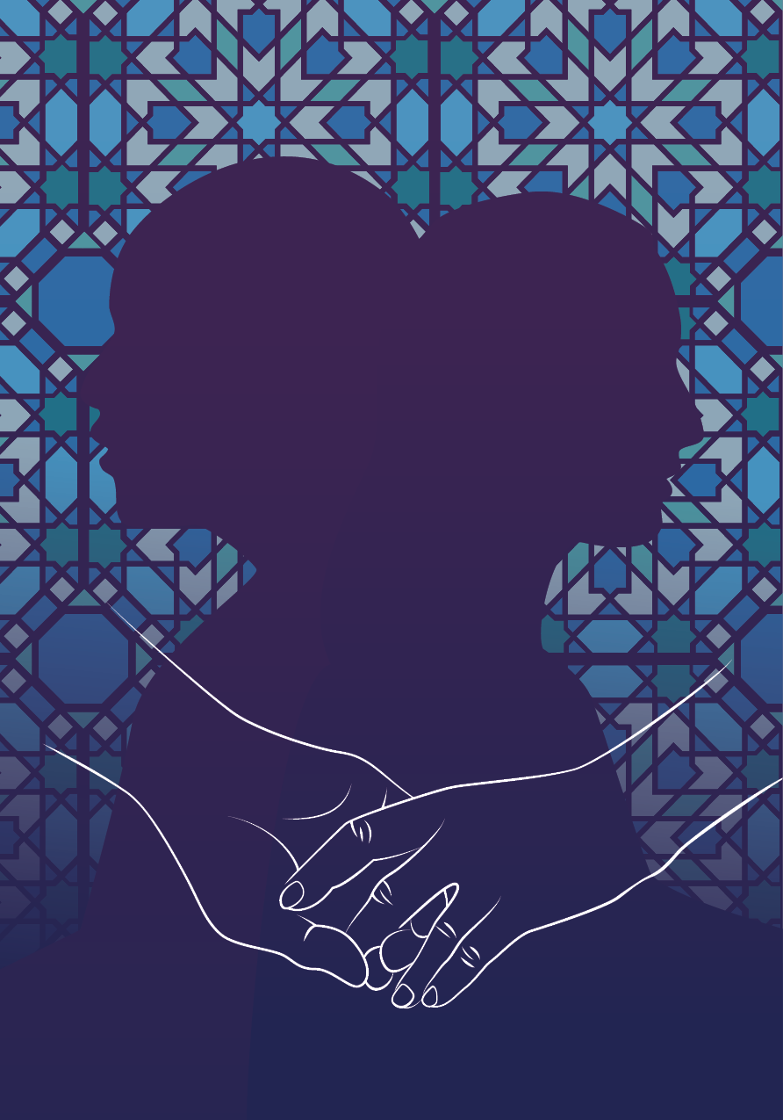
Freedom of religion or belief gives individuals and groups the right to interpret their religion in line with their convictions. Religion cannot legitimize gender-based discrimination and oppression. Discrimination based on gender and sexuality nevertheless has a long history, and gender equality can be a controversial topic within religions. All over the world, people are affected by restrictive gender norms and other structural barriers. Religiously based gender roles can also limit women’s and LGBT+ people’s rights and opportunities to participate in society. Sexual and reproductive health and rights (SRHR) and LGBT+ equality and human rights are particularly controversial. Increased efforts against discrimination and abuse based on gender, sexual orientation, gender identity, and gender expression are necessary to achieve equality for all. In all our efforts, we must ensure that we do not contribute to harm.
To effectively combat gender-based discrimination and promote human rights we must know and understand the religious and cultural context. This includes understanding that different gender identities and expressions exist in cultures and traditions in all parts of the world. Women and LGBT+ persons can be part of the same religious communities that oppose their rights. Therefore, the right to believe in a religious interpretation that includes equality in diversity, related to gender as well as sexuality, must also be defended based on freedom of religion or belief. Equally so must the right to gather to practice one’s belief be defended based on freedom of assembly.
Cooperation with religious actors will be important for achieving gender equality. In several contexts, religious leaders can be positive and constructive actors who use their influence to emphasize that violations of women’s and LGBT+ rights cannot be justified by religion. For some religious leaders, however, questions about SRHR and LGBT+ rights will be difficult. Although gender and equality are dealt with together in this guidance tool, this does not mean that representatives of the Foreign Service must address these issues at the same time. The local context should determine how these questions are raised in meetings with local actors.

Gender equality
Several religions are associated with traditional patriarchal traditions which, on the one hand, recognize men and women as valuable and created by God, but which, on the other hand, promote gendered power structures that work against women and LGBT+ people.
Gender equality is necessary for inclusive and sustainable development, and the right to freedom of religion or belief is a fundamental freedom. Nevertheless, there is a widespread opinion that the right to freedom of religion or belief and the human rights of women and LGBT+ persons are in conflict. Gender equality has become a struggle that also applies to the right to freedom of religion or belief.
Conservative political and religious groups are mobilizing against increased gender equality. Acceptance of gender and sexuality diversity is portrayed as a threat to family, tradition, and nation, often with reference to religious scriptures or doctrines. These forces are referred to as the “anti-gender movement” and have a negative impact on women’s and LGBT+ rights in many countries. Conservative and religious groups often refer to traditional family values to mark opposition to what are portrayed as Western secular values. A particular aim of this movement is to limit women’s right to sexual and reproductive health, to maintain or introduce bans on same-sex sexual relations, to fight against the right of homosexuals and lesbians to found a family, and the right of trans people to define their gender identity. Conservative Christian, Jewish and Muslim groups have at times stood together on such views.

The women’s rights movement has been largely secular and often given little attention to the role of religion in women’s lives. Still, there are many examples of women and others who use their faith to fight for gender equality, anchored in their religion or beliefs.
Several Muslim majority countries have entered reservations against articles in the Convention on the Elimination of All Forms of Discrimination against Women on the basis of sharia law. This especially applies to article 16 on the elimination of discrimination against women in all matters relating to marriage. Among the Western countries, only the United States has not ratified the convention.
The priorities for the Norwegian efforts to promote gender equality are outlined in the Action Plan for Women’s Rights and Gender Equality in Norway’s Foreign and Development Policy and Development Policy, “A just world is an equal world”, which was launched in 2023. It includes an emphasis on combating patriarchal power structures and restrictive gender norms, based on cultural and religious traditions among other factors. Changing norms and power relations and strengthening women’s individual and collective influence and decision-making authority is the basis for this. Dialogue and cooperation with religious leaders and faith-based organizations and networks that can contribute to promoting progressive voices working for gender equality will be important to achieve the goals of the Action Plan.

Sexual and reproductive health and rights
Everyone has a right to decide over their own bodies and sexuality, and to be able to realise their sexual and reproductive rights. This is a matter of freedom and dignity. The right to decide over one’s own body and sexuality is also about self-determination of one’s own gender, which is fundamental to personal freedom and identity.
In its international efforts to promote gender equality, the Norwegian Government will give priority to support women’s right to decide over their own bodies. On a global basis, Norway works to protect and strengthen the normative framework for sexual and reproductive health and rights (SRHR) and to promote non-discrimination in access to health services. SRHR is part of the UN’s Sustainable Development Goal 3.7 on gender equality and the empowerment of all women and girls. Key elements included in SRHR are sexuality education, family planning, contraception, safe childbirth and safe abortion. Securing SRHR can help prevent unwanted pregnancies, and unnecessary pain and death during pregnancy.
In recent years, opposition to SRHR work has increased. The opposition is justified by the fact that SRHR threatens family values, culture, and morality. It will be important to be aware of the authorities’ and religious leaders’ use of power politics to oppose progress in this area.
There are also contradictions internationally between the right to protect unborn life and the right to safe abortion. The right to self-determined and safe abortion is challenged in several countries through restrictive legislation, prohibitions, and stigmatization. This happens even though banning abortion does not reduce the number of abortions, but causes more women, especially younger women, to die because of unsafe abortions. From the Norwegian side, we are concerned that women’s right to SRHR and safe abortion cannot be restricted with reference to religious traditions.

Gender-based violence
Female genital mutilation, child- and forced marriage, domestic and intimate partner violence, and honor killings prevent gender equality. Children, especially girls, around the world are particularly vulnerable to discrimination and harmful practices. The work against gender-based violence is enshrined in the UN’s Sustainable Development Goal 5. In some societies, violent cultures of honor are legitimized with reference to religion. According to human rights, religion does not allow for discrimination, nor permits violence or harmful practices. Such attitudes must be combated. In all our work, we must ensure that we do not contribute to violations of human rights. This is part of the operationalization of human rights and equality as a cross-cutting issue.
The Council of Europe Convention on preventing and combating violence against women and domestic violence (Istanbul Convention) is the most comprehensive international human rights treaty on the protection of women against gender-based violence. The Convention safeguards non-discrimination based on gender, sexual orientation, and gender identity. The Convention recognises violence against women as a violation of human rights.
The main purpose of the Convention is to prevent violence, protect victims and ensure prosecution of perpetrators. The Convention also aims to increase awareness and change attitudes. It states that violence against women is a manifestation of historically unequal power relations between women and men in society. In some religious communities, women are largely confined to the home, and domestic violence is hidden and considered to be a private family matter. This makes it more difficult for women to get the protection to which they are entitled.
The Convention supports SDG 5 Achieve gender equality and empower all women and girls, in particular targets 5.2 and 5.3 that deal with the elimination of all forms of violence against women and girls. The Convention is binding for all countries that have ratified it and serves as inspiration for other countries as well.
The right to freedom of religion or belief, in a gender perspective, entails that all people have the same rights regardless of their sexual orientation, gender identity and gender expression. In 2011, the UN Human Rights Council adopted a resolution on protection against violence and discrimination based on sexual orientation and gender identity, and in 2016 it appointed an independent expert on the topic with a mandate to assess and address various aspects of the resolution. This mandate has provided an important basis for documenting abuse of LGBT+ people, and for making recommendations on the protection of LGBT+ people and their rights to member countries. In 2023, the UN Independent Expert on sexual orientation and gender identity presented a thematic report on freedom of religion or belief and freedom from violence and discrimination based on sexual orientation and gender identity.
Violence and discrimination based on sexual orientation, gender identity and gender expression are a problem throughout the world. Engaging in same-sex relations is still a crime in some countries, and some have laws that impose the death penalty as a legal punishment for it. LGBT+ people are at higher risk of being subjected to physical and sexual violence, or forced to submit to conversion therapy, exorcism and other practices designed to make people change, renounce or suppress their identities. Individuals experience stigmatisation, abuse and exclusion both within their family and in their local community, and this has long-term negative impacts on their physical and mental health and quality of life. In 2020, the UN’s Special Rapporteur on freedom of religion or belief put forward recommendations related to gender-based discrimination and violence, including against lesbians, gays, bisexuals and transgender people.
In many countries and communities, religious groups claim that religious teachings prohibit same-sex relations and take the view that gender is purely biologically determined. Religious leaders, authority figures and others deny that LGBT+ people are entitled to equal status and human rights, invoking the need to protect religious and traditional values as justification. Growing resistance to comprehensive sexuality education in schools illustrates the broad mobilisation that is emerging in many countries against the rights of LGBT+ people and gender equality in general.
For many people, religion and beliefs are of existential importance. People who are excluded from a religious community because of their sexual orientation or gender identity may be prevented from practising their faith and vulnerable to harmful conversion therapy. Both the UN High Commissioner for Human Rights and other UN agencies have recommended that countries implement measures to prohibit or abolish conversion therapy.
Norway is at the forefront internationally in efforts to combat discrimination and abuse based on sexual orientation, gender identity and gender expression. Norway’s national Action Plan for Gender and Sexuality Diversity focuses on, among other things, LGBT+ people in religious communities. The Action Plan also includes measures for international efforts, including for sexual and reproductive health and rights for all.


What is the role of the Foreign Service?
- Increase the interaction between groups working to promote freedom of religion or belief and those working to promote the rights of women and LGBT+ people and gender equality, locally, nationally, and internationally, including with the foreign service’s strategic partners in the field. (See Appendix 4 in the electronic edition).
- Play an active role in supporting international efforts protecting gender equality, including close collaboration with the UN High Commissioner for Human Rights in combatting religiously justified gender-based violence.
- Contribute to the development of Norwegian positions and recommendations for the Universal Periodic Review (UPR) in the UN Human Rights Council, which promotes freedom of religion or belief in a way that ensures the rights of women and LGBT+ people.
- Strengthen gender equality and women’s right to participation and co-determination through establishing dialogue and cooperation with religious leaders and faith-based organisations.
- Strengthen the right to self-determination when it comes to bodily autonomy and sexuality by intensifying Norwegian efforts, establish alliances with faith-based organizations, and increase support for activities relating to family planning, contraception, safe abortions, and SRHR for all.
- Foster dialogue with progressive forces in the area of freedom of religion or belief to safeguard women’s access to safe abortion and use development aid as a tool in promoting safe abortion in countries where it is possible to collaborate with local actors.
- Emphasise that the right to freedom of religion or belief cannot be used to restrict the right of women and LGBT+ persons to realise their human rights, including their sexual and reproductive rights.
- Underline that gender equality entails the ability of all women to realise their rights, including their sexual and reproductive rights, and highlight that access to SRHR enables women to obtain an education and engage in paid employment, and also prevents unnecessary suffering and death caused by pregnancy.
- Identify and mobilise untraditional actors, including liberal faith-based organisations, to promote gender equality efforts.
- Combat religiously motivated persecution and discrimination against people based on sexual orientation and gender identity. Facilitate safe meeting places and dialogue between religious leaders, women’s organisations and LGBT+ organisations.
- Ensure that partners who receive financial support for the promotion of freedom of religion or belief do not counter Norway’s efforts for gender equality and human rights.
- Contribute to knowledge building to support locally adapted measures against discrimination and harmful practices against at women, children, and LGBT+ people.

The interaction between freedom of expression and freedom of religion or belief
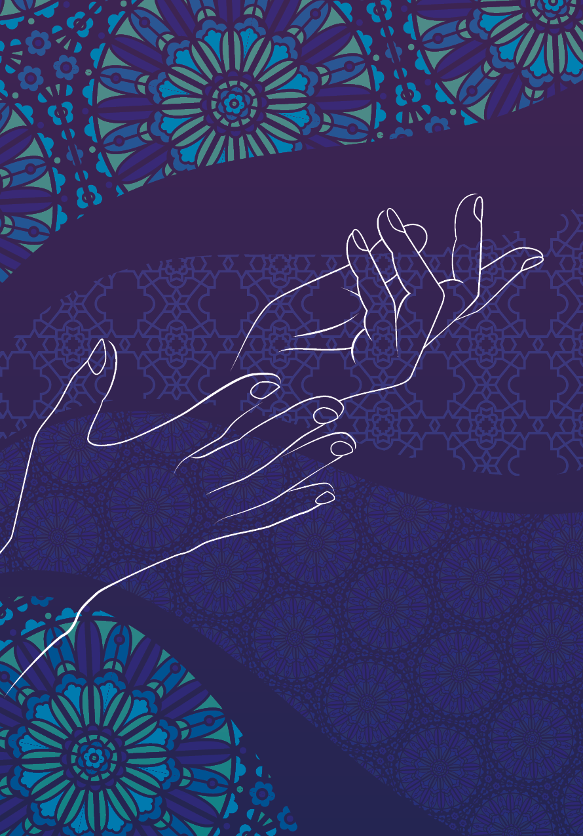
Like freedom of religion or belief, the right to freedom of opinion and expression means that individuals have the right to acquire new knowledge and develop their own opinions, and to have, change or freely communicate their own convictions. This is described in detail in the Ministry of Foreign Affairs’ Strategy for promoting freedom of expression in foreign and development policy (2021).
Freedom of expression plays an essential part of the right to freedom of religion or belief. Wearing a particular item of clothing or following special dietary rules may be an important expression of an individual’s religion or belief (see Chapter 2 for examples from Norway). Freedom of expression is thus a vital component and pre-requisite of the individual’s right to freely exercise their religion or belief in all practical aspects of their daily lives. Although the focus of these two rights can differ, both protect the integrity of the individual person and their right to form their own opinions and convictions.
Freedom of expression also encompasses the right of individuals to manifest their religion or beliefs, including preaching, which is imperative in many religious and belief communities. At the same time, freedom of expression includes the right to criticise other people’s religions or beliefs. However, this right may be restricted under certain circumstances, for example to protect the rights and freedoms of others, and to prevent hate speech.
Freedom of expression is enshrined in Article 19 of the Universal Declaration of Human Rights and in Article 19 of the International Covenant on Civil and Political Rights.
Article 19 of the International Covenant on Civil and Political Rights states that:
- Everyone shall have the right to hold opinions without interference.
- Everyone shall have the right to freedom of expression; this right shall include freedom to seek, receive and impart information and ideas of all kinds, regardless of frontiers, either orally, in writing or in print, in the form of art, or through any other media of his choice.
- The exercise of the rights provided for in paragraph 2 of this article carries with it special duties and responsibilities. It may therefore be subject to certain restrictions, but these shall only be such as are provided by law and are necessary:
- For respect of the rights or reputations of others;
- For the protection of national security or of public order (ordre public), or of public health or morals.

Blasphemy and apostasy
Freedom of religion or belief and freedom of expression have been pitted against one another at times. During the period 1999–2010, the Organisation of Islamic Cooperation proposed various resolutions in the UN on combating defamation of religions.
The clash between freedom of religion or belief and freedom of expression reached its climax during the controversy over the Danish cartoons featuring the Prophet Muhammad in 2005–2006. The resolutions called for legal protection against defamation of religions, and Islam in particular. This was inconsistent with the premise of both freedom of religion or belief and freedom of expression.
In 2011, the UN Human Rights Council adopted a resolution on combating intolerance, negative stereotyping and stigmatisation of, and discrimination, incitement to violence and violence against, persons based on religion or belief (HRC res. 16/18).
As part of the follow up to this resolution, a mechanism was created to facilitate the discussion of complex cultural, religious, political, and legal issues through a series of expert-level intergovernmental meetings. This is known as the Istanbul Process.
The Istanbul Process encourages the implementation of HRC res. 16/18, but it is clear from the meetings that there is considerable disagreement. The UN Special Rapporteur on freedom of religion or belief has also pointed to the importance of linking implementation of the resolution to other relevant frameworks, such as the Rabat Plan of Action on the prohibition of advocacy of national, racial or religious hatred that constitutes incitement to discrimination, hostility or violence. The Rabat Plan of Action provides countries with guidance on how to weigh considerations relating to the right to freedom of expression (Article 19) against the prohibition against certain forms of hate speech (Article 20) in the International Covenant on Civil and Political Rights.

During the period 2011–2012, the UN High Commissioner for Human Rights initiated a series of expert workshops to promote international debate on hatred towards religious groups. This resulted in the adoption of the Rabat Plan of Action. While the plan of action recognises the right of countries to restrict freedom of speech and introduce legislation prohibiting incitement to hatred, discrimination and violence, it emphasises that the threshold for such restrictions must be high and proposes a six-part threshold test for contextual evaluations. Further, the Plan of Action advocates the use of non-restrictive measures to counter intolerance, stigmatisation and hatred. These could include cross-cultural dialogue and education to promote tolerance and diversity, as well as measures and policies that promote and protect the freedom of expression of minorities and indigenous peoples.
Discussions about blasphemy and blasphemy laws are still relevant and show the juxtaposition of freedom of religion or belief and freedom of expression by religious actors. In discussions relating to criticism of religion perceived to be blasphemous, it is often assumed that the two rights reflect different interests. Whereas freedom of expression is often presented as the epitome of liberal freedoms because it allows space for political provocation, artistic experimentation and religious criticism, it is widely believed that freedom of religion or belief restricts precisely this space. Freedom of religion or belief is thus perceived to be a ‘less liberal’ right.
Laws prohibiting apostasy (renunciation of a religion) still apply in many countries and may impose severe penalties. This is incompatible with the right to freedom of religion or belief, which safeguards the individual’s right to choose or change their religion or belief.
Also, laws prohibiting blasphemy restrict the right to freedom of expression. While arguments about the need to protect religious communities are often used to justify these laws, they are in practice often a means of stifling criticism of existing power structures. There are several examples of blasphemy laws being used as a basis for accusations against religious minorities or dissidents, including non-believers. Multiple Muslim countries have defended blasphemy laws citing the argument that they are based on sharia law and are intended to protect Islam as a religion. But such laws can also be used to quell debate and persecute religious and belief minorities both within and outside of Islam.

Hate speech against minorities
Promoting the positive synergies between freedom of religion or belief and freedom of expression does not diminish the need to address potential dilemmas. Hate speech and incitement to hate crimes are often specifically targeted towards minorities, including religious minorities. Speech can be harmful even if it is not defined as illegal. Hate speech can create a climate of fear, discouraging minorities from participating in the public debate. It may also serve to sow or reinforce division between groups in society. Social media has a become a tool for spreading hate speech, magnifying the impacts of hate speech on individuals, groups and society as a whole.
In 2019, as part of an effort to combat growing xenophobia and racism in many countries, the UN Secretary-General launched the UN Strategy and Plan of Action on Hate Speech. The UN defines hate speech as, “any kind of communication in speech, writing or behaviour that attacks or uses pejorative or discriminatory language with reference to a person or a group on the basis of who they are, in other words, based on their religion, ethnicity, nationality, race, colour, descent, gender or other identity factor.”

The UN Strategy and Plan of Action on Hate Speech is guided by four key principles:
- The strategy and its implementation is to be in line with the right to freedom of opinion and expression. The UN supports more speech, not less, as the key means to address hate speech;
- Tackling hate speech is the responsibility of all – governments, societies, the private sector, starting with individual women and men. All are responsible, all must act;
- In the digital age, the UN should support a new generation of digital citizens, empowered to recognise, reject and stand up to hate speech;
- We need to know more to act effectively – this calls for coordinated data collection and research, including on the root causes, drivers and conditions conducive to hate speech.
The plan incorporates 13 key commitments.

The Council of Europe also works to combat hate speech. Their efforts are based on several recommendations from the Committee of Ministers to the member states, including Recommendation on hate speech (1997) and Recommendation on blasphemy, religious insults and hate speech against persons on grounds of their religion (2007). Recommendation on combating hate speech (2022) establishes the first and to date only international intergovernmental definition of hate speech where hate speech based on affiliation or perceived affiliation with a religion or religious group is included in the definition.
The European Commission against Racism and Intolerance (ECRI) monitors implementation of ECRI recommendations in Council of Europe member states. This includes ECRI General Policy Recommendation No. 1 on combating racism, xenophobia, antisemitism and intolerance, No. 5 on preventing and combating anti-Muslim racism and discrimination, No. 9 on preventing and combating Antisemitism, and No. 15 on Combating Hate Speech. Norway’s national strategies are in line with the ECRI’s recommendations.
In a number of countries and regions, the right to freedom of religion or belief is under great pressure. The UN Special Rapporteur on freedom of religion or belief has urged national authorities to introduce all necessary measures to combat discrimination and prohibit all expressions of hatred that constitute incitement to violence. Under certain circumstances, countries may place limitations on freedom of expression. The purpose should never be to protect the religion itself.
As in the case of freedom of religion or belief, any such limitations on freedom of expression must be prescribed by law, serve a legitimate purpose and be necessary to protect public order, health or morals, national security or the fundamental rights and freedoms of others.
The exercise of the right to freedom of expression may be subject to certain restrictions, as set out in Article 19 of the International Covenant on Civil and Political Rights. Such restrictions must be prescribed by law and must be necessary to ensure: 3.a) respect for the rights or reputations of others; and 3.b) protection of national security or of public order, or of public health or morals. In addition to this, under Article 20: 1) any propaganda for war shall be prohibited by law; and 2) any advocacy of national, racial or religious hatred that constitutes incitement to discrimination, hostility or violence shall be prohibited by law.
For Norway, it is important to stress that freedom of expression is a human right and a building block of any democracy. Respect for freedom of expression remains essential even in situations where there is contention regarding the statements put forward. It is also important to emphasise that freedom of religion or belief is a human right that cannot be fully realised without freedom of expression, and vice versa. Like most countries, Norway has laws that prohibit hate speech or incitement to violence, and that thus curtail freedom of expression. The prohibition against discriminatory or hateful statements in section 185 of the Norwegian Penal Code is intended to protect both minorities and society as a whole from the antagonism that can arise if hate speech against minorities is allowed to spread. Such statements are punishable by law if they are made in public or in the presence of others.

What is the role of the Foreign Service?
- Have a good understanding of Norwegian positions on freedom of expression, freedom of religion or belief, and blasphemy, as well as the Government’s Action Plans on Gender and Sexual Diversity, Racism and Discrimination on the Grounds of Ethnicity and Religion, Anti-Semitism, and Discrimination and Hatred Towards Muslims.
- Make active use of the Norwegian Strategy for promoting freedom of expression in foreign and development policy to promote human rights and democracy.
- Determine whether countries have repealed legislation that prohibits apostasy and blasphemy, or in some other way restricts the right to change one’s religion. If countries have criminalised blasphemy or in some other way prohibited it in legislation, this is incompatible with the right to freedom of expression.
- Follow individual cases in which defenders of the right to freedom of religion or belief have come under pressure. In cases of a sensitive nature, it can be useful to coordinate closely with like-minded countries. If helpful for the case, consider issuing a démarche together with other countries. Attending court hearings can also be considered. It sends a message to the authorities and is often greatly appreciated by the families of those concerned.
- Be in contact with international organisations that Norway supports and that carry out activities at country level, and support measures promoting freedom of religion or belief, including interreligious dialogue, tolerance, anti-discrimination and respect for human rights, in line with these guidelines.
- Be in contact with the UN at country level on implementation of the UN Strategy and Plan of Action on Hate Speech.
- Support activities and events in connection with the UN’s International Day Commemorating Victims of Violence Based on Religion or Belief, held annually on August 22.
Dealing with incidents such as the publication of cartoons of religious figures, Quran burning, etc.
- Freedom of expression is a human right and a cornerstone of any democracy. It is enshrined in the Norwegian Constitution. The Norwegian Government will defend the right to freedom of expression, even when it does not agree with the statement being put forward.
- The right to freedom of expression is fundamental, but it is not absolute. Restrictions on freedom of expression must be prescribed by law and involve the protection of other people’s rights and reputations, the protection of confidential information, national security, territorial integrity, public safety and order, and the protection of public health and morals.
- Freedom of religion or belief is also a constitutional human right in Norway. Freedom of religion or belief cannot be fully realised without freedom of expression. Likewise, realisation of freedom of expression hinges on freedom of religion or belief. Freedom of expression is vital to ensuring an open and constructive dialogue about religion and belief, and without freedom of expression, it is not possible to safeguard the right of individuals to practise their religion or belief.
- In Norway, all people have the right to freedom of expression and the right to practise their religion or belief without harassment.
- The Norwegian Government will intensify efforts to combat online harassment and draw up a new action plan to combat racism, extremism and radicalisation. The Government has also appointed a committee to enhance knowledge about radicalisation and extremism.
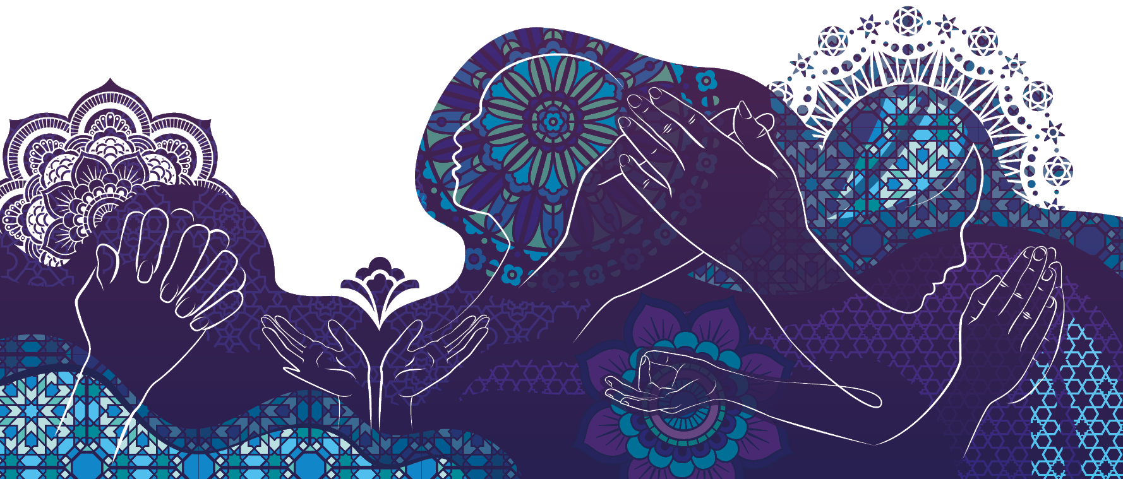

Appendix 1
The normative basis for the right to freedom of religion or belief
The Universal Declaration of Human Rights of 1948 lays the foundation for international efforts to protect human rights and applies to all UN member countries. Human rights have further been made legally binding by being incorporated into various international conventions and covenants, and member states ratifying these into legal obligations. The right to freedom of religion or belief is enshrined in the International Covenant on Civil and Political Rights and in several regional human rights instruments.
Freedom of religion or belief means that all people have the right to choose and to practise their religion or belief, either alone or in community with others, in public or in private. It includes the freedom to convert to another religion, including to have no religion, to observe religious traditions in the daily life, including to openly display one’s religious affiliation. In other words, the right to freedom of religion or belief protects individuals, not ideologies or religions. Non-discrimination and freedom from coercion and harmful practices are core principles.
Freedom of religion or belief also has a collective dimension, which is closely linked to freedom of assembly. Collective freedom of religion or belief primarily focuses on the autonomy of religious communities: their right to exist and freedom to determine their own practices in accordance with their religion or beliefs. The individual and collective aspects of the right to freedom of religion or belief are inextricably linked. Government regulation will often have an impact on both.
Freedom of religion or belief is enshrined in Article 18 of the Universal Declaration of Human Rights, Article 18 of in the International Covenant on Civil and Political Rights, and Article 9 of the European Convention on Human Rights, which all set out that everyone has the right to freedom of thought, conscience and religion.
This right includes the freedom to change one’s religion or belief, and the freedom, either alone or in community with others and in public or private, to manifest his religion or belief in teaching, practice, worship and observance.’
Article 18 of the International Covenant on Civil and Political Rights:
- Everyone shall have the right to freedom of thought, conscience and religion. This right shall include freedom to have or to adopt a religion or belief of his choice, and freedom, either individually or in community with others and in public or private, to manifest his religion or belief in worship, observance, practice and teaching.
- No one shall be subject to coercion which would impair his freedom to have or to adopt a religion or belief of his choice.
- Freedom to manifest one’s religion or beliefs may be subject only to such limitations as are prescribed by law and are necessary to protect public safety, order, health, or morals or the fundamental rights and freedoms of others.
- The States Parties to the present Covenant undertake to have respect for the liberty of parents and, when applicable, legal guardians to ensure the religious and moral education of their children in conformity with their own convictions.

The UN Human Rights Committee is the body of independent experts that monitors implementation of the ICCPR by its state parties. The Human Rights Committee’s General Comment No. 22 (1993) is a normative interpretation of Article 18 of the International Covenant on Civil and Political Rights. It points out that the freedom to manifest religion or belief encompasses a broad range of acts, including the building of places of worship, the observance of dietary regulations, the wearing of distinctive clothing or head coverings, participation in rituals associated with certain stages of life, and the use of a particular language customarily spoken by a group. In addition, the general comment specifically mentions ‘acts integral to the conduct by religious groups of their basic affairs’, such as ‘the freedom to choose their religious leaders, priests and teachers’.
The right to freedom of religion or belief promotes respect for diversity. It does not place one religion or belief system over another. It is not the role of the state to seek to change or influence religious traditions or the interpretation of these. At the same time, freedom of religion or belief includes the right of individuals to seek to bring about change in their own religious or belief communities, and the state has an obligation to protect such individuals from any coercion they may face from within their own communities.
Everyone has the right to freedom of thought, conscience and religion. This right may not be restricted under any circumstances. Government authorities may, however, place certain limitations on the freedom to manifest one’s religion or beliefs. Any such limitations must be prescribed by law, and must be proportionate and necessary to protect public safety, order, health or morals, or the fundamental rights and freedoms of others.
Freedom of religion or belief is an integral part of the human rights system. The Vienna Declaration and Programme of Action, adopted at the UN World Conference on Human Rights in 1993, states that “all human rights are ‘universal, indivisible and interdependent and interrelated”, and that they must be treated “in a fair and equal manner” across the globe. It is only when all human rights are respected that the protection of human rights can be said to be complete and genuine.
Issues relating to freedom of religion or belief often involve sensitive political matters. This may partly explain why, despite the significant challenges in this area, such issues are only included in roughly 3 % of the recommendations made to individual countries under the Universal Periodic Review process. The UN Special Rapporteur on freedom of religion or belief has called attention to this.
The thematic reports of the UN Special Rapporteur on freedom of religion or belief will be of great use in the Foreign Service’s efforts in this area. See the website of the Special Rapporteur for information about the mandate. These guidelines seek to shed light on how the right to freedom of religion or belief is linked to other human rights and to show how this right can only be properly understood in the context of the broader human rights agenda.
For a more detailed discussion of the normative framework for the right to freedom of religion or belief, in Norwegian law, see chapter 5 in Prop. 130 L (2018–2019) Proposition to the Storting (Norwegian only), available on the Government website (regjeringen.no).

Appendix 2
Historical timeline for freedom of religion or belief in Norway
1537 The Lutheran Reformation in Norway is introduced by Royal Decree in 1537.
1814 The Norwegian Constitution continues the religious monopoly and excludes Jews and Catholic monastic orders.
1842 The Conventical Act (Konventikkelplakaten) is repealed.
1845 Enactment of the first Dissenter Act. This makes it possible for Christian denominations to establish other religious communities in Norway and gives Norwegians the right to resign membership of the Church of Norway.
1851 Article 2 of the Constitution denying Jews entry to the realm is repealed.
1850 Several of the Protestant free churches found in Norway today are established during the second half of the 1800s.
1878 The Constitutional provisions on required religious affiliation for government officials are partially repealed.
1891 The Dissenter Act is amended. Non-Christian religious groups are given the right to establish religious communities in Norway.
1892 The requirement that judges profess the Lutheran faith is repealed; this is extended to include county governors in 1894.
1897 The prohibition against Catholic monastic orders is repealed, except for the Jesuit order.
1915–17 Dissenters are allowed to teach all subjects except Christianity in primary and lower secondary school. The requirement that heads of schools and their deputies profess the Lutheran faith is continued.
1919 The requirement that government ministers profess the Lutheran faith is partially repealed and is limited to one-half of the Council of State.
1948 The Universal Declaration of Human Rights is adopted by the UN and ratified by Norway.
1952 Norway ratifies the European Convention on Human Rights, which was adopted by the Council of Europe in 1950 and entered into effect in 1953.
1956 The prohibition against the Jesuit order is repealed.
1964 Freedom of religion is explicitly incorporated into the Constitution for the first time.
1969 The Dissenter Act is replaced by the Act relating to religious communities, etc.
1969 Tuition on Christianity as a school subject is no longer regarded as the official domain of the Church of Norway for Christian education.
1972 Norway ratifies the International Covenant on Civil and Political Rights, which was adopted by the UN in 1966 and entered into effect in 1976.
1999 The Norwegian Human Rights Act incorporates five international conventions with additional protocols into Norwegian law, giving these precedence over Norwegian law in cases of conflict with other statutes.
2012 The Constitution is amended, making Norway a secular country with no official religion.
2017 The Church of Norway is established as a separate legal entity.
2021 A new act consolidating existing legislation on religious and belief communities (trossamfunnsloven) entered into effect.

Appendix 3
Goal hierarchy for Norway’s efforts to promote freedom of religion or belief
This goal hierarchy for the Foreign Service’s efforts relating to freedom of religion or belief has been drawn up to facilitate results-based management activities across a complex area that has expanded significantly. The goal hierarchy is to be used as a tool for assessing missions’ new efforts, initiatives and projects, with the aim of improving the strategic management of this portfolio. An overall results framework for the goal hierarchy will not be developed at present; instead, the results frameworks for the individual agreements will form the basis for this work.
Impact
Individuals and groups can exercise their freedom of religion or belief, and are not discriminated against on this basis
Outcome I: Individuals and groups have legal protection and equal access to resources and services so that, in line with Agenda 2030, no one is left behind due to their religion or belief.
Outputs:
- Individuals and groups that belong to religious minorities have equal access to basic services, especially regarding health and education.
- Individuals and groups that belong to religious minorities have equal rights to choose their occupation, receive fair remuneration and equal pay for equal work, have a decent standard of living and engage in business activities.
- Individuals and groups that belong to religious minorities have access to protection against harassment, violence and threats, and access to legal aid.
Outcome II: Civil society organisations can exercise and promote freedom of religion or belief.
Outputs:
- Human rights defenders and the free media can document and communicate violations of freedom of religion or belief, other violations of the rights of religious minorities, and any patterns to be discerned in such violations.
- Religious leaders and actors, young people and other groups and individuals have knowledge and awareness about the right to freedom of religion or belief.
- Civil society organisations can advocate for the inclusion of freedom of religion or belief and the rights of religious minorities in legislation and policy, and for the incorporation of considerations relating to the right to freedom of religion or belief in the implementation of legislation and policy.
- Civil society organisations can operate freely and have access to inclusive arenas for exchange of experience, dialogue and cooperation.
Outcome III: National authorities and private actors support freedom of religion or belief in legislation and in practice.
Outputs:
- National legislation protects and promotes freedom of religion or belief and the rights of religious minorities (in accordance with international law).
- National and local authorities and politicians speak out in support of freedom of religion or belief, and design, incorporate into law and implement policies in a manner that ensures respect for the right to freedom of religion or belief.
- National and local authorities ensure that parties responsible for violations of the rights of religious minorities are held legally liable.
- The education system is based on respect for freedom of religion or belief and includes the right to freedom of religion or belief and religious diversity in curricula, teacher training and lessons.
- Public institutions and private businesses do not discriminate against individuals or groups based on their religion or belief, and implement remedial measures in areas where this occurs.
Outcome IV: International actors challenge national actors and hold them accountable in issues relating to freedom of religion or belief and the rights of religious minorities.
Outputs:
- The UN and other international and regional multilateral actors promote freedom of religion or belief in their work.
- Norway promotes freedom of religion or belief in its political dialogues and in relevant bilateral contexts.

Article 18 of the Universal Declaration of Human Rights provides the basis for the Foreign Service’s support for measures that promote freedom of religion or belief:
‘Everyone has the right to freedom of thought, conscience and religion; this right includes freedom to change his religion or belief, and freedom, either alone or in community with others and in public or private, to manifest his religion or belief in teaching, practice, worship and observance.’
This article also covers the right to have no religion or belief. Restrictions in relation to this human right often affect minorities. These restrictions not only prevent people from manifesting their religion or belief, but also affect them politically, socially and economically, and make them very vulnerable. Efforts to promote freedom of religion or belief will therefore be targeted towards the needs of the weakest groups and individuals in society. They may also involve measures that confront discriminatory attitudes and practices in the mainstream population. When targeted towards the education system, the labour market, various institutions, the media and the digital space, measures of this type will benefit everyone, both the majority and the minority groups, and women and men alike.
It is important to be aware that freedom of religion or belief may not be exercised in a way that restricts individuals’ freedoms in other areas. This applies in particular in cases where vulnerability due to religion or belief is combined with vulnerability due to other factors, for example gender, age, sexual orientation, etc. It is important to mainstream a gender perspective in this work. The Ministry expects these considerations to be taken into account in all programmes and projects that are granted funding.

Appendix 4
Key resources and suggestions for further reading
International resources:
Office of the UN High Commissioner for Human Rights (OHCHR)/Special Rapporteur on freedom of religion or belief
www.ohchr.org/en/special-procedures/sr-religion-or-belief
OHCHR and the “Faith for Rights” framework
www.ohchr.org/en/faith-for-rights
EU
www.eeas.europa.eu/sites/default/files/137585.pdf
www.eeas.europa.eu/eeas/standing-freedom-religion-or-belief_en
www.religiousfreedom.eu
www.religiousfreedom.eu/work
OSSE
www.osce.org/odihr/freedom-of-religion-or-belief
www.osce.org/odihr/429389
The Council of Europe
www.coe.int/en/web/portal
US Commission on International Religious Freedom (USCIRF)
www.uscirf.gov
Minority Rights Group International
minorityrights.org
International Media Support
mediasupport.org
Freedom House
freedomhouse.org/issues/equality-human-rights
Norwegian resources
Norwegian Ministry of Foreign Affairs
Human rights - regjeringen.no
For MFA and Norad staff only:
UDintra
Budskapsplattformen på UDintra
Norad – Norwegian Agency for Development Cooperation
Minorities of faith and belief (norad.no)
Ministry of Children and Families
Ministry of Children and Families - regjeringen.no
Ministry of Culture and Equality
Equality and diversity - regjeringen.no
Ministry of Local Government and Regional Development
Ministry of Local Government and Regional Development - regjeringen.no
Stefanus Alliance International
www.stefanus.no/english
www.forb-learning.org
The Oslo Coalition on Freedom of Religion or Belief
www.jus.uio.no/smr/english/about/id/oslocoalition
The International Panel of Parliamentarians for Freedom of Religion or Belief – IPPFORB
www.ippforb.com
The Global Interfaith Network for People of All Sexes, Sexual Orientations, Gender Identities and Expressions (GIN-SSOGIE)
gin-ssogie.org
The Norwegian Center for Holocaust and Minority Studies
www.hlsenteret.no/english
The Council for Religious and Life Stance Communities in Norway (STL)
stl.no/english

Appendix 5
Overview of core UN conventions
Four UN conventions are particularly important for the protection of religious minorities:
The International Covenant on Civil and Political Rights of 1966 states that the rights set out in the convention apply regardless of a person’s religion or other status (Article 2). Article 18 states that freedom of thought, conscience and religion includes freedom to have or adopt a religion or belief of one’s choice and freedom to manifest one’s religion or belief, either individually or in community with others and in public or in private; and freedom to ensure the religious and moral education of one’s children in conformity with one’s own convictions. The convention also states that all persons are equal before the law and may not be discriminated against on the grounds of religion or other status (Article 26). Article 27 specifically deals with the protection of religious, ethnic, and linguistic minorities.
International Covenant on Civil and Political Rights | OHCHR
The International Covenant on Economic, Social and Cultural Rights of 1966 states that the rights recognized in the convention (to work, an adequate standard of living, food, clothing, housing, and the highest attainable standard of health) apply regardless of a person’s religion (Article 2). Article 13 recognizes the right to education, which should promote understanding, tolerance, and friendship between all racial, ethnic, or religious groups.
International Covenant on Economic, Social and Cultural Rights | OHCHR
The Convention on the Rights of the Child of 1989 enjoys more support than any other human rights convention, but its provisions are typically vaguer, and its application is limited by reservations made by many states when ratifying the convention. Article 14 states that the child has the right to freedom of thought, conscience, and religion, but that the freedom to manifest their religion or beliefs may be subject to limitations prescribed by law and are necessary to protect public safety, order, health or morals, or the fundamental rights and freedoms of others.
Convention on the Rights of the Child | OHCHR
The Convention on the Elimination of All Forms of Discrimination against Women of 1979 condemns all forms of discrimination against women (Article 2). Women’s rights must be protected by law, and national penal provisions that constitute discrimination against women must be repealed. Most countries have ratified the convention, including all those in the Middle East apart from Iran. However, many countries have also entered reservations, for example that the state concerned will comply with the provisions of a particular article if they are not in conflict with shari’a law.
Convention on the Elimination of All Forms of Discrimination against Women New York, 18 December 1979 | OHCHR

