Norway in the North
A High North policy for a new era
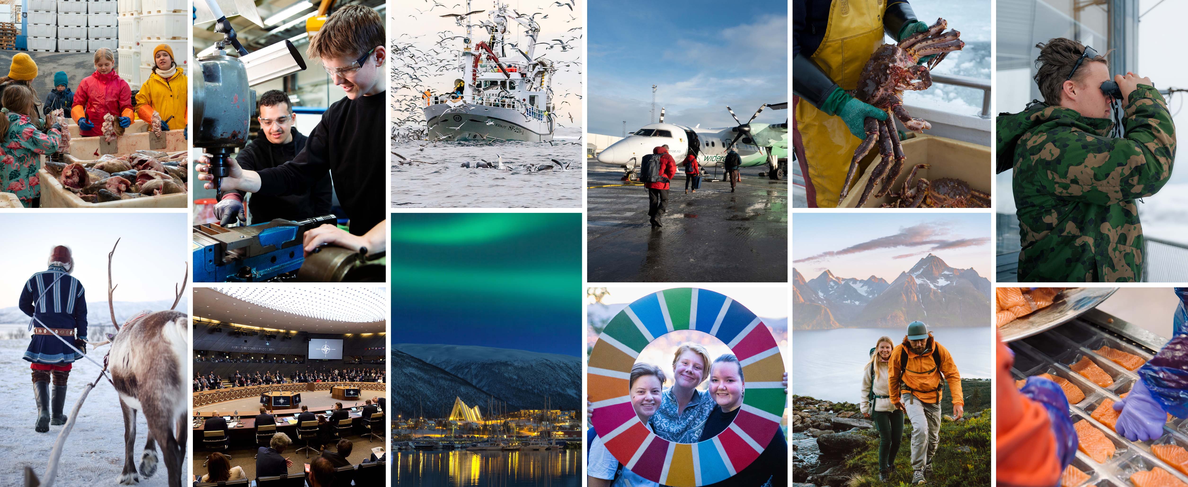

Introduction
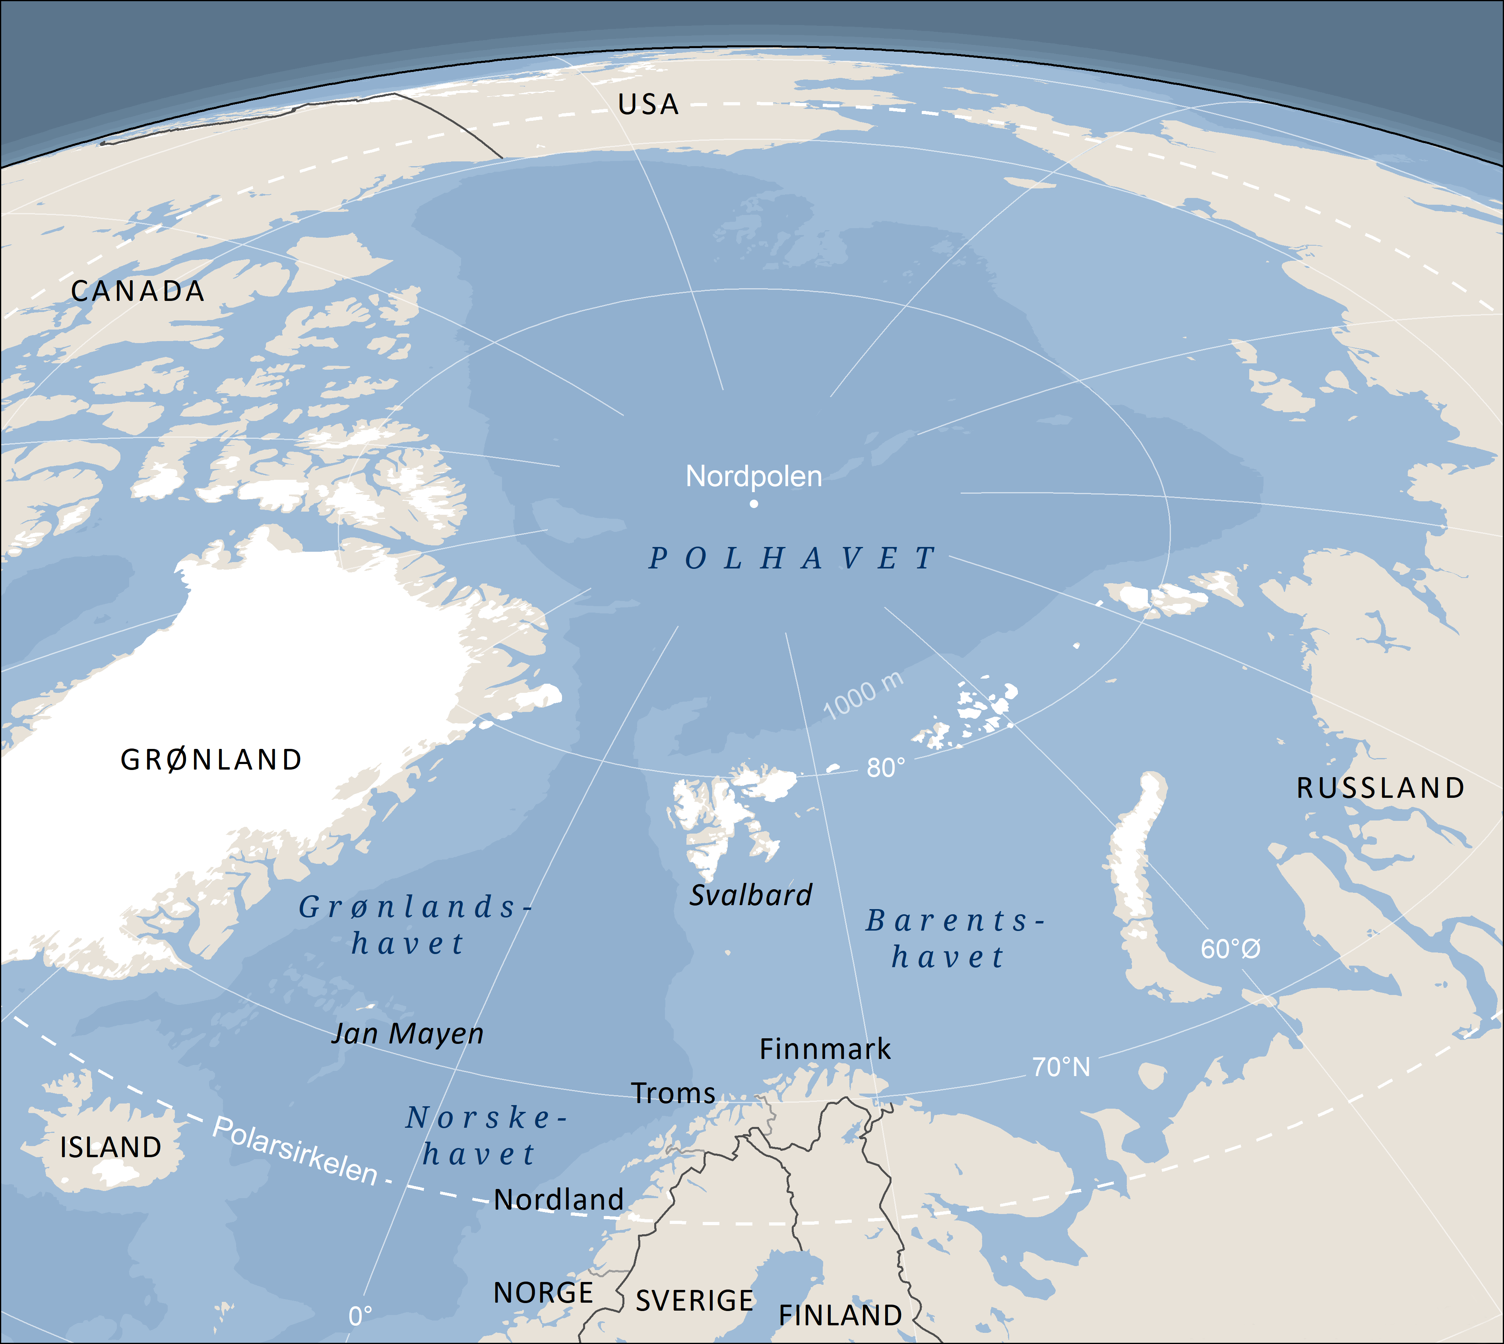
Norwegian Polar Institute 2025
Russia’s illegal war of aggression against Ukraine is the greatest security threat facing Europe and Norway today. The war is having a direct impact on the business sector and communities in the north. Maintaining settlement patterns, activity levels, and security and preparedness along Norway’s border and the external border of both NATO and the Schengen area is a matter of strategic national importance. The initiatives Norway implements in the north are of both national and international significance.
At the same time, these initiatives have clear consequences for daily life in North Norway. Urban settlements in the north play an important role as regional social and economic centres. But local communities in North Norway are often far apart, face demographic challenges and have a limited labour market. Reduced access to fisheries resources is placing further pressure on the region.
International interest in the Arctic is growing as a result of the deteriorating security situation, heightened global competition and the dramatic pace of climate change in the region. The major planned defence investments, combined with the initiatives to expand space-related activities on Andøya and boost electricity production and industrial activity in Finnmark, will bring investments in the billions to the region. This will promote job creation, business activity, improvement of infrastructure and local development.
The aim of Norway’s High North strategy is to ensure that North Norway is home to vibrant local communities where people want to live, and that enhance our national security and preparedness.
This High North strategy is based on Norway’s fundamental security interests as defined in our National Security Strategy: a free and independent Norway, a robust democracy, a safe society with a high level of trust, an open and adaptable economy, allied solidarity and unity in Europe, and a world that seeks solutions based on international law.
This strategy is also underpinned by Norway’s climate policy and indigenous policy. Norway has a statutory target of becoming a low-emission society by 2050. However, climate risk and the need for climate change adaptation must be properly taken into account in planning processes. The importance of Sámi culture as a valuable part of Norway’s historical heritage must also be recognised.
The geographical scope of this strategy comprises North Norway and the circumpolar Arctic. The main focus is on North Norway, Norway’s ocean areas and the northern parts of the neighbouring Nordic countries. Svalbard is only mentioned in this strategy where specifically relevant. The Government’s general Svalbard policy is set out in a dedicated white paper that was presented in 2024.
The Government has identified five priority areas:
1. Norway’s freedom of action and influence in the High North
We will uphold Norway’s sovereignty and sovereign rights and promote stability by maintaining a civilian and military presence in the region and strengthening total preparedness and situational awareness. Research and knowledge provide the basis for good policy development, sound management and sustainable business activities. It is of fundamental importance that developments in the Arctic are in line with international law. We will continue to support multilateral forums such as the Arctic Council. We will strengthen cooperation within the northern Nordic region and cooperation with our Nordic Allies, with the US and Canada, and with key European Allies and other non-Arctic countries where this is in Norway’s interests.
2. A total defence that provides security, promotes activity and enhances preparedness
The planned defence investments in North Norway will not only provide security, but will also promote job creation, innovation and value creation. The business sector plays a vital role as a supplier to the Norwegian Armed Forces and as a driver of new growth, technology and ideas. Society’s ability to deal with crises, war and unforeseen events is the cornerstone of our total preparedness. The objective is to increase national control and ensure a coordinated national effort to keep Norway safe.
3. Vibrant, safe communities
Cooperation between the central government administration, the counties and the municipalities, and innovation in service provision and social development will be vital in the years ahead. Regional cooperation with neighbouring Nordic countries will also be important for exchanging experience and building capacity and knowledge. The aim is for people to be able to study where they live and work, for children to have a positive environment to grow up in, and for young people to view the north as an attractive place to live. Vibrant communities in the north make Norway stronger.
4. Infrastructure to connect communities
Access to electronic communications and an efficient, accessible transport system are vital for building attractive, dynamic local communities in the north. In view of the long distances between communities and limited resources, priority must be given to measures that strengthen preparedness and promote settlement growth and business development. We will increase mobility across national borders in the north and develop infrastructure that enhances our total preparedness.
5. Business development to promote value creation
A profitable and diverse business sector in the north is important in terms of settlement patterns, value creation, and preparedness and security, both for Norway and in a wider European context. Norway’s rich natural resources, both onshore and offshore, are our greatest comparative advantage. The initiative to boost electricity production and industrial activity in Finnmark and the major effort to strengthen our national defence will promote development in the north. We will also work towards restructuring and growth in the seafood industry, which is a mainstay of many local communities.

Norway’s freedom of action and influence in the High North
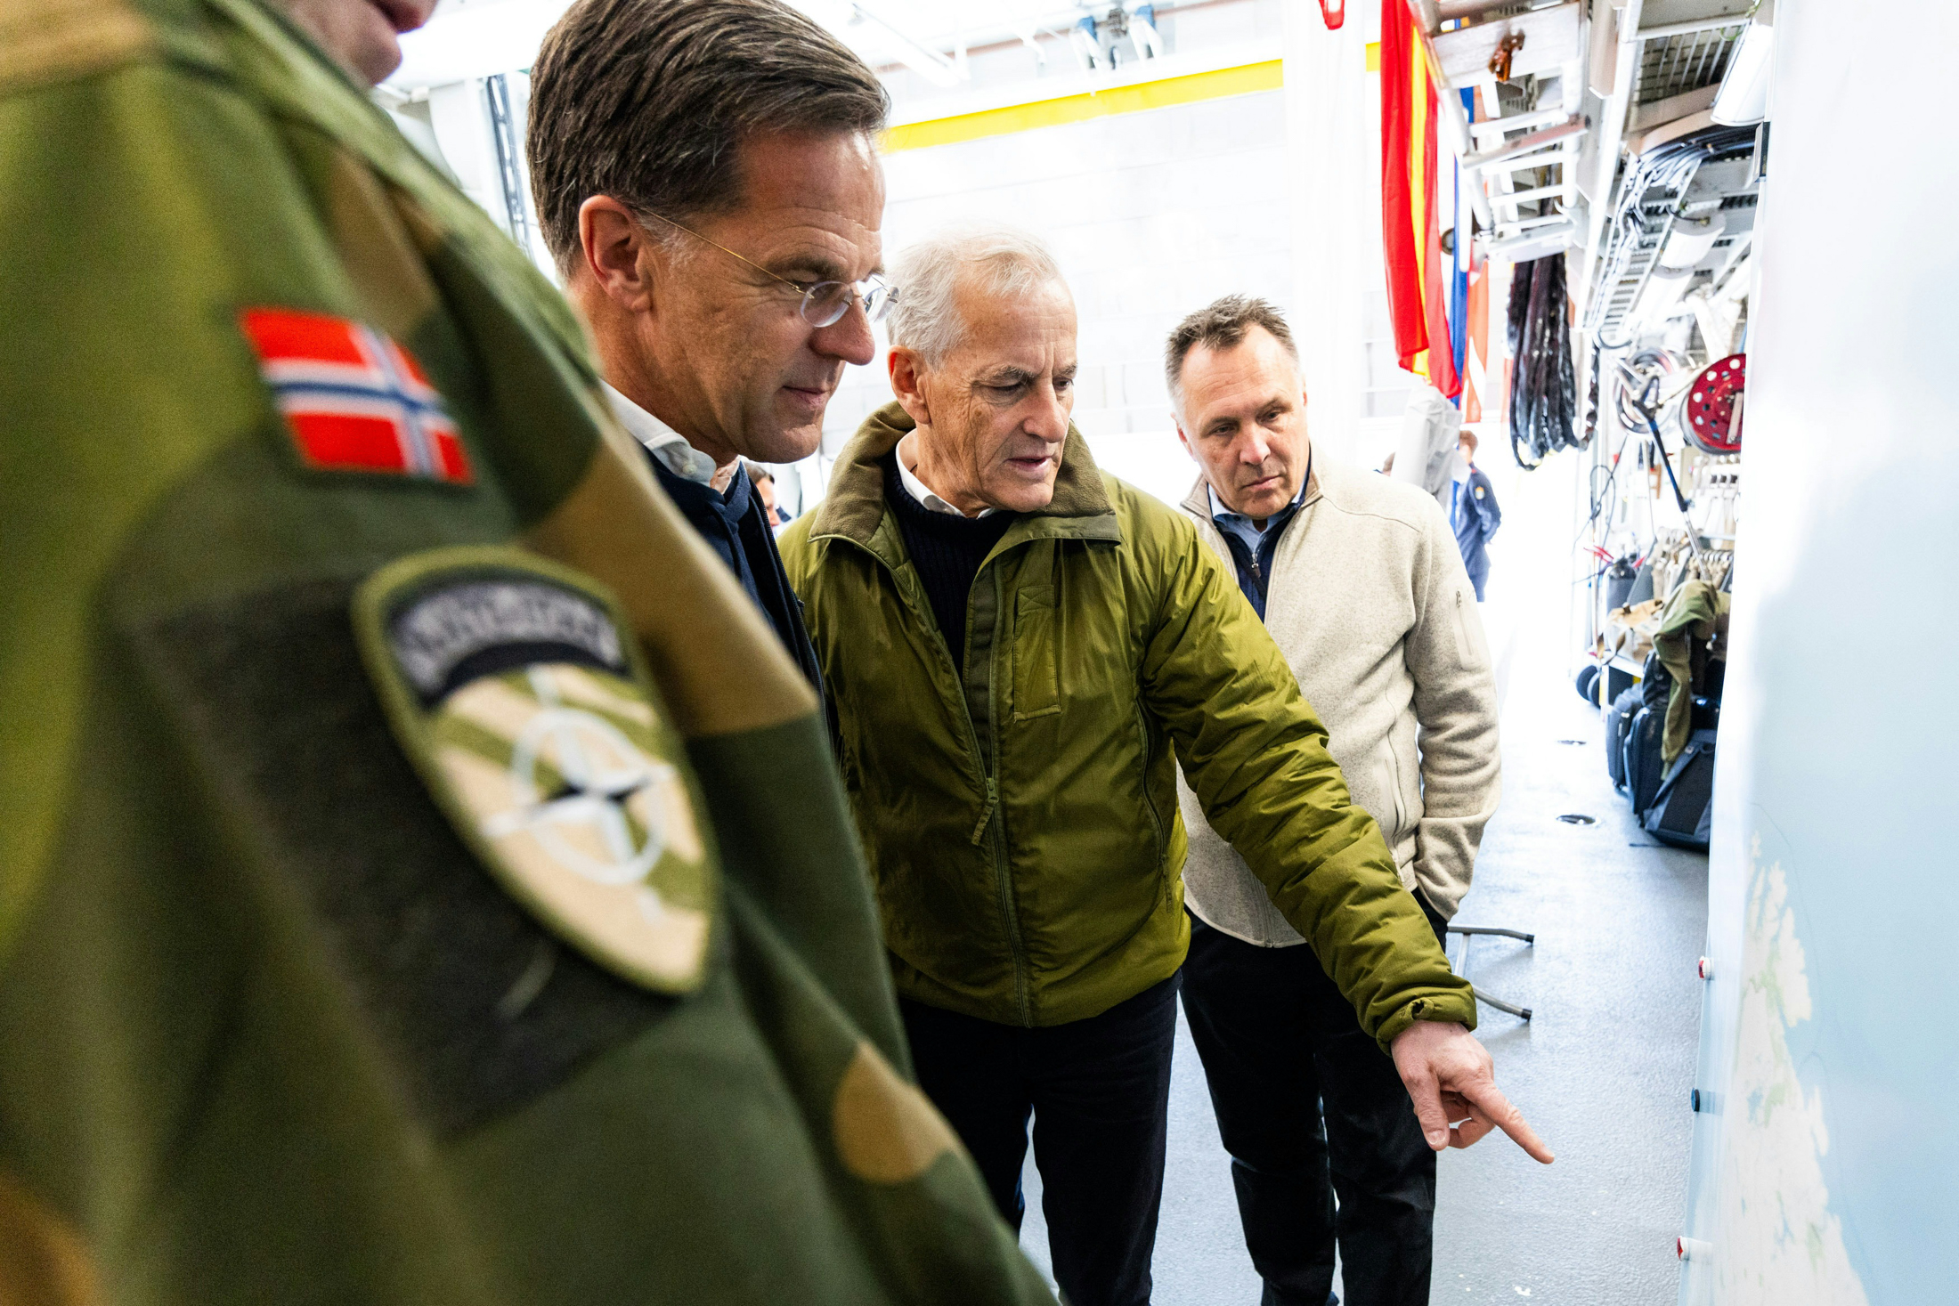
Photo: NATO
Safeguarding Norwegian interests in the High North will be a more demanding task for Norway in the years ahead. Upholding Norwegian sovereignty and sovereign rights will require a strong defence capability, cooperation with Allies, physical presence, knowledge, and sound administration. The legal framework that regulates borders, activity and public administrative practice must be maintained. We must support forums and cooperation arenas that address cross-border issues, including international climate and environmental obligations.
Russia’s war of aggression against Ukraine is a serious violation of international law and a threat to security across Europe. It is having a direct impact on the Norwegian High North and Norway’s neighbouring areas and has disrupted most activities involving cross-border cooperation with Russia. Norway will pursue a coherent, consistent and predictable Russia policy. In order to safeguard Norwegian interests and promote stability and security in the High North, there is still a need to maintain contact with Russian civilian and military authorities in areas such as border administration, search and rescue, and fisheries management in the Barents Sea.
With the defence of national interests as the point of departure, it is essential that Norway has the knowledge needed and ability to influence future developments, in an uncertain and unpredictable world. Shrinking sea ice cover and greater accessibility are increasing the strategic importance of the region. In light of this, Norway needs to strengthen its preparedness, situational awareness and response capacity, in collaboration with Allies, using both military and civilian resources. Norway is monitoring developments in maritime traffic through the Northeast Passage and in the sea areas off Norway, including movements of the Russian shadow fleet.
For Norway, it is of fundamental importance that developments in the Arctic are in line with international law and adhere to international rules and norms. The 1982 UN Convention on the Law of the Sea (UNCLOS) constitutes the basic international legal framework for all maritime activity, including in the Arctic. The Convention establishes rights and obligations pertaining to freedom of navigation, marine scientific surveys, exploitation and protection of the marine environment and its resources, delimitation of maritime areas, delineation of the outer limits of the continental shelf and other uses of the sea.
Multilateral cooperation in forums such as the Arctic Council will continue to be a priority for Norway moving forward. Norway is to be a clear and active voice in NATO and will work to enhance knowledge of the Arctic region, including the Norwegian High North, within the Alliance. We will seek to ensure that the Allied presence in the north is adequately adapted to Norwegian conditions and based on our situational awareness. The Government will work to incorporate issues relating to the Arctic into the development of European foreign and security policy, promote closer cooperation between the EU and NATO in the north, and help shape relevant EU initiatives.

Norwegian security and sovereignty
The Government is strengthening Norway’s defence capability in the north through increased national investments and close cooperation with Allied countries. In the region near the border with Russia, steps are being taken to improve infrastructure, surveillance and mobility in collaboration with Sweden and Finland. Border controls are being strengthened, and new sensors and surveillance systems are being used to enhance security along the border with Russia. The Government is working to improve maritime security and situational awareness in the region by investing in new military vessels, undersea capabilities, intelligence, surveillance and closer civilian-military and public-private cooperation. Digital and space-based surveillance capabilities in the High North will be strengthened. The Government is also strengthening Norway’s ability to counter complex threats such as cyberattacks, disinformation, sabotage and the use of migration as a tool to exert pressure on the Schengen external border. The Coast Guard and other authorities work together to ensure responsible, integrated resource management and to uphold Norway’s sovereignty and sovereign rights, using, among other things, satellite solutions and by maintaining a physical presence. Norway will also strengthen its capacity to protect and repair critical infrastructure on the Norwegian continental shelf, in cooperation with Allies.
Norway will carry out broader, more predictable controls of foreign investments. Actors involved in the delivery of critical services or in vulnerable value chains must exercise due diligence with regard to investments from countries with which Norway has no established security cooperation.

International and Nordic cooperation
Norway will be a strong voice in international processes relating to the environment, ocean management and use of resources in the Arctic. The Arctic Council is the most important international forum for knowledge production, cooperation, dialogue and diplomacy in the Arctic. The four main priority areas of the Norwegian chairship of the Arctic Council (2023–2025) were the oceans, climate and environment, sustainable economic development and people in the north, with Arctic youth and indigenous peoples as cross-cutting priorities.
Norway gives priority to maintaining close dialogue with Allies in and outside the region, and will contribute actively to NATO processes, sharing its insight into Russian and Chinese activity in the north. We will work to reduce the risk of conflict and misunderstandings that can lead to escalation and heightened tensions, and to enhance understanding among our Allies of our national positions.
Norway will further develop bilateral cooperation on Arctic affairs, giving priority to the Nordic countries, other Arctic Allies and key European Allies, to enhance joint situational awareness and promote Norwegian interests in the north. We will also strengthen collaboration with other non-Arctic countries, in particular countries that are actively involved in knowledge development and environmental cooperation relating to the Arctic and that recognise the importance of a rules-based world order. A prerequisite for such collaboration is that it is in line with national security interests. Norway will follow a restrictive policy with regard to Chinese activity in the High North.
Cooperation in the northern Nordic region will be strengthened. Cross-border cooperation schemes adapted to a new era should be established between Norway, Sweden and Finland. In Norway’s view, such initiatives must be based on local and regional needs, with the clear support of the national authorities.
Given the current security situation, it is essential to strengthen Norway’s capacity to receive Allied reinforcements. Harmonised border-crossing systems are important in order to improve military mobility. We will also harmonise legislation to facilitate labour mobility and cross-border services and strengthen cooperation to limit adverse impacts on the environment and safeguard the interests of indigenous people.

Norway as a polar nation
Norway’s role as a polar nation is underpinned by a knowledge-based Arctic policy. Norway has a number of leading research communities and gives priority to maintaining research infrastructure, strong institutions and international cooperation on climate issues, the environment and sustainable development. By working together, the research and business communities can also take full advantage of Norway’s geographical location in the Arctic and use their knowledge to find solutions to national and global challenges.
Svalbard provides a basis for crucial international cooperation on environmental, climate and polar research. The University Centre in Svalbard (UNIS) plays a key role in educating future polar researchers and offers programmes to provide representatives of the public administration and other sectors with insight into polar issues. The new research office established in cooperation between the Research Council of Norway and the Norwegian Polar Institute will strengthen Norwegian leadership of research activities in Svalbard.
The Government will strengthen Norwegian research efforts in Arctic waters. Funding has been allocated to the Research Council of Norway to support the joint efforts of the 18 research institutions participating in the new 10-year Arctic Ocean 2050 research programme, where the research vessel Kronprins Haakon will have a central role.

A total defence that provides security, promotes activity and enhances preparedness
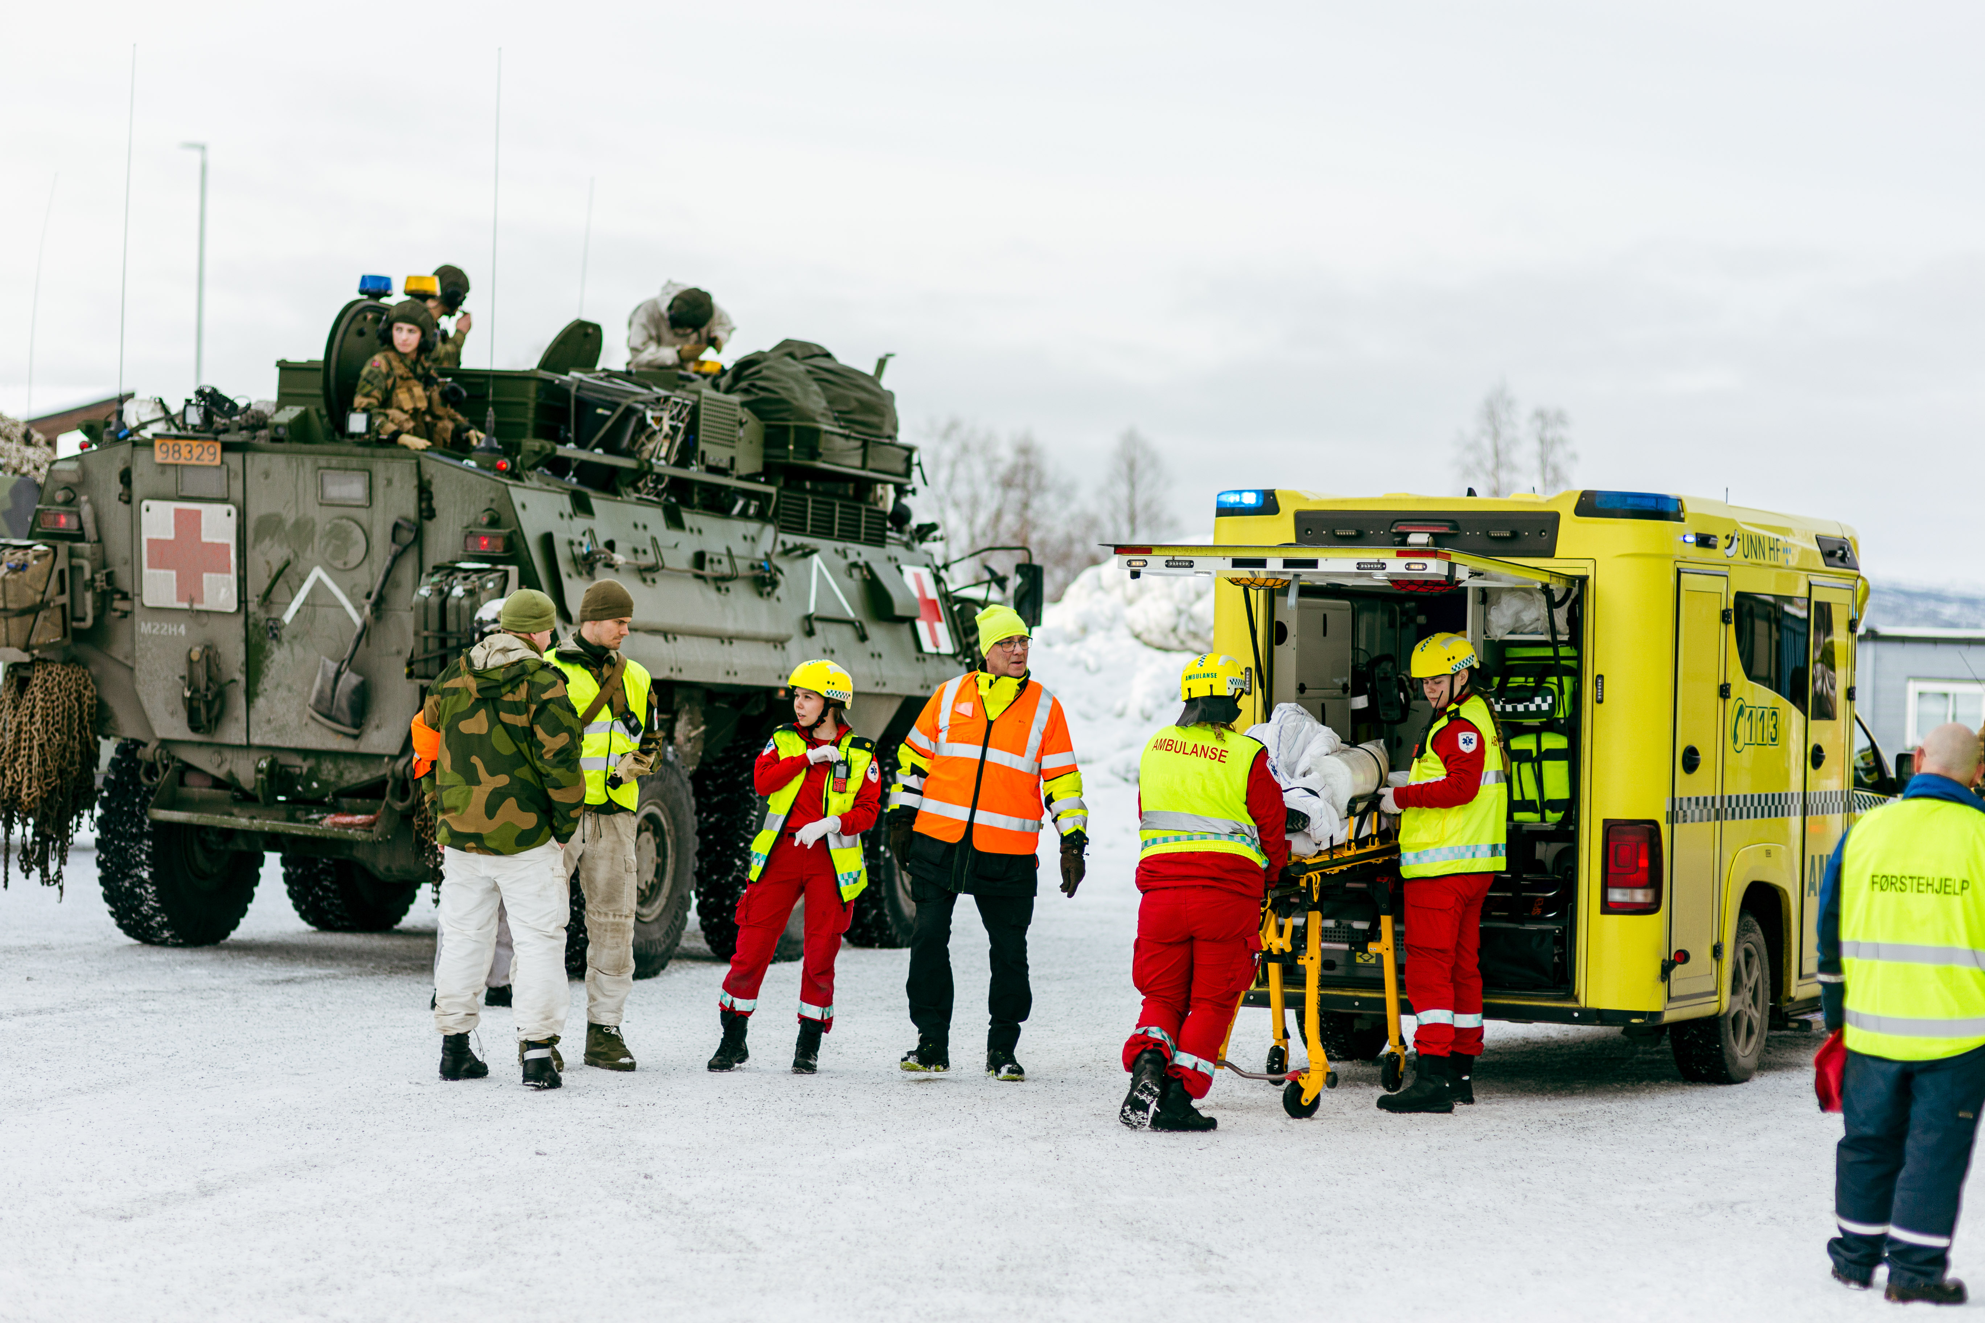
Photo: Kristian Berg/Forsvaret
Norway needs to strengthen its defence capabilities on land, at sea, in the air, in the digital domain and in outer space. Norway is giving priority to enhancing national situational awareness capacity, increasing physical presence, facilitating continuous operations and ensuring adaptable responses, both alone and together with Allies. The Storting (Norwegian parliament) has unanimously adopted a historic plan for upgrading the Armed Forces in the period from 2025 to 2036.
Civilian society, too, must be equipped to deal with crisis and war, and must be capable of backing up military efforts and resisting complex threats. We must build up civilian resilience, particularly in the north.

Security through greater Armed Forces presence
The Government has proposed Reitan, in the municipality of Bodø, as the permanent location for NATO’s new Combined Air Operations Centre (CAOC). The air operations centre will strengthen the role of the region as a hub in the Alliance. A major investment in land forces is also planned. By 2032, the Finnmark Land Command will be expanded to become the Finnmark Brigade, with Porsangmoen Base as the centre of activity. Steps will be taken to strengthen the Home Guard’s capacity to conduct operations in Troms and Finnmark counties. The further development of the newly established Tromsø rapid response force in the Nord-Hålogaland Home Guard District (HV-16) will continue. A new rapid response force is being created for operations in Finnmark.
Creating a framework for extensive Allied presence in North Norway is another important element. Bardufoss Air Station, the Setermoen garrison and associated firing ranges are defined as Agreed Facilities and Areas under the Supplementary Defense Cooperation Agreement (SDCA) between Norway and the US. The agreement provides the basis for further developing military cooperation with the US in these places and increasing US presence in the region.
In order to strengthen cooperation between the countries in the northern Nordic region, the Government will ensure that training exercises, including for crisis and war scenarios, are held regularly and involve both civilian and military actors. Norway will also participate in joint exercises such as the Rescue Borealis exercise in Finland in autumn 2025. Actors that are well prepared and have trained together across national borders to prepare for emergencies provide greater security for the population not only in times of crisis and war, but also in peacetime.

Investments in defence help to build strong local communities
The planned defence investments in North Norway will provide security for the population while also supporting the development of civilian infrastructure and strengthening innovation capacity in the region. The next 10 years will see over NOK 50 billion in investments and the creation of more than 1 700 new jobs in the north, under the Long-term Defence Plan. There will also be an expanded Allied presence and an increase in the number of reservists and conscripts. All this will open up major opportunities for value creation.
The defence sector and local communities are to cooperate on developing strong urban and rural centres, meeting places and suitable housing. Civilian-military cooperation will also increase the number of young people in Finnmark who are motivated to serve in the Armed Forces. It is important to build local communities that can provide the Armed Forces and Allied partners with the support they need from the business sector and other civilian actors in the event of a crisis or war. Having multiple local and regional suppliers to the Armed Forces strengthens civilian preparedness and promotes more vibrant local communities.
Early involvement of the local community and good meeting places are essential to ensure that the development of infrastructure for the Armed Forces adequately safeguards the interests of the local population. Increased defence activity in the region will give due consideration to Sámi culture and traditional Sámi industries. The Government will maintain a dialogue with affected reindeer husbandry districts on matters related to military exercises, training and other military needs. This includes area zoning plans to provide a predictable framework for the use of firing ranges and training areas.

Strengthening civilian resilience
The Government will develop a dedicated zone for national initiatives to strengthen civilian preparedness in Troms and Finnmark, based on NATO’s baseline requirements for resilience in critical civilian societal functions. Norway’s northern municipalities play a crucial role in national emergency preparedness. To fulfil their responsibilities and obligations in this area, the municipalities are dependent on access to adequate expertise and capacity. The Government will work to increase both capacity and expertise, giving special priority to eastern Finnmark. The Norwegian Civil Defence is an important resource in this context, and the Government will ensure that the Civil Defence has a local presence and that municipalities have access to its services.
The Government will ensure that the central government administration increases it presence in North Norway in order to build expertise, contact networks and cooperation across sectors and administrative levels in the region as well as between Norway, Finland and Sweden. Cross-sectoral cooperation has already been established between regional health authorities and the Armed Forces on dealing with mass-casualty events in the north. The Norwegian Directorate for Civil Protection (DSB) has been given national responsibility for tasks relating to total defence and civilian protection measures, with special focus on the Norwegian High North, and eastern Finnmark in particular.
The Government will create a framework to enable the municipalities involved in defence-related activities to hold regular exercises with relevant emergency preparedness actors to train to provide support to the military, including in a conflict situation. Municipalities designated to receive Allied forces are to be given special follow-up by the Armed Forces.
Norway will continue to take part in Nordic cooperation on personnel security in connection with the operation and maintenance of digital infrastructure, health preparedness, security of supply and mass evacuation planning. We are seeking to enter into binding cooperation with Sweden on ensuring security of supply, modelled on the existing agreement with Finland.

Vibrant, safe local communities
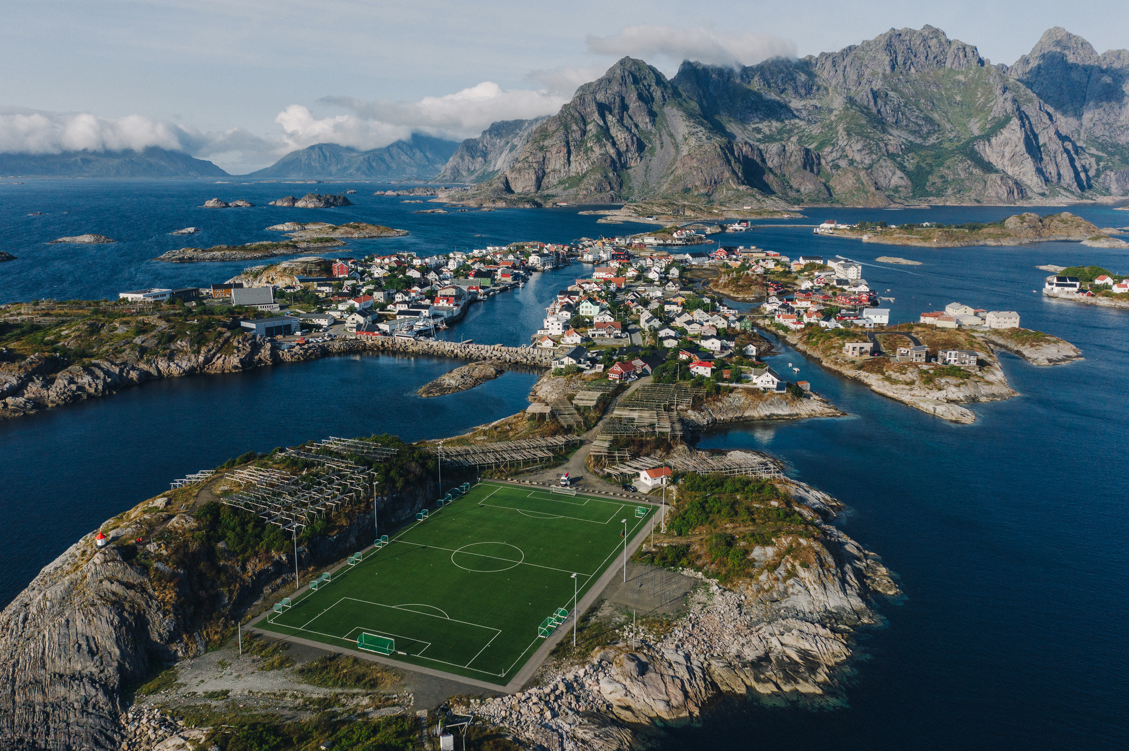
Photo: Oleh_Slobodeniuk/iStock
The key to the development of North Norway lies in ensuring that people in the region have not just something to live on, but also something to live for. Safe, well-functioning local communities are essential for maintaining settlement patterns and activity levels.

Access to basic services
There is a great need for labour and skills in both the public and the private sectors in the north. Priority is being given to measures that make the region more attractive to young adults and families with children. The Government is also working to increase access to flexible, varied and decentralised educational options that allow young people to live at home for longer and enable them to forge ties with local businesses, including in sparsely populated areas where there are long distances between communities and economic centres.
In order to provide reliable, accessible health care, coordination between hospitals and municipal health services has been strengthened. Effective municipal health and care services are a key component in enhancing people’s sense of security and quality of life and ensuring equitable access across the country. High-speed broadband and mobile networks can be used to maintain decentralised health services and reduce the need for patients to travel a long way for routine consultations. To reduce travel costs for patients and increase health service efficiency, the Government will establish a pilot scheme to cover more of the travel costs incurred by patients within the Northern Norway Regional Health Authority.

Promoting cultural life and building identity in local communities
North Norway is home to diverse communities with considerable linguistic and cultural differences. Harassment and discrimination of the Sámi population are still a problem. The Government will take steps to increase knowledge of and expertise on Sámi and Kven language and culture, with a view to promoting reconciliation and understanding. The Government has allocated more funding to enhance knowledge of health and living conditions among the Sámi population and promote Sámi cultural transmission. Sámi people are to have access to information in their own language.
The Government will work to expand local sports activities and reduce participation costs, and will encourage increased participation in cultural activities. The Government has built a number of cultural centres in North Norway and provides support to cultural organisations, museums and theatrical institutions. The Government also supports international cultural cooperation initiatives such as Pikene på Broen, the Dáiddadállu Sámi artist network in Kautokeino, the BarentsKult cultural grant programme and the Arctic Arts Summit collaborative platform.
The Government will give priority to participating in the EU’s Interreg programmes as a means of supporting regional cooperation across national borders and local development in the High North. We will continue to take part in the North Atlantic Cooperation (NORA), where knowledge sharing and cooperation between small-scale stakeholders promote development at the local level.

Strong municipalities that provide safety and security
Well-functioning municipalities provide the local population with access to high-quality education and welfare services, housing and jobs. Adequate governance and implementation capacity in the municipal sector is essential to achieve social development, provide housing, deliver statutory services, and maintain emergency preparedness. The Government will facilitate improved coordination and cooperation between municipalities, counties and county governors to ensure more effective use of public resources and strengthen governance, planning and restructuring capacity in the municipalities.
The Government is considering new models for cooperation between municipalities, between different administrative levels and through special rural growth agreements. This will involve amending the regulatory framework to facilitate more effective cooperation. The goal is to encourage joint problem-solving and service development. The Government is seeking to ensure that the joint efforts of counties, county governors and other national authorities vis-à-vis the municipalities are well coordinated and strengthen the municipalities and intermunicipal cooperation.
The housing stock rebuilt after the end of World War II, when all the buildings in Finnmark and northern Troms were burned to the ground, was uniform and is now ageing. These houses are rarely put on the market, and few new houses are being built. The Government will strengthen efforts to enhance the quality and functionality of the housing stock and increase residential construction.

Infrastructure to connect communities

Photo: Everste/iStock
Access to reliable electronic communications and an efficient, accessible transport system are essential to ensuring people’s safety and security, an active business sector and dynamic communities. The development of transport systems and other infrastructure must also play a part in mitigating climate change and limiting biodiversity loss.
In the National Transport Plan 2025–2036, the Government has set out a number of measures to adapt the transport sector to the new security landscape. Cooperation between the transport and defence sectors on meeting military needs for transport infrastructure has been strengthened. Most of the new measures are to be implemented in the north. The Government has also strengthened Nordic cooperation in the transport and defence sectors. A strategic corridor for military mobility through North Norway, North Sweden and North Finland is to be developed. The Nordic transport ministers have taken the initiative to draw up a joint strategy for border crossings, civilian preparedness and security of supply based on the respective countries’ strategic transport plans.
Steps will be taken to increase rail capacity for passengers and freight, giving priority to military mobility and civil protection. In the work to further develop the national road network, the Government will give priority to traffic safety, important commercial corridors, military mobility and security of supply. In the National Transport Plan 2025-2036, the Government has increased the allocations for county roads to enable the counties in the north to better maintain the county road network.
The decentralised airport structure and air services available in the north are key to reducing disadvantages due to geographical distances. The Government will facilitate good, reasonably-priced regional air services, both for passengers and for the state as procurer. The fishing ports are vital to maintain value creation, jobs and settlement patterns in communities dependent on fisheries. Priority is therefore being given to measures to upgrade fairways and fishing ports in North Norway in order to accommodate larger vessels.
The Government attaches importance to providing people and businesses with access to high-quality, resilient mobile and broadband services. This is essential to maintaining critical public functions, settlement patterns, transport systems and business activity. We will update the regional risk and vulnerability analyses and seek to expand the use of cross-border digital routes between Norway and neighbouring Nordic countries to further strengthen the foundation for reliable digital services in the north.

Business development to promote value creation
Photo: Einar Aslaksen, TRY/Equinor
Throughout North Norway, the region’s abundant natural resources provide the basis for activities and value creation. This includes in areas such as fisheries, aquaculture, agriculture, reindeer husbandry, tourism, the maritime sector, the petroleum industry, energy-intensive industries and mineral extraction. The Government aims to ensure that the resources found in the north are used to promote value and job creation based on sustainable management. Many species and ecosystems are becoming more vulnerable due to climate change. The impacts on reindeer husbandry are particularly severe. Norway will continue to be at the forefront of knowledge development on the Arctic, with a view to ensuring sound management of these resources to the benefit of current and future generations.

Sustainability, adaptation and growth in the seafood industry
The traditional fisheries industry is competing on a global market and needs knowledge and innovation capacity to adapt to seasonal variations and comply with extensive fisheries legislation. The Government will provide more funding for research on species diversity and the potential use of marine resources in the Barents Sea and in coastal waters off North Norway, and to ensure that fisheries resources are managed sustainably. The Government has also intensified its efforts to protect wild salmon, including through measures to combat the spread of pink salmon. The Government has also strengthened management and control of resource harvesting under the Directorate of Fisheries and the Blue Justice centre in Vardø.
Production capacity in the aquaculture industry in the northernmost areas has been increased. The Government will start up mapping of the seabed in the Varangerfjorden, which could facilitate new activity and help identify ways to enable traditional fisheries and aquaculture to coexist.
The fishing tourism industry also generates activity and value creation along the Norwegian coast and helps local communities that are dependent on fisheries to adapt and diversify. The Government is working actively to make fishing tourism more sustainable, including through regulation and more effective control of catches.

Business activity to build dynamic communities
The Government is seeking to increase preparedness and self-sufficiency through its agricultural and reindeer husbandry policies. The Government is giving particular priority to promoting sustainable food production and value creation in order to strengthen the resilience of vulnerable producers, prevent a decline in the number of farms, and enhance regional comparative advantages in Arctic agriculture.
The Government is strengthening the framework conditions for reindeer husbandry and will continue to support those whose main livelihood comes from reindeer husbandry. Sámi industries strengthen Sámi communities, culture and identity. The Sámi tourism industry attracts visitors from all over the world, and reindeer products are in demand. Sámi music has seen success in Europe, and the International Sámi Film Institute collaborates with prominent international institutions. The Government’s policies seek to facilitate profitable and varied economic activities in Sámi communities, and encourage the development of commercial activities based on Sámi culture and identity all over the country.
The tourism industry in North Norway is growing fast, opening up a wide range of opportunities for businesses and local communities. As the number of visitors rises, there will be a need to provide a wider range of services and experiences, paving the way for increased sales of locally produced food and drink based on ingredients from the seafood industry, agriculture, reindeer husbandry and hunting. In many municipalities, the growth in tourism is putting pressure on public services, local communities and the natural environment. One challenge is the establishment, operation and maintenance of tourism-related public goods. The new Visitor’s Fee Act will give municipalities under particularly great pressure from tourism a tool for funding tourism-related public goods.

Industries contributing to European security of supply
Limited grid capacity is one of the biggest obstacles to growth and development in Finnmark county. The Government has launched a major initiative to expand the power grid and increase power production in Finnmark. Adequate access to electricity is essential both to ensure preparedness and security as well to promote development of industrial and business projects. The industrial sector in North Norway is already working hard to implement the green transition and is at the forefront internationally in achieving energy efficiency, low greenhouse gas emissions and a circular economy. The Snøhvit field and Melkøya facility currently make up the largest industrial complex in North Norway. The Snøhvit Future project will increase gas production, extend the lifespan of Hammerfest LNG and reduce CO2 emissions from the plant by 90 %. The Government will work to facilitate profitable oil and gas production in a long-term perspective and will also follow up the management strategy for mineral activities on the continental shelf.
There is still great potential for mineral extraction in the Arctic. A number of the critical raw materials needed by Norway and Europe can be found here. The strategic importance of the planned copper mining project Nussir has been recognised by the EU, and various other projects may be realised in the coming years that could create new value chains in the region. The new Mineral Resources Act will make it easier for the industry to develop projects. Among other things, the Act emphasises the need for early dialogue and clarification between developers, relevant licensing authorities and municipalities. Sámi rights holders have also been given greater protection. We will continue to give priority to geological surveys and to increasing knowledge of key issues, including reindeer husbandry.
Space infrastructure for surveillance, communication and navigation purposes is particularly valuable for North Norway and Norwegian waters. The region has both important infrastructure for downlinking data and satellite launch facilities at Andøya Spaceport. The aerospace company Andøya Space has been providing services relating to space and atmospheric research and environmental monitoring since 1962. The Government’s proposed new Space Act will facilitate business development, innovation and peaceful exploration of space. Participation in the European Space Agency (ESA), EU space programmes and cooperation with the US provides good opportunities for further developing Norwegian space-related activities. The Earth observation research cluster in Tromsø provides insights on climate change, landslide and avalanche risk, and ocean- and land-based activities in the Arctic.

Effective spatial management processes for land-intensive sectors
The development of renewable energy, business activities and infrastructure is key to building viable local communities and ensuring stable and sustainable settlement patterns. It is also essential to take into account environmental considerations, Sámi interests and other forms of land use. The decision-making processes and dialogue between the parties involved must ensure that the various interests and concerns pertaining to land use are made known and considered. The Government has introduced a package of measures for the reindeer husbandry industry and power supply sector to allow an expansion of electricity production and the grid while at the same time protecting the interests of reindeer herders. It includes measures to better enable reindeer herding districts to follow up land use cases, gain a better overview of land use in reindeer herding areas, and establish a methodology for including reindeer husbandry in environmental impact assessments.

