One digital public sector
Digital strategy for the public sector 2019–2025

Foreword
Norway has a well-functioning and efficient public sector. There are nevertheless major challenges. We must deliver even better services to citizens, businesses and voluntary organisations. To accomplish this, we must use new technology, be innovative and be able to change.
These challenges cannot be resolved in individual agencies or sectors. We need to collaborate across agencies and sectors to create seamless services that meet the needs of the users, regardless of who provides the service.
Digitalisation shall promote a more efficient public sector, more value creation in the business sector and, not least, a simpler everyday life for most people.
This digital strategy follows up Meld. St. 27 (2015–2016) Report to the Storting Digital Agenda for Norway. The strategy defines the common goals and focus areas for digitalisation activities towards 2025, and will support digital transformation throughout the entire public sector.
No one should be passed back and forth between different public actors. That is why we must work together to meet the needs of the users. The goal of having one digital public sector requires that we change our work methods and structures, have the right skills, and perform more tasks digitally. We shall offer seamless services, use common solutions rather than establishing individual ones, and ensure that the common solutions work across administrative levels and sectors.
We must share and reuse more public data, and we must ensure that regulations are digitalisation friendly. This requires that we cooperate in new ways, and that the local government sector also be given sufficient influence in national digitalisation initiatives through good models for cooperation and collaborative governance. This is therefore a common strategy for both the local and the central government sectors. Digitalisation in the public sector shall simultaneously contribute to increased value creation in the business sector.
Norway is at the forefront in using technology. We should benefit from this. In our work, we have placed emphasis on including a broad range of actors, both inside and outside public administration. The local government sector has made important contributions. We would like to thank everyone for their valuable input and strong commitment along the way.
Large and important tasks lie ahead of us. We will now work together to implement all the good initiatives.

Oslo, 11 June 2019
Nikolai Astrup
Minister of Digitalisation Ministry of Local Government and Modernisation

Gunn Marit Helgesen
President
Norwegian Association of Local and Regional Authorities

Introduction
This strategy applies to the public sector for the period 2019–2025. The direction of the work on digitalising public services closely aligns with the guidelines in Report No. 27 (2015–2016) to the Storting Digital Agenda for Norway, and this strategy follows up the white paper. The strategy applies at the general level and provides guidelines for digitalisation activities in the public sector and any sector-specific strategies. The strategy is cross-sectoral, and should both maintain an overall perspective and support sectoral goals for digitalisation of the public sector.
Digitalisation of the public sector aims to give citizens, businesses and the voluntary sector a simpler everyday life through better services and more efficient use of resources by government agencies, and facilitate increased productivity in society at large. The purpose of the strategy is to support a digital transformation in the individual agencies and in the public sector as a whole. Digital transformation means changing the fundamental ways in which agencies perform tasks using technology. This means that the agencies will undergo radical changes aimed at achieving enhanced user experiences and smarter, more efficient performance of tasks. Such an approach may require the organisation to be restructured, areas of responsibility reorganised, regulations revised, or processes redesigned. This has as much to do with change management, skills and organisational development, public administration policy and public administration development as it does with technology.
The public sector needs to enhance its ability to work flexibly and innovatively so that new work methods and processes can be implemented. Digitalisation is not just about what we should digitalise, but how digitalisation can create innovation and improve efficiency. At the same time, a user-centric approach is not always compatible with improving efficiency in the public sector. This strategy shall facilitate smarter ways of performing tasks throughout the public sector and value creation in the business sector.
The strategy’s main measures focus on user-centric service development and more efficient and coordinated utilisation of common IT solutions by developing a common ecosystem for digital collaboration in the public sector. The strategy requires that cyber security be integrated into the service development, operation and management of common IT solutions, in accordance with the objectives of the National Cyber Security Strategy for Norway.
Goals for our work towards 2025:
- The public sector shall be digitalised in a transparent, inclusive and trustworthy way
- More tasks shall be performed digitally, and as seamless services
- All citizens, businesses and voluntary organisations that have the ability to do so, shall communicate digitally with the public sector
- The public sector shall exploit the potential of sharing and using data to create user-friendly services, and to promote value creation in the business sector
- Local and central government agencies shall develop their services based on a common digital ecosystem for collaboration
- Local and central government agencies shall realise benefits from digitalisation in a systematic manner
To achieve these goals and support digital transformation, the strategy shall focus on the following areas:
- A user-centric focus through development of more seamless services based on key life events
- The public sector shall collaborate better on digital services and streamline the use of resources through enhanced coordination across administrative levels and sectors, and systematically realise benefits from digitalisation
- Data shall be shared and reused in the public sector to a greater degree, and open data shall be published for innovation and value creation in the business sector
- National digital collaboration and service development, common solutions and common architectures shall be established in a hierarchically controlled and coordinated ecosystem
- Cooperation with the private sector on digitalisation will be enhanced to achieve better, more efficient services and to facilitate innovation
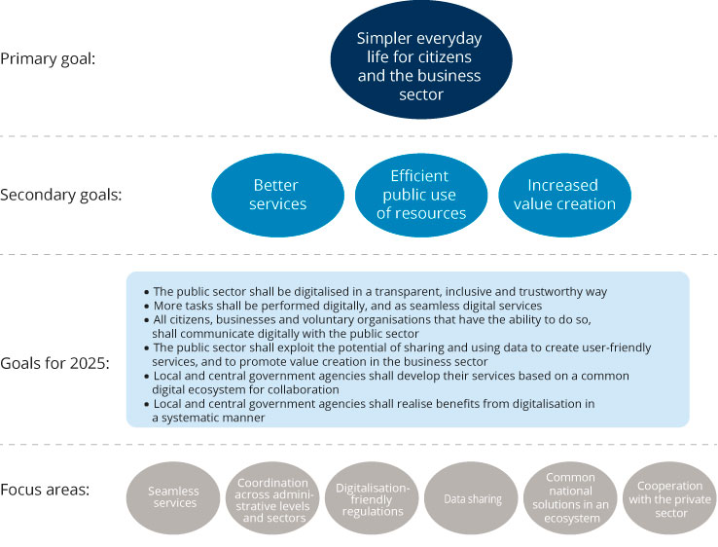
          - Goals and focus areas in the digital strategy for the public sector for the period 2019–2025
Innovation in the public sector is the subject of a separate white paper due to be presented to the Storting (the Norwegian parliament) in 2020. A national strategy for artificial intelligence will launched in 2019. The Digital21 strategy was drafted by a government-appointed working group, and proposes initiatives for increased digitalisation in the business sector. These proposals will be followed up to some extent in this strategy. This applies in particular to the reuse of data, digitalisation- friendly regulations and public–private partnership.
Background
A narrower economic scope of action and increased expectations from users require that the public sector work in new ways. Coordination and cooperation across administrative levels and sectors is needed for the public sector to realise the benefits of new technology. We are well underway in digitalising the public sector. We have a good starting point with good basic data registers, a well-developed digital infrastructure and a high level of digital competence in the population.
Statistics Norway’s survey on the use of ICT in households shows that Norway ranks top in Europe in using public online services. In 2017, nine out of 10 people in Norway communicated with the public sector via the internet during the past year (see Figure 1.2 below). Few other countries in Europe have a corresponding use of public online services. In 2018, 88 per cent of Norwegians between the ages of 16 and 79 had used at least one of the three online services featured in the survey over the past twelve months. This represents an increase from 72 per cent in 2009 and from 83 per cent in 2017. The most common use of public online services is to search for information.
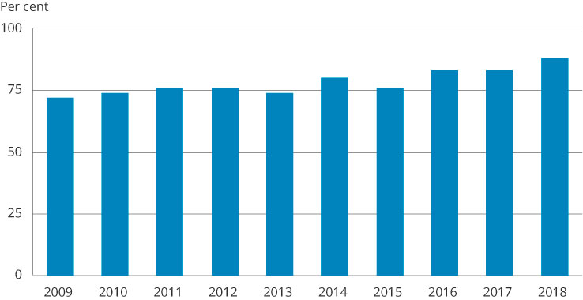
          - Percentage of the population that has used public online services.
Statistics Norway
In its Digital Government Review of Norway from 2017 , the OECD cites Norway as one of the countries that has come furthest in digitalisation, but highlights the need for stronger governance and coordination of this work. The OECD particularly highlights the need for stronger coordination and clarification of roles and responsibilities between sectors and administrative levels. It recommends that Norway set ambitious and binding goals in the future to increase the pace of efficiency improvement and digitalisation. The Office of the Auditor General has also highlighted areas for improvement related to, for example, realising benefits, using common solutions and a need for stronger central governance.

              - Box 1.1 Governance and the distribution of responsibilities in public administration
The Government is the highest administrative body of the central administration, and is accountable to the Storting for preparing cases and implementing resolutions adopted by the Storting. The ministries shall ensure that adopted policies are implemented, often through external agencies such as directorates. The ministries are also responsible for managing and monitoring underlying agencies (agency governance) and state-owned companies (corporate governance).
The municipalities and county authorities are separate legal entities that can make decisions on their own initiative, and are responsible for, and exercise their autonomy within, a national framework, regulated in practice through statutes, regulations and budget limits adopted by the Storting. Local government autonomy is established by the Constitution and more closely regulated by the new Local Government Act adopted by the Storting on 22 June 2018. Limitations on local government autonomy must have statutory authority. The Local Government Act also establishes that local government autonomy should not be limited more than is necessary to safeguard national objectives

Safeguarding privacy protection and information security is critical to the success of the public sector in its digitalisation activities. Digitalisation requires far-reaching changes in the way the public sector performs its tasks, and thereby how documentation is protected and managed. The ambition to increase digitalisation in the public sector means that enhancing privacy protection and information security becomes increasingly important. Privacy protection and information security are fundamental to digitalisation activities and must constitute an integral component from the outset. Public confidence in the public sector is higher in Norway than in many other countries. Increased digitalisation shall protect citizens’ due process and privacy rights, and ensure a high level of confidence in the public sector. In January 2019, the Government presented a national strategy for cyber security and a national strategy for cyber security competence. Cyber security activities must be approached from an overall perspective, across sectors and administrative levels, and in the context of other civil protection activities.
Norway has close cooperation with the EU, Norway’s most important trading partner, in a number of important areas. This applies to, for example, the EU’s efforts to facilitate a digital internal market. The goal is to ensure that the business sector and private individuals can easily and efficiently interact digitally across national borders. The EU is preparing a new general IT strategy that will replace the current strategy after 2020. Norway is closely following this process and will contribute to formulating the new strategy. Norway will also cooperate closely with the EU on formulating new regulations and framework conditions for forward-looking technologies, including artificial intelligence and blockchain technology. In 2019, Norway signed declarations of cooperation with the EU on the digitisation of cultural heritage and on women and digitalisation.
Digital Europe Programme
The EU has proposed the establishment of a comprehensive digitalisation programme, Digital Europe Programme (DEP), for the period 2021–2027. It is the first time that the EU proposes a programme dedicated specifically to digitalisation, and the programme signals a change of pace in the initiative for the digital transformation of Europe. The programme has a proposed budget of EUR 9.2 billion divided into five main areas: High Performance Computing (EUR 2.7 billion), Artificial Intelligence (EUR 2.5 billion), Cyber security and Trust (EUR 2 billion), Digital Transformation and Interoperability (EUR 1.3 billion) and Digital Skills (EUR 0.7 billion). The Government is considering Norway’s possible affiliation with the DEP programme.
Digital North
In 2017, the Nordic Council of Ministers issued a declaration aimed at closer Nordic–Baltic cooperation on digitalisation. Closer cooperation shall enhance the digital transformation, but also increase the region’s potential to influence relevant processes in the EU. This cooperation shall also make it easier to develop cross-border digital infrastructures. From 2018, this cooperation was expanded by a ministerial declaration of cooperation on artificial intelligence and a declaration on the early adoption of 5G technology.

Seamless services and a user-centric focus
Public services shall be perceived as seamless and integrated by the users, regardless of which government agency provides them. Municipalities, county authorities and central government agencies must cooperate across administrative levels and sectors in order to achieve this ambition. Users are defined as citizens, the voluntary sector, and public and private enterprises.
A user-centric focus is one of five key priorities in the Digital Agenda for Norway. The goal is for users to perceive their interaction with the public sector as seamless and efficient, as one digital public sector.
              - Kantar survey: The Digital Citizen
To strengthen the knowledge base on what digital life will mean for the average citizen, the Ministry of Local Government and Modernisation commissioned Kantar TNS to conduct a qualitative study. The report points out that many people would like interaction with the public sector that is fast, efficient and frictionless, as well as seamless digital communication between government agencies, among other things. Challenges in using digital services are often due more to a lack of understanding of public administration and regulations than to a lack of digital competence. The study also emphasises the need to facilitate integration and seamlessness in the digital services offered to individual citizens. In general, users consider public digital services to be a resource; they save time, increase availability and are environmentally friendly. Many people also highlight chat services as a useful option.
Where are we?
Today users often have to use with multiple services from different agencies to have their needs met or to perform tasks. Users often have to visit multiple websites to obtain information and complete digital services. The extent to which government agencies view services in a broader context and familiarise themselves with users’ needs varies considerably. IT in Practice for 2019 shows that digitalisation is increasing in the public sector, but is stagnating in terms of developing advanced digital services for users. Other surveys show that the user experience is fragmented and that the services are not very seamless. This particularly applies to services provided across sectors and administrative levels. The users desire more seamless digital services, even for matters that involve multiple agencies.
              - A user perspective of digitalisation of the public sector
Sentio Research Norway conducted a quantitative survey of digitalisation of public services from a user perspective on behalf of the Ministry of Local Government and Modernisation.
The survey was aimed at users in the population and in the business sector. The population is most familiar with the services from the Norwegian Tax Administration/Altinn and Health Norway. Business owners are most familiar with the services providing certificates of registration and tax certificates.
A total of 58 per cent of the population and 64 per cent of business owners responded that they were satisfied with the public digital services.
In the population, 30 per cent responded that they believed that digitalisation should increase, 44 per cent that the current level was sufficient, and 13 per cent that digitalisation had gone too far. Among business owners, 41 per cent responded that digitalisation should increase, 47 per cent that the current level was sufficient, and 9 per cent that digitalisation had gone too far. A total of 49 per cent of the population responded that their expectations for digital services from the public sector are influenced by the digitalisation of services in the private sector. The figures below from the Sentio survey illustrate business owners’ awareness of public digital services, and citizens’ awareness of digital services from the Norwegian Tax Administration/Altinn.
Sentio survey: Business owners’ awareness of public digital services.
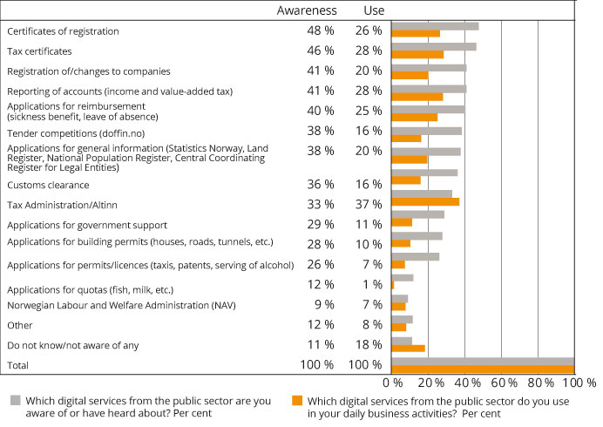
          - Business owners’ awareness of public digital services
Sentio survey: Awareness of digital services, by percentage of the population
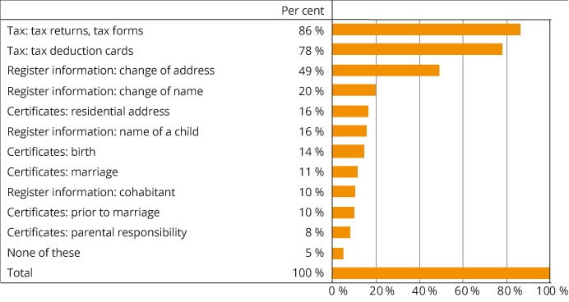
          - Percentage of the population that is aware of or has used digital services from the Norwegian Tax Administration/Altinn (n=1005)
Services related to childbirth, wedding ceremonies and marriage, change of address in the table «Knowledge of digital services, by percentage of the population» are based on the National Population Register in the Norwegian Tax Administration. The Norwegian Tax Administration is modernising the National Population Register and several of the services are being digitalised in cooperation with other authorities. For example, citizens currently notify both the Norwegian Tax Administration and Norway Post of changes of address. In the new service, they can do this in a single process whereby notifications are sent to both the Norwegian Tax Administration and Norway Post.
In some sectors, initiatives are already underway to develop seamless services across administrative levels and sectors. Some examples of this are DigiHelse (DigiHealth) and DigiSos (DigiSocial), which are joint initiatives in the local government sector that have been developed in cooperation with central government agencies. However, there is a need for a more systematic focus on developing seamless services across sectors and administrative levels.
              - DigiHelse
Users of home-based services can easily and safely contact the health services in their municipality at helsenorge.no. They can send and receive messages, view appointments, and receive notifications about home visits completed. The initiative shall ensure a uniform service offering to citizens. DigiHelse (DigiHealth) is a collaborative initiative between the local government sector and the Norwegian Directorate of eHealth.
DigiSos (DigiSocial) is a collaborative project between the local government sector and the Norwegian Labour and Welfare Administration (NAV). The project develops digital services for social assistance recipients at nav.no. The first service to be developed is a digital application for financial assistance with a digital guide. In addition, it provides functionality for viewing applications and their status on the Mitt NAV (My NAV) website.
A seamless service is not necessarily a single service or process. The goal is to develop solutions so that when private individuals are logged in on a local government, county or central government solution or website, relevant information, messages and services from other government agencies are made available at the same time. Users shall have easy access to their data, relevant information and help. This can be accomplished by systematically facilitating information in such a way that users can access data about themselves in different contexts during their dialogue with the public sector. This does not require new central portals, but it may entail development of functionality that can be included in public solutions. For example, this could be a «virtual assistant» giving users access to data and services that are relevant to them, regardless of which website or solution is used. Such functionality may also be relevant to the business and voluntary sectors. Several other countries are in the process of establishing such user-centric solutions.
              - What is a virtual assistant?
A virtual assistant helps ensure that public information and services are perceived as seamless to the user. It serves as a filter showing relevant and individually adapted information when the citizen is logged in on public websites.
The aim of using a virtual assistant is that citizens who, for example, are applying to their municipality for care benefit, will be shown a link to relevant information the central or local government has on the individual in question, relevant services from NAV and other government agencies, and, for example, a link to a message box where relevant decisions are stored. Such an assistant could be made available to citizens regardless of which public website or service they are logged into. In other words, the information will follow individual citizens rather than the current system, where citizens have to know most things in advance, both who provides a service and how they can access it. Privacy considerations will be of decisive importance in developing such functionality.

              - Use of virtual assistants in Australia and Estonia
Australia and Estonia are currently developing personalised and seamless services tailored to individual users that focus on access to and transparency of data and decisions. Estonia is building a virtual assistant on top of the services, to guide citizens in their interaction with the public sector. Estonia calls this a «human-centric data governance structure». The Australian authorities have also introduced something they call a virtual assistant, providing citizens with a simpler way to solve their problems. In both examples, information the authorities have on the citizen is used to adapt smart services to individual needs, regardless of how they are organised.
Life events as a starting point for seamless services
Important situations and life events for the users shall form the basis for developing seamless services. Basing services on life events provides a user-centric focus. Regardless of sector or administrative level, life events shall therefore form the basis for developing seamless services. The life events approach originates in the EU, which benchmarks Norway based on a number of life events to measure the level of digitalisation of the public sector.
The strategy highlights seven life events for which development of seamless services shall initially be prioritised. However, this shall not prevent development of other seamless services. The life events selected relate to important situations that affect almost everyone during their lifetime, such as births, deaths and inheritance. Situations have also been selected where a more seamless process would simplify citizens’ difficult everyday life situations, such as caring a seriously ill child, losing or finding a job, and being new in Norway. Seamless services in connection with starting and managing a business or a voluntary organisation will simplify everyday life for the business and voluntary sectors, respectively. A service related to educational choices could be linked to several of these life events, such as losing or finding a job. The decision to use life events also supports the Government’s National Inclusion Initiative, which was launched in 2018 with the goal of helping more people enter the labour market.
Experience from development of seamless services in the public sector shows that incentives are lacking for cooperating and developing services across sectors and administrative levels. Users often have complex needs that require collaboration and cooperation between agencies. The sector-based organisation of government agencies largely entails vertical financing, management and reporting. As a result, agencies are not adequately measured or rewarded for cross-sectoral cooperation. Moreover, conflicting considerations may emerge when digital services are being developed, such as between user centricity and efficiency. Investing in seamless services when the benefits are realised outside of an actor’s own agency or administrative level requires binding cooperation between the actors.
How should we proceed in creating more seamless services?
Creating seamless services is a challenging exercise that involves a number of actors. The central and local government sectors must cooperate to achieve a broad understanding of problems and user insights when seamless services are to be developed. It is important that one actor take the initiative and involve sectoral ministries, the Norwegian Association of Local and Regional Authorities and other relevant partners in mapping needs and developing a seamless service. Together, the actors and users must define the initiatives and projects to be implemented in order to realise the service. Among other things, this may entail a review of regulations, organisation and opportunities for digital collaboration. For example, in connection with the event «start and manage a business», the local government sector could serve as the starting point for planning the work.
The work on seamless services should, as far as possible, build on existing and ongoing initiatives. A basic prerequisite for achieving seamless services is an overview of what data is available and where and how the data can be shared. The directory services under the National Data Directory shall be further developed and used in developing seamless services.
The public sector shall facilitate equal participation in society for all citizens, regardless of functional ability or life situation. One key success factor in this regard is that the services offered be universally designed. Another is the public sector’s use of plain language in its communication and interaction with users. This also applies to the development of seamless services. The strategy period lasts until 2025. By then, the actors should be well underway with all the projects, and should have completed some of them.
More knowledge is needed on how services should be viewed in the context of life events, including when services cut across the purview of different administrative levels. New insights should be used to coordinate the responsible actors to develop seamless and coherent services. Laws and regulations, including definitions of concepts, are currently harmonised only to a limited extent between the various service areas. This makes it difficult to share and reuse data, which is an important prerequisite for developing seamless digital services. Another challenge is the lack of methodologies for cooperation and cross-sectoral development of services. In particular, there is a lack of methodology for organising and managing projects that entail binding collaboration between central government agencies within various specialist sectors and across central and local government sectors. The public sector also lacks models for cost sharing and for calculating and realising benefits when multiple agencies cooperate, as well as incentive mechanisms for working across sectors and administrative levels. Systematised experiences gained from working on seamless services would form the basis for developing future seamless services and other cross-sectoral development initiatives.
The new Directorate of Digitalisation shall monitor the work done on seamless services by, for example, developing methodologies and gathering knowledge. The Directorate shall also specifically assist the responsible ministries with operationalising and organising the initiatives when when needed and requested. This can be done through, for example, policy instruments such as the Co-financing Mechanism, the Digitalisation Council and the Stimulation Scheme for Innovation and Service Design (StimuLab). This work will be carried out in cooperation with the Norwegian Association of Local and Regional Authorities, which will be responsible for anchoring initiatives in the local government sector’s collaborative governance arenas for digitalisation and for involving the local government sector in the work. Many of the largest municipalities and county authorities have resourceful centres of expertise that can contribute to this work, but good examples of service innovation by means of technology can also found in smaller municipalities.
The Government will:
- Initially prioritise the development of seamless services for the following life events:
  - Having children (Ministry of Labour and Social Affairs)
  - Having a seriously ill child (Ministry of Health and Care Services)
  - Losing and finding a job (Ministry of Labour and Social Affairs)
  - New in Norway (Ministry of Education and Integration)
  - Death and inheritance (Ministry of Local Government and Modernisation)
  - Starting and managing a voluntary organisation (Ministry of Culture and Equality)
  - Starting and managing a business (Ministry of Trade, Industry and Fisheries)
- In cooperation with the Norwegian Association of Local and Regional Authorities, develop methods for and gather knowledge on user orientation, organisation and coordination with a view to developing and operating seamless services across sectors and administrative levels
- In cooperation with the Norwegian Association of Local and Regional Authorities, develop common principles for good usability of digital services
- In cooperation with the Norwegian Association of Local and Regional Authorities, consider concepts for realising a citizen-oriented solution, such as a virtual assistant, for easy access to citizens’ own data, information and personalised services

Increased data sharing and value creation
Users should not have to provide information which the public sector has already obtained. Increased data sharing is also a prerequisite for developing seamless services across sectors and administrative levels. The public sector shall share data when it can and protect data when it must. Open public data shall be made available for reuse for developing new services and value creation in the business sector.
Data is a resource that can be better exploited. All tasks performed and services developed in the public sector involve the use of data. The ways in which we exploit data is changing dramatically, and allow for completely new ways of performing tasks. Increased data sharing is also a prerequisite for developing more seamless and tailored services for users. Citizens, businesses and voluntary organisations shall encounter one digital public sector. The Digital Agenda for Norway establishes the principle that public administration shall reuse information instead of asking users to provide information they have already disclosed; the «once-only» principle.
Better provisions shall be made for reusing open data. The reuse of public information is about giving businesses, researchers and civil society access to open data from the public sector in ways that allow them to be used in new contexts, create new services and drive value creation.
Where are we?
To achieve the Digital Agenda’s once-only objective, work has begun to establish «order in one’s own house». «Order in one’s own house» has been imposed on central government agencies through the Digitalisation Circular. In order to reuse data from others for the purpose of administrative processing and performing other tasks, the agencies must first know that the data exists, where it is located and what it can be used for. «Order in one’s own house» entails good information management, and a separate guide has been prepared on this topic. «Order in one’s own house» is also decisive to properly safeguarding privacy. In addition to knowing where data is located and how it can be used in practice, the agencies must have a legal basis for reusing data through statutory authority or consent.
Making open public data more accessible has been a priority measure in recent years. The Freedom of Information Act gives everyone a right to reuse information that is public, under certain terms and conditions. A national data directory has been established. The National Data Directory is an overview of what data the various government agencies have registered, how it is related, and what it means. The National Data Directory marks the first step towards achieving the once-only objective.
However, the requirements in the Digitalisation Circular and the guidelines for making public data available are not adequately followed up by the central government agencies. At the turn of the year 2018/2019, only around 20 per cent of the central government agencies had published one or more data sets on www.data.norge.no, which is part of the National Data Directory. It is estimated that only around 10 per cent of relevant data sets have been made available. No special guidelines apply for municipalities concerning the reuse of data beyond the provisions in the Freedom of Information Act.
Public and private enterprises wishing to reuse public data that has not already been published on www.data.norge.no must request access to data which government agencies could proactively have made available and published as open data. Inadequate descriptions of open data from the public sector render it less visible to potential users. Moreover, Norway’s ranking in several international open data barometers is falling. The situation is better in certain areas; for example, geospatial data is published on www.geonorge.no to follow up the Spatial Data Act, and transport data is published on vegvesen.no. These data descriptions are imported into the National Data Directory.
              - National Data Directory
The National Data Directory is an overview of what data is registered by various government agencies, how it is related, and what it means. The data directory enables searches in the data registered by government agencies. The data directory will make it easier for government agencies and other enterprises to reuse information that is already registered. As of June 2019, the National Data Directory contained 1,259 data sets, 20 APIs, 3,326 concepts and 577 information models.

              - Farm maps: https://gardskart.nibio.no
Farm maps show the land resources and area statistics for agricultural properties. They are not separate maps, but are rather composed of information from multiple sources. The solution utilises real-time data from multiple sources, and gives business owners and employees in public administration access to the same information. Farm maps support the work of farmers in connection with operational planning, documentation and applications, and at the same time enhance the efficiency of administrative processing in agricultural management. This service has been adapted for use by agricultural management authorities and by the owners and users of agricultural properties, but is open to all.
Where are we going?
The work that has been carried out in the area of information management has given us a good foundation for establishing a common overview of what data exists, what it means, and how it can be shared. In future, the value of the national data directories, the National Data Directory and data.norge.no, will depend on the agencies’ doing their share of the work on establishing the principle of establishing «order in one’s own house». This means describing their own data, concepts, information models and APIs, and actively sharing data in accordance with national guidelines. In addition, there is a need for new measures to increase the pace of the work and achieve the goals.
There is a need for enhanced competence in regulations and frameworks for data sharing and in the relationships between law and technology and between business and management models. There is also a need for more knowledge of how infrastructure in both the central and local government sectors can be adapted for data sharing. There is a need for an arena that can help data owners and users in this area and that can facilitate the exchange of experience in the public sector. Such an arena will be important in connection with developing seamless services, cross-sector digitalisation projects and work on more digitalisation-friendly regulations.
Data sharing must take place within the framework of the legal system in general, and within the scope of the privacy protection regulations in particular. Any use of personal data requires a legal basis under Article 6 of the General Data Protection Regulation. A concrete assessment of the need for regulatory amendments must be made when the need to share data arises, such as when seamless services are to be developed or where data sharing between agencies is relevant. Safeguarding the privacy of users entails, among other things, data used in a service holding the right quality and the user knowing where the information originated. Another prerequisite for data sharing is that the data is suitable for reuse; reuse must not be incompatible with the original purpose for collecting the data, and there must be conformity between the concepts used.
To avoid falling out of step with the wishes and needs of the population, the public sector must be better able to adopt the latest technologies, such as artificial intelligence and the internet of things. The new technology can be used to develop better public digital service offerings that are perceived as more relevant and adapted to the needs of individual citizens and agencies. Such adaptation will also be important for developing the jobs of tomorrow and for ensuring a more sustainable welfare society.
              - Increased data sharing in planning and building application processes
For private individuals and business owners wanting to submit building application to municipalities, complying with regulatory requirements for information is challenging. Both the applicant and the municipality need access to data from a number of sectoral authorities, in addition to the municipality’s own planning data, cadastral data, etc. In order to realise the benefits of a fully digital building application process, the relevant data must be adapted for digital self-service.
Through the common services platform BYGG (Build), the Norwegian Building Authority has established the infrastructure for fully digital building application processes, from completing building applications to the municipality’s decisions on building application. BYGG is a digital regulatory platform that checks and submits building applications to the relevant municipalities.
The Ministry of Local Government and Modernisation has completed a five-year programme to establish more digital planning processes, one of the objectives of which was to acquire more uniform and precise digital planning maps that conform with the planning regulations, and to develop digital planning regulations. This will result in faster and simpler building application processing for the municipalities. The Ministry will develop a digital toolkit for simpler, more uniform handling of digital land use planning matters for relevant actors.
The Norwegian Association of Local and Regional Authorities has developed a new aid for the municipalities, ePlanSak, in cooperation with the Ministry of Local Government and Modernisation and the municipalities. This is a product specification for use by the municipalities when digitalising the planning process and procuring new professional systems.
A basic prerequisite for sharing data is that we know what data is located where, what it means and whether it can be shared. A physical infrastructure for data sharing will make it easier for agencies to assess possibilities for data sharing and to facilitate the actual sharing. This work is complex for an agency to do alone. Common problems and needs can be better addressed by more centralised and coordinated performance of tasks. Some actors undertake to distribute data from one or more data providers to many data consumers. Some data providers have created, or are in the process of creating, solutions where multiple data consumers can connect. For example, the Norwegian Public Roads Administration’s Vehicle Information web service or the Norwegian Directorate of eHealth’s planned health analysis platform. For the local government sector as an administrative level, FIKS has been established as a sharing platform. There are also several sectoral sharing platforms, including PEPPOL (Difi) and Nye Feide, and a data distributor for the eBevis service in Altinn.

              - Norwegian Tax Administration and the a-ordning scheme
The a-ordning scheme is a coordinated service for employers to report information on income and employees to the Norwegian Labour and Welfare Administration (NAV), Statistics Norway and the Norwegian Tax Administration. The scheme is digital. Information is sent electronically, either through the employer’s payroll system or through a service in Altinn. The Norwegian Tax Administration manages the scheme on behalf of the other agencies. The intention is to simplify and coordinate reporting by employers. At the same time, there is considerable potential for reusing this information in public administrative procedures and in the private sector. The information can only be distributed to private and public actors who may receive the information with the consent of the citizen or by law. Growing demand for this data challenges the Norwegian Tax Administration’s existing core activities and places new demands on the agency’s management, uptime, security levels, etc., because other authorities and private individuals will become dependent on information that is managed by the Norwegian Tax Administration. The Norwegian Tax Administration has prepared a policy for data sharing in order to manage the growing demand.

              - eBevis service
The eBevis (eDocumentation) service simplifies procurement processes by allowing tenderers to avoid having to submit documentation of information which the public sector already has, such as tax certificates. When the contracting authority has a legal basis (legal authority or consent), the information may be obtained directly from the data sources, collated and delivered to public contracting authorities. The eBevis service has been developed so that the solution can also be used for other similar purposes.
In addition to sectoral sharing platforms, there is a need to consider development of a common methodology, set of principles and framework for a generic «data distributor». Such a generic methodology can be used for specific data sharing services. A central data distributor will be able to distribute data from one or more data providers to data consumers with the same needs, with regulated roles and responsibilities between the parties sharing the data. The a-ordning scheme contains information which several municipal services need. However, it is necessary to clarify the legal basis for such reuse of information, and to conduct a semantic review of the data so that the right information can be obtained from the right service. For this purpose, APIs (data retrieval interfaces) must be developed that can ensure the required data quality for use in the relevant local government services. The development of a framework for such a data distribution service is the first step towards establishing specific services (platforms) for distributing data to new relevant consumers. The Norwegian Association of Local and Regional Authorities, in collaboration with its members, will be an important actor in such work.
An ever increasing volume of information is being produced. The potential societal benefits from using big data are considerable. If conditions are made favourable, exploitation of big data can benefit many sectors, provide opportunities for enhancing the efficiency of the public sector in general and further development of services that are better tailored to users’ needs. Future requirements and opportunities cannot be met or exploited using yesterday’s methods and tools. A data lake is a method of storing all kinds of data, and can be likened to a central data warehouse for all types of data: structured and unstructured, documents and logs, images, audio and video. A data lake will serve as a source of all data within a given subject area that can be accessed by multiple users, and as a tool for streamlining, learning, planning and exploring opportunities, and will form an important basis for machine learning and artificial intelligence. A data lake can be built internally within an agency or as a common solution for multiple agencies or an entire sector. A data lake can facilitate efficient and standardised data sharing with secure access mechanisms.
Some examples of data lakes already exist where data can be collected and analysed by means of, for example, artificial intelligence. Such data lakes have been established, or are under establishment, by the Norwegian Directorate of eHealth (health analysis platform) and the City of Bergen (Lungegårdsvannet).
The Agency for Public Management and eGovernment (Difi) has completed a concept study that describes the current situation and future ambitions for sharing public data. The establishment of a data distributor, data lake and national resource centre for data sharing are the key recommendations from the evaluation.
              - City of Bergen’s data lake: Lungegårdsvannet
In 2018, the City of Bergen established a data lake that will contain data from many different subject areas and agencies in the city and that can be shared with other parts of the city and the business sector. An initiative has been taken to establish cooperation to enable the local government sector to build on and further develop the experiences gained from Bergen. This will be viewed in connection with central government activities in this area.
Work related to information management needs to be systematised and harmonised to provide a better overview of registers and basic data, and of what data can be shared. High-quality data is a prerequisite for both complying with privacy protection legislation and making full use of machine learning and artificial intelligence.
Artificial intelligence (AI) will enable us to gain new knowledge from the large volumes of information we have in the public sector, and help us perform tasks in new ways. However, use of artificial intelligence in the public sector also raises complex questions about transparency, responsibility, due process and privacy.
              - Norwegian State Educational Loan Fund and artificial intelligence
The Norwegian State Educational Loan Fund has had positive experiences of using of machine learning to select candidates for «residential verification», i.e. verifying the residential address of customers registered as living away from home by checking their address against that of their parents. The Norwegian State Educational Loan Fund’s residential verification in 2018 encompassed 25,000 students. A total of 15,000 was selected based on artificial intelligence (machine learning), while 10,000 were selected in the ordinary manner by random selection (control group). The results show that artificial intelligence makes it easier to identify students who did not in fact live away from home. A total of 5.5 per cent in the control group and 11.6 per cent in the machine learning group failed the residential verification. This means that the Norwegian State Educational Loan Fund can avoid having to verify those who, with high probability, do in fact live away from home and are thus entitled to have their loan converted to an educational grant. This means that fewer students need to submit documentation, which in turn means less administration by the Norwegian State Educational Loan Fund. The students who were selected had to document that they lived away from their parents in 2017, as they had declared to the Norwegian State Educational Loan Fund.

The Government has decided to create a national strategy for artificial intelligence. This strategy will, among other things, look at:
- how we should organise the education and research sector in order to build advanced expertise in AI in Norway
- how we can make use of AI in the public sector
- how development of AI can affect working life
- the need for basic digital competence, as well as continuing and further education
- how Norway’s business sector can exploit the commercial potential of AI
Important prerequisites for enabling Norway to exploit AI are infrastructure in the form of broadband and 5G (fifth generation mobile network), computing power and, not least, collecting and structuring data and making it available

              - Language technology
Language technology products and services in Norwegian are a fundamental component in digitalising the public sector. Språkbanken is a service provided by the National Library offering text and voice resources for use in developing language technology in Norwegian. Common to many language technology solutions is the large volume of new and subject-specific data needed to function optimally. Securing deposits of resources to Språkbanken is a challenge.
The Government will:
- Establish a national resource centre for sharing data, with expertise in the relationship between law, technology, business and administrative processes as a learning environment and a knowledge repository for the entire public sector
- n cooperation with the Norwegian Association of Local and Regional Authorities, consider the use of existing data lakes (collections of large volumes of data), including regional and agency data lakes that can support data analysis and service development
- In cooperation with the Norwegian Association of Local and Regional Authorities, consider a generic data distributor, which entails, among other things, knowledge and methodology for how data can be properly shared through establishing principles for responsibilities, cost reimbursement and realisation of benefits
- Consider a possible obligation to publish open public data
- Prepare a national strategy for artificial intelligence

Clear and digitalisation-friendly regulations
The regulatory framework must be adapted to facilitate increased data sharing and more seamless services. Regulations should be clear and understandable, without unnecessary discretionary provisions and with harmonised concepts. Regulations should also facilitate full or partial automation of administrative procedures, appropriate use of artificial intelligence, and digital transformation.
The regulations shall support and facilitate the objectives of the Digital Agenda for Norway concerning seamless and proactive services, data-driven innovation, user centricity and the once-only principle. This means that the regulations must allow more data sharing and full or partial automation of executive work and administrative procedures. At the same time, the regulations shall safeguard privacy, principles of due process and other trustworthiness requirements. The regulations should be clear and understandable, without undue complexity or unnecessary discretionary provisions, and the concepts must be harmonised where appropriate.
Where are we?
With few exceptions, the current regulations are technology neutral. The regulations do not contain any direct barriers to digital communication, with a few exceptions. Through the eRegel (eRegulation) project, a project that was carried out at the turn of the millennium, an extensive effort was made to amend regulations that prevented electronic communication. Thereafter, a principle was established that regulations shall be interpreted as technology neutral, and that any requirements for paper-based communication shall be specifically stipulated in the relevant provisions. In other words, requirements for written communication and signatures will not in themselves prevent electronic communication. If manual administrative procedures or manual signature are required, this must be explicitly stated in the provision.
The remaining obstacles to digitalisation were mapped in both 2013 and 2017. The mappings showed that few direct obstacles to digital communication remained in the regulations. However, the fact that no specific obstacles to digital communication remain does not mean that the regulations have been adapted for digitalisation. The mapping report from 2013 also shows that regulations are interpreted too stringently due to lack of expertise, and that there is a general lack of awareness of the Regulations on electronic communications networks and services and of the need for technology neutrality in their interpretation.
Where are we going?
Technology offers opportunities for new, automated work methods and processes. Technology also offers the possibility to provide services without prior application. The current regulations relating to proper administrative procedures also work quite well in a digitalised public administration, but there is untapped potential in using regulations to achieve a more data-driven public administration. Ensuring that regulations keep up with digital developments is a challenging task. Creating digitalisation-friendly regulations is an ongoing effort, one where it is essential that whoever formulates the regulations understands the relationship between processes, technology and regulations. There is therefore a need to define the principles and characteristics of digitalisation-friendly regulations. This work must also be viewed in the context of efforts to promote plain legal language and innovation in the public sector.
Digitalisation-friendly regulations are also regulations that are adapted to new business models and to emerging technologies such as self-driving vehicles and drones. Regulations must be reviewed to identify any specific obstacles that remain. At the same time, changes must be considered that enable increased data sharing and more digitalised collaboration across administrative levels and sectors. Such changes should, for example, be considered specifically in connection with efforts to develop seamless digital services.
The Government will:
- Review the regulations to consider removing any remaining obstacles to digitalisation, based on the work to develop seamless services
- Initiate dialogue with the business sector, voluntary organisations and agencies in the public sector to obtain input on specific obstacles to digitalisation in existing regulations
- Prepare a guide for digitalisation-friendly regulations and plain legal language
- Discuss and refer to the guide for digitalisation-friendly regulations in the Guidelines on Drafting Technique and Preparation of Legislation

A common ecosystem for national digital collaboration
Municipalities, county authorities and central government agencies must be able to collaborate in order to develop user-centric, seamless and efficient digital services. Existing service development platforms shall be better utilised.
There is a need to see existing and planned service development platforms and basic data registers, etc. as a common «ecosystem» that shall enable government agencies to collaborate digitally and have access to the necessary common functionality and common IT architectures. The ecosystem must be managed in a coordinated manner, and its must be coordinated.
There are currently seven national common components: Altinn, ID-porten (ID-gateway), Digital Mailbox for Citizens, National Population Register, Contact and Reservation Register, Land Register and Central Coordinating Register for Legal Entities. There are several other common IT solutions and technical platforms, such as helsenorge.no, nav.no, the National Data Directory and the FIKS platform. Common standards, principles, and reference architectures have also been prepared. Collectively, they represent a common ecosystem for national digital collaboration and service development for the public sector.
Where are we?
Municipalities, county authorities and central government agencies are offering a growing number of digital services to citizens and the business sector. In its digitalisation activities, the public sector has access to a number of common IT solutions and some common IT architectures. The figure below provides an overview of key common components and common solutions for use by municipalities, county authorities and central government agencies. This overview is not exhaustive, but shows a basic selection. For example, common sectoral solutions are not shown.
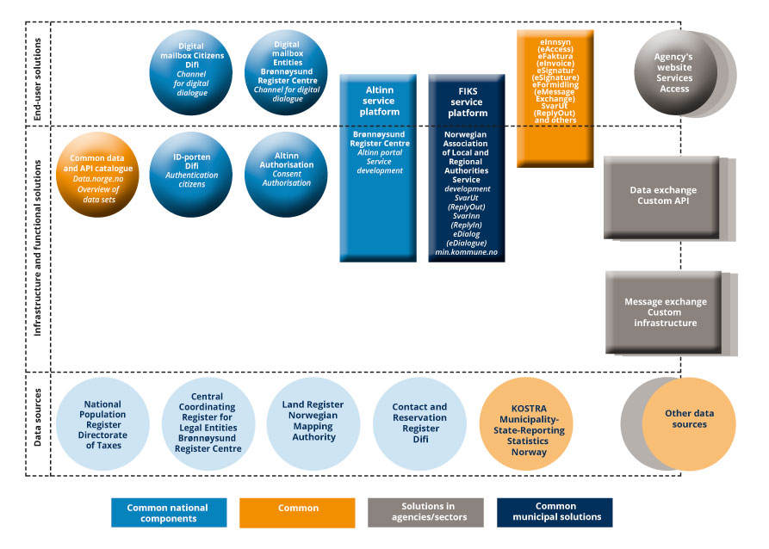
          - Overview of key common components and common solutions in 2019
Several surveys show that the common national solutions are widely used among central government, county and local government agencies in digitalisation activities, but challenges have also been identified. Moreover, the public sector has a strong need to reduce costs by realising the benefits of digitalisation, such as reusing existing solutions.
Responsibility for common components and common solutions is divided among many actors, and management of the central government solutions aligns with sectoral responsibility and line management. The Norwegian Association of Local and Regional Authorities is currently responsible for managing common services and common components within the FIKS framework, which has in turn been developed for reuse and collaboration with common central government components. The Norwegian Association of Local and Regional Authorities has also recently established a common architecture for the local government sector, in cooperation with the sector and with central government actors such as the Norwegian Directorate of eHealth, the Agency for Public Management and eGovernment (Difi) and the Norwegian Labour and Welfare Administration (NAV), where the local government sector’s collaboration with central government is a primary focus.
No sufficiently uniform and coordinated approach to what common functionality and common IT architectures the public sector needs has been established. Likewise, no uniform and coordinated management models have been established to support efficient use of resources in the public sector. Sometimes similar or overlapping functionality is developed in parallel, and in some cases there is a lack of incentives to reuse existing solutions rather than develop new ones. A lack of transparency regarding development plans also increases the risk of functionality being duplicated.
Safeguarding information security in the public sector is first and foremost an agency responsibility. The authorities must enable agencies to protect themselves from cyber incidents. The public sector must have sound management and control of its cyber security. Particular focus must be placed on safeguarding cyber security in the common national components and in other critical systems provided by public sector agencies. It is important that agencies in the public sector have a common understanding of and approach to security challenges. The objectives for security activities in the public sector are discussed in more detail in the National Cyber Security Strategy for Norway, which was launched by the Government in January 2019.
Secure electronic identification (eID) is a crucial factor in digital public administration. The use of market solutions for logging into public digital services through ID-porten has been a successful strategy. The number of logins to date shows a marked increase in the use of digital services from the public sector (see the figures below).
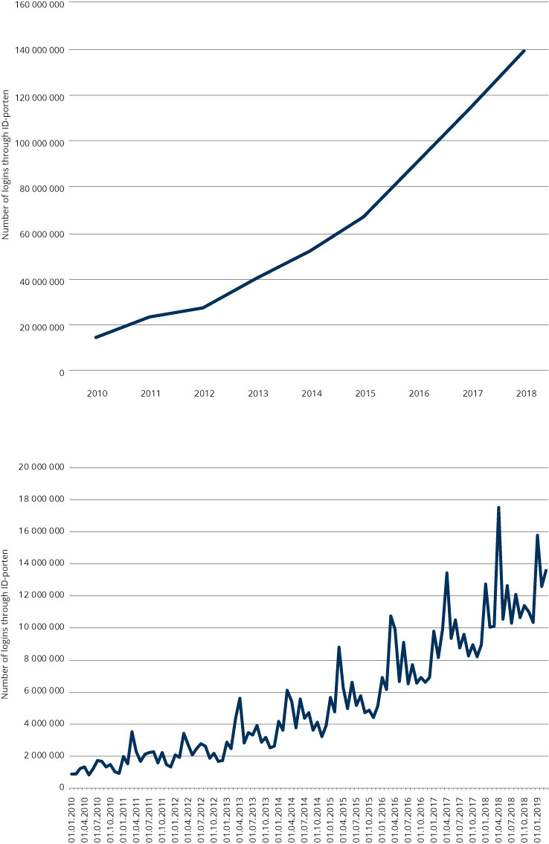
          - Number of ID-porten logins for the period 2010–2018
The use of eID and eSignatur (eSignature) in the public sector is regulated by the Act relating to electronic trust services. The Framework for Identification and Traceability provides guidelines on risk assessment and choice of security level for securing electronic communications with respect to verifying identity and linking identity to a document or transaction.
Where are we going?
At present, the managers of common solutions have different contractual, financing and payment models for similar solutions. There is no comprehensive overview of what common functionality is available or how agencies can implement common functionality. Lack of coordination of common functionality and common architectures leads to fewer benefits, inefficiency, lack of goal achievement, more bureaucracy for agencies and higher usage costs. The public sector is unable to fully realise the potential benefits of developing common solutions for identical needs. The ecosystem can help solve several of these challenges.
The key elements of the common ecosystem should be:
- common data sources, such as master data and basic data registers
- common solutions
- common architectures, such as reference architectures, standards, guides and frameworks
- standard access for multiple users
- standard business models and contracts
- harmonised financing and payment models
The goal is for services, websites and data sources in municipalities, county authorities and central government agencies to work together.
The digitalisation activities take place in the agencies, so a strategy to create common solutions for identical needs must not prevent agencies from developing innovative solutions that will benefit users. The decisive factor is to find a good balance between these considerations. The content of the ecosystem shall satisfy common needs for efficient task performance, information sharing and development of user-friendly and seamless services in municipalities, county authorities and central government agencies.
Existing IT infrastructure in the public sector must be maintained to facilitate continuous development and innovation of digital services. This must occur at the same time as new digital solutions are developed at an ever-increasing pace. From a socio-economic perspective, this suggests that there may be several good reasons why the public sector should make more use of solutions developed in the market rather than develop its own. Nonetheless, there can be no doubt that the public sector will also need solid in-house IT expertise, regardless of how the public sector chooses to use the market in future.
The common solutions must be easier to adopt, and it must be clarified which actors can use them, which parts of the common solutions can be used, and on what terms, including private entities and voluntary organisations. Contracts must be coordinated, be standardised, and be designed in such a way that they stimulate use. For example, there is a need to consider how the local and central governments can ensure access to the basic data registers on equal terms. Administrative responsibility for the solutions must be clearly assigned, and management and financing better coordinated. It is also important to maintain and further develop the good collaboration that has been established with the private market on developing common solutions that are part of the ecosystem.
External attacks on the public sector’s common solutions represent a serious security risk. For example, if ID-porten (ID Gateway) were put out of action, access to public services would be severely reduced. Establishment of a dedicated computer emergency response team (CERT) function for the common ecosystem should be considered to manage such challenges, in accordance with the framework defined in the National Cyber Security Strategy for Norway (section 3.4). CERT functions are already in place in various sectors, such as Power CERT and Health CERT, and it should be possible to draw on their experiences.
The figure below illustrates a potential future common ecosystem and its key elements. A key change is the establishment of coordinated governance and coordination of the content included in the ecosystem. In principle, the seven common components – Difi and the Brønnøysund Register Centre’s common solutions and the FIKS platform (Norwegian Association of Local and Regional Authorities) – will constitute the core of the ecosystem. Any expansion of the ecosystem would be subject to consultation with the responsible sectoral ministries.
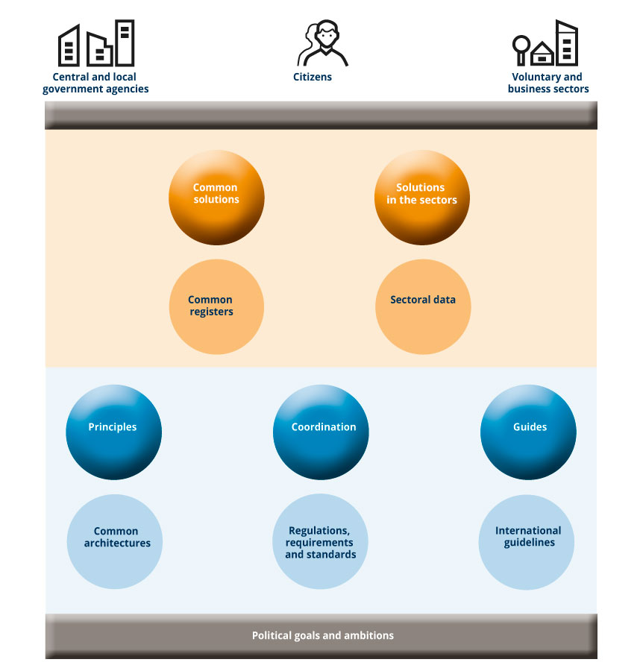
          - Common ecosystem for national digital collaboration and service development towards 2025
Work is underway on establishing a European governmental interoperability platform that will contribute to cross-border digital collaboration. In the same manner as the European platform, the ecosystem shall facilitate good collaboration between local and central government agencies, and with citizens, voluntary organisations and the business sector in Norway. This requires good cooperation between the administrative levels with respect to legal, organisational, semantic and technical issues.
In order to use digital public services, citizens must have the opportunity to acquire simple and secure eIDs. It is an important goal for all citizens to have an eID that can be used for the services they need. All groups, including foreign nationals without a Norwegian national identity number, and children and adolescents, should be able to obtain an eID at the level they have a need for it. In an increasingly digital public sector, individuals who, for one reason or another, are unable to act digitally themselves, must have the opportunity to be represented by a proxy. Provisions must therefore be made for the use of digital authorisations and digital consent.
It is important to ensure that electronic identities can be securely issued, that the solutions meet the necessary security requirements, and that they be as user friendly as possible. There is also a need to facilitate the use of electronic employee IDs. Some sectoral employee IDs have already been developed, such as Helse-ID in the health and care sector and Feide in the education sector. In addition to employees in the education sector, Feide is also used by pupils (from the first year of primary school) and students. Sectoral employee IDs create a significant challenge for the local government sector, which will have to deal simultaneously with multiple specialist sectors in the central government. Guidelines for the use of employee IDs should be included in the strategy for using eID and eSignatur in the public sector.
Goals for a common ecosystem for national digital collaboration and service development
- Public sector facilitates innovation and value creation
When the public sector develops common solutions, collaboration with the private business sector in an ecosystem is taken into account. It is clear which of the common solutions in the ecosystem that can also be used by private enterprises, and on what conditions and terms.
- Municipalities, county authorities and central government agencies digitalise their services
Municipalities, county authorities and central government agencies use common solutions and common architectures in developing their services. The public sector shall use its resources efficiently, and the agencies shall share data and make their services to users seamless.
- A common ecosystem for national digital collaboration and service development is readily available, easy to use and meets common needs
It is easy for municipalities, county authorities and central government agencies to keep track of the content of the ecosystem. The combined content is coordinated and managed in a coordinated manner. Common solutions are developed for similar needs, the content is coherent, and new needs are identified and addressed. Governance models, financing models and contractual terms and conditions are coordinated to ease implementation of common solutions. This takes place in close cooperation with the managers of the common solutions. Responsibility for the individual parts of the ecosystem is clearly defined and assigned. 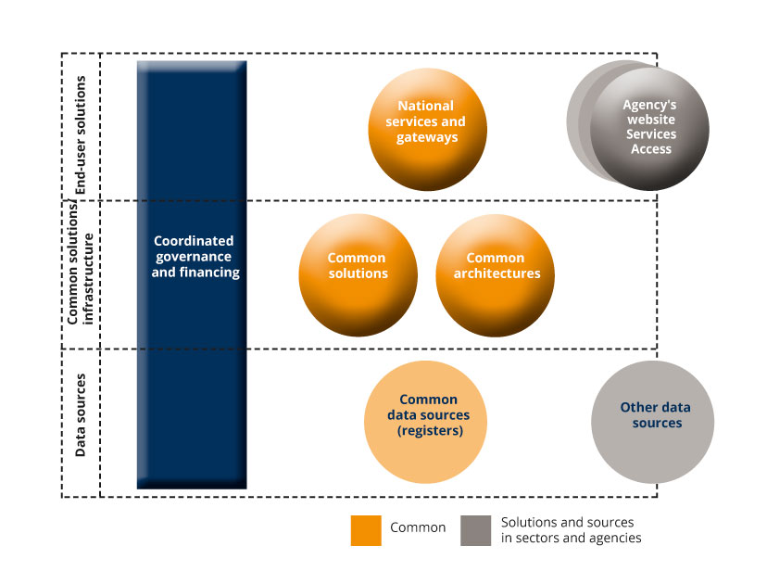
          - Coordinated governance of the ecosystem
The Norwegian Association of Local and Regional Authorities coordinates local government interests, and the Ministry of Local Government and Modernisation coordinates central government interests in the ecosystem. An important prerequisite is that all actors who have common solutions in the ecosystem participate in its coordination and governance. Cooperation agreements are entered into between the Ministry of Local Government and Modernisation and the Norwegian Association of Local and Regional Authorities to ensure predictability for both the central and local government sectors. The cooperation agreements must be anchored in the collaborative governance model for digitalisation in the local government sector. The agencies shall cover their own costs for integrating their services and enterprise systems with components of the ecosystem.
The Government will:
- In consultation with the Norwegian Association of Local and Regional Authorities, establish arenas for coordinating the combined content of the common ecosystem for national digital collaboration and service development
- Ensure that the Ministry of Local Government and Modernisation take responsibility for coordinating central and local government interests in the common ecosystem for national digital collaboration and service development, including assessing whether the cooperation agreements between the Ministry of Local Government and Modernisation and the Norwegian Association of Local and Regional Authorities safeguard these interests
- Enable governance of the common national solutions in the ecosystem through the letters of allocation to central government managers of the national common solutions to be conducted in a coordinated manner
- Consider how eID and eSignatur can be provided for all groups that need them, and provide guidelines for the use of employee IDs
- Assess the need to establish a CERT function for the ecosystem

Governance and coordination for a more seamless public sector
To ensure seamless services, increased data sharing and increased use of common IT solutions, collaboration and coordination across sectors and between the central and local government sectors must be strengthened. The aim of the Government is to facilitate a more systematic realisation of benefits from digitalisation.
Establishing seamless services in a sectorally managed public sector can be challenging. A sectorally organised central government clarifies responsibilities and is in many cases functional and efficient, but it can pose challenges in performing tasks across sectors and administrative levels. Municipalities and county authorities provide services to citizens, voluntary organisations and the business sector
in a number of areas. Therefore, the local government sector often needs cross-sectoral collaboration, both between specialist areas and with the central government in the digitalisation area, and central government solutions also cover local government needs. The local government sector finds that its digitalisation activities are challenged by the fact that the central government is sectorally organised and poorly coordinated. On the other hand, central government agencies finds that the local government sector can be poorly coordinated and insufficiently digitalised.
Where are we?
Cooperation between the central and local government sectors has been strengthened in recent years. IT policy and local government policy have been gathered under the same ministry specifically to facilitate better collaboration. Several coordination measures have also been implemented, such as the collaborative governance model for digitalisation in the local government sector and DigiFin, the financing scheme for local government IT projects.
              - DigiFin scheme
The DigiFin financing scheme was established so that the local government sector can collectively develop more common digital solutions. The scheme makes it possible to develop better citizen services faster and at a lower cost.
The Ministry of Local Government and Modernisation has contributed NOK 125 million to the financing of this scheme. The premise is that the local government sector shall contribute at least as much. Most counties and municipalities have already paid their share to participate in the scheme based on their population. The Executive Board of the Norwegian Association of Local and Regional Authorities has passed a resolution to contribute up to NOK 40 million.
Those who may receive support from the scheme are:
- Municipalities
- County authorities
- Norwegian Association of Local and Regional Authorities
- Municipally-owned enterprises and intermunicipal companies may also receive support if the municipality or county authority participates in the application
Projects that have received support from the scheme to date are DigiHelse, DigiSos and MinSide.

In the local government sector, coordination in recent years has largely been based on the principle of volunteerism and cost sharing. Moreover, the Norwegian Association of Local and Regional Authorities plays a role in coordinating digitalisation activities in the local government sector. A collaborative governance model for digitalisation has been established in the local government sector: the KommIT Council and its underlying committees. In addition, several regional digitalisation cooperation initiatives have been established, and more are under establishment. The KommIT structure is viewed in the context of the regional cooperation initiatives. This has proven to be effective, and has contributed greatly to mobilising the municipalities and county authorities. For example, in the course of only a few years almost all the municipalities have implemented the SvarUt (ReplyOut) service for the digital distribution of mail. Support for the voluntary financing scheme DigiFin for joint local government projects – the costs of which are shared among the Ministry of Local Government and Modernisation, the Norwegian Association of Local and Regional Authorities, municipalities and county authorities – has grown so much in the course of a year that over 90 per cent of citizens in Norway live in a DigiFin municipality. The county authorities have also established cooperation on several digitalisation initiatives.
Where are we going?
The key instruments for managing and coordinating digitalisation in the central government are organisation, agency governance and corporate governance, regulations and financing. However, no mechanisms are in place to monitor compliance with common instructions, such as the Digitalisation Circular, by central government agencies. The reasons for this should therefore be investigated, and it should be assessed how compliance can be monitored appropriately. Moreover, when a service involves multiple agencies and administrative levels, the challenge is that responsibility for costs and benefits may lie in different places.
Realising benefits is a challenging task, and requires structured and continuous monitoring throughout the digitalisation initiative. Active and structured work to identify opportunities for benefits is something that most government agencies do well. The challenge lies in monitoring benefits realisation activities so that government agencies can realise the expected benefits. It is important that work in this area be strengthened and that priority be given to initiatives and measures offering the greatest benefit or potential benefit.
Realising benefits is also challenging when the digital transformation entails innovation and the use of methods where one is not necessarily familiar with the solution in the initial phase of the project, but where one is looking for benefits along the way. There is therefore a need to strengthen expertise in and guidance on how to realise benefits in general, and in innovation and digital transformation in particular. The Co-financing Mechanism has stipulated clear requirements for benefits realisation activities in connection with applications for project support. This is a good example of guidelines on which benefits realisation activities can be based, and consideration should be given to expanding it to apply to digitalisation initiatives in general. A methodology for more systematic realisation of benefits from digitalisation is also needed, especially in connection with the common infrastructure.
              - Norwegian State Project Model
The Government has decided to lower the threshold value for large-scale digitalisation projects in the Norwegian State Project Model (Norwegian Association of Local and Regional Authorities scheme) with effect from September 2019. A guide is being prepared that will highlight conditions specific to the appraisal and quality assurance of large-scale digitalisation projects. A new threshold value and guide will help improve the basis for proper prioritisation and successful completion of large-scale digitalisation projects.
There is a need for a uniform policy and measures that support and drive digitalisation across the public sector. Financing mechanisms and a methodology that make it easier for agencies to cooperate on cross-sectoral initiatives must be further developed. To monitor digitalisation initiatives across the public sector and stimulate a more strategic approach to digitalisation in each sector, it is important that the ministries assign a strategic function with responsibility for coordinating digitalisation. This is recommended by the OECD, among others, and several countries have already implemented such functions. Developing principles for cost sharing for cross-sectoral digital services should also be considered.
SKATE plays an important role as a strategic cooperation council in the digitalisation area. SKATE consists of directors from nine central government agencies and two senior representatives from the local government sector who shall contribute to a better coordinated digitalisation of the public sector. However, SKATE can potentially play a more strategic role than today in promoting cross-sectoral digitalisation. It may also be relevant to consider whether supplemental strategic arenas are needed to support realisation of seamless services across sectors and administrative levels.
Although the Norwegian Association of Local and Regional Authorities is involved in a growing number of strategic discussions, collaboration with central government agencies remains unsystematic, fragmented and poorly coordinated. The extent to which central government agencies involve the local government sector in digitalisation projects varies, and little emphasis is placed on the economic consequences and benefits for the local government sector.
Coordination of digitalisation activities in municipalities, county authorities and central government agencies in the time ahead shall lay the foundation for developing seamless services for citizens, voluntary organisations and the business sector. To achieve this, the central and local government sectors must cooperate in new and more binding ways. This is in line with the recommendations of the Office of the Auditor General. Cooperation models for digitalisation activities in the public sector that ensure coordination and collaboration across and within the sectors and administrative levels should therefore be developed. The model should give the local government sector sufficient influence in national digitalisation activities, and is therefore also referred to as collaborative governance, without changing the fundamental principles for governance and the distribution of responsibilities in public administration.
The following principles shall form the basis for such a model:
- Equality and influence: The governance model must contribute to giving the parties genuine joint consultation. Representation on boards and committees in which collaborative governance takes place must lay the foundation for equal and balanced participation and influence.
- Representativeness: The local government sector’s representatives on central government boards and committees must be appointed and participate on behalf of the entire sector. The Norwegian Association of Local and Regional Authorities appoints the representatives for the local government sector. Correspondingly, central government agencies will appoint their own representatives on committees and boards.
- Early involvement: The committees and boards on which collaborative governance takes place must be involved as early as possible in relevant national matters that affect their mandate or area of responsibility.
Experience from cooperation between the central government and local government sectors in the e-health area can form the basis for good cooperation models. It is also necessary to establish an arena in which cross-sectoral problems and priorities in general can be discussed. Such an arena should be formed at a political level with representatives from both the local and the central government sectors, such as in the consultation mechanism, and be supported by appropriate arenas at the administrative level. The development of models for cost sharing in joint digitalisation initiatives should be anchored in this cooperation.
              - Cooperation between the central and local government sectors in the e-health area
Cooperation between the local government sector and central government on digitalisation efforts has been enhanced in recent years, including in the health and care sector through the establishment of the National Board for E-health and its underlying specialist and prioritisation committees. There is still a need for more and better coordination and collaboration between the health and care services in the central and local government sectors. An important example is the need for better access to patient information. The long-term vision is «one citizen – one record».
The health platform in the Central Norway Regional Health Authority has now completed procurement of a solution for a common patient record for use by hospitals, municipalities and general practitioners. This is the first time that a common solution has been established for the municipal and specialist health services, general practitioners and contract specialists. The other health regions in the specialist health service are further developing and coordinating their solutions. The Norwegian Directorate of eHealth has also been commissioned to undertake a pilot project aimed at establishing a national solution for collaboration and a common municipal patient record for the municipal health and care services outside the Central Norway Regional Health Authority. The initiative will involve municipalities, general practitioners and the specialist health service, and will require municipalities to coordinate on key issues, such as governance and organisation.
The Government will:
- Consider how the mandate for SKATE can be reinforced and further developed
- Prepare a guide for the ministries on strategic governance of digitalisation
- Consider further development of offers of competence building, transfer of experience and assistance in benefits realisation activities in the digitalisation area in the ministries
- Assess the need for cost-sharing principles for new digitalisation initiatives
- In cooperation with the Norwegian Association of Local and Regional Authorities, prepare guidelines with common principles for when and how the local government sector shall be involved in central government decisions that concern digitalisation and that affect the local government sector
- Establish arenas within the consultation mechanism to monitor digitalisation initiatives affecting the local government sector, including initiatives in the digital strategy
- Ensure that the model for stronger and more systematic cooperation and coordination between the central and local government sectors (collaborative governance model) be established initially for the areas with the greatest degree of collaboration, such as the sectors responsible for health and care, childhood, and education

Enhanced cooperation with the private sector
We must improve the efficiency of the public sector to leverage its resources. The public sector should not do itself what the market can do better. Digital collaboration with the business sector and voluntary organisations can provide the basis for new, innovative services.
A lot of good work is done to improve efficiency in the individual agencies. Improving the efficiency of public services is, among other things, about assessing whether the public sector should produce its own services and solutions or purchase them in the market instead.
Where are we?
The choice between producing custom services and solutions and buying them in the market is primarily a question of what is most lucrative. However, it is also a question of what provides the best services for citizens and businesses, and of what generates the best opportunities for innovation. Therefore, the public sector shall in principle not do itself what the market can do better, but instead determine what needs must be satisfied in order to build sustainable digital services, and enter into dialogue with the market on possible solutions.
The Digitalisation Circular requires central government agencies to have a sourcing strategy for how they will digitalise their services. The sourcing of service production, i.e. deciding whether to produce their own services or buy them in the market, or even leave it to non-profit actors, should be a natural part of the agencies’ considerations in connection with development activities.
The public sector spends over NOK 500 billion annually on procurements, but a small portion of this money appears to be actively used to stimulate innovation. Therefore, a goal will be to increase the innovation impact of public procurements. Innovation procurements are about using public procurements to streamline and renew the public sector, while the business sector innovates and creates new jobs at the same time. The National Programme for Supplier Development was established in 2010, and serves as an operational driver and facilitator to increase the strategic use and innovation impact of public procurements in Norway. Since its inception in 2010, the programme has assisted municipal and central government agencies with over 200 procurements, and has developed a methodology for public procurement of innovation
              - Innovation partnership with the City of Stavanger
In an innovation partnership, public and private enterprises work together to develop completely new solutions to present and future societal challenges. The scheme is both a legal procurement procedure based on the Public Procurement Act and a working model for dialogue and innovation cooperation with the business sector. The goal is to develop brand new products and solutions that are currently not available in the market. An innovation partnership is based on public needs, requires anchoring with top management, and includes the business and public sectors in both understanding needs and formulating solutions.
The City of Stavanger is the first in Norway to test the new innovation partnership form of competition. It all started when the City of Stavanger wanted new innovative solutions for increased activation and coping skills for users on short-term stays in nursing homes. Only one week in bed results in a 10 per cent reduction in endurance and a 20 per cent reduction in muscle strength. At present, short-term stays cost the city NOK 200 million annually. The savings potential from shorter stays and fewer readmissions is huge. Through the innovation partnership, the business sector has, in close cooperation with the city, developed a smart wheeled walker and/or activation robot. When development is completed, the contracting authority can choose to purchase the solution without first having to go through a competitive tendering process, and the project is now in the negotiation phase for procurement. The project has also created three spin-off enterprises – the municipalities of Kristiansand and Bærum and NAV Assistive Technology – who may also buy the solutions if they so wish.
Public–Private Digital Cooperation was established in 2016 by the Brønnøysund Register Centre, the Norwegian Tax administration and Finance Norway. In 2018, NAV and the police joined the initiative. The parties found that cooperation on some specific projects could produce significant socio-economic benefits. Public–Private Digital Cooperation is about streamlining the exchange of information a party needs. Cooperation is based on a portfolio mindset, whereby the parties’ efforts and benefits shall balance out over time. A key component in this cooperation is that, over time, the benefits from various cooperation measures in the Public–Private Digital Cooperation shall pass to the financial services industry, citizens and central government sector. The best-known solution is consent-based loan applications. In 2018, this initiative was expanded to cooperation with the agricultural sector based on a corresponding model, and the aquaculture sector followed suit in 2019.
              - Consent-based loan applications
Consent-based loan applications have been developed by the Norwegian Tax Administration, Brønnøysund Register Centre and the financial services industry, represented by Finance Norway and Bits AS. Consent-based loan applications simplify loan applications for consumers through cooperation between government agencies and the financial services industry. Loan applicants no longer need to submit tax returns and pay slips to the bank, but can instead give digital consent through Altinn to allow the Norwegian Tax Administration to share information on income, debts and net assets with the bank. The Norwegian Tax Administration, Brønnøysund Register Centre and Finance Norway were awarded the 2018 Digitalisation Award for this service.
Where are we going?
The public sector shall avoid developing digital solutions in competition with the private sector. The public sector shall also exploit the innovative power of the private sector in developing public digital solutions and services, but at the same time exercise active ownership to define what needs are to be satisfied through such cooperation. In addition, the public sector shall publish open public data to stimulate innovation in both the public and private sectors. There is a need to develop common principles for cooperating on digitalisation between the private, voluntary and public sectors. Several issues need to be considered in more detail, such as how costs should be distributed, the relationship to state aid and the procurement regulations, and which business models should be used for individual projects.
Cooperation with the private sector may also challenge the public sector’s social mission and present the authorities with new questions, such as how the technical and security adaptations should be carried out and financed. Allowing a government agency to become a supplier of data to another actor may create a need to set new requirements for the agency’s IT systems and thereby challenge the agency’s core tasks. This must also be taken into account in connection with drawing up principles for cooperating with the private sector.
The public sector must continually assess whether problems can be solved in new and more efficient ways. Public–Private Digital Cooperation makes better services for citizens, voluntary organisations and business sectors possible by sharing data across sectors. Experience from Public–Private Digital Cooperation will be relevant when cooperation with the private sector is further developed in the digitalisation area.
The public sector must be receptive to new ways of cooperating with the market and exploit the opportunities that lie in innovative public procurements. Experience shows that public contracting authorities generally specify solutions in detail when they put contracts out to tender rather than describe their needs. Moreover, procurement processes are often long and suppliers specifications unnecessarily stringent. This means that start-up companies and other small and medium-sized IT service providers with good and innovative solutions to public sector needs are rarely considered. In the United States, the public sector has had various schemes in place that stimulate cooperation between the public sector and start-up companies for many years. Now such schemes are beginning to spread throughout Europe. The Netherlands, Spain and Scotland have established programmes that link public sector needs with start-up companies and facilitate collaboration.
              - Start-up in Residence: City of San Francisco
The City of San Francisco has worked on simplifying procurement processes to make it easier for government agencies to find and buy innovative digital solutions. This has further stimulated cooperation with the private sector, through, for example, Start-up in Residence (STiR). The idea behind STiR is to connect government agencies with start-up companies wishing to develop solutions that answer challenges in the city.

              - The CivTech Programme in Scotland
This programme is a framework of assistance and expertise that combines expertise from the public sector with creativity from the private sector to solve real problems, develop new solutions, and offer better, faster and easier services for everyone. Key to this approach is co-production with citizens and support from academia and private investors.
The vision of CivTech is to foster a mindset among public employees that is about daring to bring about innovation in the public sector through solving challenges in cooperation with ambitious companies, and developing solutions that improve people’s lives. Such a mindset is about recognising opportunities and daring to take them further.
The Government will:
- Prepare common principles for cooperating with the private sector on digitalisation with a view to further developing such cooperation
- Initiate activities to establish a programme for increased collaboration between the public sector and start-up companies based on the model used for corresponding programmes in the United States and Europe

Increased digital competence in the public sector
Digital competence will become a critical factor for the digital transformation capability of government agencies and their ability to realise benefits from digitalisation.
It is difficult to predict what competence will be needed in future. There has been a shift away from the heavy focus on technology in the 1980s and 1990s via digitalisation in the 2000s, which focused on improving the existing processes by means of digital technology and data. Today the focus is on digital transformation, where digitalisation has a greater impact on the core activities of an agency. Future competence needs are essentially based on having knowledge of how the opportunities that lie in technology can be exploited in the agencies.
Where are we?
Surveys show that managers and employees in both private and public enterprises lack the necessary competence to see and utilise the opportunities provided by technology. Government agencies struggle in taking the next step in the development of more advanced digital services.
Statistics Norway’s survey on the use of ICT in the public sector shows that three out of four central government agencies that have attempted to recruit IT specialists in the past year experienced problems. The corresponding figure among the municipalities is 36 per cent (see the figure below). However, there are wide variations in the public sector in terms of how many agencies experience difficulties in recruitment processes. Municipalities with large populations, and central government agencies with many employees, often try to recruit people with a high level of IT competence. An increasing number of central government agencies are also reporting that lack of competence is a large or quite large obstacle to developing digital solutions. In 2019, 36 per cent of the central government agencies reported the lack of competence as a problem. For municipalities, the corresponding figure is 43 per cent.
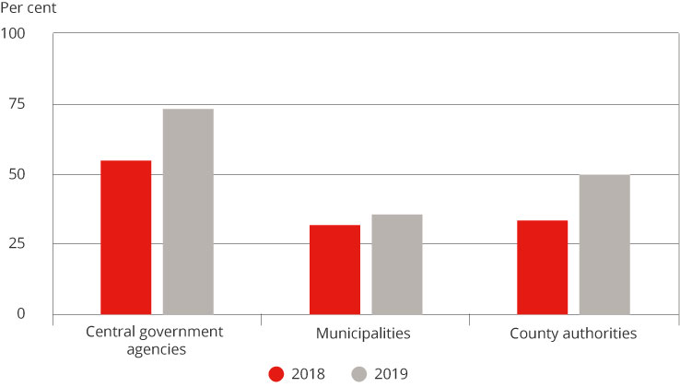
          - Have had problems recruiting ICT specialists
Use of ICT in the public sector, Statistics Norway
Increased digital competence is not just about recruitment; it is also about developing the competence of employees and managers. Moreover, it is about developing work processes and a culture that supports digitalisation to the benefit of citizens, voluntary organisations and the business sector. Competence requirements for managers, employees and agencies must be changed if we are to complete the digital transformation. New ways of working require competence in restructuring and change, ever increasing digital skills, and in some cases digital expertise. We need increased and new competence to deliver services and tasks in new and better ways to the users; for example, in connection with developing seamless digital services.
Public sector employees must be able to deal with a working life and a society that are more technology intensive, with high demands for restructuring and lifelong learning. When work processes are automated, many employees will risk losing their work tasks. Competence development and retraining are important initiatives in this context.
Where are we going?
The public sector must adopt a strategic approach to competence development and must focus not only on competence requirements when recruiting and in connection with further and continuing education for employees, but also on how to meet the public sector’s future competence needs. Digital competence can cover everything from IT specialists who can programme or who have procurement competence to general competence in digital tools. It is therefore necessary to develop a separate strategy for digital competence in the public sector.
The Government and the social partners are parties to the Norwegian Strategy for Skills Policy. One of the policy initiatives is to «strengthen and develop digital skills across the workforce to utilise new technology and ensure the successful implementation of new division of labour». The work on developing a strategy for digital competence in the public sector must be seen in the context of the Norwegian Strategy for Skills Policy, other skills development initiatives and sectoral strategies, and the work on the white paper on innovation.
The Government will:
Prepare a strategy for digital competence in the public sector. The Norwegian Association of Local and Regional Authorities and other relevant actors will be involved in this work

Cyber security
Cyber security is a fundamental prerequisite for maintaining trust in the public sector’s IT systems and public digital services. Successful digitalisation is therefore also about safeguarding security and privacy requirements in a good way.
In January 2019, the Government published a national strategy for cyber security. This strategy also encompasses a subsidiary strategy for cyber security competence. The strategy is accompanied by an action plan with a number of concrete measures. Measure 5 in particular will support digitalisation of the public sector. With these strategies, the Government will achieve a common basis for handling cyber security challenges. The challenges arise from a rapid and far-reaching digitalisation of Norwegian society. Further development from previous national strategies is based on the need for strengthened public–private, civilian–military and international cooperation. The strategy’s primary target group comprises authorities and agencies in the private and public sectors, including municipalities and county authorities. The strategy also makes provisions ensuring that private individuals have the necessary knowledge and understanding of risks in order to use technology safely and securely.
The National Cyber Security Strategy for Norway defines goals for five priority areas:
Norwegian companies digitalise in a secure and trustworthy manner, and are able to protect themselves against cyber incidents.
- Critical societal functions are supported by a robust and reliable digital infrastructure.
- Improved cyber security competence is aligned with the needs of society.
- Society has improved ability to detect and handle cyber attacks.
- The police have strengthened their ability to prevent and combat cyber crime.
The Ministry of Justice and Public Security and the Ministry of Defence have the overall responsibility for following up the national strategy for cyber security. The individual ministries are responsible for ensuring that the strategy’s priorities and measures are followed up in their respective sectors.
National Cyber Security Strategy for Norway – Measure 5: Secure digitalisation in the public sector
Cyber security activities must be viewed from an overall perspective, across sectors and administrative levels, and in the context of civil protection activities. Secure digitalisation in the public sector is a key measure in the strategy.
The Agency for Public Management and eGovernment (Difi) evaluated the work on information security in central government agencies in 2018. The evaluation showed the need for continued reinforcement of work on the governance and control of information security in the agencies. Moreover, it emerged that all the ministries should improve their monitoring of security activities in the underlying agencies. The National Cyber Security Strategy for Norway states that:
- Difi’s work on the governance and control of information security shall be expanded to encompass both the central government administration and the municipalities because the challenges in the central government administration also apply to the municipalities.
- The agencies in the public sector shall be provided with more coordinated and comprehensive guidance on cyber security.
- Difi shall further develop its role with respect to guidance and recommendations in this area.
- Agency governance of cyber security shall be adapted to materiality and risk. In cooperation with the Norwegian Government Agency for Financial Management, Difi shall provide guidance to agency managers so that they can adequately monitor cyber security.
- Difi’s work in this area shall also be reconciled with the relevant authorities, with special emphasis on the Norwegian National Security Authority and the Norwegian Data Protection Authority.
- The Norwegian Directorate for Civil Protection shall facilitate and hold courses in the planning and execution of exercises for government agencies. Difi contributes to the development of exercises in the area of cyber security.
- The recommendations from the evaluation in 2018 shall be followed up through cooperation between Difi, the Norwegian Government Agency for Financial Management, the Norwegian Directorate for Civil Protection, the Norwegian Centre for Information Security (NorSIS) and the Norwegian National Security Authority.
The Ministry of Local Government and Modernisation is responsible for following up Measure 5. It is important that security considerations, which must be safeguarded by the local government sector as a separate administrative level, be allowed to play a necessary part in national activities and that the local government sector be ensured joint consultation on the implementation of initiatives.
The new Directorate of Digitalisation, in cooperation with the Norwegian Association of Local and Regional Authorities, Norwegian National Security Authority and the Norwegian Data Protection Authority, will play a key role in the work on a strengthened and coordinated approach to cyber security in public administration.

Economic and administrative consequences
The initiatives in the current strategy shall contribute to better use of resources and more efficient management through enhanced cooperation between the central and local government sectors, the development of seamless services related to selected life events, increased data sharing, development of more digitalisation-friendly regulations, and access to the necessary common functionality and common architectures (common ecosystem).
It is necessary to consider the economic and administrative consequences of the initiatives in the strategy in more detail. The initiatives shall be covered in principle by the current budgets of the relevant ministries. The initiatives in the strategy shall be considered in accordance with the Instrutions for Official Studies and Reports and Circular R-109/14 concerning socio-economic analyses. In the long term, the consequences must be handled within the ordinary budget processes.

Published by:
Ministry of Local Government and Modernisation
Ordering of publications:
Norwegian Government Security and Service Organisation
www.publikasjoner.dep.no
Phone: +47 22 24 00 00
Publications are also available at:
www.regjeringen.no
Publication code: H-2448 E
Illustrations: Bjørn Sæthren, 07 Media AS
Printed by: 10/2019 Norwegian Government Security and Service Organisation. Print run 200

«Norway ranks top in Europe for use of public online services», Use of ICT in Households, Statistics Norway, published on 16 April 2019.
OECD Digital Government Review of Norway 2017, https://www.oecd.org/gov/digitalgovernment-review-of-norway-9789264279742-en.htm.
The Digital Citizen. A qualitative study of everyday digital life, Kantar TNS, 2019 https://www.regjeringen.no/no/dokumenter/den-digitale-borger/id2637043/.
IT in Practice 2019 – The Digitalisation Report.
Sentio, Kantar TNS and IT in Practice 2018.
Kantar TNS.
EU’s eGovernment Benchmark Https://www.difi.no/rapporter-og-statistikk/nokkeltall-og-statistikk/digitalisering/eus-egovernment-benchmark.
Common Data Directory, https://fellesdatakatalog.brreg.no/.
Guide for «order in one’s own house»: https://www.difi.no/fagomrader-og-tjenester/digitalisering-og-samordning/nasjonal-arkitektur/informasjonsforvaltning/veileder-orden-i-eget-hus
Common Data Directory https://fellesdatakatalog.brreg.no/.
Mapping and assessment of big data in the public sector, Vivento AS and Agenda Kaupang AS, 2015.
Difi Report 2018:7 Data Sharing: Concept Study, https://www.difi.no/rapport/2018/11/deling-av-data-konseptvalgutredning.
Mapping of obstacles in the regulations for digital communication, working group report, 2013 https://www.regjeringen.no/no/dokumenter/kartlegging-av-hindringer-i-regelverk-fo/id738939/.
Including IT in Practice 2018 and Difi’s overview of digitalisation initiatives in central government
OECD Digital Government Review of Norway 2017.
IT in Practice 2018.
«Public sector struggles with the recruitment of ICT specialists», Use of ICT in the public sector, Statistics Norway, published on 29 April 2019.

