The data centre industry
– a sustainable industry of the future for the digital Norway


Foreword
Norway aims to be the most digitalised country in the world by 2030. Not because digitalisation itself is so important, but because digitalisation is the tool we need to solve some of the biggest challenges facing society. Norway aims to further develop the welfare state and ensure good welfare services for all, while managing a smaller workforce of working age, which is why we need to create more in the years ahead.
The Støre Government regards data centres as critical digital infrastructure. The Government has, for the first time, taken on responsibility for the regulation of the data centre industry. By 1 July 2025, all data centres exceeding 500 kW must register, and the Government is setting requirements for their security and preparedness. In this strategy, we clarify requirements for security, better utilisation of excess heat, and measures to limit the mining of cryptocurrency. The Government wants to facilitate storage of Norwegian data on Norwegian soil, and provide the authorities with better oversight and control of the data centre industry.
Everything we store in the cloud at any given time ends up in a physical data centre that requires space, power, technology and labour. Each of us interacts with at least 40 data centres a day. For private individuals, this means that holiday photos, emails, tax returns, diplomas, and health records are stored in data centres. For businesses, it involves storing purchase histories, orders, employment information, trade secrets, and strategies, among other things. The development and use of AI and other enabling digital technologies, whether in the public sector, businesses, or among the general population, also require data to be organised, processed, and stored somewhere. This is precisely why we rely on data centres in Norway, as all sectors and society as a whole heavily depend on technology.
When discussing data centres, we should therefore consider value creation and security. This is precisely what this strategy addresses. The Labour Party Government believes that the data centre industry represents modern industrial development, and that data centres in Norway shall contribute to socioeconomic beneficial purposes through secure and robust digital communication, jobs, and business development with technology. It is an industry with great growth potential, an industry we need, an industry that must be regulated, and an industry that can lead the way for greener technology development.
Data centres are the heart of the digital infrastructure, and the need for data storage and processing capacity is constantly growing. I hope this strategy will contribute to greater knowledge about the data centre industry and motivate the industry to make future-oriented choices. Enjoy reading, whether you read it in print or online, where it in practice is downloaded from a data centre.

Karianne O. Tung
Minister of Digitalisation and Public Governance

Introduction
These are the overriding objectives set by the Government for its data centre policy:
- Norway shall be an attractive location to data centre establishments that contribute to overall value creation, increased security and the safeguarding of Norwegian interests.
- Data centre establishments shall strengthen local communities and contribute to value creation at the local and national levels.
- The data centre industry shall have predictable and appropriate framework conditions. The framework conditions for the industry shall balance and safeguard both national security interests and crime prevention interests, and the desired establishment and development of data centres in Norway.
- Data centres shall have adequate security in times of peace, crisis and war. Norway has robust data centres that ensure both national and regional autonomy of data centre services. The most critical digital services shall be delivered from data centres in Norway or from data centres located with allies.
- The data centre industry in Norway shall be sustainable and have a low climate and environmental footprint.
- The development of the data centre industry shall be guided by the following principles:
- The development and operation of data centres must take into account how they affect the climate, the environment, nature and society as a whole. Critical digital infrastructure as a prioritised development purpose shall be developed within a framework of sound decisions for nature, considering differentiated land-use management.
- Data centre developments shall be land-efficient and, as far as possible, shall not be planned in areas with climate and environmental values that are of national or significant regional interest.
- Data storage and processing shall be based on renewable energy. Data centres in Norway shall be energy efficient.
- Data centres in Norway must capitalise on the real opportunities for energy recovery and reuse of excess heat from their operations.
- All hardware in data centres shall be reused or recycled to the extent possible.
One of the goals of the National Digitalisation Strategy 2024–2030: The Digital Norway of the Future is for Norway to become the most digitalised country in the world. As a follow-up to the National Digitalisation Strategy, the Government is now presenting a new Data Centre Strategy.
Data centres located in Norway, combined with a sound and robust national digital infrastructure in general, enable critical digital services to be produced domestically rather than abroad. This will enhance national control and secure opportunities for national autonomy. At the same time, it may be appropriate to adopt a flexible approach. This means, for example, that some services are produced on international cloud service platforms, but that provisions are made for data storage and service production to be seamlessly transferred to Norwegian data centres in the event of a crisis or emergency situation. Conversely, in certain critical situations, we may need to move parts of our data storage and service production out of Norwegian data centres to allied countries.
The most critical digital services shall be delivered from data centres in Norway or from data centres located with our allies. We also aim to ensure that data centres and data centre services have adequate security in times of peace, crisis and war. The Government has enhanced the national control of data centres. Data centres are now regulated by the new Act relating to electronic communications (Electronic Communications Act). Among other things, the Electronic Communications Act introduces a registration obligation for data centre operators and requirements for adequate security in data centres. Norwegian data centres are subject to supervision. The ability to maintain data storage and processing capacity in Norway has been identified as a fundamental national function under the Security Act. The Government has initiated work on making the Act applicable to data centres that are of significant importance to fundamental national functions or national security interests.
Interest in establishing data centres in Norway has grown in recent years and is currently high. The Norwegian data centre industry can be broadly divided into the ‘ordinary’ data centre industry, with data centres that support the use of digital services and technologies in a number of critical areas (traditional data centre operations, high performance computing (HPC)), and the ‘cryptocurrency industry’, with data centres engaged in data centre activities specifically related to cryptocurrency mining. These are among the most energy-intensive data centres. The Government wants to facilitate the establishment of data centres that foster innovation and value creation which contribute to modern industry and business development. It is undesirable for a large proportion of power resources used by data centres to be allocated to cryptocurrency mining, and the Government is therefore working to prevent cryptocurrency mining in Norway.
For the Norwegian welfare society and a sustainable economy, it is crucial that we succeed in the digital and green transition. Data centres and artificial intelligence can, in isolation, support emission reductions across all sectors through digital solutions, such as more climate-friendly and efficient production processes in industry and trade. At the same time, data centres are highly energy-intensive and require considerable space. These considerations must be balanced when establishing new data centres.
Electrical power is the main input factor for data centres. In its report on the state of the power system from 2025, the Norwegian Water Resources and Energy Directorate (NVE) writes that it expects an increase in power consumption of around 10 terawatt hours (TWh) by 2029. The Directorate estimates that the power surplus in 2029 will be 11 TWh. The reduction in the power surplus is lesser than previously projected. The speed and extent of the increase in consumption remain uncertain. If power becomes a scarce resource in the future, it could affect our ability to meet our climate, industry, and energy policy targets. To boost national value creation and the industry’s international competitiveness, the Government will adopt a strategic and comprehensive approach to increasing net sustainability from Norwegian data centres. This will require cross-sectoral co-operation.

What is a data centre?
A data centre is a facility, part of a facility or group of facilities used to place, connect and operate IT and network equipment for data storage, data processing or data transmission, and related activities, cf. Section 1-5(36) of the Electronic Communications Act. A data centre service is a service that facilitates the placement, connection and operation of IT and network equipment for data storage, data processing and data transmission. The service also includes physical security, power and cooling, and may include other related services, cf. Section 1-5(37) of the Electronic Communications Act.
Data centres vary in nature and size. They range from basic server rooms to hyperscale data centre installations that consume several hundred megawatts of power. A data centre can be part of a business’ internal infrastructure, or it can serve as a core activity by providing data centre services to external clients. All businesses send and receive data, and a data centre is therefore a critical component in the operations of many businesses. Data centre services are offered through different business models and with varying scope.
Data centres can be roughly divided into three categories: Hyperscale, Colocation and Edge.
- Hyperscale (large, dedicated data centres): Such data centres are typically owned and operated by major international companies, including Meta, Microsoft, Apple, Amazon, and Google, which enables them to provide their own services, such as infrastructure (storage and data processing), platform services, or software-as-a-service offerings. These services are utilised by a diverse group of users, and depending on the type of service, they are marketed to both businesses and consumers.
- Colocation (colocation data centre): Such data centres are owned and operated by a data centre operator, such as Stack, Bulk, or Green Mountain in Norway, or companies like Equinix, NTT, and CenturyLink internationally. The operator either sells space, cooling, network connections, or power to various customers who run their own IT, or IT operations are sold as a service. For example, Microsoft operates some of its cloud services aimed at Norwegian customers from such colocation data centres in Norway.
- Edge (often smaller installations – typically container-sized): Edge centres are often located close to where the data is generated. Such centres are typically owned and operated by telecommunications firms or large IT operators that offer data processing as a service.

The framework for this Data Centre Strategy
Data centres have become a vital part of the digital infrastructure, and the data centre industry in Norway is now an established industry that has experienced substantial growth in recent years.
This strategy addresses the physical aspects of the data centre, that is to say the data centre facility, but does not cover the logical part of service delivery (logical infrastructure, platforms, and application services). At the same time, the fact is all digitalisation, innovation and value creation based on digital solutions rely on the logical service layer provided by the data centre facility.
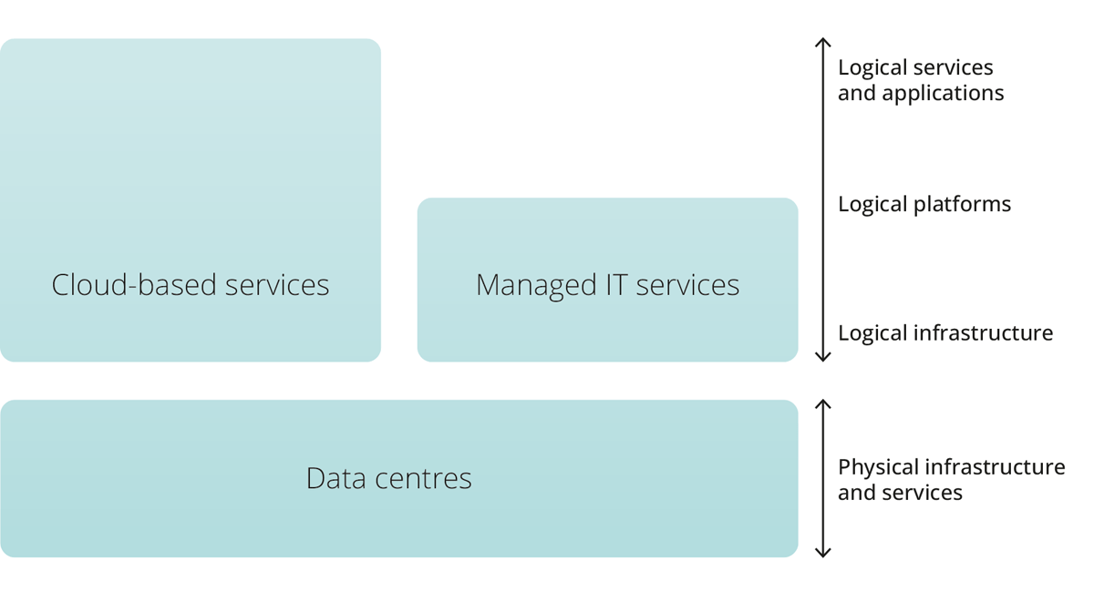
Source: Anskaffelse av datasentertjenester [Procurement of data centre services. Available in Norwegian only] (The Norwegian National Security Authority (NSM)/Norwegian Communications Authority (Nkom), 2024)
The Government wants Norway to remain an attractive country for investment in data centres that contribute to value creation, increased security and the safeguarding of Norwegian interests. With this strategy, the Government aims to further promote measures that can support ongoing growth in the data centre industry, while ensuring that development occurs sustainably and aligns with security needs and considerations.
              - The Electronic Communications Act
The Norwegian Parliament (the Storting) has enacted a new Act relating to electronic communications (the Electronic Communications Act). This is the first time legislation has been introduced to regulate the data centre industry in Norway. New Regulations relating to data centres entered into force on 1 January 2025, at the same time as the new Electronic Communications Act. The new regulations require data centre operators to register with the Norwegian Communications Authority. Data centre operators are required to register their name, address, the physical location of the data centre, and details regarding the data centre operator’s legal status or organisation number. Additionally, they are required to describe the services provided in the data centre and register information about certain public or municipal authorities and businesses that are their clients. They are also required to estimate the amount of power used for cryptocurrency mining and the size of the subscribed electrical capacity. The regulations also require operators to appoint a representative who can physically attend the data centre with the authority and knowledge to follow up on inquiries from the authorities. The registration duty requires data centre operators to register prior to commencing operations. For data centre operators already in operation, a transitional arrangement has been established that will gradually phase in the registration duty until 1 July 2025.

An industry that contributes to value creation and jobs
The data centre industry can contribute to value creation and jobs both locally and nationally in Norway. The Government has set the following goal:
It should be attractive to establish data centres in Norway, and the data centres that are established should create ripple effects in the form of jobs and local value creation.
Status
Data centre establishments can help strengthen value creation both locally and nationally, forming the basis for new and improved services for the population. Access to data centre capacity and services is essential because all data-based value creation, research and development depend on data being organised, processed and stored. In some cases, geographical distance to the data centre also plays an important role, for example, when using real-time data, which often requires what is referred to as an edge data centre, cf. section 2.1. In several of the critical regional industries, including aquaculture and agriculture, the use of technology is becoming increasingly important, and businesses are becoming increasingly adept at using the data they generate.
Many of the data centres in Norway are currently situated in rural areas, with several located in smaller local communities. The construction, establishment and operation of a new data centre could contribute to employment among a wide range of local suppliers and subcontractors. Data centre establishments can also help attract key competence to local communities, which in turn can lead to the development of new clusters of competence in rural areas.
Rising use of AI is anticipated to drive significant growth in demand for data centre capacity and data centre services. In a written submission to the Ministry of Digitalisation and Public Governance in January 2025, the Norwegian Data Centre Industry (NDI) emphasised that data centres on Norwegian soil can represent a “strategic opportunity for Norway” and serve as “a driving force for the establishment and development of a global supplier industry”. NDI draws parallels with the petroleum industry, highlighting the emergence of a robust supplier sector connected to data centres in areas such as electricity distribution, cooling technology, backup power, physical security, and autonomous building systems. Norway has robust industries in the energy, marine and maritime sectors, as well as in building and construction. By harnessing competence across sectors, we can stimulate innovation and, in time, the export of innovative solutions, such as businesses that design and build data centres or business models and equipment that optimise the interaction between data centres and the power grid.
The way forward
As the demand for data storage and processing grows and new data centres are established, the use of power, land, and natural resources in the data centre industry will also increase. Enabling technologies, such as AI, will establish the data centre industry as a key industry in the digital and green transition, as data centres are a vital part of the infrastructure on which these technologies depend. The growth, design criteria, and net footprint of data centres will mainly be influenced by or connected to the development, expansion, and utilisation of such enabling technologies.
The data centre industry is a market-driven and commercially developed industry. The framework conditions for the industry, such as taxes, fees and regulations, are crucial to the goal of a future-oriented data centre industry that grows in step with data storage and processing demands and contributes to private and public value creation and good local synergies. The Government wants the framework conditions for the data centre industry to support market-driven development, allowing potential underlying sectors and value chains linked to data centres to emerge. How Norway positions itself in terms of developing the infrastructure for enabling digital technologies will, among other things, determine how Norway can assert itself in the global AI race. By utilising our power for data centres in Norway rather than selling it abroad, we are laying the foundation for Norwegian value creation and for the establishment and development of a global supplier industry. We shall generate value and competitiveness while safeguarding the climate and nature. The public sector plays a vital role in this context (see section 5.2).

Digital infrastructure and enabling technologies
The Government will facilitate the green and digital transition of the business sector. Norwegian businesses should utilise artificial intelligence (AI) to unlock the potential for greater efficiency, enhanced quality, and new opportunities for innovation. In the public sector, there is significant potential to adopt AI to work in novel ways and create better, more user-friendly services for citizens. The Government wants all public enterprises to have begun using AI by 2030 and is working to establish a national AI infrastructure by 2030, cf. the National Digitalisation Strategy 2024–2030: The Digital Norway of the Future. A central element of the AI infrastructure will be a national compute infrastructure, which the Government is actively working to develop, cf. the white paper on a plan to strengthen Norway’s research system (Meld. St. 14 (2024–2025)). Data centres and access to capacity for data storage, data processing, and related services are an essential part of the goal and are necessary for operating computing power and cloud services to support Norwegian AI, including training Norwegian language models.
AI demands substantial computing power for training and use, leading to increased data traffic and electronic waste, and consuming more energy than traditional data centre operations. Resource and energy efficiency are therefore crucial for climate-friendly AI, known as green AI. Because AI has great potential to benefit society, Norway has joined an international coalition for sustainable AI, the Coalition for Sustainable AI, which was initiated by the Government of France in collaboration with the United Nations Environment Programme (UNEP) and the International Telecommunication Union (ITU).
AI can support the green transition by enhancing efficiency in industry and facilitating improvements and optimisation in areas such as production processes and the energy system. AI and other enabling technologies are central to the development of the Industry 4.0 concept, which involves the integration of digital technologies and automation in industrial production with smart factories and integrated systems. The EU is focused on climate and environmental issues in this context, and describes the optimisation of production processes, reuse, and circularity as “Industry 5.0”. The fourth industrial revolution is not yet complete, and this fifth industrial revolution advances it further by integrating climate and environmental concerns.
Blockchain technology enables decentralised networks that can, among other things, enhance efficiency, trust, and transparency in value chains and financial transactions. The Internet of Things (IoT) helps to collect data and connect billions of devices. In the long term, the growing number of data-driven and autonomous processes will heighten the demand for processing near the user through edge computing and more distributed data centres.
Quantum computers – even though they are in an early stage of development – represent a potential technological revolution that will require specialised data centres with unique infrastructure. Norway shall have a strategy for quantum technology in place by 2026. Such enabling technologies lay the foundation for technological breakthroughs with considerable potential to transform society, the economy, and working life. They enable advanced digital services and innovative solutions across sectors. It is about modern industrial development and value creation.
              - Lefdal Mine Data Centre – a stronghold for Norway’s first supercomputer and essential research data
Sigma2 AS, the state-owned company responsible for the national e-infrastructure for computational science (heavy computing) and storage of scientific data in Norway, has placed its data centre within the Lefdal Mine Data Centre facility, which is located inside the old Lefdal mine outside Måløy.
Sigma2 is funded by the Ministry of Education and Research through the Research Council of Norway, and receives funding from and collaborates with the Norwegian University of Science and Technology (NTNU) and the universities of Bergen, Oslo, and Tromsø to operate the national services known as NRIS (Norwegian research infrastructure services). Today, Sigma2 has users who conduct research across a wide range of fields, from language and language models to climate, the ocean, health, and notably the natural sciences of physics, chemistry, and biology. The Norwegian Institute of Public Health employed Sigma2’s services to determine the epidemiological reproduction number (R number) and vaccine effectiveness during the COVID-19 pandemic.
The mountain hall provides a safe and secure environment for the operation of the critical infrastructure managed by Sigma2. The company provides Norwegian researchers and research institutions with access to some of the world’s most powerful supercomputers, and the national supercomputer is now being installed in Sigma2’s data centre, with operations scheduled to commence in 2025.

Data centre establishments and the role of local authorities
The Government aims for the data centre industry to have favourable conditions for growth and value creation, and for data centre establishments to be carried out in a way that generates positive synergy effects in the host municipalities. The Government wants data centre establishments to strengthen local communities. It is essential that the planning of data centre establishments balances consideration for business development with consideration for the power system and the impact on the local environment, other local activities or other planned establishments. It will continue to be up to the municipalities themselves to decide whether to establish data centres in their areas.
Rural areas are appealing sites for data centre establishments, both because of their access to land and because Norway has several large energy-producing counties with a stable renewable power system that is internationally competitive in terms of price. Both municipalities and county authorities play a key role in the realisation of data centre establishments. It is the municipalities that receive and process applications for data centre establishment. In their role as planning authorities, they can decide whether and where data centres can be built. It is therefore essential that municipalities have a comprehensive understanding of data centres and the data centre industry, so that they are well-equipped to identify and assess the various aspects of applications for data centre establishments. In this context, it may be helpful for municipalities to exchange experiences from processes they have had with data centre establishments.
              - Basic elements for assessing applications for data centre establishment
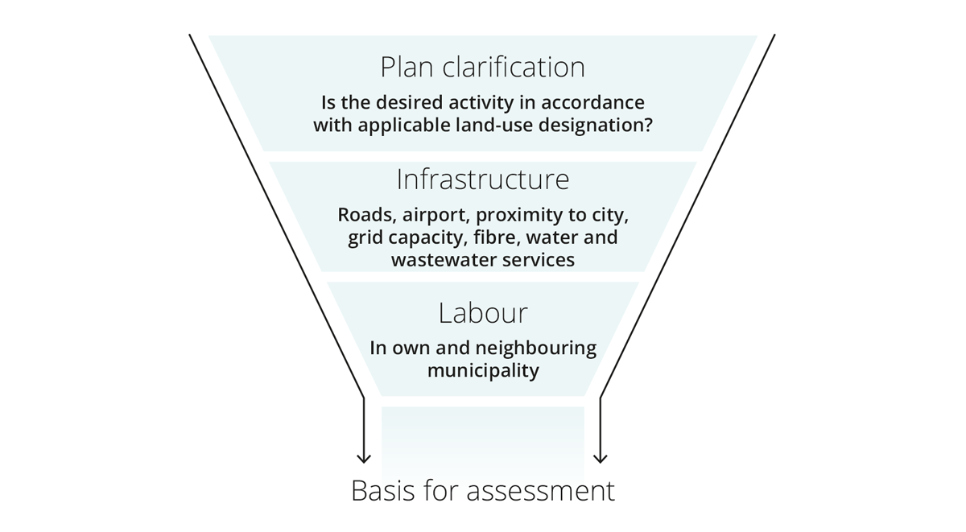
Some key points (non-exhaustive list):
- Who is responsible for initiating contact?
- What requirements should be imposed on the developer?
- Does the municipality have the resources to support the implementation of the planned establishment?
- Has the project undergone adequate quality assurance?
- What potential ripple effects could the project have in the municipality? (Is there existing industry or other commercial activity in the municipality that could strengthen or benefit from this establishment? How will the establishment contribute to the local labour market?)
Source: Rettleiar for kommunane: etablering av datasenter [Guide for municipalities: establishment of data centres. Available in Norwegian only] (Ministry of Local Government and Regional Development, 2023)
In April 2023, the Ministry of Local Government and Regional Development published a guide for municipalities in connection with the establishment of data centres. The guide offers information on the precautions they should take and the options available to them when they receive enquiries from interested parties about establishing a data centre or if they wish to establish one themselves. Additionally, the guide outlines common features of cryptocurrency data centres. The guide states that the area designated for data centre establishments shall be allocated for commercial buildings in the land-use element of the municipal master plan and regulated for the land use purpose “other industry” in detailed zoning plans. The Ministry of Local Government and Regional Development has also decided that data centres are to constitute a separate sub-purpose under the main purpose of development and construction at the zoning plan level in the new Map and Planning Regulations, which entered into force on the 1 of July this year. The purpose is to allow municipalities to control their land for data centres if they wish.
There are several important issues and priorities that municipalities must consider if they wish to facilitate the establishment of data centres, including access to power and infrastructure, and whether the desired land use may conflict with important soil conservation, environmental and social considerations. The establishment of energy-intensive industries should be considered from a regional perspective. Regional plans are a good tool for viewing industrial areas in relation to, among other things, energy needs, power production and the capacity of the power grid and other infrastructure. If the county authority develops a regional plan, it shall serve as the basis for municipal planning. The municipality should also consider whether there is existing industry or business activity that can benefit from the establishment of a data centre, whether the establishment is in accordance with current municipal plans, and how the establishment will contribute to the local labour market.
              - The process of applying to establish a data centre – what does a data centre operator typically emphasise?
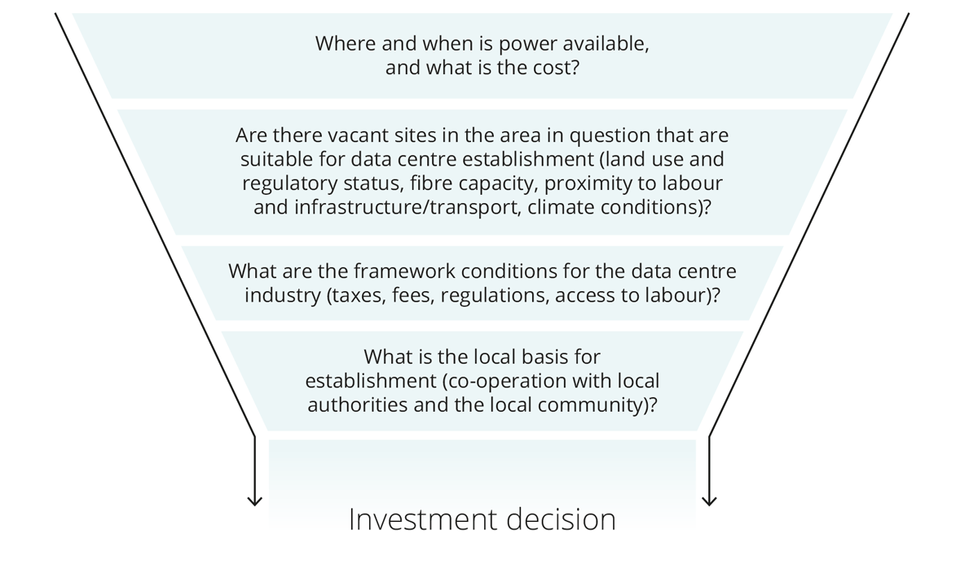
(The priorities of individual actors may vary.)

Development opportunities, employment and potential ripple effects locally and nationally
Norway requires new, profitable businesses and industries that generate new jobs and boost value creation. The Government aims to increase Norwegian exports outside oil and gas by 50 per cent by 2030. At the same time, it is important to safeguard the opportunities offered by digitalisation to further develop existing industries and jobs. Data storage and processing capacity constitutes critical infrastructure both nationally and locally, and the establishment of data centres in rural areas can provide regional opportunities with positive value creation effects. The data centre industry and related value chains can also strengthen Norwegian exports. The policy instrument system, including Innovation Norway, will play a crucial role in achieving the goal of increasing exports.
Several municipalities have found that establishing a data centre has not had the positive ripple effects and impacts on the local community that they had anticipated. This is especially the case for establishments that have been found to be involved in cryptocurrency mining. In several such cases, the establishment has led to frustration, dissatisfaction, and difficult local debates, as the data centre consumes substantial resources but has little or no impact on the local community or creates little to no value locally. This is undesirable, and the Government wants data centre establishments that use essential resources to strengthen local communities and promote sustainable value creation both locally and nationally.
Employment connected to the data centre industry relies on access to competent labour. The Government wants the Norwegian data centre industry to be a competence-based industry offering opportunities across all levels of education, while contributing to fair practice in the labour market.
              - Value chains that create growth, employment and opportunities throughout the country
An analysis of the ripple effects of completed and potential data centre establishments in Norway, prepared by Implement Consulting on behalf of the Ministry of Local Government and Regional Development in 2020, shows that data centres contribute to employment and jobs both directly and indirectly. Data centre establishments vary in size, but in some cases, the construction of a data centre can create several hundred jobs. The jobs are often distributed among various local subcontractors. Once a data centre is operational, it boosts employment by creating jobs at the data centre and related activities, as well as through private consumption by those directly and indirectly employed. Any consumption from business activities connected to the data centre also contributes.
At the same time, the data centre indirectly contributes to employment and jobs throughout the country. Cloud services, sensor technology and the Internet of Things (IoT), big data analysis, artificial intelligence and high-performance computing (HPC) are some of the most essential technological drivers in the data economy. All of these technologies are dependent on a data centre. Wik Consult has assessed the Norwegian data economy on behalf of the Norwegian Communications Authority (Nkom). The assessment estimates that the data economy will account for 5.4 per cent of Norway’s GDP in 2025. In addition, the operation of data centres contributes to tax revenues for society.
Norwegian Data Centre Industry (NDI), which represents a total of 80 different actors in the data centre industry in Norway, has commissioned Samfunnsøkonomisk Analyse to estimate the development in full-time equivalents and value creation, both directly and indirectly linked to the data centre industry, up to 2034. In 2024, the estimates were presented in a report. According to the report, data centre operators in Norway have several data centres in operation. However, most operators are still in an establishment and development phase, partly because many data centres are established and expanded in multiple stages. A significant portion of today’s activity is therefore likely related to the construction and installation of physical capital. In the long term, the industry will progressively shift into an operational phase.
The report also showed that NDI members employed 730 full-time equivalents, including contracted full-time equivalents, as of September 2024, and that a total of 3,686 full-time equivalents with subcontractors were involved in projects. This means that around 4,400 full-time equivalents were associated with the activities of NDI members in 2024. This is almost twice as many as the 2,300 full-time equivalents reported by members in 2023. The growth is connected to the substantial investments by data centre operators in expanding existing facilities and building new ones.
Considering that most data centre operators are registered in industry group 63.110 Data processing, hosting and related services, and comparing this with the total value added in mainland Norway, the report estimates that the data centre industry contributed 0.14 per cent of the total value added in Norway in 2024. The report estimates that Norwegian data centres could generate NOK 28 billion in value creation and employment, equivalent to 25,000 full-time equivalents in 2031. The most significant effects will stem from the establishment of data centres. The number of full-time equivalents will decrease after 2031, when the data centres enter an operational phase and investments are expected to decline. The projections are uncertain. The economic impact analysis commissioned by the Ministry of Local Government and Regional Development in 2020 estimates that the industry could potentially contribute NOK 30.9 billion to Norway’s GDP and employ just under 25,000 people in 2030, based on a scenario with 25 per cent annual growth in the data centre industry.
Data centre establishments can also contribute to the development of important local ecosystems for digital development and value creation. This can occur when data centres attract sought-after cutting-edge competence and form partnerships with other businesses and local commercial activities, but also through their contributions to developing other key infrastructure, such as fibre-optic cables or road infrastructure.

              - World-leading technology in Vennesla
In Vennesla, Bulk is in the process of upgrading its data centre park, NO1 Campus. Ten years after Bulk, which has Norwegian majority owners, opened its data centre at Støleheia, the company is expanding with a new data centre building specially designed for AI. The new building will complement the two existing data centre buildings. In addition to providing data processing services for Norwegian and international companies, Bulk has positioned itself in data processing infrastructure as a step in the industrialisation of the AI industry.
Bulk collaborates with the U.S. multinational company Nvidia, which designs processors for AI servers. It has been included in their global network of data centres that are considered to have optimal conditions for rolling out AI on Nvidia’s DGX platform. Bulk also has a partnership with the global technology company CoreWeave, which is installing world-leading technology at Støleheia in what will be one of the largest AI clusters in Europe.
Vennesla identifies itself as “the green urban village”. Vennesla has ample access to hydropower, and the municipality is eager to explore how international technological innovations can generate opportunities for local development and employment by combining external power sources with internal power resources. Statnett’s transformer station at Stølen is among the largest in Europe, featuring twelve separate transmission routes that provide a highly reliable power supply.
Since 2014, Bulk has invested approximately NOK 5 billion in the data centre park in Southern Norway, and the construction of the new AI data centre will involve further investments of several billion more. Currently, more than 50 people are permanently employed by Bulk at Støleheia, and several hundred have been or are being contracted during periods of building and expansion of the data centre park. In 2024, a maximum of 550 people was working at the NO1 Campus. Additionally, there are local and regional subcontractors working on projects outside the area where the data centre park is situated. A total of 370,000 project hours were carried out at N01 Campus in 2024.
Agder hosts one of Norway’s foremost IT clusters, Digin, where Bulk and approximately 130 other member businesses collaborate to promote innovation and knowledge development in IT, digitalisation, and technology. In collaboration with Meta, Google and Amazon, Bulk has also built a submarine fibre-optic cable from New Jersey in the United States to Støleheia in Vennesla, with branches to Denmark and Ireland.
To utilise the energy twice, active efforts are underway with local and regional partners from the energy sector on reusing excess heat from data centres. This includes investigating the establishment of district heating facilities capable of supplying heat to other industries that may establish themselves in the vicinity of N01. Bulk is also in the process of assessing the role that data centres play in the power system and identifying opportunities where data centres can help relieve pressure on the grid in the future.

              - A data centre revitalised a former NATO ammunition depot and is supporting the transition of a town with a long industrial heritage
On Rennesøy island in Boknafjorden, Green Mountain operates the SVG-Rennesøy data centre in what was once a NATO ammunition depot. The facility, acquired by the former Rennesøy municipality (now Stavanger Municipality), has a nuclear-secure design, proximity to the fjord, and the possibility of seawater cooling. This makes it well-suited for a data centre.
Since its establishment in 2011, the data centre has supported a total of  - NOK 2.3 billion in Norwegian value creation – NOK 873 million in the development phase and NOK 1.4 billion in the operational phase. NOK 1.2 billion of the value creation in the operational phase constitutes local value creation.  - Approximately 1,600 full-time equivalents in Norway – 980 full-time equivalents in the development phase, of which approximately half are local employees, and 630 full-time equivalents in the operational phase, of which approximately 80 per cent are local employees | Green Mountain has invested NOK 1.3 billion in the establishment and expansion of the data centre in the period 2011–2024. |  | In 2024, 80 people had SVG-Rennesøy as their permanent workplace:  - permanent employees at Green Mountain: 40 people  - permanent contracted labour: 22 people  - employees and permanent contracted labour with customers: 11 and 7 people, respectively  - In addition, there are 37 full-time equivalents at the administrative office in Stavanger.
- NOK 117 million in local value creation and 119 full-time equivalents in the local municipalities from local consumption by employees | SVG-Rennesøy and the economic activity associated with the data centre have supported around NOK 210 million in tax revenue during the operational phase since 2013:  - approx. NOK 177 million to the central government  - approx. NOK 27 million to Stavanger Municipality  - NOK 5.5 million to Rogaland County Authority
Green Mountain also has a data centre in Rjukan, TEL-Rjukan. During a period of transition for the region, after Hydro scaled down its production in Rjukan in the early 1990s, the construction and expansion of the data centre has generated investments of over NOK 1 billion.
Since its establishment in 2014, the data centre has supported  - approximately NOK 860 million in Norwegian value creation – approximately NOK 524 million in the development phase and NOK 337 million in the operational phase  - approximately 715 full-time equivalents in Norway – 425 full-time equivalents in the development phase, of which approximately 25 per cent are located in Tinn Municipality, and 290 full-time equivalents in the operational phase, of which 90 per cent are local employees | Green Mountain has invested over NOK 1 billion in the establishment and expansion of the data centre since its inception in 2014. | In 2024, 77 people had TEL-Rjukan as their permanent workplace:  - permanent employees at Green Mountain: 35 persons  - permanent contracted labour: 25 persons  - employees and permanent contracted staff at customers: 6 and 11
- NOK 25 million in local value creation and 28 local full-time equivalents from the local consumption by employees | TEL-Rjukan and the economic activity associated with the data centre have generated tax revenues totalling NOK 80 million in the operational phase since 2014:  - approx. NOK 63 million to the central government  - approx. NOK 14 million directly to Tinn Municipality  - NOK 3 million to Telemark County
Source: Ringvirkninger av Green Mountain sitt datasenter på Rennesøy [Ripple effects of Green Mountain’s data centre in Rennesøy. Available in Norwegian only] (Menon publication no. 145/2024) and Ringvirkninger av Green Mountain sitt datasenter på Rjukan [Ripple effects of Green Mountain’s data centre in Rjukan. Available in Norwegian only] (Menon publication no. 102/2024)

The Government
- will strengthen Norway’s position as an attractive data centre nation to attract data centre establishments that meet national needs
- wants data centre establishments in Norway to contribute to local value creation
- will ensure predictable framework conditions that provide good growth conditions for data centres in Norway
- will facilitate investments in data centres that strengthen Norwegian digital infrastructure and support innovation and growth throughout the country
- will contribute to a robust and sustainable ecosystem connected to the data centre industry, generating new and attractive jobs across different parts of the country
- wants the development in the data centre industry to be market-driven and enable the emergence of potential new underlying industries and value chains
- wants the data centre industry to contribute to the increased emergence of a market-driven supplier industry connected to data centres in Norway
- wants the data centre industry in Norway, with associated value chains, to support the Government’s target of a 50 per cent increase in exports
- wants the growth in the data centre industry to contribute to increased employment in Norway
- wants the Norwegian data centre industry to be attractive partners for the development and use of AI
- will support municipalities in their role as planning authorities for data centre establishments, and establish an arena where they can receive guidance and exchange experiences in connection with data centre establishments
- will work with the Norwegian Association of Local and Regional Authorities (KS) to implement measures to increase knowledge about data centres and the data centre industry among Norwegian municipalities, based on the municipal guidelines for data centre establishments
- wants data centre development to contribute to fair practice in the labour market and to be carried out in accordance with relevant industry standards, such as the fair practice rules for building and construction contracts
- will assess the competence needs in the data centre industry in collaboration with the industry and facilitate adequate and adapted educational pathways
- will work to ensure that the data centre industry is a competence-based industry that facilitates the use of skilled workers and apprentices
- will utilise information derived from the registration obligation for data centre operators in the work on future-oriented framework conditions that contribute to the development of the data centre industry in Norway

An industry that contributes to a more secure and prepared Norway
Data centres in Norway contribute to critical digital services being produced domestically and help build a more secure and prepared digital Norway. The Government has set the following goal:
Data centres and data centre services shall contribute to Norway’s security and preparedness in times of peace, crisis and war.

Data centres – the heart of our digital infrastructure
Status
Data centres represent the heart of Norway’s digital infrastructure and is an integral part of our critical digital infrastructure. This infrastructure forms the basis for the ever-increasing use of critical internet services and cloud-based services within most sectors of society, such as public services, health services and banking and financial services. Data centres are also referenced in the white paper on total preparedness as one of the key services for managing crisis situations. Data centres are where data is stored and digital services are produced.
Most data centres are designed with redundancy and emergency systems to ensure high uptime and reliability. Data centres store and process large amounts of data that are essential for industry, the business sector, public authorities and individuals. Data centres are also venues where we process and store some of our most sensitive and strategic data, making both ownership and location crucial to security interests. A single interruption in the operation of a data centre can have significant consequences – from large financial losses to threats to public services and national security.
The infrastructure in data centres can also be misused for criminal activities and activities that threaten national security. The Norwegian police has found that cybercriminals and other threat actors who have the ability and willingness to commit crime against businesses, infrastructure and services can connect to data centres in Norway, and that data centres in Norway are used for criminal activities both domestically and against other countries.
The way forward
For Norway, as one of the most digitalised countries in the world, it is imperative to maintain adequate security and preparedness for its entire digital infrastructure. In the white paper National control and cyber resilience to safeguard national security (Meld. St. 9 (2022–2023)), the Government expresses the need to strengthen legislation in areas including digital security and data centres. As more sensitive data is stored in data centres, the threat environment is also becoming increasingly challenging. An increasing number of state and non-state actors are devoting considerable resources to attempt to disrupt the functioning of data centres or exploit the data processed there. Therefore, data centres need to be prepared.
The new Electronic Communications Act sets important requirements for adequate security and preparedness in data centres to safeguard Norway’s digital infrastructure in times of peace, crisis and war. The requirements for adequate security are evolving in line with technological developments and what is technically feasible. The requirements are also influenced by the services the data centre provides. The data centre industry in Norway is fairly new, but today, many essential services are provided by data centres. Dependence on data centres can pose a major societal vulnerability, as the loss or degradation of services may lead to significant challenges. The Government’s aim is to ensure that data centres and data centre services can manage situations outside normal operations and to enhance digital preparedness so that the digital infrastructure can be recovered if something fails.
The Ministry of Digitalisation and Public Governance regards Norwegian data centres as significant to national security interests and has designated them as a fundamental national function in terms of their capacity to store and process data within Norway. Some data centres are already subject to the Security Act, and more will be assessed in the future.

The most critical societal functions are provided from data centres in Norway or with allies
In the National Digitalisation Strategy and the white paper on national control and cyber resilience (Meld. St. 9 (2022–2023)), the Government emphasised the importance of being able to deliver critical data centre services from Norway or allied countries. Furthermore, in 2024, the Government appointed an Expert Committee for National Control of Critical Digital Communications Infrastructure (Electronic Communications Security Committee). The Electronic Communications Security Committee prepared a report recommending measures to strengthen control over critical digital communications infrastructure, including data centre capacity. To ensure that Norway can protect critical services and information, it is not only necessary to have sufficient data centre capacity, but also to ensure that the data centres from which these services are delivered are secure. At the same time, the current security policy situation has demonstrated how vital it is to maintain a robust digital infrastructure, including geo-redundancy and the ability to migrate data centre services out of the country on short notice. Similarly, allied countries may wish to have their critical data services delivered from Norway. Ownership structures and an overview of entities that manage digital communications infrastructure are also significant for national control, and the Electronic Communications Security Committee highlights that digital communications infrastructure is made up of complex value chains that are subject to ongoing development.

Total Defence and critical needs
To ensure that the state can maintain control and freedom of action throughout the entire crisis spectrum, it is essential to have access to both proprietary and commercially operated data centres with an appropriate level of security.
The Total Defence must have access to data centre capacity under national technical and legal control in times of peace, crisis and war, with authorised personnel and central government oversight. Therefore, it is important to have data centres on Norwegian soil.

Preventing data centres in Norway from being misused for criminal purposes
The Government is committed to preventing data centres in Norway from being misused for criminal purposes. Another phenomenon observed in Norway is that state actors rent servers in data centres, under the guise of being legitimate businesses. They can use the servers they rent to compromise targets in both Norway and the rest of the world. The Ministry of Digitalisation and Public Governance will therefore ensure that the authorities are able to prevent, avert, stop, and investigate criminal conduct, as well as address the loss of data centre services that are important to society. Among other things, data centre operators should have access to up-to-date information about their own customers’ names and contact details, and on specific terms disclose such information to the Norwegian Communications Authority (Nkom), the National Security Authority (NSM), the Norwegian Police Security Service (PST), the police and the prosecution authorities. The purpose is to enable the authorities to carry out their tasks related to crime prevention. It will also help reduce the attractiveness of data centre misuse in Norway to criminal actors. At the same time, it is important to ensure the desired establishment and development of data centres in Norway and to provide appropriate framework conditions for the data centre industry.

Specification of requirements for the physical and logical security of data centres and documentation of an adequate level of security
Data centres underpin an increasing number of critical societal functions and values. Knowledge of relevant security assessments is therefore important when businesses are to procure data centre services. The thematic report Anskaffelse av datasentertjenester [Procurement of data centre services. Available in Norwegian only], prepared by Nkom and NSM in November 2024, is a helpful guide for businesses that need data centre services. Among other things, the report provides guidance on physical security and outlines the requirements that should be set for personnel with access.
The Government wants public and private enterprises to be more aware of the need to establish robust security requirements when purchasing data centre services, including requirements for physical security, personnel, and subcontractors. This is particularly important due to the risk of value chain attacks, which both NSM and PST have mentioned in their annual risk and threat assessments.

Assessments of critical societal functions’ use of data centres
The National Digitalisation Strategy includes the goal of strengthening digital security and preparedness. In a report on Norwegian data centres and digital autonomy, NSM recommends assessing where critical societal functions are produced.
The Ministry of Digitalisation and Public Governance has carried out assessments of critical societal functions’ use of data centres and will continue to conduct such assessments. The aim is to identify whether sectors and their redundancy are concentrated in a few data centres, and whether this poses a concentration risk in that several critical societal functions are dependent on only a few data centres.

Priority connection to the power grid in the interests of national security
Under the Energy Act, anyone who wishes to do so has the right to be connected to the grid, cf. section 5.1. Connections can only be made once the necessary grid investments have been completed, and in many areas, multiple actors are queued for access. The current Energy Act does not allow for national security interests to be given special priority in assessments of priority in the queue for connection to the power grid. The current security policy situation necessitates a legal basis with clear and predictable frameworks for prioritised connection to the grid when it is necessary in the interests of national security, such as the defence industry and critical societal functions.
The Government
- wants critical digital services to be able to be produced domestically, so that we achieve a more secure and prepared digital Norway
- wants critical societal functions to use data centres in Norway or with allies
- will ensure, with the new Electronic Communications Act, that data centre operators maintain an adequate level of security and preparedness, and that critical societal actors are given priority where necessary
- Wants the functions on which society is most dependent to be delivered from data centres in Norway or with allies and partners, and investigate the need for more data centres in Norway with Norwegian majority ownership
- will ensure appropriate framework conditions for the data centre industry to safeguard both national security interests and crime prevention interests, and the desired establishment and development of data centres in Norway
- wants public authorities and bodies, when purchasing data centre services, to specify requirements for the physical and logical security of data centres and require data centre operators to document an adequate level of security in accordance with recognised security standards
- will continue to conduct assessments of the use of data centres by critical societal functions
- will establish a fundamental national function for data centres that is adapted to the security policy situation, and continuously assess which data centres support fundamental national functions and national security interests, with corresponding application of the Security Act
- will establish relevant forums for data centre operators subject to the Security Act
- will participate actively in European co-operation to contribute to appropriate, and primarily pan-European, solutions for safeguarding digital security, combating crime, and national security interests related to data centre activities
- will establish a new authority in the Energy Act to enable the prioritisation of connections for specific end-users where necessary in the interest of national security.

Establishment of data centres and international transmission routes throughout the country
Status
The authorities have long placed great emphasis on strengthening the security, robustness and diversity of our national and international fibre-optic infrastructure. A key objective of the Government’s National Digitalisation Strategy is to provide high-speed broadband to everyone by 2030 and to ensure that we have robust electronic communications networks throughout the country. An important element of this is ensuring that Norway has high-capacity links to multiple countries from all parts of the country.
The recommendations from the Committee on Digital Vulnerabilities in Society (the Lysne Committee) in 2015 have been followed up by, among others, Nkom through national goals for robust and secure fibre-optic infrastructure towards 2030. The goals represent an operationalisation of the overriding strategies in the white paper on mobile, broadband and internet services (Meld. St. 28 (2020–2021)). One of the goals is “robust transmission grids throughout the country”. This means working to ensure that fibre-optic networks are available throughout the country, that each fibre operator has good redundancy, and that different networks are physically and logically independent of each other. Another goal is that “Norway has a good supply of high-capacity fibre-optic connections to several countries from all regions”. This also entails good distribution of internet and data traffic between Norway and other countries via these connections, to reduce concentration risk.
Norwegian broadband policy is market-based, and fibre roll-out is mainly carried out on a commercial basis. Therefore, facilitating market-based development is also an important means of achieving the goal of a robust and secure fibre infrastructure. In recent years, the Norwegian data centre industry has been an important driver of market-based development towards meeting the mentioned goals, particularly with regard to subsea fibre-optic cables.
The way forward

Norwegian data centres contribute to strengthening the national and international fibre infrastructure
Since 2020, new high-capacity international subsea fibre-optic connections have been established from Norway both to the United States (Bulk), the United Kingdom (Bulk and Tampnet), Denmark (Altibox), and Sweden (Tampnet). In addition, new high-capacity fibre-optic connections have been established along entirely new routes domestically – including new coastal fibre between Bergen and Trondheim (N0r5ke Fibre) and between Stavanger and Oslo over the mountains (Altibox). Several new national and international projects are also in the planning stage.
Major fibre infrastructure projects in recent years driven by demand from the data centre and cloud services industry
Subsea fibre-optic connections in operation:
- Altibox – Skagenfibre, Larvik–Hirtshals (Denmark)
- Altibox – NO–UK, Stavanger–Newcastle (England)
- Altibox – land fibre, Stavanger–Oslo
- Bulk – Havfrue, Kristiansand–New Jersey (USA)
- Bulk – Havsil, Kristiansand–Hanstholm (Denmark)
- Bulk – Inter-City Ring, Oslo– Kristiansand– Stavanger– Bergen
- N0r5ke – N0r5ke Viking I, Bergen–Trondheim
- Tampnet – Egersund–Ula–Aberdeen (Scotland)
- Tampnet – Norfest, Stavanger–Oslo–Sweden
Subsea fibre-optic connections in the planning stage:
- N0r5ke – N0r5ke Viking II, Bergen–Oslo–Trondheim
- Far North Fibre – Norway/Ireland–Japan via the Northwest Passage
- Polar Connect – Norway–Asia via the Arctic Ocean
- Bulk – Leif Erikson, Kristiansand–Canada
Strengthening the national fibre infrastructure will not only benefit data centre operators and their customers. It also enables national and regional providers of electronic communications networks to purchase access to expand and strengthen the redundancy of their own networks.
In addition to market-based development, the Government is contributing with publicly funded measures to make the fibre infrastructure less vulnerable in exposed areas. The authorities have contributed several hundred million kroner to measures to strengthen the fibre infrastructure between Svalbard and the mainland and in Finnmark, Troms, Nordland and Trøndelag counties. The measures have been implemented following thorough regional risk and vulnerability assessments. The Parliament (The Storting) has also decided to build a new fibre-optic connection to Svalbard. In line with the National Digitalisation Strategy, the Government will carry out risk and vulnerability analyses in all regions of the country.

Norwegian data centres contribute to strengthening national digital autonomy
Since 1 January 2025, the Government has been able to require data centres to have national autonomy, pursuant to the Regulations relating to data centres (Forskrift om datasenter).
National autonomy in the Regulations relating to data centres
Section 2-9. Authority to require data centres to have national autonomy
In a crisis or emergency situation, the Norwegian Communications Authority may oblige data centre operators to operate and maintain their services using personnel and technical solutions in Norway.
In force on 1 January 2025
The production of electronic communication services and other critical digital services is increasingly taking place on cloud-based platforms in data centres. Virtualisation and cloud technology enable, among other things, the seamless transfer of service processing between different physical data centre locations as needed. This can be achieved using everything from global cloud platforms such as Microsoft Azure, Amazon Web Services, and Google Cloud to purely national cloud platforms.
On one hand, developments are progressing towards more intricate international value and supply chains. On the other hand, cloud technology is scalable and geographically flexible. Norwegian data centres and a strong digital infrastructure thus facilitate the production of critical digital services in Norway rather than in data centres abroad. This will strengthen national control and autonomy.
              - Telenor, Hafslund and Hitec Vision are investing billions (NOK) in new data centres in Oslo with an emphasis on national ownership, security and sustainability
Skygard focuses on establishing secure data centres with a high level of security, where critical business and societal security data can be stored and fulfil both sectoral and national requirements for data storage and processing. Skygard is designed for AI and to facilitate national cloud solutions that are owned and operated on Norwegian soil.
Skygard plans to establish three data centres in the Greater Oslo Region. The first is located at Hovin, where customers will begin moving in as early as 2025. The establishment will create jobs in connection with the construction, operation and maintenance of the centres

Norwegian data centres contribute to strengthening regional digital autonomy
Regional digital autonomy means that certain digital services shall be able to function in a region, for example, Northern Norway, in the event of a communications breakdown or other events that isolate the region from the rest of the country.
Norwegian regional data centres help to strengthen regional autonomy. A general trend is that digital content and digital services are being migrated to regional data centres closer to users to enhance performance and response times for the services. The more data and services that are produced in regional data centres, the greater the incentive for regional, national and international fibre operators to connect to the data centres and exchange traffic there. Overall, this will strengthen the regional digital infrastructure. Where direct fibre-optic connections to other countries are established from regional data centres, the region will also have direct access to internet and cloud services from other countries, even in the event that communication with the rest of the country is lost.
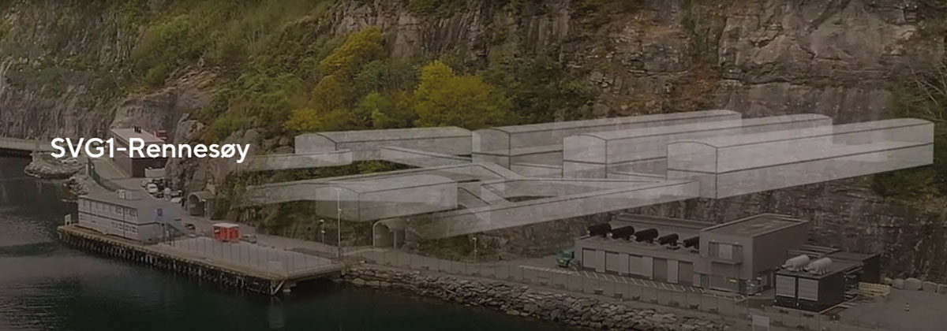
Stavanger has become the largest regional hub for digital infrastructure outside Oslo
GreenMountain’s SVG1 colocation data centre on Rennesøy island near Stavanger has become a digital hub in South-Western Norway.
The data centre connects to several national fibre operators. Altibox has also established a subsea fibre-optic connection directly from Rennesøy to England. This helps the region access internet and cloud services from abroad without having to route traffic through Oslo.
At the data centre, the national Internet exchange operator, Norwegian Internet eXchange (NIX), operates a regional Internet exchange point, which is the largest in terms of traffic outside Oslo.
The Government
- wants Norway to have robust data centres that provide both national and regional autonomy for data centre services
- will work to ensure that data centres and international transmission routes are established throughout the country to scale redundant solutions that are important for business and society, and to support fundamental national functions

A data centre industry for a greener future
The Government has high ambitions for the climate impact of data centres in Norway and for the industry’s contribution to meeting climate targets. The Government has set the following goal:
The data centre industry in Norway shall be sustainable and have a low climate and environmental footprint.

The need for electrical power and efficient energy use in data centres
Status
The fact that Norway has good access to renewable electrical power makes us well-suited for data centre establishments. Our cold climate also provides us with a good starting point for energy efficiency in data centres. For example, less energy is required for cooling here than in other parts of the world.
Data centres require a significant amount of electrical power. In the Norwegian Water Resources and Energy Directorate (NVE) report on the state of the power system in Norway from 2025, the main conclusion is that Norway will continue to have a positive power balance in a normal year until 2030. NVE expects power consumption to continue rising over the next five years, but has revised its projected increase downward from previous forecasts, partly because several plans for battery factories and hydrogen production have recently been postponed, scaled back, or cancelled.
Power consumption, grid connection, energy efficiency and excess heat are key aspects of the relationship between the data centre industry and the power system. The members of the Norwegian Data Centre Industry (NDI) have signed the Climate Neutral Pact, a self-imposed commitment to be climate neutral by 2030, and several of them have already entered into local partnerships to utilise excess heat from their data centres. According to NDI’s annual report, 9 of the 18 largest data centres have heat recovery, mainly in the form of local systems.
The total electricity consumption for digital infrastructure in Norway in 2024 is estimated at 3.7 TWh in Nkom’s sustainability analysis (see section 5.2), which represents 2.6 per cent of Norway’s total electricity consumption of 140 TWh. The figure below illustrates the distribution of total electricity consumption across various parts of Norway’s digital infrastructure. As the figure shows, data centres accounted for around 41 per cent of this consumption.
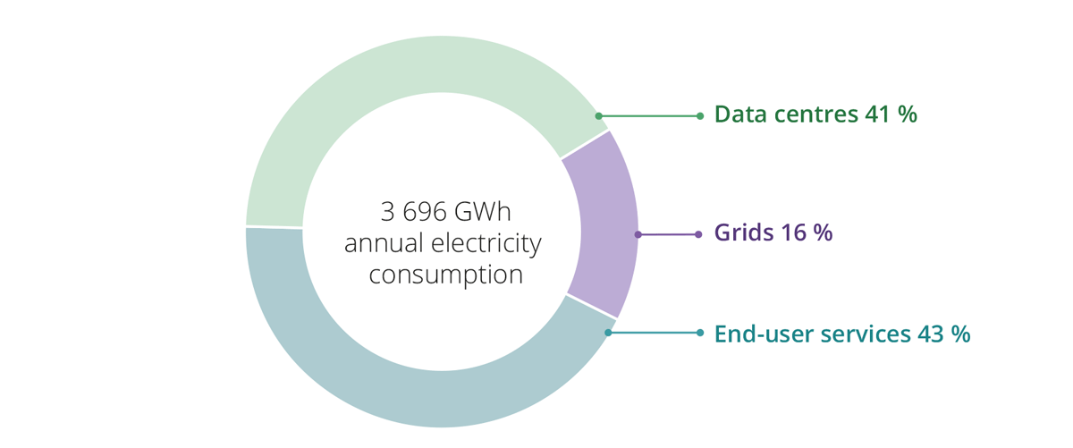
Source: The Norwegian Communications Authority (2025) Fotavtrykket fra norsk digital infrastruktur 2024 [The footprint of Norwegian digital infrastructure 2024. Available in Norwegian only]
Data centre services is one of the areas that are expanding, as a result of the rising use of big data and artificial intelligence. NVE expects power consumption in the data centre industry to increase from 2.5 TWh in 2024 to 6.0 TWh in 2030. In its long-term power market analysis from 2023, NVE assumes that electricity use in data centres could increase to 8 TWh by 2040. NVE emphasises that there is considerable uncertainty surrounding the development of power consumption in the coming years.
The grid has limited available capacity for connecting new major consumers. Statnett, the system operator of Norway’s power system, states that 2,691 megawatts (MW) are presently reserved for new data centres. In addition, projects requiring 4,390 MW are currently awaiting connection in the capacity queue.
The widespread emergence of AI technology will be a significant driver of how much data is stored and processed, and thus of power consumption in data centres. The table below shows the typical share of energy consumption for different types of AI activity. As the table shows, model training is an activity that does not depend on proximity to the end user and can, in principle, be carried out anywhere in the world, thus representing a market opportunity for Norwegian data centres.
Type of activity | Share of energy consumption | Description
Model development | 10% | Models are developed and fine-tuned prior to training.
Model training | 30% | Algorithms learn by processing a comprehensive data set to make predictions or decisions without exact input-response relationships being programmed in advance. This demands substantial computational effort and consumes a lot of energy over extended periods. This activity does not require a rapid response and can, in principle, be undertaken anywhere in the world.
Use | 60% | The activity involves the implementation and application of developed AI models in real-world scenarios. This requires computational resources to interpret new data and generate results or predictions based on pre-trained models. This activity often requires a rapid response and to a greater extent must be carried out in proximity to the user.
Under the Energy Act, anyone who wishes to do so has the right to be connected to the power grid. A large number of actors have applied to connect to the grid in recent years to establish new commercial and industrial activities or phase out fossil fuels through electrification. The grid companies report that there is little spare capacity in the grid that has not been reserved or utilised. Therefore, many of the actors seeking grid connection are now queued. It is therefore imperative for the Government to facilitate faster establishment of grid facilities in the future and to ensure that the grid is used as efficiently as possible. This work is well underway.
Where it is not possible to connect a customer to the existing grid, agreements on connection with conditions for disconnection or limitation of the customer’s consumption may be an alternative to investing in grid facilities. Conditional connection means that the customer accepts that the power supply may be reduced or entirely disconnected if required to ensure the stable operation of the power system. The actual conditions must be determined according to the grid situation at the location where the customer will be connected. In principle, data centres are well-suited for connection on certain conditions. Ordinary data centres have high requirements for security of supply and often have their own backup power solutions, such as battery capacity and diesel generators. Since they are largely able to sustain themselves during power outages, they can additionally contribute flexibility to the power market.
There must always be a balance between consumption and production in the power system, and Statnett among other things uses various reserve products to balance the system. Ordinary data centres are well-suited to participating in reserve markets. In addition to being an essential driver of digital innovation and business development, and providing more efficient and climate-friendly solutions and services, data centres therefore can also contribute to the power market. Statnett and the grid companies are working with the data centre industry to promote participation in the power markets.
The data centre industry can take measures to limit the need for electricity and facilitate the use of excess heat for various purposes. Data centres generate large amounts of excess heat that can be reused for other purposes, where this is beneficial for society. NVE points out that there is considerable potential for increased reuse of excess heat from data centres, but that there are several barriers to utilising excess heat. The most significant barriers are a lack of infrastructure for transporting and storing heat. However, there are also organisational barriers, for example, related to the parties having to agree on the price and ownership of infrastructure (pipes, heat pumps, etc.), who will bear the investment costs and have operational responsibility, and assessing the risk of one of the parties withdrawing from the collaboration. Excess heat from data centres also has a relatively low temperature. This often necessitates measures to increase the temperature in order to utilise the excess heat.
Nevertheless, several examples exist of excess heat from data centres in Norway being utilised today. Many smaller data centres are situated in central locations where district heating infrastructure is also available, partly because they offer services that need to be close to the market. The largest data centres are often established in locations that are favourable due to the electricity grid and affordable land prices. In such large data centres, which require several terawatt hours of power, there will also be several terawatt hours of excess heat. This will require the extensive development of compatible businesses with high heat demand if a significant share of the excess heat from large data centres is to be utilised.
              - Collaborating to ensure efficient energy recovery and help reduce the climate footprint
Skygard, a data centre operator owned by Telenor, Hafslund and HitecVision, is currently building a data centre facility in Hovinbyen that will be used in Hafslund Celsio’s district heating network. This will ensure efficient energy recovery and help reduce the climate footprint of the data centre facility’s operations. The energy from the data centre facility in Hovinbyen will be used to heat both commercial buildings and residential homes in the area, and the excess heat will be able to heat up to 12,000 flats in Oslo. The collaboration with Skygard will enable Hafslund Celsio to supply more district heating to Oslo, produced from local surplus energy. The collaboration also contributes to supporting the goals of emission reductions and sustainable energy use for both Oslo and the whole country.
Hafslund Celsio is also collaborating with Stack Infrastructures on the reuse of excess heat from Stack’s data centre facility at Ulven, which is used for district heating for 5,000 homes in Oslo.

              - More sustainable operation with solar panels on the roof
Orange Business’s data centre in Lørenskog is the first in Norway to have solar panels on its roof. The 10,000 square metre data centre facility is expected to produce around 450 megawatt hours annually, equivalent to approximately 3.5 per cent of the data centre facility’s annual energy consumption.
Orange Business has a goal of reducing the company’s global carbon footprint by 30 per cent by 2025, and the solar cell facility is one of many measures that will help them achieve this goal. The company also plans to install similar solar power systems at its data centre facility in Grorud outside Oslo.
The way forward

Energy efficiency
Norway has a national goal of improving the energy intensity of the mainland economy by 30 per cent from 2015 to 2030, cf. the white paper on Norwegian energy policy towards 2030 (Meld. St. 25 (2015–2016)). Energy intensity indicates the amount of energy used relative to value creation, calculated by dividing energy consumption by gross domestic product. Energy efficiency is a measure of how effectively energy is utilised, for example, in the production of a product or service.
The Government believes that increased energy efficiency in data centres is vital for a green and sustainable data centre industry. There is much to be gained from colocating the data storage and processing needs of multiple businesses, so that these needs can be met through a single, more energy-efficient facility. To achieve an energy-efficient data centre industry, the companies must also prioritise reducing their power consumption.
The Government has introduced new energy assessment requirements for companies with an average annual consumption exceeding 2.5 GWh. The requirements entail preparing an implementation plan for beneficial energy measures to be presented to company management. Findings from the assessments and the implementation of measures shall be reported in the annual report or published in another way. The first energy assessment shall be implemented before 1 October 2026. Energy assessments will help to make data centre operators in Norway more aware of energy consumption and energy efficiency.
It may also be appropriate to develop an energy labelling scheme for the data centre industry. Nkom has therefore initiated preliminary discussions with the Norwegian Data Centre Industry about such a scheme.

Excess heat
The reuse of excess heat in the data centre industry must increase. If we use energy more efficiently, we will not need to expand power production and the grid as much as we would otherwise have to. Operators planning data centres have a responsibility to help ensure that excess heat from data centres can be utilised.
The Government has therefore introduced a regulation requiring a cost-benefit analysis of the possibilities for utilising excess heat from data centres above 2 MW. The regulation entered into force on 1 April 2025 and applies to the planning of new data centre facilities. NVE must approve the analysis before construction or upgrades can commence, and NVE has prepared a guide to accompany the regulations. In line with the 2023 action plan for energy efficiency, the Government is working on expanding and tightening the requirements for conducting cost-benefit analyses. In this context, the Government is looking at possible changes to ensure that the regulations cover more facilities and impose stricter requirements for the implementation of beneficial measures.
In addition, the Government has introduced requirements in the Regulations relating to pollution control stipulating that those who operate or control the operation of the facility must, to the greatest extent possible, ensure that surplus energy from existing and new facilities is utilised internally.
In the early planning phase, municipalities also have a responsibility to facilitate the utilisation of excess heat, cf. section 3.2. The new national planning guidelines for climate and energy stipulate that municipalities shall have an up-to-date overview of the possibilities for supplying heating and cooling based on local energy sources, and facilitate the utilisation of local heating and cooling sources, including excess heat. In addition, public support schemes can contribute to promoting the reuse of waste heat.
The Government
- wants the energy authorities to closely monitor how energy use in the data centre industry is developing and report regularly on this development
- will follow up on energy assessments among data centre operators by way of supervision
- will submit a legislative proposal for public consultation that requires more facilities to carry out cost-benefit analyses of excess heat utilisation, as well as requirements to implement beneficial measures, including data centres
- will follow up and evaluate the effects of newly established measures to increase the reuse of excess heat
- wants the data centre industry to utilise the opportunities offered by existing support schemes for the use of excess heat
- will continue to implement the measures announced in the Government’s action plan to accelerate grid development and improve grid utilisation

Climate challenges and environmental impact
Status
To ensure sustainability and welfare for the future, it is crucial that Norway succeeds in the digital and green transition. As centres for the storage and processing of data and digital services, data centres are the very heart of the digital infrastructure and an essential prerequisite for innovation and development in both the public and private sectors. As such, data centres play an essential role in the transition to a sustainable society. There is currently considerable international interest in establishing data centres in Norway, and the Norwegian data centre industry has grown rapidly over the last decade. The increased interest in Norway as a data centre location stems from Norway’s favourable climate conditions, with naturally low outdoor temperatures, access to suitable land areas, clean and renewable energy, and lower electricity prices compared to many other parts of the world. The figures below show that Norway is in a class of its own compared to other countries in Europe when it comes to access to emission-free and renewable power and low average temperatures.
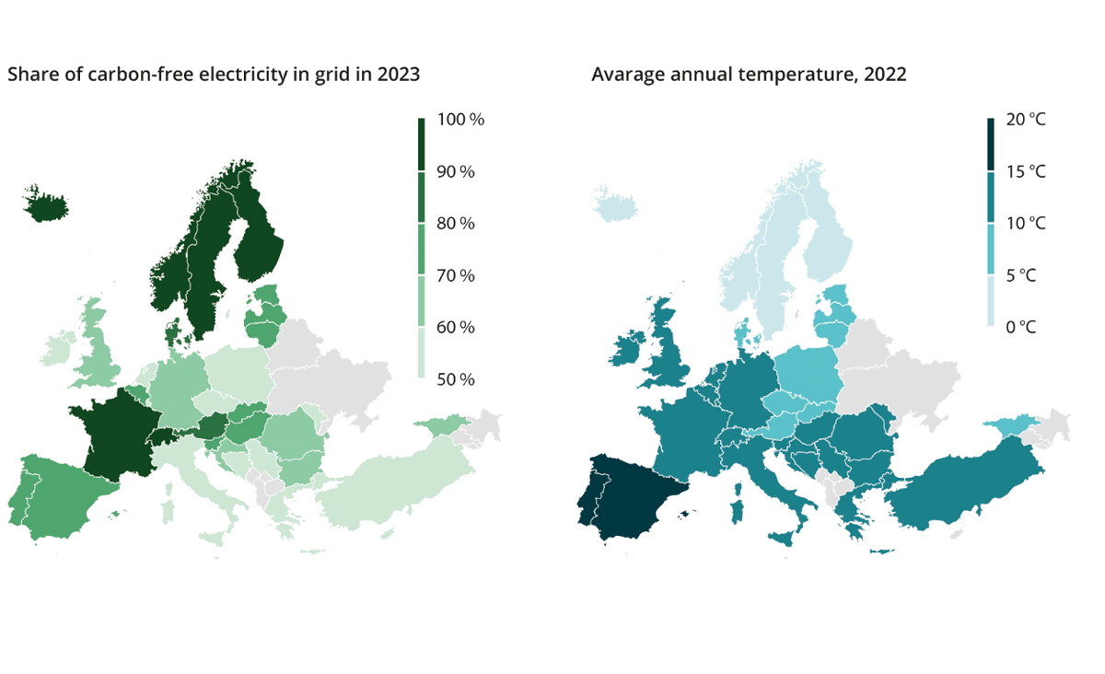
Source: The role of power in unlocking the European AI revolution, McKinsey 2024.
With naturally low outdoor temperatures, less energy is needed to run cooling systems in data centres. However, because data centres consume large amounts of power and require large areas of land, the data centre industry also has a climate and environmental footprint. The expected growth in the development and use of AI could affect the footprint of the data centre industry, as demand for data centre capacity is likely to increase.
The EU is a driver in the efforts for a sustainable data centre industry. The European Commission will introduce new mechanisms for measuring the energy efficiency of data centres and electronic communications networks used by European companies in the EU’s Digital Economy and Society Index (DESI). At the same time, within the framework of the 2023 Energy Efficiency Directive, the EU has adopted a first common assessment scheme requiring the reporting of specific information and key figures annually to a European database, including total energy consumption, energy consumption for IT equipment, water supply and reuse of excess heat, using a common measurement and calculation method and defined sustainability indicators for data centres. The requirements apply to all data centre operators managing data centres with an installed power consumption of at least 500 kW. Directive 2012/27/EU of the European Parliament and of the Council on energy efficiency, as amended by Directive 2018/2002 of the European Parliament and of the Council, is expected to be incorporated into the EEA Agreement, and we refer to the discussion of this in Prop. 136 S (2024–2025). Directive 2023/1791 of the European Parliament and of the Council repeals the directives from 2021 and 2018, effective 12 October 2025. No decision has yet been made on whether the 2023 Directive will be incorporated into the EEA Agreement and transposed into Norwegian law. The EU has also developed common criteria for green public procurement for data centres, server rooms and cloud services, and will work to establish a European Code of Conduct for the sustainability of electronic communications networks by 2025. The EU also has several other measures that affect data centres, including the EU’s Action Plan for the Digitalisation of the Energy System, the revision of the Ecodesign Directive, and the new Taxonomy Regulation. The EU initiatives in this area that are legal acts may be EEA-relevant and could have an impact on Norwegian law.
              - The Norwegian Communications Authority is leading the way with an analysis of the climate and environmental impact of Norwegian digital infrastructure from a consumer perspective
Currently, there is no knowledge-based and cost-effective framework for documenting the sustainability potential and actual environmental impact of digitalisation at the national level. However, the Norwegian Communications Authority (Nkom) has conducted an analysis of the climate and environmental impact of digital infrastructure in operation on Norwegian soil. The analysis, which is one of the first of its kind in the world, is divided into two parts and addresses the situation in 2024 and the expected development towards 2030 and 2050. It shows that the adverse impact will increase in the future; however, to determine the net sustainability of digital infrastructure, both positive and negative effects must be considered. The analysis only considers first-order, or direct, effects related to the life cycle of digital infrastructure in Norway. This means that the positive spillover effects of having a digital infrastructure are not considered. Based on the analysis, Nkom is also in the process of developing a beta version of an index that assesses digital sustainability nationally in Norway.
The total climate footprint of digital infrastructure in Norway in 2024 is estimated at 1.1 million tonnes of CO2 emissions, based on a location-based electricity mix (the electricity physically used in Norway). By comparison, direct emissions from the aviation sector were 1.2 million tonnes of CO2 equivalents in 2023. The table below shows the climate footprint of Norwegian digital infrastructure, per technical segment and life cycle phase, based on a location-based electricity mix. The footprint is expressed in thousands of tonnes (kt) of CO2 equivalents. It is worth noting that end-user devices, which include various types of devices used for digital communication, account for as much as 76 per cent of the total climate footprint. It is particularly the production of end-user devices that accounts for a significant share of the climate footprint. The actual production does not take place in Norway, but the equipment is used here.
Life cycle phase | End-user devices | Grids | Data centres | Total
Production | 694 kt | 98 kt | 37 kt | 830 kt
Distribution | 53 kt | 14 kt | 2 kt | 69 kt
Packaging | 19 kt | - | - | 19 kt
Use | 93 kt | 40 kt | 67 kt | 200 kt
Disposal | 10 kt | 12 kt | 0,2 kt | 22 kt
Total | 868 kt | 165 kt | 106 kt | 1140 kt
Data centres accounted for 9 per cent of the total climate footprint, with 106 kilotonnes of CO2 emissions in 2024, and are expected to increase the most towards 2050. As shown in the figure below, energy consumption in the form of electricity (reuse of excess heat is not taken into account) and IT equipment (servers, storage capacity and network equipment) accounted for most of the emissions from data centres, at 54 and 36 per cent, respectively.
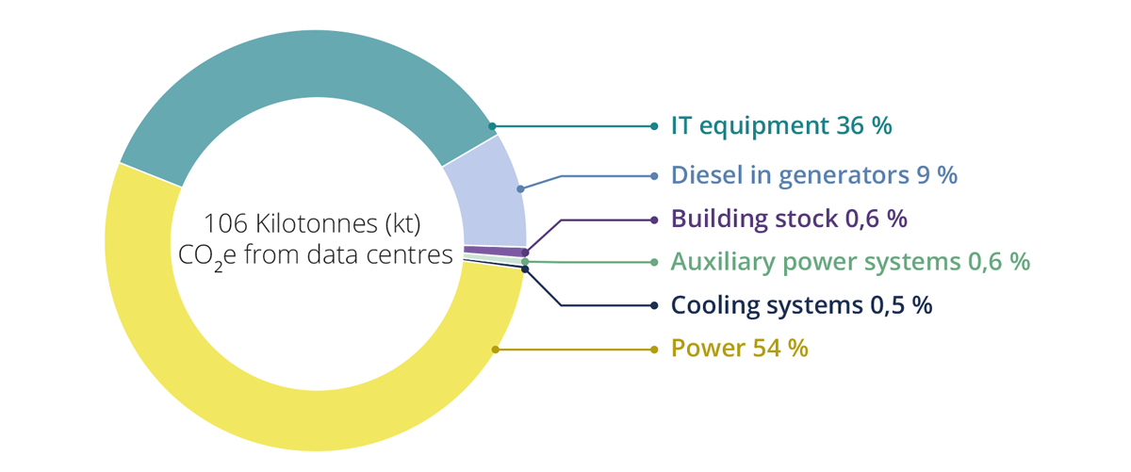
The way forward
The Climate Change Act stipulates that the target is to achieve reductions in greenhouse gas emissions of the order of 90-95 per cent from the level in the reference year of 1990, in order to become a low-emission society by 2050. This means that Norway must transform and reduce emissions across all sectors of society, including the public and business sectors. The report by the 2050 Climate Committee, Norwegian Official Report (NOU) 2023: 25 The transition to low emissions: Climate policy choices towards 2050, highlights technology as one of the paths to a low-emission society.
The green and digital transitions are both complex and necessary, and have great potential for increased sustainability, competitiveness, and value creation. The data centre industry can support emissions reductions across all sectors through digitalisation, and is essential for the realisation of the white paper The Norwegian industry – competitiveness for a new time (Meld. St. 16 (2024–2025)) by acting as a driving force for new digital solutions and data-based innovation in industry. At the same time, the data centre industry also has a climate and environmental footprint in that it consumes large amounts of power and requires large areas of land.
The favourable conditions in Norway, including low outdoor temperatures, access to suitable land, clean and renewable energy, and lower electricity prices compared to other countries, are critical competitive advantages not only for the data centre industry but also for many other industries and for Norwegian society as a whole. It is crucial that we manage and utilise these advantages in a sustainable manner, creating good synergies and ensuring their retention in the future. Sustainability also enhances competitiveness, and sustainability in Norwegian data centres helps to preserve and strengthen the competitiveness of Norwegian business and society.
In the Norwegian action plan for biodiversity (Meld. St. 35 (2023–2024)), critical digital infrastructure is mentioned as a prioritised development purpose. Among other things, the report states: “In land-use management, socially beneficial purposes such as renewable power production, power lines, critical digital infrastructure, and defence shall be given particular weight in the event of conflicts between development purposes.” This is further followed up in the Royal Decree of 20 December 2024, where the central government planning guidelines for land use and mobility state as follows in section 7.7: “Municipalities, county authorities and central government authorities should co-operate to facilitate sufficient land for renewable energy production, power lines, defence purposes and critical digital infrastructure. In land-use management, socioeconomic beneficial purposes such as those mentioned above shall be given particular weight in the event of conflicts between development purposes.” At the same time, the white paper promotes a goal of reducing the development of particularly important natural areas. New data centres must also be established in a way that contributes to achieving this goal.
The type of equipment used for processing and storing data also affects the climate footprint of data centres. Technological equipment is advancing rapidly, and new, more efficient solutions are constantly entering the market. Therefore, recycling electronic waste from data centres in Norway is vital.
The public sector can play a crucial role by ensuring that greater emphasis is placed on energy and resource efficiency in the data centre industry in Norway. The public sector is a major purchaser and therefore has considerable purchasing power. Targeted use of public procurement is important. For example, public authorities and bodies can, to a greater extent, require the use of more energy-efficient IT equipment in contracts for the provision of data centre services. Public procurement of data centre services can also be designed to encourage the reuse of excess heat from the data centre in question.
Public-Private Partnerships (PPPs) at the industry level can also make it easier to jointly identify, prioritise and initiate activities and measures for value-creating and digital sustainability. It is also essential to establish a framework that can contribute to more regular documentation of the sustainability potential and the actual environmental impact of digitalisation at the national level. Such a framework will enable better management and facilitation of a value-creating data centre industry and desirable digitalisation.
In the long term, it may be of interest to quantify changes in biodiversity on Norwegian soil as a result of data centres and digital infrastructure. The Norwegian Environment Agency is working with Statistics Norway (SSB) to develop natural resource accounts for Norway. The natural resource accounts will provide a better overview of the distribution of nature, its condition and associated ecosystem services, and how these develop over time. This will provide better knowledge of how the degradation and use of nature impacts biodiversity. Part of the work also involves improving mapping data on nature. With improved maps and knowledge, it could become possible to link activities within Norway’s borders more effectively to potential changes in biodiversity.

Energy-intensive mining of cryptocurrencies
The Government has a clear intention to limit cryptocurrency mining to the greatest extent possible. Cryptocurrency mining is resource-intensive in terms of power consumption and generates minimal benefits for the local community in terms of job opportunities and income. There is little public information available about cryptocurrency mining in Norway. The registration obligation in the new Regulations relating to data centres (Forskrift om datasenter) will eventually make it easier to obtain an overview, monitor developments and supervise data centres, including those that mine cryptocurrency.
Norway is an attractive country for cryptocurrency mining due to its combination of low electricity prices, renewable energy, a stable power system and a cool climate, which result in lower cooling costs. Electricity is the primary input factor for mining cryptocurrency. Proof of Work (PoW) technology is the most energy-intensive method for validating cryptocurrencies. It is also the method used by Bitcoin, which is by far the most mined cryptocurrency in Norway. Measures targeting PoW will therefore affect both the majority of mining and the majority of power consumption for cryptocurrency mining in Norway.
The Government has assessed its scope to regulate cryptocurrency mining. We must ensure that any measures taken are effective and target cryptocurrency mining. The Government has decided to investigate a central government planning provision with a temporary and limited prohibition on the establishment of data centres that mainly engage in energy-intensive cryptocurrency mining. A central government planning provision may be limited to a geographical area or apply to the entire country. It can be introduced to safeguard national or regional interests, such as high power consumption in areas with limited grid capacity, jobs, environmental impact or other societal considerations. Central government planning provisions are legally binding rules and are adopted by Royal Decree. The introduction of a central government planning provision will not, by itself, bring new responsibilities for the municipal sector.
The measure aims to free up power, grid capacity and land for other purposes. At the same time, the measure must not affect data centres that are necessary for the desired digitalisation of society. Data centres are a vital part of the digital infrastructure and a critical prerequisite for all digitalisation. It will be important to distinguish between useful applications of blockchain technology and AI so as not to impede innovation and development in areas that are beneficial to society. EEA legal assessments must be carried out. The Government will closely monitor what the European Commission writes in its forthcoming report on crypto-technology, climate and environmental impacts and remedies.
The Government
- will establish a public-private partnership between the electronic communication authorities and industry actors within digital infrastructure and services to set common goals and formulate common visions related to increased and lasting sustainability, for example, a possible energy labelling scheme for data centres in Norway, the promotion of circular solutions for ICT equipment, and waste management in the data centre industry
- wants the new sustainability analysis commissioned by Nkom to serve as the basis for measurements and projections of the national status regarding digital sustainability
- will promote climate-friendly solutions in relevant international forums to inspire other countries
- will take the initiative for Nordic co-operation to be at the forefront of innovation and sustainable solutions
- will investigate a central government planning provision with a temporary and limited prohibition on the establishment of data centres that mainly engage in energy-intensive cryptocurrency mining

Implement Consulting Group (2020) Datasentre i Norge: Ringvirkningsanalyse av gjennomførte og potensielle etableringer [Data centres in Norway: Economic impact analysis of completed and potential establishments. Available in Norwegian only].
WIK-Consult (2024) Market Study of the Norwegian Data Economy (2403800).
Samfunnsøkonomisk Analyse (2024) Verdiskaping i norsk datasenterindustri [Value creation in the Norwegian data centre industry. Available in Norwegian only], report no. 33-2024.
NSM (2022) Norske datasenter og digital autonomi, fire sikkerhetsfaglige anbefalinger ved datasenter [Norwegian data centres and digital autonomy, four security recommendations for data centres. Available in Norwegian only].
Nkom (2017) Robuste og sikre nasjonale transportnett [Robust and secure national transport networks. Available in Norwegian only]. Nkom (2022) Robuste transmisjonsnett for Norge mot 2030 [Robust transmission grids for Norway towards 2030. Available in Norwegian only].
The Norwegian Communications Authority (Nkom) (2025) Fotavtrykket fra norsk digital infrastruktur 2024 [The footprint of Norwegian digital infrastructure 2024. Available in Norwegian only] Power consumption is calculated based on various data sources for the technical segments, with varying degrees of uncertainty. For data centres, total electricity consumption is based on figures from Elhub. This is regarded as the least uncertain data source, as the figures are based on measurements. For end-user devices, the average power consumption for each type of device has been estimated and totalled by multiplying it by the number of devices of each type in use. For networks, Nkom has obtained estimates of electricity consumption per base station from the tower companies. The estimates are then scaled up based on the number of transmitters. These estimates are therefore based on some primary data, but also contain some hypotheses.
Statnett, juni 2025
EPRI (2024) Powering Intelligence Analyzing Artificial Intelligence and Data Center Energy Consumption.
Norwegian Water Resources and Energy Directorate (2024) NVEs vurdering av utvidelse av regelverk knyttet til utnyttelse av overskuddsvarme, saksnummer 202403770-2 [NVE’s assessment of the expansion of regulations related to the utilisation of waste heat, case number 202403770-2. Available in Norwegian only].
Norwegian Communications Authority (2025) Fotavtrykket fra norsk digital infrastruktur 2024 [The footprint of Norwegian digital infrastructure 2024. Available in Norwegian only] Norway’s national greenhouse gas accounts, and its commitments under the Paris Agreement, are based on emissions that occur within the country’s geographical borders. This analysis adopts a different approach, concentrating on who ultimately consumes goods and services, regardless of where the emissions occur globally. This means that emissions from the extraction of raw materials and the production of goods imported from other countries are included.
From a location-based perspective, the local physical electricity mix is applied, and in Norway, this is mainly hydroelectric power. In the analysis commissioned by Nkom, the Norwegian average physical consumption mix has been applied, which takes into account what is produced in Norway during a year, as well as what is imported from and exported to other countries. This results in an emission factor of 49.7 grams of CO₂ equivalents per kilowatt hour, based on life cycle calculations in ecoinvent, which includes a full life cycle assessment.

