Drones and Advanced Air Mobility
Meld. St. 15 (2024–2025) Report to the Storting (white paper)
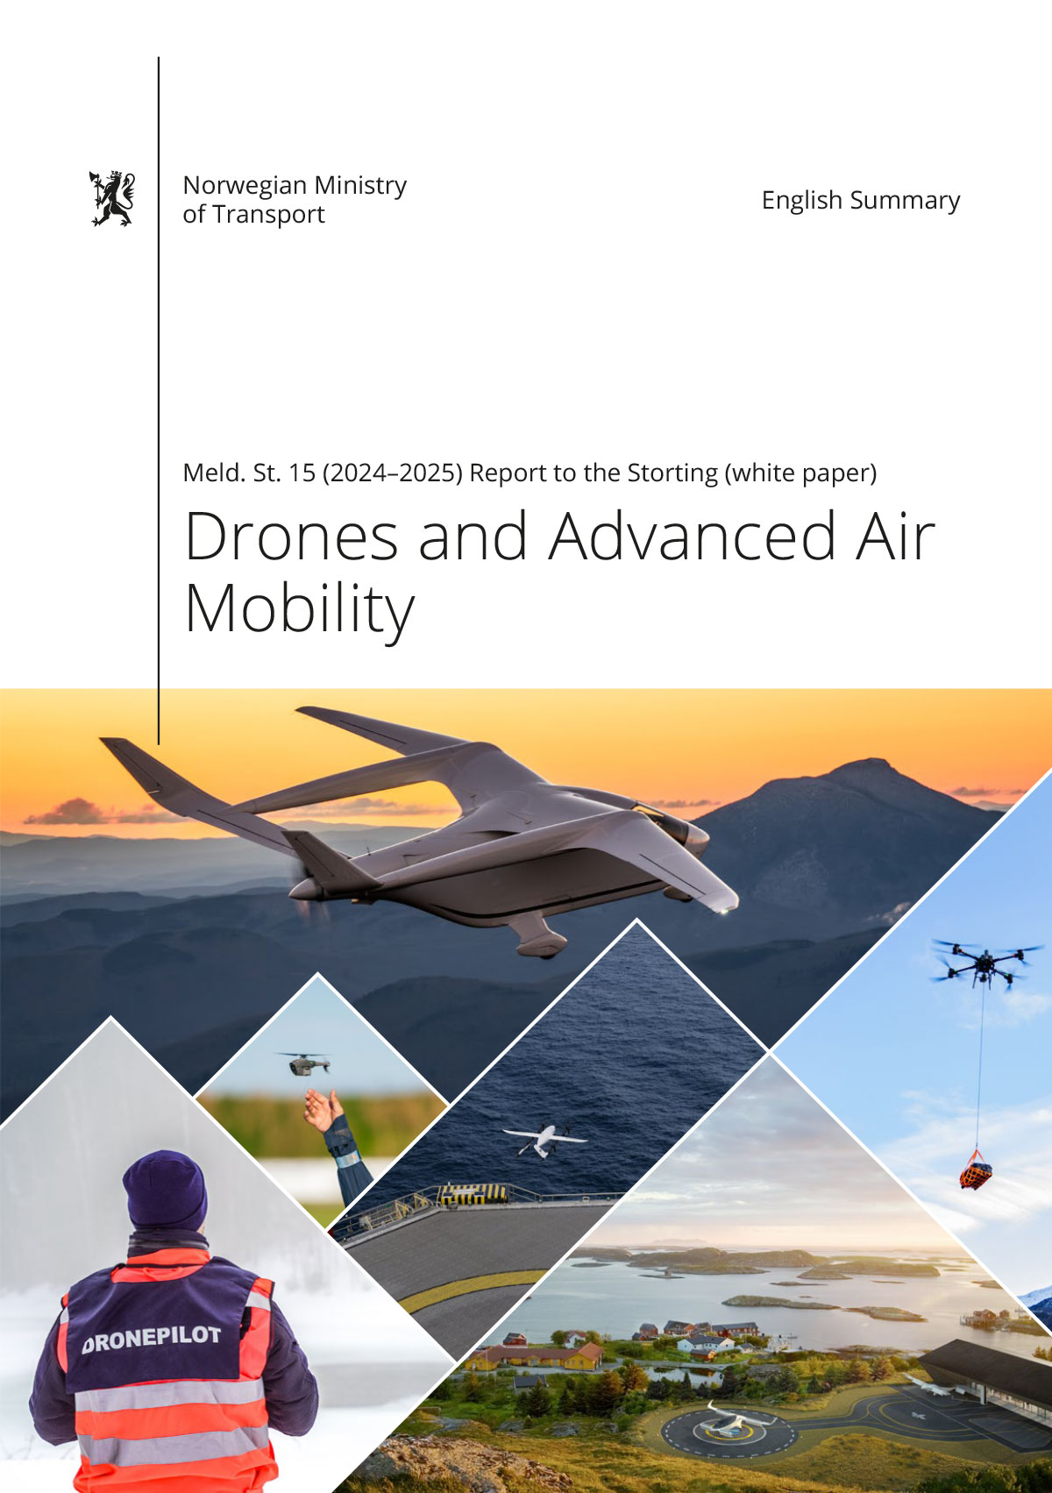

Foreword
On 28 March 2025, the Støre Government presented Report to the Storting (white paper) No. 15 (2024–2025) Drones and Advanced Air Mobility. The Norwegian Parliament (Storting) considered the report during the spring og 2025. This document is a summary of the white paper.
The white paper provides an overarching and comprehensive review that outlines the goals and instruments facilitating a safe, targeted, and sustainable development and integration of Unmanned Aircraft Systems (UAS, hereafter «drones») and advanced air mobility (AAM) in Norway. These technologies are poised to transform transportation, logistics, environmental management, and public services. The white paper seeks to describe economic and environmental benefits while ensuring safety, public trust, national security and alignment with international standards.
As a nation with long distances, challenging topography, extensive coastlines and dispersed settlement patterns, Norway presents unique opportunities for drones and AAM. The introduction of zero and low emission technologies, automation, and digitalization in aviation can improve connectivity, enable more sustainable logistics and reduce greenhouse gas emissions. The introduction of drones and AAM constitutes a paradigm shift in aviation that enables decentralized, low-emission air transport systems, and the Norwegian government aims to position Norway as a driving force for the development of drones and AAM by facilitating early adoption of the new technologies now being introduced in aviation, a strong innovation ecosystem, and a commitment to become a low-emission society by 2050.
The white paper builds i.a. on the the previously published reports to the Storting (white papers); No. 14 (2023–2024) National Transport Plan 2025–2036 and No. 10 (2022–2023) National Aviation Strategy, emphasizing drones and AAM’s role in accessibility, climate mitigation, technological innovation, and public sector efficiency. Their integration will mainly complement – but also has the potential in some instances to replace – traditional transport modes, providing important services in both rural and urban contexts.

Jon-Ivar Nygård
Minister of Transport (Labour Party)

Note: This English summary was prepared with the assistance of artificial intelligence under human supervision, to ensure accessibility and clarity for an international -audience. In case of any ambiguity or discrepancy, the original Norwegian version – Meld. St. 15 (2024–2024) Droner og ny luftmobilitet – takes precedence.

Introduction
This white paper outlines the Norwegian Government’s strategic direction for integrating Unmanned Aircraft Systems (UAS, hereafter «drones») and advanced air mobility (AAM) into civil society. Drones and AAM are expected to revolutionize transportation, logistics, and public services. The strategy set out in the white paper aims to balance innovation with safety, promote environmental responsibility, and ensure that Norway remains aligned with global developments. Through deliberate regulation, infrastructure development efforts, and international cooperation, the government undertakes to position Norway as a leader in sustainable, future-ready aviation. The government’s aim is to ensure that these technologies are introduced in a safe, effective, and regulated manner while unlocking economic and environmental benefits. This initiative supports Norway’s broader goals of climate neutrality, rural connectivity, and national preparedness.
The Norwegian Ministry of Transport holds overarching responsibility for policy coordination related to drones and AAM, working in close collaboration with other ministries and public authorities. To realize the anticipated economic value from the drone and AAM sector, the government emphasizes the need for coordinated action across ministries and continuous consultation with relevant stakeholders. In parallel, Norway will deepen its international engagement to contribute to global rulemaking and to seize emerging trade opportunities.
The white paper also underscores the importance of monitoring the social impacts of drone and AAM deployment and adjusting policy instruments as needed to ensure balanced, responsible progress.
This white paper primarily addresses the civil sector. The government has initiated work on a dedicated drone strategy for the Norwegian defence sector. There are strong synergies between civil and military applications of drones, including in counter-drone measures. Leveraging these synergies will be a key success factor for both Norway’s drone industry and national defence capability.

Paradigm Shift in Aviation
The aviation sector is undergoing a fundamental transformation. While conventional aviation continues to rely on airport-centric infrastructure and fossil-based propulsion, a new wave of technologies – most notably drones and AAM – is emerging, driven by automation, electrification, and digital innovation. This shift marks a move toward more flexible, decentralized, and sustainable aviation systems.
In Norway, these developments hold particular promise due to the country’s dispersed population, mountainous geography, and challenging climatic conditions. Drones and AAM offer new possibilities for delivering critical services, improving logistics, and enhancing connectivity in remote regions. The Norwegian government actively supports the safe and sustainable integration of these technologies in line with national transport and climate policies.
Recognizing the strategic significance of these developments, the Norwegian government has adopted a proactive and coordinated policy approach. Within the frameworks of the National Transport Plan 2025–2036 and the National Aviation Strategy, drones and AAM are identified as transformative tools for achieving national goals related to accessibility, climate mitigation, technological innovation, and public sector efficiency. These strategies envision a transport system that is not only safe and efficient, but also aligned with the broader transition to a low-emission society by 2050.
The integration of drones and AAM into the national transport system is being approached holistically. In the near term, drones are already delivering clear benefits across several sectors. In infrastructure and civil engineering, drones are used for bridge inspections, construction monitoring, and geodata collection. In the energy sector, they contribute to the safe and cost-effective inspection of power lines and wind turbines. Health and emergency services have begun operations or trials using drones to transport medical samples, deliver emergency equipment such as defibrillators, and support search-and-rescue operations. These applications not only increase operational efficiency but also reduce environmental footprints and human risk.
Looking ahead, Norway is preparing for the gradual introduction of larger, often piloted, electric aircraft capable of transporting people and heavier cargo. These aircraft vary widely in size and configuration, from vertical take-off and landing (VTOL) models suitable for intra-city travel, to short take-off and landing (STOL) vehicles optimized for regional connections. Many of these models combine the lift characteristics of helicopters with the energy efficiency of fixed-wing aircraft.
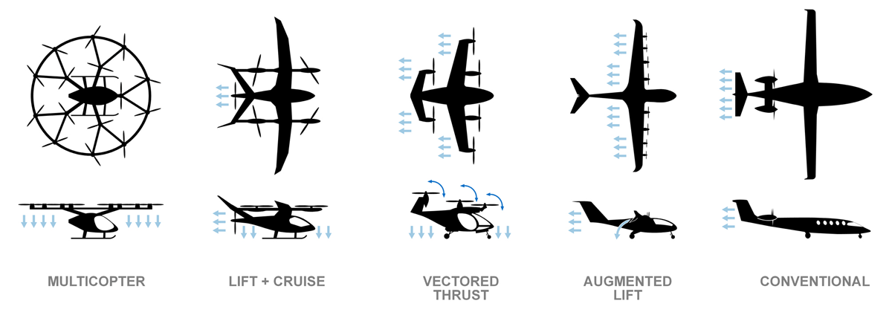
          - Categories of AAM aircraft
Source: SMG Consulting
Norway anticipates that the initial adoption of these technologies will take place in the freight sector. Cargo operations – especially those serving offshore installations, medical logistics, and remote regions – offer ideal test cases due to their recurring routes and lower complexity compared to passenger services. As the technology matures and regulatory frameworks evolve, passenger transport is expected to follow. This transition is likely to begin with short-range, on-demand services connecting industrial parks, regional hubs, and eventually smaller urban centers.
To support this evolution, a comprehensive ecosystem must be developed. Norway is working to ensure that the physical and digital infrastructure is in place to accommodate new aircraft types and flight patterns. This includes not only the adaptation of existing airports, particularly within the country’s well-developed regional airport network, but also the construction of new landing facilities – known as vertiports – near population centers and logistics hubs. Equally important is the establishment of advanced airspace management systems capable of safely integrating manned and unmanned aircraft. These systems must be supported by appropriate legislation, certification processes, training programs, and maintenance operations, all of which are being addressed through cross-sectoral collaboration.
One of the most important initiatives to accelerate this development is the establishment of Norway as an international test arena for zero- and low-emission aviation. With state funding and a national mandate, this initiative provides a platform for the demonstration and regulatory evaluation of emerging technologies under real-world conditions. The test arena brings together regulators, developers, industry stakeholders, and researchers to build shared knowledge, reduce uncertainties, and identify barriers to adoption. It also enables iterative learning across operational, regulatory, and societal dimensions, helping to ensure that new aviation solutions are not only technically feasible but also scalable, safe, and publicly acceptable.
Norway’s leadership in electrification across other transport sectors – including its early adoption of electric vehicles and ferries – provides a strong foundation for this work. Furthermore, the government’s targeted use of public funding, policy incentives, and interministerial coordination strengthens the institutional capacity to guide this transition. The test arena is expected to yield significant insights into the regulatory adaptations required, while also attracting domestic and international investment in clean aviation technologies.
Nevertheless, the introduction of drones and AAM is not without challenges. Issues such as airspace integration, safety in mixed manned and unmanned traffic environments, noise pollution, public trust in automation, and data privacy are all critical considerations. Norway’s approach emphasizes transparency, incremental implementation, and active public engagement. Studies have shown that while public attitudes towards AAM are generally positive, there remains a strong emphasis on safety, reliability, and community benefit. These factors will continue to shape both policy development and technology design.
Importantly, drones and AAM are not intended to replace existing transport modes, but rather to complement them. In sparsely populated areas, they may offer viable alternatives where road or rail connections are limited. In urban contexts, they can enhance emergency response capabilities or offer niche transport services where time is critical. Their contribution to the broader goals of climate mitigation and social inclusion makes them a valuable addition to Norway’s long-term approach to sustainable mobility.
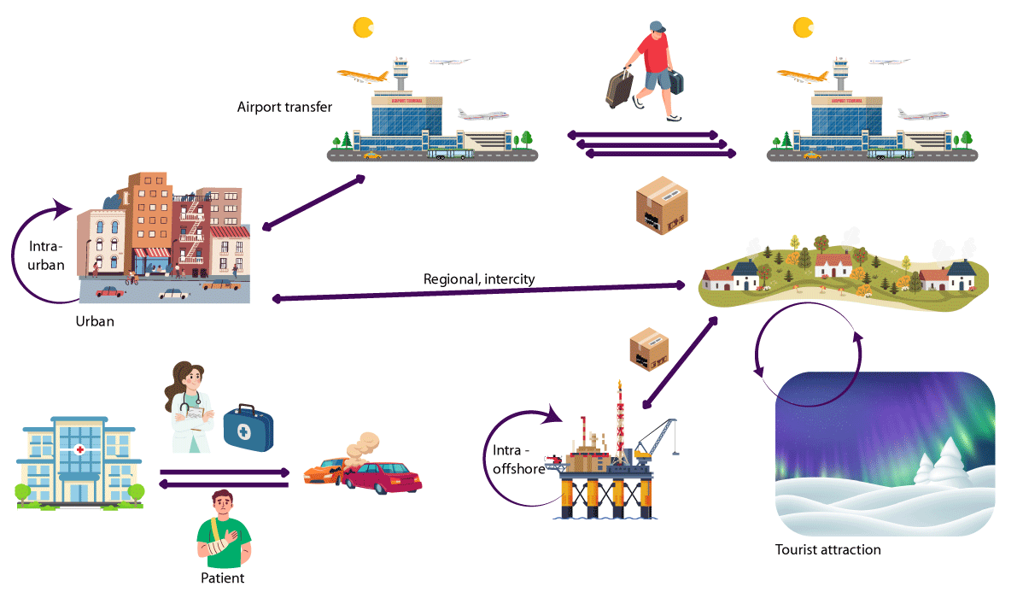
          - Use cases of drones and AAM
Source: Avinor AS
As part of its future-oriented vision, the Norwegian government has reaffirmed its commitment to ensuring that the benefits of these technologies reach all parts of the country. Efforts are being made to involve municipalities, regional authorities, and private actors in planning and implementation. The government is also continuing its work through a dedicated interministerial drone and AAM coordination group, ensuring that national security, environmental protection, and societal welfare remain central to policy formulation.
In summary, Norway is positioning itself at the forefront of the global shift toward sustainable and intelligent aviation. By aligning regulatory innovation with societal needs and technological progress, and by embedding new aerial systems within a coordinated national transport framework, Norway aims to realize the full potential of drones and AAM – not just as tools for innovation, but as instruments of public value.
To ensure that drones and AAM technologies contribute meaningfully to national development and innovation, the Norwegian government commits to:
- Promoting the use of drones and AAM in ways that benefit society and support equitable development across the entire country
- Assessing how drones and AAM can complement and enhance the mobility provided by conventional aviation as part of long-term transport sector planning
- Leveraging Norway’s role as an international test arena for zero- and low-emission aviation to support the safe and targeted introduction of new aviation technologies
- Continuing and strengthening the interministerial working group tasked with addressing strategic challenges related to drones and AAM

Market Development and Public Sector Facilitation
As the drone and AAM sectors continue to evolve, the Norwegian government recognizes the importance of facilitating a competitive and innovation-driven ecosystem. The following outlines the development of the drone services market, the role of the public sector as both regulator and enabler, and the instruments available to support industry growth through research, education, and public sector procurement.
The drone services market in Norway has seen substantial growth in recent years, with services such as infrastructure inspection, mapping, and logistics now comprising 76% of the total industry turnover. This highlights the central role of service providers as the main market drivers. Increasing professionalism and close public-private cooperation have significantly enhanced operational quality and compliance standards.
Public agencies play a pivotal role in market formation by procuring drone services from private operators. This stimulates innovation and capacity-building in the private sector while allowing the public sector to access cost-effective and specialized solutions.
At the same time the Norwegian government emphasizes that drone deployment in public services must balance flexibility, efficiency, and strategic autonomy – especially in sectors related to national security or critical societal functions.
Predictable and efficient regulatory processes are essential to enable innovation while ensuring safety and public trust. Industry stakeholders have emphasized the need to streamline airspace access, improve operation approval procedures – particularly for beyond visual line of sight (BVLOS) operations – and enable controlled testing of new technologies. Key regulatory priorities include integration with manned aviation, achieving real-time visibility and digital coordination, and improving collaboration among industry, regulators, and academia. The national test arena for zero and low-emission aviation, referenced in the previous chapter, plays an important role in bridging innovation and regulation.
The government supports innovation through a well-developed framework of funding instruments. Core actors in this ecosystem include Innovation Norway, the Research Council of Norway, Enova, Investinor, and Siva. These institutions provide a range of support mechanisms, including grants, loans, and guarantees; business development services; and access to networks and innovation clusters. Additionally, Norwegian companies can access European programs such as Horizon Europe and InvestEU, ensuring alignment with broader European goals for technological innovation and market integration.
The government places strong emphasis on building a skilled workforce and advancing technical knowledge. Key national initiatives include projects focused on medical drone logistics, research on anti-icing systems for drones operating in Arctic conditions, and the development of safe, traceable production methods for autonomous aircraft.
Educational pathways are also expanding. Currently, six secondary schools offer formal drone operator training. UiT The Arctic University of Norway offers a bachelor’s degree in drone technology, while the Norwegian University of Science and Technology (NTNU) supports interdisciplinary master-level research. Despite growing interest, a shortage of apprenticeship placements remains a challenge. Government efforts are underway to increase opportunities, particularly within the public sector.
The government aims to foster a sustainable, competitive drone and AAM industry by promoting knowledge-sharing between public and private actors, developing public procurement as a tool for market development, enhancing access to research funding and education, supporting international standardization and certification efforts, and encouraging industry-led development of commercially viable solutions.
To support the growth of a robust and internationally competitive drone industry, the government commits to:
- Enabling a competitive Norwegian drone sector that can continue to succeed in international markets
- Raising awareness of the potential of drone technology for both private and public sector applications
- Encouraging more private and public sector organizations to recognize the value of offering apprenticeship placements to upper secondary school students specializing in drone operations and technology
- Facilitating collaboration and knowledge exchange between public and private actors, and across different levels of government

Regulatory Framework and Aviation Safety
Norway’s regulatory framework for unmanned aviation is designed to ensure operations that are safe, proportionate, and conducive to innovation, while providing legal certainty for industry and authorities alike. Norway adheres closely to international and EU standards, particularly those of the International Civil Aviation Organization (ICAO) and the European Union Aviation Safety Agency (EASA), through the Chicago Convention and the EEA Agreement. While most rules are harmonised across the EU/EEA, Norway maintains national regulations in areas not covered by common European legislation such as civil state drone operations and enforcement protocols.
The Norwegian Civil Aviation Authority plays a central role in licensing, oversight, and public safety communication. Drone operators and pilots are subject to registration and certification requirements, which vary by operational category (open, specific and certified).
The government recognizes the need to adapt regulatory frameworks in response to rapid technological advances. Several initiatives are currently underway to address this need. These include the development of a new national regulation specifically for state-operated drone use, and preparations for implementing certified-category operations, including vertical take-off and landing (VTOL) aircraft. The government is also exploring safety standards tailored to drone operators and evaluating new requirements – such as mandatory registration of drones, not just pilots or operators – in an effort to combat non-compliance and enhance overall accountability.
Norwegian authorities actively participate in international standard-setting and regulatory bodies to ensure that national interests are reflected, and work to make drone legislation more accessible, comprehensible, and aligned with real-world operational contexts. The aim is to strengthen legal clarity, support market innovation, ensure national security, and reduce barriers for responsible operators.
The government also seeks to promote a safety culture among drone users, aligning them with the professional norms of traditional aviation.
To ensure that regulation keeps pace with technological advancements and supports safe, responsible drone operations, the government commits to:
- Continuing efforts to make drone regulations more accessible and understandable
- Actively contributing to the development of common European and other international regulations and standards for drones and AAM, while advocating for rules that are well adapted to Norwegian needs and interests
- Evaluating whether there is a need to introduce mandatory registration requirements for drones
- Ensuring that the Civil Aviation Authority continuously assesses the need for national requirements in line with technological developments, within the framework of EEA law
- Promoting a stronger integration of drone operators into Norway’s broader aviation safety culture
- Assessing how to better facilitate beyond visual line of sight (BVLOS) drone operations for industries with specific operational needs

Integration into National Airspace
Norwegian authorities are actively working to enable the safe and effective integration of drones and AAM solutions into its national airspace. This transformation is driven by emerging technologies, increased demand, and the diversification of airspace users. As always, aviation safety remains the highest priority.
A core objective of the authorities’ approach is to ensure that drones can operate safely alongside manned aviation. Achieving this requires a combination of new digital infrastructure, procedural frameworks, and regulatory tools – particularly in the lower airspace where drone operations are most concentrated.
While controlled airspace is actively managed by air traffic control services, much of the lower airspace remains uncontrolled. In these areas, traditional «see and avoid» principles are no longer sufficient due to the increasing volume and complexity of unmanned operations.
The government recognizes the need to modernize systems for traffic coordination, flight awareness, and risk management. New procedures and digital tools are being introduced to support both manned and unmanned operations while safeguarding existing airspace users and uses, including those related to national security and civil protection.
The Norwegian Airspace Strategy adopted in 2021 outlines how the growing number of airspace users – particularly drones – creates new demands on capacity and coordination. The 2021 strategy introduced a purpose-based prioritization model for access to airspace, ensuring that the function and urgency of an operation take precedence over whether an aircraft is manned or unmanned. However, legacy systems and practices still often assign drones the lowest operational priority, particularly in controlled airspace near airports.
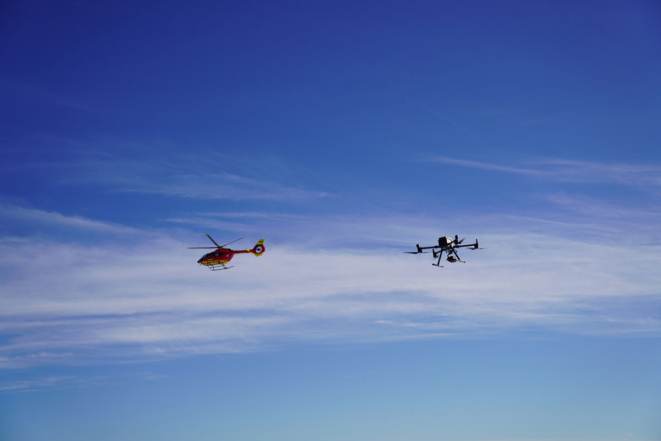
          - Concurrent use of airspace
Photo: Avinor AS
To address this, Norwegian authorities are working to establish predictable and equitable procedures for access to both controlled and uncontrolled airspace. This includes exploring technology-neutral frameworks and flexible scheduling arrangements – especially for operations in close proximity to urban centers or essential infrastructure.
Norway has implemented the U-space regulation (Regulation (EU) 2021/664), which introduces designated airspace volumes where complex drone operations can be conducted safely and simultaneously through certified digital services. These services will be provided by authorized U-space service providers (USSPs) and coordinated via a Common Information Service (CIS).
The Norwegian Air Navigation Service Provider – Avinor – has been designated as Common Information System (CIS) Provider. The government expects initial U-space airspaces to be launched in research and innovation contexts, followed by limited commercial deployments in high-demand areas such as logistics hubs and industrial zones.
To improve visibility and coordination across all airspace users – not only in U-space airspaces – the government has introduced a framework for a Digital Integrated Aeronautical Information Service. This system will consolidate information about flight restrictions, dynamic no-fly zones, airspace structures, and operational intentions from a range of civil and military sources.
The solution aims to ensure that all airspace users – manned or unmanned – can access timely and relevant information through a single digital interface. The services is also intended to support law enforcement, environmental oversight, and emergency response by providing a baseline understanding of typical airspace usage, thereby helping to identify irregular or potentially harmful drone activity.
A key enabler of safe integration is electronic conspicuity – the digital visibility of all aircraft in the airspace. The government foresees a phased introduction of mandatory conspicuity requirements, focusing first on drones flying beyond visual line of sight (BVLOS) or above certain altitude thresholds. The government is also considering standards such as ADS-L, a simplified alternative to ADS-B for unmanned aircraft.
Remote identification technologies, both direct (e.g., Bluetooth or Wi-Fi-based) and network-based, are being explored as additional layers of safety and accountability. The authorities are aware of privacy concerns and are working to ensure appropriate protections and operational exemptions, especially for sensitive government missions.
To provide legal and operational clarity, UAS geographical zones will be established and published digitally. These zones – introduced with Regulation (EU) 2019/947 – may restrict or regulate drone activity based on safety, security, privacy, or environmental criteria. A central challenge lies in collecting, harmonizing, and disseminating spatial data from multiple public authorities responsible for these areas. Norwegian authorities is currently assessing the legal and administrative frameworks needed to support this coordination.
The development and operation of digital services, including CIS and the Digital Integrated Aeronautical Information Service, will incur significant costs. Norway is evaluating financing models that reflect user benefit and fair cost-sharing, while safeguarding access to uncontrolled airspace for new and existing users. Drone operators are expected to bear a significant share of the cost, but fee structures may be differentiated to ensure proportionality and avoid undermining innovation or public interest applications.
The government's approach is grounded in the principle of stepwise implementation. Recognizing the rapid pace of technological change and the unpredictability of market developments, the government aims to implement solutions incrementally – solving the most pressing challenges first, then expanding capabilities over time.
As the drone sector evolves from isolated test environments into scaled operations across a variety of sectors, ensuring fair access to airspace and high safety standards will remain a national priority.
To ensure safe, efficient, and integrated use of Norwegian airspace for both manned and unmanned aviation, the government commits to:
- Prioritizing airspace access based primarily on the purpose of the activity, regardless of whether the aircraft is manned or unmanned
- Evaluating whether access to airspace for drone operations near airports should be made more flexible
- Assessing the need for new or clarified procedures in uncontrolled airspace that consider beyond visual line of sight (BVLOS) operations and electronic conspicuity technologies
- Facilitating the establishment of U-space airspaces in Norway
- Investigating whether all low-altitude flights should be subject to mandatory registration in the Digital Integrated Aeronautical Information Service
- Reviewing the appropriate distribution of responsibilities among various actors when establishing UAS geographical zones, including who should be responsible for publishing the zones
- Assessing whether the Civil Aviation Authority should be assigned a coordinating role to ensure consistent management of the creation, modification, and removal of airspace structures in Norway
- Evaluating which areas, if any, should be exempt from publication as UAS geographical zones due to safety or practical concerns, such as the presence of military vessels or other security-critical areas
- Reviewing existing legislation and, if necessary, proposing new legislative tools to mandate the submission of mapping data to a centralized notification service
- Enabling the development and deployment of electronic conspicuity solutions aimed at achieving full integration between manned and unmanned aviation
- Examining whether, and to what extent, electronic conspicuity should be mandated for airspace users who are not currently subject to such requirements

Autonomy, Artificial Intelligence and Data Governance
The increasing automation and integration of artificial intelligence (AI) in drone systems and AAM technologies are transforming the way aerial operations are conducted in both civil and public sectors. The government recognizes the significant societal benefits of these developments – ranging from improved operational efficiency and real-time data acquisition to enhanced situational awareness in complex environments. At the same time, this transformation raises important ethical, legal, and societal questions, particularly concerning privacy, transparency, and trust.
Autonomous drone systems are being developed at various levels of capability – from remotely operated platforms with pre-programmed routes to fully autonomous systems capable of adapting to dynamic environments without human intervention. As autonomy becomes more advanced, often enabled by AI-based perception and decision-making, the operational role of human pilots shifts from direct control to supervision and oversight.
These advancements are particularly relevant in harsh or data-scarce environments, such as mountainous regions, tunnels, or disaster areas, where drones equipped with advanced navigation and sensing systems can operate safely without constant connectivity. Use cases include powerline inspections, emergency response, infrastructure monitoring, and delivery operations.
Autonomous capabilities are further strengthened by AI technologies that enable drones to interpret data, adjust in real-time, and execute complex tasks such as object recognition, anomaly detection, and precision imaging. For example, AI-powered drones can autonomously inspect high-voltage isolators by dynamically adjusting sensors and flight paths based on visual pattern recognition, reducing the need for human involvement and improving data quality.
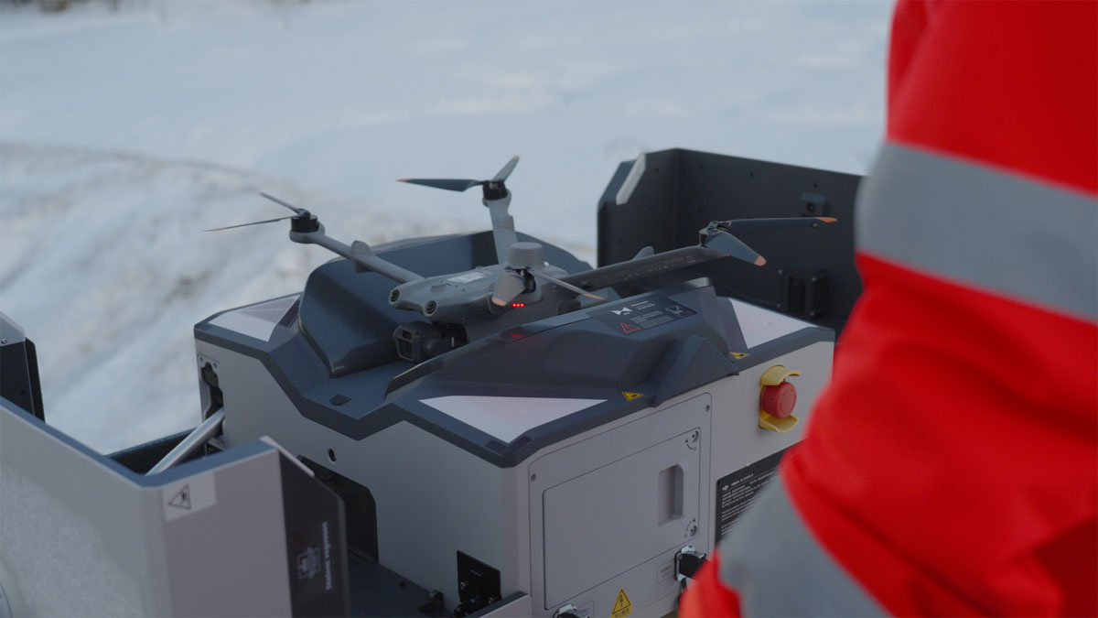
          - Drone-in-a-box
Photo: Norwegian Public Roads Administration/ Johan Peter Kraugerud, Red Ant AS
The government views autonomy, in combination with AI, as a prerequisite for scaling drone operations in a safe, efficient, and economically sustainable manner.
For autonomous systems to be accepted and trusted, especially in safety-critical applications, it is essential that their behavior is transparent and explainable. This includes the ability to understand how a system reaches a decision, particularly when outcomes affect public safety, security, or individual rights.
The government therefore supports the development of explainable AI – methods and frameworks that make algorithmic processes interpretable to both technical stakeholders and the general public. Explainability not only helps ensure ethical and legal compliance, but also supports system developers in identifying and correcting bias, error, or unintended behavior in algorithmic models.
As drones increasingly operate as data collection platforms and digital nodes, they become part of the broader cyber-physical infrastructure. Their software systems, communication links, and processing tools must therefore meet high standards of information security and resilience.
Risks such as unauthorized data access, system hacking, and foreign control over proprietary software used for drone operation and data processing have been identified as areas of concern. The government stresses the importance of secure data transmission, strict access controls, and clear policies for software dependency, particularly in operations involving sensitive or critical infrastructure.
The increased use of drones – especially in urban and residential areas – raises concerns related to privacy and data protection. Drones equipped with high-resolution cameras and sensors can collect vast amounts of information, including personal data, often without the knowledge or consent of those affected. This creates a need for clear and enforceable guidelines on data minimization, purpose limitation, and transparency of data use.
Operators, both public and private, are encouraged to conduct Data Protection Impact Assessments (DPIAs) prior to deploying drones for information-gathering purposes. These assessments must evaluate the potential impact on individual privacy and include appropriate safeguards.
To strengthen public trust, the government is considering a range of additional measures. These include raising awareness among drone operators about their data protection obligations, integrating privacy considerations into pilot training and licensing processes, and promoting public information campaigns in densely populated areas where drone activity is more frequent.
Technological solutions such as remote identification – where drone identity and operator information can be accessed in real-time – are crucial to improving accountability and reducing public anxiety. While such systems are already mandatory for most drone categories under current EU regulations, the government is assessing whether requirements should be expanded to include smaller drones, especially when operated near sensitive locations or in urban areas.
The aim is to strike a balance between public safety and innovation, ensuring that hobbyist or low-risk operations are not unnecessarily burdened while safeguarding against misuse in privacy-sensitive contexts.
Beyond privacy, the physical presence and sound of drones can negatively impact quality of life, especially when operations occur near homes, in parks, or in recreational nature areas. Even electrically powered, low-acoustic-signature drones can become a source of chronic disturbance if operated frequently or unpredictably.
The government emphasizes that drone operators must remain conscious of the social and acoustic footprint of their activities. This involves careful flight path planning, coordination of operations in terms of timing, use of noise-reducing technologies and aircraft designs, and, where possible, consolidation of operations to minimize the overall number of flights.
Maintaining public trust in drones and AAM technologies will depend not only on safety and efficiency, but also on ensuring that their use does not compromise the general public’s right to a peaceful living environment.
To support the safe and responsible use of autonomy and AI in drones and AAM, the government commits to:
- Facilitating the development and safe, effective use of automation, autonomy, and artificial intelligence in aviation
- Assessing the need for measures to protect personal privacy from unnecessary disturbances, including noise and visual disruptions resulting from increased drone and AAM activity
- Evaluating whether remote identification should be made mandatory for all drones
- Exploring measures to raise awareness about privacy and data protection among all drone operators using cameras or other types of sensors

Climate, Environment and Agriculture
The government recognizes the growing potential of drones and AAM in contributing to national and international climate and environmental goals. Provided that the new aircraft types are emission-free and replace means of transport and equipment powered by fossil energy sources, there is potential to reduce greenhouse gas emissions. Furthermore, drones and AAM can help to reduce both land use and the burden of physical movement with other vehicles on the ground in vulnerable areas.
At the same time, the increasing presence of aircrafts in low-altitude airspace introduces new environmental and regulatory challenges. The government is working to balance the benefits of drones and AAM against risks such as noise, wildlife disturbance and overuse in vulnerable areas.
In the agricultural sector, drones are already being used to improve productivity while reducing environmental impacts. Through high-resolution imaging and AI-driven analytics, drones can monitor soil moisture, plant health, and biomass throughout the growing season. These data are used to optimize irrigation, fertilization, and pesticide application – key elements of precision agriculture.
Drones can also assist in detecting wildlife, such as fawns hidden in tall grass, before harvesting begins, helping to avoid unnecessary harm. Furthermore, drone-based seeding and fertilizer spreading can reduce soil compaction compared to traditional tractors, especially in soft or hilly terrain.
In livestock management, drones integrated with GPS tracking and AI algorithms are used to monitor grazing herds, particularly sheep, cattle and semi-domesticated reindeer. Drones support real-time tracking of animals, identification of distressed or immobile individuals, and efficient documentation of grazing boundaries and losses. These capabilities are especially useful in rugged terrain and during search-and-rescue operations for animals lost in remote areas.
Reindeer herders are increasingly using drones for daily oversight, herding, and mapping tasks. Lightweight and portable drones reduce the need for motorized vehicles such as snowmobiles and helicopters, helping to cut costs, emissions and noise. Drones equipped with thermal cameras allow for population surveys and monitoring of calving rates without disturbing vulnerable animals. AI-assisted tools are under development to automatically count herds and distinguish species using infrared and visual signatures.
These technological advances can assist not only individual herders but also public authorities managing reindeer husbandry policies and compensation systems.
The forestry sector in Norway is an early adopter of drone technologies. Drones are used extensively for forest inventory, post-harvest assessments, and planning of timber operations. Prior to salvage logging after natural disturbances – such as storms, fires, or pest outbreaks – drones can quickly provide high-resolution data to support damage assessments and emergency response.
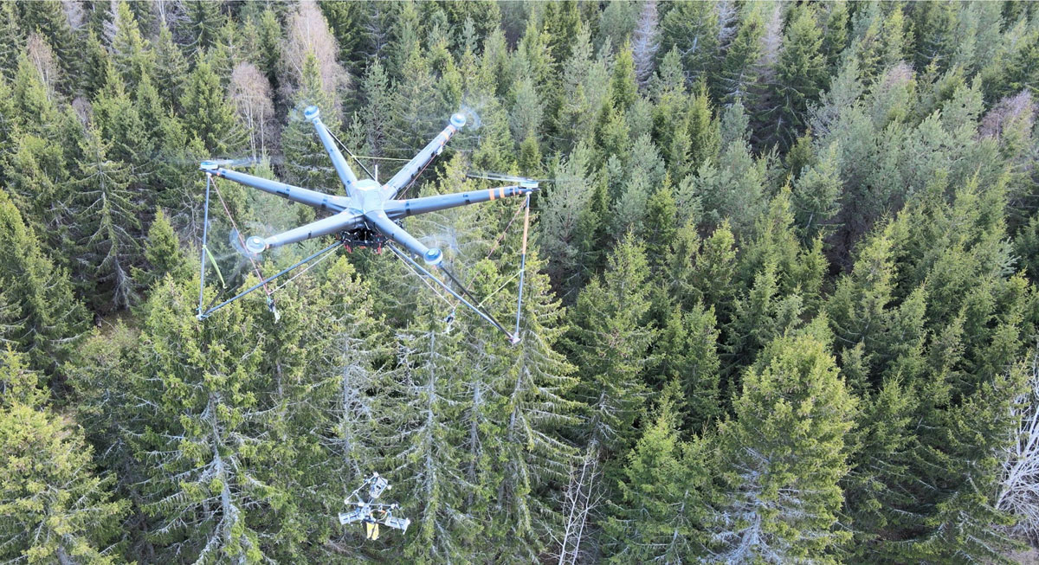
          - Forest thinning operation using a drone with attached cutting device
Photo: AirForestry AB
Drones equipped with LiDAR (Light Detection and Ranging) sensors are particularly valuable for producing detailed 3D maps of forest structure, tree height and density, which support sustainable forest management. As drone capacity, range, and lift capabilities improve, their use in large-scale forest operations is expanding. Experimental projects in Sweden are also testing heavy-lift drones for selective thinning and timber extraction. In Norway, Statskog SF is evaluating this concept and aims to start test thinning using drones in 2027.
Drones are proving effective in a variety of environmental protection and enforcement roles. These include monitoring illegal activity (e.g., poaching, unauthorized vehicle access), tracking ecosystem changes, identifying marine and land-based litter, and inspecting protected areas. Public authorities use drones for both real-time operations and long-term observation of sensitive areas.
While the use of drones for active hunting is prohibited under Norwegian law, they may be used under strict conditions by wildlife management authorities for animal search operations or sanctioned lethal wildlife control. Remote operations enable rapid deployment in cases involving injured or diseased animals, reducing suffering and improving response coordination. Thermal imaging and live video feeds can aid wildlife officers in tracking, identification, and planning safe interventions.
Though quieter than helicopters and all-terrain vehicles, drones are not entirely silent. Wildlife – including birds and mammals – can be sensitive to low-frequency noise, movement, and visual disturbances. In certain habitats, such as seabird nesting cliffs, even small drones flown too close can disrupt breeding behavior or provoke stress responses. Ongoing research is exploring how different species respond to drone presence, and the government is considering whether additional guidelines are needed for drone use near sensitive wildlife.
To reduce unintended harm, operators are encouraged to fly at safe distances, avoid nesting seasons, and observe best practices for environmentally responsible drone operations.
A range of regulations affect drone use in environmental and agricultural contexts. For example, the Nature Diversity Act and the Act relating to Motor Traffic on Uncultivated Land and in Watercourses impose duties of care on drone operators to avoid environmental harm. Separate provisions apply to protected areas, where local regulations may restrict or prohibit drone use entirely, including takeoff, landing or flight through specific zones.
Drone spraying of pesticides is currently prohibited in Norway, except under special exemptions for research or emergencies. The government is monitoring EU developments in this area and evaluating the need for harmonized standards, environmental risk assessments and safe application methods.
The government sees drones and AAM as part of the effort to decarbonize the transport sector. These aircraft can help reduce physical ground traffic and infrastructure footprints in sensitive or inaccessible areas, which can further support nature preservation and reduced land use. Tasks traditionally carried out by helicopters – such as powerline inspections, environmental monitoring, or remote logistics – can increasingly be handled by low or zero-emission aircraft, with significantly lower carbon footprints.
Wider adoption of drones and AAM with zero and low emission propulsion systems will contribute to the increased power demand across the transport sector. While their energy needs are modest compared to larger transport modes, their cumulative impact – especially in rural or off-grid areas – will require planning for adequate power infrastructure and charging capacity. The government is therefore coordinating energy demand forecasts with transport planning.
Furthermore, drones are subject to electronic waste regulations, as they contain materials such as lithium and rare earth elements. According to Norwegian law, drone manufacturers may be required to assess supply chain risks and increase recycling of strategic components (these requirements correspond with similar regulations in the EU Critical Raw Materials Act). This ensures proper handling of critical raw materials and reduces environmental risks associated with improper disposal.
To ensure that the growing use of drones and AAM supports environmental, agricultural, and climate goals, the government commits to:
- Facilitating the adoption of drones and AAM in ways that reduce greenhouse gas emissions and lessen the impact on nature
- Encouraging the use of drones for mapping, monitoring, and inspection activities in agricultural and environmental management
- Evaluating the need for guidelines to prevent harm or disturbance to nature, wildlife and birds
- Providing information about drone use restrictions in protected areas, during hunting, and more broadly, about the potential impacts of drones on ecosystems
- Assessing whether drone technology can improve the effectiveness of sanctioned lethal wildlife control efforts related to large carnivores
- Further investigating the noise and other disturbances drones may cause to nature and wildlife, and evaluating whether current regulations adequately protect these interests
- Monitoring developments in the use of drones for plant protection products application, including discussions in relevant EU forums

Civil Protection and National Security
Drones are playing an increasingly central role in public safety, civil protection and national defense in Norway. In light of rising drone activity and evolving geopolitical threats, the Norwegian government is working systematically to harness the societal benefits of drone technology while mitigating the risks associated with unauthorized or malicious drone use.
Drones are extensively used by the Norwegian police for real-time surveillance, situational awareness, and evidence gathering during tactical operations, public events, and emergency response. More than 100 police officers across Norway are now trained drone pilots, and police districts are equipped to use drones for efficient, safe, and often life-saving interventions. A «Drone as First Responder» concept is being tested to further enhance responsiveness through remote-controlled drone stations (drone-in-a-box).
Drones provide critical support in search and rescue operations, particularly in hard-to-reach or hazardous environments such as mountainous terrain, avalanche sites, and water bodies. Their use improves the effectiveness of rescue missions and allows for safer operations. Coordination guidelines for air resources, including drones, have been developed to ensure efficient integration with helicopters and manned aircraft.
Fire and rescue services increasingly deploy drones for risk assessment, monitoring wildfires, and mapping disaster areas. Specialized drones with heavy-lifting capabilities have been introduced to transport firefighting equipment to remote areas. Drones are also under evaluation for use in hazardous environments (CBRNE incidents), allowing emergency responders to assess risks remotely.
The Norwegian Armed Forces have used drones for decades and will invest in tactical and long-range systems for intelligence, surveillance and reconnaissance. The war in Ukraine highlights the strategic importance of drones and counter-drone capabilities in modern warfare. The government is developing a national drone strategy for the defence sector that will provide a framework for the development, acquisition and use of drones and drone defence systems. Coordination with NATO and partners is ongoing to develop and build interoperable systems and shared capabilities.

          - Black Hornet personal reconnaissance drone developed in Norway
Photo: TELEDYNE FLIR Defense
The government emphasizes the need to detect, deter, and respond to unauthorized or malicious drone activity. This includes both negligent use by private individuals and intentional threats from state or non-state actors. Countermeasures include drone detection systems, legal frameworks for restricted airspace, and emerging technologies for neutralizing drones.
A key concern is national control over sensitive data collected by drones used in critical infrastructure sectors such as energy and healthcare. Vulnerabilities linked to reliance on foreign suppliers, particularly from countries with which Norway lacks security agreements are a cause of concern. Public entities may need to retain in-house drone capabilities or ensure secure procurement practices that include risk assessments and information protection.
To support effective oversight, the government is considering new legislation enabling civil aviation authorities to impose fixed penalties for minor violations and expanding inter-agency data-sharing protocols. A possible national drone detection center is under evaluation, and work is ongoing to clarify the legal basis for real-time identification of drone operators.
At the request of the Norwegian government, an expert group has assessed the legal and ethical challenges related to the potential use of jamming technology against drones. Currently, only the police and the Armed Forces are authorized to actively interfere against drones that pose security threats. Responsibility for risk assessment and the implementation of protective measures lies with individual operators, including owners of critical infrastructure; however, the Electronic Communications Act does not permit them to use jamming. Extending such authority would require amendments to the law and would place full responsibility for safe and responsible implementation on the operator.
The expert group also notes that technological developments, such as more robust drones and their increasing reliance on 5G networks, will make effective jamming increasingly difficult, likely requiring alternative drone counter-measures in the future. The group raised several fundamental legal and practical questions, including doubts about whether jamming would achieve the intended effect. On this basis, the government will not, at this stage, proceed with granting any actors other than the police and the Armed Forces a legal basis to neutralize drones.
As drone technology evolves rapidly, the government is taking a proactive approach to regulation, capacity-building, and international cooperation. This includes legislative reforms, operational training, and continued investments in secure infrastructure. The goal is to ensure that the benefits of drone technology are fully realized while maintaining the safety and resilience of society in the face of new and emerging threats.
To strengthen national security and enforcement related to drone operations, the government commits to:
- Presenting a dedicated drone strategy for the defense sector
- Exploring measures to raise awareness about supply chain security in order to safeguard national security interests
- Evaluating whether the Civil Aviation Authority should be granted authority to issue fixed penalties for minor violations of drone regulations
- Assessing the establishment of a drone detection center in Norway
- Initiating regulatory work aimed at establishing general rules for the sharing of information on illegal drone activity
- Considering amendments to the regulation on unmanned aircraft to clearly define which restrictions on drone operations should be subject to criminal penalties

Drone Industry Insights (2022)

