Council on Ethics for the Norwegian Government Pension Fund Global
Annual Report 2025
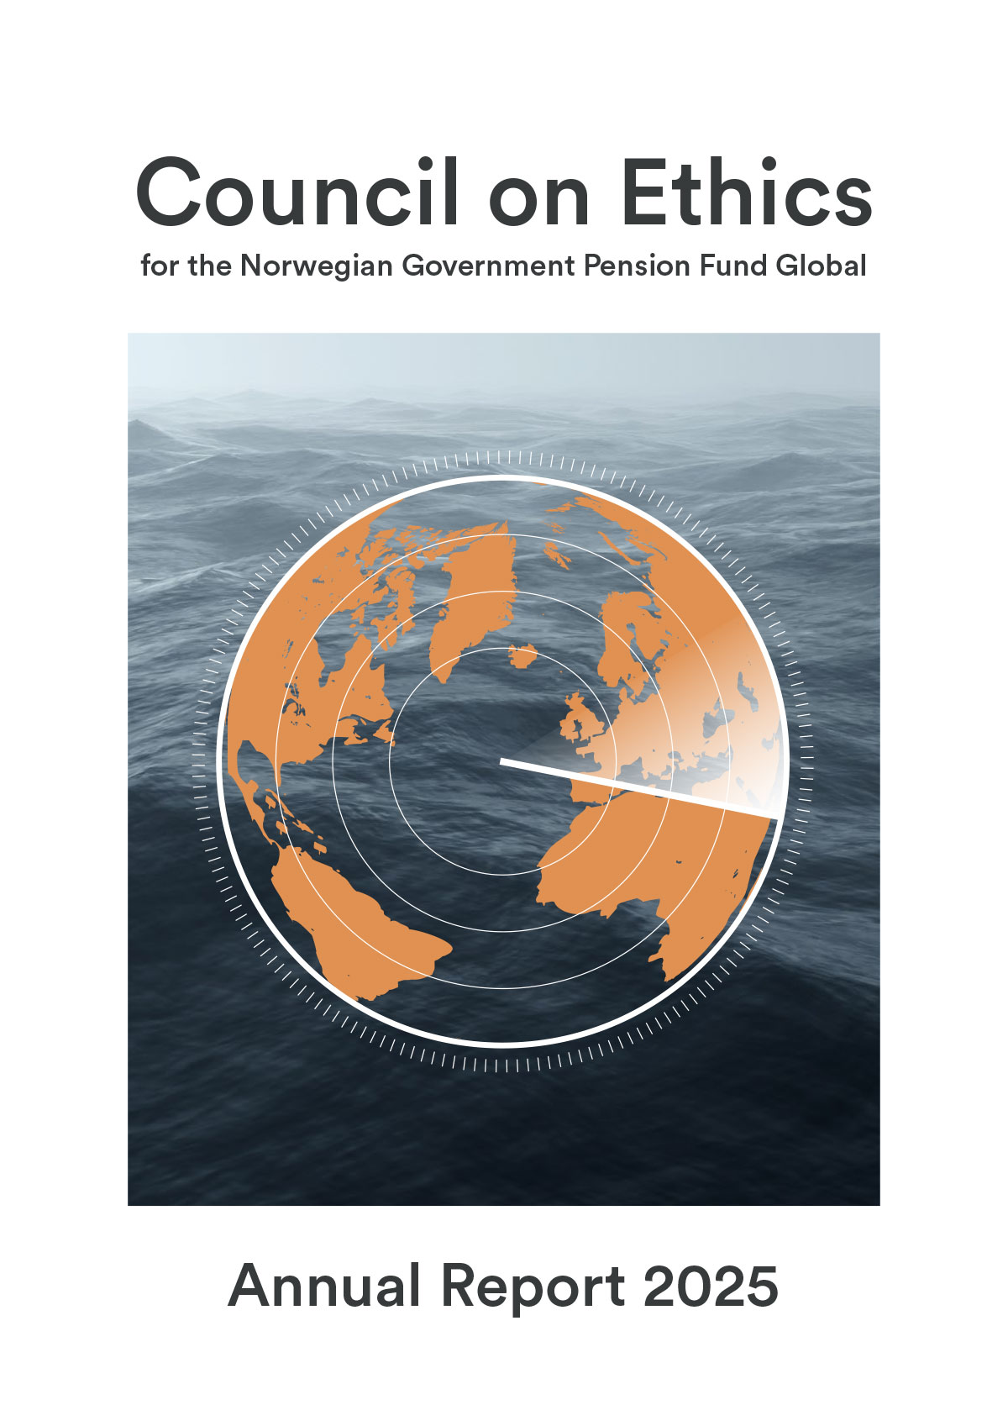

Introduction

Foreword by the Chair
2025 was an exceptionally challenging year for the Council on Ethics. Initially, the Government Pension Fund Global’s investments and the Council’s work were drawn into the wide-ranging political and public debate about Norway’s policy on Palestine. Subsequently, the Guidelines for Observation and Exclusion of companies from the GPFG, which define the Council’s mandate, were replaced by interim ethical guidelines.
Under these interim guidelines, the Council shares information on companies with Norges Bank according to the same criteria as before but no longer provides advice on observation or exclusion. Norges Bank assesses how to follow up these cases in its ownership activities based on the information provided by the Council. The interim guidelines will apply until the Norwegian Parliament decides how ethical considerations will be reflected in the management of the Fund.
The Council’s work covers a broad range of business sectors and geographical regions. In 2025, for example, the Council assessed mining companies, energy companies, banks, weapons manufacturers, beverage producers and courier services. A variety of topics was considered, including contribution to war crimes, corruption, money laundering, loss of nature, pollution, as well as violations of labour rights and the rights of Indigenous peoples. The cases extend across all continents.
A common thread running through these cases is the question of whether there is an unacceptable risk that companies in which the GPFG is invested are responsible for or contribute to violations of the norms outlined in the ethical guidelines. The concept of “contribution” is fundamental to understanding the guidelines and was a key topic in the debate about the GPFG’s investments connected to the conflict in Gaza and the West Bank.
The Graver Committee, appointed by the government in 2004 to establish the foundation for the Fund’s ethical guidelines, concluded that an investor can only be considered complicit when an action was reasonably foreseeable and when there is a systematic connection or causal link between a company’s operations and the action in question. At the same time, the Committee found that investments in a company cannot be regarded as a contribution to actions that could not reasonably have been foreseen or known, nor to matters over which the company itself has limited control.
Later on, the Mestad Committee, created in 2020, clarified that the term “contribution” in the ethical guidelines does not refer to criminal complicity but to the ordinary meaning of contributing to something. Reflecting new developments in society, the Committee recommended a slightly broader interpretation of the term “contribution”, encompassing also norm violations occurring in the supply chain of companies.
Together, these two committees, which had their reports ratified by the Norwegian Parliament, provide important guidance on how the term “contribution” in the ethical guidelines should be understood. In public debates about the GPFG’s investments in conflict-affected areas, many of these nuances have been overlooked. I would therefore like to emphasise that the Council’s assessments of individual companies have been based on the wording of the guidelines and the guidance provided by experts and ratified by the Parliament, not on opinions expressed in the public debate.
In 2025, the government appointed a third committee to prepare recommendations for the Parliament’s upcoming revision of the ethical guidelines. The Council agrees that geopolitical developments in recent years justify a new review of the ethical guidelines, as has been done previously. In the committee’s work, questions relating to the concept of “contribution” will again be central: Where does it begin and end, and how should it be implemented? The Council supports this work and will contribute information, professional insight, and practical experience.
In the meantime, the Council continues to work in accordance with the interim ethical guidelines. Although the results of these endeavours will not be published, the Council’s methodology remains the same, based on a robust factual foundation and thorough assessment processes.
Svein Richard Brandtzæg – Chair of the Council on Ethics

Members of the Council on Ethics
Svein Richard Brandtzæg (Chair)
Brandtzæg has a doctorate in engineering from the Norwegian University of Science and Technology (NTNU) and a diploma in business administration from BI Norwegian Business School. Over the course of 34 years, he occupied a variety of positions at Norsk Hydro ASA, both in Norway and abroad. For 10 years up until 2019, he was the company’s CEO. Brandtzæg has served on the boards of directors of numerous enterprises and industry associations. He is currently chair of Dormakaba AG (Switzerland) and a director of Mondi PLC (UK) and Rotork PLC (UK). Brandtzæg is also CMI mentor at Chair Mentors International.
Siv Helen Rygh Torstensen (Vice Chair)
Rygh Torstensen is a lawyer, who is currently EVP Legal & Compliance at Equinor ASA. She has worked for Equinor in a variety of roles since 1998, mostly in the Legal & Compliance Department. She has previously served as the company’s Chief Compliance Officer. Rygh Torstensen also headed the CEO’s Office for three years until August 2019. Before joining Equinor, she worked as a lawyer with the law firm Cappelen & Krefting DA and in Stavanger City Council’s Legal Services Department.
Vigdis Vandvik
Vandvik has a PhD in plant ecology and is a professor in the Department of Biological Sciences at the University of Bergen, where she also heads the CeSAM Centre for Sustainable Area Management. Since 2017, she has been affiliated with the Bjerknes Centre for Climate Research. Vandvik has extensive experience at the intersection between research, public administration and environmental policy, and has participated in a number of national and international research projects, knowledge processes and committees. She has also participated in various advisory councils and commissions. Vandvik was previously a member of the Norwegian government’s Nature Risk Committee. She is the lead author of several reports published by the Intergovernmental Science-Policy Platform on Biodiversity and Ecosystem Services (IPBES) and the Intergovernmental Panel on Climate Change (IPCC).
Egil Matsen
Matsen holds a PhD in Economics from the Norwegian School of Economics and Business Administration (NHH) and is CEO of Sparebankstiftelsen DNB. He has previously served as Deputy Governor of Norges Bank, with particular responsibility for the Norwegian Government Pension Fund Global (GPFG) and was a member of the Bank’s Executive Board. He has also been employed as CEO of Forte Fondsforvaltning, professor and head of the Department of Economics at the NTNU, and served as a member of KLP’s board of directors.
Cecilie Hellestveit (until 10 November 2025)
Hellestveit is a lawyer, with a doctorate in humanitarian law. She also holds an MPhil in Middle Eastern Studies. Hellestveit has worked at various research institutions, including PRIO, SMR, NUPI, IKOS and ILPI. She has also been affiliated with the Atlantic Council in Washington DC and the Max Planck Institute in Germany. She is currently a researcher at the Norwegian Academy of International Law and is a special advisor at the Norwegian National Human Rights Institution. She is also affiliated with the Norwegian University of Science and Technology (NTNU). Hellestveit works within academia on issues relating to international law and armed conflict. She has authored a textbook on the international law of war as well as several books on contemporary armed conflicts.
Secretariat
The Council on Ethics has a multi-disciplinary secretariat, whose members carry out assessments and prepare matters for the Council’s consideration. At the start of 2025, the secretariat had nine employees and was led by Eli Lund.

The work of the Council on Ethics
The Council on Ethics’ mandate is decided politically through guidelines determined by the Norwegian Ministry of Finance. On 7 November 2025, those guidelines were materially altered. Until that date, the Council’s task was to assess companies against predetermined criteria and, depending on the outcome, issue recommendations to Norges Bank to exclude them from investment by the GPFG or place them under observation. Under the prevailing, interim guidelines, the Council will share information regarding such companies with the Bank. This information is referred to as risk assessments in the annual report. Both the product-based criteria, covering the production of tobacco, cannabis, coal and certain types of weapons, and the conduct-based criteria, covering financial crime, the sale of weapons to certain states, human rights abuses, environmental damage and greenhouse gas emissions, remain in place. The guidelines are forward-looking and apply to unacceptable conditions that are ongoing or may occur in the future.
Portfolio monitoring and information gathering
The Council continuously monitors whether GPFG-invested companies engage in business activities which fall within the scope of the ethical guidelines. Two portfolio monitoring services pick up on relevant information about, respectively, product-related and conduct-related cases. In addition, the Council monitors a number of databases and websites containing information about, for example, corruption, weapons sales or business activity in areas of conflict. It also receives relevant information from organisations and individuals. This information may be received directly or forwarded from Norges bank.
To identify cases that are not necessarily covered by news monitoring, the Council also conducts specific investigations into areas where the risk of serious norm violations is high. This may, for example, involve the surveying of companies that impact nature conservancy areas.
Furthermore, the Council keeps track of issues that have previously led to companies being excluded and where similar cases may arise. Examples of such issues include shipbreaking in certain countries and the exploitation of natural resources in Western Sahara.
The Council assesses every company that is identified in relation to the product-based criteria. With respect to the conduct-based criteria, where cases are many and highly diverse in nature, the Council investigates those where the risk of the companies causing, or contributing to, serious norm violations is considered to be greatest. In its initial assessment, the Council attaches weight to the seriousness and scale of the norm violation, the company’s association therewith and the likelihood of the norm violation continuing in the future. Particularly serious cases are given priority. These may be cases linked to escalating conflicts or serious individual incidents in which GPFG-invested companies are involved.
If the Council decides to pursue a case, a thorough investigation of the allegation levelled at the company concerned is set in train. The secretariat gathers information, both through conversations with experts and from open sources. In some cases, the Council also makes use of consultants and research institutions, for example, to investigate working conditions or the environmental impact of companies’ activities. The companies being investigated are also important sources of information.
            - Overview of the Council’s activities in the period 2023–2025
Year | 2023 | 2024 | 2025
No. of limited companies in the GPFG at year-end | 8859 | 8659 | 7201
No. of companies excluded at the recommendation of the Council on Ethics at year-end | 92 | 105 | 115
No. of companies placed under observation at the recommendation of the Council on Ethics | 12 | 8 | 9
No. of companies on which the Council on Ethics issued a recommendation during the year | 15 | 21 | 19
No. of companies excluded during the year at the recommendation of the Council on Ethics | 6 | 14 | 10
No. of companies placed under observation during the year | 5 | 0 | 2
No. of observations terminated during the year | 2 | 4 | 1
No. of exclusions revoked during the year | 2 | 1 | 0
No. of new cases accepted for assessment during the year | 102 | 163 | 261
No. of cases concluded during the year | 100 | 143 | 222
Total no. of companies under assessment during the year | 209 | 268 | 363
No. of companies the Council has been in contact with | 69 | 76 | 76
No. of companies the Council has met with | 11 | 22 | 24
No. of Council meetings | 10 | 10 | 15
Secretariat (no. of staff) | 9 | 9 | 9
Budget (NOK million) | 18,1 | 20,3 | 20,3
The table above summarises the extent of the Council’s endeavours with respect to companies in 2025, compared with in 2024 and 2023. Companies excluded by Norges Bank under the coal criterion, without the Council’s recommendation, are not included in the table.
Summary of the Council’s activities in 2025
Table 1.1 provides an overview of the Council’s activities in the period 2023–2025. The companies in the GPFG’s portfolio constitute the starting point for the Council’s endeavours. At the close of 2025, the GPFG was invested in around 7,200 limited liability companies, headquartered in around 70 countries. The number of companies in the GPFG’s investment portfolio has been significantly reduced in recent years. However, this has not so far led to fewer cases being picked up on via the portfolio monitoring process.
At the close of the year, 115 companies had been excluded from the GPFG at the recommendation of the Council on Ethics, while nine were under observation. Furthermore, Norges Bank has, at its own initiative, excluded 65 companies under the coal criterion and placed 11 under observation.
In 2025, the Council recommended that 17 companies be excluded, one company’s exclusion should be revoked, while one company should be placed under observation. Norges Bank’s decision and the Council’s recommendation with respect to eight of these companies have been published. Those recommendations on which a decision had not been made prior to 7 November 2025 will be treated as information provided in accordance with the interim ethical guidelines. The Council also issued one risk assessment to Norges Bank under these guidelines in 2025.
The Council has a heavy caseload and will normally have cases relating to the majority of criteria under assessment at any given time. It is not unusual for a single company to be linked to several cases, or for a case to encompass multiple companies. In 2025, the Council worked on 395 cases, involving 363 companies. Of these, 261 were identified during the year, while 64 were identified in 2024. During the same period, the assessment of 247 cases was terminated. This includes companies for which a recommendation was made to Norges Bank, companies where the Council’s investigations found no grounds for either exclusion or observation, and companies in which the GPFG was no longer invested. In 2025, 11 companies under investigation by the Council exited the GPFG before a conclusion had been arrived at.
The majority of cases did not end in a recommendation to exclude or observe the company or companies concerned, but were shelved at an earlier stage in the assessment process. A recommendation to exclude was issued in eight of the new cases initiated in 2025, while a risk assessment was sent to Norges Bank, pursuant to the ethical interim guidelines, in connection with one of the cases. 174 of the year’s new cases were terminated with no recommendation being issued or information shared with Norges Bank.
In 2025, the Council put its portfolio management services out to tender once again. We see that suppliers find it difficult to achieve the same high level of coverage with respect to news monitoring in all regions, especially emerging markets. As can be seen in Figure 1.1, more than 50 per cent of the limited companies in the GFPG’s portfolio are domiciled in Asia, while these account for just 18 per cent of its market value. This means that these investments comprise many small companies with smaller operations than, for example, the companies included in the North American portion of the portfolio, which accounts for 57 per cent of its market value but just 20 per cent of the companies. Since the majority of investors are most interested in larger, Western companies, the majority of those supplying ESG-related news monitoring services place the greatest emphasis on these. It is also easier to keep track of and report on English-language news media, even though artificial intelligence-related developments also offer new opportunities here.
          - Regional breakdown of the GPFG’s 7,201 shareholdings at 31 December 2025
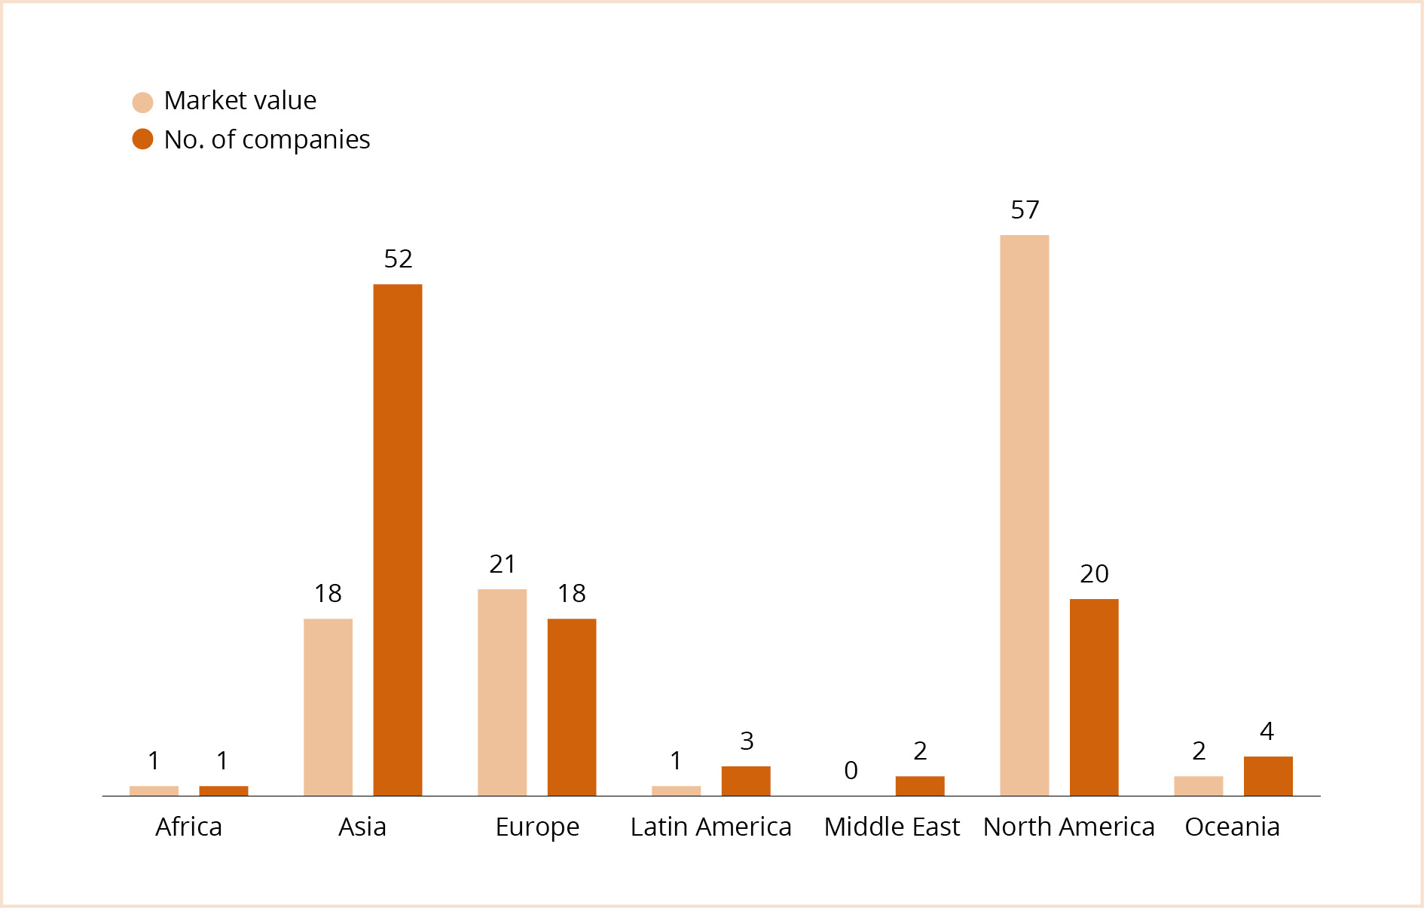
Regional percentage distribution of the GPFG’s shareholdings by market value and no. of companies.
          - Regional breakdown of the companies assessed by the Council in 2025
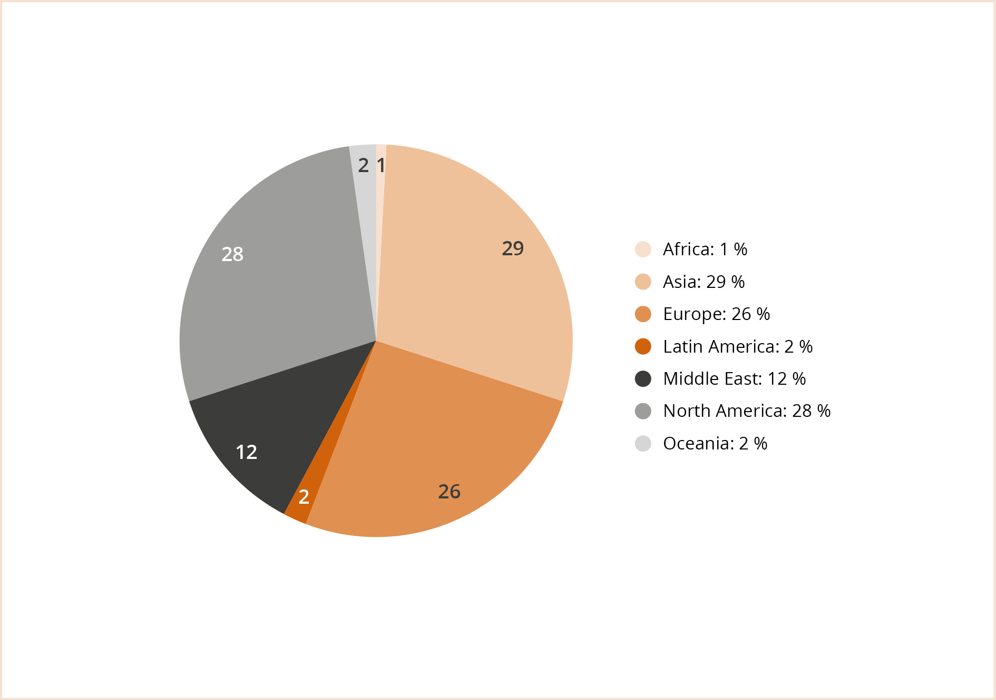
Fig. 1.2 shows a percentage breakdown of companies from different regions that the Council has assessed in 2025. The geographic breakdown varies considerably from year to year and reflects both topical issues and those issues on which the Council has decided to focus at any given time. In 2025, the conflict in the West Bank and the war in Gaza continued to significantly impact the number of companies assessed. A preponderance of the companies with links to the conflict are domiciled in Europe and North America, in addition to Israel.
Of the just over 100 Asian companies that the Council assessed in 2025, one-third were linked to human rights cases, while one third were linked to financial crime cases. Most of the human rights cases related to working conditions, with many of the companies being selected for further investigation because they operate in a sector and a country where the risk of labour rights violations is high. On the financial crime side, a review of money laundering risk relating to casino operations included many Asian companies. Three of the companies on which the Council issued recommendations in 2025 were Asian.
The Council worked on around 100 companies from 15 European countries in 2025. Just under half of the cases are based on a review of lists of companies which, in various ways, are linked to the violation of international law in the West Bank and Gaza. Thirty of the cases related to the risk of financial crime. One of the companies on which the Council issued a recommendation in 2025 was European.
The dominant topic for the approximately 120 companies domiciled in the American continent concerns their potential contribution to the violation of the rights of individuals in situations of war and conflict through business operations linked to the West Bank and Gaza. The Council has also assessed a number of US companies under the financial crime criterion, following reviews of companies in, respectively, the health and casino/gambling sectors. Seven of the companies on which the Council issued recommendations in 2025 were from North America, while three were from Latin America.
Approximately 45 companies domiciled in the Middle East were assessed in 2025. Almost all of these were Israeli companies, which were assessed in relation to the risk that they, through their business operations in the West Bank and Gaza, may be contributing to the violation of the rights of individuals in situations of war and conflict. Five of the companies on which the Council issued recommendations in 2025 were domiciled in the Middle East.
          - Breakdown of the Council’s activities in the period 2023–2025 by criterion
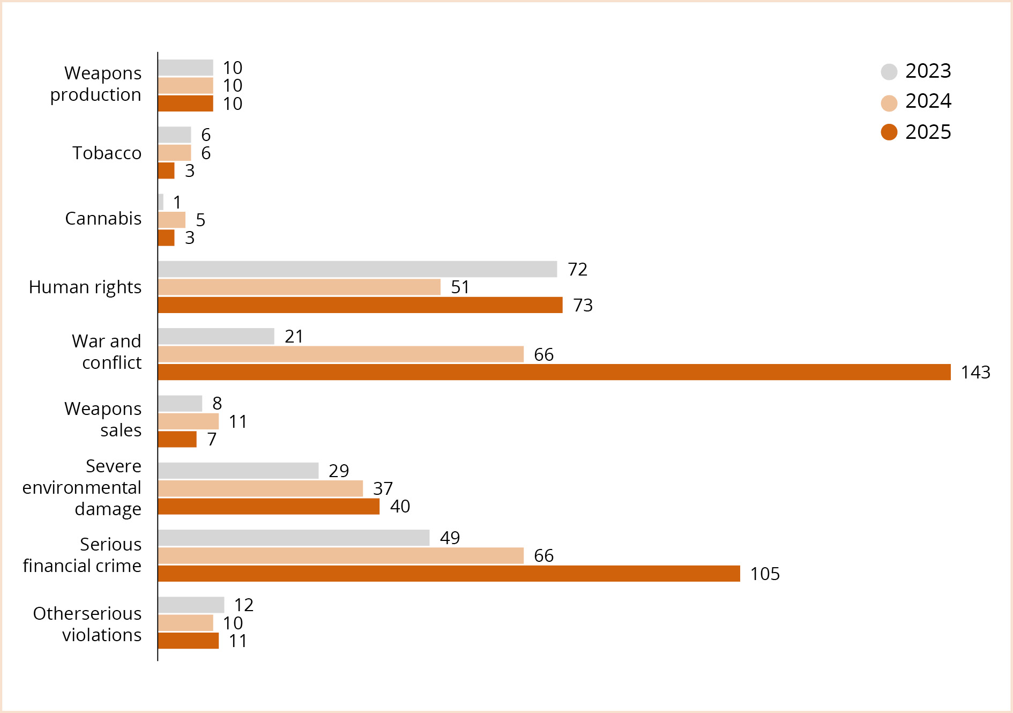
Fig. 1.3 shows a breakdown of the cases on which the Council has worked, distributed by criterion, in the period 2023–2025.
During the period, there has been a manyfold increase in the number of cases assessed under the war and conflict criterion. This increase is ascribable primarily to the war in Gaza and the escalating violations of international law in the West Bank, with which a number of GPFG-invested companies have links. In 2025, the Council recommended that six companies be excluded from investment by the GPFG under this criterion, due to their business links to the West Bank.
The number of companies assessed in relation to financial crime has also risen sharply during the period. Much of this increase may be attributed to the fact that the criterion was extended in 2021 to cover all financial crime and not, as previously, merely corruption. The large number of companies assessed each year in relation to this criterion is due to the fact that the Council often carries out sector based reviews to identify those companies which warrant further investigation. In 2025, in addition to corruption, for example in the health sector, the Council has reviewed companies in the casino and gambling industry, which is a sector with a heightened risk of money laundering. The Council issued recommendations on two companies pursuant to this criterion in 2025, one recommendation related to money laundering and the other to gross corruption.
Human rights cases still account for a significant proportion of the Council’s work. Labour rights violations, including the risk of forced labour, constitute the dominant topic. However, all of the three recommendations issued in 2025 under the human rights criterion concern violation of the rights of Indigenous peoples. In two of these recommendations, there was also an independent justification under the environmental criterion related to the loss of biodiversity.
Apart from biodiversity loss, serious industrial and mining-related pollution has been the most important assessment topic pursuant to the environmental criterion in 2025. The other recommendations concern three companies in the same business group whose exclusion was recommended on the grounds of their failure to clean up pollution caused by mining operations.
Under the criterion addressing other particularly serious violations of fundamental ethical norms, the Council has worked in part on cases relating to the risk of serious animal welfare violations.
Under the product-based criteria, the Council has assessed several companies that produce, respectively, nuclear weapons and cannabis. The Council has issued recommendations to Norges Bank concerning five companies in this area.
Contact with companies
Before the Council comes to a conclusion, it is normally in contact with the companies concerned several times. Early in the assessment process, the Council sends a letter containing questions regarding the issue at hand. Companies that have been assessed pursuant to the conduct-based criteria have also been invited to comment on a draft version of the Council’s recommendation to exclude it or place it under observation.
In 2025, the Council was in contact with 76 companies and met with 24 of these. When the Council meets with companies, it is often late in the assessment process, often on the basis of a draft recommendation to exclude or observe. Fig. 1.4 provides a breakdown of the companies with which the Council has been in contact in 2025, distributed by criterion.
          - Breakdown of contact with companies by criterion
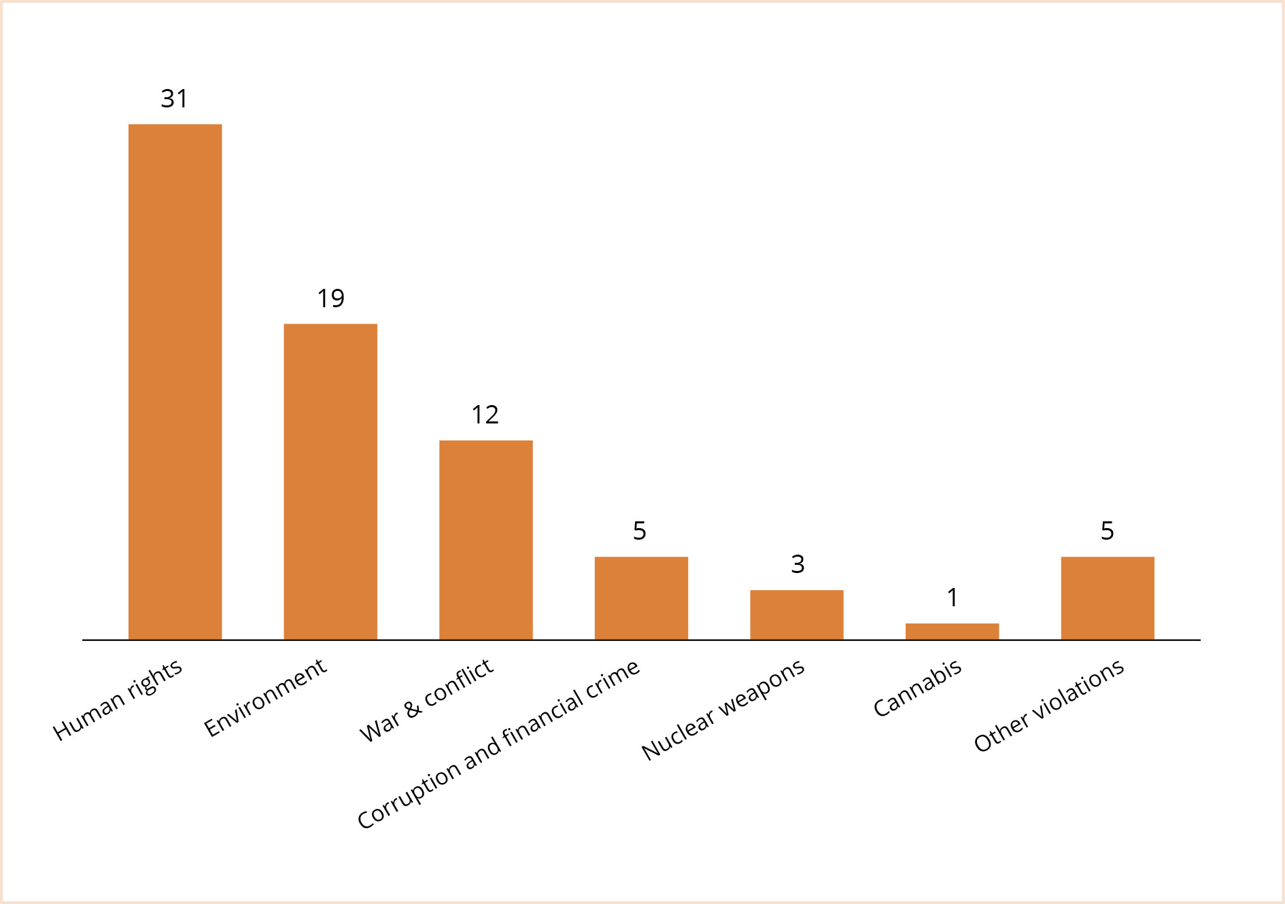
The Council attaches great importance to information provided by the companies themselves and takes the view that any failure to respond on the part of companies may help to heighten the ethical risk.
Assessment of companies that have been excluded or placed under observation
A company is not excluded for a specific period of time, and its exclusion may be revoked if the grounds therefore cease to exist. Norges Bank makes a formal decision to revoke a company’s exclusion at the recommendation of the Council. In 2025, the Council was in contact with six excluded companies that sought to have the grounds for their exclusion reassessed.
Companies that have been placed under observation are monitored continuously by the Council, which often submits one or more observation reports per company to Norges Bank during the observation period. An observation report is a status report in which the Council describes important development trends. Observation reports on two companies were issued in 2025. When the specified observation period has come to an end, the Council will issue a recommendation to terminate observation if there are no grounds for continued scrutiny. In 2025, the observation of one company was discontinued.

Work under the various criteria

Product-based criteria

The criteria apply to GPFG-invested companies which themselves or through entities they control:
- develop or produce weapons or key components of weapons that violate fundamental humanitarian principles through their normal use. Such weapons include biological weapons, chemical weapons, nuclear weapons, non-detectable fragments, incendiary weapons, blinding laser weapons, antipersonnel mines and cluster munitions
- produce tobacco or tobacco-products
- produce cannabis for recreational use
The criterion applies to mining companies and power producers which themselves, or consolidated through entities they control, either:
- derive 30 per cent or more of their income from thermal coal,
- base 30 per cent or more of their operations on thermal coal,
- extract more than 20 million tonnes of thermal coal per year, or
- have the capacity to generate more than 10,000 MW of electricity from thermal coal.
In relation to the product-based criteria, the Council’s work consists of evaluating cases that are identified via the portfolio monitoring process. In 2025, the Council recommended the exclusion of one company that produces cannabis for recreational purposes. However, the bulk of the Council’s work related to the weapons criterion. The Council recommended the exclusion of two companies that produce key nuclear weapons components. In addition, it was recommended that the grounds for one company’s exclusion be altered from cluster munitions to nuclear weapons.
With regard to the coal criterion, Norges Bank is authorised to make decisions concerning the observation or exclusion of companies without a recommendation from the Council on Ethics. A division of labour has been agreed between Norges Bank and the Council, under which the Bank identifies and assesses companies which fall within the scope of the coal criterion. The consultant charged with monitoring the portfolio with respect to the product-based criteria nevertheless reports to the Council on companies which may fall within the scope of this criterion. The Council shares all relevant information with the Bank. This division of labour is continued under the interim ethical guidelines.

Serious or systematic human rights violations

The criterion applies to GPFG-invested companies if there is an unacceptable risk that the company contributes to or is responsible for:
a. serious or systematic human rights violations
This criterion covers a wide range of issues. During the year, the Council has worked on cases relating to conditions in asylum reception centres, forced relocations, violence against local communities and human rights abuses linked to the use of digital technology. In 2025, cases regarding labour rights, and the rights of Indigenous peoples required the greatest share of the Council’s resources.
In 2025, the Council recommended the exclusion of three companies under the human rights criterion. These recommendations concerned the violations of Indigenous peoples’ rights in Indonesia and Colombia.

Labour rights
Labour rights abuses accounted for the bulk of the 70 or so human rights cases that the Council worked on in 2025. Around half of these cases relate to the working conditions experienced by migrant workers. Migrant workers are particularly vulnerable to exploitative employment terms, particularly in relation to recruitment processes, which can leave them in situations of employer control that may amount to coercive conditions and render them unable to terminate their employment freely.
For a number of years, the Council has worked on cases in the Gulf States, where migrant workers make up a large proportion of the labour force. The Council is unable to commission on-site investigations in these countries due to security concerns. The Council therefore bases its assessments on reliable media reporting and reports from credible NGOs. In 2025, the Council examined companies that provide courier and transport services via digital platforms. These platform companies have no formal employer responsibility for the couriers, who are employed by staffing agencies, yet the couriers wear the platform companies’ uniforms.
The couriers often come from the poorest countries in Asia and Africa and find themselves trapped in unacceptable working conditions that are difficult to escape, partly due to high recruitment fees and the retention of their identity documents. The investigations have also uncovered long working hours, the absence of regular rest days, and hazardous working conditions.
Poor working conditions for migrants are nonetheless not unique to this part of the world. The Council investigates serious cases that are identified via news monitoring, irrespective of where the companies operate or are registered. In 2025, one company was placed under observation due to the risk that it is contributing to the violation of migrant workers’ rights at shipyards in Italy. Furthermore, media reports about working conditions for migrant workers in Taiwan led the Council to select certain companies for further investigation. These investigations are expected to be conducted in 2026.
In some countries, such as India, internal migration is widespread. The Council has investigated companies whose workforce was found to be made up of 90 per cent internal migrants. Almost none of these workers had formal employment contracts, they were obliged to work long hours and were unable to organise or join a trade union. Serious harassment of female workers was also uncovered. These investigations were based on interviews and a review of documents.
In 2025, the Council also started investigating employment conditions in the shoe industry. The GPFG has invested in relatively few shoe manufacturers, and the Council aims to examine all GPFG-invested companies producing footwear in certain countries where the risk of labour rights abuses is high. These investigations involve both factory inspections and interviews with employees. So far, a small number of manufacturers have been scrutinised, and the investigations did not identify labour rights violations of a severity that would justify recommending exclusion.
Experience from such investigations shows that even though companies often have good guidelines, these are not necessarily reflected in actual working conditions. Investigations that provide tangible and direct knowledge of working conditions have therefore been crucial for assessing whether the companies’ practices are acceptable. At the same time, the investigations have formed an important foundation for further dialogue with the companies, a process that has in some cases resulted in the implementation of concrete measures to improve working conditions in the facilities.

Indigenous peoples’ rights
Projects that require large areas of land or involve extensive changes to the natural environment in areas inhabited by Indigenous peoples constitute a significant risk of infringing Indigenous peoples’ rights. High-risk sectors include mining, oil and gas extraction, large scale agriculture and energy projects, including renewable energy facilities such as hydropower plants and wind farms. The three recommendations to exclude companies that the Council issued in 2025 are linked to the extraction of natural resources.
More than 476 million people belonging to Indigenous peoples live in approximately 90 countries across the globe, encompassing more than 5,000 different ethnic groups. They live in all parts of the world and represent a wide cultural and linguistic diversity. Indigenous peoples often have strong ties to nature and maintain traditional knowledge that is closely connected to the sustainable use of natural resources. They play a key role in the preservation of biodiversity. More than 36 per cent of the world’s intact forests are located within the traditional territories of Indigenous peoples. At the same time, Indigenous peoples are among the world’s most marginalised groups and are often subject to discrimination, poverty, the loss of land and systematic human rights abuses.
Indigenous peoples’ rights are covered by the human rights criterion set out in the GPFG’s ethical guidelines. The Mestad Committee (2020) and subsequent report to the Storting on the management of the GPFG emphasised that “Indigenous peoples are extremely vulnerable to human rights abuses, for example, in connection with infrastructure construction projects and the extraction of natural resources. Major construction projects have the potential to violate individual rights, in addition to putting Indigenous peoples’ culture, way of life and livelihood in danger.”
Indigenous peoples’ rights are protected through internationally recognised conventions, particularly the United Nations Declaration on the Rights of Indigenous Peoples (UNDRIP) and ILO Convention No. 169. These establish the right of Indigenous peoples to self-determination, which means that they can freely determine their political status and govern their own economic, social and cultural development. They also establish the principle of free, prior and informed consent (FPIC), which requires that Indigenous peoples must be consulted with the aim of obtaining their consent before measures affecting them are implemented. Indigenous peoples have the right to own, use and control their traditional territories and natural resources, as well as to preserve and develop their culture, language and identity.
In previous recommendations, the Council has highlighted the effects of norm violations on vulnerable groups to which companies in the GPFG may be contributing. Indigenous peoples and tribal peoples are not by nature vulnerable groups, but they can be placed in vulnerable situations, often as a result of corporate activities. For Indigenous peoples who depend directly on water and natural resources in their territories, the effects of projects that require large areas of land or involve significant disruption to the natural environment may be greater than for other groups in society. A violation may therefore have disproportionately serious consequences for Indigenous peoples compared with the wider population.
Indigenous peoples who live in voluntary isolation are in an especially vulnerable situation. These are groups who have chosen not to have contact with outsiders. They may also be groups who have previously been in contact with other groups in society, but who have withdrawn as a survival strategy. Such groups are completely dependent on their traditional territories and natural resources to survive.
One of the cases on which the Council issued a recommendation in 2025 concerned the risk associated with mining operations in an area of Indonesian rainforest occupied by isolated Indigenous peoples. Deforestation linked to the mining operation would reduce the territory and means of subsistence of this Indigenous group, which could put their health, way of life and very existence in danger. In its assessment, the Council emphasised the necessity of avoiding unwanted contact with outsiders, due to the serious risk this could pose to the health of individuals with no immunity to common diseases, and out of consideration for the group’s right to self-determination.
In such cases, the Council expects companies to refrain from operating in the area and not to establish contact with the Indigenous group. This is in line with the guidelines and recommendations of the UN High Commissioner for Human Rights (OHCHR) and the Inter-American Commission on Human Rights (IACHR). The Council has identified countries and areas where Indigenous peoples live in voluntary isolation and will continue to follow up companies engaged in projects that may pose a potential risk to such groups.
Cases concerning Indigenous peoples’ rights often have an environmental dimension. Indigenous peoples’ ways of life are closely linked to nature, and they depend directly on water from rivers and food from agriculture and forestry, including grains, fruit, berries, fish and game. Major alterations to the natural environment within their territories that can pollute water and soil, or destroy forests, could therefore lead to the loss of livelihoods to a far greater extent than for other groups in society. In 2025, the Council assessed the consequences of oil-related operations on two different Indigenous peoples in Colombia and issued a recommendation to exclude one Colombian company.

Serious violations of the rights of individuals in situations of war or conflict and companies’ weapons sales
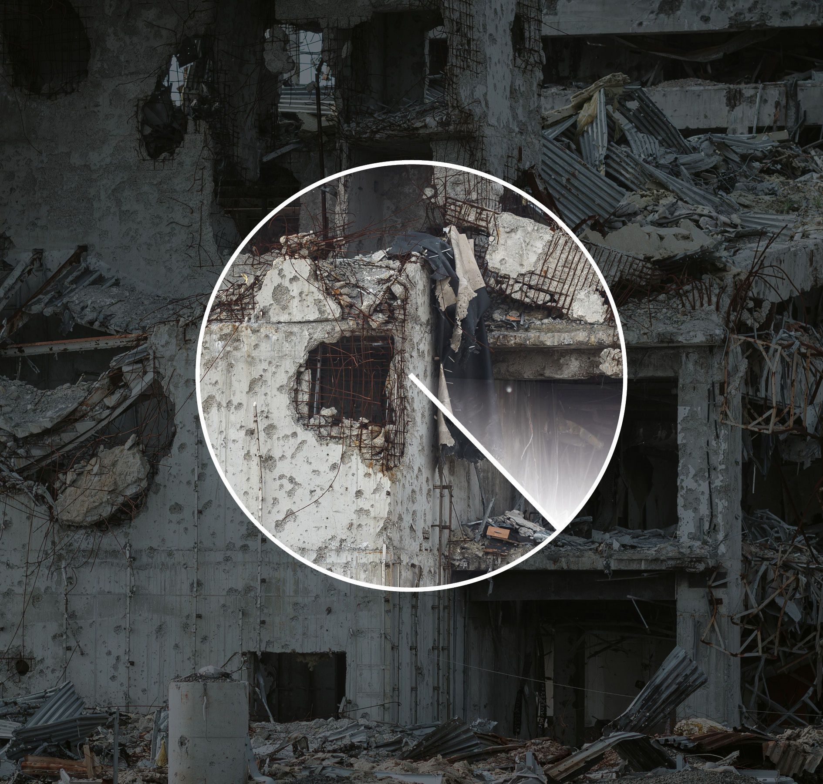
The criteria apply to GPFG-invested companies if there is an unacceptable risk that the company contributes to or is responsible for:
b. serious violations of the rights of individuals in situations of war or conflict
c. the sale of weapons to states engaged in armed conflict that use the weapons in ways that constitute serious and systematic violations of the international rules on the conduct of hostilities
d. the sale of weapons or military materiel to states that are subject to investment restrictions on government bonds as described in section 2-1(2)(c) of the Management mandate for the Government Pension Fund Global
The serious conflicts that characterised the world in 2024 continued in 2025.The bulk of the Council’s work under this criterion has related to companies linked to the occupation of the West Bank and the war in Gaza. In 2025, the Council recommended that six companies be excluded on the grounds of such activities. An observation report was also issued in connection with companies operating in Myanmar. Following the introduction of the interim ethical guidelines, the Council has sent Norges Bank a risk assessment relating to a company with ties to settlements in the West Bank.

West Bank and Gaza
Section 4(c) of the ethical guidelines applies to companies which sell weapons to states that use them in ways that constitute serious and systematic violations of the international rules on the conduct of hostilities. Application of this criterion is subject to several constraints, including the requirement that the types of weapons concerned must be capable of targeting civilians in particular and that deliveries of such weapons must be ongoing or at least of recent date.
In both 2024 and 2025, the Council investigated whether GPFG-invested companies should be excluded on the grounds that they sold weapons used in the war in Gaza. The Council’s mandate applies to companies in the GPFG’s portfolio. Several companies which supplied relevant weapons types to Israel were already excluded from the GPFG and were therefore not assessed. Certain GPFG-invested companies were, nevertheless, evaluated. After a thorough assessment, however, the Council did not recommend the exclusion of any companies under section 4(c) of the ethical guidelines. This was primarily because the deliveries either comprised weapons or military materiel that the guidelines were not intended to encompass, or because the deliveries were no longer ongoing.
Section 4(b) of the ethical guidelines applies to companies that contribute to serious violations of the rights of individuals in situations of war or conflict. Over the years, a total of 14 companies have been excluded from investment by the GPFG with reference to this criterion, on the grounds of their business links to Israeli settlements in the West Bank. The starting point for the Council’s assessments is that the settlements have been established in violation of international law.
Several companies have operations which, in various ways, may be linked to the settlements. However, the Council does not take the position that any form of association is inherently grounds for exclusion. In previous years, the Council has recommended the exclusion of construction companies which build settlements and companies which build and supply critical infrastructure to the settlements. The deteriorating situation in the area increases the expectation that companies will exercise caution. In 2025, the Council recommended the exclusion of five Israeli banks which, through various financing arrangements, contribute to the construction of settlements. The Council also recommended the exclusion of a US company which, through deliveries to the US authorities, supplies bulldozers that, after modification for military use, are used for the widespread, illegal destruction of Palestinian property.
Several campaigns aiming to dissuade investment in companies that may be linked to Israel’s occupation of the West Bank have published lists and overviews of companies operating in the territory. The UN High Commissioner for Human Rights (OHCHR) has also produced an overview of such companies. These lists provide useful information for the Council’s work.
The Council has not recommended the exclusion of every company included in such lists because the criteria for a company’s inclusion therein do not necessarily match the criteria set out in the GPFG’s ethical guidelines. While many such lists include all companies which have or have had links to the conflict, the GPFG’s ethical guidelines require not only that companies have a close connection to the norm violations but that the connection must be ongoing for the ethical risk to be unacceptable. In some cases, it has not been possible to verify that the companies in fact have the specified business activities.
The Council on Ethics reported on its work with respect to companies linked to this area of conflict in a letter to the Norwegian Ministry of Finance on 18 August 2025. In this letter, the Council undertook to perform a new review of companies with potential links to the conflict. A large number of the companies that were assessed in 2025 were included in this review. In December 2025, the Council sent Norges Bank a risk assessment resulting from this ongoing effort.

Myanmar
The Council continues to monitor GPFG-invested companies with operations in Myanmar, where the UN High Commissioner for Human Rights (OHCHR), among others, has reported a worsening of the humanitarian and human rights situation in 2025.
The bulk of the Council’s work has been linked to two companies, which were placed under observation in 2023 due to their partnership with a state-owned Myanmar telecoms company and the risk that they are contributing to serious human rights abuses enabled by means of government surveillance of the telecommunications network. The Council has engaged in extensive dialogue and held several meetings with these companies in 2025. The companies have informed the Council of changes in the partnership agreement with the Myanmar telecoms company, under the terms of which an organisational and financial ring-fence has been established between the companies and the state-owned entity. Furthermore, the companies have, following discussions with NGOs, established systems for regular due diligence assessments in the human rights area.
This indicates that the companies are now working in a more targeted and systematic fashion to reduce the risk of contributing to human rights violations. In December 2025, the Council submitted an observation report to Norges Bank on developments in the companies’ efforts, and will continue its dialogue with them in 2026.

Russia’s war of aggression
The Council is monitoring GPFG-invested companies that are contributing to Russia’s war of aggression against Ukraine. Several of the companies in the GPFG’s portfolio have operations in Russia, without this alone constituting grounds for exclusion. Such cases are assessed under the weapons sales criteria and the criterion covering other particularly serious violations of fundamental ethical norms.
Since Russia’s full-scale invasion of Ukraine in February 2022, two companies have been excluded from investment by the GPFG due to their links to Russia’s warfare. Since it has been decided that the GPFG will divest all its holdings in Russian companies as soon as practicable, the Council does not monitor companies domiciled in Russia. Those companies which the Council assessed in 2025 were from other countries and those efforts resulted in no recommendations to exclude or place them under observation.

Severe environmental damage and unacceptable greenhouse gas emissions

The criteria apply to GPFG-invested companies if there is an unacceptable risk that the company contributes to or is responsible for:
e. severe environmental damage
f. acts or omissions that on an aggregate company level lead to unacceptable greenhouse gas emissions

Severe environmental damage
In 2025, the Council recommended that five companies be excluded under the environmental criterion. These recommendations related, respectively, to deforestation associated with mining operations and failure to clean up spillage from mining.
In 2025, the Council prioritised cases relating to:
- The loss of biodiversity – deforestation related to mining and the development of plantations in areas containing critically endangered species and intact, globally important ecosystems
- The identification of companies operating inside UNESCO World Heritage Sites
- Severe pollution caused by oil and gas production and mining, with the risk of permanent harm to people’s health and the environment
- The production and use of per- and polyfluoroalkyl substances (PFAS)
In recent years, the underlying norms for what are considered to be acceptable practices by business operations that impact the natural environment have become more pronounced. The Kunming-Montreal Global Biodiversity Framework (GBF) from 2022 has established ambitious goals to halt the loss of nature and ecosystems by 2030. This has raised the level of expectation with respect to companies’ due diligence in areas containing globally important biodiversity, including biodiversity hotspots and intact areas of wilderness.
Globally, 36 biodiversity hotspots have been designated. These are regions that have lost more than 70 per cent of their original vegetation, while continuing to provide habitats for a significant proportion of the world’s biodiversity in the form of endemic species (species found only in that location). In 2024, the Council began surveying companies with activities in biodiversity hotspots. In 2025, the Council assessed several cases in which companies’ operations in such hotspots risk harming the areas’ natural values.
For the Council, it is important that companies avoid taking actions that could result in irreversible damage not only in areas classified as UNESCO World Heritage Sites but also those containing globally important natural values, such as the intact parts of the Amazon rainforest. In assessing whether a company contributes to serious environmental damage, the Council on Ethics may in some cases also take into account the cumulative environmental pressure in the area where the company operates. This is particularly relevant in regions that are already under significant pressure from other industries and actors, for example through deforestation or other land use. When the overall pressure in an area is high, the risk of serious environmental damage may increase, which warrants stricter requirements regarding the company’s due diligence and preventive measures.
Many areas of intact forest and rich biodiversity are inhabited by Indigenous peoples. In such cases, companies may be assessed under both the environmental and human rights criteria. Two of the recommendations issued in 2025 related precisely to mining operations that result in the loss of vast tracts of old-growth tropical forest that is home to both uncontacted Indigenous peoples and threatened, endemic plant and animal species. In this case, the Council concluded that mining activities resulted in an unacceptable risk of severe environmental damage in the form of lost biodiversity and in the violation of Indigenous peoples’ rights.
Industrial and mine pollution is an enduring aspect of the Council’s work. In 2025, the Council recommended the exclusion of three mining companies due to inadequate clean-up of pollution.
The Council also worked in relation to companies whose oil production activities constitute a major risk of serious and permanent harm to the health of people living in the local community. One challenge in this effort is the difficulty of identifying a direct causal link between the companies’ emissions and the local population’s health issues.
The production and use of PFAS, often called “forever chemicals”, have also been a topic in the Council’s work. PFAS do not degrade and can accumulate in people and animals, with potentially serious consequences for health and the environment. Many of the world’s largest producers of PFAS figure in the GPFG’s portfolio. In 2025, the Council assessed companies that produce or use these substances on a large scale. The work was challenging because of the difficulty in obtaining specific information about which substances the companies produce and in what quantities. Furthermore, very little information is available about PFAS-producers in Asia. Without sufficient information, it was impossible to assess the extent to which some companies’ output is more environmentally harmful than others. The Council therefore terminated its investigation into this issue in 2025.

Unacceptable greenhouse gas emissions
The GPFG’s ethical guidelines have contained a criterion relating to unacceptable greenhouse gas emissions since 2016. The Council has issued five recommendations to exclude companies and a total of four companies have actually been excluded under this criterion. Through a change in the guidelines in 2022, Norges Bank was permitted to exclude companies under this criterion at its own initiative and without a prior recommendation from the Council. Since then, the Bank has in practice assumed responsibility for the climate criterion. This division of labour will be continued under the interim guidelines. The Council will, for a period, follow up the companies that have already been excluded but does not normally assess new companies.

Gross corruption and other serious financial crime

The criterion applies to GPFG-invested companies if there is an unacceptable risk that the company contributes to or is responsible for:
g. gross corruption or other serious financial crime

Gross corruption
In 2025, the Council recommended that one Indian company be excluded due to a risk of corruption. This company was selected following a review of companies in the Utilities sector in 2024.
The Council continuously monitors allegations of corruption linked to companies in the GPFG’s portfolio. Companies associated with several serious allegations of corruption are systematically registered, sorted by sector and ranked by risk. This overview is updated continuously and forms the basis for further prioritisation. Within individual sectors, allegations have accumulated over time against so many companies that it is possible to conduct more general, sector-wide reviews.
In 2025, in line with this approach, the Council embarked on a review of companies in the Health Care sector (as defined in the FTSE Index) that have been involved in corruption. The last time the Council performed a similar sector-wide review was in 2018. The review in 2025 covered around 50 companies producing, for example, pharmaceuticals, medical equipment or materials, or operating hospitals or clinics.
Corruption cases in the Health Care sector can roughly be divided into two main categories. One category relates to “grand corruption”, where significant sums are paid in bribes to highly placed decision-makers in order to win major contracts, such as deliveries of medicines or medical equipment to the public health service. The second category relates to more systematic but less extensive bribes or illegal kickbacks to doctors, pharmacists and other actors within the sector to promote the use of specific pharmaceuticals, influence patient referrals to specific health service providers, etc. These smaller bribes are often camouflaged in the form of lecture fees, payments for consulting services or illegal discounts, or they may consist of gifts, dinners, entertainments, travel, etc. It is this latter form of corruption which seems to be most widespread in the sector. Despite consisting of relatively small individual amounts, the total scale of this type of bribery from each individual company can nevertheless be substantial.
The sectoral review of companies in the Health Care sector was still ongoing at the close of 2025. So far, no companies have been selected for further investigation. In addition to this sectoral review, the Council, in 2025, started assessing two companies in the construction sector and the oil and gas sector, respectively, after these were flagged via the normal portfolio monitoring process.
The Council examines how companies placed under observation are working to develop and improve their anti-corruption systems. The Council evaluates whether the companies have established anti-corruption systems in line with internationally recognised standards, and whether these systems are effectively implemented in practice. If no new corruption allegations emerge and the company’s systems are deemed to be adequate, the Council normally recommends that observation be discontinued. In 2025, two companies were under observation for corruption risk.

Other serious financial crime
In 2025, the Council recommended that one company be placed under observation due to a risk of future non-compliance with regulatory requirements related to the prevention and detection of money laundering. The company, a major international bank, has repeatedly been involved in money laundering and non-compliance with related regulatory requirements. In 2024, the company was fined a record amount by the US authorities following an extensive investigation into the laundering of proceeds from the sale of narcotics and serious failures to comply with anti-money laundering regulations.
Although such sanctions imposed by the authorities normally provide strong incentives to prevent similar incidents in the future, the Council considered that the investigation had revealed systematic failings in the company’s corporate culture. In the Council’s assessment, such failings can take a long time to rectify. In the interim, the risk of repeated violations remains elevated.
In line with the Mestad Committee’s recommendations, the Council recommends observation, rather than exclusion, in cases relating to serious financial crime more frequently than in other types of cases. This is, in part, because companies often implement wide-ranging measures after a norm violation and because powerful responses from the authorities can lead to improvements. The objective of observation is to monitor developments in the company concerned’s practices and assess whether the risk has been reduced to an acceptable level.
In 2025, the Council performed a sector-wide review of companies in the Casino and Gambling sector, which is generally considered to have an elevated risk of money laundering. The sector-wide review covered 44 companies, three of which have been selected for further investigation. In addition, the Council assessed the risk associated with cryptocurrencies.
Apart from sector-wide reviews, the Council continuously monitors allegations made against companies that fall within this criterion. Particular attention is paid to companies which have repeatedly been involved in various forms of financial crime, to the extent that a pattern of behaviour has been established which constitutes an unacceptable risk of future norm violations.

Other particularly serious violations of fundamental ethical norms
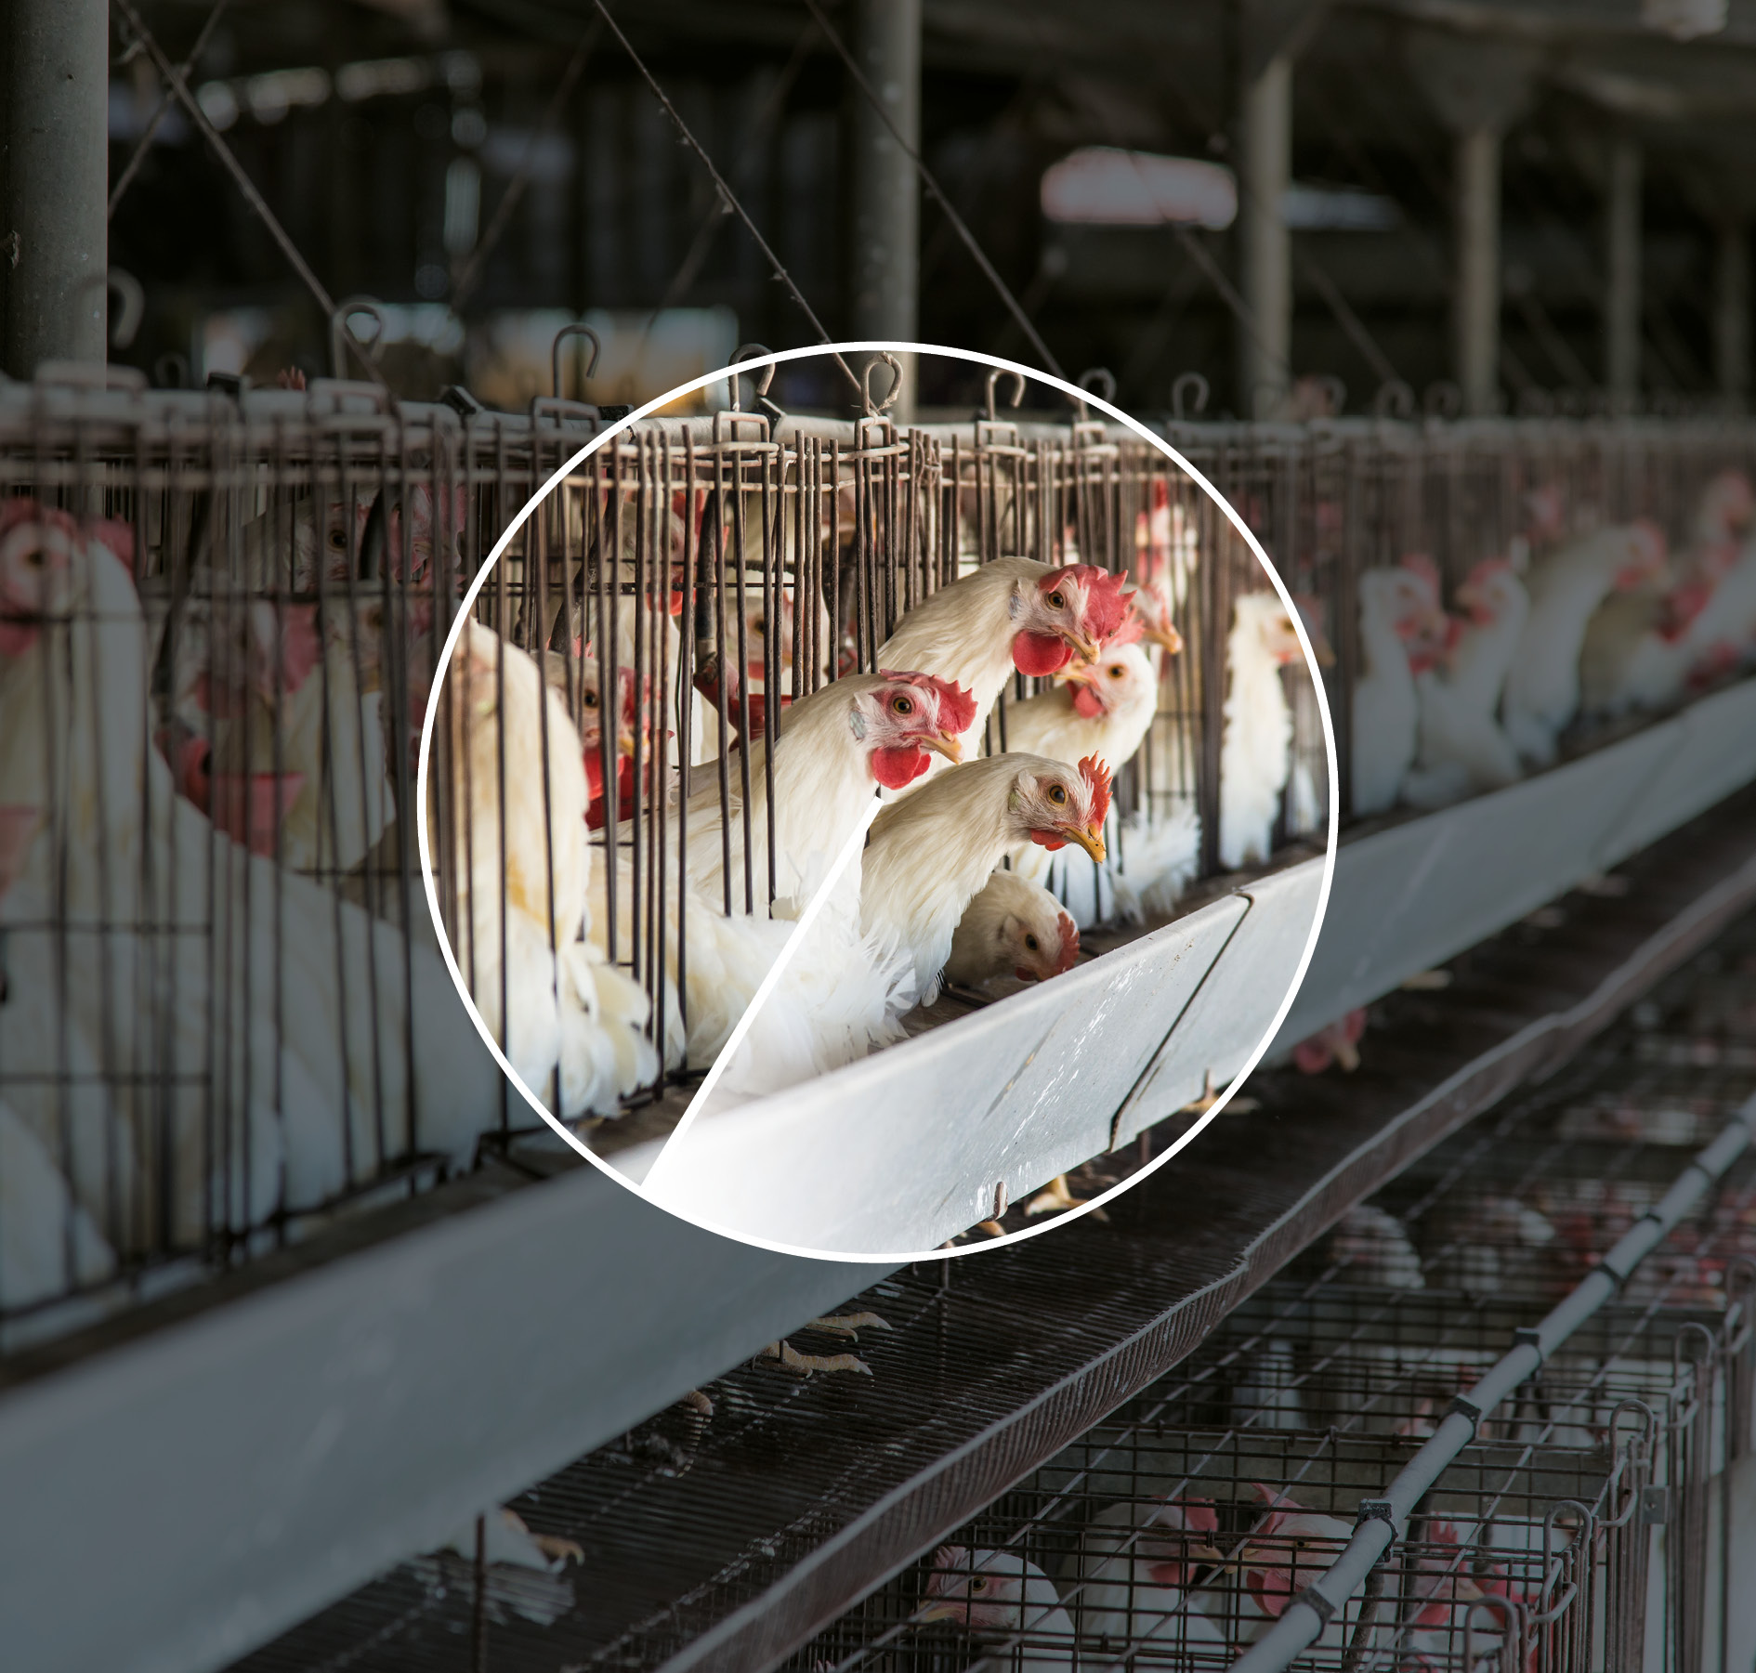
The criterion applies to GPFG-invested companies if there is an unacceptable risk that the company contributes to or is responsible for:
h. other particularly serious violations of fundamental ethical norms
This criterion may be applied in cases that do not fit neatly under the other criteria. For example, in 2025 the Council worked on cases relating to serious animal welfare violations and companies’ possible contribution to Russia’s war against Ukraine. The Council also followed up a company that is under observation due to the risk that its operations could harm irreplaceable prehistoric cultural heritage sites.
With respect to animal welfare cases, the Council assesses companies on the seriousness of the norm violations, the connection between the company and the violations, and the probability of the practice continuing in the future. The Council pays particular attention to cases where GPFG-invested companies systematically subject a large number of animals to serious welfare violations and where there are no tangible or credible plans to improve the conditions concerned.
In 2025, the Council was in contact with several companies which control the entire production chain for broiler chicken – from hatching to ready-processed product. In addition, the Council has commissioned an assessment of welfare indicators for broiler chicken. The Council has also monitored animal welfare conditions relating to the keeping of reptiles, including crocodiles and snakes, destined for the production of exotic leathers.

The Council’s activities, 2015–2025

Introduction
In its 2014 annual report, the Council on Ethics summarized its first ten years in connection with significant amendments to the ethical guidelines for the Government Pension Fund Global. As the guidelines established at that time have now been suspended, the Council on Ethics considers it appropriate to once again summarize certain key features from the past decade. The aim is to highlight experiences that may be relevant to the assessment of the GPFG’s ethical framework.

Interim Ethical Guidelines
On 7 November 2025, the Norwegian Ministry of Finance established interim ethical guidelines that replaced the previous Guidelines for Observation and Exclusion of Companies from the Government Pension Fund Global. Although the interim guidelines retain the criteria from the previous document, they also constitute a substantial change in the Council’s mandate. The Council’s ability to recommend observation or exclusion has been put on hold.
Instead, the Council will provide information to Norges Bank concerning companies whose activities fall within the scope of the product-based and conduct-based criteria. Norges Bank will then determine whether the companies identified by the Council should be followed up through the regular exercise of its ownership, which includes dialogue with companies, voting at company meetings and, if relevant, the divestment of shares within the Bank’s investment mandate.
The Council will largely continue to apply the same methodological approach as before. This includes portfolio monitoring, information-gathering and engagement with companies. As before, the Council will prioritize companies with the highest risk of involvement with serious breeches of fundamental ethical norms. In cases where the risk is deemed to be unacceptable, the Council will share that information with Norges Bank in the form of risk assessments.
The Council intends to apply the same treshold for submitting such risk assesments as previously used for recommending observation or exclusion. In accordance with the guidelines, the Council’s risk assessments will not be published. Recommendations to discontinue observation or revoke a company’s exclusion will, however, be published on the Council’s website, as before.
A government-appointed committee has been established to review the GPFG’s ethical framework. The committee is due to submit its report by 15 October 2026. The Ministry of Finance has indicated that it will submit the committee’s report for public consultation. The matter will then be presented to the Storting.

Revisions of the Guidelines, 2015–2025
The Guidelines for Observation and Exclusion of Companies from the Government Pension Fund Global have undergone two major revisions in the period 2015–2025. Both revisions have impacted the Council’s work and have expanded the grounds for exclusion from investment by the GPFG. The changes must be seen in the context of both political priorities and developments in international norms for responsible business conduct.
In 2016, a product-based coal criterion and a conduct-based climate criterion were introduced. With respect to the coal criterion, Norges Bank was permitted to exclude companies without any prior recommendation from the Council on Ethics. Initially, the criterion covered coal companies and power generators which based more than 30 per cent of their businesses on thermal coal. As of 2019, absolute threshold values were also introduced. This meant that companies with a substantial coal-based operation could be excluded even though their share of the overall business came to less than 30 per cent. The coal criterion has resulted in the largest number of exclusions from the GPFG. At the close of 2025, 65 companies had been excluded on these grounds. The Council has played no part in these exclusions.
With respect to the conduct-based climate criterion, the Council initially had sole responsibility for identifying relevant companies. Since 2022, Norges Bank was permitted to exclude companies under this criterion without any recommendation from the Council. Since then, the Council has not dealt with the climate criterion.
The second and most comprehensive revision of the guidelines took place in 2021. The majority of the changes built on the Official Norwegian Report NOU 2020:7 Values and Responsibility.
Firstly, a new conduct-based criterion was introduced which allowed for the exclusion of companies that sell weapons to states engaged in armed conflicts, that use the weapons in ways that constitute serious and systematic violations of the international rules on the conduct of hostilities. At the same time, the corruption criterion was expanded to include other serious financial crime, including money laundering.
Secondly, a new product-based criterion covering the production of cannabis for recreational purposes was introduced. In addition, it was specified that the product-based weapons criterion should also cover the production of nuclear weapons delivery systems, which the Council had not previously considered to provide sufficient grounds for exclusion. In practice, this meant that companies making submarines capable of carrying nuclear weapon would be excluded.
Guidance was also given which, in total, led to a modest expansion of the guidelines’ scope. Among other things, greater emphasis was placed on companies’ willingness to share information about their business operations, particularly when they operate in high-risk areas and where opportunities to gather information through other channels are limited. Furthermore, companies’ accountability, pursuant to the guidelines, was slightly expanded through a discussion of situations in which companies may be deemed to contribute to norm violations for which other actors are directly responsible.
The main elements of the guidelines were nevertheless retained. It was established that the guidelines for exclusion and observation should stand on their own; neither the criteria nor the threshold for exclusion should be directly deduced from internationally recognised instruments such as the OECD’s Guidelines for Multinational Enterprises or the UN’s Guiding Principles on Business and Human Rights. It was still understood that the ethical assessments would continue to be performed independently of financial or political considerations. Furthermore, transparency with respect to the ethical assessments was maintained in that both Norges Bank’s decisions and the Council’s recommendations were to be published.

Outcome of the Council’s Work
From 2015 up to and including 2025, Norges Bank has excluded 88 companies from investment by the GPFG at the recommendation of the Council on Ethics. Of these, 13 were excluded as a result of the changes in the guidelines. The exclusions are distributed among all the criteria and involve companies from 22 countries. The business activities that formed the grounds for exclusion are located in 21 countries across all continents.
During the same period, Norges Bank has placed 23 companies under observation following a recommendation by the Council to either exclude or observe. Of these, the Council has directly recommended the observation of 16 companies, while Norges Bank has decided to place under observation seven companies whose exclusion the Council had recommended. The observation period is normally set at four years but may also have a different duration.
Norges Bank has also decided to follow up ten companies through engagement, on the basis of the Council’s recommendation to either exclude or observe. The Council is not permitted to recommend engagement as a course of action.
Every year, the Council reviews the excluded companies and recommends that exclusion be revoked if the grounds for exclusion have ceased to exist and there are no other circumstances to indicate that the companies should remain excluded. During the period, 20 companies have had their exclusion revoked, while the observation of 12 companies has been discontinued. Two of the observations ended with the companies concerned being excluded, while the other companies were removed from the observation list because the risk of serious norm violations was no longer deemed to be unacceptable.

Access to Information
The Council makes use of several information services to identify matters associated with GPFG-invested companies which fall within the scope of the guidelines. Such information services have been substantially expanded during the period. Information in multiple languages is picked up, and many databases cover more companies than before. Information “travels” more easily into the Council’s portfolio monitoring systems from media articles and NGO reports.
It is not clear, however, whether the underlying information is more extensive or of a higher quality than it used to be. In some places, the Council perceives press freedom to have become more restricted during the period. Elsewhere, journalists, consultants and NGOs conducting investigations are facing greater threats to their personal safety. In the past decade, the Council has commissioned a number of consultancy assignments to investigate, among other things, working conditions at GPFG-invested companies. Lately, the political context has sometimes limited the Council’s ability to carry out such investigations. At the same time, the emergence of social media, where everyone can be their own publisher, has given better access to information. The challenge in using such sources is that the information is not vetted by reputable media outlets.
The emergence of artificial intelligence may also have a major impact on access to information. On the one hand, it will become easier to gather and compile information. On the other, such information may be more easily manipulated. The need to verify sources and data will therefore be more important than before.

Dialogue with Companies
During the period, the Council has assessed over 1,000 cases and has, on average, been in contact with around 60 companies a year. The ethical guidelines required the Council to give those companies under assessment the opportunity to present information and views early in the process, and to clarify which matters could form the grounds for observation or exclusion. Every company on track to be excluded or placed under observation under the conduct-based criteria was also entitled to receive a draft of the recommendation for comment.
During this period, the Council has met with around 125 companies, in most cases at the initiative of the companies themselves. The purpose of these meetings has been to gather relevant information to assess whether a company should be excluded under the guidelines. The meetings have also provided insight into how companies work to act responsibly and reduce risks across different areas.
Although it is important that companies have strategies and guidelines to prevent norm violations, such strategies are not, in the Council’s experience, necessarily implemented in practice. The Council has therefore requested more concrete information about risk assessments as well as whistleblowing reports and channels, action plans and the implementation of measures. In the Council’s opinion, solid support at the senior management level is necessary for strategies to actually be implemented and create lasting results. A further crucial factor is that the operational levels feel a sense of ownership of the processes, and that development and follow-up of guidelines are not solely based on contributions from external consultants.
Despite a slight easing of regulatory requirements with respect to companies’ social responsibility in recent years, the Council notes that companies still wish to disclose how they fulfil their responsibilities. The Council has the impression that the norm developments that were introduced with the UN’s Guiding Principles on Business and Human Rights in 2011 have led to greater awareness and a greater understanding of how companies should behave globally. This has also given companies and investors a common ethical platform and a “language” with which to communicate about such topics. In this area, conditions have changed considerably since the Council commenced its work.

Procedures and Challenges
According to the product-based criteria, all companies which produce certain types of weapons, tobacco and cannabis should be excluded from investment by the GPFG. The Council has therefore given priority to such cases.
Up until 2021, the main challenge with the product-based criteria was to determine what should be defined as key components of nuclear weapons. Such weapons consist of hundreds of components which are all necessary and tailored for this use. To exclude producers of all such components would be far-reaching and would, in practice, be very difficult to accomplish. For this reason, in 2017, the Council engaged a nuclear weapons expert to provide specialised advice on this issue. The case that was particularly highlighted was that of nuclear weapons delivery platforms. This case was later discussed by the Mestad Committee and subsequently became a matter for political consideration.
For the tobacco and cannabis criterion, there were no comparable challenges with respect to their interpretation. Here, the challenge has primarily been to identify all companies that produce such products. The GPFG is invested in far more companies than most other investment funds with ethical criteria. It is therefore not obvious that the screening providers which the Council uses to identify such companies covers the entire portfolio.
Following the introduction of the conduct-based criteria, the guidelines opened the possibility that companies could be excluded, but this was not required, as it was for the product-based criteria. This was due both to the fact that engagement was the preferred course of action and to the fact that identifying and assessing every single company that could potentially be encompassed by the criteria was unrealistic.
Changes in the composition of the portfolio and the global situation have been the greatest challenges facing the Council during the period. In 2015, companies domiciled in certain Gulf States entered the GPFG. Some time later, new share classes from China were included in the reference index. Access to information in these new markets was limited, at the same time as the GPFG was exposed to greater ethical risk, for example risks related to forced labour. The Council has devoted considerable resources to gathering relevant information about companies in these markets.
In addition, the geopolitical situation has influenced the Council’s focus. Cases relating to situations of war and conflict have constituted a growing proportion of the Council’s efforts. The Council has surveyed companies’ activities connected to conflict areas and assessed whether their ties to international law violations qualify for exclusion under the guidelines. Companies with ties to the conflicts in Myanmar, the West Bank, Sudan and Ukraine account for almost a quarter of the decisions to exclude or observe that have been taken during the period.
Labour rights abuses have been the topic for almost as large a proportion of the Council’s recommendations. Since companies have direct responsibility for working conditions in their own operations, this is a natural focal point for the work. Poor working conditions are not unusual and are often a socially accepted practice. Such human rights abuses are therefore often not picked up on by the media. In many cases, the Council has engaged external consultants to investigate working conditions at factories and plantations where the risk of poor working conditions is high. One challenge is that such investigations cannot always be carried out where conditions are most serious, due to safety concerns. The Council always contacts the companies under investigation but does not restrict itself to investigating only those companies that are willing to share information.
These investigations generally encompass several companies in the same industry or country, so that the findings can be calibrated. The high threshold for exclusion means that not all labour rights abuses qualify for exclusion. The Council focuses on serious and systematic abuses, where the risk of the practice continuing is significant. Most of the companies that are excluded on the grounds of labour rights abuses have demonstrated elements of coercion in the employment relationships, serious harassment of workers, including of a sexual nature, or other working conditions harmful to workers’ health. Several cases relate to migrant workers, who are particularly vulnerable to exploitation, partly because they have often paid high recruitment fees, and because work and residence permits may be tied to the employment relationship.
The Council has dealt with a wide range of issues under the human rights criterion. Examples include companies that displace Indigenous peoples from their territories, and companies that supply surveillance technology that enables serious abuses to take place. There have been cases involving forced relocation, violence against local communities and attacks on refugee reception centres. The Council has also considered cases involving illegal organ trade, serious violence resulting from online hate speech, infringement of freedom of expression, and the arrest of women who become pregnant outside of marriage.
Two main challenges recur in the majority of cases. First, does the Council have access to reliable and verifiable information? Second, is the company’s association with the norm violation sufficiently close to qualify for exclusion under the guidelines? When making these assessments, the Council relies, for instance, on the discussions contained in the Mestad Committee’s report, which explains that “contribution” does not mean legal complicity, but simply “to contribute to”.
The Mestad Committee’s starting point was that the threshold for exclusion should be high and that it should be operationalised through an assessment of the norm violations’ seriousness and the closeness of the companies’ involvement in them. The committee stated that closeness may arise “if a company’s actions or omissions may be said to cause, facilitate or encourage their business associate to commit a norm violation. In connection with particularly serious and foreseeable norm violations, the requirement for closeness may be less stringent.” The committee also attached weight to the steps the company has taken to investigate or prevent norm violations, as well the significance of the company’s contribution.
Assessments of companies’ contribution in situations of war or conflict have been particularly challenging. In such cases, a number of companies may, to varying extents, contribute to extremely serious norm violations committed by state actors. In established conflicts, the norm violations are often foreseeable. Based on the directions underpinning the guidelines, the Council has identified some factors which are included in its assessment of companies’ contribution. A key factor is the importance of the company’s activities in enabling the norm violation to take place. The Council also attaches importance to whether those contributions are sporadic or if the company supplies products and services that are specially adapted for use in the conflict situation.
In environment-related cases, assessing whether the environmental damage is sufficiently serious can pose a challenge. For the majority of the companies that have been excluded under the environmental criterion, loss of biodiversity has been a key assessment topic. Business activity is often at the expense of nature, and may be deemed to result in severe environmental damage, even if it is approved or accepted by national authorities.
The Council’s investigations into large, land-intensive projects in tropical rainforests show that even when forest restoration and other mitigating measures are planned, there is considerable scientific uncertainty about whether the ecosystems can be restored in a satisfactory manner. In such situations, the precautionary principle is central. When the affected areas have a high conservation value and the potential for damage is large or long-lasting, the Council may conclude that there is an unacceptable risk of severe environmental damage, also in cases where the activity is considered acceptable within ordinary administrative processes.
Although few companies are excluded or placed under observation pursuant to the guidelines’ section 4(g) on corruption and other serious financial crime, a great deal of work goes on “behind the scenes”. The Council’s first step is to identify companies that are involved in several cases of a certain scope and scale. Then the Council reviews what selected companies have done to prevent new cases. Companies are obliged to have systems to prevent financial crime, and the Council’s assessments generally address how these systems are implemented in practice. This is a resource-intensive and wide-ranging process for each company under review. In such cases, the assessment of future risk is the most difficult aspect.

The Council’s Experience
The Council considers that the guidelines for observation and exclusion have, generally, worked well in safeguarding the ethical considerations on which there has been political consensus.
Each of the criteria has its distinct challenges, which require professional insight. The vast majority of cases also require significant effort if they are to be assessed properly.
The product-based criteria leave little room for manoeuvre and have resulted in a large number of exclusions which follow almost automatically from the political directions that have been given. There is greater room for discretionary judgement with respect to the conduct-based criteria – both for the Council in its assessment and for Norges Bank in its decision-making.
The reference to international conventions in the preparatory materials for applying the guidelines has served as an important point of reference for the Council’s work, even though these conventions are binding on states and not companies. In some cases, it is relatively easy to assess what these references should imply for the assessment of companies, but not in others.
The salient point in many cases is whether a company must be deemed to contribute to norm violations that other parties are directly responsible for. Here, it has been necessary for the Council to rely on discussions in the guidelines’ preparatory works in order to establish a consistent practice.
Regardless of how guidelines or preparatory works are formulated, situations will always arise which have not been foreseen, and which must be resolved within the established frameworks. It is not reasonable to expect that every question that may arise in connection with companies in which the GPFG is invested will prompt a specific reaction from the GPFG. There must be room for prioritisation, discretionary judgement and practical adjustments.

Letters

Renewed review of the application of the ethical guidelines and investments in Israeli companies
Letter to the Norwegian Ministry of Finance, dated 18 August 2025
We refer to your letter of 5 August in which the Ministry of Finance asks for an updated review of the Council’s efforts to follow-up the ethical guidelines in relation to the investments the Norwegian Government Pension Fund Global (GPFG) has in Israeli companies.
The Council on Ethics’ mandate and methodology
The Council’s work is based on the Guidelines for Observation and Exclusion of Companies from the Government Pension Fund Global. The Council’s task is to make recommendations to Norges Bank about GPFG-invested companies which should be excluded or placed under observation pursuant to these guidelines.
The Council must assess the future risk that companies will contribute to, or themselves be responsible for, serious violations of ethical norms, and determine whether that risk is unacceptable. This is not an overarching risk assessment based on country or business sector, but a specific assessment of each individual company’s business activities. As part of its monitoring of companies in the GPFG portfolio, the Council tracks relevant databases and overviews, and performs its own reviews of companies, business sectors and areas with a particularly high ethical risk. When investments that may fall under the criteria for observation or exclusion are identified, the Council first evaluates whether the alleged norm violations are serious and within the scope of the guidelines. It then assesses whether the company’s connection to these violations is sufficiently direct to warrant possible exclusion. Finally, the Council considers the likelihood that the violations – and the company’s involvement in them – will continue.
The Council’s recommendations contain the factual information which forms the basis for exclusion, a review of how the ethical guidelines have been applied, and the Council’s assessment. In line with the guidelines, the Council must ensure that each case is thoroughly examined before issuing any advice. The Council’s work is grounded in diligence and integrity, as required by the guidelines. Because the recommendations are made public, it is essential that all information is well documented, accurate, and based on reliable and verifiable sources.
The guidelines also emphasise the principle of contradiction. Accordingly, the companies concerned are given the opportunity to provide relevant information and perspectives early in the process. When a company is considered for exclusion under the conduct‑based criteria, it also receives a draft of the recommendation before it is submitted. This thorough inquiry process, which includes several necessary steps, means that each case takes time to complete. This is true even in cases where third parties have supplied useful information to the Council.
The war in Gaza and the extensive violations of international law in the West Bank are extremely serious and require special measures from the Council. As norm violations grow more severe, companies are expected to exercise heightened due diligence, and their responsibility for contributing to such violations correspondingly increases. We believe that the measures now being presented by Norges Bank and the Council on Ethics will enable us to handle this situation more effectively, as they allow for faster identification and follow‑up of relevant cases. However, the Council cannot guarantee that it has always identified, assessed, and acted upon all relevant information. The Council’s mandate is to assess companies in which the GPFG is already invested. It therefore does not constitute a failure in the Council’s work if the portfolio contains companies that ought to be excluded. On the contrary, this is the starting point for the Council’s task. The key question is how long it could and should take to complete all steps in the assessment process. We believe that the measures described in this letter will shorten the time needed for the Council to identify and assess companies that contribute to violations of international law in Gaza and the West Bank.
The Council’s work so far in 2025
The case complex to which the Council has paid most attention over the years is the occupation of the West Bank and the war in Gaza. Of the 132 companies that have been excluded at the recommendation of the Council since 2004, 11 companies were excluded on the grounds of their contribution to Israel’s illegal occupation of the West Bank. The first company was excluded in 2009 and the latest in 2025. From 2020 to this point in 2025, the Council has assessed around 150 companies with links to areas of conflict. More than 80 of these were linked to the West Bank and Gaza.
Developments in both the war in Gaza and the occupation of the West Bank are dramatic. The norm violations have become more serious since 7 October 2023 and have deteriorated further in 2025. In recent years, therefore, the Council has heightened its expectations with respect to due diligence from companies with links to the conflict. In line with this, the Council advised Norges Bank in June and the beginning of July to exclude a further six companies which are deemed to contribute to Israel’s violation of international law. These recommendations have not yet been made public.
The steadily worsening situation has created a need for greater insight and follow-up, which has resulted in a heavier workload than the Council normally handles. In June this year, to obtain a better overview of companies’ links to the international law violations, the Council initiated a process to engage a consultant specialising in conflict areas.
The exchange of information with Norges Bank has also increased and intensified. Norges Bank has in the past week shared an overview of the Israeli companies which are currently in the GPFG’s portfolio. The Council then performed a new, provisional review of these companies. The Council immediately shared information about six of the companies with Norges Bank, as well as its internal overview of the other companies’ activities relating to Gaza and the West Bank.
A material part of the Council’s work relating to Gaza and the occupation of the West Bank concerns non-Israeli companies. A number of NGOs and others have published lists and reports on companies with links to the international law violations taking place there. These have been important sources of information for the Council, and are also key sources for consultant that offer information about companies’ business activities.
The Council has assessed a number of companies included on such lists. Most cases have been evaluated under the criterion relating to companies’ contributions to serious violations of the rights of individuals in situations of war or conflict. In these assessments, the Council has emphasised whether the companies’ activities are significant for the norm violation, whether their products or services are specifically tailored for use in the occupied territory, and whether the companies have an established presence in the area. Because the guidelines are forward‑looking, it is also materially important whether the company’s activities are expected to continue.
Some companies have been assessed under the criterion relating to the sale of weapons, while others have been evaluated under different criteria. For example, in September 2024, Norges Bank excluded General Dynamics Corp., based on the Council’s April 2024 recommendation, due to the company’s production of key components for nuclear weapons.
The day‑to‑day portfolio monitoring is regularly put out to tender, and this autumn we will enter into new contracts for these services. In the tender documents, we have already specified the need for more intensive monitoring of information reported directly by companies in which the GPFG is invested. We have also taken steps to integrate information from the portfolio‑monitoring process into our internal case‑handling system. This will strengthen our ability to follow up relevant issues more closely.
New measures and plans for the work going forward
The Council is prepared to undertake a more detailed assessment of the Israeli companies in the portfolio. We will review these companies quarterly, on the basis of various lists and other information, such as the companies’ own websites, for as long as the extraordinary situation in Gaza and the West Bank continues.
We will also perform our own reviews of public lists of non-Israeli companies. At each of our monthly meetings, we will decide how new cases should be processed further. In the past week, we have engaged in a dialogue with our consultant for news-based portfolio monitoring, with a view to ensuring that relevant information about this complex issue is communicated separately to the Council.
There is a considerable turnover of companies in the GPFG, and companies’ business operations are also constantly changing. The follow-up of companies by state authorities, for example, through export control regimes, is variable. For this reason, the Council must constantly obtain information and assess new companies and reassess companies that the Council has previously dealt with. This work is complex and wide-ranging, since there are many potential companies and several relevant exclusion criteria targeting different aspects.
To tackle the growing complexity and volume of cases, the Council will strengthen the secretariat’s capacity and allocate additional resources to assess companies linked to conflict areas. In such cases, the Council will also facilitate a faster than usual administrative process. This may, for example, be achieved by setting shorter deadlines in our dialogue with the companies being assessed.
In its annual reports for 2023 and 2024, the Council outlined its assessments of the various ways in which companies may be linked to violations of international law committed by Israel. The basis for these assessments rests on political directives stating that the threshold for exclusion from the GPFG must be high, and that not every form of connection between a company and a state’s norm violations will necessarily warrant exclusion. These directives remain unchanged. However, heightened due‑diligence requirements arising from developments in this extraordinary situation do influence the Council’s discretionary judgments. The Council is continuously evaluating whether its application of the guidelines remains appropriate in light of the extremely serious developments in Gaza and the West Bank.
The Council strives to follow up cases in a thorough and responsible manner, in line with the directives governing this arrangement. In the present situation, the Council recognises that it might have been possible to identify and assess information about certain companies earlier and more quickly. This is now being reviewed with the aim of learning from the experience and further developing the Council’s work.
Summary
The bullet-point list below sums up the steps the Council is taking to strengthen and speed up its efforts to identify and assess companies under the criteria and guidelines it administers:
- Systematic and regular review of companies linked to Israel’s occupation of the West Bank and war in Gaza.
- Updated assessment and review of companies which have previously been assessed in relation to the situation in Gaza and the West Bank.
- Strengthen the secretariat’s capacity to work on companies’ links to conflicts.
- Intensified information-sharing with Norges Bank to ensure better access to information and effective coordination of potential measures.
- Reinforced news monitoring, with a particular focus on companies and business sectors which may be involved in the conflict.
- Greater use of consultants to meet the need for increased assessment capacity.
- Internal evaluation of existing resources, processes and methods, with a view to identifying improvement points and strengthening the Council’s capacity to respond.
These measures reflect the complex situation and the serious humanitarian and human rights challenges associated with the conflict. In line with developments and the information available at any given time, the Council will constantly assess the necessity of further measures within its mandate.
The guidelines for observation and exclusion are nevertheless just one part of a shared suite of responses, with the Council and Norges Bank having different and complementary roles in the work to achieve responsible fund management. The serious and escalating situation in the conflict underscores the need for a holistic assessment of available tools in order to ensure a speedy and coordinated administrative process.
Yours sincerely,
Svein Richard Brandtzæg – Chair of the Council on Ethics

Observation and exclusion of companies

List of excluded companies as at 31 December 2025
Severe environmental damage
- Astra International Tbk
- Barrick Gold Corp
- Beijing Tong Ren Tang Chinese Medicine Co Ltd
- Bharat Heavy Electricals Ltd
- China Traditional Chinese Medicine Holdings Co Ltd
- Duke Energy Corp (including the wholly owned subsidiaries listed below)
- Duke Energy Carolinas LLC
- Duke Energy Progress LLC
- Progress Energy Inc
- ElSewedy Electric Co
- Freeport-McMoRan Inc
- Genting Bhd
- GMK Norilskiy Nickel PAO
- Grand Pharmaceutical Group Ltd
- Halcyon Agri Corp Ltd
- Jardine Cycle & Carriage Ltd
- Jardine Matheson Holdings Ltd
- NHPC Ltd
- POSCO Holdings Inc
- Posco International Corp
- Power Construction Group of China Ltd
- Ta Ann Holdings Bhd
- Tianjin Pharmaceutical Da Re Tang Group Corp Ltd
- Tong Ren Tang Technologies Co Ltd
- Vale SA
- Volcan Cia Minera SAA
- WTK Holdings Bhd
- Young Poong Corp
- Yunnan Baiyao Group Co Ltd
- Zijin Mining Group Co Ltd
Severe environmental damage | Serious human rights abuses
- Eramet SA
- Evergreen Marine Corp Taiwan Ltd
- Korea Line Corp
- Vedanta Ltd
Serious violations of the rights of individuals in situations of war or conflict
- Adani Ports and Special Economic Zone Ltd
- Ashtrom Group Ltd
- Bank Hapoalim BM
- Bank Leumi Le-Israel BM
- Bezeq The Israeli Telecommunication Corp Ltd
- Caterpillar Inc
- Danya Cebus Ltd
- Elco Ltd
- Electra Ltd/Israel
- FIBI Holdings Ltd
- First International Bank of Israel Ltd/The
- GAIL India Ltd
- Korea Gas Corp
- Mivne Real Estate KD Ltd
- Mizrahi Tefahot Bank Ltd
- Oil & Natural Gas Corp Ltd
- Paz Retail And Energy Ltd
- PTT Oil and Retail Business PCL
- PTT PCL
- Shapir Engineering and Industry Ltd
- Shikun & Binui Ltd
Other serious violations of fundamental ethical norms
- Delek Group Ltd
- Elbit Systems Ltd
- Evraz PLC
Gross corruption or other serious financial crimes
- China State Construction Engineering Corp Ltd
- JBS SA
- Petroleos Mexicanos
- ZTE Corp
Serious or systematic human rights abuses
- Centrais Eletricas Brasileiras SA (Eletrobras)
- Cognyte Software Ltd
- Formosa Chemicals & Fibre Corp
- Formosa Taffeta Co Ltd
- Honeys Holdings Co Ltd
- Li Ning Co Ltd
- Lu Thai Textile Co Ltd
- Page Industries Ltd
- Prosegur Cia de Seguridad SA
- Zuari Agro Chemicals Ltd
Sale of weapons to states engaged in armed conflict that use the weapons in ways that constitute violations of the international rules on the conduct of hostilities
- AviChina Industry & Technology Co Ltd
- Bharat Electronics Ltd
Sale of weapons or military materiel to states that are subject to investment restrictions on government bonds as described in section 2-1(2)(c) of the Management Mandate for the Government Pension Fund Global
- Weichai Power Co Ltd
Unacceptable greenhouse gas emissions
- Canadian Natural Resources Ltd
- Cenovus Energy Inc
- Imperial Oil Ltd
- Suncor Energy Inc
Production of nuclear weapons
- Airbus SE
- BAE Systems Plc
- Boeing Co
- BWX Technologies Inc
- Fluor Corp
- General Dynamics Corp
- Honeywell International Inc
- Huntington Ingalls Industries Inc
- Jacobs Solutions Inc
- L3Harris Technologies Inc
- Larsen & Toubro Ltd
- Lockheed Martin Corp
- Northrop Grumman Corp
- Safran SA
Production of cluster munitions
- Poongsan Corp
- Textron Inc
Production of tobacco
- Altria Group Inc
- British American Tobacco Malaysia Bhd
- British American Tobacco Plc
- Eastern Co SAE
- Gudang Garam tbk pt
- Hanjaya Mandala Sampoerna Tbk PT
- Huabao International Holdings Ltd
- Imperial Brands Plc
- ITC Ltd
- Japan Tobacco Inc
- KT&G Corp
- Philip Morris Cr AS
- Philip Morris International Inc
- RLX Technology Inc
- Scandinavian Tobacco Group A/S
- Shanghai Industrial Holdings Ltd
- Turning Point Brands Inc
- Universal Corp/VA
- Vector Group Ltd
Production of cannabis
- Aurora Cannabis Inc
- Canopy Growth Corp
- Cronos Group Inc
- Tilray Brands Inc
Production of coal or coal-fired energy
- Aboitiz Power Corp
- AES Andes SA
- AES Corp
- AGL Energy Ltd
- ALLETE Inc
- Alliant Energy Corp
- Ameren Corp
- American Electric Power Co Inc
- CESC Ltd
- CEZ AS
- China Coal Energy Co Ltd
- China Power International Development Ltd
- China Resources Power Holdings Co Ltd
- China Shenhua Energy Co Ltd
- Chugoku Electric Power Co Inc/The
- CLP Holdings Ltd
- Coal India Ltd
- CONSOL Energy Inc
- Datang International Power Generation Co Ltd
- DMCI Holdings Inc
- DTE Energy Co
- Electric Power Development Co Ltd
- Electricity Generating PCL
- Emera Inc
- Engie Energia Chile SA
- Evergy Inc
- Exxaro Resources Ltd
- FirstEnergy Corp
- Glencore PLC
- Great River Energy
- Guangdong Electric Power Development Co Ltd
- Gujarat Mineral Development Corp Ltd
- HK Electric Investments & HK Electric Investments Ltd
- Hokkaido Electric Power Co Inc
- Hokuriku Electric Power Co
- Huadian Energy Co Ltd
- Huadian Power International Corp Ltd
- Huaneng Power International Inc
- IDACORP Inc
- Inner Mongolia Yitai Coal Co Ltd
- Korea Electric Power Corp
- Lubelski Wegiel Bogdanka SA
- Malakoff Corp Bhd
- MGE Energy Inc
- New Hope Corp Ltd
- NRG Energy Inc
- NTPC Ltd
- Okinawa Electric Power Co Inc/The
- Otter Tail Corp
- PacifiCorp
- Peabody Energy Corp
- PGE Polska Grupa Energetyczna SA
- Reliance Infrastructure Ltd
- Reliance Power Ltd
- Sasol Ltd
- SDIC Power Holdings Co Ltd
- Shikoku Electric Power Co Inc
- Tata Power Co Ltd/The
- Tenaga Nasional Bhd
- Tri-State Generation and Transmission Association Inc
- Washington H Soul Pattinson & Co Ltd
- WEC Energy Group Inc
- Whitehaven Coal Ltd
- Xcel Energy Inc
- Yankuang Energy Group Co Ltd

List of companies under observation
Serious violations of the rights of individuals in situations of war or conflict
- KDDI Corp
- Sumitomo Corp
Serious environmental damage
- Marfrig Global Foods SA
Severe environmental damage | Serious or systematic human rights abuses
- Pan Ocean Co Ltd
Other serious violations of fundamental ethical norms
- Semen Indonesia Persero Tbk PT
Gross corruption or other serious financial crimes
- Bombardier Inc
- Petrofac Ltd
- Toronto-Dominion Bank/The
Serious or systematic human rights abuses
- Fincantieri SPA
Production of coal or coal-fired energy
- Berkshire Hathaway Energy Co
- CMS Energy Corp
- Kyushu Electric Power Co Inc
- MidAmerican Energy Co
- NorthWestern Corp
- OGE Energy Corp
- Pinnacle West Capital Corp
- RWE AG
- Tohoku Electric Power Co Inc
- Uniper SE
- Vistra Corp
The list is updated on an ongoing basis and may be found at https://www.nbim.no/ en/responsible-investment/exclusion-of-companies/

Published recommendations regarding companies
            - List of companies on which recommendations were published in 2025
Company | Criterion | Recommendation | Decision | Issued | Published
Bank Hapoalim BM | War and conflict | Exclusion | Exclusion | 02.07.2025 | 25.08.2025
Bank Leumi Le-Israel BM | War and conflict | Exclusion | Exclusion | 02.07.2025 | 25.08.2025
Caterpillar Inc | War and conflict | Exclusion | Exclusion | 02.07.2025 | 25.08.2025
Eramet SA | Human rights and environment | Exclusion | Exclusion | 18.03.2025 | 12.09.2025
FIBI Holdings Ltd | War and conflict | Exclusion | Exclusion | 25.06.2025 | 25.08.2025
Fincantieri SpA | Human rights | Observation | Observation | 05.11.2024 | 06.02.2025
First International Bank of Israel Ltd/The | War and conflict | Exclusion | Exclusion | 25.06.2025 | 25.02.2025
Mizrahi Tefahot Bank Ltd | War and conflict | Exclusion | Exclusion | 02.07.2025 | 25.02.2025
ORLEN SA | Human rights | Termination of observation | Termination of observation | 02.12.2024 | 07.02.2025
Paz Retail and Energy Ltd | War and conflict | Exclusion | Exclusion | 19.12.2024 | 11.05.2025
Petroleos Mexicanos | Corruption and serious financial crime | Exclusion | Exclusion | 18.11.2024 | 11.05.2025
Rio Tinto Ltd and Rio Tinto PLC | Environmental damage | Exclusion | Exercise of ownership rights | 05.11.2024 | 11.05.2025
RLX Technology Inc | Tobacco | Exclusion | Exclusion | 26.06.2024 | 15.01.2025
South32 Ltd | Environmental damage | Exclusion | Exercise of ownership rights | 05.11.2024 | 11.05.2025
Toronto-Dominion Bank/The | Corruption and serious financial crime | Observation | Observation | 05.03.2025 | 11.05.2025
Bank Hapoalim BM | War and conflict | Exclusion | Exclusion | 02.07.2025 | 25.08.2025
Bank Leumi Le-Israel BM | War and conflict | Exclusion | Exclusion | 02.07.2025 | 25.08.2025
Caterpillar Inc | War and conflict | Exclusion | Exclusion | 02.07.2025 | 25.08.2025
Eramet SA | Human rights and environment | Exclusion | Exclusion | 18.03.2025 | 12.09.2025
FIBI Holdings Ltd | War and conflict | Exclusion | Exclusion | 25.06.2025 | 25.08.2025
The Council on Ethics has published its recommendations on its website at the same time as Norges Bank has published its decision on the matter. Please find below a summary of the recommendations that were published in 2025. The summaries are drawn from the recommendations whose full text may be found at www.etikkradet.no.
Pursuant to the previous guidelines, Norges Bank was required to consider whether the exercise of ownership rights could be an appropriate way to reduce the risk of continued norm violations or could be more appropriate for other reasons, before making any decision to exclude a company from investment by the GPFG or to place it under observation. On two occasions in 2025, the Bank decided to exercise its influence as a shareholder after receiving a recommendation to exclude from the Council on Ethics. These recommendations concerned the mining companies Rio Tinto PLC/Rio Tinto Ltd (Rio Tinto Group) and South32 Ltd. Norges Bank is therefore responsible for following up these companies.

Brief summary of the year’s recommendations

Bank Hapoalim BM
Issued 2 July 2025
The Council on Ethics recommends that Bank Hapoalim BM (BHBM) be excluded from investment by the Norwegian Government Pension Fund Global (GPFG) due to an unacceptable risk that the company is contributing to serious violations of the rights of individuals in situations of war or conflict.
BHBM is an Israeli bank, which provides financial services and products to businesses and individuals in Israel and the Israeli settlements in the West Bank, including East Jerusalem.
At the close of 2024, the GPFG owned 1.39 per cent of the company’s shares, worth NOK 2.5 billion. The company is listed on the Tel Aviv Stock Exchange (TASE).
BHBM provides financial services in the form of guarantees to building contractors which construct apartment buildings in the West Bank, including East Jerusalem. The guarantees are legally mandatory and are intended to safeguard homebuyers in the event that the building contractor collapses into administration. BHBM has issued such guarantees in connection with residential property projects in the Occupied Palestinian Territory (OPT) on several occasions in recent years, most recently in 2024. The guarantees are a necessary precondition for the construction of residential property in the OPT in violation of international law.
The Council therefore considers there to be an unacceptable risk that BHBM is contributing to the violation of international law in a way that constitutes grounds for exclusion from investment by the GPFG.

Bank Leumi Le-Israel BM
Issued 2 July 2025
The Council on Ethics recommends that Bank Leumi Le-Israel BM (BLLI) be excluded from investment by the Norwegian Government Pension Fund Global (GPFG) due to an unacceptable risk that the company is contributing to serious violations of the rights of individuals in situations of war or conflict.
BLLI is an Israeli bank, which provides financial services and products to businesses and individuals in Israel and the Israeli settlements in the West Bank, including East Jerusalem.
At the close of 2024, the GPFG owned 0.52 per cent of the company’s shares, worth NOK 1 billion. The company is listed on the Tel Aviv Stock Exchange (TASE).
BLLI provides financial services in the form of loans and guarantees to building contractors which construct apartment buildings and develop properties in Israeli settlements in the West Bank, including East Jerusalem. The guarantees are legally mandatory and are intended to safeguard homebuyers in the event that the building contractor collapses into administration. BLLI has issued such loans and guarantees in connection with construction projects in the Occupied Palestinian Territory (OPT) on several occasions in recent years, most recently in 2024. The loans and guarantees are a necessary precondition for the construction of residential property in the OPT in violation of international law.
The Council therefore considers there to be an unacceptable risk that BLLI is contributing to the violation of international law in a way that constitutes grounds for exclusion from investment by the GPFG.

Caterpillar Inc
Issued 2 July 2025
The Council on Ethics recommends the exclusion of Caterpillar Inc. from the Government Pension Fund Global due to an unacceptable risk that the company contributes to serious violations of individuals’ rights in situations of war or conflict.
Caterpillar is an American company that, among other things, manufactures construction machinery. As of the end of 2024, the Government Pension Fund Global held shares in the company valued at NOK 24.4 billion, corresponding to an ownership stake of 1.23 percent. The company is listed on the New York Stock Exchange.
The basis for this case is that bulldozers manufactured by Caterpillar are being used by Israeli authorities in the widespread unlawful destruction of Palestinian property.
In the Council’s assessment, there is no doubt that Caterpillar’s products are being used to commit extensive and systematic violations of international humanitarian law. The company has also not implemented any measures to prevent such use. As deliveries of the relevant machinery to Israel are now set to resume, the Council considers there to be an unacceptable risk that Caterpillar is contributing to serious violations of individuals’ rights in war or conflict situations, pursuant to section 4(b) of the Fund’s ethical guidelines.

Eramet SA
Issued 18 March 2025
The Council on Ethics recommends that Eramet SA be excluded from investment by the Norwegian Government Pension Fund Global (GPFG) due to an unacceptable risk that the company is contributing to, or is itself responsible for, serious environmental damage and gross violation of the human rights of uncontacted Indigenous people.
The Council’s assessment relates to Eramet’s participation in the joint venture PT Weda Bay Nickel (WBN), which extracts nickel on the island of Halmahera in Indonesia.
Eramet is an international mining and metals processing company which is listed on the Euronext Paris stock exchange. At the close of 2024, the GPFG owned 0.74 per cent of the company’s shares, worth NOK 134 million.
Eramet acquired a stake in WBN in 2006 and currently holds a 38.9 per cent indirect shareholding in the joint venture. Development of the mine commenced in 2017 and it went into operation in 2019. The concession area extends across 450 km2 . So far, 27 km2 has been developed. The mine has an expected lifespan of 25 years. Eramet is its operator.
Mining operations will result in the deforestation of large areas of intact rainforest. The concession area is part of a biodiversity hotspot and overlaps with both a Key Biodiversity Area and an Endemic Bird Area. WBN’s own surveys have identified the entire concession area as a critical habitat, in other words, an area of high conservation value and importance for biodiversity, with many endemic species. The Council attaches importance to the fact that each one of these different classifications emphasises the area’s material contribution to global biodiversity and the importance of its preservation.
WBN will implement measures to reduce the environmental impact of its operations. The measures include, for example, “avoidance zones” and “offset areas” both inside and outside of the concession area. WBN states that the goal of these measures is to achieve a net positive outcome – in other words, a measurably positive impact on biodiversity. Given that the area to be cleared of forest has a high conservation value, it is not clear to the Council how a net gain in biodiversity may be achieved in connection this project.
In this case, the risk of serious environmental damage is closely linked to the rights of Indigenous people. The deforestation and environmental damage associated with to the mining operation could threaten the survival of the O’Hongana Manyawa people, who are one of the last uncontacted Indigenous peoples in Indonesia.
Uncontacted Indigenous people have themselves decided to live isolated from the outside world. Contact with outsiders may have fatal consequences for the group because they do not have immunity to diseases that are common in other communities. The O’Hongana Manyawa people’s livelihood, way of life and culture are based on the resources contained in the Halmahera Forest. Surveys show that the territory of this group of Indigenous people lies both inside and outside of WBN’s concession area.
A decisive factor for the Council has been that deforestation and the fragmentation of forest land as a result of mining operations will increase substantially in the years ahead and that it will result in a corresponding reduction in the O’Hongana Manyawa people’s territory. This encroachment on the land they occupy could increase the risk of their coming into contact with outsiders.
Eramet denies that uncontacted Indigenous people live in or near its concession area. The company points out that the latest investigations to which it has contributed have found no evidence of this. The Council attaches greater weight to the environmental impact assessment carried out in 2010, which found that such groups were present in and around the concession area and that more recent surveys have confirmed this. The Council would also like to point out that mining operations will affect these groups even though they remain exclusively outside the concession area.
The Council considers that WBN and Eramet are failing to exercise the necessary due diligence to prevent their mining operations from causing significant and irreversible harm to the environment and to people. The Council attaches importance to the fact that isolated Indigenous groups are among the most vulnerable populations in the world, and that the O’Hongana Manyawa do not have anywhere else to live than Halmahera’s rainforest. The Council considers that the risk of Eramet contributing to serious environmental damage and gross human rights violations will remain unacceptable for as long as the joint venture’s activities lead to the loss of large swathes of intact rainforest and the territory of uncontacted Indigenous people is not protected.

FIBI Holdings Ltd / First International Bank of Israel
Issued 2 July 2025
The Council on Ethics for the Norwegian Government Pension Fund Global (GPFG) recommends that First International Bank of Israel and the parent company FIBI Holdings Ltd be excluded from investment by the GPFG due to an unacceptable risk that the companies is contributing to serious violation of the rights of individuals in situations of war or conflict.
First International Bank of Israel is an Israeli bank that provides financial services and products to businesses and individuals in Israel and Israeli settlements in the West Bank, including East Jerusalem. FIBI Holdings Ltd owns 48.34 percent of the shares in First International Bank of Israel.
At the close of December 2024, the GPFG owned 0.99 per cent of First International Bank of Israel, worth NOK 553 million, and shares valued at NOK 345 million, corresponding to a 1.68 percent ownership stake in FIBI Holdings Ltd. Both companies are listed on the Tel Aviv Stock Exchange.
First International Bank of Israel provides financial services in the form of guarantees to construction companies building apartment blocks in the West Bank, including East Jerusalem. These guarantees are required by law and are intended to safeguard consumers in the event that the construction company collapses into administration. First International Bank of Israel has issued such guarantees in connection with housing projects in the Occupied Palestinian Territory (OPT) multiple times over the course of the past few years, most recently in 2024. These guarantees are a necessary precondition for the construction of residential properties in the OPT, which is in violation of international law.
The Council therefore considers that there is an unacceptable risk that First International Bank of Israel and the parent company FIBI Holdings Ltd is contributing to the violations of international law in a way that constitutes grounds for recommending that the company be excluded from investment by the GPFG.

Fincantieri SpA
Issued 5 November 2024
The Council on Ethics recommends that the Italian company Fincantieri SpA be placed under observation due to the risk that it is contributing to serious or systematic human rights abuses. This recommendation rests on the risk that migrant workers employed by subcontractors engaged at Fincantieri’s shipyards in Italy are being exploited. Observation entails the Council monitoring the case going forward and making a new assessment at a later date.
Fincantieri is one of the world’s largest shipbuilders. It has shipyards in Italy, Brazil, Norway, Romania, USA and Vietnam. The Italian state owns over 71 per cent of the company’s shares.
At the close of June 2024, the Norwegian Government Pension Fund Global (GPFG) owned 0.52 per cent of Fincantieri’s shares, worth NOK 45.9 million.
The shipyards are vast construction sites, where Fincantieri coordinates a large number of subcontractors. In 2023, over 45,000 workers, employed by around 2,400 different companies, were involved in a variety of production processes at the company’s Italian shipyards. Many of the workers come from non-European countries.
A series of legal proceedings have revealed that several thousand people who have been employed by subcontractors at Fincantieri’s shipyards have been subjected to grossly exploitative working conditions. The workers’ pay and employment terms have deviated sharply from statutory and collectively agreed terms and conditions. This includes non-payment of overtime or supplements for work performed at night and on public holidays. The workers have had to work illegally long working hours and have received no sick pay. The Council accords weight to the fact that these practices have, in particular, impacted immigrants who are dependent on employment contracts to obtain residence permits in Italy. In this very vulnerable situation, they are at the mercy of their employer.
Although the workers are employed not by Fincantieri but by its subcontractors, the Council takes the view that Fincantieri is contributing to the abuses. The Council accords weight to the fact that the work is performed at Fincantieri’s shipyards, access to which is controlled. Furthermore, the Council finds it important that several employees and former employees of Fincantieri have been indicted for complicity in the exploitation of labour and that the company itself stands indicted for failing to have adequate systems in place to prevent this.
In its assessment of future risk, the Council attaches importance to the company’s response when allegations of labour rights violations have come to light, and what the company has done to reduce the risk of such violations.
The Council notes that the company has attempted to silence criticism by taking legal action against journalists, the labour inspectorate and trade union leaders. Nor are the labour rights violations mentioned in the company’s extensive sustainability reports. The Council considers that Fincantieri has persistently provided an overly positive impression of employment conditions at its yards.
The above notwithstanding, the Council acknowledges that Fincantieri has established a system to safeguard labour rights, and accords especial weight to the fact that this system seems to be under development. In the Council’s opinion, the system has, so far, not been sufficiently extensive or targeted, but notes that, in 2023, the company performed its first ever due diligence assessment (on its European operations) in accordance with the UN Guiding Principles for Business and Human Rights. This has enabled the company to draw up an action plan that is intended to reduce the risk. However, no quantitative targets for the company’s initiatives have been disclosed, and the system for monitoring labour rights compliance will not been in place until 2025. The Council therefore considers that uncertainty still attaches to how the situation will develop going forward.

Mizrahi Tefahot Bank Ltd
Issued 2 July 2025
The Council on Ethics recommends that Mizrahi Tefahot Ltd (MTB) be excluded from investment by the Norwegian Government Pension Fund Global (GPFG) due to an unacceptable risk that the company is contributing to serious violations of the rights of individuals in situations of war or conflict.
MTB is an Israeli bank, which provides financial services and products to businesses and individuals in Israel and the Israeli settlements in the West Bank, including East Jerusalem.
At the close of 2024, the GPFG owned 0.63 per cent of the company’s shares, worth NOK 797 million. The company is listed on the Tel Aviv Stock Exchange (TASE).
MTB provides financial services in the form of guarantees to building contractors which construct apartment buildings in the West Bank, including East Jerusalem. The guarantees are legally mandatory and are intended to safeguard homebuyers in the event that the building contractor collapses into administration. MTB has issued such guarantees in connection with housing projects in the Occupied Palestinian Territory (OPT) on several occasions in recent years. The guarantees are a necessary precondition for the construction of residential property in the OPT in violation of international law.
The Council therefore considers there to be an unacceptable risk that MTB is contributing to the violation of international law in a way that constitutes grounds for exclusion from investment by the GPFG.

ORLEN SA
Issued 2 December 2024
At the recommendation of the Council on Ethics, the Polish energy company Orlen was placed under observation in February 2023 due to an unacceptable risk that it was contributing to human rights abuses. The Council’s recommendation rested on Orlen’s acquisition of Polska Press, one of the country’s largest newspaper publishers and a substantial media enterprise in Poland.
At the close of June 2024, the Norwegian Government Pension Fund Global (GPFG) owned 0.19 per cent of Orlen’s shares, worth NOK 390 million. The Polish state owns 49.9 per cent of the company, making it Orlen’s largest shareholder.
The Council’s recommendation was based on the risk that the Polish state, through its controlling interest in Orlen, would exert political influence over Polska Press. This would have implications for press freedom and therefore freedom of expression in Poland. The exercise of political influence on the media is particularly serious in connection with elections. However, because of uncertainty about the extent to which this risk would materialise in connection with the then forthcoming general elections, the Council recommended that the company be placed under observation.
The Council commissioned the monitoring of Polska Press-owned newspapers’ election coverage in 2023, compared with media coverage of the election campaign in 2019. In the Council’s opinion, both this study and other available information have confirmed that Orlen’s ownership of Polska Press led to the editorial content of Polska Press’s newspapers being subjected to political influence, and that this restricted freedom of the press in Poland.
In March 2024, Orlen’s board of directors and executive management were replaced, and the company has subsequently decided to divest its ownership of Polska Press. The Council also attaches importance to the fact that guidelines forbidding the group from participating in political activity are currently being introduced. The commercial management of Polska Press has, moreover, been disconnected from editorial decision-making, while new editors of regional newspapers have been recruited via open recruitment processes. This could strengthen editorial freedom going forward.
The Council considers that the changes implemented at Orlen and Polska Press following the 2023 general elections indicate that there is no longer an unacceptable risk that the company is helping to restrict press freedom and freedom of expression in Poland.
The Council therefore recommends that observation of Orlen SA be terminated.

Paz Retail and Energy Ltd
Issued 19 December 2024
The Council on Ethics recommends that Paz Retail and Energy Ltd (Paz) be excluded from investment by the Norwegian Government Pension Fund Global (GPFG) due to an unacceptable risk that the company is contributing to serious violation of the rights of individuals in situations or war or conflict.
Paz is an Israeli company which operates filling stations. The company is listed on the Tel Aviv Stock Exchange. At the close of June 2024, the GPFG owned 0.57 per cent of the company’s shares, worth NOK 58.6 million.
Paz owns and operates filling stations in nine Israeli settlements in the West Bank, thereby supplying the settlements with fuel. Several of these settlements have been built far inside the Occupied Palestinian Territory (OPT) and are linked to Israel by dedicated access roads.
By operating infrastructure for the supply of fuel to the settlements, Paz is contributing to their perpetuation. The settlements have been established in violation of international law, and their perpetuation constitutes an ongoing violation thereof. The Council therefore considers that Paz is contributing to the violation of international law in such a way as to give grounds for recommending its exclusion from investment by the GPFG.

Petroleos Mexicanos
Issued 18 November 2024
The Council on Ethics recommends that Petroleos Mexicanos (Pemex) be excluded from investment by the Norwegian Government Pension Fund Global (GPFG) pursuant to the criterion relating to gross corruption or other serious financial crime set out in the Guidelines for Observation and Exclusion of Companies from the Government Pension Fund Global.
Pemex is a fully integrated oil and gas company, with a total workforce of approximately 130,000. The company is wholly owned by the Mexican state. Through its three divisions/subsidiaries, Pemex Exploration and Production, Pemex Logistics and Pemex Industrial Transformation, Pemex engages in the exploration, production, refining, sale, storage and transport of oil and gas, as well as the development and production of other petrochemical products. At the close of June 2024, the GPFG owned fixed-income securities in the company worth around NOK 1,443 million.
The Council’s investigations have revealed that Pemex may be linked to multiple allegations or suspicions of corruption in Mexico in the period 2004–2023 where a significant number of employees in the company are supposed to have received bribes. The allegations and suspicions encompass many former Pemex employees, and several of the cases have led to legal settlements in the USA. It is still unclear how many of the cases concerned have ended in penalties being imposed on those involved in Pemex. Nor is it clear how much in total is supposed to have been paid in bribes. However, given that Pemex’s former CEO is alleged to have received almost USD 14 million in bribes, the indications are that substantial sums have been involved.
As a state-owned company, Pemex has a governance system that enables normal control mechanisms to be more easily set aside. This represents a major inherent risk of corruption. The important factor is therefore whether Pemex clearly signals that it takes allegations of corruption seriously. The Council considers that Pemex’s information about possible corruption and other financial irregularities relating to contracts is insufficiently transparent. Rather than providing information on the cases that have been highlighted in the media, the company rejects information published in the media out of hand, calling it untrue and sensationalised. This weakens trust in whether the company has an adequate response to these cases. In this connection, the Council on Ethics will also point out that the situation for journalists who write about corruption in Mexico is extremely challenging.
Given that the company’s former CEO has been under investigation since 2017, and that the company may be linked to a substantial number of corruption cases over the past 20 years, the Council considers that the “tone from the top” at Pemex is too passive with respect to corruption.
Pemex has an anti-corruption system that appears to contain many of the elements required by internationally recognised recommendations. At the same time, however, the Council considers that the company grants too little insight into how this system works in practice. Pemex has not shared any detailed information about the most important findings of its latest corruption risk assessment, how the company’s anticorruption work is organised and performed in practice, or how many employees are actually engaged in the prevention of corruption. Nor has Pemex shared documentation about the way it handles specific contracts or whistleblowing reports, as requested by the Council.
Furthermore, the Council considers it vital that corrupt acts are met with an adequate response – either from the company itself or from the responsible authorities – and in a timely fashion. It is the Council’s understanding that fraud is primarily penalised by bodies external to Pemex, since the company discloses that it has no information about how specific cases are followed up. In light of this, the Council considers that Pemex does not accord sufficient weight to the enforcement aspect of the fight against corruption. In this connection, the Council would also like to highlight the more overarching risk picture. Here, Mexico has a very low standing on the corruption indexes issued by both the World Bank and Transparency International, while Freedom House and other organisations report weak enforcement and a high level of impunity in the country.
Taken together, this does not provide reasonable assurance that Pemex has implemented adequate measures to prevent, detect and respond to corruption, or that this is something that is adequately prioritised by the company’s board and executive management. The Council therefore deems the risk of gross corruption in relation to Pemex’s operations to be unacceptably high.

Rio Tinto Ltd and Rio Tinto PLC
Issued 5 November 2024
The Council on Ethics recommends the exclusion of Rio Tinto PLC and Rio Tinto Ltd (Rio Tinto Group) from investment by the Norwegian Government Pension Fund Global (GPFG) due to an unacceptable risk that the company contributes to severe environmental damage. The Council’s recommendation is based on Rio Tinto’s participation in the joint venture Mineração Rio do Norte (MRN), which operates a bauxite mine in the Amazon rainforest.
Rio Tinto is a global mining company with a dual-listed corporate structure, managed as a single economic unit. Rio Tinto PLC and Rio Tinto Ltd are listed on the stock exchanges in London and Australia, respectively. At the end of June 2024, the GPFG owned 2.2 per cent of the company’s shares, worth approximately NOK 25 billion.
MRN is a joint venture between Rio Tinto (22 per cent), Glencore (45 per cent) and South32 Ltd (33 per cent). In accordance with previous recommendations, the Council assumes that all participants in a joint venture are responsible for its business activities.
MRN has operated the bauxite mine in the Saracá-Taquera National Forest in the Brazilian Amazon since the late 1970s and is planning to expand the mine with effect from 2026. The new project will occupy an additional 100 km2 and an area of approximately 64 km2 will be completely deforested during the project’s lifespan. The new mine area is located in currently intact rainforest.
Knowledge about biodiversity and the importance of nature conservation and ecosystem services has significantly increased since the 1970s The Council on Ethics refers to the Global Assessment Report published by the Intergovernmental Science-Policy Platform on Biodiversity and Ecosystem Services (IPBES) and the Kunming-Montreal Global Biodiversity Framework, which both conclude that halting the loss of biodiversity is crucial. At the same time, there is an ongoing and drastic decline in biodiversity globally. The Amazon rainforest is the largest on Earth and harbours more than a tenth of the world’s biodiversity. Due to its vast size, it plays an important role in climate regulation, both regionally and globally. The rainforest is under enormous pressure from legal and illegal business activities, and from climate change. Brazil is responsible for the majority of the deforestation in the Amazon, with an estimated loss of 700,000 km2 in the period to 2018.
The Council attaches importance to the fact that MRN’s expansion of the mine will result in the deforestation and degradation of intact areas of the Amazon, with consequent adverse impacts on biodiversity, including both discovered and undiscovered species.
The Council notes that MRN uses the mitigation hiearchy developed by the International Finance Corporation (IFC), and has made decisions that will, to some extent, reduce the scale of its land use.
Rio Tinto points out that it through its participation in MRN, the company is promoting “best practice” with respect to environmental and human rights issues. The Council considers that this is something to be expected from any company and that the company’s proposed measures do not materially alter the fact that expansion of the mine will result in the clearance of substantial tracts of intact tropical rainforest in an area of globally significant environmental value.
The Council also presumes, as Rio Tinto points out, that MRN is doing what it can to restore deforested areas. The Council attaches importance to studies showing that even with the application of the most advanced methods for forest restoration, it will take decades before the forest has a profile similar to today’s, if that is at all possible. The Council therefore considers that such restoration will be insufficient to mitigate the environmental damage resulting from the removal of intact forest.
The Council on Ethics concludes that the Fund’s investments in companies that contribute to deforestation and degradation of intact rainforest located in part of an ecosystem of crucial importance to the conservation of a significant share of the world’s biodiversity, must be considered to contravene the ethical guidelines.

RLX Technology Inc
Issued 26 June 2024
The Council recommends that RLX Technology Inc be excluded from the GPFG because of the company’s production of tobacco or tobacco products.
RLX Technology Inc is a holding company registered in the Cayman Islands. RLX is the company behind Relx, the leading brand in the Chinese e-cigarette market. On the basis of the information available, the Council has assessed whether RLX Technology Inc or entities under its control produce tobacco or tobacco products. The Council finds that RLX Technology Inc controls Shenzhen Wuxin Technology Co Ltd, whose subsidiary Shenzhen Fangxin Technology produces e-liquid containing nicotine from tobacco plants.

South32 Ltd
Issued 5 November 2024
The Council on Ethics recommends the exclusion of South32 Ltd from investment by the Norwegian Government Pension Fund Global (GPFG) due to an unacceptable risk that the company contributes to severe environmental damage. The Council’s recommendation is based on South32 Ltd’s participation in the joint venture Mineração Rio do Norte (MRN), which operates a bauxite mine in the Amazon rainforest.
South32 Ltd is a diversified metals and mining company. The company runs operations in Australia, Africa, South America, the Netherlands, UK and Singapore. South32 Ltd is listed on the Australian stock exchange, and at the end of June, 2024, GPFG owned 1.78 per cent of the company’s shares, worth approximately NOK 2 billion.
MRN is a joint venture between South32 Ltd (33 per cent), Glencore (45 per cent) and Rio Tinto (22 per cent). In accordance with previous recommendations, the Council assumes that all participants in a joint venture are responsible for its business activities.
MRN has operated the bauxite mine in the Saracá-Taquera National Forest in the Brazilian Amazon since the late 1970s and is planning to expand the mine with effect from 2026. The new project will occupy an additional 100 km2 and an area of 64 km2 will be completely deforested during the project’s lifespan. The new mine area is located in currently intact rainforest.
Knowledge about biodiversity and the importance of nature conservation and ecosystem services has significantly increased since the 1970s The Council on Ethics refers to the Global Assessment Report published by the Intergovernmental Science-Policy Platform on Biodiversity and Ecosystem Services (IPBES) and the Kunming-Montreal Global Biodiversity Framework, which both conclude that halting the loss of biodiversity is crucial.
At the same time, there is an ongoing and drastic decline in biodiversity globally. The Amazon rainforest is the largest on Earth and harbours more than a tenth of the world’s biodiversity. Due to its vast size, it plays an important role in climate regulation, both regionally and globally. The rainforest is under enormous pressure from legal and illegal business activities, and from climate change. Brazil is responsible for the majority of the deforestation in the Amazon, with an estimated loss of 700,000 km2 in the period to 2018.
The Council attaches importance to the fact that MRN’s expansion of the mine will result in the deforestation and degradation of intact areas of the Amazon, with consequent adverse impacts on biodiversity, including both discovered and undiscovered species.
The Council notes that MRN uses the mitigation hiearchy developed by the International Finance Corporation (IFC), and has made decisions that will, to some extent, reduce the scale of its land use. However, the Council also notes that the company’s proposed measures do not materially alter the fact that expansion of the mine will result in the clearance of substantial tracts of intact tropical rainforest in an area of globally significant environmental value.
The Council on Ethics concludes that the Fund’s investments in companies that contribute to deforestation and degradation of intact rainforest located in part of an ecosystem of crucial importance to the conservation of a significant share of the world’s biodiversity, must be considered to contravene the ethical guidelines.

Toronto-Dominion Bank/The
Issued 5 March 2025
The Council on Ethics recommends that Toronto-Dominion Bank (TD) be placed under observation pursuant to section 4(g) of the Guidelines for Observation and Exclusion of Companies from the Government Pension Fund Global (the ethical guidelines), which addresses gross corruption and other serious financial crime.
TD is one of Canada’s largest banks. Headquartered in Toronto, it has more than 95,000 employees worldwide. The company has a significant presence and activity along the USA’s eastern seaboard. TD is listed on the Toronto Stock Exchange (TSX) and the New York Stock Exchange (NYSE). As at 31 December 2024, the Norwegian Government Pension Fund Global (GPFG) owned 1.05 per cent of the company’s shares, worth just over NOK 11 billion.
The Council’s inquiries have found that TD may be linked to multiple allegations of financial crime and money laundering. In 2024, the company was fined USD 3 billion by the authorities in the USA and over CAD 9 million by the authorities in Canada for wide-ranging failings in its anti-money laundering (AML) programme. In addition, the US authorities’ investigation led to TD’s wholly owned US subsidiary pleading guilty to offences relating to non-compliance with regulatory requirements and anti-money laundering provisions in the period 2014 to 2024. For example, TD is alleged to have laundered proceeds of crime worth more than USD 600 million, primarily related to the sale of narcotics. TD received a civil, administrative fine for similar, though less serious, offences in 2013.
Because the GPFG’s ethical guidelines are forward looking, the issue under assessment is whether there is an unacceptable risk that the company will contribute to, or be responsible for, equivalent norm violations in the future. When assessing whether an unacceptable risk exists, the Council attaches importance not only to the measures and systems a company has implemented to prevent further incidents, but also the extent to which its previous history may, overall, establish a pattern of behaviour that raises the risk of new financial crimes being committed to an unacceptable level.
In its assessment of TD, the Council has attached considerable importance to the fact that employees at various branches of the bank have, independently of each other, been able to help several criminal networks to launder money over multiple years. The Council considers that this, combined with the US investigation’s allegation that leading employees knew about the company’s failings, is indicative of ingrained systemic and cultural problems at the company. Furthermore, the Council considers that the repeated fines imposed on TD and multiple allegations relating to financial crime, including failure to properly comply with regulatory requirements in relation to money laundering, could indicate a pattern of behaviour that raises the risk of new financial crimes being committed to an unacceptable level.
The above notwithstanding, the Council has decided to recommend that TD be placed under observation rather than be excluded from investment by the GPFG. This is because the fines imposed on TD in 2024, combined with requirements for improvement, provide an incentive for the company to avoid future episodes of this type. Furthermore, TD has made wide-ranging personnel changes and announced investments and measures intended to prevent anything similar happening again. At the same time, the company recognises that it may not succeed in achieving certain critical targets in its improvement plan. The Council therefore considers that uncertainty attaches to developments going forward, see section 6(5) of the ethical guidelines.
Observation of TD will enable the Council to obtain information about the company’s improvement process and monitor whether new information linking TD to financial crime comes to light.

Guidelines for Observation and Exclusion of companies from the Government Pension Fund Global (GPFG)
Guidelines for Observation and Exclusion of companies from the Government Pension Fund Global (GPFG)
These guidelines were repealed on 7 November 2025. The Council on Ethics’ work up until 7 November 2025 was carried out in accordance with these guidelines. As of 7 November 2025, the Council on Ethics has worked under temporary ethical guidelines for the Government Pension Fund Global.

I. Purpose and scope

§ 1 Purpose
The purpose of the Guidelines for Observation and Exclusion of companies from the Government Pension Fund Global (the ethical guidelines) is to avoid that the Government Pension Fund Global (GPFG) is invested in companies that cause or contribute to serious violations of fundamental ethical norms, as set out in these guidelines’ sections 3 and 4.

§ 2 Scope
These guidelines apply to the work of the Council on Ethics for the Government Pension Fund Global (the Council on Ethics) and Norges Bank (the Bank) on the observation and exclusion of companies from the GPFG’s equity and fixed-income portfolios. Advice and decisions pursuant to the criteria set out in section 3 may also apply to companies only included in the reference index or to be included in the reference index.

II. Criteria for observation and exclusion of companies

§ 3 Criteria for product-based observation and exclusion of companies
(1) The GPFG shall not be invested in companies which themselves or through entities they control:
- develop or produce weapons or key components of weapons that violate fundamental humanitarian principles through their normal use. Such weapons include biological weapons, chemical weapons, nuclear weapons, non-detectable fragments, incendiary weapons, blinding laser weapons, antipersonnel mines and cluster munitions
- produce tobacco or tobacco-products
- produce cannabis for recreational use
(2) Observation or exclusion may be decided for mining companies and power producers which themselves, or consolidated through entities they control, either:
- derive 30 per cent or more of their income from thermal coal,
- base 30 per cent or more of their operations on thermal coal,
- extract more than 20 million tonnes of thermal coal per year, or
- have the capacity to generate more than 10,000 MW of electricity from thermal coal.

§ 4 Criteria for conduct-based observation and exclusion of companies
Companies may be excluded or placed under observation if there is an unacceptable risk that the company contributes to or is responsible for:
- serious or systematic human rights violations
- serious violations of the rights of individuals in situations of war or conflict
- the sale of weapons to states engaged in armed conflict that use the weapons in ways that constitute serious and systematic violations of the international rules on the conduct of hostilities
- the sale of weapons or military materiel to states that are subject to investment restrictions on government bonds as described in section 2-1(2)(c) of the Management mandate for the Government Pension Fund Global
- severe environmental damage
- acts or omissions that on an aggregate company level lead to unacceptable greenhouse gas emissions
- gross corruption or other serious financial crime
- other particularly serious violations of fundamental ethical norms.

III. Organisation of the work

§ 5 The Council on Ethics’ work
(1) The Council on Ethics makes recommendations to the Bank on the observation and exclusion of companies in the GPFG’s portfolio, in accordance with the criteria set out in sections 3 and 4, and on the revocation of observation and exclusion decisions; see subsection 7 and section 6(7).
(2) The Council on Ethics monitors the GPFG’s investments, see section 2, for the purpose of identifying companies that contribute to or are themselves responsible for the products or conducts set out in sections 3 and 4.
(3) The Council on Ethics takes up cases at its own initiative or at the request of the Bank. The Council on Ethics shall develop and publish principles for the selection of companies for closer investigation.
(4) The Council on Ethics shall be free to gather the information it deems necessary and shall ensure that each matter is thoroughly investigated before making a recommendation regarding observation, exclusion or revocation of such decisions.
(5) A company that is being considered for observation or exclusion shall be given an opportunity to present information and opinions to the Council on Ethics at an early stage of the process. In this context, the Council on Ethics shall clarify to the company what circumstances may form the basis for observation or exclusion. If the Council on Ethics decides to recommend observation or exclusion under section 4, its draft recommendation shall be presented to the company for comments.
(6) The Council on Ethics shall describe the grounds for its recommendations to the Bank. The Bank may adopt more detailed requirements relating to the form of such recommendations.
(7) The Council on Ethics shall have routines for assessing whether basis for observation or exclusion still exists. In light of new information, the Council on Ethics may recommend that the Bank revoke an observation or exclusion decision. These routines must be made public. Companies that have been excluded must be informed of these routines separately.

§ 6 Norges Bank’s work
(1) Based on the advice submitted by the Council on Ethics, the Bank makes decisions on observation and exclusion in accordance with the criteria set out in sections 3 and 4, and on the revocation of observation and exclusion decisions; see section 5(7) and section 6(7). The Bank may, at its own discretion, make decisions on observation and exclusion, and on the revocation of such decisions under section 3(2) and section 4(f).
(2) In assessments pursuant to section 3(2), importance shall also be attached to forward looking assessments, including any plans the company may have that will change the level of extraction of coal or coal power capacity relating to thermal coal, reduce the income ratio or business share based on thermal coal and/or increase the income ratio or business share relating to renewable energy sources.
(3) Advice and decisions on the exclusion of companies pursuant to section 3(2) shall not encompass a company’s green bonds, where these are recognised through inclusion in indexes for such bonds or verified by a recognised third party.
(4) In assessing whether a company is to be excluded under section 4, the Bank may, inter alia, consider factors such as the probability of future violations of norms, the severity and extent of the violations and the connection between the norm violation and the company in which the Fund is invested. The Bank may also consider the breadth of the company’s operations, including whether the company is doing what can be expected to reduce the risk of violations of norms within a reasonable time frame. Relevant factors in these assessments include the company’s corporate governance, guidelines and efforts on environmental and social conditions, and whether the company is contributing to remedying measures with respect to those who are or have previously been affected by the company’s conduct.
(5) Companies may be placed under observation if it is uncertain whether grounds for exclusion exist or what developments may occur forward in time, or when expedient for other reasons. Before any decision to exclude a company or place it under observation is made pursuant to section 6(1), the Bank must consider whether the exercise of ownership rights could be an appropriate way to reduce the risk of continued norm violations or could be more appropriate for other reasons. The Bank shall consider the full range of measures at its disposal and apply the measures in a coherent manner.
(6) The Bank shall ensure that sufficient information is available before it makes a decision regarding the exercise of ownership rights, observation or exclusion, or revokes any such decision.
(7) On the basis of new information, the Bank may ask the Council on Ethics to assess whether the grounds for observation or exclusion continue to exist.

§ 7 Exchange of information and coordination between the Bank and the Council on Ethics
(1) To facilitate good coordination between the Bank and the Council on Ethics, and the effective interaction of different measures, the Bank and the Council shall hold regular meetings.
(2) The Council on Ethics provides the Bank with information about companies it has selected for an initial assessment under these guidelines. The Bank provides the Council on Ethics with a list of the companies it is working on and company information that could be relevant for the Council’s assessments.
(3) The Council on Ethics may ask the Bank for information on matters concerning individual companies, including how specific companies are dealt with in the context of the exercise of ownership rights. The Council on Ethics may ask the Bank to contact companies with which the Council is unable to establish contact for the purpose of soliciting information. The Bank may ask the Council on Ethics to make its assessments of individual companies available to it and be given access to the Council’s communications with the companies concerned.
(4) The Bank and the Council on Ethics shall establish detailed procedures for the exchange of information and coordination to clarify responsibilities and promote productive communication and integration of the work of the Bank and the Council on Ethics.
(5) Communication with the companies shall be coordinated. The Bank may attend meetings that the Council on Ethics has with companies. The Bank exercises the GPFG’s shareholder rights; see Management mandate for the Government Pension Fund Global.

§ 8 The Council on Ethics’ composition and organisation
(1) The Council on Ethics consists of five members based on nomination by the Bank and appointed by the Ministry of Finance. The Ministry also appoints a chair and deputy chair based on nomination by the Bank. The Bank’s nominations shall be submitted to the Ministry no later than three months prior to the expiry of the appointment period.
(2) The Council on Ethics performs its work independently and autonomously. The Council on Ethics’ composition must ensure that it possesses the required expertise to perform its functions as defined in these guidelines.
(3) Members of the Council on Ethics shall be appointed for a period of four years. If a Council member steps down during their period of appointment, a new member may be appointed before the remaining portion of the period has expired.
(4) The Ministry sets the remuneration payable to the members of the Council on Ethics and the Council on Ethics’ budget.
(5) The Council on Ethics has its own secretariat, which falls administratively under the Ministry’s purview. The Council on Ethics shall ensure that the secretariat has appropriate procedures and routines in place.
(6) The Council on Ethics shall prepare an annual operating plan, which shall be submitted to the Ministry. The operating plan shall describe the priorities set by the Council on Ethics for its work; see section 5.
(7) The Council on Ethics shall provide the Ministry with an annual report on its activities. This report shall be submitted no later than three months after the end of each calendar year.
(8) The Council on Ethics shall evaluate its work regularly.

§ 9 Meetings with the Ministry of Finance
(1) The Ministry, the Bank and the Council on Ethics shall meet at least once a year. The report on responsible investment management included in the annual report to the Norwegian parliament (Stortinget) on the management of the GPFG shall be based in part on the information exchanged at such meetings.
(2) The Ministry and the Council on Ethics shall meet at least once a year. The following matters shall be discussed at these meetings:
- activities in the preceding year
- other matters reported by the Ministry and the Council on Ethics for further consideration.

IV. Public disclosure

§ 10 Publication
(1) The Bank shall publish its decisions pursuant to these guidelines. Such public disclosure shall be in accordance with section 6-1(5) of the Management mandate for the Government Pension Fund Global. When the Bank publishes its decisions, the Council on Ethics shall publish its recommendations. When the Bank makes decisions in accordance with section 6(1)(2) at its own discretion or decides to implement a measure other than that recommended by the Council on Ethics, the Bank shall explain its decision.
(2) The Bank shall keep a publicly available list of companies that have been excluded from the GPFG or have been placed under observation pursuant to these guidelines. Each year, the Bank shall publish details of the progress made in cases involving the exercise of ownership rights under these guidelines.

V. Other provisions

§ 11 Power of amendment
The Ministry may issue additions or make amendments to these guidelines.

§ 12 Entry into force
§ 4(1)-(3) enter into force immediately. Other sections enter into force 1 January 2015. From that same date, the Guidelines for Observation and Exclusion from the Government Pension Fund Global (GPFG) adopted on 1 January 2010 are rescinded.

Interim ethical guidelines for the Government Pension Fund Global
Established by the Ministry of Finance on 7 November 2025 pursuant to Order in Council of 19 November 2004 No. 4997 section 2 and the Government Pension Fund Act section 3 second paragraph, and Section 10 first paragraph.
This translation is for informational purposes only. Legal authenticity remains with the original Norwegian version, Midlertidige etiske retningslinjer for Statens pensjonsfond utland, as published at lovdata.no.

I. Purpose and scope

Section 1. Purpose
The purpose of these Interim guidelines for the Government Pension Fund Global (GPFG) is to identify companies that cause or contribute to serious violations of fundamental ethical norms as set out in sections 3 and 4 of these Guidelines, with an aim to potentially inform ownership activities by Norges Bank.

Section 2. Scope
These Guidelines apply to the work of the Council on Ethics for the Government Pension Fund Global (the Council on Ethics) and Norges Bank (the Bank) for the purpose of identifying companies in the Government Pension Fund Global’s (the Fund) equity and fixed-income portfolios for potential ownership activities.

II. Criteria for identifying companies for potential ownership activities

Section 3. Product-based criteria
(1) Companies shall be identified for potential ownership activities based on whether the company itself or through entities they control:
- develop or produce weapons or key components for weapons that, in normal use, violate fundamental humanitarian principles, including biological weapons, chemical weapons, nuclear weapons, non-detectable fragments, incendiary weapons, blinding laser weapons, anti-personnel mines, and cluster munitions
- produce tobacco or tobacco-products
- produce cannabis for recreational use
(2) Mining companies and power producers shall be identified for potential ownership activities based on whether they themselves, or consolidated through the entities they control, either:
- derive 30 per cent or more of their income from thermal coal,
- base 30 per cent or more of their operations on thermal coal,
- extract more than 20 million tonnes of thermal coal per year, or
- have the capacity to generate more than 10,000 MW of electricity from thermal coal.

Section 4. Conduct-based criteria
Companies shall be identified for potential ownership activities based on whether there is an unacceptable risk that the company contributes to or is responsible for:
- serious or systematic human rights violations
- serious violations of the rights of individuals in situations of war or conflict
- the sale of weapons to states engaged in armed conflict that use the weapons in ways that constitute serious and systematic violations of the international rules on the conduct of hostilities
- the sale of weapons or military materiel to states that are subject to investment restrictions on government bonds as described in section 2-1 second paragraph litra c of the Management mandate for the Government Pension Fund Global
- severe environmental damage
- acts or omissions that on an aggregate company level lead to unacceptable greenhouse gas emissions
- gross corruption or other serious financial crime
- other particularly serious violations of fundamental ethical norms.

III. Organisation of the Work

Section 5. The Council on Ethics’ work
(1) The Council on Ethics informs the Bank about companies in the GPFG’s portfolio that have been identified for potential ownership activities, in accordance with the criteria set out in sections 3 and 4. The Council on Ethics provides recommendations on the revocation of observation and exclusion decisions, see fifth paragraph and section 6 third paragraph.
(2) The Council on Ethics monitors the GPFG’s investments, see section 2, for the purpose of identifying companies that contribute to or are themselves responsible for the products or conducts set out in sections 3 and 4.
(3) The Council on Ethics takes up cases at its own initiative or at the request of the Bank. The Council on Ethics shall develop and publish principles for the selection of companies for closer investigation.
(4) The Council on Ethics shall, at its full discretion, gather the information it deems necessary and shall ensure that each matter is thoroughly investigated, providing the Bank with complete and accurate information.
(5) The Council on Ethics shall have routines for assessing whether the basis for decisions on observation or exclusion still exists in cases where the Bank has made such decisions. In light of new information, the Council on Ethics may recommend that the Bank revoke an observation or exclusion decision. These routines must be made public. Companies that have been excluded must be informed of these routines separately.

Section 6. Norges Bank’s work
(1) The Bank shall assess information about companies it receives from the Council on Ethics pursuant to section 5 first paragraph as part of the Bank’s ownership activities.
(2) The Bank may, following recommendations from the Council on Ethics in accordance with section 5 first and fifth paragraphs make decisions to revoke an observation or exclusion decision. In assessments pursuant to section 3 second paragraph, importance shall also be attached to forward looking assessments, including any plans the company may have that will change the level of extraction of coal or coal power capacity relating to thermal coal, reduce the income ratio or business share based on thermal coal and/or increase the income ratio or business share relating to renewable energy sources.
(3) On the basis of new information, the Bank may ask the Council on Ethics to assess whether the grounds for observation or exclusion continue to exist.

Section 7. Exchange of information and coordination between the Bank and the Council on Ethics
(1) To facilitate good coordination between the Bank and the Council on Ethics, the Bank and the Council shall hold regular meetings.
(2) The Council on Ethics shall inform the Bank about companies it has identified for initial assessments under these Guidelines. The Bank shall inform the Council on Ethics about companies with which it is working and company information that could be relevant to the Council on Ethics’ assessments.
(3) The Council on Ethics may ask the Bank for information on matters concerning individual companies, including how specific companies are dealt with in the context of the exercise of ownership rights. The Council on Ethics may ask the Bank to contact companies with which the Council is unable to establish contact for the purpose of soliciting information. The Bank may ask the Council on Ethics to make its assessments of individual companies available to it and to be informed on the Council’s communications with the companies concerned.
(4) The Bank and the Council on Ethics shall establish detailed procedures for the exchange of information and coordination to clarify responsibilities and promote productive communication and integration of the work of the Bank and the Council on Ethics.
(5) Communication with the companies shall be coordinated. The Bank may attend meetings that the Council on Ethics has with companies. The Bank exercises the GPFG’s shareholder rights, see Management mandate for the Government Pension Fund Global.

Section 8. The Council on Ethics’ composition and organisation
(1) The Council on Ethics consists of five members based on nomination by the Bank and appointed by the Ministry of Finance. The Ministry also appoints a chair and deputy chair based on nomination by the Bank. The Bank’s nominations shall be submitted to the Ministry no later than three months prior to the expiry of the appointment period.
(2) The Council on Ethics performs its work independently and autonomously. The Council on Ethics’ composition must ensure that it possesses the required expertise to perform its functions as defined in these guidelines.
(3) Members of the Council on Ethics shall be appointed for a period of four years. If a Council member steps down during their period of appointment, a new member may be appointed before the remaining portion of the period has expired.
(4) The Ministry sets the remuneration payable to the members of the Council on Ethics and the Council on Ethics’ budget.
(5) The Council on Ethics has its own secretariat, which falls administratively under the Ministry’s purview. The Council on Ethics shall ensure that the secretariat has appropriate procedures and routines in place
(6) The Council on Ethics shall prepare an annual operating plan, which shall be submitted to the Ministry. The operating plan shall describe the priorities set by the Council on Ethics for its work, see section 5.
(7) The Council on Ethics shall provide the Ministry with an annual report on its activities. This report shall be submitted no later than three months after the end of each calendar year.
(8) The Council on Ethics shall evaluate its work regularly.

Section 9. Meetings with the Ministry of Finance
(1) The Ministry, the Bank and the Council on Ethics shall meet at least once a year. The report on responsible investment management included in the annual report to the Norwegian parliament (Stortinget) on the management of the GPFG shall be based in part on the information exchanged at such meetings.
(2) The Ministry and the Council on Ethics shall meet at least once a year. The following matters shall be discussed at these meetings:
- activities in the preceding year
- other matters reported by the Ministry and the Council on Ethics for further consideration.

IV. Public disclosure

Section 10. Publication
(1) The Bank shall publish its decisions on the revocation of observation and exclusion in connection with its semi-annual and annual reporting, see the Mandate for the management of the Government Pension Fund Global, section 6-1 fifth paragraph. The Council on Ethics shall simultaneously publish its recommendations on the revocation of observation and exclusion.
(2) The Bank shall keep a publicly available list of companies that are excluded from the GPFG or are placed under observation.

V. Other provisions

Section 11. Power of amendment
The Ministry may make additions to or changes in these Guidelines.

Section 12. Transitional provision
(1) Annual reporting for the period 1 January 2025 to 6 November 2025 shall be done in accordance with the requirements for annual reporting as stated in the Guidelines of 18 December 2014 for observation and exclusion of companies from the Government Pension Fund Global as they read 6 November 2025.
(2) Norges Bank’s annual reporting for the period 1 January 2025 to 6 November 2025 shall be done in accordance with the requirements for annual reporting as stated in the Mandate of 8 November 2010 for the management of the Government Pension Fund Global, section 6-1 fifth paragraph as they read 6 November 2025.

Section 13. Entry into force
(1) The Guidelines enter into force immediately.
(2) From that same date, the Guidelines for Observation and Exclusion from the Government Pension Fund Global (GPFG) adopted on 18 December 2014 are repealed.

United Nations Development Programme (UNDP) (2021), 10 things to know about Indigenous peoples, https://stories.undp.org/10-things-we-all-should-know-about-indigenous-people. Fa, Julia E., et al. (2020), Importance of Indigenous Peoples’ lands for the conservation of Intact Forest Landscapes, Frontiers in Ecology and the Environment 18.3 (2020), https://doi.org/10.1002/fee.2148. Sze, Jocelyne S., et al. (2024), Indigenous Peoples’ Lands are critical for safeguarding vertebrate diversity across the tropics, Global Change Biology 30.1, https://doi.org/10.1111/gcb.16981.
Norwegian Ministry of Finance (2021), Meld. St. 24 (2020–2021) The Government Pension Fund 2021, p. 113, https://www.regjeringen.no/no/dokumenter/meld.-st.-24-20202021/id2843255/.
FPIC: Free, Prior and Informed Consent.
Land is Life, Pueblos Indigenas en Aislamiento: territorios y Desarrollo en la Amazonia y Gran Chaco (2019). https://acervo.socioambiental.org/sites/default/files/documents/F6L00002.pdf.
UN High Commissioner for Human Rights (OHCHR) (February 2012), Directrices de Protección para Los Pueblos Indígenas en Aislamiento y en Contacto Inicial de la Región Amazónica, el Gran Chaco y la Región Oriental de Paraguay, https://acnudh.org/wp-content/uploads/2019/07/015-Directrices-de-Protección-para-los-Pueblos-Indígenas-en-Aislamiento-y-en-Contacto-Inicial-de-la-Región-Amazónica-el-Gran-Chaco-y-la-Región-Oriental-de-Paraguay.pdf. Inter-American Commission on Human Rights (IACHR) (December 2013), Pueblos Indígenas en Aislamiento Voluntário y Contacto Inicial en las Américas: Recomendaciones para el Pleno Respeto a sus Derechos Humanos, https://www.oas.org/es/cidh/indigenas/docs/pdf/informe-pueblos-indigenas-aislamiento-voluntario.pdf.
NOU 2020: 7 – Values and Responsibility, pp. 159–160: https://www.regjeringen.no/contentassets/86dac65c22384dda9584dc2b1a052a91/no/pdfs/nou202020200007000dddpdfs.pdf.
The guidelines are available here: Guidelines for Observation and Exclusion of Companies from the Government Pension Fund Global – Lovdata.
Meld. St. 24 (2020–2021), for example, para. 7.9, p. 136. Available here: Meld. St. 24 (2020–2021).
The Council on Ethics gave a detailed account of its working methods in its 2024 annual report, available here: Council on Ethics – Annual Report 2024.

